**Landing Pages**

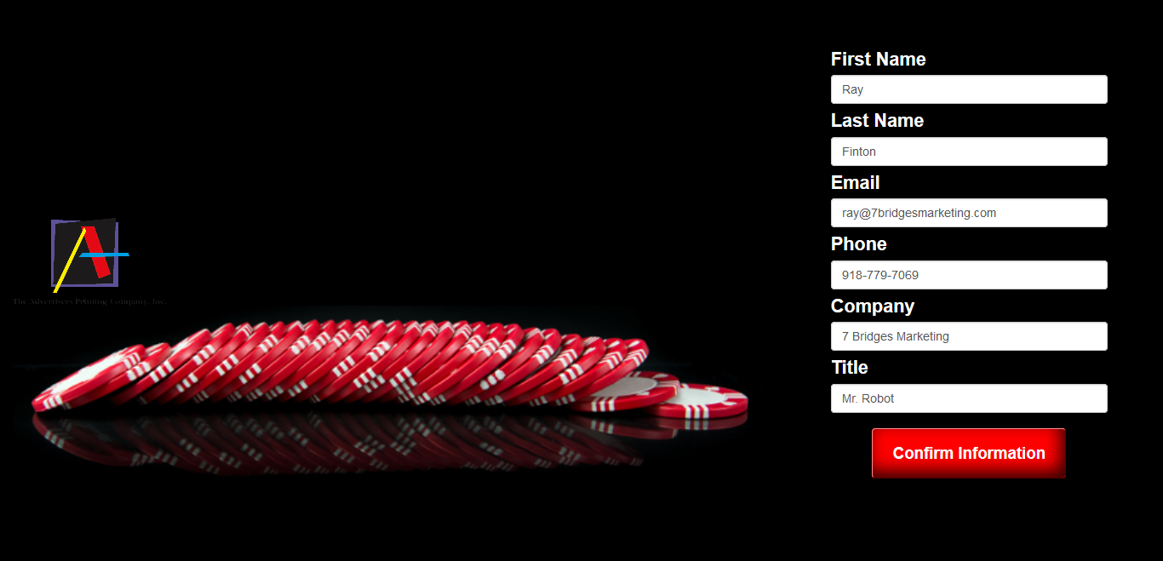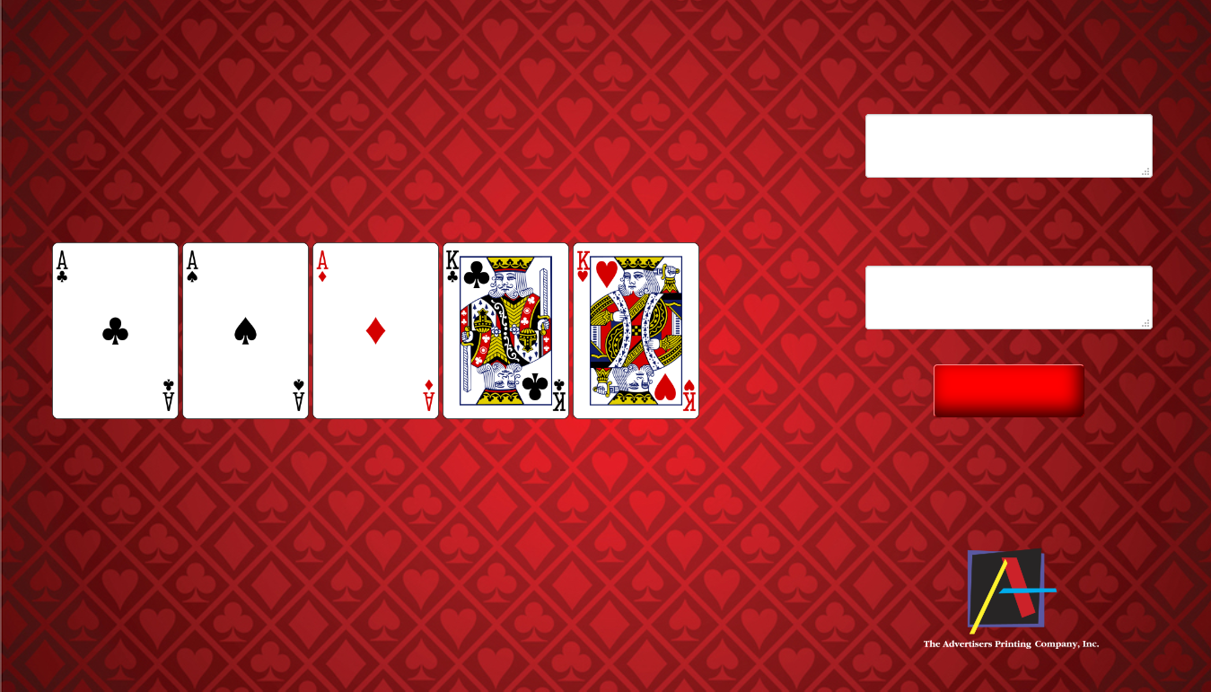

**##firstname##, thanks for your feedback. Let us show you how to increase your odds and win more students. Confirm your information for a chance to win a Free 3- month marketing campaign.**

Play Your Hand

What increase in engagement would you like to see in 2017?

Do you use personalization in your direct marketing today?

**##firstname##,**

**Play your hand and win new students! Find out how to use advanced personalization and data optimization techniques to improve engagement.**

**Enter a drawing to receive a Free 3-month Recruitment Marketing Campaign by answering two questions. You will also receive an article about the Power of Personalization in direct marketing and a case study of a University who won big results!**

**Email Invite**

To: ##email##

From: ##rep_name##  
Subject: ##firstname##, play your hand to win more students

  
  
  
  
##firstname##,

Play your hand and win new students! Checkout the link

below to find out how to use advanced personalization

and data optimization techniques to improve engagement.

http://winmorestudents.com/RayFinton

Respectfully,

Alex Fechner

The Advertisers Printing Company

1229 S. Vandeventer Ave.

St. Louis, MO 63110

Click here to unsubscribe.

**Thank you email**

To: ##email##

From: ##rep_name##

Subject: Your case study and article from Advertisers Printing Company

##firstname##,

Thanks for take the time to answer questions. Here are the

links to the article and case study. I hope those give you

some ideas on how to make an impact with your direct

marketing and WIN new students! You’re now in the

drawing for the Free 3-month marketing campaign.

Download Article

Download Case Study

Respectfully,

Alex Fechner

The Advertisers Printing Company

1229 S. Vandeventer Ave.

St. Louis, MO 63110

Click here to unsubscribe.