**TIBCO Enterprise Message Service on Azure**

**Summary:**

The TIBCO Enterprise Message Service Marketplace offering deploys a multi-tier Linux solution to create a Fault-Tolerant TIBCO EMS environment on Azure. The solution includes access tier VMs, EMS Client tier VMs, and EMS Server tier VMs running either Red Hat Enterprise or CentOS Linux 7.5. It will also create two Azure shared file systems for EMS shared storage. All components are highly available; with all virtual machines in separate "availability sets", all VM disks "managed" by Azure, and the Azure File shares being replicated to another region. Additionally, the solution provides full TIBCO EMS data encryption from the EMS server to the Azure file system via CIFS encryption, and while the data is at rest. The solution follows standard best practices for deploying Azure Resource Manager templates.

The customer must have an Azure account which allows them to purchase the solution in the Azure Marketplace.

**Marketplace Solution Architecture:**

This solution will deploy:

* Multiple storage accounts: for storing VM's disks of each tier, one for storing diagnostics data, and two for the EMS Shared Data stores.
* One Virtual Network with one subnet.
* Two Network Security Groups: one for access to the virtual network from an external source, and a second network security group for accessing the internal EMS VMs.
* Load Balancer to load balance access to the Access servers. This will provide high availability to the solution, with only requiring the Public IP Address of the Load Balancer.
* Three Public IP Addresses, one for the Load balancer and other two for the Access servers.
* Three Virtual Machine Availability sets for Access Tier, EMS Client Tier, and the EMS Server tier.
* The two Access VMs will facilitate ssh access to all other tier VMs.
* Two Linux VMs for each EMS tier for high availability.
* Each Linux VM has a choice of sizes. The EMS virtual machines choices are all based on advanced network capabilities.

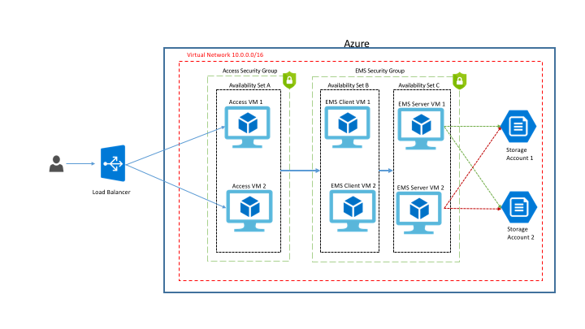

**Licenses and Costs:**

A license for TIBCO Enterprise Message Service is required to use TIBCO EMS in Azure. The user is responsible for obtaining a TIBCO EMS license and the TIBCO EMS software. The software can be downloaded [[here]](http://edelivery.tibco.com/) at https://edelivery.tibco.com with evaluation versions available [[here]](http://tap.tibco.com/) at https://tap.tibco.com. To request an evaluation license, contact TIBCO [[here]](http://www.tibco.com/contact-us) at https://www.tibco.com/contact-us. TIBCO EMS version 8.4 is required.

The Linux 7.5 images used in this solution is the PAYG model and do not require the user to license them. The virtual machine instances will be licensed automatically after the instances are first launched. Use of the Linux images carry a separate hourly charge that is in addition to Microsoft's Linux VM rates. Total price of the VM consists of the base Linux VM price plus any VM image surcharge. Click [[here]](https://azure.microsoft.com/en-us/pricing/details/virtual-machines/red-hat/) at https://azure.microsoft.com/en-us/pricing/details/virtual-machines/red-hat/ for pricing details.

**Prerequisites:**

Azure Subscription with specified payment method (Red Hat Enterprise/Centos Linux are Marketplace products and require a payment method to be specified in Azure Subscription)

TIBCO EMS license and software is required, and must be obtained before deploying TIBCO EMS in Azure.

An existing Azure Storage Account is required. A "files" share must be created in the storage account, and the TIBCO EMS installer (.zip) must be uploaded to the existing Azure Storage Account/File share.

TIBCO EMS version 8.4 is required. No other software/files should be located in the file share. Note: The existing Storage Account name, share name, and the Key are required in the Deployment steps.

**Tutorial:**

After logging in to the Azure portal, select *Create a resource,* to access the Azure Marketplace:

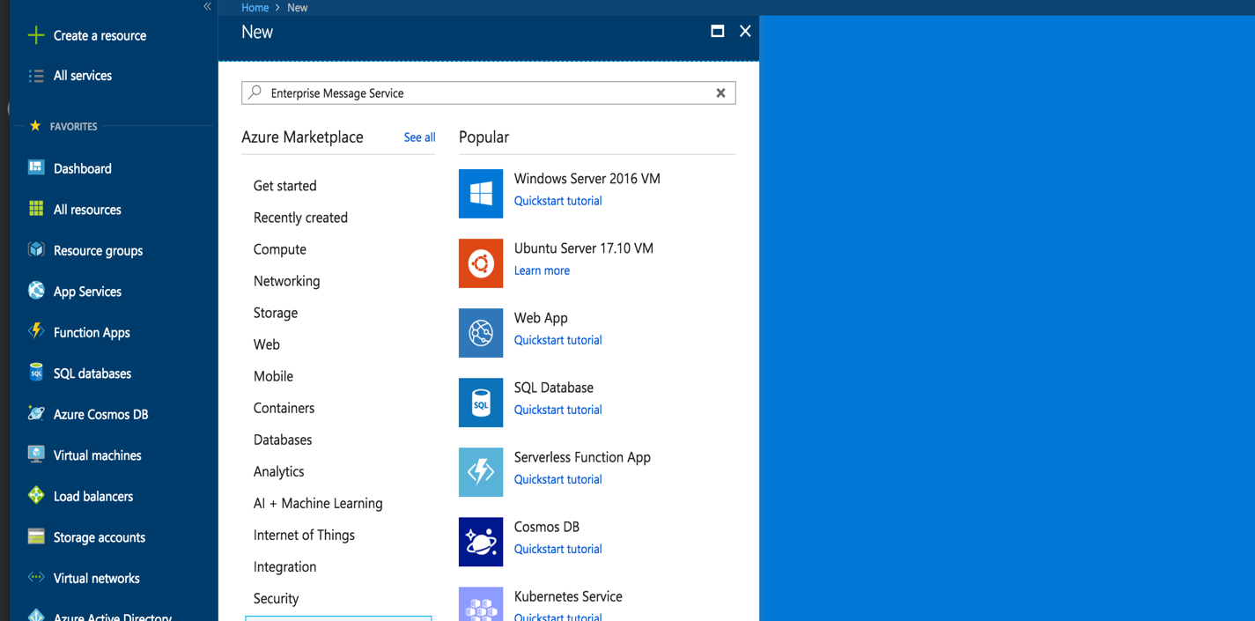

Within the Azure Marketplace, find the TIBCO Enterprise Message Service offering.

After selecting the Enterprise Message Service, the customer needs to create the deployment to start the process:

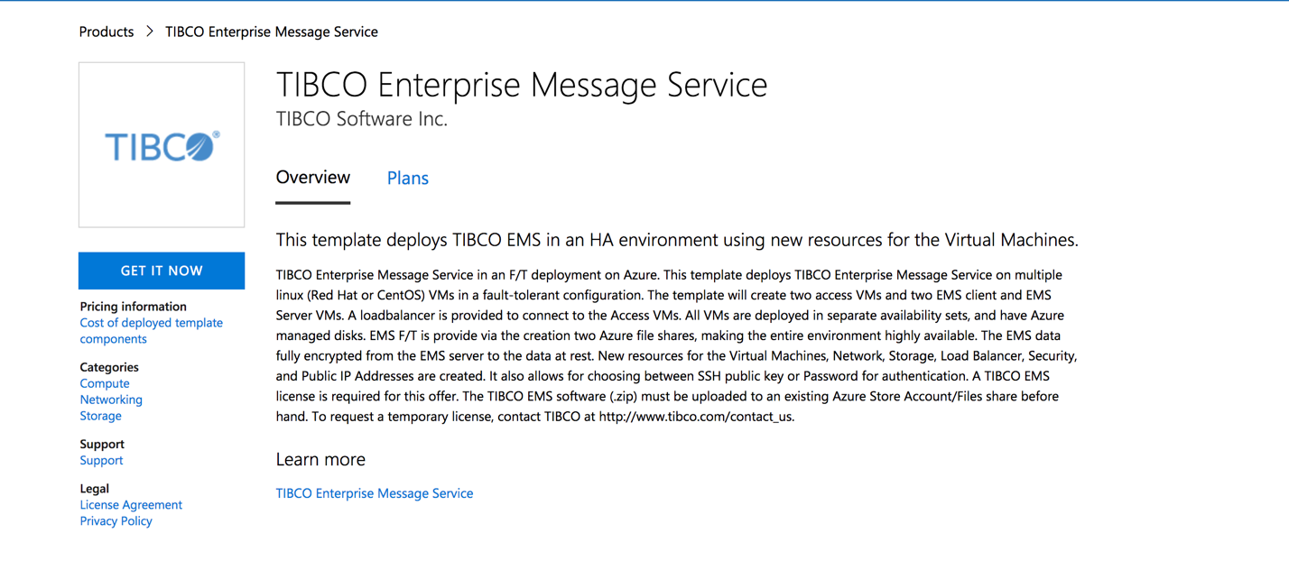

Begin the configuration process in the “Basics” section. The following fields need to be filled in:

* **Username:** This is the administrative user on all of the VMs. This user ID will be used during the configuration process as the VMs and EMS are configured and launched. The default is *tibco.*
* **Authentication Type:** This should default to password, but SSH public key can also be selected.
* **Password or SSH Public Key:** Based on the selection in the Authentication type, the customer will have to supply a password or SSH Public Key for authentication. If a password is selected, the password must be a minimum of twelve (12) characters.
* **Subscription:** This in most cases will be the default subscription of the Azure account.
* **Resource Group:** Enter a new resource group, or an existing resource group. If the resource group exists, it must not contain any existing resources. For a new resource group, it is recommended to use a name that identifies the use of the resource group.
* **Location**: Choose a region from the dropdown that is appropriate for your implementation.

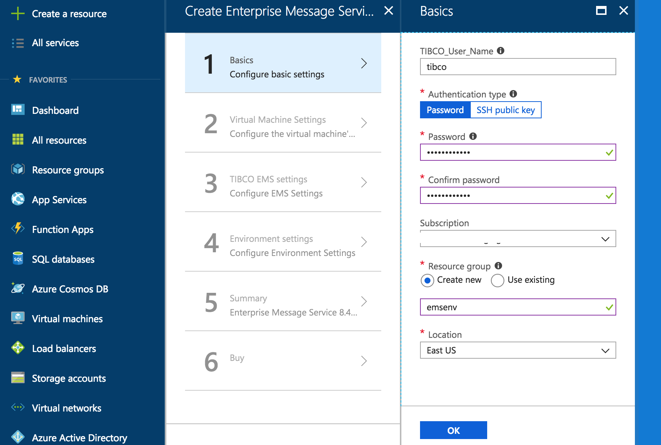

Once the basic section has been completed, the setup will move on to the Virtual Machines Settings section.

**Virtual Machine OS:**

* Enter the Linux Operating System to use for all six VMs that will be created. The choices are *RHEL* or *CentOS.*
* Enter the publisher of the OS. *RedHat* for RHEL or *OpenLogic* for CentOS.

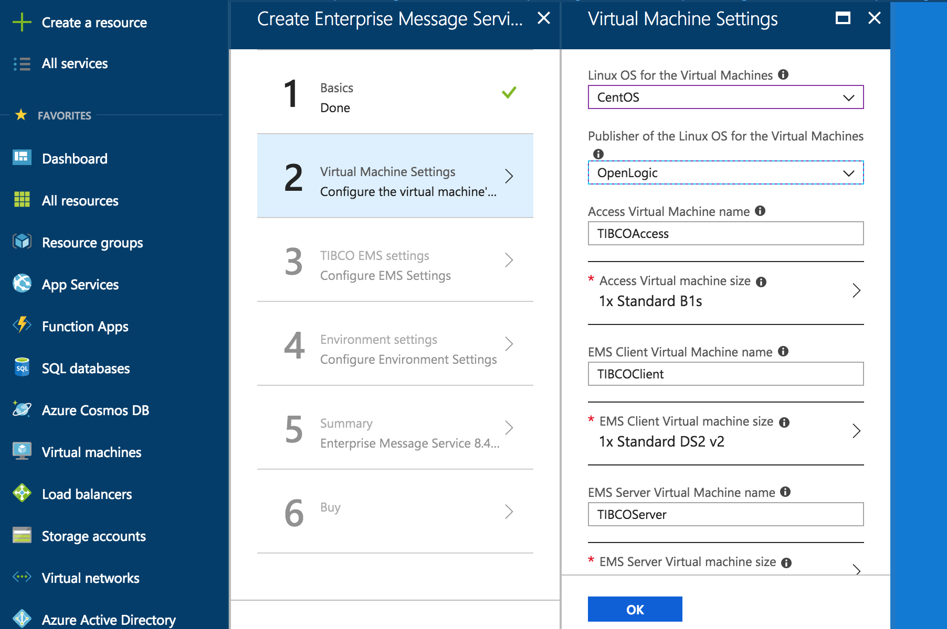

**Virtual Machine / Virtual Machine Size:**

* Enter the name for Access Virtual Machines. The default is *TIBCOAccess.* Two VMs will be created, and “-1” and “-2” will be appended to the machine name.
* Choose the VM size. Choose from the available sizes for the Access virtual machines. The recommended size is a *Standard B1s.*
* Enter the name for the EMS Client Virtual Machines. The default is *TIBCOClient.* Two VMs will be created, and “-1” and “-2” will b appended to the machine name.
* Choose the VM size. Choose from the available sizes for the EMS Client virtual machines. The recommended size is a *Standard DS2_v2.*
* Enter the name for the EMS Server Virtual Machines. The default is *TIBCOServer.* Two VMs will be created, and “-1” and “-2” will b appended to the machine name.
* Choose the VM size. Choose from the available sizes for the EMS Server virtual machines. The recommended size is a *Standard DS3_v2.*

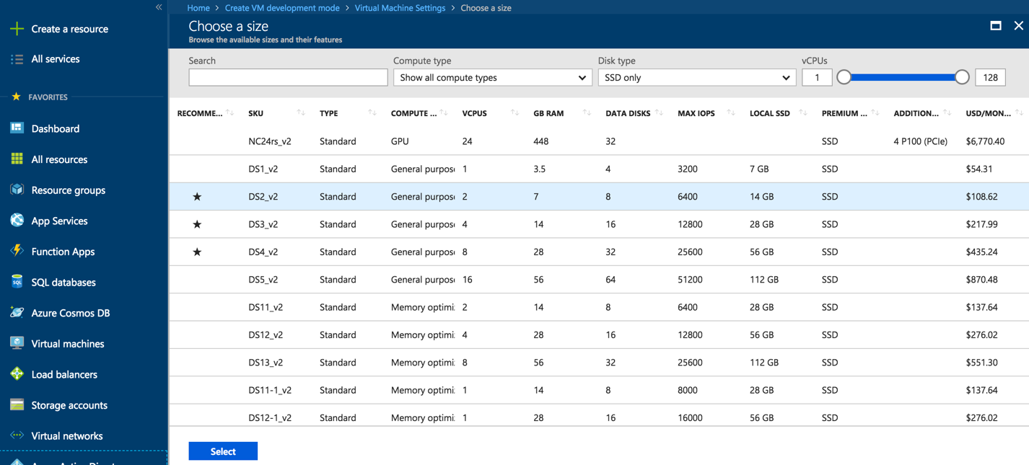

Once the Virtual Machine Setting are complete, the setup will move on to the EMS Setting:

* Enter the EMS Port number to be used. The default is *7222.*
* Enter the name of the first Storage account to be created for the EMS shared data. The default is *tibemssa1* with the *resource group ID* appended. Appending the resource group id ensures a globally unique name.
* Enter the name of the second Storage account to be created for the EMS shared data. The default is *tibemssa2* with the *resource group ID* appended. Appending the resource group id ensures a globally unique name.
* Enter the name of the existing Azure Storage account where the EMS installer (.zip) is located.
* Enter the *key* for the existing Azure Storage account.
* Confirm the *key.*
* Enter the name of the existing Azure “files” share under the Storage account where the EMS installer (.zip) is located.

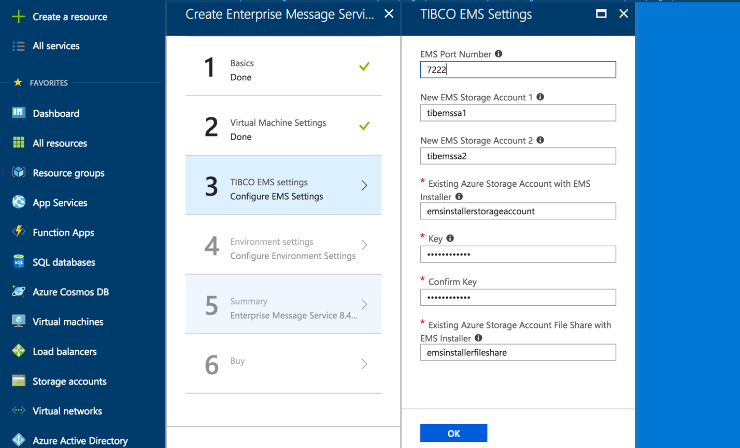

The final section to be completed contains Environment Settings for the virtual network and security groups.

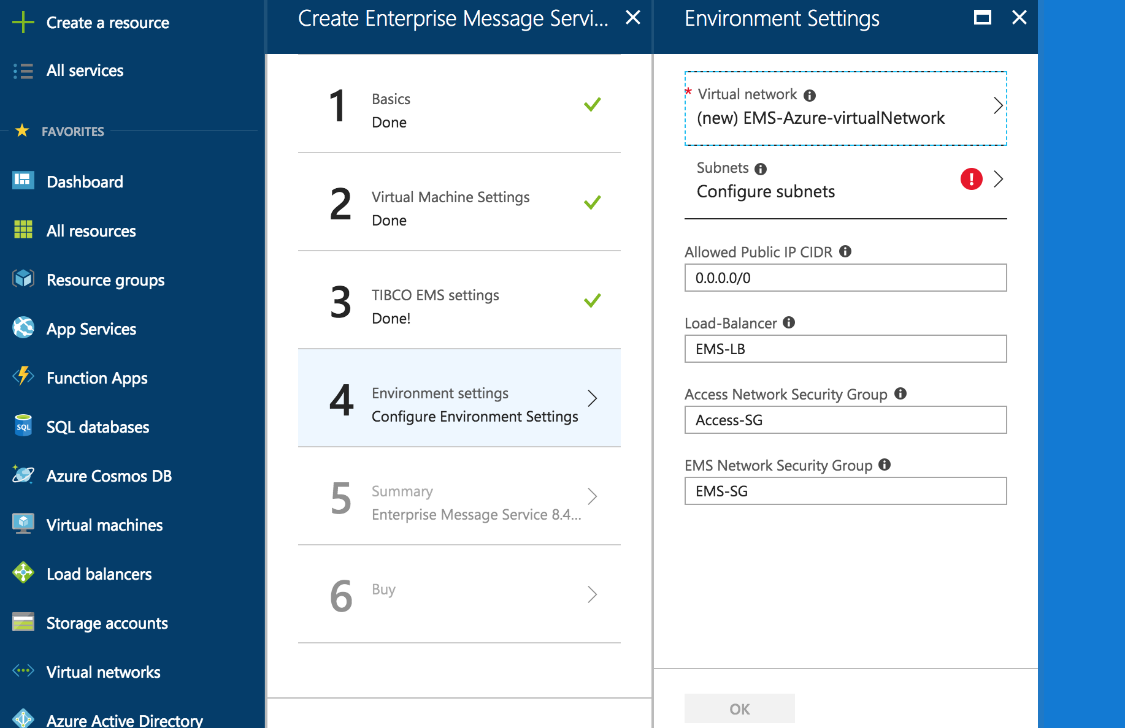

* Click on *Virtual Network* to bring up the virtual network sub-menu, and enter the Nameand Address spacefor the new Azure virtual network. The defaults are *EMS-Azure-virtualNetwork* and *10.1.0.0/16* respectively.

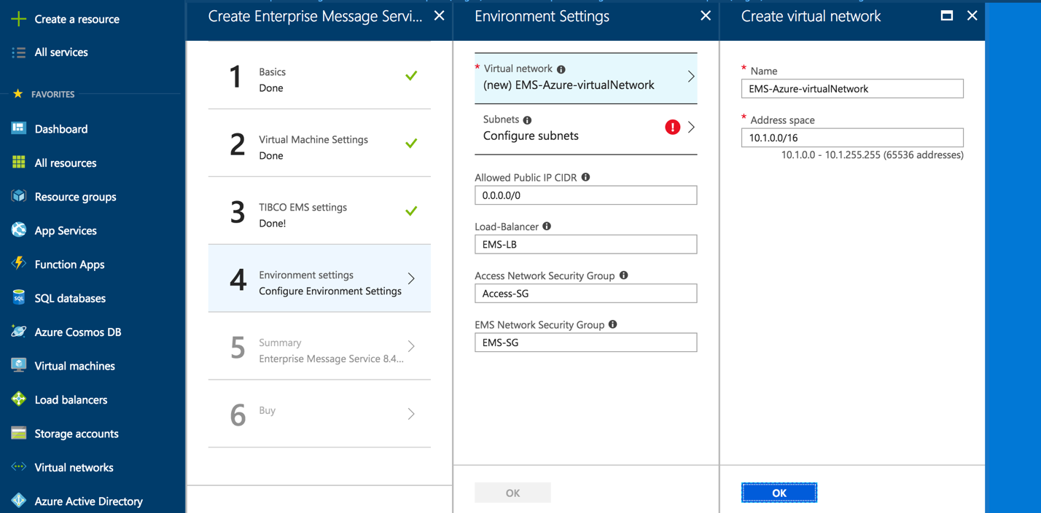

* Click on *Configure subnets* to show the subnet sub-menu, and enter the Subnet nameand Subnet address prefixfor the subnet to be created. The defaults are *subnet* and *10.1.0.0/24* respectively.

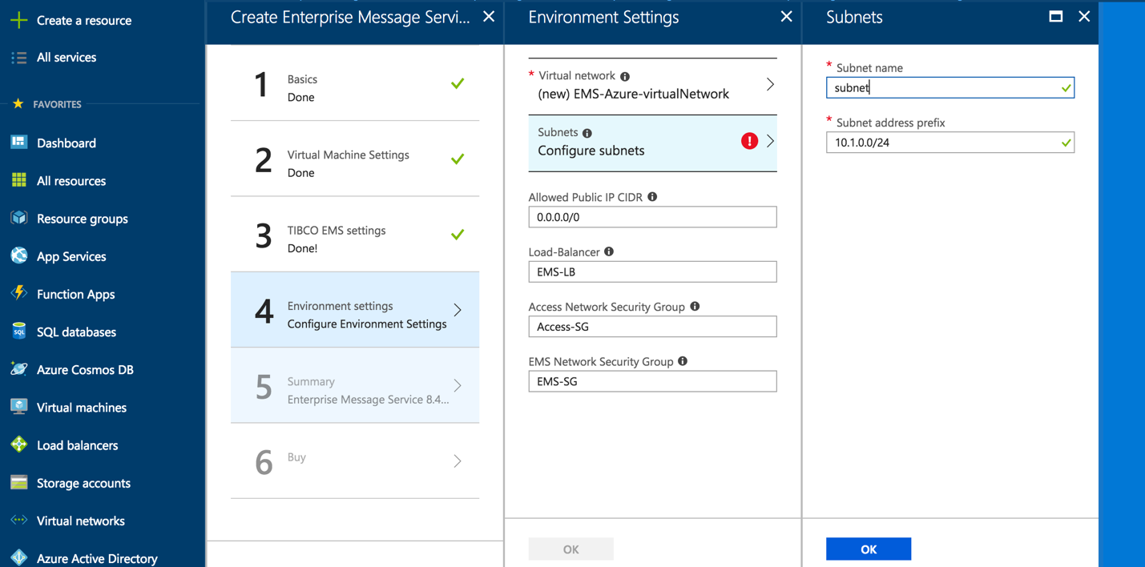

* Enter the Allowed Public IP CIDR which can access the EMS Azure virtual environment. The default is *0.0.0.0/0* (any IP Address).
* Enter the name of the Load-Balancer to be created. The default is *EMS-LB.*
* Enter the name of the Access Network Security Group. The default is *Access-SG.*
* Enter the name of the EMS Network Security Group. The default is *EMS-SG.*

**Summary:** Once the settings are complete and “OK” selected, the Azure Portal will take the user to the Summary page where they can review their choices.

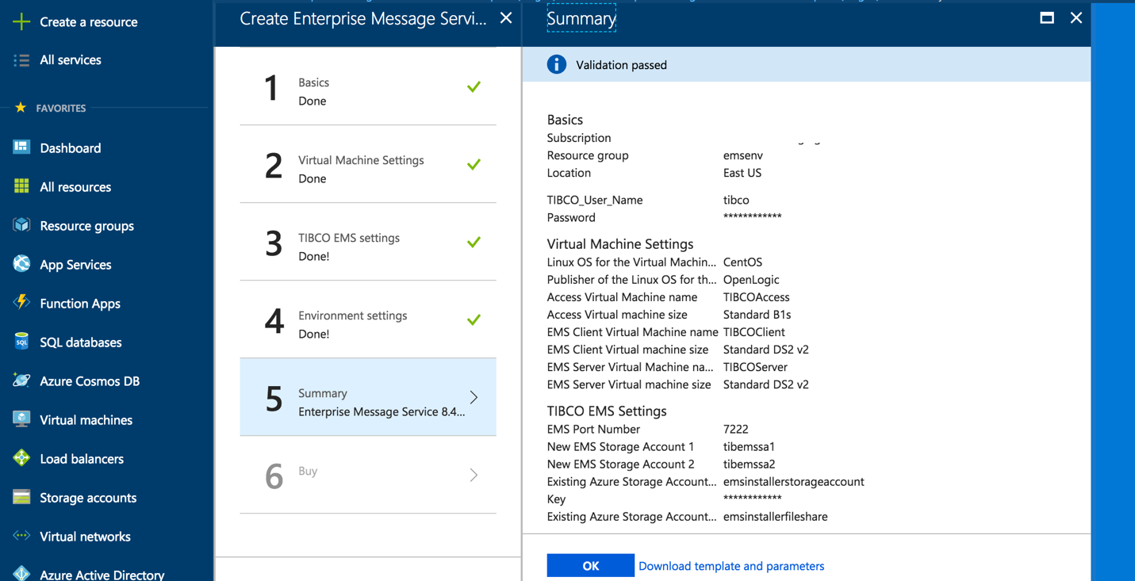

Once the Summary has been approved. The user is presented with the EULA and the option to purchase/create the Azure Marketplace offering.

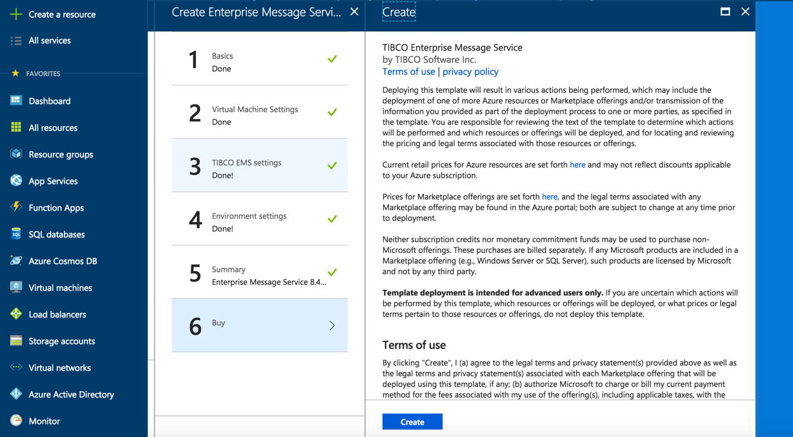

Once the *Create* button is clicked, the template will create the new TIBCO Enterprise Message Service environment in Azure based on the provided inputs.

The template will take approximately 15 minutes to complete.

Once completed, go to the main Azure Dashboard, and click on *Resource Groups*. Click on the new resource group created by the Marketplace template, and then click on *deployments.* There should be only one. Click on the deployment name, and then on *outputs.*

The outputs will show:

* Public IP Address for the Load-Balancer
* Public IP Addresses for the two Access VMs
* Private IP Addresses for the two EMS Client VMs
* Private IP Addresses for the two EMS Servers VMs
* The names of the two new Storage Accounts and Keys for the EMS data
* The existing Storage Account used for the EMS installer

Access the new environment on Azure using ssh to the public IP address for the load-balancer. From there, access to the EMS client and Server VMs is available via ssh.

The two new storage accounts/file shares will be mounted via CIFS, and TIBCO EMS will be running and available via the EMS port provided during the the configuration.