**DS 1st exam test, January 22nd, 2024**

**Download the data**

1. Consider the file sciprog-qcb-2024-01-22-FIRSTNAME-LASTNAME-ID.zip and extract it on your desktop.
2. Rename sciprog-qcb-2024-01-22-FIRSTNAME-LASTNAME-ID folder:

Replace **FIRSTNAME**, **LASTNAME**, and **ID** with your first name, last name and student id number. **Failure to comply with these instructions will result in the loss of 1 point on your grade.**

like sciprog-qcb-2024-01-22-alessandro-romanel-432432

From now on, you will be editing the files in that folder.

1. Edit the files following the instructions.
2. At the end of the exam, **compress** the folder in a zip file

sciprog-qcb-2024-01-22-alessandro-romanel-432432.zip

and submit it. This is what will be evaluated. Please, include in the zip archive all the files required to execute your implementations!

**NOTE**: You can only use the data structures and packages provided in the exam script files. **Importing other Python packages IS NOT allowed** unless explicitly stated in the exam instructions. Using Python collections or other libraries will impact your final grade. Still, **IT IS ALLOWED** to use **built-in Python operators** as we have done during the practical classes (max, min, len, reversed, list comprehensions, etc).

**Exercise 1 [FIRST MODULE]**

The dataset, titled "jobs_in_data.csv," offers comprehensive details about the salaries of workers worldwide in the field of Data Science. Each row in the table corresponds to an employee, and the columns include various information such as work_year, job_title, job_category, and more.

The dataset looks like the following:

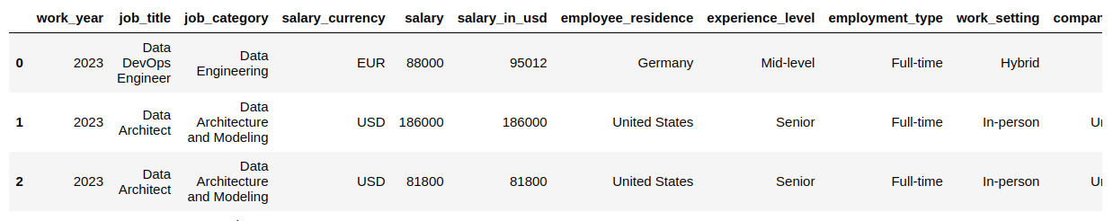

1. Load the dataset
2. Create the function **max_min_salary** to PRINT the "job_category" and "company_location" associated with the highest and lowest "salary_in_usd."

def **max_min_salary**(dataset):

…

**return** res

**OUTPUT**

> min salary:

> Category: Machine Learning and AI

> Location: Germany

> Salary: 14000

> MAX salary:

> Category: Data Science and Research

> Location: United States

> Salary: 450000

1. Develop a function, named "**get_exp_level**," which retrieves the "experience_level" of the employee holding the highest "salary_in_usd." Specify the associated "company_location" and "company_size."   
     
   Test the function with "company_location" set to Ireland and "company_size" set to "M."  
     
    def **get_exp_level**(dataset, company_location, company_size):

…

**return** experience_level

1. Create a function that accepts dataset, "work_setting" (default value: "Remote") and "employee_residence" (default value: "Canada") as input parameters. The function should generate a dictionary with years as keys and nested dictionaries as values. The inner dictionary's keys should be "job_category," and the corresponding values should be the average and standard deviation of the salary. Finally, return and print the resulting dictionary.

NOTE: name the function **average_salary_over_time**  
  
 def **average_salary_over_time**(dataset, work_setting … ):

…

**return** dictionary

The resulting dictionary should have the following structure:

{

2023:

{

'Data Engineering': [salary mean, salary standard deviation],

'Machine Learning and AI': [salary mean, salary standard deviation]

...

},

2022:

{

'Machine Learning and AI': [salary mean, salary standard deviation],

…

},

…

}

1. Utilize the earlier function with the given parameters: employee_residence set to "United States" and work_setting set to "In-person." Save the resulting dictionary in a file named "res.json" using either the json module or the standard IO module.
2. Create a function named "plot_jobs_category_over_time(data)" that reproduces the following chart:

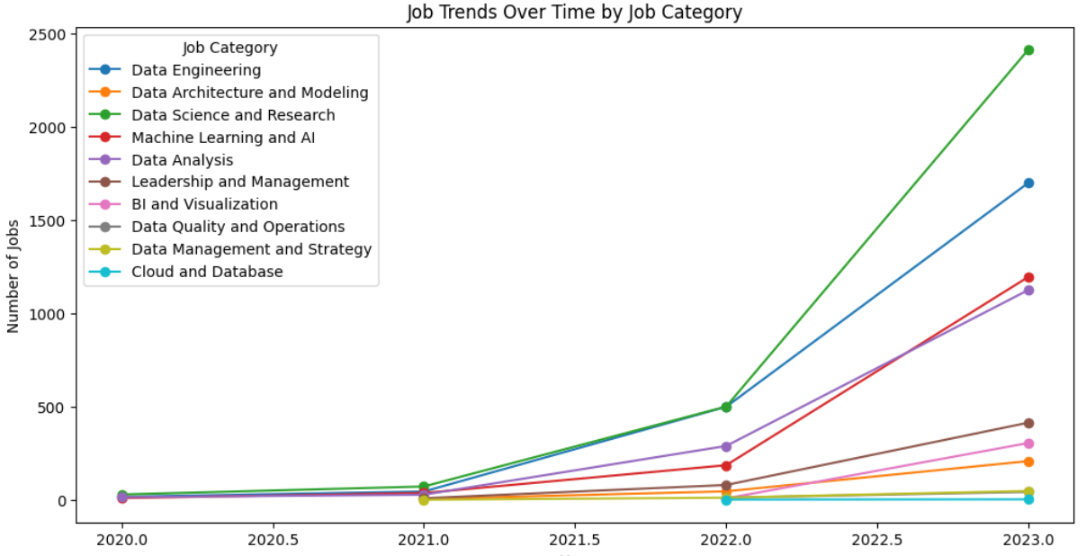

The chart depicts the evolution of job categories over time. Each line corresponds to a specific category, with the y-axis representing the number of employees and the x-axis denoting the years. Please ensure to include a legend, title, and label for the y-axis.

**Exercise 2 [SECOND MODULE, theory]**

Given a list *L* of *n* elements, a value *v*, a value *low* equal to 0 and value *high* equal to *n-1*, please compute the asymptotic computational complexity of the following function, explaining your reasoning.

def func(L, low, high, v):

if high >= low:

mid = (high + low) // 2

if L[mid] == v:

return mid

elif L[mid] > v:

return func(L, low, mid - 1, v)

else:

return func(L, mid + 1, high, v)

else:

return -1

**Exercise 3 [SECOND MODULE, theory]**

Describe the differences between the Depth-First and the Breadth-First Search algorithms for visiting graphs. Then, apply BFS to the graph below.

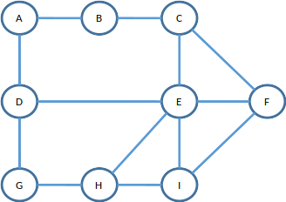

**Exercise 4 [SECOND MODULE, practical]**

Consider the BinaryTree implementation provided in the file exercise4.py. Complete the code where required:

1. ```**mirror_binary_tree**``` is a function that takes as input a ```**BinaryTree**``` and mirrors the tree itself (each left and right nodes are mirrored).   
Given the ```BinaryTree```:

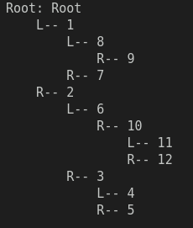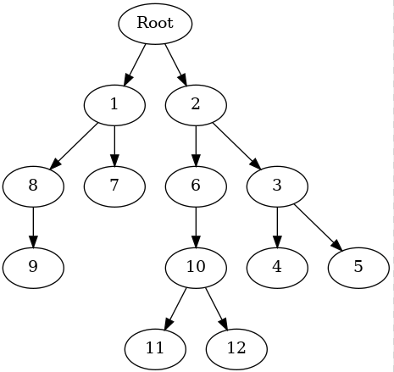

you should obtain:

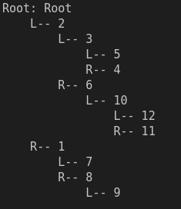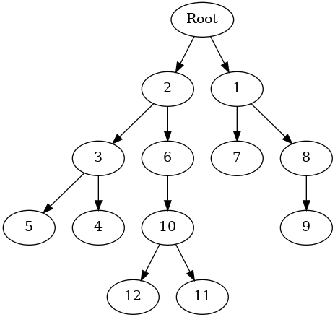

2. ``` **get_width_and_sum** ``` a function that takes as input a ```**BinaryTree**``` and returns a list of tuples, one for each level of the tree, containing three values:

- the level number (starting with root as 0);

- the width of the level (number of nodes in that level);

- the sum of the values of the nodes of that level.

