I used Tableau to analyse and visualise the dataset. I created three tables.

The first table visualises how many authors committed their comments and how many comments they have committed. We can see that two authors have no specific name. The author who wrote most is Thomas, the author who wrote less is murari.

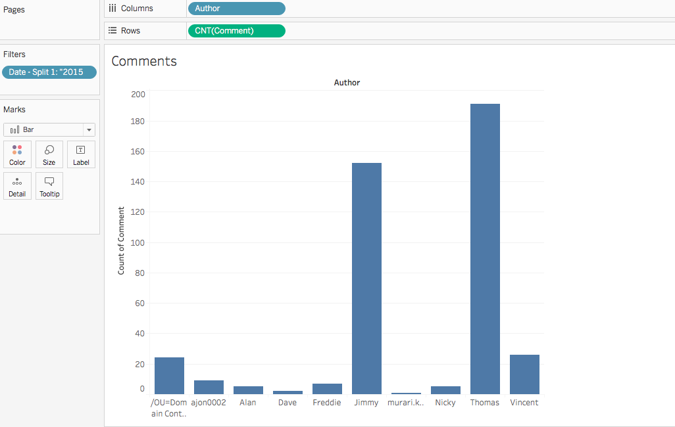

In the second table we see that the dataset includes comments starting in July and ending in November, of the same year. July was the month with most comments, though not much more than October and November. September was the month with the fewest comments.

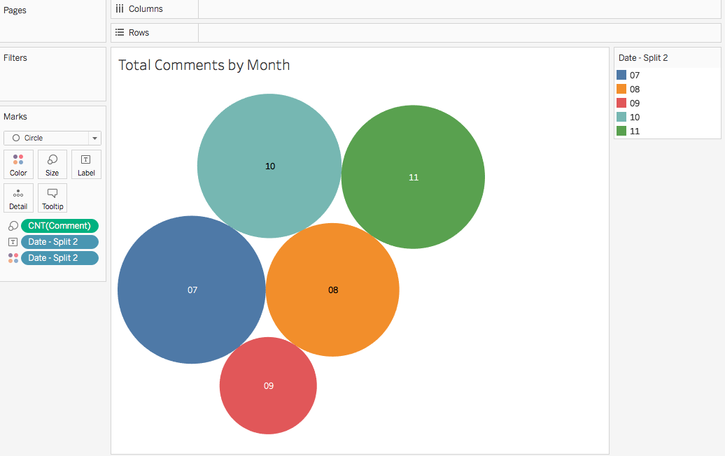

Lastly, I compared Thomas, the author who wrote most, to the general trend. We see that he also wrote less in September but he wrote more in October than in July, contrasting with the total amount of lines committed. It would be interesting to know why the number of commits/lines dipped in September and rose again in October. It might be simply a coincidence.

