Abstract

Getting User Input
For this I used the man page for `getline` and used the example it gave.
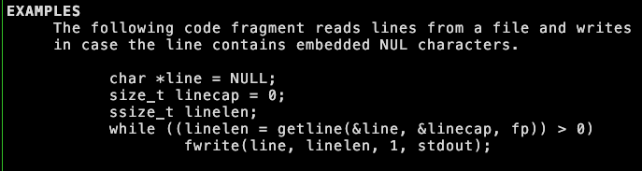
In this example, they demonstrate exactly how to use the getline stdlib function. The parameters and return value are all very important to get right. It will modify the parameters passed by value, so these must be within the spec that getline outlines.

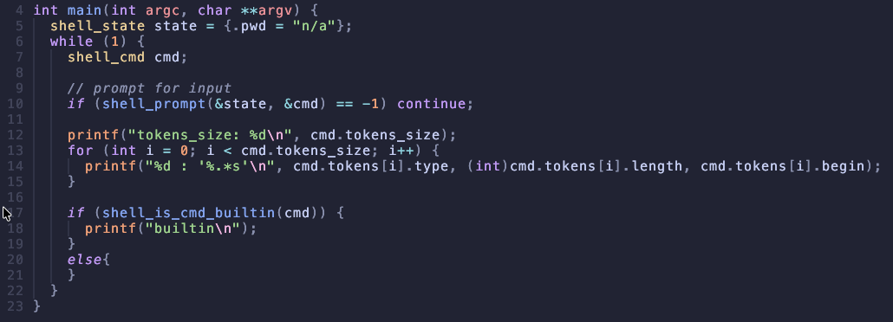
This main function represents the
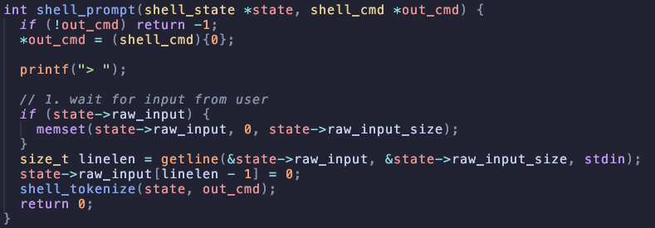
This code represents

