# Config

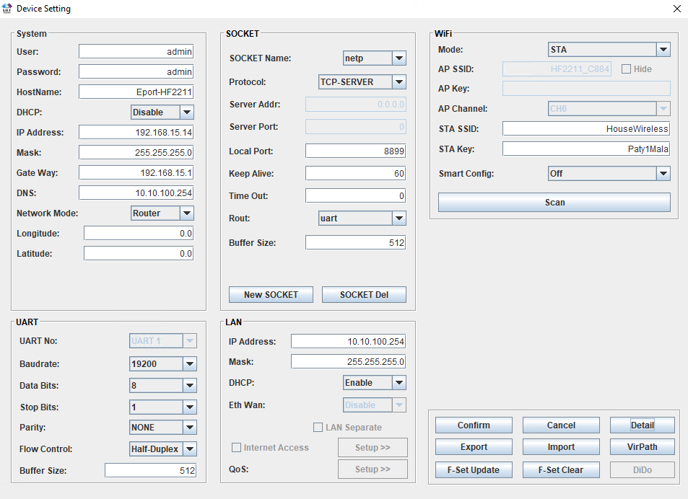

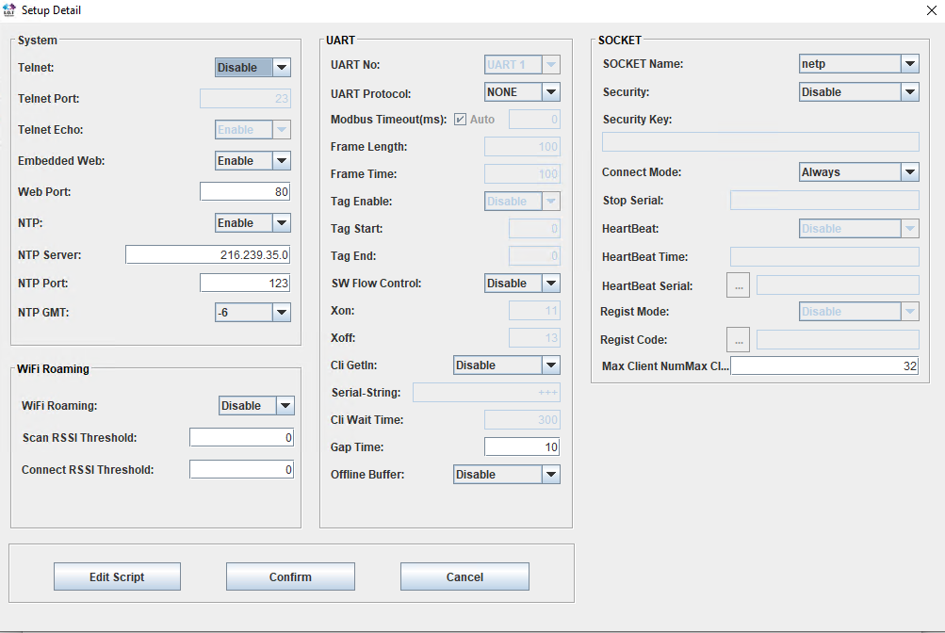

# Script COM keep alive

KEEP_ALIVE = [0x10,0x02,0x01,0x01,0x00,0x14,0x10,0x03]

FRAME = [0xAA]

RECV UART uart0

IF (INPUT==KEEP_ALIVE && FRAME!=[0xAA])

OUTPUT=FRAME

SEND(UART, uart0, FRAME)

FRAME = [0xAA]

ELSE

OUTPUT=INPUT

END

RETURN(TRUE)

END

RECV SOCK netp

FRAME=INPUT

RETURN(FALSE)

END

# Script SEM Keep Alive

KEEP_ALIVE = [0x10,0x02,0x01,0x01,0x00,0x14,0x10,0x03]

FRAME = [0xAA]

RECV UART uart0

IF (INPUT==KEEP_ALIVE)

IF (FRAME!=[0xAA])

OUTPUT=FRAME

SEND(UART, uart0, FRAME)

FRAME = [0xAA]

END

ELSE

OUTPUT=INPUT

END

RETURN(TRUE)

END

RECV SOCK netp

FRAME=INPUT

RETURN(FALSE)

END

# Comandos

LIGHT OFF

10 02 00 05 00 00 00 20 FF 01 36 10 03

LIGHTS ON

10 02 00 05 00 00 20 00 FF 01 36 10 03

LIGHTS TOGGLE

10 02 00 02 00 01 00 01 00 16 10 03

FILTER OFF

10 02 00 05 00 00 00 02 FF 01 18 10 03

FILTER ON

10 02 00 05 00 00 02 00 FF 01 18 10 03

HEATER ON

10 02 00 05 00 00 01 00 FF 01 17 10 03

HEATER OFF

10 02 00 05 00 00 00 01 FF 01 17 10 03

AUX1 ON

10 02 00 05 00 00 10 00 00 FF 01 26 10 03

AUX1 OFF

10 02 00 05 00 00 00 10 00 FF 01 26 10 03