# Apedog configuration

Contents

Apedog configuration 1

1. Introduction 1

2. Opening configuration 2

3. Configuration of entities 3

3.1. LCs 3

3.2. Users 4

3.3. Terms 5

3.4. Quarters 6

3.5. KPI units 7

3.6. Business perspectives 8

3.7. Critical success factors 8

3.8. Key performance indicators 9

4. Task configuration 10

4.1. Introduction 10

4.2. Responsible person configuration 10

4.3. Strategy configuration 11

4.4. Action configuration 12

4.5. Operation configuration 13

## Introduction

As we wanted o make Apedog usable for every Aiesec country, it was required to make it as much configurable as possible. You can configure almost everything, from structure of BP->CSF->KPI to length of terms and quarters. I would like to point out that following of the manual is needed for the right functionality of the system. In case of any doubts, during configuration it is the right time to contact me on krystof1000@gmail.com

## Opening configuration

To open the configuration you must be logged as MC: Open praha.aiesec.cz/apedog and login as MC (case sensitive) and password aiesec (you can change it later).

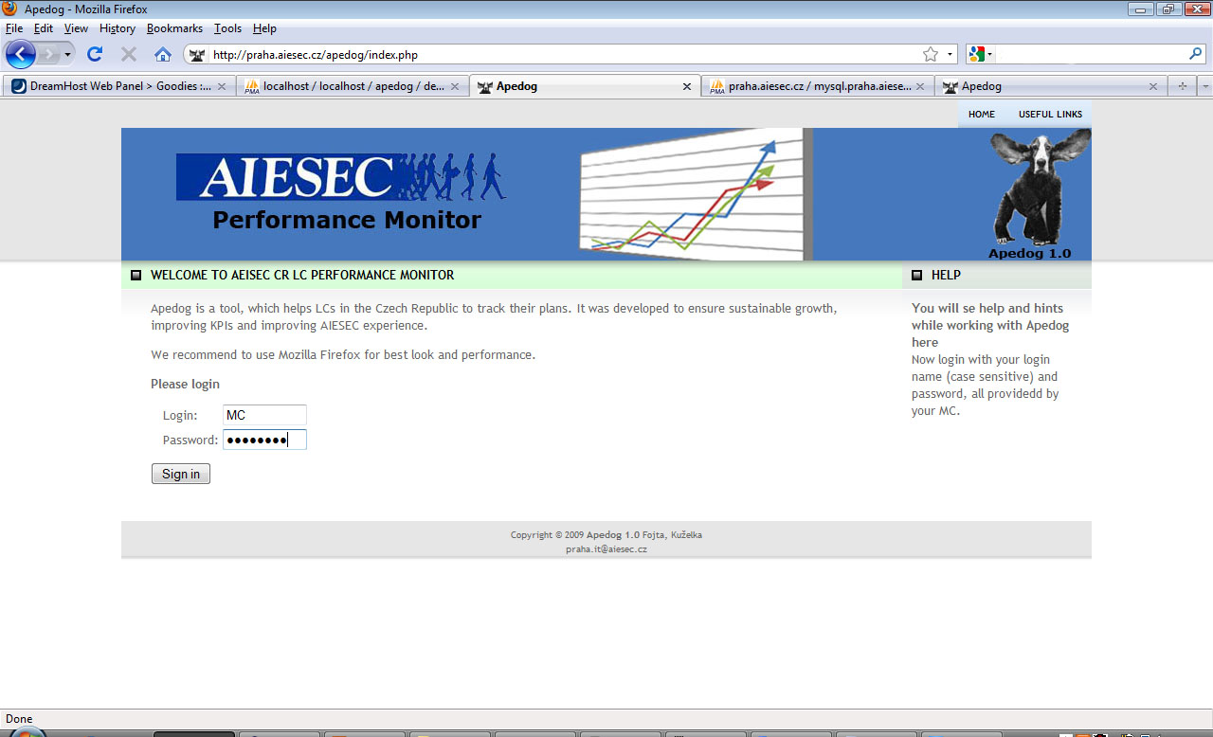

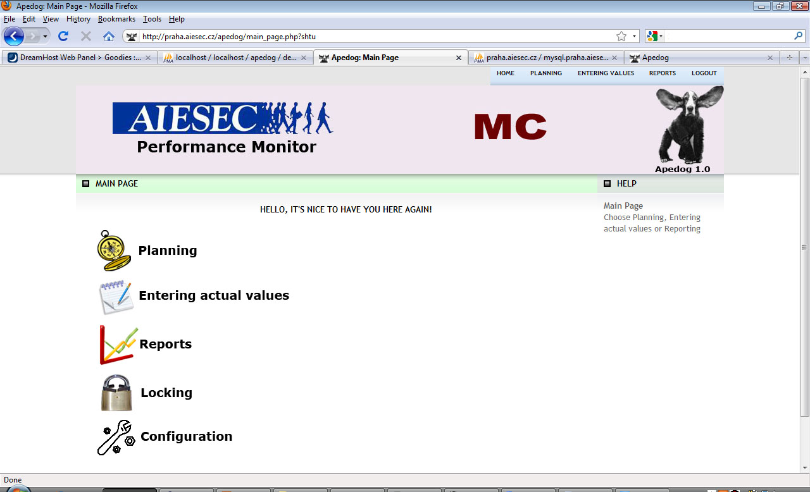

Now go to configuration to set everything what is needed. It is quite important to follow the flow of configuration as we sometime need instance of one entity to create another.

## Configuration of entities

### LCs

Firstly, we will set other LCs. Go to “LC” configuration.

As you can see, there already is MC, you need it and some its user in order to use configuration. Its users can also lock others’ LCs’ Planning and Entering actual values and can see more wide output (also from LCs)

We will make other LCs. So we want use “new – create new item”. We make LC called

Praha. Description is voluntary. And save it by pressing “Save”.

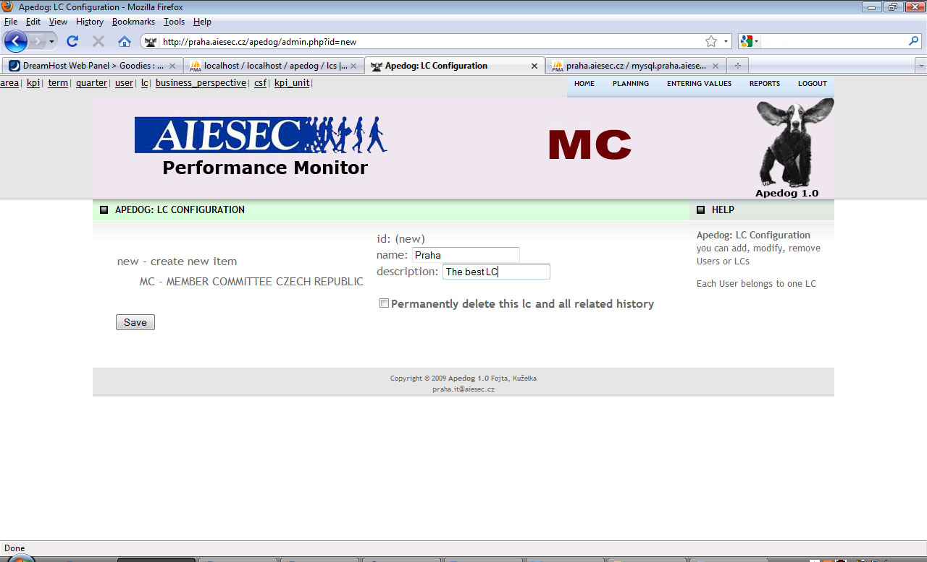

You can edit or delete all items by pressing on them in a list under “new – create new item”. Created and updated columns shows date when specific item was created and updated and it is changed automatically when you press save so you don’t have to edit it manually.

### Users

For adding User for this LC we either press on LC and use Add new User or we go to User configuration manually.

So we want to add User Kryštof Kuželka and as we won’t make other users for Praha, we can set his login as Praha. We choose his password and insert mail and name, where, if Praha LC forgets to enter actual values for some KPI even after 25 days after the end of quarter, mail with reminder will be sent. We also mustn’t forget to check if the right LC (Praha) is chosen.

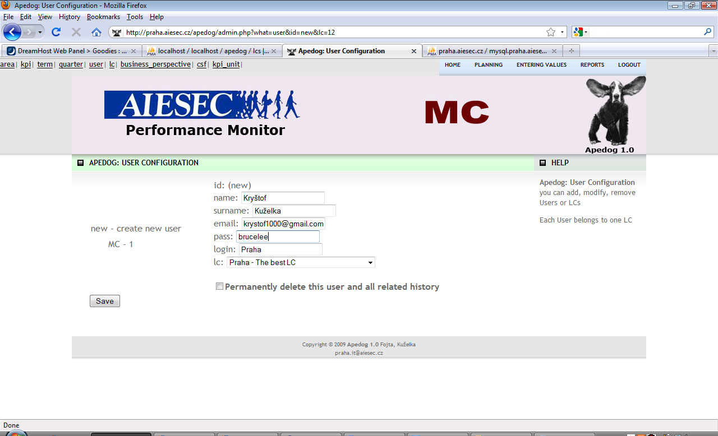

### Terms

Firstly we go to term configuration and configure some terms. We set value of number_of_term as an order for all lists of terms (the best idea is to set number 1 for first term we are tracking, number 2 for second etc.). It is important to make sure number_of_term makes sequence (1,2,3,4,…).

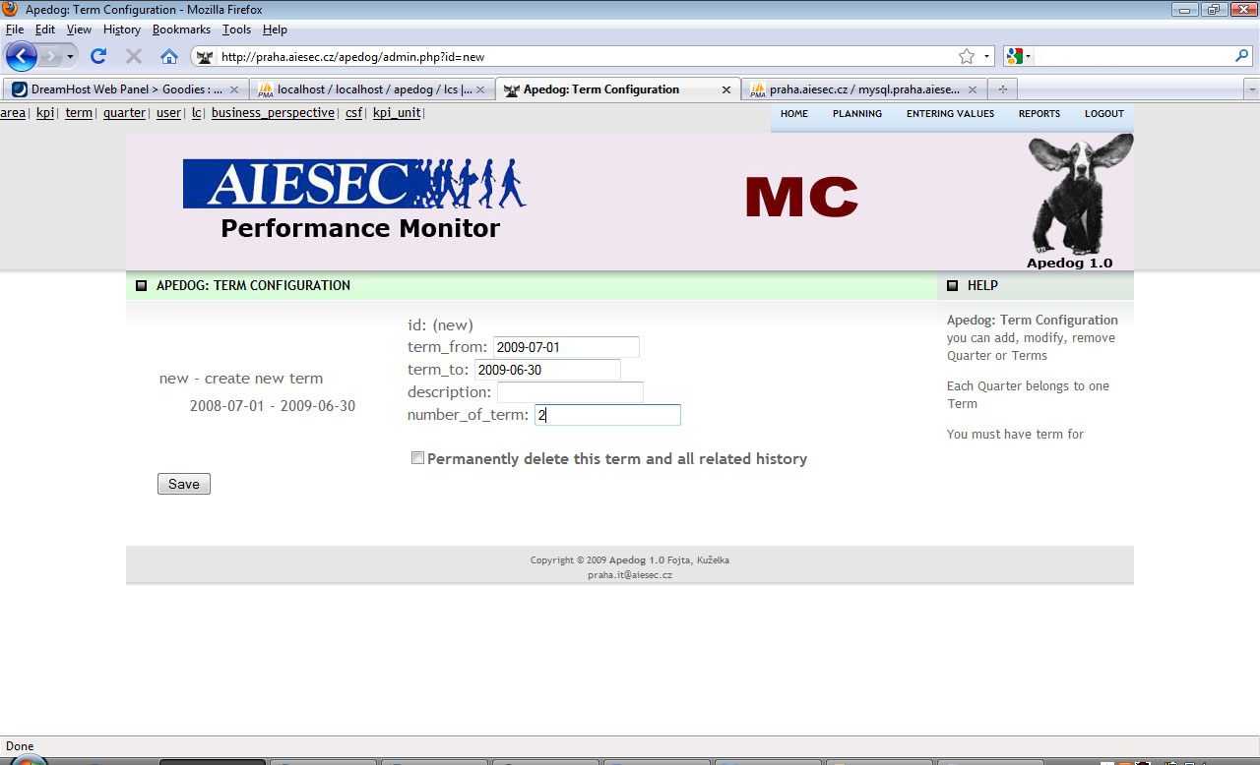

### Quarters

Now we similarly define quarters for terms. We decided to use quarters as the best time period for us as month is so short time to enter values for 50 KPIs or so. Of course you can make 12 quarters in term and choose periods whatever you like but it will still be called quarters. Quarter_in_term has similar function as number_of_term in term. It also determines order of quarters and allows choosing which the quarter that was year ago is. I strongly recommend inserting values 1,2,3 and 4 for the quarter_in_term.

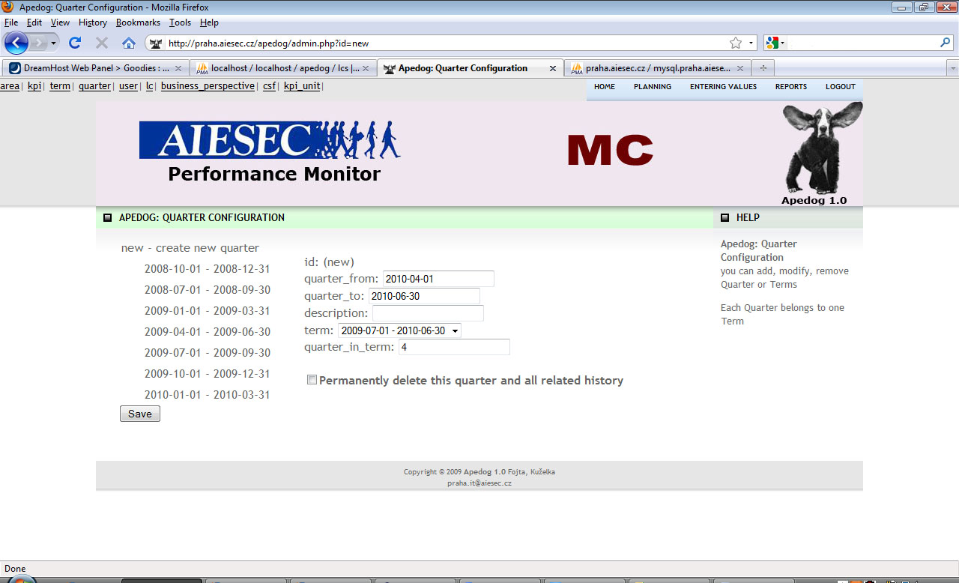

### KPI Units

We would definitely like to make some list of units available for KPIs. To do that, go to the kpi_unit.

The name of kpi unit is what will be shown right next to every value of this KPI.

Spec means specification. The only thing that matters is if you type in boolean. Try it! That will cause, this KPI won’t have input field but dropdown menu with yes/no. If you choose boolean you don’t have to do insert name.

Description is just for your information, what is meant by this unit.

I will create several other units like ‘%’, ‘CZK’ (it is Czech currency), etc.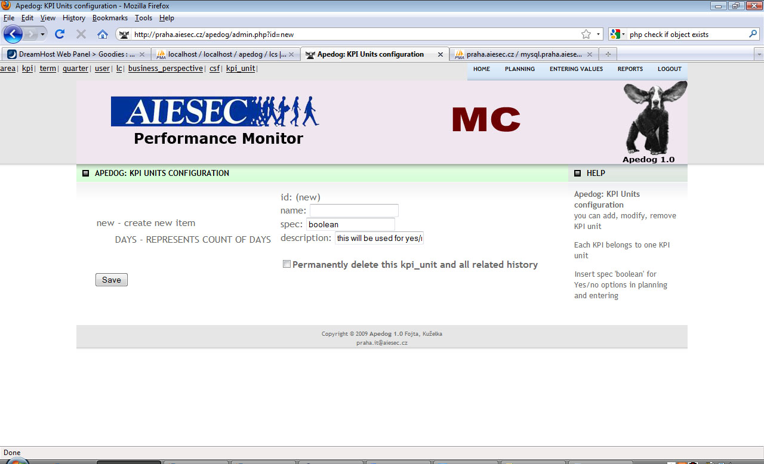

### Business perspectives

I will create some BPs in BP configuration. The order, how you create it, will take effect in order in Reports so think twice before you create it.

### Critical success factors

For each BP I will create some CSFs. If you delete BP, CSF remains but loses its parent. If CSFdoesn’t have a parent, it is not shown in reports.

BP->CSF->KPI creates tree structure and if you don’t have Balance score card you could call these ‘groups’ differently. Nevertheless, you can easily use it. Put your indicators(KPI) into some group(CSF) and these groups put into another parent group(BP).

### Key performance indicators

* Name: Name of KPI
* Description: Help when user roll over KPI (same as for CSF)
* Area: definitely choose one of function areas
* CSF the KPI belongs to
* Kpi_unit: if you want to have a unit next to value of KPI or if you want to have boolean choice choose one of KPI units we defined before
* Graphs: type of graph used for this KPI, you will have to try it☺
* End_of_term: Imagine your LC made 3 exchanges for this KPI in first quarter, 5 in second, 2 in third and 4 in fourth. What should be value at the end of term? Is it sum? Is it the last value (4)?
* All_lcs: quite similar. Imagine first LC achieved 5Xs, second LC 3, third 7. What is the output for whole country? Is it sum? It probably is. But what if you have percentage? Average? What if it is yes or no? If at least one yes => yes? It is just some kind of logic.
* In_bsc: if you choose no, the lcs will see this KPI just if they check the option Include custom KPIs in Reports section
* Lc: which LC should have this KPI? It is multi select (use ctrl, tab will make some special KPI just for Prague that other LCs won’t have. It is reasonable to not include those in balance score card and make it custom.

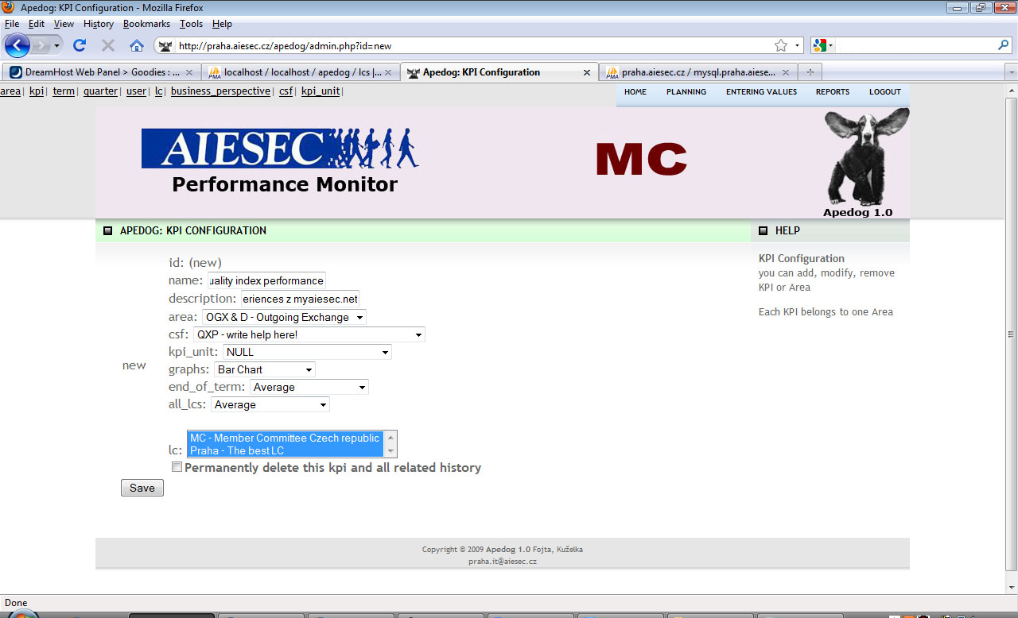

## Task configuration

### Introduction

The following functionality was added to Apedog with release 2.0 on October 2010. It is not required configuration for the basic planning/tracking functionality of the system. What is provided is task tracking system with email reminders.

What was required is the structure of task. Large groups – **strategy**, medium – **action** and tasks themselves – **operation**. This whole structure is under CSF.

### Responsible person configuration

To configure responsible person for the operation we go to report section and click on CSF. Then we click on **+** under the Responsible column. Pop up appears and we insert name and email as receiver of reminders.

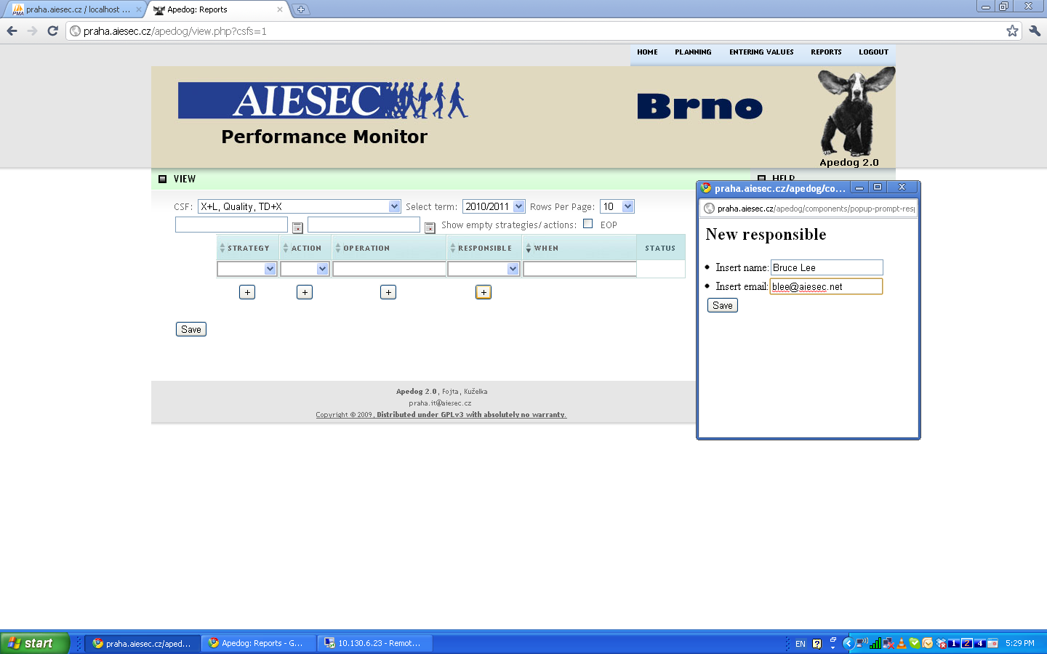

### Strategy configuration

To configure strategy we go to report section and click on CSF. Then we click on **+** under the Strategy column. The chosen CSF will be parent for the strategy. We insert name of strategy and click on save.

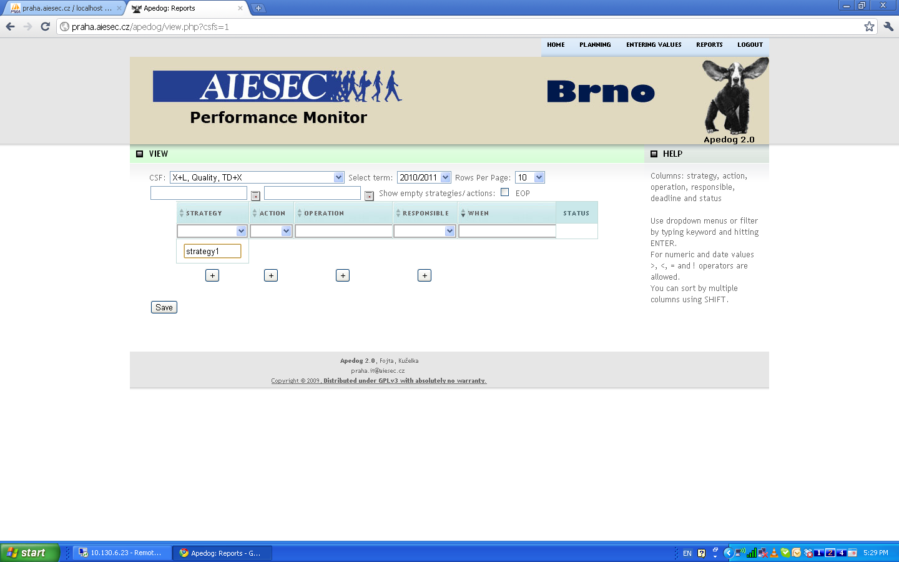

### Action configuration

To configure action we go to report section and click on CSF. Then we click on **+** under the Action column. Then we choose strategy to which action belongs to. We insert name of action and click on save.

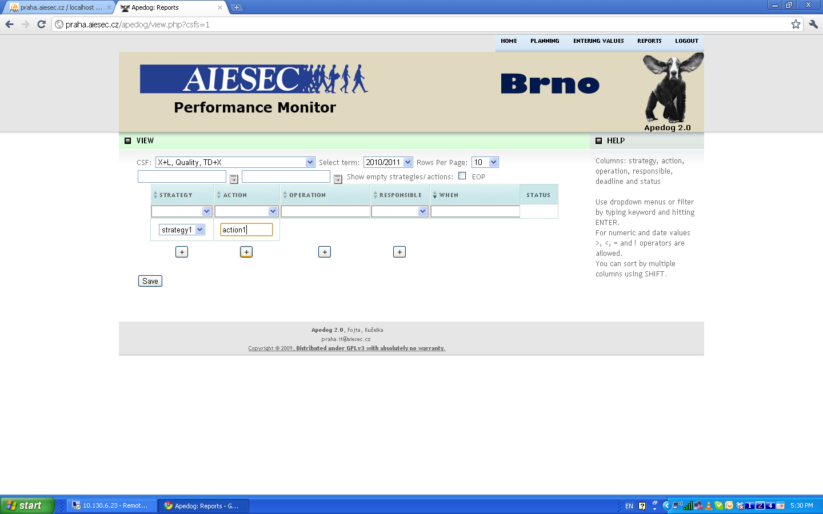

### Operation configuration

To configure operation we go to report section and click on CSF. Then we click on **+** under the operation column. Then we choose action to which operation belongs to. We insert name of operation, choose responsible person and insert DDL, (1 day before it the responsible person will get email notification if status is not checked) and click on save.

If responsible person fulfills the operation, he/she checks the status and click save. You as MCP (LCP) will get email notification about it. So it is important to give access to the account of the system to the responsible people.

