Section 4. Model Optimization and Flooding Prediction *
4.1 Data Sources
In this part of experiment, we will use 15 datasets of catchments in the United Kingdom. The first 9 datasets come from the Ouse Catchment data which are river sensor readings for predictions. Ouse Catchment data were supplied by the Ridings Area Office of the Environment Agency North-East. Three sensors from three river level gauges, namely: Skelton (the nearest to the city of York), the upstream station at Crakehill and the upstream station at Skip Bridge. The target sensor for prediction is Skelton. Detailed information is listed in List 4.1 and Table 4.1.

List 4.1 Ouse Catchment data

Data name: Ouse Catchment data
Data owner: Ridings Area Office of the Environment Agency North-East, UK.
Data source: www.ccg.leeds.ac.uk/simon/nndown.html
Time span: 08/25/1986 – 02/23/1995
Data size: 1920
Time Interval b/w measurement: 15 min.

Table 4.1 Sizes of Ouse Catchment data

 | Crakehill | Skelton | Skipbridge | Comments
8/25/86-8/29/86 | 480 | 480 | 480 | Training
12/25/94-12/31/94 | 672 | 672 | 672 | Training
1/26/95-2/23/95 | 768 | 768 | 768 | Prediction
Total size | 1920 | 1920 | 1920

The second 6 datasets are Serwent Catchment data provided by the British National River Flow Archive. There are 6 sensors in the upper Serwent catchment, as illustrated in Figure 4.1. Detailed information is listed in List 4.2 and Table 4.2.

List 4.1 Ouse Catchment data

Data name: Serwent Catchment data
Data source: http://www.nerc-wallingford.ac.uk/ih/nrfa/river_flow_data/index.htm
Time span: November 1, 1971 - January 31, 1977
Data size: 1919
Time Interval b/w measurement: 24 hrs.

Table 4.2 Sizes of Serwent Catchment data

 | Derwent@  Long Bridge | Derwent@  Matlock Bath | Derwent@  Chat Sworth | Derwent@  What  Stand Well | Wye@  Ashford | Amber@  Wind  Field  Park
11/1/1971-1/31/1977 | 1919 | 1919 | 1919 | 1919 | 1919 | 1919

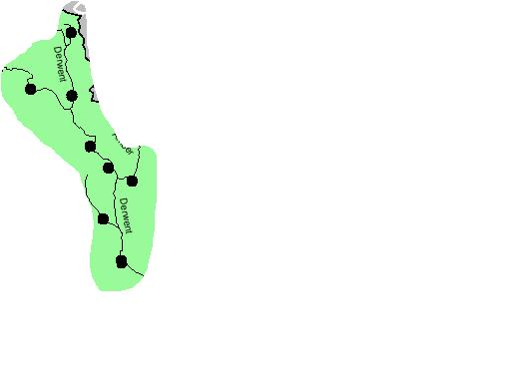
Figure 4.1 Serwent Catchment Sensor distributions

4.2 Data Format
For data of both Ouse catchment and Serwent catchment, we use a vector of sensor readings at the same time to represent a state of the EMM. In Ouse catchment data, three readings are available at the same time from three different locations. Therefore we use

<r1, r2, r3>

to represent a state, where r1, r2, r3 are sensor readings from the three locations at a certain time. Furthermore, we concatenate the three datasets available for each of the locations, as shown in Table 4.1 to form a larger dataset. The combined dataset has a dimension of 3 by 1920.

Similarly in the Serwent data 6 locations have reading sensors. We will use a vector of length of 6 to represent a state of EMM. After combining the 6 datasets, we obtain a larger dataset with a dimension of 6 by 1919. The format of a state thus will be,

<r1, r2, r3, r4, r5, r6>.

_____________________________________________

* From CSE8331 Project 2 Implementations of EMM for Predictions, by Yu Meng, December 1, 2003.

