Demystifying R Survey Report

# About our Respondents

We did a **survey** on September 6, 2022. We received responses from 327 people.

## Age

Respondents listed their age. The youngest respondent was 0 years old and the oldest respondent was 79. The mean age was 38.5.

The graphs below shows the age of respondents broken into three groups.

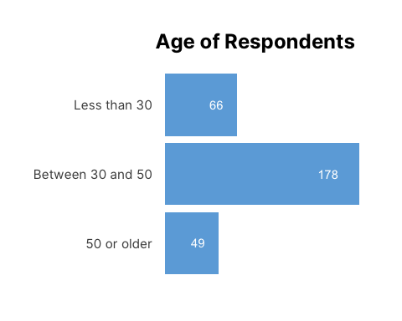

## Education

The education levels of respondents are below.

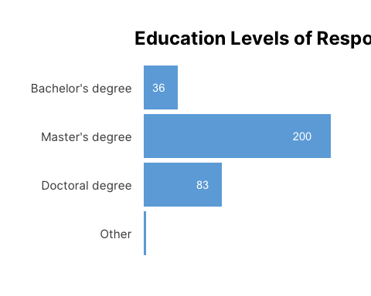

## Locations

Respondents listed the location of their primary residence. The map below shows their locations.

## Gender

Respondents were asked to list their gender, in whatever form they choose to identify it.

The original responses are below.

## # A tibble: 307 × 1  
## `Gender (Original Response)`  
## <chr>   
## 1 Boy   
## 2 Boy   
## 3 Boy   
## 4 Queer   
## 5 Female   
## 6 Female   
## 7 female   
## 8 Female   
## 9 female   
## 10 Female   
## # … with 297 more rows

We then used the [gendercoder package](https://github.com/ropenscilabs/gendercoder) to recode responses. The table below shows the original responses and the recoded responses.

## # A tibble: 307 × 2  
## `Original Responses` `Recoded Gender`  
## <chr> <chr>   
## 1 Boy Boy   
## 2 Boy Boy   
## 3 Boy Boy   
## 4 Queer Unable to recode  
## 5 Female Woman   
## 6 Female Woman   
## 7 female Woman   
## 8 Female Woman   
## 9 female Woman   
## 10 Female Woman   
## # … with 297 more rows

We can then summarize the recoded responses, which we do in the following table.

## # A tibble: 8 × 2  
## `Recoded Gender` `Number of Responses`  
## <chr> <int>  
## 1 Agender 1  
## 2 Boy 3  
## 3 Cis Woman 3  
## 4 Man 63  
## 5 Non-Binary 2  
## 6 Transgender Man 1  
## 7 Unable to recode 10  
## 8 Woman 224

# Familiarity with R

On a 5-point scale, respondents listed their level of familiarity with R as 1.9. The figure below shows familiarity broken down by education level.

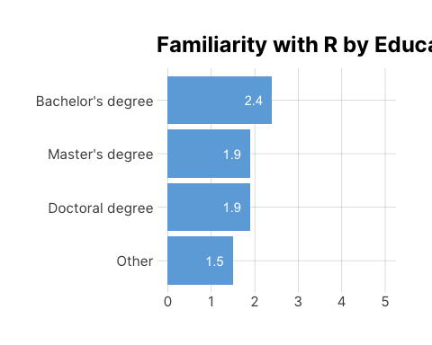

# Interest in Learning R

On a 5-point scale, respondents listed their level of interest in learning R as 4.3.

We can do a similar breakdown, but adding age. With one line of code, we can make small multiples.

