Sample Report

David Keyes

6/4/2020

Data summary

|  |  |
| --- | --- |
| Name | cars |
| Number of rows | 50 |
| Number of columns | 2 |
| _______________________ |  |
| Column type frequency: |  |
| numeric | 2 |
| ________________________ |  |
| Group variables |  |

**Variable type: numeric**

|  |  |  |  |  |  |  |  |  |  |  |
| --- | --- | --- | --- | --- | --- | --- | --- | --- | --- | --- |
| skim_variable | n_missing | complete_rate | mean | sd | p0 | p25 | p50 | p75 | p100 | hist |
| speed | 0 | 1 | 15.40 | 5.29 | 4 | 12 | 15 | 19 | 25 | ▂▅▇▇▃ |
| dist | 0 | 1 | 42.98 | 25.77 | 2 | 26 | 36 | 56 | 120 | ▅▇▅▂▁ |

# Introduction

This report is the best report ever. Pretty much the **bees’ knees**. Can’t say that I’ve *ever* seen a better report.

## Reasons Why This Report is the Best

* It’s amazing
* It’s quite amazing
* It’s seriously amazing

## R Markdown

This is an R Markdown document. Markdown is a simple formatting syntax for authoring HTML, PDF, and MS Word documents. For more details on using R Markdown see <http://rmarkdown.rstudio.com>.

When you click the **Knit** button a document will be generated that includes both content as well as the output of any embedded R code chunks within the document. You can embed an R code chunk like this:

## speed dist   
## Min. : 4.0 Min. : 2.00   
## 1st Qu.:12.0 1st Qu.: 26.00   
## Median :15.0 Median : 36.00   
## Mean :15.4 Mean : 42.98   
## 3rd Qu.:19.0 3rd Qu.: 56.00   
## Max. :25.0 Max. :120.00

## Including Plots

You can also embed plots, for example:

plot(pressure)

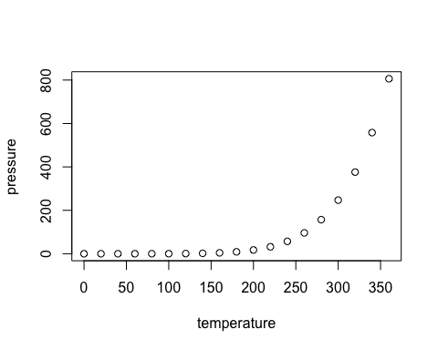

Note that the echo = FALSE parameter was added to the code chunk to prevent printing of the R code that generated the plot.