Individual differences in the computational processes that support face recognition
Raphaël Fournier
Paul Downing
Richard Ramsey
2026-09-01

Introduction
Being able to quickly and accurately recognise other people is an important aspect of everyday life, which impacts social interactions as well as more specific tasks, such as eye-witness identification and passport control checks. However, face recognition ability varies across the population. For instance, people with developmental prosopagnosia show relatively poor face recognition ability, (Dobel et al. 2007; McConachie 1976), whereas so-called “super-recognisers” show a remarkably high face recognition ability compared to the average person (Bobak et al. 2016; Russell et al. 2009). Even if we ignore these two extreme cases, face recognition ability varies throughout the general population, especially when identifying unfamiliar individuals (Dowsett and Burton 2015; White et al. 2014). Unsurprisingly, therefore, recent research has attempted to understand the mental processes that determine variation in face recognition ability as a route to uncover the architecture of a key dimension of social perception and cognition [REF??]. Here, in this project, we move this research field forward by combining approaches from experimental, differential and mathematical psychology, to investigate how individual differences in face recognition ability relate to the computational processes that support face recognition.
Attempts to understand differences between individuals has a long history in psychological research. Indeed, differential psychology represents a major branch of psychological research that aims to understand individual differences in thought, behaviour and ability (Marsh and Boag 2013; Lubinski 2000). In the domain of face recognition, there is a growing interest in investigating individual differences across the entire spectrum of face recognition ability, rather than focussing on specific subgroups, such as “super-recognisers” (White and Kitchen 2022). To this end, several assessment tools have been designed to measure different facets of face recognition performance(Duchaine and Nakayama (2006); Burton et al. (2010); Russell et al. (2009)). For example, the Cambridge Face Memory Test (Duchaine and Nakayama (2006)) measures how many previously seen faces individuals can accurately recognise, with performance varying across the general population and being poorer in individuals with developmental prosopagnosia. As such, these tools appear to have sufficient validity to represent a marker of an individuals face recognition ability.
Using these tools as a marker of face recognition ability, past research has estimated the association between the performance on these tests and broader perceptual and cognitive processes (McCaffery et al. 2018; Noyes et al. 2018). For instance, one line of research has studied the extent to which individual difference in face processing reflect domain-general or more domain-specific differences in perceptual and cognitive abilities (McCaffery et al. 2018; Verhallen et al. 2017). [[Raph - the importance and relevance for the next two sentences needs spelling out. See my comments in the Notes file.]] Some studies have shown that face and general object perception ability are positively, but modestly associated (Dennett, McKone, Tavashmi, et al. 2012; Richler et al., n.d.; Wilmer et al. 2012). These associations remain constantly weaker than those between different face or object recognition task (Fysh et al. 2020; McCaffery et al. 2018; Wilmer et al. 2010), suggesting that domain-specific processing explains at least part of the variance between these tasks (Richler et al. 2019).
The use of directly observed or manifest measures, such as reaction time and accuracy, has made a valuable contribution to understanding the relationship between psychological processes in general and in the context of face perception. However, performance on such tests remains a distant proxy of the underlying cognitive processes at work during face recognition, which makes them far from ideal for capturing individual differences in cognitive processes (Haines et al. 2020). An alternative approach to this problem has emerged in the domain of mathematical psychology and involves using a computational model to estimate latent computational parameters, which can be closer to the cognitive processes of interest (Yarkoni 2022). For instance, [Raph - one or two sentences on the basics of evidence accumulation models. refer to ( 1] From an individual differences perspective, one can then study how variation in these latent computational parameters relates to key aspects of social behaviour, such as face recognition ability (White et al. 2016).
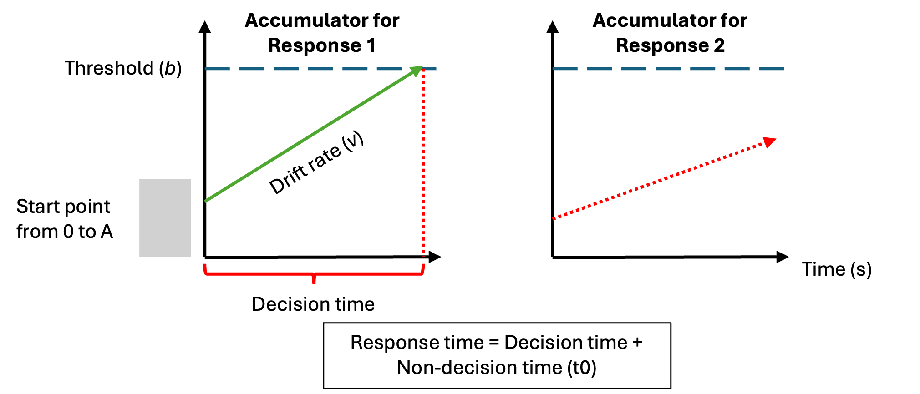
Figure 1: Schematic of the linear ballistic accumulator (LBA) model
This diagram represents the accumulation process one trial of a perceptual decision task for the linear ballistic accumulator (LBA; Brown and Heathcote (2008)). Participants are required to chose between two options (Response 1 and Response 2). In a LBA model, there is a separated accumulation of evidence (v) for each response option. In this example, the correct response is Response 1. The accumulator on the left is the accumulator for the correct response (Response 1), and the green line in represents the rate at which the evidence accumulates in favor of that response option. The accumulator on the right is the accumulator for the incorrect response (Response 2), and the dash red line represents the rate at which the evidence accumulates in favor of this response option. Once the accumulated evidence crosses the threshold (b) of a response option, the corresponding response is chosen (in this case Response 1).
Approaches from differential psychology have historically run alongside, and largely separate to, research traditions from experimental psychology, which aim to estimate the average effect (aggregated across individuals) of an experimental manipulation [REF??]. For example, we previously used an experimental approach in combination with evidence accumulation modelling to study how familiarity impacts the computational processes that support face recognition (Fournier, Downing & Ramsey, 2026). We found that different types of familiarity (visually familiar faces vs. famous faces) had a similar impact on the computational processes involved in the decision-making process of face recognition. Compared to learned faces, novel faces induced a greater accumulation of evidence (drift rate), as well as modest increase in response caution (threshold). [[This showed that – Raph what is the inference or interpretation here?? Why is it relevant in this paragraph??]]. Although we showed that these results could be replicated in both laboratory and online settings, the work aimed to estimate an average effect across a relatively small number of individuals (N~30), rather than investigate individual differences. As such, Fournier and colleagues (2026) were unable to estimate how variation in face recognition ability between individuals shapes the computational processes that determine how face recognition judgements are made.
In the present study, therefore, we combined approaches from differential, experimental and mathematical psychology to investigate how latent computational parameters in face recognition relate to face recognition ability. More specifically, based on prior results from our lab (Fournier et al., 2026), we investigated the extent to which drift rate and threshold vary as a function of face recognition ability specifically or a more general object recognition ability. This approach can provide insights regarding the domain-specificity of the computational processes involved in face recognition. To do so, we used a similar face memory task as used previously by Fournier et al. (2026) to compute key latent parameters, whilst also measuring face recognition ability (REF) and general object recognition ability (REF) in a considerably larger sample of participants (N~300) than our prior work to enable more robust estimates of between participant individual differences. Based on past research, we might expect … drift rate diff to correlate with greater ability … (REF), but it is less clear how threshold may vary. For instance, could better face recognition result in more caution or less caution… Moreover, how these patterns vary by familiar vs novel faces is also ….

Method and Materials

Pre-registration and open science
We report how we determined our sample size, all data exclusions (if any), all manipulations, and all measures in the study (Simons et al. 2017). The research question, hypotheses, experimental design, planned analysis, and exclusion criteria were preregistered (https://osf.io/b74gt/overview). Raw data and analysis code are available on Github (link github).

Participants
All participant were recruited on the Prolific platform (https://www.prolific.com). Participants had to be located in the United Kingdom or in the United States, be aged between 18-65 years old, with normal or corrected-to-normal vision and speak fluent English. Furthermore, Prolific offers the option to chose the approval rate of the participants willing to take part in the study. The approval rate is the percentage for which participants has been approved in previous experiment. An approval rating between 95% and 100% was chosen in our study to try to ensure high data quality. 383 participants completed the experiment. Following our preregistered exclusion criterion, 2 participants were excluded because their percentage of missed trials was higher than 40%, 3 because their percentage of RT outside the established range (0.2 to 2 seconds) were higher than 25% and 78 were removed because the overall accuracy was lower than 55%. In the end, data from 300 participants (141 men and 159 women) were retained for the analysis and the LBA modeling. Ages ranged from 19 to 64 ($M_{age}=$ 42, $SD_{age}=$ 11.2). Following Prolific payment principles, each participant received 9£ for the completion of the study. This experiment was accepted by the ethics committee of the Federal Institute of technology (ETH) Zurich.

Material
Participant were asked to complete the study using a desktop computer. Beforehand, the paradigm was tested on three different operative systems (PC, Macintosh and Linux) and on three web browsers (Google Chrome, Safari and Firefox). Participant were aware that using any other combination of operative systems and web browsers might lead to the inability to complete the experiment and were asked to follow these directives to ensure a consistent procedure and participant experience.

Procedure
The experiment was divided into three experimental tasks. A face recognition task was used to estimate the LBA parameters from manifest measures (accuracy and response times). Face and car recognition ability were assessed using the Cambridge Face Memory Test and the Cambridge Car Memory Test. Participants always first underwent the face recognition task and the order of two memory tests was counterbalanced.

Face recognition task
The face recognition task was divided into two distinct parts: a familiarization part and a recognition part. During the familiarization part, unknown identities were presented on the screen and participants were instructed to memorize the identity of the faces. One familiarization trial consisted of the presentation of 6 face images, one after the other, showing the same identity but varying in viewing points (3/4 left view, frontal view and 3/4 right view) and the colorimetry (colorful image, gray scale image). The duration of each image presentation was set to 0.75 second and each participant underwent 30 familiarization trials (for 30 unknown identities). During the familiarization, we introduced catch trials to ensure participants attention. After some familiarization trials, a gray scale image of a person’s face was presented on the screen. Participants were asked to press the “q” key if the face belonged to the last seen identity or the “p” key if it was not. The faces seen during the familiarization were considered the “Learned faces” within-subject condition.
In the recognition part, participants completed three blocks of 90 recognition trials. Each block was separated from another by a short break. Half of the trials were learned identities trials and the other half were new, previously unseen identities trials. In each trial, a gray scale image of a face was shown on the screen. Participants were asked to choose if they had previously seen this face in the familiarization part or not. If they did, the should press the “q” key and if they did not, the “p” key. Participants were asked to respond as quickly and accurately as possible. It is important to note that participants never saw two pictures of the same learned identity in the same block and never saw the same picture (3/4 left view, frontal view, or 3/4 right view) of a learned identity during the entire recognition part. Furthermore, each novel identity was only presented once in the entire recognition part. Response time [s] and accuracy were collected after each recognition trial. A response time limit of 2 seconds has been set for each recognition trial. If participants took longer than 2 seconds to press a response key, the text “Too late!” appeared in red on the screen and the trial was discarded, but not replaced.
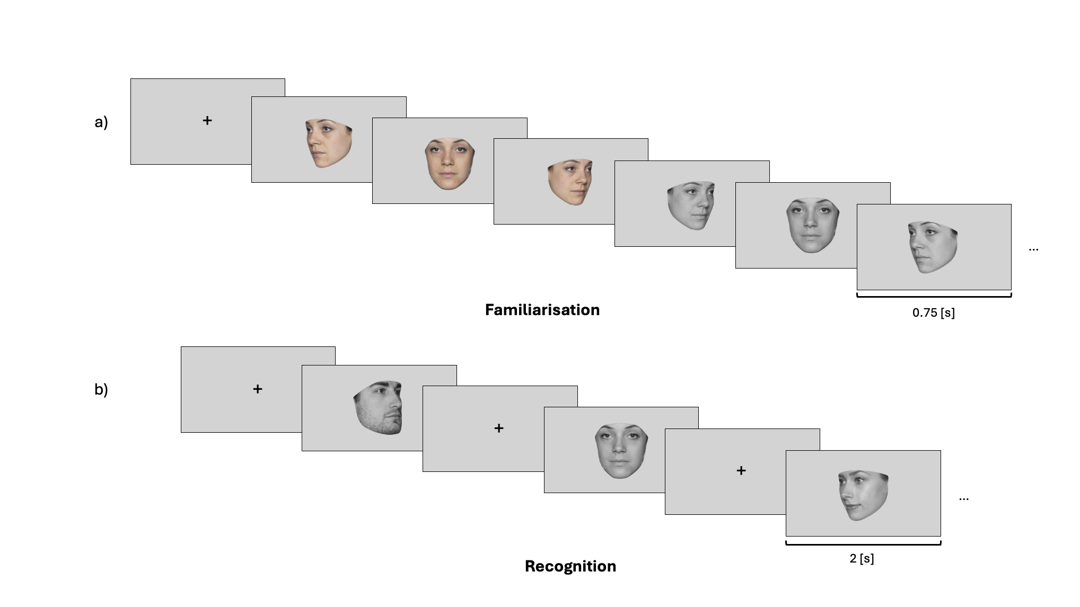
Figure 2: Experimental procedure of the face recognition task
The experimental procedure was divided into two parts: a familiarization part and a recognition part. a) In the familiarization part, participants were asked to memorize the face identity of 30 identities. For each identity, participants looked at 6 pictures depicting the same identity with different face orientation (3/4 left view, frontal view and 3/4 right view) and different colorimetry (color and gray scale images) in the order presented here: 3/4 left view, frontal view and 3/4 right view in color, followed by 3/4 right view, frontal view and 3/4 left view in gray scale. b) In each trial of the recognition part, participants had to decided if they recognize the face shown on the screen from the familiarization part. If they did, they had to press the “q” key and if the did not, the “p” key. They completed three blocks of 60 trials (half of them were from the familiarization part, half were novel faces). For the recognition part, only gray scale images of faces were used (for both learned faces and novel faces).

Cambridge Memory Tests
The method of the CFMT was described in Duchaine and Nakayama (2006). Participants learned 6 Caucasian male faces in three views and had to discriminate them later from distractor faces (no time response limit, three-alternative forced-choice task, Figure 3 a). Regarding the CCMT, the method has been described in Dennett, McKone, Tavashmi, et al. (2012) and has a highly similar structure, format and scoring as the CFMT, but uses cars instead of faces as stimuli.
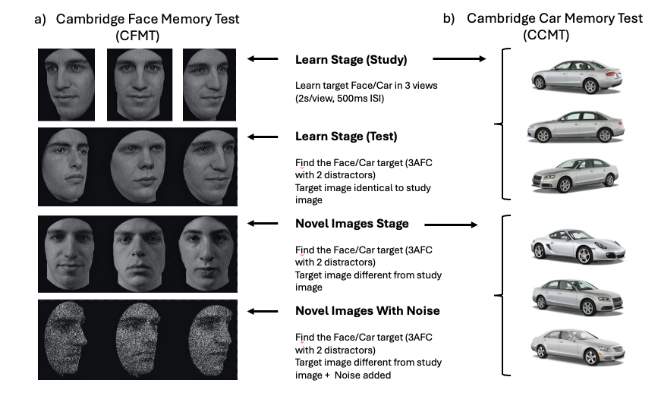
Figure 3: The two Cambridge Memory Tests
Illustration of (a) the Cambridge Face Memory Test (CFMT; ref Duchain & Nakayama, 2006) and (b) the Cambridge Car Memory Test (CCMT; red Dennett et al., 2012a). These two tests are highly similar, differing only in the category of the presented stimuli. Both tests are composed of three stages: Learn (including Study and Test), Novel Images and Novel Images with Noise. In the Learn stage, participants learn target faces/cars and are then tested on the recognition of the identical images to the learned targets. In the Novel Images and Novel Images with Noise stages, recognition targets are different pictures of the same learned targets, but differing in views, lightning or both. For the CCMT (b), the car pictures showed here are not the one used in the CCMT and served only as a representation of the stimuli used in the Learn stage and the Novel stages of the CCMT. This illustration has been taken and slightly modified from Dennett, McKone, Edwards, et al. (2012). 3AFC = three-alternative forced choice; ISI = interstimulus interval.

Stimuli
The face images used in the faces recognition task consisted of images selected from two different data sets of face images: the Face Research Lab London Set (DeBruine, Lisa; Jones, Benedict (2017): https://doi.org/10.6084/m9.figshare.5047666.v5) and the Color FERET Database (https://www.nist.gov/itl/products-and-services/color-feret-database). Each of these data sets is composed of images of different identities faces taken from different angle points. 102 identities were selected from the Face Research Lab London Set and 51 from the Color FERET Database. For each selected identity, three pictures of the face at three different view points (3/4 left view, frontal view and 3/4 right view) were cropped following the outline of the face.
To ensure that the stimuli that we used are reproducible, we used the webmorphR R Package (DeBruine (2022)) to crop the face images. The code used to crop the original pictures can be found on OSF (OSF link).

Evidence accumulation modeling
The model and priors specification as well as the model estimation are all identical to the one described in (ref: Fournier et al., in press). The priors specifications are described in Supplementary Materials.

Model specification
A hierarchical LBA models was fit to the accuracy and response times of the face recognition task. The model specifications are outlined in our preregistration (Table 1). The LBA framework assumes a separate evidence accumulator for each response alternative, with potentially different parameter values. Accordingly, one accumulator corresponded to the “Learned” response and the other to the “Novel” response. Threshold was allowed to vary by participants’ response (Learned/Novel) and mean drift rate varied as a function of both stimulus type (Learned/Novel) and weather the accumulator corresponded to the correct response for that stimulus (TRUE vs. FALSE). For example, when a Learned stimulus was presented, the Learned accumulator was designed as TRUE, whereas the Novel accumulator was designed as FALSE. The difference in drift rate between the TRUE and FALSE accumulators reflects the quality of information supporting a decision, with larger differences indicating stronger and more discriminative evidence accumulation (Lewandowsky and Oberauer (2018)). The standard deviation of the TRUE accumulator was allowed to vary according to accumulator match status, whereas the standard deviation of the FALSE accumulator was constrained to be constant to ensure model identifiability (Donkin et al. (2009)). In the preregistered model, a single start-point parameter (A), and single non-decision time parameter (t0) were estimated. Alternative model specifications that permitted variation in these parameters are reported in the Supplementary Materials.
Table 1: Formula specification for the pre-registered linear ballistic accumulator model.
Parameter | Label | Condition | Response | Accuracy | Fixed
Start point | A | no | no | no
Mean drift rate | v | yes | no | yes
SD drift rate | sd_v | no | no | yes
SD false drift rate | false.sd_v |  |  |  | 1
Threshold | b | no | yes | no
Non-decision time | t0 | no | no | no
Condition = training condition (Learned vs. Novel); Response = key-press response (same vs. different); Accuracy = (true/correct vs false/incorrect); SD = standard deviation.

Model estimation
Bayesian model estimated was carried using the EMC2 R package (Stevenson et al. 2026). Priors were chosen to be weakly-informative, meaning that they have little influence on the estimation (for more details regarding the priors of each model, see Supplementary Materials). Two sampling steps were used to estimate the parameters. First, a separate estimation of the fixed effects for each participant was conducted. Parameter estimations were then used as the starting point for the full hierarchical parameter estimation.

Model fit
To ensure that the fit of our model can capture most of the main trends in the data, graphical summaries of the posterior predictions were examined. Convergence plots and posterior predictive checks can be found in Supplementary Materials.

Data analysis
Regarding the general analytical strategy, two main approaches were considered. Correlations and data visualizations were used to characterize the zero-order relationships between parameters of interest (drift rate and threshold) from the LBA model with face and object recognition ability. Linear regression was then conducted to estimate how much LBA parameters vary as a function of face recognition ability, as well as how much these parameters vary after adjusting for car recognition ability. The details of the analysis plan were preregistered (https://osf.io/b74gt/overview).

LBA parameters
In order to make inference about the magnitude of familiarity effects, differences in parameter estimates across conditions were compared. To summarize the distribution of parameters of interest, we report the median of the posterior distribution together with 95% quantile interval of the posterior distribution.

Classical correlational analysis
The median value of each parameter’s posterior distribution was correlated with the two centred scores of each of the Cambridge Memory Tests to assess the relationship between these variables.

Bayesian plausible value correlational analysis
In addition to the classical correlational analysis described above, we conducted a Bayesian plausible value correlation approach (Ly et al. 2017; Matzke et al. 2017). Instead of using point estimates (median value of each parameter’s posterior distribution), this approach permits the estimation of uncertainty in likely correlational values by correlating the parameter estimation from each sample (or “draw”) from the posterior distribution with the memory scores. A distribution of the plausible correlations between each parameter and the memory scores can then obtained. These distributions can compared between stimuli conditions (Learned vs Novel) or memory scores (face vs car) using difference contrasts. It allowed us to estimate if the strength of the correlation differs or not between conditions of interest.

Linear regression
Based on our pilot results, we preregistered two Bayesian linear regression models to quantify the extent to which drift rate vary as a function of face recognition ability alone and when accounting for car recognition ability. The results of the linear regresison for the threshold parameter are available in the Supplementary materials.An index coding approach was used (no grand interecept) where each condition of interest has its own intercept (see Table 2 for the details of each regression models).
Table 2: Formula specification for the pre-registered linear regression models.
Parameter | Condition | Ability | Formula
Median drift rate | familiarity:accuracy | Face | Median drift rate: 0 + familiarity:accuracy + face_ability + (0|participant)
Median drift rate | familiarity:accuracy | Face + Car | Median drift rate: 0 + familiarity:accuracy + face_ability + car_ability + (0|participant)
familiarity = face familiarity (Learned vs. Novel); accuracy = response accuracy (TRUE vs. FALSE)

Inferential criteria
Using a Bayesian approach in our regression analysis allowed us to evaluate the posterior distributions of the parameter of our predictor of interest (Face Memory score). To evaluate these posterior distributions, we used three complementary criteria: sign, size and precision (Cumming 2014; Kruschke and Liddell 2018; McElreath, n.d.). To address the sign (or direction) of the effect, we reported if the median value is positive or negative. Second, we evaluated the size or magnitude of the posterior distribution by considering the size of the median value as well as the extent to which lower or upper bounds of the 95% quantile interval approach zero (no relationship). For example, if the 95% quantile interval excluded zero, we would have been reasonably confident in our inference of a non-zero effect. Furthermore, we used the width of the 95% quantile intervals as an indicator of estimation precision. Whereas narrow estimates indicate precise estimates, wider intervals indicate substantial uncertainty about the estimated parameter value, which may warrant a more cautious interpretation.

Results

LBA parameters
Posterior distributions for drift rate and threshold parameters are visualized in Figure 4 and Figure 5 and the medians and 95% quantile intervals are summarised in Table 3.
Threshold: Inspection of the posterior distribution shows that there is an effect of familiarity on the threshold parameter.
Drift rate: Inspection of the posterior distribution shows that there is a familiarity effect in drift rate difference. The quality of the evidence accumulation was greater for Novel faces compared to Learned faces.
  (a) Threshold by response
  (b) Threshold (novel - learned) contrast
Figure 4: Threshold estimates

  (a) Drift rate (TRUE - FALSE) by condition
  (b) Drift rate (novel - learned) contrast
Figure 5: Drift rate estimates

Table 3: Posterior median and 95% quantile intervals for threshold and drift rate parameters.
Parameter | Condition | Median | 95% QI
Threshold | novel | 2.25 | [2.169, 2.323]
Threshold | learned | 1.89 | [1.822, 1.96]
Threshold contrast | novel - learned | 0.35 | [0.316, 0.394]
Drift rate | novel | 1.15 | [1.098, 1.199]
Drift rate | learned | 0.15 | [0.097, 0.195]
Drift rate contrast | novel - learned | 1 | [0.91, 1.094]
QI = quantile interval.

Correlations
We examined point-wise recognition ability linear relationship with point estimates (median) of the posterior distribution of each of the LBA parameters of interest. These relationships can been see in Figure 6 for both recognition ability. Visual inspections of these correlations seemed to show that the accumulation of evidence (drift rate) for learned and novel faces increases as face recognition ability increases. A similar conclusion could be drawn from the inspection of the response caution (threshold) towards the “Learned” response. However the strength of these relationship remains weak (the highest r value is 0.24) and we used a Bayesian plausible value correlational approach to determine the uncertainty linked to these associations.
(a) Median threshold correlations with recognition ability

(b) Median drift rate correlations with recognition ability

Figure 6: Point estimates correlations with recognition scores

Bayesian plausible value correlational analysis
To estimate the uncertainty linked to the relationships between LBA estimated parameters and face recognition ability, we used a Bayesian plausible value correlational analysis. Like described above (see Methods), instead of using a single point estimate to assess the strength of the relationship between our variables of interest, the posterior distribution of the LBA parameters allow us to use the entire sampling distribution to do it. We calculated the Person’s r between each sample value from our posterior distribution for each parameter of each subject and their face recognition ability. The posterior distributions of threshold plausible correlation values and their contrast are shown in Figure 7. Posterior correlations with true and false drift rate for both conditions and recognition abilities can be found in Figure 8, and correlations with drift rate differences (true-false) by conditions as well as drift rate contrast (novel-false) in Figure 9. Table 4 provides a summary of these distributions.
Threshold: There is a positive relationship between response caution for both learned and novel faces and recognition ability. Regarding face recognition ability, people with a higher face recognition ability have a higher response caution for learned faces whereas people with a higher car recognition ability have a higher threshold for both learned and novel faces.
Drift rate: A higher face recognition ability is associated with a greater drift rate for both novel and learned faces. However, a higher car recognition ability is only associated with an increase drift rate for novel faces.
  (a) Posterior correlations values distributions between threshold by response and recognition abilities
  (b) Posterior correlations values distribution between threshold difference (novel-learned) and recognition abilities
Figure 7: Plausible correlation values distributions between threshold and recognition abilities. Points denote the median of the distribution and error bars represent 95% quantile intervals.
Figure 8: Plausible correlation values distributions between drift rate TRUE and FALSE by stimulus and recognition abilities. Points denote the median of the distribution and error bars represent 95% quantile intervals.
  (a) Posterior correlations values distributions between drift rate by stimulus (TRUE - FALSE) and recognition abilities
  (b) Posterior correlations values distribution between drift rate difference (novel-learned) and recognition abilities
Figure 9: Plausible correlation values distributions between drift rate differences and recognition abilities. Points denote the median of the distribution and error bars represent 95% quantile intervals.

Table 4: Median r and 95% quantile intervals of the plausible value correlations between LBA parameters and recogntion ability scores.
 |  |  | Face |  | Car
Parameter | Condition | Accuracy | median r_Face | 95% QI_Face | median r_Car | 95% QI_Car
Threshold | Learned |  | 0.12 | [0.06, 0.18] | 0.13 | [0.08, 0.19]
Threshold | Novel |  | 0.06 | [-0.00, 0.11] | 0.18 | [0.13, 0.24]
Threshold | Novel-Learned |  | -0.06 | [-0.11, -0.02] | 0.10 | [0.05, 0.14]
Drift | Learned | True | 0.05 | [-0.02, 0.12] | 0.13 | [0.06, 0.19]
Drift | Learned | False | -0.05 | [-0.12, 0.02] | 0.12 | [0.06, 0.19]
Drift | Learned |  | 0.14 | [0.07, 0.21] | -0.01 | [-0.08, 0.06]
Drift | Novel | True | 0.05 | [-0.02, 0.12] | 0.16 | [0.09, 0.22]
Drift | Novel | False | -0.12 | [-0.19, -0.05] | 0.06 | [-0.01, 0.13]
Drift | Novel |  | 0.20 | [0.14, 0.27] | 0.13 | [0.07, 0.19]
Drift | Novel-Learned |  | 0.05 | [-0.02, 0.12] | 0.08 | [0.01, 0.15]
Note. Blue = 95% QI entirely above zero; red = 95% QI entirely below zero.

Bayesian linear regression
Following our preregistration, the predictions of the two regression models for drift rate can be seen in Figure 10.
(a) Face model: predicted drift rate (TRUE and FALSE) values from face recognition ability scores

(b) Face and Car model: predicted drift rate (TRUE and FALSE) values from face recognition ability scores when accounting for car recognition ability

Figure 10: Predicted drift rate values (TRUE and FALSE) from face recognition ability scores

Discussion
Paragraph 1: Opening paragraph
This project combined approaches from experimental, differential and mathematical psychology to investigate individual differences in the computational processes that support face recognition. We show that face recognition ability is positively associated with the rate of evidence accumulation (drift rate parameter) for both learned and novel faces, as well as the response caution (threshold parameter) for learned faces. Further analyses showed that this pattern of results does not appear to reflect a more general object recognition ability, and thus the observed relationship may be partially specific to processing faces. More generally, these findings extend past work on face perception by showing that there is value to be gained by estimating how expertise in face recognition shapes the latent computational processes that support a key dimension of everyday social interactions.
Paragraph 2: Drift rate
Variation in face recognition ability had a multifaceted impact on parameters in our decision-making model, such that drift rate and threshold were both positively associated with face recognition ability. The drift rate results suggest that people who are generally better at recognizing faces accumulates more recognition signal and are more capable to ignore noisy information coming from the stimulus. Our findings are, therefore, in accordance with previous research that showed that expertise effects are primarily due to a better information extraction (Litchfield and Donovan 2017; Thompson et al. 2013; Van Der Gijp et al. 2014). We extend these findings by showing that these effects are not limited to differences between smaller subgroups of experts and novices at the edge of the face recognition distributions, but they concern variation in the general population as well.
Para 3: caution
Regarding response caution, previous studies have shown that confidence is itself a decision variable used to regulate future behavior (Fleming et al. 2018; Folke et al. 2016). The positive association between threshold and face recognition ability could reflect a better estimation of the task difficulty for people with higher face recognition ability, who voluntary increase their response caution to ensure a better performance given the task demands. However, future research is required to confirm this suggestion. Overall, our results suggest that not only does high face recognition ability predict a better ability to extract meaningful information for the recognition success but also predict the voluntary strategic decision of the subject to be more cautious.
Paragraph 4: Theoretical implications for individual differences investigation
Moving beyond manifest / observed measures to uncover novel insight into the structure of cognition and expertise in the domain of face perception. Most differential studies in face processing have used test scores to estimate different abilities underlying face processing and investigated if these abilities were related to each other or to other predictors of interest (McCaffery et al. 2018; Noyes et al. 2018). Here we move this research field into a new direction, which feel has many benefits for understanding the cognitive processes involved in social perception and cognition more generally. [[Raph - some more detail and depth here eventually - I can help. Just signposting for now]]
Paragraph 5: Mentioning the object recognition ability correlations Our main aim of this work was to investigate how face recognition ability predicts computational processes involved in face perception. However, since we measured object (car) recognition ability in all participants, we decided to run some exploratory analyses using car recognition as a predictor to see how car and face recognition abilities may compare.
Object recognition ability was positively correlated with drift face for novel faces, but not for learned faces. Furthermore, object recognition did not predict the discrimination between TRUE and FALSE drift rate for learned faces, like face recognition ability does. These exploratory analyses point towards a situation where variation in car recognition abilities shows a distinctly different relationship to the computational processes involved in face recognition.
We speculate on the differences between car and recognition abilities, which may lead to this pattern of results, but stress that future work would need to confirm these proposals. Object recognition is known to rely mostly on individual features processing, while face recognition combines featural and configural processing (Cabeza and Kato 2000; Madole and Cohen 1995; Tversky and Hemenway 1984). Novel face recognition relies more on feature information matching and, as a novel face becomes more familiar, the reliance on configural processing increases (Schwaninger et al. 2002). We suggest that relying on visual feature processing alone help to accumulate meaningful information for the recognition of visually familiar faces but also contribute to the accumulation of information detrimental to the recognition process (noise). Whereas relying on both (visual information processing and holistic processing) seems to increase the accumulation of meaningful information while decreasing the noise coming from detrimental visual information to the recognition process. Future research should investigate if the different patterns of associations between recognition abilities and latent components of the recognition process are related to different types of information processing.
Paragraph 6: Limitations Previous evidence accumulation model development studies have highlighted how the number of trials per cell of the design influences the validity and precision of how model parameters are estimated (Alexandrowicz and Gula 2020; Lerche et al. 2017; Wagenmakers et al. 2007). Our design (90 trials per condition) and control of error rates in our face recognition task followed the minimum recommendations to apply EAM (Lüken et al. 2025). Nonetheless, adding more trials per condition (e.g., 200 per condition; Boag et al. (2025)) would have increased the robustness of our parameter estimates.
Another limitation is the use of the Cambridge Car Memory Test as an estimate of object recognition ability. While numerous studies have used this score for this motive (ref:), it can be argued like recognizing pictures of a specific object like cars might not encompass the depth and complexity of object recognition ability. We decided to use this test because of the direct comparison it offers to the score of the Cambridge Face Memory Test as well the fact the instructions and task structure are almost identical in the two tests.
Alexandrowicz, Rainer W., and Bartosz Gula. 2020. “Comparing Eight Parameter Estimation Methods for the Ratcliff Diffusion Model Using Free Software.” Frontiers in Psychology 11: 484737. https://doi.org/10.3389/fpsyg.2020.484737.
Boag, Russell J., Reilly J. Innes, Niek Stevenson, et al. 2025. “An Expert Guide to Planning Experimental Tasks for Evidence-Accumulation Modeling.” Advances in Methods and Practices in Psychological Science 8 (2): 25152459251336127. https://doi.org/10.1177/25152459251336127.
Bobak, Anna K., Peter J. B. Hancock, and Sarah Bate. 2016. “Super‐recognisers in Action: Evidence from Face‐matching and Face Memory Tasks.” Applied Cognitive Psychology 30 (1): 81–91. https://doi.org/10.1002/acp.3170.
Brown, Scott D., and Andrew Heathcote. 2008. “The Simplest Complete Model of Choice Response Time: Linear Ballistic Accumulation.” Cognitive Psychology 57 (3): 153–78. https://doi.org/10.1016/j.cogpsych.2007.12.002.
Burton, A. Mike, David White, and Allan McNeill. 2010. “The Glasgow Face Matching Test.” Behavior Research Methods 42 (1): 286–91. https://doi.org/10.3758/BRM.42.1.286.
Cabeza, Roberto, and Takashi Kato. 2000. “Features Are Also Important: Contributions of Featural and Configural Processing to Face Recognition.” Psychological Science 11 (5): 429–33. https://doi.org/10.1111/1467-9280.00283.
Cumming, Geoff. 2014. “The New Statistics: Why and How.” Psychological Science 25 (1): 7–29. https://doi.org/10.1177/0956797613504966.
DeBruine, Lisa M. 2022. webmorphR : Reproducible Stimuli. Zenodo. https://doi.org/10.5281/zenodo.6570965.
Dennett, Hugh W., Elinor McKone, Mark Edwards, and Tirta Susilo. 2012. “Face Aftereffects Predict Individual Differences in Face Recognition Ability.” Psychological Science 23 (11): 1279–87. https://doi.org/10.1177/0956797612446350.
Dennett, Hugh W., Elinor McKone, Raka Tavashmi, et al. 2012. “The Cambridge Car Memory Test: A Task Matched in Format to the Cambridge Face Memory Test, with Norms, Reliability, Sex Differences, Dissociations from Face Memory, and Expertise Effects.” Behavior Research Methods 44 (2): 587–605. https://doi.org/10.3758/s13428-011-0160-2.
Dobel, C, J Bolte, M Aicher, and S Schweinberger. 2007. “Prosopagnosia Without Apparent Cause: Overview and Diagnosis of Six Cases.” Cortex 43 (6): 718–33. https://doi.org/10.1016/S0010-9452(08)70501-X.
Donkin, Chris, Lee Averell, Scott Brown, and Andrew Heathcote. 2009. “Getting More from Accuracy and Response Time Data: Methods for Fitting the Linear Ballistic Accumulator.” Behavior Research Methods 41 (4): 1095–110. https://doi.org/10.3758/BRM.41.4.1095.
Dowsett, Andrew J., and A. Mike Burton. 2015. “Unfamiliar Face Matching: Pairs Out‐perform Individuals and Provide a Route to Training.” British Journal of Psychology 106 (3): 433–45. https://doi.org/10.1111/bjop.12103.
Duchaine, Brad, and Ken Nakayama. 2006. “The Cambridge Face Memory Test: Results for Neurologically Intact Individuals and an Investigation of Its Validity Using Inverted Face Stimuli and Prosopagnosic Participants.” Neuropsychologia 44 (4): 576–85. https://doi.org/10.1016/j.neuropsychologia.2005.07.001.
Fleming, Stephen M., Elisabeth J. Van Der Putten, and Nathaniel D. Daw. 2018. “Neural Mediators of Changes of Mind about Perceptual Decisions.” Nature Neuroscience 21 (4): 617–24. https://doi.org/10.1038/s41593-018-0104-6.
Folke, Tomas, Catrine Jacobsen, Stephen M. Fleming, and Benedetto De Martino. 2016. “Explicit Representation of Confidence Informs Future Value-Based Decisions.” Nature Human Behaviour 1 (1): 0002. https://doi.org/10.1038/s41562-016-0002.
Fysh, Matthew C., Lisa Stacchi, and Meike Ramon. 2020. “Differences Between and Within Individuals, and Subprocesses of Face Cognition: Implications for Theory, Research and Personnel Selection.” Royal Society Open Science 7 (9): 200233. https://doi.org/10.1098/rsos.200233.
Haines, Nathaniel, Peter Kvam, Louis Irving, et al. 2020. Theoretically Informed Generative Models Can Advance the Psychological and Brain Sciences: Lessons from the Reliability Paradox. August 24. https://osf.io/xr7y3_v1.
Kruschke, John K., and Torrin M. Liddell. 2018. “Bayesian Data Analysis for Newcomers.” Psychonomic Bulletin & Review 25 (1): 155–77. https://doi.org/10.3758/s13423-017-1272-1.
Lerche, Veronika, Andreas Voss, and Markus Nagler. 2017. “How Many Trials Are Required for Parameter Estimation in Diffusion Modeling? A Comparison of Different Optimization Criteria.” Behavior Research Methods 49 (2): 513–37. https://doi.org/10.3758/s13428-016-0740-2.
Lewandowsky, Stephan, and Klaus Oberauer. 2018. “Computational Modeling in Cognition and Cognitive Neuroscience.” In Stevens’ Handbook of Experimental Psychology and Cognitive Neuroscience, 1st ed., edited by John T. Wixted. Wiley. https://doi.org/10.1002/9781119170174.epcn501.
Litchfield, Damien, and Tim Donovan. 2017. “The Flash-Preview Moving Window Paradigm: Unpacking Visual Expertise One Glimpse at a Time.” Frontline Learning Research 5 (3): 66–80. https://doi.org/10.14786/flr.v5i3.269.
Lubinski, David. 2000. “Scientific and Social Significance of Assessing Individual Differences: ‘Sinking Shafts at a Few Critical Points’.” Annual Review of Psychology 51 (1): 405–44. https://doi.org/10.1146/annurev.psych.51.1.405.
Lüken, Malte, Andrew Heathcote, Julia M. Haaf, and Dora Matzke. 2025. “Parameter Identifiability in Evidence-Accumulation Models: The Effect of Error Rates on the Diffusion Decision Model and the Linear Ballistic Accumulator.” Psychonomic Bulletin & Review 32 (3): 1411–24. https://doi.org/10.3758/s13423-024-02621-1.
Ly, Alexander, Udo Boehm, Andrew Heathcote, et al. 2017. “A Flexible and Efficient Hierarchical Bayesian Approach to the Exploration of Individual Differences in Cognitive‐model‐based Neuroscience.” In Computational Models of Brain and Behavior, 1st ed., edited by Ahmed A. Moustafa. Wiley. https://doi.org/10.1002/9781119159193.ch34.
Madole, Kelly L., and Leslie B. Cohen. 1995. “The Role of Object Parts in Infants’ Attention to Form-Function Correlations.” Developmental Psychology 31 (4): 637–48. https://doi.org/10.1037/0012-1649.31.4.637.
Marsh, Tim, and Simon Boag. 2013. “Evolutionary and Differential Psychology: Conceptual Conflicts and the Path to Integration.” Frontiers in Psychology 4. https://doi.org/10.3389/fpsyg.2013.00655.
Matzke, Dora, Alexander Ly, Ravi Selker, et al. 2017. “Bayesian Inference for Correlations in the Presence of Measurement Error and Estimation Uncertainty.” Collabra: Psychology 3 (1): 25. https://doi.org/10.1525/collabra.78.
McCaffery, Jennifer M., David J. Robertson, Andrew W. Young, and A. Mike Burton. 2018. “Individual Differences in Face Identity Processing.” Cognitive Research: Principles and Implications 3 (1): 21. https://doi.org/10.1186/s41235-018-0112-9.
McConachie, Helen R. 1976. “Developmental Prosopagnosia. A Single Case Report.” Cortex 12 (1): 76–82. https://doi.org/10.1016/S0010-9452(76)80033-0.
McElreath, Richard. n.d. Statistical Rethinking: A Bayesian Course with Examples in r and Stan.
Noyes, Eilidh, Matthew Q. Hill, and Alice J. O’Toole. 2018. “Face Recognition Ability Does Not Predict Person Identification Performance: Using Individual Data in the Interpretation of Group Results.” Cognitive Research: Principles and Implications 3 (1): 23. https://doi.org/10.1186/s41235-018-0117-4.
Richler, Jennifer J., Andrew J. Tomarken, Mackenzie A. Sunday, et al. 2019. “Individual Differences in Object Recognition.” Psychological Review 126 (2): 226–51. https://doi.org/10.1037/rev0000129.
Richler, Jennifer J, Andrew J Tomarken, Mackenzie A Sunday, et al. n.d. Individual Differences in Object Recognition.
Russell, Richard, Brad Duchaine, and Ken Nakayama. 2009. “Super-Recognizers: People with Extraordinary Face Recognition Ability.” Psychonomic Bulletin & Review 16 (2): 252–57. https://doi.org/10.3758/PBR.16.2.252.
Schwaninger, Adrian, Janek S. Lobmaier, and Stephan M. Collishaw. 2002. “Role of Featural and Configural Information in Familiar and Unfamiliar Face Recognition.” In Biologically Motivated Computer Vision, edited by Heinrich H. Bülthoff, Christian Wallraven, Seong-Whan Lee, and Tomaso A. Poggio, vol. 2525. Springer Berlin Heidelberg. https://doi.org/10.1007/3-540-36181-2_64.
Simons, Daniel, Yuichi Shoda, and D. Lindsay. 2017. “Constraints on Generality (COG): A Proposed Addition to All Empirical Papers.” Perspectives on Psychological Science 12 (August): 174569161770863. https://doi.org/10.1177/1745691617708630.
Stevenson, Niek, Michelle Donzallaz, Andrew Heathcote, and Steven Miletić. 2026. EMC2: Bayesian Hierarchical Analysis of Cognitive Models of Choice. https://doi.org/10.32614/CRAN.package.EMC2.
Thompson, Matthew B., Jason M. Tangen, and Duncan J. McCarthy. 2013. “Expertise in Fingerprint Identification.” Journal of Forensic Sciences 58 (6): 1519–30. https://doi.org/10.1111/1556-4029.12203.
Tversky, Barbara, and Kathleen Hemenway. 1984. “Objects, Parts, and Categories.” Journal of Experimental Psychology: General 113 (2): 169–93. https://doi.org/10.1037/0096-3445.113.2.169.
Van Der Gijp, A., M. F. Van Der Schaaf, I. C. Van Der Schaaf, et al. 2014. “Interpretation of Radiological Images: Towards a Framework of Knowledge and Skills.” Advances in Health Sciences Education 19 (4): 565–80. https://doi.org/10.1007/s10459-013-9488-y.
Verhallen, Roeland J., Jenny M. Bosten, Patrick T. Goodbourn, Adam J. Lawrance-Owen, Gary Bargary, and J. D. Mollon. 2017. “General and Specific Factors in the Processing of Faces.” Vision Research 141 (December): 217–27. https://doi.org/10.1016/j.visres.2016.12.014.
Wagenmakers, Eric-Jan, Han L. J. Van Der Maas, and Raoul P. P. P. Grasman. 2007. “An EZ-Diffusion Model for Response Time and Accuracy.” Psychonomic Bulletin & Review 14 (1): 3–22. https://doi.org/10.3758/BF03194023.
White, Corey N., Ryan A. Curl, and Jennifer F. Sloane. 2016. “Using Decision Models to Enhance Investigations of Individual Differences in Cognitive Neuroscience.” Frontiers in Psychology 7 (February). https://doi.org/10.3389/fpsyg.2016.00081.
White, Corey N., and Kiah N. Kitchen. 2022. “On the Need to Improve the Way Individual Differences in Cognitive Function Are Measured with Reaction Time Tasks.” Current Directions in Psychological Science 31 (3): 223–30. https://doi.org/10.1177/09637214221077060.
White, David, Richard I. Kemp, Rob Jenkins, Michael Matheson, and A. Mike Burton. 2014. “Passport Officers’ Errors in Face Matching.” PLoS ONE 9 (8): e103510. https://doi.org/10.1371/journal.pone.0103510.
Wilmer, Jeremy B., Laura Germine, Christopher F. Chabris, et al. 2010. “Human Face Recognition Ability Is Specific and Highly Heritable.” Proceedings of the National Academy of Sciences 107 (11): 5238–41. https://doi.org/10.1073/pnas.0913053107.
Wilmer, Jeremy B., Laura Germine, Christopher F. Chabris, Garga Chatterjee, Margaret Gerbasi, and Ken Nakayama. 2012. “Capturing Specific Abilities as a Window into Human Individuality: The Example of Face Recognition.” Cognitive Neuropsychology 29 (5-6): 360–92. https://doi.org/10.1080/02643294.2012.753433.
Yarkoni, Tal. 2022. “The Generalizability Crisis.” Behavioral and Brain Sciences 45 (January): e1. https://doi.org/10.1017/S0140525X20001685.

