US Supreme Court - Project meeting #1

# Agents

* Chief Justice + eight associate justices (nominated by the president, confirmed by the Senate)
* Current Justices
  + John Roberts - Chief Justice **C**
  + Anthony Kennedy **C** who occasionally voted L (supported gay marriage, quintessential swing vote on racial issues)
  + Clarence Thomas **C**
  + Ruth bader Ginsburg **L**
  + Stephen Breyer **L**
  + Samuel Alito **C**
  + Sonia Sotomayor **L**
  + Elena Kagan **L**
  + Neil Gorsuch **C**
* Lifetime tenure unless they resign, retire, or are removed after impeachment
* Each justices employs law clerks. There is also a pool of common clerks. They act as lobbying tools.

## *From the data*

37 Justices

AFortas AJGoldberg AMKennedy AScalia BRWhite   
 581 475 2797 2851 4943   
 CEWhittaker CThomas DHSouter EKagan EWarren   
 691 2248 1748 537 2205   
FFrankfurter FMurphy FMVinson HABlackmun HHBurton   
 1917 387 812 3768 1388   
 HLBlack JGRoberts JHarlan2 JPStevens LFPowell   
 3302 945 2351 4260 2650   
 NMGorsuch PStewart RBGinsburg RHJackson SAAlito   
 44 3590 2011 899 919   
 SDOConnor SFReed SGBreyer SMinton SSotomayor   
 2910 1151 1913 717 627   
 TCClark TMarshall WBRutledge WEBurger WHRehnquist   
 2292 3879 387 2807 4529   
 WJBrennan WODouglas   
 5325 4001

# Terms

* A term of the Supreme Court commences on the first Monday of each October, and continues until June or early July of the following year. Each term consists of alternating periods of around two weeks known as “sittings” and “recesses.” Justices hear cases and deliver rulings during sittings; they discuss cases and write opinions during recesses.

**From the data** How many terms?

[1] 71

# Rules

* Stages: oral arguments, decision (The way that an opinion is written can be critical to the final vote. It is not uncommon for justices to switch votes in response to an opinion or the reassignment of that opinion (O’Brien, 2005: 262))
* Cases are decided by majority vote of the Justices
* Cases argued in a Term usually receive a decision by the end of the term

# Objectives of agents

* First, as the highest court in the land, it is the court of last resort for those looking for justice.
* Second, due to its power of judicial review, it plays an essential role in ensuring that each branch of government recognizes the limits of its own power.
* Third, it protects civil rights and liberties by striking down laws that violate the Constitution.
* Finally, it sets appropriate limits on democratic government by ensuring that popular majorities cannot pass laws that harm and/or take undue advantage of unpopular minorities. In essence, it serves to ensure that the changing views of a majority do not undermine the fundamental values common to all Americans, i.e., freedom of speech, freedom of religion, and due process of law.

# Are all agents equal?

Yes

# Who do the agents represent?

* Justices do not represent or receive official endorsements from political parties informally categorized as being judicial conservatives, moderates, or liberals. It refers legal outlook rather than a political or legislative one.
* Following the confirmation of Neil Gorsuch in 2017, the Court consists of five justices appointed by Republican presidents and four appointed by Democratic presidents. in the 2009 term, almost half the cases were decided unanimously, and only about 20% were decided by a 5-to-4 vote. Barely one in ten cases involved the narrow liberal/conservative divide (fewer if the cases where Sotomayor recused herself are not included).
* However, in fourteen of the sixteen 5–4 decisions, the Court divided along the traditional ideological lines (with Ginsburg, Breyer, Sotomayor, and Kagan on the liberal side, and Roberts, Scalia, Thomas, and Alito on the conservative, and Kennedy providing the “swing vote”). This represents 87% of those 16 cases, the highest rate in the past 10 years.
* There are cases that defied the popular conception of the ideological lines of the Court

# Are there mechanisms to punish the agents?

* Impeachment by Congress is the only legal avenue that exists for punishing or removing a Supreme Court justice – a historically rare option that’s been tried, but has never succeeded. The congressional bar for impeachment starts relatively low – that is, the House only needs a simple majority to vote for impeachment proceedings to begin; but the bar is raised fairly high in the Senate, where a two-thirds majority is needed to convict.

# What are the drivers of voting behaviour? (party id, etc)

* Justices: conservative, moderate or liberal in their philosophies of law and judicial interpretation (see above ‘Current Justices’)
* It has long been commonly assumed that a justice’s votes reflects her judicial decision making philosophy as well as her:
* ideological leaning. Quinn-Martin and Segal-Cover scores, which act as ideological proxies
* personal attitudes
* values
* political philosophies
* policy preferences
* Congress sees justices as playing a more political role than in the past
* Back in the day, party ID - Samuel Chase (1796-1811), impeached because of his conservative partisan leanings (federalist)

## Have these factors changed over time?

# Perceptions of vote trading ~ is it perceived as bad?

* There is anecdotal evidence of vote trading, of justices using their law clerks for this purpose - O’Brien, 2005 -
  + O’Brien, 2005: 278)? It has been clearly established that justices bargain for votes within the framework of a case.
  + There are also instances when the same justice has ruled differently on an identical issue in separate cases. These discrepancies in voting behaviour could point to the possibility of logrolling among Supreme Court justices (Justice White).
  + Scholars have questioned why vote trading in the Supreme Court should or should not be objectionable (Hasen, 2000: 1347-1348).

# What other types of trading exists?

## Is there any evidence? Anecdotal, interviewees, empirical studies?

* A poll conducted in June 2012 by The New York Times and CBS News showed just 44% of Americans approve of the job the Supreme Court is doing. Three-quarters said justices’ decisions are sometimes influenced by their political or personal views
* Justices are accused of accepting gifts and expensive travel from private donors

# What are the main questions discussed in the literature related to the Supreme Court?

* [3 models of Supreme Court’s decision making: legal, attitudinal and rational](https://books.google.co.uk/books?hl=en&lr=&id=ULG_G5xLTCwC&oi=fnd&pg=PR11&dq=US+supreme+court+strategic+behaviour&ots=TN5GyBxc9C&sig=AZTNF1HSELrMKSl6LY-87IpuW5E#v=onepage&q=US%20supreme%20court%20strategic%20behaviour&f=false)
* What are the idoelogical values of the justices?
* ideal points
* strategic voting - [evidence for sophisticated behavior, ranging from votes to deny a case one prefers to reverse to votes to grant cases one prefers to affirm](https://academic.oup.com/jleo/article-abstract/15/3/549/905798)

## Have these Q changed through time?

* [no empirical evidence of tactical voting until late 90’s](https://academic.oup.com/jleo/article-abstract/15/3/549/905798)
* more recently, that [justices do not have temporally constant ideal points](https://www.cambridge.org/core/journals/political-analysis/article/dynamic-ideal-point-estimation-via-markov-chain-monte-carlo-for-the-us-supreme-court-19531999/2A57930D5D0C81216491B40CA2BA5D12)

## Are there any open questions?

## Any link between these Q and vote trading? (such as racial profiling)?

## Any methods complimentary to vote trading?

## Any normative discussions? (more affirmative action, etc)

# What are the seminal works in understanding the Supreme Court?

Top 10 publications:

* [Epstein, L., Segal, J. A., Spaeth, H. J., & Walker, T. G. (2015). The Supreme Court compendium: Data, decisions, and developments. Cq Press.](https://books.google.co.uk/books?hl=en&lr=&id=QEkdCAAAQBAJ&oi=fnd&pg=PT18&dq=supreme+court+spaeth&ots=qIiP6zSTjb&sig=cLnAlcF5UpS4ChQDb89E_0mt-Ck#v=onepage&q=supreme%20court%20spaeth&f=false)
* [Segal, J. A., Epstein, L., Cameron, C. M., & Spaeth, H. J. (1995). Ideological values and the votes of US Supreme Court justices revisited. The Journal of Politics, 57(3), 812-823.](https://www.journals.uchicago.edu/doi/abs/10.2307/2960194)
* [Segal, J. A., & Cover, A. D. (1989). Ideological values and the votes of US Supreme Court justices. American Political Science Review, 83(2), 557-565.](https://www.cambridge.org/core/journals/american-political-science-review/article/ideological-values-and-the-votes-of-us-supreme-court-justices/62BB60DFD26F685264AE86BFE3EFBE0F)
* [Epstein, L., Hoekstra, V., Segal, J. A., & Spaeth, H. J. (1998). Do political preferences change? A longitudinal study of US Supreme Court justices. The Journal of Politics, 60(3), 801-818.](https://www.journals.uchicago.edu/doi/abs/10.2307/2647649)
* [Perry, H. W. (2009). Deciding to decide: agenda setting in the United States Supreme Court. Harvard University Press.](https://books.google.co.uk/books?hl=en&lr=&id=UReZT7fNPTUC&oi=fnd&pg=PA1&dq=US+supreme+court+strategic+behaviour&ots=yNW0dXm1xc&sig=rEW8BwcdgNQ9cqHfvJgCvyOcljU#v=onepage&q=US%20supreme%20court%20strategic%20behaviour&f=false)

## What journals?

* AJPS (American Journal of Political Science)
* APSR (American Political Science Review)

## The methodological level

* estimating ideal points with MCMC

# Decisions - Opinions

## Who writes the opinions?

* The Justice who authors the majority or principal opinion summarizes the opinion from the bench during a regularly scheduled session of the Court.
* the majority opinion may be broken down into numbered or lettered sections. This allows judges who write an opinion “concurring in part” or “dissenting in part” to easily identify which parts they join with the majority, and which sections they do not.
* [anecdotal evifdence](http://www.slate.com/news-and-politics/2018/07/trumps-lies-are-winning-you-can-fight-back.html) that some justices use ghost writers [here](https://www.usnews.com/opinion/articles/2008/12/09/william-rehnquist-writes-in-1957-on-supreme-court-law-clerks-influence#close-modalß)
* [about 30 percent](https://www.amazon.com/dp/0814794203/ref=as_li_ss_til?tag=slatmaga-20&camp=0&creative=0&linkCode=as4&creativeASIN=0814794203&adid=1AXNHPADNPPM1N4TMHW2&) of the opinions issued by the Supreme Court are almost entirely the work of law clerks, with clerks responsible for the majority of the court’s output. This is a relatively recent development: The Supreme Court began to institute clerks only in the 1890s, but by the mid-20th century they were already playing a significant role in drafting opinions.

[There are four basic types of opinions:](https://www.quora.com/What-are-the-different-types-of-Supreme-Court-opinions)

1. Majority opinions. Almost every case has a majority opinion. It expresses the reasons the court is deciding the case the way it is.
2. Dissenting opinion. This is the kind of opinion when the justice writing it disagrees with the result of the majority opinion. For instance, Justice Harlan believed that the 14th Amendment prohibits the separate but equal principle even though the majority of the Plessy v. Ferguson court ruled to the contrary.
3. Concurring opinion. A justice will write this type of opinion when they generally agree with the majority opinion but want to make a specific point that the majority chose not to. For instance, in one of the flag burning cases, Justice Kennedy joined the majority ruling that such conduct is legal under the First Amendment but wrote separately to express his own opinion that the conduct was disgusting but protected.
4. Concurring in the judgment. A justice will write this kind of opinion when they disagree with the reasoning of the majority but their own reasoning leads to the same results (affirmance, reversal, etc.) as the majority.

## *From the data*

Number of opinions (total)

[1] 8675

In the dataset, we have the vote of each justice for each decision, which leaves us with

[1] 78857

Average number of opinions per term

[1] 122.1831

Number of dissent vs majority opinions

dissent majority   
 13506 62061

Majority decisions

##   
## dissent majority  
## AFortas 56 472  
## AJGoldberg 39 406  
## AMKennedy 226 2483  
## AScalia 474 2342  
## BRWhite 570 4205  
## CEWhittaker 139 504  
## CThomas 429 1782  
## DHSouter 284 1434  
## EKagan 67 424  
## EWarren 225 1890  
## FFrankfurter 376 1365  
## FMurphy 84 285  
## FMVinson 87 688  
## HABlackmun 599 3023  
## HHBurton 227 1118  
## HLBlack 733 2452  
## JGRoberts 101 823  
## JHarlan2 591 1618  
## JPStevens 1054 3032  
## LFPowell 243 2184  
## NMGorsuch 3 14  
## PStewart 554 2918  
## RBGinsburg 391 1602  
## RHJackson 179 638  
## SAAlito 147 738  
## SDOConnor 356 2492  
## SFReed 171 932  
## SGBreyer 337 1538  
## SMinton 89 578  
## SSotomayor 109 498  
## TCClark 271 1881  
## TMarshall 968 2627  
## WBRutledge 91 285  
## WEBurger 358 2382  
## WHRehnquist 755 3622  
## WJBrennan 1063 4093  
## WODouglas 1060 2693

A more detailed view on Justices’ votes

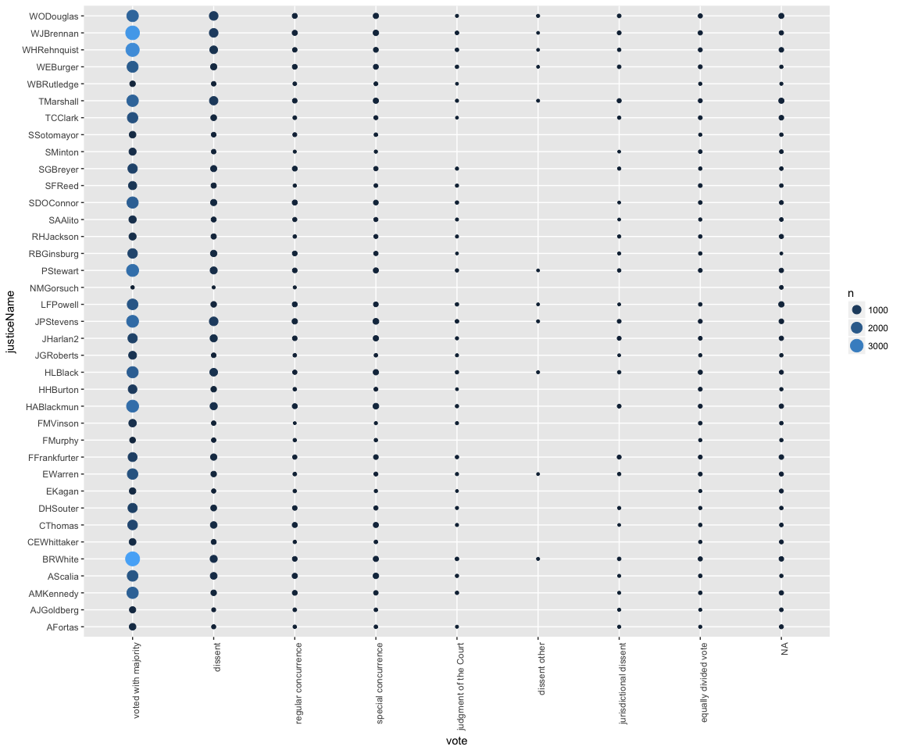

Direction of the decision

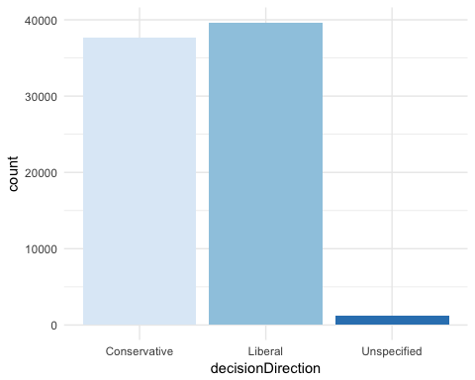

Number of unanimous decisions

[1] 2516.111

How many votes were narrow? (opinions in which majority votes are 5)

FALSE TRUE   
63508 15349

How many opinions are concurring? (vote=3 & vote=4)

[1] 1989

# About the text data

#### [The structure of an opinion](https://www.americanbar.org/publications/insights_on_law_andsociety/13/fall_2012/how_to_read_a_ussupremecourtopinion.html)

* Syllabus
  + The facts of the case and the path that the case has taken to get to the Supreme Court
  + The last portion of the syllabus sometimes summarizes which justice authored the main opinion, which justices joined in the main opinion, and which justices might have issued concurring or dissenting opinions.
* Main Opinion
  + This is the Court’s official decision in the case. In legal terms, the opinion announces a decision and provides an explanation for the decision by articulating the legal rationale that the justices relied upon to reach the decision.
  + Per curiam opinions, however, do not identify any authors, and are simply, opinions of the Court.
* Concurring and Dissenting Opinions
  + Often, there are multiple opinions within the document because the justices are not in agreement. Justices who agree with the result of the main opinionß, but base their decision on a different rationale may issue one or more concurring opinion(s). Likewise, justices who disagree with the main opinion in both result and legal rationale may issue one or more dissenting opinion(s).

### Formal elements of an opinion

1. Headings typically include the Court term in which the opinion was announced
2. case docket number
3. argument dates, and decision date
4. the case name, which helps determine the parties involved in the case (see sidebar)
5. there might be an explanation of where the case came from before reaching the Court
6. Often, there is a note about certiorari, an order by which a higher court reviews the decision of a lower court.

### How to read it (the big picture):

* facts
* legal dispute
* disposition
  + Affirm - allow the lower court’s ruling to stand
  + Reverse, Void, or Vacate - over-turn the lower court’s ruling
  + Remand - send the case back to a lower court for retrial Sometimes the Court combines the last two of these options—reverse and remand—and not only overturns the lower court’s decision, but also orders a retrial.

Average number of words in the opinions

## [1] 2180.257

Average number of words in the opinions after we remove stopwords

[1] 1216.396