Cobertura Vacinal

Raphael Saldanha

22 February, 2023

## Pacotes

library(tidyverse)

## ── Attaching packages ─────────────────────────────────────── tidyverse 1.3.2 ──  
## ✔ ggplot2 3.4.1 ✔ purrr 1.0.1  
## ✔ tibble 3.1.8 ✔ dplyr 1.1.0  
## ✔ tidyr 1.3.0 ✔ stringr 1.5.0  
## ✔ readr 2.1.4 ✔ forcats 1.0.0  
## ── Conflicts ────────────────────────────────────────── tidyverse_conflicts() ──  
## ✖ dplyr::filter() masks stats::filter()  
## ✖ dplyr::lag() masks stats::lag()

library(arrow)

##   
## Attaching package: 'arrow'  
##   
## The following object is masked from 'package:utils':  
##   
## timestamp

library(lubridate)

##   
## Attaching package: 'lubridate'  
##   
## The following object is masked from 'package:arrow':  
##   
## duration  
##   
## The following objects are masked from 'package:base':  
##   
## date, intersect, setdiff, union

library(hrbrthemes)

## NOTE: Either Arial Narrow or Roboto Condensed fonts are required to use these themes.  
## Please use hrbrthemes::import_roboto_condensed() to install Roboto Condensed and  
## if Arial Narrow is not on your system, please see https://bit.ly/arialnarrow

library(viridis)

## Loading required package: viridisLite

## Dados

tmp <- tempfile()  
download.file(  
 url = "https://raw.githubusercontent.com/wcota/covid19br/master/cases-brazil-states.csv",   
 destfile = tmp  
)  
  
read_csv_arrow(file = tmp, ) %>%  
 write_parquet(sink = "cobertura.parquet")  
  
unlink(tmp)  
  
cobertura <- read_parquet(file = "cobertura.parquet")

## Brasil

cobertura %>%  
 filter(state == "TOTAL") %>%  
 filter(date >= as.Date("2021-01-01")) %>%  
 select(  
 date,   
 vaccinated_per_100_inhabitants,   
 vaccinated_second_per_100_inhabitants,   
 vaccinated_third_per_100_inhabitants,   
 vaccinated_single_per_100_inhabitants  
 ) %>%  
 pivot_longer(!date) %>%  
 mutate(name = case_when(  
 name == "vaccinated_per_100_inhabitants" ~ "1a dose",  
 name == "vaccinated_second_per_100_inhabitants" ~ "2a dose",  
 name == "vaccinated_third_per_100_inhabitants" ~ "3a dose",  
 name == "vaccinated_single_per_100_inhabitants" ~ "Dose única"  
 )) %>%   
 ggplot(aes(x = date, y = value/100, color = name)) +  
 geom_line(lwd = 1.3) +  
 scale_y_continuous(labels = scales::label_percent(), limits = c(0,1)) +  
 scale_x_date(date_breaks = "1 month",  
 date_labels = "%m/%y") +  
 theme_ipsum() +  
 theme(legend.position = "bottom", legend.direction = "horizontal") +  
 labs(title = "Percentual acumulado da população brasileira vacinada",  
 subtitle = "segundo a dose",   
 caption = "Dados consolidados por W.Cota",  
 color = "", y = "", x = "")

## Warning: Removed 64 rows containing missing values (`geom_line()`).

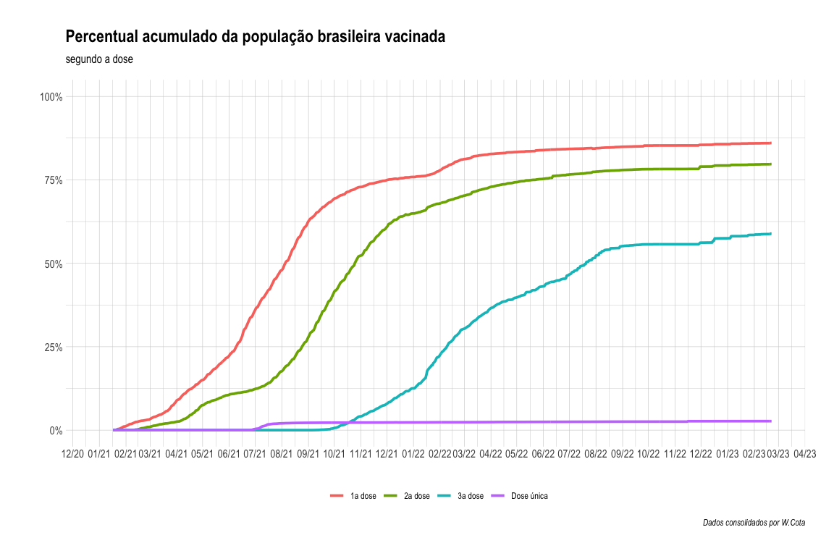

cobertura %>%  
 filter(state == "TOTAL") %>%  
 filter(date >= as.Date("2021-01-01")) %>%  
 filter(date <= as.Date("2022-02-01")) %>%  
 select(  
 date,   
 vaccinated_per_100_inhabitants,   
 vaccinated_second_per_100_inhabitants,   
 vaccinated_third_per_100_inhabitants,   
 vaccinated_single_per_100_inhabitants  
 ) %>%  
 pivot_longer(!date) %>%  
 mutate(name = case_when(  
 name == "vaccinated_per_100_inhabitants" ~ "1a dose",  
 name == "vaccinated_second_per_100_inhabitants" ~ "2a dose",  
 name == "vaccinated_third_per_100_inhabitants" ~ "3a dose",  
 name == "vaccinated_single_per_100_inhabitants" ~ "Dose única"  
 )) %>%  
 ggplot(aes(x = date, y = value/100, color = name)) +  
 geom_line(lwd = 1.3) +  
 scale_y_continuous(labels = scales::label_percent(), limits = c(0,1)) +  
 scale_x_date(date_breaks = "1 month",  
 date_labels = "%m/%y") +  
 theme_ipsum() +  
 theme(legend.position = "bottom", legend.direction = "horizontal") +  
 labs(title = "Percentual acumulado da população brasileira vacinada",  
 subtitle = "segundo a dose (até 2022-03-01)",   
 caption = "Dados consolidados por W.Cota",  
 color = "", y = "", x = "")

## Warning: Removed 64 rows containing missing values (`geom_line()`).

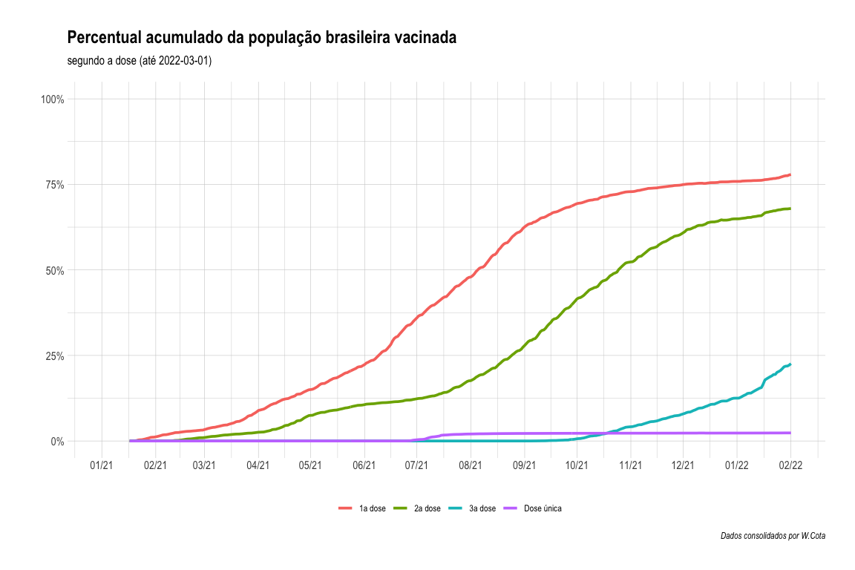

res_03 <- read_parquet(file = "parquets/res_03.parquet")  
  
res_03 %>%  
 filter(nome_fabricante == "ASTRAZENECA/FIOCRUZ") %>%  
 filter(data_aplicacao >= as.Date("2021-01-01")) %>%  
 select(-nome_fabricante) %>%  
 arrange(data_aplicacao) %>%  
 mutate(doses_cum = cumsum(pessoas)) %>%  
 ggplot(aes(x = data_aplicacao, y = doses_cum)) +  
 geom_line(lwd = 1.3, color = "purple") +  
 scale_y_continuous(labels = scales::label_comma()) +  
 scale_x_date(date_breaks = "1 month",  
 date_labels = "%m/%y") +  
 theme_ipsum() +  
 theme(legend.position = "bottom", legend.direction = "horizontal") +  
 labs(title = "Quantidade acumulada de doses aplicadas",  
 subtitle = "fabricadas pela AstraZeneca, por dia da aplicação",   
 caption = "Dados do SI-PNI",  
 fill = "", y = "", x = "")

