Niche Breadth and Predicted Range Expansion—Contrasting a Specialist and Generalist Frog Species in Panama
Robert Fu
Biogeography GEOG_2129W_10, February 27th 2026
Abstract
Understanding why some species expand into new regions while others remain restricted is a central question in biogeography, and ecological niche breadth provides a powerful framework for explaining these differences. Generalists, with broad climatic tolerances, are expected to maintain or increase suitability under changing conditions, whereas specialists are more vulnerable to environmental shifts. This study evaluates that expectation using two co-occurring Costa Rican frog species that differ sharply in ecological breadth: the generalist Smilisca baudinii and the specialist Isthmohyla pseudopuma. Species distribution models were calibrated using Costa Rican occurrence data and projected into Panama under three future CMIP6 climate periods to assess each species’ potential for regional expansion. The projections revealed a consistent divergence between the two species. S. baudinii showed broad and increasing suitability across Panama, including a pronounced expansion through a central corridor between the Golfo de Panamá and the Caribbean Sea. In contrast, I. pseudopuma exhibited a restricted and progressively shrinking area of moderate suitability near the Costa Rica–Panama border, with no new suitable regions emerging. These results support the hypothesis that generalists are more capable of tracking future climatic conditions than specialists. More broadly, the findings reinforce niche breadth as a key determinant of species’ resilience and potential range expansion under climate change, highlighting the contrasting vulnerabilities and opportunities faced by specialist and generalist amphibians in a warming world.

Introduction
According to the theory of natural selection, species that can tolerate or adapt to external selective pressures—such as climatic or habitat conditions—are more likely to persist, expand, and occupy new regions. In biogeography, this leads to a central question: why do some species occupy broad geographic areas while others remain restricted to narrow environmental zones? A major driver of these patterns is ecological niche breadth, which determines how broadly a species can tolerate environmental variation. Generalist species, with wide climatic and habitat tolerances, often achieve larger geographic ranges and greater dispersal success, whereas specialists are typically restricted to narrower environmental conditions and smaller distributions (Slatyer et al., 2013; Sexton et al., 2009). This distribution is fundamental to understanding how species respond to environmental pressure, colonize new territories (habitats), and survive under changing conditions
Among the animal taxa, niche breadth has been utilized to predict both the distribution extent and ecological resilience of species. According to Joanne Clavel et al.’s research across multiple animal species, specialist species are declining globally at a faster rate than generalists, leading to communities becoming increasingly dominated by generalists over time (Clavel et al., 2011). The two studies done by William E. Cooper Jr and Laurie J. Vitt (2002) and Laurie J. Vitt with Eric R. Pianka (2005) on lizard species also support this pattern, showing that species with broader ecological niches tend to occupy larger geographic ranges (Cooper & Vitt, 2002; Vitt & Pianka, 2005). Furthermore, Bonetti and Wiens (2014) showed that amphibians follow the same pattern, with species in stable, resource‑rich environments evolving narrower climatic niches and therefore exhibiting more restricted geographic ranges. This contrast in ecological flexibility becomes especially evident during dispersal events, where generalists are more capable of shifting or expanding their realized niches than specialists (Tingley et al., 2012).
And, notably, this pattern is not exclusive in the animal kingdom. Global analyses of plant distributions show that species with broader climatic tolerances consistently occupy larger ranges, suggesting that the generalist–specialist contrast represents a widespread ecological rule rather than a taxon‑specific pattern (Slatyer, Hirst & Sexton, 2013). Similarly, the patterns are evident in fungi and bacteria also (Peay et al., 2016; Barberán et al., 2014). Together, these findings highlight niche breadth as a key determinant of species distributions across diverse lineages.
Taken together, these studies reveal a consistent pattern: species with broad ecological tolerances tend to achieve wider geographic distributions and greater dispersal success, whereas those with narrow niches are more constrained in both range and resilience. This consistency across taxon solidified niche breadth as a fundamental factor shaping species’ biogeographic outcomes and provides a clear reason to compare a generalist and a specialist species within the same region.

Study Structure
To evaluate these theoretical expectations in a real biogeographic context, the study focuses on two frog species that differ sharply in ecological breadth yet co‑occur within Costa Rica. I want to compare a habitat specialist with a broad‑tolerance generalist, and the goal is to use Costa Rican occurrence records and project them into Panama to evaluate whether each species could plausibly expand into this adjacent region. By focusing on predicted suitability rather than confirmed presence.
Why Costa Rica as a starting point?
The reason I chose Costa Rica as the species pool from which two frog species were initially selected is that it offers a broad diversity of frog species, making it much easier to find a generalist–specialist pair that co‑occur in the same region. And this high diversity reflects a wide range of microclimates and habitat types, which in turn support many narrowly specialized frog species, further supporting the expectation of finding a pair of specialist/generalist frog species.
Species Choice: Isthmohyla pseudopuma
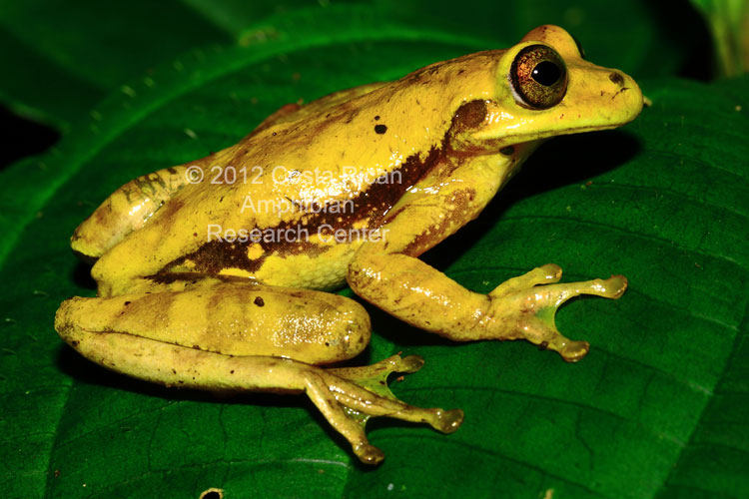
I chose Isthmohyla pseudopuma as my specialist frog species (shown in Figure 1), which is commonly referred to as a treefrog. It is a member of the family Hylidae found in Costa Rica and western Panama, occurring along the Cordillera de Talamanca and adjacent mountain ranges.
Figure 1: Isthmohyla pseudopuma adult. Source: C.R.A.M. Amphibian Conservation (cramphibian.com).
This species occupies mid-elevation montane zones and is typically found at elevations of 1,120~2,340 m. Their habitats are strongly associated with humid montane forests and wetlands(IUCN SSC Amphibian Specialist Group, 2021).
I chose this species as my specialist frog because it has a relatively narrow habitat range, limited habitat flexibility, and a strong dependence on cloud forest microclimates. Notably, its breeding depends heavily on precipitation. Reproduction occurs immediately after heavy rains and relies on small temporary ponds, which makes the species particularly vulnerable to changes in precipitation patterns. These factors together support its role as a typical habitat and climate specialist (IUCN SSC Amphibian Specialist Group, 2021).
Species Choice: Smilisca baudinii
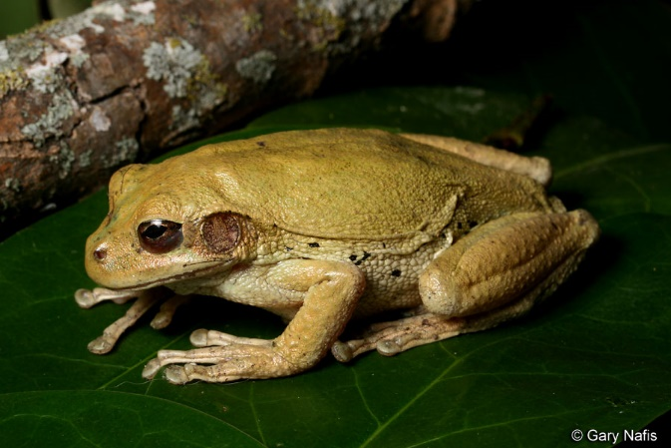
I chose Smilisca baudinii as my generalist frog species (shown in Figure 2), which is commonly referred to as a Mexican treefrog. It is also a member of the family Hylidae found in a wide distribution across Central America and southern North America, including Costa Rica.
Figure 2: Smilisca baudinii (Mexican treefrog). Source: California Herps (n.d.).
This species is typically found from sea level to 1,610 m in elevation. Its distribution covers all of the major habitats important to Isthmohyla pseudopuma, including tropical moist forests and seasonal wetlands, and extends further into tropical dry forests, savannas, and shrublands. It is also not described as being dependent on precipitation for breeding. These factors together support its role as a typical habitat and climate generalist (IUCN SSC Amphibian Specialist Group, 2020).
Clarifying Distribution Differences
Although the two species differ greatly in their overall distribution scales, this contrast is intentional because it allows the study to view how niche breadth influences predicted suitability when both species are modeled within the same regional context, and the choice of Panama as the prediction region is due to its proximity to the original habitat of both species. And the possible (one confirmed and one uncertain) appearance of both species in the region.
Hypothesis
With the ecological contrast between the two species established, this study tests the expectation that the generalist (S.baudinii) will exhibit broader predicted climatic suitability in Panama than the specialist (I.pseudopuma). In other words, when both species are projected into the same adjacent region, the generalist is expected to show greater potential for future expansion.

Method
Study species and occurrence data
I obtained occurrence records for Isthmohyla pseudopuma and Smilisca baudinii using the Obtain Occurrence Data component in Wallace. For I. pseudopuma, I set the maximum number of records to 1000, and for S. baudinii I used a limit of 500 to avoid Application Programming Interface (API) errors during retrieval. I downloaded all records from Global Biodiversity Information Facility (GBIF) and cleaned them using Wallace’s built-in filters, removing duplicate coordinates, missing geographic information, and invalid points. I used the cleaned datasets for all subsequent model calibration steps.
Accessible area (M) definition
I defined the accessible area (M) for each species using a user‑drawn polygon. These polygons captured the known Costa Rican distributions of the two species. I used each polygon to mask environmental layers and to restrict background sampling to areas that were ecologically and historically accessible.
Environmental predictors
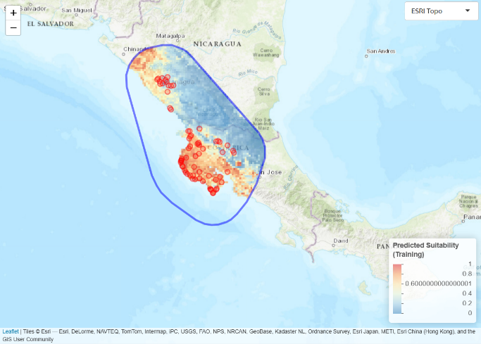
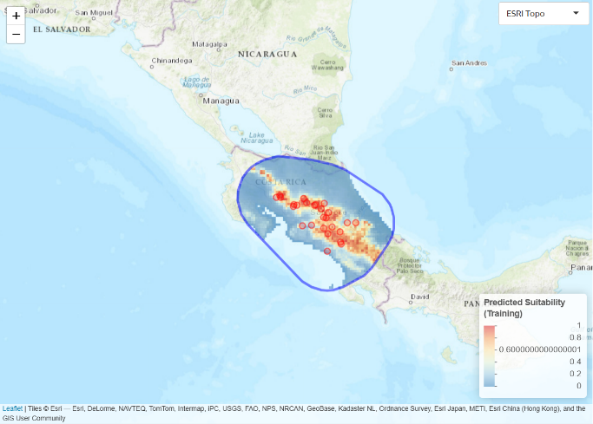
I obtained bioclimatic variables from WorldClim v2 at 2.5-arcmin resolution using the Select WorldClim Bioclimatic Variables component. To reduce redundancy and avoid inflating model performance through collinearity, I evaluated variable correlations and distributions in the Environmental Space module and removed highly correlated predictors (|r| ≥ 0.7). Retaining only variables with clearer biological interpretability ensured that each predictor contributed distinct ecological information, which improves both model stability and the precision of response curves. I used the same final variable set for both species to maintain comparability across models.
Figure 4. Accessible area (M) and calibration data for Smilisca baudinii.
Figure 3. Accessible area (M) and calibration data for Isthmohyla pseudopuma.
Background sampling and data partitioning
I sampled background points within each species’ M using the Background Points component, setting the number of points to 2000 (or the maximum available when constrained by M). I partitioned occurrence data using the Spatial Partition module with Block (k = 4) to reduce spatial autocorrelation between training and testing subsets.
Model calibration
I calibrated species distribution models using the Maxent algorithm in the Model component. I specified feature classes L, Q, and H, and I evaluated regularization multipliers from 0.5 to 4 in increments of 0.5. I enabled clamping to limit extreme extrapolation during transfer. I selected the best-performing model for each species using ENMeval’s evaluation metrics to balance predictive performance and model complexity.
Model transfer to Panama
I projected each species’ best model to a user-defined Panama polygon using the Transfer component. For future climate conditions, I used Coupled Model Intercomparison Project Phase 6 (CMIP6) layers from the Canadian Earth System Model version 5 (CanESM5) global circulation model at 2.5-arcmin resolution. These layers correspond to the Intergovernmental Panel on Climate Change (IPCC)’s Shared Socioeconomic Pathway 2–4.5 (SSP2-4.5), a “middle-of-the-road” scenario in which socioeconomic trends follow historical patterns and emissions neither dramatically worsen nor rapidly improve. This scenario represents moderate mitigation and is commonly used to evaluate plausible mid-century climate trajectories. To assess temporal sensitivity, I generated projections for three future periods: 2021–2040, 2041–2060, and 2061–2080. I applied the same variables, resolution, and General Circulation Model (GCM) across all projections and both species to ensure comparability. The resulting continuous suitability maps (0–1) allowed me to compare how the specialist and generalist species respond to projected climate change through time.

Result and Discussion
Outcome and interpretation
After the test, I found that projected suitability differed markedly between the two species across all three time periods; the prediction visualization is shown in Figure 5. Suitability values range from 0 to 1, represented from blue (low suitability) to red (high suitability), which helps interpret spatial patterns even when the legend is viewed at a smaller scale.
As shown in Figure 5, S. baudinii consistently exhibited substantially higher predicted suitability in Panama than I. pseudowavuna. The generalist species (S. baudinii) showed an increase in suitability over time, with orange and red areas (0.6–1.0) expanding and intensifying from 2021–2040 to 2061–2080 (D→F). This expansion occurred broadly across central and eastern Panama, with the most visually pronounced increase forming a corridor between the Golfo de Panamá and the Caribbean Sea.
In contrast, the specialist species (I. pseudowavuna) exhibited a decline in suitability. The small patches of moderate suitability (green–yellow, ~0.3–0.6) in the northwestern portion of the projection region, near the Costa Rica–Panama border, shrank and became increasingly fragmented across the three time periods (A→C). No new areas of suitability emerged elsewhere.
This produced a reversed temporal pattern: suitability for the generalist expanded under future climate scenarios, while suitability for the specialist contracted.

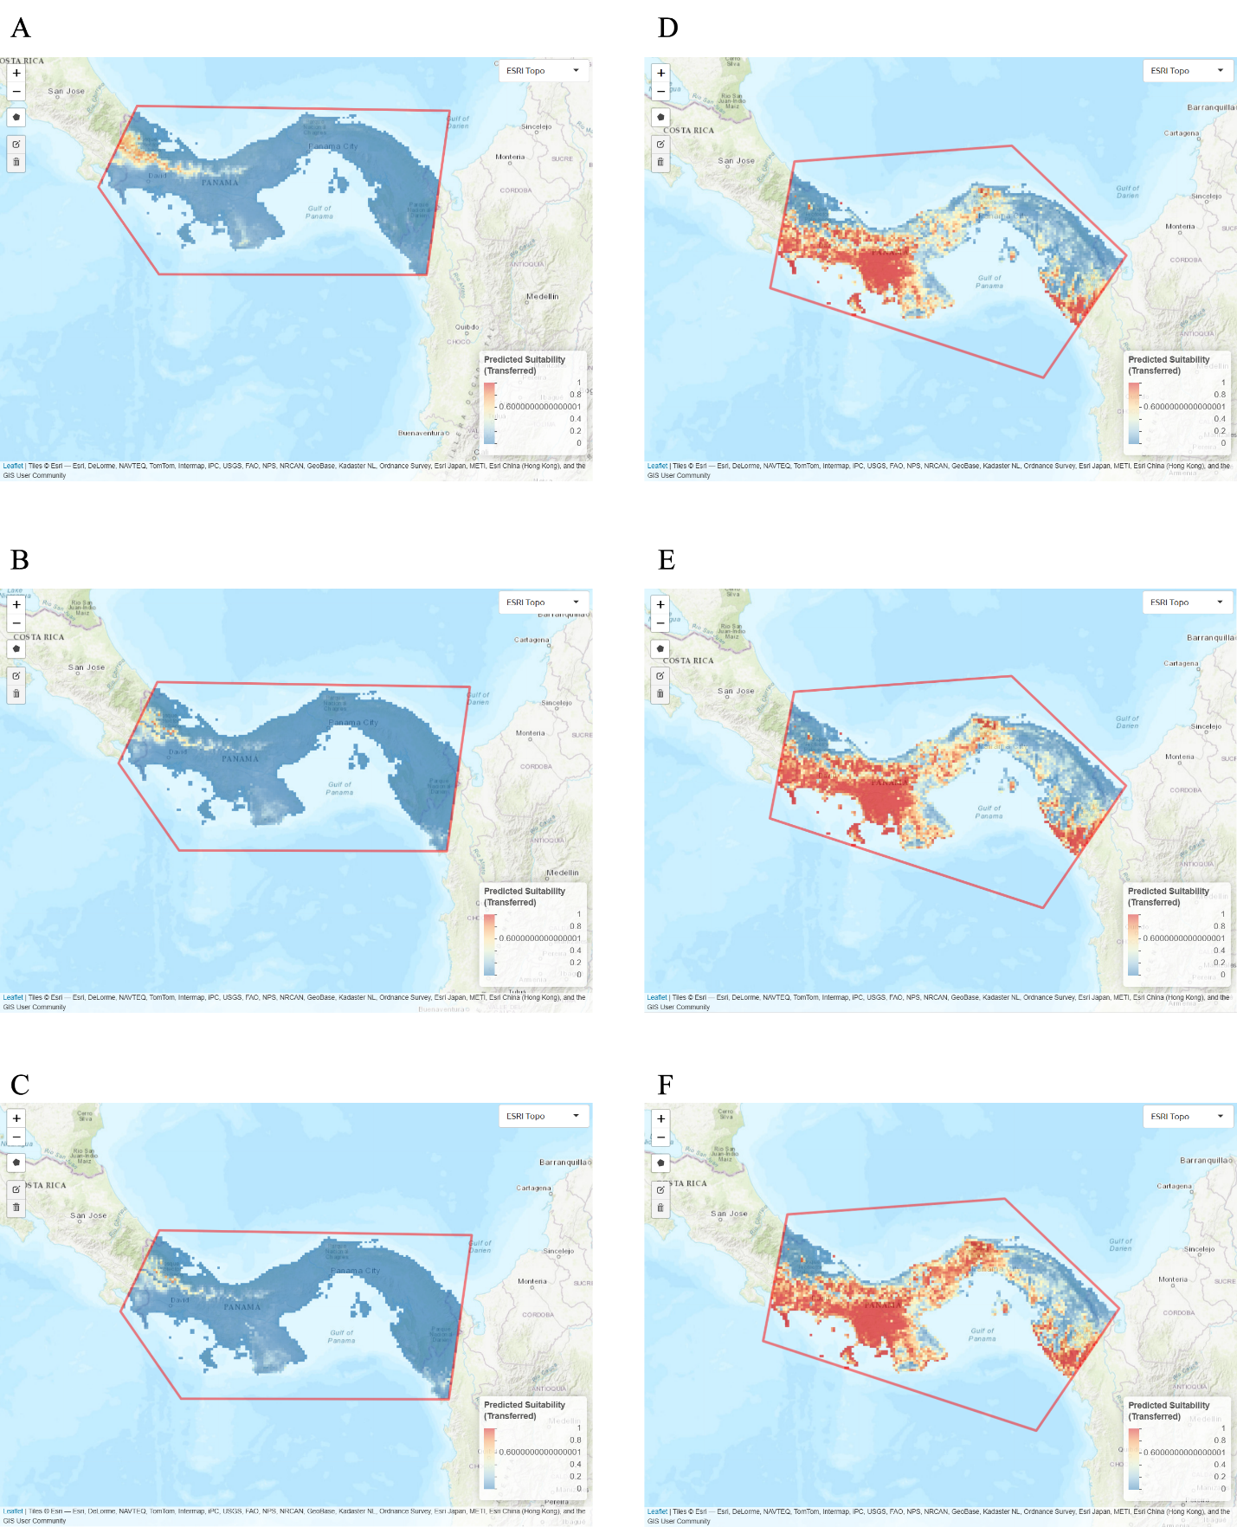
Figure 5: Future suitability projections for Isthmohyla pseudopuma (A–C) and Smilisca baudinii (D–F) in Panama under three CMIP6 CanESM5 time periods. Panels show suitability for 2021–2040 (A, D), 2041–2060 (B, E), and 2061–2080 (C, F). Values range from 0 (low) to 1 (high).
Future predictions
Based on the Wallace prediction, we can see that the divergent distribution and development of S.baudinii and I.pseudopuma align with expectations from niche-breadth theory. Generalist species typically tolerate a wider range of climatic conditions, allowing them to maintain or expand suitable habitat under environmental change. In this study, S.baudinii showed broad and increasing distribution across Panama, including a significant expansion through the centennial corridor between the Golfo de Panamá and the Caribbean Sea. If we expand the time further, based on the pattern, future climatic conditions may create or enhance dispersal-relevant pathways for this generalist amphibian in the region.
In contrast, I. pseudopuma exhibited a narrow and declining suitability footprint. The species retained only a small area of moderate suitability near the Costa Rica–Panama border, and this area contracted and fragmented over time. Such patterns are consistent with the vulnerability of montane or microhabitatspecialist amphibians, whose climatic tolerances and dispersal capacities limit their ability to track shifting conditions. Given that this species is already documented as having a decreasing population trend (IUCN SSC Amphibian Specialist Group, 2021), the projected contraction in suitable habitat reinforces concerns about its long-term persistence in the region.
These patterns push me to think more seriously about what they mean beyond the model outputs themselves. For I. pseudodowara, the shrinking and fragmentation of suitable habitat suggest that conservation attention may need to focus on the northwestern border region, where the last pockets of moderate suitability persist. Identifying microrefugia or monitoring climatic stability in these areas could be an important next step. Even though this study is predictive rather than prescriptive, the results highlight a clear need to consider how rapidly specialists may lose ground under mid‑century climate scenarios.
For S. baudinii, the expanding suitability raises different questions. While the species appears resilient, its increasing presence across central and eastern Panama could reshape local amphibian communities. I find it important to consider whether this expansion might lead to new interactions—competitive, ecological, or even disease‑related—that future studies should explore.
More broadly, these results remind me that niche breadth is not just a theoretical concept but a practical lens for anticipating which species may struggle or thrive as climates shift. Extending this approach to other Neotropical amphibians, or integrating dispersal modeling, genetic connectivity, or microclimate data, could help build a more complete picture of how biodiversity in the region may reorganize in the coming decades.

Conclusion
The projections supported my initial hypothesis that the generalist S. baudinii would show broader and expanding climatic suitability across Panama. Its suitability footprint increased across much of the region, reinforcing how generalist species can capitalize on shifting environmental conditions. In contrast, the specialist I. pseudopuma exhibited a restricted and contracting suitability footprint. This outcome was more pronounced than I originally expected: rather than remaining stable, the specialist’s suitable habitat actively shrank under future climatic conditions.
This divergence adds an important layer of complexity to the final results. It suggests that climate change may not simply create new opportunities for generalists—it may simultaneously erode the already-limited habitat available to specialists. In this case, I. pseudopuma’s contraction aligns with broader patterns observed in montane and microhabitat-restricted amphibians, whose narrow tolerances and limited dispersal capacity make them particularly vulnerable to rapid environmental change.
Together, these contrasting responses highlight how niche breadth shapes species’ capacity to track future climatic conditions. For conservation planning, this means that generalists and specialists will not just diverge in their future trajectories—they may do so in opposite directions, with generalists expanding into new areas while specialists face accelerating habitat loss. Understanding these dynamics will be essential for anticipating which species may require targeted monitoring, habitat protection, or further ecological study as climate conditions continue to shift.

AI Usage
- Abstract and method section writing
I used AI to help refine the clarity and structure of my writing. For example, I asked prompts such as:
- “Can you help me rewrite this Methods paragraph to improve clarity while keeping the scientific meaning?”
- “Summarize this section in a concise, academically appropriate abstract-style paragraph.”
- Topic brainstorming
I used AI to explore possible angles and framing for the project. Example prompts included:
- “Give me several ways to frame a research question about niche breadth and future climatic suitability.” These brainstorming prompts helped me consider different perspectives before deciding on my final approach.
- Troubleshooting During the Wallace Test
When I encountered issues running components in Wallace, I used AI to clarify steps and identify potential mistakes. Example prompts included:
- “What does it mean when Wallace shows an error during the Transfer component, and how can I check my environmental layers?”
- “Explain how to interpret correlation filtering in Wallace and what to do if variables fail to load.” These prompts helped me diagnose workflow issues but did not perform any analysis on my behalf.

References
Barberán, A., Casamayor, E. O., & Fierer, N. (2014). The microbial contribution to macroecology: Patterns and processes in microbial biogeography. Ecology Letters, 17(11), 1287–1299. https://doi.org/10.1111/ele.12282
California Herps. (n.d.). Smilisca baudinii [Photograph]. Retrieved February 24, 2026, from https://californiaherps.com/noncal/misc/miscfrogs/pages/s.baudinii.html
Clavel, J., Julliard, R., & Devictor, V. (2011). Worldwide decline of specialist species: Toward a global functional homogenization? Frontiers in Ecology and the Environment, 9(4), 222–228. https://doi.org/10.1890/080216
Cooper, W. E., Jr., & Vitt, L. J. (2002). Distribution, extent, and evolution of plant consumption by lizards. Journal of Zoology, 257(4), 487–517. https://doi.org/10.1017/S0952836902001085
C.R.A.M. Amphibian Conservation. (n.d.). Isthmohyla pseudopuma [Photograph]. Retrieved February 24, 2026, from https://cramphibian.com/family-hylidae-2/
IUCN SSC Amphibian Specialist Group. (2020). Craugastor fitzingeri. The IUCN Red List of Threatened Species 2020: e.T55616A54347154. Retrieved February 24, 2026, from https://www.iucnredlist.org/species/55616/54347154
IUCN SSC Amphibian Specialist Group. (2021). Craugastor podiciferus. The IUCN Red List of Threatened Species 2021: e.T143847252A53962488. Retrieved February 24, 2026, from https://www.iucnredlist.org/species/143847252/53962488
Kass, J. M., PinillaBuitrago, G. E., Paz, A., Johnson, B. A., GrisalesBetancur, V., Meenan, S. I., Attali, D., Broennimann, O., Galante, P. J., Maitner, B. S., Owens, H. L., Varela, S., AielloLammens, M. E., Merow, C., Blair, M. E., & Anderson, R. P. (2023). Wallace 2: A shiny app for modeling species niches and distributions redesigned to facilitate expansion via module contributions. Ecography, 2023, e06547. https://doi.org/10.1111/ecog.06547
Maria Fernanda Bonetti, John J. Wiens; Evolution of climatic niche specialization: a phylogenetic analysis in amphibians. Proc Biol Sci 1 November 2014; 281 (1795): 20133229. https://doi.org/10.1098/rspb.2013.3229
Peay, K., Kennedy, P. & Talbot, J. Dimensions of biodiversity in the Earth mycobiome. Nat Rev Microbiol 14, 434–447 (2016). https://doi.org/10.1038/nrmicro.2016.59
R. Tingley, M. Vallinoto, F. Sequeira, & M.R. Kearney, Realized niche shift during a global biological invasion, Proc. Natl. Acad. Sci. U.S.A. 111 (28) 10233-10238, https://doi.org/10.1073/pnas.1405766111 (2014).
Sexton, J. P., McIntyre, P. J., Angert, A. L., & Rice, K. J. (2009). Evolution and ecology of species range limits. Annual Review of Ecology, Evolution, and Systematics, 40, 415–436. https://doi.org/10.1146/annurev.ecolsys.110308.120317
Slatyer, R. A., Hirst, M., & Sexton, J. P. (2013). Niche breadth predicts geographical range size: A general ecological pattern. Ecology Letters, 16(8), 1104–1114. https://doi.org/10.1111/ele.12140
Vitt, L. J., Pianka, E. R., Cooper, W. E. Jr., & Schwenk, K. (2005). History and the global ecology of squamate reptiles. Proceedings of the National Academy of Sciences, 102(3), 373–378. https://doi.org/10.1073/pnas.0501104102

