# Exam-st12

## 1 Image restoration

### a)

Figure1b) 0 , Q < T = 5%

S = { 255, Q > 1-T = 95%

O , sonst

Figure1c) S = h * O

Figure1d) S = h * O + n

### b)

i)

Figure1b) Median Filter

Figure1c) Inverse Filter

Figure1d) Wiener Filter

ii)

Median Filter) The median filter identifies the median value for each pixel, depending on the size of the filter-kernel. Finally, the median value is set as the new pixel-value. That means, that very high or low values don´t have an influence on the new pixel value. In terms of shot-noise, like in Figure1b), this could lead to a great improvement.

Inverse Filter) The inverse filter uses the idea, that a blurred image is primarily a noiseless image convoluted with a filter. We know that a convolution in spatial domain means a multiplication in frequency domain, thus we assume that a differentiation of the noise-term in frequency domain will lead to the original image. In terms of Figure1c) where the image is degraded but not noisy, this could improve the image quality.

Wiener Filter) The wiener filter works basically like the inverse filter, but it takes noise into account. Where the inverse filter divides through a degradation term, the wiener filter adds a noise-term to the differentiation. The formula is (Image / (degradation-term + noise-term)) where the noise-term is (1 / (signal-to-noise-ratio)^2)

### c)

We can see, that the image is blurred but the edges are preserved. This result could be caused by a bilateral filter.

Pseudo-Inverse Filter. Don´t use a threshold for filter-value = 0 -> artefact

## 2 Convolution

### a)

-1/2 | 1/6 |-7/6 | 1/2

1/6 |-6/9 | 4/9 | 1/6

-7/4 | 4/6 | 1/6 |-1

### b)

The filter in Figure3a) is the Laplacian filter. It belongs to the category of high-pas-filters, which implies that it preserves the edges in an image.

### c)

i) In b) we assume, that every pixel next to our image has the value zero. This leads to a darker value of the pixels at the border. The view could be changed, by using a different type of boarder handling in spatial domain.

In c) there was used a discrete fourier transformation which is described as a periodic function. The image is repeated to all sides, thus pixels on borders have an influence on the opposite border of the image.

ii) For the result of Fig. 1c) in spatial domain, we need to use the wrapping method for border-handling. This means, when the filter kernel step out of our image at the right side, we use pixels from the very left side of the image for convolution, an converse.

iii) To achieve the result in Fig 1b) we could attach a black border to the image before convolution and remove it after the execution. One way to do this is by using the copyMakeBorder() funkction of OpenCV.

## 3 Interest Points

### a)

The structure tensor is used to filter interesting points by using the intensity gradient / grey value gradient..

Used by the Förstner operator to detect interesting points.

# Exam-st13

## 1 Image Properties

### a)

Each pixel in the image is assigned to the corresponding grey-level value on the histogram and increases this value. The result is a histogram, where frequently occurring grey-levels have a higher value than less frequent ones.

### b)

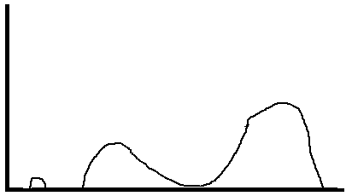

### c)

i) The image is bright.

ii) The image has low contrast.

iii) The image mainly consists of a homogeneous fore- and background.

### d)

The contrast of in image could be enhanced by stretching the color-spectrum to its maximum values. The parts of the histogram with high peaks need to be stretched, whilst parts of the histogram with fewer values needs to be compressed. The contrast is at it´s best, if all color-values have the same amount of values.

## 2 Image Restoration

### a)

Gaussian filter

### b)

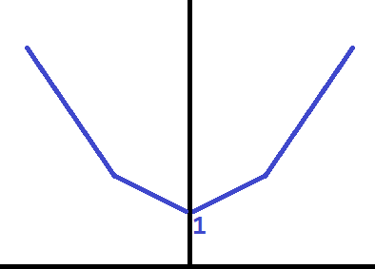

### c)

The image needs to be with zero noise, we need knowledge of the filter kernel, which causes the blurring and…

### d)

The inverse filter should be adapted with respect to noise, like the wiener filter for example.

Original Image = acquired image / (filter + noise) = O = S / (H+n) = S*Q

### e)

i) The wiener filter is not able to handle with multiplied noise. It´s just defined for additive noise.

ii) s = h(o)*n

s = h*o => S = H*O => O = S* 1/H = S*Q

ln(O) = ln(S*Q) = ln(S) + ln(Q) => ln(S) = ln(Q) – ln(O) = ln(Q/O) => S = Q / O

ln(s)=ln(h(o))+ln(n)

## 3 Correlation

### a)

h(t) o x(t) <---------> H(m) * X(m)*

The correlation theorem is useful, because a multiplication in frequency domain is much faster, than a correlation in spatial domain. That means, that she could correlate her image with more templates in the same time.

### b)

Figure 3b) shows a box filter. One property of the filter is that every pixel of the filter-kernel has the same amount of influence on the result. The filter is operated in frequency domain. Because a frequency is a periodic signal, the image is repeated on every edge of the image. Thus, the borders of the image have an influence on their opposite ones. The borders at the top and bottom of the image have the same values, that´s why we can´t see that influence there.

### c)

The upper and lower border would be grey, instead of white.