CITI BIKE – BIKE SHARE DASHBOARD

Rika Fukamachi

2019/10/13

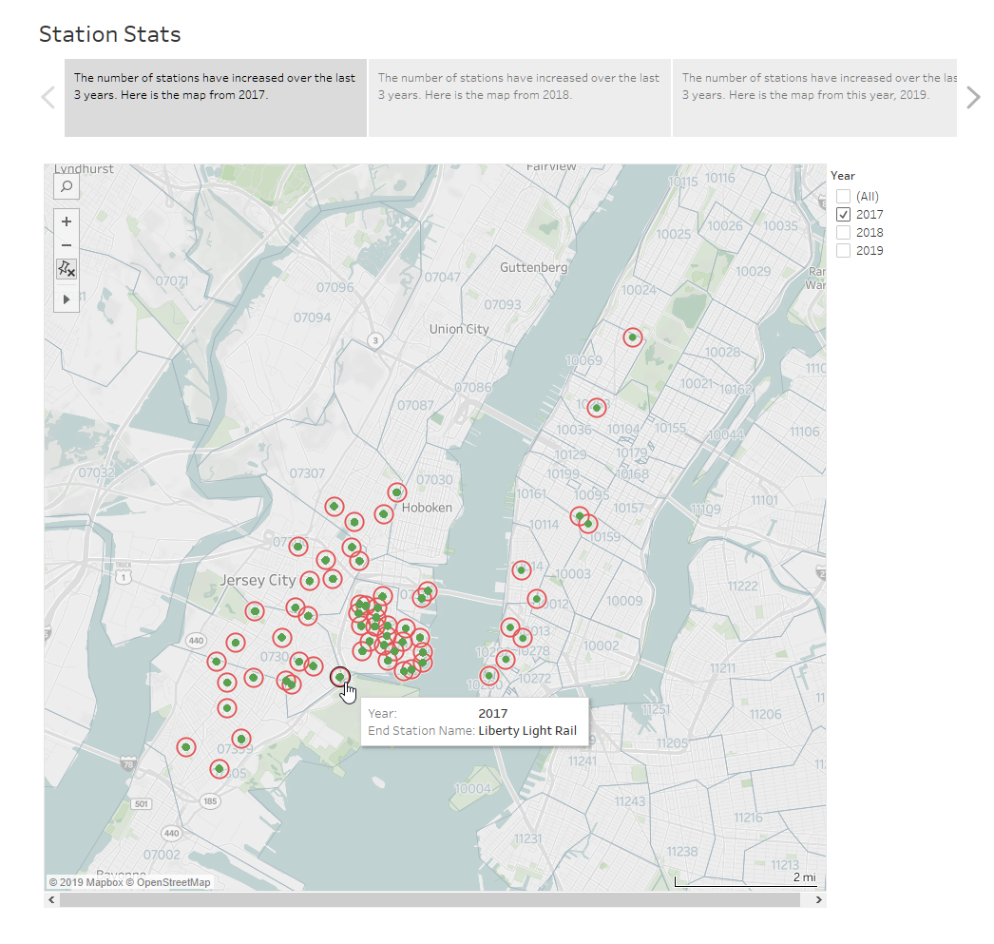

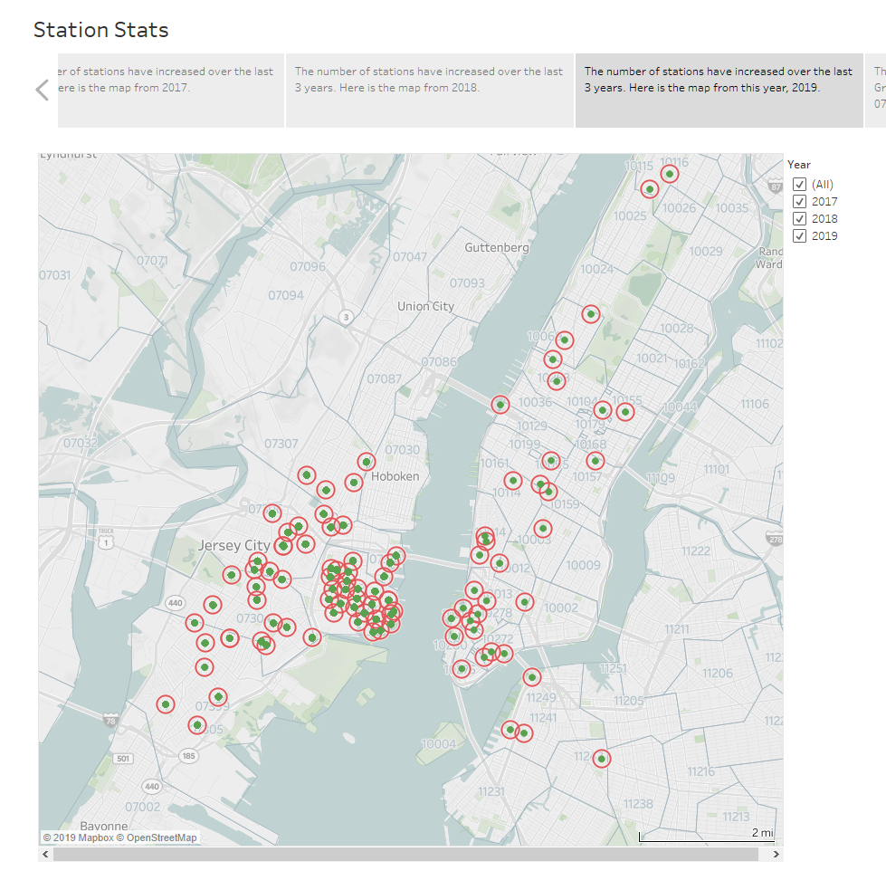

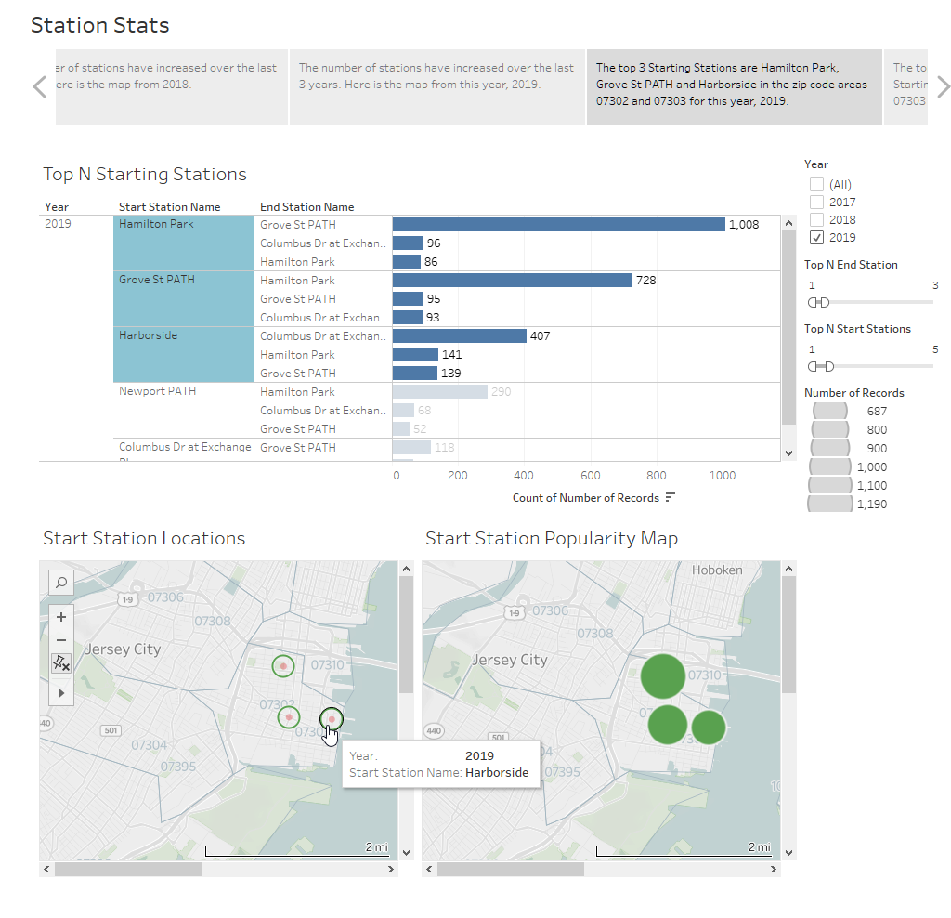

Here is a screenshot of the 2019 Start Station Popularity Map without the earlier filters of ‘top 3’ being applied: The green signifies ‘Start’ and are sized according to the total number of trips that started from that station.

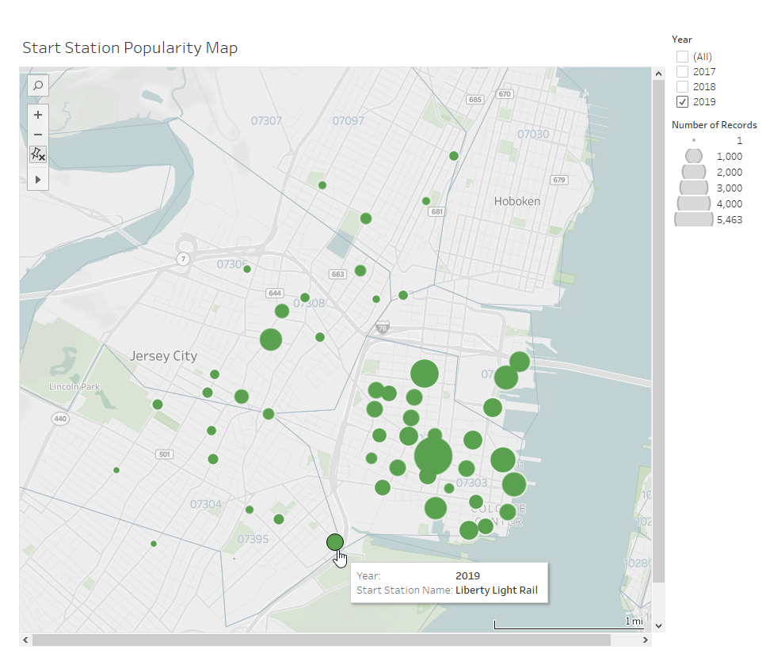

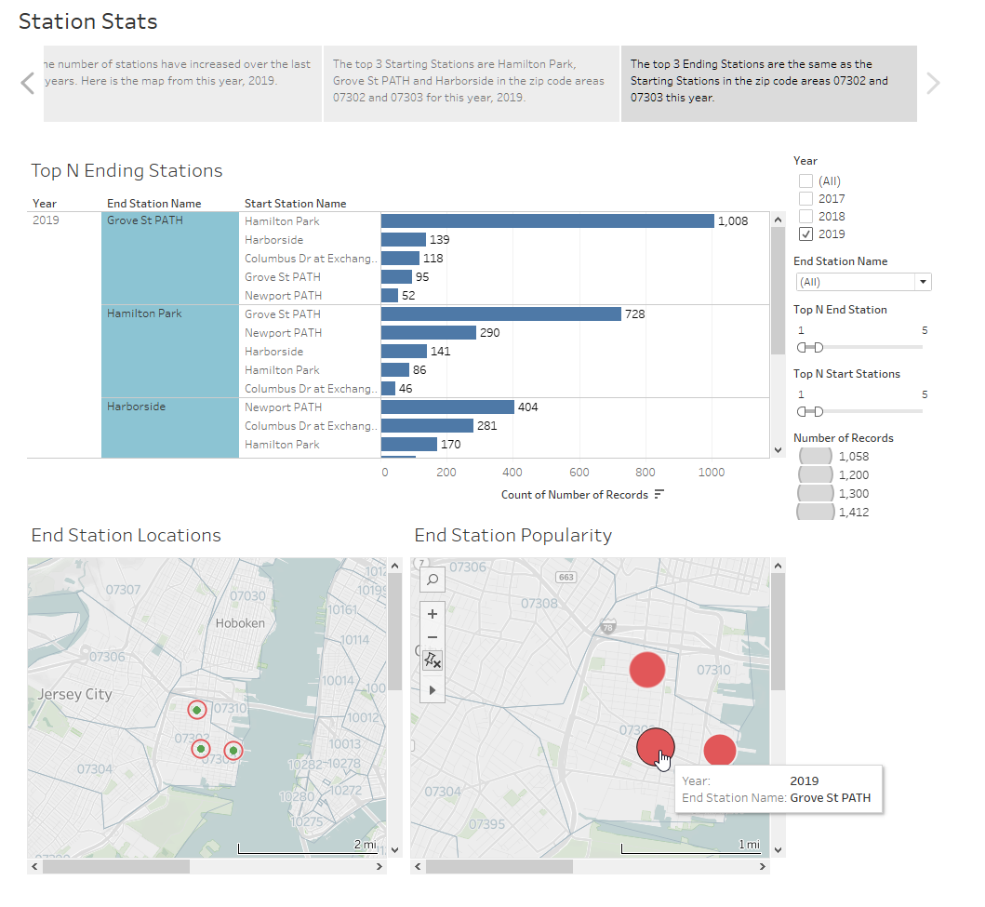

Here is a screenshot of the 2019 End Station Popularity Map without the last filters of ‘top 3’ being applied: The red signifies ‘End’ and are sized according to the total number of trips that ended at that station.

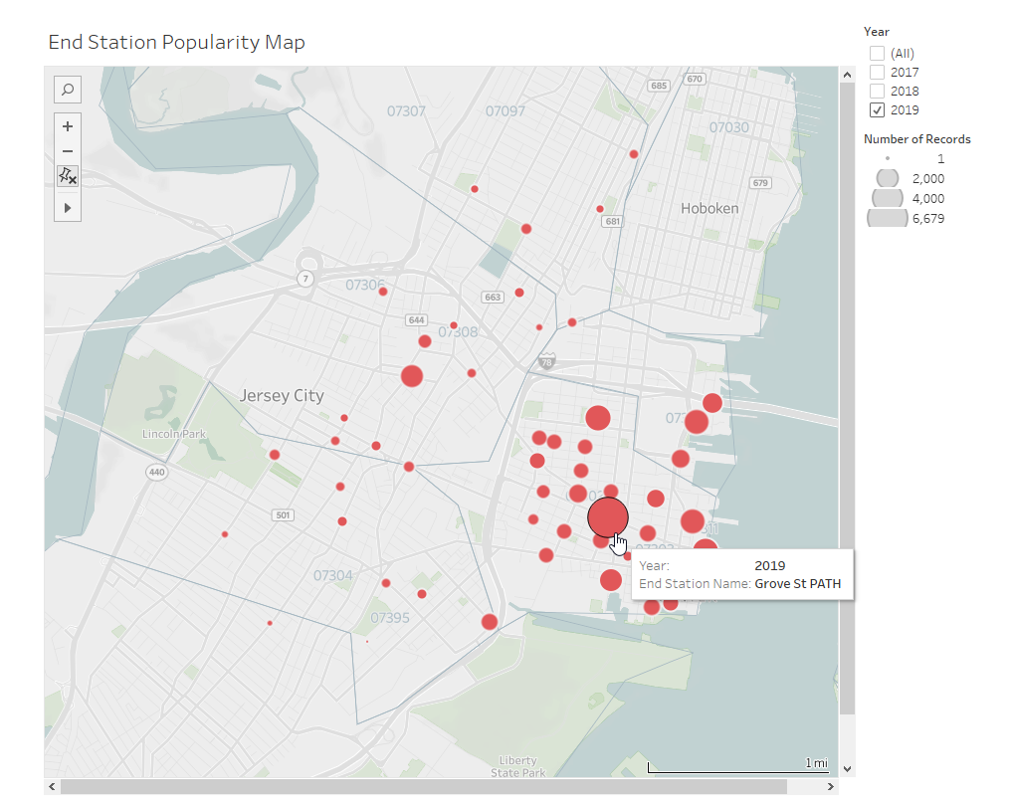

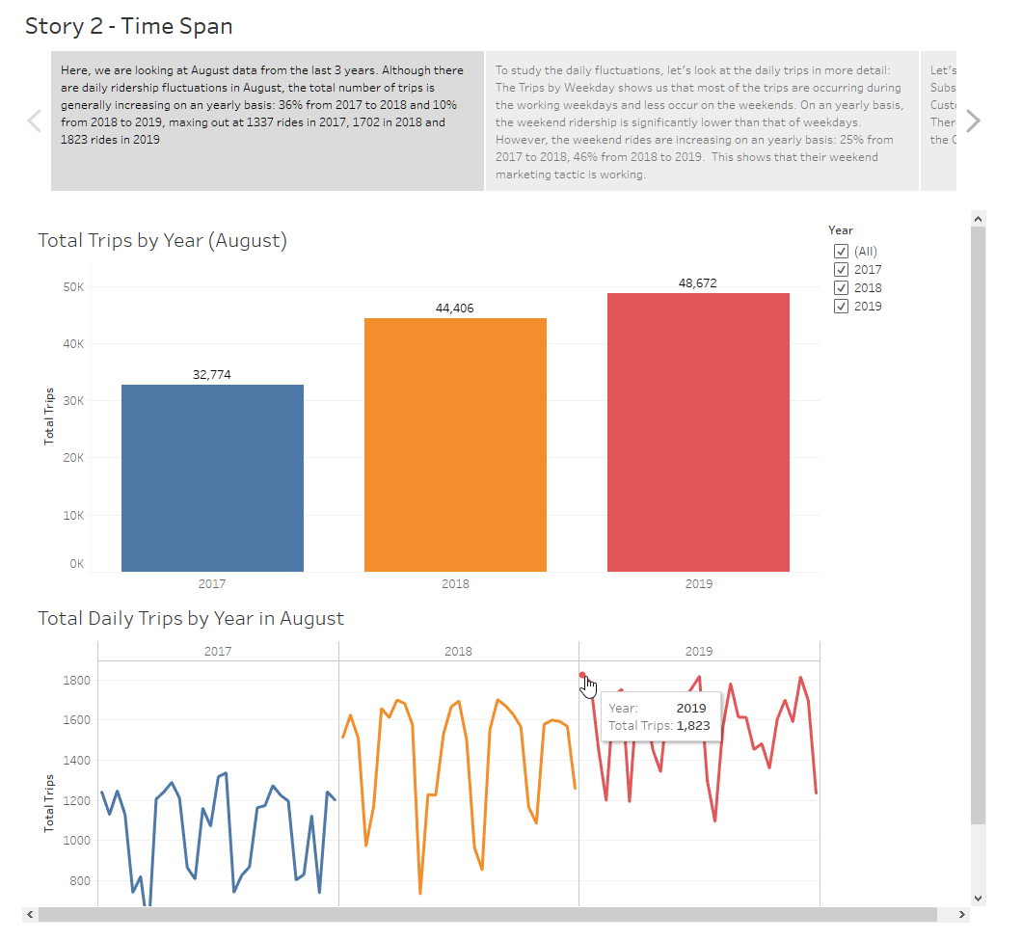

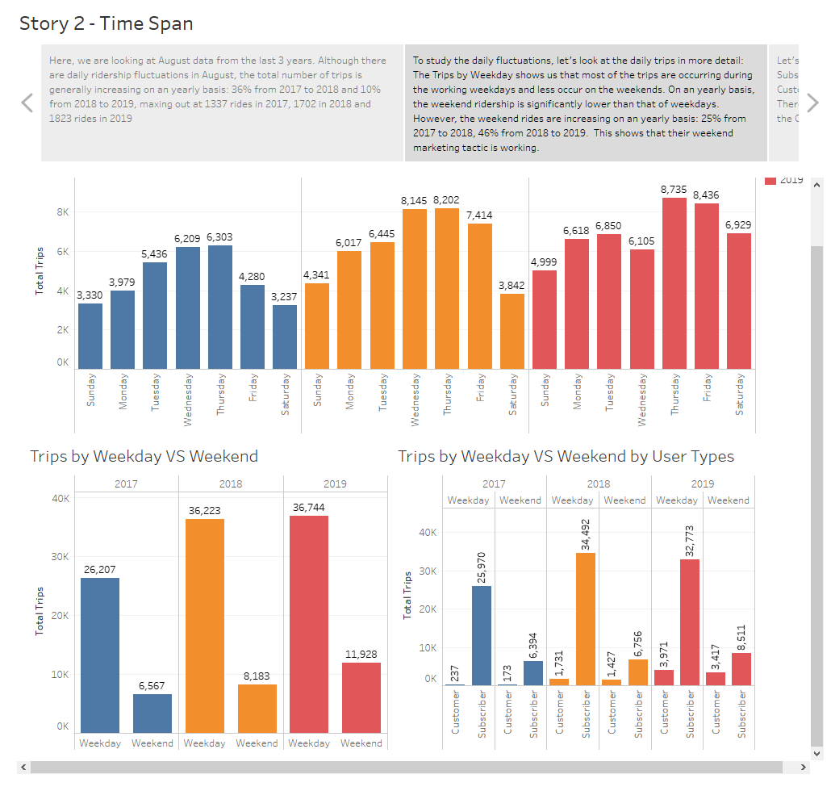

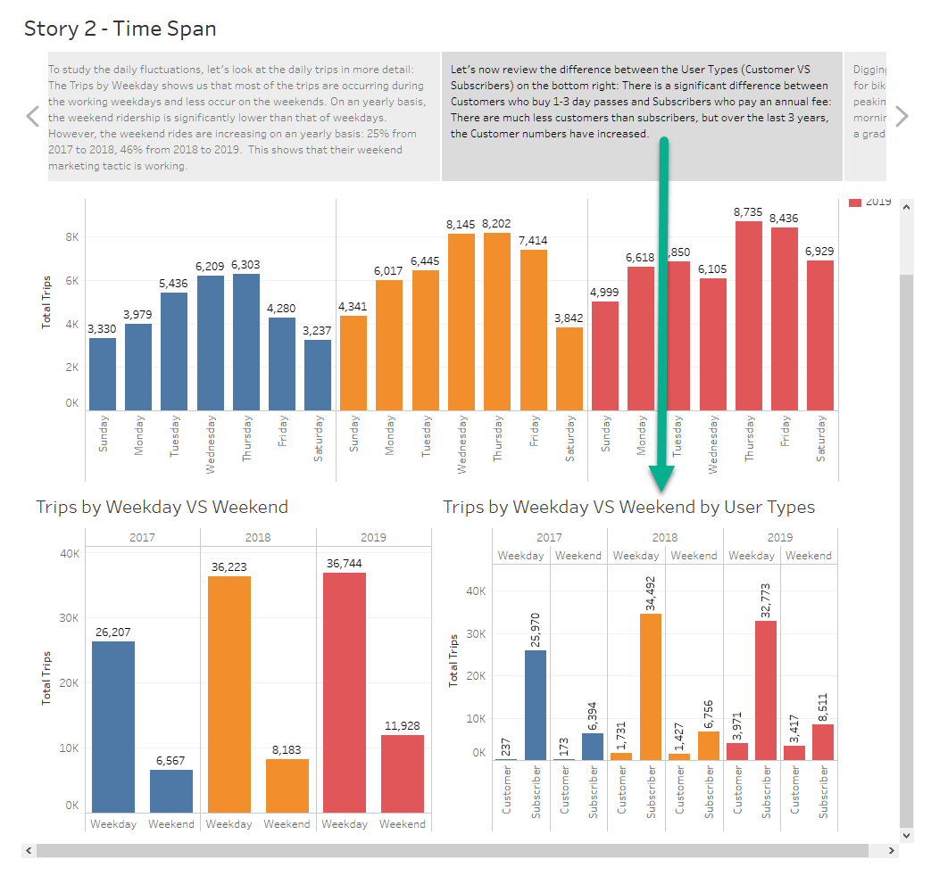

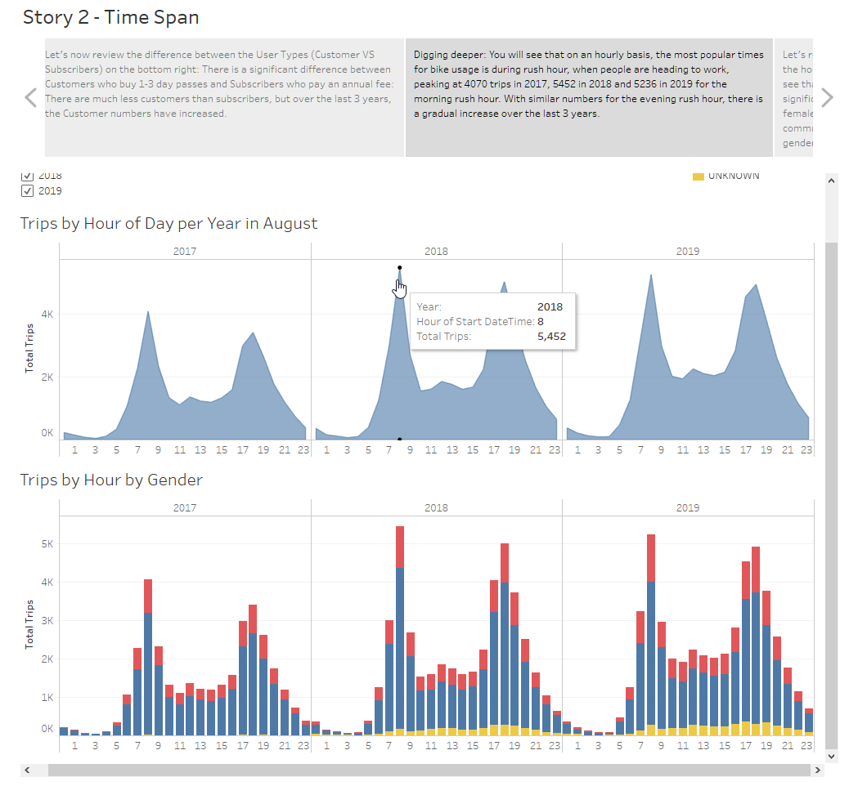

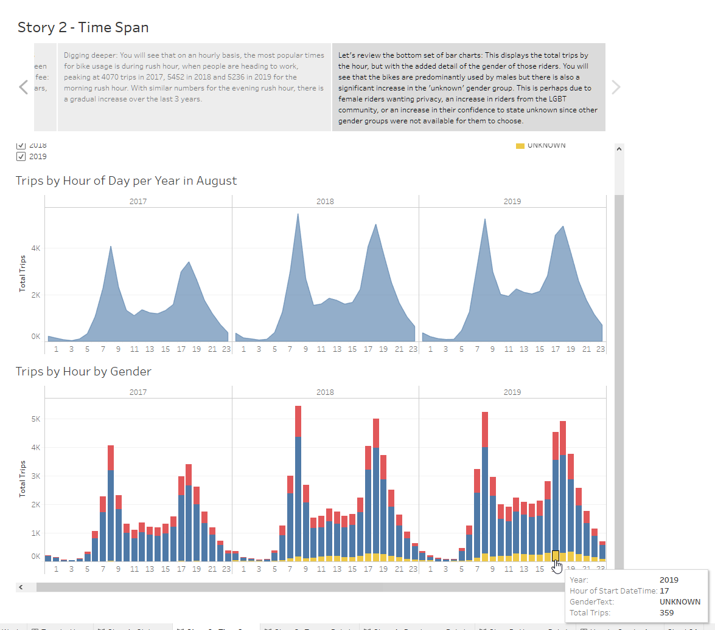

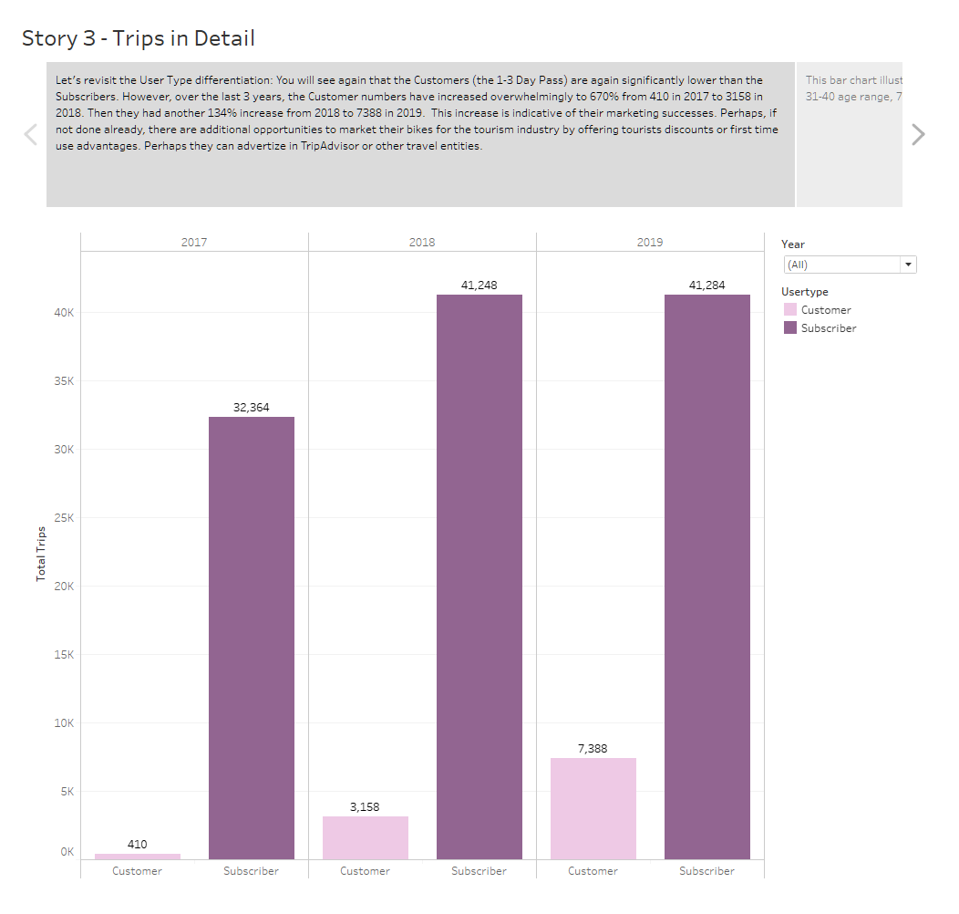

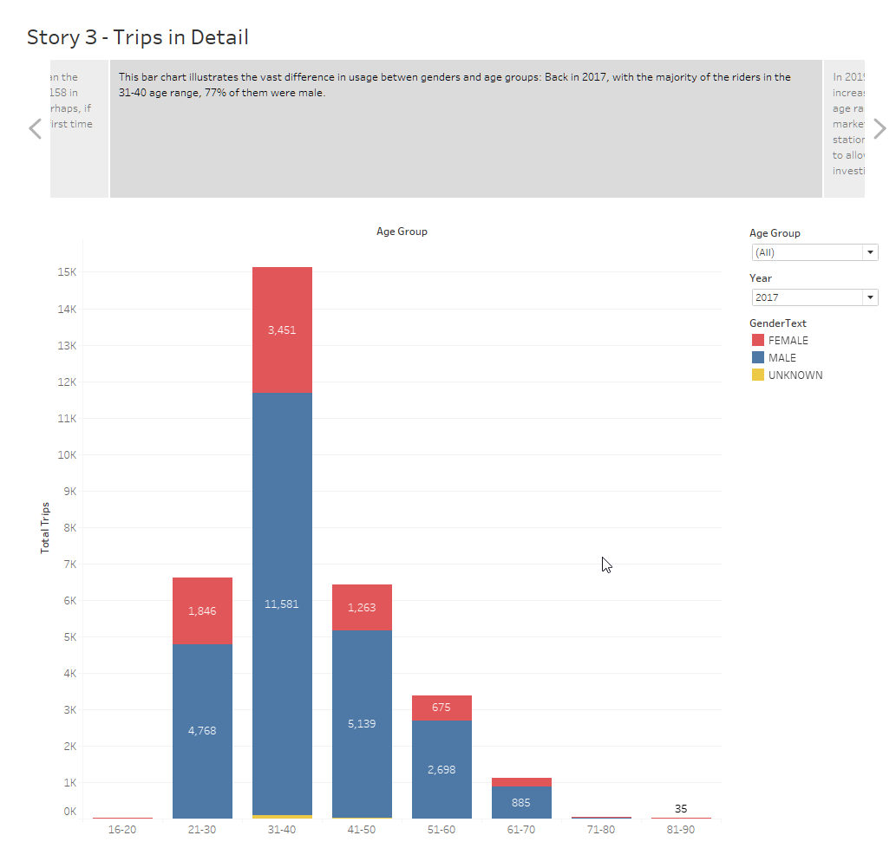

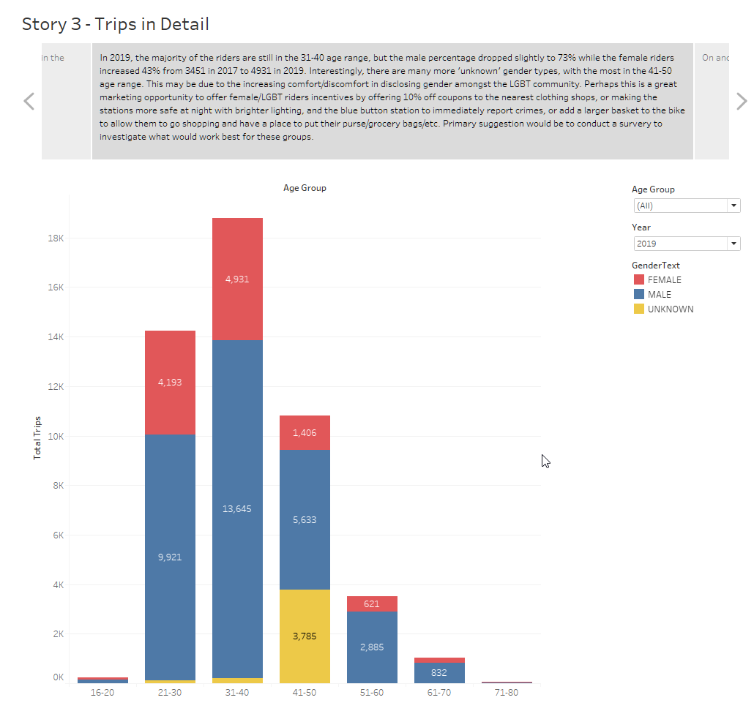

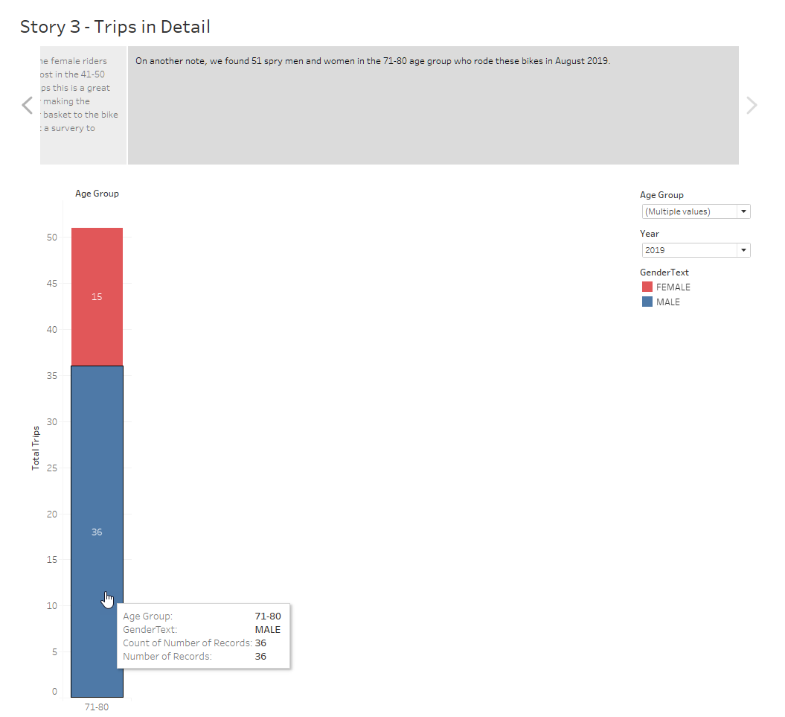

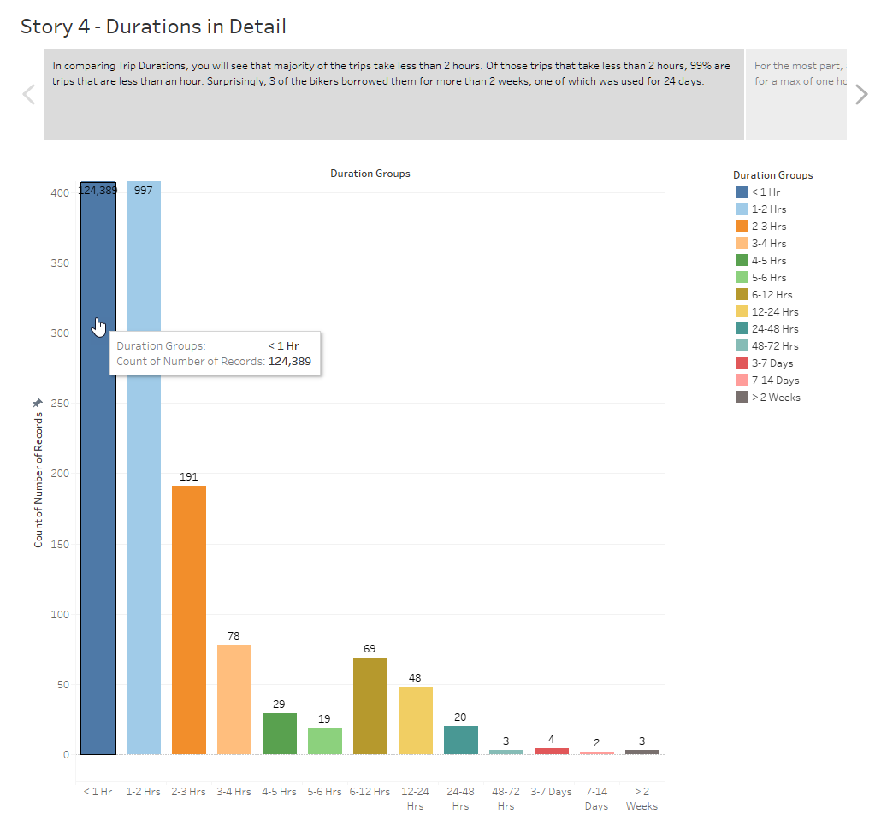

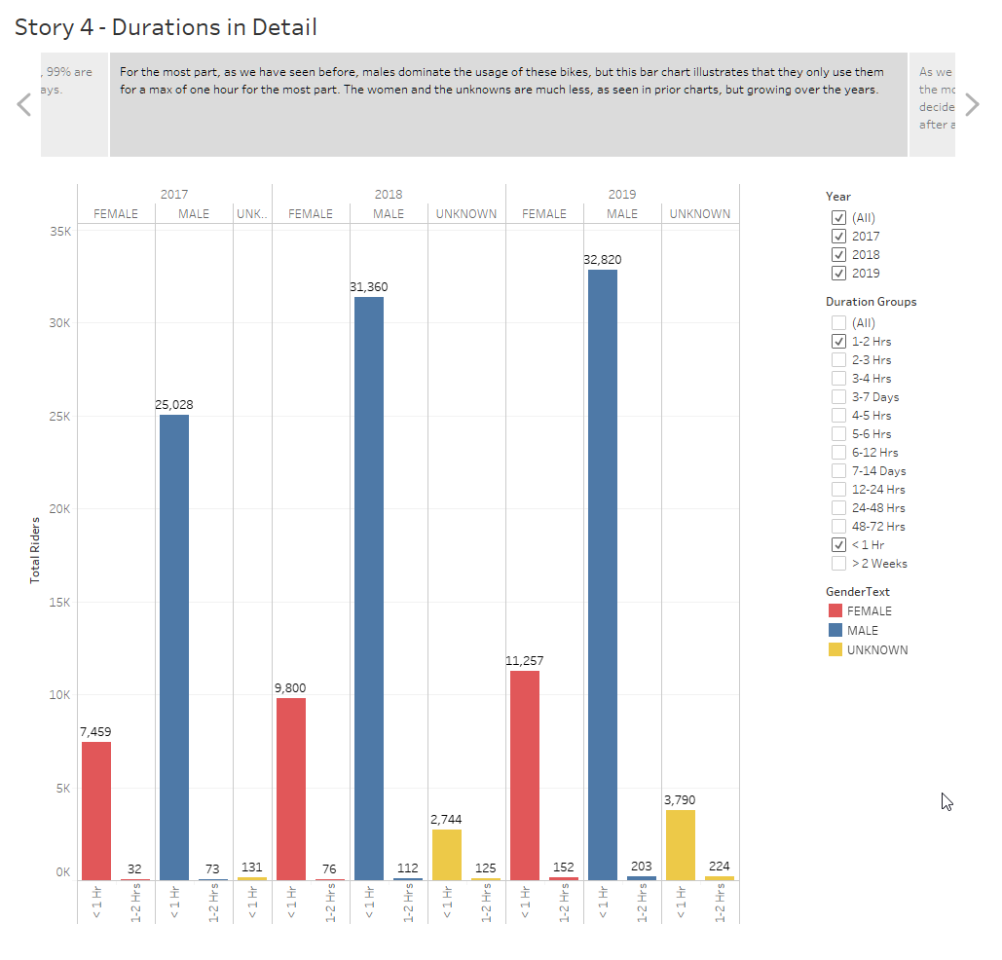

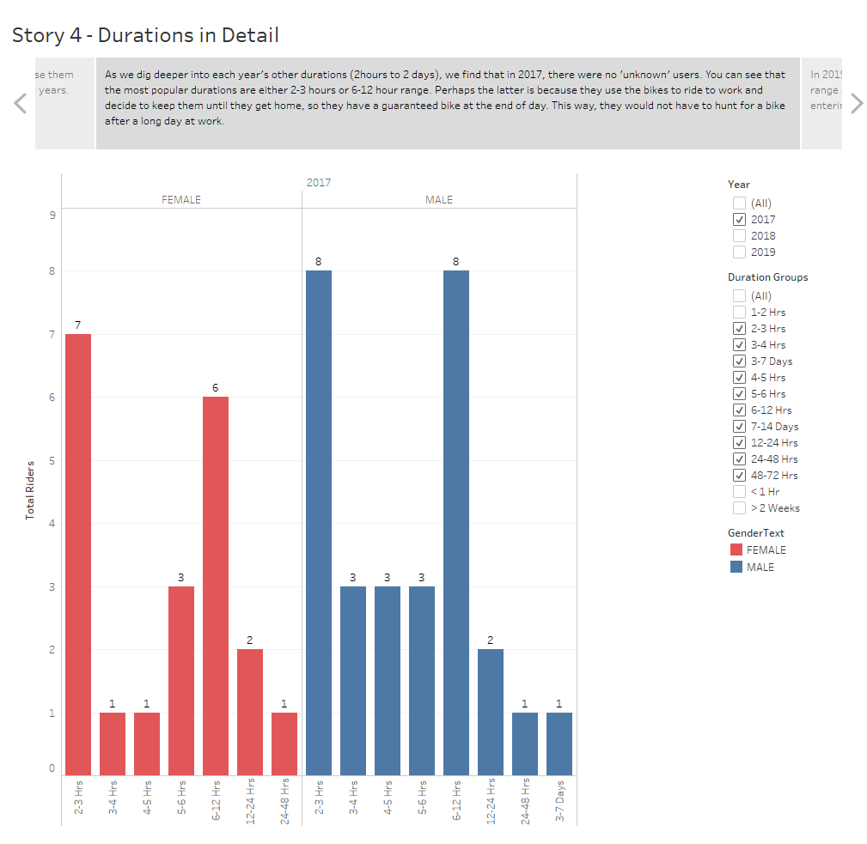

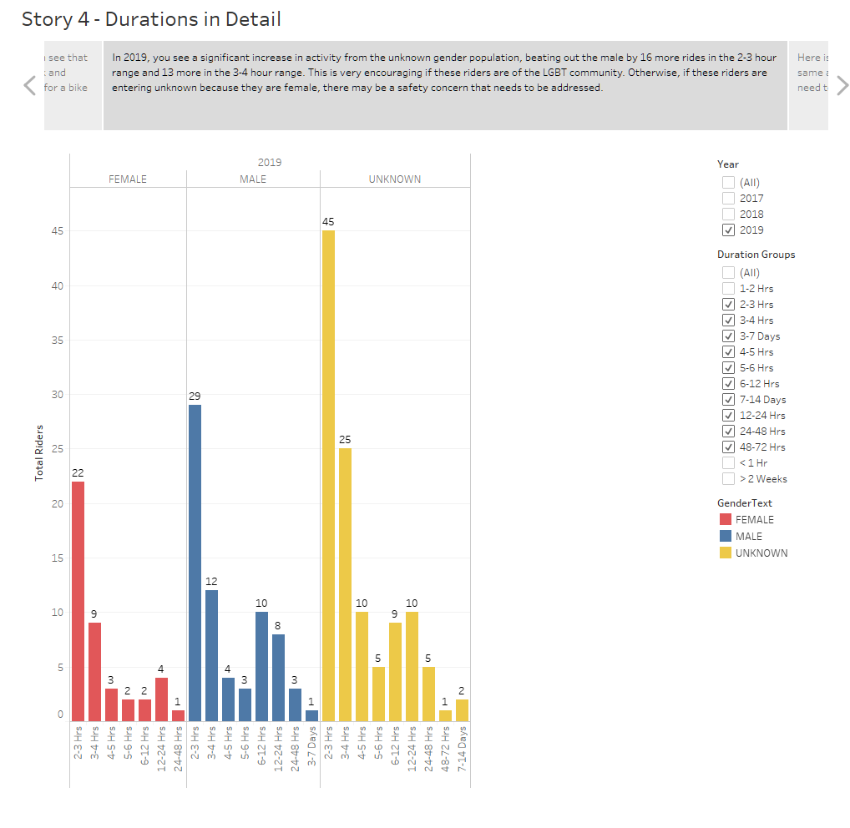

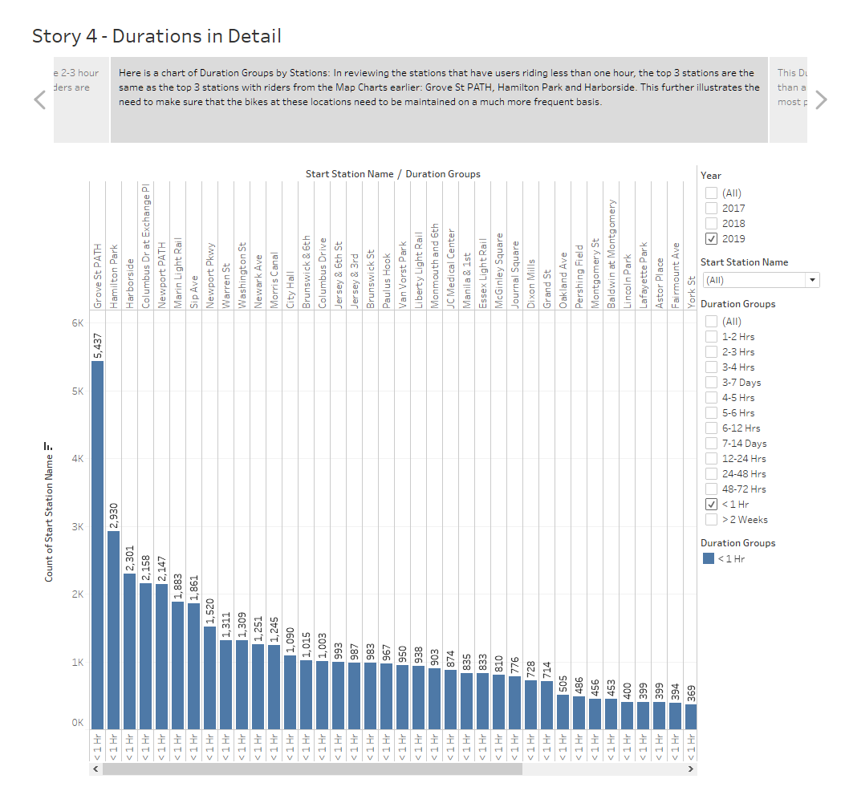

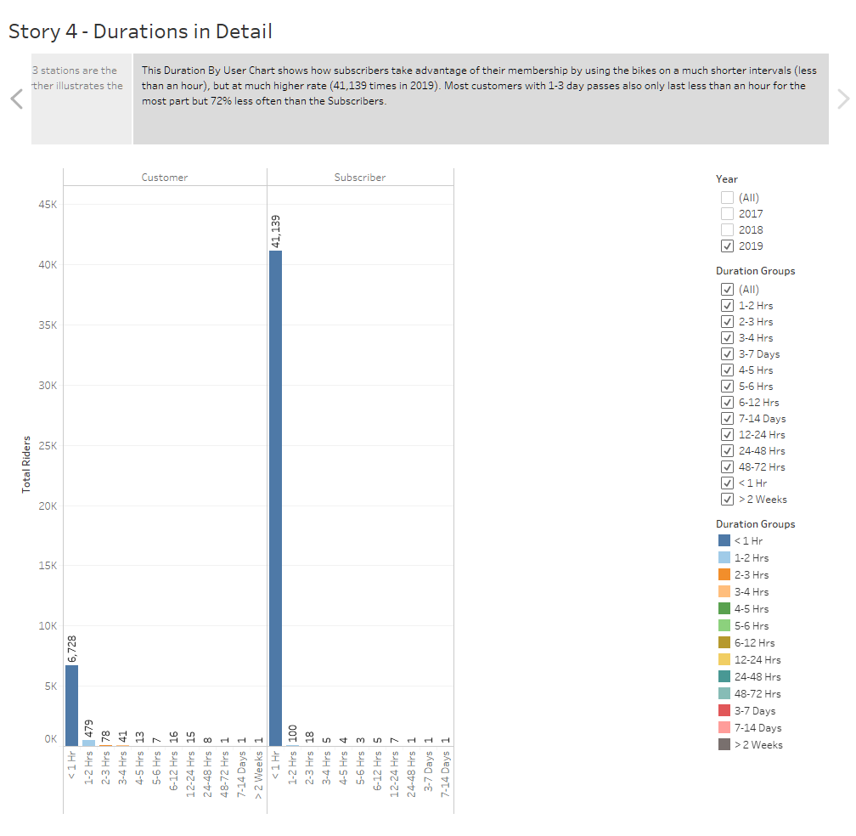

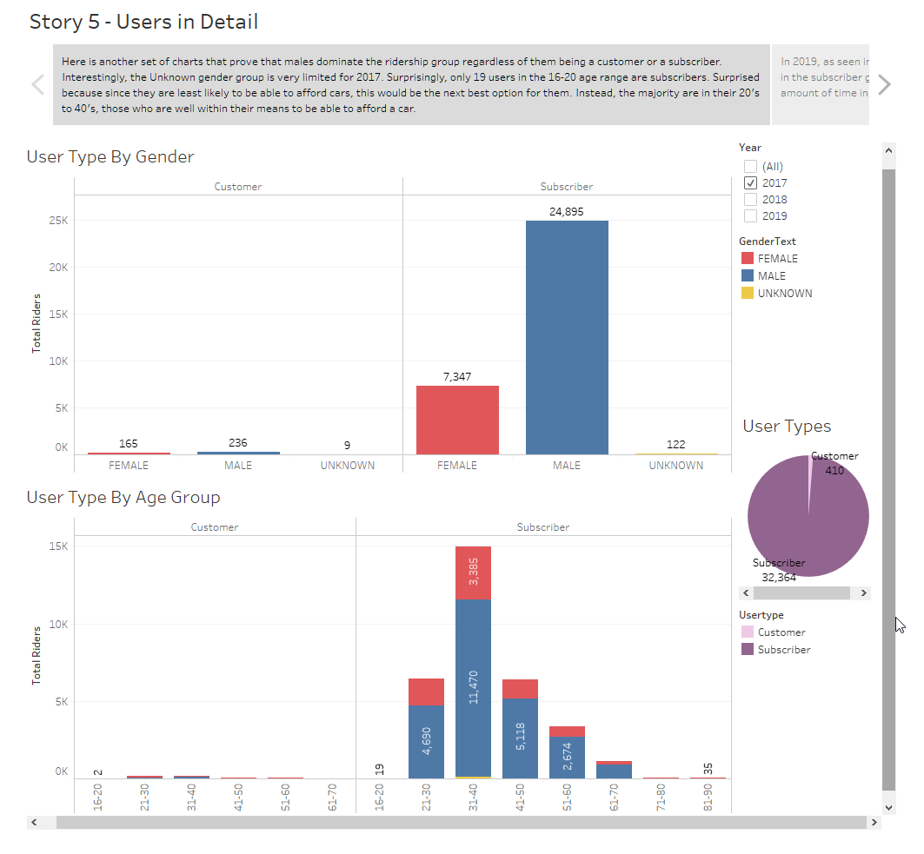

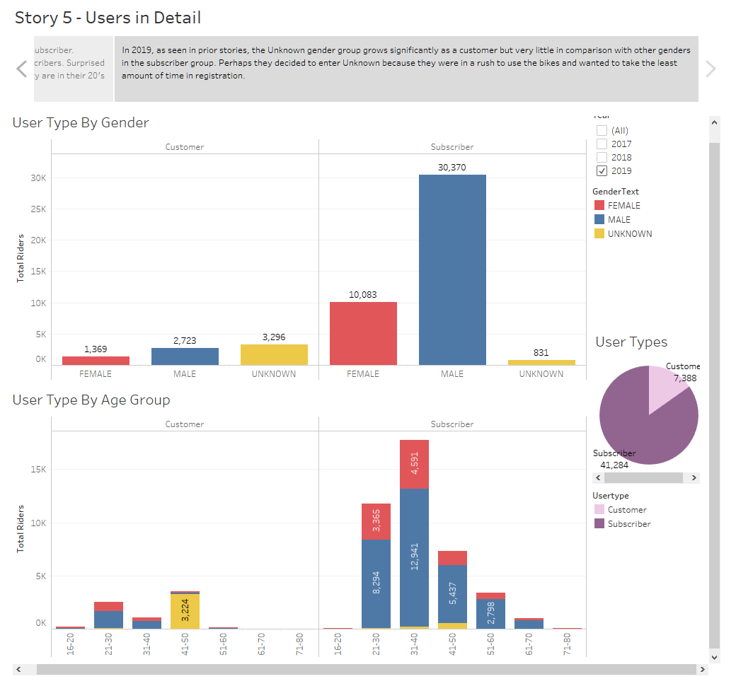

**SUMMARY:**

Overall, the marketing team is doing a great job in attracting female and unknown gender groups to ride, as well as to increase the ridership on weekends. Although I already mentioned adding baskets or more lighting for the evening patrons, such measures will improve the female and unknown gender groups to join.

Perhaps an incentive to attract the 16-20 age range may be of some benefit, as long as they are responsible. Stationing them in front of high schools/colleges may improve profits, provided you get the parents/schools and neighborhood approvals.

Although a subscription type user may be preferred over customer types, it may increase profit if more resources are pooled into the tourism side of marketing. If not already, adding this bike share as an option on Air B&B, Kayak, Expedia or TripAdvisor may bring in more Customer type riders.

With improved safety measures (if any are needed), marketing to the senior/retired population may also be of some benefit. Other suggestions may be to add more stations in front of senior community centers or pharmacies.

Lastly, to make some more profit, you may want to offer advertising opportunities for other businesses by allowing them to put their ads (for a fee) on a part of the bicycle while still keeping the CITI part of the bike prominent.