**Ammeter**

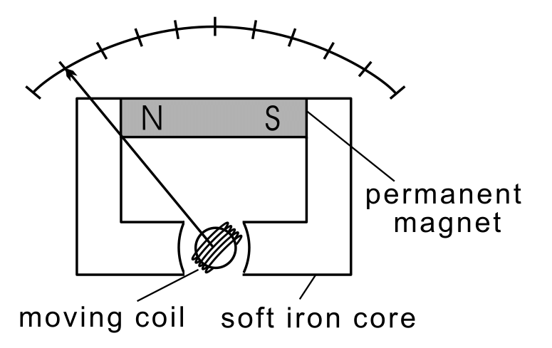

**Moving coil ammeter**

It uses magnetic deflection, where current passing through a **coil** placed in the magnetic field of a permanent magnet causes the **coil** to **move**. A **moving coil** meter indicates the average (mean) of a varying current through it, which is zero for AC.

**Soft iron core**

A soft iron core is used in a moving coil galvanometer. The soft iron core attracts the magnetic lines of force and hence the strength of the magnetic field increases if we use soft iron core. Thus the sensitivity of galvanometer increases. Also the use of soft iron core makes the magnetic field radial (i.e the plane of the coil will be always parallel to the direction of magnetic field).

**Permanent Magnet**

The D'Arsonval galvanometer is a moving coil **ammeter**. It **uses magnetic** deflection, where current passing through a coil placed in the **magnetic** field of a **permanent magnet** causes the coil to move. Because the **magnetic** field is polarised, the meter needle acts in opposite directions for each direction of current.

**Ammeter**

An **ammeter** (from **Am**pere **Meter**) is a [measuring instrument](https://en.wikipedia.org/wiki/Measuring_instrument) used to measure the [current](https://en.wikipedia.org/wiki/Electric_current) in a [circuit](https://en.wikipedia.org/wiki/Electrical_circuit). Electric currents are measured in [amperes](https://en.wikipedia.org/wiki/Ampere) (A), hence the name. Instruments used to measure smaller currents, in the milliampere or microampere range, are designated as *milliammeters* or *microammeters*. Early ammeters were laboratory instruments which relied on the Earth's magnetic field for operation. By the late 19th century, improved instruments were designed which could be mounted in any position and allowed accurate measurements in [electric power systems](https://en.wikipedia.org/wiki/Electric_power_system). It is generally represented by letter 'A' in a circle. Ammeters have very low resistance and are always connected in series in any circuit.

**Alligator Clip Black**

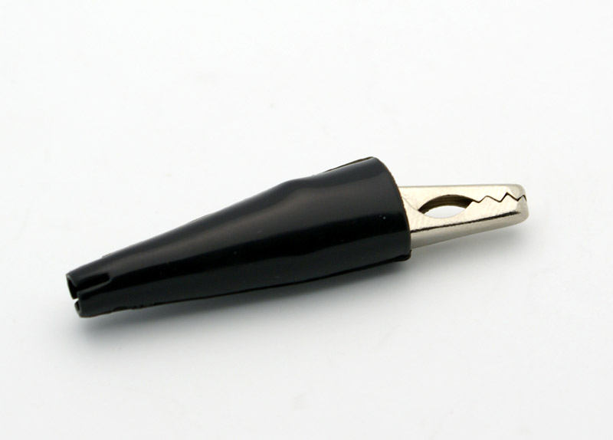

[clip](https://www.thefreedictionary.com/clip) – any of various small fasteners used to hold loose articles together

[clip lead](https://www.thefreedictionary.com/clip+lead) - a short piece of wire with alligator clips on both ends

[jaw](https://www.thefreedictionary.com/jaw)  - holding device consisting of one or both of the opposing parts of a tool that

 close to hold an object.

**Alligator Clip Black**

A **crocodile clip** (also **alligator clip**) is a sprung metal clip with long, serrated jaws which is used for creating a temporary [electrical connection](https://en.wikipedia.org/wiki/Electrical_connection). This simple mechanical device gets its name from the resemblance of its jaws to that of an [alligator](https://en.wikipedia.org/wiki/Alligator)'s or [crocodile](https://en.wikipedia.org/wiki/Crocodile)'s. It is used to connect an electrical cable to a battery or some other component. Functioning much like a spring-loaded [clothespin](https://en.wikipedia.org/wiki/Clothespin), the clip's tapered, serrated jaws are forced together by a [spring](https://en.wikipedia.org/wiki/Spring_(device)) to grip an object. When manufactured for electronics testing and evaluation, one jaw of the clip is typically permanently crimped or soldered to a wire, or is bent to form the inner tubular contact of a ~4 mm female [banana jack](https://en.wikipedia.org/wiki/Banana_connector), enabling quick non-permanent connection between a circuit under test and laboratory equipment or to another [electrical circuit](https://en.wikipedia.org/wiki/Electrical_circuit). The clip is typically covered by a plastic shroud or "boot" to prevent accidental short-circuits.

**Alligator Clip Red**

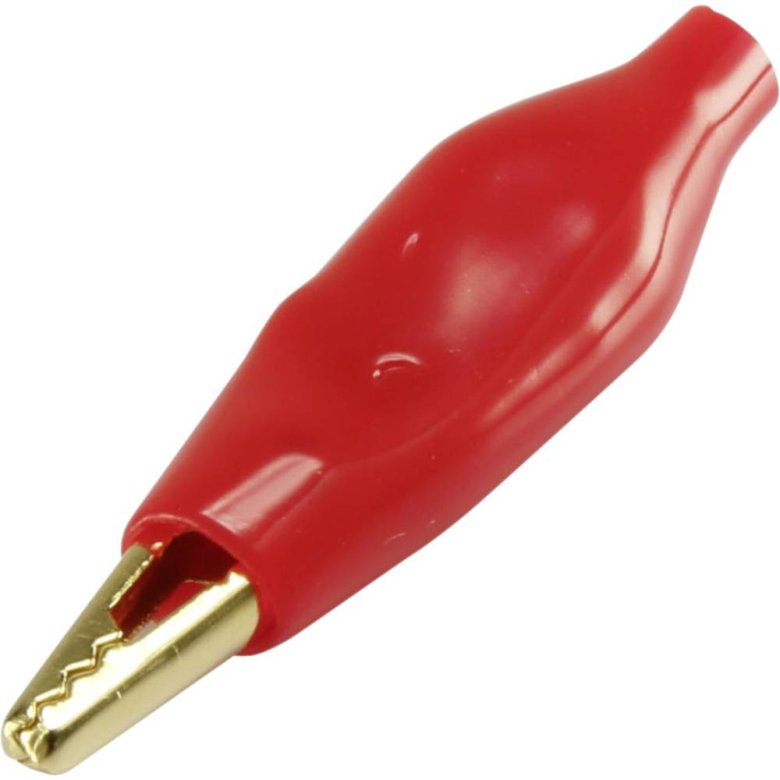

A **crocodile clip** (also **alligator clip**) is a sprung metal**clip** with long, serrated jaws, which is used for creating a temporary electrical connection. This simple mechanical device gets its name from the resemblance of its jaws to that of an **alligator**'s or **crocodile**'s.

**Aluminum Cube**

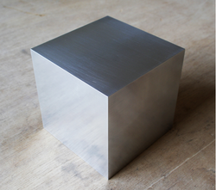

**Leslie's cube** is a device used in the measurement or demonstration of the variations in [thermal radiation](https://en.wikipedia.org/wiki/Thermal_radiation) emitted from different surfaces at the same temperature. It was devised in 1804 by [John Leslie](https://en.wikipedia.org/wiki/John_Leslie_(physicist)) (1766–1832), a Scottish mathematician and physicist.[[1]](https://en.wikipedia.org/wiki/Leslie_cube#cite_note-1) In the version of the experiment described by [John Tyndall](https://en.wikipedia.org/wiki/John_Tyndall) in the late 1800s,[[2]](https://en.wikipedia.org/wiki/Leslie_cube" \l "cite_note-2) one of the cube's vertical sides is coated with a layer of gold, another with a layer of silver, a third with a layer of copper, while the fourth side is coated with a varnish of [isinglass](https://en.wikipedia.org/wiki/Isinglass). The cube is made from a solid block of metal with a central cavity. In use, the cavity was filled with hot water; the entire cube has essentially the same temperature as the water. The thermal detector (on the far right in the figure) showed much greater emission from the side with varnish than from any of the other three sides.

**Bar Magnet**

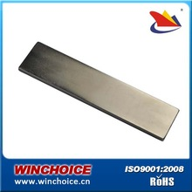

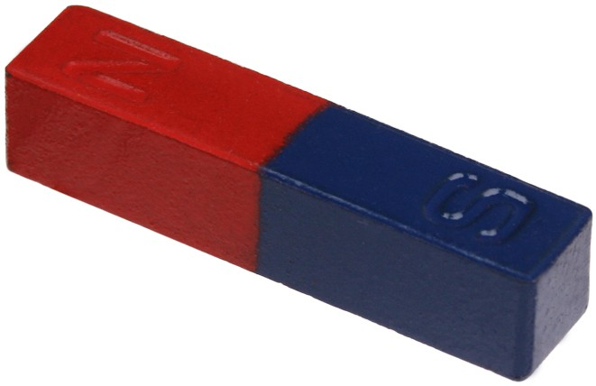

**Small**

**Big**

The **North Magnetic Pole** is the wandering point on the surface of [Earth](https://en.wikipedia.org/wiki/Earth)'s [Northern Hemisphere](https://en.wikipedia.org/wiki/Northern_Hemisphere) at which the [planet's magnetic field](https://en.wikipedia.org/wiki/Earth%27s_magnetic_field) points vertically downwards (in other words, if a magnetic compass needle is allowed to rotate about a horizontal axis, it will point straight down). There is only one location where this occurs, near (but distinct from) the [Geographic North Pole](https://en.wikipedia.org/wiki/Geographic_North_Pole) and the [Geomagnetic North Pole](https://en.wikipedia.org/wiki/Geomagnetic_North_Pole).

The North Magnetic Pole moves over time due to magnetic changes in the [Earth's core](https://en.wikipedia.org/wiki/Outer_core). In 2001, it was determined by the [Geological Survey of Canada](https://en.wikipedia.org/wiki/Geological_Survey_of_Canada) to lie west of [Ellesmere Island](https://en.wikipedia.org/wiki/Ellesmere_Island) in [northern Canada](https://en.wikipedia.org/wiki/Northern_Canada) at [81.3°N 110.8°W](https://tools.wmflabs.org/geohack/geohack.php?pagename=North_Magnetic_Pole&params=81.3_N_110.8_W_&title=Magnetic+North+Pole+2001). It was situated at [83.1°N 117.8°W](https://tools.wmflabs.org/geohack/geohack.php?pagename=North_Magnetic_Pole&params=83.1_N_117.8_W_&title=Magnetic+North+Pole+2005+est) in 2005. In 2009, while still situated within the Canadian Arctic territorial claim at [84.9°N 131.0°W](https://tools.wmflabs.org/geohack/geohack.php?pagename=North_Magnetic_Pole&params=84.9_N_131.0_W_&title=Magnetic+North+Pole+2009), it was moving toward [Russia](https://en.wikipedia.org/wiki/Russia) at between 55 and 60 kilometers (34 and 37 mi) per year. As of 2017, the pole is projected to have moved beyond the Canadian Arctic territorial claim to [86.5°N 172.6°W](https://tools.wmflabs.org/geohack/geohack.php?pagename=North_Magnetic_Pole&params=86.5_N_172.6_W_&title=Magnetic+North+Pole+2017+est).

Its southern hemisphere counterpart is the [South Magnetic Pole](https://en.wikipedia.org/wiki/South_Magnetic_Pole). Since the Earth's magnetic field is not exactly symmetrical, the North and South Magnetic Poles are not [antipodal](https://en.wikipedia.org/wiki/Antipodes), meaning that a straight line drawn from one to the other does not pass through the geometric center of the Earth.

The Earth's North and South Magnetic Poles are also known as **Magnetic Dip Poles**, with reference to the vertical "dip" of the magnetic field lines at those points.

The **South Magnetic Pole** is the wandering point on the [Earth](https://en.wikipedia.org/wiki/Earth)'s [Southern Hemisphere](https://en.wikipedia.org/wiki/Southern_Hemisphere) where the field lines are directed vertically upwards. It should not be confused with the **South Geomagnetic Pole** described later.

For historical reasons, the "end" of a freely hanging magnet that points (roughly) north is itself called the "north pole" of the magnet, and the other end, pointing south, is called the magnet's "south pole". Because opposite poles attract, the Earth's South Magnetic Pole is physically actually a magnetic **north** pole (see also [North Magnetic Pole § Polarity](https://en.wikipedia.org/wiki/North_Magnetic_Pole#Polarity)).

The South Magnetic Pole is constantly shifting due to changes in the Earth's magnetic field. As of 2005 it was calculated to lie at [64°31′48″S 137°51′36″E](https://tools.wmflabs.org/geohack/geohack.php?pagename=South_Magnetic_Pole&params=64_31_48_S_137_51_36_E_region:AQ_type:landmark),placing it off the coast of Antarctica, between [Adélie Land](https://en.wikipedia.org/wiki/Ad%C3%A9lie_Land" \o "Adélie Land) and [Wilkes Land](https://en.wikipedia.org/wiki/Wilkes_Land). In 2015, it lay at [64.28°S 136.59°E](https://tools.wmflabs.org/geohack/geohack.php?pagename=South_Magnetic_Pole&params=64.28_S_136.59_E_region:AQ_type:landmark) (est). That point lies outside the [Antarctic Circle](https://en.wikipedia.org/wiki/Antarctic_Circle). Due to [polar drift](https://en.wikipedia.org/wiki/Polar_drift), the pole is moving northwest by about 10 to 15 kilometres (6 to 9 mi) per year. Its current distance from the actual [Geographic South Pole](https://en.wikipedia.org/wiki/South_Pole)is approximately 2,860 km (1,780 mi). The nearest permanent science station is [Dumont d'Urville Station](https://en.wikipedia.org/wiki/Dumont_d%27Urville_Station). Wilkes Land contains a large gravitational [mass concentration](https://en.wikipedia.org/wiki/Wilkes_Land_crater#Wilkes_Land_mass_concentration).

**Bar Magnet**

The main function of bar magnets is to pick up small metallic objects like metal shavings or nails and screws, as magnetic stirring rods in laboratory applications, and as magnets on refrigerators. Their most common application is the needle used in compasses.

**Brass Ball**

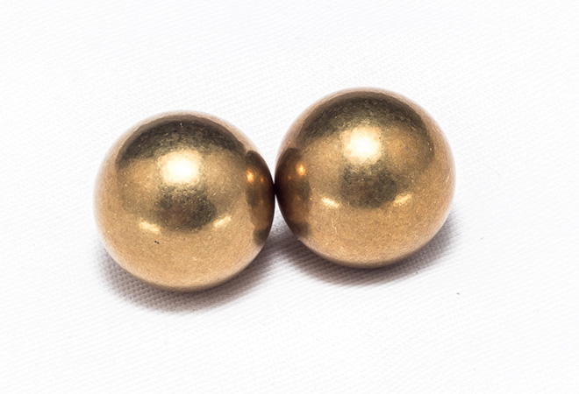

Brass balls exhibit good corrosion resistance in environments where fuel oil, gasoline, kerosene, and alcohol are present. Brass is a non-ferrous material. Brass balls provide excellent resistance to corrosion by water. Brass also exhibits excellent electrical conductivity. Abbott manufactures Brass balls for the automotive and electronic industries. Abbott brass balls are also widely used in the security and appliance industries for dip and tilt switches. Brass balls are available in a range of sizes, tolerances and grades of brass.

**Calorimeter**

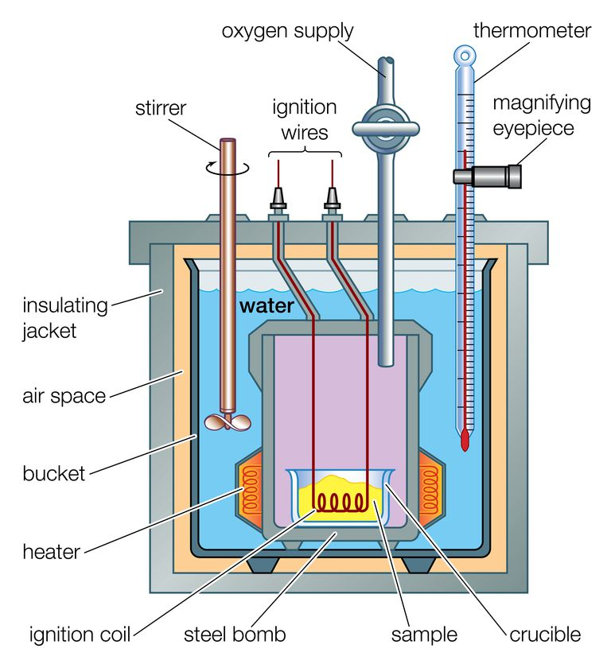

**Oxygen Supply**

Oxygen Bomb Calorimeters (also known as Constant Volume Calorimeters) are used for [various applications in different industries](https://www.ddscalorimeters.com/applications/) to calculate the heat released from a combustion reaction (also known as a combustion calorimeter), the calorific value of the sample, be it any solid or liquid substance like coal and oil, is then measured.

**Thermometer**

A **thermometer** is a device that [measures temperature](https://en.wikipedia.org/wiki/Temperature_measurement) or a [temperature gradient](https://en.wikipedia.org/wiki/Temperature_gradient). A thermometer has two important elements: (1) a temperature sensor (e.g. the bulb of a [mercury-in-glass thermometer](https://en.wikipedia.org/wiki/Mercury-in-glass_thermometer) or the digital sensor in an [infrared thermometer](https://en.wikipedia.org/wiki/Infrared_thermometer)) in which some change occurs with a change in temperature; and (2) some means of converting this change into a numerical value (e.g. the visible scale that is marked on a mercury-in-glass thermometer or the digital readout on an infrared model). Thermometers are widely used in technology and industry to monitor processes, in [meteorology](https://en.wikipedia.org/wiki/Meteorology), in medicine, and in scientific research.

**Magnifying eyepiece**

An **eyepiece**, or ocular lens, is a type of lens that is attached to a variety of optical devices such as telescopes and microscopes. The **eyepiece** is placed near the focal point of the objective to **magnify** this image. The amount of **magnification** depends on the focal length of the **eyepiece**.

**Stirrer**

Stirrer is used in a calorimeter to ensure proper mixing of the contents of the calorimeter. This will help in correct measurement of temperature, and thus the involved heat exchange calculated will have less error.

**Ignition Wires**

A small electrical spark is used to ignite the sample. The energy produced by the reaction is trapped in the steel bomb and the surrounding water. The temperature increase is measured and, along with the known heat capacity of the **calorimeter**, is used to calculate the energy produced by the reaction.

**Insulating Jacket**

An insulation jacket is an outer boundary layer used to serve as the primary protective layer that is adhered to a corrosion prone metal surface to prevent its direct contact with corrosion causing agents such as water or other chemicals and/or to provide thermal protection.

**Bucket**

A water bucket is used to carry [water](https://en.wikipedia.org/wiki/Water).

**Heater**

A **heater** is a piece of equipment or a machine, which is used to raise the temperature of something.

**Ignition Coil**

An ignition coil (also called a spark coil) is an introduction coil in an automobile's **ignition** system that transforms the battery's low voltage to the thousands of volts needed to create an electric spark in the spark plugs to ignite the fuel.

**Crucible**

A **crucible** is a melting pot used for extremely hot chemical reactions — the **crucible** needs to be melt-proof. Literally, a **crucible** is a vessel used for very hot processes, like fusing metals. Another **meaning** of the word is a very significant and difficult trial or test.

**Sample**

The measurement of heat using a simple **calorimeter**, like the coffee cup **calorimeter**, is an **example** of constant-pressure **calorimetry**, since the pressure (atmospheric pressure) remains constant during the process. Constant-pressure calorimetry is used in determining the changes in enthalpy occurring in solution.

**Calorimeter**

A **calorimeter** is an object **used** for **calorimetry**, or the process of measuring the heat of chemical reactions or physical changes as well as heat capacity. Differential scanning **calorimeters**, isothermal micro **calorimeters**, titration **calorimeters** and accelerated rate **calorimeters** are among the most common types.

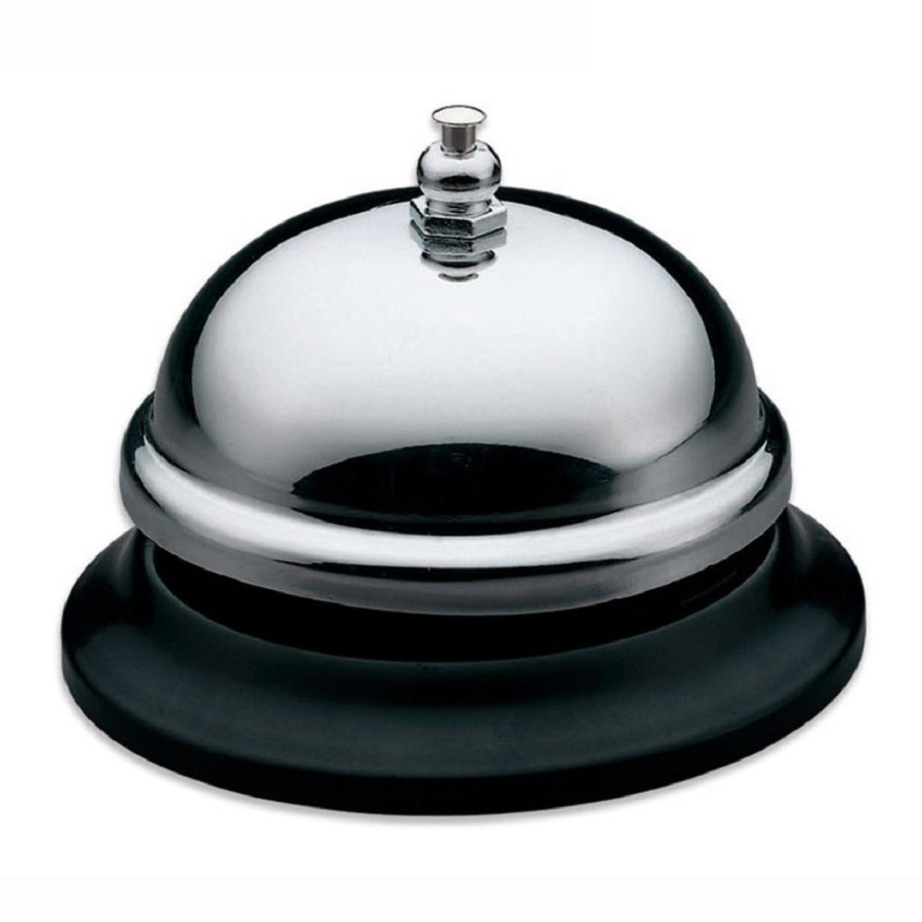**Call Bell**

A **call bell** is **used** in hotels or other such facilities where people need to **call** attention to the person in charge to check them in, take their bags, of for any other reasons. It is mostly **used** in restaurants and usually attached to every table in restaurants.

**Can Black**