TRANSFER LEARNING-BASED CLASSIFICATION OF POULTRY DISEASES FOR ENHANCED HEALTH MANAGEMENT

INTERNSHIP PROJECT REPORT

Submitted By

BORA RAJA GOPALA REDDY
Hall Ticket No: 23331A4208

Department of Computer Science and Engineering (Artificial Intelligence & Machine Learning)

Maharaj Vijayaram Gajapathi Raj College of Engineering

Faculty Mentor: Satyanarayana Reddy

Academic Year: 2026–2027

ABSTRACT
Poultry farming plays a vital role in food production and economic development. Early detection of poultry diseases is essential to reduce mortality rates and improve farm productivity. Traditional diagnosis methods often require expert intervention and laboratory testing, which may not be easily accessible in rural areas.
This project presents a Deep Learning based Poultry Disease Detection System developed using Transfer Learning techniques. The system classifies poultry images into four categories: Healthy, Coccidiosis, Salmonella, and New Castle Disease.
The VGG16 Transfer Learning architecture was used to train the classification model. The trained model was integrated into a Flask web application that allows users to upload poultry images and receive disease predictions instantly.
The developed solution demonstrates how Artificial Intelligence can support poultry health management through automated image-based disease classification.

CHAPTER 1: INTRODUCTION
Poultry diseases significantly affect the poultry industry by reducing productivity, increasing mortality rates, and causing economic losses. Early diagnosis is essential for effective disease control and treatment.
Recent advancements in Artificial Intelligence and Deep Learning have enabled automated disease detection systems capable of analyzing images and identifying diseases accurately.
The objective of this project is to develop an AI-powered Poultry Disease Detection System that can classify poultry diseases using image classification techniques and provide predictions through a web application.

CHAPTER 2: OBJECTIVES

The objectives of this project are:
• Develop an AI-based poultry disease detection system.
• Classify poultry images into four categories.
• Implement Transfer Learning using VGG16.
• Deploy the trained model using Flask.
• Provide real-time disease prediction through a web interface.
• Assist farmers and researchers in disease identification.

CHAPTER 3: DATASET DESCRIPTION

The dataset used for this project was obtained from Kaggle.
Dataset Classes:
• Healthy
• Coccidiosis
• Salmonella
• New Castle Disease
The images were preprocessed and organized into separate folders according to their disease categories. Data augmentation techniques were applied to improve model generalization and reduce overfitting.
Dataset Source:
https://www.kaggle.com/datasets/chandrashekarnatesh/poultry-diseases

CHAPTER 4: TECHNOLOGIES USED

Programming Language: Python
Deep Learning Framework: TensorFlow Keras
Web Framework: Flask
Frontend: HTML CSS
Libraries: NumPy OpenCV Matplotlib
Version Control: GitHub

CHAPTER 5: MODEL DEVELOPMENT

Transfer Learning was used to improve classification performance while reducing training time.
The VGG16 architecture was selected as the base model because of its strong feature extraction capability and proven performance in image classification tasks.
Training Workflow:
- Dataset Collection
- Data Preprocessing
- Data Augmentation
- Transfer Learning with VGG16
- Model Training
- Model Evaluation
- Flask Integration
The final model predicts one of the following classes:
• Healthy
• Coccidiosis
• Salmonella
• New Castle Disease

CHAPTER 6: SYSTEM IMPLEMENTATION

Figure 1: Home Page

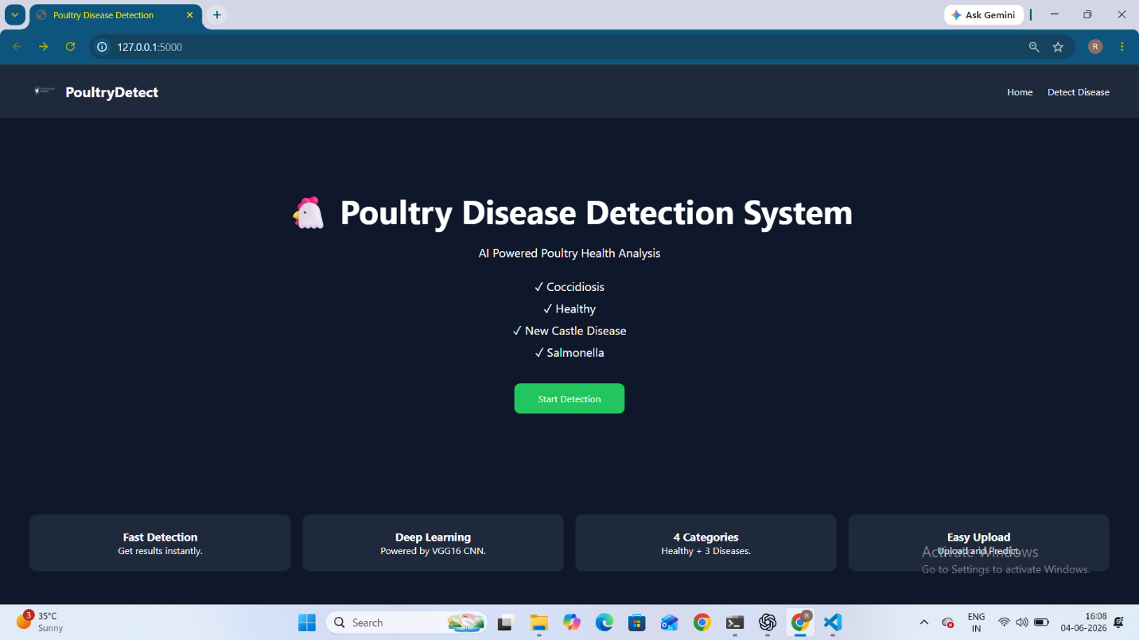

The home page provides information about the Poultry Disease Detection System and allows users to access the prediction module.

Figure 2: Prediction Page

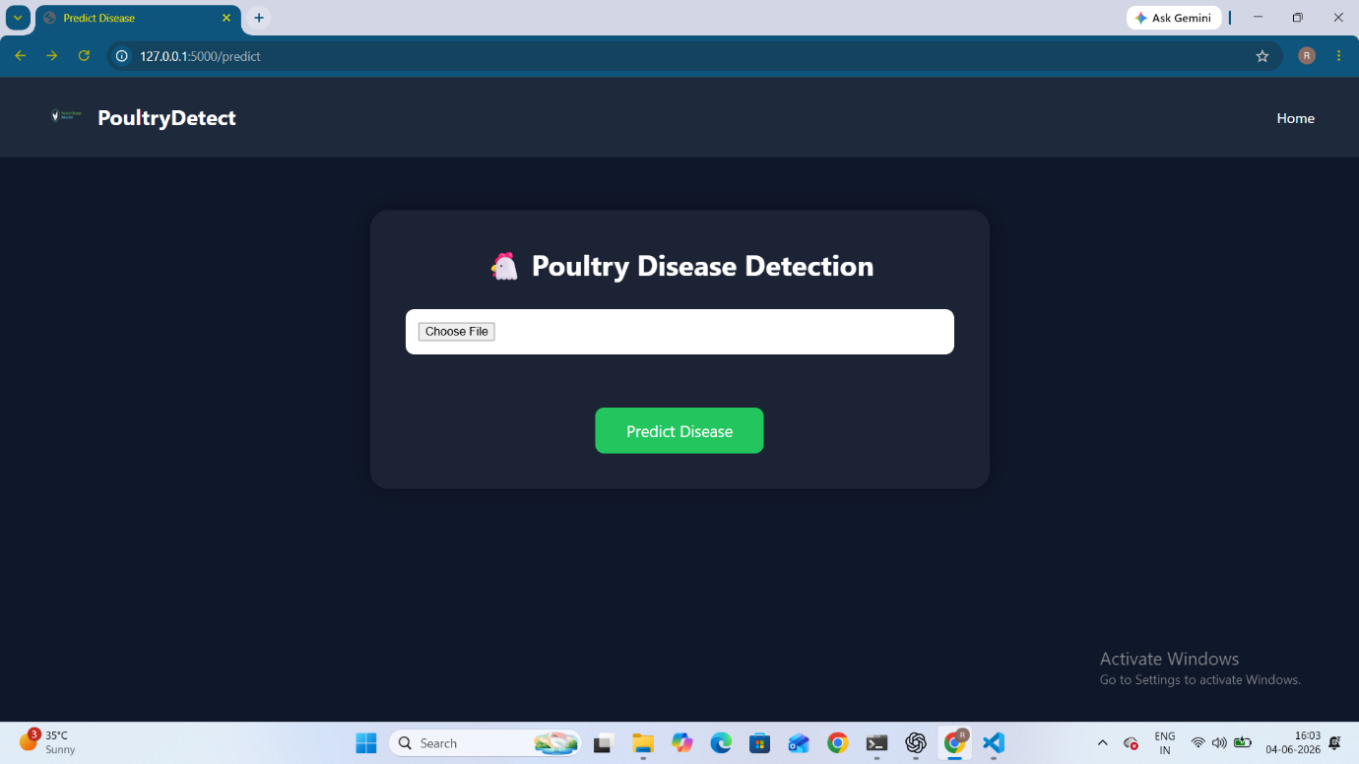

The prediction page enables users to upload poultry images for disease classification.

Figure 3: Image Upload

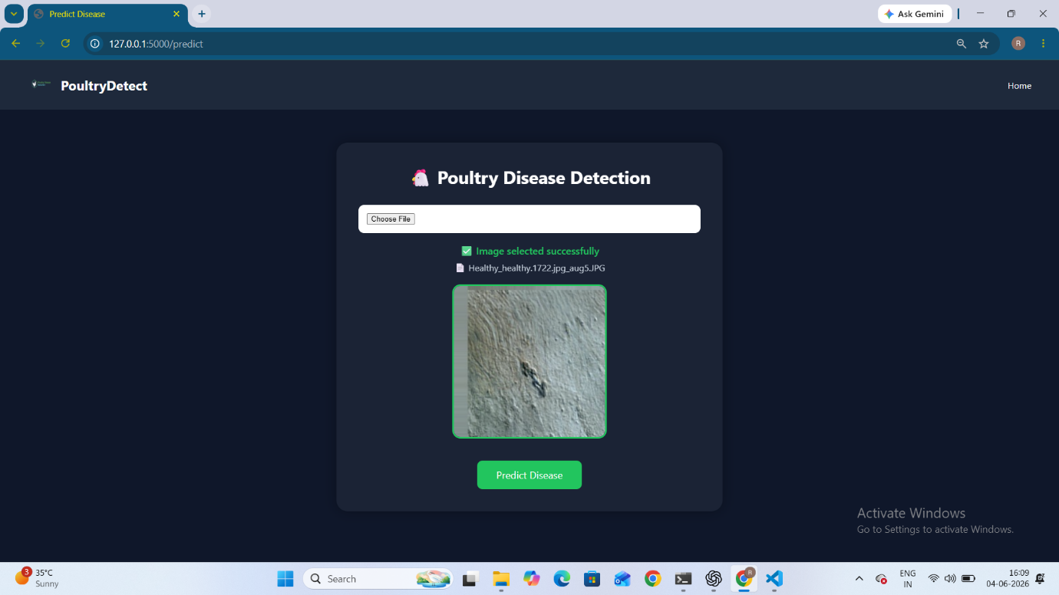

The uploaded image is displayed before prediction for user verification.

Figure 4: Healthy Prediction

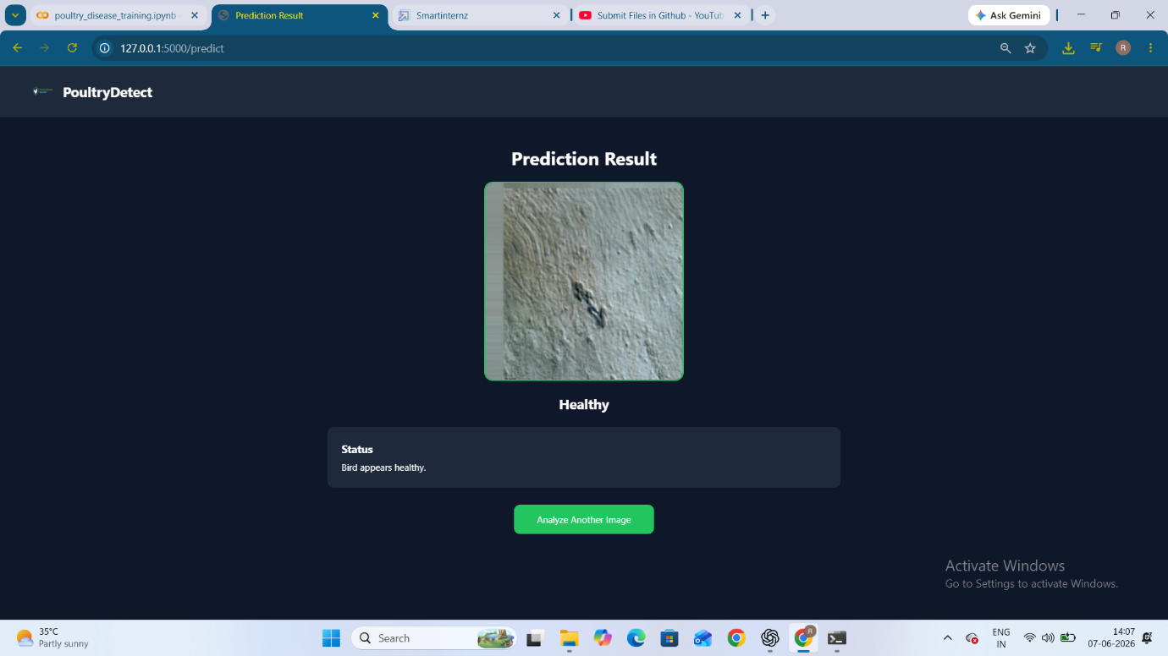

The system correctly identifies healthy poultry images.

Figure 5: Coccidiosis Prediction

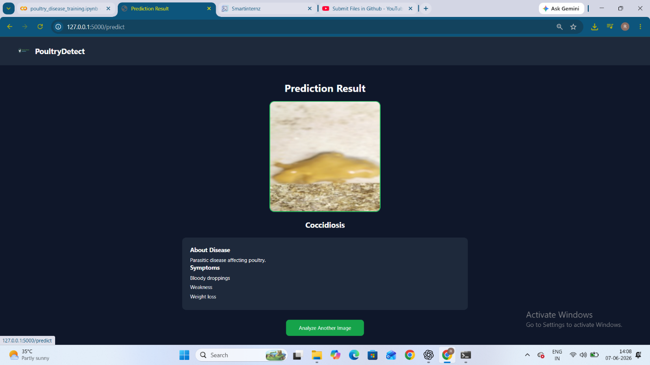

The system detects poultry affected by Coccidiosis.

Figure 6: Salmonella Prediction

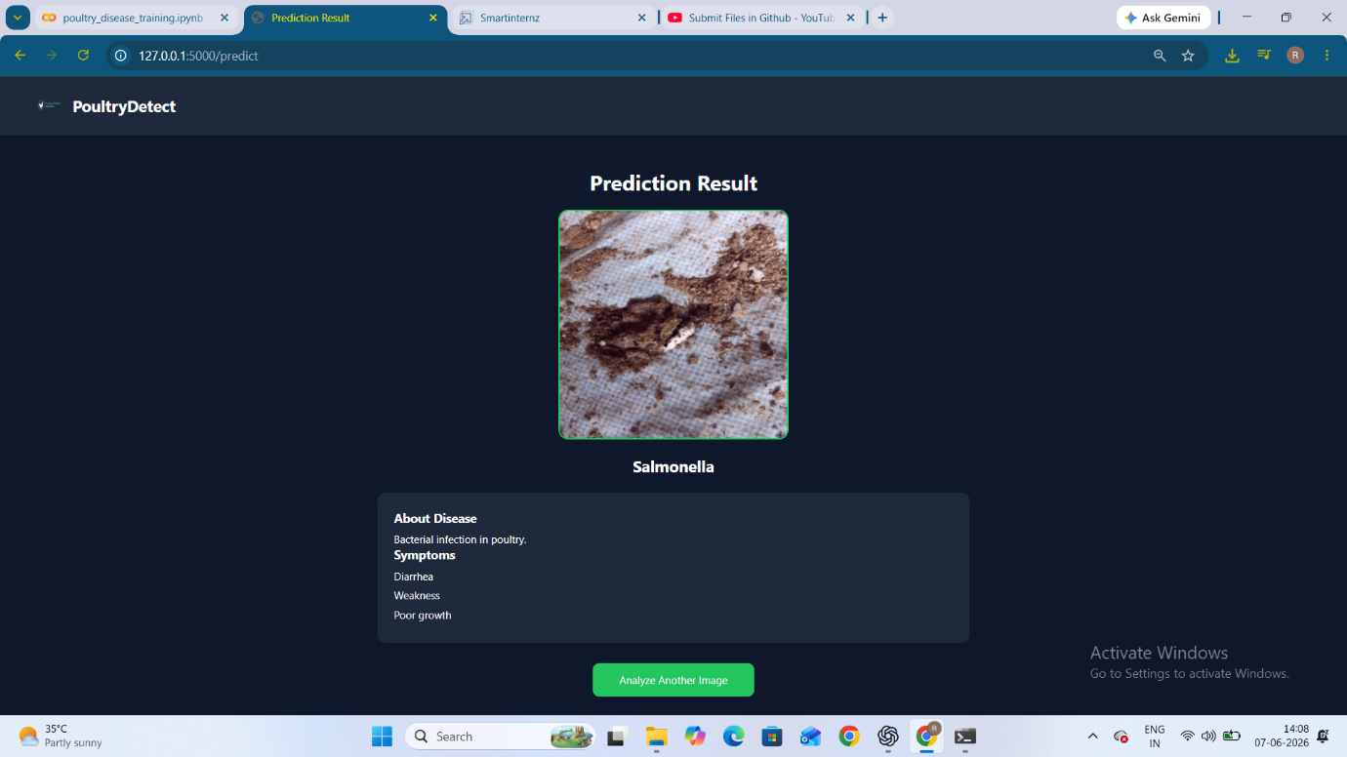

The model identifies Salmonella disease cases.

Figure 7: New Castle Disease Prediction

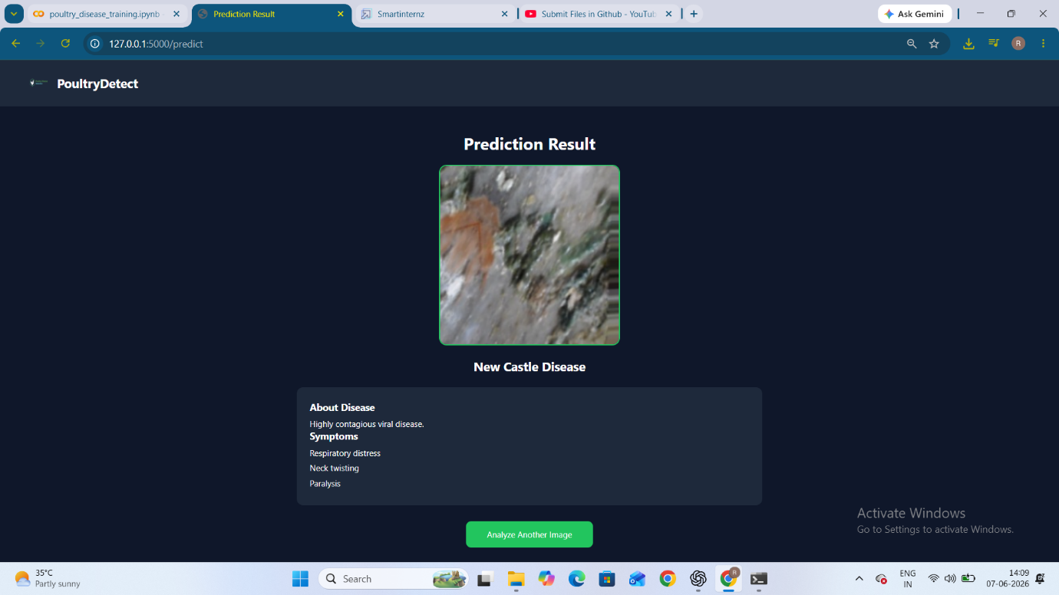

The model detects New Castle Disease and displays the prediction result.

Figure 8: GitHub Repository

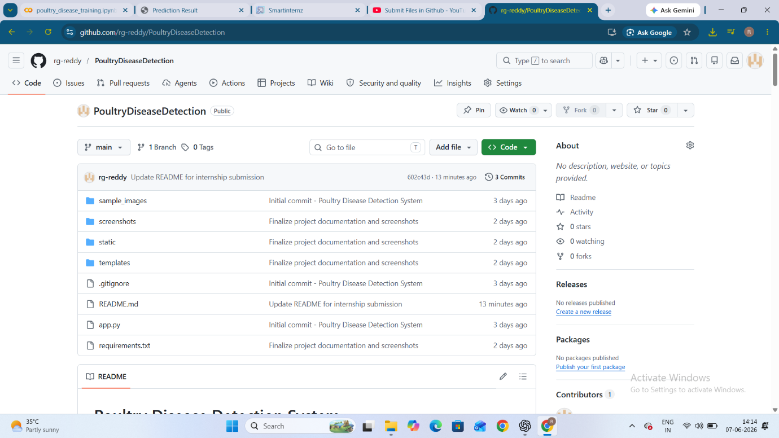

The GitHub repository contains the complete source code, documentation, screenshots, and project resources.

Figure 9: Project Structure

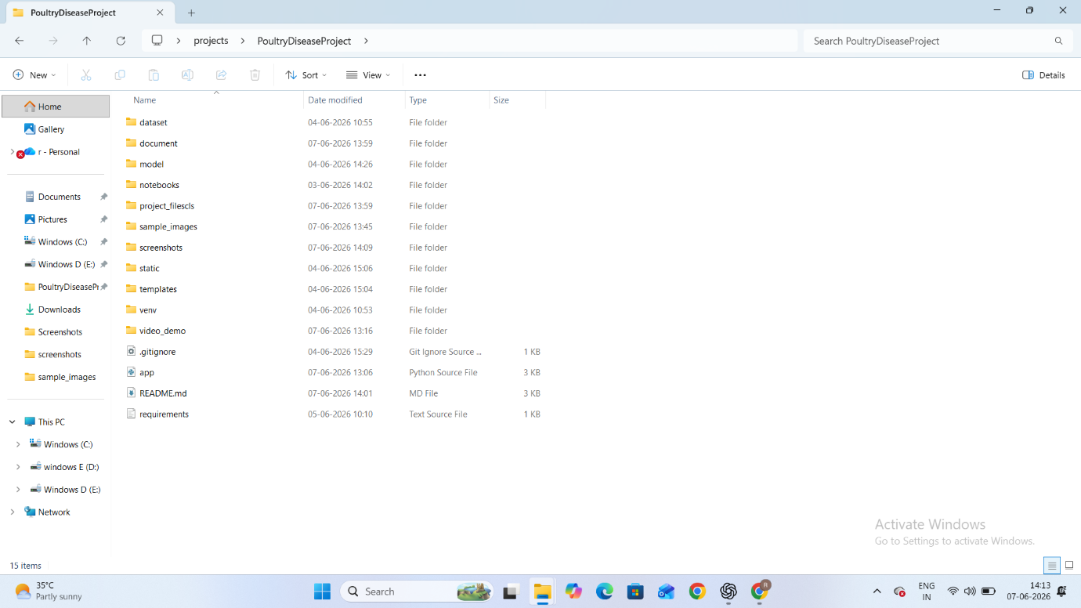

The project follows a modular folder structure for maintainability and scalability.

Figure 10: Terminal Execution

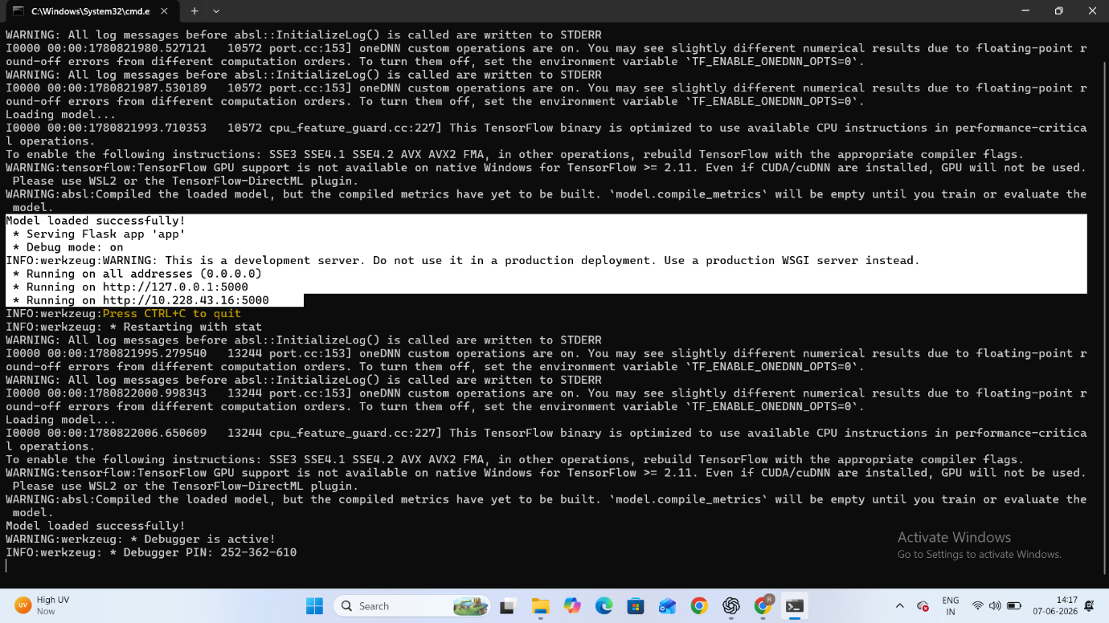

The terminal output confirms successful loading of the trained model and execution of the Flask application.

CHAPTER 7: RESULTS

The developed Poultry Disease Detection System successfully classifies poultry images into four categories using Transfer Learning.
The Flask application provides real-time predictions through a user-friendly interface.
The project demonstrates the practical application of Deep Learning and Computer Vision in poultry health monitoring.

CHAPTER 8: CONCLUSION
The Poultry Disease Detection System was successfully developed using Transfer Learning and Deep Learning techniques.
The VGG16 model was integrated into a Flask web application capable of classifying poultry diseases from images. The developed system can assist farmers, researchers, and veterinary professionals by providing rapid disease identification and supporting better poultry health management.

FUTURE SCOPE
• Mobile Application Deployment
• Cloud-Based Prediction Services
• Additional Poultry Disease Categories
• IoT Integration
• Real-Time Farm Monitoring
• Explainable Artificial Intelligence

REFERENCES
Kaggle Poultry Disease Dataset: https://www.kaggle.com/datasets/chandrashekarnatesh/poultry-diseases
TensorFlow Documentation: https://www.tensorflow.org
Keras Documentation: https://keras.io
Flask Documentation: https://flask.palletsprojects.com
GitHub Repository: https://github.com/rg-reddy/PoultryDiseaseDetection
LinkedIn Profile: https://www.linkedin.com/in/raja-gopala-reddy-bora-754b172a1
SmartInternz: https://smartinternz.com
APSCHE Internship Portal: https://apsche.smartinternz.com

