Concurrent Program Verifier

by Maxim Mozgovoy and Mordechai (Moti) Ben-Ari

System Architecture

Introduction
This part of the documentation describes CPV for programmers, who want to understand the inner ideology of CPV to be able to make more or less significant changes in the system.
Since all CPV features are available through user interface, the first part of this document is devoted to it. You will be able to see how various visible controls are connected with code-level classes and methods; therefore, you’ll have an understanding about what is going on “under the hood”.
After that we will shortly consider JGraph — a library, which is heavily used by CPV. We will talk about custom JGraph extensions and their purpose in CPV.
Next three sections describe internal representation of concurrent programs and state space diagram building issues.
The last section provides the full file listing with a short description of each file.

User Interface
Main Application Window
On this stage you may want to have a look at three files: Application.java, MainFrame.java and MainFrame_AboutBox.java. The first of them contains the main project class, which loads the main application window, nothing more. Although, there are some important public static variables declared in this class:
public static MainFrame frame; // main application frame
public static Program theprogram = null; // currently loaded program
public static ILRunner therunner = new ILRunner(); // ILRunner instance
public static String CurrentFileName = null; // filename of the currently loaded program
File MainFrame_AboutBox.java contains the definition of the “about box” window.
File MainFrame.java is more interesting. Let’s have a more detailed look at it. The most important thing here is the main menu:
Menu Item | Handler | Description
File, New | jMenuFileNew_actionPerformed() | Close previous program, create a new one.
File, Open | jMenuFileOpen_actionPerformed() | Close previous program, then load a new one from file.
File, Save | jMenuFileSave_actionPerformed() | If current filename is defined, just save, otherwise call File, Save As… handler
File, Save As… | jMenuFileSaveAs_actionPerformed() | Input a filename, then save the program.
File, Close | jMenuFileClose_actionPerformed() | If the program not modified, close it; otherwise optionally save it.
File, Exit | jMenuFileExit_actionPerformed() | Exit from the CPV
Process, Add | jMenuProcessAdd_actionPerformed() | Input the name of new process, then create its window.
Process, Rename | jMenuProcessRename_actionPerformed() | Input new name of the current process, then rename it.
Process, Remove | jMenuProcessRemove_actionPerformed() | Remove the current process.
Help, About | jMenuHelpAbout_actionPerformed() | Show an about box.

Notice also the line
public JDesktopPane desktop = new JDesktopPane();
which defines a parental surface (“desktop”) of all MDI windows.
Now let’s consider a simplified class diagram of this part of CPV (fig. 1).
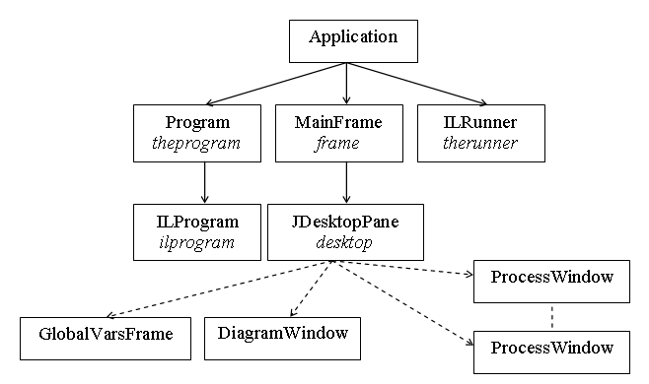
Fig. 1. Simplified CPV class diagram
When an instance of Program class is created, new instances of GlobalVarsFrame and DiagramWindow are added to desktop (so you have to use desktop for accessing them). New ProcessWindow instances are created in jMenuProcessAdd_actionPerformed() function (when adding a new process).
Now let’s continue with MDI child windows.
Child Windows
Each child window is a successor of JInternalFrame class; most of them also contain some JGraph-based object (fig. 2).
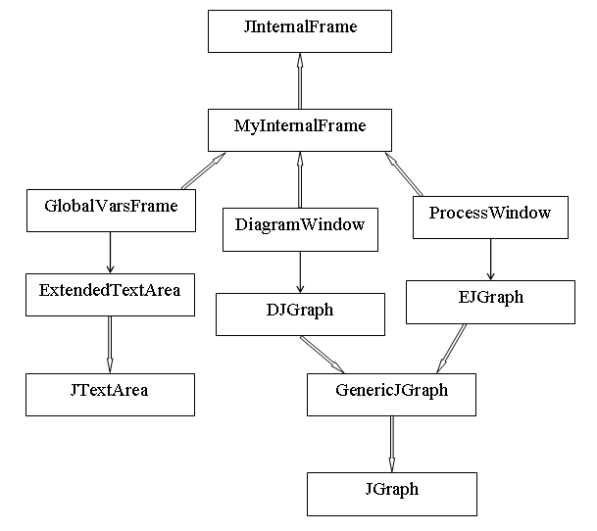
Fig. 2. Child windows diagram
GlobalVarsFrame class represents a frame for global variables. Since this frame contains a text area, an instance of GlobalVarsFrame aggregates an ExtendedTextArea object which is, basically, an ordinary JTextArea instance with “fast templates” support.
DiagramWindow is a window for state space diagrams. This class encapsulates two buttons (OK and Cancel) and an area for the diagram (an instance of DJGraph class).
ProcessWindow is a window for the flowchart. It contains an instance of EJGraph class, which is used as a drawing surface.
Before proceeding to the next topic, we should consider an important issue: JGraph.

JGraph
CPV heavily uses open source JGraph library (http://jgraph.sourceforge.net) for drawing graphics. JGraph is quite big (dozens of classes) and complicated, extensible Swing component for graphs visualization. It is impossible to understand CPV drawing functions without knowing JGraph ideology. Here we will consider the most basic JGraph issues; it is highly recommended to analyze JGraph documentation to be more assured in your actions.
JGraph itself provides only quite basic possibilities for graph handling: you can create simple labeled rectangular nodes and connect them using straight arrows. On the other hand, it is possible to provide custom node/vertex views, mouse handlers, etc., so the flexibility of JGraph is very high (although it doesn’t mean convenience for the programmer!).
CPV JGraph extension diagram is shown on the fig. 3.
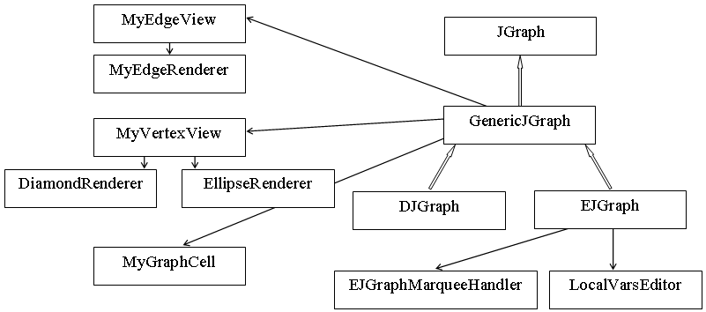
Fig. 3. JGraph extension for CPV
GenericJGraph class introduces a new type of edges (which is implemented in MyEdgeView class and is being drawn by MyEdgeRenderer class) and vertices (MyGraphCell, MyVertexView and DiamondRenderer/EllipseRenderer classes). It also provides save/load possibilities and functions for inserting vertices of a new type and connecting them with custom arrows. All these classes are made according to a standard JGraph way of providing custom vertices/edges; refer to JGraph documentation for details.
Note a concept of port, which is widely used in JGraph. Ports are “snap points” in graph vertices; so if you have, for instance, four ports per vertex, you can bind arrows to four different points inside a vertex. Diamond-styled block (branching) has three ports, while any other block has only one port.
Note also that *View classes provide an interface for accessing the object views while *Renderer ones perform actual drawing.
DJGraph is a very simple GenericJGraph extension, which is intended to store state space diagrams. EJGraph is a more complex component containing the full set of methods for flowchart editing purposes. Two non-trivial issues are vertex editing and mouse handling: if you edit a local variables frame (not just an ordinary vertex), an instance of LocalVarsEditor class is created and used for this action; working with a mouse is performed using custom marquee handler (EJGraphMarqueeHandler class) — the standard JGraph approach.
Draw attention once again: almost all classes in MyJGraph package implement standard JGraph interfaces in a quite usual manner; therefore, the best way to understand how they work is to read JGraph documentation and to examine samples.
Recall that our final aim is state space diagram building. Before proceeding to it, let’s become familiar with Intermediate Language.

Intermediate Language (IL)
Flowcharts is a convenient way for representing the program for human, but it is hard to execute them directly; therefore, a special Intermediate Language (IL) was designed. When CPV needs to analyze the program (actually, just before state space diagram building process), it requests IL representation of the program by calling GetILRepresentation() method of the Program class.
Any concurrent program, represented by means of Intermediate Language is a vector of strings; each of them is either a special section identifier (beginning of the process, beginning of the variables declaration section, end of the process, etc.) or a program statement (assignment, branching, semaphore operation). Consider various IL elements:
IL Element | Corresponding Flowchart Element | Description
__commonvariables | — | Beginning of the common variables declaration section.
__endofcommonvariables | — | End of the common variables declaration section.
__process ProcName | — | Beginning of the process ProcName and its local variables declaration section.
__code | — | End of the local variables declaration section, beginning of the actual code.
__endproc | — | End of the process.
bool x Value | x : boolean := Value; | Boolean variable declaration.
int x Min Max Value | x : integer(Min..Max) := Value; | Integer variable declaration.
sem x Value | x : semaphore := Value; | Semaphore variable declaration.
asgn x y goto N | x := y; | Simple assignment.
asgn x not y goto N | x := not y; | Boolean NOT-assignment.
asgn x y op z goto N | x := y op z; | Assignment with operation op.
wait s goto N | wait(s); | Semaphore Wait() operation.
signal s goto N | signal(s); | Semaphore Signal() operation.
if x ifop y goto N else M | x ifop y | IF construction with ifop relation.

Note that each imperative instruction has an obligatory goto section, which states a line number of the next statement to be executed (in flowcharts we use arrows for the same purpose).
Each imperative IL statement can also have an optional section “//description” (e.g. “asgn x y goto 5//x := y;”). State space diagram builder uses the FIRST part of the statement (before “//”) to analyze program behavior, and the SECOND part (after “//”) to print a current process line in state space diagram nodes. Probably, you want to see descriptions like “p1: i=4, j=7, i := 5;” instead of “p1: i=4, j=7, asgn i 5” in the state space diagram nodes, but IL representation is the only thing available to state space diagram builder (flowchart is NOT available there), so it should use “//” sections.
Consider an IL representation of the sample program (fig. 4).
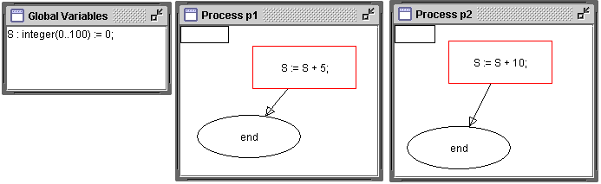
Fig. 4. Sample concurrent program
__commonvariables
int S 0 100 0
__endofcommonvariables
__process p1
__code
asgn S S + 5 goto 1//S := S + 5;
__endproc
__process p2
__code
asgn S S + 10 goto 1//S := S + 10;
__endproc

Such an assembly-like code is quite easy to analyze and execute.
The translation is made mainly by Translator class which defines two methods: TranslateVariable() (translating a given variable definition) and TranslateConstruction() (translating a given imperative instruction).

Obtaining a Set of States
Initialize button of Diagram Window is that “big red lever”, which starts state space diagram building process. At first, it initializes ILRunner instance Application.therunner with IL representation of the current program. Let’s have a closer look at ILRunner and ILProgram classes.
ILProgram class provides the basic interface to the program (represented by the IL). It contains methods such as GetLine() (which returns an arbitrary line of the IL text) or GetVariables() (returns a vector of variables declared in a given line range).
ILRunner class contains important high-level methods such as Initialize() (get an IL representation and generate starting state of the program), ExpandState() (expand a given state — i.e. generate all derived states) or ExpandAll() (expand all remaining states).
Although, IL-represented program is quite “easy” to execute, it is still a non-trivial issue; so let’s consider it in more detail. Execution process is performed by means of possibilities of the following classes: Vairable and its successors SemVariable, BoolVariable and IntVariable, ILExecutor, ProcessState and ProgramState.
Maybe “the central” class here is ProgramState. It, basically, represents some state of a program (not surprisingly). Remember that “a state of the program” means an aggregate of common and local variables values and current line identifier in each process. Each instance of ProgramState holds these values. ProgramState class also provides several very important methods. Consider some of them:
Name | Description
ToString() | Returns a string representation of the program state.
MakeOneStep() | Returns a new program state, obtained by executing the next instruction in a given process.
GetNextStates() | Returns a vector of all derived program states.
MakeStartingState() | Static method, which generates a starting state of the program.

ProgramState class uses the possibilities of ProcessState class, which holds information about some single process. GetNextStates(), basically, sequentially selects each process in the program and calls MakeOneStep() to obtain a set of new program states. MakeOneStep() function, for its turn, should somehow execute IL statements. To do it, we have a special class ILExecutor, which has only one public method Execute(), executing a given statement in a given process.
There are also several additional classes, intended for working with variables. Variable class and its successors can represent variables as objects and define some basic operations on them (such as value get/set or creating new variable objects from IL representation). Executing routine can perform operations on variable objects only, so it is essential to have them.

State Space Diagram Building
To be able to obtain all derived states of the given state means to have a half of the work done. The second half is to visualize them. Fortunately, it is not a hard task. Suppose we have to expand some program state. At first, we should obtain all derived states. If some of these states are already on the screen, just make a transition (an arrow) from the current state to them; then create a new node for each generated state, which is not on the screen so far, and connect it with the current state by an arrow. If we have to expand all states, expand the current state, then its successors sequentially, then their successors and so on.
There is one more small issue: state space diagram layouting, i.e. how to position new graph nodes on the diagram surface? Layouting interface is encapsulated in GraphLayoutManager class. It provides two methods: Initialize() (call before creating the first node) and GetNextPoint(), which returns suggested coordinates of the next graph node to be positioned. For now, this layouting manager uses a very basic algorithm, but it is possible to change this behavior to something more advanced.

Appendix A: full file listing

File Name | Description
MyJGraph/DiamondRenderer.java | Renderer for diamond-styled (branching) blocks.
MyJGraph/DJGraph.java | JGraph extension for state space diagrams visualization.
MyJGraph/EJGraph.java | JGraph extension for the flowchart editor.
MyJGraph/EJGraphMarqueeHandler.java | Custom marquee handler (high-level mouse handling).
MyJGraph/EllipseRenderer.java | Renderer for ellipse-styled blocks.
MyJGraph/GenericJGraph.java | Generic JGraph extension.
MyJGraph/LocalVarsEditor.java | Local variables editor window class.
MyJGraph/MyEdgeRenderer.java | Custom edge renderer.
MyJGraph/MyEdgeView.java | Custom edge view class.
MyJGraph/MyGraphCell.java | Custom graph cell class.
MyJGraph/MyVertexView.java | Custom vertex view class.
Runner/BoolVariable.java | Boolean variable class.
Runner/GraphLayoutManager.java | State space diagram layouting manager.
Runner/ILExecutor.java | Execute IL commands.
Runner/ILProgram.java | Basic interface for IL-represented program.
Runner/ILRunner.java | Expands program states, forming a state space diagram.
Runner/IntVariable.java | Integer variable class.
Runner/ProcessState.java | The state of the individual process.
Runner/ProgramState.java | The state of the program.
Runner/SemVariable.java | Semaphore variable class.
Runner/Variable.java | Generic variable class.
Application.java | Main application class.
DiagramWindow.java | MDI child: diagram window class.
ExtendedTextArea.java | JTextArea with “fast templates”.
GlobalVarsFrame.java | MDI child: global variables frame.
MainFrame.java | Main window class.
MainFrame_AboutBox.java | About box dialog class.
MyException.java | Simple custom exception class.
MyInternalFrame.java | Common ancestor of MDI children.
ProcessWindow.java | MDI child: process window class.
Program.java | The program (as a set of flowcharts).
RuntimeErrorException.java | Runtime error exception (e.g. type mismatch).
SyntaxErrorException.java | Syntax error exception (e.g. bad variable declaration).
Translator.java | Translates flowchart statements to IL commands.

