ADVANCED ANALYSIS REPORT
Advanced Data Analysis and Visualization in Logistics
Finding delivery, cost and bottleneck patterns in a simulated shipment network with Python
Item | Details
Task | Week 3: Advanced Data Analysis and Visualization in Logistics
Internship | Logistics Data Analyst Intern (22 Oct 2026 – 19 Nov 2026)
Prepared by | Riya Gupta
Tools | Python (pandas, NumPy, matplotlib, seaborn)
Data | Hypothetical dataset of 6,000 shipments in 2025 (simulated)

1. Executive Summary
This report explores a hypothetical logistics network of 6,000 shipments sent across India in 2025 by four carriers, three transport modes and four origin hubs. Using Python, it calculates summary statistics, studies distributions and correlations, and presents seven visualizations that answer three practical questions: how reliable is delivery, what drives cost, and where are the bottlenecks.
The headline findings are: overall on-time delivery is 65.3%, far below the 95% target used as a reference in Week 1. The weak points are very specific. Carrier C delivers on time only 49% of the time, the East region only 50%, and the last quarter of the year (October to December) drops to 47% compared with 72% in January to September. Mumbai hub holds shipments for 13.3 hours on average against 9.4 hours at the other hubs. Air freight costs about 2.6 times as much per km as road, while on-time performance is almost the same for all three modes. Section 7 turns these findings into recommendations.

2. Data Simulation

2.1 Dataset structure
No real company data was used. The dataset is generated by the function simulate() in the script, with fixed random seed so results can be repeated. Realistic relationships were built in: longer distance means longer scheduled time, heavier and longer shipments cost more, air is faster and more expensive, and some carriers, regions and months are more delay-prone. These patterns are the "answers" that the analysis should be able to recover, which makes the dataset a good test of the methods. The patterns are assumptions, not facts about any real network.
Variable | Meaning | Type / values
shipment_id, ship_date | Identifier and dispatch date | Integer; dates across 2025
origin_hub | Dispatch hub | Delhi, Mumbai, Chennai, Kolkata
dest_region | Destination region | North, South, East, West, Central
mode, carrier | Transport mode and carrier | Road, Rail, Air; Carrier A to D
distance_km, weight_kg | Shipment distance and weight (volume proxy) | Numeric; skewed to the right
scheduled_days, actual_days | Promised and actual delivery time | Integer days
freight_cost, fuel_surcharge_pct | Transport cost and fuel surcharge | Numeric (cost in rupees); percent
dwell_hours | Hours the shipment waits at the origin hub | Numeric
Derived: delay_days, on_time, cost_per_km, cost_per_kg | Actual minus scheduled days; 1 if delay is 0 or less; cost ratios | Created in add_features()

2.2 KPIs used
Three measures from the Week 1 plan are used: on-time delivery rate (share of shipments with delay of 0 days or less), average delay in days, and cost per km. Hub dwell time is added as an operational bottleneck measure.

2.3 Sample of the data
The first five rows of the generated dataset are shown below, exactly as printed by the script.
ID | Date | Hub | Region | Mode | Carrier | Dist km | Wt kg | Sched | Actual | Cost
1 | 2025-02-18 | Kolkata | East | Road | Carrier B | 847 | 146.2 | 3 | 5 | 861
2 | 2025-02-16 | Delhi | South | Road | Carrier C | 1144 | 157.4 | 4 | 6 | 893
3 | 2025-10-18 | Kolkata | East | Road | Carrier C | 924 | 207.4 | 3 | 6 | 1087
4 | 2025-07-02 | Chennai | North | Air | Carrier A | 2089 | 427.9 | 2 | 2 | 10660
5 | 2025-08-04 | Mumbai | East | Road | Carrier C | 622 | 60.5 | 2 | 5 | 577

2.4 Worked example: how one shipment becomes KPIs
Take shipment 1 (Kolkata to East, Road, Carrier B). It was scheduled for 3 days but took 5 days, so delay_days = 5 - 3 = 2. The rule on_time = 1 if delay_days is 0 or less gives on_time = 0, so this shipment counts as late. Its freight cost was 861 over 847 km, so cost_per_km = 861 / 847 = 1.02. Doing the same for all 6,000 rows gives the dataset used in the rest of the report: the on-time rate is the mean of the on_time column (3,919 on-time shipments out of 6,000 = 65.3%).
Shipment 5 shows how a problem lane looks: it went from the Mumbai hub to East with Carrier C, was scheduled for 2 days and took 5, a 3-day delay. Shipments 2 and 3 are also Carrier C and both were 2 and 3 days late. Individual rows like these are what the group tables below add up.

3. Exploratory Data Analysis

3.1 Central tendency and spread
The simulated dataset has no missing values or duplicates, so the Week 2 cleaning steps were not needed here. The table below gives the mean, median, standard deviation and skewness of the key numeric columns.
Variable | Mean | Median | Std dev | Skewness | Shape
distance_km | 1,036.1 | 960.5 | 515.8 | 0.93 | Moderate right skew
weight_kg | 244.6 | 178.6 | 228.1 | 3.36 | Strong right skew
scheduled_days | 3.48 | 3 | 1.50 | 0.62 | Mild
actual_days | 4.01 | 4 | 1.80 | 0.80 | Mild
delay_days | 0.53 | 0 | 1.01 | 2.66 | Strong right skew
freight_cost | 1,417.8 | 971.0 | 1,549.5 | 6.93 | Very strong skew
dwell_hours | 10.57 | 8.7 | 7.59 | 1.63 | Right skew

Three points stand out. First, for weight and freight cost the mean is much higher than the median (1,418 against 971 for cost), which means a small number of heavy shipments pull the average up. For skewed variables like these, the median describes a "typical" shipment better than the mean. Second, the median delay is 0 days but the mean is 0.53 days, so most shipments are on time and a minority are very late. Third, the actual delivery time (4.01 days) is half a day longer than the scheduled time (3.48 days) on average.

3.2 Group comparisons
Group | Shipments | On-time % | Avg delay (days) | Other measure
Mode: Road | 3,754 | 65.1 | 0.52 | Cost per km 1.32; 53.7% of total cost
Mode: Rail | 1,514 | 65.5 | 0.55 | Cost per km 1.08; 17.3% of total cost
Mode: Air | 732 | 65.8 | 0.55 | Cost per km 3.48; 29.0% of total cost
Carrier A | 2,129 | 73.0 | 0.35 | Cost per km 1.52
Carrier B | 1,811 | 67.9 | 0.47 | Cost per km 1.51
Carrier C | 1,185 | 49.5 | 0.93 | Cost per km 1.53
Carrier D | 875 | 62.9 | 0.57 | Cost per km 1.59
Region: East | – | 50.3 | 0.91 | Weakest region
Region: West | – | 70.2 | 0.41 | Strongest region
Hub: Mumbai | – | 65.6 | – | Dwell time 13.3 hours (others 9.4)

3.3 Time pattern
Monthly volume is steady, between 473 and 537 shipments a month. On-time performance, however, is between 69% and 75% from January to September and then falls to 48%, 49% and 45% in October, November and December. For the shipments sent in October to December, the average on-time rate is 47.1% (against 71.5% for the rest of the year), and the average dwell time rises from 9.9 to 12.5 hours.

3.4 Correlations
Pearson correlation was calculated between all numeric variables (Figure 6). The correlation coefficient r runs from -1 to +1; values near 0 mean no straight-line relationship. The main results are: distance and scheduled days are strongly related (0.74); weight is the strongest driver of freight cost (0.58), ahead of distance (0.30); and delay days has almost no linear relationship with distance (-0.01), weight (0.00) or dwell time (0.05). This means that long routes are not more likely to be late in this network; the delay comes from who carries the shipment, where it goes and when.

3.5 Statistical tests: are the differences real?
Charts can show differences that are only random noise, so three standard tests were run in the script. A p-value below 0.05 is the usual threshold for saying a difference is unlikely to be chance.
Question | Test and result | p-value | Conclusion
Does on-time rate differ by carrier? | Chi-square test of independence on the carrier by on-time table (A: 1,554 on time and 575 late; B: 1,229 and 582; C: 586 and 599; D: 550 and 325). chi-square = 194.5 with 3 degrees of freedom | 6.4e-42 | Yes, the differences between carriers are real
Is Oct-Dec worse than Jan-Sep? | Two-proportion z-test: 71.5% on time in Jan-Sep (n = 4,483) against 47.1% in Oct-Dec (n = 1,517); z = 17.3 | below 1e-16 | Yes, the seasonal drop is real
Is Mumbai dwell time longer? | Welch's t-test: 13.3 hours at Mumbai (n = 1,776) against 9.4 hours at other hubs (n = 4,224); t = 16.4 | 3.0e-57 | Yes, Mumbai is slower

Worked check for the z-test: the pooled on-time rate is 3,919 / 6,000 = 0.653, so the standard error is the square root of 0.653 x 0.347 x (1/4,483 + 1/1,517) = 0.0141, and z = (0.715 - 0.471) / 0.0141 = 17.3, which matches the script. With such large samples even small differences become significant, so the practical size of the difference (24 percentage points) matters more than the p-value alone.

4. Visualizations and Why Each Was Chosen
Visualization | Question answered | Why this chart type
Fig 1: Histograms | How are delivery time and delay distributed? | A histogram shows the full shape of one numeric variable, including skew and the share of late shipments, which a single average hides.
Fig 2: Bar and line chart with two axes | How do volume and on-time rate change over the year? | Time trends read best as lines; volume is added as bars so we can see that the drop is not caused by more volume.
Fig 3: Box plot and bar chart | How does cost per km differ by mode? How does on-time rate differ by carrier? | A box plot compares the median, spread and outliers of skewed cost across groups. A bar chart suits one rate for a few categories, with the 95% target shown as a line.
Fig 4: Scatter plot | How does cost grow with distance, by mode? | A scatter plot shows the relationship between two numeric variables, and colour shows the mode.
Fig 5: Heatmap | Which carrier and region combinations perform worst? | A heatmap compares two categories at once, and colour makes weak cells visible immediately.
Fig 6: Correlation heatmap | Which variables move together? | It summarises many pairwise relationships in one view and helps choose variables for later models.
Fig 7: Grouped bar chart | Is hub congestion worse in Oct-Dec, and at which hub? | Grouped bars put two periods side by side for each hub with exact values labelled, which is the clearest way to compare a few categories across two conditions.

5. Visualization Outputs and Interpretation

5.1 Distribution of delivery time and delay
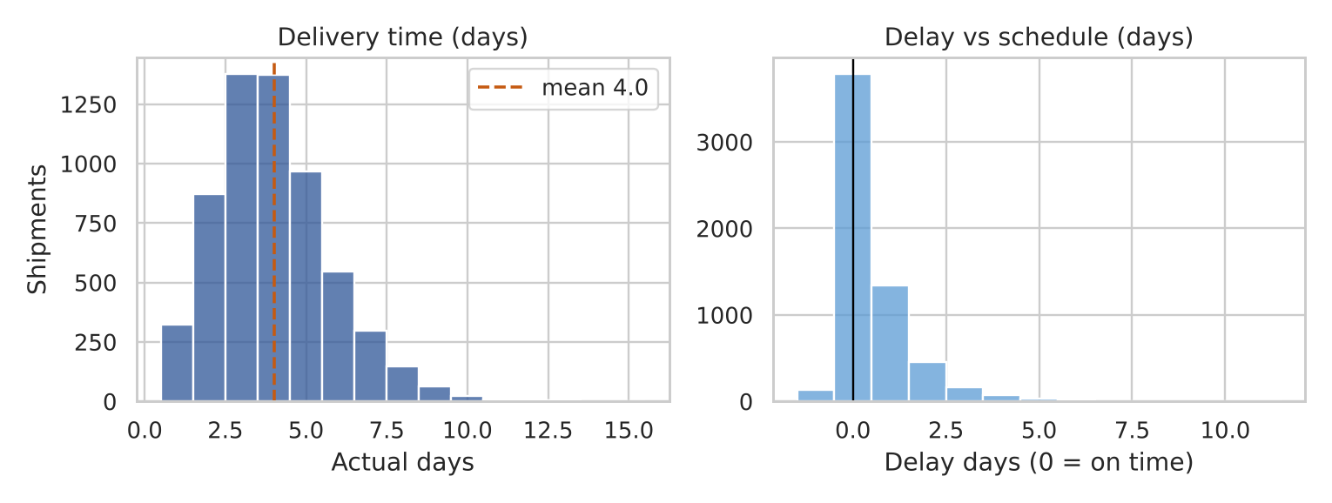
Figure 1. Distribution of actual delivery time and of delay against schedule
Most shipments arrive in 3 to 5 days, with a mean of 4.0. The delay chart is concentrated at 0 and below, but it has a long right tail of shipments that are 3 or more days late. Because of this tail, the average delay (0.53 days) is a poor summary and the share of late shipments (34.7%) is a better KPI to report.

5.2 Monthly volume and on-time delivery
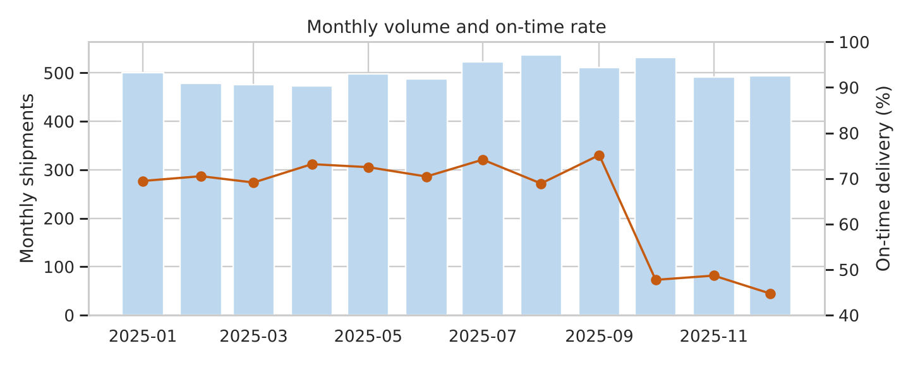
Figure 2. Monthly shipments (bars) and on-time delivery rate (line)
The bars are almost flat, but the line falls sharply after September. This shows that the October to December problem is not simply "more shipments". Something else changes in the last quarter, such as carrier capacity, hub congestion, or festive-season conditions. In this dataset, dwell time at hubs also increases in the same months, which fits a congestion explanation, but the data cannot prove the cause.

5.3 Cost per km by mode and on-time rate by carrier
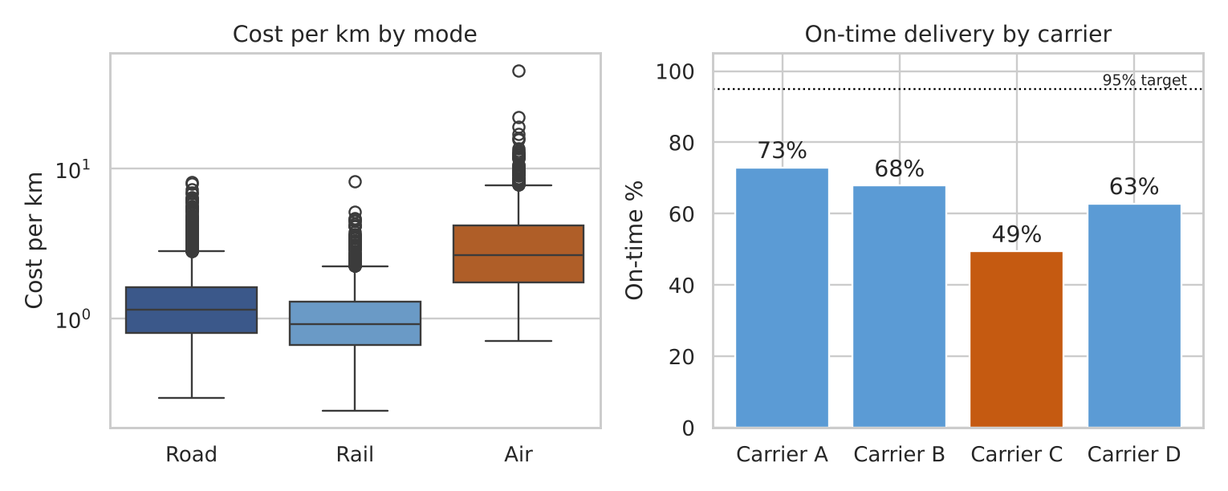
Figure 3. Cost per km by transport mode (log scale) and on-time delivery by carrier
A logarithmic scale is used on the left because air costs are far higher and more spread out. The median cost per km is about 1.1 for road, 0.9 for rail and 2.6 for air. Air handles only 12% of shipments but generates 29% of freight cost, while on-time performance is nearly the same for all modes (65% to 66%), so the extra spend on air does not buy better reliability in this data. On the right, Carrier C is far below the others at 49%, while its price per km (1.53) is the same as that of Carrier A (1.52), which delivers 73% on time. In other words, the network pays the same price for much worse service.

5.4 Freight cost against distance
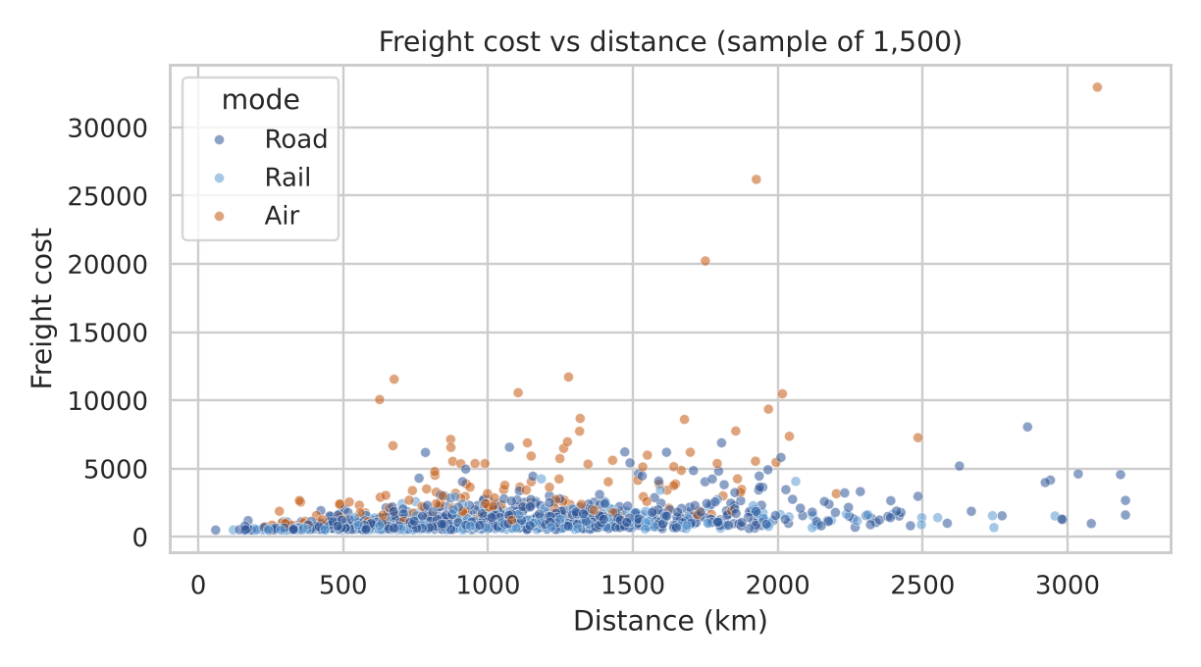
Figure 4. Freight cost against distance, coloured by transport mode
Cost increases with distance, but the points spread widely at each distance. This is because cost also depends on weight and on mode: the correlation of cost with weight (0.58) is almost twice as strong as with distance (0.30). Air shipments (orange) form the upper band. A simple price per km is therefore not enough for budgeting; any later cost model should include weight and mode.

5.5 On-time rate by carrier and destination region
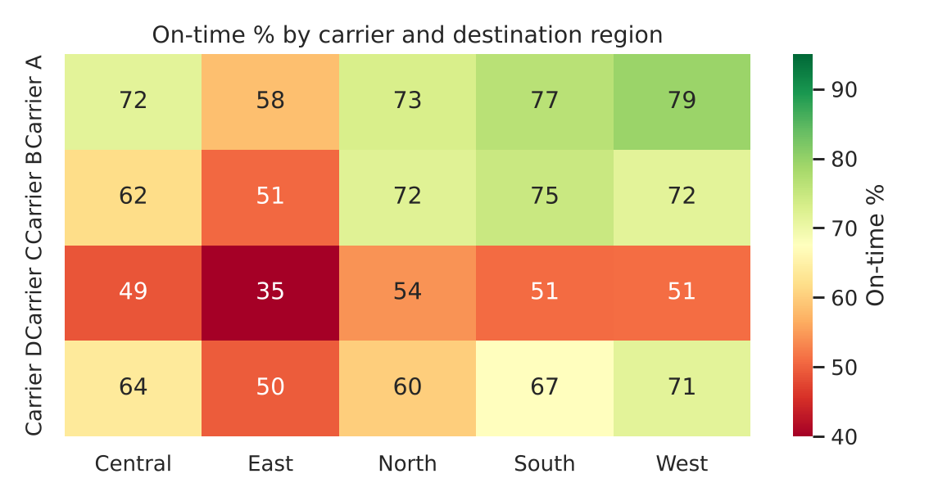
Figure 5. On-time delivery (%) by carrier and destination region
The East column is the weakest for every carrier (35% to 58%), so East is a network-wide problem, and Carrier C is the weakest row in every region (35% to 54%). The worst cell is Carrier C to East at 35%, which covers 154 shipments. The best cells are Carrier A to West (79%) and Carrier A to South (77%). The two effects add up, which is why looking at carrier or region alone would hide the worst lane.

5.6 Correlation matrix
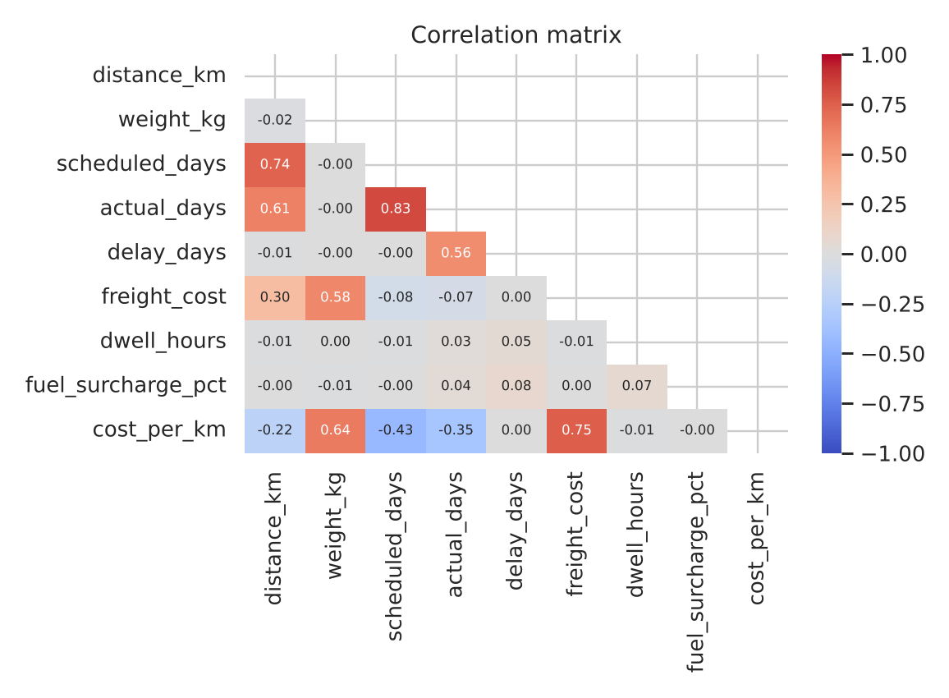
Figure 6. Correlation matrix of numeric variables
Strong correlations are mostly "built-in" ones: distance with scheduled days (0.74) and with actual days (0.61), and weight with cost per kg or per km. The row for delay days is almost empty, with only a small link to actual days (0.56, by construction), fuel surcharge (0.08) and dwell time (0.05). This confirms that delays have to be explained with categories (carrier, region, month), not with distance or weight, and that a correlation matrix alone would not find them. This is why the heatmap in Figure 5 and the time chart in Figure 2 were needed.

5.7 Hub dwell time by period
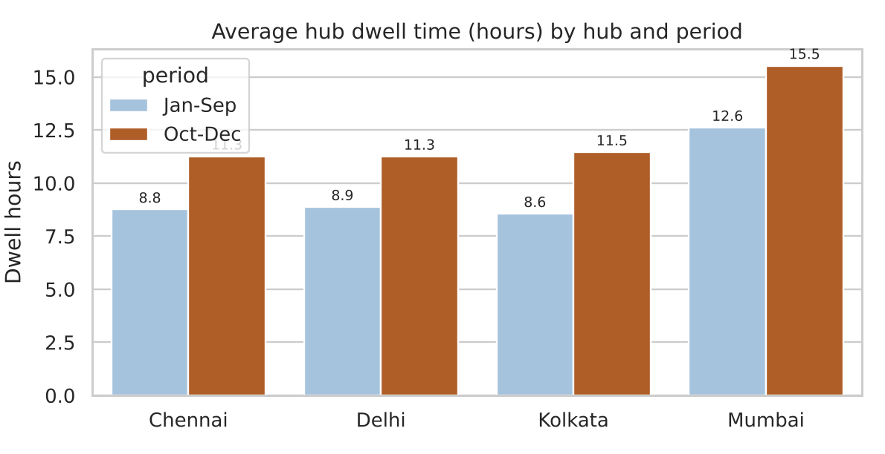
Figure 7. Average hub dwell time (hours) by hub, Jan-Sep against Oct-Dec
Mumbai is the slowest hub in both periods (12.6 hours in Jan-Sep and 15.5 hours in Oct-Dec), and every hub gets slower in the last quarter. Mumbai in Oct-Dec is therefore the worst combination. Because dwell time has only a weak direct link with delay days (r = 0.05), fixing the hub alone will not solve the lateness; it should be combined with carrier and regional actions.

6. Python Code and How to Run It
The complete script, analysis_demo.py, is reproduced in full in Appendix A, with nothing removed, and its complete console output is in Appendix B. The script was run end to end with no errors. It needs Python 3 with pandas, NumPy, SciPy, matplotlib and seaborn.
Step | What to do
1. Install | pip install pandas numpy scipy matplotlib seaborn
2. Run | python analysis_demo.py (takes a few seconds)
3. Outputs | Prints the statistics and tests (Appendix B), saves fig1 to fig7 as PNG images and saves simulated_shipments.csv
4. Reproducibility | The random seed is fixed (seed=11), so the same numbers appear on every run

The script is organised in the following functions, which correspond to the report sections.
Function | Purpose
simulate() | Generates 6,000 shipments with built-in patterns (carrier, region, season and hub effects)
add_features() | Creates delay_days, on_time, cost_per_km, cost_per_kg, month and weekday
eda() | Prints mean, median, standard deviation and skewness, group tables, monthly table and the correlation matrix
tests_and_examples() | Prints the data preview, the three statistical tests, the worked example, the what-if and the sanity checks
fig1 to fig7 | One function per chart, each saving a PNG at 170 dpi

A short extract is shown here to illustrate the style; the same code appears in full in Appendix A.
def add_features(df):
df = df.copy()
df["delay_days"] = df["actual_days"] - df["scheduled_days"]
df["on_time"] = (df["delay_days"] <= 0).astype(int)
df["cost_per_km"] = df["freight_cost"] / df["distance_km"]
df["cost_per_kg"] = df["freight_cost"] / df["weight_kg"]
df["month"] = df["ship_date"].dt.to_period("M").dt.to_timestamp()
df["weekday"] = df["ship_date"].dt.day_name()
return df
# Example: on-time rate by carrier (used for Figure 3)
ots = df.groupby("carrier")["on_time"].mean() * 100
print(ots.round(1))
# Carrier A 73.0 | Carrier B 67.9 | Carrier C 49.5 | Carrier D 62.9

7. Insights and Recommendations
Area | What the analysis shows | Recommendation
Operational efficiency | On-time rate is 65.3% overall. Actual time is on average 0.5 day longer than planned. | Set a target and track on-time rate weekly by carrier, region and month, as a dashboard. Review schedules as well: if many shipments miss by one day, the promised times may be too optimistic.
Carrier performance | Carrier C is on time 49% of the time, but charges the same per km as Carrier A (73%). | Put Carrier C on a service-level improvement plan, link payment to on-time performance, and move East-bound volume to Carrier A or B. What-if calculated in code: if Carrier C matched Carrier B in every region, 223 more shipments would arrive on time and overall on-time rate would rise from 65.3% to 69.0% (+3.7 points).
Regional bottleneck | East is the weakest region for every carrier (50% on time overall). | Investigate the East lanes (road conditions, partner capacity, last-mile network) and consider a buffer or a different carrier mix there.
Seasonal bottleneck | On-time rate falls from 71.5% to 47.1% in October to December, with flat volume and longer dwell time. | Plan capacity before October: book extra carrier capacity, dispatch earlier, and add hub staff or dock slots.
Hub bottleneck | Mumbai hub dwell time is 13.3 hours against 9.4 elsewhere, and 15.5 hours in the last quarter. | Review loading, documentation and dock scheduling at Mumbai; use Chennai or Kolkata as a model of practice.
Cost drivers | Weight is the main cost driver. Air carries 12% of shipments but 29% of cost, and is 2.6 times as costly per km as road; rail is about 18% cheaper than road. | Reserve air for urgent shipments only; move heavy, non-urgent long-distance freight to rail where possible; use weight and mode in cost forecasts.

Limitations
- The data is simulated, so the patterns are the ones built into the generator. The value of the exercise is the method, which can be applied unchanged to real shipment records.
- Correlation does not prove cause. For example, the dwell time rise in the last quarter fits a congestion story but does not prove it.
- Improvement figures (such as the +3.7-point what-if) are illustrations and would need to be tested on real data and with real contracts.

Next steps
Apply the same code to the real DataCo file, add a statistical test (for example, a chi-square test of on-time rate across carriers), and build a late-delivery prediction model with the features that proved useful here: carrier, region, month and hub.

8. Conclusion
Visualization turned a table of 6,000 rows into clear decisions. Averages alone showed an acceptable network, with an average delay of half a day. The charts showed instead that the problems are concentrated in a few places: one carrier, one region, one quarter and one hub. This kind of analysis lets a logistics manager spend effort where it matters most, instead of treating all shipments alike.

Appendix A: Complete Python Script (analysis_demo.py)
"""Week 3: Advanced data analysis and visualization for a hypothetical logistics network.
Generates a simulated shipment dataset, runs EDA and produces seven charts."""
import numpy as np, pandas as pd
import matplotlib
matplotlib.use("Agg")
import matplotlib.pyplot as plt
import seaborn as sns

sns.set_theme(style="whitegrid", context="notebook")
PAL = {"Road": "#2E5597", "Rail": "#5B9BD5", "Air": "#C55A11"}

# ---------- 1. Data simulation ----------
def simulate(n=6000, seed=11):
rng = np.random.default_rng(seed)
dates = pd.Timestamp("2025-01-01") + pd.to_timedelta(rng.integers(0, 365, n), unit="D")
df = pd.DataFrame({
"shipment_id": np.arange(1, n + 1),
"ship_date": dates,
"origin_hub": rng.choice(["Delhi", "Mumbai", "Chennai", "Kolkata"], n, p=[.32, .3, .22, .16]),
"dest_region": rng.choice(["North", "South", "East", "West", "Central"], n, p=[.25, .25, .15, .2, .15]),
"mode": rng.choice(["Road", "Rail", "Air"], n, p=[.62, .26, .12]),
"carrier": rng.choice(["Carrier A", "Carrier B", "Carrier C", "Carrier D"], n, p=[.35, .3, .2, .15]),
})
df["distance_km"] = rng.gamma(4, 260, n).clip(60, 3200).round(0)
df["weight_kg"] = rng.lognormal(5.2, .8, n).clip(5, 4000).round(1)
speed = df["mode"].map({"Road": 450, "Rail": 380, "Air": 1500}) # km per day
df["scheduled_days"] = np.ceil(df["distance_km"] / speed + df["mode"].map({"Road": 0.6, "Rail": 1.4, "Air": 0.3})).astype(int)
m = df["ship_date"].dt.month
peak = np.where(m.isin([10, 11, 12]), 0.9, 0.0) # festive-season congestion
carrier_delay = df["carrier"].map({"Carrier A": 0.1, "Carrier B": 0.25, "Carrier C": 0.9, "Carrier D": 0.35})
region_delay = df["dest_region"].map({"North": 0.2, "South": 0.1, "East": 0.8, "West": 0.15, "Central": 0.4})
delay = rng.gamma(1.4, 0.55, n) * (0.5 + carrier_delay + region_delay + peak) - 0.55
df["actual_days"] = np.maximum(1, np.round(df["scheduled_days"] + delay)).astype(int)
rate = df["mode"].map({"Road": 3.1, "Rail": 2.0, "Air": 11.5}) # cost per tonne-km scale
df["freight_cost"] = (df["distance_km"] * (df["weight_kg"] / 1000) * rate * rng.normal(1, .08, n) + 450).round(0)
df["fuel_surcharge_pct"] = (rng.normal(9, 2, n) + (m.isin([10, 11, 12, 1]) * 2)).clip(2, 20).round(1)
df["dwell_hours"] = (rng.gamma(2.2, 4, n) * (1 + 0.45 * (df["origin_hub"] == "Mumbai") + 0.35 * m.isin([10, 11, 12]))).round(1)
return df

# ---------- 2. Feature engineering ----------
def add_features(df):
df = df.copy()
df["delay_days"] = df["actual_days"] - df["scheduled_days"]
df["on_time"] = (df["delay_days"] <= 0).astype(int)
df["cost_per_km"] = df["freight_cost"] / df["distance_km"]
df["cost_per_kg"] = df["freight_cost"] / df["weight_kg"]
df["month"] = df["ship_date"].dt.to_period("M").dt.to_timestamp()
df["weekday"] = df["ship_date"].dt.day_name()
return df

# ---------- 3. Exploratory analysis ----------
def eda(df):
num = ["distance_km", "weight_kg", "scheduled_days", "actual_days", "delay_days", "freight_cost", "dwell_hours"]
print("Rows:", len(df), "| missing cells:", int(df.isna().sum().sum()))
desc = df[num].agg(["mean", "median", "std", "skew"]).T.round(2)
print(desc.to_string())
print("Overall on-time rate: %.1f%%" % (100 * df.on_time.mean()))
print("Mean cost per km: %.2f" % df.cost_per_km.mean())
print(df.groupby("mode").agg(shipments=("shipment_id", "size"), ontime=("on_time", "mean"), cost=("freight_cost", "mean"),
cost_km=("cost_per_km", "mean"), delay=("delay_days", "mean")).round(3).to_string())
print(df.groupby("carrier").agg(shipments=("shipment_id", "size"), ontime=("on_time", "mean"), delay=("delay_days", "mean"),
cost_km=("cost_per_km", "mean")).round(3).to_string())
print(df.groupby("dest_region").agg(ontime=("on_time", "mean"), delay=("delay_days", "mean")).round(3).to_string())
print(df.groupby("origin_hub").agg(dwell=("dwell_hours", "mean"), ontime=("on_time", "mean")).round(3).to_string())
mt = df.groupby("month").agg(volume=("shipment_id", "size"), ontime=("on_time", "mean"), dwell=("dwell_hours", "mean"), cost_km=("cost_per_km", "mean"))
print(mt.round(3).to_string())
corr = df[num + ["fuel_surcharge_pct", "cost_per_km"]].corr().round(2)
print(corr.to_string())
return corr

# ---------- 3b. Statistical tests, worked example and what-if ----------
def tests_and_examples(df):
from scipy import stats
print("\n=== Dataset preview (first 5 rows) ===")
print(df[["shipment_id", "ship_date", "origin_hub", "dest_region", "mode", "carrier", "distance_km",
"weight_kg", "scheduled_days", "actual_days", "freight_cost"]].head(5).to_string(index=False))
# chi-square: is on-time rate independent of carrier?
ct = pd.crosstab(df["carrier"], df["on_time"])
chi2, p, dof, _ = stats.chi2_contingency(ct)
print("\n=== Chi-square test: carrier vs on-time ===")
print(ct.to_string()); print(f"chi2 = {chi2:.1f}, dof = {dof}, p-value = {p:.2e}")
# two-proportion z-test: Oct-Dec vs Jan-Sep
q4 = df["ship_date"].dt.month >= 10
a, b = df.loc[q4, "on_time"], df.loc[~q4, "on_time"]
p1, p2, n1, n2 = a.mean(), b.mean(), len(a), len(b)
pp = (a.sum() + b.sum()) / (n1 + n2); z = (p2 - p1) / np.sqrt(pp * (1 - pp) * (1 / n1 + 1 / n2))
print("\n=== Two-proportion z-test: Jan-Sep vs Oct-Dec on-time rate ===")
print(f"Jan-Sep: {100*p2:.1f}% (n={n2}) | Oct-Dec: {100*p1:.1f}% (n={n1}) | z = {z:.1f} | p {"< 1e-16" if 2*(1-stats.norm.cdf(abs(z))) < 1e-16 else "= %.1e" % (2*(1-stats.norm.cdf(abs(z))))}")
# t-test: dwell time Mumbai vs others
m = df.loc[df.origin_hub == "Mumbai", "dwell_hours"]; o = df.loc[df.origin_hub != "Mumbai", "dwell_hours"]
t, pt = stats.ttest_ind(m, o, equal_var=False)
print("\n=== Welch t-test: dwell hours, Mumbai vs other hubs ===")
print(f"Mumbai {m.mean():.1f} h (n={len(m)}) | Others {o.mean():.1f} h (n={len(o)}) | t = {t:.1f} | p = {pt:.1e}")
# worked example: one real shipment, step by step
r = df.iloc[0]
print("\n=== Worked example: shipment", int(r.shipment_id), "===")
print(f"scheduled_days = {r.scheduled_days}, actual_days = {r.actual_days} -> delay_days = {r.actual_days} - {r.scheduled_days} = {r.delay_days}")
print(f"on_time = 1 if delay_days <= 0 else 0 -> {r.on_time}")
print(f"freight_cost = {r.freight_cost:.0f}, distance_km = {r.distance_km:.0f} -> cost_per_km = {r.freight_cost:.0f} / {r.distance_km:.0f} = {r.cost_per_km:.2f}")
# worst lane
lane = df[(df.carrier == "Carrier C") & (df.dest_region == "East")]
print(f"\nWorst lane Carrier C -> East: {len(lane)} shipments, on-time {100*lane.on_time.mean():.1f}%, avg delay {lane.delay_days.mean():.2f} days")
# what-if: Carrier C performs like Carrier B within each destination region
ontime_b = df[df.carrier == "Carrier B"].groupby("dest_region")["on_time"].mean()
c = df[df.carrier == "Carrier C"]
gained = (c["dest_region"].map(ontime_b) - c["on_time"]).sum()
print("\n=== What-if: Carrier C reaches Carrier B's on-time rate in every region ===")
print(f"Extra on-time shipments = {gained:.0f} of {len(df)} -> overall on-time {100*df.on_time.mean():.1f}% -> {100*(df.on_time.sum()+gained)/len(df):.1f}%")
# sanity checks
assert df["shipment_id"].is_unique and df.isna().sum().sum() == 0 and (df["actual_days"] >= 1).all()
print("\nSanity checks passed: unique ids, no missing values, actual_days >= 1")

# ---------- 4. Visualizations ----------
def save(fig, name):
fig.tight_layout(); fig.savefig(name, dpi=170); plt.close(fig)

def fig1_distribution(df):
fig, ax = plt.subplots(1, 2, figsize=(9, 3.4))
sns.histplot(df["actual_days"], discrete=True, color="#2E5597", ax=ax[0])
ax[0].axvline(df["actual_days"].mean(), color="#C55A11", ls="--", label=f"mean {df.actual_days.mean():.1f}")
ax[0].set(title="Delivery time (days)", xlabel="Actual days", ylabel="Shipments"); ax[0].legend()
sns.histplot(df["delay_days"], discrete=True, color="#5B9BD5", ax=ax[1])
ax[1].axvline(0, color="black", lw=1)
ax[1].set(title="Delay vs schedule (days)", xlabel="Delay days (0 = on time)", ylabel="")
save(fig, "fig1_distribution.png")

def fig2_trend(df):
mt = df.groupby("month").agg(volume=("shipment_id", "size"), ontime=("on_time", "mean")).reset_index()
fig, ax = plt.subplots(figsize=(8.5, 3.4))
ax.bar(mt["month"], mt["volume"], width=22, color="#BDD7EE", label="Shipments")
ax.set_ylabel("Monthly shipments")
ax2 = ax.twinx(); ax2.grid(False)
ax2.plot(mt["month"], 100 * mt["ontime"], color="#C55A11", marker="o", label="On-time %")
ax2.set_ylabel("On-time delivery (%)"); ax2.set_ylim(40, 100)
ax.set_title("Monthly volume and on-time rate"); ax.set_xlabel("")
save(fig, "fig2_trend.png")

def fig3_cost_box(df):
fig, ax = plt.subplots(1, 2, figsize=(9, 3.6))
sns.boxplot(data=df, x="mode", y="cost_per_km", hue="mode", palette=PAL, legend=False, order=["Road", "Rail", "Air"], ax=ax[0])
ax[0].set(title="Cost per km by mode", xlabel="", ylabel="Cost per km"); ax[0].set_yscale("log")
ot = (df.groupby("carrier")["on_time"].mean() * 100).reindex(["Carrier A", "Carrier B", "Carrier C", "Carrier D"])
bars = ax[1].bar(ot.index, ot.values, color=["#5B9BD5", "#5B9BD5", "#C55A11", "#5B9BD5"])
ax[1].bar_label(bars, fmt="%.0f%%", padding=2)
ax[1].axhline(95, color="black", ls=":", lw=1); ax[1].text(3.45, 96, "95% target", ha="right", fontsize=8)
ax[1].set(title="On-time delivery by carrier", xlabel="", ylabel="On-time %", ylim=(0, 105))
save(fig, "fig3_cost_box.png")

def fig4_scatter(df):
s = df.sample(1500, random_state=1)
fig, ax = plt.subplots(figsize=(7.2, 4))
sns.scatterplot(data=s, x="distance_km", y="freight_cost", hue="mode", palette=PAL, alpha=.55, s=18, ax=ax)
ax.set(title="Freight cost vs distance (sample of 1,500)", xlabel="Distance (km)", ylabel="Freight cost")
save(fig, "fig4_scatter.png")

def fig5_heatmap_delay(df):
pv = df.pivot_table(index="carrier", columns="dest_region", values="on_time", aggfunc="mean") * 100
fig, ax = plt.subplots(figsize=(6.8, 3.6))
sns.heatmap(pv, annot=True, fmt=".0f", cmap="RdYlGn", vmin=40, vmax=95, cbar_kws={"label": "On-time %"}, ax=ax)
ax.set(title="On-time % by carrier and destination region", xlabel="", ylabel="")
save(fig, "fig5_heatmap_ontime.png")

def fig6_corr(corr):
fig, ax = plt.subplots(figsize=(6.8, 5))
mask = np.triu(np.ones_like(corr, dtype=bool))
sns.heatmap(corr, mask=mask, annot=True, fmt=".2f", cmap="coolwarm", center=0, vmin=-1, vmax=1, ax=ax, annot_kws={"size": 7})
ax.set_title("Correlation matrix")
save(fig, "fig6_corr.png")

def fig7_dwell(df):
d = df.assign(period=np.where(df["ship_date"].dt.month >= 10, "Oct-Dec", "Jan-Sep"))
g = d.groupby(["origin_hub", "period"])["dwell_hours"].mean().reset_index()
fig, ax = plt.subplots(figsize=(7, 3.6))
sns.barplot(data=g, x="origin_hub", y="dwell_hours", hue="period", palette={"Jan-Sep": "#9DC3E6", "Oct-Dec": "#C55A11"}, ax=ax)
for c in ax.containers: ax.bar_label(c, fmt="%.1f", padding=2, fontsize=8)
ax.set(title="Average hub dwell time (hours) by hub and period", xlabel="", ylabel="Dwell hours")
save(fig, "fig7_dwell.png")

if __name__ == "__main__":
df = add_features(simulate())
corr = eda(df)
tests_and_examples(df)
fig1_distribution(df); fig2_trend(df); fig3_cost_box(df)
fig4_scatter(df); fig5_heatmap_delay(df); fig6_corr(corr); fig7_dwell(df)
df.to_csv("simulated_shipments.csv", index=False)

Appendix B: Complete Console Output of the Run
This is the unedited text printed when the script is run, which shows that the code runs end to end.
Rows: 6000 | missing cells: 0
mean median std skew
distance_km 1036.12 960.5 515.75 0.93
weight_kg 244.60 178.6 228.05 3.36
scheduled_days 3.48 3.0 1.50 0.62
actual_days 4.01 4.0 1.80 0.80
delay_days 0.53 0.0 1.01 2.66
freight_cost 1417.79 971.0 1549.51 6.93
dwell_hours 10.57 8.7 7.59 1.63
Overall on-time rate: 65.3%
Mean cost per km: 1.53
shipments ontime cost cost_km delay
mode
Air 732 0.658 3369.684 3.478 0.548
Rail 1514 0.655 972.650 1.084 0.545
Road 3754 0.651 1216.717 1.322 0.523
shipments ontime delay cost_km
carrier
Carrier A 2129 0.730 0.349 1.517
Carrier B 1811 0.679 0.469 1.505
Carrier C 1185 0.495 0.927 1.526
Carrier D 875 0.629 0.570 1.586
ontime delay
dest_region
Central 0.630 0.583
East 0.503 0.909
North 0.671 0.483
South 0.695 0.437
West 0.702 0.406
dwell ontime
origin_hub
Chennai 9.393 0.661
Delhi 9.496 0.640
Kolkata 9.240 0.665
Mumbai 13.337 0.656
volume ontime dwell cost_km
month
2025-01-01 501 0.695 9.892 1.481
2025-02-01 478 0.705 10.373 1.521
2025-03-01 476 0.691 10.161 1.619
2025-04-01 473 0.732 10.032 1.540
2025-05-01 498 0.725 9.979 1.608
2025-06-01 487 0.704 9.852 1.444
2025-07-01 522 0.741 9.467 1.583
2025-08-01 537 0.689 9.790 1.500
2025-09-01 511 0.751 9.672 1.537
2025-10-01 532 0.477 12.049 1.525
2025-11-01 491 0.487 13.053 1.427
2025-12-01 494 0.447 12.533 1.518
distance_km weight_kg scheduled_days actual_days delay_days freight_cost dwell_hours fuel_surcharge_pct cost_per_km
distance_km 1.00 -0.02 0.74 0.61 -0.01 0.30 -0.01 -0.00 -0.22
weight_kg -0.02 1.00 -0.00 -0.00 -0.00 0.58 0.00 -0.01 0.64
scheduled_days 0.74 -0.00 1.00 0.83 -0.00 -0.08 -0.01 -0.00 -0.43
actual_days 0.61 -0.00 0.83 1.00 0.56 -0.07 0.03 0.04 -0.35
delay_days -0.01 -0.00 -0.00 0.56 1.00 0.00 0.05 0.08 0.00
freight_cost 0.30 0.58 -0.08 -0.07 0.00 1.00 -0.01 0.00 0.75
dwell_hours -0.01 0.00 -0.01 0.03 0.05 -0.01 1.00 0.07 -0.01
fuel_surcharge_pct -0.00 -0.01 -0.00 0.04 0.08 0.00 0.07 1.00 -0.00
cost_per_km -0.22 0.64 -0.43 -0.35 0.00 0.75 -0.01 -0.00 1.00

=== Dataset preview (first 5 rows) ===
shipment_id ship_date origin_hub dest_region mode carrier distance_km weight_kg scheduled_days actual_days freight_cost
1 2025-02-18 Kolkata East Road Carrier B 847.0 146.2 3 5 861.0
2 2025-02-16 Delhi South Road Carrier C 1144.0 157.4 4 6 893.0
3 2025-10-18 Kolkata East Road Carrier C 924.0 207.4 3 6 1087.0
4 2025-07-02 Chennai North Air Carrier A 2089.0 427.9 2 2 10660.0
5 2025-08-04 Mumbai East Road Carrier C 622.0 60.5 2 5 577.0

=== Chi-square test: carrier vs on-time ===
on_time 0 1
carrier
Carrier A 575 1554
Carrier B 582 1229
Carrier C 599 586
Carrier D 325 550
chi2 = 194.5, dof = 3, p-value = 6.36e-42

=== Two-proportion z-test: Jan-Sep vs Oct-Dec on-time rate ===
Jan-Sep: 71.5% (n=4483) | Oct-Dec: 47.1% (n=1517) | z = 17.3 | p < 1e-16

=== Welch t-test: dwell hours, Mumbai vs other hubs ===
Mumbai 13.3 h (n=1776) | Others 9.4 h (n=4224) | t = 16.4 | p = 3.0e-57

=== Worked example: shipment 1 ===
scheduled_days = 3, actual_days = 5 -> delay_days = 5 - 3 = 2
on_time = 1 if delay_days <= 0 else 0 -> 0
freight_cost = 861, distance_km = 847 -> cost_per_km = 861 / 847 = 1.02

Worst lane Carrier C -> East: 154 shipments, on-time 35.1%, avg delay 1.36 days

=== What-if: Carrier C reaches Carrier B's on-time rate in every region ===
Extra on-time shipments = 223 of 6000 -> overall on-time 65.3% -> 69.0%

Sanity checks passed: unique ids, no missing values, actual_days >= 1

References
[1] Constante, F., Silva, F. and Pereira, A. (2019). DataCo Smart Supply Chain for Big Data Analysis. Mendeley Data, V5. https://data.mendeley.com/datasets/8gx2fvg2k6
[2] World Bank. Logistics Performance Index: Overall (1=low to 5=high). https://data.worldbank.org/indicator/LP.LPI.OVRL.XQ
[3] Stone3PL. Logistics KPIs: Metrics to Measure Shipping, Warehouse, and Fulfillment Performance. https://stone3pl.com/logistics-kpis-metrics-to-measure-shipping-warehouse-and-fulfillment-performance
[4] WWEX. Supply Chain KPIs: The Metrics That Actually Matter for Logistics Leadership. https://www.wwex.com/shipping-resources/supply-chain-kpis
[5] Waskom, M. seaborn: statistical data visualization. https://seaborn.pydata.org
[6] Hunter, J. D. Matplotlib: A 2D graphics environment. https://matplotlib.org

