LOGISTICS DELIVERY OPTIMIZATION
Week 3: Advanced Data Analysis & Visualization
Python • Exploratory Data Analysis • Visualization • Insights

1. Executive Summary
This project analyzes a hypothetical logistics dataset containing 200 shipment records. The analysis focuses on delivery time, shipment volume, transportation cost, distance, vehicle type, region, and delivery status. Python with Pandas, NumPy, and Matplotlib was used to perform exploratory data analysis and create visualizations. The results help identify operational patterns, cost drivers, and areas where logistics performance can be improved.

2. Objectives
- Perform exploratory data analysis (EDA) on logistics operations.
- Calculate central tendencies, distributions, and correlations.
- Visualize important logistics performance metrics.
- Identify cost drivers and potential delivery bottlenecks.
- Provide practical recommendations based on the analysis.

3. Dataset Description
The dataset contains 200 hypothetical shipment records. It is synthetic and is intended for academic analysis rather than real-world operational reporting.
Variable | Type | Description
Shipment_ID | Categorical | Unique shipment identifier
Delivery_Time_Days | Numeric | Time required to deliver a shipment
Shipment_Volume | Numeric | Shipment quantity/volume
Transport_Cost | Numeric | Transportation cost
Distance_KM | Numeric | Delivery distance
Vehicle_Type | Categorical | Truck, Van, or Bike
Region | Categorical | Delivery region
Delivery_Status | Categorical | On Time or Delayed

4. Data Quality Check
Total missing values: 0. No missing values were found in the generated dataset.
Duplicate Shipment_ID values: 0.

5. Exploratory Data Analysis
Central tendencies were calculated using mean and median, while standard deviation and minimum/maximum values were used to understand spread and range.
Metric | Count | Mean | Median | Std. Dev. | Min | Max
Delivery_Time_Days | 200 | 4.44 | 4.50 | 1.39 | 1.00 | 8.60
Shipment_Volume | 200 | 256.00 | 261.00 | 140.66 | 10.00 | 500.00
Transport_Cost | 200 | 7788.95 | 7797.00 | 3916.21 | 933.00 | 14991.00
Distance_KM | 200 | 514.33 | 497.50 | 292.88 | 20.00 | 996.00

6. Visualizations and Interpretation

Delivery Time Distribution
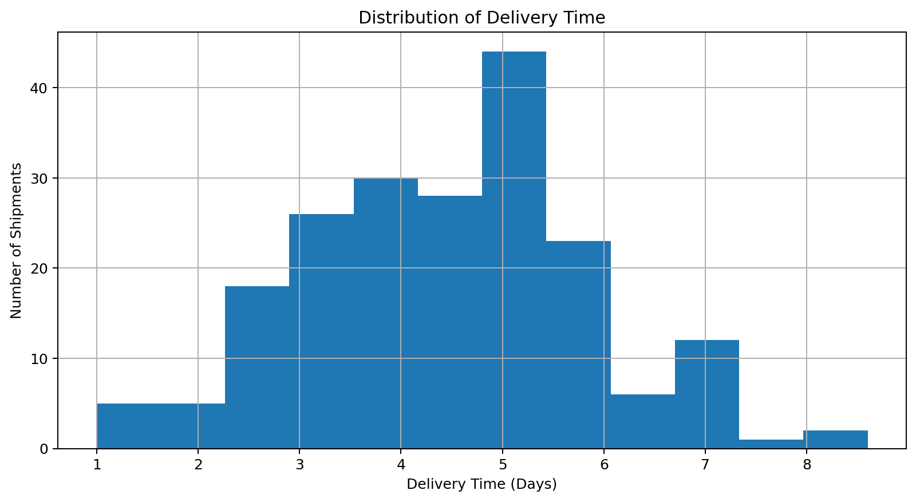
Interpretation: The histogram shows how delivery times are distributed. Most shipments are concentrated around the central delivery-time range, while longer delivery times indicate potential delayed shipments.

Transportation Cost Distribution
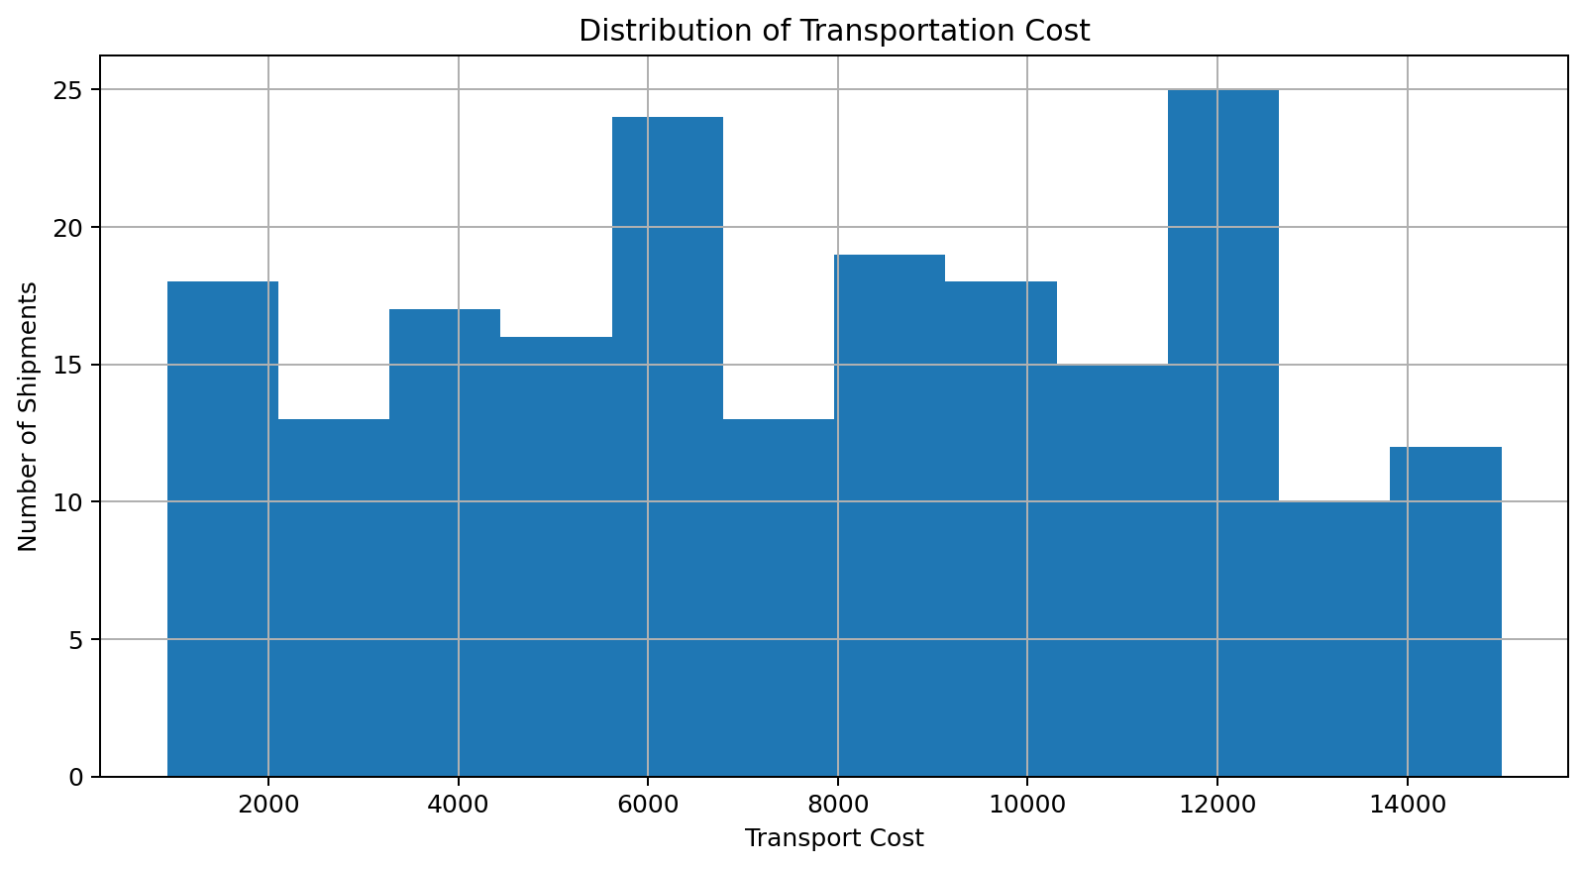
Interpretation: The cost distribution shows the spread of transportation expenses. This helps management understand whether costs are concentrated in a narrow range or have high variability.

Average Shipment Volume by Vehicle Type
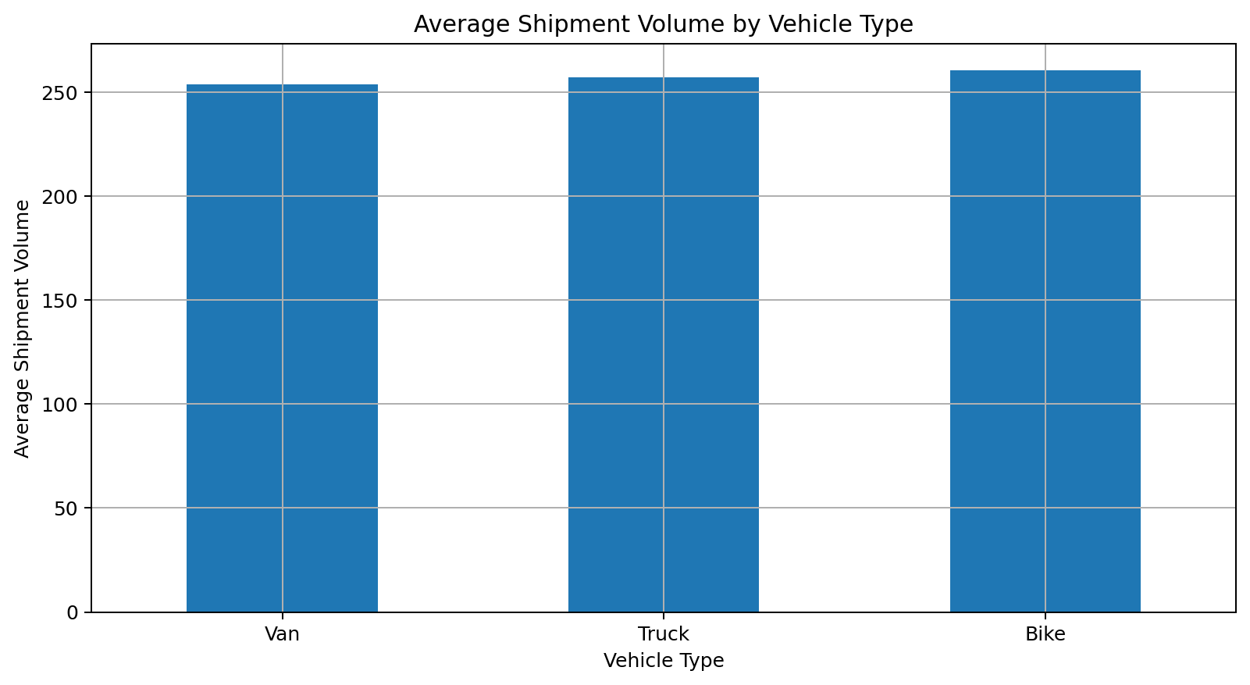
Interpretation: Comparing average shipment volume by vehicle helps evaluate which vehicle categories are handling larger loads and supports better vehicle allocation.

Delivery Status Overview
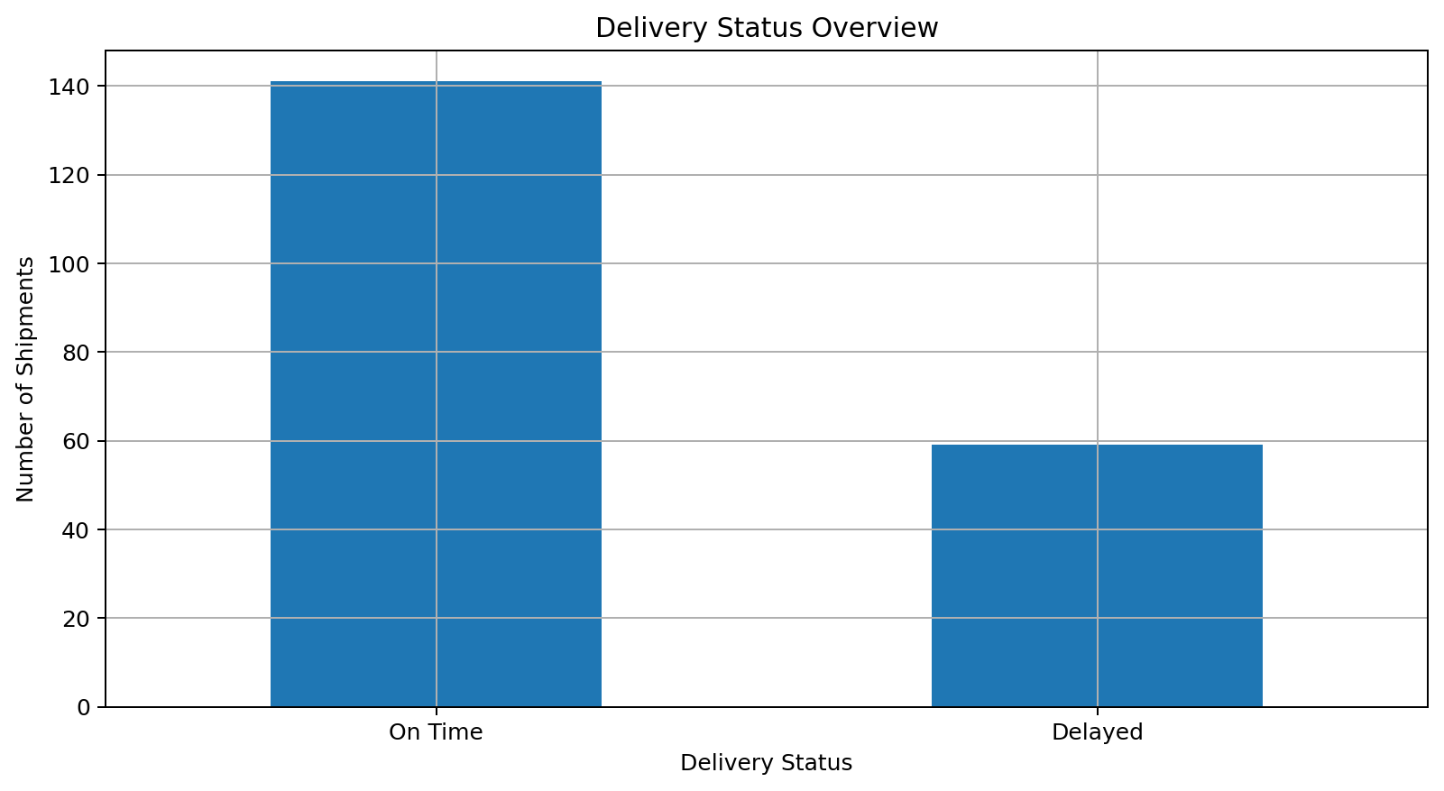
Interpretation: The status chart compares on-time and delayed shipments. It provides a quick view of overall service performance.

Distance vs Transportation Cost
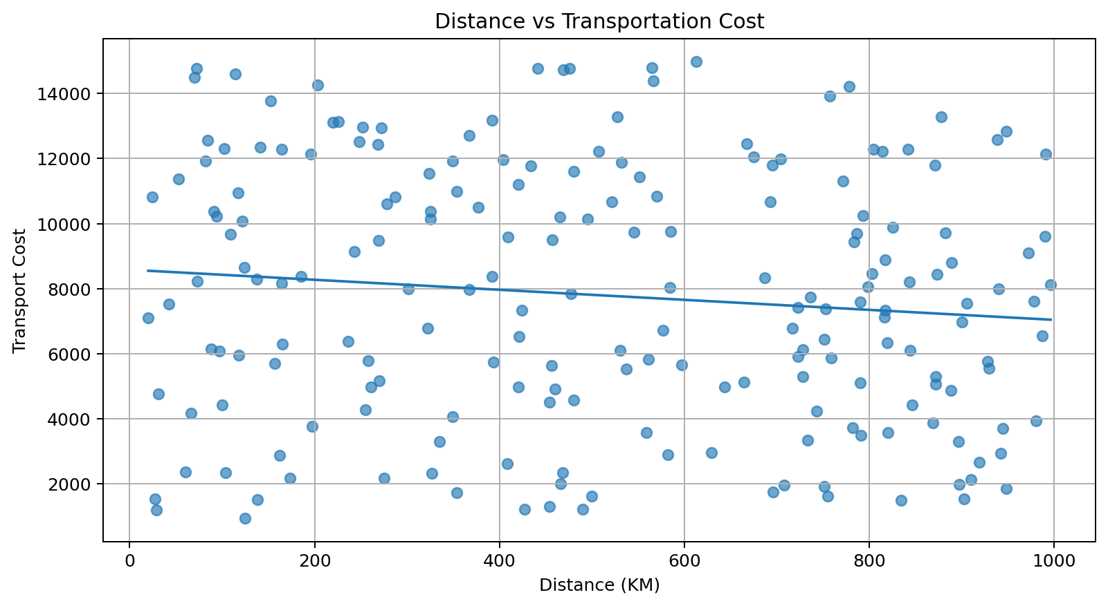
Interpretation: The scatter plot examines whether longer routes tend to have higher transportation costs. A positive pattern would indicate distance as an important cost driver.

Average Delivery Time by Region
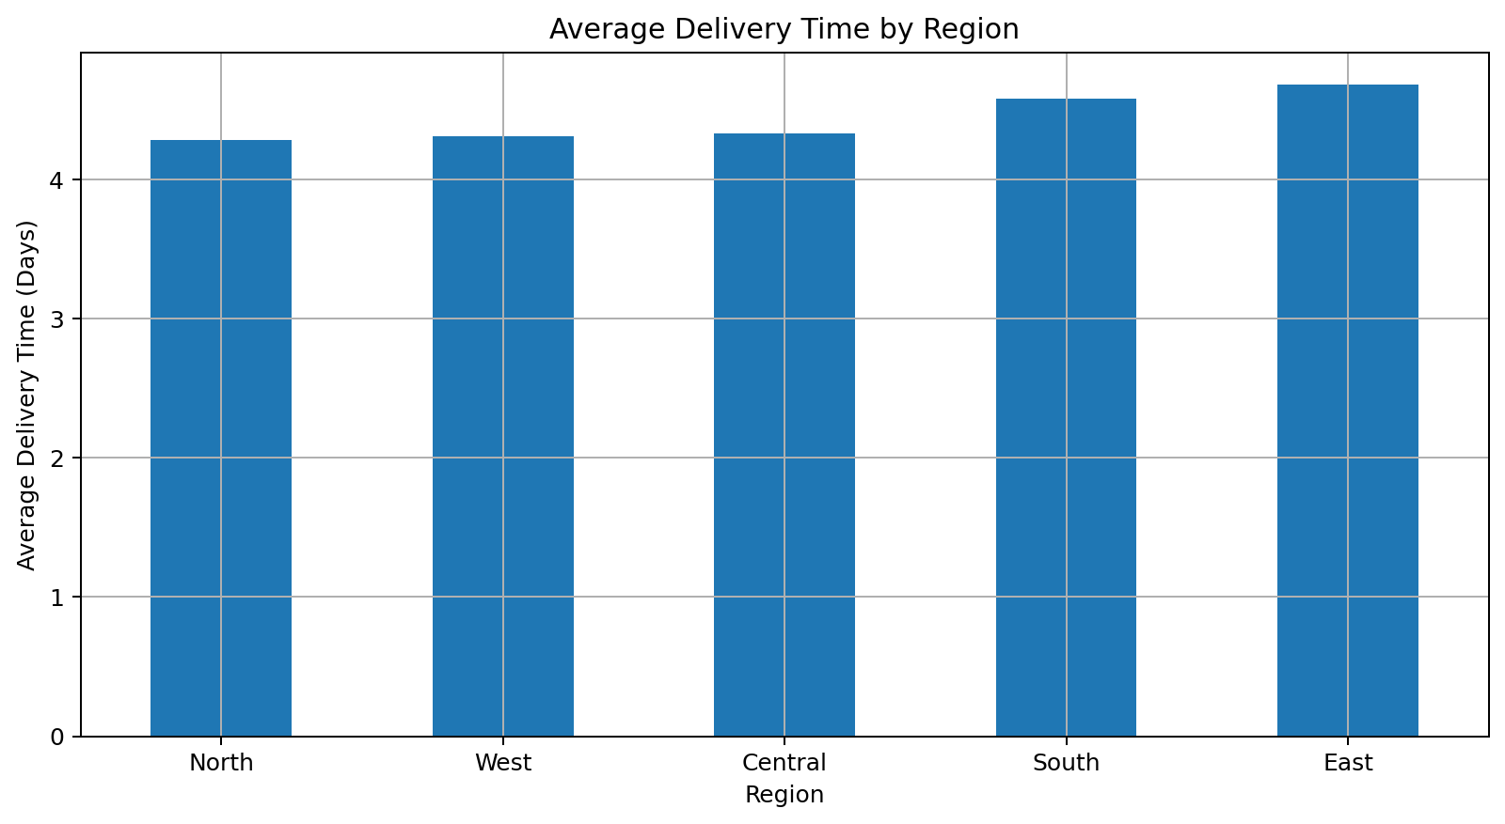
Interpretation: Regional comparison highlights areas with relatively higher delivery times. These regions can be investigated for routing, capacity, or operational bottlenecks.

Correlation Matrix
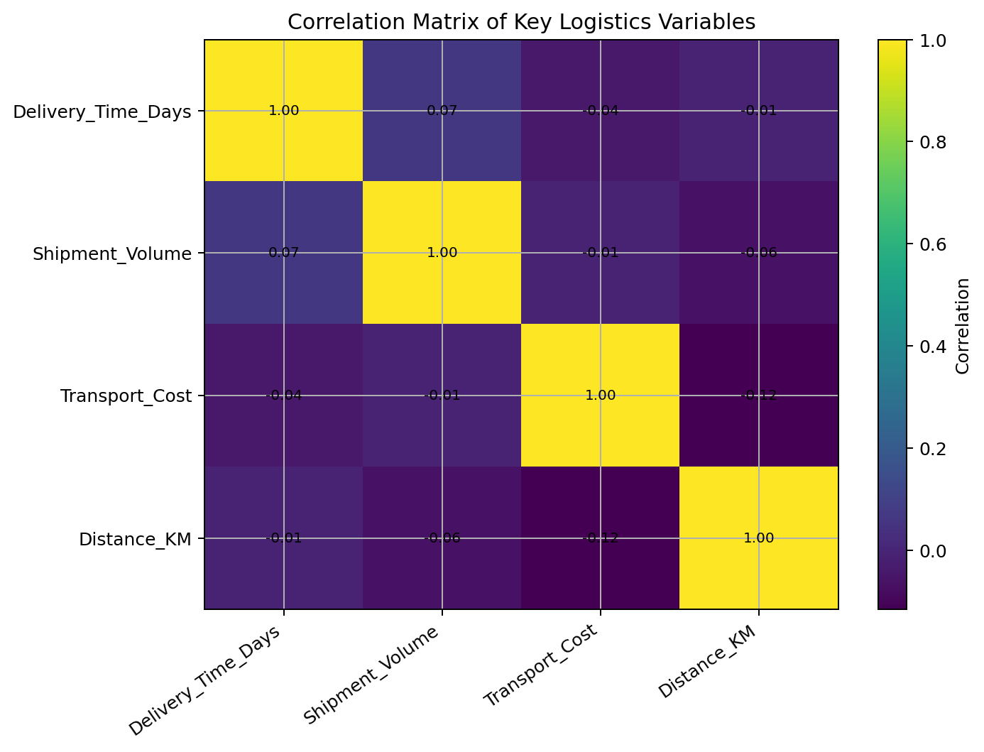
Interpretation: The correlation matrix summarizes relationships between numeric logistics variables and helps identify variables that move together.

7. Analytical Insights
- Delivery time is centered around approximately 4.44 days.
- Average transportation cost is approximately 7788.95.
- Distance and transportation cost have a correlation of -0.12, which indicates their relationship in this synthetic dataset.
- Distance and delivery time have a correlation of -0.01.
- Transportation cost and delivery time have a correlation of -0.04.
- The region with the lowest average delivery time is North, while the highest is East.
- Among the vehicle categories, Bike has the lowest average delivery time, while Van has the highest.

8. Potential Bottlenecks
- Long-distance shipments may require closer monitoring because route length can affect cost and delivery time.
- Regions with comparatively higher average delivery time should be reviewed for routing, traffic, capacity, or dispatch issues.
- High variation in transportation cost suggests that shipment distance, vehicle selection, and load characteristics should be monitored together.
- Delayed shipments should be segmented by region and vehicle type to identify operational patterns.

9. Recommendations
- Use route optimization for longer-distance shipments to reduce unnecessary travel and transportation cost.
- Review regional performance weekly and investigate regions with consistently high delivery times.
- Match vehicle capacity with shipment volume to improve utilization and reduce inefficient trips.
- Create a delivery-time dashboard with on-time percentage, average delivery time, average cost, and delayed shipment count.
- Track cost per kilometer as an additional KPI for transportation efficiency.
- Use historical shipment data to build predictive models for delay risk in future phases.

10. Python Tools and Techniques
Pandas was used for data loading, grouping, descriptive statistics, and correlation analysis. NumPy supported numerical operations and synthetic dataset generation. Matplotlib was used to create histograms, bar charts, scatter plots, and the correlation matrix.

11. Conclusion
The analysis demonstrates how exploratory data analysis and visualization can convert logistics records into useful operational information. The project highlights delivery performance, cost behavior, regional variation, and vehicle-level differences. The recommended next step is to combine these KPIs with real historical logistics data and develop a dashboard or predictive delay model for decision support.

12. Appendix: Python Code
import pandas as pd
import numpy as np
import matplotlib.pyplot as plt

# Load data
df = pd.read_csv("logistics_week3_dataset.csv")

# Basic inspection
print(df.head())
print(df.info())
print("\nMissing values:\n", df.isnull().sum())

# Central tendencies and distributions
numeric_cols = [
"Delivery_Time_Days", "Shipment_Volume",
"Transport_Cost", "Distance_KM"
]
print("\nDescriptive Statistics:")
print(df[numeric_cols].describe())
print("\nMedian:")
print(df[numeric_cols].median())

# Correlation
print("\nCorrelation Matrix:")
print(df[numeric_cols].corr())

# Delivery status
print("\nDelivery Status:")
print(df["Delivery_Status"].value_counts())

# Vehicle analysis
print("\nVehicle Summary:")
print(df.groupby("Vehicle_Type")[numeric_cols].mean().round(2))

# Region analysis
print("\nRegion Summary:")
print(df.groupby("Region")[numeric_cols].mean().round(2))

# Visualizations
plt.figure(figsize=(9,5))
plt.hist(df["Delivery_Time_Days"], bins=12)
plt.title("Distribution of Delivery Time")
plt.xlabel("Delivery Time (Days)")
plt.ylabel("Number of Shipments")
plt.tight_layout()
plt.show()

plt.figure(figsize=(9,5))
plt.scatter(df["Distance_KM"], df["Transport_Cost"], alpha=0.65)
plt.title("Distance vs Transportation Cost")
plt.xlabel("Distance (KM)")
plt.ylabel("Transport Cost")
plt.tight_layout()
plt.show()

