­ DATA STRUCTURES – RECORD

**ABHYUDAYA VASISHT**

**REG NO.. : 23011101008**

**ROLL NO. : 23110522**

# Week 1 – Pointers Recap and Abstraction: Date :24-01-24

# 1.Sum of Integers

**1.**Aim:

To Write a C++ program to find the sum of 'n' integers using only pointers

**2.Algorithm:**

Input: n ,numbers

Output: sum

1. **Start**.
2. Allocate memory dynamically to store the number of integers n and the sum of the integers (**sum**). Initialize **sum** to 0.
3. Prompt the user to enter the number of integers they wish to sum up and store this value in **n**.
4. While the value of **n** is not equal to 0, repeat steps 5-7.
5. Allocate memory dynamically for a temporary integer pointer (**num**) to store the current integer entered by the user.
6. Prompt the user to enter an integer and store this value in **num**.
7. Add the value pointed to by **num** to **sum**, decrement the value of **n**, and free the memory allocated for **num**.
8. After exiting the loop, print the value of **sum** as the sum of the entered integers.
9. Free the memory allocated for **sum** and **n**.
10. **End**

3.Time complexity analysis- O(n)

4.CODE

// program to find the sum of 'n' integers using only pointers

#include <stdio.h>

#include <stdlib.h>

int main()

{

    int *number, *loop_ptr, *ptr, *sum;

    sum = (int*) malloc(sizeof(int));

    loop_ptr = (int*) malloc(sizeof(int));

    number = (int*) malloc(sizeof(int));

    printf("Enter the number of entries: ");

    scanf("%d",number);

    ptr = (int*) malloc(*number * sizeof(int));

    printf("Enter the %d entries:\n", *number);

    for (*loop_ptr = 0; *loop_ptr < *number; (*loop_ptr)++)

     {

        scanf("%d", ptr + *loop_ptr);

        *sum += *(ptr + *loop_ptr);

     }

    printf("The required sum is = %d", *sum);

    return 0;

}

5.OUTPUT

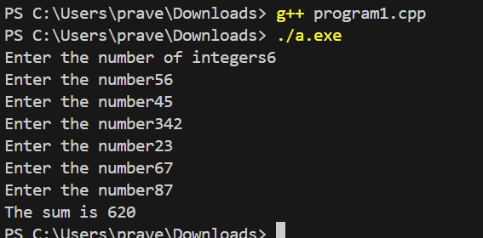

# 2.Calculator:

## Aim:

To implement a calculator that performs various arithmetic operations.

## Algorithm:

1. Start the program
2. Declare and initialize variables `choice`, `num1`, and `num2` to 0.
3. Prompt the user to enter the first number (`num1`).
4. Read the value of `num1` from the user.
5. Prompt the user to enter the second number (`num2`).
6. Read the value of `num2` from the user.
7. Display the menu with options for arithmetic operations.
8. Read the user's choice (`choice`).
9. Perform the following steps in a loop until the user chooses to exit:
   1. If `choice` is 1, add `num1` and `num2`, and display the result.
   2. If `choice` is 2, subtract `num2` from `num1`, and display the result.
   3. If `choice` is 3, multiply `num1` and `num2`, and display the result.
   4. If `choice` is 4:
      1. If num2==0, display an error message indicating division by zero is not possible.
      2. Else, divide `num1` by `num2` and display the result.
   5. If `choice` is 5, exit the loop.
   6. If `choice` is invalid, display an error message.
10. End the program.

**Complexity:**

1. Addition – O(1)
2. Subtraction – O(1)
3. Multiplication – O(1)
4. Division – O(1)

## Code:

### Header file:

//Code:

#include <stdio.h>

//Function definition

void accept_two_numbers(int *a, int *b){

    printf("\nEnter value of first number: ");

    scanf("%d", a);

    printf("\nEnter value of second number: ");

    scanf("%d", b);

}

int sum(int a, int b){

    return a + b;

}

int diff(int a, int b){

    return a - b;

}

int prod(int a, int b){

    return a * b;

}

float quo(int a, int b){

    return (float)a / b;

}

### Main [cpp] file:

//Code:

#include <stdio.h>

//  including header file into c++ program

#include "program2.h"

int main(){

    int oper, x, y;

    while (oper != 6){

        printf("\n 1. Set ");

        printf("\n 2. Add ");

        printf("\n 3. Subtract ");

        printf("\n 4. Multiply ");

        printf("\n 5. Divide ");

        printf("\n 6. Exit ");

        printf("\nSelect an option from 1 to 5. ");

        scanf("%d", &oper);

        if (oper == 1){

            accept_two_numbers(&x, &y);

        }

        else if (oper == 2){

            int add = sum(x, y);

            printf("\nsum of two numbers: %d", add);

        }

        else if (oper == 3){

            int sub = diff(x, y);

            printf("\ndifference of two numbers: %d", sub);

        }

        else if (oper == 4){

            int mult = prod(x, y);

            printf("\nproduct of the numbers: %d", mult);

        }

        else if (oper == 5){

            float div = quo(x, y);

            printf("\nquotient of two numbers: %.2f", div);

        }

        else

            printf("\nsuch operation is not available");

    }

    return 0;

}

**Output:**

# 

# Week 2 – Searching and Sorting: Date: 31-01-24

1. **Searching:**

## Aim:

To check if the given number is present in the array.

**Algorithm:**

* 1. Search:
     1. Set flag to -1.
     2. Initialize i to 0.
     3. Repeat until i is less than n:
     4. If arr[i] equals target:
        1. Set flag to i.
        2. Break the loop.
     5. Increment i by 1.
     6. Return flag.

#### Complexity Analysis:

a. Search – Time Complexity O(n)

#### Code:

// Binary Search implementation using array .

#include<stdio.h>

int binarySearch(int a[], int, int, int) ;

int main() {

    int i, num, search_element ;

    printf("How many numbers are there in array? ") ;

    scanf("%d", &num) ;

    int a[num] ;

    printf("What are the elements of the array (in ascending order)? ") ;

    for(i = 0; i < num; i++) {

        scanf("%d", &a[i]) ;

    }

    printf("Enter the roll number that is to be searched: ") ;

    scanf("%d", &search_element) ;

    int index = binarySearch(a, 0, num-1, search_element) ;

    if (index != -1) {

        printf("The roll number %d is present in the array and it is at position %d.\n", search_element, index + 1) ;

    } else {

        printf("The roll number is not present in the array.\n") ;

    }

    return 0;

}

int binarySearch(int b[], int start, int end, int s) {

    while(start <= end) {

        int mid=((start+end)/2) ;

        if (b[mid] == s) {

            return mid ;

        }

        if (b[mid] < s) {

            start = mid+1 ;

        } else {

            end = mid-1 ;

        }

    }

    return -1 ;

}

**Output:**

# Sorting:

## Aim:

To sort an integer array in ascending or descending order

## Algorithm:

**Input: unsorted array**

**Output: sorted array**

* 1. Ascend – sort:

1. Initialize variables i, j, and temp.
2. Start an outer loop from j = 0 to num - 1.
3. Within the outer loop, start an inner loop from i = 0 to num - 1 - j.
4. Inside the inner loop:
5. Compare n[i] and n[i + 1].
6. If n[i] is greater than n[i + 1], swap n[i] and n[i + 1].
7. After each pass through the array (j), the smallest element will be placed at the beginning of the array.
   1. Descend – sort:
8. Initialize variables i, j, and temp.
9. Start an outer loop from j = 0 to num - 1.
10. Within the outer loop, start an inner loop from i = 0 to num - 1 - j.
11. Inside the loop, compare n[i] and n[i + 1].
12. If n[i] is lesser than n[i + 1], swap n[i] and n[i + 1].
13. After each pass through the array (j), the largest element will be placed at the beginning of the array.

**Complexity:**

The program was implemented using *bubble sort* algorithm and it has a time complexity of O(n^2) in the worst case, where n is the number of elements in the array.

1. Ascending – O(n^2)
2. Descending – O(n^2)

## Code:

//Sorting of numbers in ascending and descending order .

#include<stdio.h>

void ascending_order (int*,int,int arr[]) ;

void descending_order (int*,int,int arr[]) ;

int main()

{

 int size,i ;

 printf("how many elements are in the array?") ;

 scanf("%d",&size) ;

 printf("enter the elements of array:") ;

 int a[size] ;

 for(i=0;i<size;i++) {

 scanf("%d",&a[i]) ;

 }

 ascending_order(a,size,a);

 descending_order(a,size,a) ;

 return 0 ;

}

void ascending_order(int *p,int len,int arr[]) {

   int i ,j ,temp ;

   for(i=0;i<len;i++) {

      for(j=0;j<len;j++){

         if(*(p+j)>*(p+j+1)){

             temp = *(p+j) ;

             *(p+j) = *(p+j+1) ;

             *(p+j+1) = temp ;

             }

      }

   }

    printf("the elements in ascending order are:\n") ;

   for(i=0;i<len;i++) {

      printf("%d\n",*p) ;

           p++ ;

           }

}

void descending_order(int*p,int len,int arr[]) {

    int i, j,temp ;

     for(i=0;i<len;i++) {

         for(j=0;j<len;j++){

          if(*(p+j) <*(p+j+1)){

             temp = *(p+j) ;

             *(p+j) = *(p+j+1) ;

             *(p+j+1) = temp ;

            }

         }

     }

   printf("the elements in descending order are:\n") ;

   for(i=0;i<len;i++) {

      printf("%d\n",*p);

      p++;

           }

}

**Output:**

# Sorting and Searching [Roll no]:

## Aim:

To search for the given roll number in a sorted array.

## Algorithm:

Input: sorted array

Output : unsorted array

1. Compare the roll number with the middle element.
2. If present -> return index + 1
3. Otherwise check if the roll number to be searched is bigger than the number in the current index.
4. If so, set the current location as the starting point and repeat 1
5. Otherwise, set the current location as the ending point and repeat 1
6. If there are no more elements to be searched, then return that the roll number is not present in the array.

**Complexity:**

Binary search has a time complexity of O(log n), where n is the number of elements in the array. This is because the search space reduces by half in each step..

## Code:

// search operation in array

#include<stdio.h>

void search(int a[],int ,int ) ;

int main(){

    int i,num,search_element ;

    printf("how many numbers are there in array?") ;

    scanf("%d",&num) ;

    int a[num] ;

    printf("what are the elements of the array ?") ;

    for(i=0;i<num;i++){

        scanf("%d",&a[i]) ;

        }

    printf("enter the number that is to be searched:") ;

    scanf("%d",&search_element) ;

    search(a,num,search_element) ;

    return 0 ;

}

void search(int b[],int n,int s){

    int i;

    for(i=0;i<n;i++){

        if(b[i]==s){

            printf("the element is present in the array and it is in %d position",i+1) ;

            return ;

        }

    }

    printf ("the element not is present in the array") ;

}

## Output:

**WEEK 3: List ADT: Array implementation Date:07/02/24**

**Aim:**

**To** Write a C++ menu driven program to implement List ADT using arrays. Maintain proper boundary conditions and follow good coding practices.

TIME COMPLEXITY ANALYSIS:

1. Insertion at beginning : O(n)
2. Insertion at end : O(1)
3. Insertion at position : O(n)
4. Deletion at beginning: O(n)
5. Deletion at end: O(n)
6. Deletion at position: O(n)
7. Search: O(n)
8. Display: O(n)

ALGORITHM:

1. Insert at beginning

Input: num,arr

Output: 1 if element is added else 0

If cur=size-1

Return 0

Else

Temp=cur

While temp!=0

Arr[temp+1]=arr[temp]

Temp--

Arr[0]=num

Inc cur

Return 1

2)Insert at end

Input:num,arr

Output:1 if number is added else 0

If cur=size-1

Return 0

Else

Arr[cur]=num

Return 1

3)Insert at end

Input:num,pos,arr

Output:1 if element is added and 0 if not

If cur=size-1 or pos>cur

Return 0

Else

Temp=pos

Repeat until temp>=cur

Arr[temp+1]=arr[temp]

Arr[pos]=num

Cur++

Return 1

4)Delete at beginning

Input : arr

Output: 0 or 1

If cur=-1

Return 0

Else

Temp=0

Repeat until temp=cur

Arr[temp]=arr[temp+1]

Cur - -

Return 1

5) Delete at end

Input: arr

Output:0 or 1

If cur=-1

Return 0

Else

Cur - -

Return 1

6) Delete at position

Input: arr

Output:0 or 1

If cur=-1

Return 0;

Else:

If pos=0

Call delbeg

Else if pos=cur

Call delend

Else

Temp=pos

Repeat until temp<=cur

Arr[temp]=arr[temp+1]

Cur- -

Return 1

7) Search

Input: num,arr

Output: 0 or 1

I=0

Repeat until I is not greater than or equal to cur

If arr[i]=num

Return 1

Return 0

8)Display

Input: arr

Output: displaying the elements

If cur =-1

Display array is empty

else

Temp=0

Repeat until temp <=cur

Display arr[temp]

TIME COMPLEXITY ANALYSIS:

1. Insertion at beginning -Θ(1)
2. Insertion at end- Θ(1)
3. Insertion at position- O(n)
4. Deletion at beginning- O(n)
5. Deletion at end- Θ(1)
6. Deletion at position O(n)
7. Search - 0(n)
8. Display- O(n)

CODE:

// code to implement list_ADT using arrays.

#include<stdio.h>

#include<stdlib.h>

#define SIZE 5

// defining a class with list as its tagname .

class list{

   int arr[SIZE] ;

   int cur ;

   public :

       list(){

           cur = -1 ;

       }

       int insert_beg(int) ;

       int insert_end(int) ;

       void display() ;

       int delete_beg() ;

       int delete_end() ;

       int search(int) ;

       int insert_pos(int,int) ;

       int delete_pos(int) ;

 };

// main function where the code is excecuted .

int

main(){

   list l1 ;

   int choice ;

   int num ;

   int flag ;

   int pos ;

   while(1){

   printf("1.Insert in the begining.\n2.Insert in the end.\n3.Insert at a position.\n") ;

   printf("4.Delete in the begining\n5.Delete in the end.\n6.Delete at a position.\n") ;

   printf("7.Display the contents in the list\n8.Search for an element\n9.Exit ") ;

   printf("Enter your choice: ") ;

   scanf("%d",&choice) ;

   // switch case to perform the specified function by the user.

   switch(choice){

       case 1:

           printf("\nwhat is the number to be inserted?") ;

           scanf("%d",&num) ;

           flag = l1.insert_beg(num) ;

           if(flag){

               printf("\nthe number is successfully inserted in the begining list.\n") ;

           }

           else{

               printf("\nAny element cannot be added.The list is already FULL!.\n") ;

           }

           break ;

       case 2:

            printf("\nWhat is the number to be inserted?\n") ;

            scanf("%d",&num) ;

            flag = l1.insert_end(num) ;

            if(flag){

                printf("\nthe number is successfully inserted at the end of the list.\n") ;

            }

            else{

                printf("\nAny element cannot be added.The list is already FULL!.\n") ;

            }

           break ;

       case 3:

            printf("\nAt which position number is to be inserted?\n") ;

            scanf("%d",&pos) ;

            printf("\nEnter the number that should be inserted:\n") ;

            scanf("%d",&num) ;

            flag = l1.insert_pos(num,pos) ;

            if (flag){

                printf("\nNumber is successfully inserted at %d position\n",pos) ;

            }

            else{

                printf("\nNumber cannot be inserted!,The list is already full.\n") ;

            }

           break ;

       case 4:

            flag = l1.delete_beg() ;

            if (flag)

                printf("\nThe begining element has been successfully deleted.\n") ;

            else

                printf("\nThe list is already empty,there is no number to delete.\n") ;

           break ;

       case 5:

            flag = l1.delete_end() ;

            if(flag)

                printf("\nElement is successfully deleted at the end\n") ;

            else

                printf("\nThere are no elements in the list to delete in the end.\n") ;

           break ;

       case 6:

            printf("\nWhich position number should be deleted?\n") ;

            scanf("%d",&pos) ;

            flag = l1.delete_pos(pos) ;

            if(flag){

                printf("\nThe number at %d position is successfully deleted.\n",num) ;

            }

            else{

                printf("\nThere is no number at %d position to delete.\n",num) ;

            }

           break ;

       case 7:

            l1.display() ;

           break ;

       case 8:

            printf("\nwhat is the number to be searched?\n") ;

            scanf("%d",&num) ;

            flag = l1.search(num) ;

            if(flag==-1){

                printf("\nThe number %d is not there in the list.\n",num) ;

            }

            else{

                printf("\nThe number %d is there in the %d position of the list.\n",num,flag+1) ;

            }

           break ;

       case 9:

            exit(0) ;

           break ;

       default :

           printf("\nInvalid Choice .Try Again!") ;

           break ;

   }

   }

return 0 ;

}

// function definition for inserting an element in the begining .

int list::insert_beg(int num){

   if(cur == SIZE-1){

       return 0 ;

   }

   else if(cur==-1){

       cur=0 ;

       arr[0]=num ;

       return 1 ;

   }

   else{

       for(int i=cur;i>=0;i--)

       {

         arr[i+1]=arr[i] ;

       }

       arr[0]=num ;

       cur++ ;

       return 1 ;

   }

   }

// function for displaying the contents of the list.

void list::display(){

    printf("\n") ;

    printf("the elements of the list are: ") ;

    for(int i=0;i<=cur;i++){

        printf("%d,",arr[i]) ;

    }

    printf("\n") ;

}

//function for inserting an element in the end.

int list::insert_end(int num){

    if(cur==SIZE-1){

        return 0;

    }

    else{

        cur++ ;

        arr[cur]=num ;

        return 1 ;

    }

    }

// function to delete an element in the begining.

int list::delete_beg(){

    if(cur==-1){

        return 0 ;

    }

    else if(cur==0){

        arr[0]=0 ;

        cur=-1 ;

        return 1 ;

    }

    else{

        for(int i=1;i<=cur;i++){

            arr[i-1]=arr[i] ;

        }

    cur-- ;

    return 1 ;

    }

}

//function to delete an element in the end .

int list::delete_end(){

    if(cur==-1){

        return 0 ;

    }

    else{

        arr[cur]=0 ;

        cur-- ;

        return 1 ;

        }

    }

//function to search an element in the list.

int list::search(int num){

    for(int i=0;i<SIZE;i++){

        if(arr[i]==num){

            return i ;

        }

    }

         return -1 ;

        }

//function to insert a number at a specific position in the list.

int list::insert_pos(int num,int pos){

    if(pos==1){

        if(cur == SIZE-1){

       return 0 ;

   }

   else if(cur==-1){

       cur=0 ;

       arr[0]=num ;

       return 1 ;

   }

   else{

       for(int i=cur;i>=0;i--)

       {

         arr[i+1]=arr[i] ;

       }

       arr[0]=num ;

       cur++ ;

       return 1 ;

   }

    }

    else if(pos==5){

         if(cur==SIZE-1){

        return 0;

    }

    else{

        cur++ ;

        arr[cur]=num ;

        return 1 ;

    }

    }

    else{

        if(cur==SIZE-1){

            return 0 ;

        }

        else{

            for(int i=pos;i<=cur;i++){

                arr[pos]=arr[pos-1] ;

            }

            arr[pos-1]=num ;

            cur++ ;

            return 1 ;

            }

        }

        }

//function to delete a number at a specific position in the list.

int list::delete_pos(int pos){

    if(cur==-1){

        return 0 ;

    }

    else{

        if(pos>0){

            for(int i=cur;i>=pos;i--){

                arr[cur-1]=arr[cur] ;

            }

            cur-- ;

        }

        return 1 ;

        }

}

OUTPUT:

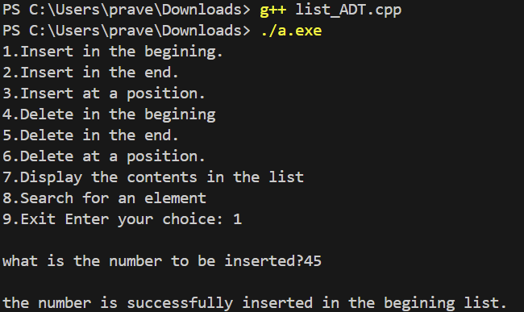

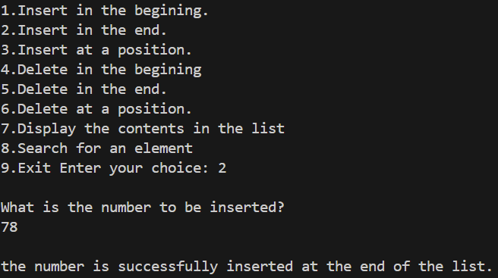

WEEK 4:LIST ADT:SINGLY LINKED LIST Date:14/02/24

1.AIM:

To Write a C++ menu-driven program to implement List ADT using a singly linked list.

2.FUNCTIONS USED

1. Insert at beginning :O(1)
2. Insert at end: O(n)
3. Insert at pos: O(n)
4. Delete at beginning: O(1)
5. Delete at pos: O(n)
6. Delete at end : O(n)
7. Search : O(n)
8. Display : O(n)
9. Display reverse : O(n)

10.Reverse link : O(n)

3.ALGORITHM:

1.INSERT AT BEGINNING:

Input:num,head

Output: 0 or 1

If head=NULL

Head=newnode

Return 1

Else

Newnode->next=head

Head=newnode

Return 1

2.INSERT AT END:

Input:num,head

Output:0 or 1

If head=NULL

Head=newnode

Return 1

Else

Temp=head

Repeat until temp->next!=NULL

Temp=temp->next

Temp->next=newnode

Return 1

3.INSERT AT POS:

Input:num,pos,head

Output:0 or 1

If pos=0

Call insertbeg()

Else

Temp=head

Repeat until temp->next!=NULL and pos!=1

Temp=temp->next

Pos- -

Newnode->next=temp->next

Temp->next=newnode

Return 1

4.DELETE AT BEGINNING:

Input: head

Output: 0 or 1

If head==NULL

Return 0

Else

Head=head->next

Return 1

5.DELETE AT END:

Input: head

Output:0 or 1

If head=NULL

Return 0

Else

Temp=head

Repeat until temp->next!=NULL

Temp2=temp

Temp=temp->next

Temp2->next=NULL

Free(temp)

Return 1

6.DELETE AT POS:

Input: pos,head

Output: 0 or 1

If head=NULL

Return 0

Else

Temp=head

Repeat until temp->next!-NULL and pos!=1

Temp2=temp

Temp=temp->next

Pos- -

Temp2->next=temp->next

Free(temp)

Return 1

7.SEARCH:

Input: num,head

Output: 0 or 1

If head=NULL

Return 0

Else

Temp=head

Repeat until temp->next!=NULL

If temp->data=num

Return 1

Temp=temp->next

Return 0

8.DISPLAY:

Input:head

Output: All the elements in the list

If head=NULL

Display the list is empty

Else

Temp=head

Repeat until temp!=NULL

Display temp->data

Temp=temp->next

9.DISPLAY REVERSE:

Input:head

Ouput: elements displayed in reverse order

If head=NULL

Return

Else

Call disrev(head->next)

Display head->data

10.REVERSELINK :

Input: head

Output: List is reversed (0 or 1)

If head=NULL

Return 0

Else

Initialize temp1 and temp2 to NULL

Repeat until head!=NULL

Temp2=head->next

Head->next=temp1

Temp1=head;

Head=temp2

Head=temp1

Return 1

CODE:

//  C++ menu-driven program to implement List ADT using a singly linked list.

#include<stdio.h>

#include<stdlib.h>

class linked_list{

    struct node{

    int data ;

    struct node *link ;

    };

    struct node *head ;

    public :

        linked_list(){

            head = NULL ;

        }

        int ins_beg(int);

        int ins_end(int);

        int ins_pos(int,int,int);

        int del_beg();

        int del_end();

        int del_pos(int,int);

        int search(int,int);

        void display();

        void dis_rev(int);

        int reverse();

};

int main(){

    linked_list l1 ;

    int choice ;

    int flag ;

    int count = 0 ;

    int pos ;

    int num ;

    while(1){

    printf("which operation you want to perform ?\n") ;

    printf("1. Insert Beginning\n2. Insert End\n3. Insert Position\n4. Delete Beginning\n") ;

    printf("5. Delete End\n6. Delete Position\n7. Search\n8. Display\n") ;

    printf("9. Display Reverse\n10. Reverse Link\n11. Exit\n") ;

    scanf("%d",&choice) ;

    switch(choice)

    {

        case 1 :

            printf("\nWhich number should be inserted in the begining?\n") ;

            scanf("%d",&num) ;

            flag = l1.ins_beg(num) ;

            if(flag){

                printf("\nThe number is successfully inserted in the begining\n") ;

                }

            else{

                printf("\nSome error!,Unable to insert.\n") ;

            }

            break ;

        case 2 :

            printf("\nWhich number should be inserted at the end?\n") ;

            scanf("%d",&num) ;

            flag = l1.ins_end(num) ;

            if(flag){

                printf("\nThe number is successfully inserted at the end.\n") ;

            }

            else{

                printf("\nSome error!,Unable to insert.\n") ;

            }

            break ;

        case 3 :

            printf("\nAt which position number has to be inserted?\n") ;

            scanf("%d",&pos) ;

            printf("\nWhat is the number to be inserted?\n") ;

            scanf("%d",&num) ;

            flag = l1.ins_pos(pos,num,count) ;

            if(flag){

                printf("The number %d is successfully inserted at %d position\n",num,pos) ;

            }

            else{

                printf("\nUnable to insert,SOME ERROR:(\n") ;

            }

            break ;

        case 4 :

            flag = l1.del_beg() ;

            if(flag){

                printf("\nThe begining element is successfully deleted.\n") ;

            }

            else{

                printf("\nThe list is already empty.There is no element to delete :) .\n") ;

            }

            break ;

        case 5 :

            if(flag){

                printf("\nThe end element of the linkedlist is successfully deleted :).\n") ;

            }

            else{

                printf("\nThere is no element in the linkedlist to delete :).\n") ;

            }

            break ;

        case 6 :

            printf("\nNode at which position has to be deleted?\n") ;

            scanf("%d",&pos) ;

            flag = l1.del_pos(pos,count) ;

            if(flag){

                printf("The number at %d position in the linkedlist is successfully deleted:)\n",pos) ;

            }

            else{

                printf("\nThere is no element at the given position to delete\n") ;

            }

            break ;

        case 7 :

            printf("\nWhich element are you searching for?\n") ;

            scanf("%d",&num) ;

            flag = l1.search(num,count) ;

            if(flag==-1){

                printf("\nThe element is not found in the LL\n") ;

            }

            else{

                printf("\nThe element %d is in %d position.\n",num,flag) ;

            }

            break ;

        case 8 :

            l1.display() ;

            break ;

        case 9 :

            l1.dis_rev(count) ;

            break ;

        case 10 :

            flag = l1.reverse() ;

            if(flag){

                printf("\nThe string is reversed successfully\n") ;

                l1.dis_rev(count) ;

            }

            else{

                printf("\nERROR ,Unable to reverse the linked_list\n") ;

            }

            break ;

        case 11 :

            exit(1) ;

            break ;

    default :

        printf("\nINVALID CHOICE OF OPERATION\n") ;

    }

}

return 0 ;

}

// method for inserting a node in the begining.

int linked_list::ins_beg(int num){

    struct node *fresh = (struct node*)malloc(sizeof(struct node)) ;

    if(head == NULL){

        fresh->link = NULL ;

        fresh->data = num ;

        head = fresh ;

        return 1 ;

    }

    else {

        fresh->link = head ;

        fresh->data = num ;

        head = fresh ;

        return 1 ;

    }

}

// method for inserting a node at the end.

int linked_list::ins_end(int num){

    struct node *fresh = (struct node*)malloc(sizeof(struct node)) ;

    struct node *tail = head ;

    if(head == NULL){

        fresh->data = num ;

        fresh->link = NULL ;

        head = fresh ;

        return 1 ;

    }

    else {

        fresh->data = num ;

        fresh->link = NULL ;

        while(tail->link!=NULL){

            tail = tail->link ;

        }

        tail->link = fresh ;

        return 1 ;

    }

    free(tail) ;

}

// method for displaying the contents of the linked list.

void linked_list::display(){

    struct node *temp = head ;

    if(temp==NULL){

        printf("\nThe linkedlist is empty.There is nothing to print in the linkedlist\n") ;

    }

    else{

        printf("\nThe elements of the linkedlist are :\n") ;

        while(temp!=NULL){

            printf("%d ,",temp->data) ;

            temp = temp->link ;

        }

    }

    free(temp) ;

}

// method for deleting the begining node of the list.

int linked_list::del_beg(){

    if(head==NULL){

        return 0 ;

    }

    else{

        head = head->link ;

        return 1 ;

    }

}

// method for deleting the last node of the list.

int linked_list::del_end(){

    if(head==NULL){

        return 0 ;

    }

    else if(head->link==NULL){

        head = NULL ;

        return 1 ;

    }

    else{

        struct node *temp = head ;

        struct node *prev ;

        while(temp->link!=NULL){

            prev=temp ;

            temp=temp->link ;

        }

       prev->link=NULL ;

       free(temp) ;

       free(prev) ;

       return 1 ;

    }

}

// method for searching an element in the list.

int linked_list::search(int num,int count){

    struct node *temp = head ;

    while(temp!=NULL){

        if(temp->data==num){

            return count ;

        }

        else{

            return -1 ;

        }

        temp=temp->link ;

        count++ ;

    }

    return count ;

}

// method for inserting a node at a position.

//  if position=1,then it means index is 0 .

int linked_list::ins_pos(int pos,int num,int count){

    struct node *temp = head ;

    while (temp!=NULL){

        temp = temp->link ;

        count++ ;

    }

    if(pos>count){

        return 0 ;

    }

    else if(pos<=count){

        struct node *fresh = (struct node*)malloc(sizeof(struct node)) ;

        for (int i=0;i<pos-1;i++){

            temp=temp->link ;

        }

        fresh->data = num ;

        fresh->link = temp->link ;

        temp->link = fresh ;

    }

    return 1 ;

}

// method for deleting a node at a position.

int linked_list::del_pos(int pos,int count){

    struct node *temp = head ;

    while(temp!=NULL){

        temp = temp->link ;

        count++ ;

    }

    if(pos>count){

        return 0 ;

    }

    else if(pos<=count){

        for(int i=0;i<pos-1;i++){

            temp = temp->link ;

        }

        temp->link = temp->link->link ;

    }

    return 1 ;

}

// method for displaying the linked list in reverse.

void linked_list::dis_rev(int count){

    int arr[10] ;

    printf("The elements of the linked list in reverse order are:") ;

    struct node* temp=head;

    while(temp!=NULL){

        arr[count] =    temp->data ;

        temp = temp->link ;

        count++ ;

    }

    for(int j=count-1;j>=0;j--){

        printf("%d ",arr[j]);

    }

    printf("\n") ;

}

// method for reversing the linked list

int linked_list::reverse(){

    if(head!=NULL){

        struct node* temp = head  ;

        struct node* prev = NULL ;

        struct node* next ;

        while(temp!=NULL){

            next=temp->link;

            temp->link=prev;

            prev=temp;

            temp=next;

            head=prev;

        }

        return 1 ;

    }

    else{

        return 0 ;

    }

}

5.OUTPUT

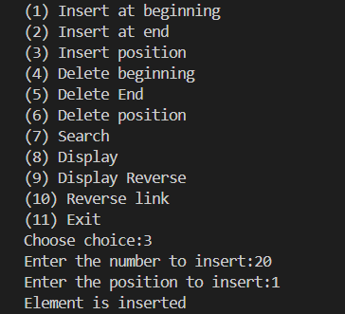

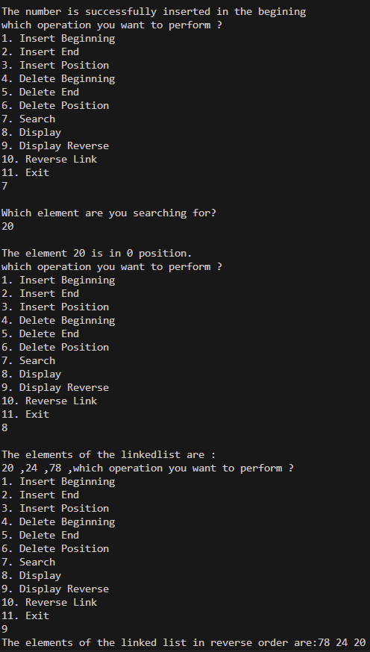

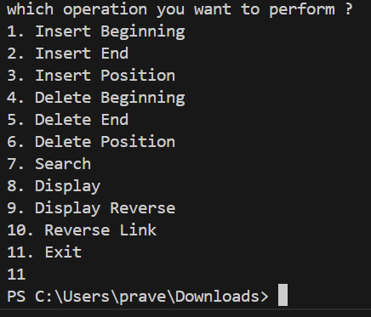

**2)Implement List ADT using a singly linked list.**

1.AIM:

To Write a C++ menu-driven program to implement List ADT using a singly linked list

2:ALGORITHM:

1.INSERT ASCENDING:

Input: num (an integer to be inserted in ascending order)

Output: 1 (indicating successful insertion)

1. Create a new node and set its data to num and address to nullptr.

2. Check if the list is empty or if the new node should be inserted before the head:

a. If true, point new node's address to the current head and update head to new node.

3. Otherwise:

a. Initialize a temporary pointer temp to head.

b. Traverse the list to find the correct insertion point:

- While temp's next is not nullptr and temp's next data is less than num, move temp to the next node.

c. Insert the new node in the found position:

- Set new node's address to temp's next.

- Set temp's next to the new node.

4. Return 1 to indicate success.

2.MERGE:

Input: l1, l2 (linked lists to be merged), l3 (an empty linked list to store the result)

Output: 1 (indicating successful merge)

1. Initialize pointers temp1 and temp2 to the heads of l1 and l2, respectively.

2. While either temp1 or temp2 is not nullptr:

a. Compare the data at temp1 and temp2:

i. If temp1's data is less than or equal to temp2's data or temp2 is nullptr, insert temp1's data into l3, move temp1 to next.

ii. Otherwise, insert temp2's data into l3, move temp2 to next.

3. Return 1 to indicate that the merge was successful.

3.DISPLAY:

Output: Print the elements of the list or a message if the list is empty.

1. Check if the list is empty:

a. If true, print "List is empty!"

2. Otherwise:

a. Initialize a temporary pointer temp to head.

b. Traverse the list:

- Print the data at temp.

- Move temp to the next node.

3.TIME COMPLEXITY ANALYSIS:

1. insert_ascending: O(n)

2. merge: O(n + m)

3. display: O(n)

4.CODE:

Headerfile:

// Header file where the LL_operations functions are defined.

#include<stdio.h>

#include<stdlib.h>

class list{

    private:

        struct node{

        int data ;

        struct node *next ;

        };

    typedef struct node node ;

    node *head ;

    node gethead(){

        return *head ;

    };

    int count ;

    public:

        list(){

        head=NULL ;

        count=0 ;

        }

        int insert(int) ;

        void display() ;

        int merge(list,list) ;

};

// Method for inserting a input number from user into a list in ascending order.

int list::insert(int num){

    node *temp=head ;

    if(head==NULL||num<=temp->data){

        node *newnode=(node*)malloc(sizeof(node)) ;

        newnode->data=num ;

        newnode->next=head ;

        head=newnode ;

        count++ ;

        return 1 ;

    }

    else{

        if(count==1){

            node *newnode=(node*)malloc(sizeof(node)) ;

            newnode->data=num ;

            newnode->next=NULL ;

            head->next=newnode ;

            count++ ;

            return 1 ;

        }

        else{

            node *newnode=(node*)malloc(sizeof(node)) ;

            newnode->data=num ;

            int temp2=0 ;

            for(int i=0 ;i<count-1 ;i++){

                if(num>temp->data&&num<=temp->next->data){

                    newnode->next=temp->next ;

                    temp->next=newnode ;

                    count++ ;

                    return 1 ;

                }

                temp=temp->next ;

            }

            temp->next=newnode ;

            newnode->next=NULL ;

            count++ ;

            return 1 ;

        }

        return 0 ;

    }

}

//Method for displaying the elements of the list.

void list::display(){

    node *temp ;

    temp=head ;

    if(temp==NULL){

    printf("\nList is empty!\n") ;

    }

    else{

        while (temp!=NULL){

            printf("%d ,",temp->data) ;

            temp=temp->next ;

        }

    }

}

//Method for merging two lists into one list .

int list::merge(list l2,list l3){

    node *temp=l2.head ;

    for(int i=0 ;i<l2.count ;i++){

        l3.insert(temp->data) ;

        temp=temp->next ;

    }

    return 1 ;

}

Cpp file:

// C++ menu-driven program to implement List ADT using a singly linked list.

// You have a gethead() private member function that returns the address of the head value of a list

#include<stdio.h>

#include<stdlib.h>

// including the header file "merge_list.h"

#include"LL_headerfile.h"

int main(){

    int choice,num ;

    int flag ;

    list l1,l2,l3 ;

    while(1){

        getchar() ;

        getchar() ;

        system("clear") ;

        printf("\n1.Insert in list 1\n2.Insert in list 2\n3.Merge\n4.Display\n5.Exit\n") ;

        printf("Enter your choice:") ;

        scanf("%d",&choice) ;

        switch (choice){

        case 1:

            printf("\nEnter the number :") ;

            scanf("%d",&num) ;

            flag = l1.insert(num) ;

            if(flag){

                printf("\nInsertion of %d successful !",num) ;

            }

            else{

                printf("\nInsertion Failed !") ;

            }

            break ;

        case 2:

            printf("\nEnter the number :") ;

            scanf("%d",&num) ;

            flag = l2.insert(num) ;

            if(flag){

                printf("\nInsertion of %d successful !!",num) ;

            }

            else{

                printf("\nInsertion Failed !") ;

            }

            break ;

        case 3:

            l3=l1 ;

            flag = l3.merge(l2,l3) ;

            if(flag){

                printf("\n Merger Successful !") ;

                l3.display() ;

            }

            else{

                printf("\nList Merging failed !") ;

            }

            break  ;

        case 4:

            printf("\nThe elements of the list 1 are:") ;

            l1.display() ;

            printf("\nThe elements of the list 2 are:") ;

            l2.display() ;

            break ;

        case 5:

            exit(0) ;

            break ;

        default:

            break ;

        }

    }

}

5.OUTPUT :

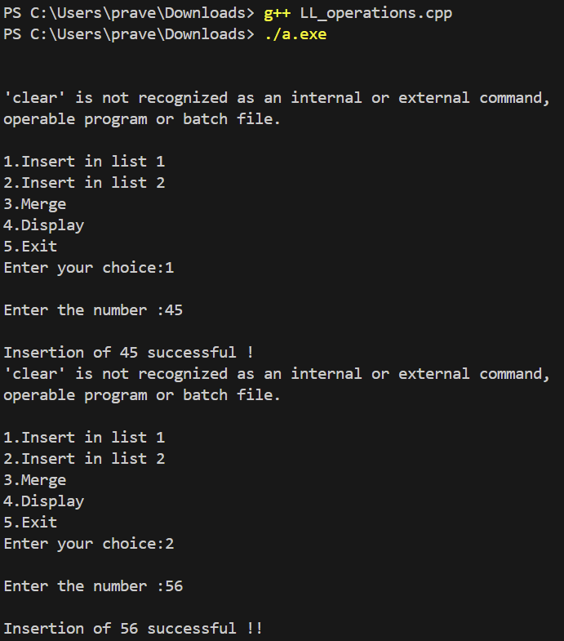

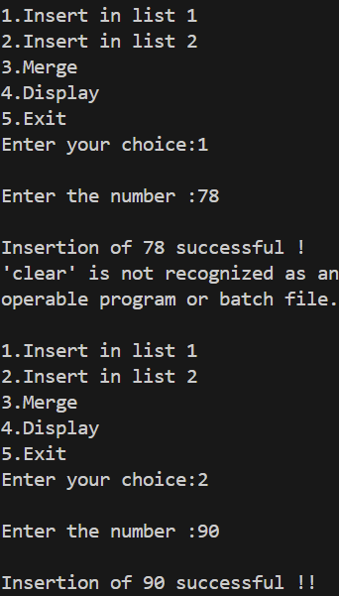

**WEEK 5-LIST ADT- DOUBLY LINKED LIST Date-21/02/24**

1.AIM:

To Write a C++ menu-driven program to implement List ADT using a doubly linked list

2.TIME COMPLEXITY ANALYSIS:

1.Insert at beginning : O(1)

2.Insert at end : O(n)

3.Insert at position: O(n)

4.Delete at beginning : O(1)

5.Delete at end : O(n)

6.Delete at position : O(n)

7.Search : O(n)

8.Display : O(n)

3.ALGORITHM

1.INSERT AT BEGINNING:

Input:num,head

Output: 0 or 1

Initialize newnode

if head=NULL

Head=newnode

Return 1

Else

Head->prev=newnode

Newnode->next=head

Head=newnode

Return 1

2.INSERT AT END:

Input : num,head

Output : 0 or 1

If head=NULL

Head=newnode

Return 1

Else

Set temp=head

Repeat until temp->next!=NULL

Temp=temp->next

Newnode->prev=temp

Temp->next=newnode

Return 1

3.INSERT AT POS:

Input : num,pos,head

Output : 0 or 1

If pos=0

Call insertbeg

Else

Set temp=head

Repeat until temp->next!=NULL and pos!=1

Temp2=temp

Temp=temp->next

Pos- -

Temp2->next=newnode

Newnode->prev=temp2

Newnode->next=temp

Return 1

4.DELETE AT BEGINNING:

Input : head

Output : 0 or 1

If head=NULL

Return 0

Else

Head=head->next

Head->prev=NULL

Return 1

5.DELETE AT END:

Input : head

Output : 0 or 1

If head=NULL

Return 0

Else

Set temp=head

Repeat until temp->next!=NULL

Temp=temp->next

Temp2=temp->next

Temp->next=NULL

Free temp2

Return 1

6.DELETE AT POS:

Input : head

Output : 0 or 1

If head==NULL

Return 0

Else if pos=1

Call delbeg

Else

Set temp=head

Repeat until temp->next!=NULL and pos!=1

Temp2=temp

Temp=temp->next

Temp2->next=temp->next

Temp->prev=temp2

Free temp1

7.SEARCH:

Input: head

Output: 0 or 1

If head=NULL

Return 0

Else

Set Temp=head

Repeat until temp->next!=NULL

If temp->data=num

Return 1

Temp=temp->next

Return 0

8.DISPLAY:

Input:head

Output: All the elements in the list

If head=NULL

Display the list is empty

Else

Temp=head

Repeat until temp!=NULL

Display temp->data

Temp=temp->next

4.CODE

//  C++ menu-driven program to implement List ADT using a doubly linked list.

#include<stdio.h>

#include<stdlib.h>

class doubly{

    struct node{

    int data ;

    struct node *link ;

    struct node *prev ;

    };

    struct node *head ;

    public :

        doubly(){

            head = NULL ;

        }

        int ins_beg(int);

        int ins_end(int);

        int ins_pos(int,int,int);

        int del_beg();

        int del_end();

        int del_pos(int,int);

        int search(int ,int);

        void display();

};

int main(){

    doubly l1 ;

    int choice ;

    int flag ;

    int pos ;

    int num ;

    int count = 0 ;

    while(1){

    printf("which operation you want to perform ?\n") ;

    printf("1. Insert Beginning\n2. Insert End\n3. Insert Position\n") ;

    printf("4. Delete Beginning\n5. Delete End\n6. Delete Position\n") ;

    printf("7. Search\n8. Display\n9. Exit\n") ;

    scanf("%d",&choice) ;

    switch(choice){

        case 1:

            printf("\nWhich number should be inserted in the begining?\n") ;

            scanf("%d",&num) ;

            flag = l1.ins_beg(num) ;

            if(flag){

                printf("\nThe number is successfully inserted in the begining\n") ;

                }

            else{

                printf("\nSome error!,Unable to insert.\n") ;

            }

            break ;

        case 2:

            printf("\nWhich number should be inserted at the end?\n") ;

            scanf("%d",&num) ;

            flag = l1.ins_end(num) ;

            if(flag){

                printf("\nThe number is successfully inserted at the end.\n") ;

            }

            else{

                printf("\nSome error!,Unable to insert.\n") ;

            }

            break ;

        case 3:

            printf("\nAt which position do you want to add the element\n") ;

            scanf("%d",&pos) ;

            printf("Enter the element you want to insert at %d position.\n",pos) ;

            scanf("%d",&num) ;

            flag = l1.ins_pos(num,pos,count) ;

            if(flag==-1){

                printf("Some Error! ,Unable to insert at given position\n") ;

            }

            else{

                printf("The number has %d been successfully inserted at %d position\n",num,pos) ;

            }

        case 4:

            flag = l1.del_beg() ;

            if(flag){

                printf("\nThe begining node is successfully deleted in doubly linkedlist\n") ;

            }

            else{

                printf("\nThere are no elements in the list to delete:(\n") ;

            }

            break ;

        case 5:

            flag = l1.del_end() ;

            if(flag){

                printf("\nThe last node of doubly linkedlist is successfully deleted\n") ;

            }

            else{

                printf("\nThe list is already empty,nothing to delete :)\n") ;

            }

            break ;

        case 6 :

            flag = l1.del_pos(pos,count) ;

            if(flag){

                printf("\nThe %d node of the doubly linkedlist is successfully deleted.\n",pos) ;

            }

            else{

                 printf("\nThe list is already empty,nothing to delete :)\n") ;

            }

            break ;

        case 7:

            printf("\nWhat is the number you are sarching for?\n") ;

            scanf("%d",num) ;

            flag = l1.search(num,count) ;

            if(flag==-1){

                printf("%d is not present in the doubly linkedlist\n",num) ;

            }

            else{

                printf("Number %d is present at %d position in the doubly linkedlist\n",num,flag) ;

            }

            break ;

        case 8:

            l1.display() ;

            break ;

        default:

            printf("\nINVALID CHOICE!!!\n") ;

    }

    }

}

// Method for inserting a node in the begining.

int doubly::ins_beg(int num){

    struct node *fresh = (struct node*)malloc(sizeof(struct node)) ;

    if(head==NULL){

        fresh->prev = NULL ;

        fresh->link = NULL ;

        fresh->data = num ;

        head = fresh ;

        return 1 ;

    }

    else {

        fresh->prev = NULL ;

        fresh->data = num ;

        fresh->link = head ;

        head = fresh ;

        return 1 ;

    }

}

// Method for displaying the contents of the linked list.

void doubly::display(){

    struct node *temp = head ;

    if(temp==NULL){

        printf("\nThe doubly linkedlist is empty.There is nothing to print in the doubly linkedlist\n") ;

    }

    else{

        printf("\nThe elements of the doubly linkedlist are :\n") ;

        while(temp!=NULL){

            printf("%d ,",temp->data) ;

            temp = temp->link ;

        }

        printf("\n") ;

    }

    free(temp) ;

}

// Method for inserting a node in the end .

int doubly::ins_end(int num){

    struct node *temp = head ;

    struct node *fresh = (struct node*)malloc(sizeof(struct node)) ;

    if(head==NULL){

        fresh->data = num ;

        fresh->link = NULL ;

        fresh->prev = NULL ;

        head = fresh ;

        return 1 ;

    }

    else{

        fresh->data = num ;

        fresh->link = NULL ;

        while(temp->link!=NULL){

            temp = temp->link ;

        }

        temp->link = fresh ;

        fresh->prev = temp ;

    }

        return 1 ;

}

// Method for deleting a node in the begining .

int doubly::del_beg(){

    struct node *temp = head ;

    if(head==NULL){

       return 0 ;

    }

    else{

        temp->link->prev = NULL ;

        head = temp->link ;

        return 1 ;

    }

}

// Method for deleting a node in the end .

int doubly::del_end(){

    struct node *temp = head ;

    if(head==NULL){

       return 0 ;

    }

    else{

        while(temp->link!=NULL){

            temp = temp->link ;

        }

        temp->link = NULL ;

        return 1 ;

    }

    free(temp) ;

}

// Method for searchig an element in the doubly linkedlist.

int doubly::search(int num,int count){

    struct node *temp = head ;

    if(head==NULL){

        return -1 ;

    }

    else{

        while(temp->link!=NULL){

            count++ ;

            if(temp->data==num){

                return count ;

            }

            temp = temp->link ;

        }

    }

    return -1 ;

}

// Method for inserting a node at a position .

int doubly::ins_pos(int num,int pos,int count){

    struct node *fresh = (struct node*)malloc(sizeof(struct node));

    struct node *temp = head;

    fresh->data = num;

    while (temp != NULL && count < pos - 1) {

        count++;

        temp = temp->link;

    }

    if (count != pos - 1) {

        // Invalid position

        free(fresh); // Free the allocated memory for fresh

        return 0;

    }

    fresh->link = temp->link;

    if (temp->link != NULL) {

        temp->link->prev = fresh;

    }

    temp->link = fresh;

    fresh->prev = temp;

    return 1;

}

// Method for deleting a node at a position

int doubly::del_pos(int pos,int count){

    struct node *temp = head ;

    while(temp!=NULL){

        temp = temp->link ;

        count++ ;

    }

    if(pos>count){

        return 0 ;

    }

    else if(pos<=count){

        for(int i=0;i<pos-1;i++){

            temp = temp->link ;

        }

        temp->link = temp->link->link ;

        temp->link->prev = temp ;

    }

    return 1 ;

}

5.OUTPUT:

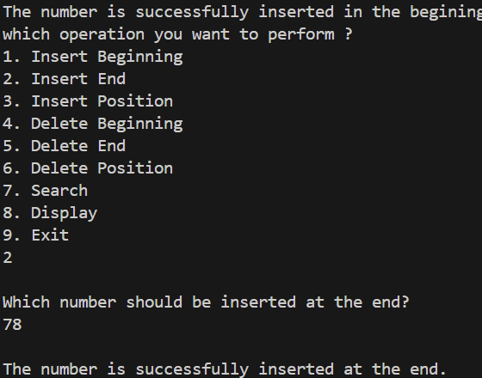

1. **A browser's front and back functionality**

1.AIM

Write a C++ menu-driven program to implement a browser's front and back functionality.

2.TIME COMPLEXITY ANALYSIS:

1.INSERT WEBPAGE : O(n)

2.FRONT: O(1)

3.BACK : O(1)

3.ALGORITHM

1.INSERT WEBPAGE:

Input: webpage,head ,current

Output : 0 or 1

If head=NULL

Head=newnode

Current=newode

Else if head!=current

Set temp1=head

Repeat until head!=current

Head=head->next

Temp2=temp1

Temp1=temp1->next

Free temp2

Return insert(webpage)

Else

Head->prev=newnode

Newnode->next=newnode

Head=newnode

Return 1

2.FRONT:

Input: head,current

Output : 0 or 1

If head=NULL

Return 0

Else

Current=current->prev

Return 1

3.BACK:

Input : head,current

Output : 0 or 1

If head=NULL

Return 0

Else

Current=current->next

Return 1

4.CODE:

HEADER FILE:

// HeaderFile that includes the opertions of doubly linked list

// in the means of web_page represented as data.

#include<stdio.h>

#include<stdlib.h>

class browser{

    private:

    struct node{

        int data ;

        struct node*prev ;

        struct node*next ;

    } ;

    typedef struct node node ;

    node *head ;

    int current ;

    public:

    browser(){

        head=NULL ;

        current=-1 ;

    }

    int newpage(int) ;

    void front() ;

    void back() ;

} ;

// To move to the next page .

// Going to next node of the doubly linked_list.

void browser::front(){

    node *temp=head ;

    if (current==-1)

        printf("\n No next page exists , please add one to travers !!") ;

    else{

        for(int i=0 ;i<current ;i++){

        temp=temp->next ;

    }

    if(temp->next==NULL)

        printf("\n No next page exists , please add one to travers !!!") ;

    else{

        printf("\nCurrent :%d",temp->next->data) ;

        current++ ;

    }

    }

}

// To move to the back page

// Going to previous node of the doubly linked_list.

void browser::back(){

    node *temp=head ;

    if (current==-1 ||current==0)

    printf("\n No next page exists , please add one to travers !!") ;

    else{

        for(int i=0 ;i<(current-1) ;i++){

        temp=temp->next ;

        }

        printf("Current: %d",temp->data) ;

        current-- ;

    }

}

// To create a new webpage.

// Creating a new node in the end ,i.e. insertion at the end.

int browser::newpage(int num){

    if(current==-1){

        node *newnode=(node*)malloc(sizeof(node)) ;

        newnode->prev=NULL ;

        newnode->data=num ;

        newnode->next=head ;

        head=newnode ;

        current++ ;

        return 1 ;

    }

    else{

        node *temp=head,*temp2,*temp3 ;

        for(int i=0 ;i<current ;i++){

            temp=temp->next ;

            }

            temp3=temp ;

            temp=temp->next ;

            temp2=temp ;

        while(temp2!=NULL){

            temp2=temp->next ;

            free(temp) ;

            temp=temp2 ;

        }

        node *newnode=(node*)malloc(sizeof(newnode)) ;

        newnode->data=num ;

        newnode->next=NULL ;

        newnode->prev=temp3 ;

        temp3->next=newnode ;

        current++ ;

        return 1 ;

    }

    return 0 ;

}

CPP FILE:

//  C++ menu-driven program to implement a browser's front and back functionality.

// Imagine that an integer number represents each webpage.

#include<stdio.h>

#include<stdlib.h>

// Including header file that has operations of doubly linked_list.

#include"web_browser.h"

int main(){

    int choice;

    int num;

    browser b1;

    printf("\n\t\t___WEB_BROWSER___\n");

    while(1){

        getchar();

        getchar();

        system("clear");

        printf("1.New webpage\n2.Next\n3.Back\n4.Exit\nEnter :");

        printf("\nWhat do you want to perform?\n");

        scanf("%d",&choice);

        switch (choice){

            case 1:

                printf("\nEnter the number :");

                scanf("%d",&num);

                if(b1.newpage(num))

                printf("\nNew page created successfully !!\nCurrent :%d",num);

                else

                    printf("\nCreation of new page Failed !!");

                break;

            case 2:

                b1.front();

                break;

            case 3:

                b1.back();

                break;

            case 4:

                exit(0);

            default:

                printf("\nInvalid choice ,please try again  !!");

                break;

        }

    }

}

5.OUTPUT:

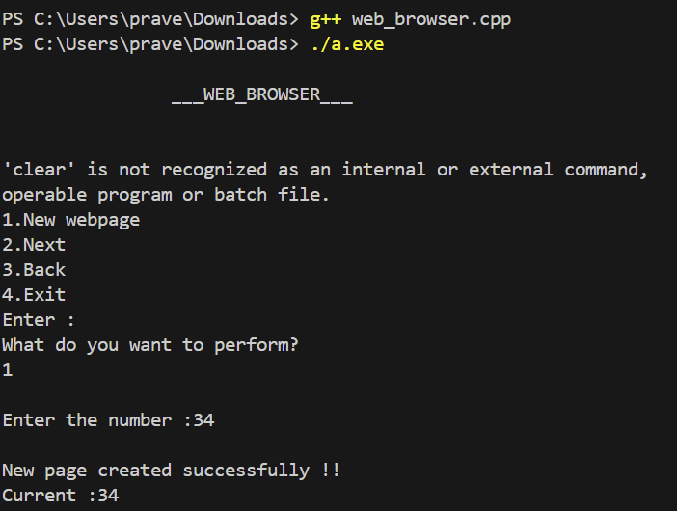

WEEK 6- STACK ADT Date-28/02/24

1.AIM:

To Write a separate C++ menu-driven program to implement stack ADT using a character array of size 5

2.TIME COMPLEXITY ANALYSIS:

1. PUSH: O(1)

2. POP: O(1)

3. PEEK: O(1)

3.ALGORITHM:

1.PUSH:

Input: chr

Output: 1 if element is pushed, 0 otherwise

If top equals size-1

Return 0 indicating stack is full

Else

Increment top

Assign chr to arr at index top

Return 1 indicating success

End If

2.POP:

Output: 1 if element is popped, 0 otherwise

If top equals -1

Return 0 indicating stack is empty

Else

For i from 0 to size-1

Assign value of arr[i+1] to arr[i]

End For

Decrement top

Return 1 indicating success

End If

3.PEEK:

Output: Print the top element of the stack

If top is not equal to -1

Print arr at index top

Else

Print message indicating stack is empty

End If

4.CODE:

// C++ menu-driven program to implement stack ADT using a character array of size 5

#include<stdio.h>

#include<stdlib.h>

#define SIZE 5

class array{

    char arr[SIZE] ;

    int top ;

    public :

        array(){

            top = -1 ;

        }

        int push(char) ;

        int pop() ;

        char peek();

};

int main(){

    array a1 ;

    int choice ;

    int flag ;

    char new_char ;

    char flag1 ;

    while(1){

        printf("\nWhat operation you want to perform on the stack?\n") ;

        printf("1 .PUSH\n2 .POP\n3 .PEEK\n4 .EXIT\n") ;

        scanf("%d",&choice) ;

    switch(choice){

        case 1:

            printf("\nwhat is the character to be inserted in the stack?") ;

            scanf(" %c",&new_char) ;

            flag = a1.push(new_char) ;

            if(flag){

                printf("\nThe character is successfully inserted in the stack.\n") ;

            }

            else{

                 printf("\nAny element cannot be added.The stack is already FULL!.\n") ;

            }

            break ;

        case 2:

            flag = a1.pop() ;

            if(flag){

                printf("\nElement is successfully popped out from the stack.\n") ;

            }

            else{

                printf("\nThere are no elements in the stack to pop.\n") ;

            }

            break ;

        case 3:

            flag1 = a1.peek() ;

            if(flag1 == '1'){

                printf("The stack is empty,No elements are inserted yet.") ;

            }

            else{

                printf("The last element inserted in the stack is %c",flag1) ;

            }

            break ;

        case 4:

            exit(0) ;

        default :

            printf("\nPlease enter a valid choice :)\n") ;

            break ;

    }

    }

}

// Method for pushing an element in the stack.

// (Method for  inserting an element in the end in an array.)

int array::push(char new_char){

    if(top==SIZE-1){

        return 0;

    }

    else{

        top++ ;

        arr[top]=new_char ;

        return 1 ;

    }

}

// Method for poping an element from the stack.

// (Method for deleting an element in the end of the array.)

int array::pop(){

    if(top==-1){

        return 0 ;

    }

    else{

        top-- ;

        return 1 ;

        }

    }

// Method for peeking the element of the stack.

// (Method for printing the last element of the array.)

char array::peek(){

    if(top==-1){

        return '1' ;

    }

    else{

        return arr[top] ;

    }

}

5.OUTPUT

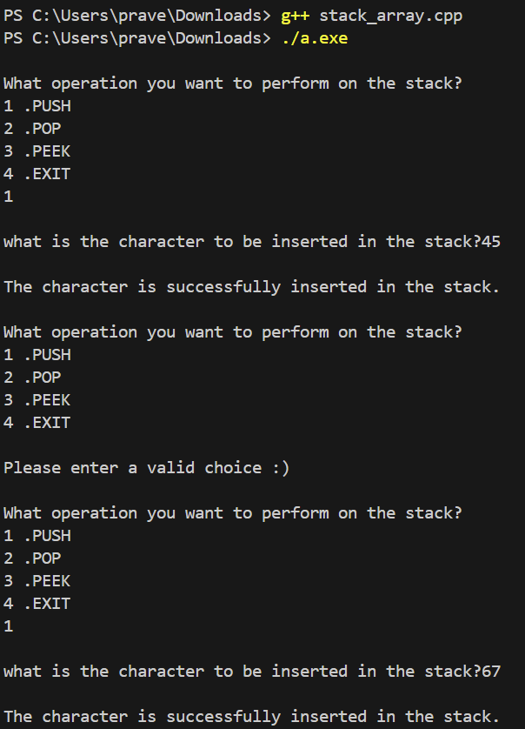

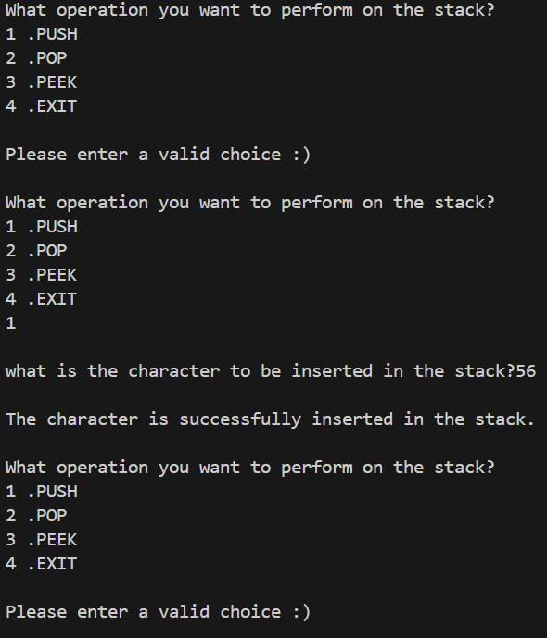

1.AIM:

To  Write a separate C++ menu-driven program to implement stack ADT using a character singly linked list.

2.TIME COMPLEXITY ANALYSIS:

1.PUSH:O(1)

2.POP:O(1)

3.PEEK:O(1)

3.ALGORITHM:

1.PUSH:

Input: chr,stack

Output: 1 if element is pushed, 0 otherwise

Create a new node with data set to chr

If head is NULL

Set newnode next to NULL

Set head to newnode

Else

Set newnode next to head

Set head to newnode

End If

Return 1 indicating success

2.POP:

Output: 1 if element is popped, 0 otherwise

If head is NULL

Return 0 indicating stack is empty

Else

Set temp to head

Set head to head next

Free temp

Return 1 indicating success

End If

3.PEEK:

Check if the head of the stack is NULL, indicating the stack is empty.

If the stack is empty, print "The stack is empty".

Otherwise, print the data of the head node, which is the top element of the stack.

4.CODE:

// C++ menu-driven program to implement stack ADT using a singly linked list.

#include<stdio.h>

#include<stdlib.h>

class list{

    struct node {

        char data ;

        struct node *link ;

    };

    struct node *top ;

    public :

        list(){

            top = NULL ;

        }

        int push(char) ;

        int pop() ;

        char peek() ;

};

int main(){

    list l1 ;

    int choice ;

    int flag ;

    char new_char ;

    char flag1 ;

    while(1){

        printf("\nWhat operation you want to perform on the stack?\n") ;

        printf("1 .PUSH\n2 .POP\n3 .PEEK\n4 .EXIT\n") ;

        scanf("%d",&choice) ;

    switch(choice){

        case 1 :

            printf("\nWhich character should be inserted in the stack?\n") ;

            scanf(" %c",&new_char) ;

            flag = l1.push(new_char) ;

            if(flag){

                printf("\nThe character is successfully inserted in the stack.\n") ;

            }

            else

                printf("\nSome error!,Unable to insert.\n") ;

            break ;

        case 2:

            flag = l1.pop() ;

            if(flag){

                printf("\nElement is successfully popped out from the stack.\n") ;

            }

            else{

                printf("\nThere are no elements in the stack to pop.\n") ;

            }

            break ;

        case 3:

            flag1 = l1.peek() ;

            if(flag == '1'){

                printf("The stack is empty,No elements are inserted yet.") ;

            }

            else{

                printf("The last element inserted in the stack is %c",flag1) ;

            }

            break ;

        case 4:

            exit(0) ;

        default :

            printf("\nPlease enter a valid choice :)\n") ;

            break ;

    }

    }

}

// Method for pushing an element in the stack.

// (Method for  inserting an element in the begining of the list.)

int list::push(char new_char){

    struct node *fresh = (struct node*)malloc(sizeof(struct node)) ;

    if(top == NULL){

        fresh->link = NULL ;

        fresh->data = new_char ;

        top = fresh ;

        return 1 ;

    }

    else {

        fresh->link = top ;

        fresh->data = new_char ;

        top = fresh ;

        return 1 ;

    }

}

// Method for poping an element from the stack.

// (Method for deleting an element in the begining of the singly linked list.)

int list::pop(){

    if(top==NULL){

        return 0 ;

    }

    else{

        top = top->link ;

        return 1 ;

    }

}

// Method for peeking the element of the stack.

// (Method for printing the first element of the linkedlist.)

char list::peek(){

    if(top==NULL){

        return '1' ;

    }

    else{

        return top->data ;

    }

}

5.OUTPUT

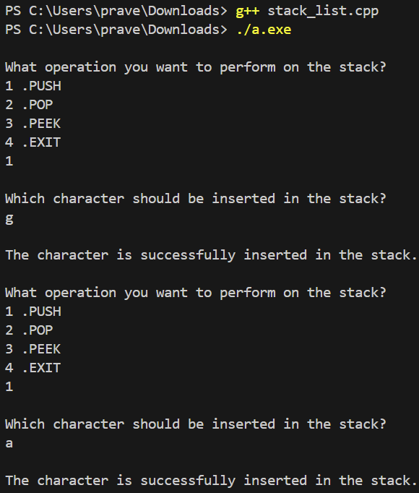

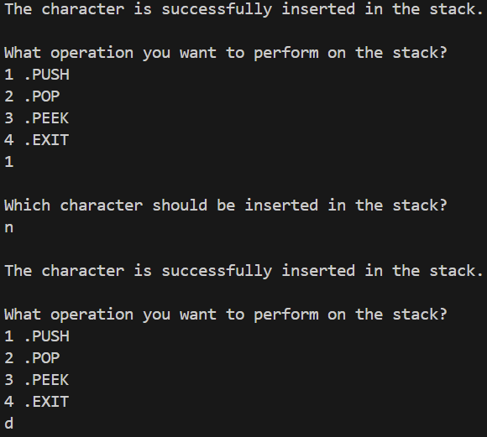

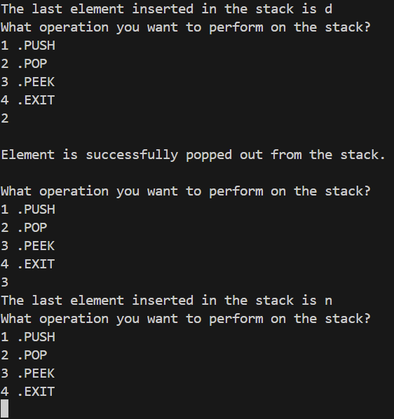

1.AIM:

To  Write a C++ menu-driven program to implement infix to postfix and postfix evaluation.

2.ALGORITHM:

Stack headerfile is imported from the previous code

CHECK:

Input: arr (an array of characters), l1 (pointer to operator stack), l2 (pointer to output stack)

Output: None (the stacks are modified directly)

1. Initialize count to 0

2. Loop through each character in arr until a null terminator '\0' is encountered:

a. If the current character is '*', '/' or '%':

i. If count is 3:

A. Push the top element of l1 onto l2

B. Pop the top element from l1

C. If l1 is empty, set count to 0

D. Otherwise, update count based on the new top of l1

ii. Else:

A. Push the current character onto l1

B. Set count to 3

b. If the current character is '+' or '-':

i. If count is 3 or 2:

A. Repeat steps i.A to i.D as above

ii. Else:

A. Push the current character onto l1

B. Set count to 2

c. If the current character is '=':

i. If count is 1:

A. Repeat steps i.A to i.D as above

ii. Else:

A. Push the current character onto l1

B. Set count to 1

d. If the current character is an operand (not an operator or '='):

i. Push the current character onto l2

3. While l1 is not empty:

a. Push the top element of l1 onto l2

b. Pop the top element from l1

End Loop

3.TIME COMPLEXITY ANALYSIS:

Check:O(n)

4.CODE:

Headerfile:

/*Program to implement stack ADT using singly linked list*/

#include<stdio.h>

#include<stdlib.h>

#include<string.h>

class stack_link {

  struct node{

    char data ;

    struct node *next ;

} ;

struct node *head ;

public:

  stack_link(){

    head=NULL ;

  }

    void push(char chr) ;

    void pop() ;

    char peek() ;

    void check(char arr[25],stack_link *l1,stack_link *l2) ;

    void display() ;

} ;

//Method to push a character into a stack

void stack_link:: push(char chr){

    struct node *newnode=(struct node *)malloc(sizeof(struct node)) ;

    newnode->data=chr ;

    if(head==NULL){

      newnode->next=NULL ;

      head=newnode ;

    }

    else{

       newnode->next=head ;

       head=newnode ;

    }

}

// Method to pop a character from the stack

 void stack_link::pop(){

    struct node *temp=head ;

    if(head!=NULL){

        head=head->next ;

        free(temp) ;

        temp=NULL ;

    }

}

void stack_link ::display(){

    struct node *temp1=head ;

    struct node *temp2=NULL ;

    while(temp1->next!=NULL){

            temp2=temp1 ;

            temp1=temp1->next ;

        }

        temp2->next=NULL ;

        free(temp1) ;

        temp1==NULL ;

}

char stack_link::peek(){

    struct node *temp=head ;

    while(temp!=NULL){

       temp=temp->next ;

    }

    return temp->data ;

}

void stack_link:: check(char arr[25],stack_link *l1,stack_link *l2){

    struct node *temp=head ;

    char char1 ;

    int count=0 ;

    for(int i=0 ;arr[i]!='\0' ;i++){

        if(arr[i]=='*'||arr[i]=='/'|| arr[i]=='%'){

            if(count==3){

                char1=l1->peek() ;

                l2->push(char1) ;

                l1->pop() ;

                if(l1->head==NULL){

                    count=0 ;

                }

                else if ( char1=='*' || char1=='/' || char1=='%'){

                    count=3 ;

                }

                else if ( char1=='+' || char1=='-'){

                    count=2 ;

                }

                else if( char1=='=') {

                    count==1 ;

                }

            }

            else {

                l1->push(arr[i]) ;

                count=3 ;

            }

        }

        else if(arr[i]=='+'||arr[i]=='-'){

            if(count==3 || count==2){

                char1=l1->peek() ;

                l2->push(char1) ;

                l1->pop() ;

                char1=l1->peek() ;

                if(l1->head==NULL){

                    count=0 ;

                }

                else if ( char1=='*' || char1=='/' || char1=='%'){

                    count=3 ;

                }

                else if ( char1=='+' || char1=='-'){

                    count=2 ;

                }

                else if( char1=='='){

                    count==1 ;

                }

            }

            else{

                l1->push(arr[i]) ;

                count=2 ;

            }

        }

        else if(arr[i]=='='){

            if(count==1){

                char1=l1->peek() ;

                l2->push(char1) ;

                l1->pop() ;

                if(l1->head==NULL){

                    count=0 ;

                }

                else if ( char1=='*' || char1=='/' || char1=='%'){

                    count=3 ;

                }

                else if ( char1=='+' || char1=='-'){

                    count=2 ;

                }

                else if( char1=='='){

                    count==1 ;

                }

            }

            else{

            l1->push(arr[i]) ;

            count=1 ;

            }

        }

        else{

            l2->push(arr[i]) ;

        }

    }

    while(l1->head!=NULL){

        l2->push(l1->peek()) ;

        l1->pop() ;

    }

}

Cpp file:

#include<stdio.h>

#include"in_post.h"

int main(){

    stack_link l1,l2,l3 ;

    char arr[25] ;

    printf("Enter the expression:") ;

    scanf("%24s",arr) ;

    l3.check(arr,&l1,&l2) ;

    l2.display() ;

    printf("\n") ;

    return 0 ;

}

5.OUTPUT:

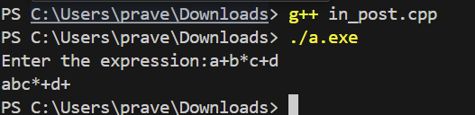

1.AIM:

To Write a C++ menu-driven program to get a string of '(' and ')' parenthesis from the user and check whether they are balanced.

2.ALGORITHMS:

Stack headerfile is imported from the previous code

Check:

Input: arr (an array of characters)

Output: 1 if parentheses are balanced, 0 otherwise

1. Loop through each character in arr until a null terminator '\0' is encountered:

a. If the current character is '(':

i. Push 'a' onto the stack.

b. If the current character is ')':

i. If the stack is empty (head is NULL), return 0 (unbalanced).

ii. Otherwise, pop the top element from the stack.

End Loop

2. After the loop, check if the stack is empty:

a. If the stack is empty (head is NULL), return 1 (parentheses are balanced).

b. Otherwise, return 0 (parentheses are not balanced).

3.TIME COMPLEXITY ANALYSIS:

CHECK:O(N)

4.CODE:

Headerfile:

// program to implement stack ADT using a singly linked list.

// Header file that includes the operations performed on the stack.

#include<stdlib.h>

class list{

    struct node {

        char data ;

        struct node *link ;

    };

    struct node *top ;

    public :

        list(){

            top = NULL ;

        }

        int push(char) ;

        int pop() ;

        char peek() ;

};

// Method for pushing an element in the stack.

// (Method for  inserting an element in the begining of the list.)

int list::push(char new_char){

    struct node *fresh = (struct node*)malloc(sizeof(struct node)) ;

    if(top == NULL){

        fresh->link = NULL ;

        fresh->data = new_char ;

        top = fresh ;

        return 1 ;

    }

    else {

        fresh->link = top ;

        fresh->data = new_char ;

        top = fresh ;

        return 1 ;

    }

}

// Method for poping an element from the stack.

// (Method for deleting an element in the begining of the singly linked list.)

int list::pop(){

    if(top==NULL){

        return 0 ;

    }

    else{

        top = top->link ;

        return 1 ;

    }

}

// Method for peeking the element of the stack.

// (Method for printing the first element of the linkedlist.)

char list::peek(){

    if(top==NULL){

        return '1' ;

    }

    else{

        return top->data ;

    }

}

Cpp file:

// A C++ menu-driven program to get a string of '(' and ')'

// parenthesis from the user and check whether they are balanced.

#include<stdio.h>

#include"paranthesis.h"

void check_balance(list l1) ;

int main(){

    int choice ;

    int count ;

    list l1 ;

    while(1){

        printf("\nEnter Your Choice:\n1 . For Checking Balance\n2 . For Exit\n") ;

        scanf("%d", &choice) ;

        switch(choice){

            case 1:

                check_balance(l1) ;

                break ;

            case 2:

                exit(0) ;

                break ;

            default:

                printf("\nError ! Enter a valid choice\n") ;

                break ;

        }

    }

}

void check_balance(list l1){

    int count ;

    printf("\nHow many characters are there in the string?\n") ;

    scanf("%d",&count) ;

    char* str = (char*)malloc(count * sizeof(char)) ;

    printf("\nEnter the string that has to be checked:\n") ;

    scanf("%s",str) ;

    if(*str==')'){

        printf("The string is not balanced") ;

    }

    else{

        for(int i = 0;i<count;i++){

            if(*str=='('){

                l1.push(*str) ;

                str++ ;

            }

            else if(*str==')'){

                l1.pop() ;

                str++ ;

            }

        }

    if(l1.peek()=='1'){

        printf("The string is balanced") ;

    }

    else{

        printf("The string is not balanced") ;

    }

    }

}

5.OUTPUT:

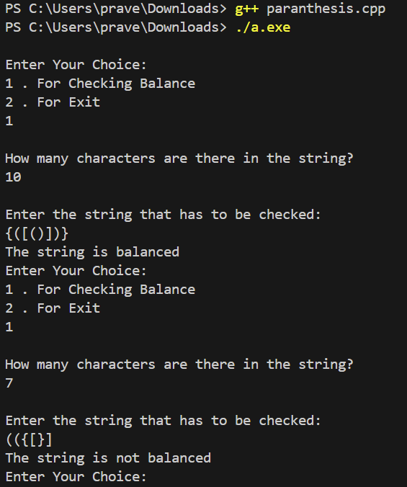

WEEK 7-QUEUE AND CIRCULAR QUEUE ADT Date:06/03/24

1.AIM:

T0 Write a separate C++ menu-driven program to implement Queue ADT using an integer array of size 5.

2.ALGORITHMS:

1.ENQUEUE:

Input: num (an integer to be added to the queue),arr

Output: 1 if the operation is successful, 0 otherwise

1. Check if the queue is full:

- If (rear + 1) % size == front, then return 0 (queue is full).

2. Check if the queue is empty:

- If front == -1, then set front and rear to 0.

3. Otherwise:

- Set rear to (rear + 1) % size.

- Store num at arr[rear].

4. Return 1 indicating that the operation was successful.

2.DEQUEUE:

Input: arr

Output: 1 if the operation is successful, 0 otherwise

1. Check if the queue is empty:

- If front == -1, then return 0 (queue is empty).

2. Check if the front equals the rear:

- If true, then set front and rear to -1 (the queue will be empty after this operation).

3. Otherwise:

- Increment front using front = (front + 1) % size.

4. Return 1 indicating that the operation was successful.

3.PEEK:

Output: Prints the element at the front of the queue

1. Check if the queue is empty:

- If front == -1, print "The queue is empty".

2. Otherwise:

- Print the element at arr[front].

3.TIME COMPLEXITY ANALYSIS:

1. **Enqueue**: O(1)
2. **Dequeue**: O(1)
3. **Peek**: O(1)

4.CODE:

// C++ menu-driven program to implement queue ADT using an integer array of size 5.

#include<stdio.h>

#include<stdlib.h>

#define SIZE 5

class queue{

   int arr[SIZE] ;

   int front,rear ;

   public :

       queue(){

           front = -1 ;

           rear = -1 ;

       }

       int enqueue(int) ;

       int dequeue() ;

       int peek() ;

 };

int main(){

    queue q1 ;

    int choice ;

    int num ;

    int flag ;

    int pos ;

    while(1){

        printf("\nWhich operation do you want to perform?\n") ;

        printf("1 .enqueue\n2 .dequeue\n3 .Peek\n4 .EXIT\n") ;

        printf("Enter the serial.no. of the operation you want to perform : ") ;

        scanf("%d",&choice) ;

    switch(choice){

        case 1:

            printf("\nWhat is the number to be inserted?") ;

            scanf("%d",&num) ;

            flag = q1.enqueue(num) ;

            if(flag){

                printf("\nThe number is successfully inserted in the queue.\n") ;

            }

            else{

                printf("\nAny element cannot be added.The queue is already FULL!.\n") ;

            }

            break ;

        case 2:

            flag = q1.dequeue() ;

            if(flag)

                printf("\nThe element is successfully dequeued from the queue.\n") ;

            else

                printf("\nqueue is already empty\nAdd some elements in the queue to dequeue :)\n") ;

           break ;

        case 3:

            flag = q1.peek() ;

            if(flag==-1){

                printf("\nThe queue is empty,Please insert an element first\n") ;

            }

            else{

                printf("The peek value of the queue is %d",flag) ;

            }

            break ;

        case 4:

            exit(0) ;

            break ;

        default :

            printf("\nPlease enter a valid choice :)\n") ;

    }

   }

}

// Method for inserting a member in the queue.

int queue::enqueue(int num){

    if((rear==-1) && (front==-1)){

        arr[0] = num ;

        front++ ;

        rear++ ;

        return 1 ;

    }

    else{

        if((front == SIZE-1) && (rear == SIZE-1)){

            return 0 ;

        }

        else{

            arr[rear+1] == num ;

            rear++ ;

    }

        return 1 ;

    }

}

// Method for removing a number from the circular_queue.

int queue::dequeue(){

    if(front < SIZE-1){

        front++ ;

    }

    else if((front==SIZE-1) && (rear==SIZE-1)){

        front = -1 ;

        rear = -1 ;

    }

    else if((front==-1) && (rear==-1)){

        return 0 ;

    }

    return 1 ;

}

// Method for showing the peek value of the queue.

// Method for showing the element i.e. gonna come out when we dequeue it .

int queue::peek(){

    if((front==-1) && (rear==-1)){

        return -1 ;

    }

    else{

        return arr[front] ;

    }

}

5.OUTPUT:

1.AIM:

To Write a separate C++ menu-driven program to implement Queue ADT using an integer-linked list

2.ALGORITHMS:

1.ENQUEUE:

Input: num (integer value to be enqueued),list

Output: 1 if the enqueue operation is successful, 0 otherwise (though this setup always returns 1 upon successful memory allocation)

1. Create a new node dynamically allocating memory for it.

2. Set the data of the new node to num and its next pointer to NULL.

3. Check if the queue (front pointer) is empty:

- If yes, set both front and rear pointers to this new node.

- If no, append the new node to the end of the queue (rear->next) and move the rear pointer to this new node.

4. Return 1 to indicate that the enqueue operation was successful.

2.DEQUEUE:

Input: list

Output: 1 if an element is successfully dequeued, 0 if the queue is empty.

1. Check if the queue (front pointer) is empty:

- If yes, return 0 indicating the queue is empty and nothing to dequeue.

2. Set a temporary pointer (temp) to the front.

3. Update the front pointer to the next node in the queue.

4. Free the memory of the node pointed by temp.

5. If after updating, the front becomes NULL, also set the rear to NULL (handling the last element removal).

6. Return 1 to indicate the dequeue operation was successful.

3.PEEK:

Input:list

Output: Print the value of the front element of the queue.

1. Check if the queue is empty (front is NULL):

- If not empty, print the data value of the front node.

- If empty, print an appropriate message indicating the queue is empty (though in your current code, this check is missing and could be added for safety).

3.TIME COMPLEXITY ANALYSIS:

1.ENQUEUE:O(1)

2.DEQUEUE:O(1)

3.PEEK:O(1)

4.CODE:

// C++ menu-driven program to implement queue ADT using linked list.

#include<stdio.h>

#include<stdlib.h>

class queue{

    struct node{

    int data ;

    struct node *link ;

    };

    struct node *front ;

    struct node *rear ;

    public :

        queue(){

            front = NULL ;

            rear = NULL ;

        }

       int enqueue(int) ;

       int dequeue() ;

       int peek() ;

 };

int main(){

    queue q1 ;

    int choice ;

    int num ;

    int flag ;

    int pos ;

    printf("\nEnter any key to proceed\n") ;

    getchar() ;

    while(1){

        printf("\nWhich operation do you want to perform?\n") ;

        printf("1 .enqueue\n2 .dequeue\n3 .Peek\n4 .EXIT\n") ;

        printf("Enter the serial.no. of the operation you want to perform : ") ;

        scanf("%d",&choice) ;

    switch(choice){

        case 1:

            printf("\nWhat is the number to be inserted?") ;

            scanf("%d",&num) ;

            flag = q1.enqueue(num) ;

            if(flag){

                printf("\nThe number is successfully inserted in the queue.\n") ;

            }

            else{

                printf("\nAny element cannot be added.The queue is already FULL!.\n") ;

            }

            break ;

        case 2:

            flag = q1.dequeue() ;

            if(flag)

                printf("\nThe element is successfully dequeued from the queue.\n") ;

            else

                printf("\nqueue is already empty\nAdd some elements in the queue to dequeue :)\n") ;

           break ;

        case 3:

            flag = q1.peek() ;

            if(flag==-1){

                printf("\nThe queue is empty,Please insert an element first\n") ;

            }

            else{

                printf("The peek value of the queue is %d",flag) ;

            }

            break ;

        case 4:

            exit(0) ;

            break ;

        default :

            printf("\nPlease enter a valid choice :)\n") ;

            break ;

    }

   }

}

// Method for inserting a member in the queue.

int queue::enqueue(int num){

    struct node *newnode = (struct node*)malloc(sizeof(node)) ;

    newnode->data = num ;

    newnode->link = NULL ;

    if((rear==NULL) && (front==NULL)){

        front = newnode ;

        rear = newnode ;

        return 1 ;

    }

    else{

        rear->link = newnode ;

        rear = newnode ;

        return 1 ;

        }

        return 0 ;

}

// Method for removing a number from the queue.

int queue::dequeue(){

    if((front==NULL) && (rear==NULL)){

        return 0 ;

    }

    else{

        front = front->link ;

        return 1 ;

    }

}

// Method for showing the peek value of the queue.

// Method for showing the element i.e. gonna come out when we dequeue it .

int queue::peek(){

    if((front==NULL) && (rear==NULL)){

        return -1 ;

    }

    else{

        return front->data ;

    }

}

5.OUTPUT:

1.AIM:

To Write a separate C++ menu-driven program to implement Circular Queue ADT using an integer-linked list.

2.ALGORITHMS:

1.ENQUEUE:

Input: num (integer to be added to the queue),list

Output: 1 on successful insertion, 0 on failure (though failure isn't possible unless memory allocation fails)

1. Allocate memory for a new node.

2. Set the data of the new node to num.

3. If the queue is empty:

- Set the new node's next pointer to point to itself (making it circular).

- Set both front and rear pointers to the new node.

4. If the queue is not empty:

- Set the new node's next pointer to the front.

- Update the rear's next pointer to point to the new node.

- Move the rear pointer to the new node.

5. Return 1 to indicate success.

2.DEQUEUE:

Output: 1 if an element is successfully dequeued, 0 if the queue is empty.

1. If the queue is empty (front is NULL):

- Return 0.

2. If the queue has only one node (front == rear):

- Free the node.

- Set front and rear to NULL.

3. If the queue has more than one node:

- Set the front to the next node of the front.

- Adjust the rear's next pointer to point to the new front.

- Free the old front node.

4. Return 1 to indicate success.

3.PEEK:

Output: Displays the data of the front element.

1. If the queue is not empty:

- Print the data of the front node.

2. If the queue is empty:

- Print an appropriate message indicating that the queue is empty. (This check should ideally be included for safety)

3.TIME COMPLEXITY ANALYSIS:

1.ENQUEUE:O(1)

2.DEQUEUE:O(1)

3.PEEK:O(1)

4.CODE:

// C++ menu-driven program to implement circular_queue ADT using linked list.

#include<stdio.h>

#include<stdlib.h>

class queue{

    struct node{

    int data ;

    struct node *link ;

    };

    struct node *front ;

    struct node *rear ;

    public :

        queue(){

            front = NULL ;

            rear = NULL ;

        }

       int enqueue(int) ;

       int dequeue() ;

       int peek() ;

 };

int main(){

    queue q1 ;

    int choice ;

    int num ;

    int flag ;

    int pos ;

    printf("\nEnter any key to proceed\n") ;

    getchar() ;

    while(1){

        printf("\nWhich operation do you want to perform?\n") ;

        printf("1 .enqueue\n2 .dequeue\n3 .Peek\n4 .EXIT\n") ;

        printf("Enter the serial.no. of the operation you want to perform : ") ;

        scanf("%d",&choice) ;

        switch(choice){

            case 1:

                printf("\nWhat is the number to be inserted?") ;

                scanf("%d",&num) ;

                flag = q1.enqueue(num) ;

                if(flag){

                    printf("\nThe number is successfully inserted in the queue.\n") ;

                }

                else{

                    printf("\nAny element cannot be added.The queue is already FULL!.\n") ;

                }

                break ;

            case 2:

                flag = q1.dequeue() ;

                if(flag)

                    printf("\nThe element is successfully dequeued from the queue.\n") ;

                else

                    printf("\nqueue is already empty\nAdd some elements in the queue to dequeue :)\n") ;

            break ;

            case 3:

                flag = q1.peek() ;

                if(flag==-1){

                    printf("\nThe queue is empty,Please insert an element first\n") ;

                }

                else{

                    printf("The peek value of the queue is %d",flag) ;

                }

                break ;

            case 4:

                exit(0) ;

                break ;

            default :

                printf("\nPlease enter a valid choice :)\n") ;

                break ;

        }

    }

}

// Method for inserting a member in the circular_queue.

int queue::enqueue(int num){

    struct node *temp ;

    struct node *newnode = (struct node*)malloc(sizeof(node)) ;

    newnode->data = num ;

    if((rear==NULL) && (front==NULL)){

        front = newnode ;

        rear = newnode ;

        newnode->link = newnode ;

        return 1 ;

    }

    else{

        rear->link = newnode ;

        rear = newnode ;

        newnode->link = front ;

        return 1 ;

    }

        return 0 ;

}

// Method for removing a number from the queue.

int queue::dequeue(){

    if((front==NULL) && (rear==NULL)){

        return 0 ;

    }

    else{

        front = front->link ;

        rear->link = front ;

        return 1 ;

    }

}

// Method for showing the peek value of the queue.

// Method for showing the element i.e. gonna come out when we dequeue it .

int queue::peek(){

    if((front==NULL) && (rear==NULL)){

        return -1 ;

    }

    else{

        return front->data ;

    }

}

5.OUTPUT:

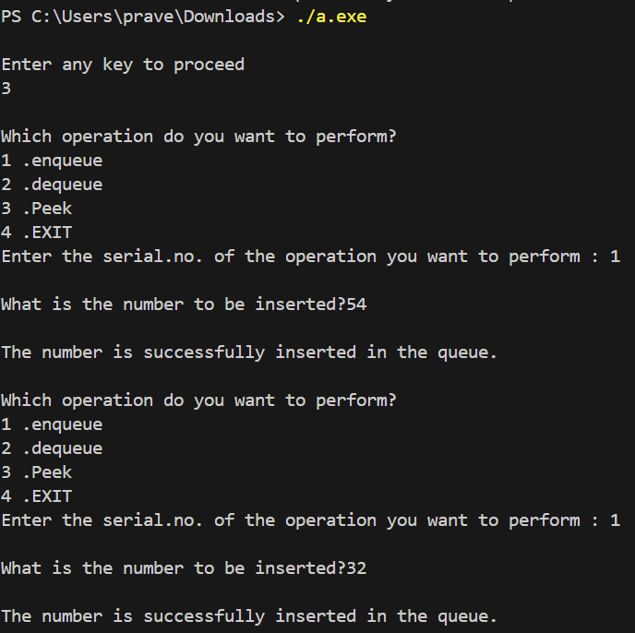

1.AIM:

To Implement the round-robin scheduling algorithm using the circular queue ADT

2.ALGORITHMS:

1.ENQUEUE:

Input: num (remaining CPU time for the task)

Output: 1 on successful insertion

1. Allocate memory for a new node.

2. Set the new node's data to num.

3. If the queue is empty (front is NULL):

- Set newnode's next pointer to itself.

- Set both front and rear pointers to this new node.

4. If the queue is not empty:

- Set newnode's next pointer to front.

- Update rear's next pointer to point to the new node.

- Move the rear pointer to the new node.

5. Return 1 to indicate success.

2.DEQUEUE:

Output: 1 if a process is removed or moved to the end of the queue, 0 if the queue is empty.

1. Check if the queue is empty:

- If true, return 0.

2. If the process at the front of the queue requires time less than or equal to the timeslot:

- Remove the front node.

- If it was the only node, reset front and rear to NULL.

- Else, adjust front to the next node and rear's next to the new front.

- Free the removed node.

3. If the process requires more time than the timeslot:

- Calculate the remaining time after the current timeslot.

- Remove the front node.

- Enqueue the remaining time as a new task at the rear of the queue.

- Adjust the front to the next node and rear's next to the new front if not the only node.

4. Return 1 to indicate the task was processed.

3.TIME COMPLEXITY ANALYSIS:

1.ENQUEUE:O(1)

2.DEQUEUE:O(1)

4.CODE:

Headerfile:

//program to implement cpu timeslot

#include<stdio.h>

#include<stdlib.h>

#define timeslot 25

class queue

{

  struct node

  {

    int data;

    struct node *next;

  };

    struct node *front;

    struct node *rear;

  public:

  queue()

  {

   front=NULL;

   rear=NULL;

  }

  int enqueue(int num);

  int dequeue();

};

//Method to insert an element in the queue

int queue::enqueue(int num)

{

  struct node *newnode=(struct node *)malloc(sizeof(struct node));

  if(front==NULL)

  {

    newnode->data=num;

    newnode->next=newnode;

    front=newnode;

    rear=newnode;

    return 1;

  }

  else

  {

    newnode->data=num;

    newnode->next=front;

    rear->next=newnode;

    rear=newnode;

    return 1;

  }

}

// Method to delete an element from the queue

int queue:: dequeue()

{

  if(front==NULL)

  {

    return 0;

  }

  else

  {

    if(front->data-timeslot<=0)

    {

      if(front==rear)

      {

        front=NULL;

        rear=NULL;

        return 1;

      }

      else

      {

        struct node *temp=front;

        front=front->next;

        rear->next=front;

        free(temp);

        temp=NULL;

        return 1;

      }

    }

    else

    {

      int time;

      time=front->data-timeslot;

      if(front==rear)

      {

        front=NULL;

        rear=NULL;

      }

      else

      {

        struct node *temp=front;

        front=front->next;

        rear->next=front;

        free(temp);

        temp=NULL;

      }

      enqueue(time);

      return 1;

    }

  }

}

Cpp file:

#include<stdio.h>

#include<stdlib.h>

#include"e.h"

int main()

{

    queue q1;

    int choice;

    char i;

    while(1)

    {

        printf("\n(1) Insert");

        printf("\n(2) Execute");

        printf("\n(3) Exit");

        printf("\nEnter your choice:");

        scanf("%d",&choice);

        getchar();

        switch (choice)

        {

            case 1:

            int num1;

            printf("Enter the number to insert:");

            scanf("%d",&num1);

            if(q1.enqueue(num1))

            {

              printf("Element is inserted successfully");

            }

            else

            {

              printf("Operation failed!");

            }

            break;

            case 2:

            if(q1.dequeue())

            {

              printf("Element is removed successfully");

            }

            else

            {

              printf("The queue is empty!");

            }

            break;

            case 3:

            return 0;

        }

    }

}

5.OUTPUT:

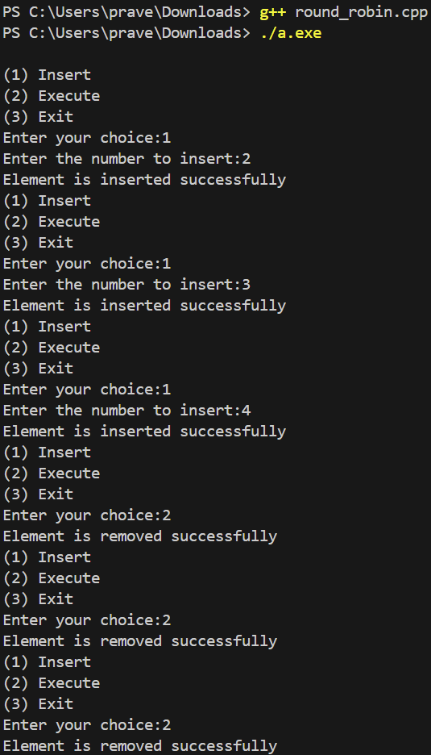

1.AIM:

To write a program to remove ‘+’ and non ‘+’ character in the left of ‘+’ from a string

2.ALGORITHMS:

CHECK:

Input: string (an array of characters), s1 (pointer to the first stack), s2 (pointer to the second stack)

Output: None (the stacks are modified directly)

1. Loop through each character in the string:

a. If the character is not '+':

- Push the character onto stack s1.

b. If the character is '+':

- Check if the next node in s1 is not NULL.

- If it's not NULL, pop the top character from s1.

2. After processing all characters in the string:

- While s1 is not empty:

- Pop a character from s1.

- Push the popped character onto s2.

End

3.TIME COMPLEXITY ANALYSIS:

Check:O(1)

4.CODE:

Headerfile:

#include<stdio.h>

#include<stdlib.h>

class stack

{

  struct node

{

    char data;

    struct node *next;

};

struct node *head;

public:

  stack()

  {

    head=NULL;

  }

    int push(char chr);

    char pop();

    void peek();

    void check(char string[25],stack *s1,stack *s2);

};

//Method to push a character into a stack

int stack:: push(char chr)

{

    struct node *newnode=(struct node *)malloc(sizeof(struct node));

    newnode->data=chr;

    if(head==NULL)

    {

      newnode->next=NULL;

      head=newnode;

      return 1;

    }

    else

    {

       newnode->next=head;

       head=newnode;

       return 1;

    }

}

// Method to pop a character from the stack

char stack::pop()

{

    struct node *temp=head;

    if(head==NULL)

    {

        return '\0';

    }

    else

    {

        char data;

        data=head->data;

        head=head->next;

        free(temp);

        temp=NULL;

        return data;

    }

}

// Method to display the last element in a stack

void stack::peek()

{

    struct node *temp=(struct node*)malloc(sizeof(struct node));

    temp=head;

    while(temp!=NULL)

    {

        printf("%c",temp->data);

        temp=temp->next;

    }

}

void stack::check(char string[25],stack*s1,stack *s2)

{

    for(int i=0;string[i]!='\0';i++)

    {

        if (string[i]!='+')

        {

            s1->push(string[i]);

        }

        else if(string[i]=='+')

        {

            if(s1->head->next!=NULL)

            {

              s1->pop();

            }

        }

    }

    while(s1->head!=NULL)

    {

        s2->push(s1->pop());

    }

}

Cpp file:

// program to remove '+' and non'+' left character from a given string

#include<stdio.h>

#include"f.h"

int main()

{

    stack s1,s2;

    char string[25];

        printf("Enter the string:");

        scanf(" %24s",string);

        s2.check(string,&s1,&s2);

        s2.peek();

}

5.OUTPUT:

WEEK 8- TREE ADT-BINARY TREE Date-20/03//24

1.AIM:

To Write a separate C++ menu-driven program to implement Tree ADT using a character binary tree

2.ALGORITHMS:

1.INSERT:

Input: num,root

Output: 0 or 1

If root = NULL

Root=newnode

Return 1

Else

Repeat untill node is inserted

If choice= 1

Go left

If choice= 2

Go right

2.DELETE:

Input: root

Output: none

If root=NULL

Return 0

Else if 1 child:

Set temp=child

Free node

Return temp

Else if 2 children

Set leftmost= rightchild

Repeat until leftmost->left=NULL/

Leftmost=leftmost->left

Leftmost->left=leftchild

Return rightchild

Else

Call delete(root->left or root->right)

3.INORDER:

Input : root

Output : Displays all the elements

If root=NULL

Return;

Else

Call inorder(root->left)

Display root->data

Call inorder(root->right)

4.POSTORDER:

Input : root

Output : Displays all the elements

If root=NULL

Return

Else

Call postorder(root->left)

Call postorder(root->right)

Display root->data

5.PREORDER:

Input : root

Output : displays all the elements

if root=NULL

return

else

Display root->data

call preorder(root->left)  
 call preorder(root->right)

6.SEARCH:

Input : num,root

Output : true or false

if root = NULL

return false

else if root->data=num

return true

else

call search(num,root->left) or search(num,root->right)

3.TIME COMPLEXITY ANALYSIS

1.INSERT: O(n)

2.DELETE:O(n)

3.INORDER:O(n)

4.POSTORDER:O(n)

5.PREORDER:O(n)

6.SEARCH:O(n)

4.CODE:

// Program to implement the Tree ADT using a character binary tree.

#include <stdio.h>

#include <stdlib.h>

struct Node{

    char data ;

    struct Node *left ;

    struct Node *right ;

};

class BinaryTree{

    struct Node *root ;

public:

    BinaryTree(){

        root = NULL ;

    }

    struct Node *getRoot(){

            return root ;

        };

    void insert(char) ;

    void preOrder(struct Node *) ;

    void postOrder(struct Node *) ;

    void inOrder(struct Node *) ;

    int search(struct Node *, char) ;

    void deleteNode(char) ;

    struct Node *deleteNodeRecursive(Node *, char ch){

        if (root == NULL){

            return root ;

        }

        if (root->data == ch){

            free(root) ;

            return NULL ;

        }

        root->left = deleteNodeRecursive(root->left, ch) ;

        root->right = deleteNodeRecursive(root->right, ch) ;

        return root ;

    }

};

int main(){

    BinaryTree tree ;

    int choice ;

    char ch ;

    while (1){

        printf("\n1. Insert\n2. Preorder\n3. Postorder\n4. Inorder\n5. Search\n6.Delete\n7.Exit\nEnter your choice: ") ;

        scanf("%d", &choice) ;

        switch (choice){

        case 1:

            printf("Enter the character to insert: ") ;

            scanf(" %c", &ch) ;

            tree.insert(ch) ;

            break ;

        case 2:

            printf("Preorder: ") ;

            tree.preOrder(tree.getRoot()) ;

            break ;

        case 3:

            printf("Postorder: ") ;

            tree.postOrder(tree.getRoot()) ;

            break ;

        case 4:

            printf("Inorder: ") ;

            tree.inOrder(tree.getRoot()) ;

            break ;

        case 5:

            int found ;

            printf("Enter the character to search: ") ;

            scanf(" %c", &ch) ;

            found = tree.search(tree.getRoot(), ch) ;

            if (found == 1){

                printf("Element %c found in the tree.", ch) ;

            }

            else{

                printf("Element not found in the tree.") ;

            }

            break ;

        case 6:

            printf("Enter the character to delete: ") ;

            scanf(" %c", &ch) ;

            tree.deleteNode(ch) ;

            break ;

        case 7:

            printf("Exit successful") ;

            exit(0) ;

        default:

            printf("Invalid choice\n") ;

            break ;

        }

    }

    printf("\n") ;

    return 0 ;

}

// Method to insert a node in the binary tree: O(height of the tree)

void BinaryTree::insert(char ch){

    struct Node *newNode = (struct Node *)malloc(sizeof(struct Node)) ;

    newNode->data = ch ;

    newNode->left = NULL ;

    newNode->right = NULL ;

    if (root == NULL){

        root = newNode ;

        return ;

    }

    else{

        struct Node *temp = root ;

        while (1){

            char choice ;

            printf("Enter the direction to insert (l/r) of %c: ", temp->data) ;

            scanf(" %c", &choice) ;

            if (choice == 'l' || choice == 'L'){

                if (temp->left == NULL){

                    temp->left = newNode ;

                    break ;

                }

                else{

                    temp = temp->left ;

                }

            }

            else{

                if (temp->right == NULL){

                    temp->right = newNode ;

                    break ;

                }

                else{

                    temp = temp->right ;

                }

            }

        }

    }

}

// Method to traverse the binary tree in preorder: O(n)

void BinaryTree::preOrder(struct Node *root){

    if (root == NULL){

        return ;

    }

    printf("%c ", root->data) ; // Change %d to %c

    preOrder(root->left) ;

    preOrder(root->right) ;

}

// Method to traverse the binary tree in postorder: O(n)

void BinaryTree::postOrder(struct Node *root){

    if (root == NULL){

        return ;

    }

    postOrder(root->left) ;

    postOrder(root->right) ;

    printf("%c ", root->data) ; // Change %d to %c

}

// Method to traverse the binary tree in inorder: O(n)

void BinaryTree::inOrder(struct Node *root){

    if (root == NULL){

        return ;

    }

    inOrder(root->left) ;

    printf("%c ", root->data) ; // Change %d to %c

    inOrder(root->right) ;

}

// Method to search for a node in the binary tree: O(n)

int BinaryTree::search(struct Node *root, char ch){

    if (root == NULL){

        return 0 ;

    }

    if (root->data == ch){

        return 1 ;

    }

    int res1 = search(root->left, ch) ;

    if (res1 == 1){

        return 1 ;

    }

    int res2 = search(root->right, ch) ;

    return res2 ;

}

// Method to delete a node in the binary tree: O(n)

void BinaryTree::deleteNode(char ch){

    if (search(root, ch) == 1){

        root = deleteNodeRecursive(root, ch) ;

    }

    else{

        printf("No element found,nothing to be deleted.") ;

    }

}

5.OUTPUT:

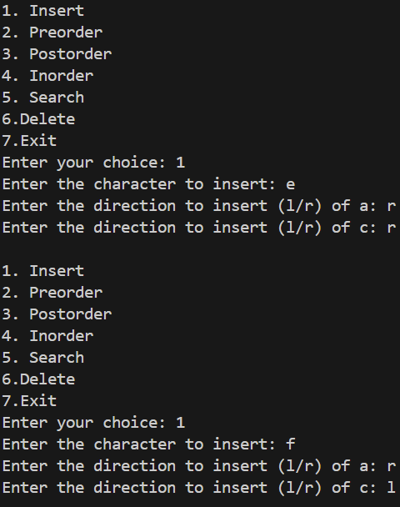

1.AIM:

To Add a "construct expression tree" method to the binary tree data structure

2.ALGORITHMS:

1. INSERT:

Input : string,root

Output : none

For char in string

If char Is a operator

Newnode->left=pop

Newnode->right=pop

Else

Assign char to a newnode

Push newnode

2.INORDER:

Input : root

Output : Displays all the elements

If root=NULL

Return;

Else

Call inorder(root->left)

Display root->data

Call inorder(root->right)

3.POSTORDER:

Input : root

Output : Displays all the elements

If root=NULL

Return

Else

Call postorder(root->left)

Call postorder(root->right)

Display root->data

4.PREORDER:

Input : root

Output : displays all the elements

if root=NULL

return

else

Display root->data

call preorder(root->left)  
 call preorder(root->right)

3.TIME COMPLEXITY ANALYSIS:

1. INSERT:O(n)
2. INORDER:O(n)
3. PREORDER:O(n)
4. POSTORDER:O(n)

4.CODE:

//program to implement binary expression tree

#include<stdio.h>

#include<stdlib.h>

class bintree{

    struct node{

        struct node *left ;

        char data ;

        struct node *right ;

        struct node *next ;

    } ;

    struct node *root ;

    // Method for printing the elements inorder .

    void inorder(struct node *root){

        if (root==NULL){

            return  ;

        }

        else{

            inorder(root->left) ;

            printf("%c\t",root->data) ;

            inorder(root->right) ;

        }

    }

    // Method for printing the elements preorder .

    void preorder(struct node *root){

        if(root==NULL){

            return ;

        }

        else{

            printf("%c\t",root->data) ;

            preorder(root->left) ;

            preorder(root->right) ;

        }

    }

    // Method for printing the elements postorder .

    void postorder(struct node *root){

        if(root==NULL){

            return ;

        }

        else{

            postorder(root->left) ;

            postorder(root->right) ;

            printf("%c\t",root->data) ;

        }

    }

    // Method to insert a new node in ADT that behaves like a stack.

    void push(struct node *newnode){

        if(root==NULL){

            root=newnode ;

        }

        else{

        newnode->next=root ;

        root=newnode ;

        }

    }

    // Method to poping node in ADT that behaves like a stack.

    struct node * pop(){

        if (root==NULL){

            return NULL ;

        }

        else{

            struct node *temp=root ;

            root=root->next ;

            return temp ;

        }

    }

    public:

        void callin(){

            inorder(root) ;

        }

        void callpre(){

            preorder(root) ;

        }

        void callpost(){

            postorder(root) ;

        }

        bintree(){

            root=NULL ;

        }

        void insert(char string[25]) ;

} ;

int main(){

    bintree b1 ;

    char string[25] ;

    int choice ;

    while(1){

        printf("\n(1) Postfix Expression") ;

        printf("\n(2) Preorder") ;

        printf("\n(3) Inorder ") ;

        printf("\n(4) postorder") ;

        printf("\n(5) Exit") ;

        printf("\nEnter your choice") ;

        scanf("%d",&choice) ;

        getchar() ;

        switch (choice){

            case 1:

                printf("Enter the expression") ;

                scanf(" %24s",string) ;

                b1.insert(string) ;

                break ;

            case 2:

                b1.callpre() ;

                break ;

            case 3:

                b1.callin() ;

                break ;

            case 4:

                b1.callpost() ;

                break ;

            case 5:

                return 0 ;

        }

    }

}

// Method for converting atring into a binary tree of postfix expression.

void bintree::insert(char string[25]){

    for(int i=0 ;string[i]!='\0' ;i++){

           struct node *newnode=(struct node *)malloc(sizeof(struct node)) ;

            newnode->data=string[i] ;

            newnode->left=NULL ;

            newnode->right=NULL ;

            newnode->next=NULL ;

        if(string[i]=='*' || string[i]=='/' || string[i]=='+'|| string[i]=='-'){

            newnode->right=pop() ;

            newnode->left=pop() ;

        }

         push(newnode) ;

    }

}

5.OUTPUT:

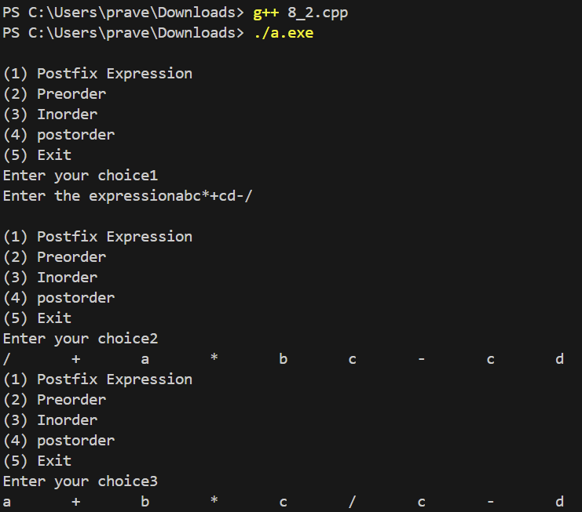

.AIM:

To identify the **optimal**ADT that can find a given number, its previous smaller element, and the next bigger element.

2.ALGORITHM:

1. Get the input from the user

2. Store it in the array

3.Traverse the array

4. Repeat until array reaches null character

5.If element < key and >lower

Lower=element

6.If element >key and < upper

Upper=element

3.TIME COMPLEXITY ANALYSIS: O(n)

4.CODE:

#include <stdio.h>

int main(){

    int array[] = {4,1,1,2,6,8,3,9,7,5} ;

    int len = sizeof(array) / sizeof(int) ;

    int number ;

    int lower = 0 ;

    int upper = 0 ;

    int flagl=0,flagu=0 ;

    printf("Enter Number: ") ;

    scanf("%d", &number) ;

    for(int i = 0 ; i < len ; i++){

        if(array[i] < number && (lower == 0 || array[i] > lower)){

            lower = array[i] ;

            flagl=1 ;

        }

        else if(array[i] > number && (upper == 0 || array[i] < upper)){

            upper = array[i] ;

            flagu=1 ;

        }

    }

    if(flagl==0){

        printf("None %d %d", number, upper) ;

    }

    else if (flagu==0){

       printf(" %d %d None",lower, number) ;

    }

    else{

        printf(" %d %d %d",lower, number,upper) ;

    }

    return 0 ;

}

5.OUTPUT:

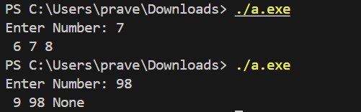

WEEK 9- TREE ADT-BINARY SEARCH TREE Date:27/03/24

1.AIM:

To Write a separate C++ menu-driven program to implement Tree ADT using a character binary tree

2.ALGORITHMS:

1.INSERT:

Input: num

Output: 0 or 1

If root = NULL

Root=newnode

Return 1

Else

Set temp=root

Repeat until node is inserted

If num<key

Go left and insert if temp->left is NULL else repeat

Else

Go right and insert if temp->right is NULL else repeat

2.INORDER:

Input : root

Output : Displays all the elements

If root=NULL

Return;

Else

Call inorder(root->left)

Display root->data

Call inorder(root->right)

3.POSTORDER:

Input : root

Output : Displays all the elements

If root=NULL

Return

Else

Call postorder(root->left)

Call postorder(root->right)

Display root->data

4.PREORDER:

Input : root

Output : displays all the elements

if root=NULL

return

else

Display root->data

call preorder(root->left)  
 call preorder(root->right)

6.SEARCH:

Input : num,root

Output : true or false

if root = NULL

return false

else if root->data=num

return true

else

if key<root

call search(num,root->left)

else

call search(num,root->right)

3.TIME COMPLEXITY ANALYSIS :

1.INSERT:O(n)

2.PREORDER:O(n)

3.INORDER:O(n)

4.POSTORDER:O(n)

5.SEARCH:O(n)

4.CODE:

//Program to implement Tree ADT using binary search tree

#include<stdio.h>

#include<stdlib.h>

class bst{

    struct node {

        int data ;

        struct node *left ;

        struct node *right ;

    };

    struct node *root ;

    // Method for travesing a binary search tree inorder .

    void inorder(struct node *root){

        if(root==NULL){

            return ;

        }

        else{

            inorder(root->left) ;

            printf("%d\t",root->data) ;

            inorder(root->right) ;

        }

    }

    // Method for travesing a binary search tree preorder .

    void preorder(struct node *root){

        if(root==NULL){

            return ;

        }

        else{

            printf("%d\t",root->data) ;

            preorder(root->left) ;

            preorder(root->right) ;

        }

    }

    // Method for travesing a binary search tree postorder .

    void postorder(struct node *root){

        if(root==NULL){

            return ;

        }

        else{

            postorder(root->left) ;

            postorder(root->right) ;

            printf("%d\t",root->data) ;

        }

    }

// Method to search the element inside a binary search tree .

int search(struct node *root,int num){

    if(root==NULL){

        return 0 ;

    }

    else if (root->data==num){

        return 1 ;

    }

    else{

        if(root->data>num){

            search(root->left,num) ;

        }

        else {

            search(root->right,num) ;

        }

    }

}

// Utility function to find the node with the minimum value in a subtree

struct node* delete_node(struct node* root, int num){

    if (root == NULL){

        return NULL ;

    }

    if (num < root->data){

        root->left = delete_node(root->left, num) ;

    }

    else if (num >= root->data) {

        root->right = delete_node(root->right, num) ;

    }

    else {

        // Node with one child or no child

        if (root->left == NULL &&root->right!=NULL) {

            struct node* temp = root->right ;

            free(root) ;

            return temp ;

        }

        else if (root->right == NULL&&root->right!=NULL){

            struct node* temp = root->left ;

            free(root) ;

            return temp ;

        }

        // Node with two children: Get the inorder successor (smallest in the right subtree)

        struct node* temp = root->right ;

        while(temp->left!=NULL){

            temp=temp->left ;

        }

        root->data = temp->data ;

        root->right = delete_node(root->right, temp->data) ;

    }

    return root ;

}

    public:

        bst(){

            root=NULL ;

        }

        void callin(){

            inorder(root) ;

        }

        void callpre(){

            preorder(root) ;

        }

        void callpost(){

            postorder(root) ;

        }

        int callsearch(int num){

            return search(root,num) ;

        }

        int calldelete(int num){

            delete_node(root,num) ;

        }

        int insert(int num) ;

};

int main(){

    bst b1 ;

    int choice ;

    while(1){

        printf("\n(1) Insert") ;

        printf("\n(2) Inorder") ;

        printf("\n(3) Preorder") ;

        printf("\n(4) Postorder") ;

        printf("\n(5) Search") ;

        printf("\n(6) Delete") ;

        printf("\n(7) Exit") ;

        printf("\n Enter your choice:") ;

        scanf("%d",&choice) ;

        switch (choice){

            case 1:

                int num1 ;

                printf("Enter the number to insert:") ;

                scanf("%d",&num1) ;

                if(b1.insert(num1)){

                    printf("Number is inserted successfully") ;

                }

                else{

                    printf("Operation failed") ;

                }

                break ;

            case 2:

                b1.callin() ;

                break ;

            case 3:

                b1.callpre() ;

                break ;

            case 4:

                b1.callpost() ;

                break ;

            case 5:

                int num5 ;

                printf("Enter the number to search:") ;

                scanf("%d",&num5) ;

                if(b1.callsearch(num5)){

                    printf("The number is found in the tree") ;

                }

                else{

                    printf("The number is not found") ;

                }

                break ;

            case 6:

                int num6 ;

                printf("Enter the number to delete:") ;

                scanf("%d",&num6) ;

                b1.calldelete(num6) ;

                break ;

            case 7 :

                return 0 ;

        }

    }

}

// Method to insert a number in binary search tree .

int bst::insert(int num){

    struct node *temp=root ;

    struct node *newnode=(struct node *)malloc(sizeof(struct node)) ;

    newnode->data=num ;

    newnode->left=NULL ;

    newnode->right=NULL ;

    if(root==NULL){

        root=newnode ;

        return 1 ;

    }

    else{

        while(1){

        if(temp->data>num){

            if(temp->left==NULL){

                temp->left=newnode ;

                return 1 ;

            }

            temp=temp->left ;

        }

        else if(temp->data<=num){

            if(temp->right==NULL){

                temp->right=newnode ;

                return 1 ;

            }

            temp=temp->right ;

        }

    }

}

}

5.OUTPUT:

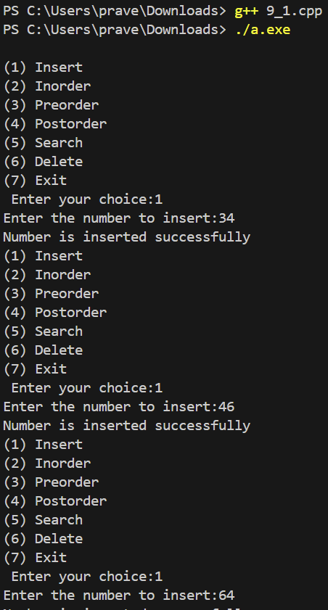 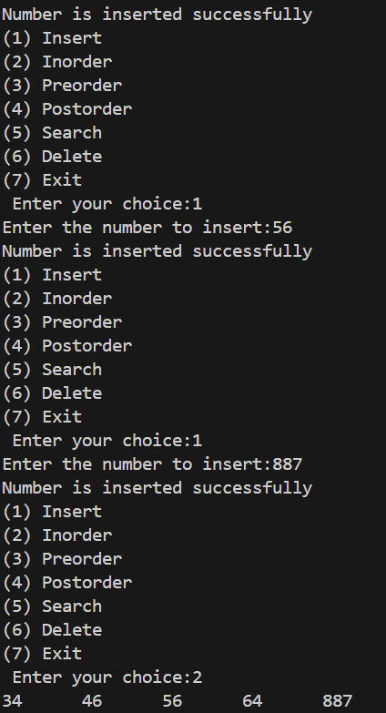

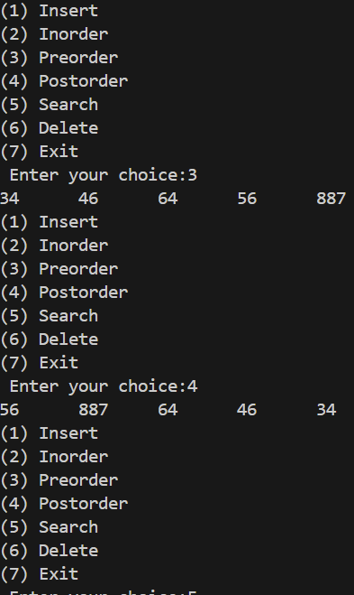

1.AIM:

To write a program to find the count of ideal substrings In a string

2:ALGORITHMS:

Stack headerfile is imported from previous code (lab 6)

CHECK:

1)start

1. Initialize a **count** variable to 0.
2. Loop through the characters of the provided string in steps of 3.
3. For each step, push three characters onto the stack **s1**.
4. Pop the three characters from the stack into variables **a**, **b**, and **c**.
5. Check if all three characters are different.
6. If they are different, increment the **count**.
7. After the loop, return the **count**
8. Stop

TIME COMPLEXITY ANALYSIS:

CHECK: O(n)

3.CODE:

Headerfile:

// Header file that has program to implement stack ADT using singly linked list .

#include<stdio.h>

#include<stdlib.h>

class stack{

    struct node{

    char data ;

    struct node *next ;

    };

    struct node *head ;

    public:

      stack(){

      head=NULL ;

      }

      int push(char chr) ;

      char pop() ;

      char peek() ;

};

//Method to push a character into a stack

int stack:: push(char chr){

    struct node *newnode=(struct node *)malloc(sizeof(struct node)) ;

    newnode->data=chr ;

    if(head==NULL){

      newnode->next=NULL ;

      head=newnode ;

      return 1 ;

    }

    else{

       newnode->next=head ;

       head=newnode ;

       return 1 ;

    }

}

// Method to pop a character from the stack

char stack::pop(){

    struct node *temp=head ;

    if(head==NULL){

        return '\0' ;

    }

    else{

        char ll=head->data ;

        head=head->next ;

        free(temp) ;

        temp=NULL ;

        return ll ;

    }

}

// Method to display the last element in a stack

char stack::peek(){

    return head->data ;

}

Cpp file:

//  Program to count the ideal number of substrings given a string of length 'n' .

// (An ideal sub-string has a length of 3 with no repeating characters.)

#include<stdio.h>

#include<string.h>

#include"9_2.h"

int check(char string[25],stack s1) ;

int main(){

    stack s1 ;

    char string[25] ;

    printf("Enter the string") ;

    scanf(" %24s",string) ;

    printf("The count of ideal substring=%d",check(string,s1)) ;

    return 0 ;

}

// Method to check the input string is a ideal string or not .

int check(char string[25],stack s1){

    int count=0 ;

    char a,b,c ;

    for(int i =0 ;string[i+2]!='\0' ;i++){

        s1.push(string[i]) ;

        s1.push(string[i+1]) ;

        s1.push(string[i+2]) ;

        a=s1.pop() ;

        b=s1.pop() ;

        c=s1.pop() ;

        if(a!=b && b!=c && a!=c){

            count ++ ;

        }

    }

    return count ;

}

Output :

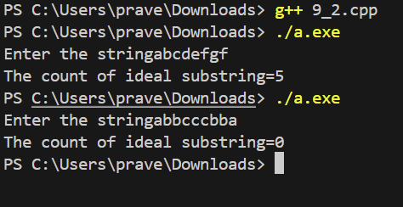

WEEK 10 -PRIORITY QUEUE ADT-HEAP DATE-03/04/24

1.AIM:

To Write a separate C++ menu-driven program to implement Priority Queue ADT using a max heap.

2.TIME COMPLEXITY ANALYSIS:

1.INSERT:O(nlogn)

2.HEAPIFY: O(logn)

3.DISPLAY:O(n)

4.DELETE:O(n)

5.SORT:O(nlogn)

6.SEARCH:O(n)

3.ALGORITHMS:

1.INSERT:

Input : num,arr,cur

Output : 0 or 1

If cur=size-1

Return 0

Else if cur=-1

Arr[cur++]=num

Return 1

Else

Cur++

Arr[cur]=num

Call heapfiy

Return 1

2.HEAPIFY:

Input : arr,cur

Output : elements are heapified

Set temp=cur

Repeat until temp > 0

Parent =i-1/2

If arr[i]>arr[parent]

Swap arr[i] and arr[parent]

3.DISPLAY:

Input : arr,cur

Output : elements

Set temp=cur

Repeat until temp >=0

Display arr[temp]

4.DELETE:

Input : arr,cur

Ouput : the max element

If cur=-1

Return -1

Else

Temp=arr[cur]

Arr[0]=arr[cur]

Call heapify

Return temp

5.SORT:

Input : arr,cur,queue

Output : sorted elements

Repeat until cur>=0

Queue->push(call delete)

Repeat until queue is empty

Queue->pop

6.SEARCH:

Input : num,arr,cur

Output : 0 or 1

If cur=-1

Return 0

Else

Set temp=0

Repeat until temp<=cur

If arr[temp]=num

Return 1

Temp++

Return 0

4.CODE

//Implementing priority queue ADT using heap

#include<stdio.h>

#include<stdlib.h>

#define SIZE 16

class heap

{

    int arr[SIZE];

    int cur;

    public:

        heap()

        {

            cur=-1;

        }

        int insert(int);

        void heapify(int);

        void display();

        int search(int);

        void heapifydown(int*,int,int);

        int del();

        void heapsort();

};

int main()

{

    getchar();

    getchar();

    system("clear");

    int choice, num;

    heap Heap;

    while (1) {

        printf("\n\t1. Insert\n\t2. Delete\n\t3. Display\n\t4. Search\n\t5. Sort (Heap Sort) \n\t6. Exit");

        printf("\nEnter your choice:");

        scanf("%d", &choice);

        switch (choice) {

            case (1):

                printf("\nEnter the number to be inserted:");

                scanf("%d", &num);

                Heap.insert(num);

                break;

            case (2):

                Heap.del();

                break;

            case (3):

                Heap.display();

                break;

            case (4):

                printf("\nEnter a number to search in the heap:");

                scanf("%d",&num);

                if (Heap.search(num))

                    printf("\nThe number %d is found in the heap",num);

                else

                    printf("\nThe number %d is not found in heap",num);

                break;

            case (5):

                Heap.heapsort();

                break;

            case (6):

                printf("\nExiting the program");

                exit(0);

                break;

            default:

                printf("\nEnter valid choice");

                break;

        }

    }

}

//Time complexity:O(logn)

void heap::heapify(int index)

{

    int par_index=(index-1)/2;

    int temp;

    if(arr[index]>arr[par_index])

    {

        temp=arr[par_index];

        arr[par_index]=arr[index];

        arr[index]=temp;

        heapify(par_index);

    }

}

//Time complexity:O(logn)

int heap::insert(int num)

{

    if(cur==SIZE-1)

    {

        return -1;

    }

    else{

        arr[cur++]=num;

        heapify(cur);

        return 1;

    }

}

//Time complexity :O(n)

void heap::display()

{

    if(cur==-1)

    {

        printf("\nHeap is empty !!");

    }

    else{

    for (int i=0;i<=cur;i++)

    {

        printf("%d\t",arr[i]);

    }

    }

}

//Time complexity :0(n)

int heap::search(int num)

{

    if(cur==-1)

    return 0;

    else{

        for (int i =0;i<=cur;i++)

        {

            if (arr[i]==num)

            return 1;

        }

        return 0;

    }

}

//Time complexity:O(logn)

void heap::heapifydown(int *arr,int parent,int cur)

{

    int left=(parent*2 )+1;

    int right=(parent*2 )+2;

    int lar_index=parent;

    if(left<=cur&&arr[left]<arr[lar_index])

    lar_index=left;

    if(right<=cur&&arr[right]<arr[lar_index])

    lar_index=left;

    if(lar_index!=parent)

    {

        int temp=arr[parent];

        arr[parent]=arr[lar_index];

        arr[lar_index]=temp;

        heapifydown(arr,lar_index,cur);

    }

}

//Time complexity:o(logn)

int heap::del()

{

     if (cur < 0) {

        printf("\nHeap is empty");

        return -1;

    }

    int removed_data=arr[0];

    arr[0] = arr[cur];

    cur--;

    heapifydown(arr,0,cur);

    printf("\nRoot node deleted successfully");

    return removed_data;

}

//To implement heap sort. Time complexity:O(nlogn)

void heap::heapsort() {

    int n = cur;

    int sortedArray[SIZE];

    for (int i = 0; i <= n; i++) {

        sortedArray[i] = arr[i];

    }

    for (int i = n / 2 - 1; i >= 0; i--)

        heapifydown(sortedArray, i, cur);

    for (int i = n; i > 0; i--) {

        int temp = sortedArray[0];

        sortedArray[0] = sortedArray[i];

        sortedArray[i] = temp;

        heapifydown(sortedArray, 0, i - 1);

    }

    printf("\nSorted Array: ");

    for (int i = 0; i <= n; i++) {

        printf("%d ", sortedArray[i]);

    }

    printf("\n");

}

5.OUTPUT:

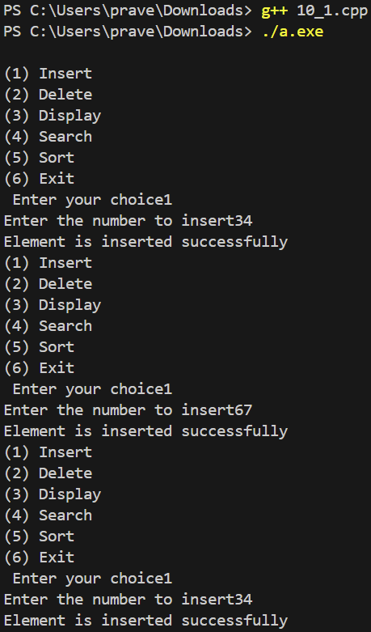 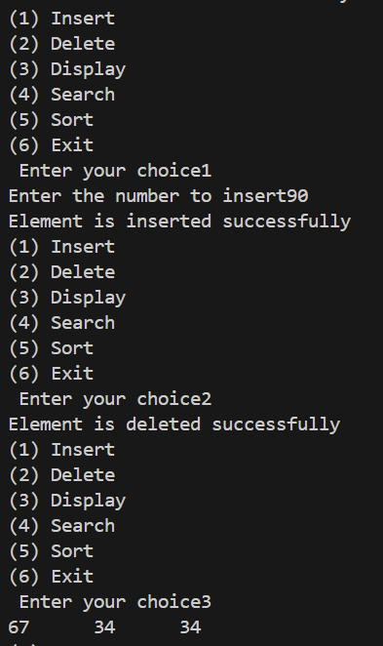

WEEK 11- HASH ADT -HASH TABLE Date-10/04/24

1.AIM:

To Write a separate C++ menu-driven program to implement Hash ADT with Separate Chaining.

2.TIME COMPLEXITY ANALYSIS

1.INSERT- O(n)

2.DELETE:O(n)

3.SEARCH:O(n)

3.ALGORITHM:

1.INSERT:

Input : num,hashtable

Output : 0 or 1

Index= num mod size

If hashtable[index]=NULL

Hashtable[index]=num

Return 1

Else

Set temp=hashtable[index]

Repeat until temp->next!=NULL

Temp=temp->next

Temp->next=num

Return 1

2.SEARCH:

Input : num,hashtable

Output: 0 or 1

Index=num mod size

If hashtable[index]=NULL

Return 0

Else

Set temp=hashtable[index]

Repeat until temp->next!=NULL

If temp->data=num

Return 1

Temp=temp->next

Return 0

3.DELETE:

Input : num,hashtable

Output : 0 or 1

Index= num mod size

If hashtable[index]=NULL

return 0

else if hashtable[index]=num

hashtable[index]=temp->next

Else

Set temp=hashtable[index]

Repeat until temp->!=NULL && temp->data!=num

Temp2=temp

Temp=temp->next

If temp=NULL

Return 0

If temp->data=num

Temp2->next=temp->next

Return 1

4.CODE:

// C++ menu-driven program to implement Hash ADT with Separate Chaining.

#include<stdio.h>

#include<stdlib.h>

#define SIZE 10

class hash{

    struct node{

        int num ;

        struct node *next ;

    } ;

    typedef struct node node ;

    node *arr[SIZE] ;

    public:

    hash(){

    for (int i=0 ;i<SIZE ;i++)

    arr[i]=NULL ;

    }

    int insert(int) ;

    int search(int) ;

    int del(int) ;

} ;

int main(){

    hash h ;

    int choice,num ;

    while (1){

        getchar() ;

        getchar() ;

        system("clear") ;

        printf("\n1.Insert\n2.Delete\n3.Search\n4.Exit\nEnter your choice :") ;

        scanf("%d",&choice) ;

        switch (choice){

        case 1:

            printf("\nEnter the num :") ;

            scanf("%d",&num) ;

            if(h.insert(num))

            printf("\nInsertion of %d was successful !!",num) ;

            else

            printf("\nInsertion Failed !!") ;

            break ;

        case 2:

            printf("\nEnter the num :") ;

            scanf("%d",&num) ;

            if(h.del(num))

            printf("\nDeletion of %d was successful !!",num) ;

            else

            printf("\nDeletion Failed ,%d wasn't found!!",num) ;

            break ;

        case 3:

            printf("\nEnter the num :") ;

            scanf("%d",&num) ;

            if(h.search(num))

            printf("\n %d was found in the table !!",num) ;

            else

            printf("\n%d wasn't found  !!",num) ;

            break ;

        case 4:

            exit(0) ;

            break ;

        default:

            printf("\nInvalid choice, try again !!") ;

            break ;

        }

    }

}

// Method to insert an element in the hash table .

int hash::insert(int num){

    node *newnode=(node*)malloc(sizeof(node)) ;

    newnode->num=num ;

    newnode->next=NULL ;

    int key =num%10 ;

    if (arr[key]==NULL){

        arr[key]=newnode ;

        return 1 ;

    }

    else{

        node *temp=arr[key] ;

        if(arr[key]->num!=num)

        {

        while (temp->next!=NULL){

            if(temp->num==num){

                return 0 ;

            }

            else{

            temp=temp->next ;

            }

        }

        temp=newnode ;

        return 1 ;

        }

        else{

            return 0 ;

        }

    }

}

// Method to search an element in the hash table .

int hash::search(int num){

    int key=num%10 ;

    node *temp=arr[key] ;

    while(temp!=NULL){

        if(temp->num==num)

        return 1 ;

        temp=temp->next ;

    }

    return 0 ;

}

// Method tp delete an elementin the hash table .

int hash::del(int num){

    int key=num%10 ;

    node *temp=arr[key] ;

    if(temp!=NULL){

        if(temp->next!=NULL){

            while(temp->next!=NULL){

                if(temp->next->num==num){

                    node *temp2=temp->next ;

                    temp->next=temp2->next ;

                    free(temp2) ;

                    return 1 ;

                }

            }

    }

        else{

            if(arr[key]->num==num){

                arr[key]=NULL ;

                free(temp) ;

                return 1 ;

            }

    }

    }

    return 0 ;

}

5.OUTPUT:

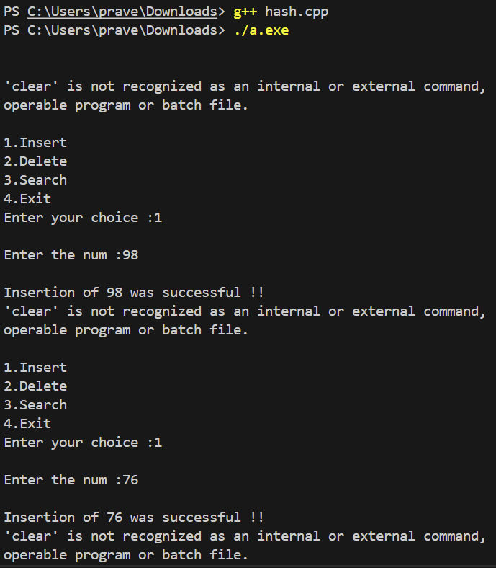 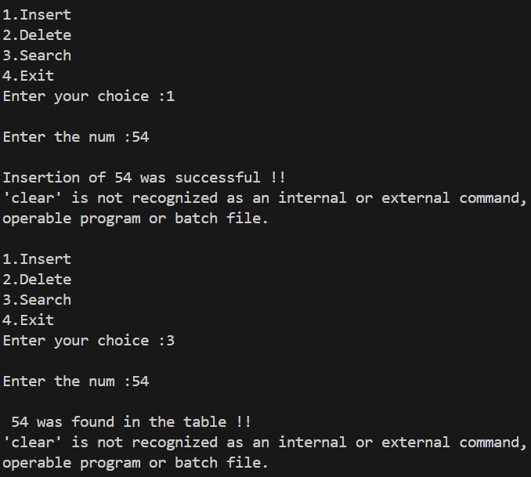

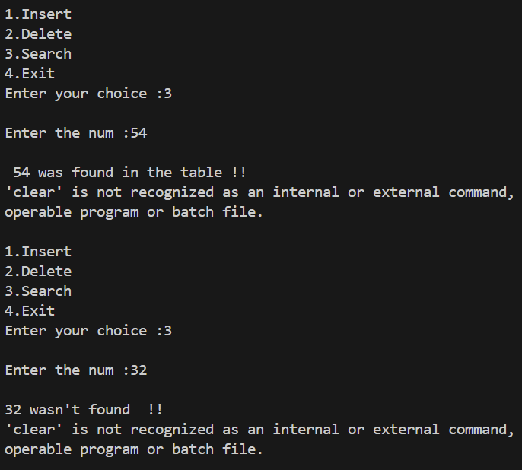 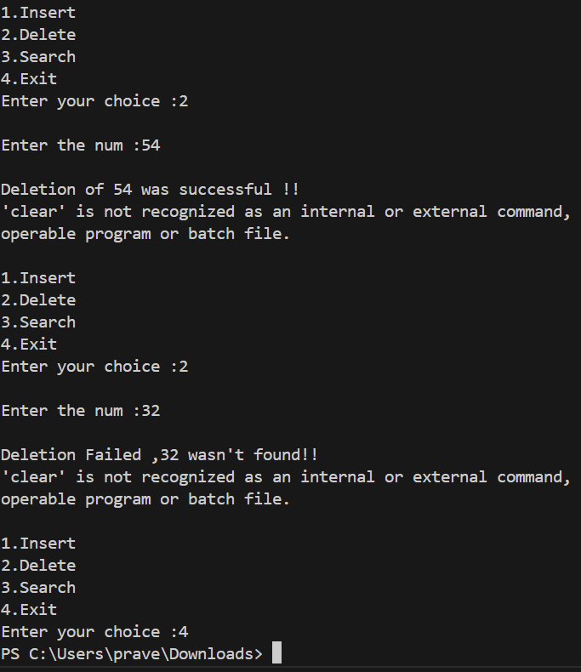

WEEK 12-GRAPH ADT Date:15/04/24

AIM:

To Write a separate C++ menu-driven program to implement Hash ADT with Linear Probing.  
ALGORITHMS:

1)INSERTION:

Input: num,hashtable

Output: 1 if element is added else 0

index = num % size

If hashtable[index] is -1

hashtable[index] = num

Return 1

Else

Loop from index to size-1

If hashtable[index] is -1

hashtable[index] = num

Return 1

Increment index

End Loop

End If

Return 0

2)DELETION:

Input: num,hashtable

Output: 1 if number is deleted else 0

index = num % size

Loop from index to size-1

If hashtable[index] equals num

hashtable[index] = -1

Return 1

Else If hashtable[index] is -1

Return 0

End If

Increment index

End Loop

Return 0

3)DISPLAY:

Input: hashtable

Output: all the elements are displayed

Loop from i=0 to size-1

If hashtable[i] is not -1

Print hashtable[i]

End If

End Loop

4)SEARCH:

Input: num,hashtable

Output: 1 if element is found else 0

index = num % size

Loop from index to size-1

If hashtable[index] equals num

Return 1

Else If hashtable[index] is -1

Return 0

End If

Increment index

End Loop

Return 0

TIME COMPLEXITY ANALYSIS:

1. INSERT: O(n)

2. DELETE: O(n)

3. SEARCH: O(n)

CODE:

// To implement Hash ADT using linear probing

#include<stdio.h>

#include<stdlib.h>

#define size 25

class hash

{

    int hashtable[size]={0};

    public:

    hash()

    {

       for(int i=0;i<size;i++)

       {

        hashtable[i]=-1;

       }

    }

    int insert(int num);

    void display();

    int del(int num);

    int search(int num);

};

int main()

{

    hash h1;

    int choice;

    while(1)

    {

        printf("\n(1) Insert");

        printf("\n(2) Delete");

        printf("\n(3) Search");

        printf("\n(4) Display");

        printf("\n(5) Exit");

        printf("\n Enter your choice");

        scanf("%d",&choice);

        switch (choice)

        {

            case 1:

            int num1;

            printf("Enter the number to insert");

            scanf("%d",&num1);

            if(h1.insert(num1))

            {

               printf("Element is inserted successfully");

            }

            else

            {

                printf("fail");

            }

            break;

            case 2:

            int num2;

            printf("Enter the number to delete");

            scanf("%d",&num2);

            if(h1.del(num2))

            {

                printf("Number is deleted successfully");

            }

            else

            {

                printf("Element is not present");

            }

            break;

            case 3:

            int num3;

            printf("Enter the element to search");

            scanf("%d",&num3);

            if(h1.search(num3))

            {

                printf("Element is found");

            }

            else

            {

                printf("Element is not found");

            }

            break;

            case 4:

            h1.display();

            break;

            case 5:

            return 0;

        }

    }

}

//method to insert the element

int hash::insert(int num)

{

   int index=num%size;

   if(hashtable[index]==-1)

   {

    hashtable[index]=num;

    return 1;

   }

   else

   {

      while(index!=size-1)

      {

        if(hashtable[index]==-1)

        {

            hashtable[index]=num;

            return 1;

        }

        index++;

      }

   }

   return 0;

}

//method to display the elements

void hash:: display()

{

   for(int i=0;i<size;i++)

   {

    if(hashtable[i]!=-1)

    {

        printf("%d\t",hashtable[i]);

    }

   }

}

//method to delete a element

int hash :: del(int num)

{

    int index=num%size;

    while(index<size-1)

    {

       if(hashtable[index]==num)

       {

          hashtable[index]=-1;

          return 1;

       }

       else if(hashtable[index]==-1)

       {

          return 0;

       }

       index++;

    }

    return 0;

}

//method to search an element

int hash:: search(int num)

{

    int index=num%size;

    while(index<size-1)

    {

        if(hashtable[index]==num)

        {

            return 1;

        }

        else if(hashtable[index]==-1)

        {

            return 0;

        }

        index++;

    }

    return 0;

}

OUTPUT:

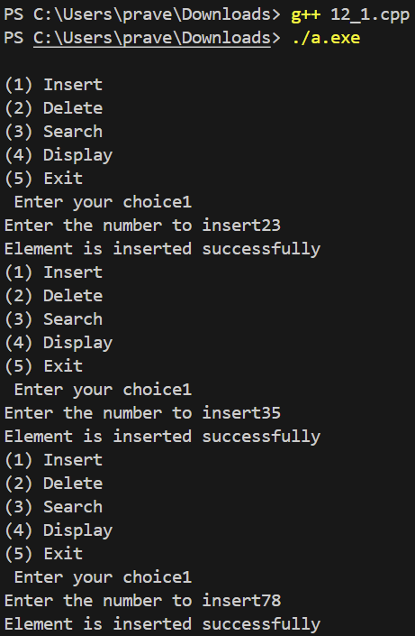

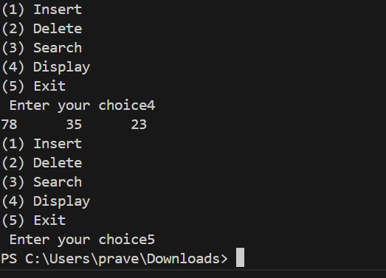

AIM:

To  Write a separate C++ menu-driven program to implement Hash ADT with Quadratic Probing

ALGORITHMS :

1. INSERT:

Input: num,hashtable

Output: 1 if element is added else 0

index = num % size

If hashtable[index] is -1

hashtable[index] = num

Return 1

Else

i = 1

While true

index = index + i * i

If index >= size

Break

If hashtable[index] is -1

hashtable[index] = num

Return 1

Increment i

End While

End If

Return 0

2. DELETE:

Input: num,hashtable

Output: 1 if number is deleted else 0

index = num % size

i = 0

While true

If hashtable[index] equals num

hashtable[index] = -1

Return 1

Else If hashtable[index] is -1

Return 0

End If

index = index + i * i

If index >= size

Break

Increment i

End While

Return 0

3. SEARCH:

Input: num,hashtable

Output: 1 if element is found else 0

index = num % size

i = 0

While true

If hashtable[index] equals num

Return 1

Else If hashtable[index] is -1

Return 0

End If

index = index + i * i

If index >= size

Break

Increment i

End While

Return 0

4.DISPLAY:

Input: hashtable

Output: elements are displayed

For i = 0 to size-1

If hashtable[i] is not -1

Print hashtable[i]

End If

End For

TIME COMPLEXITY ANALYSIS:

1. INSERT: O(n) in the worst case

2. DELETE: O(n) in the worst case

3. SEARCH: O(n) in the worst case

4.DISPLAY:O(n)

CODE:

// To implement Hash ADT using quadratic probing

#include<stdio.h>

#include<stdlib.h>

#define size 25

class hash

{

    int hashtable[size]={0};

    public:

    hash()

    {

       for(int i=0;i<size;i++)

       {

        hashtable[i]=-1;

       }

    }

    int insert(int num);

    void display();

    int del(int num);

    int search(int num);

};

int main()

{

    hash h1;

    int choice;

    while(1)

    {

        printf("\n(1) Insert");

        printf("\n(2) Delete");

        printf("\n(3) Search");

        printf("\n(4) Display");

        printf("\n(5) Exit");

        printf("\n Enter your choice");

        scanf("%d",&choice);

        switch (choice)

        {

            case 1:

            int num1;

            printf("Enter the number to insert");

            scanf("%d",&num1);

            if(h1.insert(num1))

            {

               printf("Element is inserted successfully");

            }

            else

            {

                printf("fail");

            }

            break;

            case 2:

            int num2;

            printf("Enter the number to delete");

            scanf("%d",&num2);

            if(h1.del(num2))

            {

                printf("Number is deleted successfully");

            }

            else

            {

                printf("Element is not present");

            }

            break;

            case 3:

            int num3;

            printf("Enter the element to search");

            scanf("%d",&num3);

            if(h1.search(num3))

            {

                printf("Element is found");

            }

            else

            {

                printf("Element is not found");

            }

            break;

            case 4:

            h1.display();

            break;

            case 5:

            return 0;

        }

    }

}

//method to insert the element

int hash::insert(int num)

{

   int index=num%size;

   if(hashtable[index]==-1)

   {

    hashtable[index]=num;

    return 1;

   }

   else

   {

      int i=1;

      while(index!=size-1)

      {

        if(hashtable[index]==-1)

        {

            hashtable[index]=num;

            return 1;

        }

        index=i*i +index;

        i++;

      }

   }

   return 0;

}

//method to display the elements

void hash:: display()

{

   for(int i=0;i<size;i++)

   {

    if(hashtable[i]!=-1)

    {

        printf("%d\t",hashtable[i]);

    }

   }

}

//method to delete a element

int hash :: del(int num)

{

    int index=num%size;

    int i=0;

    while(index<size-1)

    {

       if(hashtable[index]==num)

       {

          hashtable[index]=-1;

          return 1;

       }

       else if(hashtable[index]==-1)

       {

          return 0;

       }

       index=i*i +index;

       i++;

    }

    return 0;

}

//method to search an element

int hash:: search(int num)

{

    int index=num%size;

    int i=0;

    while(index<size-1)

    {

        if(hashtable[index]==num)

        {

            return 1;

        }

        else if(hashtable[index]==-1)

        {

            return 0;

        }

        index=i*i +index;

        i++;

    }

    return 0;

}

OUTPUT:

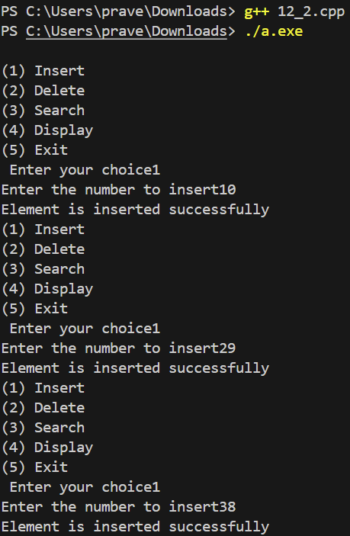 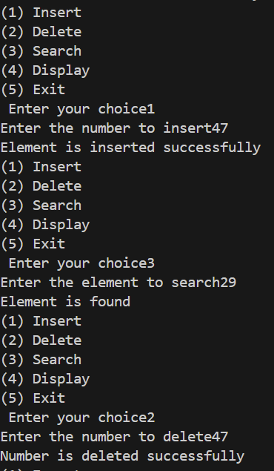

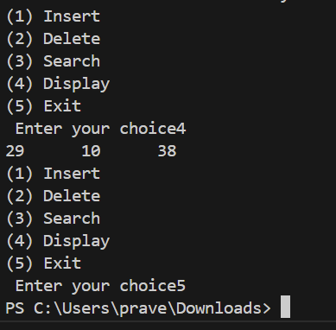

AIM:

To Write a separate C++ menu-driven program to implement Graph ADT with an adjacency matrix.

ALGORITHMS:

1.INSERT:

Input: u, v,list

Output: 1 if edge is added, 0 otherwise

Create newnode1 with data u and newnode2 with data v

For i from 0 to cur-1

If adjacencylist[i] data equals u

For k from 0 to cur-1

If adjacencylist[k] data equals v

Set temp to adjacencylist[i]

While temp next is not NULL

Move temp to temp next

End While

Set temp next to newnode2

Return 1

End If

End For

Set adjacencylist[cur] to newnode2

Increment cur

Return 1

End If

If adjacencylist[i] data equals v

Similar block as above for adding newnode1

End If

End For

If u equals v

Add self-loop only once to adjacencylist at cur

Else

Add both newnode1 and newnode2 to adjacencylist at cur and cur+1

Increment cur by 2

Return 1

2.DELETE:

Input: v,list

Output: 1 if vertex is deleted, 0 otherwise

For i from 0 to cur-1

If adjacencylist[i] data equals v

Set adjacencylist[i] to NULL

For k from i to cur-1

Shift adjacencylist[k+1] to adjacencylist[k]

End For

Decrement cur

Return 1

End If

End For

Return 0

3.SEARCH:

Input: v

Output: 1 if vertex is found, 0 otherwise

For i from 0 to cur-1

If adjacencylist[i] data equals v

Return 1

End If

End For

Return 0

4.DISPLAY:

Input: None

Output: Print all vertices and their edges

For i from 0 to cur-1

Print adjacencylist[i] data

End For

TIME COMPLEXITY ANALYSIS:

1. INSERT: O(cur^2) because of the nested loop, but O(1) if adjacency list for u or v is already present

2. DELETE: O(cur) because it requires a single loop through the current list of vertices

3. SEARCH: O(cur) as it may need to look at each vertex in the worst case

4.DISPLAY:O(n)

CODE:

// To implement Graph ADT with an adjaceny list

#include<stdio.h>

#include<stdlib.h>

#define size 5

class hash

{

    struct node

    {

        int data;

        struct node *next;

    };

    int cur;

    struct node *adjacencylist[size];

    struct node *head;

    public:

    hash()

    {

        for (int i=0;i<size;i++)

        {

            adjacencylist[i]=NULL;

        }

        cur=0;

    }

    int insert (int u,int v);

    void display();

    void ldis(struct node *head);

    int search(int v);

    int del(int v);

};

int main()

{

    hash h1;

    int choice;

    while(1)

    {

        printf("\n(1) Insert");

        printf("\n(2) Delete");

        printf("\n(3) Search");

        printf("\n(4) Display");

        printf("\n(5) Exit");

        printf("\n Enter your choice");

        scanf("%d",&choice);

        switch (choice)

        {

            case 1:

            int v11,v12;

            printf("Enter the vertex 1:");

            scanf("%d",&v11);

            printf("Enter the vertex 2:");

            scanf("%d",&v12);

            if(h1.insert(v11,v12))

            {

               printf("Element is inserted successfully");

            }

            else

            {

                printf("fail");

            }

            break;

            case 2:

            int v21;

            printf("Enter the vertex to be deleted");

            scanf("%d",&v21);

            if(h1.del(v21))

            {

                printf("Number is deleted successfully");

            }

            else

            {

                printf("Element is not present");

            }

            break;

            case 3:

            int v3;

            printf("Enter the vertex to search");

            scanf("%d",&v3);

            if(h1.search(v3))

            {

                printf("Element is found");

            }

            else

            {

                printf("Element is not found");

            }

            break;

            case 4:

            h1.display();

            break;

            case 5:

            return 0;

        }

    }

}

//method to insert the element

int hash:: insert(int v1,int v2)

{

    struct node *newnode1=(struct node *)malloc(sizeof(struct node));

    struct node *newnode2=(struct node *)malloc(sizeof(struct node));

    newnode1->data=v1;

    newnode1->next=NULL;

    newnode2->data=v2;

    newnode2->next=NULL;

    for (int i=0;i<cur;i++)

    {

        if(adjacencylist[i]->data==v1)

        {

            for(int k=0;k<cur;k++)

            {

                if(adjacencylist[k]->data==v2)

                {

                struct node *temp=adjacencylist[i];

                while(temp->next!=NULL)

                {

                temp=temp->next;

                }

                temp->next=newnode2;

                return 1;

                }

            }

            adjacencylist[cur]=newnode2;

            cur++;

            return 1;

        }

        if(adjacencylist[i]->data==v2)

        {

            for(int k=0;k<cur;k++)

            {

                if(adjacencylist[k]->data==v1)

                {

                struct node *temp=adjacencylist[i];

                while(temp->next!=NULL)

                {

                temp=temp->next;

                }

                temp->next=newnode1;

                return 1;

                }

            }

            adjacencylist[cur]=newnode1;

            cur++;

            return 1;

        }

    }

    if(v1==v2)

    {

        adjacencylist[cur]=newnode1;

        adjacencylist[cur]->next=newnode2;

        cur++;

        return 1;

    }

    adjacencylist[cur]=newnode1;

    adjacencylist[cur+1]=newnode2;

    cur+=2;

    return 1;

}

// method to display

void hash:: display()

{

   for(int i=0;i<cur;i++)

   {

    printf("%d\t",adjacencylist[i]->data);

   }

}

// method to delete the element

int hash:: del(int v)

{

    for (int i=0;i<cur;i++)

    {

        if(adjacencylist[i]->data==v)

        {

            adjacencylist[i]=NULL;

            for (int k=i;k<cur;k++)

            {

                adjacencylist[k]=adjacencylist[k+1];

            }

            cur--;

            return 1;

        }

    }

    return 0;

}

//method to search

int hash::search(int v)

{

    for (int i=0;i<cur;i++)

    {

        if(adjacencylist[i]->data==v)

        {

            return 1;

        }

    }

    return 0;

}

OUTPUT:

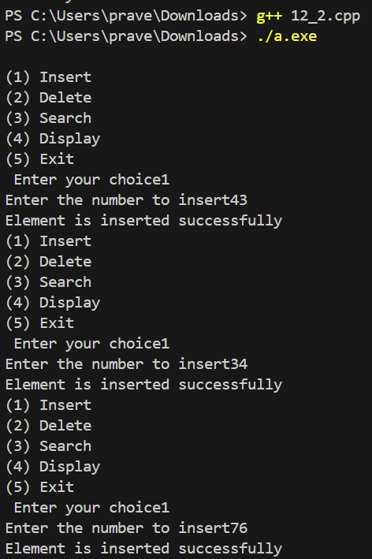 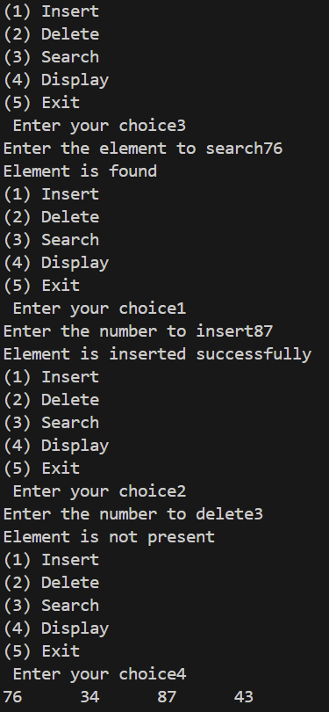

AIM:

To Write a separate C++ menu-driven program to implement Graph ADT with an adjacency matrix.

ALGORITHMS:

1.INSERT:

Input: v1, v2,matrix

Output: 1 if edge is added, 0 otherwise

If cur is greater than or equal to N

Print "Vertex does not exist"

Return 0

Else

Set row to 0, col to 0

For i from 1 to cur

If adjacencymatrix[0][i] equals v1

Set col to i

If adjacencymatrix[i][0] equals v2

Set row to i

End For

For i from 1 to cur

If adjacencymatrix[0][i] equals v2

Set col to i

If adjacencymatrix[i][0] equals v1

Set row to i

End For

If row is not 0 and col is not 0

Set adjacencymatrix[row][col] and adjacencymatrix[col][row] to 1

Return 1

Else If row is not 0 and col is 0, or row is 0 and col is not 0

Print "Please provide a valid vertex"

Return 0

Else

Set adjacencymatrix[0][cur] to v1

Set adjacencymatrix[cur][0] to v1

Set adjacencymatrix[0][cur+1] to v2

Set adjacencymatrix[cur+1][0] to v2

Set adjacencymatrix[cur][cur+1] and adjacencymatrix[cur+1][cur] to 1

Increment cur by 2

Return 1

End If

End If

2.DELETE:

Input: v,matrix

Output: 1 if vertex is deleted, 0 otherwise

If cur equals 1

Print "The matrix is empty already"

Return 0

End If

For i from 1 to cur

If adjacencymatrix[0][i] equals v

For j from i to cur

Shift adjacencymatrix[0][j+1] left to adjacencymatrix[0][j]

End For

End If

If adjacencymatrix[i][0] equals v

For j from i to cur

Shift adjacencymatrix[j+1][0] up to adjacencymatrix[j][0]

End For

Decrement cur

Return 1

End If

End For

3.SEARCH:

Input: v,matrix

Output: 1 if vertex is found, 0 otherwise

For i from 1 to cur

If adjacencymatrix[0][i] equals v

Return 1

End If

End For

Return 0

4.DISPLAY:

Input: None

Output: None

For i from 0 to cur-1

For j from 0 to cur-1

Print adjacencymatrix[i][j]

End For

Print newline

End For

TIME COMPLEXITY ANALYSIS:

1. INSERT: O(N)

2. DELETE: O(N)

3. SEARCH: O(N)

4.DISPLAY:O(N)

CODE:

// To implement Graph ADT with an adjaceny matrix

#include<stdio.h>

#include<stdlib.h>

#define N 6

class graph

{

    int adjacencymatrix[N][N];

    int cur;

    public:

    graph()

    {

        for (int i=0;i<N;i++)

        {

            for (int j=0;j<N;j++)

            {

            adjacencymatrix[i][j]=0;

            }

        }

        cur=1;

    }

    int insert (int u,int v);

    void display();

    int del(int v);

    int search(int v);

};

int main()

{

    graph g1;

    int choice;

    while(1)

    {

        printf("\n(1) Insert");

        printf("\n(2) Delete");

        printf("\n(3) Search");

        printf("\n(4) Display");

        printf("\n(5) Exit");

        printf("\n Enter your choice");

        scanf("%d",&choice);

        switch (choice)

        {

            case 1:

            int v1,v2;

            printf("Enter the vertex 1:");

            scanf("%d",&v1);

            printf("Enter the vertex 2:");

            scanf("%d",&v2);

            if(g1.insert(v1,v2))

            {

               printf("vertex is inserted successfully");

            }

            break;

            case 2:

            int v;

            printf("Enter the vertex to be deleted:");

            scanf("%d",&v);

            if(g1.del(v))

            {

                printf("vertex is deleted successfully");

            }

            else

            {

                printf("vertex is not present");

            }

            break;

            case 3:

            int v3;

            printf("Enter the vertex to search");

            scanf("%d",&v3);

            if(g1.search(v3))

            {

                printf("vertex is found");

            }

            else

            {

                printf("vertex is not found");

            }

            break;

            case 4:

            g1.display();

            break;

            case 5:

            return 0;

        }

    }

}

//method to insert

int graph:: insert(int v1,int v2)

{

    if(cur>=N)

    {

        printf("Vertex does not exist");

        return 0;

    }

    else

    {

        int row=0,col=0;

        for (int i=1;i<=cur;i++)

        {

            if(adjacencymatrix[0][i]==v1)

            {

               col=i;

            }

            if(adjacencymatrix[i][0]==v2)

            {

               row=i;

            }

        for (int i=1;i<=cur;i++)

        {

            if(adjacencymatrix[0][i]==v2)

            {

               col=i;

            }

            if(adjacencymatrix[i][0]==v1)

            {

               row=i;

            }

        }

        if(row!=0 && col!=0)

        {

        adjacencymatrix[row][col]=1;

        adjacencymatrix[col][row]=1;

        return 1;

        }

        else if(row!= 0 && col==0|| row==0 && col!=0)

        {

          printf("Please provide a valid vertex");

          return 0;

        }

        else

        {

        adjacencymatrix[0][cur]=v1;

        adjacencymatrix[0][cur+1]=v2;

        adjacencymatrix[cur][0]=v1;

        adjacencymatrix[cur+1][0]=v2;

        adjacencymatrix[cur][cur+1]=1;

        adjacencymatrix[cur+1][cur]=1;

        cur+=2;

        return 1;

        }

    }

}

}

//method to display

void graph::display()

{

    for (int i=0;i<cur;i++)

    {

        for (int j=0;j<cur;j++)

        {

            printf("%d\t",adjacencymatrix[i][j]);

        }

        printf("\n");

    }

}

//method to delete

int graph:: del(int v)

{

    if(cur==1)

    {

        printf("The matrix is empty already");

        return 0;

    }

    for (int i=1;i<=cur;i++)

    {

        if(adjacencymatrix[0][i]==v)

        {

            for (int j=i;j<=cur;j++)

            {

            adjacencymatrix[0][j]=adjacencymatrix[0][j+1];

            }

        }

        if(adjacencymatrix[i][0]==v)

        {

            for(int j=i;j<=cur;j++)

            {

            adjacencymatrix[j][0]=adjacencymatrix[j+1][0];

            }

            cur--;

        }

    }

    return 1;

}

//method to search

int graph:: search(int v)

{

    for (int i=1;i<=cur;i++)

    {

        if(adjacencymatrix[0][i]==v)

        {

            return 1;

        }

    }

    return 0;

}

OUTPUT:



