**Assignment 6**

**Points 30**

**Please follow the following instructions to complete this assignment.**

1. Open Xcode from the launchpad of your mac.
2. Click on create a new Xcode project. Select the iOS template and click on the App application.
3. Click on next which will prompt you to choose options for the project.
4. Provide product name as **Lastname_GroceryApp**, “**nwmsu**” for organization identifier, “**storyboard**” as interface and swift as language.
5. Click on next and select an appropriate location to save your app and click on create. A project directory will be loaded.
6. When you are done with selecting the location of the project on your local storage, moving further you can see project settings screen. Set your **Project Format** to “Xcode 13.0-compatible” in your Project Document settings.
7. Now look into **Deployment Info** settings on the same project settings and set it to “ios 15.5” and make sure to check iPhone and iPad. Check below image and highlighted portion with red and follow accordingly.

1. **Note:** Follow the exact instructions given and don’t modify any other settings as it causes application not to run in different machines.
2. From the project navigator click on “Main” file, a blank mobile screen will be loaded where the required fields for an app need to be added.
3. Click on the storyboard then select editor from the top panel options, click on embed in option from the list and select navigation controller.
4. Rename the View Controller file to **GrocerySectionsViewController.**
5. Following image demonstrates the above step. Once the navigation controller is selected navigation controller scene should be visible in the storyboard.

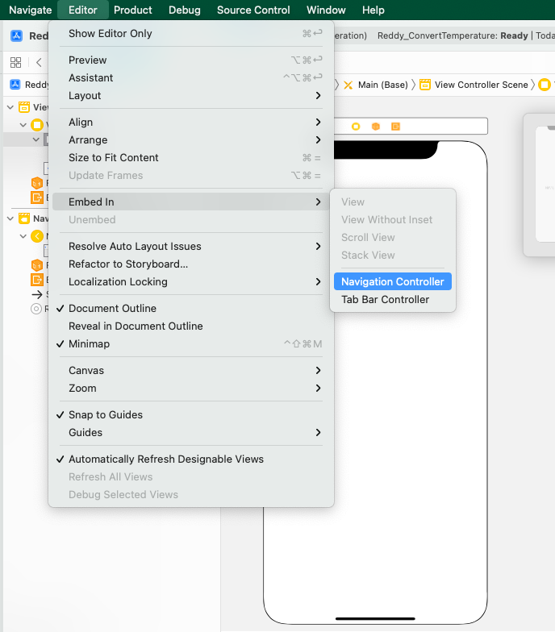

1. Now let’s add a Table View and set top, left, bottom and right constraints to 0. Now go to the attribute inspector of table view and select the prototype cell to 1. Now give the identifier to the cell as “**sectionCell**”. Now while making a connection to the View Controller, give the name for the outlet as grocerySectionsTableView.
2. Now from the library in the Main add a new View Controller. Now right click on the project, create a new file, select Cocoa Touch Class and select next. Now select the class as GroceryItemsViewController. Now in the identity inspector of the newly added view controller, give the name of the class as “**GroceryItemsViewController**”. Drag a Table View and set top, left, right and bottom contraints to 0. Select the prototype cells to 1 and in the give the name of the identifier of the cell to “**itemCell**”. Now give a connection in the GroceryItemsViewController for this table view and name it as “**groceryItemsTableView**”. Create a segue from the table view of **GrocerySectionsViewController** and name the identifier as “**itemsSegue**”.
3. Now Create another view Controller and create a new Cocoa Touch Class and give the name as **ItemInfoViewController**. In the identity inspector of the view controller give the class name as ItemInfoViewController. Now add an image, button and a textView with height 150. Now add your own constraints to all the objects so that the View is adjustable in all the mobiles. While making the connections, give the name of the image as itemImageViewOutlet, button as showItemInfoAction (IBAction) and the textview as itemInfoOutlet. Create a segue from the table view of **GroceryItemsViewController** and name the identifier as “**itemInfoSegue**”
4. We use structs for populating the data. Create a new swift file and name it as “**GrocerySections**”. Inside the **GrocerySections** struct create 2 variables ***section*** and items_Array of type **“****GroceryItem”.**
5. Now create a new struct in the same GrocerySections file but outside the GrocerySections struct and name the struct as “**GroceryItem”.**
6. The GroceryItem struct contains 3 variables one is **itemName**, **itemImage** to display the image and **itemInfo** a brief description about the product.
7. Create an array with atleast 3-5 sections for Example: “Meat”,”Salads”,”Fruits” etc. Create atleast three sections.
8. Create atleast 5 items for each section with appropriate images and information about the item.
9. Refer **StudentApp** for generating the data and how to pass array into the view controller.
10. Whenever we click any row in **GrocerySectionsViewController**, we need to get the items related to the sections in the next view controller i.e., **GroceryItemsViewController**.
11. Image should be animated when displaying. Use any animation that is mentioned in the class.
12. When we click on any item in **GroceryItemsViewController** it should navigate to next Controller i.e., **ItemInfoViewController** and the image related to the item must be displayed. When we click on the button get Info, we need to get the details related to the item in the textView.
13. Display section name as title in the (**GroceryItemsViewController**) and item name as the title in the (**ItemInfoViewController**). Use **self.title** in the viewDidLoad() to change the title.
14. Find the sample images below.

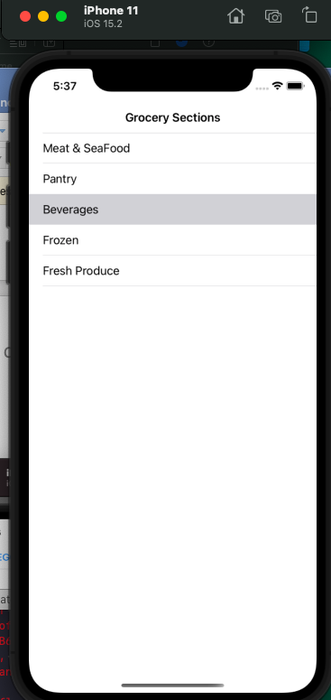

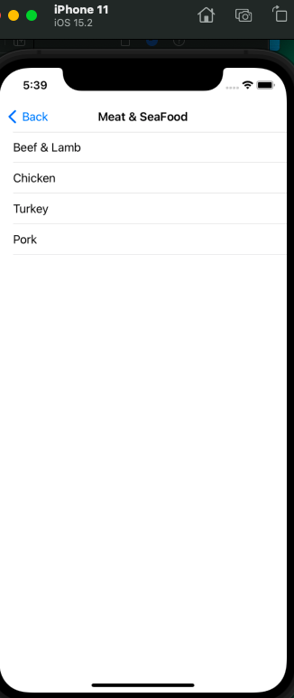

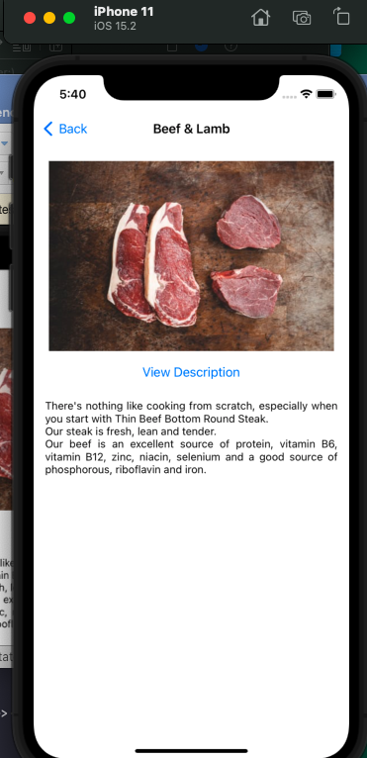

**Please submit your app as compressed file, your compressed files should contain Lastname_ GroceryApp** **folder and Lastname_****GroceryApp.xcodeproj file. Please check your submission by downloading the submitted file and rechecking in xcode.**