**Assignment 7**

**Points 20**

**Please follow the following instructions to complete this assignment.**

1. Open XCode from the launchpad of your mac.
2. Click on create a new XCode project. Select the iOS template and click on the App application.
3. Click on next which will prompt you to choose options for the project.
4. Provide product name as **Lastname_Movies**, “**nwmsu**” for organization identifier, “**storyboard**” as interface and swift as language.
5. Click on next and select an appropriate location to save your app and click on create. A project directory will be loaded.
6. When you are done with selecting the location of the project on your local storage, moving further you can see project settings screen. Set your **Project Format** to “Xcode 13.0-compatible” in your Project Document settings.
7. Now look into **Deployment Info** settings on the same project settings and set it to “ios 15.5” and make sure to check iPhone and iPad. Check below image and highlighted portion with red and follow accordingly.

1. **Note:** Follow the exact instructions given and don’t modify any other settings as it causes application not to run in different machines.
2. From the project navigator click on “Main” file, a blank mobile screen will be loaded where the required fields for an app need to be added
3. Click on the story board then select editor from the top pane options, click on embed in option from the list and select navigation controller.
4. Rename the View Controller file to **GenreViewController.**
5. Following image demonstrates the above step. Once the navigation controller is selected navigation controller scene should be visible in the storyboard.

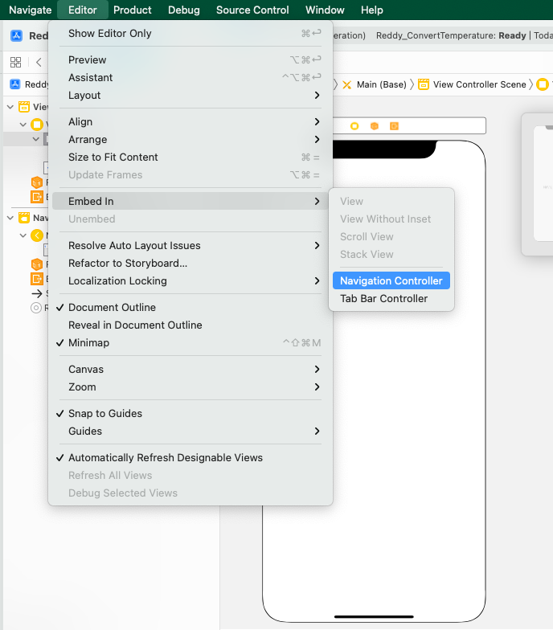

1. Now let’s add a Table View and set top, left, bottom and right constraints to 0. Now go to the attribute inspector of table view and select the prototype cell to 1, give the identifier to the cell as “**sectionCell**”. While making a connection to the View Controller, give the name for the outlet as **genreTableView**.
2. Now from the library in the Main add a new View Controller, next right click on the project, create a new file, select cocoa touch class and click next, give the class name as **MoviesViewController**. Now select the class as MoviesViewController**,** in the identity inspector of the newly added view controller. Drag a Collection View to MoviesViewController and set top, left and right constraints to 5 and give height as 300. Give the name of the identifier of the cell as “**movieCell**”. Add an image to the collection view cell. Refer class example of collection view for setting constraints to the image.
3. Add 6 labels to the MoviesViewController and embed them in a stack, give constraints to the top, left and right as 20. Keep the collection view scroll direction to horizontal.
4. Create a new Cocoa Touch Class with name **MovieCollectionViewCell** which should be subclass of **UICollectionViewCell.**
5. Create an outlet for collection view by connecting it to **MoviesViewController** and name it as **movieCollectionView**.
6. Now connect all the 6 labels to MoviesViewController and name them as **movieNameLabel**, **movieRatingLabel**, **movieBoxOfficeLabel**, **movieYearLabel**, **moviePlotLabel**, **movieCastLabel**.
7. Create a segue from the table view of GenreViewController to MoviesViewController and name the identifier as “**movieSegue**”.
8. We use structs for populating the data. Create a new swift file and name it as “**MovieData**”.

Inside this file create two structs namely **Movie** and **Genre**.

1. The Movie struct contains 7 variables namely **title** of type String, i**mage** of type UIImage**, releasedYear** of type String**, movieRating** of type String**, boxOffice** of type String**, moviePlot** of type String**, cast** of String array. Struct Genre contains **category** of type String, and **movies** of type struct array Movies.
2. Add at least 3 values to genre and each movie struct array in the genre should contain at least 5 movies.
3. Refer previous assignmentfor generating the data and how to pass array into the view controller.
4. Whenever we click any genre, genre related movies should be opened in the next view controller in a collection view and the title of view controller should be genre name.
5. When we click on any of the movie, movie details should be populated to the labels. By default, when you navigate from the view controller you should show first movie details.
6. Find the sample images of the app below for your reference.

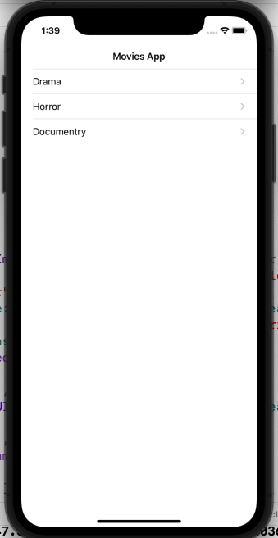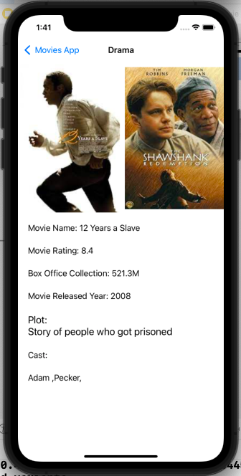

**Please submit your app as compressed file, your compressed files should contain Lastname_ Movies** **folder and Lastname_Movies.xcodeproj file. Please check your submission by downloading the submitted file and rechecking in xcode.**