Am I on the right track?
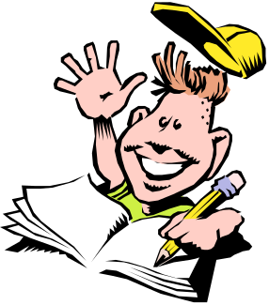

Do I know…

- ...the objective of the task
- ...the what, how, why and when of the task?
- ...the steps
            - mind map, draft, storyboard, etc.?
- ...what material I need?
- ...the resources available to me?

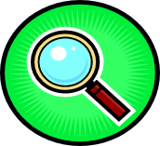

Am I on the right track?

- I keep the objectives of the task in mind.
- I respect the procedure.
- I make the necessary changes to make sure I stay on track.


Am I satisfied...?

- ...with my final product?
- ...with my procedure (strategies I used)?
- ...with my learning (knowledge)?

