MM2 HW7

RyanGallagher

2023-04-17

##### Read the grip data. It consists of 2 treatments (trt), 2 genders (gender), and 3 measurement occasions (time=1,2,3), a baseline covariate (x), and a response variable (y).

### 1.) Fit a marginal model for repeated measures including trt, gender, time, and x. Use the unstructured covariance for errors. Treat trt, gender, and time as categorical variables. State your model and assumptions.

*SAS Code*:

/* I think we can use both glimmix and mix */  
proc glimmix data=grip;  
 class trt gender time;  
 model y=trt gender time x / solution ddfm=kr;  
 random _residual_ / subject=subject type=un vcorr;  
run;  
  
proc mixed data=grip;  
 class trt gender time;  
 model y = trt gender time x / solution;  
 repeated time / type=un subject=subject;  
run;

I used both to compare outcomes, and they give relatively the same results. Our model:

$$y=67.7588+−1.2531*trt_{1}+−36.8416*Female+−1.0910*time_{1}+3.6568*time_{2}+0.7431*x$$

This marginal model assumts that y is continuous and normally distributed. It assumes that the residuals are IID. I believe we also need our repeated variable (time) to have $cov\left(time,trt\right)∼cov\left(time,gender\right)∼cov\left(time,x\right)$.

### 2.) Test whether there is an interaction between time and the other 3 predictor variables.

SAS CODE:

proc mixed data=grip;  
 class trt gender time;  
 model y=trt|time gender|time x|time / solution;  
 repeated time / type=un subject=subject;  
run;

SAS OUTPUT:

Standard  
Effect Gender trt time Estimate Error DF t Value Pr > |t|  
  
Intercept 64.1267 20.1602 63 3.18 0.0023  
trt 1 2.0622 9.3901 63 0.22 0.8269  
trt 2 0 . . . .   
time 1 -2.3002 20.3533 63 -0.11 0.9104  
time 2 20.6555 12.5269 63 1.65 0.1041  
time 3 0 . . . .   
trt*time 1 1 -2.4383 9.4753 63 -0.26 0.7978  
trt*time 1 2 -6.2186 5.9195 63 -1.05 0.2975  
trt*time 1 3 0 . . . .   
trt*time 2 1 0 . . . .   
trt*time 2 2 0 . . . .   
trt*time 2 3 0 . . . .   
Gender F -26.1487 14.1067 63 -1.85 0.0685  
Gender M 0 . . . .   
Gender*time F 1 -9.2879 14.2404 63 -0.65 0.5166  
Gender*time F 2 -16.5809 8.7703 63 -1.89 0.0633  
Gender*time F 3 0 . . . .   
Gender*time M 1 0 . . . .   
Gender*time M 2 0 . . . .   
Gender*time M 3 0 . . . .   
x 0.7162 0.09969 63 7.18 <.0001  
x*time 1 0.05515 0.1006 63 0.55 0.5856  
x*time 2 -0.04048 0.06184 63 -0.65 0.5152  
x*time 3 0 . . . .

We find that there is no intercation between time and any of the other 3 predictor variables (however Gender=F and time=2 is very close to significance).

### 3) Plot a boxplot of residuals for gender. What did you observe?

knitr::include_graphics("/Users/ryangallagher/Desktop/MedicalCollegeofWisconsin/BIOS_04232_MM2/SGPlot.png")

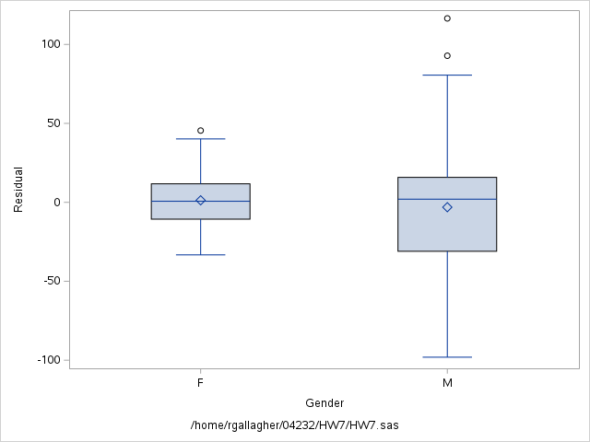

We find that the Female residuals are relatively normal, where the Male residuals are quite skewed (likely as a result of two large outliars)

### 4) Base on your observation in (3), what is your recommendation? Fit a marginal model based on your recommendation. State your model and assumptions.

I decided to try a log transformation on y. This produces the box plot:

knitr::include_graphics("/Users/ryangallagher/Desktop/MedicalCollegeofWisconsin/BIOS_04232_MM2/SGPlot1.png")

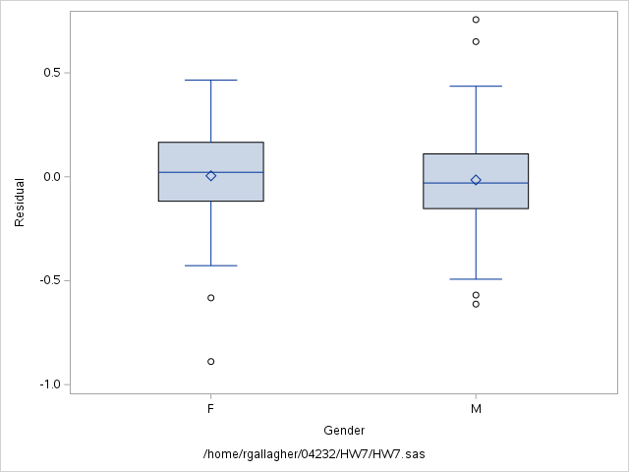 Here is a marginal model using the SAS code:

data grip2;  
 set grip;  
 y_prime = log(y);  
run;  
  
proc mixed data=grip2;  
 class trt gender time;  
 model y_prime = trt gender time x / ddfm=kr solution residual outp=residuals2;  
 repeated time / type=un subject=subject;  
run;

Where we get the model:

$$log\left(y\right)=4.34+0.0126*trt_{1}+−.2904*Female+−0.2452*time_{1}+0.01880*time_{2}+0.005019*x$$

And it has the same assumptions as with the untranformed version of this model.

### 5) Based on your model in (4), test whether time=1 and time=2 are equal.

SAS INPUT:

proc mixed data=grip2;  
 class trt gender time;  
 model y_prime = trt gender time x / ddfm=kr solution;  
 repeated time / type=un subject=subject;  
 lsmeans time / diff cl;  
run;

SAS OUTPUT:

Differences of Least Squares Means  
   
 Standard  
 Effect time _time Estimate Error DF t Value Pr > |t| Alpha  
  
 time 1 2 -0.04332 0.02805 64.2 -1.54 0.1274 0.05  
 time 1 3 -0.02452 0.03112 61.3 -0.79 0.4339 0.05  
 time 2 3 0.01880 0.02118 57.9 0.89 0.3784 0.05  
  
 Differences of Least Squares Means  
   
 Effect time _time Lower Upper  
  
 time 1 2 -0.09936 0.01272  
 time 1 3 -0.08675 0.03771  
 time 2 3 -0.02360 0.06120

Thus, we see that the difference between time=1 and time=2 are not significantly different since the p_val > 0.05. We can also see that their CI for difference is [-0.09936, 0.01272], which overlaps 0. This means that we cannot confidently say that the difference between time 1 and time 2 isn’t 0.