CSE 350 — DIGITAL ELECTRONICS AND PULSE TECHNIQUES
COURSE PROJECT REPORT
Pulse Width Modulation with Application
Design of an Op-Amp Pulse Width Modulator for Sensor-Based Energy-Efficient Lighting Control
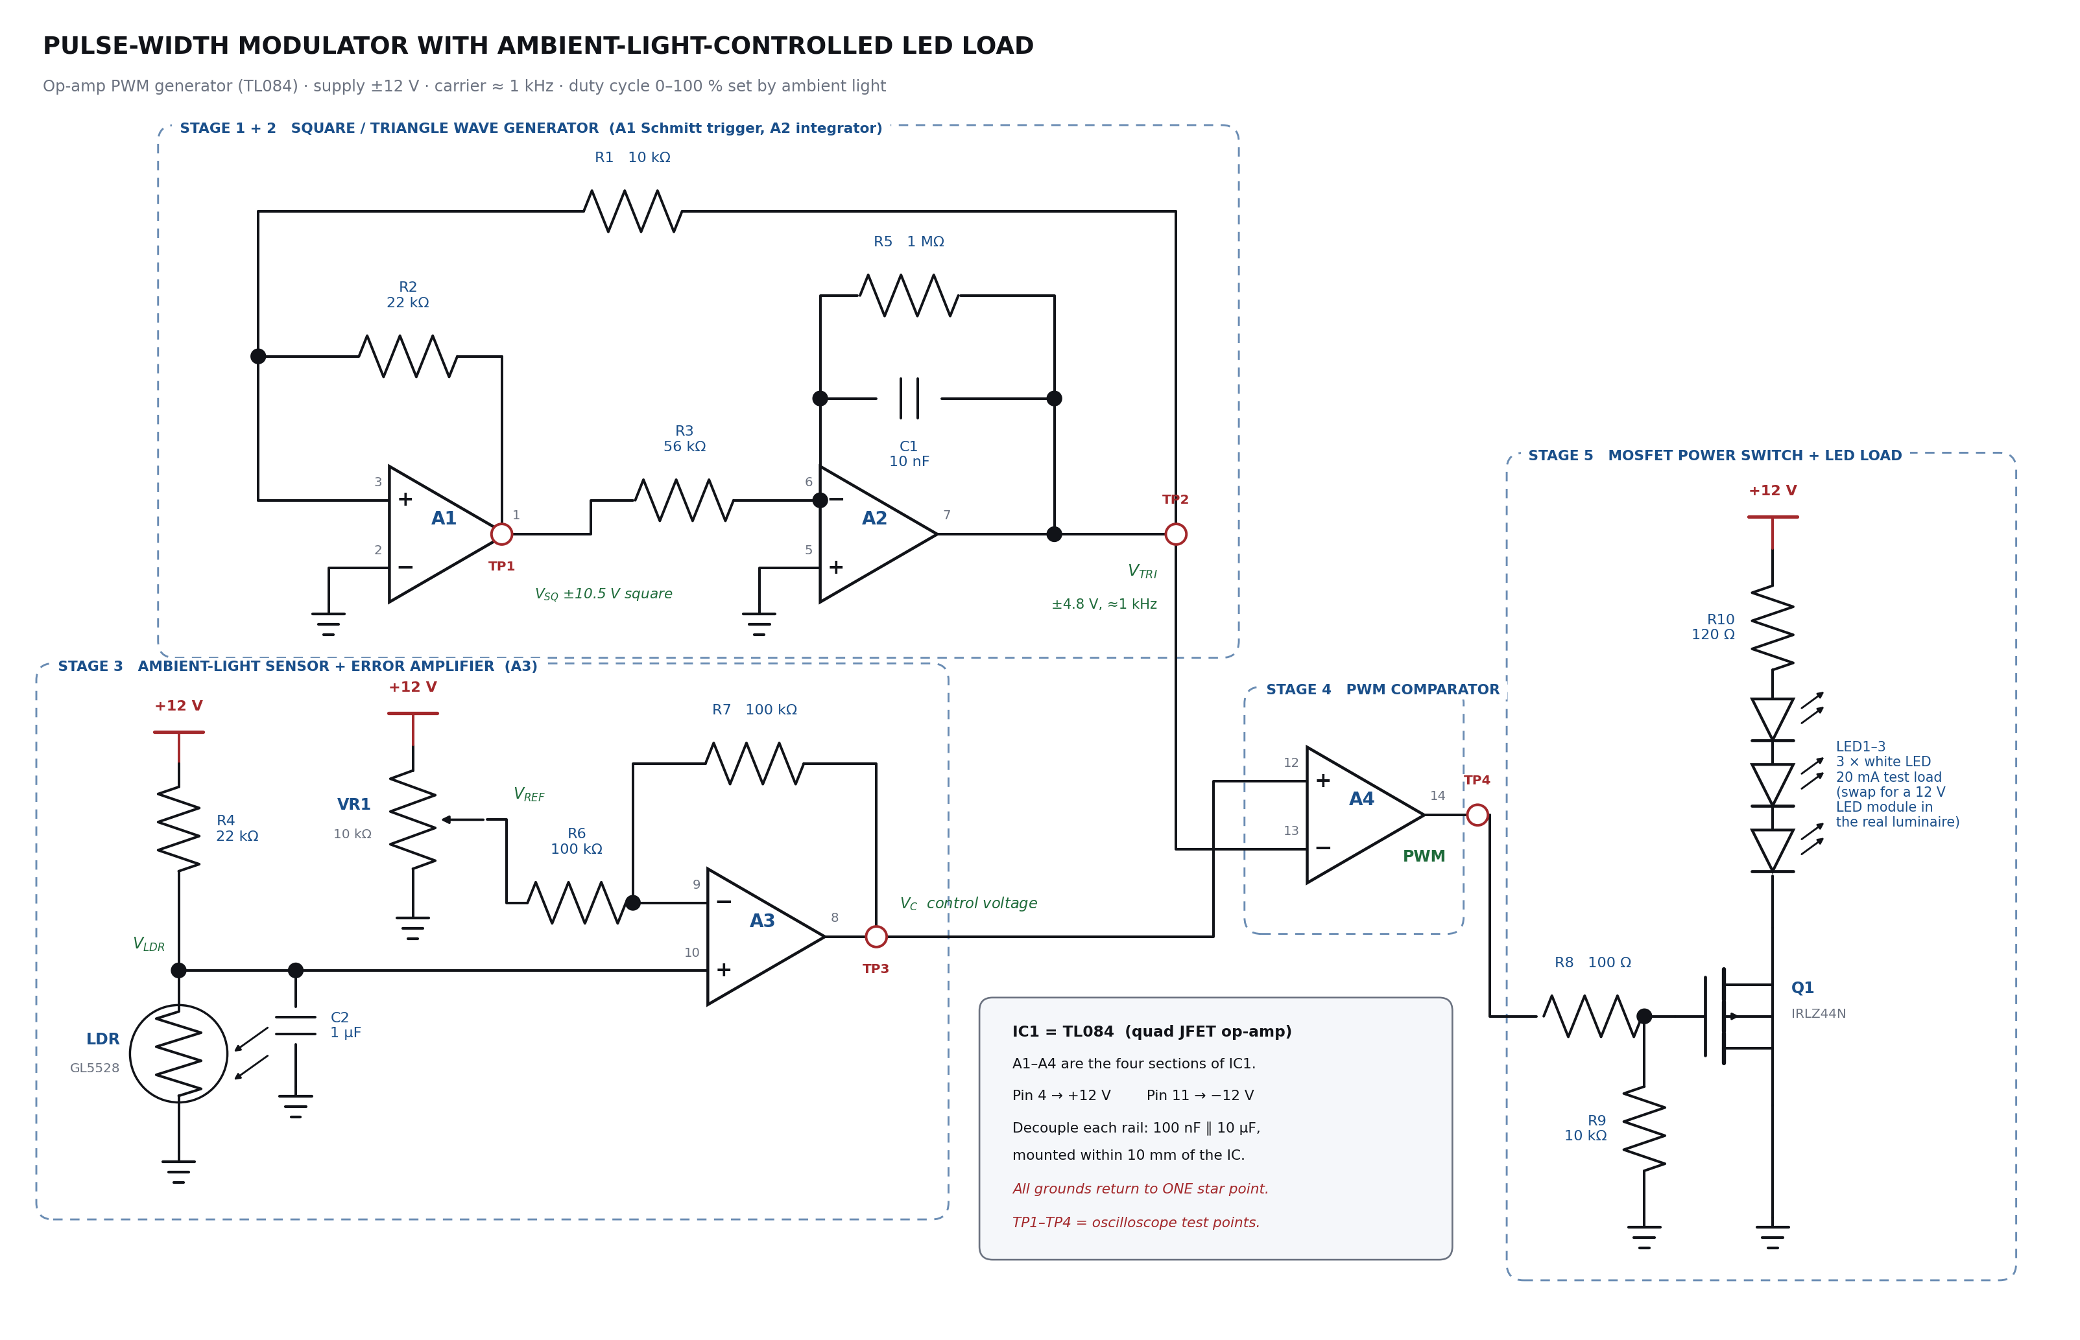

Project Deliverable
“Students must design a pulse width modulator using op-amps with applications such as energy efficient lighting control based on sensors.”
Student name — Student ID — Section — Date

Table of Contents

(In Word, right-click the table above and choose “Update Field” to fill in the page numbers.)

1. Abstract
This project designs, analyses and documents a complete pulse width modulator (PWM) built entirely from operational amplifiers, and applies it to a practical problem: an energy-efficient LED luminaire that automatically dims itself in response to the amount of daylight already present in the room.
A single TL084 quad op-amp provides all four active stages. Two sections form a self-running square/triangle wave generator that produces the PWM carrier: A1 is a non-inverting Schmitt trigger and A2 is an inverting integrator, connected in a regenerative loop. A third section, A3, converts the resistance of a light-dependent resistor (LDR) into a DC control voltage and compares it against an adjustable set-point. The fourth section, A4, works open-loop as a comparator: it compares the control voltage with the triangle carrier and produces a rectangular wave whose pulse width — and therefore whose duty cycle — is directly proportional to the control voltage. A logic-level power MOSFET switches the LED load at that duty cycle.
The measured design targets are a carrier frequency of 982 Hz, a triangle amplitude of ±4.8 V and a duty cycle that varies linearly from 0 % to 100 % over a control-voltage range of ±4.8 V. With the sensor chain calibrated for an indoor working plane, the lamp runs at full brightness below about 3 lux of ambient light, dims progressively between 3 lux and 40 lux, and switches off completely above 40 lux. An optional passive-infrared (PIR) add-on drops the lamp to a low standby level when the room is unoccupied. Taken together, daylight harvesting and occupancy dimming reduce the energy used by a 10 W luminaire by approximately 59 % over a 12-hour operating day.

2. Objectives of the Project
- To understand pulse width modulation as a pulse technique: what duty cycle is, how it carries information, and why the average value of a pulse train is proportional to it.
- To design a stable triangular-wave carrier generator using operational amplifiers only, and to derive its amplitude and frequency from first principles.
- To design an op-amp comparator stage that converts a DC control voltage into a proportional pulse width.
- To design a sensor interface that converts a physical quantity (ambient illuminance) into that control voltage, with a user-adjustable set-point.
- To drive a real load efficiently with the resulting pulse train using a power MOSFET, and to quantify the energy saved compared with an uncontrolled lamp.
- To document the complete circuit, the design calculations, the expected waveforms, a bill of materials, and a build-and-test procedure that another student could follow.

3. Theoretical Background

3.1 What pulse width modulation is
A pulse train is described by three quantities: its amplitude, its period T (or frequency f = 1/T), and the fraction of each period during which it is high. That fraction is the duty cycle:
D = t_ON / T × 100 %
In pulse width modulation the amplitude and the period are both held constant, and only t_ON is varied. The information — in this project, “how bright should the lamp be?” — is encoded purely in the width of each pulse. This is what makes PWM a member of the pulse-modulation family, alongside pulse amplitude modulation (PAM) and pulse position modulation (PPM).
The reason PWM is useful for power control is the average value of the waveform. For a rectangular pulse train that switches between 0 V and Vₛₘ:
V_avg = D × V_sm
A load with any thermal, mechanical or optical inertia — a lamp, a heater, a motor, and to a large extent the human eye — responds to this average rather than to the individual pulses. So by changing only the pulse width we obtain smooth, continuous control of the delivered power, while the switching element itself is only ever fully ON or fully OFF.

3.2 Why PWM rather than analogue dimming
The obvious alternative is to put a variable resistor or a linear pass transistor in series with the lamp. That works, but the series element must drop the unwanted voltage while carrying the full load current, so it dissipates real power as heat. Efficiency falls roughly in proportion to the dimming.
A switching element behaves very differently. When it is OFF, current is zero, so the power (V × I) is zero. When it is ON, the voltage across it is tiny — for the IRLZ44N MOSFET used here, the on-resistance is about 0.028 Ω, giving roughly 11 µW of loss at 20 mA — so the power is again almost zero. Loss only occurs during the brief switching transitions. This is why PWM is the standard method in every modern LED driver, motor controller and switch-mode supply.
For LEDs specifically there is a second advantage. An LED's colour temperature shifts noticeably when its forward current is reduced, so analogue dimming makes a white LED look progressively warmer and less consistent. With PWM the LED always runs at its rated current when it is on; only the on-time changes. Luminous flux is therefore very nearly linear with duty cycle and the colour stays constant.

3.3 The three building blocks of any PWM generator
Every analogue PWM generator, regardless of the components used, contains the same three functional parts:
- A carrier generator that produces a periodic ramp — a triangle or a sawtooth. Its frequency fixes the switching frequency; its peak amplitude fixes the span of the control range.
- A control-voltage source, which is the modulating signal. In a motor drive it might come from a speed potentiometer; here it comes from a light sensor.
- A comparator, which produces a high output whenever the control voltage exceeds the instantaneous carrier voltage. Because the carrier is a straight ramp, the time spent above any given control level is a linear function of that level — which is exactly what makes the modulator linear.
In this project all three blocks, plus the sensor conditioning, are implemented with the four amplifiers inside one TL084 package.

4. Design Approach and Block Diagram
Figure 1 shows how the system is partitioned. The upper chain is the carrier generator; it runs continuously and knows nothing about the light level. The lower chain is the sensor path, which produces a slowly-varying DC. The two meet at the comparator, whose output drives the power switch.
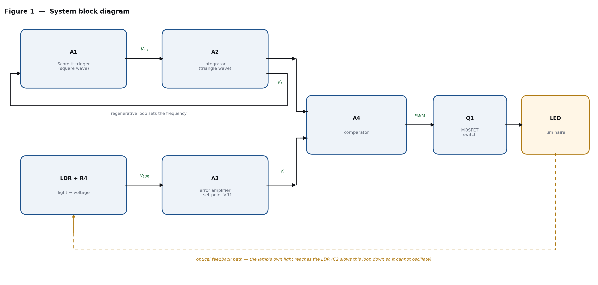
Figure 1 — System block diagram. The upper path generates the carrier; the lower path generates the control voltage; the comparator combines them.
One feature of this particular application deserves attention at the design stage: the lamp illuminates the same room that the sensor is measuring, so there is an unavoidable optical feedback path from the LED back to the LDR (shown dashed in Figure 1). If that loop were fast, the lamp would hunt — it would brighten, see its own light, dim, then brighten again. Two deliberate design choices prevent this. First, capacitor C2 across the sensor node gives the control voltage a time constant of roughly 10 ms to 20 ms, far slower than the 1 ms carrier, which also filters out 100 Hz ripple from any mains lighting nearby. Second, the sensor is physically placed so that it looks at the daylight source rather than directly at the lamp. The recommended build has the LDR pointing at the window or the ceiling.

5. Complete Circuit Diagram
The complete schematic is given on the following page (Figure 2). It is drawn in the five functional stages described in Section 6, with dashed outlines marking each stage. Test points TP1 to TP4 are marked in red; these are the four places an oscilloscope should be connected during testing.
A full-resolution copy of this schematic is supplied as a separate PNG file alongside this document, so that it can be printed at A3 or zoomed for component-level reading.

Figure 2 — Complete circuit diagram of the op-amp pulse width modulator with ambient-light-controlled LED load.

6. Circuit Description and Design Calculations
The circuit is analysed stage by stage. Throughout, V_sat denotes the saturated output voltage of a TL084 section on a ±12 V supply. The datasheet guarantees an output swing to within about 1.5 V of each rail with a 10 kΩ load, so V_sat ≈ 10.5 V is used for all calculations.

6.1 Stage 1 — Schmitt trigger (A1)
A1 is a non-inverting Schmitt trigger. Its inverting input (pin 2) is tied to ground, and its non-inverting input (pin 3) is driven by a two-resistor network: R1 brings in the triangle wave from A2, and R2 provides positive feedback from A1's own output. Because the feedback is positive, A1 has no linear region — its output sits at either +V_sat or −V_sat and snaps between them.
By superposition, the voltage at pin 3 is:
V₊ = V_TRI · R2/(R1+R2) + V_SQ · R1/(R1+R2)
The output changes state at the instant V₊ crosses zero. Setting V₊ = 0 and solving:
V_TRI (switching) = − V_SQ · R1 / R2
Since V_SQ is either +V_sat or −V_sat, the two switching thresholds are symmetrical about ground, and the peak amplitude of the triangle is fixed entirely by the resistor ratio:
V_P = V_sat · R1/R2 = 10.5 × 10 k / 22 k = 4.77 V → 9.55 V peak-to-peak
R1 and R2 therefore set the amplitude of the carrier, and with it the span of control voltage needed to sweep the duty cycle from 0 % to 100 %. A ratio of 10 k : 22 k was chosen because ±4.8 V is comfortably inside the linear output range of A2, leaves headroom before clipping, and is large enough that comparator offset voltages (a few millivolts) contribute negligible duty-cycle error.

6.2 Stage 2 — Integrator (A2)
A2 is a standard inverting (Miller) integrator: R3 feeds current from A1's square-wave output into the virtual earth at pin 6, and that current can only flow into C1. The capacitor voltage therefore ramps at a constant rate:
dV_TRI/dt = − V_SQ / (R3 · C1)
With V_SQ constant at ±10.5 V, the slope is constant at 10.5 / (56 k × 10 n) = 18.75 mV/µs, which is what makes the output a straight-sided triangle rather than an exponential. Note the sign: while A1's output is HIGH the triangle ramps down, and vice versa. This is visible in Figure 3.
The triangle must travel from −V_P to +V_P during one half-period, so:
T/2 = 2 V_P · R3 C1 / V_sat = 2 (R1/R2) R3 C1
f = R2 / (4 · R1 · R3 · C1)
Substituting R1 = 10 kΩ, R2 = 22 kΩ, R3 = 56 kΩ and C1 = 10 nF:
f = 22 000 / (4 × 10 000 × 56 000 × 10⁻⁸) = 982 Hz T = 1.018 ms
Note that V_sat cancels out of the frequency expression — the frequency depends only on passive components, which is why it is stable. The amplitude, however, does depend on V_sat, and this is discussed as a limitation in Section 15.
Why R5 is there. A pure integrator has infinite DC gain, so the op-amp's input offset voltage and bias current would slowly charge C1 until the output stuck against a rail. R5 = 1 MΩ in parallel with C1 limits the DC gain to R5/R3 ≈ 18, which is enough to keep the operating point centred. At the working frequency the reactance of C1 is only about 16 kΩ, far below 1 MΩ, so R5 has no measurable effect on the shape of the triangle.

6.3 Stage 3 — Light sensor and error amplifier (A3)
The sensor is a GL5528 cadmium-sulphide LDR, whose resistance falls as illuminance rises — roughly 1 MΩ in darkness, about 15 kΩ at 10 lux, and a few hundred ohms in direct sunlight. It forms the lower leg of a potential divider with R4 = 22 kΩ:
V_LDR = 12 × R_LDR / (R4 + R_LDR)
Placing the LDR in the lower leg is deliberate. It means V_LDR rises as the room gets darker, which is the polarity we want: darker room → higher control voltage → wider pulses → brighter lamp. No inverting stage is needed anywhere in the chain.
A3 is a non-inverting amplifier whose lower feedback leg returns to the set-point voltage V_REF instead of to ground. This one modification turns a plain amplifier into a difference amplifier with gain, without loading the sensor at all (the LDR drives the op-amp's own non-inverting input, which has essentially infinite input impedance). Its output is:
V_C = V_LDR (1 + R7/R6) − V_REF (R7/R6)
With R6 = R7 = 100 kΩ this simplifies to:
V_C = 2 V_LDR − V_REF
VR1 sets V_REF anywhere between 0 V and +12 V, which moves the whole dimming characteristic left or right along the light axis. Because the gain is 2 and the carrier peak is ±4.8 V, the full 0–100 % duty range is covered by a 4.8 V change in V_LDR. Setting VR1 for V_REF = 9.73 V places the 50 % point at R_LDR = 15 kΩ, i.e. about 10 lux, which suits a corridor or a desk area.
Why C2 is there. C2 = 1 µF works against the Thevenin resistance of the divider (at most 22 kΩ) to give a low-pass corner of roughly 7 Hz. It performs two jobs at once: it removes the 100 Hz flicker that any nearby mains lamp induces in the LDR, and it deliberately slows the optical feedback loop described in Section 4 so that the system settles smoothly instead of hunting.

6.4 Stage 4 — PWM comparator (A4)
A4 is used open-loop, with no feedback network at all, so its enormous open-loop gain drives the output hard into one rail or the other. The control voltage goes to the non-inverting input and the triangle carrier to the inverting input, so:
V_PWM = +V_sat when V_C > V_TRI ; −V_sat otherwise
Because the carrier rises and falls linearly between −V_P and +V_P, the fraction of each period spent above any horizontal line at height V_C is a simple linear function of V_C:
D = (V_C + V_P) / (2 V_P) = ½ (1 + V_C / V_P) clamped to 0…100 %
This is the central equation of the whole project. It says the modulator is perfectly linear, and that its full control range is exactly ±V_P = ±4.8 V. Outside that range the comparator simply saturates, giving a clean 0 % (lamp off) or 100 % (lamp fully on) — which is desirable behaviour, not a fault.

6.5 Stage 5 — Power switch and LED load
Q1 is an IRLZ44N logic-level N-channel MOSFET. “Logic-level” matters: an ordinary MOSFET needs 10 V of gate drive to reach its rated on-resistance, whereas the IRLZ44N is fully enhanced at about 5 V, giving margin even if the op-amp swing is reduced.
- R8 (100 Ω) limits the peak current the op-amp must deliver into the gate capacitance and damps ringing on the gate lead. With a 21 V swing the peak gate current is about 105 mA, within the TL084's short-circuit-limited output.
- R9 (10 kΩ) holds the gate at 0 V while power is coming up, so the LED cannot flash on before the op-amps have settled.
- The comparator output swings to −10.5 V during the off period. This reverse gate voltage is harmless — it is well inside the IRLZ44N's ±16 V V_GS rating — and it actually turns the MOSFET off harder and faster than a 0 V drive would.
For bench testing the load is three white LEDs in series (about 9.6 V total forward drop) with R10 = 120 Ω, giving a peak current of (12 − 9.6)/120 = 20 mA. In a real luminaire this branch is replaced by a 12 V LED strip or module, and R10 is either resized for the module's current or omitted if the module already contains its own constant-current regulator. The MOSFET and the switching scheme need no change; only the load branch is scaled.

6.6 Why a TL084 and not an LM324
The LM324 is the cheaper and more common quad op-amp, and it would work — but not well, and the reason is instructive for a pulse-techniques course. The comparator output has to travel 21 V (from −10.5 V to +10.5 V) on every edge. How long that takes is set by the slew rate:
Device | Slew rate | Time for a 21 V edge | As a fraction of the 1.018 ms period
TL084 (JFET input) | 13 V/µs | 1.62 µs | 0.16 %
LM324 (bipolar) | 0.5 V/µs | 42 µs | 4.1 %

A 4.1 % smear on every edge is a direct duty-cycle error, it puts a hard limit on the minimum achievable pulse width, and — worse — it keeps the MOSFET in its linear region for 42 µs twice per cycle, where it dissipates real heat. The TL084's JFET input stage also draws only a few tens of picoamps of bias current, which matters at the 1 MΩ integrator resistor and at the high-impedance sensor node. A TL074 or TL064 is a direct pin-compatible substitute.

7. How the Circuit Works — Step-by-Step Walkthrough
Follow the signal from left to right in Figure 2.
- Assume at switch-on that A1's output happens to sit at +10.5 V. R3 then pushes a constant current of 10.5 V / 56 kΩ = 188 µA into A2's virtual earth. That current has nowhere to go but into C1, so A2's output ramps downwards at a fixed 18.75 mV/µs.
- A1 is watching that falling ramp through R1. When it reaches −4.77 V, the voltage at A1 pin 3 crosses zero and A1 snaps to −10.5 V.
- The integrator current reverses, so A2's output now ramps upwards at the same rate. When it reaches +4.77 V, A1 snaps back to +10.5 V. The cycle repeats indefinitely at 982 Hz. No external trigger, clock or crystal is needed — the loop is self-starting because op-amp noise and offset are always enough to break the initial symmetry.
- Meanwhile, on the sensor side, the LDR and R4 produce a DC voltage that rises as the room gets darker. A3 amplifies the difference between this and the VR1 set-point by a factor of two, giving V_C. This voltage changes over seconds, not microseconds, so as far as the comparator is concerned it is a constant DC level.
- A4 compares them continuously. Whenever the triangle dips below V_C, the output goes high; whenever the triangle rises above V_C, the output goes low. A high V_C (dark room) means the triangle spends most of its cycle below it, so the pulses are wide. A low V_C (bright room) means the triangle spends most of its cycle above it, so the pulses are narrow.
- Those pulses drive Q1's gate. The LED string is therefore switched on and off 982 times per second, and the eye integrates this into a steady brightness proportional to the duty cycle.
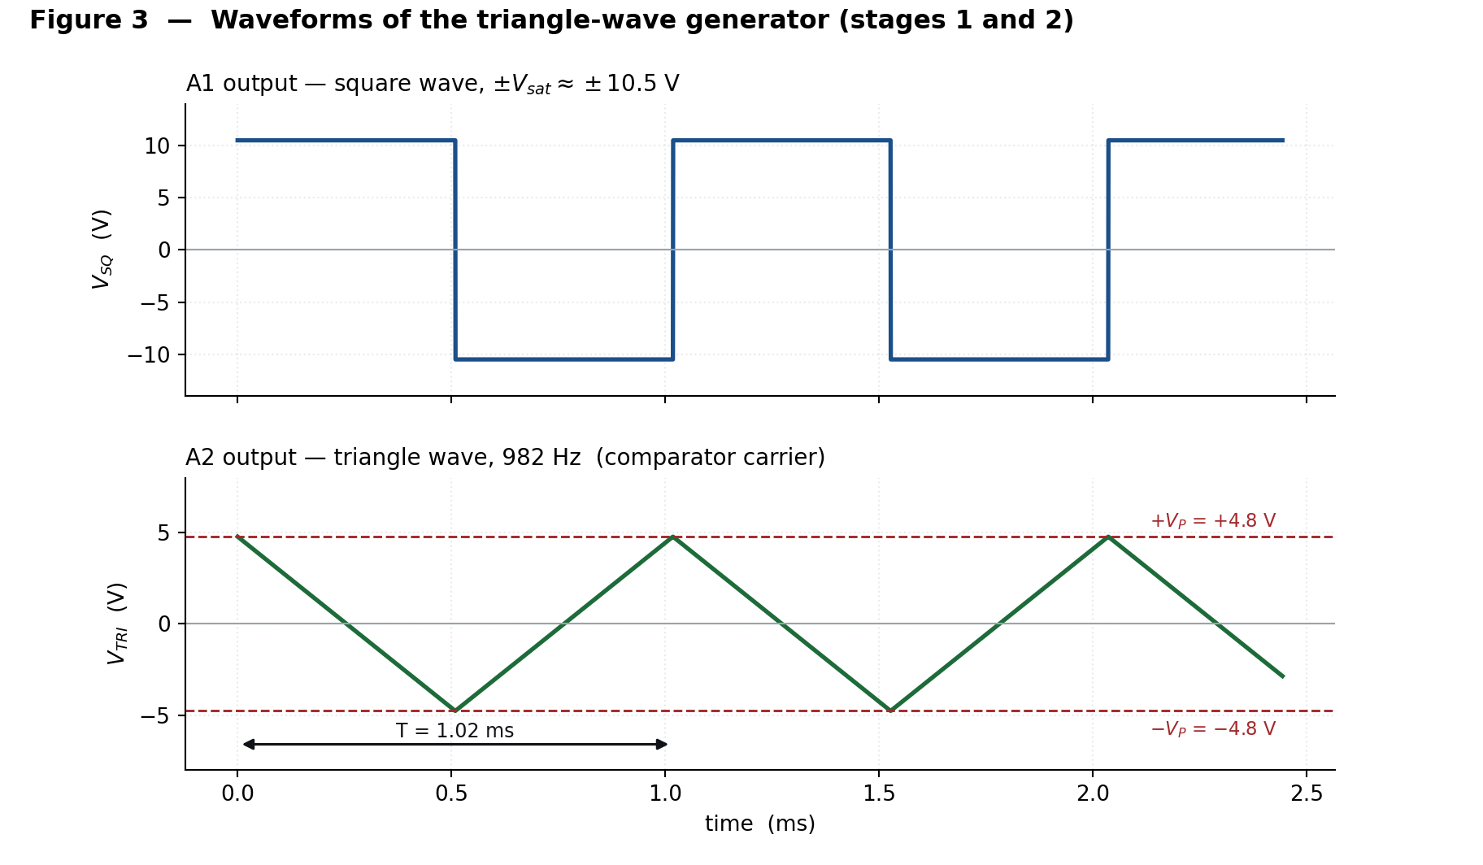
Figure 3 — Waveforms at TP1 and TP2. Note that the triangle ramps down while the square wave is high, because A2 is an inverting integrator.
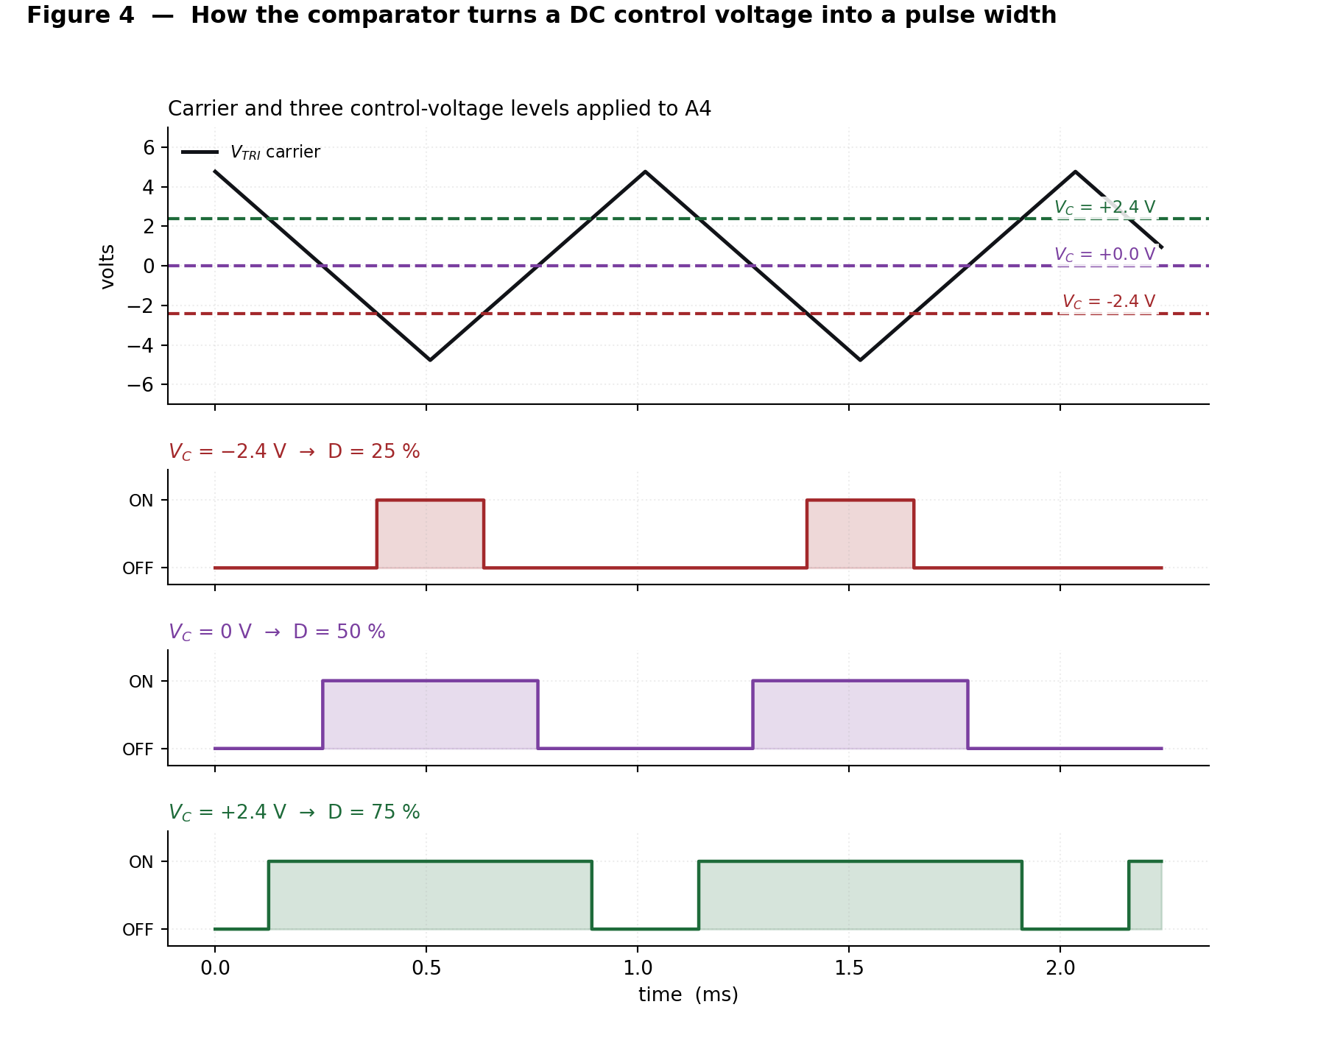
Figure 4 — Comparator action at three control-voltage levels. The horizontal line is the DC control voltage; the pulse width is simply the length of time the triangle spends below it.

8. Transfer Characteristics and Expected Results
Figure 5(a) plots the duty cycle against control voltage. The relationship is a straight line inside the ±4.8 V control band and flat outside it. Figure 5(b) converts the horizontal axis into ambient illuminance using the LDR's characteristic, showing the behaviour the user actually sees.
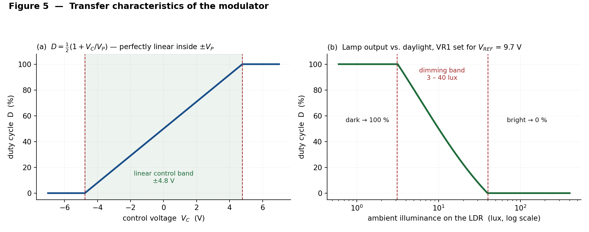
Figure 5 — (a) Duty cycle versus control voltage. (b) Lamp output versus ambient illuminance with VR1 set for V_REF = 9.73 V.
The table below gives five calculated operating points. The LDR resistance is obtained from the divider equation and the illuminance from the GL5528 characteristic R ≈ 15 kΩ × (10/E)^0.7.
Control voltage V_C | Duty cycle D | V_LDR | LDR resistance | Approx. illuminance | Lamp appearance
−4.8 V | 0 % | 2.48 V | 5.7 kΩ | 40 lux | off — room already bright
−2.4 V | 25 % | 3.67 V | 9.7 kΩ | 19 lux | dim
0 V | 50 % | 4.87 V | 15.0 kΩ | 10 lux | half brightness (set-point)
+2.4 V | 75 % | 6.06 V | 22.4 kΩ | 5.6 lux | bright
+4.8 V | 100 % | 7.25 V | 33.6 kΩ | 3.2 lux | full output — room dark

Two further predicted results are worth recording for comparison with measurement. The average LED current should follow I_avg = D × 20 mA, so the meter should read 5 mA at 25 % and 15 mA at 75 %. And the carrier frequency should stay within a few per cent of 982 Hz regardless of the light level — if it moves with the light, something is wrong in the wiring between stages.

9. Component List (Bill of Materials)
Ref | Value / Part | Function in the circuit | Qty
IC1 | TL084 (or TL074 / TL064) | Quad JFET op-amp — A1, A2, A3, A4 | 1
Q1 | IRLZ44N | Logic-level N-channel power MOSFET, LED switch | 1
LDR | GL5528 (5 mm CdS cell) | Ambient-light sensor | 1
R1 | 10 kΩ, 1/4 W, 1 % | Schmitt trigger — sets triangle amplitude | 1
R2 | 22 kΩ, 1/4 W, 1 % | Schmitt trigger positive feedback | 1
R3 | 56 kΩ, 1/4 W, 1 % | Integrator input resistor — sets frequency | 1
R4 | 22 kΩ, 1/4 W | Upper leg of the LDR divider | 1
R5 | 1 MΩ, 1/4 W | DC stabilisation across the integrator capacitor | 1
R6, R7 | 100 kΩ, 1/4 W, 1 % | Error-amplifier gain-setting pair (gain = 2) | 2
R8 | 100 Ω, 1/4 W | MOSFET gate series resistor | 1
R9 | 10 kΩ, 1/4 W | MOSFET gate pull-down | 1
R10 | 120 Ω, 1/2 W | LED current-limiting resistor (bench load) | 1
VR1 | 10 kΩ linear potentiometer | Light-level set-point adjustment | 1
C1 | 10 nF polyester / C0G | Integrator capacitor — sets frequency | 1
C2 | 1 µF ceramic or film | Sensor low-pass filter, loop damping | 1
C3, C4 | 100 nF ceramic | Supply decoupling at IC1 pins 4 and 11 | 2
C5, C6 | 10 µF / 25 V electrolytic | Bulk supply decoupling | 2
LED1–3 | 5 mm white LED | Test load (replace with a 12 V LED module) | 3
PSU | ±12 V dual supply | Bench supply or two 12 V adapters in series | 1

Optional occupancy add-on (Section 11.2): PIR module HC-SR501 × 1; 7805 regulator × 1; 2N3904 transistors × 2 (Q2, Q3); 10 kΩ resistors × 4 (R11–R14); 0.33 µF and 0.1 µF regulator capacitors.
Use 1 % metal-film resistors for R1, R2, R3, R6 and R7, and a polyester or C0G capacitor for C1. These five components alone determine the carrier frequency, the carrier amplitude and the control gain, so their tolerance directly becomes duty-cycle error. Everything else can be 5 % carbon film.

10. Wiring Guide (Node-by-Node Connection List)
Build the circuit one node at a time and tick each row off as it is wired. The TL084 pin-out is given in Figure 6.
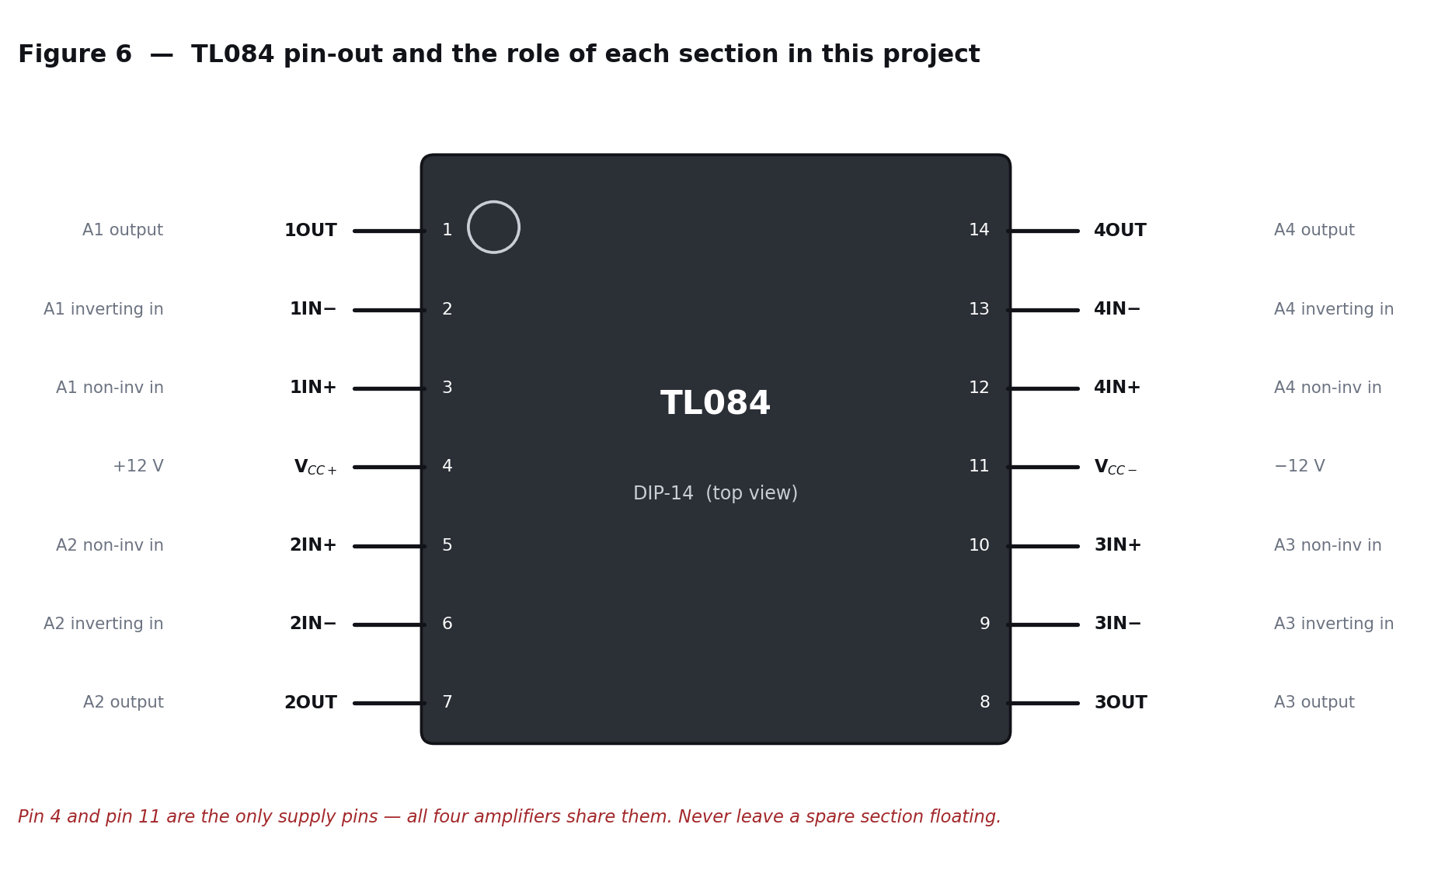
Figure 6 — TL084 DIP-14 pin-out, annotated with the role of each section in this project.
Node | Everything that connects to it
+12 V | IC1 pin 4 · R4 (top) · VR1 (top) · R10 (top) · C3, C5 (+)
−12 V | IC1 pin 11 · C4, C6 (−)
GND (star point) | IC1 pin 2 · IC1 pin 5 · LDR (bottom) · C2 · VR1 (bottom) · R9 · Q1 source · supply common
N1 | IC1 pin 3 · R1 · R2
TP1 V_SQ | IC1 pin 1 · R2 · R3
N2 | IC1 pin 6 · R3 · C1 · R5
TP2 V_TRI | IC1 pin 7 · C1 · R5 · R1 · IC1 pin 13
V_LDR | IC1 pin 10 · R4 (bottom) · LDR (top) · C2
V_REF | VR1 wiper · R6
N3 | IC1 pin 9 · R6 · R7
TP3 V_C | IC1 pin 8 · R7 · IC1 pin 12
TP4 PWM | IC1 pin 14 · R8
GATE | R8 · R9 · Q1 gate
DRAIN | Q1 drain · LED3 cathode
LED string | R10 (bottom) → LED1 anode; LED1 cathode → LED2 anode; LED2 cathode → LED3 anode

Two wiring points cause most first-time failures. First, R2 must go to pin 3 (the non-inverting input) — if it is accidentally wired to pin 2 the feedback becomes negative, A1 behaves as a linear amplifier, and nothing oscillates. Second, all grounds must meet at a single star point near the IC; a daisy-chained ground shares the LED switching current with the sensor node and produces visible jitter on the pulse width.

11. Application: Energy-Efficient Lighting Control

11.1 Daylight harvesting
The application implemented here is daylight harvesting: the lamp contributes only the light that the daylight is not already providing, so the total illuminance on the working plane stays roughly constant through the day while the electrical energy consumed falls sharply. Commercial systems do exactly this; the circuit in Figure 2 is a minimal all-analogue version of one.
The behaviour is that of a proportional controller. A3 forms the error between the measured light level and the set-point, multiplies it by a gain of two, and the comparator converts that error into lamp power. Because the loop gain is finite there is a small steady-state offset — a real photometric controller would add an integral term — but for lighting, where the eye is very tolerant of slow level changes, proportional control is entirely adequate and is what most commercial daylight sensors actually use.
Commissioning is a single adjustment. At the time of day when the lamp should be at half output, turn VR1 until it is. That is the whole calibration procedure.

11.2 Occupancy add-on — dimming an empty room
Daylight harvesting saves nothing at night in an empty room. A passive-infrared sensor closes that gap. Rather than switching the lamp off completely — which is unpleasant and unsafe in a corridor — the add-on in Figure 7 drops it to a low standby level, which is the approach used in modern car parks and stairwells.
The method is deliberately simple and requires no change at all to the main board. Q3 switches a 10 kΩ resistor in parallel with the LDR whenever the room is vacant. The parallel combination is always lower than the LDR alone, so V_LDR falls and the modulator behaves exactly as if the room had become brighter. Q2 is only there to invert the PIR's logic, because the HC-SR501 output goes high on motion whereas the shunt is needed on no motion.
Calculated behaviour with R11 = 10 kΩ, taking a dark room (LDR = 100 kΩ):
Condition | Effective sensor resistance | V_LDR | V_C | Duty cycle
Dark room, occupied | 100 kΩ | 9.84 V | +9.9 V (saturated) | 100 %
Dark room, vacant | 100 kΩ ∥ 10 kΩ = 9.1 kΩ | 3.51 V | −2.71 V | 22 %
Bright room, either | < 5.7 kΩ | < 2.48 V | < −4.8 V | 0 %

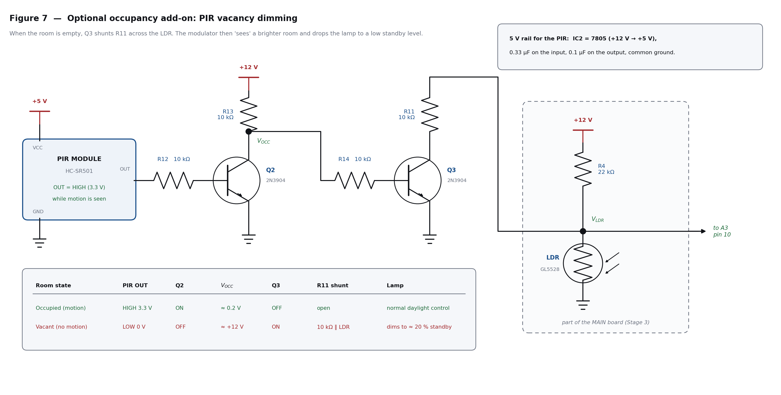
Figure 7 — Optional PIR occupancy add-on. Q3 shunts R11 across the LDR when the room is empty, so the modulator dims the lamp to a standby level.

11.3 Energy saving — worked calculation
Consider one 10 W LED luminaire in an office corridor, operated for 12 hours a day. Without control it simply runs at full power for the whole period.
Period | Duration | Duty cycle | Average power | Energy per day
Daylight hours (lamp not needed) | 4 h | 0 % | 0 W | 0 Wh
Evening, corridor occupied | 5 h | 85 % | 8.5 W | 42.5 Wh
Evening, corridor empty (standby) | 3 h | 22 % | 2.2 W | 6.6 Wh
Total with PWM control | 12 h | — | — | 49.1 Wh
Total without control (reference) | 12 h | 100 % | 10 W | 120.0 Wh

Energy saving = (120.0 − 49.1) / 120.0 = 59.1 %
That is 70.9 Wh saved per luminaire per day, or 25.9 kWh per year. Across a fifty-luminaire building the annual saving is about 1 290 kWh. The additional component cost per luminaire is roughly the price of one op-amp, one MOSFET, one LDR and a handful of passives.
Two secondary benefits are worth noting. Running an LED at reduced average current lowers its junction temperature, which extends its useful life — LED lumen depreciation is strongly temperature-dependent. And because the switch is either fully on or fully off, the saving is a genuine reduction in energy drawn from the supply, not merely a redistribution into heat in a series element.

12. Construction and Testing Procedure

12.1 Recommended build order
- Fit IC1 in a socket. Wire the supply rails and both decoupling pairs first, then power up with nothing else connected and confirm +12 V on pin 4 and −12 V on pin 11.
- Build stages 1 and 2 (R1, R2, R3, R5, C1). Power up and look at TP1 and TP2. You should have a square wave and a triangle immediately. Do not proceed until this works — everything downstream depends on it.
- Build stage 3 (LDR, R4, C2, VR1, R6, R7). Connect a DC voltmeter to TP3 and confirm the reading rises when you cover the LDR and falls when you shine a torch on it.
- Build stage 4 (the two wires into pins 12 and 13). Look at TP4 with the scope and confirm the pulse width changes as you shade the LDR.
- Build stage 5 last (R8, R9, Q1, R10, LEDs). Keep the LED wiring physically away from the sensor wiring.

12.2 Expected measurements
Test point | Instrument | Expected reading | Acceptable tolerance
TP1 V_SQ | Oscilloscope | Square wave, ±10.5 V, 982 Hz, 50 % duty | ±10 % on frequency
TP2 V_TRI | Oscilloscope | Triangle, ±4.8 V (9.5 V p-p), 982 Hz | ±10 % on amplitude
TP3 V_C | DC voltmeter | −4.8 V (bright) to +4.8 V (dark) | monotonic with light
TP4 PWM | Oscilloscope | Rectangular, ±10.5 V, 982 Hz, width varies | 0–100 % achievable
LED branch | DC ammeter | I_avg = D × 20 mA | ±15 %
Q1 case | Finger / IR thermometer | Ambient temperature | must not be warm

A useful additional experiment for the report: disconnect the LDR and drive pin 10 from a bench supply instead. Sweep it slowly and record duty cycle against V_C on the scope. Plotting those points on top of Figure 5(a) demonstrates the linearity of the modulator directly, independently of the sensor's own non-linearity.

12.3 Troubleshooting
Symptom | Most likely cause | What to do
No oscillation; TP1 sits at a rail | R2 wired to pin 2 instead of pin 3, so the feedback is negative | Move R2 to pin 3 and confirm pin 2 is grounded
Triangle is curved, not straight | R5 too small, or C1 is a leaky electrolytic | Use 1 MΩ for R5 and a polyester or C0G capacitor for C1
Triangle amplitude wrong | R1/R2 ratio incorrect, or supply is not ±12 V | Recheck the ratio; V_P = V_sat × R1/R2
Frequency far from 982 Hz | C1 tolerance — disc ceramics are often 20 % out | Measure C1 and, if needed, trim R3
Duty cycle stuck at 0 % or 100 % | VR1 set so that V_C lies outside ±4.8 V | Readjust VR1 while watching TP3 on a meter
Lamp slowly pulses up and down | Optical feedback — the LDR is seeing the lamp | Shield or reposition the LDR; increase C2 to 4.7 µF
Visible flicker | Carrier frequency too low for the observer | Reduce C1 to 3.3 nF, which raises the carrier to about 3 kHz
Q1 gets hot | Gate not fully driven, or a non-logic-level MOSFET fitted | Confirm the part is an IRLZ44N and that TP4 swings the full ±10.5 V
Everything dead | Supply rails swapped on pins 4 and 11 | Power down immediately; the IC has probably been damaged

13. Simulation
The design should be verified in simulation before it is built. The listing below is an LTspice netlist of the complete circuit. Save it as a .cir file and open it with File › Open. The .step directive sweeps the LDR through the five operating points tabulated in Section 8, so a single run produces the whole family of duty cycles.
* CSE350 - Op-amp PWM modulator with LDR light control
.lib UniversalOpamp2.sub

V1 VP 0 12
V2 VN 0 -12

* ---- A1 : Schmitt trigger -------------------------------------
XA1 N1 0 VP VN VSQ level2 Avol=1Meg GBW=3Meg Slew=13Meg
R1 VTRI N1 10k
R2 VSQ N1 22k

* ---- A2 : integrator ------------------------------------------
XA2 0 N2 VP VN VTRI level2 Avol=1Meg GBW=3Meg Slew=13Meg
R3 VSQ N2 56k
C1 N2 VTRI 10n
R5 N2 VTRI 1Meg

* ---- Stage 3 : sensor + error amplifier -----------------------
.param Rl=15k
R4 VP VLDR 22k
RLDR VLDR 0 {Rl}
C2 VLDR 0 1u
VREF VREF 0 9.73
R6 VREF N3 100k
R7 N3 VC 100k
XA3 VLDR N3 VP VN VC level2 Avol=1Meg GBW=3Meg Slew=13Meg

* ---- A4 : PWM comparator --------------------------------------
XA4 VC VTRI VP VN VPWM level2 Avol=1Meg GBW=3Meg Slew=13Meg

* ---- Stage 5 : MOSFET switch and LED load ---------------------
R8 VPWM GATE 100
R9 GATE 0 10k
M1 DRN GATE 0 0 IRLZ44N
R10 VP LA 120
D1 LA LB WLED
D2 LB LC WLED
D3 LC DRN WLED
.model WLED D(Is=1e-20 N=2 Rs=2)
.model IRLZ44N VDMOS(Rd=0 Rs=0.01 Vto=1.6 Kp=25 Cgdmax=1.5n
+ Cgdmin=0.1n Cgs=1.6n Cjo=1n Rb=0.01 mfg=Generic Vds=55 Ron=0.028)

* ---- analysis --------------------------------------------------
.step param Rl list 5.7k 9.7k 15k 22.4k 33.6k
.tran 0 20m 10m 1u
.end

Plot V(VTRI) and V(VC) on one pane and V(VPWM) on another. The five stepped traces should show duty cycles of approximately 0 %, 25 %, 50 %, 75 % and 100 %, matching the table in Section 8. In Multisim or Proteus the same circuit can be entered directly using the built-in TL084 and IRLZ44N models, with the LDR replaced by a variable resistor.

14. Advantages of the Design
- High efficiency. The switching element is only ever saturated or cut off, so conduction loss is measured in microwatts and there is no series dropper resistor wasting power.
- Exact linearity. D = ½(1 + V_C/V_P) is a first-order result with no approximations, so the relationship between control voltage and delivered power is a straight line.
- No microcontroller, no firmware, no clock. The circuit is fully analogue, starts instantly on power-up, and cannot crash or need reflashing.
- Component economy. One 8-taka quad op-amp provides the oscillator, the integrator, the signal conditioning and the comparator.
- Frequency independent of supply voltage. V_sat cancels in the frequency equation, so the carrier does not drift as the battery or adapter sags.
- Constant LED colour temperature, because the LED always runs at its rated current when it conducts.
- Single-control commissioning. One potentiometer sets the entire light-level characteristic.

15. Limitations and Possible Improvements
Limitation | Why it happens | How it could be improved
Carrier amplitude depends on V_sat | V_P = V_sat × R1/R2, and V_sat varies with supply voltage and temperature, so the duty-cycle calibration drifts | Clamp A1's output with back-to-back Zener diodes so V_P is set by the Zener voltage instead
CdS LDR is slow and contains cadmium | Response time is tens of milliseconds and the cell is restricted under RoHS | Use a silicon photodiode with a transimpedance amplifier, or a BH1750 digital lux sensor
Proportional control leaves a steady-state offset | There is no integral term in the loop | Add an integrating capacitor around A3 to make it a PI controller
982 Hz may be visible to some observers | IEEE Std 1789-2015 places frequencies above roughly 3 kHz in the no-observable-effect region | Reduce C1 to 3.3 nF, which raises the carrier to 2 976 Hz with no other change
Sharp switching edges radiate interference | The MOSFET switches 21 V in under 2 µs | Add a small gate resistor increase or an RC snubber; keep the load loop area small
Lamp can go fully off | 0 % duty is reachable, which is unsafe in a stairwell | Add a diode clamp on V_C to impose a minimum duty cycle of about 10 %
Single sensor, single zone | One LDR controls one luminaire | Buffer V_C and distribute it to several comparator/MOSFET channels for multi-lamp zoning

16. Conclusion
A complete pulse width modulator has been designed using nothing but the four amplifiers inside a single TL084. The Schmitt-trigger-plus-integrator loop produces a 982 Hz triangular carrier of ±4.8 V whose frequency depends only on passive components, and an open-loop comparator converts a DC control voltage into a pulse train whose duty cycle follows D = ½(1 + V_C/V_P) exactly.
Applying that modulator to lighting control required only one additional amplifier stage. An LDR in a divider produces a voltage that rises with darkness, and a non-inverting amplifier referenced to an adjustable set-point turns that into the control voltage. The result is a luminaire that runs at full output below about 3 lux, dims progressively up to 40 lux, and switches off above that; adding a PIR sensor and two transistors makes it drop to a 22 % standby level in an empty room.
The worked energy calculation shows a 59 % reduction in daily consumption for a 10 W corridor luminaire. More importantly for the course, the project demonstrates the central idea of pulse techniques: that a continuous physical quantity can be carried in the timing of a two-state waveform, and that processing information in the time domain rather than the amplitude domain buys both efficiency and noise immunity.

17. References
[1] J. Millman and H. Taub, Pulse, Digital and Switching Waveforms. New York: McGraw-Hill. — Chapters on comparators, Schmitt triggers and time-base generators.
[2] A. S. Sedra and K. C. Smith, Microelectronic Circuits, 7th ed. Oxford University Press. — Op-amp integrators, comparators and astable multivibrators.
[3] R. L. Boylestad and L. Nashelsky, Electronic Devices and Circuit Theory, 11th ed. Pearson. — Op-amp applications and MOSFET switching.
[4] N. Mohan, T. M. Undeland and W. P. Robbins, Power Electronics: Converters, Applications and Design, 3rd ed. Wiley. — Fundamentals of PWM and the sine-triangle comparison method.
[5] Texas Instruments, TL08xx JFET-Input Operational Amplifiers, datasheet SLOS081.
[6] Texas Instruments, Application Report SLOA067, Triangle Wave Generator Using Op Amps.
[7] Infineon Technologies (International Rectifier), IRLZ44N HEXFET Power MOSFET, datasheet PD-91339.
[8] IEEE Std 1789-2015, IEEE Recommended Practices for Modulating Current in High-Brightness LEDs for Mitigating Health Risks to Viewers.
[9] Senba Optical, GL55 Series Photoresistor datasheet (GL5528 characteristics).

