**Problem Statement:**

Big Mountain Resort, a ski resort located in Montana.The resort's pricing strategy has been to charge a premium above the average price of resorts in its market segment.There's a suspicion that Big Mountain is not capitalizing on its facilities as much as it could. Basing their pricing on just the market average does not provide the business with a good sense of how important some facilities are compared to others. This hampers investment strategy.The business wants some guidance on how to select a better value for their ticket price. They are also considering a number of changes that they hope will either cut costs without undermining the ticket price or will support an even higher ticket price.

Big Mountain Resort has recently installed an additional chair lift to help increase the distribution of visitors across the mountain. This additional chair increases their operating costs by $1,540,000 this season.

The business has shortlisted some options:

1. Permanently closing down up to 10 of the least used runs. This doesn't impact any other resort statistics.
2. Increase the vertical drop by adding a run to a point 150 feet lower down but requiring the installation of an additional chair lift to bring skiers back up, without additional snow making coverage
3. Same as number 2, but adding 2 acres of snow making cover
4. Increase the longest run by 0.2 mile to boast 3.5 miles length, requiring an additional snow making coverage of 4 acres

The expected number of visitors over the season is 350,000 and, on average, visitors ski for five days.

**Summary:**

**Model Used: Random Forest regressor**

Big Mountain Resort currently charges $81.00. Suggested modeled price is $96.17. Even with the expected mean absolute error of $10.29, this suggests there is room for an increase.

**Current Price of all resorts vs the state of Montana**

|  |  |
| --- | --- |
|  |  |

Random Forest Model was selected to perform the feature analysis and the dominant top four features are:

* fastQuads
* Runs
* Snow Making_ac
* vertical_drop

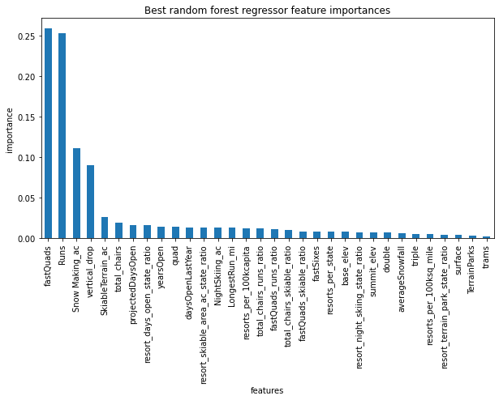Comparison between the ski resorts and Big Mountain on the above features gave following insights:

|  |  |
| --- | --- |
| Most resorts have no fast quads. Big Mountain has 3, which puts it high up that league table. There are some values much higher, but they are rare. | Big Mountain compares well for the number of runs. There are some resorts with more, but not many. |
|  |  |
|  |  |
| Big Mountain is very high up the league table of snowmaking. | Big Mountain is doing well for vertical drop, but there are still quite a few resorts with a greater drop. |

The model was used to verify the scenarios suggested by the business. Below are the findings:

**Scenario 1: Close up to 10 of the least used runs.** 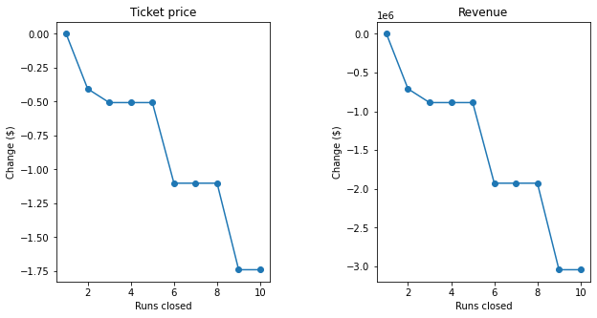

The model says closing one run makes no difference. Closing 2 and 3 successively reduces support for ticket price and so revenue. If Big Mountain closes down 3 runs, it seems they may as well close down 4 or 5 as there's no further loss in ticket price. Increasing the closures down to 6 or more leads to a large drop.

**Scenario 2: In this scenario, Big Mountain is adding a run, increasing the vertical drop by 150 feet, and installing an additional chair lift.**

This scenario increases support for ticket price by $1.51. Over the season, this could be expected to amount to $2,637,681. As mentioned, this additional chair increases their operating costs by $1,540,000 this season

**Scenario 3: In this scenario, you are repeating the previous one but adding 2 acres of snow making.**

This scenario increases support for ticket price by $1.51. Over the season, this could be expected to amount to $2,637,681. Such a small increase in the snow making area makes no difference!

**Scenario 4:This scenario calls for increasing the longest run by .2 miles and guaranteeing its snow coverage by adding 4 acres of snow making capability.**

No difference whatsoever. Although the longest run feature was used in the linear model, the random forest model (the one we chose because of its better performance) only has the longest run way down in the feature importance list.

## **Further work:**

Main assumption made in the model price prediction is that the expected number of visitors over the season is 350,000 and, on average, visitors ski for five days. This data needs to be captured correctly to get better accuracy.

Scenario 1, when closing down the unused runs, how much operational cost is saved needs to be taken into consideration. Closing down 4 or 5 does not have further loss in ticket price, so closing the 4 or 5 unused runs could lower the operational cost.

Big Mountain does have good facilities as compared to other resorts in the country. The validity of the model is based on the fact that the pricing of the other resorts is accurately set. The operation cost of the resorts would definitely play a big role in identifying the profit margins.

Other factors to consider to attract more customers would be to consider how accessible the resort itself is to customers. Can it be reached easily? Does it have good lodging/restaurants around? The data is more concentrated on the facilities in the resort, but other data points could lead to the pricing. The resort may have best in class facilities for skiing but if it is not accessible, that would mean less customers.

If the model is approved by the stakeholders, this would mean to automate the model. Create a tool/interface with the most important features, so stakeholders can playground with the features to determine the impact.