#### 1. What is IBM Cloud?

IBM Cloud is a cloud computing platform offered by IBM. It offers a variety of services, including storage, computing, networking, and analytics.

#### 2. Can you explain what a cloud service provider (CSP) is?

A cloud service provider is a company that offers cloud computing services to customers. These services can include storage, networking, computing, and more. IBM is one of the leading CSPs in the world.

#### 3. What are the main components of IBM Cloud?

IBM Cloud is a cloud computing platform that offers a wide range of services, including storage, networking, analytics, and more. The main components of IBM Cloud are the IBM Cloud Public, the IBM Cloud Private, and the IBM Cloud Hybrid.

#### 4. What is the difference between Infrastructure as a Service (IaaS), Platform as a Service (PaaS), and Software as a Service (SaaS)?

IaaS is a cloud computing model in which a third-party provider delivers infrastructure — typically, servers, storage, networking, and data center space — on a pay-as-you-go basis.

IMG_256

PaaS is a cloud computing model in which a third-party provider delivers a platform — typically, a development environment — on a pay-as-you-go basis.

SaaS is a cloud computing model in which a third-party provider delivers software — typically, a web-based application — on a pay-as-you-go basis.

#### 5. How do you create an account on IBM Cloud?

You can create an account on IBM Cloud by visiting the website and clicking on the “Create an account” link. You will then need to provide some basic information, such as your name, email address, and a password. Once you have completed the registration process, you will be able to log in and start using IBM Cloud.

#### 6. How can you access your services using the command line interface (CLI)?

The IBM Cloud CLI is a powerful tool that lets you manage your IBM Cloud services from the command line. You can install it on your local machine, and then use it to interact with your services and resources. To use the CLI, you will need to first set up an IBM Cloud account and login. Once you have done that, you can install the CLI and start using it to manage your services.

#### 7. What is the best way to export data from the CLI in a format that’s easy to import into Excel?

The best way to export data from the CLI in a format that’s easy to import into Excel is to use the CSV export command. This command will take the data from the CLI and output it in a CSV file that can be easily imported into Excel.

#### 8. What tools does IBM provide for monitoring and managing resources?

IBM Cloud provides a variety of tools for monitoring and managing resources, including the Cloud Monitoring service, the Cloud Management Console, and the Cloud Automation Manager. These tools can help you keep track of your resource usage, identify potential issues, and automate tasks to improve efficiency.

IMG_257

#### 9. What are some common characteristics of applications developed for IBM Cloud?

Some common characteristics of applications developed for IBM Cloud include being able to run on multiple cloud environments, being highly scalable, and being able to take advantage of IBM Cloud services.

#### 10. Can you give me some examples of real-world applications on IBM Cloud?

There are many real-world applications on IBM Cloud, including:

-A banking application that allows customers to check their balances and transfer money

-A healthcare application that allows doctors and patients to securely share medical information

-A retail application that allows customers to purchase items and track their orders

-An educational application that allows students and teachers to collaborate on assignments and projects

#### 11. Can you describe the process used by IBM Cloud to deploy code?

The process used by IBM Cloud to deploy code is known as the “Blue-Green” deployment process. This process involves first creating a new version of the code (the “blue” code), and then deploying this code to a new environment. Once the blue code is deployed and running successfully, the old version of the code (the “green” code) is then removed. This process ensures that there is always a working version of the code available, and that any new code can be quickly rolled back if necessary.

IMG_258

#### 12. Can you explain how the billing works on the platform?

The IBM Cloud platform bills customers based on usage, with charges appearing on a monthly invoice. There are three main types of charges: subscription, usage, and add-on. Subscription charges are for the use of services, usage charges are for the actual resources used, and add-on charges are for additional features or services.

#### 13. Can you tell me about some of the most popular features of IBM Cloud?

Some of the most popular features of IBM Cloud include its scalability, flexibility, and security. IBM Cloud can scale to meet the needs of any business, from small businesses to enterprise organizations. It is also highly flexible, allowing businesses to customize their applications and infrastructure to meet their specific needs. Finally, IBM Cloud is highly secure, with multiple layers of security to protect data and applications.

#### 14. What are the various options available for uploading data to IBM Cloud Object Storage?

The various options available for uploading data to IBM Cloud Object Storage are the IBM Cloud Object Storage web console, the IBM Cloud Object Storage API, the IBM Cloud Object Storage CLI, and the IBM Cloud Object Storage SDK.

#### 15. What are the different types of storage available on IBM Cloud?

IBM Cloud offers three types of storage: Object Storage, Block Storage, and File Storage. Object Storage is best suited for storing large amounts of data that can be accessed by applications. Block Storage is best for storing data that needs to be accessed quickly, such as databases. File Storage is best for storing data that needs to be accessed by multiple users simultaneously.

#### 16. Is it possible to find out what type of storage was used for a given object? If yes, then how?What are some ways to access stored objects?

Yes, it is possible to find out what type of storage was used for a given object. You can do this by looking at the object’s metadata. The metadata for an object will include information on the object’s storage class.

#### 17. What happens when you delete an object from IBM Cloud Object Storage?

When you delete an object from IBM Cloud Object Storage, it is permanently removed from the system and can no longer be accessed by anyone.

#### 18. Are there any restrictions on the size of the files that can be uploaded to the object store? If yes, then what are they? What are some use cases for IBM Cloud Object Storage?

There are no restrictions on the size of files that can be uploaded to the object store. This makes it ideal for storing large amounts of data, such as video or image files. It can also be used for storing backups or for archival purposes.

### **1. Explain the major concepts of Object Oriented Programming in the context of C++ programming language.**

There are four major concepts in Object-Oriented Programming. They are as follows:

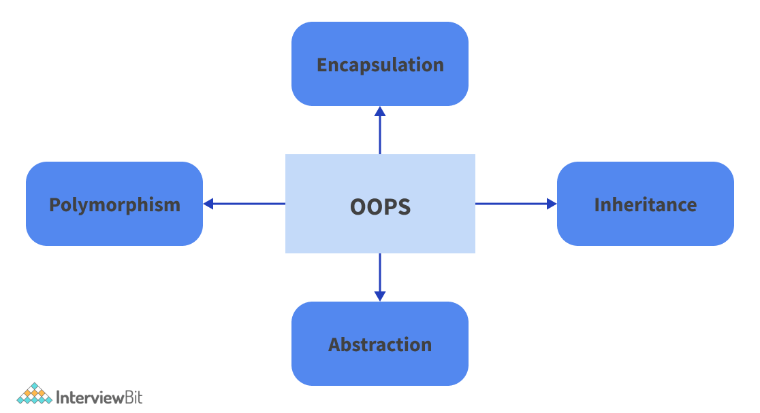

* ****Encapsulation:****Encapsulation is described as the binding of data and the functions that alter it in Object-Oriented Programming. Encapsulation makes a class's variables or data concealed from other classes and that they can only be accessible through member functions of the class in which it is stated.  
  *Let us consider the following example:*   
  In a company, there are different divisions such as accounts, finance, sales, and so on. The finance department’s duty is to keep track of all financial data and the transactions performed on them. Similarly, the sales department’s duty is to keep track of all sales-related activities.   
  Let us assume that an official from the finance department requires the sales data for a specific month. In this scenario, he cannot access the sales section's data directly. An official from the sales department must be contacted because only he can access the data. Here, the process of asking the sales officials for the data depicts encapsulation. The sales department's data and the people who can influence it are bundled together under the category "sales section."
* ****Abstraction:****Abstraction refers to revealing only the most important information while concealing the details. Data abstraction refers to exposing only the most important aspects of the data to the outside world while concealing the implementation specifics.  
  Consider the case of a man driving a vehicle. The man only knows that pressing the accelerators will increase the vehicle's speed and that applying the brakes will stop it, but he has no idea how the speed is increased by pressing the accelerators, nor does he understand the car's inner mechanism or how the accelerator, brakes, and other controls are implemented in the car. This is the definition of abstraction.
* ****Inheritance:****Inheritance refers to a class's capacity to derive features and traits from another class. One of the most significant characteristics of Object-Oriented Programming is inheritance. A class that inherits properties from another class is referred to as a subclass or a derived class. A class whose properties and member functions are inherited by other classes are referred to as superclass or base class. Inheritance supports the concept of "reusability".  
  Consider a class Vehicle that contains all the essential functions which a vehicle must possess. This includes accelerating speed, applying brakes, changing gear and so on.  
  Now let us assume the classes Car, Bus, Truck and so on. All of these classes can be considered as a subclass of the class Vehicle since all of them must essentially possess all the properties of the class Vehicle.
* ****Polymorphism:****Polymorphism refers to the fact that something exists in multiple forms. Polymorphism, in simple terms, is the ability of a message to be displayed in multiple formats. For example, at the same time, a person might have a variety of characteristics. At the same time, he is a father, a spouse, and a worker. As a result, the same person behaves differently in different settings. Polymorphism is the term for this.  
  There are mainly two types of polymorphism in C++. They are as follows:
  + ****Compile Time Polymorphism:**** Function overloading and operator overloading is used to achieve this form of polymorphism.
  + ****Runtime Polymorphism:**** Function Overriding is used to generate this form of polymorphism.

### **2. Explain function overloading and function overriding in the context of C++ programming language. Differentiate between them.**

* ****Function Overloading:****

It allows for multiple definitions of the function by modifying the signature, i.e. the number of parameters, the datatype of the parameters, and the return type.

****For example:****

**using** **namespace** std;

// Method 1**void** **overloadedMethod**(**int** x){

cout << "In Overloaded Method 1" << endl;

}

// Method 2**void** **overloadedMethod**(**float** x){

cout << "In Overloaded Method 2" << endl;

}

// Method 3**void** **overloadedMethod**(**int** x1, **float** x2){

cout << "In Overloaded Method 2" << endl;

}

**int** **main**(){

**int** x = 5;

**float** y = 5.5;

overloadedMethod(x);

overloadedMethod(y);

overloadedMethod(x, y);

**return** 0;

}

****Output:****

In Overloaded Method 1

In Overloaded Method 2

In Overloaded Method 3

****Explanation:****

In the above code, we have three functions with the same name and return type. However, they have different function signatures which differentiates them from each other. When we pass a parameter of int type, method 1 gets executed. When we pass a parameter of float type, method 2 gets executed. When we pass both an int and a float type parameter, method 3 gets executed.

* ****Function Overriding:****

It is the redefining of a base class function in a derived class with the same signature, that is, the return type and parameters. It's only possible in derived classes.

**class** **Test**

{**public**:

**virtual** **void** **print**(){ cout << "Test Function"; }

};

**class** **Sample** : **public** Test

{**public**:

**void** **print**(){ cout << "In Sample Function";}

};**int** **main**(){

Test obj = **new** Sample();

obj.print();

**return** 0;

}

****Output:****

 In Sample Function

In the above code, the class Sample extends the class Test and therefore inherits all its properties. We can clearly see that both the classes have a function ‘print’ with the same function signature and return type. Therefore, the above code implements function overriding. Since we have added a virtual keyword in the function of the base class, the function is called according to the type of object being referred to and so the print function of the Sample class gets called.

The following points illustrate the differences between function overloading and function overriding:

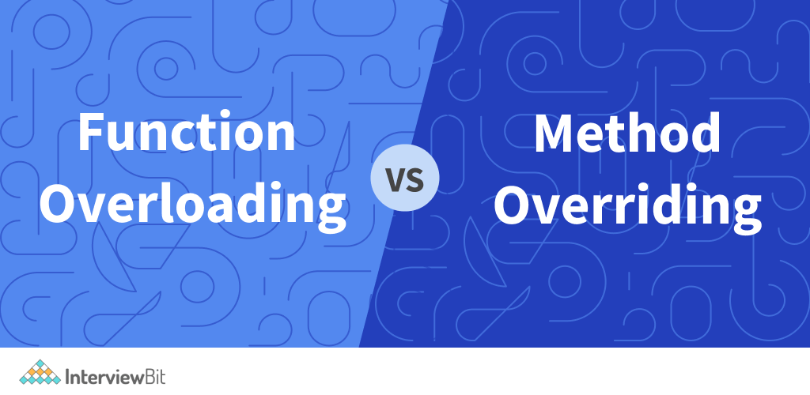

* When one class inherits from another, it causes overriding of functions. Overloading can happen in the same class.
* Overloaded functions must have a different function signature, which means they must have a different number of parameters or a different type of parameter. Function signatures must be identical when overriding.
* Overloaded functions are present in the same scope of a class while overridden functions are present in different scopes.

### **3. What are the functions of an operating system?**

Following are the functions of an operating system :

* ****Provides user interface:**** Operating systems provide an interface between computer hardware and the users. It makes it easy for the user to access the hardware in a systematic manner.
* ****Maintains system performance****: Helps increase performance by monitoring overall system health. To get a thorough picture of the system's health, keep track of the time between service requests and system responses. This can aid performance by providing critical information for troubleshooting issues.
* ****Security****: To safeguard user data, the operating system employs password protection and other similar measures. It also protects applications and user data from illegal access.
* ****Error-detection****: The operating system constantly monitors the system in order to detect errors and prevent a computer system from failing.
* ****Memory Management****: The primary memory, often known as main memory, is managed by the operating system. The main memory consists of a vast array of bytes or words, each of which is allocated an address. Main memory is rapid storage that the CPU can access directly. A program must first be loaded into the main memory before it can be executed. For memory management, an operating system performs the following tasks:
  + It keeps track of primary memory, i.e., which user programmes use specific bytes of memory. Memory addresses that have already been assigned, as well as memory addresses that have yet to be used.
  + The OS determines the order in which processes are permitted memory access and for how long in multiprogramming. It allocates memory to a process when the process asks for it and deallocates memory when the process exits or performs an I/O activity.
* ****Processor Management:**** In a multiprogramming environment, the operating system determines the sequence in which tasks access the processor and the amount of processing time each process has.
* ****Device Management:**** An operating system (OS) controls device connectivity through drivers. It keeps track of all the devices that are linked to the system. The Input/Output controller is a program that is responsible for all devices. Determines which processes are allowed access to a device and for how long. Allocates devices in a way that is both effective and efficient. When a gadget is no longer needed, it is deallocated.
* ****File Management:**** A file system is divided into directories to make navigation and usage more efficient. Other directories and files may be found in these directories. The operating system keeps track of where data is kept, user access settings, and the state of each file, among other things.

### **4. Differentiate between primary memory and secondary memory in the context of a computer.**

* ****Primary/Main Memory:****The computer memory that is directly accessible by the CPU is referred to as primary memory. It is made up of DRAM (Dynamic Random Access Memory) and provides the processor with an actual working area. It keeps track of the data and instructions that the processor is currently processing. Example - RAM (Random Access Memory)
* ****Secondary Memory:**** Because the processor does not directly interface with the secondary memory, the contents of the secondary memory are first transferred to the primary memory and then accessed by the processor. Example - Hard disk, USB drive, etc.

The following table illustrates the differences between primary memory and secondary memory:

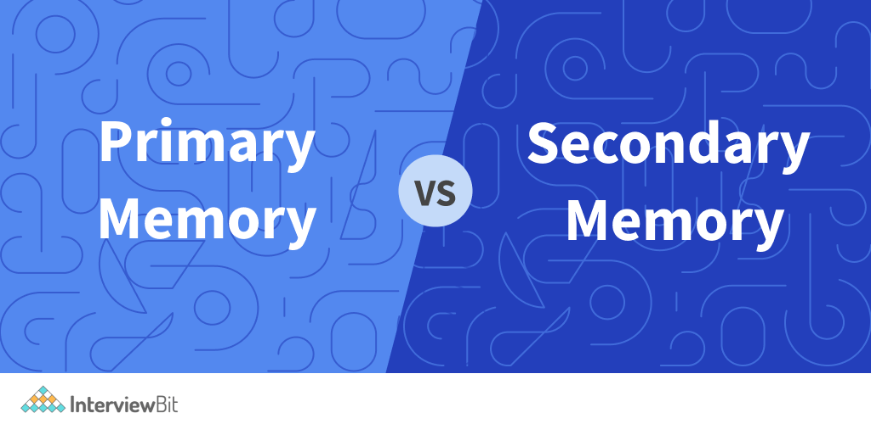

| **Primary Memory** | **Secondary Memory** |
| --- | --- |
| Storage in primary memory is temporary. | Storage in secondary memory is permanent. |
| Processor/CPU has immediate access to primary memory. | Processor/CPU does not have immediate access to primary memory. |
| It may be volatile (requires power to maintain the stored information) or non-volatile in nature. | It is always non-volatile (does not require power to maintain the stored information) in nature. |
| Semiconductor memories are the memory devices utilised for primary memory. | Magnetic and optical memories are used as secondary memory devices. |
| Primary memory is more expensive than secondary memory. | When compared to primary memory devices, secondary memory devices are less expensive. |

### **5. What do you understand about processes and threads in the context of an operating system?**

* ****Process:**** Any program in execution is referred to as a process. Any process is controlled by a process control block. Process priority, process id, process state, CPU, register, and other information are all stored in the Process Control Block (PCB). Child Processes are created when a process spawns another process. It takes longer for a process to end, and it is isolated, which means it doesn't share memory with other processes.
* ****Thread:**** A thread is a section of a process, which means that a process can have several threads, all of which are contained within the process. A thread can be in one of three states: running, ready, or blocked. Threads require less time to terminate than processes, but they do not isolate like processes.

The following table illustrates the differences between them:

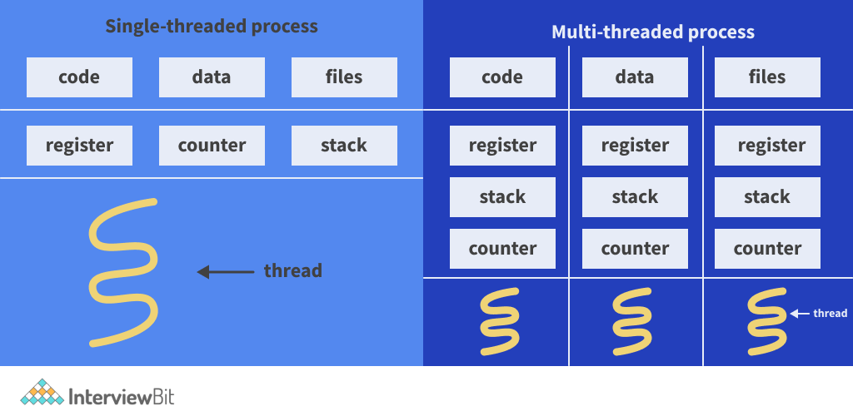

| **Process** | **Thread** |
| --- | --- |
| The creation of a process takes more time. | The creation of a thread takes less time. |
| Switching between contexts from one process to another takes longer. | Switching between contexts from one thread to another takes less time. |
| In terms of intercommunication, the process is inefficient. | In terms of intercommunication, Thread is more efficient. |
| Different processes use different areas of memory. They do not share memory. | Threads of the same process share memory. |
| The Process Control Block, Stack, and Address Space are all unique to each process. | All threads of the same process share the process control block but have different thread control blocks, stack and address space. |
| When one process gets blocked, it does not affect the other running processes. | When one thread gets blocked, all the other threads of the same process get blocked. |
| The operating system interface is used for process switching. | Thread switching does not necessitate invoking an operating system or causing a kernel interrupt. |

### **6. What is a DataBase Management System? What are its advantages over traditional file systems?**

A [database management system](https://www.interviewbit.com/dbms-interview-questions/" \t "https://www.interviewbit.com/ibm-interview-questions/_blank) is a piece of software that manages databases. Examples of database management systems include MySQL, Oracle, and other commercial databases. A database management system (DBMS) provides an interface for doing tasks such as building a database, saving data in it, updating data, and creating a table in the database, among others. It ensures the database's safety and security. It also ensures data consistency when there are multiple users.

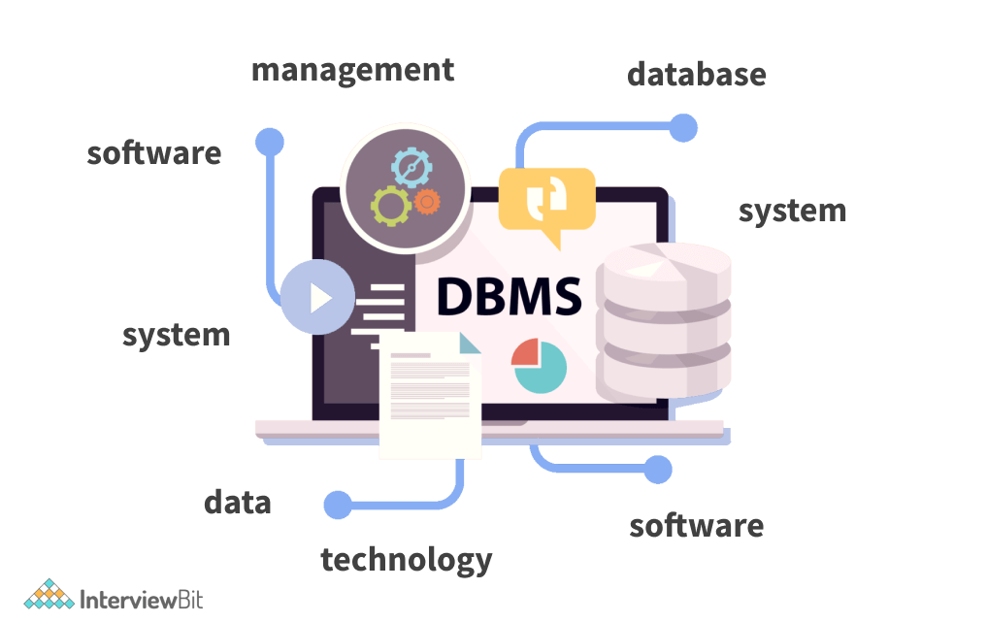

Following are the ****advantages of a database management system**** over traditional file systems :

* ****Better Data Management:**** Database management makes it possible for users to access better-managed data. As a result, end-users will be able to take a quick check at their data and respond quickly to any changes.
* ****Enhanced Data Security:**** As the number of users grows, the rate at which data is transferred or shared grows as well, raising the danger of data security. It is frequently used in the corporate sphere, where organisations devote a significant amount of money, time, and effort to assure data security and proper use. A Database Management System (DBMS) helps firms improve data security by providing a better platform for data privacy and security regulations.
* ****Reduced Data Inconsistency:**** In a database management system, data inconsistency is minimised when various versions of the same data appear in different places. For example, data inconsistency occurs when a student's name is saved as "William Shakespeare" on the school's main computer, while the same student's name is saved as "W. Shakespeare" on the teacher's registered system.
* ****Faster data access:**** The database management system (DBMS) aids in the production of speedy responses to database queries, allowing for faster and more accurate data access. End users, for example, will have improved access to data while dealing with massive amounts of sales data, allowing for a speedier sales cycle.

### **7. What do you know about the ACID properties of a transaction in the context of a database management system?**

In a SQL Database, every transaction must follow some specific set of properties. These properties are referred to as ACID properties. They are as follows:

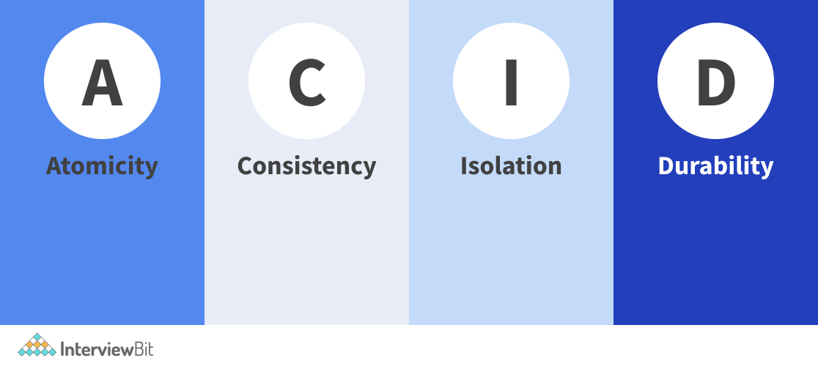

* ****A for Atomicity:**** This means that either the complete transaction occurs at once or it does not occur at all. There is no middle ground, which means that transactions do not take place in stages. Each transaction is treated as a single entity that is either completed or not conducted at all. It entails the following two procedures.
  + ****Abort:****If a transaction aborts, any database modifications are lost.
  + ****Commit:**** When a transaction commits, the changes it contains become visible.  
    The 'All or nothing rule' is another name for atomicity.  
    For example, consider a bank transaction from one account to another. The transaction must either be completed entirely or must be failed. There cannot be a midway transaction such as money has been debited from one account but has not been credited to the other account.
* ****C for Consistency:**** This property implies that integrity constraints must be fulfilled before and after the transaction to ensure that the database is consistent. It refers to a database's correctness.   
  For example, if a bank transaction is performed from account A having X money to an account B having Y money, then after the transaction has been performed the total amount of money must remain the same, that is, X + Y.
* ****I for Isolation:**** This attribute assures that several transactions can take place at the same time without causing database state inconsistencies. Transactions take place in a non-interfering manner. Changes made in one transaction are not visible to other transactions until that transaction's update is written to memory or committed. This feature assures that concurrently executing transactions results in a state that is identical to the one attained if they were executed sequentially in some order.  
  For example, a bank has many ATMs present in a country. All of the ATMs can operate at the same time. They function as if they are the only transaction being performed on the bank’s database thereby, implementing isolation.
* ****D for Durability:**** This attribute ensures that once a transaction has completed execution, the database updates and modifications are saved and written to memory and that they survive even if the system fails. These modifications are now saved in non-volatile memory and are permanent. As a result, the transaction's effects are never lost.  
  For example, a backup database must be maintained so that if in any case, the primary database fails, we can recover the data from the backup database.

### **8. Differentiate between struct and union in the context of C programming language.**

* ****struct:****In C, a structure is a user-defined data type that allows you to combine data objects of various types. A record is represented by a structure.

****Syntax:****

 struct structureName

{

member definition;

member definition;

...

member definition;

};

* ****union:**** In C, a union is a unique data type that allows you to store many data types in the same memory region. A union can have numerous members, but only one of them can have a value at any given time. Unions are a useful approach to reuse the same memory space for numerous purposes.

****Syntax:****

 union unionName

{

member definition;

member definition;

...

member definition;

};

The following table illustrates the differences between struct and union:

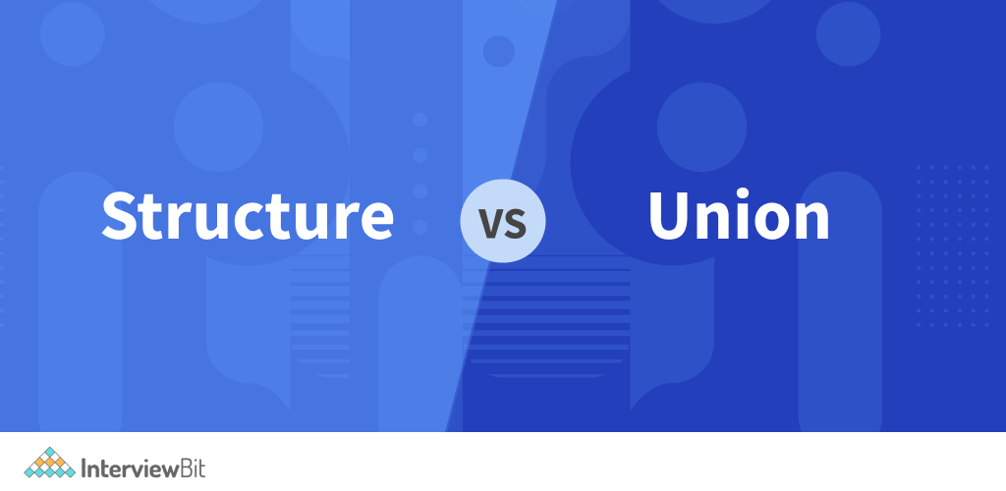

| **struct** | **union** |
| --- | --- |
| A structure is defined using the struct keyword. | Union is defined by the keyword union. |
| The compiler allocates memory to each variable member when the variables are declared in a structure. The total size of each data member determines the size of a structure. | When a variable is declared in a union, the compiler allocates memory to the variable member with the largest size. A union's size is determined by the size of its largest data member. |
| Changing a variable's value has no effect on other variables present in the struct. | Changing the value of one variable member will have an impact on the other variables present in the union. |
| Each variable's member has its own memory area. | Members of a variable share the memory space of the variable with the largest size. |
| Multiple variables in a structure can be initialised at the same time. | Only the first data member of a union can be initialised. |
| At any point in the program, all variable members store some value. | At any given point in the program, exactly one data member stores a value. |
| It's used to keep track of various data types' values. | It's used to save one value at a time from a variety of data types. |
| It provides for the simultaneous access and retrieval of any data member. | It lets you access and retrieves individual data members at a time. |

### **9. Differentiate between variable/ function declaration and definition in the context of any OOPs programming language.**

The purpose of a variable declaration is to tell the compiler of the following information: the variable's name, the kind of value it stores, and the initial value if any. Declaration, in other words, provides information about a variable's attributes. The definition of a variable allocates memory space for the variable and specifies where the variable will be stored.

The following table illustrates the differences between definition and declaration:

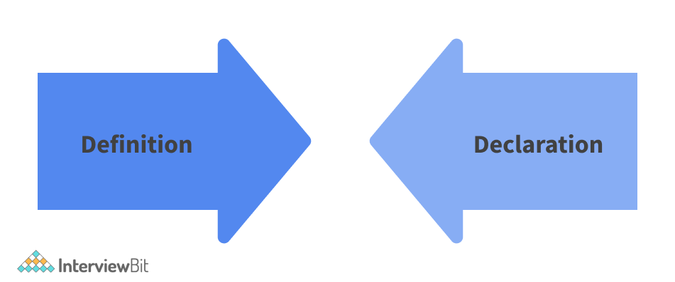

| **Definition** | **Declaration** |
| --- | --- |
| Only one time can a variable or function be defined. | There is no limit to how many times a variable or function can be declared. |
| Memory is allocated during definition. | Memory is not allocated during declaration. |
| Example:  void fun()  {  cout << “Hello World” << “\n”;  }  The above code defines a void function named “fun” and the compiler allocates the memory for it as soon as it encounters the above code. | Example:  void fun();  The above code declares a void function named “fun”. |

### **10. What do you understand about arrays? What are some of the real life applications of an array?**

A collection of items stored in contiguous memory spaces is referred to as an array. The objective is to group together goods of the same type. This makes calculating the position of each element easy by simply adding an offset to a base value, such as the memory address of the array's first element.

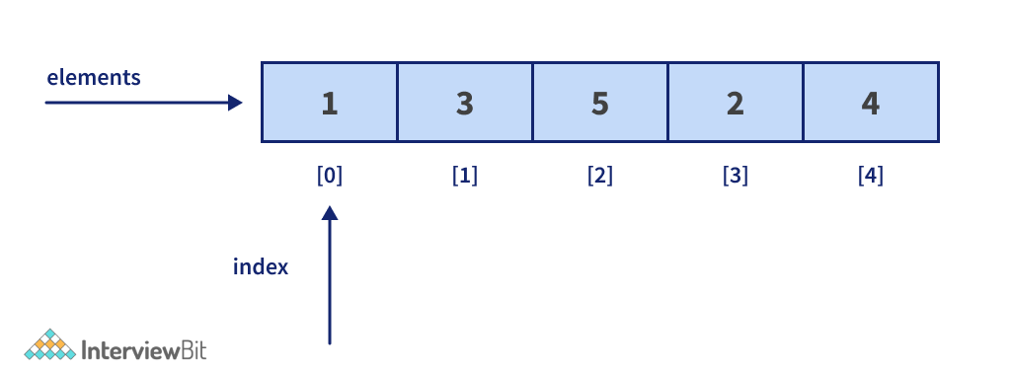

Following are the real-life applications of an array:

* Arrays can be used to store data in a tabular style as a simple application. For example, if we want to save our contacts on our phones, the software will simply create an array with all of our contacts.
* The arrangement of a game's leaderboard may be done simply by using arrays to record the score and arranging them in descending order to clearly see each player's rank in the game.
* A straightforward question paper consists of an array of numbered questions, each of which is assigned a set of marks.
* In image processing, 2D arrays, often called matrices, are used.
* It's also used in speech recognition, where each spoken signal is represented by an array.

### **11. What do you understand about a deadlock in the context of operating systems? What are the necessary conditions for a deadlock?**

A deadlock occurs when a group of processes is halted because each process is holding a resource and waiting for another process to obtain it.

Consider the situation when two trains are approaching each other on the same track and there is only one track: once they are in front of each other, neither train can move. In operating systems, a similar situation happens when two or more processes hold some resources while waiting on resources owned by other processes (s).

For example, let us assume that there are two trucks trying to cross a one-way bridge from opposite ends. None of the trucks is ready to move back and neither can any of them cross the bridge. In this situation, a deadlock has been obtained.

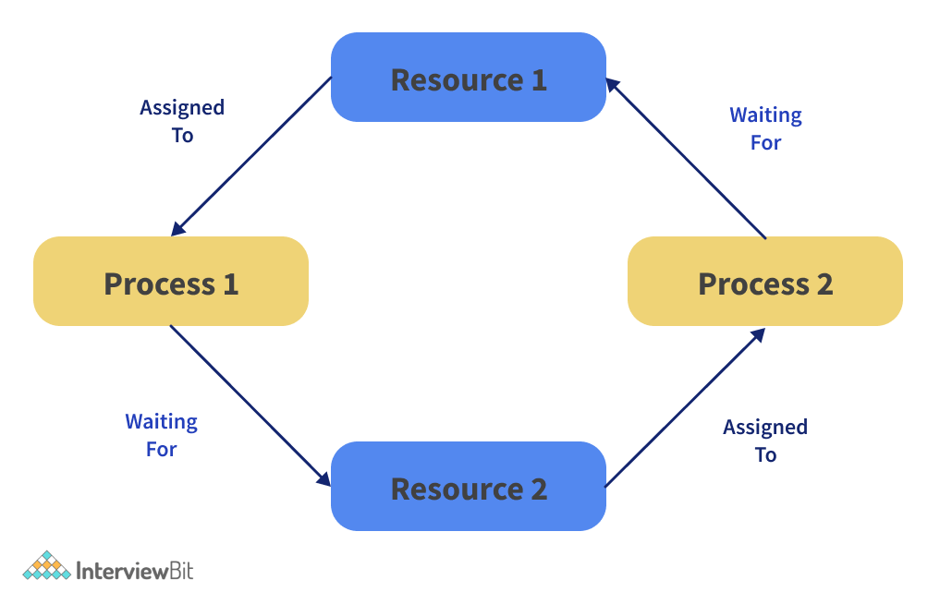

Following are the necessary conditions for a deadlock :

* ****Mutual Exclusion:**** One or more resources are not available for sharing. That is, only one process can use the resource at a time.
* ****Hold and Wait:**** A process is holding at least one resource and waiting for further resources.
* ****No Preemption:**** A resource can only be obtained from a process if it is released by the process. There can be no forced snatching of the resources.
* ****Circular Wait:**** A group of processes are waiting for each other in a circular fashion.

### **12. Differentiate between quick sort and merge sort in the context of sorting algorithms.**

 Following are the differences between quick sort and merge:

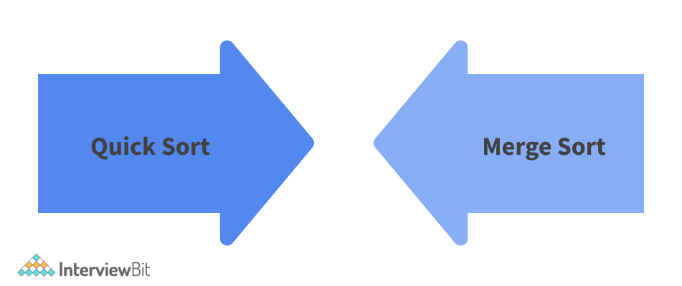

| **Quick Sort** | **Merge Sort** |
| --- | --- |
| In a quick sort, the array is divided into any ratio. In a quick sort, there is no requirement to divide the array of components into equal sections. | The array is divided into only two halves (i.e. n/2) in the merge sort. |
| The worst-case complexity of quick sort is O(n2) | In merge sort, the worst and average cases have the same complexity O (n log n). |
| The quick sort, on the other hand, does not function well with large datasets. | Merge sorting can be used on any form of data set, regardless of its size (either large or small). |
| The quick sort is in place since it does not necessitate any extra storage. | Merge sort is not in place because it requires additional memory space to hold the auxiliary arrays. |
| Quick sort is unstable (two elements with the same value may appear in a different order in the sorted array from that in the unsorted input array) in this situation. However, with a few code tweaks, it may be made stable. | Merge sort is stable because two elements with the same value appear in the sorted output in the same order as they did in the unsorted input array. |
| Quick sort is preferred for arrays. | Merge sort is preferred for linked lists. |
| Quicksort has a good cache locality, making it faster than merge sort (in many cases like in a virtual memory environment). | Merge sort has a poor locality of reference. |

### **13. What do you understand about an entry controlled loop in the context of OOPs programming?**

An entry control loop examines the condition at the point of entry and passes control to the body of the loop if the condition or expression becomes true.

The name "entry control loop" comes from the fact that this sort of loop regulates loop entry.

for loops and while loops are examples of entry controlled loops.

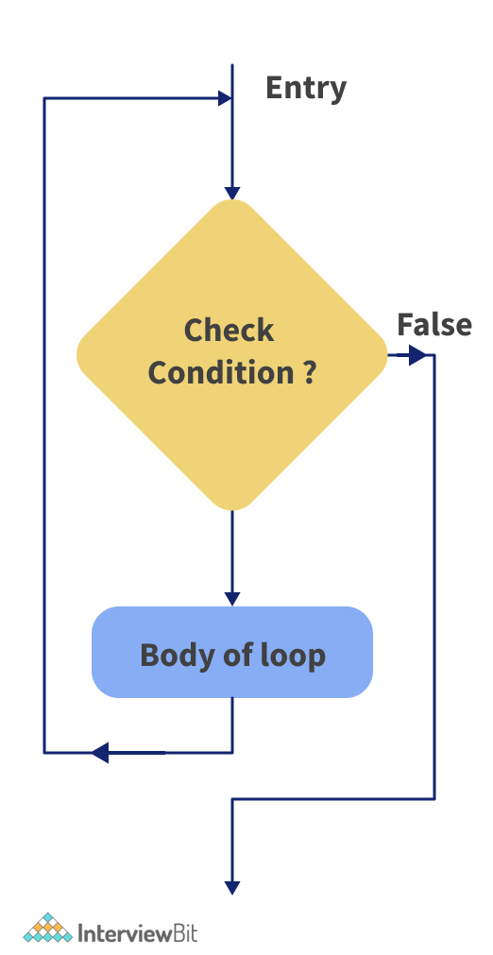

### **14. What do you understand about procedural programming? How is it different from object oriented programming?**

Procedural programming is a programming model that evolved from structured programming and is based on the concept of invoking procedures. Procedures, often known as routines, subroutines, or functions, are essentially a set of instructions to be executed. Any procedure in a program can be invoked at any time during execution, either by other procedures or by the program itself.

The following table illustrates the differences between procedural programming and object-oriented programming:

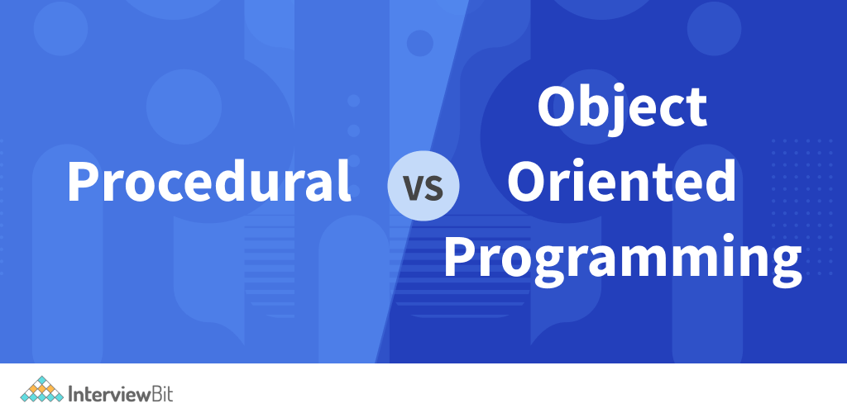

| **Procedural Programming** | **Object-Oriented Programming** |
| --- | --- |
| In procedural programming, the program is broken down into little modules known as functions. | Object-oriented programming divides a program into discrete pieces called objects. |
| The top-down technique is used in procedural programming. | The bottom-up method is used in object-oriented programming. |
| It's not straightforward to add new data and functions. | It's simple to add additional data and functions. |
| Overloading is not possible with procedural programming. | In object-oriented programming, overloading is possible. |
| Because procedural programming lacks a proper method for hiding data, it is insecure. | Data is hidden in object-oriented programming, making it safer. |
| In procedural programming, function takes precedence over data. | Data is more important than function in object-oriented programming. |
| C, FORTRAN, Pascal, Basic, and other programming languages are examples. | C++, Java, Python, C#, and other programming languages are examples. |

### **15. Given a sorted array of 0s and 1s. The goal is to discover the index of the sorted array’s first '1'. It's possible that the array is made up entirely of 0s or 1s. If there are no 1's in the array, display "-1."**

****Example:****  
Input:   
arr = {0, 0, 0, 0, 1, 1, 1}  
Output :  
4

Input :  
Arr = {0, 0, 0, 0}  
Output :  
-1

### ****Approach:****

It is given that the array is sorted. We use this property of the array and apply binary search to find the first occurrence of 1 in the given array. We start with the whole array as our search space and find the middle element. If we encounter 0 as the middle element, it implies that our answer lies to the right side of the middle element. If we encounter 1 as the middle element, our answer can either be this index or the indices left to the current middle if there are more 1s preceding the current middle.

****Code:****

 #include <bits/stdc++.h>

using namespace std;

// function to find the first occurrence of 1 in the give sorted array

int findIndex(int arr[], int low, int high)

{

while (low <= high) {

int mid = low + (high - low) / 2;

// we check if the mid element is a 1 and the mid - 1 element is 0

if (arr[mid] == 1 && (mid == 0 || arr[mid - 1] == 0))

return mid;

// our answer lies to the left of mid, we reduce our search space

else if (arr[mid] == 1)

high = mid - 1;

// our answer lies to the right of mid, we reduce our search space

else

low = mid + 1;

}

// we return -1 since 1 is not present in the array

return -1;

}

int main()

{

int arr[] = { 0, 0, 0, 0, 1, 1, 1, 1 };

int n = sizeof(arr) / sizeof(arr[0]);

cout << findIndex(arr, 0, n - 1);

return 0;

}

****Output:****

 4

****Explanation :****

In the above code, we defined a function named ‘findIndex’ which finds the first occurrence of the first one in the sorted array. We reduce the search space by changing the values of low and high as per the current value of the middle element. If low exceeds high, we return -1 which indicates that no 1 is present in the array.

### **16. Write a program to convert the characters of a string into the opposite case, that is, if a character is lowercase, convert it to upper case and vice versa.**

Input :  
“inTerVieWbiT”  
Output :  
“INtERvIEwVIt”

Input :  
“Hello World”  
Output :  
“hELLO wORLD”

### ****Approach:****

We scan each character of the string one by one. If the current character is in lowercase, we subtract 32 from the character and convert it to uppercase. Similarly, if the current character is in uppercase, we add 32 to the character and convert it to lowercase.

****Code:****

 #include <iostream>

using namespace std;

// Function to convert the characters of the string to its opposite case

void changeCase(string& s)

{

int len = s.length();

for (int i = 0; i < len; i++) {

if (s[i] >= 'a' && s[i] <= 'z')

{

s[i] = s[i] - 32;// Subtracting 32 from the character

}

else if (s[i] >= 'A' && s[i] <= 'Z')

{

s[i] = s[i] + 32;// Adding 32 to the character

}

}

}

int main()

{

string s = "inTerVieWbiT";

cout << "Original String : " << s << "\n";

changeCase(s);

cout << "Changed String : " << s << "\n";

return 0;

}

****Output:****

Original String : inTerVieWbiT

Changed String : INtERvIEwBIt

****Explanation :****

In the above code, we define a function named ‘changeCase’ which takes a reference of a string as a parameter. We iterate through each character of the string and change the character to its opposite case by either adding or subtracting 32.

### **17. Write a program to calculate how many ways can we make change for N cents if we have an endless supply of each of the C = C1, C2,..Cm valued coins? It makes no difference what order the coins are placed in.**

****Example:****  
Input :  
N = 4, C = { 1, 2, 3}  
Output :   
4  
Explanation:  
There are 4 possible combinations : {1, 1, 1, 1}, {1, 1, 2}, {1, 3}, {2, 2}

Input :  
N = 10, C = {2, 3, 5, 6}  
Output :  
5  
Explanation:  
There are 5 possible combinations ; {2, 2, 2, 2, 2}, {2, 2, 3, 3}, {2, 2, 6}, {2, 3, 5}, {5, 5}

### ****Approach:****

We can divide all set solutions into two sets to count the total number of solutions.

1) Solutions that are devoid of the mth coin (or Cm).

2) At least one Cm is present in the solution.

If solve(C[], m, n) is the function for counting the number of solutions, it may be represented as the sum of solve(C[], m-1, n) and solve(C[], m, n-Cm). We will use dynamic programming to store the result for a particular value of n and m. This will optimise our time complexity to O(nm).

****Code:****

 #include<bits/stdc++.h>

using namespace std;

// function to count the number of ways n can be represented from a coin set of size m

int solve( int C[], int m, int n )

{

int dp[n + 1][m];//Creating a 2D matrix of size (n + 1) 8 m to store the result of each state of our problem

// Filling the matrix for the base case when n = 0

for (int i = 0; i < m; i++)

dp[0][i] = 1;

// Filling the entries in the dp table in bottom up fashion

for (int i = 1; i < n + 1; i++)

{

for (int j = 0; j < m; j++)

{

// Including C[j] in our current state's answer

int x = (i-C[j] >= 0) ? dp[i - C[j]][j] : 0;

// Excluding C[j] in our current state's answer

int y = (j >= 1) ? dp[i][j - 1] : 0;

// storing the sum of x and y in our current state's answer

dp[i][j] = x + y;

}

}

return dp[n][m - 1];

}

int main()

{

int C[] = {2, 3, 5, 6};

int m = sizeof(C)/sizeof(C[0]);

int n = 10;

cout << solve(C, m, n);

return 0;

}

****Output:****

 5

****Explanation:****

In the above code, we define a function named ‘solve’ which returns the number of ways in which n can be represented from a set of m coins having distinct values. We create a dp table of size (n+1) \* m. dp[i][j] represents the number of ways in which i can be represented by a set of j coins. Here, we have used the recurrence formula dp[i][j] = x + y. Here, x = dp[i - C[j]][j], y = dp[i][j-1].

### **18. What is the purpose of the sudo command in the context of the UNIX operating system?**

sudo is a short form of Super Users DO. In Linux, the sudo command is commonly used as a prefix to a command that only superusers are permitted to run. If you use the prefix "sudo" before any command, it will run it with elevated privileges, allowing a user with the necessary permissions to run a command as another user, such as the superuser. This is the Windows version of the "run as administrator" option.

The sudoers file, stored at "/etc/sudoers," must contain an entry for each user who may use the sudo command. Remember to use the sudo command to edit or inspect the sudoers file. The "visudo" command is suggested for editing the sudoers file.

### **19. What do you know about virtual memory in the context of operating systems?**

Virtual Memory is a storage allocation system that allows secondary memory to be addressed as if it were the main memory. The addresses used by an application to refer to memory are distinct from the addresses used by the memory system to designate physical storage sites, and program-generated addresses are automatically translated to machine addresses.

The capacity of virtual storage is limited by the computer system's addressing method, and the amount of secondary memory available is determined by the number of main storage sites available rather than the actual number of main storage locations.

### **20. What are the three types of schedulers in the context of operating systems? Explain.**

 Schedulers are specialised computer programs that manage process scheduling in a variety of ways. Their primary responsibility is to choose which jobs to submit into the system and which processes to run.

Following are the three types of schedules:

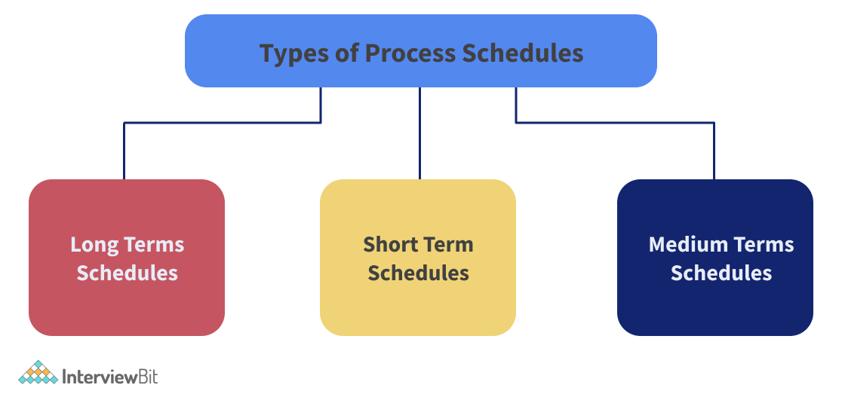

* ****Long Term Scheduler:**** It is also known as a job scheduler. A long-term scheduler determines which programs are accepted for processing into the system. It chooses processes from the ready queue and loads them into memory so they can be executed. For CPU scheduling, the process loads into memory. The job scheduler's main goal is to deliver a balanced mix of jobs, such as I/O bound and CPU bound workloads. It also regulates how much multiprogramming is done. If the degree of multiprogramming remains constant, the average rate of process creation must be equal to the average rate of process departure from the system.
* ****Medium Term Scheduler:**** Medium Term Schedulers are used for swapping processes in the main memory. It clears the memory occupied by the processes. The degree of multiprogramming is reduced as a result. The swapped out-processes are handled by the medium-term scheduler.
* ****Short Term Scheduler:**** It's also referred to as a CPU scheduler. Its primary goal is to improve system performance in accordance with the set of criteria established. It is the transition from the process's ready to running stage. The CPU scheduler chooses a process from among those that are ready to run and allocates CPU to that process. Short-term schedulers usually referred to as dispatchers, decide which process to run next.

### **1)  What is Watson Analytics?**

It is a cloud and analytics-based service for the individuals in business to successfully solve the problems faced in business which they need to skip through each day. These difficulties include problems related to any tools or data, measuring difficulties and they might be lacking the skills. They might also be on the board like understanding the churn of the customer, able to analyze which employer might decide to leave, analyzing the loss of money by operations. There are many other things that can be measured but they are rarely predicted with any accuracy. And these include marketing, failures in the asset, and satisfaction of the customers.

### **2) Mention the group which would be benefitted from Watson Analytics.**

People who don’t have any expertise in the analysis are the ones who benefit the most from this. They might have very trivial problems from the organization’s point of view. Someone might have an interaction of data on the cloud. A person can access it because it is at the lesser end of the list of priorities. In that data of interaction one can view who has posted, the time duration, and the number of tweets that went up. This information can be thrown into Watson Analytics and get insights into information like what is the time during which it was posted and the amount of people reading it. So these are the people who benefit who might have analytic problems that are solvable by Watson Analytics but need not necessarily have access to the required resources.

### **3) What else can be accomplished by the business through Watson Analytics?**

This is to know what is the real problem and trying to know what exactly can be done about the dame. Trying to find out sales managers' data around the deals, the quantity of the deal is the deal old or new, people working on that deal, etc. On the spreadsheets, there are many variables and the results can either be a win or loss in the deal. So Watson Analytics can take these deals and predict if they are going to be a win or loss. So action can be taken beforehand and this can be helpful for changing the outcome. It also helps in showing the effect of the downside of any decisions.

### **4) Role of cloud in Watson Analytics.**

When using new technology or app most people expect to use all of it almost immediately without any guide or manual to go through. Cloud is that which brings to the user new features without any waiting period or date. It can be implemented almost immediately and the users can help with the testing which can enable in the development of newer features. It’s a huge advantage to both the users as well as the makers. It is also helpful in studying the using pattern of the people. It can be useful in studying the features which are favored by the people and the ones which they aren’t using much. These things can be taken and molded to make it better for the usage of the people.

### **5) Mention one of the most important features in the journey of Watson Analytics.**

There are various processes like accessing the data, preparation, analyzing it, refining it, and many such processes. Watson Analytics is the one that unifies all of it. This is done by very innovative methods of automation and allowing people to do all of this at their own will. It works on an interaction that is language-like. It bridges the gap between the understanding of humans and the advanced methods of computing. It moves matter from discovering to knowing about what is most important and is essential.

### **6)  Name some of the organizations which are using IBM Watson Analytics.**

 Paschall Truck Lines, Mears Groups, Minter Ellison, Caliber Patient Care are the names of some of the organizations which are using the Watson Analysis.

### **7) How do you think this has benefitted them?**

It gas helped them with their patterns of hiring, it has helped with the development of health strategies and safety, identifying the profitable companies and redirecting the resources accordingly, helping the companies with the policies, determining the performances of people in the company, helps in studying the sales of the company and their practices, helping them making a real-time adjustment in their campaigns of marketing. These are some of the ways in which the organizations have been helped and benefitted with the use of Watson Analytics.

### **8) How is it useful in terms of Social Media?**

The IBM Watson Analytics is useful when it comes to social media. It is helpful in guiding the individual by giving them the usage of social networking and create a visualization of the data on its own which is insightful and all of this happens on the cloud. A person gets relevant and reliable content on any topic and this gives the user the patterns and their relationships. It is useful in collecting the audience's preference and gain insight into the market and also a comparison of data with other sources which gives information from different perspectives.

### **9) Who developed IBM Watson Analytics?**

It was developed by David Ferucci along with a research team that was lead by him.

### **10)Why was it developed?**

It was initially developed for answering the questions on Jeopardy which was a quiz show and it was specifically designed for that. And it acquires the price money by competing with the previous winners.

Its first commercial use was in the year 2013 in the month of February. It was first used for utilizing management-related decisions in the treatment of lung cancer at a Center in New York along with an insurance company. This was the first use of IBM Watson software.

### **11) What is the source of information for Watson?**

It obtains information from different sources which include newswire, dictionaries, thesaurus, literary work. it also makes use of taxonomies, ontologies, and databases. It used WrodNet, Yago, DBPedia. Various documents, references, and encyclopedias were used to build upon the knowledge.

### **12) How is it beneficial for the business?**

It is a service of visualization and analysis of data used to discover the meaning and patterns in the data quickly in your own way. One can get an answer they understand with the guided way to discover the data and its automatic prediction of analysis and the use of natural language. It's about spotting data and a trend quickly and visualizing the data quickly on the dashboard.

### **13) Who was it named after?**

It was named after Thomas. J. Watson was the founder of IBM.

### **14)What does and can Watson do?**

It merges [artificial intelligence](https://mindmajix.com/benefits-of-artificial-intelligence" \o "Benefits of Artificial Intelligence" \t "https://mindmajix.com/_blank) and sophisticated software for the utmost performance as a machine for answering questions.

### **15) What is the cost of IBM Watson?**

It would be somewhere around a few million with an approximate value of 3 million dollars.

### **16)What do you mean by cognitive solutions?**

It is a method of simulating human thought processes in a computer. It includes using data mining, processing of data language, pattern recognition for mimicking the work of a human brain. It involves the system of self-learning.

### **17) What is cognitive technology?**

Cognitive technology is the product of artificial intelligence. Now, these products can conduct tasks that could initially be performed only by human beings.

### **18) Give examples of cognitive technologies?**

Some of the examples of cognitive technologies are machine learning, speech recognition, computer vision, robotics, and language processing. These are some of the many such products of cognitive technology.

### **19) What can be said about cognitive automation?**

There’s a lot of work done in terms of artificial intelligence and automation processes in robotics and there are many more capabilities that are emerging. This cognitive automation is useful to enhance and emulate the strengths that the human mind has.

### **20) What is cognitive analysis?**

It is a terminology which is a description of the application of analytics and technologies of cognitive computing by the organizations which helps the human make smarter, quicker, and effective decisions.

### **21)What are certain features of Watson Analytics?**

It provides a programmed list of terms and context related to the topic which strengthens the analysis and improves it. It also breaks the topics into different metrics which helps in analyzing the topic in a better way. It helps in understanding the shades of social media automatically. With the help of technical and advanced knowledge and training, audience insight can be gained. One can obtain answers in a language one can understand. Guides a person to appropriate conclusions effectively and quickly. It also helps to move beyond a programmed sentiment.

### **22) Are there any software or hardware requirements?**

There are not any hardware or software requirements for the social media use of IBM Watson Analytics.

### **23)  What are some of the technical details required?**

Some of the browsers which support it are Mozilla Firefox, ESR, Google Chrome, Microsoft Explorer, Apple Safari. So the user needs to have a device workstation or a mobile that can run the web browsers which support it.

### **24) What do you mean by cognitive artificial intelligence?**

It is one subdivision of artificial intelligence that deals with behaviors that are cognitive that is which are related to thinking and has not much to do with motor control or perception.

### **25) What are some of the advantages of IBM Watson Analytics?**

Some of the advantages of IBM Watson Analytics are as follows: it is known to process data that is unstructured, it fills in any limitations by the human and also has minimal errors as opposed to humans, it is like a support for making a decision and it does not act as a replacement for human in any way. It is known to improve the performance and it also improves the abilities by providing the data which is available at its best. It transforms as well as improves the services which are provided to the customers. It can handle a huge amount of data. It can at one point accumulate and posse a large amount of data with it. It is known to have competitive sustainable advantages.

### **26)  What are some of the disadvantages of IBM Watson Analytics.**

Some of the disadvantages of IBM Watson Analytics are as follows:

It is available only in one language which is English because of this the area of usage becomes limited. It is known to be seen as a technology that is disruptive. It takes a lot of time and money for its maintenance. One limitation is that it cannot directly process the data which is structured. It increases the rate of the data but it does it only with the help of limited use of resources.

### **27) What are certain barriers to the adoption of IBM Watson Analytics?**

The barriers to the adoption of IBM Watson Analytics is as follows:

The cost of switching is apparently very high in IBM Watson. It requires a lot of time for the integration of Watson and the services provided by it in a company or an organization. It usually focuses its target on the bigger companies and organizations that they think can afford to take the Watson. It also requires a lot of time and an equal amount of effort in order to teach the use of Watson if it needs to be taught to its optimal potential.

### **28)  What is the future use of IBM Watson?**

IBM is known to have announced the inauguration of a new unit of the business that would look after the development and commercialize cognitive advisories that will be delivered by the cloud.

### **29) In what sectors can IBM Watson be applied?**

It can be applied in various sectors which include Cognitive applications, healthcare, information technology, travel, retail, government, etc. These are only some of the areas and they can be applied in many such areas.