See Last Minute Notes on all subjects [here](https://www.geeksforgeeks.org/lmns-gq/).

## [Propositional Logic](https://www.geeksforgeeks.org/proposition-logic/" \t "https://www.geeksforgeeks.org/last-minute-notes-discrete-mathematics/_blank)

1. **Implication( →)**: For any two propositions p and q, the statement “if p then q” is called an implication and it is denoted by p → q.

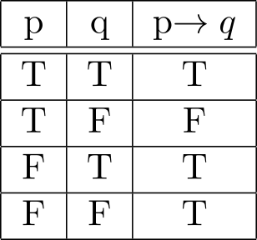

1. **if and only if(↔)**: For any two propositions p and q, the statement “p if and only if(iff) q” is called a biconditional and it is denoted by p ↔ q.

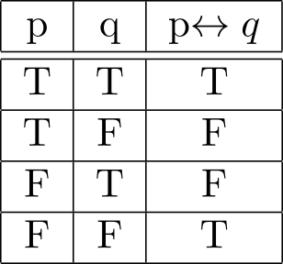

**De Morgan’s Law**:

* + Rendered by QuickLaTeX.com
  + Rendered by QuickLaTeX.com

**Special Conditional Statements**

1.**Implication :** Rendered by QuickLaTeX.com  
2.**Converse :** The converse of the proposition Rendered by QuickLaTeX.com is Rendered by QuickLaTeX.com  
3.**Contrapositive :** The contrapositive of the proposition Rendered by QuickLaTeX.com is Rendered by QuickLaTeX.com  
4.**Inverse :** The inverse of the proposition Rendered by QuickLaTeX.com is Rendered by QuickLaTeX.com

**Types of propositions based on Truth values**  
1.**Tautology** – A proposition which is always true, is called a tautology.  
2.**Contradiction** – A proposition which is always false, is called a contradiction.  
3.**Contingency** – A proposition that is neither a tautology nor a contradiction is called a contingency.

**There are two very important equivalences involving quantifiers**

1. Rendered by QuickLaTeX.com

2. Rendered by QuickLaTeX.com

**Rules of inference**  
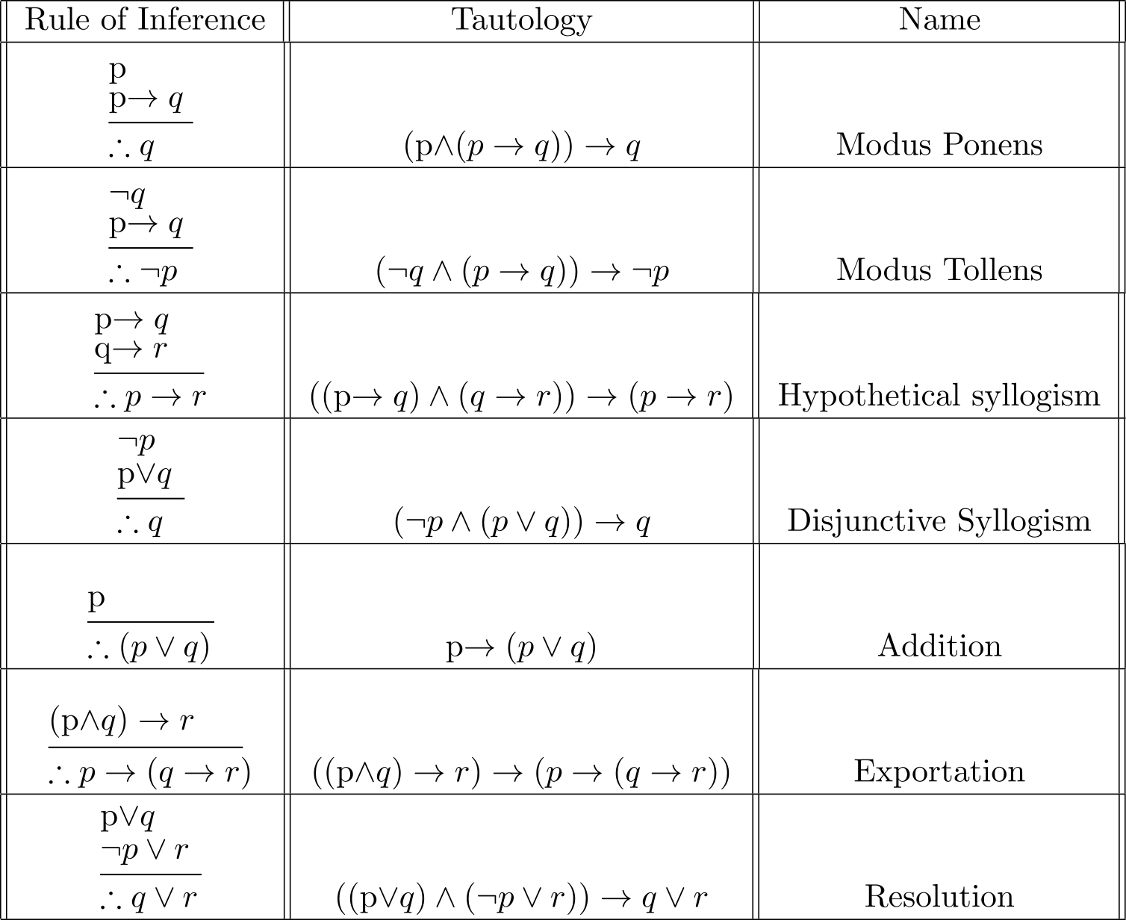

## [Combinatrics](https://www.geeksforgeeks.org/mathematics-combinatorics-basics/" \t "https://www.geeksforgeeks.org/last-minute-notes-discrete-mathematics/_blank)

**Permutation**: A permutation of a set of distinct objects is an ordered arrangement of these objects.

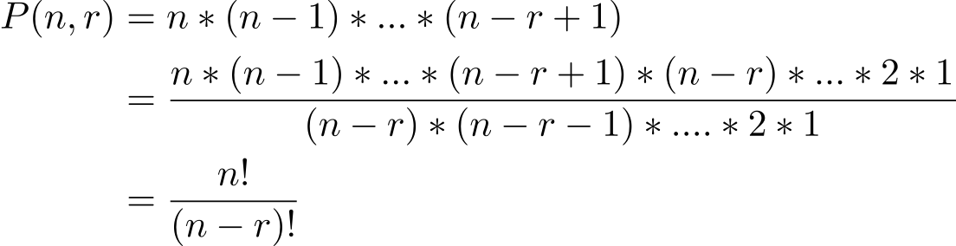

**Combination**: A combination of a set of distinct objects is just a count of the number of ways a specific number of elements can be selected from a set of a certain size. The order of elements does not matter in a combination.  
Rendered by QuickLaTeX.com  
which gives us-

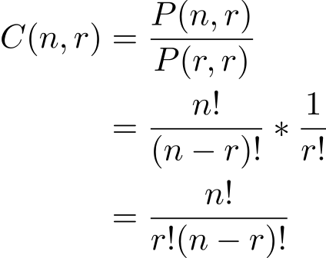

**Binomial Coefficients**: The Rendered by QuickLaTeX.com-combinations from a set of Rendered by QuickLaTeX.com elements if denoted by Rendered by QuickLaTeX.com. This number is also called a binomial coefficient since it occurs as a coefficient in the expansion of powers of binomial expressions.  
Let Rendered by QuickLaTeX.com and Rendered by QuickLaTeX.com be variables and Rendered by QuickLaTeX.com be a non-negative integer. Then

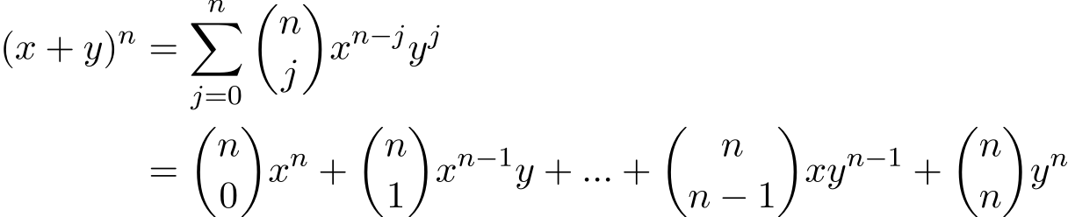

**The binomial expansion using Combinatorial symbols**

*Rendered by QuickLaTeX.com*

## [Set Theory](https://www.geeksforgeeks.org/set-theory/" \t "https://www.geeksforgeeks.org/last-minute-notes-discrete-mathematics/_blank)

A **Set**is an unordered collection of objects, known as elements or members of the set.  
An element ‘a’ belong to a set A can be written as ‘a ∈ A’, ‘a ∉ A’ denotes that a is not an element of the set A.

**Equal sets**  
Two sets are said to be equal if both have same elements. For example A = {1, 3, 9, 7} and B = {3, 1, 7, 9} are equal sets.

**NOTE: Order of elements of a set doesn’t matter.**

**Subset**

A set A is said to be **subset**of another set B if and only if every element of set A is also a part of other set B.  
Denoted by ‘**⊆**‘.  
‘A ⊆ B ‘ denotes A is a subset of B.

To prove A is the subset of B, we need to simply show that if x belongs to A then x also belongs to B.  
To prove A is not a subset of B, we need to find out one element which is part of set A but not belong to set B.

[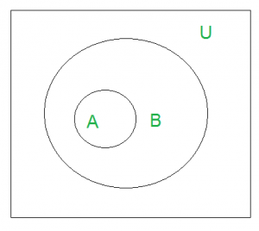](https://www.geeksforgeeks.org/wp-content/uploads/gq/2015/06/asubsetB.png)

‘U’ denotes the universal set. Above Venn Diagram shows that A is a subset of B.

**Size of a Set**  
Size of a set can be finite or infinite.

For example

Finite set: Set of natural numbers less than 100.

Infinite set: Set of real numbers.

Size of the set S is known as **Cardinality number**, denoted as |S|.

Note: Cardinality of a null set is 0.

**Power Sets**  
The power set is the set all possible subset of the set S. Denoted by P(S).  
Example: What is the power set of {0, 1, 2}?  
Solution: All possible subsets  
{∅}, {0}, {1}, {2}, {0, 1}, {0, 2}, {1, 2}, {0, 1, 2}.  
Note: Empty set and set itself is also the member of this set of subsets.

**Cardinality of power set** is Rendered by QuickLaTeX.com, where n is the number of elements in a set.

**Cartesian Products**  
Let A and B be two sets. Cartesian product of A and B is denoted by A × B, is the set of all ordered pairs (a, b), where a belong to A and b belong to B.

A × B = {(a, b) | a ∈ A ∧ b ∈ B}.

**The cardinality of A × B** is N*M, where N is the Cardinality of A and M is the cardinality of B.

Note: A × B is not the same as B × A.

**Union**  
Union of the sets A and B, denoted by A ∪ B, is the set of distinct element belongs to set A or set B, or both.

**Intersection**  
The intersection of the sets A and B, denoted by A ∩ B, is the set of elements belongs to both A and B i.e. set of the common element in A and B.

**Disjoint**  
Two sets are said to be disjoint if their intersection is the empty set .i.e sets have no common elements.

**Set Difference**  
Difference between sets is denoted by ‘A – B’, is the set containing elements of set A but not in B. i.e all elements of A except the element of B.  
**Complement**  
The complement of a set A, denoted by Rendered by QuickLaTeX.com, is the set of all the elements except A. Complement of the set A is U – A.

**Formula:**

* + Rendered by QuickLaTeX.com
  + Rendered by QuickLaTeX.com

[Group](https://www.geeksforgeeks.org/groups-discrete-mathematics/" \t "https://www.geeksforgeeks.org/last-minute-notes-discrete-mathematics/_blank)  
A non-empty set G, (G, *) is called a group if it follows the following axiom:

* + **Closure:**(a*b) belongs to G for all a, b ∈ G.
  + **Associativity:** a*(b*c) = (a*b)*c ∀ a, b, c belongs to G.
  + **Identity Element:**There exists e ∈ G such that a*e = e*a = a ∀ a ∈ G
  + **Inverses:**∀ a ∈ G there exists a-1 ∈ G such that a*a-1 = a-1*a = e

## [Relations And Functions](https://www.geeksforgeeks.org/relations-and-their-types/" \t "https://www.geeksforgeeks.org/last-minute-notes-discrete-mathematics/_blank)

|A| = m and |B| = n, then  
1. No. of functions from A to B = nm  
2. No. of one to one function = (n, P, m)  
3. No. of onto function =nm – (n, C, 1)*(n-1)m + (n, C, 2)*(n-2)m …. +(-1)m*(n, C, n-1), if m >= n; 0 otherwise  
4. Necessary condition for bijective function |A| = |B|  
5. The no. of bijection function =n!  
6. No. of relations =2mn  
7. No. of reflexive relations =2n(n-1)  
8. No. of symmetric relations = 2n(n+1)/2  
9. No. of Anti Symmetric Relations = 2n*3n(n-1)/2  
10. No. of asymmetric relations = 3n(n-1)/2  
11. No. of irreflexive relations = 2n(n-1)

12. A relation is a partial order if

1) Reflexive

2) Antisymmetric

3) Transitive

13. Meet Semi Lattice :

For all a, b belongs to L a∧b exists

14. Join Semi Lattice

For all a, b belongs to L a∨b exists

15. A poset is called Lattice if it is both meet and join semi-lattice  
16. Complemented Lattice : Every element has complement  
17. Distributive Lattice : Every Element has zero or 1 complement .  
18. Boolean Lattice: It should be both complemented and distributive. Every element has exactly one complement.  
19. A relation is an equivalence if

1) Reflexive

2) symmetric

3) Transitive

## [Graph Theory](https://www.geeksforgeeks.org/mathematics-graph-theory-basics-set-1/" \t "https://www.geeksforgeeks.org/last-minute-notes-discrete-mathematics/_blank)

1. No. of edges in a complete graph = n(n-1)/2  
2. Bipartite Graph : There is no edges between any two vertices of same partition . In complete bipartite graph no. of edges =m*n  
3. Sum of degree of all vertices is equal to twice the number of edges.  
4. Maximum no. of connected components in graph with n vertices = n  
5. Minimum number of connected components =

0 (null graph)

1 (not null graph)

6. Minimum no. of edges to have connected graph with n vertices = n-1  
7. To guarantee that a graph with n vertices is connected, minimum no. of edges required = {(n-1)*(n-2)/2 } + 1  
8. A graph is euler graph if it there exists atmost 2 vertices of odd – degree  
9. Tree

-> Has exactly one path btw any two vertices

-> not contain cycle

-> connected

-> no. of edges = n -1

10. For complete graph the no . of spanning tree possible = nn-2

11. For simple connected[planar graph](https://www.geeksforgeeks.org/mathematics-planar-graphs-graph-coloring/" \t "https://www.geeksforgeeks.org/last-minute-notes-discrete-mathematics/_blank)

* + A graph is planar if and only if it does not contain a subdivision of K5 and K3, 3 as a subgraph.
  + Let G be a connected planar graph, and let n, m and f denote, respectively, the numbers of vertices, edges, and faces in a plane drawing of G. Then n – m + f = 2.
  + Let G be a connected planar simple graph with n vertices and m edges, and no triangles. Then m ≤ 2n – 4.
  + Let G be a connected planar simple graph with n vertices, where n ? 3 and m edges. Then m ≤ 3n – 6.

12.) Every [bipartite graph](https://www.geeksforgeeks.org/bipartite-graph/" \t "https://www.geeksforgeeks.org/last-minute-notes-discrete-mathematics/_blank) is 2 colourable and vice versa  
13.) The no. of perfect matchings for a complete graph (2n)/(2nn!)  
14.) The no. of complete matchings for Kn.n = n!

Glossary