### **1. Explain the characteristics of IoT.**

The following are the most important features of IoT on which it operates:

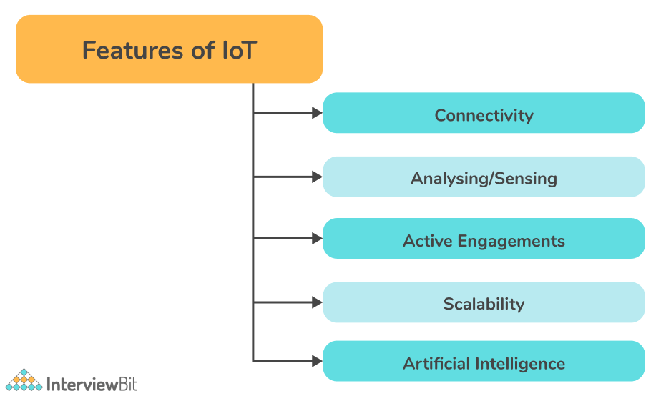

* ****Connectivity:****Connectivity is the most important aspect of IoT. The IoT ecosystem (i.e. sensors, compute engines, data hubs, etc.) cannot operate properly without seamless communication among the interrelated components or objects. There are many ways to connect IoT devices including radio waves, Bluetooth, Wi-Fi, and Li-Fi.
* ****Analyzing/Sensing:****Once all the relevant things are connected, the next step is to analyze data that is being collected and use it to build effective business intelligence. It is very important to extract knowledge from the generated data. A sensor, for example, generates data, but those data won't be of much use unless they are interpreted properly by us.
* ****Active Engagements:****A lot of today's interactions with connected technology occur via passive engagement. Through IoT, multiple products, cross-platform technologies, and services work together on an active engagement basis. The use of cloud computing in blockchain enables active engagements among IoT components in general.
* ****Scalability:****Each day, more and more elements are connecting to the IoT zone. IoT setups should therefore be able to handle massive expansion. The data generated as a result is immense, and it should be handled correctly.
* ****Artificial Intelligence:****The IoT essentially makes things such as mobile phones, wearables, vehicles, etc., smart and enhances life by making use of data collection, artificial intelligence algorithms, and networked technologies. For example, if you have a coffee machine whose beans are going to end, it will order coffee beans from the retailer of your choice.

### **2. What are the different components of IoT?**

IoT devices usually consist of four main components as follows:

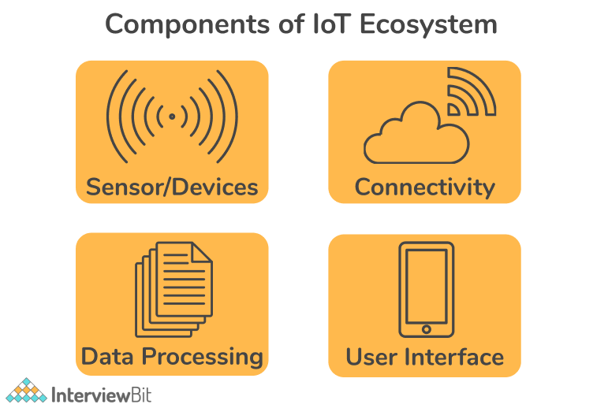

* ****Sensors:****A sensor or device is an important component for gathering live data from the surrounding environment. The nature of this data can vary. This could be as simple as your phone having a temperature sensor, GPS, an accelerometer, or as complex as a live video feature on a social media platform. Sensors make it possible for IoT devices to connect to the real world and environment.
* ****Connectivity:****Upon collection, all data is sent to a cloud infrastructure. This could be done by connecting the sensors to the cloud using a variety of communication mediums such as mobile or satellite networks, Bluetooth, WI-FI, WAN, etc. Various IoT devices use different types of connectivity.
* ****Data Processing:****Once the data has been collected, and has reached the cloud, it is the responsibility of the data processors to process it. Data processing software can enhance IoT devices in a wide range of ways, from adjusting the temperature of the air conditioner to recognizing faces on mobile phones.
* ****User Interface:****An IoT device interacts with a user through a User Interface. A user interface is the visible, tangible component of an IoT system that can be accessed by users. It involves presenting the information in a way that is valuable to the end-user. A well-designed user interface will simplify the experience for users and encourage them to interact more. Information needs to be made accessible to end-users in some way, like sending them alerts via notification, email or text message.

### **3. What are the advantages of IoT?**

An IoT (Internet of Things) system is an advanced automation and analytics system that makes use of networking, big data, sensing, and Artificial Intelligence to provide a complete solution. It provides the following benefits:

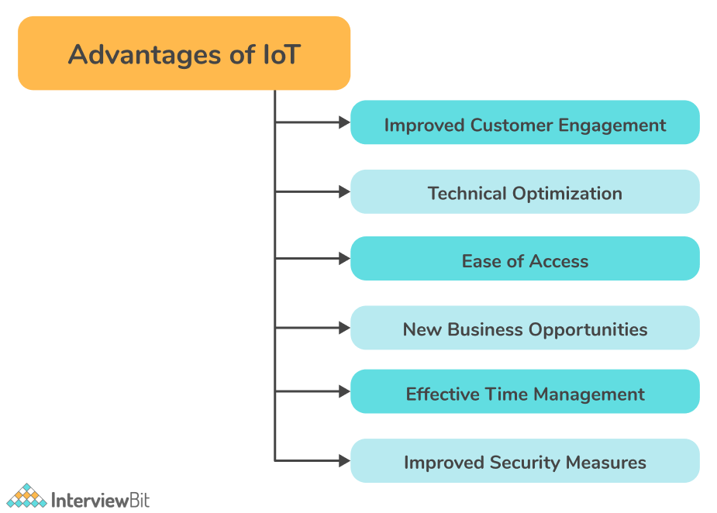

* ****Improved customer engagement:****IoT facilitates a better customer experience by automating tasks. In a car, for instance, any issue will be detected automatically by sensors. It will be notified to both the driver and manufacturer.
* ****Technical optimization:**** IoT has improved technology and made it more efficient. It has turned even old "dumb" devices into "smart" ones by making them able to transmit data over the internet, facilitating communication with people and other IoT-enabled devices. For example, coffee machines, smart toys, smart microwaves, etc.
* ****Ease of Access:**** IoT has now enabled access to real-time information from (almost) any location. All you need is a smart device connected to the internet.
* ****Improved Insights:**** Currently we rely on superficial insights to make decisions, but IoT provides real-time insights that lead to more efficient resource management.
* ****New business opportunities:**** By collecting and analyzing data from the network, you can uncover new business insights and generate new opportunities while reducing operational costs.
* ****Effective Time Management****: Overall, the Internet of Things can save you a lot of time. While we commute to work, we can read the latest news on our phones, browse a blog about our favourite hobby, or shop online.
* ****Improved security measures:****Using IoT, access control systems can provide additional security to organizations and individuals. As an example, IoT technology in surveillance can assist in improving security standards in an organization, as well as identifying any suspicious activity.

### **4. What are the challenges or risks associated with IoT?**

The following are some security risks associated with IoT:

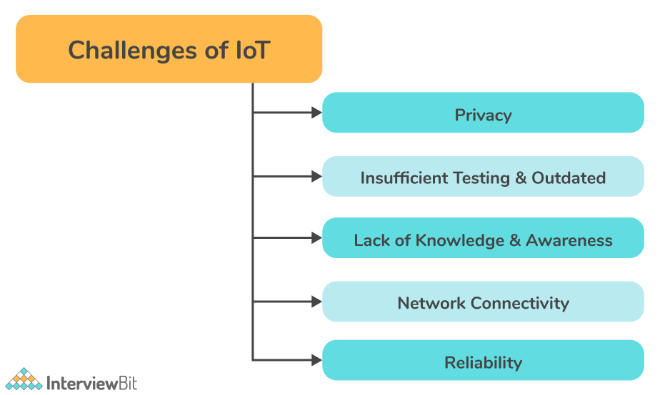

* ****Privacy:****Connected IoT devices are vulnerable to hacking. Many IoT devices collect and transmit personal data over an open network without encryption, making it easy for hackers to access. Hackers may also use cloud endpoints to attack servers.
* ****Insufficient testing & Outdated product:**** In a fast-paced market like IoT, many companies or manufacturers rush to start releasing their products and software without doing enough testing. Many of them don't provide timely updates as well. Unlike other devices such as smartphones, IoT devices are not updated, which can leave them vulnerable to data theft. Thus, IoT devices should be tested thoroughly and updated as soon as new vulnerabilities are identified in order to maintain security.
* ****Lack of knowledge and awareness:**** Despite being a growing technology, people do not know much about IoT. A major security threat associated with IoT is the user's lack of knowledge and awareness of its capabilities. This poses a threat to all users.
* ****Network Connectivity:****Network connectivity can be challenging for many IoT devices. Particularly if such devices are widely dispersed, in remote locations, or if bandwidth is severely limited.
* ****Reliability:****Given the highly distributed nature of IoT devices, it can be difficult to ensure the reliability of IoT systems. Various conditions can affect the components that make up an IoT system, such as natural disasters, disruptions in cloud services, power outages, and system failures.

### **5. What are different types of sensors in IoT?**

In recent years, Internet-of-Thing sensors have gained importance for enhancing productivity, lowering costs, and improving worker safety. Sensors are devices that detect changes in the environment condition and act accordingly. They detect specific types of conditions (such as light, heat, sound, distance, pressure, presence or absence of gas/liquid, etc.) in the physical world and then generate a signal (usually an electrical signal) as a measure of their magnitude. Sensors commonly used in IoT systems include:

* Temperature sensors
* Pressure sensor
* Motion detection sensors
* Gas sensor
* Proximity sensor
* IR sensors
* Smoke Sensor, etc.

### **6. What are different layers of the IoT protocol stack? Write the classification of IoT protocols.**

Internet of Things (IoT) protocols are ways of protecting data and ensuring it is exchanged securely between devices via the Internet. IoT protocols define how data is transmitted across the internet. By doing so, they ensure that data being exchanged between connected IoT devices is secure.

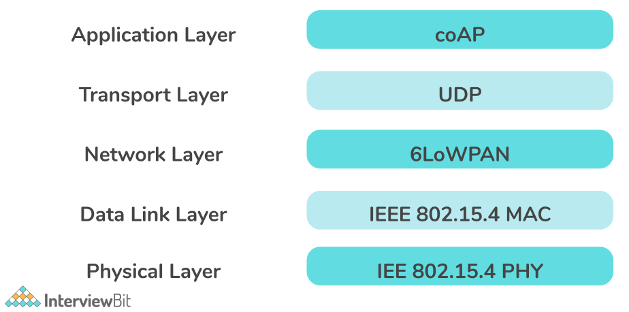

****Classification of IoT Protocols****-

| **Layer** | **Protocol** |
| --- | --- |
| Application layer | * Advanced Message Queuing Protocol (AMQP) * Message Queue Telemetry Transport (MQTT) * Constrained Application Protocol (CoAP) |
| Transport layer | * User Datagram Protocol (UDP) * Transmission Control Protocol (TCP) |
| Network layer | * 6LoWPAN * IP |
| Datalink layer | * LPWAN * IEEE 802.15.4 MAC |
| Physical layer | * IEEE 802.15.4 MAC * Near field communication (NFC) * Radio frequency identification (RFID) * Bluetooth Low Energy (BLE) * Ethernet |

### **7. What are different communication models in IoT?**

In general, the Internet of Things is about connecting devices to the Internet, but how they connect is not always obvious. IoT devices connect and communicate through their technical communication models. An effective communication model shows how the process works and helps one understand how communication can be done. The Internet of Things (IoT) enables people and things (devices) to be connected wherever they are, using any network or service they like.

Types of communication models -

* ****Request-Response Model:**** This communication model is based on the client (IoT Device) making requests and the server responding to those requests. Upon receiving a request, the server decides what response to provide, fetches the requested data, prepares the response, and then sends it back to the client. This model is stateless because the data between requests is not retained, therefore each request is handled independently.

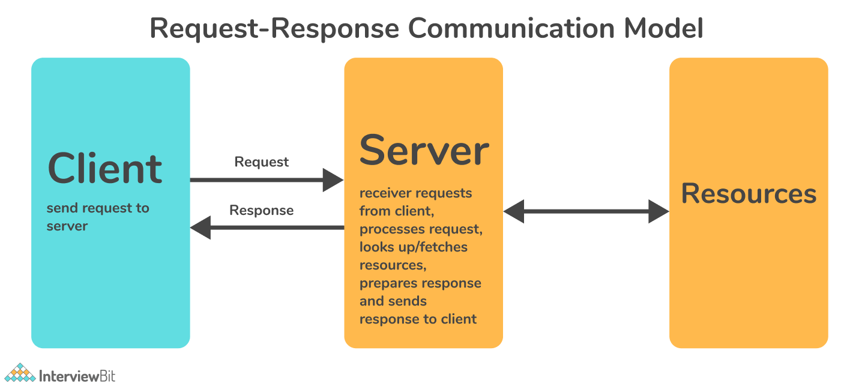

* ****Publisher-Subscriber Model:****Publishers, brokers, and consumers are all involved in this communication model. Publishes are the sources of data that send data to topics. The broker manages the topics, and consumers (consume data from topics) subscribe to the topics. Publishers and consumers are unaware of each other. Upon receiving data for a topic from the publisher, the broker forwards it to all subscribed consumers. As a result, brokers are responsible for receiving data from publishers and sending it to the appropriate consumers.

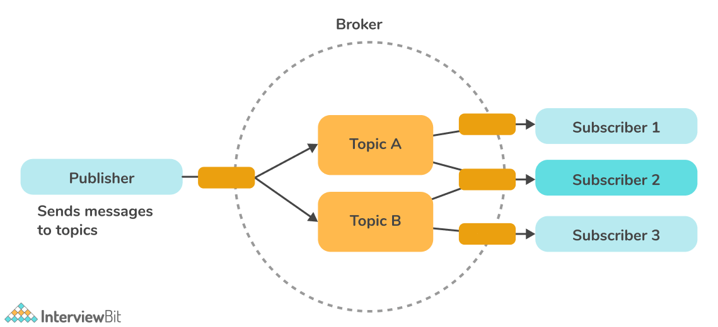

* ****Push-Pull Model:****This communication model entails data producers pushing the data into queues, while data consumers pull the data from the queues. Neither producer nor consumer needs to know about each other. The queues help decouple the messages between the consumers and the producers. Also, queues act as a buffer when there is a mismatch between the rate at which producers push data and the rate at which consumers pull it.

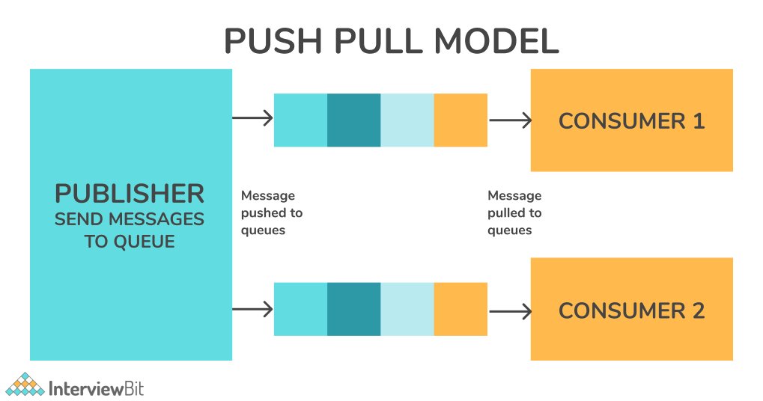

* ****Exclusive-Pair Model:**** Exclusive pairs are full-duplex, bidirectional communication models developed for constant/continuous connections between a client and server. After a connection is established, clients and servers can exchange messages. As long as a client doesn't send a request to close the connection, the connection remains open. The server is aware of every open connection.

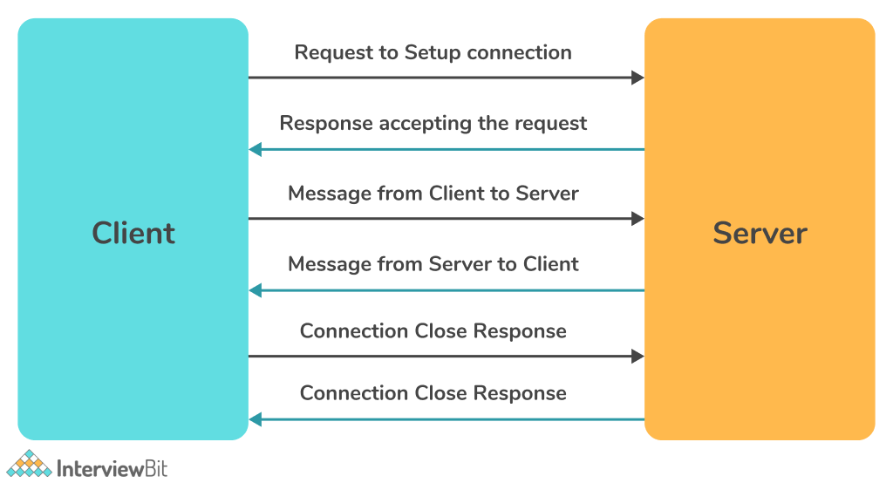

### **8. Write some of the most common IoT applications.**

Following are some of the most common real-world applications of IoT:

* ****Smart Homes:**** Smart homes are one of the most practical applications of IoT. Though IoT is applied in smart homes at various levels, the best one combines intelligent systems and entertainment. Example: Set-top box that allows you to record shows from remote, an automatic lighting system, a smart lock, etc.
* ****Connect Health:****Connected health systems allow for real-time monitoring and patient care. Patient data assists in better medical decisions. Also, IoT improves the power, precision, and availability of current devices.
* ****Wearables:**** Wearable devices have emerged as one of the earliest industries to deploy the IoT at scale. Various wearable devices are available today, such as Fit Bits, heart rate monitors, and smartwatches.
* ****Connected Cars:**** Connected cars use internet connectivity and onboard sensors to optimize their operation, maintenance, and passengers' comfort. Some of the leading automakers are working on bringing the next revolution to the car industry, including Tesla, BMW, Apple, and Google.
* ****Hospitality:**** By applying IoT to the hotel industry, a higher level of service quality is achieved. Various interactions can be automated by using electronic keys that are sent directly to the mobile devices of guests. Therefore, the IoT technology enables integrated applications to manage activities such as tracking guests' locations, sending offers or information about interesting activities, placing orders for room service or room orders, and automatically charging the room account.
* ****Farming:**** A variety of tools are being developed to deal with Drip Irrigation, understanding crop patterns, Water Distribution, drones for farm surveillance, etc. Farmers will be able to increase yields and address concerns using these methods.

### **9. Explain how IoT works.**

Artificial Intelligence is at the core of IoT devices. The IoT consists of multiple components: sensors, a cloud component, data processing software, and cutting-edge user interfaces.

IoT systems consist of sensors/devices connected to the cloud via some form of connectivity. A Raspberry Pi equipped with a quadcore processor can be used as an "Internet gateway" for IoT devices. It is a card-sized computer using which you can control outputs with GIPO (general purpose input/output) pins as well as collect data about real-world conditions using sensors. A sensor gathers live data from the surrounding environment and sent to a cloud infrastructure. Once the data reaches the cloud, the software can process it and decide what action to take, such as sending an alert or automatically adjusting the sensors/devices without user intervention.

A user interface is used if user input is required or if they want to check in on the system. Adjustments made by the user are then sent inversely through the system - from the user interface to the cloud, and from the cloud back to the sensors/devices to make changes. As a result, a highly reactive and intuitive device is created which greatly increases automation.

### **10. What do you mean by BLE (Bluetooth Low Energy)?**

Beginners may see BLE (Bluetooth Low Energy) as a type of Bluetooth that uses less power, uses less energy. BLE, or Bluetooth Smart, is a relatively new form of Bluetooth technology that consumes much less power and costs than classic Bluetooth while offering a similar range of communication. As shown in the following diagram, BLE is not a replacement for Classic Bluetooth and they both serve a specific marketplace.

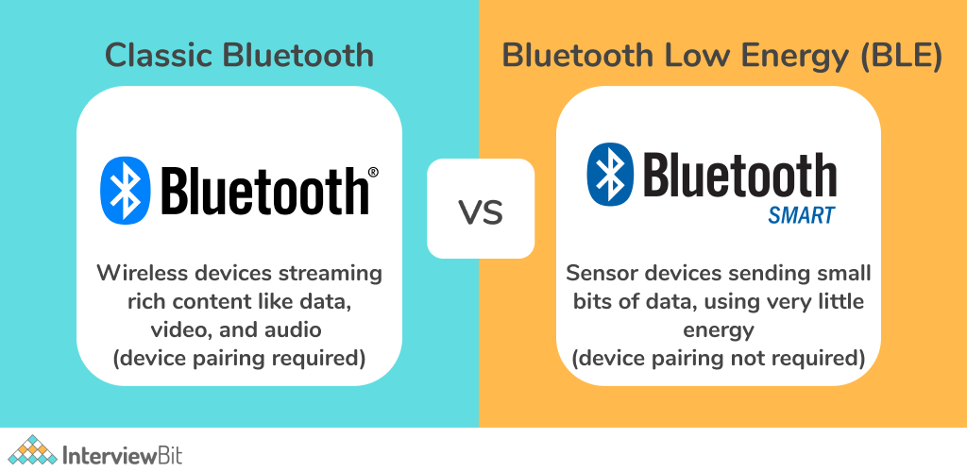

The Bluetooth Low Energy technology has been developed with the purpose of facilitating the IoT. Generally, the Internet of Things is about connecting devices with each other, usually via a wireless connection, such as Bluetooth low energy to allow them to communicate and share data. With its high energy efficiency, BLE has become a preferred and ideal choice for IoT. IoT enthusiasts and application developers have increasingly adopted Bluetooth LE to connect smart devices.

### **11. What is a thermocouple sensor?**

A thermocouple is a sensor that measures temperature by coupling two metal pieces together. The temperature is measured at a junction between these two pieces of metal which are joined at one end. A small voltage is generated by the metal conductors, which can be interpreted to calculate the temperature. A thermocouple is a simple, robust, and cost-effective temperature sensor available in multiple types and sizes. Additionally, they measure a wide temperature range, making them suitable for a variety of applications, such as scientific research, industrial settings, home appliances, and so on.

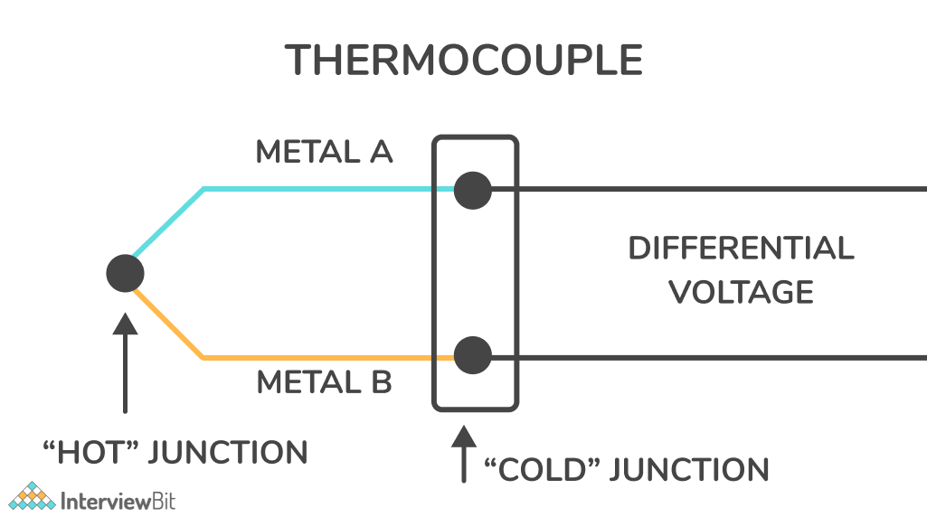

### **12. Explain the term ‘smart city’ in IoT.**

IoT technology has been a driving force behind the development of smart cities since their inception. IoT technology will continue to grow as more countries adopt next-generation connectivity, and it will have a greater impact on our lives.  Connected sensors, lights, and meters are some of the IoT devices in smart cities that collect and analyze data. As a result, cities use this data to improve infrastructure, utilities, and other city services.

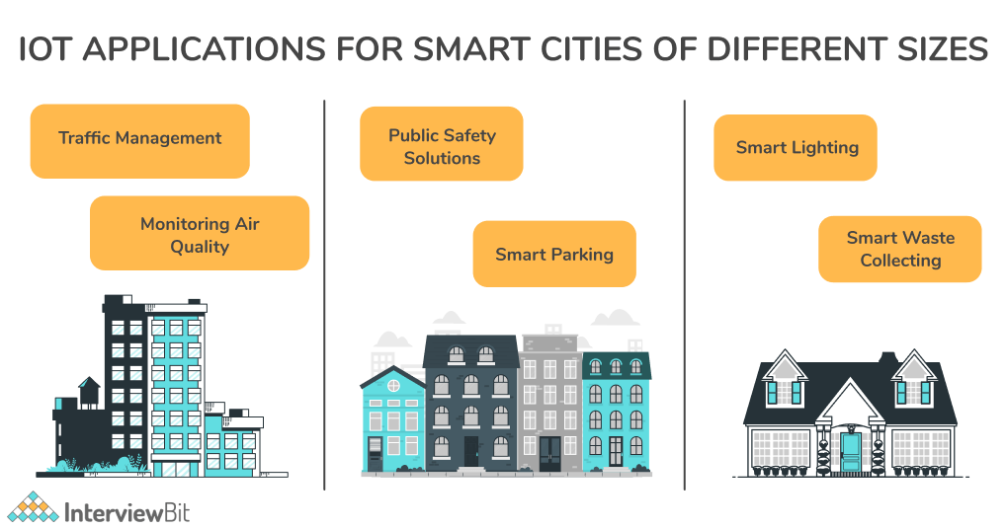

It is possible to create clever energy grids, automated waste management systems, smart homes, advanced security systems, traffic management mechanisms, water conservation mechanisms, smart lighting, and more with the help of the IoT. IoT has added a new layer of artificial intelligence and innovation to public utilities and urban planning, allowing them to be highly intuitive. These innovations have led to the emergence of smart homes and cities.

### **13. What do you mean by PWM (Pulse Width Modulation)?**

Have trouble adjusting the brightness of the LEDs in your project? Changing the voltage of the power supply directly in the circuit isn't easy. In that case, you can use Pulse Width Modulation (PWM).

Pulse Width Modulation (PWM), also referred to as PDM (Pulse Duration Modulation) refers to changing the amount of power that is delivered to a device. PWM is a technique for generating an analog signal from a digital source and is an efficient way to control the amount of energy delivered to a load without wasting any energy. PWM regulates voltage and is therefore used to control brightness in Smart Lighting Systems and also to control motor speed.

### **14. Explain Shodan.**

Shodan (Sentient Hyper-Optimized Data Access Network) is a search engine similar to Google, but it does not search for websites, but rather maps and information about internet-connected devices/systems. Shodan is sometimes referred to as an IoT search engine. To put it simply, Shodan is an IoT tool used to identify Internet-connected devices. It keeps track of all the machines with direct Internet access.

Cybersecurity experts use Shodan as a tool to protect individuals, companies, and even public utilities against cyber-attacks. Shodan lets you search for any internet-connected device, and it will tell you if it is publicly available or not.

### **15. What do you mean by IoT Contiki?**

Contiki is an operating system developed for IoT devices with limited memory, power, bandwidth, and processing power. Despite being minimalist, it still contains many of the features common to modern operating systems. Programs, processes, resources, memory, and communication can be managed with its help. Due to its lightweight (by modern standards), mature, and flexible nature, it has become a go-to operating system by many academics, researchers, and professionals.



### **16. Name some of the most suitable databases for IoT.**

The following databases are suitable for IoT:

* InfluxDB
* Apache Cassandra
* RethinkDB
* MongoDB
* Sqlite

### **17. Explain sharding.**

Sharding is the process of splitting very large databases into smaller, faster, and easier to manage pieces, called data shards. A shard is a small portion or chunk of a large data set. The principle of sharding is to split a logical dataset into multiple databases in order to store it more efficiently. In the case of a dataset that cannot be stored in a single database, sharding is necessary.

### **18. What do you mean by replication?**

In replication, data is synchronized between two or more servers. This is a method of storing the same data on more than one site or server. This feature allows data to be accessed seamlessly even during server downtimes or heavy traffic. Users gain consistent access to data while not interfering with or slowing down those of other users.

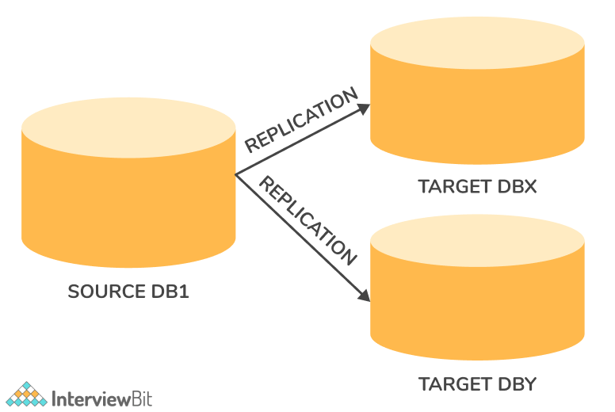

Replication of data is more than just a backup. A publisher is considered to be the server that originates the data, and a subscriber is the one where it is replicated. Data replication involves the publisher synchronizing its transaction with the subscriber and updating subscriber data automatically. A change made on the publisher's side is automatically reflected on the subscriber's side as well.

## **IoT Questions for Experienced**

### **19. State the difference between IoT and M2M.**

****IoT (Internet of Things):****It is referred to as a network comprised of interconnected physical objects that are capable of collecting and exchanging data. These devices contain embedded systems (software, electronics, networks, and sensors) that are able to collect data about the surrounding environment, transmit data over a network, respond to remote commands, or take actions based on data collected. The Internet of Things (IoT) is a subset of M2M (Machine to Machine) technology. In IoT, two machines communicate without human intervention, making it a part of M2M.

****M2M (Machine to Machine):**** In M2M, devices communicate with each other directly via wired or wireless channels, without any human interaction. It enables devices to communicate and share data with each other without relying on the internet. Several applications of M2M communications are available, including security, tracking, and tracing, manufacturing, and facility management.

| **IoT** | **M2M** |
| --- | --- |
| It is a network of connected devices (via the Internet) that have the ability to collect, process, and transmit data automatically without human intervention. | It allows two or more machines to communicate directly and perform certain tasks without requiring human intervention. |
| In addition, IoT enables objects to interact with the internal and/or external environments, thereby influencing their decision-making. | The M2M model exhibits some degree of intelligence. Devices capture data and share it with other connected devices, forming an intelligent network. |
| It facilitates cloud-based communication. | End-to-end communication between devices/machines is supported. |
| In order to improve the end-user experience, data is shared between other applications. | Only parties communicating with each other have access to the data. |
| Internet access is usually required for devices to communicate and share data. | Devices don't usually require an Internet connection for communication. |
| Many machines are able to communicate over the internet. | The communication between machines is limited to one at a time. |
| Open API integrations are supported. | Open API integrations are not supported. |
| A number of Internet protocols are used, including HTTP, FTP, and Telnet. | Communication technologies and traditional protocols are used. |

### **20. What do you mean by IoT Gateway? What is the role of a gateway in IoT?**

Devices such as IoT gateways enable communication between IoT devices, sensors, equipment, and systems. Basically, an IoT gateway is a central hub for all IoT devices. It connects the IoT devices to each other and to the cloud, converting communication among the devices and analyzing data to create useful information. Several critical functions are performed by an IoT gateway, including translating protocols, encrypting, processing, managing, and filtering data. As part of an IoT ecosystem, gateways sit between devices and sensors to communicate with the cloud.

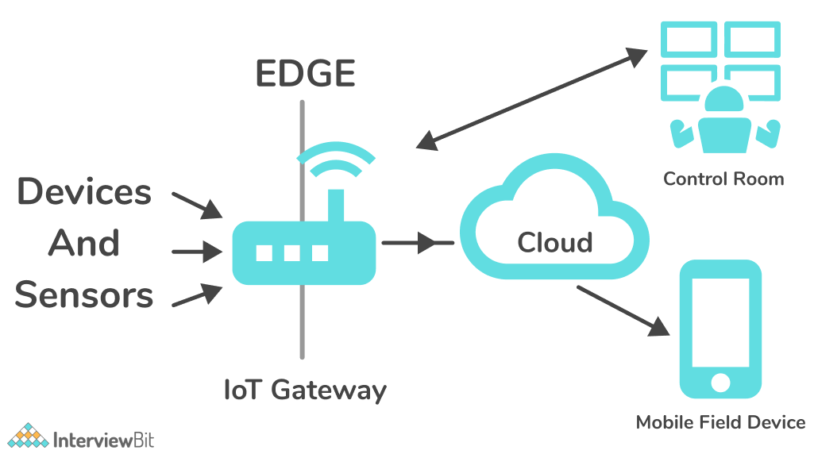

IoT gateways are commonly used for the following purposes:

* Interconnecting devices
* Connecting devices to the cloud
* Transforming IoT communications
* Data filtering
* Reducing security risks, etc.

### **21. Explain WoT (Web of Things).**

WoT (Web of Things) is an advancement of the Internet of Things by integrating smart things not only with the Internet (network) but with the Web Architecture (application). In short, the Web of Things (WoT) is aimed at facilitating the interoperability and usability of IoT.  It is a web standard for enabling communication between smart devices and web applications.

### **22. What do you mean by MQTT (Message Queue Telemetry Transport Protocol)?**

The Message Queuing Telemetry Transport protocol (MQTT) is a publish/subscribe message protocol designed for networks with limited bandwidth and IoT devices with extremely high latency (delay in data transmission). This messaging protocol is simple and lightweight, suited to devices and networks with low bandwidth, high latency, or insecure networks. It has been designed to reduce network bandwidth and resource requirements of devices and to ensure supply security. Furthermore, these principles are beneficial for IoT or M2M devices, since battery life and bandwidth are very important. Because MQTT is efficient and lightweight, it can be used to monitor or control a large amount of data. Nowadays, MQTT is used in a variety of industries, including automotive, manufacturing, telephony, oil and gas.

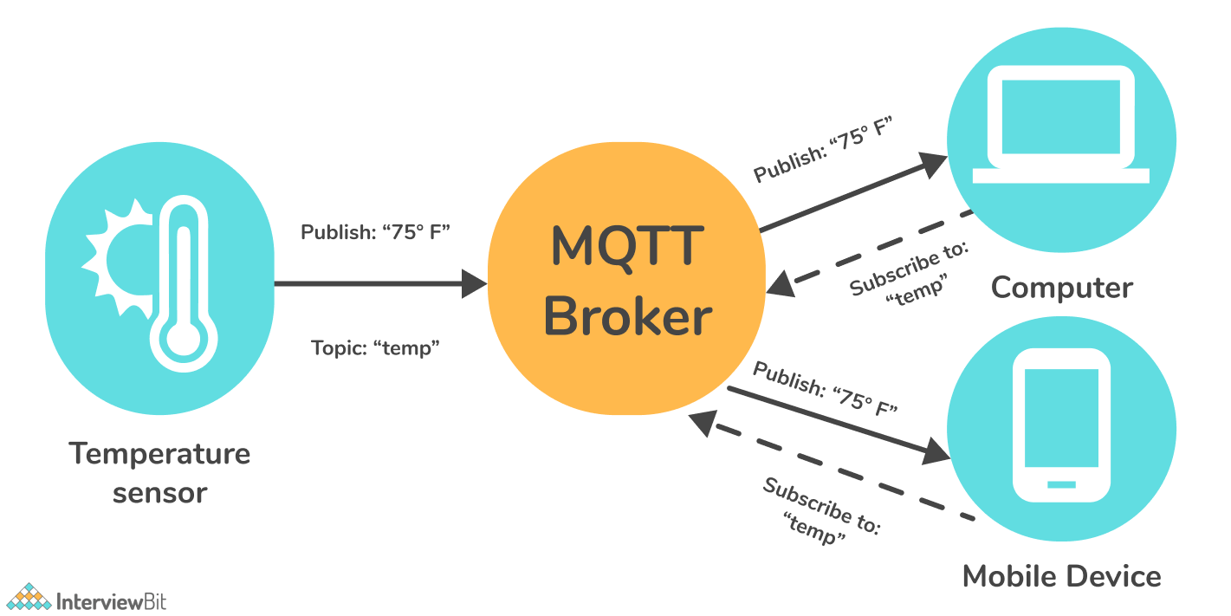

Publishes are the sources of data that send data to topics. The broker manages the topics, and consumers subscribe to the topics. Upon receiving data for a topic from the publisher, the broker forwards it to all subscribed consumers. As a result, brokers are responsible for receiving data from publishers and sending it to the appropriate consumers.

### **23. Explain Bluegiga APX4 protocol.**

The Bluegiga APx4 is a low power wireless System-on-Module (SOM). It's an ideal development platform for developing gateways since it's equipped with integrated Wi-Fi, Bluetooth 4.0, ARM, and Linux. Wireless and Bluetooth low energy (BLE) can be used together without interference as they are compliant with coexistence protocols. Bluegiga Apx4 supports both Wi-Fi and Bluetooth, and its 450mhz Arm9 processor provides smooth performance.

### **24. What is IoT device management and why do we need it?**

Once installed, IoT devices may need to be updated or timely fixed. Occasionally, it must be replaced or repaired, resulting in downtime. The problem can be solved using IoT Device management, which can keep the devices in good shape. IoT device management involves provisioning, authenticating, configuring, monitoring, provisioning, and maintaining the connected devices and software's. Effective device management is vital for ensuring the health, security, and connectivity of IoT devices.  In order to manage IoT devices, you need to meet the following four requirements.

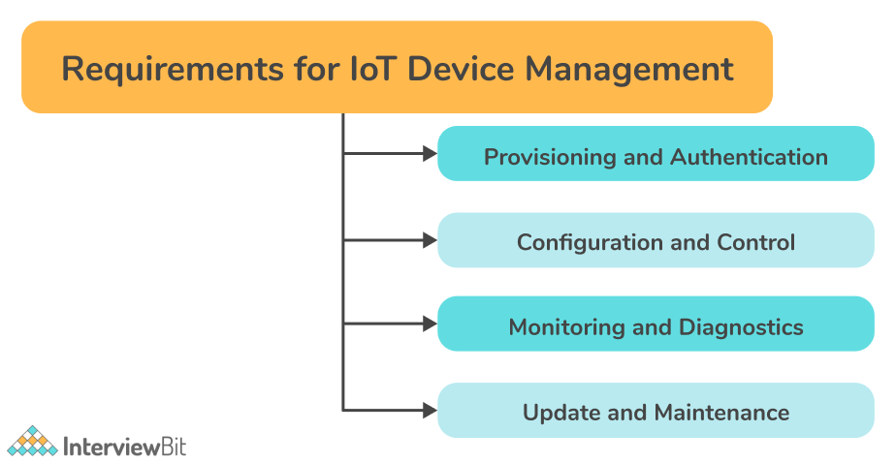

* ****Provisioning and Authentication:****IoT devices can be attacked quite easily since their network can be accessed via the Internet. This problem is solved by provisioning and authenticating the devices. By provisioning, you modify the device from its off-the-shelf settings to those needed for it to work with your network. In order to prevent intrusions and safeguard proprietary information, authentication ensures only authorized devices are enrolled.
* ****Configuration and Control:**** It is always necessary to configure a new device before you can begin using it. It is also critical to control and configure devices after deployment to ensure certain aspects such as performance, security, and functionality. Implementing control capability will be easier this way.
* ****Monitoring and Diagnostics:****The device may go down for a time when there are software bugs or certain other issues. To diagnose these issues, users must constantly monitor their devices. Device management assists in diagnosing these issues in order to resolve them quickly and efficiently.
* ****Updates and Maintenance:****For a device to function flawlessly, it must be updated after it has been installed. This may involve adding new features. Good device management hinges on the ability to update and maintain the software of remote devices securely.

### **25. State the difference between IoT and IIoT.**

****IoT (Internet of Things):**** Any device that can connect to the internet and transfer data to a remote data server is termed the Internet of Things (IoT).

****IIoT (Industrial Internet of Things):**** In the case of IoT devices used for industrial purposes, these devices are referred to as Industrial Internet of Things (IIoT). IIoT is the subset of IoT.

****Difference between IIoT and IoT-****

| **IIoT** | **IoT** |
| --- | --- |
| It supports industrial-oriented applications such as manufacturing, power plants, oil & gas, etc. | It supports customer-oriented applications such as wearables to robots and machines. |
| The focus is on large scale networks. | The focus is on small scale networks. |
| Both wired and wireless communication methods are utilized. | Typically, wireless communication methods are utilized. |
| A large amount of data is handled. | It can handle data ranging from medium to high. |
| This is a B2B (business-to-business) and is designed to increase efficiency and safety at production facilities. | This is B2C (business-to-consumer) and is designed to make the lives of consumers more convenient. |

### **26. Explain the meaning of Arduino.**

Arduino is an open-source platform for building electronics projects using easy-to-use hardware and software. A microcontroller is the common feature of all Arduino boards. The microcontrollers on board are capable of reading inputs (e.g., light on a sensor, an object near a sensor) and converting them to outputs (drive a motor, ring an alarm, turn on an LED, display information on an LCD). It is possible to connect multiple devices and exchange data in real-time between them. It is also possible to monitor them remotely using a simple interface.

### **27. What do you mean by Raspberry Pi?**

Raspberry Pi is a card-sized computer with features like General Purpose Input Output (GPIO) pins, WiFi, and Bluetooth that allow it to communicate, control, and connect to other external devices. Combining IoT applications with Raspberry Pi helps businesses embrace technology more effectively.

### **28. Explain sketch in Arduino and how will you reduce the size of sketch.**

Arduino refers to a program as a sketch. In other words, it is a bit of code that is uploaded to and executed on an Arduino board. It is possible to reduce the size of the sketch by removing unnecessary libraries from the code and making it simple and short.

### **29. What is GPIO (General Purpose Input/Output)?**

GPIO (General-purpose input/output) is a standard interface using which Raspberry Pi and other microcontrollers can connect to external electronic components/devices. These are basically programmable pins on an integrated circuit or board that allow digital input or output signals to be controlled programmatically.

### **30. State different between Arduino and Raspberry Pi.**

We can use many different kinds of controller boards for our hardware projects. Arduino and Raspberry Pi are among the most popular.

Difference between Arduino and Raspberry Pi-

| **Arduino** | **Raspberry Pi** |
| --- | --- |
| Arduino is an open-source, programmable USB microcontroller. | It is a microprocessor-based minicomputer (SBC). |
| Arduino boards have a microcontroller that includes a CPU, RAM, and ROM. The Arduino Board has additional hardware for power supply, programming, and IO (Input/Output) connectivity. | The Raspberry Pi SBC (Single board computer) comes with everything you need to run a computer, from a processor, memory, storage, graphics driver, to connectors. |
| With Arduino, you can interface sensors and control LEDs and motors. | It works well for developing Python-based applications. |
| It has a simple hardware and software architecture. | On the other hand, Raspberry Pi boards have a complex architecture. |
| It is possible to build your own Arduino board using the open-source hardware and software files of Arduino. | Since the Raspberry Pi is not open-source, it cannot be used for this purpose. |
| It is used to run one single task at a time. | It can perform several tasks at once such as running software, web browsing, doing programming, etc.. |

### **31. State difference between IoT and WSN (Wireless Sensor Network)?**

****WSN (Wireless sensor network):**** It uses a network of dedicated sensors to monitor and record the physical conditions of the environment and to organize the recorded data at one central location. WSN: Sensor nodes connected without a wire to gather data.

****IoT (Internet of Things)****: It is referred to as a network comprised of interconnected physical objects that are capable of collecting and exchanging data. These devices contain embedded systems (software, electronics, networks, and sensors) that are able to collect data about the surrounding environment, transmit data over a network, respond to remote commands, or take actions based on data collected. IoT: WSN + Any physical object (Thing) + IP address + Internet + App + Cloud computing + etc.…

### **32. Explain IoT GE-PREDIX.**

GE (General Electric) Predix is a software platform for collecting industrial instrument data. This platform enables industrial-grade analytics for operations optimization and performance management via a cloud-based PaaS (platform as a service).

### **33. Name some of the wearable Arduino Boards.**

The following wearable Arduino boards are available:

* Lilypad Arduino main board
* Lilypad Arduino simple
* Lilypad Arduino simple snap
* Lilypad Arduino USB

### **34. Explain IoT asset tracking.**

"Asset tracking" entails tracking a particular asset and its location, whether it's a hammer, an X-ray machine, a vehicle, a shipping crate, or even a person. How does the IoT fit in here? Rather than manually tracking assets like a supervisor filling out a form when the asset arrives at a specific location, IoT tracking systems use sensors and asset management software to track things automatically. The assets are fitted with sensors, which broadcast their location over the internet on a continuous or periodic basis, and the software displays this information for you to see. Different types of IoT asset tracking systems transmit location information differently, such as via GPS, Wi-Fi, or cellular networks.

### **35. What do you mean by “Thingful”?**

Thingful is a search engine for the internet of things (IoT). Using millions of publicly available IoT data resources, it provides a geographical index of real-time data from connected devices around the globe. With Thingful, IoT managers can detect patterns, identify anomalies, and analyze trends to solve problems.

### **1) What is the Internet Of Things (IoT)?**

Internet of Things (IoT) is a network of physical objects or people called “things” that are embedded with software, electronics, network, and sensors that allow these objects to collect and exchange data. The goal of IoT is to extend to internet connectivity from standard devices like computer, mobile, tablet to relatively dumb devices like a toaster.

### **2) Explain Raspberry Pi**

Raspberry Pi is a computer which is capable of doing all the operations like a conventional computer. It has other features such as onboard WiFi, GPIO pins, and Bluetooth in order to communicate with external things.

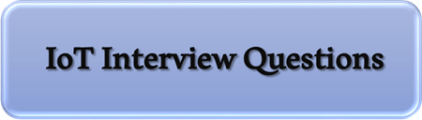

### **3) How to run Raspberry pi in headless mode?**

Raspberry pi in headless mode can be run by using SSH. The latest operating system has an inbuilt VNC server that is installed for taking remote desktop on Raspberry Pi.

### **4) What are the fundamental components of IoT?**

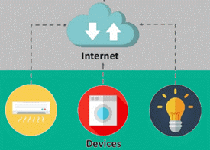

The four fundamental components of an IoT system are:

* ****Sensors/Devices:**** Sensors or devices are a key component that helps you to collect live data from the surrounding environment. All this data may have various levels of complexities. It could be a simple temperature monitoring sensor, or it may be in the form of the video feed.
* ****Connectivity:**** All the collected data is sent to a cloud infrastructure. The sensors should be connected to the cloud using various mediums of communications. These communication mediums include mobile or satellite networks, Bluetooth, WI-FI, WAN, etc.
* ****Data Processing:**** Once that data is collected, and it gets to the cloud, the software product performs processing on the gathered data. This process can be just checking the temperature, reading on devices like AC or heaters. However, it can sometimes also be very complex, like identifying objects, using computer vision on video.
* ****User Interface:****The information needs to be available to the end-user in some way, which can be achieved by triggering alarms on their phones or sending them notification through email or text message. The user sometimes might need an interface which actively checks their IoT system.

### **5) What is the difference between IoT and IIoT?**

The difference between IoT and IIoT is:

|  |  |
| --- | --- |
| **IoT** | **IIoT** |
| The full form of IoT is the [Internet of Things](https://www.guru99.com/iot-tutorial.html). | The full form of IIoT is the Industrial Internet of Things. |
| A service model is human-centric. | A service model is machine-centric. |
| It supports customer-oriented applications. | It supports industry-oriented applications. |
| Communication transportation is done through wireless devices. | Communication transportation is done through both wired and wireless devices. |
| The quality of data is medium to high. | The quality of data is high to very high. |
| Criticality is not severe. | Criticality is severe. |

### **6) List layers of IoT protocol stack**

Layers of IoT protocol stack are: 1) Sensing and information, 2) Network connectivity, 3) Information processing layer, 4) Application layer.

### **7) What are the disadvantages of IoT?**

The disadvantages of IoT are:

* ****Security:**** IoT technology creates an ecosystem of connected devices. However, during this process, the system may offer little authentication control despite sufficient cybersecurity measures.
* ****Privacy:**** The use of IoT, exposes a substantial amount of personal data, in extreme detail, without the user’s active participation. This creates lots of privacy issues.
* ****Flexibility:**** There is a huge concern regarding the flexibility of an IoT system. It is mainly regarding integrating with another system as there are many diverse systems involved in the process.
* ****Complexity:**** The design of the IoT system is also quite complicated. Moreover, it’s deployment and maintenance also not very easy.
* ****Compliance:**** IoT has its own set of rules and regulations. However, because of its complexity, the task of compliance is quite challenging.

### **8) Define Arduino**

Arduino is a free electronics platform having easy to use hardware and software. It has a microcontroller capable of reading input from sensors to control the motors programmatically.

### **9) List mostly used sensors types in IoT**

Mostly used sensor types in IoT are:

* Smoke sensor
* Temperature sensors
* Pressure sensor
* Motion detection sensors
* Gas sensor
* Proximity sensor
* IR sensors

### **10) Mention the basic difference between IoT and sensor businesses?**

A sensor business does not need an active internet connection to work. Internet of Things requires a control side to work.

### **11) What are the advantages of IoT?**

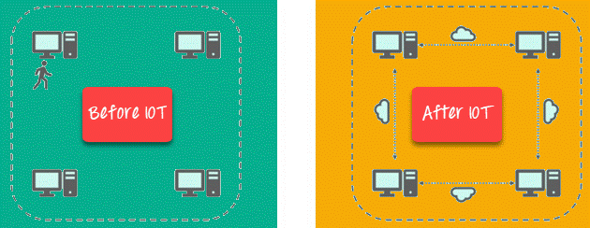

Key benefits of IoT technology are as follows:

* ****Technical Optimization:**** IoT technology helps a lot in improving techniques and making them better. For example, with IoT, a manufacturer is able to collect data from various car sensors. The manufacturer analyses them to improve its design and make them more efficient.
* ****Improved Data Collection:**** Traditional data collection has its limitations and its design for passive use. IoT facilitates immediate action on data.
* ****Reduced Waste:**** IoT offers real-time information leading to effective decision making & management of resources. For example, if a manufacturer finds an issue in multiple car engines, he can track the manufacturing plan of those engines and solves this issue with the manufacturing belt.
* ****Improved Customer Engagement:**** IoT allows you to improve customer experience by detecting problems and improving the process.

### **12) What is Bluegiga APX4 protocol?**

The Bluegiga APX4 is a solution that supports both the WiFI and BLE platform, and it is based on a 450MHz ARM9 processor.

### **13) What are the most common IoT applications?**

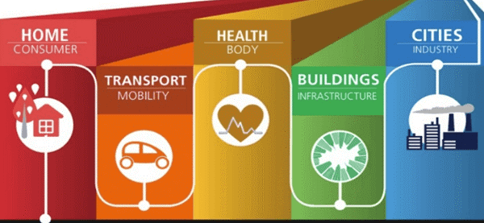

The most common IoT applications are:

* ****Smart Thermostats:**** Helps you to save resources on heating bills by knowing your usage patterns.
* ****Connected Cars:**** IoT helps automobile companies handle billing, parking, insurance, and other related stuff automatically.
* ****Activity Trackers:**** Helps you to capture heart rate patterns, calorie expenditure, activity levels, and skin temperature on your wrist.
* ****Smart Outlets:**** Remotely turn any device on or off. It also allows you to track a device’s energy level and get custom notifications directly into your smartphone.
* ****Parking Sensors:**** IoT technology helps users to identify the real-time availability of parking spaces on their phones.
* ****Connect Health:**** The concept of a connected healthcare system facilitates real-time health monitoring and patient care. It helps in improved medical decision-making based on patient data.

### **14) What is Pulse Width Modulation?**

PWM or Pulse Width Modulation is a variation of how much time the signal is high in an analog fashion. The signal can be high or low, and the user can even change the proportion of the time.

### **15) Mention applications of PWM in IoT**

Applications of PWM in IoT are controlling the speed of DC motor, Controlling the direction of a servo moto, Dimming LED, etc.

### **16) List available wireless communications boards available in Raspberry Pi?**

Wireless communications boards available in Raspberry Pi are 1) WiFi and 2) BLE/Bluetooth.

### **17) What are the functions used to read analog and digital data from a sensor in Arduino?**

Functions used to read analog and digital data from a sensor in Arduino are: digitalRead() and digitalWrite().

### **18) What is Bluetooth Low Energy?**

Bluetooth Low Energy is a wireless PAN (Personal Area Network) technology. It uses less power to transmit long-distance over a short distance.

### **19) Define MicroPython**

MicroPython is a Python implementation, which includes a small subset of its standard library. It can be optimized to run on the ModeMCU microcontroller.

### **20) List available models in Raspberry Pi**

Models of Raspberry Pi are:

* Raspberry Pi 1 Model B
* Raspberry Pi 1 Model B+
* Raspberry Pi 1 Model A
* Raspberry Pi Zero
* Raspberry Pi 3 Model B
* Raspberry Pi 1model A+
* Raspberry Pi Zero W
* Raspberry Pi 2

### **21) What are the challenges of IoT?**

Important challenges of IoT are:

* Insufficient testing and updating
* Concern regarding data security and privacy
* Software complexity
* Data volumes and interpretation
* Integration with AI and automation
* Devices require a constant power supply which is difficult
* Interaction and short-range communication

### **22) Mention some of the commonly used water sensors**

The commonly used water sensors are:

* Turbidity sensor
* Total organic carbon sensor
* pH sensor
* Conductivity sensor

### **23) Differentiate between Arduino and Raspberry pi**

The difference between Arduino and Raspberry pi is:

|  |  |
| --- | --- |
| **Arduino** | **Raspberry pi** |
| Arduino is an open, programmable USB microcontroller. | Raspberry pi is a credit card size computer. |
| It can execute one program at a time. | Users can run more than one program at a time. |

### **24) What are mostly used IoT protocols?**

The mostly used IoT protocols are:

* XMPP
* AMQP
* Very Simple Control Protocol (VSCP)
* Data Distribution Service (DDS)
* MQTT protocol
* WiFi
* Simple Text Oriented Messaging Protocol(STOMP)
* Zigbee

### **25) What are IoT publishers?**

IoT Publishers are sensors that send real-time data to intermediate devices or middleware.

### **26) What is a library in Arduino?**

Arduino library is a collection of code that is already written for controlling module or sensor.

### **27) Mention some of the wearable Arduino boards**

Wearable Arduino boards are:

* Lilypad Arduino main board
* Lilypad Arduino simple
* Lilypad Arduino simple snap
* Lilypad Arduino USB

### **28) What is replication?**

Replication is the act of syncing data between two or more servers.

### **29) What is IoT Thingworx?**

Thingworx is a platform for the fast development and deployment of connected devices. It is a collection of integrated IoT development tools that support analysis, production, property, and alternative aspects of IoT development.

### **30) What is Salesforce IoT Cloud?**

The Salesforce IoT Cloud is an online platform for storing and processing IoT information.

It is an assortment of various application development elements, which are called lightning.

This program gathers information from websites, devices, customers, and partners. It then triggers actions for period responses.

### **31) Explain IoT GE-PREDIX**

GE or General Electric Predix is a software for the information assortment from industrial instruments. It offers a PaaS which allows users performance management and operation optimization facility. It connects instrumentation, people, and information in an exceedingly conventional technique.

### **32) List out Some popular companies are working on IoT**

Popular companies working on [IoT](https://www.guru99.com/best-iot-companies.html) are: 1) Philips, 2) LG, 3) Google, 4) Apple and 5) Samsung.

### **33) What are various types are of CAN Frame?**

Various types of CAN frames are: 1) data frame, 2) request frame, 3) error frame, and 4) overload frame.

### **34) What is the main difference between floating CPU and fixed-point CPU?**

Floating CPU can take floating value directly, whereas fixed CPU is converted to integer format. Thereby, it leads to the loss of some resolution.

### **35) Define GPIO**

GPIO is a programmable pin that can be used to control input or output pins programmatically.

### **36) Explain Android things**

Android things is an Android-based OS that is built for embedded devices.

### **37) What is the aim of airflow sensors?**

The main aim of airflow sensors is to measure the air level in the soil. This sensor enables one to measure it dynamically, from one location, or multiple locations of the garden.

### **38) Mention suitable databases for IoT**

Suitable databases for IoT are:

* influx DB
* Apache Cassandra
* RethinkDB
* MongoDB
* Sqlite

### **39) Why use the scheduler in RTOS?**

Scheduler in RTOS is used for switching one task to another.

### **40) Mention real-time usage of Raspberry pi**

* Home a
* Portable webserver
* manipulating the robots
* Internet radio

### **41) Define IoT Contiki**

IoT Contiki is software that targets explicitly little devices connected with the Internet. It is used with process power bandwidth, power, and restricted memory. Contiki helps for the management of programs, resources, processes, communication, and memory.

### **42) What is data in IoT?**

Data in IoT refers to the information that is collected by the installed devices at any building.

### **43) List majorly used IoT controllers by industries**

Majorly used IoT controllers by industries are: 1) Siemens IoT 2020 and 2) Arduino.

### **44) What is a crystal oscillator?**

A crystal oscillator is the main part of the microprocessor. It executes every single pulse one instruction in CPU.

### **45) What is the importance of the Internet of Everything?**

Internet of Everything is important because:

* It brings together people, processes, things, and data to make network connections valuable and relevant.
* It converts the information into actions to create new capabilities and opportunities for businesses.

### **46) What is WSN?**

The full form of WSN is Wireless Sensor Network. It is a network of notes, design to observe and to study physical parameters of the application.

### **47) What is Zigbee?**

Zigbee is the same like Bluetooth. It used in a complex system for low power operation, robustness, and high security.

### **48) What is Z-Wave?**

Z-Wave is an IoT technology that uses low power RF communication. It is designed for home automation products like lamp controllers and sensors.

### **49) How to install a new library in Arduino?**

A new library in Arduino can be installed by selecting the library from the sketch option in Toolbar.

### **50) What is MQTT?**

The full form of MQTT is Message Queue Telemetry Transport Protocol. It is a messaging protocol that is used for tracking devices in IoT.

### **51) Name some important IoT hardware**

IoT hardware includes varieties of devices like router, bridge, sensor, etc.

### **52) What are the operating systems supported by Pi?**

Operating systems supported by Pi are:

* Raspbian
* Open ELEC (Open Embedded Linux Entertainment center)
* RISC OS
* Lakka
* OSMC (Open Source Media Centre)
* Windows IoT Core

### **53) How to reduce the size of the sketch?**

Reducing the size of the sketch is can be reduced by removing unwanted libraries from the code and make code short and simple.

### **54) What are the various types of antennas designed for IoT devices?**

Various types of antennas designed for [IoT devices](https://www.guru99.com/best-iot-devices.html) are:

* Chip Antenna
* PCB Antenna
* Wire Antenna
* Proprietary Antenna
* Whip Antenna

### **55) What is the difference between M2M and IoT?**

The difference between M2M and IoT is:

|  |  |
| --- | --- |
| **M2M** | **IoT** |
| Communication is done within an embedded software at the client site. | Communication is done for grand-scale projects. |
| It uses isolated systems of devices having the same standards. | It uses integrated devices, applications, and data across varying standards. |
| M2M offers limited scalability options. | IoT is inherently more scalable. |
| A cellular network or wired network is used for device connectivity. | It uses an active Internet connection for device connectivity. |
| Machines can communicate with one machine at a time. | Many machines can communicate with each other over the Internet. |

### **56) What are the features of influxDB?**

Features of influxDB are:

* Provides support of visualization tools
* Works with distributed time-series database
* It does not have any external dependencies

### **57) How to program Arduino?**

Programmers can use the Arduino IDE in order to write an Arduino program. Developers can also use Node.js Johny five-module in order to control Arduino.

### **58) What are IoT testing tools?**

IoT testing tools can be divided into hardware and software:

* ****IoT testing software:****Tcpdump and Wireshark.
* ****Hardware for IoT testing:**** JTAG Dongle, Digital Storage Oscilloscope, and Software Defined Radio.

### **59) How to store the high-volume file into Arduino?**

A specification called Gridfs can be used for storing high volume file into Arduino.

### **60) Mention IoT software**

IoT software are: 1) Blockchain, 2) windows IoT, 3) Predix, 4) Microsoft Azure, 5) Bluemix, and 6) Node-RED.

### **61) What is Shodan?**

Shodan is an IOT testing tool that can be used to discover which of your devices are connected to the Internet. It allows you to keep track of all the computers which are directly accessible from the Internet.

### **62) What is a thing in IoT?**

IOT thing is an item having an embedded and connected computing device.

### **63) What is Thermocouple?**

A Thermocouple is a device which consists of two different conductors joined together to form an electrical junction.

### **64) Mention some examples of MEMS sensor**

* MPU6050- Gyroscope
* ADXL345
* piezoelectric sensor
* Accelerometer

### **65) What are IoT test approaches?**

IoT test approaches are: 1) Usability, 2) IoT Security, 3) Connectivity, 4) Performance, 5) Compatibility Testing, 6) Pilot Testing, 7) Regulatory Testing, and 8) Upgrade testing.

### **66) What is sharding?**

Sharding is a method to split data into collections and stored in machines.

### **67) List hardware prototypes used in IoT**

Hardware Prototypes used in IoT are 1) Raspberry Pi, 2) ARM Cortex Family, and 3) Arduino.

### **68) What is IoT Testing?**

[IoT testing](https://www.guru99.com/iot-testing-challenges-tools.html) is a type of testing to check IoT devices. Today there is an increasing need to deliver better and faster services. There is a huge demand to access, create, use, and share data from any device. The thrust is to provide greater insight and control over various interconnected IoT devices. Hence, the IoT testing framework is important.

### **69) What are the types of IoT?**

There are two types of IoT:

* ****Internet of Things:**** It creates a business that uses a gadgets to perform a task.
* ****Industrial Internet of Things:**** It creates business in the industry like agriculture.

### **70) What is Thingful?**

Thingful is a search engine for the Internet of Things. It allows secure interoperability between millions of IoT objects via the Internet. This IOT testing tool also to control how data is used and empowers to take more decisive and valuable decisions.

### **71) What are interrupts in Arduino?**

Interrupts enable specific tasks to process in the background and are enabled by default. Its main job is to ensure the device processor responds fastly to essential events.

### **72) What is Asset Tracking?**

Asset Tracking or Asset management is the process of keeping track of physical assets and information.

### **73) What are the risks associated with the IOE Internet of Everything?**

Risks associated with IOE are 1) Privacy, 2) Security, 3) Network congestion, and 4) Electricity consumption at the peaks.

### **74) What is the basic difference between the IoT network and Wireless Sensor Network?**

Wireless Sensor Network things connected to the wireless network and gather some monitoring environment or data. IoT contains a combination of:

* WSN
* Internet
* Cloud Storage
* web or mobile application

### **75) What is the importance of the network in IoT?**

The network is the main part of the IoT. It is responsible for providing a practical and smart system that makes strong infrastructure. The network offers scalability to help devices coordinate with other lines with the Internet.

### **76) What is the connection between IoT and sensors in the commercial enterprise?**

Sensors may be used in devices that are not net-connected, while devices need to be connected to the Net with IoT. Yet, sensing is a part of IoT, even if the device is not connected to the Net.

### **77) Explain the types of testing in IoT?**

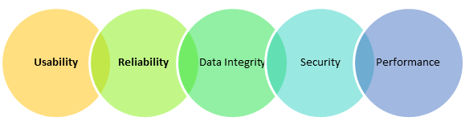

IoT devises testing types are:

* ****Usability Testing:****There are so many devices of different shape and form factors are used by the users. Moreover, the perception also varies from one user to others. That’s why checking the usability of the system is very important in IoT testing.
* ****Compatibility Testing:****There are lots of devices that can be connected through the IoT system. These devices have varied software and hardware configuration. Therefore, a possible combination is huge. As a result, checking the compatibility in the IoT system is important.
* ****Reliability and Scalability Testing:****Reliability and Scalability is important for building an IoT test environment which involves a simulation of sensors by utilizing virtualization tools and technologies.
* ****Data Integrity Testing:****It’s important to check the Data integrity in IoT testing as it requires a large amount of data and its application.
* ****Security testing:****In the IoT environment, many users are accessing a massive amount of data. Thus, it is important to validate user via authentication, have data privacy controls as part of security testing.
* ****Performance Testing:****Performance testing is important to create a strategic approach for developing and implementing an IoT testing plan.

## **Q1. What is the Internet of Things (IoT)?**

**Ans.** Internet of Things (IoT) refers to the network of physical devices or objects called ‘things’. These devices are embedded with sensors, electronics, software, etc., which enable them to gather data and share it with other internet-connected devices and systems without human interactions. The term ‘things’ in the Internet of Things includes everything in our day-to-day life which is accessed or connected through the internet, like smartphones, wearables, electronic appliances, etc.

*Interested in learning more about IoT? Read our post – [what is IoT](https://www.naukri.com/learning/what-is-iot-the-internet-of-things-st563-tg1199" \t "https://www.naukri.com/learning/articles/iot-interview-questions-and-answers/_blank)?*

## **Q2. What are the different components of IoT systems?**

**Ans.** IoT systems consist of four main components:

### 1. Sensors

Sensors collect data from their surroundings. This data could be a simple temperature reading, GPS, accelerometer, or even a complex one like a live video feature on a social media platform. Thus, sensors are the devices that sense the environment and perform multiple tasks. Multiple sensors can be part of a device that does more than just sense things, like a smartphone.

### 2. Connectivity

The data collected by sensors is sent to the cloud through different ways like Bluetooth, WiFi, cellular, satellite, Ethernet, low-power wide-area networks (LPWAN), etc. Now the devices can interact freely with each other in a transparent manner. These connectivity options differ from each other in terms of range, bandwidth, and power consumption. Different IoT applications use different connectivity options depending on their needs.

### 3. Data Processing

After the data is gathered by the sensors and gets to the cloud, the software starts processing the collected information and data to perform the required tasks. The tasks could be as simple as checking if the temperature reading is within the acceptable range. It could be as complex as using the computer vision on the video to identify objects

This phase includes different techniques like classification, calculations, and sorting to get meaningful information from the data received. Data processing software enhances the automation in IoT devices.

### 4. User Interface

## User Interface is the means by which a user and an IoT device interact. This phase involves making the information useful to the end-user. It can be done by sending an alert to the user via text, notification, or email. **Q3. What are the different types of sensors in IoT?**

**Ans.** The different types of sensors in IoT are:

|  |  |
| --- | --- |
| **Sensor** | **Function** |
| Temperature sensor | Measures the amount of heat energy in a source. Detects temperature changes and converts them into data. |
| Proximity sensor | It is responsible for the non-contact detection of objects near the sensor. |
| Pressure sensor | Measures the pressure changes in gases and liquids. |
| Humidity sensor | Measure the amount of water vapor in the atmosphere of air or other gases. |
| Motion detection sensor | It detects the physical movement (motion) in a given area and transforms motion into an electric signal. |
| Optical Sensor | Measures a physical quantity of light and converts rays of light into electrical signals. |
| Smoke sensor | It detects smoke (airborne particulates and gases) and its level. |
| Accelerometers | Measures an object’s linear acceleration based on vibration. |
| Gyroscope | It measures an angular position based on the principle of the rigidity of space. |
| + More 2 Rows |  |

*Check out the top [online IoT Courses](https://www.naukri.com/learning/internet-of-things-courses-certification-training-st563" \t "https://www.naukri.com/learning/articles/iot-interview-questions-and-answers/_blank) here.*

## **Q4. What are the top security risks related to IoT?**

**Ans.** Following are some of the security risks that revolve around IoT:

### 1. Privacy

IoT devices are vulnerable to hacking. Many IoT devices collect personal information and some of them send this personal information across the network without any encryption. This information can be easily traced and read by hackers. Cloud endpoints could also be used by hackers to attack servers.

### 2. Web interface

Simple default passwords pose a threat when it comes to the user web interface. The use of weak passwords on the web interface may enable hackers to easily identify accounts of users and misuse them.

*Check out the [Top Security Courses For IT Professionals](https://www.naukri.com/learning/articles/top-security-courses-for-it-professionals-to-pursue/" \t "https://www.naukri.com/learning/articles/iot-interview-questions-and-answers/_blank)*

### 3. Rogue IoT Devices

Rogue IoT devices are just plain counterfeit malicious devices that are installed in secured networks without authorization. Some examples of rogue IoT devices are Raspberry Pi and WiFi Pineapple. A rogue device either replaces the original IoT device or appears as a member of a group to gather sensitive information. These devices break the network perimeter.

### 4. Insufficient testing & Lack of updates

The IoT market is fast-paced, which is why many companies or manufacturers are in a hurry to create and release their products and software without sufficiently testing them. Some of them also fail in providing timely software updates.

Compared to other devices like smartphones, IoT devices continue to be used without the necessary updates, which can enable hackers to steal sensitive information. Thus, sufficient testing and timely updates are critical for maintaining security on IoT devices. They should be updated right after new vulnerabilities are identified.

### 5. Lack of user Knowledge & Awareness

Since IoT is a new technology, people still do not know much about it. One of the biggest security threats related to IoT is the user’s lack of knowledge and awareness of the IoT functionality. This puts everybody at risk.

*Explore the concept of ethical hacking, read our blog – [what is Ethical Hacking](https://www.naukri.com/learning/what-is-ethical-hacking-st603-tg161" \t "https://www.naukri.com/learning/articles/iot-interview-questions-and-answers/_blank)?*

## **Q5. Explain IoT Protocols. Name some of the popular IoT Protocols.**

**Ans.** IoT protocols are a set of rules that guide how data gets sent to the internet. They ensure optimum security to the data being exchanged between connected IoT devices.

Some of the popular IoT protocols are:

|  |  |
| --- | --- |
| **Layer** | **Protocol** |
| Application layer | * Advanced Message Queuing Protocol (AMQP) * Message Queue Telemetry Transport (MQTT) * Constrained Application Protocol (CoAP) |
| Transport layer | * User Datagram Protocol (UDP) * Transmission Control Protocol (TCP) |
| Network layer | * 6LoWPAN * IP |
| Datalink layer | * LPWAN * IEEE 802.15.4 |
| Physical layer | * Near field communication (NFC) * Radio frequency identification (RFID) * Bluetooth Low Energy (BLE) * Ethernet |

## **Q6. Name the different types of CAN Frames.**

****Ans.**** The different types of frames in CAN are:

* Data frame
* Remote frame
* Error frame
* Overload frame

## **Q7. Which databases are suitable for IoT?**

****Ans.**** The databases that are suitable for IoT and can store data of IoT applications include:

* influx DB
* MongoDB
* Apache Cassandra
* RethinkDB
* Sqlite

Check Out the [Best Online Courses](https://www.naukri.com/learning/" \t "https://www.naukri.com/learning/articles/iot-interview-questions-and-answers/_blank)

## **Q8. Explain the Bluegiga APX4 protocol.**

****Ans.**** Bluegiga APx4 protocol is a low-power wireless System-on-Module that supports the WiFI and BLE platforms. Based on a 450MHz ARM9 processor, this protocol is an excellent platform for wireless gateways.

## **Q9. Explain Pulse Width Modulation (PWM).**

Ans. Pulse Width Modulation (PWM) is a modulation technique used in communication systems. It produces variable-width pulses that signify the amplitude of an analog input signal. It helps in encoding the amplitude of a signal into a pulse width/duration of another signal for transmission.

## **Q10. Name the different types of antennas used for IoT devices.**

****Ans.**** The different types of antennas used for IoT devices are:

* Wire Antenna
* PCB Antenna
* Chip Antenna
* Whip Antenna
* Proprietary Antenna

## **Q11. What is the difference between IoT and IIoT?**

**Ans.** The differences between IoT and IIoT are:

|  |  |
| --- | --- |
| **IoT** | **IIoT** |
| IoT stands for Internet of Things | IIoT stands for Industrial Internet of Things. |
| It focuses on consumer-oriented gadgets like wearables, home appliances, thermostats, etc. | It supports industry-oriented applications like manufacturing, power plants, etc. |
| Deals with small-scale networks. | IIoT deals with large-scale networks. |
| IoT works on a high volume of data. | It handles medium to high range data. |
| It is less reliable. | IIoT is highly reliable. |
| IoT makes consumer’s life more convenient and easier. | It works to increase safety and efficiency in production facilities. |

## **Q12. What is Raspberry Pi?**

**Ans.** Raspberry Pi is a small, low-cost, card-sized computer with a set of features like General Purpose Input Output (GPIO), pins, WiFi, and Bluetooth that can be used to connect, control, and communicate with external electronic devices. The combination of IoT applications and Raspberry Pi enables businesses to embrace technology more efficiently.

*****Also Read:****[5 Best Cyber Security Programming Languages to Learn](https://www.naukri.com/learning/articles/best-programming-languages-to-learn-for-cybersecurity-professionals/" \t "https://www.naukri.com/learning/articles/iot-interview-questions-and-answers/_blank)***

## **Q13. What is Arduino? What are its features?**

**Ans.** Arduino is a platform that offers easy-to-use hardware and software to create electronics projects. It has a microcontroller (physical programmable circuit board) and a piece of software that can be used to write and upload computer code to the physical board. Arduino boards read inputs like a light on a sensor and turn them into an output like activating a motor.

Some of the features of Arduino are:

1. Cross-platform – The Arduino IDE is designed to run on different operating systems, like Windows, macOS, and Linux.
2. Open source and extensible software and hardware.
3. Easy-to-use for beginners.
4. Inexpensive compared to other microcontroller platforms.

## **Q14. What are the differences between Arduino and Raspberry Pi?**

**Ans.** The differences between Arduino and Raspberry Pi are:

|  |  |
| --- | --- |
| **Arduino** | **Raspberry Pi** |
| Arduino is a microcontroller board. | Raspberry Pi is a microprocessor-based mini computer (SBC). |
| CPU architecture: 8 bit | CPU architecture: 64 bit |
| It has 2kB (Kilobytes) of RAM | It has 1GB of RAM |
| Arduino is very easy to use | It is more complicated to use than an Arduino. |
| Arduino can be programmed using C or C++ programming languages. | [Python](https://www.naukri.com/learning/what-is-python-st619-tg21), Scratch, Ruby, C, C++ can be used for developing applications. |
| It is used for running a single task repeatedly. | It can perform multiple tasks simultaneously |

*****Learn about various Programming Courses, Skills and Careers, read our blog  –****[what is Programming](https://www.naukri.com/learning/what-is-programming-st619)****?*****

## **Q15. What are the differences between IoT and M2M?**

**Ans.** The differences between IoT and M2M are:

|  |  |
| --- | --- |
| **IoT (Internet of Things)** | **M2M (Machine to Machine)** |
| Devices are connected over the network using various communication types. | It uses a point-to-point connection. Two or more machines communicate with each other using a wired or wireless mechanism. |
| Internet connection is required for communication. | M2M devices are not dependent on the Internet. |
| Data is shared between other applications. | Data sharing is limited to the communicating parties. |
| More scalable. | It has limited scalability options. |
| It uses integrated devices, applications, and data across varying standards. | M2M uses isolated systems of devices having the same standards. |
| Supports open API integrations. | Does not support open API integrations. |
| Example: Smart wearables, Big data | Example: Data and Information, sens |

#### 1. What is IoT?

IoT refers to the [internet of things](https://www.techtarget.com/iotagenda/definition/Internet-of-Things-IoT). It is a system of interrelated physical devices that are each assigned a unique identifier. IoT extends internet connectivity beyond traditional platforms, such as PCs, laptops and mobile phones.

IoT devices can transfer data over a network without requiring human interaction. The devices [contain embedded systems](https://www.techtarget.com/iotagenda/feature/5-embedded-system-terms-IoT-admins-must-know) that can perform different types of operations, such as collecting information about the surrounding environment, transmitting data over a network, responding to remote commands, or carrying out actions based on the collected data. [IoT devices](https://www.techtarget.com/iotagenda/definition/IoT-device) can include wearables, implants, vehicles, machinery, smartphones, appliances, computing systems or any other device that can be uniquely identified, transfer data and participate in a network.

#### 2. What industries can benefit from IoT?

A wide range of industries can benefit from IoT, including healthcare, agriculture, manufacturing, automotive, public transportation, utilities and energy, environmental, smart cities, smart homes, and consumer devices.

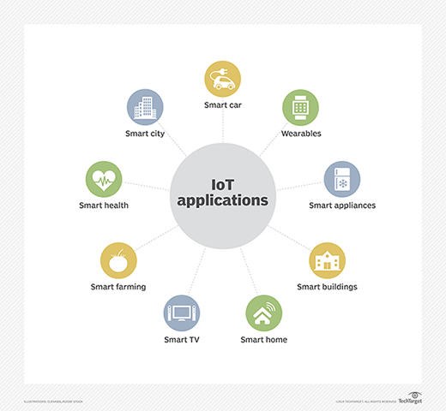A wide range of industries can benefit from IoT.

#### 3. How can IoT benefit the healthcare industry?

IoT [benefits the healthcare industry](https://www.techtarget.com/iotagenda/feature/Can-we-expect-the-Internet-of-Things-in-healthcare) -- often through what is called the [internet of medical things](https://www.techtarget.com/iotagenda/definition/IoMT-Internet-of-Medical-Things) -- in multiple ways:

* Wearable devices [can monitor a patient's vitals or health condition](https://www.techtarget.com/iotagenda/feature/Connected-medical-devices-experts-highlight-IoT-remote-monitoring)and automatically send status updates back to the medical facility.
* Implanted IoT devices can help maintain a patient's health and automatically provide medical facilities with data about implants and their operations. Some implants can also be adjusted without requiring additional surgery.
* Medical facilities can [provide patients with wearables](https://www.techtarget.com/searchitchannel/news/252493546/Partners-pursue-health-related-IoT-system-integration)that make it easier to monitor and track them, especially patients who get easily confused or are young. Wearables can also track patient flow to optimize processes, such as admitting or discharging.
* Medical facilities can provide wearables to staff to help improve productivity by tracking their movements and then analyzing the collected data to determine better ways to manage workflow and optimize daily tasks.
* IoT can potentially help medical facilities and patients better manage their medicationsthroughout all phases of the medication cycle -- from writing and filling a prescription to tracking usage and reminding patients when it's time to take specific doses.
* IoT can help medical facilities improve how they manage their physical environments and assets, as well as internal operations, while making it easier to [automate certain processes](https://www.techtarget.com/searchhealthit/feature/Top-5-predictions-on-digital-future-in-healthcare-post-COVID-19), such as tracking and ordering supplies. IoT can potentially also facilitate robotics for carrying out routine tasks.
* Medical facilities can use IoT to connect medical equipment in different locations so they can more effectively share data and coordinate patient efforts, while eliminating extra paperwork and manual processes.
* Medical equipment can use IoT devices to monitor procedures to ensure no errors occur that could jeopardize human health.

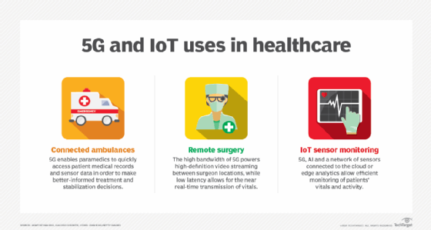Benefits of IoT in the healthcare industry.

#### 4. What is meant by a smart city in IoT?

A [smart city](https://www.techtarget.com/iotagenda/definition/smart-city) is an urban area that uses IoT technologies to connect city services and enhance their delivery. Smart cities can help reduce crime, optimize public transportation, improve air quality, streamline traffic flow, lower energy use, manage infrastructure, reduce health risks, simplify parking, manage utilities, and improve a variety of other processes. Using sensor-driven data collection, the smart city can orchestrate and automate a wide range of services, while reducing costs and making those services easier to access for more people.

Implementing a smart city takes more than just spreading IoT devices around. The city needs a comprehensive infrastructure for deploying and maintaining those devices, as well as for processing, [analyzing and storing the data](https://www.techtarget.com/iotagenda/blog/IoT-Agenda/A-sense-of-place-How-IoT-sensor-data-powers-smart-cities). The system requires sophisticated applications that incorporate advanced technologies, such as artificial intelligence (AI) and predictive analytics. The system must also address security and privacy concerns, as well as interoperability issues that might arise. Not surprisingly, such an effort can take significant time and money, yet the [benefits of a smart city](https://www.techtarget.com/iotagenda/blog/IoT-Agenda/IoT-based-smart-cities-Shaping-the-future-well-live-in) could be well worth the effort for the municipality that can make it work.

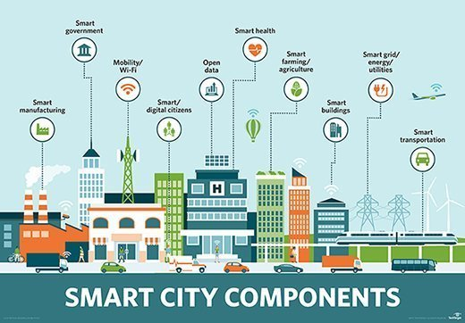Components of a smart city that use IoT.

#### 5. What are the main components of the IoT architecture?

The [IoT architecture](https://www.techtarget.com/iotagenda/tip/A-comprehensive-view-of-the-4-IoT-architecture-layers) consists of the following components:

* ****Smart devices**** include embedded systems for carrying out tasks such as collecting and transmitting data or responding to commands from external control and management systems.
* ****Data processing platforms**** include the hardware and software necessary to process and analyze the data coming in over the network from the IoT devices.
* ****Storage platforms**** [manage and store the data](https://www.techtarget.com/iotagenda/tip/Understand-IoT-data-storage-options-for-data-deluge) and interface with the data processing platform to support its operations.
* ****Network infrastructure**** [facilitates communications](https://www.techtarget.com/searchnetworking/tip/5-steps-to-achieve-network-infrastructure-modernization) between the devices and the data processing and storage platforms.
* A ****UI**** [enables individuals to connect directly to IoT devices](https://www.techtarget.com/iotagenda/feature/The-IoT-user-interface-designs-Thinking-beyond-the-screen) to configure and manage them, as well as verify their status and troubleshoot them. The UI might also provide a way to view the device's collected data or generated logs. This interface is separate from those used to view data collected on the data processing or storage platforms.

There are other ways to categorize IoT architecture. For example, treat data processing and storage platforms as a single component, or the break the data processing platform into multiple components, such as hardware and software.

#### 6. What is an embedded system on an IoT device?

An [embedded system](https://www.techtarget.com/iotagenda/definition/embedded-system) is a combination of hardware, software and [firmware](https://www.techtarget.com/iotagenda/definition/embedded-firmware) that's configured for a specific purpose. It's essentially a small computer that can be embedded in mechanical or electrical systems, such as automobiles, industrial equipment, medical devices, smart speakers or digital watches. An embedded system might be programmable or have fixed functionality.

It's generally made up of a processor, memory, power supply and communication ports and includes the software necessary to carry out operations. Some embedded systems might also run a [lightweight OS](https://www.techtarget.com/iotagenda/definition/embedded-operating-system), such as a stripped-down version of Linux.

An embedded system uses communication ports to transmit data from its processor to a peripheral device, which might be a gateway, central data processing platform or another embedded system. The processor might be a [microprocessor](https://www.techtarget.com/whatis/definition/microprocessor-logic-chip) or a [microcontroller](https://www.techtarget.com/iotagenda/definition/microcontroller), which is a microprocessor that includes integrated memory and peripheral interfaces. To interpret the collected data, the processor uses specialized software stored in memory.

Embedded systems can vary significantly between IoT devices in terms of complexity and function, but they all provide the capacity to process and transmit data.

#### 7. What are the primary hardware components that make up an embedded system?

An embedded system can include any of the following types of hardware components:

* ****Sensor or other input device.****Gathers information from the observable world and converts it to an electrical signal. The type of data gathered depends on the input device.
* ****Analog-to-digital converter.****Changes an electrical signal from analog to digital.
* ****Processor.**** Processes the digital data the sensor or other input device collects.
* ****Memory.**** Stores specialized software and the digital data the sensor or other input device collects.
* ****Digital-to-analog converter.****Changes the digital data from the processor into analog data.
* ****Actuator.**** Takes action based on the data collected from a sensor or other input device.

An embedded system might comprise multiple sensors and [actuators](https://www.techtarget.com/iotagenda/definition/actuator). For example, a system might include several sensors that gather environmental information, which is converted and sent to the processor. Once processed, the data is converted again and sent on to several actuators, which carry out prescribed actions.

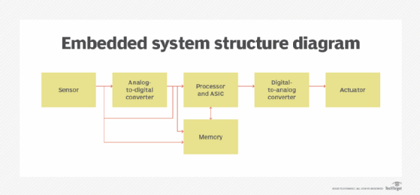Hardware components of an embedded system.

#### 8. What is a sensor in an IoT device?

A sensor is a physical object that detects and responds to input from its surrounding environment, essentially reading the environment for information. For example, a sensor that measures temperatures within a piece of heavy machinery detects and responds to the temperature within that machinery, as opposed to registering the outside temperature. The information that a sensor gathers is typically transmitted electronically to other components in an embedded system, where it is converted and processed as necessary.

The IoT industry [supports many types of sensors](https://www.techtarget.com/iotagenda/opinion/How-smart-sensors-are-transforming-the-Internet-of-Things), including those that can measure light, heat, motion, moisture, temperature, pressure, proximity, smoke, chemicals, air quality or other environmental conditions. Some IoT devices contain multiple sensors to capture a mix of data. For example, an office building might include smart thermostats that track both temperature and motion. That way, if no one is in the room, the thermostat automatically lowers the heat.

A sensor is different from an actuator, which responds to the data the sensor generates.

#### 9. What are some examples of sensors that can be used in agriculture?

Many sensors are available for agriculture, including the following:

* ****Airflow.**** Measures soil's air permeability.
* ****Acoustic.**** Measures the level of noise from [pests](https://www.techtarget.com/searchenterpriseai/feature/Agricultural-AI-yields-better-crops-through-data-analytics).
* ****Chemical.**** Measures levels of a specific chemical, such as ammonium, potassium or nitrate, or measures such conditions as pH levels or presence of a specific ion.
* ****Electromagnetic.**** Measures the soil's ability to conduct electrical charge, which can be used to determine characteristics such as water content, organic matter or degree of saturation.
* ****Electrochemical.**** Measures the nutrients within the soil.
* ****Humidity.**** Measures the moisture within the air, such as in a greenhouse.
* ****Soil moisture.**** Measures the wetness of the soil.

Learn more about [smart farming](https://www.techtarget.com/iotagenda/definition/smart-farming), its [challenges](https://www.techtarget.com/iotagenda/answer/What-are-the-challenges-of-building-a-smart-agriculture-system) and [benefits](https://www.techtarget.com/iotagenda/answer/What-are-the-benefits-of-smart-farming-systems), and [security concerns](https://www.techtarget.com/iotagenda/blog/IoT-Agenda/IoT-cybersecurity-A-major-concern-for-agriculture).

#### 10. What is a thermocouple sensor?

A thermocouple sensor is a common type of sensor that measures temperature. The sensor includes two dissimilar electrical metal conductors joined at one end to form an electrical junction, which is where the temperature is measured. The two metal conductors produce a small voltage that can be interpreted to calculate the temperature. Thermocouples come in multiple types and sizes, are inexpensive to build and are highly versatile. They can also measure a wide range of temperatures, making them well suited for a variety of applications, including scientific research, industrial settings, home appliances and other environments.

#### 11. What are some of the main differences between Arduino and Raspberry Pi?

Arduino and Raspberry Pi are electronic prototyping platforms used extensively in IoT devices. The following table describes some of the differences between the two platforms.

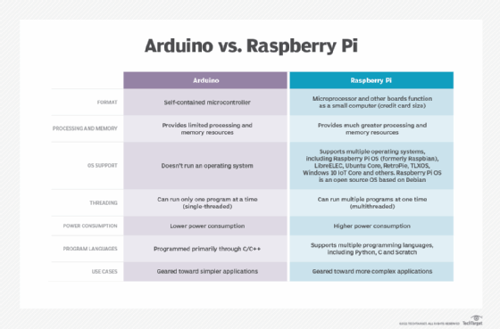Arduino and Raspberry Pi prototyping platforms are used extensively in IoT devices.

#### 12. What are GPIO pins in Raspberry Pi platforms?

General-purpose I/O (GPIO) is a standard interface that [Raspberry Pi](https://www.techtarget.com/whatis/definition/Raspberry-Pi-35-computer) and other microcontrollers use to connect to external electronic components. Recent Raspberry Pi models are configured with 40 GPIO pins, which are used for multiple purposes. For example, GPIO pins supply 3.3 volt or 5 volt direct current power, provide a ground for devices, serve as a [serial peripheral interface](https://www.techtarget.com/whatis/definition/serial-peripheral-interface-SPI) bus, act as a [universal asynchronous receiver/transmitter](https://www.techtarget.com/whatis/definition/UART-Universal-Asynchronous-Receiver-Transmitter) or deliver other functionality. One of the biggest advantages of Raspberry Pi GPIO pins is that IoT developers can control them through software, making them especially flexible and able to serve specific IoT purposes.

#### 13. What role does a gateway play in IoT?

An IoT gateway is a physical device or software program that facilitates communications between IoT devices and the network that carries device data to a centralized platform, such as the public cloud, where data is processed and stored. Smart device gateways and cloud endpoint protection products can move data in both directions, while helping to protect data from being compromised, often employing such techniques as tamper detection, encryption, crypto engines or hardware random number generators. Gateways might also include features that enhance IoT communications, such as caching, buffering, filtering, data cleansing or even data aggregation.

#### 14. What is the OSI model and what communication layers does it define?

The Open Systems Interconnection ([OSI](https://www.techtarget.com/searchnetworking/definition/OSI)) model provides a foundation for internet communication, including IoT systems. The OSI model defines a standard for how devices transfer data and communicate with each other over a network and is divided into seven layers that build on top of each other:

* ****Layer 1: Physical layer.****Transports data using electrical, mechanical or procedural interfaces, sending bits from one device to another along the network.
* ****Layer 2: Data link layer.****A protocol layer that handles how data is moved into and out of a physical link in a network. It also addresses bit transmission errors.
* ****Layer 3: Network layer.****Packages data with the network address information and selects the appropriate network routes. It then forwards the packaged data up the stack to the transport layer.
* ****Layer 4: Transport layer.****Transfers data across a network, while providing error-checking mechanisms and data flow controls.
* ****Layer 5: Session layer.****Establishes, authenticates, coordinates and terminates conversations between applications. It also reestablishes connections after interruptions.
* ****Layer 6: Presentation layer.****Translates and formats the data for the [application layer](https://www.techtarget.com/iotagenda/feature/Common-application-layer-protocols-in-IoT-explained) using semantics accepted by the application. It also carries out required encryption and decryption operations.
* ****Layer 7: Application layer.****Enables an end user, whether software or human, to interact with the data through the necessary interfaces.

#### 15. What are some of the protocols used for IoT communication?

The following list includes many of the protocols being used for IoT:

* [Advanced Message Queuing Protocol](https://www.techtarget.com/whatis/definition/Advanced-Message-Queuing-Protocol-AMQP)
* Bluetooth
* Bluetooth Low Energy ([Bluetooth LE](https://www.techtarget.com/iotagenda/definition/Bluetooth-Low-Energy-Bluetooth-LE))
* [Constrained Application Protocol](https://www.techtarget.com/whatis/definition/Constrained-Application-Protocol)
* Data Distribution Service
* Extensible Messaging and Presence Protocol
* [Message Queuing Telemetry Transport](https://www.techtarget.com/iotagenda/definition/MQTT-MQ-Telemetry-Transport)
* Simple Text Oriented Messaging Protocol
* Very Simple Control Protocol
* Wi-Fi
* [Zigbee](https://www.techtarget.com/iotagenda/definition/ZigBee)

Cellular IoT protocols, such as LTE-M, narrowband IoT and [5G](https://www.techtarget.com/searchnetworking/definition/5G) can also facilitate IoT communications. In fact, 5G promises to play a significant role in the coming onslaught of IoT devices.

#### 16. What are the main differences between Bluetooth and Bluetooth LE?

Bluetooth, sometimes referred to as Bluetooth Classic, is typically used for different purposes than Bluetooth Low Energy. Bluetooth Classic can handle much more data but consumes a lot more power. Bluetooth LE requires less power but can't exchange nearly as much data. The following table provides an overview of some of the specific differences between the two technologies.

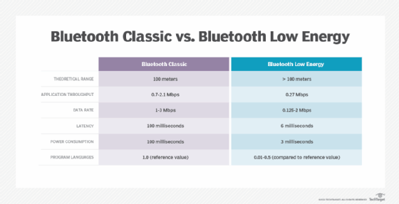Explore the major differences among Bluetooth Classic, standard Bluetooth technology and Bluetooth Low Energy.

#### 17. What impact could IPv6 have on IoT?

[Internet Protocol Version 6](https://www.techtarget.com/searchnetworking/definition/IPv6-Internet-Protocol-Version-6), commonly referred to as IPv6, is an upgrade from IPv4. One of the most significant changes is IPv6 increases the size of IP addresses from 32 bits to 128 bits. Because of its 32-bit limitation, IPv4 can support only about 4.2 billion addresses, which has already proved insufficient. The mounting number of IoT devices and other platforms that use IP addresses requires a system that can handle future addressing needs. The industry designed IPv6 to accommodate trillions of devices, making it well suited for IoT. IPv6 also promises improvements in security and connectivity. It's the additional IP addresses that take center stage, however, which is why many believe that [IPv6 will play a pivotal role](https://www.techtarget.com/searchsecurity/tip/IPv6-addresses-Security-recommendations-for-usage) in the future success of IoT.

#### 18. What is the Zigbee Alliance?

The Zigbee Alliance is a group of organizations working together to [create, evolve and promote open standards for IoT](https://csa-iot.org/" \t "https://www.techtarget.com/whatis/feature/_blank) platforms and devices. It's developing global standards for wireless device-to-device IoT communication and certifies products to help ensure interoperability. One of its most well-known efforts is Zigbee, an open standard for implementing low-power, self-organizing [mesh networks](https://www.techtarget.com/iotagenda/feature/Using-mesh-networking-to-interconnect-IoT-devices). Zigbee-certified products can use the same IoT language to connect and communicate with each other, reducing interoperability issues. Zigbee is based on the IEEE 802.15 specification but adds network and security layers in addition to an application framework.

#### 19. What are some use cases for IoT data analytics?

The following use cases represent ways [IoT data analytics](https://www.techtarget.com/iotagenda/feature/Reach-business-objectives-with-the-right-IoT-data-pipeline) can benefit organizations:

* forecasting customer requirements and desires to better plan product features and release cycles, as well as deliver new value-added services;
* optimizing HVAC equipment in office buildings, shopping malls, medical centers, data centers and other enclosed environments;
* improving the level of care given to patients with similar conditions, while being able to better understand those conditions and target the needs of specific individuals;
* [optimizing delivery operations](https://www.techtarget.com/iotagenda/blog/IoT-Agenda/Future-outlook-of-IoT-in-logistics-and-transportation-industries), such as scheduling, routing and vehicle maintenance, as well as reducing fuel costs and emissions;
* acquiring in-depth knowledge of how consumers use their products so a company can develop more strategic marketing campaigns;
* predicting and identifying potential security threats to better protect data and meet compliance requirements;
* tracking how utilities are delivered to customers across regions and better understanding their usage patterns;
* improving agricultural practices to achieve more abundant yet sustainable yields; and
* optimizing manufacturing operations to make better use of equipment and improve workflows.

#### 20. How can edge computing benefit IoT?

[Edge computing](https://www.techtarget.com/searchdatacenter/definition/edge-computing) can benefit IoT in a number of ways:

* supporting IoT devices in environments with limited network connectivity, such as cruise ships, agricultural settings, offshore oil rigs or other remote locations;
* reducing network congestion by preprocessing data in an edge environment and then transmitting only the aggregated data to a central repository;
* reducing latency by processing the data closer to the IoT devices generating that data, resulting in quicker response times;
* reducing potential security and compliance risks by transmitting less data across the internet or by creating smaller network segments that are easier to manage and troubleshoot; and
* decentralizing [massive cloud centers](https://www.techtarget.com/iotagenda/feature/IoT-edge-cloud-balances-the-best-of-cloud-and-edge-computing)to better serve specific environments and reduce the costs and complexities that come with transmitting, managing, storing and processing large data sets on a centralized platform.

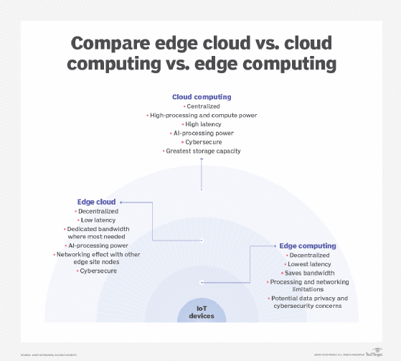

#### 21. How could 5G cellular networks impact IoT?

The coming wave of 5G networks could impact IoT in a variety of ways:

* Higher bandwidth and faster throughputs make it possible to support [more advanced use cases](https://www.techtarget.com/searchnetworking/tip/Top-5G-use-cases-for-business-include-fixed-wireless-healthcare), especially those that require quicker response times, such as traffic control systems or automated public transportation.
* Organizations can distribute more sensors to capture a wider range of information about environmental factors or equipment behavior, resulting in more comprehensive analytics and a [greater capacity of automating operations](https://www.techtarget.com/searchenterpriseai/feature/How-5G-and-artificial-intelligence-may-influence-each-other)both at the industrial level and consumer level.
* 5G could enable IoT on a more comprehensive scalein areas where it might be otherwise difficult to achieve, [helping industries such as healthcare](https://www.techtarget.com/iotagenda/feature/3-ways-5G-IoT-use-cases-in-healthcare-push-better-patient-care) and agriculture.
* The faster throughput and ability to handle data from more sensors makes it easier to establish smart cities, which require a higher saturation of IoT devices.
* Manufacturers could [use 5G to better track inventory](https://www.techtarget.com/iotagenda/tip/5G-in-manufacturing-propels-change-throughout-the-industry)throughout its lifecycle, as well as better control workflows and optimize operations.
* 5G enables organizations and governments to respond more quickly and efficiently to different types of incidents, such as medical emergencies, pipeline leaks, fires, traffic accidents, weather events or natural disasters.
* Automobiles can benefit from 5G [as cars become more connected](https://www.computerweekly.com/news/252480081/5G-propels-connected-vehicles-into-top-gear), helping to keep them safer, better maintained and more fuel efficient, while also making the autonomous car more of a reality.

#### 22. What are some of the biggest security vulnerabilities that come with IoT?

Security remains a huge part of IoT. The [Open Web Application Security Project](https://www.techtarget.com/searchsoftwarequality/definition/OWASP) has identified the top 10 IoT security vulnerabilities:

1. weak, guessable or hardcoded passwords
2. insecure network services
3. insecure ecosystem interfaces
4. lack of secure update mechanisms
5. use of insecure or outdated components
6. insufficient privacy protection
7. insecure data transfer and storage
8. lack of device management
9. insecure default settings
10. lack of physical hardening

#### 23. What steps can an organization take to protect IoT systems and devices?

An organization can take several steps to protect its IoT systems, including the following:

* Incorporate security at the design phase, with security enabled by default.
* Use public key infrastructures and [509 digital certificates](https://www.techtarget.com/searchsecurity/definition/X509-certificate)to secure IoT devices.
* Use application performance indicators to safeguard data integrity.
* Ensure each device has a unique identifier, and implement [endpoint hardening](https://www.techtarget.com/iotagenda/tip/Dont-forget-IoT-physical-security-when-planning-protection), such as making devices tamper-proof or tamper-evident.
* Use advanced cryptographic algorithms to encrypt data in transit and at rest.
* Protect networks by disabling port forwarding, closing unused ports, blocking unauthorized IP addresses and keeping network software and firmware up to date. Also, implement antimalware, firewalls, intrusion detection systems, intrusion prevention systems and any [other necessary protections](https://www.techtarget.com/iotagenda/tip/5-IoT-security-threats-to-prioritize).
* Use network access control mechanisms to identify and inventory IoT devices connecting to the network.
* Use separate networks for IoT devices that connect directly to the internet.
* Use security gateways to serve as intermediaries [between the IoT devices and the network](https://www.techtarget.com/iotagenda/tip/6-steps-to-prioritize-IoT-gateway-security).
* Continuously update and patch any software that participates in the IoT system or is used to manage IoT components.
* Provide security training and education for individuals who participate in the IoT system at any level -- whether planning, deploying, developing or managing.

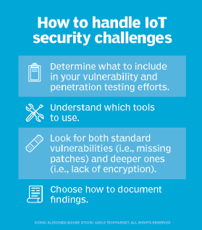

#### 24. What are the top challenges of implementing an IoT system?

Organizations that want to implement an effective IoT system [face a variety of challenges](https://www.techtarget.com/iotagenda/feature/4-IoT-connectivity-challenges-and-strategies-to-tackle-them):

* IoT can generate massive volumes of data, and organizations must be able to effectively manage, store, process and analyze that data to realize the fullest potential from their IoT systems.
* In some circumstances, [managing power supplies for IoT devices](https://www.techtarget.com/iotagenda/feature/IoT-battery-outlook-Types-of-batteries-for-IoT-devices)can be difficult, especially devices in hard-to-reach locations or those that rely on battery power.
* [Managing IoT devices](https://www.techtarget.com/iotagenda/post/4-steps-IT-can-take-to-manage-the-IoT-device-explosion)can be an overwhelming undertaking even for the most seasoned IT administrators, who must often take extra steps to monitor and manage those devices.
* [Maintaining network connectivity](https://www.techtarget.com/iotagenda/feature/Everything-you-need-to-know-about-IoT-connectivity-options)for multiple IoT device types can be a significant challenge, especially when those devices are highly distributed or in remote locations or if bandwidth is severely limited.
* The [lack of common IoT standards](https://www.techtarget.com/iotagenda/tip/How-to-deal-with-the-lack-of-IoT-standards)can make it difficult to deploy and manage large numbers of IoT devices that come from different vendors and are based on proprietary technologies that differ significantly from one another.
* Ensuring the reliability of an IoT system can be difficult because IoT devices are highly distributed and must often contend with other internet traffic. Natural disasters, disruptions in cloud services, power failures, system failures or other conditions can affect the components that make up an IoT system.
* Complying with [government regulations](https://www.computerweekly.com/news/252477375/Government-tightens-law-around-IoT-cyber-security)represents another significant challenge with IoT, especially if operating in multiple regions or in regions with conflicting or frequently changing regulations.
* IoT systems face security threats on many fronts -- [botnets](https://www.techtarget.com/searchsecurity/definition/botnet), ransomware, domain name server threats, shadow IT, physical vulnerabilities and other sources -- and organizations must be able to protect their IoT devices, network infrastructure, on-premises compute and storage resources, and all the data that comes with IoT.

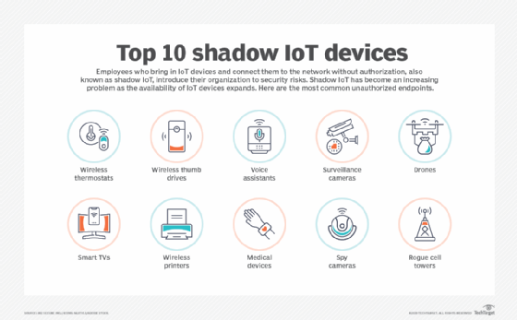

#### 25. What are the differences between IoT and IIoT?

Industrial internet of things  ([IIoT](https://www.techtarget.com/iotagenda/definition/Industrial-Internet-of-Things-IIoT)) is often defined as a subset of IoT that focuses specifically on industrial settings, such as manufacturing, agriculture or oil and gas. However, some people in the industry define IoT and IIoT as two separate efforts, with IoT focused on the consumer side of device connectivity. In either case, IIoT falls squarely on the industrial side of the equation and is concerned primarily with the use of smart sensors and actuators to enhance and automate industrial operations.

Also known as [Industry 4.0](https://www.techtarget.com/searcherp/definition/Industry-40), IIoT uses smart machines that support machine-to-machine ([M2M](https://www.techtarget.com/iotagenda/definition/machine-to-machine-M2M)) technologies or cognitive computing technologies, such as AI, [machine learning](https://www.techtarget.com/searchenterpriseai/definition/machine-learning-ML) or [deep learning](https://www.techtarget.com/searchenterpriseai/definition/deep-learning-deep-neural-network). Some machines even incorporate both types of technologies. Smart machines capture and analyze data in real time and communicate information that can be used to drive business decisions. When compared to IoT in general, IIoT tends to have stricter requirements in such areas as compatibility, security, resilience and precision. Ultimately, IIoT aims to streamline operations, improve workflows, increase productivity and maximize automation.

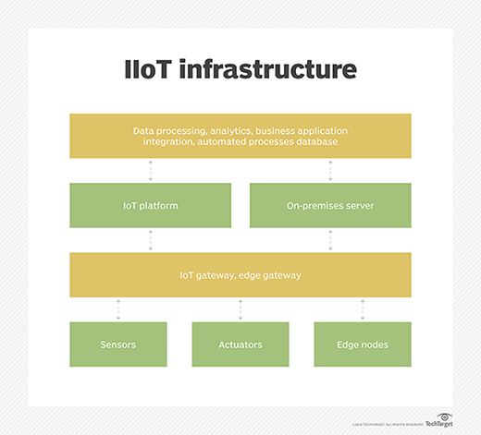

#### 26. What are the main differences between IoT and M2M?

The terms IoT and M2M are sometimes used interchangeably, but they aren't the same. M2M enables networked devices to interact with each other and carry out operations without human interaction. For example, M2M is often used to enable ATMs to communicate with a central platform. M2M devices use point-to-point communication mechanisms to exchange information via a wired or wireless network. An M2M system typically relies on standard network technologies, such as Ethernet or Wi-Fi, making it cost-effective for establishing M2M communication.

IoT is often considered an evolution of M2M that increases [connectivity capabilities](https://www.techtarget.com/iotagenda/tip/IoT-connectivity-management-platforms-optimize-deployments) to create a much larger network of communicating devices, relying on IP-based technologies to facilitate that communication. Standard M2M systems have limited scalability options and tend to be isolated systems that are best suited for simple device-to-device communication, typically with one machine at a time. IoT has a much broader range that can integrate multiples device architectures into a single ecosystem, with support for simultaneous communications across devices. However, IoT and M2M are similar in that both systems provide a structure for exchanging data between devices without human intervention.

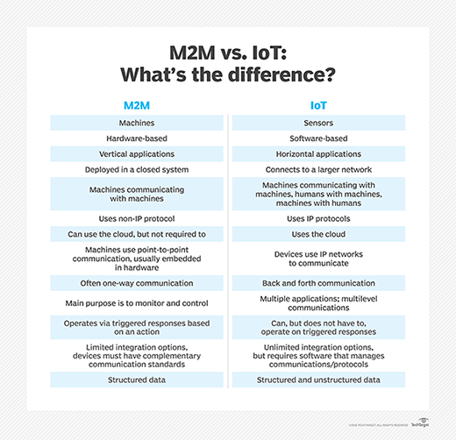

#### 27. What is IoE?

The internet of everything ([IoE](https://www.techtarget.com/iotagenda/definition/Internet-of-Everything-IoE)) is a conceptual leap that reaches beyond IoT -- with its focus on things -- into an expanded realm of connectivity that incorporates people, process and data, along with things. The concept of IoE originated with Cisco, which stated that the "benefit of IoE is derived from the compound impact of [connecting people, process, data and things](https://www.techtarget.com/iotagenda/blog/IoT-Agenda/How-to-get-the-best-from-IoE-across-the-enterprise), and the value this increased connectedness creates as 'everything' comes online."

By comparison, IoT refers only to the networked connection of physical objects, but IoE expands this network to include people-to-people and people-to-machine connections. Cisco and other proponents believe that those who harness IoE will be able to capture new value by "connecting the unconnected."

#### 28. Which types of testing should be performed on an IoT system?

Enterprises implementing an IoT system should [conduct a variety of testing](https://www.techtarget.com/iotagenda/blog/IoT-Agenda/Five-steps-toward-making-smart-IoT-testing-a-reality), including the following types:

* ****Usability.**** Ensures IoT device offers optimal UX, based on the environment in which the device will typically be used.
* ****Functionality.****Ensures all features on the IoT device work as designed.
* ****Security.**** Ensures that IoT devices, software and infrastructure -- network, compute and storage -- meet all applicable security requirements and regulatory standards.
* ****Data integrity.**** Ensures the integrity of the data across communication channels, throughout processing operations and within storage platforms.
* ****Performance.**** Ensures that IoT devices, software and infrastructure provide the performance necessary to deliver uninterrupted services within the expected time frame.
* ****Scalability.**** Ensures the IoT system can scale as necessary to meet evolving requirements without impacting performance or disrupting services.
* ****Reliability.****Ensures the IoT devices and systems can deliver the expected level of services without incurring unnecessary or prolonged downtimes.
* ****Connectivity.**** Ensures IoT devices and system components can properly communicate without disruptions in connectivity or data transfer operations and can automatically recover from any disruptions without incurring any data loss.
* ****Compatibility.**** Ensures compatibility issues between IoT devices and other system components are identified and addressed and that devices can be added, moved or removed without disruptions to services.
* ****Exploratory.**** Ensures the IoT system works as expected under real-world conditions, while detecting issues that might not be caught by other types of testing.

#### 29. What is IoT asset tracking?

[IoT asset tracking](https://www.techtarget.com/iotagenda/tip/Ensure-an-effective-IoT-asset-management-initiative) refers to the process of using IoT to monitor the location of an organization's physical assets, no matter where they're located or how they're being used. Assets can include anything from delivery vans to medical equipment to construction tools. Rather than try to track these assets manually, a company can use IoT asset tracking to automatically identify the location and movement of each tracked device, helping save time and ensure greater accuracy. At the same time, organizations can use asset tracking to simplify inventory maintenance, improve asset use, and optimize workflows and daily operations.

#### 30. What is Thingful?

[Thingful is an IoT search engine](https://www.thingful.net/" \t "https://www.techtarget.com/whatis/feature/_blank) that provides a geographical index of real-time data from connected devices around the world, using data from millions of existing public IoT data resources. The devices that generate the data can span [a variety of use cases](https://www.techtarget.com/iotagenda/tip/Top-8-IoT-applications-and-examples-in-business), such as energy, weather, aviation, shipping, air quality or animal tracking. The search engine enables users to find devices, data sets and real-time data sources through geolocation and presents them using a proprietary IoT device search ranking methodology. With Thingful, users can interoperate with millions of connected objects and sensors across the planet that generate real-time open data.

IoT managers can use Thingful to analyze trends, discover patterns and identify anomalies, as well as solve problems using existing data. The search engine can also help them kick-start IoT innovation in a community and help residents of that community learn about the IoT data and environment around them. Thingful is well suited to community engagement initiatives built around data and data education. Users can create accounts, set up time-series experiments, and generate statistical and analytical visualizations. They can also integrate local IoT data repositories.