### **1. What are the key responsibilities of Web Developers?**

It is generally expected that **[web developers](https://www.interviewbit.com/blog/web-developer-skills/" \t "https://www.interviewbit.com/web-developer-interview-questions/_blank)** will be able to perform the following tasks:

* Build products using HTML, CSS, JavaScript, PHP (Hypertext Preprocessor), and other relevant coding languages.
* Design, develop, test, debug, and deploy applications in a cross-platform, cross-browser environment.
* Coordination with designers and programmers for the development of projects.
* Develop design specifications/patterns for optimizing web programs.
* Identifying and fixing bugs, troubleshooting, and resolving website issues.
* Taking care of the technical aspects of the site, such as its cache and performance (which indicate how fast a site will run and how much traffic it can handle).
* Providing support and assistance with web management best practices.
* Keep up with the latest technology.
* Maintain and update websites to meet modern web standards.
* Monitor web traffic.

### **2. List the advantages of HTTP/2 over HTTP 1.1.**

Hypertext Transfer Protocol (HTTP) is a set of standard protocols allowing internet users to exchange website knowledge on WWW (World Wide Web). HTTP has gone through four iterations since it was introduced in 1991 i.e., HTTP/0.9, HTTP/1.0, HTTP/1.1, and HTTP/2.0. In 2015, HTTP/2 was released as a major revision to HTTP/1.1. HTTP/2.0 has the following advantages over HTTP/1.1:

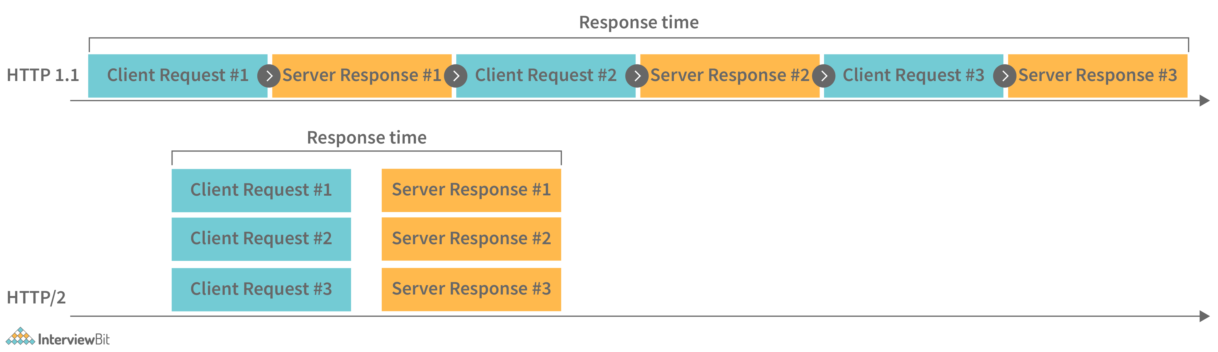

* ****Increased performance:**** It was designed specifically to speed up page loading and reduce round-trip time (RTT) for resource-intensive websites.
* ****Handle multiple resources:**** With HTTP 1.1, the web pages were manageable simply by using HTML markups and images. But with HTTP 2.0, there are now multiple resources available for web pages, including images, fonts, scripts, and more. HTTP 1.1 was not designed to handle such a large amount of resources today.
* ****Multiplexing:****Multiplexing is fully implemented in HTTP/2. It means that multiple requests are sent between browsers and servers simultaneously over a single TCP connection. Consequently, several elements of a web page can be delivered via a single TCP connection. As a result, the HTTP/1.1 head-of-line blocking problem is resolved, in which a packet at the front of the line blocks the transmission of other packets.
* ****Header Compression:**** HTTP 2.0 has the ability to compress HTTP headers to reduce overhead. When HTML headers on web pages are compressed, they can be sent between the browser and server in one trip, over a single TCP connection.
* ****Server push:****HTTP/2 servers are able to push resources into a browser's cache even before they are requested. By doing this, browsers can display content without requiring additional requests.
* ****Binary protocols:**** HTTP/2 use binary protocols, not textual. HTML/2's binary protocols consume less bandwidth, can be parsed more efficiently, and are less error-prone compared to HTTP/1.1's textual protocols.

### **3. Explain CORS (Cross-Origin Resource Sharing) and Write its Importance.**

CORS stands for Cross-origin resource sharing. It is basically defined as a browser mechanism that enables web pages from one domain to have controlled access to resources that are located at different domains (cross-domain request). In other words, it allows scripts running on a browser client to interact with and access resources from other origins. It provides and extends flexibility to the SOP (Same-Origin Policy). A same-origin policy restricts a website's ability to access resources outside its source domain. For example, if a JavaScript app wanted to call an API (Application Programming Interface) running on another domain, it would be blocked and prevented from doing so because of the SOP. Due to restrictions caused by the same-origin policy, CORS was introduced.

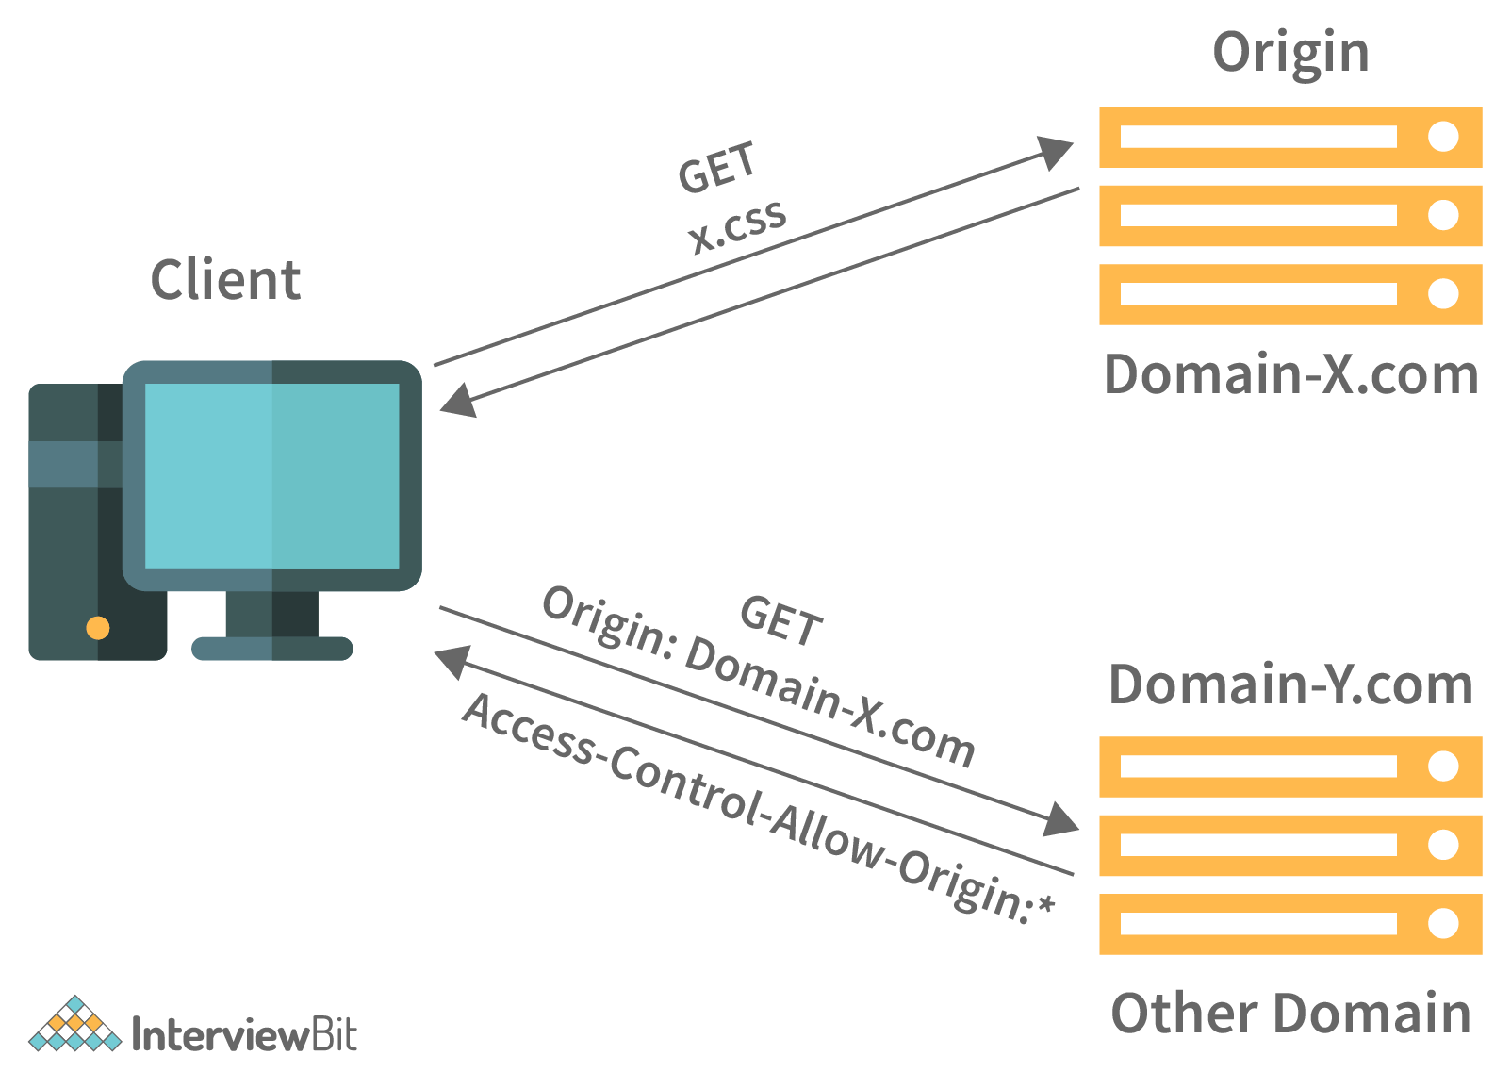

When a website's CORS policy is set up poorly, it also poses the risk of cross-domain attacks. As such, it cannot prevent cross-origin attacks such as  CSRF (Cross-Site Request Forgery).

**You can download a PDF version of Web Developer Interview Questions.**

**[IMG_258Download PDF](javascript:void(0))**

### **4. What do you mean by ETag (Entity Tag) and how does it work?**

The ETag (entity tag) is a part of the HTTP protocol. This is one of several mechanisms that HTTP provides to validate Web caches, which allows conditional requests to be made from a browser to resources. Moreover, Etags make sure that simultaneous updates of the same resource don't overwrite each other (mid-air collisions).

ETags are opaque identifiers assigned by a server to a specific version of a resource found at a specific URL. Every time the resource representation at that URL changes, an entirely new ETag is assigned. As such, ETags can be compared in the same way as fingerprints and determine if two representations of a resource are identical.

****Syntax:****

ETag: W/"<etag\_value>"

ETag: "<etag\_value>"

### **5. Explain Webpack.**

Webpack is a tool that bundles JavaScript modules, also known as static module bundlers. Modules are reusable chunks of code that are built from the JavaScript, node\_modules, images, and CSS styles of your application, and packaged so that they can be easily added to your website. If you have a large number of files, Webpack generates a single (or a few) file that runs your application.

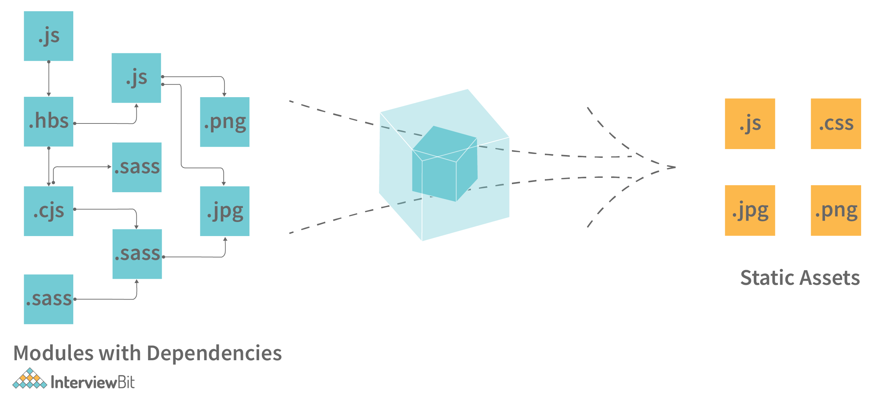

When Webpack processes your application or package, it generates a dependency graph, which consists of various modules that your webapp needs in order to function as expected. Based on this graph, it then creates a new package that contains only the bare minimum files required, often only one or a few bundle.js files which can be easily plugged into the HTML file and used in the application.

### **6. List out newly introduced input types, APIs, form elements, and elements that support media content in HTML5.**

List out newly introduced input types, APIs, form elements, and elements that support media content in HTML5.

HTML5 has been updated repeatedly in the last few years, and the addition of input types has greatly simplified its use. Among some of these input types are

* ****Colour:**** Enable users to select or choose a colour using the colour picker.
* ****Date:****Enable users to select or choose a date from a drop-down calendar.
* ****Datetime-local:**** Enable users to select or choose both local date and time.
* ****Email:****Enable users to enter an email address.
* ****Month:**** Enable users to select or choose a month and year from a drop-down calendar.
* ****Week:****Enable users to select or choose week and year from a drop-down calendar.

HTML5 introduces the following new form elements:

* ****<datalist>:****Specifies a list of options for input controls.
* ****<keygen>:**** Creates an encryption key.
* ****<output>:****Defines the result or output of an expression.
* ****<progress>:**** Heads in the direction of 100% of the maximum value.
* ****<meter>:****Provides a gauge that shows a general value within a range.

The following are some of the new APIs introduced in HTML5:

* ****History API:****Provides programs with access to the browser's history.
* ****Page visibility API:**** Enables us to determine the current visibility state of a page.
* ****Battery Status API:**** Displays the current battery status of the device.
* ****User Timing API:**** Provides programmers with high-precision timestamps for measuring application performance.
* ****Vibration API:****Provides access to the device's vibration functionality.

HTML5 includes five elements that support media as follows:

* ****<audio>:**** Used to embed audio files in a web page
* ****<video>:**** Used to embed video files in a web page.
* ****<source>:**** Used for attaching multimedia files, including audio, video, and photos.
* ****<embed>:****Used to embed external applications, usually multimedia content such as audio or video into an HTML document.
* ****<track>:****Specifies text tracks for audio and video components.

### **7. State the difference between span tag and div tag in HTML5.**

Both the div and span tags are used to indicate the part of a web page. Divs are block-level elements, whereas spans are inline elements of a web page. <div> tag is used to show block parts of the webpage whereas <span> tag is used to show inline parts of the webpage:

Example:

<**div**>A 6-month online career accelerator program<**span**>Scaler Academy<**span**></**div**>

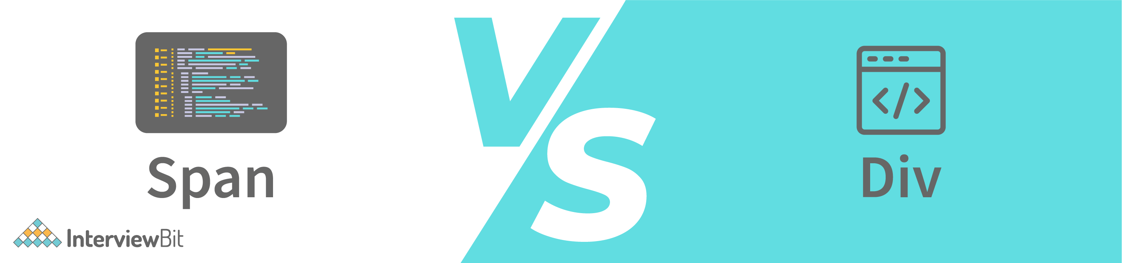

| **<span> tag** | **<div> tag** |
| --- | --- |
| Span tag will be used for inline elements and for paragraphs. | Div tags are used for block-level elements. |
| Typically, this tag is used to highlight any specific word ( or a small section of a line) on a webpage. | In general, it is used/attached to highlight a section on the webpage. |
| In this tag, we use a specific colour code in order to highlight the HTML content. | In this tag, we use borders with height and width with specified colour pixels in order to highlight the HTML content. |
| As it does not support the align attribute, the span tag will not appear on a new line. | With support for the align attribute, the div tag will appear on a new line. |

### **8. Explain HTML5 Web storage.**

HTML5 has many great features, including Web Storage, which is sometimes referred to as DOM storage (Document Object Model Storage). Web applications can use Web Storage to store data locally in the browser on the user/client’s side. Data is stored in the form of a key/value pair in the user's browser. Using web storage to store data is similar to using cookies, but web storage is faster and more convenient. Web Storage should never be used to store sensitive data. It isn't "more secure" than cookies since it isn't transmitted over the wire and isn't encrypted.

****Types of Web Storage:****

As outlined below, there are two types of web storage with different scopes and lifespans:

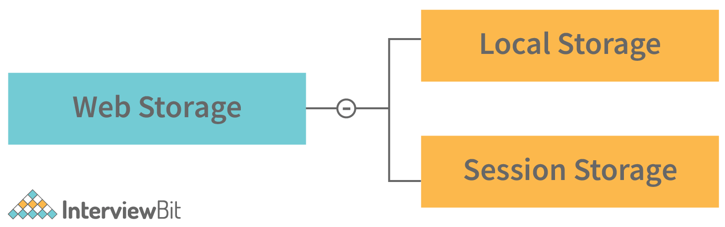

* ****Local Storage:**** This storage uses Windows.localStorage object that stores data with no expiration date. Once stored in local storage, the data will remain available even after the user's browser is closed and reopened.
* ****Session Storage:****This storage uses the Windows.sessionStorage object that stores data for one or single session only. As soon as the user closes his browser, data is lost or deleted from the browser, and the session would be lost.

### **9. Explain DOM (Document Object Model)?**

DOM stands for Document Object Model. It is basically a cross-platform, language-independent API (Application Programming Interface) for XML (Extensible Markup Language) and HTML documents. To put it simply, DOM describes the logical structure of documents and how one can access and manipulate them. For example, here is an HTML document that illustrates the DOM hierarchy.

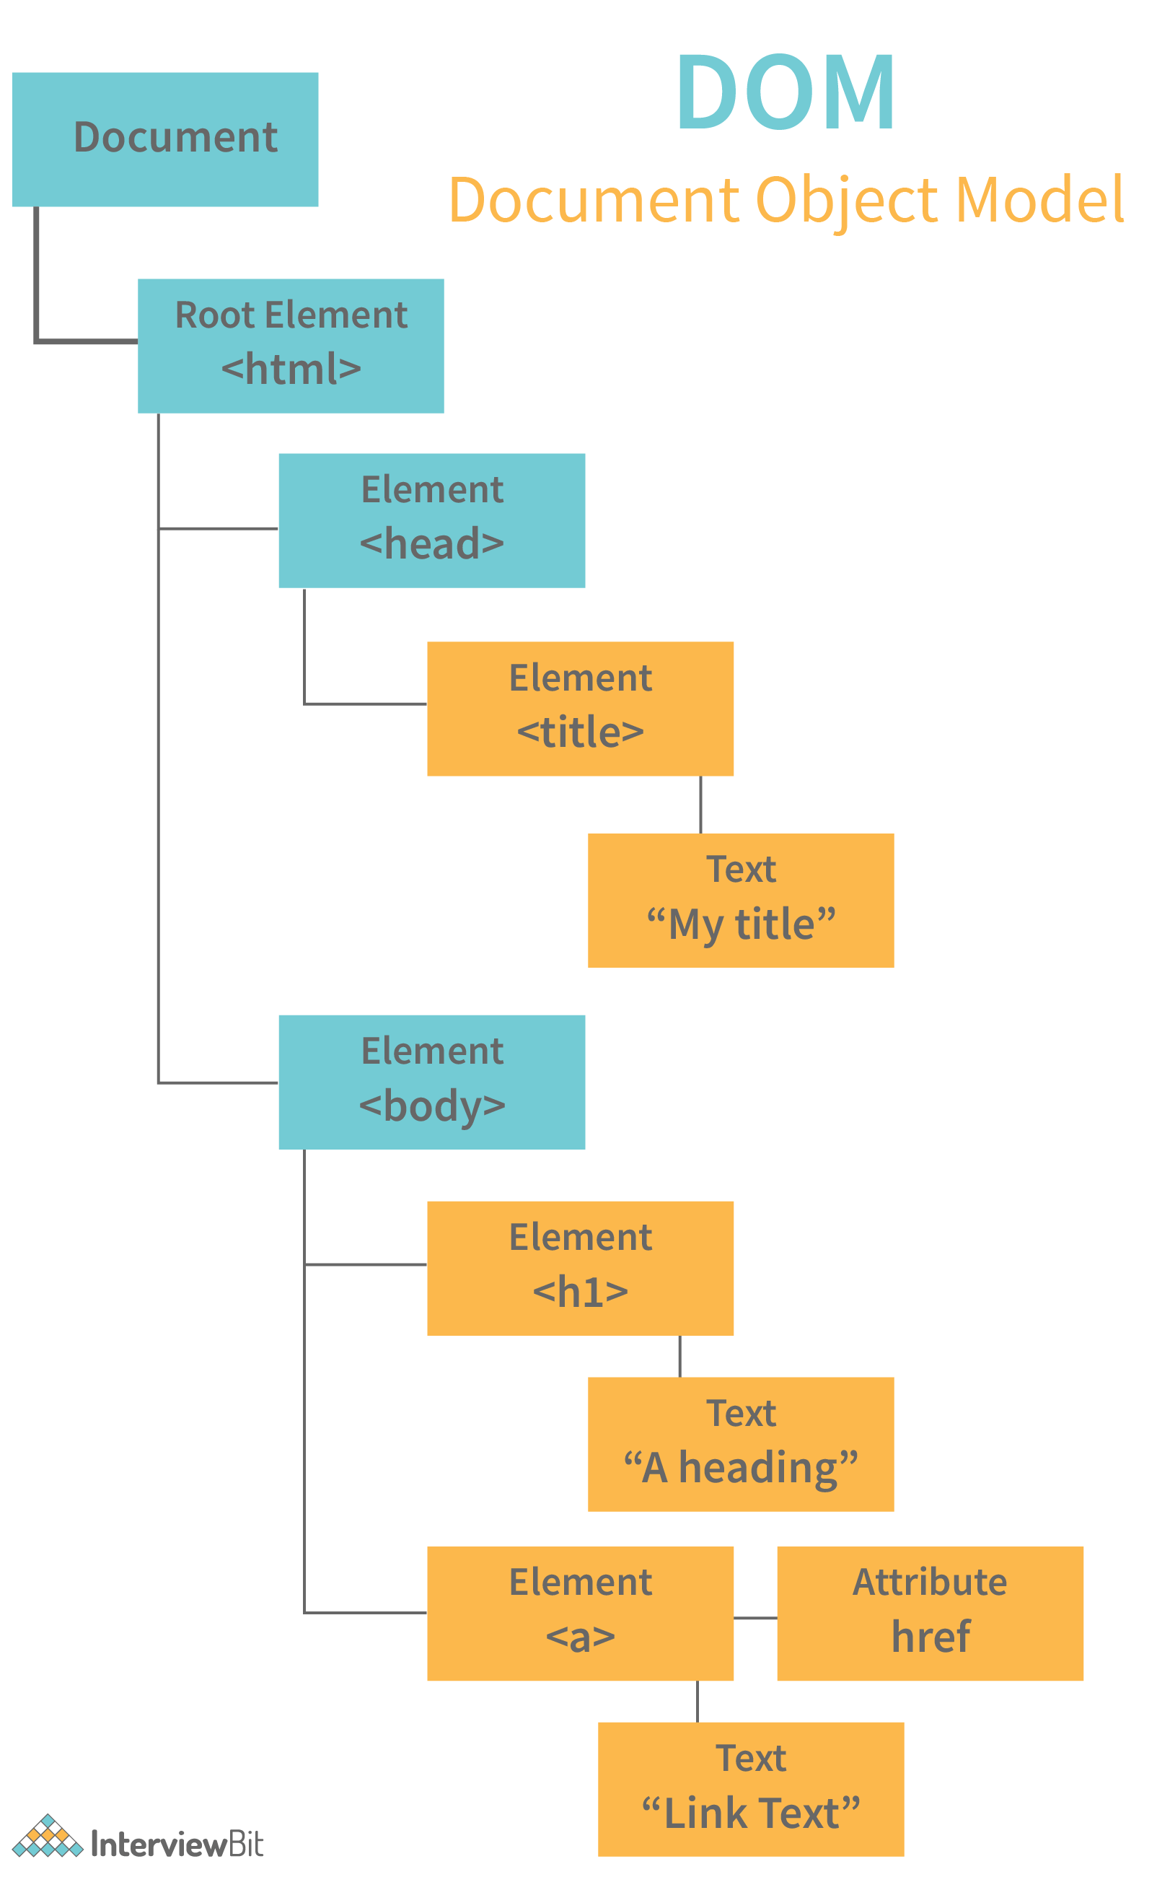

These documents are usually treated as a tree structure in which every node is an object that represents a specific part of the document. In a tree, each branch ends with a node, and each node contains objects. The DOM represents the webpage in a hierarchical structure in order for programmers and users to navigate it more easily.

### **10. What do you know about pair programming?**

Pair programming is sometimes referred to as pairing. In pair programming, two programmers work together at one (single) workstation. Those who write code are known as drivers, and those who monitor and navigate each line of code are known as navigators. Both of them may switch roles frequently.

### **11. While building a web application, how do you consider SEO, maintainability, UX, performance, and security?**

Security should be a top priority in any organization that handles vital data. On the other hand, SEO and UX should be prioritized for small and medium-sized online businesses.  You will need to pay more attention to performance and SEO if you write an online publication.

### **12. State difference between SVG (Scalable Vector Graphics) and Canvas.**

HTML5 introduced two new graphical elements, Canvas (<canvas>) and SVG (<svg>), that make your web pages more interactive and more graphically attractive. Each has its own properties and can be used to create graphic elements on web pages.

| **<svg> tag** | **<canvas> tag** |
| --- | --- |
| In web pages, SVG is used to define vector-based graphics (vector image format). Unlike raster images (ex. .jpg, .gif, .png, etc. ), vector images can be stretched or compressed without losing quality. | Canvas is a raster-based format composed of pixels. |
| SVG provides better scalability, enabling high-quality printing at any resolution. | The canvas is not suitable for printing at high resolutions since it has poor scalability. |
| Through scripting and CSS, SVG can be modified. | Modifying a canvas is only possible through the script. |
| The performance of SVG is better when dealing with fewer objects (<10k) or larger surfaces. | Canvas performs better when there is a smaller surface area or a larger number of objects (>10k). |

### **13. What is Type Coercion in JavaScript?**

The term type coercion refers to the process of converting values from one data type to another, either automatically or implicitly. For instance, you could convert a number to a string, a string to a number, or a boolean to a number, etc.

****Example:**** Number to String Conversion

<script>

// The Number 5 is converted to

// string '5' and then '+'

// concatenates both strings

const value1 = 5;

const value2 = '50';

var x = value1 + value2;

document.write(x);

</script>

Output:

550

The above example shows how JavaScript converted the number 5 into a string and concatenate the values together, resulting in 550.

### **14. What is the difference between <window.onload> and <onDocumentReady>?**

It is true that both the <window.onload> and <onDocumentReady> functions perform tasks when the page has been loaded in the browser, however, the execution of the two functions differs slightly.

* ****Window.onload:****This event is triggered when a web page has fully loaded. In other words, it waits for the DOM and all the associated resources to load, and then executes code. DOM contains all HTML tags, like anchor tag, h1 tag, p tag, etc.
* ****onDocumentReady:**** The "onDocumentReady" method, on the other hand, executes the code when the DOM has been loaded. It typically waits for HTML tags, anchor tags, etc., but not for images, videos, or other contents.

### **15. Describe the different kinds of HTTP requests supported by RESTful Web services.**

Each HTTP request type in RESTful web services has a specific purpose. Below is a description of them:

* ****GET:**** It is used to retrieve data or resources from the server but only allows read-only access. You cannot modify it.
* ****POST:****It is used for creating a new resource.
* ****PUT:****This is similar to POST, but used for updating an existing resource (if the resource doesn't exist, the API will decide whether a new resource should be created).
* ****DELETE:**** It is used to delete the resource from the server.
* ****TRACE:**** It validates the content along with the network during an HTTP request.

## **Web Development Interview Questions for Experienced**

### **16. What is the best way to integrate different stylesheets into a website?**

Typically, it depends on how your site is laid out and how users interact with it. The most efficient way, however, would be to use just a single file called styles.css (or something similar). Combining them into a single document is preferable. Loading one file is easier for a client than loading five. In order to change the style, you simply open the styles.css file, scroll down to find the appropriate section, and modify the CSS. The sheet can be linked in your HTML as follows:

<link rel="stylesheet" href="styles.css">

### **17. How do you optimize the loading time of your web application as a Web Developer?**

As a Web Developer, here are the top hacks for reducing load time and optimizing your web application's loading times:

* ****Image compression and optimization:**** Using images on your website will improve the appearance and quality of your pages. However, larger images will also slow down the loading process. Compressing and optimizing images is one of the easiest ways to improve the speed of your site. The smaller your images' file sizes, the less weight they have, which, in turn, helps your pages load faster.
* ****Put JavaScript and CSS in external files:****When JavaScript and CSS are embedded in HTML documents, they are downloaded each time the HTML document is loaded. As a result, this does not utilize browser caching, increasing the size of HTML documents. You should always place CSS and JavaScript in external files; this is best practice and makes maintaining your site easier.
* ****Reduce the number of redirects:****A website with too many redirects will take a long time to load. HTTP request and response times are prolonged every time a page redirects. If you eliminate unnecessary redirects on your site, your page load time will be significantly reduced.
* ****CSS and JavaScript files should be loaded asynchronously:**** You have CSS and JavaScript files on your website that can be loaded synchronously or asynchronously. In synchronous loading, each file is loaded one at a time, in the order in which it appears on your web page. Asynchronous loading, on the other hand, allows multiple files to be loaded simultaneously, which can speed up the performance of a website. '
* ****Minify HTML, CSS, and JavaScript****: Your pages will load faster if you optimize how your files to load. In a similar vein, you can minify your HTML, CSS, and JavaScript code. You can reduce the size of files by eliminating unnecessary spaces, characters, comments, and other components. As a result, web pages will load faster with cleaner code.

### **18. Define NPM (Node Package Manager).**

NPM stands for **[Node Package Manager](https://www.interviewbit.com/node-js-interview-questions/" \t "https://www.interviewbit.com/web-developer-interview-questions/_blank)**. It is commonly used as a default package manager for Node.js (JavaScript runtime environment). It is included in every installation of Node.js. This command-line tool installs, updates, and uninstalls Node.js packages and modules required for Node applications or projects. A package contains all files for a module, and modules are basically JavaScript libraries that can be added to a Node project as needed. It contains a number of libraries that are extremely useful to Node.js developers, speeding up the process of developing applications.

****Installing NPM:****In order to install NPM, you need to install Node.js as NPM automatically gets with Node.js.

****Check NPM Version:****The following syntax can be used to check the version of NPM that is installed on the system:

Syntax: npm -v

****Update NPM Version:**** NPM updates refer to updating the Node package manager to its latest version. One may always update the installed version if it is not the latest using the syntax given below:

Syntax: npm update [-g] [<pkg>...]

The -g flag is used to update npm globally since it is a global package and pkg refers to the package.

* Use npm@update command

npm install npm@latest -g

* Use update command

npm update -g

* Use npm@latest command

npm install npm@latest -g

### **19. What are different popup boxes that are available in JavaScript?**

Javascript uses pop-up boxes to display notifications and messages to users. Here are the different types of pop-up boxes in Javascript:

* ****Alert Box:**** This is used to display a warning message. After the alert box appears, the user needs to press the OK button to proceed.

****Syntax:****

alert("Your Alert Text")

****Example:**** Running the following script will open an alert box that contains the message: "This is Scaler Academy" along with a confirmation button OK.

<script>

alert("This is Scaler Academy");

</script>

* ****Confirm Box:**** These pop-up boxes are used as a means of obtaining authorization or permission from the user. In order to proceed, the user must click the OK or Cancel button.

****Syntax:****

confirm("Your query")

****Example:**** Upon executing the following script, it will open a confirmation box containing the following text: "Confirm this action" along with a confirmation button and cancellation button. Based on the input provided by the user, this returns a boolean. It will return true if the user clicks to confirm, and false if the user clicks cancel.

<script>

**let** bool = confirm("Confirm this action");

console.log(bool);

</script>

* ****Prompt Box:****The purpose of this type of pop-up box is to gather user input for further use. After entering the necessary information, the user has to click OK to proceed to the next stage, otherwise pressing the Cancel button returns the null value.

****Syntax:****

prompt("Your Prompt")

****Example:**** Running the following script will open a pop-up box with the message: "Enter your email". There will also be a confirmation button and a cancellation button.

<script>

**let** name = prompt("Enter your email");

console.log(name);

</script>

You'll be able to see your email on the console once you enter some input in the prompt box.

### **20. Explain the term “Scope” in JavaScript and write its different type.**

Managing the availability of variables or objects in an application is governed by the concept of scope. In JavaScript, there are two types of scope as follows:

****Global Scope:**** A variable having global scope can be accessed from anywhere in the program. These variables that are declared outside of any function can be accessed from any place in the program.

****Example:****

**let** scalerProgram = "DataScience"// code here can use scalerProgram**function** **myScaler**() {// code here can also use scalerProgram

}

****Local Scope****: Variables with a local scope can only be accessed within the same function in which they are declared. Whenever a variable is declared inside a function, it becomes local to the function. As soon as a function begins, local variables are created and deleted when the function is executed.

****Example:****

// code here can NOT use scalerProgram**function** **myScaler**() {

**let** scalerProgram = "DataScience";

// code here CAN use scalerProgram

}// code here can NOT use scalerProgram

### **21. State difference between HTML and XHTML.**

Both HTML (Hypertext Markup Language) and XHTML (Extensible Hypertext Markup Language) can be used to create web-based and Android applications.

| **HTML** | **XHTML** |
| --- | --- |
| HTML is basically a  SGML (Standard Generalized Markup Language) application. | XHTML is just an XML (Extensible Markup Language) application. |
| It is not case sensitive. It is not necessary to use lower or upper case for tags and attributes. | It is case sensitive. This means that every tag and attribute must be lowercase. |
| It is not necessary to mention quotes when using attributes. For e.g., <InterviewBit>. | It is necessary to mention quotes when using attributes. For e.g. <InterviewBit=”SCALER”>. |
| .html and .htm are the filename extensions used. | .xhtml, .xht, and .xml are the filename extensions used. |
| There is no need to write the Doctype (document type) at the top. | It is very important to write the Doctype (document type) at the top of your file. |

### **22. Can you explain what AJAX is?**

AJAX (Asynchronous JavaScript and XML) refers to a set of technologies used for developing web applications. The purpose of AJAX is to create better, faster, and more interactive web applications using these technologies such as XML, HTML/XHTML, CSS, DOM, JavaScript, XMLHttpRequest etc. Through Ajax, web applications are able to send and receive data asynchronously from the server without hampering the display or behaviour of the existing site. Using AJAX, you can exchange information with a server and update portions of a webpage without having to reload the whole page. The term "AJAX" refers to a technique for creating dynamic, fast web pages.

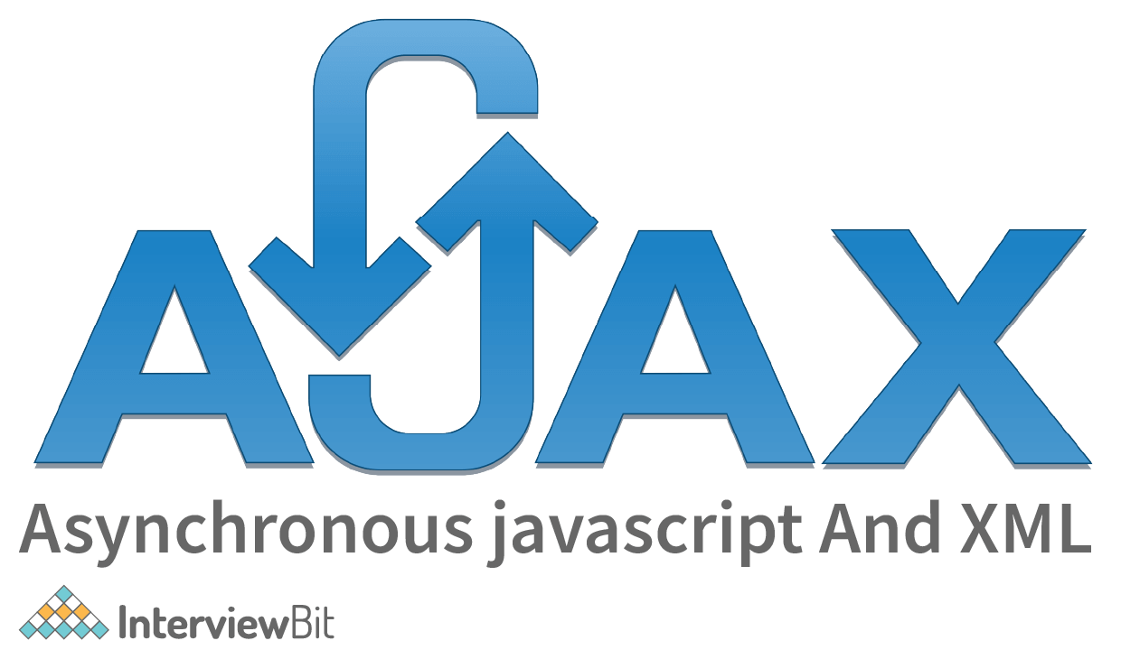

### **23. What do you mean by CDN (Content Delivery Network) in jQuery?**

CDN stands for Content Delivery Network. CDNs are geographically distributed groups of servers that deliver Internet content quickly. To provide end-users with fast, secure media delivery and web content, the servers are dispersed across many physical and network locations. Using CDNs can significantly reduce load times since they deliver files at higher bandwidth from servers located closer to your visitors than your own web server.

For faster access and better performance, web programmers and developers can leverage CDNs to host their **[jQuery Libraries](https://www.interviewbit.com/jquery-interview-questions/" \t "https://www.interviewbit.com/web-developer-interview-questions/_blank)**. Microsoft and Google have already put jQuery on their CDNs, so developers don't have to worry about that. Their only task now is to reference the hosted jQuery library.

****Google CDN****

<head>

<script type="text/javascript" src="https://ajax.googleapis.com/ajax/libs/jquery/3.6.0/jquery.min.js"></script>

</head>

****Microsoft CDN****

<head>

<script type="text/javascript" src="https://ajax.aspnetcdn.com/ajax/jQuery/jquery-3.6.0.min.js"></script>

</head>

### **24. Explain W3C (World Wide Consortium).**

W3C stands for World Wide Web Consortium. Founded in 1994, W3C is an international organization devoted to the improvement of the web. The W3C strives to help the web reach its full potential and ensure its continuous development. It sets standards (protocols) for the WWW (World Wide Web) to allow for interoperability and cooperation between all stakeholders. It develops various protocols or standards as a means of growing the web.

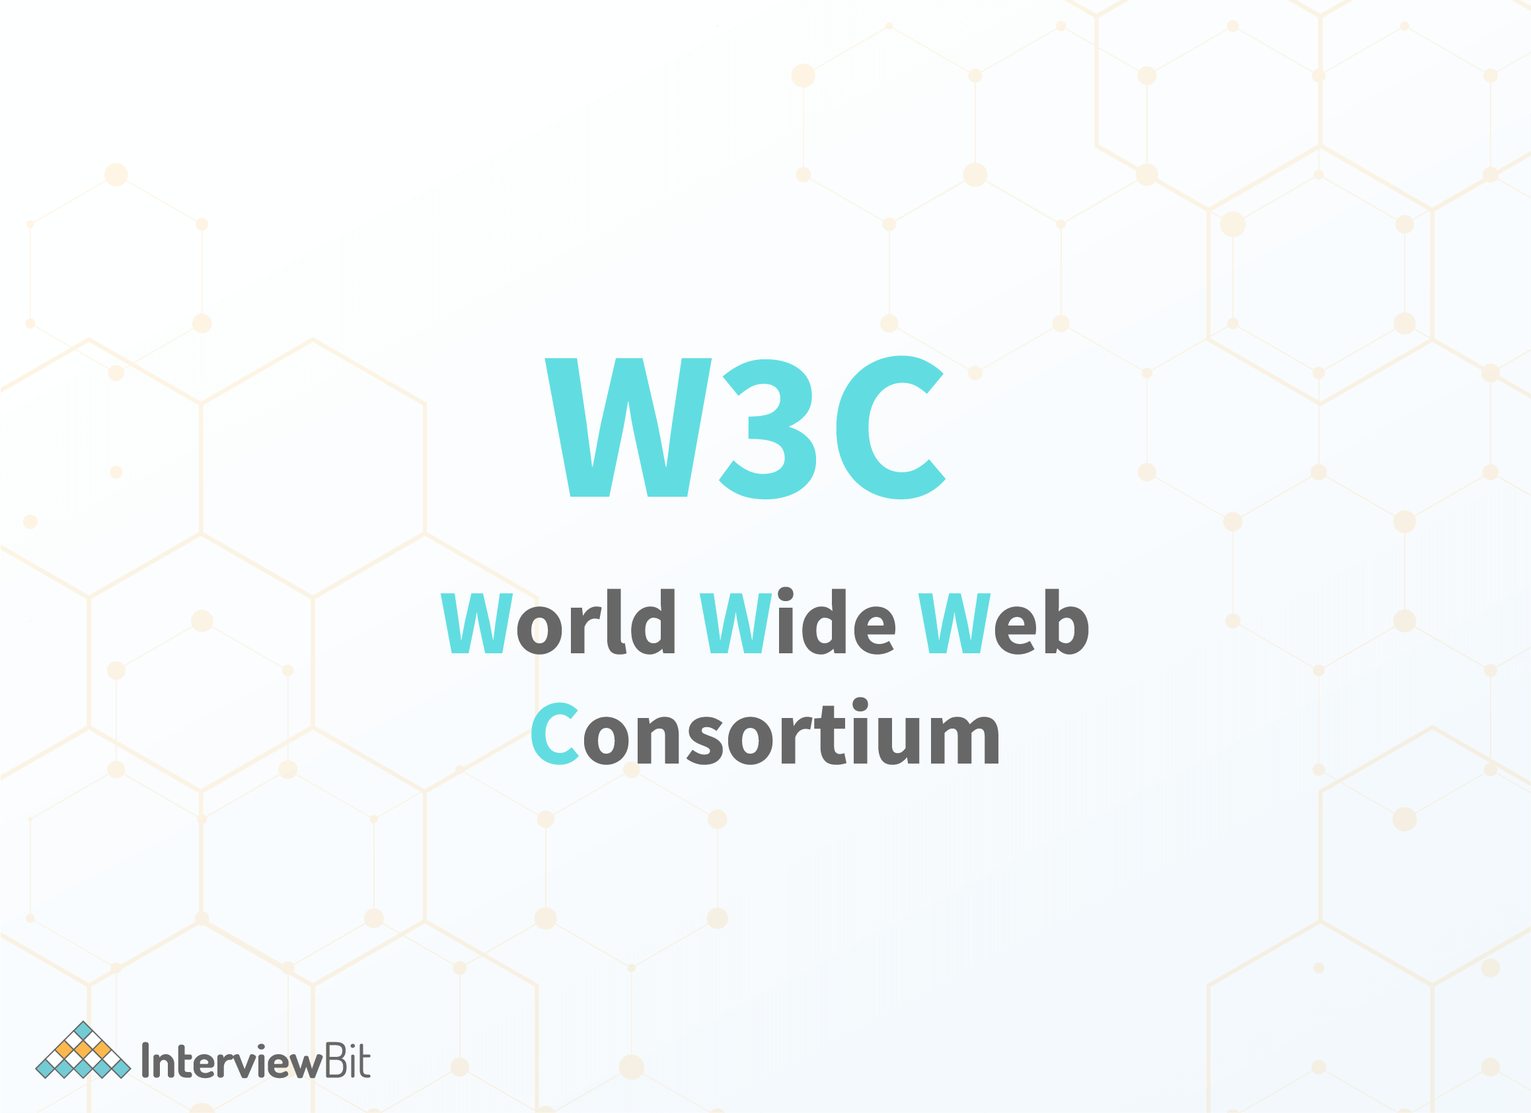

****Characteristics of W3C:****

* It develops and publishes web standards or protocols.
* Furthermore, it ensures the development and growth of the web.
* In addition, it sets the standards or protocols for web scripts, web applications, and other dynamic content.
* While designing web protocols, W3C adheres to the principles of modularity, simplicity, and extensibility.

### **25. What do you mean by CSS Selectors? Name a Few.**

**[CSS selectors](https://www.interviewbit.com/css-interview-questions/" \t "https://www.interviewbit.com/web-developer-interview-questions/_blank)** are used by web designers to specify or select HTML elements they want to style. Following are a few of the most commonly used CSS selectors:

* ****ID Selector:**** It selects HTML elements using specific id attributes.

Syntax: #idname

Example: Here is the CSS rule that will be applied to the HTML element having id="para1".

#para1 {

**text-align**: left;

**color**: blue;

}

* ****Class Selector:**** It selects HTML elements using specific class attributes.

Syntax: .classname

Example: Here is the CSS rule that will be applied to the HTML element with class="scaler".

.scaler {

**text-align**: left;

**color**: blue;

}

* ****Child Selector or Combinator:**** It selects all HTML elements that are children of the specified element. In a child selector, there are two or more selectors separated by ">".

Syntax: selector1 > selector2

Example: Here is a CSS rule that will be applied to HTML elements (<p>) that are children of a <div> element.

**div** > **p** {

**background-color**: blue;

}

### **26. What are pseudo-classes?**

A pseudo-class is basically used to define or specify a special state of an HTML element. This can be used in conjunction with an existing CSS selector to add effects to elements based on their state. For instance, changing the style of an element when a user hovers over it or using different styles for visited and unvisited links. The pseudo-class gives you the ability to do all of this.

Syntax:

selector: pseudo-class{

property: value;

}

In CSS, there are many pseudo-classes, but the ones that are most frequently used are as follows:

* ****:visited pseudo-class****: Select the links that the user has already visited.
* ****:hover pseudo-class****: A special effect can be added to an element when the mouse pointer is over it.
* ****:active pseudo-class****: Select the element that becomes active when the user clicks on it.
* ****:focus pseudo-class****: Select an element that is currently focused by the user.

### **27. Why are media queries used in CSS?**

Media queries are used in CSS to create responsive web designs. This means that the way a web page appears varies from one system to another based on the screen or the media type. The media query can be used to apply different styles or change the appearance (and even the behaviour) of a site or an app depending on a user's device type or specific characteristics (like browser viewport width, height, screen resolution, etc.). The following can be checked using media queries:

* Dimensions (width and height) of the viewport
* Dimensions (width and height) of the device
* Orientation
* Resolution

### **28. Explain long polling.**

 Long polling is generally a web application development method that is used to push information or data from the server to the client as quickly as possible. Long-polling maintains the connection between client and server after a request has been made from the client to the server. The connection is maintained until information becomes available from the server and it is ready to send it to the client.  If the server receives a request from the client, it doesn't close the connection immediately; the connection is only closed when the server sends the data back to the client or when a timeout threshold is reached (connection timeout).

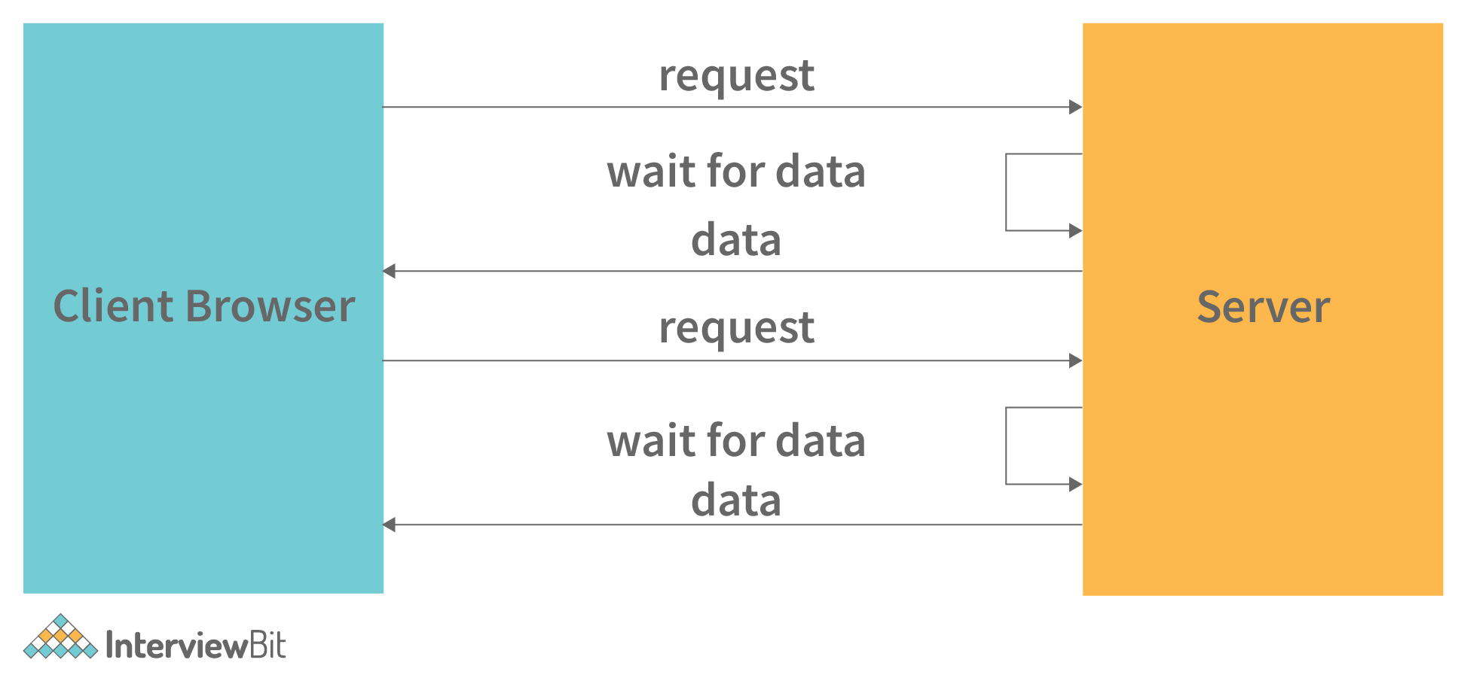

### **29. State difference between Local Storage and Cookies.**

The differences between local storage and cookies are as follows:

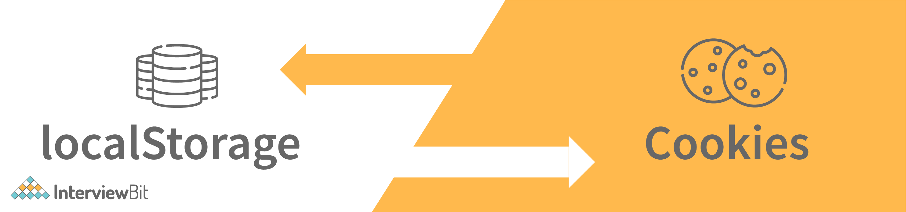

| **Local Storage** | **Cookies** |
| --- | --- |
| Local storage generally stores large amounts of data on the client's computer (client’s browser) as key-value pairs. | Simply put, a cookie is a small text file containing information about a website, like a username or a password. When you visit a particular website, this website saves some information in your local system so that it can recognize you and display results according to your preferences. |
| The client can only access local storage. It is impossible for a server to use local storage unless it deliberately makes a request to the server via GET or POST. | Servers and clients are both able to read and write cookies. |
| Local storage has a storage capacity of 5MB/10MB. | Cookies have a storage capacity of 4KB. |
| Local storage does not have an expiration date, so it must be manually removed. | Cookies have an expiration date and cookie data is purged after a certain period of time. |

### **30. What is the purpose of Canvas in HTML?**

In simple terms, Canvas (<canvas> tag) is an HTML element that enables you to draw or create graphics on a web page using JavaScript. This is a new tag in HTML5. Canvas allows you to dynamically control graphics, images, and text on your web pages, adding a great deal of interactivity. You can create graphs, combine photos, and create animated elements using the CANVAS element.

Syntax:

<canvas id = "script"> Contents... </canvas>

Example:

In this example, we have a simple \*canvas> element that only has two specific attributes: width (set width of the canvas) and height (set height of the canvas), along with the HTML5 core attributes such as id, name, and class.

<!DOCTYPE **html**><**html**>

<**body**>

<!-- canvas Tag starts here -->

<**canvas** id = "InterviewBit" width = "100"

height = "100" style = "border:1px solid blue">

</**canvas**>

<!-- canvas Tag ends here -->

</**body**></**html**>

Or

<!DOCTYPE **HTML**><**html**>

<**head**>

<**style**>

#Interviewbit{**border**:1px solid blue;}

</**style**>

</**head**>

<**body**>

<**canvas** id = "Interviewbit" width = "100" height = "100"></**canvas**>

</**body**></**html**>

Output:



### **31. What is the purpose of closures in JavaScript?**

In JavaScript, a closure is known as a JavaScript closure or JS closure. Closures allow you to access the scope (variables and parameters) of an outer function from an inner function. Every time a JavaScript function is created, a closure is created. JavaScript closures allow you to control which variables are and are not in scope in a given function, as well as which variables are shared among siblings within the same containing scope.

### **32. What is an event loop in Node JS?**

Asynchronous programming in JavaScript is made possible by the event loop. With JS, all operations occur on a single thread, but we can create the illusion of multi-threading by using smart data structures. Event loop takes care of anything that's async using a queue and listener.

So, when an async function has to be executed (or an I/O has to be performed), the main thread sends it to another thread, allowing v8 (Javascript engine) to continue running its code. The event loop consists of different phases with specific tasks like pending callbacks, close callbacks, timers, idle or prepare, poll, check, with different FIFO (First-In-First-Out) queues.

### **Conclusion**

In an era of economic uncertainty, web development is one of the most promising careers to pursue. In spite of this, web developer interviews can be intimidating, and if you are unprepared, you will become overwhelmed and lose confidence. In order to be competitive, you must be able to have a competitive edge and skill sets that set you apart from the rest. To be successful, you must have a thorough understanding and hands-on experience with integrating new technologies, CSS3, HTML5 APIs, front-end scripting language libraries, and languages like JavaScript, Python, PHP, etc. Furthermore, you must be knowledgeable about configuring applications on web servers and databases, managing SEO keywords, browser compatibility and web security.

Hope you found this article informative and helpful in clearing your doubts. Wishing you success in your next interview.

****Useful Resources:****

* [Web Development Projects](https://www.interviewbit.com/blog/web-development-projects/" \t "https://www.interviewbit.com/web-developer-interview-questions/_blank)
* [Web Development Tools](https://www.interviewbit.com/blog/web-development-tools/" \t "https://www.interviewbit.com/web-developer-interview-questions/_blank)
* [Best Web Development Books](https://www.interviewbit.com/blog/web-development-books/" \t "https://www.interviewbit.com/web-developer-interview-questions/_blank)
* [Web Development Course](https://www.scaler.com/courses/web-development/" \t "https://www.interviewbit.com/web-developer-interview-questions/_blank)

## **Frequently Asked Questions**

### **33. How to become a web developer?**

In order to become a professional web developer, you must take the following steps:

* Choose a speciality (FrontEnd/BackEnd/FullStack).
* Develop the necessary programming language skills.
* Gain Practical Experience (take on small projects and build your online portfolio).
* Learn from other websites.
* Earn Certificates (certificates in front-end or full-stack web development, JavaScript and cloud development).
* Practice! Practice!! Practice!!! (the more you practice, the better you become). **[Learn More](https://www.interviewbit.com/blog/web-developer/" \t "https://www.interviewbit.com/web-developer-interview-questions/_blank)**.

### **34. What does a web developer do?**

Typically, there are three types of web developer jobs based on skills: front-end, back-end, and full-stack development. Front-end web developers design the look of a website (visible to users) and focus on visual elements of the website. A backend developer is responsible for server-side (non-visible to users) application logic and front-end integration. Full Stack Developers work both on the Back End (server-side) and Front End (client-side) of an application.

### **35. How much time does it take to learn web development?**

For a beginner, learning web development from the ground up would take you about four to six months if you study 2-3 hours every day. Some people learn within a couple of months, while others take a year or so.

### **36. What should a web developer know?**

Web Developers must have a good understanding of HTML, CSS, and JavaScript. Additionally, you should learn about libraries and frameworks such as Bootstrap and jQuery. Having these foundational skills will help you understand how programming languages work.

### **37. Who should learn web development?**

Anyone can [become a web developer](https://www.scaler.com/courses/web-development/" \t "https://www.interviewbit.com/web-developer-interview-questions/_blank); anyone who is interested in creating websites should learn how to do so. You don't have to be a techie or have a long list of formal qualifications to pursue a career in web development. It only takes motivation and a willingness to learn to climb the career ladder.

### **38. Do web developers use coding?**

For creating websites and web applications, web developers use programming languages (such as JavaScript, and Python). A developer turns the plans and visions of web designers into what you see on your phone, tablet, or computer screen by using code.

### **39. What is the average salary of a web developer in India?**

It is estimated that web developers with 1-4 years of experience can earn around Rs 3,04,000 per annum. With 5-9 years of experience, you can expect to make around Rs 5,89,000 per year. Over ten years of experience in this field can earn you around Rs 1,000,000 annually. However, the range of the salary depends on a variety of factors such as your experience, employer (company profile), skills, and location.

### **40. Why should you be hired for a web development internship?**

As people embark on further education and prepare to enter some well-reputed organization, this is likely to be one of the most common questions they encounter.

****Sample Answer:*****"As a fresher, I am interested in starting my career with a company like yours. I am well versed in all the required subjects. Even though I am a newbie, I am a very quick learner, and I am also highly trainable. By having these two skills, I am able to learn new techniques and skills very fast, and I also adjust to new environments more quickly. I have a few fresh ideas that may help your company grow and thrive. Furthermore, I would like to learn from professionals working with your team and refine my skills".*

### **41. State the difference between a web developer and a software developer?**

The main difference between web developers and software developers pertains to the types of projects they may work on. The role of a web developer is to develop web-based applications such as websites, e-commerce, and mobile applications. As a software developer, you will focus on developing software for underlying operating systems, networks, or platforms. Software developers can be involved in the service development of web applications, etc.

### **42. How do you talk about web-development project in an interview?**

Make sure you categorize your project into several steps and explain them in a very clear manner in order to win an interview. Here are some steps to explain a project:

* Project Introduction
* Modules description
* Benefits and main features of your application
* The tools, technologies, and platforms that were used
* Contribution and your involvement in the project
* The challenges you faced in the project and how you overcame them
* Future improvements to the current system

### **43. What are different types of web development?**

Different web development types include:

* ****Front-end:****Front-end developers design the look of a website (visible to users) and focus on visual elements of the website.
* ****Back-end:**** A backend developer is responsible for server-side (non-visible to users) application logic and front-end integration.
* ****Full Stack:****Full Stack Developers work both on the Back End (server-side) and Front End (client-side) of an application.
* ****UI (User Interface) developers:****UI developers are responsible for designing and developing a website's User Interface. They design the look, feel, and presentation of web applications, as well as ensure their functionality.

### 1) Explain the key responsibilities of a Web Developer?

Key responsibilities of a web developer include:

1. Program testing and debugging web applications
2. Design, develop, test, and deploy applications.
3. Updating sites for optimized server performance.
4. Coordination with designers and programmers to develop projects.
5. Fixing bugs, troubleshooting, and resolving issues
6. Predicting and implementing periodic tests in case of system failure.
7. Developing design patterns for web program optimization.
8. Support and assist with best practices for website management.
9. Take ownership of code throughout staging, development, testing, and deployment of the project in production.

### 2) What are the prerequisites of being a web developer?

A beginner web developer is expected to have a fundamental knowledge of HTML, CSS, JavaScript, and other aspects like jQuery, SQL, and some other scripting languages. An experienced web developer is expected to have all the given aspects and great knowledge of design patterns.

### 3) Enlist the advantages of HTTP/2 as compared with HTTP 1.1/.

The advantages are:

1. Data compression through HTTP headers.
2. Ease of logical server push technology.
3. Prioritizing a request.
4. Page element loading through TCP connection.

### 4) What is CORA? Why is it so important?

Cross-Origin Resource Sharing (CORS) is defined as the browser mechanism that involves controlled resources access granted outside the given domain. It can enable a web page to access the resource with a different domain. It is a relaxation of some policies associated with browsers implemented on the same origin.

CORS is important because it follows the same-origin policy by channeling XMLHttpRequest and fetching JavaScript to make URL calls in the same location where the script is running. Without CORS, there will be restrictions in accessing some critical resources that power the web.

### 5) What is ETag, and how does it function?

An ETag is termed an opaque identifier that is usually allocated by the webserver. It is primarily used within the same version of the resources provided in the URL. ETag is an important part of HTTP and is responsible for reading client requests to notify whether to send the file (HTTP 200) or inform the client through a local copy (HTTP 304).

### 6) Enlist some of the latest form elements of HTML5.

<datalist> : specifies input controls option list.

<keygen> : encryption key generator.

<output> : result generator of expression.

<progress> : max value directional to 100%.

<meter> : provides a range for displaying values within a range

### 7) How to integrate different stylesheets into a website?

It depends on the factor of how the site is laid out. However, for the most efficient performance, one file can be used with styles.css. If you want to change any style, open up the styles.css file, and in the relevant section, you can modify CSS. You can also link your HTML file through the below command.

<link rel="stylesheet" href="styles.css">

### 8) Enlist some tricks to reduce the load time of a web application.

Some of the most popular hacks to reduce load time are:

1. Save the images as a compressed file so that image size can be optimized to screen resolution.
2. Remove every JavaScript file to reduce mobile data.
3. Minify and combine CSS and JS to call them in the footer.
4. Switch to asynchronous JavaScript.

### 9) What is the correct way to include JavaScript into your HTML?

The most effective way to include JavaScript in your HTML is by referring to event handlers or including inline code.

### 10) What are some of the pop-up boxes available in JavaScript? Explain them.

There are usually three types of boxes available in JavaScript. They are:

****ALERT**** displays a message with an OK button.

****CONFIRM****: displays a confirmation window with OK and Cancel buttons.

****PROMPT****: displays a pop-up dialog box seeking user inputs followed by confirmation buttons.

### 11) Define Scope in JavaScript and name different types of Scopes.

The scope is usually defined to felicitate the accessibility of variables and methods(functions) in applications. There are two types of Scopes in JavaScript: Local and Global.

### 12) What is the difference between '==' and '===' operators?

Although both of the operators belong to the comparison operator category, the '==' operator checks the given values, whereas the '===' behaves like an equality operator and checks both the value and their type.

### 13) What is the difference between <div> and <frame> in HTML?

With frames, you can display more than one document in the browser window. Also, the <frame> tag can be used to declare a separate window within a frameset.

With division, you can define a section in an HTML document and block elements within certain formats and styles. Division can serve local content, although the content is not independent of the page constituent.

### 14) State how HTML differs from XHTML?

Although, HTML and XHTML are known for writing web pages but HTML is extended version from SGML tagging. On the other hand, XHTML is just an application of markup language called Extensible Markup Language.

However, HTML usually has three components, i.e., start and end tag, elemental attribute tags, and content in text and graphics. In contrast, XHTML includes a single root element that constitutes only lower case elements whose values assigned should be nested and closed. They also need to round with quotation marks. Therefore, it comes down to a conclusion that XHTML is more expressive than HTML is more framed.

### 15) What is Node Package Manager or NPM?

NPM is a package manager for JavaScript. NPM is designed to put modules intact so that nodes when the need can find them. It is designed to maintain and serve conflicts arising in dependencies. It is mostly used to install programs, configure them, publish and develop them using the intact resources in the modules.

### 16) What is Webpack?

Webpack in JavaScript is generally a static module bundler designed to bundle JS files in the browser and check their usage. It dynamically puts various files, assets, images, and fonts in a graph of dependency. It enables you to use the required () method to point to the files and figure out how they will be processed in the final bundle of JavaScript. Initially, a webpack slows down when used initially, but the speed eventually picks when correctly used.

### 17) What is Document Object Model (DOM)?

DOM is defined as the ****interface channeling**** cross-platform programming and is primarily used to represent HTML and XML documents in nodes and objects. In simple words, DOM defines the way of manipulating the logical structure of the documents and how they are accessed. It can enable developers to modify, create, or remove the document structure, content, and style used.

Moreover, whenever a document is displayed in the browser, it contains the combined style because it automatically converts the styling components like CSS into DOM. The DOM combines these styling components in the content of the document.

### 18) How can you effectively handle type conversion in JavaScript?

Since JavaScript is a weakly typed language, it automatically converts the data to that type to which an operator or statement expects a particular data type to be converted. JavaScript supports automatic type conversion, and it is the only way to handle different types of type conversion techniques for JavaScript developers.

### 19) What is CDN in jQuery? What are the advantages of it?

A ****Content Delivery Network**** (CDN) is an interconnection of computer systems globally, and it contains cache files for users to access. It enables users to access the content quite fast by duplicating or caching the content optimally stored on multiple servers and then directing them according to the proximity. Some of the advantages of using CDN are as follows:

1. Faster delivery of content.
2. Less load frequency across pages.
3. Low latency and infatuation rate with little packet loss.
4. Highest bandwidth-saving ability.
5. Best analytics usage report.
6. Secure content storage.

### 20) What is W3C? Why is it considered important?

W3C abbreviates for ****World Web Consortium****. It is an international community of developers and teams that emphasize standardizing, correcting, and developing the web across global users and defining best practices. The World Wide Web (****WWW****) is a standard set by W3C and has different member organizations that control it through various IT-related projects. W3C is considered important because it leads the World Wide Web to its greatest potential and ensures its growth in the long term.

Moreover, W3C mainly focuses on developing certain constraints and guidelines for critical web assets like HTML and CSS programming. It also focuses on XML technology, web devices, authority tools, and web browsing experience. It helps web developers to write scalable code and run it everywhere. A web developer is expected to enforce these open standards to ensure that web content is accessible to all audiences globally and delivers a great user experience.

### 21) What is Ajax? Enlist some of its utilities.

Asynchronous JavaScript ****XML**** or ****AJAX**** enables different applications to transport data to and from a server asynchronously without refreshing the web page. It simply ensures that some parts of the page are automatically updated without reloading the entire page to fetch new resources on the same page. AJAX can be implemented anywhere in the web application where small chunks of information can be retrieved or saved. This technology helps developers to create faster, efficient and interactive web applications. Some of the utilities or benefits of AJAX are:

1. Faster callback performance.
2. Allows asynchronous calls to a web server.
3. Improves web performance and usability.
4. User-friendly, easy to understand, and implement.

### 22) What are some of the latest features of CSS3?

CSS3 has brought tremendous changes ranging from making a more user-friendly framework and has become powerful. Some of the latest features added CSS3 are:

1. Animation enabled.
2. Offers rounded corners to objects.
3. Custom layout.
4. Efficient placement of media queries.

### 23) What is Responsive Web Design (RWD)?

Responsive web design is generally a concept of creating web pages that can be easily scaled across various resolutions without losing any information or screen tearing. The main concept of responsive web design is to deliver the structure of the web page that can be automatically adjusted across various platforms and devices with an optimal viewing experience.

### 24) Enlist some of the types of CSS used.

There are mainly three types of CSS used: They are:

Inline CSS: Supports additional CSS inline with HTML elements grouped.

External CSS: Used to import an external CSS file to the current HTML document.

Embedded CSS: Uses <style> attribute to add CSS styles.

### 25) Why is the selector used in CSS?

The selector in CSS is used in styling with the rule of the inline elements. It is easy to choose and select HTML elements with selector usage based on factors including attributes, ID, and name.

### 26) What are CSS box model components?

The CSS box model components represent an entity under which HTML content is enclosed, like a box or a button element. Some of its components are:

****Border****: Denotes the content and padding around borders.

****Content****: Focuses on the actual displaying content.

****Padding****: Portrays space around the element.

****Margin****: Focused on the top layer of the box element.

### 27) What are some of the CSS3 transition properties?

Transition in CSS3 is very easy to use, and it provides rapid effects in terms of animation. Some of the main transition properties of CSS3 are:

1. transition-delay
2. transition-duration
3. transition-property
4. transition-timing-function

### 28) Why do we use pseudo-classes in CSS?

Pseudo-classes in CSS are popular ways to change the styling elements in CSS by changing their states. There are plenty of instances where pseudo-classes are used. They are:

1. Hovering the mouse over an element to change the style.
2. Providing out-of-focus animations.
3. Providing external link styles.

### 29) Why are media queries used in CSS3?

Media queries in CSS are used to define different media asset queries that are responsive and come in different varieties of shapes and sizes depending upon the viewer's window. The entities may include height, width, viewport, resolution, orientation, etc.

### 30) What are GET and POST? Explain what the difference between getting and Post is?

A GET request is generally used in the instances like AJAX calls to an API. GET requests are limited and secure. The user can easily view them if they have the URL.

A POST request is typically used to store data in a database submitted through a form. POST requests are more secure than getting requests. They have two steps to utilize the resource and remain hidden from the user.

### 31) Why do we use DOCTYPE in HTML?

DOCTYPE in HTML denotes the instruction given to a web browser regarding the version of markup language. The web browsers understand the Document Type Definition (DTD) from the HTML document and provide some markup language rules so that the web browser can easily interpret the content correctly.

### 32) What is lazy loading?

Lazy loading is defined as a design pattern used in computer programming to delay the object initialization until a certain required period. Lazy loading is time-constrained since the code gets loaded when the user needs it. For instance, a button on a page directs to a different layout when it is clicked. Hence, there is no need for code loading for the initial layout. Besides, lazy loading contributes to the overall performance of a program if properly utilized.

### 33) What is Event Bubbling?

Event bubbling is defined as the type of event propagation where the target element is first triggered. The triggering causes all the events of the child node to pass them to the parent node. The main reason for doing event bubbling is to get the speed since the code needs to traverse the DOM tree only once.

### 34) What is a Closure?

A closure is termed as a sequence of function bundling referencing the enclosing state. It allows you to access the scope of external function from an inner function. Whenever another function renders a function, this is when the concept of closure becomes more relevant. Thus, the rendered function will have access to the variable not in the global scope but can individually access their closure.

### **1) Explain what are the key responsibilities of a Web Developer?**

* Program test and debug all web applications
* Design, develop, test and deploy web applications
* Uploading sites onto server and registering it with different search engines
* Coordinate with other designers and programmers to develop web projects
* Fix bugs, troubleshoot and resolve problems
* In case of system failure initiate periodic testing and implement contingency plans
* Develop appropriate code structures to solve specific tasks
* Support and assist in the upkeep and [maintenance](https://career.guru99.com/top-12-maintenance-and-repair-interview-questions/" \o "maintenance) of websites
* Assume ownership of code throughout staging, development, testing and production

### **2) What web developer should know?**

A good web developer should know

* [HTML](https://career.guru99.com/top-50-html-interview-questions/" \o "HTML)
* [CSS](https://career.guru99.com/top-50-csscascading-style-sheet-interview-questions/" \o "CSS)
* [SQL](https://www.guru99.com/sql-server-questions.html" \o "SQL)
* PHP/Ruby/Python
* [JQuery](https://career.guru99.com/top-50-jquery-interview-questions/" \o "JQuery)
* JavaScript

### **3) Explain what is CORS? How does it work?**

(CORS) Cross-Origin Resource Sharing is a mechanism that enables many resources (e.g., JavaScript, fonts etc.) on a web page to be requested from another domain outside the domain from which the resource originated.  It is a mechanism supported in [HTML](https://career.guru99.com/top-50-html-interview-questions/" \o "HTML)5 that manages XMLHttpRequest access to a domain different.

### **6) Explain what is long polling?**

Long polling is a web application development pattern used to emulate pushing data from the server to the client.  When the long polling is used, the client sends a request to the server, and the connection remains intact until the server is ready to send data to the client. The connection will be closed only after the data is sent back to the client or connection timeout occurs.

### **7) Explain what is DTD (Document Type Declaration)? Mention what is the difference between CDATA and PCDATA in DTD?**

A DTD means Document Type Definition (DTD) which defines the structure, legal elements and attributes of an [XML](https://career.guru99.com/xml-interview-questions/" \o "XML) document.

* ****PCDATA****: A PCDATA is a Parsed Character Data. XML parsers usually parse all the text in an XML document.
* ****CDATA****: While CDATA is an Unparsed Character Data, the term CDATA is used about text data that should not be parsed by the XML parser.

### **8) Mention some tips you can use to reduce the load time of a web application that you have written?**

To decrease the load time of a web application you have to follow the following tips

* Optimize images to no longer than screen resolution and save it as a compressed file
* Eliminate all JavaScript files to reduce the amount of transferable data
* Combine & Mininify all [CSS](https://career.guru99.com/top-50-csscascading-style-sheet-interview-questions/" \o "CSS) and JS and call them in footer
* Defer or Asynch JS Files

### **9) Mention what is the correct way to include JavaScript into your HTML?**

The correct way to include JavaScript into your HTML is by using inline event handlers or inline code.

### **10) Explain in CSS, how can you make a form element’s background color change when the user is entering text? Does this work in all browsers?**

Yes, you can change the default look of form elements by styling their HTML tags: input, select and text area but it won’t work for all browsers.

### **11) Explain what is the difference between cookies and local storage?**

|  |  |  |
| --- | --- | --- |
|  | ****Cookies**** | ****Local Storage**** |
| ****Client Side/ Server Side**** | Data accessible both at client side and server side. The data is sent to the serverside with every cookie request. | Only at the local browser side data is accessible. Server cannot use local storage until deliberately sent a request to the server via POST or GET |
| ****Size**** | Storage capacity of cookies is 4095 bytes/cookie | Storage capacity of local storage is 5MB per domain |
| ****Expiration**** | Cookies have expiration and cookie data gets deleted after some time | There is no expiration and has to remove manually |

### **12) In HTML what tag can be used for a multi-line text input control?**

For multi-line text input control, you can use the “textarea tag”.

### **13) Explain how can you refer to CSS file in the web page?**

You can refer to the .CSS file in the webpage by using the <link> tag.  It should be kept between <head></head>tag. ****For example**** <linkhref=”/css/mystyle.css” type=”text/css” rel=”stylesheet”/>

### **14) List out few ways you can reduce page load time?**

You can do following things to reduce the page load time

* Reduce image size
* Remove unnecessary widgets
* HTTP compression
* Placing CSS at the top and script reference at the bottom or in external files
* Reduce lookups
* Minimize redirects
* Caching,

### **15) In HTML mention the difference between <div> and <frame>?**

The difference between <div> and <frame> is that a <div>

|  |  |
| --- | --- |
| ****Frame**** | ****Div**** |
| With frames, you can show more than one HTML document in the same browser window | The <div> tag defines a division or a section in an HTML document |
| The frame tag declares one particular window within a frameset | The <div> is used to group block-elements to format them with styles |
| Frames can load other resources using HTML | On the other hand page, divisions can serve local content in the manner of the frames, but that content is not independent of the page though |

### **16) How XHTML is different from HTML?**

* XHTML requires that all tags should be in lowercase
* XHTML requires that all tags should be closed properly
* XHTML requires that all attributes are enclosed in double quotes
* XHTML forbids inline elements from containing block level elements

### **17) List out the new APIs provided by HTML 5 standard?**

* HTML 5 comes with number of new APIs
* Media [API](https://career.guru99.com/top-20-questions-on-api-testing/" \o "API)
* Text track API
* Application Cache API
* Data transfer API
* User Interaction
* Command API
* Constraint Validation API
* History API

****Question: What are the advantages of HTTP 2.0 over HTTP 1.1?****

Answer: This technical question is meant to test your overall knowledge, explore your experience level with both HTTP 2.0 and HTTP 1.1, and ensure you have the communication skills that a good Web Developer needs.

In other words, it is important to provide a concise and easy-to-understand answer. HTTP 2.0 improves search engine rankings, consumes less broadband, and offers better loading speeds.

****Question: As a Web Developer, what steps do you take to optimize your site’s loading time?****

Answer: There are many different ways you can reduce the page load time:

* Cleaning the web code
* Minimizing redirects
* Caching
* Choosing smaller images or reducing image size
* Removing extraneous widgets
* Reducing lookups

Explain to the hiring manager how you then check the speed (perhaps using Google PageSpeed Insights) to verify the success of your actions, or to see if further effort is needed.

### Additional Technical Interview Questions for Web Developers

|  |
| --- |
| When you create a web page or web application, what is your workflow and process? |
| What specific coding languages do you work with? |
| What web development tools do you use? |
| In a hypothetical scenario, you have five different style sheets. What is your approach to best integrate them into the site? |
| How do you organize your JavaScript code? |
| What is your time management approach during a development cycle? How do you approach estimating how long specific web development tasks will take? |
| When you’re building a web application, how do you take into account SEO, maintainability, UX design, performance, and security? |
| How do you approach web accessibility? How do you make sure your websites and applications are accessible to users? |
| Please guide me through the process of creating a web page from scratch. |
| When you’re looking at other people’s code, how do you test for bugs? |
| When you’re building a website or online application, what user interface and security principles do you consider? |
| Please provide an example of a website or web application that you don’t like. What would you change to improve it? |

## Common Personal Web Developer Interview Questions

A Web Developer often has to collaborate with other departments, so employers are seeking candidates that would be a good overall fit with the company.

Personal questions can reveal a lot about a job candidate outside of their technical qualifications.

Personal interview questions for a Web Developer may include:

****Question: What is your approach for keeping on top of web development industry news and trends? How do you apply this to your work?****

Answer: You need to show your interviewer that you are passionate about the development industry and determined to stay on top of the latest trends. Try to provide a diverse list of specific web development blogs and vlogs, social-media influencers, YouTube channels, and more.

Jeff Atwood, Jeffrey Zeldman, Brad Frost, Sara Soueidan, and Rachel Andrew are a few popular senior developers on social media!

You could bring up an interesting article or webinar you saw recently. It is also worth mentioning if you have a circle of colleagues or professional contacts who enjoy sharing interesting development-related content.

### Additional Personal Web Development Interview Questions

|  |
| --- |
| Tell me about yourself. |
| How would you describe your preferred development environment? |
| Please tell us about the projects you’re working on (or have worked on) in your spare time. |
| Where do you see your web development career in five years? |
| What are your interests outside of web and software development? |
| What kind of team environment do you feel helps you thrive? |
| Why did you decide to pursue coding? Why are you interested in a Web Developer career? |
| What are your favorite types of projects to work on? |
| Are there any specific projects at our company that you are excited about? |

## Common Situational Web Developer Interview Questions

At any stage of your Web Developer career, leadership and communication skills are two important qualities to have. These skills will also help you take on more responsibility and begin to start managing teams of other developers.

To assess your leadership and communication abilities, employers may ask questions such as:

****Question: Please explain JavaScript to me in a way that even someone with no coding experience could understand.****

Answer: JavaScript is a programming language that is used for dynamic content, which refers to animations, graphics, newsfeeds, slideshows, autocomplete suggestions, interactive forms, or anything else on a web page that changes, moves, or shifts without the user hitting refresh.

JavaScript is also essential for developing mobile applications, creating browser-based games, and working on a website’s back end. JavaScript is so widely used that major web browsers can render JavaScript without downloading any additional programs or compilers.

### Additional Situational Interview Questions for Web Developers

|  |
| --- |
| Can you recall a time when you solved a problem that didn’t involve coding? |
| How would the Web Developers and Project Managers you have worked with describe you and your working style? |
| How do you communicate your progress to clients and/or stakeholders? |
| Give me an example of how you would describe and define web development to someone who is completely new to tech. |
| When you’re coding, do you enjoy working as part of a team? What do you think contributes to a successful team? |
| How do you help your team members improve their coding skills? |

## Common Behavioral Web Developer Interview Questions

With behavioral interview questions, employers are seeking to understand how your past behavior may translate into the current position. Focus on explaining the situation or problem, how you handled it, and the result or outcome of your actions.

To assess your behavioral skills, employers may ask questions such as:

****Question: Please tell me about a time you received negative feedback. How did you respond?****

Answer: Even an entry-level Web Developer has likely faced criticism at some point. The hiring manager will be looking to see that you have the communication skills and service-oriented attitude to respond in a professional manner to negative criticism and ultimately use it to improve the quality of your work.

Still, you should not choose an example where a client was unhappy simply because of poor work.

A good example would be a time when a client or stakeholder was not pleased with a web application or product even though it was developed according to an agreed-upon plan.

If you can then describe how you pivoted from your original plan to create something that everyone was happy with, it will show that you are adaptable and devoted to customer service.

## ****Q1. What is a pseudo-class?****

****Ans.**** It is a CSS technique that sets the style when an element changes its state. E.g. style changes when mouse hover, different styles for visited or unvisited links, etc.

There are four different types of pseudo-classes:

* ****Links****: These pseudo-classes are used to style the link both in its normal state by default and when it has already been visited
* ****Dynamic****: Dynamic pseudo-classes can be applied to any element to define how they are shown when the cursor is located on them, or by clicking on them or when they are selected
* ****Structural****: Structural pseudo-classes allow to style elements based on an exact numerical position of the element
* ****Others****: Some elements can be styled differently based on the language or what type of label they are not.

|  |  |  |  |
| --- | --- | --- | --- |
| **Format** | **Name** | **Elements are styled if** | **Compatibility** |
| **Link and Dynamic Pseudo-classes** | | | |
| : link | Link | the value of the href attribute is not in the history | IE4, FF1, O3.5, S1, CSS1 |
| : visited | Link Visited | the value of the href attribute is in the history | IE4, FF1, O3.5, S1, CSS1 |
| : target | Target Link | a targeted link | FF1.3, O9.5, S1.3, CSS3 |
| : active | Active | the element has been clicked | IE7, FF1, O3.5, S1, CSS1 |
| : hover | On | the cursor is over the element | IE4 \*, FF1, O3.5, S1, CSS2 |
| : focus | Focus | the element captures the focus of the document | IE7, FF1, O7, S1, CSS2 |
| \* Only available for the item before IE7 | | | |
| **Structural and Other Pseudo-classes** | | | |

## ****Q2. What is Namespacing in JavaScript?****

****Ans.**** It is usually not a good practice to use global variables in programming languages including JavaScript. However, you may have to use global variables sometimes. So, JavaScript introduces the concept of namespacing which ties down a part of the code and registers it with a unique name.

The namespace is nothing more than a container name where we hold classes, functions, and variables that can be repeated with the same name in other namespaces or namespace without involving an error.

## ****Q3. How can you reduce page loading time?****

****Ans.**** These are the following ways you can reduce web page loading time –

* Reduce the image size
* Use the latest generation formats for images
* Minify HTML, CSS, and Javascript
* Postpone uploading off-screen images
* Create Accelerated Mobile Pages ( AMPs)
* Remove unnecessary widgets
* Avoid multiple redirects
* Place CSS at the top and script referencing at the bottom or external files
* Reduce lookups
* Minimize redirects and caching
* Check the current speed of the website
* Finding a good hosting to host your website
* Clean the web code

## ****Q4.**What is CORS? Why is it important?**

**Ans.** This is an important ****web development interview question****.

Cross-Origin Resource Sharing (CORS) is a browser mechanism that allows controlled access to resources located outside of a given domain. It enables a web page from one domain to access a resource with a different domain (a cross-domain request). It is a relaxation of the same-origin policy implemented in modern browsers.

Due to the same-origin policy followed by XMLHttpRequest and fetch, JavaScript can only make calls to URLs that live on the same origin as the location where the script is running. Without features like CORS, websites are restricted to accessing resources from the same origin through the same-origin policy.

## ****Q5. What are the advantages of HTTP 2.0 over HTTP 1.1?****

****Ans.**** The major advantages of HTTP 2.0 over HTTP 1.1 include ****–****

* Higher loading speed
* Improvement of web positioning
* Automatic prioritization
* Less broadband consumption
* Immediate presentation

## ****Q6. How do you take into account SEO, maintainability, UX, performance, and security when you’re building a web application?****

****Ans.**** Explain how you prioritize your actions as per the requirements of the organization. If your organization handles vital data, then security will be your top priority. If it is a medium-sized online business, SEO and UX might be your top priority, and so on.

## ****Q7. What are the new form elements introduced in HTML5?****

****Ans.**** The new form elements introduced in HTML5 are:

* <datalist> – specifies a list of options for input controls
* <keygen> – generates an encryption key
* <output> – defines the result of an expression
* <progress> – heads only in the direction of 100% of the max value
* <meter> – provides for a gauge, displaying a general value within a range

## ****Q8. What’s the best way to integrate 5 different stylesheets into a website?****

****Ans.**** It usually depends on how the site is laid out. However, the most efficient way would be using just one file called styles.css (or similar). If you want to change the style, you just open up styles.css, scroll to find the relevant section, and modify the CSS. You can link the sheet in your HTML as –

<link rel=”stylesheet” href=”styles.css”>

## ****Q9. Explain the use of Canvas in HTML.****

****Ans.**** The HTML <canvas> element is used to draw graphics using JavaScript. We can use it to draw graphs, combine photos, or create basic animations.

## ****Q10. What’s the difference between Canvas and SVG?****

****Ans.**** Canvas is an HTML5 element that can draw graphics on the fly with the help of JavaScript. SVG (Scalable Vector Graphics) is used to display vector-based graphics on the web. The major differences are –

|  |  |
| --- | --- |
| **Canvas** | **SVG** |
| Pixel-based (dynamic .png) | Based form |
| Single HTML element. (Inspect the element in the Developer Tool. You can see only the canvas tag) | Multiple graphic elements, which become part of the DOM |
| Modified via script only | Modified via script and CSS |
| The interaction between the event model and the user is granular (x, y) | The interaction between the event model and the user is summarized (rect, path) |
| Performance is better with a smaller footprint, a larger number of objects (> 10k), or both | Performance is better with a smaller number of objects (<10k), a larger surface, or both |

## ****Q11. What is the default border size of a Canvas?****

****Ans.**** There is no default border size of a Canvas. You can adjust using CSS.

*To learn more about web development, read our blog – [what is Web Development?](https://www.naukri.com/learning/what-is-web-development-st609-tg15)*

## ****Q12. What is the difference between IDs and Classes?****

****Ans.****The differences between IDs and Classes are:

|  |  |
| --- | --- |
| **ID’s** | **Class** |
| They are unique | They are not unique |
| Each element can have only one ID | You can use the same class on multiple elements. |
| Each page can have only one element with that ID | You can use multiple classes on the same element |
| Find and modify the style to any single element | Find and modify the style to any number of elements |

## ****Q13. What is your preferred development environment?****

****Ans.**** This question is not about checking if you are perfect for the same environment as the organization works but to measure if you are flexible to work in any environment. So, give them a hint that you are able to adapt to any environment with the core skills that you have.

## ****Q14. Which are the new APIs provided by HTML5?****

****Ans.**** The new APIs are –

* Media API
* Text track API
* Application cache API
* Data transfer API
* User interaction API
* Command API
* Constraint validation API
* History API

## ****Q15. What are your key responsibilities in your current organization?****

****Ans.**** This is one of the frequently asked ****web developer interview questions****.

You can talk about your current job role in a reply to this question. usually, the most common job responsibilities of a web developer include –

* Writing well designed, testable, efficient code by using best software development practices
* Creating website layout/user interface by using standard HTML/CSS practices
* Integrating data from various back-end services and databases
* Gathering and refine specifications and requirements based on the client’s requirements
* Creating and maintain software documentation
* Maintaining, expand, and scale the websites
* Staying plugged into emerging technologies/industry trends, and apply them to operations and activities
* Meeting with clients or management to discuss the needs and design of a website
* Cooperating with web designers to match visual design intent
* Creating and test applications for a website
* Writing code for the website, using programming languages such as HTML or XML
* Integrating graphics, audio, and video into the website

## ****Q16. What is the difference between null value and undefined value in JavaScript?****

****Ans.**** In JavaScript, undefined means a variable has been declared but has not yet been assigned a value. On the other hand, null is an assignment value. Undefined is a type whereas null is an object.

## ****Q17. What are the web technologies that you are proficient in?****

****Ans.**** As already mentioned, you must have expert skills in three technologies: HTML5, CSS3, and JavaScript. Apart from that, you should be able to have at least some working knowledge of some of the other technologies like popular frameworks, APIs, and database management.

## ****Q18. What are the different types of pop-up boxes available in JavaScript? Explain them.****

****Ans.**** There are three types of pop-up boxes:

* Alert – it just displays a message with an OK button.
* Confirm – it pops up a confirmation message window with the OK and Cancel button.
* Prompt – it pops up a dialog box asking the user input followed confirmation buttons.

## ****Q19. What is Scope in JavaScript? Name the different types of Scopes.****

****Ans.**** The scope defines the accessibility of the functions and variables in an application. There are two types of scopes:

* Local – variables defined inside a function are in the local scope.
* Global – variables defined outside of a function are in the global scope.

## ****Q20. What is the difference between ‘==’ and ‘===’ operators in JavaScript?****

****Ans.**** Though both of them belong to the comparison operator category, the ‘==’ operator checks the value whereas, the ‘===’ operator checks both the value and the type. The ‘===’ operator will test for strict equality and will not perform the type conversion. If the two values are not of the same type, the ‘===’ operator will return false.

## ****Q21. By which mechanism in JavaScript can you detect the operating system on a client machine?****

****Ans.**** The operating system on a client system can be known by using the JavaScript property navigator.appVersion.

*Check out the [Top Web Development Courses to Start a Career as a Web Developer](https://www.naukri.com/learning/articles/top-web-development-courses-to-start-a-career-as-a-web-developer/)*

## ****Q22. Which one do you use the most, CSS Animations or JavaScript Animations?****

****Ans.****Both. CSS animation and JavaScript animation are the two primary ways of creating web animations. As per the project requirement and the kind of the desired effect, I have used both of them.

****Cases when CSS animations work well:****

* When the transitions are simple. For example, toggling within the element states.
* When the UI elements are self-contained. Like in showing a tooltip.

****Cases when JavaScript animations work well:****

* When advanced animation effects are expected in the project, like bouncing, stop pause, etc.
* When a superior level of control is required, JS animation works well.
* Helpful when drawing in HTML canvas.

## ****Q23. Have you used Git for pushing live changes on the website?****

****Ans.****Yes, Git is a great help to streamline live updates on the website. For this, I made use of a post-receive hook. Through this, I was able to copy updates from the remote server repo and update them onto the live site.

## ****Q24. Which web development tools do you use?****

****Ans.****There are several web development tools available and being into the role of a web developer, I have used multiple of them like:

* GitHub to work together with a team on a particular project.
* CodeKit to minify, combine, and syntax-check in JavaScript.
* JS to structure the web application and even develop a one-page application.
* CodePen to deploy a website and build test cases.
* Grunt for automating repetitive tasks.

## ****Q25. As a web developer, how do you optimize your site’s loading time?****

****Ans.****As a developer, I will optimize the site by –

* Implementing caching
* Minifying CSS, HTML, and JavaScript codes

## ****Q26. How is HTML different from XHTML?****

****Ans.****HTML and XHTML are both known for writing web pages. But, HTML is extended from SGML tagging whereas XHTML is an application of Extensible Markup Language (XML).

HTML has three components – element tag pair (start tag and end tag), attributes of the element within the tag, and content in the form of both text and graphics. Whereas XHTML includes only a single root element which includes lower case elements and the value that is assigned should be closed, nested, and must be surrounded by quotation marks. Looking at the difference, XHTML is more expressive when compared to HTML.

It is an important ****web development interview question for freshers****.

## ****Q27. Have you gone through our website? Please mention what you didn’t like about the site?****

****Ans.****Now, this is a tricky question and here the interviewer is checking your skills to identify what is good as per you and as a developer how in-depth knowledge do you have about the site’s functionality. So, the first thing is that you must visit their website before appearing for the interview as this will show your interviewer that you are serious about the role and at the same time you are well-prepared.

Next, you need to do is observe some good points about the site from a developer’s point of view and also make a checklist of pitfalls. Note, please mention only genuine points where your expertise can be of help.

## ****Q28. How do you handle a client who is unhappy with your team’s web delivery?****

****Ans.****For every company, the client is the king and no one wants to lose his or her clients at any cost. Therefore, when appearing for a web developer interview round, you must be well prepared as the recruiter can shoot this question.

You can start by narrating any previous incident that is related to client handling. Define the issues the client was facing, and later narrate the solutions, which you or your team had performed to help the client. This will let the recruiter know that you have the capability to handle and nurture clients.

## ****Q29. What do you know about HTTP/3?****

****Ans.**** HTTP/3 is the new third-generation HTTP standard that was recently made available in late 2019. It is known for its new standards, fast, reliable, and secure connection. HTTP/3 promises a faster web experience as it uses QUIC. This new internet transport protocol introduces first-class citizens. Brands like Google and Facebook are now using QUIC because of its swift ability to speed up the web.

Explore [Popular Online Courses](https://www.naukri.com/learning/)

## ****Q30. What will you do when an image or a hyperlink is not displaying correctly?****

****Ans.**** Many times it happens that some images are not properly displayed on the page and that severely affects the SEO and if happens multiple times, it hampers the overall rankings. So, I keep on checking things like missing href and alt tags.

## ****Q31. Do you have any experience in developing multilingual websites?****

****Ans.**** It is not necessary that you hold experience in developing multilingual sites but you must know the basics of how it is done. You can tell the recruiter the process that involves Unicode encoding and usage of the ‘lang’ attribute.

*Also Read: [Top JavaScript Interview Questions and Answers](https://www.naukri.com/learning/articles/top-javascript-interview-questions-and-answers/)*

## **Q32: What are the different HTTP request types supported in Restful Web Services? Can you explain the purpose of each?**

****Ans.**** Restful web services supported HTTP request types are GET, POST, PUT, and DELETE.

The purpose of each of the HTTP request types in Restful web service is:

****1. GET****

Also known as the idempotent method, GET retrieves data from the server.

****2. POST****

POST is used for creating a new entity i.e. a resource without an ID.  On the creation of a request, the ID of the newly created entity is returned as part of the response to this HTTP request. It is often used while uploading a file or submitting a completed web form.

****3. PUT****

To update an existing entity.

****4. DELETE****

To remove the resource from the server.

## **Q33. What is Type Coercion in JavaScript?**

****Ans.**** Type coercion refers to the conversion of a value from one type to another (e.g Number to String, String to Number, or Boolean to Number) with similar content. In case the behavior of the implicit conversion is not sure, then the constructors of a data type can be used to convert any value to that datatype.

Let’s take a look at some more ****web development interview questions****.

## **Q34. What is an ETag and how does it work?**

****Ans.**** An entity tag or an ETag is an HTTP header that is used for web cache validation and conditional requests from browsers for resources. It is allocated by a web server to a specific version of a resource found at a URL.  When the server reads the ETag from the client request, the server can then tell whether to send the file or tell the client just to use their local copy.

## **Q35. What is npm? [Node.js]**

****Ans.**** npm stands for Node Package Manager. It is a package manager for JavaScript. npm puts modules in place so that nodes can find them. npm also manages dependency conflicts. It is used to publish, discover, install, and develop node programs.

## **Q36. What is Webpack?**

****Ans.**** Webpack is a static module bundler for JavaScript. It is a build tool that is used is to bundle JavaScript files for usage in a browser. It puts the bundles of assets, such as codes, images, fonts, and files in a dependency graph, and enables you to use require() in your source code to point to local files, like images, and decide how they’re processed in the final Javascript bundle.

While a webpack may slow you down at the beginning, it can give you great speed benefits when used correctly.

## **Q37. What is DOM (Document Object Model)?**

****Ans.**** The Document Object Model (DOM) is a cross-platform programming interface that represents HTML and XML documents as nodes and objects. In simple terms, it defines the logical structure of documents and the way the documents are accessed and manipulated. DOM enables programmers to create, modify, and delete the document structure, style, and content.

When a document is displayed on a browser, the content of the document must be combined with its style information. The browser converts HTML and CSS into the DOM. The DOM combines the document’s content with its style.

## **Q38. What is Cross-site Scripting (XSS)?**

****Ans.**** Cross-site scripting (XSS) is a security exploit that enables an attacker to introduce malicious client-side code into a website. When the untrusted links are unintentionally clicked by the victims, the cookies information is passed to the attackers so that they can bypass access controls.

*Learn about the definition, scope, and skills required to become a full-stack developer, read our post – [what is Full-Stack Development](https://www.naukri.com/learning/what-is-fullstack-development-st644-tg1410" \t "https://www.naukri.com/learning/articles/top-web-developer-interview-questions-answers/_blank)?*

## **Q39. What is the difference between responsive design and adaptive design?**

****Ans.**** The responsive design follows the principle of flexibility. It adapts to the size of the screen and offers the optimal viewing experience of a website regardless of what type of device is used to see it. Responsive websites use CSS media queries and flexible grids to change styles based on different factors related to the device, such as display type, width, and height.

Adaptive design uses static designs instead of flexible layouts. Its design is based on breakpoints that do not respond once they are initially loaded. It detects the type of device used and its other features, then provides the feature and layout based on a predefined set of characteristics.

Similarity: Both responsive and adaptive designs optimize the user experience across different target devices. Both adjust for different viewport sizes, resolutions, and control mechanisms.

## **Q40. What is progressive rendering in HTML?**

****Ans.**** Progressive Rendering or Progressive Server Side Rendering is a technique with which you can sequentially update small parts of the entire webpage and stream it to the client in parts without waiting for the whole page to be rendered.

It means that when you start rendering the critical content on the server, you can stream it to the client without waiting for non-critical content to be rendered. It bridges the benefits of both CSR (Client Side Rendering) and SSR (Server Side Rendering).

## **Q41. Explain the functional and non-functional requirements?**

****Ans.**** Functional requirements define the specific functionality of the system, It describes what the system does or must not do.

Non-functional requirements, on the other hand, define how the system should do it. It specifies a system’s type, in terms of accessibility, reliability, capacity, usability, maintainability, and security. Non-functional requirements describe system behavior, features, and general characteristics that affect the user experience.

Non-functional requirements do not affect the basic functionality of the system. The system will continue to perform its basic purpose, even if the non-functional requirements are not met.

Explore [Free Online Courses with Certificates](https://www.naukri.com/learning/free-online-courses-certificates)

## **Q42. What is the difference between span and div tag in HTML5?**

****Ans.**** The following are the differences between <Div> tag and <Span> tag.

|  |  |
| --- | --- |
| **<DIV> tag** | **<SPAN> tag** |
| It is a block-level element. | The <span> tag is an inline element. |
| It is usually used/attached to wrap a section that you want to highlight on the webpage. | This tag is typically used to wrap any specific word (a small section of a line) that you want to highlight on the webpage. |
| This tag accepts the align attribute. | <span> tag does not accept the align attribute. |

## **Q43. What are CSS selectors? Name some.**

****Ans.****It is one of the commonly asked ****web development interview questions****.

CSS selectors are a part of a CSS ruleset. With CSS selectors, you can “find” HTML elements you want to style. They select HTML elements according to their id, class, type, attribute, etc.

There are several different types of selectors in CSS.

* Element Selector
* Id Selector
* Class Selector
* Universal Selector
* Attribute selectors
* Pseudo-Classes
* Pseudo-Elements
* Combinator

## ****Q44. Explain the use of Child selectors in CSS.****

****Ans.**** Child selectors are used for matching all the elements which are the child of a specified element. It looks for the child component of an element in CSS. A child selector gives the relation between two elements.

## **Q45. Explain quirks, full standards, and almost standards mode.**

****Ans.**** Quirks, full standards, and almost standards mode are the three modes for layout engines in web browsers.

In quirks mode, the layout emulates nonstandard behavior in Navigator 4, Internet Explorer 5. This is typically used for the websites that were built before the introduction of web standards.

In full standards mode, the behavior is described by the HTML and CSS specifications. Most modern browsers use this mode.

In almost standards mode, there is only a small number of quirks implementation.

## **Q46. What is HTML5 Web Storage?**

****Ans.**** HTML5 web storage enables your web applications to store data locally within the user’s browser. The data is stored in name/value pairs, and a web page can only access data stored by itself.

In simple terms, web storage allows large amounts of application data to be stored locally. It does not affect the performance of your web application.

There are two types of web storage to store data locally:

* Local storage: This stores data with no expiration date. The data once stored in the local storage will be present even when the user’s browser is closed and reopened.
* Session storage: It stores data for one session only. The data will be deleted from the browser once the user’s browser is closed and the session would be lost.

## **Q47. What is the difference between ES5 and ES6?**

****Ans.**** ES5 is an abbreviation of ECMAScript 5 while ES6 is an abbreviation of ECMAScript 6. ECMA is a trademarked scripting language specification defined by ECMA International. The difference between ES5 and ES6 are:

|  |  |
| --- | --- |
| **ES5** | **ES6** |
| It is the fifth edition of the ECMAScript. | ES6 is the sixth edition of the ECMAScript. |
| ES5 was introduced in 2009. | ES6 was introduced in 2015. |
| It supports primitive data types – string, number, boolean, null, and undefined. | In ES6, there are some additions to JavaScript data types, such as a new primitive data type ‘symbol’ for supporting unique values. |
| In ES5, you can define the variables only by using the var keyword. | In ES6, you can define variables in two ways- let and const. |
| Both function and return keywords define a function. | An arrow function is a new feature of ES6 due to which you won’t require the function keyword to define the function. |
| It has a lower performance than ES6. | It has some new features compared to ES5. Thus, it has a higher performance than ES5. |

## **Q48. What is long polling?**

**Ans.**Long polling is a technique of having a persistent connection with the server. In long polling, the client polls the server requesting new information. The server holds a client’s connection open for as long as possible. The connection is closed only after the data is sent back to the client or connection timeout occurs.

Long Polling Flow:

* A request is sent to the server.
* The server holds a client’s connection until new data is available.
* The server responds to the request when the new information appears.
* The browser immediately sends another request.

## **Q49. What is DTD (Document Type Declaration)? What are its advantages?**

**Ans.** DTD (Document Type Declaration) defines the structure of an XML document, i.e. what elements and attributes are permitted. It can be declared inside an XML document (inline) or as an external reference.

* Internal DTD Declaration: When a DTD is declared within the file
* External DTD Declaration: When a DTD is declared in a separate file.

The advantages of DTD are:

1. It provides validating parsers with a map of how to validate the XML document.
2. It enables you to define your own format for the XML files enabling users and developers to understand the structure of the data.

## **Q50. Explain what is the difference between local storage and cookies?**

**Ans.**The differences between local storage and cookies are:

|  |  |
| --- | --- |
| **Local Storage** | **Cookies** |
| Local Storage is for the client-side. | These are for the client as well as the server-side. |
| It is larger and can hold information on the client-side. | They are smaller and send data to the server-side with every HTTP request |
| Storage capacity is 5MB per domain. | Storage capacity is 4095 bytes/cookie. |
| It does not have an expiration and has to be removed manually. | They have an expiration. Cookie data get deleted after some time. You can set the expiration duration. |

*Must Read: [Frontend vs Backend Developer – What’s the Difference](https://www.naukri.com/learning/articles/front-end-developer-vs-back-end-developer-whats-the-difference/)*

## **Q51. What are CSS transitions? What are their properties?**

Transitions in CSS3 enable the element to smoothly and gradually change from one state to another. They are easy to use and provide efficient animation effects. Two main properties that are required in transition:

1. transition-property
2. transition-duration
3. transition-timing-function
4. transition-delay

## **Q52. How to handle type conversion in JavaScript?**

**Ans.** JavaScript is a weakly typed language. It means that whenever an operator or statement expects a particular data-type, JavaScript automatically converts the data to that type. Javascript supports automatic type conversion. It is the common way of conversion of types used by JavaScript developers.

*Explore the Top Web Development Course Providers:*

* [Popular Web Development Courses on Coursera](https://www.naukri.com/learning/web-development-courses-certification-training-by-coursera-st644" \t "https://www.naukri.com/learning/articles/top-web-developer-interview-questions-answers/_blank)
* [Top Web Development Courses on Udemy](https://www.naukri.com/learning/web-development-courses-certification-training-by-udemy-st644" \t "https://www.naukri.com/learning/articles/top-web-developer-interview-questions-answers/_blank)
* [Best Web Development Courses on edX](https://www.naukri.com/learning/web-development-courses-certification-training-by-edx-st644" \t "https://www.naukri.com/learning/articles/top-web-developer-interview-questions-answers/_blank)
* [Best Web Development Courses on Pluralsight](https://www.naukri.com/learning/web-development-courses-certification-training-by-pluralsight-st644" \t "https://www.naukri.com/learning/articles/top-web-developer-interview-questions-answers/_blank)

## **Q53. Explain the use of media queries in CSS3?**

**Ans.** Media queries are used to define styles in CSS. They enable you to format the documents so that they can be presented correctly on different sizes of output devices like desktops, smartphones, and tablets.

Media queries are used for the following:

* Orientation: Landscape or Portrait
* Hide Elements
* Change Font Size
* Adjust Height and Width
* Adjust Resolution

## **Q54. What is the use of float property in CSS?**

**Ans.** Float is a popular property in CSS to control the layout and position of an element on a web page.

**CSS Syntax**

float: none|left|right|initial|inherit;

**Float Property Values**

|  |  |
| --- | --- |
| **Float Value** | **Description** |
| none | This is the default. The element will not float. |
| left | The element floats to the left of its containing block. |
| right | The element floats to the right |
| inherit | Inherits this property from its parent element. |
| initial | Sets this property to its default value. |
| Inline-end | The element floats on the end side of its containing block. |

## **Q55. Explain the difference between <window.onload> and <onDocumentReady>?**

**Ans.** Both <window.onload> and <onDocumentReady> functions are used to perform tasks when the page is loaded in the browser. The following are the differences between them:

|  |  |
| --- | --- |
| **<window.onload>** | **<onDocumentReady>** |
| The code in <window.onload> is executed when the DOM tree is ready. All the external resources like images and videos are loaded. | It will execute the code when the DOM tree has been built. It will not wait for other resources like images and videos to load. |
| Loading of the external resources delays the execution of the actual script when the page gets displayed. | <onDocumentReady> reduces any delays in actions. |
| It is not cross-browser compatible while using something like jQuery. | It is compatible with all browsers. |

## **Q56. What is the use of .each() function in jQuery?**

**Ans.** The .each() method is used to iterate over a set of elements in jQuery. It specifies a function to run for each matched element and allows us to loop through different datasets such as arrays or objects. To return the loop early, we can return false from the callback function.

**Syntax:**

**$(selector).each(function(index,element))**

The .each() accepts a parameter function(index,element), which is the callback function that executes for each selected element. This function requires two parameters (optional), namely, index and element. A callback function needs to be passed to the .each() method.

## **Q57. What is the content delivery network (CDN) in jQuery? What are its benefits?**

**Ans.**A Content Delivery Network (CDN) is an interconnected system of computers that exist all over the world and cache files for users to access. It provides web content quickly to users by duplicating or caching the content on multiple servers and directing the content to users in proximity. A CDN offers many advantages. Some of them are:

1. Faster content delivery.
2. Significantly reduces the load time of a page.
3. Lower network latency and packet loss.
4. Provides higher savings in the bandwidth.
5. Reduces bandwidth consumption.
6. Segmenting the audience becomes easy.
7. Offer better usage analytics.
8. Offer secure storage capacity for content.

## **Q58. What are the different types of CDNs supported in jQuery?**

**Ans.** The two most popular CDNs supported in jQuery are:

**1. Google:**

It is used to jQuery from the Google libraries API

****Code to load jQuery Framework from Google CDN****

Copy Code<script type=”text/javascript” src=”http://ajax.googleapis.com/ajax/libs/jquery/1.9.1/jquery.min.js”>

</script>

**2. Microsoft:**

It is used to load from jQuery AJAX CDN

**Code to load jQuery Framework from Microsoft CDN**

Copy Code<script type=”text/javascript”

    src=”http://ajax.microsoft.com/ajax/jquery/jquery-1.9.1.min.js”>

</script>

*Also Read: [HTML Interview Questions and Answers](https://www.naukri.com/learning/articles/top-html-interview-questions-and-answers/)*

## **Q59. What is the use of comments in JavaScript?**

**Ans.** JavaScript comments are used to explain the source code and to make it more readable for the end-user. They also prevent some code lines from being executed during testing.

There are two types of comments in JavaScript:

### **1. Single-line comments:**

It is used to comment a part of a line or a full line of code in JavaScript. “//” is used for single-line comment insertion

#### **Example:**

// Example of a single-line comment

### **2. Multi-line comments:**

It is used to leave a long comment or commenting out a block of code. “/\* \*/” is used to add multi-line comments.

#### **Example:**

/\* Example

of a

multi-line

comment\*/

## **Q60. What is ‘use strict’? What are its advantages?**

**Ans.** ‘use strict’ is used to enable strict mode to automate stricter parsing and error handling when JavaScript code is run. This allows us to run a restricted variant of JavaScript. It enables us to assess the JavaScript code and throw more errors fix issues that may arise for future JavaScript releases.

The advantages of ‘use strict’ are:

1. Eliminates some unreasonable features of Javascript syntax
2. Eliminates some insecurities in the operation of the code
3. Ensures the security of the code running
4. Improves compiler efficiency

## **Q61. List the methods to provide effects in jQuery.**

**Ans.** The following are some of the methods used to provide effects in jQuery:

* queue() – shows the queued functions on the selected elements
* show() – displays the selected elements
* hide() – hides the matched or selected elements
* delay() – sets a delay for all queued functions on the selected elements
* animate() – runs a custom animation on the selected elements
* fadeIn() – fades in the selected elements
* fadeOut() – fades out the selected elements
* toggle() – toggles between the hide() and shows() methods
* stop() – stops the currently running animation for the selected elements

## **Q62. What is z-index in CSS?**

**Ans.** The z-index property helps to specify the stack order of positioned elements that may overlap one another. The default value of z-index is zero and can take on either a positive or negative number. Overlapping elements with a higher z-index cover those with a lower index.

z-index property can have the following values:

* auto – Default value.
* initial – sets the property to its default value (0).
* number – Integer value. It can be positive or negative.
* inherit – Value inherited from the parent element.

## **Q63. What is W3C and why is it important?**

**Ans.** W3C stands for World Wide Consortium. It is an international community that focuses on developing, improving, and standardizing the web. W3C sets standards for the World Wide Web (WWW) and consists of several member organizations from a variety of IT-related industries. The mission of W3C is to lead the World Wide Web to its full potential and ensure its long-term growth.

W3C is focused on developing protocols and guidelines for key aspects of the web, like HTML and CSS coding, XLM technology, web devices, and web browsing and authoring tools, etc. It helps developers to write one set of code and have it work everywhere.

A web developer must enforce these standards to ensure that web content is accessible in all browsers to reach all audiences, as well as optimize the user experience.

## ****Q64. Explain the DRY principle.****

****Ans.**** DRY stands for Don’t repeat yourself. It is a software development principle that reduces the repetition of software patterns. It replaces it with abstractions or uses data normalization to avoid redundancy.

## ****Q65. Name the different formats for data exchange.****

****Ans.**** Different formats used for data exchange include XML, JSON, CSV, and Text formats.

## **Q66. What is Pagination in CSS?**

**Ans.** Pagination refers to the process of dividing the document into pages and providing numbers to them. It is a sequence of pages on a website and is very important for content-heavy websites. Pagination reduces the scroll while reading as well as reduces the efforts to browse through specific pages which helps in increasing the value of the website. There are different types of Pagination in CSS, some of them are:

1. Simple Pagination
2. Bordered Pagination
3. Centered Pagination
4. Rounded Border Pagination
5. Active and Hoverable Pagination
6. Rounded Active and Hoverable Buttons

**We can implement Simple Pagination using the below syntax:**

.pagination {

    display:type

}

.pagination body {

    color:colorname

    decoration:type

}

## **Q67. Explain the components of the CSS box model.**

**Ans.** The CSS box model is essentially an entity or a box that encloses all of the HTML elements. A box helps in creating layouts with CSS and in aligning items with other items.

The box model allows us to add a border around elements, and to define space between elements.

A CSS box model has four components:

* Content – It is the actual content to be displayed.
* Padding – It refers to the empty space around the content.
* Border – It is the border around the padding and content.
* Margin – It is the top layer of the box element. It refers to the empty space outside the border.

## **Q68. Which CSS property will you use to add rounded corners to elements?**

**Ans.** With the CSS <border-radius property>, we can give rounded corners to any element. This property defines the radius of an element’s corners and can be applied to any or all four sides as per the requirement. The CSS rounded borders will be noticeable if the colors of the background or borders differ from the colors that surround the rounded element.

The <border-radius> property has four attributes for setting CSS rounded borders to different edges:

* <border-top-left-radius>
* <border-top-right-radius>
* <border-bottom-left-radius>
* <border-bottom-right-radius>

## **Q69. How to diagnose and fix the browser freeze issue in Chrome, Firefox, and Edge?**

**Ans.** The root cause of the browser freeze issue can be diagnosed and resolved using the below steps:

* **Identify and remove malfunctioning extensions**

A malfunctioning add-on or extension can cause your browser to freeze. You can check the add-ons that you have installed and remove which you no longer need. Having too many extensions can also freeze or slow down your browser.

* **Reduce your browser’s memory usage**

Browsers consume a lot of memory, especially if you have a lot of tabs open. If your computer doesn’t have that much RAM your browser might slow down or even crash.

* **Disable unnecessary scripts**

The unnecessary scripts running in the browser can cause it to freeze, including hangs and freezes. You can take the help of add-ons like NoScript for Firefox and uMatrix for Chrome that block plugins such as JavaScript, Java, Flash, etc. from running on sites other than those you have allowed.

* **Scan for malware**

A malicious can mess with your browser’s security and cause connection problems. You must scan your browser for malware with any basic or built-in malware scanner.

* **Reset and reinstall your browser**

If you’ve tried everything and still the issue persists, then uninstall the browser and install the latest version.

## **Q70. What is pair programming?**

**Ans.** Also known as pairing and programming in pairs, pair programming is a practice where two developers work using only one machine to solve the problems at hand. Each programmer will have a keyboard and a mouse. While one programmer (the driver) will perform the coding, the other (the observer)  will check the code while also figuring out where to go next. The two programmers switch roles frequently. Below are some advantages of pair programming:

* More efficient
* Two heads are better than one
* Fewer coding mistakes
* Great way to share knowledge
* Problems can be solves faster and quicker
* Enhancement of interpersonal skills

This is one of the most important ****web developer interview questions****, which is asked to check if you can work with other people easily and effectively.

*Check out the top [Programming Courses](https://www.naukri.com/learning/programming-courses-certification-training-st619)*

## **Q71. What is Ajax?**

**Ans.** AJAX stands for Asynchronous JavaScript and XML. It enables applications to transport data to or from a server asynchronously without refreshing the page. It means that parts of a web page are updated, without reloading the entire page. AJAX can be used anywhere in a web application where small amounts of information could be saved or retrieved from the server without posting back the entire page. This technique helps in creating better, faster, and interactive web applications. Below are some benefits of AJAX:

* Helps in performing perform a callbacks
* Allows us to make asynchronous calls to a web server
* Improved the speed and usability of a web application
* User-friendly

## **Q72. What is Event Bubbling?**

**Ans.**This is one of the important ****interview questions on web development****.

Event Bubbling is a type of event propagation in which one element is nested inside a second element, and both elements have registered a handle to that event. This process starts with the element that triggers the event and then bubbles up to the containing elements in the hierarchy. The event is first captured and handled by the innermost element and then successfully propagated to outer elements. Thus, when an event happens on an element, it first runs the handlers on it, then on its parent, then all other ancestors.

### ****1. What is the difference between SOAP and REST?****

|  |  |
| --- | --- |
| ****SOAP**** | ****REST**** |
| A Web Development protocol | An architectural platform |
| Works with XML | Works with XML, HTML, and plain text |
| SOAP cannot use REST | REST can make use of SOAP |

### ****2. What is the use of a namespace in Web Development?****

A namespace is a simple global object that is used to hold methods, properties, and other objects in them. It adds ease of use via modularity, thereby, providing users with the ability to reuse the code and avoid naming conflicts.

### ****3. What are the newly introduced input types in HTML5?****

****HTML5**** has had multiple revamps in the past years, and the addition of input types has made it very easy to work with. Some of these input types are as follows:

* color
* date
* Datetime-local
* email
* month
* number range

### ****4. What are the five elements that support media content in HTML5?****

There are five main elements in HTML5 that support media:

* <audio>
* <video>
* <source>
* <embed>
* <track>

****Are you ready to learn more about Web Development? Read our comprehensive guide on**[Web Development Tutorial](https://intellipaat.com/blog/web-development-tutorial/" \t "https://intellipaat.com/blog/interview-question/web-developer-interview-questions/_blank)**now!****

### ****5. What is SVG and why is it used?****

SVG stands for Scalable Vector Graphics. It is used to display vector-based graphics over the web. The graphical content it can render is based on an XML format. With SVG, the graphical content is of superior quality thereby providing the user with the ability to furnish high-quality images.

### ****6. What is the use of Canvas in HTML?****

Canvas was added onto HTML5 to give users the ability to draw graphics on the go, using JavaScript. There are a variety of methods in <canvas> to allow for the drawing of paths, circles, boxes, images, and more.

Next up on this top Web Developer interview questions and answers, let us understand the difference between canvas and SVG.

### ****7. What is the difference between Canvas and SVG?****

|  |  |
| --- | --- |
| ****Canvas**** | ****SVG**** |
| Resolution dependant | Resolution independent |
| Does not support event handlers | Supports event handlers |
| Works well for small-scale rendering applications | Performs better for large-scale rendering applications |

****Enroll in our**[UI UX course](https://intellipaat.com/ui-ux-design-course/" \t "https://intellipaat.com/blog/interview-question/web-developer-interview-questions/_blank)**in collaboration with IIT Guwahati and learn from expert faculty!****

### ****8. How can page loading time be reduced?****

There are many factors that affect the page loading time of a website. However, some methods can be implemented to reduce it drastically. They are given below:

* Reduction in the image size
* Removal of unnecessary widgets
* HTTP compression
* Reduction in lookups
* Minimal redirection and caching

### ****9. What is the use of CORS?****

CORS stands for Cross-origin Resource Sharing. It is a mechanism that allows a variety of resources to be requested at a time from a domain that is outside the current request domain.

The next web application interview question comprises an important difference. Check it out below.

### ****10. What is the difference between localStorage and sessionStorage objects?****

|  |  |
| --- | --- |
| ****localStorage**** | ****sessionStorage**** |
| No expiry is there for stored data | The object is valid for only a single session |
| Data is not deleted upon the closure of the window | The object is immediately deleted upon closing the window |

### ****11. What are some of the new features that are introduced in CSS3?****

CSS3 has brought about a lot of changes, making the overall framework more user-friendly and powerful. Some of the features that were added and are very popularly used now are:

* Rounded corners
* Animation
* Custom layout
* Media queries

****If you want to become a React.js developer. Check out our**[React JS Course](https://intellipaat.com/react-js-certification-training-course/" \t "https://intellipaat.com/blog/interview-question/web-developer-interview-questions/_blank)**today!****

### ****12. What is Responsive Web Design (RWD) in HTML and CSS?****

Responsive Web Design is a concept that is used to create web pages that can scale across multiple resolutions without any loss of information or screen tearing.

It automatically adjusts the structure of the web page based on the device it is viewed on to provide optimal viewing experience.

### ****13. What are some of the types of CSS that are used?****

There are three main types of CSS present:

* ****Inline CSS:**** Supports the addition of CSS inline, alongside HTML elements
* ****External CSS:**** Used to import an external CSS file to the HTML document
* ****Embedded CSS:**** Used to add CSS styles by making use of the <style> attribute

### ****14. What is the use of a selector in CSS?****

A CSS selector is used with a rule in the inline elements, which require styling. With the help of selectors, it is easy to find and select HTML elements based on factors, such as name, ID, attribute, etc.

### ****15. Can you give an example of using an ID selector in CSS?****

The ID selector is used in CSS to point to a target element for usage. It is denoted in the following example:

#example {padding: 20px;}

<p id="SelectorExample">

...

</p>

### ****16. What is the use of grouping in CSS3?****

Grouping is used in CSS3 to give users the ability to reuse and apply the same CSS style element to multiple HTML entities, using just one single declaration statement.

A simple example of grouping is as shown below:

#grouped g, ul { padding-top: 20px; margin: 1; }

**Career Transition**

[](javascript:void(0);)

### ****17. What is the use of a class selector in CSS?****

Class selectors in CSS begin with a “.” (period) key and are followed by the name of the class. It is used to select a statement and modify the style of that element in the corresponding part of the HTML tag.

Consider the following example:

.exampleclass {font-family: TimesNewRomanl; font-size: 20; background: red;}

<div class="sampleclass">

...

</div>

Next up on these web technologies interview questions, let us understand a little about the use of Webkit.

### ****18. What is the use of Webkit in CSS3?****

Webkit is an important software component in CSS that allows for the easy rendering of HTML and CSS elements in a variety of browsers, such as Chrome, Firefox, and Safari.

There are many engines for browsers such as:

* Gecko for Mozilla
* Presto for Opera
* Edge for Internet Explorer

### ****19. What are the uses of child selectors in CSS?****

Child selectors are primarily used in CSS to look up the ‘child’ component of an element in CSS.

Consider an example where the <ul> tag is used in a paragraph. Then, the ‘ul’ tag becomes a child of the paragraph element. To implement this in CSS, the following syntax is used:

p > ul { font-size:20px; }

****A web developer is paid well. Check out our blog on**[Web Developer Salary](https://intellipaat.com/blog/web-developer-salary/" \t "https://intellipaat.com/blog/interview-question/web-developer-interview-questions/_blank)**!****

Next up on this top Web Developer interview questions and answers blog, let us take a look at the intermediate set of questions.

## **Intermediate Interview Questions**

### ****20. How does CSS3 help in implementing rounded borders easily?****

CSS3 has the <border-radius> property that allows elements to be created with nice-looking rounded corners. This can easily be applied to all four sides or as per requirement.

The <border-radius> property has four attributes for four corners:

* <border-top-left-radius>
* <border-top-right-radius>
* <border-bottom-left-radius>
* <border-bottom-right-radius>

### ****21. What is pagination? How can pagination be implemented?****

Pagination is a simple sequence of pages on a website. These pages are interconnected and have similar content to display to the users.

A simple example is the page selector on an e-commerce site that allows the users to browse through the products present on multiple pages rather than scrolling up and down on one single page.

It can easily be implemented in CSS3 using the following code:

<div class="main\_container">

<div class="pagination">

<ul>

<li><a href="#"></a></li>

<li><a href="#"></a></li>

<li class="active"><a href="#"></a></li>

<li><a href="#"></a></li>

</ul>

</div>

</div>

### ****22. What are the components of the CSS box model?****

The CSS box model is used to represent an entity that encloses all of the ****HTML****content into a box or a button element.

There are four components:

1. ****Border:**** Denotes the padding and content around the border
2. ****Content:**** Refers to the actual content to be displayed
3. ****Margin:**** Refers to the top layer of the box element
4. ****Padding:**** Defines the empty space around the element

### ****23. What are some of the properties of transitions in CSS3?****

Transitions in CSS3 are easy to use, and they provide users with rapid and efficient animation effects.

The four main properties present in the transitions are:

* transition-delay
* transition-duration
* transition-property
* transition-timing-function

### ****24. What is the use of pseudo-classes in CSS?****

Pseudo-classes are used as a popular technique in CSS to change the style of an element when this element changes its state.

There are numerous examples of when you use a pseudo-class:

* For the style change when the mouse moves over the element
* For out-of-focus animations
* For providing styles for external links

We have to understand media queries in the next set of interview questions for web developers. Let’s check it out.

### ****25. What is the use of media queries in CSS3?****

Media queries are used to define styles in CSS, which are responsive based on a variety of shapes and sizes of the viewing window.

They are used to adjust the following entities:

* Height
* Width
* Viewport
* Resolution
* Orientation

If you are looking forward to becoming proficient in **[Web Development](https://intellipaat.com/blog/what-is-web-development/" \t "https://intellipaat.com/blog/interview-question/web-developer-interview-questions/_blank)**, make sure to check out Intellipaat’s latest offerings for the **[Full Stack Developer Course](https://intellipaat.com/full-stack-web-developer-mean-stack-certification-training/" \t "https://intellipaat.com/blog/interview-question/web-developer-interview-questions/_blank)**.

### ****26. Why is float used in CSS?****

Float is a popular property in CSS to control the layout and position of an element on a web page.

Any element can be placed on the web page as per requirement. Consider the following example:

div  { float: right; }

Here, the contents of div will be placed on the right side of the screen.

### ****27. What is z-index in CSS?****

Z-index is a property in CSS that is used to define the order of elements on a web page. It works on the basis of order indices, where a higher-order element will appear before a lower-order element.

It only applies to elements that are positioned, i.e., those elements having the position attribute compulsorily.

Consider the following example:

div {

position: fixed;

left: 15px;

top: 20px;

z-index: -1;

}

### ****28. Why are external style sheets preferred?****

External style sheets provide an ample amount of advantages to developers. Some of the benefits are as follows:

* Classes can be reused any number of times.
* They allow for the style control of multiple documents through a single file.
* Selectors and grouping can be used to apply styles easily.

### ****29. What is the meaning of long polling in Web Development?****

Long polling is a development pattern that is used to emulate a data push operation from a server to a client machine.

When long polling is operational, the client sends in a request to the server, and the data is pushed. The connection will timeout only when the data is sent to the client or after the timeout criteria are met.

### ****30. What are some of the Web Development technologies that you know?****

This question is very common in a Web Development interview. The answer is based on your learning, experience, and proficiency in this field. However, a good [Web Developer](https://intellipaat.com/blog/what-is-web-developer/" \t "https://intellipaat.com/blog/interview-question/web-developer-interview-questions/_blank) will have profound working skills in any of the following technologies:

* HTML
* CSS
* JavaScript
* SQL
* Python
* PHP

****Check out our blog to learn more about**[Web Developer Skills](https://intellipaat.com/blog/web-developer-skills/" \t "https://intellipaat.com/blog/interview-question/web-developer-interview-questions/_blank)**!****

### ****31. What is the difference between cookies and local storage?****

|  |  |
| --- | --- |
| ****Cookies**** | ****Local Storage**** |
| Cookie data is accessible for both the client and the server | Data is stored only on the local browser in the client-side machine |
| Cookies have an expiry time, and data gets deleted post expiration | There is no expiry in local storage unless the data is manually deleted |

In the next set of interview questions for web developers, we have a very important question regarding HTML and XHTML.

### ****32. What is the difference between XHTML and HTML?****

|  |  |
| --- | --- |
| ****XHTML**** | ****HTML**** |
| Tags should be in lowercase | It is not case sensitive |
| Tags should be closed once opened | Open-ended tags can be used |
| Attributes must be enclosed in double quotes | Attributes can be used without quotation marks |

### ****33. What are the various data types present in JavaScript?****

JavaScript supports the following data types:

* Boolean
* Number
* Object
* Undefined
* Null
* String
* Function

To get in-depth knowledge of Reactjs, Check out our [ReactJS Tutorial](https://intellipaat.com/blog/reactjs-tutorial/" \t "https://intellipaat.com/blog/interview-question/web-developer-interview-questions/_blank)!

### ****34. How can styles or classes be changed in elements using JavaScript?****

JavaScript can be used to easily modify classes and styles in an element by making use of the following syntax:

Modify styles: document.getElementById(“input”).style.fontSize = “10”;

Modify class: document.getElementById(“button”).className = “classname”;

Next up on this top Web Development interview questions and answers blog, let us take a look at the advanced set of questions.

## **Advanced Interview Questions**

The following will cover the senior web developer interview questions but we suggest you go through them even if you are a fresher or an intermediate web developer candidate.

### ****35. What are the types of popup boxes present in JavaScript?****

There are three types of dialog boxes, which are used in JavaScript:

* Alert: Presents users with a message and an ‘Ok’ button
* Confirm: Gives the users a window with ‘Ok’ and ‘Cancel’ buttons
* Prompt: Shows the user input, alongside ‘Ok’ and ‘Cancel’ buttons

### ****36. What is the difference between <window.onload> and <onDocumentReady>?****

The <window.onload> event is not called until a page is completely loaded with the entire styling from CSS and images. The event does add a bit of delay when rendering a web page. With the <onDocumentReady> event, it will wait only till the DOM is initialized and will begin the event action. This ensures to reduce any delays in actions.

### ****37. How is type conversion handled in JavaScript?****

JavaScript supports automatic type conversion. Since it is weakly typed, you can pass a function as an argument into another function easily.

This ensures that there are no errors or data type-associated warnings as values get converted to the required data type automatically.

### ****38. What is the meaning of the scope of a variable in JavaScript?****

Scope refers to the accessibility of functions and underlying variables in the running environment. There are two scopes supported in JavaScript:

* ****Local scope****: Here, values and functions declared inside the same function can only be accessed within that function and not outside it. Consider the following example:

// Code present here cannot use localVariable

function myFunction() {

var localVariable = "This is a local variable";

// Code present here can use localVariable

}

* ****Global scope****:  If a variable is declared as global, it can be accessed from anywhere in the application. Consider the following example:

var globalVariable = "This is a Global variable";

// Code present here can use globalVariable

function myFunction() {

// Code present here can also use globalVariable

}

### ****39. How are comments used in JavaScript?****

JavaScript supports two types of comment insertion in the code. Single-line comments and multi-line comments.

* ****Single-line comment****: “//” is used for single-line comment insertion

Example:

//This is a single-line comment

* ****Multi-line comment****: “/\* \*/” is used to add multi-line comments

Example:

/\* This

is a

multi-line

comment\*/

Coming to the next set of interview questions for web developers, here is a common question for JavaScript.

### ****40. What are undefined and undeclared variables in JavaScript?****

Variables that have been declared already but not initialized are known as undefined variables.

On the other hand, if a variable is being used in a program without being declared, then it is considered an undeclared variable.

Consider the following example:

var undefVar;

alert(undefVar); // undefined variable

alert(notDeclared); // accessing an undeclared variable

### ****41. What is the method used to submit forms in JavaScript?****

Forms can be submitted easily in JavaScript by calling the following method:

document.forms[0].submit();

Here, the ‘0’ denotes the index of the form.

### ****42. Why is <this> keyword used a lot in JavaScript?****

The <this> keyword is used to access the current object present in a program. This object resides inside a method, and the keyword is used for referencing the corresponding variable or the object.

### ****43. What is the use of the <defer> attribute in JavaScript?****

The attribute is used as a boolean type attribute. It is used to delay the execution of the JavaScript code on a web page until the parser completely loads and initializes the page.

For example:

### ****44. How can you prioritize SEO, maintainability, performance, and security in a web application?****

This is a commonly asked question in a Web Development interview. Here, the interviewer is trying to assess your understanding of the working environment in the firm you’ve applied for.

If it is a large firm, then security will get higher priority over **[SEO](https://intellipaat.com/blog/what-is-seo/" \t "https://intellipaat.com/blog/interview-question/web-developer-interview-questions/_blank)**. Whereas, if it is a publication firm, SEO gets the preference. A little groundwork about the company should help you answer this question.

The next web developer interview question we will look at is regarding jQuery. Let’s check it out.

### ****45. What is the result if a jQuery Event Handler returns false?****

If the jQuery Event Handler returns a boolean false value, it simply means that the event will not execute further and will halt the execution for the particular action it is associated with.

### ****46. What is the use of the each() function in jQuery?****

The each() function in jQuery is used to iterate over a set of elements. A function can be passed to each() method. This will result in the execution of each of the events for which the object has been called.

### ****47. What is Pair Programming?****

Pair programming is a scenario where you will be working closely with a colleague on the project, and this is done to help solve the problems at hand. If the development scenario is fast-paced, Agile development might not work efficiently. The interviewer asks this question to see whether you can work with other people easily and effectively.

### ****48. What is the use of the $() function in jQuery?****

The $() function is used as a wrapper to wrap objects into their jQuery counterparts. This is done to give users the ability to call any method that is defined for the jQuery object.

****Note****: Selectors can also be passed to the $() function, resulting in the output of a jQuery object that contains matched DOM elements.

### ****49. What are the advantages of using a Content Delivery Network (CDN) in jQuery?****

CDNs are widely used in jQuery as they offer an ample number of advantages for users.

* CDNs cause a significant reduction in the load for the server.
* They provide large amounts of savings in the bandwidth.
* jQuery frameworks load faster due to optimizations.
* CDNs have a caching ability that adds to quicker load times.

### ****50. What are the types of CDNs supported in jQuery?****

There are two widely used CDNs with jQuery:

* ****Microsoft:**** Used to load from jQuery AJAX CDN
* ****Google:**** Used to load jQuery from the Google Libraries API

If you are looking forward to becoming proficient in Web Development, make sure to check out Intellipaat’s latest offerings for the **[Web Development Online Courses](https://intellipaat.com/course-cat/website-development/" \t "https://intellipaat.com/blog/interview-question/web-developer-interview-questions/_blank)**. With these programs, you can become an expert in Web Development and earn a course certificate as well.

****Q #1) Explain the functionality of a browser.****

****Answer:**** ****Browser offers various features. These are as follows:****

* It helps access HTML pages and all web elements used in web-based applications, as well as websites, and display responses from other sites as an answer to the requests.
* Allows web search for the site of your interest by entering URL or web address in the address bar and view response by using any of the search engines.
* Navigation controls are used for going back to recently opened pages by clicking the back button and next button to move forward.
* History keeps track of the visited sites in chronological order. It allows remembering or bookmarking sites of your interest to refer or explore at a later stage. It also saves previously visited sites in the form of cache and make visitor recognized by sites, making access to those sites quicker.
* Manages passwords for frequently used websites requiring authentication and in most cases keep users already logged into the account.
* Allows accessing various sites, exchanging information via API calls, communication via email, data, and media file-sharing software.

****Example of browsers:**** Internet Explorer, Mozilla Firefox, Google Chrome, Opera, Safari.

****Q #2) Explain HTML 5, CSS3, JavaScript, and their importance in web development.****

****Answer:****

* HTML is a platform and browser independent markup language with a series of tags that provide the structure for a web page.
* CSS improves page layout and its contents with style.
* JavaScript controls the behavior of web elements, and thereby makes your website interactive/responsive, validates user input values, capture website visitor’s information and recognize previous visitors, help in analyzing the percentage of blog post visitors click-through rate.

****Q #3) What do you understand by Framework?****

****Answer:**** Framework is a structure that provides a platform to create applications. It is a collection of similar types of files placed in such a way that they are configured to connect/integrate with each other internally.

****Example:**** API framework, that contains well tested, pre-written, and compiled classes to accomplish common functionalities like upload file feature, read file contents, reports in PDF and similar formats integrated with their web application.

****Q #4) What is a library with context to web development?****

****Answer:**** A library is a collection of code that are pretested and designed for expected functionalities developed by developers and are available in repositories. Web developers can integrate these libraries and utilize their functionalities rather than reinventing the code to accomplish the same functionality from the beginning.

You can use iText and Apache FOP libraries in your application to help export your data in pdf format files.

****Q #5) What are the reasons for the browser freeze issue?****

****Answer:**** ****To identify the root cause and to resolve the frequent browser freeze issue, follow the steps mentioned below:****

Here, we are considering Google Chrome as the default browser.

1. ****Check any issue related to the Internet:**** Click on Window icon (Start) -> Select Control Panel -> Under Network and Internet -> Click on View network status and tasks -> Check View your active network – click on connect or disconnect -> It should display Internet connection for the selected network.
2. ****Chrome is not closed properly:**** On the extreme to down right corner, right-click and select start task manager, if you find multiple chrome.exe under processes tab, right-click on that record and select End process. This will free up RAM space. Then relaunch Chrome again.
3. ****Disable Chrome Extensions:**** Open Chrome browser and type in the address bar -> chrome://extensions/ and press Enter. Disable all active extensions and restart the Chrome browser again. Go to Chrome extensions and enable all extensions.
4. ****Scan computer for any malware:****Launch Chrome and navigate to settings. Click on Advanced, find Reset, and Clean up. Click on Clean up computer.
5. ****Reset Chrome settings:**** Launch Chrome, go to settings, click on Advanced, find Reset and clean up and click Restore settings to their original defaults.
6. ****Remove Incompatible applications:**** During a scan, if Chrome detects any incompatible application, click on update or remove incompatible applications.
7. Finally, if the issue still persists, uninstall the Chrome version, and install the latest version.

****Q #6) How to improve the user experience for users visiting your website?****

****Answer:**** ****Following are the suggestions to improve the user experience:****

* Your website/application should be running 24×7.
* It should handle multiple user access load during peak time or season.
* It should be user friendly, and easy to navigate to the features that the visitor is looking for.
* Should have engaging videos to introduce your product features.
* The website should be searched from search engines based on keywords entered.
* The website should be integrated with a payment gateway with all possible alternatives for transactions.
* Should have free to use features available for users to decide on buying your product.
* User data should be secured while accessing the website.
* Sessions and cache features should recognize returning visitors.

****Q #7) What are the video formats used in web development?****

****Answer:**** ****Some video formats supported and used in web development are listed below:****

* AVI by Microsoft
* FLV Adobe flash video player
* WMV supported by Windows media player
* MOV by QuickTime player
* MP4 supported by mobiles and other platforms

****Q #8) How would you include accessibility features to your website?****

****Answer:**** Accessibility is an essential feature required to be implemented on your website to allow visitors with special needs, disabilities to access and explore your website.

* The website should be keyboard friendly, i.e. all features should be accessible without the use of a mouse.
* Users should be able to turn off dynamic and moving content such as GIF files, animations, video files. These contents may affect adversely to epileptic users.
* Transcripts/captions for watching videos. For deaf users, watching a video with subtitles is not enough, features like captions should be displayed during the video run.
* Voice assistance feature and tagging photos, graphics, and buttons for visually impaired visitors are essential to follow steps as directed to explore and use features offered in the website
* Auto-complete features in the search bar and easy to find features for visitors with delayed or poor motor skills.
* Increase the size of the clickable area. Use subtle colors for visitors having color blindness.

****Q #9) When would you apply AJAX in your web application?****

****Answer:**** AJAX updates section of page contents, without reloading the entire page. This feature is essential when user needs fast results, without any delay of waiting for the request sent by clicking the submit button and waiting for the response. The server load can be reduced by applying AJAX with less number of requests which saves bandwidth.

You can use AJAX for form validation. Instead of pop-up windows, the lightbox can be used, sorting and filter the content in tabular format, displaying results or votes using the chat application, reloading captcha for authentication checks.

****Q #10) How can we implement web services in web-based applications?****

****Answer:**** Web application sends requests to a web service using the HTTP protocol. At a given URL, the web service processes the request and returns the response back to the application. SOAP and RESTful are two types of web services.

****Q #11) How and what security features can you apply to your website?****

****Answer:**** ****To guard your website against data theft, you need to improve security for your website, such as****

* Enforce strong password policy, allowing password to have at least 10 characters and should contain upper, lower, special characters and numerals.
* Host that installs your website should have a backup facility, installed antivirus and firewall to secure your content.
* The Login page should have Captcha, OTP features, block account feature( in event of entering 3 wrong passwords), etc. to prevent access to your account by unauthorized visitor.

****Q #12) What configuration and setup is required for sending emails via your website?****

****Answer:**** Ideally you can configure your SMTP on a single server using a third-party service like Gmail SMTP, or use elastic email, using hostname, port, username, and password.

****Q #13) What would you build a responsive website for?****

****Answer:**** Responsive web design help automatically resize the browser width and height based on desktops, tablets, and mobile with respect to desktop or laptop monitor size.

****Q #14) What are the formats for data exchange?****

****Answer:**** Various data exchange formats are XML, CSV, JSON, and Text formats.

****Q #15) What do you mean by protocol?****

****Answer:**** In networking terminology, the protocol is a set of rules to format and process data. In order to communicate, both devices should have the same protocol. Internet Protocol (IP) is a network layer protocol and is responsible for routing. Transmission Control Protocol (TCP) transfers packets of data across networks.

HyperText Transfer Protocol (HTTP) is a layer 7 used in the Internet and transfers data between devices. User Datagram Protocol (UDP) are used in fast data exchange applications like video streaming and gaming.

****Q #16) What techniques would you apply to reduce page load time?****

****Answer:**** ****In order to reduce page load time and improve performance, the following techniques can be applied:****

* Apply latest versions of web building technologies like CSS3 and HTML5
* Use JavaScript and Style Sheets to minimum
* Try to avoid the use of Redirects
* Use the small size of images
* Include code from Content Delivery Network (CDN)
* Apply AJAX for fast and responsive web applications

****Q #17) List the differences between HTTP 1.1 and 2.0?****

****Answer:**** ****The differences between HTTP 1.1 and HTTP 2 are listed in the below table:****

| **HTTP 1.1** | **HTTP 2** |
| --- | --- |
| Request sent and responses received were in plain text format. | Messages both request and response are encapsulated in binary format, giving more protection from any unauthorized alterations. |
| Finds difficulty in handling whitespace, capitalization and line endings. | Use binary protocols that handle elements like whitespace, capitalization and line endings more efficiently |
| Needs more bandwidth to process the page contents | Consumes less bandwidth to display page contents |
| Prioritization of loading contents is not possible in HTTP 1.1 | Developers have control over prioritizing / uploading content in the order of their preference. |
| Loads resources one after another taking time to load the contents on a page | Sends multiple streams of data using single TCP connection., resolving head-of-line blocking problem in HTTP 1.1 |
| Metadata is transferred in plain text, hence need more overhead to handle | Uses header compression mechanism, that reduce overhead |
| HTTP 1.1 can handle only plain text, and is not compatible to process CSS, JavaScript, images, sounds, videos, and digitized smell, touch samples. | Uses server push help to store resources to be used in request in browser's cache, even before requested, displaying content quickly. |

****Q #18) What priorities you would consider while building a web application?****

****Answer:**** ****The following priorities should be kept in mind while building web applications:****

* Web site pages should be tested for performance as it should load as quickly as possible.
* Applications pages should not have any broken links.
* The application should be compatible with all major browsers like Mozilla Firefox, Google Chrome, Internet Explorer and Opera.
* The site should contain keywords that are accessible to search engines.
* There should be seamless connectivity with the database.
* Database entities such as stored procedures should be thoroughly tested with valid input.
* Backend tables should be secured, tamper-proof.
* Data insertion should be validated by constraints at column and row levels.
* Inserting data into DB tables and viewing them in the user interface process should be as quickly as possible.
* The framework being used to integrate pages should be simple and should be tested without any compilation.
* User input pages should be designed with minimal inputs from the user, elements used should be user friendly to access.
* Use of HTTP2 to load page content quickly.
* The use of JavaScript should be minimum.
* Accessibility provision such as a speaker to read the text, bigger font size, screen touch access should be provided so that people with physical limitations can also access the website with ease.
* Should integrate media files like audio and video that can be opened without relying on local software to execute these files.
* Web pages should be responsive to mobile screens.

****Q #19) What are the new features introduced in HTML5?****

****Answer:**** New semantic, graphic, multimedia elements were introduced in HTML5, various attributes to elements were added whereas few elements were removed.

It added major new features such as multimedia elements video and audio, geolocation API, APIs on the web storage, web socket, JS web worker, Canvas and Drag-n-Drop were also introduced.

****Q #20) Explain with examples, differences between Canvas and SVG.****

****Answer:**** Canvas and SVG both containers are used to store graphics in the HTML page, however, they have the following differences between them.

| **SVG** | **Canvas** |
| --- | --- |
| < svg > is a container element for graphics like box, circle, ellipse etc in HTML page | < canvas > is container for drawing graphics using javascript |
| SVG is scalable and suitable for high resolution printing | Canvas is not scalable and are not suitable for high resolution printing |
| Display better performance loading small number of objects and large surface objects | Display better performance loading large number of objects and small surface object |
| SVG can be modified by script and css | Canvas can be modified only with script |
| SVG is vector based made of shapes | Canvas is raster based made of pixels |

****Q #21) What is the DOM element and its hierarchy?****

****Answer:**** Document object is an HTML document that gets displayed in a browser window when we access the web page. DOM or Document Object Model is the way this document is accessed or modified.

****The window object**** is a parent of all the elements, followed by a Document object that displays page content, then comes the ****Form object****, which is identified by <form> </form> tags.

****Form control elements:**** All the input elements like text fields, buttons, radio buttons, checkboxes, lists, etc. are contained in the form object.

****Q #22) When should you use id and class selector?****

****Answer:**** ID as a selector is defined to uniquely identify it as an element, hence there should not be same ID applied to any other element within the same page. Whereas class selectors are types of CSS selectors that are applied in order to add style to that element, ****for**** ****example,**** font family, font size, or color, hence class selectors can be applied to multiple elements.

In JavaScript we have ****getElementById()**** method that returns the first element found in source code, whereas ****getElementsByClassName()**** method returns collection of elements with particular classname.

****Q #23) Explain APIs introduced by HTML5.****

****Answer:**** ****HTML 5 has introduced the following API methods:****

* ****High-Resolution Time API:****It gives the current time in resolution to sub-millisecond, independent of system clock skew or adjustments.
* ****User Timing API:****This allows accurate measurement of JavaScript code performance.
* ****Navigation Timing API:****It helps in the assessment of time-lapse log during page load delays and takes account of page redirect, DNS lookup, and time to construct DOM, TCP connection delays, etc.
* ****Network Information API:****It helps identify web visitor’s connection type and status of the entire bandwidth log.
* ****Vibration API:****It can stimulate reaction during certain events in gaming applications by vibrating user devices (mobile phone) giving ultimate user experience.
* ****Battery Status API:****It offers information about device battery state such as charging, remaining seconds till it is fully discharged, etc.
* ****Page Visibility API:****It gives details about page visibility statuses like minimized, currently focused, providing decisions on stopping CPU or bandwidth consumptions.
* ****Fullscreen API:****It enables a full-screen display from the user based on the specification of the application.
* ****getUserMedia API:****It provides access to multimedia streams such as video, audio, or both embedded in a web page.
* ****WebSocket API:****It maintains a persistent connection between browser and server.
* **[Geolocation API](https://www.softwaretestinghelp.com/best-ip-geolocation-api/)**:****This helps track the geographical location of the place and people via Global Positioning System (GPS) and retrieves latitude and longitude thereby plotting real-time position on the map.

****Q #24) What is the difference between Null, Empty, and Undefined value and how can you handle each?****

****Answer:**** Empty string, Null, and Undefined are similar in type, but differ from each other.

****Undefined:****When we just declare a variable but have assigned no value. OR variable is not existent or not declared. ****Example:**** value; console.log(value); ==> undefined

****Null:****Identifiers or names given to functions, variables, does exist, but has no value. i.e. value is null.****Example:**** val = null

****Empty String:****When a variable with the string data type does not contain any character data. ****Example:**** a =””;

****Q #25) Explain different pop-up windows used in JavaScript.****

****Answer:**** There are mainly three types of pop up boxes in JavaScript, viz. Alert, Confirm, and Prompt.

****Alert**** is a pop-up window to give information to the user with the Ok button. Users can read the message and click on the Ok button to close this window.

****The syntax used for alert in JavaScript:****

alert("message");

****Confirm**** is a pop-up window for users to decide and select either one of the options, from OK and Cancel.

* In order to agree with the message like *Do you want to?*, the user can click OK to confirm the decision.
* In order to disagree with the message, the user can click Cancel and opt-out from the decision.

****Prompt**** is a type of pop-up where the user is advised to enter some value like name, or age, and upon clicking the OK button, it accepts the value entered. ****Example:**** ****yourage = prompt(“Enter your valid age”);****

****Q #26) Describe the use of CSS animation with example.****

****Answer:**** You can add animation (gradually change from one style to another) to HTML elements without the use of JavaScript or Flash, using CSS animations.

Keyframes are specified that hold what styles the element will be changed at certain times.

****An example is as given in the below screen:****

[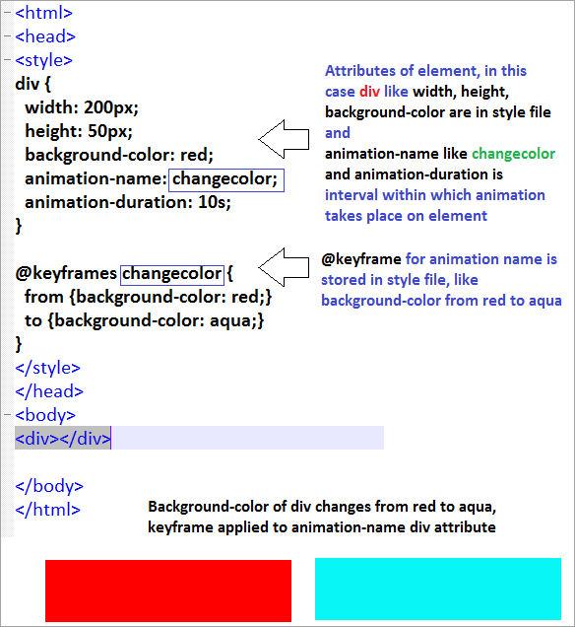](https://www.softwaretestinghelp.com/wp-content/qa/uploads/2020/10/cssanim-1.png)

CSS animation example change of color from red to aqua

****Q #27) Explain the purpose of each of the HTTP request types supported by RESTful Web services****

****Answer:**** ****In RESTful web service, each HTTP request type has a specific purpose. These are explained below:****

* ****GET**** is a type of request that retrieves data from the server.
* ****POST**** is a type of request used to submit fresh data form details and then upload a file.
* ****PUT**** is a request similar to POST but applied for updating an existing entity.
* ****DELETE**** is a request similar to PUT and is used to delete the resource from the server.
* ****TRACE**** is used to validate content received along with the network during a request.
* ****HEAD**** is similar to GET but receives response headers during the request.

****Q #28) What are the differences between Span and Div tag in HTML5?****

****Answer:**** Div and Span are both used to represent a particular section of the webpage, but both differ from each other as explained in the table below:

| **Div** | **Span** |
| --- | --- |
| Div is a block level element | Span is an inline element |
| Div tag is used to wrap sections of document | Span tag is used to wrap text and images in small portions |
| Div is used creating CSS based layouts | Span is used to add style to text |
| Div accepts align attribute | Span does not accept align attribute |

****Q #29) Explain Pseudo class in CSS with examples.****

****Answer:**** Pseudo class in cascading style sheets is a keyword applied to HTML element’s selectors, to add special style on HTML events like onblur, onclick, onchange, onhover etc., in reference to external factors like previous website visit from navigation history, position or movement of the mouse, form element’s content status.

****The syntax for Pseudo class:****

cssselector : pseudo-class { attribute: value; }

****Example:****

[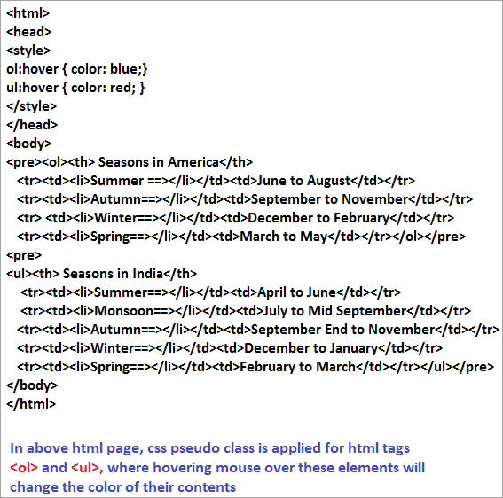](https://www.softwaretestinghelp.com/wp-content/qa/uploads/2020/10/pseudoclasscode.png)

****CSS pseudo-class in HTML page:****

[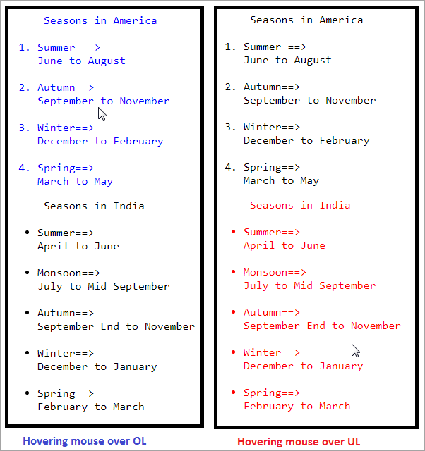](https://www.softwaretestinghelp.com/wp-content/qa/uploads/2020/10/effectofpseudo.png)

****Hovering mouse over different elements display effects of pseudo-class.****