1. What do you understand about cloud computing?
- Cloud computing refers to the usage of computing resources (servers) on the internet (refers to the term cloud) for the purpose of storing, managing, analyzing, and processing the data. Here, instead of maintaining our own servers, we use the infrastructure provided and maintained by third-party vendors such as Microsoft, AWS, etc, and pay them based on the server usage time duration.
- Cloud computing enhances the speed of execution, ensures flexibility of resources, and easier scalability.
- Cloud computing can be used to attain high fault tolerance and high system availability and this can also be done dynamically as per the infrastructural requirements of the application.
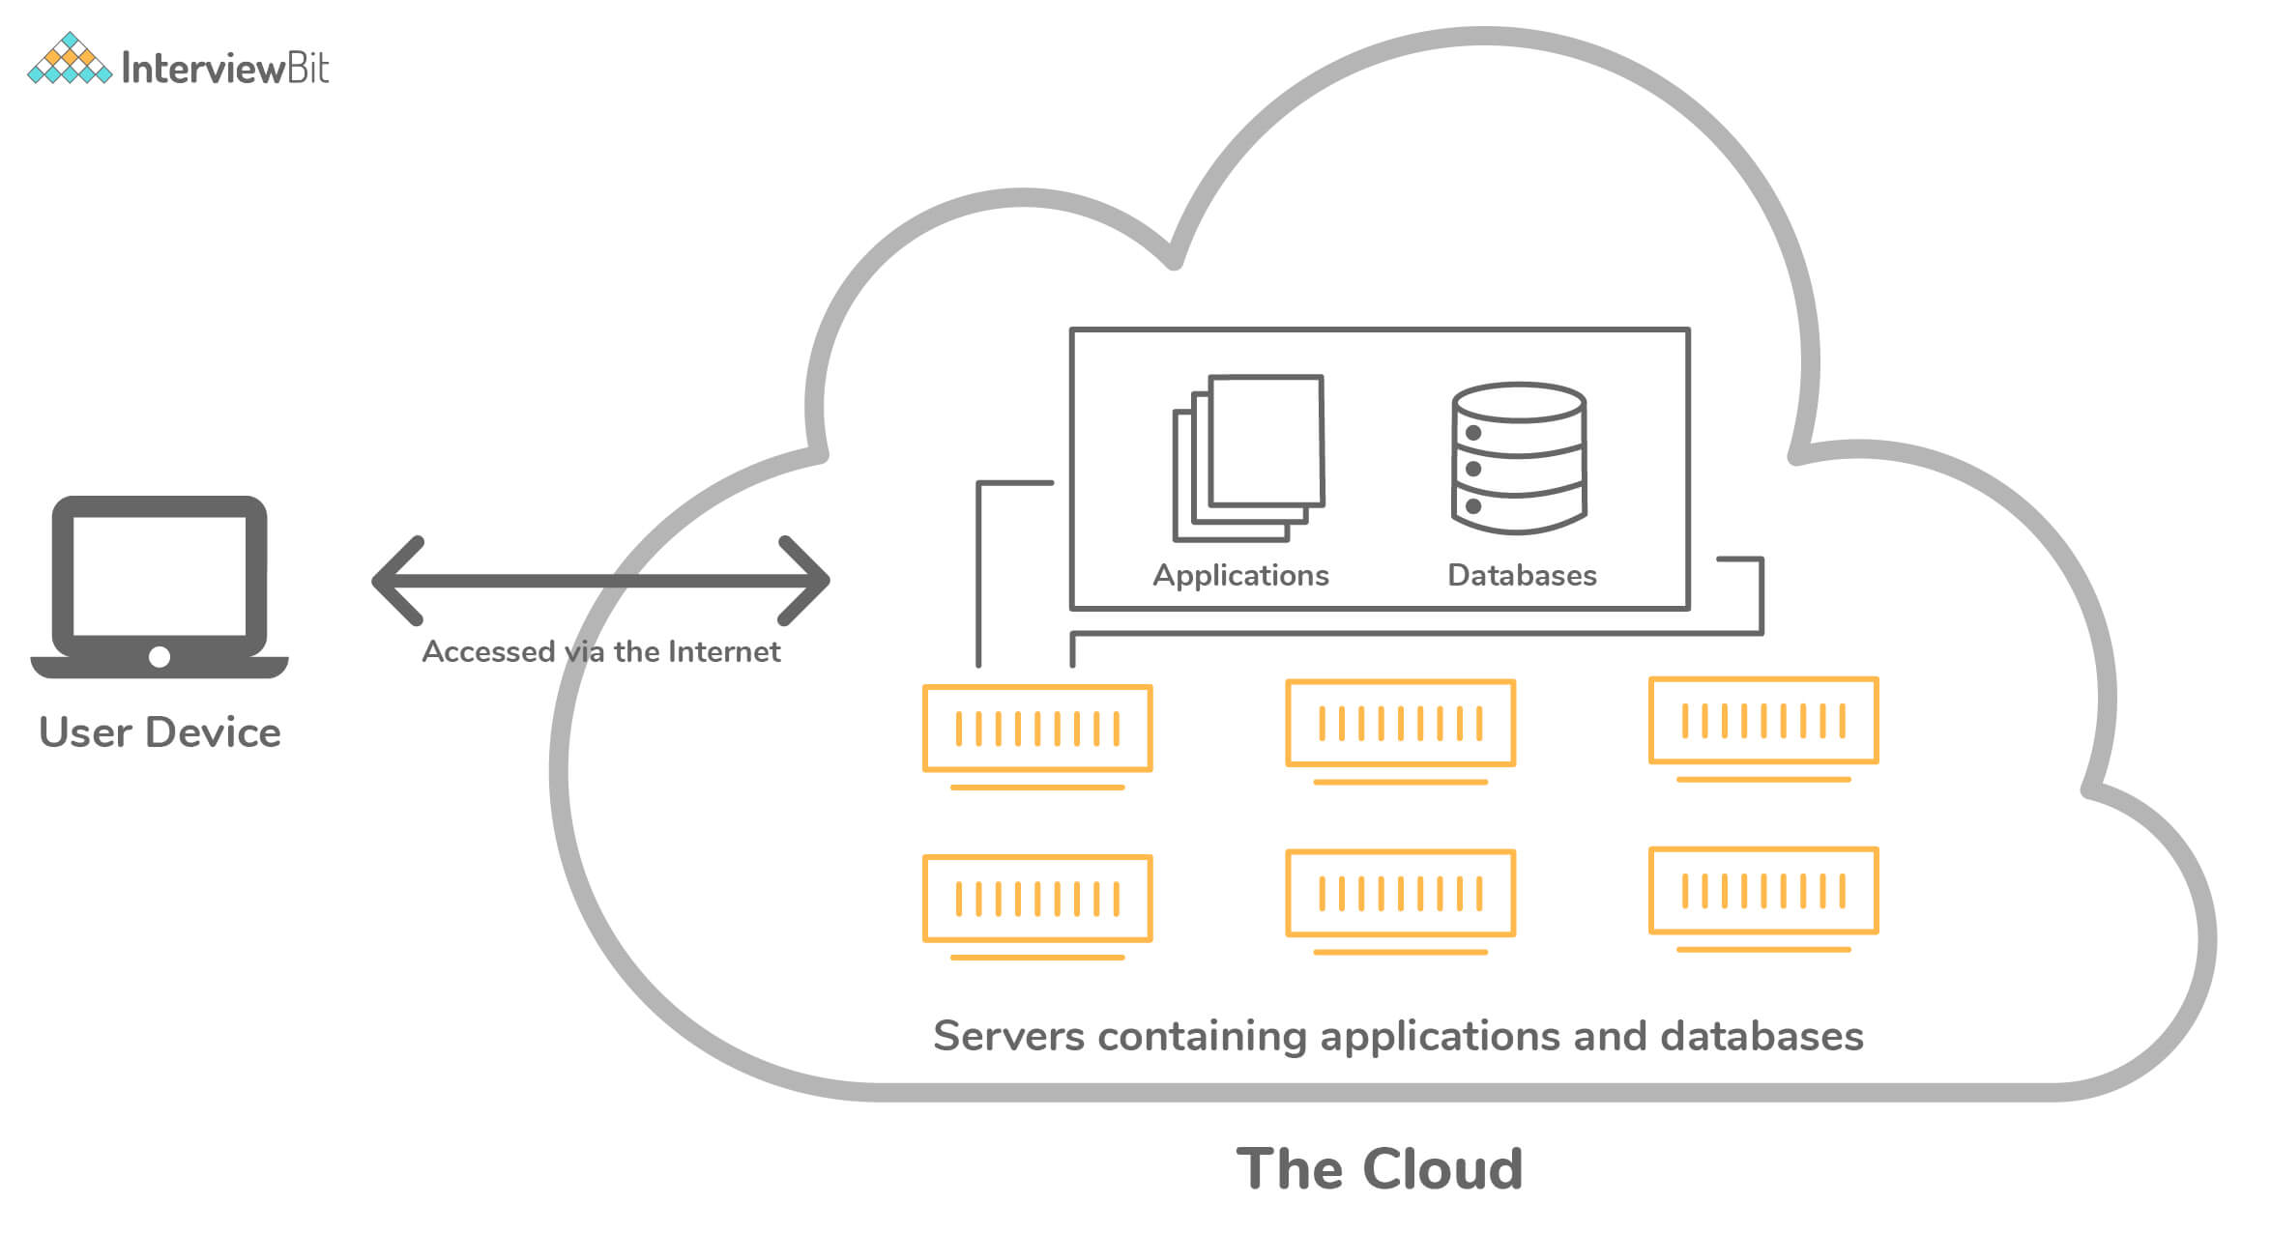Cloud Computing

2. Can you tell something about Azure Cloud Service?
- Azure Cloud Service is a classic example of a platform as a service (PaaS). This was designed to support those applications which demand high scalability, reliability, and availability all within the constraints of reduced cost of operations. These are hosted on virtual VMs and Azure provides more control over them by letting the developers install the necessary software and enabling them to control remotely.
- Azure cloud services are used for deploying multi-tier web-based applications in Azure by means of creating an instance of cloud service. It is also possible to define multiple roles such as web roles, worker roles, etc for the purpose of distributed processing. Azure cloud services help in the easier and flexible scalability of the application.
- Each role of the cloud service has its own purpose and thereby its own configuration and application files.
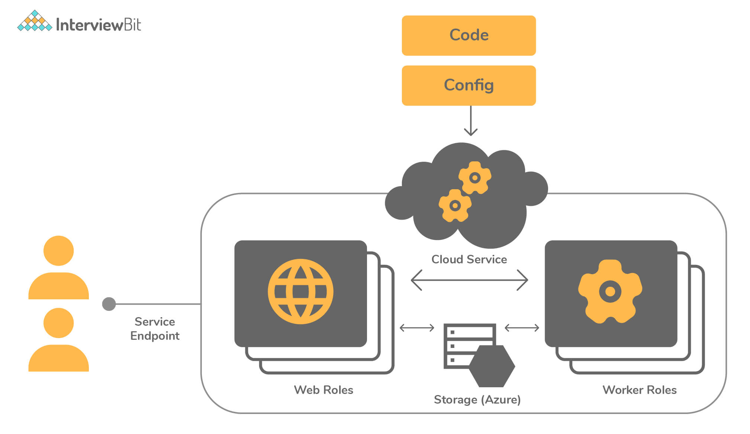Azure Cloud Service

3. What are the various models available for cloud deployment?
There are 3 models available for cloud deployment:
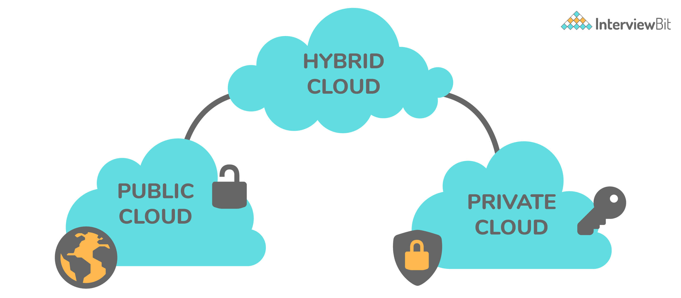Models For Cloud Deployment
- Public Cloud: In this model, the cloud infrastructure is owned publicly by the cloud provider and there are chances that the server resources could be shared between multiple applications.
- Private Cloud: Here, the cloud infrastructure is owned exclusively by us or exclusive service is provided by the cloud provider to us.
  - This includes hosting our applications on our own on-premise servers or hosting the application on a dedicated server provided by the cloud provider.
- Hybrid Cloud: As the name itself says, this model is the hybrid combination of private cloud and the public cloud.
  - This might include the scenario of using on-premise servers for processing confidential, sensitive data and using public cloud features for hosting public-facing applications.
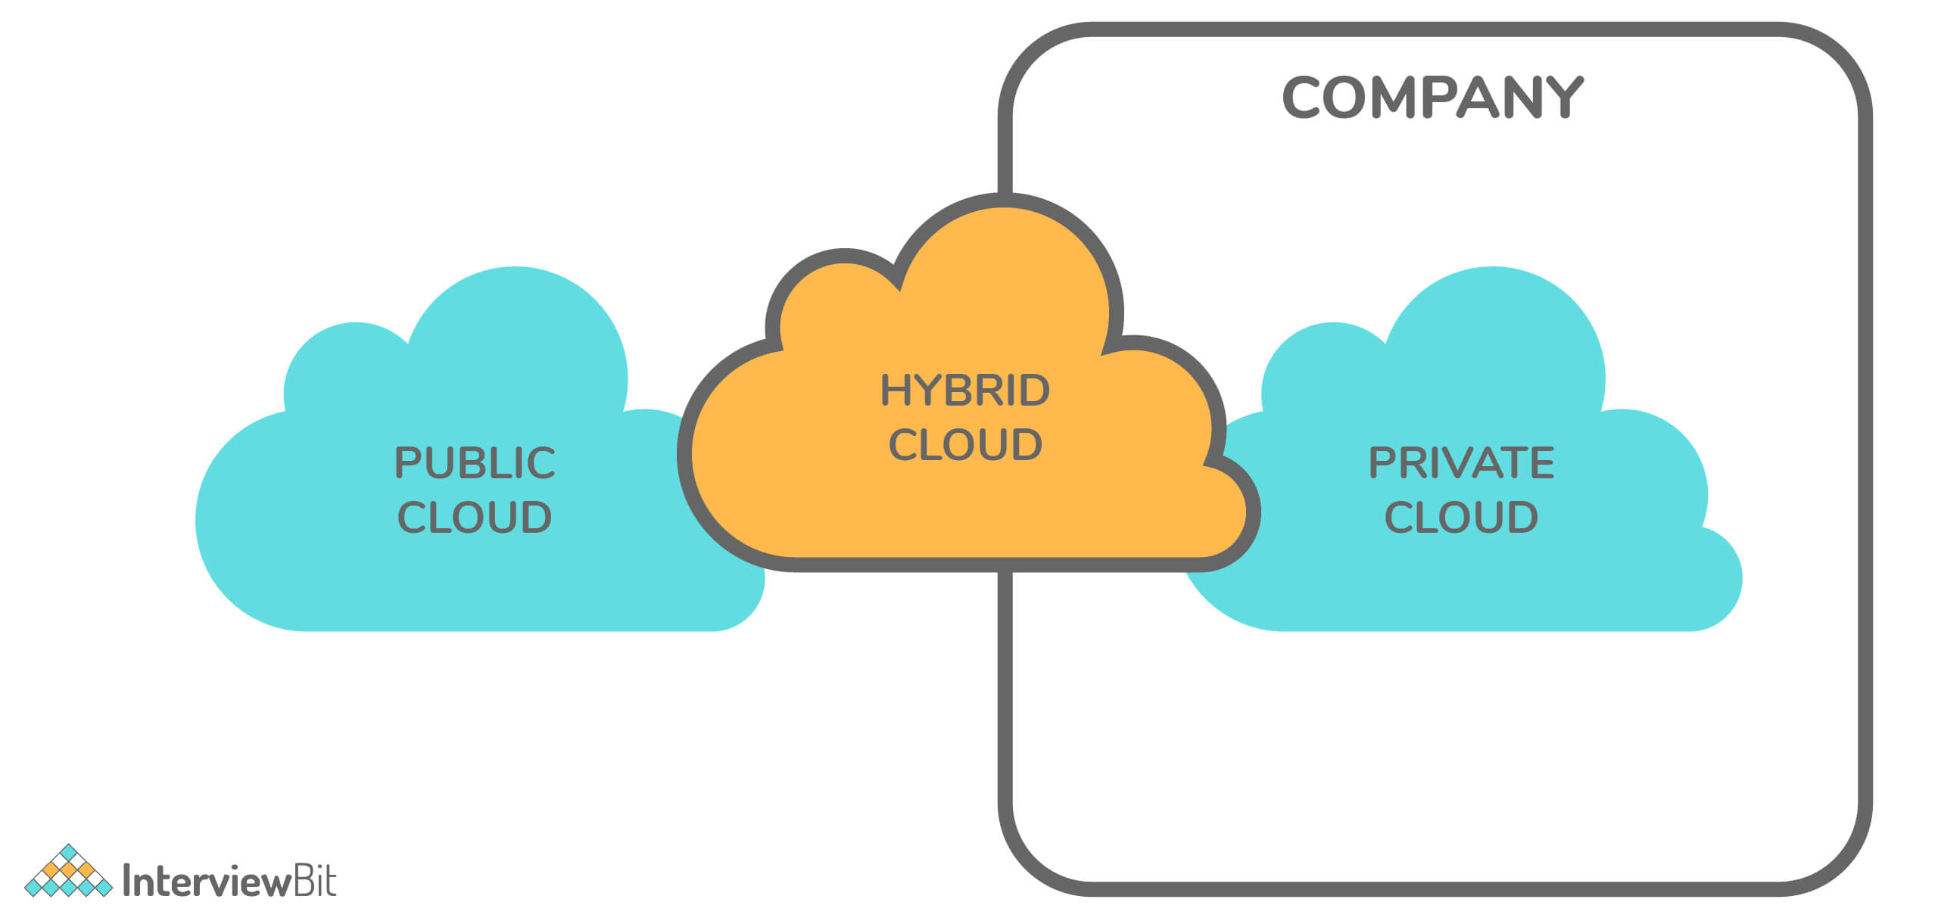Hybrid Cloud
Here, we use the best of both worlds to our requirements and advantage.

4. Define role instance in Azure.
A role instance is nothing but a virtual machine where the application code runs with the help of running role configurations. There can also be multiple instances of a role as per the definition in the cloud service configuration files.

5. How many cloud service roles are provided by Azure?
Cloud service roles comprise a set of application and configuration files. There are 2 kinds of roles provided by Azure:
- Web role: This provides a dedicated web server belonging to IIS (Internet Information Services) that is used for automatic deployment and hosting of front-end websites.
- Worker role: These roles help the applications hosted within them to run asynchronously for longer durations and are independent of the user interactions and generally do not use IIS. They are also ideal for performing background processes. The applications are run in a standalone manner.

6. Why is Azure Diagnostics API needed?
- Azure Diagnostics API helps us collect diagnostic data such as performance monitoring, system event logs, etc from the applications that are running on Azure.
- For the verbose monitoring of the data, Azure Diagnostics has to be enabled for the cloud service roles.
- The diagnostics data can be used for building visual chart representations for better monitoring and also for creating performance metric alerts.

7. Define Azure Service Level Agreement (SLA)?
- The Azure SLA is a contract that ensures or guarantees that when two or more role instances of a role are deployed on Azure, access to that cloud service is guaranteed for at least 99.95% of the time.
- It also states that if the role instance process is not in the running state, then the detection of such processes and corrective action for the same will be taken 99.9% percent of the time.
- If the mentioned guarantees are not satisfied at any point in time, then Azure credits a percentage of monthly fees to us depending on the pricing model of the respective Azure services.

8. What is Azure Resource Manager?
Azure Resource Manager is a service provided by Azure to provide management and application deployment in Azure.
The resource manager provides the management layer that helps the developer to create, modify or delete the resources in the Azure subscription account. This feature comes in handy when we have requirements like managing access controls, locks, ensuring the security of the resources post-deployment, and organization of those resources.

9. What is NSG?
NSG stands for Network Security Group that has a list of ACL (Access Control List) rules which either allows/denies network traffic to subnets or NICs (Network Interface Card) connected to a subnet or both. When NSG is linked with a subnet, then the ACL rules are applied to all the Virtual Machines in that subnet.
Restrictions of traffic to individual NIC can be done by associating NSG directly to that NIC.

10. VM creation is possible using Azure Resource Manager in a Virtual Network which was created by means of classic deployment. True or False?
False. Azure does not support this.

Intermediate Interview Questions

11. What is Azure Redis Cache?
- It is an open-source, in-memory Redis cache system provided and maintained by Azure.
- It helps the web applications to improve the performance by fetching data from the backend database and storing it into the Redis cache for the first request and then fetching data from the Redis cache for all subsequent requests.
- Azure Redis Cache provides powerful and secure caching mechanisms by making use of the Azure cloud.
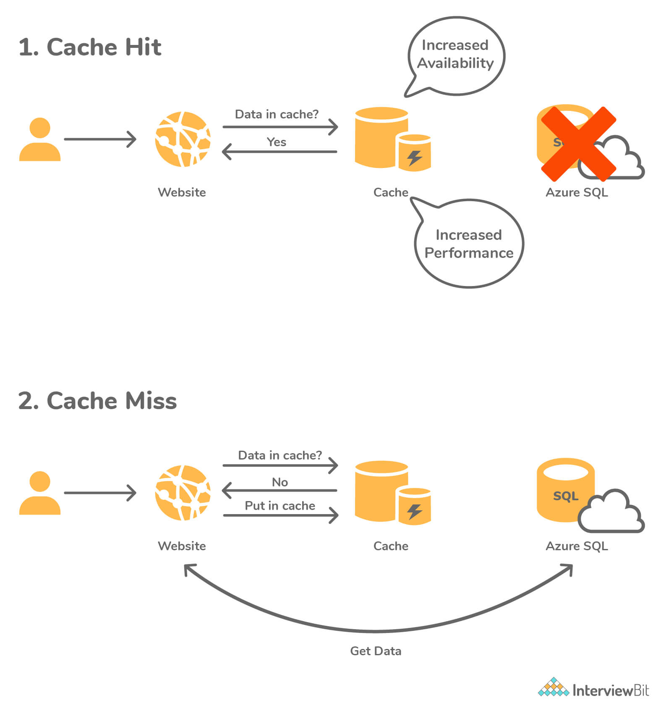Azure Redis Cache

12. Define Azure virtual machine scale sets
- These are the Azure computation resources that can be used to deploy and manage sets of identical Virtual Machines (VMs).
- These scale sets are configured in the same manner and are designed to support the autoscaling of the applications without the need for pre-provisioning of the VMs.
- They help to build large-scale applications targeting big data and containerized workloads in an easier manner.
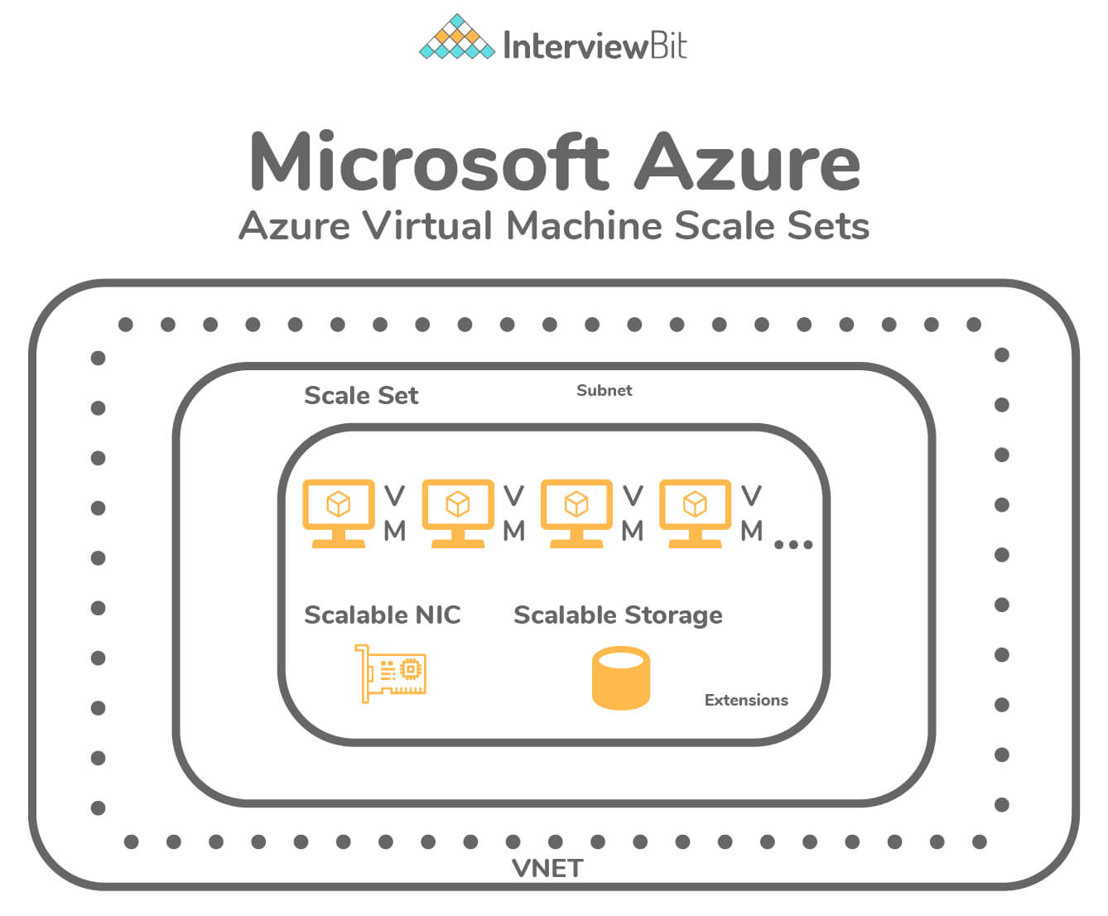Azure virtual machine

13. What do you understand about the “Availability Set”?
- Availability Set is nothing but a logical grouping of VMs (Virtual Machines) that allows Azure cloud to understand how the application was developed for providing availability and redundancy.
- Each VM in the availability set is assigned 2 kinds of domains by Azure:
  - Fault Domain: These define the grouping of VMs that would share a common power source and common network switch. The VMs within availability sets are separated across up to 3 fault domains by default. This separation of VMs in fault domains helps our applications to be available by reducing impacts of network outages, power interruptions, and certain hardware failures.
  - Update Domain: These indicate the grouping of VMs and underlying hardware which are eligible to be rebooted at the same time. Only one update domain can be rebooted at a time, however, the order of reboot does not proceed in a sequential manner. Before the maintenance of another update domain, the previously rebooted domain is given a recovery time of 30 minutes to ensure that the domain is up.
- Azure provides flexibility to configure up to 3 fault domains and 20 update domains for an availability set.
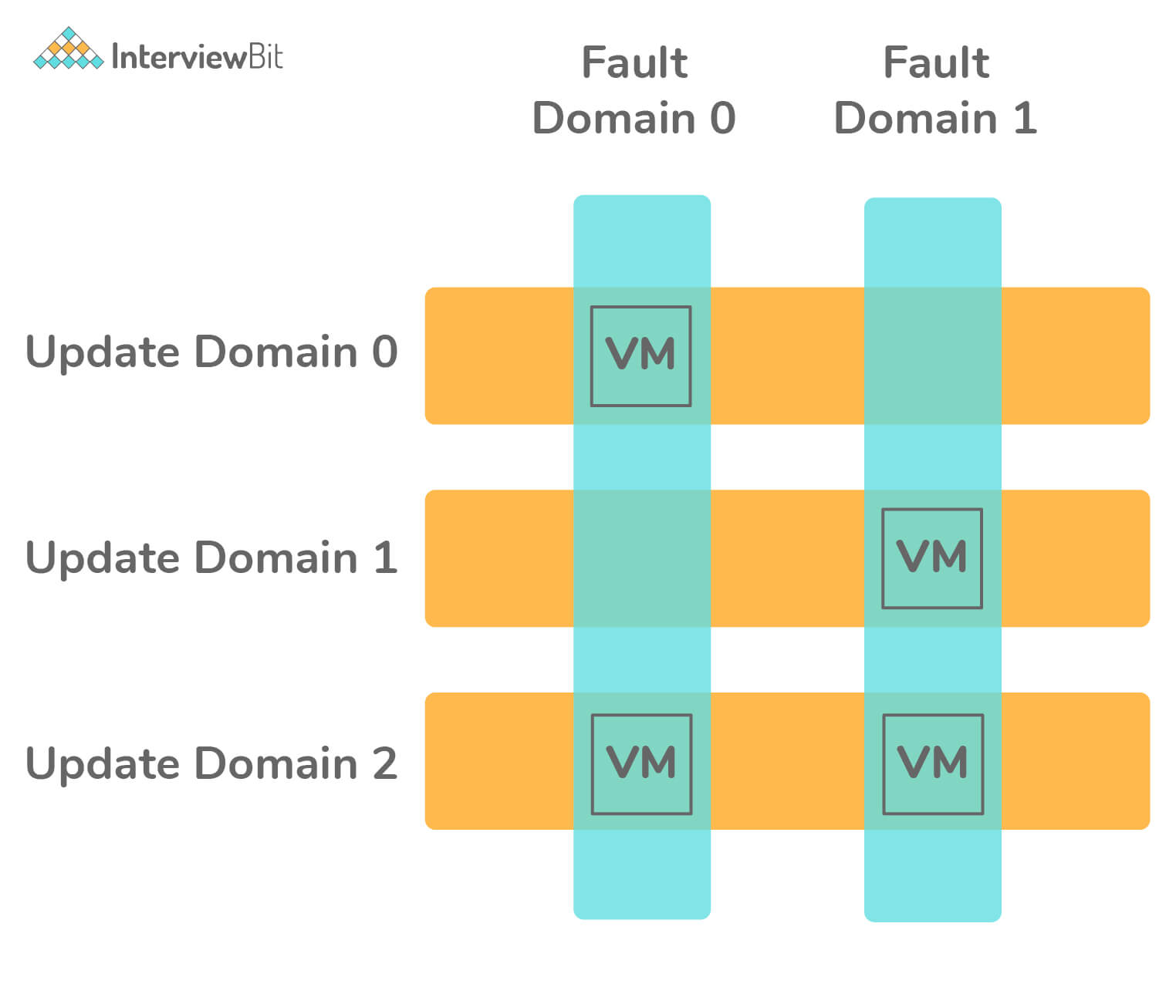Availability Set

14. What are the available options for deployment environments provided by Azure?
Azure provides two deployment environments, they are:
- Staging Environment: This environment is used for validating the changes of our application before making them live into the main environment.
  - Here, the application is identified by means of GUID (Globally Unique Identifier) of Azure which has the URL as: GUID.cloudapp.net
- Production Environment: This is the main environment where our application goes live and can be accessed by the target audience which can be accessed by means of DNS friendly URL: appName.cloudapp.net

15. What do you need to do when drive failure occurs?
The following steps need to be performed when the drive failure occurs:
- To make sure that the Azure Storage functions without fail, we need to ensure that the drive is not mounted.
- Replace the drive so that the drive gets remounted and formatted.

16. Is it possible to design applications that handle connection failure in Azure?
Yes, it is possible and is done by means of the Transient Fault Handling Block. There can be multiple causes of transient failures while using the cloud environment:
- Due to the presence of more load balancers, we can see that the application to database connections fail periodically.
- While using multi-tenant services, the calls get slower and eventually time out because other applications are using resources to hit the same resource heavily.
- The last cause can be we ourselves as the user trying to hit the resource very frequently which causes the service to deliberately deny the connection to us to support other tenants in the architecture.
Instead of showing errors to the user periodically, the application can recognize the errors that are transient and automatically try to perform the same operation again typically after some seconds with the hope of establishing the connection. By making use of the Transient Fault Handling Application Block mechanism, we can generate the retry intervals and make the application perform retries. In the majority of the cases, the error would be resolved on the second try and hence the user need not be made aware of these errors unnecessarily.
Following is the sample code that can be used for the retry policy. Here, if the connection is not successful, then the action is retried based on the retry policy defined. There are 3 retry strategies - Fixed Interval, Incremental Interval, Exponential Backoff Strategy.
/***
* Class to detect Transient Blocks - Here
* OperationCancelledException is
* detected and then the retry strategy is employed.
*/
internal class AppTransientDetection : ITransientErrorDetectionStrategy
{
bool IsTransient(Exception exception) =>
exception is OperationCanceledException;
}

/***
* Retry Strategy - Here Fixed Interval Strategy is employed and is retried for 5 times.
*/
RetryStrategy retryStrategy = new FixedInterval(retryCount: 5, retryInterval: TimeSpan.FromSeconds(2));

RetryPolicy retryPolicy = new RetryPolicy(new AppTransientDetection(), retryStrategy);
retryPolicy.ExecuteAction(() => {
try {
string commandText = @”USE FEDERATION User_Federation(ShardId =” + shardId + “) WITH RESET, FILTERING=ON”;
userEntity.Connection.Open();
userEntity.ExecuteStoreCommand(commandText);
} catch (Exception e) {
userEntity.Connection.Close();
SqlConnection.ClearAllPools();
}
});

17. Define azure storage key.
- Azure storage key is used for authentication for validating access for the azure storage service to control access of data based on the project requirements.
- 2 types of storage keys are given for the authentication purpose -
  - Primary Access Key
  - Secondary Access Key
- The main purpose of the secondary access key is for avoiding downtime of the website or application.

18. What is cspack in Azure?
It is a command-line tool that is used for generating service package files. The tool also helps in preparing the application for deployment in Microsoft Azure or compute emulator.
Every project of cloud service type has the .cscfg file which is basically the cloud service configuration file that is generated by means of cspack tool and is primarily used to store:
- The number of role instances for the deployment of each role in the project.
- The thumbprint of the certificates.
- User-defined configuration and settings.

19. What is the best Azure solution for executing the code without a server?
- Azure Functions service can be used for executing the code without a server.
- Serverless Azure Functions are used for simplifying complex orchestration and challenging resolutions. They are meant for being stateless and short-lived.
- They help to connect with other services without the need for hard coding of the integrations thereby making the development process faster.
- It helps the developer to write and concentrate on the business logic code thereby saving time and effort.
- They also provide the features of monitoring and analyzing code performance by means of Azure Application Insights that help in identifying bottlenecks and failure points across the components of the application.

20. What would be the best feature recommended by Azure for having a common file sharing system between multiple virtual machines?
Azure provides a service called Azure File System which is used as a common repository system for sharing the data across the Virtual Machines configured by making use of protocols like SMB, FTPS, NFS, etc.

21. Is it possible to login to a Linux Virtual Machine without using a password?
Yes, it is possible by making use of the Key Vault mapping to any Admin VM, we can log in to another VM without the need for a password.

22. What are the differences between Azure Scale Sets and Availability Sets?
The main difference between Azure Scale Sets and Availability Sets are given below:
Criteria | Azure Scale Sets | Azure Availability Sets
Definition | They are a group of identically configured VMs that are spread across multiple fault domains. | They are the group of discretely configured VMs that are spread across various fault domains.
Default Domain | These have 5 fault domains and update domains by default. | By default, these have 3 fault domains and 5 update domains.
Workload Type | These are used when there are unpredictable workloads that require the feature of auto scalability. | These are used when there are predictable workload requirements.
Configuration Style | Here, the VMs are configured and created in the same manner from the same image. | Here, the VMs are created by making use of different images and configurations.
VM Count | The number of VMs can be increased/decreased based on the demand or the pre-defined schedule. | A VM can be added to an availability set only at the time of the set’s creation.
Distribution style | Here, the VM scale sets can be distributed across multiple data centers or within a single data center. | Here, the VMs are automatically distributed in a data center.

23. What would happen when the maximum failed attempts are reached during the process of Azure ID Authentication?
In case of maximum failed attempts, the azure account would get locked and the method of locking is dependent on the protocol that analyzes the entered password and the IP addresses of the login requests.

24. Is it possible to get a public DNS or IP address for the Azure Internal Load Balancer?
No! As the name itself says, Azure Internal Load Balancer supports only Private IP addresses, and hence the assignment of a public IP address or DNS name is not possible.

25. What is Azure Blob Storage?
- Azure Blob storage is the object storage solution provided by Microsoft for the cloud. Blob stands for “Binary Large Object”. Blob-based storage is used to store massive unstructured data in terms of text or binary format. It is ideal for serving documents/images/audio/video/text directly to browser.
- The data stored in the blob storage is accessible from anywhere in the world. The blobs are tied to user accounts by grouping them into containers. The Azure Blob Service has 3 components:
  - Storage Account: This can be a General Storage Account or Blob Storage Account registered in Microsoft Azure.
  - Container: Container is used for grouping blobs. We can store an unlimited number of blobs in a container. The name of the container should start in lowercase.
  - Blob: A blob is a Binary Large Object like a file or document of any type and size. There are 3 kinds of Blobs supported by Azure:
    - Block blobs: These are intended for text and binary files and can support up to 195GB, i.e up to 50k blocks of up to 4MB each.
    - Append blobs: These are used for appending operations like logging data in log files.
    - Page blobs: These are meant for frequent read/write operations.
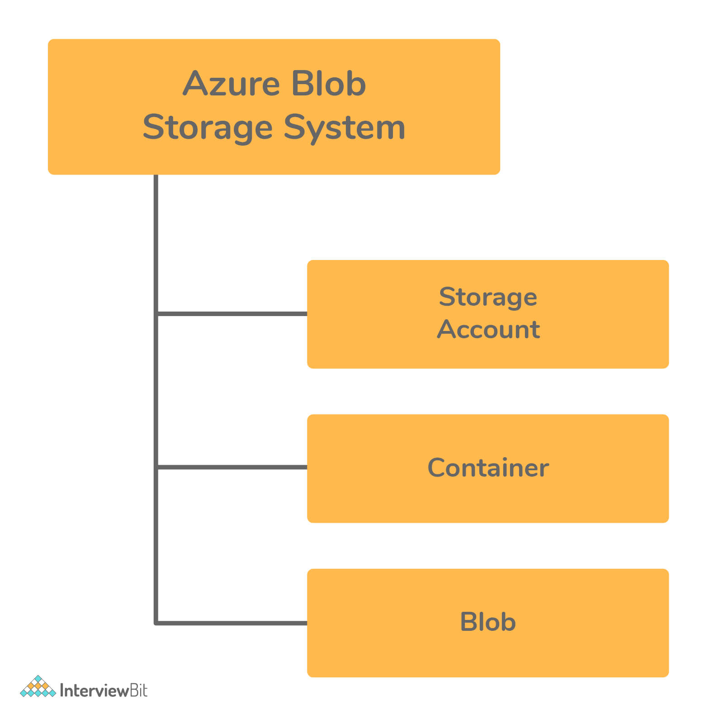Azure Blob Storage

Azure Interview Questions For Experienced

26. What do you understand by Azure Scheduler?
Azure Scheduler helps us to invoke certain background trigger events or activities like calling HTTP/S endpoints or to present a message on the queue on any schedule.
By using this Azure Schedule, the jobs present in the cloud call services present within and outside of the Azure to execute those jobs on-demand that are routinely on a repeated regular schedule or start those jobs at a future specified date.
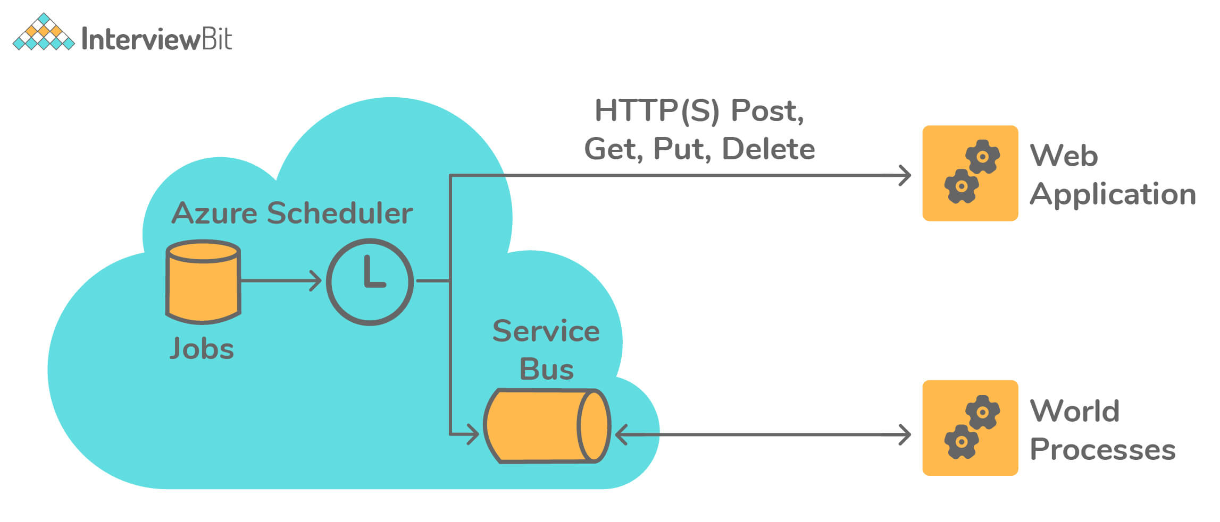Azure Scheduler

27. Is it possible to map the Windows machines running on two different port numbers, say 80 and 81, on an IIS Web Server to an Azure Load Balancer?
Yes, it can be done by defining a separate Load Balancer Role in Azure.

28. You have an application running on the On-Prem Server and have backup on Azure East US region. Now, On-Prem server application access fails. Is it possible to access the application via the Azure environment?
Yes, it is totally possible by making use of the Site Recovery Service provided by Azure. It is capable of handling fail-over and fail-back scenarios between On-Prem Servers and Azure environments.

29. What feature of Azure can be used to stop the issue of high load on the application in cases of no man support on the flow?
This issue can be stopped by making use of VM Scale sets by defining proper configuration and conditions to provision a new VM whenever the load to the application increases.
- Azure VM Scale Sets lets the developer create and manage a group of VMs that are load balanced. The scale sets can be configured in such a way that the count of VMs can automatically be increased or decreased based on the application demand or based on a pre-defined schedule.
- Usage of Scale Sets ensures high availability of the applications and allows the developers to manage, update and configure large VMs centrally and also help them support the development of large-scale applications supporting big data, big workloads, and compute loads.
- Azure scale sets can support up to 1,000 VMs. If the custom VM images are created and uploaded, then the limit is 600 VMs.

30. What are the types of storage services apart from blob storage provided by Azure?
Azure provides overall 4 types of storage services - Blob Service, Table Storage, Queue Storage, and File Storage Services as shown in the figure below:
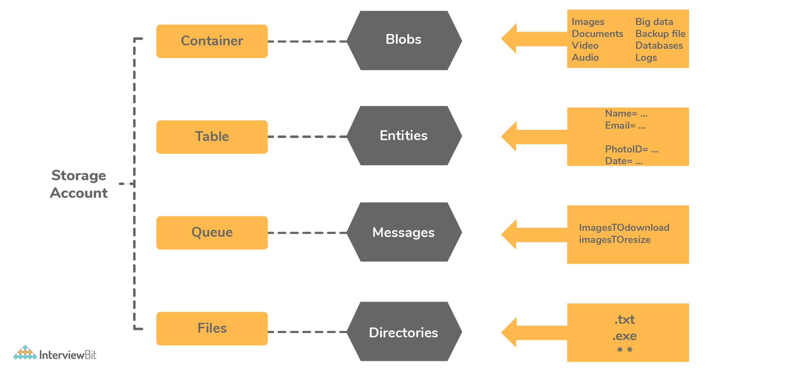Types of Storage Services
- Azure Table Storage: This type of storage lets user deploy their applications with semi-structured data and a NoSQL-based key-value store.
  - This is used when there is a need for applications that follow a flexible schema of data.
  - Table Storage focuses on enterprise-level data and follows strongly consistent models.
  - The data is represented in terms of Entities grouped under tables.
- Azure Queue Storage: This storage provides a message queue system for handling large workloads by letting users develop and build flexible and modular applications.
  - This storage ensures that the application becomes less prone to failure of individual components and is scalable.
  - With the help of message queues, it provides the queue monitoring feature for helping the application to ensure the user demands are met.
- Azure File Storage: This storage type provides features of file sharing that are accessible using SMB (Server Message Block) Protocol. The data in this storage is protected by HTTPS and SMB 3.0 Protocol.
  - They are used for improving the performance and capabilities of on-premise applications.
  - The OS deployments and hardware management is taken by Azure itself.

31. What are IaaS, PaaS and SaaS?
IaaS: This stands for “Infrastructure as a Service” which provides a set of capabilities like OS, network connectivities, etc which are at the infrastructural level and are delivered as pay per use policy. The infrastructure is used for hosting applications. Examples include Azure VM, VNET, etc.
PaaS: PaaS stands for “Platform as a Service” which is mostly about underlying infrastructure abstraction to the developers for enabling quicker development of the applications without the need for worry about hosting management. Examples include Azure web apps, Storage services, cloud services, etc.
SaaS: SaaS stands for “Software as a Service” and are those applications which are delivered using the service delivery model where the applications are simply consumed and used by an organization. These applications are generally mobilized by making the organization pay for their usage or through ads. Examples include applications like Office 365, Gmail, SharePoint Online, and so on.
The following table shows the difference between the On-Prem Service, IaaS, PaaS, and SaaS services. We can observe that as we go right, the level of control the developer or the user has over the application reduces.
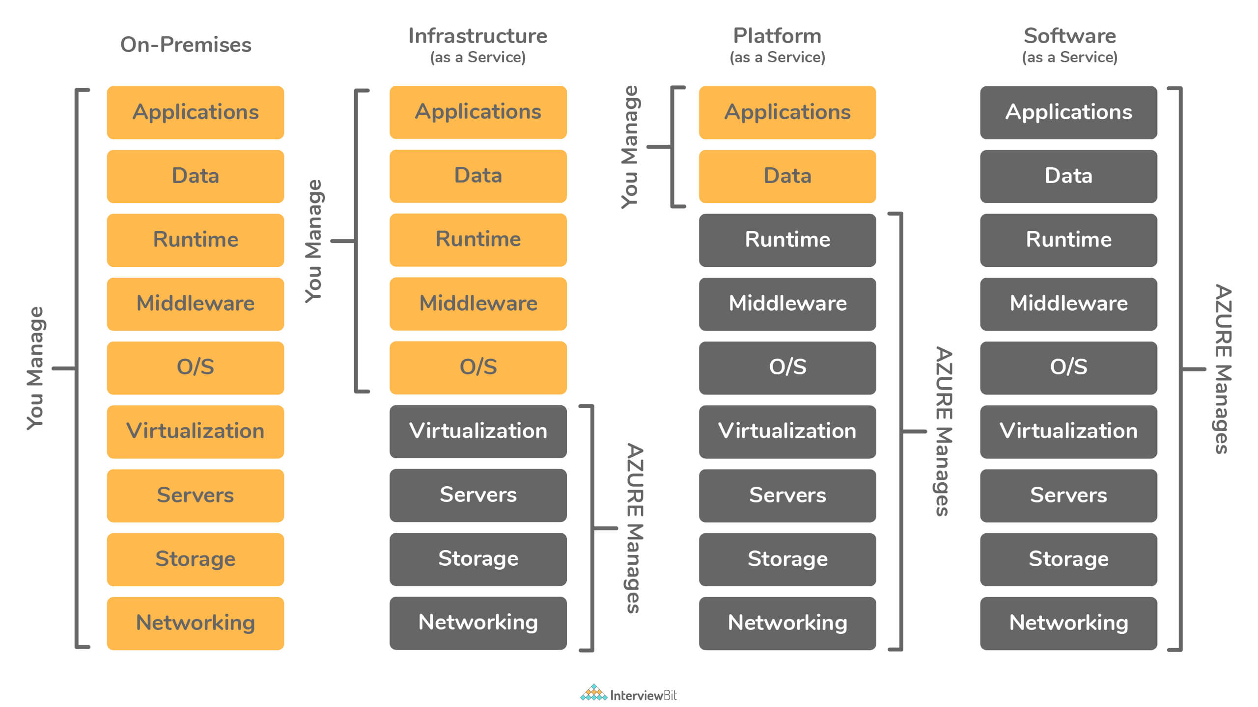IaaS, PaaS and SaaS

32. What are the differences between the Azure Table Storage and the Azure SQL service?
The main difference between Azure Table Storage and Azure SQL Service is given below:
Table Storage Service | Azure SQL Table
This follows a NoSQL type of storage on Azure. | This follows the relational storage structure on Azure.
The data is stored in key-value format and is referred to as Entity. | The data here is stored in rows and columns combination in the SQL table.
The data schema is not enforced for storage. | The data schema is enforced for storing data and if the schema violation occurs, then it results in an error.
The relationship between tables is not possible. | Relationships between tables are defined by means of the foreign keys.
The partition and row key combination are considered unique for each entity. | Uniqueness can be defined by the user by means of a primary key or unique key.
This service can be used for storing log information or diagnostics data. | This service is widely used for transaction-based applications.

33. Consider a scenario where an application front end hosting is done on Azure but the customer needs the database hosting to be done on on-premise server due to security concerns. What are the ways to handle the connectivity in Azure for this scenario?
- Possibility 1: Azure VNET based “Point to Site” service can be a correct choice for this scenario of connecting one on-premise DB to an Azure-hosted app. “Point to Site” is valid for cases where the count of resources to be connected via VPN is very limited.
- Possibility 2: In case there is a large number of resources for connection, then “Site to Site” or “Express routes” are the other options that could be considered.
  - There might be chances that using “Site to Site” might lead to network latency as VPN due to these work only via Internet (public infrastructure). In such cases, “Express Routes” are used as it provides dedicated leased line for overcoming latency issues.
- Possibility 3: In case the customer is not willing to work via VNET, then Windows Communication Foundation (WCF) service can be developed and hosted on-premise which would have CRUD operations meant only for the database hosted on-premise. This works by means of using the “Service bus relay” option for developing communication between the Azure-hosted app to the WCF service for database access.

34. What are the differences between the Azure Storage Queue and the Azure Service Bus Queue?
The main difference between Azure Storage Queue and the Azure Service Bus Queue is given below:
Azure Storage Queue | Azure Service Bus Queue
Here, the FIFO (First In First Out) ordering is not guaranteed. | The FIFO order is guaranteed for the messages by means of sessions.
Sessions are not supported. | Sessions that are messaging level are supported here.
Here, only the “At Least Once delivery” model is supported. | This supports “At least once”, “Atmost once” and “Exactly once” delivery models for the messages.
There is no automatic detection of duplicates here. | Automatic duplicate detection is supported here.
Does not support dead lettering. | Supports dead lettering.
The size of the message is 64KB. | The size of the message is 256KB.
Supports one-to-one delivery of messages. | Supports both one to one and one-to-many deliveries of messages.
The transaction is not supported. | The transaction is supported here.
This queue supports only batch receive. | This supports both batch send and batch receive of messages.
The behavior of receiving messages is non-blocking. | The behavior can be either blocking or non-blocking based on the configuration.

35. What are the possible causes of the client application to be disconnected from the cache?
There can be 2 possible causes:
- Client-side causes:
  - The application might have been redeployed.
  - The application might have just performed a scaling operation.
  - The client-side networking layer has been changed.
  - There might be transient errors in the client or the network between the client and the server.
  - Another possible reason could be the bandwidth threshold limits have been crossed.
- Server-side causes:
  - It might occur if the Azure Redis Cache service itself might undergo a failover from the primary to the secondary node.
  - The server instance where the cache was deployed might have undergone patching or maintenance.

36. How can a VM be created by means of Azure CLI?
az vm create `
--resource-group myResourceGroupName `
--name myVM --image win2016datacenter `
--admin-username AzureuserNAME `
--admin-password AzurePASSWORD

1. What are the different types of services offered in the cloud?
IAAS VS PAAS VS SAAS  IAAS | PAAS | SAAS
In infrastructure as a service, you get the raw hardware from your cloud provider as a service i.e you get a server which you can configure with your own will. | Platform as a Service, gives you a platform to publish without giving the access to the underlying software or OS. | You get software as a service in Azure, i.e no infrastructure, no platform, simple software that you can use without purchasing it.
For Example: Azure VM, Amazon EC2. | For example: Web Apps, Mobile Apps in Azure. | For example: when you launch a VM on Azure, you are not buying the OS, you are basically renting it for the time you will be running that instance.

2. What is cloud computing?
Explanation: It is the use of servers on the internet to “store”, “manage” and “process” data. The difference is, instead of using your own servers, you are using someone else’s servers to do your task, paying them for the amount of time you use it for.

3. What are the different cloud deployment models?
Explanation: Following are the three cloud deployment models:



Microsoft Azure Certification Training Course (AZ 305)
Explore Curriculum

Public Cloud: The infrastructure is owned by your cloud provider and the server that you are using could be a multi-tenant system.
Private Cloud: The infrastructure is owned by you or your cloud provider gives you that service exclusively. For eg: Hosting your website on your servers, or hosting your website with the cloud provider on a dedicated server.
Hybrid Cloud: When you use both Public Cloud, Private Cloud together, it is called Hybrid Cloud. For Example: Using your in-house servers for confidential data, and the public cloud for hosting your company’s public facing website. This type of setup would be a hybrid cloud.

4. I have some private servers on my premises, also I have distributed some of my workload on the public cloud, what is this architecture called?
- Virtual Private Network
- Private Cloud
- Virtual Private Cloud
- Hybrid Cloud
Answer: D. Hybrid Cloud
Explanation: This type of architecture would be a hybrid cloud. Why? Because we are using both, the public cloud, and on premises servers i.e the private cloud. To make this hybrid architecture easy to use, wouldn’t it be better if your private and public cloud were all on the same network (virtually). This is established by including your public cloud servers in a virtual private cloud, and connecting virtual cloud with your on premise servers using a VPN (Virtual Private Network).
Apart from this Azure Interview Questions Blog, if you want to get trained from professionals on this technology, you can opt for a structured training from edureka! Click below to know more.

Section 2: Basic Azure Questions and Answers for Freshers

5. What is Microsoft Azure and why is it used?
Explanation: As discussed above, the companies which provide the cloud service are called the Cloud Providers. There are a lot of cloud providers out there, out of them one is Microsoft Azure. It is used for accessing Microsoft’s infrastructure for cloud.

6. Which service in Azure is used to manage resources in Azure?
- Application Insights
- Azure Resource Manager
- Azure Portal
- Log Analytics
Answer: B Azure Resource Manager
Explanation: Azure Resource Manager is used to “manage” infrastructures which involve a no. of azure services. It can be used to deploy, manage and delete all the resources together using a simple JSON script.

7. Which of the following web applications can be deployed with Azure?
- ASP.NET
- PHP
- WCF
- All of the mentioned
Answer: D All of the mentioned
Explanation: Microsoft also has released SDKs for both Java and Ruby to allow applications written in those languages to place calls to the Azure Service Platform API to the AppFabric Service.

Section 3: Azure Interview Questions and Answers for Experienced Professional

8. What are Roles and why do we use them?
Explanation: Roles are nothing servers in layman terms. These servers are managed, load balanced, Platform as a Service virtual machines that work together to achieve a common goal.
There are 3 types of roles in Microsoft Azure:

Cloud Computing Training
- Web Role
- Worker Role
- VM Role
Let’s discuss each of these roles in detail:
- Web Role – A web role is basically used to deploy a website, using languages supported by the IIS platform like, PHP, .NET etc. It is configured and customized to run web applications.
- Worker Role – A worker role is more like an help to the Web role, it used to execute background processes unlike the Web Role which is used to deploy the website.
- VM Role – The VM role is used by a user to schedule tasks and other windows services. This role can be used to customize the machines on which the web and worker role is running.

9. A _________ role is a virtual machine instance running Microsoft IIS Web server that can accept and respond to HTTP or HTTPS requests.
- Web
- Server
- Worker
- Client
Answer: A. Web
Explanation: The answer should be Web Roles, there are no roles such as Server or Client roles. Also, Worker roles can only communicate with Azure Storage or through direct connections to clients.
Apart from this Azure Interview Questions Blog, if you want to get trained from professionals on this technology, you can opt for a structured training from edureka! Click below to know more.

10. Is it possible to create a Virtual Machine using Azure Resource Manager in a Virtual Network that was created using classic deployment?
Explanation: This is not supported. You cannot use Azure Resource Manager to deploy a virtual machine into a virtual network that was created using classic deployment.

11. What are virtual machine scale sets in Azure?
Explanation: Virtual machine scale sets are Azure compute resource that you can use to deploy and manage a set of identical VMs. With all the VMs configured the same, scale sets are designed to support true autoscale, and no pre-provisioning of VMs is required. So it’s easier to build large-scale services that target big compute, big data, and containerized workloads.

12. Are data disks supported within scale sets?
Explanation: Yes. A scale set can define an attached data disk configuration that applies to all VMs in the set. Other options for storing data include:
- Azure files (SMB shared drives)
- OS drive
- Temp drive (local, not backed by Azure Storage)
- Azure data service (for example, Azure tables, Azure blobs)
- External data service (for example, remote database)

13. What is an Availability Set?
Explanation: An availability set is a logical grouping of VMs that allows Azure to understand how your application is built to provide redundancy and availability. It is recommended that two or more VMs are created within an availability set to provide for a highly available application and to meet the 99.95% Azure SLA. When a single VM is used with Azure Premium Storage, the Azure SLA applies for unplanned maintenance events.
Apart from this Azure Interview Questions Blog, if you want to get trained from professionals on this technology, you can opt for a structured training from edureka! Click below to know more.

14. What are Fault Domains?
Explanation: A fault domain is a logical group of underlying hardware that share a common power source and network switch, similar to a rack within an on-premise data-centers. As you create VMs within an availability set, the Azure platform automatically distributes your VMs across these fault domains. This approach limits the impact of potential physical hardware failures, network outages, or power interruptions.

15. What are Update Domains?
Explanation: An update domain is a logical group of underlying hardware that can undergo maintenance or can be rebooted at the same time. As you create VMs within an availability set, the Azure platform automatically distributes your VMs across these update domains. This approach ensures that at least one instance of your application always remains running as the Azure platform undergoes periodic maintenance. The order of update domains being rebooted may not proceed sequentially during planned maintenance, but only one update domain is rebooted at a time.



Microsoft Azure Certification Training Course (AZ 305)
Weekday / Weekend BatchesSee Batch Details

16. What are Network Security Groups?
Explanation: A network security group (NSG) contains a list of Access Control List (ACL) rules that allow or deny network traffic to subnets, NICs, or both. NSGs can be associated with either subnets or individual NICs connected to a subnet. When an NSG is associated with a subnet, the ACL rules apply to all the VMs in that subnet. In addition, traffic to an individual NIC can be restricted by associating an NSG directly to a NIC.

17. Do scale sets work with Azure availability sets?
Explanation: Yes. A scale set is an implicit availability set with 5 fault domains and 5 update domains. Scale sets of more than 100 VMs span multiple placement groups, which are equivalent to multiple availability sets. An availability set of VMs can exist in the same virtual network as a scale set of VMs. A common configuration is to put control node VMs (which often require unique configuration) in an availability set and put data nodes in the scale set.
Want to upskill yourself to get ahead in your career? Check out this video

Top 10 Technologies to Learn in 2022 | Edureka

18. What is a break-fix issue?
Explanation: Technical problems are called break-fix issue, it is an industry term which refers to “work involved in supporting a technology when it fails in the normal course of its function, which requires intervention by a support organization to be restored to working order”.

19. Why is Azure Active Directory used?
Explanation: Azure Active Directory is an Identity and Access Management system. It is used to grant access to your employees to specific products and services in your network. For example: Salesforce.com, twitter etc. Azure AD has some in-built support for applications in its gallery which can be added directly.

20. What happens when you exhaust the maximum failed attempts for authenticating yourself via Azure AD?
Explanation: We use a more sophisticated strategy to lock accounts. This is based on the IP address of the request and the passwords entered. The duration of the lockout also increases based on the likelihood that it is an attack.

21. Where can I find a list of applications that are pre-integrated with Azure AD and their capabilities?
Explanation: Azure AD has around 2600 pre-integrated applications. All pre-integrated applications support single sign-on (SSO). SSO let you use your organizational credentials to access your apps. Some of the applications also support automated provisioning and de-provisioning.
Apart from this Azure Interview Questions Blog, if you want to get trained from professionals on this technology, you can opt for a structured training from edureka! Click below to know more.

22. How can I use applications with Azure AD that I’m using on-premises?
Explanation: Azure AD gives you an easy and secure way to connect to the web applications you choose. You can access these applications in the same way you access your SaaS apps in Azure AD, no need for a VPN to change your network infrastructure.

23. What is Azure Service Fabric?
Explanation: Azure Service Fabric is a distributed systems platform that makes it easy to package, deploy, and manage scalable and reliable micro-services. Service Fabric also addresses the significant challenges in developing and managing cloud applications. Developers and administrators can avoid complex infrastructure problems and focus on implementing mission-critical, demanding workloads that are scalable, reliable, and manageable. Service Fabric represents the next-generation middleware platform for building and managing these enterprise-class, tier-1, cloud-scale applications.

24. What is a VNet?
Explanation: VNet is a representation of your own network in the cloud. It logically isolates your instances launched in the cloud, from the rest of your resources.

25. What are the differences between Subscription Administrator and Directory Administrator?
Explanation: By default, one is assigned the Subscription Administrator role when he/she signs up for Azure. A subscription admin can use either a Microsoft account or a work or school account from the directory that the Azure subscription is associated with. This role is authorized to manage services in the Azure portal. If others need to sign in and access services by using the same subscription, you can add them as co-admins.
Azure AD has a different set of admin roles to manage the directory and identity-related features. These admins will have access to various features in the Azure portal or the Azure classic portal. The admin’s role determines what they can do, like create or edit users, assign administrative roles to others, reset user passwords, manage user licenses, or manage domains.

26. Are there any scale limitations for customers using managed disks?
Explanation: Managed Disks eliminates the limits associated with storage accounts. However, the number of managed disks per subscription is limited to 2000 by default.

27. What is the difference between Service Bus Queues and Storage Queues?
Explanation: The Azure Storage Queue is simple and the developer experience is quite good. It uses the local Azure Storage Emulator and debugging is made quite easy. The tooling for Azure Storage Queues allows you to easily peek at the top 32 messages and if the messages are in XML or Json, you’re able to visualize their contents directly from Visual Studio Furthermore, these queues can be purged of their contents, which is especially useful during development and QA efforts.
The Azure Service Bus Queues are evolved and surrounded by many useful mechanisms that make it enterprise-worthy! They are built into the Service Bus and are able to forward messages to other Queues and Topics. They have a built-in dead-letter queue and messages have a time to live that you control, hence messages don’t automatically disappear after 7 days.
Furthermore, Azure Service Bus Queues have the ability of deleting themselves after a configurable amount of idle time. This feature is very practical when you create Queues for each user, because if a user hasn’t interacted with a Queue for the past month, it automatically gets clean it up. Its also a great way to drive costs down. You shouldn’t have to pay for storage that you don’t need. These Queues are limited to a maximum of 80gb. Once you’ve reached this limit your application will start receiving exceptions.
Find out our Microsoft Azure Training in Top Cities/Countries
India | USA | Other Cities/Countries
Bangalore | New York | UK
Hyderabad | Chicago | London
Delhi | Atlanta | Canada
Chennai | Houston | Toronto
Mumbai | Los Angeles | Australia
Pune | Boston | UAE
Kolkata | Miami | Dubai
Ahmedabad | San Francisco | Philippines

28. What is Azure Redis Cache?
Redis is an open source (BSD licensed), in-memory data structure store, used as a database, cache and message broker. Azure Redis Cache is based on the popular open-source Redis cache. It gives you access to a secure, dedicated Redis cache, managed by Microsoft, and accessible from any application within Azure. It supports data structures such as strings, hashes, lists, sets, sorted sets with range queries, bitmaps, hyperloglogs and geospatial indexes with radius queries.
Apart from this Azure Interview Questions Blog, if you want to get trained from professionals on this technology, you can opt for a structured training from edureka! Click below to know more.

29. Why doesn’t Azure Redis Cache have an MSDN class library reference like some of the other Azure services?
Explanation: Microsoft Azure Redis Cache is based on the popular open source Redis Cache and can be accessed by a wide variety of Redis clients for many programming languages. Each client has its own API that makes calls to the Redis cache instance using Redis commands.
Because each client is different, there is not one centralized class reference on MSDN, and each client maintains its own reference documentation. In addition to the reference documentation, there are several tutorials showing how to get started with Azure Redis Cache using different languages and cache clients. To access these tutorials, see How to use Azure Redis Cache and click the desired language from the language switcher at the top of the article.

30. What are Redis databases?
Explanation: Redis Databases are just a logical separation of data within the same Redis instance. The cache memory is shared between all the databases and actual memory consumption of a given database depends on the keys/values stored in that database. For example, a C6 cache has 53 GB of memory. You can choose to put all 53 GB into one database or you can split it up between multiple databases.

31. Is it possible to add an existing VM to an availability set?
Explanation: No. If you want your VM to be part of an availability set, you need to create the VM within the set. There currently no way to add a VM to an availability set after it has been created.

32. What are the username requirements when creating a VM?
Explanation: Usernames can be a maximum of 20 characters in length and cannot end in a period (“.”).
The following usernames are not allowed:
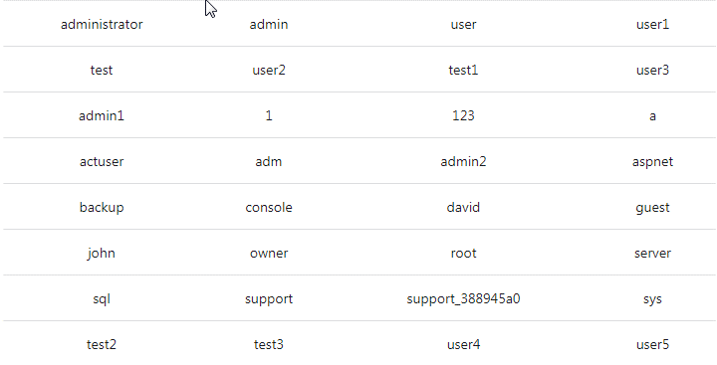

33. What are the password requirements when creating a VM?
Explanation: Passwords must be 12 – 123 characters in length and meet 3 out of the following 4 complexity requirements:
- Have lower characters
- Have upper characters
- Have a digit
- Have a special character (Regex match [W_])
The following passwords are not allowed:
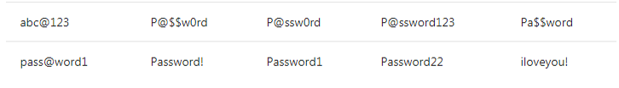
Apart from this Azure Interview Questions Blog, if you want to get trained from professionals on this technology, you can opt for a structured training from edureka! Click below to know more.

34. How much storage can I use with a virtual machine?
Explanation: Each data disk can be up to 1 TB. The number of data disks which you can use depends on the size of the virtual machine.
Azure Managed Disks are the new and recommended disk storage offerings for use with Azure Virtual Machines for persistent storage of data. You can use multiple Managed Disks with each Virtual Machine. Managed Disks offer two types of durable storage options: Premium and Standard Managed Disks.
Azure storage accounts can also provide storage for the operating system disk and any data disks. Each disk is a .vhd file stored as a page blob.

35. How can one create a Virtual Machine in Powershell?
# Define a credential object $cred = Get-Credential # Create a virtual machine configuration $vmConfig = New-AzureRmVMConfig -VMName myVM -VMSize Standard_DS2 |
` Set-AzureRmVMOperatingSystem -Windows -ComputerName myVM -Credential $cred |
` Set-AzureRmVMSourceImage -PublisherName MicrosoftWindowsServer -Offer WindowsServer `
-Skus 2016-Datacenter -Version latest | Add-AzureRmVMNetworkInterface -Id $nic.Id

36. How to create a Network Security Group and a Network Security Group Rule?
# Create an inbound network security group rule for port 3389$nsgRuleRDP = New-AzureRmNetworkSecurityRuleConfig -Name myNetworkSecurityGroupRuleRDP -Protocol Tcp `
-Direction Inbound -Priority 1000 -SourceAddressPrefix * -SourcePortRange * -DestinationAddressPrefix * `
-DestinationPortRange 3389 -Access Allow
# Create an inbound network security group rule for port 80$nsgRuleWeb = New-AzureRmNetworkSecurityRuleConfig -Name myNetworkSecurityGroupRuleWWW -Protocol Tcp `
-Direction Inbound -Priority 1001 -SourceAddressPrefix * -SourcePortRange * -DestinationAddressPrefix * `
-DestinationPortRange 80 -Access Allow
# Create a network security group$nsg = New-AzureRmNetworkSecurityGroup -ResourceGroupName myResourceGroup -Location EastUS `
-Name myNetworkSecurityGroup -SecurityRules $nsgRuleRDP,$nsgRuleWeb

37. How to create a new storage account and container using Power Shell?
$storageName = "st" + (Get-Random)
New-AzureRmStorageAccount -ResourceGroupName "myResourceGroup" -AccountName $storageName -Location "West US" -SkuName "Standard_LRS" -Kind Storage$accountKey = (Get-AzureRmStorageAccountKey -ResourceGroupName myResourceGroup -Name $storageName).Value[0]$context = New-AzureStorageContext -StorageAccountName $storageName -StorageAccountKey $accountKey
New-AzureStorageContainer -Name "templates" -Context $context -Permission Container

38. How can one create a VM in Azure CLI?
az vm create ` --resource-group myResourceGroup ` --name myVM --image win2016datacenter ` --admin-username azureuser ` --admin-password myPassword12
Apart from this Azure Interview Questions Blog, if you want to get trained from professionals on this technology, you can opt for a structured training from edureka! Click below to know more.

39. What are the various power states of a VM?
Power State | Description
Starting | Indicates the virtual machine is being started
Running | Indicates that the virtual machine is running
Stopping | Indicates that the virtual machine is being stopped
Stopped | Indicates that the virtual machine is stopped
Deallocating | Indicates that the virtual machine is being deallocated
Deallocated | Indicates that the virtual machine is completely removed from the hypervisor but still available in the control plane. Virtual Machines in the deallocated state do not incur compute charges.

40. How can you retrieve the state of a particular VM?
Get-AzureRmVM `
-ResourceGroupName myResourceGroup `
-Name myVM `
-Status | Select @{n="Status"; e={$_.Statuses[1].Code}}

41. How can you stop a VM using Power Shell?
Stop-AzureRmVM -ResourceGroupName myResourceGroupVM -Name "myVM" -Force

42. Why was my client disconnected from the cache?
Explanation: The following are some common reason for a cache disconnect.
- Client-side causes
  - The client application was redeployed.
  - The client application performed a scaling operation.
  - In the case of Cloud Services or Web Apps, this may be due to auto-scaling.
  - The networking layer on the client side changed.
  - Transient errors occurred in the client or in the network nodes between the client and the server.
  - The bandwidth threshold limits were reached.
  - CPU bound operations took too long to complete.
- Server-side causes
  - On the standard cache offering, the Azure Redis Cache service initiated a fail-over from the primary node to the secondary node.
  - Azure was patching the instance where the cache was deployed
  - This can be for Redis server updates or general VM maintenance.

43. What is Azure Search?
Explanation: Azure Search is a cloud search-as-a-service solution that delegates server and infrastructure management to Microsoft, leaving you with a ready-to-use service that you can populate with your data and then use to add search to your web or mobile application. Azure Search allows you to easily add a robust search experience to your applications using a simple REST API or .NET SDK without managing search infrastructure or becoming an expert in search.

44. My web app still uses an old Docker container image after I’ve updated the image on Docker Hub. Does Azure support continuous integration/deployment of custom containers?
Explanation: Yes, it does. For private registries, you can update the container by stopping and then re-starting your web app. Alternatively, you can also change or add a dummy application setting to force an update of your container.
Apart from this Azure Interview Questions Blog, if you want to get trained from professionals on this technology, you can opt for a structured training from edureka! Click below to know more.

45. What are the expected values for the Startup File section when I configure the runtime stack?
Explanation: For Node.Js, you specify the PM2 configuration file or your script file. For .NET Core, specify your compiled DLL name. For Ruby, you can specify the Ruby script that you want to initialize your app with.

46. How are Azure Marketplace subscriptions priced?
Explanation:
Pricing will vary based on product types. ISV software charges and Azure infrastructure costs are charged separately through your Azure subscription. Pricing models include:
BYOL Model: Bring-your-own-license. You obtain outside of the Azure Marketplace, the right to access or use the offering and are not charged Azure Marketplace fees for use of the offering in the Azure Marketplace.
Free: Free SKU. Customers are not charged Azure Marketplace fees for use of the offering.
Free Software Trial: Full-featured version of the offer that is promotionally free for a limited period of time. You will not be charged Azure Marketplace fees for use of the offering during a trial period. Upon expiration of the trial period, customers will automatically be charged based on standard rates for use of the offering.
Usage-Based: You are charged or billed based on the extent of your use of the offering. For Virtual Machines Images, you are charged an hourly Azure Marketplace fee. For Data Services, Developer services, and APIs, you are charged per unit of measurement as defined by the offering.
Monthly Fee: You are charged or billed a fixed monthly fee for a subscription to the offering (from the date of subscription start for that particular plan). The monthly fee is not prorated for mid-month cancellations or unused services.

47. What is the difference between “price,” “software price,” and “total price” in the cost structure for Virtual Machine offers in the Azure Marketplace?
Explanation: “Price” refers to the cost of the Azure Virtual Machine to run the software. “Software price” refers to the cost of the publisher software running on an Azure Virtual Machine. “Total price” refers to the combined total cost of the Azure Virtual Machine and the publisher software running on an Azure Virtual Machine.

48. What are stateful and stateless microservices for Service Fabric?
Explanation: Service Fabric enables you to build applications that consist of microservices. Stateless microservices (such as protocol gateways and web proxies) do not maintain a mutable state outside a request and its response from the service. Azure Cloud Services worker roles are an example of a stateless service. Stateful microservices (such as user accounts, databases, devices, shopping carts, and queues) maintain a mutable, authoritative state beyond the request and its response. Today’s Internet-scale applications consist of a combination of stateless and stateful microservices.

49. What is the meaning of application partitions?
Explanation: The application partitions are a part of the Active Directory system and having said so, they are directory partitions which are replicated to domain controllers. Usually, domain controllers that are included in the process of directory partitions hold a replica of that directory partition. The attributes and values of application partitions is that you can replicated them to any specific domain controller in a forest, meaning that it could lessen replication traffic. While the domain directory partitions transfer all their data to all of the domains, the application partitions can focus on only one in the domain area. This makes application partitions redundant and more available.

50. What are special Azure Regions?
Explanation: Azure has some special regions that you may wish to use when buildingyour applications for compliance or legal purposes. These special regions include:
- US Gov Virginia and US Gov Iowa
  - A physical and logical network-isolated instance of Azure for US government agencies and partners, operated by screened US persons. Includes additional compliance certifications such as FedRAMP and DISA.
- China East and China North
  - These regions are available through a unique partnership between Microsoft and 21Vianet, whereby Microsoft does not directly maintain the datacenters.
- Germany Central and Germany Northeast
  - These regions are available via a data trustee model whereby customer data remains in Germany under control of T-Systems, a Deutsche Telekom company, acting as the German data trustee.

1. What is Azure Cloud Service?
Cloud service can convey multiple web applications in Azure, characterizing a number of parts to disseminate handling and permit adaptable scaling of your application. A cloud service comprises a minimum of one web part, as well as specialist parts, each with its own particular application documents and design. The fundamental favorable position of cloud service is the capacity to help more complex multilevel structures.
Learn end-to-end Azure concepts through the Microsoft Azure Course in Hyderabad to take your career to a whole new level!

2. Differentiate between Microsoft Azure and AWS.
Features | Microsoft Azure | Amazon Web Services (AWS)
Analytics | Azure Stream Analytics | Amazon Kinesis
Backup Options | Azure Backup | Amazon Glacier
Compliance | Azure Trust Center | AWS CLoudHSM
Content Delivery Network (CDN) | Azure CDN | Amazon CloudFront
Data Orchestration | Azure Data Factory | AWS Data Pipeline
Hybrid Cloud Storage | StorSimple | AWS Storage Gateway
Monitoring | Azure Operational Insights | Amazon CloudTrail
NoSQL Database Options | Azure DocumentDB | Amazon DynamoDB

3. What is Azure DevOps?
Azure DevOps is a SaaS platform that provides development services for creating work plans, working together on code, developing applications, and deploying them. It offers an end-to-end DevOps toolchain for the development and deployment of software. It is able to integrate with a number of popular tools in the market and is a great way for setting up a DevOps toolchain.
Learn more about Azure DevOps from this Azure DevOps Interview Questions blog by Intellipaat.

4. What is Azure Active Directory (Azure AD)?
Azure AD is a cloud-based IAM solution and directory by Microsoft. It brings together application access management, core directory services, and identity protection and turns them into a single solution. It helps employees of an organization sign in and access resources such as:
- External resources, including Microsoft 365, the Azure portal, and a big number of SaaS applications
- Internal resources, such as apps on a corporate network and intranet, as well as any cloud-based apps built by that organization
Azure AD is intended for use by:
- IT Admins
- App Developers
- Azure, Office 365, Microsoft 365, or Dynamics CRM online subscribers

5. What is Azure Data Factory?
Azure Data Factory is a serverless and cloud-based data integration service and platform used for the creation of ETL and ELT pipelines. It helps in the creation of data-driven workflows for the planning and execution of data movements and data transformation at scale.

6. What is Azure Databricks?
Azure Databricks is a Data Analytics platform that offers two environments for the development of data-intensive applications:
- Azure Databricks SQL Analytics
- Azure Databricks Workspace
Azure Databricks’ integration with the security, compute, analytics, storage, and AI services that are natively provided by cloud providers facilitate the unification of data and AI workloads.
窗体底端

7. What is Azure Data Lake?
Azure Data Lake is a cloud platform that supports Big Data Analytics through its unlimited storage for structured, semi-structured, or unstructured data of all types and sizes.

8. What are Azure resources?
Any entity managed by Azure can be referred to as an Azure resource. The following are some examples of Azure resources: Storage accounts, virtual networks, virtual machines, etc.

9. What are the roles implemented in Windows Azure?
- Web Role
- Worker Role
- Virtual Machine Role
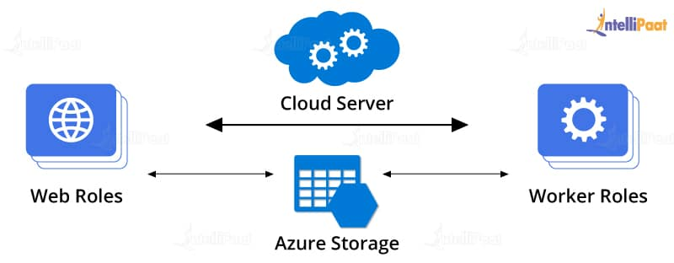
Web Role: It gives a web solution that is front-end. This is like an ASP.NET application. While under facilitating, Azure gives IIS and required services.
Worker Role: It gives solutions for background service. It can run long activities.
Virtual Machine Role: The roles of both web and worker are executed on virtual machines. The Virtual Machine Roles give the client the capacity to modify the Azure Virtual Machine on which the web and worker roles are running.
Go through this Microsoft Azure Certification to get a clear understanding of various certifications Microsoft Azure!

10. What are the three principal segments of the Windows Azure platform?

Windows Azure has three principal segments: Compute, Storage, and Fabric.
A. Windows Azure Compute
Windows Azure gives a code that can be managed by the hosting environment. It gives the calculation benefit through parts. Windows Azure backs three types of roles:
- Web roles utilized for web application programming and upheld by IIS7
- Worker roles utilized for foundation handling of web roles
- Virtual machine (VM) roles utilized for moving windows server applications to Windows Azure in a simple way
B. Windows Azure Storage
It gives four types of storage services:
- Queues for informing between web parts and worker roles
- Tables for storing structural data
- BLOBs (Binary Large Objects) to store contents, records, or vast information
- Windows Azure Drives (VHD) to mount a page BLOB. These can be transferred and downloaded by means of BLOBs
C. Windows Azure AppFabric
AppFabric provides five services:
- Service bus
- Access
- Caching
- Integration
- Composite
Learn from the Azure DevOps Tutorial blog by Intellipaat.

11. Define Windows Azure AppFabric.
Windows Azure Diagnostics empowers you to gather diagnostic data from an application running in Windows Azure. Diagnostic data is used for capacity planning and evaluation.

12. What is the distinction between Windows Azure Queues and Windows Azure Service Bus Queues?
Azure Queues give a solid, diligent messaging between and within the services. They also highlight a very straightforward rest-based get/put/peek interface.
Bus Queues are part of a more extensive Windows Azure messaging framework that supports queuing.
Career Transition

13. What is table storage in Windows Azure?
Windows Azure Table storage service stores a lot of organized information. Windows Azure tables are perfect for putting away organized, non-relational data.
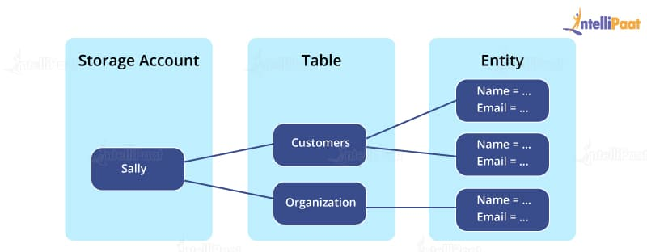
Table: A table is a collection of entities. Tables don’t uphold a blueprint on elements, which implies that a solitary table can contain substances that have distinctive arrangements of properties. A record can contain numerous tables.
Entity: An entity is an arrangement of properties, like a database row. An entity can be up to 1 MB in size.
Properties: A property is a name-value pair. Every entity can incorporate up to 252 properties to store data. Every entity likewise has three system properties that determine a segment key, a row key, and a timestamp.
Become a master of Azure by going through this online Azure Training in Toronto!

14. What is autoscaling in Azure?
Scaling by including extra instances is frequently referred to as scaling out. Windows Azure likewise supports scaling up by utilizing bigger roles rather than more role instances.
By adding and expelling role instances to our Windows Azure application while it is running, we can adjust the execution of the application against its running costs.
An autoscaling solution reduces the amount of manual work engaged in dynamically scaling an application.

15. What are the features of Windows Azure?
Windows Azure runs and stores the information on Microsoft data centers.
The main features are as follows:
- Websites enable the designers to assemble the sites utilizing ASP.NET, PHP, etc., and send these websites utilizing FTP, Git, etc.
- SQL database, formally known as Azure database, makes, broadens, and scales the application into the cloud utilizing Microsoft SQL Server.
- This is Microsoft’s Platform as a Service that supports multilevel applications and automated deployment.
Best Microsoft Azure Training for Administration (AZ-103 = AZ-100 and AZ-101)

16. What are the differences between a public cloud and a private cloud?
Private clouds are those that are constructed solely for an individual enterprise. They enable a firm to have applications in the cloud while tending to concerns with respect to data security and control that is frequently ailing in a public cloud environment.
Private cloud is otherwise called an internal cloud or enterprise cloud and dwells on the organization’s Intranet or hosted data center where the data is protected.
Watch this video on Microsoft Azure Training:

That’s it for our basic Azure Architect interview questions. Let’s move onto the next section on Intermediate Azure Administrator interview questions.

17. What is IaaS, PaaS, and SaaS?
IaaS: IaaS is short for Infrastructure as a Service. It offers a range of capabilities, such as OS and network connectivity, that are at the infrastructural level. It follows a pay-per-use policy. It is used to host applications. Azure VM and VNET are examples of this kind of infrastructure.
PaaS: PaaS is an acronym for Platform as a Service. It primarily includes underlying infrastructure abstraction that allows quicker development of applications without the hassle of hosting management. Azure web apps, cloud services, storage services, etc., are all examples of PaaS.
SaaS: SaaS stands for Software as a Service. These applications are delivered with the help of a service delivery model where applications are simply used by an organization. SaaS follows subscription-based payments or ads. Examples of SaaS are Gmail, Office 365, SharePoint Online, etc.

18. Is it possible to get a public DNS or IP address for the Azure Internal Load Balancer?
No. Azure Internal Load Balancer supports only private IP addresses.

19. What is Azure Resource Manager?
Azure Resource Manager, offered by Azure, provides management and application deployment in Azure. The management layer helps to build, modify, or delete resources in the Azure subscription account. It is useful while managing access controls, locks, and security of resources.

20. What is NSG?
NSG or Network Security Group contains a list of ACL rules that allow or deny network traffic to subnets, network interface cards (NICs) linked to a subnet, or both. When an NSG is connected to a subnet, the ACL rules are for all virtual machines that are located in that subnet. The traffic restrictions to an individual NIC are achieved by linking the NSG directly to that NIC.
Do you want to get a DevOps Engineer job? Enhance your knowledge on DevOps by enrolling for Intellipaat’s DevOps Course!

21. What is Azure Redis Cache?
Azure Redis Cache is an in-memory Redis cache system by Azure that helps web applications to optimize performance. Data is fetched from the backend database and stored in the Redis cache for the first request. On subsequent requests, data is fetched from the Redis cache. Azure Redis cache provides powerful and secure caching mechanisms by using Azure Cloud.

22. Define Azure storage key
Azure storage key is used to authenticate access to Azure storage service data depending on the project requirements. There are two types of storage keys that are used for authentication:
- Primary access key
- Secondary access key, to avoid downtime of the website or application

23. What is CSPack in Azure?
CSPack is a command-line tool that generates the service package file and prepares an application for deployment in Azure or Compute Emulator. Every cloud service type project includes the cloud service configuration file, .cscfg file, generated using CSPack. It stores:
- The number of role instances for each role deployment
- The certificate thumbprints
- User-defined configurations

Intermediate Azure Interview Questions

24. Why is Azure Diagnostics API necessary?
Azure Diagnostics API helps to gather diagnostic data, such as system event logs and performance monitoring, from applications operating on Azure. Azure Diagnostics has to be enabled for the cloud service roles. The collected data can be later used for creating visual chart representations that enable better monitoring and create performance metric alerts.

25. What are the deployment environment options provided by Azure?
There are two deployment environments:
- Staging environment: It is used to validate the changes of an application before making it live.
- Production environment: This is where applications go live and can be accessed by target users with a DNS-friendly URL.

26. What is Azure Blob Storage?
Azure Blob (binary large object) storage is the object storage solution for the cloud. It is capable of storing large unstructured data in text or binary format and is suitable for serving documents, media, or text to the browser directly. The data is accessible from anywhere.
The blobs are grouped into containers and tied to user accounts. This service has three components:
- Storage account: This can be a general storage account or a blob storage account registered in Microsoft Azure.
- Container: Containers are used for grouping blobs. Each container can store an unlimited number of blobs. The container name should be in lowercase.
- Blob: A blob is a file or document of any type and size. Three kinds of blobs are supported by Azure:
  - Block blobs: Text and binary files up to 195GB, 50,000 blocks of maximum 4 MB each
  - Append blobs: Appends operations such as logging data in log files
  - Page blobs: For frequent read or write operations

27. What is a role instance in Azure?
Role instance is a virtual machine where application code is run using running role configurations. Multiple instances of a role are also possible according to the definition in cloud service configuration files.

28. What is Windows Azure Portal?
To run an application, a designer gets to the Windows Azure Portal through his/her web program by logging in with a Windows Live ID. The user at that point chooses whether to create a host account for running applications, a storage account for storing data, or both.
Once the designer has a host account, he/she can utilize a Windows Azure Portal to submit applications to Windows Azure.

29. Explain Azure Fabric.
Azure Fabric is the principal core concept. It gives a service called Azure Fabric Controller. It is called the OS for Azure since it handles/oversees:
- All roles (processing) and resources
- Sending and activating services
- Monitoring the health of all services
- Releasing and allocating resources
- Provisioning VM, terminating, etc.
- Patches get updated for the installed OS on VM in the most automated form

30. What do you comprehend about Hybrid Cloud?
A hybrid cloud is a blend of internal and external cloud services, a mix of a private cloud joined with the utilization of public cloud services. This kind of cloud is most appropriate when you need to keep the classified information in your vicinity (private cloud) and consume alternate services from a public cloud.
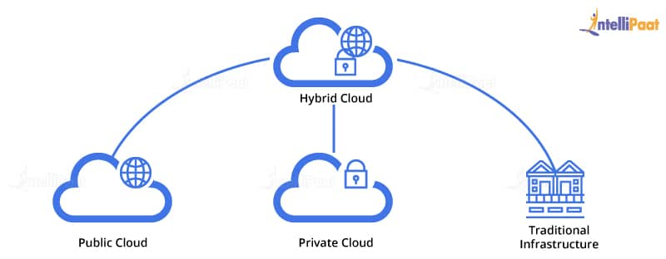

31. What is a storage key?
Storage keys or access keys are utilized as a validation mode for accessing the storage services account to control data based on our prerequisites. In Windows Azure, we have an alternative to give a primary access key and a secondary access key, despite the fact that we will utilize a solitary access key to confirm our application to the storage. The primary reason to give the secondary access key is to avoid downtime to the application.
Courses you may like

32. What is Windows Azure Traffic Manager?
It enables users to control the distribution of user traffic of installed Azure cloud services. There are three distinctive load-balancing strategies provided by Azure. The Manager who works on traffic applies a routing policy to the Domain Name Service (DNS) questions on your domain names and maps the DNS courses to the apt instances of your applications.

33. What is federation in SQL Azure?
Organization in SQL Azure is introduced for scalability. Federation helps both managers and developers scale information. It helps managers by making repartitioning and redistributing of information in a simpler manner. It enables developers in the layer of routing and sharing of information. It helps in routing without application downtime.

34. What is SQL Azure database?
SQL Azure database is just an approach to get associated with cloud services where you can store your database into the cloud. Microsoft Azure is the most ideal approach to utilize PaaS where you can have different databases on a similar account.
Microsoft SQL Azure has a similar component of SQL Server, i.e., high accessibility, versatility, and security in the core.
Microsoft Azure SQL database has an element; it makes backups of each active database automatically. Consistently a backup is taken and geo-repeated to empower the 1-hour recuperation point objective (RPO) for Geo-Restore.

35. What are the different types of Storage areas in Windows Azure?
BLOB: BLOBs offer a component for storing a lot of content or binary data, for example, pictures, audio, and visual documents. They can scale up to 200 terabytes and can be acquired by utilizing REST APIs.
Table: Tables represent storage areas across machines for information that is in the form of properties on the cloud.
Line: The sole target of a queue is to empower communication among Web and Worker Role instances. They help in storing messages that may be accessed by a customer.

36. What is the concept of the table in Windows Azure?
A table is a kind of Azure Storage where you can store your information. BLOBs are put in a compartment and an entity on a table.
Following are the key concepts in a table:
- Tables allow structured data storage.
- There can be 0 to n number of tables in a storage account.
- Tables store information as an accumulation of elements.
- An element has an essential key and properties as a key–value pair.

37. How to secure Azure functions?
One can secure Azure functions through the following:
- Security Center
- Log and monitor
- HTTPS
- Function access keys
- Authentication/authorization
- Permissions
- Secret management
- Set up usage quotas
- Data validation
- Error handling
- Disabled remote debugging
- Restricted CORS access
- Store the data encrypted
- Secure deployment
- Deployment credentials
- Disabled FTP
- Secure scm endpoint
- Continuous security validation
- Network security

38. What is Conditional Access in Azure?
Conditional Access is used by Azure AD as a tool to make decisions, bring signals together, and impose organizational policies.
Through Conditional Access policies, one can implement the right access controls whenever required to keep the organization secure and stay out of the users’ way when not needed.

39. When should you use a static IP address in Azure?
In Azure, a static IP address is used when the address connected to the device is not to be changed.

40. How does Azure Site Recovery work?
Site Recovery orchestrates and automates the replication of Azure VMs in different locations—on-premises machines to a secondary data center, and on-premises VMs and physical servers to Azure.
It contributes to business continuity and disaster recovery (BCDR) by enabling access to apps from the secondary location in case of an outage at the primary site.
Wish to make a career in the world of Cloud Computing? Start with Azure Tutorial!

41. Why should you use Azure CDN?
Azure CDN reduces the bandwidth and load time. It also helps speed up the responsiveness.

42. Explain the benefits of Traffic Manager.
Azure Traffic Manager has the following benefits:
- Optimized performance
- No downtime during the update or maintenance process
- Easily configurable on the Windows Azure portal

43. What is the difference between a library and a list?
A library is an interface that enables the management and storage of a document created in Word, Excel, or PowerPoint. A list, on the other hand, is the representation of an item in a tabular format (with columns and rows). It can be attached with documents.

44. How many services are there in Azure?
Azure has over 6,000 flexible offerings, and it utilizes the data capacity offered by Microsoft for Software, Platform, and Infrastructure as a Service (SaaS, PaaS, and IaaS).

45. How many types of backups are there in Azure?
Azure Backup includes three types of replications that keep both storage and data highly available.
- Geo-redundant storage (GRS): The default and recommended option that replicates data to a secondary region far from the primary location
- Locally redundant storage (LRS): Creates three copies of the data in a storage scale unit within a data center
- Zone-redundant storage (ZRS): Replicates the data in availability zones with data residency and resiliency in the same region and has no downtime
That’s it for Intermediate Azure Interview questions and answers. Now, we will move on to advanced Azure Interview questions.

46. How can you have a common file-sharing system among multiple virtual machines?
Azure files system is used as a common repository system for data sharing among virtual machines that are configured using protocols such as NFS, FTPS, SMB, etc.

47. What is the TFS build system in Azure?
A build is the solution of an output. In Azure projects, you get the record with a .cspkg extension, that is, a Cloud Service Package is utilized for the deployment of your cloud administration.
Build Servers: In general terms, a build server is a machine where you put your deployment packages.
To utilize Team Foundation Build, you should have no less than one build machine. This machine can be a physical machine or a virtual machine.
Build Controllers: Manufacture Controllers are the component in the build system that accepts the build requests from any task inside the group project. Each build controller is dedicated to a solitary team project collection. So, there is a balanced relationship between a team project and a build controller.
Build Agents: Build Agents are components in the build system that accomplishes more processor-concentrated work.

48. What is Azure App Service?
Azure App Service is a completely managed Platform-as-a-Service (PaaS) offering for proficient developers that conveys a rich arrangement of abilities to the web, mobile, and integration scenarios. Mobile apps in Azure App Service offer a very adaptable, universally accessible mobile application development platform for Enterprise Developers and System Integrators that conveys a rich set of capacities to mobile engineers.
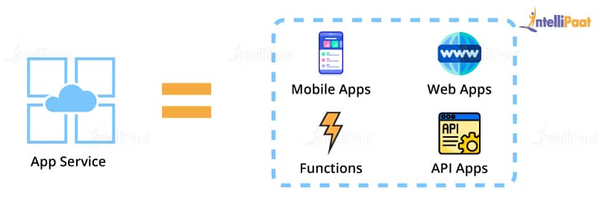

49. What is profiling in Azure?
Profiling is only a procedure for measuring the performance analysis of an application. It is normally done to guarantee that the application is sufficiently steady and can maintain overwhelming traffic.
Visual Studio gives us different tools to do it by gathering the performance information from the application that likewise helps in troubleshooting issues.
Once the profiling wizard is run, it sets up the execution session and collects the data of the sample.
The profiling reports help in:
- Deciding the longest running strategies inside the application
- Measuring the execution time of every strategy in the call stack
- Assessing memory allocation

50. What is cmdlet in Azure?
A cmdlet is a lightweight command that is utilized as a part of the Microsoft PowerShell environment. The cmdlets are summoned by the Windows PowerShell to automate the scripts which are in the command line. Windows PowerShell runtime additionally invokes them automatically through Windows PowerShell APIs.

51. What is Windows Azure Scheduler?
Windows Azure Scheduler enables you to invoke activities, for example, calling HTTP/S endpoints or presenting a message on a storage queue on any schedule.
With Scheduler, you make jobs in the cloud that dependably call services both inside and outside of Windows Azure and execute those jobs on-demand, on a routinely repeating schedule, or assign them for a future date.
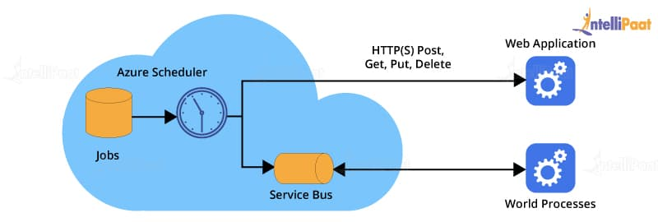

52. How can you create an HDInsight Cluster in Azure?
To make an Azure HDInsight Cluster, open the Azure portal > click on New > select Data Services > click on HDInsight.
Hadoop is the default and native execution of Apache Hadoop.
HBase is an Apache open-source NoSQL database based on Hadoop that gives random access and solid consistency for a lot of unstructured data.
Apache Storm is a distributed, fault-tolerant, open-source computation system that enables you to process data in real-time.

53. What is Text Analytics API in Azure Machine?
Content Analytics API is a part of content examination web administrations worked with Azure Machine Learning. The API can be utilized to analyze unstructured content for tasks such as sentiment analysis and key-phrase extraction.
The API restores a numeric score between 0 and 1. Scores near 1 show positive sentiment, while scores near 0 demonstrate negative sentiment.
The upside of this API is that another new model need not be planned and prepared; the user just needs to bring the data and call the service to get the sentiment results.

54. What is the Migration Assistant tool in Azure Websites?
Migration Assistant tool will examine our IIS installation and recognize the sites that can be migrated to the cloud, featuring any components which can’t be migrated or are unsupported on the platform.
Once broken down, this tool will likewise create sites and databases provided under the given Azure membership.

55. What is the distinction between Public Cloud and Private Cloud?
A public cloud is utilized as a service through the Internet by users, while a private cloud is deployed within specific limits like firewall settings and is totally overseen and checked by the users dealing with it in an organization.

56. What is Azure Service Level Agreement (SLA)?
The SLA ensures that, when you send two or more role instances for each role, access to your cloud service will be maintained not less than 99.95 percent of the time. Additionally, identification and re-correction activities will be started 99.9 percent of the time when a role instance’s procedure isn’t running.

57. How to add an administrator to the Azure portal?
To add an administrator to the Azure portal, it has to be given the owner role. It will be able to manage only those resources in the subscription that are assigned to it. To add an administrator, follow these steps:
- Sign in to the Azure portal
- Go to the Hub menu and then to Subscription and select the subscription that the administrator will need access to
- Select Access control (IAM) in the subscription blade, and then click on Add
- Go to Select a role, and click on Owner
- Here, provide the email address of the user to be assigned as the owner
- Click on the user, and then click on Select

58. How to connect to Azure Database from SQL Management Studio?
- The first time you start the SQL Server Management Studio, the Connect to Server dialog box opens up automatically. You can also open it manually by going to Object Explorer > Connect > Database Engine.
- Then, enter the following information in the Connect to Server window:
Server Type Database Engine
Server Name Enter the name of your Azure SQL Database or Azure Managed Instance
Authentication SQL Server Authentication
Login Enter the server account user ID
Password Enter the server account passwordYou can also choose to change the additional connection options by going to Options.
- Click on Connect after completing all the required fields
If the firewall settings are not set up, a prompt appears to configure the same. Once signed in, provide the Azure account login information, and set the firewall rule. Then, click on OK.
- To verify if your Azure Database connection is successful, expand and explore Object Explorer for the server name, the SQL Server version, and the username.

59. How to create a virtual machine on Azure?
To create a VM on Azure, you need to follow the below steps:
- Sign in to Azure
- Sign in to the Azure portal
- Search for virtual machines in the search box
- Under Services, select Virtual machines
- Click on Add in the Virtual machines page
- In the Basics tab, under Project details, select the correct subscription, and choose Create new resource group
- Type myResourceGroup for the name
- Under Instance details, the Virtual machine name should be myVM
- Choose your Region [e.g., (US) East US]
- Choose Windows Server 2019 Datacenter for the Image
- Leave the rest as default
- Under Administrator account, enter a username and a password
- Under Inbound port rules, click on Allow selected ports, and then select HTTP (80) and RDP (3389) for Select inbound ports
- The rest will remain as default here
- Finally, click on the Review + create button

60. How to deploy SQL Database in Azure?
- Authenticate to the Azure portal
- Click on SQL Databases
- Click on Servers
- Click on a server name to connect to
- Press Configure
- Open SQL Server Management Studio
- Connect to Database services (usually, this happens by default)
- Finally, click on Connect

61. How to export users from Azure Active Directory?
You can export users from Azure AD by following the below-mentioned steps:
- Install the Azure PowerShell module using the following cmdlet:
install-module az

- To connect to Azure AD and Azure, run:
Connect-azaccount

- To export, all users to a CSV file, run:
Get-AzADUser | export-csv file.csv

- If you only need to export the first 10 users, then you can use:
Get-AzADUser -First 10 | export-csv file.csv

- To export all users after the first 2 users, you can use:
Get-AzADUser -Skip 2 | ft

62. How to create a resource group in Azure?
To create a resource group in Azure:
- Log in to the Azure portal
- In the menu on the left, select Resource groups
- In the Resource groups page, click on Add
- Fill in the details in the fields as follows:
  - Subscription: Select your Microsoft Azure subscription
  - Resource group name: Enter a unique name
  - Resource details region: Select a location
- Click on Review + create
- Once validation is passed, click on Create to create your resource group
That’s it in our blog on MS Azure interview questions and answers. Hope these Azure questions help you in your Azure Interview job preparation.

63. What are the differences between Azure Scale Sets and Availability Sets?
The major difference is that Azure scale sets have identical VM’s, and in the case of Availability sets, there is no hard and fast rule for the VM’s to be identical. Let us see other differences here –
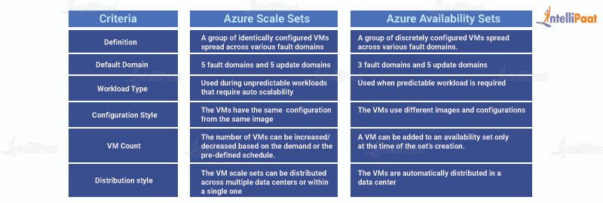

64. What are the different storage services available in Azure apart from Blob storage?
Azure offers three other types of storage services, apart from Blob storage, table storage, queue Storage, and file storage.
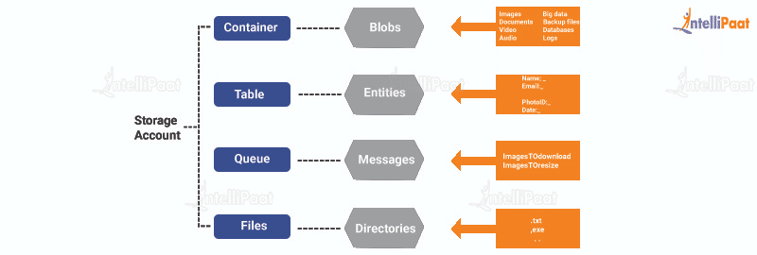
- Azure table storage: It allows the deployment of applications with semi-structured data and a key-value store, which is NoSQL-based.
  - Used when there is a requirement for applications with a flexible data schema
  - Emphasis is on enterprise-level data and strongly follows consistent models
  - Data is in terms of entities grouped under tables
- Azure queue storage: The message queue system is capable of handling large workloads through the development of flexible and durable applications.
  - Ensures that the applications are scalable and less likely to have component failures
  - The queue monitoring helps the application ensure that the requirements are met
- Azure file storage: It offers file sharing and access using server message block (SMB) protocol. The data is secured with SMB 3.0 and HTTPS.
  - Improves the performance of on-premise applications
  - Azure takes care of OS deployments and hardware management

65. What is the difference between Azure Table Storage and the Azure SQL service?
The major difference is that Azure SQL uses a relational storage structure and Azure Table follows centralized structured data without relations. Other differences are –
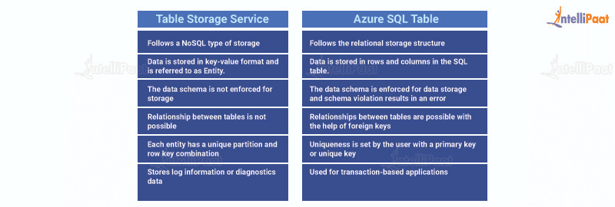

66. Create a Virtual Machine with Azure CLI.
Following is an example how one can create a VM using Azure CLI:
az vm create \
--resource-group myResourceGroupName \
--name myVM \
--image Win19Datacenter \
--public-ip-sku Standard \
--admin-username AzureuserNAME \
--admin-password AzurePASSWORD

Scenario-based Azure Interview Questions

67. How will you execute code with the help of Azure if there is no server?
Azure Functions can execute code without a server. These services simplify complex orchestration and challenges. They help connect with other services without hard coding of integrations, which speeds up the development process.
Developers can write and focus on the business logic code saving time and effort. Azure Application Insights can help analyze and monitor code performance as well as identify hiccups and failure points across various application components.

68. What will you do in case of a drive failure?
When a drive failure occurs, the following steps need to be performed:
- Ensure that the drive is not mounted so that Azure Storage is functioning without fail
- Replace the drive so that it is remounted and formatted

69. What could be the reason for the client application to be disconnected from the cache?
There could be two possible reasons:
- Client-end

  - Redeployment of application
  - Scaling operation by application
  - Change in the client-side networking layer
  - Transient errors in the client or network between the client and the server
  - The crossing of bandwidth threshold limits
- Server-end

  - Azure Redis Cache service had a failover from the primary node to the secondary node
  - The server instance where the cache was deployed had patching or maintenance

70. How can you stop the high load issue on an application in cases of no man support on the flow?
Azure VM Scale Sets can be used to define proper configurations and conditions and provide a new VM whenever there is a high load.
The VM Scale Sets allows the developer to create and manage a group of load-balanced VMs. The scale sets can be configured in accordance with the demand of the application or a predefined schedule that automatically adjusts the number of VMs.
Using scale sets ensures that the applications are highly available and enable the management, updation, and configuration of large VMs centrally. It also supports large-scale application development with big workloads, big data, and compute loads. Azure Scale Sets supports up to 1,000 VMs and 600 VMs for custom VM images.

71. What would happen if tone reaches the maximum failed attempts for Azure ID authentication?
In this situation, the Azure account will get locked depending on the protocol analyzing the entered password and the IP address from where the login is requested.

72. If you have an application running on the on-premise server and Azure East US region has a backup, will you be able to access the application via the Azure environment in case of an on-premise server application access failure?
Yes. One can access the application by using the Site Recovery Service by Azure. It is capable of handling fail-over and fail-back scenarios between on-premise servers and Azure environments.

73. In case the front-end hosting of an application is done on Azure, if the user needs the database hosting to be done on an on-premise server due to security concerns, how will you handle the Azure connectivity?
There are a few possibilities to resolve this:
- Azure VNET based point-to-site service can be used to connect one on-premise DB to an Azure-hosted application. This is valid where there are limited resources to be connected via VPN.
- In case of more resources for connection, site to site or express routes are the solution. Site to site might cause network latency as the VPN works only via public infrastructure, which is the internet. In that case, express routes can be used as it has a dedicated leased line that solves latency issues.
- In case VNET is not preferred, Windows Communication Foundation (WCF) service can be developed and hosted on-premise. It will have CRUD operations intended solely for the database that is hosted on-premise. It uses the service bus relay that can build communication between the Azure-hosted app to the WCF service for database access.

74. You have an Azure subscription that contains an Azure Log Analytics workspace. You have a resource group that contains 100 virtual machines. The virtual machines run Linux. You need to collect events from the virtual machines to the log analytics workspace. Which type of data source should be configured in the workspace?
The answer is Syslog, which is an event logging protocol that is common to Linux. Applications will send messages that may be stored on the local machine or delivered to a Syslog collector. When the log analytics agent for Linux is installed, it configures the local Syslog daemon to forward messages to the agent. The agent then sends the message to Azure Monitor where a corresponding record is created.

75. You create a container image named Image1 on a developer workstation. You plan to create an Azure web app for containers named WebAppContainer that will use Image1. You need to upload Image1 to Azure. The solution must ensure that WebAppContainer can use Image1. To which storage type should you upload Image1?
Image1 should be uploaded to the Azure container registry. The registry credentials are configured in the web app. App service needs information about the registry and image to pull the private image. In the Azure portal, go to Container settings from the web app and update the Image source, Registry, and Save.

76. You have an Azure subscription that contains 100 virtual machines. You have a set of Pester tests in PowerShell that validate the virtual machine environment. You need to run the tests whenever there is an operating system update on the virtual machines. The solution must minimize implementation time and recurring costs. Which three resources should you use to implement the tests?
The three resources to use to implement the test are the Azure Automation runbook, an alert rule, and an alert action group. Azure Automation runbooks can be called by using action groups or by using classic alerts to automate tasks based on alerts. Alerts are one of the key features of Azure Monitor. They allow alerts on actions within an Azure subscription.

77. You have an Azure App Service app. You need to implement tracing for the app. The tracing information must include the following:
- Usage trends
- AJAX call responses
- Page load speed by browser server and browser exceptions
What should you do?
The Azure Application Insights site extension should be enabled in this scenario. For web pages, Application Insights JavaScript SDK automatically collects AJAX calls as dependencies.

78. You have an Azure virtual machine named VM1 and an Azure Active Directory (Azure AD) tenant named adatum.com. VM1 has the following settings:
IP address: 10.10.0.10
System-assigned managed identity: On
You need to create a script that will run from within VM1 to retrieve the authentication token of VM1. Which address should you use in the script?
The answer is 169.254.169.254. The code that is running on the VM can request a token from the Azure Instance Metadata Service identity endpoint, accessible only from within the VM:
http://169.254.169.254/metadata/identity/oauth2/token

79. You are designing an Azure solution. The solution must meet the following requirements:
- Distribute traffic to different pools of dedicated virtual machines (VMs) based on rules
- Provide SSL offloading capabilities
You need to recommend a solution to distribute network traffic. Which technology should you recommend?
If you require SSL offloading, application layer treatment, or wish to delegate certificate management to Azure, Azure’s Layer 7 load balancer application gateway should be used.

80. You have an Azure Cosmos DB account named Account1. Account1 includes a database named DB1 that contains a container named Container1. The partition key for Container1 is set to /city. You plan to change the partition key for Container1. What should you do first?
The Change Feed Processor and Bulk Executor Library, in Azure Cosmos DB, can be leveraged to achieve a live migration of data from one container to another. This allows the redistribution of data to match the desired new partition key scheme and make the relevant application changes afterward. Thus, achieving the effect of updating your partition key.

81. You have an Azure subscription that contains a resource group named RG1. RG1 contains multiple resources. You need to trigger an alert when the resources in RG1 consume US$1,000. What should you do?
Budgets should be created to manage costs and alerts should be set to automatically notify if stakeholders are overspending. To set it up, one should go to the Azure Portal, select Cost Management + Billing -> Cost Management -> Go to Cost Management.

82. You have an Azure Kubernetes Service (AKS) cluster named Clus1 in a resource group named RG1. An administrator plans to manage Clus1 from an Azure AD-joined device. You need to ensure that the administrator can deploy the YAML application manifest file for a container application. You install the Azure CLI on the device. Which command should you run next?
kubectl apply –f appl.yaml
applies a configuration change to a resource from a file or stdin.

83. Your company has the groups shown in the following table.
Group | Number of Members
Managers | 10
Sales | 100
Development | 15
The company has an Azure subscription that contains an Azure AD tenant named contoso.com. An administrator named Admin1 attempts to enable Enterprise State Roaming for all the users in the Managers group. Admin1 reports that the options for enterprise state roaming are unavailable from Azure AD. You verify that Admin1 is assigned the global administrator role. You need to ensure that Admin1 can enable enterprise state roaming. What should you do?
Purchase an Azure AD Premium P1 license for each user in the Managers group. Enterprise state roaming is available to any organization with an Azure AD Premium or Enterprise Mobility + Security (EMS) license.

84. Your company has an office in Seattle. You have an Azure subscription that contains a virtual network named VNET1. You create a site-to-site VPN between the Seattle office and VNET1. VNET1 contains the subnets shown in the following table.
Name | IP Address Space
Subnet1 | 10.1.1.0/24
GatewaySubnet | 10.1.200.8/28
You need to route all internet-bound traffic from Subnet1 to the Seattle office. What should you create?
A route for Subnet1 that uses the virtual network gateway as the next hop should be created. A route with the 0.0.0.0/0 address prefix instructs Azure how to route traffic destined for an IP address that is not within the address prefix of any other route in a subnet’s route table.
When a subnet is created, Azure creates a default route to the 0.0.0.0/0 address prefix, with the internet next hop type. We need to create a custom route in Azure to use a virtual network gateway in the Seattle office as the next hop.

85. You have an Azure web app named App1 that is configured to run between two and five instances. There are currently three instances of App1 running. App1 has the following autoscale rules: Increase the instance count by one when the CPU percentage is greater or equal to 80. Decrease the instance count by one when the CPU percentage is less than or equal to 60. You are evaluating the following CPU percentage of utilization for App1:
- 60 percent
- 55 percent
- 50 percent
- 45 percent
You need to identify which utilizations will cause App1 to scale in.
Azure Monitor autoscaling allows you to scale the number of running instances up or down, based on telemetry data or metrics. Scale-in occurs when the instances are decreased. For this rule, the instances are decreased when the CPU usage is 60 percent or lower. Hence, the answer is 45 percent, 50 percent, and 55 percent.

86. You have an on-premises network that contains a Hyper-V host named Host1. Host1 runs Windows Server 2016 and hosts 10 virtual machines that run Windows Server 2016. You plan to replicate the virtual machines to Azure by using Azure Site Recovery. You create a Recovery Services vault named ASR1 and a Hyper-V site named Site1. You need to add Host1 to ASR1. What should you do?
Download the installation file for the Azure Site Recovery Provider. Download the vault registration key.
Install the Azure Site Recovery Provider on Host1 and register the server.

87. You have an Azure subscription named Subscription1 that contains a virtual network named VNet1. VNet1 is in a resource group named RG1. Subscription1 has a user named User1. User1 has the following roles:
- Reader
- Security admin
- Security reader
You need to ensure that User1 can assign the reader role for VNet1 to other users. What should you do?
User1 should be assigned the owner role for VNet1.

88. A company hosts virtual machines (VMs) in an on-premises data center and in Azure. The on-premises and Azure-based VMs communicate using ExpressRoute. The company wants to be able to continue regular operations if the ExpressRoute connection fails. Failover connections must use the internet and must not require multiprotocol label switching (MPLS) support. You need to recommend a solution that provides continued operations. What should you recommend?
In this case, a VPN connection should be set up.

89. You have a resource group named RG1. RG1 contains an Azure Storage account named storageaccount1 and a virtual machine named VM1 that runs Windows Server 2016. storageaccount1 contains the disk files for VM1. You apply a ReadOnly lock to RG1. What can you do from the Azure portal?
View the keys of storageaccount1. ReadOnly allows authorized users to read a resource, but they cannot delete or update the resource. Applying this lock is similar to restricting all authorized users to the permissions granted by the reader role.

1. Why Did You Choose a Career in Cloud Computing?
These types of Azure interview questions require a thoughtful, honest response. By thinking through your answer ahead of time, you’ll be ready to say something your interviewer will approve of. Show that you care about the field and that you have a passion for cloud computing and the problems it can solve.

2. Why Did You Choose Microsoft Azure and Not Aws?
Your response to this question is based on your own background and experience. Maybe you come from a developer background, so Azure appealed to you. Maybe your first cloud computing role just happened to be with Azure. As with the question above, the key here is to be ready to give an intelligent answer to the question.

3. How Does Microsoft Azure Compare to Aws?
This might be a matter of opinion for you, so answer as you see fit. In general, people say Azure is a better choice because it’s a Microsoft product, making it easier for organizations already using Windows Server, SQL Server, and Exchange to move to the cloud. In addition, because of Microsoft’s deep knowledge of developer tools, Azure offers multiple app deployment options for developers, which makes it stand out against AWS.

4. How Did You Learn Azure?
Did you learn Azure through a certification? Through on-the-job experience? A little of each? However you learned it, make sure to demonstrate to the interviewer that you have practical experience (if you’re new to the field) and that you are continuing to learn.

5. Tell Me About a Problem You Solved at Your Prior Job.
This is something to spend some time on when you’re preparing responses to possible Azure interview questions. As a cloud architect, you need to show that you are a good listener and problem solver, as well as a good communicator. Yes, you need to know the technology, but cloud computing does not usually involve sitting isolated in a cubicle. You’ll have stakeholders to listen to, problems to solve, and options to present. When you answer questions like these, try to convey that you are a team player and a good communicator, in addition to being a really good Azure architect.

6. What is the difference between SaaS, PaaS, and IaaS?
This is one of the most common Azure interview questions. Cloud Computing has three types of service models, that are IaaS, PaaS, and SaaS
Infrastructure as a Service(IaaS) | Platform as a Service(PaaS) | Software as a Service(SaaS)
It provides users with components such as OS, networking capabilities, etc. This is a paid service, based on usage and can be used to host applications. | It enables developers to build and work with applications without having to worry about the infrastructure or management of the hosting environment. | It involves applications being consumed and used by organizations. Usually, organizations pay for their use of the application
Example - Azure Virtual Machine, Azure VNET | Example - Azure SQL, Azure Storage | Example - Office 365, Salesforce

Azure Interview Questions and Answers for Experienced

7. What are the instance types offered by Azure?
Azure offers a number of different instance types based on what needs they fulfill.
- General Purpose - CPU to memory ratio is balanced. Provides low to medium traffic web servers, small to medium databases and is ideal for testing and development
Largest instance size: Standard_D64_v3
256 GB Memory and 1600 GB SSD Temp Storage
- Compute Optimized - High CPU to memory ratio. Best suited for medium traffic web servers, application servers, batch processes, and network appliances
Largest instance size: Standard_F72s_V2
144 GB Memory and 576 GB SSD Temp Storage
- Memory-Optimized - High memory to CPU ratio. Best suited for relational database servers, in-memory analytics, and medium to large caches
Largest instance size: Standard_M128m
3892 GB Memory and 14,336 GB SSD Temp Storage
- Storage Optimized - Provides high disk IO and throughput. Best suited for Big Data, NoSQL and SQL Databases
Largest instance size: Standard_L32s
256 GB Memory and 5630 GB SSD Temp Storage
- GPU - Virtual Machines that specialize in heavy graphic rendering and video editing. It also helps with model training and inferencing with deep learning
Largest instance size: Standard_ND24rs
448 GB Memory and 2948 GB SSD Temp Storage
4 GPUs and 96 GB Memory
- High-Performance Compute - Provides Azure’s fastest and powerful CPU virtual machines with optional high throughput interfaces
Largest instance size: Standard_L32s
224 GB Memory and 2000 GB SSD Temp Storage

8. What are the deployment environments offered by Azure?
This is one of the most frequently asked Azure interview questions, and you must know the answer. Azure offers two deployment environments:

Staging Environment:
- It provides a platform to validate changes to your application before it can be made live in the production environment
- In this stage, the app can be identified using the Azure’s Globally Unique Identifier (GUID) in URL form (GUID.cloudapp.net)

Production Environment:
- This environment is used to store the live application
- It can be differentiated from the staging environment with an URL that’s more DNS friendly (servicename.cloudapp.net)
Interested in becoming a cloud architect? Join our Cloud Architect Master’s Program and learn AWS, Microsoft Azure, and Google Cloud Platform from the ground up!

9. Differentiate between repetitive and minimal monitoring.
Repetitive / Verbose Monitoring | Minimal Monitoring
It collects metrics based on performance | It is a default configuration method
It allows a close analysis of data fed during the process of application | It allows a close analysis of data fed during the process of application

10. Which one amongst Microsoft Azure ML Studio and GCP Cloud AutoML is better?
When we compare both in terms of services, Azure ML Studio wins the verdict since it has Classification, Regression, Anomaly Detection, Clustering, Recommendation, and Ranking features.
On the other hand, GCP Cloud AutoML has Clustering, Regression, and Recommendation features. Moreover, Azure has a drag and drop options that make the process easier to carry out.
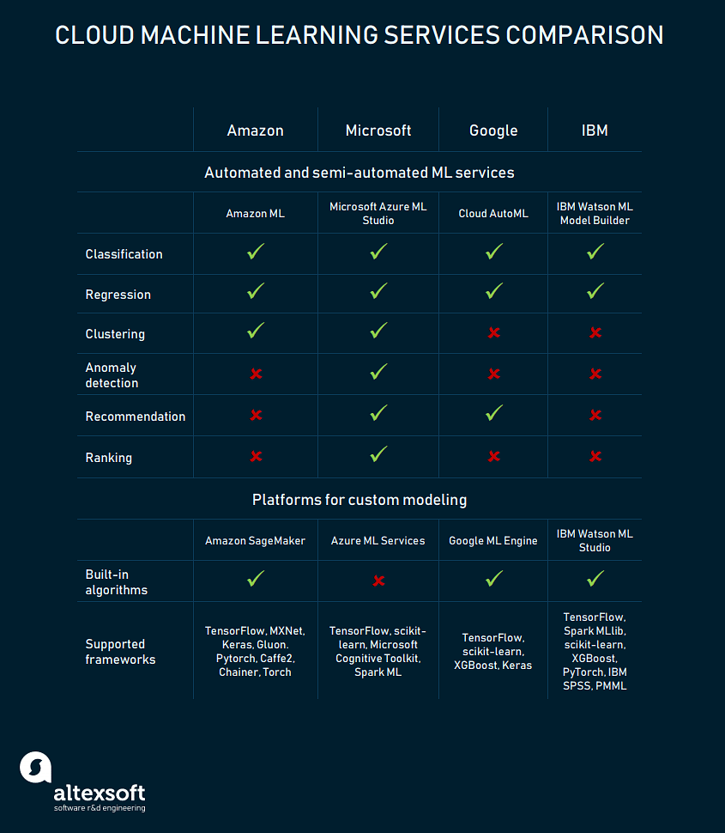

11. What are the advantages of Scaling in Azure?
Azure performs scaling with the help of a feature known as Autoscaling. Autoscaling helps to deal with changing demands in Cloud Services, Mobile Services, Virtual Machines, and Websites. Below are a few of its advantages:
- Maximizes application performance
- Scale up or down based on demand
- Schedule scaling to particular time periods
- Highly cost-effective
To be doubly sure, and to prove your credibility to a potential employer you should consider getting certified and enrolling in our comprehensive Cloud Architect Master’s Program today!

12. How is Windows Active Directory and Azure Active Directory different?
This one’s another regular question from the list of Azure interview questions.
Windows Active Directory | Azure Active Directory
It is a directory service that facilitates working with interconnected, complex and different network resources in a unified manner | Azure Active Directory (Azure AD) is Microsoft’s multi-tenant, cloud-based directory and identity management service
Uses 5 layers to store data, store user details, issue and manage certifications, etc. | Uses 5 layers to store data, store user details, issue and manage certifications, etc.
Works with an emphasis on on-premises units like applications, file services, printers, etc. | Emphasizes on web-based services that use RESTful interfaces

13. What are the types of Queues offered by Azure?
Azure offers two types of queues:

Storage Queues:
- It is a part of Azure’s Storage infrastructure
- It provides messaging within and between services
- It is best suited when users need to store more than 80 GB of messages in queues
- It can provide side logs of all transactions executed against the user’s queues

Service Bus Queues:
- It is a part of Azure’s messaging infrastructure
- It integrates application or application components that span multiple communication protocols, network environments, etc.
- It provides a FIFO style of delivery
- The user’s queue size has to remain under 80 GB

14. What are the advantages of the Azure Resource Manager?
Azure Resource Manager enables users to manage their usage of application resources. Few of the advantages of Azure Resource Manager are:
- ARM helps deploy, manage and monitor all the resources for an application, a solution or a group
- Users can be granted access to resources they require
- It obtains comprehensive billing information for all the resources in the group
- Provisioning resources is made much easier with the help of templates

15. Azure interview questions can also have MCQ’s like follows: Which of the following web applications can be deployed with Azure?
a. ASP.NET
b. PHP
c. WCF
d. All of the mentioned
Answer: a) ASP.NET

16. How has integrating hybrid cloud been useful for Azure?
The Hybrid Cloud boosts productivity by using Azure and the Azure stack for building and deploying applications for the cloud and on-premises applications. Integrating hybrid cloud been useful for Azure in the following ways:
- It obtains greater efficiency with a combination of Azure services and DevOps processes and tools
- Users can take advantage of constantly updated Azure services and other Azure Marketplace applications
- It enables it to be deployed regardless of its location, the cloud, or on-premises.
- This enables applications to be created at a higher speed

17. What is the Federation in Azure SQL?
SQL Azure Federation provides tools that can enable developers to access or share databases among themselves in SQL Azure.
- It enables users to take advantage of resources within the cloud
- It allows users to have their own database or share databases amongst each other
- It reduces the possibility of a single point of failure
- It provides cost-effectiveness, by using cloud resources only when needed
Learn how to design, plan, and scale cloud implementation and excel in the field of cloud computing with our popular Cloud Architect Master's course

18. What are the different types of storage offered by Azure?
Storage questions are very commonly asked during an Azure Interview. Azure has four different types of storage. They are:

Azure Blob Storage
Blob Storage enables users to store unstructured data that can include pictures, music, video files, etc. along with their metadata.
- When an object is changed, it is verified to ensure it is of the latest version.
- It provides maximum flexibility to optimize the user’s storage needs.
- Unstructured data is available to customers through REST-based object storage

Azure Table Storage
Table Storage enables users to perform deployment with semi-structured datasets and a NoSQL key-value store.
- It is used to create applications requiring flexible data schema
- It follows a strong consistency model, focusing on enterprises

Azure File Storage
File Storage provides file-sharing capabilities accessible by the SMB (Server Message Block) protocol
- The data is protected by SMB 3.0 and HTTPS
- Azure takes care of managing hardware and operating system deployments
- It improves on-premises performance and capabilities

Azure Queue Storage
Queue Storage provides message queueing for large workloads
- It enables users to build flexible applications and separate functions
- It ensures the application is scalable and less prone to individual components failing
- It enables queue monitoring which helps ensure customer demands are met

19. What is the Text Analysis API in Azure Machine Learning?
Text Analysis API is a set of web services that can be used for text analysis. It is used to analyze unstructured text for sentiment analysis and keyphrase extraction. It provides results that range between 0 and 1, to elicit a positive or negative sentiment.

When a new model is created, it doesn’t need to be designed and trained, users need to add the data and call the service to obtain the sentiment analysis.

20. What are the advantages of Azure Queue Storage?
Queue storage enables message queueing for large workloads in a simple, cost-effective, and durable manner. Few of its advantages are:
- It provides rich client libraries for Java, Android, C++, PHP, Ruby, etc.
- It enables users to build flexible apps and separate functions for greater durability
- It ensures users’ applications are scalable and less prone to individual component failure
- It enables queue monitoring to ensure servers aren’t overwhelmed by sudden traffic bursts

21. What are the two kinds of Azure Web Service roles?
A cloud service role is a set of managed and load-balanced virtual machines that work together to perform tasks. The two kinds of Azure Web Service roles are:

Web Roles
- It is a cloud service role that is used to run web applications developed in programming languages supported by IIS (Internet Information Services) like ASP.NET, PHP, etc.
- It automatically deploys and hosts applications through the users IIS

Worker Roles
- It runs applications and other tasks that don't require IIS. It performs supporting background tasks along with web roles
- It doesn’t use IIS and runs user applications standalone

22. What is Azure Service Fabric?
Service Fabric provides a platform that makes the process of developing microservices and managing the application lifecycle easier.
- It produces applications with a faster time to market
- It supports Windows/ Linux, on-premises or other clouds
- It provides the ability to scale up to a thousand machine

23. How can Azure handle this situation?
A client wants the front end of his/ her application to be hosted on Azure, but wants the database to be hosted on-premises.
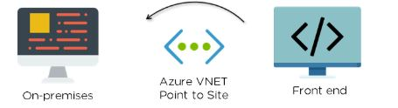
Solution - The ideal solution in this scenario is to use Azure VNET based “Point to Site”. It’s best suited for scenarios where there are only a limited number of resources that need to be connected

24. What is the Azure Traffic Manager?
Azure Traffic Manager is a traffic load balancer that enables users to provide high availability and responsiveness by distributing traffic in an optimal manner across global Azure regions.
- It provides multiple automatic failover options
- It helps reduce application downtime
- It enables the distribution of user traffic across multiple locations
- It enables users to know where customers are connecting from

25. How can Azure handle this situation?
You need to isolate network traffic among VMs in a subnet, which is part of a Virtual Network with little downtime and impact on users?
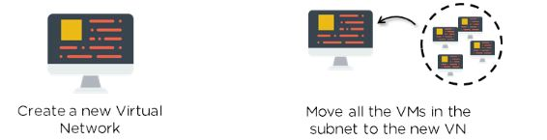
Solution - This would ensure that the virtual machines are kept isolated without the need for additional security, like a Network Security Group.
To be doubly sure, and to prove your credibility to a potential employer you should consider getting certified and enrolling in our comprehensive Cloud Architect Master’s Program today!

26. With respect to Azure, what is public, private, and hybrid cloud?
Public Cloud - Every component that the user is using in his/ her application are running only on Azure
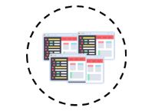
Private Cloud - Azure services are being run within an on-premises data center or on-premises data centers are used by the user to host systems or applications
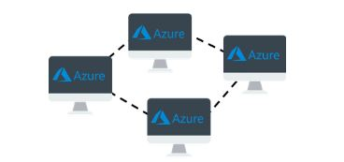
Hybrid Cloud - Combines features of both Public and Private cloud. Some of the user’s components are being run on Azure and others within an on-premises datacenter
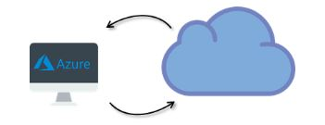

27. What kind of storage is best suited to handle unstructured data?
Questions on Blob Storage can be seen in the list of Azure Interview Questions.
Blob Storage provides storage capacity for data. It places data into different tiers based on how often they’re accessed.
- Any type of unstructured data can be stored
- Data integrity is maintained every time an object is changed
- It helps to increase app performance and reduces bandwidth consumption

28. How do you set up an Azure Virtual Machine?
Setting up a VM is one of the most important Azure Interview Questions.
The below image would explain clearly how to set up an Azure Virtual Machine:
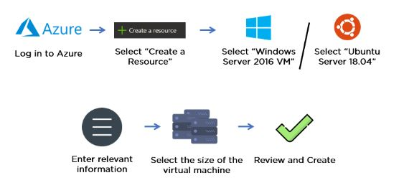

29. How do you handle this scenario?
You need to make sure your Virtual Machines are able to communicate securely with each other to ensure security.
Solution - Azure Virtual Network enables Azure resources to communicate with each other, the internet, or on-premises networks securely.
- Users can create their own private networks
- It provides users with an isolated and highly secure environment for applications
- All traffic stays within the Azure network
- It allows users to design their own networks

30. How do you handle this scenario?
You need to ensure that every time a user logs in, they are not asked to re-enter their passwords as part of the authentication.
a. To enable Microsoft Account authentication
b. Deploy ExpressRoute
c. Set up a VPN between premises and datacenter. Set up an AD domain controller in VM and implement integrated Windows Authentication
d. Configure Azure AD Sync to use single sign-on
Solution - d) Configure Azure AD Sync to use single sign-on
- Single sign-on (SSO) is a property of access control of multiple related, but independent software systems. With this property, a user logs in once and gains access to all systems without being prompted to log in again at each of them.

31. Azure Storage plays the same role in Azure that ______ plays in Amazon Web Services.
a. S3.
b. EC2
c. EC3
d. All of the mentioned
Answer: a) S3

32. Which service in Azure is used to manage resources in Azure?
a. Azure Resource Manager
b. Application Insights
c. Log Analytics
d. Azure Portal
Answer: a) Azure Resource Manager

33. How do you handle this scenario?
You need to ensure that virtual machines remain available while migrating to Azure. What would be the appropriate service to use?
a. Traffic Manager
b. Update Domains
c. Express Route
d. Cloud Services
Solution - c) Express Route

34. How do you handle this scenario?
a. You administer a website called web game. You’re required to validate and deploy changes made to your website by your development team with minimum downtime
b. Create a new linked resource
c. Create a staging environment for the site
d. Enable remote debugging on the website
Solution - b) Create a staging environment for the site

35. How do you handle this scenario?
These scenarios are important on the list of Azure Interview Questions
Your standard tier application is used across the world and uses the Azure website standard tier. It uses a large number of image files. However, this causes the application to load slowly
a. Configure Azure blob storage with a custom domain
b. Configure Azure website Autoscaling to increase instances at high loads
c. Configure Azure CDN to cache all responses from the application’s web endpoint
d. Configure Azure CDN to cache site images and content stored in Azure blob storage
Solution - d)Configure Azure CDN to cache site images and content stored in Azure blob storage
Blobs that benefit the most from Azure CDN caching are those that are accessed frequently during their time-to-live (TTL) period. A blob stays in the cache for the TTL period and then is refreshed by the blob service after that time is elapsed. Then the process repeats.

1. What is Azure Cloud Service?
By creating a cloud service, you can deploy a multi-tier web application in Azure, defining multiple roles to distribute processing and allow flexible scaling of your application. An Azure cloud service consists of one or more web roles and/or worker roles, each with its own application files and configuration.
Azure Websites and Virtual Machines also enable web applications on Azure. The main advantage of cloud services is the ability to support more complex multi-tier architectures.

2. What is a cloud service role?
A cloud service role is comprised of application files and a configuration. A cloud service can have two types of roles.

3. What is the link to a resource?
To show your cloud service’s dependencies on other resources, such as an Azure SQL Database instance, you can “link” the resource to the cloud service. In the Preview Management Portal, you can view linked resources on the Linked Resources page, view their status on the dashboard, and scale a linked SQL Database instance along with the service roles on the Scale page. Linking a resource in this sense does not connect the resource to the application; you must configure the connections in the application code.

4. What is scale a cloud service?
A cloud service is scaled out by increasing the number of role instances (virtual machines) deployed for a role. A cloud service is scaled in by decreasing role instances. In the Preview Management Portal, you can also scale a linked SQL Database instance, by changing the SQL Database edition and the maximum database size, when you scale your service roles.

5. What is a web role?
A web role provides a dedicated Internet Information Services (IIS) web-server used for hosting front-end web applications.

6. What is a worker's role?
Applications hosted within worker roles can run asynchronous, long-running, or perpetual tasks independent of user interaction or input.

7. What is a role instance?
A role instance is a virtual machine on which the application code and role configuration run. A role can have multiple instances, defined in the service configuration file.

8. What is a guest operating system?
The guest operating system for a cloud service is the operating system installed on the role instances (virtual machines) on which your application code runs.
[ Related Article: Benefits of Azure Automation ]

9. What is a cloud service component?
Three components are required in order to deploy an application as a cloud service in Azure:

10. What are deployment environments?
Azure offers two deployment environments for cloud services: a staging environment in which you can test your deployment before you promote it to the production environment. The two environments are distinguished only by the virtual IP addresses (VIPs) by which the cloud service is accessed.
In the staging environment, the cloud service’s globally unique identifier (GUID) identifies it in URLs (GUID.cloudapp.net). In the production environment, the URL is based on the friendlier DNS prefix assigned to the cloud service (for example, myservice.cloudapp.net).

11. What is a service definition file?
The cloud service definition file (.csdef) defines the service model, including the number of roles.

12. What is a service configuration file?
The cloud service configuration file (.cscfg) provides configuration settings for the cloud service and individual roles, including the number of role instances.

13. What is a service package?
The service package (.cspkg) contains the application code and the service definition file.

14. What is a cloud service deployment?
A cloud service deployment is an instance of a cloud service deployed to the Azure staging or production environment. You can maintain deployments in both staging and production.

15. What is Azure Diagnostics?
Azure Diagnostics is the API that enables you to collect diagnostic data from applications running in Azure. Azure Diagnostics must be enabled for cloud service roles in order for verbose monitoring to be turned on.

16. What is Azure Service Level Agreement (SLA)?
The Azure Compute SLA guarantees that, when you deploy two or more role instances for every role, access to your cloud service will be maintained at least 99.95 percent of the time. Also, detection and corrective action will be initiated 99.9 percent of the time when a role instance’s process is not running.

17. What is Cloud Computing?
Cloud computing is the use of computing resources (hardware and software) that are delivered as a service over a network (typically the Internet).

18. What is the Service Model in Cloud Computing?
Cloud computing providers offer their services according to three fundamental models: Infrastructure as a service (IaaS), platform as a service (PaaS), and software as a service (SaaS) where IaaS is the most basic and each higher model abstracts from the details of the lower models.
- Examples of IaaS include Amazon CloudFormation (and underlying services such as Amazon EC2), Rackspace Cloud, Terremark, Windows Azure Virtual Machines, Google Compute Engine. and Joyent.
- Examples of PaaS include Amazon Elastic Beanstalk, Cloud Foundry, Heroku, Force.com, EngineYard, Mendix, Google App Engine, Windows Azure Compute, and OrangeScape.
- Examples of SaaS include Google Apps, Microsoft Office 365, and Onlive. Source from.

19. What are the different cloud deployment models?
Cloud deployment models describe how cloud services are offered to users. The major deployment models associated with cloud computing are listed below:
- Public cloud: Here, computing services are offered through third-party providers across the public internet and server.
- Private cloud: Here, computing services are offered either over the private internal network or the internet only to the selected users.
- Hybrid cloud: Here, the cloud computing environment combines both public cloud and private cloud, allowing to share data and applications between them.
Visit here to learn Microsoft Azure Course in Hyderabad

20. Explain traffic manager benefits in Azure?
The major benefits offered by the traffic manager in Azure are:
- Distribution of traffic based on several traffic-routing methods.
- Continuous monitoring of endpoint health and automatic failover when endpoints fail.

21. What is a break-fix issue?
In Azure, break-fix issues are referred to as technical problems. It is an industry term used when “work involved in supporting a technology when it fails its normal course of action”.

22. What is Azure Active Directory and how it is used?
Microsoft offers Azure active directory(Azure AD), a fully managed multi-tenant service that implements identity and access capabilities for applications running in Azure as well as applications operating in the on-premises environment. It is used for providing single sign-on and multi-factor authentication to help users from protecting attacks.
[ Related Article: What is Azure Arc? ]

23. What is an Availability Set?
Availability Set is a logical grouping capability majorly employed for separating VM sources from each other when they are deployed. They are used for building reliable cloud solutions.
The VMs placed in the Availability set are run across various physical servers, storage units, compute racks, and network switches in Azure. If any failure occurs, only VMs subset is affected, and the overall solution stays operational.

24. What is the use of a Lookup transformation?
Lookup transformation is used for performing lookups by combining data in input columns with columns in the reference dataset. The reference table can be a new table or an existing table, view, or the SQL result query result.

25. Name the web application types that can be deployed with Azure?
The web applications that can be deployed with Azure are ASP.Net, PHP, and WCF.

26. Explain Azure Resource Manager?
Azure Resource Manager is used for provisioning management and deployment services in Azure. The management layer is used for updating and deleting resources in Azure subscription. You can organize related resources in resource groups and deploy your resources with JSON templates.

27. What is a Fault Domain?
A Fault domain represents the group of the underlying hardware that shares a common power source and network switch. Every fault domain comprises some racks and each contains a virtual machine. When you create virtual machines within an availability set, your virtual machines are automatically distributed across the fault domains in the Azure platform.

28. What are Update Domains?
The updated domain represents the group of the underlying hardware that can be rebooted or can withstand maintenance at the same time. When you create virtual machines within an availability set, your virtual machines are automatically distributed across the update domains by the Azure platform. This ensures that at least one instance of your applications always remains working when the Azure platform is under periodic maintenance.

29. What is the difference between Azure Service Bus Queues and Storage Queues?
Two types of queue mechanisms are supported by Azure: Storage queues and Service Bus queues.
- Storage queues: These are part of the Azure storage infrastructure, features a simple REST-based GET/PUT/PEEK interface. Provides persistent and reliable messaging within and between services.
- Service Bus queues: These are part of a broader Azure messaging infrastructure that helps to queue as well as publish/subscribe, and more advanced integration patterns.

30. Explain Azure Service Fabric?
Azure Service Fabric is a distributed platform designed by Microsoft to facilitate the development, deployment, and management of highly scalable and customizable applications. The applications created in this environment consist of detached microservices that communicate with each other through service application programming interfaces.

31. Define the Azure Redis Cache?
Azure Redis Cache is an open-source and in-memory Redis cache that helps web applications to fetch data from a backend data source into cache and server web pages from the cache to enhance the application performance. It provides a powerful and secure way to cache the application’s data in the Azure cloud.

32. Explain the types of services you can build with the Service Fabric?
Majorly, two types of services you can build on Service Fabric:
- Stateless Services: No state is stored in the service. The longer-term state is stored in an external database. This is the typical application/data layer approach to build services.
- Stateful Services: The state is stored in the service. Allows the state to persist without the need for an external database.

33. What is the Windows Azure Platform?
A collective name of Microsoft’s Platform as a Service (PaaS) offering which provides a programming platform, a deployment vehicle, and a runtime environment of cloud computing hosted in Microsoft data centers.

34. What are the roles available in Windows Azure?
All three roles (web, worker, VM) are essentially Windows Server 2008. Web and Worker roles are nearly identical: With Web and Worker roles, the OS and related patches are taken care of for you; you build your app’s components without having to manage a VM

35. What is the difference between the Windows Azure Platform and Windows Azure?
The former is Microsoft’s PaaS offering including Windows Azure, SQL Azure, and AppFabric; while the latter is part of the offering and Microsoft’s cloud OS.

36. What are the three main components of the Windows Azure Platform?
- Compute.
- Storage.
- AppFabric.

Azure Interview Questions for Experienced

37. What is Windows Azure compute emulator?
The compute emulator is a local emulator of Windows Azure that you can use to build and test your application before deploying it to Windows Azure.

38. What is the fabric?
In the Windows Azure cloud fabric is nothing but a combination of many virtualized instances which run the client application
Checkout Microsoft Azure Course in Bangalore

39. How many instances of a Role should be deployed to satisfy Azure SLA (service level agreement)? And what’s the benefit of Azure SLA?
TWO. And if we do so, the role would have external connectivity at least 99.95% of the time.

40. What are the options to manage the session state in Windows Azure?
- Windows Azure Caching
- SQL Azure
- Azure Table

41. What is CSPack?
It is a command-line tool that generates a service package file (.cspkg) and prepares an application for deployment, either to Windows Azure or to the compute emulator.

42. What is Csrun?
It is a command-line tool that deploys a packaged application to the Windows Azure compute emulator and manages the running service.

43. What is the guest OS?
It is the operating system that runs on the virtual machine that hosts an instance of a role.
[ Related Article: Learn Azure Key Vault ]

44. How to programmatically scale-out Azure Worker Role instances?
Using AutoScaling Application Block

45. What is the difference between Public Cloud and Private Cloud?
A public cloud is used as a service via the Internet by the users, whereas a private cloud, as the name conveys is deployed within certain boundaries like firewall settings and is completely managed and monitored by the users working on it in an organization.

Azure Administrator Interview Questions and Answers

46. How to design applications to handle connection failure in Windows Azure?
The Transient Fault Handling Application Block supports various standard ways of generating the retry delay time interval, including fixed interval, incremental interval (the interval increases by a standard amount), and exponential back-off (the interval doubles with some random variation).
static RetryPolicy policy = new RetryPolicy(5, TimeSpan.FromSeconds(2), TimeSpan.FromSeconds(2)); policy.ExecuteAction(() => { try { string federationCmdText = @”USE FEDERATION Customer_Federation(ShardId =” + shardId + “) WITH RESET, FILTERING=ON”; customerEntity.Connection.Open(); customerEntity.ExecuteStoreCommand(federationCmdText); } catch (Exception e) { customerEntity.Connection.Close(); SqlConnection.ClearAllPools(); } });

47. What is Windows Azure Diagnostics?
Windows Azure Diagnostics enables you to collect diagnostic data from an application running in Windows Azure. You can use diagnostic data for debugging and troubleshooting, measuring performance, monitoring resource usage, traffic analysis and capacity planning, and auditing.
HTTP://WWW.WINDOWSAZURE.COM/EN-US/DEVELOP/NET/COMMON-TASKS/DIAGNOSTICS/

48. What is Blob?
BLOB stands for Binary Large Object. Blob is a file of any type and size.
The Azure Blob Storage offers two types of blobs:
- Block Blob
- Page Blob
URL format: Blobs are addressable using the following URL format:

49. What is the difference between Block Blob vs Page Blob?
Block blobs are comprised of blocks, each of which is identified by a block ID.
You create or modify a block blob by uploading a set of blocks and committing them by their block IDs.
If you are uploading a block blob that is no more than 64 MB in size, you can also upload it in its entirety with a single Put Blob operation. -Each block can be a maximum of 4 MB in size. The maximum size for a block blob in version 2009-09-19 is 200 GB or up to 50,000 blocks.
Page blobs are a collection of pages. A page is a range of data that is identified by its offset from the start of the blob. To create a page blob, you initialize the page blob by calling Put Blob and specifying its maximum size.
-The maximum size for a page blob is 1 TB. A page written to a page blob may be up to 1 TB in size.
what to use block blobs for streaming video. “The application must provide random read/write access” which is supported by Page Blobs

50. What is the difference between Windows Azure Queues and Windows Azure Service Bus Queues?
Windows Azure supports two types of queue mechanisms: Windows Azure Queues and Service Bus Queues.
- Windows Azure Queues, which are part of the Windows Azure storage infrastructure, feature a simple REST-based Get/Put/Peek interface, providing reliable, persistent messaging within and between services.
- Service Bus Queues are part of a broader Windows Azure messaging infrastructure dead-letters queuing as well as publish/subscribe, Web service remoting, and integration patterns.
HTTP://WCFPRO.WORDPRESS.COM/2010/12/06/COMMUNICATION-IN-WINDOWS-AZURE/
HTTP://MSDN.MICROSOFT.COM/EN-US/LIBRARY/WINDOWSAZURE/HH767287.ASPX

51. What is the dead letter queue?
- Messages are placed on the dead-letter sub-queue by the messaging system in the following scenarios.
- When a message expires and dead-lettering for expired messages is set to true in a queue or subscription.
- When the max delivery count for a message is exceeded on a queue or subscription.
- When a filter evaluation exception occurs in a subscription and dead-lettering is enabled on filter evaluation exceptions.

52. What are swap deployments?
To promote a deployment in the Azure staging environment to the production environment, you can “swap” the deployments by switching the VIPs by which the two deployments are accessed. After the deployment, the DNS name for the cloud service points to the deployment that had been in the staging environment.

53. What is minimal vs. verbose monitoring?
Minimal monitoring, which is configured by default for a cloud service, uses performance counters gathered from the host operating systems for role instances (virtual machines). Verbose monitoring gathers additional metrics based on performance data within the role instances to enable a closer analysis of issues that occur during application processing. For more information

54. What are the instance sizes of Azure?
Windows Azure will handle the load balancing for all of the instances that are created. The VM sizes are as follows:
- Compute Instance Size CPU Memory Instance Storage I/O Performance
- Extra Small 1.0 GHz 768 MB 20 GB Low
- Small 1.6 GHz 1.75 GB 225 GB Moderate
- Medium 2 x 1.6 GHz 3.5 GB 490 GB High
- Large 4 x 1.6 GHz 7 GB 1,000 GB High
- Extra-large 8 x 1.6 GHz 14 GB 2,040 GB High

55. What is table storage in Windows Azure?
The Windows Azure Table storage service stores large amounts of structured data.
The service is a NoSQL data store that accepts authenticated calls from inside and outside the Windows Azure cloud.
Windows Azure tables are ideal for storing structured, non-relational data
- Table: A table is a collection of entities. Tables don’t enforce a schema on entities, which means a single table can contain entities that have different sets of properties. An account can contain many tables
- Entity: An entity is a set of properties, similar to a database row. An entity can be up to 1MB in size.
- Properties: A property is a name-value pair. Each entity can include up to 252 properties to store data. Each entity also has 3 system properties that specify a partition key, a row key, and a timestamp.
Entities with the same partition key can be queried more quickly, and inserted/updated in atomic operations. An entity’s row key is its unique identifier within a partition.

1. What is Cloud Computing?
Cloud computing is a term referred to storing and accessing data over the internet. It doesn’t store any data on the hard disk of your personal computer. In cloud computing, you are allowed accessing data from a remote server.

2. What is Microsoft Azure?
Azure is a cloud computing platform which was launched by Microsoft in Feb 2010. It is a highly flexible cloud platform that offers development, data storage, service hosting, and service management.


3. Explain the Importance of the role and how many types of roles are available in Windows Azure?
Roles are a very important concept in Windows Azure, and learning them is the base for further programming.
Three types of roles in Windows Azure are:
- Web Role: It is used to deploy website by using langue which is supported by the IIS platform customized to run the web apps.
- Worker Role: It helps you to execute the process that runs in the background.
- VM Role: It helps you to schedule the windows services and task.

4. Why should you use Azure CDN?
Azure CDN should be used to reduce load time and bandwidth as well as speed the responsiveness.

5. Name some important applications of Microsoft Azure
Most important application of Microsoft Azure are:
Infrastructure Services, Mobile Apps, Web Applications, Cloud Services, Storage, Media Services, etc.

6. What is Azure as PaaS?
PaaS is a computing platform that includes an operating system, programming language execution environment, database, or web services. Developers and application providers use this type of Azure services.

7. Explain the crucial benefits of Traffic Manager
Traffic management offers many advantages for the user:
- Increase the performance
- No Downtime required for update or Maintenance
- You can easily configure Azure Traffic manager on Windows Azure portal.

8. What are Break-fix issues in Microsoft Azure?
In, Microsoft Azure, all the technical problem is called break-fix issues. This term uses when “work involved in support a technology when it fails in the normal course of its function.

9. Explain Diagnostics in Windows Azure
Windows Azure Diagnostic offers the facility to store diagnostic data. In Azure, some diagnostics data is stored in the table, while some are stored in a blob. The diagnostic monitor runs in Windows Azure as well as in the computer’s emulator for collecting data for a role instance.

10. State the difference between repetitive and minimal monitoring.
Verbose monitoring collects metrics based on performance. It allows a close analysis of data fed during the process of application.
On the other hand, minimal monitoring is a default configuration method. It makes the user of performance counters gathered from the operating system of the host.

11. What is the main difference between the repository and the powerhouse server?
The main difference between them is that repository servers are instead of the integrity, consistency, and uniformity while powerhouse server governs the integration of different aspects of the database repository.

12. Explain command task in Microsoft Azure
Command task is an operational window which set off the flow of either single or multiple common whiles when the system is running.

13. What are unconnected lookups?
Unconnected lookup the input ins take by the LKP operation. In this type of lookup method, User-defined values are disregarded in the unconnected lookups.

14. Explain Cmdlet command of Microsoft Azure
A cmdlet is a command which is utilized as a part of the Microsoft PowerShell environment. The cmdlet is called by the Windows PowerShell to automate the scripts which are in the command line.

15. What is the use of the Migration Assistant tool in Azure Websites?
Migration Assistant tool helps you to examine your IIS installation. It helps you to recognize which site can be migrated to the cloud. It is also featuring components which are either not migrated or unsupported on the Azure platform.

16. What is the use of Azure Active Directory?
Azure Active Directory is an identify and access management system. It is very much similar to the active directories. It allows you to grant your employee in accessing specific products and services within the network.

17. What is HDInsight in Microsoft Azure?
HDInsight is a could service which that makes it easy. It is fast and cost-effective to process a massive amount of data using with the help of open-source frameworks like Spark, Hadoop, Hive, Storm and R. HDInsight offers various type of scenarios which includes ETL, data warehousing, and Machine Learning.

18. Explain role instance in Microsoft Azure
A role instance is a virtual instance on which the application code and role configuration run. A role can have multiple instances, which are defined in the service configuration file.

19. Explain the term ‘service fabric’ in Azure
Service fabric is a middleware platform which gives more scalable outcome. It mostly renders with a more managed and reliable enterprise.

20. Explain Availability Set
It is a logical grouping of Virtual Machines. It allows the Azure cloud to build understand how the application for a user is built to provide availability and redundancy.

21. Name the types of web application which can be deployed with Azure
ASP.Net, PHP, WCF are a type of web application which can be deployed with SQL Azure.

22. How many customers subscriptions allowed in managed disks?
The number of managed disks subscription is limited to 2000.

23. Explain the service definition file
The course service definition file (.csdef) defines the service mode. It includes a number of roles.

24. State the difference between copy and shortcut
Copied means transferring an object from one to another folder which takes double space. The shortcut is a dynamic Link on an object which saves the space which shows changes in the original object.

25. Name the services which are used to manage resources in Azure
- Application Insights
- Azure Portal
- Azure Resource manager
- Log Analytics

26. Explain enterprise warehousing
Enterprise warehousing is the phenomenon where the data is developed by the organization having access at a single point throughout the globe. The warehousing allows serving to get linked to a single point with the assistance of periodic handling.

27. What are the important drawbacks of using Microsoft Azure?
- Cloud computing is not possible if you are not able to connect to the Internet.
- Azure is a web-based app which needs a lot of bandwidth to download, as do large documents.
- Web-based applications can sometimes be slower compared accessing similar software program on your desktop PC.

28. What is MOSS?
Microsoft SharePoint Server (MOSS) that consist of a complete version of the portal platform. It allows a user to manage, share and even create the document.

29. What is the step you need to perform when drive failure occurs?
When there is an instance that the drive has failed, the following step should be performed:
- The drive should be not mounted, which allows the object Azure storage to function without fail.
- The second scenario is replacing the drive in which the desired step will remounting, formatting the drive.

30. What it’s the difference between PROC MEANS and PROC SUMMARY?
- PROC MEANS: It refers to the subgroup of statist created in the persistence of the BY statement.
- PROC SUMMARY: It is the support statistic giving all varieties of information running simultaneously.

31. State the difference between a library and a list
The library is an interface which allows to manage and store a document which can be created using Word, Excel, or PowerPoint.
On the other hand, the list is the representation of the item in a tabular format using column and rows. It can be attached with documents.

32. Can you create VM by using Microsoft Azure Resource Manager in a Virtual Network?
No, it is not possible to create a virtual machine using the Azure Resource Manager.

33. What is the use of VNET?
With the help of VNET, you can represent your network within the cloud. It could insulate the instance logically which are launched within the cloud.

34. What the important requirements when creating a new Virtual Machine?
The length of the user name should not more than 20 characters, and it should not end with a period.

35. Name various power states of a Virtual Machine.
Various power states of a Virtual Machine are: Running, Starting, Stopping, Deallocating, etc.

36. Explain lookup transformation
Lookup transformation helps you to finds outsource qualifier. It may be either active/passive lookup transformation.

37. What are the three main components of the Windows Azure platform?
Three most important components of the Windows Azure platform are:
- Compute
- Storage
- AppFabric

38. Explain cspack in Microsoft Azure
Cspack is a command-line tool which generates a service package file. It also helps you to prepares an application for deployment, either in compute emulator or Microsoft Windows Azure.

39. What is the purpose of using an application partition scheme in Azure?
An application partition aims to reduce the replication traffic within a specific domain area.

40. Explain Azure Service Level Agreement
The Service ensures that when you send two or more roles instances for each role, access to your cloud service will be maintained 9 out of 10 times. Moreover, identification re-correction activity will be stared when the procedure of a role instance is not running.

41. What do you mean by the network security groups?
A network security group allows you to manage the network traffic to NIC or subnets etc. If it is connected in the best possible way, then the network load will be distributed wisely.

42. What happens when you exhaust the maximum failed attempts by authenticating yourself using Azure AD?
We use a more method to lock accounts. This is based on the IP address of the request and the passwords entered by the user.

43. Explain the concept of the table in Windows Azure
A table is one kind of Azure store. In which you can store your information.
Below given are the key concepts of the table:
- Tables allow structure data storage
- There can be 0 to n table in a storage account.
- An element has an essential key and properties as a key-value pair.

44. What is the use of Temp Drive in VM?
Temp Drive is used for Paging in Azure. However, it is a short drive, and you should not use it for storage.

45. Explain guest OS in Microsoft Azure
Guest OS is an operating system which runs on the virtual machine which allows you to hosts an instance of a role.

46. When will you find the list of built-in app with ADD?
The Azure Active Directory has more than 2500 built-in app. It allows you to access the application more securely.

47. Are data disks provide support within scale sets?
Yes, a scale allows you to define an attached data disk configuration which applies to all VMs In the set. Other options for data storing are:
- Azure files
- Azure Data services
- OS drive
- External data service

48. State the difference pricing model of Microsoft Azure
Here, are different pricing model of Microsoft Azure:
BYOL Model: It brings your license model. It is just right to access model. You can obtain it outside of the Azure Marketplace. This model is not charged any fees.
Free Software Trial: It is a full-featured version which is promotionally free for a limited period of time. However, for excessive use, you need to pay fees.
Usage-based: This is a widely used model of Microsoft Azure. Here, user are changed for only that service which is used by them.
Monthly fee: Here, you need to pay a fixed monthly payment for a subscription.

49. What is csrun?
Csrun is a command-line tool that deploys a packaged application to the Windows Azure compute emulator and manages the running service.

50. Name two blobs used in Microsoft Azure
Two types of blobs offer in Azure are:
- Block Blob
- Page Blob

51. How much storage can a user with a virtual machine use?
Each data disk on the VM can be up to 1 TB. However, the number of data disks, which you can use depends on the size of the virtual machine.

52. Name three types of Disks used by VMs
Three types of disk used in VMs are:
- Operating system disk
- Temporary disk
- Data disk

53. Name two types of cloud services
Two most common could services are:
- Public cloud
- Private cloud

1) What is Cloud Computing?
It is a platform where we can store and access our data over the internet. We can store and access our data from anywhere in the world.

2) What is Azure Cloud Service?
The Azure Cloud service offers multiple web applications in Azure; it categorizes the services and allows us the flexible scaling for our use. The Azure cloud service was launched in the year 2010. It is a dynamic cloud platform that offers development, data storage, service hosting, and service management.

3) Which service in Azure can be used to manage resources?
Azure Resource Manager is used to manage resources in Microsoft Azure. It is used to deploy, manage, and delete all the resources together using a simple JSON script.

4) What type of web application can be deployed with Azure?
Microsoft released SDKs for both Java and Ruby to allow applications written in those languages to place calls to the Azure Service Platform API to the AppFabric Service.

5) Explain Role in terms of Microsoft Azure.
Roles are nothing, but the servers are layman terms. Servers are managed, load-balanced, platform as a Service virtual machines that work together to achieve a common goal.
These roles are divided into three parts
- Web Role: It is used to deploy a website, using the languages supported by the IIS platform (like PHP, .NET, etc.). It was configured and customized to run web applications.
- Worker Role: It helps the web role to execute background processes, unlike the web Role, which is used to deploy the website.
- VM Role: It can be used by a user to schedule tasks and other windows services. We can use the VM role to customize the machine on which the web and worker role is running.

6) What is Virtual Machine scale sets?
It is an Azure compute resource that we can use to deploy and manage a set of identical VMs. It is easy to build large-scale services that target big compute, big data, and containerized workloads if all the VMs configured the same.

7) What are the principal segments of the Windows Azure platform?
Windows Azure has the following three principal segments:
- Windows Azure Compute: It gives a code that can be managed by the hosting environment. It provides the benefit of calculation through parts. It consists of three types of roles - Web Role, Worker Role, and VM Role.
- Windows Azure Storage: It gives four types of Storage services - Queue, Tables, Blobs, and Windows Azure Drives (VHD)
- Windows Azure AppFabric: AppFabric provides five services - Service bus, Access, Caching, Integration, and Composite.

8) What do you understand by autoscaling in Azure?
Azure provides the scaling of the services automatically when needed. It depends upon the use, time, and traffic that comes to our application. For example - The traffic will be higher during the examination on any exam-related application or website. Then Azure will automatically modify the setting and provide the resources as required.

9) What is the storage key?
A storage key is an authentication method that can be used to validate access for the storage service account to control data based on our prerequisites. We have an alternative to give a primary access key and a secondary access key. The main reason for using a secondary access key is to avoid downtime to the application or website.

10) Explain the SQL Azure database.
Microsoft Azure SQL database is a way to get associated with cloud services where we can store our database into the cloud. It has a similar component of SQL Server, i.e., high accessibility, versatility, and security in the core.

11) Explain cmdlet in Azure?
A cmdlet is a lightweight command that can be used as a part of the Microsoft Azure PowerShell environment. The cmdlets are summoned by the Azure PowerShell that automates the script, which is in the command line. Azure PowerShell runtime additionally invokes them automatically through Azure PowerShell APIs.

12) Explain the Migration Assistant tool in Microsoft Azure.
The migration assistant tool examines our IIS installation and recognizes the sites that can be migrated to the cloud, featuring any components which can't be relocated or not supported by the platform. This tool similarly creates websites and databases provided under the given Azure membership.

13) What is Azure SLA (Service Level Agreement)?
The SLA ensures that when we send two or more role instances for each role. Access to our cloud service will be maintained with an accuracy of 99.95 % of the time. The identification and re-correction activities will be started 99.9 % of the time whenever a role instance's procedure is not running.

14) What is Availability Set in Azure?
Availability Set is a grouping of Azure Virtual Machines. The availability set allows the Azure cloud to build and understand how the application for a user is constructed to provide availability and redundancy.

15) What steps should we take in case of drive failure?
In case of a drive failure, we should follow these steps:
- Unmount the drive, which allows the Azure storage object to function without fault.
- In the case of replacement, we will format and remount the drive.

16) Why we use VNet? Name the power states of a Virtual Machine.
We can represent our network within the cloud using VNet. VNet logically isolates our instances launched in the cloud, from the rest of our resources. The various power state of a Virtual Machine is: Running, Starting, Stopping, Deallocating, etc.

17) What is network security groups?
A network security group allows us to manage the network traffic to NIC or subnets etc. The network load will be distributed as needed if it is connected wisely.

18) What is cspack?
Cspack is a command-line tool, which is used to generate a service package file. It helps us to prepare an application for deployment, either in compute emulator or Microsoft Windows Azure.

19) Name two blobs used in Microsoft Azure.
The two types of blobs in Azure are:
- Block Blob
- Page Blob

20) Can we add an existing VM to an availability set?
No, if we want our VM to be part of an availability set, then we need to create the VM within the set.

21) How much storage can we use with a virtual machine?
In Azure, each data disk can be up to 1 TB. The number of disks we can use depends upon the size of the virtual machine. Azure Managed Disks are the recommended disk storage offering to use with Azure Virtual Machines for persistent storage of data. We can use multiple Managed Disks with each Virtual Machine.

22) How to create a VM in Azure CLI?

- az vm create `
- --resource-group myResourceGroup `
- --name myVM --image win2016datacenter `
- --admin-username Azureuser `
- --admin-password myPassword12

23) What is Azure Search?
It is a cloud search-as-a-service solution that delegates server and infrastructure management to Microsoft, leaving us with a ready-to-use service that we can populate with our data and then use to add search to our web or mobile application. Azure search allows us to easily add a robust search experience to our applications using a simple REST API or .NET SDK without managing search infrastructure or becoming an expert in search.

24) Explain stateful and stateless micro-services for Service Fabric?
Service Fabric enables us to build applications that consist of microservices. Stateless micro-service doesn't maintain a mutable state outside a request. Azure Cloud Service's worker role is an example of a stateless service. Stateful microservice maintains a mutable, authoritative state beyond the request and its response.

25) What is a Web role in Azure Cloud Service?
A web role in Azure is a virtual machine instance running Microsoft IIS Web server that can accept and respond to HTTP or HTTPS requests.

26) Can we create a VM using Azure Resource Manager in a Virtual Network that was created using classic deployment?
It is not supported by the Azure portal. We cannot use Azure Resource Manager to deploy a Virtual machine into a virtual network which was created using classic deployment.

27) What are the options available in Azure for data storage?
Options for storing data includes:
- Azure files
- OS drive
- Scale set
- Temp drive
- Azure data service
- External data service

28) What is Azure Redis Cache?
Redis cache is an open-source, in-memory data structure store, which is used as a database, cache, and message broker. Azure Redis Cache resembles the famous open-source Redis cache. It provides access to a secure and dedicated Redis cache that is managed by Microsoft and accessible from any application inside Azure.

29) What are Redis databases?
It is a fully managed, open-source, compatible in-memory data store to power fast and scalable applications.

30) How to create a VM in PowerShell?

- # Define a credential object
- $cred = Get-Credential
- # Create a virtual machine configuration
- $vmConfig = New-AzureRmVMConfig -VMName myVM -VMSize Standard_DS2 |
- ` Set-AzureRmVMOperatingSystem -Windows -ComputerName myVM -Credential $cred |
- ` Set-AzureRmVMSourceImage -PublisherName MicrosoftWindowsServer -Offer WindowsServer `
- -Skus 2016-Datacenter -Version latest | Add-AzureRmVMNetworkInterface -Id $nic.Id

1. What is meant by Microsoft Azure and Azure diagnostic?
Answer: This is one of the most basic Azure cloud interview questions asked very often. Microsoft Azure is a cloud computing interface that is implemented by Microsoft so as to get benefited from cloud computing.
Azure diagnostics is an API based system that collects the data to diagnose the application which is constantly running. It tunes with the verbose monitoring by enabling roles of the cloud services.

2. What is meant by cloud computing?
Answer: This is a basic question that finds its mention in most of the Microsoft Azure interview questions eBook. Cloud Computing is the high-level abstraction procedure that focuses on business logic. This is a service delivered via the internet that aids you with the computing services without laying much importance on the infrastructural needs just like the electric supply.

3. What is the scalability of cloud computing?
Answer: If the above question appears as the Azure cloud interview questions your most appropriate answer will be scaling is one of the advantages that are of two types;
- Vertical scaling, where the configuration yields to increase the existing capacity of the machine. Just like expanding the size of the RAM from 4GB to 32GB.
- Horizontal Scaling, an aspect where the physical aspect is increased like putting multiple machines at work instead of replacing the existing machine.

4. What are the advantages of cloud computing?
Answer: There are several advantages of cloud computing which are as follows;
- The versatility of the system can be altered if the business requires certain modification.
- They are highly available which increases its end users to get benefited by every inch.
- The system is capable of tolerating fault of a single part and overcomes it by remaining completely functional.
- The service allows you to pay only when the system is in use. You can easily reallocate the system when you use them and get saved from the charge.
- The system has brought into light the payment for the operation rather than the investment in the machines.

5. What is meant by PaaS, SaaS, and IaaS?
Answer: These are the basic terms while dealing with the cloud services and are commonly asked in an Azure interview:
- PaaS stands for Platform as a Service that enables you to get a platform to deliver without directly giving authorization to the OS software.
- SaaS stands for Software as a Service is devoid of platform infrastructure software that can be used without direct purchase.
- IaaS stands for Infrastructure as a Service which enables you to get the hardware from the provider as the desired service which can be configured by the user.

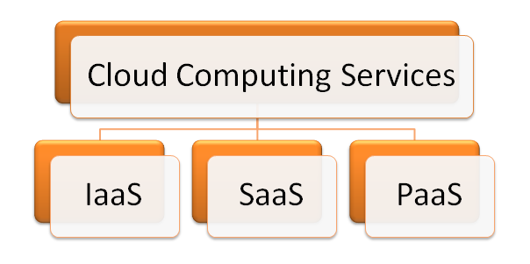6. Explain the different deployment model of the cloud?
Answer: When asked as the Azure cloud interview question you should answer it in the following way. There are various deployment models for the cloud;
- Private Cloud Deployment Model is one where you own the infrastructure and the cloud provider enables you to get the service exclusively.
- Public Cloud Deployment Model is one where you get the multi-tenant infrastructure from the service provider exclusively.
- Hybrid Cloud Deployment Model is a set up of intermixed public and private data in which the confidential data will be served in-house and the public directed website is there to address the public.
Wondering how much an Azure Administrator can earn. Read our previous article to have a deep insight into the Azure Administrator salary.

7. What are the main functions of the Azure Cloud Service?
Answer: The main functions of the Azure Cloud Service are;
- It is designed to host the running application and at the same time manage the background running application.
- The application of web processing is termed as “web role” whereas the background processing is termed as the “worker role”.

8. State the purpose of the cloud configuration file?
Answer: There is a primary .csfg file available with each and every cloud service. The main purpose of this file is
- They hold the main copy of certificates.
- They have the storage of user-defined settings.
- There are a number of instances in any service project.


9. Which services are used to manage the resources in Azure?
Answer: When you are asked about Azure cloud interview questions, it should be answered that the Azure resource manager is the infrastructure that is involved in managing deploys or deleting all the resources. Note that Azure resource manager is one of the top Azure services so you may get more questions on it.

10. What do you mean by roles?
Answer: This is another basic yet important question asked as the Azure Interview Questions which should be answered in the following way:
Roles in cloud management are often termed to be nothing servers that are linked to managing and balancing the platform as service machine that collaborates works to attain the goal.

11. What are the different types of roles?
Answer: There are basically three different types of roles;
- Web Role that is used to deploy website by making use of language which is supported by the IIS platform customized to run the web application.
- VM Role is used to schedule the window services and task. It is done by the user through customization of the machine on which the worker’s role is running.
- Worker Role is to execute the process that runs in the background by deploying the website.
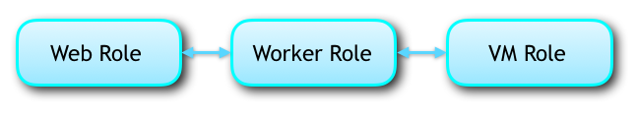

General Azure Interview Questions and Answers
So, you have gone through all the basic questions, now let’s take a step ahead and move to some general Azure interview questions. Interviewer generally asks these questions to check the knowledge of the candidate on various aspects.

12. What do you mean by a domain?
Answer: This is one of the common Azure Interview Questions that may be asked which should be answered as follows the interconnected and interlinked nodes that are often a measure undertaken by the organization is known as the domain. These relations are carried by only one point of the organization.

13. Explain the fault domain.
Answer: This is one of the common Azure interview questions which should be answered that it is a logical working domain in which the underlying hardware is sharing a common power source and switch network. This means that when VMs is created the Azure distributes the VM across the fault domain that limits the potential impact of hardware failure, power interruption or outages of the network.

14. Discuss Update Domain.
Answer: It is a logical group that undergoes maintenance by rebooting the system. The system automatically distributes the created VMs all across the updated domain that enables the user to run any one of the application while the Azure platform is undergoing maintenance. The update domain does not work sequentially to the manual rebooting.

15. Differentiate between the verbose and minimal monitoring.
Answer: Verbose monitoring collects metrics based on the performance that enables close analysis of data that fed during the processing of application whereas the minimal monitoring is a default configuration that makes the use of the performance counters gathered from the operating system of the host. Proceed to the more Azure cloud interview questions that are quite common.
Thinking Why should I go for an Azure certification? Here are the Top 7 Reasons to go for Microsoft Azure Certification.

16. What do you mean by a BLOB and what are their types?
Answer: BLOB is a Binary Large Object that is composed of any size and type of file. They are mainly of two types-the page and the block blob.

17. What is meant by the block blob and page BLOB?
Answer: Blob is a block that is having a specific block ID. Each block in this block BLOB comprises of the 4MB and maximum size of this BLOB limits to 200 GB. Whereas the Page blob contains pages in which data range is determined by the offsets. The maximum limit is 1TB where a single page is of the size 1TB.

18. Differentiate between the Windows Azure bus queues and Windows Azure queues?
Answer: Windows Azure queues take care of the storage infrastructure of Windows Azure. The features include the REST based Peek/Get/Put interface that enables the users to get persistent messaging in-between the services and reliability.
Bus queues are a broader aspect of the messaging infrastructure with publishing and subscribing the integrating patterns of remote web service.

19. What is meant by the DeadLetter queue?
Answer: Messages are transferred to the DeadLetter queue in the following situation;
- When the delivery count has exceeded for a message that is on a queue.
- When the expiry date of the message has crossed and the entire expired message is held in a queue.
- When there is an evaluation exception set by default and the subscription is enabled with dead letter filter.

20. Explain the Window Azure platform?
Answer: It is collectively a PaaS developed by the Microsoft programmed to run a deployment vehicle and a runtime for the data center to host the cloud computing. Let’s proceed to the next general Azure Interview Questions that may be asked.

21. How is the price of the Azure subscription placed?
Answer: The prices vary in accordance with the product type. The various pricing models are;
- The free model where our customers can avail the system exempted from the market fee.
- The BYOL scheme where the Azure is fetched the Azure with a fee that is not encircled around the limits of market price.
- The trial of the free software where the client gets the full version with an advanced feature for a limited period of time. With the expiration of the introductory period, you will be charged standard rates.
- Usage Based Fee that is billed in accordance with the service that you have taken. Like if you are subscribed for the virtual image then hourly fees may be charged.
- Monthly bills are activated if you sign a particular plan. The fee is not allocated for cancellation or mid-month unused service.
Preparing for Google Cloud Interview? Here’s Top 30 Google Cloud Interview Questions and Answers

Azure Interview Questions and Answers for Experienced
If you are a cloud professional with some considerable experience on the Azure platform, you may come across some advanced Azure interview questions. So, let’s get prepared with some frequently asked Azure interview questions for experienced.

22. What are the sizes of the Azure VM?
Answer: It is another basic question that finds its place in the series of top Microsoft Azure interview questions. The Windows Azure is destined to balance a variety of sizes. Most of the VM sizes are:
- The extra large computer has 8*1.6 GHz of Instance size, with instance storage of 2040 GB, CPU memory of 14 GB. The I/O performance is high.
- The large computer has 4*1.6 GHz of Instance size, with instance storage of 1000 GB, CPU memory of 7 GB. The I/O performance is high.
- The medium computer has 2*1.6 GHz of Instance size, with instance storage of 490 GB, CPU memory of 3.5 GB. The I/O performance is high.
- Small computer has 1.6 GHz of Instance size, with instance storage of 225 GB, CPU memory of 1.75 GB. The I/O performance is moderate.
- The extra small computer has 1.0 GHz of Instance size of 20 GB, with instance storage of 20 GB, CPU memory of 768MB. The I/O performance is low.
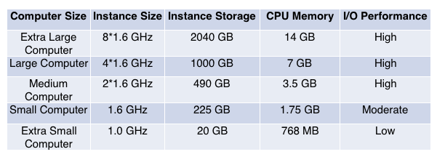

23. What is meant by table storage?
Answer: It is an interface that is capable of storing bulk amount of structured but non-relational data. It is a service of the NoSQL data store that takes authenticated calls from either outside or inside the Azure cloud. The table is a collaborated entity that in turn is a set of properties which is a paired up of name and value.

24. Differentiate between the repository and the powerhouse server?
Answer: Repository servers are those which are in lieu of the integrity, consistency, and uniformity whereas the powerhouse server governs the integration of different aspects of the database repository.

25. What is meant by the enterprise warehousing?
Answer: It is the phenomenon where the data is developed by the organization having access at a single point throughout the globe. The warehousing enables the server to get linked to a single point with the assistance of periodic handling.
Azure is the top second cloud player among the top three (AWS, Azure, and Google Cloud). Let’s have a comparison between three i.e. AWS vs Azure vs Google

26. What do you mean by lookup transformation?
Answer: Lookup transformation aids to determine source qualifier. It can be active or passive lookup transformation. The process is yield to get the access the relevant information or the data.

27. What is meant by the connected lookups?
Answer: In the unconnected lookup, the input is directly taken from the transformation that takes part in the flow of data. The connected data lookup is built as both a static and dynamic cache. This can be oriented via multiple ports that can give the output. It is defined by user defined entity.

28. What is meant by the unconnected lookups?
Answer: The answer to this Microsoft Azure interview question should be that in the unconnected lookups the input is taken by the LKP operation. Nature is dynamic having a single output port. User-defined values are disregarded in the unconnected lookups.

29. What is meant by the command task?
Answer: Command task is an operational window that sets off the flow of one or multiple command shell while the system is still running.

30. What are the PowerCenter commands that can be used in Informatica?
Answer: The languages for transformation that can be provided with some basic comment signifiers that are;
- Slashes (//)
- Dashes (–)
If these common signifiers are absent in the line the power integration service will ignore the text.
If you want to land your dream job as an Azure Data Engineer, you must pass the DP 200 and DP 201 certification exams to achieve the Microsoft Certified Azure Data Engineer badge. It will enhance your chances of cracking the interview.

31. What is the difference between copy and shortcut?
Answer: The answer to this Microsoft Azure interview question will be copied is transferring an object from one to another folder that takes double space. There is no change that corresponds to the original object.
The shortcut is a dynamic link of the object that saves the space reflecting changes in the original object.

32. What do you mean by a service fabric in Azure?
Answer: This is one of the advanced Microsoft azure interview questions that should be answered by stating Service fabric is a middleware platform of the following generation that gives the more scalable outcome. It renders with the more managed and reliable enterprise.

33. What are the benefits of the traffic manager in Windows Azure?
Answer: Traffic manager is allocated to control the distribution of the user to deploy the cloud service. The benefit of the traffic manager constitutes;
- It makes the application to be available worldwide through automated traffic control machinery.
- The traffic managing service contributes to high performance by loading the page faster and convenient usage.
- There is no lag of time to maintain or upgrade the existing system. The system keeps running in the back while the system takes time for up gradation.
- The configuration is made easy through the Azure portal.

SQL Azure Interview Questions and Answers
If you are an Azure data engineer and going for an Azure interview, it is common to come across database-related questions i.e. SQL-based. So, let’s get prepared for that too. Just go through the following SQL Azure interview questions.

34. Discuss the different database types in SQL Azure?
Answer: This is one of the commonly asked SQL Azure interview questions that must be answered by stating that there are two major type of database in SQL Azure;
- Web Edition – It is having a limit of 5GB SQL that is related to the relational database. The basic advantage is that they can be self-maintained, tolerant to a fault and highly available.
- Business-based Edition – they support 50GB of T-SQL that is self-managed, tolerant to a fault and highly available. They are suited for the custom web applications or ISV application.

35. How is Azure Resource Manager beneficial over the classic services?
Answer: The benefits of the Azure Resource Manager that overshadows the benefit of the classic services are;
- The resources need not be managed, deployed or monitored one at a time. They are chain deployment activities throughout the lifecycle without the need for individual data handling.
- The data is also deployed at a consistent pace with the ARM service. It enables the user to use a declarative template that indicates the deployment.
- Since the role-based control is present in the management platform that provides you with the access to the resources that leads you to control.
- You can mark dependencies between the resources that enable you to get the correct order of deployment.
- The resources may be tagged and organized logically so that it is convenient to follow up the billing of your company.

36. Enlist the monitoring features that are present in the SharePoint 2010?
Answer: This is one of the SQL Azure interview questions that should be answered by stating that the SharePoint 2010 is a diagnostic logging that takes into the data that are a direct indication of the state of the system. Sometimes it also specifies some timer tasks that are performed to monitor the collected information. The features include;
- It collects the data on event log, timer service, and performance counter.
- They are involved with data that are search usage.
- They provide matrices that are yielding a collection of sites.

37. State the class that can be used to retrieve data?
Answer: The class that can be used to get data from more than one list is the SPSite Data Query that is able to query data that are present in more than one list all across the diverse web collections. It is featured to aggregate data without the external links and only through the SharePoint.

38. Compare the STS and SPS and state its important features?
Answer: SPS is the SharePoint Portal Service which manages the documents and has a search engine more efficient in penetrating the multiple sources of content.
STS stands for the SharePoint team management. As the name suggests they are better for the document management for a large organization and has a moderate search engine.

39. Explain MOSS?
Answer: The answer to this SQL Microsoft Azure interview question for experienced will be MOSS is abbreviated for Microsoft Office SharePoint Server that constitutes a complete version of the portal platform that yields the user to manage, share and even create the document.

40. What is the difference between a library and a list?
Answer: The library is an interface that yields one to manage and store a document that can be created using Excel, PowerPoint or Word. The list is the representation of the item in a tabulated format using column and rows. Lists are not used to make a document but can attach documents.

41. What do you mean by SAS?
Answer: This is one of the common SQL Azure interview questions that should be answered by stating that SAS is an abbreviation for Statistical analytical System which is a software suite performing analysis of multiple variables. It is in linked to the predictive analysis, data handling, advanced analytics or corporative intelligence. It produces a smooth interface that offers graphical and clicks based solution. It is user-friendly for the technical or the non-technical with advanced features.

42. State some features of SAS?
Answer: There is some interlinked feature of SAS which includes;
- It provides the user access to manage the resources just like that of the DBMS.
- It is leading with the leading analytical to carry out different business services and products.
- It enables easy visualization and interpretation with the use of graphs and its breaks the complex panels into simple plots.
- It is very efficient in delivering the business analysis which leads to manufacturing the products that can be distributed worldwide.

43. Describe the common architecture of SharePoint 2010?
Answer: There are three main architectural design of the SharePoint 2010 which includes;
- The enterprise farm which is uncommon as it completely is dedicated to the service and aids via the automated management with the feasible isolation of data.
- There is a single farm that is associated with multiple services whose potential advantages are management via individual service application which enables with a more complex targeting of sites to a particular application of service.
- Lastly, the single farms employed in single service are very common and at the same time easy to deploy. The application service is simple to be allocated with fullest resource utilization and management.

44. Describe the log analytics?
Answer: This question can be asked among the SQL Azure interview questions. The operational management service of the Log Analytics provides the entire requirement that runs the particular service. It manifests automation, security, log analytics and availability at a particular dashboard. It generates Power data source that enables the user to get the visuals of the raw data. It is introduced in three different tiers of prices that include free, premium and standard. You enjoy the convenience of searching the data at a single dashboard and export the results.

Advanced Azure Interview Questions and Answers
In the series of Azure interview questions, here we bring some advanced Azure interview questions for you with the detailed answers. Preparing through these questions will prepare you to crack the tough to tough interview.

43. State what will you do in case of a drive failure?
Answer: This is one of the another Microsoft Azure interview questions for experienced that should be answered in the following manner. When there is an instance that the drive has failed the following step should be performed;
- The first is that the drive should be not mounted enabling the object storage to function without fail.
- The second scenario is replacing the drive in which the desired step will be remounting, formatting the drive.

44. State what should be done in case of a service failure?
Answer: In the case of the service failure the following steps need to be performed;
- Ensure that the object s services have stopped running which will enable the object services to withstand the failure.
- To complete the last lap of work pending you can allow the system object storage remain functional by making the machined to again get back to online. Once they are started, the online replication will instantly activate with the missing updated files.
- If you are incapable to replace drive then do remove the drive and let the system stay not mounted.

45. Give a clear overview of API in Azure?
Answer: The Test Analytics in API is a web service that is built with the Azure learning. It is an effective tool to analyze the unstructured data like the extraction of the key phrase. It runs with the binomial scoring unit that is either 0 or 1 where 1 corresponds to a positive and 0 corresponds to a negative viewpoint. The advantage is that it does not need any assistance with designing and training which imply that the data is in the hands of directly the user. Proceed to find more Microsoft Azure interview questions for experienced.
Microsoft Azure certifications have their own recognition in the Cloud industry. Let’s find out their place among the Top 5 Cloud Certifications!

46. Explain how does a character analytics API function?
Answer: The working of the character analytics of API does not account for the characterization of words like good or bad. It uses the advanced feature through which the processing of natural language is mediated.

47. Differentiate between the PROC SUMMARY and PROC MEANS?
Answer: This is one of the stars marked questions found in the list of top Microsoft Azure interview questions and answers pdf.
PROC MEANS refers to the subgroup statist created in the persistence of the BY statement that will be involved. The data here is sorted beforehand with the assistance of BY variables.
PROC SUMMARY is the aid of statistics giving all varieties of information running simultaneously and is produced for every subgroup automatically. The information in the outlet is not created.

50. If the client gets disconnected from cache with the services state the probable cause?
Answer: If the client gets disconnected the causal factor can be distributed into two categories;
The cause on the operator side;
- There might be a failure in the transfer of the standard cache from one node to the other.
- While the service was processing and dispatching the cache got deployed.
- There was a server update or an automated VM maintenance.
The fault on the client side;
- The application of the client accidentally got redeployed.
- The application on the client side got auto-scaling.
- The layer of the network on the client side altered.
- There was a transient error on the network node.
- The bound operation took more time.
- The upper limit of the bandwidth was reached.
Share And Win – Share this article on Twitter and get 25% OFF on Azure Certification Courses. Share it now and send us a mail to support@whizlabs.com with your Twitter post link.

Updated Questions:
51. How do we configure load balancer and why I should have a backend pool for load balancer?
Load Balancer is a resource that helps balancing the load across mutliple servers. In order to configure a load balancer we need a frontend ip, backend pool, health probes and load balancing rules. Backend pool is the target machine that processes the end user requests, with out backend pool there is no use of load balancer.
52. How do you trouble shoot connectivity issues between VM’s with in Azure?
- Check whether NIC is misconfigured
- Check whether network traffic is blocked by NSG or UDR
- Check whether network traffic is blocked by VM firewall
- Check whether VM app or service is listening on the port
- Check whether the problem is caused by SNAT
- Check whether traffic is blocked by ACLs for the classic VM
- Check whether the endpoint is created for the classic VM
- Try to connect to a VM network share
- Check Inter-Vnet connectivity
Troubleshooting connectivity problems between Azure VMs | Microsoft Docs
53. What are the high level requirements before establishing site to site connectivity
We need to first create a VPN gateway with site-to-site as the option
We need to create a logical resource to represent on-prem router and present it as local gateway. To establish connectivity we need to have public ip of remote router and its pre-shared key.
54. What does it mean by VM agent unable to communicate with Azure Backup?
Possible reasons for this issue are, the Azure VM agent might be stopped, outdated, in an inconsistent state, or not installed. These states prevent the Azure Backup service from triggering snapshots or communicating with Azure Backup.
55. What is Gateway Transit option for a VNET?
Gateway transit enables one virtual network to use the VPN gateway in the peered virtual network for cross-premises or VNet-to-VNet connectivity. To use this setting, only one of the virtual network in the peering can have a gateway configured. It is to allow peered network to reach to On-prem servers if the first VNET has a Site-to-Site VPN established already
56. What is the difference between standard SSD and premium SSD?
Premium SSD disks, perform better than Standard SSD disks, with very low latencies, high IOPS/throughput and even better consistency with provisioned disk performance, and it is the recommended disk type for all other production workloads.
https://azure.microsoft.com/en-in/blog/preview-standard-ssd-disks-for-azure-virtual-machine-workloads/
57. How to deny access for one VM and allow access for one VM
By using Network security groups(NSG) or Application security group(ASG), we can define inbound rules to allow or deny access to specific vms
58. How to differentiate deployment VM and test VM’s in vm creation ?
There is no such difference option during VM creation.
A VM can be differentiated on basis of applications where it hosts, and this only happens after VM is up and running.
59. Is there any live stream between on prem ad to azure ad ?
AD Connect is the tool used to sync on prem ad objects to azure ad.
60. How will you do patching while migrating onprem VM?
We don’t patch any VM during migration, we can start it after migration from the Azure portal.
61. What is Traffic manager and how it works in azure ?
Traffic manager is a global load balancer, it works based on DNS. There are 6 profiles pre-defined in TM, and based on your needs you need to choose which profile is well suited.
62. How do you troubleshoot RDP connections to an Azure virtual machine?
- Reset Remote Desktop configuration.
- Check Network Security Group rules / Cloud Services endpoints.
- Review VM console logs.
- Reset the NIC for the VM.
- Check the VM Resource Health.
- Reset your VM password.
- Restart your VM.
- Redeploy your VM.

Explain Azure Cloud Services.

Azure Cloud Services is a Paas (platform-as-a-service) product that intends to provide robust, efficient, and cost-effective applications. Azure Cloud Services are hosted on virtual machines, and they let one have a higher degree of control over the VMs by allowing software installation on the VMs and also making them remotely accessible.
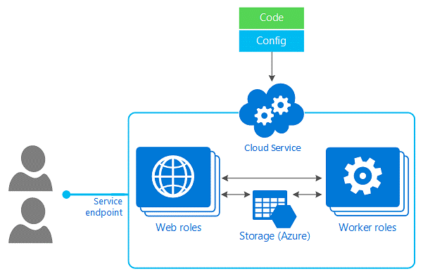
Source: Microsoft Azure docs
By launching a cloud service instance, Azure cloud services can be utilized to implement multi-tier web-based apps in Azure. Azure cloud services aid an application's scalability by making it easier and more adaptable. The two types of Azure Cloud Services roles are-

Web role (has a dedicated web server that uses IIS to automatically launch and host your app).

Worker role (allows apps to run by themselves without using IIS and helps run background processes).

What do you understand about the Azure SLA?

As the name suggests, Azure SLA (Service Level Agreement) is a service contract stating that when you deploy two or more role instances of a service on Azure, access to that cloud service is available for at least 99.9% of the time. It also indicates that if the role instance is not functioning, it will identify and resolve that role instance 99.9% of the time.
Suppose any of the points mentioned above fail to satisfy at any moment. In that case, Azure will credit the concerned user a certain percentage of their monthly payments based on the pricing model of the Azure services in question.

List the different cloud deployment models available in Azure.

Based on one's business requirements, there are three different cloud deployment models in which you can deploy any Azure cloud service -

Private Cloud- It comprises cloud computing resources owned entirely by a single company. This could mean hosting one's apps on their on-site servers or a dedicated server offered by the cloud service provider.

Public Cloud- The most common cloud deployment model, the public cloud, involves a third-party cloud service provider to manage and control the cloud resources distributed via the internet. The cloud provider owns all hardware, software, and other supporting facilities in this case. Example- Microsoft Azure.

Hybrid Cloud- A hybrid cloud is a blend of private and public clouds. These cloud deployment models employ private cloud service features such as processing confidential data and public cloud services such as hosting commercial applications.

Define IaaS, PaaS, and SaaS.

IaaS- IaaS stands for Infrastructure as a Service. It is a cloud computing service that hosts apps on the infrastructure and allows you to avail storage, networking resources, etc., on demand. Each resource is available as an individual service facility, and one has to only pay for it for as long as he needs to use it. Azure VM, VNET, etc., are some popularly known examples of IaaS.

PaaS- PaaS stands for Platform as a Service. It offers both- a cloud development and deployment environment, with facilities that enable users to produce simple cloud-based apps or even complex, cloud-enabled business systems. A user only pays for the resources he needs from a cloud service provider and accesses them over a secure Internet connection. Users are in charge of the applications and services they create, and the cloud service provider manages the rest. Azure web apps, Storage services, cloud services, and other services are all examples of PaaS.

SaaS- SaaS stands for Software as a Service. Organizations avail SaaS applications through a service delivery mechanism. This works by charging the organization for their use or by displaying advertisements. User interaction with cloud-based programs through the Internet can occur through software as a service (SaaS). The service provider's data center hosts the underlying infrastructure, software, and app data. Applications such as Office 365, Gmail, SharePoint Online, and others are examples of SaaS.

Explain Azure Redis Cache.

Azure Redis Cache is an in-memory data storage, or cache system, based on Redis that boosts the flexibility and efficiency of applications that rely significantly on backend data stores. It can handle massive numbers of application requests by storing highly trafficked data in server memory, where it can be written to and read fast. Redis open-source (OSS Redis) and Redis Enterprise (from Redis Labs) are both available as managed services through Azure Redis Cache. It offers safe and dedicated Redis server facilities and complete Redis API support. Microsoft runs this service, which can be helpful for any Azure-based or non-Azure-based application.

Why isn't there an MSDN class library reference for Azure Redis Cache?

Microsoft Azure Redis Cache is built on the famous open source Redis Cache and can be accessible by several Redis clients written in various computer languages. Every client has its API for making Redis commands calls to the cache instance. There is no unified class reference on MSDN since each client is unique and keeps its reference data.

What are availability sets?

An availability set is a cluster of virtual machines that enables Azure to understand how an application offers redundancy and high accessibility. To provide a highly available application and achieve the 99.95 percent Azure SLA, creating two or more VMs within an availability set is safer. The two domains assigned to every VM in an availability set are- an update domain and a fault domain.
Update domains combine virtual machines and the underlying hardware that can reboot simultaneously. Before the maintenance on a different update domain, a restarted update domain takes 30 minutes to recover.
Fault domains are the set of virtual machines that share a common power source and a common network switch. Virtual machines specified in your availability set are split into up to three failure domains by default. Integrating virtual machines into an availability set helps mitigate the impact of hardware malfunctions, network outages, and power outages.

Define Azure Functions in detail.

The Azure Functions is a serverless code computation service that allows you to run code without a server on demand, such as Events and External-Invoke. They are stateless and short-lived, and azure Functions may automatically scale up in response to the request. They tend to speed up the development process by avoiding the need to perform any integration coding for you to connect to other services. They also offer Azure Application Insights for monitoring and evaluating code performance, which aids in the identification of bottlenecks and failure locations throughout the application's components. You can write Functions in C#, Node, Java, Python, and other languages.

What do you understand about Azure Active Directory?

Microsoft's Azure Active Directory (Azure AD) is a cloud-based authentication and authorization service. It weaves application access management, core directory services, and identity protection into a single solution. It enables all employees in an organization to sign in and access resources in the following areas:
i) External resources such as Microsoft 365, the Azure gateway, and millions of other SaaS services.
ii) Internal resources, such as apps on your company's intranet and network and any cloud service apps built by your company.

Define CSPack in Azure.

CSPack is a command-line tool that generates package files for applications that must deploy in Azure. CSPack uses the data from the service definition and service configuration files to define the content within a package. You can upload an application package file (.cspkg) to Azure via the Azure site using CSPack. The package is named [ServiceDefinitionFileName].cspkg by default, but you can change it with the /out option of CSPack. Every cloud service project contains a cscfg file, essentially a cloud service configuration file generated by the cspack tool.

Explain Azure Blob storage.

Azure Blob storage is a Microsoft storage offering that is meant explicitly for cloud objects and is suitable for holding vast quantities of unstructured data. Unstructured data, such as text or binary data, does not correspond to a specific data model or description.
Blob storage is suitable for sharing images/docs directly to a browser, storing files meant for multiple access, streaming audio/video files, backing up data, creating log files, etc.
There are three types of resources available in blob storage:

A storage account- In Azure, a storage account gives your data its namespace.

A container in the storage account- A container manages a group of blobs, and there are no constraints on the number of blobs stored in a container.

A blob within the container- A blob is a Binary Large Object (BLOB), which can be any form of file or document of any size. Azure supports three different types of Blobs:

Block blobs: These are meant to store individual blocks of text and binary files and have a storage capacity of up to 195GB.

Append blobs: These are useful for append tasks like logging data in log files.

Page blobs: These store random access files up to 8 TiB and are intended for reading/writing operations that occur often.

Learn more about real-world big data applications with unique examples of big data projects.

Azure Solution Architect Interview Questions
In this section, we'll cover some of the popular Azure interview questions along with their answers suitable for the role of Azure Solution Architect.

Explain Service Bus Queue and Storage Queue.

Azure Service Bus Queues belong to the Azure messaging framework and include queuing, publishing, subscribing, etc. They are part of the Service Bus and can pass messages through to other Queues and Topics. The Azure Service Bus Queues feature a built-in dead-letter queue and allow you to choose a timeline for messages so they can last as long as you want them to! They connect applications or parts of applications that cover different communication protocols, data treaties, trust domains, or security protocols.
Azure Storage Queues belong to the Azure storage framework and are easy to use. They allow easy debugging by using the local Azure Storage Emulator. The set of Azure Storage Queue tools enables you to take a quick look at the top 32 messages and visualize the contents of those belonging to XML/JSON right from Visual Studio. Another feature of storage queues that ensures smooth development and QA operations is that the contents of these queues can be emptied when needed. Authenticated HTTP or HTTPS calls allow you to access the queue messages regardless of your geographical location. Queue messages have a maximum capacity of 64 KB and can hold millions of messages depending upon the storage account's overall capacity limit.

Can you specify the storage limit associated with a virtual machine?

When it comes to the storage limit associated with virtual machines, each data disk has a maximum capacity of 1 TB. The amount of data disks one can use is determined by the virtual machine's size. Azure Managed Disks is a new and highly recommended disk storage option for Azure Virtual Machines for long-term data storage. Each Virtual Machine can have many Managed Disks. Premium and Standard Managed Disks are two types of long-term storage options offered by Managed Disks. Also, storage for the OS disk and any data disks can be provided via Azure storage accounts. Each disk is a page blob that is stored in a .vhd file format.

What is meant by Azure Cognitive Search?

Azure Cognitive Search is a cloud search solution that entrusts server and infrastructure maintenance to Microsoft. It provides developers with platforms, APIs, and tools for creating ready-to-use advanced search experiences in web, mobile, and corporate applications over private, diverse content. By using a simple REST API or.NET SDK, you can easily add a powerful search experience to your applications without having to manage search infrastructure or become a search specialist. For apps that depend exclusively on the search for both feature extraction and content navigation, Azure Cognitive Search is the ideal cloud provider for full-text search operations over content repositories and databases on Azure.

What is Azure CosmosDB?

Azure CosmosDB is one of the PaaS features offered by Microsoft. It is a cloud-based NoSQL database that deals mainly with modern app development. CosmosDB data can be easily shared and replicated anywhere in the world, which ensures faster and more efficient app development. Capacity management, automatic scaling, and serverless databases aid in matching demand with storage capacity.
Azure Cosmos DB takes care of database administration for you, including auto-management, updates, etc., and also includes features such as single-digit millisecond response times, rapid scalability, SLA-backed availability, and enterprise-grade privacy.

Which Cosmos DB component will you use if you need to provide your application temporary access to Cosmos DB?

The two URLs, Read and Read-Write, allow you to share your Azure Cosmos DB account with other people for a specified duration of time. Since the account access has an expiration time window of 24 hours, you can regain access by using a newly-generated access URL or the connection string.

Read URL- Other users can browse the databases, collections, queries, and other resources linked with that specific account, provided you share the read-only URL with them.

Read-Write URL- Other users can read and alter the databases, collections, queries, and other resources linked with that specific account if you share the Read-Write URL with them.

What Azure feature may be used to prevent high application load in the case of no-man assistance on the flow?

The solution to this problem involves using VM Scale sets, which define the necessary configuration and requirements for provisioning a new VM whenever there is an escalation in the application load. Developers can use Azure VM Scale Sets to build and manage a load-balanced collection of VMs. The number of virtual machine instances can be increased or decreased automatically in response to demand or a set timeline. Scale sets enable developers to facilitate the construction of large-scale applications that support huge data, massive workloads, and compute loads. They ensure the high availability of the applications and allow developers to manage, update, and configure large VMs centrally.

Is sticky session support available in Traffic Manager?

Since the Traffic Manager works at the DNS level, clients are directed to the ideal service endpoint using DNS responses. This also means that clients manage to connect directly to the service endpoint, bypassing Traffic Manager, which results in the HTTP traffic between the client and the server remaining unknown to the Traffic Manager. Furthermore, the recursive DNS service owns the source IP address of the DNS query received by the Traffic Manager instead of the client. As a result, Traffic Manager is unable to track individual clients or create sticky sessions. This constraint exists in the case of all DNS-based traffic control solutions, including Traffic Manager.

Explain the Site Recovery feature of Azure.

Site Recovery is a service that keeps corporate apps and workloads operational during outages, assuring smooth business processes. This feature offered by Azure works in such a way that it copies activities from a primary location to a secondary location with the help of physical and virtual machines (VMs). When your primary location goes down, you switch to the secondary location, where you can access the apps. You can roll back to the principal location once it has been restored. Site Recovery ensures replication for Azure VMs, on-site VMs, Azure Stack VMs, and physical servers.

What is meant by Azure Service Fabric?

Azure Service Fabric is a parallel processing platform that ensures simple packaging, smooth deployment, and efficient handling of robust and reliable microservices and containers. Service Fabric allows you to create microservice-based applications. The major constraints in designing and administering cloud-native apps are also handled by Service Fabric. It has a huge emphasis on designing stateful services. You can run container-based stateful services written in any language or code using the Service Fabric computing architecture. Also, you can create Service Fabric clusters in the private clouds with Windows Server and Linux, as well as in other public clouds.

How does Azure Traffic Manager differ from Azure Load Balancer?

Azure Traffic Manager is mainly responsible for sending traffic globally on the basis of dynamic principles. This leads to an enhanced user experience that reflects how your application is distributed worldwide. Your public endpoints will also experience benefits such as high accessibility and responsiveness. For diverse application objectives and spontaneous recovery systems, Traffic Manager offers a variety of traffic-routing mechanisms and endpoint tracking solutions.
The Azure Load Balancer handles the routing of traffic within a certain region. It is used together with Azure Traffic Manager, which directs traffic to a region between virtual machines. When the two are coupled, you get global traffic control with local backup. The Azure Load Balancer service offers a high-performance, low bandwidth Layer 4 load-balancing solution for all UDP and TCP protocols. It can ensure the smooth handling of millions of queries per second while maintaining high availability.

Azure Administrator Interview Questions
If you are preparing for an Azure Administrator job interview, then here are some popular Azure interview questions you might find helpful.

Distinguish between an Azure SQL Database and a SQL managed instance.

Azure SQL Database is a fully managed PaaS database server that keeps track of most database management tasks like data upgradations, patching, data backups, etc., without the need for human intervention. Azure SQL Database always runs on the most recent stable version of the Microsoft SQL Server database system, and its built-in PaaS capabilities allow you to concentrate on the domain-specific database management and performance activities that play a major role in upscaling your business. It also enables you to develop a highly accessible and rich in performance data storage layer for Azure apps and solutions.
Azure SQL Managed Instance is an efficient, highly scalable database solution by Microsoft. It is fully compatible with the latest SQL Server (Enterprise Edition) database system and offers a native VNet implementation that resolves basic safety issues, as well as a commercial model that is appealing to existing SQL Server users. Existing SQL Server users are enabled to migrate their local workloads to the cloud with minimal changes. Simultaneously, SQL Managed Instance retains all PaaS functionalities, including automated upgrades, automated backups, and high accessibility, thereby lowering administration expenses.

In Azure Synapse Analytics, what does a dedicated SQL pool mean?

The enterprise data warehousing solutions included in Azure Synapse Analytics are referred to as a dedicated SQL pool. When using Synapse SQL, a dedicated SQL pool constitutes a group of analytic tools that are deployed. Data Warehousing Units are solely responsible for determining the size of a dedicated SQL pool. Once the dedicated SQL pool is established, you can use basic PolyBase T-SQL queries to import massive amounts of data and then leverage the distributed data processor to run high-performance analyses. As data gets merged and analyzed, a dedicated SQL pool becomes the only source your company can rely on for reliable high-speed insights.

What are the steps to link SQL Management Studio to an Azure database?

i. The Connect to Server dialogue box automatically appears when you launch SQL Server Management Studio for the first time. Alternatively, you can also go to Object Explorer > Connect > Database Engine.
ii. Then, in the Connect to Server window, input the following information-
Server Type- Here, you need to enter the database engine
Server Name- Enter the name of the Azure SQL Database or Azure Managed Instance you want to use.
Authentication- Enter the SQL Server Authentication
Login- Enter the user ID for the server account.
Password- Enter the password for the server account.
iii. Once you've filled all the required fields, click on Connect.
If the firewall settings aren't configured, a popup occurs to do so. Provide the Azure account login credentials once you've signed in. After that, click OK.
iv. Select and browse Object Explorer for the hostname, SQL Server version, and username to see whether your Azure Database connection is successful.

Explain Azure Backup. Mention some of its advantages.

Azure Backup is a cloud-based solution offered by Microsoft that allows you to backup Azure Windows VMs, Azure Managed Disks, Azure File shares, SQL Server databases, SAP HANA databases, Azure PostgreSQL databases, etc.
Some primary benefits of Azure Backup include-

Azure Backup is a convenient way to back up your on-premises data to the cloud. Without building extensive on-premises backup solutions, you may get short and long-term backup.

Azure Backup enables separate backups to protect original data from unexpected damage. Backups are retained in a Recovery Services storage with built-in recovery point management.

Azure Backup delivers high availability with minimal maintenance or monitoring overhead by leveraging the Azure cloud's core ability and infinite capacity.

Discuss the different types of backups available in Azure?

To maintain the high availability of your data as well as storage, Azure Backup supports three methods of backup-
i. Locally redundant storage (LRS) copies your data three times in a centralized storage unit within the same region. LRS is a cost-effective option for safeguarding data against local hardware breakdowns.
ii. Geo-redundant storage (GRS) is the standard and preferred backup mode that replicates your data to a secondary region far away from the primary location of the source data. GRS is more expensive than LRS, but it provides greater data resilience, even in the event of a local disruption.
iii. Zone-redundant storage (ZRS) backs up data in availability zones, ensuring data retention and durability in the same zone. You can back up your essential activities that involve data retention and must run without disruption since ZRS has zero latency.

What types of storage services does Azure provide?

The following data options are provided on the Azure Storage platform:
i. Azure Blob Storage- Text and binary data can be stored in Azure Blobs, which is highly scalable object storage. It stores arbitrary data and allows them to be retrieved as block blobs on a huge scale.
ii. Azure File Storage- Managed file sharing for cloud and on-premises operations can be done with Azure Files. Using the standard Server Message Block (SMB) protocol, you can access fully managed cloud file shares from just about anywhere.
iii. Azure Queue Storage- Azure Queues is a messaging repository that allows application modules to communicate reliably. Asynchronous message queueing between software modules is supported.
iv. Azure Table Storage- Azure Tables is a NoSQL database for storing structured data without a schema. It lets you store organized NoSQL data in the cloud and provides a schemaless key/attribute storage.
v. Azure Disk Storage- Block-level storage units for Azure VMs are called Azure Disks. They allow data to be kept and retrieved from an associated virtual hard disk continuously.

How does a Classic Subscription Administrator role differ from a Directory Administrator role?

When you sign up for an Azure subscription, you are automatically assigned the Classic Subscription Administrator position. You have full access to the Azure subscription and can log in with a Microsoft account or an office/a personal account from the Azure subscription's directory. This job has access to the Azure interface and can manage services there with the help of the Azure site, Azure Resource Manager APIs, etc. You can add others as co-admins if they need to sign in and access services using the same Azure subscription. Both the owner and the co-admins have the same access.
Azure AD offers a set of various different admin roles that are responsible for governing different features. These administrators will be able to use the Azure portal to access a wide range of capabilities. The admin's status dictates the functions they can perform, such as modifying users, assigning administrative duties to others, handling domains, and all other tasks that belong to Azure AD resources in a directory.

What are Network Security Groups in Azure?

A network security group is a group of security rules (Access Control List of rules) that allow or prohibit incoming and outgoing network traffic for various Azure resources. Subnets or specific NICs connected to a subnet can be linked with NSGs in such a way that the rules apply to every single VM in that particular subnet. You can define the sender and receiver address, as well as the host and protocol, for each rule.

Define application partitions in Azure Active Directory.

The application partitions are directory partitions that are copied to domain controllers and belong to the Azure Active Directory system. These domain controllers that are involved in the partitioning procedure keep a copy of the partition. Application partitions have the advantage of being able to be cloned to any individual domain controller, potentially leading to traffic reduction. Although domain directory partitions can transport their entire data to all the domains, application partitions in the domain area can only target one. This minimizes the need for application partitions and thereby increases their availability.

What do you mean by Azure Resource Manager Templates (ARM)?

Azure Resource Manager (ARM) templates are JSON files mainly used to implement infrastructure as code for your Azure solutions. The template outlines your project's infrastructure and configuration. A declarative syntax is used in the template, which allows you to declare what you want to deliver without the use of any actual programming/coding. The template must include the resources to launch as well as their attributes.

Briefly discuss the Azure Kubernetes Service (AKS).

Azure Kubernetes Service (AKS) aims at the easy installation of a hosted Kubernetes cluster on Azure. It is solely responsible for managing containerized applications. It's an open-source solution for scaling, automatic deployment, and managing traffic. Azure deals with important functions like health diagnosis and management as a managed Kubernetes service. You solely manage and maintain the agent nodes because the Kubernetes masters are controlled by Azure. As a result, AKS is completely free; you only have to pay for the agent nodes in your clusters.

What is the procedure for adding an administrator to the Azure portal?

The owner role must be assigned to an administrator before it may be added to the Azure portal. It will only be able to control the subscription's resources that have been assigned to it. These are the steps to add an administrator:
i. Firstly, to use the Azure portal, go to https://azure.microsoft.com/en-in/features/azure-portal/ and sign in.
ii. Then, select the Hub menu followed by Subscription, and select the subscription that the administrator will need access to.
iii. In the subscription blade, select Access control (IAM) and then click Add.
iv. Select Owner from the drop-down menu under Select a role.
v. In this field, enter the email address of the user who will be designated as the owner.
vi. Select the user by clicking on his or her name.

Define table storage in Azure.

Huge quantities of structured data are stored in the Windows Azure Table storage service.
It is a NoSQL service that takes calls from both inside and outside the Windows Azure cloud.
Table: A table is a grouping of objects. Tables do not impose a format on entities; therefore, a single table can contain entities with various sets of characteristics. Many tables can be found in a single account.
Entity: Similar to a database entry, an entity is a collection of attributes. A single entity can be 1MB in size.
Properties: A name-value pair is referred to as a property. Each object can have up to 252 properties. In addition, each entity has three system properties: a partition key, a row key, and a timestamp.
Explore Categories
Apache Hive Projects Apache Hbase Projects Apache Pig Projects Apache Oozie Projects Apache Impala Projects Apache Flume Projects Spark SQL Projects Spark GraphX Projects Spark MLlib Projects Apache Zepellin Projects Apache Kafka Projects Neo4j Projects Redis Projects Microsoft Azure Projects Google Cloud Projects GCP AWS Projects

Azure Cloud Engineer Interview Questions

Why do we use Profilers in Azure?

Azure Profilers are used to trace and assess the performance of applications that are under production in Azure. This is usually done to ensure that the application is stable and capable of handling high traffic. Profiler automatically collects data at scale without causing any inconvenience to your consumers. In order to address a certain web request, Profiler can assist you in finding the "hot" code route that takes up the longest time duration.

Define Content Delivery Networks in Azure.

A content delivery network (CDN) is a decentralized network of servers that delivers web information to users quickly and effectively. In order to reduce latency, CDNs keep buffer data on edge nodes in point-of-presence (POP) locations close to target users. Whether you are building or maintaining websites or mobile apps, encrypting and delivering streaming services, system updates, etc., the Azure Content Delivery Network (CDN) can help you minimize the page load time, reduce bandwidth, and improve responsiveness.

What do you mean by Azure HDInsight?

Azure HDInsight is a Hadoop feature distribution on the cloud. It is responsible for faster and cost-effective processing of vast amounts of data in a configurable framework. You can deploy Hadoop, Spark, Hive, LLAP, Kafka, Storm, R, and other popular open-source frameworks. You can use these frameworks to allow situations that deal with extract, transform, and load (ETL), data warehousing, machine learning, and the Internet of Things (IoT).

What do you mean by Azure File Sync?

Azure File Sync is a Microsoft service that enables you to centralize your organization's file shares in Azure Files in a way that does not hamper the flexibility, scalability, and consistency of a local file server. Your Windows Server machines become a rapid cache of your Azure file sharing, and to access your data locally, you can use any method supported by Windows Server, including SMB, Network File System (NFS), and File Transfer Protocol Service (FTPS).

Which Azure service allows users to identify email messages that should be regulated from a safety point of view through authentication, encryption, and identity regulations, and why?

The answer is the Azure Information Protection service.
When the Azure Information Protection client is installed, it interacts with the operations of end-users. Users and admins can access a file tracking website once a file has been protected. This gives them insight into who accesses the files and when these materials are accessed. Users have the opportunity to withdraw access to the file(s) in question if they detect any type of violation.

Explain Azure Virtual Networks (VNet).

The Azure Virtual Network (VNet) is the most basic component of your Azure private network. With the help of VNet, many types of Azure resources, such as Azure Virtual Machines (VM), can connect anonymously with one other, the internet, and even local networks. VNet works just like any standard network in a locally-owned data center, but in addition to a standard network's features, it offers Azure's operational features like scalability, availability, and exclusion. Interaction of Azure resources with the internet, connection with Azure resources, communication with local resources, screening and directing network traffic, and connection with Azure services are all scenarios that can be executed with a virtual network.

Mention the key segments of Windows Azure.

Windows Azure Compute: It provides a code that the hosting environment can control. A key benefit of using Azure Compute is that it is able to calculate through sections. Web Role, Worker Role, and VM Role are the three sorts of roles available.

Windows Azure Storage (VHD): Queue, Tables, Blobs, and Windows Azure Drives are the four types of storage services provided by Windows Azure Storage (VHD)

Windows Azure AppFabric: Service bus, Access, Caching, Integration, and Composite are the five services provided by Windows Azure AppFabric.

What is meant by autoscaling in Azure?

Autoscale is an inbuilt feature of Cloud Services, Virtual Machine Scale Sets, and Websites that enables applications to expand to adapt to changing demand. Scaling out refers to increasing the number of instances in a system. Scaling up in Windows Azure is also possible by using larger role instances rather than additional role instances. You may balance the performance of your Windows Azure application against its operational costs by adding and removing role instances while it is running. The amount of manual work necessary in dynamically scaling an application is reduced with an autoscaling solution.

Password resets are frequently required when users are shut out of their accounts. You opt to use Azure Self-Service to reset your password. What are your options for deploying this service? What types of authentication are accepted?

First, you need to select the total number of authentication techniques for a password reset, and the number of authentication techniques users can access once you've enabled password reset for all. Ideally, you should keep multiple authentication options even though there's a need for just one. You can either send an email notification to the user's registered email address, a text or security code to the user's phone, or a series of security questions. Security questions can be customized to mandate a specified number of questions to be submitted for users in your Active Directory tenant (3-5). In addition, you must specify the number of correctly answered security questions that must be answered in order for an effective password reset.

Scenario-Based Azure Interview Questions
In any job interview, scenario-based questions are one of the most challenging and crucial segments. Here are some of the scenario-based azure interview questions, along with their answers.

In case of a missing server, how will you use Azure to execute code?

Azure Functions may run code without the need for a server. These services make complicated operations and issues easier to manage. They let clients access other services without having to manually code integrations, which accelerates development. Azure Application Insights can assist with code performance analysis and monitoring, as well as identifying inefficiencies and problem areas across multiple application modules.
Suppose you have learned all the basics of Spark. What’s next? Start exploring ProjectPro’s repository, where you will find different Spark Projects for Practice.

In what way will you manage the Azure connectivity if an application's front-end hosting is done on Azure, but the user requires database hosting on a local server owing to safety reasons?

There are different ways to deal with this:
i. In case of fewer resources to be connected, a local database can be connected to such an application using the Azure VNET-based point-to-site service.
ii. Site-to-site or express routes are the solutions if more resources need to be connected. Due to the VPN's reliance on public infrastructures, such as the internet, response time may get delayed from site to site. Alternatively, express routes can be used in this scenario because they have a dedicated leased line that overcomes lag constraints.
iii. In case none of the above options are suitable, a Windows Communication Foundation (WCF) service can be built and hosted locally. The CRUD operations in the service would remain specific to the local database.

Suppose ‘Acc1' is the name of your Azure Cosmos DB account. Acc1 has a database associated with it called DB1. The database again consists of a container named Cont1, which has its partition key set to /city. What should you do if you wish to modify Container1's partition key?

Certain features offered by Azure Cosmos DB, such as Change Feed Processor and Bulk Executor Library, can be used to perform a live data transfer between containers. This enables data redistribution to meet the intended new partition key strategy, as well as subsequent application updates. As a result, you'll be able to update your partition key.

Suppose you're working on building an Azure web app as part of a solution for your business. The web app must allow users to sign in with their Facebook login credentials. What would you suggest, and why?

Business-to-Consumer (B2C) functionalities offered by the Azure Active Directory (Azure AD) can be linked into applications. Azure AD B2C uses OpenID Connect, which is supported by a wide network of services, including Twitter, Google, and several others. Azure AD B2C safeguards your applications from denial-of-service and password threats and features user interface customizations that make it simple to deploy into your existing applications.

Your company acquires customer purchase data from a variety of retail outlets, and you're working on a system that will analyze the data and forecast future customer purchases for each retailer. Which Azure service do you recommend?

Azure Machine Learning is a data analytics service offered by Microsoft that provides end-to-end solutions for data science problems. It is a data science method that enables computers to predict future actions, results, and trends on the basis of given data. Computers that implement the machine learning technology can operate without any specific hard-core programming. Azure Machine Learning offers many open-source features that allow users to design, implement, and manage predictive models across a variety of environments.

A company has multiple virtual machines (VMs) that were generated using the standard deployment approach. To improve administration, you should transfer the standard VMs to Azure Resource Groups. What are your alternatives for resolving this?

When resources were produced under the old deployment model, there was no provision for resource group management, resulting in the management of higher numbers of resources and the difficulty of executing easy resource management in a unified manner. The latest Azure Resource Manager deployment approach, on the other hand, allows you to move resources like virtual machines between resources, even VMs produced using the classic deployment style. To migrate standard VMs to resource groups, you can try using the Azure portal, Azure PowerShell, or the Azure CLI.

You've decided to use Multiple Stage Builds to improve the accessibility and management of the Dockerfile. What are the points to consider for having multiple-stage builds?

You should consider using Container Modularity, avoiding Application Data, avoiding any extra modules, and adopting an Appropriate Base. Multi-stage builds are a recently updated feature that requires at least Docker 17.05 on both the daemon and the client. Those who are willing to improve Dockerfiles while making them comprehensible and manageable would benefit from multi-stage builds.

You are employed as an architect in a company that keeps track of Azure environments for clients. During peak activity hours, a client reports that various Azure services are inefficient and unavailable. You must assist the client in addressing the problem and find solutions for modifying Azure resources. What are the necessary tools you can use to fix this?

There are two tools- Azure Monitor and Azure Advisor should be used.

You should utilize Azure Monitor for time-critical alerts and notifications because it has the fastest monitoring processor. For a more detailed review, these statistics can be forwarded to Azure Log Analytics.

Azure Advisor examines your resource configuration and performance statistics and provides solutions that enable you to optimize the cost-effectiveness, efficiency, accessibility, and integrity of your Azure services after the data is available. Moreover, the Advisor cost recommendations page can help you streamline and lower your entire Azure expense.

Azure Data Factory Interview Questions
Azure Data Factory (ADF) is an Azure platform-as-a-service (PaaS) for integrating data from multiple sources in the cloud. Below are some of the popular Azure Data Factory interview questions for you-

What is Integration Runtime? What are the different types of integration runtimes?

Integration runtime is a computational infrastructure that Azure Data Factory uses to deliver integration features, such as Data Flows and Data Movement, across various network settings. It can employ resources from public networks or hybrid settings (public and private networks).
There are three different types of integration runtimes-
i. Azure Integration Runtime- It is responsible for patching, scaling, and maintaining the underlying infrastructure.
ii. Self-Hosted Integration Runtime- It is similar to Azure Integration Runtime in terms of code, but it's installed on-premises systems or virtual machines across virtual networks.
iii. Azure SSIS Integration Runtime- It allows users to run SSIS packages in a controlled environment. You can use Azure SSIS Integration Runtime to lift and shift SSIS packages to the data factory.

What are the two levels of security in Windows Azure ADLS Gen2?

i. Role-based Access Control- It covers built-in Azure roles such as reader, contributor, owner, or customer roles. It specifies who can run the service and also gives users access to built-in data explorer tools.
ii. Access Control List - Azure Data Lake Storage determines which data objects users can read, write, or execute.

What are the two different types of data flow transformations in Azure Data Factory?

i. Mapping data flow- This is a visually oriented data transformation task that allows users to create graphical data transformation logic without the need for any expert/professional.
ii. Wrangling data flow- This is a Power Query Online-integrated data preparation process that doesn't require any coding.

Azure Power BI Interview Questions
The integration of Azure Analytics and Power BI provides scalable insights, helping you to build the data-driven mindset you need to succeed in today's fast-paced, competitive world. Business analysts, IT experts, and data scientists can all work together seamlessly using Azure Power BI, resulting in a uniform version of events that delivers insights throughout their organization.
Check out these Azure interview questions on Azure Power BI-

What do you understand by Power BI-Embedded in Windows Azure?

Power BI Embedded is a platform-as-a-service (PaaS) analytics solution that allows developers and ISVs (Individual Software Vendors) to seamlessly integrate their dashboards, Visuals, and insights into an application for their clients. One of the best features of Power BI Embedded is that customers require no prior knowledge about Power BI.

What are the two types of analytics solutions available in Power BI-Embedded?

There are two types of analytics solutions in Power BI-embedded:
i. Embed for your customers- You can use this solution to create a Power BI app with non-interactive authentication. Independent software providers (ISVs) who develop applications for third parties are most likely to choose this approach.
ii. Embed for your organization- You can use this solution to create an app that requires you to login in with your Power BI credentials. Users can only access embedded content on the Power BI service once they have signed in. This solution is intended for large enterprises that are developing an internal app.

What are the different types of Power BI-embedded authentication flows?

There are different authentication flows for the embed for your customers and embed for your organization embedding solutions.
i. The authentication flow for the embed for your customers solution is non-interactive. To access Power BI, users do not need to sign in to Azure AD. Instead, your web app authenticates against Azure AD and generates the embed token using a reserved Azure AD identity. A service principal or a master user can be used as the reserved identity.
ii. An interactive authentication flow is used in the Embed for your organization solution. Users of the web app log in to Azure AD using their Power BI credentials. They must accept the API permissions that were assigned to the app when it was registered with Azure AD.

Microsoft SQL Azure Interview Questions
Azure SQL services are efficient and reliable, making it easier to deploy SQL workloads to Azure Virtual Machines. Azure SQL provides a uniform, consistent experience across your entire SQL portfolio and a wide range of deployment solutions from the edge to the cloud.
Take a look at these Microsoft SQL Azure interview questions-

Briefly define SQL Azure firewall.

SQL Azure Firewall is a cloud-based service that enables you to determine IP addresses and filter traffic to a VNet. It is designed for high availability and unlimited cloud scalability, as well as protecting inbound and outbound traffic to the VNet.
SQL Azure firewall is a Microsoft Azure Platform cloud computing database service that allows you to host and access SQL databases.

What is the best way to back up SQL Azure data in Windows Azure?

To deal with hardware failures, SQL Azure stores three copies of a database. You can use the COPY command to generate a copy of a SQL Azure database to deal with user-level problems. You can also use BCP, SSIS, and other tools to backup SQL Azure data to a local SQL server, but point-in-time recovery is currently unavailable.

How can you make a SQL Azure Database perform better?

The execution plan and statistics of a query can be used to tune a SQL Azure database. To monitor and manage SQL Azure databases, you can use SQL Azure's Dynamic Management views. Network latency and bandwidth also have an impact on SQL Azure performance. In this case, the best performance comes from code that is close to the application topology.

Azure Interview Questions on Service Bus
Azure Service Bus is a cloud-based messaging service that connects any cloud-based apps, devices, and services to other apps and services.
We have a few Azure Service Bus interview questions for you to explore-

Give a brief overview of Azure Service Bus Queue.

Azure Service Bus Queues are storage locations for messages. When you have numerous apps or pieces of a distributed application that need to communicate with each other, service bus queues prove to be very helpful. Multiple messages are received and subsequently sent from the queue, which is similar to a distribution center.

How do you move a namespace from one Azure subscription to another?

Using the Azure portal or PowerShell instructions, you can migrate a namespace from one Azure subscription to another. The namespace must already be active in order to perform the operation. On both the source and destination subscriptions, the user running the commands must be an administrator.

What is the storage location for data in Azure Service Bus?

For its backend storage layer, the Azure Service Bus standard tier uses Azure SQL Database. The premium tier of Azure Service Bus saves metadata and data in the locations you choose. When you configure geo-disaster recovery for an Azure Service Bus premium namespace, the metadata is copied to the secondary region you choose.

Azure Migration Interview Questions
Azure Migrate is a migration solution that assists businesses in determining the benefits of shifting their on-premises infrastructure, data, and apps to the public cloud.
Here are a few useful interview questions and answers on Azure Migration-

What migration options are available in Azure Migrate: Server Migration?

Agentless migration and agent-based migration are two solutions for migrating your source servers and virtual machines to Azure using the Azure Migrate: Server Migration tool.
i. Agentless migrations- These migrations do not involve the installation of any software (agents) on the source VMs/servers. The agentless option enables replication by integrating with the virtualization provider.
ii. Agent-based migrations- These migrations involve the installation of Azure Migrate software (agents) on the source VMs/machines to be migrated. The replication ability of the agent-based solution is not dependent on the virtualization platform.

Is it possible to migrate to several subscriptions using the same Azure Migrate project?

Yes, an Azure Migrate project can migrate to multiple subscriptions (same Azure tenant) in the same destination region. When allowing replication for a machine or a group of machines, you can choose the target subscription. For agentless VMware migrations, the target region is locked after the first replication, and for agent-based and agentless Hyper-V migrations, the target region is locked during the replication appliance and Hyper-V provider installation, respectively.

What effect does the churn rate have on agentless replication?

The churn pattern is more relevant than the churn rate since agentless replication takes in data. When a file is written multiple times, the rate has little effect. In the next cycle, however, a pattern in which any other sector is written produces a lot of churns. You can let the data fold as much as necessary before scheduling the next cycle if you want to transfer the least volume of data possible.
Most Watched Projects
Build an Analytical Platform for eCommerce using AWS ServicesView Project
Customer Churn Prediction Analysis using Ensemble TechniquesView Project
Hands-On Real Time PySpark Project for BeginnersView Project
Learn to Build a Polynomial Regression Model from ScratchView Project
Build an AWS ETL Data Pipeline in Python on YouTube DataView Project
Build an Analytical Platform for eCommerce using AWS ServicesView Project
Customer Churn Prediction Analysis using Ensemble TechniquesView Project
Hands-On Real Time PySpark Project for BeginnersView Project
Learn to Build a Polynomial Regression Model from ScratchView Project
Build an AWS ETL Data Pipeline in Python on YouTube DataView Project
Build an Analytical Platform for eCommerce using AWS ServicesView Project
Customer Churn Prediction Analysis using Ensemble TechniquesView Project
Hands-On Real Time PySpark Project for BeginnersView Project
View all Most Watched Projects

Azure Networking Interview Questions
Azure Networking is a web-based communication technology for connecting various resources. Microsoft Azure offers various services and tools to help you build a powerful and flexible network.
Check out these important Azure interview questions on Azure Networking-

What do you mean by Azure Route Server in Windows Azure?

Azure Route Server allows you to share routing data easily via the Border Gateway Protocol (BGP) routing protocol between any NVA that supports BGP and the Azure Software Defined Network (SDN) on the Azure Virtual Network (VNET) without manually setting or maintaining route tables. Azure Route Server is a completely managed service with high availability. Dynamic routing between the network virtual appliance (NVA) and virtual network is easier with Azure Route Server.

What is the purpose of using virtual hub routing in Windows Azure?

A router oversees all routing between gateways using the Border Gateway Protocol and hence provides routing capabilities to a virtual hub. Virtual hubs include several gateways, such as a Site-to-Site VPN gateway, an ExpressRoute gateway, a point-to-site gateway, and an Azure Firewall. This router can also enable transit connections between virtual networks connected to a virtual hub, with an average speed of up to 50 Gbps. These routing options are accessible to customers with Standard Virtual WAN.

Briefly explain the concept of network security groups (NSGs).

A network security group (NSG) is a collection of access control lists (ACLs) that allow or deny network traffic to subnets, network interface cards (NICs), or both. NSGs can be associated with subnets or individual NICs belonging to a subnet. When an NSG is attached to a subnet, the ACL rules apply to all VMs on that subnet. Furthermore, traffic to a NIC can be managed by directly connecting an NSG to it.

Wipro Azure Interview Questions | Azure Interview Questions for 5 Years Experience
Here are a few Azure interview questions from various cloud computing job interviews in Wipro-

How do you connect Azure Databricks to an Azure storage account?

Create a Storage Account and a private container in which you will upload a blob file.

Once you upload the blob file, select Generate SAS from the context menu.

Copy the blob SAS Token and save it for future use.

Make an Azure Databricks account. Now, click on Create and pick the subscription (if you have any) and the resource group name (if you have any). Select the location where you want to build these data bricks and then the pricing tier.

Click Review + Create, then wait for the validation to complete.

Once your validation is done, click Create.

Once your deployment is complete, click the Go to resource option.

Click on Launch Workspace, and it will redirect you to the Azure Databricks page.

Now, in the left pane, select Clusters and then Create Cluster, giving the cluster a name and selecting Standard as the Cluster-Mode.

Now you must start your cluster and ensure that it is operational.

In the left pane, right-click on workspace -> create -> notebook.

Now assign a name for the notebook, choose Scala as the default language, and choose the previous cluster you built before clicking on Create.

To connect your storage account, place the following code into the notebook.

val containerName = ""
val storageAccountName = ""
val sas = ""
val config = "fs.azure.sas." + containerName+ "." + storageAccountName + ".blob.core.windows.net"
dbutils.fs.mount(
source = "wasbs://"+containerName+"@"+storageAccountName+".blob.core.windows.net/employe_data.csv",
extraConfigs = Map(config -> sas))
val mydf = spark.read.option("header","true").option("inferSchema", "true").csv("/mnt/myfile")
display(mydf)

You've successfully connected your Azure DataBricks to your storage account if you can retrieve the relevant data.

71. State the primary difference between the repository and the powerhouse server.
The key difference is that repository servers manage the accuracy, consistency, and uniformity of the database repository, whereas the powerhouse server manages the integration of multiple elements of the database repository.

72. What do you mean by role instance in Windows Azure?
A role instance is a virtual instance that runs the application code as well as the role configuration. Multiple instances of a role can be specified in the service configuration file.

HCL Azure Interview Questions
Here are a few Azure interview questions from various cloud computing job interviews in HCL-

73. What does the cmdlet command do in Windows Azure?
You can use the cmdlet command in the Microsoft PowerShell environment. Windows PowerShell uses this cmdlet to automate command-line scripts.

74. What do you understand by HDInsight in Windows Azure?
Azure HDInsight is a customizable, enterprise-grade solution for open-source analytics that allows you to run popular open-source frameworks like Apache Hadoop, Spark, Hive, Kafka, and more. You can also process large volumes of data quickly and easily while making use of the vast open-source project ecosystem and Azure's global scale. HDInsight enables you to move your large data workloads and processing to the cloud with ease.

75. Briefly define enterprise warehousing in Windows Azure.
Enterprise warehousing is a feature in which an organization creates data and accesses it from a single location around the world. With the use of periodic handling, warehousing allows serving to be associated to a single point.

Accenture Azure Interview Questions
Here are a few Azure interview questions from various cloud computing job interviews in Accenture-

76. Define Cspack and Csrun in Microsoft Azure.
Cspack is a command-line tool that creates a service package file and aids in preparing an application for deployment to compute emulator or on Microsoft Azure.
Csrun is a command-line tool for deploying and managing bundled applications on the Windows Azure compute emulator.

77. How do you define Windows Azure Diagnostics?
The Azure Diagnostics VM extension allows you to collect tracking data from your Windows VM, such as performance counters and event logs. You can specify what data you want to gather and where do you want to send it, such as an Azure Storage account or an Azure Event Hub. You can also leverage this information to create charts and metric alerts in the Windows Azure platform.

78. How do you handle session states in Windows Azure?
There are three ways of managing session states in Windows Azure.
i. In-Proc, which saves session state in the memory of each web server.
ii. State Server, which maintains the state of a session in another process( ASP.NET state service).
iii. SQL Server, that keeps session state in a database.
Access Data Science and Machine Learning Project Code Examples

Kickstart Your Career with the Azure Interview Questions
All set to rock your next Azure job interview? Oh, wait! There is one final step in your interview preparation process. Explore some real-world Azure projects to strengthen your portfolio. ProjectPro offers some excellent Microsoft Azure projects on real-world business challenges. Practice these projects and land your dream Azure job in no time!
- What is Azure AD?
Azure Active Directory is primarily an identity and access management service offered by Microsoft Azure cloud platform to manage the access to the applications and other services, which can be external resources like Microsoft 365 and internal resources like apps in the intranet of a corporate.
- Which of the following is compute in Azure?
- VM instances
- Commodity servers
It is VM instances because Azure is a cloud offering that facilitates serverless computing without installing on-site server infrastructure.
Commodity servers are the on-site server infrastructure that is required to be installed to compute.
- What is the format of an Azure resource template?
Azure resource template uses JSON format to import the schema, parameters, resources and all other necessary configurations.
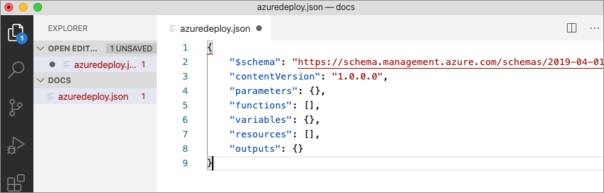
To learn more, refer to this link: https://docs.microsoft.com/en-us/azure/azure-resource-manager/templates/overview
- Which service of Microsoft Azure provides the users with access to the open-source framework Hadoop?
Azure HDInsight service provides access to the open-source framework of Hadoop. In addition to this, the HDInsight service serves as an ETL and analytical platform that enables the users to use Spark, Hive, LLAP, Kafka, Storm, R, and more
To learn more, refer this link: https://docs.microsoft.com/en-in/azure/hdinsight/hdinsight-overview
- Which of the following statements regarding operating system upgrades of an Azure virtual machine is true?
A. No OS upgrades
B. Only upgrades of client OS
C. All OS upgrades
D. Only upgrades of server OS
None of the OS upgrades are supported by Microsoft.
Either the works can be migrated from old to the new VMs, or Virtual Hard Disk files are to be downloaded to get extended support.
To learn more, refer this link: https://docs.microsoft.com/en-us/azure/virtual-machines/windows/prepare-for-upload-vhd-image
- Which of the features are provided only with Microsoft Azure active directory premium p2?
The premium P2 version of the Azure AD has features of Identity Protection and governance.
Identity protection – Vulnerable and risky account detection, event investigation and conditional access policies.
Identity governance – Privileged Identity Management, Access reviews, and entitlement management.
- When a data disk to an Azure virtual machine is added, what drive type is created?
Virtual Hard Disks are created.
Quick check – Azure Course
- Which is the core unit of the Azure networking component?
Virtual Networks are the core azure networking components as it is responsible for all the vital administrative functions. VN has full control over IP addresses assignments and name resolution. Azure networking component plays a key role in providing administrators with full access to security settings. Routing rules for movement of data from one machine to another are determined by the Azure virtual networks.
- What are the steps for deploying a VM in Azure?
The steps to creating a virtual machine on azure are:
- Navigate to the Azure portal
- Type ‘Virtual Machine’ in the search bar and click on the service. Go to ‘Create a virtual machine’.
- Click on ‘New’ –> Compute –> Virtual Machine
- Key in the DNS name
- Choose image and size from the drop-down menu
- Choose authentication type and provide the username and password
- Select the region
- Click on ‘Create and Review’ once the validation has passed.
- What is MS Azure?
Azure is a cloud computing platform with Infrastructure as a Service (IaaS), Platform as a Service (PaaS), and Software as a Service (SaaS). These are services used for analytics, virtual computing, storage, networking, and much more.
Also Read: Microsoft Azure: Benefits, Use Cases, Applications | What is Microsoft Azure?
- Which VPN types are supported by Azure?
The following cross-premises connections are supported:
- Site-to-Site – This type of connection requires a VPN device or RRAS.
- Point-to-Site –. This connection does not require a VPN device.
- VNet-to-VNet – This connection is similar to Site-to-Site configuration. It does not require a VPN device.
- Multi-Site – This is a kind of Site-to-Site configuration that facilitates connecting with multiple on-premises sites to a virtual network.
- ExpressRoute – ExpressRoute is a private connection to Azure from WAN, not a VPN connection over the public Internet
- How to create an Azure account?
Microsoft Azure offers a free 30-day trial period.
- Go to azure.com and click the “Start free” button.
- Once logged in, provide details
- Follow the prompts to verify the account by phone.
- Credit card details are needed to be furnished.
- Tick “I agree” and click “Sign Up.
- To continue, click the “My Account” link at the top right corner or go to the Microsoft Azure Portal: https://portal.azure.com/
- How are web applications deployed in Azure?
Microsoft offers two deployment models.
- Classic deployment model
- Azure resource manager.
The web applications that can be deployed are WCF, PHP and ASP.NET.
- What kind of store is Azure table storage?
Azure Table Storage is a NoSQL key-value store that stores semi-structured datasets, allowing you to create massively scalable apps that require a flexible data schema and JSON is used to serialize data.
- Which of the following modules is not included in Azure PowerShell?
- Azure system manager module
- Azure module
- Azure resource manager module
- Azure profile module
Azure system manager module.
To work with Azure resources directly from local machine, the help of the Azure module, Azure resource manager module, and Azure profile module are needed.
- Mention the OS on which Azure PowerShell can be used?
Azure PowerShell can be used in numerous operating systems, including:
- Windows 7 and later versions
- Linux OS
- Mac OS
- What is the Azure app service?
Azure App Service is a web hosting service for building web apps, mobile back ends and RESTful APIs, and it is fully managed by the cloud provider, Azure.
- Azure Kubernetes service belongs to which category?
Azure Kubernetes service cannot be directly categorised as it is a kind of PaaS wrapper over the underlying Virtual Machine set used for the cluster. It is charged only for the worker nodes that are part of the VM scale-set, which is technically an IaaS. The managers are a kind of wrapper PaaS service and are taken care of by the Azure cloud provider.
- Using which tool by Azure will you be able to estimate the costs that you would incur on Azure?
A pricing calculator is a tool provided by Microsoft Azure to estimate costs by adding the required products and example scenarios.
- What is a static IP address in Azure?
Static IP address is used when the change of the address connected to the device is unwanted.
Dynamic IP address is used whenever a change of address is needed and is assigned to other devices to access it.
Azure Virtual machine will be assigned a dynamic IP address by default.
Also Read: Comparing Amazon Web Services, Microsoft Azure and Google Cloud
- Mention the emulators that are installed with the SDK in Azure?
Azure SDK has two emulators – Compute Emulator and Storage Emulator. Developers use these to operate the cloud applications on the local machine. Compute Emulator mimics the computing environment. To use a compute emulator, Visual Studio is to be run as an administrator.
- What is Azure in .net?
1.Web applications
.NET web applications are hosted in Azure with ASP.NET, a set of tools and libraries for building web applications and services. With further use of auto-scaling, patching, CI/CD, advanced performance monitoring and production debugging snapshots with Azure App, Service building and running web applications becomes easier.
- Serverless computing
Run on is an event-driven and serverless compute that fully supports .NET using Azure Functions.
- Data services
Managed database services from Azure that are secure, scalable, redundant, relational and non-relational data stores easily with .NET.
- How to create VM in Azure?
Steps to Create an Azure Virtual Machine (VM)
- Log in to the Azure Portal.
- Click on Create Resource and select Windows Server 2016 Datacenter.
- Fill in the Subscription, resource group name and VM name and image.
- Click on the Change Size hyperlink and choose the desire configuration. Select region accordingly. Standard DS1 v2 size is selected by default.
- Key in the administrator account credentials and Inbound ports.
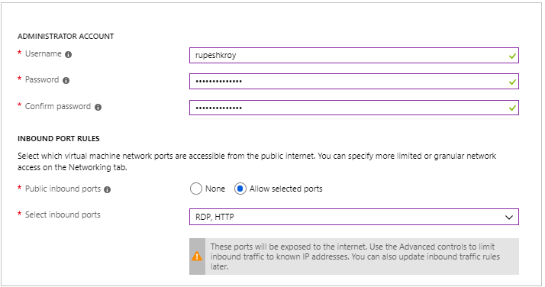
- Click on the Next button to go to the Disks section.
- Select the OS disk type – Premium SSD, Standard SSD and Standard HDD.
- Select the OS disk type – Premium SSD, Standard SSD and Standard HDD.
- Create a Virtual Network for the Virtual Machine and assign a subnet to it.
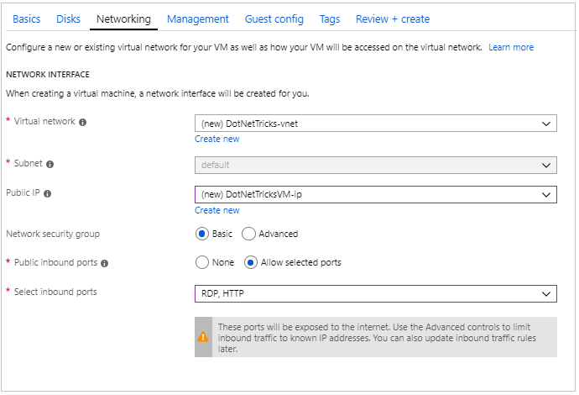
- Click on Next to configure the management section.
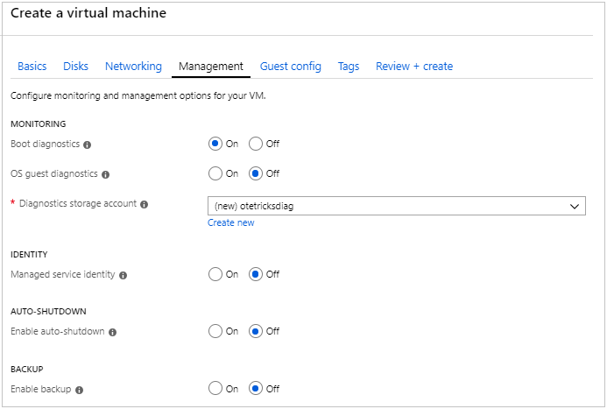
- Click Next to go to Guest Configs.
- Click on Next to go to Tags sections.
- Click on Next and review all the settings selected. Click on create.
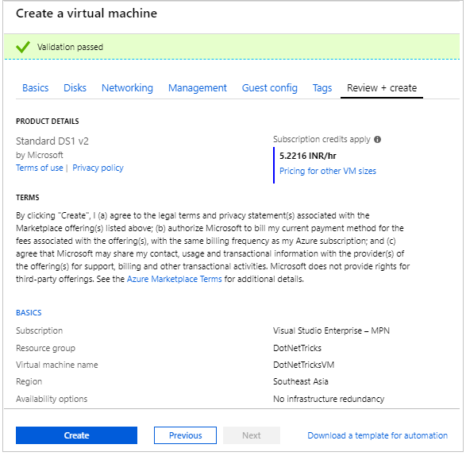
- Go to the All Resources section on the left panel and see the created resources:
  - Virtual machine
  - OS Disk
  - Network Interface
  - Public IP
  - Network Security Group
  - Virtual Network
  - Storage Account
  - Recovery Service Vault
- Click on Virtual machine to get the RDP file.
- What is the Azure SQL database?
Azure SQL DB is a SQL Server Database engine instance that is fully managed by the cloud provider. This deployment model makes it easy to transfer on-premises applications to the cloud with very few application and database changes.
- Which tool helps to estimate costs that will incur on Azure?
The price calculator tool is an Azure tool to use in estimating the costs (https://azure.microsoft.com/en-us/pricing/calculator/). This tool allows to select and estimate the cost of deploying resources to Azure.
- Which of the following is supported on Azure virtual machines?
- Azure AD Connect
- Microsoft BizTalk Server 2013 and later versions
- Microsoft Dynamics AX 2012 R3 and later updates
- Microsoft Dynamics GP 2013 and later versions
- Microsoft Dynamics NAV 2013 and later versions
- Exchange Server 2013 and later versions
- Forefront Identity Manager 2010 R2 SP1 and later versions
- Microsoft HPC Pack 2012 and later versions
- Project Server 2013 and later versions
- SharePoint Server 2010 and later versions on Azure virtual machines.
- SQL Server 2008 and later versions
- Failover Cluster Instances (FCI).
- System Centre 2012 Service Pack 1 (SP1) and later versions are supported for the following applications:
- App Controller
- Configuration Manager
- Data Protection Manager
- Endpoint Protection
- Operations Manager
- Orchestrator
- Server Application Virtualization
- Service Manager
27. How to delete an Azure account?
Step-1: Login to the Microsoft Azure portal
Step-2: Click on the Cost Management + Billing link from the left navigation
Step-3: Click on the Subscriptions link from the left navigation
Step-4: Click on the Manage button on the Cost Management + Billing page.
Step-5: Click on the Subscription name.
Step-6: Click on the Cancel subscription link from the next screen to Cancel Azure Subscription.
Step-7: Select – Yes, cancel my subscription option
- You need to add data to Azure by using the Azure import service. What should you do?
Import job involves the following steps:
- A number of drives needed, destination blob location for the data in Azure storage is to be determined.
- Copy data using the WAImportExport tool to disk drives and encrypt the disk drives with BitLocker.
- Create an import job in the target storage account in the Azure portal. Upload the drive journal files.
- Input the return address and carrier account number for shipping the drives back to you.
- Ship the disk drives to the shipping address provided during job creation.
- Key in the delivery tracking number in the import job details and submit the import job.
- Drives are received and processed at the Azure data centre.
- Drives are shipped using the carrier account to the return address provided in the import job.
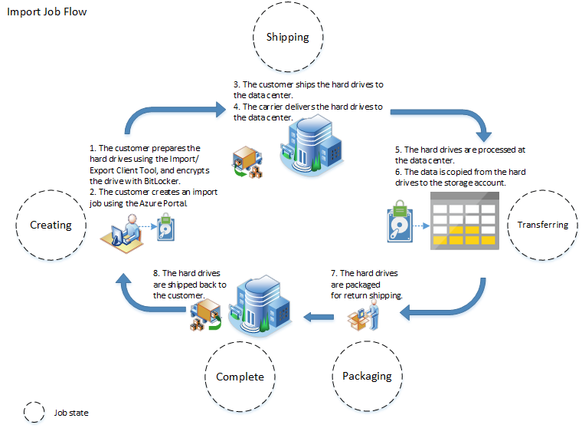
- What kind of a store in the Azure table storage?
NoSQL Azure table storage is a key-value store that handles semi-structured data. It is highly flexible and scalable. JSON is used to serialise data.
- Which of the web applications can be deployed with Azure?
- Windows Communication Foundation (WCF),
- PHP and
- ASP.NET
Microsoft Azure is offering two deployment models for:
- Classic deployment model
- Azure resource manager
Software development kits for Java and Ruby allow applications to place calls to the Azure service centre.

