窗体顶端
Q.1Explain the examples of data processing in Keras.
Some of the examples include: Firstly, neural networks don't process raw data, like text files, encoded JPEG image files, or CSV files. They process vectorized & standardized representations. Secondly, text files need to be read into string tensors, then split into words. Finally, the words need to be indexed and turned into integer tensors. Thirdly, images need to be read and decoded into integer tensors, then converted to floating points and normalized to small values (usually between 0 and 1). Lastly, CSV data needs to be parsed, with numerical features converted to floating-point tensors and categorical features indexed and converted to integer tensors. Then each feature typically needs to be normalized to zero-mean and unit variance.
窗体底端
窗体顶端
Q.2Name the types of inputs in the Keras model.
Keras models accept three types of inputs: Firstly, NumPy arrays, just like Scikit-Learn and many other Python-based libraries. This is a good option if your data fits in memory. Secondly, TensorFlow Dataset objects. This is a high-performance option that is more suitable for datasets that do not fit in memory and that are streamed from a disk or from a distributed filesystem. Lastly, Python generators that yield batches of data (such as custom subclasses of the keras.utils.Sequence class).
窗体底端
窗体顶端
Q.3What is Long Short Term Memory (LSTM)? Explain its process.
LSTM’s have a Nature of Remembering information for long periods of time is their Default behavior. The LSTM had a three-step Process:
1. Forget Gate This gate Decides which information is to be omitted from the cell in that particular timestamp. It is decided by the sigmoid function. However, it looks at the previous state(ht-1) and the content input(Xt) and outputs a number between 0(omit this)and 1(keep this)for each number in the cell state Ct−1.
2. Update Gate/input gate Decides how much of this unit is added to the current state. In this, the Sigmoid function decides which values to let through 0,1. and tanh function gives weightage to the values which are passed deciding their level of importance ranging from-1 to 1.
3. Output Gate Decides which part of the current cell makes it to the output. In this, the Sigmoid function decides which values to let through 0,1. and tanh function gives weightage to the values which are passed deciding their level of importance ranging from-1 to 1 and multiplied with an output of Sigmoid.
窗体底端
窗体顶端
Q.4Explain the term regularization.
Regularization is a method that makes slight modifications to the learning algorithm such that the model generalizes better. This in turn improves the model’s performance on the unseen data as well.
窗体底端
窗体顶端
Q.5Name some of the regularization techniques.
The techniques are as follows:
1. L2 and L1 Regularization
2. Dropout
3. Early Stopping
4. Data Augmentation
窗体底端
窗体顶端
Q.6Explain the L2 and L1 Regularization techniques.
L2 and L1 are the most common types of regularization. Regularization works on the premise that smaller weights lead to simpler models which result helps in avoiding overfitting. So to obtain a smaller weight matrix, these techniques add a ‘regularization term’ along with the loss to obtain the cost function. Here, Cost function = Loss + Regularization term However, the difference between L1 and L2 regularization techniques lies in the nature of this regularization term. In general, the addition of this regularization term causes the values of the weight matrices to reduce, leading to simpler models.
窗体底端
窗体顶端
Q.7What do you understand about Dropout and early stopping techniques?
Dropout means that during the training, randomly selected neurons are turned off or ‘dropped’ out. It means that they are temporarily obstructed from influencing or activating the downward neuron in a forward pass, and none of the weights updates is applied on the backward pass. Whereas Early Stopping is a kind of cross-validation strategy where one part of the training set is used as a validation set, and the performance of the model is gauged against this set. So if the performance on this validation set gets worse, the training on the model is immediately stopped. However, the main idea behind this technique is that while fitting a neural network on training data, consecutively, the model is evaluated on the unseen data or the validation set after each iteration. So if the performance on this validation set is decreasing or remaining the same for certain iterations, then the process of model training is stopped.
窗体底端
窗体顶端
Q.8What is Convolutional Neural Network?
A Convolutional Neural Network (ConvNet/CNN) is a Deep Learning algorithm that can take in an input image, assign importance to various aspects/objects in the image and be able to differentiate one from the other. The pre-processing required in a ConvNet is much lower as compared to other classification algorithms. While in primitive methods filters are hand-engineered, with enough training, ConvNets have the ability to learn these filters/characteristics.
窗体底端
窗体顶端
Q.9Explain the process of training a CNN.
The process for training a CNN for classifying images consists of the following steps −
1. Data Preparation In this step, we center-crop the images and resize them so that all images for training and testing would be of the same size. This is usually done by running a small Python script on the image data.
2. Model Definition In this step, we define a CNN architecture. The configuration is stored in .pb (protobuf) file.
3. Solver Definition In this, we define the solver configuration file. The solver does the model optimization.
4. Model Training In this, we use the built-in Caffe utility to train the model. The training may take a considerable amount of time and CPU usage. After the training is completed, Caffe stores the model in a file, which can, later on, be used on test data and final deployment for predictions.
窗体底端
窗体顶端
Q.10What do you know about Data preprocessing with Keras?
Once your data is in the form of string/int/float NumpPy arrays, or a Dataset object (or Python generator) that yields batches of string/int/float tensors, it is time to preprocess the data. This can mean: Firstly, Tokenization of string data, followed by token indexing. Secondly, Feature normalization. Thirdly, Rescaling the data to small values. In general, input values to a neural network should be close to zero -- typically we expect either data with zero-mean and unit-variance, or data in the [0, 1] range.
窗体底端
窗体顶端
Q.11What do you understand about callbacks?
Callbacks are an important feature of Keras that is configured in fit(). Callbacks are objects that get called by the model at different points during training like: Firstly, at the beginning and end of each batch Secondly, at the beginning and end of each epoch However, callbacks are a way to make model trainable entirely scriptable. This can be used for periodically saving your model.
窗体底端
窗体顶端
Q.12Explain the process of debugging your model with eager execution.
If you write custom training steps or custom layers, you will need to debug them. The debugging experience refers to an integral part of a framework and with Keras, the debugging workflow is designed with the user in mind. However, by default, Keras models are compiled to highly optimized computation graphs that deliver fast execution times. That means that the Python code you write is not the code you are actually executing. This introduces a layer of indirection that can make debugging hard. Further, it is better to perform debugging in a step-by-step manner. You want to be able to sprinkle your code with a print() statement to see what your data looks like after every operation, you want to be able to use pdb. You can achieve this by running your model eagerly. With eager execution, the Python code you write is the code that gets executed. Simply pass run_eagerly=True to compile():
窗体底端
窗体顶端
Q.13Explain the role of multiple GPUs in Keras.
Keras has built-in industry-strength support for multi-GPU training and distributed multi-worker training, via the tf.distribute API. However, if you have multiple GPUs on your machine, you can train your model on all of them by: Firstly, creating a tf.distribute.MirroredStrategy object. Secondly, creating and compiling your model inside the strategy's scope. Lastly, calling fit() and evaluate() on a dataset as usual.
窗体底端
窗体顶端
Q.14What is a Keras Tuner?
Keras Tuner is an easy-to-use, scalable hyperparameter optimization framework that solves the pain points of hyperparameter search. In this, you can easily configure your search space with a define-by-run syntax, then leverage one of the available search algorithms for finding the best hyperparameter values for your models. Further, Keras Tuner comes with Bayesian Optimization, Hyperband, and Random Search algorithms built-in, and is also designed to be easy for researchers to extend in order to experiment with new search algorithms.
窗体底端
窗体顶端
Q.15What is AutoKeras?
AutoKeras refers to an AutoML system based on Keras. It is developed by DATA Lab at Texas A&M University. The purpose of AutoKeras is to make machine learning accessible for everyone. It provides high-level end-to-end APIs such as ImageClassifier or TextClassifier to solve machine learning problems in a few lines, as well as flexible building blocks to perform architecture search.
窗体底端
窗体顶端
Q.16Describe the installation & compatibility of Keras.
Keras comes packaged with TensorFlow 2 as tensorflow.keras. However, to start using Keras, simply install TensorFlow 2. Keras/TensorFlow is compatible with: Python 3.5–3.8 Ubuntu 16.04 or later Windows 7 or later macOS 10.12.6 (Sierra) or later.
窗体底端
窗体顶端
Q.17Define the following terms: TensorFlow Cloud, TensorFlow.js and TensorFlow Lite.
TensorFlow Cloud is managed by the Keras team at Google that refers to a set of utilities to help you run large-scale Keras training jobs on GCP with very little configuration effort. Running your experiments on 8 or more GPUs in the cloud should be as easy as calling model.fit(). TensorFlow.js is TensorFlow's JavaScript runtime, capable of running TensorFlow models in the browser or on a Node.js server, both for training and inference. It natively supports loading Keras models, including the ability to fine-tune or retrain your Keras models directly in the browser. TensorFlow Lite is a runtime for an efficient on-device inference that has native support for Keras models. Deploy your models on Android, iOS, or on embedded devices.
窗体底端
窗体顶端
Q.18How can we create Keras models?
There are three ways to create Keras models: Firstly, by the Sequential model. This is very straightforward (a simple list of layers), but is limited to single-input, single-output stacks of layers. Secondly using the Functional API. This is an easy-to-use, fully-featured API that supports arbitrary model architectures. This is the Keras "industry strength" model. Lastly, by Model subclassing. Here you implement everything from scratch on your own. Use this if you have complex, out-of-the-box research use cases.
窗体底端
窗体顶端
Q.19Explain the classes in a Keras Tuner API.
Firstly, the Hyperparameters class is used for specifying a set of hyperparameters and their values, to be used in the model building function. Secondly, the Tuner subclasses corresponding to different tuning algorithms are called directly by the user to begin the search or to get the best models. Thirdly, the Oracle subclasses are the core search algorithms, receiving model evaluation results from the Tuner and providing new hyperparameter values. Lastly, the HyperModel subclasses are predefined search spaces for certain model families like ResNet and XceptionNet.
窗体底端
窗体顶端
Q.20Describe the steps for creating a deep Learning Project in Python with Keras.
1. Load Data The first step is for defining the functions and classes. In this, we will use the NumPy library to load our dataset and we will use two classes from the Keras library to define our model.
2. Define Keras Model Models in Keras are defined as a sequence of layers. Here, we will create a Sequential model and add layers one at a time until we are happy with our network architecture. However, ensure that the input layer has the right number of input features. This can be specified when creating the first layer with the input_dim argument and setting it to 8 for the 8 input variables.
3. Compile Keras Model After defining the model, compile it. However, compiling the model uses the efficient numerical libraries under the covers (the so-called backend) such as Theano or TensorFlow. The backend automatically chooses the best way to represent the network for training and making predictions to run on your hardware, such as CPU or GPU or even distributed. During compiling, specify some additional properties required when training the network. And, also specify the loss function to use to evaluate a set of weights, the optimizer is used to search through different weights for the network and any optional metrics we would like to collect and report during training.
4. Fit Keras Model After defining and compiling it is ready for efficient computation. Now, execute the model on some data. We can train or fit our model on our loaded data by calling the fit() function on the model. However, training occurs over epochs and each epoch is split into batches. Epoch: One pass through all of the rows in the training dataset. Batch: One or more samples are considered by the model within an epoch before weights are updated. You must know that one epoch is comprised of one or more batches, depending on the chosen batch size and the model is fit for many epochs.
5. Evaluate Keras Model After training the neural network on the entire dataset and we can examine the performance of the network on the same dataset. However, we can evaluate your model on your training dataset using the evaluate() function on your model and pass it the same input and output used to train the model. Further, the evaluate() function will return a list with two values. The first will be the loss of the model on the dataset and the second will be the accuracy of the model on the dataset.
窗体底端
窗体顶端
Q.21What is Artificial Neural Network?
Artificial Neural Network (ANN) is at the very core of Deep Learning an advanced version of Machine Learning techniques. ANNs are versatile, adaptive, and scalable, making them appropriate for tackling large datasets and highly complex Machine Learning tasks such as image classification (e.g., Google Images), speech recognition (e.g., Apple’s Siri), video recommendation (e.g., YouTube), or analyzing sentiments among customers (e.g. Twitter Sentiment Analyzer).
窗体底端
窗体顶端
Q.22Define Cross-Validation.
Cross-validation is a method for examining a machine learning model and testing its performance. CV is mostly used in applied ML tasks. It helps in comparing and selecting an appropriate model for the specific predictive modeling problem. However, it is easy to understand, easy to implement, and it tends to have a lower bias than other methods used to count the model’s efficiency scores.
窗体底端
窗体顶端
Q.23Describe the algorithm steps used to cross-validate a model.
- At first, divide the dataset into two parts: one for training, other for testing
- Then , training the model on the training set
- Validating the model on the test set
- Lastly, repeating 1-3 steps a couple of times. This number depends on the CV method that you are using
窗体底端
窗体顶端
Q.24Explain the k-Fold cross-validation technique with the algorithm.
k-Fold CV is a method that minimizes the disadvantages of the hold-out method. k-Fold introduces a new way of splitting the dataset which helps to overcome the “test only once bottleneck”. The algorithm of the k-Fold technique:
- Firstly, select a number of folds – k. Usually, k is 5 or 10 but you can select any number which is less than the dataset’s length.
- Secondly, divide the dataset into k equal (if possible) parts (they are called folds)
- Then, select k – 1 folds which will be the training set. The remaining fold will be the test set
- Fourthly, train the model on the training set. On each iteration of cross-validation, you must train a new model independently of the model trained on the previous iteration
- Then, validate on the test set After that, save the result of the validation
- Now, repeat steps 3 – 6 k times. Every time use the remaining fold as the test set.
- In the end, you should have validated the model on every fold that you have. Lastly, for having the final score average the results that you got on step 6.
窗体底端
窗体顶端
Q.25Define Cross-Validation in Deep Learning.
Cross-validation in Deep Learning (DL) can be tricky because most of the CV techniques need training the model at least a couple of times. However, in deep learning, you would normally tempt to avoid CV because of the cost associated with training k different models. Rather than doing k-Fold or other CV techniques, you might use a random subset of your training data as a hold-out for validation purposes. For example, Keras’s deep learning library enables you to pass one of two parameters for the fit function that performs training. This covers: Firstly, validation_split: percentage of the data that should be held out for validation Secondly, validation_data: a tuple of (X, y) which should be used for validation. This parameter overrides the validation_split parameter which means you can use only one of these parameters at once. And, the same method is used in other DL frameworks such as PyTorch and MxNet. They also suggest giving the dataset into three parts: training, validation, and testing.
窗体底端
窗体顶端
Q.26Name the types of cross-validation methods.
Some of the cross-validation methods are:
- Hold-out K-folds
- Leave-one-out
- Leave-p-out
- Stratified K-folds
- Repeated K-folds
- Nested K-folds
窗体底端
窗体顶端
Q.27What is an imbalance classification?
An imbalanced classification problem is an example of a classification problem in which the distribution of examples over the known classes is biased or skewed. The distribution can range from a slight bias to a severe imbalance where there is one example in the minority class for hundreds, thousands, or millions of examples in the majority class or classes. Further, this creates a challenge for predictive modeling as most of the machine learning algorithms used for classification were designed around the assumption of an equal number of examples for each class. This results in models that have poor predictive performance, specifically for the minority class.
窗体底端
窗体顶端
Q.28Explain Image Data Augmentation in Keras?
Image data augmentation is a method that can be used to artificially expand the size of a training dataset by creating modified versions of images in the dataset. However, training deep learning neural network models on more data can result in more skillful models, and the augmentation techniques can create variations of the images that can improve the ability of the fit models to generalize what they have learned to new images. And, the Keras deep learning neural network library provides the capability to fit models using image data augmentation via the ImageDataGenerator class.
窗体底端
窗体顶端
Q.29Name the main types of data augmentation techniques for image data.
- Image shifts via the width_shift_range and height_shift_range arguments.
- The image flips via the horizontal_flip and vertical_flip arguments.
- Image rotations via the rotation_range argument Image brightness via the brightness_range argument.
- Image zoom via the zoom_range argument.
窗体底端
窗体顶端
Q.30What is a confusion matrix?
A confusion matrix, also known as an error matrix, is a specific table layout that allows visualization of the performance of an algorithm, typically a supervised learning one. Every row of the matrix represents the instances in an actual class while each column represents the instances in a predicted class, or vice versa. The name stems from the fact that it makes it easy to see whether the system is confusing two classes. Further, it can be considered as a special kind of contingency table, with two dimensions ("actual" and "predicted"), and identical sets of "classes" in both dimensions.
窗体底端
窗体顶端
Q.31What is Keras?
Keras is a high level API built on TensorFlow (and can be used on top of Theano too). It is more user-friendly and easy to use as compared to TensofrFlow.
窗体底端
窗体顶端
Q.32Why is there a need for keras?
Keras is an API designed for human beings, not machines. Keras follows best practices for reducing cognitive load: it offers consistent & simple APIs, it minimizes the number of user actions required for common use cases, and it provides clear and actionable feedback upon user error.
窗体底端
窗体顶端
Q.33Is keras a library?
Yes, Keras is an open-source neural-network library written in Python.
窗体底端
窗体顶端
Q.34Who invented keras?
François Chollet invented Keras and he is currently working as an AI Researcher at Google.
窗体底端
窗体顶端
Q.35What is flatten layer in keras?
The role of the Flatten layer in Keras is super simple: A flatten operation on a tensor reshapes the tensor to have a shape that is equal to the number of elements contained in the tensor.
窗体底端
窗体顶端
Q.36What is keras dropout?
Dropout is a regularization technique for neural network models proposed by Srivastava, it is a technique where randomly selected neurons are ignored during training.
窗体底端
Keras is a high-level neural networks API, capable of running on top of Tensorflow, Theano, and CNTK. It enables fast experimentation through a high-level, user-friendly, modular, and extensible API. Keras can also be run on both CPU and GPU.
Keras was developed and is maintained by Francois Chollet and is part of the Tensorflow core, which makes it Tensorflows preferred high-level API.
Keras is a deep learning API written in Python, running on top of the machine learning platform TensorFlow. It was developed with a focus on enabling fast experimentation. Being able to go from idea to result as fast as possible is key to doing good research.
Keras is the high-level API of TensorFlow 2: an approachable, highly-productive interface for solving machine learning problems, with a focus on modern deep learning. It provides essential abstractions and building blocks for developing and shipping machine learning solutions with high iteration velocity.
Keras empowers engineers and researchers to take full advantage of the scalability and cross-platform capabilities of TensorFlow 2: you can run Keras on TPU or on large clusters of GPUs, and you can export your Keras models to run in the browser or on a mobile device.
let’s move on to Questions and Answers,
1. Who is the Creator of Keras?
Answer: François Chollet, He is currently working as an AI Researcher at Google
2. Types are layers in Keras?
Answer:
- Core Layers
- Convolutional Layers
- Pooling Layers
- Locally-connected Layers
- Recurrent Layers
- Embedding Layers
- Merge Layers
- Advanced Activations Layers
- Normalization Layers
- Noise layers
3. How can TensorFlow Text be used to preprocess sequence modeling?
Answer:
4. Explain the examples of data processing in Keras.
Answer: Some of the examples include: Firstly, neural networks don’t process raw data, like text files, encoded JPEG image files, or CSV files. They process vectorized & standardized representations. Secondly, text files need to be read into string tensors, then split into words. Finally, the words need to be indexed and turned into integer tensors. Thirdly, images need to be read and decoded into integer tensors, then converted to floating points and normalized to small values (usually between 0 and 1). Lastly, CSV data needs to be parsed, with numerical features converted to floating-point tensors and categorical features indexed and converted to integer tensors. Then each feature typically needs to be normalized to zero-mean and unit variance.
5. Name the types of inputs in the Keras model.
Answer: Keras models accept three types of inputs: Firstly, NumPy arrays, just like Scikit-Learn and many other Python-based libraries. This is a good option if your data fits in memory. Secondly, TensorFlow Dataset objects. This is a high-performance option that is more suitable for datasets that do not fit in memory and that are streamed from a disk or from a distributed filesystem. Lastly, Python generators that yield batches of data (such as custom subclasses of the keras.utils.Sequence class).
6. Explain the term regularization.
Answer: Regularization is a method that makes slight modifications to the learning algorithm such that the model generalizes better. This in turn improves the model’s performance on the unseen data as well.
7. Name some of the regularization techniques.
Answer:
The techniques are as follows:
- L2 and L1 Regularization
- Dropout
- Early Stopping
- Data Augmentation
8. Explain the L2 and L1 Regularization techniques.
Answer: L2 and L1 are the most common types of regularization. Regularization works on the premise that smaller weights lead to simpler models which result helps in avoiding overfitting. So to obtain a smaller weight matrix, these techniques add a ‘regularization term’ along with the loss to obtain the cost function. Here, Cost function = Loss + Regularization term However, the difference between L1 and L2 regularization techniques lies in the nature of this regularization term. In general, the addition of this regularization term causes the values of the weight matrices to reduce, leading to simpler models.
9. What is Convolutional Neural Network?
Answer: A Convolutional Neural Network (ConvNet/CNN) is a Deep Learning algorithm that can take in an input image, assign importance to various aspects/objects in the image and be able to differentiate one from the other. The pre-processing required in a ConvNet is much lower as compared to other classification algorithms. While in primitive methods filters are hand-engineered, with enough training, ConvNets have the ability to learn these filters/characteristics.
10. What do you understand about Dropout and early stopping techniques?
Answer: Dropout means that during the training, randomly selected neurons are turned off or ‘dropped’ out. It means that they are temporarily obstructed from influencing or activating the downward neuron in a forward pass, and none of the weights updates is applied on the backward pass. Whereas Early Stopping is a kind of cross-validation strategy where one part of the training set is used as a validation set, and the performance of the model is gauged against this set. So if the performance on this validation set gets worse, the training on the model is immediately stopped. However, the main idea behind this technique is that while fitting a neural network on training data, consecutively, the model is evaluated on the unseen data or the validation set after each iteration. So if the performance on this validation set is decreasing or remaining the same for certain iterations, then the process of model training is stopped.
11. What do you understand about callbacks?
Answer: Callbacks are an important feature of Keras that is configured in fit(). Callbacks are objects that get called by the model at different points during training like: Firstly, at the beginning and end of each batch Secondly, at the beginning and end of each epoch However, callbacks are a way to make model trainable entirely scriptable. This can be used for periodically saving your model.
12. Explain the process of training a CNN.
Answer: The process for training a CNN for classifying images consists of the following steps −
- Data Preparation In this step, we center-crop the images and resize them so that all images for training and testing would be of the same size. This is usually done by running a small Python script on the image data.
- Model Definition In this step, we define a CNN architecture. The configuration is stored in .pb (protobuf) file.
- Solver Definition In this, we define the solver configuration file. The solver does the model optimization.
- Model Training In this, we use the built-in Caffe utility to train the model. The training may take a considerable amount of time and CPU usage. After the training is completed, Caffe stores the model in a file, which can, later on, be used on test data and final deployment for predictions.
13. What do you know about Data preprocessing with Keras?
Answer: Once your data is in the form of string/int/float NumpPy arrays, or a Dataset object (or Python generator) that yields batches of string/int/float tensors, it is time to preprocess the data. This can mean: Firstly, Tokenization of string data, followed by token indexing. Secondly, Feature normalization. Thirdly, Rescaling the data to small values. In general, input values to a neural network should be close to zero — typically we expect either data with zero-mean and unit-variance, or data in the [0, 1] range.
14. Explain the process of debugging your model with eager execution.
Answer: If you write custom training steps or custom layers, you will need to debug them. The debugging experience refers to an integral part of a framework and with Keras, the debugging workflow is designed with the user in mind. However, by default, Keras models are compiled to highly optimized computation graphs that deliver fast execution times. That means that the Python code you write is not the code you are actually executing. This introduces a layer of indirection that can make debugging hard. Further, it is better to perform debugging in a step-by-step manner. You want to be able to sprinkle your code with a print() statement to see what your data looks like after every operation, you want to be able to use pdb. You can achieve this by running your model eagerly. With eager execution, the Python code you write is the code that gets executed. Simply pass run_eagerly=True to compile():
15. What is a Keras Tuner?
Answer: Keras Tuner is an easy-to-use, scalable hyperparameter optimization framework that solves the pain points of hyperparameter search. In this, you can easily configure your search space with a define-by-run syntax, then leverage one of the available search algorithms for finding the best hyperparameter values for your models. Further, Keras Tuner comes with Bayesian Optimization, Hyperband, and Random Search algorithms built-in, and is also designed to be easy for researchers to extend in order to experiment with new search algorithms.
16. Explain the role of multiple GPUs in Keras.
Answer: Keras has built-in industry-strength support for multi-GPU training and distributed multi-worker training, via the tf.distribute API. However, if you have multiple GPUs on your machine, you can train your model on all of them by: Firstly, creating a tf.distribute.MirroredStrategy object. Secondly, creating and compiling your model inside the strategy’s scope. Lastly, calling fit() and evaluate() on a dataset as usual.
17. Describe the installation & compatibility of Keras.
Answer: Keras comes packaged with TensorFlow 2 as tensorflow.keras. However, to start using Keras, simply install TensorFlow 2. Keras/TensorFlow is compatible with: Python 3.5–3.8 Ubuntu 16.04 or later Windows 7 or later macOS 10.12.6 (Sierra) or later.
18. What is AutoKeras?
Answer: AutoKeras refers to an AutoML system based on Keras. It is developed by DATA Lab at Texas A&M University. The purpose of AutoKeras is to make machine learning accessible for everyone. It provides high-level end-to-end APIs such as ImageClassifier or TextClassifier to solve machine learning problems in a few lines, as well as flexible building blocks to perform architecture search.
19. How can we create Keras models?
Answer: There are three ways to create Keras models: Firstly, by the Sequential model. This is very straightforward (a simple list of layers), but is limited to single-input, single-output stacks of layers. Secondly using the Functional API. This is an easy-to-use, fully-featured API that supports arbitrary model architectures. This is the Keras “industry strength” model. Lastly, by Model subclassing. Here you implement everything from scratch on your own. Use this if you have complex, out-of-the-box research use cases.
20. Define the following terms: TensorFlow Cloud, TensorFlow.js and TensorFlow Lite.
Answer: TensorFlow Cloud is managed by the Keras team at Google that refers to a set of utilities to help you run large-scale Keras training jobs on GCP with very little configuration effort. Running your experiments on 8 or more GPUs in the cloud should be as easy as calling model.fit(). TensorFlow.js is TensorFlow’s JavaScript runtime, capable of running TensorFlow models in the browser or on a Node.js server, both for training and inference. It natively supports loading Keras models, including the ability to fine-tune or retrain your Keras models directly in the browser. TensorFlow Lite is a runtime for an efficient on-device inference that has native support for Keras models. Deploy your models on Android, iOS, or on embedded devices.
21. Describe the steps for creating a deep Learning Project in Python with Keras.
Answer:
- Load Data The first step is for defining the functions and classes. In this, we will use the NumPy library to load our dataset and we will use two classes from the Keras library to define our model.
- Define Keras Model Models in Keras are defined as a sequence of layers. Here, we will create a Sequential model and add layers one at a time until we are happy with our network architecture. However, ensure that the input layer has the right number of input features. This can be specified when creating the first layer with the input_dim argument and setting it to 8 for the 8 input variables.
- Compile Keras Model After defining the model, compile it. However, compiling the model uses the efficient numerical libraries under the covers (the so-called backend) such as Theano or TensorFlow. The backend automatically chooses the best way to represent the network for training and making predictions to run on your hardware, such as CPU or GPU or even distributed. During compiling, specify some additional properties required when training the network. And, also specify the loss function to use to evaluate a set of weights, the optimizer is used to search through different weights for the network and any optional metrics we would like to collect and report during training.
- Fit Keras Model After defining and compiling it is ready for efficient computation. Now, execute the model on some data. We can train or fit our model on our loaded data by calling the fit() function on the model. However, training occurs over epochs and each epoch is split into batches. Epoch: One pass through all of the rows in the training dataset. Batch: One or more samples are considered by the model within an epoch before weights are updated. You must know that one epoch is comprised of one or more batches, depending on the chosen batch size and the model is fit for many epochs.
- Evaluate Keras Model After training the neural network on the entire dataset and we can examine the performance of the network on the same dataset. However, we can evaluate your model on your training dataset using the evaluate() function on your model and pass it the same input and output used to train the model. Further, the evaluate() function will return a list with two values. The first will be the loss of the model on the dataset and the second will be the accuracy of the model on the dataset.
22. Explain the classes in a Keras Tuner API.
Answer: Firstly, the Hyperparameters class is used for specifying a set of hyperparameters and their values, to be used in the model building function. Secondly, the Tuner subclasses corresponding to different tuning algorithms are called directly by the user to begin the search or to get the best models. Thirdly, the Oracle subclasses are the core search algorithms, receiving model evaluation results from the Tuner and providing new hyperparameter values. Lastly, the HyperModel subclasses are predefined search spaces for certain model families like ResNet and XceptionNet.
23. Define Cross-Validation.
Answer: Cross-validation is a method for examining a machine learning model and testing its performance. CV is mostly used in applied ML tasks. It helps in comparing and selecting an appropriate model for the specific predictive modeling problem. However, it is easy to understand, easy to implement, and it tends to have a lower bias than other methods used to count the model’s efficiency scores.
24. What is Artificial Neural Network?
Answers: Artificial Neural Network (ANN) is at the very core of Deep Learning an advanced version of Machine Learning techniques. ANNs are versatile, adaptive, and scalable, making them appropriate for tackling large datasets and highly complex Machine Learning tasks such as image classification (e.g., Google Images), speech recognition (e.g., Apple’s Siri), video recommendation (e.g., YouTube), or analyzing sentiments among customers (e.g. Twitter Sentiment Analyzer).
25. Describe the algorithm steps used to cross-validate a model.
Answer:
- At first, divide the dataset into two parts: one for training, other for testing
- Then , training the model on the training set
- Validating the model on the test set
- Lastly, repeating 1-3 steps a couple of times. This number depends on the CV method that you are using
26. Define Cross-Validation in Deep Learning.
Answer: Cross-validation in Deep Learning (DL) can be tricky because most of the CV techniques need training the model at least a couple of times. However, in deep learning, you would normally tempt to avoid CV because of the cost associated with training k different models. Rather than doing k-Fold or other CV techniques, you might use a random subset of your training data as a hold-out for validation purposes. For example, Keras’s deep learning library enables you to pass one of two parameters for the fit function that performs training. This covers: Firstly, validation_split: percentage of the data that should be held out for validation Secondly, validation_data: a tuple of (X, y) which should be used for validation. This parameter overrides the validation_split parameter which means you can use only one of these parameters at once. And, the same method is used in other DL frameworks such as PyTorch and MxNet. They also suggest giving the dataset into three parts: training, validation, and testing.
27. Explain the k-Fold cross-validation technique with the algorithm.
Answer:
k-Fold CV is a method that minimizes the disadvantages of the hold-out method. k-Fold introduces a new way of splitting the dataset which helps to overcome the “test only once bottleneck”. The algorithm of the k-Fold technique:
- Firstly, select a number of folds – k. Usually, k is 5 or 10 but you can select any number which is less than the dataset’s length.
- Secondly, divide the dataset into k equal (if possible) parts (they are called folds)
- Then, select k – 1 folds which will be the training set. The remaining fold will be the test set
- Fourthly, train the model on the training set. On each iteration of cross-validation, you must train a new model independently of the model trained on the previous iteration
- Then, validate on the test set After that, save the result of the validation
- Now, repeat steps 3 – 6 k times.
- Every time use the remaining fold as the test set.
In the end, you should have validated the model on every fold that you have. Lastly, for having the final score average the results that you got on step 6.
28. Name the types of cross-validation methods.
Answers:
Some of the cross-validation methods are:
- Hold-out K-folds
- Leave-one-out
- Leave-p-out
- Stratified K-folds
- Repeated K-folds
- Nested K-folds
29. Explain Image Data Augmentation in Keras?
Answer: Image data augmentation is a method that can be used to artificially expand the size of a training dataset by creating modified versions of images in the dataset. However, training deep learning neural network models on more data can result in more skillful models, and the augmentation techniques can create variations of the images that can improve the ability of the fit models to generalize what they have learned to new images. And, the Keras deep learning neural network library provides the capability to fit models using image data augmentation via the ImageDataGenerator class.
30. What is an imbalance classification?
Answer: An imbalanced classification problem is an example of a classification problem in which the distribution of examples over the known classes is biased or skewed. The distribution can range from a slight bias to a severe imbalance where there is one example in the minority class for hundreds, thousands, or millions of examples in the majority class or classes. Further, this creates a challenge for predictive modeling as most of the machine learning algorithms used for classification were designed around the assumption of an equal number of examples for each class. This results in models that have poor predictive performance, specifically for the minority class.
31. Name the main types of data augmentation techniques for image data.
Answer:
- Image shifts via the width_shift_range and height_shift_range arguments.
- The image flips via the horizontal_flip and vertical_flip arguments.
- Image rotations via the rotation_range argument Image brightness via the brightness_range argument.
- Image zoom via the zoom_range argument.
32. What is a confusion matrix?
Answer: A confusion matrix, also known as an error matrix, is a specific table layout that allows visualization of the performance of an algorithm, typically a supervised learning one. Every row of the matrix represents the instances in an actual class while each column represents the instances in a predicted class, or vice versa. The name stems from the fact that it makes it easy to see whether the system is confusing two classes. Further, it can be considered as a special kind of contingency table, with two dimensions (“actual” and “predicted”), and identical sets of “classes” in both dimensions.
33. Why is there a need for keras?
Answer: Keras is an API designed for human beings, not machines. Keras follows best practices for reducing cognitive load: it offers consistent & simple APIs, it minimizes the number of user actions required for common use cases, and it provides clear and actionable feedback upon user error.
34. What is flatten layer in keras?
Answer: The role of the Flatten layer in Keras is super simple: A flatten operation on a tensor reshapes the tensor to have a shape that is equal to the number of elements contained in the tensor.
35. Is keras a library?
Answer: Yes, Keras is an open-source neural-network library written in Python.
36. What is keras dropout?
Answer: Dropout is a regularization technique for neural network models proposed by Srivastava, it is a technique where randomly selected neurons are ignored during training.
37. What are regularizers in keras?
Answer:
keras.regularizers.l1(0.)
keras.regularizers.l2(0.)
keras.regularizers.l1_l2(l1=0.01, l2=0.01)
38. What are available constraints in keras?
Answers:
- MaxNorm
- NonNeg
- UnitNorm
- MinMaxNorm
39. How can I use Keras with datasets that don’t fit in memory?
Answer:
You should use the tf.data API to create tf.data.Dataset objects — an abstraction over a data pipeline that can pull data from local disk, from a distributed file system, from GCS, etc., as well as efficiently apply various data transformations.
For instance, the utility tf.keras.preprocessing.image_dataset_from_directory will create a dataset that reads image data from a local directory. Likewise, the utility tf.keras.preprocessing.text_dataset_from_directory will create a dataset that reads text files from a local directory.
Dataset objects can be directly passed to fit(), or can be iterated over in a custom low-level training loop.
model.fit(dataset, epochs=10, validation_data=val_dataset)
40. What is a Neural Network?
Answer: Neural Networks replicate the way humans learn, inspired by how the neurons in our brains fire, only much simpler.
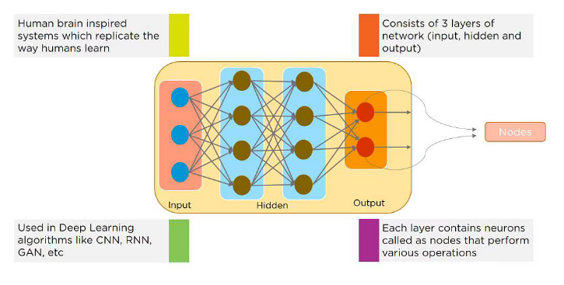
41. What Is a Multi-layer Perceptron(MLP)?
Answer:
As in Neural Networks, MLPs have an input layer, a hidden layer, and an output layer. It has the same structure as a single layer perceptron with one or more hidden layers. A single layer perceptron can classify only linear separable classes with binary output (0,1), but MLP can classify nonlinear classes.
Except for the input layer, each node in the other layers uses a nonlinear activation function. This means the input layers, the data coming in, and the activation function is based upon all nodes and weights being added together, producing the output. MLP uses a supervised learning method called “backpropagation.” In backpropagation, the neural network calculates the error with the help of cost function. It propagates this error backward from where it came (adjusts the weights to train the model more accurately).
42. What Is the Role of Activation Functions in a Neural Network?
Answer: At the most basic level, an activation function decides whether a neuron should be fired or not. It accepts the weighted sum of the inputs and bias as input to any activation function. Step function, Sigmoid, ReLU, Tanh, and Softmax are examples of activation functions.
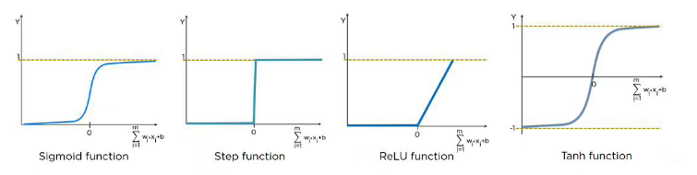
43. What Are the Applications of a Recurrent Neural Network (RNN)?
Answer: The RNN can be used for sentiment analysis, text mining, and image captioning. Recurrent Neural Networks can also address time series problems such as predicting the prices of stocks in a month or quarter.
44. What Are Hyperparameters?
Answer:
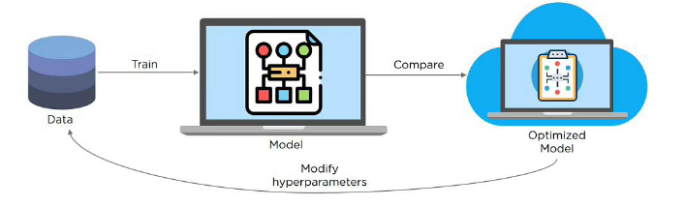
45. What Is the Difference Between Batch Gradient Descent and Stochastic Gradient Descent?
Answer:
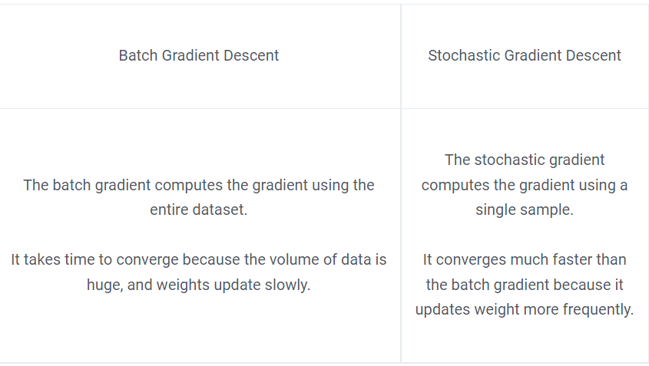
46. What is Overfitting and Underfitting, and How to Combat Them?
Answer:
Overfitting occurs when the model learns the details and noise in the training data to the degree that it adversely impacts the execution of the model on new information. It is more likely to occur with nonlinear models that have more flexibility when learning a target function. An example would be if a model is looking at cars and trucks, but only recognizes trucks that have a specific box shape. It might not be able to notice a flatbed truck because there’s only a particular kind of truck it saw in training. The model performs well on training data, but not in the real world.
Underfitting alludes to a model that is neither well-trained on data nor can generalize to new information. This usually happens when there is less and incorrect data to train a model. Underfitting has both poor performance and accuracy.
To combat overfitting and underfitting, you can resample the data to estimate the model accuracy (k-fold cross-validation) and by having a validation dataset to evaluate the model.
47. How Are Weights Initialized in a Network?
Answer: There are two methods here: we can either initialize the weights to zero or assign them randomly.
Initializing all weights to 0: This makes your model similar to a linear model. All the neurons and every layer perform the same operation, giving the same output and making the deep net useless.
Initializing all weights randomly: Here, the weights are assigned randomly by initializing them very close to 0. It gives better accuracy to the model since every neuron performs different computations. This is the most commonly used method.
48. What is Pooling on CNN, and How Does It Work?
Answer: Pooling is used to reduce the spatial dimensions of a CNN. It performs down-sampling operations to reduce the dimensionality and creates a pooled feature map by sliding a filter matrix over the input matrix.
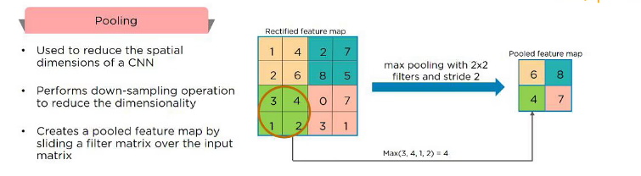
49. What Is the Difference Between Epoch, Batch, and Iteration in Deep Learning?
Answer:
- Epoch – Represents one iteration over the entire dataset (everything put into the training model).
- Batch – Refers to when we cannot pass the entire dataset into the neural network at once, so we divide the dataset into several batches.
- Iteration – if we have 10,000 images as data and a batch size of 200. then an epoch should run 50 iterations (10,000 divided by 50).
50. Why is Tensorflow the Most Preferred Library in Deep Learning?
Answer: Tensorflow provides both C++ and Python APIs, making it easier to work on and has a faster compilation time compared to other Deep Learning libraries like Keras and Torch. Tensorflow supports both CPU and GPU computing devices.
- Author

- Recent Posts

Q1:
How would you freeze all the layers in the Keras model
Junior

Keras 62

Problem
Consider the code:
from keras.models import Sequentialfrom keras.layers import Dense from tensorflow.keras.optimizers import SGD
# Set model
model=Sequential()
layer=Dense(64,kernel_initializer='glorot_uniform',input_shape=(784,))
model.add(layer)
layer2=Dense(784, activation='sigmoid',kernel_initializer='glorot_uniform')
model.add(layer2)
# Set optimizer
opt = SGD()
# Compile
model.compile(loss='relu', optimizer=opt,metrics = ['mae'])
# Complete code to freeze layers# ...
Answer
All layers & models have a layer.trainable boolean attribute. To freeze them, we just iterate over the layers and set the attribute to False:
# Loop for freezing all layers for layer in model.layers:
layer.trainable = False
# Checkingprint(layer.trainable)print(layer2.trainable)
Output:
False
False
Having Machine Learning, Data Science or Python Interview? Check 62 Keras Interview Questions
Source: stackoverflow.com

Q2:
Name the different ways to build a model with Keras that you know
Junior

Keras 62

Answer
- The Sequential model: the most approachable API, it's basically a Python list. As such, it’s limited to simple stacks of layers.
- The Functional API, which focuses on graph-like model architectures. It represents a nice mid-point between usability and flexibility, and as such, it’s the most commonly used model-building API.
- Model subclassing: a low-level option where you write everything yourself from scratch. This is ideal if you want full control over every little thing. However, you won’t get access to many built-in Keras features, and you will be more at risk of making mistakes.
Having Machine Learning, Data Science or Python Interview? Check 62 Keras Interview Questions
Source: www.manning.com

Q3:
What are kernel_initializers in Keras and what is their significance?
Junior

Keras 62

Answer
The neural network needs to start with some weights and then iteratively update them to better values. The term kernel_initializer is a fancy term for which statistical distribution or function to use for initializing the weights. In the case of some statistical distribution defined, Keras will generate numbers from that statistical distribution and use them as starting weights.
For example, in the code model.add(Dense(13, input_dim=13, kernel_initializer='normal', activation='relu')) normal distribution will be used to initialise weights. You can use other functions and distributions like Glorot Normal, Glorot uniform, etc.
Having Machine Learning, Data Science or Python Interview? Check 62 Keras Interview Questions
Source: datascience.stackexchange.com

Q4:
What do compile, fit, and predict do in Keras sequential models?
Junior

Keras 62

Answer
Those methods perform the steps that we need to do when we want to train a model:
- First, we want to decide on a model architecture, this is the number of hidden layers and activation functions, and that's what compile does.
- Secondly, the fit train our model to get all the parameters to the correct value to map our inputs to our outputs.
- Lastly, we will want to use this model to do some feed-forward passes to predict novel inputs, that's what the predict method does.
Having Machine Learning, Data Science or Python Interview? Check 62 Keras Interview Questions
Source: datascience.stackexchange.com

Q5:
What does the Flatten layer do in Keras?
Junior

Keras 62

Answer
keras.layers.flatten() converts the multi-dimensional arrays into flattened one-dimensional arrays or single-dimensional arrays. In other words, it takes all the elements in the original tensor (multi-dimensional array) and puts them into a single-dimensional array.
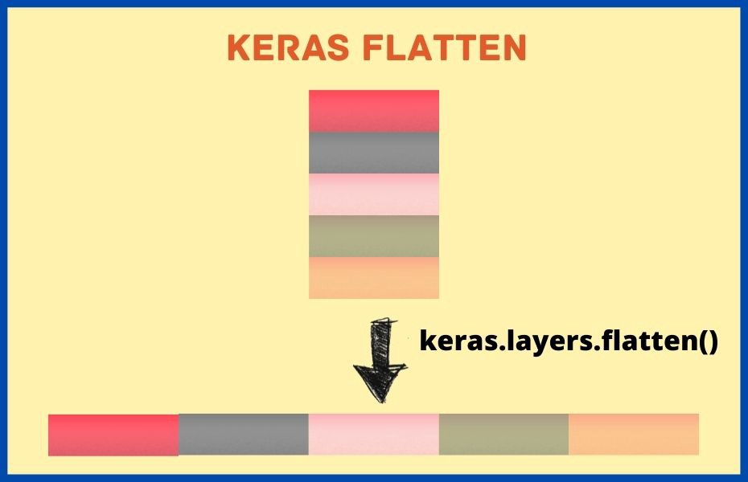
From the image above we see that the flatten operation on a tensor reshapes the tensor to have the shape that is equal to the number of elements contained in tensor non including the batch dimension.
Having Machine Learning, Data Science or Python Interview? Check 62 Keras Interview Questions
Source: kevinmlean.medium.com

101 Data Science Interview Questions (ANSWERED, PDF) To Get Your Next ML Job

 Data Processing 81

Machine Learning 18

Neural Networks 132

Q6:
What is a callback in Keras and when is useful?
Junior

Keras 62

Answer
A callback is an object (a class instance implementing specific methods) that is passed to the model in the call to fit() and that is called by the model at various points during training. It has access to all the available data about the state of the model and its performance, and it can take action: interrupt training, save a model, load a different weight set, or otherwise alter the state of the model.
Callbacks are useful to:
- Write TensorBoard logs after every batch of training to monitor your metrics
- Periodically save the model to disk.
- Do early stopping when a monitored metric has stopped improving.
- Get a view on internal states and statistics of a model during training, etc.
Having Machine Learning, Data Science or Python Interview? Check 62 Keras Interview Questions
Source: www.manning.com

Q7:
What is the difference between Keras model.evaluate() and model.predict()?
Junior

Keras 62

Answer

The model.evaluate() function first predicts the output for the given input and then computes the metrics function specified in the model.compile, and based on y_true and y_pred it returns the computed metric value as the output for every batch.

The model.predict() function will give you the actual predictions for all samples in a batch, for all batches.

So even if you use the same data, the differences between the outputs will be there because the value of a loss function will be almost always different than the predicted values.

Having Machine Learning, Data Science or Python Interview? Check 62 Keras Interview Questions
Source: stackoverflow.com

Q8:
What is the difference between model.fit() and model.evaluate() in Keras?
Junior

Keras 62

Answer
- fit() is for training the model with the given inputs (and corresponding training labels).
- evaluate() is for evaluating the already trained model using the validation (or test) data and the corresponding labels. Returns the loss value and metrics values for the model.
Having Machine Learning, Data Science or Python Interview? Check 62 Keras Interview Questions
Source: stackoverflow.com

Pandas 68

 Searching 24

 Feature Engineering 27

Curse of Dimensionality 14

MATLAB 59

Scikit-Learn 31

K-Nearest Neighbors 13

Autoencoders 13

MLOps 30

Q-Learning 11

Check FullStack.Cafe - 3877 Full-Stack, Coding & System Design Questions and Answers

Q9:
What is the difference between predict and predict_on_batch methods of a Keras model?
Junior

Keras 62

Answer
The difference lies in when you pass as x data that is larger than one batch.
- predict will go through all the data, batch by batch, predicting labels. It thus internally does the splitting in batches and feeding one batch at a time.
- predict_on_batch, on the other hand, assumes that the data you pass in is exactly one batch and thus feeds it to the network. It won't try to split it (which, depending on your setup, might prove problematic for your GPU memory if the array is very big).
Having Machine Learning, Data Science or Python Interview? Check 62 Keras Interview Questions
Source: stackoverflow.com

27 Reinforcement Learning Interview Questions (ANSWERED) for Machine Learning Engineers

Reinforcement Learning 54

Q10:
What's the difference between units, input shape and output shape in a Keras Layer class?
Junior

Keras 62

Answer
- The units is the amount of neurons, or cells that the layer has inside it.
- The shapes are consequences of the model's configuration and are tuples representing how many elements an array or tensor has in each dimension. What flows between layers are tensors. Tensors can be seen as matrices with shapes. In Keras, the input layer itself is not a layer, but a tensor and its shape it's the input shape. It's that starting tensor you send to the first hidden layer. This tensor must have the same shape as the training data.
- Given the input shape, all other shapes are results of layers calculations: The units of each layer will define the output shape (the shape of the tensor that is produced by the layer and that will be the input of the next layer).
- Furthermore, each type of Layer works in a particular way. For example,
  - Dense layers have output shape based on units
  - Convolutional layers have output shapes based on filters, etc.
Having Machine Learning, Data Science or Python Interview? Check 62 Keras Interview Questions
Source: keras.io

Q11:
How to create custom metrics with Keras?
Mid

Keras 62

Answer
You can implement a custom metric in two ways:

As simple callables, in which the callable has signature metric_fn(y_true, y_pred) that returns an array of losses (one of sample in the input batch). y_true and y_pred must be tensors so in order to correctly calculate the metric you need to use keras.backend functionality. For example:

import keras.backend as K
def mean_pred(y_true, y_pred):
return K.mean(y_pred)

model.compile(optimizer='sgd',
loss='binary_crossentropy',
metrics=['accuracy', mean_pred])

As subclasses of Metric, in which you have to override the update_state, result, and reset_state functions, where:

  - update_state() does all the updates to state variables and calculates the metric,
  - result() returns the value for the metric from state variables.
  - reset_state() sets the metric value at the beginning of each epoch to a predefined constant.
Having Machine Learning, Data Science or Python Interview? Check 62 Keras Interview Questions
Source: neptune.ai

Q12:
How to get the neural network weights for every epoch using Keras callbacks?
Mid

Keras 62

Problem
In the code below there is a simple model. The goal is to get weights for every epoch from the model after it is trained. How to do it using callbacks?
import numpy as npimport tensorflow as tffrom tensorflow import kerasfrom keras import layers

# Set seed to get reproducible results
np.random.seed(42)
tf.random.set_seed(42)
# Generate data
start, stop = 1,100
cnt = stop - start + 1
b,k = 1,2

xs = np.linspace(start, stop, num = cnt)
ys = np.array([k*x + b for x in xs])
# Simple model with one feature and one unit for regression task
model = keras.Sequential([
layers.Dense(units=1, input_shape=[1], activation='relu')])
model.compile(loss='mae', optimizer='adam')

batch_size = 20
epochs = 10
# Write callback...
Answer
You may use the Lambda callback and get_weights() method from the Sequential model to hand save the weights in a dictionary.
# Generate Callback
weights_dict = {}
weight_callback = tf.keras.callbacks.LambdaCallback \( on_epoch_end=lambda epoch, logs: weights_dict.update({epoch:model.get_weights()}))

history = model.fit(xs, ys, batch_size=batch_size, epochs=epochs,
callbacks=[weight_callback],verbose=0)
# Retrive weightsfor epoch,weights in weights_dict.items():
print(f"Epoch #{epoch}")
print(f"Weights: {weights[0]}, bias: {weights[1]} \n")
Output:
Epoch #0
Weights: [[0.5750251]], bias: [0.00499998]

Epoch #1
Weights: [[0.57998466]], bias: [0.00999998]

Epoch #2
Weights: [[0.58493966]], bias: [0.01499997]

Epoch #3
Weights: [[0.5898572]], bias: [0.01999997]

Epoch #4
Weights: [[0.5948121]], bias: [0.02499996]

Epoch #5
Weights: [[0.5997918]], bias: [0.02999996]

Epoch #6
Weights: [[0.6047719]], bias: [0.03499996]

Epoch #7
Weights: [[0.6097574]], bias: [0.03999995]

Epoch #8
Weights: [[0.61469406]], bias: [0.04499994]

Epoch #9
Weights: [[0.6196337]], bias: [0.04999993]
Having Machine Learning, Data Science or Python Interview? Check 62 Keras Interview Questions
Source: datascience.stackexchange.com

Q13:
How would you merge two different models in Keras
Mid

Keras 62

Problem
In the attached figure, I would like to fetch the middle layer A2 of dimension 8, and use this as input to the layer B1 (of dimension 8 again) in Model B and then combine both Model A and Model B as a single model.
Note: A1 is the input layer to Model A and B1 is the input layer to Model B.
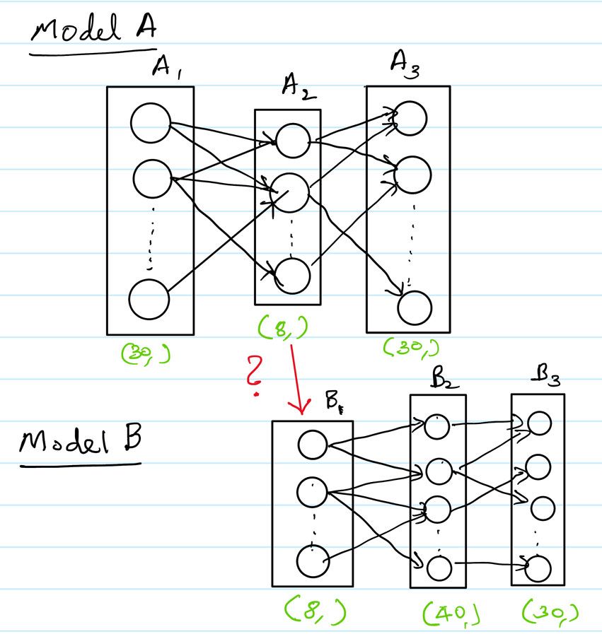
Answer
Consider:
from keras.layers import Input, Densefrom keras.models import Modelfrom keras.utils.vis_utils import plot_model

A1 = Input(shape=(30,),name='A1')
A2 = Dense(8, activation='relu',name='A2')(A1)
A3 = Dense(30, activation='relu',name='A3')(A2)

B2 = Dense(40, activation='relu',name='B2')(A2)
B3 = Dense(30, activation='relu',name='B3')(B2)

merged = Model(inputs=[A1],outputs=[A3,B3])
plot_model(merged,to_file='demo.png',show_shapes=True)
Output structure:
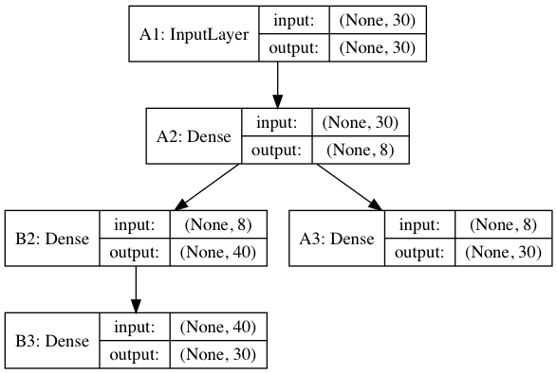
Having Machine Learning, Data Science or Python Interview? Check 62 Keras Interview Questions
Source: datascience.stackexchange.com

35 Advanced Statistics Interview Questions For Data Scientists and ML Engineers

Naïve Bayes 18

Probability 34

Statistics 58

Q14:
In Keras, what's the difference between kernel, bias, and activity regularizers, and when to use which?
Mid

Keras 62

Answer
Given the regression equation y=Wx+by=Wx+b where xx is the input, WW the weights matrix, and bb the bias, then
- Kernel Regularizer: Tries to reduce the weights WW (excluding bias).
- Bias Regularizer: Tries to reduce the bias bb.
- Activity Regularizer: Tries to reduce the layer's output yy, thus will reduce the weights and adjust bias so Wx+bWx+b is smallest.
Usually, if you have no prior on the distribution that you wish to model, you would only use the kernel regularizer, since a large enough network can still model your function even if the regularization on the weights are big. We could also apply kernel_regularizer to penalize the weights which are very large causing the network to overfit, after applying kernel_regularizer the weights will become smaller.
On other hand, if you want the output function to pass through (or have an intercept closer to) the origin, you can use the bias regularizer. But if you want the output to be smaller (or closer to 0), you can use the activity regularizer, using this we could also reduce overfitting.
Having Machine Learning, Data Science or Python Interview? Check 62 Keras Interview Questions
Source: stats.stackexchange.com

Q15:
What is Transfer learning and how can you implement it in Keras?
Mid

Deep Learning 51

Answer
Transfer learning consists of taking features learned on one problem and leveraging them on a new, similar problem. For instance, features from a model that has learned to identify raccoons may be useful to kick-start a model meant to identify tanukis.
The typical transfer-learning workflow in Keras is:
- Instantiate a base model and load pre-trained weights into it.
base_model = keras.applications.Xception(
weights='imagenet', # Load weights pre-trained on ImageNet.
input_shape=(150, 150, 3),
include_top=False) # Do not include the ImageNet classifier at the top.
- Freeze all layers in the base model by setting trainable = False to avoid updating during training.
base_model.trainable = False
- Create a new model on top of the output of one (or several) layers from the base model.
inputs = keras.Input(shape=(150, 150, 3))
x = base_model(inputs, training=False)# Convert features of shape `base_model.output_shape[1:]` to vectors
x = keras.layers.GlobalAveragePooling2D()(x)# A Dense classifier with a single unit (binary classification)
outputs = keras.layers.Dense(1)(x)
model = keras.Model(inputs, outputs)
- Train your new model on your new dataset.
model.compile(optimizer=keras.optimizers.Adam(),
loss=keras.losses.BinaryCrossentropy(from_logits=True),
metrics=[keras.metrics.BinaryAccuracy()])
model.fit(new_dataset, epochs=20, callbacks=..., validation_data=...)
- Once the model has converged on the new data, you can try to unfreeze all or part of the base model and retrain the whole model end-to-end with a very low learning rate. This is an optional last step that can potentially give you incremental improvements, but it could also potentially lead to quick overfitting.
# Unfreeze the base model
base_model.trainable = True
# Recompile the model after you make any changes to the `trainable` attribute
model.compile(optimizer=keras.optimizers.Adam(1e-5),
loss=keras.losses.BinaryCrossentropy(from_logits=True),
metrics=[keras.metrics.BinaryAccuracy()])
# Train end-to-end
model.fit(new_dataset, epochs=10, callbacks=..., validation_data=...)
Having Machine Learning, Data Science or Python Interview? Check 51 Deep Learning Interview Questions
Source: keras.io

 Bias & Variance 14

SVM 56

K-Means Clustering 41

 Sorting 26

Supervised Learning 31

RNN 17

Logistic Regression 24

 Unsupervised Learning 27

 PCA 17

Linear Algebra 41

Check FullStack.Cafe - 3877 Full-Stack, Coding & System Design Questions and Answers

Q16:
What is the advantage of using Functional vs Sequential models in Keras?
Mid

Keras 62

Answer
The Sequential model API is a way of creating deep learning models where an instance of the Sequential class is created and model layers are created and added to it. This is great for developing deep learning models in most situations, but it also has some limitations: For example, it is not straightforward to define models that may have multiple different input sources, produce multiple output destinations or models that re-use layers.
The Keras functional API provides a more flexible way for defining models. It specifically allows you to define multiple input or output models as well as models that share layers. More than that, it allows you to define ad hoc acyclic network graphs.
In the functional API, the models are defined by creating instances of layers and connecting them directly to each other in pairs, then defining a Model that specifies the layers to act as the input and output to the model. As a result, creating complex networks such as siamese networks or residual networks becomes possible.
Having Machine Learning, Data Science or Python Interview? Check 62 Keras Interview Questions
Source: machinelearningmastery.com

Q17:
What's the difference between LSTM() and LSTMCell() in Keras?
Mid

Keras 62

Answer
- LSTM is a recurrent layer.
- LSTMCell is an object (which happens to be a layer too) used by the LSTM layer that contains the calculation logic for one step.
A recurrent layer contains a cell object:
- The cell contains the core code for the calculations of each step,
- while the recurrent layer commands the cell and performs the actual recurrent calculations.
Usually, people use LSTM layers in their code, or they use RNN layers containing LSTMCell. Both things are almost the same. An LSTM layer is an RNN layer using an LSTMCell.
Having Machine Learning, Data Science or Python Interview? Check 62 Keras Interview Questions
Source: stackoverflow.com

27 SVM Interview Questions (ANSWERED) To Master Before ML & Data Science Interview

SVM 56

Q18:
When would you use a Data Generator in Keras?
Mid

Keras 62

Answer
Data Generators is one of the most useful features of the Keras API. Consider a scenario where you have lots of data, so much that you cannot have all of it at once in the RAM.
Well, the solution to this can be loading the mini-batches fed to the model dynamically. This is exactly what data generators do and why they are useful. They can generate the model input dynamically thus forming a pipeline from the storage to the RAM to load the data as and when it is required. Another advantage of this pipeline is, one can easily apply preprocessing routines on these mini-batches of data as they are prepared to feed the model.
Having Machine Learning, Data Science or Python Interview? Check 62 Keras Interview Questions
Source: medium.datadriveninvestor.com

Q19:
Where would you put a BatchNormalization function in a Keras model?
Mid

Keras 62

Answer
- BatchNormalization (BN) is just another layer, so you can use it as such to create your desired network architecture.
- The general use case is to use BN is between the linear and non-linear layers in the network, because it normalizes the input to your activation function so that you're centered in the linear section of the activation function (such as Sigmoid).

1. What is Deep Learning?
If you are going for a deep learning interview, you definitely know what exactly deep learning is. However, with this question the interviewee expects you to give an in-detail answer, with an example. Deep Learning involves taking large volumes of structured or unstructured data and using complex algorithms to train neural networks. It performs complex operations to extract hidden patterns and features (for instance, distinguishing the image of a cat from that of a dog).
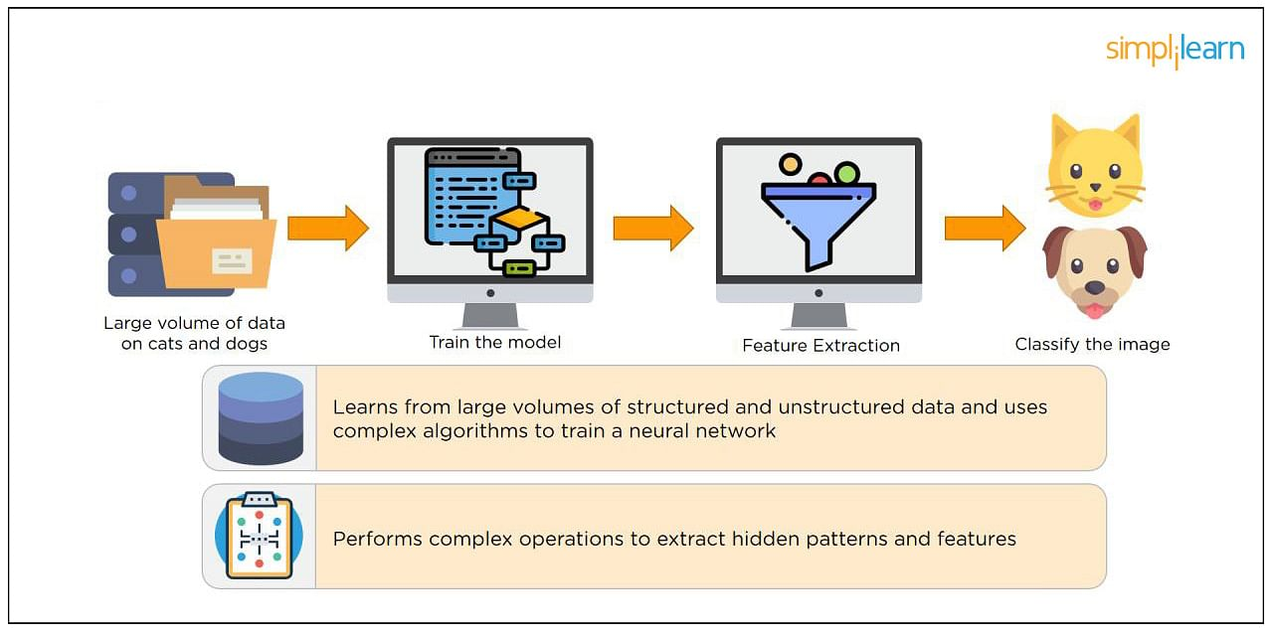

Deep Learning Course (with TensorFlow & Keras)
Master the Deep Learning Concepts and ModelsVIEW COURSE
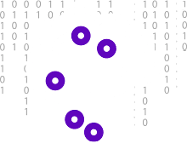

2. What is a Neural Network?
Neural Networks replicate the way humans learn, inspired by how the neurons in our brains fire, only much simpler.
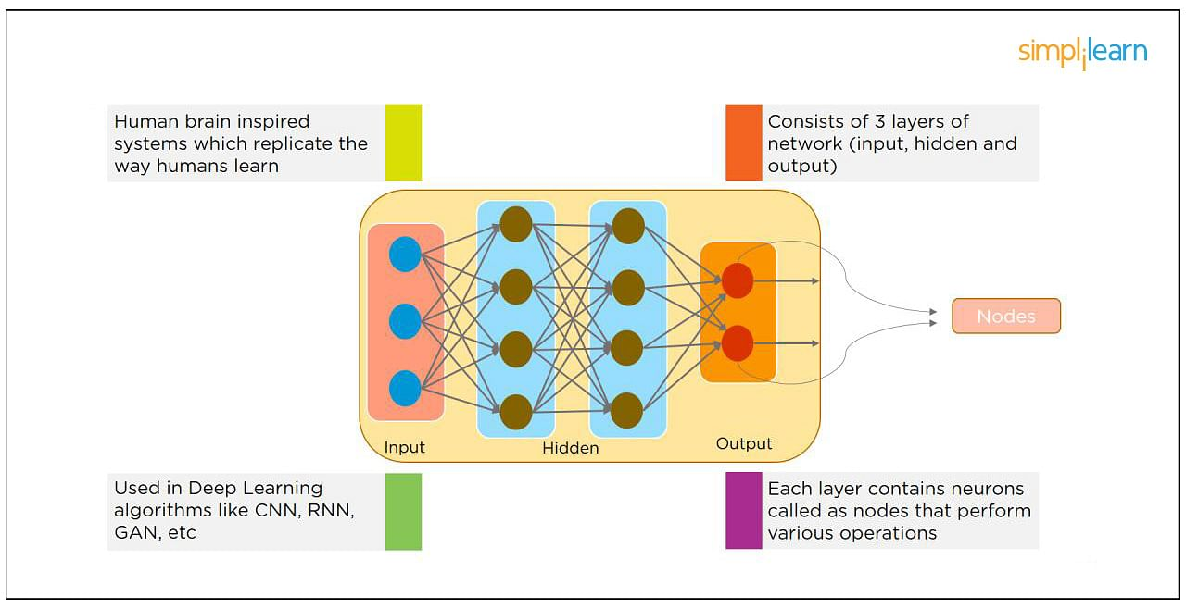
The most common Neural Networks consist of three network layers:
- An input layer
- A hidden layer (this is the most important layer where feature extraction takes place, and adjustments are made to train faster and function better)
- An output layer
Each sheet contains neurons called “nodes,” performing various operations. Neural Networks are used in deep learning algorithms like CNN, RNN, GAN, etc.

3. What Is a Multi-layer Perceptron(MLP)?
As in Neural Networks, MLPs have an input layer, a hidden layer, and an output layer. It has the same structure as a single layer perceptron with one or more hidden layers. A single layer perceptron can classify only linear separable classes with binary output (0,1), but MLP can classify nonlinear classes.
Except for the input layer, each node in the other layers uses a nonlinear activation function. This means the input layers, the data coming in, and the activation function is based upon all nodes and weights being added together, producing the output. MLP uses a supervised learning method called “backpropagation.” In backpropagation, the neural network calculates the error with the help of cost function. It propagates this error backward from where it came (adjusts the weights to train the model more accurately).

4. What Is Data Normalization, and Why Do We Need It?
The process of standardizing and reforming data is called “Data Normalization.” It’s a pre-processing step to eliminate data redundancy. Often, data comes in, and you get the same information in different formats. In these cases, you should rescale values to fit into a particular range, achieving better convergence.

5. What is the Boltzmann Machine?
One of the most basic Deep Learning models is a Boltzmann Machine, resembling a simplified version of the Multi-Layer Perceptron. This model features a visible input layer and a hidden layer -- just a two-layer neural net that makes stochastic decisions as to whether a neuron should be on or off. Nodes are connected across layers, but no two nodes of the same layer are connected.

6. What Is the Role of Activation Functions in a Neural Network?
At the most basic level, an activation function decides whether a neuron should be fired or not. It accepts the weighted sum of the inputs and bias as input to any activation function. Step function, Sigmoid, ReLU, Tanh, and Softmax are examples of activation functions.
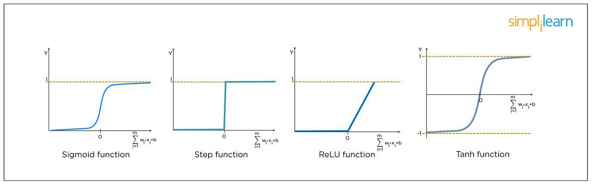

Free Webinar: AI for Business Decision Making
December 1, Thursday | 9 PM ISTREGISTER NOW


7. What Is the Cost Function?
Also referred to as “loss” or “error,” cost function is a measure to evaluate how good your model’s performance is. It’s used to compute the error of the output layer during backpropagation. We push that error backward through the neural network and use that during the different training functions.
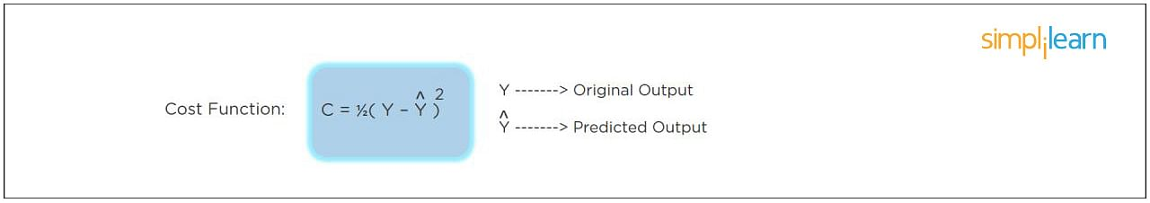

8. What Is Gradient Descent?
Gradient Descent is an optimal algorithm to minimize the cost function or to minimize an error. The aim is to find the local-global minima of a function. This determines the direction the model should take to reduce the error.
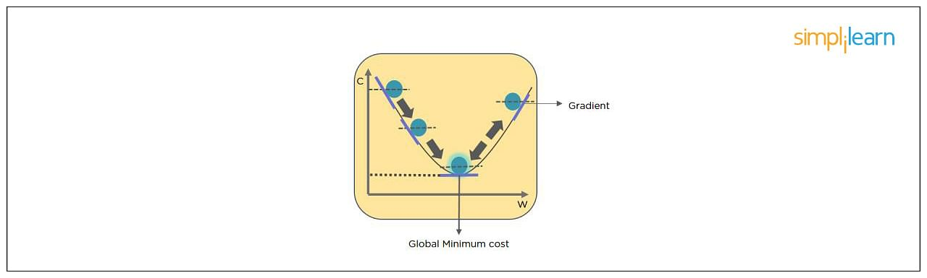

9. What Do You Understand by Backpropagation?
This is one of the most frequently asked deep learning interview questions. Backpropagation is a technique to improve the performance of the network. It backpropagates the error and updates the weights to reduce the error.
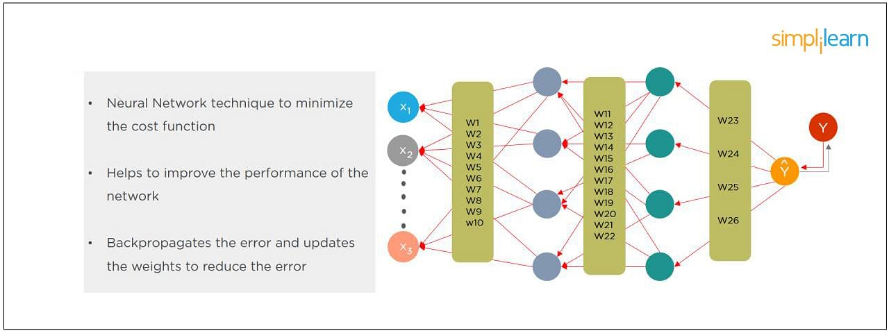

10. What Is the Difference Between a Feedforward Neural Network and Recurrent Neural Network?
In this deep learning interview question, the interviewee expects you to give a detailed answer.
A Feedforward Neural Network signals travel in one direction from input to output. There are no feedback loops; the network considers only the current input. It cannot memorize previous inputs (e.g., CNN).
A Recurrent Neural Network’s signals travel in both directions, creating a looped network. It considers the current input with the previously received inputs for generating the output of a layer and can memorize past data due to its internal memory.
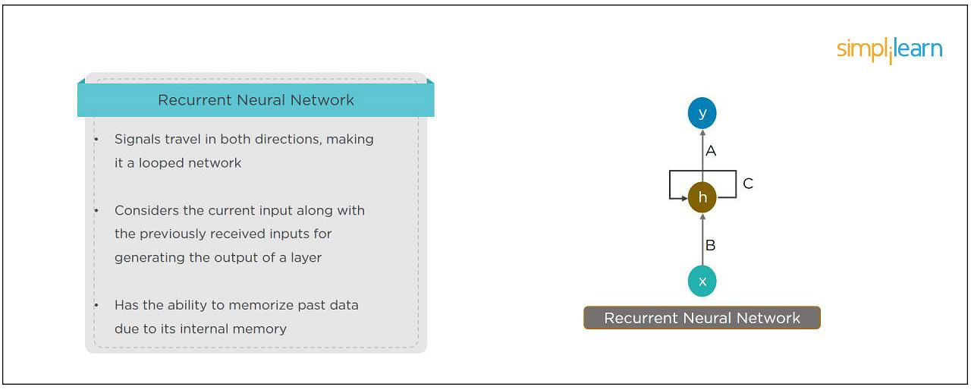

11. What Are the Applications of a Recurrent Neural Network (RNN)?
The RNN can be used for sentiment analysis, text mining, and image captioning. Recurrent Neural Networks can also address time series problems such as predicting the prices of stocks in a month or quarter.

PCP in AI and Machine Learning
In Partnership with Purdue UniversityEXPLORE COURSE


12. What Are the Softmax and ReLU Functions?
Softmax is an activation function that generates the output between zero and one. It divides each output, such that the total sum of the outputs is equal to one. Softmax is often used for output layers.
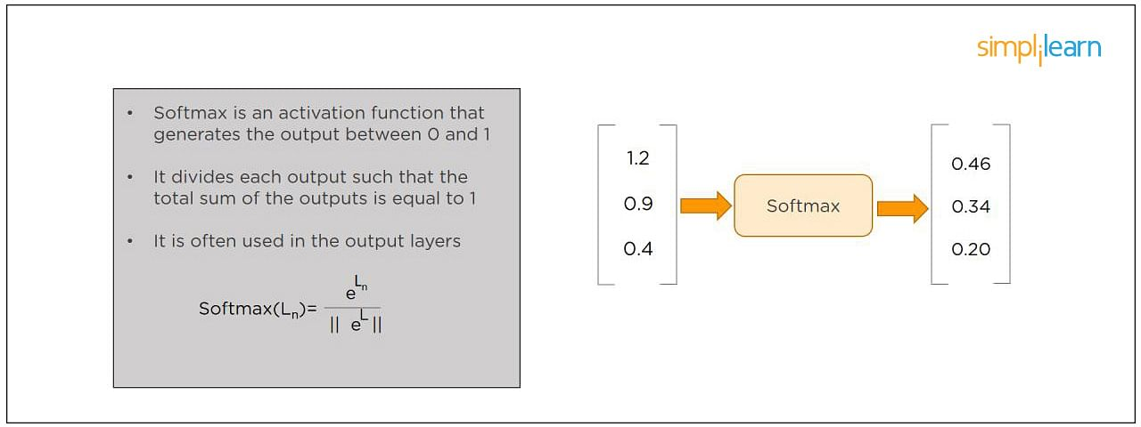
ReLU (or Rectified Linear Unit) is the most widely used activation function. It gives an output of X if X is positive and zeros otherwise. ReLU is often used for hidden layers.
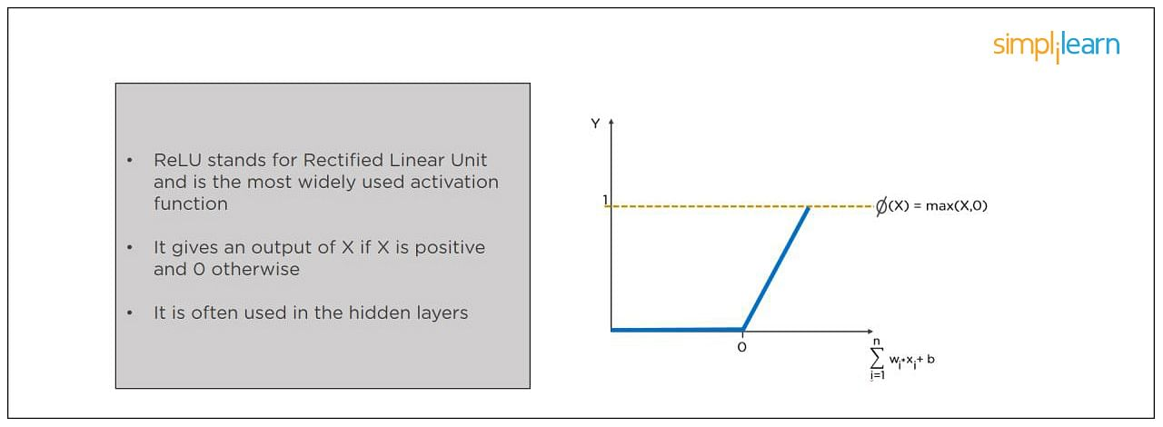

13. What Are Hyperparameters?
This is another frequently asked deep learning interview question. With neural networks, you’re usually working with hyperparameters once the data is formatted correctly. A hyperparameter is a parameter whose value is set before the learning process begins. It determines how a network is trained and the structure of the network (such as the number of hidden units, the learning rate, epochs, etc.).
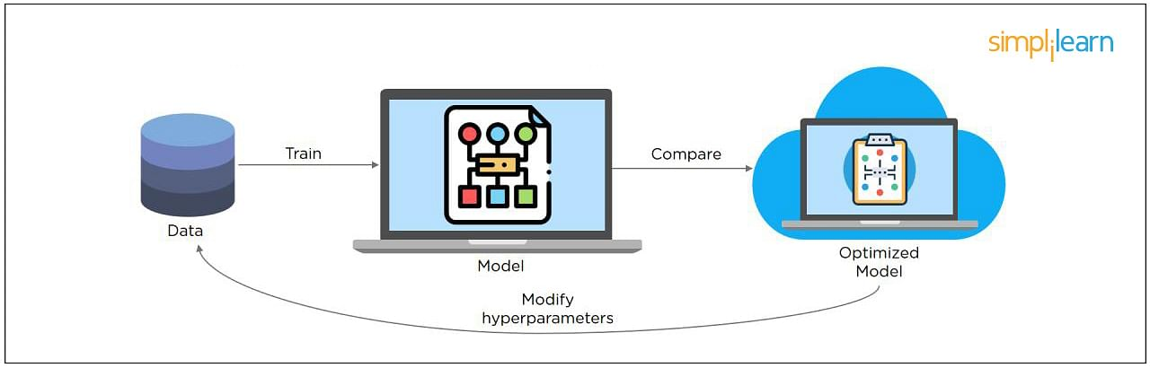

14. What Will Happen If the Learning Rate Is Set Too Low or Too High?
When your learning rate is too low, training of the model will progress very slowly as we are making minimal updates to the weights. It will take many updates before reaching the minimum point.
If the learning rate is set too high, this causes undesirable divergent behavior to the loss function due to drastic updates in weights. It may fail to converge (model can give a good output) or even diverge (data is too chaotic for the network to train).
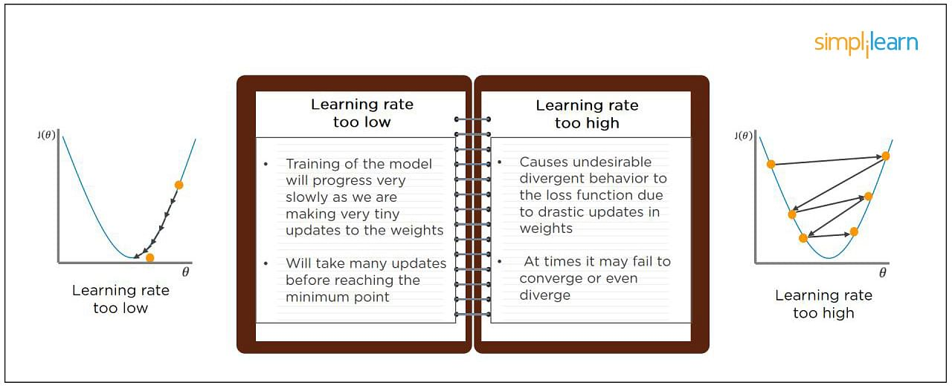

15. What Is Dropout and Batch Normalization?
Dropout is a technique of dropping out hidden and visible units of a network randomly to prevent overfitting of data (typically dropping 20 percent of the nodes). It doubles the number of iterations needed to converge the network.
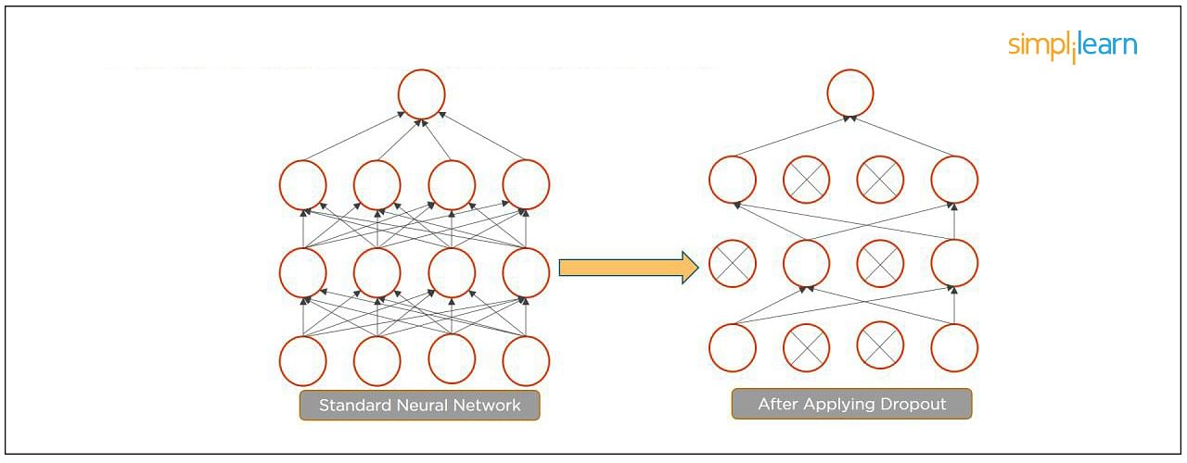
Batch normalization is the technique to improve the performance and stability of neural networks by normalizing the inputs in every layer so that they have mean output activation of zero and standard deviation of one.
The next step on this top Deep Learning interview questions and answers blog will be to discuss intermediate questions.

16. What Is the Difference Between Batch Gradient Descent and Stochastic Gradient Descent?
Batch Gradient Descent | Stochastic Gradient Descent
The batch gradient computes the gradient using the entire dataset.  It takes time to converge because the volume of data is huge, and weights update slowly. | The stochastic gradient computes the gradient using a single sample.  It converges much faster than the batch gradient because it updates weight more frequently.

FREE Machine Learning Certification Course
To become a Machine Learning EngineerEXPLORE COURSE


17. What is Overfitting and Underfitting, and How to Combat Them?
Overfitting occurs when the model learns the details and noise in the training data to the degree that it adversely impacts the execution of the model on new information. It is more likely to occur with nonlinear models that have more flexibility when learning a target function. An example would be if a model is looking at cars and trucks, but only recognizes trucks that have a specific box shape. It might not be able to notice a flatbed truck because there's only a particular kind of truck it saw in training. The model performs well on training data, but not in the real world.
Underfitting alludes to a model that is neither well-trained on data nor can generalize to new information. This usually happens when there is less and incorrect data to train a model. Underfitting has both poor performance and accuracy.
To combat overfitting and underfitting, you can resample the data to estimate the model accuracy (k-fold cross-validation) and by having a validation dataset to evaluate the model.

18. How Are Weights Initialized in a Network?
There are two methods here: we can either initialize the weights to zero or assign them randomly.
Initializing all weights to 0: This makes your model similar to a linear model. All the neurons and every layer perform the same operation, giving the same output and making the deep net useless.
Initializing all weights randomly: Here, the weights are assigned randomly by initializing them very close to 0. It gives better accuracy to the model since every neuron performs different computations. This is the most commonly used method.

19. What Are the Different Layers on CNN?
There are four layers in CNN:
- Convolutional Layer - the layer that performs a convolutional operation, creating several smaller picture windows to go over the data.
- ReLU Layer - it brings non-linearity to the network and converts all the negative pixels to zero. The output is a rectified feature map.
- Pooling Layer - pooling is a down-sampling operation that reduces the dimensionality of the feature map.
- Fully Connected Layer - this layer recognizes and classifies the objects in the image.
Master the deep learning concepts and TensorFlow open-source framework with the Deep Learning Course with TensorFlow Certification. Check out the course preview today.

20. What is Pooling on CNN, and How Does It Work?
Pooling is used to reduce the spatial dimensions of a CNN. It performs down-sampling operations to reduce the dimensionality and creates a pooled feature map by sliding a filter matrix over the input matrix.
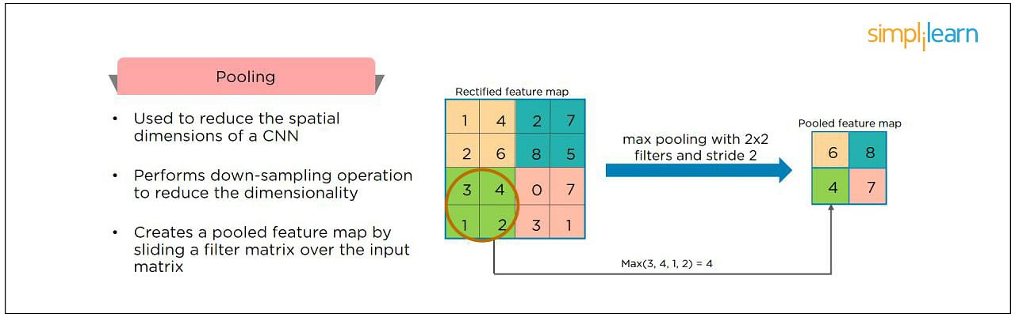

Free Course: Machine Learning Algorithms
Learn the Basics of Machine Learning AlgorithmsENROLL NOW

21. How Does an LSTM Network Work?
Long-Short-Term Memory (LSTM) is a special kind of recurrent neural network capable of learning long-term dependencies, remembering information for long periods as its default behavior. There are three steps in an LSTM network:
- Step 1: The network decides what to forget and what to remember.
- Step 2: It selectively updates cell state values.
- Step 3: The network decides what part of the current state makes it to the output.
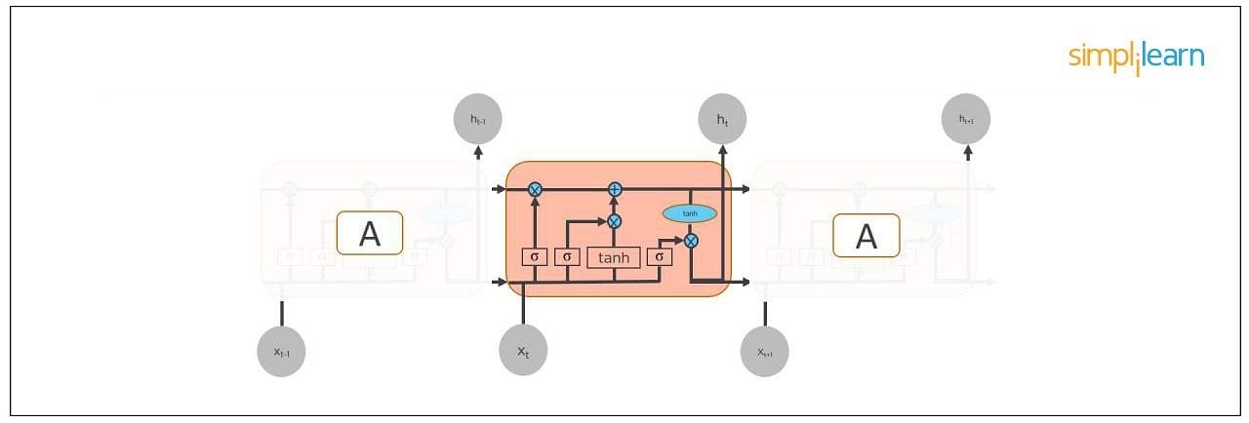

22. What Are Vanishing and Exploding Gradients?
While training an RNN, your slope can become either too small or too large; this makes the training difficult. When the slope is too small, the problem is known as a “Vanishing Gradient.” When the slope tends to grow exponentially instead of decaying, it’s referred to as an “Exploding Gradient.” Gradient problems lead to long training times, poor performance, and low accuracy.
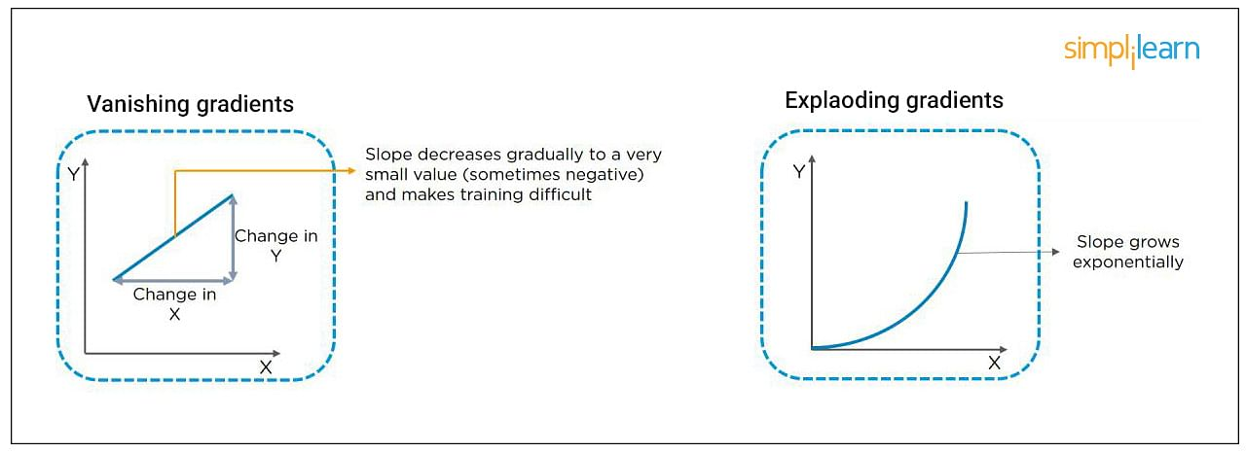

Free Deep Learning for Beginners Course
Master the Basics of Deep LearningENROLL NOW

23. What Is the Difference Between Epoch, Batch, and Iteration in Deep Learning?
- Epoch - Represents one iteration over the entire dataset (everything put into the training model).
- Batch - Refers to when we cannot pass the entire dataset into the neural network at once, so we divide the dataset into several batches.
- Iteration - if we have 10,000 images as data and a batch size of 200. then an epoch should run 50 iterations (10,000 divided by 50).

24. Why is Tensorflow the Most Preferred Library in Deep Learning?
Tensorflow provides both C++ and Python APIs, making it easier to work on and has a faster compilation time compared to other Deep Learning libraries like Keras and Torch. Tensorflow supports both CPU and GPU computing devices.

25. What Do You Mean by Tensor in Tensorflow?
This is another most frequently asked deep learning interview question. A tensor is a mathematical object represented as arrays of higher dimensions. These arrays of data with different dimensions and ranks fed as input to the neural network are called “Tensors.”
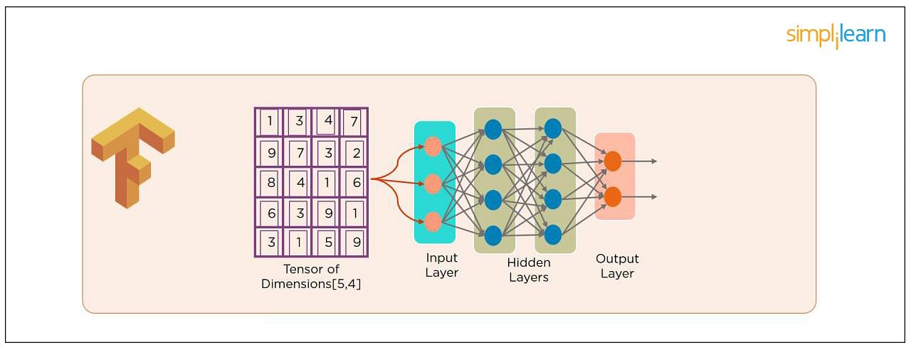

26. What Are the Programming Elements in Tensorflow?
Constants - Constants are parameters whose value does not change. To define a constant we use tf.constant() command. For example:
a = tf.constant(2.0,tf.float32)
b = tf.constant(3.0)
Print(a, b)
Variables - Variables allow us to add new trainable parameters to graph. To define a variable, we use the tf.Variable() command and initialize them before running the graph in a session. An example:
W = tf.Variable([.3].dtype=tf.float32)
b = tf.Variable([-.3].dtype=tf.float32)
Placeholders - these allow us to feed data to a tensorflow model from outside a model. It permits a value to be assigned later. To define a placeholder, we use the tf.placeholder() command. An example:
a = tf.placeholder (tf.float32)
b = a*2
with tf.Session() as sess:
result = sess.run(b,feed_dict={a:3.0})
print result
Sessions - a session is run to evaluate the nodes. This is called the “Tensorflow runtime.” For example:
a = tf.constant(2.0)
b = tf.constant(4.0)
c = a+b
# Launch Session
Sess = tf.Session()
# Evaluate the tensor c
print(sess.run(c))

27. Explain a Computational Graph.
Everything in a tensorflow is based on creating a computational graph. It has a network of nodes where each node operates, Nodes represent mathematical operations, and edges represent tensors. Since data flows in the form of a graph, it is also called a “DataFlow Graph.”

28. Explain Generative Adversarial Network.
Suppose there is a wine shop purchasing wine from dealers, which they resell later. But some dealers sell fake wine. In this case, the shop owner should be able to distinguish between fake and authentic wine.
The forger will try different techniques to sell fake wine and make sure specific techniques go past the shop owner’s check. The shop owner would probably get some feedback from wine experts that some of the wine is not original. The owner would have to improve how he determines whether a wine is fake or authentic.
The forger’s goal is to create wines that are indistinguishable from the authentic ones while the shop owner intends to tell if the wine is real or not accurately.
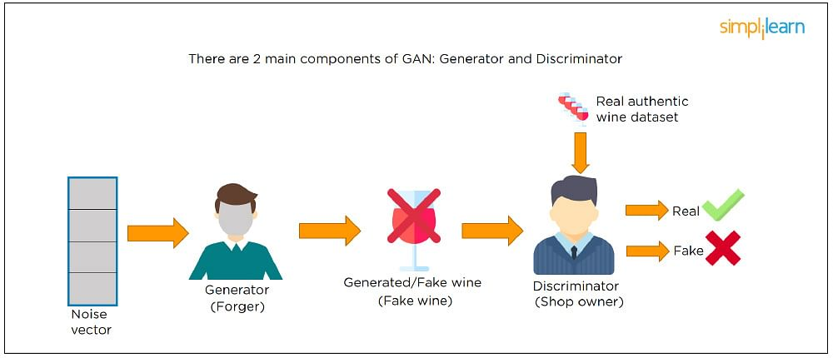
Let us understand this example with the help of an image shown above.
There is a noise vector coming into the forger who is generating fake wine.
Here the forger acts as a Generator.
The shop owner acts as a Discriminator.
The Discriminator gets two inputs; one is the fake wine, while the other is the real authentic wine. The shop owner has to figure out whether it is real or fake.
So, there are two primary components of Generative Adversarial Network (GAN) named:
- Generator
- Discriminator
The generator is a CNN that keeps keys producing images and is closer in appearance to the real images while the discriminator tries to determine the difference between real and fake images The ultimate aim is to make the discriminator learn to identify real and fake images.

29. What Is an Auto-encoder?
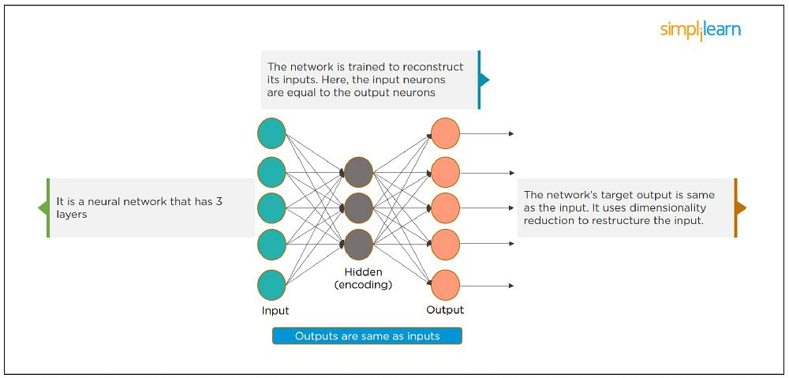
This Neural Network has three layers in which the input neurons are equal to the output neurons. The network's target outside is the same as the input. It uses dimensionality reduction to restructure the input. It works by compressing the image input to a latent space representation then reconstructing the output from this representation.

30. What Is Bagging and Boosting?
Bagging and Boosting are ensemble techniques to train multiple models using the same learning algorithm and then taking a call.
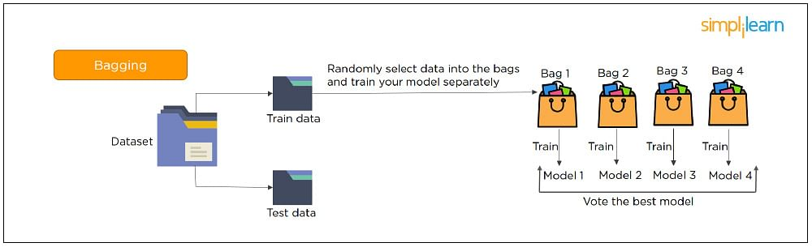
With Bagging, we take a dataset and split it into training data and test data. Then we randomly select data to place into the bags and train the model separately.
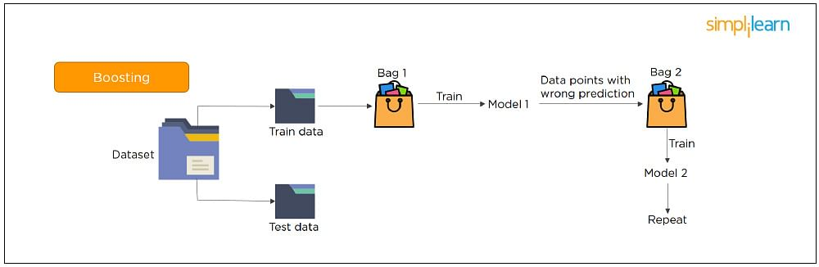
With Boosting, the emphasis is on selecting data points which give wrong output to improve the accuracy.
The following are some of the most important advanced deep learning interview questions that you should know!

31. What is the significance of using the Fourier transform in Deep Learning tasks?
The Fourier transform function efficiently analyzes, maintains, and manages large datasets. You can use it to generate real-time array data that is helpful for processing multiple signals.

32. What do you understand by transfer learning? Name a few commonly used transfer learning models.
Transfer learning is the process of transferring the learning from a model to another model without having to train it from scratch. It takes critical parts of a pre-trained model and applies them to solve new but similar machine learning problems.
Some of the popular transfer learning models are:
- VGG-16
- BERT
- GTP-3
- Inception V3
- XCeption

33. What is the difference between SAME and VALID padding in Tensorflow?
Using the Tensorflow library, tf.nn.max_pool performs the max-pooling operation. Tf.nn.max_pool has a padding argument that takes 2 values - SAME or VALID.
With padding == “SAME” ensures that the filter is applied to all the elements of the input.
The input image gets fully covered by the filter and specified stride. The padding type is named SAME as the output size is the same as the input size (when stride=1).
With padding == “VALID” implies there is no padding in the input image. The filter window always stays inside the input image. It assumes that all the dimensions are valid so that the input image gets fully covered by a filter and the stride defined by you.

34. What are some of the uses of Autoencoders in Deep Learning?
- Autoencoders are used to convert black and white images into colored images.
- Autoencoder helps to extract features and hidden patterns in the data.
- It is also used to reduce the dimensionality of data.
- It can also be used to remove noises from images.

35. What is the Swish Function?
Swish is an activation function proposed by Google which is an alternative to the ReLU activation function.
It is represented as: f(x) = x * sigmoid(x).
The Swish function works better than ReLU for a variety of deeper models.
The derivative of Swist can be written as: y’ = y + sigmoid(x) * (1 - y)

36. What are the reasons for mini-batch gradient being so useful?
- Mini-batch gradient is highly efficient compared to stochastic gradient descent.
- It lets you attain generalization by finding the flat minima.
- Mini-batch gradient helps avoid local minima to allow gradient approximation for the whole dataset.

37. What do you understand by Leaky ReLU activation function?
Leaky ReLU is an advanced version of the ReLU activation function. In general, the ReLU function defines the gradient to be 0 when all the values of inputs are less than zero. This deactivates the neurons. To overcome this problem, Leaky ReLU activation functions are used. It has a very small slope for negative values instead of a flat slope.

38. What is Data Augmentation in Deep Learning?
Data Augmentation is the process of creating new data by enhancing the size and quality of training datasets to ensure better models can be built using them. There are different techniques to augment data such as numerical data augmentation, image augmentation, GAN-based augmentation, and text augmentation.

39. Explain the Adam optimization algorithm.
Adaptive Moment Estimation or Adam optimization is an extension to the stochastic gradient descent. This algorithm is useful when working with complex problems involving vast amounts of data or parameters. It needs less memory and is efficient.
Adam optimization algorithm is a combination of two gradient descent methodologies -
Momentum and Root Mean Square Propagation.

40. Why is a convolutional neural network preferred over a dense neural network for an image classification task?
- The number of parameters in a convolutional neural network is much more diminutive than that of a Dense Neural Network. Hence, a CNN is less likely to overfit.
- CNN allows you to look at the weights of a filter and visualize what the network learned. So, this gives a better understanding of the model.
- CNN trains models in a hierarchical way, i.e., it learns the patterns by explaining complex patterns using simpler ones.

41. Which strategy does not prevent a model from over-fitting to the training data?
- Dropout
- Pooling
- Data augmentation
- Early stopping
Answer: b) Pooling - It’s a layer in CNN that performs a downsampling operation.

42. Explain two ways to deal with the vanishing gradient problem in a deep neural network.
- Use the ReLU activation function instead of the sigmoid function
- Initialize neural networks using Xavier initialization that works with tanh activation.

43. Why is a deep neural network better than a shallow neural network?
Both deep and shallow neural networks can approximate the values of a function. But the deep neural network is more efficient as it learns something new in every layer. A shallow neural network has only one hidden layer. But a deep neural network has several hidden layers that create a deeper representation and computation capability.

44. What is the need to add randomness in the weight initialization process?
If you set the weights to zero, then every neuron at each layer will produce the same result and the same gradient value during backpropagation. So, the neural network won’t be able to learn the function as there is no asymmetry between the neurons. Hence, randomness to the weight initialization process is crucial.

45. How can you train hyperparameters in a neural network?
Hyperparameters in a neural network can be trained using four components:
Batch size: Indicates the size of the input data.
Epochs: Denotes the number of times the training data is visible to the neural network to train.
Momentum: Used to get an idea of the next steps that occur with the data being executed.
Learning rate: Represents the time required for the network to update the parameters and learn.
In this article, I am covering keras interview questions and answers only. I am not covering like regular questions about NN and deep learning topics here, If you are interested know basics you can refer, datascience interview questions, deep learning interview questions.
What is Keras ?
Who is the Creator of Keras ?
François Chollet, He is currently working as an AI Researcher at Google
What is advantages of Keras ?
What is difference between keras and tensorflow ?
What is difference between keras and pytorch?
How to setup keras with tensorflow backend ?
Types are layers in keras ?
- Core Layers
- Convolutional Layers
- Pooling Layers
- Locally-connected Layers
- Recurrent Layers
- Embedding Layers
- Merge Layers
- Advanced Activations Layers
- Normalization Layers
- Noise layers
What is input Layer ? When we will use this layer ?
What is Dense Layer ? When we will use this layer ?
What is Convolutional Layer ? When we will use this layer ?
What is Pooling Layer ? When we will use this layer ?
What is Locally Connected layers ? When we use this layers ?
What is Noise Layer ? When we will use this layer ?
What is Recurrent Layer ? When we will use this layer ?
What is Embedding Layer ? When we will use this layer ?
What is Merge Layer ? When we will use this layer ?
What is Normalization Layer ? When we will use this layer ?
What is Sequence Preprocessing in keras ?
What is Text Preprocessing in keras ?
What is Image Preprocessing in keras ?
What is activation function ?
Different Types of activation function in keras ?
Available activations
softmax
keras.activations.softmax(x, axis=-1)
elu
keras.activations.elu(x, alpha=1.0)
selu
keras.activations.selu(x)
softplus
keras.activations.softplus(x)
Softplus activation function.
softsign
keras.activations.softsign(x)
relu
keras.activations.relu(x, alpha=0.0, max_value=None, threshold=0.0)
tanh
keras.activations.tanh(x)
sigmoid
keras.activations.sigmoid(x)
hard_sigmoid
keras.activations.hard_sigmoid(x)
exponential
keras.activations.exponential(x)
linear
keras.activations.linear(x)
What are advanced activation functions in keras ?
LeakyReLU, PReLU
What are regularizers in keras ?
- keras.regularizers.l1(0.)
- keras.regularizers.l2(0.)
- keras.regularizers.l1_l2(l1=0.01, l2=0.01)
What is initializers in keras ?
What are Different Types of initializers in keras ?
Initializer
keras.initializers.Initializer()
Zeros
keras.initializers.Zeros()
Ones
keras.initializers.Ones()
Constant
keras.initializers.Constant(value=0)
RandomNormal
keras.initializers.RandomNormal(mean=0.0, stddev=0.05, seed=None)
RandomUniform
keras.initializers.RandomUniform(minval=-0.05, maxval=0.05, seed=None)
TruncatedNormal
keras.initializers.TruncatedNormal(mean=0.0, stddev=0.05, seed=None)
VarianceScaling
keras.initializers.VarianceScaling(scale=1.0, mode=’fan_in’, distribution=’normal’, seed=None)
Orthogonal
keras.initializers.Orthogonal(gain=1.0, seed=None)
Identity
keras.initializers.Identity(gain=1.0)
glorot_normal
keras.initializers.glorot_normal(seed=None)
glorot_uniform
keras.initializers.glorot_uniform(seed=None)
he_normal
keras.initializers.he_normal(seed=None)
lecun_normal
keras.initializers.lecun_normal(seed=None)
he_uniform
keras.initializers.he_uniform(seed=None)
How can you create custom initializer in keras ?
What is Callback in Keras ?
What are different types of callbacks in keras ?
- BaseLogger
- TerminateOnNaN
- ProgbarLogger
- History
- ModelCheckpoint
- EarlyStopping
- Arguments
- RemoteMonitor
- LearningRateScheduler
- TensorBoard
- ReduceLROnPlateau
- CSVLogger
- LambdaCallback
What are constraints in keras ?
What are available constraints in keras ?
- MaxNorm
- NonNeg
- UnitNorm
- MinMaxNorm
Different Types of metrics in keras ?
- binary_accuracy
- categorical_accuracy
- sparse_categorical_accuracy
- top_k_categorical_accuracy
- sparse_top_k_categorical_accuracy
Different types of loss functions in keras ?
- Mean_squared_error
- Mean_absolute_error
- Mean_absolute_percentage_error
- Mean_squared_logarithmic_error
- Squared_hinge
- Hinge
- Categorical_hinge
- Logcosh
What are predefined models in Keras for images Classification ?
Models for image classification with weights trained on ImageNet:
- Xception
- VGG16
- VGG19
- ResNet50
- InceptionV3
- InceptionResNetV2
- MobileNet
- DenseNet
- NASNet
- MobileNetV2
Keras is a popular open-source library for deep learning. When applying for a position in machine learning or artificial intelligence, it is likely that employers will expect you to have a strong understanding and familiarity with Keras. Understanding what Keras questions you are most likely to encounter and how to properly answer them improves your chances of making a positive impression on the hiring manager. In this article, we discuss the most commonly asked Keras questions and how you should respond.

Keras Interview Questions and Answers
Here are 20 commonly asked Keras interview questions and answers to prepare you for your interview:

1. What is Keras?
Keras is a high-level neural networks API, written in Python and capable of running on top of TensorFlow, CNTK, or Theano. It was developed with a focus on enabling fast experimentation. Being able to go from idea to result with the least possible delay is key to doing good research.

2. What are the main features of Keras?
The main features of Keras are its user friendliness, modularity, and extensibility. Keras is designed to be user friendly, meaning that it is easy to use and understand. It is also modular, meaning that it is composed of a number of different modules that can be used together or separately. Finally, it is extensible, meaning that new modules can be added to it to extend its functionality.

3. How does Keras differ from other deep learning frameworks like PyTorch and TensorFlow?
Keras is a high-level deep learning framework that runs on top of other frameworks like TensorFlow and PyTorch. It is designed to be user-friendly and easy to use, making it a popular choice for deep learning projects. Keras also has a wide range of built-in features and functions, which makes it a more complete deep learning solution than some other frameworks.

4. What APIs does Keras have?
Keras has two main APIs: the Sequential API and the Functional API. The Sequential API is used for creating simple models, while the Functional API is used for creating more complex models.

5. Can you explain what a Sequential model is in Keras?
A Sequential model is a linear stack of layers in Keras. This is the most common type of model used in Keras, and is suitable for a wide variety of tasks.

6. Can you give me some examples of when to use functional API vs sequential models?
Functional API models are generally used when you need more flexibility in your model architecture, such as when you need to have multiple input or output layers. Sequential models are used when you need a simple, linear stack of layers.

7. Can you explain how different types of layers work in Keras?
There are a number of different types of layers that you can use in Keras, each of which serves a different purpose. For example, there are convolutional layers, which are typically used in image processing tasks, and recurrent layers, which are designed for working with sequences of data. There are also a number of different layer types that can be used for more general purposes, such as fully connected layers and dropout layers.

8. Can you explain how convolutional layers work in Keras?
Convolutional layers are a type of layer commonly used in convolutional neural networks. A convolutional layer applies a convolution operation to the input, passing a filter over the input and producing an output. The convolution operation is a mathematical operation that takes two inputs (a matrix and a kernel) and produces an output (a matrix). The convolution operation is used in many fields, including image processing and signal processing.

9. What do you understand about pooling layers in Keras?
Pooling layers are used in Keras to reduce the dimensionality of the data, while also retaining important information. There are two types of pooling layers: max pooling and average pooling. Max pooling takes the maximum value from each pool, while average pooling takes the average value from each pool.

10. How many ways can we initialize weights in Keras?
There are three ways that we can initialize weights in Keras:
1. Initializing all weights to the same value
2. Initializing weights randomly
3. Initializing weights using a pre-trained model

11. Can you explain the process of training a neural network using Keras?
The process of training a neural network using Keras typically involves four steps:
1. Define the model architecture, including the input layer, hidden layers, and output layer.
2. Compile the model, specifying the optimizer and loss function.
3. Train the model on the training data, specifying the batch size, number of epochs, and validation data.
4. Evaluate the model on the test data.

12. Why do you think batch normalization is important for training deep networks?
Batch normalization is important for training deep networks because it helps to prevent the internal covariate shift problem. This problem occurs when the distribution of the input data changes during training, which can lead to training instability and slow convergence. Batch normalization helps to mitigate this problem by normalizing the input data at each layer, which stabilizes the training process and leads to faster convergence.

13. What’s the advantage of using the “relu” activation function over other functions like tanh or sigmoid?
The “relu” activation function is known to help alleviate the vanishing gradient problem. This is a problem where the gradient of the error function gets progressively smaller as training progresses, making it difficult for the model to learn. The “relu” function helps to keep the gradient from vanishing, making training faster and more effective.

14. Is it possible to resume training after closing a session in Keras? If yes, then how?
Yes, it is possible to resume training after closing a session in Keras. You can do this by using the fit() function again with the same parameters that you used to close the session.

15. How do you make sure that your model has enough capacity to fit a complicated dataset?
There are a few ways to make sure that your model has enough capacity to fit a complicated dataset. One way is to increase the number of layers in your model. You can also increase the number of neurons in each layer. Finally, you can increase the number of epochs that you train your model for.

16. What are some common issues you might run into while training a neural network with Keras?
Some common issues you might run into while training a neural network with Keras include overfitting, underfitting, and vanishing gradients. Overfitting occurs when your model has too much capacity and begins to learn the noise in your training data instead of the signal. Underfitting occurs when your model doesn’t have enough capacity to learn the signal in your training data. Vanishing gradients occur when the gradients of the weights in your neural network become very small, making it difficult for the network to learn.

17. What’s the best way to visualise loss curves during the training process?
The best way to visualise loss curves during the training process is to use a tool like TensorBoard. TensorBoard is a tool that allows you to visualise your training process, including loss curves, in order to help you identify trends and optimize your training process.

18. Can you explain what mean squared error is?
Mean squared error is a loss function that is used in regression problems. It is the average of the squared difference between the predicted value and the actual value.

19. What is cross-entropy loss? When should it be used instead of MSE?
Cross-entropy loss is a loss function that is used for classification problems. It is used to calculate the error rate between the predicted class and the actual class. MSE is used for regression problems and is used to calculate the error between the predicted value and the actual value.

20. What is the difference between categorical_crossentropy and sparse_categorical_crossentropy? Which one would you recommend in certain situations?
Categorical crossentropy is used when your labels are one-hot encoded, meaning each label is a separate category. Sparse categorical crossentropy is used when your labels are integers, where each integer corresponds to a category. In general, categorical crossentropy is recommended when your labels are one-hot encoded, and sparse categorical crossentropy is recommended when your labels are integers.

