1. Why was Machine Learning Introduced?
The simplest answer is to make our lives easier. In the early days of “intelligent” applications, many systems used hardcoded rules of “if” and “else” decisions to process data or adjust the user input. Think of a spam filter whose job is to move the appropriate incoming email messages to a spam folder.
But with the machine learning algorithms, we are given ample information for the data to learn and identify the patterns from the data.
Unlike the normal problems we don’t need to write the new rules for each problem in machine learning, we just need to use the same workflow but with a different dataset.
Let’s talk about Alan Turing, in his 1950 paper, “Computing Machinery and Intelligence”, Alan asked, “Can machines think?”
Full paper here
The paper describes the “Imitation Game”, which includes three participants -
- Human acting as a judge,
- Another human, and
- A computer is an attempt to convince the judge that it is human.
The judge asks the other two participants to talk. While they respond the judge needs to decide which response came from the computer. If the judge could not tell the difference the computer won the game.
The test continues today as an annual competition in artificial intelligence. The aim is simple enough: convince the judge that they are chatting to a human instead of a computer chatbot program.

2. What are Different Types of Machine Learning algorithms?
There are various types of machine learning algorithms. Here is the list of them in a broad category based on:
- Whether they are trained with human supervision (Supervised, unsupervised, reinforcement learning)
- The criteria in the below diagram are not exclusive, we can combine them any way we like.
Types of Machine Learning algorithms

3. What is Supervised Learning?
Supervised learning is a machine learning algorithm of inferring a function from labeled training data. The training data consists of a set of training examples.
Example: 01
Knowing the height and weight identifying the gender of the person. Below are the popular supervised learning algorithms.
- Support Vector Machines
- Regression
- Naive Bayes
- Decision Trees
- K-nearest Neighbour Algorithm and Neural Networks.
Example: 02
If you build a T-shirt classifier, the labels will be “this is an S, this is an M and this is L”, based on showing the classifier examples of S, M, and L.
You can download a PDF version of Machine Learning Interview Questions.
Download PDF

4. What is Unsupervised Learning?
Unsupervised learning is also a type of machine learning algorithm used to find patterns on the set of data given. In this, we don’t have any dependent variable or label to predict. Unsupervised Learning Algorithms:
- Clustering,
- Anomaly Detection,
- Neural Networks and Latent Variable Models.
Example:
In the same example, a T-shirt clustering will categorize as “collar style and V neck style”, “crew neck style” and “sleeve types”.

5. What is ‘Naive’ in a Naive Bayes?
The Naive Bayes method is a supervised learning algorithm, it is naive since it makes assumptions by applying Bayes’ theorem that all attributes are independent of each other.
Bayes’ theorem states the following relationship, given class variable y and dependent vector x1 through xn:
P(yi | x1,..., xn) =P(yi)P(x1,..., xn | yi)(P(x1,..., xn)
Using the naive conditional independence assumption that each xiis independent: for all I this relationship is simplified to:
P(xi | yi, x1, ..., xi-1, xi+1, ...., xn) = P(xi | yi)
Since, P(x1,..., xn) is a constant given the input, we can use the following classification rule:
P(yi | x1, ..., xn) = P(y) ni=1P(xi | yi)P(x1,...,xn) and we can also use Maximum A Posteriori (MAP) estimation to estimate P(yi)and P(yi | xi) the former is then the relative frequency of class yin the training set.
P(yi | x1,..., xn) P(yi) ni=1P(xi | yi)
y = arg max P(yi)ni=1P(xi | yi)
The different naive Bayes classifiers mainly differ by the assumptions they make regarding the distribution of P(yi | xi): can be Bernoulli, binomial, Gaussian, and so on.

6. What is PCA? When do you use it?
Principal component analysis (PCA) is most commonly used for dimension reduction.
In this case, PCA measures the variation in each variable (or column in the table). If there is little variation, it throws the variable out, as illustrated in the figure below:
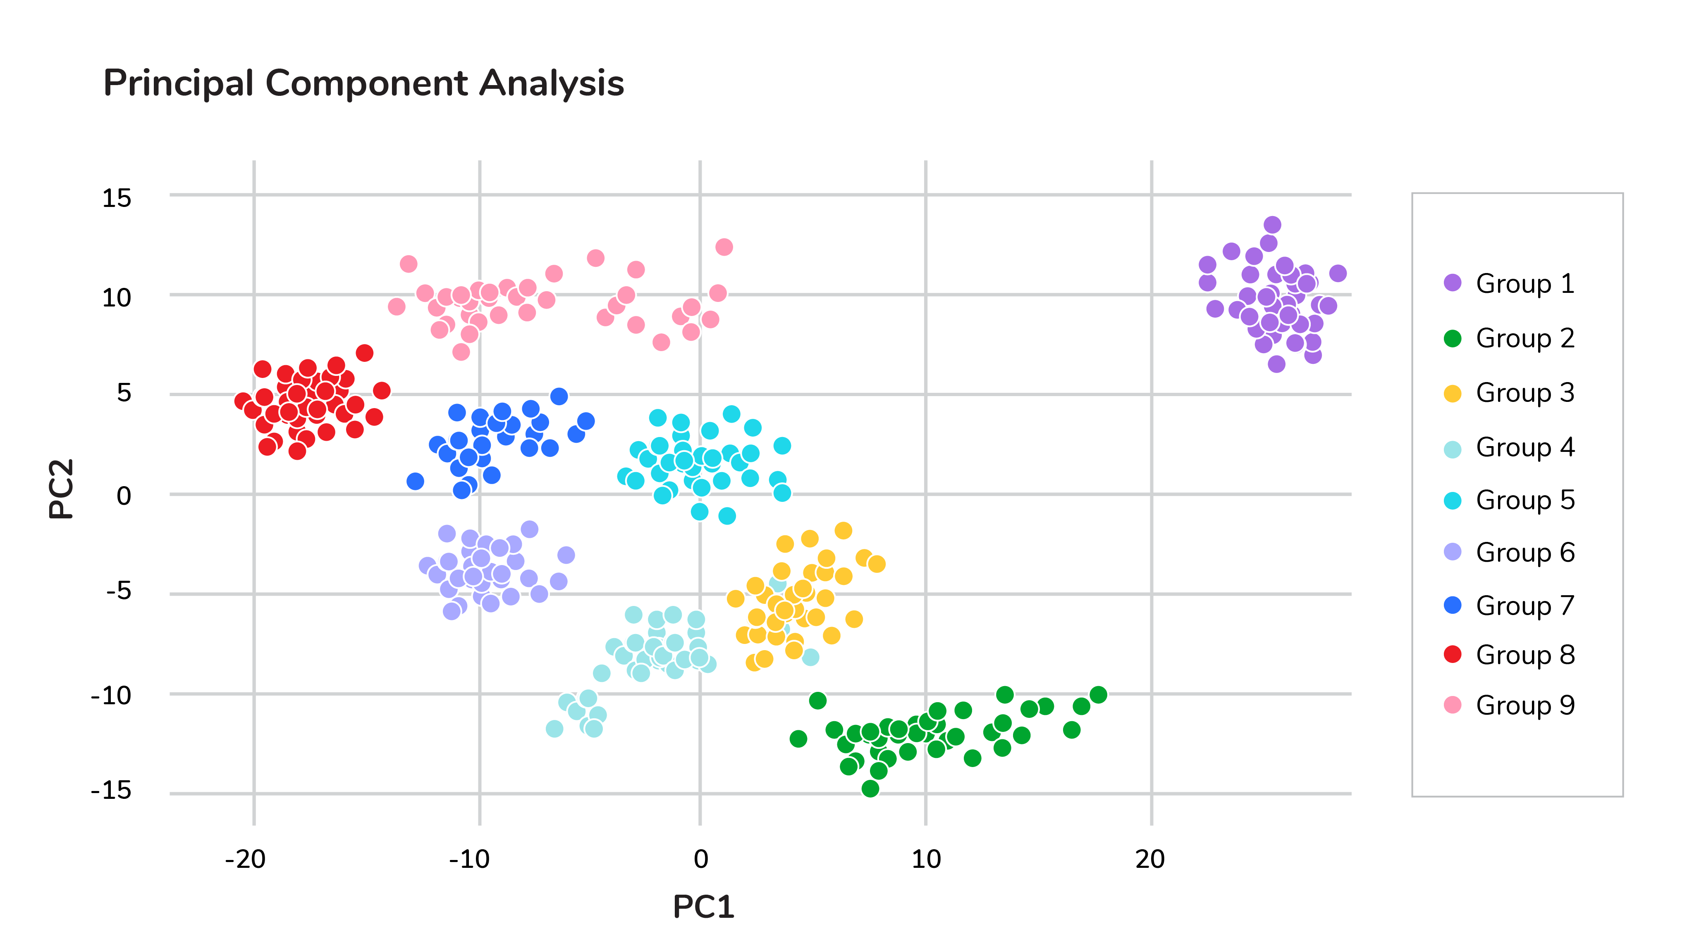Principal component analysis (PCA)
Thus making the dataset easier to visualize. PCA is used in finance, neuroscience, and pharmacology.
It is very useful as a preprocessing step, especially when there are linear correlations between features.

7. Explain SVM Algorithm in Detail
A Support Vector Machine (SVM) is a very powerful and versatile supervised machine learning model, capable of performing linear or non-linear classification, regression, and even outlier detection.
Suppose we have given some data points that each belong to one of two classes, and the goal is to separate two classes based on a set of examples.
In SVM, a data point is viewed as a p-dimensional vector (a list of p numbers), and we wanted to know whether we can separate such points with a (p-1)-dimensional hyperplane. This is called a linear classifier.
There are many hyperplanes that classify the data. To choose the best hyperplane that represents the largest separation or margin between the two classes.
If such a hyperplane exists, it is known as a maximum-margin hyperplane and the linear classifier it defines is known as a maximum margin classifier. The best hyperplane that divides the data in H3
We have data (x1, y1), ..., (xn, yn), and different features (xii, ..., xip), and yiis either 1 or -1.
The equation of the hyperplane H3 is the set of points satisfying:
w. x-b = 0
Where w is the normal vector of the hyperplane. The parameter b||w||determines the offset of the hyperplane from the original along the normal vector w
So for each i, either xiis in the hyperplane of 1 or -1. Basically, xisatisfies:
w . xi - b = 1 or w. xi - b = -1
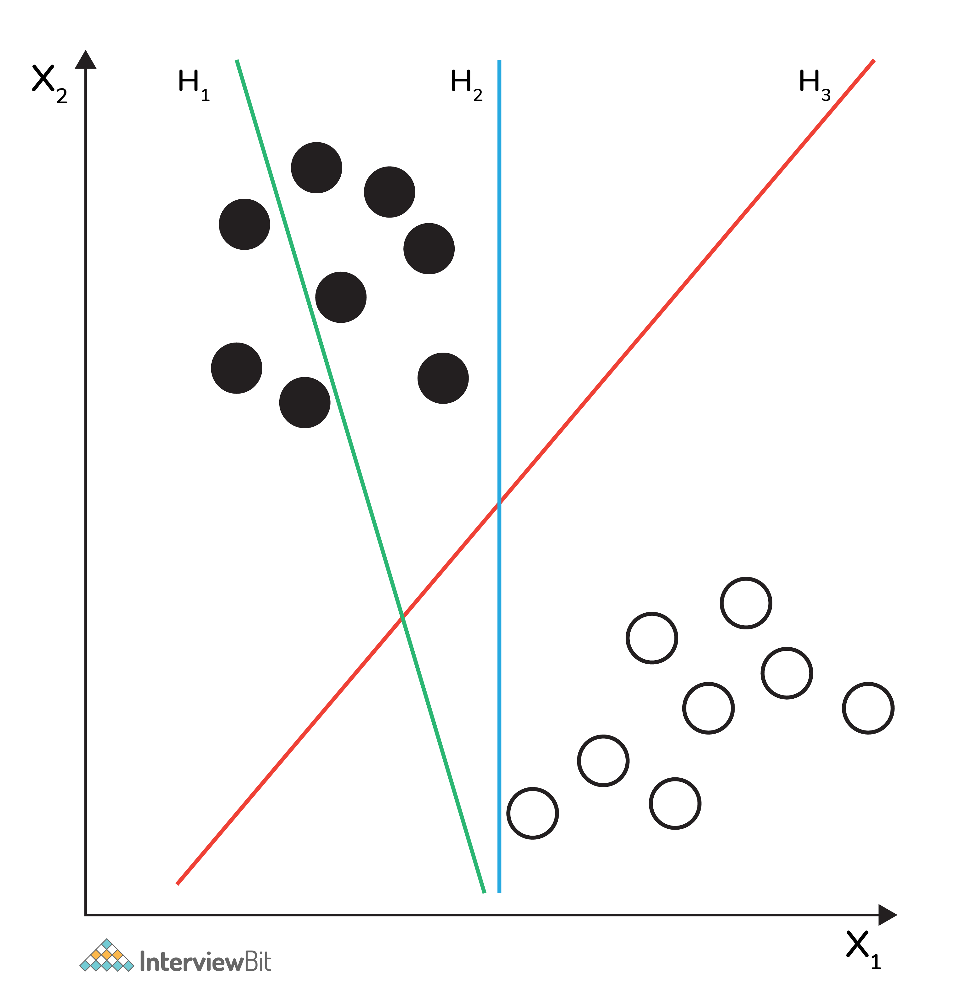Support Vector Machine (SVM)

8. What are Support Vectors in SVM?
A Support Vector Machine (SVM) is an algorithm that tries to fit a line (or plane or hyperplane) between the different classes that maximizes the distance from the line to the points of the classes.
In this way, it tries to find a robust separation between the classes. The Support Vectors are the points of the edge of the dividing hyperplane as in the below figure.
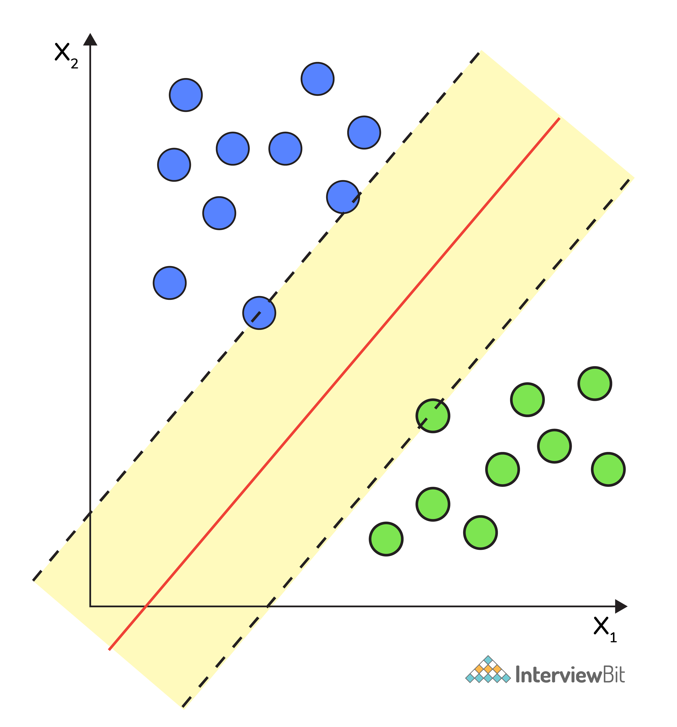Support Vector Machine (SVM)

9. What are Different Kernels in SVM?
There are six types of kernels in SVM:
- Linear kernel - used when data is linearly separable.
- Polynomial kernel - When you have discrete data that has no natural notion of smoothness.
- Radial basis kernel - Create a decision boundary able to do a much better job of separating two classes than the linear kernel.
- Sigmoid kernel - used as an activation function for neural networks.

10. What is Cross-Validation?
Cross-validation is a method of splitting all your data into three parts: training, testing, and validation data. Data is split into k subsets, and the model has trained on k-1of those datasets.
The last subset is held for testing. This is done for each of the subsets. This is k-fold cross-validation. Finally, the scores from all the k-folds are averaged to produce the final score.
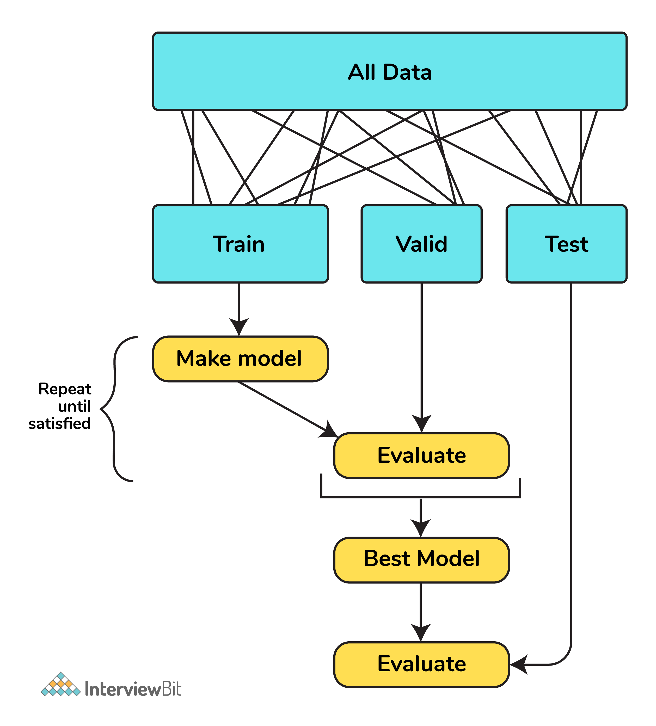Cross-validation

11. What is Bias in Machine Learning?
Bias in data tells us there is inconsistency in data. The inconsistency may occur for several reasons which are not mutually exclusive.
For example, a tech giant like Amazon to speed the hiring process they build one engine where they are going to give 100 resumes, it will spit out the top five, and hire those.
When the company realized the software was not producing gender-neutral results it was tweaked to remove this bias.

12. Explain the Difference Between Classification and Regression?
Classification is used to produce discrete results, classification is used to classify data into some specific categories.
For example, classifying emails into spam and non-spam categories.
Whereas, regression deals with continuous data.
For example, predicting stock prices at a certain point in time.
Classification is used to predict the output into a group of classes.
For example, Is it Hot or Cold tomorrow?
Whereas, regression is used to predict the relationship that data represents.
For example, What is the temperature tomorrow?

Advanced Machine Learning Questions

13. What is F1 score? How would you use it?
Let’s have a look at this table before directly jumping into the F1 score.
Prediction | Predicted Yes | Predicted No
Actual Yes | True Positive (TP) | False Negative (FN)
Actual No | False Positive (FP) | True Negative (TN)
In binary classification we consider the F1 score to be a measure of the model’s accuracy. The F1 score is a weighted average of precision and recall scores.
F1 = 2TP/2TP + FP + FN
We see scores for F1 between 0 and 1, where 0 is the worst score and 1 is the best score.
The F1 score is typically used in information retrieval to see how well a model retrieves relevant results and our model is performing.

14. Define Precision and Recall?
Precision and recall are ways of monitoring the power of machine learning implementation. But they often used at the same time.
Precision answers the question, “Out of the items that the classifier predicted to be relevant, how many are truly relevant?”
Whereas, recall answers the question, “Out of all the items that are truly relevant, how many are found by the classifier?
In general, the meaning of precision is the fact of being exact and accurate. So the same will go in our machine learning model as well. If you have a set of items that your model needs to predict to be relevant. How many items are truly relevant?
The below figure shows the Venn diagram that precision and recall.
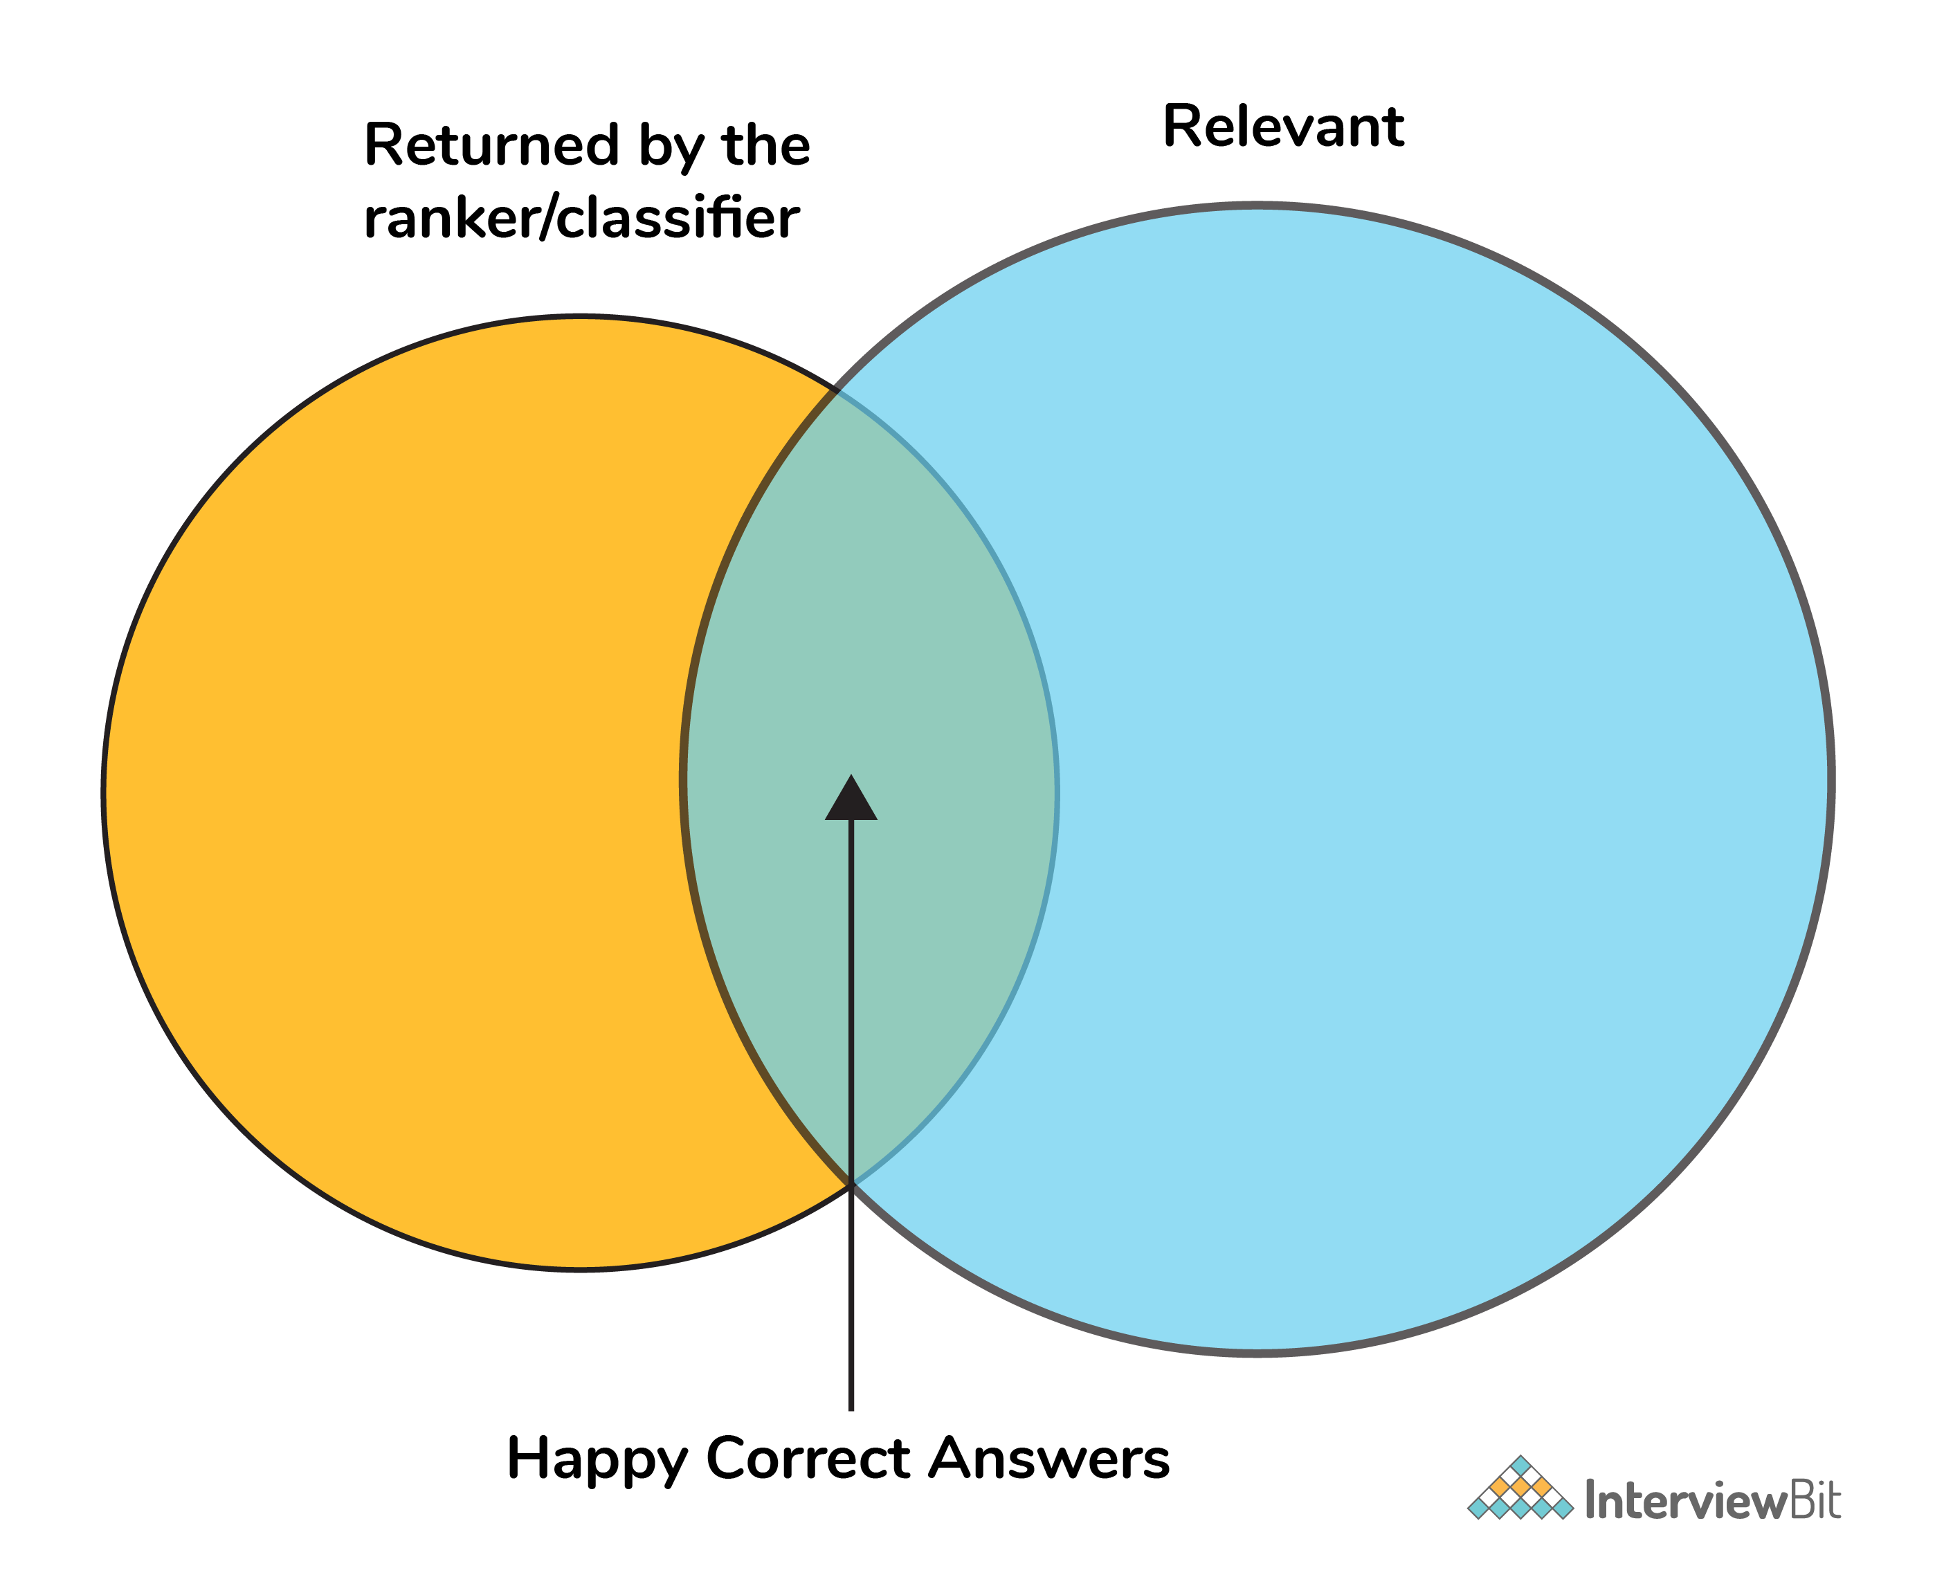Precision and recall
Mathematically, precision and recall can be defined as the following:
precision = # happy correct answers/# total items returned by ranker
recall = # happy correct answers/# total relevant answers

15. How to Tackle Overfitting and Underfitting?
Overfitting means the model fitted to training data too well, in this case, we need to resample the data and estimate the model accuracy using techniques like k-fold cross-validation.
Whereas for the Underfitting case we are not able to understand or capture the patterns from the data, in this case, we need to change the algorithms, or we need to feed more data points to the model.

16. What is a Neural Network?
It is a simplified model of the human brain. Much like the brain, it has neurons that activate when encountering something similar.
The different neurons are connected via connections that help information flow from one neuron to another.

17. What are Loss Function and Cost Functions? Explain the key Difference Between them?
When calculating loss we consider only a single data point, then we use the term loss function.
Whereas, when calculating the sum of error for multiple data then we use the cost function. There is no major difference.
In other words, the loss function is to capture the difference between the actual and predicted values for a single record whereas cost functions aggregate the difference for the entire training dataset.
The Most commonly used loss functions are Mean-squared error and Hinge loss.
Mean-Squared Error(MSE): In simple words, we can say how our model predicted values against the actual values.
MSE = √(predicted value - actual value)2
Hinge loss: It is used to train the machine learning classifier, which is
L(y) = max(0,1- yy)
Where y = -1 or 1 indicating two classes and y represents the output form of the classifier. The most common cost function represents the total cost as the sum of the fixed costs and the variable costs in the equation y = mx + b

18. What is Ensemble learning?
Ensemble learning is a method that combines multiple machine learning models to create more powerful models.
There are many reasons for a model to be different. Few reasons are:
- Different Population
- Different Hypothesis
- Different modeling techniques
When working with the model’s training and testing data, we will experience an error. This error might be bias, variance, and irreducible error.
Now the model should always have a balance between bias and variance, which we call a bias-variance trade-off.
This ensemble learning is a way to perform this trade-off.
There are many ensemble techniques available but when aggregating multiple models there are two general methods:
- Bagging, a native method: take the training set and generate new training sets off of it.
- Boosting, a more elegant method: similar to bagging, boosting is used to optimize the best weighting scheme for a training set.

19. How do you make sure which Machine Learning Algorithm to use?
It completely depends on the dataset we have. If the data is discrete we use SVM. If the dataset is continuous we use linear regression.
So there is no specific way that lets us know which ML algorithm to use, it all depends on the exploratory data analysis (EDA).
EDA is like “interviewing” the dataset; As part of our interview we do the following:
- Classify our variables as continuous, categorical, and so forth.
- Summarize our variables using descriptive statistics.
- Visualize our variables using charts.
Based on the above observations select one best-fit algorithm for a particular dataset.

20. How to Handle Outlier Values?
An Outlier is an observation in the dataset that is far away from other observations in the dataset. Tools used to discover outliers are
- Box plot
- Z-score
- Scatter plot, etc.
Typically, we need to follow three simple strategies to handle outliers:
- We can drop them.
- We can mark them as outliers and include them as a feature.
- Likewise, we can transform the feature to reduce the effect of the outlier.

21. What is a Random Forest? How does it work?
Random forest is a versatile machine learning method capable of performing both regression and classification tasks.
Like bagging and boosting, random forest works by combining a set of other tree models. Random forest builds a tree from a random sample of the columns in the test data.
Here’s are the steps how a random forest creates the trees:
- Take a sample size from the training data.
- Begin with a single node.
- Run the following algorithm, from the start node:
  - If the number of observations is less than node size then stop.
  - Select random variables.
  - Find the variable that does the “best” job of splitting the observations.
  - Split the observations into two nodes.
  - Call step `a` on each of these nodes.

22. What is Collaborative Filtering? And Content-Based Filtering?
Collaborative filtering is a proven technique for personalized content recommendations. Collaborative filtering is a type of recommendation system that predicts new content by matching the interests of the individual user with the preferences of many users.
Content-based recommender systems are focused only on the preferences of the user. New recommendations are made to the user from similar content according to the user’s previous choices.
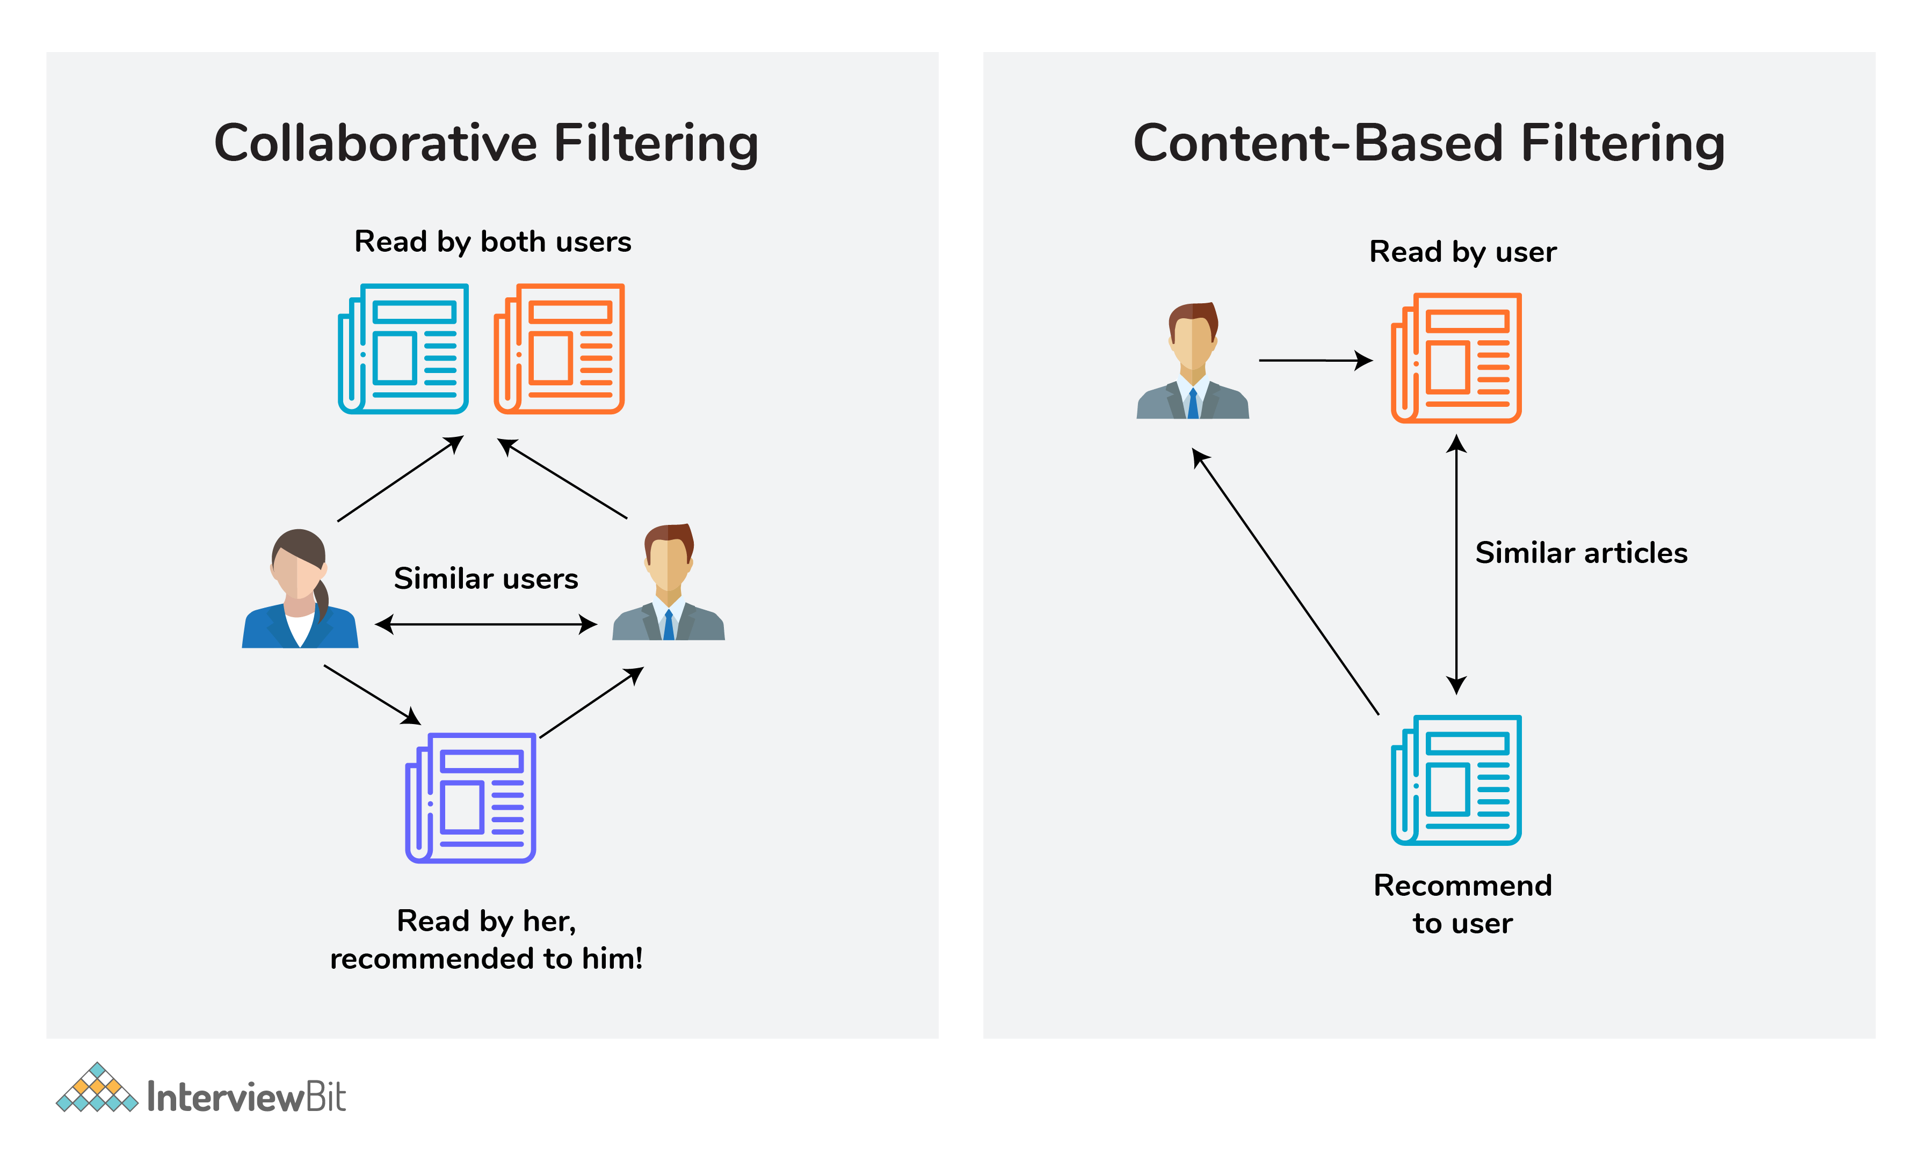Collaborative Filtering and Content-Based Filtering

23. What is Clustering?
Clustering is the process of grouping a set of objects into a number of groups. Objects should be similar to one another within the same cluster and dissimilar to those in other clusters.
A few types of clustering are:
- Hierarchical clustering
- K means clustering
- Density-based clustering
- Fuzzy clustering, etc.

24. How can you select K for K-means Clustering?
There are two kinds of methods that include direct methods and statistical testing methods:
- Direct methods: It contains elbow and silhouette
- Statistical testing methods: It has gap statistics.
The silhouette is the most frequently used while determining the optimal value of k.

25. What are Recommender Systems?
A recommendation engine is a system used to predict users’ interests and recommend products that are quite likely interesting for them.
Data required for recommender systems stems from explicit user ratings after watching a film or listening to a song, from implicit search engine queries and purchase histories, or from other knowledge about the users/items themselves.

26. How do check the Normality of a dataset?
Visually, we can use plots. A few of the normality checks are as follows:
- Shapiro-Wilk Test
- Anderson-Darling Test
- Martinez-Iglewicz Test
- Kolmogorov-Smirnov Test
- D’Agostino Skewness Test

27. Can logistic regression use for more than 2 classes?
No, by default logistic regression is a binary classifier, so it cannot be applied to more than 2 classes. However, it can be extended for solving multi-class classification problems (multinomial logistic regression)

28. Explain Correlation and Covariance?
Correlation is used for measuring and also for estimating the quantitative relationship between two variables. Correlation measures how strongly two variables are related. Examples like, income and expenditure, demand and supply, etc.
Covariance is a simple way to measure the correlation between two variables. The problem with covariance is that they are hard to compare without normalization.

29. What is P-value?
P-values are used to make a decision about a hypothesis test. P-value is the minimum significant level at which you can reject the null hypothesis. The lower the p-value, the more likely you reject the null hypothesis.

30. What are Parametric and Non-Parametric Models?
Parametric models will have limited parameters and to predict new data, you only need to know the parameter of the model.
Non-Parametric models have no limits in taking a number of parameters, allowing for more flexibility and to predict new data. You need to know the state of the data and model parameters.

31. What is Reinforcement Learning?
Reinforcement learning is different from the other types of learning like supervised and unsupervised. In reinforcement learning, we are given neither data nor labels. Our learning is based on the rewards given to the agent by the environment.

32. Difference Between Sigmoid and Softmax functions?
The sigmoid function is used for binary classification. The probabilities sum needs to be 1. Whereas, Softmax function is used for multi-classification. The probabilities sum will be 1.

1. What Are the Different Types of Machine Learning?
There are three types of machine learning:

Supervised Learning
In supervised machine learning, a model makes predictions or decisions based on past or labeled data. Labeled data refers to sets of data that are given tags or labels, and thus made more meaningful.
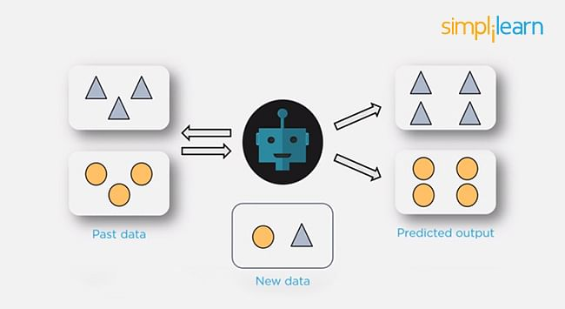

Unsupervised Learning
In unsupervised learning, we don't have labeled data. A model can identify patterns, anomalies, and relationships in the input data.
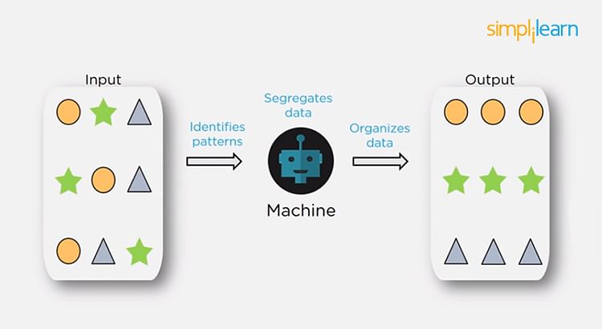

Reinforcement Learning
Using reinforcement learning, the model can learn based on the rewards it received for its previous action.
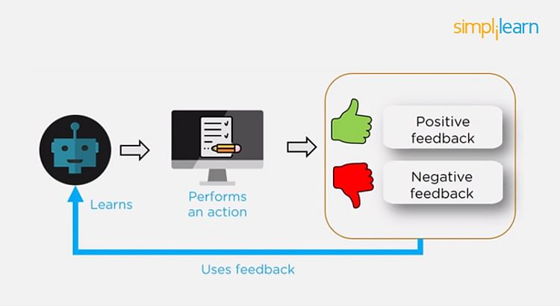
Consider an environment where an agent is working. The agent is given a target to achieve. Every time the agent takes some action toward the target, it is given positive feedback. And, if the action taken is going away from the goal, the agent is given negative feedback.

2. What is Overfitting, and How Can You Avoid It?
The Overfitting is a situation that occurs when a model learns the training set too well, taking up random fluctuations in the training data as concepts. These impact the model’s ability to generalize and don’t apply to new data.
When a model is given the training data, it shows 100 percent accuracy—technically a slight loss. But, when we use the test data, there may be an error and low efficiency. This condition is known as overfitting.
There are multiple ways of avoiding overfitting, such as:
- Regularization. It involves a cost term for the features involved with the objective function
- Making a simple model. With lesser variables and parameters, the variance can be reduced
- Cross-validation methods like k-folds can also be used
- If some model parameters are likely to cause overfitting, techniques for regularization like LASSO can be used that penalize these parameters

3. What is ‘training Set’ and ‘test Set’ in a Machine Learning Model? How Much Data Will You Allocate for Your Training, Validation, and Test Sets?
There is a three-step process followed to create a model:
- Train the model
- Test the model
- Deploy the model
Training Set | Test Set
- The training set is examples given to the model to analyze and learn  - 70% of the total data is typically taken as the training dataset  - This is labeled data used to train the model | - The test set is used to test the accuracy of the hypothesis generated by the model  - Remaining 30% is taken as testing dataset  - We test without labeled data and then verify results with labels
Consider a case where you have labeled data for 1,000 records. One way to train the model is to expose all 1,000 records during the training process. Then you take a small set of the same data to test the model, which would give good results in this case.
But, this is not an accurate way of testing. So, we set aside a portion of that data called the ‘test set’ before starting the training process. The remaining data is called the ‘training set’ that we use for training the model. The training set passes through the model multiple times until the accuracy is high, and errors are minimized.
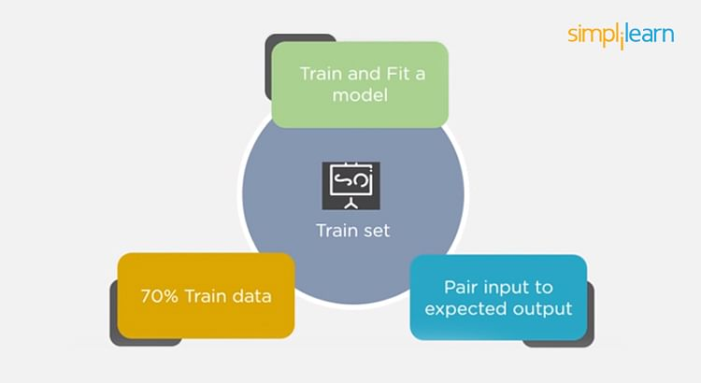
Now, we pass the test data to check if the model can accurately predict the values and determine if training is effective. If you get errors, you either need to change your model or retrain it with more data.
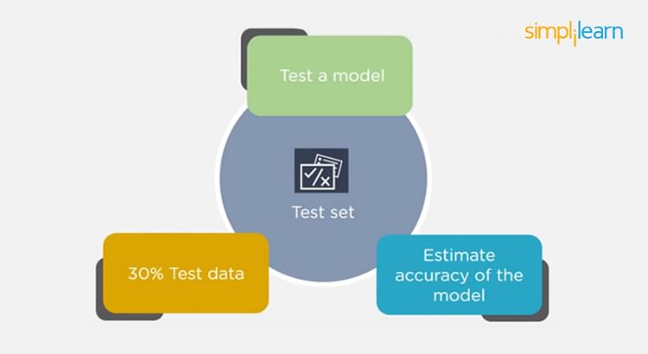
Regarding the question of how to split the data into a training set and test set, there is no fixed rule, and the ratio can vary based on individual preferences.

4. How Do You Handle Missing or Corrupted Data in a Dataset?
One of the easiest ways to handle missing or corrupted data is to drop those rows or columns or replace them entirely with some other value.
There are two useful methods in Pandas:
- IsNull() and dropna() will help to find the columns/rows with missing data and drop them
- Fillna() will replace the wrong values with a placeholder value
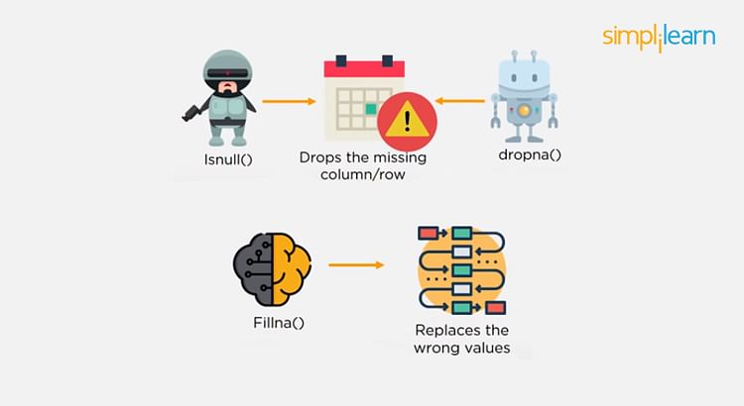

5. How Can You Choose a Classifier Based on a Training Set Data Size?
When the training set is small, a model that has a right bias and low variance seems to work better because they are less likely to overfit.
For example, Naive Bayes works best when the training set is large. Models with low bias and high variance tend to perform better as they work fine with complex relationships.

6. Explain the Confusion Matrix with Respect to Machine Learning Algorithms.
A confusion matrix (or error matrix) is a specific table that is used to measure the performance of an algorithm. It is mostly used in supervised learning; in unsupervised learning, it’s called the matching matrix.
The confusion matrix has two parameters:
- Actual
- Predicted
It also has identical sets of features in both of these dimensions.
Consider a confusion matrix (binary matrix) shown below:
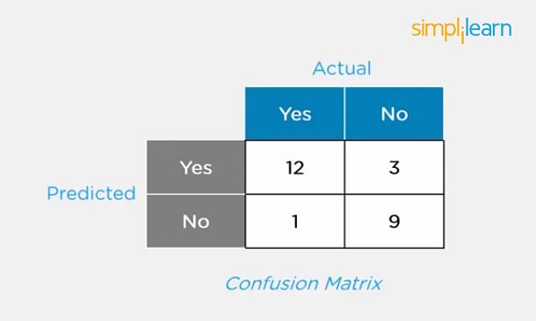
Here,
For actual values:
Total Yes = 12+1 = 13
Total No = 3+9 = 12
Similarly, for predicted values:
Total Yes = 12+3 = 15
Total No = 1+9 = 10
For a model to be accurate, the values across the diagonals should be high. The total sum of all the values in the matrix equals the total observations in the test data set.
For the above matrix, total observations = 12+3+1+9 = 25
Now, accuracy = sum of the values across the diagonal/total dataset
= (12+9) / 25
= 21 / 25
= 84%

7. What Is a False Positive and False Negative and How Are They Significant?
False positives are those cases that wrongly get classified as True but are False.
False negatives are those cases that wrongly get classified as False but are True.
In the term ‘False Positive,’ the word ‘Positive’ refers to the ‘Yes’ row of the predicted value in the confusion matrix. The complete term indicates that the system has predicted it as a positive, but the actual value is negative.
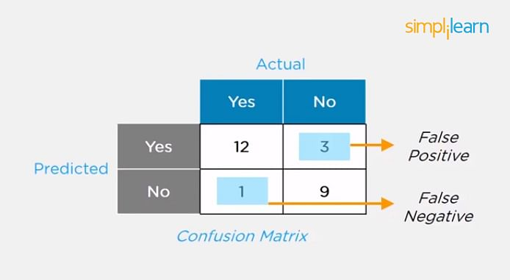
So, looking at the confusion matrix, we get:
False-positive = 3
True positive = 12
Similarly, in the term ‘False Negative,’ the word ‘Negative’ refers to the ‘No’ row of the predicted value in the confusion matrix. And the complete term indicates that the system has predicted it as negative, but the actual value is positive.
So, looking at the confusion matrix, we get:
False Negative = 1
True Negative = 9

8. What Are the Three Stages of Building a Model in Machine Learning?
The three stages of building a machine learning model are:

Model Building
- Choose a suitable algorithm for the model and train it according to the requirement

Model Testing
- Check the accuracy of the model through the test data

Applying the Model
- Make the required changes after testing and use the final model for real-time projects
Here, it’s important to remember that once in a while, the model needs to be checked to make sure it’s working correctly. It should be modified to make sure that it is up-to-date.

9. What is Deep Learning?
The Deep learning is a subset of machine learning that involves systems that think and learn like humans using artificial neural networks. The term ‘deep’ comes from the fact that you can have several layers of neural networks.
One of the primary differences between machine learning and deep learning is that feature engineering is done manually in machine learning. In the case of deep learning, the model consisting of neural networks will automatically determine which features to use (and which not to use).
This is a commonly asked question asked in both Machine Learning Interviews as well as Deep Learning Interview Questions

10. What Are the Differences Between Machine Learning and Deep Learning?
Learn more: Difference Between AI,ML and Deep Learning
Machine Learning | Deep Learning
- Enables machines to take decisions on their own, based on past data  - It needs only a small amount of data for training  - Works well on the low-end system, so you don't need large machines  - Most features need to be identified in advance and manually coded  - The problem is divided into two parts and solved individually and then combined | - Enables machines to take decisions with the help of artificial neural networks  - It needs a large amount of training data  - Needs high-end machines because it requires a lot of computing power  - The machine learns the features from the data it is provided  - The problem is solved in an end-to-end manner

11. What Are the Applications of Supervised Machine Learning in Modern Businesses?
Applications of supervised machine learning include:

Email Spam Detection
- Here we train the model using historical data that consists of emails categorized as spam or not spam. This labeled information is fed as input to the model.

Healthcare Diagnosis
- By providing images regarding a disease, a model can be trained to detect if a person is suffering from the disease or not.

Sentiment Analysis
- This refers to the process of using algorithms to mine documents and determine whether they’re positive, neutral, or negative in sentiment.

Fraud Detection
- By training the model to identify suspicious patterns, we can detect instances of possible fraud.
Related Interview Questions and Answers
AI | Data Science

12. What is Semi-supervised Machine Learning?
Supervised learning uses data that is completely labeled, whereas unsupervised learning uses no training data.
In the case of semi-supervised learning, the training data contains a small amount of labeled data and a large amount of unlabeled data.
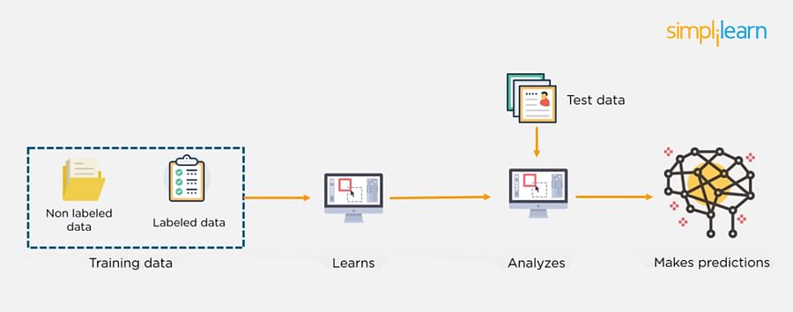

13. What Are Unsupervised Machine Learning Techniques?
There are two techniques used in unsupervised learning: clustering and association.

Clustering
Clustering problems involve data to be divided into subsets. These subsets, also called clusters, contain data that are similar to each other. Different clusters reveal different details about the objects, unlike classification or regression.
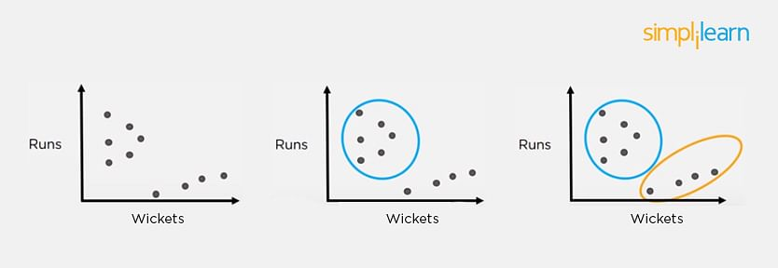

Association
In an association problem, we identify patterns of associations between different variables or items.
For example, an e-commerce website can suggest other items for you to buy, based on the prior purchases that you have made, spending habits, items in your wishlist, other customers’ purchase habits, and so on.
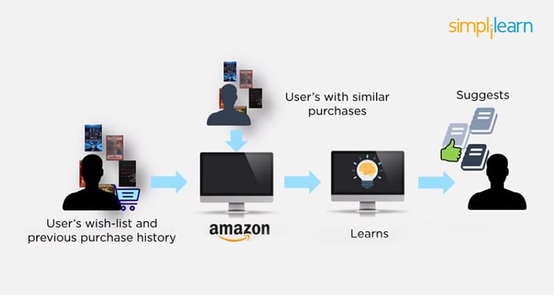

14. What is the Difference Between Supervised and Unsupervised Machine Learning?
- Supervised learning - This model learns from the labeled data and makes a future prediction as output
- Unsupervised learning - This model uses unlabeled input data and allows the algorithm to act on that information without guidance.

15. What is the Difference Between Inductive Machine Learning and Deductive Machine Learning?
Inductive Learning | Deductive Learning
- It observes instances based on defined principles to draw a conclusion  - Example: Explaining to a child to keep away from the fire by showing a video where fire causes damage | - It concludes experiences  - Example: Allow the child to play with fire. If he or she gets burned, they will learn that it is dangerous and will refrain from making the same mistake again

16. Compare K-means and KNN Algorithms.
K-means | KNN
- K-Means is unsupervised  - K-Means is a clustering algorithm  - The points in each cluster are similar to each other, and each cluster is different from its neighboring clusters | - KNN is supervised in nature  - KNN is a classification algorithm  - It classifies an unlabeled observation based on its K (can be any number) surrounding neighbors

17. What Is ‘naive’ in the Naive Bayes Classifier?
The classifier is called ‘naive’ because it makes assumptions that may or may not turn out to be correct.
The algorithm assumes that the presence of one feature of a class is not related to the presence of any other feature (absolute independence of features), given the class variable.
For instance, a fruit may be considered to be a cherry if it is red in color and round in shape, regardless of other features. This assumption may or may not be right (as an apple also matches the description).

18. Explain How a System Can Play a Game of Chess Using Reinforcement Learning.
Reinforcement learning has an environment and an agent. The agent performs some actions to achieve a specific goal. Every time the agent performs a task that is taking it towards the goal, it is rewarded. And, every time it takes a step that goes against that goal or in the reverse direction, it is penalized.
Earlier, chess programs had to determine the best moves after much research on numerous factors. Building a machine designed to play such games would require many rules to be specified.
With reinforced learning, we don’t have to deal with this problem as the learning agent learns by playing the game. It will make a move (decision), check if it’s the right move (feedback), and keep the outcomes in memory for the next step it takes (learning). There is a reward for every correct decision the system takes and punishment for the wrong one.

19. How Will You Know Which Machine Learning Algorithm to Choose for Your Classification Problem?
While there is no fixed rule to choose an algorithm for a classification problem, you can follow these guidelines:
- If accuracy is a concern, test different algorithms and cross-validate them
- If the training dataset is small, use models that have low variance and high bias
- If the training dataset is large, use models that have high variance and little bias

20. How is Amazon Able to Recommend Other Things to Buy? How Does the Recommendation Engine Work?
Once a user buys something from Amazon, Amazon stores that purchase data for future reference and finds products that are most likely also to be bought, it is possible because of the Association algorithm, which can identify patterns in a given dataset.
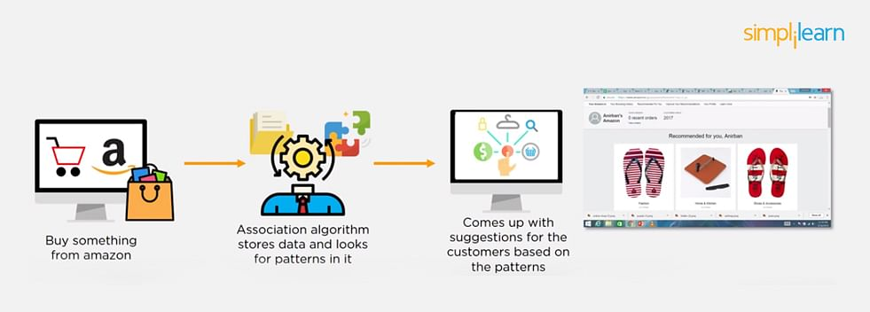

21. When Will You Use Classification over Regression?
Classification is used when your target is categorical, while regression is used when your target variable is continuous. Both classification and regression belong to the category of supervised machine learning algorithms.
Examples of classification problems include:
- Predicting yes or no
- Estimating gender
- Breed of an animal
- Type of color
Examples of regression problems include:
- Estimating sales and price of a product
- Predicting the score of a team
- Predicting the amount of rainfall

22. How Do You Design an Email Spam Filter?
Building a spam filter involves the following process:
- The email spam filter will be fed with thousands of emails
- Each of these emails already has a label: ‘spam’ or ‘not spam.’
- The supervised machine learning algorithm will then determine which type of emails are being marked as spam based on spam words like the lottery, free offer, no money, full refund, etc.
- The next time an email is about to hit your inbox, the spam filter will use statistical analysis and algorithms like Decision Trees and SVM to determine how likely the email is spam
- If the likelihood is high, it will label it as spam, and the email won’t hit your inbox
- Based on the accuracy of each model, we will use the algorithm with the highest accuracy after testing all the models
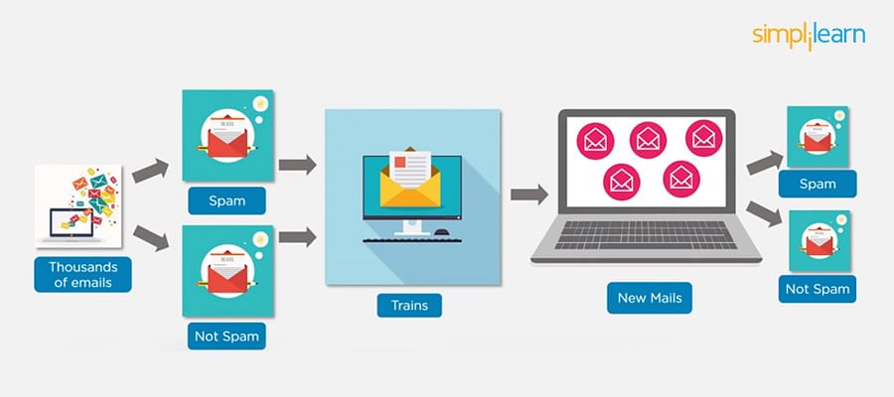

23. What is a Random Forest?
A ‘random forest’ is a supervised machine learning algorithm that is generally used for classification problems. It operates by constructing multiple decision trees during the training phase. The random forest chooses the decision of the majority of the trees as the final decision.
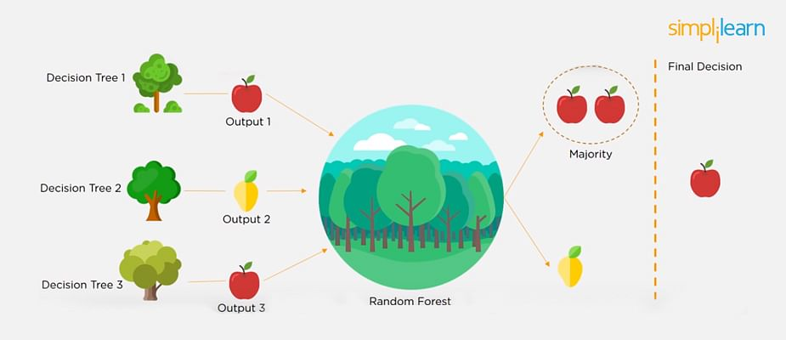

24. Considering a Long List of Machine Learning Algorithms, given a Data Set, How Do You Decide Which One to Use?
There is no master algorithm for all situations. Choosing an algorithm depends on the following questions:
- How much data do you have, and is it continuous or categorical?
- Is the problem related to classification, association, clustering, or regression?
- Predefined variables (labeled), unlabeled, or mix?
- What is the goal?
Based on the above questions, the following algorithms can be used:
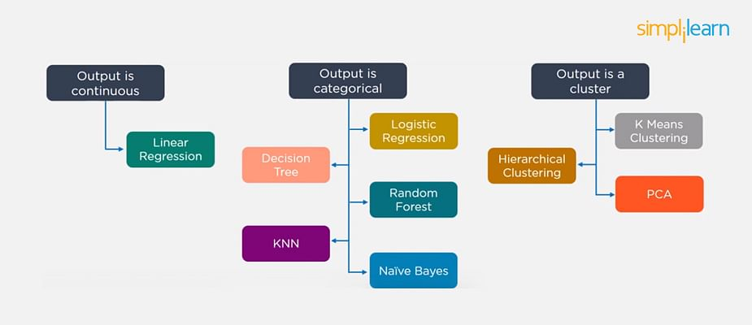
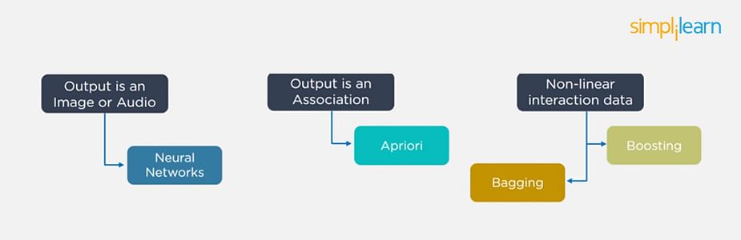

FREE Machine Learning Certification Course
To become a Machine Learning EngineerEXPLORE COURSE


25. What is Bias and Variance in a Machine Learning Model?

Bias
Bias in a machine learning model occurs when the predicted values are further from the actual values. Low bias indicates a model where the prediction values are very close to the actual ones.
Underfitting: High bias can cause an algorithm to miss the relevant relations between features and target outputs.

Variance
Variance refers to the amount the target model will change when trained with different training data. For a good model, the variance should be minimized.
Overfitting: High variance can cause an algorithm to model the random noise in the training data rather than the intended outputs.

26. What is the Trade-off Between Bias and Variance?
The bias-variance decomposition essentially decomposes the learning error from any algorithm by adding the bias, variance, and a bit of irreducible error due to noise in the underlying dataset.
Necessarily, if you make the model more complex and add more variables, you’ll lose bias but gain variance. To get the optimally-reduced amount of error, you’ll have to trade off bias and variance. Neither high bias nor high variance is desired.
High bias and low variance algorithms train models that are consistent, but inaccurate on average.
High variance and low bias algorithms train models that are accurate but inconsistent.

27. Define Precision and Recall.

Precision
Precision is the ratio of several events you can correctly recall to the total number of events you recall (mix of correct and wrong recalls).
Precision = (True Positive) / (True Positive + False Positive)

Recall
A recall is the ratio of the number of events you can recall the number of total events.
Recall = (True Positive) / (True Positive + False Negative)

28. What is a Decision Tree Classification?
A decision tree builds classification (or regression) models as a tree structure, with datasets broken up into ever-smaller subsets while developing the decision tree, literally in a tree-like way with branches and nodes. Decision trees can handle both categorical and numerical data.

29. What is Pruning in Decision Trees, and How Is It Done?
Pruning is a technique in machine learning that reduces the size of decision trees. It reduces the complexity of the final classifier, and hence improves predictive accuracy by the reduction of overfitting.
Pruning can occur in:
- Top-down fashion. It will traverse nodes and trim subtrees starting at the root
- Bottom-up fashion. It will begin at the leaf nodes
There is a popular pruning algorithm called reduced error pruning, in which:
- Starting at the leaves, each node is replaced with its most popular class
- If the prediction accuracy is not affected, the change is kept
- There is an advantage of simplicity and speed

30. Briefly Explain Logistic Regression.
Logistic regression is a classification algorithm used to predict a binary outcome for a given set of independent variables.
The output of logistic regression is either a 0 or 1 with a threshold value of generally 0.5. Any value above 0.5 is considered as 1, and any point below 0.5 is considered as 0.
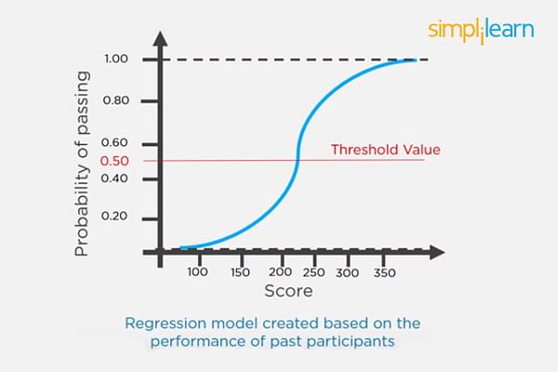

31. Explain the K Nearest Neighbor Algorithm.
K nearest neighbor algorithm is a classification algorithm that works in a way that a new data point is assigned to a neighboring group to which it is most similar.
In K nearest neighbors, K can be an integer greater than 1. So, for every new data point, we want to classify, we compute to which neighboring group it is closest.
Let us classify an object using the following example. Consider there are three clusters:
- Football
- Basketball
- Tennis ball
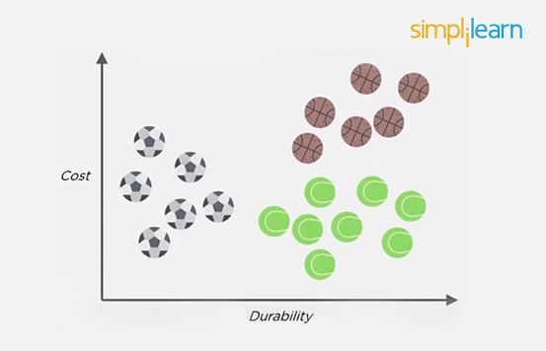
Let the new data point to be classified is a black ball. We use KNN to classify it. Assume K = 5 (initially).
Next, we find the K (five) nearest data points, as shown.
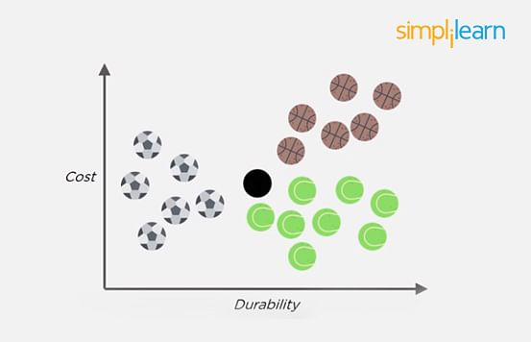
Observe that all five selected points do not belong to the same cluster. There are three tennis balls and one each of basketball and football.
When multiple classes are involved, we prefer the majority. Here the majority is with the tennis ball, so the new data point is assigned to this cluster.

32. What is a Recommendation System?
Anyone who has used Spotify or shopped at Amazon will recognize a recommendation system: It’s an information filtering system that predicts what a user might want to hear or see based on choice patterns provided by the user.

33. What is Kernel SVM?
Kernel SVM is the abbreviated version of the kernel support vector machine. Kernel methods are a class of algorithms for pattern analysis, and the most common one is the kernel SVM.

34. What Are Some Methods of Reducing Dimensionality?
You can reduce dimensionality by combining features with feature engineering, removing collinear features, or using algorithmic dimensionality reduction.
Now that you have gone through these machine learning interview questions, you must have got an idea of your strengths and weaknesses in this domain.

35. What is Principal Component Analysis?
Principal Component Analysis or PCA is a multivariate statistical technique that is used for analyzing quantitative data. The objective of PCA is to reduce higher dimensional data to lower dimensions, remove noise, and extract crucial information such as features and attributes from large amounts of data.

36. What do you understand by the F1 score?
The F1 score is a metric that combines both Precision and Recall. It is also the weighted average of precision and recall.
The F1 score can be calculated using the below formula:
F1 = 2 * (P * R) / (P + R)
The F1 score is one when both Precision and Recall scores are one.

37. What do you understand by Type I vs Type II error?
Type I Error: Type I error occurs when the null hypothesis is true and we reject it.
Type II Error: Type II error occurs when the null hypothesis is false and we accept it.
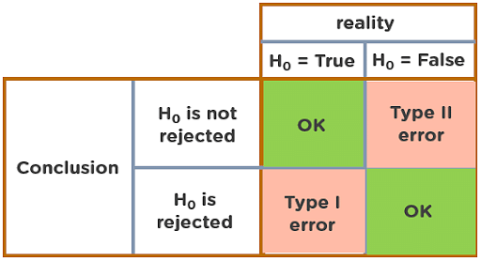

38. Explain Correlation and Covariance?
Correlation: Correlation tells us how strongly two random variables are related to each other. It takes values between -1 to +1.
Formula to calculate Correlation:
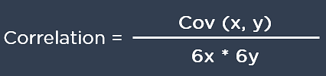
Covariance: Covariance tells us the direction of the linear relationship between two random variables. It can take any value between - ∞ and + ∞.
Formula to calculate Covariance:
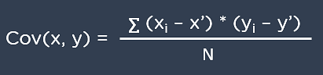

39. What are Support Vectors in SVM?
Support Vectors are data points that are nearest to the hyperplane. It influences the position and orientation of the hyperplane. Removing the support vectors will alter the position of the hyperplane. The support vectors help us build our support vector machine model.
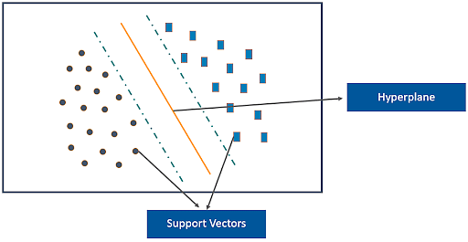

40. What is Ensemble learning?
Ensemble learning is a combination of the results obtained from multiple machine learning models to increase the accuracy for improved decision-making.
Example: A Random Forest with 100 trees can provide much better results than using just one decision tree.
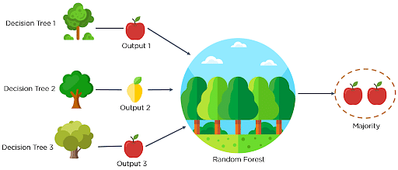

41. What is Cross-Validation?
Cross-Validation in Machine Learning is a statistical resampling technique that uses different parts of the dataset to train and test a machine learning algorithm on different iterations. The aim of cross-validation is to test the model’s ability to predict a new set of data that was not used to train the model. Cross-validation avoids the overfitting of data.
K-Fold Cross Validation is the most popular resampling technique that divides the whole dataset into K sets of equal sizes.

42. What are the different methods to split a tree in a decision tree algorithm?
Variance: Splitting the nodes of a decision tree using the variance is done when the target variable is continuous.
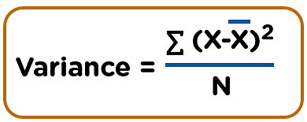
Information Gain: Splitting the nodes of a decision tree using Information Gain is preferred when the target variable is categorical.
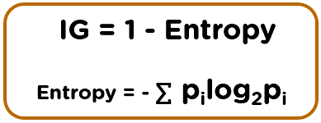
Gini Impurity: Splitting the nodes of a decision tree using Gini Impurity is followed when the target variable is categorical.
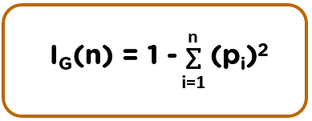

43. How does the Support Vector Machine algorithm handle self-learning?
The SVM algorithm has a learning rate and expansion rate which takes care of self-learning. The learning rate compensates or penalizes the hyperplanes for making all the incorrect moves while the expansion rate handles finding the maximum separation area between different classes.

44. What are the assumptions you need to take before starting with linear regression?
There are primarily 5 assumptions for a Linear Regression model:
- Multivariate normality
- No auto-correlation
- Homoscedasticity
- Linear relationship
- No or little multicollinearity

45. What is the difference between Lasso and Ridge regression?
Lasso(also known as L1) and Ridge(also known as L2) regression are two popular regularization techniques that are used to avoid overfitting of data. These methods are used to penalize the coefficients to find the optimum solution and reduce complexity. The Lasso regression works by penalizing the sum of the absolute values of the coefficients. In Ridge or L2 regression, the penalty function is determined by the sum of the squares of the coefficients.

) What do you understand by Machine learning?
Machine learning is the form of Artificial Intelligence that deals with system programming and automates data analysis to enable computers to learn and act through experiences without being explicitly programmed.
For example, Robots are coded in such a way that they can perform the tasks based on data they collect from sensors. They automatically learn programs from data and improve with experiences.

2) Differentiate between inductive learning and deductive learning?
In inductive learning, the model learns by examples from a set of observed instances to draw a generalized conclusion. On the other side, in deductive learning, the model first applies the conclusion, and then the conclusion is drawn.
- Inductive learning is the method of using observations to draw conclusions.
- Deductive learning is the method of using conclusions to form observations.
For example, if we have to explain to a kid that playing with fire can cause burns. There are two ways we can explain this to a kid; we can show training examples of various fire accidents or images of burnt people and label them as "Hazardous". In this case, a kid will understand with the help of examples and not play with the fire. It is the form of Inductive machine learning. The other way to teach the same thing is to let the kid play with the fire and wait to see what happens. If the kid gets a burn, it will teach the kid not to play with fire and avoid going near it. It is the form of deductive learning.

3) What is the difference between Data Mining and Machine Learning?
Data mining can be described as the process in which the structured data tries to abstract knowledge or interesting unknown patterns. During this process, machine learning algorithms are used.
Machine learning represents the study, design, and development of the algorithms which provide the ability to the processors to learn without being explicitly programmed.

4) What is the meaning of Overfitting in Machine learning?
Overfitting can be seen in machine learning when a statistical model describes random error or noise instead of the underlying relationship. Overfitting is usually observed when a model is excessively complex. It happens because of having too many parameters concerning the number of training data types. The model displays poor performance, which has been overfitted.

5) Why overfitting occurs?
The possibility of overfitting occurs when the criteria used for training the model is not as per the criteria used to judge the efficiency of a model.

6) What is the method to avoid overfitting?
Overfitting occurs when we have a small dataset, and a model is trying to learn from it. By using a large amount of data, overfitting can be avoided. But if we have a small database and are forced to build a model based on that, then we can use a technique known as cross-validation. In this method, a model is usually given a dataset of a known data on which training data set is run and dataset of unknown data against which the model is tested. The primary aim of cross-validation is to define a dataset to "test" the model in the training phase. If there is sufficient data, 'Isotonic Regression' is used to prevent overfitting.

7) Differentiate supervised and unsupervised machine learning.
- In supervised machine learning, the machine is trained using labeled data. Then a new dataset is given into the learning model so that the algorithm provides a positive outcome by analyzing the labeled data. For example, we first require to label the data which is necessary to train the model while performing classification.
- In the unsupervised machine learning, the machine is not trained using labeled data and let the algorithms make the decisions without any corresponding output variables.

8) How does Machine Learning differ from Deep Learning?
- Machine learning is all about algorithms which are used to parse data, learn from that data, and then apply whatever they have learned to make informed decisions.
- Deep learning is a part of machine learning, which is inspired by the structure of the human brain and is particularly useful in feature detection.

9) How is KNN different from k-means?
KNN or K nearest neighbors is a supervised algorithm which is used for classification purpose. In KNN, a test sample is given as the class of the majority of its nearest neighbors. On the other side, K-means is an unsupervised algorithm which is mainly used for clustering. In k-means clustering, it needs a set of unlabeled points and a threshold only. The algorithm further takes unlabeled data and learns how to cluster it into groups by computing the mean of the distance between different unlabeled points.

10) What are the different types of Algorithm methods in Machine Learning?
The different types of algorithm methods in machine earning are:
- Supervised Learning
- Semi-supervised Learning
- Unsupervised Learning
- Transduction
- Reinforcement Learning

11) What do you understand by Reinforcement Learning technique?
Reinforcement learning is an algorithm technique used in Machine Learning. It involves an agent that interacts with its environment by producing actions & discovering errors or rewards. Reinforcement learning is employed by different software and machines to search for the best suitable behavior or path it should follow in a specific situation. It usually learns on the basis of reward or penalty given for every action it performs.

12) What is the trade-off between bias and variance?
Both bias and variance are errors. Bias is an error due to erroneous or overly simplistic assumptions in the learning algorithm. It can lead to the model under-fitting the data, making it hard to have high predictive accuracy and generalize the knowledge from the training set to the test set.
Variance is an error due to too much complexity in the learning algorithm. It leads to the algorithm being highly sensitive to high degrees of variation in the training data, which can lead the model to overfit the data.
To optimally reduce the number of errors, we will need to tradeoff bias and variance.

13) How do classification and regression differ?
Classification | Regression
- Classification is the task to predict a discrete class label. | - Regression is the task to predict a continuous quantity.
- In a classification problem, data is labeled into one of two or more classes. | - A regression problem needs the prediction of a quantity.
- A classification having problem with two classes is called binary classification, and more than two classes is called multi-class classification | - A regression problem containing multiple input variables is called a multivariate regression problem.
- Classifying an email as spam or non-spam is an example of a classification problem. | - Predicting the price of a stock over a period of time is a regression problem.

14) What are the five popular algorithms we use in Machine Learning?
Five popular algorithms are:

- Decision Trees
- Probabilistic Networks
- Neural Networks
- Support Vector Machines
- Nearest Neighbor

15) What do you mean by ensemble learning?
Numerous models, such as classifiers are strategically made and combined to solve a specific computational program which is known as ensemble learning. The ensemble methods are also known as committee-based learning or learning multiple classifier systems. It trains various hypotheses to fix the same issue. One of the most suitable examples of ensemble modeling is the random forest trees where several decision trees are used to predict outcomes. It is used to improve the classification, function approximation, prediction, etc. of a model.

16) What is a model selection in Machine Learning?
The process of choosing models among diverse mathematical models, which are used to define the same data is known as Model Selection. Model learning is applied to the fields of statistics, data mining, and machine learning.

17) What are the three stages of building the hypotheses or model in machine learning?
There are three stages to build hypotheses or model in machine learning:
- Model building
It chooses a suitable algorithm for the model and trains it according to the requirement of the problem.
- Applying the model
It is responsible for checking the accuracy of the model through the test data.
- Model testing
It performs the required changes after testing and apply the final model.

18) What according to you, is the standard approach to supervised learning?
In supervised learning, the standard approach is to split the set of example into the training set and the test.

19) Describe 'Training set' and 'training Test'.
In various areas of information of machine learning, a set of data is used to discover the potentially predictive relationship, which is known as 'Training Set'. The training set is an example that is given to the learner. Besides, the 'Test set' is used to test the accuracy of the hypotheses generated by the learner. It is the set of instances held back from the learner. Thus, the training set is distinct from the test set.

20) What are the common ways to handle missing data in a dataset?
Missing data is one of the standard factors while working with data and handling. It is considered as one of the greatest challenges faced by the data analysts. There are many ways one can impute the missing values. Some of the common methods to handle missing data in datasets can be defined as deleting the rows, replacing with mean/median/mode, predicting the missing values, assigning a unique category, using algorithms that support missing values, etc.

21) What do you understand by ILP?
ILP stands for Inductive Logic Programming. It is a part of machine learning which uses logic programming. It aims at searching patterns in data which can be used to build predictive models. In this process, the logic programs are assumed as a hypothesis.

22) What are the necessary steps involved in Machine Learning Project?
There are several essential steps we must follow to achieve a good working model while doing a Machine Learning Project. Those steps may include parameter tuning, data preparation, data collection, training the model, model evaluation, and prediction, etc.

23) Describe Precision and Recall?
Precision and Recall both are the measures which are used in the information retrieval domain to measure how good an information retrieval system reclaims the related data as requested by the user.
Precision can be said as a positive predictive value. It is the fraction of relevant instances among the received instances.
On the other side, recall is the fraction of relevant instances that have been retrieved over the total amount or relevant instances. The recall is also known as sensitivity.

24) What do you understand by Decision Tree in Machine Learning?
Decision Trees can be defined as the Supervised Machine Learning, where the data is continuously split according to a certain parameter. It builds classification or regression models as similar as a tree structure, with datasets broken up into ever smaller subsets while developing the decision tree. The tree can be defined by two entities, namely decision nodes, and leaves. The leaves are the decisions or the outcomes, and the decision nodes are where the data is split. Decision trees can manage both categorical and numerical data.

25) What are the functions of Supervised Learning?
- Classification
- Speech Recognition
- Regression
- Predict Time Series
- Annotate Strings

26) What are the functions of Unsupervised Learning?
- Finding clusters of the data
- Finding low-dimensional representations of the data
- Finding interesting directions in data
- Finding novel observations/ database cleaning
- Finding interesting coordinates and correlations

27) What do you understand by algorithm independent machine learning?
Algorithm independent machine learning can be defined as machine learning, where mathematical foundations are independent of any particular classifier or learning algorithm.

28) Describe the classifier in machine learning.
A classifier is a case of a hypothesis or discrete-valued function which is used to assign class labels to particular data points. It is a system that inputs a vector of discrete or continuous feature values and outputs a single discrete value, the class.

29) What do you mean by Genetic Programming?
Genetic Programming (GP) is almost similar to an Evolutionary Algorithm, a subset of machine learning. Genetic programming software systems implement an algorithm that uses random mutation, a fitness function, crossover, and multiple generations of evolution to resolve a user-defined task. The genetic programming model is based on testing and choosing the best option among a set of results.

30) What is SVM in machine learning? What are the classification methods that SVM can handle?
SVM stands for Support Vector Machine. SVM are supervised learning models with an associated learning algorithm which analyze the data used for classification and regression analysis.
The classification methods that SVM can handle are:
- Combining binary classifiers
- Modifying binary to incorporate multiclass learning

31) How will you explain a linked list and an array?
An array is a datatype which is widely implemented as a default type, in almost all the modern programming languages. It is used to store data of a similar type.
But there are many use-cases where we don't know the quantity of data to be stored. For such cases, advanced data structures are required, and one such data structure is linked list.
There are some points which explain how the linked list is different from an array:
ARRAY | LINKED LIST
- An array is a group of elements of a similar data type. | - Linked List is an ordered group of elements of the same type, which are connected using pointers.
- Elements are stored consecutively in the memory. | - New elements can be stored anywhere in memory.
- An Array supports Random Access. It means that the elements can be accessed directly using their index value, like arr[0] for 1st element, arr[5] for 6th element, etc.  As a result, accessing elements in an array is fast with constant time complexity of O(1). | - Linked List supports Sequential Access. It means that we have to traverse the complete linked list, up to that element sequentially which element/node we want to access in a linked list.  To access the nth element of a linked list, the time complexity is O(n).
- Memory is allocated at compile time as soon as the array is declared. It is known as Static Memory Allocation. | - Memory is allocated at runtime, whenever a new node is added. It is known as Dynamic Memory Allocation.
- Insertion and Deletion operation takes more time in the array, as the memory locations are consecutive and fixed. | - In case of a linked list, a new element is stored at the first free available memory location.  Thus, Insertion and Deletion operations are fast in the linked list.
- Size of the array must be declared at the time of array declaration. | - Size of a Linked list is variable. It grows at runtime whenever nodes are added to it.

32) What do you understand by the Confusion Matrix?
A confusion matrix is a table which is used for summarizing the performance of a classification algorithm. It is also known as the error matrix.
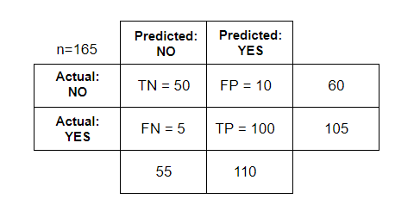
Where,
TN= True Negative
TP= True Positive
FN= False Negative
FP= False Positive

33) Explain True Positive, True Negative, False Positive, and False Negative in Confusion Matrix with an example.
- True Positive
When a model correctly predicts the positive class, it is said to be a true positive.
For example, Umpire gives a Batsman NOT OUT when he is NOT OUT.
- True Negative
When a model correctly predicts the negative class, it is said to be a true negative.
For example, Umpire gives a Batsman OUT when he is OUT.
- False Positive
When a model incorrectly predicts the positive class, it is said to be a false positive. It is also known as 'Type I' error.
For example, Umpire gives a Batsman NOT OUT when he is OUT.
- False Negative
When a model incorrectly predicts the negative class, it is said to be a false negative. It is also known as 'Type II' error.
For example, Umpire gives a Batsman OUT when he is NOT OUT.

34) What according to you, is more important between model accuracy and model performance?
Model accuracy is a subset of model performance. The accuracy of the model is directly proportional to the performance of the model. Thus, better the performance of the model, more accurate are the predictions.

35) What is Bagging and Boosting?
- Bagging is a process in ensemble learning which is used for improving unstable estimation or classification schemes.
- Boosting methods are used sequentially to reduce the bias of the combined model.

36) What are the similarities and differences between bagging and boosting in Machine Learning?
Similarities of Bagging and Boosting
- Both are the ensemble methods to get N learns from 1 learner.
- Both generate several training data sets with random sampling.
- Both generate the final result by taking the average of N learners.
- Both reduce variance and provide higher scalability.
Differences between Bagging and Boosting
- Although they are built independently, but for Bagging, Boosting tries to add new models which perform well where previous models fail.
- Only Boosting determines the weight for the data to tip the scales in favor of the most challenging cases.
- Only Boosting tries to reduce bias. Instead, Bagging may solve the problem of over-fitting while boosting can increase it.

37) What do you understand by Cluster Sampling?
Cluster Sampling is a process of randomly selecting intact groups within a defined population, sharing similar characteristics. Cluster sample is a probability where each sampling unit is a collection or cluster of elements.
For example, if we are clustering the total number of managers in a set of companies, in that case, managers (sample) will represent elements and companies will represent clusters.

38) What do you know about Bayesian Networks?
Bayesian Networks also referred to as 'belief networks' or 'casual networks', are used to represent the graphical model for probability relationship among a set of variables.
For example, a Bayesian network can be used to represent the probabilistic relationships between diseases and symptoms. As per the symptoms, the network can also compute the probabilities of the presence of various diseases.
Efficient algorithms can perform inference or learning in Bayesian networks. Bayesian networks which relate the variables (e.g., speech signals or protein sequences) are called dynamic Bayesian networks.

39) Which are the two components of Bayesian logic program?
A Bayesian logic program consists of two components:
- Logical
It contains a set of Bayesian Clauses, which capture the qualitative structure of the domain.
- Quantitative
It is used to encode quantitative information about the domain.

40) Describe dimension reduction in machine learning.
Dimension reduction is the process which is used to reduce the number of random variables under considerations.
Dimension reduction can be divided into feature selection and extraction.

41) Why instance-based learning algorithm sometimes referred to as Lazy learning algorithm?
In machine learning, lazy learning can be described as a method where induction and generalization processes are delayed until classification is performed. Because of the same property, an instance-based learning algorithm is sometimes called lazy learning algorithm.

42) What do you understand by the F1 score?
The F1 score represents the measurement of a model's performance. It is referred to as a weighted average of the precision and recall of a model. The results tending to 1 are considered as the best, and those tending to 0 are the worst. It could be used in classification tests, where true negatives don't matter much.

43) How is a decision tree pruned?
Pruning is said to occur in decision trees when the branches which may consist of weak predictive power are removed to reduce the complexity of the model and increase the predictive accuracy of a decision tree model. Pruning can occur bottom-up and top-down, with approaches such as reduced error pruning and cost complexity pruning.
Reduced error pruning is the simplest version, and it replaces each node. If it is unable to decrease predictive accuracy, one should keep it pruned. But, it usually comes pretty close to an approach that would optimize for maximum accuracy.

44) What are the Recommended Systems?
Recommended System is a sub-directory of information filtering systems. It predicts the preferences or rankings offered by a user to a product. According to the preferences, it provides similar recommendations to a user. Recommendation systems are widely used in movies, news, research articles, products, social tips, music, etc.

45) What do you understand by Underfitting?
Underfitting is an issue when we have a low error in both the training set and the testing set. Few algorithms work better for interpretations but fail for better predictions.

46) When does regularization become necessary in Machine Learning?
Regularization is necessary whenever the model begins to overfit/ underfit. It is a cost term for bringing in more features with the objective function. Hence, it tries to push the coefficients for many variables to zero and reduce cost term. It helps to reduce model complexity so that the model can become better at predicting (generalizing).

47) What is Regularization? What kind of problems does regularization solve?
A regularization is a form of regression, which constrains/ regularizes or shrinks the coefficient estimates towards zero. In other words, it discourages learning a more complex or flexible model to avoid the risk of overfitting. It reduces the variance of the model, without a substantial increase in its bias.
Regularization is used to address overfitting problems as it penalizes the loss function by adding a multiple of an L1 (LASSO) or an L2 (Ridge) norm of weights vector w.

48) Why do we need to convert categorical variables into factor? Which functions are used to perform the conversion?
Most Machine learning algorithms require number as input. That is why we convert categorical values into factors to get numerical values. We also don't have to deal with dummy variables.
The functions factor() and as.factor() are used to convert variables into factors.

49) Do you think that treating a categorical variable as a continuous variable would result in a better predictive model?
For a better predictive model, the categorical variable can be considered as a continuous variable only when the variable is ordinal in nature.

50) How is machine learning used in day-to-day life?
Most of the people are already using machine learning in their everyday life. Assume that you are engaging with the internet, you are actually expressing your preferences, likes, dislikes through your searches. All these things are picked up by cookies coming on your computer, from this, the behavior of a user is evaluated. It helps to increase the progress of a user through the internet and provide similar suggestions.
The navigation system can also be considered as one of the examples where we are using machine learning to calculate a distance between two places using optimization techniques. Surely, people are going to more engage with machine learning in the near future.

1. Explain the terms Artificial Intelligence (AI), Machine Learning (ML) and Deep Learning?
Artificial Intelligence (AI) is the domain of producing intelligent machines. ML refers to systems that can assimilate from experience (training data) and Deep Learning (DL) states to systems that learn from experience on large data sets. ML can be considered as a subset of AI. Deep Learning (DL) is ML but useful to large data sets. The figure below roughly encapsulates the relation between AI, ML, and DL:
In summary, DL is a subset of ML & both were the subsets of AI.
Additional Information: ASR (Automatic Speech Recognition) & NLP (Natural Language Processing) fall under AI and overlay with ML & DL as ML is often utilized for NLP and ASR tasks.

2. What are the different types of Learning/ Training models in ML?
ML algorithms can be primarily classified depending on the presence/absence of target variables.
A. Supervised learning: [Target is present]
The machine learns using labelled data. The model is trained on an existing data set before it starts making decisions with the new data.
The target variable is continuous: Linear Regression, polynomial Regression, and quadratic Regression.
The target variable is categorical: Logistic regression, Naive Bayes, KNN, SVM, Decision Tree, Gradient Boosting, ADA boosting, Bagging, Random forest etc.
B. Unsupervised learning: [Target is absent]
The machine is trained on unlabelled data and without any proper guidance. It automatically infers patterns and relationships in the data by creating clusters. The model learns through observations and deduced structures in the data.
Principal component Analysis, Factor analysis, Singular Value Decomposition etc.
C. Reinforcement Learning:
The model learns through a trial and error method. This kind of learning involves an agent that will interact with the environment to create actions and then discover errors or rewards of that action.

3. What is the difference between deep learning and machine learning?
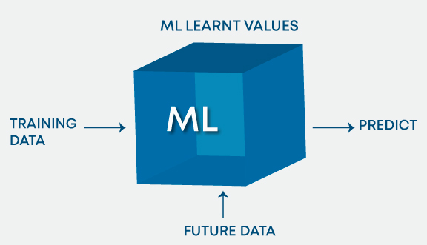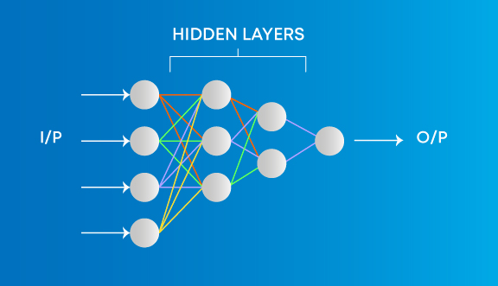
Machine Learning involves algorithms that learn from patterns of data and then apply it to decision making. Deep Learning, on the other hand, is able to learn through processing data on its own and is quite similar to the human brain where it identifies something, analyse it, and makes a decision.
The key differences are as follows:
- The manner in which data is presented to the system.
- Machine learning algorithms always require structured data and deep learning networks rely on layers of artificial neural networks.

4. What is the main key difference between supervised and unsupervised machine learning?
Supervised learning | Unsupervised learning
The supervised learning technique needs labelled data to train the model. For example, to solve a classification problem (a supervised learning task), you need to have label data to train the model and to classify the data into your labelled groups. | Unsupervised learning does not need any labelled dataset. This is the main key difference between supervised learning and unsupervised learning.
Learn Machine Learning

5. How do you select important variables while working on a data set?
There are various means to select important variables from a data set that include the following:
- Identify and discard correlated variables before finalizing on important variables
- The variables could be selected based on ‘p’ values from Linear Regression
- Forward, Backward, and Stepwise selection
- Lasso Regression
- Random Forest and plot variable chart
- Top features can be selected based on information gain for the available set of features.

6. There are many machine learning algorithms till now. If given a data set, how can one determine which algorithm to be used for that?
Machine Learning algorithm to be used purely depends on the type of data in a given dataset. If data is linear then, we use linear regression. If data shows non-linearity then, the bagging algorithm would do better. If the data is to be analyzed/interpreted for some business purposes then we can use decision trees or SVM. If the dataset consists of images, videos, audios then, neural networks would be helpful to get the solution accurately.
So, there is no certain metric to decide which algorithm to be used for a given situation or a data set. We need to explore the data using EDA (Exploratory Data Analysis) and understand the purpose of using the dataset to come up with the best fit algorithm. So, it is important to study all the algorithms in detail.

7. How are covariance and correlation different from one another?
Covariance | Correlation
Covariance measures how two variables are related to each other and how one would vary with respect to changes in the other variable. If the value is positive it means there is a direct relationship between the variables and one would increase or decrease with an increase or decrease in the base variable respectively, given that all other conditions remain constant. | Correlation quantifies the relationship between two random variables and has only three specific values, i.e., 1, 0, and -1.
1 denotes a positive relationship, -1 denotes a negative relationship, and 0 denotes that the two variables are independent of each other.

8. State the differences between causality and correlation?
Causality applies to situations where one action, say X, causes an outcome, say Y, whereas Correlation is just relating one action (X) to another action(Y) but X does not necessarily cause Y.

9. We look at machine learning software almost all the time. How do we apply Machine Learning to Hardware?
We have to build ML algorithms in System Verilog which is a Hardware development Language and then program it onto an FPGA to apply Machine Learning to hardware.

10. Explain One-hot encoding and Label Encoding. How do they affect the dimensionality of the given dataset?
One-hot encoding is the representation of categorical variables as binary vectors. Label Encoding is converting labels/words into numeric form. Using one-hot encoding increases the dimensionality of the data set. Label encoding doesn’t affect the dimensionality of the data set. One-hot encoding creates a new variable for each level in the variable whereas, in Label encoding, the levels of a variable get encoded as 1 and 0.
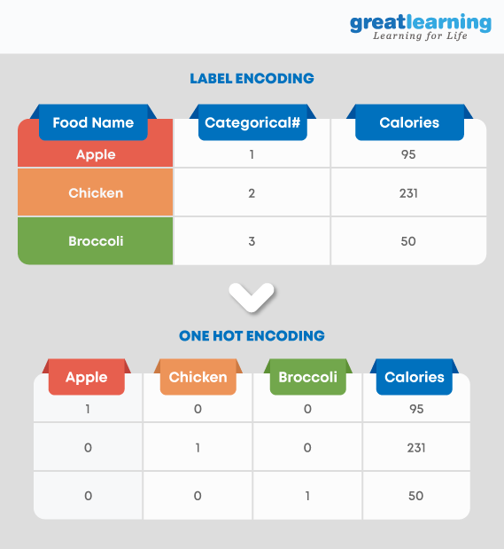

Deep Learning Interview Questions
Deep Learning is a part of machine learning that works with neural networks. It involves a hierarchical structure of networks that set up a process to help machines learn the human logic behind any action. We have compiled a list of the frequently asked deep learning interview questions to help you prepare.

11. When does regularization come into play in Machine Learning?
At times when the model begins to underfit or overfit, regularization becomes necessary. It is a regression that diverts or regularizes the coefficient estimates towards zero. It reduces flexibility and discourages learning in a model to avoid the risk of overfitting. The model complexity is reduced and it becomes better at predicting.
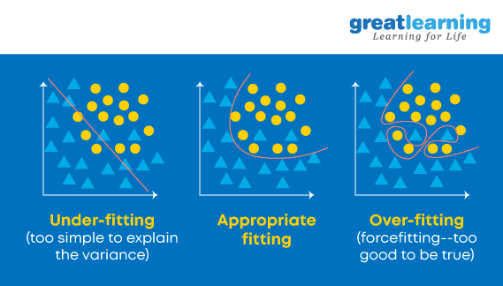

12. What is Bias, Variance and what do you mean by Bias-Variance Tradeoff?
Both are errors in Machine Learning Algorithms. When the algorithm has limited flexibility to deduce the correct observation from the dataset, it results in bias. On the other hand, variance occurs when the model is extremely sensitive to small fluctuations.
If one adds more features while building a model, it will add more complexity and we will lose bias but gain some variance. In order to maintain the optimal amount of error, we perform a tradeoff between bias and variance based on the needs of a business.
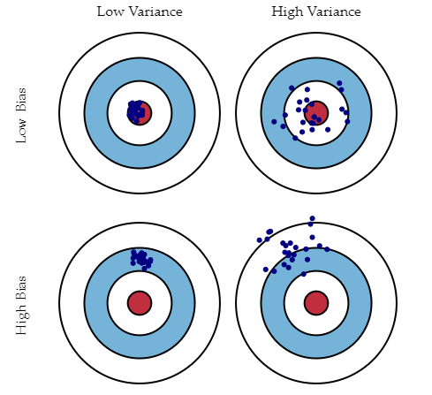Source: Understanding the Bias-Variance Tradeoff: Scott Fortmann – Roe
Bias stands for the error because of the erroneous or overly simplistic assumptions in the learning algorithm . This assumption can lead to the model underfitting the data, making it hard for it to have high predictive accuracy and for you to generalize your knowledge from the training set to the test set.
Variance is also an error because of too much complexity in the learning algorithm. This can be the reason for the algorithm being highly sensitive to high degrees of variation in training data, which can lead your model to overfit the data. Carrying too much noise from the training data for your model to be very useful for your test data.
The bias-variance decomposition essentially decomposes the learning error from any algorithm by adding the bias, the variance and a bit of irreducible error due to noise in the underlying dataset. Essentially, if you make the model more complex and add more variables, you’ll lose bias but gain some variance — in order to get the optimally reduced amount of error, you’ll have to trade off bias and variance. You don’t want either high bias or high variance in your model.

13. How can we relate standard deviation and variance?
Standard deviation refers to the spread of your data from the mean. Variance is the average degree to which each point differs from the mean i.e. the average of all data points. We can relate Standard deviation and Variance because it is the square root of Variance.

14. A data set is given to you and it has missing values which spread along 1 standard deviation from the mean. How much of the data would remain untouched?
It is given that the data is spread across mean that is the data is spread across an average. So, we can presume that it is a normal distribution. In a normal distribution, about 68% of data lies in 1 standard deviation from averages like mean, mode or median. That means about 32% of the data remains uninfluenced by missing values.

15. Is a high variance in data good or bad?
Higher variance directly means that the data spread is big and the feature has a variety of data. Usually, high variance in a feature is seen as not so good quality.

16. If your dataset is suffering from high variance, how would you handle it?
For datasets with high variance, we could use the bagging algorithm to handle it. Bagging algorithm splits the data into subgroups with sampling replicated from random data. After the data is split, random data is used to create rules using a training algorithm. Then we use polling technique to combine all the predicted outcomes of the model.

17. A data set is given to you about utilities fraud detection. You have built aclassifier model and achieved a performance score of 98.5%. Is this a goodmodel? If yes, justify. If not, what can you do about it?
Data set about utilities fraud detection is not balanced enough i.e. imbalanced. In such a data set, accuracy score cannot be the measure of performance as it may only be predict the majority class label correctly but in this case our point of interest is to predict the minority label. But often minorities are treated as noise and ignored. So, there is a high probability of misclassification of the minority label as compared to the majority label. For evaluating the model performance in case of imbalanced data sets, we should use Sensitivity (True Positive rate) or Specificity (True Negative rate) to determine class label wise performance of the classification model. If the minority class label’s performance is not so good, we could do the following:
- We can use under sampling or over sampling to balance the data.
- We can change the prediction threshold value.
- We can assign weights to labels such that the minority class labels get larger weights.
- We could detect anomalies.

18. Explain the handling of missing or corrupted values in the given dataset.
An easy way to handle missing values or corrupted values is to drop the corresponding rows or columns. If there are too many rows or columns to drop then we consider replacing the missing or corrupted values with some new value.
Identifying missing values and dropping the rows or columns can be done by using IsNull() and dropna( ) functions in Pandas. Also, the Fillna() function in Pandas replaces the incorrect values with the placeholder value.

19. What is Time series?
A Time series is a sequence of numerical data points in successive order. It tracks the movement of the chosen data points, over a specified period of time and records the data points at regular intervals. Time series doesn’t require any minimum or maximum time input. Analysts often use Time series to examine data according to their specific requirement.


20. What is a Box-Cox transformation?
Box-Cox transformation is a power transform which transforms non-normal dependent variables into normal variables as normality is the most common assumption made while using many statistical techniques. It has a lambda parameter which when set to 0 implies that this transform is equivalent to log-transform. It is used for variance stabilization and also to normalize the distribution.

21. What is the difference between stochastic gradient descent (SGD) and gradient descent (GD)?
Gradient Descent and Stochastic Gradient Descent are the algorithms that find the set of parameters that will minimize a loss function.
The difference is that in Gradient Descend, all training samples are evaluated for each set of parameters. While in Stochastic Gradient Descent only one training sample is evaluated for the set of parameters identified.

22. What is the exploding gradient problem while using the back propagation technique?
When large error gradients accumulate and result in large changes in the neural network weights during training, it is called the exploding gradient problem. The values of weights can become so large as to overflow and result in NaN values. This makes the model unstable and the learning of the model to stall just like the vanishing gradient problem. This is one of the most commonly asked interview questions on machine learning.

23. Can you mention some advantages and disadvantages of decision trees?
The advantages of decision trees are that they are easier to interpret, are nonparametric and hence robust to outliers, and have relatively few parameters to tune.
On the other hand, the disadvantage is that they are prone to overfitting.
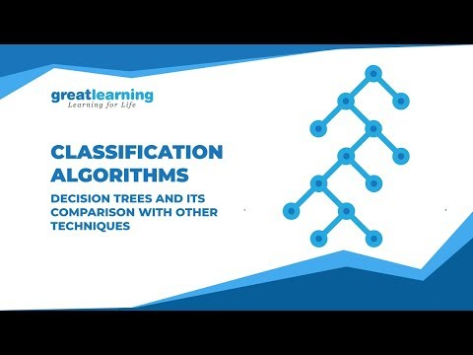

24. Explain the differences between Random Forest and Gradient Boosting machines.
Random Forests | Gradient Boosting
Random forests are a significant number of decision trees pooled using averages or majority rules at the end. | Gradient boosting machines also combine decision trees but at the beginning of the process, unlike Random forests.
The random forest creates each tree independent of the others while gradient boosting develops one tree at a time. | Gradient boosting yields better outcomes than random forests if parameters are carefully tuned but it’s not a good option if the data set contains a lot of outliers/anomalies/noise as it can result in overfitting of the model.
Random forests perform well for multiclass object detection. | Gradient Boosting performs well when there is data which is not balanced such as in real-time risk assessment.

25. What is a confusion matrix and why do you need it?
Confusion matrix (also called the error matrix) is a table that is frequently used to illustrate the performance of a classification model i.e. classifier on a set of test data for which the true values are well-known.
It allows us to visualize the performance of an algorithm/model. It allows us to easily identify the confusion between different classes. It is used as a performance measure of a model/algorithm.
A confusion matrix is known as a summary of predictions on a classification model. The number of right and wrong predictions were summarized with count values and broken down by each class label. It gives us information about the errors made through the classifier and also the types of errors made by a classifier.
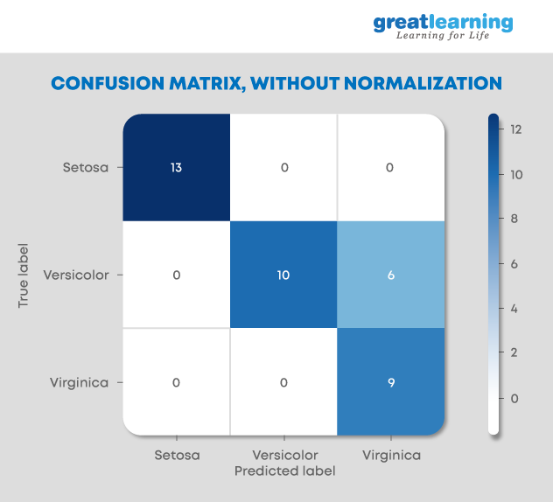

26. What’s a Fourier transform?
Fourier Transform is a mathematical technique that transforms any function of time to a function of frequency. Fourier transform is closely related to Fourier series. It takes any time-based pattern for input and calculates the overall cycle offset, rotation speed and strength for all possible cycles. Fourier transform is best applied to waveforms since it has functions of time and space. Once a Fourier transform applied on a waveform, it gets decomposed into a sinusoid.

27. What do you mean by Associative Rule Mining (ARM)?
Associative Rule Mining is one of the techniques to discover patterns in data like features (dimensions) which occur together and features (dimensions) which are correlated. It is mostly used in Market-based Analysis to find how frequently an itemset occurs in a transaction. Association rules have to satisfy minimum support and minimum confidence at the very same time. Association rule generation generally comprised of two different steps:
- “A min support threshold is given to obtain all frequent item-sets in a database.”
- “A min confidence constraint is given to these frequent item-sets in order to form the association rules.”
Support is a measure of how often the “item set” appears in the data set and Confidence is a measure of how often a particular rule has been found to be true.

28. What is Marginalisation? Explain the process.
Marginalisation is summing the probability of a random variable X given joint probability distribution of X with other variables. It is an application of the law of total probability.
P(X=x) = ∑YP(X=x,Y)
Given the joint probability P(X=x,Y), we can use marginalization to find P(X=x). So, it is to find distribution of one random variable by exhausting cases on other random variables.

29. Explain the phrase “Curse of Dimensionality”.
The Curse of Dimensionality refers to the situation when your data has too many features.
The phrase is used to express the difficulty of using brute force or grid search to optimize a function with too many inputs.
It can also refer to several other issues like:
- If we have more features than observations, we have a risk of overfitting the model.
- When we have too many features, observations become harder to cluster. Too many dimensions cause every observation in the dataset to appear equidistant from all others and no meaningful clusters can be formed.
Dimensionality reduction techniques like PCA come to the rescue in such cases.

30. What is the Principle Component Analysis?
The idea here is to reduce the dimensionality of the data set by reducing the number of variables that are correlated with each other. Although the variation needs to be retained to the maximum extent.
The variables are transformed into a new set of variables that are known as Principal Components’. These PCs are the eigenvectors of a covariance matrix and therefore are orthogonal.

31. Why is rotation of components so important in Principle Component Analysis (PCA)?
Rotation in PCA is very important as it maximizes the separation within the variance obtained by all the components because of which interpretation of components would become easier. If the components are not rotated, then we need extended components to describe variance of the components.

32. What are outliers? Mention three methods to deal with outliers.
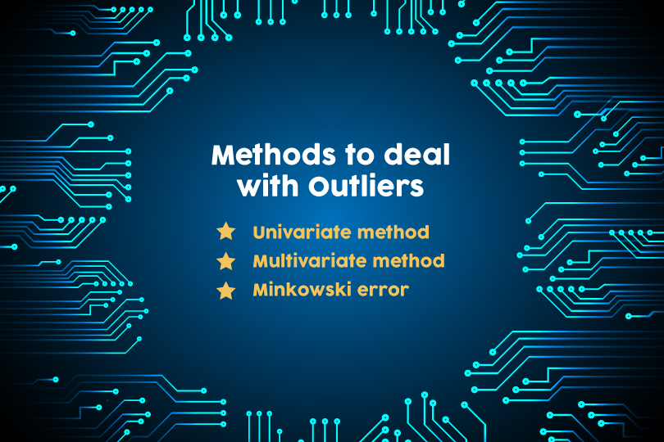
A data point that is considerably distant from the other similar data points is known as an outlier. They may occur due to experimental errors or variability in measurement. They are problematic and can mislead a training process, which eventually results in longer training time, inaccurate models, and poor results.
The three methods to deal with outliers are:
Univariate method – looks for data points having extreme values on a single variable
Multivariate method – looks for unusual combinations on all the variables
Minkowski error – reduces the contribution of potential outliers in the training process
Also Read - Advantages of pursuing a career in Machine Learning

33. What is the difference between regularization and normalisation?
Normalisation | Regularisation
Normalisation adjusts the data; . If your data is on very different scales (especially low to high), you would want to normalise the data. Alter each column to have compatible basic statistics. This can be helpful to make sure there is no loss of accuracy. One of the goals of model training is to identify the signal and ignore the noise if the model is given free rein to minimize error, there is a possibility of suffering from overfitting. | Regularisation adjusts the prediction function. Regularization imposes some control on this by providing simpler fitting functions over complex ones.

34. Explain the difference between Normalization and Standardization.
Normalization and Standardization are the two very popular methods used for feature scaling.
Normalisation | Standardization
Normalization refers to re-scaling the values to fit into a range of [0,1].  Normalization is useful when all parameters need to have an identical positive scale however the outliers from the data set are lost. | Standardization refers to re-scaling data to have a mean of 0 and a standard deviation of 1 (Unit variance)

35. List the most popular distribution curves along with scenarios where you will use them in an algorithm.
The most popular distribution curves are as follows- Bernoulli Distribution, Uniform Distribution, Binomial Distribution, Normal Distribution, Poisson Distribution, and Exponential Distribution.
Each of these distribution curves is used in various scenarios.
Bernoulli Distribution can be used to check if a team will win a championship or not, a newborn child is either male or female, you either pass an exam or not, etc.
Uniform distribution is a probability distribution that has a constant probability. Rolling a single dice is one example because it has a fixed number of outcomes.
Binomial distribution is a probability with only two possible outcomes, the prefix ‘bi’ means two or twice. An example of this would be a coin toss. The outcome will either be heads or tails.
Normal distribution describes how the values of a variable are distributed. It is typically a symmetric distribution where most of the observations cluster around the central peak. The values further away from the mean taper off equally in both directions. An example would be the height of students in a classroom.
Poisson distribution helps predict the probability of certain events happening when you know how often that event has occurred. It can be used by businessmen to make forecasts about the number of customers on certain days and allows them to adjust supply according to the demand.
Exponential distribution is concerned with the amount of time until a specific event occurs. For example, how long a car battery would last, in months.

36. How do we check the normality of a data set or a feature?
Visually, we can check it using plots. There is a list of Normality checks, they are as follow:
- Shapiro-Wilk W Test
- Anderson-Darling Test
- Martinez-Iglewicz Test
- Kolmogorov-Smirnov Test
- D’Agostino Skewness Test

37. What is Linear Regression?
Linear Function can be defined as a Mathematical function on a 2D plane as, Y =Mx +C, where Y is a dependent variable and X is Independent Variable, C is Intercept and M is slope and same can be expressed as Y is a Function of X or Y = F(x).
At any given value of X, one can compute the value of Y, using the equation of Line. This relation between Y and X, with a degree of the polynomial as 1 is called Linear Regression.
In Predictive Modeling, LR is represented as Y = Bo + B1x1 + B2x2
The value of B1 and B2 determines the strength of the correlation between features and the dependent variable.
Example: Stock Value in $ = Intercept + (+/-B1)*(Opening value of Stock) + (+/-B2)*(Previous Day Highest value of Stock)

38. Differentiate between regression and classification.
Regression and classification are categorized under the same umbrella of supervised machine learning. The main difference between them is that the output variable in the regression is numerical (or continuous) while that for classification is categorical (or discrete).
Example: To predict the definite Temperature of a place is Regression problem whereas predicting whether the day will be Sunny cloudy or there will be rain is a case of classification.

39. What is target imbalance? How do we fix it? A scenario where you have performed target imbalance on data. Which metrics and algorithms do you find suitable to input this data onto?
If you have categorical variables as the target when you cluster them together or perform a frequency count on them if there are certain categories which are more in number as compared to others by a very significant number. This is known as the target imbalance.
Example: Target column – 0,0,0,1,0,2,0,0,1,1 [0s: 60%, 1: 30%, 2:10%] 0 are in majority. To fix this, we can perform up-sampling or down-sampling. Before fixing this problem let’s assume that the performance metrics used was confusion metrics. After fixing this problem we can shift the metric system to AUC: ROC. Since we added/deleted data [up sampling or downsampling], we can go ahead with a stricter algorithm like SVM, Gradient boosting or ADA boosting.

40. List all assumptions for data to be met before starting with linear regression.
Before starting linear regression, the assumptions to be met are as follow:
- Linear relationship
- Multivariate normality
- No or little multicollinearity
- No auto-correlation
- Homoscedasticity

41. When does the linear regression line stop rotating or finds an optimal spot where it is fitted on data?
A place where the highest RSquared value is found, is the place where the line comes to rest. RSquared represents the amount of variance captured by the virtual linear regression line with respect to the total variance captured by the dataset.

42. Why is logistic regression a type of classification technique and not a regression? Name the function it is derived from?
Since the target column is categorical, it uses linear regression to create an odd function that is wrapped with a log function to use regression as a classifier. Hence, it is a type of classification technique and not a regression. It is derived from cost function.

43. What could be the issue when the beta value for a certain variable varies way too much in each subset when regression is run on different subsets of the given dataset?
Variations in the beta values in every subset implies that the dataset is heterogeneous. To overcome this problem, we can use a different model for each of the clustered subsets of the dataset or use a non-parametric model such as decision trees.

44. What does the term Variance Inflation Factor mean?
Variation Inflation Factor (VIF) is the ratio of the variance of the model to the variance of the model with only one independent variable. VIF gives the estimate of the volume of multicollinearity in a set of many regression variables.
VIF = Variance of model with one independent variable

45. Which machine learning algorithm is known as the lazy learner and why is it called so?
KNN is a Machine Learning algorithm known as a lazy learner. K-NN is a lazy learner because it doesn’t learn any machine learnt values or variables from the training data but dynamically calculates distance every time it wants to classify, hence memorising the training dataset instead.

Machine Learning Interview Questions for Experienced
We know what the companies are looking for, and with that in mind, we have prepared the set of Machine Learning interview questions an experienced professional may be asked. So, prepare accordingly if you wish to ace the interview in one go.

46. Is it possible to use KNN for image processing?
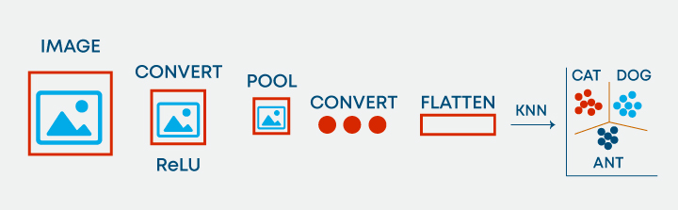
Yes, it is possible to use KNN for image processing. It can be done by converting the 3-dimensional image into a single-dimensional vector and using the same as input to KNN.

47. Differentiate between K-Means and KNN algorithms?
KNN algorithms | K-Means
KNN algorithms is Supervised Learning where-as K-Means is Unsupervised Learning. With KNN, we predict the label of the unidentified element based on its nearest neighbour and further extend this approach for solving classification/regression-based problems. | K-Means is Unsupervised Learning, where we don’t have any Labels present, in other words, no Target Variables and thus we try to cluster the data based upon their coord

NLP Interview Questions
NLP or Natural Language Processing helps machines analyse natural languages with the intention of learning them. It extracts information from data by applying machine learning algorithms. Apart from learning the basics of NLP, it is important to prepare specifically for the interviews. Check out the top NLP Interview Questions

48. How does the SVM algorithm deal with self-learning?
SVM has a learning rate and expansion rate which takes care of this. The learning rate compensates or penalises the hyperplanes for making all the wrong moves and expansion rate deals with finding the maximum separation area between classes.

49. What are Kernels in SVM? List popular kernels used in SVM along with a scenario of their applications.
The function of the kernel is to take data as input and transform it into the required form. A few popular Kernels used in SVM are as follows: RBF, Linear, Sigmoid, Polynomial, Hyperbolic, Laplace, etc.

50. What is Kernel Trick in an SVM Algorithm?
Kernel Trick is a mathematical function which when applied on data points, can find the region of classification between two different classes. Based on the choice of function, be it linear or radial, which purely depends upon the distribution of data, one can build a classifier.

51. What are ensemble models? Explain how ensemble techniques yield better learning as compared to traditional classification ML algorithms.
An ensemble is a group of models that are used together for prediction both in classification and regression classes. Ensemble learning helps improve ML results because it combines several models. By doing so, it allows for a better predictive performance compared to a single model.
They are superior to individual models as they reduce variance, average out biases, and have lesser chances of overfitting.

52. What are overfitting and underfitting? Why does the decision tree algorithm suffer often with overfitting problems?
Overfitting is a statistical model or machine learning algorithm which captures the noise of the data. Underfitting is a model or machine learning algorithm which does not fit the data well enough and occurs if the model or algorithm shows low variance but high bias.
In decision trees, overfitting occurs when the tree is designed to perfectly fit all samples in the training data set. This results in branches with strict rules or sparse data and affects the accuracy when predicting samples that aren’t part of the training set.
Also Read: Overfitting and Underfitting in Machine Learning

53. What is OOB error and how does it occur?
For each bootstrap sample, there is one-third of data that was not used in the creation of the tree, i.e., it was out of the sample. This data is referred to as out of bag data. In order to get an unbiased measure of the accuracy of the model over test data, out of bag error is used. The out of bag data is passed for each tree is passed through that tree and the outputs are aggregated to give out of bag error. This percentage error is quite effective in estimating the error in the testing set and does not require further cross-validation.

54. Why boosting is a more stable algorithm as compared to other ensemble algorithms?
Boosting focuses on errors found in previous iterations until they become obsolete. Whereas in bagging there is no corrective loop. This is why boosting is a more stable algorithm compared to other ensemble algorithms.

55. How do you handle outliers in the data?
Outlier is an observation in the data set that is far away from other observations in the data set. We can discover outliers using tools and functions like box plot, scatter plot, Z-Score, IQR score etc. and then handle them based on the visualization we have got. To handle outliers, we can cap at some threshold, use transformations to reduce skewness of the data and remove outliers if they are anomalies or errors.

56. List popular cross validation techniques.
There are mainly six types of cross validation techniques. They are as follow:
- K fold
- Stratified k fold
- Leave one out
- Bootstrapping
- Random search cv
- Grid search cv

57. Is it possible to test for the probability of improving model accuracy without cross-validation techniques? If yes, please explain.
Yes, it is possible to test for the probability of improving model accuracy without cross-validation techniques. We can do so by running the ML model for say n number of iterations, recording the accuracy. Plot all the accuracies and remove the 5% of low probability values. Measure the left [low] cut off and right [high] cut off. With the remaining 95% confidence, we can say that the model can go as low or as high [as mentioned within cut off points].

58. Name a popular dimensionality reduction algorithm.
Popular dimensionality reduction algorithms are Principal Component Analysis and Factor Analysis.
Principal Component Analysis creates one or more index variables from a larger set of measured variables. Factor Analysis is a model of the measurement of a latent variable. This latent variable cannot be measured with a single variable and is seen through a relationship it causes in a set of y variables.

59. How can we use a dataset without the target variable into supervised learning algorithms?
Input the data set into a clustering algorithm, generate optimal clusters, label the cluster numbers as the new target variable. Now, the dataset has independent and target variables present. This ensures that the dataset is ready to be used in supervised learning algorithms.

60. List all types of popular recommendation systems? Name and explain two personalized recommendation systems along with their ease of implementation.
Popularity based recommendation, content-based recommendation, user-based collaborative filter, and item-based recommendation are the popular types of recommendation systems.
Personalised Recommendation systems are- Content-based recommendation, user-based collaborative filter, and item-based recommendation. User-based collaborative filter and item-based recommendations are more personalised. Ease to maintain: Similarity matrix can be maintained easily with Item-based recommendation.

61. How do we deal with sparsity issues in recommendation systems? How do we measure its effectiveness? Explain.
Singular value decomposition can be used to generate the prediction matrix. RMSE is the measure that helps us understand how close the prediction matrix is to the original matrix.

62. Name and define techniques used to find similarities in the recommendation system.
Pearson correlation and Cosine correlation are techniques used to find similarities in recommendation systems.

63. State the limitations of Fixed Basis Function.
Linear separability in feature space doesn’t imply linear separability in input space. So, Inputs are non-linearly transformed using vectors of basic functions with increased dimensionality. Limitations of Fixed basis functions are:
- Non-Linear transformations cannot remove overlap between two classes but they can increase overlap.
- Often it is not clear which basis functions are the best fit for a given task. So, learning the basic functions can be useful over using fixed basis functions.
- If we want to use only fixed ones, we can use a lot of them and let the model figure out the best fit but that would lead to overfitting the model thereby making it unstable.

64. Define and explain the concept of Inductive Bias with some examples.
Inductive Bias is a set of assumptions that humans use to predict outputs given inputs that the learning algorithm has not encountered yet. When we are trying to learn Y from X and the hypothesis space for Y is infinite, we need to reduce the scope by our beliefs/assumptions about the hypothesis space which is also called inductive bias. Through these assumptions, we constrain our hypothesis space and also get the capability to incrementally test and improve on the data using hyper-parameters. Examples:
- We assume that Y varies linearly with X while applying Linear regression.
- We assume that there exists a hyperplane separating negative and positive examples.

65. Explain the term instance-based learning.
Instance Based Learning is a set of procedures for regression and classification which produce a class label prediction based on resemblance to its nearest neighbors in the training data set. These algorithms just collects all the data and get an answer when required or queried. In simple words they are a set of procedures for solving new problems based on the solutions of already solved problems in the past which are similar to the current problem.

66. Keeping train and test split criteria in mind, is it good to perform scaling before the split or after the split?
Scaling should be done post-train and test split ideally. If the data is closely packed, then scaling post or pre-split should not make much difference.

67. Define precision, recall and F1 Score?
The metric used to access the performance of the classification model is Confusion Metric. Confusion Metric can be further interpreted with the following terms:-
True Positives (TP) – These are the correctly predicted positive values. It implies that the value of the actual class is yes and the value of the predicted class is also yes.
True Negatives (TN) – These are the correctly predicted negative values. It implies that the value of the actual class is no and the value of the predicted class is also no.
False positives and false negatives, these values occur when your actual class contradicts with the predicted class.
Now,
Recall, also known as Sensitivity is the ratio of true positive rate (TP), to all observations in actual class – yes
Recall = TP/(TP+FN)
Precision is the ratio of positive predictive value, which measures the amount of accurate positives model predicted viz a viz number of positives it claims.
Precision = TP/(TP+FP)
Accuracy is the most intuitive performance measure and it is simply a ratio of correctly predicted observation to the total observations.
Accuracy = (TP+TN)/(TP+FP+FN+TN)
F1 Score is the weighted average of Precision and Recall. Therefore, this score takes both false positives and false negatives into account. Intuitively it is not as easy to understand as accuracy, but F1 is usually more useful than accuracy, especially if you have an uneven class distribution. Accuracy works best if false positives and false negatives have a similar cost. If the cost of false positives and false negatives are very different, it’s better to look at both Precision and Recall.

68. Plot validation score and training score with data set size on the x-axis and another plot with model complexity on the x-axis.
For high bias in the models, the performance of the model on the validation data set is similar to the performance on the training data set. For high variance in the models, the performance of the model on the validation set is worse than the performance on the training set.

69. What is Bayes’ Theorem? State at least 1 use case with respect to the machine learning context?
Bayes’ Theorem describes the probability of an event, based on prior knowledge of conditions that might be related to the event. For example, if cancer is related to age, then, using Bayes’ theorem, a person’s age can be used to more accurately assess the probability that they have cancer than can be done without the knowledge of the person’s age.
Chain rule for Bayesian probability can be used to predict the likelihood of the next word in the sentence.

70. What is Naive Bayes? Why is it Naive?
Naive Bayes classifiers are a series of classification algorithms that are based on the Bayes theorem. This family of algorithm shares a common principle which treats every pair of features independently while being classified.
Naive Bayes is considered Naive because the attributes in it (for the class) is independent of others in the same class. This lack of dependence between two attributes of the same class creates the quality of naiveness.
Read more about Naive Bayes.

71. Explain how a Naive Bayes Classifier works.
Naive Bayes classifiers are a family of algorithms which are derived from the Bayes theorem of probability. It works on the fundamental assumption that every set of two features that is being classified is independent of each other and every feature makes an equal and independent contribution to the outcome.
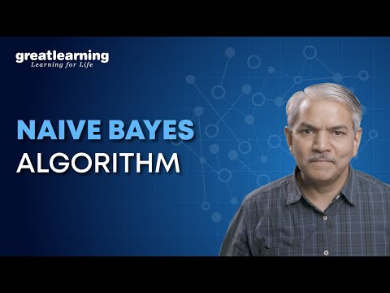

72. What do the terms prior probability and marginal likelihood in context of Naive Bayes theorem mean?
Prior probability is the percentage of dependent binary variables in the data set. If you are given a dataset and dependent variable is either 1 or 0 and percentage of 1 is 65% and percentage of 0 is 35%. Then, the probability that any new input for that variable of being 1 would be 65%.
Marginal likelihood is the denominator of the Bayes equation and it makes sure that the posterior probability is valid by making its area 1.

73. Explain the difference between Lasso and Ridge?
Lasso(L1) and Ridge(L2) are the regularization techniques where we penalize the coefficients to find the optimum solution. In ridge, the penalty function is defined by the sum of the squares of the coefficients and for the Lasso, we penalize the sum of the absolute values of the coefficients. Another type of regularization method is ElasticNet, it is a hybrid penalizing function of both lasso and ridge.

74. What’s the difference between probability and likelihood?
Probability is the measure of the likelihood that an event will occur that is, what is the certainty that a specific event will occur? Where-as a likelihood function is a function of parameters within the parameter space that describes the probability of obtaining the observed data.
So the fundamental difference is, Probability attaches to possible results; likelihood attaches to hypotheses.


75. Why would you Prune your tree?
In the context of data science or AIML, pruning refers to the process of reducing redundant branches of a decision tree. Decision Trees are prone to overfitting, pruning the tree helps to reduce the size and minimizes the chances of overfitting. Pruning involves turning branches of a decision tree into leaf nodes and removing the leaf nodes from the original branch. It serves as a tool to perform the tradeoff.


76. Model accuracy or Model performance? Which one will you prefer and why?
This is a trick question, one should first get a clear idea, what is Model Performance? If Performance means speed, then it depends upon the nature of the application, any application related to the real-time scenario will need high speed as an important feature. Example: The best of Search Results will lose its virtue if the Query results do not appear fast.
If Performance is hinted at Why Accuracy is not the most important virtue – For any imbalanced data set, more than Accuracy, it will be an F1 score than will explain the business case and in case data is imbalanced, then Precision and Recall will be more important than rest.

77. List the advantages and limitations of the Temporal Difference Learning Method.
Temporal Difference Learning Method is a mix of Monte Carlo method and Dynamic programming method. Some of the advantages of this method include:
- It can learn in every step online or offline.
- It can learn from a sequence which is not complete as well.
- It can work in continuous environments.
- It has lower variance compared to MC method and is more efficient than MC method.
Limitations of TD method are:
- It is a biased estimation.
- It is more sensitive to initialization.

78. How would you handle an imbalanced dataset?
Sampling Techniques can help with an imbalanced dataset. There are two ways to perform sampling, Under Sample or Over Sampling.
In Under Sampling, we reduce the size of the majority class to match minority class thus help by improving performance w.r.t storage and run-time execution, but it potentially discards useful information.
For Over Sampling, we upsample the Minority class and thus solve the problem of information loss, however, we get into the trouble of having Overfitting.
There are other techniques as well –
Cluster-Based Over Sampling – In this case, the K-means clustering algorithm is independently applied to minority and majority class instances. This is to identify clusters in the dataset. Subsequently, each cluster is oversampled such that all clusters of the same class have an equal number of instances and all classes have the same size
Synthetic Minority Over-sampling Technique (SMOTE) – A subset of data is taken from the minority class as an example and then new synthetic similar instances are created which are then added to the original dataset. This technique is good for Numerical data points.

79. Mention some of the EDA Techniques?
Exploratory Data Analysis (EDA) helps analysts to understand the data better and forms the foundation of better models.
Visualization
- Univariate visualization
- Bivariate visualization
- Multivariate visualization
Missing Value Treatment – Replace missing values with Either Mean/Median
Outlier Detection – Use Boxplot to identify the distribution of Outliers, then Apply IQR to set the boundary for IQR
Transformation – Based on the distribution, apply a transformation on the features
Scaling the Dataset – Apply MinMax, Standard Scaler or Z Score Scaling mechanism to scale the data.
Feature Engineering – Need of the domain, and SME knowledge helps Analyst find derivative fields which can fetch more information about the nature of the data
Dimensionality reduction — Helps in reducing the volume of data without losing much information


80. Mention why feature engineering is important in model building and list out some of the techniques used for feature engineering.
Algorithms necessitate features with some specific characteristics to work appropriately. The data is initially in a raw form. You need to extract features from this data before supplying it to the algorithm. This process is called feature engineering. When you have relevant features, the complexity of the algorithms reduces. Then, even if a non-ideal algorithm is used, results come out to be accurate.
Feature engineering primarily has two goals:
- Prepare the suitable input data set to be compatible with the machine learning algorithm constraints.
- Enhance the performance of machine learning models.
Some of the techniques used for feature engineering include Imputation, Binning, Outliers Handling, Log transform, grouping operations, One-Hot encoding, Feature split, Scaling, Extracting date.

81. Differentiate between Statistical Modeling and Machine Learning?
Machine learning models are about making accurate predictions about the situations, like Foot Fall in restaurants, Stock-Price, etc. where-as, Statistical models are designed for inference about the relationships between variables, as What drives the sales in a restaurant, is it food or Ambience.

82. Differentiate between Boosting and Bagging?
Bagging and Boosting are variants of Ensemble Techniques.
Bootstrap Aggregation or bagging is a method that is used to reduce the variance for algorithms having very high variance. Decision trees are a particular family of classifiers which are susceptible to having high bias.
Decision trees have a lot of sensitiveness to the type of data they are trained on. Hence generalization of results is often much more complex to achieve in them despite very high fine-tuning. The results vary greatly if the training data is changed in decision trees.
Hence bagging is utilised where multiple decision trees are made which are trained on samples of the original data and the final result is the average of all these individual models.
Boosting is the process of using an n-weak classifier system for prediction such that every weak classifier compensates for the weaknesses of its classifiers. By weak classifier, we imply a classifier which performs poorly on a given data set.
It’s evident that boosting is not an algorithm rather it’s a process. Weak classifiers used are generally logistic regression, shallow decision trees etc.
There are many algorithms which make use of boosting processes but two of them are mainly used: Adaboost and Gradient Boosting and XGBoost.

83. What is the significance of Gamma and Regularization in SVM?
The gamma defines influence. Low values meaning ‘far’ and high values meaning ‘close’. If gamma is too large, the radius of the area of influence of the support vectors only includes the support vector itself and no amount of regularization with C will be able to prevent overfitting. If gamma is very small, the model is too constrained and cannot capture the complexity of the data.
The regularization parameter (lambda) serves as a degree of importance that is given to miss-classifications. This can be used to draw the tradeoff with OverFitting.

84. Define ROC curve work
The graphical representation of the contrast between true positive rates and the false positive rate at various thresholds is known as the ROC curve. It is used as a proxy for the trade-off between true positives vs the false positives.
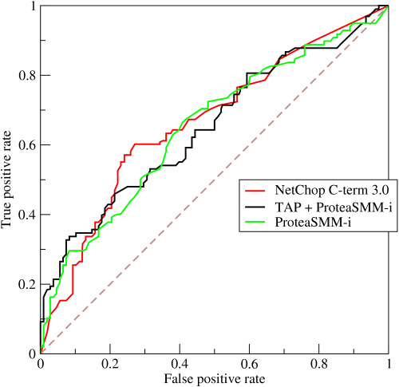

85. What is the difference between a generative and discriminative model?
A generative model learns the different categories of data. On the other hand, a discriminative model will only learn the distinctions between different categories of data. Discriminative models perform much better than the generative models when it comes to classification tasks.

86. What are hyperparameters and how are they different from parameters?
A parameter is a variable that is internal to the model and whose value is estimated from the training data. They are often saved as part of the learned model. Examples include weights, biases etc.
A hyperparameter is a variable that is external to the model whose value cannot be estimated from the data. They are often used to estimate model parameters. The choice of parameters is sensitive to implementation. Examples include learning rate, hidden layers etc.

87. What is shattering a set of points? Explain VC dimension.
In order to shatter a given configuration of points, a classifier must be able to, for all possible assignments of positive and negative for the points, perfectly partition the plane such that positive points are separated from negative points. For a configuration of n points, there are 2n possible assignments of positive or negative.
When choosing a classifier, we need to consider the type of data to be classified and this can be known by VC dimension of a classifier. It is defined as cardinality of the largest set of points that the classification algorithm i.e. the classifier can shatter. In order to have a VC dimension of at least n, a classifier must be able to shatter a single given configuration of n points.

88. What are some differences between a linked list and an array?
Arrays and Linked lists are both used to store linear data of similar types. However, there are a few difference between them.
Array | Linked List
Elements are well-indexed, making specific element accessing easier | Elements need to be accessed in a cumulative manner
Operations (insertion, deletion) are faster in array | Linked list takes linear time, making operations a bit slower
Arrays are of fixed size | Linked lists are dynamic and flexible
Memory is assigned during compile time in an array | Memory is allocated during execution or runtime in Linked list.
Elements are stored consecutively in arrays. | Elements are stored randomly in Linked list
Memory utilization is inefficient in the array | Memory utilization is efficient in the linked list.

89. What is the meshgrid () method and the contourf () method? State some usesof both.
The meshgrid( ) function in numpy takes two arguments as input : range of x-values in the grid, range of y-values in the grid whereas meshgrid needs to be built before the contourf( ) function in matplotlib is used which takes in many inputs : x-values, y-values, fitting curve (contour line) to be plotted in grid, colours etc.
Meshgrid () function is used to create a grid using 1-D arrays of x-axis inputs and y-axis inputs to represent the matrix indexing. Contourf () is used to draw filled contours using the given x-axis inputs, y-axis inputs, contour line, colours etc.

90. Describe a hash table.
Hashing is a technique for identifying unique objects from a group of similar objects. Hash functions are large keys converted into small keys in hashing techniques. The values of hash functions are stored in data structures which are known hash table.

91. List the advantages and disadvantages of using Neural Networks.
Advantages:
We can store information on the entire network instead of storing it in a database. It has the ability to work and give a good accuracy even with inadequate information. A neural network has parallel processing ability and distributed memory.
Disadvantages:
Neural Networks requires processors which are capable of parallel processing. It’s unexplained functioning of the network is also quite an issue as it reduces the trust in the network in some situations like when we have to show the problem we noticed to the network. Duration of the network is mostly unknown. We can only know that the training is finished by looking at the error value but it doesn’t give us optimal results.

92. You have to train a 12GB dataset using a neural network with a machine which has only 3GB RAM. How would you go about it?
We can use NumPy arrays to solve this issue. Load all the data into an array. In NumPy, arrays have a property to map the complete dataset without loading it completely in memory. We can pass the index of the array, dividing data into batches, to get the data required and then pass the data into the neural networks. But be careful about keeping the batch size normal.

Machine Learning Coding Interview Questions

93. Write a simple code to binarize data.
Conversion of data into binary values on the basis of certain threshold is known as binarizing of data. Values below the threshold are set to 0 and those above the threshold are set to 1 which is useful for feature engineering.
Code:
from sklearn.preprocessing import Binarizer
import pandas
import numpy
names_list = ['Alaska', 'Pratyush', 'Pierce', 'Sandra', 'Soundarya', 'Meredith', 'Richard', 'Jackson', 'Tom',’Joe’]
data_frame = pandas.read_csv(url, names=names_list)
array = dataframe.values
# Splitting the array into input and output
A = array [: 0:7]
B = array [:7]
binarizer = Binarizer(threshold=0.0). fit(X)
binaryA = binarizer.transform(A)
numpy.set_printoptions(precision=5)
print (binaryA [0:7:])

Machine Learning Using Python Interview Questions

94. What is an Array?
The array is defined as a collection of similar items, stored in a contiguous manner. Arrays is an intuitive concept as the need to group similar objects together arises in our day to day lives. Arrays satisfy the same need. How are they stored in the memory? Arrays consume blocks of data, where each element in the array consumes one unit of memory. The size of the unit depends on the type of data being used. For example, if the data type of elements of the array is int, then 4 bytes of data will be used to store each element. For character data type, 1 byte will be used. This is implementation specific, and the above units may change from computer to computer.
Example:
fruits = [‘apple’, banana’, pineapple’]
In the above case, fruits is a list that comprises of three fruits. To access them individually, we use their indexes. Python and C are 0- indexed languages, that is, the first index is 0. MATLAB on the contrary starts from 1, and thus is a 1-indexed language.

95. What are the advantages and disadvantages of using an Array?
- Advantages:
- Random access is enabled
- Saves memory
- Cache friendly
- Predictable compile timing
- Helps in re-usability of code
- Disadvantages:
- Addition and deletion of records is time consuming even though we get the element of interest immediately through random access. This is due to the fact that the elements need to be reordered after insertion or deletion.
- If contiguous blocks of memory are not available in the memory, then there is an overhead on the CPU to search for the most optimal contiguous location available for the requirement.
Now that we know what arrays are, we shall understand them in detail by solving some interview questions. Before that, let us see the functions that Python as a language provides for arrays, also known as, lists.
append() – Adds an element at the end of the list
copy() – returns a copy of a list.
reverse() – reverses the elements of the list
sort() – sorts the elements in ascending order by default.

96. What is Lists in Python?
Lists is an effective data structure provided in python. There are various functionalities associated with the same. Let us consider the scenario where we want to copy a list to another list. If the same operation had to be done in C programming language, we would have to write our own function to implement the same.
On the contrary, Python provides us with a function called copy. We can copy a list to another just by calling the copy function.
new_list = old_list.copy()
We need to be careful while using the function. copy() is a shallow copy function, that is, it only stores the references of the original list in the new list. If the given argument is a compound data structure like a list then python creates another object of the same type (in this case, a new list) but for everything inside old list, only their reference is copied. Essentially, the new list consists of references to the elements of the older list.
Hence, upon changing the original list, the new list values also change. This can be dangerous in many applications. Therefore, Python provides us with another functionality called as deepcopy. Intuitively, we may consider that deepcopy() would follow the same paradigm, and the only difference would be that for each element we will recursively call deepcopy. Practically, this is not the case.
deepcopy() preserves the graphical structure of the original compound data. Let us understand this better with the help of an example:

import copy.deepcopy
a = [1,2]
b = [a,a] # there's only 1 object a
c = deepcopy(b)

# check the result by executing these lines
c[0] is a # return False, a new object a' is created
c[0] is c[1] # return True, c is [a',a'] not [a',a'']
This is the tricky part, during the process of deepcopy() a hashtable implemented as a dictionary in python is used to map: old_object reference onto new_object reference.
Therefore, this prevents unnecessary duplicates and thus preserves the structure of the copied compound data structure. Thus, in this case, c[0] is not equal to a, as internally their addresses are different.
Normal copy
>>> a = [[1, 2, 3], [4, 5, 6]]
>>> b = list(a)
>>> a
[[1, 2, 3], [4, 5, 6]]
>>> b
[[1, 2, 3], [4, 5, 6]]
>>> a[0][1] = 10
>>> a
[[1, 10, 3], [4, 5, 6]]
>>> b # b changes too -> Not a deepcopy.
[[1, 10, 3], [4, 5, 6]]

Deep copy

>>> import copy
>>> b = copy.deepcopy(a)
>>> a
[[1, 10, 3], [4, 5, 6]]
>>> b
[[1, 10, 3], [4, 5, 6]]
>>> a[0][1] = 9
>>> a
[[1, 9, 3], [4, 5, 6]]
>>> b # b doesn't change -> Deep Copy
[[1, 10, 3], [4, 5, 6]]
Now that we have understood the concept of lists, let us solve interview questions to get better exposure on the same.

97. Given an array of integers where each element represents the max number of steps that can be made forward from that element. The task is to find the minimum number of jumps to reach the end of the array (starting from the first element). If an element is 0, then cannot move through that element.
Solution: This problem is famously called as end of array problem. We want to determine the minimum number of jumps required in order to reach the end. The element in the array represents the maximum number of jumps that, that particular element can take.
Let us understand how to approach the problem initially.
We need to reach the end. Therefore, let us have a count that tells us how near we are to the end. Consider the array A=[1,2,3,1,1]
In the above example we can go from
> 2 - >3 - > 1 - > 1 - 4 jumps
1 - > 2 - > 1 - > 1 - 3 jumps
1 - > 2 - > 3 - > 1 - 3 jumps
Hence, we have a fair idea of the problem. Let us come up with a logic for the same.
Let us start from the end and move backwards as that makes more sense intuitionally. We will use variables right and prev_r denoting previous right to keep track of the jumps.
Initially, right = prev_r = the last but one element. We consider the distance of an element to the end, and the number of jumps possible by that element. Therefore, if the sum of the number of jumps possible and the distance is greater than the previous element, then we will discard the previous element and use the second element’s value to jump. Try it out using a pen and paper first. The logic will seem very straight forward to implement. Later, implement it on your own and then verify with the result.
def min_jmp(arr):

n = len(arr)
right = prev_r = n-1
count = 0

# We start from rightmost index and travesre array to find the leftmost index
# from which we can reach index 'right'
while True:
for j in (range(prev_r-1,-1,-1)):
if j + arr[j] >= prev_r:
right = j

if prev_r != right:
prev_r = right
else:
break

count += 1

return count if right == 0 else -1

# Enter the elements separated by a space
arr = list(map(int, input().split()))
print(min_jmp(n, arr))

98. Given a string S consisting only ‘a’s and ‘b’s, print the last index of the ‘b’ present in it.
When we have are given a string of a’s and b’s, we can immediately find out the first location of a character occurring. Therefore, to find the last occurrence of a character, we reverse the string and find the first occurrence, which is equivalent to the last occurrence in the original string.
Here, we are given input as a string. Therefore, we begin by splitting the characters element wise using the function split. Later, we reverse the array, find the first occurrence position value, and get the index by finding the value len – position -1, where position is the index value.
def split(word):
return [(char) for char in word]

a = input()
a= split(a)
a_rev = a[::-1]
pos = -1
for i in range(len(a_rev)):
if a_rev[i] == ‘b’:
pos = len(a_rev)- i -1
print(pos)
break
else:
continue
if pos==-1:
print(-1)

99. Rotate the elements of an array by d positions to the left. Let us initially look at an example.
A = [1,2,3,4,5]
A <<2
[3,4,5,1,2]
A<<3
[4,5,1,2,3]
There exists a pattern here, that is, the first d elements are being interchanged with last n-d +1 elements. Therefore we can just swap the elements. Correct? What if the size of the array is huge, say 10000 elements. There are chances of memory error, run-time error etc. Therefore, we do it more carefully. We rotate the elements one by one in order to prevent the above errors, in case of large arrays.
# Rotate all the elements left by 1 position
def rot_left_once ( arr):
n = len( arr)
tmp = arr [0]
for i in range ( n-1): #[0,n-2]
arr[i] = arr[i + 1]
arr[n-1] = tmp

# Use the above function to repeat the process for d times.
def rot_left (arr, d):
n = len (arr)
for i in range (d):
rot_left_once ( arr, n)

arr = list( map( int, input().split()))
rot =int( input())
leftRotate ( arr, rot)

for i in range( len(arr)):
print( arr[i], end=' ')

100. Water Trapping Problem
Given an array arr[] of N non-negative integers which represents the height of blocks at index I, where the width of each block is 1. Compute how much water can be trapped in between blocks after raining.
# Structure is like below:
# | |
# |_|
# answer is we can trap two units of water.
Solution: We are given an array, where each element denotes the height of the block. One unit of height is equal to one unit of water, given there exists space between the 2 elements to store it. Therefore, we need to find out all such pairs that exist which can store water. We need to take care of the possible cases:
- There should be no overlap of water saved
- Water should not overflow
Therefore, let us find start with the extreme elements, and move towards the centre.
n = int(input())
arr = [int(i) for i in input().split()]
left, right = [arr[0]], [0] * n
# left =[arr[0]]
#right = [ 0 0 0 0…0] n terms
right[n-1] = arr[-1] # right most element
# we use two arrays left[ ] and right[ ], which keep track of elements greater than all
# elements the order of traversal respectively.
for elem in arr[1 : ]:
left.append(max(left[-1], elem) )
for i in range( len( arr)-2, -1, -1):
right[i] = max( arr[i] , right[i+1] )
water = 0
# once we have the arrays left, and right, we can find the water capacity between these arrays.

for i in range( 1, n - 1):
add_water = min( left[i - 1], right[i]) - arr[i]
if add_water > 0:
water += add_water
print(water)

101. Explain Eigenvectors and Eigenvalues.
Ans. Linear transformations are helpful to understand using eigenvectors. They find their prime usage in the creation of covariance and correlation matrices in data science.
Simply put, eigenvectors are directional entities along which linear transformation features like compression, flip etc. can be applied.
Eigenvalues are the magnitude of the linear transformation features along each direction of an Eigenvector.

102. How would you define the number of clusters in a clustering algorithm?
Ans. The number of clusters can be determined by finding the silhouette score. Often we aim to get some inferences from data using clustering techniques so that we can have a broader picture of a number of classes being represented by the data. In this case, the silhouette score helps us determine the number of cluster centres to cluster our data along.
Another technique that can be used is the elbow method.

103. What are the performance metrics that can be used to estimate the efficiency of a linear regression model?
Ans. The performance metric that is used in this case is:
- Mean Squared Error
- R2 score
- Adjusted R2 score
- Mean Absolute score

104. What is the default method of splitting in decision trees?
The default method of splitting in decision trees is the Gini Index. Gini Index is the measure of impurity of a particular node.
This can be changed by making changes to classifier parameters.

105. How is p-value useful?
Ans. The p-value gives the probability of the null hypothesis is true. It gives us the statistical significance of our results. In other words, p-value determines the confidence of a model in a particular output.

106. Can logistic regression be used for classes more than 2?
Ans. No, logistic regression cannot be used for classes more than 2 as it is a binary classifier. For multi-class classification algorithms like Decision Trees, Naïve Bayes’ Classifiers are better suited.

107. What are the hyperparameters of a logistic regression model?
Ans. Classifier penalty, classifier solver and classifier C are the trainable hyperparameters of a Logistic Regression Classifier. These can be specified exclusively with values in Grid Search to hyper tune a Logistic Classifier.

108. Name a few hyper-parameters of decision trees?
Ans. The most important features which one can tune in decision trees are:
- Splitting criteria
- Min_leaves
- Min_samples
- Max_depth

109. How to deal with multicollinearity?
Ans. Multi collinearity can be dealt with by the following steps:
- Remove highly correlated predictors from the model.
- Use Partial Least Squares Regression (PLS) or Principal Components Analysis

110. What is Heteroscedasticity?
Ans. It is a situation in which the variance of a variable is unequal across the range of values of the predictor variable.
It should be avoided in regression as it introduces unnecessary variance.

111. Is ARIMA model a good fit for every time series problem?
Ans. No, ARIMA model is not suitable for every type of time series problem. There are situations where ARMA model and others also come in handy.
ARIMA is best when different standard temporal structures require to be captured for time series data.

112. How do you deal with the class imbalance in a classification problem?
Ans. Class imbalance can be dealt with in the following ways:
- Using class weights
- Using Sampling
- Using SMOTE
- Choosing loss functions like Focal Loss

113. What is the role of cross-validation?
Ans. Cross-validation is a technique which is used to increase the performance of a machine learning algorithm, where the machine is fed sampled data out of the same data for a few times. The sampling is done so that the dataset is broken into small parts of the equal number of rows, and a random part is chosen as the test set, while all other parts are chosen as train sets.

114. What is a voting model?
Ans. A voting model is an ensemble model which combines several classifiers but to produce the final result, in case of a classification-based model, takes into account, the classification of a certain data point of all the models and picks the most vouched/voted/generated option from all the given classes in the target column.

115. How to deal with very few data samples? Is it possible to make a model out of it?
Ans. If very few data samples are there, we can make use of oversampling to produce new data points. In this way, we can have new data points.

116. What are the hyperparameters of an SVM?
Ans. The gamma value, c value and the type of kernel are the hyperparameters of an SVM model.

117. What is Pandas Profiling?
Ans. Pandas profiling is a step to find the effective number of usable data. It gives us the statistics of NULL values and the usable values and thus makes variable selection and data selection for building models in the preprocessing phase very effective.

118. What impact does correlation have on PCA?
Ans. If data is correlated PCA does not work well. Because of the correlation of variables the effective variance of variables decreases. Hence correlated data when used for PCA does not work well.

119. How is PCA different from LDA?
Ans. PCA is unsupervised. LDA is unsupervised.
PCA takes into consideration the variance. LDA takes into account the distribution of classes.

120. What distance metrics can be used in KNN?
Ans. Following distance metrics can be used in KNN.
- Manhattan
- Minkowski
- Tanimoto
- Jaccard
- Mahalanobis

121. Which metrics can be used to measure correlation of categorical data?
Ans. Chi square test can be used for doing so. It gives the measure of correlation between categorical predictors.

122. Which algorithm can be used in value imputation in both categorical and continuous categories of data?
Ans. KNN is the only algorithm that can be used for imputation of both categorical and continuous variables.

123. When should ridge regression be preferred over lasso?
Ans. We should use ridge regression when we want to use all predictors and not remove any as it reduces the coefficient values but does not nullify them.

124. Which algorithms can be used for important variable selection?
Ans. Random Forest, Xgboost and plot variable importance charts can be used for variable selection.

125. What ensemble technique is used by Random forests?
Ans. Bagging is the technique used by Random Forests. Random forests are a collection of trees which work on sampled data from the original dataset with the final prediction being a voted average of all trees.

126. What ensemble technique is used by gradient boosting trees?
Ans. Boosting is the technique used by GBM.

127. If we have a high bias error what does it mean? How to treat it?
Ans. High bias error means that that model we are using is ignoring all the important trends in the model and the model is underfitting.
To reduce underfitting:
- We need to increase the complexity of the model
- Number of features need to be increased
Sometimes it also gives the impression that the data is noisy. Hence noise from data should be removed so that most important signals are found by the model to make effective predictions.
Increasing the number of epochs results in increasing the duration of training of the model. It’s helpful in reducing the error.

128. Which type of sampling is better for a classification model and why?
Ans. Stratified sampling is better in case of classification problems because it takes into account the balance of classes in train and test sets. The proportion of classes is maintained and hence the model performs better. In case of random sampling of data, the data is divided into two parts without taking into consideration the balance classes in the train and test sets. Hence some classes might be present only in tarin sets or validation sets. Hence the results of the resulting model are poor in this case.

129. What is a good metric for measuring the level of multicollinearity?
Ans. VIF or 1/tolerance is a good measure of measuring multicollinearity in models. VIF is the percentage of the variance of a predictor which remains unaffected by other predictors. So higher the VIF value, greater is the multicollinearity amongst the predictors.
A rule of thumb for interpreting the variance inflation factor:
- 1 = not correlated.
- Between 1 and 5 = moderately correlated.
- Greater than 5 = highly correlated.

130. When can be a categorical value treated as a continuous variable and what effect does it have when done so?
Ans. A categorical predictor can be treated as a continuous one when the nature of data points it represents is ordinal. If the predictor variable is having ordinal data then it can be treated as continuous and its inclusion in the model increases the performance of the model.

131. What is the role of maximum likelihood in logistic regression.
Ans. Maximum likelihood equation helps in estimation of most probable values of the estimator’s predictor variable coefficients which produces results which are the most likely or most probable and are quite close to the truth values.

132. Which distance do we measure in the case of KNN?
Ans. The hamming distance is measured in case of KNN for the determination of nearest neighbours. Kmeans uses euclidean distance.

133. What is a pipeline?
Ans. A pipeline is a sophisticated way of writing software such that each intended action while building a model can be serialized and the process calls the individual functions for the individual tasks. The tasks are carried out in sequence for a given sequence of data points and the entire process can be run onto n threads by use of composite estimators in scikit learn.

134. Which sampling technique is most suitable when working with time-series data?
Ans. We can use a custom iterative sampling such that we continuously add samples to the train set. We only should keep in mind that the sample used for validation should be added to the next train sets and a new sample is used for validation.

135. What are the benefits of pruning?
Ans. Pruning helps in the following:
- Reduces overfitting
- Shortens the size of the tree
- Reduces complexity of the model
- Increases bias

136. What is normal distribution?
Ans. The distribution having the below properties is called normal distribution.
- The mean, mode and median are all equal.
- The curve is symmetric at the center (i.e. around the mean, μ).
- Exactly half of the values are to the left of center and exactly half the values are to the right.
- The total area under the curve is 1.

137. What is the 68 per cent rule in normal distribution?
Ans. The normal distribution is a bell-shaped curve. Most of the data points are around the median. Hence approximately 68 per cent of the data is around the median. Since there is no skewness and its bell-shaped.

138. What is a chi-square test?
Ans. A chi-square determines if a sample data matches a population.
A chi-square test for independence compares two variables in a contingency table to see if they are related.
A very small chi-square test statistics implies observed data fits the expected data extremely well.

139. What is a random variable?
Ans. A Random Variable is a set of possible values from a random experiment. Example: Tossing a coin: we could get Heads or Tails. Rolling of a dice: we get 6 values

140. What is the degree of freedom?
Ans. It is the number of independent values or quantities which can be assigned to a statistical distribution. It is used in Hypothesis testing and chi-square test.

141. Which kind of recommendation system is used by amazon to recommend similar items?
Ans. Amazon uses a collaborative filtering algorithm for the recommendation of similar items. It’s a user to user similarity based mapping of user likeness and susceptibility to buy.

142. What is a false positive?
Ans. It is a test result which wrongly indicates that a particular condition or attribute is present.
Example – “Stress testing, a routine diagnostic tool used in detecting heart disease, results in a significant number of false positives in women”

143. What is a false negative?
Ans. A test result which wrongly indicates that a particular condition or attribute is absent.
Example – “it’s possible to have a false negative—the test says you aren’t pregnant when you are”

144. What is the error term composed of in regression?
Ans. Error is a sum of bias error+variance error+ irreducible error in regression. Bias and variance error can be reduced but not the irreducible error.

145. Which performance metric is better R2 or adjusted R2?
Ans. Adjusted R2 because the performance of predictors impacts it. R2 is independent of predictors and shows performance improvement through increase if the number of predictors is increased.

146. What’s the difference between Type I and Type II error?
Type I and Type II error in machine learning refers to false values. Type I is equivalent to a False positive while Type II is equivalent to a False negative. In Type I error, a hypothesis which ought to be accepted doesn’t get accepted. Similarly, for Type II error, the hypothesis gets rejected which should have been accepted in the first place.

147. What do you understand by L1 and L2 regularization?
L2 regularization: It tries to spread error among all the terms. L2 corresponds to a Gaussian prior.
L1 regularization: It is more binary/sparse, with many variables either being assigned a 1 or 0 in weighting. L1 corresponds to setting a Laplacean prior on the terms.

148. Which one is better, Naive Bayes Algorithm or Decision Trees?
Although it depends on the problem you are solving, but some general advantages are following:
Naive Bayes:
- Work well with small dataset compared to DT which need more data
- Lesser overfitting
- Smaller in size and faster in processing
Decision Trees:
- Decision Trees are very flexible, easy to understand, and easy to debug
- No preprocessing or transformation of features required
- Prone to overfitting but you can use pruning or Random forests to avoid that.

149. What do you mean by the ROC curve?
Receiver operating characteristics (ROC curve): ROC curve illustrates the diagnostic ability of a binary classifier. It is calculated/created by plotting True Positive against False Positive at various threshold settings. The performance metric of ROC curve is AUC (area under curve). Higher the area under the curve, better the prediction power of the model.

150. What do you mean by AUC curve?
AUC (area under curve). Higher the area under the curve, better the prediction power of the model.

151. What is log likelihood in logistic regression?
It is the sum of the likelihood residuals. At record level, the natural log of the error (residual) is calculated for each record, multiplied by minus one, and those values are totaled. That total is then used as the basis for deviance (2 x ll) and likelihood (exp(ll)).
The same calculation can be applied to a naive model that assumes absolutely no predictive power, and a saturated model assuming perfect predictions.
The likelihood values are used to compare different models, while the deviances (test, naive, and saturated) can be used to determine the predictive power and accuracy. Logistic regression accuracy of the model will always be 100 percent for the development data set, but that is not the case once a model is applied to another data set.

152. How would you evaluate a logistic regression model?
Model Evaluation is a very important part in any analysis to answer the following questions,
How well does the model fit the data?, Which predictors are most important?, Are the predictions accurate?
So the following are the criterion to access the model performance,
- Akaike Information Criteria (AIC): In simple terms, AIC estimates the relative amount of information lost by a given model. So the less information lost the higher the quality of the model. Therefore, we always prefer models with minimum AIC.
- Receiver operating characteristics (ROC curve): ROC curve illustrates the diagnostic ability of a binary classifier. It is calculated/ created by plotting True Positive against False Positive at various threshold settings. The performance metric of ROC curve is AUC (area under curve). Higher the area under the curve, better the prediction power of the model.
- Confusion Matrix: In order to find out how well the model does in predicting the target variable, we use a confusion matrix/ classification rate. It is nothing but a tabular representation of actual Vs predicted values which helps us to find the accuracy of the model.

153. What are the advantages of SVM algorithms?
SVM algorithms have basically advantages in terms of complexity. First I would like to clear that both Logistic regression as well as SVM can form non linear decision surfaces and can be coupled with the kernel trick. If Logistic regression can be coupled with kernel then why use SVM?
● SVM is found to have better performance practically in most cases.
● SVM is computationally cheaper O(N^2*K) where K is no of support vectors (support vectors are those points that lie on the class margin) where as logistic regression is O(N^3)
● Classifier in SVM depends only on a subset of points . Since we need to maximize distance between closest points of two classes (aka margin) we need to care about only a subset of points unlike logistic regression.

154. Why does XGBoost perform better than SVM?
First reason is that XGBoos is an ensemble method that uses many trees to make a decision so it gains power by repeating itself.
SVM is a linear separator, when data is not linearly separable SVM needs a Kernel to project the data into a space where it can separate it, there lies its greatest strength and weakness, by being able to project data into a high dimensional space SVM can find a linear separation for almost any data but at the same time it needs to use a Kernel and we can argue that there’s not a perfect kernel for every dataset.

155. What is the difference between SVM Rank and SVR (Support Vector Regression)?
One is used for ranking and the other is used for regression.
There is a crucial difference between regression and ranking. In regression, the absolute value is crucial. A real number is predicted.
In ranking, the only thing of concern is the ordering of a set of examples. We only want to know which example has the highest rank, which one has the second-highest, and so on. From the data, we only know that example 1 should be ranked higher than example 2, which in turn should be ranked higher than example 3, and so on. We do not know by how much example 1 is ranked higher than example 2, or whether this difference is bigger than the difference between examples 2 and 3.

156. What is the difference between the normal soft margin SVM and SVM with a linear kernel?
Hard-margin
You have the basic SVM – hard margin. This assumes that data is very well behaved, and you can find a perfect classifier – which will have 0 error on train data.
Soft-margin
Data is usually not well behaved, so SVM hard margins may not have a solution at all. So we allow for a little bit of error on some points. So the training error will not be 0, but average error over all points is minimized.
Kernels
The above assume that the best classifier is a straight line. But what is it is not a straight line. (e.g. it is a circle, inside a circle is one class, outside is another class). If we are able to map the data into higher dimensions – the higher dimension may give us a straight line.

157. How is linear classifier relevant to SVM?
An svm is a type of linear classifier. If you don’t mess with kernels, it’s arguably the most simple type of linear classifier.
Linear classifiers (all?) learn linear fictions from your data that map your input to scores like so: scores = Wx + b. Where W is a matrix of learned weights, b is a learned bias vector that shifts your scores, and x is your input data. This type of function may look familiar to you if you remember y = mx + b from high school.
A typical svm loss function ( the function that tells you how good your calculated scores are in relation to the correct labels ) would be hinge loss. It takes the form: Loss = sum over all scores except the correct score of max(0, scores – scores(correct class) + 1).

158. What are the advantages of using a naive Bayes for classification?
- Very simple, easy to implement and fast.
- If the NB conditional independence assumption holds, then it will converge quicker than discriminative models like logistic regression.
- Even if the NB assumption doesn’t hold, it works great in practice.
- Need less training data.
- Highly scalable. It scales linearly with the number of predictors and data points.
- Can be used for both binary and mult-iclass classification problems.
- Can make probabilistic predictions.
- Handles continuous and discrete data.
- Not sensitive to irrelevant features.

159. Are Gaussian Naive Bayes the same as binomial Naive Bayes?
Binomial Naive Bayes: It assumes that all our features are binary such that they take only two values. Means 0s can represent “word does not occur in the document” and 1s as “word occurs in the document”.
Gaussian Naive Bayes: Because of the assumption of the normal distribution, Gaussian Naive Bayes is used in cases when all our features are continuous. For example in Iris dataset features are sepal width, petal width, sepal length, petal length. So its features can have different values in the data set as width and length can vary. We can’t represent features in terms of their occurrences. This means data is continuous. Hence we use Gaussian Naive Bayes here.

160. What is the difference between the Naive Bayes Classifier and the Bayes classifier?
Naive Bayes assumes conditional independence, P(X|Y, Z)=P(X|Z)
P(X|Y,Z)=P(X|Z)
P(X|Y,Z)=P(X|Z), Whereas more general Bayes Nets (sometimes called Bayesian Belief Networks), will allow the user to specify which attributes are, in fact, conditionally independent.
For the Bayesian network as a classifier, the features are selected based on some scoring functions like Bayesian scoring function and minimal description length(the two are equivalent in theory to each other given that there is enough training data). The scoring functions mainly restrict the structure (connections and directions) and the parameters(likelihood) using the data. After the structure has been learned the class is only determined by the nodes in the Markov blanket(its parents, its children, and the parents of its children), and all variables given the Markov blanket are discarded.

161. In what real world applications is Naive Bayes classifier used?
Some of real world examples are as given below
- To mark an email as spam, or not spam?
- Classify a news article about technology, politics, or sports?
- Check a piece of text expressing positive emotions, or negative emotions?
- Also used for face recognition software

162. Is naive Bayes supervised or unsupervised?
First, Naive Bayes is not one algorithm but a family of Algorithms that inherits the following attributes:
- Discriminant Functions
- Probabilistic Generative Models
- Bayesian Theorem
- Naive Assumptions of Independence and Equal Importance of feature vectors.
Moreover, it is a special type of Supervised Learning algorithm that could do simultaneous multi-class predictions (as depicted by standing topics in many news apps).
Since these are generative models, so based upon the assumptions of the random variable mapping of each feature vector these may even be classified as Gaussian Naive Bayes, Multinomial Naive Bayes, Bernoulli Naive Bayes, etc.

163. What do you understand by selection bias in Machine Learning?
Selection bias stands for the bias which was introduced by the selection of individuals, groups or data for doing analysis in a way that the proper randomization is not achieved. It ensures that the sample obtained is not representative of the population intended to be analyzed and sometimes it is referred to as the selection effect. This is the part of distortion of a statistical analysis which results from the method of collecting samples. If you don’t take the selection bias into the account then some conclusions of the study may not be accurate.
The types of selection bias includes:
- Sampling bias: It is a systematic error due to a non-random sample of a population causing some members of the population to be less likely to be included than others resulting in a biased sample.
- Time interval: A trial may be terminated early at an extreme value (often for ethical reasons), but the extreme value is likely to be reached by the variable with the largest variance, even if all variables have a similar mean.
- Data: When specific subsets of data are chosen to support a conclusion or rejection of bad data on arbitrary grounds, instead of according to previously stated or generally agreed criteria.
- Attrition: Attrition bias is a kind of selection bias caused by attrition (loss of participants) discounting trial subjects/tests that did not run to completion.

164. What do you understand by Precision and Recall?
In pattern recognition, The information retrieval and classification in machine learning are part of precision. It is also called as positive predictive value which is the fraction of relevant instances among the retrieved instances.
Recall is also known as sensitivity and the fraction of the total amount of relevant instances which were actually retrieved.
Both precision and recall are therefore based on an understanding and measure of relevance.

165. What Are the Three Stages of Building a Model in Machine Learning?
To build a model in machine learning, you need to follow few steps:
- Understand the business model
- Data acquisitions
- Data cleaning
- Exploratory data analysis
- Use machine learning algorithms to make a model
- Use unknown dataset to check the accuracy of the model

166. How Do You Design an Email Spam Filter in Machine Learning?
- Understand the business model: Try to understand the related attributes for the spam mail
- Data acquisitions: Collect the spam mail to read the hidden pattern from them
- Data cleaning: Clean the unstructured or semi structured data
- Exploratory data analysis: Use statistical concepts to understand the data like spread, outlier, etc.
- Use machine learning algorithms to make a model: can use naive bayes or some other algorithms as well
- Use unknown dataset to check the accuracy of the model

167. What is the difference between Entropy and Information Gain?
The information gain is based on the decrease in entropy after a dataset is split on an attribute. Constructing a decision tree is all about finding the attribute that returns the highest information gain (i.e., the most homogeneous branches). Step 1: Calculate entropy of the target.

168. What are collinearity and multicollinearity?
Collinearity is a linear association between two predictors. Multicollinearity is a situation where two or more predictors are highly linearly related.

169. What is Kernel SVM?
SVM algorithms have basically advantages in terms of complexity. First I would like to clear that both Logistic regression as well as SVM can form non linear decision surfaces and can be coupled with the kernel trick. If Logistic regression can be coupled with kernel then why use SVM?
● SVM is found to have better performance practically in most cases.
● SVM is computationally cheaper O(N^2*K) where K is no of support vectors (support vectors are those points that lie on the class margin) where as logistic regression is O(N^3)
● Classifier in SVM depends only on a subset of points . Since we need to maximize distance between closest points of two classes (aka margin) we need to care about only a subset of points unlike logistic regression.

170. What is the process of carrying out a linear regression?
Linear Regression Analysis consists of more than just fitting a linear line through a cloud of data points. It consists of 3 stages–
- analyzing the correlation and directionality of the data,
- estimating the model, i.e., fitting the line,
- evaluating the validity and usefulness of the model.
“KickStart your Artificial Intelligence Journey with Great Learning which offers high-rated Artificial Intelligence courses with world-class training by industry leaders. Whether you’re interested in machine learning, data mining, or data analysis, Great Learning has a course for you!”
Also Read Top Common Interview Questions

Machine Learning Interview Questions FAQ’s

1. How do I start a career in machine learning?
There is no fixed or definitive guide through which you can start your machine learning career. The first step is to understand the basic principles of the subject and learn a few key concepts such as algorithms and data structures, coding capabilities, calculus, linear algebra, statistics. For better data analysis, You should have clear understanding of statistics for Machine Learning. The next step would be to take up an ML course or read the top books for self-learning. You can also work on projects to get a hands-on experience.

2. What is the best way to learn machine learning?
Any way that suits your style of learning can be considered as the best way to learn. Different people may enjoy different methods. Some of the common ways would be through taking up basics of machine learning course for free, watching YouTube videos, reading blogs with relevant topics, read books which can help you self-learn.

3. What degree do you need for machine learning?
Most hiring companies will look for a masters or doctoral degree in the relevant domain. The field of study includes computer science or mathematics. But having the necessary skills even without the degree can help you land a ML job too.

4. How do you break into machine learning?
The most common way to get into a machine learning career is to acquire the necessary skills. Learn programming languages such as C, C++, Python, and Java. Gain basic knowledge about various ML algorithms, mathematical knowledge about calculus and statistics. This will help you go a long way.

5. How difficult is machine learning?
Machine Learning is a vast concept that contains a lot different aspects. With the right guidance and with consistent hard-work, it may not be very difficult to learn. It definitely requires a lot of time and effort, but if you’re interested in the subject and are willing to learn, it won’t be too difficult.

6. What is machine learning for beginners?
Machine Learning for beginners will consist of the basic concepts such as types of Machine Learning (Supervised, Unsupervised, Reinforcement Learning). Each of these types of ML have different algorithms and libraries within them, such as, Classification and Regression. There are various classification algorithms and regression algorithms such as Linear Regression. This would be the first thing you will learn before moving ahead with other concepts.

7. What level of math is required for machine learning?
You will need to know statistical concepts, linear algebra, probability, Multivariate Calculus, Optimization. As you go into the more in-depth concepts of ML, you will need more knowledge regarding these topics.

8. Does machine learning require coding?
Programming is a part of Machine Learning. It is important to know programming languages such as Python.

1. Explain Machine Learning, Artificial Intelligence, and Deep Learning
It is common to get confused between the three in-demand technologies, Machine Learning, Artificial Intelligence, and Deep Learning. These three technologies, though a little different from one another, are interrelated. While Deep Learning is a subset of Machine Learning, Machine Learning is a subset of Artificial Intelligence. Since some terms and techniques may overlap in these technologies, it is easy to get confused among them.

So, let us learn about these technologies in detail:
- Machine Learning: Machine Learning involves various statistical and Deep Learning techniques that allow machines to use their past experiences and get better at performing specific tasks without having to be monitored.
- Artificial Intelligence: Artificial Intelligence uses numerous Machine Learning and Deep Learning techniques that enable computer systems to perform tasks using human-like intelligence with logic and rules.
- Deep Learning: Deep Learning comprises several algorithms that enable software to learn from themselves and perform various business tasks including image and speech recognition. Deep Learning is possible when systems expose their multilayered neural networks to large volumes of data for learning.
Willing to master AI & ML skills? Check our AI and Machine Learning Courses in collaboration with top universities Now!

2. What is Bias and Variance in Machine Learning?
- Bias is the difference between the average prediction of a model and the correct value of the model. If the bias value is high, then the prediction of the model is not accurate. Hence, the bias value should be as low as possible to make the desired predictions.
- Variance is the number that gives the difference of prediction over a training set and the anticipated value of other training sets. High variance may lead to large fluctuation in the output. Therefore, a model’s output should have low variance.
The following diagram shows the bias-variance trade-off:
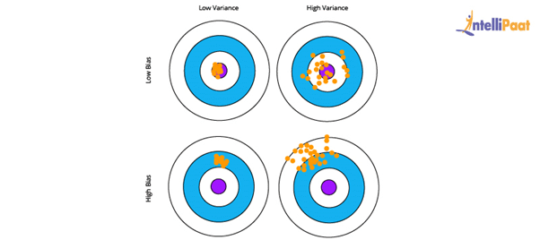
Here, the desired result is the blue circle at the center. If we get off from the blue section, then the prediction goes wrong.
Interested in learning Machine Learning? Enroll in our Machine Learning Training now!

3. What is Clustering in Machine Learning?
Clustering is a technique used in unsupervised learning that involves grouping data points. The clustering algorithm can be used with a set of data points. This technique will allow you to classify all data points into their particular groups. The data points that are thrown into the same category have similar features and properties, while the data points that belong to different groups have distinct features and properties. Statistical data analysis can be performed by this method. Let us take a look at three of the most popular and useful clustering algorithms.
- K-means clustering: This algorithm is commonly used when there is data with no specific group or category. K-means clustering allows you to find the hidden patterns in the data, which can be used to classify the data into various groups. The variable k is used to represent the number of groups the data is divided into, and the data points are clustered using the similarity of features. Here, the centroids of the clusters are used for labeling new data.
- Mean-shift clustering: The main aim of this algorithm is to update the center-point candidates to be mean and find the center points of all groups. In mean-shift clustering, unlike k-means clustering, the possible number of clusters need not be selected as it can automatically be discovered by the mean shift.
- Density-based spatial clustering of applications with noise (DBSCAN): This clustering algorithm is based on density and has similarities with mean-shift clustering. There is no need to preset the number of clusters, but unlike mean-shift clustering, DBSCAN identifies outliers and treats them like noise. Moreover, it can identify arbitrarily-sized and -shaped clusters without much effort.

4. What is Linear Regression in Machine Learning?
Linear Regression is a supervised Machine Learning algorithm. It is used to find the linear relationship between the dependent and independent variables for predictive analysis.
The equation for Linear Regression:

where:
- X is the input or independent variable
- Y is the output or dependent variable
- a is the intercept, and b is the coefficient of X
Below is the best-fit line that shows the data of weight, Y or the dependent variable, and the
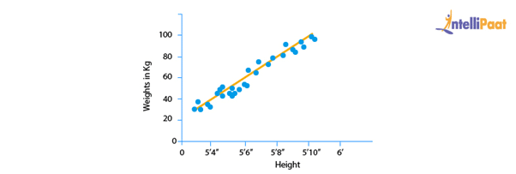
ata of height, X or the independent variable, of 21-year-old candidates scattered over the plot. The straight line shows the best linear relationship that would help in predicting the weight of candidates according to their height.
To get this best-fit line, the best values of a and b should be found. By adjusting the values of a and b, the errors in the prediction of Y can be reduced.
This is how linear regression helps in finding the linear relationship and predicting the output.
窗体底端

5. What is a Decision Tree in Machine Learning?
A decision tree is used to explain the sequence of actions that must be performed to get the desired output. It is a hierarchical diagram that shows the actions.
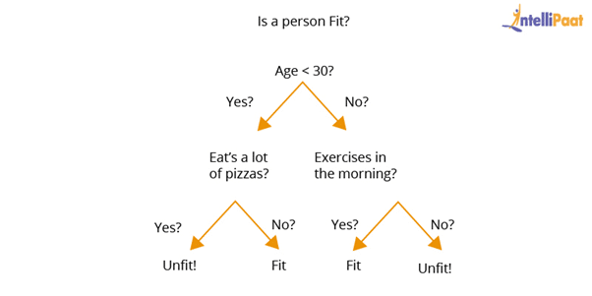
An algorithm can be created for a decision tree on the basis of the set hierarchy of actions.
In the above decision-tree diagram, a sequence of actions has been made for driving a vehicle with or without a license.

6. What is Overfitting in Machine Learning and how can it be avoided?
Overfitting happens when a machine has an inadequate dataset and tries to learn from it. So, overfitting is inversely proportional to the amount of data.
For small databases, overfitting can be bypassed by the cross-validation method. In this approach, a dataset is divided into two sections. These two sections will comprise the testing and training dataset. To train a model, the training dataset is used, and for testing the model for new inputs, the testing dataset is used.
This is how to avoid overfitting.

7. What is Hypothesis in Machine Learning?
Machine Learning allows the use of available dataset to understand a specific function that maps input to output in the best possible way. This problem is known as function approximation. Here, approximation needs to be used for the unknown target function that maps all plausible observations based on the given problem in the best manner. Hypothesis in Machine learning is a model that helps in approximating the target function and performing the necessary input-to-output mappings. The choice and configuration of algorithms allow defining the space of plausible hypotheses that may be represented by a model.
In the hypothesis, lowercase h (h) is used for a specific hypothesis, while uppercase h (H) is used for the hypothesis space that is being searched. Let us briefly understand these notations:
- Hypothesis (h): A hypothesis is a specific model that helps in mapping input to output; the mapping can further be used for evaluation and prediction.
- Hypothesis set (H): Hypothesis set consists of a space of hypotheses that can be used to map inputs to outputs, which can be searched. The general constraints include the choice of problem framing, the model, and the model configuration.

8. What are the differences between Deep Learning and Machine Learning?
- Deep Learning: Deep Learning allows machines to make various business-related decisions using artificial neural networks, which is one of the reasons why it needs a vast amount of data for training. Since there is a lot of computing power required, Deep Learning requires high-end systems as well. The systems acquire various properties and features with the help of the given data, and the problem is solved using an end-to-end method.
- Machine Learning: Machine Learning gives machines the ability to make business decisions without any external help, using the knowledge gained from past data. Machine Learning systems require relatively small amounts of data to train themselves, and most of the features need to be manually coded and understood in advance. In Machine Learning, a given business problem is dissected into two and then solved individually. Once the solutions of both have been acquired, they are then combined.

9. What are the differences between Supervised and Unsupervised Machine Learning?
- Supervised learning: The algorithms of supervised learning use labeled data to get trained. The models take direct feedback to confirm whether the output that is being predicted is, indeed, correct. Moreover, both the input data and the output data are provided to the model, and the main aim here is to train the model to predict the output upon receiving new data. Supervised learning offers accurate results and can largely be divided into two parts, classification and regression.
- Unsupervised learning: The algorithms of unsupervised learning use unlabeled data for training purposes. In unsupervised learning, the models identify hidden data trends and do not take any feedback. The unsupervised learning model is only provided with input data. Unsupervised learning’s main aim is to identify hidden patterns to extract information from unknown sets of data. It can also be classified into two parts, clustering, and associations. Unfortunately, unsupervised learning offers results that are comparatively less accurate.
Learn more about Machine Learning from this Machine Learning tutorial!

10. What is Bayes’s Theorem in Machine Learning?
Bayes’s theorem offers the probability of any given event to occur using prior knowledge. In mathematical terms, it can be defined as the true positive rate of the given sample condition divided by the sum of the true positive rate of the said condition and the false positive rate of the entire population.
Two of the most significant applications of Bayes’s theorem in Machine Learning are Bayesian optimization and Bayesian belief networks. This theorem is also the foundation behind the Machine Learning brand that involves the Naive Bayes classifier.
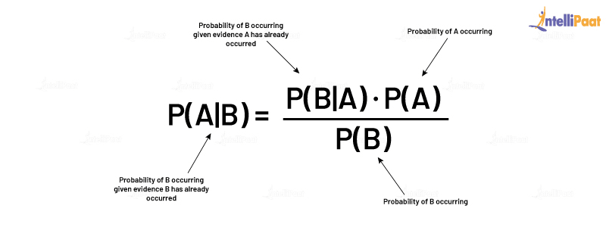

11. What is PCA in Machine Learning?
Multidimensional data is at play in the real world. Data visualization and computation become more challenging with the increase in dimensions. In such a scenario, the dimensions of data might have to be reduced to analyze and visualize it easily. This is done by:
- Removing irrelevant dimensions
- Keeping only the most relevant dimensions
This is where Principal Component Analysis (PCA) is used.
The goal of PCA is to find a fresh collection of uncorrelated dimensions (orthogonal) and rank them on the basis of variance.
Mechanism of PCA:
- Compute the covariance matrix for data objects
- Compute eigenvectors and eigenvalues in descending order
- Select the initial N eigenvectors to get new dimensions
- Finally, change the initial n-dimensional data objects into N-dimensions
Example: Below are two graphs showing data points or objects and two directions, one is green and the other is yellow. Graph 2 is arrived at by rotating Graph 1 so that the x-axis and y-axis represent the green and yellow direction respectively.
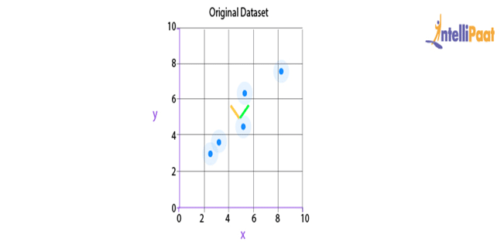
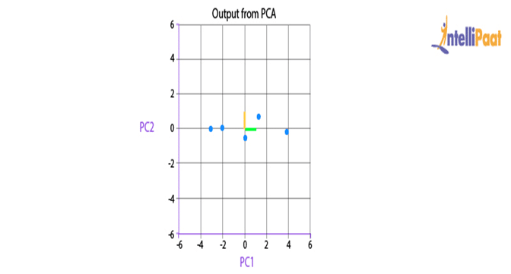
After the rotation of data points, it can be inferred that the green direction, the x-axis, gives the line that best fits the data points.
Here, two-dimensional data is being represented; but in real life, the data would be multidimensional and complex. So, after recognizing the importance of each direction, the area of dimensional analysis can be reduced by cutting off the less-significant directions.
Now, we will go through another important Machine Learning interview question on PCA.
Career Transition

12. What is Support Vector Machine (SVM) in Machine Learning?
SVM is a Machine Learning algorithm that is majorly used for classification. It is used on top of the high dimensionality of the characteristic vector.
The following is the code for SVM classifier:
# Introducing required libraries
from sklearn import datasets
from sklearn.metrics import confusion_matrix
from sklearn.model_selection import train_test_split
# Stacking the Iris dataset
iris = datasets.load_iris()
# A -> features and B -> label
A = iris.data
B = iris.target
# Breaking A and B into train and test data
A_train, A_test, B_train, B_test = train_test_split(A, B, random_state = 0)
# Training a linear SVM classifier
from sklearn.svm import SVC
svm_model_linear = SVC(kernel = 'linear', C = 1).fit(A_train, B_train)
svm_predictions = svm_model_linear.predict(A_test)
# Model accuracy for A_test
accuracy = svm_model_linear.score(A_test, B_test)
# Creating a confusion matrix
cm = confusion_matrix(B_test, svm_predictions)

13. What is Cross-validation in Machine Learning?
Cross-validation allows a system to increase the performance of the given Machine Learning algorithm, which is fed a number of sample data from the dataset. This sampling process is done to break the dataset into smaller parts that have the same number of rows, out of which a random part is selected as a test set and the rest of the parts are kept as train sets. Cross-validation consists of the following techniques:
- Holdout method
- K-fold cross-validation
- Stratified k-fold cross-validation
- Leave p-out cross-validation

14. What is Entropy in Machine Learning?
Entropy in Machine Learning measures the randomness in the data that needs to be processed. The more entropy in the given data, the more difficult it becomes to draw any useful conclusion from the data. For example, let us take the flipping of a coin. The result of this act is random as it does not favor heads or tails. Here, the result for any number of tosses cannot be predicted easily as there is no definite relationship between the action of flipping and the possible outcomes.

15. What is Epoch in Machine Learning?
Epoch in Machine Learning is used to indicate the count of passes in a given training dataset where the Machine Learning algorithm has done its job. Generally, when there is a large chunk of data, it is grouped into several batches. All these batches go through the given model, and this process is referred to as iteration. Now, if the batch size comprises the complete training dataset, then the count of iterations is the same as that of epochs.
In case there is more than one batch, d*e=i*b is the formula used, wherein d is the dataset, e is the number of epochs, i is the number of iterations, and b is the batch size.

Intermediate-level Questions

16. What are the types of Machine Learning?
This is one of the most basic interview questions that everyone must know.
So, basically, there are three types of Machine Learning. They are described as follows:
Supervised learning: In this type of Machine Learning, machines learn under the supervision of labeled data. There is a training dataset on which a machine is trained, and it gives the output according to its training.
Unsupervised learning: This type of Machine Learning has unlabeled data unlike supervised learning. Unsupervised learning works on data under absolutely no supervision. Unsupervised learning tries to identify patterns in data and makes clusters of similar entities. After that, when a new input data is fed into the model, it does not identify the entity; rather, it puts the entity in a cluster of similar objects.

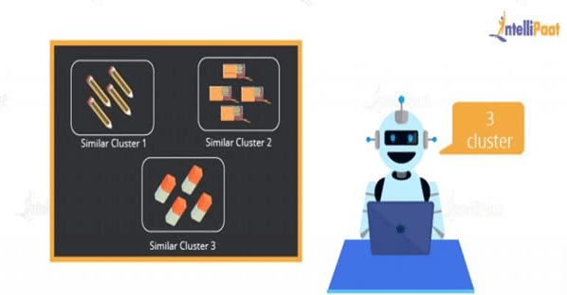
Reinforcement learning: Reinforcement learning includes models that learn and traverse to find the best possible move. The algorithms for reinforcement learning are constructed in a way that they try to find the best possible suite of action on the basis of the reward and punishment theory.
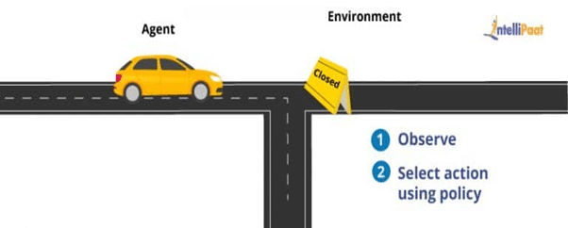
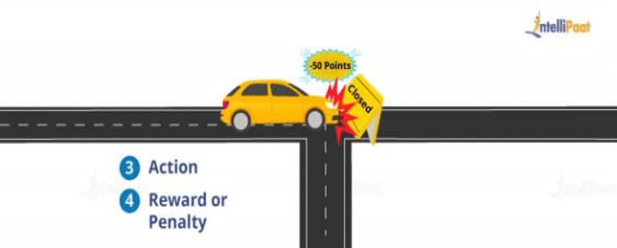
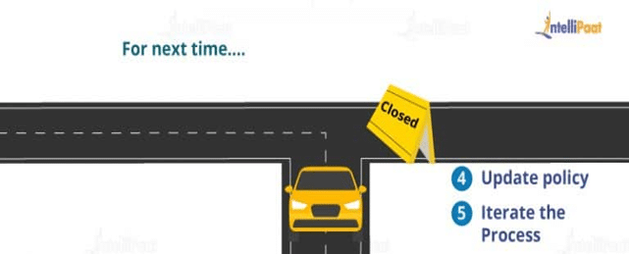

17. Differentiate between Classification and Regression in Machine Learning
In Machine Learning, there are various types of prediction problems based on supervised and unsupervised learning. They are classification, regression, clustering, and association. Here, we will discuss classification and regression.
Classification: In classification, a Machine Learning model is created that assists in differentiating data into separate categories. The data is labeled and categorized based on the input parameters.
For example, predictions have to be made on the churning out customers for a particular product based on some recorded data. Either the customers will churn out or they will not. So, the labels for this would be “Yes” and “No.”
Regression: It is the process of creating a model for distinguishing data into continuous real values, instead of using classes or discrete values. It can also identify the distribution movement depending on historical data. It is used for predicting the occurrence of an event depending on the degree of association of variables.
For example, the prediction of weather conditions depends on factors such as temperature, air pressure, solar radiation, elevation, and distance from the sea. The relation among these factors assists in predicting the weather condition.

18. How is the suitability of a Machine Learning Algorithm determined for a particular problem?
To identify a Machine Learning Algorithm for a particular problem, the following steps should be followed:
Step 1: Problem classification: Classification of the problem depends on the classification of input and output:
- Classifying the input: Classification of the input depends on whether there is data labeled (supervised learning) or unlabeled (unsupervised learning), or whether a model has to be created that interacts with the environment and improves itself (reinforcement learning.)
- Classifying the output: If the output of a model is required as a class, then some classification techniques need to be used.
If the output is a number, then regression techniques must be used; if the output is a different cluster of inputs, then clustering techniques should be used.
Step 2: Checking the algorithms in hand: After classifying the problem, the available algorithms that can be deployed for solving the classified problem should be considered.
Step 3: Implementing the algorithms: If there are multiple algorithms available, then all of them are to be implemented. Finally, the algorithm that gives the best performance is selected.

19. What is the Variance Inflation Factor?
Variance inflation factor (VIF) is the estimate of the volume of multicollinearity in a collection of many regression variables.
VIF = Variance of the model / Variance of the model with a single independent variable
This ratio has to be calculated for every independent variable. If VIF is high, then it shows the high collinearity of the independent variables.
Courses you may like

20. What is a Confusion Matrix?
Confusion matrix is used to explain a model’s performance and gives a summary of predictions of the classification problems. It assists in identifying the uncertainty between classes.
Confusion matrix gives the count of correct and incorrect values and error types. Accuracy of the model:
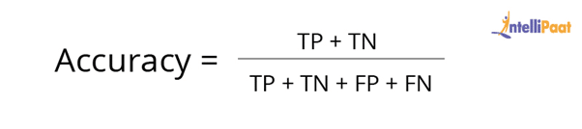
For example, consider the following confusion matrix. It consists of values as true positive, true negative, false positive, and false negative for a classification model. Now, the accuracy of the model can be calculated as follows:

So, in the example:
Accuracy = (200 + 50) / (200 + 50 + 10 + 60) = 0.78
This means that the model’s accuracy is 0.78, corresponding to its True Positive, True Negative, False Positive, and False Negative values.

21. What are Type I and Type II Errors?
Type I Error: Type I Error, false positive, is an error where the outcome of a test shows the nonacceptance of a true condition.
For example, suppose a person gets diagnosed with depression even when they are not suffering from the same, it is a case of false positive.
Type II Error: Type II Error, false negative, is an error where the outcome of a test shows the acceptance of a false condition.
For example, the CT scan of a person shows that they do not have a disease but in fact they do have the disease. Here, the test accepts the false condition that the person does not have the disease. This is a case of false negative.

22. When should Classification be used over Regression?
Both classification and regression are associated with prediction. Classification involves the identification of values or entities that lie in a specific group. Regression entails predicting a response value from consecutive sets of outcomes.
Classification is chosen over regression when the output of the model needs to yield the belongingness of data points in a dataset to a particular category.
For example, If you want to predict the price of a house, you should use regression since it is a numerical variable. However, if you are trying to predict whether a house situated in a particular area is going to be high-, medium-, or low-priced, then a classification model should be used.

23. Explain Logistic Regression
Logistic regression is the proper regression analysis used when the dependent variable is categorical or binary. Like all regression analyses, logistic regression is a technique for predictive analysis. Logistic regression is used to explain data and the relationship between one dependent binary variable and one or more independent variables. Logistic regression is also employed to predict the probability of categorical dependent variables.
Logistic regression can be used in the following scenarios:
- To predict whether a citizen is a Senior Citizen (1) or not (0)
- To check whether a person has a disease (Yes) or not (No)
There are three types of logistic regression:
- Binary logistic regression: In this type of logistic regression, there are only two outcomes possible.
Example: To predict whether it will rain (1) or not (0)
- Multinomial logistic regression: In this type of logistic regression, the output consists of three or more unordered categories.
Example: Predicting whether the prize of the house is high, medium, or low.
- Ordinal logistic regression: In this type of logistic regression, the output consists of three or more ordered categories.
Example: Rating an Android application from one to five stars.
Interested in learning Machine Learning? Enroll in this Machine Learning Training in Bangalore!

24. How to handle Missing or Corrupted Data in a Dataset?
In Python pandas, there are two methods to locate lost or corrupted data and discard those values:
- isNull(): It can be used for detecting the missing values.
- dropna(): It can be used for removing columns or rows with null values.
fillna() can be used to fill the void values with placeholder values.

25. Why is rotation required in PCA? What will happen if the components are not rotated?
Rotation is a significant step in principal component analysis (PCA.) Rotation maximizes the separation within the variance obtained by the components. This makes the interpretation of the components easier.
The motive behind conducting PCA is to choose fewer components that can explain the greatest variance in a dataset. When rotation is performed, the original coordinates of the points get changed. However, there is no change in the relative position of the components.
If the components are not rotated, then there needs to be more extended components to describe the variance.

26. What is ROC Curve and what does it represent?
ROC stands for receiver operating characteristic. ROC Curve is used to graphically represent the trade-off between true and false-positive rates.
In ROC, the area under the curve (AUC) gives an idea about the accuracy of the model.
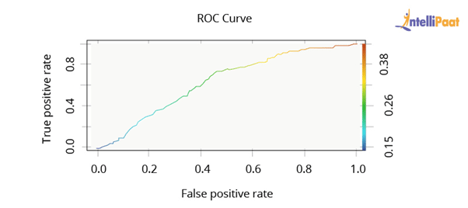
The above graph shows a ROC curve. The greater the AUC, the better the performance of the model.
Next, we will be taking a look at Machine Learning interview questions on rescaling, binarizing, and standardizing.

27. Why are Validation and Test Datasets Needed?
Data is split into three different categories while creating a model:
- Training dataset: Training dataset is used for building a model and adjusting its variables. The correctness of the model built on the training dataset cannot be relied on as the model might give incorrect outputs after being fed new inputs.
- Validation dataset: Validation dataset is used to look into a model’s response. After this, the hyperparameters on the basis of the estimated benchmark of the validation dataset data are tuned.When a model’s response is evaluated by using the validation dataset, the model is indirectly trained with the validation set. This may lead to the overfitting of the model to specific data. So, this model will not be strong enough to give the desired response to real-world data.
- Test dataset: Test dataset is the subset of the actual dataset, which is not yet used to train the model. The model is unaware of this dataset. So, by using the test dataset, the response of the created model can be computed on hidden data. The model’s performance is tested on the basis of the test dataset.Note: The model is always exposed to the test dataset after tuning the hyperparameters on top of the validation dataset.
As we know, the evaluation of the model on the basis of the validation dataset would not be enough. Thus, the test dataset is used for computing the efficiency of the model.

28. Explain the difference between KNN and K-means Clustering
K-nearest neighbors (KNN): It is a supervised Machine Learning algorithm. In KNN, identified or labeled data is given to the model. The model then matches the points based on the distance from the closest points.
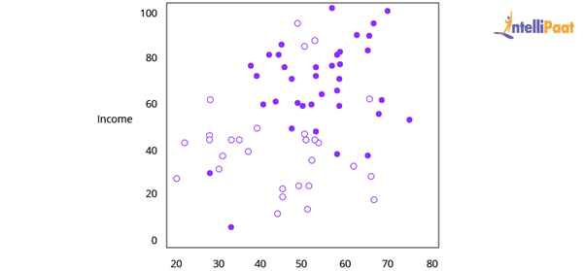
K-means clustering: It is an unsupervised Machine Learning algorithm. In K-means clustering, unidentified or unlabeled data is given to the model. The algorithm then creates batches of points based on the average of the distances between distinct points.
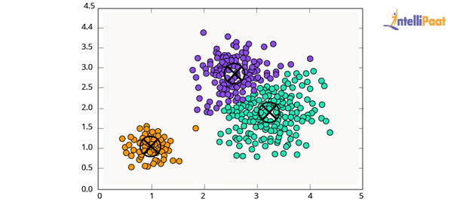

29. What is Dimensionality Reduction?
In the real world, Machine Learning models are built on top of features and parameters. These features can be multidimensional and large in number. Sometimes, the features may be irrelevant and it becomes a difficult task to visualize them.
This is where dimensionality reduction is used to cut down irrelevant and redundant features with the help of principal variables. These principal variables conserve the features, and are a subgroup, of the parent variables.

30. Both being Tree-based Algorithms, how is Random Forest different from Gradient Boosting Machine (GBM)?
The main difference between a random forest and GBM is the use of techniques. Random forest advances predictions using a technique called bagging. On the other hand, GBM advances predictions with the help of a technique called boosting.
- Bagging: In bagging, we apply arbitrary sampling and we divide the dataset into N. After that, we build a model by employing a single training algorithm. Following that, we combine the final predictions by polling. Bagging helps to increase the efficiency of a model by decreasing the variance to eschew overfitting.
- Boosting: In boosting, the algorithm tries to review and correct the inadmissible predictions at the initial iteration. After that, the algorithm’s sequence of iterations for correction continues until we get the desired prediction. Boosting assists in reducing bias and variance for strengthening the weak learners.

31. What is meant by Parametric and Non-parametric Models?
Parametric models refer to the models having a limited number of parameters. In case of parametric models, only the parameter of a model is needed to be known to make predictions regarding the new data.
Non-parametric models do not have any restrictions on the number of parameters, which makes new data predictions more flexible. In case of non-parametric models, the knowledge of model parameters and the state of the data needs to be known to make predictions.

32. Differentiate between Sigmoid and Softmax Functions
Sigmoid and Softmax functions differ based on their usage in Machine Learning task classification. Sigmoid function is used in the case of binary classification, while Softmax function is used in case of multi-classification.

33. In Machine Learning, for how many classes can Logistic Regression be used?
Logistic regression cannot be used for more than two classes. Logistic regression is, by default, a binary classifier. However, in cases where multi-class classification problems need to be solved, the default number of classes can be extended, i.e., multinomial logistic regression.

34. What do you understand about the P-value?
P-value is used in decision-making while testing a hypothesis. The null hypothesis is rejected at the minimum significance level of the P-value. A lower P-value indicates that the null hypothesis is to be rejected.

35. What is meant by Correlation and Covariance?
Correlation is a mathematical concept used in statistics and probability theory to measure, estimate, and compare data samples taken from different populations. In simpler terms, correlation helps in establishing a quantitative relationship between two variables.
Covariance is also a mathematical concept; it is a simpler way to arrive at a correlation between two variables. Covariance basically helps in determining what change or affect does one variable has on another.

36. What are the Various Tests for Checking the Normality of a Dataset?
In Machine Learning, checking the normality of a dataset is very important. Hence, certain tests are performed on a dataset to check its normality. Some of them are:
- D’Agostino Skewness Test
- Shapiro-Wilk Test
- Anderson-Darling Test
- Jarque-Bera Test
- Kolmogorov-Smirnov Test

37. What are the Two Main Types of Filtering in Machine Learning? Explain.
The two types of filtering are:
- Collaborative filtering
- Content-based filtering
Collaborative filtering refers to a recommender system where the interests of the individual user are matched with preferences of multiple users to predict new content.
Content-based filtering is a recommender system where the focus is only on the preferences of the individual user and not on multiple users.

38. Outlier Values can be Discovered from which Tools?
The various tools that can be used to discover outlier values are scatterplots, boxplots, Z-score, etc.

39. What is meant by Ensemble Learning?
Ensemble learning refers to the combination of multiple Machine Learning models to create more powerful models. The primary techniques involved in ensemble learning are bagging and boosting.

Watch this complete course video on Machine Learning Interview Questions

40. What are the Various Kernels that are present in SVM?
The various kernels that are present in SVM are:
- Linear
- Polynomial
- Radial Basis
- Sigmoid

Advanced-level Questions

41. Suppose you found that your model is suffering from high variance. Which algorithm do you think could handle this situation and why?
Handling High Variance
- For handling issues of high variance, we should use the bagging algorithm.
- The bagging algorithm would split data into subgroups with a replicated sampling of random data.
- Once the algorithm splits the data, we can use random data to create rules using a particular training algorithm.
- After that, we can use polling for combining the predictions of the model.

42. What is Rescaling of Data and how is it done?
In real-world scenarios, the attributes present in data are in a varying pattern. So, rescaling the characteristics to a common scale is beneficial for algorithms to process data efficiently.
We can rescale data using Scikit-learn. The code for rescaling the data using MinMaxScaler is as follows:
#Rescaling data
import pandas
import scipy
import numpy
from sklearn.preprocessing import MinMaxScaler
names = ['Abhi', 'Piyush', 'Pranay', 'Sourav', 'Sid', 'Mike', 'pedi', 'Jack', 'Tim']
Dataframe = pandas.read_csv(url, names=names)
Array = dataframe.values
# Splitting the array into input and output
X = array[:,0:8]
Y = array[:,8]
Scaler = MinMaxScaler(feature_range=(0, 1))
rescaledX = scaler.fit_transform(X)
# Summarizing the modified data
numpy.set_printoptions(precision=3)
print(rescaledX[0:5,:])
Apart from the theoretical concepts, some interviewers also focus on the implementation of Machine Learning topics. The following Interview Questions are related to the implementation of theoretical concepts.

43. What is Binarizing of Data? How to Binarize?
Converting data into binary values on the basis of threshold values is known as binarizing of data. The values that are less than the threshold are set to 0 and the values that are greater than the threshold are set to 1. This process is useful when feature engineering has to be performed. This can also be used for adding unique features. Data can be binarized using Scikit-learn. The code for binarizing data using Binarizer is as follows:
from sklearn.preprocessing import Binarizer
import pandasimport numpynames = ['Abhi', 'Piyush', 'Pranay', 'Sourav', 'Sid', 'Mike', 'pedi', 'Jack', 'Tim']dataframe = pandas.read_csv(url, names=names)array = dataframe.values# Splitting the array into input and outputX = array[:,0:8]Y = array[:,8]binarizer = Binarizer(threshold=0.0).fit(X)binaryX = binarizer.transform(X)# Summarizing the modified datanumpy.set_printoptions(precision=3)print(binaryX[0:5,:])

44. How to Standardize Data?
Standardization is the method that is used for rescaling data attributes. The attributes are likely to have a mean value of 0 and a value of the standard deviation of 1. The main objective of standardization is to prompt the mean and standard deviation for the attributes.
Data can be standardized using Scikit-learn. The code for standardizing the data using StandardScaler is as follows:
# Python code to Standardize data (0 mean, 1 stdev)
from sklearn.preprocessing import StandardScaler
import pandas
import numpy
names = ['Abhi', 'Piyush', 'Pranay', 'Sourav', 'Sid', 'Mike', 'pedi', 'Jack', 'Tim']
dataframe = pandas.read_csv(url, names=names)
array = dataframe.values
# Separate the array into input and output components
X = array[:,0:8]
Y = array[:,8]
scaler = StandardScaler().fit(X)
rescaledX = scaler.transform(X)
# Summarize the transformed data
numpy.set_printoptions(precision=3)
print(rescaledX[0:5,:])

45. We know that one-hot encoding increases the dimensionality of a dataset, but label encoding doesn’t. How?
When one-hot encoding is used, there is an increase in the dimensionality of a dataset. The reason for the increase in dimensionality is that every class in categorical variables, forms a different variable.
Example: Suppose there is a variable “Color.” It has three sublevels, “Yellow,” “Purple,” and “Orange.” So, one-hot encoding “Color” will create three different variables as Color.Yellow, Color.Purple, and Color.Orange.
In label encoding, the subclasses of a certain variable get the value 0 and 1. So, label encoding is only used for binary variables.
This is why one-hot encoding increases the dimensionality of data and label encoding does not.
Now, if you are interested in doing an end-to-end certification course in Machine Learning, you can check out Intellipaat’s Machine Learning Course with Python.

46. Executing a binary classification tree algorithm is a simple task. But how does tree splitting take place? How does the tree determine which variable to break at the root node and which at its child nodes?
Gini index and Node Entropy assist the binary classification tree to make decisions. Basically, the tree algorithm determines the feasible feature that is used to distribute data into the most genuine child nodes.
According to the Gini index, if we arbitrarily pick a pair of objects from a group, then they should be of identical class and the probability for this event should be 1.
The following are the steps to compute the Gini index:
- Compute Gini for sub-nodes with the formula: The sum of the square of probability for success and failure (p^2 + q^2)
- Compute Gini for split by weighted Gini rate of every node of the split
Now, Entropy is the degree of indecency that is given by the following:
Where a and b are the probabilities of success and failure of the node
When Entropy = 0, the node is homogenous
When Entropy is high, both groups are present at 50–50 percent in the node.
Finally, to determine the suitability of the node as a root node, the entropy should be very low.

47. Imagine you are given a dataset consisting of variables having more than 30% missing values. Let’s say, out of 50 variables, 16 variables have missing values, which is higher than 30%. How will you deal with them?
To deal with the missing values, we will do the following:
- We will specify a different class for the missing values.
- Now, we will check the distribution of values, and we will hold those missing values that are defining a pattern.
- Then, we will charge these values into yet another class while eliminating others.

48. Explain False Negative, False Positive, True Negative, and True Positive with a simple example.
True Positive (TP): When the Machine Learning model correctly predicts the condition, it is said to have a True Positive value.
True Negative (TN): When the Machine Learning model correctly predicts the negative condition or class, then it is said to have a True Negative value.
False Positive (FP): When the Machine Learning model incorrectly predicts a negative class or condition, then it is said to have a False Positive value.
False Negative (FN): When the Machine Learning model incorrectly predicts a positive class or condition, then it is said to have a False Negative value.

49. What is F1-score and How Is It Used?
F-score or F1-score is a measure of overall accuracy of a binary classification model. Before understanding F1-score, it is crucial to understand two more measures of accuracy, i.e., precision and recall.
Precision is defined as the percentage of True Positives to the total number of positive classifications predicted by the model. In other words,
Precision = (No. of True Positives / No. True Positives + No. of False Positives)
Recall is defined as the percentage of True Positives to the total number of actual positive labeled data passed to the model. In other words,
Precision = (No. of True Positives / No. True Positives + No. of False Negatives)
Both precision and recall are partial measures of accuracy of a model. F1-score combines precision and recall and provides an overall score to measure a model’s accuracy.
F1-score = 2 × (Precision × Recall) / (Precision + Recall)
This is why, F1-score is the most popular measure of accuracy in any Machine-Learning-based binary classification model.

50. How to Implement the KNN Classification Algorithm?
Iris dataset is used for implementing the KNN classification algorithm.
# KNN classification algorithm
from sklearn.datasets import load_iris
from sklearn.neighbors import KNeighborsClassifier
import numpy as np
from sklearn.model_selection import train_test_split
iris_dataset=load_iris()
A_train, A_test, B_train, B_test = ztrain_test_split(iris_dataset["data"], iris_dataset["target"], random_state=0)
kn = KNeighborsClassifier(n_neighbors=1)
kn.fit(A_train, B_train)
A_new = np.array([[8, 2.5, 1, 1.2]])
prediction = kn.predict(A_new)
print("Predicted target value: {}\n".format(prediction))
print("Predicted feature name: {}\n".format
(iris_dataset["target_names"][prediction]))
print("Test score: {:.2f}".format(kn.score(A_test, B_test)))
Output:
Predicted Target Name: [0]
Predicted Feature Name: [‘ Setosa’]
Test Score: 0.92

Machine Learning Interview Questions: Algorithms/Theory
Machine learning interview questions about ML algorithms will test your grasp of the theory behind machine learning.

Q1: What’s the trade-off between bias and variance?
Answer: Bias is error due to erroneous or overly simplistic assumptions in the learning algorithm you’re using. This can lead to the model underfitting your data, making it hard for it to have high predictive accuracy and for you to generalize your knowledge from the training set to the test set.
Variance is error due to too much complexity in the learning algorithm you’re using. This leads to the algorithm being highly sensitive to high degrees of variation in your training data, which can lead your model to overfit the data. You’ll be carrying too much noise from your training data for your model to be very useful for your test data.
The bias-variance decomposition essentially decomposes the learning error from any algorithm by adding the bias, the variance and a bit of irreducible error due to noise in the underlying dataset. Essentially, if you make the model more complex and add more variables, you’ll lose bias but gain some variance — in order to get the optimally reduced amount of error, you’ll have to tradeoff bias and variance. You don’t want either high bias or high variance in your model.
More reading: Bias-Variance Tradeoff (Wikipedia)

Q2: What is the difference between supervised and unsupervised machine learning?
Answer: Supervised learning requires training labeled data. For example, in order to do classification (a supervised learning task), you’ll need to first label the data you’ll use to train the model to classify data into your labeled groups. Unsupervised learning, in contrast, does not require labeling data explicitly.
More reading: Classic examples of supervised vs. unsupervised learning (Springboard)

Q3: How is KNN different from k-means clustering?
Answer: K-Nearest Neighbors is a supervised classification algorithm, while k-means clustering is an unsupervised clustering algorithm. While the mechanisms may seem similar at first, what this really means is that in order for K-Nearest Neighbors to work, you need labeled data you want to classify an unlabeled point into (thus the nearest neighbor part). K-means clustering requires only a set of unlabeled points and a threshold: the algorithm will take unlabeled points and gradually learn how to cluster them into groups by computing the mean of the distance between different points.
The critical difference here is that KNN needs labeled points and is thus supervised learning, while k-means doesn’t—and is thus unsupervised learning.
More reading: How is the k-nearest neighbor algorithm different from k-means clustering? (Quora)

Q4: Explain how a ROC curve works.
Answer: The ROC curve is a graphical representation of the contrast between true positive rates and the false positive rate at various thresholds. It’s often used as a proxy for the trade-off between the sensitivity of the model (true positives) vs the fall-out or the probability it will trigger a false alarm (false positives).
More reading: Receiver operating characteristic (Wikipedia)

Q5: Define precision and recall.
Answer: Recall is also known as the true positive rate: the amount of positives your model claims compared to the actual number of positives there are throughout the data. Precision is also known as the positive predictive value, and it is a measure of the amount of accurate positives your model claims compared to the number of positives it actually claims. It can be easier to think of recall and precision in the context of a case where you’ve predicted that there were 10 apples and 5 oranges in a case of 10 apples. You’d have perfect recall (there are actually 10 apples, and you predicted there would be 10) but 66.7% precision because out of the 15 events you predicted, only 10 (the apples) are correct.
Explanation: Out of a sample size of 15 (10 apples + 5 oranges), you have identified 10 apples as apples BUT you have also incorrectly predicted 5 oranges as apples. This implies that the true positive figure is 10 (10 correctly identified apples), whereas the false positive figure is 5 (5 oranges incorrectly tagged as apples).
As per the formula of Precision = True Positive / (True Positive + False Positive), therefore the precision rate is 67%.
As per the Recall formula = True Positive / (True Positive + False Negative), hence the recall rate is 100%. This is because not a single apple was incorrectly predicted as an orange.
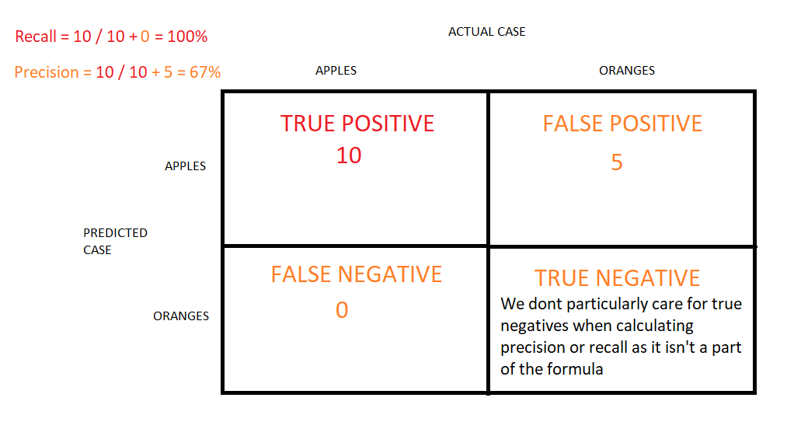
More reading: Precision and recall (Wikipedia)

Q6: What is Bayes’ Theorem? How is it useful in a machine learning context?
Answer: Bayes’ Theorem gives you the posterior probability of an event given what is known as prior knowledge.
Mathematically, it’s expressed as the true positive rate of a condition sample divided by the sum of the false positive rate of the population and the true positive rate of a condition. Say you had a 60% chance of actually having the flu after a flu test, but out of people who had the flu, the test will be false 50% of the time, and the overall population only has a 5% chance of having the flu. Would you actually have a 60% chance of having the flu after having a positive test?
Bayes’ Theorem says no. It says that you have a (.6 * 0.05) (True Positive Rate of a Condition Sample) / (.6*0.05)(True Positive Rate of a Condition Sample) + (.5*0.95) (False Positive Rate of a Population) = 0.0594 or 5.94% chance of getting a flu.
Bayes’ Theorem is the basis behind a branch of machine learning that most notably includes the Naive Bayes classifier. That’s something important to consider when you’re faced with machine learning interview questions.
More reading: An Intuitive (and Short) Explanation of Bayes’ Theorem (BetterExplained)

Q7: Why is “Naive” Bayes naive?
Answer: Despite its practical applications, especially in text mining, Naive Bayes is considered “Naive” because it makes an assumption that is virtually impossible to see in real-life data: the conditional probability is calculated as the pure product of the individual probabilities of components. This implies the absolute independence of features — a condition probably never met in real life.
As a Quora commenter put it whimsically, a Naive Bayes classifier that figured out that you liked pickles and ice cream would probably naively recommend you a pickle ice cream.
More reading: Why is “naive Bayes” naive? (Quora)

Q8: Explain the difference between L1 and L2 regularization.
Answer: L2 regularization tends to spread error among all the terms, while L1 is more binary/sparse, with many variables either being assigned a 1 or 0 in weighting. L1 corresponds to setting a Laplacean prior on the terms, while L2 corresponds to a Gaussian prior.
More reading: What is the difference between L1 and L2 regularization? (Quora)

Q9: What’s your favorite algorithm, and can you explain it to me in less than a minute?
Answer: Interviewers ask such machine learning interview questions to test your understanding of how to communicate complex and technical nuances with poise and the ability to summarize quickly and efficiently. While answering such questions, make sure you have a choice and ensure you can explain different algorithms so simply and effectively that a five-year-old could grasp the basics!

Q10: What’s the difference between Type I and Type II error?
Answer: Don’t think that this is a trick question! Many machine learning interview questions will be an attempt to lob basic questions at you just to make sure you’re on top of your game and you’ve prepared all of your bases.
Type I error is a false positive, while Type II error is a false negative. Briefly stated, Type I error means claiming something has happened when it hasn’t, while Type II error means that you claim nothing is happening when in fact something is.
A clever way to think about this is to think of Type I error as telling a man he is pregnant, while Type II error means you tell a pregnant woman she isn’t carrying a baby.
More reading: Type I and type II errors (Wikipedia)

Q11: What’s a Fourier transform?
Answer: A Fourier transform is a generic method to decompose generic functions into a superposition of symmetric functions. Or as this more intuitive tutorial puts it, given a smoothie, it’s how we find the recipe. The Fourier transform finds the set of cycle speeds, amplitudes, and phases to match any time signal. A Fourier transform converts a signal from time to frequency domain—it’s a very common way to extract features from audio signals or other time series such as sensor data.
More reading: Fourier transform (Wikipedia)

Q12: What’s the difference between probability and likelihood?
More reading: What is the difference between “likelihood” and “probability”? (Cross Validated)

Q13: What is deep learning, and how does it contrast with other machine learning algorithms?
Answer: Deep learning is a subset of machine learning that is concerned with neural networks: how to use backpropagation and certain principles from neuroscience to more accurately model large sets of unlabelled or semi-structured data. In that sense, deep learning represents an unsupervised learning algorithm that learns representations of data through the use of neural nets.
More reading: Deep learning (Wikipedia)

Q14: What’s the difference between a generative and discriminative model?
Answer: A generative model will learn categories of data while a discriminative model will simply learn the distinction between different categories of data. Discriminative models will generally outperform generative models on classification tasks.
More reading: What is the difference between a Generative and Discriminative Algorithm? (Stack Overflow)

Q15: What cross-validation technique would you use on a time series dataset?
Answer: Instead of using standard k-folds cross-validation, you have to pay attention to the fact that a time series is not randomly distributed data—it is inherently ordered by chronological order. If a pattern emerges in later time periods, for example, your model may still pick up on it even if that effect doesn’t hold in earlier years!
You’ll want to do something like forward chaining where you’ll be able to model on past data then look at forward-facing data.
- Fold 1 : training [1], test [2]
- Fold 2 : training [1 2], test [3]
- Fold 3 : training [1 2 3], test [4]
- Fold 4 : training [1 2 3 4], test [5]
- Fold 5 : training [1 2 3 4 5], test [6]
More reading: Using k-fold cross-validation for time-series model selection (CrossValidated)

Q16: How is a decision tree pruned?
Answer: Pruning is what happens in decision trees when branches that have weak predictive power are removed in order to reduce the complexity of the model and increase the predictive accuracy of a decision tree model. Pruning can happen bottom-up and top-down, with approaches such as reduced error pruning and cost complexity pruning.
Reduced error pruning is perhaps the simplest version: replace each node. If it doesn’t decrease predictive accuracy, keep it pruned. While simple, this heuristic actually comes pretty close to an approach that would optimize for maximum accuracy.
More reading: Pruning (decision trees)

Q17: Which is more important to you: model accuracy or model performance?
Answer: Such machine learning interview questions tests your grasp of the nuances of machine learning model performance! Machine learning interview questions often look towards the details. There are models with higher accuracy that can perform worse in predictive power—how does that make sense?
Well, it has everything to do with how model accuracy is only a subset of model performance, and at that, a sometimes misleading one. For example, if you wanted to detect fraud in a massive dataset with a sample of millions, a more accurate model would most likely predict no fraud at all if only a vast minority of cases were fraud. However, this would be useless for a predictive model—a model designed to find fraud that asserted there was no fraud at all! Questions like this help you demonstrate that you understand model accuracy isn’t the be-all and end-all of model performance.
More reading: Accuracy paradox (Wikipedia)

Q18: What’s the F1 score? How would you use it?
Answer: The F1 score is a measure of a model’s performance. It is a weighted average of the precision and recall of a model, with results tending to 1 being the best, and those tending to 0 being the worst. You would use it in classification tests where true negatives don’t matter much.
More reading: F1 score (Wikipedia)

Q19: How would you handle an imbalanced dataset?
Answer: An imbalanced dataset is when you have, for example, a classification test and 90% of the data is in one class. That leads to problems: an accuracy of 90% can be skewed if you have no predictive power on the other category of data! Here are a few tactics to get over the hump:
- Collect more data to even the imbalances in the dataset.
- Resample the dataset to correct for imbalances.
- Try a different algorithm altogether on your dataset.
What’s important here is that you have a keen sense for what damage an unbalanced dataset can cause, and how to balance that.
More reading: 8 Tactics to Combat Imbalanced Classes in Your Machine Learning Dataset (Machine Learning Mastery)

Q20: When should you use classification over regression?
Answer: Classification produces discrete values and dataset to strict categories, while regression gives you continuous results that allow you to better distinguish differences between individual points. You would use classification over regression if you wanted your results to reflect the belongingness of data points in your dataset to certain explicit categories (ex: If you wanted to know whether a name was male or female rather than just how correlated they were with male and female names.)
More reading: Regression vs Classification (Math StackExchange)

Q21: Name an example where ensemble techniques might be useful.
Answer: Ensemble techniques use a combination of learning algorithms to optimize better predictive performance. They typically reduce overfitting in models and make the model more robust (unlikely to be influenced by small changes in the training data).
You could list some examples of ensemble methods (bagging, boosting, the “bucket of models” method) and demonstrate how they could increase predictive power.
More reading: Ensemble learning (Wikipedia)

Q22: How do you ensure you’re not overfitting with a model?
Answer: This is a simple restatement of a fundamental problem in machine learning: the possibility of overfitting training data and carrying the noise of that data through to the test set, thereby providing inaccurate generalizations.
There are three main methods to avoid overfitting:
- Keep the model simpler: reduce variance by taking into account fewer variables and parameters, thereby removing some of the noise in the training data.
- Use cross-validation techniques such as k-folds cross-validation.
- Use regularization techniques such as LASSO that penalize certain model parameters if they’re likely to cause overfitting.
More reading: How can I avoid overfitting? (Quora)

Q23: What evaluation approaches would you work to gauge the effectiveness of a machine learning model?
Answer: You would first split the dataset into training and test sets, or perhaps use cross-validation techniques to further segment the dataset into composite sets of training and test sets within the data. You should then implement a choice selection of performance metrics: here is a fairly comprehensive list. You could use measures such as the F1 score, the accuracy, and the confusion matrix. What’s important here is to demonstrate that you understand the nuances of how a model is measured and how to choose the right performance measures for the right situations.
More reading: How to Evaluate Machine Learning Algorithms (Machine Learning Mastery)

Q24: How would you evaluate a logistic regression model?
Answer: A subsection of the question above. You have to demonstrate an understanding of what the typical goals of a logistic regression are (classification, prediction, etc.) and bring up a few examples and use cases.
More reading: Evaluating a logistic regression (CrossValidated), Logistic Regression in Plain English
More reading: How a Machine Learning Algorithm Helped Make Hurricane Damage Assessments Safer, Cheaper, and More Effective

Q25: What’s the “kernel trick” and how is it useful?
Answer: The Kernel trick involves kernel functions that can enable in higher-dimension spaces without explicitly calculating the coordinates of points within that dimension: instead, kernel functions compute the inner products between the images of all pairs of data in a feature space. This allows them the very useful attribute of calculating the coordinates of higher dimensions while being computationally cheaper than the explicit calculation of said coordinates. Many algorithms can be expressed in terms of inner products. Using the kernel trick enables us effectively run algorithms in a high-dimensional space with lower-dimensional data.
More reading: Kernel method (Wikipedia)

Machine Learning Interview Questions: Programming
These machine learning interview questions test your knowledge of programming principles you need to implement machine learning principles in practice. Machine learning interview questions tend to be technical questions that test your logic and programming skills: this section focuses more on the latter.

Q26: How do you handle missing or corrupted data in a dataset?
Answer: You could find missing/corrupted data in a dataset and either drop those rows or columns, or decide to replace them with another value.
In Pandas, there are two very useful methods: isnull() and dropna() that will help you find columns of data with missing or corrupted data and drop those values. If you want to fill the invalid values with a placeholder value (for example, 0), you could use the fillna() method.
More reading: Handling missing data (O’Reilly)

Q27: Do you have experience with Spark or big data tools for machine learning?
Answer: You’ll want to get familiar with the meaning of big data for different companies and the different tools they’ll want. Spark is the big data tool most in demand now, able to handle immense datasets with speed. Be honest if you don’t have experience with the tools demanded, but also take a look at job descriptions and see what tools pop up: you’ll want to invest in familiarizing yourself with them.
More reading: 50 Top Open Source Tools for Big Data (Datamation)

Q28: Pick an algorithm. Write the pseudo-code for a parallel implementation.
Answer: This kind of question demonstrates your ability to think in parallelism and how you could handle concurrency in programming implementations dealing with big data. Take a look at pseudocode frameworks such as Peril-L and visualization tools such as Web Sequence Diagrams to help you demonstrate your ability to write code that reflects parallelism.
More reading: Writing pseudocode for parallel programming (Stack Overflow)

Q29: What are some differences between a linked list and an array?
Answer: An array is an ordered collection of objects. A linked list is a series of objects with pointers that direct how to process them sequentially. An array assumes that every element has the same size, unlike the linked list. A linked list can more easily grow organically: an array has to be pre-defined or re-defined for organic growth. Shuffling a linked list involves changing which points direct where—meanwhile, shuffling an array is more complex and takes more memory.
More reading: Array versus linked list (Stack Overflow)

Q30: Describe a hash table.
Answer: A hash table is a data structure that produces an associative array. A key is mapped to certain values through the use of a hash function. They are often used for tasks such as database indexing.
More reading: Hash table (Wikipedia)

Q31: Which data visualization libraries do you use? What are your thoughts on the best data visualization tools?
Answer: What’s important here is to define your views on how to properly visualize data and your personal preferences when it comes to tools. Popular tools include R’s ggplot, Python’s seaborn and matplotlib, and tools such as Plot.ly and Tableau.
More reading: 31 Free Data Visualization Tools (Springboard)
Related: 20 Python Interview Questions

Q32: Given two strings, A and B, of the same length n, find whether it is possible to cut both strings at a common point such that the first part of A and the second part of B form a palindrome.
Answer: You’ll often get standard algorithms and data structures questions as part of your interview process as a machine learning engineer that might feel akin to a software engineering interview. In this case, this comes from Google’s interview process. There are multiple ways to check for palindromes—one way of doing so if you’re using a programming language such as Python is to reverse the string and check to see if it still equals the original string, for example. The thing to look out for here is the category of questions you can expect, which will be akin to software engineering questions that drill down to your knowledge of algorithms and data structures. Make sure that you’re totally comfortable with the language of your choice to express that logic.
More reading: Glassdoor ML interview questions

Q33: How are primary and foreign keys related in SQL?
Answer: Most machine learning engineers are going to have to be conversant with a lot of different data formats. SQL is still one of the key ones used. Your ability to understand how to manipulate SQL databases will be something you’ll most likely need to demonstrate. In this example, you can talk about how foreign keys allow you to match up and join tables together on the primary key of the corresponding table—but just as useful is to talk through how you would think about setting up SQL tables and querying them.
More reading: What is the difference between a primary and foreign key in SQL? and 105 SQL interview questions

Q34: How does XML and CSVs compare in terms of size?
Answer: In practice, XML is much more verbose than CSVs are and takes up a lot more space. CSVs use some separators to categorize and organize data into neat columns. XML uses tags to delineate a tree-like structure for key-value pairs. You’ll often get XML back as a way to semi-structure data from APIs or HTTP responses. In practice, you’ll want to ingest XML data and try to process it into a usable CSV. This sort of question tests your familiarity with data wrangling sometimes messy data formats.
More reading: How Can XML Be Used?

Q35: What are the data types supported by JSON?
Answer: This tests your knowledge of JSON, another popular file format that wraps with JavaScript. There are six basic JSON datatypes you can manipulate: strings, numbers, objects, arrays, booleans, and null values.
More reading: JSON datatypes

Q36: How would you build a data pipeline?
Answer: Data pipelines are the bread and butter of machine learning engineers, who take data science models and find ways to automate and scale them. Make sure you’re familiar with the tools to build data pipelines (such as Apache Airflow) and the platforms where you can host models and pipelines (such as Google Cloud or AWS or Azure). Explain the steps required in a functioning data pipeline and talk through your actual experience building and scaling them in production.
More reading: 10 Minutes to Building A Machine Learning Pipeline With Apache Airflow

Machine Learning Interview Questions: Company/Industry Specific
These machine learning interview questions deal with how to implement your general machine learning knowledge to a specific company’s requirements. You’ll be asked to create case studies and extend your knowledge of the company and industry you’re applying for with your machine learning skills.

Q37: What do you think is the most valuable data in our business?
Answer: This question or questions like it really try to test you on two dimensions. The first is your knowledge of the business and the industry itself, as well as your understanding of the business model. The second is whether you can pick how correlated data is to business outcomes in general, and then how you apply that thinking to your context about the company. You’ll want to research the business model and ask good questions to your recruiter—and start thinking about what business problems they probably want to solve most with their data.
More reading: Three Recommendations For Making The Most Of Valuable Data

Q38: How would you implement a recommendation system for our company’s users?
Answer: A lot of machine learning interview questions of this type will involve the implementation of machine learning models to a company’s problems. You’ll have to research the company and its industry in-depth, especially the revenue drivers the company has, and the types of users the company takes on in the context of the industry it’s in.
More reading: How to Implement A Recommendation System? (Stack Overflow)

Q39: How can we use your machine learning skills to generate revenue?
Answer: This is a tricky question. The ideal answer would demonstrate knowledge of what drives the business and how your skills could relate. For example, if you were interviewing for music-streaming startup Spotify, you could remark that your skills at developing a better recommendation model would increase user retention, which would then increase revenue in the long run.
The startup metrics Slideshare linked above will help you understand exactly what performance indicators are important for startups and tech companies as they think about revenue and growth.
More reading: Startup Metrics for Startups (500 Startups)

Q40: What do you think of our current data process?

Answer: This kind of question requires you to listen carefully and impart feedback in a manner that is constructive and insightful. Your interviewer is trying to gauge if you’d be a valuable member of their team and whether you grasp the nuances of why certain things are set the way they are in the company’s data process based on company or industry-specific conditions. They’re trying to see if you can be an intellectual peer. Act accordingly.
More reading: The Data Science Process Email Course (Springboard)

Machine Learning Interview Questions: General Machine Learning Interest
This series of machine learning interview questions attempt to gauge your passion and interest in machine learning. The right answers will serve as a testament to your commitment to being a lifelong learner in machine learning.

Q41: What are the last machine learning papers you’ve read?
Answer: Keeping up with the latest scientific literature on machine learning is a must if you want to demonstrate an interest in a machine learning position. This overview of deep learning in Nature by the scions of deep learning themselves (from Hinton to Bengio to LeCun) can be a good reference paper and an overview of what’s happening in deep learning — and the kind of paper you might want to cite.
More reading: What are some of the best research papers/books for machine learning?

Q42: Do you have research experience in machine learning?
Answer: Related to the last point, most organizations hiring for machine learning positions will look for your formal experience in the field. Research papers, co-authored or supervised by leaders in the field, can make the difference between you being hired and not. Make sure you have a summary of your research experience and papers ready—and an explanation for your background and lack of formal research experience if you don’t.

Q43: What are your favorite use cases of machine learning models?
Answer: The Quora thread below contains some examples, such as decision trees that categorize people into different tiers of intelligence based on IQ scores. Make sure that you have a few examples in mind and describe what resonated with you. It’s important that you demonstrate an interest in how machine learning is implemented.
More reading: What are the typical use cases for different machine learning algorithms? (Quora)

Q44: How would you approach the “Netflix Prize” competition?
Answer: The Netflix Prize was a famed competition where Netflix offered $1,000,000 for a better collaborative filtering algorithm. The team that won called BellKor had a 10% improvement and used an ensemble of different methods to win. Some familiarity with the case and its solution will help demonstrate you’ve paid attention to machine learning for a while.
More reading: Netflix Prize (Wikipedia)

Q45: Where do you usually source datasets?
Answer: Machine learning interview questions like these try to get at the heart of your machine learning interest. Somebody who is truly passionate about machine learning will have gone off and done side projects on their own, and have a good idea of what great datasets are out there. If you’re missing any, check out Quandl for economic and financial data, and Kaggle’s Datasets collection for another great list.
More reading: 19 Free Public Data Sets For Your First Data Science Project (Springboard)

Q46: How do you think Google is training data for self-driving cars?
Answer: Machine learning interview questions like this one really test your knowledge of different machine learning methods, and your inventiveness if you don’t know the answer. Google is currently using recaptcha to source labeled data on storefronts and traffic signs. They are also building on training data collected by Sebastian Thrun at GoogleX—some of which was obtained by his grad students driving buggies on desert dunes!
More reading: Waymo Tech

Q47: How would you simulate the approach AlphaGo took to beat Lee Sedol at Go?
Answer: AlphaGo beating Lee Sedol, the best human player at Go, in a best-of-five series was a truly seminal event in the history of machine learning and deep learning. The Nature paper above describes how this was accomplished with “Monte-Carlo tree search with deep neural networks that have been trained by supervised learning, from human expert games, and by reinforcement learning from games of self-play.”
More reading: Mastering the game of Go with deep neural networks and tree search (Nature)

Q48: What are your thoughts on GPT-3 and OpenAI’s model?
Answer: GPT-3 is a new language generation model developed by OpenAI. It was marked as exciting because with very little change in architecture, and a ton more data, GPT-3 could generate what seemed to be human-like conversational pieces, up to and including novel-size works and the ability to create code from natural language. There are many perspectives on GPT-3 throughout the Internet — if it comes up in an interview setting, be prepared to address this topic (and trending topics like it) intelligently to demonstrate that you follow the latest advances in machine learning.
More reading: Language Models are Few-Shot Learners

Q49: What models do you train for fun, and what GPU/hardware do you use?
Answer: Such machine learning interview questions tests whether you’ve worked on machine learning projects outside of a corporate role and whether you understand the basics of how to resource projects and allocate GPU-time efficiently. Expect questions like this to come from hiring managers that are interested in getting a greater sense behind your portfolio, and what you’ve done independently.
More reading: Where to get free GPU cloud hours for machine learning

Q50: What are some of your favorite APIs to explore?
Answer: If you’ve worked with external data sources, it’s likely you’ll have a few favorite APIs that you’ve gone through. You can be thoughtful here about the kinds of experiments and pipelines you’ve run in the past, along with how you think about the APIs you’ve used before.
More reading: Awesome APIs

Q51: How do you think quantum computing will affect machine learning?
Answer: With the recent announcement of more breakthroughs in quantum computing, the question of how this new format and way of thinking through hardware serves as a useful proxy to explain classical computing and machine learning, and some of the hardware nuances that might make some algorithms much easier to do on a quantum machine. Demonstrating some knowledge in this area helps show that you’re interested in machine learning at a much higher level than just implementation details.

Q1. What are the different types of Machine Learning?
 | Supervised Learning | Unsupervised Learning | Reinforcement Learning
Definition | The machine learns by using labelled data | The machine is trained on labelled data without any guidance | An agent interacts with its environment by producing actions & discovers errors or rewards
Types of Problems | Regression or Classification | Association or Classification | Reward Based
Types of Data | Labelled Data | Unlabelled Data | No pre-defined data
Training | External Supervision | No Supervision | No Supervision
Approach | Map Labelled input to known output | Understand pattern and discover output | Follow trail and error method
Popular Algorithms | Linear regression, Logistic regression, SVM, KNN, etc | K-means, C-means, etc | Q-Learning, SARSA, etc

Types of Machine Learning – Machine Learning Interview Questions – Edureka
There are three ways in which machines learn:
- Supervised Learning
- Unsupervised Learning
- Reinforcement Learning
Supervised Learning:
Supervised learning is a method in which the machine learns using labeled data.
- It is like learning under the guidance of a teacher
- Training dataset is like a teacher which is used to train the machine
- Model is trained on a pre-defined dataset before it starts making decisions when given new data
Unsupervised Learning:
Unsupervised learning is a method in which the machine is trained on unlabelled data or without any guidance
- It is like learning without a teacher.
- Model learns through observation & finds structures in data.
- Model is given a dataset and is left to automatically find patterns and relationships in that dataset by creating clusters.
Reinforcement Learning:
Reinforcement learning involves an agent that interacts with its environment by producing actions & discovers errors or rewards.
- It is like being stuck in an isolated island, where you must explore the environment and learn how to live and adapt to the living conditions on your own.
- Model learns through the hit and trial method
- It learns on the basis of reward or penalty given for every action it performs

Q2. How would you explain Machine Learning to a school-going kid?
- Suppose your friend invites you to his party where you meet total strangers. Since you have no idea about them, you will mentally classify them on the basis of gender, age group, dressing, etc.
- In this scenario, the strangers represent unlabeled data and the process of classifying unlabeled data points is nothing but unsupervised learning.
- Since you didn’t use any prior knowledge about people and classified them on-the-go, this becomes an unsupervised learning problem.

Q3. How does Deep Learning differ from Machine Learning?
Deep Learning | Machine Learning
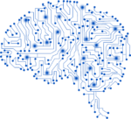Deep Learning is a form of machine learning that is inspired by the structure of the human brain and is particularly effective in feature detection. |   Machine Learning is all about algorithms that parse data, learn from that data, and then apply what they’ve learned to make informed decisions.
Deep Learning vs Machine Learning – Machine Learning Interview Questions – Edureka

Q4. Explain Classification and Regression
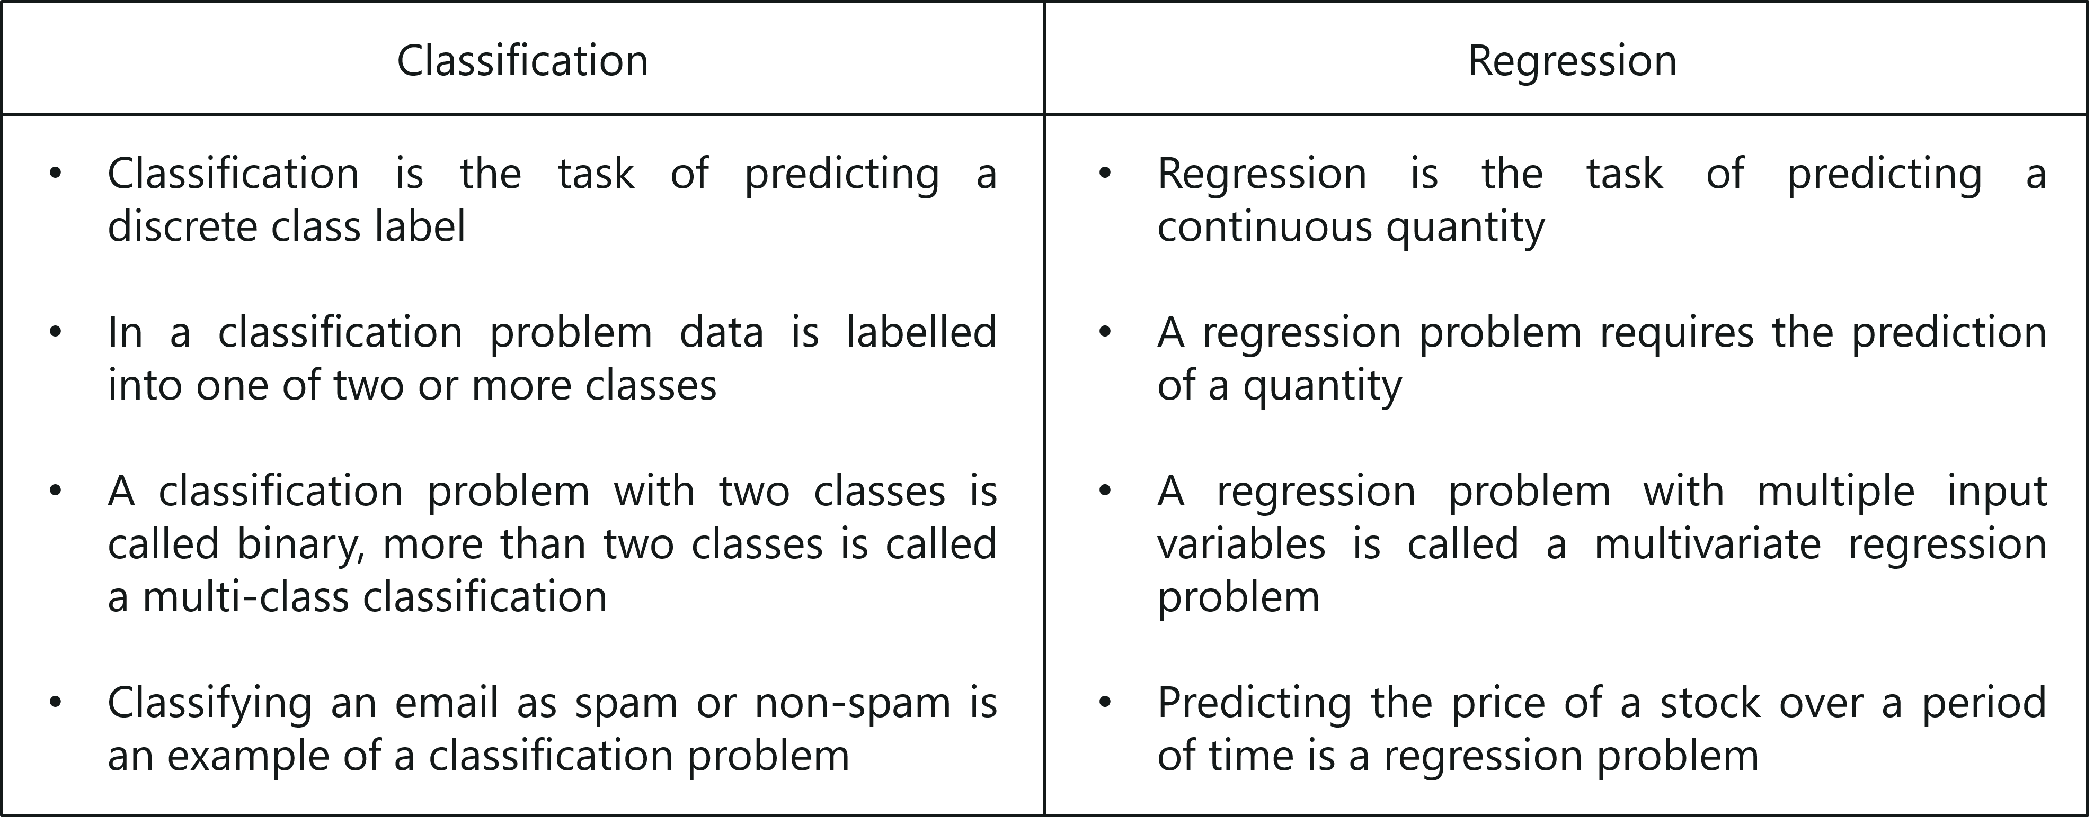
Classification vs Regression – Machine Learning Interview Questions – Edureka

Q5. What do you understand by selection bias?
- It is a statistical error that causes a bias in the sampling portion of an experiment.
- The error causes one sampling group to be selected more often than other groups included in the experiment.
- Selection bias may produce an inaccurate conclusion if the selection bias is not identified.

Q6. What do you understand by Precision and Recall?
Let me explain you this with an analogy:
- Imagine that, your girlfriend gave you a birthday surprise every year for the last 10 years. One day, your girlfriend asks you: ‘Sweetie, do you remember all the birthday surprises from me?’
- To stay on good terms with your girlfriend, you need to recall all the 10 events from your memory. Therefore, recall is the ratio of the number of events you can correctly recall, to the total number of events.
- If you can recall all 10 events correctly, then, your recall ratio is 1.0 (100%) and if you can recall 7 events correctly, your recall ratio is 0.7 (70%)
However, you might be wrong in some answers.
- For example, let’s assume that you took 15 guesses out of which 10 were correct and 5 were wrong. This means that you can recall all events but not so precisely
- Therefore, precision is the ratio of a number of events you can correctly recall, to the total number of events you can recall (mix of correct and wrong recalls).
- From the above example (10 real events, 15 answers: 10 correct, 5 wrong), you get 100% recall but your precision is only 66.67% (10 / 15)

Q7. Explain false negative, false positive, true negative and true positive with a simple example.
Let’s consider a scenario of a fire emergency:
- True Positive: If the alarm goes on in case of a fire.
Fire is positive and prediction made by the system is true.
- False Positive: If the alarm goes on, and there is no fire.
System predicted fire to be positive which is a wrong prediction, hence the prediction is false.
- False Negative: If the alarm does not ring but there was a fire.
System predicted fire to be negative which was false since there was fire.
- True Negative: If the alarm does not ring and there was no fire.
The fire is negative and this prediction was true.

Q8. What is a Confusion Matrix?
A confusion matrix or an error matrix is a table which is used for summarizing the performance of a classification algorithm.
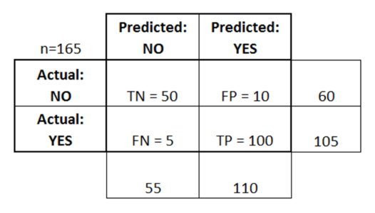
Confusion Matrix – Machine Learning Interview Questions – Edureka
Consider the above table where:
- TN = True Negative
- TP = True Positive
- FN = False Negative
- FP = False Positive

Q9. What is the difference between inductive and deductive learning?
- Inductive learning is the process of using observations to draw conclusions
- Deductive learning is the process of using conclusions to form observations
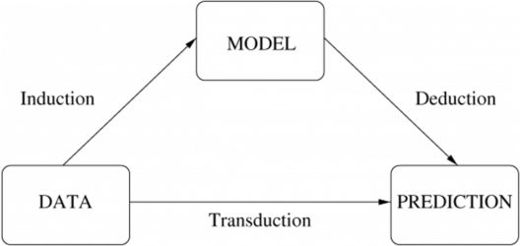
Inductive vs Deductive learning – Machine Learning Interview Questions – Edureka

Q10. How is KNN different from K-means clustering?
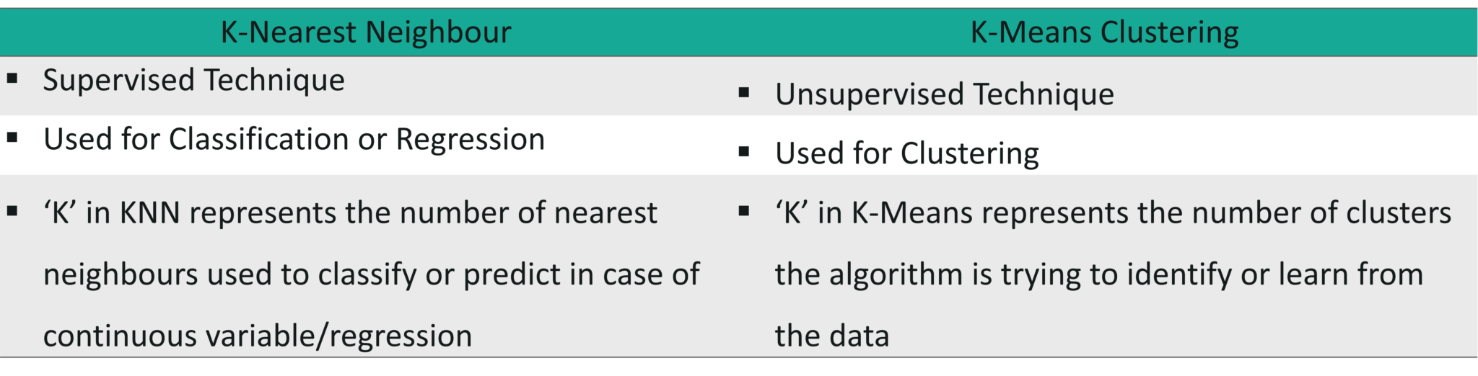
K-means vs KNN – Machine Learning Interview Questions – Edureka

Q11. What is ROC curve and what does it represent?
Receiver Operating Characteristic curve (or ROC curve) is a fundamental tool for diagnostic test evaluation and is a plot of the true positive rate (Sensitivity) against the false positive rate (Specificity) for the different possible cut-off points of a diagnostic test.



Python Machine Learning Certification Training
- Instructor-led Live Sessions
- Real-life Case Studies
- Assignments
- Lifetime Access
Explore Curriculum

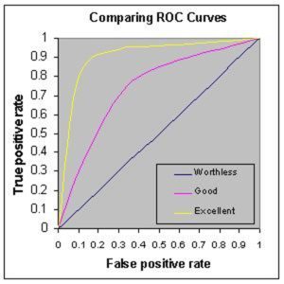
ROC – Machine Learning Interview Questions – Edureka
- It shows the tradeoff between sensitivity and specificity (any increase in sensitivity will be accompanied by a decrease in specificity).
- The closer the curve follows the left-hand border and then the top border of the ROC space, the more accurate the test.
- The closer the curve comes to the 45-degree diagonal of the ROC space, the less accurate the test.
- The slope of the tangent line at a cutpoint gives the likelihood ratio (LR) for that value of the test.
- The area under the curve is a measure of test accuracy.

Q12. What’s the difference between Type I and Type II error?
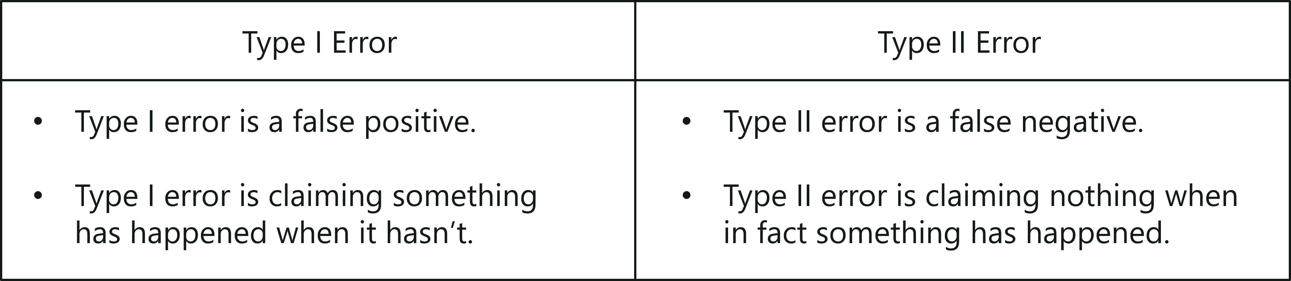
Type 1 vs Type 2 Error – Machine Learning Interview Questions – Edureka
Q13. Is it better to have too many false positives or too many false negatives? Explain.

False Negatives vs False Positives – Machine Learning Interview Questions – Edureka
It depends on the question as well as on the domain for which we are trying to solve the problem. If you’re using Machine Learning in the domain of medical testing, then a false negative is very risky, since the report will not show any health problem when a person is actually unwell. Similarly, if Machine Learning is used in spam detection, then a false positive is very risky because the algorithm may classify an important email as spam.

Q14. Which is more important to you – model accuracy or model performance?

Model Accuracy vs Performance – Machine Learning Interview Questions – Edureka
Well, you must know that model accuracy is only a subset of model performance. The accuracy of the model and performance of the model are directly proportional and hence better the performance of the model, more accurate are the predictions.

Q15. What is the difference between Gini Impurity and Entropy in a Decision Tree?
- Gini Impurity and Entropy are the metrics used for deciding how to split a Decision Tree.
- Gini measurement is the probability of a random sample being classified correctly if you randomly pick a label according to the distribution in the branch.
- Entropy is a measurement to calculate the lack of information. You calculate the Information Gain (difference in entropies) by making a split. This measure helps to reduce the uncertainty about the output label.

Q16. What is the difference between Entropy and Information Gain?
- Entropy is an indicator of how messy your data is. It decreases as you reach closer to the leaf node.
- The Information Gain is based on the decrease in entropy after a dataset is split on an attribute. It keeps on increasing as you reach closer to the leaf node.

Q17. What is Overfitting? And how do you ensure you’re not overfitting with a model?
Over-fitting occurs when a model studies the training data to such an extent that it negatively influences the performance of the model on new data.
This means that the disturbance in the training data is recorded and learned as concepts by the model. But the problem here is that these concepts do not apply to the testing data and negatively impact the model’s ability to classify the new data, hence reducing the accuracy on the testing data.
Three main methods to avoid overfitting:
- Collect more data so that the model can be trained with varied samples.
- Use ensembling methods, such as Random Forest. It is based on the idea of bagging, which is used to reduce the variation in the predictions by combining the result of multiple Decision trees on different samples of the data set.
- Choose the right algorithm.

Q18.Explain Ensemble learning technique in Machine Learning.

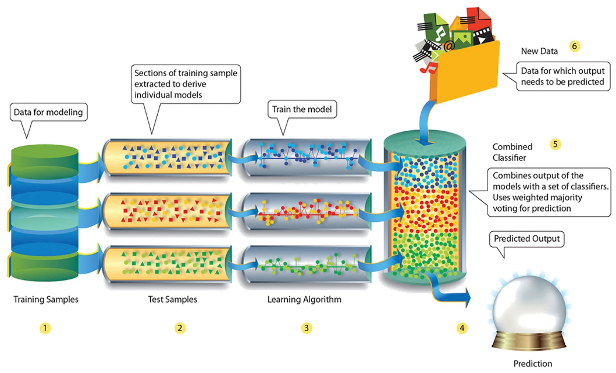
Ensemble Learning – Machine Learning Interview Questions – Edureka
Ensemble learning is a technique that is used to create multiple Machine Learning models, which are then combined to produce more accurate results. A general Machine Learning model is built by using the entire training data set. However, in Ensemble Learning the training data set is split into multiple subsets, wherein each subset is used to build a separate model. After the models are trained, they are then combined to predict an outcome in such a way that the variance in the output is reduced.

Q19. What is bagging and boosting in Machine Learning?
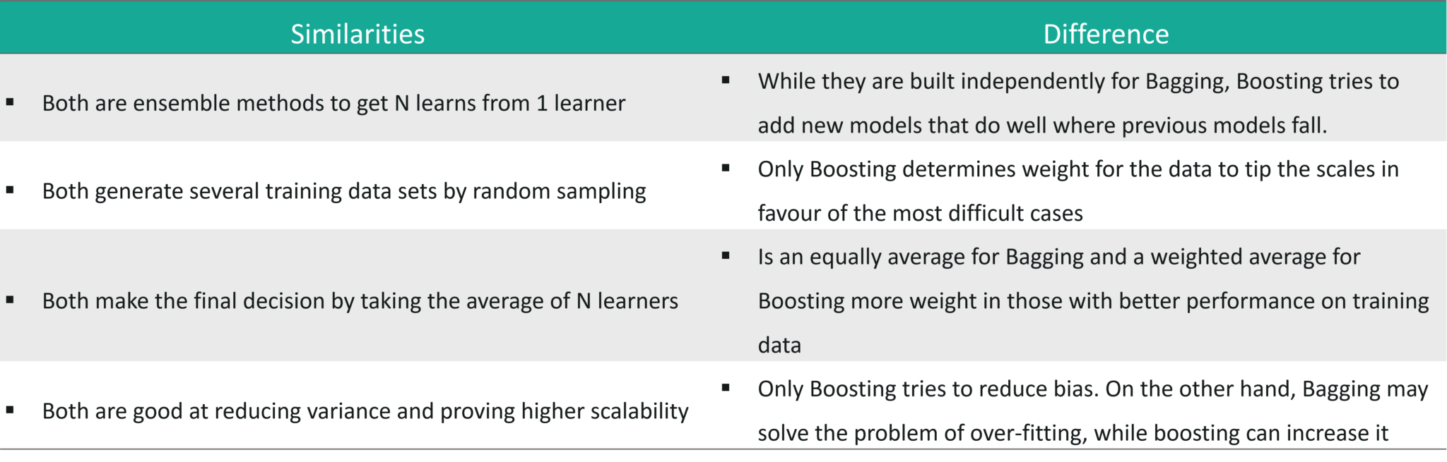
Bagging & Boosting – Machine Learning Interview Questions – Edureka

Q20. How would you screen for outliers and what should you do if you find one?
The following methods can be used to screen outliers:
- Boxplot: A box plot represents the distribution of the data and its variability. The box plot contains the upper and lower quartiles, so the box basically spans the Inter-Quartile Range (IQR). One of the main reasons why box plots are used is to detect outliers in the data. Since the box plot spans the IQR, it detects the data points that lie outside this range. These data points are nothing but outliers.
- Probabilistic and statistical models: Statistical models such as normal distribution and exponential distribution can be used to detect any variations in the distribution of data points. If any data point is found outside the distribution range, it is rendered as an outlier.
- Linear models: Linear models such as logistic regression can be trained to flag outliers. In this manner, the model picks up the next outlier it sees.
- Proximity-based models: An example of this kind of model is the K-means clustering model wherein, data points form multiple or ‘k’ number of clusters based on features such as similarity or distance. Since similar data points form clusters, the outliers also form their own cluster. In this way, proximity-based models can easily help detect outliers.
How do you handle these outliers?
- If your data set is huge and rich then you can risk dropping the outliers.
- However, if your data set is small then you can cap the outliers, by setting a threshold percentile. For example, the data points that are above the 95th percentile can be used to cap the outliers.
- Lastly, based on the data exploration stage, you can narrow down some rules and impute the outliers based on those business rules.

Q21. What are collinearity and multicollinearity?
- Collinearity occurs when two predictor variables (e.g., x1 and x2) in a multiple regression have some correlation.
- Multicollinearity occurs when more than two predictor variables (e.g., x1, x2, and x3) are inter-correlated.

Q22. What do you understand by Eigenvectors and Eigenvalues?
- Eigenvectors: Eigenvectors are those vectors whose direction remains unchanged even when a linear transformation is performed on them.
- Eigenvalues: Eigenvalue is the scalar that is used for the transformation of an Eigenvector.
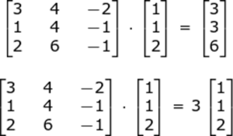
Eigenvalue & Eigenvectors – Machine Learning Interview Questions – Edureka
In the above example, 3 is an Eigenvalue, with the original vector in the multiplication problem being an eigenvector.
The Eigenvector of a square matrix A is a nonzero vector x such that for some number λ, we have the following:
Ax = λx,

Q23. What is A/B Testing?
- A/B is Statistical hypothesis testing for randomized experiment with two variables A and B. It is used to compare two models that use different predictor variables in order to check which variable fits best for a given sample of data.
- Consider a scenario where you’ve created two models (using different predictor variables) that can be used to recommend products for an e-commerce platform.
- A/B Testing can be used to compare these two models to check which one best recommends products to a customer.
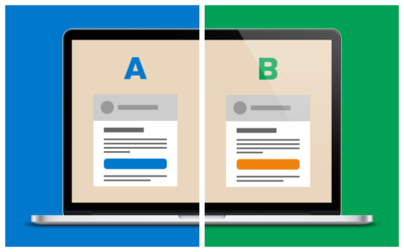
A/B Testing – Machine Learning Interview Questions – Edureka

Q24. What is Cluster Sampling?
- It is a process of randomly selecting intact groups within a defined population, sharing similar characteristics.
- Cluster Sample is a probability sample where each sampling unit is a collection or cluster of elements.
- For example, if you’re clustering the total number of managers in a set of companies, in that case, managers (samples) will represent elements and companies will represent clusters.

Q25. Running a binary classification tree algorithm is quite easy. But do you know how the tree decides on which variable to split at the root node and its succeeding child nodes?
- Measures such as, Gini Index and Entropy can be used to decide which variable is best fitted for splitting the Decision Tree at the root node.
- We can calculate Gini as following:
Calculate Gini for sub-nodes, using the formula – sum of square of probability for success and failure (p^2+q^2).
- Calculate Gini for split using weighted Gini score of each node of that split
- Entropy is the measure of impurity or randomness in the data, (for binary class):
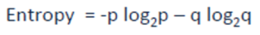Here p and q is the probability of success and failure respectively in that node.
- Entropy is zero when a node is homogeneous and is maximum when both the classes are present in a node at 50% – 50%. To sum it up, the entropy must be as low as possible in order to decide whether or not a variable is suitable as the root node.
To learn more about Artificial Intelligence and Machine Learning, then read the Artificial Intelligence tutorial. Also, enroll in PGP AI and ML courses by NIT Warangal to become proficient.

Machine Learning With Python Questions
This set of Machine Learning interview questions deal with Python-related Machine Learning questions.

Q1. Name a few libraries in Python used for Data Analysis and Scientific Computations.
Here is a list of Python libraries mainly used for Data Analysis:
- NumPy
- SciPy
- Pandas
- SciKit
- Matplotlib
- Seaborn
- Bokeh

Q2. Which library would you prefer for plotting in Python language: Seaborn or Matplotlib or Bokeh?

Python Libraries – Machine Learning Interview Questions – Edureka
It depends on the visualization you’re trying to achieve. Each of these libraries is used for a specific purpose:
- Matplotlib: Used for basic plotting like bars, pies, lines, scatter plots, etc
- Seaborn: Is built on top of Matplotlib and Pandas to ease data plotting. It is used for statistical visualizations like creating heatmaps or showing the distribution of your data
- Bokeh: Used for interactive visualization. In case your data is too complex and you haven’t found any “message” in the data, then use Bokeh to create interactive visualizations that will allow your viewers to explore the data themselves

Q3. How are NumPy and SciPy related?
- NumPy is part of SciPy.
- NumPy defines arrays along with some basic numerical functions like indexing, sorting, reshaping, etc.
- SciPy implements computations such as numerical integration, optimization and machine learning using NumPy’s functionality.

Q4. What is the main difference between a Pandas series and a single-column DataFrame in Python?
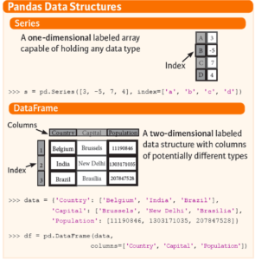
Pandas Series vs DataFrame – Machine Learning Interview Questions – Edureka

Q5. How can you handle duplicate values in a dataset for a variable in Python?
Consider the following Python code:
1  2  3  4  5  6  7 | bill_data=pd.read_csv("datasetsTelecom Data AnalysisBill.csv")  bill_data.shape  #Identify duplicates records in the data  Dupes = bill_data.duplicated()  sum(dupes)  #Removing Duplicates  bill_data_uniq = bill_data.drop_duplicates()

Q6. Write a basic Machine Learning program to check the accuracy of a model, by importing any dataset using any classifier?
1  2  3  4  5  6  7  8  9  10  11  12  13  14  15  16  17  18 | #importing dataset  import sklearn  from sklearn import datasets  iris = datasets.load_iris()  X = iris.data  Y = iris.target  #splitting the dataset  from sklearn.cross_validation import train_test_split  X_train, Y_train, X_test, Y_test = train_test_split(X,Y, test_size = 0.5)  #Selecting Classifier  my_classifier = tree.DecisionTreeClassifier()  My_classifier.fit(X_train, Y_train)  predictions = my_classifier(X_test)  #check accuracy  From sklear.metrics import accuracy_score  print accuracy_score(y_test, predictions)

Machine Learning Scenario Based Questions
This set of Machine Learning interview questions deal with scenario-based Machine Learning questions.

Q1. You are given a data set consisting of variables having more than 30% missing values? Let’s say, out of 50 variables, 8 variables have missing values higher than 30%. How will you deal with them?
- Assign a unique category to the missing values, who knows the missing values might uncover some trend.
- We can remove them blatantly.
- Or, we can sensibly check their distribution with the target variable, and if found any pattern we’ll keep those missing values and assign them a new category while removing others.

Q2. Write an SQL query that makes recommendations using the pages that your friends liked. Assume you have two tables: a two-column table of users and their friends, and a two-column table of users and the pages they liked. It should not recommend pages you already like.
1  2  3  4  5 | SELECT f.user_id, l.page_id  FROM friend f JOIN like l  ON f.friend_id = l.user_id  WHERE l.page_id NOT IN (SELECT page_id FROM like  WHERE user_id = f.user_id)

Q3. There’s a game where you are asked to roll two fair six-sided dice. If the sum of the values on the dice equals seven, then you win $21. However, you must pay $5 to play each time you roll both dice. Do you play this game? And in the follow-up: If he plays 6 times what is the probability of making money from this game?
- The first condition states that if the sum of the values on the 2 dices is equal to 7, then you win $21. But for all the other cases you must pay $5.
- First, let’s calculate the number of possible cases. Since we have two 6-sided dices, the total number of cases => 6*6 = 36.
- Out of 36 cases, we must calculate the number of cases that produces a sum of 7 (in such a way that the sum of the values on the 2 dices is equal to 7)
- Possible combinations that produce a sum of 7 is, (1,6), (2,5), (3,4), (4,3), (5,2) and (6,1). All these 6 combinations generate a sum of 7.
- This means that out of 36 chances, only 6 will produce a sum of 7. On taking the ratio, we get: 6/36 = 1/6
- So this suggests that we have a chance of winning $21, once in 6 games.
- So to answer the question if a person plays 6 times, he will win one game of $21, whereas for the other 5 games he will have to pay $5 each, which is $25 for all five games. Therefore, he will face a loss because he wins $21 but ends up paying $25.

Q4. We have two options for serving ads within Newsfeed:
1 – out of every 25 stories, one will be an ad
2 – every story has a 4% chance of being an ad

For each option, what is the expected number of ads shown in 100 news stories?
If we go with option 2, what is the chance a user will be shown only a single ad in 100 stories? What about no ads at all?
- The expected number of ads shown in 100 new stories for option 1 is equal to 4 (100/25 = 4).
- Similarly, for option 2, the expected number of ads shown in 100 new stories is also equal to 4 (4/100 = 1/25 which suggests that one out of every 25 stories will be an ad, therefore in 100 new stories there will be 4 ads)
- Therefore for each option, the total number of ads shown in 100 new stories is 4.
- The second part of the question can be solved by using Binomial distribution. Binomial distribution takes three parameters:
  - The probability of success and failure, which in our case is 4%.
  - The total number of cases, which is 100 in our case.
  - The probability of the outcome, which is a chance that a user will be shown only a single ad in 100 stories
- p(single ad) = (0.96)^99*(0.04)^1
(note: here 0.96 denotes the chance of not seeing an ad in 100 stories, 99 denotes the possibility of seeing only 1 ad, 0.04 is the probability of seeing an ad once in 100 stories )
- In total, there are 100 positions for the ad. Therefore, 100 * p(single ad) = 7.03%

Q5. How would you predict who will renew their subscription next month? What data would you need to solve this? What analysis would you do? Would you build predictive models? If so, which algorithms?
- Let’s assume that we’re trying to predict renewal rate for Netflix subscription. So our problem statement is to predict which users will renew their subscription plan for the next month.
- Next, we must understand the data that is needed to solve this problem. In this case, we need to check the number of hours the channel is active for each household, the number of adults in the household, number of kids, which channels are streamed the most, how much time is spent on each channel, how much has the watch rate varied from last month, etc. Such data is needed to predict whether or not a person will continue the subscription for the upcoming month.
- After collecting this data, it is important that you find patterns and correlations. For example, we know that if a household has kids, then they are more likely to subscribe. Similarly, by studying the watch rate of the previous month, you can predict whether a person is still interested in a subscription. Such trends must be studied.
- The next step is analysis. For this kind of problem statement, you must use a classification algorithm that classifies customers into 2 groups:
  - Customers who are likely to subscribe next month
  - Customers who are not likely to subscribe next month
- Would you build predictive models? Yes, in order to achieve this you must build a predictive model that classifies the customers into 2 classes like mentioned above.
- Which algorithms to choose? You can choose classification algorithms such as Logistic Regression, Random Forest, Support Vector Machine, etc.
- Once you’ve opted the right algorithm, you must perform model evaluation to calculate the efficiency of the algorithm. This is followed by deployment.

Q6. How do you map nicknames (Pete, Andy, Nick, Rob, etc) to real names?
- This problem can be solved in n number of ways. Let’s assume that you’re given a data set containing 1000s of twitter interactions. You will begin by studying the relationship between two people by carefully analyzing the words used in the tweets.
- This kind of problem statement can be solved by implementing Text Mining using Natural Language Processing techniques, wherein each word in a sentence is broken down and co-relations between various words are found.
- NLP is actively used in understanding customer feedback, performing sentimental analysis on Twitter and Facebook. Thus, one of the ways to solve this problem is through Text Mining and Natural Language Processing techniques.

Q7. A jar has 1000 coins, of which 999 are fair and 1 is double headed. Pick a coin at random, and toss it 10 times. Given that you see 10 heads, what is the probability that the next toss of that coin is also a head?
- There are two ways of choosing a coin. One is to pick a fair coin and the other is to pick the one with two heads.
- Probability of selecting fair coin = 999/1000 = 0.999
Probability of selecting unfair coin = 1/1000 = 0.001
- Selecting 10 heads in a row = Selecting fair coin * Getting 10 heads + Selecting an unfair coin
- P (A) = 0.999 * (1/2)^10 = 0.999 * (1/1024) = 0.000976
P (B) = 0.001 * 1 = 0.001
P( A / A + B ) = 0.000976 / (0.000976 + 0.001) = 0.4939
P( B / A + B ) = 0.001 / 0.001976 = 0.5061
- Probability of selecting another head = P(A/A+B) * 0.5 + P(B/A+B) * 1 = 0.4939 * 0.5 + 0.5061 = 0.7531

Q8. Suppose you are given a data set which has missing values spread along 1 standard deviation from the median. What percentage of data would remain unaffected and Why?
Since the data is spread across the median, let’s assume it’s a normal distribution.
As you know, in a normal distribution, ~68% of the data lies in 1 standard deviation from mean (or mode, median), which leaves ~32% of the data unaffected. Therefore, ~32% of the data would remain unaffected by missing values.

Q9. You are given a cancer detection data set. Let’s suppose when you build a classification model you achieved an accuracy of 96%. Why shouldn’t you be happy with your model performance? What can you do about it?
You can do the following:
- Add more data
- Treat missing outlier values
- Feature Engineering
- Feature Selection
- Multiple Algorithms
- Algorithm Tuning
- Ensemble Method
- Cross-Validation

Q10. You are working on a time series data set. Your manager has asked you to build a high accuracy model. You start with the decision tree algorithm since you know it works fairly well on all kinds of data. Later, you tried a time series regression model and got higher accuracy than the decision tree model. Can this happen? Why?
- Time series data is based on linearity while a decision tree algorithm is known to work best to detect non-linear interactions
- Decision tree fails to provide robust predictions. Why?
  - The reason is that it couldn’t map the linear relationship as good as a regression model did.
  - We also know that a linear regression model can provide a robust prediction only if the data set satisfies its linearity assumptions.

Q11. Suppose you found that your model is suffering from low bias and high variance. Which algorithm you think could tackle this situation and Why?
Type 1: How to tackle high variance?
- Low bias occurs when the model’s predicted values are near to actual values.
- In this case, we can use the bagging algorithm (eg: Random Forest) to tackle high variance problem.
- Bagging algorithm will divide the data set into its subsets with repeated randomized sampling.
- Once divided, these samples can be used to generate a set of models using a single learning algorithm. Later, the model predictions are combined using voting (classification) or averaging (regression).
Type 2: How to tackle high variance?
- Lower the model complexity by using regularization technique, where higher model coefficients get penalized.
- You can also use top n features from variable importance chart. It might be possible that with all the variable in the data set, the algorithm is facing difficulty in finding the meaningful signal.

Q12. You are given a data set. The data set contains many variables, some of which are highly correlated and you know about it. Your manager has asked you to run PCA. Would you remove correlated variables first? Why?
Possibly, you might get tempted to say no, but that would be incorrect.
Discarding correlated variables will have a substantial effect on PCA because, in the presence of correlated variables, the variance explained by a particular component gets inflated.

Q13. You are asked to build a multiple regression model but your model R² isn’t as good as you wanted. For improvement, you remove the intercept term now your model R² becomes 0.8 from 0.3. Is it possible? How?
Yes, it is possible.
- The intercept term refers to model prediction without any independent variable or in other words, mean prediction
R² = 1 – ∑(Y – Y´)²/∑(Y – Ymean)² where Y´ is the predicted value.
- In the presence of the intercept term, R² value will evaluate your model with respect to the mean model.
- In the absence of the intercept term (Ymean), the model can make no such evaluation,
- With large denominator,
Value of ∑(Y – Y´)²/∑(Y)² equation becomes smaller than actual, thereby resulting in a higher value of R².

Q14. You’re asked to build a random forest model with 10000 trees. During its training, you got training error as 0.00. But, on testing the validation error was 34.23. What is going on? Haven’t you trained your model perfectly?
- The model is overfitting the data.
- Training error of 0.00 means that the classifier has mimicked the training data patterns to an extent.
- But when this classifier runs on the unseen sample, it was not able to find those patterns and returned the predictions with more number of errors.
- In Random Forest, it usually happens when we use a larger number of trees than necessary. Hence, to avoid such situations, we should tune the number of trees using cross-validation.
Q15. ‘People who bought this also bought…’ recommendations seen on Amazon is based on which algorithm?
E-commerce websites like Amazon make use of Machine Learning to recommend products to their customers. The basic idea of this kind of recommendation comes from collaborative filtering. Collaborative filtering is the process of comparing users with similar shopping behaviors in order to recommend products to a new user with similar shopping behavior.



Python Machine Learning Certification Training
Weekday / Weekend BatchesSee Batch Details

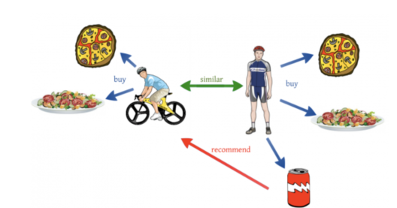
Collaborative Filtering – Machine Learning Interview Questions – Edureka
To better understand this, let’s look at an example. Let’s say a user A who is a sports enthusiast bought, pizza, pasta, and a coke. Now a couple of weeks later, another user B who rides a bicycle buys pizza and pasta. He does not buy the coke, but Amazon recommends a bottle of coke to user B since his shopping behaviors and his lifestyle is quite similar to user A. This is how collaborative filtering works.
So these are the most frequently asked questions in a Machine Learning Interview. However, if you wish to brush up more on your knowledge, you can go through these blogs:
- Machine Learning Tutorial for Beginners
- Top 10 Applications of Machine Learning: Machine Learning Applications in Daily Life
- Machine Learning Algorithms
With this, we come to an end to this blog. I hope these Machine Learning Interview Questions will help you ace your Machine Learning Interview.
Learn the fundamentals of Machine Learning, machine learning steps and methods that include unsupervised and supervised learning, mathematical and heuristic aspects, and hands-on modeling to create algorithms. You will be prepared for the position of Machine Learning engineer. The Machine Learning Course Masters Program will provide you with the most in-depth and practical information on machine-learning applications in real-world situations. Additionally, you’ll learn the essentials needed to be successful in the field of machine learning, such as statistical analysis, Python, and data science.

1) What are the basic differences between Machine Learning and Deep Learning?
Differences between Machine Learning and Deep Learning are:
 | Machine Learning | Deep Learning
Definition | Sub-discipline of AI | A subset of machine learning
Data | Parses the data | Creates an artificial neural network
Accuracy | Requires manual intervention means decreased accuracy | Self-learning capabilities mean higher accuracy
Interpretability | Machine Learning is Faster | 10 Times Faster than ML
Output | ML models produce a numerical output | DL algorithms can range from an image to text or even an audio
Data dependencies | High | Low
Hardware dependencies | Can work on low-end machines. | Heavily depend on high-end machines
Future | Effective with image recognition and face recognition in mobiles | Not much effective due to data processing limitations

2) What is the difference between Bias and Variance?
- Bias: Bias can be defined as a situation where an error has occurred due to the use of assumptions in the learning algorithm.
- Variance: Variance is an error caused because of the complexity of the algorithm that is been used to analyze the data.

3) What is the difference between supervised and unsupervised machine learning?
Supervised learning is a process where it requires training labeled data. When it comes to Unsupervised learning doesn’t require data labeling.



4) What are the three stages of model building in machine learning?
Following are the three stages of model building:
- Model Building: In this stage, we will choose the ideal algorithm for the model, and we will train it based on our requirements.
- Model Testing: In this stage, we will check the model's accuracy by using test data.
- Applying Model: After testing, we have to make the changes, and then we can use the model for real-time projects.

5) What are the applications of supervised machine learning?
Following are the applications of machine learning:
- Fraud Identification: Supervised learning trains the model for identifying the suspicious patterns; we can identify the feasible fraud instances.
- Healthcare: By giving images about a disease, supervised machine learning can train the model for detecting whether a person is affected by illness or not.
- Email spam identification: We train the model through historical data which contains emails that are classified as spam or not spam. This labeled data is supplied as the input to the model.
- Sentiment Analysis: This relates to the process of using algorithms for mining the documents and determining if they are negative, neutral, positive in sentiment.
Related Article - Artificial Intelligence Vs Machine Learning

6) What are the techniques of Unsupervised machine learning?
Following are the different techniques of unsupervised machine learning:
- Clustering: It includes the data that must be divided into subsets. These subsets are also known as clusters. Diverse clusters disclose details about objects, unlike regression or classification.
- Association: In the association problem, we can recognize the association patterns between different items and variables. For instance, e-commerce can indicate other items for us to buy according to our previous purchases.

7) What are the different types of Machine Learning?
Following are the different kinds of machine learning:
- Unsupervised Learning: In this kind of machine learning, we will not have labeled data. A model can recognize anomalies, relationships, and patterns in the input data.
- Supervised Learning: In this kind of machine learning, the model makes decisions or predictions according to the labeled or past data. Labeled data relates to data sets that provide labels or tags.
- Reinforcement Learning: In reinforcement learning, a model can learn according to the rewards it obtained from its past actions.

8) What is Deep Learning?
Deep learning is a branch of machine learning which is relevant to neural networks. Deep learning tells us how to use the principles and backpropagation from neuroscience to the large sets of semi-structured or unlabelled data. Deep learning portrays the unsupervised learning algorithm which learns data representation by using neural nets
Explore - Deep Learning Tools for more information

9) How to Build a Data Pipeline?
Data pipelines are the core of the machine learning engineers, which take data science models and discover methods for scaling and automating them if you are accustomed to the tools for building the platforms and data pipelines where we can host pipelines and models.

10) How is KNN different from k-means clustering?
K-Nearest Neighbours is a supervised algorithm, and k-means clustering is an unsupervised algorithm. For the K-nearest neighbors to work, we require labeled data to classify the unlabeled point. K-means clustering needs only a threshold and a group of unlabeled points: the algorithm takes the unlabeled points and slowly learns how to divide them into groups by calculating the mean of distance between the points.

11) Comparision between Machine Learning and Big Data
Machine Learning Vs Big Data
Feature | Machine Learning | Big Data
Data Use | Technology that helps in reducing human intervention. | Data research, especially when working with huge data.
Operations | Existing data helps to tech machine what can be done further | Design patterns with analytics on existing data in terms of decision making.
Pattern Recognition | Similar to Big Data, existing data helps in pattern recognition. | Sequence and classification analysis helps in pattern recognition.
Data Volume | Best performance, while working with small datasets. | Datasets help in understanding and solving problems associated with large data volumes.
Application | Read existing data to predict future information. | Storing and analyzing patterns within huge data volumes.

12) Explain what is precision and Recall?
- Recall: It is known as a true positive rate. The number of positives that your model has claimed compared to the actual defined number of positives available throughout the data.
- Precision: It is also known as a positive predicted value. This is more based on the prediction. It is a measure of the number of accurate positives that the model claims when compared to the number of positives it actually claims.

13) What is your favorite algorithm and also explain the algorithm briefly in a minute?
This type of question is very common and asked by the interviewers to understand the candidate's skills and assess how well he can communicate complex theories in the simplest language.
This one is a tough question and usually, individuals are not at all prepared for this situation so please be prepared and have a choice of algorithms and make sure you practice a lot before going into any sort of interviews.
Related Article - Machine Learning Applications

14) What is the difference between Type1 and Type2 errors?
Type 1 error is classified as a false positive. I.e. This error claims that something has happened but the fact is nothing has happened. It is like a false fire alarm. The alarm rings but there is no fire.
Type 2 error is classified as a false negative. I.e. This error claims that nothing has happened but the fact is that actually, something happened at the instance.
The best way to differentiate a type 1 vs type 2 error is:
- Calling a man to be pregnant- This is a Type 1 example
- Calling pregnant women and telling them that she isn’t carrying any baby- This is a type 2 example

15) Define what is Fourier Transform in a single sentence?
A process of decomposing generic functions into a superposition of symmetric functions is considered to be a Fourier Transform.

16) What is deep learning?
Deep learning is a process where it is considered to be a subset of the machine learning process.

17) What is the F1 score?
The F1 score is defined as a measure of a model’s performance.

18) How is the F1 score is used?
The average Precision and Recall of a model is nothing but an F1 score measure. Based on the results, the F1 score is 1 then it is classified as best and 0 being the worst.

19) How can you ensure that you are not overfitting with a particular model?
In Machine Learning concepts, they are three main methods or processes to avoid overfitting:
Firstly, keep the model simple
Must and should use cross-validation techniques
It is mandatory to use regularization techniques, for example, LASSO.

20) How to handle or missing data in a dataset?
An individual can easily find missing or corrupted data in a data set either by dropping the rows or columns. On contrary, they can decide to replace the data with another value.
In Pandas they are two ways to identify the missing data, these two methods are very useful.
isnull() and dropna().

21) Do you have any relevant experience on Spark or any of the big data tools that are used for Machine Learning?
Well, this sort of question is tricky to answer and the best way to respond back is, to be honest. Make sure you are familiar with Big data is and the different tools that are available. If you know about Spark then it is always good to talk about it and if you are unsure then it is best, to be honest, and let the interviewer know about it.
So for this, you have to prepare what is Spark and it's good to prepare other available Big data tools that are used for Machine learning.
Related Article - Machine Learning with Python

22) Pick an algorithm and write a Pseudocode for the same?
This question depicts your understanding of the algorithm. This is something that one has to be very creative and also should have in-depth knowledge about the algorithms and first and foremost the individual should have a good understanding of the algorithms. The best way to answer this question would be to start off with Web Sequence Diagrams.

23) What is the difference between an array and a Linked list?
An array is an ordered fashion of collection of objects while a linked list is a series of objects that are processed in sequential order.

24): Define a hash table?
They are generally used for database indexing. A hash table is nothing but a data structure that produces an associative array.

25) Mention any one of the data visualization tools that you are familiar with?
This is another question where one has to be completely honest and also giving out your personal experience with these type of tools are really important. Some of the data visualization tools are Tableau, Plot.ly, and matplotlib.

26) What is your opinion on our current data process?
This type of question is asked and the individuals have to carefully listen to their use case and at the same time, the reply should be in a constructive and insightful manner. Based on your responses, the interviewer will have a chance to review and understand whether you are a value add to their team or not.

27) Please let us know what was your last read book or learning paper on Machine Learning?
This type of question is asked to see whether the individual has a keen interest in learning and also he is up to the latest market standards. This is something that every candidate should be looking out for and it is vital for individuals to read through the latest publishings.

28) What is your favorite use case for machine learning models?
The decision tree is one of my favorite use cases for machine learning models.

29) Is rotation necessary in PCA?
Yes, rotation is definitely necessary because it maximizes the differences between the variance captured by the components.

30) What happens if the components are not rotated in PCA?
It is a straight effect. If the components are not rotated then it will diminish eventually and one has to use a lot of various components to explain the data set variance.

31) Explain why Naive Bayes is so Naive?
It is based on an assumption that all of the features in the data set are important, equal, and independent.

32) How Recall and True positive rates are related?
The relation is True Positive Rate = Recall.

33) Assume that you are working on a data set, explain how would you select important variables?
The following are a few methods that can be used to select important variables:
- Use of Lasso Regression method.
- Using Random Forest, plot variable importance chart.
- Using Linear regression.

34) Explain how we can capture the correlation between continuous and categorical variables?
Yes, it is possible by using the ANCOVA technique. It stands for Analysis of Covariance. It is used to calculate the association between continuous and categorical variables.

35) Explain the concept of machine learning and assume that you are explaining this to a 5-year-old baby?
Yes, the question itself is the answer.
Machine learning is exactly the same way how babies do their day-to-day activities, the way they walk or sleep, etc. It is a common fact that babies cannot walk straight away and they fall and then they get up again and then try. This is the same thing when it comes to machine learning, it is all about how the algorithm is working and at the same time redefining every time to make sure the end result is as perfect as possible.
One has to take real-time examples while explaining these questions.

36) What is the difference between Machine learning and Data Mining?
Data mining is about working on unstructured data and then extract it to a level where interesting and unknown patterns are identified. Machine learning is a process or a study whether it closely relates to the design, development of the algorithms that provide an ability to the machines to capacity to learn.

37) What is inductive machine learning?
Inductive machine learning is all about a process of learning by live examples.

38) Please state a few popular Machine Learning algorithms?
Few popular Machine Learning algorithms are:
- Nearest Neighbour
- Neural Networks
- Decision Trees etc
- Support vector machines

39) What are the different types of algorithm techniques are available in machine learning?
Some of them are :
- Supervised learning
- Unsupervised learning
- Semi-supervised learning
- Transduction
- Learning to learn

40) What are the three stages to build the model in machine learning?
The three stages to build the model in machine learning is:
- Model building
- Model testing
- Applying the model

41) Explain how the ROC curve works?
A ROC curve (receiver operating characteristic) is a graph that shows the performance of a classification model at all classification thresholds. It plots two parameters -

True positive rate

False-positive rate

True Positive Rate (TPR) is defined as follows:
TPR = TP/(TP+FN)
False Positive Rate (FPR) is defined as follows:
FPR = FP/(FP+TN)

42) What is the difference between L1 and L2 regularization?
Regularization is a process of introducing some information in order to prevent overfitting.
L1 Regularization | L2 Regularization
It is more binary/sparse | Tends to spread error among all the terms
L1 regularization corresponds to setting a Laplacean prior on the terms | It corresponds to a Gaussian prior

43) What is a type 1 and type 2 error?

Type 1 Error - Type 1 error also called false positive, is asserting something true when it is actually false.

Type 2 Error - Type 2 error also called false negative, is a test result indicating that a condition is failed but in actuality it is successful.

44) What is the difference between machine learning and deep learning?
Deep learning is a subset of machine learning and is called so because it makes use of deep neural networks. Let’s find out machine learning Vs Deep learning
 | Machine learning | Deep Learning
Data dependencies | Performs better on small and medium datasets | Works better for big datasets
Hardware dependencies | Work on low-end machines | Requires powerful machine, preferably with GPU
Interpretability | Algorithms are easy to interpret | Difficult to interpret
Execution time | From a few minutes to hours | It May take up to a week
Feature Engineering | Need to understand the features that represent the data | No need to understand the best feature that represents the data

45) What is Bayes Theorem and how it is used in machine learning?
Bayes theorem is a way of calculating conditional probability ie. finding the probability of an event occurring based on the given probability of other events that have already occurred. Mathematically, it is stated as -
P(A|B) = {P(B|A).P(A)}/P(B)
Bayes theorem has become a very useful tool in applied machine learning. It provides a way of thinking about the relationship shared by data and the models.
A machine learning model is a specific way of thinking about the structured relationship in the data such as relationships shared by input (x) and output (y).
If we have some prior domain knowledge about the hypothesis, Then the Bayes theorem can help in solving machine learning problems.

46) What is cross-validation techniques would you be using on a time series dataset?
Cross-validation is used for tuning the hyperparameters and producing measurements of model performance. With the time series data, we can't use the traditional cross-validation technique due to two main reasons which are as follows -

Temporal dependencies

Arbitrary Choice of Test Set

For time-series data, we use nested cross-validation that provides an almost unbiased estimate of the true error. A nested CV consists of an inner loop for parameter tuning and an outer loop for error estimation.

47) What are the Discriminative and generative models?
To understand these terms better, let us consider an example. Suppose a person has two kids - kid A and kid B. Kid A learns and understands everything in depth whereas Kid B can only learn the differences between what he sees. One day, that person took them to the zoo where they saw a deer and a lion. After coming from the zoo, the person showed them an animal and asked them what it was. Kid A drew the images of both the animals he saw in the zoo. He compared the images and answered "the animal is deer" based on the closest match of the image. As Kid B learns things based on only differences, therefore, he easily answered: "the animal is deer.".
In ML, we call Kid A a Generative Model and Kid B a Discriminative Model. To make it more clear, the Generative Model ‌learns the joint probability distribution p(x,y). It predicts the conditional probability using Bayes Theorem. Whereas a Discriminative model ‌predicts the conditional probability distribution p(y|x). Both of these models are used in supervised learning problems.

48) How is a decision tree pruned?
In Machine learning, pruning means simplifying and optimizing a decision tree by cutting nodes of the tree that causes overfitting. The pruning process can be divided into two types -

Bottom-up pruning - procedure starts at the last node

Top-down pruning - procedure starts at the root node

Pruning is done to increase the predictive accuracy of a decision tree model.

49) What is more important - model accuracy or model performance?
Accuracy is more important in machine learning models. We can improve model performance by using distributed computing and parallelizing over the scored assets. But accuracy should be built during the model training process.

50) How would you handle an imbalanced dataset?
Imbalanced data set is a classification problem where the number of observations per class is not distributed equally. For some classes, there will be a large number of observations whereas for others fewer observations are present. We can fix this issue by -

Collecting more data to even the imbalances in the dataset.

Resample the dataset to correct for imbalances.

Try a different algorithm altogether on your dataset.

51) When should you use classification over regression?
In supervised learning, we have datasets and a list of outcomes. Types of outcomes that we have helped us categorize the problem into classification and regression. For regression problems, the outcomes are typically in real numbers whereas for classification problems outcomes are classes or categories. Therefore, we can say that we would use regression if the outputs are in real numbers and we would go with classifications if the outputs are in the form of classes or categories.

52) Tell me a situation where ensemble techniques might be useful?
Ensemble learning combines several models into one predictive model to decrease the variance and improve results. The ensemble method is divided into two groups - the sequential method and the parallel method.
Sequential method - base learners are generated sequentially
Parallel method - base learners are generated parallelly
Ensembles techniques are -

Bagging

Stacking

Boosting

Scenario - suppose you want to buy a new pair of headphones. What will you do? Being an aware consumer, first, you will do research on which company offers the best headphones and also take some suggestions from your friends. In short, you will be making informed decisions after thoroughly researching work.

53) What are the data types supported by JSON?
Here, the interviewer wants to test your knowledge of JSON. There are six basic data types supported by JSON: strings, numbers, objects, arrays, booleans, and null values.

54) According to you, what is the most valuable data in our business?
Through this question, the interviewer tries to test you on two dimensions: your knowledge and understanding about business models and how you correlated data and apply that thinking about the company. To answer this question, you’ll have to research the business model, learn their business problems, and solve most with their data.

55) Tell us about machine learning papers you’ve read lately?
To answer this question, you need to keep yourself updated with the latest scientific literature on machine learning to demonstrate your interest in a machine learning position.

56) What GPU/hardware do you use and what models do you train for?
This question tests if you have handled machine learning projects outside of a corporate role and understand how to resource projects and allocate GPU time efficiently. These kinds of questions are usually asked by hiring managers as they want to know what you’ve done independently.
There are some general questions that an interviewer may ask you depending upon your working experiences and awareness. Some of them are as follows -

Do you have research experience in machine learning?

What uses cases do you like the most in machine learning?

What are your views on GPT-3 and OpenAI’s model?

57) What is a Fourier Transform?
Fourier Transform is a general method for decomposing the general functions into asymmetric functions superposition. The Fourier transform discovers the cycle set amplitudes, phases, and speeds for matching any time signal. Fourier transform converts the signal from the time to frequency domain.

58) What is the use of the Kernel trick?
Kernel trick includes kernel functions that can allow higher-dimension spaces without externally computing the dimension’s points coordinates. Kernel functions calculate the inner products among the images of all the data pairs in the feature space. This enables them to attribute computing coordinates of higher dimensions when the computation of the said coordinates’ external calculation is cheaper.

59) Why Naive Bayes is Naive?
Regardless of its practical applications, particularly in text mining, we consider Naive Bayes naive because it makes superposition which is practically impossible to see in real-time data. We calculate the conditional probability in the form of the product of the separate probabilities of the components.

60) Define Overfitting? How do we assure that we are not overfitting a model?
Overfitting happens when the model researches the training data to affect the model performance on the latest data significantly. This indicates that we record the disruption in the training data, and we learn the concepts by model. The problem is that concepts that do not employ the testing data negatively affect the ability of the model for classifying the new data; therefore, it decreases the testing data accuracy.
To avoid Overfitting, we have to apply the following methods:
- We collect more data so that we can train the model with diverse samples.
- We can avoid overfitting by using the ensembling methods, like Random Forest. According to the bagging idea, we use them to minimize the change in the projections by joining the result of the multiple decision trees on various samples of the data set.
- By Selecting the correct algorithm, we can avoid overfitting.

61) Explain Cluster sampling?
Cluster sampling is a process of arbitrarily choosing the integral algorithms inside a specified population, and distributing the same characteristics. Cluster sampling is the likelihood sample where a single sampling unit is a cluster or collection of the elements. For instance, if we are clustering the cumulative number of managers in a group of companies, in such a case, managers will depict employees and companies will depict the clusters.

62) What are the methods available to screen the Outliers?
We can use the following methods to screen the outliers:
Linear models: Linear models like logistic regression can be trained to screen the outliers. In this way, the model collects the subsequent outlier it meets.
Boxplot: The box plot depicts the allocation of the data and its changeability. Box plot includes lower and upper quartiles; therefore, the box fundamentally stretches the Inter-Quartile Range(IQR). The main reason for using the box plot is to identify the outliers in the data.
Proximity-based models: K-means clustering is the example of this kind of model, where data points form various or “k” clusters based on the features like distance or similarity.
Probabilistic and Statistical models: We can use statistical models like exponential distribution and normal distribution for identifying the variations in the allocation of the data points. If we found any data point outside the distribution scope, then we can render it an outlier.

1) What is Machine learning?
Machine learning is a branch of computer science which deals with system programming in order to automatically learn and improve with experience. For example: Robots are programed so that they can perform the task based on data they gather from sensors. It automatically learns programs from data.

2) Mention the difference between Data Mining and Machine learning?
Machine learning relates with the study, design and development of the algorithms that give computers the capability to learn without being explicitly programmed. While, data mining can be defined as the process in which the unstructured data tries to extract knowledge or unknown interesting patterns. During this process machine, learning algorithms are used.

3) What is ‘Overfitting’ in Machine learning?
In machine learning, when a statistical model describes random error or noise instead of underlying relationship ‘overfitting’ occurs. When a model is excessively complex, overfitting is normally observed, because of having too many parameters with respect to the number of training data types. The model exhibits poor performance which has been overfit.

4) Why overfitting happens?
The possibility of overfitting exists as the criteria used for training the model is not the same as the criteria used to judge the efficacy of a model.

5) How can you avoid overfitting?
By using a lot of data overfitting can be avoided, overfitting happens relatively as you have a small dataset, and you try to learn from it. But if you have a small database and you are forced to come with a model based on that. In such situation, you can use a technique known as cross validation. In this method the dataset splits into two section, testing and training datasets, the testing dataset will only test the model while, in training dataset, the datapoints will come up with the model.
In this technique, a model is usually given a dataset of a known data on which training (training data set) is run and a dataset of unknown data against which the model is tested. The idea of cross validation is to define a dataset to “test” the model in the training phase.

6) What is inductive machine learning?
The inductive machine learning involves the process of learning by examples, where a system, from a set of observed instances tries to induce a general rule.

7) What are the five popular algorithms of Machine Learning?
- Decision Trees
- Neural Networks (back propagation)
- Probabilistic networks
- Nearest Neighbor
- Support vector machines

8) What are the different Algorithm techniques in Machine Learning?
The different types of techniques in Machine Learning are
- Supervised Learning
- Unsupervised Learning
- Semi-supervised Learning
- Reinforcement Learning
- Transduction
- Learning to Learn

9) What are the three stages to build the hypotheses or model in machine learning?
- Model building
- Model testing
- Applying the model

10) What is the standard approach to supervised learning?
The standard approach to supervised learning is to split the set of example into the training set and the test.

11) What is ‘Training set’ and ‘Test set’?
In various areas of information science like machine learning, a set of data is used to discover the potentially predictive relationship known as ‘Training Set’. Training set is an examples given to the learner, while Test set is used to test the accuracy of the hypotheses generated by the learner, and it is the set of example held back from the learner. Training set are distinct from Test set.

12) List down various approaches for machine learning?
The different approaches in Machine Learning are
- Concept Vs Classification Learning
- Symbolic Vs Statistical Learning
- Inductive Vs Analytical Learning

13) What is not Machine Learning?
- Artificial Intelligence
- Rule based inference

14) Explain what is the function of ‘Unsupervised Learning’?
- Find clusters of the data
- Find low-dimensional representations of the data
- Find interesting directions in data
- Interesting coordinates and correlations
- Find novel observations/ database cleaning

15) Explain what is the function of ‘Supervised Learning’?
- Classifications
- Speech recognition
- Regression
- Predict time series
- Annotate strings

16) What is algorithm independent machine learning?
Machine learning in where mathematical foundations is independent of any particular classifier or learning algorithm is referred as algorithm independent machine learning?

17) What is the difference between artificial learning and machine learning?
Designing and developing algorithms according to the behaviours based on empirical data are known as Machine Learning. While artificial intelligence in addition to machine learning, it also covers other aspects like knowledge representation, natural language processing, planning, robotics etc.

18) What is classifier in machine learning?
A classifier in a Machine Learning is a system that inputs a vector of discrete or continuous feature values and outputs a single discrete value, the class.

19) What are the advantages of Naive Bayes?
In Naïve Bayes classifier will converge quicker than discriminative models like logistic regression, so you need less training data. The main advantage is that it can’t learn interactions between features.

20) In what areas Pattern Recognition is used?
Pattern Recognition can be used in
- Computer Vision
- Speech Recognition
- Data Mining
- Statistics
- Informal Retrieval
- Bio-Informatics

21) What is Genetic Programming?
Genetic programming is one of the two techniques used in machine learning. The model is based on the testing and selecting the best choice among a set of results.

22) What is Inductive Logic Programming in Machine Learning?
Inductive Logic Programming (ILP) is a subfield of machine learning which uses logical programming representing background knowledge and examples.

23) What is Model Selection in Machine Learning?
The process of selecting models among different mathematical models, which are used to describe the same data set is known as Model Selection. Model selection is applied to the fields of statistics, machine learning and data mining.

24) What are the two methods used for the calibration in Supervised Learning?
The two methods used for predicting good probabilities in Supervised Learning are
- Platt Calibration
- Isotonic Regression
These methods are designed for binary classification, and it is not trivial.

25) Which method is frequently used to prevent overfitting?
When there is sufficient data ‘Isotonic Regression’ is used to prevent an overfitting issue.

26) What is the difference between heuristic for rule learning and heuristics for decision trees?
The difference is that the heuristics for decision trees evaluate the average quality of a number of disjointed sets while rule learners only evaluate the quality of the set of instances that is covered with the candidate rule.

27) What is Perceptron in Machine Learning?
In Machine Learning, Perceptron is a supervised learning algorithm for binary classifiers where a binary classifier is a deciding function of whether an input represents a vector or a number.

28) Explain the two components of Bayesian logic program?
Bayesian logic program consists of two components. The first component is a logical one ; it consists of a set of Bayesian Clauses, which captures the qualitative structure of the domain. The second component is a quantitative one, it encodes the quantitative information about the domain.

29) What are Bayesian Networks (BN)?
Bayesian Network is used to represent the graphical model for probability relationship among a set of variables.

30) Why instance based learning algorithm sometimes referred as Lazy learning algorithm?
Instance based learning algorithm is also referred as Lazy learning algorithm as they delay the induction or generalization process until classification is performed.

31) What are the two classification methods that SVM ( Support Vector Machine) can handle?
- Combining binary classifiers
- Modifying binary to incorporate multiclass learning

32) What is ensemble learning?
To solve a particular computational program, multiple models such as classifiers or experts are strategically generated and combined. This process is known as ensemble learning.

33) Why ensemble learning is used?
Ensemble learning is used to improve the classification, prediction, function approximation etc of a model.

34) When to use ensemble learning?
Ensemble learning is used when you build component classifiers that are more accurate and independent from each other.

35) What are the two paradigms of ensemble methods?
The two paradigms of ensemble methods are
- Sequential ensemble methods
- Parallel ensemble methods

36) What is the general principle of an ensemble method and what is bagging and boosting in ensemble method?
The general principle of an ensemble method is to combine the predictions of several models built with a given learning algorithm in order to improve robustness over a single model. Bagging is a method in ensemble for improving unstable estimation or classification schemes. While boosting method are used sequentially to reduce the bias of the combined model. Boosting and Bagging both can reduce errors by reducing the variance term.

37) What is bias-variance decomposition of classification error in ensemble method?
The expected error of a learning algorithm can be decomposed into bias and variance. A bias term measures how closely the average classifier produced by the learning algorithm matches the target function. The variance term measures how much the learning algorithm’s prediction fluctuates for different training sets.

38) What is an Incremental Learning algorithm in ensemble?
Incremental learning method is the ability of an algorithm to learn from new data that may be available after classifier has already been generated from already available dataset.

39) What is PCA, KPCA and ICA used for?
PCA (Principal Components Analysis), KPCA ( Kernel based Principal Component Analysis) and ICA ( Independent Component Analysis) are important feature extraction techniques used for dimensionality reduction.

40) What is dimension reduction in Machine Learning?
In Machine Learning and statistics, dimension reduction is the process of reducing the number of random variables under considerations and can be divided into feature selection and feature extraction.

41) What are support vector machines?
Support vector machines are supervised learning algorithms used for classification and regression analysis.

42) What are the components of relational evaluation techniques?
The important components of relational evaluation techniques are
- Data Acquisition
- Ground Truth Acquisition
- Cross Validation Technique
- Query Type
- Scoring Metric
- Significance Test

43) What are the different methods for Sequential Supervised Learning?
The different methods to solve Sequential Supervised Learning problems are
- Sliding-window methods
- Recurrent sliding windows
- Hidden Markow models
- Maximum entropy Markow models
- Conditional random fields
- Graph transformer networks

44) What are the areas in robotics and information processing where sequential prediction problem arises?
The areas in robotics and information processing where sequential prediction problem arises are
- Imitation Learning
- Structured prediction
- Model based reinforcement learning

45) What is batch statistical learning?
Statistical learning techniques allow learning a function or predictor from a set of observed data that can make predictions about unseen or future data. These techniques provide guarantees on the performance of the learned predictor on the future unseen data based on a statistical assumption on the data generating process.

46) What is PAC Learning?
PAC (Probably Approximately Correct) learning is a learning framework that has been introduced to analyze learning algorithms and their statistical efficiency.

47) What are the different categories you can categorized the sequence learning process?
- Sequence prediction
- Sequence generation
- Sequence recognition
- Sequential decision

48) What is sequence learning?
Sequence learning is a method of teaching and learning in a logical manner.

49) What are two techniques of Machine Learning?
The two techniques of Machine Learning are
- Genetic Programming
- Inductive Learning

50) Give a popular application of machine learning that you see on day to day basis?
The recommendation engine implemented by major ecommerce websites uses Machine Learning.

Q1. What are some of the most commonly used Machine Learning algorithms?
Ans. Most commonly used machine learning algorithms based on supervised and unsupervised machine learning are:
- Linear Regression
- Logistic Regression
- Decision Tree
- SVM
- Naive Bayes
- KNN
- K-Means
- Random Forest
- Dimensionality Reduction Algorithms
- Boosting algorithms
You may like – Top 10 Machine Learning Algorithms for Beginners

Q2. How Do You Handle Missing or Corrupted Data in a Dataset?
Ans: Method of dealing with missing data is completely scenario based. Same method cannot be applied to all the datasets. One of the easiest ways to deal with handling missing or corrupted data in a dataset is by simply dropping the row. But simply dropping the multiple rows of data might result in error if the size of data is low.
There are two useful methods in Pandas:
- IsNull() and dropna() will help to find the columns/rows with missing data and drop them
- Fillna() will replace the wrong values with a fixed value. You can even replace the dataset with the mean value or simply 0

Read more: Handling missing data for Machine Learning Algorithms

Q3. What are different types of Machine Learning?
Ans: Machine Learning is broadly categorized in four types:
- Supervised Learning
- Unsupervised Learning
- Semi-Supervised Learning
- Reinforcement Learning
Supervised Learning: In this type of machine learning the model is trained on the labelled dataset for classification and regression based problem. Some of the algorithm which are a part of supervised learning are Linear Regression, Logistic Regression, Decision Tree, Random Forest, Naive Bayes.
Unsupervised Learning: In this type of machine learning the model is trained for finding patterns, anomalies and clusters in unlabeled dataset. Some of the algorithm which are a part of unsupervised learning are K-Means, C-Means, Hierarchical Clustering.
Semi Supervised Learning: In this type of machine learning the model is trained using both labelled and unlabeled datasets.
Reinforcement Learning: In this type of machine learning the model is left to train on their own using the concept of rewards and penalty. In simple words, there’s an agent with a task to completed with rewards, penalties and many hurdles in between.
Read more: Difference between Supervised and Unsupervised Learning

Q4. What is Overfitting and how to avoid it?
Overfitting is a situation which occurs when the model learns the training dataset too well. An overfit model will give high accuracy in case of training dataset even 100% accuracy, but the same model will result in low accuracy when it is applied to a new dataset. High accuracy on training data and low accuracy on validation data or new data is the case of a overfit model.
Why does Overfitting occurs?
- Size of Training data is too low
Low size of training dataset results in overfitting condition. Model learns each and every data points when the size of training data is too low. In this case the error will be negligible when the model is trained on training data, but when tested on a new data the error rate of the model will be high and the predictions made would be incorrect.
- Model tries to make predictions on Noisy Data
Overfitting also occurs when the model tries to make predictions on data that is very noisy, which is caused due to an overly complex model having too many parameters. So, due to this, the overfitted model is inaccurate as the trend does not reflect the reality present in the data.
Different ways to deal with the overfitting condition:
- Train with more data: Increase the data that you are using to train your model. Low data will mostly result in an overfitting condition.
- Data Augmentation: Data augmentation makes a sample data look slightly different every time the model processes it.
- Cross Validation: Cross-validation is a powerful measure which can help us deal with overfitting. The initial training data is used to generate multiple mini train-test splits. Use these splits to tune your model.
Read more: Understanding the concept of overfitting and underfitting

Q5. What do you understand by ensemble learning?
Ans: Ensemble learning is a machine learning technique that is used to combine different machine learning base models using the concept of bagging and boosting to improve the accuracy of the model.

Q6. What are the different stages of building a model in Machine Learning?
Ans: Different phases of machine learning are:
S.No | Stages of Machine Learning | Python Libraries for each stage
1 | Data Acquisition | Beautiful Soup, Selenium, Scrapy, Tweepy, PySQL
2 | Data Cleaning | Pandas, Dora, Arrow, Scrubadub, Missingno, Dabl, spacy, NLTK
3 | Data Manipulation | Modin, Pandas, Pandas-Profiling, Dask, Polars, Pyspark, featuretools. AutoFeat
4 | Data Visualization | Matplotlib, Plotly, Seaborn, Sweetviz, Autoviz
5 | Building Machine Learning Models | Scikit-Learn, Pytorch, Tensorflow, Pyspark, MLlib, Weka, Knime, Prophet, MLflow, H2O, Autosklearn, OpenCV, spacy, NLTK, detectron, yolo
6 | Model Optimisation | HyperOpt, Optuna
7 | Model Deployment | Heroku, Streamlit, Flask, Django, AWS Sagemaker

Q7. What is Cost Function?
Ans: Cost function or loss function is an important parameter which tells us how well a model is performing. The main agenda while training a model is to optimize the cost function. It is the measure of how wrong the model is in estimating the relationship between X(input) and Y(output) Parameter.
Read more: Gradient Descent cost function in machine learning

Q8. What is Linear Regression in Machine Learning
Ans: Linear Regression is a supervised machine learning algorithm which is trained on labelled dataset and is used to predict continuous data.
Linear Regression models a finds a linear relationship between continuous independent variable (x) and dependent variables (Y). The relationship between the dependent and independent variable is figured out using a straight line equation of Y = mx + c, where m is the slope of line and c is the intercept.
Also Read – Difference between simple linear regression and multiple linear regression

Q9. Name the paradigms of ensemble methods.
Ans: There are two paradigms of ensemble methods, which are –
- Bagging
- Boosting
To learn about data science, read our blog on – What is data science?

Q10. What is Regularization?
Ans: Regularization is a technique to improve the validation score. Most of the time, it is achieved by reducing the training score.

Q11. What are the full forms of PCA, KPCA, and ICA, and what is their use?
Ans: PCA – Principal Components Analysis
KPCA – Kernel-based Principal Component Analysis
ICA – Independent Component Analysis
These are important feature extraction techniques, which are majorly used for dimensionality reduction.

Q12. Name the components of relational evaluation techniques.
Ans: The main components of relational evaluation techniques are –
- Data Acquisition
- Ground Truth Acquisition
- Cross-Validation Technique
- Query Type
- Scoring Metric
- Significance Test

Q13. What is a Confusion Matrix?
Ans: A confusion matrix is a summary of correct and incorrect predictions and helps visualize the outcomes. Confusion Matrix is a simple technique for checking the performance of a classification model for a given set of test data.
Confusion matrix has two most important parameters: Actual and Predicted values
Let’s understand TP, FP, FN, TN in terms of Coronavirus affected people analogy.
- True Positive: Actual values is positive and is correctly predicted.
  - You predicted that a person is Corona positive and he actually is having Corona.
- True Negative: Actual value is negative and it is correctly predicted.
  - You predicted that person is Corona negative and he actually is NOT having Corona.
- False Negative: Actual value is negative and is incorrectly predicted (Type 2 Error)
  - You predicted that person is Corona negative but actually he was Corona positive.
- False Positive: Actual value is positive and is incorrectly predicted
  - You predicted the person is Corona positive but actually he is not having Corona.

Q14. What is a ROC curve?
Ans: It is a Receiver Operating Characteristic (ROC curve), a fundamental tool for diagnostic test evaluation. ROC curve is a plot of Sensitivity against Specificity for probable cut-off points of a diagnostic test. It is the graphical representation of the contrast between true positive rates and the false positive rate at different thresholds.
Read more: Difference between ROC and AUC

Q15. Can you name some libraries in Python used for Data Analysis and Scientific Computations?
Ans: Python is among the most discussed topics in machine learning interview questions.
Some of the key Python libraries used in Data Analysis include –
- Bokeh
- Matplotlib
- NumPy
- Pandas
- SciKit
- SciPy
- Seaborn
Interesting read – Powerful Python Libraries for Data Science and Machine Learning
Q16. What is the difference between supervised and unsupervised machine learning.
Ans: Supervised learning is all about training labeled data for tasks like data classification, while unsupervised learning does not require explicitly labeling data.
Supervised Learning | Unsupervised Learning
The input data is labeled. | The input data is not labeled.
The data is classified based on the training dataset. | Assigns properties of the given data to categorize it.
Supervised algorithms have a training phase to learn the mapping between input and output. | Unsupervised algorithms have no training phase.
Used for prediction problems. | Used for detecting anomalies and clusters in the dataset.
Supervised algorithms include Classification and Regression. | Unsupervised algorithms include Clustering and Association.
Algorithms used – Linear Regression, Logistic Regression, Decision Tree, Random Forest, etc. | Algorithms used – K-Means, C- Means, Hierarchical Clustering, etc.

Q17. Name different methods to solve Sequential Supervised Learning problems.
Ans: Some of the most popular methods to solve Sequential Supervised Learning problems include –
- Sliding-window methods
- Recurrent sliding windows
- Hidden Markov models
- Maximum entropy Markov models
- Conditional random fields
- Graph transformer networks

Q18. What is the use of Box-Cox transformation?
Ans: The Box-Cox transformation is a generalized “power transformation” that ensures normal data transformation and distribution. It is used to eliminate heteroscedasticity.

Q19. What is a Fourier transform?
Ans: It is a generic method to breaks a waveform into an alternate representation, mainly characterized by sine and cosines.

Q20. What is PAC Learning?
Ans: It is an abbreviation for Probably Approximately Correct. This learning framework analyzes learning algorithms and statistical efficiency.

Q21. What are the different machine learning approaches?
Ans. The different machine learning approaches are –
- Concept Vs. Classification Learning
- Symbolic Vs. Statistical Learning
- Inductive Vs. Analytical Learning

Q22. What is Gradient Descent?
Ans: Gradient Descent is a popular algorithm used for training Machine Learning models. It is also used to find the values of parameters of a function (f) to minimize a cost function.

Q23. What is a Hash Table?
Ans: A Hash Table is a data structure that produces an associative array, and is used for database indexing.

Q24. What is the difference between Causation and Correlation?
Ans: Causation denotes any causal relationship between two events and represents its cause and effects.
Correlation determines the relationship between two or more variables.
Causation necessarily denotes the presence of correlation, but correlation does not necessarily denote causation.

Q25. What is the difference between a Validation Set and a Test Set?
Ans: The validation set is used to minimize overfitting. This is used in parameter selection, which means that it helps to verify any accuracy improvement over the training data set. Test Set is used to test and evaluate the performance of a trained Machine Learning model.

Q26. What is a Boltzmann Machine?
Ans: Boltzmann Machines have a simple learning algorithm that helps to discover exciting features in training data. These were among the first neural networks to learn internal representations and are capable of solving severe combinatory problems.

Q27. What are Recommender Systems?
Ans: Recommender systems are information filtering systems that predict which products will attract customers, but these systems are not ideal for every business situation. These systems are used in movies, news, research articles, products, etc. These systems are content and collaborative filtering-based.

Q28. What is Deep Learning?
Ans: Deep Learning is an artificial intelligence function used in decision-making. It is among the most important functions of machine learning and among the most commonly asked machine learning interview questions.
Deep Learning imitates the human brain’s functioning to process the data and create the patterns used in decision-making. Deep learning is a key technology behind automated driving, automated machine translation, automated game playing, object classification in photographs, and automated handwriting generation, among others.

Learn more – What is Deep Learning?

Q29. What are imbalanced datasets?
Ans: Imbalanced datasets refer to the different numbers of data points available for different classes.

Q30. How would you handle imbalanced datasets?
Ans: We can handle imbalanced datasets in the following ways –
Oversampling/Undersampling – We can use oversampling or undersampling instead of sampling with a uniform distribution from the training dataset. This will help to see a more balanced dataset.
Data augmentation – We can modify the existing data in a controlled way by adding data in the less frequent categories.
Use of appropriate metrics – Usage of metrics like precision, recall, and F-score can help to describe the model accuracy in a better way if an imbalanced dataset is being used.

Q31. What is Pattern Recognition?
Ans: Pattern recognition is the process of data classification by recognizing patterns and data regularities. This methodology involves the use of machine learning algorithms.

Q32. Where can you use Pattern Recognition?
Ans: Pattern Recognition can be used in
- Bio-Informatics
- Computer Vision
- Data Mining
- Informal Retrieval
- Statistics
- Speech Recognition

Explore Deep Learning and Neural Networks Online Courses

Q33. What is Data augmentation? Can you give an example?
Ans: Data augmentation is a machine learning strategy that enables the users to increase the data diversity for training models remarkably from internal and external sources within an enterprise. This does not require any new data collection.
Modification in images is one of the most helpful examples of data augmentation. We can easily perform the following activities on an image and modify it –
- Resizing the image
- Flipping it horizontally or vertically
- Adding noise
- Deforming
- Modifying colors

Q34. Mention the differences between Type I and Type II errors.
Ans: The most significant differences between Type I and Type II errors are –
Type I Error | Type II Error
False-positive error | False-negative error
Claims something when nothing has happened | Claims nothing when something has happened
It is the probability of rejecting a true null hypothesis | It is the probability of failing to reject a false null hypothesis

Q35. How will you perform static analysis in a Python application?
Ans: PyChecker can be helpful as a static analyzer to identify the bugs in the Python project. This also helps to find out the complexity-related bugs. Pylint is another tool that is helpful in checking if the Python module is at par with the coding standards.

Learn more about Python

Q36. What is Genetic Programming?
Ans: Genetic Programming is a type of Evolutionary Algorithm (EA). It can be used to solve problems across different fields, including optimization, automatic programming, and machine learning. Genetic Programming is inspired by biological evolution. This system implements algorithms that use random mutation, crossover, fitness functions, and multiple generations of evolution, which altogether contribute to solving user-defined tasks.

Q37. What are the different types of Genetic Programming?
Ans: Different types of Genetic Programming are –
- Cartesian Genetic Programming (CGP)
- Extended Compact Genetic Programming (ECGP)
- Genetic Improvement of Software for Multiple Objectives (GISMO)
- Grammatical Evolution
- Linear Genetic Programming (LGP)
- Probabilistic Incremental Program Evolution (PIPE)
- Stack-based Genetic Programming
- Strongly Typed Genetic Programming (STGP)
- Tree-based Genetic Programming

Q38. What is the Model Selection?
Ans: It is one of the most important machine learning interview questions.
Model Selection refers to a process of selecting models from different mathematical models for describing the same data set. The model selection has its applications across various fields, including statistics, machine learning as well as data mining.

Q39. Which classification methods can be handled by Support Vector Machines?
Ans: SVMs can handle two classification methods –
- Combining binary classifiers
- Modifying binary to incorporate multiclass learning

Classification in Data Mining – A Beginner’s Guide

Q40. In how many groups can SVM models be classified?
Ans: SVM models are classified into four distinct groups:
- Classification SVM Type 1 (also called C-SVM classification)
- Classification SVM Type 2 (also called nu-SVM classification)
- Regression SVM Type 1 (also called epsilon-SVM regression)
- Regression SVM Type 2 (also called nu-SVM regression)

Q41. High variance in data – is it good or bad?
Ans: It is bad. Higher variance in the data suggests that the spread of data is bigger and the dataset is not presenting a very accurate or representative picture of the relationship between the inputs and predicted output.

Q42. If your dataset has the issue of high variance, how would you handle it?
Ans: We can use a bagging algorithm to handle the high variance in datasets. These algorithms split the data into subgroups with sampling replicated from random data. After the data is split, we can use random data to create rules using a training algorithm. We can then use the polling technique to combine all the predicted outcomes of the dataset.

Q43. What knowledge do you need to have to extract the predicted information from the raw data?
Ans. To extract the predicted information from the raw data, one must have a good understanding of mathematics, statistics, computer science, machine learning, data visualization, cluster analysis, and data modeling.

Q44. What is logistic regression?
Ans. Logistic regression is a statistical technique used to predict a binary result that is zero or one, or a yes or a no.
You may like – Most Popular Regression in Machine Learning Techniques

Q45. Why is data cleansing important in data analysis?
Ans. Data is accumulated from a variety of sources. It is important to ensure that the data collected is good enough for analysis. Data cleaning or erasure ensures that data is complete and accurate, and does not contain redundant or irrelevant components.

Data Cleaning In Data Mining – Stages, Usage, and Importance

Q45. What does the A/B test aim to accomplish?
Ans. It is a statistical hypothesis test used to detect any changes to the website so that measures can be taken to maximize the possibility of the desired result.

Q46. Python or R – Which is the best for machine learning?
Ans. In machine learning projects, both R and Python come with their own advantages. However, Python is more useful in data manipulation and repetitive tasks, making it the right choice if you plan to build a digital product based on machine learning. Moreover, to develop a tool for ad-hoc analysis at an early stage of the project, R is more suitable.

Q47. What is TF / IDF vectorization?
Ans. TF-IDF stands for Reverse Document Frequency. It is a numerical statistic is used to determine the importance of a word in a document of a collection or corpus.

Q48. What are tensioners?
Ans. Tensors are similar to matrices in programming languages, but here they are larger. Tensors can be considered as a generalization of matrices that form a matrix of n dimensions. TensorFlow provides methods that can be used to easily create tensor functions and calculate their derivatives. This is what distinguishes tensors from NumPy matrices.

Q49. What are the benefits of using TensorFlow?
Ans. TensorFlow has numerous advantages, which is why it is the most widely used framework for machine learning. Some of which include –
- Platform independence
- GPU use for distributed computing
- Self-differentiation capacity
- Open source and a great community
- Highly customizable according to requirements
- Support for asynchronous calculations

Must Read – Data Science Interview Questions and Answers

Q50. Are there any limitations to using TensorFlow?
Ans. Although TensorFlow offers numerous benefits, it has a caveat or two in current versions:
- No support for OpenCL (Open Computing Language) yet
- GPU memory conflicts when used with Theano
- It can be overwhelming for beginners to start

Q51. Can we capture the correlation between continuous and categorical variables?
Ans: Yes, we can establish the correlation between continuous and categorical variables by using the Analysis of Covariance or ANCOVA technique. ANCOVA controls the effects of selected other continuous variables, which co-vary with the dependent.

Q52. What is selection bias?
Ans: A statistical error that leads to a bias in the sampling portion of an experiment is called selection bias. If the selection bias remains unidentified, it may lead to a wrong conclusion.

Q53. What is PCA? Why is it used?
Ans: Principal component analysis (PCA) is one of the most popular statistical analysis methods used in dimension reduction. PCA is mainly used to summarize the data structure while acquiring factors that are not correlated with each other.

Q54. Explain Features vs. Labels.
Ans. Features are the input information and are independent variables. Labels are the output information for a mode and are dependent variables. Features are one column of the data in your input set and are used in prediction. Labels are the information that gets predicted.

Q55. What is Bias in Machine Learning?
Ans. Data bias in machine learning is a type of error and suggests that there is some inconsistency in data. This error is usually an indication that certain elements of a dataset are more heavily weighted than others. The inconsistencies are not mutually exclusive.

Q56. What is an OOB error?
Ans. OOB or Out Of Bag (OOB) error is the average error for each calculated sample using predictions from the trees that do not contain in their respective bootstrap sample. OOB error is calculated to get an unbiased measure of the accuracy of the model over test data.

