1. What is the difference between Machine Learning and Deep Learning?
Machine Learning forms a subset of Artificial Intelligence, where we use statistics and algorithms to train machines with data, thereby, helping them improve with experience.
Deep Learning is a part of Machine Learning, which involves mimicking the human brain in terms of structures called neurons, thereby, forming neural networks.
Enroll in our Machine Learning Training in collaboration with IIT Madras and learn from Expert to be an Expert.

2. What is a perceptron?
A perceptron is similar to the actual neuron in the human brain. It receives inputs from various entities and applies functions to these inputs, which transform them to be the output.
A perceptron is mainly used to perform binary classification where it sees an input, computes functions based on the weights of the input, and outputs the required transformation.

3. How is Deep Learning better than Machine Learning?
Machine Learning is powerful in a way that it is sufficient to solve most of the problems. However, Deep Learning gets an upper hand when it comes to working with data that has a large number of dimensions. With data that is large in size, a Deep Learning model can easily work with it as it is built to handle this.

4. What are some of the most used applications of Deep Learning?
Deep Learning is used in a variety of fields today. The most used ones are as follows:
- Sentiment Analysis
- Computer Vision
- Automatic Text Generation
- Object Detection
- Natural Language Processing
- Image Recognition

5. What is the meaning of overfitting?
Overfitting is a very common issue when working with Deep Learning. It is a scenario where the Deep Learning algorithm vigorously hunts through the data to obtain some valid information.
This makes the Deep Learning model pick up noise rather than useful data, causing very high variance and low bias. This makes the model less accurate, and this is an undesirable effect that can be prevented.

6. What are activation functions?
Activation functions are entities in Deep Learning that are used to translate inputs into a usable output parameter. It is a function that decides if a neuron needs activation or not by calculating the weighted sum on it with the bias.
Using an activation function makes the model output to be non-linear. There are many types of activation functions:
- ReLU
- Softmax
- Sigmoid
- Linear
- Tanh
窗体底端

7. Why is Fourier transform used in Deep Learning?
Fourier transform is an effective package used for analyzing and managing large amounts of data present in a database. It can take in real-time array data and process it quickly. This ensures that high efficiency is maintained and also makes the model more open to processing a variety of signals.

8. What are the steps involved in training a perception in Deep Learning?
There are five main steps that determine the learning of a perceptron:
- Initialize thresholds and weights
- Provide inputs
- Calculate outputs
- Update weights in each step
- Repeat steps 2 to 4

9. What is the use of the loss function?
The loss function is used as a measure of accuracy to see if a neural network has learned accurately from the training data or not. This is done by comparing the training dataset to the testing dataset.
The loss function is a primary measure of the performance of the neural network. In Deep Learning, a good performing network will have a low loss function at all times when training.

10. What are some of the Deep Learning frameworks or tools that you have used?
This question is quite common in a Deep Learning interview. Make sure to answer based on the experience you have with the tools.
However, some of the top Deep Learning frameworks out there today are:
- TensorFlow
- Keras
- PyTorch
- Caffe2
- CNTK
- MXNet
- Theano

11. What is the use of the swish function?
The swish function is a self-gated activation function developed by Google. It is now a popular activation function used by many as Google claims that it outperforms all of the other activation functions in terms of computational efficiency.

12. What are autoencoders?
Autoencoders are artificial neural networks that learn without any supervision. Here, these networks have the ability to automatically learn by mapping the inputs to the corresponding outputs.
Autoencoders, as the name suggests, consist of two entities:
- Encoder: Used to fit the input into an internal computation state
- Decoder: Used to convert the computational state back into the output

13. What are the steps to be followed to use the gradient descent algorithm?
There are five main steps that are used to initialize and use the gradient descent algorithm:
- Initialize biases and weights for the network
- Send input data through the network (the input layer)
- Calculate the difference (the error) between expected and predicted values
- Change values in neurons to minimize the loss function
- Multiple iterations to determine the best weights for efficient working

14. Differentiate between a single-layer perceptron and a multi-layer perceptron.
Single-layer Perceptron | Multi-layer Perceptron
Cannot classify non-linear data points | Can classify non-linear data
Takes in a limited amount of parameters | Withstands a lot of parameters
Less efficient with large data | Highly efficient with large datasets

Career Transition

15. What is data normalization in Deep Learning?
Data normalization is a preprocessing step that is used to refit the data into a specific range. This ensures that the network can learn effectively as it has better convergence when performing backpropagation.

16. What is forward propagation?
Forward propagation is the scenario where inputs are passed to the hidden layer with weights. In every single hidden layer, the output of the activation function is calculated until the next layer can be processed. It is called forward propagation as the process begins from the input layer and moves toward the final output layer.

17. What is backpropagation?
Backpropagation is used to minimize the cost function by first seeing how the value changes when weights and biases are tweaked in the neural network. This change is easily calculated by understanding the gradient at every hidden layer. It is called backpropagation as the process begins from the output layer, moving backward to the input layers.

18. What are hyperparameters in Deep Learning?
Hyperparameters are variables used to determine the structure of a neural network. They are also used to understand parameters, such as the learning rate and the number of hidden layers, and more, present in the neural network.

19. How can hyperparameters be trained in neural networks?
Hyperparameters can be trained using four components as shown below:
- Batch size: This is used to denote the size of the input chunk. Batch sizes can be varied and cut into sub-batches based on the requirement.
- Epochs: An epoch denotes the number of times the training data is visible to the neural network so that it can train. Since the process is iterative, the number of epochs will vary based on the data.
- Momentum: Momentum is used to understand the next consecutive steps that occur with the current data being executed at hand. It is used to avoid oscillations when training.
- Learning rate: Learning rate is used as a parameter to denote the time required for the network to update the parameters and learn.
Next up on this top Deep Learning interview questions and answers blog, let us take a look at the intermediate questions.

Intermediate Interview Questions

20. What is the meaning of dropout in Deep Learning?
Dropout is a technique that is used to avoid overfitting a model in Deep Learning. If the dropout value is too low, then it will have minimal effect on learning. If it is too high, then the model can under-learn, thereby, causing lower efficiency.

21. What are tensors?
Tensors are multidimensional arrays in Deep Learning that are used to represent data. They represent the data with higher dimensions. Due to the high-level nature of the programming languages, the syntax of tensors is easily understood and broadly used.

22. What is the meaning of model capacity in Deep Learning?
In Deep Learning, model capacity refers to the capacity of the model to take in a variety of mapping functions. Higher model capacity means a large amount of information can be stored in the network.
We will check out neural network interview questions alongside as it is also a vital part of Deep Learning.

23. What is a Boltzmann machine?
A Boltzmann machine is a type of recurrent neural network that uses binary decisions, alongside biases, to function. These neural networks can be hooked up together to create deep belief networks, which are very sophisticated and used to solve the most complex problems out there.

24. What are some of the advantages of using TensorFlow?
TensorFlow has numerous advantages, and some of them are as follows:
- High amount of flexibility and platform independence
- Trains using CPU and GPU
- Supports auto differentiation and its features
- Handles threads and asynchronous computation easily
- Open-source
- Has a large community
Cours

25. What is a computational graph in Deep Learning?
A computation graph is a series of operations that are performed to take inputs and arrange them as nodes in a graph structure. It can be considered as a way of implementing mathematical calculations into a graph. This helps in parallel processing and provides high performance in terms of computational capability.
If you are looking forward to becoming an expert in Deep Learning, make sure to check out Intellipaat’s AI Engineer Course.

26. What is a CNN?
CNNs are convolutional neural networks that are used to perform analysis on images and visuals. These classes of neural networks can input a multi-channel image and work on it easily.
These Deep Learning questions must be answered in a concise way. So make sure to understand them and revisit them if necessary.

27. What are the various layers present in a CNN?
There are four main layers that form a convolutional neural network:
- Convolution: These are layers consisting of entities called filters that are used as parameters to train the network.
- ReLu: It is used as the activation function and is always used with the convolution layer.
- Pooling: Pooling is the concept of shrinking the complex data entities that form after convolution and is primarily used to maintain the size of an image after shrinkage.
- Connectedness: This is used to ensure that all of the layers in the neural network are fully connected and activation can be computed using the bias easily.

28. What is an RNN in Deep Learning?
RNNs stand for recurrent neural networks, which form to be a popular type of artificial neural network. They are used to process sequences of data, text, genomes, handwriting, and more. RNNs make use of backpropagation for the training requirements.

29. What is a vanishing gradient when using RNNs?
Vanishing gradient is a scenario that occurs when we use RNNs. Since RNNs make use of backpropagation, gradients at every step of the way will tend to get smaller as the network traverses through backward iterations. This equates to the model learning very slowly, thereby, causing efficiency problems in the network.

30. What is exploding gradient descent in Deep Learning?
Exploding gradients are an issue causing a scenario that clumps up the gradients. This creates a large number of updates of the weights in the model when training.
The working of gradient descent is based on the condition that the updates are small and controlled. Controlling the updates will directly affect the efficiency of the model.

31. What is the use of LSTM?
LSTM stands for long short-term memory. It is a type of RNN that is used to sequence a string of data. It consists of feedback chains that give it the ability to perform like a general-purpose computational entity.

32. Where are autoencoders used?
Autoencoders have a wide variety of usage in the real world. The following are some of the popular ones:
- Adding color to black–white images
- Removing noise from images
- Dimensionality reduction
- Feature removal and variation

33. What are the types of autoencoders?
There are four main types of autoencoders:
- Deep autoencoders
- Convolutional autoencoders
- Sparse autoencoders
- Contractive autoencoders

34. What is a Restricted Boltzmann Machine?
A Restricted Boltzmann Machine, or RBM for short, is an undirected graphical model that is popularly used in Deep Learning today. It is an algorithm that is used to perform:
- Dimensionality reduction
- Regression
- Classification
- Collaborative filtering
- Topic modeling
Next up on this top Deep Learning interview questions and answers blog, let us take a look at the advanced questions.

35. What are some of the limitations of Deep Learning?
There are a few disadvantages of Deep Learning as mentioned below:
- Networks in Deep Learning require a huge amount of data to train well.
- Deep Learning concepts can be complex to implement sometimes.
- Achieving a high amount of model efficiency is difficult in many cases.
These are some of the vital advanced deep learning interview questions that you have to know about!

36. What are the variants of gradient descent?
There are three variants of gradient descent as shown below:
- Stochastic gradient descent: A single training example is used for the calculation of gradient and for updating parameters.
- Batch gradient descent: Gradient is calculated for the entire dataset, and parameters are updated at every iteration.
- Mini-batch gradient descent: Samples are broken down into smaller-sized batches and then worked on as in the case of stochastic gradient descent.

37. Why is mini-batch gradient descent so popular?
Mini-batch gradient descent is popular as:
- It is more efficient when compared to stochastic gradient descent.
- Generalization is done by finding the flat minima.
- It helps avoid the local minima by allowing the approximation of the gradient for the entire dataset.

38. What are deep autoencoders?
Deep autoencoders are an extension of the regular autoencoders. Here, the first layer is responsible for the first-order function execution of the input. The second layer will take care of the second-order functions, and it goes on.
Usually, a deep autoencoder is a combination of two or more symmetrical deep-belief networks where:
- The first five shallow layers consist of the encoding part
- The other layers take care of the decoding part
On the next set of Deep Learning questions, let us look further into the topic.

39. Why is the Leaky ReLU function used in Deep Learning?
Leaky ReLU, also called LReL, is used to manage a function to allow the passing of small-sized negative values if the input value to the network is less than zero.

40. What are some of the examples of supervised learning algorithms in Deep Learning?
There are three main supervised learning algorithms in Deep Learning:
- Artificial neural networks
- Convolutional neural networks
- Recurrent neural networks

41. What are some of the examples of unsupervised learning algorithms in Deep Learning?
There are three main unsupervised learning algorithms in Deep Learning:
- Autoencoders
- Boltzmann machines
- Self-organizing maps
Next up, let us look at more neural network interview questions that will help you ace the interviews.

42. Can we initialize the weights of a network to start from zero?
Yes, it is possible to begin with zero initialization. However, it is not recommended to use because setting up the weights to zero initially will cause all of the neurons to produce the same output and the same gradients when performing backpropagation. This means that the network will not have the ability to learn at all due to the absence of asymmetry between each of the neurons.

43. What is the meaning of valid padding and same padding in CNN?
- Valid padding: It is used when there is no requirement for padding. The output matrix will have the dimensions (n – f + 1) X (n – f + 1) after convolution.
- Same padding: Here, padding elements are added all around the output matrix. It will have the same dimensions as the input matrix.

44. What are some of the applications of transfer learning in Deep Learning?
Transfer learning is a scenario where a large model is trained on a dataset with a large amount of data and this model is used on simpler datasets, thereby resulting in extremely efficient and accurate neural networks.
The popular examples of transfer learning are in the case of:
- BERT
- ResNet
- GPT-2
- VGG-16

45. How is the transformer architecture better than RNNs in Deep Learning?
With the use of sequential processing, programmers were up against:
- The usage of high processing power
- The difficulty of parallel execution
This caused the rise of the transformer architecture. Here, there is a mechanism called attention mechanism, which is used to map all of the dependencies between sentences, thereby making huge progress in the case of NLP models.

46. What are the steps involved in the working of an LSTM network?
There are three main steps involved in the working of an LSTM network:
- The network picks up the information that it has to remember and identifies what to forget.
- Cell state values are updated based on Step 1.
- The network calculates and analyzes which part of the current state should make it to the output.

47. What are the elements in TensorFlow that are programmable?
In TensorFlow, users can program three elements:
- Constants
- Variables
- Placeholders

48. What is the meaning of bagging and boosting in Deep Learning?
Bagging is the concept of splitting a dataset and randomly placing it into bags for training the model.
Boosting is the scenario where incorrect data points are used to force the model to produce the wrong output. This is used to retrain the model and increase accuracy.

49. What are generative adversarial networks (GANs)?
Generative adversarial networks are used to achieve generative modeling in Deep Learning. It is an unsupervised task that involves the discovery of patterns in the input data to generate the output.
The generator is used to generate new examples, while the discriminator is used to classify the examples generated by the generator.

50. Why are generative adversarial networks (GANs) so popular?
Generative adversarial networks are used for a variety of purposes. In the case of working with images, they have a high amount of traction and efficient working.
- Creation of art: GANs are used to create artistic images, sketches, and paintings.
- Image enhancement: They are used to greatly enhance the resolution of the input images.
- Image translation: They are also used to change certain aspects, such as day to night and summer to winter, in images easily.
If you are looking forward to becoming an expert in Deep Learning, make sure to check out Intellipaat’s AI Course. With this program, you can become proficient in all of the concepts of Deep Learning and AI and earn a course certificate as well.

1. What is Deep Learning?
If you are going for a deep learning interview, you definitely know what exactly deep learning is. However, with this question the interviewee expects you to give an in-detail answer, with an example. Deep Learning involves taking large volumes of structured or unstructured data and using complex algorithms to train neural networks. It performs complex operations to extract hidden patterns and features (for instance, distinguishing the image of a cat from that of a dog).
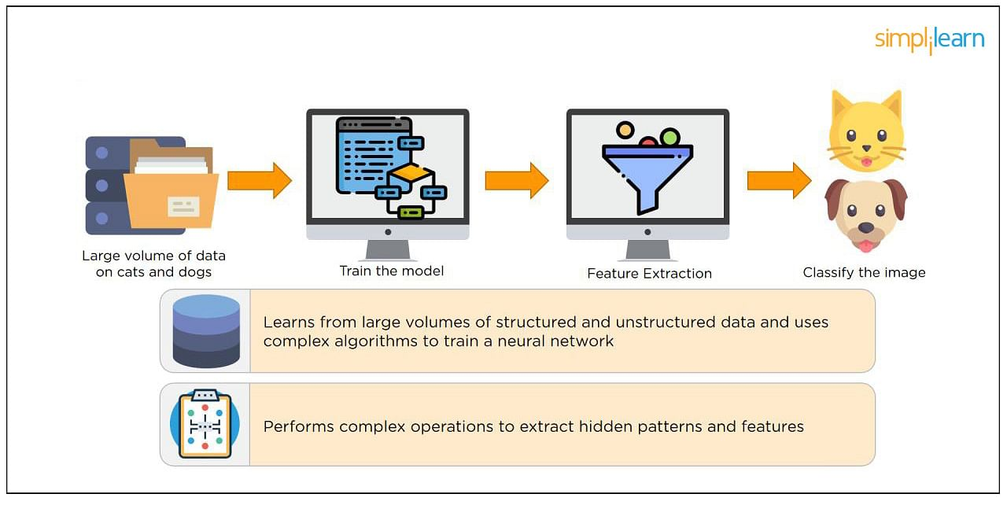

2. What is a Neural Network?
Neural Networks replicate the way humans learn, inspired by how the neurons in our brains fire, only much simpler.
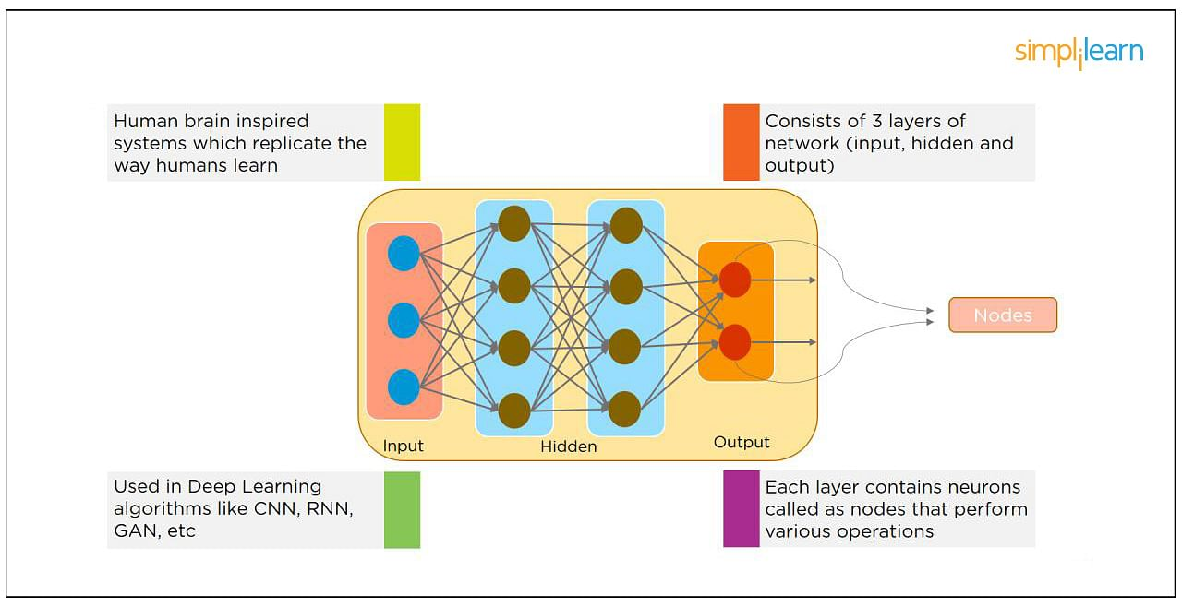
The most common Neural Networks consist of three network layers:
- An input layer
- A hidden layer (this is the most important layer where feature extraction takes place, and adjustments are made to train faster and function better)
- An output layer
Each sheet contains neurons called “nodes,” performing various operations. Neural Networks are used in deep learning algorithms like CNN, RNN, GAN, etc.

3. What Is a Multi-layer Perceptron(MLP)?
As in Neural Networks, MLPs have an input layer, a hidden layer, and an output layer. It has the same structure as a single layer perceptron with one or more hidden layers. A single layer perceptron can classify only linear separable classes with binary output (0,1), but MLP can classify nonlinear classes.
Except for the input layer, each node in the other layers uses a nonlinear activation function. This means the input layers, the data coming in, and the activation function is based upon all nodes and weights being added together, producing the output. MLP uses a supervised learning method called “backpropagation.” In backpropagation, the neural network calculates the error with the help of cost function. It propagates this error backward from where it came (adjusts the weights to train the model more accurately).

4. What Is Data Normalization, and Why Do We Need It?
The process of standardizing and reforming data is called “Data Normalization.” It’s a pre-processing step to eliminate data redundancy. Often, data comes in, and you get the same information in different formats. In these cases, you should rescale values to fit into a particular range, achieving better convergence.

5. What is the Boltzmann Machine?
One of the most basic Deep Learning models is a Boltzmann Machine, resembling a simplified version of the Multi-Layer Perceptron. This model features a visible input layer and a hidden layer -- just a two-layer neural net that makes stochastic decisions as to whether a neuron should be on or off. Nodes are connected across layers, but no two nodes of the same layer are connected.

6. What Is the Role of Activation Functions in a Neural Network?
At the most basic level, an activation function decides whether a neuron should be fired or not. It accepts the weighted sum of the inputs and bias as input to any activation function. Step function, Sigmoid, ReLU, Tanh, and Softmax are examples of activation functions.

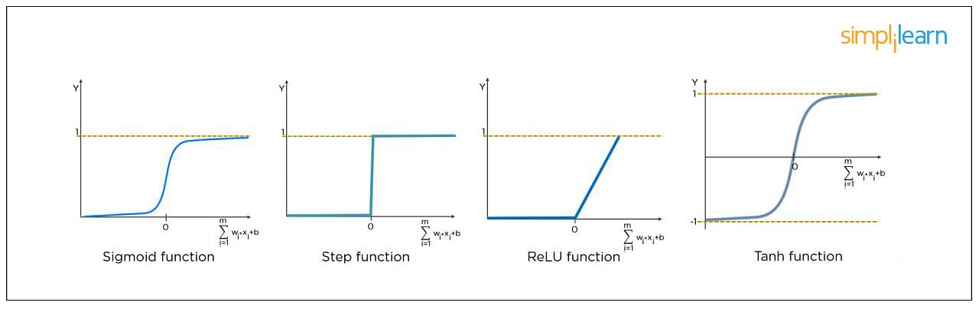

7. What Is the Cost Function?
Also referred to as “loss” or “error,” cost function is a measure to evaluate how good your model’s performance is. It’s used to compute the error of the output layer during backpropagation. We push that error backward through the neural network and use that during the different training functions.
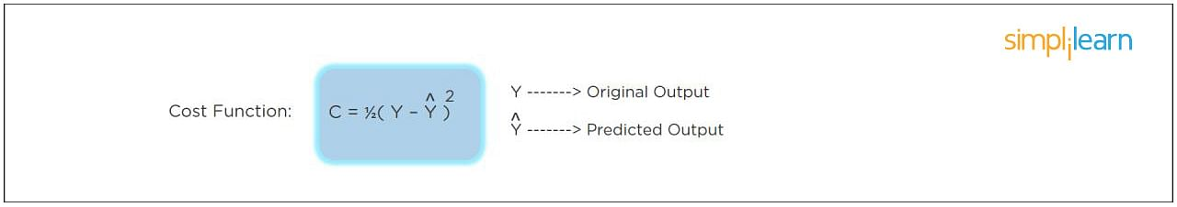

8. What Is Gradient Descent?
Gradient Descent is an optimal algorithm to minimize the cost function or to minimize an error. The aim is to find the local-global minima of a function. This determines the direction the model should take to reduce the error.
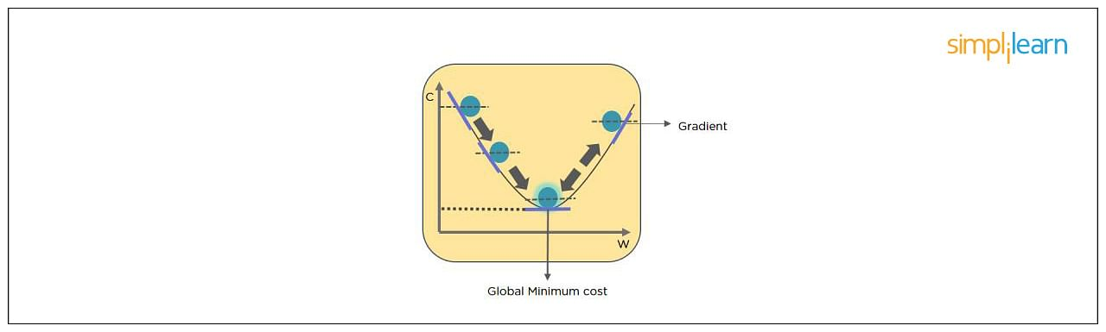

9. What Do You Understand by Backpropagation?
This is one of the most frequently asked deep learning interview questions. Backpropagation is a technique to improve the performance of the network. It backpropagates the error and updates the weights to reduce the error.
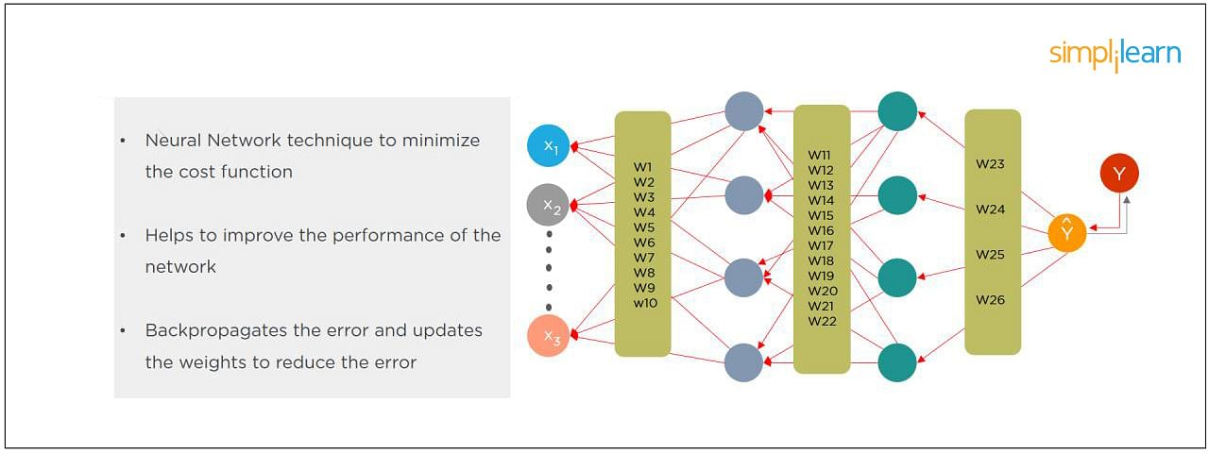

10. What Is the Difference Between a Feedforward Neural Network and Recurrent Neural Network?
In this deep learning interview question, the interviewee expects you to give a detailed answer.
A Feedforward Neural Network signals travel in one direction from input to output. There are no feedback loops; the network considers only the current input. It cannot memorize previous inputs (e.g., CNN).
A Recurrent Neural Network’s signals travel in both directions, creating a looped network. It considers the current input with the previously received inputs for generating the output of a layer and can memorize past data due to its internal memory.
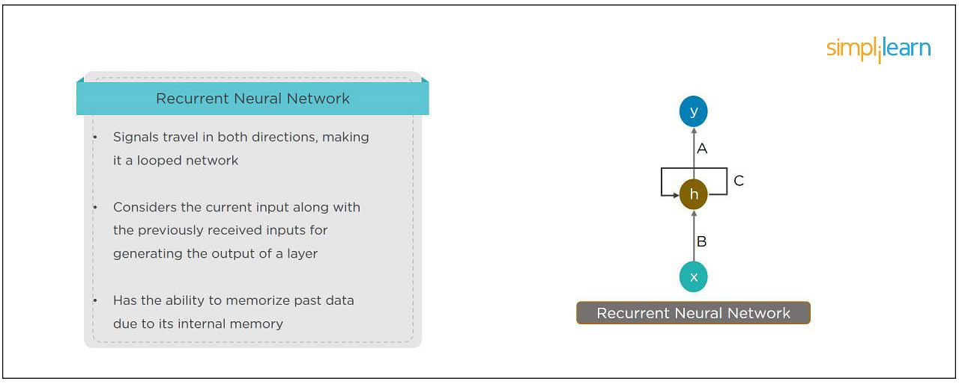

11. What Are the Applications of a Recurrent Neural Network (RNN)?
The RNN can be used for sentiment analysis, text mining, and image captioning. Recurrent Neural Networks can also address time series problems such as predicting the prices of stocks in a month or quarter.

12. What Are the Softmax and ReLU Functions?
Softmax is an activation function that generates the output between zero and one. It divides each output, such that the total sum of the outputs is equal to one. Softmax is often used for output layers.
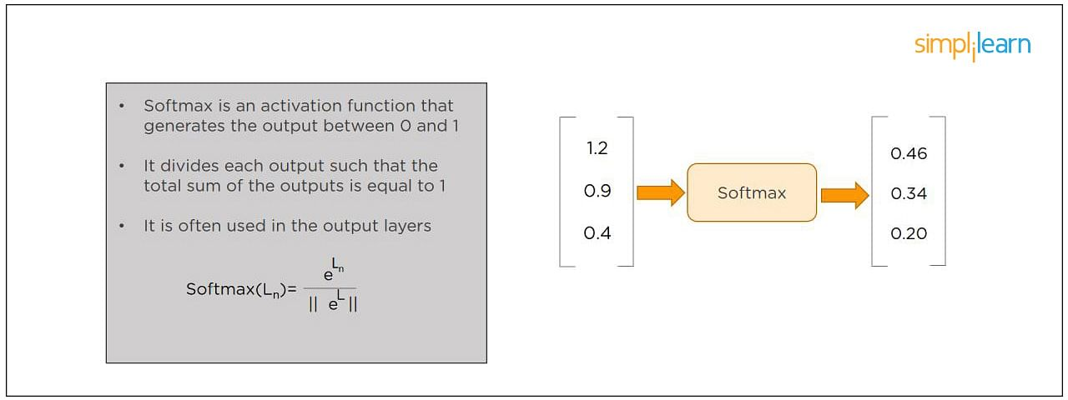
ReLU (or Rectified Linear Unit) is the most widely used activation function. It gives an output of X if X is positive and zeros otherwise. ReLU is often used for hidden layers.
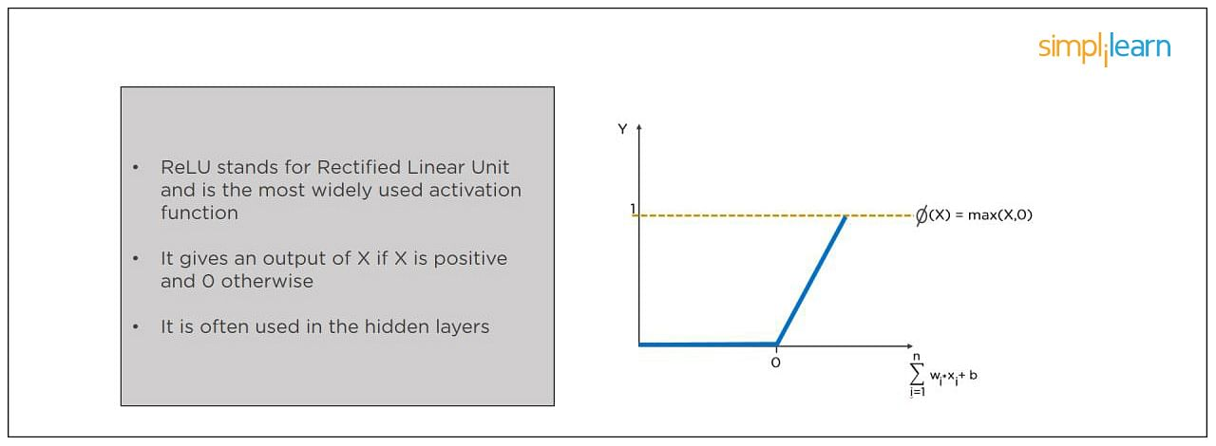

13. What Are Hyperparameters?
This is another frequently asked deep learning interview question. With neural networks, you’re usually working with hyperparameters once the data is formatted correctly. A hyperparameter is a parameter whose value is set before the learning process begins. It determines how a network is trained and the structure of the network (such as the number of hidden units, the learning rate, epochs, etc.).
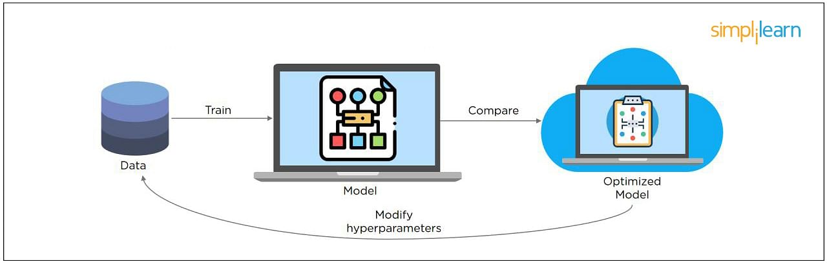

14. What Will Happen If the Learning Rate Is Set Too Low or Too High?
When your learning rate is too low, training of the model will progress very slowly as we are making minimal updates to the weights. It will take many updates before reaching the minimum point.
If the learning rate is set too high, this causes undesirable divergent behavior to the loss function due to drastic updates in weights. It may fail to converge (model can give a good output) or even diverge (data is too chaotic for the network to train).
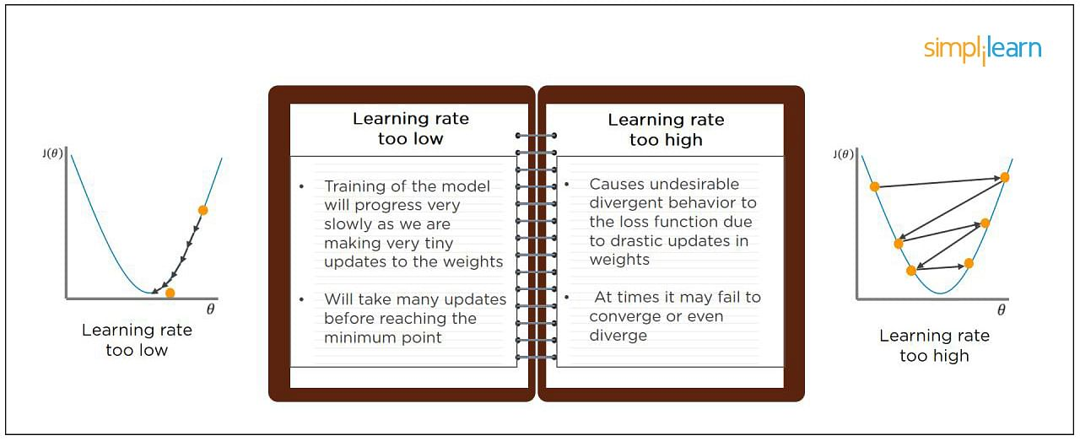

15. What Is Dropout and Batch Normalization?
Dropout is a technique of dropping out hidden and visible units of a network randomly to prevent overfitting of data (typically dropping 20 percent of the nodes). It doubles the number of iterations needed to converge the network.
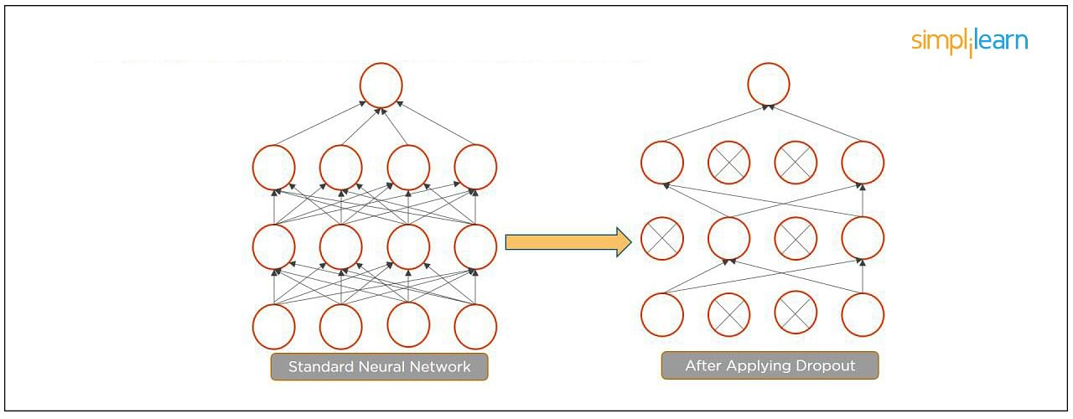
Batch normalization is the technique to improve the performance and stability of neural networks by normalizing the inputs in every layer so that they have mean output activation of zero and standard deviation of one.
The next step on this top Deep Learning interview questions and answers blog will be to discuss intermediate questions.

16. What Is the Difference Between Batch Gradient Descent and Stochastic Gradient Descent?
Batch Gradient Descent | Stochastic Gradient Descent
The batch gradient computes the gradient using the entire dataset.  It takes time to converge because the volume of data is huge, and weights update slowly. | The stochastic gradient computes the gradient using a single sample.  It converges much faster than the batch gradient because it updates weight more frequently.

17. What is Overfitting and Underfitting, and How to Combat Them?
Overfitting occurs when the model learns the details and noise in the training data to the degree that it adversely impacts the execution of the model on new information. It is more likely to occur with nonlinear models that have more flexibility when learning a target function. An example would be if a model is looking at cars and trucks, but only recognizes trucks that have a specific box shape. It might not be able to notice a flatbed truck because there's only a particular kind of truck it saw in training. The model performs well on training data, but not in the real world.
Underfitting alludes to a model that is neither well-trained on data nor can generalize to new information. This usually happens when there is less and incorrect data to train a model. Underfitting has both poor performance and accuracy.
To combat overfitting and underfitting, you can resample the data to estimate the model accuracy (k-fold cross-validation) and by having a validation dataset to evaluate the model.

18. How Are Weights Initialized in a Network?
There are two methods here: we can either initialize the weights to zero or assign them randomly.
Initializing all weights to 0: This makes your model similar to a linear model. All the neurons and every layer perform the same operation, giving the same output and making the deep net useless.
Initializing all weights randomly: Here, the weights are assigned randomly by initializing them very close to 0. It gives better accuracy to the model since every neuron performs different computations. This is the most commonly used method.

19. What Are the Different Layers on CNN?
There are four layers in CNN:
- Convolutional Layer - the layer that performs a convolutional operation, creating several smaller picture windows to go over the data.
- ReLU Layer - it brings non-linearity to the network and converts all the negative pixels to zero. The output is a rectified feature map.
- Pooling Layer - pooling is a down-sampling operation that reduces the dimensionality of the feature map.
- Fully Connected Layer - this layer recognizes and classifies the objects in the image.
Master the deep learning concepts and TensorFlow open-source framework with the Deep Learning Course with TensorFlow Certification. Check out the course preview today.

20. What is Pooling on CNN, and How Does It Work?
Pooling is used to reduce the spatial dimensions of a CNN. It performs down-sampling operations to reduce the dimensionality and creates a pooled feature map by sliding a filter matrix over the input matrix.
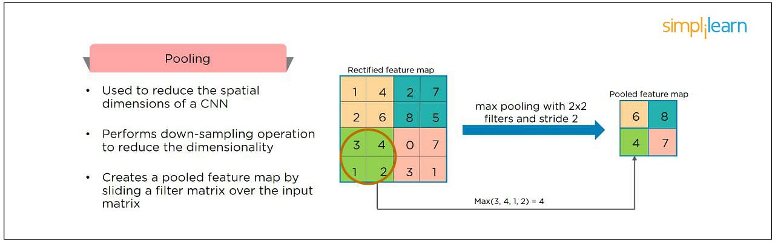

21. How Does an LSTM Network Work?
Long-Short-Term Memory (LSTM) is a special kind of recurrent neural network capable of learning long-term dependencies, remembering information for long periods as its default behavior. There are three steps in an LSTM network:
- Step 1: The network decides what to forget and what to remember.
- Step 2: It selectively updates cell state values.
- Step 3: The network decides what part of the current state makes it to the output.
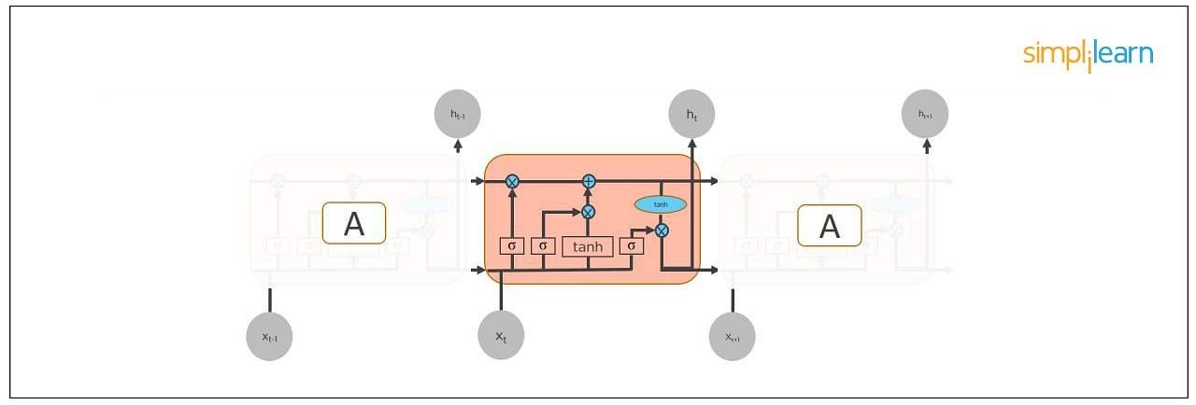

22. What Are Vanishing and Exploding Gradients?
While training an RNN, your slope can become either too small or too large; this makes the training difficult. When the slope is too small, the problem is known as a “Vanishing Gradient.” When the slope tends to grow exponentially instead of decaying, it’s referred to as an “Exploding Gradient.” Gradient problems lead to long training times, poor performance, and low accuracy.
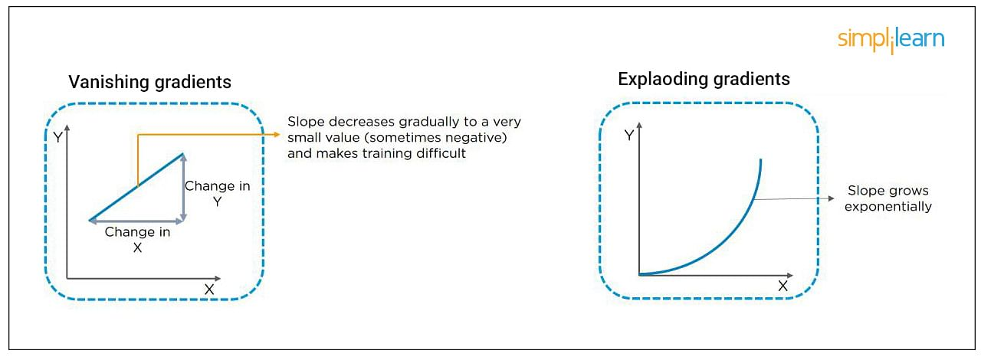

23. What Is the Difference Between Epoch, Batch, and Iteration in Deep Learning?
- Epoch - Represents one iteration over the entire dataset (everything put into the training model).
- Batch - Refers to when we cannot pass the entire dataset into the neural network at once, so we divide the dataset into several batches.
- Iteration - if we have 10,000 images as data and a batch size of 200. then an epoch should run 50 iterations (10,000 divided by 50).

24. Why is Tensorflow the Most Preferred Library in Deep Learning?
Tensorflow provides both C++ and Python APIs, making it easier to work on and has a faster compilation time compared to other Deep Learning libraries like Keras and Torch. Tensorflow supports both CPU and GPU computing devices.

25. What Do You Mean by Tensor in Tensorflow?
This is another most frequently asked deep learning interview question. A tensor is a mathematical object represented as arrays of higher dimensions. These arrays of data with different dimensions and ranks fed as input to the neural network are called “Tensors.”
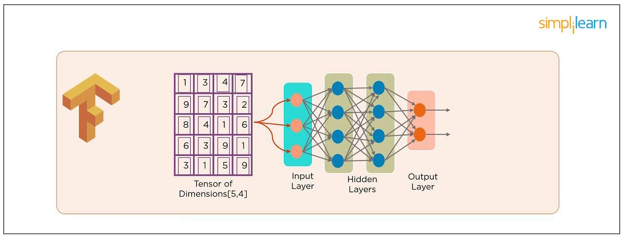

26. What Are the Programming Elements in Tensorflow?
Constants - Constants are parameters whose value does not change. To define a constant we use tf.constant() command. For example:
a = tf.constant(2.0,tf.float32)
b = tf.constant(3.0)
Print(a, b)
Variables - Variables allow us to add new trainable parameters to graph. To define a variable, we use the tf.Variable() command and initialize them before running the graph in a session. An example:
W = tf.Variable([.3].dtype=tf.float32)
b = tf.Variable([-.3].dtype=tf.float32)
Placeholders - these allow us to feed data to a tensorflow model from outside a model. It permits a value to be assigned later. To define a placeholder, we use the tf.placeholder() command. An example:
a = tf.placeholder (tf.float32)
b = a*2
with tf.Session() as sess:
result = sess.run(b,feed_dict={a:3.0})
print result
Sessions - a session is run to evaluate the nodes. This is called the “Tensorflow runtime.” For example:
a = tf.constant(2.0)
b = tf.constant(4.0)
c = a+b
# Launch Session
Sess = tf.Session()
# Evaluate the tensor c
print(sess.run(c))

27. Explain a Computational Graph.
Everything in a tensorflow is based on creating a computational graph. It has a network of nodes where each node operates, Nodes represent mathematical operations, and edges represent tensors. Since data flows in the form of a graph, it is also called a “DataFlow Graph.”

28. Explain Generative Adversarial Network.
Suppose there is a wine shop purchasing wine from dealers, which they resell later. But some dealers sell fake wine. In this case, the shop owner should be able to distinguish between fake and authentic wine.
The forger will try different techniques to sell fake wine and make sure specific techniques go past the shop owner’s check. The shop owner would probably get some feedback from wine experts that some of the wine is not original. The owner would have to improve how he determines whether a wine is fake or authentic.
The forger’s goal is to create wines that are indistinguishable from the authentic ones while the shop owner intends to tell if the wine is real or not accurately.
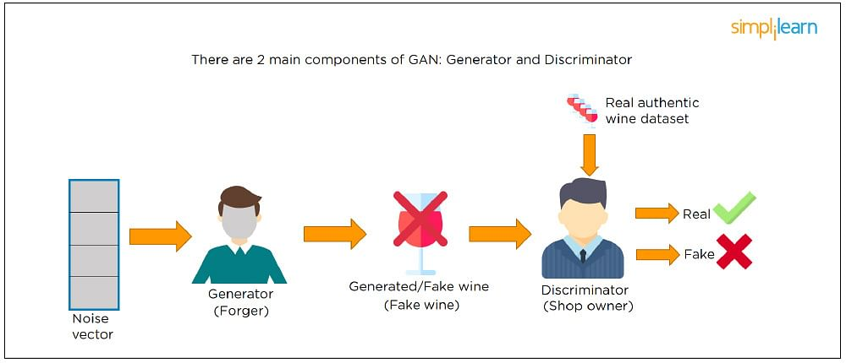
Let us understand this example with the help of an image shown above.
There is a noise vector coming into the forger who is generating fake wine.
Here the forger acts as a Generator.
The shop owner acts as a Discriminator.
The Discriminator gets two inputs; one is the fake wine, while the other is the real authentic wine. The shop owner has to figure out whether it is real or fake.
So, there are two primary components of Generative Adversarial Network (GAN) named:
- Generator
- Discriminator
The generator is a CNN that keeps keys producing images and is closer in appearance to the real images while the discriminator tries to determine the difference between real and fake images The ultimate aim is to make the discriminator learn to identify real and fake images.

29. What Is an Auto-encoder?
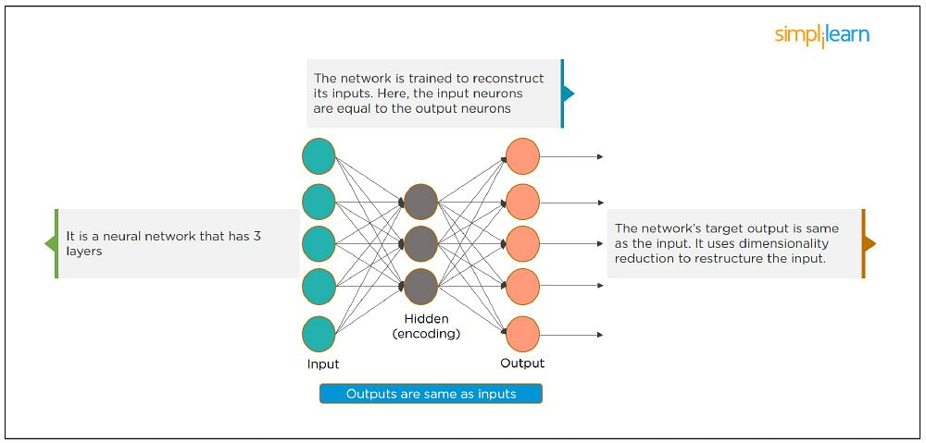
This Neural Network has three layers in which the input neurons are equal to the output neurons. The network's target outside is the same as the input. It uses dimensionality reduction to restructure the input. It works by compressing the image input to a latent space representation then reconstructing the output from this representation.

30. What Is Bagging and Boosting?
Bagging and Boosting are ensemble techniques to train multiple models using the same learning algorithm and then taking a call.
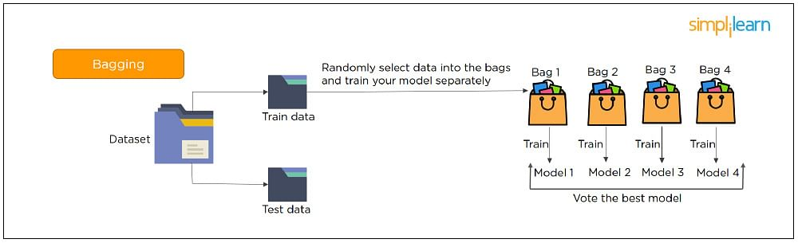
With Bagging, we take a dataset and split it into training data and test data. Then we randomly select data to place into the bags and train the model separately.
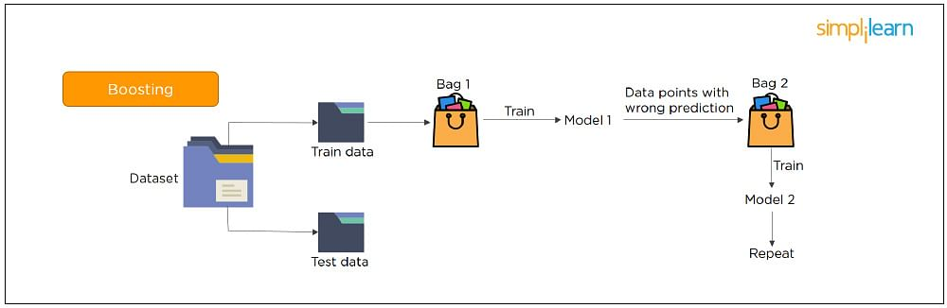
With Boosting, the emphasis is on selecting data points which give wrong output to improve the accuracy.
The following are some of the most important advanced deep learning interview questions that you should know!

31. What is the significance of using the Fourier transform in Deep Learning tasks?
The Fourier transform function efficiently analyzes, maintains, and manages large datasets. You can use it to generate real-time array data that is helpful for processing multiple signals.

32. What do you understand by transfer learning? Name a few commonly used transfer learning models.
Transfer learning is the process of transferring the learning from a model to another model without having to train it from scratch. It takes critical parts of a pre-trained model and applies them to solve new but similar machine learning problems.
Some of the popular transfer learning models are:
- VGG-16
- BERT
- GTP-3
- Inception V3
- XCeption

33. What is the difference between SAME and VALID padding in Tensorflow?
Using the Tensorflow library, tf.nn.max_pool performs the max-pooling operation. Tf.nn.max_pool has a padding argument that takes 2 values - SAME or VALID.
With padding == “SAME” ensures that the filter is applied to all the elements of the input.
The input image gets fully covered by the filter and specified stride. The padding type is named SAME as the output size is the same as the input size (when stride=1).
With padding == “VALID” implies there is no padding in the input image. The filter window always stays inside the input image. It assumes that all the dimensions are valid so that the input image gets fully covered by a filter and the stride defined by you.

34. What are some of the uses of Autoencoders in Deep Learning?
- Autoencoders are used to convert black and white images into colored images.
- Autoencoder helps to extract features and hidden patterns in the data.
- It is also used to reduce the dimensionality of data.
- It can also be used to remove noises from images.

35. What is the Swish Function?
Swish is an activation function proposed by Google which is an alternative to the ReLU activation function.
It is represented as: f(x) = x * sigmoid(x).
The Swish function works better than ReLU for a variety of deeper models.
The derivative of Swist can be written as: y’ = y + sigmoid(x) * (1 - y)

36. What are the reasons for mini-batch gradient being so useful?
- Mini-batch gradient is highly efficient compared to stochastic gradient descent.
- It lets you attain generalization by finding the flat minima.
- Mini-batch gradient helps avoid local minima to allow gradient approximation for the whole dataset.

37. What do you understand by Leaky ReLU activation function?
Leaky ReLU is an advanced version of the ReLU activation function. In general, the ReLU function defines the gradient to be 0 when all the values of inputs are less than zero. This deactivates the neurons. To overcome this problem, Leaky ReLU activation functions are used. It has a very small slope for negative values instead of a flat slope.

38. What is Data Augmentation in Deep Learning?
Data Augmentation is the process of creating new data by enhancing the size and quality of training datasets to ensure better models can be built using them. There are different techniques to augment data such as numerical data augmentation, image augmentation, GAN-based augmentation, and text augmentation.

39. Explain the Adam optimization algorithm.
Adaptive Moment Estimation or Adam optimization is an extension to the stochastic gradient descent. This algorithm is useful when working with complex problems involving vast amounts of data or parameters. It needs less memory and is efficient.
Adam optimization algorithm is a combination of two gradient descent methodologies -
Momentum and Root Mean Square Propagation.

40. Why is a convolutional neural network preferred over a dense neural network for an image classification task?
- The number of parameters in a convolutional neural network is much more diminutive than that of a Dense Neural Network. Hence, a CNN is less likely to overfit.
- CNN allows you to look at the weights of a filter and visualize what the network learned. So, this gives a better understanding of the model.
- CNN trains models in a hierarchical way, i.e., it learns the patterns by explaining complex patterns using simpler ones.

41. Which strategy does not prevent a model from over-fitting to the training data?
- Dropout
- Pooling
- Data augmentation
- Early stopping
Answer: b) Pooling - It’s a layer in CNN that performs a downsampling operation.

42. Explain two ways to deal with the vanishing gradient problem in a deep neural network.
- Use the ReLU activation function instead of the sigmoid function
- Initialize neural networks using Xavier initialization that works with tanh activation.

43. Why is a deep neural network better than a shallow neural network?
Both deep and shallow neural networks can approximate the values of a function. But the deep neural network is more efficient as it learns something new in every layer. A shallow neural network has only one hidden layer. But a deep neural network has several hidden layers that create a deeper representation and computation capability.

44. What is the need to add randomness in the weight initialization process?
If you set the weights to zero, then every neuron at each layer will produce the same result and the same gradient value during backpropagation. So, the neural network won’t be able to learn the function as there is no asymmetry between the neurons. Hence, randomness to the weight initialization process is crucial.

45. How can you train hyperparameters in a neural network?
Hyperparameters in a neural network can be trained using four components:
Batch size: Indicates the size of the input data.
Epochs: Denotes the number of times the training data is visible to the neural network to train.
Momentum: Used to get an idea of the next steps that occur with the data being executed.
Learning rate: Represents the time required for the network to update the parameters and learn

1) What is deep learning?
Deep learning is a part of machine learning with an algorithm inspired by the structure and function of the brain, which is called an artificial neural network. In the mid-1960s, Alexey Grigorevich Ivakhnenko published the first general, while working on deep learning network. Deep learning is suited over a range of fields such as computer vision, speech recognition, natural language processing, etc.

2) What are the main differences between AI, Machine Learning, and Deep Learning?
- AI stands for Artificial Intelligence. It is a technique which enables machines to mimic human behavior.
- Machine Learning is a subset of AI which uses statistical methods to enable machines to improve with experiences.
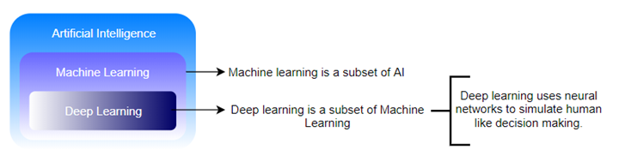
- Deep learning is a part of Machine learning, which makes the computation of multi-layer neural networks feasible. It takes advantage of neural networks to simulate human-like decision making.

3) Differentiate supervised and unsupervised deep learning procedures.
- Supervised learning is a system in which both input and desired output data are provided. Input and output data are labeled to provide a learning basis for future data processing.
- Unsupervised procedure does not need labeling information explicitly, and the operations can be carried out without the same. The common unsupervised learning method is cluster analysis. It is used for exploratory data analysis to find hidden patterns or grouping in data.

4) What are the applications of deep learning?
There are various applications of deep learning:
- Computer vision
- Natural language processing and pattern recognition
- Image recognition and processing
- Machine translation
- Sentiment analysis
- Question Answering system
- Object Classification and Detection
- Automatic Handwriting Generation
- Automatic Text Generation.

5) Do you think that deep network is better than a shallow one?
Both shallow and deep networks are good enough and capable of approximating any function. But for the same level of accuracy, deeper networks can be much more efficient in terms of computation and number of parameters. Deeper networks can create deep representations. At every layer, the network learns a new, more abstract representation of the input.
Play Videox

6) What do you mean by "overfitting"?
Overfitting is the most common issue which occurs in deep learning. It usually occurs when a deep learning algorithm apprehends the sound of specific data. It also appears when the particular algorithm is well suitable for the data and shows up when the algorithm or model represents high variance and low bias.

7) What is Backpropagation?
Backpropagation is a training algorithm which is used for multilayer neural networks. It transfers the error information from the end of the network to all the weights inside the network. It allows the efficient computation of the gradient.
Backpropagation can be divided into the following steps:
- It can forward propagation of training data through the network to generate output.
- It uses target value and output value to compute error derivative concerning output activations.
- It can backpropagate to compute the derivative of the error concerning output activations in the previous layer and continue for all hidden layers.
- It uses the previously calculated derivatives for output and all hidden layers to calculate the error derivative concerning weights.
- It updates the weights.

8) What is the function of the Fourier Transform in Deep Learning?
Fourier transform package is highly efficient for analyzing, maintaining, and managing a large databases. The software is created with a high-quality feature known as the special portrayal. One can effectively utilize it to generate real-time array data, which is extremely helpful for processing all categories of signals.

9) Describe the theory of autonomous form of deep learning in a few words.
There are several forms and categories available for the particular subject, but the autonomous pattern represents independent or unspecified mathematical bases which are free from any specific categorizer or formula.

10) What is the use of Deep learning in today's age, and how is it adding data scientists?
Deep learning has brought significant changes or revolution in the field of machine learning and data science. The concept of a complex neural network (CNN) is the main center of attention for data scientists. It is widely taken because of its advantages in performing next-level machine learning operations. The advantages of deep learning also include the process of clarifying and simplifying issues based on an algorithm due to its utmost flexible and adaptable nature. It is one of the rare procedures which allow the movement of data in independent pathways. Most of the data scientists are viewing this particular medium as an advanced additive and extended way to the existing process of machine learning and utilizing the same for solving complex day to day issues.

11) What are the deep learning frameworks or tools?
Deep learning frameworks or tools are:
Tensorflow, Keras, Chainer, Pytorch, Theano & Ecosystem, Caffe2, CNTK, DyNetGensim, DSSTNE, Gluon, Paddle, Mxnet, BigDL

12) What are the disadvantages of deep learning?
There are some disadvantages of deep learning, which are:
- Deep learning model takes longer time to execute the model. In some cases, it even takes several days to execute a single model depends on complexity.
- The deep learning model is not good for small data sets, and it fails here.

13) What is the meaning of term weight initialization in neural networks?
In neural networking, weight initialization is one of the essential factors. A bad weight initialization prevents a network from learning. On the other side, a good weight initialization helps in giving a quicker convergence and a better overall error. Biases can be initialized to zero. The standard rule for setting the weights is to be close to zero without being too small.

14) Explain Data Normalization.
Data normalization is an essential preprocessing step, which is used to rescale values to fit in a specific range. It assures better convergence during backpropagation. In general, data normalization boils down to subtracting the mean of each data point and dividing by its standard deviation.

15) Why is zero initialization not a good weight initialization process?
If the set of weights in the network is put to a zero, then all the neurons at each layer will start producing the same output and the same gradients during backpropagation.
As a result, the network cannot learn at all because there is no source of asymmetry between neurons. That is the reason why we need to add randomness to the weight initialization process.

16) What are the prerequisites for starting in Deep Learning?
There are some basic requirements for starting in Deep Learning, which are:
- Machine Learning
- Mathematics
- Python Programming

17) What are the supervised learning algorithms in Deep learning?
- Artificial neural network
- Convolution neural network
- Recurrent neural network

18) What are the unsupervised learning algorithms in Deep learning?
- Self Organizing Maps
- Deep belief networks (Boltzmann Machine)
- Auto Encoders

19) How many layers in the neural network?
- Input Layer
The input layer contains input neurons which send information to the hidden layer.
- Hidden Layer
The hidden layer is used to send data to the output layer.
- Output Layer
The data is made available at the output layer.

20) What is the use of the Activation function?
The activation function is used to introduce nonlinearity into the neural network so that it can learn more complex function. Without the Activation function, the neural network would be only able to learn function, which is a linear combination of its input data.
Activation function translates the inputs into outputs. The activation function is responsible for deciding whether a neuron should be activated or not. It makes the decision by calculating the weighted sum and further adding bias with it. The basic purpose of the activation function is to introduce non-linearity into the output of a neuron.

21) How many types of activation function are available?
- Binary Step
- Sigmoid
- Tanh
- ReLU
- Leaky ReLU
- Softmax
- Swish

22) What is a binary step function?
The binary step function is an activation function, which is usually based on a threshold. If the input value is above or below a particular threshold limit, the neuron is activated, then it sends the same signal to the next layer. This function does not allow multi-value outputs.

23) What is the sigmoid function?
The sigmoid activation function is also called the logistic function. It is traditionally a trendy activation function for neural networks. The input data to the function is transformed into a value between 0.0 and 1.0. Input values that are much larger than 1.0 are transformed to the value 1.0. Similarly, values that are much smaller than 0.0 are transformed into 0.0. The shape of the function for all possible inputs is an S-shape from zero up through 0.5 to 1.0. It was the default activation used on neural networks, in the early 1990s.

24) What is Tanh function?
The hyperbolic tangent function, also known as tanh for short, is a similar shaped nonlinear activation function. It provides output values between -1.0 and 1.0. Later in the 1990s and through the 2000s, this function was preferred over the sigmoid activation function as models. It was easier to train and often had better predictive performance.

25) What is ReLU function?
A node or unit which implements the activation function is referred to as a rectified linear activation unit or ReLU for short. Generally, networks that use the rectifier function for the hidden layers are referred to as rectified networks.
Adoption of ReLU may easily be considered one of the few milestones in the deep learning revolution.

26) What is the use of leaky ReLU function?
The Leaky ReLU (LReLU or LReL) manages the function to allow small negative values when the input is less than zero.

27) What is the softmax function?
The softmax function is used to calculate the probability distribution of the event over 'n' different events. One of the main advantages of using softmax is the output probabilities range. The range will be between 0 to 1, and the sum of all the probabilities will be equal to one. When the softmax function is used for multi-classification model, it returns the probabilities of each class, and the target class will have a high probability.

28) What is a Swish function?
Swish is a new, self-gated activation function. Researchers at Google discovered the Swish function. According to their paper, it performs better than ReLU with a similar level of computational efficiency.

29) What is the most used activation function?
Relu function is the most used activation function. It helps us to solve vanishing gradient problems.

30) Can Relu function be used in output layer?
No, Relu function has to be used in hidden layers.

31) In which layer softmax activation function used?
Softmax activation function has to be used in the output layer.

32) What do you understand by Autoencoder?
Autoencoder is an artificial neural network. It can learn representation for a set of data without any supervision. The network automatically learns by copying its input to the output; typically,internet representation consists of smaller dimensions than the input vector. As a result, they can learn efficient ways of representing the data. Autoencoder consists of two parts; an encoder tries to fit the inputs to the internal representation, and a decoder converts the internal state to the outputs.

33) What do you mean by Dropout?
Dropout is a cheap regulation technique used for reducing overfitting in neural networks. We randomly drop out a set of nodes at each training step. As a result, we create a different model for each training case, and all of these models share weights. It's a form of model averaging.

34) What do you understand by Tensors?
Tensors are nothing but a de facto for representing the data in deep learning. They are just multidimensional arrays, which allows us to represent the data having higher dimensions. In general, we deal with high dimensional data sets where dimensions refer to different features present in the data set.

35) What do you understand by Boltzmann Machine?
A Boltzmann machine (also known as stochastic Hopfield network with hidden units) is a type of recurrent neural network. In a Boltzmann machine, nodes make binary decisions with some bias. Boltzmann machines can be strung together to create more sophisticated systems such as deep belief networks. Boltzmann Machines can be used to optimize the solution to a problem.
Some important points about Boltzmann Machine-
- It uses a recurrent structure.
- It consists of stochastic neurons, which include one of the two possible states, either 1 or 0.
- The neurons present in this are either in an adaptive state (free state) or clamped state (frozen state).
- If we apply simulated annealing or discrete Hopfield network, then it would become a Boltzmann Machine.

36) What is Model Capacity?
The capacity of a deep learning neural network controls the scope of the types of mapping functions that it can learn. Model capacity can approximate any given function. When there is a higher model capacity, it means that the larger amount of information can be stored in the network.

37) What is the cost function?
A cost function describes us how well the neural network is performing with respect to its given training sample and the expected output. It may depend on variables such as weights and biases.It provides the performance of a neural network as a whole. In deep learning, our priority is to minimize the cost function. That's why we prefer to use the concept of gradient descent.

38) Explain gradient descent?
An optimization algorithm that is used to minimize some function by repeatedly moving in the direction of steepest descent as specified by the negative of the gradient is known as gradient descent. It's an iteration algorithm, in every iteration algorithm, we compute the gradient of a cost function, concerning each parameter and update the parameter of the function via the following formula:
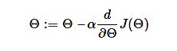
Where,
Θ - is the parameter vector,
α - learning rate,
J(Θ) - is a cost function
In machine learning, it is used to update the parameters of our model. Parameters represent the coefficients in linear regression and weights in neural networks.

39) Explain the following variant of Gradient Descent: Stochastic, Batch, and Mini-batch?
- Stochastic Gradient Descent
Stochastic gradient descent is used to calculate the gradient and update the parameters by using only a single training example.
- Batch Gradient Descent
Batch gradient descent is used to calculate the gradients for the whole dataset and perform just one update at each iteration.
- Mini-batch Gradient Descent
Mini-batch gradient descent is a variation of stochastic gradient descent. Instead of a single training example, mini-batch of samples is used. Mini-batch gradient descent is one of the most popular optimization algorithms.

40) What are the main benefits of Mini-batch Gradient Descent?
- It is computationally efficient compared to stochastic gradient descent.
- It improves generalization by finding flat minima.
- It improves convergence by using mini-batches. We can approximate the gradient of the entire training set, which might help to avoid local minima.

41) What is matrix element-wise multiplication? Explain with an example.
Element-wise matrix multiplication is used to take two matrices of the same dimensions. It further produces another combined matrix with the elements that are a product of corresponding elements of matrix a and b.
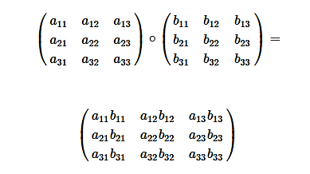

42) What do you understand by a convolutional neural network?
A convolutional neural network, often called CNN, is a feedforward neural network. It uses convolution in at least one of its layers. The convolutional layer contains a set of filter (kernels). This filter is sliding across the entire input image, computing the dot product between the weights of the filter and the input image. As a result of training, the network automatically learns filters that can detect specific features.

43) Explain the different layers of CNN.
There are four layered concepts that we should understand in CNN (Convolutional Neural Network):
- Convolution
This layer comprises of a set of independent filters. All these filters are initialized randomly. These filters then become our parameters which will be learned by the network subsequently.
- ReLU
The ReLu layer is used with the convolutional layer.
- Pooling
It reduces the spatial size of the representation to lower the number of parameters and computation in the network. This layer operates on each feature map independently.
- Full Collectedness
Neurons in a completely connected layer have complete connections to all activations in the previous layer, as seen in regular Neural Networks. Their activations can be easily computed with a matrix multiplication followed by a bias offset.

44) What is an RNN?
RNN stands for Recurrent Neural Networks. These are the artificial neural networks which are designed to recognize patterns in sequences of data such as handwriting, text, the spoken word, genomes, and numerical time series data. RNN use backpropagation algorithm for training because of their internal memory. RNN can remember important things about the input they received, which enables them to be very precise in predicting what's coming next.

45) What are the issues faced while training in Recurrent Networks?
Recurrent Neural Network uses backpropagation algorithm for training, but it is applied on every timestamp. It is usually known as Back-propagation Through Time (BTT).
There are two significant issues with Back-propagation, such as:
- Vanishing Gradient
When we perform Back-propagation, the gradients tend to get smaller and smaller because we keep on moving backward in the Network. As a result, the neurons in the earlier layer learn very slowly if we compare it with the neurons in the later layers.Earlier layers are more valuable because they are responsible for learning and detecting simple patterns. They are the building blocks of the network.
If they provide improper or inaccurate results, then how can we expect the next layers and complete network to perform nicely and provide accurate results. The training procedure tales long, and the prediction accuracy of the model decreases.
- Exploding Gradient
Exploding gradients are the main problem when large error gradients accumulate. They provide result in very large updates to neural network model weights during training.
Gradient Descent process works best when updates are small and controlled. When the magnitudes of the gradient accumulate, an unstable network is likely to occur. It can cause poor prediction of results or even a model that reports nothing useful.

46) Explain the importance of LSTM.
LSTM stands for Long short-term memory. It is an artificial RNN (Recurrent Neural Network) architecture, which is used in the field of deep learning. LSTM has feedback connections which makes it a "general purpose computer." It can process not only a single data point but also entire sequences of data.
They are a special kind of RNN which are capable of learning long-term dependencies.

47) What are the different layers of Autoencoders? Explain briefly.
An autoencoder contains three layers:
- Encoder
The encoder is used to compress the input into a latent space representation. It encodes the input images as a compressed representation in a reduced dimension. The compressed images are the distorted version of the original image.
- Code
The code layer is used to represent the compressed input which is fed to the decoder.
- Decoder
The decoder layer decodes the encoded image back to its original dimension. The decoded image is a reduced reconstruction of the original image. It is automatically reconstructed from the latent space representation.

48) What do you understand by Deep Autoencoders?
Deep Autoencoder is the extension of the simple Autoencoder. The first layer present in DeepAutoencoder is responsible for first-order functions in the raw input. The second layer is responsible for second-order functions corresponding to patterns in the appearance of first-order functions. Deeper layers which are available in the Deep Autoencoder tend to learn even high-order features.
A deep autoencoder is the combination of two, symmetrical deep-belief networks:
- First four or five shallow layers represent the encoding half.
- The other combination of four or five layers makes up the decoding half.

49) What are the three steps to developing the necessary assumption structure in Deep learning?
The procedure of developing an assumption structure involves three specific actions.
- The first step contains algorithm development. This particular process is lengthy.
- The second step contains algorithm analyzing, which represents the in-process methodology.
- The third step is about implementing the general algorithm in the final procedure. The entire framework is interlinked and required for throughout the process.

50) What do you understand by Perceptron? Also, explain its type.
A perceptron is a neural network unit (an artificial neuron) that does certain computations to detect features. It is an algorithm for supervised learning of binary classifiers. This algorithm is used to enable neurons to learn and processes elements in the training set one at a time.
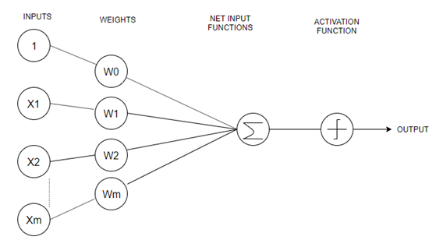
There are two types of perceptrons:
- Single-Layer Perceptron
Single layer perceptrons can learn only linearly separable patterns.
- Multilayer Perceptrons
Multilayer perceptrons or feedforward neural networks with two or more layers have the higher processing power.

1. What is Deep Learning?
Deep learning is a machine learning technology that involves neural networks. The term ‘deep’ in deep learning refers to the hierarchical structure of the networks used to teach computers natural human actions.
It is commonly used in medical research, driverless cars, and other cases where precision and accuracy are important.
Deep Learning Interview Questions PDF

2. What is the difference between deep learning, machine learning and AI?
Both Deep Learning and Machine Learning are part of Artificial intelligence and the difference between all the three domains is really just about the specificities. While deep learning deals with neural networks attempting to train machines through several layers of logic, machine learning is all about algorithms which uses historical data to teach machines. Artificial intelligence, of course, is the broader term which refers to any method which helps machines to mimic basic human actions.

3. What is the difference between supervised and unsupervised deep learning?
Supervised learning refers to the learning method which trains machines through labelled data. This data is already categorised and tagged to the correct set of answers. When a machine is fed this data, it analyses the training set and produces the correct result.
Unsupervised learning, on the other hand, does not require the data to be labelled. Machines self-learn from identifying patterns and model data according to probability densities.

4. What are data visualisation libraries?
Data visualisation libraries help in understanding complex ideas by using visual elements such as graphs, charts, maps and more. The visualisation tools help you to recognise patterns, trends, outliers and more, making it possible to design your data according to the requirement. Popular data visualisation libraries include D3, React-Vis, Chart.js, vx, and more.

5. What is overfitting?
Overfitting is a type of modelling error which results in the failure to predict future observations effectively or fit additional data in the existing model. It occurs when a function is too closely fit to a limited set of data points and usually ends with more parameters than the data can accommodate. It is common for huge data sets to have some anomalies, so when this data is used for any kind of modelling, it can result in inaccuracies in the analysis.
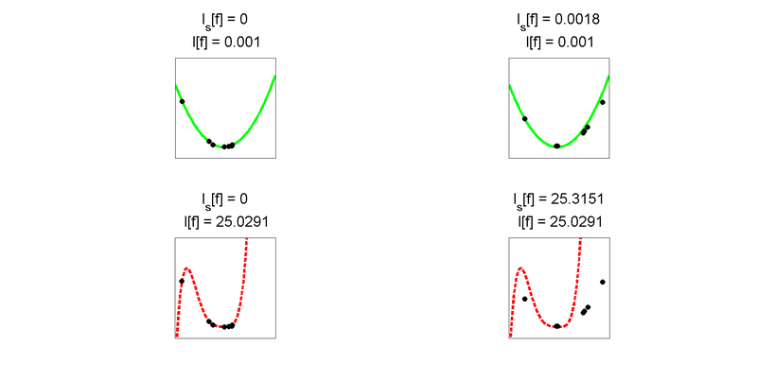

6. How to prevent overfitting?
Overfitting can be prevented by following a few methods namely-
- Cross-validation: Where the initial training data is split into several mini-test sets and each mini data set is used to tune the model.
- Remove features: Remove irrelevant features manually from the algorithms and use feature selection heuristics to identify the important features
- Regularisation: This involves various ways of making your model simpler so that there’s little room for error due to obscurity. Adding penalty parameters and pruning your decision tree are ways of doing that.
- Ensembling: These are machine learning techniques for combining multiple separate predictions. The most popular methods of ensembling are bagging and boosting.

7. How are Deep networks better than shallow networks?
Neural networks include hidden layers apart from input and output layers. Shallow neural networks use a single hidden layer between the input and output layers whereas Deep neural networks, use multiple layers. For a shallow network to fit into any function, it needs to have a lot of parameters. However, since deep networks have several layers, it can fit functions better even with a limited number of parameters. Today deep networks have become preferable owing to its ability to work on any kind of data modelling, whether it is for voice or image recognition.

8. What is Perceptron? And how does it work?
Perceptron is a machine learning algorithm which came to exist from the 1950s. It is a single layer neural network with a linear classifier to work on a set of input data. Since perceptron uses classified data points which are already labelled, it is a supervised learning process.
Perceptron algorithms often present visual charts for users where output datasets are processed to provide the required output. The input data goes through an iterative loop to teach machines. This loop not only iterates but also evolves every time a dataset is fed to the machine. The algorithm improvises its output based on its findings each time so that after a period of time, the output data is more sophisticated and accurate.
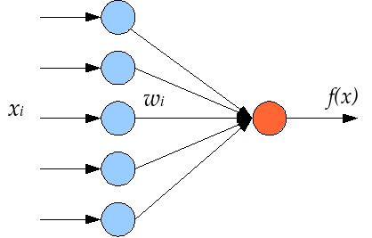

9. What is Multilayer Perceptron and Boltzmann Machine?
Similar to single layer perceptron, multilayer perceptrons have input, output and hidden layers. However, since MLPs have more than one hidden layer, they are capable of classifying non-linear classes. Each node in the hidden layers uses a nonlinear activation function along with the input layers to produce the output through ‘backpropagation’. In this method, the neural networks calculate the errors using cost function and pushes the error backwards to the source to train the model more accurately.
The Boltzmann machine is a simplified version of the multilayer perceptron. This is a two layer model with a visible input layer and a hidden layer which makes stochastic decisions for the neurons. The nodes of this model are connected across layers without being connected to each other.

10. What are activation functions and its types?
Activation functions introduce non-linear properties to our network, allowing it to learn more complex functions. The main purpose of an activation function is to convert an input signal of a node in an A-NN to an output signal. This output signal is then used as an input in the next layer in the stack. To get the output of that layer and feed it as an input to the next layer, we must take the sum of the products of the inputs (x) and their corresponding weights (w) and apply the activation function f(x) to it, in an A-NN.
There are various types of activation functions, such as-
Linear or Identity,
Unit or Binary Step,
Sigmoid or Logistic,
Tanh,
ReLU, and
Softmax.

11. What is inductive reasoning machine learning?
Inductive reasoning focuses as much on the conclusion as the premises and treats the conclusion as part of the reasoning to justify any behaviour. Also known as the ‘cause and effect reasoning’, inductive reasoning tries to prove a conclusion by backtracing to the inputs and picks up that logic as part of its learning.
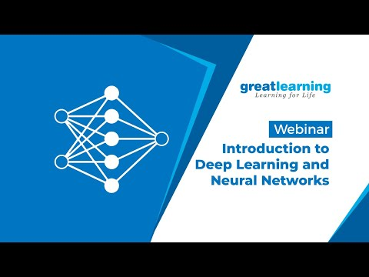

12. What is the use of Fourier Transform in Deep Learning?
Fourier transform is used in machine learning to process signals. The fourier series is a method of breaking down signals into frequency components. It is applicable to non-periodic signals such as a delta function and enables such signals to be measured in terms of frequencies instead of time. Fourier transform is useful when you are working on a system where the transfer function is known.
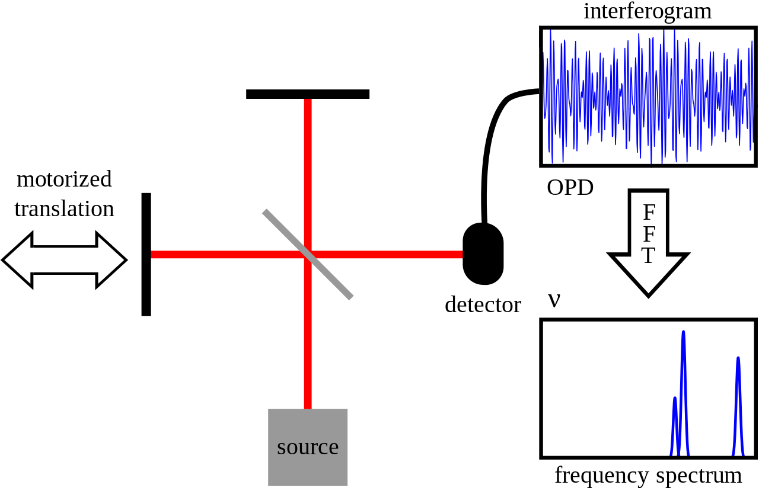

13. What is gradient descent? What are the steps for using a gradient descent algorithm?
An optimization algorithm which is used to learn the value of parameters that minimize cost function is known as a gradient descent. It is an iterative algorithm and moves in the direction of steepest descent. It is defined by the negative of the gradient. It was first proposed in 1847 by Augustin-Louis Cauchy. The steps involved in using a gradient descent algorithm are as follows-
-Initialize a random weight and bias
-Pass an input through the network and get the value from the output layer
-Calculate if there is an error between the actual value and the predicted value
-Go to each neuron which is contributing to the error and change its respective value so that the error is reduced
-Reiterate the steps until the best weights of the network are found

14. What are the benefits of mini-batch gradient descent?
Mini-batch gradient descent, a variation of the gradient descent algorithm, splits any training dataset into small batches to study data model errors and update accordingly. It is the most commonly used gradient descent used for deep learning.
The benefits of using a mini-batch gradient descent is that it allows a more robust convergence without involving the local minima. Even computationally, it is more efficient than other gradient descents (stochastic and batch gradient descents). Mini-batching can work even with zero training data in memory and algorithm implementation.

15. What are Vanishing and Exploding gradients?
Vanishing gradient occurs when backpropagation does not function properly while training the neural networks. In such cases, the network parameters and hyperparameters do not match resulting in the slope becoming too small and decreasing.
In the case of an exploding gradient, there is a significant increase in the norm of the gradient during training. This results in unstable networks that are unable to learn from the training data, especially when the input has a long series of data.

16. What is the difference between Epoch, Batch, and Iteration?
Epoch, iteration and batch are different types of processing datasets and algorithms for gradient descent. Epoch is the process of passing an entire dataset forward and backward through a neural network just once. Often the dataset is too big to be passed in a single attempt so it is passed several times to generate accurate results. When this happens, i.e., a limited set of data is passed through a neural network several times, it is known as an iterative process. However, if the data set is broken down into a number of batches or subsets to ensure it passes through the neural networks successfully, it is known as batch. All the three methods, i.e., epoch, iteration and batch size are basically ways of working on the gradient descent depending on the size of the data set.
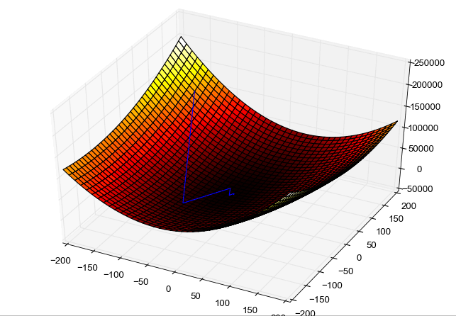

17. How to choose the appropriate formula to solve issues on classification?
Choosing the right metrics and formula to classify your data is extremely important for understanding and optimising the model. Use a model evaluation procedure to choose between different model types, features and tuning parameters. Train and test these models on the same set of data, split-test the models or cross-validate the models by comparing average results with test split results.

18. What is backpropagation?
A training algorithm which is used for a multilayer neural network is known as backpropagation. In backpropagation, the error is moved from the end of the network to all weights, thus allowing efficient computing of the gradient. It is typically divided into several steps, such as-
-Forward propagation of the training data so that the output is generated.
-By using the target value and the output value, error derivative can be computed. (with respect to output activation)
-We then propagate for computing the derivative of the error (with respect to output activation) and continue to do so for all of the hidden layers.
-By using the previously calculated derivatives, we can calculate error derivatives with respect to the weights.
-Update the weights.

19. What are hyperparameters?
Hyperparameters are created from prior observation before a dataset is captured and used in deep learning algorithms to train a model. Hyperparameters need to be initialised before training a model. The benefits of using hyperparameters are that they can control the behaviour of a training model and impact its performance significantly.
Hyperparameters can be optimised by Grid search, Random search, and Bayesian optimisation. Choosing good hyperparameters ensure easy management of large datasets.
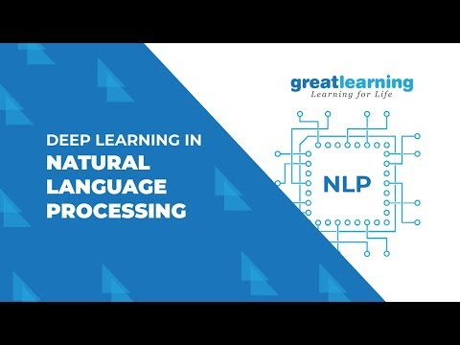

20. What is underfitting and how can it be prevented?
When a model cannot train data or generalise new data, it is referred to as underfitting.
If a model has a good performance metric, it is easy to detect the error. In the case of underfitting, the model does not learn enough and is incapable of predicting correct results.
Underfitting can be prevented by using more training data, adding dropouts, reducing the capacity of networks and regularising weight.

21. What are Recurrent Neural Networks?
Recurrent Neural Networks are neural networks which uses the output from the previous step as inputs for the current step. Unlike a traditional neural network, where the inputs and outputs are independent of each other, in a recurrent neural network, the preceding outputs are crucial to decide the next. It features a hidden layer which carries data regarding a sequence.

22. What are the different layers of a convoluted neural network?
The different types of layers of a CNN include:
- Convolutional Layer: This is the core layer which has sets of learnable filters with receptive field. This is the first layer which extracts features from the input data.
- ReLU Layer: This layer converts negative pixels to zero by making the networks non-linear.
- Pooling Layer: This layer progressively reduces the spatial size of the representation by reducing computation and parameters in the network. The most common approach of pooling is max pooling.

23. What is the most preferred library in Deep Learning and why?
Tensorflow is the most preferred library in deep learning.
Tensorflow provides high flexibility owing to its low-level structure. It can fit into any kind of functionality for any model. Tensorflow is popular among researchers as it can be changed according to the requirement and control networks better.

24. What do you understand by Tensors?
Tensors are multidimensional arrays which allow us to represent data that have a higher dimension. Deep learning deals with high dimensional datasets. Here, dimensions refer to the various features that are present in the dataset.

25. What are deep autoencoders?
Two symmetrical deep-belief networks which typically have four or five shallow layers that represent the encoding half of the net and a second set of four or five layers that represent the decoding half are together known as deep autoencoder. These layers are restricted Boltzmann machines and the building blocks of deep belief networks.
To process the dataset MNIST, a deep autoencoder uses binary transformations after each RBM. They can also be used for other datasets on which you would use Gaussian rectified transformations instead of the RBM.

26. What is the ultimate use of Deep learning in today’s age and how is it aiding data scientists?
Deep learning is used for a number of cases including language recognition, self-driving cars, text generation, video and image editing and more. However, the most important use of deep learning is perhaps in the field of computer vision where computers are fed relevant data to learn object detection, image restoration and segmentation, medical diagnostics, monitoring crops and livestock, and more. Scientists are using deep learning across industries to automate surveillance-based and repetitive tasks to improve productivity and accuracy.

27. What are the benefits of supervised learning procedure?
With supervised learning, you can train the classifier perfectly so that it has a perfect decision boundary. Specific definitions of the classes helps machines distinguish between various classes accurately. Once the training is completed, the decision boundary can be reused for the mathematical formula, instead of the training data. Supervised learning is especially helpful for predictions on data with numerical values.

28. How does unsupervised learning aid in deep learning?
Unsupervised learning has been heralded as the future of deep learning. It actually mimics how humans learn. The biggest advantage of using this method is that unlike supervised learning, unsupervised can scaled up. A strong unsupervised algorithm will be capable of learning by distinguishing without many examples.
Now that we have covered the top Deep Learning interview questions, it’s safe to say that you will give it your best shot and impress the interviewer with your answers. Don’t forget to check out the Deep Learning Tutorial to ensure you don’t miss out on any topic. You can also create your own deep learning machine to check your expertise on the domain. Without any further ado, get set and good luck!

Deep Learning FAQs
1. How do you prepare for a deep learning interview?
Preparing for an interview may seem quite intimidating. However, if you are clear with the fundamentals of deep learning, you can answer the questions confidently. Reading blogs, taking up a free online course to brush up your skills, and attending mock interview sessions are some ways through which you can prepare for a deep learning interview.
2. What are the topics in deep learning?
Deep Learning is a machine learning technology that makes use of neural networks. It is a broad concept that has several topics within it. Some of the concepts under deep learning are: basics of neural networks, common activation functions, recurrent neural networks, convolutional neural networks, back propagation, and more.
3. What is the best way to learn deep learning?
The best way to learn deep learning would vary from one individual to another. However, you can learn through blog posts, YouTube video content, free online courses, taking up a PG program, implementing the concepts learnt in your work environment, and though books. All the methods of learning are equally beneficial.
4. Can I directly learn deep learning?
Deep learning is a part of Machine Learning. To learning Deep Learning concepts, it is necessary to have a basic understanding of ML as well. However, there may be a few algorithms/models that are part of deep learning and not Machine Learning. You can learn those directly.
5. How do you master deep learning?
To master deep learning, start with learning the basic concepts. Once the foundational concepts of deep learning are clear, you can practice and implement the skills that you learnt in your daily work. Working on different projects and real-time activities will help you master deep learning.
6. How do I start deep learning?
To start deep learning, you can head over to Great Learning Academy and take up the Introduction to Deep Learning Free Online Course. This course covers all the basic concepts required for you to step into the world of deep learning and build your career.
7. How hard is deep learning?
The difficulty level of the time taken to learn deep learning varies from one individual to another. If you come from a technical background, it might be slightly easier for you to enter the field. If you are from a non-technical background, you may have to spend a longer amount of time to learn the basics and then deep dive into the other concepts.
8. How good is deep learning?
Deep learning is the best choice when it comes to concepts such as natural language processing or NLP, image processing, and speech recognition. It is extremely powerful in working with unstructured data.

Q1. Differentiate between AI, Machine Learning and Deep Learning.
Artificial Intelligence is a technique that enables machines to mimic human behavior.
Machine Learning is a subset of AI technique which uses statistical methods to enable machines to improve with experience.
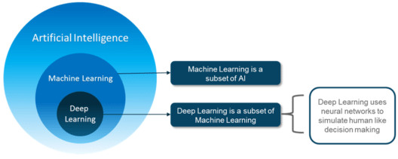
Deep learning is a subset of ML which make the computation of multi-layer neural network feasible. It uses Neural networks to simulate human-like decision making.

Q2. Do you think Deep Learning is Better than Machine Learning? If so, why?
Though traditional ML algorithms solve a lot of our cases, they are not useful while working with high dimensional data, that is where we have a large number of inputs and outputs. For example, in the case of handwriting recognition, we have a large amount of input where we will have a different type of inputs associated with different type of handwriting.
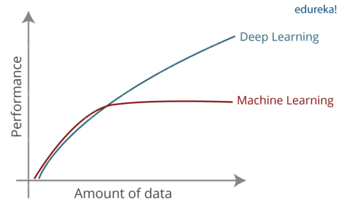
The second major challenge is to tell the computer what are the features it should look for that will play an important role in predicting the outcome as well as to achieve better accuracy while doing so.

Q3. What is Perceptron? And How does it Work?
If we focus on the structure of a biological neuron, it has dendrites which are used to receive inputs. These inputs are summed in the cell body and using the Axon it is passed on to the next biological neuron as shown below.

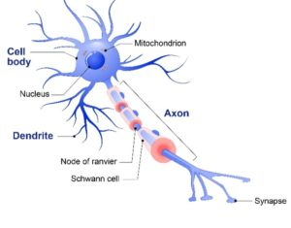
- Dendrite: Receives signals from other neurons
- Cell Body: Sums all the inputs
- Axon: It is used to transmit signals to the other cells
Similarly, a perceptron receives multiple inputs, applies various transformations and functions and provides an output. A Perceptron is a linear model used for binary classification. It models a neuron which has a set of inputs, each of which is given a specific weight. The neuron computes some function on these weighted inputs and gives the output.
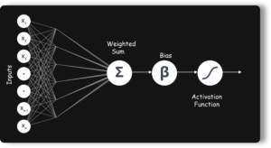

Q4. What is the role of weights and bias?
For a perceptron, there can be one more input called bias. While the weights determine the slope of the classifier line, bias allows us to shift the line towards left or right. Normally bias is treated as another weighted input with the input value x0.
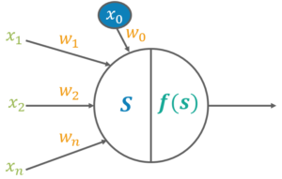

Q5. What are the activation functions?
Activation function translates the inputs into outputs. Activation function decides whether a neuron should be activated or not by calculating the weighted sum and further adding bias with it. The purpose of the activation function is to introduce non-linearity into the output of a neuron.
There can be many Activation functions like:
- Linear or Identity
- Unit or Binary Step
- Sigmoid or Logistic
- Tanh
- ReLU
- Softmax

Q6. Explain Learning of a Perceptron.
- Initializing the weights and threshold.
- Provide the input and calculate the output.
- Update the weights.
- Repeat Steps 2 and 3
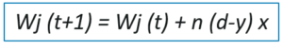
Wj (t+1) – Updated Weight
Wj (t) – Old Weight
d – Desired Output
y – Actual Output
x – Input

Q7. What is the significance of a Cost/Loss function?
A cost function is a measure of the accuracy of the neural network with respect to a given training sample and expected output. It provides the performance of a neural network as a whole. In deep learning, the goal is to minimize the cost function. For that, we use the concept of gradient descent.

Q8. What is gradient descent?
Gradient descent is an optimization algorithm used to minimize some function by iteratively moving in the direction of steepest descent as defined by the negative of the gradient.
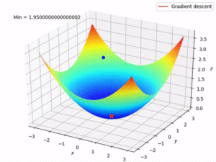
Stochastic Gradient Descent: Uses only a single training example to calculate the gradient and update parameters.
Batch Gradient Descent: Calculate the gradients for the whole dataset and perform just one update at each iteration.
Mini-batch Gradient Descent: Mini-batch gradient is a variation of stochastic gradient descent where instead of single training example, mini-batch of samples is used. It’s one of the most popular optimization algorithms.

Q9. What are the benefits of mini-batch gradient descent?
- This is more efficient compared to stochastic gradient descent.
- The generalization by finding the flat minima.
- Mini-batches allows help to approximate the gradient of the entire training set which helps us to avoid local minima.
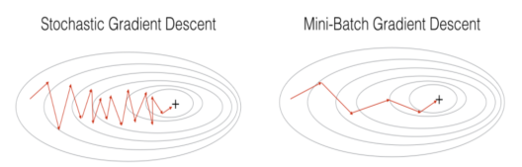

Q10.What are the steps for using a gradient descent algorithm?
- Initialize random weight and bias.
- Pass an input through the network and get values from the output layer.
- Calculate the error between the actual value and the predicted value.
- Go to each neuron which contributes to the error and then change its respective values to reduce the error.
- Reiterate until you find the best weights of the network.

Q11. Create a Gradient Descent in python.
1  2  3  4  5  6  7  8  9  10  11  12  13 | params = [weights_hidden, weights_output, bias_hidden, bias_output]  def sgd(cost, params, lr=0.05):  grads = T.grad(cost=cost, wrt=params)  updates = []  for p, g in zip(params, grads):  updates.append([p, p - g * lr])  return updates  updates = sgd(cost, params)

Q12. What are the shortcomings of a single layer perceptron?
Well, there are two major problems:
- Single-Layer Perceptrons cannot classify non-linearly separable data points.
- Complex problems, that involve a lot of parameters cannot be solved by Single-Layer Perceptrons
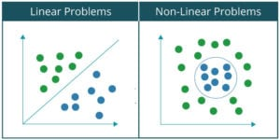

Q13. What is a Multi-Layer-Perceptron
A multilayer perceptron (MLP) is a deep, artificial neural network. It is composed of more than one perceptron. They are composed of an input layer to receive the signal, an output layer that makes a decision or prediction about the input, and in between those two, an arbitrary number of hidden layers that are the true computational engine of the MLP.

Q14. What are the different parts of a multi-layer perceptron?
Input Nodes: The Input nodes provide information from the outside world to the network and are together referred to as the “Input Layer”. No computation is performed in any of the Input nodes – they just pass on the information to the hidden nodes.
Hidden Nodes: The Hidden nodes perform computations and transfer information from the input nodes to the output nodes. A collection of hidden nodes forms a “Hidden Layer”. While a network will only have a single input layer and a single output layer, it can have zero or multiple Hidden Layers.
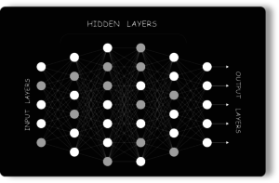
Output Nodes: The Output nodes are collectively referred to as the “Output Layer” and are responsible for computations and transferring information from the network to the outside world.

Q15. What Is Data Normalization And Why Do We Need It?



Data Analytics with R Programming Certification Training
- Instructor-led Sessions
- Real-life Case
- Assignments
- Lifetime Access
Explore Curriculum

Data normalization is very important preprocessing step, used to rescale values to fit in a specific range to assure better convergence during backpropagation. In general, it boils down to subtracting the mean of each data point and dividing by its standard deviation.
These were some basic Deep Learning Interview Questions. Now, let’s move on to some advanced ones.

Advance Interview Questions
Q16. Which is Better Deep Networks or Shallow ones? and Why?
Both the Networks, be it shallow or Deep are capable of approximating any function. But what matters is how precise that network is in terms of getting the results. A shallow network works with only a few features, as it can’t extract more. But a deep network goes deep by computing efficiently and working on more features/parameters.
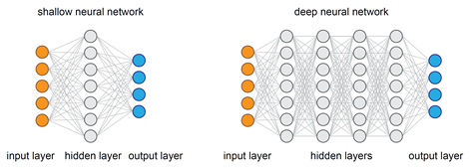

Q17. Why is Weight Initialization important in Neural Networks?
Weight initialization is one of the very important steps. A bad weight initialization can prevent a network from learning but good weight initialization helps in giving a quicker convergence and a better overall error.
Biases can be generally initialized to zero. The rule for setting the weights is to be close to zero without being too small.

Q18. What’s the difference between a feed-forward and a backpropagation neural network?
A Feed-Forward Neural Network is a type of Neural Network architecture where the connections are “fed forward”, i.e. do not form cycles. The term “Feed-Forward” is also used when you input something at the input layer and it travels from input to hidden and from hidden to the output layer.
Backpropagation is a training algorithm consisting of 2 steps:
- Feed-Forward the values.
- Calculate the error and propagate it back to the earlier layers.
So to be precise, forward-propagation is part of the backpropagation algorithm but comes before back-propagating.

Q19. What are the Hperparameteres? Name a few used in any Neural Network.
Hyperparameters are the variables which determine the network structure(Eg: Number of Hidden Units) and the variables which determine how the network is trained(Eg: Learning Rate). Hyperparameters are set before training.
- Number of Hidden Layers
- Network Weight Initialization
- Activation Function
- Learning Rate
- Momentum
- Number of Epochs
- Batch Size

Q20. Explain the different Hyperparameters related to Network and Training.
Network Hyperparameters

The number of Hidden Layers: Many hidden units within a layer with regularization techniques can increase accuracy. Smaller number of units may cause underfitting.
Network Weight Initialization: Ideally, it may be better to use different weight initialization schemes according to the activation function used on each layer. Mostly uniform distribution is used.
Activation function: Activation functions are used to introduce nonlinearity to models, which allows deep learning models to learn nonlinear prediction boundaries.
Training Hyperparameters

Learning Rate: The learning rate defines how quickly a network updates its parameters. Low learning rate slows down the learning process but converges smoothly. Larger learning rate speeds up the learning but may not converge.
Momentum: Momentum helps to know the direction of the next step with the knowledge of the previous steps. It helps to prevent oscillations. A typical choice of momentum is between 0.5 to 0.9.
The number of epochs: Number of epochs is the number of times the whole training data is shown to the network while training. Increase the number of epochs until the validation accuracy starts decreasing even when training accuracy is increasing(overfitting).
Batch size: Mini batch size is the number of sub-samples given to the network after which parameter update happens. A good default for batch size might be 32. Also try 32, 64, 128, 256, and so on.

Q21. What is Dropout?
Dropout is a regularization technique to avoid overfitting thus increasing the generalizing power. Generally, we should use a small dropout value of 20%-50% of neurons with 20% providing a good starting point. A probability too low has minimal effect and a value too high results in under-learning by the network.
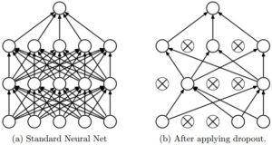
Use a larger network. You are likely to get better performance when dropout is used on a larger network, giving the model more of an opportunity to learn independent representations.

Q22. In training a neural network, you notice that the loss does not decrease in the few starting epochs. What could be the reason?
The reasons for this could be:
- The learning is rate is low
- Regularization parameter is high
- Stuck at local minima

Q23. Name a few deep learning frameworks
- TensorFlow
- Caffe
- The Microsoft Cognitive Toolkit/CNTK
- Torch/PyTorch
- MXNet
- Chainer
- Keras

Q24. What are Tensors?
Tensors are nothing but a de facto for representing the data in deep learning. They are just multidimensional arrays, that allows you to represent data having higher dimensions. In general, Deep Learning you deal with high dimensional data sets where dimensions refer to different features present in the data set.
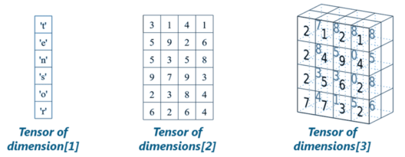

Q25. List a few advantages of TensorFlow?


- It has platform flexibility
- It is easily trainable on CPU as well as GPU for distributed computing.
- TensorFlow has auto differentiation capabilities
- It has advanced support for threads, asynchronous computation, and queue es.
- It is a customizable and open source.

Q26. What is Computational Graph?
A computational graph is a series of TensorFlow operations arranged as nodes in the graph. Each node takes zero or more tensors as input and produces a tensor as output.
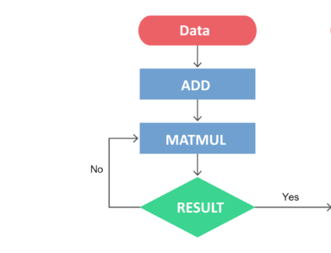
Basically, one can think of a Computational Graph as an alternative way of conceptualizing mathematical calculations that takes place in a TensorFlow program. The operations assigned to different nodes of a Computational Graph can be performed in parallel, thus, providing better performance in terms of computations.

Q27. What is a CNN?
Convolutional neural network (CNN, or ConvNet) is a class of deep neural networks, most commonly applied to analyzing visual imagery. Unlike neural networks, where the input is a vector, here the input is a multi-channeled image. CNNs use a variation of multilayer perceptrons designed to require minimal preprocessing.

Q28. Explain the different Layers of CNN.
There are four layered concepts we should understand in Convolutional Neural Networks:
Convolution: The convolution layer comprises of a set of independent filters. All these filters are initialized randomly and become our parameters which will be learned by the network subsequently.
ReLu: This layer is used with the convolutional layer.

Data Science Training

DATA SCIENCE AND MACHINE LEARNING INTERNSHIP PROGRAM

Data Science and Machine Learning Internship Program
Reviews
5(10)

DATA SCIENCE WITH PYTHON CERTIFICATION COURSE

Data Science with Python Certification Course
Reviews
5(110292)

PYTHON CERTIFICATION TRAINING COURSE

Python Certification Training Course
Reviews
5(38767)

PYTHON MACHINE LEARNING CERTIFICATION TRAINING

Python Machine Learning Certification Training
Reviews
5(12941)

DATA SCIENCE WITH R PROGRAMMING CERTIFICATION TRAINING COURSE

Data Science with R Programming Certification Training Course
Reviews
5(39459)

DATA ANALYTICS WITH R PROGRAMMING CERTIFICATION TRAINING

Data Analytics with R Programming Certification Training
Reviews
5(25787)

STATISTICS ESSENTIALS FOR ANALYTICS

Statistics Essentials for Analytics
Reviews
5(6326)

SAS TRAINING AND CERTIFICATION

SAS Training and Certification
Reviews
5(5254)

ANALYTICS FOR RETAIL BANKS

Analytics for Retail Banks
Reviews
5(1540)

Next
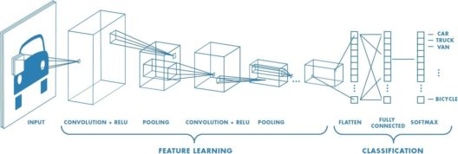

Pooling: Its function is to progressively reduce the spatial size of the representation to reduce the number of parameters and computation in the network. Pooling layer operates on each feature map independently.
Full Connectedness: Neurons in a fully connected layer have full connections to all activations in the previous layer, as seen in regular Neural Networks. Their activations can hence be computed with a matrix multiplication followed by a bias offset.

Q29. What is an RNN?
Recurrent Networks are a type of artificial neural network designed to recognize patterns in sequences of data, such as text, genomes, handwriting, the spoken word, numerical times series data. Recurrent Neural Networks use backpropagation algorithm for training Because of their internal memory, RNN’s are able to remember important things about the input they received, which enables them to be very precise in predicting what’s coming next.

Q30. What are some issues faced while training an RNN?
Recurrent Neural Networks use backpropagation algorithm for training, but it is applied for every timestamp. It is commonly known as Back-propagation Through Time (BTT).
There are some issues with Back-propagation such as:
- Vanishing Gradient
- Exploding Gradient

Q31. What is Vanishing Gradient? And how is this harmful?
When we do Back-propagation, the gradients tend to get smaller and smaller as we keep on moving backward in the Network. This means that the neurons in the Earlier layers learn very slowly as compared to the neurons in the later layers in the Hierarchy.
Earlier layers in the Network are important because they are responsible to learn and detecting the simple patterns and are actually the building blocks of our Network.
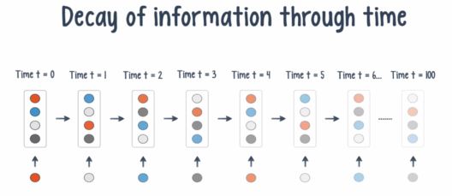
Obviously, if they give improper and inaccurate results, then how can we expect the next layers and the complete Network to perform nicely and produce accurate results. The Training process takes too long and the Prediction Accuracy of the Model will decrease.

Q32. What is Exploding Gradient Descent?
Exploding gradients are a problem when large error gradients accumulate and result in very large updates to neural network model weights during training.
Gradient Descent process works best when these updates are small and controlled. When the magnitudes of the gradients accumulate, an unstable network is likely to occur, which can cause poor prediction of results or even a model that reports nothing useful what so ever.

Q33. Explain the importance of LSTM.
Long short-term memory(LSTM) is an artificial recurrent neural network architecture used in the field of deep learning. Unlike standard feedforward neural networks, LSTM has feedback connections that make it a “general purpose computer”. It can not only process single data points, but also entire sequences of data.
They are a special kind of Recurrent Neural Networks which are capable of learning long-term dependencies.

Q34. What are capsules in Capsule Neural Network?
Capsules are a vector specifying the features of the object and its likelihood. These features can be any of the instantiation parameters like position, size, orientation, deformation, velocity, hue, texture and much more.
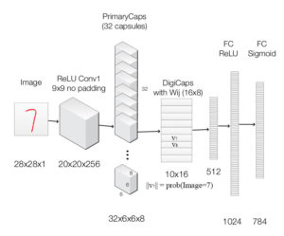
A capsule can also specify its attributes like angle and size so that it can represent the same generic information. Now, just like a neural network has layers of neurons, a capsule network can have layers of capsules.
Now, let’s continue this Deep Learning Interview Questions and move to the section of autoencoders and RBMs.

Q35. Explain Autoencoders and it’s uses.
An autoencoder neural network is an Unsupervised Machine learning algorithm that applies backpropagation, setting the target values to be equal to the inputs. Autoencoders are used to reduce the size of our inputs into a smaller representation. If anyone needs the original data, they can reconstruct it from the compressed data.
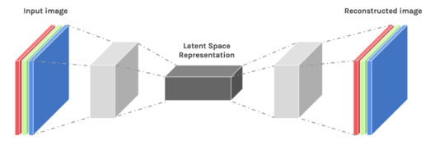

Q36. In terms of Dimensionality Reduction, How does Autoencoder differ from PCAs?
- An autoencoder can learn non-linear transformations with a non-linear activation function and multiple layers.
- It doesn’t have to learn dense layers. It can use convolutional layers to learn which is better for video, image and series data.
- It is more efficient to learn several layers with an autoencoder rather than learn one huge transformation with PCA.
- An autoencoder provides a representation of each layer as the output.
- It can make use of pre-trained layers from another model to apply transfer learning to enhance the encoder/decoder.
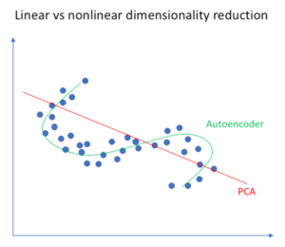

Q37. Give some real-life examples where autoencoders can be applied.
Image Coloring: Autoencoders are used for converting any black and white picture into a colored image. Depending on what is in the picture, it is possible to tell what the color should be.
Feature variation: It extracts only the required features of an image and generates the output by removing any noise or unnecessary interruption.
Dimensionality Reduction: The reconstructed image is the same as our input but with reduced dimensions. It helps in providing a similar image with a reduced pixel value.
Denoising Image: The input seen by the autoencoder is not the raw input but a stochastically corrupted version. A denoising autoencoder is thus trained to reconstruct the original input from the noisy version.

Q38. what are the different layers of Autoencoders?
An Autoencoder consist of three layers:
- Encoder
- Code
- Decoder
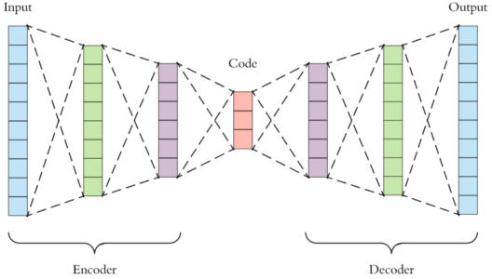

Q39. Explain the architecture of an Autoencoder.
Encoder: This part of the network compresses the input into a latent space representation. The encoder layer encodes the input image as a compressed representation in a reduced dimension. The compressed image is the distorted version of the original image.
Code: This part of the network represents the compressed input which is fed to the decoder.
Decoder: This layer decodes the encoded image back to the original dimension. The decoded image is a lossy reconstruction of the original image and it is reconstructed from the latent space representation.

Q40. What is a Bottleneck in autoencoder and why is it used?
The layer between the encoder and decoder, ie. the code is also known as Bottleneck. This is a well-designed approach to decide which aspects of observed data are relevant information and what aspects can be discarded.
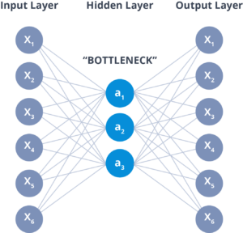
It does this by balancing two criteria:
- Compactness of representation, measured as the compressibility.
- It retains some behaviourally relevant variables from the input.

Q41. Is there any variation of Autoencoders?



Data Analytics with R Programming Certification Training
Weekday / Weekend BatchesSee Batch Details

- Convolution Autoencoders
- Sparse Autoencoders
- Deep Autoencoders
- Contractive Autoencoders

Q42. What are Deep Autoencoders?
The extension of the simple Autoencoder is the Deep Autoencoder. The first layer of the Deep Autoencoder is used for first-order features in the raw input. The second layer is used for second-order features corresponding to patterns in the appearance of first-order features. Deeper layers of the Deep Autoencoder tend to learn even higher-order features.
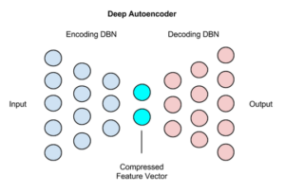
A deep autoencoder is composed of two, symmetrical deep-belief networks:
- First four or five shallow layers representing the encoding half of the net.
- The second set of four or five layers that make up the decoding half.

Q43. What is a Restricted Boltzmann Machine?
Restricted Boltzmann Machine is an undirected graphical model that plays a major role in Deep Learning Framework in recent times.
It is an algorithm which is useful for dimensionality reduction, classification, regression, collaborative filtering, feature learning, and topic modeling.
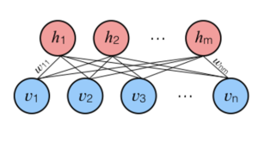

Q44. How Does RBM differ from Autoencoders?
Autoencoder is a simple 3-layer neural network where output units are directly connected back to input units. Typically, the number of hidden units is much less than the number of visible ones. The task of training is to minimize an error or reconstruction, i.e. find the most efficient compact representation for input data.
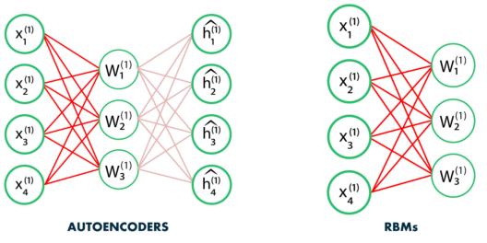
RBM shares a similar idea, but it uses stochastic units with particular distribution instead of deterministic distribution. The task of training is to find out how these two sets of variables are actually connected to each other.
One aspect that distinguishes RBM from other autoencoders is that it has two biases. The hidden bias helps the RBM produce the activations on the forward pass, while The visible layer’s biases help the RBM learn the reconstructions on the backward pass.
Now, Coming to the final questions of this “Deep Learning Interview Questions” series.
Q45. What are some limitations of deep learning?
- Deep learning usually requires large amounts of training data.
- Deep neural networks are easily fooled.
- Successes of deep learning are purely empirical, deep learning algorithms have been criticized as uninterpretable “black-boxes”.
- Deep learning thus far has not been well integrated with prior knowledge.

Q1:
How are Neural Networks modelled?
Entry

Neural Networks 132

Answer
- Artificial neural networks are modelled from biological neurons.
- The connections of the biological neuron are modeled as weights.
  - A positive weight reflects an excitatory connection, while negative values mean inhibitory connections.
  - All inputs are modified by a weight and summed. This activity is referred to as a linear combination.
- Finally, an activation function controls the amplitude of the output. For example, an acceptable range of output is usually between 0 and 1, or it could be −1 and 1.
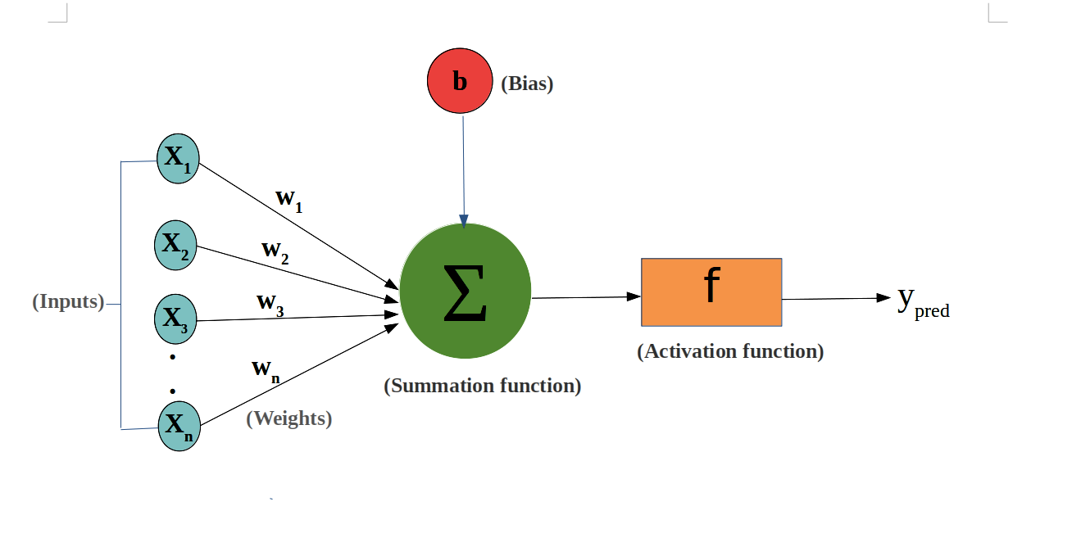
Having Machine Learning, Data Science or Python Interview? Check 132 Neural Networks Interview Questions
Source: en.wikipedia.org

Q2:
What are Ensemble methods and how are they useful in Deep Learning?
Entry

Deep Learning 51

Answer
- Ensemble methods are used to increase the generalization power of a model. These methods are applicable to both deep learning as well as machine learning algorithms.
- Some ensemble methods introduced in neural networks are Dropout and Dropconnect. The improvement in the model depends on the type of data and the nature of neural architecture.
Having Machine Learning, Data Science or Python Interview? Check 51 Deep Learning Interview Questions
Source: Neural Networks and Deep Learning: A Textbook by Charu C. Aggarwal

Q3:
What is the difference between Machine Learning and Deep Learning?
Entry

Deep Learning 51

Answer
- Machine Learning depends on humans to learn. Humans determine the hierarchy of features to determine the difference between the data input. It usually requires more structured data to learn.
- Deep Learning automates much of the feature extraction piece of the process. It eliminates the manual human intervention required.
- Machine Learning is less dependent on the amount of data as compared to deep learning.
- Deep Learning requires a lot of data to give high accuracy. It would take thousands or millions of data points which are trained for days or weeks to give an acceptable accurate model.
Having Machine Learning, Data Science or Python Interview? Check 51 Deep Learning Interview Questions
Source: ibm.com

Q4:
How can Neural Networks be Unsupervised?
Junior

 Unsupervised Learning 27

Answer
- Neural Networks are used in unsupervised learning to learn better representations of the input data.
- Neural networks can learn a mapping from document to real-valued vector in such a way that resulting vectors are similar for documents with similar content. This can be achieved using autoencoders which is a model that is trained to reconstruct the original vector from a smaller representation with reconstruction error as a cost function.
- There are neural networks that are specifically designed for clustering as well. The most widely known is the self-organizing maps (SOM).
Having Machine Learning, Data Science or Python Interview? Check 27 Unsupervised Learning Interview Questions
Source: stats.stackexchange.com

Q5:
How do Neural Networks get the optimal Weights and Bias values?
Junior

Neural Networks 132

Answer
- The neural networks get the optimal weights and bias values through an Error Gradient.
- To decide whether to increase or decrease the current weights and bias, it needs to be compared to the optimal value. This is found by the gradients of error with respect to weights and bias:
\frac{\partial E}{\partial W}, \frac{\partial E}{\partial b}∂W∂E​,∂b∂E​
- The gradient value is calculated from a selected algorithm called backpropagation.
- An optimization algorithm utilizes the gradient to improve the weight values and bias.
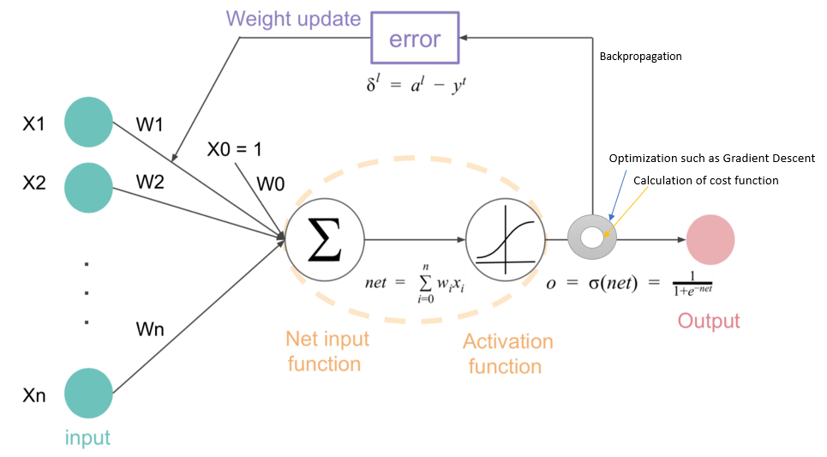
Having Machine Learning, Data Science or Python Interview? Check 132 Neural Networks Interview Questions
Source: towardsdatascience.com

21 Genetic Algorithms Interview Questions For ML And Data Science Interview

Genetic Algorithms 45

Q6:
How does Ensemble Systems help in Incremental Learning?
Junior

Ensemble Learning 49

Answer
- Incremental learning refers to the ability of an algorithm to learn from new data that may become available after a classifier has already been generated from a previously available dataset.
- An algorithm is said to be an incremental learning algorithm if, for a sequence of training datasets, it produces a sequence of hypotheses where the current hypothesis describes all data that have been seen thus far but depends only on previous hypotheses and the current training data.
- Ensemble-based systems can be used for such problems by training an additional classifier (or an additional ensemble of classifiers) on each dataset that becomes available.
Having Machine Learning, Data Science or Python Interview? Check 49 Ensemble Learning Interview Questions
Source: www.scholarpedia.org

Q7:
How to know whether your model is suffering from the problem of Exploding Gradients?
Junior

Deep Learning 51

Answer
There are some subtle signs that you may be suffering from exploding gradients during the training of your network, such as:
- The model is unable to get traction on your training data (e g. poor loss).
- The model is unstable, resulting in large changes in loss from update to update.
- The model loss goes to NaN during training.
If you have these types of problems, you can dig deeper to see if you have a problem with exploding gradients. There are some less subtle signs that you can use to confirm that you have exploding gradients:
- The model weights quickly become very large during training.
- The model weights go to NaN values during training.
- The error gradient values are consistently above 1.0 for each node and layer during training.
Having Machine Learning, Data Science or Python Interview? Check 51 Deep Learning Interview Questions
Source: machinelearningmastery.com

Q8:
How to know whether your model is suffering from the problem of Vanishing Gradients?
Junior

Deep Learning 51

Answer
- The model will improve very slowly during the training phase and it is also possible that training stops very early, meaning that any further training does not improve the model.
- The weights closer to the output layer of the model would witness more of a change whereas the layers that occur closer to the input layer would not change much (if at all).
- Model weights shrink exponentially and become very small when training the model.
- The model weights become 0 in the training phase.

Q9:
How would you choose the Activation Function for a Deep Learning model?
Junior

Deep Learning 51

Answer
- If the output to be predicted is real, then it makes sense to use a Linear Activation function.
- If the output to be predicted is a probability of a binary class, then a Sigmoid function should be used.
- If the output to be predicted has two classes, then a Tanh function can be used.
- ReLU function can be used in many different cases due to its computational simplicity.
Having Machine Learning, Data Science or Python Interview? Check 51 Deep Learning Interview Questions
Source: www.amazon.com

23 Logistic Regression Interview Questions (SOLVED) To Nail On ML Interview

Logistic Regression 24

Q10:
What are Loss Functions in Neural Networks?
Junior

Neural Networks 132

Answer
- Neural network requires a loss function to be chosen when designing and configuring the model.
- While optimizing the model, an objective function is either a loss function or its negative. The objective function is sought to be maximized or minimized (output which has the highest or lowest score respectively). Typically, in a neural network the error should be minimized.
- The loss function should reduce all the aspects of a complex model down to a single scalar value, which allows the candidate solutions to be ranked and compared.
- The loss function chosen by the designer should capture the properties of the problem and be motivated by concerns that are important to the project.
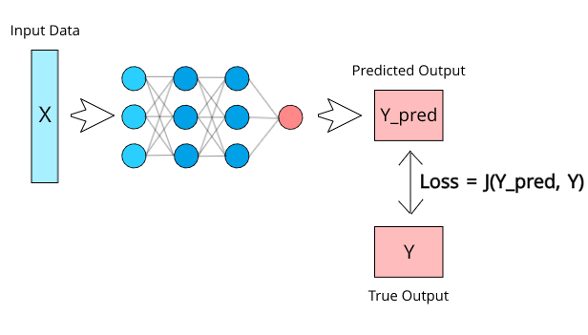
Having Machine Learning, Data Science or Python Interview? Check 132 Neural Networks Interview Questions
Source: machinelearningmastery.com

Q11:
What are the roles of an Activation Function?
Junior

Neural Networks 132

Answer
- Activation Functions help in keeping the value of the output from the neuron restricted to a certain limit as per the requirement. If the limit is not set then the output will reach very high magnitudes. Most activation functions convert the output to -1 to 1 or to 0 to 1.
- The most important role of the activation function is the ability to add non-linearity to the neural network. Most of the models in real-life is non-linear so the activation functions help to create a non-linear model.
- The activation function is responsible for deciding whether a neuron should be activated or not.
Having Machine Learning, Data Science or Python Interview? Check 132 Neural Networks Interview Questions
Source: towardsdatascience.com

Q12:
What is an Activation Function?
Junior

Neural Networks 132

Answer
- An activation function applies a step rule (convert the numerical output into +1 or -1) to check if the output of the weighting function is greater than zero or not.
- An activation function of a node defines the output of the node given an input or set of inputs to the node.
- Activation functions can be divided into three categories:
  - Ridge functions
  - Radial functions, and
  - Fold functions.
- A type of ridge function called Rectified Linear Function (ReLU) is shown below:
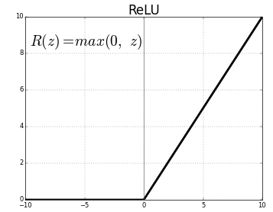
- A type of radial function called Gaussian Function is shown below:
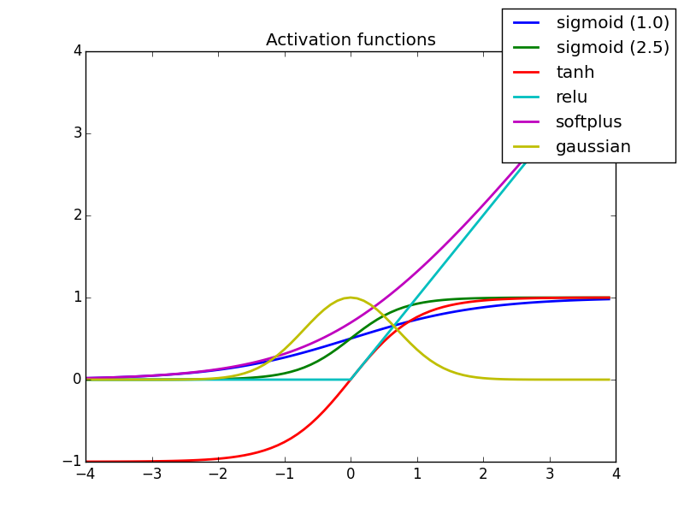
- A fold function perform an aggregation over the inputs, such as taking the mean, minimum or maximum.
Having Machine Learning, Data Science or Python Interview? Check 132 Neural Networks Interview Questions
Source: en.wikipedia.org

Q13:
What's the difference between Convolutional Neural Networks (CNN) and Recurrent Neural Networks (RNN) and in which cases would use each one?
Junior

RNN 17

Answer
Convolutional neural nets apply a convolution to the data before using it in fully connected layers.

They are best used in cases where you want positional invariance, that is to say, you want features to be captured regardless of where they are in the input sample.

Think of a picture with all sorts of animals in it. If you apply a convolutional neural net to classify whether there is a cat in the picture, it will identify the cat no matter what position in the picture the cat is (at the top, the bottom, left or right). This is very useful for image classification.

Recurrent neural nets are neural networks that keep state between input samples. They remember previous input samples and use those to help classify the current input sample.

They are most useful when the order of your data is important. So for instance in speech (previous words do help identify the current word), video (frames are ordered) and also text processing.

Generally speaking, problems related to time-series data (data with a timestamp on them) are good candidates to be solved well with recurrent neural nets.

Having Machine Learning, Data Science or Python Interview? Check 17 RNN Interview Questions
Source: stats.stackexchange.com

20 k-Means Clustering Interview Questions (EXPLAINED) For ML Engineers

K-Means Clustering 41

Q14:
Why does the performance of Deep Learning improve as more data is fed to it?
Junior

Deep Learning 51

Answer
- One of the best benefits of Deep Learning is its ability to perform automatic feature extraction from raw data.
- When the number of data fed into the learning algorithm increases, there will be more edge cases taken into consideration and hence the algorithm will learn to make the right decisions in those edge cases.
Having Machine Learning, Data Science or Python Interview? Check 51 Deep Learning Interview Questions
Source: machinelearningmastery.com

Q15:
Are there any problems when using Batch Normalization in Deep Neural Networks?
Mid

Deep Learning 51

Answer
Batch Normalization (BN) focuses on standardizing the inputs to any particular layer (i.e. activations from previous layers). Standardizing the inputs mean that inputs to any layer in the network should have approximately zero mean and unit variance, but each layer doesn’t need to expect inputs with zero mean and unit variance, instead, probably the model might perform better with some other mean and variance. Hence the BN layer also introduces two learnable parameters γ and β.
In this process, BN calculates the mini-batch mean and variance) in every training iteration, therefore it requires larger batch sizes while training so that it can effectively approximate the population mean and variance from the mini-batch. This makes BN harder to train networks for applications such as object detection, semantic segmentation, etc because they generally work with high input resolution (often as big as 1024 x 2048) and training with larger batch sizes is not computationally feasible. Moreover, during test (or inference) time, the BN layer doesn’t calculate the mean and variance from the test data mini-batch but uses the fixed mean and variance calculated from the training data. This requires caution while using BN and introduces additional complexity.
Having Machine Learning, Data Science or Python Interview? Check 51 Deep Learning Interview Questions
Source: towardsdatascience.com

Q16:
Can autoencoders be used for feature generation? If yes, how?
Mid

Autoencoders 13

Answer
Yes, The encoding component of the autoencoder can be used to generate new features for a model to take in and process when performing a task. Because the encoder has learned to take in a standard input and compress it such that each feature in the encoded representation contains the most important information from the standard input, these encoded features can be exploited to create features and aid the prediction of another model.
The purpose of feature generation is to generate, or add features rather than replace them. Thus, when using autoencoders for feature generation, the encoder provides one set of encoded, information-rich features that are considered alongside the original set of features.
To use autoencoders for feature generation, the encoder's output is concatenated (or merged through some other mechanism) with the original input data, such that the remainder of the network can consider and process both sets of features.
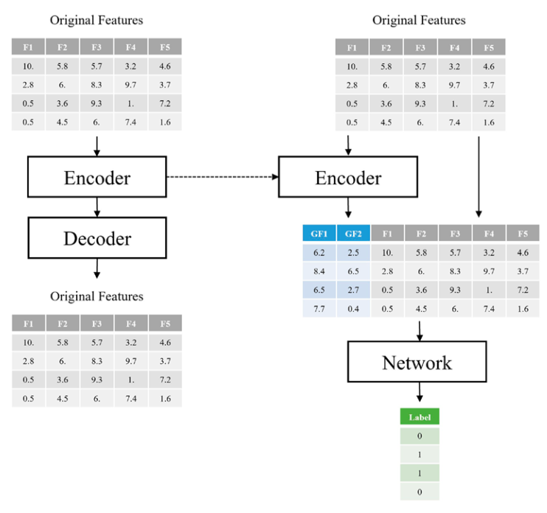
However, if the autoencoder itself does not obtain a relatively high performance in reconstruction (i.e., middling, mediocre performance), forcing the new network model only to take in mediocre-level features could limit its performance. Alternatively, if the data is not of extremely high complexity, like tabular data or lower-resolution images, having an encoder compress the original inputs may be valuable, but not completely necessary. In many cases, models intended for less complex data benefit from processing both the original input and encoded features.
Having Machine Learning, Data Science or Python Interview? Check 13 Autoencoders Interview Questions
Source: link.springer.com

Q17:
Describe the architecture of a typical Convolutional Neural Network (CNN)
Mid

CNN 13

Answer
- In a typical CNN architecture, a few convolutional layers are connected in a cascade style.
- Each convolutional layer is followed by a Rectified Linear Unit (ReLU) layer, then a pooling layer, then one or more convolutional layers (+ReLU), then another pooling layer.
- The output from each convolution layer is a set of objects called feature maps, generated by a single kernel filter.
- The feature maps are used to define a new input to the next layer.
- At the end, there is one or more fully connected layers.
- Pretty much depending on problem type, the network might be deep though.
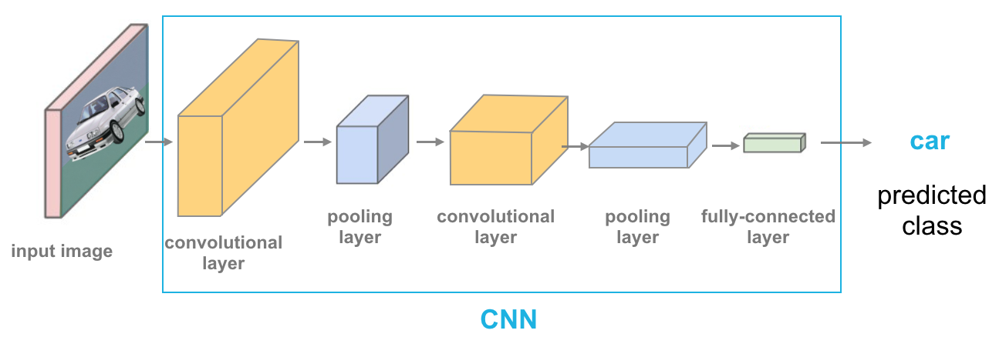
Having Machine Learning, Data Science or Python Interview? Check 13 CNN Interview Questions
Source: www.amazon.com

23 Advanced R Programming Interview Questions (ANSWERED) For Data Scientists

R 41

Q18:
Explain the working of a Perceptron
Mid

Deep Learning 51

Answer
- In a single layer Neural Network, a set of inputs are directly mapped to an output by using a generalized variation of a linear function. This is called a perceptron.
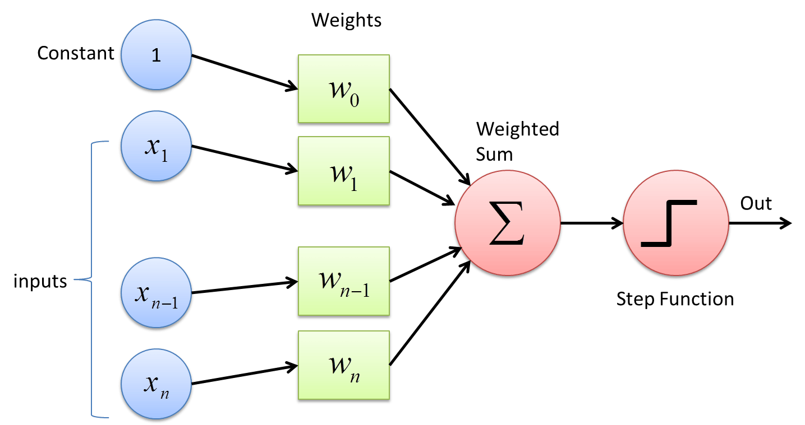
- A perceptron may be designed to give a binary class output. Historical cases for which the class variable is observed, and other cases in which the class variable has not been observed needs to be predicted.
Having Machine Learning, Data Science or Python Interview? Check 51 Deep Learning Interview Questions
Source: www.amazon.com

Q19:
Explain why the Initialization process of weights and bias is important for NN?
Mid

Neural Networks 132

Answer
The initialization step can be critical to the model's performance, and it requires the right method.
- Initializing the weights to zero leads the network to learn zero output which makes the network not learn anything.
- Initializing the weights to be too large causes the network to experience exploding gradients.
- Initializing the weights to be too small causes the network to experience vanishing gradients.
To find the perfect initialization, there are a few rules of thumb to follow:
- The mean of activations should be zero.
- The variance of activations should stay the same across every layer.
Having Machine Learning, Data Science or Python Interview? Check 132 Neural Networks Interview Questions
Source: www.deeplearning.ai

Q20:
How can you convert a Dense Layer of a CNN into a Fully Convolutional Layer?
Mid

Deep Learning 51

Answer
If you have a CNN with some dense layers on top, you can convert these dense layers to convolutional layers to create an FCN in the following way:
- Replace the lowest dense layer with a convolutional layer with a kernel size equal to the layer's input size, with one filter per neuron in the dense layer, and use valid padding.
- Generally, the stride should be 1, but you can set it to a higher value if you want.
- The activation function should be the same as the dense layer's.
- The other dense layers should be converted the same way, but using 1 × 1 filters.
- It is actually possible to convert a trained CNN this way by appropriately reshaping the dense layers' weight matrices.
Having Machine Learning, Data Science or Python Interview? Check 51 Deep Learning Interview Questions
Source: www.amazon.com

Q21:
How does Randomized Connection Dropping affect the Deep Learning model?
Mid

Deep Learning 51

Answer
- The random dropping of connections between different layers in a multilayer neural network often leads to diverse models in which different combinations of features are used to construct the hidden variables.
- The dropping of connections between layers creates less powerful models because of the addition of constraints to the model-building process. However, since different random connections are dropped from different models, the predictions from different models are very diverse.
Having Machine Learning, Data Science or Python Interview? Check 51 Deep Learning Interview Questions
Source: www.amazon.com

21 Recommendation Systems Interview Questions and Answers

Recommendation Systems 30

Q22:
How many dimensions must the inputs of an RNN layer have? What does each dimension represent? What about its outputs?
Mid

RNN 17

Answer
An RNN layer must have three-dimensional inputs:
- The first dimension is the batch dimension (its size is the batch size.
- The second dimension represents the time (its size is the number of time steps),
- And the third dimension holds the inputs at each time step (its size is the number of input features per time step).
For example, if you want to process a batch containing 5 time series of 10 time steps each, with 2 values per time step (e.g., the temperature and the wind speed), the shape will be [5, 10, 2].
The outputs are also three-dimensional, with the same first two dimensions, but the last dimension is equal to the number of neurons. For example, if an RNN layer with 32 neurons processes the batch we just discussed, the output will have a shape of [5, 10, 32].
Check FullStack.Cafe - 3877 Full-Stack, Coding & System Design Questions and Answers

Q23:
How to choose the features for a Neural Network?
Mid

 Data Processing 81

Answer
- A very strong correlation between the new feature and an existing feature is a fairly good sign that the new feature provides little new information.

A low correlation between the new feature and existing features is likely preferable.

A strong linear correlation between the new feature and the predicted variable is a good sign that a new feature will be valuable, but the absence of a high correlation is not necessarily a sign of a poor feature, because neural networks are not restricted to linear combinations of variables.

If the new feature was manually constructed from a combination of existing features, consider leaving it out. The beauty of neural networks is that little feature engineering and preprocessing are required - features are instead learned by intermediate layers.

Whenever possible, prefer learning features to engineering them.

Having Machine Learning, Data Science or Python Interview? Check 81 Data Processing Interview Questions
Source: datascience.stackexchange.com

Q24:
How would you change a neural network from regression to classification?
Mid

Neural Networks 132

Answer
A neural network designed for a regression problem can easily be changed to classification.
It requires two changes to the code:
- A change to the output layer.
- A change to the loss function.
A neural network designed for regression will likely have an output layer with one node to output one value and a linear activation function, for example, in Keras this would be:
...
model.add(Dense(1, activation='linear'))
We can change this to a binary classification problem (two classes) by changing the activation to sigmoid, for example:
...
model.add(Dense(1, activation='sigmoid'))
We can change this to a multi-class classification problem (more than two classes) by changing the number of nodes in the layer to the number of classes (e.g. 3 in this example) and the activation function to softmax, for example:
model.add(Dense(3, activation='softmax'))
Finally, the model will have an error based loss function, such as 'MSE' or 'MAE', for example:
...# compile model
model.compile(loss='mse', optimizer='adam')
We must change the loss function for a binary classification problem (two classes) to binary_crossentropy, for example:
...# compile model
model.compile(loss='binary_crossentropy', optimizer='adam')
We must change the loss function for a multi-class classification problem (more than two classes) to categorical_crossentropy, for example:
...# compile model
model.compile(loss='categorical_crossentropy', optimizer='adam')
That is it. Ultimately, it's recommended to re-tuning the hyperparameters of the neural network for your specific predictive modeling problem.
Having Machine Learning, Data Science or Python Interview? Check 132 Neural Networks Interview Questions
Source: machinelearningmastery.com

Q25:
How would you choose the Loss Function for a Deep Learning model?
Mid

Deep Learning 51

Answer

Binary targets: In this case, the observed value is drawn from -1 to 1. The loss function for this case is shown as follows:

L = log(1 + exp(-y.\hat y))L=log(1+exp(−y.y^​))

Where, \hat yy^​ is the predicted output. y is the observed output.

This type of loss function implements a machine learning method known as logistic regression.

Categorical targets: If y are the probabilities of k classes, and rth class is the ground truth class, the loss function for a single instance is defined as follows:

L = -log(\hat y_r)L=−log(y^​r​)

This type of loss function implements multinomial logistic regression, and it is called cross-entropy loss.

Binary logistic regression is similar to multinomial logistic regression with the value of k set to 2.

Having Machine Learning, Data Science or Python Interview? Check 51 Deep Learning Interview Questions
Source: Neural Networks and Deep Learning: A Textbook by Charu C. Aggarwal

21 Anomaly Detection Interview Questions For Data Analysts & ML Engineers

Anomaly Detection 47

Q26:
How would you tune the Network Structure (Model Design) Hyperparameters to get the highest accuracy in an Artificial Neural Network?
Mid

Neural Networks 132

Answer
Hyperparameters are the variables which determine the network structure and the variables that determine how the network is trained. Some hyperparameters which can be tuned in the neural network include:
- Number of hidden layers: Less number of hidden layers may cause underfitting. Increasing the number of hidden layers will improve accuracy.
- Dropout: It is a regularization technique to avoid overfitting (increasing the validation accuracy). If the neural network is large then using dropout will cause the network to learn independent representations well.
- Network Weight Initialization: Initializing the weights according to the activation function used will give better performance.
- Activation function: Activation functions give nonlinearity to the neural network. The activation function is chosen according to the prediction made such as using sigmoid for binary predictions and softmax for multi-class predictions.
Having Machine Learning, Data Science or Python Interview? Check 132 Neural Networks Interview Questions
Source: towardsdatascience.com

Q27:
Is it a good idea to use CNN to classify 1D signal?
Mid

Neural Networks 132

Answer
If for 1D signal you mean time-series data, where you assume temporal dependence between the values, then convolutional neural networks (CNN) are one of the possible approaches. The most popular neural network approach to such data is to use recurrent neural networks (RNN), but you can alternatively use CNNs, or a hybrid approach (quasi-recurrent neural networks, QRNN).
With RNN, you would use a cell that takes as input previous hidden state and current input value, to return output and another hidden state, so the information flows via the hidden states.
With CNN, you would use sliding window of some width, that would look at certain (learned) patterns in the data, and stack such windows on top of each other, so that higher-level windows would look for patterns within the lower-level patterns. Using such sliding windows may be helpful for finding things such as repeating patterns within the data (e.g. seasonal patterns). QRNN layers mix both approaches.
Name some CNNs architectures that you know
Mid

Deep Learning 51

Answer

The ResNet architectures: or residual neural networks, uses residual connections, or skip connections, which are connections between layers that skip over at least one intermediate layer. ResNet comes in two versions: ResNetV1 and ResNetV2: ResNetV1 passes the data through a convolutional layer before batch normalization and an activation layer, whereas ResNetV2 passes data through the batch normalization and activation layers before the convolutional layer (reversed).

InceptionV3: uses a module/cell-based structure in which certain sets of layers are repeated. Inception networks are more computationally efficient by reducing the number of parameters necessary and limiting the memory and resources needed to be consumed. This architecture was designed primarily with a focus on minimizing computational cost, whereas ResNet focuses on maximizing accuracy.

MobileNet: designed to perform well on mobile phone deep learning applications, uses depth-wise separable convolutions, which are convolutions that apply not only spatially but also depth-wise. MobileNet has more parameters than Inception but less than ResNet; correspondingly, MobileNet has been generally observed to perform worse than ResNet but better than Inception.

Having Machine Learning, Data Science or Python Interview? Check 51 Deep Learning Interview Questions
Source: link.springer.com

Q29:
What are Generative Adversarial Networks?
Mid

Deep Learning 51

Answer
- A Generative Adversarial Network (GAN) is a type of neural network architecture for generative modeling.
- GAN has the capability to generate examples for image datasets, photographs, characters, etc.
- Generative adversarial networks are a model of data generation that can create a generative model of a base data set by using an adversarial game between two players. The two players correspond to a generator and a discriminator.
- The generator takes Gaussian noise as input and produces an output, which is a generated sample like the base data.
- The discriminator is a probabilistic classifier like logistic regression whose job is to distinguish real samples from the base dataset and the generated sample.
27 SVM Interview Questions (ANSWERED) To Master Before ML & Data Science Interview

SVM 56

Q30:
What are some advantages of using Multilayer Perceptron over a Single-layer Perceptron?
Mid

Neural Networks 132

Answer
- A multilayer perceptron is a type of neural network which has many layers of perceptron stacked on top of each other.
- Mathematically, multilayer perceptron are capable of learning any mapping function and have been proven to be a universal approximation algorithm.
- Single layer perceptron only learn linear patterns, while multilayer perceptron can learn complex relationships. This predictive capability comes from the multi-layered structure of the network, so that the features can be combined into higher-order features.
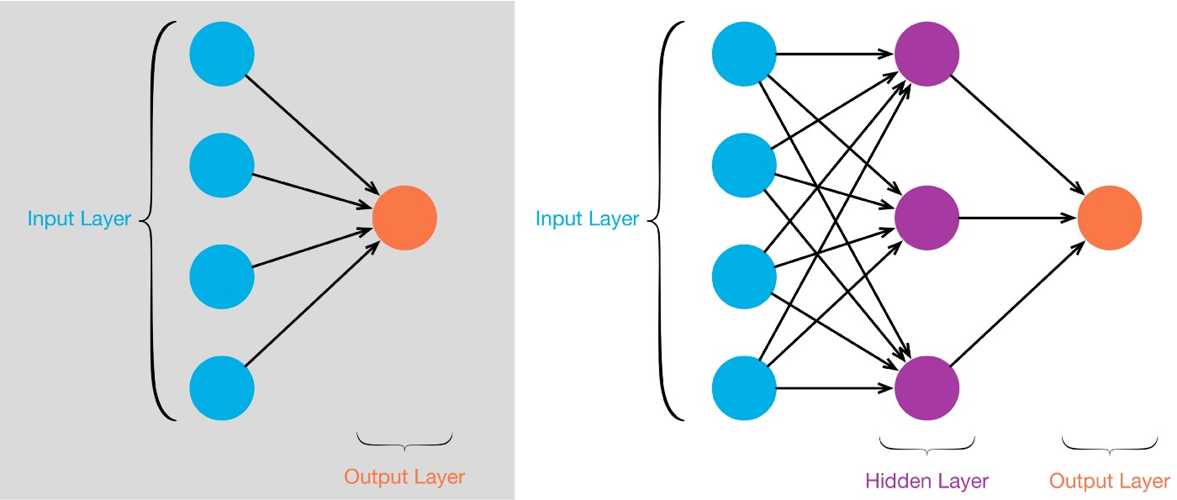

Q31:
What are some criticisms of Neural Networks?
Mid

Neural Networks 132

Answer
- Neural networks require too much data to train. A classification network may require thousands of examples in a single class for it to identify it in unseen data. Due to this, sometimes it is not feasible to create ANN models for fringe applications.
- Neural networks are not interpretable. The user needs to input data into the network and it outputs the required output, but the work that goes into processing the input and giving an output is not understandable to human beings.
- The power required to train the neural network is extremely high compared to the amount of power that a human brain uses (around 20 Watts) to do almost the same things such as image classification.

Q32:
What are some differences between SVMs and Neural Networks?
Mid

SVM 56

Answer
- SVM has a number of parameters that increases linearly with the linear increase in the size of the input. All the parameters of the SVM interacts with one another.

Neural Networks have as many layers as possible, but due to the complex interaction between the model's parameters, NN always has a higher complexity when compared with SVM with a similar number of parameters.

SVMs use only a subset of data for training. They can reliably define the decision boundary solely on the basis of the support vectors. As a result, they do not require much data for training.

- Neural Networks get trained based on the batches of data fed into it. This means that the specific decision boundary that the neural network learns is highly dependent on the order in which the batches of data are presented to it. This, in turn, requires processing the whole training dataset; or otherwise, the network may perform extremely poorly.

Q33:
What does 1x1 convolution mean in a Neural Network?
Mid

Deep Learning 51

Answer
A 1x1 convolution simply maps an input pixel with all its channels to an output pixel, not looking at anything around itself. It is often used to reduce the number of depth channels since it is often very slow to multiply volumes with extremely large depths.
input (256 depth) -> 1x1 convolution (64 depth) -> 4x4 convolution (256 depth)

input (256 depth) -> 4x4 convolution (256 depth)
The bottom one is about ~3.7x slower.
Theoretically, the neural network can choose which input colors to look at using this, instead of brute force-multiplying everything.
27 Probability Interview Questions (ANSWERED) For Data Scientists & ML Devs

Probability 34

Q34:
What happens when you trade the Breadth of a Neural Network for the Depth?
Mid

Deep Learning 51

Answer
- Networks with more layers (Depth) tend to require fewer units per layer because the composition functions created by successive layers make the neural network more powerful.
- The number of units in each layer of a deep network can be decreased to such an extent that when compared to a shallower network (more Breadth), the deep network has far fewer parameters even when added up over the greater number of layers.
- In neural networks with many layers the loss derivatives with respect to the weights in different layers of the network tend to have vastly different magnitudes, which causes challenges in properly choosing step sizes. This can lead to vanishing and exploding gradient problems.
Having Machine Learning, Data Science or Python Interview? Check 51 Deep Learning Interview Questions
Source: Neural Networks and Deep Learning: A Textbook by Charu C. Aggarwal

Q35:
What is Early Stopping in Deep Learning?
Mid

Deep Learning 51

Answer
- Early stopping in deep learning is a type of regularization where the training is stopped after a few iterations.
- When training a large network, there will be a point during training when the model will stop generalizing and start learning the statistical noise in the training dataset. This makes the networks unable to predict new data.
- Defining early stopping in a neural network will prevent the network from overfitting.
- One way of defining early stopping is to start training the model and if the performance of the model starts to degrade, then stopping the training process.
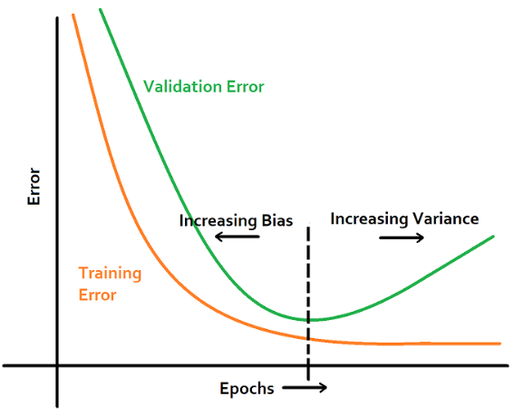
Having Machine Learning, Data Science or Python Interview? Check 51 Deep Learning Interview Questions
Source: Neural Networks and Deep Learning: A Textbook by Charu C. Aggarwal

Q36:
What is the Exploding Gradient Problem in artificial Neural Networks?
Mid

Neural Networks 132

Answer
- Exploding gradient problem is a problem in a neural network where a large error gradient accumulates which results in very large updates to the neural network model weights during training.
- This causes the neural network to stop learning.
- In deep multilayer perceptron networks, this problem creates an unstable network that can not learn from the training data, or at its worst, it creates a NaN weight value that can not be updated.
- In recurrent neural networks, this problem causes the network to be unable to learn from long input sequences of data.

Q37:
What is the Vanishing Gradient Problem in Artificial Neural Networks?
Mid

Neural Networks 132

Answer
- The vanishing gradient problem is encountered in artificial neural networks with gradient-based learning methods and backpropagation.
- In these learning methods, each of the neural networks weights receives an update proportional to the partial derivative of the error function with respect to the current weight in each iteration of training. Sometimes when gradients become vanishingly small, this prevents the weight to change value.
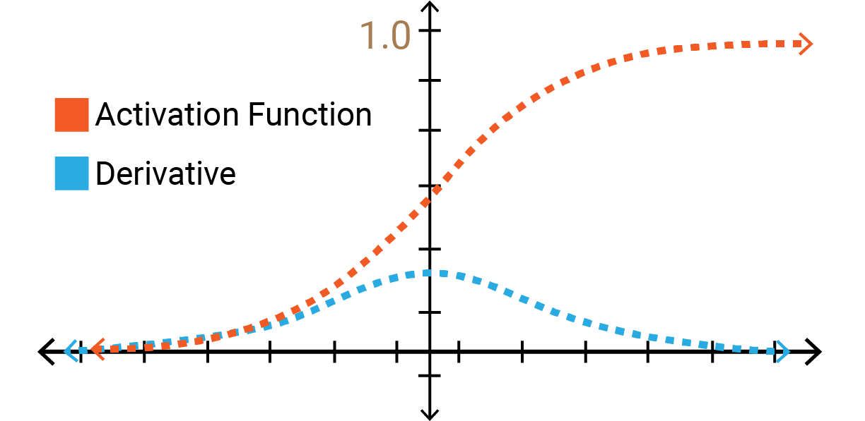

- If the neural network has many hidden layers, the gradients in the earlier layers will become very low as we multiply the derivatives of each layer. As a result, learning in the earlier layers becomes very slow.
- This can cause the neural network to stop learning.
- This problem of vanishing gradient descent happens when training neural networks with many layers because the gradient diminishes dramatically as it propagates backwards through the network.

Many fixes and workarounds have been proposed and investigated to fix the vanishing gradient problem, such as

  - alternate weight initialization schemes,
  - unsupervised pre-training,
  - layer-wise training, and
  - variations on gradient descent.
Perhaps the most common change is the use of the rectified linear activation function that has become the new default, instead of the hyperbolic tangent activation function that was the default through the late 1990s and 2000s.
Having Machine Learning, Data Science or Python Interview? Check 132 Neural Networks Interview Questions
Source: machinelearningmastery.com
20 k-Means Clustering Interview Questions (EXPLAINED) For ML Engineers

K-Means Clustering 41

Q38:
What is the difference between Linear Activation Function and Non-linear Activation Function?
Mid

Deep Learning 51

Answer
- A Linear Activation function is represented by the following equation:
A = cxA=cx

- A linear activation function takes the inputs, multiplied by weights for each neuron, and creates an output signal proportional to the input.
- A Non-linear Activation function uses non-linear activation functions. They create complex mappings between the networks inputs and outputs. It is important to create complex mappings because images, audio, and video are non-linear or have high dimensionality.
Having Machine Learning, Data Science or Python Interview? Check 51 Deep Learning Interview Questions
Source: xzz201920.medium.com

Q39:
What is the importance of using Non-linear Activation function?
Mid

Deep Learning 51

Answer
- Neural networks with only linear activation does not gain from increasing the number of layers in it due to the fact that all linear functions add up to a single linear function. So, if there are many layers in a network with only linear activation functions, it is as though there is only one layer.
- Non-linear activation functions allow the stacking of different layers and it will not be treated as a single layer as in the linear activation layer.
- The derivation of a linear function is a constant (it has no relation to the input), so it is not possible to use backpropagation when it comes to linear functions.
- Non-linear functions allow backpropagation due to the fact that they can be differentiated, and their derivative is related to the input.
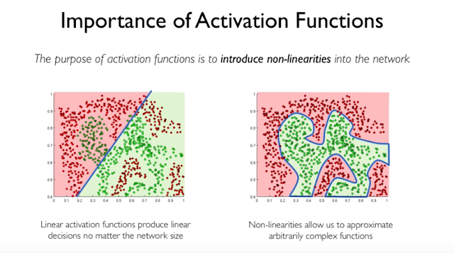
Having Machine Learning, Data Science or Python Interview? Check 51 Deep Learning Interview Questions
Source: xzz201920.medium.com

Q40:
What type of Neural Networks do Deep Reinforcement Learning use?
Mid

Reinforcement Learning 54

Answer
- Reinforcement learning is a type of machine learning paradigm where the model take action to maximize the notion of cumulative reward much like living beings do.
- Learning how to play games, and self-driving cars are all modeled as a reinforcement learning problem.
- If the problem to be modeled is a game, then the screen is taken as input. The algorithm takes the pixels as input and passes it through multiple layers of convolutional neural networks to give an output for the next steps to take. The outcome of the steps taken by the model serves as the positive or negative reinforcement.
Having Machine Learning, Data Science or Python Interview? Check 54 Reinforcement Learning Interview Questions
Source: en.wikipedia.org

Q41:
What types of Recurrent Neural Networks (RNN) do you know?
Mid

RNN 17

Answer
There are different types of recurrent neural networks with varying architectures. Some examples are:
- One to one: Here there is a single (xt,yt) pair. Traditional neural networks employ a one to one architecture.
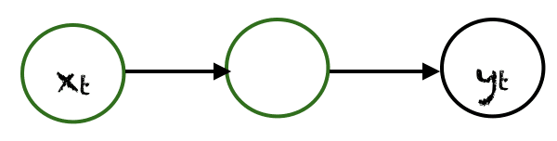
- One to many: In one to many networks, a single input at xt can produce multiple outputs, e.g., yt0, yt1, yt2 Music generation is an example area, where one to many networks are employed.
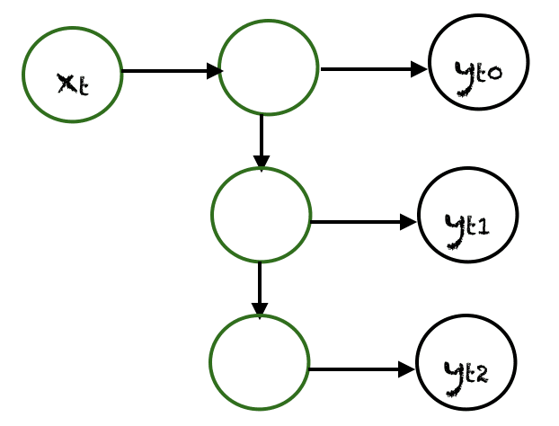
- Many to one: In this case, many inputs from different time steps produce a single output. For example, xt, xt+1, xt+2 can produce a single output. Such networks are employed in sentiment analysis or emotion detection, where the class label depends upon a sequence of words.
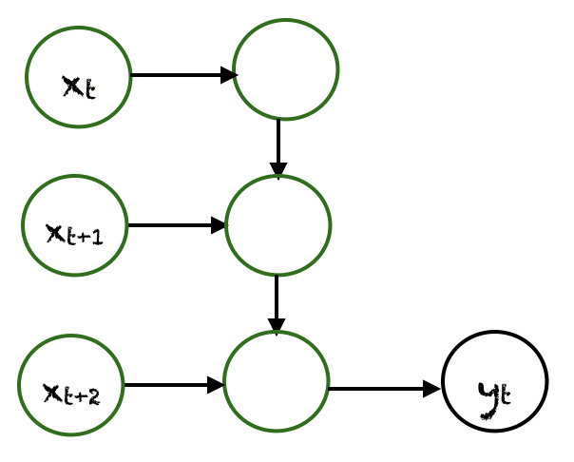
- Many to many: There are many possibilities for many to many. An example is shown below, where two inputs produce three outputs. Many to many networks are applied in machine translation, e.g, English to French or vice versa translation systems.
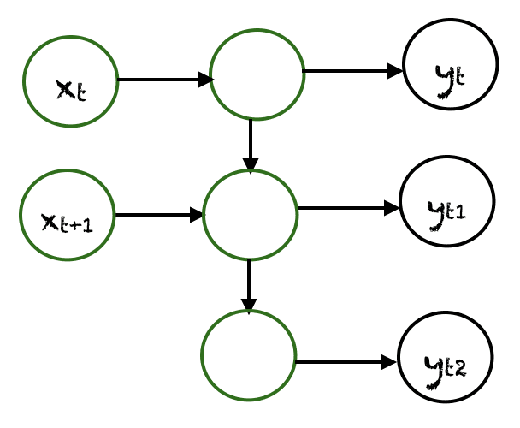
25 Linear Regression Interview Questions Every Machine Learning Engineer Must Know

Linear Regression 48

Q42:
What's the difference between Batch Normalization, Instance Normalization and Layer Normalization?
Mid

Deep Learning 51

Answer
Let us establish some notations: we will assume that the activations at any layer would be of the dimensions NxCxHxW, where:
- N = Batch Size,
- C = Number of Channels (filters) in that layer,
- H = Height of each activation map,
- W = Width of each activation map.
Generally, normalization of activations requires shifting and scaling the activations by mean (μ) and standard deviation (σ) respectively. Batch Normalization, Instance Normalization and Layer Normalization differ in the manner these statistics are calculated.

In Batch normalization, mean and variance are calculated for each individual channel across all samples and both spatial dimensions H and W.

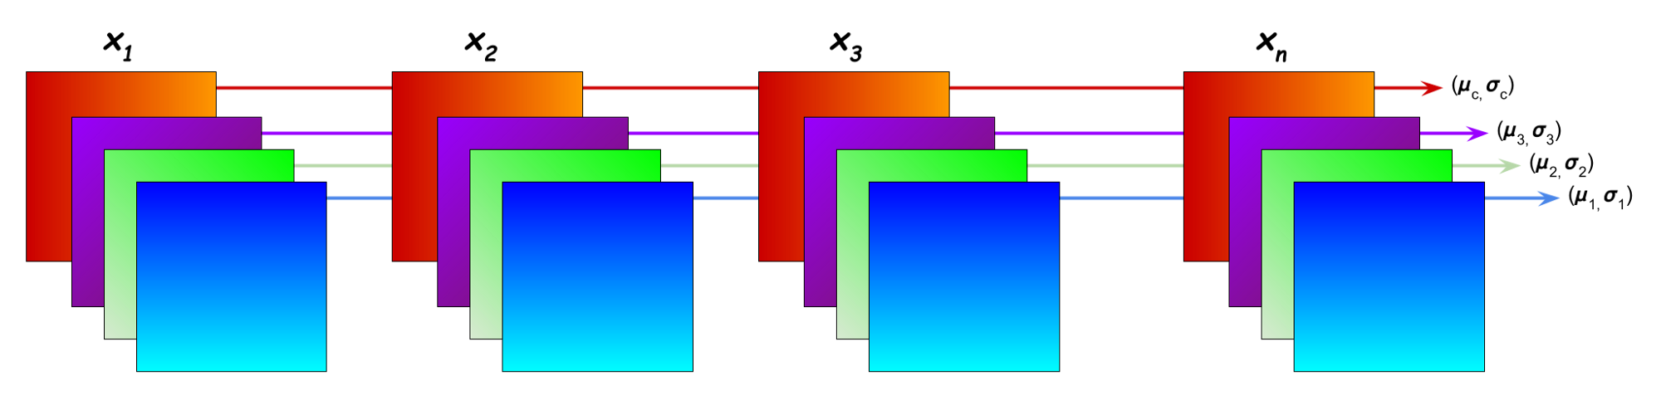

In Instance normalization, mean and variance are calculated for each individual channel for each individual sample across both spatial dimensions H and W.

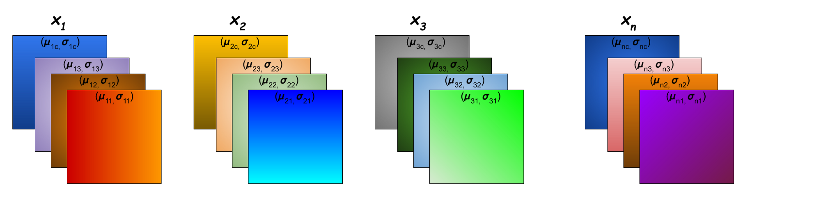

In Layer normalization, mean and variance are calculated for each individual sample across all channels and both spatial dimensions H and W.

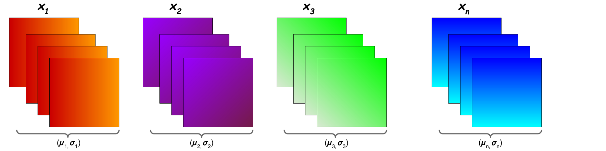

Having Machine Learning, Data Science or Python Interview? Check 51 Deep Learning Interview Questions
Source: becominghuman.ai

Q43:
What's the difference between GAN and autoencoders?
Mid

Autoencoders 13

Answer

The job of an autoencoder is to simultaneously learn an encoding network and decoding network. This means an input (e.g. an image) is given to the encoder, which attempts to reduce the input to a strongly compressed encoded form, which is then fed to the decoder.

The network learns this encoding/decoding because the loss metric increases with the difference between the input and output image -every iteration, the encoder gets a little bit better at finding an efficient compressed form of the input information, and the decoder gets a little bit better at reconstructing the input from the encoded form.

To summarize, an autoencoder learns to represent some input information very efficiently, and subsequently how to reconstruct the input from its compressed form.

In Generative Adversarial Networks, we have a "generator" whose job is to take some noise signal and transform it to some target space (again, images are a popular example). The other component (the adversary) is the "discriminator", whose job is to distinguish real images drawn from the desired target space from the fake images created by the generator. In this case, the network is trained in two alternating phases, each with a different loss.

In short, A GAN uses an adversarial feedback loop to learn how to generate some information that "seems real" (i.e. looks the same/sounds the same/is otherwise indistinguishable from some real data).

Q44:
What's the difference between Recurrent Neural Networks and Recursive Neural Networks?
Mid

RNN 17

Answer

Recurrent Neural Networks:

  - It is used for sequential inputs where the time factor is the main differentiating factor between the elements of the sequence, that's why it's commonly used in time-series.
  - When we unfold the network, at each time step, it accepts the user input at that time step and the output of the hidden layer that was computed at the previous time step.
  - The weights are shared (and dimensionality remains constant) along the length of the sequence.
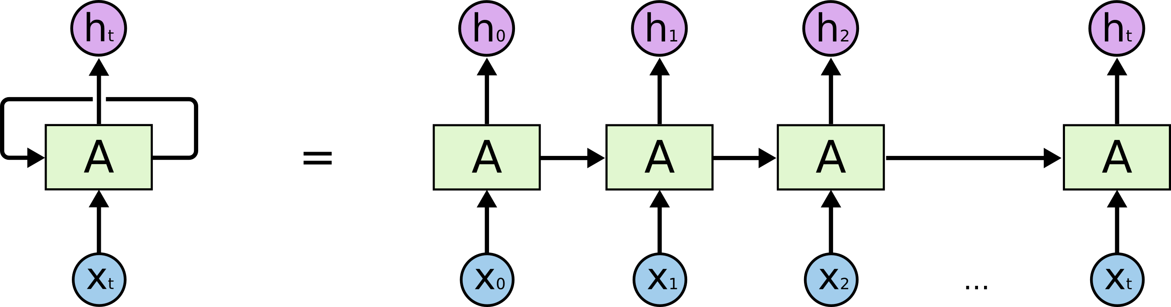

Recursive Neural Networks:

  - Is more like a hierarchical network where there is really no time aspect to the input sequence but the input has to be processed hierarchically in a tree fashion.
  - Is very used in NLP, where the way to learn a parse tree of a sentence is recursively taking the output of the operation performed on a smaller chunk of the text.
  - Here, the weights are shared (and dimensionality remains constant) at every node.
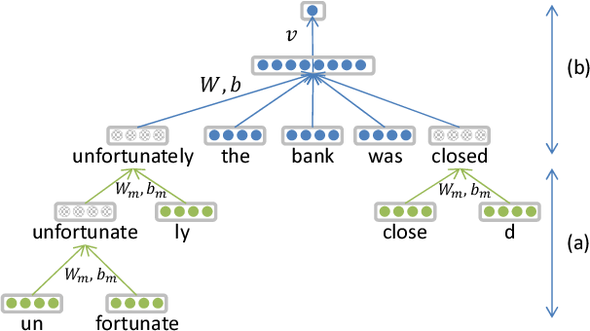
Having Machine Learning, Data Science or Python Interview? Check 17 RNN Interview Questions
Source: stats.stackexchange.com

Q45:
What's the difference between an Autoencoder and Variational Autoencoder?
Mid

Autoencoders 13

Answer
- An autoencoder consists of two parts, an encoder, and a decoder. The encoder compresses the data from a higher-dimensional space to a lower-dimensional space (also called the latent space), while the decoder does the opposite i.e., convert the latent space back to higher-dimensional space. One drawback of this latent space is that is not regularized: there may be parts of the latent space that doesn't correspond to any data point from the original data so we say that the latent space lacks the generative capability. Once the network is trained, and the training data is removed, we have no way of knowing if the output generated by the decoder from a randomly sampled latent vector is valid or not.
- The two main uses of an autoencoder are to compress data to two (or three) dimensions so it can be graphed and to compress and decompress images or documents, which removes noise in the data.

Q1. What are the different types of activation functions?
This is an important Deep Learning coding interview question. You must know the following types of activation functions:
- Sigmoid function: It is a nonlinear function in an ANN that is mostly used in feedforward neural networks. It's a differentiable real function with positive derivatives and a certain degree of smoothness. It is written as: {"detectHand":false}.
- Hyperbolic tangent function (Tanh): It is a smoother, zero-centered function (range of -1 to +1). The output is represented by:{"detectHand":false}. The primary advantage of this function is that it gives a zero-centered output that helps in backpropagation.
- Softmax function: It is used to generate probability distribution from a vector of real numbers. This function returns the output between 0 and 1, with the sum of probabilities equals to 1. This is written as: {"detectHand":false}. It is used in multi-class models, returning probabilities of each class, with the target having the highest probability.
- Softsign function: It is commonly used in regression computation issues and text-to-speech applications. It’s a quadratic polynomial, written as: {"detectHand":false}.
- Rectified linear unit of function: It outperforms other AFs in generalization and performance. The function is roughly linear and preserves the features of linear models, making gradient-descent approaches easier to optimize. It is written as: {"detectHand":false}.
- Exponential linear unit of function: The major advantage of this function is that it can solve the vanishing gradient problem by employing identity for positive values and boosting the model's learning properties. It is represented by: {"detectHand":false}.

Q2. How does recurrent neural network backpropagation vary from artificial neural network backpropagation?
Each node in a recurrent neural network has an additional loop. This makes it different from artificial neural network propagation. This loop incorporates a temporal component into the network. The main advantage of recurrent neural networks is that they allow for sequential data information. This is usually impossible with a generic artificial neural network.

Q3. Can a deep learning model be solely built on linear regression?
If you are well-versed in Deep Learning, you can answer these types of Deep Learning interview questions with ease.
A deep learning model may be solely built on linear regression. However, the problem should be represented by a linear equation, which does not boost the machine learning model's predictive capacity due to the addition of nodes. Hence, building a deep learning model solely on linear regression creates no spectacular results.

Q4. What is a computational graph in Deep Learning?
This is one of the important topics asked in Deep Learning interview questions.
A computational graph is a series of operations performed to take inputs and arrange them as nodes in a graph. It is a way of implementing mathematical calculations into a graph. This way, it will help in parallel processing and provide high performance in terms of computational capability.

Q5. What are the types of autoencoders, and where are they used?
This is a commonly asked in Deep Learning interview question. You must have a sound understanding of what autoencoders are to answer this.
Autoencoders are used worldwide. Some of the popular usages of autoencoders are:
- Adding color to black-white images
- Removing noise from images
- Dimensionality reduction
- Feature removal and variation
You must know there are four types of autoencoders. They are:
- Deep autoencoders
- Convolutional autoencoders
- Sparse autoencoders
- Contractive autoencoders
Recommended Reading: Google Machine Learning Engineer Interview Prep

Deep Learning NLP Interview Questions
To excel at ML or data science interviews, you must have profound knowledge of natural language processing (NLP) in Deep Learning. Following are a few questions that you must practice to nail your Deep Learning interview at FAANG and tier-1 tech companies.

Q1. What do you understand about text normalization in NLP?
These types of Deep Learning interview questions test your fundamental knowledge of the subject.
When developing NLP tools to work with exceptional data, it's beneficial to attain a canonical representation of textual content. This is known as textual normalization. Textual normalization captures different kinds of variations into one representation.

Q2. Do you know what feature engineering is?
When you employ machine learning methods to complete your modeling, you need to input pre-processed text into an NLP algorithm. This set of strategies used for this process is known as feature engineering or feature extraction. The main purpose of feature extraction is to convert the text's qualities into a numeric vector that NLP algorithms can understand. This stage is known as text representation.

Q3. Explain TF-IDF in NLP.
TF-IDF is known as Term-Frequency-Inverse Document Frequency. It helps you get the importance of a particular word relative to other words in the corpus. It converts words into vectors and adds semantic information, resulting in weighted unusual words. These words can be utilized in various NLP applications. Moreover, it's a common scoring metric in information retrieval and summarization.

Q4. What do you understand about POS tagging?
A part-of-speed (POS) tagger reads the text in a language and assigns speed parts to each word, such as noun, verb, adverb, and others. POS taggers employ an algorithm to label terms in text bodies. These labels create various complex categories with tags like "noun plural" or other complicated labels.

Q5. What is the difference between NLP and NLU?
This is one of the most asked Deep Learning interview questions. The differences between NLP and NLU are:
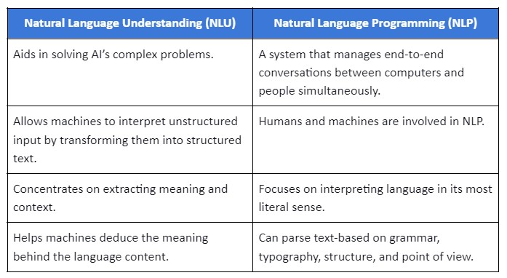
Recommended Reading: Amazon Machine Learning Engineer Interview Prep

Deep Learning Computer Vision Interview Questions
If you are applying for a role of a Computer Vision Engineer in any top company, you must practice the following Deep Learning computer vision interview questions to uplevel your preparation:

Q1. What are the features detected by the initial layers of a neural network used for computer vision? How is it different from what is detected by the later neural network layers?
Neural network's earlier layers detect simple features of an image (for example, edges or corners). As you go deeper, the features become increasingly complex, detecting patterns and shapes in the neural network. The later layers can detect intricate patterns, such as complete objects.

Q2. How will you address the edge pixels issue during convolutional operation?
You can use padding to address the issue of filter or kernel extracting information from the edge pixels less compared to the central pixel. Padding is the addition of one or more rows or columns of pixels along the boundary of the image.
It forms the new pixels of the picture. Therefore, it results in insufficient extraction of information from the original edge pixels. It also prevents the shrinking of an image due to the convolution operations.

Q3. You are given a 5x5 image with a 3x3 filter and a padding p = 1. What will be the resultant image's size if a convolutional stride of s = 2 is used?
You should know that for an nxn image with an fxf filter, padding p, and stride length s, resultant image's size after convolution has the shape n + 2p - fs + 1 x n + 2p - fs + 1. Therefore, per the data provided, the resulting size of the image will be (((5 + 2 * 1 - 3) / 2) + 1) x (((5 + 2 * 1 - 3) / 2) + 1)= 3 x 3.

Q4. What will be the resultant image size for an RGB image of 10x10x3 convolved with a 3x3 filter?
The convolution operation is not possible for such dimensions of an RGB image. The third dimension (number of channels) should be the same to achieve convolution. However, if the 10x10x3 image is convolved in a 3x3x3 filter, the dimensions of the resultant image will be 4x4.

Q5. How many parameters need to be learned in pooling layers?
The pooling layer contains hyperparameters describing the filter size and the stride length. These parameters are set and work as a fixed computation. Hence, no parameters are to be learned in the pooling layers.
- What kind of a neural network will you use in deep learning regression via Keras-TensorFlow? Or How will you decide the best neural network model for a given problem?
The foremost step when deciding on choosing a neural network model is to have a good know-how of the data and then decide the best model for it. Also, factoring in whether it is a linearly separable problem or not is important when deciding on a neural network model. So, the task at hand and the data play a vital role in choosing the best neural network model for a given problem. However, it is always better to start with a simple model like multi-layer perceptron (MLP) that has just one hidden layer unlike CNN, LSTM, or RNN that require configuring the nodes and layers. MLP is considered the simplest neural network because the weight initialization is not sensitive and also there is no need to define a structure for the network beforehand.
Ace Your Next Job Interview with Mock Interviews from Experts to Improve Your Skills and Boost Confidence!

- Why do we need autoencoders when there are already powerful dimensionality reduction techniques like Principal Component Analysis?
The curse of dimensionality (the problems that arise when working with high-dimensional data) is a common problem when working on machine learning or deep learning projects. Curse of Dimensionality causes lots of difficulties while training a model because it requires training a lot of parameters on a scarce dataset leading to issues like overfitting, large training times, and poor generalization. PCA and autoencoders are used to tackle these issues. PCA is an unsupervised technique wherein the actual data is projected to the direction of high variance while autoencoders are neural networks used for compressing the data into a low dimensional latent space and then try to reconstruct the actual high dimensional data.
PCA or autoencoders are effective only when the features have some relationship with each other. A general thumb rule between choosing PCA and Autoencoders is the size of data. Autoencoders work great for larger datasets and PCA works well for smaller datasets. Autoencoders are usually preferred when there is a need for modeling non-linearities and relatively complex relationships. Autoencoders can encode a lot of information with fewer dimensions when there is a curvature in low dim structure or non-linearity, making them a better choice over PCA in such scenarios.
Autoencoders are usually preferred for identifying data anomalies rather than for reducing data. Anomalous data points can be identified using the reconstruction error, PCA is not good for reconstructing data particularly when there are non-linear relationships.
New Projects
CycleGAN Implementation for Image-To-Image TranslationView Project
End-to-End ML Model Monitoring using Airflow and DockerView Project
Build Streaming Data Pipeline using Azure Stream AnalyticsView Project
Learn to Build a Siamese Neural Network for Image SimilarityView Project
PyTorch Project to Build a GAN Model on MNIST DatasetView Project
PyTorch Project to Build a GAN Model on MNIST DatasetView Project
Build a Data Pipeline in AWS using NiFi, Spark, and ELK StackView Project
Getting Started with Pyspark on AWS EMR and AthenaView Project
Build a Credit Default Risk Prediction Model with LightGBMView Project
Build a Text Generator Model using Amazon SageMakerView Project
CycleGAN Implementation for Image-To-Image TranslationView Project
End-to-End ML Model Monitoring using Airflow and DockerView Project
Build Streaming Data Pipeline using Azure Stream AnalyticsView Project
Learn to Build a Siamese Neural Network for Image SimilarityView Project
PyTorch Project to Build a GAN Model on MNIST DatasetView Project
PyTorch Project to Build a GAN Model on MNIST DatasetView Project
Build a Data Pipeline in AWS using NiFi, Spark, and ELK StackView Project
Getting Started with Pyspark on AWS EMR and AthenaView Project
Build a Credit Default Risk Prediction Model with LightGBMView Project
Build a Text Generator Model using Amazon SageMakerView Project
View all New Projects
- Say you have to build a neural network architecture; how will you decide how many neurons and hidden layers are needed for the network?
Given a business problem, there is no hard and fast rule to determine the exact number of neurons and hidden layers required to build a neural network architecture. The optimal size of the hidden layer in a neural network lies between the size of the output layers and the size of the input. However, here are some common approaches that have the advantage of making a great start to building a neural network architecture –
- To address any specific real-world predictive modeling problem, the best way is to start with rough systematic experimentation and find out what would work best for any given dataset based on prior experience working with neural networks on similar real-world problems. Based on the understanding of any given problem domain and one’s experience working with neural networks, one can choose the network configuration. The number of layers and neurons used on similar problems is always a great way to start testing the configuration of a neural network.
- It is always advisable, to begin with, simple neural network architecture and then go on to enhance the complexity of the neural network.
- Try working with varying depths of networks and configure deep neural networks only for challenging predictive modeling problems where depth can be beneficial.
- Why CNN is preferred over ANN for Image Classification tasks even though it is possible to solve image classification using ANN?
One common problem with using ANN’s for image classification is that ANN’s react differently to input images and their shifted versions. Let’s consider a simple example where you have the picture of a dog in the top left of an image and in another image, there is a picture of a dog at the bottom right. ANN will assume that a dog will always appear in this section of any image, however, that’s not the case. ANN’s require concrete data points meaning if you are building a deep learning model to distinguish between cats and dogs, the length of the ears, the width of the nose, and other features should be provided as data points while if using CNN for image classification spatial features are extracted from the input images. When there are thousands of features to be extracted, CNN is a better choice because it gathers features on its own, unlike ANN where each individual feature needs to be measured.
Training a neural network model becomes computationally heavy (requiring additional storage and processing capability) as the number of layers and parameters increases. Tuning the increased number of parameters can be a tedious task with ANN, unlike CNN where the time for tuning parameters is reduced making it an ideal choice for image classification problems.
- Why Sigmoid or Tanh is not preferred to be used as the activation function in the hidden layer of the neural network?
A common problem with Tanh or Sigmoid functions is that they saturate. Once saturated, the learning algorithms cannot adapt to the weights and enhance the performance of the model. Thus, Sigmoid or Tanh activation functions prevent the neural network from learning effectively leading to a vanishing gradient problem. The vanishing gradient problem can be addressed with the use of Rectified Linear Activation Function (ReLu) instead of sigmoid and using a Xavier initialization.
- Why does the exploding gradient problem happen?
When the model weights grow exponentially and become unexpectedly large in the end when training the model, exploding gradient problem happens. In a neural network with n hidden layers, n derivatives are multiplied together. If the weights that are multiplied are greater than 1 then the gradient increases exponentially greater than the usual one and eventually explodes as you propagate through the model. The situation wherein the value of weights is more than 1 makes the output exponentially larger hindering the model training and impacting the overall accuracy of the model is referred to as the exploding gradients problem. Exploding gradients is a serious problem because the model cannot learn from its training data resulting in a poor loss. One can deal with the exploding gradient problem either by gradient clipping, weight regularization, or with the use of LSTM’s.
Get Closer To Your Dream of Becoming a Data Scientist with 70+ Solved End-to-End ML Projects
- How to fix the constant validation accuracy in CNN model training?
Constant validation accuracy is a common problem when training any neural network because the network just remembers the sample and results in an overfitting problem. Overfitting of a model means that the neural network model works fantastic on the training sample but the performance of the model sinks in on the validation set. Here are some tips to try to fix the constant validation accuracy in CNN –
- It is always advisable to divide the dataset into training, validation, and test set.
- When working with little data, this problem can be solved by changing the parameters of the neural network by trial and error.
- Increasing the size of the training dataset.
- Use batch normalization.
- Regularization
- Reduce the network complexity
- What do you understand by learning rate in a neural network model? What happens if the learning rate is too high or too low?
Learning rate is one of the most important configurable hyperparameters used in the training of a neural network. The value of the learning rate lies between 0 and 1. Choosing the learning rate is one of the most challenging aspects of training a neural network because it is the parameter that controls how quickly or slowly a neural network model adapts to a given problem and learns. A higher learning rate value means that the model requires few training epochs and results in rapid changes while a smaller learning rate implies that the model will take a long time to converge or might never converge and get stuck on a suboptimal solution. Thus, it is advisable not to use a learning rate that is too low or too high but instead a good learning rate value should be discovered through trial and error.
- What kind of a network would you prefer – a shallow network or a deep network for voice recognition?
Every neural network has a hidden layer along with input and output layers. Neural networks that use a single hidden layer are known as shallow neural networks while those that use multiple hidden layers are referred to as deep neural networks. Both shallow and deep networks are capable of fitting into any function but shallow networks require a lot of parameters, unlike deep networks that can fit functions even with a limited number of parameters because of several layers. Deep networks are preferred today over shallow networks because at every layer the model learns a novel and abstract representation of the input. Also, they are much more efficient in terms of the number of parameters and computations compared to shallow networks.
- Can you train a neural network model by initializing all biases as 0?
Yes, there is a possibility that the neural network model will learn even if all the biases are initialized to 0.
- Can you train a neural network model by initializing all the weights to 0?
No, it is not possible to train a model by initializing all the weights to 0 because the neural network will never learn to perform a given task. Initializing all weights to zeros will cause the derivatives to remain the same for every w in W [1] because of which neurons will learn the same features in every iteration. Not just 0, but any kind of constant initialization of weights is likely to produce a poor result.
- Why is it important to introduce non-linearities in a neural network?
Without non-linearities, a neural network will act like a perceptron regardless of how many layers are there making the output linearly dependent on the input. In other words, having a neural network with n layers and m hidden units with linear activation functions is just like having a linear neural network without hidden layers that can only find linear separation boundaries. A neural network without non-linearities cannot find appropriate solutions and classify the data correctly for complex problems.
100+ Datasets for Machine Learning Projects Curated Specially For You
- Why dropout is effective in deep networks?
The problem with deep neural networks is that they are most likely to overfit training data with few examples. Overfitting can be reduced by ensembles of networks with different model configurations but this requires the additional effort of maintaining multiple models and is also computationally expensive. Dropout is one of the easiest and exceptionally successful methods to reduce dependencies in deep neural networks and overcome overfitting problems. When using the dropout regularization method, a single neural network model is used to similar different network architecture by dropping out nodes while training. It is considered an effective method of regularization as it improves generalization errors and is also computationally cheap.
- A deep learning model finds close to 12 million face vectors. How will you find a new face quickly?
You will need to know about One-Shot Learning for Face Recognition which is a classification task where is one or more examples(faces in this case) are used for classifying new examples(faces) in the future. One needs to know about the method of indexing data to retrieve a new face faster. A new face can be recognized by finding the vectors that are close )most similar) to the input face but in this case, the system would have become super slow if we were to calculate the distance to 12 million vectors. A convenient way would be to index data on real vector space by dividing the data into easy structures for querying (almost like a tree data structure). It is easier to find the vector that is in close proximity with time very quickly whenever new data is available. Techniques like Annoy Indexing, Locality Sensitive Hashing, and Approximate Nearest Neighbours can be used for this purpose.
- What has fostered the implementation and experimentation of powerful neural network architectures in the industry?
Flexibility makes deep learning powerful. Neural networks are universal function approximators so even if it is a complex enough problem at hand(where the formula between input and output is not known), a neural network can be approximated. Also, transfer learning (where the trained weights of an existing neural network can be used to initialize the weights of another network that performs similar tasks) makes the application of deep learning much easier under situations when training a neural network from scratch is costly or almost impossible when there is data scarcity.
Faster and powerful computational resources are also a prime reason for the adoption of neural network architectures. One cannot deny the fact that it is faster to train a neural network in just minutes with GPU acceleration which would otherwise take days for the network to learn.
- Can you build deep learning models based solely on linear regression?
Yes, it is definitely possible to build deep networks using a linear function as the activation function for each layer if the problem is represented by a linear equation. However, a problem that is a composition of linear functions is a linear function and there is nothing extraordinary that can be achieved with the implementation of a deep network because adding more nodes to the network will not increase the predictive power of the machine learning model.
- When training a deep learning model you observe that after a few epochs the accuracy of the model decreases. How will you address this problem?
The decrease in the accuracy of a deep learning model after a few epochs implies that the model is learning from the characteristics of the dataset and not considering the features. This is referred to as the overfitting of the deep learning model. You can either use dropout regularization or early stopping to fix this issue. Early stopping as the phrase implies stops training the deep learning model any further the moment you notice a drop inaccuracy of the model. Dropout regularization is a technique wherein a few nodes or output layers are dropped so that the remaining nodes have varying weights.
- What is the impact on a model with an improperly set learning rate on weights?
With images as inputs, an improperly set learning rate can cause noisy features. Having an ill-chosen learning rate determines the prediction quality of a model and can result in an unconverged neural network.
Master deep learning concepts with the solved end-to-end library of Deep Learning Projects
19)What do you understand by the terms Batch, Iterations, and Epoch in training a neural network model?
- Epoch refers to the iteration where the complete dataset is passed forward and backward through the neural network only once.
- It is not possible to pass the complete dataset to the network in one go so the dataset is divided into parts. This is referred to as the Batch.
- The total number of batches needed to complete one epoch is referred to as iteration. For example, if you have 60,000 data rows and the batch size is 1000 then each epoch will run 60 iterations.
20) Is it possible to calculate the learning rate for a model a priori?
For simple models, it could be possible to set the best learning rate value a priori. However, for complex models, it is not possible to calculate the best learning rate through theoretical deductions that can actually make accurate predictions. Observations and experiences do play a vital role in defining the optimal learning rate.
Access Data Science and Machine Learning Project Code Examples
21) What is the theoretical foundation of neural networks?
To answer this question one needs to explain the universal approximation theorem that forms the base on why neural networks work.
Introducing non-linearity via an activation function allows us to approximate any function. It’s quite simple, really. —â€ŠElon Musk
According to the Universal Approximation Theorem, a neural network having a single hidden layer containing a finite number of neurons can approximate any continuous function to a reasonable accuracy for inputs in a specific range. However, if the function has large gaps it is not possible to approximate it. Meaning, if a neural network is trained with inputs between 20 and 30, we cannot be assured that it will work well for inputs between 60 and 70.
22) What are the commonly used approaches to set the learning rate?
- Using a fixed learning rate value for the complete learning process.
- Using a learning rate schedule
- Making use of adaptive learning rates
- Adding momentum to the classical SGD equation.
23) Is there any difference between neural networks and deep learning?
Ideally, there is no significant difference between deep learning networks and neural networks. Deep learning networks are neural networks but with a slightly complex architecture than they were in 1990s. It is the availability of hardware and computational resources that has made it feasible to implement them now.
24) You want to train a deep learning model on a 10GB dataset but your machine has 4GB RAM. How will you go about implementing a solution to this deep learning problem?
One of the possible ways to answer this question would be to say that a neural network can be trained by loading the data into the NumPy array and defining a small batch size.NumPy doesn’t load the complete dataset into the memory but creates a complete mapping of the dataset. NumPy offers several tools for compressing large datasets that can be integrated with other NN packages like PyTorch, TensorFlow, or Keras.
25) How will the predictability of a neural network impact if you use a ReLu activation function and then use the Sigmoid function in the final layer of the network?
The neural network will predict only one class for all types of inputs because the output of a ReLu activation function is always a non-negative result.
26) What are the limitations of using a perceptron?
A major drawback to using a perceptron is that they can only linearly separable functions and cannot handle non-linear inputs.
27) How will you differentiate between a multi-class and multi-label classification problem?
In a multi-class classification problem, the classification task has more than two mutually exclusive classes whereas in a multi-label problem each label has a different classification task, however, the tasks are related somehow. For example, classifying a set of images of animals which may be cats, dogs, or bears is a multi-class classification problem that assumes that each sample has only one label meaning an image can be classified as either a cat or a dog but not both at the same time. Now imagine that you want to process the below image. The image shown below needs to be classified as both cat and dog because the image shows both the animals. In a multi-label classification problem, a set of labels are assigned to each sample and the classes are not mutually exclusive. So, a pattern can belong to one or more classes in a multi-label classification problem.
28) What do you understand by transfer learning?
You know how to ride a bicycle, so it will be easy for you to learn to drive a bike. This is transfer learning. You have some skill and you can learn a new skill that relates to it without having to learn it from scratch. Transfer learning is a process in which the learning can be transferred from one model to another without having to make the model learn everything from scratch. The features and weights can be used for training the new model providing reusability. Transfer learning works well in training a model easily when there is limited data.
29) What is fine-tuning and how is it different from transfer learning?
In transfer learning, the feature extraction part remains untouched and only the prediction layer is retrained by changing the weights based on the application. On the contrary in fine-tuning, the prediction layer along with the feature extraction stage can be retrained making the process flexible.
30) Why do we use convolutions for images instead of using fully connected layers?
Each convolution kernel in a CNN acts like its own feature detector and has a partially in-built translation in-variance. Using convolutions lets one preserve, encode and make use of the spatial information from the image, unlike fully connected layers that do not have any relative spatial information.
31) What do you understand by Gradient Clipping?
Gradient Clipping is used to deal with the exploding gradient problem that occurs during the backpropagation. The gradient values are forced element-wise to a particular minimum or maximum value if the gradient has crossed the expected range. Gradient clipping provides numerical stability while training a neural network but does not provide any performance improvements.
32) What do you understand by end-to-end learning?
It is a deep learning process where a model gets raw data as the input and all the various parts are trained simultaneously to produce the desired outcome with no intermediate tasks. The advantage of end-to-end learning is that there is no need for implicitly doing feature engineering which usually leads to a lower bias. A good example that you can quote in the content of end-to-end learning is driverless cars. They use human-provided input as guidance and are trained to automatically learn and process the information using a CNN to complete tasks.
33) Are convolutional neural networks translation-invariant?
Convolutional neural networks are translation invariant only to a certain extent but pooling can make them translation invariant. Making a CNN completely translation-invariant might not be possible. However, by feeding the right kind of data this can be achieved although this might not be a feasible solution.
34) What is the advantage of using small kernels like 3x3 than using a few large ones.
Smaller kernels let you use more filters so you can use a greater number of activations functions and let the CNN learn a more discriminative mapping function. Also, smaller kernels capture more spatial context and use fewer computations and parameters making them a better choice over large ones.
35) How can you generate a dataset on multiple cores in real-time that can be fed to the deep learning model?
One of the major challenges today in CV is the need to load large datasets of videos and images but there is not enough memory on the machine. In such situations, data generators act as a magic wand when it comes to loading a dataset that is memory-consuming. You can talk about the various data generators Keras model class provides. When working with big data, in most of the cases it might not be required to load all the data into RAM as it would be memory wastage, could lead to memory overflow, and also take a longer time to process. Making use of generative functions is highly beneficial then as they generate the data to be directly fed into the model in each batch for training.
36) How do you bring balance to the force when handling imbalanced datasets in deep learning?
It is next to impossible to have a perfectly balanced real-world dataset when working on deep learning problems so there will be some level of class imbalance within the data that can be tackled either by –
- Weight Balancing -
- Over and Under Sampling
37) What are the benefits of using batch normalization when training a neural network?
- Batch normalization optimizes the network training process making it easier to build and faster to train a deep neural network.
- Batch normalization regulates the values going into each activation function making activation functions more viable because non-linearities that don’t seem to work well become viable with the use of batch normalization.
- Batch normalization makes it easier to initialize weights and also allows the use of higher learning rates ultimately increasing the speed at which the network trains.
Get FREE Access to Machine Learning Example Codes for Data Cleaning, Data Munging, and Data Visualization
38) Which is better LSTM or GRU?
LSTM works well for problems where accuracy is critical and sequence is large whereas if you want less memory consumption and faster operations, opt for GRU. Refer here for detailed Answer: /recipes/what-is-difference-between-gru-and-lstm-explain-with-example
39) RMSProp and Adam optimizer adjust gradients? Does this mean that they perform gradient clipping?
This does not inherently mean that they perform gradient clipping because gradient clipping involves setting up predetermined values beyond which the gradients cannot go, unlike Adam and RMSProp that make multiplicative adjustments to gradients.
40) Can you name a few hyperparameters used for training a neural network.
When training any neural networks there are two types of hyperparameters-one that define the structure of the neural network and the other determining how a neural network is trained. Listed are a few hyperparameters that are set before training any neural network –
- Initialization of weights
- Setting the number of hidden layers
- Learning Rate
- Number of epochs
- Activation Functions
- Batch Size
- Momentum
41) When is multi-task learning usually preferred?
Multi-task learning with deep neural networks is a subfield wherein several tasks are learned by a shared model. This reduces overfitting, enhances data efficiency, and speeds up the learning process with the use of auxiliary information. Multi-task learning is useful when there is a small amount of data for any given task and we can benefit from training a deep learning model on a large dataset.
42) Explain the Adam Optimizer in one minute.
Adaptive momentum or Adam optimizer is an optimization algorithm designed to deal with sparse gradients on noisy problems. Adam optimizer improves convergence through momentum that ensures that a model does not get stuck in saddle point and also provides per-parameter updates for faster convergence.
43) Which loss function is preferred for multi-category classification?
Cross-Entropy loss function
44) To what kind of problems can the cross-entropy loss function be applied?
- Binary Classification Problems
- Multi-Label Classification Problems
- Multi-Category Classification Problems
45) List the steps to implement a gradient descent algorithm.
- The first step is to initialize random weight and bias.
- Get values from the output layer by passing the input through the neural network.
- Determine the error between the actual and predicted value.
- Based on the neurons that contribute to the error, modify the values to minimize the error.
- Repeat the process until the optimal weights are found for the neural network.
46) How important is it to shuffle the training data when using batch gradient descent?
Shuffling the training dataset will not make much of a difference because the gradient is calculated at every epoch using the complete training dataset.
47) What is the benefit of using max-pooling in classification convolutional neural networks?
The feature maps become smaller after max-pooling in CNN and hence help reduce the computation and also give more translation in-variance. Also, we don’t lose much semantic information because we’re taking the maximum activation.
48) Can you name a few data structures that are commonly used in deep learning?
You can talk about computational graphs, tensors, matrices, data frames, and lists.
49) Can you add an L2 regularization to a recurrent neural network to overcome the vanishing gradient problem?
This can actually worsen the vanishing gradient problem because the L2 regularization will shrink weights towards zero.
50) How will you implement Batch Normalization in RNN?
It is not possible to use batch normalization in RNN because statistics are computed per batch and thus batch normalization will not consider the recurrent part of the neural network. An alternative to this could be layer normalization in RNN or reparameterizing the LSTM layer that allows the use of batch normalization.

Recommended Reading
- Data Scientist Interview Questions and Answers
- Machine Learning Interview Questions and Answers
- Data Analyst Interview Questions and Answers
- Top 20 Logistic Regression Interview Questions and Answers

Top 10 Deep Learning Interview Questions and Answers for 2022
1. Given that there are so many deep learning algorithms, how will you determine which deep learning algorithm has to be used for a dataset.
Artificial Neural Network Artificial Neural Network or sometimes called Classic Neural Network is a connection of multilayered perceptrons. This algorithm can be used when the data is properly structured in a tabular form. Both Classification and regression problems can be solved using ANNs Convolutional Neural Networks These networks are the best proven ones to build any prediction model involving image data as input. To put it in general terms, CNN works best on data with spatial relationships and hence these can also produce state-of-the-art results for NLP problems such as topic modelling, document classification and so on. Recurrent Neural Networks RNNs come into picture when we have sequential data where the order of the data entered is also important. RNNs can provide solutions for problems involving Time Series data. More often, rather than vanilla RNNs, gated networks like LSTMs (Long short term memory) and GRUs(Gated Recurrent units) are proven to give much better results. Autoencoders Autoencoders are widely used in the deep learning community these days because of its ability to operate automatically based on its inputs even before taking an activation function and final output decoding. These can be used when we have problems such as feature detection, recommendation systems and other compelling problems.
2. How do one-hot encoding and label encoding affect the dimensionality of a dataset?
Label encoding does not really affect the dataset in any way because in label encoding, we only provide labels to each category in the column.
For example,
Place of birth  (before label encoding) | Place of birth  (after label encoding)
Delhi | 0
Hyderabad | 1
Chennai | 2
Delhi | 0
In the above example, we are mapping Delhi -> 0, Hyderabad -> 1, and Chennai -> 2.
In one hot encoding, we create columns to each of the category in the dataset. Thus, the more the number of categories in the column, the more are the columns generated after one hot encoding. Let us consider the very same dataset that we saw above. After one hot encoding it will look like the table shown below
Place of birth (Delhi) | Place of birth (Hyderabad) | Place of birth (Chennai)
1 | 0 | 0
0 | 1 | 0
0 | 0 | 1
1 | 0 | 0
If the value is ‘Delhi’, then only the column meant for ‘Delhi’ takes the value 1 and the other columns takes the value 0.
Often, we don't consider the last/first category after one hot encoding the variable because it can be clearly understood that if all the existing entries for the category are 0, then it belongs to the category that we dropped. This is much clearly explained with the example below
Place of birth (Delhi) | Place of birth (Hyderabad)
1 | 0
0 | 1
0 | 0
1 | 0
Here , we already know that there are 3 unique categories in the variable (Delhi, Hyderabad, and Chennai). There are two zeros in the 3rd row which clearly implies that it does not belong to both the categories and the one which remains in Chennai. Therefore, the decoded value for that row is Chennai.
3. Why are GPUs important for implementing deep learning models?
Whenever we are trying to build any neural network model, the model training phase is the most resource-consuming job. Each iteration of model training comprises thousands (or even more) of matrix multiplication operations taking place. If there are less than around 1 lakh parameters in a neural network model, then it would not take more than a few minutes (or few hours at most) to train. But when we have millions of parameters, that is when our sizable computers would probably give up. This is where GPUs come into the picture. GPUs (Graphics Processing Units) are nothing but CPUs but with more ALUs (Arithmetic logic units) than our normal CPUs which are specifically meant for this kind of heavy mathematical computation.
4. Which is the best algorithm for face detection ?
There are several machine learning algorithms available for face detection but the best ones are the ones which involve CNNs and deep learning. Some notable algorithms for face detection are listed below FaceNet Probablisit Face Embedding ArcFace Cosface Spherface
5. What evaluation approaches do you use to gauge the effectiveness of deep learning models?
6. When training a neural network, you observe that the loss does not decrease in the first few epochs. What are the possible reasons for this?
7. What are the commonly used techniques to deal with the overfitting of a deep learning model?
8. What kind of gradient descent variant is the best for handling data that is too big to handle in RAM simultaneously?
9. How will you explain the success and recent rise in demand for deep learning in the industry?
10. How do you select the depth of a neural network?
1)What is Deep Learning?
2)Which deep learning framework do you prefer to work with – PyTorch or TensorFlow and why? Refer PyTorch vs Tensorflow for answer
3) Talk about a deep learning project you’ve worked on and the tools you used?
4) Have you used the ReLu activation function in your neural network? Can you explain how does the ReLu activation function works?
Yes, I have used ReLu in my neural networks. ReLu stands for Rectified Linear Unit. Basically, the function returns the input value as it is if it is positive or returns zero if it is negative. If the function is plotted in a line graph, it would look like the graph shown below
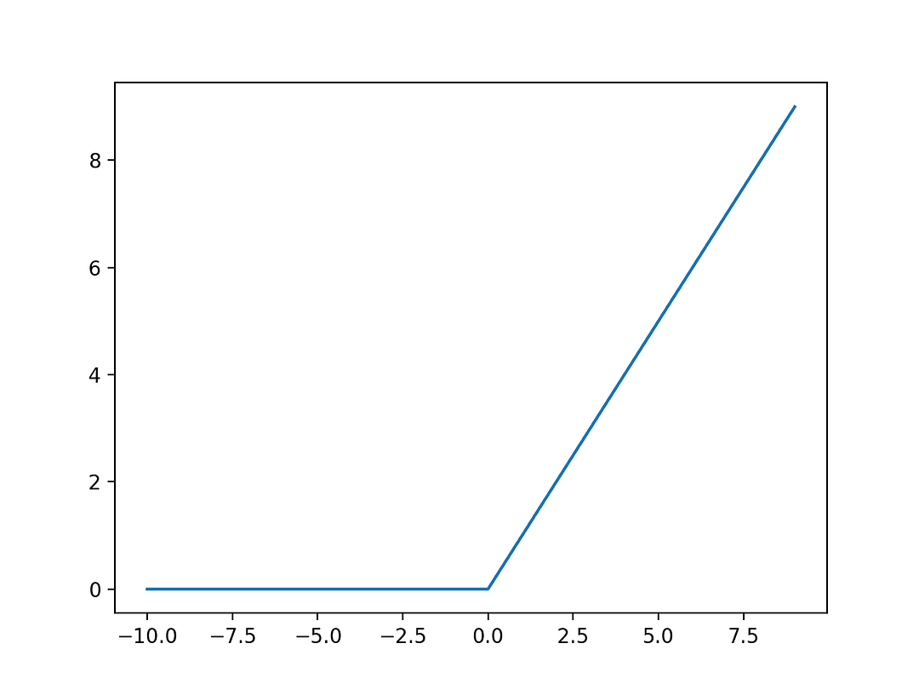
The main purpose of formulating this function was to overcome the Vanishing gradient problem caused by preliminary activation functions like Sigmoid and TanH which prevented us from building deeper neural network models. Now a days, this function has become a default activation function for many types of neural network models because models that use this function are easily trainable and don't suffer from the vanishing gradient problem.
5) How often do you use pre-trained models for your neural network?
6) What does the future of video analysis look like with the use of deep learning solutions? How effective/good is video analysis currently?
7) Tell us about your passion for deep learning. Do you like to participate in deep learning/machine learning hackathons, write blogs around novel deep learning tools, or attend local meetups, etc ?
8) Describe the last time you felt frustrated solving a deep learning challenge, and how did you overcome it?

What is more important to you the performance of your deep learning model or its accuracy?

Given the dataset, how will you decide which deep learning model to use and how to implement it?

What is the last deep learning research paper you’ve read?

What are the most commonly used neural network paradigms ? (Hint: Talk about Encoder-Decoder Structures, LSTM, GAN, and CNN)

Is it possible to use a neural network as a tool of dimensionality reduction?

How deep learning models tackle the curse of dimensionality?

15) What are the pros and cons of using neural networks?
Pros :
Neural networks are highly flexible and can be used for both classification and regression problems and sometimes for problems much more complex than that Neural networks are highly scalable. We can add as many layers with as many neurons as we want Neural networks are proven to produce best results when we have a lot of data points. They work best for non linear data such as image data, text data and so on. They can be used on any data that can be converted to numbers.
Cons :
1. The well known disadvantage of neural networks is their "black box" nature. That is, we don't know how or why our neural network came up with a certain output. For example, when we feed an image of a dog into a neural network and it predicts it to be a duck, we may find it difficult to understand what caused it to arrive at this prediction.
2. Developing a neural network model takes much time.
3. Neural networks are more computationally expensive than traditional algorithms.
4. The amount of computational power needed for a neural network depends mostly on the size of data, depth and complexity of the network.
5. To train a neural network model, it requires much more data than training a traditional machine learning model.
16) How is a Capsule Neural Network different from a Convolutional Neural Network?
17) What is a GAN and what are the different types of GAN you’ve worked with?
18) For any given problem, how do you decide if you have to use transfer learning or fine-tuning?
Transfer learning is a method used when a model is developed for one task is reused to work on a second task. Fine tuning is one approach to achieve transfer learning. In Transfer Learning we train the model with a dataset and after we train the same model with another dataset that has a different distribution of classes. In Fine-tuning, an approach of Transfer Learning, we have a dataset, and we make an 80-20 split and use 80% of it in training. Then we train the same model with the remaining 20%. Usually, we change the learning rate to a smaller one, so it does not have a significant impact on the already adjusted weights. To decide which method to choose, one should experiment first by using transfer learning as it is easy and fast, and if it does not suffice the purpose, then use fine tuning.
19) Can you share some tricks or techniques that you use to fight to overfit a deep learning model and get better generalization?
Overfitting of a model is defined when, a model performs well on the training data (low bias) and performs badly / poorly on the test data (high variance). In short, the model has learned over a certain pattern of data and is not useful for any other data. Overfitting can be detected by checking the performance metrics like loss and accuracy of a given model. There are several tips and techniques one can use in order to reduce the over fitting of a deep learning model. • Increase the size of training data. • Reduce number of layers in the hidden layer, this will reduce the networks capacity.
- Apply regularization •
- Add dropout layers.
- Early stopping – try to stop the training before the validation loss increases.
- Make use of data augmentation.
20) Explain the difference between Gradient Descent and Stochastic Gradient Descent.
To begin with, Gradient descent and stochastic gradient descent both are popular machine learning and deep learning optimization algorithms which are used for updating a set of parameters in an iterative way in order to minimize an error function. In gradient descent in order to update parameters, the entire dataset set is to be considered for a particular iteration while in stochastic gradient descent, computation is carried over only one single training sample. For example, if a dataset has 10000 datapoints, then GD, will train on all the 10000 datapoints and this will take a longer time, while on the other hand, Stochastic GD, will be much faster as we will train on only a single sample and update the parameters. This is because Stochastic gradient descent usually converges faster than gradient descent on large datasets, because updates are more frequent.
21) Which one do you think is more powerful – a two-layer NN without any activation function or a two-layer decision tree?
- When you say a two-layer neural network, it basically contains, one input layer, one hidden layer and one output layer. An activation function is important while dealing with neural networks as they are needed while dealing with complicate and nonlinear complex functional mappings between inputs and response variable.
- When a two-layer neural network has no activation function, it is just a linear network. A Neural Network without Activation function would simply be a Linear regression Model, which has limited power and does not perform good most of the times.
- Two-layer decision tree is just a decision tree with depth of 2.
- So, while comparing between these two models, two-layer neural network (without activation function) is more powerful than the two-layer decision tree, since two-layer neural network will take more attributes into consideration while building a model and in case of 2-layer decision tree, only 2 or 3 attributes will be considered.
22) Can you name the breakthrough project that garnered the popularity and adoption of deep learning?
- The last decade has seen remarkable improvements in the ability of computers to understand the world around them. One of these breakthroughs is, an artificial intelligence technique called deep learning.
- Deep learning, unlike machine learning is based on neural networks, a type of data structure loosely inspired by networks of biological neurons. Neural networks are organized into layers, with inputs from one layer connected to outputs from the next layer.
- Computer scientists have been experimenting with neural networks since the 1950s. But two significant breakthroughs—one in 1986, the other in 2012—laid the foundation for today's vast deep learning industry.
- The fortunes of neural networks were revived by a famous 1986 paper (link: https://www.iro.umontreal.ca/~vincentp/ift3395/lectures/backprop_old.pdf) that introduced the concept of backpropagation, a practical method to train deep neural networks.
- Backpropagation made deeper networks more computationally tractable, but those deeper networks still required more computing resources than shallower networks.
- Research results in the 1990s and 2000s often suggested diminishing returns to making neural networks more complex. Then a famous 2012 paper(link: https://papers.nips.cc/paper/2012/file/c399862d3b9d6b76c8436e924a68c45b-Paper.pdf)—which described a neural network dubbed AlexNet after lead researcher Alex Krizhevsky—transformed people's thinking.
- Dramatically deeper networks could deliver breakthrough performance, but only if they were combined with ample computing power and lots and lots of data.
23) Differentiate between bias and variance with respect to deep learning models and how can you achieve a balance between the two?
While understanding predictions, understanding the prediction errors is most important. There are mainly two broad types of errors, reducible and irreducible. In reducible errors we have two kinds, bias and variance. Gaining a proper understanding of these errors helps one built an accurate model by avoiding overfitting and underfitting of the model.
In order to obtain the optimal balance between the two errors, the model must always aim at maintain a low bias and a low variance. An optimal balance of bias and variance would never overfit or underfit the model.
Bias – In the above diagram, the training error (blue dotted line) is high in the initial stage (high bias) and then decreases sustainably (low bias) High bias means, the data is under fitting, and hence the data must have a low bias to achieve good results. In order to achieve low bias:
- Try increasing the number of iterations / epochs
- Try a bigger network
Variance – the variance in deep learning is nothing but the difference between the validation error and the training error. In the above figure, we can see that the gap between the training error and validation error is high, i.e., the variance is high. This is the case of overfitting. The model should have low variance and can be achieved by: i. Increasing the training data ii. Using regularization iii. Using different neural network architectures.
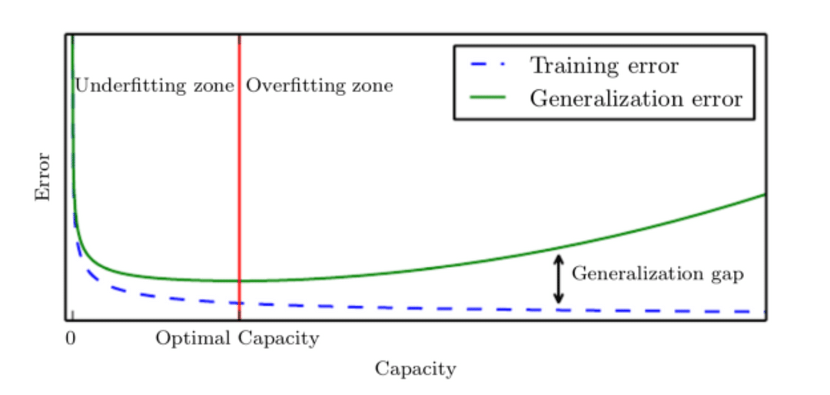
24) What are your thoughts about using GPT3 for our business?
GPT-3, or the third generation Generative Pre-trained Transformer, is a neural network machine. GPT-3 is a text predictor. Given a text or phrase, GPT-3 returns a human-like response to text completion in natural language. GPT-3 has a wide range of applications serving the industry today. It is a powerful tool that can create applications for responding to customer queries, language translator (say, asking a question in English and expecting an answer in Spanish) etc.
GPT3 can also do everything from creating spreadsheets to building complex CSS or even deploying Amazon Web Services (AWS) instances. So, can using GPT-3 help your business? Well, it can help in many ways. It all depends on what you need it to do, but it is a super versatile deep learning model applied to many applications.
Some more applications of GPT-3 that you can probably use in your business are:
- Generate emails from short descriptions. An application that can expand the given brief description into a formatted and grammatically correct professional email.
- Generate python codes from a description. Generate Flask (Python) API code just by describing the functions in English using GPT-3.
- Generate a deep learning model based on a description. For more details related to GPT-3 applications, visit the following link: https://www.louisbouchard.ai/can-gpt-3-really-help-you/
25) Can you train a neural network without using back-propagation? If yes, what technique will you use to accomplish this?
- In a neural network, back propagation is the process of repeatedly adjusting the weights of the layers in the network in order to minimise the difference between the actual output and the desired output, i.e., the loss.
- These adjusted weights result in making the hidden units of neural network to represent key features of the data. Are there any other ways to carry on the process rather than back propagation?
- Indeed, there are various optimization algorithms that does not require back-propagation to train the neural network.
- Among them are evolutionary optimization and Jeff Hinton’s capsule routing. However, none of these methods exhibit a competitive performance against back-propagation based algorithms.
26) Describe your research experience in the field of deep learning?
27) Explain the working of a perceptron.
• Perceptron's were developed in the 1950s and 1960s by the scientist Frank Rosenblatt, inspired by earlier work by Warren McCulloch and Walter Pitts.
• A perceptron is one of the simplest ANN (artificial neural network) unit that does certain computations in order to detect features or business intelligence in the input data.
• Perceptron is based on an artificial neuron called a threshold logic unit (TLU)
• The inputs and output are numbers rather then binary values and each input connection is associated with a weight.
• The TLU computes a weighted sum of its inputs: (z = w1 x1 + w2 x2 + â‹¯ + wn xn = wT x), then applies a step function to that sum and outputs the result: hw(x) = step(z), where z = wT x.
• A single TLU can be used for simple linear binary classification.
28) Differentiate between a feed-forward neural network and a recurrent neural network.
29) Why don’t we see the exploding or vanishing gradient problem in feed-forward neural networks?
30) How do you decide the size of the filter when performing a convolution operation in a CNN?
- While performing a convolution operation in CNN, filters detect spatial patterns such as edges in images by detecting the changes in the intensity of values of the images.
- There is no particular answer to how many filters or the best number of filters one can use.
- To decide the filter size, I would say it strongly depends on the type and complexity of the image data.
- A fair number of features is learned from experience after repeatedly working with similar types of datasets.
- In general, the more features you want to capture in an image, the higher the number of filters required in a CNN. The number of filters is a hyper-parameter that can be later tuned.
31) When designing a CNN, can we find out how many convolutional layers should we use?
- While designing a CNN, Convolutional layers are the layers where filters are applied to the original image, or to other feature maps in a deep CNN.
- The more convolutional layers the better as each convolutional layer reduces the number of input features to the fully connected layers, although after about two or three layers the accuracy gain becomes rather small so you need to decide whether your main focus is generalisation accuracy or training time.
- All image recognition tasks are different so the best method is to simply try incrementing the number of convolutional layers one at a time until you are satisfied by the result.

1. Why do we need Deep Learning when Machine Learning is present?
Machine learning is a framework that takes past data to identify the relationships among the features. The machines can predict the new data with the help of mathematical relationships by getting dynamic, accurate, and stable models.
On the other hand, deep learning is a segment of machine learning that uses complex algorithms based on the biological neural network to mimic the human brain and take decisions and actions like a human.
Deep Learning is inspired by the brain’s functioning and structure to train neural networks. Deep learning also performs various complex operations to extract hidden features and patterns.
The critical aspect differentiating the two is that deep learning can extract hidden features and patterns present in the data. In contrast, other machine learning can reduce dimensions but not identify new features.
For more details, please also read Machine Learning vs Deep learning- What Is the Difference?

2. What are the applications of Deep Learning?
The applications of Deep Learning bucketed according to the type of learning are:
The supervised tasks in deep learning are:
- Text Classification
- Sentiment Analysis
- Auto-Tagging System
- Image Classification
- Audio Classification
- Forecasting
The unsupervised tasks in deep learning are:
- Image Segmentation
- Image Localization
- Image Captioning
- Object Detection or Identification
The problems that involve generating data in deep learning are:
- Machine Translation
- Chatbots
- Speech to Text
- Recommendation Systems
- Automatic Text Generation
You may also like to read: Top 15 Real World Applications of Artificial Intelligence

3. Name the Deep Learning frameworks and tools that you have used.
The deep learning frameworks and tools are:
- Keras
- TensorFlow
- PyTorch
- Theano
- CNTK
- Caffe2
- MXNet

4. List the commonly used data structures in deep learning.
The data structures used in deep learning are:
- Lists
- Dictionaries
- DataFrames
- Matrices
- Tensors
- Computation Graphs

5. What are the supervised and unsupervised learning algorithms in Deep Learning?
The supervised learning algorithms are:
- Artificial Neural Network (ANN)
- Perceptron (single and multi-layer)
- Convolution Neural Network (CNN)
- Recurrent Neural Network (RNN)
The unsupervised learning algorithms are:
- Autoencoders
- Self-Organizing Maps (SOMs)
- Boltzmann Machine
- Generative adversarial networks (GANs)

6. What are deep and shallow networks? Which one is better and why?
A shallow neural network has only one hidden layer, and a deep neural network has more hidden layers.
Both the networks have the ability to approximate any function. A shallow network requires more parameters as is limited by the layers, whereas a deep network can leverage its number of layers to compute efficiently and extract more abstract features.
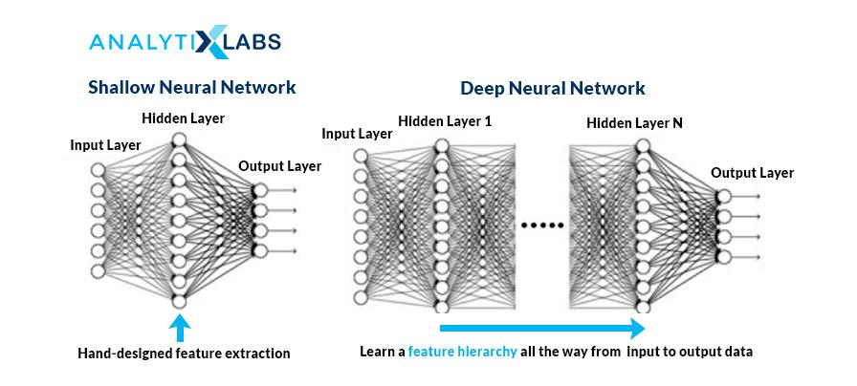
Source: cloudfront.net

7. What is the difference between Single-Layer and Multi-Layer Perceptron?
In a neural network, a perceptron is the processing unit that performs computations to extract features. It is the building block of the Artificial Neural Network (ANN).
A single layer perceptron is the simplest neural network without any hidden layer. It is a linear classifier with only one neuron and can perform binary classification. It can only classify the linear separable classes having output as binary.
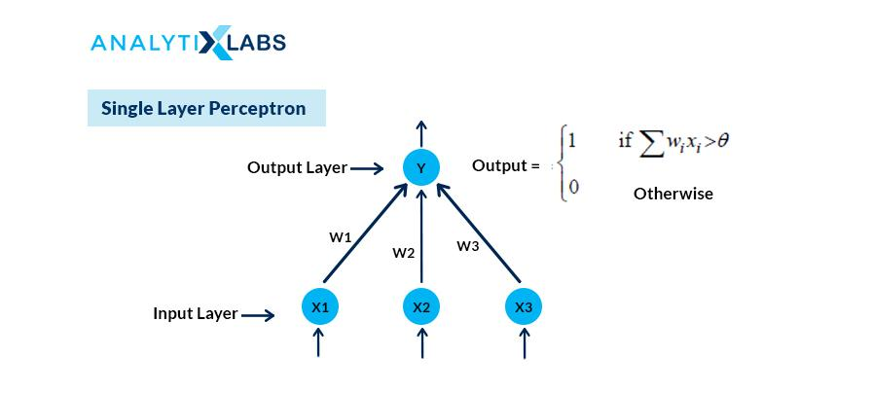
Source: saedsayad.com
A multilayer perceptron (MLP) is another class of Artificial Neural Network (ANN) that has more than one perceptron. MLP consists of three layers: input, hidden, and output layer. The input layer receives the information, and the output layer makes the prediction or decision.
There can be one or more hidden layers in an MLP. It can classify the non-linearly separable data points as hidden, and the output layer uses a nonlinear activation function.
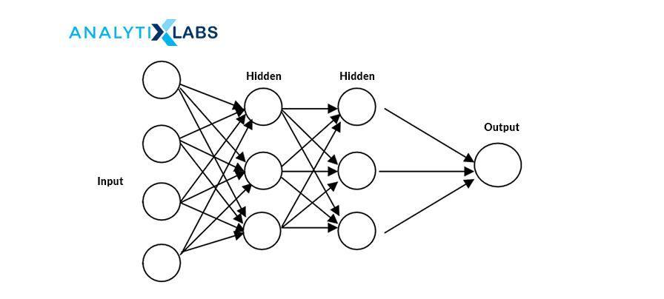
Source: static.packt-cdn.com

8. What are the components of the neural network?
A neural network has:
- Layers:
  - Input Layer: This layer consists of the inputs or the independent X variable.
  - Hidden Layer: It is the layer that extracts features and helps with fine-tuning the model
  - Output Layer: It is the result or the outcome of the network and depends on the type of business problem.
- Neurons
- Weight and Bias
- Activation Function
Both the hidden and the output layer contain nodes.

9. Explain how a neural network works?
There are three steps to perform in any neural network:
- First, take the input variables and estimate the output or the predicted Y values.
- Next, calculate the loss or the error term, and lastly
- Minimize the loss function or the error term by using the backward propagation i.e the loss value is taken backwardly one by one each layer to update the weights in such a way that the error term is minimized.

10. What role do weights and bias play in a neural network? How are the weights initialized?
Ans. It controls the strength of the connections between the neurons and determines the slope coefficients or the betas. Weights or interconnections transform the input data within the hidden layers of the network. The initial values of the weights (or betas) are randomly assigned between 0 and 1.
Bias is the constant intercept term. It is the default value of the model when no inputs or independent variables are present.

11. What is forward and backward propagation?
Forward and backward propagation is the way to adjust the weights or the betas.
In Forward propagation, the weight and biases are randomly initialized. Forward propagation is the process in which the inputs move from the hidden layer to the output layer, i.e., from left to right. In every hidden layer, the activation function’s output is calculated until the other layer is processed.
Backward propagation, go in the reverse order. First, adjust the output layer weights (keeping the weights of the input and hidden layers constant). Relative to the forward propagation, the backward propagation converges faster to the optimal solution of minimized error term since going from the output to the hidden layer and then to the input later.
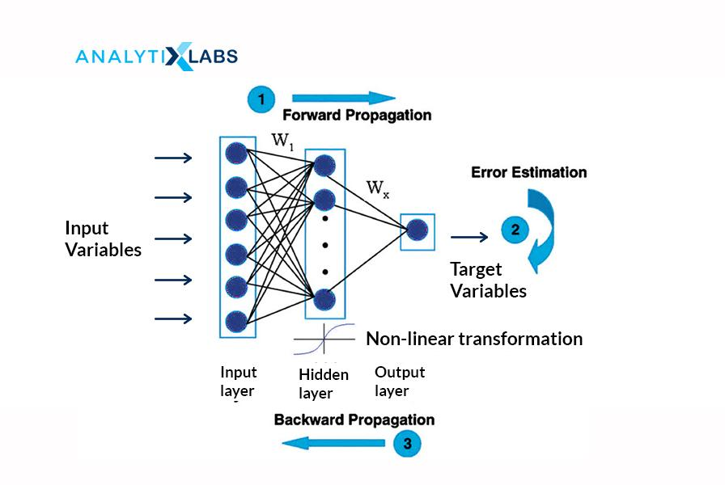
Source: researchgate.net

12. What is an activation function and why is it needed?
Ans. The activation function transforms the inputs into the output by introducing non-linearity to the outcome of a neuron. It helps in deciding to activate or not activate a neuron by calculating the weighted sum with the bias with it.
Activating a neuron will enable the model output to be nonlinear. It is also known as the squashing function. Some of the commonly used activation functions are:
- Step binary function
- Linear or Identity
- Sigmoid
- Softmax
- Tanh
- ReLU
The objective of the activation function is to add non-linearity to the function.
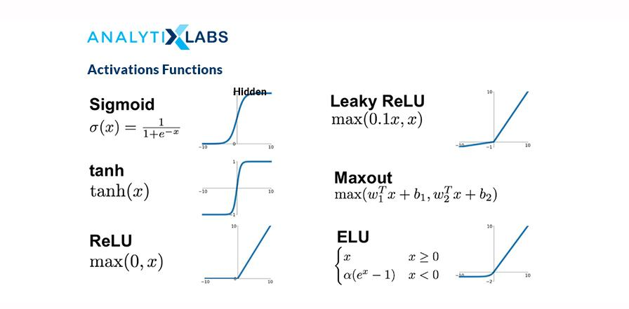
Source: miro.medium.com

13. Which activation function do we use for each layer?
Ans. The activation function is only applied to hidden and output layers as the input layer do not have nodes or neurons. We need the outcome in terms of class predicted (1 or 0) on the output layer, so we use sigmoid for binary classification and softmax for multi-classification. For the hidden layer, we do not need the answer in 1 or 0, so use the Rectified linear unit (or ReLU).

14. Why can we not use sigmoid or tanh to activate the hidden layer of the neural network?
The reason for not using Sigmoid or tanh for hidden layers is that these are susceptible to the vanishing gradient problem. By applying to the hidden layers, the gradients get saturated. During the backpropagation process, the error will reduce further (because of the chain rule), and the weights would not get updated, which will lead to no learning, and eventually, the model would not predict.

15. What is the difference between ReLU and LeakyReLU functions?
ReLU is half rectified from the bottom. In ReLU, the function f(x) = 0 when x< 0 and f(x) = x when x >= 0. This way, in ReLU, the gradient is always zero for all the input values which are less than zero. It can lead to the ‘dying ReLU’ problem by deactivating the neurons in that region.
On the other hand, the Leaky ReLU function is f(x) = max(0.001x, x) when x < 0, so it will have a slight positive slope (of 0.01) and, therefore, a non-zero value, and consequently the model continues to learn without hitting a dead-end.
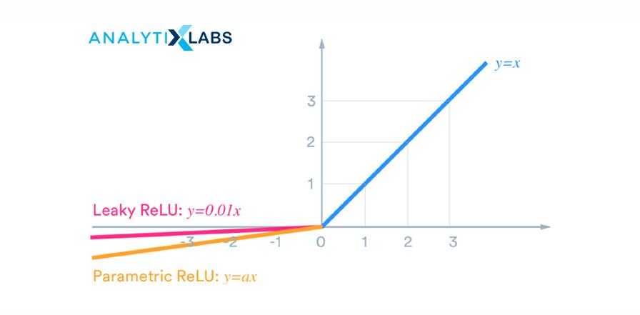
Source: miro.medium.com

16. What are the challenges with gradient descent and What are the treatments?
The challenges of Gradient Descent are:
- Gradient descent gets stuck at local minima, and
- It has a constant learning rate
The remedies are:
For the first challenge, use another optimizer called stochastic or mini-batch gradient descent with momentum, and for the second challenge, employ an RMSProp optimizer.
Moving out of the local minima requires accumulating momentum or speed. The gradient descent with momentum calculates the exponentially weighted average sum of the previous gradients and uses this weighted sum to update the weights.
RMSProp scales the learning rate depending on the square of the gradients, which eventually leads to faster convergence to the optimal solution.

17. What is Adaptive Moment Estimation (or Adam)?
Adaptive Moment Estimation (or Adam) combines the Stochastic Gradient Descent with Momentum and RMSProp. It can adapt the learning rate and find the exponential weights to the historical derivatives. It gives importance to both the past gradients and the previous learning rates.

18. What is the vanishing gradient problem? How is it different from the exploding gradient problem?

Ans. The purpose of the gradient descent algorithm is to update the weights and biases of the neural network by taking small steps towards the minimum value of the loss function.
The vanishing gradient problem occurs when these steps towards the optimal solution taken are too small, thus leading to gradients disappearing. In other words, the changes in the weights and bias terms are so minimal, almost equivalent to negligible. This way, the model does not learn anything, and the model performance deteriorates.
On the other hand, when the steps are too large, the gradients explode. This enlarges the updates to weights and bias terms, leading to an unstable network.
Both of these problems happen while using the Recurrent Neural Network (RNN) since RNNs use backpropagation through time.

19. What are the ways to treat the vanishing and exploding gradient problem?
To fix the vanishing gradient problem, must use:
- ReLU activation function in the hidden layers instead of tanh and sigmoid, and
- Xavier initialization
To treat the exploding gradients problem can:
- Re-design the network with fewer layers.
- Instead of RNN, use Long Short-Term Memory (LSTM) model
- Use gradient clipping, and
- Use the weight regularization

20. What are batch, mini-batch, and stochastic gradient descent? Which one would you use and why?
In a batch gradient descent:
- At each iteration, the gradient is computed for the entire dataset. It is also known as the vanilla gradient descent.
- The convergence to the optimal solution is slow as the training data is large with many samples and many features.
In Stochastic Gradient Descent (SGD):
- The gradient is estimated for a single observation at each iteration.
- As compared to the batch gradient, SGD converges much faster because it updates the weight more frequently and is therefore efficient for large data.
Mini-Batch Gradient Descent:
- It is the combination of batch gradient descent and SGD. It is also referred to as the vanilla mini-batch gradient descent.
- Here, the gradients are estimated by taking one batch or group of observations (similar to SGD for considering one sample) and then like batch gradient descent, training on this entire batch.
- It works faster than both batch gradient and SGD.
Summarizing the variants of the gradient descents:
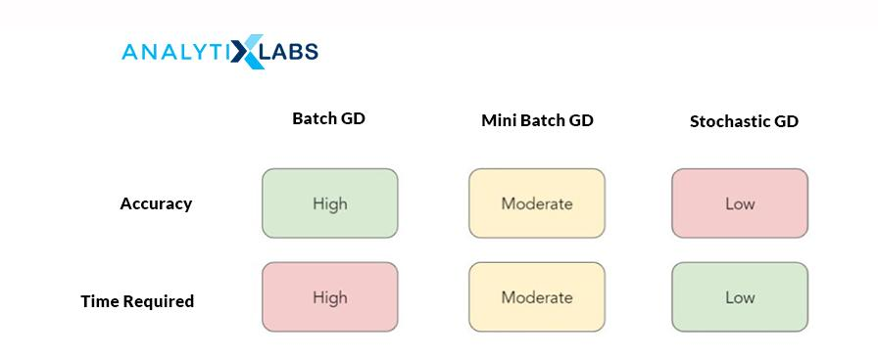
Mini-Batch Gradient Descent is the best variant to use because:
- Using the mini-batches improves the convergence, and also avoids the local minima to allow gradient approximation for the entire dataset.
- It is computationally more efficient in comparison to stochastic gradient descent.
- It helps in improving the generalization by finding the flat minima.

21. What is data or image augmentation?
Ans. Data or Image augmentation is a technique for increasing the input data for the model to train and upon. It is done by manipulating the original data. Data augmentation also helps in reducing the overfitting problem.
In image data, an image can be rotated, flipped horizontally or vertically, cropped, converted its channel, added Gaussian blur, scaled, jittering its color, randomly translated, and sheared to create more images used for training.

22. How do you differentiate between CNN and RNN? Which algorithm should be used when?
Convolution Neural Network (CNN) is a type of Feedforward Neural Network (FNN) having convolution as one of its layers. It creates a set of kernels (or filters) that learns and detects features from the unstructured data. CNNs are applicable for performing and analyzing image, signal, and video data. It is used for image recognition, analyzing visual imagery.
In a CNN, the signals travel in uni-direction from the input to output. It takes in only the current input, so it cannot create any network feedback loop and memorize previous inputs.
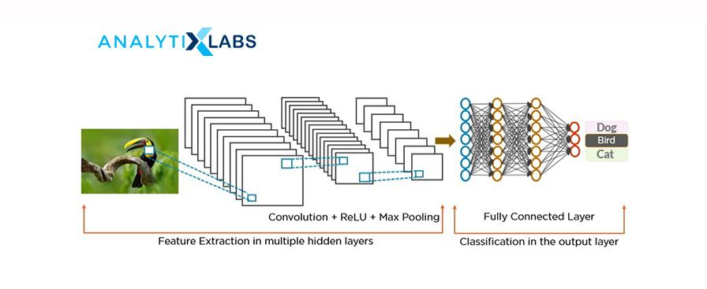
Source: miro.medium.com
Recurrent neural network (RNN), a class of artificial neural network, is applied to sequential data to perform complex tasks such as retrieving patterns in the text, time-series data, handwriting, and genomes.
RNNs use Back-propagation Through Time (BTT) to train and store the output of a layer and feed it back to the input layer, enabling it to have an internal state (or memory) for processing the sequences. Unlike CNN, RNN has interconnected neurons in each layer, and the signals travel in both directions that create a looped network.
It is used for image captioning, time series forecasting, recognizing handwriting, chatbots creation, fraud, and anomalies detection.
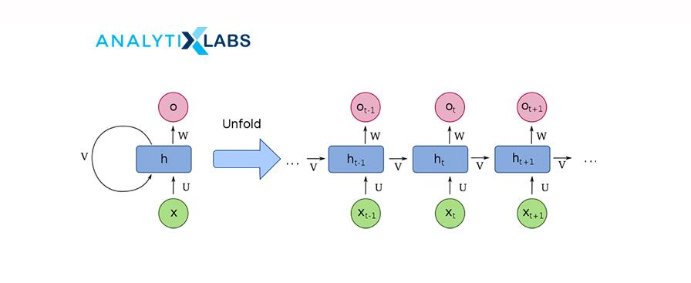
Source: wikimedia.org

23. Why do we use Convolutional Neural Network (CNN) for image data and not the Feedforward Neural Network (FNN)?
A convolutional neural network (CNN) is better than a feedforward neural network (FNN) for image data because CNN reads the image in parts rather than taking the entire picture.
CNN has a convolution layer that has filters to build the feature maps. It follows a hierarchical model that creates a network in the shape of a funnel, returns the processed outcome to a densely connected layer in which all the neurons are interconnected, and returns the final image as classified or identified.
This helps in sharing the features parameter, dimensionality reduction and also reduces the computations.

24. Please explain the difference between Conv1D, Conv2D, and Conv3D?
- Conv1D is applicable for input signals which are similar to the voice i.e audio data.
- Conv2D is useful for images, and
- Conv3D is used for videos having a frame for each period.

25. Explain the different layers of CNN. When using CNN, for which all layers are the parameters estimated?
There are four different layers of Convolution Neural Network (CNN):
- Convolutional Layer: The input (images) undergoes a convolution operation. This layer consists of a set of filters (or kernels) which further creates a subset of images, called feature maps. These maps are used to train the neural network.
- ReLu Layer: It adds non-linearity to the network converting the negative pixels to zero. It results in a rectified or corrected feature map.
- Pooling: This layer down-samples and reduces the dimensions of the feature maps. It does so by reducing the spatial size of the representation to a lower number of features in patches of the feature map.
- Fully Connected Layer: In this layer, like a feedforward neural network, all the layers are fully connected meaning the neurons of each layer are connected to neurons of another layer also have complete activations. This layer identifies and classifies the image.
- Flatten layer: It is connected with the fully connected layer. Flatten converts the data into a one-dimensional array to pass as the input for the next layer.
The parameters are estimated for the convolution and fully connected layer, not the flatter and pooling layer.

26. In CNN, what is the difference between valid and the same padding?
Valid padding is used when there is no need for padding. After convolution, the output dimensions of the output matrix are (n – f + 1) X (n – f + 1).
In the Same padding, the elements are added around the edges of the output matrix to keep the dimensions of the input and output matrix the same.

27. What is the difference between dropout and batch normalization?
Ans. Patented by Google, Dropout, and BatchNorm are techniques to improve a deep learning algorithm by reducing the overfitting of the model.
Using the dropout, we can randomly and probabilistically drop or set nodes to zero within layers of a neural network, i.e., effectively making those neurons invisible or “dropped out.” It is a way of creating a different model for each training and averaging the model performance of the network.
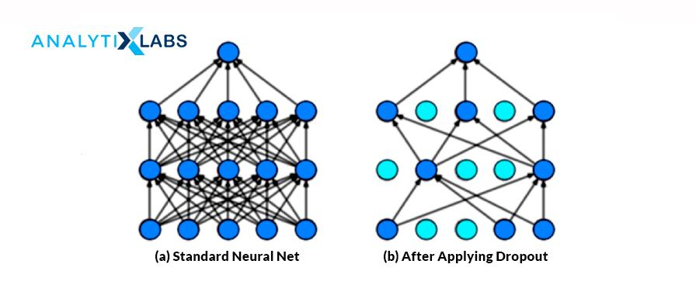
Source: miro.medium.com
The batch normalization technique standardizes the inputs of the network. It normalizes the hidden layer’s activations with a mean of zero and a standard deviation of each layer. This helps reduce the training time by easily initializing the weights and allowing higher learning rates.

28. What is transfer learning? Why is it needed? Name commonly-used transfer learning models.
Transfer learning is the process where learning from a model can be transferred to another without needing to train the model from scratch. There are three ways to use transfer learning:
- Extract features from the pre-trained model and also take away the output from the pre-trained model and then use it on the data for the current problem.
- Use both the architecture and weights of the pre-trained model and take that to train on our dataset.
- Train some layers and freeze the other layers of the pre-trained model. This works by extracting the weights of some of the layers and use for our neural network and fine-tune the model.
The most commonly-used transfer learning models are:
- ResNet
- VGG-16
- GTP-2 and GPT-3
- BERT

29. Does the problem of overfitting happen in neural networks? If yes then how would you treat it?
Ans. Yes, overfitting can occur in a neural network. Following are the ways to prevent overfitting in a neural network or improve a deep learning algorithm:
- Early Stopping
- Dropout
- Batch Normalization
- Data or Image Augmentation
- Weight Sharing

30. Do we have regularizers for neural networks?
Yes, the dropout is a regularizer.

31. What are hyperparameters? List the hyperparameters used in a neural network.
It helps to determine the structure of the neural network and how the network will be trained. Hyperparameters are the variables that are set before the training starts. These are the values that cannot be learned from the data and must be defined by the user. The hyperparameters of an artificial neural network are:
- Number of hidden layers
- Number of Nodes in the hidden layer
- Number of epochs (or iterations)
- Batch size
- Optimizer
- Activation Function
- Learning Rate
- Momentum
- Network Weight Initialization

32. Explain how LSTM, and GRU work. Which is the best one to use and why?
Long Short-Term Memory (LSTM) is a variant of the recurrent neural network that can learn long-term dependencies. It uses three gates: forget gate, input, output gate, and standard units to include a ‘memory cell’ that helps maintain the information in memory for long periods. It uses the feedback loop and gates to “remember” & “forget” information.

The LSTM network works in the following manner:
- Step 1: The network picks and decides which information to remember and what to forget.
- Step 2: It selectively updates the cell state values based on the first step.
- Step 3: The network calculates to decide which part of the current state would make it to the output.
Gated Recurrent Unit (GRU) is a special case of LSTM. It uses two gates: a reset gate and an update gate. The reset gate decides how to combine the new input with the previous time steps’ memory. The update gate decides how much of the last memory should be kept. The update gate of GRU is the combination of the input and forget gate of LSTM.
GRU is preferred over LSTM as LSTM can become complex by having an additional gate. GRU also resolves the vanishing gradient problem, operates faster, and takes less memory consumption as GRU does not have internal memory.
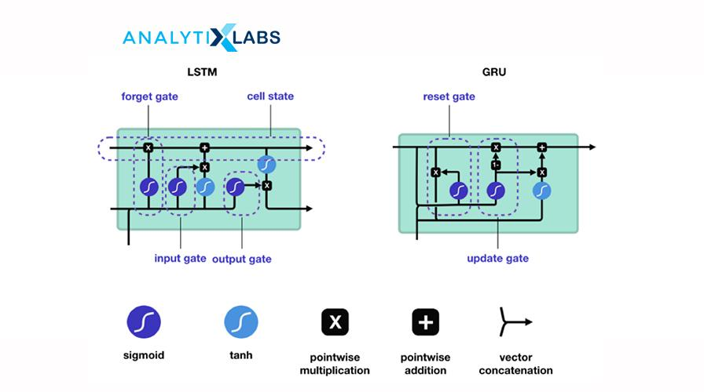
Source: miro.medium.com

33. What are Autoencoders? What is the use of Autoencoders?
Autoencoders is an unsupervised deep learning algorithm. Its goal is to automatically learn to map the inputs to the corresponding outputs without any supervision and direction. It comprises of two parts (which are different from the Encoder-Decoder model):
- Encoder: fits the input into an internal representation
- Decoder: converts the internal computational states back into the output
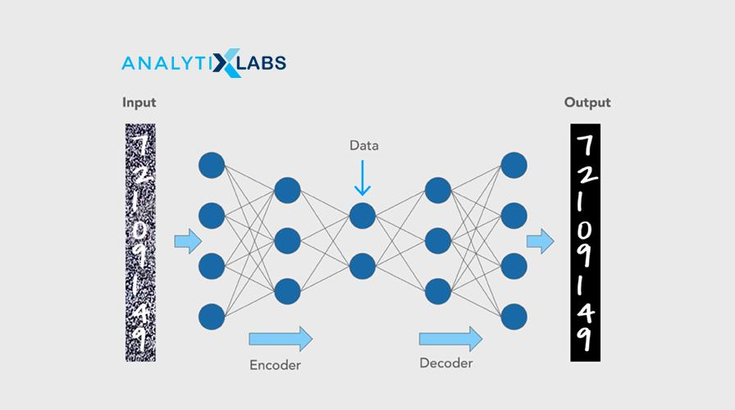
Source: cloudfront.net
Autoencoders are primarily used for dimensionality reduction to decrease the size of the inputs into a smaller representation and are also used for image reconstruction, denoising images, and image colorization.

34. What are GANs?
Generative adversarial networks (GANs) are unsupervised algorithms that use two neural networks: one generator and a discriminator. It generates data with the intent to uncover patterns to create the output.
The generator generates new data, and the discriminator classifies the generated data by the generator. Both these parts are trained simultaneously and compete with each other.
GANs are popular with image data as they are highly efficient and have high traction. These are used in image generation, image enhancement, translation, video, voice generation, and age progression.

35. Explain the Boltzmann machine. What is a Restricted Boltzmann machine?
Ans. The Boltzmann Machine resembles a Multilayer Perceptron with a hidden layer and a visible input layer. This model makes binary decisions, and bias, i.e., takes stochastic decisions to decide if a neuron must remain on or off. These generative types of models are bidirectional and stochastic models where nodes across different layers can connect; however, two nodes within the same layer can not connect.
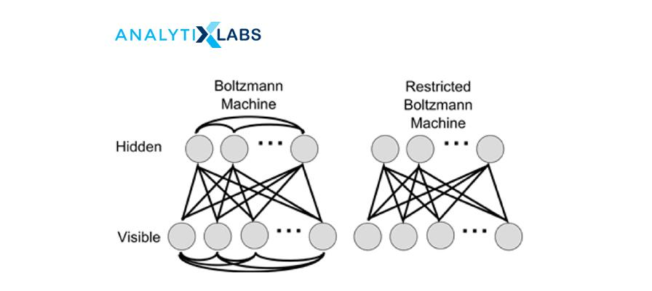
Source: researchgate.net
A Restricted Boltzmann Machine (RBM), a variant of the Boltzmann machine. It is an undirected graphical model that can be trained in either supervised or unsupervised ways based on the task. It is an algorithm that is used to perform:
- Regression
- Collaborative filtering
- Classification
- Dimensionality reduction
- Feature Learning
- Topic modeling
Restricted Boltzmann Machine is the Boltzmann Machine with restrictions where the restrictions are the visible nodes that should not connect with each other, and the hidden nodes shouldn’t connect with each other.

36. What are Seq2Seq (encoder-decoder) models? How is it different from Autoencoders?
The encoder-decoder model is a recurrent neural network (RNN) architecture with two RNNS and is used for sequence problems such as machine translation. One part is the encoder that encodes the inputs into a fixed-length vector representation. The second part is the decoder that decodes or represents another series of symbols as the output.
It is different from the autoencoder as autoencoder is an unsupervised architecture focussing on reducing dimensions and is applicable for image data.
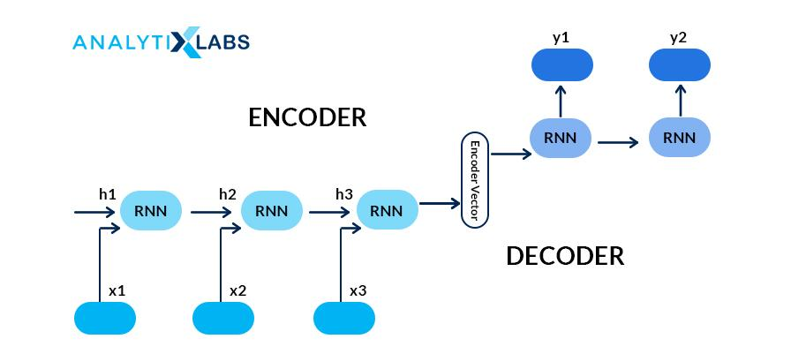
Source: miro.medium.com

37. What is the difference between epoch, batch, and iteration in deep learning? We have a dataset with 10,000 records and a batch size of 100 then for how many iterations will our model run for?
Epoch is the number of iterations over which we train the model. Batch is referred to the size of the subsets that the dataset is divided into to pass in the model.
The model will run for 100 iterations ( (10,000 divided by 100) for 1000 records and have a batch of 100.

38. What are tensors?
Tensors are mathematical objects, and in deep learning, tensors are one of the data structures. These multi-dimensional arrays represent data with higher dimensions, and one can execute various mathematical operations on these. In other words, tensors are data container that stores data with different dimensions in a neural network.
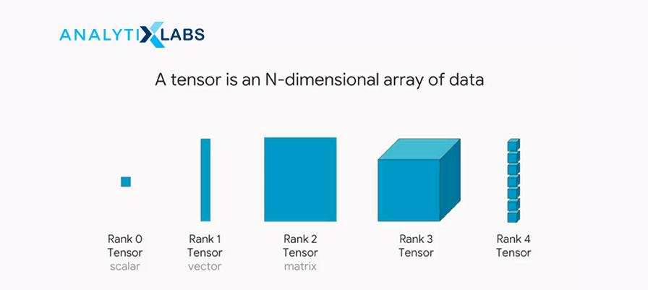
Source: miro.medium.com
To explore more on tensors, read Tensors — Representation of Data In Neural Networks and TensorFlow Basics: Tensor, Shape, Type, Sessions & Operators.

39. What is a computational graph? How is it useful for Deep Learning?
A computational graph is a series of operations represented in a network form, where each node represents a mathematical operation, and the edges are the tensors. Each node takes input as one or more tensors and returns in output a tensor. This sequence of TensorFlow operations is also known as the ‘DataFlow Graph.’
The USP of this graph is processing can happen parallelly hence is computationally efficient. The graph is immensely helpful for deep learning as it takes in a large number of inputs and has multiple layers requiring more computations. It can chart out the mathematical workflow graphically.
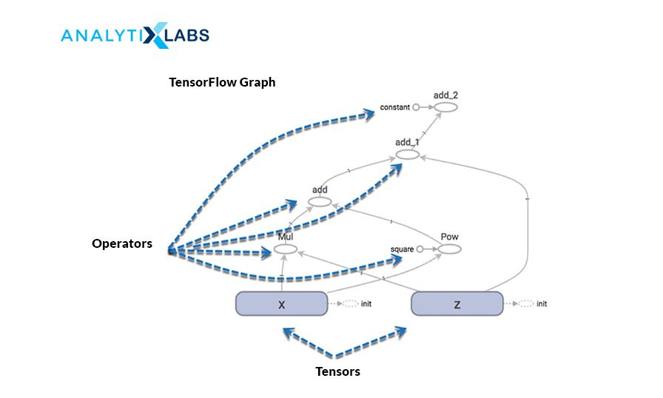
Source: guru99.com

40. What is model capacity?
Ans. Model capacity refers to the degree of a deep learning neural network to control the types of mapping functions it can take and learn from. It is the ability to approximate any given function. The higher the model capacity, the more amount of information can be stored in the network.

Beginner level Deep Learning Interview Tips
It would be beneficial to do the following to prepare for the deep learning interview:
- Having good theoretical knowledge
It is imperative to have a sound, solid theoretical knowledge of deep learning topics. Starting from the basics of neural networks, their architecture, the several parameters used in it. A good working understanding of the commonly used models such as Convolution Neural Network (CNN), Recurrent Neural Network (RNN), Long-Short Term Memory (LSTM), Gated Recurrent Unit (GRU).
Be thorough with how the models help solve a business problem, how to improve the neural network and the respective hyperparameters. Additionally, know what transfer learning is, why it is needed and how it is employed. Be well-versed with the fundamentals of the underlying concepts used in the models. Keep revisiting these deep learning interview questions to revise your concepts.
- Work with real-world Deep Learning cases
Nothing beats the old-age saying practice makes a man perfect! All the theory is not of any good if not applied. It is crucial to have worked with the business cases to solve any real-life problems. It is best to showcase your work, skills by having a portfolio on GitHub and/or Kaggle.
- Study Deep Learning interview questions
The above deep learning interview questions and answers would be a good starting point to study. Practice your answers; take mocks. It would save you many rounds of drilling work if you could hear yourself when you answer a question! Technical rounds can get a little daunting at times. In such cases, keep a mind hack trick handy to swift through it.
- Read about the Company and Role
It is an excellent practice to research and read well beforehand the job description, about the company, if possible know its contemporaries. Be aware of the needed skill sets and tools, talk about how you have those skills, and work on cases requiring those tools (only if you have!) Assess and answer yourself on questions such as telling us something about yourself and what you can bring to the role. Have a list of questions to ask the interviewer at the end of the interview.
- Interview Étiquettes
Some of the very subtle and essential things that we can tend to forgo while preparing for interviews are:
- Being punctual for the interviews for both virtual and in-person. Logging in at least a couple of minutes before time will allow you to breathe in, be settled, collect your thoughts and not rush hush through (after all a good start is half done
- Being honest and integral about what you know and don’t know. On your resume add only the things you know, and have worked on yourself.
- Listen to the interviewer and answer questions to the best of your ability and understanding. Ask in case you are not clear about the question. Answer only to the question asked, sometimes we tend to answer for what was not even asked. If you are not sure or do not know the answer, it is polite to say I don’t know than conjuring up incorrect answers.

How to get expertise in Deep learning?
- Having a Beginner’s Mind
We all want to leverage the benefits of this highly-sort, demanding, and lucrative job and build fantastic working models, but Rome was not built in a day this field like any other.
First, work with the basics, get your fundamentals in place and then progress to the advanced topics in deep learning such as transformers, machine translations, speech-to-text, applied computer vision, BERT, YOLO.
- Do not forget your Machine Learning Stuff!
If you were expecting that you could let your Machine Learning books, notes, models catch dust, then sorry to disappoint, but you can’t proceed with deep Learning until you have Machine Learning under your belt!
Deep Learning without Machine learning would be like you have become a doctor without having had science in 12th class! (No, no, Munna-Bhai MBBS works here!) There is a reason why Deep Learning is a subset of Machine Learning, and it has to be the last one to be learned and mastered. The pecking order of things is important.
- Pick your Deep Learning framework
There are three popular frameworks to work with deep learning problems: Keras, TensorFlow, and PyTorch. Keras is easier to start working and implementing the Deep Learning models upon as it has pre-defined functions as sklearn had for Machine Learning. Keras has TensorFlow at its backend.
PyTorch requires more work, as we need to define functions to the same task that is handier in Keras. Ideally, start with Keras, and once you have a grasp of the models, clear on the architecture et al. and then learn PyTorch and diverse out.
- Practice Practice and some more Practice!
It would be good to have intuition built for neural networks, the logical understanding of things, how the pieces are joined together. The curiosity to ask questions, understand, learn and then apply all that knowledge gained is the key. It is one thing to understand the architecture of the network, but only once you start putting that into solving real-life cases will you be able to learn more and fine-tune your approach.
- Explore the problems and datasets
Play around with every kind of dataset you can get your hands-on, and over a period of time, you will learn which area of Deep Learning you have flair and liking for. This can only come up with having worked with lots of problems and diversifying the use cases. It is exactly like how you get to know yourself
- Learn Model Deployment
Eventually, the models you are making have to be deployed for them to be of use. Therefore, it is of immense benefit to learn how to deploy your models. The skill will not only give you added advantage but also make you more efficient.
Hope this repository of deep learning interview questions has been helpful to you. Some of the FAQs related to it are:

