1. What do you understand by Natural Language Processing?
Natural Language Processing is a field of computer science that deals with communication between computer systems and humans. It is a technique used in Artificial Intelligence and Machine Learning. It is used to create automated software that helps understand human spoken languages to extract useful information from the data it gets in the form of audio. Techniques in NLP allow computer systems to process and interpret data in the form of natural languages.

If you want to learn Natural Language Processing then go through the following tutorial:


2. List any two real-life applications of Natural Language Processing.
Two real-life applications of Natural Language Processing are as follows:
- Google Translate: Google Translate is one of the famous applications of Natural Language Processing. It helps convert written or spoken sentences into any language. Also, we can find the correct pronunciation and meaning of a word by using Google Translate. It uses advanced techniques of Natural Language Processing to achieve success in translating sentences into various languages.
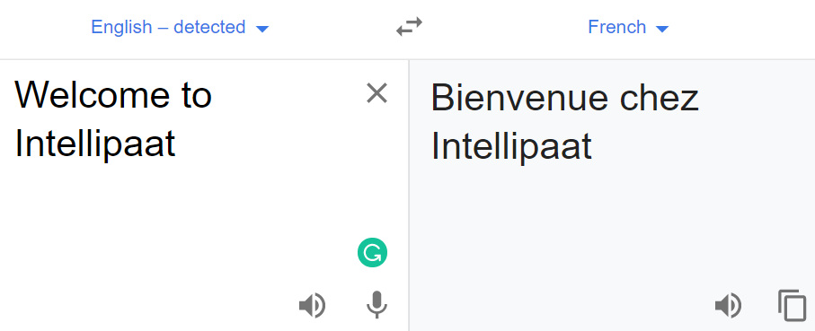
- Chatbots: To provide a better customer support service, companies have started using chatbots for 24/7 service. AI Chatbots help resolve the basic queries of customers. If a chatbot is not able to resolve any query, then it forwards it to the support team, while still engaging the customer. It helps make customers feel that the customer support team is quickly attending them. With the help of chatbots, companies have become capable of building cordial relations with customers. It is only possible with the help of Natural Language Processing.
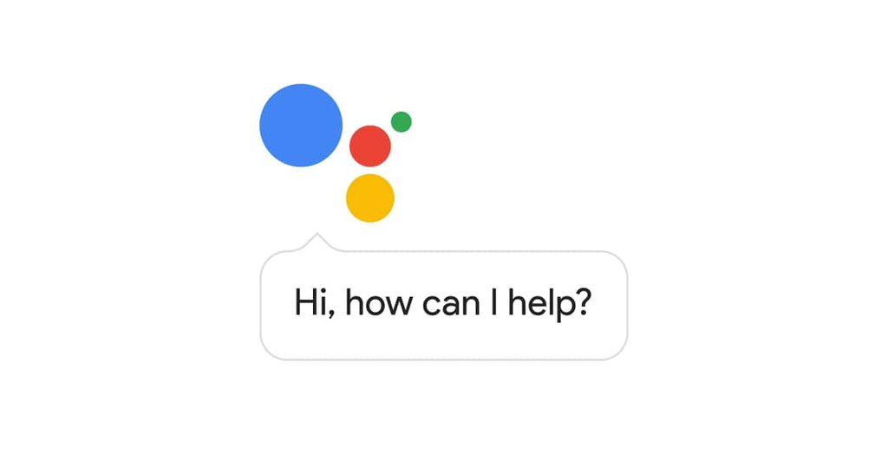

3. What are stop words?
Stop words are said to be useless data for a search engine. Words such as articles, prepositions, etc. are considered as stop words. There are stop words such as was, were, is, am, the, a, an, how, why, and many more. In Natural Language Processing, we eliminate the stop words to understand and analyze the meaning of a sentence. The removal of stop words is one of the most important tasks for search engines. Engineers design the algorithms of search engines in such a way that they ignore the use of stop words. This helps show the relevant search result for a query.

4. What is NLTK?
NLTK is a Python library, which stands for Natural Language Toolkit. We use NLTK to process data in human spoken languages. NLTK allows us to apply techniques such as parsing, tokenization, lemmatization, stemming, and more to understand natural languages. It helps in categorizing text, parsing linguistic structure, analyzing documents, etc.
A few of the libraries of the NLTK package that we often use in NLP are:
- SequentialBackoffTagger
- DefaultTagger
- UnigramTagger
- treebank
- wordnet
- FreqDist
- patterns
- RegexpTagger
- backoff_tagger
- UnigramTagger, BigramTagger, and TrigramTagger
Get 100% Hike!
Master Most in Demand Skills Now !
窗体顶端
窗体底端

5. What is Syntactic Analysis?
Syntactic analysis is a technique of analyzing sentences to extract meaning from it. Using syntactic analysis, a machine can analyze and understand the order of words arranged in a sentence. NLP employs grammar rules of a language that helps in the syntactic analysis of the combination and order of words in documents.
The techniques used for syntactic analysis are as follows:
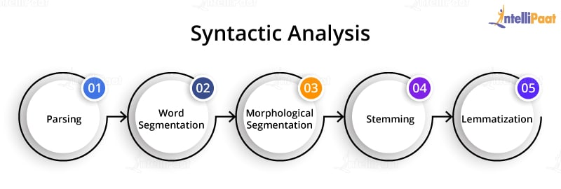
- Parsing: It helps in deciding the structure of a sentence or text in a document. It helps analyze the words in the text based on the grammar of the language.
- Word segmentation: The segmentation of words segregates the text into small significant units.
- Morphological segmentation: The purpose of morphological segmentation is to break words into their base form.
- Stemming: It is the process of removing the suffix from a word to obtain its root word.
- Lemmatization: It helps combine words using suffixes, without altering the meaning of the word.

6. What is Semantic Analysis?
Semantic analysis helps make a machine understand the meaning of a text. It uses various algorithms for the interpretation of words in sentences. It also helps understand the structure of a sentence.
Techniques used for semantic analysis are as given below:
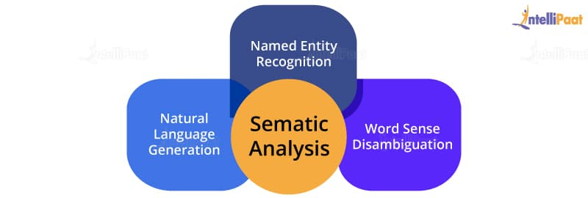
- Named entity recognition: This is the process of information retrieval that helps identify entities such as the name of a person, organization, place, time, emotion, etc.
- Word sense disambiguation: It helps identify the sense of a word used in different sentences.
- Natural language generation: It is a process used by the software to convert the structured data into human spoken languages. By using NLG, organizations can automate content for custom reports.
If you want to learn Artificial Intelligence then enroll in Artificial Intelligence Training now!

7. List the components of Natural Language Processing.
The major components of NLP are as follows:
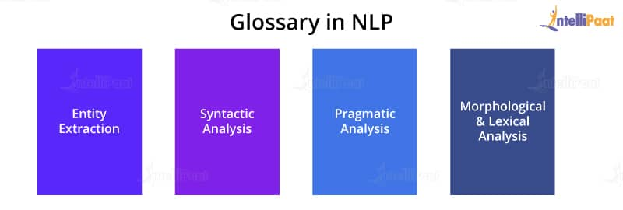
- Entity extraction: Entity extraction refers to the retrieval of information such as place, person, organization, etc. by the segmentation of a sentence. It helps in the recognition of an entity in a text.
- Syntactic analysis: Syntactic analysis helps draw the specific meaning of a text.
- Pragmatic analysis: To find useful information from a text, we implement pragmatic analysis techniques.
- Morphological and lexical analysis: It helps in explaining the structure of words by analyzing them through parsing.

8. What is Latent Semantic Indexing (LSI)?
Latent semantic indexing is a mathematical technique used to improve the accuracy of the information retrieval process. The design of LSI algorithms allows machines to detect the hidden (latent) correlation between semantics (words). To enhance information understanding, machines generate various concepts that associate with the words of a sentence.
The technique used for information understanding is called singular value decomposition. It is generally used to handle static and unstructured data. The matrix obtained for singular value decomposition contains rows for words and columns for documents. This method best suits to identify components and group them according to their types.
The main principle behind LSI is that words carry a similar meaning when used in a similar context. Computational LSI models are slow in comparison to other models. However, they are good at contextual awareness that helps improve the analysis and understanding of a text or a document.
Career Transition




9. What are Regular Expressions?
A regular expression is used to match and tag words. It consists of a series of characters for matching strings.
Suppose, if A and B are regular expressions, then the following are true for them:
- If {ɛ} is a regular language, then ɛ is a regular expression for it.
- If A and B are regular expressions, then A + B is also a regular expression within the language {A, B}.
- If A and B are regular expressions, then the concatenation of A and B (A.B) is a regular expression.
- If A is a regular expression, then A* (A occurring multiple times) is also a regular expression.

10. What is Regular Grammar?
Regular grammar is used to represent a regular language.
A regular grammar comprises rules in the form of A -> a, A -> aB, and many more. The rules help detect and analyze strings by automated computation.
Regular grammar consists of four tuples:
- ‘N’ is used to represent the non-terminal set.
- ‘∑’ represents the set of terminals.
- ‘P’ stands for the set of productions.
- ‘S € N’ denotes the start of non-terminal.

11. What is Parsing in the context of NLP?
Parsing in NLP refers to the understanding of a sentence and its grammatical structure by a machine. Parsing allows the machine to understand the meaning of a word in a sentence and the grouping of words, phrases, nouns, subjects, and objects in a sentence. Parsing helps analyze the text or the document to extract useful insights from it. To understand parsing, refer to the below diagram:
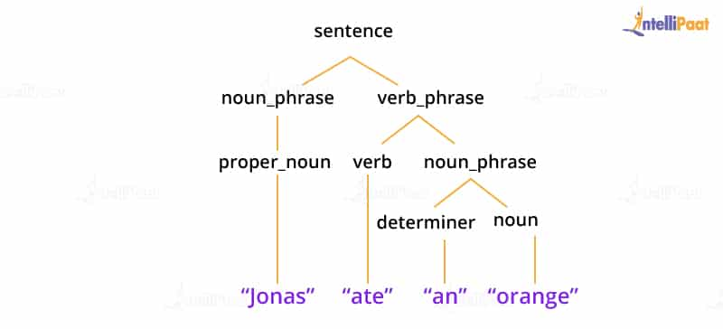
In this, ‘Jonas ate an orange’ is parsed to understand the structure of the sentence.

Intermediate NLP Interview Questions

12. What is TF-IDF?
TFIDF or Term Frequency-Inverse Document Frequency indicates the importance of a word in a set. It helps in information retrieval with numerical statistics. For a specific document, TF-IDF shows a frequency that helps identify the keywords in a document. The major use of TF-IDF in NLP is the extraction of useful information from crucial documents by statistical data. It is ideally used to classify and summarize the text in documents and filter out stop words.
TF helps calculate the ratio of the frequency of a term in a document and the total number of terms. Whereas, IDF denotes the importance of the term in a document.
The formula for calculating TF-IDF:
TF(W) = (Frequency of W in a document)/(The total number of terms in the document)
IDF(W) = log_e(The total number of documents/The number of documents having the term W)
When TF*IDF is high, the frequency of the term is less and vice versa.
Google uses TF-IDF to decide the index of search results according to the relevancy of pages. The design of the TF-IDF algorithm helps optimize the search results in Google. It helps quality content rank up in search results.
If you want to know more about ‘What is Natural Language Processing?’ you can go through this Natural Language Processing Using Python course!

13. Define the terminology in NLP.
This is one of the most often asked NLP interview questions.
The interpretation of Natural Language Processing depends on various factors, and they are:
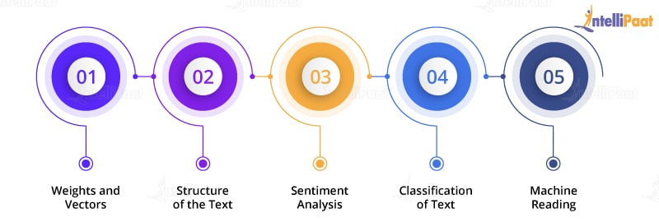
Weights and Vectors
- Use of TF-IDF for information retrieval
- Length (TF-IDF and doc)
- Google Word Vectors
- Word Vectors
Structure of the Text
- POS tagging
- Head of the sentence
- Named Entity Recognition (NER)
Sentiment Analysis
- Knowledge of the characteristics of sentiment
- Knowledge about entities and the common dictionary available for sentiment analysis
Classification of Text
- Supervised learning algorithm
- Training set
- Validation set
- Test set
- Features of the text
- LDA
Machine Reading
- Removal of possible entities
- Joining with other entities
- DBpedia
FRED (lib) Pikes
Courses you may like




14. Explain Dependency Parsing in NLP.
Dependency parsing helps assign a syntactic structure to a sentence. Therefore, it is also called syntactic parsing. Dependency parsing is one of the critical tasks in NLP. It allows the analysis of a sentence using parsing algorithms. Also, by using the parse tree in dependency parsing, we can check the grammar and analyze the semantic structure of a sentence.
For implementing dependency parsing, we use the spacy package. It implements token properties to operate the dependency parse tree.
The below diagram shows the dependency parse tree:
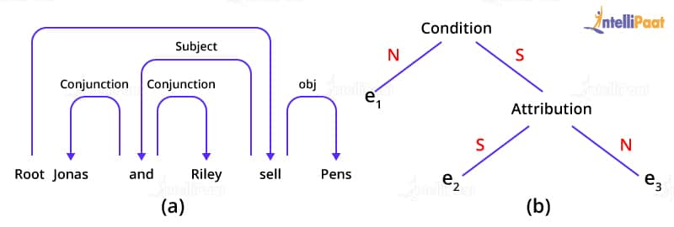

15. What is the difference between NLP and NLU?
The below table shows the difference between NLP and NLU: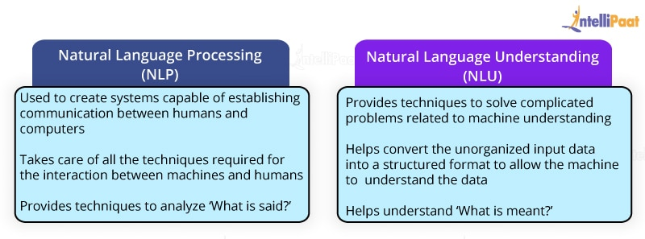

16. What is the difference between NLP and CI?
The below table shows the difference between NLP and CI:
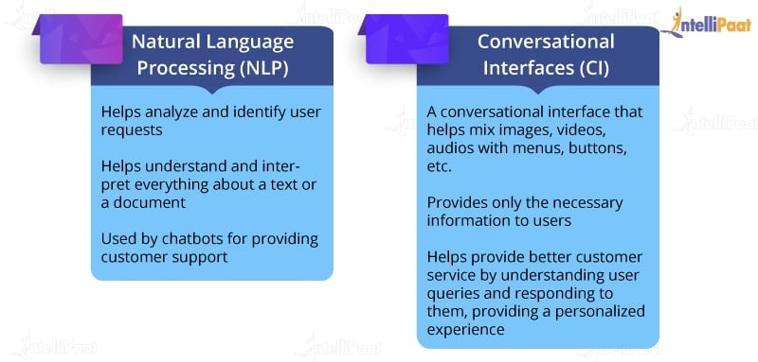

17. What is Pragmatic Analysis?
Pragmatic analysis is an important task in NLP for interpreting knowledge that is lying outside a given document. The aim of implementing pragmatic analysis is to focus on exploring a different aspect of the document or text in a language. This requires a comprehensive knowledge of the real world. The pragmatic analysis allows software applications for the critical interpretation of the real-world data to know the actual meaning of sentences and words.
Example:
Consider this sentence: ‘Do you know what time it is?’
This sentence can either be asked for knowing the time or for yelling at someone to make them note the time. This depends on the context in which we use the sentence.

18. What is Pragmatic Ambiguity?
Pragmatic ambiguity refers to the multiple descriptions of a word or a sentence. An ambiguity arises when the meaning of the sentence is not clear. The words of the sentence may have different meanings. Therefore, in practical situations, it becomes a challenging task for a machine to understand the meaning of a sentence. This leads to pragmatic ambiguity.
Example:
Check out the below sentence.
‘Are you feeling hungry?’
The given sentence could be either a question or a formal way of offering food.

19. What are unigrams, bigrams, trigrams, and n-grams in NLP?
When we parse a sentence one word at a time, then it is called a unigram. The sentence parsed two words at a time is a bigram.
When the sentence is parsed three words at a time, then it is a trigram. Similarly, n-gram refers to the parsing of n words at a time.
Example: To understand unigrams, bigrams, and trigrams, you can refer to the below diagram:
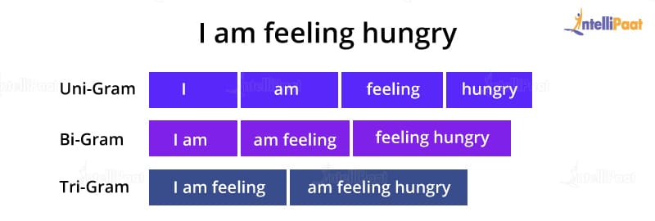
Therefore, parsing allows machines to understand the individual meaning of a word in a sentence. Also, this type of parsing helps predict the next word and correct spelling errors.
Are you interested in learning Artificial Intelligence from experts? Enroll in our AI Course in Bangalore now!

20. What are the steps involved in solving an NLP problem?
Below are the steps involved in solving an NLP problem:
- Gather the text from the available dataset or by web scraping
- Apply stemming and lemmatization for text cleaning
- Apply feature engineering techniques
- Embed using word2vec
- Train the built model using neural networks or other Machine Learning techniques
- Evaluate the model’s performance
- Make appropriate changes in the model
- Deploy the model


21. What is Feature Extraction in NLP?
Features or characteristics of a word help in text or document analysis. They also help in sentiment analysis of a text. Feature extraction is one of the techniques that are used by recommendation systems. Reviews such as ‘excellent,’ ‘good,’ or ‘great’ for a movie are positive reviews, recognized by a recommender system. The recommender system also tries to identify the features of the text that help in describing the context of a word or a sentence. Then, it makes a group or category of the words that have some common characteristics. Now, whenever a new word arrives, the system categorizes it as per the labels of such groups.

22. What is precision and recall?
The metrics used to test an NLP model are precision, recall, and F1. Also, we use accuracy for evaluating the model’s performance. The ratio of prediction and the desired output yields the accuracy of the model.
Precision is the ratio of true positive instances and the total number of positively predicted instances.
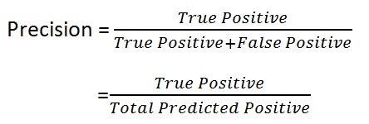
Recall is the ratio of true positive instances and the total actual positive instances.
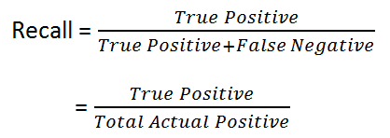

23. What is F1 score in NLP?
F1 score evaluates the weighted average of recall and precision. It considers both false negative and false positive instances while evaluating the model. F1 score is more accountable than accuracy for an NLP model when there is an uneven distribution of class. Let us look at the formula for calculating F1 score:
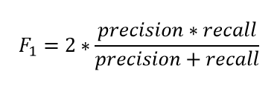
If you are preparing for an Artificial Intelligence job interview, go through this top Artificial Intelligence Interview Questions and Answers!

Advanced NLP Interview Questions

24. How to tokenize a sentence using the nltk package?
Tokenization is a process used in NLP to split a sentence into tokens. Sentence tokenization refers to splitting a text or paragraph into sentences.
For tokenizing, we will import sent_tokenize from the nltk package:
from nltk.tokenize import sent_tokenize<>
We will use the below paragraph for sentence tokenization:
Para = “Hi Guys. Welcome to Intellipaat. This is a blog on the NLP interview questions and answers.”
sent_tokenize(Para)
Output:
[ 'Hi Guys.' ,
'Welcome to Intellipaat. ',
'This is a blog on the NLP interview questions and answers. ' ]
Tokenizing a word refers to splitting a sentence into words.
Now, to tokenize a word, we will import word_tokenize from the nltk package.
from nltk.tokenize import word_tokenize
Para = “Hi Guys. Welcome to Intellipaat. This is a blog on the NLP interview questions and answers.”
word_tokenize(Para)
Output:
[ 'Hi' , 'Guys' , ' . ' , 'Welcome' , 'to' , 'Intellipaat' , ' . ' , 'This' , 'is' , 'a', 'blog' , 'on' , 'the' , 'NLP' , 'interview' , 'questions' , 'and' , 'answers' , ' . ' ]

25. Explain how we can do parsing.
Parsing is the method to identify and understand the syntactic structure of a text. It is done by analyzing the individual elements of the text. The machine parses the text one word at a time, then two at a time, further three, and so on.
- When the machine parses the text one word at a time, then it is a unigram.
- When the text is parsed two words at a time, it is a bigram.
- The set of words is a trigram when the machine parses three words at a time.
Look at the below diagram to understand unigram, bigram, and trigram.
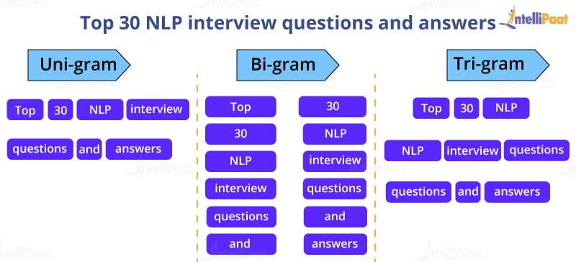
Now, let’s implement parsing with the help of the nltk package.
import nltk
text = ”Top 30 NLP interview questions and answers”
We will now tokenize the text using word_tokenize.
text_token= word_tokenize(text)
Now, we will use the function for extracting unigrams, bigrams, and trigrams.
list(nltk.unigrams(text))
Output:
[ "Top 30 NLP interview questions and answer"]
list(nltk.bigrams(text))
Output:
["Top 30", "30 NLP", "NLP interview", "interview questions", "questions and", "and answer"]
list(nltk.trigrams(text))
Output:
["Top 30 NLP", "NLP interview questions", "questions and answers"]
For extracting n-grams, we can use the function nltk.ngrams and give the argument n for the number of parsers.
list(nltk.ngrams(text,n))

26. Explain Stemming with the help of an example.
In Natural Language Processing, stemming is the method to extract the root word by removing suffixes and prefixes from a word.
For example, we can reduce ‘stemming’ to ‘stem’ by removing ‘m’ and ‘ing.’
We use various algorithms for implementing stemming, and one of them is PorterStemmer.
First, we will import PorterStemmer from the nltk package.
from nltk.stem import PorterStemmer
Creating an object for PorterStemmer
pst=PorterStemmer()
pst.stem(“running”), pst.stem(“cookies”), pst.stem(“flying”)
Output:
(‘run’, ‘cooki', ‘fly’ )

27. Explain Lemmatization with the help of an example.
We use stemming and lemmatization to extract root words. However, stemming may not give the actual word, whereas lemmatization generates a meaningful word.
In lemmatization, rather than just removing the suffix and the prefix, the process tries to find out the root word with its proper meaning.
Example: ‘Bricks’ becomes ‘brick,’ ‘corpora’ becomes ‘corpus,’ etc.
Let’s implement lemmatization with the help of some nltk packages.
First, we will import the required packages.
from nltk.stem import wordnet
from nltk.stem import WordnetLemmatizer
Creating an object for WordnetLemmatizer()
lemma= WordnetLemmatizer()
list = [“Dogs”, “Corpora”, “Studies”]
for n in list:
print(n + “:” + lemma.lemmatize(n))
Output:
Dogs: Dog
Corpora: Corpus
Studies: Study
Interested in learning Artificial Intelligence? Go through this Artificial Intelligence Tutorial!

28. What is Parts-of-speech Tagging?
The parts-of-speech (POS) tagging is used to assign tags to words such as nouns, adjectives, verbs, and more. The software uses the POS tagging to first read the text and then differentiate the words by tagging. The software uses algorithms for the parts-of-speech tagging. POS tagging is one of the most essential tools in Natural Language Processing. It helps in making the machine understand the meaning of a sentence.
We will look at the implementation of the POS tagging using stop words.
Let’s import the required nltk packages.
import nltk
from nltk.corpus import stopwords
from nltk.tokenize import word_tokenize, sent_tokenize
stop_words = set(stopwords.words('english'))
txt = "Sourav, Pratyush, and Abhinav are good friends."
Tokenizing using sent_tokenize
tokenized_text = sent_tokenize(txt)
To find punctuation and words in a string, we will use word_tokenizer and then remove the stop words.
for n in tokenized_text:
wordsList = nltk.word_tokenize(i)
wordsList = [w for w in wordsList if not w instop_words]
Now, we will use the POS tagger.
tagged_words = nltk.pos_tag(wordsList)
print(tagged_words)
Output:
[('Sourav', 'NNP'), ('Pratyush', 'NNP'), ('Abhinav', 'NNP'), ('good', 'JJ'), ('friends', 'NNS')]

29. Explain Named Entity Recognition by implementing it.
Named Entity Recognition (NER) is an information retrieval process. NER helps classify named entities such as monetary figures, location, things, people, time, and more. It allows the software to analyze and understand the meaning of the text. NER is mostly used in NLP, Artificial Intelligence, and Machine Learning. One of the real-life applications of NER is chatbots used for customer support.
Let’s implement NER using the spacy package.
Importing the spacy package:
import spacy
nlp = spacy.load('en_core_web_sm')
Text = "The head office of Google is in California"
document = nlp(text)for ent in document.ents:
print(ent.text, ent.start_char, ent.end_char, ent.label_)
Output:
Office 9 15 Place
Google 19 25 ORG
California 32 41 GPE

30. How to check word similarity using the spacy package?
To find out the similarity among words, we use word similarity. We evaluate the similarity with the help of a number that lies between 0 and 1. We use the spacy library to implement the technique of word similarity.
import spacy
nlp = spacy.load('en_core_web_md')
print("Enter the words")
input_words = input()
tokens = nlp(input_words)
for i in tokens:
print(i.text, i.has_vector, i.vector_norm, i.is_oov)
token_1, token_2 = tokens[0], tokens[1]
print("Similarity between words:", token_1.similarity(token_2))
Output:
hot True 5.6898586 False
cold True6.5396233 False
Similarity: 0.597265

Natural Language Toolkit
NLTK is a leading platform for building Python programs to work with human language data. It provides easy-to-use interfaces to over 50 corpora and lexical resources such as WordNet, along with a suite of text processing libraries for classification, tokenization, stemming, tagging, parsing, and semantic reasoning, wrappers for industrial-strength NLP libraries, and an active discussion forum.
Thanks to a hands-on guide introducing programming fundamentals alongside topics in computational linguistics, plus comprehensive API documentation, NLTK is suitable for linguists, engineers, students, educators, researchers, and industry users alike. NLTK is available for Windows, Mac OS X, and Linux. Best of all, NLTK is a free, open source, community-driven project.
NLTK has been called “a wonderful tool for teaching, and working in, computational linguistics using Python,” and “an amazing library to play with natural language.”
Natural Language Processing with Python provides a practical introduction to programming for language processing. Written by the creators of NLTK, it guides the reader through the fundamentals of writing Python programs, working with corpora, categorizing text, analyzing linguistic structure, and more. The online version of the book has been been updated for Python 3 and NLTK 3. (The original Python 2 version is still available at https://www.nltk.org/book_1ed.)

Some simple things you can do with NLTK
Tokenize and tag some text:
>>> import nltk>>> sentence = """At eight o'clock on Thursday morning... Arthur didn't feel very good.""">>> tokens = nltk.word_tokenize(sentence)>>> tokens['At', 'eight', "o'clock", 'on', 'Thursday', 'morning','Arthur', 'did', "n't", 'feel', 'very', 'good', '.']>>> tagged = nltk.pos_tag(tokens)>>> tagged[0:6][('At', 'IN'), ('eight', 'CD'), ("o'clock", 'JJ'), ('on', 'IN'),('Thursday', 'NNP'), ('morning', 'NN')]
Identify named entities:
>>> entities = nltk.chunk.ne_chunk(tagged)>>> entitiesTree('S', [('At', 'IN'), ('eight', 'CD'), ("o'clock", 'JJ'), ('on', 'IN'), ('Thursday', 'NNP'), ('morning', 'NN'), Tree('PERSON', [('Arthur', 'NNP')]), ('did', 'VBD'), ("n't", 'RB'), ('feel', 'VB'), ('very', 'RB'), ('good', 'JJ'), ('.', '.')])
Display a parse tree:
>>> from nltk.corpus import treebank>>> t = treebank.parsed_sents('wsj_0001.mrg')[0]>>> t.draw()

Natural language processing (NLP) is a field that focuses on making natural human language usable by computer programs. NLTK, or Natural Language Toolkit, is a Python package that you can use for NLP.
A lot of the data that you could be analyzing is unstructured data and contains human-readable text. Before you can analyze that data programmatically, you first need to preprocess it. In this tutorial, you’ll take your first look at the kinds of text preprocessing tasks you can do with NLTK so that you’ll be ready to apply them in future projects. You’ll also see how to do some basic text analysis and create visualizations.
If you’re familiar with the basics of using Python and would like to get your feet wet with some NLP, then you’ve come to the right place.
By the end of this tutorial, you’ll know how to:
- Find text to analyze
- Preprocess your text for analysis
- Analyze your text
- Create visualizations based on your analysis
Let’s get Pythoning!
Free Download: Get a sample chapter from Python Basics: A Practical Introduction to Python 3 to see how you can go from beginner to intermediate in Python with a complete curriculum, up-to-date for Python 3.8.

Getting Started With Python’s NLTK
The first thing you need to do is make sure that you have Python installed. For this tutorial, you’ll be using Python 3.9. If you don’t yet have Python installed, then check out Python 3 Installation & Setup Guide to get started.
Once you have that dealt with, your next step is to install NLTK with pip. It’s a best practice to install it in a virtual environment. To learn more about virtual environments, check out Python Virtual Environments: A Primer.
For this tutorial, you’ll be installing version 3.5:
$ python -m pip install nltk==3.5
In order to create visualizations for named entity recognition, you’ll also need to install NumPy and Matplotlib:
$ python -m pip install numpy matplotlib
If you’d like to know more about how pip works, then you can check out What Is Pip? A Guide for New Pythonistas. You can also take a look at the official page on installing NLTK data.

Remove ads

Tokenizing
By tokenizing, you can conveniently split up text by word or by sentence. This will allow you to work with smaller pieces of text that are still relatively coherent and meaningful even outside of the context of the rest of the text. It’s your first step in turning unstructured data into structured data, which is easier to analyze.
When you’re analyzing text, you’ll be tokenizing by word and tokenizing by sentence. Here’s what both types of tokenization bring to the table:

Tokenizing by word: Words are like the atoms of natural language. They’re the smallest unit of meaning that still makes sense on its own. Tokenizing your text by word allows you to identify words that come up particularly often. For example, if you were analyzing a group of job ads, then you might find that the word “Python” comes up often. That could suggest high demand for Python knowledge, but you’d need to look deeper to know more.

Tokenizing by sentence: When you tokenize by sentence, you can analyze how those words relate to one another and see more context. Are there a lot of negative words around the word “Python” because the hiring manager doesn’t like Python? Are there more terms from the domain of herpetology than the domain of software development, suggesting that you may be dealing with an entirely different kind of python than you were expecting?

Here’s how to import the relevant parts of NLTK so you can tokenize by word and by sentence:
>>>
>>> from nltk.tokenize import sent_tokenize, word_tokenize
Now that you’ve imported what you need, you can create a string to tokenize. Here’s a quote from Dune that you can use:
>>>
>>> example_string = """... Muad'Dib learned rapidly because his first training was in how to learn.... And the first lesson of all was the basic trust that he could learn.... It's shocking to find how many people do not believe they can learn,... and how many more believe learning to be difficult."""
You can use sent_tokenize() to split up example_string into sentences:
>>>
>>> sent_tokenize(example_string)["Muad'Dib learned rapidly because his first training was in how to learn.",'And the first lesson of all was the basic trust that he could learn.',"It's shocking to find how many people do not believe they can learn, and how many more believe learning to be difficult."]
Tokenizing example_string by sentence gives you a list of three strings that are sentences:
- "Muad'Dib learned rapidly because his first training was in how to learn."
- 'And the first lesson of all was the basic trust that he could learn.'
- "It's shocking to find how many people do not believe they can learn, and how many more believe learning to be difficult."
Now try tokenizing example_string by word:
>>>
>>> word_tokenize(example_string)["Muad'Dib", 'learned', 'rapidly', 'because', 'his', 'first', 'training', 'was', 'in', 'how', 'to', 'learn', '.', 'And', 'the', 'first', 'lesson', 'of', 'all', 'was', 'the', 'basic', 'trust', 'that', 'he', 'could', 'learn', '.', 'It', "'s", 'shocking', 'to', 'find', 'how', 'many', 'people', 'do', 'not', 'believe', 'they', 'can', 'learn', ',', 'and', 'how', 'many', 'more', 'believe', 'learning', 'to', 'be', 'difficult', '.']
You got a list of strings that NLTK considers to be words, such as:
- "Muad'Dib"
- 'training'
- 'how'
But the following strings were also considered to be words:
- "'s"
- ','
- '.'
See how "It's" was split at the apostrophe to give you 'It' and "'s", but "Muad'Dib" was left whole? This happened because NLTK knows that 'It' and "'s" (a contraction of “is”) are two distinct words, so it counted them separately. But "Muad'Dib" isn’t an accepted contraction like "It's", so it wasn’t read as two separate words and was left intact.

Filtering Stop Words
Stop words are words that you want to ignore, so you filter them out of your text when you’re processing it. Very common words like 'in', 'is', and 'an' are often used as stop words since they don’t add a lot of meaning to a text in and of themselves.
Here’s how to import the relevant parts of NLTK in order to filter out stop words:
>>>
>>> nltk.download("stopwords")>>> from nltk.corpus import stopwords>>> from nltk.tokenize import word_tokenize
Here’s a quote from Worf that you can filter:
>>>
>>> worf_quote = "Sir, I protest. I am not a merry man!"
Now tokenize worf_quote by word and store the resulting list in words_in_quote:
>>>
>>> words_in_quote = word_tokenize(worf_quote)>>> words_in_quote['Sir', ',', 'protest', '.', 'merry', 'man', '!']
You have a list of the words in worf_quote, so the next step is to create a set of stop words to filter words_in_quote. For this example, you’ll need to focus on stop words in "english":
>>>
>>> stop_words = set(stopwords.words("english"))
Next, create an empty list to hold the words that make it past the filter:
>>>
>>> filtered_list = []
You created an empty list, filtered_list, to hold all the words in words_in_quote that aren’t stop words. Now you can use stop_words to filter words_in_quote:
>>>
>>> for word in words_in_quote:... if word.casefold() not in stop_words:... filtered_list.append(word)
You iterated over words_in_quote with a for loop and added all the words that weren’t stop words to filtered_list. You used .casefold() on word so you could ignore whether the letters in word were uppercase or lowercase. This is worth doing because stopwords.words('english') includes only lowercase versions of stop words.
Alternatively, you could use a list comprehension to make a list of all the words in your text that aren’t stop words:
>>>
>>> filtered_list = [... word for word in words_in_quote if word.casefold() not in stop_words... ]
When you use a list comprehension, you don’t create an empty list and then add items to the end of it. Instead, you define the list and its contents at the same time. Using a list comprehension is often seen as more Pythonic.
Take a look at the words that ended up in filtered_list:
>>>
>>> filtered_list['Sir', ',', 'protest', '.', 'merry', 'man', '!']
You filtered out a few words like 'am' and 'a', but you also filtered out 'not', which does affect the overall meaning of the sentence. (Worf won’t be happy about this.)
Words like 'I' and 'not' may seem too important to filter out, and depending on what kind of analysis you want to do, they can be. Here’s why:

'I' is a pronoun, which are context words rather than content words:

Content words give you information about the topics covered in the text or the sentiment that the author has about those topics.

Context words give you information about writing style. You can observe patterns in how authors use context words in order to quantify their writing style. Once you’ve quantified their writing style, you can analyze a text written by an unknown author to see how closely it follows a particular writing style so you can try to identify who the author is.

'not' is technically an adverb but has still been included in NLTK’s list of stop words for English. If you want to edit the list of stop words to exclude 'not' or make other changes, then you can download it.

So, 'I' and 'not' can be important parts of a sentence, but it depends on what you’re trying to learn from that sentence.

Remove ads

Stemming
Stemming is a text processing task in which you reduce words to their root, which is the core part of a word. For example, the words “helping” and “helper” share the root “help.” Stemming allows you to zero in on the basic meaning of a word rather than all the details of how it’s being used. NLTK has more than one stemmer, but you’ll be using the Porter stemmer.
Here’s how to import the relevant parts of NLTK in order to start stemming:
>>>
>>> from nltk.stem import PorterStemmer>>> from nltk.tokenize import word_tokenize
Now that you’re done importing, you can create a stemmer with PorterStemmer():
>>>
>>> stemmer = PorterStemmer()
The next step is for you to create a string to stem. Here’s one you can use:
>>>
>>> string_for_stemming = """... The crew of the USS Discovery discovered many discoveries.... Discovering is what explorers do."""
Before you can stem the words in that string, you need to separate all the words in it:
>>>
>>> words = word_tokenize(string_for_stemming)
Now that you have a list of all the tokenized words from the string, take a look at what’s in words:
>>>
>>> words['The', 'crew', 'of', 'the', 'USS', 'Discovery', 'discovered', 'many', 'discoveries', '.', 'Discovering', 'is', 'what', 'explorers', 'do', '.']
Create a list of the stemmed versions of the words in words by using stemmer.stem() in a list comprehension:
>>>
>>> stemmed_words = [stemmer.stem(word) for word in words]
Take a look at what’s in stemmed_words:
>>>
>>> stemmed_words['the', 'crew', 'of', 'the', 'uss', 'discoveri', 'discov', 'mani', 'discoveri', '.', 'discov', 'is', 'what', 'explor', 'do', '.']
Here’s what happened to all the words that started with 'discov' or 'Discov':
Original word | Stemmed version
'Discovery' | 'discoveri'
'discovered' | 'discov'
'discoveries' | 'discoveri'
'Discovering' | 'discov'
Those results look a little inconsistent. Why would 'Discovery' give you 'discoveri' when 'Discovering' gives you 'discov'?
Understemming and overstemming are two ways stemming can go wrong:
- Understemming happens when two related words should be reduced to the same stem but aren’t. This is a false negative.
- Overstemming happens when two unrelated words are reduced to the same stem even though they shouldn’t be. This is a false positive.
The Porter stemming algorithm dates from 1979, so it’s a little on the older side. The Snowball stemmer, which is also called Porter2, is an improvement on the original and is also available through NLTK, so you can use that one in your own projects. It’s also worth noting that the purpose of the Porter stemmer is not to produce complete words but to find variant forms of a word.
Fortunately, you have some other ways to reduce words to their core meaning, such as lemmatizing, which you’ll see later in this tutorial. But first, we need to cover parts of speech.

Remove ads

Tagging Parts of Speech
Part of speech is a grammatical term that deals with the roles words play when you use them together in sentences. Tagging parts of speech, or POS tagging, is the task of labeling the words in your text according to their part of speech.
In English, there are eight parts of speech:
Part of speech | Role | Examples
Noun | Is a person, place, or thing | mountain, bagel, Poland
Pronoun | Replaces a noun | you, she, we
Adjective | Gives information about what a noun is like | efficient, windy, colorful
Verb | Is an action or a state of being | learn, is, go
Adverb | Gives information about a verb, an adjective, or another adverb | efficiently, always, very
Preposition | Gives information about how a noun or pronoun is connected to another word | from, about, at
Conjunction | Connects two other words or phrases | so, because, and
Interjection | Is an exclamation | yay, ow, wow
Some sources also include the category articles (like “a” or “the”) in the list of parts of speech, but other sources consider them to be adjectives. NLTK uses the word determiner to refer to articles.
Here’s how to import the relevant parts of NLTK in order to tag parts of speech:
>>>
>>> from nltk.tokenize import word_tokenize
Now create some text to tag. You can use this Carl Sagan quote:
>>>
>>> sagan_quote = """... If you wish to make an apple pie from scratch,... you must first invent the universe."""
Use word_tokenize to separate the words in that string and store them in a list:
>>>
>>> words_in_sagan_quote = word_tokenize(sagan_quote)
Now call nltk.pos_tag() on your new list of words:
>>>
>>> import nltk>>> nltk.pos_tag(words_in_sagan_quote)[('If', 'IN'), ('you', 'PRP'), ('wish', 'VBP'), ('to', 'TO'), ('make', 'VB'), ('an', 'DT'), ('apple', 'NN'), ('pie', 'NN'), ('from', 'IN'), ('scratch', 'NN'), (',', ','), ('you', 'PRP'), ('must', 'MD'), ('first', 'VB'), ('invent', 'VB'), ('the', 'DT'), ('universe', 'NN'), ('.', '.')]
All the words in the quote are now in a separate tuple, with a tag that represents their part of speech. But what do the tags mean? Here’s how to get a list of tags and their meanings:
>>>
>>> nltk.help.upenn_tagset()
The list is quite long, but feel free to expand the box below to see it.
POS Tags and Their MeaningsShow/Hide
Here’s a summary that you can use to get started with NLTK’s POS tags:
Tags that start with | Deal with
JJ | Adjectives
NN | Nouns
RB | Adverbs
PRP | Pronouns
VB | Verbs
Now that you know what the POS tags mean, you can see that your tagging was fairly successful:
- 'pie' was tagged NN because it’s a singular noun.
- 'you' was tagged PRP because it’s a personal pronoun.
- 'invent' was tagged VB because it’s the base form of a verb.
But how would NLTK handle tagging the parts of speech in a text that is basically gibberish? Jabberwocky is a nonsense poem that doesn’t technically mean much but is still written in a way that can convey some kind of meaning to English speakers.
Make a string to hold an excerpt from this poem:
>>>
>>> jabberwocky_excerpt = """... 'Twas brillig, and the slithy toves did gyre and gimble in the wabe:... all mimsy were the borogoves, and the mome raths outgrabe."""
Use word_tokenize to separate the words in the excerpt and store them in a list:
>>>
>>> words_in_excerpt = word_tokenize(jabberwocky_excerpt)
Call nltk.pos_tag() on your new list of words:
>>>
>>> nltk.pos_tag(words_in_excerpt)[("'T", 'NN'), ('was', 'VBD'), ('brillig', 'VBN'), (',', ','), ('and', 'CC'), ('the', 'DT'), ('slithy', 'JJ'), ('toves', 'NNS'), ('did', 'VBD'), ('gyre', 'NN'), ('and', 'CC'), ('gimble', 'JJ'), ('in', 'IN'), ('the', 'DT'), ('wabe', 'NN'), (':', ':'), ('all', 'DT'), ('mimsy', 'NNS'), ('were', 'VBD'), ('the', 'DT'), ('borogoves', 'NNS'), (',', ','), ('and', 'CC'), ('the', 'DT'), ('mome', 'JJ'), ('raths', 'NNS'), ('outgrabe', 'RB'), ('.', '.')]
Accepted English words like 'and' and 'the' were correctly tagged as a conjunction and a determiner, respectively. The gibberish word 'slithy' was tagged as an adjective, which is what a human English speaker would probably assume from the context of the poem as well. Way to go, NLTK!

Remove ads

Lemmatizing
Now that you’re up to speed on parts of speech, you can circle back to lemmatizing. Like stemming, lemmatizing reduces words to their core meaning, but it will give you a complete English word that makes sense on its own instead of just a fragment of a word like 'discoveri'.
Note: A lemma is a word that represents a whole group of words, and that group of words is called a lexeme.
For example, if you were to look up the word “blending” in a dictionary, then you’d need to look at the entry for “blend,” but you would find “blending” listed in that entry.
In this example, “blend” is the lemma, and “blending” is part of the lexeme. So when you lemmatize a word, you are reducing it to its lemma.
Here’s how to import the relevant parts of NLTK in order to start lemmatizing:
>>>
>>> from nltk.stem import WordNetLemmatizer
Create a lemmatizer to use:
>>>
>>> lemmatizer = WordNetLemmatizer()
Let’s start with lemmatizing a plural noun:
>>>
>>> lemmatizer.lemmatize("scarves")'scarf'
"scarves" gave you 'scarf', so that’s already a bit more sophisticated than what you would have gotten with the Porter stemmer, which is 'scarv'. Next, create a string with more than one word to lemmatize:
>>>
>>> string_for_lemmatizing = "The friends of DeSoto love scarves."
Now tokenize that string by word:
>>>
>>> words = word_tokenize(string_for_lemmatizing)
Here’s your list of words:
>>>
>>> words['The', 'friends', 'of', 'DeSoto', 'love' 'scarves', '.']
Create a list containing all the words in words after they’ve been lemmatized:
>>>
>>> lemmatized_words = [lemmatizer.lemmatize(word) for word in words]
Here’s the list you got:
>>>
>>> lemmatized_words['The', 'friend', 'of', 'DeSoto', 'love', 'scarf', '.'
That looks right. The plurals 'friends' and 'scarves' became the singulars 'friend' and 'scarf'.
But what would happen if you lemmatized a word that looked very different from its lemma? Try lemmatizing "worst":
>>>
>>> lemmatizer.lemmatize("worst")'worst'
You got the result 'worst' because lemmatizer.lemmatize() assumed that "worst" was a noun. You can make it clear that you want "worst" to be an adjective:
>>>
>>> lemmatizer.lemmatize("worst", pos="a")'bad'
The default parameter for pos is 'n' for noun, but you made sure that "worst" was treated as an adjective by adding the parameter pos="a". As a result, you got 'bad', which looks very different from your original word and is nothing like what you’d get if you were stemming. This is because "worst" is the superlative form of the adjective 'bad', and lemmatizing reduces superlatives as well as comparatives to their lemmas.
Now that you know how to use NLTK to tag parts of speech, you can try tagging your words before lemmatizing them to avoid mixing up homographs, or words that are spelled the same but have different meanings and can be different parts of speech.

Remove ads

Chunking
While tokenizing allows you to identify words and sentences, chunking allows you to identify phrases.
Note: A phrase is a word or group of words that works as a single unit to perform a grammatical function. Noun phrases are built around a noun.
Here are some examples:
- “A planet”
- “A tilting planet”
- “A swiftly tilting planet”
Chunking makes use of POS tags to group words and apply chunk tags to those groups. Chunks don’t overlap, so one instance of a word can be in only one chunk at a time.
Here’s how to import the relevant parts of NLTK in order to chunk:
>>>
>>> from nltk.tokenize import word_tokenize
Before you can chunk, you need to make sure that the parts of speech in your text are tagged, so create a string for POS tagging. You can use this quote from The Lord of the Rings:
>>>
>>> lotr_quote = "It's a dangerous business, Frodo, going out your door."
Now tokenize that string by word:
>>>
>>> words_in_lotr_quote = word_tokenize(lotr_quote)>>> words_in_lotr_quote['It', "'s", 'a', 'dangerous', 'business', ',', 'Frodo', ',', 'going', 'out', 'your', 'door', '.']
Now you’ve got a list of all of the words in lotr_quote.
The next step is to tag those words by part of speech:
>>>
>>> nltk.download("averaged_perceptron_tagger")>>> lotr_pos_tags = nltk.pos_tag(words_in_lotr_quote)>>> lotr_pos_tags[('It', 'PRP'), ("'s", 'VBZ'), ('a', 'DT'), ('dangerous', 'JJ'), ('business', 'NN'), (',', ','), ('Frodo', 'NNP'), (',', ','), ('going', 'VBG'), ('out', 'RP'), ('your', 'PRP$'), ('door', 'NN'), ('.', '.')]
You’ve got a list of tuples of all the words in the quote, along with their POS tag. In order to chunk, you first need to define a chunk grammar.
Note: A chunk grammar is a combination of rules on how sentences should be chunked. It often uses regular expressions, or regexes.
For this tutorial, you don’t need to know how regular expressions work, but they will definitely come in handy for you in the future if you want to process text.
Create a chunk grammar with one regular expression rule:
>>>
>>> grammar = "NP: {<DT>?<JJ>*<NN>}"
NP stands for noun phrase. You can learn more about noun phrase chunking in Chapter 7 of Natural Language Processing with Python—Analyzing Text with the Natural Language Toolkit.
According to the rule you created, your chunks:
- Start with an optional (?) determiner ('DT')
- Can have any number (*) of adjectives (JJ)
- End with a noun (<NN>)
Create a chunk parser with this grammar:
>>>
>>> chunk_parser = nltk.RegexpParser(grammar)
Now try it out with your quote:
>>>
>>> tree = chunk_parser.parse(lotr_pos_tags)
Here’s how you can see a visual representation of this tree:
>>>
>>> tree.draw()
This is what the visual representation looks like:
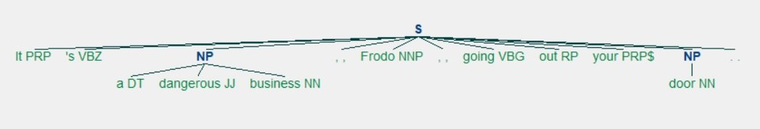
You got two noun phrases:
- 'a dangerous business' has a determiner, an adjective, and a noun.
- 'door' has just a noun.
Now that you know about chunking, it’s time to look at chinking.

Remove ads

Chinking
Chinking is used together with chunking, but while chunking is used to include a pattern, chinking is used to exclude a pattern.
Let’s reuse the quote you used in the section on chunking. You already have a list of tuples containing each of the words in the quote along with its part of speech tag:
>>>
>>> lotr_pos_tags[('It', 'PRP'), ("'s", 'VBZ'), ('a', 'DT'), ('dangerous', 'JJ'), ('business', 'NN'), (',', ','), ('Frodo', 'NNP'), (',', ','), ('going', 'VBG'), ('out', 'RP'), ('your', 'PRP$'), ('door', 'NN'), ('.', '.')]
The next step is to create a grammar to determine what you want to include and exclude in your chunks. This time, you’re going to use more than one line because you’re going to have more than one rule. Because you’re using more than one line for the grammar, you’ll be using triple quotes ("""):
>>>
>>> grammar = """... Chunk: {<.*>+}... }<JJ>{"""
The first rule of your grammar is {<.*>+}. This rule has curly braces that face inward ({}) because it’s used to determine what patterns you want to include in you chunks. In this case, you want to include everything: <.*>+.
The second rule of your grammar is }<JJ>{. This rule has curly braces that face outward (}{) because it’s used to determine what patterns you want to exclude in your chunks. In this case, you want to exclude adjectives: <JJ>.
Create a chunk parser with this grammar:
>>>
>>> chunk_parser = nltk.RegexpParser(grammar)
Now chunk your sentence with the chink you specified:
>>>
>>> tree = chunk_parser.parse(lotr_pos_tags)
You get this tree as a result:
>>>
>>> treeTree('S', [Tree('Chunk', [('It', 'PRP'), ("'s", 'VBZ'), ('a', 'DT')]), ('dangerous', 'JJ'), Tree('Chunk', [('business', 'NN'), (',', ','), ('Frodo', 'NNP'), (',', ','), ('going', 'VBG'), ('out', 'RP'), ('your', 'PRP$'), ('door', 'NN'), ('.', '.')])])
In this case, ('dangerous', 'JJ') was excluded from the chunks because it’s an adjective (JJ). But that will be easier to see if you get a graphic representation again:
>>>
>>> tree.draw()
You get this visual representation of the tree:
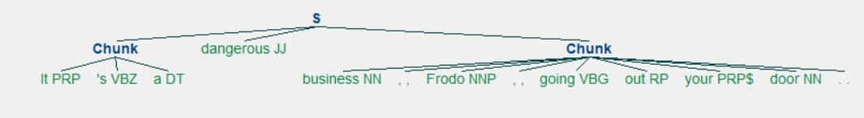
Here, you’ve excluded the adjective 'dangerous' from your chunks and are left with two chunks containing everything else. The first chunk has all the text that appeared before the adjective that was excluded. The second chunk contains everything after the adjective that was excluded.
Now that you know how to exclude patterns from your chunks, it’s time to look into named entity recognition (NER).

Remove ads

Using Named Entity Recognition (NER)
Named entities are noun phrases that refer to specific locations, people, organizations, and so on. With named entity recognition, you can find the named entities in your texts and also determine what kind of named entity they are.
Here’s the list of named entity types from the NLTK book:
NE type | Examples
ORGANIZATION | Georgia-Pacific Corp., WHO
PERSON | Eddy Bonte, President Obama
LOCATION | Murray River, Mount Everest
DATE | June, 2008-06-29
TIME | two fifty a m, 1:30 p.m.
MONEY | 175 million Canadian dollars, GBP 10.40
PERCENT | twenty pct, 18.75 %
FACILITY | Washington Monument, Stonehenge
GPE | South East Asia, Midlothian
You can use nltk.ne_chunk() to recognize named entities. Let’s use lotr_pos_tags again to test it out:
>>>
>>> nltk.download("maxent_ne_chunker")>>> nltk.download("words")>>> tree = nltk.ne_chunk(lotr_pos_tags)
Now take a look at the visual representation:
>>>
>>> tree.draw()
Here’s what you get:
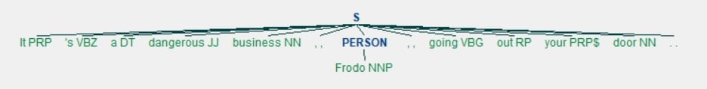
See how Frodo has been tagged as a PERSON? You also have the option to use the parameter binary=True if you just want to know what the named entities are but not what kind of named entity they are:
>>>
>>> tree = nltk.ne_chunk(lotr_pos_tags, binary=True)>>> tree.draw()
Now all you see is that Frodo is an NE:
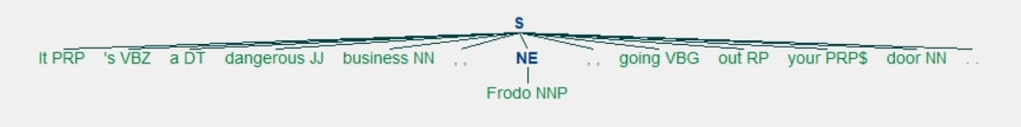
That’s how you can identify named entities! But you can take this one step further and extract named entities directly from your text. Create a string from which to extract named entities. You can use this quote from The War of the Worlds:
>>>
>>> quote = """... Men like Schiaparelli watched the red planet—it is odd, by-the-bye, that... for countless centuries Mars has been the star of war—but failed to... interpret the fluctuating appearances of the markings they mapped so well.... All that time the Martians must have been getting ready....... During the opposition of 1894 a great light was seen on the illuminated... part of the disk, first at the Lick Observatory, then by Perrotin of Nice,... and then by other observers. English readers heard of it first in the... issue of Nature dated August 2."""
Now create a function to extract named entities:
>>>
>>> def extract_ne(quote):... words = word_tokenize(quote, language=language)... tags = nltk.pos_tag(words)... tree = nltk.ne_chunk(tags, binary=True)... return set(... " ".join(i[0] for i in t)... for t in tree... if hasattr(t, "label") and t.label() == "NE"... )
With this function, you gather all named entities, with no repeats. In order to do that, you tokenize by word, apply part of speech tags to those words, and then extract named entities based on those tags. Because you included binary=True, the named entities you’ll get won’t be labeled more specifically. You’ll just know that they’re named entities.
Take a look at the information you extracted:
>>>
>>> extract_ne(quote){'Lick Observatory', 'Mars', 'Nature', 'Perrotin', 'Schiaparelli'}
You missed the city of Nice, possibly because NLTK interpreted it as a regular English adjective, but you still got the following:
- An institution: 'Lick Observatory'
- A planet: 'Mars'
- A publication: 'Nature'
- People: 'Perrotin', 'Schiaparelli'
That’s some pretty decent variety!

Remove ads

Getting Text to Analyze
Now that you’ve done some text processing tasks with small example texts, you’re ready to analyze a bunch of texts at once. A group of texts is called a corpus. NLTK provides several corpora covering everything from novels hosted by Project Gutenberg to inaugural speeches by presidents of the United States.
In order to analyze texts in NLTK, you first need to import them. This requires nltk.download("book"), which is a pretty big download:
>>>
>>> nltk.download("book")>>> from nltk.book import **** Introductory Examples for the NLTK Book ***Loading text1, ..., text9 and sent1, ..., sent9Type the name of the text or sentence to view it.Type: 'texts()' or 'sents()' to list the materials.text1: Moby Dick by Herman Melville 1851text2: Sense and Sensibility by Jane Austen 1811text3: The Book of Genesistext4: Inaugural Address Corpustext5: Chat Corpustext6: Monty Python and the Holy Grailtext7: Wall Street Journaltext8: Personals Corpustext9: The Man Who Was Thursday by G . K . Chesterton 1908
You now have access to a few linear texts (such as Sense and Sensibility and Monty Python and the Holy Grail) as well as a few groups of texts (such as a chat corpus and a personals corpus). Human nature is fascinating, so let’s see what we can find out by taking a closer look at the personals corpus!
This corpus is a collection of personals ads, which were an early version of online dating. If you wanted to meet someone, then you could place an ad in a newspaper and wait for other readers to respond to you.
If you’d like to learn how to get other texts to analyze, then you can check out Chapter 3 of Natural Language Processing with Python – Analyzing Text with the Natural Language Toolkit.

Using a Concordance
When you use a concordance, you can see each time a word is used, along with its immediate context. This can give you a peek into how a word is being used at the sentence level and what words are used with it.
Let’s see what these good people looking for love have to say! The personals corpus is called text8, so we’re going to call .concordance() on it with the parameter "man":
>>>
>>> text8.concordance("man")Displaying 14 of 14 matches: to hearing from you all . ABLE young man seeks , sexy older women . Phone forble relationship . GENUINE ATTRACTIVE MAN 40 y . o ., no ties , secure , 5 ft .ship , and quality times . VIETNAMESE MAN Single , never married , financiallyip . WELL DRESSED emotionally healthy man 37 like to meet full figured woman fo nth subs LIKE TO BE MISTRESS of YOUR MAN like to be treated well . Bold DTE noeeks lady in similar position MARRIED MAN 50 , attrac . fit , seeks lady 40 - 5eks nice girl 25 - 30 serious rship . Man 46 attractive fit , assertive , and k 40 - 50 sought by Aussie mid 40s b / man f / ship r / ship LOVE to meet widowediscreet times . Sth E Subs . MARRIED MAN 42yo 6ft , fit , seeks Lady for discrwoman , seeks professional , employed man , with interests in theatre , dining tall and of large build seeks a good man . I am a nonsmoker , social drinker ,lead to relationship . SEEKING HONEST MAN I am 41 y . o ., 5 ft . 4 , med . bui quiet times . Seeks 35 - 45 , honest man with good SOH & similar interests , f genuine , caring , honest and normal man for fship , poss rship . S / S , S /
Interestingly, the last three of those fourteen matches have to do with seeking an honest man, specifically:
- SEEKING HONEST MAN
- Seeks 35 - 45 , honest man with good SOH & similar interests
- genuine , caring , honest and normal man for fship , poss rship
Let’s see if there’s a similar pattern with the word "woman":
>>>
>>> text8.concordance("woman")Displaying 11 of 11 matches:at home . Seeking an honest , caring woman , slim or med . build , who enjoys tthy man 37 like to meet full figured woman for relationship . 48 slim , shy , Srry . MALE 58 years old . Is there a Woman who would like to spend 1 weekend a other interests . Seeking Christian Woman for fship , view to rship . SWM 45 DALE 60 - burly beared seeks intimate woman for outings n / s s / d F / ston / Pington . SCORPIO 47 seeks passionate woman for discreet intimate encounters SEXle dad . 42 , East sub . 5 " 9 seeks woman 30 + for f / ship relationship TALLpersonal trainer looking for married woman age open for fun MARRIED Dark guy 37rinker , seeking slim - medium build woman who is happy in life , age open . AC. O . TERTIARY Educated professional woman , seeks professional , employed man real romantic , age 50 - 65 y . o . WOMAN OF SUBSTANCE 56 , 59 kg ., 50 , fit
The issue of honesty came up in the first match only:
Seeking an honest , caring woman , slim or med . build
Dipping into a corpus with a concordance won’t give you the full picture, but it can still be interesting to take a peek and see if anything stands out.

Making a Dispersion Plot
You can use a dispersion plot to see how much a particular word appears and where it appears. So far, we’ve looked for "man" and "woman", but it would be interesting to see how much those words are used compared to their synonyms:
>>>
>>> text8.dispersion_plot(... ["woman", "lady", "girl", "gal", "man", "gentleman", "boy", "guy"]... )
Here’s the dispersion plot you get:
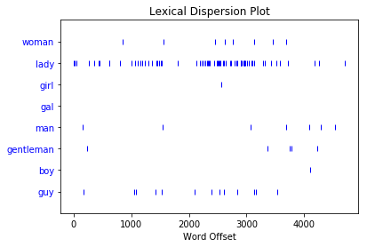
Each vertical blue line represents one instance of a word. Each horizontal row of blue lines represents the corpus as a whole. This plot shows that:
- "lady" was used a lot more than "woman" or "girl". There were no instances of "gal".
- "man" and "guy" were used a similar number of times and were more common than "gentleman" or "boy".
You use a dispersion plot when you want to see where words show up in a text or corpus. If you’re analyzing a single text, this can help you see which words show up near each other. If you’re analyzing a corpus of texts that is organized chronologically, it can help you see which words were being used more or less over a period of time.
Staying on the theme of romance, see what you can find out by making a dispersion plot for Sense and Sensibility, which is text2. Jane Austen novels talk a lot about people’s homes, so make a dispersion plot with the names of a few homes:
>>>
>>> text2.dispersion_plot(["Allenham", "Whitwell", "Cleveland", "Combe"])
Here’s the plot you get:
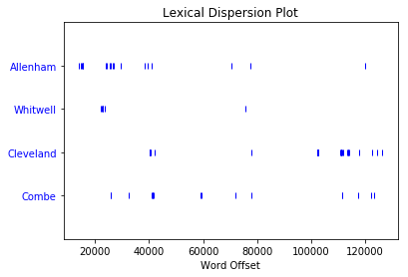
Apparently Allenham is mentioned a lot in the first third of the novel and then doesn’t come up much again. Cleveland, on the other hand, barely comes up in the first two thirds but shows up a fair bit in the last third. This distribution reflects changes in the relationship between Marianne and Willoughby:
- Allenham is the home of Willoughby’s benefactress and comes up a lot when Marianne is first interested in him.
- Cleveland is a home that Marianne stays at after she goes to see Willoughby in London and things go wrong.
Dispersion plots are just one type of visualization you can make for textual data. The next one you’ll take a look at is frequency distributions.

Remove ads

Making a Frequency Distribution
With a frequency distribution, you can check which words show up most frequently in your text. You’ll need to get started with an import:
>>>
>>> from nltk import FreqDist
FreqDist is a subclass of collections.Counter. Here’s how to create a frequency distribution of the entire corpus of personals ads:
>>>
>>> frequency_distribution = FreqDist(text8)>>> print(frequency_distribution)<FreqDist with 1108 samples and 4867 outcomes>
Since 1108 samples and 4867 outcomes is a lot of information, start by narrowing that down. Here’s how to see the 20 most common words in the corpus:
>>>
>>> frequency_distribution.most_common(20)[(',', 539), ('.', 353), ('/', 110), ('for', 99), ('and', 74), ('to', 74), ('lady', 68), ('-', 66), ('seeks', 60), ('a', 52), ('with', 44), ('S', 36), ('ship', 33), ('&', 30), ('relationship', 29), ('fun', 28), ('in', 27), ('slim', 27), ('build', 27), ('o', 26)]
You have a lot of stop words in your frequency distribution, but you can remove them just as you did earlier. Create a list of all of the words in text8 that aren’t stop words:
>>>
>>> meaningful_words = [... word for word in text8 if word.casefold() not in stop_words... ]
Now that you have a list of all of the words in your corpus that aren’t stop words, make a frequency distribution:
>>>
>>> frequency_distribution = FreqDist(meaningful_words)
Take a look at the 20 most common words:
>>>
>>> frequency_distribution.most_common(20)[(',', 539), ('.', 353), ('/', 110), ('lady', 68), ('-', 66), ('seeks', 60), ('ship', 33), ('&', 30), ('relationship', 29), ('fun', 28), ('slim', 27), ('build', 27), ('smoker', 23), ('50', 23), ('non', 22), ('movies', 22), ('good', 21), ('honest', 20), ('dining', 19), ('rship', 18)]
You can turn this list into a graph:
>>>
>>> frequency_distribution.plot(20, cumulative=True)
Here’s the graph you get:
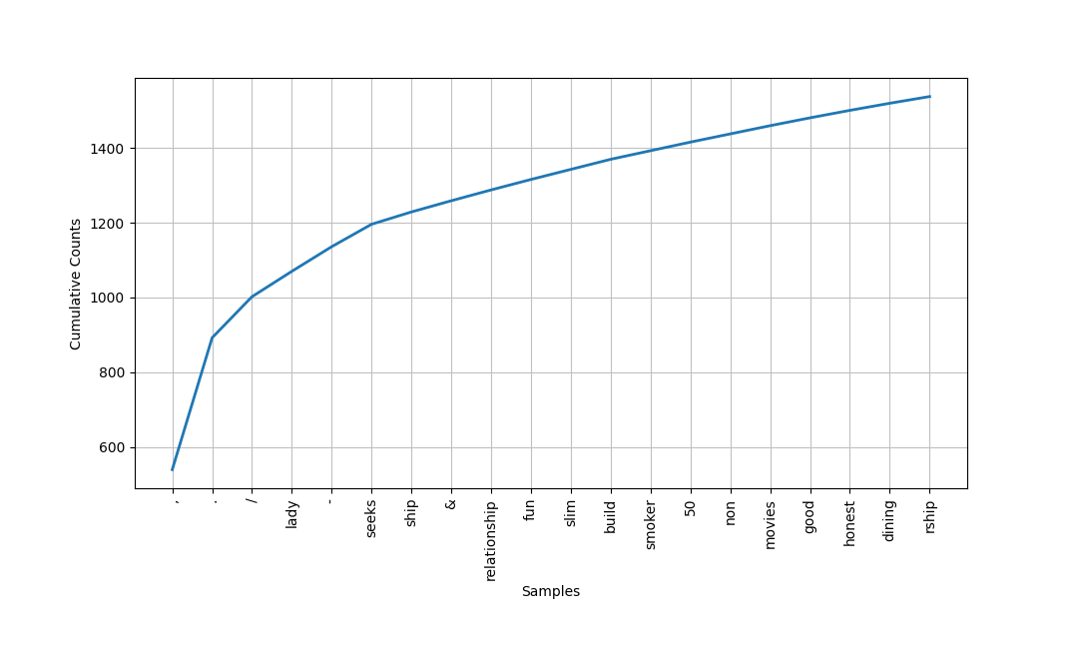
Some of the most common words are:
- 'lady'
- 'seeks'
- 'ship'
- 'relationship'
- 'fun'
- 'slim'
- 'build'
- 'smoker'
- '50'
- 'non'
- 'movies'
- 'good'
- 'honest'
From what you’ve already learned about the people writing these personals ads, they did seem interested in honesty and used the word 'lady' a lot. In addition, 'slim' and 'build' both show up the same number of times. You saw slim and build used near each other when you were learning about concordances, so maybe those two words are commonly used together in this corpus. That brings us to collocations!

Remove ads

Finding Collocations
A collocation is a sequence of words that shows up often. If you’re interested in common collocations in English, then you can check out The BBI Dictionary of English Word Combinations. It’s a handy reference you can use to help you make sure your writing is idiomatic. Here are some examples of collocations that use the word “tree”:
- Syntax tree
- Family tree
- Decision tree
To see pairs of words that come up often in your corpus, you need to call .collocations() on it:
>>>
>>> text8.collocations()would like; medium build; social drinker; quiet nights; non smoker;long term; age open; Would like; easy going; financially secure; funtimes; similar interests; Age open; weekends away; poss rship; wellpresented; never married; single mum; permanent relationship; slimbuild
slim build did show up, as did medium build and several other word combinations. No long walks on the beach though!
But what would happen if you looked for collocations after lemmatizing the words in your corpus? Would you find some word combinations that you missed the first time around because they came up in slightly varied versions?
If you followed the instructions earlier, then you’ll already have a lemmatizer, but you can’t call collocations() on just any data type, so you’re going to need to do some prep work. Start by creating a list of the lemmatized versions of all the words in text8:
>>>
>>> lemmatized_words = [lemmatizer.lemmatize(word) for word in text8]
But in order for you to be able to do the linguistic processing tasks you’ve seen so far, you need to make an NLTK text with this list:
>>>
>>> new_text = nltk.Text(lemmatized_words)
Here’s how to see the collocations in your new_text:
>>>
>>> new_text.collocations()medium build; social drinker; non smoker; long term; would like; ageopen; easy going; financially secure; Would like; quiet night; Ageopen; well presented; never married; single mum; permanentrelationship; slim build; year old; similar interest; fun time; Photopls
Compared to your previous list of collocations, this new one is missing a few:
- weekends away
- poss rship
The idea of quiet nights still shows up in the lemmatized version, quiet night. Your latest search for collocations also brought up a few news ones:
- year old suggests that users often mention ages.
- photo pls suggests that users often request one or more photos.
That’s how you can find common word combinations to see what people are talking about and how they’re talking about it!

Conclusion
Congratulations on taking your first steps with NLP! A whole new world of unstructured data is now open for you to explore. Now that you’ve covered the basics of text analytics tasks, you can get out there are find some texts to analyze and see what you can learn about the texts themselves as well as the people who wrote them and the topics they’re about.
Now you know how to:
- Find text to analyze
- Preprocess your text for analysis
- Analyze your text
- Create visualizations based on your analysis

Introduction:
NLTK is a toolkit build for working with NLP in Python. It provides us various text processing libraries with a lot of test datasets. A variety of tasks can be performed using NLTK such as tokenizing, parse tree visualization, etc… In this article, we will go through how we can set up NLTK in our system and use them for performing various NLP tasks during the text processing step.
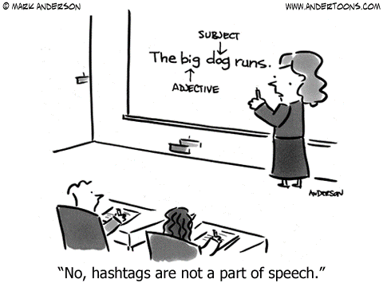
Source:https://www.hackerearth.com/blog/developers/natural-language-processing-components-and-implementations/

Text Processing steps discussed in this article:
- Tokenization
- Lower case conversion
- Stop Words removal
- Stemming
- Lemmatization
- Parse tree or Syntax Tree generation
- POS Tagging

Installing NLTK:
Use the pip install method to install NLTK in your system:
pip install nltk
To understand the basics of NLP follow this link:


Recession Proof Your Career
Become a Data Science with 100% Job GuaranteeKnow More

Downloading the datasets:
This is optional, but if you feel that you need those datasets before starting to work on the problem.
import nltk
nltk.download()
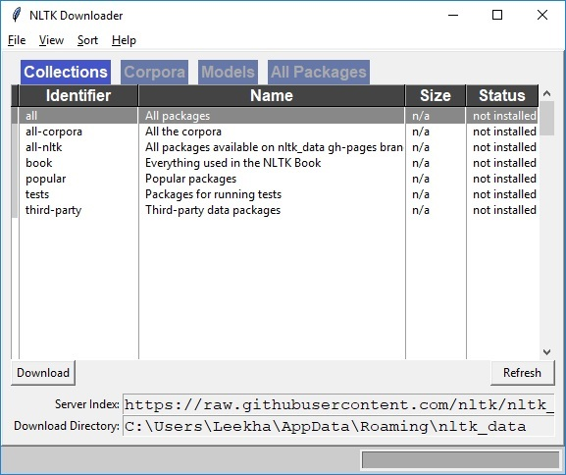
Source: https://thinkinfi.com/how-to-download-nltk-corpus-manually/
You can see this screen and install the required corpus. Once you have completed this step let’s dive deep into the different operations using NLTK.

Tokenization:
The breaking down of text into smaller units is called tokens. tokens are a small part of that text. If we have a sentence, the idea is to separate each word and build a vocabulary such that we can represent all words uniquely in a list. Numbers, words, etc.. all fall under tokens.
Python Code:
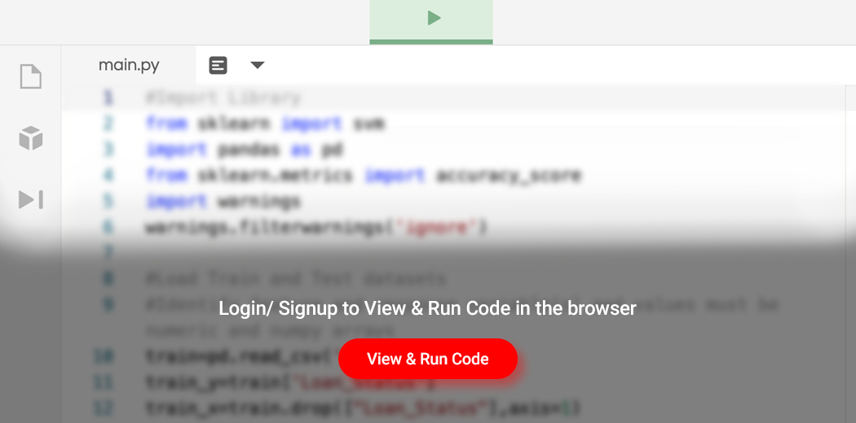

Lower case conversion:
We want our model to not get confused by seeing the same word with different cases like one starting with capital and one without and interpret both differently. So we convert all words into the lower case to avoid redundancy in the token list.
text = re.sub(r"[^a-zA-Z0-9]", " ", text.lower())
words = text.split()
print(words)
# output -> ['natural', 'language', 'processing', 'is', 'an', 'exciting', 'area', 'huge', 'budget', 'have', 'been', 'allocated', 'for', 'this']

Stop Words removal:
When we use the features from a text to model, we will encounter a lot of noise. These are the stop words like the, he, her, etc… which don’t help us and, just be removed before processing for cleaner processing inside the model. With NLTK we can see all the stop words available in the English language.
from nltk.corpus import stopwords
print(stopwords.words("english"))
# output->
['i', 'me', 'my', 'myself', 'we', 'our', 'ours', 'ourselves', 'you', "you're", "you've", "you'll", "you'd", 'your', 'yours', 'yourself', 'yourselves', 'he', 'him', 'his', 'himself', 'she', "she's", 'her', 'hers', 'herself', 'it', "it's", 'its', 'itself', 'they', 'them', 'their', 'theirs', 'themselves', 'what', 'which', 'who', 'whom', 'this', 'that', "that'll", 'these', 'those', 'am', 'is', 'are', 'was', 'were', 'be', 'been', 'being', 'have', 'has', 'had', 'having', 'do', 'does', 'did', 'doing', 'a', 'an', 'the', 'and', 'but', 'if', 'or', 'because', 'as', 'until', 'while', 'of', 'at', 'by', 'for', 'with', 'about', 'against', 'between', 'into', 'through', 'during', 'before', 'after', 'above', 'below', 'to', 'from', 'up', 'down', 'in', 'out', 'on', 'off', 'over', 'under', 'again', 'further', 'then', 'once', 'here', 'there', 'when', 'where', 'why', 'how', 'all', 'any', 'both', 'each', 'few', 'more', 'most', 'other', 'some', 'such', 'no', 'nor', 'not', 'only', 'own', 'same', 'so', 'than', 'too', 'very', 's', 't', 'can', 'will', 'just', 'don', "don't", 'should', "should've", 'now', 'd', 'll', 'm', 'o', 're', 've', 'y', 'ain', 'aren', "aren't", 'couldn', "couldn't", 'didn', "didn't", 'doesn', "doesn't", 'hadn', "hadn't", 'hasn', "hasn't", 'haven', "haven't", 'isn', "isn't", 'ma', 'mightn', "mightn't", 'mustn', "mustn't", 'needn', "needn't", 'shan', "shan't", 'shouldn', "shouldn't", 'wasn', "wasn't", 'weren', "weren't", 'won', "won't", 'wouldn', "wouldn't"]
# Remove stop words
words = [w for w in words if w not in stopwords.words(“english”)]
print(words)
# output -> [‘natural’, ‘language’, ‘processing’, ‘exciting’, ‘area’, ‘huge’, ‘budget’, ‘allocated’]

Stemming:
In our text we may find many words like playing, played, playfully, etc… which have a root word, play all of these convey the same meaning. So we can just extract the root word and remove the rest. Here the root word formed is called ‘stem’ and it is not necessarily that stem needs to exist and have a meaning. Just by committing the suffix and prefix, we generate the stems.
NLTK provides us with PorterStemmer LancasterStemmer and SnowballStemmer packages.
from nltk.stem.porter import PorterStemmer
# Reduce words to their stems
stemmed = [PorterStemmer().stem(w) for w in words]
print(stemmed)
# output -> ['natur', 'languag', 'process', 'excit', 'area', 'huge', 'budget', 'alloc']

Lemmatization:
We want to extract the base form of the word here. The word extracted here is called Lemma and it is available in the dictionary. We have the WordNet corpus and the lemma generated will be available in this corpus. NLTK provides us with the WordNet Lemmatizer that makes use of the WordNet Database to lookup lemmas of words.
from nltk.stem.wordnet import WordNetLemmatizer
# Reduce words to their root form
lemmed = [WordNetLemmatizer().lemmatize(w) for w in words]
print(lemmed)
#output -> ['natural', 'language', 'processing', 'exciting', 'area', 'huge', 'budget', 'allocated']
Stemming is much faster than lemmatization as it doesn’t need to lookup in the dictionary and just follows the algorithm to generate the root words.

Parse tree or Syntax Tree generation :
We can define grammar and then use NLTK RegexpParser to extract all parts of speech from the sentence and draw functions to visualize it.
# Import required libraries
import nltk
nltk.download('punkt')
nltk.download('averaged_perceptron_tagger')
from nltk import pos_tag, word_tokenize, RegexpParser
# Example text
sample_text = "The quick brown fox jumps over the lazy dog"
# Find all parts of speech in above sentence
tagged = pos_tag(word_tokenize(sample_text))
#Extract all parts of speech from any text
chunker = RegexpParser("""
NP: {?*} #To extract Noun Phrases
P: {} #To extract Prepositions
V: {} #To extract Verbs
PP: {
} #To extract Prepositional Phrases
VP: { *} #To extract Verb Phrases
“””)
# Print all parts of speech in above sentence
output = chunker.parse(tagged)
print(“After Extractingn”, output)
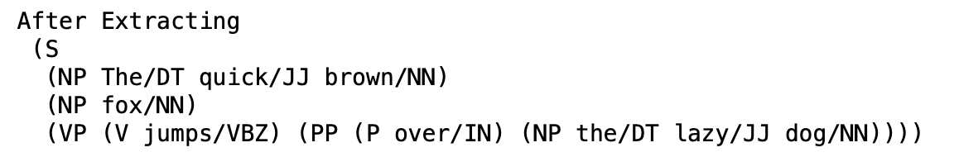
output.draw()
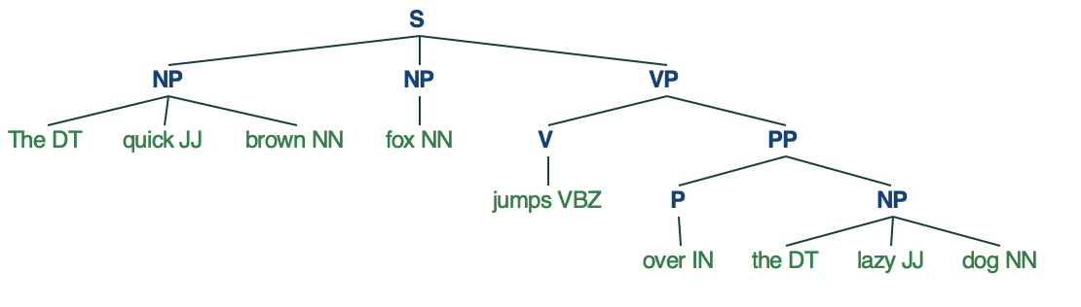
Source: https://www.geeksforgeeks.org/syntax-tree-natural-language-processing/

POS Tagging:
Part of Speech tagging is used in text processing to avoid confusion between two same words that have different meanings. With respect to the definition and context, we give each word a particular tag and process them. Two Steps are used here:
- Tokenize text (word_tokenize).
- Apply the pos_tag from NLTK to the above step.
import nltk
from nltk.corpus import stopwords
nltk.download('punkt')
nltk.download('averaged_perceptron_tagger')
from nltk.tokenize import word_tokenize, sent_tokenize
stop_words = set(stopwords.words('english'))
txt = "Natural language processing is an exciting area."
" Huge budget have been allocated for this."
# sent_tokenize is one of instances of
# PunktSentenceTokenizer from the nltk.tokenize.punkt module
tokenized = sent_tokenize(txt)
for i in tokenized:
# Word tokenizers is used to find the words
# and punctuation in a string
wordsList = nltk.word_tokenize(i)
# removing stop words from wordList
wordsList = [w for w in wordsList if not w in stop_words]
# Using a Tagger. Which is part-of-speech
# tagger or POS-tagger.
tagged = nltk.pos_tag(wordsList)
print(tagged)
# output -> [('Natural', 'JJ'), ('language', 'NN'), ('processing', 'NN'), ('exciting', 'JJ'), ('

