窗体顶端
Compare Caffe to Caffe2?
Original Caffe framework is considered useful for large-scale product use cases, especially with its unparalleled performance and well tested C++ codebase. Also Caffe has some design choices that are inherited from its original use case - conventional CNN applications. Also a new computation patterns have emerged, especially distributed computation, mobile, reduced precision computation, and more non-vision use cases, its design has shown some limitations. Following are the points that describe how Caffe2 improves Caffe 1.0 -
1. first-class support for large-scale distributed training
2. Mobile deployment
3. New hardware support (in addition to CPU and CUDA)
4. Flexibility for future directions such as quantized computation
5. Stress tested by the vast scale of Facebook applications
窗体底端
窗体顶端
Q.2What are the new features in Caffe2?
The primary reason of computation in Caffe2 are the Operators such that these as a more flexible version of the layers from Caffe. Also Caffe2 comes with over 400 different operators and provides guidance for the community to create and contribute to this growing resource.
窗体底端
窗体顶端
Q.3Differentiate between Caffe2 and PyTorch?
Some of the point of difference are -
1. Caffe2 has been built to excel at mobile and at large scale deployments which is new in Caffe2 to support multi-GPU, and bringing Torch and Caffe2 together with the same level of GPU support.
2. Caffe2 has been built to excel at utilizing both multiple GPUs on a single-host and multiple hosts with GPUs. On the other hand PyTorch is great for research, experimentation and trying out exotic neural networks
3. Caffe2 is headed towards supporting more industrial-strength applications with a heavy focus on mobile. On the other hand PyTorch doesn’t do mobile or doesn’t scale or that you can’t use Caffe2 with some awesome new paradigm of neural network.
窗体底端
窗体顶端
Q.4Why should we use Caffe?
Following are the popular features of Cafe -
1. Expressive architecture that encourages application and innovation. Such that models and optimization are defined by configuration without hard-coding. Switch between CPU and GPU by setting a single flag to train on a GPU machine then deploy to commodity clusters or mobile devices.
2. Extensible code fosters active development. In Caffe’s first year, it has been forked by over 1,000 developers and had many significant changes contributed back. Thanks to these contributors the framework tracks the state-of-the-art in both code and models.
3. Speed makes Caffe perfect for research experiments and industry deployment. Caffe can process over 60M images per day with a single NVIDIA K40 GPU*. That’s 1 ms/image for inference and 4 ms/image for learning and more recent library versions and hardware are faster still. We believe that Caffe is among the fastest convnet implementations available.
4. Community: Caffe already powers academic research projects, startup prototypes, and even large-scale industrial applications in vision, speech, and multimedia. Join our community of brewers on the caffe-users group and Github.
窗体底端
窗体顶端
Q.5Name the heterogeneous computing architectures are currently supported by Caffe?
The heterogeneous computing architectures are currently supported by Caffe -
1. GPUs
2. FPGAs
3. Dedicated CNN processors
窗体底端
窗体顶端
Q.6What is Caffe?
CAFFE abbreviated as Convolutional Architecture for Fast Feature Embedding is a deep learning framework, that was originally developed at University of California, Berkeley. It is open source, under a BSD license. It is written in C++, with a Python interface.
窗体底端
窗体顶端
Q.7Explain the difference between Machine Learning and Deep Learning.
In a machine learning algorithm, the selection of features in the dataset plays an extremely important role in getting the desired prediction accuracy. In traditional machine learning techniques, feature selection is done mostly by human inspection, judgment, and deep domain knowledge. And, in deep learning algorithms, feature engineering is done automatically. Generally, feature engineering is time-consuming and requires good expertise in the domain. For implementing the automatic feature extraction, the deep learning algorithms typically ask for a huge amount of data, so if you have only thousands and tens of thousands of data points, the deep learning technique may fail to give you satisfactory results. With larger data, the deep learning algorithms produce better results compared to traditional ML algorithms with an added advantage of less or no feature engineering.
窗体底端
窗体顶端
Q.8What are Caffe2 Operators?
In Caffe2, the Operator is the basic unit of computation. However, Caffe2 provides an exhaustive list of operators. This includes the operator called FC, which computes the result of passing an input vector X into a fully connected network with a two-dimensional weight matrix W and a single-dimensional bias vector b. In other words, it computes the following mathematical equation Y = X * W^T + b Where X has dimensions (M x k), W has dimensions (n x k) and b is (1 x n). The output Y will be of dimension (M x n), where M is the batch size. Further, for the vectors X and W, we will use the GaussianFill operator to create some random data. And, for generating bias values b, we will use ConstantFill operator.
窗体底端
窗体顶端
Q.9How to create a network in Caffe2?
Firstly, import the required packages − from caffe2.python import core, workspace After that, define the network by calling core.Net as follows − net = core.Net("SingleLayerFC") The name of the network is specified as SingleLayerFC. At this point, the network object called the net is created.
窗体底端
窗体顶端
Q.10Name the methods of Image Processing.
Image processing consists of two steps. 1. Image Resizing 2. Image Cropping
窗体底端
窗体顶端
Q.11Explain the process of Image Resizing.
In this, firstly, we will write a function for resizing the image. Here, we will resize the image to 227x227. The function resize can be defined as: def resize(img, input_height, input_width): Now, we obtain the aspect ratio of the image by dividing the width by the height. original_aspect = img.shape[1]/float(img.shape[0]) However, if the aspect ratio is greater than 1, it indicates that the image is wide, that to say it is in the landscape mode. For adjusting the image height and return the resized image use the following code: if(original_aspect>1): new_height = int(original_aspect * input_height) return skimage.transform.resize(img, (input_width, new_height), mode='constant', anti_aliasing=True, anti_aliasing_sigma=None) Further, if the aspect ratio is less than 1, it indicates the portrait mode. For adjusting the width use the following code: if(original_aspect<1): new_width = int(input_width/original_aspect) return skimage.transform.resize(img, (new_width, input_height), mode='constant', anti_aliasing=True, anti_aliasing_sigma=None) Lastly, if the aspect ratio equals 1, we do not make any height/width adjustments. if(original_aspect == 1): return skimage.transform.resize(img, (input_width, input_height), mode='constant', anti_aliasing=True, anti_aliasing_sigma=None)
窗体底端
窗体顶端
Q.12Explain the process of Image Cropping.
Firstly, declare the crop_image function as follows: def crop_image(img,cropx,cropy): After that, extract the dimensions of the image using the following statement: y,x,c = img.shape Then, create a new starting point for the image using the following two lines of code − startx = x//2-(cropx//2) starty = y//2-(cropy//2) Lastly, return the cropped image by creating an image object with the new dimensions: return img[starty:starty+cropy,startx:startx+cropx]
窗体底端
窗体顶端
Q.13Define the term NumPy.
NumPy refers to a Python library allowing easy numerical calculations involving single and multidimensional arrays and matrices. This excels in performing numerical calculations. Many data science libraries like Pandas, Scikit-learn, SciPy, matplotlib, etc. depend on NumPy. It forms an integral part of today’s data science applications written in Python. Further, this provides: Firstly, a powerful N-dimensional array object called as ndarray Secondly, broadcasting functions Thirdly, tools for integrating C/C++ and Fortran code Lastly, useful linear algebra, Fourier transform, and random number capabilities
窗体底端
窗体顶端
Q.14How to create a matrix in NumPy?
Creating a matrix using lists: 1 2 3 4 5 6 Syntax: ## Import numpy import numpy as np ## Create a 2D numpy array using python lists arr = np.array([[ 1, 2, 3],[ 4, 5, 6]]) print(arr) Here, np.array is used to create NumPy array from a list. NumPy arrays are of type ndarray. Further, the output of the above program is: It represents a 2D matrix where input to np.array() is a list of lists [[ 1, 2, 3],[ 4, 5, 6]] . Each list in the parent list forms a row in the matrix.
窗体底端
窗体顶端
Q.15What is a Deep Neural Network?
A deep neural network represents the type of machine learning when the system uses many layers of nodes for deriving high-level functions from input information. It means converting the data into a more creative and abstract component.
窗体底端
窗体顶端
Q.16What is Convolutional Neural Network?
A Convolutional Neural Network (ConvNet/CNN) is a Deep Learning algorithm that can take in an input image, assign importance to various aspects/objects in the image and be able to differentiate one from the other. The pre-processing required in a ConvNet is much lower as compared to other classification algorithms. While in primitive methods filters are hand-engineered, with enough training, ConvNets have the ability to learn these filters/characteristics.
窗体底端
窗体顶端
Q.17Explain the process of training a CNN.
The process for training a CNN for classifying images consists of the following steps − 1. Data Preparation In this step, we center-crop the images and resize them so that all images for training and testing would be of the same size. This is usually done by running a small Python script on the image data. 2. Model Definition In this step, we define a CNN architecture. The configuration is stored in .pb (protobuf) file. 3. Solver Definition In this, we define the solver configuration file. The solver does the model optimization. 4. Model Training In this, we use the built-in Caffe utility to train the model. The training may take a considerable amount of time and CPU usage. After the training is completed, Caffe stores the model in a file, which can, later on, be used on test data and final deployment for predictions.
窗体底端
窗体顶端
Q.18Define an activation function.
The activation function refers to the non-linear function that we apply over the output data coming out of a particular layer of neurons before it propagates as the input to the next layer.
窗体底端
窗体顶端
Q.19What do you understand by the term Sigmoid?
The sigmoid function is one of the nonlinear activation functions for deep learning that takes a real-valued number as an input and compresses all its outputs to the range of [0,1. There are many functions with the characteristic of an “S” shaped curve known as sigmoid functions. The most commonly used function is the logistic function.
窗体底端
窗体顶端
Q.20What is ReLU?
ReLU stands for Rectified Linear Unit that is the non-linear activation function for deep learning which was first popularized in the context of a convolution neural network (CNN). If the input is positive then the function would output the value itself, if the input is negative the output would be zero. Further, the process of ReLu function evaluation is computationally efficient as it does not involve computing exp(x), and therefore, in practice, it converges much faster than logistic/Tanh for the same performance. That’s why, ReLU has become a de-facto standard for large convolutional neural network architectures such as Inception, ResNet, MobileNet, VGGNet, etc.
窗体底端
窗体顶端
Q.21What are Recurrent neural networks?
Recurrent neural networks are one of the staples of deep learning, enabling neural networks to work with sequences of data like text, audio, and video. They can be used for boiling a sequence down into a high-level understanding, annotating sequences, and even generating new sequences from scratch. However, the basic RNN design struggles with longer sequences, but a special variant long short-term memory” networks can even work with these. Such models have been found to be very powerful, achieving remarkable results in many tasks including translation, voice recognition, and image captioning. As a result, recurrent neural networks have become very widespread in the last few years.
窗体底端
窗体顶端
Q.22What is word embedding in NLP?
In natural language processing (NLP), word embedding is a term used for the representation of words for text analysis, typically in the form of a real-valued vector that encodes the meaning of the word such that the words that are closer in the vector space are expected to be similar in meaning. This can be obtained using a set of language modeling and feature learning techniques where words or phrases from the vocabulary are mapped to vectors of real numbers. Conceptually it involves the mathematical embedding from space with many dimensions per word to a continuous vector space with a much lower dimension.
窗体底端
窗体顶端
Q.23Explain the different types of Recurrent neural networks (RNN).
The core reason that recurrent nets are more exciting is that they allow us to operate over sequences of vectors: Sequences in the input, the output, or in the most general case both. Some of the example types include:
1. One-to-one This is also known Plain/Vaniall Neural network. It deals with the Fixed size of the input to the Fixed size of Output where they are independent of previous information/output. For example, Image classification.
2. One-to-Many This deals with a fixed size of information as input that gives a sequence of data as output. For example, Image Captioning takes an image as input and outputs a sentence of words.
3. Many-to-One It takes a Sequence of information as input and outputs a fixed size of the output. For example, sentiment analysis where a given sentence is classified as expressing positive or negative sentiment.
4. Many-to-Many It takes a Sequence of information as input and processes it recurrently outputs a Sequence of data. For example, Machine Translation, where an RNN reads a sentence in English and then outputs a sentence in French.
窗体底端
窗体顶端
Q.24What is Long Short Term Memory (LSTM)? Explain its process.
LSTM’s have a Nature of Remembering information for long periods of time is their Default behavior. The LSTM had a three-step Process:
1. Forget Gate This gate Decides which information is to be omitted from the cell in that particular timestamp. It is decided by the sigmoid function. However, it looks at the previous state(ht-1) and the content input(Xt) and outputs a number between 0(omit this)and 1(keep this)for each number in the cell state Ct−1.
2. Update Gate/input gate Decides how much of this unit is added to the current state. In this, the Sigmoid function decides which values to let through 0,1. and tanh function gives weightage to the values which are passed deciding their level of importance ranging from-1 to 1.
3. Output Gate Decides which part of the current cell makes it to the output. In this, the Sigmoid function decides which values to let through 0,1. and tanh function gives weightage to the values which are passed deciding their level of importance ranging from-1 to 1 and multiplied with an output of Sigmoid.
窗体底端
窗体顶端
Q.25What is sequence learning?
Sequence learning is an integrated part of conscious and nonconscious learning as well as activities. Sequences of information or sequences of actions are used in various everyday tasks: from sequencing sounds in a speech to sequencing movements in typing or playing instruments to sequencing actions in driving an automobile. Further, it can be used to study skill acquisition and in studies of various groups ranging from neuropsychological patients to infants. However, sequence learning can also be referred to as sequential behavior, behavior sequencing, and serial order in behavior.
窗体底端
窗体顶端
Q.26Explain the term regularization.
Regularization is a method that makes slight modifications to the learning algorithm such that the model generalizes better. This in turn improves the model’s performance on the unseen data as well. 20. Name some of the regularization techniques. The techniques are as follows: 1. L2 and L1 Regularization 2. Dropout 3. Early Stopping 4. Data Augmentation
窗体底端
窗体顶端
Q.27Explain the L2 and L1 Regularization techniques.
L2 and L1 are the most common types of regularization. Regularization works on the premise that smaller weights lead to simpler models which result helps in avoiding overfitting. So to obtain a smaller weight matrix, these techniques add a ‘regularization term’ along with the loss to obtain the cost function. Here, Cost function = Loss + Regularization term However, the difference between L1 and L2 regularization techniques lies in the nature of this regularization term. In general, the addition of this regularization term causes the values of the weight matrices to reduce, leading to simpler models.
窗体底端
窗体顶端
Q.28What do you understand about Dropout and early stopping techniques?
Dropout means that during the training, randomly selected neurons are turned off or ‘dropped’ out. It means that they are temporarily obstructed from influencing or activating the downward neuron in a forward pass, and none of the weights updates is applied on the backward pass. Whereas Early Stopping is a kind of cross-validation strategy where one part of the training set is used as a validation set, and the performance of the model is gauged against this set. So if the performance on this validation set gets worse, the training on the model is immediately stopped. However, the main idea behind this technique is that while fitting a neural network on training data, consecutively, the model is evaluated on the unseen data or the validation set after each iteration. So if the performance on this validation set is decreasing or remaining the same for certain iterations, then the process of model training is stopped.
窗体底端
窗体顶端
Q.29What is Data Augmentation?
This states that a simple way to reduce overfitting is to increase the data, and this technique helps in doing so. However, Data augmentation is a regularization technique, which is used generally when we have images as data sets. It creates additional data artificially from the existing training data by making minor changes such as rotation, flipping, cropping, or blurring a few pixels in the image, and this process generates more and more data. Through this regularization technique, the model variance is reduced, which in turn decreases the regularization error.
窗体底端
窗体顶端
Q.30What do you know about Model Zoo?
Model Zoo can be considered as a machine learning model deployment platform with a focus on ease of use. Deploy your model to an HTTP endpoint with a single line of code: from modelzoo.tensorflow import deploy, predict # Train or load your TensorFlow here. model = train_model() # Deploy with one function. model_name = deploy(model) # Make predictions from Python. predictions = predict(model_name, image="test.jpg")
窗体底端
窗体顶端
Q.31What are the features of the Model Zoo?
Model Zoo offers single function deployment so, there is no need to write any code or learn new technologies. Secondly, it provides real-time monitoring of model features and predictions. Thirdly, this performs autoscaling down to zero during periods of low activity to save costs, and up to accommodate bursts of demand. Next, it contains auto-generated documentation of the model inputs and outputs. Model Zoo has an in-built web interface for testing and sharing models. Lastly, it has a Python client library for making predictions.
窗体底端
窗体顶端
Q.32Define supervised learning.
Supervised learning or supervised machine learning refers to a subcategory of machine learning and artificial intelligence. It is defined by its use of labeled datasets for training algorithms for classifying data or predicting outcomes accurately. As input data is fed into the model, it adjusts its weights until the model has been fitted appropriately, which occurs as part of the cross-validation process. Supervised learning helps organizations solve a variety of real-world problems at scale, such as classifying spam in a separate folder from your inbox.
窗体底端
窗体顶端
Q.33What do you know about K-nearest neighbor?
K-nearest neighbor (KNN algorithm) refers to a non-parametric algorithm that classifies data points based on their proximity and association to other available data. This algorithm assumes that similar data points can be found near each other. As a result, it seeks in calculating the distance between data points through Euclidean distance, and then it allocated a category based on the most frequent category or average. Further, KNN is typically used for recommendation engines and image recognition.
窗体底端
窗体顶端
Q.34What is transfer learning (TL)?
Transfer learning (TL) can be defined as a research problem in machine learning (ML) that focuses on storing knowledge gained while solving one problem and applying it to a different but related problem. For example, knowledge gained while learning to recognize cars could apply when trying to recognize trucks. This area of research supports some relation to the long history of psychological literature on the transfer of learning, although formal ties between the two fields are limited. Further, reusing or transferring information from previously learned tasks for the learning of new tasks has the potential to significantly improve the sample efficiency of a reinforcement learning agent.
窗体底端
窗体顶端
Q.35Explain what is Deep reinforcement learning?
Deep reinforcement learning (deep RL) can be defined as a subfield of machine learning that combines reinforcement learning (RL) and deep learning. RL considers the problem of a computational agent learning to make decisions by trial and error. Deep RL incorporates deep learning into the solution, enabling agents to make decisions from unstructured input data without manual engineering of the state space. Moreover, the Deep RL algorithms are able to take in very large inputs and decide what actions to perform to optimize an objective. Deep reinforcement learning has been used for a diverse set of applications including but not limited to robotics, video games, natural language processing, computer vision, education, transportation, finance, and healthcare.
窗体底端
窗体顶端
Q.36Explain the term, Naive Bayes.
Naive Bayes can be considered as a classification approach that adopts the principle of class conditional independence from the Bayes Theorem. This means that the presence of one feature does not impact the presence of another in the probability of a given outcome, and each predictor has an equal effect on that result. Further, there are three types of Naïve Bayes classifiers: Multinomial Naïve Bayes Bernoulli Naïve Bayes Gaussian Naïve Bayes.
窗体底端
One of the most important fields of our times, Artificial Intelligence, is also very pervasive. Our lives are captivated by the tools and applications of this lucrative domain. The key sub-field within this domain is Deep Learning. It is heavily dominating the job market.
You wouldn’t need more than a glance through the jobs available to know how much in demand is for skilled professionals who know how to work through the unstructured data in the form of images, texts, audio, and video. You can not step into such a role without preparing yourself, sharpening your arsenal, and having your way worked through real-life cases.
Wouldn’t it be great if we had all the deep learning interview questions in one place? This article will help you precisely with that! We shall provide you with interview questions on deep learning, deep learning python interview questions, the tips for deep learning interview questions and answers, and how you can get expertise in this domain.
AnalytixLabs, a training solutions and capacity building firm, is India’s top-ranked Artificial Intelligence & Data Science Institute. Being led by a team of IIM, IIT, ISB, and McKinsey alumni, the institute is in its tenth year. Offering a wide range of data analytics courses, including detailed project work that enables individuals to be fit for the professional roles in AI, Data Science, and Data Engineering. With its decade of experience in providing meticulous, practical, and tailored learning, AnalytixLabs has proficiency in making aspirants “industry-ready” professionals.
Let’s look at the interview questions on deep learning …

Top 40 Deep Learning Interview Questions

1. Why do we need Deep Learning when Machine Learning is present?
Machine learning is a framework that takes past data to identify the relationships among the features. The machines can predict the new data with the help of mathematical relationships by getting dynamic, accurate, and stable models.
On the other hand, deep learning is a segment of machine learning that uses complex algorithms based on the biological neural network to mimic the human brain and take decisions and actions like a human.
Deep Learning is inspired by the brain’s functioning and structure to train neural networks. Deep learning also performs various complex operations to extract hidden features and patterns.
The critical aspect differentiating the two is that deep learning can extract hidden features and patterns present in the data. In contrast, other machine learning can reduce dimensions but not identify new features.
For more details, please also read Machine Learning vs Deep learning- What Is the Difference?

2. What are the applications of Deep Learning?
The applications of Deep Learning bucketed according to the type of learning are:
The supervised tasks in deep learning are:
- Text Classification
- Sentiment Analysis
- Auto-Tagging System
- Image Classification
- Audio Classification
- Forecasting
The unsupervised tasks in deep learning are:
- Image Segmentation
- Image Localization
- Image Captioning
- Object Detection or Identification
The problems that involve generating data in deep learning are:
- Machine Translation
- Chatbots
- Speech to Text
- Recommendation Systems
- Automatic Text Generation
You may also like to read: Top 15 Real World Applications of Artificial Intelligence

3. Name the Deep Learning frameworks and tools that you have used.
The deep learning frameworks and tools are:
- Keras
- TensorFlow
- PyTorch
- Theano
- CNTK
- Caffe2
- MXNet

4. List the commonly used data structures in deep learning.
The data structures used in deep learning are:
- Lists
- Dictionaries
- DataFrames
- Matrices
- Tensors
- Computation Graphs

5. What are the supervised and unsupervised learning algorithms in Deep Learning?
The supervised learning algorithms are:
- Artificial Neural Network (ANN)
- Perceptron (single and multi-layer)
- Convolution Neural Network (CNN)
- Recurrent Neural Network (RNN)
The unsupervised learning algorithms are:
- Autoencoders
- Self-Organizing Maps (SOMs)
- Boltzmann Machine
- Generative adversarial networks (GANs)

6. What are deep and shallow networks? Which one is better and why?
A shallow neural network has only one hidden layer, and a deep neural network has more hidden layers.
Both the networks have the ability to approximate any function. A shallow network requires more parameters as is limited by the layers, whereas a deep network can leverage its number of layers to compute efficiently and extract more abstract features.
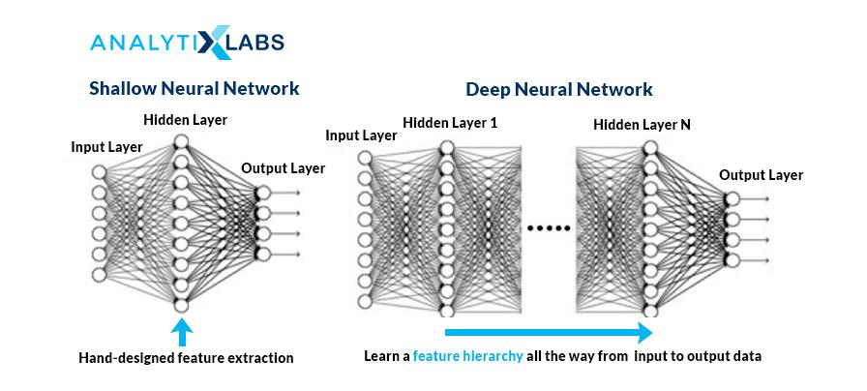
Source: cloudfront.net

7. What is the difference between Single-Layer and Multi-Layer Perceptron?
In a neural network, a perceptron is the processing unit that performs computations to extract features. It is the building block of the Artificial Neural Network (ANN).
A single layer perceptron is the simplest neural network without any hidden layer. It is a linear classifier with only one neuron and can perform binary classification. It can only classify the linear separable classes having output as binary.
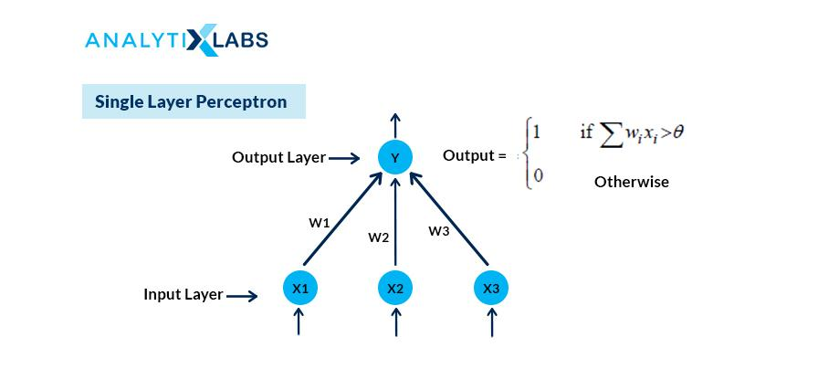
Source: saedsayad.com
A multilayer perceptron (MLP) is another class of Artificial Neural Network (ANN) that has more than one perceptron. MLP consists of three layers: input, hidden, and output layer. The input layer receives the information, and the output layer makes the prediction or decision.
There can be one or more hidden layers in an MLP. It can classify the non-linearly separable data points as hidden, and the output layer uses a nonlinear activation function.
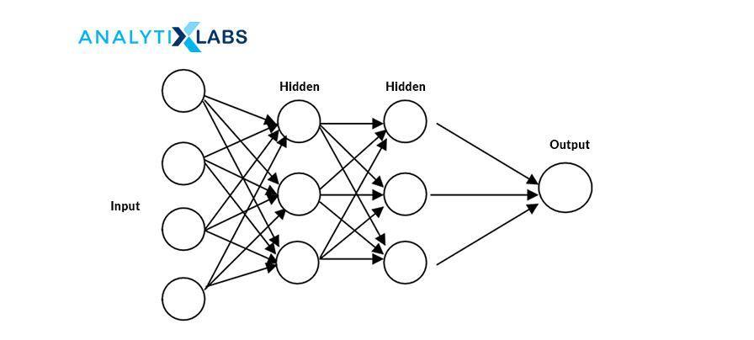
Source: static.packt-cdn.com

8. What are the components of the neural network?
A neural network has:
- Layers:
  - Input Layer: This layer consists of the inputs or the independent X variable.
  - Hidden Layer: It is the layer that extracts features and helps with fine-tuning the model
  - Output Layer: It is the result or the outcome of the network and depends on the type of business problem.
- Neurons
- Weight and Bias
- Activation Function
Both the hidden and the output layer contain nodes.

9. Explain how a neural network works?
There are three steps to perform in any neural network:
- First, take the input variables and estimate the output or the predicted Y values.
- Next, calculate the loss or the error term, and lastly
- Minimize the loss function or the error term by using the backward propagation i.e the loss value is taken backwardly one by one each layer to update the weights in such a way that the error term is minimized.

10. What role do weights and bias play in a neural network? How are the weights initialized?
Ans. It controls the strength of the connections between the neurons and determines the slope coefficients or the betas. Weights or interconnections transform the input data within the hidden layers of the network. The initial values of the weights (or betas) are randomly assigned between 0 and 1.
Bias is the constant intercept term. It is the default value of the model when no inputs or independent variables are present.

11. What is forward and backward propagation?
Forward and backward propagation is the way to adjust the weights or the betas.
In Forward propagation, the weight and biases are randomly initialized. Forward propagation is the process in which the inputs move from the hidden layer to the output layer, i.e., from left to right. In every hidden layer, the activation function’s output is calculated until the other layer is processed.
Backward propagation, go in the reverse order. First, adjust the output layer weights (keeping the weights of the input and hidden layers constant). Relative to the forward propagation, the backward propagation converges faster to the optimal solution of minimized error term since going from the output to the hidden layer and then to the input later.
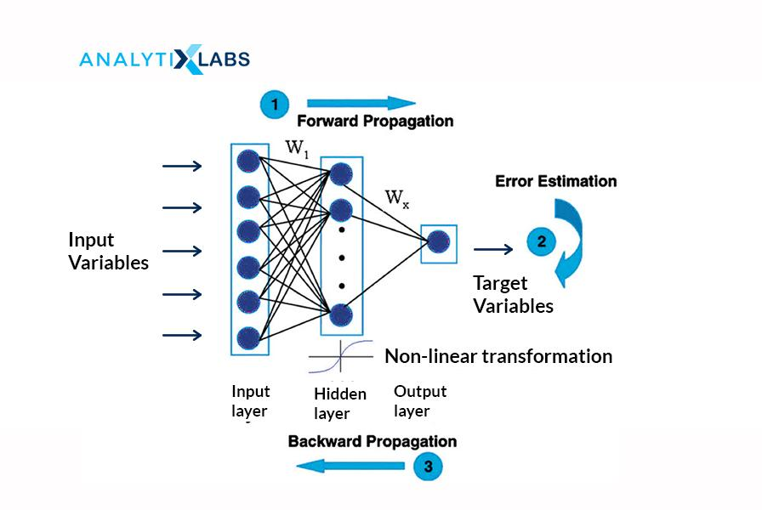
Source: researchgate.net

12. What is an activation function and why is it needed?
Ans. The activation function transforms the inputs into the output by introducing non-linearity to the outcome of a neuron. It helps in deciding to activate or not activate a neuron by calculating the weighted sum with the bias with it.
Activating a neuron will enable the model output to be nonlinear. It is also known as the squashing function. Some of the commonly used activation functions are:
- Step binary function
- Linear or Identity
- Sigmoid
- Softmax
- Tanh
- ReLU
The objective of the activation function is to add non-linearity to the function.
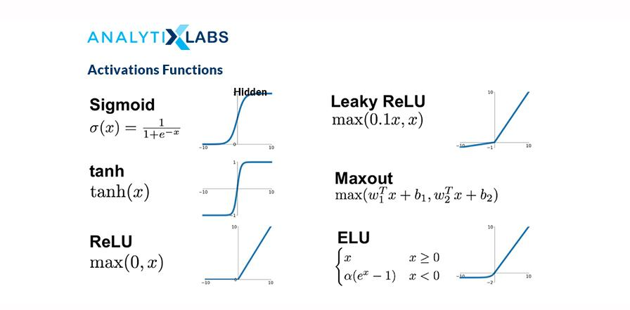
Source: miro.medium.com

13. Which activation function do we use for each layer?
Ans. The activation function is only applied to hidden and output layers as the input layer do not have nodes or neurons. We need the outcome in terms of class predicted (1 or 0) on the output layer, so we use sigmoid for binary classification and softmax for multi-classification. For the hidden layer, we do not need the answer in 1 or 0, so use the Rectified linear unit (or ReLU).

14. Why can we not use sigmoid or tanh to activate the hidden layer of the neural network?
The reason for not using Sigmoid or tanh for hidden layers is that these are susceptible to the vanishing gradient problem. By applying to the hidden layers, the gradients get saturated. During the backpropagation process, the error will reduce further (because of the chain rule), and the weights would not get updated, which will lead to no learning, and eventually, the model would not predict.

15. What is the difference between ReLU and LeakyReLU functions?
ReLU is half rectified from the bottom. In ReLU, the function f(x) = 0 when x< 0 and f(x) = x when x >= 0. This way, in ReLU, the gradient is always zero for all the input values which are less than zero. It can lead to the ‘dying ReLU’ problem by deactivating the neurons in that region.
On the other hand, the Leaky ReLU function is f(x) = max(0.001x, x) when x < 0, so it will have a slight positive slope (of 0.01) and, therefore, a non-zero value, and consequently the model continues to learn without hitting a dead-end.
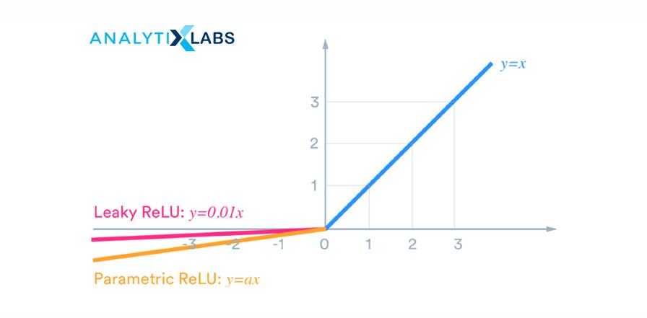
Source: miro.medium.com

16. What are the challenges with gradient descent and What are the treatments?
The challenges of Gradient Descent are:
- Gradient descent gets stuck at local minima, and
- It has a constant learning rate
The remedies are:
For the first challenge, use another optimizer called stochastic or mini-batch gradient descent with momentum, and for the second challenge, employ an RMSProp optimizer.
Moving out of the local minima requires accumulating momentum or speed. The gradient descent with momentum calculates the exponentially weighted average sum of the previous gradients and uses this weighted sum to update the weights.
RMSProp scales the learning rate depending on the square of the gradients, which eventually leads to faster convergence to the optimal solution.

17. What is Adaptive Moment Estimation (or Adam)?
Adaptive Moment Estimation (or Adam) combines the Stochastic Gradient Descent with Momentum and RMSProp. It can adapt the learning rate and find the exponential weights to the historical derivatives. It gives importance to both the past gradients and the previous learning rates.

18. What is the vanishing gradient problem? How is it different from the exploding gradient problem?

Ans. The purpose of the gradient descent algorithm is to update the weights and biases of the neural network by taking small steps towards the minimum value of the loss function.
The vanishing gradient problem occurs when these steps towards the optimal solution taken are too small, thus leading to gradients disappearing. In other words, the changes in the weights and bias terms are so minimal, almost equivalent to negligible. This way, the model does not learn anything, and the model performance deteriorates.
On the other hand, when the steps are too large, the gradients explode. This enlarges the updates to weights and bias terms, leading to an unstable network.
Both of these problems happen while using the Recurrent Neural Network (RNN) since RNNs use backpropagation through time.

19. What are the ways to treat the vanishing and exploding gradient problem?
To fix the vanishing gradient problem, must use:
- ReLU activation function in the hidden layers instead of tanh and sigmoid, and
- Xavier initialization
To treat the exploding gradients problem can:
- Re-design the network with fewer layers.
- Instead of RNN, use Long Short-Term Memory (LSTM) model
- Use gradient clipping, and
- Use the weight regularization

20. What are batch, mini-batch, and stochastic gradient descent? Which one would you use and why?
In a batch gradient descent:
- At each iteration, the gradient is computed for the entire dataset. It is also known as the vanilla gradient descent.
- The convergence to the optimal solution is slow as the training data is large with many samples and many features.
In Stochastic Gradient Descent (SGD):
- The gradient is estimated for a single observation at each iteration.
- As compared to the batch gradient, SGD converges much faster because it updates the weight more frequently and is therefore efficient for large data.
Mini-Batch Gradient Descent:
- It is the combination of batch gradient descent and SGD. It is also referred to as the vanilla mini-batch gradient descent.
- Here, the gradients are estimated by taking one batch or group of observations (similar to SGD for considering one sample) and then like batch gradient descent, training on this entire batch.
- It works faster than both batch gradient and SGD.
Summarizing the variants of the gradient descents:
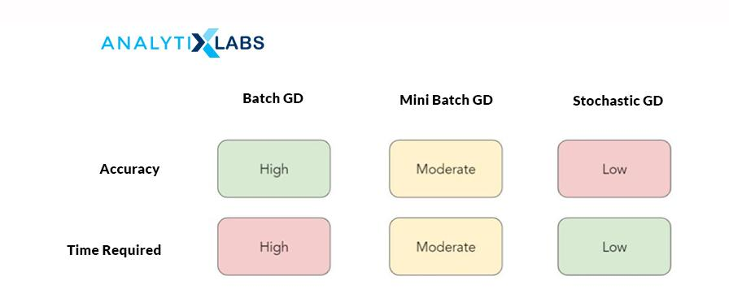
Mini-Batch Gradient Descent is the best variant to use because:
- Using the mini-batches improves the convergence, and also avoids the local minima to allow gradient approximation for the entire dataset.
- It is computationally more efficient in comparison to stochastic gradient descent.
- It helps in improving the generalization by finding the flat minima.

21. What is data or image augmentation?
Ans. Data or Image augmentation is a technique for increasing the input data for the model to train and upon. It is done by manipulating the original data. Data augmentation also helps in reducing the overfitting problem.
In image data, an image can be rotated, flipped horizontally or vertically, cropped, converted its channel, added Gaussian blur, scaled, jittering its color, randomly translated, and sheared to create more images used for training.

22. How do you differentiate between CNN and RNN? Which algorithm should be used when?
Convolution Neural Network (CNN) is a type of Feedforward Neural Network (FNN) having convolution as one of its layers. It creates a set of kernels (or filters) that learns and detects features from the unstructured data. CNNs are applicable for performing and analyzing image, signal, and video data. It is used for image recognition, analyzing visual imagery.
In a CNN, the signals travel in uni-direction from the input to output. It takes in only the current input, so it cannot create any network feedback loop and memorize previous inputs.
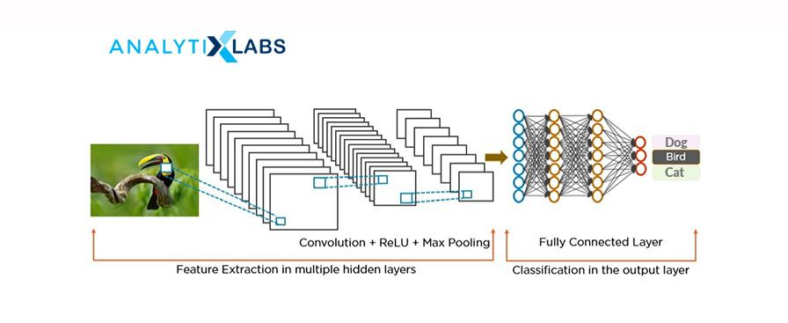
Source: miro.medium.com
Recurrent neural network (RNN), a class of artificial neural network, is applied to sequential data to perform complex tasks such as retrieving patterns in the text, time-series data, handwriting, and genomes.
RNNs use Back-propagation Through Time (BTT) to train and store the output of a layer and feed it back to the input layer, enabling it to have an internal state (or memory) for processing the sequences. Unlike CNN, RNN has interconnected neurons in each layer, and the signals travel in both directions that create a looped network.
It is used for image captioning, time series forecasting, recognizing handwriting, chatbots creation, fraud, and anomalies detection.
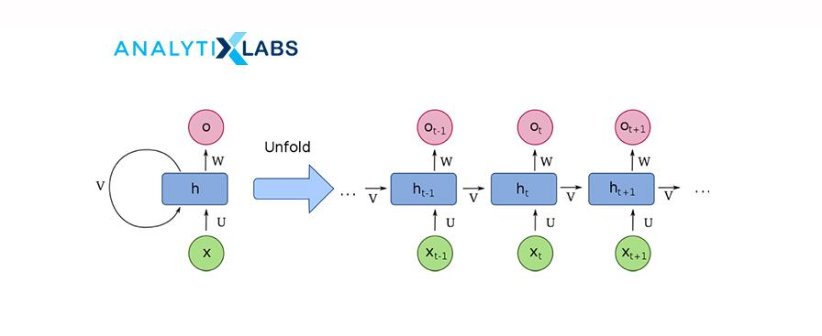
Source: wikimedia.org

23. Why do we use Convolutional Neural Network (CNN) for image data and not the Feedforward Neural Network (FNN)?
A convolutional neural network (CNN) is better than a feedforward neural network (FNN) for image data because CNN reads the image in parts rather than taking the entire picture.
CNN has a convolution layer that has filters to build the feature maps. It follows a hierarchical model that creates a network in the shape of a funnel, returns the processed outcome to a densely connected layer in which all the neurons are interconnected, and returns the final image as classified or identified.
This helps in sharing the features parameter, dimensionality reduction and also reduces the computations.

24. Please explain the difference between Conv1D, Conv2D, and Conv3D?
- Conv1D is applicable for input signals which are similar to the voice i.e audio data.
- Conv2D is useful for images, and
- Conv3D is used for videos having a frame for each period.

25. Explain the different layers of CNN. When using CNN, for which all layers are the parameters estimated?
There are four different layers of Convolution Neural Network (CNN):
- Convolutional Layer: The input (images) undergoes a convolution operation. This layer consists of a set of filters (or kernels) which further creates a subset of images, called feature maps. These maps are used to train the neural network.
- ReLu Layer: It adds non-linearity to the network converting the negative pixels to zero. It results in a rectified or corrected feature map.
- Pooling: This layer down-samples and reduces the dimensions of the feature maps. It does so by reducing the spatial size of the representation to a lower number of features in patches of the feature map.
- Fully Connected Layer: In this layer, like a feedforward neural network, all the layers are fully connected meaning the neurons of each layer are connected to neurons of another layer also have complete activations. This layer identifies and classifies the image.
- Flatten layer: It is connected with the fully connected layer. Flatten converts the data into a one-dimensional array to pass as the input for the next layer.
The parameters are estimated for the convolution and fully connected layer, not the flatter and pooling layer.

26. In CNN, what is the difference between valid and the same padding?
Valid padding is used when there is no need for padding. After convolution, the output dimensions of the output matrix are (n – f + 1) X (n – f + 1).
In the Same padding, the elements are added around the edges of the output matrix to keep the dimensions of the input and output matrix the same.

27. What is the difference between dropout and batch normalization?
Ans. Patented by Google, Dropout, and BatchNorm are techniques to improve a deep learning algorithm by reducing the overfitting of the model.
Using the dropout, we can randomly and probabilistically drop or set nodes to zero within layers of a neural network, i.e., effectively making those neurons invisible or “dropped out.” It is a way of creating a different model for each training and averaging the model performance of the network.
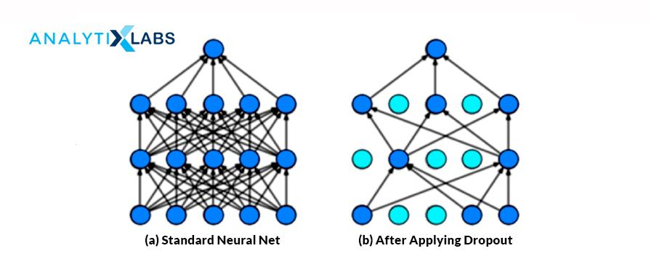
Source: miro.medium.com
The batch normalization technique standardizes the inputs of the network. It normalizes the hidden layer’s activations with a mean of zero and a standard deviation of each layer. This helps reduce the training time by easily initializing the weights and allowing higher learning rates.

28. What is transfer learning? Why is it needed? Name commonly-used transfer learning models.
Transfer learning is the process where learning from a model can be transferred to another without needing to train the model from scratch. There are three ways to use transfer learning:
- Extract features from the pre-trained model and also take away the output from the pre-trained model and then use it on the data for the current problem.
- Use both the architecture and weights of the pre-trained model and take that to train on our dataset.
- Train some layers and freeze the other layers of the pre-trained model. This works by extracting the weights of some of the layers and use for our neural network and fine-tune the model.
The most commonly-used transfer learning models are:
- ResNet
- VGG-16
- GTP-2 and GPT-3
- BERT

29. Does the problem of overfitting happen in neural networks? If yes then how would you treat it?
Ans. Yes, overfitting can occur in a neural network. Following are the ways to prevent overfitting in a neural network or improve a deep learning algorithm:
- Early Stopping
- Dropout
- Batch Normalization
- Data or Image Augmentation
- Weight Sharing

30. Do we have regularizers for neural networks?
Yes, the dropout is a regularizer.

31. What are hyperparameters? List the hyperparameters used in a neural network.
It helps to determine the structure of the neural network and how the network will be trained. Hyperparameters are the variables that are set before the training starts. These are the values that cannot be learned from the data and must be defined by the user. The hyperparameters of an artificial neural network are:
- Number of hidden layers
- Number of Nodes in the hidden layer
- Number of epochs (or iterations)
- Batch size
- Optimizer
- Activation Function
- Learning Rate
- Momentum
- Network Weight Initialization

32. Explain how LSTM, and GRU work. Which is the best one to use and why?
Long Short-Term Memory (LSTM) is a variant of the recurrent neural network that can learn long-term dependencies. It uses three gates: forget gate, input, output gate, and standard units to include a ‘memory cell’ that helps maintain the information in memory for long periods. It uses the feedback loop and gates to “remember” & “forget” information.

The LSTM network works in the following manner:
- Step 1: The network picks and decides which information to remember and what to forget.
- Step 2: It selectively updates the cell state values based on the first step.
- Step 3: The network calculates to decide which part of the current state would make it to the output.
Gated Recurrent Unit (GRU) is a special case of LSTM. It uses two gates: a reset gate and an update gate. The reset gate decides how to combine the new input with the previous time steps’ memory. The update gate decides how much of the last memory should be kept. The update gate of GRU is the combination of the input and forget gate of LSTM.
GRU is preferred over LSTM as LSTM can become complex by having an additional gate. GRU also resolves the vanishing gradient problem, operates faster, and takes less memory consumption as GRU does not have internal memory.
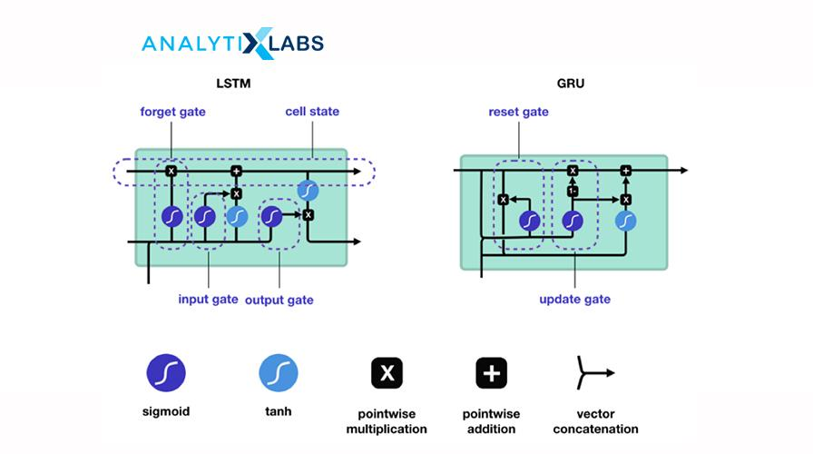
Source: miro.medium.com

33. What are Autoencoders? What is the use of Autoencoders?
Autoencoders is an unsupervised deep learning algorithm. Its goal is to automatically learn to map the inputs to the corresponding outputs without any supervision and direction. It comprises of two parts (which are different from the Encoder-Decoder model):
- Encoder: fits the input into an internal representation
- Decoder: converts the internal computational states back into the output
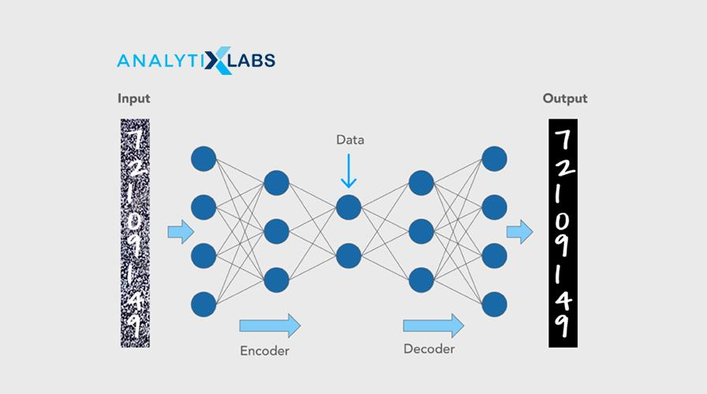
Source: cloudfront.net
Autoencoders are primarily used for dimensionality reduction to decrease the size of the inputs into a smaller representation and are also used for image reconstruction, denoising images, and image colorization.

34. What are GANs?
Generative adversarial networks (GANs) are unsupervised algorithms that use two neural networks: one generator and a discriminator. It generates data with the intent to uncover patterns to create the output.
The generator generates new data, and the discriminator classifies the generated data by the generator. Both these parts are trained simultaneously and compete with each other.
GANs are popular with image data as they are highly efficient and have high traction. These are used in image generation, image enhancement, translation, video, voice generation, and age progression.

35. Explain the Boltzmann machine. What is a Restricted Boltzmann machine?
Ans. The Boltzmann Machine resembles a Multilayer Perceptron with a hidden layer and a visible input layer. This model makes binary decisions, and bias, i.e., takes stochastic decisions to decide if a neuron must remain on or off. These generative types of models are bidirectional and stochastic models where nodes across different layers can connect; however, two nodes within the same layer can not connect.
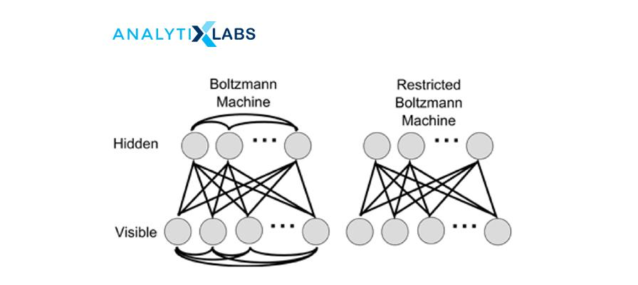
Source: researchgate.net
A Restricted Boltzmann Machine (RBM), a variant of the Boltzmann machine. It is an undirected graphical model that can be trained in either supervised or unsupervised ways based on the task. It is an algorithm that is used to perform:
- Regression
- Collaborative filtering
- Classification
- Dimensionality reduction
- Feature Learning
- Topic modeling
Restricted Boltzmann Machine is the Boltzmann Machine with restrictions where the restrictions are the visible nodes that should not connect with each other, and the hidden nodes shouldn’t connect with each other.

36. What are Seq2Seq (encoder-decoder) models? How is it different from Autoencoders?
The encoder-decoder model is a recurrent neural network (RNN) architecture with two RNNS and is used for sequence problems such as machine translation. One part is the encoder that encodes the inputs into a fixed-length vector representation. The second part is the decoder that decodes or represents another series of symbols as the output.
It is different from the autoencoder as autoencoder is an unsupervised architecture focussing on reducing dimensions and is applicable for image data.
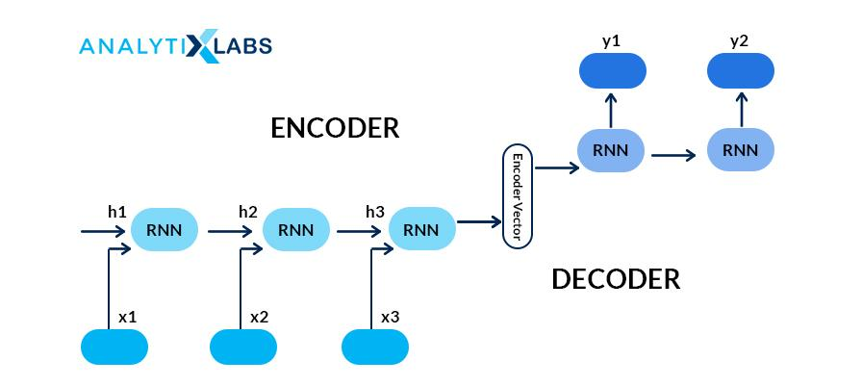
Source: miro.medium.com

37. What is the difference between epoch, batch, and iteration in deep learning? We have a dataset with 10,000 records and a batch size of 100 then for how many iterations will our model run for?
Epoch is the number of iterations over which we train the model. Batch is referred to the size of the subsets that the dataset is divided into to pass in the model.
The model will run for 100 iterations ( (10,000 divided by 100) for 1000 records and have a batch of 100.

38. What are tensors?
Tensors are mathematical objects, and in deep learning, tensors are one of the data structures. These multi-dimensional arrays represent data with higher dimensions, and one can execute various mathematical operations on these. In other words, tensors are data container that stores data with different dimensions in a neural network.
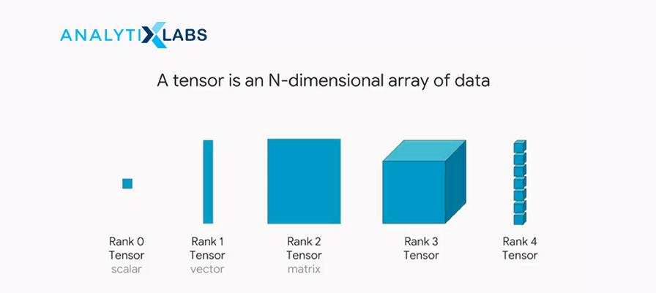
Source: miro.medium.com
To explore more on tensors, read Tensors — Representation of Data In Neural Networks and TensorFlow Basics: Tensor, Shape, Type, Sessions & Operators.

39. What is a computational graph? How is it useful for Deep Learning?
A computational graph is a series of operations represented in a network form, where each node represents a mathematical operation, and the edges are the tensors. Each node takes input as one or more tensors and returns in output a tensor. This sequence of TensorFlow operations is also known as the ‘DataFlow Graph.’
The USP of this graph is processing can happen parallelly hence is computationally efficient. The graph is immensely helpful for deep learning as it takes in a large number of inputs and has multiple layers requiring more computations. It can chart out the mathematical workflow graphically.
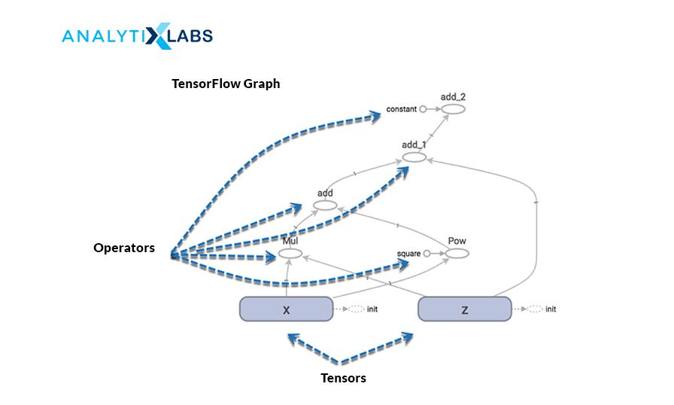
Source: guru99.com

40. What is model capacity?
Ans. Model capacity refers to the degree of a deep learning neural network to control the types of mapping functions it can take and learn from. It is the ability to approximate any given function. The higher the model capacity, the more amount of information can be stored in the network.

Beginner level Deep Learning Interview Tips
It would be beneficial to do the following to prepare for the deep learning interview:
- Having good theoretical knowledge
It is imperative to have a sound, solid theoretical knowledge of deep learning topics. Starting from the basics of neural networks, their architecture, the several parameters used in it. A good working understanding of the commonly used models such as Convolution Neural Network (CNN), Recurrent Neural Network (RNN), Long-Short Term Memory (LSTM), Gated Recurrent Unit (GRU).
Be thorough with how the models help solve a business problem, how to improve the neural network and the respective hyperparameters. Additionally, know what transfer learning is, why it is needed and how it is employed. Be well-versed with the fundamentals of the underlying concepts used in the models. Keep revisiting these deep learning interview questions to revise your concepts.
- Work with real-world Deep Learning cases
Nothing beats the old-age saying practice makes a man perfect! All the theory is not of any good if not applied. It is crucial to have worked with the business cases to solve any real-life problems. It is best to showcase your work, skills by having a portfolio on GitHub and/or Kaggle.
- Study Deep Learning interview questions
The above deep learning interview questions and answers would be a good starting point to study. Practice your answers; take mocks. It would save you many rounds of drilling work if you could hear yourself when you answer a question! Technical rounds can get a little daunting at times. In such cases, keep a mind hack trick handy to swift through it.
- Read about the Company and Role
It is an excellent practice to research and read well beforehand the job description, about the company, if possible know its contemporaries. Be aware of the needed skill sets and tools, talk about how you have those skills, and work on cases requiring those tools (only if you have!) Assess and answer yourself on questions such as telling us something about yourself and what you can bring to the role. Have a list of questions to ask the interviewer at the end of the interview.
- Interview Étiquettes
Some of the very subtle and essential things that we can tend to forgo while preparing for interviews are:
- Being punctual for the interviews for both virtual and in-person. Logging in at least a couple of minutes before time will allow you to breathe in, be settled, collect your thoughts and not rush hush through (after all a good start is half done
- Being honest and integral about what you know and don’t know. On your resume add only the things you know, and have worked on yourself.
- Listen to the interviewer and answer questions to the best of your ability and understanding. Ask in case you are not clear about the question. Answer only to the question asked, sometimes we tend to answer for what was not even asked. If you are not sure or do not know the answer, it is polite to say I don’t know than conjuring up incorrect answers.

How to get expertise in Deep learning?
- Having a Beginner’s Mind
We all want to leverage the benefits of this highly-sort, demanding, and lucrative job and build fantastic working models, but Rome was not built in a day this field like any other.
First, work with the basics, get your fundamentals in place and then progress to the advanced topics in deep learning such as transformers, machine translations, speech-to-text, applied computer vision, BERT, YOLO.
- Do not forget your Machine Learning Stuff!
If you were expecting that you could let your Machine Learning books, notes, models catch dust, then sorry to disappoint, but you can’t proceed with deep Learning until you have Machine Learning under your belt!
Deep Learning without Machine learning would be like you have become a doctor without having had science in 12th class! (No, no, Munna-Bhai MBBS works here!) There is a reason why Deep Learning is a subset of Machine Learning, and it has to be the last one to be learned and mastered. The pecking order of things is important.
- Pick your Deep Learning framework
There are three popular frameworks to work with deep learning problems: Keras, TensorFlow, and PyTorch. Keras is easier to start working and implementing the Deep Learning models upon as it has pre-defined functions as sklearn had for Machine Learning. Keras has TensorFlow at its backend.
PyTorch requires more work, as we need to define functions to the same task that is handier in Keras. Ideally, start with Keras, and once you have a grasp of the models, clear on the architecture et al. and then learn PyTorch and diverse out.
- Practice Practice and some more Practice!
It would be good to have intuition built for neural networks, the logical understanding of things, how the pieces are joined together. The curiosity to ask questions, understand, learn and then apply all that knowledge gained is the key. It is one thing to understand the architecture of the network, but only once you start putting that into solving real-life cases will you be able to learn more and fine-tune your approach.
- Explore the problems and datasets
Play around with every kind of dataset you can get your hands-on, and over a period of time, you will learn which area of Deep Learning you have flair and liking for. This can only come up with having worked with lots of problems and diversifying the use cases. It is exactly like how you get to know yourself
- Learn Model Deployment
Eventually, the models you are making have to be deployed for them to be of use. Therefore, it is of immense benefit to learn how to deploy your models. The skill will not only give you added advantage but also make you more efficient.
Hope this repository of deep learning interview questions has been helpful to you. Some of the FAQs related to it are:
For hands-on AI projects, also refer to 18 (Interesting) Artificial Intelligence Projects Ideas

FAQs – Frequently Asked Questions
Ques 1. What are the topics in Deep Learning?
Ans. The topics in Deep Learning are:
- Basics of Neural Networks
  - Perceptrons
  - Multi-Layer Perceptron
  - Forward and Backward Propagation
  - Gradient Descent Algorithm
  - Loss Function
  - Activation Functions
  - Optimizers
- Convolutional Neural Networks (CNN)
- Recurrent Neural Networks (RNN)
- Long-Short Term Memory (LSTM)
- Gated Recurrent Unit (GRU)
- Autoencoders
- Encoder-Decoder
- Attention Models
- Transformers
- Restricted Boltzmann Machine (RBM)
- Speech-to-Text Analytics
- Image, Text, and Audio Processing
- Computer Vision
- Transfer Learning
- Techniques to improve the Deep Learning model
- Deep Learning Frameworks such as Keras, TensorFlow, PyTorch
Ques 2. How do you prepare for a Deep Learning interview?
Ans. To prepare for a deep learning interview, you must have a very sound theoretical knowledge of the basics of neural networks, the terminologies involved in it, and the different algorithms used covered in the topics of deep learning above. Go over the deep learning interview questions.
You must also have an end-to-end working knowledge of algorithms themselves. Be thorough with a deep learning project’s workflow and be ready to walk through your best or favorite deep learning use case during the interview. Having a repository to showcase your work and a portfolio on Github or Kaggle, or both is an added advantage.
Also, study for the deep learning python interview questions. Implementing the business cases on different frameworks of deep learning such as Keras and Pytorch is a must-know. It is important to know the use, functionalities of the modules, methods available within these packages.

What is Caffe and How it works? An Overview and Its Use Cases
RAJESH KUMAR MARCH 30, 2022 LEAVE A COMMENT

History & Origin of Caffe
Deep learning is the new big trend in machine learning. It had many recent successes in computer vision, automatic speech recognition and natural language processing.
The goal of this blog post is to give you a hands-on introduction to deep learning. To do this, we will build a Cat/Dog image classifier using a deep learning algorithm called convolutional neural network (CNN) and a Kaggle dataset.
This post is divided into 2 main parts. The first part covers some core concepts behind deep learning, while the second part is structured in a hands-on tutorial format.
In the first part of the hands-on tutorial (section 4), we will build a Cat/Dog image classifier using a convolutional neural network from scratch. In the second part of the tutorial (section 5), we will cover an advanced technique for training convolutional neural networks called transfer learning. We will use some Python code and a popular open source deep learning framework called Caffe to build the classifier. Our classifier will be able to achieve a classification accuracy of 97%.
By the end of this post, you will understand how convolutional neural networks work, and you will get familiar with the steps and the code for building these networks.

What is Caffe
Caffe is a deep learning framework made with expression, speed, and modularity in mind. It is developed by Berkeley AI Research (BAIR) and by community contributors. Yangqing Jia created the project during his PhD at UC Berkeley. Caffe is released under the BSD 2-Clause license.
Expressive architecture encourages application and innovation. Models and optimization are defined by configuration without hard-coding. Switch between CPU and GPU by setting a single flag to train on a GPU machine then deploy to commodity clusters or mobile devices.
Extensible code fosters active development. In Caffe’s first year, it has been forked by over 1,000 developers and had many significant changes contributed back. Thanks to these contributors the framework tracks the state-of-the-art in both code and models.
Speed makes Caffe perfect for research experiments and industry deployment. Caffe can process over 60M images per day with a single NVIDIA K40 GPU*. That’s 1 ms/image for inference and 4 ms/image for learning and more recent library versions and hardware are faster still. We believe that Caffe is among the fastest convnet implementations available.

How Caffe works aka Caffe architecture?
Classification using a machine learning algorithm has 2 phases:
- Training phase: In this phase, we train a machine learning algorithm using a dataset comprised of the images and their corresponding labels.
- Prediction phase: In this phase, we utilize the trained model to predict labels of unseen images.
The training phase for an image classification problem has 2 main steps:
- Feature Extraction: In this phase, we utilize domain knowledge to extract new features that will be used by the machine learning algorithm. HoG and SIFT are examples of features used in image classification.
- Model Training: In this phase, we utilize a clean dataset composed of the images’ features and the corresponding labels to train the machine learning model.
In the predicition phase, we apply the same feature extraction process to the new images and we pass the features to the trained machine learning algorithm to predict the label.
The main difference between traditional machine learning and deep learning algorithms is in the feature engineering. In traditional machine learning algorithms, we need to hand-craft the features. By contrast, in deep learning algorithms feature engineering is done automatically by the algorithm. Feature engineering is difficult, time-consuming and requires domain expertise. The promise of deep learning is more accurate machine learning algorithms compared to traditional machine learning with less or no feature engineering.

Use case of Caffe
Caffe is being used in academic research projects, startup prototypes, and even large-scale industrial applications in vision, speech, and multimedia. Yahoo! has also integrated Caffe with Apache Spark to create CaffeOnSpark, a distributed deep learning framework.

Feature and Advantage of using Caffe
- Once you venture outside of Caffe’s comfort zone, i.e. convnets, its usability drops significantly. For example, try doing RNN for language modeling in Caffe.
- All the machinery e.g. protobuf, layers etc. comes in the way once you try to define your own layer types.
- Only a few input formats and only one output format, HDF5 (although you can always run it using its Python/C++/Matlab interface and getting output data from there).
- Multi-GPU training is partially supported but not all the different ways of doing that such as model/data parallelism etc.
- Many interesting modifications are only available in patches submitted by different people.

Best Alternative of Caffe
Top 10 Alternatives to Caffe
- Keras.
- DeepPy.
- NVIDIA Deep Learning GPU Training System (DIGITS)
- TFLearn.
- Torch.
- Clarifai.
- Microsoft Cognitive Toolkit (Formerly CNTK)
- AWS Deep Learning AMIs.

Best Resources, Tutorials and Guide for Caffe
- DevOpsSchool
- ScmGalaxy
- Edureka
- Simplilearn

Free Video Tutorials of Caffe

Interview Questions and Answer for Caffe
Q1: What is the difference between Machine Learning and Deep Learning?
Answer
- Machine Learning depends on humans to learn. Humans determine the hierarchy of features to determine the difference between the data input. It usually requires more structured data to learn.
- Deep Learning automates much of the feature extraction piece of the process. It eliminates the manual human intervention required.
- Machine Learning is less dependent on the amount of data as compared to deep learning.
- Deep Learning requires a lot of data to give high accuracy. It would take thousands or millions of data points which are trained for days or weeks to give an acceptable accurate model.
Q2: What are Ensemble methods and how are they useful in Deep Learning?
Answer
- Ensemble methods are used to increase the generalization power of a model. These methods are applicable to both deep learning as well as machine learning algorithms.
- Some ensemble methods introduced in neural networks are Dropout and Dropconnect. The improvement in the model depends on the type of data and the nature of neural architecture.
Q3: What advantages does Deep Learning have over Machine Learning?
Answer
- Deep Learning gives a better performance compared to machine learning if the dataset is large enough.
- Deep Learning does not need the person designing the model to have a lot of domain understanding for feature introspection. Deep learning outshines other methods if there is no feature engineering done.
- Deep Learning really shines when it comes to complex problems such as image classification, natural language processing, and speech recognition.
Q4: Why does the performance of Deep Learning improve as more data is fed to it?
Answer
- One of the best benefits of Deep Learning is its ability to perform automatic feature extraction from raw data.
- When the number of data fed into the learning algorithm increases, there will be more edge cases taken into consideration and hence the algorithm will learn to make the right decisions in those edge cases.
Q5: What is the difference between Deep Learning and Artificial Neural Networks?
Answer
- When researchers started to create large artificial neural networks, they started to use the word deep to refer to them.
- As the term deep learning started to be used, it is generally understood that it stands for artificial neural networks which are deep as opposed to shallow artificial neural networks.
- Deep Artificial Neural Networks and Deep Learning are generally the same thing and mostly used interchangeably.
Q5: What is the difference between Deep Learning and Artificial Neural Networks?
Answer
- When researchers started to create large artificial neural networks, they started to use the word deep to refer to them.
- As the term deep learning started to be used, it is generally understood that it stands for artificial neural networks which are deep as opposed to shallow artificial neural networks.
- Deep Artificial Neural Networks and Deep Learning are generally the same thing and mostly used interchangeably.
Q6: How would you choose the Activation Function for a Deep Learning model?
Answer
- If the output to be predicted is real, then it makes sense to use a Linear Activation function.
- If the output to be predicted is a probability of a binary class, then a Sigmoid function should be used.
- If the output to be predicted has two classes, then a Tanh function can be used.
- ReLU function can be used in many different cases due to its computational simplicity.

Q7: How does Ensemble Systems help in Incremental Learning?
Answer
- Incremental learning refers to the ability of an algorithm to learn from new data that may become available after a classifier has already been generated from a previously available dataset.
- An algorithm is said to be an incremental learning algorithm if, for a sequence of training datasets, it produces a sequence of hypotheses where the current hypothesis describes all data that have been seen thus far but depends only on previous hypotheses and the current training data.
- Ensemble-based systems can be used for such problems by training an additional classifier (or an additional ensemble of classifiers) on each dataset that becomes available.
Q9: How to know whether your model is suffering from the problem of Vanishing Gradients?
Answer
- The model will improve very slowly during the training phase and it is also possible that training stops very early, meaning that any further training does not improve the model.
- The weights closer to the output layer of the model would witness more of a change whereas the layers that occur closer to the input layer would not change much (if at all).
- Model weights shrink exponentially and become very small when training the model.
- The model weights become 0 in the training phase.
Q10: How to know whether your model is suffering from the problem of Exploding Gradients?
Answer
There are some subtle signs that you may be suffering from exploding gradients during the training of your network, such as:
- The model is unable to get traction on your training data (e g. poor loss).
- The model is unstable, resulting in large changes in loss from update to update.
- The model loss goes to NaN during training.
If you have these types of problems, you can dig deeper to see if you have a problem with exploding gradients. There are some less subtle signs that you can use to confirm that you have exploding gradients:
- The model weights quickly become very large during training.
- The model weights go to NaN values during training.
- The error gradient values are consistently above 1.0 for each node and layer during training.

