1) What is TensorFlow?
TensorFlow is a Python-based library which is used for creating machine learning applications. It is a low-level toolkit to perform complex mathematics. It offers users the customizability option to build experimental learning architectures. It also helps the users to work with them, and to turn them into running software. It was initially created by researchers and engineers working on the Google Brain Team, and It became open source in 2015.
TensorFlow is made up of two words Tensor and Flow; a tensor is known as data representation for multi-dimensional array and flow means a series of operations performed on tensors.

2) What do you know about Tensors?
The Tensor is a generalization of vectors or matrices of the n-dimensional array which is used in computer programming. It represents a multitude of data in the form of numbers. There are few other n-dimensional array libraries which are available on the internet such as Numpy, but TensorFlow stands apart from those libraries. It provides methods to create tensor functions and automatically compute derivatives.
Play Videox

A graph can conduct all operations in the Tensor. We can say that the edge of the node is known as Tensor. We need a feature vector as the initial input to implement a Tensor. The models are fed with the list of objects in the machine learning, and these objects are called feature vectors.
We can understand the Tensors with the help of the diagram given below:
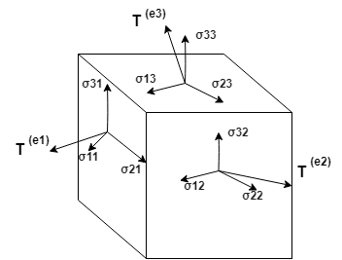
Here, the arrow represents multi-dimensions. There is a Tensor which is known as stress, and it describes things happening in two directions.

3) How many types of Tensors are there?
There are three types of Tensors used to create neural network models:
- Constant Tensor
Constant Tensors are used as constants, as the name suggests. They create a node that takes a value and does not change it. A constant can be created using tf.constant.
tf.constant(value, dtype=None, shape=None, name='Const', verify_shape=False)
It accepts the five arguments.
- Variable Tensor
Variable Tensors are the nodes which provide their current value as output. It means that they can retain their value over multiple executions of a graph.
- Place Holder Tensor
Placeholders Tensors are essential than variables. These are used to assign data in a later time. Placeholders are the nodes whose value is fed at the time of execution. Assume, we have inputs to our network which are dependent on some external data. Also, we do not want our graph to depend on any real value while developing the graph, then Placeholders are useful datatype. We can even build a graph without any data.
Therefore, placeholders do not require any initial value. They only need a datatype (such as float32) and a tensor shape, so the graph still knows what to compute with even though it does not have any stored values.

4) Explain TensorBoard?
TensorBoard is a suite of visualizing tools for inspecting and understanding TensorFlow runs and graphs. It is an easy solution to Tensorflow offered by the creators that let us visualize the graphs. It plots quantitative metrics about the graph with additional data like images to pass through it.TensorBoard currently supports five visualizations techniques such as scalars, images, audio, histograms, and graphs. It improves the accuracy and flow of graphs.

5) What is the main feature of TensorFlow?
Tensorflow has APIs support for a wide variety of languages such as Matlab and C++. Researchers are continuously trying to making it better. A javascript library, tensorflow.js, has also been introduced for training and deploying machine learning models.

6) What are the advantages of TensorFlow?
Some of the main advantages of TensorFlow are given below:
- It can be easily trained on CPU as well as GPU for distributed computing.
- It has auto differentiation capabilities.
- It has platform flexibility.
- It is easily customizable and open-source.
- It has advanced support for threads, asynchronous computations, and queues.

7) List a few limitations of Tensorflow.
TensorFlow has some limitations, as mentioned here:
- It does not provide support for OpenCL (Open Computing Language).
- It requires prior knowledge of advanced calculus and linear algebra along with a pretty good understanding of Machine learning.
- It has GPU memory conflicts with Theano if imported in the same scope.

8) Which client languages are supported in TensorFlow?
TensorFlow provides support for multiple client languages, one of the best among them is Python. There are some experimental interfaces which are available for C++, Java, and Go. A language bindings for many other languages such as C#, Julia, Ruby, and Scala are created and supported by the open-source community.
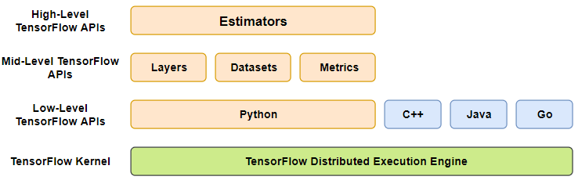

9) What are the three working components of TensorFlow Architecture?
TensorFlow architecture works in three parts:
- Preprocessing the data
- Building the model
- Training and estimating the model

10) Explain few options to load data into TensorFlow.
Loading the data into TensorFlow is the first step before training a machine learning algorithm. There are two ways to load the data:
- Load data in memory
It is the easiest method. All the data is loaded into memory as a single array. One can write a Python code which is unrelated to TensorFlow.
- Tensorflow data pipeline
TensorFlow has built-in APIs which help to load the data, perform the operations, and feed the machine learning algorithm easily. This method is mostly used when there is a large dataset.

11) Describe the common steps to most TensorFlow algorithms?
- Import data, generate data, or setting a data-pipeline through placeholders.
- Feed the data through the computational graph.
- Evaluate output on the loss function.
- Use backpropagation to modify the variables.
- Repeat until stopping condition.

12) Mention the name of some methods to deal with the overfitting in TensorFlow.
- Dropout Technique
- Regularization
- Batch Normalization

13) What do you know about TensorFlow Managers?
The TensorFlow managers are responsible for loading, unloading, lookup, and lifetime management of all servable objects via their loaders. TensorFlow Managers control the full lifecycle of Servables, including:
- Loading Servables
- Serving Servables
- Unloading Servables
It is an abstract class. Its syntax is:

- #include <manager.h>

14) What are TensorFlow servables? Also, explain TensorFlow Serving.
The clients use some objects to perform the computations, and these objects are known as Servables. The size of the servable is flexible. A single servable might contain anything from a lookup table to a single model to a tuple of inference models. These servables are the central rudimentary units in TensorFlow Serving.
TensorFlow Serving is designed for production environments. It is a flexible, high-performance serving system used for machine learning models. TensorFlow Serving easily deploys new algorithms and experiments while keeping the same server architecture and APIs. TensorFlow Serving provides out-of-the-box integration with TensorFlow models. It can also be easily extended to serve other types of models and data whenever required.
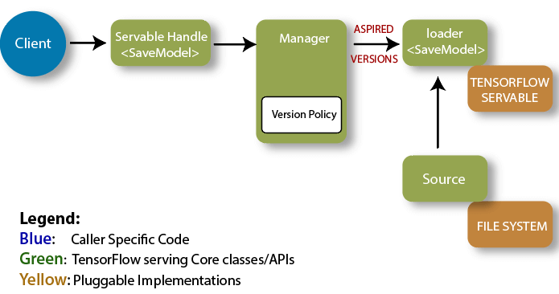

15) What are the use cases of TensorFlow?
Tensorflow is an essential tool for deep learning. It has mainly five use cases, they are:
- Text-Based Applications
- Voice/Sound Recognition
- Time Series
- Image Recognition
- Video Detection

16) Where can you run a TensorFlow?
TensorFlow can run on different platforms:
- Operating System such as Windows, OS, and Linux
- Cloud Web Service
- Mobile OS like IOS and Android

17) When will you find overfit condition of a model in TensorFlow?
There are variations in the training data, and this data needs to be verified through TensorFlow. Overfitting can be probably seen if the variations are huge in the data. The best possible solution is to remove the noise from the available data upto the possible extent.

18) What are the loaders of TensorFlow?
The loader can be implemented to load, unload, and access a new type of servable machine learning model. These loaders are used for adding algorithms and data on the backend. The function load() is used to load the model from the saved model.

19) List some products that are built using TensorFlow.
There are a few products built using TensorFlow:
- Nsynth
- Giorgio Cam
- Hand Writing Recognition
- Teachable Machine

20) What are the sources in TensorFlow?
Sources are that type of modules which identify and provide servables. Each source provides zero or many servable streams. A single loader is supplied for each servable version makes it accessible so that it can be loaded.

21) What are the benefits of TensorFlow over other libraries? Explain.
There are many benefits of TensorFlow over other libraries which are given below:
- Scalability
TensorFlow provides easily scaled machine learning applications and infrastructure.
- Visualization of Data
Visualizing the graph is very straight-forward in TensorFlow. TensorBoard(a suite of visualization tools) is used to visualize TensorFlow graphs.
- Debugging Facility
tfdbg is a specialized debugger for TensorFlow. It lets us view the internal structure and states of running TensorFlow graphs during training and inference.
- Pipelining
TensorFlow's Dataset module tf.data is used to build efficient pipelines for images and text.

22) What do you understand by Deep Speech?
DeepSpeech is an open-source engine used to convert Speech into Text. It uses a model which is trained by machine learning techniques. It is based on Baidu's Deep Speech research paper. It uses Google's TensorFlow to make the implementation easier.
We can list the command line options through deep Speech, and the syntax for that is given below:

- ./deepspeech.py

23) What do you know about TensorFlow abstractions?
TensorFlow contains abstraction libraries such as TF-Slim and kereas, which provides simplified high-level access to TensorFlow. Such abstractions help to streamline the construction of data flow graphs.
TensorFlow abstractions not only help to make the code cleaner but also reduce the length of codes drastically. As a result, it significantly reduces development time.

24) How does TensorFlow use Python API?
Python is the primary language when it comes to TensorFlow and its development. It is the first and most recognizable language supported by TensorFlow and still supporting most of the features. It seems like the functionality of TensorFlow was initially defined in Python and later moved to C++.

25) What are the APIs used inside the TensorFlow project?
Most of the APIs inside TensorFlow are based on Python language. They have low-level options for the users such as tf.manual or tf.nn.relu used to build Neural Network Architecture. These APIs are also used to design a deep neural network having higher levels of abstraction.

26) What are the APIs used outside the TensorFlow project?
There are a few APIs used outside the TensorFlow project, which are:
- TFLearn
TFLearn provides a high-level API which makes neural network building and training fast and easy. This API is fully compatible with Tensorflow. Its API can be indicated as tf.contrib.learn.
- TensorLayer
TensorLayer is a TensorFlow-based deep learning and reinforcement learning library. It is designed for researchers and engineers. It provides an extensive collection of customizable neural layers/functions which are crucial for building real-world AI applications.
- PrettyTensor
Pretty Tensor delivers high-level builder API for TensorFlow. It offers thin wrappers on Tensors so that you can easily build multi-layer neural networks.
Pretty Tensor provides a set of objects that behave likes Tensors. It also supports a chainable object syntax to define neural networks and other layered architectures in TensorFlow quickly.
- Sonnet
Sonnet is a library which is built on top of TensorFlow for creating complex neural networks. It is a part of Google's DeepMind project, which features a modular approach.

27) How do we create tensors from Python objects?
We can create tensors such as numpy arrays and lists with the help of Python objects. We can easily perform it using tf.convert_to_tensor() operation.

28) What are the variables in TensorFlow?
Variables in TensorFlow are also known as tensor objects. These objects hold the values which can be modified during the execution of the program.
A TensorFlow variable is the best way which is used to represent a shared, persistent state manipulated by the program.

29) What is the lifetime of a variable?
A variable is created when we first run the tf.Variable.initializer operation for that variable in a session. It gets destroyed when tf.Session.close is processed.

30) Differentiate between tf.variable and tf.placeholder.
The tf.variable and tf.placeholder both are almost similar to each other, but there are some differences as following:
tf.variable | tf.placeholder
- It defines variable values which are modified with time. | - It defines specific input data that does not change with time.
- It requires an initial value at the time of definition. | - It does not require an initial value at the time of definition.

31) What is Scalar Dashboard?
Scaler Dashboard visualizes scaler statistics that vary over time. It uses a simple API for performing such visualizations. For example, We might want to examine the model's loss or learning rate.
We can compare multiple runs, and the data is established by tag.

32) What is a Histogram Dashboard?
The Histogram Dashboard is used to display how the statistical distribution of a Tensor varies overtime. It helps to visualize the data recorded via tf.summary.histogram. Each chart displays the temporal "slices" of data, where each slice is a histogram of the tensor at a given step. It is arranged with the oldest timestep in the back, and the most recent timestep in front.
If a Histogram mode is changed from "offset" to "overlay", the perspective will rotate. As a result, every histogram slice is rendered as a line and overlaid with one another.

33) What do you know about Distribution Dashboard in TensorFlow?
The Distribution Dashboard is another way that is used to visualize histogram data from tf.summary.histogram. It displays some high-level statistics on a distribution. Each line on the chart is used to represent a percentile in the distribution over the data. For example, the bottom line displays how the minimum value changes over time and the line in the middle displays how the median changes. Reading it from top to bottom, the lines provide the following meaning: [maximum, 93%, 84%, 69%, 50%, 31%, 16%, 7%, minimum].

34) What is Image Dashboard in TensorBoard?
The Image Dashboard is used to display png files that were saved via a tf.summary.image. The dashboard is configured in such a way so that each row corresponds to a different tag, and each column corresponds to a run. The image dashboard also supports arbitrary pngs which can be used to embed custom visualizations (e.g.,matplotlib scatterplots) into TensorBoard. This dashboard always shows the latest image for each tag.

35) What do you know about Audio Dashboard?
The Audio Dashboard is used to embed playable audio widgets for audio stored via a tf.summary.audio. The dashboard is configured so that each row corresponds to a different tag, and each column corresponds to a run. The Audio dashboard always embeds the latest audio for each tag.

36) Describe Graph Explorer in TensorFlow?
The Graph Explorer can be used while visualizing a TensorBoard graph. It is also responsible for enabling inspection of the TensorFlow model. To get the best use of the graph visualizer, one should use name scopes to group the ops in a graph hierarchically. Otherwise, the graph may be challenging to decipher.

37) What is Embedding Projector?
The Embedding Projector allows visualizing high-dimensional data. For example, one can view input data after it has been embedded in a high- dimensional space by model. The embedding projector reads data from the model checkpoint file. It may be configured with additional metadata, like a vocabulary file or sprite images.

38) What do you understand by Text Dashboard?
The Text Dashboard is used to display text snippets stored via tf.summary.text. Other features, such as hyperlinks, lists, and tables, are also supported.

39) Can I run TensorBoard without TensorFlow?
If you do not have TensorFlow installed then, TensorBoard 1.14+ can be run but with a reduced feature set. The primary limitation is that as of TensorFlow 1.14, only the following plugins are supported: scalars, custom scalars, image, audio, graph, projector (partial), distributions, histograms, text, PR curves, mesh. Also, there is no support for log directories on Google Cloud Storage.

40) What are the different dashboards in TensorFlow?
There are different types of dashboards in TensorBoard which perform various tasks in the tensor board:
- Scalar Dashboard
- Histogram Dashboard
- Distributer Dashboard
- Image Dashboard
- Audio Dashboard
- Graph Explorer
- Projector
- Text Dashboard

41) What is the main operation in TensorFlow?
The main operation in TensorFlow is defined as passing values and assigning the output to another tensor.

42) What is more important to you between the performance and accuracy of a model, in machine learning based on TensorFlow?
It usually depends on the complete performance. Both performance and accuracy, weigh equal, although accuracy is prominent in most of the models.

43) Can TensorFlow be deployed in container software?
TensorFlow can be used with containerization tools such as Docker. It can be helpful to deploy a sentiment analysis model which uses character level ConvNet networks for text classification.

44) How can someone report a vulnerability in TensorFlow?
A person can report about any security issue directly to security@tensorflow.org. The report to this email is delivered to the security team at TensorFlow. The emails are then acknowledged within 24 hours, and detailed response is provided within a week along with the next steps.

45) What are the components used for deploying a lite model file in TensorFlow?
- Java API
Java API is a wrapper around C++ API on Android.
- C++ API
C++ API loads the TensorFlow Lite model and calls the interpreter.
- Interpreter
The interpreter can be used to execute the model. It uses particular kernel loading, which is a unique feature of TensorFlow Lite.

46) What are the differences between TensorFlow and PyTorch?
TensorFlow | PyTorch
- The TensorFlow is based on Theano library. | - PyTorch is a software-based on the Torch library.
- It is produced by Google. | - It is developed by Facebook.
- TensorFlow does not have any option at run time. | - PyTorch includes computational graph at the runtime.
- TensorFlow has TensorBoard for visualizing machine learning model. | - PyTorch doesn't have any feature like visualization.

47) Can word embedding be used in TensorFlow? Name two models used in word embedding?
Word embedding is used in Natural Language Processing as a representation of words, and they can be used in TensorFlow where it is also known as Word2vec.
The two models used in word embedding are - The continuous bag of words model and the skip-gram model.

48) What do you understand by TensorFlow Estimators?
Estimators is a high-level API which reduces much of the code you previously needed to write while training a TensorFlow model. Estimators are very flexible, and it allows to override the default behavior if there is any specific requirement for the model.
There are two possible ways of building a model using Estimators:
- Pre-made Estimator
These are predefined estimators. These are created to generate a specific type of model, e.g., DNNClassifier, which is a pre-made estimator.
- Estimator (base class)
It provides complete control of how a model should be created by using a model_fn function.
These functions are consumed by the class tf.estimator.Estimator. The functions return an initialized estimator, upon which we can call .train, .eval, and .predict.
A schematic of Estimator can be seen as:
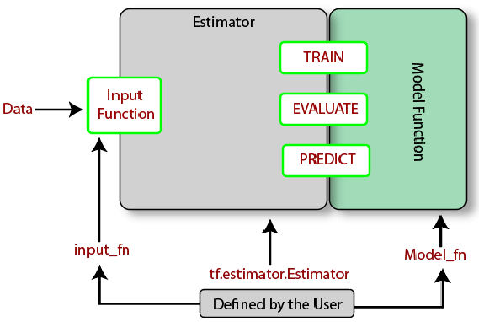

49) What are some statistical distribution functions provided by TensorFlow?
A wide variety of statistical distributions is available which is provided by TensorFlow and located inside:

- tf.contrib.distributions
It contains distributions like Beta, Bernoulli, Chi2, Dirichlet, Gamma, Uniform, etc. These are important building blocks when it comes to building machine learning algorithms, especially for probabilistic approaches like Bayesian models.

50) What is the difference between Tensor.eval() and Session.run()?
In TensorFlow, we create graphs and provide values to that graph. The graph itself processes all the hardwork and generates the output based on the configuration that we have applied in the graph. Now, when we provide values to the graph, then first, we need to create a TensorFlow session.

- tf.Session()
Once the session is initialized, then we are supposed to use that session. It is necessary because all the variables and settings are now part of the session.
So, there are two possible ways that we can apply to pass external values to the graph so that the graph accepts them.
- The first one is to call the .run() while you are using the session and it is being executed.
- Another way to this is to use .eval(). The full syntax of .eval() is

- tf.get_default_session().run(values)
At the place of values.eval(), we can put tf.get_default_session().run(values) and It will provide the same behavior. Here, eval is using the default session and then executing run().

1. What is TensorFlow?
TensorFlow is the world’s most used library for Machine Learning. Developed in 2015 by the Google Brain Team, it ensures to provide an easy-to-use low-level toolkit that can handle complex mathematical operations and learning architectures.

2. What are tensors?
Tensors are similar to arrays in programming languages, but here, they are of higher dimensions. It can be considered as a generalization of matrices that form an n-dimensional array. TensorFlow provides methods that can be used to create tensor functions and compute their derivatives easily. This is what sets tensors apart from the NumPy arrays.

3. What is the meaning of TensorBoard?
TensorBoard is a Graphical User Interface (GUI) that is provided by TensorFlow to help users visualize graphs, plots, and other metrics easily without having to write a lot of code. TensorBoard provides an ample number of advantages in terms of readability, ease of use, and performance metrics.

4. What are some of the advantages of using TensorFlow?
TensorFlow has numerous advantages, and this is why it is the most used framework for Machine Learning in the world. Some of its advantages are given below:
- Platform independency
- Usage of GPU for distributed computing
- Auto-differentiation capability
- Open-source and large community
- Highly customizable based on requirements
- Support for asynchronous computations

5. Are there any limitations to using TensorFlow?
Even though TensorFlow provides numerous advantages, it has one or two caveats in the current versions:
- No support for OpenCL (Open Computing Language) yet
- GPU memory conflicts when used with Theano
- Can be overwhelming for beginners to get started
Next up on these TensorFlow coding interview questions, let us check out about the types of tensors.

6. What are the types of tensors available in TensorFlow?
There are three main types of tensors:
- Constant tensors
- Variable tensors
- Placeholder tensors

7. How can data be loaded into TensorFlow?
There are two ways that you can use to load data into TensorFlow before training Machine Learning algorithms:
- Data load into memory: Here, the data is loaded into the memory as a single array unit. It is the easiest way to load the data.
- TensorFlow data pipeline: It is making use of the built-in APIs to load the data and feed it across to the algorithm.

8. What is the simple working of an algorithm in TensorFlow?
There are five main steps that govern the working of the majority of algorithms in TensorFlow. They are as follows:
- Data import or data generation, alongside setting up a data pipeline
- Data input through computational graphs
- Generation of the loss function to evaluate the output
- Backpropagation to modify the data
- Iterating until output criteria are met

9. What are the methods that can be used to handle overfitting in TensorFlow?
There are three methods, which can be used to easily handle the condition of overfitting when using TensorFlow:
- Batch normalization
- Regularization technique
- Dropouts

10. What are the languages that are supported in TensorFlow?
TensorFlow supports a wide variety of languages for programmers to write the code in. The preferred language presently is Python.
However, experimental support is being implemented for other languages, such as Go, Java, and C++. Also, language bindings for Ruby, Scala, and Julia are being developed by the open-source community.

11. What are placeholder tensors?
Placeholder tensors are entities that provide an advantage over a regular variable. It is used to assign data at a later point in time.
Placeholders can be used to build graphs without any prior data being present. This means that they do not require any sort of initialization for usage.

12. What are managers in TensorFlow?
TensorFlow managers are entities that are responsible for handling the following activities for servable objects:
- Loading
- Unloading
- Lookup
- Lifetime management


13. Where is TensorFlow mostly used?
TensorFlow is used in all of the domains that cover Machine Learning and Deep Learning. Being the most essential tool, the following are some of the main use cases of TensorFlow:
- Time series analysis
- Image recognition
- Voice recognition
- Video upscaling
- Test-based applications

14. What are TensorFlow servables?
Servables in TensorFlow are simply the objects that client machines use to perform computations. The size of these objects is flexible. Servables can include a variety of information like any entity from a lookup table to a tuple needed for inference models.

15. How does the Python API work with TensorFlow?
Python is the primary language when it comes to working with TensorFlow. TensorFlow provides ample number of functionalities when used with the API, such as:
- Automatic checkpoints
- Automatic logging
- Simple training distribution
- Queue-runner design methods

16. What are some of the APIs outside of the TensorFlow project?
Following are some of the APIs developed by Machine Learning enthusiasts across the globe:
- TFLearn: A popular Python package
- TensorLayer: For layering architecture support
- Pretty Tensor: Google’s project providing a chaining interface
- Sonnet: Provides a modular approach to programming

17. What are TensorFlow loaders?
Loaders are used in TensorFlow to load, unload, and work with servable objects. The loaders are primarily used to add algorithms and data into TensorFlow for working.
The load() function is used to pre-load a model from a saved entity easily.

18. What makes TensorFlow advantageous over other libraries?
Following are some of the benefits of TensorFlow over other libraries:
- Pipelines: data is used to build efficient pipelines for text and image processing.
- Debugging: tfdbg is used to track the state and structure of objects for easy debugging.
- Visualization: TensorBoard provides an elegant user interface for users to visualize graphs.
- Scalability: It can scale Deep Learning applications and their associated infrastructure easily.

19. What are TensorFlow abstractions?
TensorFlow contains certain libraries used for abstraction such as Keras and TF-Slim. They are used to provide high-level access to data and model life cycle for programmers using TensorFlow. This can help them easily maintain clean code and also reduce the length of the code exponentially.
Next up on this top TensorFlow interview questions and answers post, we will take a look at the intermediate set of questions.

Intermediate Interview Questions

20. What are the differences between tf.variable and tf.placeholder in TensorFlow?
tf.variable | tf.placeholder
Defines values for variables that change with time | Defines inputs that do not change with time
Requires initialization when defined | Does not require initialization during defining

21. What is a graph explorer in TensorFlow?
A graph explorer is used to visualize a graph on TensorBoard. It is also used for the inspection operations of a model in TensorFlow. To easily understand the flow in a graph, it is recommended to use a graph visualizer in TensorBoard.
Next up on these TensorFlow coding interview questions, let us check out variables and their lifetimes.

22. How is variable lifetime tracked in TensorFlow?
The lifetime of a variable is automatically tracked after its initialization, using the tf.Variable.initializer operation.
Later, after the usage, the session can be closed and the variable can be destroyed, using the tf.Session.close operation.

23. What are the types of dashboards supported by TensorFlow?
TensorFlow supports a variety of dashboards that are used to perform numerous tasks on TensorBoard easily:
- Scalar dashboard
- Image dashboard
- Graph dashboard
- Text dashboard
- Distributer dashboard
- Histogram dashboard

24. Can TensorFlow be deployed onto a container architecture?
Yes, TensorFlow can be easily used with containerization tools like Docker. The containerization tools alongside TensorFlow are mostly used to deploy various models that require text classification using convolutional neural networks.
If you are looking forward to becoming an expert in TensorFlow and AI, make sure to check out Intellipaat’s AI Engineer Course.

25. Differentiate between TensorFlow and PyTorch.
TensorFlow | PyTorch
Developed by Google | Developed by Facebook
No support for runtime graph operations | Provides computational graph operations at runtime
Offers TensorBoard for visualization | No visualization tools offered in the bundle
Based on the Theano library | Based on the Torch library

26. Is word embedding supported in TensorFlow?
Yes, word embedding is supported in TensorFlow. It is widely used in the field of Natural Language Processing. When TensorFlow is being used, it is called Word2vec.
Two models are used for word embedding in TensorFlow:
- The Continuous Bag of Words model
- The Skip-Gram model
Next, it is vital that you understand the use of estimators and that is exactly what we will look at in these TensorFlow coding interview questions.

27. What is the use of estimators in TensorFlow?
Estimators in TensorFlow are high-level APIs used to provide a high amount of code reusability when training a model. They can also override the default behavior of any aspect of the model.
There are two ways of the model building using estimators:
- Premade estimator: Used to create a specific model like DNNClassifier
- Base class estimator: Used to control a model using a model_fn function

28. What statistical distribution functions are provided by TensorFlow?
Numerous statistical distribution functions are offered by TensorFlow. They are all located inside the tf.contrib.distributions package.
The distributions supported are:
- Beta
- Bernoulli
- Chi2
- Dirichlet
- Gamma
- Uniform

29. Can you use TensorBoard without installing TensorFlow?
If TensorFlow is not installed, users can still make use of TensorBoard (versions above 1.14) in a standalone mode with redacted features.
Following plugins are supported:
- Scalars
- Image
- Audio
- Graph
- Projector
- Histograms
- Mesh


30. What is the meaning of the embedding projector in TensorFlow?
Embedding projector is an entity in TensorFlow that is used to easily visualize high-dimensional data.
It is used to read the data from the model checkpoint file prior to visualization and to view the input data after it has been embedded into a high-dimensional space by the model.

31. What are the differences between CNN and RNN?
Convolutional Neural Network (CNN) | Recurrent Neural Network (RNN)
Used to handle image data | Best suited to handle sequential data
Fixed input and output data types | Flexible input and output data lengths
Ideal for image and video processing | Ideal for speech and text analysis
Efficient and powerful when compared to RNN | Provides less number of feature sets

32. What is the difference between Type 1 and Type 2 errors?
In simple terms, Type 1 errors refer to the occurrence of a false positive outcome, and Type 2 errors denote the occurrence of a false negative value when performing complex computations.

33. When using TensorFlow, is performance always preferred over accuracy?
No, performance is not always preferred over accuracy when you use TensorFlow. This completely depends on the type of requirement and what the model is trying to achieve. The general rule of thumb is to provide equal weightage to model accuracy and performance.
The next set of TensorFlow interview questions will show the importance of using an example along with concepts to explain.

34. Can you give an example to create a tensor using the constant() function in TensorFlow?
Tensors are most commonly created using the constant() function. The values to be input into the tensor are given as arguments as shown below:
import tensorflow as tf
t1 = tf.constant([[1, 2, 3], [4, 5, 6], [7, 8, 9]])
t2 = tf.constant(["String One", "String Two", "String Three"])
sess = tf.Session()
print(t1)
print(sess.run(t1))
print("\n")
print(t2)
print(sess.run(t2))
Next up on this top TensorFlow interview questions and answers post, we will take a look at the advanced set of questions.

Advanced Interview Questions

35. What are some of the products that are built using TensorFlow?
There are many products that are built completely using TensorFlow. Some of them are as follows:
- Teachable Machine
- Handwriting Recognition
- Giorgio Cam
- NSynth

36. What is the meaning of Deep Speech?
Deep Speech is a speech-to-text engine that is open-source and uses TensorFlow. It is trained based on Machine Learning techniques and uses a simple syntax to process speech from an input to produce textual output on the other end.
The following syntax can be used to view all of the CLI options for Deep Speech:
./deepspeech.py

37. What is the use of a histogram dashboard in TensorFlow?
Histogram dashboards are widely used to display complex statistical distributions of a tensor in a simple way. Every histogram chart will have a slice of data that denotes the data that the tensor has at the point of representation.

38. How is audio stored in the audio dashboard?
The audio dashboard serves to primarily help users embed playable widgets stored in files. Tf.summary.audio is used for the storage of these files, and the tagging system is used to embed the latest audio based on the storage policies.

39. What are some of the components needed to deploy a Lite model file?
In TensorFlow, three main components are used to deploy a Lite model:
- Java API: Used as a wrapper around the C++ API for Android
- C++ API: Used to load the TensorFlow Lite model and call the interpreter
- Interpreter: Used to handle kernel loading and the execution of the model

40. What is TensorFlow JS?
TensorFlow JS is a library that gives users the functionality of using browsers to run Machine Learning models. High-level APIs work with JavaScript to support a variety of entities in the backend, such as WebGL, to use a GPU to render functionality (if available). Models can be imported, re-trained, and executed easily by just using a browser.

41. What are activation functions in TensorFlow?
Activation functions are functions applied to the output side of a neural network that serves to be the input of the next layer. It forms a very important part of neural networks as it provides nonlinearity that sets apart a neural network from logistic regression.

42. What is the code that is used to check the version of TensorFlow using Python?
There are two commands depending on the Python version:
Python 2:
python -c 'import tensor flow as tf; print(tf.__version__)'
Python 3:
python3 -c 'import tensor flow as tf; print(tf.__version__)'

43. What is model quantization in TensorFlow?
The process of handling the complexity that follows when optimizing inferences can be greatly minimized using TensorFlow. Model quantization is primarily used to reduce the representation of weights and also for the storage and computation of the activation function.
Using model quantization provides users with two main advantages:
- Support for a variety of CPU platforms
- SIMD instruction handling capabilities

44. What is the simple syntax that can be used to convert a NumPy array into a tensor?
There are two ways a NumPy array can be converted into a tensor when working with Python. The first one is as follows:
- train.shuffle_batch()
And the second way is:
- convert_to_tensor(tensor1d, dtype = tf.float64)
The high-level code offers a good amount of readability and ease-of-use and denoted by the above piece of code.

45. How is the weighted standard error computed in TensorFlow?
The weighted standard error is a standard metric that is used to compute the coefficient of determination when working with a linear regression model.
It provides an easy way to evaluate the model and can be used as shown below:
# Used along with TFLearn estimators
weighted_r2 = WeightedR2()
regression = regression(net, metric=weighted_r2)

46. What are some of the commonly used optimizers when training a model in TensorFlow?
You can use many optimizers based on various factors, such as the learning rate, performance metric, dropout, gradient, and more.
Following are some of the popular optimizers:
- AdaDelta
- AdaGrad
- Adam
- Momentum
- RMSprop
- Stochastic Gradient Descent

47. What is the use of ArrayFlow and FeedDictFlow in TensorFlow?
ArrayFlow is used to convert array entities into tensors and store them automatically in a queue data structure.
- data_flow.ArrayFlow()
FeedDictFlow is used to generate a stream of batch data from the input dataset. The working is based on two queues, where one is used to generate batches and the other is used to load the data and apply preprocessing methods to it.
- data_flow.FeedDictFlow()

48. What are some of the parameters to consider when implementing the Word2vec algorithm in TensorFlow?
The Word2vec algorithm is used to compute the vector representations of words from an input dataset.
There are six parameters that have to be considered:
- embedding_size: Denotes the dimension of the embedding vector
- max_vocabulary_size: Denotes the total number of unique words in the vocabulary
- min_occurrence: Removes all words that do not appear at least ‘n’ number of times
- skip_window: Denotes words to be considered or not for processing
- num_skips: Denotes the number of times you can reuse an input to generate a label
- num_sampled: Denotes the number of negative examples to sample from the input
This next one on the top TensorFlow interview questions and answers blog discusses a tricky question, so pay attention!

49. What are some of the important parameters to consider when implementing a random forest algorithm in TensorFlow?
There are six main parameters you should think about and plan when implementing a random forest algorithm in TensorFlow:
- Number of inputs
- Feature count
- Number of samples per batch
- Total number of training steps
- Number of trees
- Maximum number of nodes

50. What are some of the numerical and categorical loss functions supported when working with TensorFlow?
Following are some of the widely used numerical and categorical loss functions supported when working with TensorFlow:
Numerical loss functions:
- L1 loss
- L2 loss
- Pseudo-Huber loss
Categorical loss functions:
- Hinge loss
- Cross-entropy loss
- Sigmoid-entropy loss
- Weighted cross-entropy loss
Q1. What is Tensorflow?
TensorFlow is a machine learning library created by the Brain Team of Google and made open source in 2015.
Basically, Tensorflow is a low-level toolkit for doing complicated math and it offers the users customizability to build experimental learning architectures, to work with them and to turn them into running software.
Q2. What does the latest release of TensorFlow have to offer?
The latest release of TensorFlow is 1.7.0 and is available on www.tensorflow.org. It has been designed with deep learning in mind but applicable to a much wider range of problems.
Q3. What are Tensors?
Tensors are higher dimensional arrays which are used in computer programming to represent a multitude of data in the form of numbers.
There are other n-d array libraries available on the internet like Numpy but TensorFlow stands apart from them as it offers methods to create tensor functions and automatically compute derivatives.
Q4. What is a TensorBoard?
TensorBoard, a suit of visualizing tools, is an easy solution to Tensorflow offered by the creators that lets you visualize the graphs, plot quantitative metrics about the graph with additional data like images to pass through it.
Q5. What are the features of TensorFlow?
Tensorflow has APIs for Matlab, and C++ and has a wide language support.
With each day passing by, researchers working on making it more better and recently in the latest Tensorflow Summit, tensorflow.js, a javascript library for training and deploying machine learning models has been introduced.
Q6. List a few advantages of TensorFlow?
- It has platform flexibility
- It is easily trainable on CPU as well as GPU for distributed computing.
- TensorFlow has auto differentiation capabilities
- It has advanced support for threads, asynchronous computation, and queue es.
- It is a customizable and open source.
Q7. List a few limitations of Tensorflow.
- Has GPU memory conflicts with Theano if imported in the same scope.
- No support for OpenCL
- Requires prior knowledge of advanced calculus and linear algebra along with a pretty good understanding of machine learning.
Q8. What are TensorFlow servables?
These are the central rudimentary units in TensorFlow Serving. Objects that clients use to perform the computation are called Servables.
The size of a servable is flexible. A single servable might include anything from a lookup table to a single model to a tuple of inference models.
Q9. What do the TensorFlow managers do?
Tensorflow Managers handle the full lifecycle of Servables, including:
- Loading Servables
- Serving Servables
- Unloading Servables
Q10. What are TensorFlow loaders?
Tensorflow Loaders are used for adding algorithms and data backends one of which is tensorflow itself. For example, a loader can be implemented to load, access and unload a new type of servable machine learning model.
TensorFlow Interview Questions and Answers for Freshers. Q- 1,2,3,4,5,6,7,8
TensorFlow Interview Questions and Answers for Experience. Q- 9, 10
Q11. What is deep speech?
Deep Speech developed by Mozilla is a TesnsorFlow implementation motivated by Baidu’s Deep Speech architecture.
Q12.What do you mean by sources in TensorFlow?
Sources are in simple terms, modules that find and provide servables. Each Source provides zero or more servable streams. One Loader is supplied for each servable version it makes available to be loaded.
Q13. How does TensorFlow make use of the python API?
Python is the most recognisable and “the main” language when it comes to TensorFlow and its development. The first language supported by TensorFlow and still supports most of the features. It seems as TensorFlow’s functionality first define in Python and then moved to C++.
Q14. What are the APIs inside the TensorFlow project?
The API’s inside TensorFlow are still Python-based and they have low-level options for its users such as tf.manual or tf.nnrelu which use to build neural network architecture. These APIs also use to aid designing deep neural network having higher levels of abstraction.
Q15. What are the APIs outside TensorFlow project?
- TFLearn: This API shouldn’t be seen as TF Learn, which is TensorFlow’s tf.contrib.learn. It is a separate Python package.
- TensorLayer: It comes as a separate package and is different from what TensorFlow’s layers API has in its bag.
- Pretty Tensor: It is actually a Google project which offers a fluent interface with chaining.
- Sonnet: It is a project of Google’s DeepMind which features a modular approach.
Q16. How does TensorFlow use the C++ API?.
The runtime of TensorFlow is written in C++ and mostly C++ is connected to TensorFlow through header files in tensorflow/cc. C++ API still is in experimental stages of development but Google is committed to working with C++.
Q17. In TensorFlow, what exactly Bias and Variance are? Do you find any similarity between them?
In the learning algorithms, Biases can consider as errors which can result in failure of entire model and can alter the accuracy. Some experts believe these errors are essential to enable leaner’s gain knowledge from a training point of view.
Q18. Can TensorFlow be deployed in container software?
Tensorflow can also use with containerization tools such as docker, for instance, it could use to deploy a sentiment analysis model which uses character level ConvNet networks for text classification.
Q19. What exactly Neural Networks are? What are the types of same you are familiar with?
Neural networks as the name suggests are a network of elemental processing entities that together make a complex form. There can be Artificial Neural Networks and Biological Neural Networks. The use of artificial neural networks is more common as they try to imitate the mechanics of the human brain.
Q20. What are the general advantages of using the Artifical Neural Networks?
They use to find answers to complex problems in a stepwise manner. All the information that a network can receive can easily be in any format. They also make use of real-time operations along with a good tolerance capability.
TensorFlow Interview Questions and Answers for Freshers. Q- 11,12,14,15,16,19
TensorFlow Interview Questions and Answers for Experience. Q- 13,17,18,20
Q21. What exactly do you know about Recall and Precision?
The other name of Recall is the true positive rate. It is the overall figure of positiveness a model can generally claim. The predictive value which is generally positive in nature is Precision.
The difference between the true positive rate and claimed positive rate can be defined with the help of both these options.
Q22. Name some products built using TensorFlow?
TensorFlow built the following products:
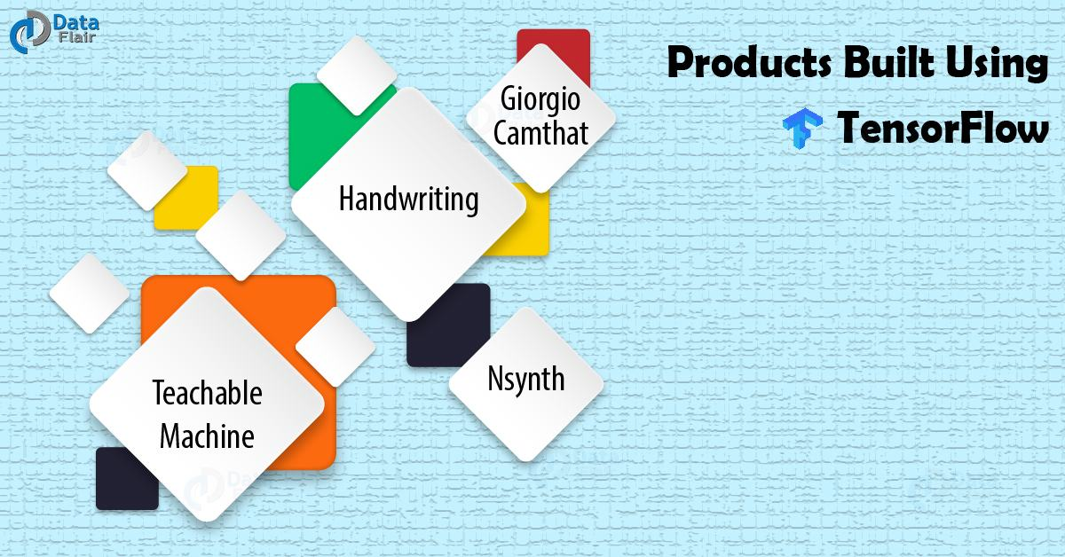
TensorFlow Interview Questions and Answers- Products Built Using TensorFlow
Teachable Machine
Nsynth
Handwriting
Giorgio Camthat
Q23. What are some advantages of TensorFlow over other libraries?
Debugging facility, scalability, visualization of data, pipelining and many more.
Q24. How can you make sure that overfitting situation is not arriving with a model you are using?
Users need to make sure that their model is simple and not have any complex statement. Variance takes into the account and the noise eliminates from the model data. Techniques like k-fold and LASSO can also help.
Q25. What exactly do you know about a ROC curve and its working?
ROC or region of convergence used to reflect data rates which classify as true positive and false positive. Represented in the form of graphs, it can use as a proximity to swap operations related to different algorithms.
Q26. In the machine learning context, how useful and reliable Bayes’ theorem is?
Baye’s theorem is useful for determining the probability of an event, obtained by dividing the actual positive rate by the false positive rate. Some of the very complex questions and challenges can solve using a simple approach and eliminated with the help of this theorem.
Q27. What difference do you find in Type I and Type II errors?
Type I error means a false positive value while Type II error means a false negative.
Q28. What would be your strategy to handle a situation indicating an imbalanced dataset?
This usually occurs when a vast set of data keep in a single class. Sampling the dataset again is one of the possible solutions and the other one being the migration of data to parallel classes. The dataset should not be damaged.
Q29. What do you know about supervised and unsupervised machine learning?
Supervised learning consists of labelled data which is not necessarily present in unsupervised learning.
Q30. In machine learning based on TensorFlow, what is more important among the performance or the accuracy of a model?
It depends on the overall experience. Both of them have an equal weightage although accuracy is most important in most of the models.

Q1:
How to obtain the value of a Tensor object in TensorFlow?
Entry

 TensorFlow 30

Answer

In TensorFlow 1.x, the easiest way to evaluate the actual value of a Tensor object is to pass it to the Session.run() method, or call Tensor.eval() when you have a default session (i.e. in a with tf.Session() block).

matrix1 = tf.constant([[3., 3.]])
matrix2 = tf.constant([[2.],[2.]])
product = tf.matmul(matrix1, matrix2)
with tf.Session() as sess:
print(sess.run(product))
print (product.eval())[[12.]][[12.]]

In Tensorflow 2.x (or in Eager mode environment) you can call numpy() method:

import tensorflow as tf

matrix1 = tf.constant([[3., 3.0]])
matrix2 = tf.constant([[2.0],[2.0]])
product = tf.matmul(matrix1, matrix2)
print(product.numpy()) [[12.]]

Having Machine Learning, Data Science or Python Interview? Check 30 TensorFlow Interview Questions
Source: stackoverflow.com

Q2:
Complete the code below to construct and fit the required model, then visualize the final architecture and learning process using TensorBoard
Junior

TensorFlow 30

Problem
import tensorflow as tf
# Define log folder of tensorboard
log_folder = 'logs'
# Import and prepare dataset
mnist = tf.keras.datasets.mnist(X_train, y_train), (X_test, y_test) = mnist.load_data()
X_train, X_test = X_train / 255.0, X_test / 255.0
print('Training Dataset Shape: {}'.format(X_train.shape))print('No. of Training Dataset Samples: {}'.format(len(X_test)))print('Test Dataset Shape: {}'.format(X_test.shape))print('No. of Test Dataset Samples: {}'.format(len(y_test)))
# 1 .Define model
model = keras.models.Sequential()# ...# ...
# 2. Configure Tensorboard
log_dir = "logs/fit/" + datetime.datetime.now().strftime("%Y%m%d-%H%M%S")# ...# ...
# 3. Compile and train model# ...# ...
# 4. Show TensorBoard# ...# ...
Output:
Training Dataset Shape: (60000, 28, 28)
No. of Training Dataset Samples: 10000
Test Dataset Shape: (10000, 28, 28)
No. of Test Dataset Samples: 10000

The neural network must have the following architecture:

  - One Flatten() layer.
  - One Dense layer with 512 neurons using a ReLU as the activation function.
  - A Dropout layer with the probability of retaining the unit of 20%.
  - A final Dense layer, that computes the probability scores via the softmax function, for each of the 10 output labels.

Place the logs of TensorBoard in a timestamped subdirectory to allow easy selection of different training runs and create the appropriate callbacks that ensure that logs are created and stored. Additionally, enable histogram computation for every epoch.

Compile and train the model using stochastic gradient descent with the objective function sparse_categorical_crossentropy and 10 epochs.

Start TensorBoard through the command line or within a notebook experience. The two interfaces are generally the same. In notebooks, use the %tensorboard line magic. On the command line, run the same command without "%". Show and explain the dashboards.

Show the losses and the final architecture on TensorBoard.

Answer

Create required model

model = tf.keras.models.Sequential()

# Create model
model.add(tf.keras.layers.Flatten(input_shape=(28, 28)))
model.add(tf.keras.layers.Dense(512, activation='relu'))
model.add(tf.keras.layers.Dropout(0.2))
model.add(tf.keras.layers.Dense(10, activation='softmax'))

model.summary()

Output:

Model: "sequential"
_________________________________________________________________
Layer (type) Output Shape Param #
=================================================================
flatten (Flatten) (None, 784) 0

dense (Dense) (None, 512) 401920

dropout (Dropout) (None, 512) 0

dense_1 (Dense) (None, 10) 5130

=================================================================
Total params: 407,050
Trainable params: 407,050
Non-trainable params: 0
_________________________________________________________________

Configure TensorBoard

# 2. Configure Tensorboard
log_dir = "logs/fit/" + datetime.datetime.now().strftime("%Y%m%d-%H%M%S")
tensorboard_callback = tf.keras.callbacks.TensorBoard(log_dir=log_dir, histogram_freq=1)

Compile and train model

# Compile model
model.compile(optimizer='sgd',
loss='sparse_categorical_crossentropy',
metrics=['accuracy'])
# train model
model.fit(x=X_train,
y=y_train,
epochs=10,
validation_data=(X_test, y_test),
callbacks=[tensorboard_callback])

Output:

Epoch 1/10
1875/1875 [==============================] - 9s 5ms/step - loss: 0.6415 - accuracy: 0.8337 - val_loss: 0.3472 - val_accuracy: 0.9066
Epoch 2/10
1875/1875 [==============================] - 9s 5ms/step - loss: 0.3460 - accuracy: 0.9028 - val_loss: 0.2817 - val_accuracy: 0.9247
Epoch 3/10
1875/1875 [==============================] - 8s 4ms/step - loss: 0.2936 - accuracy: 0.9180 - val_loss: 0.2487 - val_accuracy: 0.9309
Epoch 4/10
1875/1875 [==============================] - 8s 4ms/step - loss: 0.2610 - accuracy: 0.9259 - val_loss: 0.2245 - val_accuracy: 0.9392
Epoch 5/10
1875/1875 [==============================] - 9s 5ms/step - loss: 0.2346 - accuracy: 0.9337 - val_loss: 0.2038 - val_accuracy: 0.9435
Epoch 6/10
1875/1875 [==============================] - 12s 6ms/step - loss: 0.2132 - accuracy: 0.9400 - val_loss: 0.1894 - val_accuracy: 0.9468
Epoch 7/10
1875/1875 [==============================] - 12s 6ms/step - loss: 0.1968 - accuracy: 0.9458 - val_loss: 0.1749 - val_accuracy: 0.9509
Epoch 8/10
1875/1875 [==============================] - 10s 5ms/step - loss: 0.1843 - accuracy: 0.9485 - val_loss: 0.1639 - val_accuracy: 0.9540
Epoch 9/10
1875/1875 [==============================] - 11s 6ms/step - loss: 0.1708 - accuracy: 0.9524 - val_loss: 0.1544 - val_accuracy: 0.9557
Epoch 10/10
1875/1875 [==============================] - 11s 6ms/step - loss: 0.1606 - accuracy: 0.9557 - val_loss: 0.1453 - val_accuracy: 0.9588
<keras.callbacks.History at 0x7f2f007d7750>

Show TensorBoard

%load_ext tensorboard # (On Jupyter notebook or Colab)%tensorboard --logdir logs/fit

Show model losses and final architecture.

The Scalars tab shows changes in the loss and metrics over the epochs.

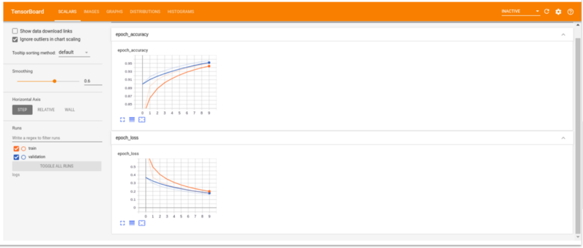

The Graphs tab shows the model's layers. We can use this to check if the architecture of the model looks as intended. To see the model select the keras tag. For this example, you’ll see a collapsed Sequential node Double-click the node to see the model’s structure:

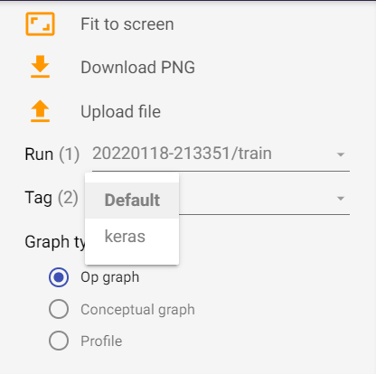

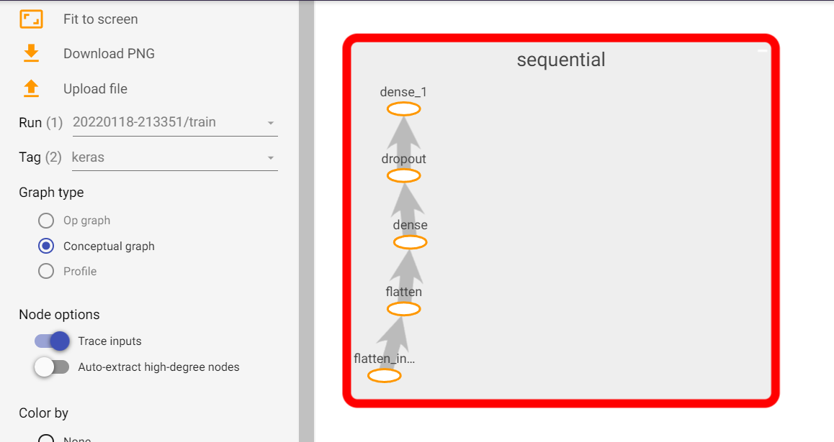

Having Machine Learning, Data Science or Python Interview? Check 30 TensorFlow Interview Questions
Source: neptune.ai

Q3:
Compute the batch inner product in TensorFlow
Junior

TensorFlow 30

Problem
I have two tensors:
- a = [batch_size, dim],

b = [batch_size, dim].

I want to do inner product for every pair in the batch, generating c = [batch_size, 1], where c[i,0]=a[i,:].T*b[i,:]. How?
Answer
In TensorFlow, there is no native .dot_product method. However, a dot product between two vectors is just element-wise multiply summed, so the following example works:
import tensorflow as tf

a = tf.constant([[1,2,3],[4,5,6]])
b = tf.constant([[2,3,4],[5,6,7]])

c = tf.reduce_sum( tf.multiply( a, b ), 1)print(c.numpy())# [20 92]
Taking the diagonal of tf.tensordot also does what you want, if you set the axes to [[1], [1]]:
d = tf.linalg.diag_part(tf.tensordot( a, b, axes=[[1],[1]]))print(d.numpy())# [20 92]
Having Machine Learning, Data Science or Python Interview? Check 30 TensorFlow Interview Questions
Source: datascience.stackexchange.com

Q4:
Construct the required data pipeline with TensorFlow
Junior

TensorFlow 30

Problem
Given the following dataset, make a data pipeline that:
- Filter the data for only positive values.
- Multiplies the data value by 2.
- Shuffle the data with buffer_size = 2.
Print the initial and the final elements of the dataset to verify the results.
dataset = [12,15,67,-56,78,90,25,-890,-45,67,90,45,34,-100,300]
Answer

Print initial dataframe

import tensorflow as tf
tf_dataset = tf.data.Dataset.from_tensor_slices(dataset)
for i in tf_dataset:
print(i.numpy())

Output:

12
15
67
-56
78
90
25
-890
-45
67
90
45
34
-100
300

Make data pipeline and print final dataset

tf_dataset_new = tf_dataset.filter(lambda x: x>0).map(lambda a: a*2).shuffle(2)
for i in tf_dataset_new:
print(i.numpy())

Output: (it could vary given randomness effects)

30
134
24
180
50
156
134
180
90
600
68

Having Machine Learning, Data Science or Python Interview? Check 30 TensorFlow Interview Questions
Source: medium.com

Q5:
How would you save an entire model in tensorflow.keras?
Junior

TensorFlow 30

Answer
To save a model's architecture, weights, and training configuration in a single file/folder we can use two different file formats: SavedModel and HDF5.

SavedModel: Models saved in this format can be restored using tf.keras.models.load_model and are compatible with TensorFlow Serving.

# Create and train a new model instance.
model = create_model()
model.fit(train_images, train_labels, epochs=5)
# Save the entire model as a SavedModel.
!mkdir -p saved_model
model.save('saved_model/my_model')

The SavedModel format is a directory containing a protobuf binary and a TensorFlow checkpoint.

HDF5 format: it's a save format using the HDF5 standard.

# Create and train a new model instance.
model = create_model()
model.fit(train_images, train_labels, epochs=5)

# Save the entire model to a HDF5 file.
model.save('my_model.h5')

Having Machine Learning, Data Science or Python Interview? Check 30 TensorFlow Interview Questions
Source: www.tensorflow.org
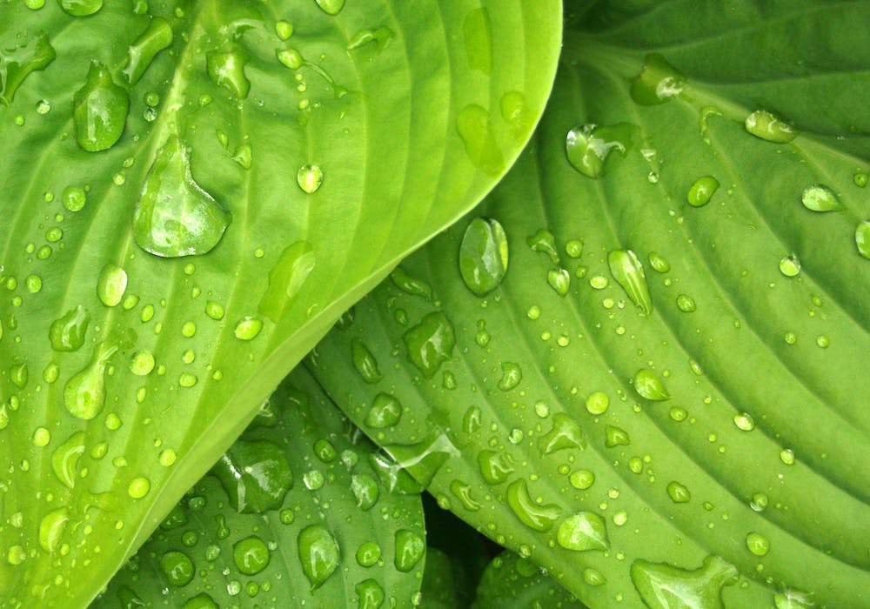
17 Gradient Descent Interview Questions Every Data Analyst And ML Engineer Must Know

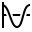 Gradient Descent 28

Q6:
In the context of merging tensors, what's the difference between tf.concat and tf.stack?
Junior

TensorFlow 30

Answer
Merging refers to merging multiple tensors into one tensor in a certain dimension. There are two kinds of Merging-concatenation and stacking:

tf.concat directly merges data on existing dimensions and does not create a new dimension. The only constraint is that the length of the non-concatenated dimensions must be the same.

tf.stack create a new dimension when merging data, it uses the parameter axis to specify where to insert the new dimension. When an axis is a positive number, it will insert a new dimension in front of axis. When the axis is negative, it will insert a new dimension in the next position. tf.stack also needs to meet the merging conditions of tensor stacking: it requires all merged tensors to have the same shape before they are merged.

import tensorflow as tf
tf.random.set_seed(42)

a = tf.random.normal([1,2,3])
b = tf.random.normal([2,2,3])
c = tf.concat([a,b], axis=0)print("c:", c)# c: tf.Tensor(# [[ 0.73423964 0.99546355 0.3393789 ]# [-0.8285848 1.3671659 1.2136413 ]]## [[-0.88899225 0.1333008 -0.48107582]# [ 0.36787292 -0.802009 -0.405421 ]]## [[-0.87827003 0.4933785 -0.20411207]# [ 0.7755407 -1.7382799 -0.10844299]]], shape=(3, 2, 3), dtype=float32)

a = tf.random.normal([2,3])
b = tf.random.normal([2,3])
d = tf.stack([a,b], axis = -1)print("d:", d)# d: tf.Tensor(# [[[ 0.20421563 1.5475597 ]# [-0.26615778 1.1176629 ]# [-0.76890045 -0.9775718 ]]## [[-0.36246812 -0.22080888]# [ 0.9352817 -1.5796733 ]# [-0.9569862 -0.34479442]]], shape=(2, 3, 2), dtype=float32)
Having Machine Learning, Data Science or Python Interview? Check 30 TensorFlow Interview Questions
Source: medium.com

Q7:
Using TensorFlow, get unique elements and their indices from x array.
Junior

TensorFlow 30

Problem
import numpy as np
_x = np.array([1, 2, 6, 4, 2, 3, 2])
Answer
- Convert numpy array to tensor with tf.convert_to_tensor()
- Use tf.unique() function to return the unique elements and its index.
import numpy as npimport tensorflow as tf

_x = np.array([1, 2, 6, 4, 2, 3, 2, 4, 1,5 ,6,8, 33 ])
x = tf.convert_to_tensor(_x)

out, indices = tf.unique(x)print(out.numpy())print(indices.numpy())# [ 1 2 6 4 3 5 8 33]# [0 1 2 3 1 4 1 3 0 5 2 6 7]
The indices have the same size as _x and contain the index of each value of _x in the unique out tensor.
Having Machine Learning, Data Science or Python Interview? Check 30 TensorFlow Interview Questions
Source: github.com

Q8:
What is the default method of variable initialisation in tf.get_variable()?
Junior

TensorFlow 30

Answer
If the initializer is None, the default initializer passed in the variable scope will be used. If that one is None too, a glorot_uniform_initializer will be used. The glorot_uniform_initializer function, initializes values from a uniform distribution.
Having Machine Learning, Data Science or Python Interview? Check 30 TensorFlow Interview Questions
Source: stackoverflow.com

Optimisation 30

 Bias & Variance 14

Keras 62

 Searching 24

 Julia 50

NumPy 39

Gradient Descent 28

Cost Function 13

Probability 34

Pandas 68

Check FullStack.Cafe - 3877 Full-Stack, Coding & System Design Questions and Answers

Q9:
What is the difference between Dataset.from_tensors and Dataset.from_tensor_slices and when would you use each one?
Junior

TensorFlow 30

Answer

from_tensors combines the input and returns a dataset with a single element; can be used to construct a larger dataset from several small datasets, i.e., the size (length) of the final dataset becomes larger;

>>> t = tf.constant([[1, 2], [3, 4]])>>> ds = tf.data.Dataset.from_tensors(t)>>> [x for x in ds]
[<tf.Tensor: shape=(2, 2), dtype=int32, numpy=
array([[1, 2],
[3, 4]], dtype=int32)>]

from_tensor_slices create a dataset with a separate element for each row of the input tensor; can be used to combine different elements into one dataset, e.g., combine features and labels into one dataset. That is, the dataset becomes "wider".

>>> t = tf.constant([[1, 2], [3, 4]])>>> ds = tf.data.Dataset.from_tensor_slices(t)>>> [x for x in ds]
[<tf.Tensor: shape=(2,), dtype=int32, numpy=array([1, 2], dtype=int32)>,
<tf.Tensor: shape=(2,), dtype=int32, numpy=array([3, 4], dtype=int32)>]

Having Machine Learning, Data Science or Python Interview? Check 30 TensorFlow Interview Questions
Source: stackoverflow.com

27 Julia Programming Interview Questions (SOLVED) for ML Engineers

Julia 50

Q10:
Complete the code below to construct and evaluate a Convolutional Network in TensorFlow
Mid

TensorFlow 30

Problem
import tensorflow as tf from tensorflow import keras as ks

mnist_fashion = ks.datasets.fashion_mnist(training_images, training_labels), (test_images, test_labels) = mnist_fashion.load_data()
# Scale values
training_images = training_images / 255.0
test_images = test_images / 255.0

training_images = training_images.reshape((60000, 28, 28, 1))
test_images = test_images.reshape((10000, 28, 28, 1))print('Training Dataset Shape: {}'.format(training_images.shape))print('No. of Training Dataset Labels: {}'.format(len(training_labels)))print('Test Dataset Shape: {}'.format(test_images.shape))print('No. of Test Dataset Labels: {}'.format(len(test_labels)))

cnn_model = ks.models.Sequential()# Write model here
Output:
Training Dataset Shape: (60000, 28, 28, 1)
No. of Training Dataset Labels: 60000
Test Dataset Shape: (10000, 28, 28, 1)
No. of Test Dataset Labels: 10000

The convolutional network must have the following architecture:

First layer: convolutional layer with ReLU activation function, with 50 convolutional kernels of shape 3 × 3.

Second layer: Max pooling layer with valid padding. This layer should take the 50 two-dimensional arrays of shape 26 x 26 as input and transform them into the same number (50) of arrays, with dimensions half that of the original (i.e., from 26 × 26 to 13 × 13 pixels).

Third layer: first this layer should convert the two-dimensional arrays of the previous layer into 1D array, then create a fully connected layer for the 50 entries using ReLU as the activation function.

Output layer: fully connected layer that provides the probability scores (with the softmax function) for each of the 10 output labels of the MNIST dataset.

Train the model using Adam optimizer with objective function sparse_categorical_crossentropy and 10 epochs.

- Evaluate the model and print the train and test losses and accuracies.
Answer

Create model as required:

cnn_model = ks.models.Sequential()
# First layer
cnn_model.add(ks.layers.Conv2D(50, (3, 3), activation='relu', input_shape=(28, 28, 1), name='Conv2D_layer'))# Second layer
cnn_model.add(ks.layers.MaxPooling2D((2, 2), name='Maxpooling_2D'))# Third layer
cnn_model.add(ks.layers.Flatten(name='Flatten'))
cnn_model.add(ks.layers.Dense(50, activation='relu',name='Hidden_layer'))# Output layer
cnn_model.add(ks.layers.Dense(10, activation='softmax',name='Output_layer'))

cnn_model.summary()

Output:

Model: "sequential"
_________________________________________________________________
Layer (type) Output Shape Param #
=================================================================
Conv2D_layer (Conv2D) (None, 26, 26, 50) 500

Maxpooling_2D (MaxPooling2D (None, 13, 13, 50) 0
)

Flatten (Flatten) (None, 8450) 0

Hidden_layer (Dense) (None, 50) 422550

Output_layer (Dense) (None, 10) 510

=================================================================
Total params: 423,560
Trainable params: 423,560
Non-trainable params: 0
_________________________________________________________________

Compile and train model:

cnn_model.compile(optimizer='adam', loss='sparse_categorical_crossentropy', metrics=['accuracy'])
cnn_model.fit(training_images, training_labels, epochs=10)

Output:

Epoch 1/10
1875/1875 [==============================] - 40s 21ms/step - loss: 0.3958 - accuracy: 0.8603
Epoch 2/10
1875/1875 [==============================] - 38s 20ms/step - loss: 0.2718 - accuracy: 0.9025
Epoch 3/10
1875/1875 [==============================] - 38s 20ms/step - loss: 0.2306 - accuracy: 0.9156
Epoch 4/10
1875/1875 [==============================] - 38s 20ms/step - loss: 0.2007 - accuracy: 0.9258
Epoch 5/10
1875/1875 [==============================] - 38s 20ms/step - loss: 0.1745 - accuracy: 0.9352
Epoch 6/10
1875/1875 [==============================] - 38s 20ms/step - loss: 0.1539 - accuracy: 0.9430
Epoch 7/10
1875/1875 [==============================] - 38s 20ms/step - loss: 0.1370 - accuracy: 0.9494
Epoch 8/10
1875/1875 [==============================] - 38s 20ms/step - loss: 0.1196 - accuracy: 0.9561
Epoch 9/10
1875/1875 [==============================] - 38s 20ms/step - loss: 0.1051 - accuracy: 0.9611
Epoch 10/10
1875/1875 [==============================] - 38s 20ms/step - loss: 0.0932 - accuracy: 0.9658
<keras.callbacks.History at 0x7fc5c8ff2650>

Model evaluation:

# Training evaluation
training_loss, training_accuracy = cnn_model.evaluate(training_images, training_labels)print('Training Accuracy {}'.format(round(float(training_accuracy), 2)))
# Test evaluation
test_loss, test_accuracy = cnn_model.evaluate(test_images, test_labels)print('Test Accuracy {}'.format(round(float(test_accuracy), 2)))

Output:

1875/1875 [==============================] - 13s 7ms/step - loss: 0.0824 - accuracy: 0.9692
Training Accuracy 0.97
313/313 [==============================] - 2s 7ms/step - loss: 0.3182 - accuracy: 0.9095
Test Accuracy 0.91

Having Machine Learning, Data Science or Python Interview? Check 30 TensorFlow Interview Questions
Source: www.amazon.com

Q11:
Compute the gradients using TensorFlow
Mid

TensorFlow 30

Problem
Given
y = x^2 ,\ z = y^2y=x2, z=y2
Compute
\frac{\partial z}{\partial x} \, , \frac{\partial y}{\partial x}∂x∂z​,∂x∂y​
at x = 3.
Answer
In TensorFlow, tf.GradientTape is an API for automatic differentiation, it computes the gradient of computation with respect to its input variables. Tensorflow records all operations executed inside the context of a tf.GradientTape onto a tape.
import tensorflow as tf

x = tf.constant(3.0)with tf.GradientTape(persistent=True) as t:
t.watch(x) # Ensures that `tensor` is being traced by this tape.
y = x * x
z = y * y
dz_dx = t.gradient(z, x) # 108.0 (4*x^3 at x = 3)
dy_dx = t.gradient(y, x) # 6.0print("dz/dx=", dz_dx.numpy())print("dy/dx=", dy_dx.numpy())del t # Drop the reference to the tape
Output:
dz/dx= 108.0
dy/dx= 6.0
Having Machine Learning, Data Science or Python Interview? Check 30 TensorFlow Interview Questions
Source: github.com

Q12:
Convert the Python function to an equivalent graph in TensorFlow
Mid

TensorFlow 30

Problem
Consider:
import tensorflow as tf
def simple_relu(x):
print(" -RELU function- ")
if tf.greater(x, 0):
return x
else:
return 0
print("Example 1: ", simple_relu(1))print("Example 2: ", simple_relu(-1))
Expected output:
-RELU function-
Example 1: 1
-RELU function-
Example 2: 0
Answer
We can use the statement tf.function to convert a Python function to an equivalent graph either as a direct call or as a decorator, but in practice, getting tf.function or a graph to work correctly can be tricky. By default, the code it's executed as a graph, so if we want to reproduce an exact Python function, we need to enable eager execution first (available in TensorFlow 2.7).
tf.config.run_functions_eagerly(True)
tf_simple_relu = tf.function(simple_relu)
print("Example 1: ", tf_simple_relu(tf.constant(1)).numpy())print("Example 2: ", tf_simple_relu(tf.constant(-1)))

tf.config.run_functions_eagerly(False)
Having Machine Learning, Data Science or Python Interview? Check 30 TensorFlow Interview Questions
Source: www.tensorflow.org

Q13:
How can you use a preprocessing layer in a TensorFlow/Keras model?
Mid

TensorFlow 30

Answer
There are two ways you could be using preprocessing layers:

Make them part of the model, like this:

inputs = keras.Input(shape=input_shape)
x = preprocessing_layer(inputs)
outputs = rest_of_the_model(x)
model = keras.Model(inputs, outputs)

With this option, preprocessing will happen on device, synchronously with the rest of the model execution, meaning that it will benefit from GPU acceleration. If you're training on GPU, this is the best option for the Normalization layer, and for all image preprocessing and data augmentation layers.

Apply the layer to the tf.data.Dataset, to obtain a dataset that yields batches of preprocessed data, like this:

dataset = dataset.map(lambda x, y: (preprocessing_layer(x), y))

With this option, your preprocessing will happen on CPU, asynchronously, and will be buffered before going into the model. In addition, if you prefetch the dataset, the preprocessing will happen efficiently in parallel with training.

Having Machine Learning, Data Science or Python Interview? Check 30 TensorFlow Interview Questions
Source: www.tensorflow.org

17 Recurrent Neural Network (RNN) Interview Questions For Data Scientists and ML Engineers

RNN 17

Q14:
How would you get the gradient of the loss at a TensorFlow variable?
Mid

TensorFlow 30

Answer
In TensorFlow 2.x you can use GradientTape to achieve this. GradientTape records the gradients of any computation that happens in the context of that. Below is an example of how we might do that.
import tensorflow as tf
# Here goes the neural network weights as tf.Variable
x = tf.Variable(3.0)
# TensorFlow operations executed within the context of# a GradientTape are recorded for differentiation with tf.GradientTape() as tape:
# Doing the computation in the context of the gradient tape
# For example computing loss
y = x ** 2
# Getting the gradient of network weights w.r.t. loss
dy_dx = tape.gradient(y, x) print(dy_dx) # Returns 6
Having Machine Learning, Data Science or Python Interview? Check 30 TensorFlow Interview Questions
Source: stackoverflow.com

Q15:
What do the TensorFlow Dataset's functions cache() and prefetch() do?
Mid

TensorFlow 30

Answer

The tf.data.Dataset.cache transformation can cache a dataset, either in memory or on local storage. This will save some operations (like file opening and data reading) from being executed during each epoch. The next epochs will reuse the data cached by the cache transformation.

Prefetch overlaps the preprocessing and model execution of a training step. While the model is executing training step s, the input pipeline is reading the data for step s+1. Doing so reduces the step time to the maximum (as opposed to the sum) of the training and the time it takes to extract the data.

Having Machine Learning, Data Science or Python Interview? Check 30 TensorFlow Interview Questions
Source: stackoverflow.com

Scikit-Learn 31

R 41

Searching 24

Decision Trees 47

MLOps 30

Clustering 40

SQL 47

Statistics 58

Julia 50

NumPy 39

Check FullStack.Cafe - 3877 Full-Stack, Coding & System Design Questions and Answers

Q16:
What does this code do?
Mid

TensorFlow 30

Problem
import tensorflow as tf

x = tf.constant([[1, 1, 1], [1, 1, 1]])
tf.reduce_sum(x, 0)
tf.reduce_sum(x, 1)
tf.reduce_sum(x, [0, 1])
Answer
x has a shape of (2, 3) (two rows and three columns):
1 1 1
1 1 1

reduce_sum computes the sum of elements across specified dimensions of a tensor and by this, it reduces the input tensor.

By doing tf.reduce_sum(x, 0) the tensor is reduced along the first dimension (rows), so the result is [1, 1, 1] + [1, 1, 1] = [2, 2, 2].

By doing tf.reduce_sum(x, 1) the tensor is reduced along the second dimension (columns), so the result is [1, 1] + [1, 1] + [1, 1] = [3, 3].

By doing tf.reduce_sum(x, [0, 1]) the tensor is reduced along BOTH dimensions (rows and columns), so the result is 1 + 1 + 1 + 1 + 1 + 1 = 6 or, equivalently, [1, 1, 1] + [1, 1, 1] = [2, 2, 2], and then 2 + 2 + 2 = 6 (reduce along rows, then reduce the resulted array).

import tensorflow as tf
x = tf.constant([[1, 1, 1], [1, 1, 1]])
print(tf.reduce_sum(x, 0) )# tf.Tensor([2 2 2], shape=(3,), dtype=int32)
print(tf.reduce_sum(x, 1) )# tf.Tensor([3 3], shape=(2,), dtype=int32)
print(tf.reduce_sum(x, [0, 1]))# tf.Tensor(6, shape=(), dtype=int32)
Having Machine Learning, Data Science or Python Interview? Check 30 TensorFlow Interview Questions
Source: stackoverflow.com

Q17:
What does batch, repeat, and shuffle do with TensorFlow Dataset?
Mid

TensorFlow 30

Answer
Imagine, you have a dataset: [1, 2, 3, 4, 5, 6], then:

dataset.shuffle(buffer_size=n) will allocate a buffer of size n for picking random entries. This buffer will be connected to the source dataset; if n = 3, we could imagine it like this:

Random buffer
|
| Source dataset where all other elements live
| |
↓ ↓[1,2,3] <= [4,5,6]

Let's assume that entry 2 was taken from the random buffer. Free space is filled by the next element from the source buffer, that is 4:

2 <= [1,3,4] <= [5,6]

We continue reading till nothing is left:

1 <= [3,4,5] <= [6]5 <= [3,4,6] <= []3 <= [4,6] <= []6 <= [4] <= []4 <= [] <= []

dataset.repeat(count=0) will repeat the dataset count number of times. In the present example, as soon as all the entries are read from the dataset and you try to read the next element, the dataset will throw an error. That's where dataset.repeat() comes into play. It will re-initialize the dataset, making it again like this:

[1,2,3] <= [4,5,6]

dataset.batch(batch_size) will take first batch_size entries and make a batch out of them. So, batch size of 3 for our example dataset will produce two batch records:

[2,1,5][3,6,4]

Having Machine Learning, Data Science or Python Interview? Check 30 TensorFlow Interview Questions
Source: stackoverflow.com

17 Principal Component Analysis (PCA) Interview Questions (ANSWERED)

 PCA 17

Q18:
What is Feature Cross and how can you create them with TensorFlow?
Mid

TensorFlow 30

Answer
A Feature Cross is a synthetic feature formed by multiplying (crossing) two or more features. Crossing combinations of features can provide predictive abilities beyond what those features can provide individually.
If you suspect that two (or more) features are more meaningful when used jointly, then you can create a crossed column. A common use case for crossed columns is to cross latitude and longitude into a single categorical feature: you start by bucketing the latitude and longitude, for example into 20 buckets each, then you cross these bucketed features into a location column. This will create a 20×20 grid over some city, and each cell in the grid will correspond to one category:
import tensorflow as tf

latitude = tf.feature_column.numeric_column("latitude")
longitude = tf.feature_column.numeric_column("longitude")
bucketized_latitude = tf.feature_column.bucketized_column(latitude,
boundaries=list(np.linspace(32., 42., 20 - 1)))
bucketized_longitude = tf.feature_column.bucketized_column(longitude,
boundaries=list(np.linspace(-125., -114., 20 - 1)))
location = tf.feature_column.crossed_column(
[bucketized_latitude, bucketized_longitude], hash_bucket_size=1000)
Note that crossed_column does not build the full table of all possible combinations (which could be very large). Instead, it is backed by a hashed_column, so you can choose how large the table is.
Having Machine Learning, Data Science or Python Interview? Check 30 TensorFlow Interview Questions
Source: developers.google.com

Q19:
What is the advantage of using a tensorflow.data.Dataset over a regular tensorflow.Tensor for a dataset?
Mid

TensorFlow 30

Answer
The main advantage is in domains where you can't fit all of your data into memory. However, there are performance improvements even in cases where all the data fit into memory. Two reasons contribute to this are because in tensorflow.data.Dataset there are two relevant methods:
- One is cache(), where some operations (like file opening and data reading) will be cached and performed only in the first epoch. This will save such operations from being executed during each epoch reducing execution time.

Another one is prefetch(): while the model is being trained on a batch in the GPU, the CPU loads and prepares the next batch. This can help save a lot of time.

Some other capabilities are allowing for the vectorization of user-defined functions (e.g. for data augmentation) and their parallelization.
Having Machine Learning, Data Science or Python Interview? Check 30 TensorFlow Interview Questions
Source: www.tensorflow.org

Q20:
What's the difference between tf.Variable and tf.get_variable?
Mid

TensorFlow 30

Answer
- tf.get_variable gets an existing variable with specified parameters from the graph, and if it doesn't exist, creates a new one. This feature it will make it way easier to refactor your code if you need to share variables at any time, e.g. in a multi-gpu setting.
- tf.Variable will always create a new variable and requires that an initial value to be specified. Is said to be is lower-level: at some point tf.get_variable() did not exist so some code still uses the low-level way.
Having Machine Learning, Data Science or Python Interview? Check 30 TensorFlow Interview Questions
Source: stackoverflow.com

Q21:
What's the difference of name_scope and variable_scope in TensorFlow?
Mid

TensorFlow 30

Answer
Let's begin with a short introduction to variable sharing: it is a mechanism in TensorFlow that allows for sharing variables accessed in different parts of the code without passing references to the variable around.
The method tf.get_variable can be used with the name of the variable as the argument to either create a new variable with such name or retrieve the one that was created before. This is different from using the tf.Variable constructor which will create a new variable every time it is called (and potentially add a suffix to the variable name if a variable with such name already exists).
It is for the purpose of the variable sharing mechanism that a separate type of scope (variable scope) was introduced. As a result, we end up having two different types of scopes:
- name scope, created using tf.name_scope.
- variable scope, created using tf.variable_scope.
Both scopes have the same effect on all operations as well as variables created using tf.Variable, i.e., the scope will be added as a prefix to the operation or variable name. However, their difference relies in that name scope is ignored by tf.get_variable.
In other words, tf.variable_scope() adds a prefix to the names of all ops and variables (no matter if you create them with tf.get_variable or tf.Variable), but tf.name_scope() ignores variables created with tf.get_variable() because it assumes that you know which variable and in which scope you wanted to use.
Having Machine Learning, Data Science or Python Interview? Check 30 TensorFlow Interview Questions
Source: stackoverflow.com

21 Anomaly Detection Interview Questions For Data Analysts & ML Engineers

Anomaly Detection 47

Q22:
Why would you bucket a feature and how can you do it with TensorFlow?
Mid

TensorFlow 30

Answer
Often, you don’t want to feed a number directly into the model, but instead, split its value into different categories based on numerical ranges. For example, consider raw data that represents the year a house was built. Instead of representing that year as a scalar numeric column, we could split the year into the following four buckets:
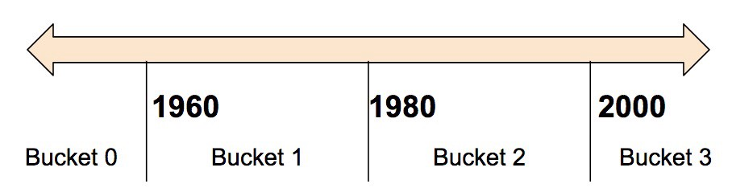
The model will represent the buckets as follows:
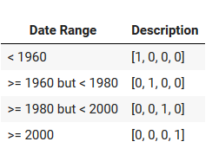
Notice that the categorization splits a single input number into a four-element vector. Therefore, the model now can learn four individual weights rather than just one; four weights create a richer model than one weight. More importantly, bucketing enables the model to clearly distinguish between different year categories since only one of the elements is set (1) and the other three elements are cleared (0).
For example, when we just use a single number (a year) as input, a linear model can only learn a linear relationship. So, bucketing provides the model with additional flexibility that the model can use to learn.
The following code demonstrates how to create a bucketed feature:
import pandas as pdimport tensorflow as tffrom tensorflow import feature_columnfrom tensorflow.keras import layers

data = {'years': [1955,1921,1963,1988,1974,1954,1995,1941,1984,1952]}
df = pd.DataFrame(data)

years = feature_column.numeric_column("years")
marks_buckets = feature_column.bucketized_column(years, boundaries=[1930,1940,1950,1960,1970,1980,1990])
# Show marks_buckets
feature_layer = layers.DenseFeatures(marks_buckets)print(feature_layer(data).numpy())
[[0. 0. 0. 1. 0. 0. 0. 0.]
[1. 0. 0. 0. 0. 0. 0. 0.]
[0. 0. 0. 0. 1. 0. 0. 0.]
[0. 0. 0. 0. 0. 0. 1. 0.]
[0. 0. 0. 0. 0. 1. 0. 0.]
[0. 0. 0. 1. 0. 0. 0. 0.]
[0. 0. 0. 0. 0. 0. 0. 1.]
[0. 0. 1. 0. 0. 0. 0. 0.]
[0. 0. 0. 0. 0. 0. 1. 0.]
[0. 0. 0. 1. 0. 0. 0. 0.]]

1. What is Tensorflow
Tensorflow is an open-source package or library developed by Google and anyone under the Apache License 2.0, and it is used to create artificial intelligence and machine learning models.

2. What are Tensors?
Tensors are pretty similar to the arrays in any programming language, but they can be in a higher dimension (n-dimension), and this will depend on the dataset you are trying to deal with.

3. What is TensorBoard?
TensorBoard is a tool provided by Tensorflow and used for visualization and measuring the performance of your machine and deep learning models such as the accuracy and the loss and many other matrices.

4. What are the benefits of using Tensorflow?
1- Tensorflow is open-source and has a large community to support you.
2- Tensorflow can be run on any platform.
3- Tensorflow is a scalable framework so you can develop anything you want.

5. What are the limitation of TensorFlow?
1- Little bit complex for beginners to start using it.
2- Tensorflow only support the GPU of NVIDIA
3- Tensorflow is slow compared to other AI frameworks

6. What are the different types of Tensors?
When you perform any action using Tensorflow that involves the manipulation of Tensors, you will use mainly four types of Tensors: tf.Variable, tf.constant, tf.placeholder, tf.SparseTensor. If you want to learn more you can further check out these best TensorFlow courses from Udemy and Coursera.
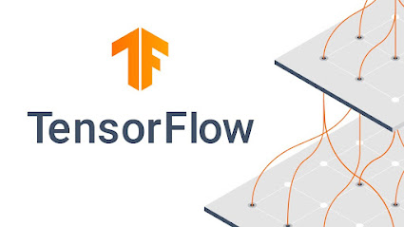

7. How data is loaded in Tensorflow
There are two ways to load your data in Tensorflow: to load data into memory as a single array unit and to load data in the pipeline by using built-in APIs.

8. What does the Tensorflow manager do?
The Tensorflow manager is responsible for many things such as loading and unloading and also the lifetime management of all servable objects.

Powered By

Top 5 Books to Learn DevOps for Developers - Best of Lot

9. What are the programming languages supported in Tensorflow?
Tensorflow supports many programming languages, but the most used one among developers is Python because of its easiness. You can use it in Java, Go, Swift, JavaScript, and much more.

10. Name some products developed using Tensorflow
Tensorflow can create a machine learning and deep learning models, and that's why many companies use this framework to develop products like Speech recognition, object detection, self-driving cars, and more.

11. The differences between supervised & unsupervised learning?
Tensorflow can solve the problem of both supervised learning which is training the model on a labeled dataset, and unsupervised learning is training the model on unlabeled data.

12. What is overfitting in Tensorflow?
Overfitting happens when your machine learning model is overtrained on the data you've provided, so when you try to see how your model works on unseen data, it will perform so much worse than you expected.

13. What are neural networks?
As the name suggests, the neural network is some algorithm that mimics how the human brain works to perform actions like face recognition and object detections, and anything that requires artificial intelligence.

14. Can you use the TensorBoard without installing Tensorflow?
The simple answer is yes. You can directly install the TensorBoard using either conda or pip, then using it in a standalone mode with redacted features, and there are many plugins supported.

15. What is the activation function?
The activation function is an essential part of the deep learning model, and it decides whether the neuron should be activated or not. The purpose is to introduce non-linearity into the output of the neuron.
Read more: https://javarevisited.blogspot.com/2021/10/top-15-tensorflow-interview-questions.html#ixzz7m2Lp8GLI

1. What is TensorFlow?
TensorFlow is an open-source framework developed by Google for machine learning. This library allows to create, execute the algorithms which are user-friendly and suitable for a system.
It allows eager execution through the visualization, which it provides with the help of TensorBoard. It eases the calculations, thus reducing the complexity of computations.

2. What are tensors?
Tensors are the representation of multi-dimensional arrays or vectors. It is the combination of digits, representing the data in its coded form. The representation of tensors is in the form of edges. The data stored in vectors have a shape, which also defines the dimensionality of a matrix.
The tensors represent scalars as well as vectors. A tensor is an object having three unique properties: Name, shape, and dtype. The graphs also contain the operations of a tensor.
Any object which is present in the model initially is called a feature vector. Graphs contain a feature vector that helps to map tensors.

3. How many types of Tensors are there?
There are three types of tensors, namely: constants, variables, and placeholders.
1. Constants: It represents the node that stores only one value, which does not change with time. The parameters in sync with constant are value, name=’Const’, shape=None, dtype=None. Its denotation is tf.constant.
2. Variables: It represents the different values at each run; hence it is named as a variable. It prints the most current value when executed. Its denotation is tf.variable.
3. Placeholders: The creation of nodes for these tensors takes place, but data assignment takes place later. The assignment takes place when the input depends on an external entity. Hence, this tensor requires the only data type and shape defined initially.
Play Videox

4. What are TensorFlow servables? Also, explain TensorFlow Serving.
It is the central unit in the architecture of TensorFlow Serving, which serves as objects used by the clients in the process of computations. It offers flexible size and granularity. It consists of one lookup table to a tuple of interference models.
Typical servables include the following:
a TensorFlow SavedModelBundle (tensorflow::Session)
a lookup table for embedding or vocabulary lookups
It improves the functionality and performance with the help of improvements:
- streaming results
- experimental APIs
- asynchronous modes of operation
TensorFlow serving allows the system of TensorFlow, which we use for machine learning. It allows us to create, use, and execute the algorithms for the system a user wants to build. It extends its functionality with the help of collaborating environments such as TensorBoard.

5. Explain the advantages and disadvantages of TensorFlow.
Advantages:
- Open-source Platform
- Data visualization
- Parallelism
- Scalable
- Compatible
- Keras friendly
- Graphical support
- Support for OS
Disadvantages:
- Symbolic Loops
- Dependency
- Frequent updates
- Architectural limitations
- Slow speed
- GPU support
- Support for Windows
- inconsistent

6. What are the variables in TensorFlow?
The objects in TensorFlow which can change the value according to the change in the state are known as variables. It prints the recent most value at the time of execution. The life of a variable starts when tf.variable.initializer initializes it.
And the life of the variable ends with the collapse of a session. It provides the state of an object which changes with time hence holds the recent updated value. It requires initialization with a declaration to work with the model.

Frequently Asked TensorFlow Interview Questions and Answers for Beginners

7. What are TensorBoard visualizations?
TensorFlow allows the formulation of graphs for the models, which is the collection of tensors and nodes.
TensorBoard helps to perform the visualization through the graphs. TensorBoard is a collection of web services that help in debugging, eager execution, and a dynamic runtime. It’s a tool that eases the debugging with its functionality and is the sole method of visualization.

8. Explain the code.
model = tf.keras.Sequential ([
tf.keras.layers.Dense(10, activation=tf.nn.relu, input_shape=(4,)),
tf.keras.layers.Dense(10, activation=tf.nn.relu),
tf.keras.layers.Dense(3)
])
Keras API helps to model the complexity of a system and provide an easy way to perform operations. It passes the data through the ReLU layer, which is an activation layer. Keras passes the data through two Dense layers with 10 nodes each, and an output layer with 3 nodes representing our label predictions.

9. Explain TensorFlow loss and optimizer.
The computation of the difference between the predicted and actual value using a function is known as the loss function. The value of this function defines the amount of difference in values.
Hence at each run, the Gradient Function optimizer checks for the changes which can help to improve the model. With the help of optimizer, the loss reduces to the minimum and attains maximum accuracy.

10. Why and how normalization is achieved in TensorFlow?
The TensorFlow system expects all inputs in a dimension. But the dataset we work does not contain significant values. Hence the normalization of data is required. We perform the batch normalization of the data.
data = tf.nn.batch_norm_with_global_normalization()

11. What are estimators?
Estimators are the high-level API, which helps to reduce the code length for training, evaluation, and prediction. It is of two types: pre-made estimators and estimators (base class).

12. What is epoch?
It defines the total time frame of training the data. Often many epochs run to train the dataset of 10s of thousands of entries. Using many epochs allows us to make a better generalization for the system.

13. Name some applications of TensorFlow.
The areas in which TensorFlow usage allows to create systems are:
- Image Recognition
- Voice Recognition
- Video Detection
- Text-based applications

14. Why are NumPy and Matplotlib used with TensorFlow?
NumPy supports multi-dimensional arrays, matrices. Hence it deals with the data in the form of arrays.
Matplotlib handles all the graphical representation in TensorFlow. It supports the MATLAB interface.

15. Explain the following example?
for epoch in range(training_epochs):
for (x, y) in zip(train_X, train_Y):
sess.run(optimizer, feed_dict = {X:x, Y:y})
The initializer runs and feeds all the training data through the epochs.

16. What is the MNIST dataset?
MNIST (Modified National Institute of Standards and Technology database) is the handwriting recognition dataset that helps to perform visual image recognition.
The dataset contains the greyscale images of the 28X28 dimension. There are 60,000 images for the training and 10,000 images for testing purposes.

17. Difference between CNN and RNN.
CNN | RNN
Convolutional Neural Network | Recurrent Neural Network
Known as the feed-forward model | For the series of data
Memoryless model | Requires memory to store previous inputs
Cannot handle sequential data | Can handle Sequential data
Used for Image recognition | Used for Text recognition
Can handle fixed length of input/ output | Can handle arbitrary lengths of input/ output
Feature compatibility is more | Feature compatibility is less
Handles permanent data | Handles temporary data

Top TensorFlow Interview Questions and Answers

18. Explain backpropagation.
After the loss calculation, the loss is given to the model for improvising the model. At each step back, the change in weights takes place which helps to reduce the loss and increase the accuracy.

19. What is embedding?
The vector representation of words is also known as word embedding. It refers to representing the words in the vector format. It helps to find the meaning of symbols so that it can make predictions.

20. How training and testing are performed?
We build each model with the help of a dataset that is either created or imported.. The dataset is divided into two portions: training and testing. Training data contains most of the values so that system gets apprehended by all types of cases.
Training data contains very few values compared to training. It tests the system for unknown values for better learning.

21. What are the activation functions?
The function which imparts the non-linear property to the output of the summation function is the activation function. The expected output represents the probability hence it restrains the value between 0 and 1.

22. What are loaders?
It manages the life cycle of servable. The loader API enables an infrastructure that is independent of data or product use cases and algorithms. Then we standardize the loader’s API for loading and unloading of servable.

23. Which Dashboards are supported by TensorFlow?
TensorFlow supports the following Dashboards:
- Scalar Dashboard
- Histogram Dashboard
- Distributer Dashboard
- Image Dashboard
- Projector
- Graph Explorer
- Audio Dashboard
- Text Dashboard

24. How deep learning and TensorFlow are related?
Deep learning is the class of machine learning which uses neural networks for its working. Hence it is also known as neural networks. TensorFlow is used for the implementation of deep learning.
Deep learning allows the system to learn the working of a system with the help of neural networks. TensorFlow helps to build such networks.

25. Explain the graph. What do these terms represent: operations and tensors?
All the complex computations in TensorFlow are implemented using graphs. Graphs are the collection of operations represented using nodes. The graph consists of nodes and edges connecting nodes.
Operations: The nodes in the graph represent operations.
Tensors: The edges in the graph represent the edges that carry weight with it.

26. State the difference between the two lines.
x = tf.constant(35, name = 'x')
y = tf.Variable(x+5, name = 'y')
print(y)
The first line declares a constant tensor that has value 35, name as x. The second line declares a variable with parameters values as x+5, name as y.

27. What are the vectors in TensorFlow?
A group of values is represented as arrays. Each value has an index representation and allows each point to be individually identified through its index position. Vectors have a magnitude and a direction.

28. What are the scalars in TensorFlow?
A scalar represents the single value, which cannot be denoted as space, i.e, it does not have directions. An entity such as temperature is a scalar.

29. Explain the term TensorFlow API.
TensorFlow has many APIs which are used for the implementation and execution of it. TensorFlow supports the following APIs:
- Python
- JavaScript
- C++
- Java
- Go
- Swift (Early Release)
- R
- Ruby
- C#

30. What is the ReLU layer?
Rectified Linear Unit Layer acts as an activation layer which activates the function having a value above a specific unit. It replaces the negative values in an image with zero, defining a linear relationship of the variable with the input. It makes the input invariant to noise; hence it is known as subsampling.

31. What is the Pooling layer?
The reduction in the size of an image takes place when data runs through the pooling layer. It aims at targeting the sections individually. It either finds the maximum value or an average of a section to reduce the size. This process is known as down-sampling.

32. What is the source?
Sources module provides the Servables, which provide one or many servable streams. For each stream, Source provides one Loader for each version. Servables can detect servables from random storage systems.
Sources manage the state of servables or versions. Sources come in use where there are delta updates between versions of servable.

33. Why is validation performed?
The input data we work on require the following points to be checked:
- The improper data type
- Out of range values
- No value
During the training, a model prepares a schema that contains the values the model should produce. Validation is done to compare the actual output with the schema.
So now when you have seen TensorFlow Interview Questions and Answers for Beginners, let’s move to Advanced TensorFlow Interview Questions and Answers.

TensorFlow Interview Questions and Answers for Experienced

1. What is dimensionality reduction?
The reduction of variables or dimensionality from the data for reducing its size and not losing the essential information. This process is known as dimensionality reduction.

2. What is an underfit and overfit condition?
The underfit condition arises when the model is not able to classify data. The situation occurs when data is not enough, or the model is linear or nonlinear.
The overfit situation arises when we train the model with a large amount of data, which leads to processing the data with noise and less accuracy. The non-linear model is the reason for overfitting.

3. Explain the concept of the ROC curve.
The ROC (Receiver Operating Characteristics) curve is the important evaluation metric which checks if the model can classify different classes of the model. The value 1 shows that it has the proper ability of classification, and 0 shows no ability of classification, and 0.5 shows no capability of classification.

4. What is the F1 score?
F1 score is the test for performance, which considers false positives and false negatives. Recall and precision help to calculate the F1 score. The calculated harmonic mean with the use of recall and precision is the f1 score.
It ranges between 0 and 1 where 0 represents the worst value and 1 is the best. It is the result of the balance between precision and recall.

5. Explain the following example.
vocab_size = 10000
model = keras.Sequential()
model.add(keras.layers.Embedding(vocab_size, 16))
model.add(keras.layers.GlobalAveragePooling1D())
model.add(keras.layers.Dense(16, activation=tf.nn.relu))
model.add(keras.layers.Dense(1, activation=tf.nn.sigmoid))
The code is for word embedding in which data is set to vectors using the embedding layer. The pooling layer converts the vector to finite length. The next 2 layers are the activation functions namely the ReLU layer and sigmoid function.

6. What is the KNN algorithm?
It is the structured algorithms to classify the data to k nearest neighbor. It does not learn from the training data. Despite this, it works on the dataset when classification occurs. It is a non-parametric algorithm that does not make any assumptions on the dataset.

7. How is the learning rate significant?
Setting a precise learning rate is critical as it helps the model to configure in different ways. Setting a low learning rate helps to learn the model with optimal weights, and a higher learning rate helps to learn the model faster with low optimal weights.

8. What does the Dense layer do?
The dense layer performs the function of the hidden layer. It passes the operation through an activation function, weights the function matrix, and creates the bias vector with the help of activation, Kernel, and bias, respectively.

9. Explain the term TensorFlow Transform.
TensorFlow Transform is used to pre-process the data over the features in the dataset. It can normalize data, convert strings, float numbers to integers. The graph for the data helps in training and serving.

10. What are type I and type II errors?
On the axis of prediction and actual result, the error can arise of two types:
1. Type I error- The error which arises when the model results as true when it has not occurred actually. It is a false positive value.
2. Type II error- The error which arises when a false hypothesis results as true in the research. It is a false negative value.

11. What happens when data misses in a dataset?
The dataset missing the files or data can either delete or recover the data using:
- Listwise Deletion
- Average or multiple Imputation
- Substitution

12. Explain the following code?
model.compile(optimizer=tf.train.AdamOptimizer(),
loss='sparse_categorical_crossentropy',
metrics=['accuracy'])
The code calculates the loss and optimizes its value using the optimizer and the unit cross entropy.

13. What is k-clustering?
The method to categorize the vectors in the k points according to their mean coordinate is known as k-clustering. It calculates k means to cluster the vectors. Initially, we randomly point out k means.
The location of a vector is found to its nearest mean, and the recalculation for mean takes place. The points are categorized after k means calculation.

Commonly asked TensorFlow Interview Questions and Answers

14. Explain Recall and Precision.
Precision and Recall are the performance metrics i.e., they give insight about the model performance.
- Precision: The quotient of true result to the actual result. It gives the percentage of true positive to the sum of a true positive and false positive.
- Recall: It is the quotient of true results to the predicted result. It gives the percentage of true positive to the sum of a true positive and false negative.

15. How is Naive Bayes theorem significant in TensorFlow?
Naive Bayes algorithm helps the models to define the probability distributions. The classification models, such as object classification etc. are built using Naive Bayes in TensorFlow.

16. What algorithms can we apply to TensorFlow?
- Linear regression
- Linear classification
- Boosted tree classification
- Boosted tree regression
- Deep learning classification

17. Explain scope with an example.
It is the process of using the variables outside the scope with the help of the name scope. The variables defined inside name_scope help to reduce the complexity of a program and its operations.
def my_op(a, b, c, name=None):
with tf.name_scope("MyOp") as scope:
a = tf.convert_to_tensor(a, name="a")
b = tf.convert_to_tensor(b, name="b")
c = tf.convert_to_tensor(c, name="c")
# Define some computation that uses `a`, `b`, and `c`.
return foo_op(..., name=scope)

18. Explain PCA.
Principal Component Analysis: We search for the variable which has a maximum variance, which helps to find the data with the higher spread. The line on which there is a maximum variance helps to incline the data over it.
This converts the 2D data into the 1D form. This technique tries to conserve the linear structure.

19. What is a one-hot encoding?
In this technique, the representation of words is done as a group of vectors of a total number of words.
For example: The man lives in the street. The arrangement of words is done in an ascending order such as in lives man street the. Now the order in which word comes in a sentence is marked 1 else 0.
Total number of words: 5 hence vector size is 5. In the end, the vectors of each word are joined to give a representation of a whole sentence.
 | In | lives | man | street | the
The | 0 | 0 | 0 | 0 | 1
Man | 0 | 0 | 1 | 0 | 0
Lives | 0 | 1 | 0 | 0 | 0
In | 1 | 0 | 0 | 0 | 0
Street | 0 | 0 | 0 | 1 | 0
This method does not work well with the large dataset and proves ineffective.

20. Name different methods of using single, multiple GPUs.
GPU can be used in the following ways:
- Device Placement Logging
- Manual Device Placement
- Optimizing TensorFlow GPU Memory
- Using a single GPU on a multi-GPU system
- Using multiple GPUs

21. What is the hashing trick in TensorFlow?
In the process of word embedding, the text is converted to a vector using the hashing trick. The hash function assigns words to a hashing space having an index. The hash function takes five parameters named as text, n, hash_function, filter, lower, and split.

22. Name the types of neural networks.
There are two types of Neural Networks namely:
- Artificial Neural Network
- Biological Neural Network

23. What are artificial neural networks?
The artificial neural network is a representation of neurons in the brain as a nodal unit. This network helps to simplify the complex issues a user faces. It reduces the problems to a user-level to solve it.
It helps to identify objects as a human does, with its algorithmic capabilities and then predict the features through labeling. We apply it to real-time operations where data is fed in any format possible.

24. Explain cross-entropy.
Cross entropy measures the performance of an event for which the probability p and q are defined for the sample of time.

25. Provide the code for manual placement of GPU.
with tf.device('/cpu:0'):
x = tf.constant([1.0, 2.0, 3.0, 4.0, 5.0, 6.0], shape=[2, 3], name='x')
y = tf.constant([1.0, 2.0, 3.0, 4.0, 5.0, 6.0], shape=[3, 2], name='y')
z = tf.matmul(x, y)
sess = tf.compat.v1.Session(config=tf.compat.v1.ConfigProto(log_device_placement=True))
print(sess.run(z))

26. What is the learning rate?
The step size in the iterations which is used to determine the minimum loss is the learning rate. It decides the value after weighing the convergence and overshooting. If the value is too low, it proceeds very slowly, and if it is high, it shows sudden diverging behavior.

27. What is a dead unit?
The neuron which does not deflects from its value during the training. This situation arises when a negative value always shows 0 after passing through the ReLU layer.

28. Name the models we use in words to vector conversion.
The models which perform word embedding are:
- Bag of words
- Skip-gram model

29. What is bias-variance decomposition?
Bias is the error that arises due to assumptions that lie far away from the real model.
Variance is the error that arises due to fluctuations in the training set.
Bias-variance decomposition is the tradeoff between the given errors to build a generalized model with minimum errors.

30. Explain the concept of logistic regression with TensorFlow.
Logistic regression is an algorithm for the categorization of data into discrete classes. The algorithm brings the non-linearity in the data with the help of a sigmoid function. It follows binary values for the classification of data.
In TensorFlow, we define the values and pass them through the sigmoid layer activation function and train it.

1. In TensorFlow, what exactly Bias and Variance are? Do you find any similarities or differences between them?
In the learning algorithms, Bias is generally considered as errors that declare their presence due to overly assumptions. These can sometimes result in the failure of the entire model and can largely affect the accuracy also in several cases. Some experts believe these errors are essential to enable learner's gain knowledge from a training point of view. On the other side, Variance is another problem that comes when the learning algorithm is quite complex. Therefore a limit is to be imposed on this.

2. When will you find the overfit condition of your model in TensorFlow?
There are variations in the training data or data that need to be verified through TensorFlow. If the variations are very large in the data, probably it could lead to this problem. The best possible solution is to remove the noise from the available data up to the possible extent.

3. What exactly do you know about Bias-Variance decomposition?
It is generally used to decompose problems such as errors that occur during learning in different algorithms. Bias keeps reducing if the data is to be made complex. Trading off the Variance and Bias are very essential to get results that are totally free from errors.
Want to become a TensorFlow Certified Professional? Visit here to learn TensorFlow Training

4. Are you familiar with a Fourier Transform?
Well, it is a mathematical concept. Basically, it is a generic method that is used for decomposing the generic functions into a superposition of other functions that are generally symmetric in nature. When it comes to finding the speeds of cycles and amplitudes, they are widely adopted in machine learning. Fourier Transformation is also used for solving some of the very complex problems of mathematics.

5. How k-means clustering is different from KNN?
K-means clustering is basically an unsupervised clustering algorithm. It is capable to tolerate some minor errors. On the other side, the KNN is a structured clustering algorithm. For reliable operations, it should be accurate and reliable. The mechanism for both seems very similar at the first glance but users need to label the data in the KNN which is not required in the k-means clustering.



6. What exactly do you know about a ROC curve and its working?
IT is basically used to reflect something very important regarding the rates which are classified as true positive rates and false-positive rates. It represents all the information in the form of graphs. Basically, it can be used as a proxy for the trade-off operations related to different algorithms.

7. What exactly Neural Networks are? What are the types of same you are familiar with?
It is basically a connection of processing elements which can be very large or very small depending on the application it is deployed for. These elements are called neurons and generally, two types of networks can be seen in this category. They are Artificial Neural Networks and Biological Neural Networks. The use of artificial neural networks is more common and generally, they are considered for creating machines which are equally powerful to human brains.

8. What are the general advantages of using Artificial Neural Networks?
They provide complete information on how to find solutions to complex problems in a stepwise manner. All the information that a network receive can easily be represented in any format. Artificial neural networks also make sure of real-time operations. In addition to this, they have excellent fault tolerance capability.

9. Compare general computers with artificial neural networks?
The artificial neural network’s information source is an example that is common in general computers. It is very necessary to choose the examples carefully as they need to be given as input to the artificial neural network. Predicting the artificial neural network outcome is not an easy job but it can be trusted for its accuracy. However, the outcomes of general computers are already well-defined and can easily be predicted.

10. What exactly do you know about Recall and Precision?
The other name of Recall is the true positive rate. Actually, it is the overall figure of positiveness a model generally claims. Precision is generally regarded as the predictive value which is positive in nature. The difference between the true positive rate the claimed positive rate can be defined with the help of both these options.

11. In the machine learning context, how useful and reliable Bayes’ theorem is according to you?
This theorem defines the probability of any event in machine learning. It represents a fixed value which is actually a mathematical calculation. This value is generally obtained by dividing the true positive rate divided by the false positive rate. In machine learning, some of the very complex problems and challenges can easily be solved and eliminated with the help of this theorem. Most of the time results provided by it are highly accurate and can easily be trusted.

12. What difference do you find in Type I and Type II errors?
Type I error is a false positive value. On the other side, Type II error is a false negative value. Type I error generally represents that something has happened when actually it doesn’t while Type II error is to representing the machine that nothing is wrong when actually something is not good.
Related Blog: Installing TensorFlow

13. In TensorFlow, what exactly the discriminative and generative methods?
All the distinctions among the different types of data can simply be learned with the help of the discriminative method. On the other side, a generative model is used for understanding a specific format of same. The tasks that can also be handled with both these approaches need to be classified in a well-defined order first.

14. What exactly do you mean by Pruning in a decision tree?
Many times it has been seen that in a cluster the predictive powers are very weak and they need to be removed. This is to cut down the overall complexity of the model or to increase the accuracy. This condition is generally considered Pruning. There is a strict limit on pruning otherwise it makes the model totally useless. The latest version available in the machine learning algorithms is Reduced error pruning.

15. What would be your strategy to handle a situation indicating an imbalanced dataset?
This situation occurs when a majority of data that is under a specific use is kept in one class only. Resampling the dataset is the best possible solution for the users. Migration of data to the parallel classes can also overcome the problem to a great extent. Users also need to make sure that a dataset is not damaged.

16. What is the application of Naïve Bayes Naïve in machine learning?
It is basically a sub-algorithm of a sub-module that defines the conditional probabilities of different components. The final results can be integrated with other possible outcomes to predict the final outcomes. It can also overcome a lot of problems which are related to unstructured data.

17. How is it possible to evaluate a logistic regression model for a user?
It is necessary for the users to fully understand the typical goals related to the concepts are. Some use cases are also to be considered for this approach.

18. What do you know about supervised and unsupervised machine learning?
One of the prime needs in supervised learning is the labeled data which is not always necessary to be present in unsupervised learning. Data labeling is important to enable the groups to handle all things in the right manner. On the other side, it is possible for the users to use data in unsupervised learning but labeling the same is not always necessary.

19. Name the two common regularizations in a machine learning approach and explain their significance to them?
These are L1 and L2 regularization. Both these have their own well-defined functions. L1 contains multiple variables that are in binary values. L2 regularization is meant for error handling and both of them largely depend on the Gaussian concept.

20. In machine learning based on TensorFlow, what is more, important to you among the performance or the accuracy of a model?
The answer to this question depends on your overall experience. Although both are important accuracy is more important in the majority of tasks. It would be good for you to boost your knowledge on nuances of machine learning to have a better reply to this question if it is asked to you in an interview.

21. What exactly F1 score is in machine learning?
It is basically a score that gives clear information regarding the overall performance of a model that is utilized for any task. The score generally varies between the two fixed values that are generally 0 and 1. The latter is regarded as the best score while 0 represents the worst performance.

22. Name the algorithm you are properly familiar with and explain everything you know about it in one minute?
Such a question basically text your information representing skills for the tasks that are technical and complex. Make sure you summarize the text properly and give the answer in a defined format. You can go with any algorithm that you have studied or practiced properly.

23. What exactly do you know about Deep learning?
It is basically related to neural networks and is generally considered as a subset of machine learning. When it comes to implementing some important principles that are related to backpropagation, this concept is applied. It is an unsupervised learning algorithm that is used for data understanding and to use neural nets properly.
Related Blog: AI & Deep Learning With TensorFlow Training

24. On a time series dataset, what type of validation technique would you prefer?
This dataset is not randomly distributed data and thus the standard techniques such as k-folds cannot be applied. Therefore a pattern-based technique would be useful here and this is because it makes sure that all the sub-tasks flow in a well-defined sequence. There are no chances of any errors that can be considered as a chronological order that creates issues related to the functionality of the model.

25. In which situation the ensemble approach is useful?
In a model, there is a need to use multiple learning algorithms. This situation needs an ensemble approach. In addition to this, there can also be a need to combine an applied part of learning algorithms for optimization or predictive performance. One of the primary aims to use this approach is to impose a limit on overfitting.

26. How can you make sure that the overfitting situation is not arriving with a model you are using?
Users need to make sure that their model is simple and is not having any complex statement. All the variance should be taken into the account and the noise should be eliminated from the model data. A cross-validation technique like k-fold is another useful method that is helpful in this matter. LASSO technique is another possible solution to this issue.

27. What exactly do you know about Kernel Trick?
All the kernel functions are involved in this trick basically. These tricks are useful to perform some advanced calculations. It is possible for users to express these functions in terms of products. Also, different algorithms can be made run effectively. the good thing is this can be done even if the dimensional data is low.

28. What if a file is corrupted or missing in a dataset?
It is possible to replace them with other values that run parallel to them. Drop and isnull are the two methods that are useful in this matter. In some special cases, it is even possible to replace them with desired values and have an error-free outcome.

29. What differences will you find in an array and a linked list?
The collection of objects in a well-defined order is generally considered an array. On the other side, a linked list is also a set of objects but they are not always necessary to be well-defined or remain in a sequence. Also, they have a pointer which is missing in the case of an array.

1. What is Deep Learning?
If you are going for a deep learning interview, you definitely know what exactly deep learning is. However, with this question the interviewee expects you to give an in-detail answer, with an example. Deep Learning involves taking large volumes of structured or unstructured data and using complex algorithms to train neural networks. It performs complex operations to extract hidden patterns and features (for instance, distinguishing the image of a cat from that of a dog).
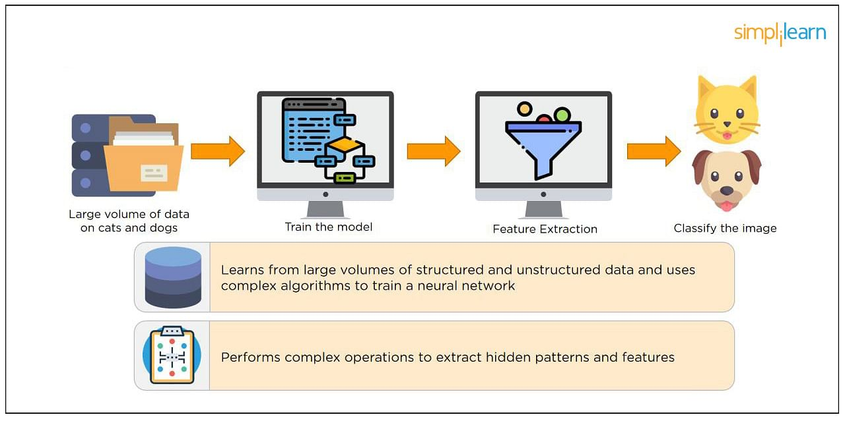

Deep Learning Course (with TensorFlow & Keras)
Master the Deep Learning Concepts and ModelsVIEW COURSE
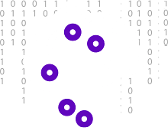

2. What is a Neural Network?
Neural Networks replicate the way humans learn, inspired by how the neurons in our brains fire, only much simpler.
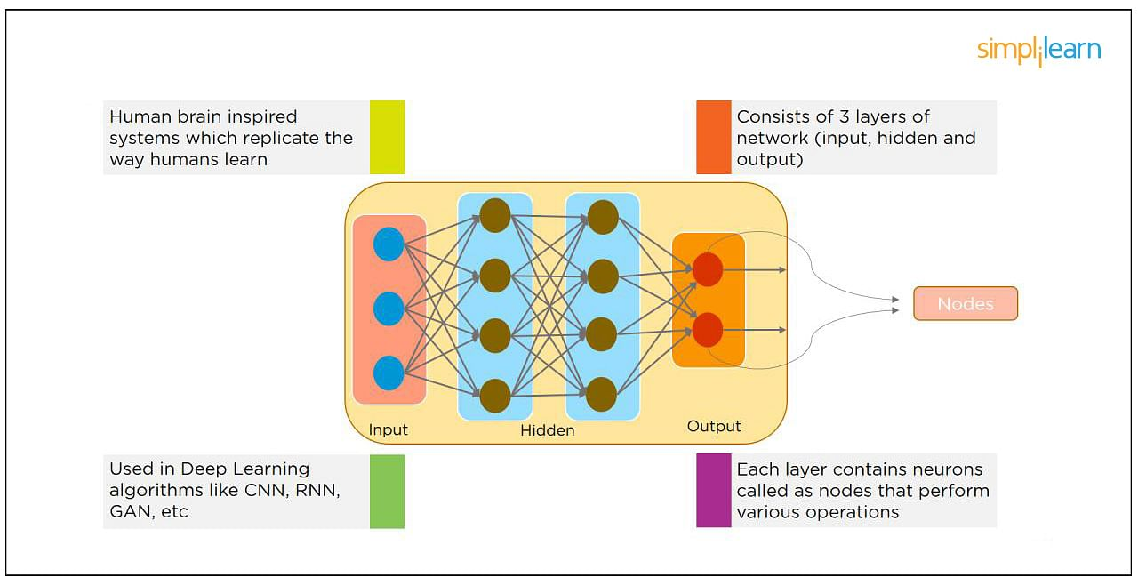
The most common Neural Networks consist of three network layers:
- An input layer
- A hidden layer (this is the most important layer where feature extraction takes place, and adjustments are made to train faster and function better)
- An output layer
Each sheet contains neurons called “nodes,” performing various operations. Neural Networks are used in deep learning algorithms like CNN, RNN, GAN, etc.

3. What Is a Multi-layer Perceptron(MLP)?
As in Neural Networks, MLPs have an input layer, a hidden layer, and an output layer. It has the same structure as a single layer perceptron with one or more hidden layers. A single layer perceptron can classify only linear separable classes with binary output (0,1), but MLP can classify nonlinear classes.
Except for the input layer, each node in the other layers uses a nonlinear activation function. This means the input layers, the data coming in, and the activation function is based upon all nodes and weights being added together, producing the output. MLP uses a supervised learning method called “backpropagation.” In backpropagation, the neural network calculates the error with the help of cost function. It propagates this error backward from where it came (adjusts the weights to train the model more accurately).

4. What Is Data Normalization, and Why Do We Need It?
The process of standardizing and reforming data is called “Data Normalization.” It’s a pre-processing step to eliminate data redundancy. Often, data comes in, and you get the same information in different formats. In these cases, you should rescale values to fit into a particular range, achieving better convergence.

5. What is the Boltzmann Machine?
One of the most basic Deep Learning models is a Boltzmann Machine, resembling a simplified version of the Multi-Layer Perceptron. This model features a visible input layer and a hidden layer -- just a two-layer neural net that makes stochastic decisions as to whether a neuron should be on or off. Nodes are connected across layers, but no two nodes of the same layer are connected.

6. What Is the Role of Activation Functions in a Neural Network?
At the most basic level, an activation function decides whether a neuron should be fired or not. It accepts the weighted sum of the inputs and bias as input to any activation function. Step function, Sigmoid, ReLU, Tanh, and Softmax are examples of activation functions.
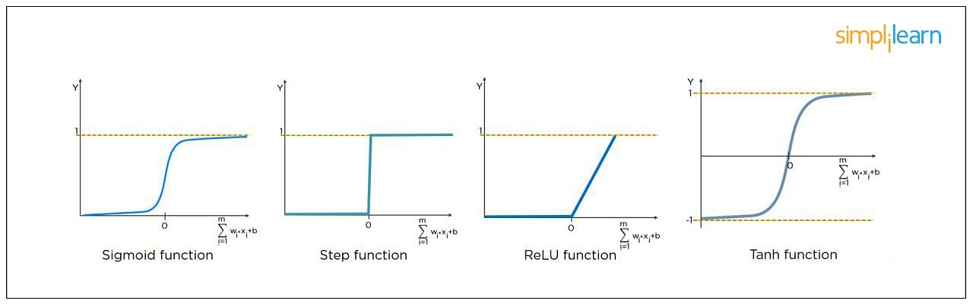

Free Webinar: AI for Business Decision Making
December 1, Thursday | 9 PM ISTREGISTER NOW


7. What Is the Cost Function?
Also referred to as “loss” or “error,” cost function is a measure to evaluate how good your model’s performance is. It’s used to compute the error of the output layer during backpropagation. We push that error backward through the neural network and use that during the different training functions.
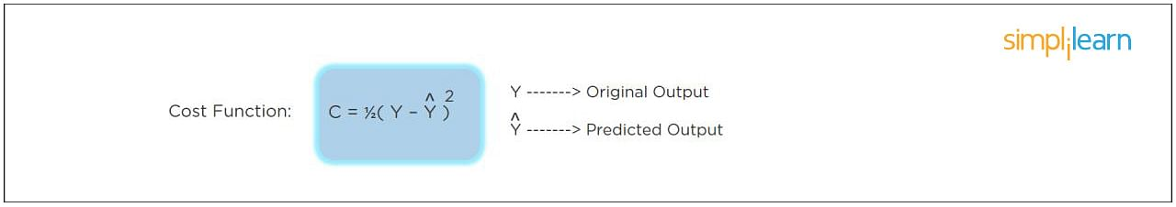

8. What Is Gradient Descent?
Gradient Descent is an optimal algorithm to minimize the cost function or to minimize an error. The aim is to find the local-global minima of a function. This determines the direction the model should take to reduce the error.
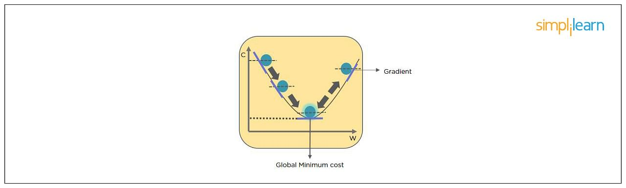

9. What Do You Understand by Backpropagation?
This is one of the most frequently asked deep learning interview questions. Backpropagation is a technique to improve the performance of the network. It backpropagates the error and updates the weights to reduce the error.
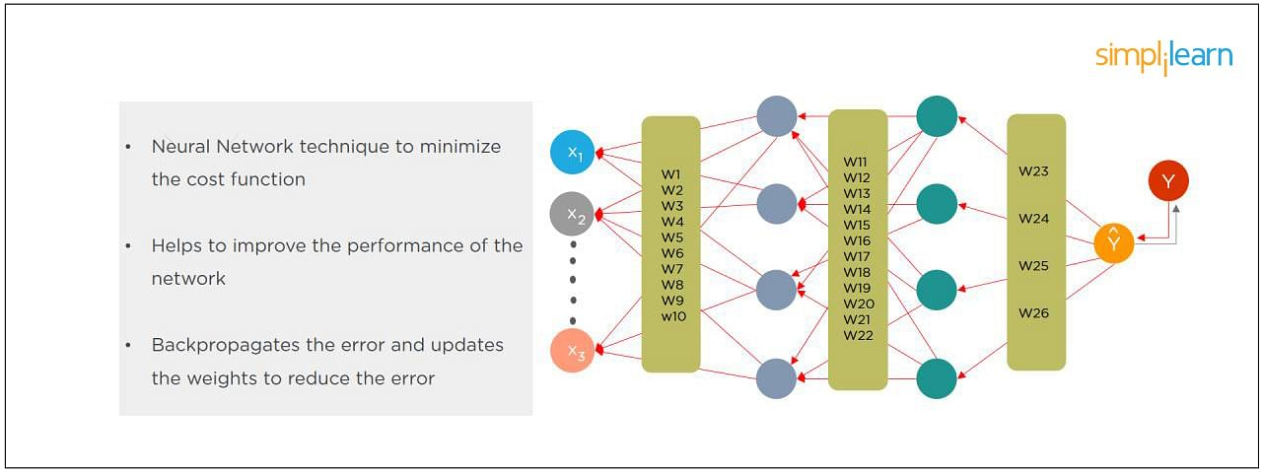

10. What Is the Difference Between a Feedforward Neural Network and Recurrent Neural Network?
In this deep learning interview question, the interviewee expects you to give a detailed answer.
A Feedforward Neural Network signals travel in one direction from input to output. There are no feedback loops; the network considers only the current input. It cannot memorize previous inputs (e.g., CNN).
A Recurrent Neural Network’s signals travel in both directions, creating a looped network. It considers the current input with the previously received inputs for generating the output of a layer and can memorize past data due to its internal memory.
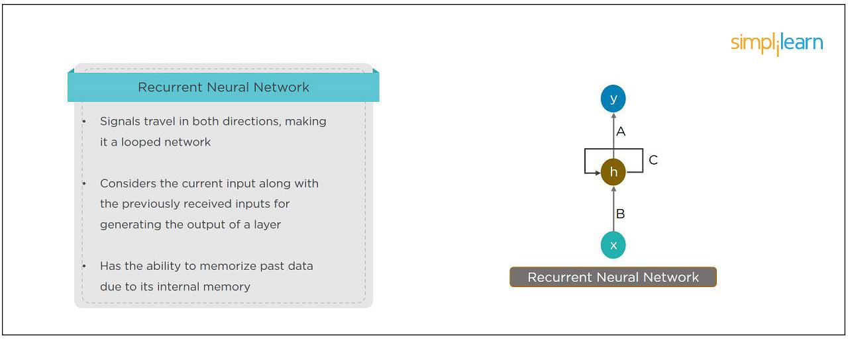

11. What Are the Applications of a Recurrent Neural Network (RNN)?
The RNN can be used for sentiment analysis, text mining, and image captioning. Recurrent Neural Networks can also address time series problems such as predicting the prices of stocks in a month or quarter.

PCP in AI and Machine Learning
In Partnership with Purdue UniversityEXPLORE COURSE


12. What Are the Softmax and ReLU Functions?
Softmax is an activation function that generates the output between zero and one. It divides each output, such that the total sum of the outputs is equal to one. Softmax is often used for output layers.
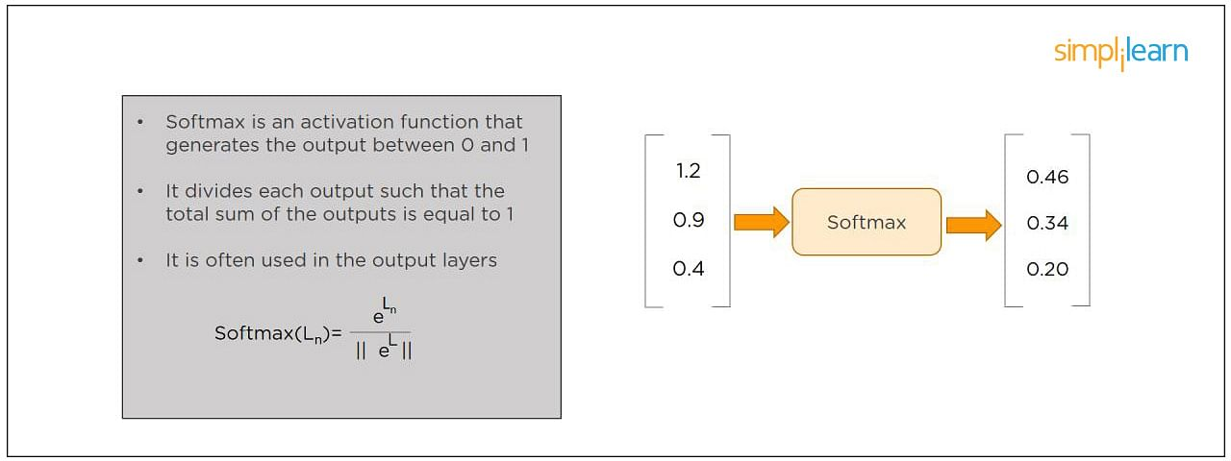
ReLU (or Rectified Linear Unit) is the most widely used activation function. It gives an output of X if X is positive and zeros otherwise. ReLU is often used for hidden layers.
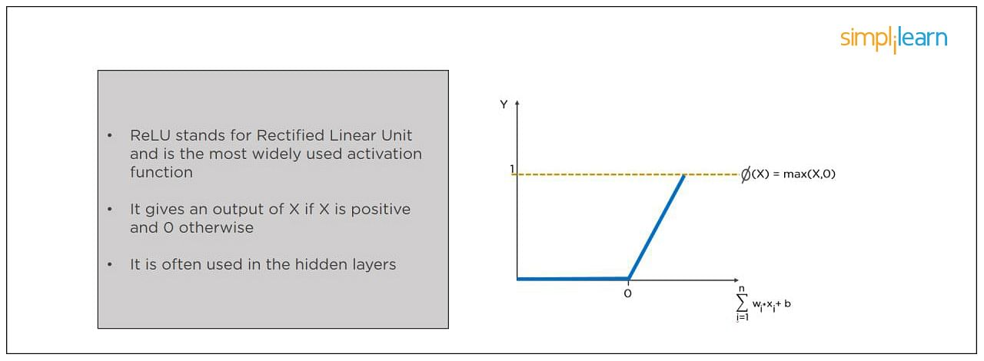

13. What Are Hyperparameters?
This is another frequently asked deep learning interview question. With neural networks, you’re usually working with hyperparameters once the data is formatted correctly. A hyperparameter is a parameter whose value is set before the learning process begins. It determines how a network is trained and the structure of the network (such as the number of hidden units, the learning rate, epochs, etc.).
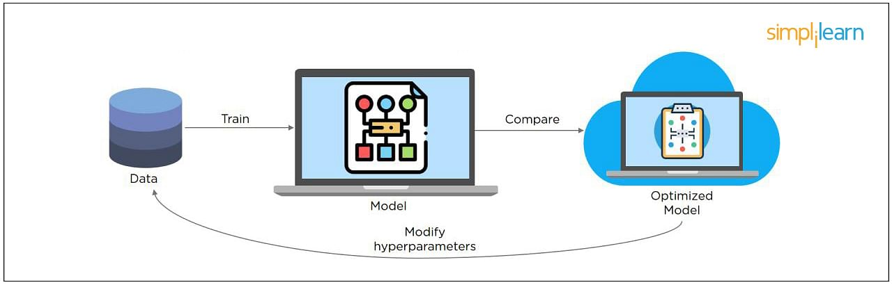

14. What Will Happen If the Learning Rate Is Set Too Low or Too High?
When your learning rate is too low, training of the model will progress very slowly as we are making minimal updates to the weights. It will take many updates before reaching the minimum point.
If the learning rate is set too high, this causes undesirable divergent behavior to the loss function due to drastic updates in weights. It may fail to converge (model can give a good output) or even diverge (data is too chaotic for the network to train).
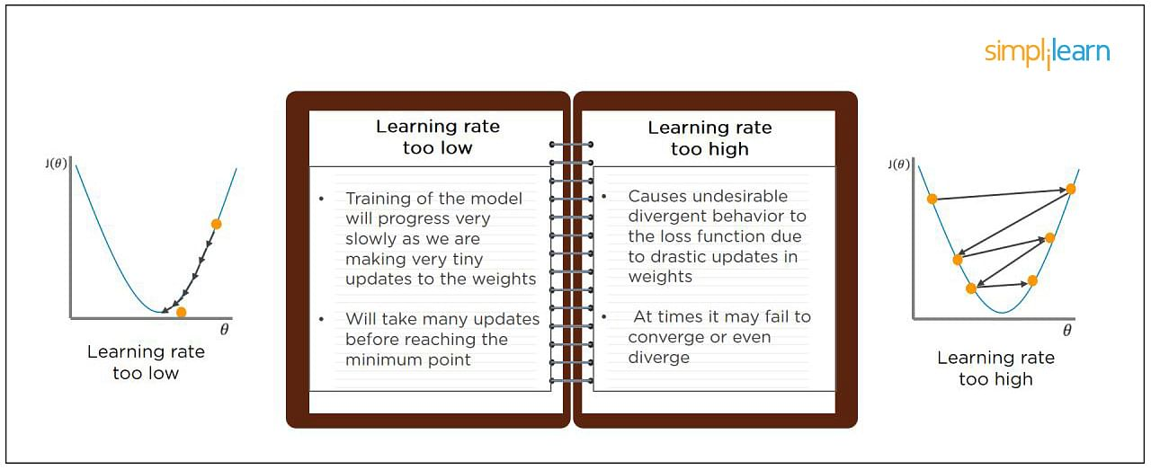

15. What Is Dropout and Batch Normalization?
Dropout is a technique of dropping out hidden and visible units of a network randomly to prevent overfitting of data (typically dropping 20 percent of the nodes). It doubles the number of iterations needed to converge the network.
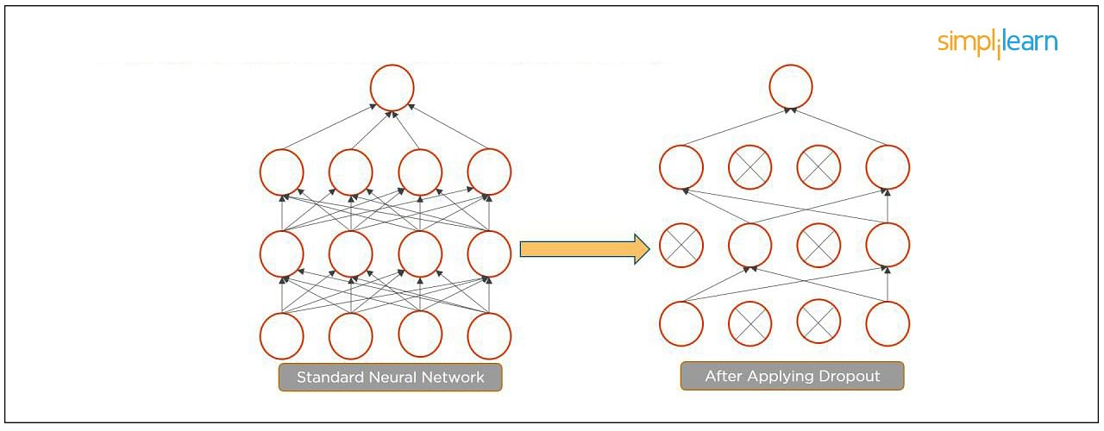
Batch normalization is the technique to improve the performance and stability of neural networks by normalizing the inputs in every layer so that they have mean output activation of zero and standard deviation of one.
The next step on this top Deep Learning interview questions and answers blog will be to discuss intermediate questions.

16. What Is the Difference Between Batch Gradient Descent and Stochastic Gradient Descent?
Batch Gradient Descent | Stochastic Gradient Descent
The batch gradient computes the gradient using the entire dataset.  It takes time to converge because the volume of data is huge, and weights update slowly. | The stochastic gradient computes the gradient using a single sample.  It converges much faster than the batch gradient because it updates weight more frequently.

FREE Machine Learning Certification Course
To become a Machine Learning EngineerEXPLORE COURSE


17. What is Overfitting and Underfitting, and How to Combat Them?
Overfitting occurs when the model learns the details and noise in the training data to the degree that it adversely impacts the execution of the model on new information. It is more likely to occur with nonlinear models that have more flexibility when learning a target function. An example would be if a model is looking at cars and trucks, but only recognizes trucks that have a specific box shape. It might not be able to notice a flatbed truck because there's only a particular kind of truck it saw in training. The model performs well on training data, but not in the real world.
Underfitting alludes to a model that is neither well-trained on data nor can generalize to new information. This usually happens when there is less and incorrect data to train a model. Underfitting has both poor performance and accuracy.
To combat overfitting and underfitting, you can resample the data to estimate the model accuracy (k-fold cross-validation) and by having a validation dataset to evaluate the model.

18. How Are Weights Initialized in a Network?
There are two methods here: we can either initialize the weights to zero or assign them randomly.
Initializing all weights to 0: This makes your model similar to a linear model. All the neurons and every layer perform the same operation, giving the same output and making the deep net useless.
Initializing all weights randomly: Here, the weights are assigned randomly by initializing them very close to 0. It gives better accuracy to the model since every neuron performs different computations. This is the most commonly used method.

19. What Are the Different Layers on CNN?
There are four layers in CNN:
- Convolutional Layer - the layer that performs a convolutional operation, creating several smaller picture windows to go over the data.
- ReLU Layer - it brings non-linearity to the network and converts all the negative pixels to zero. The output is a rectified feature map.
- Pooling Layer - pooling is a down-sampling operation that reduces the dimensionality of the feature map.
- Fully Connected Layer - this layer recognizes and classifies the objects in the image.
Master the deep learning concepts and TensorFlow open-source framework with the Deep Learning Course with TensorFlow Certification. Check out the course preview today.

20. What is Pooling on CNN, and How Does It Work?
Pooling is used to reduce the spatial dimensions of a CNN. It performs down-sampling operations to reduce the dimensionality and creates a pooled feature map by sliding a filter matrix over the input matrix.
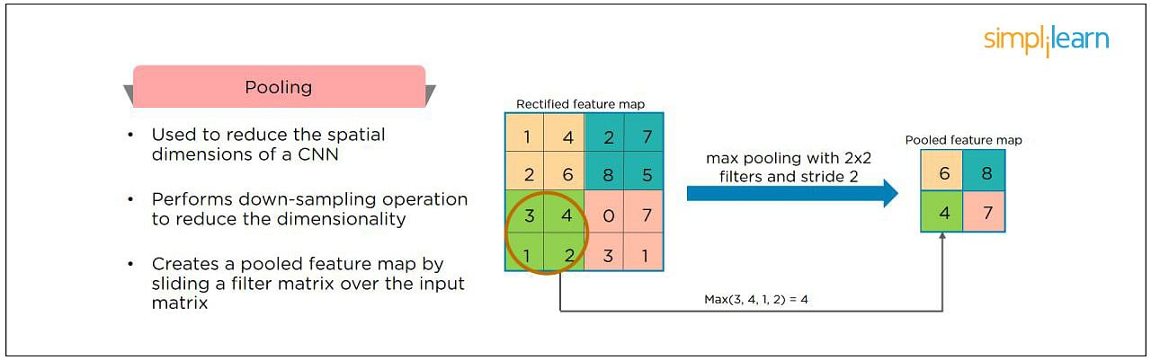

Free Course: Machine Learning Algorithms
Learn the Basics of Machine Learning AlgorithmsENROLL NOW

21. How Does an LSTM Network Work?
Long-Short-Term Memory (LSTM) is a special kind of recurrent neural network capable of learning long-term dependencies, remembering information for long periods as its default behavior. There are three steps in an LSTM network:
- Step 1: The network decides what to forget and what to remember.
- Step 2: It selectively updates cell state values.
- Step 3: The network decides what part of the current state makes it to the output.
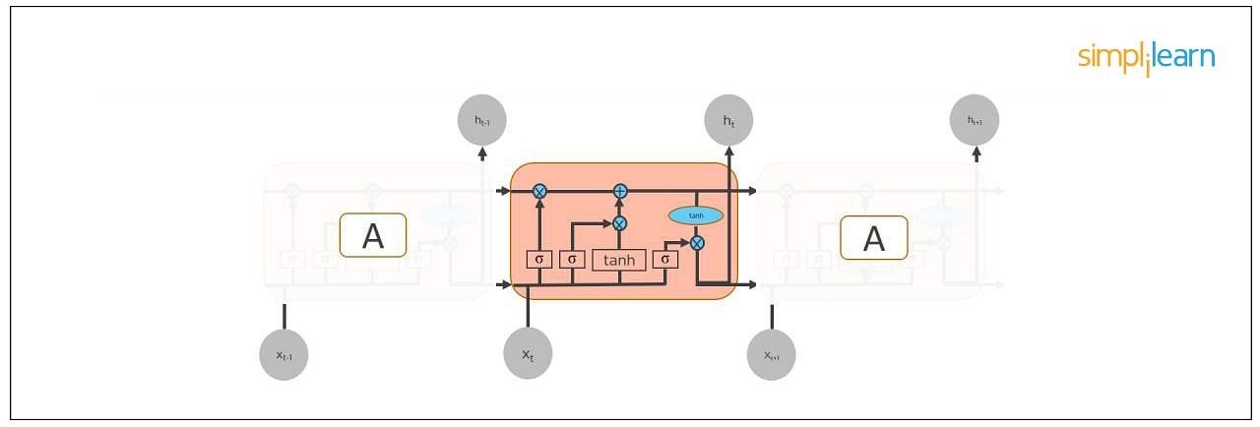

22. What Are Vanishing and Exploding Gradients?
While training an RNN, your slope can become either too small or too large; this makes the training difficult. When the slope is too small, the problem is known as a “Vanishing Gradient.” When the slope tends to grow exponentially instead of decaying, it’s referred to as an “Exploding Gradient.” Gradient problems lead to long training times, poor performance, and low accuracy.
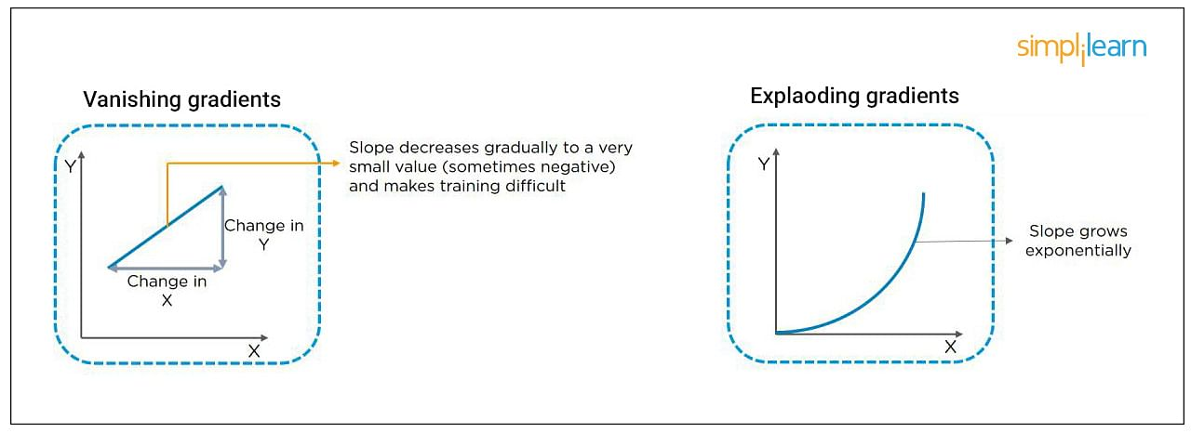

Free Deep Learning for Beginners Course
Master the Basics of Deep LearningENROLL NOW

23. What Is the Difference Between Epoch, Batch, and Iteration in Deep Learning?
- Epoch - Represents one iteration over the entire dataset (everything put into the training model).
- Batch - Refers to when we cannot pass the entire dataset into the neural network at once, so we divide the dataset into several batches.
- Iteration - if we have 10,000 images as data and a batch size of 200. then an epoch should run 50 iterations (10,000 divided by 50).

24. Why is Tensorflow the Most Preferred Library in Deep Learning?
Tensorflow provides both C++ and Python APIs, making it easier to work on and has a faster compilation time compared to other Deep Learning libraries like Keras and Torch. Tensorflow supports both CPU and GPU computing devices.

25. What Do You Mean by Tensor in Tensorflow?
This is another most frequently asked deep learning interview question. A tensor is a mathematical object represented as arrays of higher dimensions. These arrays of data with different dimensions and ranks fed as input to the neural network are called “Tensors.”
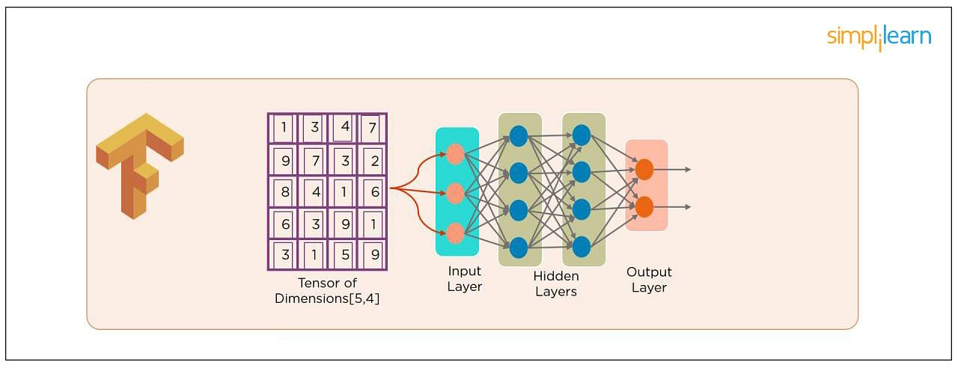

26. What Are the Programming Elements in Tensorflow?
Constants - Constants are parameters whose value does not change. To define a constant we use tf.constant() command. For example:
a = tf.constant(2.0,tf.float32)
b = tf.constant(3.0)
Print(a, b)
Variables - Variables allow us to add new trainable parameters to graph. To define a variable, we use the tf.Variable() command and initialize them before running the graph in a session. An example:
W = tf.Variable([.3].dtype=tf.float32)
b = tf.Variable([-.3].dtype=tf.float32)
Placeholders - these allow us to feed data to a tensorflow model from outside a model. It permits a value to be assigned later. To define a placeholder, we use the tf.placeholder() command. An example:
a = tf.placeholder (tf.float32)
b = a*2
with tf.Session() as sess:
result = sess.run(b,feed_dict={a:3.0})
print result
Sessions - a session is run to evaluate the nodes. This is called the “Tensorflow runtime.” For example:
a = tf.constant(2.0)
b = tf.constant(4.0)
c = a+b
# Launch Session
Sess = tf.Session()
# Evaluate the tensor c
print(sess.run(c))

27. Explain a Computational Graph.
Everything in a tensorflow is based on creating a computational graph. It has a network of nodes where each node operates, Nodes represent mathematical operations, and edges represent tensors. Since data flows in the form of a graph, it is also called a “DataFlow Graph.”

28. Explain Generative Adversarial Network.
Suppose there is a wine shop purchasing wine from dealers, which they resell later. But some dealers sell fake wine. In this case, the shop owner should be able to distinguish between fake and authentic wine.
The forger will try different techniques to sell fake wine and make sure specific techniques go past the shop owner’s check. The shop owner would probably get some feedback from wine experts that some of the wine is not original. The owner would have to improve how he determines whether a wine is fake or authentic.
The forger’s goal is to create wines that are indistinguishable from the authentic ones while the shop owner intends to tell if the wine is real or not accurately.
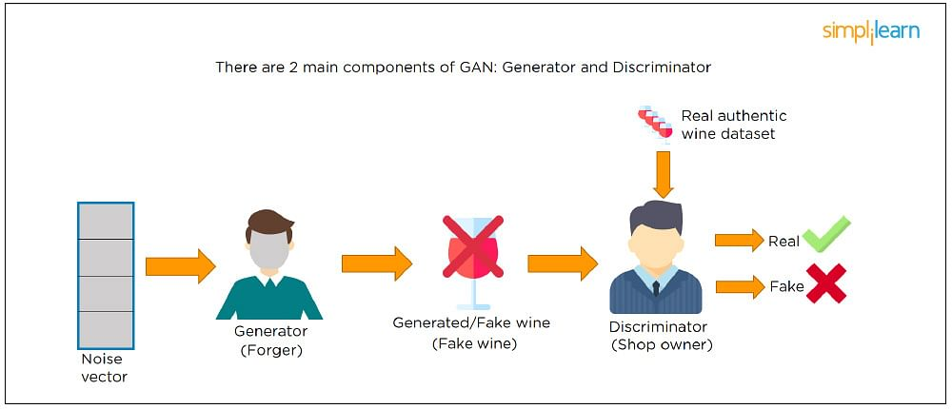
Let us understand this example with the help of an image shown above.
There is a noise vector coming into the forger who is generating fake wine.
Here the forger acts as a Generator.
The shop owner acts as a Discriminator.
The Discriminator gets two inputs; one is the fake wine, while the other is the real authentic wine. The shop owner has to figure out whether it is real or fake.
So, there are two primary components of Generative Adversarial Network (GAN) named:
- Generator
- Discriminator
The generator is a CNN that keeps keys producing images and is closer in appearance to the real images while the discriminator tries to determine the difference between real and fake images The ultimate aim is to make the discriminator learn to identify real and fake images.

29. What Is an Auto-encoder?
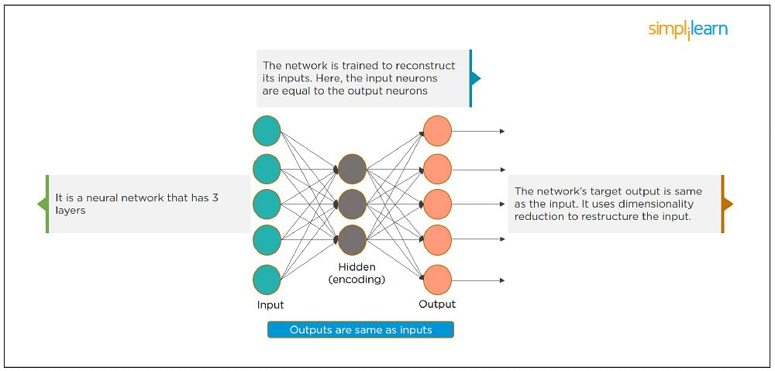
This Neural Network has three layers in which the input neurons are equal to the output neurons. The network's target outside is the same as the input. It uses dimensionality reduction to restructure the input. It works by compressing the image input to a latent space representation then reconstructing the output from this representation.

30. What Is Bagging and Boosting?
Bagging and Boosting are ensemble techniques to train multiple models using the same learning algorithm and then taking a call.
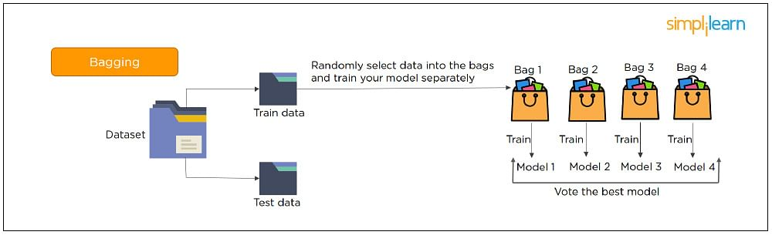
With Bagging, we take a dataset and split it into training data and test data. Then we randomly select data to place into the bags and train the model separately.
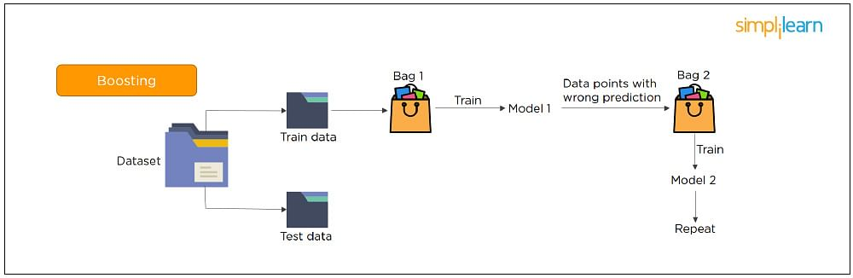
With Boosting, the emphasis is on selecting data points which give wrong output to improve the accuracy.
The following are some of the most important advanced deep learning interview questions that you should know!

31. What is the significance of using the Fourier transform in Deep Learning tasks?
The Fourier transform function efficiently analyzes, maintains, and manages large datasets. You can use it to generate real-time array data that is helpful for processing multiple signals.

32. What do you understand by transfer learning? Name a few commonly used transfer learning models.
Transfer learning is the process of transferring the learning from a model to another model without having to train it from scratch. It takes critical parts of a pre-trained model and applies them to solve new but similar machine learning problems.
Some of the popular transfer learning models are:
- VGG-16
- BERT
- GTP-3
- Inception V3
- XCeption

33. What is the difference between SAME and VALID padding in Tensorflow?
Using the Tensorflow library, tf.nn.max_pool performs the max-pooling operation. Tf.nn.max_pool has a padding argument that takes 2 values - SAME or VALID.
With padding == “SAME” ensures that the filter is applied to all the elements of the input.
The input image gets fully covered by the filter and specified stride. The padding type is named SAME as the output size is the same as the input size (when stride=1).
With padding == “VALID” implies there is no padding in the input image. The filter window always stays inside the input image. It assumes that all the dimensions are valid so that the input image gets fully covered by a filter and the stride defined by you.

34. What are some of the uses of Autoencoders in Deep Learning?
- Autoencoders are used to convert black and white images into colored images.
- Autoencoder helps to extract features and hidden patterns in the data.
- It is also used to reduce the dimensionality of data.
- It can also be used to remove noises from images.

35. What is the Swish Function?
Swish is an activation function proposed by Google which is an alternative to the ReLU activation function.
It is represented as: f(x) = x * sigmoid(x).
The Swish function works better than ReLU for a variety of deeper models.
The derivative of Swist can be written as: y’ = y + sigmoid(x) * (1 - y)

36. What are the reasons for mini-batch gradient being so useful?
- Mini-batch gradient is highly efficient compared to stochastic gradient descent.
- It lets you attain generalization by finding the flat minima.
- Mini-batch gradient helps avoid local minima to allow gradient approximation for the whole dataset.

37. What do you understand by Leaky ReLU activation function?
Leaky ReLU is an advanced version of the ReLU activation function. In general, the ReLU function defines the gradient to be 0 when all the values of inputs are less than zero. This deactivates the neurons. To overcome this problem, Leaky ReLU activation functions are used. It has a very small slope for negative values instead of a flat slope.

38. What is Data Augmentation in Deep Learning?
Data Augmentation is the process of creating new data by enhancing the size and quality of training datasets to ensure better models can be built using them. There are different techniques to augment data such as numerical data augmentation, image augmentation, GAN-based augmentation, and text augmentation.

39. Explain the Adam optimization algorithm.
Adaptive Moment Estimation or Adam optimization is an extension to the stochastic gradient descent. This algorithm is useful when working with complex problems involving vast amounts of data or parameters. It needs less memory and is efficient.
Adam optimization algorithm is a combination of two gradient descent methodologies -
Momentum and Root Mean Square Propagation.

40. Why is a convolutional neural network preferred over a dense neural network for an image classification task?
- The number of parameters in a convolutional neural network is much more diminutive than that of a Dense Neural Network. Hence, a CNN is less likely to overfit.
- CNN allows you to look at the weights of a filter and visualize what the network learned. So, this gives a better understanding of the model.
- CNN trains models in a hierarchical way, i.e., it learns the patterns by explaining complex patterns using simpler ones.

41. Which strategy does not prevent a model from over-fitting to the training data?
- Dropout
- Pooling
- Data augmentation
- Early stopping
Answer: b) Pooling - It’s a layer in CNN that performs a downsampling operation.

42. Explain two ways to deal with the vanishing gradient problem in a deep neural network.
- Use the ReLU activation function instead of the sigmoid function
- Initialize neural networks using Xavier initialization that works with tanh activation.

43. Why is a deep neural network better than a shallow neural network?
Both deep and shallow neural networks can approximate the values of a function. But the deep neural network is more efficient as it learns something new in every layer. A shallow neural network has only one hidden layer. But a deep neural network has several hidden layers that create a deeper representation and computation capability.

44. What is the need to add randomness in the weight initialization process?
If you set the weights to zero, then every neuron at each layer will produce the same result and the same gradient value during backpropagation. So, the neural network won’t be able to learn the function as there is no asymmetry between the neurons. Hence, randomness to the weight initialization process is crucial.

45. How can you train hyperparameters in a neural network?
Hyperparameters in a neural network can be trained using four components:
Batch size: Indicates the size of the input data.
Epochs: Denotes the number of times the training data is visible to the neural network to train.
Momentum: Used to get an idea of the next steps that occur with the data being executed.
Learning rate: Represents the time required for the network to update the parameters and learn.
1. What is TensorFlow?
Answer: TensorFlow is the world’s most used library for Machine Learning. Developed in 2015 by the Google Brain Team, it ensures to provide an easy-to-use low-level toolkit that can handle complex mathematical operations and learning architectures.
2. What is the meaning of TensorBoard?
Answer: TensorBoard is a Graphical User Interface (GUI) that is provided by TensorFlow to help users visualize graphs, plots, and other metrics easily without having to write a lot of code. TensorBoard provides an ample number of advantages in terms of readability, ease of use, and performance metrics.
3. What are tensors?
Answer: Tensors are similar to arrays in programming languages, but here, they are of higher dimensions. It can be considered as a generalization of matrices that form an n-dimensional array. TensorFlow provides methods that can be used to create tensor functions and compute their derivatives easily. This is what sets tensors apart from the NumPy arrays.
4. Are there any limitations to using TensorFlow?
Answer: Even though TensorFlow provides numerous advantages, it has one or two caveats in the current versions:
- No support for OpenCL (Open Computing Language) yet
- GPU memory conflicts when used with Theano
- Can be overwhelming for beginners to get started
Next up on these TensorFlow coding interview questions, let us check out about the types of tensors.
5. What are some of the advantages of using TensorFlow?
Answer: TensorFlow has numerous advantages, and this is why it is the most used framework for Machine Learning in the world. Some of its advantages are given below:
- Platform independency
- Usage of GPU for distributed computing
- Auto-differentiation capability
- Open-source and large community
- Highly customizable based on requirements
- Support for asynchronous computations
6. What is a graph explorer in TensorFlow?
Answer: A graph explorer is used to visualize a graph on TensorBoard. It is also used for the inspection operations of a model in TensorFlow. To easily understand the flow in a graph, it is recommended to use a graph visualizer in TensorBoard.
7. What is the meaning of Deep Speech?
Answer:
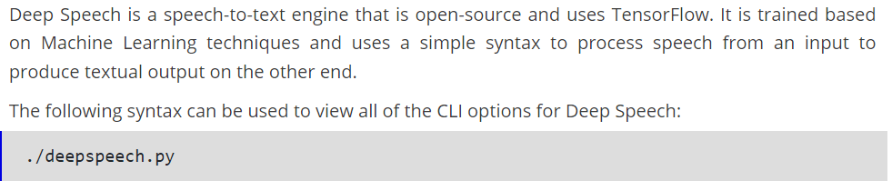
8. What are the types of tensors available in TensorFlow?
Answer: There are three main types of tensors:
- Constant tensors
- Variable tensors
- Placeholder tensors
9. How is variable lifetime tracked in TensorFlow?
Answer: The lifetime of a variable is automatically tracked after its initialization, using the tf.Variable.initializer operation.
Later, after the usage, the session can be closed and the variable can be destroyed, using the tf.Session.close operation.
10. What is the use of a histogram dashboard in TensorFlow?
Answer: Histogram dashboards are widely used to display complex statistical distributions of a tensor in a simple way. Every histogram chart will have a slice of data that denotes the data that the tensor has at the point of representation.
11. How can data be loaded into TensorFlow?
Answer: There are two ways that you can use to load data into TensorFlow before training Machine Learning algorithms:
- Data load into memory: Here, the data is loaded into the memory as a single array unit. It is the easiest way to load the data.
- TensorFlow data pipeline: It is making use of the built-in APIs to load the data and feed it across to the algorithm.
12. What are the types of dashboards supported by TensorFlow?
Answer: TensorFlow supports a variety of dashboards that are used to perform numerous tasks on TensorBoard easily:
- Scalar dashboard
- Image dashboard
- Graph dashboard
- Text dashboard
- Distributer dashboard
- Histogram dashboard
13. How is audio stored in the audio dashboard?
Answer: The audio dashboard serves to primarily help users embed playable widgets stored in files. Tf.summary.audio is used for the storage of these files, and the tagging system is used to embed the latest audio based on the storage policies.
14. What is the simple working of an algorithm in TensorFlow?
Answer: There are five main steps that govern the working of the majority of algorithms in TensorFlow. They are as follows:
- Data import or data generation, alongside setting up a data pipeline
- Data input through computational graphs
- Generation of the loss function to evaluate the output
- Backpropagation to modify the data
- Iterating until output criteria are met
15. Can TensorFlow be deployed onto a container architecture?
Answer: Yes, TensorFlow can be easily used with containerization tools like Docker. The containerization tools alongside TensorFlow are mostly used to deploy various models that require text classification using convolutional neural networks.
16. What are some of the components needed to deploy a Lite model file?
Answer: In TensorFlow, three main components are used to deploy a Lite model:
- Java API: Used as a wrapper around the C++ API for Android
- C++ API: Used to load the TensorFlow Lite model and call the interpreter
- Interpreter: Used to handle kernel loading and the execution of the model
17. What are the methods that can be used to handle overfitting in TensorFlow?
Answer: There are three methods, which can be used to easily handle the condition of overfitting when using TensorFlow:
- Batch normalization
- Regularization technique
- Dropouts
18. Differentiate between TensorFlow and PyTorch.
Answer:
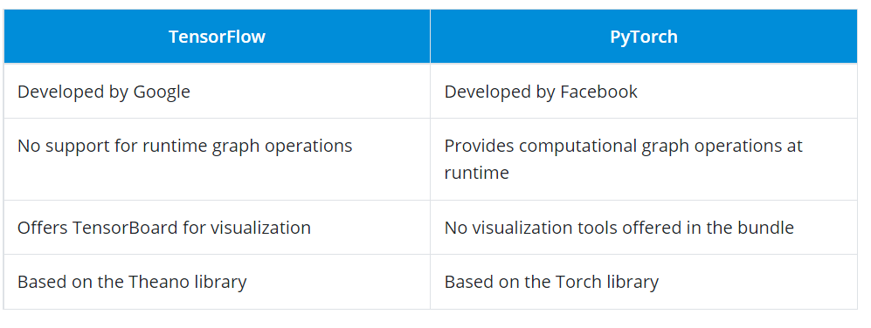
19. What is TensorFlow JS?
Answer: TensorFlow JS is a library that gives users the functionality of using browsers to run Machine Learning models. High-level APIs work with JavaScript to support a variety of entities in the backend, such as WebGL, to use a GPU to render functionality (if available). Models can be imported, re-trained, and executed easily by just using a browser.
20. What are the languages that are supported in TensorFlow?
Answer: TensorFlow supports a wide variety of languages for programmers to write the code in. The preferred language presently is Python.
However, experimental support is being implemented for other languages, such as Go, Java, and C++. Also, language bindings for Ruby, Scala, and Julia are being developed by the open-source community.
21. Is word embedding supported in TensorFlow?
Answer: Yes, word embedding is supported in TensorFlow. It is widely used in the field of Natural Language Processing. When TensorFlow is being used, it is called Word2vec.
Two models are used for word embedding in TensorFlow:
- The Continuous Bag of Words model
- The Skip-Gram model
22. What are the activation functions in TensorFlow?
Answer: Activation functions are functions applied to the output side of a neural network that serves to be the input of the next layer. It forms a very important part of neural networks as it provides nonlinearity that sets apart a neural network from logistic regression.
23. What are placeholder tensors?
Answer: Placeholder tensors are entities that provide an advantage over a regular variable. It is used to assign data at a later point in time.
Placeholders can be used to build graphs without any prior data being present. This means that they do not require any sort of initialization for usage.
24. What is the use of estimators in TensorFlow?
Answer: Estimators in TensorFlow are high-level APIs used to provide a high amount of code reusability when training a model. They can also override the default behavior of any aspect of the model.
There are two ways of the model building using estimators:
- Premade estimator: Used to create a specific model like DNNClassifier
- Base class estimator: Used to control a model using a model_fn function
25. What is the code that is used to check the version of TensorFlow using Python?
Answer:
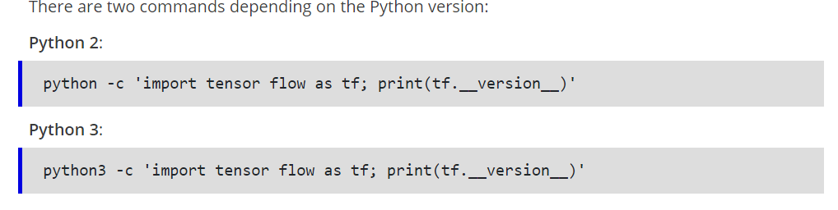
26. What are managers in TensorFlow?
Answer: TensorFlow managers are entities that are responsible for handling the following activities for servable objects:
- Loading
- Unloading
- Lookup
- Lifetime management
27. What statistical distribution functions are provided by TensorFlow?
Answer: Numerous statistical distribution functions are offered by TensorFlow. They are all located inside the tf.contrib.distributions package.
The distributions supported are:
- Beta
- Bernoulli
- Chi2
- Dirichlet
- Gamma
- Uniform
28. What is model quantization in TensorFlow?
Answer: The process of handling the complexity that follows when optimizing inferences can be greatly minimized using TensorFlow. Model quantization is primarily used to reduce the representation of weights and also for the storage and computation of the activation function.
Using model quantization provides users with two main advantages:
- Support for a variety of CPU platforms
- SIMD instruction handling capabilities
29. Where is TensorFlow mostly used?
Answer: TensorFlow is used in all of the domains that cover Machine Learning and Deep Learning. Being the most essential tool, the following are some of the main use cases of TensorFlow:
- Time series analysis
- Image recognition
- Voice recognition
- Video upscaling
- Test-based applications
30. Can you use TensorBoard without installing TensorFlow?
Answer: If TensorFlow is not installed, users can still make use of TensorBoard (versions above 1.14) in a standalone mode with redacted features.
Following plugins are supported:
- Scalars
- Image
- Audio
- Graph
- Projector
- Histograms
- Mesh
31. What is the simple syntax that can be used to convert a NumPy array into a tensor?
Answer:
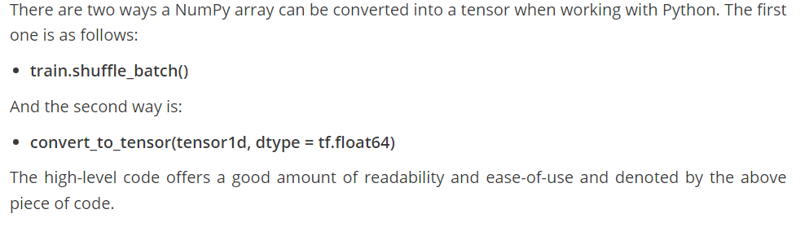
32. What are TensorFlow serves?
Answer: Servables in TensorFlow are simply the objects that client machines use to perform computations. The size of these objects is flexible. Servables can include a variety of information like any entity from a lookup table to a tuple needed for inference models.
33. What is the meaning of the embedding projector in TensorFlow?
Answer: Embedding projector is an entity in TensorFlow that is used to easily visualize high-dimensional data.
It is used to read the data from the model checkpoint file prior to visualization and to view the input data after it has been embedded into a high-dimensional space by the model.
34. How is the weighted standard error computed in TensorFlow?
Answer:
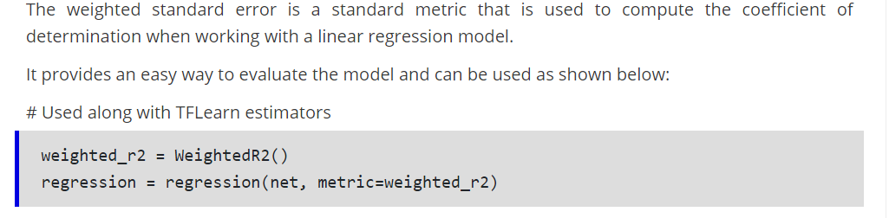
35. How does the Python API work with TensorFlow?
Answer: Python is the primary language when it comes to working with TensorFlow. TensorFlow provides an ample number of functionalities when used with the API, such as:
- Automatic checkpoints
- Automatic logging
- Simple training distribution
- Queue-runner design methods
36. What are the differences between CNN and RNN?
Answer:
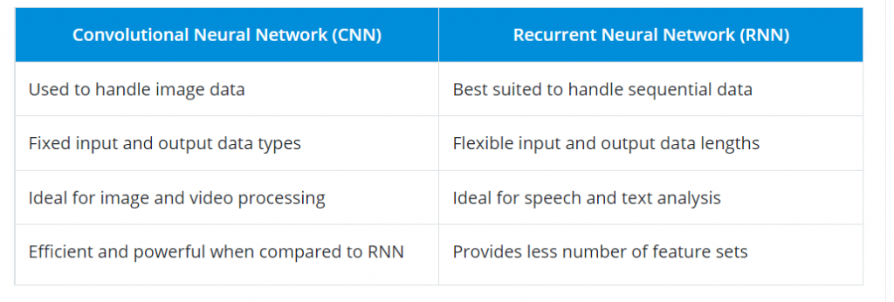
37. What are some of the commonly used optimizers when training a model in TensorFlow?
Answer: You can use many optimizers based on various factors, such as the learning rate, performance metric, dropout, gradient, and more.
Following are some of the popular optimizers:
- AdaDelta
- AdaGrad
- Adam
- Momentum
- RMSprop
- Stochastic Gradient Descent
38. What are some of the APIs outside of the TensorFlow project?
Answer: Following are some of the APIs developed by Machine Learning enthusiasts across the globe:
- TFLearn: A popular Python package
- TensorLayer: For layering architecture support
- Pretty Tensor: Google’s project providing a chaining interface
- Sonnet: Provides a modular approach to programming
39. What is the difference between Type 1 and Type 2 errors?
Answer: In simple terms, Type 1 errors refer to the occurrence of a false positive outcome, and Type 2 errors denote the occurrence of a false negative value when performing complex computations.
40. What is the use of ArrayFlow and FeedDictFlow in TensorFlow?
Answer:
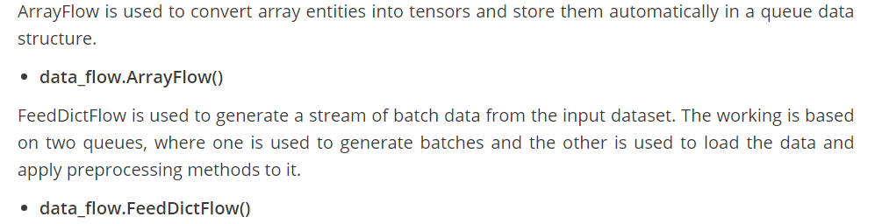
41. What are TensorFlow loaders?
Answer: Loaders are used in TensorFlow to load, unload, and work with servable objects. The loaders are primarily used to add algorithms and data into TensorFlow for working.
The load() function is used to pre-load a model from a saved entity easily.
42. When using TensorFlow, is performance always preferred over accuracy?
Answer: No, performance is not always preferred over accuracy when you use TensorFlow. This completely depends on the type of requirement and what the model is trying to achieve. The general rule of thumb is to provide equal weightage to model accuracy and performance.
The next set of TensorFlow interview questions will show the importance of using an example along with concepts to explain
43. What are some of the parameters to consider when implementing the Word2vec algorithm in TensorFlow?
Answer: The Word2vec algorithm is used to compute the vector representations of words from an input dataset.
There are six parameters that have to be considered:
- embedding_size: Denotes the dimension of the embedding vector
- max_vocabulary_size: Denotes the total number of unique words in the vocabulary
- min_occurrence: Removes all words that do not appear at least ‘n’ number of times
- skip_window: Denotes words to be considered or not for processing
- num_skips: Denotes the number of times you can reuse an input to generate a label
- num_sampled: Denotes the number of negative examples to sample from the input
44. What makes TensorFlow advantageous over other libraries?
Answer: Following are some of the benefits of TensorFlow over other libraries:
- Pipelines: data is used to build efficient pipelines for text and image processing.
- Debugging: tfdbg is used to track the state and structure of objects for easy debugging.
- Visualization: TensorBoard provides an elegant user interface for users to visualize graphs.
- Scalability: It can scale Deep Learning applications and their associated infrastructure easily.
45. Can you give an example to create a tensor using the constant() function in TensorFlow?.
Answer:
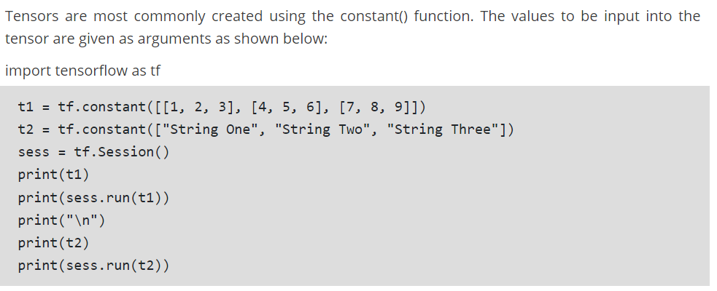
46. What are some of the important parameters to consider when implementing a random forest algorithm in TensorFlow?
Answer: There are six main parameters you should think about and plan when implementing a random forest algorithm in TensorFlow:
- Number of inputs
- Feature count
- Number of samples per batch
- Total number of training steps
- Number of trees
- Maximum number of nodes
47. What are TensorFlow abstractions?
Answer: TensorFlow contains certain libraries used for abstraction such as Keras and TF-Slim. They are used to provide high-level access to data and model life cycles for programmers using TensorFlow. This can help them easily maintain clean code and also reduce the length of the code exponentially.
Next up on this top TensorFlow interview questions and answers post, we will take a look at the intermediate set of questions.
48. What are some of the products that are built using TensorFlow?
Answer: There are many products that are built completely using TensorFlow. Some of them are as follows:
- Teachable Machine
- Handwriting Recognition
- Giorgio Cam
- NSynth
49. What are some of the numerical and categorical loss functions supported when working with TensorFlow?
Answer:
Following are some of the widely used numerical and categorical loss functions supported when working with TensorFlow:
Numerical loss functions:
L1 loss
L2 loss
Pseudo-Huber loss
Categorical loss functions:
Hinge loss
Cross-entropy loss
Sigmoid-entropy loss
Weighted cross-entropy loss
50. What are the differences between tf.variable and tf.placeholder in TensorFlow?
Answer:
