https://h2o.ai/platform/ai-cloud/make/h2o/
H2O is a scalable and fast open-source platform for machine learning. We will apply it to perform classification tasks. The dataset we are using is the Bank Marketing Dataset. Here we need to train a model which will be able to predict if the client of the bank opens the term deposit on the basis of his/her personal features of the client, marketing campaign features and current macroeconomic conditions.
During the model creation we explore various core components and functions from the H2O toolkit. You should understand that while this article covers some basic concepts of H2O, if you need more detailed information you should go to the H2O website and read documentation.
Note: for installation instructions please use the official website.

Preparation
We need to import needed libraries first:
import pandas as pdimport numpy as npimport h2o
pd.set_option('display.width', 5000)

The first thing you should do is to start the H2O. You can run method h2o.init() to initialize H2O. Many different parameters can be given to h2o.init() method in order to set up the H2O according to your needs. So, here you can change some global settings of the H2O. Nevertheless, in most cases it is enough to call this methods without any parameters, like we did below:
h2o.init()

You can see that the output from this method consists of some meta-information about your H2O cluster.
The next thing we should do is to import the dataset we will work with. This is the .csv file and the H2O has function upload_file() which will load the dataset in the memory. It is worth to say that the H2O can work with several data sources (both local and remote) and support different file formats.
bank_df = h2o.upload_file("bank-additional-full.csv")

To take a look at the dataset, you can simply type in its name and run the cell. The top 10 rows are displayed by default.
Looking at the type of this variable, we can see that the type is h2o.frame.H2OFrame. So, this is not a pandas object, but the own object of the H2O.
However, you can index and slice this H2OFrame in a familiar manner:
# show 6th rowprint(bank_df[5,:])# show 6-7 rowsprint(bank_df[5:7,:])# show first 4 columns from 6-7 rowsprint(bank_df[5:7,0:4])# show job,education and y columns from 6-7 rowsprint(bank_df[5:7, ['job', 'education', 'y']])

You can check the shape of the H2OFrame by accessing .shape attribute of it. Also, some useful information (type of columns, min, average, max values, standard deviation, number of zeros, missing values) can be generated by .describe() method.
As we can see, there are no missing data in our dataset. We have 20 columns with different categorical, integer and real number features and 1 target column (y). The target variable is binary and can take values "yes" if the customer want to subscribe a term deposit or "no" if not.
In the next cell we extract the names of columns into the variable x. Then, we remove the name of the target column (y) from this list. Also, we write the name of the target variable in the variable y.
x = bank_df.names
x.remove("y")print(x)
Y = "y"

The first model
Now let's train certain model. First, we need to split our dataset into training and testing parts. H2O allows to do this by using function split_frame(). If you pass only one element in the list as the first argument (or argument ratios), this element defines the fraction of the training dataset. The rest is the testing set. If you pass two elements, the first means training, the second - testing, and the rest - validation set. Here we want to take 70% of the sample as training set and 30% as testing set. We also fix the random state to get the reproducible results.
train, test = bank_df.split_frame([0.7], seed=42)

For the beginning, we want to use Random Forest model to classify data points. The H2ORandomForestEstimator can be found in the module h2o.estimators.
from h2o.estimators import H2ORandomForestEstimator

Then we create an instance of the estimator. Here you can specify many different parameters. We set the number of trees to 200 by assigning 200 to ntrees parameter. After this, we call the method train on the instance of estimator. We should pass names of columns with features into variable x and the name of the target column into variable y. Also, we specify training and validation samples. After we run this cell, we can see the progress bar below it, reflecting the status of the training process.
rf = H2ORandomForestEstimator(ntrees=200)
rf.train(x=x,
y=y,
training_frame=train,
validation_frame=test)

The model details can be accessed by looking at the instance of the estimator:
A lot of interesting and useful information is available here. You can notice two blocks of information. The first one is reported on the train set and the second is about test set. There are different model performance metrics (MSE, RMSE, LogLoss, AUC, Gini etc.). Confusion matrix is a very interesting metric for error analysis. H2O allows to look at confusion matrices both on the train and test set. The total fraction of errors as well as for each label are also displayed in the confusion matrices.
Interesting table is about maximum metrics at their respective errors. In the binary classification, model returns the probability of the instance to have the positive class. And then this probability should be compared with some threshold to decide if this is the positive class or negative. H2O shows in this table the maximum values for different metrics and also specify the thresholds used when achieving this maximum metrics. For example, in our case we can achieve the perfect precision on the test set by choosing the threshold 0.985. The maximum accuracy on the test set is 0.911 and it can be achieved when you choose 0.5294 as the threshold. The highest F1-score corresponds to the threshold 0.331.
While implementing your model in solution you can choose the threshold which is the best suitable for your needs. Also, you can try some more advanced things, like choosing the threshold by combining thresholds reported for max values of different metrics for both train and test sets.
One more interesting table here is the table with feature importances. The most informative columns are scaled_importance and percentage. You can see that the duration feature has the maximum predictive power for this task and dataset. This feature means the duration of a phone call with a client. Top 5 other important features, besides duration are macroeconomic indicators euribor3m and nr.employed, and also age and job of the client.
Now we want to manually compute the accuracy on the test set.
In the next cell we make predictions. You can see that method predict() returns a dataframe with the answer (yes or no) in the first column and the probabilities for no and yes in the next two columns.
rf = H2ORandomForestEstimator(ntrees=200)
rf.train(x=x,
y=y,
training_frame=train,
validation_frame=test

In the next cell we count the number of cases where the predictions equals to the actual answers and then we compute the mean which will be the accuracy of the prediction. We can see that the accuracy is 0.9041 or around 90.4%. If you return back and look at the confusion matrix you can notice that if you subtract the total error for the test set (0.0958) from 1, you will get ~0.9041, which is the accuracy we found manually.
(predictions["predict"] == test["y"]).mean()

Other algorithms
H2O provides several different models for training. Let's try some of them.
The first algorithm we want to train using the neural network. To use this model we need to import H2ODeepLearningEstimator from h2o.estimators.deeplearning module. Then, we need to create an instance of this estimator. Like in the previous example with Random Forest, here you can pass many different parameters to control the model and training process. It is important to set up the architecture of the neural network. In the parameter hidden we pass a list with a number of neurons in hidden layers. So, this parameter controls both the number of hidden layers and neurons in these layers. We set up 3 hidden layers with 100, 10 and 4 neurons in each respectively. Also, we set the activation function to be Tanh.
from h2o.estimators.deeplearning import H2ODeepLearningEstimator
dl = H2ODeepLearningEstimator(hidden=[100, 10, 4],activation='Tanh')
dl.train(x=x, y=y, training_frame=train, validation_frame=test)
predictions_dl = dl.predict(test)print((predictions_dl["predict"] == test["y"]).mean())

We can see that the accuracy is slightly lower than with Random Forest. Maybe we can fine-tune the model's parameters to get better performance.
In the next few cells we train linear model. Binomial family means that we want to perform classification with logistic regression. lambda_search allows searching optimal regularization parameter lambda.
from h2o.estimators.glm import H2OGeneralizedLinearEstimator
lm = H2OGeneralizedLinearEstimator(family="binomial",
lambda_search=True)
lm.train(x=x,
y=y,
training_frame=train,
validation_frame=test)

predictions_lm = lm.predict(test)print((predictions_lm["predict"] == test["y"]).mean())

The last model we want to use here is the Gradient Boosting algorithm. With the default parameters it can give the best results amongst all other algorithms
from h2o.estimators.gbm import H2OGradientBoostingEstimator
gb = H2OGradientBoostingEstimator()
gb.train(x=x,
y=y,
training_frame=train,
validation_frame=test)

predictions_gb = gb.predict(test)print((predictions_gb["predict"] == test["y"]).mean())

It is worth to mention about XGBoost integration in the H2O platform. XGBoost is one of the most powerful algorithms which implements the gradient boosting idea. You can install it standalone, but it is also very convenient to use XGBoost in H2O. In the cell below you can see how to create an instance of H2OXGBoostEstimator and how to train it. You should understand that XGBoost uses many parameters and very often can be very sensitive to the changes in these parameters.
param = {
"ntrees" : 400,
"max_depth" : 4,
"learn_rate" : 0.01,
"sample_rate" : 0.4,
"col_sample_rate_per_tree" : 0.8,
"min_rows" : 5,
"seed": 4241,
"score_tree_interval": 100
}
predictions_xgb = xgb.predict(test)print((predictions_xgb["predict"] == test["y"]).mean())

There are several other models available in the H2O. You should see documentation if you want to know more.

Cross validation in H2O
Cross validation is one of the core techniques used in machine learning. The basic idea is to split the dataset into several parts (folds) and then train the model on all except one fold, which will be used later for testing. On this, the current iteration finishes and the next iteration begins. On the next iteration, the testing fold is included in the training sample. Instead, certain fold from the previous training set is used for testing.
For example, we split the dataset into 3 folds. On first iteration we use 1st and 2nd folds for training and 3rd for testing. On the second iteration 1st and 3rd folds are used for training and 2nd for testing. On the third iteration the 1st folds is used for testing and the 2nd and 3rd are used for training.
Cross validation allows to estimate the model's performance in a more accurate and reliable way.
In H2O it is simple to do cross validation. If the model supports it, there is an optional parameter nfolds which can be passed when creating an instance of the model. You should specify the number of folds for cross validation using this parameter.
H2O builds nfolds + 1 models. An additional model is trained on all the available data. This is the main model you will get as the result of training.
Let's train Random Forest and perform cross validation with 3 folds. Note that we are not passing the validation (test) set, but the entire dataset.
rf_cv = H2ORandomForestEstimator(ntrees=200, nfolds=3)
rf_cv.train(x=x, y=y, training_frame=bank_df)

If you look at the output in the cell above, you will notice some differences.
The first is that instead of reporting on validation data the model reports on cross-validation data.
The second is that there is a table with cross-validation metrics summary. Here you can see many different metrics, their values for each of the fold as the test fold, the mean of these values and the standard deviation for each of the metric. For example, for first fold we get accuracy 0.9006, for second - 0.904, for third - 0.903. The mean of these values is 0.9025 and the standard deviation is 0.001. You should understand that it is important not only to have "good" values for metrics, but also to have low standard deviation. This means that your model behaves well on different examples in the dataset. But the interpretation of the results of the cross-validation isn't actually the goal of this article, so let's move to the next chapter!

Model tuning using GridSearch
Often, you need to try many different parameters and their combinations to find one which produces the best performance of the model. It is hard and sometimes tedious to do everything by hand. Grid search allows to automate this process. All you need to do is to specify the set of hyperparameters you want to try and run the GridSearch instance. The system will try all possible combinations of the parameters (train and test models for each combination). Let's look how this tool can be used in H2O.
First, you need to import the instance of the GridSearch object:
from h2o.grid.grid_search import H2OGridSearch

Now you need to specify all possible parameters which you want to try. We are going to search for an optimal combination of parameters for the XGBoost model we have built earlier. The parameters are placed inside a python dictionary where the keys are the names of the parameters and the values are the lists with possible values of these parameters.
xgb_parameters = {'max_depth': [3, 6],
'sample_rate': [0.4, 0.7],
'col_sample_rate': [0.8, 1.0],
'ntrees': [200, 300]}

The next step is a creation of the GridSearch instance. You should pass a model, id of the grid, and the dictionary with hyperparameters.
xgb_grid_search = H2OGridSearch(model=H2OXGBoostEstimator,
grid_id='example_grid',
hyper_params=xgb_parameters)

Eventually, you can run the grid search. Note that we set the higher learning rate, because grid search is a very time-consuming process. The number of models to train grows rapidly with the growth of number of hyperparameters. So, taking into account that this is only a learning example, we don't want to test many hyperparameters.
xgb_grid_search.train(x=x,
y=y,
training_frame=train,
validation_frame=test,
learn_rate=0.3,
seed=42)

We can get the results of the grid search by using method get_grid() of the GridSearch instance. We want to sort the results by accuracy metric in the descending order.
grid_results = xgb_grid_search.get_grid(sort_by='accuracy',
decreasing=True)print(grid_results)

You can see that the highest accuracy is obtained by using combination of 1.0 column sample rate, 0.4 sample rate, 200 trees and the maximum depth of one tree equal to 3.

AutoML
H2O provides the ability to perform automated machine learning. The process is very simple and is oriented on the users without much knowledge and experience in machine learning. AutoML will iterate through different models and parameters trying to find the best. There are several parameters to specify, but in most cases all you need to do is to set only the maximum runtime in seconds or maximum number of models. You can think about AutoML as something similar to GridSearch but on the level of models rather than on the level of parameters.
from h2o.automl import H2OAutoML
autoML = H2OAutoML(max_runtime_secs=120)
autoML.train(x=x,
y=y,
training_frame=bank_df)

We can take a look on the table with all tried models and their corresponding performance by checking the .leaderboard attribute of the autoML instance. GBM with 0.94 AUC metric seems to be the best model here.
leaderboard = autoML.leaderboardprint(leaderboard)

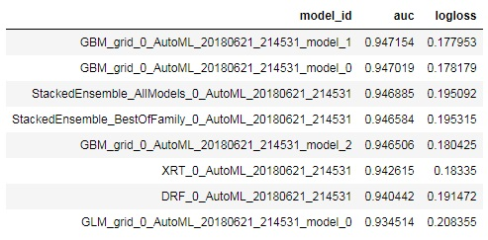
Take a look at the best model:
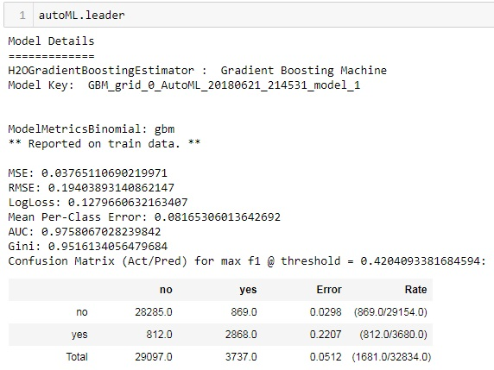
You can predict on the test set directly from the autoML instance.
predictionAML = autoML.predict(test)

Conclusion
This article is just a brief introductory overview of the H2O functionality. This is a great machine learning platform that can make some areas of machine learning work of engineers work more simple. It is a continuously developing framework. In the same way, in our opinion, it cannot be used alone. Instead, other instruments used along with H2O can make the machine learning process faster and more convenient.
In this article, we covered some basic data manipulation operations in H2O, looked at several machine learning models provided by H2O, learned how to perform cross-validation and grid search, became familiar with the automated machine learning in H2O.
You should understand that there are some features of the H2O which are below the scope of this article. So, if you are interested in learning more, please, read the official documentation.
ActiveWizards is a team of data scientists and engineers, focused exclusively on data projects (big data, data science, machine learning, data visualizations). Areas of core expertise include data science (research, machine learning algorithms, visualizations and engineering), data visualizations ( d3.js, Tableau and other), big data engineering (Hadoop, Spark, Kafka, Cassandra, HBase, MongoDB and other), and data intensive web applications development (RESTful APIs, Flask, Django, Meteor).
Original. Reposted with permission.

Democratising Machine learning with H2O

Overview of H2O: the open source, distributed in-memory machine learning platform

Photo by Pixabay from Pexels
It is important to make AI accessible to everyone for the sake of social and economic stability.
Kaggle days is a two-day event where data science enthusiasts can talk to each other face to face, exchange knowledge, and compete together. Kaggle days San Francisco just concluded and as is customary, Kaggle also organised a hackathon for the participants. I had been following Kaggle days on Twitter and the following tweet from Erin LeDell (Chief Machine Learning Scientist at H2O.ai) caught my eye.
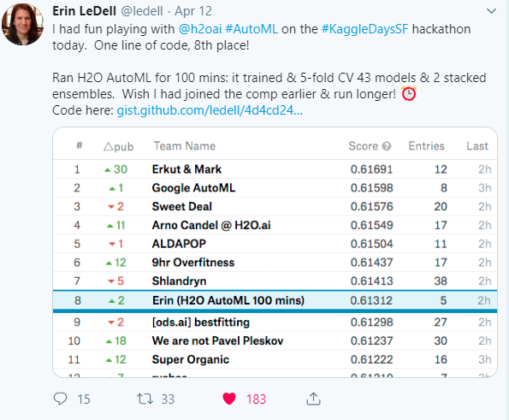
Source: Twitter
I have been experimenting with H2O for quite some time and found it really seamless and intuitive for solving ML problems. Seeing it perform so well on Leaderboard, I thought it was time that I wrote an article on the same to make it easy for others to make a transition into the world of H2O.

H2O.ai: The company behind H2O
H2O.ai is based in Mountain View, California and offers a suite of Machine Learning platforms. H2O’s core strength is its high-performing ML components, which are tightly integrated. H2O.ai is a Visionary in the Gartner Magic Quadrant for Data Science Platforms in its report released in Jan’2019.

Source: Gartner (January 2019)
Let’s take a brief look at the offerings of H2O.ai:
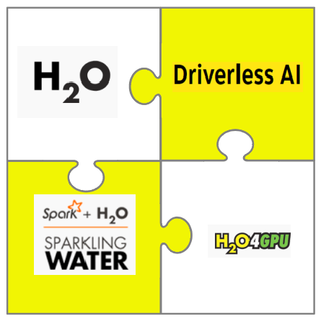
H2O.ai Products and Solutions

H2O
H2O is an open-source, distributed in-memory machine learning platform with linear scalability. H2O supports the most widely used statistical & machine learning algorithms and also has an AutoML functionality. H2O’s core code is written in Java and its REST API allows access to all the capabilities of H2O from an external program or script. The platform includes interfaces for R, Python, Scala, Java, JSON and CoffeeScript/JavaScript, along with a built-in web interface, Flow,
Since the main focus of this article is about H2O, we shall get to know more about it later in the article.

H2O Sparkling Water
Sparkling Water allows users to combine the fast, scalable machine learning algorithms of H2O with the capabilities of Spark. Sparkling Water is ideal for H2O users who need to manage large clusters for their data processing needs and want to transfer data from Spark to H2O (or vice versa).

H2O4GPU
H2O4GPU is an open-source, GPU-accelerated machine learning package with APIs in Python and R that allows anyone to take advantage of GPUs to build advanced machine learning models.

H2O Driverless AI
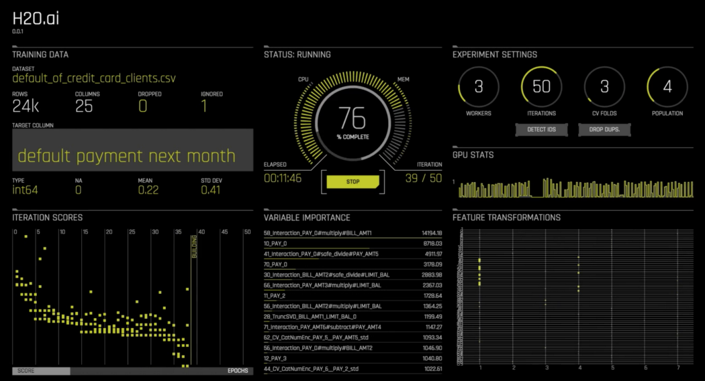
Driverless AI’s UI
H2O Driverless AI is H2O.ai’s flagship product for automatic machine learning. It fully automates some of the most challenging and productive tasks in applied data science such as feature engineering, model tuning, model ensembling and model deployment. With Driverless AI, data scientists of all proficiency levels can train and deploy modelling pipelines with just a few clicks from the GUI. Driverless AI is a commercially licensed product with a 21-day free trial version.

What is H2O
The latest version called H2O-3 is the third incarnation of H2O. H2O uses familiar interfaces like R, Python, Scala, Java, JSON and the Flow notebook/web interface, and works seamlessly with big data technologies like Hadoop and Spark. H2O can easily and quickly derive insights from the data through faster and better predictive modelling.

High-Level Architecture
H2O makes it possible to import data from multiple sources and has a fast, Scalable & Distributed Compute Engine Written in Java. Here is a high-level overview of the platform.
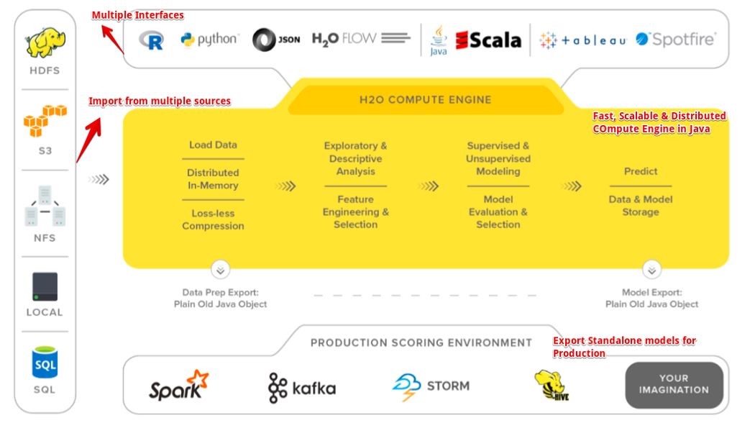
A High-Level architecture of h2o

Supported Algorithms
H2O supports a lot of commonly used algorithms of Machine Learning.
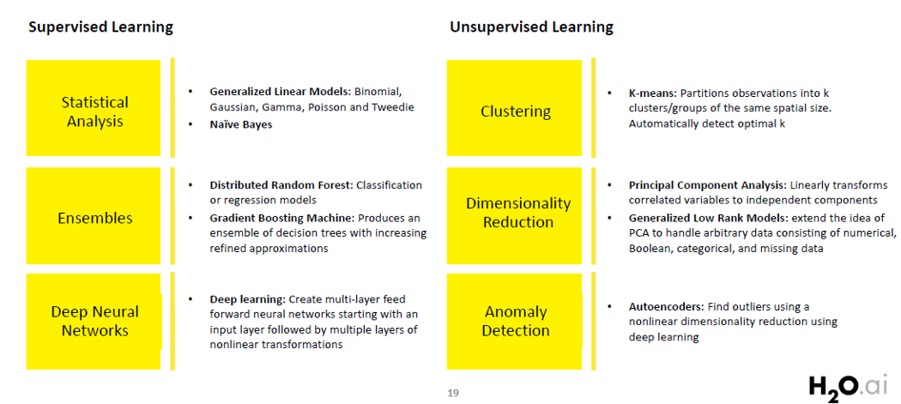
Algorithms supported by H2O

Installation
H2O offers an R package that can be installed from CRAN and a python package that can be installed from PyPI. In this article, I shall be working with only the Python implementation. Also, you may want to look at the documentation for complete details.

Pre-requisites
- Python
- Java 7 or later, which you can get at the Java download page. To build H2O or run H2O tests, the 64-bit JDK is required. To run the H2O binary using either the command line, R or Python packages, only 64-bit JRE is required.

Dependencies :
pip install requests
pip install tabulate
pip install "colorama>=0.3.8"
pip install future
- pip install
pip install -f http://h2o-release.s3.amazonaws.com/h2o/latest_stable_Py.html h2o
- conda
conda install -c h2oai h2o=3.22.1.2
Note: When installing H2O from pip in OS X El Capitan, users must include the --user flag. For example -
pip install -f http://h2o-release.s3.amazonaws.com/h2o/latest_stable_Py.html h2o --user
For R installation please refer to the official documentation here.

Testing installation
Every new python session begins by initializing a connection between the python client and the H2O cluster. A cluster is a group of H2O nodes that work together; when a job is submitted to a cluster, all the nodes in the cluster work on a portion of the job.
To check if everything is in place, open your Jupyter Notebooks and type in the following:
import h2o
h2o.init()
This is a local H2O cluster. On executing the cell, some information will be printed on the screen in a tabular format displaying amongst other things, the number of nodes, total memory, Python version etc. In case you need to report a bug, make sure you include all this information. Also, the h2o.init() makes sure that no prior instance of H2O is running.
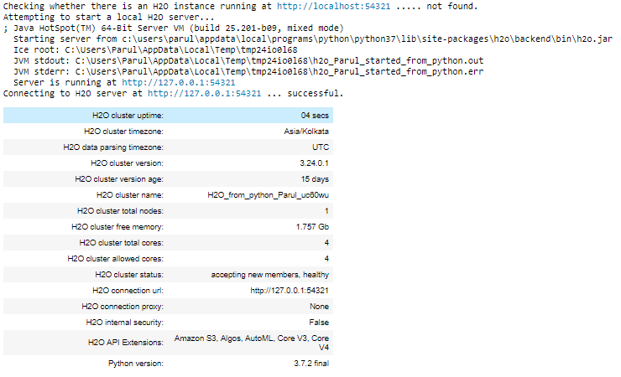
Running h2o.init() (in Python)
By default, H2O instance uses all the cores and about 25% of the system’s memory. However, in case you wish to allocate it a fixed chunk of memory, you can specify it in the init function. Let’s say we want to give the H2O instance 4GB of memory and it should only use 2 cores.
#Allocate resources
h2o.init(nthreads=2,max_mem_size=4)
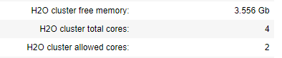
Now our H2O instance is using only 2 cores and around 4GB of memory. However, we will go with the default method.

Importing Data with H2O in Python
After the installation is successful, it’s time to get our hands dirty by working on a real-world dataset. We will be working on a Regression problem using the famous wine dataset. The task here is to predict the quality of white wine on a scale of 0–10 given a set of features as inputs.
Here is a link to the Github Repository in case you want to follow along or you can view it on my binder by clicking the image below.



Data
The data belongs to the white variants of the Portuguese “Vinho Verde” wine.
- Source: https://archive.ics.uci.edu/ml/datasets/Wine+Quality
- CSV FIle : (https://archive.ics.uci.edu/ml/machine-learning-databases/wine-quality/winequality-white.csv)

Data Import
Importing data from a local CSV file. The command is very similar to pandas.read_csv and the data is stored in memory as a H2OFrame.
wine_data = h2o.import_file("winequality-white.csv")
wine_data.head(5)# The default head() command displays the first 10 rows.
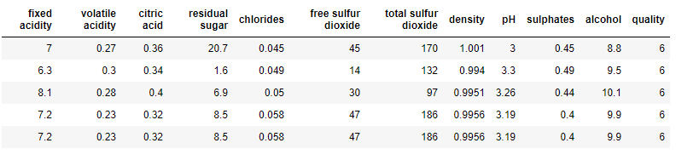
Displaying the first 5 rows of the dataset

EDA
Let us explore the dataset to get some insights.
wine_data.describe()
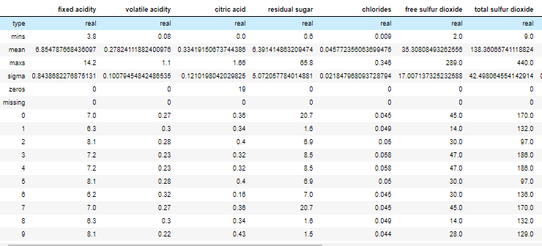
Exploring some of the columns of the dataset
All the features here are numbers and there aren’t any categorical variables. Now let us also look at the correlation of the individual features.
import matplotlib.pyplot as plt
import seaborn as sns
plt.figure(figsize=(10,10))
corr = wine_data.cor().as_data_frame()
corr.index = wine_data.columns
sns.heatmap(corr, annot = True, cmap='RdYlGn', vmin=-1, vmax=1)
plt.title("Correlation Heatmap", fontsize=16)
plt.show()
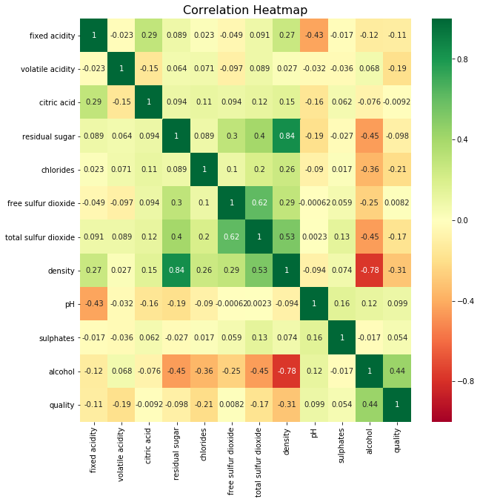

Modeling with H2O
We shall build a regression model to predict the Quality of the wine. There are a lot of algorithms available in the H2O module both for Classification as well as Regression problems.

Splitting data into Test and Training sets
Since we have only one dataset, let’s split it into training and Testing part, so that we can evaluate the model’s performance. We shall use the split_frame() function.
wine_split = wine_data.split_frame(ratios = [0.8], seed = 1234)wine_train = wine_split[0] # using 80% for training
wine_test = wine_split[1] #rest 20% for testingprint(wine_train.shape, wine_test.shape)
(3932, 12) (966, 12)

Defining Predictor Variables
predictors = list(wine_data.columns)
predictors.remove('quality') # Since we need to predict quality
predictors
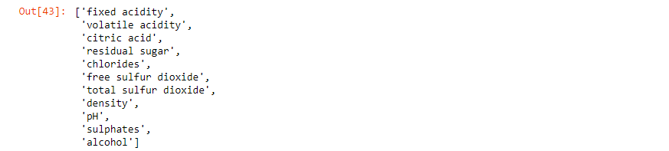

Generalized Linear Model
We shall build a Generalized Linear Model (GLM) with default settings. Generalized Linear Models (GLM) estimate regression models for outcomes following exponential distributions. In addition to the Gaussian (i.e. normal) distribution, these include Poisson, binomial, and gamma distributions. You can read more about GLM in the documentation.
# Import the function for GLM
from h2o.estimators.glm import H2OGeneralizedLinearEstimator# Set up GLM for regression
glm = H2OGeneralizedLinearEstimator(family = 'gaussian', model_id = 'glm_default')# Use .train() to build the model
glm.train(x = predictors,
y = 'quality',
training_frame = wine_train)print(glm)
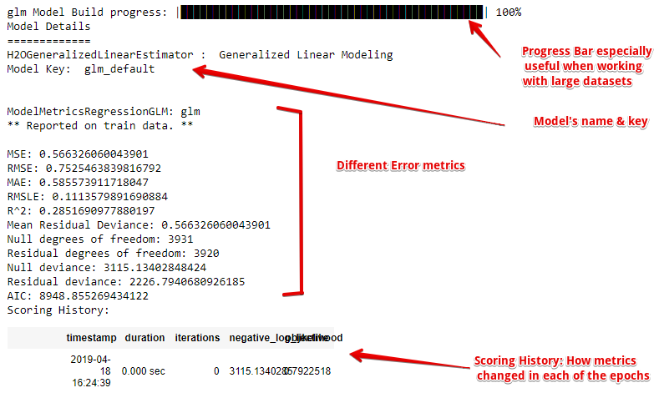
GLM model’s parameters on the Training set
Now, let’s check the model’s performance on the test dataset
glm.model_performance(wine_test)
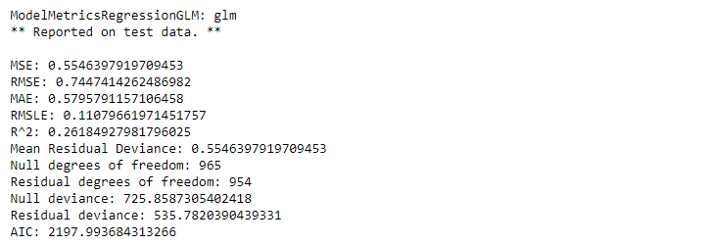

Making Predictions
Using the GLM model to make predictions in the test dataset.
predictions = glm.predict(wine_test)
predictions.head(5)
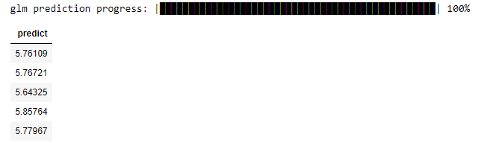
Similarly, you could use other supervised algorithms like Distributed Random Forest, Gradient Boosting Machines, and even Deep Learning.you could also tune in the hyperparameters.

H2OAutoML: Automatic Machine Learning
Automated machine learning (AutoML) is the process of automating the end-to-end process of applying machine learning to real-world problems. AutoML makes machine learning available in a true sense, even to people with no major expertise in this field. H2O’s AutoML tends to automate the training and the tuning part of the models.
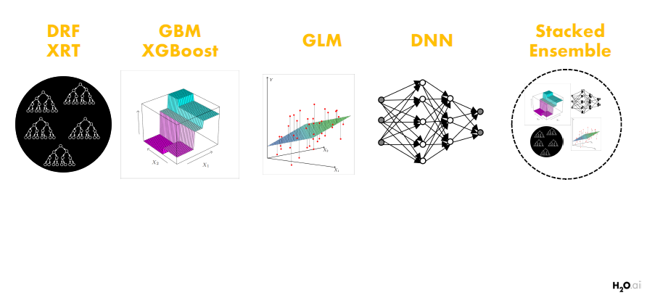
H2O AutoML: Available Algos
In this section, we shall be using the AutoML capabilities of H2O to work on the same regression problem of predicting wine quality.

Importing the AutoML Module
from h2o.automl import H2OAutoML
aml = H2OAutoML(max_models = 20, max_runtime_secs=100, seed = 1)
Here AutoML will run for 20 base models for 100 seconds. The default runtime is 1 Hour.

Training
aml.train(x=predictors, y='quality', training_frame=wine_train, validation_frame=wine_test)

Leaderboard
Now let us look at the automl leaderboard.
print(aml.leaderboard)
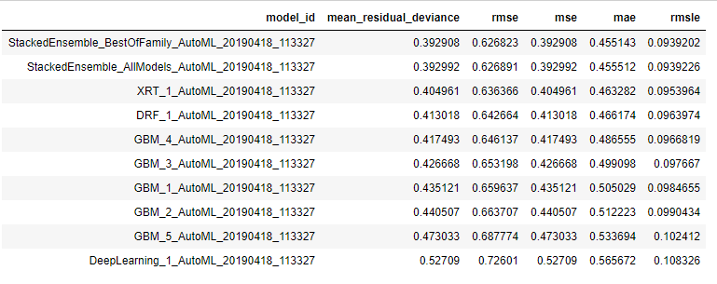
AutoML Leaderboard
The leaderboard displays the top 10 models built by AutoML with their parameters. The best model is placed on the top is a Stacked Ensemble.
The leader model is stored as aml.leader

Contribution of Individual Models
Let us look at the contribution of the individual models for this meta-learner.
metalearner = h2o.get_model(aml.leader.metalearner()['name'])
metalearner.std_coef_plot()
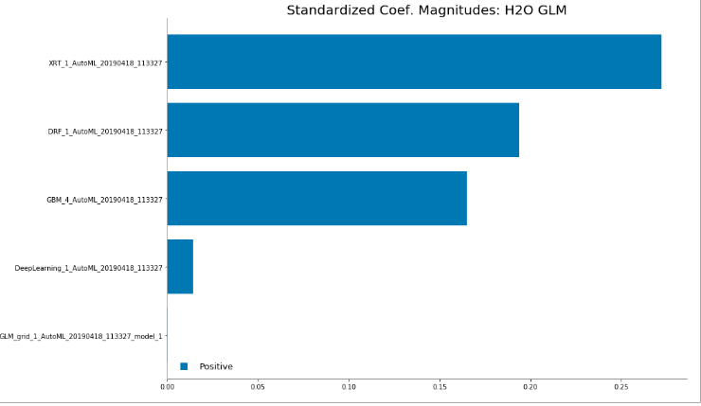
XRT( Extremely Randomized Trees) has the maximum contribution followed by Distributed Random Forests.

Predictions
preds = aml.leader.predict(wine_test)
The code above is the quickest way to get started, however, to learn more about H2O AutoML it is worth taking a look at the in-depth AutoML tutorial (available in R and Python).

Shutting Down
h2o.shutdown()

Using Flow — H2O’s Web UI
In the final leg of this article, let us have a quick overview of H2O’s open source Web UI called Flow. FLow is a web-based interactive computational environment where you can combine code execution, text, mathematics, plots and rich media into a single document, much like Jupyter Notebooks.

Launching FLow
Once H2O is up and running all you need to do is point your browser to http://localhost:54321 and you’ll see our very nice user interface called Flow.
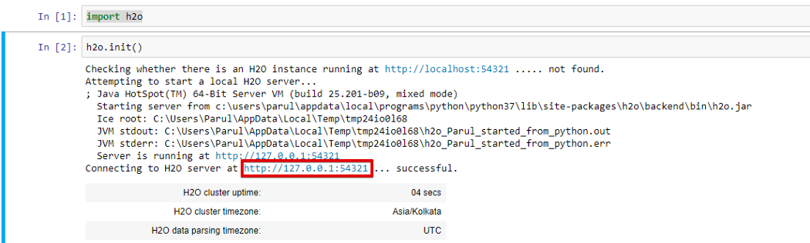
Launching H2O flow

Flow Interface
Here is a quick glance over the flow interface. You can read more about using and working with it here.
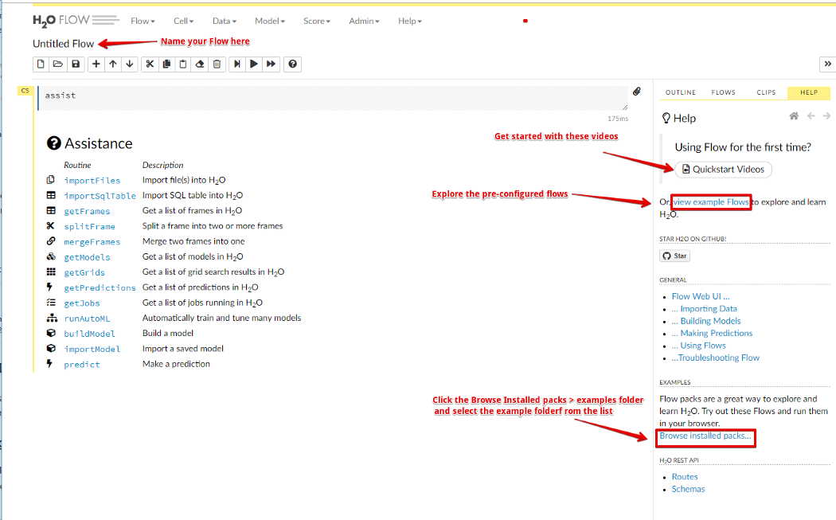
H2O’s flow interface
Flow is designed to help data scientists rapidly and easily create models, import files, split data frames and do all the things that would normally require quite a bit of typing in other environments.

Working
Let’s work through our same wine example but this time with Flow. The following video explains the model building and prediction using flow and it is kind of self-explanatory.
Demonstration of H2O Flow
For a deep dive into FLow and it’s capabilities, refer to the article below:

Getting started with H2O using Flow

A look into H2O’s open-source UI for combining code execution, text, plots, and rich media in a single document.
towardsdatascience.com

Conclusion
H2O is a powerful tool and given its capabilities, it can really transform the Data Science process for good. The capabilities and advantages of AI should be made available to everybody and not a select few. This is the real essence of Democratisation and Democratising Data Science should is essential for resolving Real problems threatening our planet.
https://www.tutorialspoint.com/h2o/index.htm

What is Auto ML?
Automated Machine Learning (AutoML) is the process of automating tasks in the machine learning pipeline such as data preprocessing, hyperparameter tuning, model selection and evaluation. In this article we will examine how to utilize open source automated machine learning package from H2O to accelerate a Data Scientist’s model development process.

Setup
pip install h2o
Let’s import the necessary packages
import h2o
from h2o.automl import H2OAutoML
Initialize the H2O cluster.
h2o.init()

Data Preparation
We will be using a dataset from UCI which describes a bank’s marketing campaign which offers clients to place a term deposit. The target variable is yes if the customer agrees and no if the customer decides not to place a term deposit.
Load the dataset as a H2OFrame
df = h2o.import_file(path='/kaggle/input/bank-marketing-campaigns-dataset/bank-additional-full.csv')
Describe the dataset. H2O provides 10 rows of sample data along with basic summary statistics for numerical columns.
df.describe(chunk_summary=True)
Split the dataset into train and test set
train, test = df.split_frame(ratios=[0.8], seed = 1)

Train AutoML Models
Let's configure the AutoML training parameters.
- max_models: Maximum number of models to train
- balance_classes: set to True to balance the class labels for tasks with imbalance data
- seed : Set for reproducibility
aml = H2OAutoML(max_models =25,
balance_classes=True,
seed =1)
We can limit the amount of time spent on searching for the best model by limiting:
- maximum number of models using max_models
- total time spent using max_runtime_secs
- time spend training any single model using max_runtime_secs_per_model.
Start the training by specifying:
- training_frame: the dataframe that contains training data
- y: the column in the training_frame which contains the target variable
aml.train(training_frame = train, y = 'y')
In addition we can also specify validation_frame which is a H2OFrame that the model is evaluated on during training. If this parameter is not set, the model will be evaluated using k-fold cross validation. Refer to the documentation for other optional parameters.
So what goes on under the hood?
H2O AutoML trains and cross validates the following models in the following order:
- three pre-specified XGBoost GBM (Gradient Boosting Machine) models
- a fixed grid of GLMs
- a default Random Forest (DRF)
- five pre-specified H2O GBMs
- a near-default Deep Neural Net
- an Extremely Randomized Forest (XRT)
- a random grid of XGBoost GBMs
- a random grid of H2O GBMs
- a random grid of Deep Neural Nets
In addition, it also trains:
- a stacked ensemble of all the models trained above
- a “Best of Family” Stacked Ensemble that contains the best performing model for each algorithm class

Evaluation
After the models are trained, we can compare the model performance using the leaderboard. H2O AutoML produces a leaderboard which ranks the trained model based on a predefined metric. By default it ranks models by ascending order of logloss and rmse for classification and regression task respectively.
lb = aml.leaderboard
lb.head(rows=lb.nrows)
The leaderboard metrics are calculated based on the cross validation set unless a leaderboard_frame is specified during training.
aml.train(training_frame = train,
y = 'y',
leaderboard_frame = my_leaderboard_frame)
In a typical machine learning evaluation for classification task, we will be interested to know performance of the best performing model such as ROC AUC, Precision, Recall, F1, Accuracy, Gains/Lift and the confusion metrics on the cross validation dataset. H2O provides all these metrics with just 2 lines of code.
Let’s get the best performing model and examine its results.
best_model = aml.get_best_model()
print(best_model)
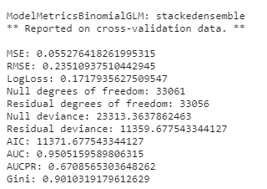
Common metrics reported on cross validation data
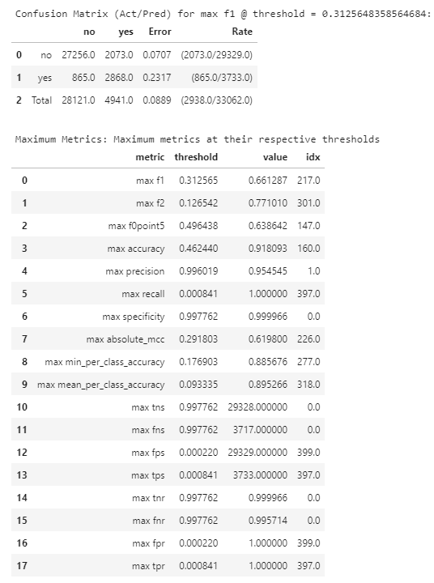
Confusion matrix and metrics at their respective maximum thresholds
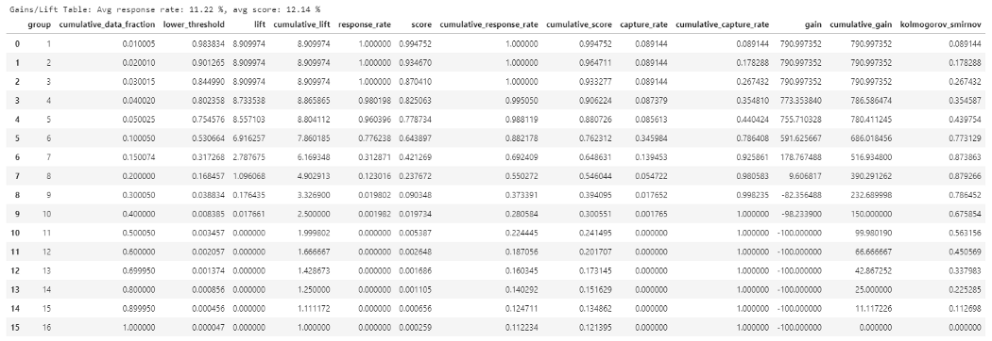
Gain/Lift chart
We can also evaluate the best model on a holdout test set using the same evaluation metrics shown above.
best_model.model_performance(test)

Save, Load and Predict
Lets save a binary model
model_path = h2o.save_model(model=best_model,path='/kaggle/working/model', force=True)print(model_path)>> /kaggle/working/model/StackedEnsemble_AllModels_AutoML_20210803_232409
The saved binary model can be loaded in a different notebook and used make predictions on a test set. Note that the H2O version that was used to train the saved binary model must be the same as the one used in our inference environment.
import h2o #must be same version used during training of the modelh2o.init()loaded_model = h2o.load_model(path='/kaggle/working/model/StackedEnsemble_AllModels_AutoML_20210803_232409')
loaded_model.predict(test)

Explainability
H2O AutoML also provides insights into model’s global explainability such as variable importance, partial dependence plot, SHAP values and model correlation with just one line of code
explain_model = aml.explain(frame = test, figsize = (8,6))
In addition, it also provides local explainability for individual records. We can input a H2OFrame into the frame argument and indicate which row we would like explained using the row_index argument. In this case we are explaining the results for row 15 of the test frame.
aml.explain_row(frame = test, row_index = 15, figsize = (8,6))

Conclusion
In this article, we examined how H2O AutoML can be used to:
- Describe a dataset
- Train models with minimal human inputs
- Make predictions on a trained model
- Explain the model’s predictions
You can find the notebook for training and inference here:
- Training
- Inference
2O is an open source, fast, and scalable machine learning framework that allows you to build models using big data and then easily productionalize them in diverse enterprise environments.
Machine Learning at Scale with H2O begins with an overview of the challenges faced in building machine learning models on large enterprise systems, and then addresses how H2O helps you to overcome them. You’ll start by exploring H2O’s in-memory distributed architecture and find out how it enables you to build highly accurate and explainable models on massive datasets using your favorite ML algorithms, language, and IDE. You’ll also get to grips with the seamless integration of H2O model building and deployment with Spark using H2O Sparkling Water. You’ll then learn how to easily deploy models with H2O MOJO. Next, the book shows you how H2O Enterprise Steam handles admin configurations and user management, and then helps you to identify different stakeholder perspectives that a data scientist must understand in order to succeed in an enterprise setting. Finally, you’ll be introduced to the H2O AI Cloud platform and explore the entire machine learning life cycle using multiple advanced AI capabilities.
By the end of this book, you’ll be able to build and deploy advanced, state-of-the-art machine learning models for your business needs.
Publication date:
July 2022
Publisher
Packt
Pages
396
ISBN
9781800566019
 Download code from GitHub

Chapter 1: Opportunities and Challenges
Machine Learning (ML) and data science are winning a popularity contest of sorts, as witnessed by their headline coverage in the popular and professional press and by expanding job openings across the technology landscape. Students typically learn ML techniques using their own computers on relatively small datasets. Those who enter the field often find themselves in the much different setting of a large company buzzing with workers performing specialized job roles, while collaborating with others scattered across the nation or world. Both data science students and data science workers have a few key things in common – they are in an exciting and growing field that businesses deem ever more critical to their future, and the data they thrive on is becoming exponentially more abundant and diverse.
There are huge opportunities for ML in enterprises because the transformational impacts of ML on businesses, customers, patients, and so on are diverse, widespread, lucrative, and life-changing. A backdrop of urgency exists as well from competitors who are all attempting the same thing. Enterprises are thus incented to invest in significant ML transformations and to supply the necessary data, tooling, production systems, and people to journey toward ML success. But challenges loom large as well, and these challenges commonly revolve around scale. The challenges of scale take on many forms inherent to ML at an enterprise level.
In this chapter, we will define and explore the challenge of ML at scale by covering the following main topics:
- ML at scale
- The ML life cycle and three challenge areas for ML at scale
- H2O.ai's answer to these challenges

ML at scale
This book is about implementing ML at scale and how to use H2O.ai technology to succeed in doing so. What specifically do we mean by ML at scale? We can see three contexts and challenges of scale during the ML life cycle – building models from large datasets, deploying these models in enterprise production environments, and executing the full range of ML activities within the complexities of enterprise processes and stakeholders. This is summarized in the following figure:
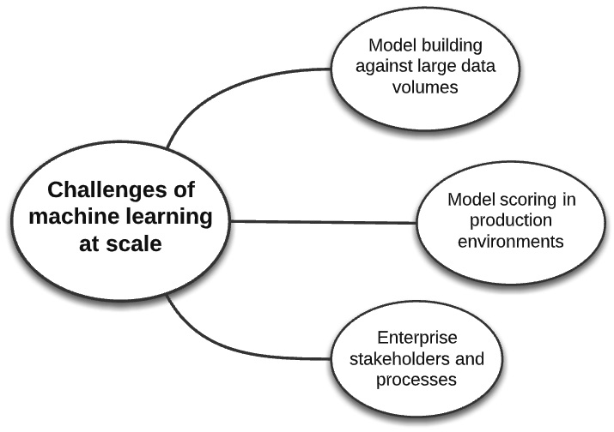
Figure 1.1 – The challenges of ML at scale
Let's drill down further on these challenges. Before doing so, we will oversee a generic conception of the ML life cycle, which will be useful as a reference throughout the book.

The ML life cycle and three challenge areas for ML at scale
The ML life cycle is a process that data scientists and enterprise stakeholders follow to build ML models and put them into production environments, where they make predictions and achieve value. In this section, we will define a simplified ML life cycle and elaborate on two broad areas that present special challenges for ML at scale.

A simplified ML life cycle
We will use the following ML life cycle representation. The goal is to achieve a simplified depiction that we can all recognize as central to ML while avoiding attempts at a canonical definition. Let's use it as our working framework for discussion:
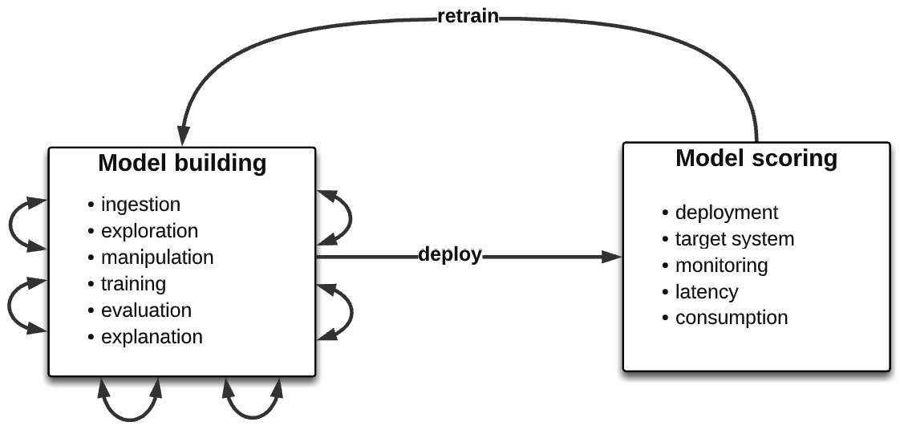
Figure 1.2 – A simplified ML life cycle
The following is a brief articulation.

Model building
Model building is a highly iterative process with frequent and unpredictable feedback loops along the way toward building a predictive model that is worthy of deploying in a business context. The steps can be summarized as follows:
- Data ingestion: Data is pulled from sources or a storage layer in the model building environment. There is often significant work onward from here in finding and accessing potentially useful data sources and transforming the data into a useable form. Typically, this is done as part of a larger data pipeline and architecture.
- Data exploration: Data is explored to understand its qualities (for example, data profiling, correlation analysis, outlier detection, and data visualization).
- Data manipulation: Data is cleaned (for example, the imputation of missing data, the reduction of categorical features, and normalization) and new features are engineered.
- Model training: An ML algorithm, scoring metric, and validation method are selected, and the model is tuned across a range of hyperparameters and tested against a test dataset.
- Model evaluation and explainability: A fit of the model is diagnosed for performance metrics, overfitting, and other diagnostics; model explainability is used to validate against domain knowledge, to explain the model decisions at individual and global levels, and to guard against institutional risks such as unfair bias against demographic groups.
- Model deployment: The model is deployed as a scoring artifact to a software system and live scoring is made.
- Model monitoring: The model is monitored to detect whether the data fed into it changes over time compared to the distribution of data it was trained on. This is called data drift and usually leads to the decreased predictive power of the model. This usually triggers the need to retrain the model with a more current dataset and then redeploy the updated model. The model may also be monitored for other patterns, such as whether it is biasing decisions against a particular demographic group and whether malicious attacks are being made to try to cause the model to malfunction.
As mentioned, a key property in the workflow is the unknown number and sequence of iteration pathways taken between these steps before a model is deployed or before the project is deemed unsuccessful in reaching that stage.

The model building challenge – state-of-the-art models at scale
Let's, for now, define a large dataset as any dataset that exceeds your ability to build ML models on your laptop or local workstation. It may be too large because your libraries simply crash or because they take an unreasonable amount of time to complete. This may occur during model training or during data ingestion, exploration, and manipulation.
We can see four separate challenges of building ML models from large data volumes, with each contributing to a larger problem in general that we call the friction of iteration. This is represented in the following diagram:
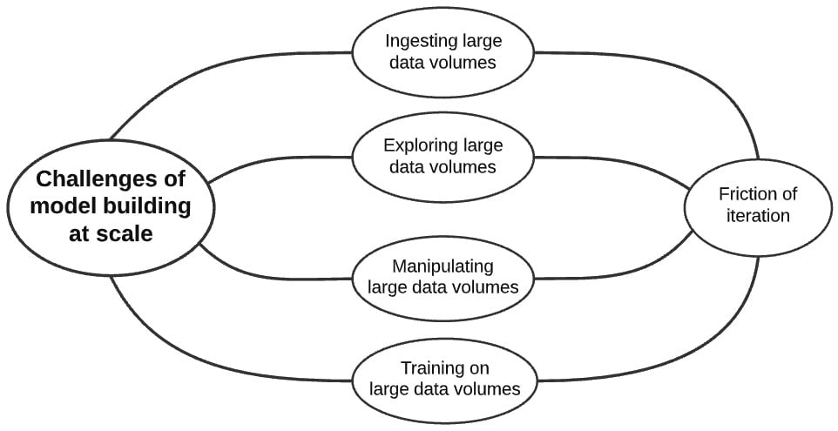
Figure 1.3 – The challenge of model building with large data volumes
Let's elaborate on this.

Challenge one – data size and location
Enterprises collect and store vast amounts of diverse data and that is a boon to the data scientist looking to build accurate models. These datasets are either stored across many systems or centralized in a common storage layer (data lake) such as the Hadoop Distributed File System (HDFS) or AWS S3. Architecting and making data available to internal consumers is a major effort and challenge for an enterprise. However, the data scientist starting the ML life cycle with large datasets typically cannot move that data, once it becomes accessible, to a local environment due to either security reasons or high volume of data.. The consequence is that the data scientist must either do one of the following:
- Move operations on the data (in other words, move the compute) to the data itself.
- Move data to a high-compute environment that they are authorized to use.

Challenge two – data size and data manipulation
Manipulating data can be compute-intensive, and attempting to do so against insufficient resources either will cause the compute to fail (for example, the script, library, or tool will crash) or take an unreasonably long amount of time. Who wants to wait 10 hours to join and filter table data when it can be done in 10 minutes? What you might consider an unreasonable amount of time is obviously relative to the dataset size; terabytes of data will always take longer to process than a few megabytes. Regardless, the speed of your data processing is critical to reducing the sum time of your iterations.

Challenge three – data size and data exploration
Challenges of data size during data exploration are identical to those during data manipulation. The data may be so large that your processing crashes or takes an unreasonable amount of time to complete while exploring models.

Challenge four – data size and model training
ML algorithms are extremely compute-intensive because they step through each record of a dataset and perform complex calculations each time, and then iterate these calculations against the dataset repeatedly to optimize toward a training metric and thus learn a predictive mathematical pattern among the noise. Our compute environment is particularly pressured during model training.
Up until now, we have been discussing dataset size in relative terms; that is, large data volumes are those that cause operations on them to either fail or take a long time to complete in a given compute environment.
In absolute terms, data scientists often explore the largest dataset possible to understand it and then sample it for model training. Others always try to use the largest dataset for model training. However, accurate models can be built from 10 GB or less of sampled or unsampled data.
The key to proper use of sampling is that you have followed appropriate statistical and theoretical practices, and not that you are forced to do so because your ML processing will crash or take a long time to complete due to large data volumes. The latter is a bad practice that produces inferior models and H2O.ai overcomes this by allowing model building with massive data volumes.
There are also cases when data sampling may not lead to an acceptable model. In other words, the data scientist may need hundreds of gigabytes or a terabyte or more of data to build a valuable model. These are cases when the following applies:
- The data scientist does not trust the sampling to produce the best model and feels that each small gain in lift warrants the use of the full dataset.
- The data scientist does not want to segment the data into separate datasets and thus separate model building exercises, or the larger stakeholder group wants a single model in production that predicts against all segments versus many that each predicts against a single segment.
- The data is highly dimensional, sparse, or both. In this case, a large number of records are needed to reduce variance and overfitting to a training dataset. This type of dataset is typical for anomaly detection, recommendation engines, predictive maintenance, security threat detection, personalized medicine, and so on. It is worth noting that the future will bring us more and more data, and thus highly dimensional and sparse datasets will become more common.
- The data is extremely imbalanced. The target variable is very rare in the dataset and a massive dataset is needed to avoid underfitting, overfitting, or weighting the target variable from these infrequent records.
- The data is highly volatile. Each subset of data that is collected is unrepresentative of the others and thus sampling or cross-validation folds may not be representative. Time series forecasting may be particularly sensitive to this problem, especially when forecast categories are highly granular (for example, yearly, monthly, daily, and hourly) against a single validation dataset.

The friction of iteration
Model building is a highly iterative process and anything that slows it down we call the friction of iteration. These causes can be due to the challenges of working with large data volumes, as previously discussed. They can also arise from simple workflow patterns such as switching among systems between each iteration or launching new environments to work on an iteration.
Any slowness during a single iteration may seem acceptable but when multiplied across the seemingly endless iterations from the project beginning to failure or success, the cost in time from this friction becomes significant, and reducing friction can be valuable. As we will see in the next section, slow model building delays the main goal of ML in an enterprise – achieving business value.

The business challenge – getting your models into enterprise production systems
The bare truth about ML initiatives is that they do not really achieve value until they are deployed to a live scoring environment. Models must meet evaluation criteria and be put into production to be deemed successful. Until that happens, from a business standpoint, little is achieved. This may seem a bit harsh, but it is typically how success is defined in data science initiatives. The following diagram maps this thinking onto the ML life cycle:
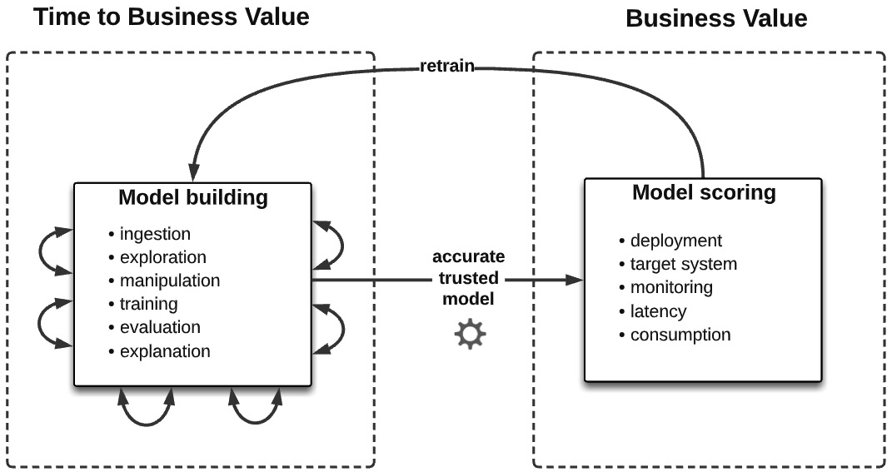
Figure 1.4 – The ML life cycle value chain
The friction of iteration from this view is thus a cost. Time taken to iterate through model building is time taken from getting business results. In other words, lower friction translates to less time to build and deploy a model to achieve business value, and more time to work on other problems and thus more models per quarter or year.
From the same point of view, time to deploy a model is viewed as a cost for similar reasons. The model deployment step may seem like a simple one-step sequence of transitioning the model to DevOps, but typically it is not. Anything that makes a model easier and more repeatable to deploy, document, and govern helps businesses achieve value sooner.
Let's now continue expanding on a larger landscape of enterprise stakeholders that data scientists must work with to build models that ultimately achieve business value.

The navigation challenge – navigating the enterprise stakeholder landscape
The data scientist in any enterprise does not work in isolation. There are multiple stakeholders who become involved directly in the ML life cycle or, more broadly, in the business cycle of initiating and consuming ML projects. Who might some of these stakeholders be? At a bare minimum, they include the business stakeholder who funded the ML project, the administrator providing the data scientist with permissions and capabilities, the DevOps or engineering team members who are responsible for model deployment and the infrastructure supporting it, perhaps marketing or sales associates whose functions are impacted directly by the model, and any other representatives of the internal or external consumers of the model. In more heavily regulated industries such as banking, insurance, or pharmaceuticals, these might include representatives or offices of various audit and risk functions – data risk, code risk, model risk, legal risk, reputational risk, compliance, external regulators, and so on. The following figure shows a general view:
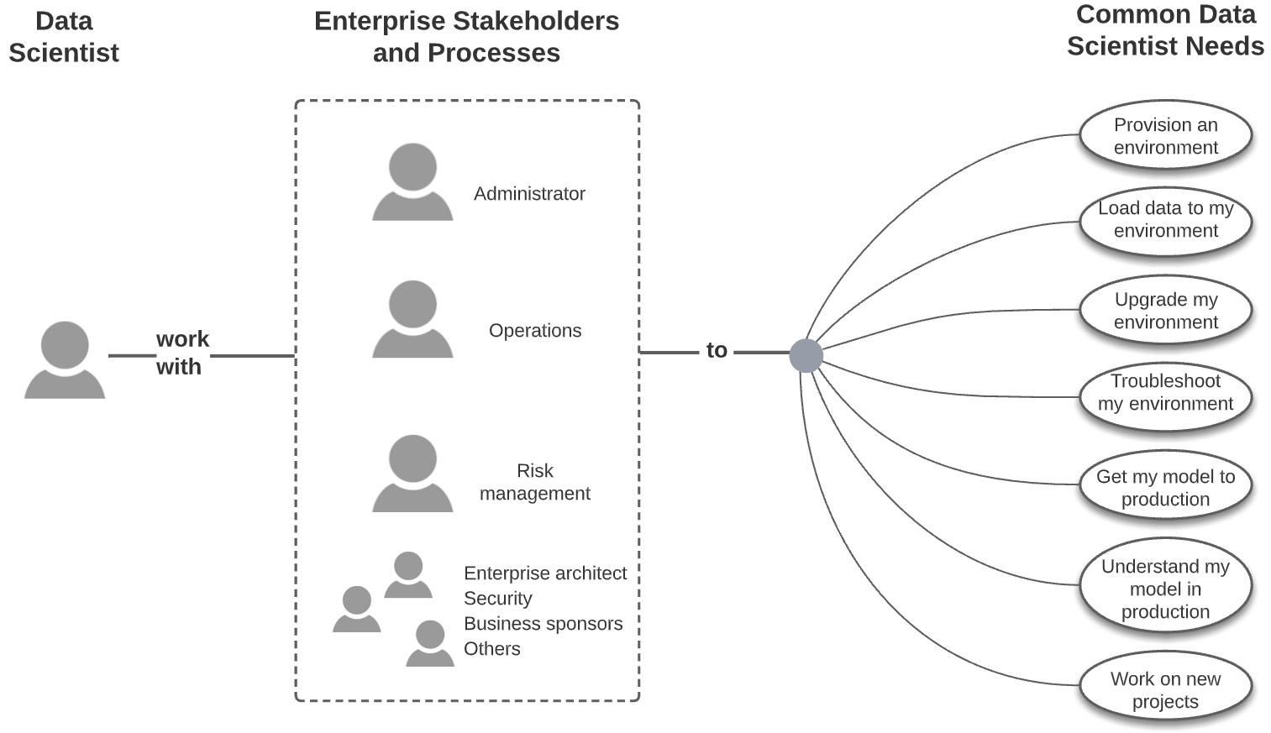
Figure 1.5 – Data scientists working with enterprise stakeholders and processes
Stakeholder interaction is thus complex. What leads to this complexity? Obviously, the specialization and siloing of job functions make things complex, and this is further amplified by the scale of the enterprise. A larger dynamic of creating repeatable processes and minimizing risk contributes as well. Explaining this complexity is the task of a different book, but its reality in the enterprise is inescapable. To a data scientist, the ability to recognize, influence, negotiate with, deliver to, and ultimately build trust with these various stakeholders is imperative to successful ML solutions at scale.
Now that we have understood the ML life cycle and the challenges inherent in its successful execution at scale, it is time for a brief introduction to how H2O.ai solves these challenges.

H2O.ai's answer to these challenges
H2O.ai provides software to build ML models at scale and overcome the challenges of doing so – model building at scale, model deployment at scale, and dealing with enterprise stakeholders' concerns and inherent friction along the way. These components are described in brief in the following diagram:
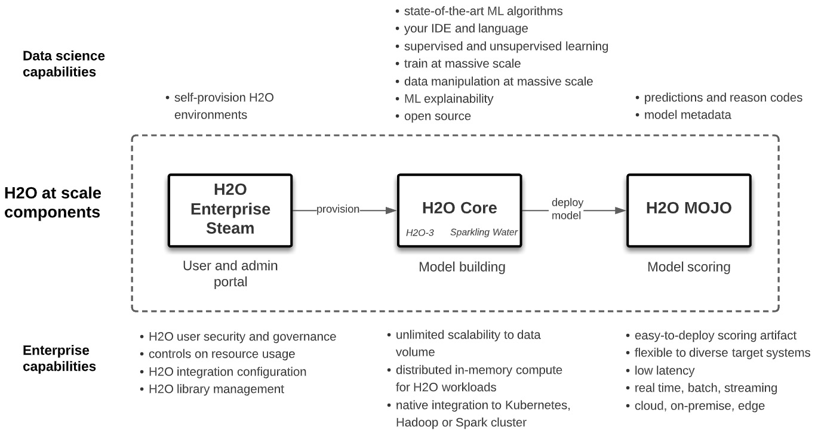
Figure 1.6 – H2O ML at scale
Subsequent chapters of this book elaborate on how these components are used to build and deploy state-of-the-art models within the complexities of the enterprise environment.
Let's try to understand these components at first glance:
- H2O Core: This is open source software that distributes state-of-the-art ML algorithms and data manipulations over a specified number of servers on Kubernetes, Hadoop, or Spark environments. Data is partitioned in memory across the designated number of servers and ML algorithm computation is run in parallel using it.
This architecture creates horizontal scalability of model building to hundreds of gigabytes or terabytes of data and generally fast processing times at lower data volumes. Data scientists work with familiar IDEs, languages, and algorithms and are abstracted away from the underlying architecture. Thus, for example, a data scientist can run an XGBoost model in Python from a Jupyter notebook against 500 GB of data in Hadoop, similar to doing so with data loaded into their laptop.
H2O Core is often referred to as H2O Open Source and comes in two forms, H2O-3 and Sparkling Water, which we will elaborate on in subsequent chapters. H2O Core can be run as a scaled-down sandbox on a single server or laptop.
- H2O Enterprise Steam: This is a web UI or API for data scientists to self-provision and manage their individual H2O Core environments. Self-provisioning includes auto-calculation of horizontal scaling based on user inputs that describe the data. Enterprise Steam is also used by administrators to manage users, including defining boundaries for their resource consumption, and to configure H2O Core integration against Hadoop, Spark, or Kubernetes.
- H2O MOJO: This is an easy-to-deploy scoring artifact exportable from models built from H2O Core. MOJOs are low latency (typically < 100 ms or faster) Java binaries that can run on any Java Virtual Machine (JVM) and thus serve predictions on diverse software systems, such as REST servers, database clients, Amazon SageMaker, Kafka queues, Spark pipelines, Hive user-defined functions (UDFs), and Internet of Things (IoT) devices.
- APIs: Each component has a rich set of APIs so that you can automate workflows, including continuous integration and continuous delivery (CI/CD) and retraining pipelines.
The focus of this book is on building and deploying state-of-the-art models at scale using H2O Core with help from Enterprise Steam and deploying those models as MOJOs within the complexities of enterprise environments.
H2O at Scale and H2O AI Cloud
We refer to H2O at scale in this book as H2O Enterprise Steam, H2O Core, and H2O Mojo because it addresses the ML at scale challenges described earlier in this chapter, especially through the distributed ML scalability that H2O Core provides for model building.
Note that H2O.ai offers a larger end-to-end ML platform called the H2O AI Cloud. The H2O AI Cloud integrates a hyper-advanced AutoML tool (called H2O Driverless AI) and other model building engines, an MLOps scoring, monitoring, and governance environment (called H2O MLOps), and a low-code software development kit, or SDK (called H2O Wave) with H2O API hooks to build AI applications that publish to the App Store. It also integrates H2O at scale as defined in this book.
H2O at scale can be deployed as standalone or as part of the H2O AI Cloud. As a standalone implementation, Enterprise Steam is not in fact required, but for reasons elaborated on later in this book, Enterprise Steam is deemed essential for enterprise implementations.
The majority of this book is focused on H2O at scale. The last part of the book will extend our understanding to the H2O AI Cloud and how H2O at scale components can leverage this larger integrated platform and vice versa.

Summary
In this chapter, we have set the stage for understanding and implementing ML at scale using H2O.ai technology. We have defined multiple forms of scale in an enterprise setting and articulated the challenges to ML from model building, model deployment, and enterprise stakeholder perspectives. We have anchored these challenges ultimately to the end goal of ML – providing business value. Finally, we briefly introduced H2O at scale components used by enterprises to overcome these challenges and achieve business value.
In the next chapter, we'll start to understand these components in greater technical detail so that we can start writing code and doing data science.

