1) What is an algorithm? What is the need for an algorithm?
An algorithm is a well-defined computational procedure that takes some values or the set of values, as an input and produces a set of values or some values, as an output.
Need for Algorithm
The algorithm provides the basic idea of the problem and an approach to solve it. Some reasons to use an algorithm are as follows.
- The algorithm improves the efficiency of an existing technique.
- To compare the performance of the algorithm with respect to other techniques.
- The algorithm gives a strong description of requirements and goal of the problems to the designer.
- The algorithm provides a reasonable understanding of the flow of the program.
- The algorithm measures the performance of the methods in different cases (Best cases, worst cases, average cases).
- The algorithm identifies the resources (input/output, memory) cycles required by the algorithm.
- With the help of an algorithm, we can measure and analyze the complexity time and space of the problems.
- The algorithm also reduces the cost of design.

2) What is the Complexity of Algorithm?
The complexity of the algorithm is a way to classify how efficient an algorithm is compared to alternative ones. Its focus is on how execution time increases with the data set to be processed. The computational complexity of the algorithm is important in computing.
It is very suitable to classify algorithm based on the relative amount of time or relative amount of space they required and specify the growth of time/ space requirement as a function of input size.
Time complexity
Time complexity is a Running time of a program as a function of the size of the input.
Space complexity
Space complexity analyzes the algorithms, based on how much space an algorithm needs to complete its task. Space complexity analysis was critical in the early days of computing (when storage space on the computer was limited).
Nowadays, the problem of space rarely occurs because space on the computer is broadly enough.
We achieve the following types of analysis for complexity
Worst-case: f(n)
It is defined by the maximum number of steps taken on any instance of size n.
Best-case: f(n)
It is defined by the minimum number of steps taken on any instance of size n.
Average-case: f(n)
It is defined by the average number of steps taken on any instance of size n.

3) Write an algorithm to reverse a string. For example, if my string is "uhsnamiH" then my result will be "Himanshu".
Algorithm to reverse a string.
Step1: start
Step2: Take two variable i and j
Step3: do length (string)-1, to set J at last position
Step4: do string [0], to set i on the first character.
Step5: string [i] is interchanged with string[j]
Step6: Increment i by 1
Step7: Increment j by 1
Step8: if i>j then go to step3
Step9: Stop

4) Write an algorithm to insert a node in a sorted linked list.
Algorithm to insert a node in a sorted linked list.
Case1:
Check if the linked list is empty then set the node as head and return it.

- New_node-> Next= head;
- Head=New_node
Case2:
Insert the new node in middle

- While( P!= insert position)
- {
- P= p-> Next;
- }
- Store_next=p->Next;
- P->Next= New_node;
- New_Node->Next = Store_next;
Case3:
Insert a node at the end

- While (P->next!= null)
- {
- P= P->Next;
- }
- P->Next = New_Node;
- New_Node->Next = null;

5) What are the Asymptotic Notations?
Asymptotic analysis is used to measure the efficiency of an algorithm that doesn't depend on machine-specific constants and prevents the algorithm from comparing the time taking algorithm. Asymptotic notation is a mathematical tool that is used to represent the time complexity of algorithms for asymptotic analysis.
The three most used asymptotic notation is as follows.
θ Notation
θ Notation defines the exact asymptotic behavior. To define a behavior, it bounds functions from above and below. A convenient way to get Theta notation of an expression is to drop low order terms and ignore leading constants.
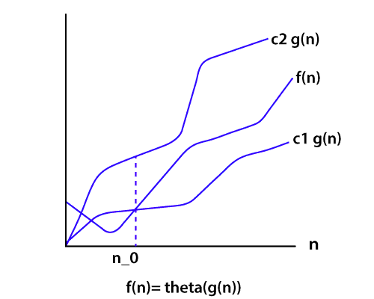
Big O Notation
The Big O notation bounds a function from above, it defines an upper bound of an algorithm. Let's consider the case of insertion sort; it takes linear time in the best case and quadratic time in the worst case. The time complexity of insertion sort is O(n²). It is useful when we only have upper bound on time complexity of an algorithm.
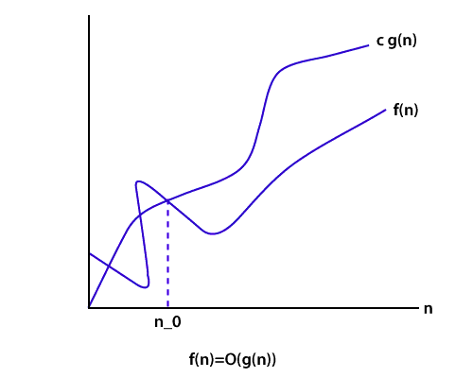
Ω Notation
Just like Big O notation provides an asymptotic upper bound, the Ω Notation provides an asymptotic lower bound on a function. It is useful when we have lower bound on time complexity of an algorithm.
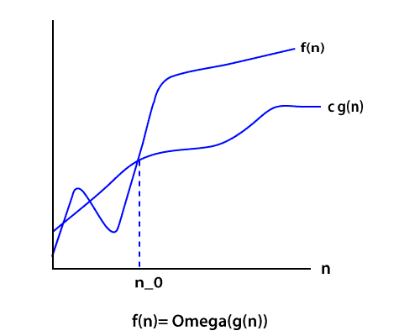

6) Explain the Bubble sort algorithm?
Bubble sort is the simplest sorting algorithm among all sorting algorithm. It repeatedly works by swapping the adjacent elements if they are in the wrong order.
e.g.
(72538) we have this array for sorting.
Pass1:
(72538) -> (27538) swap 7 and 2.
(27538) -> (25738) swap 7 and 5.
(25738) -> (25378) swap 7 and 3.
(25378) -> (25378) algorithm does not swap 7 and 8 because 7<8.
Pass2:
(25378) -> (25378) algorithm does not swap 2 and 5 because 2<5.
(25378) -> (23578) swap 3 and 5.
(23578) -> (23578) algorithm does not swap 5 and 7 because 5<7.
(23578) -> (23578) algorithm does not swap 7 and 8 because 7<8.
Here, the sorted element is (23578).

7) How to swap two integers without swapping the temporary variable in Java?
It's a very commonly asked trick question. There are many ways to solve this problem.
But the necessary condition is we have to solve it without swapping the temporary variable.
If we think about integer overflow and consider its solution, then it creates an excellent impression in the eye of interviewers.
Suppose we have two integers I and j, the value of i=7 and j=8 then how will you swap them without using a third variable. This is a journal problem.
We need to do this using Java programming constructs. We can swap numbers by performing some mathematical operations like addition, subtraction, multiplication, and division. But maybe it will create the problem of integer overflow.
Using addition and subtraction

- a= a + b;
- b=a - b; // this will act like (a+b)-b, now b is equal to a.
- a=a - b; // (a+b)-a, now, a is equal to b.
It is a nice trick. But in this trick, the integer will overflow if the addition is more than the maximum value of int primitive as defined by Integer.MAX_VALUE and if subtraction is less than minimum value i.e., Integer.MIN_VALUE.
Using XOR trick
Another solution to swap two integers without using a third variable (temp variable) is widely recognized as the best solution, as it will also work in a language which doesn't handle integer overflow like Java example C, C++. Java supports several bitwise operators. One of them is XOR (denoted by ^).

- x=x^y;
- y=x^y;
- x=x^y;

8) What is a Hash Table? How can we use this structure to find all anagrams in a dictionary?
A Hash table is a data structure for storing values to keys of arbitrary type. The Hash table consists of an index into an array by using a Hash function. Indexes are used to store the elements. We assign each possible element to a bucket by using a hash function. Multiple keys can be assigned to the same bucket, so all the key and value pairs are stored in lists within their respective buckets. Right hashing function has a great impact on performance.
To find all anagrams in a dictionary, we have to group all words that contain the same set of letters in them. So, if we map words to strings representing their sorted letters, then we could group words into lists by using their sorted letters as a key.

- FUNCTION find_anagrams(words)
- word_groups = HashTable<String, List>
- FOR word IN words
- word_groups.get_or_default(sort(word), []).push(word)
- END FOR
- anagrams = List
- FOR key, value IN word_groups
- anagrams.push(value)
- END FOR
- RETURN anagrams
The hash table contains lists mapped to strings. For each word, we add it to the list at the suitable key, or create a new list and add it to it.

9) What is Divide and Conquer algorithms?
Divide and Conquer is not an algorithm; it's a pattern for the algorithm. It is designed in a way as to take dispute on a huge input, break the input into minor pieces, and decide the problem for each of the small pieces. Now merge all of the piecewise solutions into a global solution. This strategy is called divide and conquer.
Divide and conquer uses the following steps to make a dispute on an algorithm.
Divide: In this section, the algorithm divides the original problem into a set of subproblems.
Conquer: In this section, the algorithm solves every subproblem individually.
Combine: In this section, the algorithm puts together the solutions of the subproblems to get the solution to the whole problem.

10) Explain the BFS algorithm?
BFS (Breadth First Search) is a graph traversal algorithm. It starts traversing the graph from the root node and explores all the neighboring nodes. It selects the nearest node and visits all the unexplored nodes. The algorithm follows the same procedure for each of the closest nodes until it reaches the goal state.
Algorithm
Step1: Set status=1 (ready state)
Step2: Queue the starting node A and set its status=2, i.e. (waiting state)
Step3: Repeat steps 4 and 5 until the queue is empty.
Step4: Dequeue a node N and process it and set its status=3, i.e. (processed state)
Step5: Queue all the neighbors of N that are in the ready state (status=1) and set their status =2 (waiting state)
[Stop Loop]
Step6: Exit

11) What is Dijkstra's shortest path algorithm?
Dijkstra's algorithm is an algorithm for finding the shortest path from a starting node to the target node in a weighted graph. The algorithm makes a tree of shortest paths from the starting vertex and source vertex to all other nodes in the graph.
Suppose you want to go from home to office in the shortest possible way. You know some roads are heavily congested and challenging to use this, means these edges have a large weight. In Dijkstra's algorithm, the shortest path tree found by the algorithm will try to avoid edges with larger weights.

12) Give some examples of Divide and Conquer algorithm?
Some problems that use Divide and conquer algorithm to find their solution are listed below.
- Merge Sort
- Quick Sort
- Binary Search
- Strassen's Matrix Multiplication
- Closest pair (points)

13) What are Greedy algorithms? Give some example of it?
A greedy algorithm is an algorithmic strategy which is made for the best optimal choice at each sub stage with the goal of this, eventually leading to a globally optimum solution. This means that the algorithm chooses the best solution at the moment without regard for consequences.
In other words, an algorithm that always takes the best immediate, or local, solution while finding an answer.
Greedy algorithms find the overall, ideal solution for some idealistic problems, but may discover less-than-ideal solutions for some instances of other problems.
Below is a list of algorithms that finds their solution with the use of the Greedy algorithm.
- Travelling Salesman Problem
- Prim's Minimal Spanning Tree Algorithm
- Kruskal's Minimal Spanning Tree Algorithm
- Dijkstra's Minimal Spanning Tree Algorithm
- Graph - Map Coloring
- Graph - Vertex Cover
- Knapsack Problem
- Job Scheduling Problem

14) What is a linear search?
Linear search is used on a group of items. It relies on the technique of traversing a list from start to end by visiting properties of all the elements that are found on the way.
For example, suppose an array of with some integer elements. You should find and print the position of all the elements with their value. Here, the linear search acts in a flow like matching each element from the beginning of the list to the end of the list with the integer, and if the condition is `True then printing the position of the element.'
Implementing Linear Search
Below steps are required to implement the linear search.
Step1: Traverse the array using for loop.
Step2: In every iteration, compare the target value with the current value of the array
Step3: If the values match, return the current index of the array
Step4: If the values do not match, shift on to the next array element.
Step5: If no match is found, return -1

15) What is a Binary Search Tree?
The binary search tree is a special type of data structure which has the following properties.
- Nodes which are less than root will be in the left subtree.
- Nodes which are greater than root (i.e., contains more value) will be right subtree.
- A binary search tree should not have duplicate nodes.
- Both sides subtree (i.e., left and right) also should be a binary search tree.
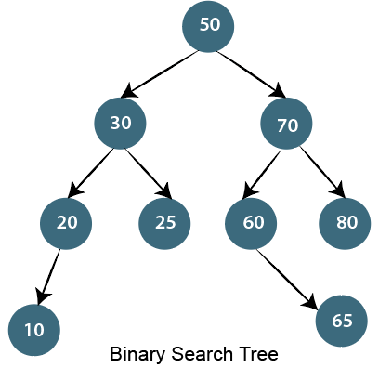

16) Write an algorithm to insert a node in the Binary search tree?
Insert node operation is a smooth operation. You need to compare it with the root node and traverse left (if smaller) or right (if greater) according to the value of the node to be inserted.
Algorithm:
- Make the root node as the current node
- If the node to be inserted < root
  - If it has left child, then traverse left
  - If it does not have left child, insert node here
- If the node to be inserted > root
  - If it has the right child, traverse right
  - If it does not have the right child, insert node here.

17) How to count leaf nodes of the binary tree?
Algorithm-
Steps for counting the number of leaf nodes are:
- If the node is null (contains null values) then return 0.
- If encountered leaf node. Left is null and node Right is null then return 1.
- Recursively calculate the number of leaf nodes using
No. of leaf nodes= no of leaf nodes in left subtree + number of leaf nodes in the right subtree.

18) How to find all possible words in a board of characters (Boggle game)?
In the given dictionary, a process to do a lookup in the dictionary and an M x N board where every cell has a single character. Identify all possible words that can be formed by order of adjacent characters. Consider that we can move to any of the available 8 adjacent characters, but a word should not have multiple instances of the same cell.
Example:

- dictionary[] = {"Java", "Point","Quiz"};
- Array[][] = {{'J', 'T', 'P',},
- {'U', 'A', 'A'},
- {'Q', 'S', 'V'}};
- isWord(str): returns true if str is present in dictionary
- else false.
Output:
Following words of the dictionary are present
JAVA

19) Write an algorithm to insert a node in a link list?
Algorithm
- Check If the Linked list does not have any value then make the node as head and return it
- Check if the value of the node to be inserted is less than the value of the head node, then insert the node at the start and make it head.
- In a loop, find the appropriate node after which the input node is to be inserted. To find the just node start from the head, keep forwarding until you reach a node whose value is greater than the input node. The node just before is the appropriate node.
- Insert the node after the proper node found in step 3.

20) How to delete a node in a given link list? Write an algorithm and a program?
Write a function to delete a given node from a Singly Linked List. The function must follow the following constraints:
- The function must accept a pointer to the start node as the first argument and node to be deleted as the second argument, i.e., a pointer to head node is not global.
- The function should not return a pointer to the head node.
- The function should not accept pointer to pointer to head node.
We may assume that the Linked List never becomes empty.
Suppose the function name is delNode(). In a direct implementation, the function needs to adjust the head pointer when the node to be deleted the first node.
C program for deleting a node in Linked List
We will handle the case when the first node to be deleted then we copy the data of the next node to head and delete the next node. In other cases when a deleted node is not the head node can be handled generally by finding the previous node.

- #include <stdio.h>
- #include <stdlib.h>
- struct Node
- {
- int data;
- struct Node *next;
- };

- void delNode(struct Node *head, struct Node *n)
- {
- if(head == n)
- {
- if(head->next == NULL)
- {
- printf("list can't be made empty because there is only one node. ");
- return;
- }
- head->data = head->next->data;
- n = head->next;
- head->next = head->next->next;
- free(n);
- return;
- }
- struct Node *prev = head;
- while(prev->next != NULL && prev->next != n)
- prev = prev->next;
- if(prev->next == NULL)
- {
- printf("\n This node is not present in List");
- return;
- }
- prev->next = prev->next->next;
- free(n);
- return;
- }
- void push(struct Node **head_ref, int new_data)
- {
- struct Node *new_node =
- (struct Node *)malloc(sizeof(struct Node));
- new_node->data = new_data;
- new_node->next = *head_ref;
- *head_ref = new_node;
- }
- void printList(struct Node *head)
- {
- while(head!=NULL)
- {
- printf("%d ",head->data);
- head=head->next;
- }
- printf("\n");
- }
- int main()
- {
- struct Node *head = NULL;
- push(&head,3);
- push(&head,2);
- push(&head,6);
- push(&head,5);
- push(&head,11);
- push(&head,10);
- push(&head,15);
- push(&head,12);
- printf("Available Link list: ");
- printList(head);
- printf("\nDelete node %d: ", head->next->next->data);
- delNode(head, head->next->next);

- printf("\nUpdated Linked List: ");
- printList(head);

- /* Let us delete the the first node */
- printf("\nDelete first node ");
- delNode(head, head);

- printf("\nUpdated Linked List: ");
- printList(head);

- getchar();
- return 0;
- }
Output:
Available Link List: 12 15 10 11 5 6 2 3
Delete node 10:
Updated Linked List: 12 15 11 5 6 2 3
Delete first node
Updated Linked list: 15 11 5 6 2 3

21) Write a c program to merge a link list into another at an alternate position?
We have two linked lists, insert nodes of the second list into the first list at substitute positions of the first list.
Example
if first list is 1->2->3 and second is 12->10->2->4->6, the first list should become 1->12->2->10->17->3->2->4->6 and second list should become empty. The nodes of the second list should only be inserted when there are positions available.
Use of extra space is not allowed i.e., insertion must be done in a place. Predictable time complexity is O(n) where n is number of nodes in first list.

- #include <stdio.h>
- #include <stdlib.h>
- struct Node
- {
- int data;
- struct Node *next;
- };
- void push(struct Node ** head_ref, int new_data)
- {
- struct Node* new_node =
- (struct Node*) malloc(sizeof(struct Node));
- new_node->data = new_data;
- new_node->next = (*head_ref);
- (*head_ref) = new_node;
- }
- void printList(struct Node *head)
- {
- struct Node *temp = head;
- while (temp != NULL)
- {
- printf("%d ", temp->data);
- temp = temp->next;
- }
- printf("\n");
- }
- void merge(struct Node *p, struct Node **q)
- {
- struct Node *p_curr = p, *q_curr = *q;
- struct Node *p_next, *q_next;
- while (p_curr != NULL && q_curr != NULL)
- {
- p_next = p_curr->next;
- q_next = q_curr->next;
- q_curr->next = p_next;
- p_curr->next = q_curr;
- p_curr = p_next;
- q_curr = q_next;
- }

- *q = q_curr;
- }
- int main()
- {
- struct Node *p = NULL, *q = NULL;
- push(&p, 3);
- push(&p, 2);
- push(&p, 1);
- printf("I Linked List:\n");
- printList(p);

- push(&q, 8);
- push(&q, 7);
- push(&q, 6);
- push(&q, 5);
- push(&q, 4);
- printf("II Linked List:\n");
- printList(q);

- merge(p, &q);

- printf("Updated I Linked List:\n");
- printList(p);

- printf("Updated II Linked List:\n");
- printList(q);
- getchar();
- return 0;
- }
Output:
I Linked List:
1 2 3
II Linked List:
4 5 6 7 8
Updated I Linked List:
1 4 2 5 3 6
Updated II Linked List:
7 8

22) Explain how the encryption algorithm works?
Encryption is the technique of converting plaintext into a secret code format it is also called as "Ciphertext." To convert the text, the algorithm uses a string of bits called as "keys" for calculations. The larger the key, the higher the number of potential patterns for Encryption. Most of the algorithm use codes fixed blocks of input that have a length of about 64 to 128 bits, while some uses stream method for encryption.

23) What Are The Criteria Of Algorithm Analysis?
An algorithm is generally analyzed by two factors.
- Time complexity
- Space complexity
Time complexity deals with the quantification of the amount of time taken by a set of code or algorithm to process or run as a function of the amount of input. In other words, the time complexity is efficiency or how long a program function takes to process a given input.
Space complexity is the amount of memory used by the algorithm to execute and produce the result.

24) What are the differences between stack and Queue?
Stack and Queue both are non-primitive data structure used for storing data elements and are based on some real-world equivalent.
Let's have a look at key differences based on the following parameters.
Working principle
The significant difference between stack and queue is that stack uses LIFO (Last in First Out) method to access and add data elements whereas Queue uses FIFO (First in first out) method to obtain data member.
Structure
In Stack, the same end is used to store and delete elements, but in Queue, one end is used for insertion, i.e., rear end and another end is used for deletion of elements.
Number of pointers used
Stack uses one pointer whereas Queue uses two pointers (in the simple case).
Operations performed
Stack operates as Push and pop while Queue operates as Enqueue and dequeuer.
Variants
Stack does not have variants while Queue has variants like a circular queue, Priority queue, doubly ended Queue.
Implementation
The stack is simpler while Queue is comparatively complex.

25) What is the difference between the Singly Linked List and Doubly Linked List data structure?
This is a traditional interview question on the data structure. The major difference between the singly linked list and the doubly linked list is the ability to traverse.
You cannot traverse back in a singly linked list because in it a node only points towards the next node and there is no pointer to the previous node.
On the other hand, the doubly linked list allows you to navigate in both directions in any linked list because it maintains two pointers towards the next and previous node.

1) Explain what is an algorithm in computing?
An algorithm is a well-defined computational procedure that take some value as input and generate some value as output. In simple words, it’s a sequence of computational steps that converts input into the output.

2) Explain what is Quick Sort algorithm?
Quick Sort algorithm has the ability to sort list or queries quickly. It is based on the principle of partition exchange sort or Divide and conquer. This type of algorithm occupies less space, and it segregates the list into three main parts.
- Elements less than the Pivot element
- Pivot element
- Elements greater than the Pivot element

3) Explain what is time complexity of Algorithm?
Time complexity of an algorithm indicates the total time needed by the program to run to completion. It is usually expressed by using the big O notation.

4) Mention what are the types of Notation used for Time Complexity?
The types of Notations used for Time Complexity includes
- Big Oh: It indicates “fewer than or the same as” <expression>iterations
- Big Omega: It indicates “more than or same as” <expression>iterations
- Big Theta: It indicates “the same as”<expression>iterations
- Little Oh: It indicates “fewer than” <expression>iterations
- Little Omega: It indicates “more than” <expression>iterations

5) Explain how binary search works?
In binary search, we compare the key with the item in the middle position of the array. If the key is less than the item searched then it must lie in the lower half of the array, if the key is greater than the item searched than it should be in upper half of the array.

6) Explain whether it is possible to use binary search for linked lists?
Since random access is not acceptable in linked list, it is impossible to reach the middle element of O(1) time. Thus, binary search is not possible for linked list.

7) Explain what is heap sort?
Heap-sort can be defined as a comparison based sorting algorithm. It divides its input into the unsorted and sorted region, until it shrinks the unsorted region by eliminating the smallest element and moving that to the sorted region.

8) Explain what is Skip list?
Skip list the method for data structuring, where it allows the algorithm to search, delete and insert elements in a symbol table or dictionary. In a skip list, each element is represented by a node. The search function returns the content of the value related to key. The insert operation associates a specified key with a new value, while the delete function deletes the specified key.

9) Explain what is Space complexity of insertion sort algorithm?
Insertion sort is an in-place sorting algorithm which means that it requires no extra or little. storage. For insertion sort, it requires only single list elements to be stored out-side the initial data, making the space-complexity 0(1).

10) Explain what a “Hash Algorithm” is and what are they used for?
“Hash Algorithm” is a hash function that takes a string of any length and decreases it to a unique fixed length string. It is used for password validity, message & data integrity and for many other cryptographic systems.

11) Explain how to find whether the linked list has a loop?
To know whether the linked list has a loop, we will take two pointer approach. If we maintain two pointers, and we increase one pointer after processing two nodes and other after processing every node, we are likely to encounter a situation where both the pointer will be pointing to the same node. This will only occur if linked list has a loop.

12) Explain how encryption algorithm works?
Encryption is the process of converting plaintext into a secret code format referred as “Ciphertext”. To convert the text, algorithm uses a string of bits referred as “keys” for calculations. The larger the key, the greater the number of potential patterns for creating cipher text. Most encryption algorithm use codes fixed blocks of input that have length about 64 to 128 bits, while some uses stream method.

13) List out some of the commonly used cryptographic algorithms?
Some of the commonly used cryptographic algorithms are
- 3-way
- Blowfish
- CAST
- CMEA
- GOST
- DES and Triple DES
- IDEA
- LOKI and so on

14) Explain what is the difference between best case scenario and worst case scenario of an algorithm?
- Best case scenario: Best case scenario for an algorithm is explained as the arrangement of data for which the algorithm performs best. For example, we take a binary search, for which the best case scenario would be if the target value is at the very center of the data you are searching. The best case time complexity would be 0 (1)
- Worst case scenario: It is referred for the worst set of input for a given algorithm. For example quicksort, which can perform worst if you select the largest or smallest element of a sublist for the pivot value. It will cause quicksort to degenerate to O (n2).

15) Explain what is Radix Sort algorithm?
Radix sort puts the element in order by comparing the digits of the numbers. It is one of the linear sorting algorithms for integers.

16) Explain what is a recursive algorithm?
Recursive algorithm is a method of solving a complicated problem by breaking a problem down into smaller and smaller sub-problems until you get the problem small enough that it can be solved easily. Usually, it involves a function calling itself.

17) Mention what are the three laws of recursion algorithm?
All recursive algorithm must follow three laws
- It should have a base case
- A recursive algorithm must call itself
- A recursive algorithm must change its state and move towards the base case

18) Explain what is bubble sort algorithm?
Bubble sort algorithm is also referred as sinking sort. In this type of sorting, the list to be sorted out compares the pair of adjacent items. If they are organized in the wrong order, it will swap the values and arrange them in the correct order.
What is an algorithm?
Informally, an algorithm is any well-defined computational procedure that takes some value, or set of values, as input and produces some value, or set of values, as output. An algorithm is thus a sequence of computational steps that transform the input into the output. (Source: Introduction to Algorithms 3rd Edition by CLRS)
What is time complexity of Binary Search?
Time complexity of binary search is O(Logn). See Binary Search for more details.
Can Binary Search be used for linked lists?
Since random access is not allowed in a linked list, we cannot reach the middle element in O(1) time. Therefore Binary Search is not possible for linked lists. There are other ways though, refer to Skip List for example.
How to find if two given rectangles overlap?
Two rectangles do not overlap if one of the following conditions is true.
1) One rectangle is above top edge of other rectangle.
2) One rectangle is on left side of left edge of other rectangle.
See Find if two rectangles overlap for more details.
How to find angle between hour and minute hands at a given time?
The idea is to take a reference point as 12. Find the angle moved by the hour and minute hands, subtract the two angles to find the angle between them. See angle between hour hand and minute hand for more details
When does the worst case of QuickSort occur?
In quickSort, we select a pivot element, then partition the given array around the pivot element by placing the pivot element at its correct position in a sorted array.
The worst case of quickSort occurs when one part after partition contains all elements and other part is empty. For example, if the input array is sorted and if the last or first element is chosen as a pivot, then the worst occurs. See https://www.geeksforgeeks.org/quick-sort/ for more details.
A sorted array is rotated at some unknown point, how to efficiently search an element in it.
A simple approach is to use linear search, but we can search in O(Logn) time using Binary Search. See Search an element in a sorted and pivoted array for more details.
Other variations of this problem like find the minimum element or maximum element in a sorted and rotated array.
Given a big string of characters, how to efficiently find the first unique character in it?
The efficient solution is to use character as an index in a count array. Traverse the given string and store index of the first occurrence of every character, also store count of occurrences. Then traverse the count array and find the smallest index with count as 1. See find the first unique character for more details.
How to count inversions in a sorted array?
Two elements arr[i] and arr[j] in an array arr[] form an inversion if a[i] > a[j] and i < j. How to count all inversions in an unsorted array. See Count Inversions in an array for all approaches.
Given a big array, how to efficiently find the kth largest element in it?
There can be many solutions for this. The best solution is to use min heap. We Build a Min Heap MH of the first k elements. For each element, after the kth element (arr[k] to arr[n-1]), compare it with the root of MH, if the element is greater than the root then make it root and call heapify for MH, Else ignore it. Finally, MH has k largest elements and the root of the MH is the kth largest element. See k largest(or smallest) elements for more details.
Given an array of size n with a range of numbers from 1 to n+1. The array doesn’t contain any duplicate, one number is missing, find the missing number.
There can be many ways to solve it. The best among is to use XOR. See Find the missing number for details. There are many variations of this problem like find the two repeating numbers, find a missing and a repeating number, etc.
How to write an efficient method to calculate x raised to the power n?
The idea is to use divide and conquer here to do it in O(Logn) time. See Write a C program to calculate pow(x,n) for more details.
Given an input string and a dictionary of words, find out if the input string can be segmented into a space-separated sequence of dictionary words.
The idea is to use Dynamic Programming. See Word Break Problem for more details.
Given a row of n coins of values v1 . . . vn, where n is even. We play a game against an opponent by alternating turns. In each turn, a player selects either the first or last coin from the row, removes it from the row permanently, and receives the value of the coin. Determine the maximum possible amount of money we can definitely win if we move first.
This is also a Dynamic Programming Question. See Optimal Strategy for a Game for more details.
You are given an array of sorted words in an arbitrary language, you need to find order (or precedence of characters) in the language. For example if the given arrays is {“baa”, “abcd”, “abca”, “cab”, “cad”}, then order of characters is ‘b’, ‘d’, ‘a’, ‘c’. Note that words are sorted and in the given language “baa” comes before “abcd”, therefore ‘b’ is before ‘a’ in output. Similarly, we can find other orders.
This can be solved using two steps: First create a graph by processing a given set of words, then do topological sorting of the created graph, See this for more details.

1. What is an algorithm?
While basic, if you happen to be asked this question, it’s important that you answer confidently and simply. An algorithm is a series of computational steps that takes in an input or multiple inputs and converts it into an output. There are several formats an algorithm can be written in which includes in plain English or as pseudocode.
Once you’ve given a concise answer like this, if you’d like to go deeper, you can do so using an example.

2. What is Quicksort?
This question is meant to test your ability to apply algorithms at least at a very basic level. A Quicksort algorithm sorts queries or lists quickly. It uses what’s referred to as a “divide and conquer” technique, partition exchange, which divides the list of items into three different parts:
- A pivot element selected from the array
- Elements less than the pivot element are placed to the left of the pivot to form a left subarray
- Elements greater than the pivot element are placed to the right of the pivot to form a right subarray
Within the subarrays a pivot element is selected and the remaining values are sorted to the left or right of the pivot. The process is repeated until there only remains a single element in the subarrays.
Time Complexities:
- Best Case: O(nlogn) This occurs when the pivot element value is close to the middle
- Worst Case: O(n2) This occurs when the pivot element value is either the largest or smallest value
- Average Case: O(nlogn)

3. What is the function of a Pivot element?
This is another shallow dive into the basics of algorithms. You can answer by explaining that a pivot element is an element chosen from the array or matrix being worked on to serve as the first element selected by the algorithm to perform calculations.
There are many ways to pick a pivot element. For arrays, pivots can be the last or first element, chosen from the middle, or even randomly selected. Depending on the algorithm, the way in which the pivot is selected may yield better results.

4. What is meant by the time complexity of an algorithm?
This is another basic element of algorithms, so your answer should begin with a brief definition. The time complexity element of an algorithm refers to the amount of iterations needed for it to be run to completion based on the input size.

5. Explain the different notations used when it comes to time complexity.
When answering this question and any follow-ups, you're demonstrating your knowledge of how algorithms work, as well as the different ways you can alter them to achieve the desired result.
Using notations helps predict the efficiency of the algorithm. The notations you use for time complexity include:
- Big Omega: This signifies “more than or same as” iterations. It is the tight lower-bound of the growth of the algorithm’s running time. This would be the best case time complexity.
- Big-O: This signifies “fewer than or the same as” iterations. It is the tight upper-bound of the growth of the algorithm’s running time. This would be the worst case time complexity.
- Big Theta: This signifies “the same as” iterations. It ​​is both a tight upper-bound and tight lower-bound on the growth of the algorithm’s running time.
- Little-O: This signifies “fewer than” iterations. It is ​​an upper-bound that is not asymptotically tight.
- Little Omega: This signifies “more than” iterations. It is the lower-bound that is not asymptotically tight.

6. How does binary search work?
Binary search is used to find an element within a sorted array. The item in the middle of the array is looked at first. If the element to look for matches the middle item then the search is complete. Otherwise, if the target element is greater than the middle element then the search is repeated on the upper half of the array (all the larger values after the middle). If it is lower than the middle element then the search is done on the lower half of the array (all the smaller values).
Time Complexities:
- Best Case: O(1) This occurs if the value matches the middle item to begin with.
- Worst Case: O(logn) Occurs if the value is at one of the end steps or is not in the array at all.
- Average Case: O(logn)

7. What is meant by a heap sort?
A heap sort involves comparing items using a sorting algorithm. The input is divided between a sorted and unsorted region. What’s shifted to the sorted region is dependent on whether working on a max-heap or min-heap. A max-heap has the element with the maximum value at the root while a min-heap has the minimum value at the root. When using heap sort on a max-heap, the unsorted region shrinks as the largest item is shifted to the sorted region. For min-heap, the smallest item is shifted to the sorted region.
In a max-heap, the parent node’s value is always greater than their children. To sort the elements of a max-heap using heap sort, the following steps are to be followed:
- Replace the last element of the heap with the root node
- Remove the newly placed last element from the heap
- Convert the now binary heap back into a max-heap
- Repeat the process until there is no more elements
Time Complexities:
- Best Case: O(nlogn)
- Worst Case: O(nlogn)
- Average Case: O(nlogn)

8. What is a skip list used for?
A skip list is used for the data structuring process. It is based on linked-lists and uses probability to build layers of new links on an original linked-list. It can be thought of as looking at a chain of bus routes. There are buses that stop at every stop but there are also buses that make only express stops. The express buses have fewer stops than that of the regular buses. Making new layers in the skip list can be thought of like the express routes. Being able to get to the most-frequented nodes more efficiently can make other tasks like inserting or deleting nodes much easier and faster than some other algorithms.

9. What are some of the most common cryptographic algorithms?
This may feel like a tough question because it sounds like you have to commit a bunch of stuff to memory, but if you miss a couple, they won’t blame you. Also, there are tons of algorithms out there. Here are some:
- IDEA
- Blowfish
- CAST
- LOKI
- DES
- GOST
- 3-way

10. What is a hash algorithm and how is it used?
You will want to get comfortable answering this question because hash algorithms are popular now due to their use in cryptography. A hash algorithm refers to a hash function, which takes a string and converts it to a fixed length regardless of how long it was to begin with. You can use it for a wide range of applications, from cryptocurrency to passwords and a range of other validation tools.

11. What role do algorithms play in cryptocurrency?
If you're interviewing for a job related to cryptocurrency, this could be a challenging question, especially if you get lost in the weeds while answering it. One way to answer this question is to mention just how heavily blockchain-based cryptocurrencies rely on cryptography. The blocks or records that make up the blockchain are secured using cryptographic methods like hash algorithms. There are also algorithms used to generate public-private keys and for “mining” cryptocurrencies.

12. How does an encryption algorithm work?
These kinds of algorithm interview questions get closer to the heart of some of the solutions you may be hired to work with. An encryption algorithm converts plain text into a code known as ciphertext. The algorithm uses keys to do this. Longer keys give you more potential options for making your ciphertext.

13. What is a radix sort algorithm?
Radix sort can come in handy with databases, and if your position may involve them, you should be ready to answer this question. Radix Sort is a sorting algorithm that avoids making comparisons by distributing elements into buckets based on their radix instead. If there are elements with more than one significant digit, then the bucket distribution is repeated for each digit.

14. What is a recursive algorithm?
A recursive algorithm refers to a way of solving a complex problem by segmenting it into smaller sub-problems. You do this again and again until you get a problem that’s small enough that it’s easy to solve. Binary search is one example of an algorithm that can be implemented to be recursive.

15. What are the three laws that govern a recursive algorithm?
These kinds of algorithm interview questions may come as follow-ups for the “What is a recursive algorithm?” question. A recursive algorithm needs to follow these laws:
- It has to have a base case.
- It has to call itself.
- It needs to change its state and shift towards the base case.

Q1:
Explain what is Binary Search
Junior

 Searching 24

Answer
When the list is sorted we can use the binary search (also known as half-interval search, logarithmic search, or binary chop) technique to find items on the list. Here's a step-by-step description of using binary search:
- Let min = 1 and max = n.
- Guess the average of max and min rounded down so that it is an integer.
- If you guessed the number, stop. You found it!
- If the guess was too low, set min to be one larger than the guess.
- If the guess was too high, set max to be one smaller than the guess.
- Go back to step two.
In this example we looking for array item with value 4:
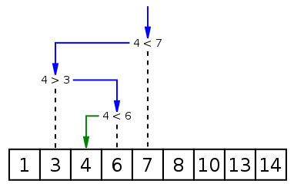
When you do one operation in binary search we reduce the size of the problem by half (look at the picture below how do we reduce the size of the problem area) hence the complexity of binary search is O(log n). The binary search algorithm can be written either recursively or iteratively.
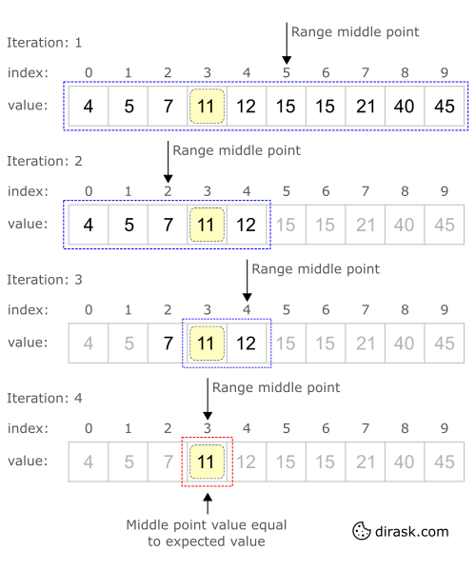
Complexity Analysis
Time:
Constant
O(1)
Dbl. Logarithmic
O(log log n)
Logarithmic
O(log n)
Square Root
O(√n)
Linear
O(n)
Linearithmic
O(n log n)
Quadratic
O(n2)
Exponential
O(2n)
Factorial
O(n!)
Space:
Constant
O(1)
Dbl. Logarithmic
O(log log n)
Logarithmic
O(log n)
Square Root
O(√n)
Linear
O(n)
Linearithmic
O(n log n)
Quadratic
O(n2)
Exponential
O(2n)
Factorial
O(n!)
Implementation
JavaScript JS
Java Java
Python PY
var binarySearch = function(array, value) {
var guess,
min = 0,
max = array.length - 1;

while(min <= max){
guess = Math.floor((min + max) /2);
if(array[guess] === value)
return guess;
else if(array[guess] < value)
min = guess + 1;
else
max = guess - 1;
}

return -1;}
Having Tech or Coding Interview? Check 24 Searching Interview Questions
Source: www.tutorialspoint.com

Q2:
Explain what is Linear (Sequential) Search and when may we use one?
Junior

Searching 24

Answer
Linear (sequential) search goes through all possible elements in some array and compare each one with the desired element. It may take up to O(n) operations, where N is the size of an array and is widely considered to be horribly slow. In linear search when you perform one operation you reduce the size of the problem by one (when you do one operation in binary search you reduce the size of the problem by half). Despite it, it can still be used when:
- You need to perform this search only once,
- You are forbidden to rearrange the elements and you do not have any extra memory,
- The array is tiny, such as ten elements or less, or the performance is not an issue at all,
- Even though in theory other search algorithms may be faster than linear search (for instance binary search), in practice even on medium-sized arrays (around 100 items or less) it might be infeasible to use anything else. On larger arrays, it only makes sense to use other, faster search methods if the data is large enough, because the initial time to prepare (sort) the data is comparable to many linear searches,
- When the list items are arranged in order of decreasing probability, and these probabilities are geometrically distributed, the cost of linear search is only O(1)
- You have no idea what you are searching.
When you ask MySQL something like SELECT x FROM y WHERE z = t, and z is a column without an index, linear search is performed with all the consequences of it. This is why adding an index to searchable columns is important.
Complexity Analysis
Time:
Constant
O(1)
Dbl. Logarithmic
O(log log n)
Logarithmic
O(log n)
Square Root
O(√n)
Linear
O(n)
Linearithmic
O(n log n)
Quadratic
O(n2)
Exponential
O(2n)
Factorial
O(n!)
Space:
Constant
O(1)
Dbl. Logarithmic
O(log log n)
Logarithmic
O(log n)
Square Root
O(√n)
Linear
O(n)
Linearithmic
O(n log n)
Quadratic
O(n2)
Exponential
O(2n)
Factorial
O(n!)
- A linear search runs in at worst linear time and makes at most n comparisons, where n is the length of the list. If each element is equally likely to be searched, then linear search has an average case of (n+1)/2 comparisons, but the average case can be affected if the search probabilities for each element vary.
- When the list items are arranged in order of decreasing probability, and these probabilities are geometrically distributed, the cost of linear search is only O(1)
Implementation
JavaScript JS
Python PY
function linearSearch(array, toFind){
for(let i = 0; i < array.length; i++){
if(array[i] === toFind) return i;
}
return -1;}
Having Tech or Coding Interview? Check 24 Searching Interview Questions
Source: bytescout.com

Q3:
Compare Binary Search vs Linear Search
Mid
Answer
- Binary search requires the input data to be sorted; linear search doesn't
- Binary search requires an ordering comparison (like >, <); linear search only requires equality comparisons (=)
- Binary search has complexity O(log n); linear search has complexity O(n)
- Binary search requires random access to the data; linear search only requires sequential access
  - this can be very important - it means a linear search can stream data of arbitrary size
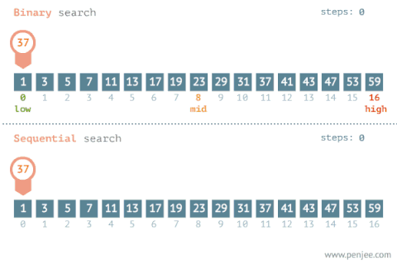
Having Tech or Coding Interview? Check 24 Searching Interview Questions
Source: stackoverflow.com

Q4:
Explain how does the Sentinel Search work?
Mid

Searching 24

Answer
The idea behind linear search is to compare the search item with the elements in the list one by one (using a loop) and stop as soon as we get the first copy of the search element in the list. Now considering the worst case in which the search element does not exist in the list of size N then the Simple Linear Search will take a total of 2N+1 comparisons (N comparisons against every element in the search list and N+1 comparisons to test against the end of the loop condition).
for (int i = 0; i < length; i++) { // N+1 comparisons
if (array[i] == elementToSearch) { // N comparisons
return i; // I found the position of the element requested
}
}
The idea of Sentinel Linear Search is to reduce the number of comparisons required to find an element in a list. Here we replace the last element of the list with the search element itself and run a while loop to see if there exists any copy of the search element in the list and quit the loop as soon as we find the search element. This will reduce one comparison in each iteration.
while(a[i] != element) // N+2 comparisons worst case
i++;
In that case the while loop makes only one comparison in each iteration and it is sure that it will terminate since the last element of the list is the search element itself. So in the worst case ( if the search element does not exists in the list ) then there will be at most N+2 comparisons (N comparisons in the while loop and 2 comparisons in the if condition). Which is better than (2N+1) comparisons as found in Simple Linear Search.
Complexity Analysis
Time:
Constant
O(1)
Dbl. Logarithmic
O(log log n)
Logarithmic
O(log n)
Square Root
O(√n)
Linear
O(n)
Linearithmic
O(n log n)
Quadratic
O(n2)
Exponential
O(2n)
Factorial
O(n!)
Space:
Constant
O(1)
Dbl. Logarithmic
O(log log n)
Logarithmic
O(log n)
Square Root
O(√n)
Linear
O(n)
Linearithmic
O(n log n)
Quadratic
O(n2)
Exponential
O(2n)
Factorial
O(n!)
Take note that both the algorithms (Simple Linear and Sentinel) have time complexity of O(n).
Implementation
C# CS
Python PY
/// <summary>/// Gets the index of first founded item/// </summary>/// <typeparam name="T">The type of array</typeparam>/// <param name="array">Input array</param>/// <param name="value">Value of searching item</param>/// <param name="equalityComparer">Custom comparer</param>/// <returns>The index of founded item or -1 if not found</returns>public static int BetterLinearSearch < T > (this IEnumerable < T > array, T value, IEqualityComparer < T > equalityComparer = null) {
if (equalityComparer == null) equalityComparer = new DefaultEqualityComparer < T > ();

int arrayLength = array.Count();

T lastItem = array.Last();
array = array.SetElement(arrayLength - 1, value);
int index = 0;
while (!equalityComparer.Equals(array.ElementAt(index), value))
index++;

if (index < arrayLength - 1) return index;

if (equalityComparer.Equals(lastItem, value)) return arrayLength - 1;

return - 1;}
Having Tech or Coding Interview? Check 24 Searching Interview Questions
Source: www.hackerearth.com

Q5:
Explain some Linear Search optimization techniques
Mid

Searching 24

Answer
If the elements you would be searching in a list are NOT uniformly distributed, then you could do certain optimizations that can help you improve the efficiency of your search algorithms. For such improvements to be effective, you do need to know the characteristics of the data being searched, the frequency and also the fact that the underlying collection needs to be modifiable.
- Most used pattern: If the likelihood of the current element being searched again is high, then move if from it's current location (say position i) to the front of the collection (say position 0). This does require moving elements from A[0, i-1] to A[1, i] to accommodate the new element at A[0].
- The disadvantage of the above pattern is that it requires a lot of movement. One quick strategy is to move an element up on success by simply swapping the target element from position x with the first element at position 0. This eventually results in a similar pattern as the frequently searched elements bubble up to the top of the list.
- On the other end of the spectrum, if an element is unlikely to be search again, then moving it to the end on find improves the chances of the other elements being searched.
Having Tech or Coding Interview? Check 24 Searching Interview Questions
Source: hoven-in.appspot.com
16 Caching Interview Questions For System Design Interview

Caching 18

Q6:
Explain what is Interpolation Search
Mid

Searching 24

Answer
Interpolation Search is an algorithm similar to Binary Search for searching for a given target value in a sorted array. It is an improvement over Binary Search for instances, where the values in a sorted array are uniformly distributed.
The binary search always chooses the middle of the remaining search space. On a contrast Interpolation search, at each search step, calculates (using interpolation formula) where in the remaining search space the target might be present, based on the low and high values of the search space and the value of the target. For example, if the value of the key is closer to the last element, interpolation search is likely to start search toward the end side. The value actually found at this estimated position is then compared to the target value. If it is not equal, then depending on the comparison, the remaining search space is reduced to the part before or after the estimated position.
The idea of the interpolation formula or partitioning logic is to return higher value of pos when element to be searched is closer to arr[hi]. And smaller value when closer to arr[low].
arr[] ==> Array where elements need to be searched
x ==> Element to be searched
low ==> Starting index in arr[]
hi ==> Ending index in arr[]

pos = low + [ (x-arr[low])*(hi-low) / (arr[hi]-arr[Low]) ]
Complexity Analysis
Time:
Constant
O(1)
Dbl. Logarithmic
O(log log n)
Logarithmic
O(log n)
Square Root
O(√n)
Linear
O(n)
Linearithmic
O(n log n)
Quadratic
O(n2)
Exponential
O(2n)
Factorial
O(n!)
Space:
Constant
O(1)
Dbl. Logarithmic
O(log log n)
Logarithmic
O(log n)
Square Root
O(√n)
Linear
O(n)
Linearithmic
O(n log n)
Quadratic
O(n2)
Exponential
O(2n)
Factorial
O(n!)
In the interpolation search algorithm, the midpoint is computed in such a way that it gives a higher probability of obtaining our search term faster. The worst case complexity of interpolation search is O(n). However, its average case complexity, under the assumption that the keys are uniformly distributed, is _O(log log N).
It can be proven that Interpolation Search repeatedly reducing the problem to a subproblem of size that is the square root of the original problem size, and algorithm will terminate after O(log log n) steps (see proof here). When the values are equally dispersed into the interval this search algorithm can be extremely useful – way faster than the binary search (that divides searching space by half).
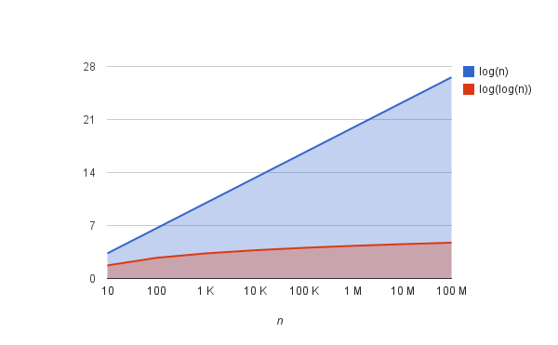
Implementation
JavaScript JS
Python PY
const interpolationSearch = (array, key) => {

// if array is empty.
if (!array.length) {
return -1;
}

let low = 0;
let high = array.length - 1;
while (low <= high && key >= array[low] && x <= array[high]) {

// calculate position with
let pos = low + Math.floor(((high - low) * (key - array[low])) / (array[high] - array[low]));

// if all elements are same then we'll have divide by 0 or 0/0
// which may cause NaN
pos = Number.isNaN(pos) ? low : pos;

if (array[pos] === key) {
return pos;
}

if (array[pos] > key) {
high = pos - 1;
} else {
low = pos + 1;
}

}

// not found.
return -1;};
Having Tech or Coding Interview? Check 24 Searching Interview Questions
Source: kdr2.com

Q7:
Explain why complexity of Binary Search is O(log n)?
Mid

Searching 24

Answer
When you do one operation in binary search we reduce the size of the problem by half. To answer the questions we have to answer, how many times can you divide N by 2 until you have 1? This is essentially saying, do a binary search (half the elements) until you found it. In a formula this would be this:
1 = N / 2x
multiply by 2x:
2x = N
now do the log2:
log2(2x) = log2 N
x log2(2) = log2 N
x 1 = log2 N
this means you can divide log N times until you have everything divided. Which means you have to divide log N ("do the binary search step") until you found your element.
The same concept explained graphically:
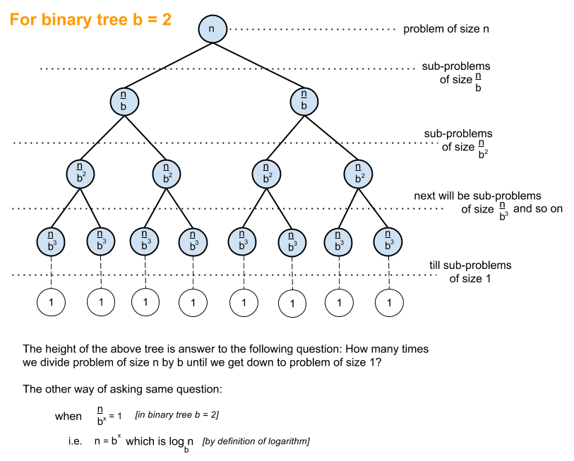
Having Tech or Coding Interview? Check 24 Searching Interview Questions
Source: stackoverflow.com

Q8:
What is a Jump (or Block) Search?
Mid

Searching 24

Answer
Jump Search (also referred to as Block Search) is an algorithm used to search for the position of a target element on a sorted data collection or structure.
The fundamental idea behind this searching technique is to search fewer number of elements compared to linear search algorithm (which scans every element in the array to check if it matches with the element being searched or not). This can be done by skipping some fixed number of array elements or jumping ahead by fixed number of steps in every iteration.
Lets consider a sorted array A[] of size n, with indexing ranging between 0 and n-1, and element x that needs to be searched in the array A[]. For implementing this algorithm, a block of size m is also required, that can be skipped or jumped in every iteration. Thus, the algorithm works as follows:
- Iteration 1: if (x==A[0]), then success, else, if (x > A[0]), then jump to the next block.
- Iteration 2: if (x==A[m]), then success, else, if (x > A[m]), then jump to the next block.
- Iteration 3: if (x==A[2m]), then success, else, if (x > A[2m]), then jump to the next block.
- At any point in time, if (x < A[km]), then a linear search is performed from index A[(k-1)m] to A[km]
Consider the following inputs:
- A[] = {0, 1, 1, 2, 3, 5, 8, 13, 21, 55, 77, 89, 101, 201, 256, 780}
- item = 77
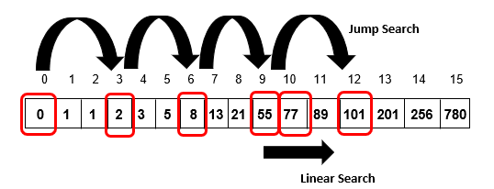
- The single most important advantage of jump search when compared to binary search is that it does not rely on the division operator (/).
- Jump Search is highly efficient for searching arrays especially when its only-seeks-forward behavior is favorable - its average performance makes it sit somewhere between Binary Search with its O(log n) complexity and Linear Search with an O(n) complexity.
Complexity Analysis
Time:
Constant
O(1)
Dbl. Logarithmic
O(log log n)
Logarithmic
O(log n)
Square Root
O(√n)
Linear
O(n)
Linearithmic
O(n log n)
Quadratic
O(n2)
Exponential
O(2n)
Factorial
O(n!)
Space:
Constant
O(1)
Dbl. Logarithmic
O(log log n)
Logarithmic
O(log n)
Square Root
O(√n)
Linear
O(n)
Linearithmic
O(n log n)
Quadratic
O(n2)
Exponential
O(2n)
Factorial
O(n!)
- Jump Search would consecutively jump to its very last block searching for the target element, in turn causing an n/m number of jumps. Additionally, if the last element’s value of this block was greater than the target element, Jump Search would perform a linear search with m-1 iterations.
- This causes Jump Search to make (n/m) jumps with additional m-1 iterations. This value is minimum at m = √n. Therefore, the optimum block size is √n. Accordingly, Jump Search maintains a worst and average case efficiency of O(√n) complexity.
- The space complexity of this algorithm is O(1) since it does not require any additional temporary variables or data structures for its implementation.
Implementation
JavaScript JS
Java Java
Python PY
function jumpSearch(arrayToSearch, valueToSearch){
var length = arrayToSearch.length;
var step = Math.floor(Math.sqrt(length));
var index = Math.min(step, length)-1;
var lowerBound = 0;
while (arrayToSearch[Math.min(step, length)-1] < valueToSearch)
{
lowerBound = step;
step += step;
if (lowerBound >= length){
return -1;
}
}

var upperBound = Math.min(step, length);
while (arrayToSearch[lowerBound] < valueToSearch)
{
lowerBound++;
if (lowerBound == upperBound){
return -1;
}
}
if (arrayToSearch[lowerBound] == valueToSearch){
return lowerBound;
}
return -1;}
Having Tech or Coding Interview? Check 24 Searching Interview Questions
Source: www.studytonight.com
Check MLStack.Cafe - 1704 Data Science & ML Interview Questions & Answers!

Q9:
What is an example of Interpolation Search being slower than Binary Search?
Mid

Searching 24

Problem
I understand that interpolation search not only requires a sorted list but also uniformly distributed. Provide an understandable situation where Interpolation search is slower than binary search.
Answer
If we assume uniform distribution of the values so we'll use simple linear interpolation. So if the values are:
1,2,3,4,5,6,7,8,9,10000000
And we search for number 9, searching using linear interpolation will go through all (excluding the first and last) the indices before finding the correct one. In such cases interpolation search will be O(n).
Having Tech or Coding Interview? Check 24 Searching Interview Questions
Source: stackoverflow.com

Q10:
What's wrong with this Recursive Binary Search function?
Mid

Searching 24

Problem
Consider:
bool recur_search(int key, int values[], int lower, int upper){
// base case 1: not in haystack
if (upper < lower)
{
return false;
}

int mid = (lower + upper) / 2;

// base case 2: found
if (key == values[mid])
{
return true;
}

// recursive cases
else if (key < values[mid])
{
recur_search(key, values, lower, mid - 1);
}
else // (key > values[mid])
{
recur_search(key, values, mid + 1, upper);
}

// to get rid of "error: control may reach end of non-void function"
return false;}
What's wrong with this code?
Answer
Classic mistake!
Even though it is calling itself correctly, it is missing the code necessary to recursively return the result. As it is written above, it will execute the recursive call to itself, but when it does find a number, it will return true on the first step back through the recursion. However, at the second step and thereafter, the code will return to the calling recursion and process the next line of code because it has no instruction to do something else. It will drop through the if(upper < lower) block and hit the return false statement. So, from there on, it will just return false back up the recursion.
The addition of one keyword, return, in two places, fixes the code:
// recursive cases...
else if (key < values[mid])
{
return recur_search(key, values, lower, mid - 1);
}
else // (key > values[mid])
{
return recur_search(key, values, mid + 1, upper);
}...

1. What is an algorithm? What are the reasons for using an algorithm?
A good understanding of algorithms is essential to every software programmer. Companies ask this question to assess the candidate's understanding of this fundamental aspect of computer engineering. Knowing the benefits of using algorithms indicates that a candidate is aware of the role algorithms play in developing software.
Example: “*An algorithm is a set of steps used to solve a problem or complete a particular task. Algorithms help the designer understand software requirements and outcomes in an effective manner, and provide a good understanding of the program flow. Efficient algorithms can improve the efficiency technique and also help reduce design costs. An algorithm can help break complex problems down into a series of logical steps using which programmers can convert it to a program.*”
Related: What Is Software Engineering? Complete Guide

2. Explain the divide-and-conquer technique in algorithms.
Divide and conquer algorithms can help one solve difficult computational problems. To ace your interview for a coding job, it is integral to understand divide and conquer. Asking this question helps the interviewer assess your approach to solving problems using this strategy.
Example: “The divide-and-conquer algorithm approach involves breaking the original problem into minor problems, solving each problem and putting all solutions together into a single efficient solution. The three steps in this approach are divide, conquer and combine. The first step divides the original problems into subproblems and the conquer step solves each subproblem individually. The last step puts together all the smaller solutions to obtain the solution to the original problem. Binary search, quick sort and merge sort are some examples for divide-and-conquer algorithms.”

3. Explain Dijkstra's shortest path algorithm.
Interviewers ask this question to determine your understanding of this algorithm pattern. In order to answer this question effectively, provide a comprehensive and concise answer with a few real-life examples to show your understanding.
Example: “The Dijkstra's shortest path algorithm finds the shortest path from starting node to target node in weighted graphs. Using the algorithm, we make a tree of the shortest paths which begin from the starting vertex to all the other nodes present in the graph. For example, consider you want to travel from point A to point B in the shortest way possible. Certain congested roads are challenging to navigate and resultantly have a large weight. In accordance to the Dijkstra's shortest path algorithm, the shortest path tree avoids edges with larger weight.”
Related: What Is the Tree Data Structure? (With Advantages And Types)

4. Explain the Quick Sort algorithm and its benefits.
Quick Sort is a sorting algorithm that is quite popular in practice. This is a common question in interviews to assess how well you understand this basic sorting algorithm.
Example: “We use Quick Sort to sort queries and lists quickly. It works on the principle of divide and conquer or partition exchange sort. The algorithm segregates a list into three parts. They are the pivot element, elements less than the pivot element and elements greater than the pivot element. The benefits of Quick Sort are that it does not require extra memory while sorting long lists, occupies less space and is cache-friendly. “

5. Explain time-complexity with respect to algorithms.
Effective programmers can assess the time complexity of algorithms, and help plan resources better, process and achieve efficient results. This is among the most basic questions asked with respect to algorithms to assess your ability and knowledge to enhance existing systems.
Example: “Time-complexity of an algorithm denotes its computational complexity and the amount of computer time to run a particular algorithm. We estimate this value by counting the elementary operations performed as a part of the algorithm. We commonly express the time complexity of algorithms through the big O notation.”

6. Explain the binary search algorithm.
Binary search algorithm is an efficient and popular searching algorithm. Since it is a commonly used technique, interviewers often include this question when testing candidates on algorithms to gauge the depth of knowledge of a potential hire.
Example: “In the binary search algorithm, one compares the key with the element that exists in the middle of the array. If the key is less than the element searched, we understand that it must exist in the lower half part of the array. In case the key is greater than the element searched, then we understand that the element must be in the upper half part of the array.”

7. Explain the bubble sort algorithm.
Bubble sort is one of the simplest sorting algorithms, which is also a common interview question. Interviewers often ask this question to freshers new to programming to evaluate them on basic concepts related to computer science and algorithms.
Example: “Also called sinking sort, bubble sort is one of the simplest sorting algorithms. The algorithm steps through elements in a given list and compares adjacent elements to each other. Then, it swaps adjacent elements that exist in the wrong order. This process repeats until the sorting process is complete and all elements are in the correct order.”

8. What is a recursive algorithm? What are the three laws of recursive algorithms?
Recursive algorithms can be powerful tools for solving functional problems of software. With recursive thinking skills, programmers learn to break down problems into smaller ones, making the understanding of this concept important for interviews.
Example: “A recursive algorithm helps one solve a complex problem by breaking it down into smaller sub-problems until one can solve the smallest sub-problem. A recursive function calls itself and passes the return value to the algorithm as a parameter again. Some examples of recursive algorithms are Fibonacci number series and factorial generation.
Recursive algorithms follow three basic laws, which include a recursive algorithm requires calling itself recursively, a recursive algorithm requires a base case and a recursive algorithm requires changing its state and moving towards the base case.”

9. Explain the differences between the best-case scenario and the worst-case scenario with respect to algorithms.
Interviewers ask this question to understand one's depth of knowledge in the area of algorithm analysis. An understanding of the best-case and worst-case scenarios in algorithms can impact system performance significantly. Briefly explaining each scenario with suitable examples is a good way of answering this question.
Example: “Best-case scenario indicates that the data arrangement is such that the algorithm performs at its optimal best. A good example is a binary search where the target value exists at the centre of the list being searched. A worst-case scenario is when an algorithm receives the worst set of inputs. An example for this can be a Quick Sort, where the pivot value is the smallest or largest element in a sub-list.”

10. How do cryptographic algorithms work? Mention some common examples of cryptographic algorithms.
Cryptographic algorithms play an important role in maintaining the integrity of sensitive information in the digital world. So, it is crucial that programmers understand how these algorithms work.
Example: “Encryption converts plain text into ciphertext or encrypted information. To convert a text into ciphertext, algorithms use special keys (strings of letters or numbers). Encryption algorithms usually use 64 to 128-bit long keys for encryption purposes.
Names of common cryptographic algorithms include LOKI, CAST, Blowfish, 3-way, CMEA, GOST, DES/Triple DES and IDEA.”
Related: How To Become A Cyber Security Analyst: A Complete Guide

11. What are hash algorithms?
Developers use hashing algorithms for a variety of purposes. Understanding the uses and working of hash algorithms is critical for developing efficient software, making it an important question that is asked during interviews. Employers want to assess the candidates' understanding of hash algorithms through this question and the efficiency they can offer.
Example: “A hashing algorithm converts data into a hashed value consisting of a character string of fixed length. It is not possible to decode or unscramble these hashed values, resultantly protecting data inputs from users. Hash algorithms are useful for password storage, document management and protection of digital signatures. The most popular hashing algorithms include SHA, MD-5, Whirlpool and RIPEMD-160.”

