Scikit-learn Interview Questions
Scikit-learn is probably the most useful library for Machine Learning in Python and focused only on modelling data. It provides a wide range of supervised and unsupervised learning algorithms via a consistent interface in Python and is built upon NumPy, SciPy and Matplotlib. This package focuses on bringing machine learning to non-specialists using a general-purpose high-level language. Being prepared with Scikit-learn library will help in Data Science job interviews.

What does the "fit()" method in scikit-learn do?
Fitting your model (using fit() method) to the training data is essentially the training part of the modelling process . The fit() method finds the coefficients for the equation specified via the algorithm being used. During the process, this method modifies the object and it returns a reference to the object. After it is trained, the model can be used to make predictions , usually with a .predict() method call.

How to Eliminating warnings from scikit-learn?
You can use the "warnings-module" to temporarily suppress warnings.
The filterwarnings call should be in the file that calls the function that gives the warning.
Actually the warning tells you exactly what is the problem, so instead of suppressing a warning it is better to get rid of it.

What does calling fit() multiple times on the same model do?
If you will execute model.fit() for a second time, it will start training again using passed data and will remove the existing results. It will reset the following inside model:
- Fitted Coefficients
- Weights
- Intercept (bias)
- And other training related stuff.
To avoid overwriting, you can use "warm_start" parameter, where it will initialise model parameters with the previous solution from fit(). Also, you can use partial_fit() method as well if you want your previous calculated stuff to stay and additionally train using next data.

How to predict time series in scikit-learn?
Time Series is a collection of data points collected at constant time intervals . Time-series prediction is on the base of theory that current value more or less depend on the past ones. A time series has two basic components: Mean and Variance. Ideally, you would like to control this components, for the variability, you can simply apply a logarithm transformation on the data, and for the trend you can differentiate it.
In the case of prediction of time series data, RNN or LSTM algorithm (Deep Learning) has been widely utilized, but scikit does not provide the build-in algorithm of it. So, you might be better off studying Tensorflow or Pytorch framework which are common tools to be enable you to build the RNN or LSTM model.


Is it possible in scikit-learn to split into three sets directly?
No, it's not possible in scikit-learn to split into three sets directly. However, one approach to dividing the dataset into train, test, validation with 0.6, 0.2, 0.2 would be to use the train_test_split method twice.

How to split data into 3 sets (train, validation and test)?
It can be achieved using numpy and pandas. With np.split() , first splitting your dataset into 3 objects, train, validate and test which will later need to be split individually into independent variables commonly known as X and target variable known as Y.
You are getting 3 different objects, which consist of the first 60% of data from df for train, the data corresponding to the interval between 60% and 80% for validate and the last 20% corresponding to 80%-100% in test.

Difference between scikit-learn and sklearn?
sklearn is how you type the scikit-learn name in python because scikit-learn isn't a valid identifier in python, so it can't be that.

Is any custom distance function using scikit-learn K-Means Clustering?
Unfortunately no: by definition, the k-means clustering algorithm relies on the eucldiean distance from the mean of each cluster. It has no metric parameter and it is not trivial to extend k-means to other distances. You could use a different metric, so even though you are still calculating the mean you could use something like the mahalnobis distance.

How do you solve overfitting in random forest of Python sklearn?
To avoid over-fitting in RF models, the main thing you need to do is optimize a tuning parameter that governs the number of features that are randomly chosen to grow each tree from the bootstrapped data. If possible, the best thing you can do is get more data, the more data the less likely it is to overfit , as random patterns that appear predictive start to get drowned out as the dataset size increases. Growing a larger forest will improve predictive accuracy, although there are usually diminishing returns once you get up to several hundreds of trees.
Look at the following params:
- n_estimators: In general the more trees the less likely the algorithm is to overfit.
- max_features: Try reducing this number. The smaller, the less likely to overfit, but too small will start to introduce under fitting.
- max_depth: Reduction of the maximum depth helps fighting with overfitting.
- min_samples_leaf: This has a similar effect to the max_depth parameter, it means the branch will stop splitting once the leaves have that number of samples each.

Is there a library function for Root mean square error (RMSE) in python?
sklearn's mean_squared_error itself contains a parameter squared with default value as True . If you set it to False, the same function will return RMSE instead of MSE.

How to extract the decision rules from scikit-learn decision-tree?
You can use Scikit learn export_text to extract the rules from a tree. Once you've fit your model, you just need two lines of code.

What is the difference between 'transform' and 'fit_transform' in sklearn
- fit() method is used for generating learning model parameters from training data. This is where the model "learns" from the data.
- transform() method is to transform the data (produce model outputs) according to the fitted model.
- fit_transform() method to do both; Fit the model to the data, then transform the data according to the fitted model.
1. What is Data Leakage and how do you avoid it in Scikit-Learn?
Answer:
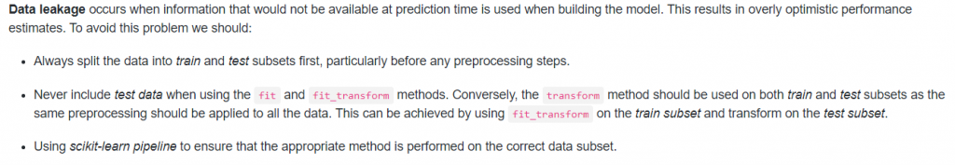
2. What are the basic objects that a ML pipeline should contain?
Answer:
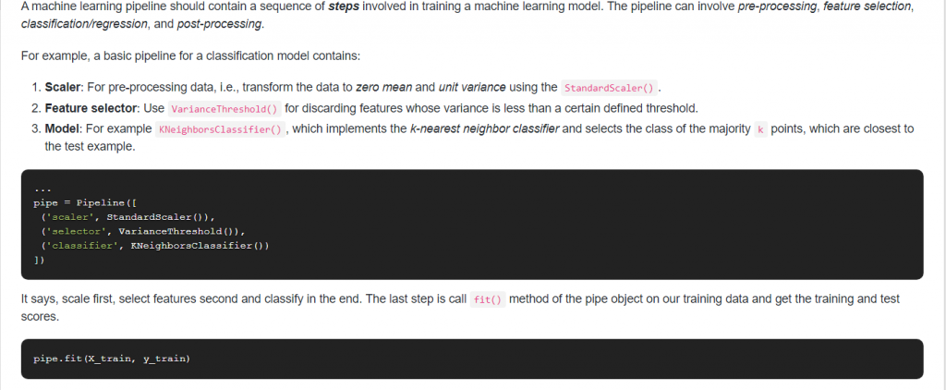
3. What is the difference between the Recursive Feature Elimination (RFE) function and SelectFromModel in Scikit-Learn?
Answer: They effectively try to achieve the same result but the methodology used by each technique varies a little:
- RFE removes least significant features over iterations. So basically it first removes a few features which are not important and then fits and removes again and fits. It repeats this iteration until it reaches a suitable number of features.
- SelectFromModel is a little less robust as it just removes less important features based on a threshold given as a parameter. There is no iteration involved.
4. What’s the difference between StandardScaler and Normalizer and when would you use each one?
Answer:
- With Normalize each sample (i.e. each row of the data matrix) with at least one non-zero component is rescaled independently of other samples so that its norm (l1 or l2) equals one.
- On another hand, StandardScaler standardizes features by removing the mean and scaling to unit variance.
- In other words Normalizer acts row-wise and StandardScaler column-wise. Normalizer does not
- remove the mean and scale by deviation but scales the whole row to unit norm.
5. What’s the problem if you call the fit() method multiple times with different X and y data? How can you overcome this issue?
Answer: Given an initial model, as soon you call model.fit(features_train, label_train) the model starts training using the features and labels that you have passed. If you will again call model.fit(features_train2, label_train2) it will start training again using passed data and will remove the previous results. The model will reset the following inside model:
- Weights
- Fitted Coefficients
- Bias, etc.
To overcome this issue we can use partial_fit() method as well if we want our previous calculated stuff to stay and additionally train using the next data.
6. How are feature_importances_ in RandomForestClassifier determined in Scikit-Learn?
Answer: The usual way to compute the feature importance values of a single tree is as follows:
You initialize an array feature_importances of all zeros with size n_features.
You traverse the tree: for each internal node that splits on feature i you compute the error reduction of that node multiplied by the number of samples that were routed to the node and add this quantity to feature_importances[i].
The error reduction depends on the impurity criterion that you use (in Scikit-learn the criterion available are Gini and entropy). It’s the impurity of the set of examples that gets routed to the internal node minus the sum of the impurities of the two partitions created by the split.
Its important that these values are relative to a specific dataset (both error reduction and the number of samples are dataset specific) thus these values cannot be compared between different datasets.
7. How can you obtain the principal components and the eigenvalues from Scikit-Learn PCA?
Answer:
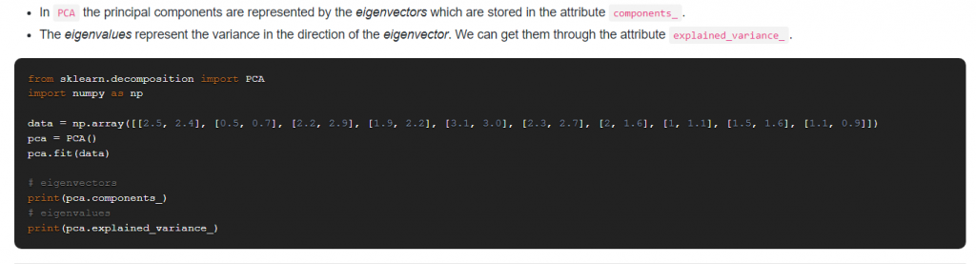
8. How do you scale data that has many outliers in Scikit-Learn?
Answer:
If the data contains many outliers, scaling using the mean and variance of the data is likely to not work very well. In these cases, we can use RobustScaler as a drop-in replacement instead.
RobustScaler removes the median and scales the data according to the quantile range (defaults to IQR: Interquartile Range). The IQR is the range between the 1st quartile (25th quantile) and the 3rd quartile (75th quantile).
Centering and scaling happen independently on each feature by computing the relevant statistics on the samples in the training set. Median and interquartile ranges are then stored to be used on later data using the transform method.
9. How do you optimize the Ridge Regression parameter?
Answer:
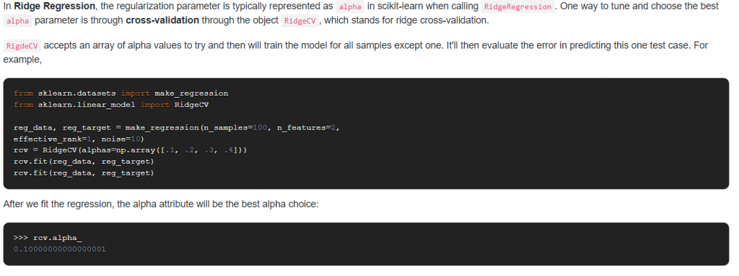
10. How would you encode a large Pandas dataframe using Scikit-Learn?
Answer:
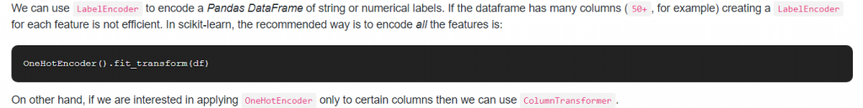
11. Is max_depth in Scikit-learn the equivalent of pruning in decision trees? If not, how a decision tree is pruned using scikit?
Answer:
- Though they have similar goals (i.e. placing some restrictions to the model so that it doesn’t grow very complex and overfit), max_depth isn’t equivalent to pruning.
- The way pruning usually works is that go back through the tree and replace branches that do not help with leaf nodes.
- However, scikit-learn does pruning based on minimal cost-complexity pruning: the subtree with the largest cost complexity that is smaller than the ccp_alpha parameter will be chosen.
12. Suppose you have multiple CPU cores available, how can you use them to reduce the computational cost?
Answer:
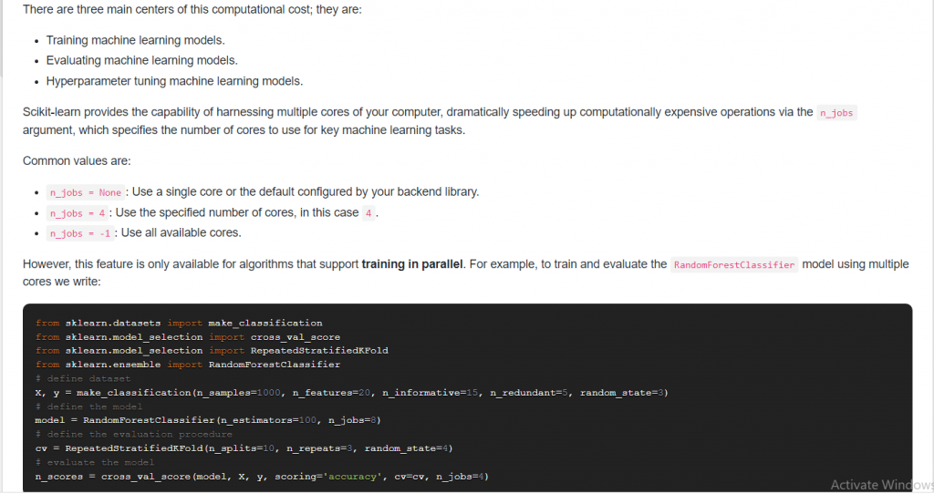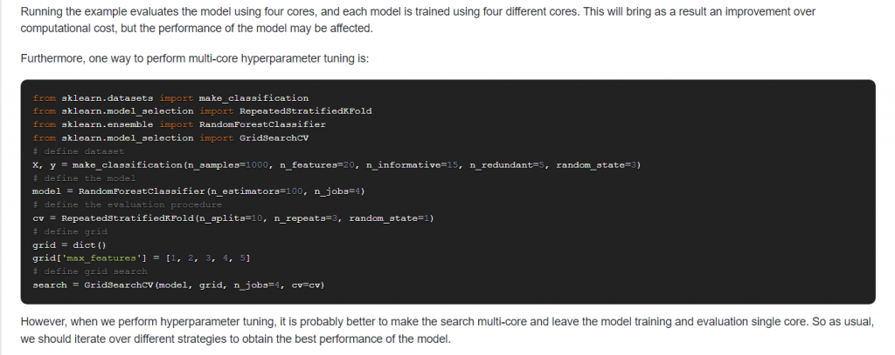
13. What is the difference between cross_validate and cross_val_score in Scikit-Learn?
Answer:
- cross_val_score calculates the score for each CV split and returns an array of scores of the estimator for each run of the cross validation.
- cross_validate it allows specifying multiple metrics for evaluation, i.e. calculate one or more scores and timings for each CV split and it returns dict containing training scores, fit-times and score-times in addition to the test score.
14. What’s the difference between fit(), transform() and fit_transform()? Why do we need these separate methods?
Answer:
- Every Scikit-Learn’s transform’s fit() calculates the model parameters (e.g. μ and σ in case of StandardScaler) and saves them as an internal object’s state.
- Afterwards, you can call its transform() method to apply the transformation to any particular set of examples.
- fit_transform() joins these two steps and is used for the initial fitting of parameters on the training set x, while also returning the transformed x’. Internally, the transformer object just calls first fit() and then transform() on the same data.
In practice, we need to have separate training and testing dataset and that is where having a separate fit() and transform() method helps. We apply fit() on the training dataset and use the transform() method on both -the training dataset and the test dataset-. Thus the training, as well as the test dataset, are then transformed (scaled) using the model parameters that were learned on applying the fit() method to the training dataset.
So for the x training set, we do fit_transform because we need to compute model parameters, and then use it to autoscale the data. For the x test set, well, we already have the model parameters, so we only do the transform part.
15. When to use OneHotEncoder vs LabelEncoder in Scikit-Learn?
Answer:
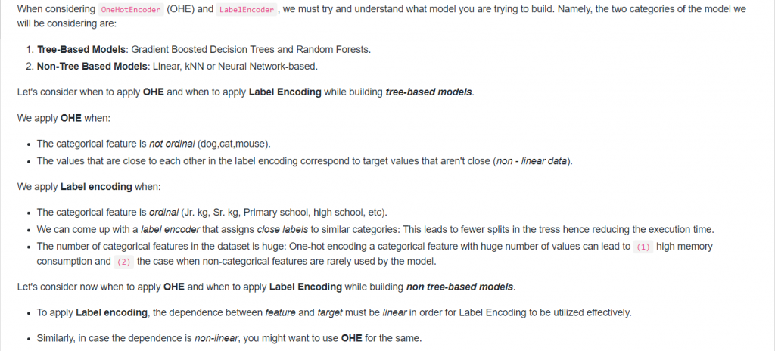
16. While using KNeighborsClassifier, when would you set weights=”distance”?
Answer:
- weights = ‘distance’ is in contrast to the default which is weights = ‘uniform’.
- When weights are uniform, a simple majority vote of the nearest neighbors are used to assign cluster membership.
- When weights are distance weighted, the voting is proportional to the distance value. Nearby points will have a greater influence than more distance points (even if the counts of different groups are similar). Therefore distance weighting is very useful when we have sparse data.
17. Would you use PCA on large datasets or there is a better alternative?
Answer: The PCA object is very useful but has certain limitations for large datasets. The biggest limitation is that PCA only supports batch processing, which means all of the data to be processed must fit in the main memory.
A better alternative to using with the large dataset is IncrementalPCA, this object uses a different form of processing and allows for partial computations which almost exactly match the results of PCA while processing the data in a minibatch fashion.
IncrementalPCA has the parameter batch_size to specify the number of samples to use for each batch and only stores estimates of component and noise variances, in order to update explained_variance_ratio_ incrementally. The memory usage depends on the number of samples per batch, rather than the number of samples to be processed in the dataset.
Therefore depending on the size of the input data, this algorithm can be much more memory efficient than a PCA and allows sparse input.
18. Are there any advantages of XGBoost over GradientBoostingClassifier?
Answer: XGBoost and sklearn’s GradientBoost are fundamentally the same as they are both gradient boosting implementations. However, there are very significant differences under the hood in a practical sense. XGBoost is a lot faster and this comes from the fact that XGBoost uses an approximation on the split points.
For example, if you have a continuous feature with 10000 possible splits, XGBoost considers only the best 300 splits by default. This behavior is controlled by the sketch_eps parameter whose default value is 0.03. We can also try lowering it and checking the difference it makes. In addition to that, XGBoost can be parallelized.
In sci-kit-learn documentation there is no mention of a sketch_eps-like feature, so we could infer that is not available. On other hand, GradientBoostingClassifier does not have a n_jobs interface parameter available, therefore parallel processing is not possible internally with sklearn’s implementation of the algorithm.
Given all the above features, XGBoost has the advantage of being memory-efficient and its performance is superior to sklearn’s GradientBoosting.
19. Can you use SVM with a custom kernel in Scikit-Learn?
Answer: Yes, we can use our own defined kernels by passing a function to the kernel parameter.
Our custom kernel must take as arguments two matrices of shape (n_samples_1, n_features), (n_samples_2, n_features) and return a kernel matrix of shape (n_samples_1, n_samples_2).
For example,
import numpy as np
from sklearn import svm
def my_kernel(X, Y):
… return np.dot(X, Y.T)
…
clf = svm.SVC(kernel=my_kernel)
20. How does sklearn KNeighborsClassifier compute class probabilites when setting weights=’uniform’?
Answer:
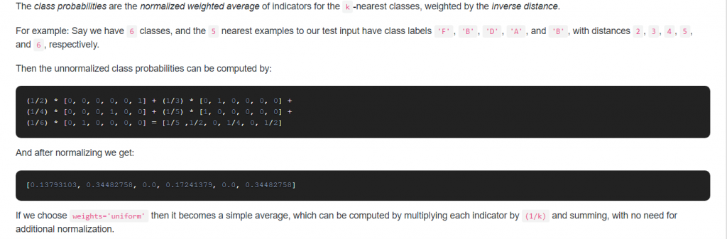
21. When you would use StratifiedKFold instead of KFold?
Answer:
- KFold is a cross-validator that divides the dataset into k folds. If shuffle is set to False, consecutive folds will be the shifted version of the previous fold. If shuffle is set to True, then the splitting will be random.
- StratifiedKFold takes the cross-validation one step further. The class distribution in the dataset is preserved in the training and test splits, i.e. each fold of the dataset has the same proportion of observations with a given label.
Therefore, we should prefer StratifiedKFold over KFold when dealing with classifications tasks with imbalanced class distributions.
22. How to predict time series in scikit-learn?
Answer: Time Series is a collection of data points collected at constant time intervals. Time-series prediction is based on the theory that the current values more or less depends on the past ones. A time series has two basic components: Mean and Variance. Ideally, you would like to control this component, for the variability, you can simply apply a logarithm transformation on the data, and for the trend, you can differentiate it.
In the case of prediction of time series data, RNN or LSTM algorithm (Deep Learning) has been widely utilized, but scikit does not provide the built-in algorithm of it. So, you might be better off studying Tensorflow or Pytorch framework which are common tools to enable you to build the RNN or LSTM model.
23. Is any custom distance function using scikit-learn K-Means Clustering?
Answer: Unfortunately no: by definition, the k-means clustering algorithm relies on the euclidean distance from the mean of each cluster. It has no metric parameter and it is not trivial to extend k-means to other distances. You could use a different metric, so even though you are still calculating the mean you could use something like the Mahalanobis distance.
24. What does the “fit()” method in scikit-learn do?
Answer: Fitting your model (using fit() method) to the training data is essentially the training part of the modeling process. The fit() method finds the coefficients for the equation specified via the algorithm being used. During the process, this method modifies the object and returns a reference to the object. After it is trained, the model can be used to make predictions, usually with a .predict() method call.
25. Is it possible in scikit-learn to split into three sets directly?
Answers:
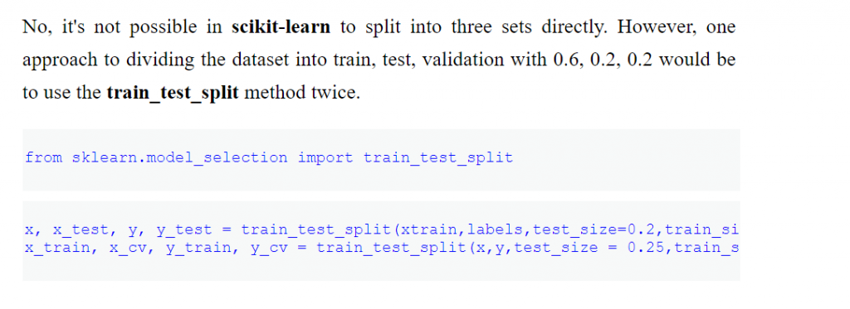

Q1:
What is Data Leakage and how do you avoid it in Scikit-Learn?
Entry

Scikit-Learn 31

Answer
Data leakage occurs when information that would not be available at prediction time is used when building the model. This results in overly optimistic performance estimates. To avoid this problem we should:

Always split the data into train and test subsets first, particularly before any preprocessing steps.

Never include test data when using the fit and fit_transform methods. Conversely, the transform method should be used on both train and test subsets as the same preprocessing should be applied to all the data. This can be achieved by using fit_transform on the train subset and transform on the test subset.

Using scikit-learn pipeline to ensure that the appropriate method is performed on the correct data subset.

Having Machine Learning, Data Science or Python Interview? Check 31 Scikit-Learn Interview Questions
Source: scikit-learn.org

Q2:
What are the basic objects that a ML pipeline should contain?
Junior

Scikit-Learn 31

Answer
A machine learning pipeline should contain a sequence of steps involved in training a machine learning model. The pipeline can involve pre-processing, feature selection, classification/regression, and post-processing.
For example, a basic pipeline for a classification model contains:
- Scaler: For pre-processing data, i.e., transform the data to zero mean and unit variance using the StandardScaler().
- Feature selector: Use VarianceThreshold() for discarding features whose variance is less than a certain defined threshold.
- Model: For example KNeighborsClassifier(), which implements the k-nearest neighbor classifier and selects the class of the majority k points, which are closest to the test example.
...
pipe = Pipeline([
('scaler', StandardScaler()),
('selector', VarianceThreshold()),
('classifier', KNeighborsClassifier())])
It says, scale first, select features second and classify in the end. The last step is call fit() method of the pipe object on our training data and get the training and test scores.
pipe.fit(X_train, y_train)
Having Machine Learning, Data Science or Python Interview? Check 31 Scikit-Learn Interview Questions
Source: machinelearningmastery.com

Q3:
What is the difference between Recursive Feature Elimination (RFE) function and SelectFromModel in Scikit-Learn?
Junior

Scikit-Learn 31

Answer
They effectively try to achieve the same result but the methodology used by each technique varies a little:

RFE removes least significant features over iterations. So basically it first removes a few features which are not important and then fits and removes again and fits. It repeats this iteration until it reaches a suitable number of features.

SelectFromModel is a little less robust as it just removes less important features based on a threshold given as a parameter. There is no iteration involved.

Having Machine Learning, Data Science or Python Interview? Check 31 Scikit-Learn Interview Questions
Source: datascience.stackexchange.com

Q4:
What's the difference between StandardScaler and Normalizer and when would you use each one?
Junior

Scikit-Learn 31

Answer

With Normalize each sample (i.e. each row of the data matrix) with at least one non-zero component is rescaled independently of other samples so that its norm (l1 or l2) equals one.

On another hand, StandardScaler standardizes features by removing the mean and scaling to unit variance.

In other words Normalizer acts row-wise and StandardScaler column-wise. Normalizer does not remove the mean and scale by deviation but scales the whole row to unit norm.

Now, regarding the question when to use each one, whether input variables require scaling depends on the specifics of your problem and of each variable:

You may have a sequence of quantities as inputs, such as prices or temperatures. If the distribution of the quantity is normal, then it should be standardized, otherwise, the data should be normalized. This applies if the range of quantity values is large (10s, 100s, etc.) or small (0.01, 0.0001). If the quantity values are small (near 0-1) and the distribution is limited (e.g. standard deviation near 1), then perhaps you can get away with no scaling of the data.

Predictive modelling problems can be complex, and it may not be clear how to best scale input data. The way to proceed is to explore modeling with the raw data, standardized data, and normalized data and see if there is a beneficial difference in the performance of the resulting model.

Having Machine Learning, Data Science or Python Interview? Check 31 Scikit-Learn Interview Questions
Source: stackoverflow.com

Q5:
What's the problem if you call the fit() method multiple times with different X and y data? How can you overcome this issue?
Junior

Scikit-Learn 31

Answer
Given an initial model, as soon you call model.fit(features_train, label_train) the model starts training using the features and labels that you have passed. If you will again call model.fit(features_train2, label_train2) it will start training again using passed data and will remove the previous results. The model will reset the following inside model:
- Weights
- Fitted Coefficients
- Bias, etc.
To overcome this issue we can use partial_fit() method as well if we want our previous calculated stuff to stay and additionally train using the next data.
Having Machine Learning, Data Science or Python Interview? Check 31 Scikit-Learn Interview Questions
Source: stackoverflow.com

27 Probability Interview Questions (ANSWERED) For Data Scientists & ML Devs

Probability 34

Q6:
How are feature_importances_ in RandomForestClassifier determined in Scikit-Learn?
Mid

Scikit-Learn 31

Answer
The usual way to compute the feature importance values of a single tree is as follows:

You initialize an array feature_importances of all zeros with size n_features.

You traverse the tree: for each internal node that splits on feature i you compute the error reduction of that node multiplied by the number of samples that was routed to the node and add this quantity to feature_importances[i].

The error reduction depends on the impurity criterion that you use (in Scikit-learn the criterion available are gini and entropy). Its the impurity of the set of examples that gets routed to the internal node minus the sum of the impurities of the two partitions created by the split.
Its important that these values are relative to a specific dataset (both error reduction and the number of samples are dataset specific) thus these values cannot be compared between different datasets.
Having Machine Learning, Data Science or Python Interview? Check 31 Scikit-Learn Interview Questions
Source: stackoverflow.com

Q7:
How can you obtain the principal components and the eigenvalues from Scikit-Learn PCA?
Mid

Scikit-Learn 31

Answer
- In PCA the principal components are represented by the eigenvectors which are stored in the attribute components_.
- The eigenvalues represent the variance in the direction of the eigenvector. We can get them through the attribute explained_variance_.
from sklearn.decomposition import PCAimport numpy as np

data = np.array([[2.5, 2.4], [0.5, 0.7], [2.2, 2.9], [1.9, 2.2], [3.1, 3.0], [2.3, 2.7], [2, 1.6], [1, 1.1], [1.5, 1.6], [1.1, 0.9]])
pca = PCA()
pca.fit(data)
# eigenvectorsprint(pca.components_)# eigenvaluesprint(pca.explained_variance_)
Having Machine Learning, Data Science or Python Interview? Check 31 Scikit-Learn Interview Questions
Source: stackoverflow.com

Q8:
How do you scale data that has many outliers in Scikit-Learn?
Mid

Scikit-Learn 31

Answer
If the data contains many outliers, scaling using the mean and variance of the data is likely to not work very well. In these cases, we can use RobustScaler as a drop-in replacement instead.
RobustScaler removes the median and scales the data according to the quantile range (defaults to IQR: Interquartile Range). The IQR is the range between the 1st quartile (25th quantile) and the 3rd quartile (75th quantile).
Centering and scaling happen independently on each feature by computing the relevant statistics on the samples in the training set. Median and interquartile range are then stored to be used on later data using the transform method.
Having Machine Learning, Data Science or Python Interview? Check 31 Scikit-Learn Interview Questions
Source: scikit-learn.org

ML Design Patterns 30

 Sorting 26

 Bias & Variance 14

 Big-O Notation 22

Data Mining 13

MATLAB 59

Curse of Dimensionality 14

Cost Function 13

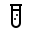 Feature Engineering 27

 Julia 50

Check FullStack.Cafe - 3877 Full-Stack, Coding & System Design Questions and Answers

Q9:
How do you optimize the Ridge Regression parameter?
Mid

Scikit-Learn 31

Answer
In Ridge Regression, the regularization parameter is typically represented as alpha in scikit-learn when calling RidgeRegression. One way to tune and choose the best alpha parameter is through cross-validation through the object RidgeCV, which stands for ridge cross-validation.
RigdeCV accepts an array of alpha values to try and then will train the model for all samples except one. It'll then evaluate the error in predicting this one test case. For example,
from sklearn.datasets import make_regressionfrom sklearn.linear_model import RidgeCV

reg_data, reg_target = make_regression(n_samples=100, n_features=2,
effective_rank=1, noise=10)
rcv = RidgeCV(alphas=np.array([.1, .2, .3, .4]))
rcv.fit(reg_data, reg_target)
rcv.fit(reg_data, reg_target)
After we fit the regression, the alpha attribute will be the best alpha choice:
>>> rcv.alpha_0.10000000000000001
Having Machine Learning, Data Science or Python Interview? Check 31 Scikit-Learn Interview Questions
Source: www.amazon.com

27 Advanced NumPy Interview Questions (ANSWERED) To Crush Your Data Science Interview

NumPy 39

Q10:
How would you encode a large Pandas dataframe using Scikit-Learn?
Mid

Scikit-Learn 31

Answer
We can use LabelEncoder to encode a Pandas DataFrame of string or numerical labels. If the dataframe has many columns (50+, for example) creating a LabelEncoder for each feature is not efficient. In scikit-learn, the recommended way is to encode all the features is:
OneHotEncoder().fit_transform(df)
On other hand, if we are interested in applying OneHotEncoder only to certain columns then we can use ColumnTransformer.
Having Machine Learning, Data Science or Python Interview? Check 31 Scikit-Learn Interview Questions
Source: stackoverflow.com

Q11:
Is max_depth in Scikit-learn the equivalent of pruning in decision trees? If not, how a decision tree is pruned using scikit?
Mid

Scikit-Learn 31

Answer
- Though they have similar goals (i.e. placing some restrictions to the model so that it doesn't grow very complex and overfit), max_depth isn't equivalent to pruning.
- The way pruning usually works is that go back through the tree and replace branches that do not help with leaf nodes.
- However, scikit-learn does pruning based on minimal cost-complexity pruning: the subtree with the largest cost complexity that is smaller than the ccp_alpha parameter will be chosen.
Having Machine Learning, Data Science or Python Interview? Check 31 Scikit-Learn Interview Questions
Source: scikit-learn.org

Q12:
Suppose you have multiple CPU cores available, how can you use them to reduce the computational cost?
Mid

Scikit-Learn 31

Answer
There are three main centers of this computational cost; they are:
- Training machine learning models.
- Evaluating machine learning models.
- Hyperparameter tuning machine learning models.
Scikit-learn provides the capability of harnessing multiple cores of your computer, dramatically speeding up computationally expensive operations via the n_jobs argument, which specifies the number of cores to use for key machine learning tasks.
Common values are:
- n_jobs = None: Use a single core or the default configured by your backend library.
- n_jobs = 4: Use the specified number of cores, in this case 4.
- n_jobs = -1: Use all available cores.
However, this feature is only available for algorithms that support training in parallel. For example, to train and evaluate the RandomForestClassifier model using multiple cores we write:
from sklearn.datasets import make_classificationfrom sklearn.model_selection import cross_val_scorefrom sklearn.model_selection import RepeatedStratifiedKFoldfrom sklearn.ensemble import RandomForestClassifier# define dataset
X, y = make_classification(n_samples=1000, n_features=20, n_informative=15, n_redundant=5, random_state=3)# define the model
model = RandomForestClassifier(n_estimators=100, n_jobs=8)# define the evaluation procedure
cv = RepeatedStratifiedKFold(n_splits=10, n_repeats=3, random_state=4)# evaluate the model
n_scores = cross_val_score(model, X, y, scoring='accuracy', cv=cv, n_jobs=4)
Running the example evaluates the model using four cores, and each model is trained using four different cores. This will bring as a result an improvement over computational cost, but the performance of the model may be affected.
Furthermore, one way to perform multi-core hyperparameter tuning is:
from sklearn.datasets import make_classificationfrom sklearn.model_selection import RepeatedStratifiedKFoldfrom sklearn.ensemble import RandomForestClassifierfrom sklearn.model_selection import GridSearchCV# define dataset
X, y = make_classification(n_samples=1000, n_features=20, n_informative=15, n_redundant=5, random_state=3)# define the model
model = RandomForestClassifier(n_estimators=100, n_jobs=4)# define the evaluation procedure
cv = RepeatedStratifiedKFold(n_splits=10, n_repeats=3, random_state=1)# define grid
grid = dict()
grid['max_features'] = [1, 2, 3, 4, 5]# define grid search
search = GridSearchCV(model, grid, n_jobs=4, cv=cv)
However, when we perform hyperparameter tuning, it is probably better to make the search multi-core and leave the model training and evaluation single core. So as usual, we should iterate over different strategies to obtain the best performance of the model.
Having Machine Learning, Data Science or Python Interview? Check 31 Scikit-Learn Interview Questions
Source: machinelearningmastery.com

Q13:
What is the difference between cross_validate and cross_val_score in Scikit-Learn?
Mid

Scikit-Learn 31

Answer
- cross_val_score calculates the score for each CV split and returns an array of scores of the estimator for each run of the cross validation.
- cross_validate it allows specifying multiple metrics for evaluation, i.e. calculate one or more scores and timings for each CV split and it returns dict containing training scores, fit-times and score-times in addition to the test score.
Having Machine Learning, Data Science or Python Interview? Check 31 Scikit-Learn Interview Questions
Source: datascience.stackexchange.com

17 Linear Algebra Interview Questions To Brush Before Data Science Interview

Linear Algebra 41

Q14:
What's the difference between fit(), transform() and fit_transform()? Why do we need these separate methods?
Mid

Scikit-Learn 31

Answer
- Every Scikit-Learn's transform's fit() calculates the model parameters (e.g. μ and σ in case of StandardScaler) and saves them as an internal object's state.
- Afterwards, you can call its transform() method to apply the transformation to any particular set of examples.
- fit_transform() joins these two steps and is used for the initial fitting of parameters on the training set x, while also returning the transformed x'. Internally, the transformer object just calls first fit() and then transform() on the same data.
In practice, we need to have separate training and testing dataset and that is where having a separate fit() and transform() method helps. We apply fit() on the training dataset and use the transform() method on both -the training dataset and the test dataset-. Thus the training, as well as the test dataset, are then transformed (scaled) using the model parameters that were learned on applying the fit() method to the training dataset.
So for x training set, we do fit_transform because we need to compute model parameters, and then use it to autoscale the data. For x test set, well, we already have the model parameters, so we only do the transform part.
Having Machine Learning, Data Science or Python Interview? Check 31 Scikit-Learn Interview Questions
Source: datascience.stackexchange.com

Q15:
When to use OneHotEncoder vs LabelEncoder in Scikit-Learn?
Mid

Scikit-Learn 31

Answer
When considering OneHotEncoder (OHE) and LabelEncoder, we must try and understand what model you are trying to build. Namely, the two categories of the model we will be considering are:
- Tree-Based Models: Gradient Boosted Decision Trees and Random Forests.
- Non-Tree Based Models: Linear, kNN or Neural Network-based.
Let's consider when to apply OHE and when to apply Label Encoding while building tree-based models.
We apply OHE when:
- The categorical feature is not ordinal (dog,cat,mouse).
- The values that are close to each other in the label encoding correspond to target values that aren't close (non - linear data).
We apply Label encoding when:
- The categorical feature is ordinal (Jr. kg, Sr. kg, Primary school, high school, etc).
- We can come up with a label encoder that assigns close labels to similar categories: This leads to fewer splits in the tress hence reducing the execution time.
- The number of categorical features in the dataset is huge: One-hot encoding a categorical feature with huge number of values can lead to (1) high memory consumption and (2) the case when non-categorical features are rarely used by the model.
Let's consider now when to apply OHE and when to apply Label Encoding while building non tree-based models.

To apply Label encoding, the dependence between feature and target must be linear in order for Label Encoding to be utilized effectively.

Similarly, in case the dependence is non-linear, you might want to use OHE for the same.

Having Machine Learning, Data Science or Python Interview? Check 31 Scikit-Learn Interview Questions
Source: datascience.stackexchange.com

Supervised Learning 31

Linear Regression 48

Q-Learning 11

Cost Function 13

Clustering 40

Scikit-Learn 31

Bias & Variance 14

 TensorFlow 30

Sorting 26

Pandas 68

Check FullStack.Cafe - 3877 Full-Stack, Coding & System Design Questions and Answers

Q16:
While using KNeighborsClassifier, when would you set weights="distance"?
Mid

Scikit-Learn 31

Answer

weights = 'distance' is in contrast to the default which is weights = 'uniform'.

When weights are uniform, a simple majority vote of the nearest neighbors are used to assign cluster membership.

When weights are distance weighted, the voting is proportional to the distance value. Nearby points will have a greater influence than more distance points (even if the counts of different groups are similar). Therefore distance weighting is very useful when we have sparse data.

Having Machine Learning, Data Science or Python Interview? Check 31 Scikit-Learn Interview Questions
Source: datascience.stackexchange.com

Q17:
Would you use PCA on large datasets or there is a better alternative?
Mid

Scikit-Learn 31

Answer
The PCA object is very useful but has certain limitations for large datasets. The biggest limitation is that PCA only supports batch processing, which means all of the data to be processed must fit in the main memory.
A better alternative to use with large dataset is IncrementalPCA, this object uses a different form of processing and allows for partial computations which almost exactly match the results of PCA while processing the data in a minibatch fashion.
IncrementalPCA has the parameter batch_size to specify the number of samples to use for each batch and only stores estimates of component and noise variances, in order to update explained_variance_ratio_ incrementally. The memory usage depends on the number of samples per batch, rather than the number of samples to be processed in the dataset.
Therefore depending on the size of the input data, this algorithm can be much more memory efficient than a PCA, and allows sparse input.
https://scikit-learn.org/stable/

