1. What is NumPy? Why should we use it?
NumPy (also called Numerical Python) is a highly flexible, optimized, open-source package meant for array processing. It provides tools for delivering high-end performance while dealing with N-dimensional powerful array objects. It is also beneficial for performing scientific computations, mathematical, and logical operations, sorting operations, I/O functions, basic statistical and linear algebra-based operations along with random simulation and broadcasting functionalities. Due to the vast range of capabilities, NumPy has become very popular and is the most preferred package. The following image represents the uses of NumPy.

2. Why is NumPy preferred over Matlab, Octave, Idl or Yorick?
NumPy is an open-source, high-performing library that allows complex mathematical and scientific computational capabilities. It makes use of Python language which is a high-level, easy-to-learn, general-purpose programming language. It supports the following:
- Powerful functions for performing complex mathematical operations on multi-dimensional matrices and arrays. The operations on ndarrays of NumPy are approximately up to 50% faster when compared to operations on native lists using loops. This efficiency is very much useful when the arrays have millions of elements.
- Provides indexing syntax to access portions of data easily in a large array.
- Provides built-in functions which help to easily perform operations related to linear algebra and statistics.
- It takes only a few lines of code to achieve complex computations using NumPy.

3. How are NumPy arrays better than Python’s lists?
- Python lists support storing heterogeneous data types whereas NumPy arrays can store datatypes of one nature itself. NumPy provides extra functional capabilities that make operating on its arrays easier which makes NumPy array advantageous in comparison to Python lists as those functions cannot be operated on heterogeneous data.
- NumPy arrays are treated as objects which results in minimal memory usage. Since Python keeps track of objects by creating or deleting them based on the requirements, NumPy objects are also treated the same way. This results in lesser memory wastage.
- NumPy arrays support multi-dimensional arrays.
- NumPy provides various powerful and efficient functions for complex computations on the arrays.
- NumPy also provides various range of functions for BitWise Operations, String Operations, Linear Algebraic operations, Arithmetic operations etc. These are not provided on Python’s default lists.
You can download a PDF version of Numpy Interview Questions.

4. What are ndarrays in NumPy?
ndarray object is the core of the NumPy package. It consists of n-dimensional arrays storing elements of the same data types and also has many operations that are done in compiled code for optimised performance. These arrays have fixed sizes defined at the time of creation. Following are some of the properties of ndarrays:
- When the size of ndarrays is changed, it results in a new array and the original array is deleted.
- The ndarrays are bound to store homogeneous data.
- They provide functions to perform advanced mathematical operations in an efficient manner.

5. What are ways of creating 1D, 2D and 3D arrays in NumPy?
Consider you have a normal python list. From this, we can create NumPy arrays by making use of the array function as follows:
- One-Dimensional array
import numpy as np

arr = [1,2,3,4] #python list
numpy_arr = np.array(arr) #numpy array
- Two-Dimensional array
import numpy as np

arr = [[1,2,3,4],[4,5,6,7]]
numpy_arr = np.array(arr)
- Three-Dimensional array
import numpy as np

arr = [[[1,2,3,4],[4,5,6,7],[7,8,9,10]]]
numpy_arr = np.array(arr)
Using the np.array() function, we can create NumPy arrays of any dimensions.

6. How do you find the data type of the elements stored in the NumPy arrays?
NumPy supports the following datatypes:
- i - integer
- S - string
- b - boolean
- f - float
- u - unsigned integer
- c - complex float
- m - timedelta
- M - datetime
- O - object
- U - unicode string
- V - fixed memory chunk for types such as void
We can make use of the dtype property that returns the type of the elements stored in the NumPy array. Let us consider the below code snippet. We create some sample arrays and we see what the data types of these arrays are.
import numpy as np

arr1 = np.array([1, 2, 3, 4])
arr2 = np.array(['I', 'love', 'Interviewbit']) # Stored as Unicode characters with length of characters ranging from 1 to 12
arr3 = np.array([1, 2, 3, 4], dtype='S') # Creating numpy array of defined type string
print(arr1.dtype)print(arr2.dtype)print(arr3.dtype)
The output will be:
int64
<U12
|S1

7. How can you reverse a NumPy array?
There are two ways of reversing a NumPy array.
- Method 1: Using the slicing method: We can make use of [::-1] for reversing the array. The following example demonstrates this:
import numpy as np
# create numpy array
arr = np.array([1, 2, 4, 6])
# To reverse array
reverse_arr = arr[::-1]print(reverse_arr)
Output:
[6 4 2 1]
- Method 2: flipud function: This function is provided by NumPy to reverse the NumPy array. Let us see the below example about its usage.
import numpy as np
# create numpy array
arr = np.array([1, 2, 4, 5, 6])
#flipud method for reversing
reverse_arr = np.flipud(arr)print(reverse_arr)
Output:
[6 5 4 2 1]

8. How is np.mean() different from np.average() in NumPy?
- np.mean() method calculates the arithmetic mean and provides additional options for input and results. For example, it has the option to specify what data types have to be taken, where the result has to be placed etc.
- np.average() computes the weighted average if the weights parameter is specified. In the case of weighted average, instead of considering that each data point is contributing equally to the final average, it considers that some data points have more weightage than the others (unequal contribution).

9. How do you count the frequency of a given positive value appearing in the NumPy array?
We can make use of the bincount() function to compute the number of times a given value is there in the array. This function accepts only positive integers and boolean expressions as the arguments.
import numpy as np
arr = np.array([1, 2, 1, 3, 5, 0, 0, 0, 2, 3])
result = np.bincount(arr)print(result)
The result is:
[3 2 2 2 0 1]
It has to be noted here that each element represents the count of the corresponding index value present in the original array. This is demonstrated in the below image:
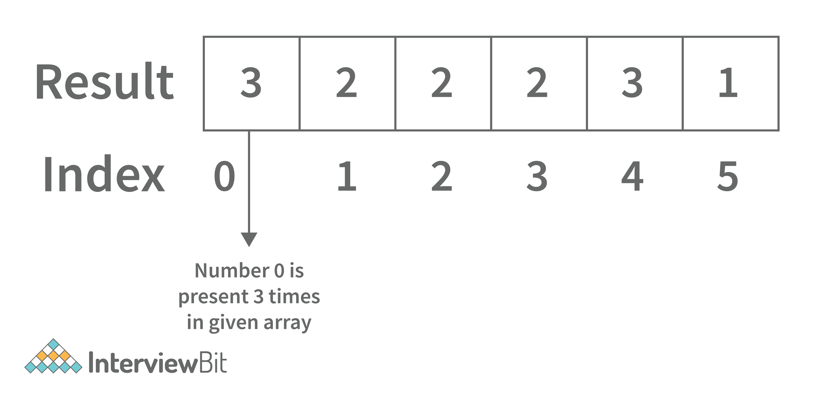

10. How do we check for an empty array (or zero elements array)?
We can check for the emptiness of a NumPy array by making use of the size attribute.
Let us consider the below example. We have NumPy array arr filled with zeros. If the size element returns zero, that means the array is empty or it only consists of zeros.
import numpy as np
arr = np.zeros((1,0)) #returns empty array
print(arr.size) #returns 0
This return 0

11. How is arr[:,0] different from arr[:,[0]]
arr[:,0] - Returns 0th index elements of all rows. In other words, return the first column elements.
import numpy as np

arr = np.array([[1,2,3,4],[5,6,7,8]])
new_arr =arr[:,0]
print(new_arr)
Output:
[1 5]
arr[:,[0]] - This returns the elements of the first column by adding extra dimension to it.
import numpy as np

arr = np.array([[1,2,3,4],[5,6,7,8]])
new_arr =arr[:,[0]]
print(new_arr)
Output:
[[1]
[5]]

12. How do you multiply 2 NumPy array matrices?
We can make use of the dot() for multiplying matrices represented as NumPy arrays. This is represented in the code snippet below:
import numpy as np
# NumPy matrices
A = np.arange(15,24).reshape(3,3)
B = np.arange(20,29).reshape(3,3)print("A: ",A)print("B: ",B)
# Multiply A and B
result = A.dot(B)print("Result: ", result)
Output
A: [[15 16 17]
[18 19 20]
[21 22 23]]
B: [[20 21 22]
[23 24 25]
[26 27 28]]
Result: [[1110 1158 1206]
[1317 1374 1431]
[1524 1590 1656]]

13. How do you concatenate 2 NumPy arrays?
Concatenating 2 arrays by adding elements to the end can be achieved by making use of the concatenate() method of the NumPy package. Syntax:
np.concatenate((a1, a2, ...), axis=0, out=None)
where,
- a1,a2: arrays of the same shape
- axis: Represents the axis along which the arrays are joined. The default value is 0.
- out: If mentioned, it specifies the destination for placing the result.
For example:
import numpy as np
a = np.array([[1, 2], [3, 4]])
b = np.array([[5, 6]])
# Concatenate with axis 0
c = np.concatenate((a,b), axis=0)print("With axis 0: \n",c )
# Concatenate with axis 1 (b.T represents transpose matrix)
d = np.concatenate((a,b.T), axis=1)print("With axis 1: \n",d )
The output would be:
With axis 0:
[[1 2]
[3 4]
[5 6]]
With axis 1:
[[1 2 5]
[3 4 6]]
Notice how the arrays are concatenated with different values of the axis.

14. How do you convert Pandas DataFrame to a NumPy array?
The to_numpy() method of the NumPy package can be used to convert Pandas DataFrame, Index and Series objects.
Consider we have a DataFrame df, we can either convert the whole Pandas DataFrame df to NumPy array or even select a subset of Pandas DataFrame to NumPy array by using the to_numpy() method as shown in the example below:
import pandas as pdimport numpy as np# Pandas DataFrame
df = pd.DataFrame(data={'A': [3, 2, 1], 'B': [6,5,4], 'C': [9, 8, 7]},
index=['i', 'j', 'k'])print("Pandas DataFrame: ")print(df)
# Convert Pandas DataFrame to NumPy Array
np_arr = df.to_numpy()print("Pandas DataFrame to NumPy array: ")print(np_arr)

# Convert specific columns of Pandas DataFrame to NumPy array
arr = df[['B', 'C']].to_numpy()print("Convert B and C columns of Pandas DataFrame to NumPy Array: ")print (arr)
The output of the above code is
Pandas DataFrame:
A B C
i 3 6 9
j 2 5 8
k 1 4 7
Pandas DataFrame to NumPy array:
[[3 6 9]
[2 5 8]
[1 4 7]]
Convert B and C columns of Pandas DataFrame to NumPy Array:
[[6 9]
[5 8]
[4 7]]

NumPY Interview Questions for Experienced

15. What do you understand by Vectorization in NumPy?
Function Vectorization technically means that the function is applied to all elements in the array. Typically, certain python functionalities on arrays (such as loops) are slower in nature because python arrays can contain elements of different data types. Since the C program expects a specific datatype, there are chances of compiler optimisation which makes C code run faster. Since NumPy arrays support storing elements of a single datatype, most of the implementations of the functions written in NumPy meant for arithmetic, logical operations etc have optimised C program code under their hood. Additionally, NumPy also helps developers create their own vectorised functions by following the below steps:
- Write your required function that takes array elements as parameters.
- Vectorize the function by making use of the vectorize() method of the NumPy package.
- Give array inputs to the vectorized function.
The below example demonstrates the process of vectorization.
import numpy as np# Define your functiondef add(arr1, arr2):
return (arr1 + arr2)

arr1 = np.array([1,2,3])
arr2 = np.array([4,5,6])
#vectorize add method
vectorized_add = np.vectorize(add)
#call vectorized method
result = vectorized_add(arr1, arr2)
print(result)
The output of above code
[5 7 9]

16. How is vstack() different from hstack() in NumPy?
Both methods are used for combining the NumPy arrays. The main difference is that the hstack method combines arrays horizontally whereas the vstack method combines arrays vertically.
For example, consider the below code.
import numpy as np
a = np.array([1,2,3])
b = np.array([4,5,6])
# vstack arrays
c = np.vstack((a,b))print("After vstack: \n",c)# hstack arrays
d = np.hstack((a,b))print("After hstack: \n",d)
The output of this code would be:
After vstack:
[[1 2 3]
[4 5 6]]
After hstack:
[1 2 3 4 5 6]
Notice how after the vstack method, the arrays were combined vertically along the column and how after the hstack method, the arrays were combined horizontally along the row.

17. How do you find the local peaks (or maxima) in a 1-D NumPy Array?
Peaks are the points that are surrounded by smaller value points on either side as shown in the image below:
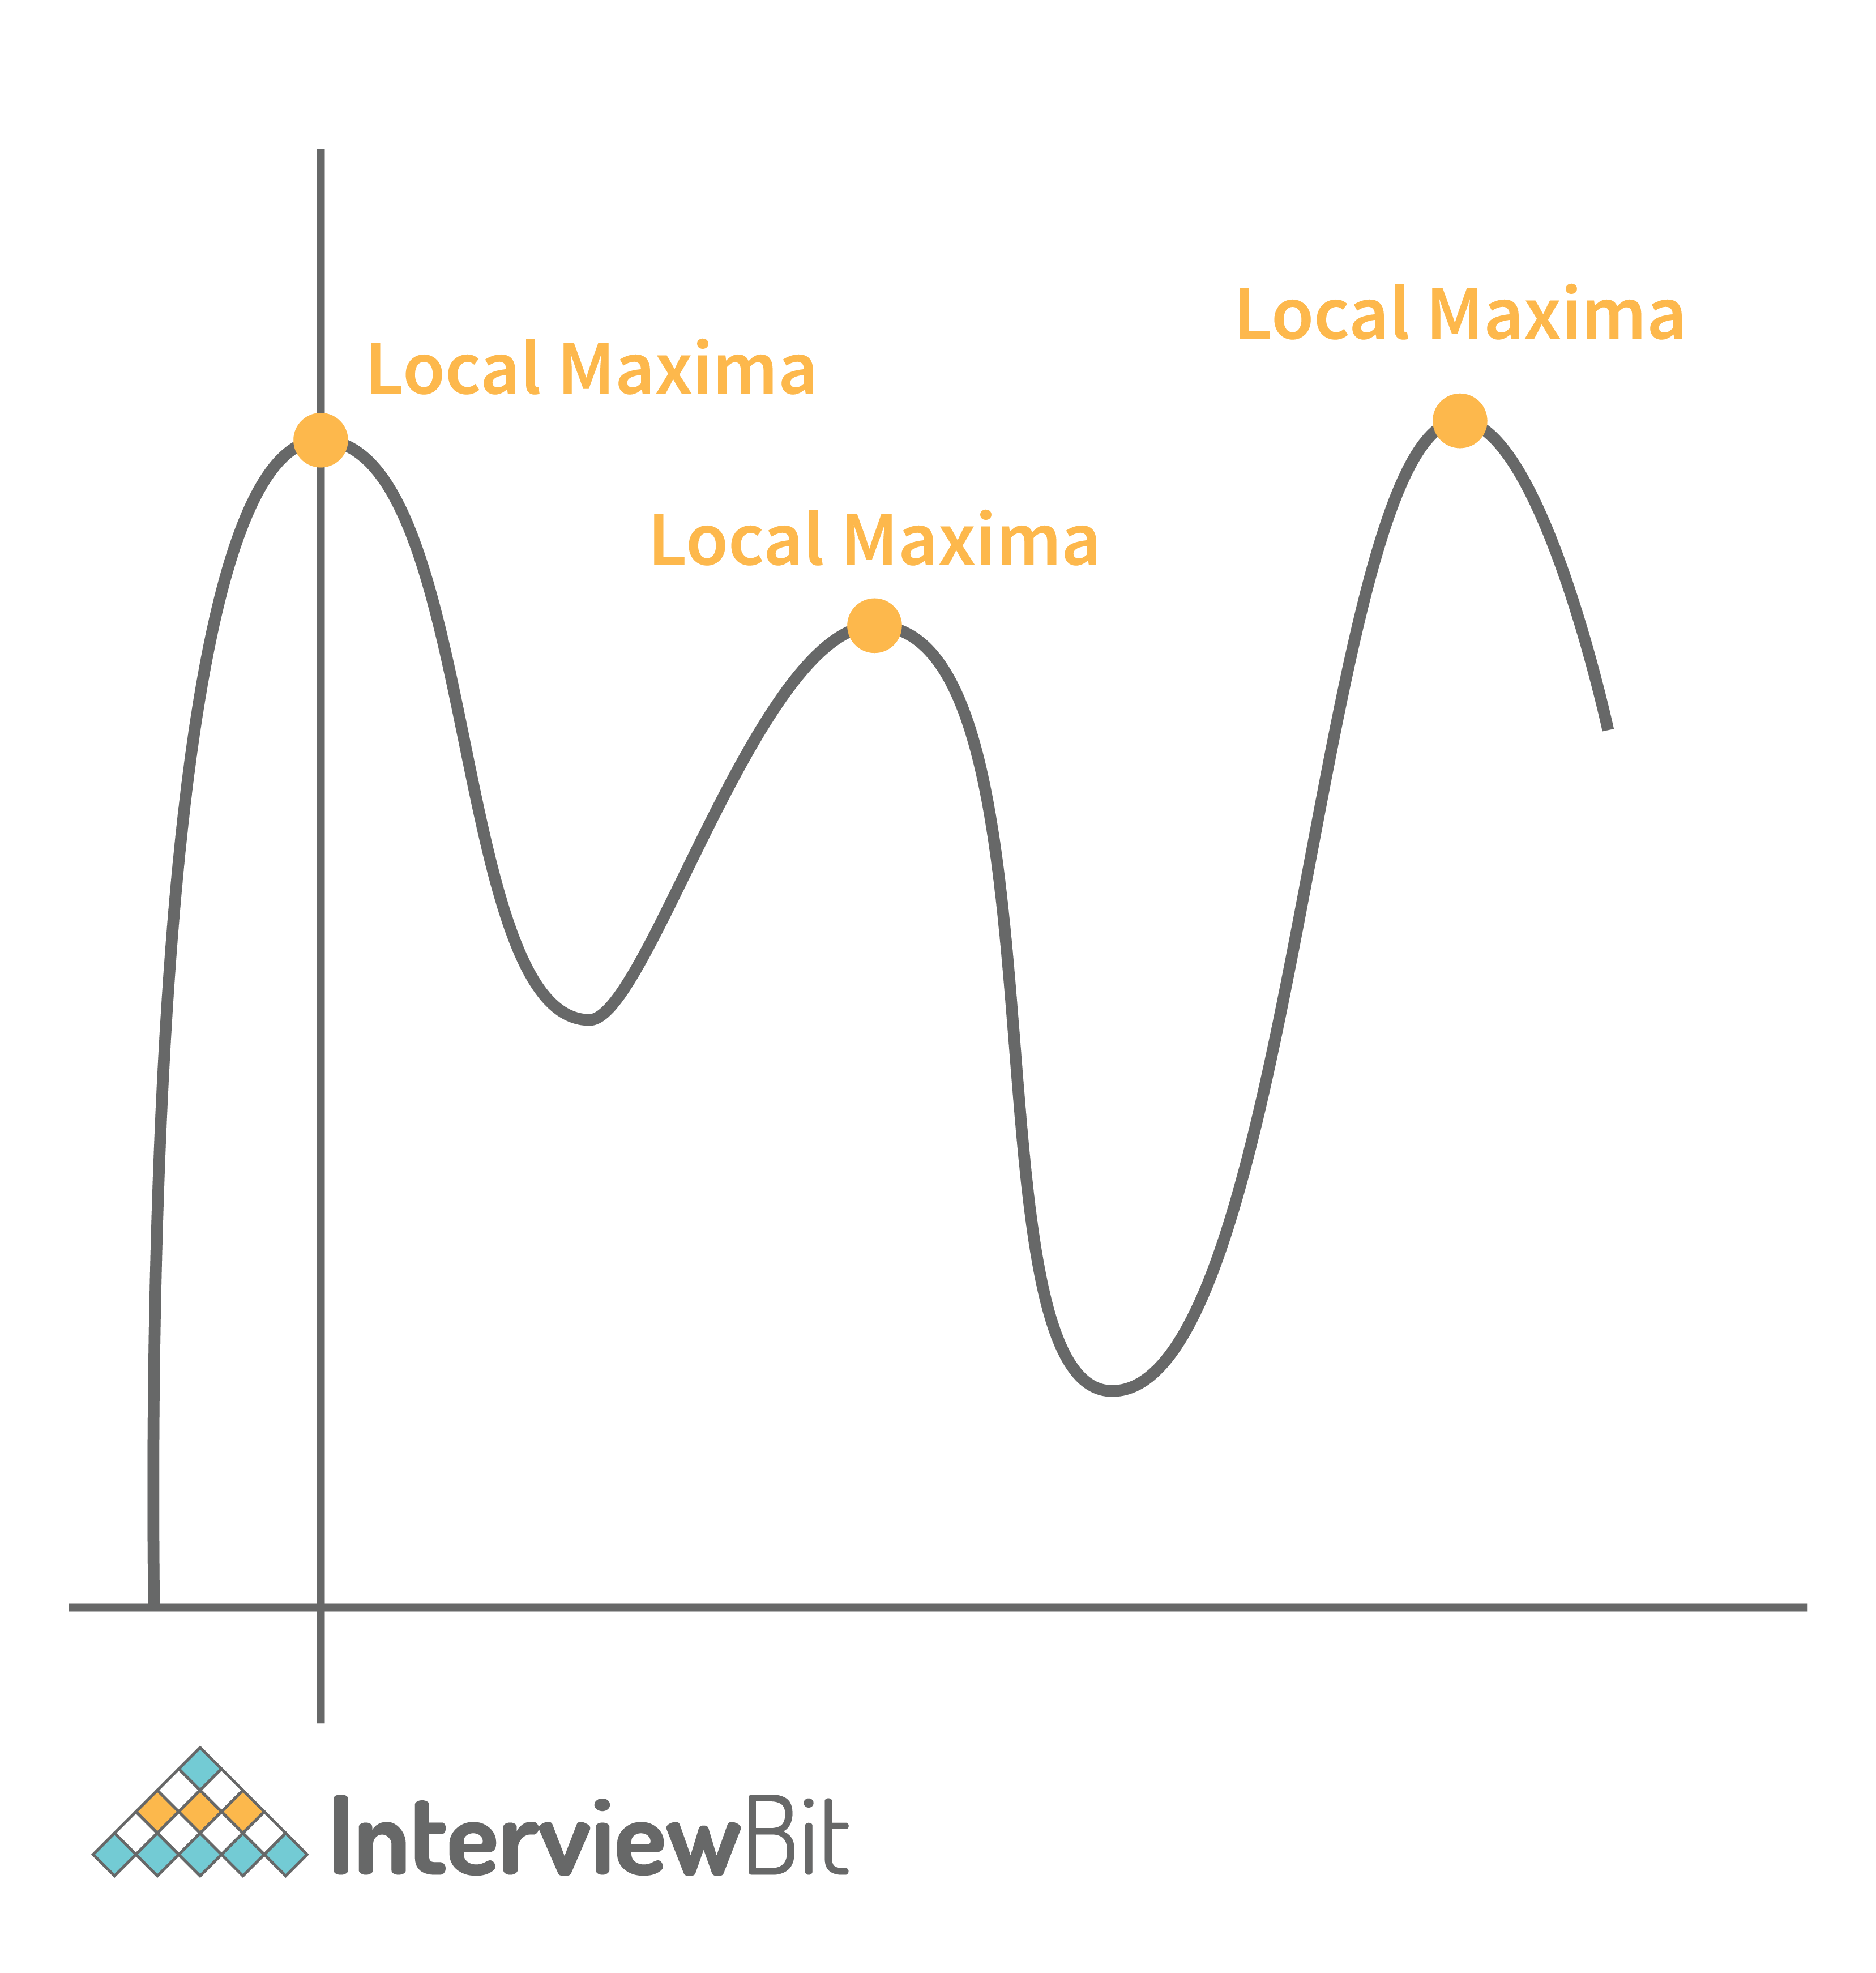
There are two ways of finding local maxima:
Using .where() method: This method lists all positions/indices where the element value at position i is greater than the element on either side of it. This method does not check for the points that have only one neighbour. This is demonstrated in the example below:
import numpy as np
# define NumPy array
arr = np.array([1, 4, 8, 1, 3, 5, 1, 6, 1, -5, -1, 19, 2])

maxima_peaks_positions = np.where((arr[1:-1] > arr[0:-2]) * (arr[1:-1] > arr[2:]))[0] + 1
print(maxima_peaks_positions)
Output:
[ 2 5 7 11]]
- The +1 at the end of the expression is required as it finds the indexes within the slice arr[1:-1] and not the entire array arr.
- The where() method returns a tuple of arrays where the first element is our required array. Hence we add [0] after the where method.
Using combination of .diff(), .sign() and .where() method:
- In this method, we calculate the difference between each element using the diff() method of NumPy.
- Then we use the sign() method on the array to get the sign of difference.
- The value can be either -1 or +1. This result is then passed on to another diff() method which returns 0, -2 or +2 value. The value 0 indicates that the points are continuously increasing or decreasing, +2 indicates minimum peak and -2 indicates maximum peak (local maxima).
- We then identify the position or indexes of the local maxima using the where() method. The reason for using +1 at the end of where and [0] after where is the same as the explanation described in Method 1 for finding local maxima.
The following code example demonstrates this:
import numpy as np
# define NumPy array
arr = np.array([1, 4, 8, 1, 3, 5, 1, 6, 1, -5, -1, 19, 2])

all_peaks = np.diff(np.sign(np.diff(arr)))
maxima_peaks_positions = np.where(all_peaks == -2)[0] + 1
print(maxima_peaks_positions)
Output:
[ 2 5 7 11]]

18. How is Vectorization related to Broadcasting in NumPy?
Vectorization involves delegating NumPy operations internally to optimized C language functions to result in faster Python code. Whereas Broadcasting refers to the methods that allow NumPy to perform array-related arithmetic operations. The size or shape of the arrays does not matter in this case. Broadcasting solves the problem of mismatched shaped arrays by replicating the smaller array along the larger array to ensure both arrays are having compatible shapes for NumPy operations. Performing Broadcasting before Vectorization helps to vectorize operations which support arrays of different dimensions.

19. What happens when the split() method is used for splitting NumPy arrays?
1. np.split() : Equally splits arrays into multiple sub-arrays. It raises Value Error when the split cannot be equal.
- Syntax:
np.split(array, sections, axis=0)
where,
- array - array that needs to be split
- sections -
  - If we give an integer X, X equal sub-arrays are obtained after dividing the array. If the split is not possible, ValueError is raised.
    - For example:
import numpy as np
a = np.arange(8)
split_arr = np.split(a, 2)
split_arr
Output
[array([0, 1, 2, 3]), array([4, 5, 6, 7])]
- If we give a 1-D sorted array then the entries would represent where the array would be split along the axis. For instance if we provide [2:3] and axis as 0, then the result would be
[arr[0:2], arr[2:3], arr[3:]]
  - If the provided index exceeds the array dimension along the given axis, then an empty subarray will be returned.
  - For example:
[array([0., 1., 2.]),
array([3.]),
array([4.]),
array([5.]),
array([], dtype=float64),
array([], dtype=float64),
array([], dtype=float64)]
The output would be:
import numpy as np
a = np.arange(6.0)
split_arr = np.split(a, [3, 4, 5, 6, 7,8])
split_arr
- axis - Along what axis the array has to be split. By default, the value is 0

20. What happens when we use the arrays_split() method for splitting the NumPy array?
The array_split() method is similar to the split() method as it helps in splitting a given array to multiple subarrays. The main difference is that the array_split() allows sections to be an integer which does not result in equal array division. For an array of length L, if we want it to split to N subarrays, then L % N subarrays of size (L//N + 1) and remaining subarrays are of size L//N.
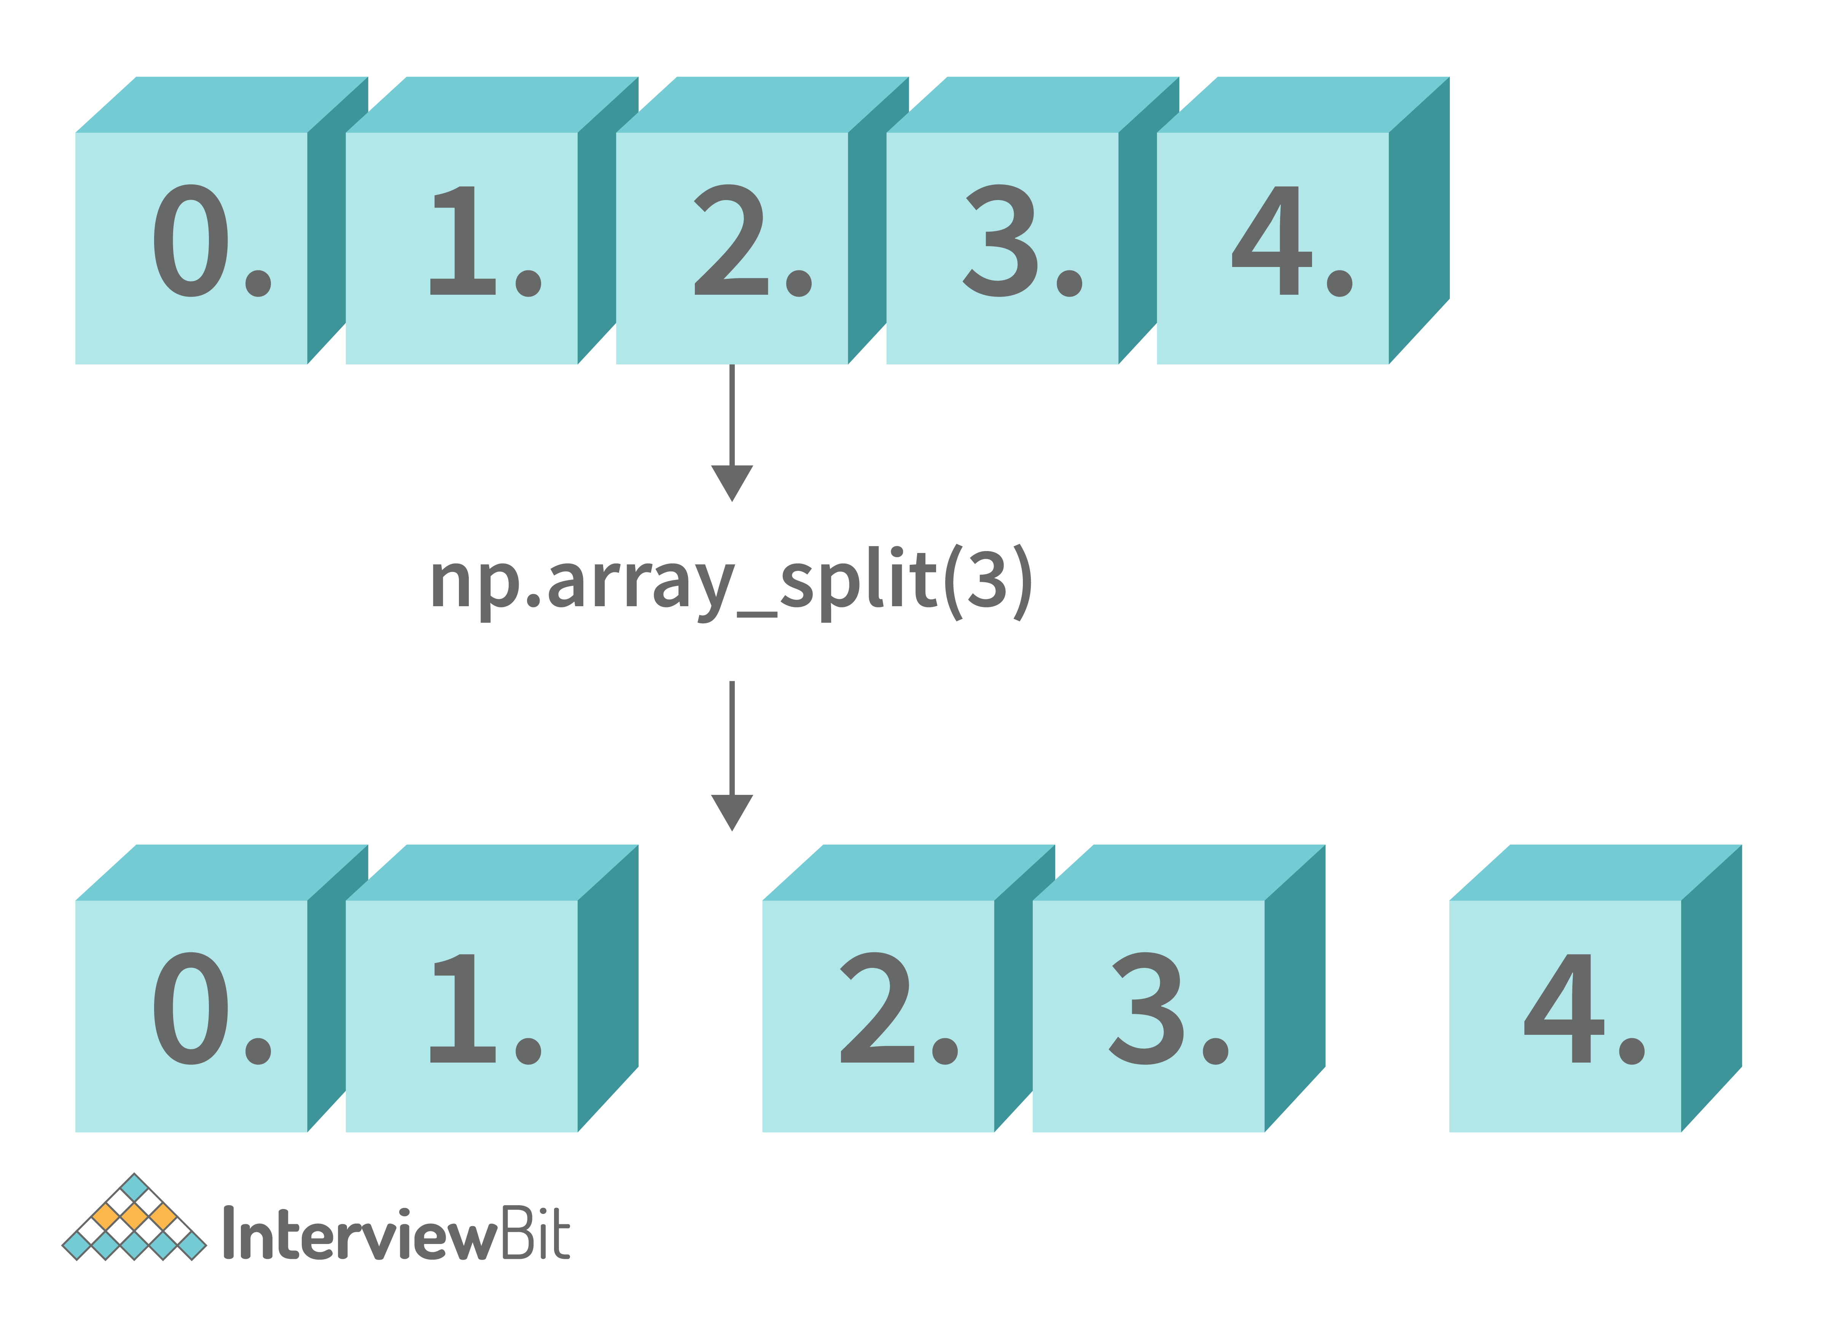
In the above figure, we see there are 5 elements in the array, we want to split the array to 3 subarrays. So L % N = 5%3 = 2 subarrays of size (L//N +1) = (5//3 +1) = 2 are returned and remaining 1 subarray of size L//N = 1 is returned.
Syntax:
np.array_split(array, sections, axis=0)
where,
- array - Given Input array.
- sections - List of indices or Number of subarrays to be returned.
- axis - Axis along which values have to be appended.
The code for the example illustrated above is:
import numpy as np
arr = np.arange(5.0)
split_arrs = np.array_split(arr, 3)
split_arrs
Output:
[array([0., 1.]), array([2., 3.]), array([4.])]

21. How will you implement the moving average for the 1D array in NumPy?
We can make use of the convolve() method. Here, it leverages the way discrete convolution is computed and uses it to find the rolling mean (moving average). Here, the sequence of ones of length equal to the length of the sliding window is convolved with the array.
We first define a calculate_moving_average function which performs the convolution of an array with the sequence of ones of sliding window length w. The mode of the convolve method will be ‘valid’ to generate the points only where the overlapping of the sequence is complete.
import numpy as np
def calculate_moving_average(arr, w):
return np.convolve(arr, np.ones(w),'valid')/w
The above-defined function can be then used for finding the moving average as shown in the examples below:
arr1 = np.array([4,5,8,9,3,2,4,2,0,2])
print("Moving average of window length 2: ")
av1 = calculate_moving_average(arr1, 2)
print(av1)

print("Moving average of window length 4: ")
av2 = calculate_moving_average(arr1, 4)
print(av2)
Output:
Moving average of window length 2:
[4.5 6.5 8.5 6. 2.5 3. 3. 1. 1. ]
Moving average of window length 4:
[6.5 6.25 5.5 4.5 2.75 2. 2. ]

22. How is fliplr different from flipud methods in NumPy?
The fliplr() method is used for flipping an array in the left or right direction. The columns are preserved but the order of elements in the columns would be different than before. This has been represented in the image below:
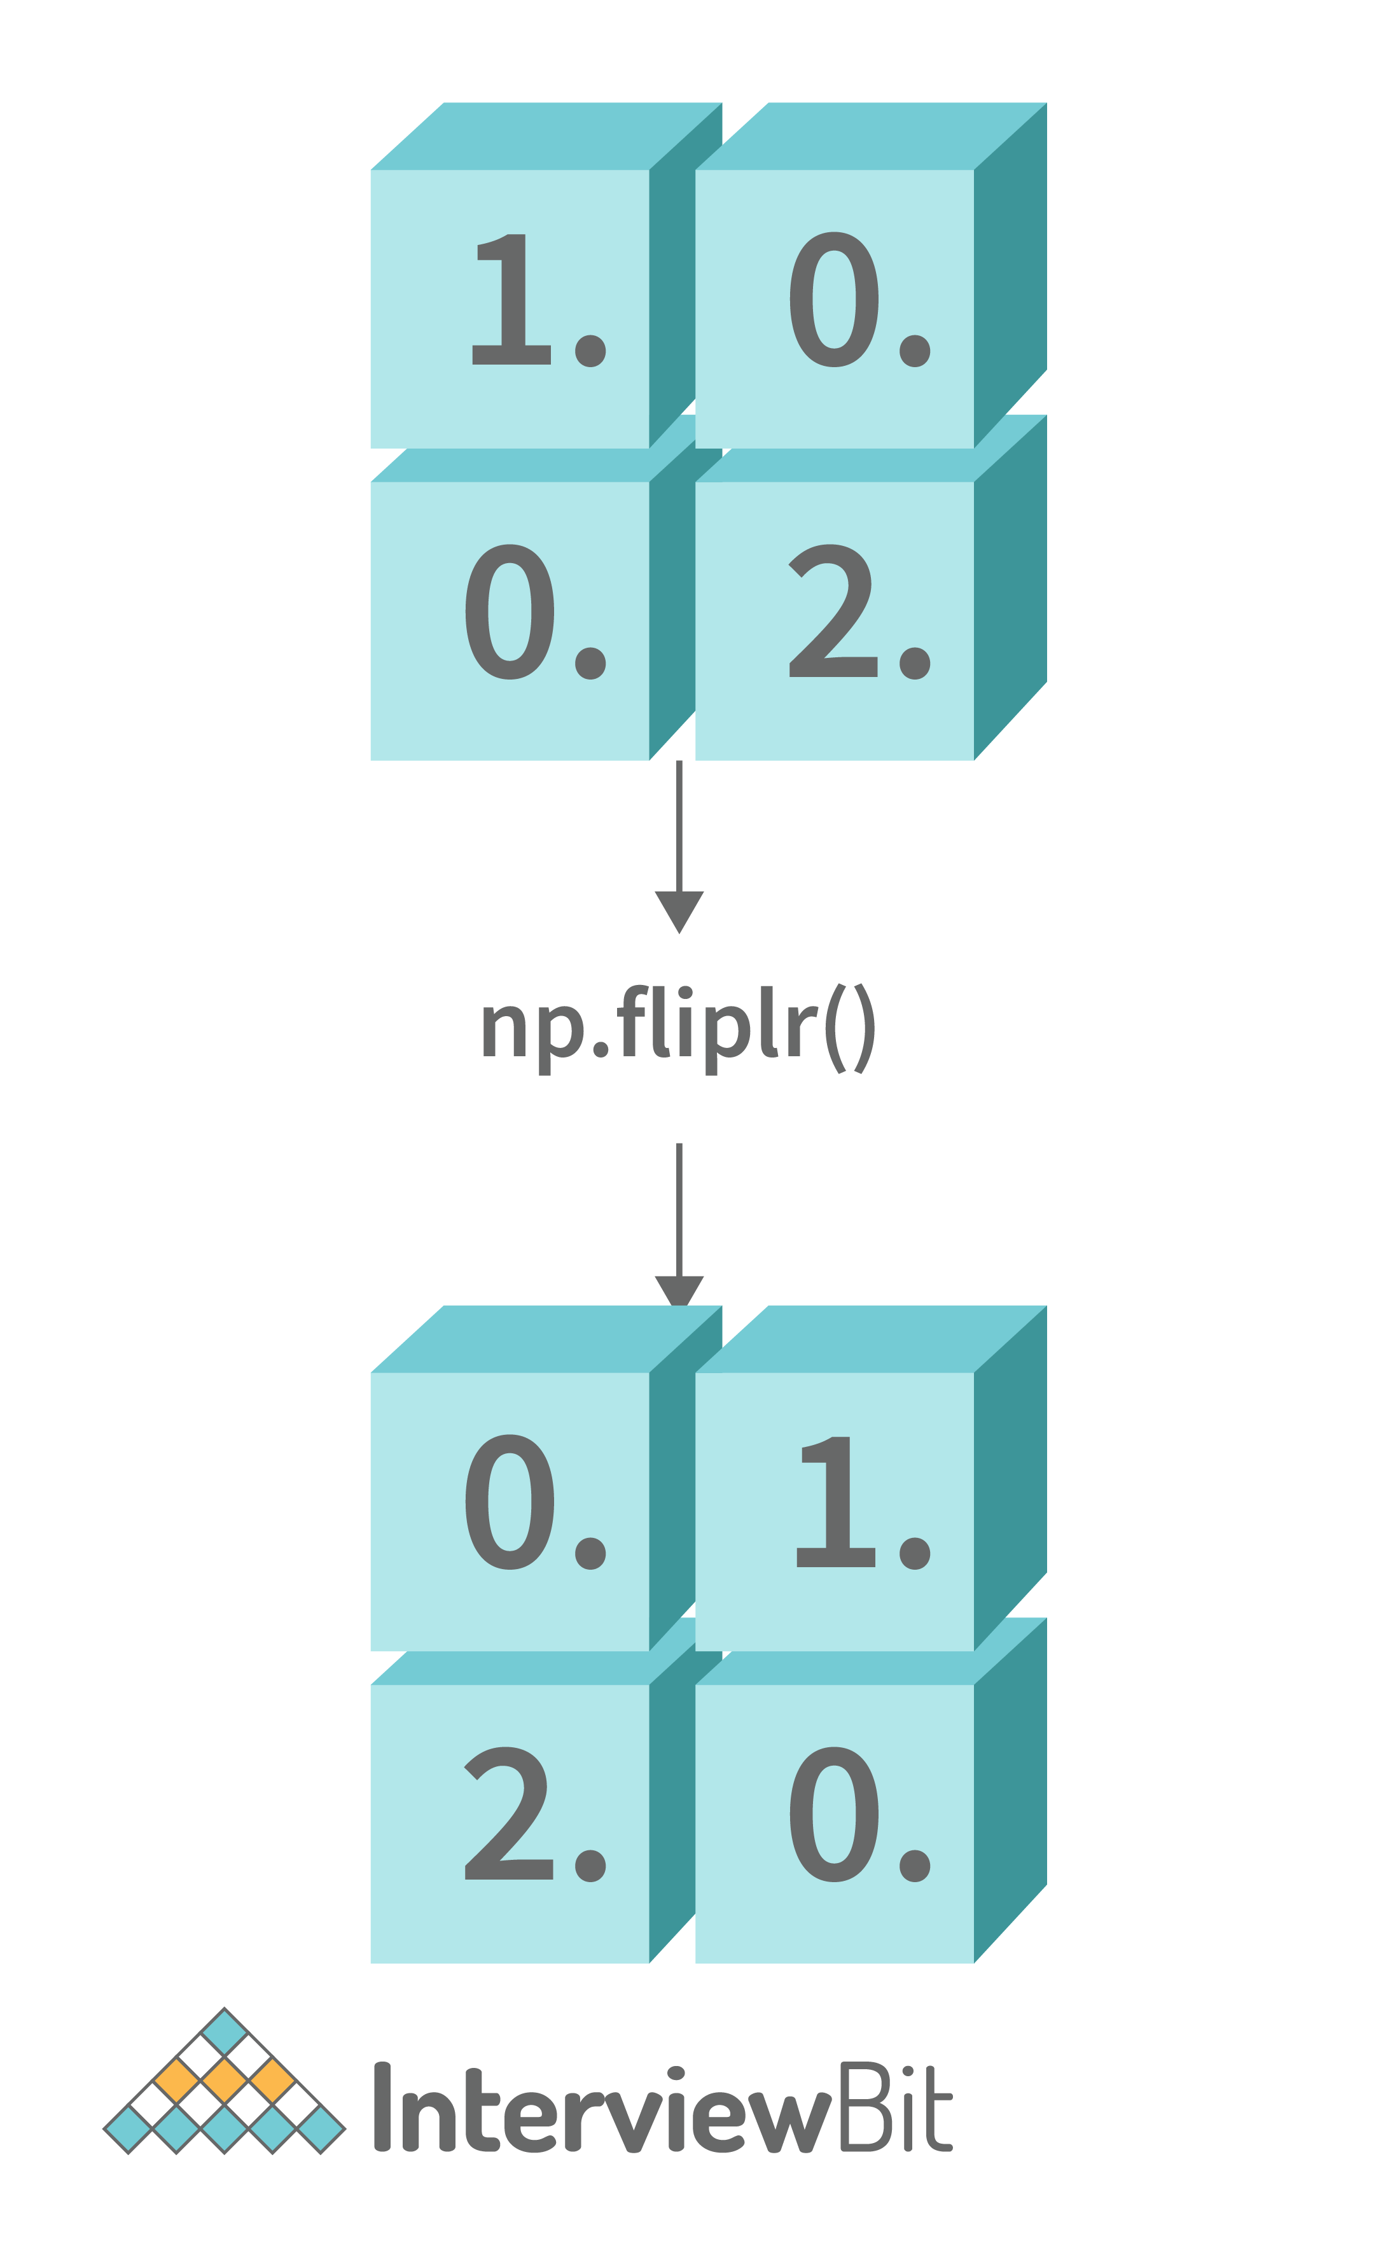
We see that the positions of the elements are flipped left or right than their original position in the result.
Syntax of fliplr:
np.fliplr(arr)
where arr is the array that has to be flipped.
The flipud function also flips the array but in the up or down direction. The rows are preserved in this case but they can appear in a different order in the result. This is represented in the image below:
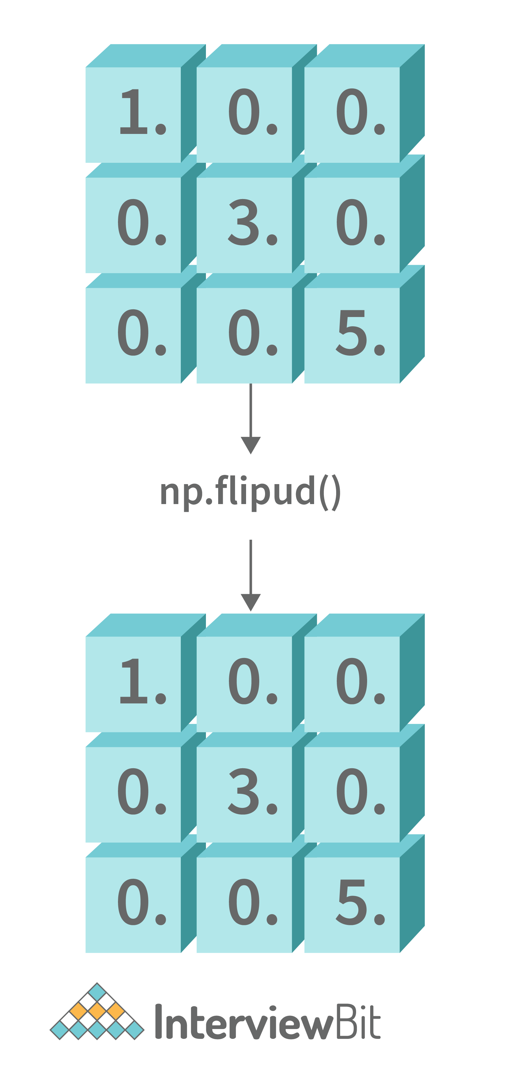
Here, we see that the numbers 1, 3 and 5 elements are flipped in the up/down direction in the result.
The syntax for flipud:
np.flipud(arr)
where arr is the array that has to be flipped.

NumPy Coding Questions

23. Write a program to convert a string element to uppercase, lowercase, capitalise the first letter, title-case and swapcase of a given NumPy array.
Sample Solution:-
import numpy as np

# Create Sample NumPy array
arr = np.array(['i', 'love', 'NumPy', 'AND', 'interviewbit'], dtype=str)

upper_case_arr = np.char.upper(arr)
lower_case_arr = np.char.lower(arr)
capitalize_case_arr = np.char.capitalize(arr)
titlecase_arr = np.char.title(arr)
swapcase_arr = np.char.swapcase(arr)

print("Upper Conversion: ", upper_case_arr)
print("Lower Conversion: ", lower_case_arr)
print("Capitalize First Letter Conversion: ", capitalize_case_arr)
print("Titlecase Conversion: ", titlecase_arr)
print("Swapcase Conversion: ", swapcase_arr)
Output:
Upper Conversion: ['I' 'LOVE' 'NUMPY' 'AND' 'INTERVIEWBIT']
Lower Conversion: ['i' 'love' 'numpy' 'and' 'interviewbit']
Capitalize First Letter Conversion: ['I' 'Love' 'Numpy' 'And' 'Interviewbit']
Titlecase Conversion: ['I' 'Love' 'Numpy' 'And' 'Interviewbit']
Swapcase Conversion: ['I' 'LOVE' 'nUMpY' 'and' 'INTERVIEWBIT']

24. Write a program to transform elements of a given string to a numeric string of 10 digits by making all the elements of a given string to a numeric string of 8 digits with zeros on the left.
Sample Solution:-
import numpy as np

# Create Sample NumPy array
arr = np.array(['22', '9', '1234', '567', '89102'], dtype=str)

zeroes_filled_arr = np.char.zfill(arr, 8)
print("Transformed array: ")
print(zeroes_filled_arr)
Output:
Transformed array:
['00000022' '00000009' '00001234' '00000567' '00089102']

25. Write a program for inserting space between characters of all elements in a NumPy array.
Sample Solution:-
import numpy as np

# Create Sample NumPy Array
arr = np.array(['i', 'love', 'NumPy', 'AND', 'interviewbit'], dtype=str)

transformed_arr = np.char.join(" ", arr)

print("Transformed Array: ")
print(transformed_arr)
Output:
Transformed Array:
['i' 'l o v e' 'N u m P y' 'A N D' 'i n t e r v i e w b i t']

26. Write a program to repeat each of the elements five times for a given array.
Sample Solution:-
import numpy as np
# Create Sample NumPy Array
arr = np.array(['i', 'love', 'NumPy', 'AND', 'interviewbit'], dtype=str)

transformed_array = np.char.multiply(arr, 5)
print("Transformed array:")
print(transformed_array)
Output:
Transformed array:
['iiiii' 'lovelovelovelovelove' 'NumPyNumPyNumPyNumPyNumPy'
'ANDANDANDANDAND'
'interviewbitinterviewbitinterviewbitinterviewbitinterviewbit']

27. Write a program for creating an integer array with values belonging to the range 10 and 60
import numpy as np
arr = np.arange(10, 60)
print(arr)
Output:
[10 11 12 13 14 15 16 17 18 19 20 21 22 23 24 25 26 27 28 29 30 31 32 33
34 35 36 37 38 39 40 41 42 43 44 45 46 47 48 49 50 51 52 53 54 55 56 57
58 59]

28. Write a program to add a border of zeros around the existing array.
For example,
If you have the below array:
[[ 1. 1. 1. 1.]
[ 1. 1. 1. 1.]
[ 1. 1. 1. 1.]]
The resultant array should be: (zeros on the border and 1s within it)
[[ 0. 0. 0. 0. 0. 0.]
[ 0. 1. 1. 1. 1. 0.]
[ 0. 1. 1. 1. 1. 0.]
[ 0. 1. 1. 1. 1. 0.]
[ 0. 0. 0. 0. 0. 0.]]
Solution:-
This can be achieved by using the pad method of the NumPy library.
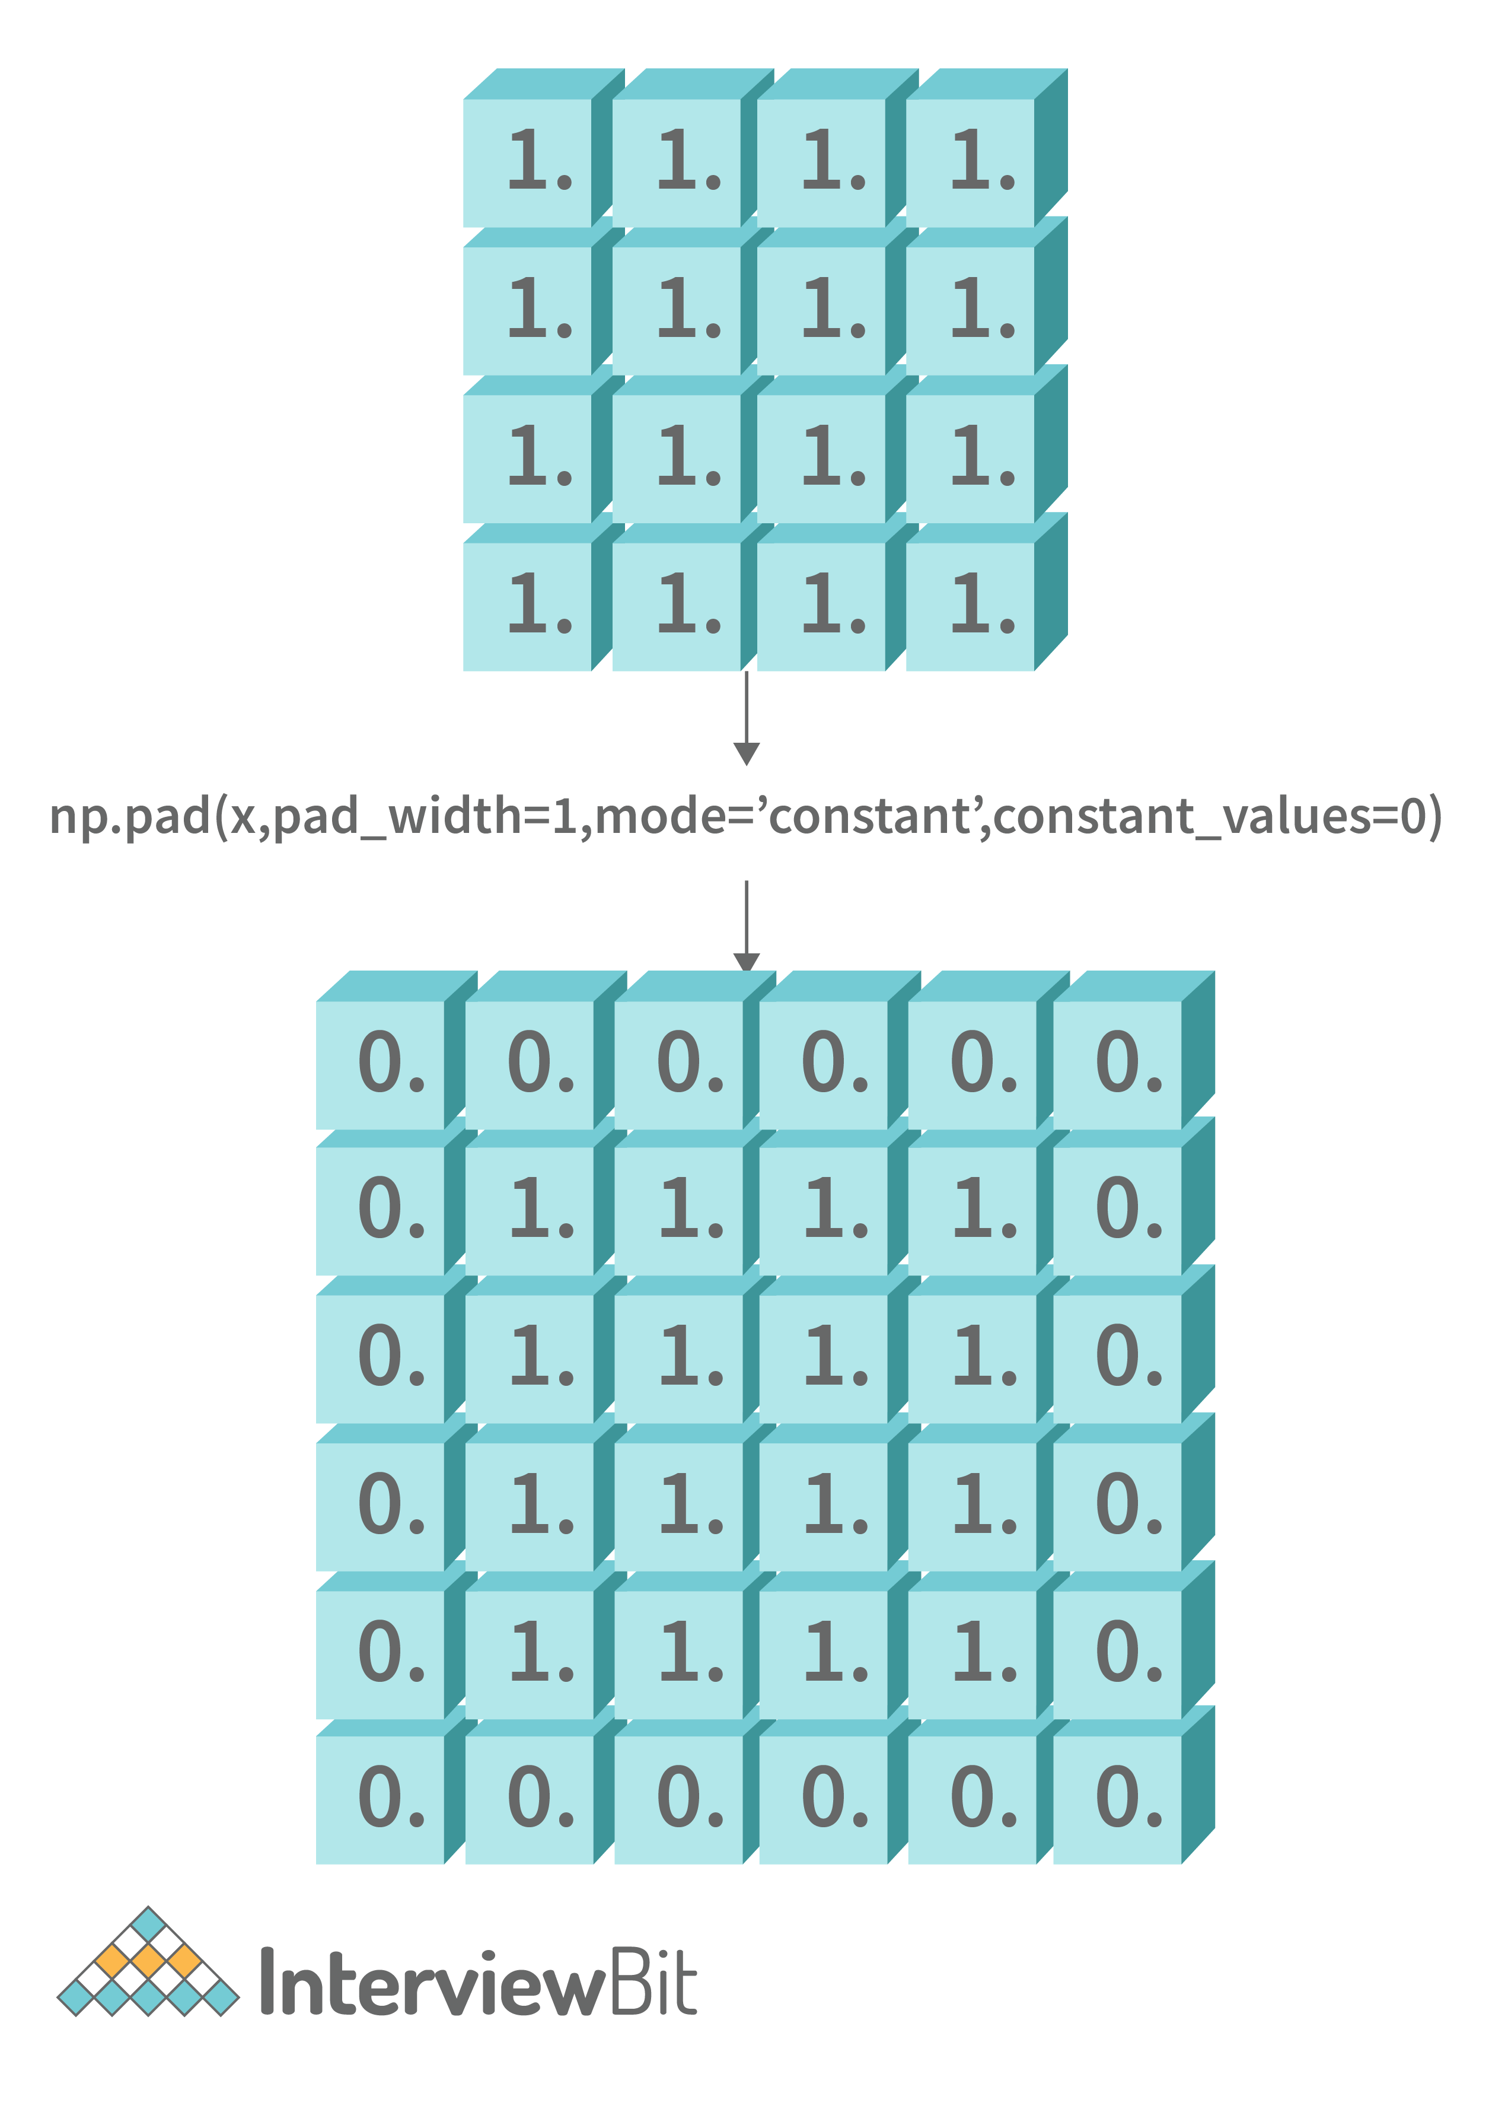
import numpy as np

# Create NumPy arrays filled with ones
ones_arr = np.ones((4,4))

print("Transformed array:")
transformed_array = np.pad(ones_arr, pad_width=1, mode='constant', constant_values=0)
print(transformed_array)
Output:
Transformed array:
[[0. 0. 0. 0. 0. 0.]
[0. 1. 1. 1. 1. 0.]
[0. 1. 1. 1. 1. 0.]
[0. 1. 1. 1. 1. 0.]
[0. 1. 1. 1. 1. 0.]
[0. 0. 0. 0. 0. 0.]]

29. Write a program for changing the dimension of a NumPy array.
We can achieve this by overriding the shape attribute of the NumPy array.
Sample Solution:
import numpy as np

#Create NumPy array
arr = np.array([1,2,3,4,5,6,7,8,9])
print("Original Shape: ", arr.shape)

# Change the shape/dimension of the array
arr.shape = (3, 3)
print("Transformed Matrix :")
print(arr)
print("Transformed Shape: ",arr.shape)
Output:
Original Shape: (9,)
Transformed Matrix :
[[1 2 3]
[4 5 6]
[7 8 9]]
Transformed Shape: (3, 3)
In this approach, care has to be taken w.r.t the number of elements present in the original array before changing the dimensions. Otherwise, it will result in the ValueError as shown below:
import numpy as np

# We have array of 8 elements
arr = np.array([1,2,3,4,5,6,7,8])

# We are trying to convert the 1D array to a 3D array which expects 9 elements
arr.shape = (3, 3)
print(arr)
Running this code would result in:
1 import numpy as np
2 arr = np.array([1,2,3,4,5,6,7,8])
----> 3 arr.shape = (3, 3)
4 print(arr)

ValueError: cannot reshape array of size 8 into shape (3,3)

30. Write a program for interchanging two axes of the NumPy array.
This can be achieved by using the swapaxes method of NumPy. The below image illustrates the meaning of swapping axes.
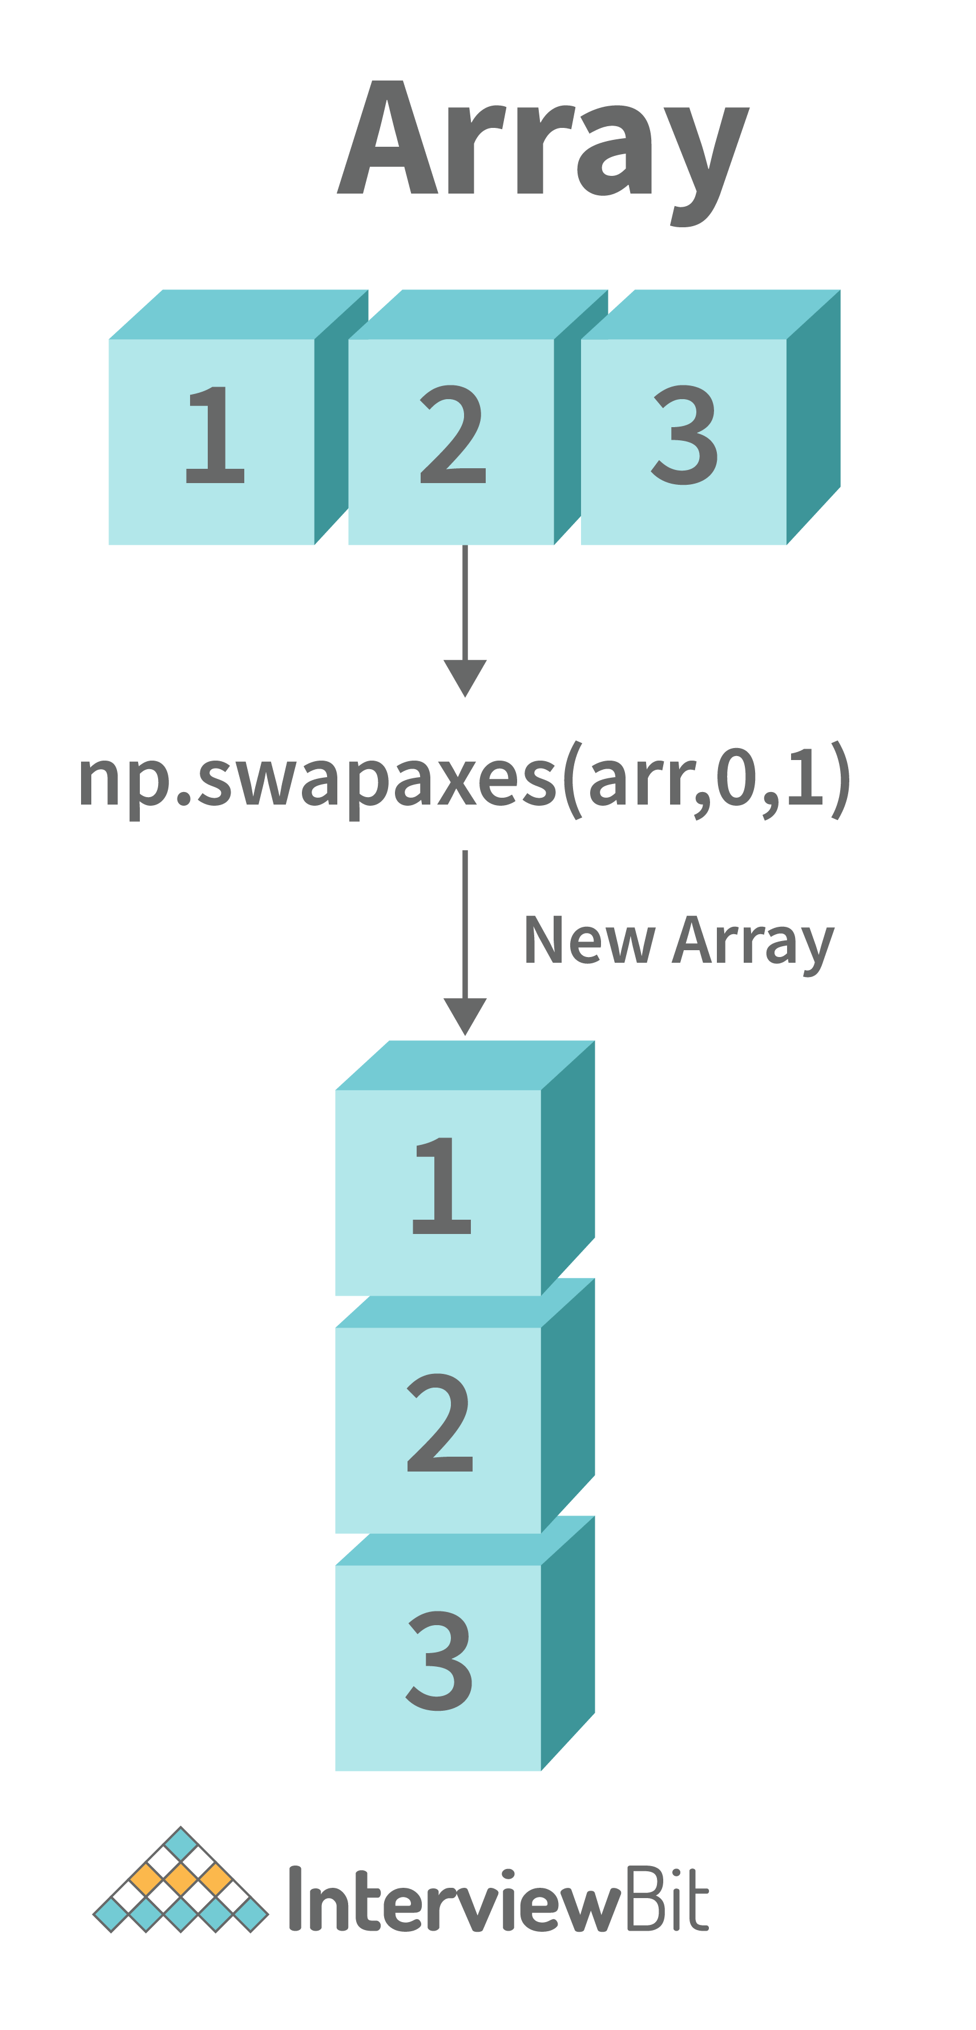
import numpy as np
arr = np.array([[1,2,3]])
print("Original array: ")
print(arr)

#Swap axes
axis_swapped_arr = np.swapaxes(arr,0,1)
print("Transformed array: ")
print(axis_swapped_arr)
Output:
Original array:
[[1 2 3]]
Transformed array:
[[1]
[2]
[3]]

Conclusion
The popularity of the NumPy package has grown immensely among the data science and python developers community ever since it was first introduced in 2005 due to the wide range of high-performing functionalities it offers. This is why it becomes essential to learn and be prepared for the interview questions about this package. In this article, we have seen the most commonly asked NumPy interview questions for freshers and experienced people, along with some questions on writing python programs which make use of NumPy functions.

1. Why do developers prefer NumPy to similar tools like Matlab, Yorick?
Developers prefer to use NumPy over other tools like Matlab for the following reasons:
- NumPy is an accessible and open-source library. You can easily access it and use it anywhere.
- It is a high-performing library integrated with multidimensional arrays and matrics. Some popular libraries
  - For Stats and ML: SciPy, Scikit-Learn, SpaCy, Statsmodels
  - Array Manipulation: Dask, PyTorch, TensorFlow
- Visualisation: Seaborn, Matplotlib, Altair, Bokeh, Plotly
- These libraries permit developers to quickly perform high-performance and complex mathematical, science, or finance calculations.
- As a developer, you can take advantage of the general purpose feature of Python as it makes it easy for you to connect with programming languages like C, C++, or Fortran.

2. List features that make NumPy unique?
Here are specific features which make NumPy unique:
- N-dimensional array object, NumPy array allows us to create a fixed size array while creating codes. But, you can change the size at runtime in case of need by deleting the old one and starting a new one. You can create different size elements of the array.
- Vectorised codes allow you to design and develop concise codes, including explicit looping, indexing, or lengthy codes. It makes the code readable and easy to execute with fewer bugs.
- It can quickly perform complex functions like broadcasting, and high-level mathematical functions such as statistics, algebra, Fourier transformation, and other scientific calculations.
- It is compatible to use NumPy in various computing platforms with dissimilar hardware.
- You can easily use NumPy with multiple sparse and distributed array libraries.

3. Share the steps of NumPy installation in Windows?
Installation of NumPy in Windows is relatively easy. You need to follow the below steps:
- Download and install Python (You can visit the official page of Python and get the executable installer file)
- Open and run that executable installer file
- Install the "pip" library on your Windows
- Now, to install NumPy in Python, follow the following steps
- Start the terminal (cmd screen)
- Type "pip install NumPy"
In this way, you can install NumPy and use it for various purposes.

4. Why is NumPy Array good compared to Python Lists?
NumPy is better than Python Lists for two primary reasons:
- NumPy Array is static and has a fixed size while creating codes. In other cases, Python Lists are dynamic and can grow dynamically.
- NumPy Array can perform vectorised operations and other advanced calculations, but Python Lists can't do these even after having a large set of functions.

5. Lists steps to create 1D, 2D, and 3D array.
You can create an array using "array" function/object class or a regular Python List. It is good to use the "array" function. Let's check the steps for creating a 1D, 2D, and 3D array:

Common Syntax
- Import "numpy" library
- Define required array like 1D, 2D, or 3D into any variable
- Call the function, array() and pass that variable
- Print and store the generated value

1D array Code:
import numpy as np
n =[10,20,30]
n = np.array(n)
print("1D array :",n)

1D array Output:
1D array : [10 20 30]

2D array Code:
import numpy as np
m = [[10,20,30], [40, 50, 60]]
m = np.array(m)
print("2D array :", m)

2D array Output:
2D array : [[10 20 30]
[40 50 60]]

3D array Code:
import numpy as np
p = [[10,20,30], [40, 50, 60], [70,80,90]]
p = np.array(m)
print("3D array :", p)

3D array Output:
3D array : [[10 20 30]
[40 50 60]
[70 80 90]]

6. How can you identify the datatype of a given NumPy array
You can determine the datatype of a given NumPy array using "dtype" property. It tells you what type of values are stored in the array.
Syntax: array object.dtype

In the following example
Code:
import numpy as np
p = [[10,20,30], [40, 50, 60], [70,80,90]]
q = 3.4
p = np.array(p)
q = np.array(q)
print("Datatype:", p.dtype)
print("Datatype:", q.dtype)

Output:
Datatype: int64
Datatype: float64

It can be seen that the compiler displays "int64" as the datatype for the p that has been initialized with integer values.

7. What does bincount() function?
The main job of the bincount() function is to count the number of times a given value appears in the array of integers. You have to take care of one point that the function takes only positive integers or Boolean expressions as an argument. You can not pass negative integers.
Syntax: array object.bincount()

Example:
Code:
import numpy as np
p = [10,20,30]
q = [5,1,7,1,8,13]
s = np.array([0, 2, 3, 0, 3, 3, 3, 0, 0, 4, 2, 1, 7, 5])
p = np.bincount(p)
q = np.bincount(q)
print("Occurrence of each digit in p:", p)
print("\nOccurence of each digit in q:", q)
print("\nOccurence of each digit in q:", np.bincount(s))
Output:
Occurrence of each digit in p: [0 0 0 0 0 0 0 0 0 0 1 0 0 0 0 0 0 0 0 0 1 0 0 0 0 0 0 0 0 0 1]
Occurence of each digit in q: [0 2 0 0 0 1 0 1 1 0 0 0 0 1]
Occurence of each digit in q: [4 1 2 4 1 1 0 1]

Let's take an example of array "q" in which 6 elements have been defined. You can see respective outcome where bincount() function returned [0, 2, 0, 0…]; it means occurrence of digits (0,1,2, 3..) sequentially.

8. What is the use of "ndim" attribute in NumPy?
The "ndim" function helps you to get the number of dimensions of the array.
Syntax: array object.ndim(); You have input array and in case if it is not, convert it.

Example:
Code:
import numpy as np
p = [[10,20,30], [40, 50, 60], [70,80,90]]
q = [10,20,30]
p = np.array(p)
q = np.array(q)
print("Dimension of array p:", p.ndim)
print("Dimension of array q:", q.ndim)
Output:
Dimension of array p: 2
Dimension of array q: 1

The outcome is showing the dimensions of arrays like array p has dimension 2 whereas array q has 1.

9. What is the use of "flipud" function in NumPy?
The "flipud" function reverses the array elements row-wise or along axis = 1 and axis = 1 respectively.
Syntax: array object.flipud() or flipud(array)

Example:
Code:
import numpy as np
array1 = [[10,20,30], [40, 50, 60], [70,80,90]]
print("Original array1 : \n", array1)

array2 = ['x','y','z']
print("Original array2 : \n", array2)
# flipud : means flip up-down

print("\nFlipped Array Example - array1 : \n", np.flipud(array1))
print("\nFlipped Array Example - array2 : \n", np.flipud(array2))
Output:
Original array1 :
[[10, 20, 30], [40, 50, 60], [70, 80, 90]]
Original array2 :
['x', 'y', 'z']

Flipped Array Example - array1 :
[[70 80 90]
[40 50 60]
[10 20 30]]

Flipped Array Example - array2 :
['z' 'y' 'x']

The output shows that both arrays have been reversed, like x,y,z is reversed into z,y,x.

10. How can you reshape NumPy array?
You can reshape the NumPy array using the function, reshape(). The function creates a new array rather than changing the original array. The function takes tuples which specify the new dimensions.
Syntax: array object.reshape() or reshape(array)

Example:
Code:
import numpy as np
array1 = np.array([10,20,30,40])
print("Original array1 : \n", array1)

array2 = np.array(['x','y','z','d','f','g'])
print("Original array2 : \n", array2)

# reshape : reshape the array like number of array, rows, columns

print("\n Reshape - array1 : \n", array1.reshape(1,2,2))
print("\n Reshape - array2 : \n", array2.reshape(1,2,3))
Output:
Original array1 :
[10 20 30 40]
Original array2 :
['x' 'y' 'z' 'd' 'f' 'g']

Reshape - array1 :
[[[10 20]
[30 40]]]

Reshape - array2 :
[[['x' 'y' 'z']
['d' 'f' 'g']]]

Based on the output, you can see that reshape function creates arrays, rows, and columns out of the data. We have reshaped array1 into one array with two rows and two columns.

NumPy is an important library of Python. Read more about Python here.

11. Name a few use cases where NumPy is useful.
- To perform complex mathematical computations on arrays
- To use multi-dimensional arrays and matrices in operations
- To execute trigonometric, statistical, and algebraic functions
- To execute transforms and methods for shape manipulation
- To generate random numbers
- To add/ delete/ sort/ split arrays
Read in detail here.

12. How many dimensions can a NumPy array have?
In NumPy, an array can have N-dimensions, and is called a ndarray.
- Ndarray is a multidimensional container which contains elements of the same type and size.
- The number of dimensions in a ndarray is also known as ‘rank’.
- A tuple of integers called ‘shape’ defines the size of the array in each dimension.
- The data type of elements in ndarray is defined by a ‘dtype’ object.

Example:
2D ndarray with size 2X3.
example = np.array([[1, 2, 3], [4, 5, 6]], np.int32)
type(example)
<class 'numpy.ndarray'>
example.shape(2, 3)
example.dtype
dtype('int32')

13. What is negative indexing in NumPy arrays?
Usually, the indices start from zero(0), continuing to 1,2,3, and so on

However in NumPy the elements can be accessed starting from the end of the array too. Negative indexing refers to the act of indexing from the end of the list starting at -1.

Example:
Print the last element from the 2nd dimension:
import numpy as np
example = np.array([[1,2,3,4,5], [6,7,8,9,10]])
print('Last element from 2nd dim: ', example[1, -1])
Output
10

14. How are NumPy Arrays better than Lists in Python?
Feature | NumPy Arrays | Python Lists
Element data type | Stores homogeneous data i.e., the elements are of the same data type | The elements can be of different data types
Flexibility | Less flexible, because operations are performed element wise | Allows more flexibility in adding, removing data
Declaration for usage | Numpy module needs to be imported for using Numpy arrays | No import is required to use Python lists
Arithmetic and matrix operations | Many vector and matrix operations are in-built | Complex statistical and analytical libraries are not available
Loops | Explicit loop is required to run through the elements | Explicit loop is not required to run through the elements

15. Explain the data types supported by NumPy.
- numpy.bool_ : bool
- numpy.byte : signed char
- numpy.ubyte : unsigned char
- numpy.short : short
- numpy.ushort : unsigned short
- numpy.intc : int
- numpy.uintc : unsigned int
- numpy.int_ : long
- numpy.uint : unsigned long
- numpy.longlong : long long
- numpy.ulonglong : unsigned long long
- numpy.half / numpy.float16 : Half precision float
- numpy.single : float
- numpy.double : double
- numpy.longdouble : long double
- numpy.csingle : float complex
- numpy.cdouble : double complex
- numpy.clongdouble : long double complex

More details and examples are here.

Intermediate NumPy Interview Questions and Answers

16. How does the flatten function differs from the ravel function?
Flatten function has been used for generating 1D versions of the multi-dimensional array. The ravel function does the same operation, but both have a difference.

The flatten() function always returns a copy. The ravel() function returns a view of the original array in most cases. Although you can't see or analyse it in the shown output, if you make changes in the array returned by ravel(), it might change the whole data of the array. This does not happen while using flatten() function.

Additionally, you can use the ravel function with any easily parseable object but flatten() function is used with true NumPy arrays.

And, last, ravel() is faster than flatten().

Syntax: array object.flatten() and array.object.ravel()

Example:
Code:
import numpy as np
p = [[10,20,30], [40, 50, 60], [70,80,90]]
p = np.array(p)
print("3D array\n :", p)
print("After applying the flatten() function\n")
print(p.flatten())
print("After applying the ravel() function\n")
print(p.ravel())
Output:
3D array
: [[10 20 30]
[40 50 60]
[70 80 90]]
After applying the flatten() function

[10 20 30 40 50 60 70 80 90]

After applying the ravel() function

[10 20 30 40 50 60 70 80 90]

There is no difference in output between the two functions. It proves that it has invisible differences to users.

17. What caused the Overflow error in NumPy?
The fixed size of NumPy numeric types causes an overflow error when a value needs more memory than available in the data type. In other words, you use a value too large to fit in the required place.

For instance, numpy.power evaluates 100**8 accurately for 64-bit integers but returns 187491924 (incorrect) for a 32-bit integer.

The behaviour of NumPy integer types differs significantly for integer overflows and might confuse users.

18. How does NumPy differ from Pandas?
NumPy | Pandas
It is a fundamental library of Python. | It is an open-source and BSD-licensed library written in Python language.
It has a set of tools like multidimensional arrays for performing scientific computation and other complex functions. | It provides a set of data analysis tools, time series, to perform multiple operations on data.
It works on numeric data and you can call it, "numpy module". | It works on tabular data, and you can call it, "pandas module".
It is also fast but memory efficient. | It is fast but consumes more memory.
It supports fewer applications compared to Pandas. | It supports broader and large industrial applications.

19. How do you calculate the moving average?
Before knowing how to calculate moving average, know what it means. It refers to a series of averages of fixed-size subsets of the total observation sets. You can also call it running average, rolling average, or rolling means.

The number of observations and size of windows are required for this calculation. You can calculate the moving average using several methods.

Using convolve function is the simplest method which is based on discrete convolution. You have to use a method that calculates discrete convolution to get a rolling mean. You can convolve with a sequence of np.ones of a length equal to the desired sliding window length.

Syntax: array object.convolve(data, window size)

Example:
Code:
import numpy as np
def moving_average(x, wsize):
return np.convolve(x, np.ones(wsize), 'valid') / wsize
data = np.array([1,3,2,7,4,8,2])
print("\n Moving Average:")
print(moving_average(data,2))
Output:
Moving Average:
[2. 2.5 4.5 5.5 6. 5. ]

Since the window size is 2, thus first moving average would be (1+3/2) i.e. 2. Similarly, the next values would be calculated during the moving average calculation.

20. What is the difference between indexing and slicing in NumPy?
The indexing and slicing are both applied to the array. Let’s see some differences below:
- Indexing creates an index, whereas slicing makes a copy. You need to use an array as an index to execute indexing. You can also index the Numpy array with other arrays or sequences with some tuple exceptions.
- Slicing returns a view (shallow copy) of the array, whereas indexing returns an original array.
- Different types of indexing are possible, but there is no slicing category.

Example:
Code:
import numpy as np
arr = np.array([1, 2, 3, 4, 5, 6, 7, 8])
print("\nIndexing in array")
print("\nfifth element:", arr[4])
print(arr[5])
print("\nSlicing in array")
print(arr[1:3])
Output:
Indexing in array

fifth element: 5
6

Slicing in array
[2 3]

Here, indexing is returning the array value at specific index like array[4] returns fifth element whereas slicing is returning a specific subset.

21. Can you create a plot in NumPy?
Yes, you can create a plot in NumPy. The "matplotlib" is a scientific plotting library in Python. You can use this library with NumPy, which creates an effective and open-source environment for creating plots. Often, function arrange(), and pyplot submodules has been used for making various plots.

Check the below example code, which is plotting a line graph. You have import, "matplotlib" compulsory. A line is drawn between two points thus, two arrays have been used as xpoints and ypoints. After that, these values have been passed to the plot() function. You can see a line in the image.

Example:
Code:
import sys
import matplotlib
matplotlib.use('Agg')
import matplotlib.pyplot as plt
import numpy as np
xpoints = np.array([0,5])
ypoints = np.array([0,150])
plt.plot(xpoints, ypoints)
plt.show()
plt.savefig(sys.stdout.buffer)
sys.stdout.flush()
Output:

Image Credit: W3schools

22. Is this possible to calculate the Euclidean distance between two arrays?
Yes, it is possible to calculate the Euclidean distance between two arrays. You can use "linalg.norm()" for this. The main job of this function is to preserve float input values even for scalar input values. That's why it is used for calculating distance.

Example:
Code:
import numpy as np
a = np.array([4,2,1,6])
b = np.array([1,3,8,2])
#Calculating distance
dist = np.linalg.norm(a-b)
print("\n Distance: ", dist)
Output:
Distance: 8.660254037844387

23. Discuss steps to deal with array objects?
Yes, it is possible to deal with array objects. Follow the steps:
- First, use a well-defined array with the correct type and dimensions. You can use PyArray_FromAny or macro to convert it from some Python object. And then use PyArray_NewFrom Descr to construct a new ndarray in desired shape and type.
- Now get the shape of the array and pointer to its actual data
- Pass this data and shape information onto a subroutine or other section of code which performs the computation
- In the case of writing an algorithm, use stride information present in the array for accessing array elements.
All these steps would help you to deal any array objects.

24. Which three types of value are accepted by missing _value argument?
The missing_value accepts the following three values
- A single value: It will be the default for all columns
- A sequence of value: Each entry will be the default for the corresponding column
- A dictionary: Each key can be a column index or a column name; the corresponding value should be a single object
Note down that you can use a special key, "None" to define a default for all columns.

25. How can you check whether any NumPy Array has elements or is empty?
Yes, it is possible to check the emptiness of NumPy Array using multiple methods. But, check the following table to know the two simplest functions to check the emptiness of an array.
numpy.any() | An array element is evaluated as True if it lies along any given axis. Simply put, it returns TRUE if the array has elements otherwise, FALSE.
numpy.size() | The function returns size of array. If the return value is zero, then the array is empty.

Example:
Code:
import numpy as np
A1 = np.array([12,13,14,15,16,17,18,19])
print("Array with elements, A1:", A1)
A2 = np.array([])
print("Array without elements:A2", A2)

#Method 1 -any()
print("Empty Array or not:A1 ", np.any(A1))
print("Empty Array or not:A2", np.any(A2))
#Method 2 - size()
print("Size function:A1 ", np.size(A1))
print("Size function:A2 ", np.size(A2))
Output:
Array with elements, A1: [12 13 14 15 16 17 18 19]
Array without elements:A2 []
Empty Array or not:A1 True
Empty Array or not:A2 False
Size function:A1 8
Size function:A2 0

It is visible that A1 array has elements and A2 does not. The function any() returns FALSE for A2 array means it is empty. Similarly, size() functions returns 0 for A2 means again, there is no elements inthe array.

You will perform better in your interview if you practice backend development skills like .NET, API, and OOPs concepts. Get sharper at backend development by clicking here.

26. Explain the operations that can be performed in NumPy.

Operations on 1-D arrays in NumPy:
- Add: Adds the elements of two arrays, depicted by ‘+’.
Example:
array1= np.array([1,2,3,4,5])
array2= np.array([1,2,3,4,5])
array3= array1 + array2
array3
Output - array([1,4,6,8,10]) <span data-ccp-props="{'201341983':0,'335559731':900,'335559740':276}"> </span>
- Multiply: Multiplies the elements with a number, depicted by ‘*’.
- Power: Square the elements in an array by using ‘**’.
Example:
array1**2
array1
Output - array1([1,4,9,16,10])

To use a higher power such as cube, use below syntax.
np.power(array1,3)
array1
Output - array1([1,8,27,64,1000])

- Conditional Expressions: Compare the array elements using a conditional expression.
Example:
array5 = array1 >= 3
array5
Output - array([False,False, True, True , True])

Operations on 2-D arrays in NumPy:
- Add: Adds elements of 2-D arrays by position.
Example:
A = np.array([[3,2],[0,1]])
B = np.array([[3,1],[2,1]])
A+B gives output as-
array([[6, 3],
[2, 2]])

- Normal multiplication: Multiples the arrays element-wise.
Example:
A*B gives output as-
array([[5, 4],
[2, 3]]) <span data-ccp-props="{'201341983':0,'335559685':2160,'335559740':276,'335559991':720}"> </span>
- Matrix Multiplication: Uses ‘@’ to perform matrix product/multiplication.
Example:
A@B gives output as-
array([[13, 5],
[ 2, 1]])

27. Why is the shape property used in NumPy?
The shape property is used to get the number of elements in each dimension of a NumPy array.
Example:
example = np.array([[1, 2, 3, 4], [5, 6, 7, 8]])
print(example.shape)
Output:
(2,4)

This means there are 2 dimensions and each dimension has 4 elements.

28. What is array slicing in NumPy?
Through slicing a portion of the array is selected, by mentioning the lower and upper limits. Slicing creates views from the actual array and does not copy them.

Syntax:
The basic slice syntax is i:j:k where i is the starting index, j is the stopping index, and k is the step (k≠0).
Example 1-D array:
x = np.array([0, 1, 2, 3, 4, 5, 6, 7, 8, 9])
x[1:7:2]
Output
array([1, 3, 5])
Example 2-D array:
a2 = np.array([[10, 11, 12, 13, 14],
[15, 16, 17, 18, 19],
[20, 21, 22, 23, 24],
[25, 26, 27, 28, 29]])
print(a2[1:,2:4])
This starts from row 1:(till the end of the array) and columns 2:4(2 and 3).

Image credit: pythoninformer.com
Example 3-D array:
a3 = np.array([[[10, 11, 12], [13, 14, 15], [16, 17, 18]],
[[20, 21, 22], [23, 24, 25], [26, 27, 28]],
[[30, 31, 32], [33, 34, 35], [36, 37, 38]]])
print(a3[:2,1:,:2])

This statement makes a selection as shown below:
- Planes: first 2 planes
- Rows: last 2 rows
- Columns: first 2 columns

29. How is the seed function used in NumPy?
- The seed function sets the seed(provides input) of a pseudo-random number generator in NumPy.
- By pseudo-random we mean that the numbers appear as randomly generated but actually are predetermined through algorithms.
- The numpy.random.seed or np.random.seed function can not be used alone and is used together with other functions.
Example:
# seed random number generator
seed(1)
# generate some random numbers
print(rand(3))

30. How to convert the data type of an array in NumPy?
The data type(dtype) of an array can be changed using the function numpy.astype().
Example: Change the array of floats to an array of integers.
arr = np.array([1.3, 2.2, 3.1])
newarr = arr.astype('i')
print(newarr)
print(newarr.dtype)
Output:
[1 2 3]
int32

31. What is the difference between copy and view in NumPy?
Copy
- Returns a copy of the original array.
- Do not share the data or memory location with the original array.
- Any modifications made in the copy will not get reflected in the original.
Example:
import numpy as np
arr = np.array([20,30,50,70])
a= arr.copy()
#changing a value in copy array
a[0] = 5
print(arr)
print(a)
Output:
[20 30 50 70]
[ 5 30 50 70]

View
- Returns a view of the original array.
- Does use the data and memory location of the original array.
- Any modifications made in the copy will get reflected in the original.
Example:
import numpy as np
arr = np.array([20,30,50,70])
a= arr.view()
#changing a value in original array
arr[0] = 100
print(arr)
print(a)
Output:
[100 30 50 70]
[100 30 50 70]

Advanced NumPy Interview Questions

32. Discuss vectorisation in NumPy? How to perform visualisation using NumPy?
Vectorisation is a vital feature in NumPy. It says that one function could apply to all array elements. This means it needs only one elemental operation to vectorise any function. Executing some operations like loops on the array is time-consuming in Python because of different data types. You all know that C languages support one specific datatype, making the code more optimised and fast. NumPy arrays support a single datatype, and most of its functions like logical, and arithmetic have optimised code. Thus you can easily vectorise your functions.

Steps:
- Write the function which will perform the required operation. It must take array elements as parameters.
- Use vectorise () method available in the NumPy package and vectorise this function.
- Now, input the array to this vectorised function.

33. Discuss uses of vstack() and hstack() functions?
vstack() and hstack() are the vector stacking functions. Both are used to merge NumPy arrays. As the name says
- vstack() - Vertical stacking means it merges the array vertically.
- hstack() - Horizontal stacking means it merges the array horizontally.

Let’s understand it with the following example.

Example:
Code:
import numpy as np
a = np.array([10,20,30])
b = np.array([40,50,60])
# vstack and hstack functions
vs = np.vstack((a,b))
print("\n Vertical Stacking\n ", vs)
print("-------------")
hs = np.hstack((a,b))
print("\n Horizontal Stacking\n ", hs)
Output:
Vertical Stacking
[[10 20 30]
[40 50 60]]
-------------

Horizontal Stacking
[10 20 30 40 50 60]

34. How is vectorisation different from broadcasting?
Vectorization | Broadcasting
Vectorization do vectorize the functions for executing complex operations such as loops. | Broadcasting is an extension of vectorization which vectorizes the array operations.
In vectorization, it is compulsory to have array same size. | In broadcasting, array could be differ in sizes to perform any operations including addition,  subtraction, etc.
It depends on NumPy operations to optimize the C language functions internally to generate the code quickly. | It is itself are separate methods which permits NumPy to execute array-related arithmetic operations.
You must perform broadcasting before vectorization to vectorize array operations of different dimensions.

35. How can you find peak or local maxima in a 1D array?
Peak refers to the highest value or point in the graph. Graphically, peaks are surrounded by the smaller value points on either side. It is also known as local maxima.
You can use two methods to calculate peak.

First/Simple method
.where() – The simplest method lists all positions and indices where the element value at position X is greater than the element on either side of this. Remember, this function doesn't check for the points with only one neighbour.

Second/Complex method
This method is complex as it uses multiple functions (.diff(), .sign(), .where()) for calculating peak.
.diff() – It calculates the difference between each element
.sign() – Use this function to get the sign of difference
.where() – Use this function to get the position or indexes of local maxima

36. What are different ways to convert a Python dictionary to a NumPy array?

First method
np.array() – Converts dictionary to nd array
List comprehension – To get all dictionary values as a list and pass it as input to array

Second method
np.array() – Converts dictionary to nd array
dictionary_obj.items - To get all dictionary values as a list and pass it as input to an array

37. What is the best way to create a Histogram?
The best way to create a Histogram is to use the function histogram(). You can apply it to the array objects, which return a pair of vectors, "the histogram of the array" and "a vector of the bin edges."

Note down that numpy.histogram only generates the data while pylab.hist plots the histogram automatically.

Example:
Code:
import sys
import matplotlib
matplotlib.use('Agg')

import matplotlib.pyplot as plt
import numpy as np

x = np.random.normal(100, 350, 250)
plt.hist(x)
plt.show()
plt.savefig(sys.stdout.buffer)
sys.stdout.flush()
Output:

38. Can you create strides from a 1D array?
Yes, you can create strides from a 1D array. Strides refer to the tuple of integer values, and each byte has been indicated by a specific dimension. Strides say how many bytes you must skip in memory for moving to the next position along with a specific axis. Like, you want to skip 4 bytes (1 value) to move to the next column, but you need 20 bytes ( 5 values) to get to the same position in the next row.

Steps:
- Import libraries and take the same data
- Create Stride
Syntax: array object.strided(array, new_array size, stride_steps in bytes)

Example:
Code:
import numpy as np
from numpy.lib.stride_tricks import as_strided
sa1 = np.array([1,3,2,5,4,7,8,1], dtype = "int32")
print("This is a Sample 1D array:", sa1)
Result = np.lib.stride_tricks.as_strided(sa1,(3,2),(12,4))
print("Array after stride","\n",Result, "\n")
print("This is the shape of original array which is an 1D array:","\n",sa1.shape,"\n")
print("This is the shape of our Result which is an 2D array:","\n",Result.shape)
Output:
This is a Sample 1D array: [1 3 2 5 4 7 8 1]
Array after stride
[[1 3]
[5 4]
[8 1]]

This is the shape of original array which is an 1D array:
(8,)
This is the shape of our Result which is an 2D array:
(3, 2)

We have strided 1D array into new array with 3 rows and 2 columns. You can see array after the stride. And, stride_steps for row is 12 bytes whereas for columns is 4 bytes.

39. How does NumPy handle numerical exceptions?
You can use two methods to handle numerical exceptions. The first is "warn" for invalid and divided numerical exceptions, whereas the second is "ignore" for underflow exceptions.

Type of behaviours
- Ignore – It takes no action when an exception occurs
- Warn – It prints a RuntimeWarning using warning modules
- Raise – It raises a FloatingPointError
- Call – It calls a function specified using a seterrcall function
- Print – It prints only warning directly to stdout
- Log – It records the error in a Log object specified by seterrcall

Types of errors
- All – applicable to all numeric exceptions
- Invalid – When NaNs are generated
- Divide – Divide by Zero error
- Overflow – Floating point overflows
- Underflow – Floating point underflows

40. What is the biggest challenge while writing extension modules in NumPy?
Reference counting is the biggest challenge while writing extension modules in NumPy. Mismanagement of reference counting might result in memory leaks and segmentation faults. It is challenging to manage the reference counting. Because you need to understand that every Python variable has a reference count, what does each function do to implement the reference count of the objects? After that, only you can use DECREF/INCREF variables appropriately.

41. What is the use of SWIG method in NumPy?
SWIG, or Simple Wrapper and Interface Generator, is one of the powerful tools. It generates wrapper code for interfacing with a diverse range of scripting languages. The tool can quickly parse header files. It can also create an interface to the target language using a code prototype.

Features:
- Support multiple scripting languages
- Good choice to wrap large C libraries and functions
- Long time availability
- C++ support

Drawbacks:
- It generates large code between C code and Python
- Performance issues which are unable to optimise
- Difficult to write codes for interface files
- It needs APIs and can't avoid reference counting issues

1) What is Numpy?
Ans: NumPy is a general-purpose array-processing package. It provides a high-performance multidimensional array object, and tools for working with these arrays. It is the fundamental package for scientific computing with Python. … A powerful N-dimensional array object. Sophisticated (broadcasting) functions.

2) Why NumPy is used in Python?
Ans: NumPy is a package in Python used for Scientific Computing. NumPy package is used to perform different operations. The ndarray (NumPy Array) is a multidimensional array used to store values of same datatype. These arrays are indexed just like Sequences, starts with zero.

3) What does NumPy mean in Python?
Ans: NumPy (pronounced /ˈnʌmpaɪ/ (NUM-py) or sometimes /ˈnʌmpi/ (NUM-pee)) is a library for the Python programming language, adding support for large, multi-dimensional arrays and matrices, along with a large collection of high-level mathematical functions to operate on these arrays.

4) Where is NumPy used?
Ans: NumPy is an open source numerical Python library. NumPy contains a multi-dimentional array and matrix data structures. It can be utilised to perform a number of mathematical operations on arrays such as trigonometric, statistical and algebraic routines. NumPy is an extension of Numeric and Numarray.

5) How to Install Numpy in Windows?
Ans: Step 1: Download Python for Windows 10/8/7. First, download the Python executable binaries on your Windows system from the official download the page of the Python. …
Step 2: Run the Python executable installer. …
Step 3: Install pip on Windows 10/8/7. …
Step 4: Install Numpy in Python using pip on Windows 10/8/7.
Installation Process of Numpy..
step1: Open the terminal
step2: type pip install numpy

6) How to import numpy in python?
Ans: import numpy as np

7) how to create 1D Array ?
Ans: num=[1,2,3]
num = np.array(num)
print(“1d array : “,num)

8) How to create 2D Array ?
Ans: num2=[[1,2,3],[4,5,6]]
num2 = np.array(num2)
print(“\n2d array : “,num2)

9) How to create 3D Array or ND Array ?
Ans: num3=[[[1,2,3],[4,5,6],[7,8,9]]]
num3 = np.array(num3)
print(“\n3d array : “,num3)

10) How to use shape for 1D Array ?
Ans: num=[1,2,3] if not defined
print(‘\nshpae of 1d ‘,num.shape)

11) How to use shape for 2D Array ?
Ans: num2=[[1,2,3],[4,5,6]] if not added
print(‘\nshpae of 2d ‘,num2.shape)

12) How to use shape for 3d or Nd Array ?
Ans: num3=[[[1,2,3],[4,5,6],[7,8,9]]] if not added
print(‘\nshpae of 3d ‘,num3.shape)

13) How to identified datatyp for numpy array?
Ans: print(‘\n data type num 1 ‘,num.dtype)
print(‘\n data type num 2 ‘,num2.dtype)
print(‘\n data type num 3 ‘,num3.dtype)

14) Print 5 zeros ?
Ans: arr = np.zeros(5)
print(‘single arrya’,arr)

15) print zeros with 2 rows and 3 columns ?
Ans: arr2 = np.zeros((2,3))
print(‘\nprint 2 rows and 3 cols : ‘,arr2)

16) use of eye() diagonal values ?
Ans: arr3 = np.eye(4)
print(‘\ndiaglonal values : ‘,arr3)

17) use of diag() square matrix ?
Ans: arr3 = np.diag([1,2,3,4])
print(‘\n square matrix’,arr3)

18) Print Range Between 1 To 15 and show 4 integers random numbers
Ans: rand_arr = np.random.randint(1,15,4)
print(‘\n random number from 1 to 15 ‘,rand_arr)

19) Print Range Between 1 To 100 and show 4 integers random numbers
Ans: rand_arr3 = np.random.randint(1,100,20)
print(‘\n random number from 1 to 100 ‘,rand_arr3)

20) Print Range Between random number 2 row and 3 cols integers random numbers
Ans: rand_arr2 = np.random.randint([2,3])
print(‘\n random number 2 row and 3 cols ‘,rand_arr2)

21) I’ve Found A Bug. What Do I Do?
The SciPy development team works hard to make SciPy as reliable as possible, but, as in any software product, bugs do occur. If you find bugs that affect your software, please tell us by entering a ticket in the SciPy bug tracker, or NumPy bug tracker, as appropriate.

22) How Can I Get Involved In Scipy?
Drop us a mail on the mailing lists. We are keen for more people to help out writing code, unit tests, documentation (including translations into other languages), and helping out with the website.

23) Is There Commercial Support Available?
Yes, commercial support is offered for SciPy by Enthought.

24) What Is The Difference Between Numpy And Scipy?
In an ideal world, NumPy would contain nothing but the array data type and the most basic operations: indexing, sorting, reshaping, basic elementwise functions, et cetera. All numerical code would reside in SciPy. However, one of NumPy’s important goals is compatibility, so NumPy tries to retain all features supported by either of its predecessors. Thus NumPy contains some linear algebra functions, even though these more properly belong in SciPy. In any case, SciPy contains more fully-featured versions of the linear algebra modules, as well as many other numerical algorithms. If you are doing scientific computing with python, you should probably install both NumPy and SciPy. Most new features belong in SciPy rather than NumPy.

25) How Do I Make Plots Using Numpy/scipy?
Plotting functionality is beyond the scope of NumPy and SciPy, which focus on numerical objects and algorithms. Several packages exist that integrate closely with NumPy to produce high quality plots, such as the immensely popular Matplotlib and the extensible, modular toolkit Chaco.

26) How Do I Make 3d Plots/visualizations Using Numpy/scipy?
Like 2D plotting, 3D graphics is beyond the scope of NumPy and SciPy, but just as in the 2D case, packages exist that integrate with NumPy. Matplotlib provides basic 3D plotting in the mplot3d subpackage, whereas Mayavi provides a wide range of high-quality 3D visualization features, utilizing the powerful VTK engine.

27) Why Both Numpy.linalg And Scipy.linalg? What’s The Difference?
One of the design goals of NumPy was to make it buildable without a Fortran compiler, and if you don’t have LAPACK available NumPy will use its own implementation. SciPy requires a Fortran compiler to be built, and heavily depends on wrapped Fortran code.
The linalg modules in NumPy and SciPy have some common functions but with different docstrings, and scipy.linalgcontains functions not found in numpy.linalg, such as functions related to LU decomposition and the Schur decomposition, multiple ways of calculating the pseudoinverse, and matrix transcendentals like the matrix logarithm. Some functions that exist in both have augmented functionality in scipy.linalg; for example scipy.linalg.eig() can take a second matrix argument for solving generalized eigenvalue problems.

28) Do Numpy And Scipy Support Python 3.x?
NumPy and SciPy support the Python 2.x series, (versions 2.6 and 2.7), as well as Python 3.2 and newer. The first release of NumPy to support Python 3 was NumPy 1.5.0. Python 3 support in SciPy starts with version 0.9.0.

29) Does Numpy/scipy Work With Jython?
No. Simply put, Jython runs on top of the Java Virtual Machine and has no way to interface with extensions written in C for the standard Python (CPython) interpreter.

30) Does Numpy/scipy Work With Ironpython (.net)?
Some users have reported success in using NumPy with Ironclad on 32-bit Windows. The current status of Ironclad support for SciPy is unknown, but there are several complicating factors (namely the Fortran compiler situation on Windows) that make it less feasible than NumPy.

31) What Is The Preferred Way To Check For An Empty (zero Element) Array?
If you are certain a variable is an array, then use the size attribute. If the variable may be a list or other sequence type, use len().
The size attribute is preferable to len because:
a = numpy.zeros((1,0))
a.size
0
whereas
len(a)
1

32) I Want To Load Data From A Text File. How Do I Make This Code More Efficient?
Use numpy.loadtxt(). Even if your text file has header and footer lines or comments, loadtxt can almost certainly read it; it is convenient and efficient.
If you find this still too slow, you should consider changing to a more efficient file format than plain text. There are a large number of alternatives, depending on your needs (and on which version of NumPy/SciPy you are using):
Text files: slow, huge, portable, human-readable; built into
NumPy Raw binary: no metadata, totally unportable, fast; built into
NumPy pickle: somewhat slow, somewhat portable (may be incompatible with different NumPy versions); built into NumPy
MATLAB format: portable; built into SciPy (scipy.io.loadmat())
HDF5: high-powered kitchen-sink format; both PyTables and h5py provide a NumPy friendly interface on top of the core HDF5 library written in C.
FITS: standard kitchen-sink format in astronomy; the astropy library provides a convenient Python interface through its io.fits package. .npy: NumPy native binary data format, simple, efficient, portable; built into NumPy as of 1.0.5.

33) Why Not Just Have A Separate Operator For Matrix Multiplication?
From Python 3.5, the @ symbol will be defined as a matrix multiplication operator, and Numpy and Scipy will make use of this. This addition was the subject of PEP 465. The separate matrix and array types exist to work around the lack of this operator in earlier versions of Python.

34) How Do I Find The Indices Of An Array Where Some Condition Is True?
Answer :The prefered idiom for doing this is to use the function numpy.nonzero() , or the nonzero() method of an array. Given an array a, the condition a > 3 returns a boolean array and since False is interpreted as 0 in Python and NumPy, np.nonzero(a > 3)yields the indices of a where the condition is true.
import numpy as np
a = np.array([[1,2,3],[4,5,6],[7,8,9]])
a > 3
array([[False, False, False],
[ True, True, True],
[ True, True, True]], dtype=bool)
np.nonzero(a > 3)
(array([1, 1, 1, 2, 2, 2]), array([0, 1, 2, 0, 1, 2]))
The nonzero() method of the boolean array can also be called.
(a > 3).nonzero()
(array([1, 1, 1, 2, 2, 2]), array([0, 1, 2, 0, 1, 2]))

35) How Do I Count The Number Of Times Each Value Appears In An Array Of Integers?
Use numpy.bincount(). The resulting array is
arr = numpy.array([0, 5, 4, 0, 4, 4, 3, 0, 0, 5, 2, 1, 1, 9])
numpy.bincount(arr)
The argument to bincount() must consist of positive integers or booleans. Negative integers are not supported.

36) List the advantages NumPy Arrays have over (nested) Python lists?
Python’s lists, even though hugely efficient containers capable of a number of functions, have several limitations when compared to NumPy arrays. It is not possible to perform vectorised operations which includes element-wise addition and multiplication.
They also require that Python store the type information of every element since they support objects of different types. This means a type dispatching code must be executed each time an operation on an element is done. Also, each iteration would have to undergo type checks and require Python API bookkeeping resulting in very few operations being carried by C loops.

37) List the steps to create a 1D array and 2D array
A one-dimensional array is created as follows:
num=[1,2,3]
num = np.array(num)
print(“1d array : “,num)
A two-dimensional array is created as follows:
num2=[[1,2,3],[4,5,6]]
num2 = np.array(num2)
print(“\n2d array : “,num2)

38) How do you create a 3D array?
A three-dimensional array is created as follows:
num3=[[[1,2,3],[4,5,6],[7,8,9]]]
num3 = np.array(num3)
print(“\n3d array : “,num3)

39) What are the steps to use shape for a 1D array, 2D array and 3D/ND array respectively?
1D Array:
num=[1,2,3] if not added
print(‘\nshpae of 1d ‘,num.shape)
2D Array:
num2=[[1,2,3],[4,5,6]] if not added
print(‘\nshpae of 2d ‘,num2.shape)
3D or ND Array:
num3=[[[1,2,3],[4,5,6],[7,8,9]]] if not added
print(‘\nshpae of 3d ‘,num3.shape)

40) How can you identify the datatype of a given NumPy array?
Use the following sequence of codes to identify the datatype of a NumPy array.
print(‘\n data type num 1 ‘,num.dtype)
print(‘\n data type num 2 ‘,num2.dtype)
print(‘\n data type num 3 ‘,num3.dtype)

41) What is the procedure to count the number of times a given value appears in an array of integers?
You can count the number of the times a given value appears using the bincount() function. It should be noted that the bincount() function accepts positive integers or boolean expressions as its argument. Negative integers cannot be used.
Use NumPy.bincount(). The resulting array is
arr = NumPy.array([0, 5, 4, 0, 4, 4, 3, 0, 0, 5, 2, 1, 1, 9])
NumPy.bincount(arr)

42) What is the procedure to find the indices of an array on NumPy where some condition is true?
You may use the function numpy.nonzero() to find the indices or an array. You can also use the nonzero() method to do so.
In the following program, we will take an array a, where the condition is a > 3. It returns a boolean array. We know False on Python and NumPy is denoted as 0. Therefore, np.nonzero(a > 3) will return the indices of the array a where the condition is True.
import numpy as np
a = np.array([[1,2,3],[4,5,6],[7,8,9]])
a > 3
array([[False, False, False],
[ True, True, True],
[ True, True, True]], dtype=bool)
np.nonzero(a > 3)
(array([1, 1, 1, 2, 2, 2]), array([0, 1, 2, 0, 1, 2]))
You can also call the nonzero() method of the boolean array.
(a > 3).nonzero()
(array([1, 1, 1, 2, 2, 2]), array([0, 1, 2, 0, 1, 2]))

43) Shown below is the input NumPy array. Delete column two and replace it with the new column given below.
import NumPy
sampleArray = NumPy.array([[34,43,73],[82,22,12],[53,94,66]])
newColumn = NumPy.array([[10,10,10]])
Expected Output:
Printing Original array
[[34 43 73]
[82 22 12]
[53 94 66]]
Array after deleting column 2 on axis 1
[[34 73]
[82 12]
[53 66]]
Array after inserting column 2 on axis 1
[[34 10 73]
[82 10 12]
[53 10 66]]
Solution:
import NumPy
print(“Printing Original array”)
sampleArray = NumPy.array([[34,43,73],[82,22,12],[53,94,66]])
print (sampleArray)
print(“Array after deleting column 2 on axis 1”)
sampleArray = NumPy.delete(sampleArray , 1, axis = 1)
print (sampleArray)
arr = NumPy.array([[10,10,10]])
print(“Array after inserting column 2 on axis 1”)
sampleArray = NumPy.insert(sampleArray , 1, arr, axis = 1)
print (sampleArray)

44) Create a two 2-D array. Plot it using matplotlib
Solution:
import NumPy
print(“Printing Original array”)
sampleArray = NumPy.array([[34,43,73],[82,22,12],[53,94,66]])
print (sampleArray)
print(“Array after deleting column 2 on axis 1”)
sampleArray = NumPy.delete(sampleArray , 1, axis = 1)
print (sampleArray)
arr = NumPy.array([[10,10,10]])
print(“Array after inserting column 2 on axis 1”)
sampleArray = NumPy.insert(sampleArray , 1, arr, axis = 1)
print (sampleArray)

45) Why NumPy is faster than list?
NumPy Arrays are faster than Python Lists because of the following reasons: An array is a collection of homogeneous data-types that are stored in contiguous memory locations. On the other hand, a list in Python is a collection of heterogeneous data types stored in non-contiguous memory locations

46) What is the main use of NumPy?
NumPy can be used to perform a wide variety of mathematical operations on arrays. It adds powerful data structures to Python that guarantee efficient calculations with arrays and matrices and it supplies an enormous library of high-level mathematical functions that operate on these arrays and matrices.

47) Does NumPy use multiple cores?
I know that numpy is configured for multiple cores, since I can see tests using numpy. dot use all my cores, so I just reimplemented mean as a dot product, and it runs way faster.

48) What is difference between NumPy and Pandas?
Difference between Pandas and NumPy: … NumPy library provides objects for multi-dimensional arrays, whereas Pandas is capable of offering an in-memory 2d table object called DataFrame. NumPy consumes less memory as compared to Pandas. Indexing of the Series objects is quite slow as compared to NumPy arrays.

49) Can you import libraries in coding interviews?
During a coding interview, you can always ask if you can use such-and-such a function from the library, but generally you can as long as that doesn’t save you from actually having to solve the problem. If you’re asked to implement a sort, for example, you shouldn’t do it by calling the library sort.

50) Does NumPy use SIMD?
NumPy comes with a flexible working mechanism that allows it to harness the SIMD features that CPUs own, in order to provide faster and more stable performance on all popular platforms.

1.What is Numpy?
Ans: NumPy is a general-purpose array-processing package. It provides a high-performance multidimensional array object, and tools for working with these arrays. It is the fundamental package for scientific computing with Python. … A powerful N-dimensional array object. Sophisticated (broadcasting) functions.

2. Why NumPy is used in Python?
Ans: NumPy is a package in Python used for Scientific Computing. NumPy package is used to perform different operations. The ndarray (NumPy Array) is a multidimensional array used to store values of same datatype. These arrays are indexed just like Sequences, starts with zero.

3. What does NumPy mean in Python?
Ans: NumPy (pronounced /ˈnʌmpaɪ/ (NUM-py) or sometimes /ˈnʌmpi/ (NUM-pee)) is a library for the Python programming language, adding support for large, multi-dimensional arrays and matrices, along with a large collection of high-level mathematical functions to operate on these arrays.

4. Where is NumPy used?
Ans: NumPy is an open source numerical Python library. NumPy contains a multi-dimentional array and matrix data structures. It can be utilised to perform a number of mathematical operations on arrays such as trigonometric, statistical and algebraic routines. NumPy is an extension of Numeric and Numarray.

5. How to Install Numpy in Windows?
Ans:
- Step 1: Download Python for Windows 10/8/7. First, download the Python executable binaries on your Windows system from the official download the page of the Python. …
- Step 2: Run the Python executable installer. …
- Step 3: Install pip on Windows 10/8/7. …
- Step 4: Install Numpy in Python using pip on Windows 10/8/7.

Installation Process of Numpy..
step1: Open the terminal
step2: type pip install numpy

6. how to import numpy in python?
Ans:
import numpy as np

7. how to create 1D Array ?
Ans:
num=[1,2,3]
num = np.array(num)
print(“1d array : “,num)

8. how to create 2D Array ?
Ans:
num2=[[1,2,3],[4,5,6]]
num2 = np.array(num2)
print(“\n2d array : “,num2)

9. how to create 3D Array or ND Array ?
Ans:
num3=[[[1,2,3],[4,5,6],[7,8,9]]]
num3 = np.array(num3)
print(“\n3d array : “,num3)

10. how to use shape for 1D Array ?
Ans:
num=[1,2,3] if not defined
print(‘\nshpae of 1d ‘,num.shape)

11. how to use shape for 2D Array ?
Ans:
num2=[[1,2,3],[4,5,6]] if not added
print(‘\nshpae of 2d ‘,num2.shape)

12. how to use shape for 3d or Nd Array ?
Ans: num3=[[[1,2,3],[4,5,6],[7,8,9]]] if not added
print(‘\nshpae of 3d ‘,num3.shape)

13. how to identified datatyp for numpy array?
Ans: print(‘\n data type num 1 ‘,num.dtype)
print(‘\n data type num 2 ‘,num2.dtype)
print(‘\n data type num 3 ‘,num3.dtype)

14. Print 5 zeros ?
Ans: arr = np.zeros(5)
print(‘single arrya’,arr)

15. print zeros with 2 rows and 3 columns ?
Ans: arr2 = np.zeros((2,3))
print(‘\nprint 2 rows and 3 cols : ‘,arr2)

16. use of eye() diagonal values ?
Ans: arr3 = np.eye(4)
print(‘\ndiaglonal values : ‘,arr3)

17. use of diag() square matrix ?
Ans:
arr3 = np.diag([1,2,3,4])
print(‘\n square matrix’,arr3)

18. Print Range Between 1 To 15 and show 4 integers random numbers
Ans: rand_arr = np.random.randint(1,15,4)
print(‘\n random number from 1 to 15 ‘,rand_arr)

19. Print Range Between 1 To 100 and show 4 integers random numbers
Ans: rand_arr3 = np.random.randint(1,100,20)
print(‘\n random number from 1 to 100 ‘,rand_arr3)

20.Print Range Between random number 2 row and 3 cols integers random numbers
Ans: rand_arr2 = np.random.randint([2,3])
print(‘\n random number 2 row and 3 cols ‘,rand_arr2)

21.describe the example of seed() function? and how to use it ? why seed()?
Ans: np.random.seed(123)
rand_arr4 = np.random.randint(1,100,20)
print(‘\nseed() showing same number only : ‘,rand_arr4)

22. What is 1d indexing? define one ex : num = np.array([5,15,25,35])?
Ans: num = np.array([5,15,25,35])
print(‘my array : ‘,num)

23. Print first position, last position and 2nd and 3rd position
Ans: num = np.array([5,15,25,35]) if not added
print(‘\n first position : ‘,num[0]) #5
print(‘\n third position : ‘,num[2]) #25

24. how to identified last number of numpy array?
Ans: num = np.array([5,15,25,35]) if not added
print(‘\n forth position : ‘,num[3])

25. if we don’t know last number of position how to show it by pragmatically ?
Ans: num = np.array([5,15,25,35]) if not added
print(‘\n last indexing done by -1 position : ‘,num[-1])

26. 1D Slicing with above numpy array..print[5,15]
Ans: num = np.array([5,15,25,35]) if not added
print(‘\n first and third position : ‘,num[0:2])

27. 1D Slicing with above numpy arra..print[5,15,25,35]
Ans: print(‘\n second upto last : ‘,num[1:])

28. What is 2d indexing? define one ex : num = np.array([1,2,3],[4,5,6],[7,8,9])
Ans: num = np.array([[1,2,3],[4,5,6],[7,8,9]]) #double bracket here for 2d array
print(‘\n my 2d array : ‘,num)

29. print row 1 column 1 output will 5
Ans: num = np.array([[1,2,3],[4,5,6],[7,8,9]])
print(‘\nprint 5 :’,num[1][1])

30. Print row 2 column 2 output will 9
Ans: num = np.array([[1,2,3],[4,5,6],[7,8,9]])
print(‘\nprint 9 : ‘,num[2][2])
num2 = np.arange(10,101)
print(num2)

31. create a matrix 3 * 3 with value ranging from 0 to 8
Ans: arr = np.arange(0,9).reshape(3,3)
print(arr)

32. create matrix 2 * 2 with value ranging from 1 to 3
Ans: arr = np.arange(0,4).reshape(2,2)
print(arr)

33. create matrix 2 * 2 with value ranging from 1 to 4
Ans: arr = np.arange(1,5).reshape(2,2)
print(arr)

34. print random number from 0 to 1
Ans: print(‘\n random number from 0 to 1 ‘,np.random.rand())

35. use numpy to generate array of 25 random numbers sampled from a standard normal distribution
Ans: print(‘\n random number 25\n ‘,np.random.rand(25))

36. insert 1 to 100 numbers and formated with 10*10
Ans: num = np.arange(1,101).reshape(10,10)
print(‘\n reshape after\n’,num)

37. print size of numarray
Ans: print(‘\n size \n’,num.size) #100

38. use of shape()
Ans: print(‘\n shape \n’,num.shape) # 10,10

39. create an array of 20 linearly spaced point between 0 to 1
Ans: num_line = np.linspace(0,1,20)
print(num_line)
#output
#[0. 0.05263158 0.10526316 0.15789474 0.21052632 0.26315789
# 0.31578947 0.36842105 0.42105263 0.47368421 0.52631579 0.57894737
# 0.63157895 0.68421053 0.73684211 0.78947368 0.84210526 0.89473684
# 0.94736842 1. ]

40. create 4*4 and print 0 to 12
Ans: num_arr = np.array([[1,2,3,4],[5,6,7,8],[9,10,11,12]])
print(num_arr)
Question 1: What is NumPy?
NumPy is an open-source, versatile general-purpose package used for array-processing. It is short on Numerical Python. It is known for its high-end performance with powerful N-dimensional array objects and the tools it is loaded with to work with arrays. The package is an extension of Python and is used to perform scientific computations and other broadcasting functions.
NumPy is easy to use, well-optimized, and highly flexible. It is compared with MATLAB on the basis of their functionalities as both of them facilitate writing fast programs as long as most of the functions work on the arrays. NumPy is closely integrated with Python and makes it a much more sophisticated programming language.
No Coding Experience Required. 360° Career support. PG Diploma in Machine Learning & AI from IIIT-B and upGrad.
Question 2: What are the uses of NumPy?
The open-source numerical library on Python supports multi-dimensional arrays and contains matrix data structures. Different types of mathematical operations can be performed on arrays using NumPy. This includes trigonometric operations as well as statistical and algebraic computations. Numeric and Numarray are extensions of NumPy.
Another answer for NumPy data science interview questions could be – “NumPy is used for scientific computing, deep learning, and financial analysis. Various functions can be performed with the aid of NumPy such as the arithmetic operations, stacking, matrix operations, broadcasting, linear algebra, etc.”
Question 3: Why is NumPy preferred to other programming tools such as IDL, Matlab, Octave, Or Yorick?
NumPy is a high-performance library in the Python programming language that allows scientific calculations. It is preferred to Idl, Matlab, Octave, Or Yorick because it is open-source and free. Also, since it uses Python which is a general-purpose programming language, it scores over a generic programming language when it comes to connecting Python’s interpreter to C/C++ and Fortran code.
NumPy supports multi-dimensional arrays and matrices and helps to perform complex mathematical operations on them.
Question 4: What are the various features of NumPy?
As a powerful open-source package used for array-processing, NumPy has various useful features. They are:
- Contains an N-dimensional array object
- It is interoperable; compatible with many hardware and computing platforms
- Works extremely well with array libraries; sparse, distributed or GPU
- Ability to perform complicated (broadcasting) functions
- Tools that enable integration with C or C++ and Fortran code
- Ability to perform high-level mathematical functions like statistics, Fourier transform, sorting, searching, linear algebra, etc
- It can also behave as a multi-dimensional container for generic data
- Supports scientific and financial calculations.
- Can work with various types of databases
- Provides multi-dimensional arrays
- Indexing, Slicing, or Masking with other arrays facilitate sin accessing the specific pixels of an image.
Must read: Excel online course free!
Question 5: How can you Install NumPy on Windows?
To install NumPy on Windows, you must first download and install Python on your computer.
Follow the steps given below to install Python:
Step 1: Visit the official page of Python and download Python and Python executable binaries on your Windows 10/8/7
Step 2: Open Python executable installer and press Run
Step 3: Install pip on your Windows system
Using pip, you can install NumPy in Python. Below is the Installation Process of NumPy:
Step 1: Start the terminal
Step 2: Type pip
Step 3: install NumPy

Explore our Popular Data Science Courses
Executive Post Graduate Programme in Data Science from IIITB | Professional Certificate Program in Data Science for Business Decision Making | Master of Science in Data Science from University of Arizona
Advanced Certificate Programme in Data Science from IIITB | Professional Certificate Program in Data Science and Business Analytics from University of Maryland | Data Science Courses
Check out our data science courses to upskill yourself.
Question 6. List the advantages NumPy Arrays have over (nested) Python lists?
Python’s lists, even though hugely efficient containers capable of a number of functions, have several limitations when compared to NumPy arrays. It is not possible to perform vectorised operations which includes element-wise addition and multiplication.
They also require that Python store the type information of every element since they support objects of different types. This means a type dispatching code must be executed each time an operation on an element is done. Also, each iteration would have to undergo type checks and require Python API bookkeeping resulting in very few operations being carried by C loops.
This makes for one of the commonly asked numpy questions, where the advantages are required to enlist. Another advantage could be the less memory space that is utilized to store the data which helps in further optimization of the code. Scientific computing and array-oriented computing are more aligned advantages of NumPy.
Question 7: List the steps to create a 1D array and 2D array
A one-dimensional array is created as follows:
num=[1,2,3]
num = np.array(num)
print(“1d array : “,num)
A two-dimensional array is created as follows:
num2=[[1,2,3],[4,5,6]]
num2 = np.array(num2)
print(“\n2d array : “,num2)
A 1-D array stands for a one-dimensional array that creates the array in one dimension. Whereas the 2D arrays have a collection of rows and columns.
Check out: Data Science Interview Questions
Question 8: How do you create a 3D array?
A three-dimensional array is created as follows:
num3=[[[1,2,3],[4,5,6],[7,8,9]]]
num3 = np.array(num3)
print(“\n3d array : “,num3)

Read our popular Data Science Articles
Data Science Career Path: A Comprehensive Career Guide | Data Science Career Growth: The Future of Work is here | Why is Data Science Important? 8 Ways Data Science Brings Value to the Business
Relevance of Data Science for Managers | The Ultimate Data Science Cheat Sheet Every Data Scientists Should Have | Top 6 Reasons Why You Should Become a Data Scientist
A Day in the Life of Data Scientist: What do they do? | Myth Busted: Data Science doesn’t need Coding | Business Intelligence vs Data Science: What are the differences?
Question 9: What are the steps to use shape for a 1D array, 2D array and 3D/ND array respectively?
1D Array:
num=[1,2,3] if not added
print(‘\nshpae of 1d ‘,num.shape)
2D Array:
num2=[[1,2,3],[4,5,6]] if not added
print(‘\nshpae of 2d ‘,num2.shape)
3D or ND Array:
num3=[[[1,2,3],[4,5,6],[7,8,9]]] if not added
print(‘\nshpae of 3d ‘,num3.shape)
Question 10: How can you identify the datatype of a given NumPy array?
Use the following sequence of codes to identify the datatype of a NumPy array.
print(‘\n data type num 1 ‘,num.dtype)
print(‘\n data type num 2 ‘,num2.dtype)
print(‘\n data type num 3 ‘,num3.dtype)
Our learners also read: Free Online Python Course for Beginners
Question 11. What is the procedure to count the number of times a given value appears in an array of integers?
You can count the number of times a given value appears using the bincount() function. It should be noted that the bincount() function accepts positive integers or boolean expressions as its argument. Negative integers cannot be used.
Use NumPy.bincount(). The resulting array is
>>> arr = NumPy.array([0, 5, 4, 0, 4, 4, 3, 0, 0, 5, 2, 1, 1, 9])
>> NumPy.bincount(arr)

Must read: Data structures and algorithm free!
Question 12. How do you check for an empty (zero Element) array?
If the variable is an array, you can check for an empty array by using the size attribute. However, it is possible that the variable is a list or a sequence type, in that case, you can use len().
The preferable way to check for a zero element is the size attribute. This is because:
>>> a = NumPy.zeros((1,0))
>>> a.size
0
whereas
>>> len(a)
1
Question 13: What is the procedure to find the indices of an array on NumPy where some condition is true?
You may use the function numpy.nonzero() to find the indices or an array. You can also use the nonzero() method to do so.
In the following program, we will take an array a, where the condition is a > 3. It returns a boolean array. We know False on Python and NumPy is denoted as 0. Therefore, np.nonzero(a > 3) will return the indices of the array a where the condition is True.
>>> import numpy as np
>>> a = np.array([[1,2,3],[4,5,6],[7,8,9]])
>>> a > 3
array([[False, False, False],
[ True, True, True],
[ True, True, True]], dtype=bool)
>>> np.nonzero(a > 3)
(array([1, 1, 1, 2, 2, 2]), array([0, 1, 2, 0, 1, 2]))
You can also call the nonzero() method of the boolean array.
>>> (a > 3).nonzero()
(array([1, 1, 1, 2, 2, 2]), array([0, 1, 2, 0, 1, 2]))
Read: Dataframe in Apache PySpark: Comprehensive Tutorial
Question 14: Shown below is the input NumPy array. Delete column two and replace it with the new column given below.
import NumPy
sampleArray = NumPy.array([[34,43,73],[82,22,12],[53,94,66]])
newColumn = NumPy.array([[10,10,10]])
upGrad’s Exclusive Data Science Webinar for you –
The Future of Consumer Data in an Open Data Economy
Video Player
00:00
35:42

Expected Output:
Printing Original array
[[34 43 73]
[82 22 12]
[53 94 66]]
Array after deleting column 2 on axis 1
[[34 73]
[82 12]
[53 66]]
Array after inserting column 2 on axis 1
[[34 10 73]
[82 10 12]
[53 10 66]]
Solution:
import NumPy
print(“Printing Original array”)
sampleArray = NumPy.array([[34,43,73],[82,22,12],[53,94,66]])
print (sampleArray)
print(“Array after deleting column 2 on axis 1”)
sampleArray = NumPy.delete(sampleArray , 1, axis = 1)
print (sampleArray)
arr = NumPy.array([[10,10,10]])
print(“Array after inserting column 2 on axis 1”)
sampleArray = NumPy.insert(sampleArray , 1, arr, axis = 1)
print (sampleArray)
Data Science Advanced Certification, 250+ Hiring Partners, 300+ Hours of Learning, 0% EMI

Top Data Science Skills to Learn in 2022
SL. No | Top Data Science Skills to Learn in 2022
1 | Data Analysis Course | Inferential Statistics Courses
2 | Hypothesis Testing Programs | Logistic Regression Courses
3 | Linear Regression Courses | Linear Algebra for Analysis
Question 15: Create a two 2-D array. Plot it using matplotlib
Solution:
import NumPy
print(“Printing Original array”)
sampleArray = NumPy.array([[34,43,73],[82,22,12],[53,94,66]])
print (sampleArray)
print(“Array after deleting column 2 on axis 1”)
sampleArray = NumPy.delete(sampleArray , 1, axis = 1)
print (sampleArray)
arr = NumPy.array([[10,10,10]])
print(“Array after inserting column 2 on axis 1”)
sampleArray = NumPy.insert(sampleArray , 1, arr, axis = 1)
print (sampleArray)

Q1:
Why to use NumPy?
Entry

NumPy 39

Answer
NumPy is the fundamental package for scientific computing in Python. It is a Python library that provides:
- a multidimensional array object,
- various derived objects (such as masked arrays and matrices), and
- an assortment of routines for fast operations on arrays, including
  - mathematical,
  - logical,
  - shape manipulation,
  - sorting,
  - selecting,
  - I/O,
  - discrete Fourier transforms,
  - basic linear algebra,
  - basic statistical operations,
  - random simulation and much more.
Having Machine Learning, Data Science or Python Interview? Check 39 NumPy Interview Questions
Source: numpy.org

Q2:
Compute the min/max for each row for a NumPy 2D array
Junior

NumPy 39

Problem
Compute the min-by-max for each row for the given 2d NumPy array:
np.random.seed(100)
a = np.random.randint(1,10, [5,3])
a#> array([[9, 9, 4],#> [8, 8, 1],#> [5, 3, 6],#> [3, 3, 3],#> [2, 1, 9]])
Answer
apply_along_axis applies the supplied function along with 1D slices of the input array, with the slices taken along the axis you specify.
Consider:
# Input
np.random.seed(100)
a = np.random.randint(1,10, [5,3])
a
# Solution
np.apply_along_axis(lambda x: np.min(x)/np.max(x), arr=a, axis=1)#> array([ 0.44444444, 0.125 , 0.5 , 1. , 0.11111111])
Having Machine Learning, Data Science or Python Interview? Check 39 NumPy Interview Questions
Source: github.com

Q3:
Explain what is ndarray in NumPy
Junior

NumPy 39

Answer
At the core of the NumPy package, is the ndarray object. This encapsulates n-dimensional arrays of homogeneous data types, with many operations being performed in compiled code for performance. There are several important differences between NumPy arrays and the standard Python sequences:
- NumPy arrays have a fixed size at creation, unlike Python lists (which can grow dynamically). Changing the size of an ndarray will create a new array and delete the original.
- The elements in a NumPy array are all required to be of the same data type, and thus will be the same size in memory. The exception: one can have arrays of (Python, including NumPy) objects, thereby allowing for arrays of different-sized elements.
- NumPy arrays facilitate advanced mathematical and other types of operations on large numbers of data. Typically, such operations are executed more efficiently and with less code than is possible using Python’s built-in sequences.
- A growing plethora of scientific and mathematical Python-based packages are using NumPy arrays; though these typically support Python-sequence input, they convert such input to NumPy arrays prior to processing, and they often output NumPy arrays. In other words, in order to efficiently use much (perhaps even most) of today’s scientific/mathematical Python-based software, just knowing how to use Python’s built-in sequence types is insufficient - one also needs to know how to use NumPy arrays.
Having Machine Learning, Data Science or Python Interview? Check 39 NumPy Interview Questions
Source: numpy.org

Q4:
How to find all occurrences of an Element in a list
Junior

NumPy 39

Answer
You can use a list comprehension:
indices = [i for i, x in enumerate(my_list) if x == "whatever"]
The iterator enumerate(my_list) yields pairs (index, item) for each item in the list. Using i, x as loop variable target unpacks these pairs into the index i and the list item x. We filter down to all x that match our criterion and select the indices i of these elements.
And for arrays we can use np.where:
import numpy as np
values = np.array([1,2,3,1,2,4,5,6,3,2,1])
searchval = 3
ii = np.where(values == searchval)[0]# returns:# ii ==>array([2, 8])
This can be significantly faster for lists (arrays) with a large number of elements vs some of the other solutions.
Having Machine Learning, Data Science or Python Interview? Check 39 NumPy Interview Questions
Source: stackoverflow.com

Q5:
How would you convert a Pandas DataFrame into a NumPy array?
Junior

NumPy 39

Answer
Use to_numpy(), which is defined on Index, Series, and DataFrame objects.
Consider:
# Setup
df = pd.DataFrame(data={'A': [1, 2, 3], 'B': [4, 5, 6], 'C': [7, 8, 9]},
index=['a', 'b', 'c'])
# Convert the entire DataFrame
df.to_numpy()# array([[1, 4, 7],# [2, 5, 8],# [3, 6, 9]])
# Convert specific columns
df[['A', 'C']].to_numpy()# array([[1, 7],# [2, 8],# [3, 9]])
Other solutions you shall avoid:
- DataFrame.values has inconsistent behaviour. With .values it was unclear whether the returned value would be the actual array, some transformation of it, or one of pandas custom arrays (like Categorical). For example, with PeriodIndex, .values generates a new ndarray of period objects each time.
- DataFrame.get_values() is simply a wrapper around DataFrame.values, so everything said above applies.
- DataFrame.as_matrix() is deprecated now, do NOT use!
Having Machine Learning, Data Science or Python Interview? Check 39 NumPy Interview Questions
Source: stackoverflow.com

23 Computer Vision Interview Questions (ANSWERED) To Nail on ML Interview

Computer Vision 36

Q6:
What is the difference between ndarray and array in NumPy?
Junior

NumPy 39

Answer
numpy.array is just a convenience function to create an ndarray; it is not a class itself.
You can also create an array using numpy.ndarray, but it is not the recommended way.
If you want to create an array from ndarray class you can do it in 2 ways as quoted:

Using array(), zeros() or empty() methods: Arrays should be constructed using array, zeros or empty (refer to the See Also section below). The parameters are given here refer to a low-level method (ndarray(…)) for instantiating an array.

From ndarray class directly: There are two modes of creating an array using __new__: If buffer is None, then only shape, dtype, and order are used. If buffer is an object exposing the buffer interface, then all keywords are interpreted.

Having Machine Learning, Data Science or Python Interview? Check 39 NumPy Interview Questions
Source: stackoverflow.com

Q7:
Convert array of indices to One-Hot encoded NumPy array
Mid

NumPy 39

Problem
Let's say I have a 1D NumPy array
a = array([1,0,3])
I would like to encode this as a 2D one-hot array
b = array([[0,1,0,0], [1,0,0,0], [0,0,0,1]])
Is there a quick way to do this?
Answer
Your array a defines the columns of the nonzero elements in the output array. You need to also define the rows and then use fancy indexing:
>>> a = np.array([1, 0, 3])>>> b = np.zeros((a.size, a.max()+1))>>> b[np.arange(a.size),a] = 1>>> b
array([[ 0., 1., 0., 0.],
[ 1., 0., 0., 0.],
[ 0., 0., 0., 1.]])
Having Machine Learning, Data Science or Python Interview? Check 39 NumPy Interview Questions
Source: stackoverflow.com

Q8:
Explain what is Vectorization in NumPy
Mid

NumPy 39

Answer
Vectorization takes one elemental operation and applies to all the elements in that array for you. Underneath, the implementatiosn are in C, hence providing substantial speed gains. NumPy already has a large number of operations vectorized, for eg: all arithmetic operators, logical operators, etc. Numpy also provides a way for you to vectorize your function. All you need to do is:
- Write a function to do the operation you want to do, taking the elements of the array as arguments.
- Vectorize the function.
- Provide the arrays as inputs to this vectorized function.
- Done
# Creating your own Vectorized function# Note that the following function would already be vectorized since `+` and `**` operations are vectorized>>> def add_square(a, b):... return (a + b)**2...>>> a_array = np.array([1,2,3])>>> b_array = np.array([4,5,6])>>> vadd_square = np.vectorize(add_square)>>> vadd_square(a_array, b_array)
array([25, 49, 81])
Having Machine Learning, Data Science or Python Interview? Check 39 NumPy Interview Questions
Source: chintak.github.io

 Data Processing 81

Clustering 40

Q-Learning 11

Curse of Dimensionality 14

Statistics 58

Dimensionality Reduction 42

 Bias & Variance 14

Computer Vision 36

 TensorFlow 30

Classification 43

Check FullStack.Cafe - 3877 Full-Stack, Coding & System Design Questions and Answers

Q9:
How to convert a numeric array to a categorical (text) array?
Mid

NumPy 39

Problem
Bin the petal length (3rd) column of iris_2d to form a text array, such that if petal length is:
- < 3 => small
- 3-5 => medium
- '>= 5 => large
# Input
url = 'https://archive.ics.uci.edu/ml/machine-learning-databases/iris/iris.data'
iris = np.genfromtxt(url, delimiter=',', dtype='object')
names = ('sepallength', 'sepalwidth', 'petallength', 'petalwidth', 'species')
Answer
Consider:
# Bin petal length
petal_length_bin = np.digitize(iris[:, 2].astype('float'), [0, 3, 5, 10])
# Map it to respective category
label_map = {1: 'small', 2: 'medium', 3: 'large', 4: np.nan}
petal_length_cat = [label_map[x] for x in petal_length_bin]
# View
petal_length_cat[:4]<#> ['small', 'small', 'small', 'small']
Having Machine Learning, Data Science or Python Interview? Check 39 NumPy Interview Questions
Source: www.machinelearningplus.com

17 Naive Bayes interview Questions (SOLVED) To Check Before Next ML Interview

Naïve Bayes 18

Statistics 58

Q10:
How to find all the local maxima (or peaks) in a 1D array?
Mid

NumPy 39

Problem
Peaks are points surrounded by smaller values on both sides.
Input:
a = np.array([1, 3, 7, 1, 2, 6, 0, 1])
Desired Output:
array([2, 5])
Answer
Consider:
a = np.array([1, 3, 7, 1, 2, 6, 0, 1])
doublediff = np.diff(np.sign(np.diff(a)))
peak_locations = np.where(doublediff == -2)[0] + 1
peak_locations# array([2, 5])
Having Machine Learning, Data Science or Python Interview? Check 39 NumPy Interview Questions
Source: www.machinelearningplus.com

Q11:
How would you reverse a NumPy array?
Mid

NumPy 39

Problem
Is there any other way to do it more efficiently?
Answer
arr = np.array(some_sequence)
reversed_arr = arr[::-1]
arr[::-1] just returns a reversed view. You can then change the original array, and the view will update to reflect the changes.
Regarding performance, it's a constant-time operation O(1). It's as fast as you can get, doesn't depend on the number of items in the array, and doesn't take long as the array grows.
Having Machine Learning, Data Science or Python Interview? Check 39 NumPy Interview Questions
Source: stackoverflow.com

Q12:
What are the advantages of NumPy over regular Python lists?
Mid

NumPy 39

Answer

Memory efficiency. NumPy's arrays are more compact than Python lists. Access to reading and writing items is also faster with NumPy.

More detailed: A Python list is an array of pointers to Python objects, at least 4 bytes per pointer plus 16 bytes for even the smallest Python object (4 for type pointer, 4 for reference count, 4 for value -- and the memory allocators rounds up to 16). A NumPy array is an array of uniform values - single-precision numbers take 4 bytes each, double-precision ones, 8 bytes.

Convenience. You get a lot of vector and matrix operations for free, which sometimes allows one to avoid unnecessary work. And they are also efficiently implemented.

- Speed. A simple test on doing a sum over a list and a NumPy array, showing that the sum on the NumPy array is 10x faster.
- Functionality. You get a lot built-in with NumPy, FFTs, convolutions, fast searching, basic statistics, linear algebra, histograms, etc.
Having Machine Learning, Data Science or Python Interview? Check 39 NumPy Interview Questions
Source: stackoverflow.com

Q13:
What are the differences between NumPy arrays and matrices?
Mid

NumPy 39

Problem
Which one should I use?
Answer
Numpy matrices are strictly 2-dimensional, while NumPy arrays (ndarrays) are N-dimensional. Matrix objects are a subclass of ndarray, so they inherit all the attributes and methods of ndarrays.
The main advantage of NumPy matrices is that they provide a convenient notation for matrix multiplication
In short, use arrays.
As per the official documents, it's no anymore advisable to use matrix class since it will be removed in the future.
- They are the standard vector/matrix/tensor type of NumPy. Many NumPy functions return arrays, not matrices.
- There is a clear distinction between element-wise operations and linear algebra operations.
- You can have standard vectors or row/column vectors if you like.
The only disadvantage of using the array type is that you will have to use dot instead of * to multiply (reduce) two tensors (scalar product, matrix-vector multiplication, etc.).
Having Machine Learning, Data Science or Python Interview? Check 39 NumPy Interview Questions
Source: stackoverflow.com

27 Advanced NumPy Interview Questions (ANSWERED) To Crush Your Data Science Interview

NumPy 39

Q14:
What are the differences between np.mean() vs np.average() in Python NumPy?
Mid

NumPy 39

Answer

np.mean always computes arithmetic mean, and has some additional options for input and output (e.g. what datatypes to use, where to place the result).

np.average can compute a weighted average if the weights parameter is supplied.

From wiki:
The weighted arithmetic mean is similar to an ordinary arithmetic mean (the most common type of average), except that instead of each of the data points contributing equally to the final average, some data points contribute more than others.
Having Machine Learning, Data Science or Python Interview? Check 39 NumPy Interview Questions
Source: stackoverflow.com

Q15:
What does einsum do in NumPy?
Mid

NumPy 39

Answer
einsum stands for Einstein’s summation. Using this function you can implement a lot of in-built functions involving summation.
Imagine that we have two multi-dimensional arrays, A and B. Now let's suppose we want to:
- multiply A with B in a particular way to create new array of products; and then maybe
- sum this new array along particular axes; and then maybe
- transpose the axes of the new array in a particular order.
There's a good chance that einsum will help us do this faster and more memory-efficiently than combinations of the NumPy functions like multiply, sum and transpose will allow.
Consider:
A = np.array([0, 1, 2])

B = np.array([[ 0, 1, 2, 3],
[ 4, 5, 6, 7],
[ 8, 9, 10, 11]])
We will multiply A and B element-wise and then sum along the rows of the new array. In "normal" NumPy we'd write:
# Normal Python>>> (A[:, np.newaxis] * B).sum(axis=1)
array([ 0, 22, 76])
# einsum>>> np.einsum('i,ij->i', A, B)
array([ 0, 22, 76])
Here is what happens:
- A has one axis; we've labelled it i. And B has two axes; we've labelled axis 0 as i and axis 1 as j.
- By repeating the label i in both input arrays, we are telling einsum that these two axes should be multiplied together. In other words, we're multiplying array A with each column of array B, just like A[:, np.newaxis] * B does.
- Notice that j does not appear as a label in our desired output; we've just used i (we want to end up with a 1D array). By omitting the label, we're telling einsum to sum along this axis. In other words, we're summing the rows of the products, just like .sum(axis=1) does.
Having Machine Learning, Data Science or Python Interview? Check 39 NumPy Interview Questions
Source: stackoverflow.com

Optimisation 30

 Feature Engineering 27

Classification 43

Bias & Variance 14

TensorFlow 30

MATLAB 59

Time Series 38

NLP 32

ML Design Patterns 30

 Random Forests 40

Check FullStack.Cafe - 3877 Full-Stack, Coding & System Design Questions and Answers

Q16:
What is the difference between Vectorisation vs Broadcasting in NumPy?
Mid

NumPy 39

Answer
- Vectorization. When looping over an array or any data structure in Python, there’s a lot of overhead involved. Vectorized operations in NumPy delegate the looping internally to highly optimized C and Fortran functions, making for a cleaner and faster Python code.
- Broadcasting is the name given to the method that NumPy uses to allow array arithmetic between arrays with a different shape or size. Broadcasting solves the problem of arithmetic between arrays of differing shapes by in effect replicating the smaller array along the last mismatched dimension. Subject to certain constraints, the smaller array is broadcast across the larger array so that they have compatible shapes.
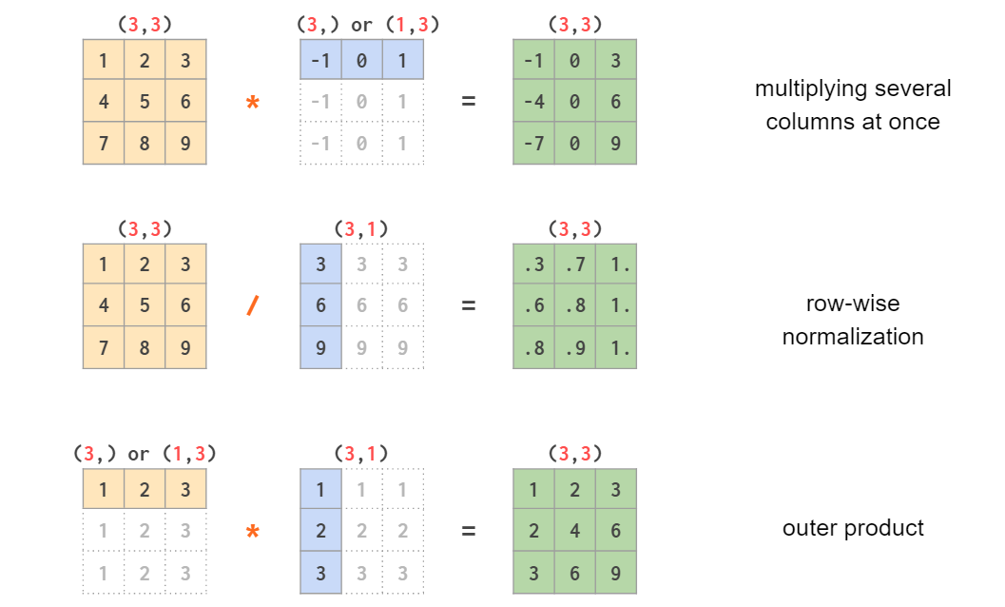
# scalar and one-dimensionalfrom numpy import array
a = array([1, 2, 3])print(a)
b = 2print(b)
c = a + bprint(c)
Having Machine Learning, Data Science or Python Interview? Check 39 NumPy Interview Questions
Source: numpy.org

Q17:
What is the difference between flatten and ravel functions in NumPy?
Mid

NumPy 39

Problem
Consider:
import numpy as np
y = np.array(((1,2,3),(4,5,6),(7,8,9)))
OUTPUT:print(y.flatten())[1 2 3 4 5 6 7 8 9]print(y.ravel())[1 2 3 4 5 6 7 8 9]
What is the need of two different functions performing same job?
Answer
The current API is that:
- flatten always returns a copy. Can only be called for true numpy arrays.
- ravel returns a view of the original array whenever possible. This isn't visible in the printed output, but if you modify the array returned by ravel, it may modify the entries in the original array. If you modify the entries in an array returned from flatten this will never happen. ravel will often be faster since no memory is copied, but you have to be more careful about modifying the array it returns. ravel can be called on any object that can successfully be parsed.
Having Machine Learning, Data Science or Python Interview? Check 39 NumPy Interview Questions
Source: stackoverflow.com

27 Julia Programming Interview Questions (SOLVED) for ML Engineers

 Julia 50

Q18:
What is the difference between test[:,0] vs test[:,[0]]? When would you use one?
Mid

NumPy 39

Answer
- test[:,0] - gives you a row vector.
>>> test[:,0]
array([1, 3, 5])
If you just want to loop over it, it's fine, but if you want to hstack with some other array with dimension 3xN, you will have
ValueError: all the input arrays must have the same number of dimensions
- test[:,[0]] - gives you a column vector:
>>> test[:,[0]]
array([[1],
[3],
[5]])
As a result, you can do concatenate or hstack operation:
>>> np.hstack((test, test[:,[0]]))
array([[1, 2, 1],
[3, 4, 3],
[5, 6, 5]])
Having Machine Learning, Data Science or Python Interview? Check 39 NumPy Interview Questions
Source: stackoverflow.com

Q19:
What is the most efficient way to map a function over a NumPy array?
Mid

NumPy 39

Answer
A direct method of applying the lambda function is always the fastest and simplest way to map a function over Numpy arrays:
import numpy as np
x = np.array([1, 2, 3, 4, 5])
f = lambda x: x ** 2
squares = f(x)
Another way is to use numpy.vectorize:
import numpy as np
x = np.array([1, 2, 3, 4, 5])
squarer = lambda t: t ** 2
vfunc = np.vectorize(squarer)
vfunc(x)# Output : array([ 1, 4, 9, 16, 25])
Note: The vectorize function is provided primarily for convenience, not for performance. The implementation is essentially a for loop.
Having Machine Learning, Data Science or Python Interview? Check 39 NumPy Interview Questions
Source: stackoverflow.com

Q20:
What is the purpose of meshgrid in Python/NumPy?
Mid

NumPy 39

Answer
The purpose of meshgrid is to create a rectangular grid out of an array of x values and an array of y values:
xx, yy = np.meshgrid(x, y)
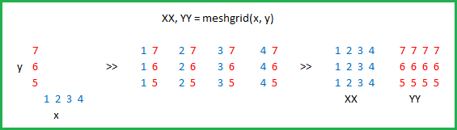
Consider:
xx, yy = np.meshgrid(xvalues, yvalues)
plt.plot(xx, yy, marker='.', color='k', linestyle='none')
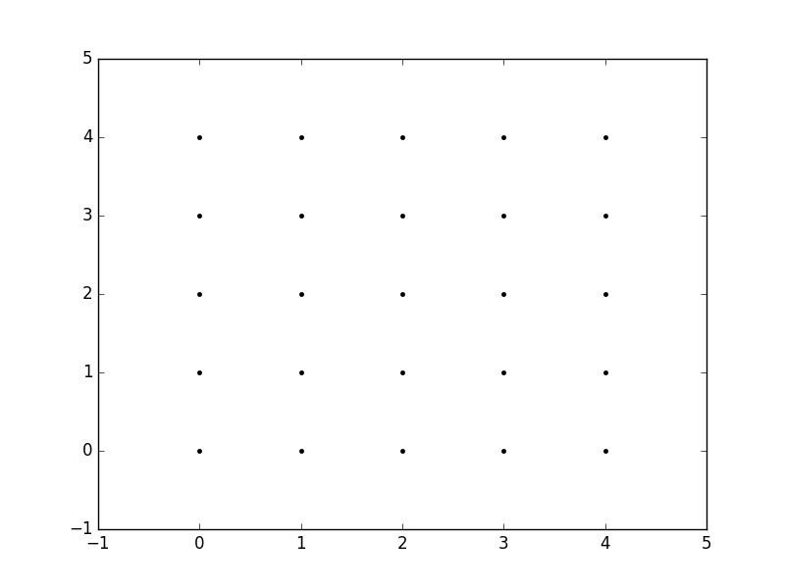
Having Machine Learning, Data Science or Python Interview? Check 39 NumPy Interview Questions
Source: stackoverflow.com

Q21:
What's the easiest way to implement a moving average with NumPy?
Mid

NumPy 39

Answer
A simple way to achieve this is by using np.convolve. The idea behind this is to leverage the way the discrete convolution is computed and use it to return a rolling mean. This can be done by convolving with a sequence of np.ones of a length equal to the sliding window length we want.
In order to do so we could define the following function:
def moving_average(x, w):
return np.convolve(x, np.ones(w), 'valid') / w
This function will be taking the convolution of the sequence x and a sequence of ones of length w. Note that the chosen mode is valid so that the convolution product is only given for points where the sequences overlap completely.
Some examples:
x = np.array([5,3,8,10,2,1,5,1,0,2])
For a moving average with a window of length 2 we would have:
moving_average(x, 2)# array([4. , 5.5, 9. , 6. , 1.5, 3. , 3. , 0.5, 1. ])
And for a window of length 4:
moving_average(x, 4)# array([6.5 , 5.75, 5.25, 4.5 , 2.25, 1.75, 2. ])
If you just want a straightforward non-weighted moving average, you can easily implement it with np.cumsum:
def moving_average(a, n=3) :
ret = np.cumsum(a, dtype=float)
ret[n:] = ret[n:] - ret[:-n]
return ret[n - 1:] / n
>>> a = np.arange(20)>>> moving_average(a)
array([ 1., 2., 3., 4., 5., 6., 7., 8., 9., 10., 11.,
12., 13., 14., 15., 16., 17., 18.])>>> moving_average(a, n=4)
array([ 1.5, 2.5, 3.5, 4.5, 5.5, 6.5, 7.5, 8.5, 9.5,
10.5, 11.5, 12.5, 13.5, 14.5, 15.5, 16.5, 17.5])

Q1. What are the most common NumPy data types?
A1. NumPy arrays support a number of numerical data types, the most common amongst them are discussed below –
An N-dimensional array type is known as ndarray. All elements stored in a ndarray should be homogeneous i.e., have the same type.
A few of the most common data types are:
- Boolean
- Integer (signed and unsigned)
- Float
- Complex

Q2. How to create NumPy arrays?
A2.
- One-dimensional array – consists of a single row.
import numpy as np
#1D Array
arr1 = np.array([1,2,3])
arr1
- Multi-dimensional array – consists of multiple rows and columns, like an Excel spreadsheet, wherein each column can be considered as a dimension.
#2D Array
X = ([[1.8, 2.5, 3.14],
[4, 5, 6]])
arr2 = np.array(X)
arr2
#3D Array
Y = ([[1,2,3],
[4,5,6],
[7,8,9]])
arr3 = np.array(Y)
arr3

Q3. How do you identify the data type of an array?
A3. Through the following command:
print('data type arr1 ', arr1.dtype)
print('data type arr2 ', arr2.dtype)
print('data type arr3 ', arr3.dtype)

Q4. List the advantages of NumPy over Python lists.
A4. Traditional Python lists have several limitations when compared to NumPy arrays –
Feature | NumPy Arrays | Python Lists
Data type | Stores homogenous data i.e., data having the same types | Stores heterogenous data i.e., elements can be of different data types
Flexibility | Less flexible, because operations are performed element-wise | Allows more flexibility in adding and removing data
Arithmetic and matrix operations | Many vectors and matrix operations are in-built | Complex statistical and analytical libraries are not available
Loops | Explicit loop is required to run through the elements | Explicit loop is not required to run through the elements
Declaration for usage | NumPy module needs to be imported for using NumPy arrays | No import is required to use Python lists

Q5. What is negative indexing in a NumPy array?
A5. In a NumPy array, the elements can be accessed in any order as shown:
As you can see, negative indexing refers to indexing from the end of the list starting at -1.

Q6. How do you count the number of times a value appears in a NumPy array of integers?
A6. For this, we will use the bincount() method that accepts only positive integers or Boolean expressions as its arguments.
arr = np.array([1, 7, 1, 1, 7, 6, 5, 1, 3, 3, 2, 0, 0])
np.bincount(arr)

Q7. How do you create an array with all values as zeros or ones?
A7. For this, we will use the np.zeros() and np.ones() methods:
#Creating array of zeros
zeros_arr = np.zeros((4,4))
zeros_arr
#Creating array of ones
ones_arr = np.ones((4,5))
ones_arr

Q8. Print an array range between 1 to 35 and show 7 integer random numbers.
rand_arr = np.random.randint(1,35,7)
rand_arr

Q9. Print the first, third, and last position of a NumPy array?
num = np.array([0, 5, 10, 15, 20, 25])
print('first position:',num[0])print('third position:',num[2])print('third position:',num[-1])
To know more about Python, click here.

Intermediate NumPy Questions

Q1. How to change the data type of a NumPy array?
A1. You can use the astype() method for this:
arr = np.array([2.7, 3.14, 5.89, 7])

new_arr = arr.astype('i')
print(new_arr)
print(new_arr.dtype)

Q2. How to reverse a 3×3 matrix?
A2.
- First, let’s create a 3×3 matrix:
matrix = np.arange(30,39).reshape(3,3)print(matrix)
- Now, let’s flatten the array:
flat = matrix.flatten()
flat
- Let’s reverse the flattened array:
reverse = flat[::-1]
reverse
- Lastly, let’s reshape the array back to a 3×3 matrix:
reverse.reshape(3,3)

Q3. How to add matrices using NumPy?
A3.
- Let’s first create two matrices:
#Construct two matrices
A = ([[1,2,3],
[4,5,6,],
[7,8,9]])

B = ([[2,4,6],
[8,10,12],
[14,16,18]])
- Now, just perform simple addition between the two ndarrays:
arr_A = np.array(A)
arr_B = np.array(B)

result = arr_A + arr_Bprint(result)

Q4. How to multiply matrices using NumPy?
A4.
- Now, let’s find the dot product of the two ndarrays we created in the above question:
#Dot product of two matrices
result = np.dot(arr_A,arr_B)print(result)
- The same result will be obtained when we use np.matmul() for matrix product:
result = np.matmul(arr_A,arr_B)print(result)
- You can also use np.multiply() to return the element-wise matrix multiplication of two ndarrays:
result = np.multiply(arr_A,arr_B)print(result)

Q5. How to find the transpose of the matrix using NumPy?
A5.
#Construct a matrix
X = ([[38,13],
[4,101],
[23,99]])
#Find the transpose of the matrix
transpose = np.transpose(X)print(transpose)

Q6. What is array slicing and how do you do it in NumPy?
A6. Slicing means extracting a portion of the given array to generate a new view of the same array without copying it. This is done by specifying the following:
- start: specifies where to start slicing from aka the lower limit
- stop: specifies where to stop slicing aka the upper limit
- step: determines the increment between each index for slicing
#Slicing a 1D array
x = np.array([2, 3, 7, 11, 13, 17, 19, 23, 29, 31, 37])
x[1:7:2]

Q7. How do you stack matrices?
A7. NumPy arrays/matrices can be stacked either horizontally or vertically through the following methods:
- np.hstack() method adds the second ndarray to the columns of the first ndarray:
#Construct two matrices
A = ([[1,2,3],
[4,5,6,],
[7,8,9]])

B = ([[2,4,6],
[8,10,12],
[14,16,18]])

arr_A = np.array(A)
arr_B = np.array(B)
#Stacking Horizontally
np.hstack((arr_A, arr_B))
- np.vstack() method combines the second ndarray as new rows in the first ndarray:
#Stacking Vertically
np.vstack((arr_A, arr_B))

Q8. How to swap two rows/columns in a 2D NumPy array?
- create an array first:
arr = np.arange(16).reshape(4,4)
arr
- Let’s swap the first and the second rows:
arr[[1,0,2,3], :]
- Let’s swap the first and the second columns of the original array:
arr[:, [1,0,2,3]]

Q9. Create a new array consisting of common values from two given arrays.
We need to find the positions where the elements of the two arrays match:
#Create two 1D arrays
a = np.array([1,2,3,2,3,4,3,4,5,6])
b = np.array([1,7,9,2,7,4,3,6,4,6])

np.where(a == b)
Split a given array into four equal-sized sub-arrays.
- For this, let’s create an 8×3 integer array:
arr = np.arange(20,44).reshape(8,3)print(arr)

- Now, you can create 4 sub-arrays using the split() function:
sub_arr = np.split(arr, 4) print(sub_arr)

Q1. What are the most common NumPy data types?
A1. NumPy arrays support a number of numerical data types, the most common amongst them are discussed below –
An N-dimensional array type is known as ndarray. All elements stored in a ndarray should be homogeneous i.e., have the same type.
A few of the most common data types are:
- Boolean
- Integer (signed and unsigned)
- Float
- Complex

Q2. How to create NumPy arrays?
A2.
- One-dimensional array – consists of a single row.
import numpy as np
#1D Array
arr1 = np.array([1,2,3])
arr1
- Multi-dimensional array – consists of multiple rows and columns, like an Excel spreadsheet, wherein each column can be considered as a dimension.
#2D Array
X = ([[1.8, 2.5, 3.14],
[4, 5, 6]])
arr2 = np.array(X)
arr2
#3D Array
Y = ([[1,2,3],
[4,5,6],
[7,8,9]])
arr3 = np.array(Y)
arr3

Q3. How do you identify the data type of an array?
A3. Through the following command:
print('data type arr1 ', arr1.dtype)
print('data type arr2 ', arr2.dtype)
print('data type arr3 ', arr3.dtype)

Q4. List the advantages of NumPy over Python lists.
A4. Traditional Python lists have several limitations when compared to NumPy arrays –
Feature | NumPy Arrays | Python Lists
Data type | Stores homogenous data i.e., data having the same types | Stores heterogenous data i.e., elements can be of different data types
Flexibility | Less flexible, because operations are performed element-wise | Allows more flexibility in adding and removing data
Arithmetic and matrix operations | Many vectors and matrix operations are in-built | Complex statistical and analytical libraries are not available
Loops | Explicit loop is required to run through the elements | Explicit loop is not required to run through the elements
Declaration for usage | NumPy module needs to be imported for using NumPy arrays | No import is required to use Python lists

Q5. What is negative indexing in a NumPy array?
A5. In a NumPy array, the elements can be accessed in any order as shown:
As you can see, negative indexing refers to indexing from the end of the list starting at -1.

Q6. How do you count the number of times a value appears in a NumPy array of integers?
A6. For this, we will use the bincount() method that accepts only positive integers or Boolean expressions as its arguments.
arr = np.array([1, 7, 1, 1, 7, 6, 5, 1, 3, 3, 2, 0, 0])
np.bincount(arr)

Q7. How do you create an array with all values as zeros or ones?
A7. For this, we will use the np.zeros() and np.ones() methods:
#Creating array of zeros
zeros_arr = np.zeros((4,4))
zeros_arr
#Creating array of ones
ones_arr = np.ones((4,5))
ones_arr

Q8. Print an array range between 1 to 35 and show 7 integer random numbers.
rand_arr = np.random.randint(1,35,7)
rand_arr

Q9. Print the first, third, and last position of a NumPy array?
num = np.array([0, 5, 10, 15, 20, 25])
print('first position:',num[0])print('third position:',num[2])print('third position:',num[-1])
To know more about Python, click here.

Intermediate NumPy Questions

Q1. How to change the data type of a NumPy array?
A1. You can use the astype() method for this:
arr = np.array([2.7, 3.14, 5.89, 7])

new_arr = arr.astype('i')
print(new_arr)
print(new_arr.dtype)

Q2. How to reverse a 3×3 matrix?
A2.
- First, let’s create a 3×3 matrix:
matrix = np.arange(30,39).reshape(3,3)print(matrix)
- Now, let’s flatten the array:
flat = matrix.flatten()
flat
- Let’s reverse the flattened array:
reverse = flat[::-1]
reverse
- Lastly, let’s reshape the array back to a 3×3 matrix:
reverse.reshape(3,3)

Q3. How to add matrices using NumPy?
A3.
- Let’s first create two matrices:
#Construct two matrices
A = ([[1,2,3],
[4,5,6,],
[7,8,9]])

B = ([[2,4,6],
[8,10,12],
[14,16,18]])
- Now, just perform simple addition between the two ndarrays:
arr_A = np.array(A)
arr_B = np.array(B)

result = arr_A + arr_Bprint(result)

Q4. How to multiply matrices using NumPy?
A4.
- Now, let’s find the dot product of the two ndarrays we created in the above question:
#Dot product of two matrices
result = np.dot(arr_A,arr_B)print(result)
- The same result will be obtained when we use np.matmul() for matrix product:
result = np.matmul(arr_A,arr_B)print(result)
- You can also use np.multiply() to return the element-wise matrix multiplication of two ndarrays:
result = np.multiply(arr_A,arr_B)print(result)

Q5. How to find the transpose of the matrix using NumPy?
A5.
#Construct a matrix
X = ([[38,13],
[4,101],
[23,99]])
#Find the transpose of the matrix
transpose = np.transpose(X)print(transpose)

Q6. What is array slicing and how do you do it in NumPy?
A6. Slicing means extracting a portion of the given array to generate a new view of the same array without copying it. This is done by specifying the following:
- start: specifies where to start slicing from aka the lower limit
- stop: specifies where to stop slicing aka the upper limit
- step: determines the increment between each index for slicing
#Slicing a 1D array
x = np.array([2, 3, 7, 11, 13, 17, 19, 23, 29, 31, 37])
x[1:7:2]

Q7. How do you stack matrices?
A7. NumPy arrays/matrices can be stacked either horizontally or vertically through the following methods:
- np.hstack() method adds the second ndarray to the columns of the first ndarray:
#Construct two matrices
A = ([[1,2,3],
[4,5,6,],
[7,8,9]])

B = ([[2,4,6],
[8,10,12],
[14,16,18]])

arr_A = np.array(A)
arr_B = np.array(B)
#Stacking Horizontally
np.hstack((arr_A, arr_B))
- np.vstack() method combines the second ndarray as new rows in the first ndarray:
#Stacking Vertically
np.vstack((arr_A, arr_B))

Q8. How to swap two rows/columns in a 2D NumPy array?
- create an array first:
arr = np.arange(16).reshape(4,4)
arr
- Let’s swap the first and the second rows:
arr[[1,0,2,3], :]
- Let’s swap the first and the second columns of the original array:
arr[:, [1,0,2,3]]

Q9. Create a new array consisting of common values from two given arrays.
We need to find the positions where the elements of the two arrays match:
#Create two 1D arrays
a = np.array([1,2,3,2,3,4,3,4,5,6])
b = np.array([1,7,9,2,7,4,3,6,4,6])

np.where(a == b)
Split a given array into four equal-sized sub-arrays.
- For this, let’s create an 8×3 integer array:
arr = np.arange(20,44).reshape(8,3)print(arr)

- Now, you can create 4 sub-arrays using the split() function:
sub_arr = np.split(arr, 4) print(sub_arr)
1 .
What Is Numpy?
NumPy is a Python extension and open-source, versatile general-purpose package used for array-processing. It is short of Numerical Python. It allows python to serve as a high-level language for manipulating numerical data, much like IDL, MATLAB, or Yorick, etc,..
It is known for its high-end performance with powerful N-dimensional array objects and the tools it is loaded with to work with arrays.
2 .
Why NumPy is used in Python?
NumPy is a package in Python used for Scientific Computing. NumPy package is used to perform different operations. The ndarray (NumPy Array) is a multidimensional array used to store values of same datatype. These arrays are indexed just like Sequences, starts with zero.
3 .
What advantages do NumPy arrays offer over (nested) Python lists?
* Python's lists are efficient general-purpose containers. They support (fairly) efficient insertion, deletion, appending, and concatenation, and Python's list comprehensions make them easy to construct and manipulate.
* They have certain limitations: they don't support "vectorized" operations like elementwise addition and multiplication, and the fact that they can contain objects of differing types mean that Python must store type information for every element, and must execute type dispatching code when operating on each element.
* NumPy is not just more efficient; it is also more convenient. We get a lot of vector and matrix operations for free, which sometimes allow one to avoid unnecessary work. And they are also efficiently implemented.
* NumPy array is faster and we get a lot built in with NumPy, FFTs, convolutions, fast searching, basic statistics, linear algebra, histograms, etc.
4 .
What are the steps to create 1D, 2D and 3D arrays?
1D array creation :
import numpy as np
one_dimensional_list = [1,2,4]
one_dimensional_arr = np.array(one_dimensional_list)print("1D array is : ",one_dimensional_arr)

2D array creation :
import numpy as np
two_dimensional_list=[[1,2,3],[4,5,6]]
two_dimensional_arr = np.array(two_dimensional_list)print("2D array is : ",two_dimensional_arr)

3D array creation :
import numpy as np
three_dimensional_list=[[[1,2,3],[4,5,6],[7,8,9]]]
three_dimensional_arr = np.array(three_dimensional_list)print("3D array is : ",three_dimensional_arr)

ND array creation : This can be achieved by giving the ndmin attribute. The below example demonstrates the creation of a 6D array:
import numpy as np
ndArray = np.array([1, 2, 3, 4], ndmin=6)print(ndArray)print('Dimensions of array:', ndArray.ndim)
5 .
Given an array a = [[1,2,3],[3,4,5],[23, 45,1] find the sum of every row in array a.

To solve the above problem, we first have to understand what the question required of us. If two subscripts reference array elements, then we have a two-dimensional array. By three subscripts, we have a three-dimensional array, etc. For 2 dimensional arrays, the elements of the arrays are stored in rows and columns. Setting the axis to 1 will calculate the sum of elements in a row. The question requires the sum of the elements in the row positions.
import numpy as np
a = [[1,2,3], [3,4,5], [23, 45,1]
Print (a.sum(axis=1))
Conversely, for column sum,
a = [[1,2,3], [3,4,5], [23, 45,1]
Print (a.sum(axis=0))

This should print [27, 51, 9]
6 .
What are the various features of NumPy?
As a powerful open-source package used for array-processing, NumPy has various useful features. They are:

* Contains a N-dimensional array object
* It is interolerable; compatible with many hardware and computing platforms
* Works extremely well with array libraries; sparse, distributed or GPU
* Ability to perform complicated (broadcasting) functions
* Tools that enable integration with C or C++ and Fortran code
* Ability to perform high-level mathematical functions like statistics, Fourier transform, sorting, searching, linear algebra, etc
* It can also behave as a multi-dimensional container for generic data
* Supports scientific and financial calculations
7 .
List the advantages NumPy Arrays have over (nested) Python lists?
Python’s lists, even though hugely efficient containers capable of a number of functions, have several limitations when compared to NumPy arrays. It is not possible to perform vectorised operations which includes element-wise addition and multiplication.

They also require that Python store the type information of every element since they support objects of different types. This means a type dispatching code must be executed each time an operation on an element is done. Also, each iteration would have to undergo type checks and require Python API bookkeeping resulting in very few operations being carried by C loops.
8 .
How can you identify the datatype of a given NumPy array?
The following sequence of codes to identify the datatype of a NumPy array.

print(‘\n data type num 1 ‘,num.dtype)

print(‘\n data type num 2 ‘,num2.dtype)

print(‘\n data type num 3 ‘,num3.dtype)
9 .
How do you calculate the memory size occupied by a NumPy array? Given an array a= [14, 98, 87]. Find the memory size it occupies.

The elements of the array are integers. From the data types and sizes table, an integer data type has a size of 4 bytes. This implies the element 14 occupies 4 bytes, 98 also occupies 4 bytes, and finally, the last element, 87, will also occupy 4 bytes. Therefore the total size of memory the array occupies is 12 bytes. Imagine the array has large data sets of integer. It will be tedious to do this manually.

However, NumPy has some attributes such as size, item size and nbytes to help solve this problem.

Size attribute : size attribute returns the total number of elements in a NumPy array.
itemsize attribute : the itemsize returns the memory size bytes of an individual element in the NumPy array.
nbytes attribute : the nbytes attribute will return the total bytes of all the elements in the NumPy array.

With these attributes, the problem can be solved using two methods or approaches.

Approach 1 :
a= [14, 98, 87].import numpy as npimport sysprint(sys.getsizeof(a)* len(a))
or
a= np.array([14,98,87])print(“The size in bytes of one element in array: “, a.itemsize)print(“The size of array: “, a.size)print(“The bytes of all elements in a: “, a.size * a.itemsize)

Approach 2 : We will use the nbytes attribute.
import numpy as np
a= np.array([14,98,87])print(“The total size of space or memory the array occupies: “, a.nbytes)
10 .
You are given a numpy array and a new column as inputs. How will you delete the second column and replace the column with a new column value?
Given array :
[[35 53 63][72 12 22][43 84 56]]
New Column values :
[
20
30
40]
Solution :
import NumPy as np#inputs
inputArray = np.array([[35,53,63],[72,12,22],[43,84,56]])
new_col = np.array([[20,30,40]])# delete 2nd column
arr = np.delete(sampleArray , 1, axis = 1)#insert new_col to array
arr = np.insert(arr , 1, new_col, axis = 1)print (arr)
1 .
How will you efficiently load data from a text file?
We can use the method numpy.loadtxt() which can automatically read the file’s header and footer lines and the comments if any.

This method is highly efficient and even if this method feels less efficient, then the data should be represented in a more efficient format such as CSV etc. Various alternatives can be considered depending on the version of NumPy used.

Following are the file formats that are supported :

* Text files : These files are generally very slow, huge but portable and are human-readable.
* Raw binary : This file does not have any metadata and is not portable. But they are fast.
* Pickle : These are borderline slow and portable but depends on the NumPy versions.
* HDF5 : This is known as the High-Powered Kitchen Sink format which supports both PyTables and h5py format.
* .npy : This is NumPy's native binary data format which is extremely simple, efficient and portable.
2 .
What is the difference between range() and arange() functions in Python?
The main difference is that the arange function is a built function in the python class that helps generate a sequence of integer values within a certain range. However, the arange function is a built-in function in the python library called Numpy, and so to use the arange function, you will have to install the NumPy package. Both range and arange functions take the same parameters shown below. (start, stop, and step). The main difference is that the range function takes only integers arguments. Otherwise, it returns an error message while the arange function will generate or return an instance of the NumPy ndarray.

* range([start], stop[, step])

* numpy.arange([start, ]stop, [step, ]dtype=None)
3 .
What is the procedure to count the number of times a given value appears in an array of integers?
You can count the number of the times a given value appears using the bincount() function. It should be noted that the bincount() function accepts positive integers or boolean expressions as its argument. Negative integers cannot be used.

Use NumPy.bincount(). The resulting array is
arr = NumPy.array([0, 5, 4, 0, 4, 4, 3, 0, 0, 5, 2, 1, 1, 9])

NumPy.bincount(arr)
4 .
How will you read CSV data into an array in NumPy?
This can be achieved by using the genfromtxt() method by setting the delimiter as a comma.

from numpy import genfromtxt
csv_data = genfromtxt('sample_doc.csv', delimiter=',')
5 .
How will you sort the array based on the Nth column?
For example, consider an array arr.
arr = np.array([[8, 3, 2],[3, 6, 5],[6, 1, 4]])

Let us try to sort the rows by the 2nd column so that we get :
[[6, 1, 4],[8, 3, 2],[3, 6, 5]]

We can do this by using the sort() method in numpy as :
import numpy as np
arr = np.array([[8, 3, 2],[3, 6, 5],[6, 1, 4]])#sort the array using np.sort
arr = np.sort(arr.view('i8,i8,i8'),
order=['f1'],
axis=0).view(np.int)

We can also perform sorting and that too inplace sorting by doing :
arr.view('i8,i8,i8').sort(order=['f1'], axis=0)
6 .
How do you check for an empty (zero Element) array?
If the variable is an array, you can check for an empty array by using the size attribute. However, it is possible that the variable is a list or a sequence type, in that case, you can use len().

The preferable way to check for a zero element is the size attribute. This is because :
a = NumPy.zeros((1,0))
a.size0

whereas

len(a)1​
7 .
How will you find the nearest value in a given numpy array?
We can use the argmin() method of numpy as shown below :

import numpy as npdef find_nearest_value(arr, value):
arr = np.asarray(arr)
idx = (np.abs(arr - value)).argmin()
return arr[idx]#Driver code
arr = np.array([ 0.21169, 0.61391, 0.6341, 0.0131, 0.16541, 0.5645, 0.5742])
value = 0.52print(find_nearest_value(arr, value)) # Prints 0.5645
8 .
How will you find the shape of any given NumPy array?
We can use the shape attribute of the numpy array to find the shape. It returns the shape of the array in terms of row count and column count of the array.

import numpy as np
arr_two_dim = np.array([("x1","x2", "x3","x4"),("x5","x6", "x7","x8" )])
arr_one_dim = np.array([3,2,4,5,6])# find and print shapeprint("2-D Array Shape: ", arr_two_dim.shape)print("1-D Array Shape: ", arr_one_dim.shape)"""
​

Output :
2-D Array Shape: (2, 4)1-D Array Shape: (5,)"""
​
9 .
How to extract all numbers between a given range from a NumPy array?
a = np.arange(15)

Method 1 :
index = np.where((a >= 5) & (a <= 10))
a[index]

Method 2 :
index = np.where(np.logical_and(a>=5, a<=10))
a[index]# (array([6, 9, 10]),)

Method 3 :
a[(a >= 5) & (a <= 10)]

10 .
How to create a numpy array sequence given only the starting point, length and the step?
Create a numpy array of length 10, starting from 5 and has a step of 3 between consecutive numbers

length = 10
start = 5
step = 3
def seq(start, length, step):
end = start + (step*length)
return np.arange(start, end, step)

seq(start, length, step)# array([ 5, 8, 11, 14, 17, 20, 23, 26, 29, 32])
1 .
Create a 4X2 integer array and Prints its attributes
The element must be a type of unsigned int16. And print the following Attributes :

* The shape of an array.
* Array dimensions.
* The Length of each element of the array in bytes.

import numpy

firstArray = numpy.empty([4,2], dtype = numpy.uint16) print("Printing Array")print(firstArray)
print("Printing numpy array Attributes")print("1> Array Shape is: ", firstArray.shape)print("2>. Array dimensions are ", firstArray.ndim)print("3>. Length of each element of array in bytes is ", firstArray.itemsize)

2 .
Create a two 2-D array and Plot it using matplotlib
import numpy
print("Printing Original array")
sampleArray = numpy.array([[34,43,73],[82,22,12],[53,94,66]]) print (sampleArray)
print("Array after deleting column 2 on axis 1")
sampleArray = numpy.delete(sampleArray , 1, axis = 1) print (sampleArray)

arr = numpy.array([[10,10,10]])
print("Array after inserting column 2 on axis 1")
sampleArray = numpy.insert(sampleArray , 1, arr, axis = 1) print (sampleArray)

3 .
Create a 5X2 integer array from a range between 100 to 200 such that the difference between each element is 10
import numpy
print("Creating 5X2 array using numpy.arange")
sampleArray = numpy.arange(100, 200, 10)
sampleArray = sampleArray.reshape(5,2)print (sampleArray)

4 .
Shown below is the input NumPy array. Delete column two and replace it with the new column given below.
import NumPy
sampleArray = NumPy.array([[34,43,73],[82,22,12],[53,94,66]])
newColumn = NumPy.array([[10,10,10]])

Expected Output :

Printing Original array[[34 43 73]
[82 22 12]
[53 94 66]]

Array after deleting column 2 on axis 1
[[34 73][82 12][53 66]]

Array after inserting column 2 on axis 1
[[34 10 73][82 10 12][53 10 66]]

Solution :

import NumPyprint(“Printing Original array”)
sampleArray = NumPy.array([[34,43,73],[82,22,12],[53,94,66]]) print (sampleArray)print(“Array after deleting column 2 on axis 1”)
sampleArray = NumPy.delete(sampleArray , 1, axis = 1) print (sampleArray)
arr = NumPy.array([[10,10,10]])print(“Array after inserting column 2 on axis 1”)
sampleArray = NumPy.insert(sampleArray , 1, arr, axis = 1) print (sampleArray)

5 .
How to convert numpy's datetime64 object to datetime's datetime object?
Convert numpy’s datetime64 object to datetime’s datetime object

# Input : a numpy datetime64 object
dt64 = np.datetime64('2018-02-25 22:10:10')
# Solutionfrom datetime import datetime
dt64.tolist()
# or

dt64.astype(datetime)# datetime.datetime(2018, 2, 25, 22, 10, 10)
https://www.w3schools.com/python/numpy/default.asp
https://www.tutorialspoint.com/numpy/index.htm
https://numpy.org/doc/stable/user/quickstart.html

