1. What is Big Data, and where does it come from? How does it work?
Big Data refers to extensive and often complicated data sets so huge that they’re beyond the capacity of managing with conventional software tools. Big Data comprises unstructured and structured data sets such as videos, photos, audio, websites, and multimedia content.

Businesses collect the data they need in countless ways, such as:
- Internet cookies
- Email tracking
- Smartphones
- Smartwatches
- Online purchase transaction forms
- Website interactions
- Transaction histories
- Social media posts
- Third-party trackers -companies that collect and sell clients and profitable data
Working with big data involves three sets of activities:
- Integration: This involves merging data often from different sources – and molding it into a form that can be analysed in a way to provide insights.
- Management: Big data must be stored in a repository where it can be collected and readily reached. The largest amount of Big Data is unstructured, causing it ill-suited for conventional relational databases, which need data in tables-and-rows format.
- Analysis: The Big Data investment return is a spectrum of worthy market insights, including details on buying patterns and customer choices. These are represented by examining large data sets with tools driven by AI and machine learning.

2. What are the 5 V’s in Big Data?
- Volume: A considerable amount of data stored in data warehouses reflects the volume. The data may reach random heights; these large volumes of data need to be examined and processed. Which may exist up to or more than terabytes and petabytes.
- Velocity: Velocity basically introduces the pace at which data is being produced in real-time. To give a simple example for recognition, imagine the rate at which Facebook, Instagram, or Twitter posts are generated per second, an hour or more.
- Variety: Big Data comprises structured, unstructured, and semi-structured data collected from varied sources. This different variety of data requires very different and specific analyzing and processing techniques with unique and appropriate algorithms.
- Veracity: Data veracity basically relates to how reliable the data is, or in a fundamental way, we can define it as the quality of the data analyzed.
- Value: Raw data is of no use or meaning but once converted into something valuable. We can extract helpful information.

3. Why businesses are using Big Data for competitive advantage.
Irrespective of the division and scope of the firm, data is now an essential tool for businesses to utilise. Companies are frequently using big data to gain a competing edge over business rivals.
Checking the datasets a company collects is just one part of the big data process. Big data professionals also need to know what the company requires from the application and how they plan to use the data to their advantage.
- Confident decision-building: Analytics aims to develop decision building, and big data endures to sustain this. Big data can help enterprises speed up their decision-making method with so much data available while still being assured of their choice. Nowadays, moving fast and reacting to broader trends and operational changes is a huge business benefit in a quick-paced society.
- Asset optimisation: Big data signifies that businesses can control assets at a personal level. This implies they can adequately optimise assets depending on the data source, improve productivity, extend the lifespan of help, and reduce the downtime some assets may require. This gives a competing advantage by assuring the company is getting the most out of its assets and links with decreasing costs.
- Cost reduction: Big data can support businesses to reduce their outgoings. From analysing energy usage to assessing the effectiveness of staff operating patterns, data collected by companies can help them recognise where they can make cost savings without having a negative impact on company operations.
- Improve customer engagement: When surveying online, consumers make confident choices indicating their decisions, habits, and tendencies that can then be used to develop and tailor consumer dialogue, which could then be interpreted into increased sales. Understanding what each client is looking for through the data collected on them means you can target them with specific products, but it also gives a personal feel that many consumers today have come to await.
- Identify new revenue streams: Analytics can further assist companies in identifying new revenue streams and expanding into other areas. For example, knowing customer trends and decisions allow firms to decide the way they should go. The data companies accumulate can also likely be sold, adding income streams and the potential to build alliances with other businesses.
You can download a PDF version of Big Data Interview Questions.
Download PDF

4. How is Hadoop and Big Data related?
If we talk about Big Data, we do talk about Hadoop as well. So, this is one of the most critical questions from an interview perspective. That you might surely face. Hadoop is an open-source framework for saving, processing, and interpreting complex, disorganized data sets for obtaining insights and knowledge. So, that is how Hadoop and Big Data are related to each other.

5. Explain the importance of Hadoop technology in Big data analytics.
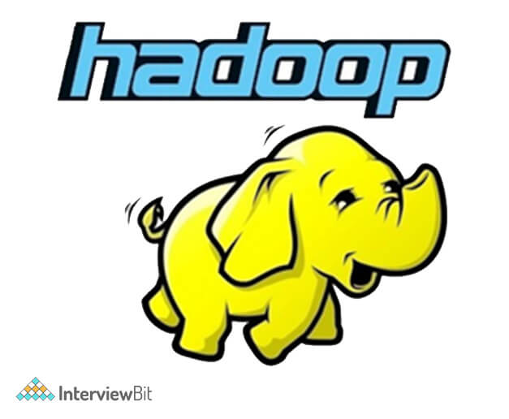
Since big data includes a large volume of data, i.e., structured, semi-structured, and unstructured data, analyzing and processing this data is quite a big task. There was a need for a tool or technology to help process the data at a rapid speed. Therefore, Hadoop is used because of its capabilities like storage, processing capability. Moreover, Hadoop is an open-source software. If you want to consider the cost, it’s beneficial for business solutions.
The main reason for its popularity in recent years is that this framework permits distributed processing of enormous data sets using crosswise clusters of computers practicing simple programming models.

6. Explain the core components of Hadoop.
Hadoop is an open-source framework intending to store and process big data in a distributed manner.
Hadoop’s Essential Components:
- HDFS (Hadoop Distributed File System) – Hadoop’s key storage system is HDFS. The extensive data is stored on HDFS. It is mainly devised for storing massive datasets in commodity hardware.
- Hadoop MapReduce – The responsible layer of Hadoop for data processing is MapReduce. It puts a request for processing of structured and unstructured data which is already stored in HDFS. It is liable for the parallel processing of a high volume of data by distributing data into detached tasks. There are two stages of processing: Map and Reduce. In simple terms, Map is a stage where data blocks are read and made available to the executors (computers /nodes /containers) for processing. Reduce is a stage where all processed data is collected and collated.
- YARN – The framework which is used to process in Hadoop is YARN. For resource management and to provide multiple data processing engines like real-time streaming, data science, and batch processing is done by YARN.

7. Explain the features of Hadoop.
Hadoop assists in not only store data but also processing big data. It is the most reliable way to handle significant data hurdles. Some salient features of Hadoop are –
- Distributed Processing – Hadoop helps in distributed processing of data, i.e., quicker processing. In Hadoop HDFS, the data is collected in a distributed manner, and the data is parallel processing, and MapReduce is liable for the same.
- Open Source – Hadoop is independent of cost as it is an open-source framework. Changes are allowed in the source code as per the user’s requirements.
- Fault Tolerance – Hadoop is highly fault-tolerant. By default, for every block, it creates three replicas at distinct nodes. This number of replicas can be modified according to the requirement. So, we can retrieve the data from a different node if one of the nodes fails. The discovery of node failure and restoration of data is made automatically.
- Scalability – It is fitted with different hardware, and we can promptly access the new device.
- Reliability – The data in Hadoop is stored on the cluster in a safe manner that is autonomous of the machine. So, the data stored in the Hadoop ecosystem’s data does not get affected by any machine breakdowns.

8. How is HDFS different from traditional NFS?
NFS (Network File system): A protocol that enables customers to access files over the network. NFS clients would allow files to be accessed as if the files live on the local device, even though they live on the disk of a networked device.
HDFS (Hadoop Distributed File System): A distributed file system is shared between multiple networked machines or nodes. HDFS is fault-tolerant because it saves various copies of files on the file system; the default replication level is 3.
The notable difference between the two is Replication/Fault Tolerance. HDFS was intended to withstand failures. NFS does not possess any fault tolerance built-in.
Benefits of HDFS over NFS:
Apart from fault tolerance, HDFS helps to create multiple replicas of files. This reduces the traditional bottleneck of many clients accessing a single file. In addition, since files have multiple images on various physical disks, reading performance scales better than NFS.

9. What is data modelling and what is the need for it.
Data Modeling as a business has been practiced in the IT sector for many decades. As an idea, the data model is a means to arrive at the diagram by examining the data in question and getting a deep knowledge. The method of representing the data visually encourages the business and the technology specialists to understand the data and understand how it will get used.
Kinds Of Data Models
The three principal types of data models are conceptual, logical, and physical. Think of them as an improvement from an abstract layout to a detailed mapping of the database setup and final form:
- Conceptual Data Model:
Conceptual data models are the most simplistic and abstract. Minor annotation happens in this model, but the overall layout and controls of the data relationships are set. You’ll find elements like basic market rules that need to be applied, the levels or entity classes of data that you plan to cover, and any other regulations that may limit layout options. Data models are usually used in the development stage of a project.
- Logical Data Model:
The logical data model extends on the basic framework laid out in the conceptual model, but it counts more relational factors. Thus, some basic annotations are related to overall properties or data attributes, but not many annotations concentrate on actual data units. Hence, this model is beneficial in data warehousing projects.
- Physical Data Model:
The physical data model is the most comprehensive and the last step before database production, it usually accounts for database management system-specific properties and rules.
Advantages Of Data Modeling:
- Data modeling offers several different benefits to companies as part of their data management:
- Before you even build a database, you’ve cleaned, organized, and modeled your data to project what your next step should look like. Data modeling advances data quality and makes databases limited, prone to mistakes and bad design.
- Data modeling produces a visual flow of data and how you plan to organize it. This supports employees know what’s happening with data and how they relate to the data management puzzle. It also develops data-related communication across departments in an organization.
- Data modeling allows more profound database design, bringing forth more useful applications and data-based business insights down the line.

10. How to deploy a Big Data Model? Mention the key steps involved.
Deploying a model into a Big Data Platform involves mainly three key steps they are,
- Data ingestion
- Data Storage
- Data Processing
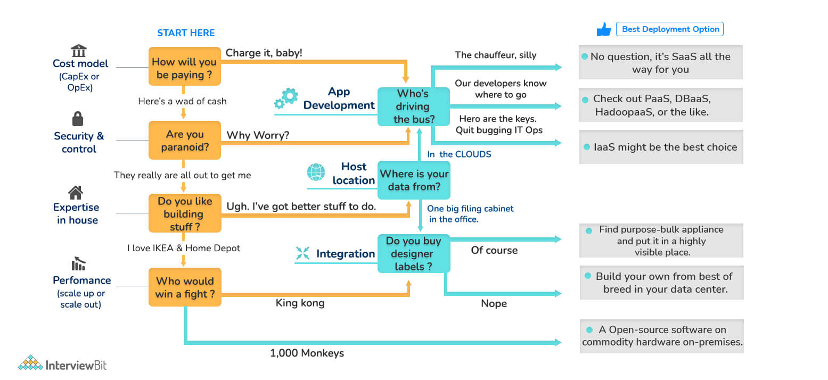
Let’s have a look at what these are,
- Data Ingestion: This process involves collecting data from different sources like social media platforms, business applications, log files, etc.
- Data Storage: When data extraction is completed, the challenge is to store this large volume of data in the database in which the Hadoop Distributed File system (HDFS) plays a vital role.
- Data Processing: After storing the data in HDFS or HBase, the next task is to analyze and visualize these large amounts of data using specific algorithms for better data processing. And yet again, this task is more straightforward if we use Hadoop, Apache Spark, Pig, etc.
After performing these essential steps, one can deploy a big data model successfully.

11. What is fsck?
The term fsck stands for File System Check, used by HDFS. It is used to check discrepancies and if there is any difficulty in the file. For instance, if there are any missing blocks in the file, HDFS gets reported through this command.

12. What are the three modes that Hadoop can run?
- Local Mode or Standalone Mode:
By default, Hadoop is configured to operate in a no distributed mode. It runs as a single Java process. Instead of HDFS, this mode utilizes the local file system. This mode is more helpful for debugging, and there isn't any requirement to configure core-site.xml, hdfs-site.xml, mapred-site.xml, masters & slaves. Standalone mode is ordinarily the quickest mode in Hadoop.
- Pseudo-distributed Mode:
In this mode, each daemon runs on a separate java process. This mode requires custom configuration ( core-site.xml, hdfs-site.xml, mapred-site.xml). The HDFS is used for input and output. This mode of deployment is beneficial for testing and debugging purposes.
- Fully Distributed Mode:
It is the production mode of Hadoop. One machine in the cluster is assigned as NameNode and another as Resource Manager exclusively. These are masters. Rest nodes act as Data Node and Node Manager. These are the slaves. Configuration parameters and environment need to be defined for Hadoop Daemons. This mode gives fully distributed computing capacity, security, fault endurance, and scalability.

13. Mention the common input formats in Hadoop.
The common input formats in Hadoop are -
- Text Input Format: This is the default input format in Hadoop.
- Key-Value Input Format: Used to read Plain Text Files in Hadoop.
- Sequence File Input format: This is used to read Files in a sequence in Hadoop.

14. What are the different Output formats in Hadoop?
The different Output formats in Hadoop are -
- Textoutputformat: TextOutputFormat is the default output format in Hadoop.
- Mapfileoutputformat: Mapfileoutputformat is used to write the output as map files in Hadoop.
- DBoutputformat: DBoutputformat is just used for writing output in relational databases and Hbase.
- Sequencefileoutputformat: Sequencefileoutputformat is used for writing sequence files.
- SequencefileAsBinaryoutputformat: SequencefileAsBinaryoutputformat is used to write keys to a sequence file in binary format.

Big Data Interview Questions for Experienced

15. What are the different big data processing techniques?
Big Data processing methods analyze big data sets at a massive scale. Offline batch data processing is typically full power and full scale, tackling arbitrary BI scenarios. In contrast, real-time stream processing is conducted on the most recent slice of data for data profiling to pick outliers, impostor transaction exposures, safety monitoring, etc. However, the most challenging task is to do fast or real-time ad-hoc analytics on a big comprehensive data set. It substantially means you need to scan tons of data within seconds. This is only probable when data is processed with high parallelism.
Different techniques of Big Data Processing are:
- Batch Processing of Big Data
- Big Data Stream Processing
- Real-Time Big Data Processing
- Map Reduce

16. What is Map Reduce in Hadoop?

Hadoop MapReduce is a software framework for processing enormous data sets. It is the main component for data processing in the Hadoop framework. It divides the input data into several parts and runs a program on every data component parallel. The word MapReduce refers to two separate and different tasks. The first is the map operation, which takes a set of data and transforms it into a diverse collection of data, where individual elements are divided into tuples. The reduce operation consolidates those data tuples based on the key and subsequently modifies the value of the key.

17. When to use MapReduce with Big Data.
MapReduce is a programming model created for distributed computation on big data sets in parallel. A MapReduce model has a map function that performs filtering and sorting and a reduced function, which serves as a summary operation.
MapReduce is an important part of the Apache Hadoop open-source ecosystem, and it’s extensively used for querying and selecting data in the Hadoop Distributed File System (HDFS). A variety of queries may be done depending on the broad spectrum of MapReduce algorithms possible for creating data selections. In addition, MapReduce is fit for iterative computation involving large quantities of data requiring parallel processing. This is because it represents a data flow rather than a procedure.
The more enhanced data we produce and accumulate, the higher the need to process all that data to make it usable. MapReduce’s iterative, parallel processing programming model is a good tool for creating a sense of big data.

18. Mention the core methods of Reducer.
The core methods of a Reducer are:
- setup(): setup is a method called just to configure different parameters for the reducer.
- reduce(): reduce is the primary operation of the reducer. The specific function of this method includes defining the task that has to be worked on for a distinct set of values that share a key.
- cleanup(): cleanup is used to clean or delete any temporary files or data after performing reduce() task.

19. Explain the distributed Cache in the MapReduce framework.
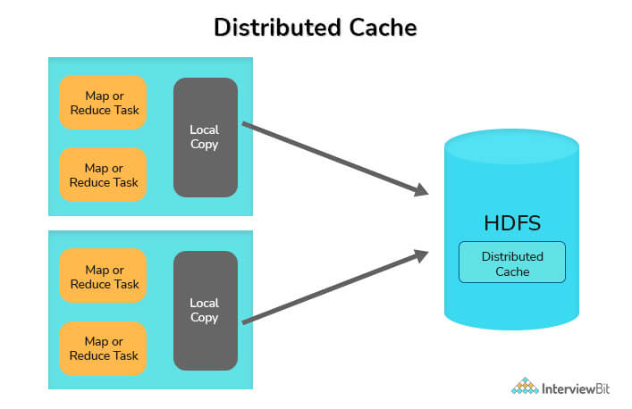
Distributed Cache is a significant feature provided by the MapReduce Framework, practiced when you want to share the files across all nodes in a Hadoop cluster. These files can be jar files or simple properties files. Hadoop's MapReduce framework allows the facility to cache small to moderate read-only files such as text files, zip files, jar files, etc., and distribute them to all the Datanodes(worker-nodes) MapReduce jobs are running. All Datanode gets a copy of the file(local-copy), which Distributed Cache sends.

20. Explain overfitting in big data? How to avoid the same.
Overfitting is generally a modeling error referring to a model that is tightly fitted to the data, i.e. When a modeling function is closely fitted to a limited data set. Due to Overfitting, the predictivity of such models gets reduced. This effect leads to a decrease in generalization ability failing to generalize when applied outside the sample data.
There are several Methods to avoid Overfitting; some of them are:
- Cross-validation: A cross-validation method refers to dividing the data into multiple small test data sets, which can be used to tune the model.
- Early stopping: After a certain number of iterations, the generalizing capacity of the model weakens; in order to avoid that, a method called early stopping is used in order to avoid Overfitting before the model crosses that point.
- Regularization: this method is used to penalize all the parameters except intercept so that the model generalizes the data instead of Overfitting.
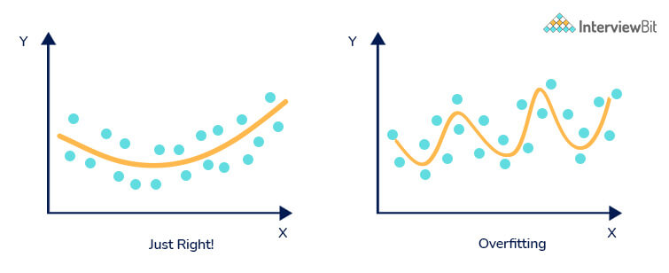

21. What is a Zookeeper? What are the benefits of using a zookeeper?
Hadoop’s most remarkable technique for addressing big data challenges is its capability to divide and conquer with Zookeeper. After the problem has been divided, the conquering relies on employing distributed and parallel processing methods across the Hadoop cluster.
The interactive tools cannot provide the insights or timeliness needed to make business judgments for big data problems. In those cases, you need to build distributed applications to solve those big data problems. Zookeeper is Hadoop’s way of coordinating all the elements of these distributed applications.
Zookeeper as technology is simple, but its features are powerful. Arguably, it would be difficult, if not impossible, to create resilient, fault-tolerant distributed Hadoop applications without it.
Benefits of using a Zookeeper are:
- Simple distributed coordination process: The coordination process among all nodes in Zookeeper is straightforward.
- Synchronization: Mutual exclusion and co-operation among server processes.
- Ordered Messages: Zookeeper tracks with a number by denoting its order with the stamping of each update; with the help of all this, messages are ordered here.
- Serialization: Encode the data according to specific rules. Ensure your application runs consistently.
- Reliability: The zookeeper is very reliable. In case of an update, it keeps all the data until forwarded.
- Atomicity: Data transfer either succeeds or fails, but no transaction is partial.

22. What is the default replication factor in HDFS?
By default, the replication factor is 3. There are no two copies that will be on the same data node. Usually, the first two copies will be on the same rack, and the third copy will be off the shelf. It is advised to set the replication factor to at least three so that one copy is always safe, even if something happens to the rack.
We can set the default replication factor of the file system and each file and directory exclusively. We can lower the replication factor for files that are not essential, and critical files should have a high replication factor.

23. Mention features of Apache sqoop.
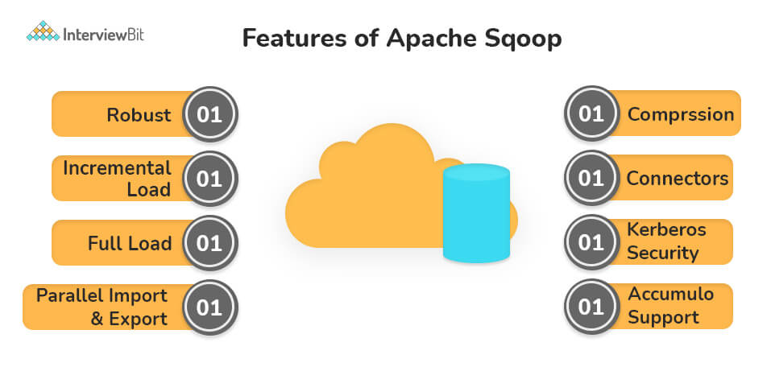
- Robust: It is extremely robust and easy to use. In addition, it has community support and contribution.
- Full Load: Loading a table in Sqoop can be done in one command. Multiple tables can also be loaded in the same process.
- Incremental Load: Incremental load functionality is also supported. Whenever the table is updated, with the help of Sqoop, it can be loaded in parts too.
- Parallel import/export: Importing and exporting of data is done by the YARN framework. It also provides fault tolerance too.
- Import results of SQL query: It allows us to import the output from the SQL query into the Hadoop Distributed File System.

24. Write the command used to copy data from the local system onto HDFS?
The command used for copying data from the Local system to HDFS is:
hadoop fs –copyFromLocal [source][destination]

25. What is partitioning in Hive?
In general partitioning in Hive is a logical division of tables into related columns such as date, city, and department based on the values of partitioned columns. Then these partitions are subdivided into buckets so that they provide extra structure to the data that may be used for more efficient querying.
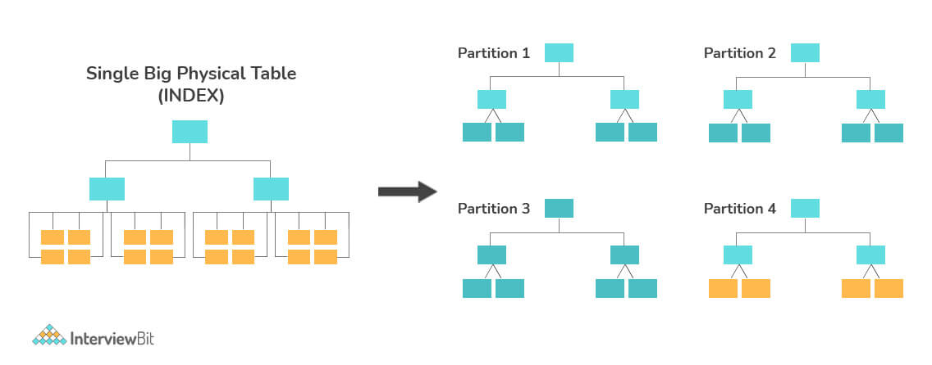
Now let’s experience data partitioning in Hive with an instance. Consider a table named Table1. The table contains client details like id, name, dept, and year of joining. Assume we need to retrieve the details of all the clients who joined in 2014.
Then, the query examines the whole table for the necessary data. But if we partition the client data by the year and save it in a different file, this will decrease the query processing time.

26. Explain Features Selection.
During processing, Big data may contain a large amount of data that is not required at a particular time, So we may be required to select only some specific features that we are interested in. The process of extracting only the needed features from the Big data is called Feature selection.
Feature selection Methods are -
- Filters Method: In this method of variable ranking, we only consider the importance and usefulness of a feature.
- Wrappers Method: In this method, ‘induction algorithm’ is used, Which can be used to produce a classifier.
- Embedded Method: This method is a combination of efficiencies of both Filters and wrappers methods.

27. How can you restart NameNode and all the daemons in Hadoop?
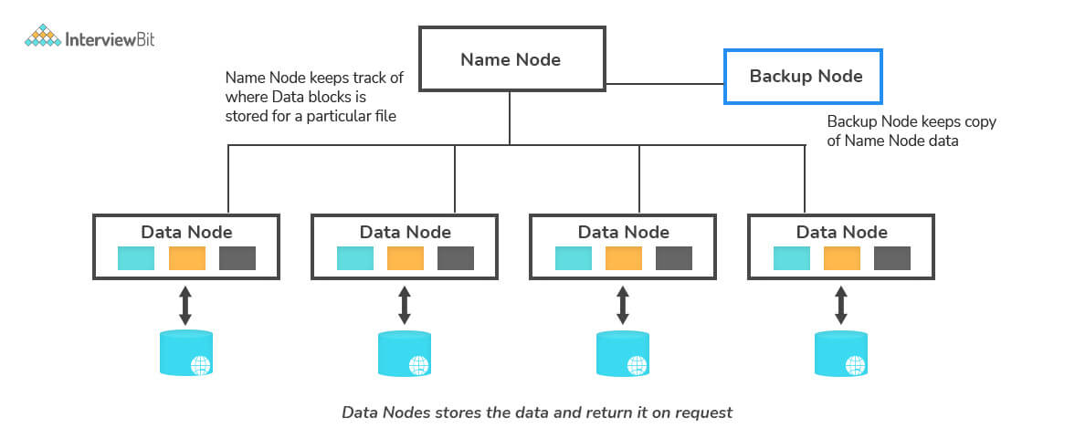
The following commands will help you restart NameNode and all the daemons:
You can stop the NameNode with ./sbin /Hadoop-daemon.sh stop NameNode command and then start the NameNode using ./sbin/Hadoop-daemon.sh start NameNode command.You can stop all the daemons with the ./sbin/stop-all.sh command and then start the daemons using the ./sbin/start-all.sh command.

28. What is the use of the -compress-codec parameter?
-compress-codec parameter is generally used to get the output file of a sqoop import in formats other than .gz.

29. What are missing values in Big data? And how to deal with it?
Missing values in Big Data generally refer to the values which aren’t present in a particular column, in the worst case they may lead to erroneous data and may provide incorrect results. There are several techniques used to deal with the missing values they are -
- Mean or Median Imputation:
When data is missing at irregular intervals, we can use list-wise or pair-wise deletion of the missing observations. Still, there can be multiple reasons why this may not be the most workable option:
  - There may not be enough notes with non-missing data to produce a reliable analysis
  - In predictive analytics, missing data can prevent the forecasts for those observations which have missing data
  - External factors may require specific observations to be part of the analysis
In such cases, we impute values for missing data. A simple technique is to use the mean or median of the non-missing observations. This can be useful in cases where the number of missing observations is low. However, for many missing values, using mean or median can result in loss of variation in data, and it is better to use imputations.
- Multivariate Imputation by Chained Equations (MICE):
MICE believes that the missing data are Missing at Random (MAR). It imputes data on a variable-by-variable basis by specifying an imputation model per variable. MICE uses predictive mean matching (PMM) for continuous variables, logistic regressions for binary variables, bayesian polytomous regressions for factor variables, and proportional odds model for ordered variables to impute missing data.
To set up the data for MICE, it is essential to note that the algorithm uses all the variables in the data for predictions. In this case, variables that may not be useful for predictions, like the ID variable, should be removed before implementing this algorithm.
Data$ID <- NULL
Secondly, as mentioned above, the algorithm treats different variables differently. So, all categorical variables should be treated as factor variables before implementing MICE.
Data$year <- as.factor(Data$year)
Data$gender <- as.factor(Data$gender)
Then you can implement the algorithm using the MICE library in R
library(mice)
init = mice(Data, maxit=0)
method = init$method
predMat = init$predictorMatrix
set.seed(101)
imputed = mice(Data, method=method, predictorMatrix=predMat, m=5)
You can also ignore some variables as predictors or skip a variable from being imputed using the MICE library in R. Additionally, the library also allows you to set a method of imputation discussed above depending upon the nature of the variable.
- Random Forest:
Random forest is a non-parametric imputation method appropriate to multiple changeable types that work well with both data missing at random and not missing at irregular. Random forest uses several decision trees to discover missing values and outputs OOB imputation error estimates.
One warning is that random forest works best with large datasets, and using random forest on small datasets encompasses the risk of overfitting. The extent of overfitting leading to false imputations will depend upon how closely the distribution for predictor variables for non-missing data resembles the distribution of predictor variables for missing data. For example, suppose the distribution of race/ethnicity for non-missing data is similar to the distribution of race/ethnicity for missing data. In that case, overfitting is not likely to throw off results. However, if the two distributions differ, the accuracy of imputations will suffer.

30. What are the things to consider when using distributed cache in Hadoop MapReduce?
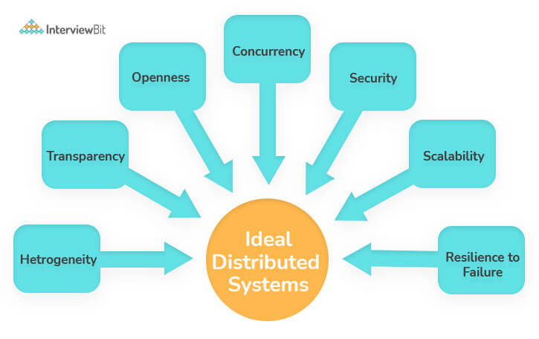
- Heterogeneity: The design of applications should allow the users to access services and run applications over a heterogeneous collection of computers and networks, considering hardware devices, OS, Network, Programming languages.
- Transparency: Distributed system Designers must hide the complexity of the system as much as they can. Some Terms of transparency are location, access, migration, relocation, and so on.
- Openness: It is a characteristic that determines whether the system can be extended and reimplemented in various ways.
- Security: Distributed system Designers must take care of confidentiality, integrity, and availability.
- Scalability: A system is said to be scalable if it can manage the increase of users and resources without undergoing a striking loss of performance.

31. Mention the main configuration parameters that has to be specified by the user to run MapReduce.
The chief configuration parameters that the user of the MapReduce framework needs to mention is:
- Job’s input Location
- Job’s Output Location
- The Input format
- The Output format
- The Class including the Map function
- The Class including the reduce function
- JAR file, which includes the mapper, the Reducer, and the driver classes.

32. How can you skip bad records in Hadoop ?
Hadoop can provide an option wherein a particular set of lousy input records could be skipped while processing map inputs. SkipBadRecords class in Hadoop offers an optional mode of execution in which the bad records can be detected and neglected in multiple attempts. This may happen due to the presence of some bugs in the map function. The user has to manually fix it, which may sometimes be possible because the bug may be in third-party libraries. With the help of this feature, only a small amount of data is lost, which may be acceptable because we are dealing with a large amount of data.

33. Explain Outliers.
Outliers are the data points that are very far from the group, which is not a part of any group or cluster. This may affect the behavior of the model, they may predict wrong results, or their accuracy will be very low. Therefore Outliers must be handled carefully as they may also contain some helpful information. The presence of these outliers may lead to misleading a Big Data model or a Machine Learning Model. The results of this may be,
- Poor Results
- Lower accuracy
- Longer Training Time
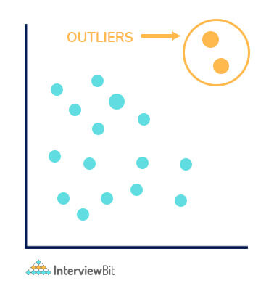

34. What is Distcp?
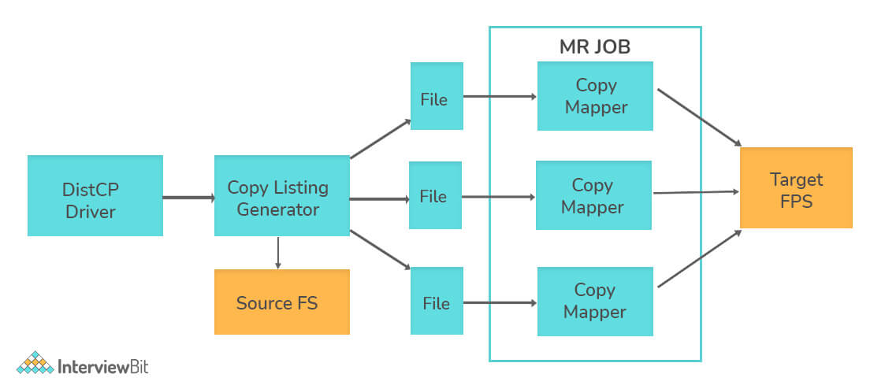
It is a Tool which is used for copying a very large amount of data to and from Hadoop file systems in parallel. It uses MapReduce to affect its distribution, error handling, recovery, and reporting. It expands a list of files and directories into input to map tasks, each of which will copy a partition of the files specified in the source list.

35. Explain Persistent, Ephemeral and Sequential Znodes.
- Persistent znodes: The default znode in ZooKeeper is the Persistent Znode. It permanently stays in the zookeeper server until any other clients leave it apart.
- Ephemeral znodes: These are the temporary znodes. It is smashed whenever the creator client logs out of the ZooKeeper server. For example, assume client1 created eznode1. Once client1 logs out of the ZooKeeper server, the eznode1 gets destroyed.
- Sequential znodes: Sequential znode is assigned a 10-digit number in numerical order at the end of its name. Assume client1 produced a sznode1. In the ZooKeeper server, the sznode1 will be named like this:
sznode0000000001.
If client1 generates another sequential znode, it will bear the following number in a sequence. So the subsequent sequential znode is <znode name>0000000002.

36. Explain the Pros and Cons of Big Data?
Pros of Big Data are:
- Increased productivity: Recently, it was found that 59.9% of businesses use big data tools like Hadoop and Spark to develop their sales. Current big data tools enable analysts to examine instantly, which enhances their productivity. Also, the insights inferred from the analysis of big data can be used by organizations to increase productivity in different forms throughout the company.
- Reduce costs: Big data analytics help businesses reduce their costs. In most companies, big data tools had served them to enhance operational performance and decrease costs, and in few other companies had started using big data to decrease expenses. Interestingly, very few companies selected cost reduction as their primary goal for big data analytics, suggesting that this is merely a very welcome side benefit for many.
- Improved customer service: Improving customer service has always been one of the primary goals for big data analytics projects, and it has been a success for many companies with the help of this. Various customer contact points like Social media, customer relationship management systems, etc., transfer a lot of information about their customers. And this analysis and data is used to improve the services for the customers
- Fraud detection: The primary purpose of using Big data analytics is in the financial services industry for detecting frauds. The advantage of big data analytics systems is that it depends on machine learning, because of which they are great at recognizing patterns and irregularities. As a result, these techniques can give banks and credit card companies the capacity to detect stolen credit cards or deceitful purchases, usually before the cardholder knows that something is wrong.
- More significant innovation: A few companies have started investing in analytics with the sole purpose to bring new things and disturb their markets. The reason behind this is if they can see the future of the market with the help of insights before their competitors, they can come out strong from that situation with a few new goods and services and capture the market quickly.
On the other hand, implementing big data analytics is not as easy as we think; there are a few difficulties too when it comes to implementing it.
Cons of Big Data are:
- Need for talent: The number one big data challenge that we have been facing for the past three years is the skill set required for it. A lot of companies also face difficulty when designing a data lake. Hiring or training staff will only increase the cost considerably, and also, imbibing big data skills takes a lot of time.
- Cybersecurity risks: Storing, especially sensitive big data will make those businesses a prime target for cyberattackers. Security is one of the top big data challenges, and cybersecurity breaches are the single greatest data threat that enterprises encounter.
- Hardware needs: Another critical concern for businesses is the IT base necessary to help big data analytics drives. Storage space for storing the data, networking bandwidth for transferring it to and from analytics systems, and calculating resources to achieve those analytics are costly to buy and keep.
- Data quality: The disadvantage in working with big data was the requirement to address data quality problems. Before companies can use big data for analytics purposes, data scientists and analysts need to ensure that the data they are working with is accurate, appropriate, and in the proper format for analysis. This slows the process, but if companies don't take care of data quality issues, they may find that the insights produced by their analytics are useless or even harmful if performed.

37. How do you convert unstructured data to structured data?
An open-ended question and there are many ways to achieve this.
- Programming: Coding/ Programming is the most tried out method to transform unstructured data into a structured form. Programming is advantageous to accomplish because we get independence with it, which you can use to change the structure of the data in any form possible. Several programming languages, such as Python, Java, etc., can be used.
- Data/Business Tools: Many BI (Business Intelligence) tools support the drag and drop functionality for converting unstructured data into structured data. One cautious thing before using BI tools is that most of these tools are paid, and we have to be financially capable to support these tools. For people who lack both experience and skills needed for option 1, this is the way to go.

38. What is data preparation?
Data preparation is the method of cleansing and modifying raw data before processing and analyzing it. It is a crucial step before processing and usually requires reformatting data, making improvements to data, and consolidating data sets to enrich data.
Data preparation is an unending task for data specialists or business users. But, it is essential to convert data into context to get insights and then, can eliminate the biased results found due to poor data quality.
For instance, the data construction process typically includes standardizing data formats, enhancing source data, and/or eliminating outliers.

39. Steps for Data preparation.
Steps for data preparation are:
- Gather data: The data preparation process starts with obtaining the correct data. This can originate from a current data catalogue or can be appended ad-hoc.
- Discover and assess data: After assembling the data, it is essential for each dataset to be identified. This step is about learning to understand the data and knowing what must be done before the data becomes valuable in a distinct context. Discovery is a big task but can be done with the help of data visualization tools that assist users and help them browse their data.
- Clean and verify data:
Even though cleaning and verifying data takes a lot of time, it is the most important step, because this step not only eliminates the incorrect data but also fills the rifts. Significant tasks here include:
  - Eliminating alien data and outliers.
  - Filling in missing values.
  - Adjusting data to a regulated pattern.
  - Masking private or sensitive data entries.
After cleaning the data, the mistakes that we came across during the data development process have to be examined and approved. Generally, an error in the system will become apparent during this step and need to be fixed before proceeding.
- Transform and enrich data:
Transforming data modernizes the arrangement or value entries to reach a well-defined result or make the data more quickly recognized by broader viewers. Improving data refers to adding and connecting data with other similar information to provide deeper insights.
- Store data:
Lastly, the data can be collected or channeled into a third-party application like a business intelligence tool-making technique for processing and analysis.

1. What do you know about the term “Big Data”?
Answer: Big Data is a term associated with complex and large datasets. A relational database cannot handle big data, and that’s why special tools and methods are used to perform operations on a vast collection of data. Big data enables companies to understand their business better and helps them derive meaningful information from the unstructured and raw data collected on a regular basis. Big data also allows the companies to take better business decisions backed by data.

2. What are the five V’s of Big Data?
Answer: The five V’s of Big data is as follows:
- Volume – Volume represents the volume i.e. amount of data that is growing at a high rate i.e. data volume in Petabytes
- Velocity – Velocity is the rate at which data grows. Social media contributes a major role in the velocity of growing data.
- Variety – Variety refers to the different data types i.e. various data formats like text, audios, videos, etc.
- Veracity – Veracity refers to the uncertainty of available data. Veracity arises due to the high volume of data that brings incompleteness and inconsistency.
- Value –Value refers to turning data into value. By turning accessed big data into values, businesses may generate revenue.
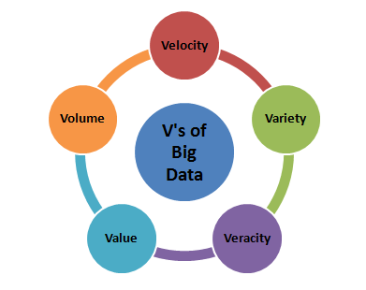5 V’s of Big Data
Note: This is one of the basic and significant questions asked in the big data interview. You can choose to explain the five V’s in detail if you see the interviewer is interested to know more. However, the names can even be mentioned if you are asked about the term “Big Data”.

3. Tell us how big data and Hadoop are related to each other.
Answer: Big data and Hadoop are almost synonyms terms. With the rise of big data, Hadoop, a framework that specializes in big data operations also became popular. The framework can be used by professionals to analyze big data and help businesses to make decisions.
Note: This question is commonly asked in a big data interview. You can go further to answer this question and try to explain the main components of Hadoop.

4. How is big data analysis helpful in increasing business revenue?
Answer: Big data analysis has become very important for the businesses. It helps businesses to differentiate themselves from others and increase the revenue. Through predictive analytics, big data analytics provides businesses customized recommendations and suggestions. Also, big data analytics enables businesses to launch new products depending on customer needs and preferences. These factors make businesses earn more revenue, and thus companies are using big data analytics. Companies may encounter a significant increase of 5-20% in revenue by implementing big data analytics. Some popular companies those are using big data analytics to increase their revenue is – Walmart, LinkedIn, Facebook, Twitter, Bank of America etc.

5. Explain the steps to be followed to deploy a Big Data solution.
Answer: Followings are the three steps that are followed to deploy a Big Data Solution –
i. Data Ingestion
The first step for deploying a big data solution is the data ingestion i.e. extraction of data from various sources. The data source may be a CRM like Salesforce, Enterprise Resource Planning System like SAP, RDBMS like MySQL or any other log files, documents, social media feeds etc. The data can be ingested either through batch jobs or real-time streaming. The extracted data is then stored in HDFS.
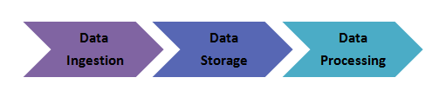Steps of Deploying Big Data Solution
ii. Data Storage
After data ingestion, the next step is to store the extracted data. The data either be stored in HDFS or NoSQL database (i.e. HBase). The HDFS storage works well for sequential access whereas HBase for random read/write access.
iii. Data Processing
The final step in deploying a big data solution is the data processing. The data is processed through one of the processing frameworks like Spark, MapReduce, Pig, etc.
Also Read: Top HBase Interview Questions with Detailed Answers

6. Define respective components of HDFS and YARN
Answer: The two main components of HDFS are-
- NameNode – This is the master node for processing metadata information for data blocks within the HDFS
- DataNode/Slave node – This is the node which acts as slave node to store the data, for processing and use by the NameNode
In addition to serving the client requests, the NameNode executes either of two following roles –
- CheckpointNode – It runs on a different host from the NameNode
- BackupNode- It is a read-only NameNode which contains file system metadata information excluding the block locations
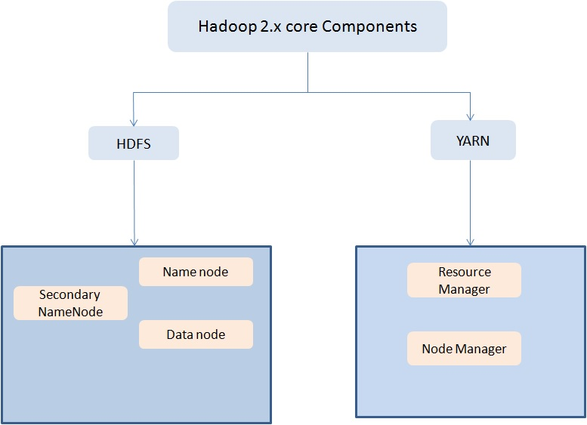
The two main components of YARN are–
- ResourceManager– This component receives processing requests and accordingly allocates to respective NodeManagers depending on processing needs.
- NodeManager– It executes tasks on each single Data Node
Preparing for HDFS interview? Here we cover the most common HDFS interview questions and answers to help you crack the interview!

7. Why is Hadoop used for Big Data Analytics?
Answer: Since data analysis has become one of the key parameters of business, hence, enterprises are dealing with massive amount of structured, unstructured and semi-structured data. Analyzing unstructured data is quite difficult where Hadoop takes major part with its capabilities of
- Storage
- Processing
- Data collection
Moreover, Hadoop is open source and runs on commodity hardware. Hence it is a cost-benefit solution for businesses.

8. What is fsck?
Answer: fsck stands for File System Check. It is a command used by HDFS. This command is used to check inconsistencies and if there is any problem in the file. For example, if there are any missing blocks for a file, HDFS gets notified through this command.

9. What are the main differences between NAS (Network-attached storage) and HDFS?
Answer: The main differences between NAS (Network-attached storage) and HDFS –
- HDFS runs on a cluster of machines while NAS runs on an individual machine. Hence, data redundancy is a common issue in HDFS. On the contrary, the replication protocol is different in case of NAS. Thus the chances of data redundancy are much less.
- Data is stored as data blocks in local drives in case of HDFS. In case of NAS, it is stored in dedicated hardware.

10. What is the Command to format the NameNode?
Answer: $ hdfs namenode -format
Big data is not just what you think, it’s a broad spectrum. There are a number of career options in Big Data World. Here is an interesting and explanatory visual on Big Data Careers.

Experience-based Big Data Interview Questions
If you have some considerable experience of working in Big Data world, you will be asked a number of questions in your big data interview based on your previous experience. These questions may be simply related to your experience or scenario based. So, get prepared with these best Big data interview questions and answers –

11. Do you have any Big Data experience? If so, please share it with us.
How to Approach: There is no specific answer to the question as it is a subjective question and the answer depends on your previous experience. Asking this question during a big data interview, the interviewer wants to understand your previous experience and is also trying to evaluate if you are fit for the project requirement.
So, how will you approach the question? If you have previous experience, start with your duties in your past position and slowly add details to the conversation. Tell them about your contributions that made the project successful. This question is generally, the 2nd or 3rd question asked in an interview. The later questions are based on this question, so answer it carefully. You should also take care not to go overboard with a single aspect of your previous job. Keep it simple and to the point.

12. Do you prefer good data or good models? Why?
How to Approach: This is a tricky question but generally asked in the big data interview. It asks you to choose between good data or good models. As a candidate, you should try to answer it from your experience. Many companies want to follow a strict process of evaluating data, means they have already selected data models. In this case, having good data can be game-changing. The other way around also works as a model is chosen based on good data.
As we already mentioned, answer it from your experience. However, don’t say that having both good data and good models is important as it is hard to have both in real life projects.

13. Will you optimize algorithms or code to make them run faster?
How to Approach: The answer to this question should always be “Yes.” Real world performance matters and it doesn’t depend on the data or model you are using in your project.
The interviewer might also be interested to know if you have had any previous experience in code or algorithm optimization. For a beginner, it obviously depends on which projects he worked on in the past. Experienced candidates can share their experience accordingly as well. However, be honest about your work, and it is fine if you haven’t optimized code in the past. Just let the interviewer know your real experience and you will be able to crack the big data interview.

14. How do you approach data preparation?
How to Approach: Data preparation is one of the crucial steps in big data projects. A big data interview may involve at least one question based on data preparation. When the interviewer asks you this question, he wants to know what steps or precautions you take during data preparation.
As you already know, data preparation is required to get necessary data which can then further be used for modeling purposes. You should convey this message to the interviewer. You should also emphasize the type of model you are going to use and reasons behind choosing that particular model. Last, but not the least, you should also discuss important data preparation terms such as transforming variables, outlier values, unstructured data, identifying gaps, and others.

15. How would you transform unstructured data into structured data?
How to Approach: Unstructured data is very common in big data. The unstructured data should be transformed into structured data to ensure proper data analysis. You can start answering the question by briefly differentiating between the two. Once done, you can now discuss the methods you use to transform one form to another. You might also share the real-world situation where you did it. If you have recently been graduated, then you can share information related to your academic projects.
By answering this question correctly, you are signaling that you understand the types of data, both structured and unstructured, and also have the practical experience to work with these. If you give an answer to this question specifically, you will definitely be able to crack the big data interview.

16. Which hardware configuration is most beneficial for Hadoop jobs?
Dual processors or core machines with a configuration of 4 / 8 GB RAM and ECC memory is ideal for running Hadoop operations. However, the hardware configuration varies based on the project-specific workflow and process flow and need customization accordingly.

17. What happens when two users try to access the same file in the HDFS?
HDFS NameNode supports exclusive write only. Hence, only the first user will receive the grant for file access and the second user will be rejected.

18. How to recover a NameNode when it is down?
The following steps need to execute to make the Hadoop cluster up and running:
- Use the FsImage which is file system metadata replica to start a new NameNode.
- Configure the DataNodes and also the clients to make them acknowledge the newly started NameNode.
- Once the new NameNode completes loading the last checkpoint FsImage which has received enough block reports from the DataNodes, it will start to serve the client.
In case of large Hadoop clusters, the NameNode recovery process consumes a lot of time which turns out to be a more significant challenge in case of routine maintenance.

19. What do you understand by Rack Awareness in Hadoop?
It is an algorithm applied to the NameNode to decide how blocks and its replicas are placed. Depending on rack definitions network traffic is minimized between DataNodes within the same rack. For example, if we consider replication factor as 3, two copies will be placed on one rack whereas the third copy in a separate rack.

20. What is the difference between “HDFS Block” and “Input Split”?
The HDFS divides the input data physically into blocks for processing which is known as HDFS Block.
Input Split is a logical division of data by mapper for mapping operation.
Enhance your Big Data skills with the experts. Here is the Complete List of Big Data Blogs where you can find latest news, trends, updates, and concepts of Big Data.

Basic Big Data Hadoop Interview Questions
Hadoop is one of the most popular Big Data frameworks, and if you are going for a Hadoop interview prepare yourself with these basic level interview questions for Big Data Hadoop. These questions will be helpful for you whether you are going for a Hadoop developer or Hadoop Admin interview.

21. Explain the difference between Hadoop and RDBMS.

Answer: The difference between Hadoop and RDBMS is as follows –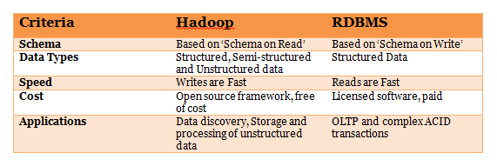22. What are the common input formats in Hadoop?
Answer: Below are the common input formats in Hadoop –
- Text Input Format – The default input format defined in Hadoop is the Text Input Format.
- Sequence File Input Format – To read files in a sequence, Sequence File Input Format is used.
- Key Value Input Format – The input format used for plain text files (files broken into lines) is the Key Value Input Format.

23. Explain some important features of Hadoop.
Answer: Hadoop supports the storage and processing of big data. It is the best solution for handling big data challenges. Some important features of Hadoop are –
- Open Source – Hadoop is an open source framework which means it is available free of cost. Also, the users are allowed to change the source code as per their requirements.
- Distributed Processing – Hadoop supports distributed processing of data i.e. faster processing. The data in Hadoop HDFS is stored in a distributed manner and MapReduce is responsible for the parallel processing of data.
- Fault Tolerance – Hadoop is highly fault-tolerant. It creates three replicas for each block at different nodes, by default. This number can be changed according to the requirement. So, we can recover the data from another node if one node fails. The detection of node failure and recovery of data is done automatically.
- Reliability – Hadoop stores data on the cluster in a reliable manner that is independent of machine. So, the data stored in Hadoop environment is not affected by the failure of the machine.
- Scalability – Another important feature of Hadoop is the scalability. It is compatible with the other hardware and we can easily ass the new hardware to the nodes.
- High Availability – The data stored in Hadoop is available to access even after the hardware failure. In case of hardware failure, the data can be accessed from another path.

24. Explain the different modes in which Hadoop run.
Answer: Apache Hadoop runs in the following three modes –
- Standalone (Local) Mode – By default, Hadoop runs in a local mode i.e. on a non-distributed, single node. This mode uses the local file system to perform input and output operation. This mode does not support the use of HDFS, so it is used for debugging. No custom configuration is needed for configuration files in this mode.
- Pseudo-Distributed Mode – In the pseudo-distributed mode, Hadoop runs on a single node just like the Standalone mode. In this mode, each daemon runs in a separate Java process. As all the daemons run on a single node, there is the same node for both the Master and Slave nodes.
- Fully – Distributed Mode – In the fully-distributed mode, all the daemons run on separate individual nodes and thus forms a multi-node cluster. There are different nodes for Master and Slave nodes.

25. Explain the core components of Hadoop.
Answer: Hadoop is an open source framework that is meant for storage and processing of big data in a distributed manner. The core components of Hadoop are –
- HDFS (Hadoop Distributed File System) – HDFS is the basic storage system of Hadoop. The large data files running on a cluster of commodity hardware are stored in HDFS. It can store data in a reliable manner even when hardware fails.
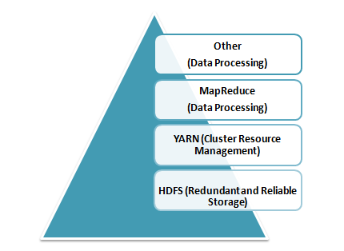Core Components of Hadoop
- Hadoop MapReduce – MapReduce is the Hadoop layer that is responsible for data processing. It writes an application to process unstructured and structured data stored in HDFS. It is responsible for the parallel processing of high volume of data by dividing data into independent tasks. The processing is done in two phases Map and Reduce. The Map is the first phase of processing that specifies complex logic code and the Reduce is the second phase of processing that specifies light-weight operations.
- YARN – The processing framework in Hadoop is YARN. It is used for resource management and provides multiple data processing engines i.e. data science, real-time streaming, and batch processing.

26. What are the configuration parameters in a “MapReduce” program?
The main configuration parameters in “MapReduce” framework are:
- Input locations of Jobs in the distributed file system
- Output location of Jobs in the distributed file system
- The input format of data
- The output format of data
- The class which contains the map function
- The class which contains the reduce function
- JAR file which contains the mapper, reducer and the driver classes

27. What is a block in HDFS and what is its default size in Hadoop 1 and Hadoop 2? Can we change the block size?
Blocks are smallest continuous data storage in a hard drive. For HDFS, blocks are stored across Hadoop cluster.
- The default block size in Hadoop 1 is: 64 MB
- The default block size in Hadoop 2 is: 128 MB
Yes, we can change block size by using the parameter – dfs.block.size located in the hdfs-site.xml file.

28. What is Distributed Cache in a MapReduce Framework
Distributed Cache is a feature of Hadoop MapReduce framework to cache files for applications. Hadoop framework makes cached files available for every map/reduce tasks running on the data nodes. Hence, the data files can access the cache file as a local file in the designated job.

29. What are the three running modes of Hadoop?
The three running modes of Hadoop are as follows:
i. Standalone or local: This is the default mode and does not need any configuration. In this mode, all the following components of Hadoop uses local file system and runs on a single JVM –
- NameNode
- DataNode
- ResourceManager
- NodeManager
ii. Pseudo-distributed: In this mode, all the master and slave Hadoop services are deployed and executed on a single node.
iii. Fully distributed: In this mode, Hadoop master and slave services are deployed and executed on separate nodes.

30. Explain JobTracker in Hadoop
JobTracker is a JVM process in Hadoop to submit and track MapReduce jobs.
JobTracker performs the following activities in Hadoop in a sequence –
- JobTracker receives jobs that a client application submits to the job tracker
- JobTracker notifies NameNode to determine data node
- JobTracker allocates TaskTracker nodes based on available slots.
- it submits the work on allocated TaskTracker Nodes,
- JobTracker monitors the TaskTracker nodes.
- When a task fails, JobTracker is notified and decides how to reallocate the task.
Prepare yourself for the next Hadoop Job Interview with Top 50 Hadoop Interview Questions and Answers.

Hadoop Developer Interview Questions for Fresher
It is not easy to crack Hadoop developer interview but the preparation can do everything. If you are a fresher, learn the Hadoop concepts and prepare properly. Have a good knowledge of the different file systems, Hadoop versions, commands, system security, etc. Here are few questions that will help you pass the Hadoop developer interview.

31. What are the different configuration files in Hadoop?
Answer: The different configuration files in Hadoop are –
core-site.xml – This configuration file contains Hadoop core configuration settings, for example, I/O settings, very common for MapReduce and HDFS. It uses hostname a port.
mapred-site.xml – This configuration file specifies a framework name for MapReduce by setting mapreduce.framework.name
hdfs-site.xml – This configuration file contains HDFS daemons configuration settings. It also specifies default block permission and replication checking on HDFS.
yarn-site.xml – This configuration file specifies configuration settings for ResourceManager and NodeManager.

32. What are the differences between Hadoop 2 and Hadoop 3?
Answer: Following are the differences between Hadoop 2 and Hadoop 3 –

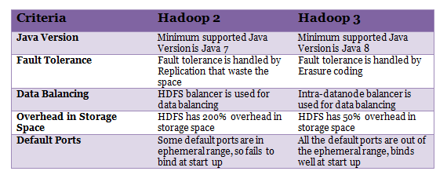33. How can you achieve security in Hadoop?
Answer: Kerberos are used to achieve security in Hadoop. There are 3 steps to access a service while using Kerberos, at a high level. Each step involves a message exchange with a server.
- Authentication – The first step involves authentication of the client to the authentication server, and then provides a time-stamped TGT (Ticket-Granting Ticket) to the client.
- Authorization – In this step, the client uses received TGT to request a service ticket from the TGS (Ticket Granting Server).
- Service Request – It is the final step to achieve security in Hadoop. Then the client uses service ticket to authenticate himself to the server.

34. What is commodity hardware?
Answer: Commodity hardware is a low-cost system identified by less-availability and low-quality. The commodity hardware comprises of RAM as it performs a number of services that require RAM for the execution. One doesn’t require high-end hardware configuration or supercomputers to run Hadoop, it can be run on any commodity hardware.

35. How is NFS different from HDFS?
Answer: There are a number of distributed file systems that work in their own way. NFS (Network File System) is one of the oldest and popular distributed file storage systems whereas HDFS (Hadoop Distributed File System) is the recently used and popular one to handle big data. The main differences between NFS and HDFS are as follows –

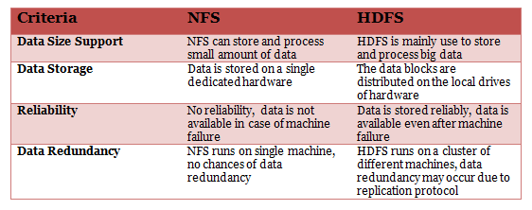36. How do Hadoop MapReduce works?
There are two phases of MapReduce operation.
- Map phase – In this phase, the input data is split by map tasks. The map tasks run in parallel. These split data is used for analysis purpose.
- Reduce phase- In this phase, the similar split data is aggregated from the entire collection and shows the result.

37. What is MapReduce? What is the syntax you use to run a MapReduce program?
MapReduce is a programming model in Hadoop for processing large data sets over a cluster of computers, commonly known as HDFS. It is a parallel programming model.
The syntax to run a MapReduce program is – hadoop_jar_file.jar /input_path /output_path.

38. What are the Port Numbers for NameNode, Task Tracker, and Job Tracker?
- NameNode – Port 50070
- Task Tracker – Port 50060
- Job Tracker – Port 50030

39.What are the different file permissions in HDFS for files or directory levels?
Hadoop distributed file system (HDFS) uses a specific permissions model for files and directories. Following user levels are used in HDFS –
- Owner
- Group
- Others.
For each of the user mentioned above following permissions are applicable –
- read (r)
- write (w)
- execute(x).
Above mentioned permissions work differently for files and directories.
For files –
- The r permission is for reading a file
- The w permission is for writing a file.
For directories –
- The r permission lists the contents of a specific directory.
- The w permission creates or deletes a directory.
- The X permission is for accessing a child directory.

40.What are the basic parameters of a Mapper?
The basic parameters of a Mapper are
- LongWritable and Text
- Text and IntWritable
Hadoop and Spark are the two most popular big data frameworks. But there is a commonly asked question – do we need Hadoop to run Spark? Watch this video to find the answer to this question.

Hadoop Developer Interview Questions for Experienced
The interviewer has more expectations from an experienced Hadoop developer, and thus his questions are one-level up. So, if you have gained some experience, don’t forget to cover command based, scenario-based, real-experience based questions. Here we bring some sample interview questions for experienced Hadoop developers.

41. How to restart all the daemons in Hadoop?
Answer: To restart all the daemons, it is required to stop all the daemons first. The Hadoop directory contains sbin directory that stores the script files to stop and start daemons in Hadoop.
Use stop daemons command /sbin/stop-all.sh to stop all the daemons and then use /sin/start-all.sh command to start all the daemons again.

42. What is the use of jps command in Hadoop?
Answer: The jps command is used to check if the Hadoop daemons are running properly or not. This command shows all the daemons running on a machine i.e. Datanode, Namenode, NodeManager, ResourceManager etc.

43. Explain the process that overwrites the replication factors in HDFS.
Answer: There are two methods to overwrite the replication factors in HDFS –
Method 1: On File Basis
In this method, the replication factor is changed on the basis of file using Hadoop FS shell. The command used for this is:
$hadoop fs – setrep –w2/my/test_file
Here, test_file is the filename that’s replication factor will be set to 2.
Method 2: On Directory Basis
In this method, the replication factor is changed on directory basis i.e. the replication factor for all the files under a given directory is modified.
$hadoop fs –setrep –w5/my/test_dir
Here, test_dir is the name of the directory, the replication factor for the directory and all the files in it will be set to 5.

44. What will happen with a NameNode that doesn’t have any data?
Answer: A NameNode without any data doesn’t exist in Hadoop. If there is a NameNode, it will contain some data in it or it won’t exist.

45. Explain NameNode recovery process.
Answer: The NameNode recovery process involves the below-mentioned steps to make Hadoop cluster running:
- In the first step in the recovery process, file system metadata replica (FsImage) starts a new NameNode.
- The next step is to configure DataNodes and Clients. These DataNodes and Clients will then acknowledge new NameNode.
- During the final step, the new NameNode starts serving the client on the completion of last checkpoint FsImage loading and receiving block reports from the DataNodes.
Note: Don’t forget to mention, this NameNode recovery process consumes a lot of time on large Hadoop clusters. Thus, it makes routine maintenance difficult. For this reason, HDFS high availability architecture is recommended to use.

46. How Is Hadoop CLASSPATH essential to start or stop Hadoop daemons?
CLASSPATH includes necessary directories that contain jar files to start or stop Hadoop daemons. Hence, setting CLASSPATH is essential to start or stop Hadoop daemons.
However, setting up CLASSPATH every time is not the standard that we follow. Usually CLASSPATH is written inside /etc/hadoop/hadoop-env.sh file. Hence, once we run Hadoop, it will load the CLASSPATH automatically.

47. Why is HDFS only suitable for large data sets and not the correct tool to use for many small files?
This is due to the performance issue of NameNode. Usually, NameNode is allocated with huge space to store metadata for the large-scale file. The metadata is supposed to be a from a single file for optimum space utilization and cost benefit. In case of small size files, NameNode does not utilize the entire space which is a performance optimization issue.

48. Why do we need Data Locality in Hadoop? Explain.
Datasets in HDFS store as blocks in DataNodes the Hadoop cluster. During the execution of a MapReduce job the individual Mapper processes the blocks (Input Splits). If the data does not reside in the same node where the Mapper is executing the job, the data needs to be copied from the DataNode over the network to the mapper DataNode.
Now if a MapReduce job has more than 100 Mapper and each Mapper tries to copy the data from other DataNode in the cluster simultaneously, it would cause serious network congestion which is a big performance issue of the overall system. Hence, data proximity to the computation is an effective and cost-effective solution which is technically termed as Data locality in Hadoop. It helps to increase the overall throughput of the system.
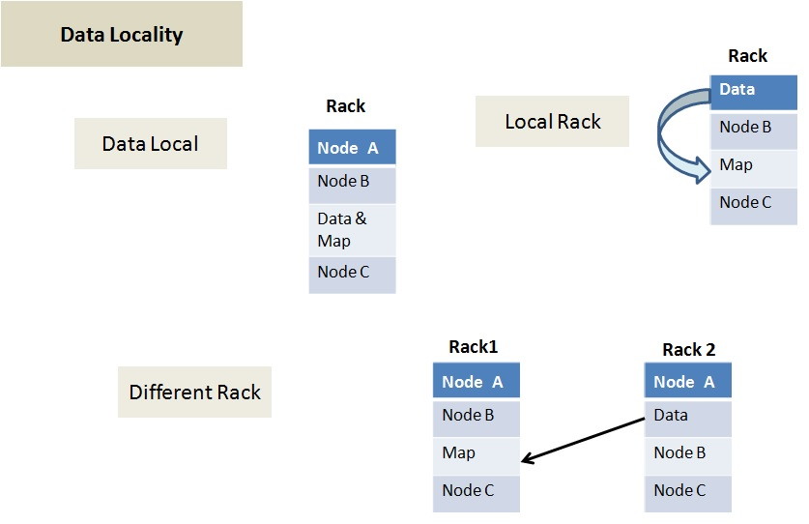
Data locality can be of three types:
- Data local – In this type data and the mapper resides on the same node. This is the closest proximity of data and the most preferred scenario.
- Rack Local – In this scenarios mapper and data reside on the same rack but on the different data nodes.
- Different Rack – In this scenario mapper and data reside on the different racks.

49. DFS can handle a large volume of data then why do we need Hadoop framework?
Hadoop is not only for storing large data but also to process those big data. Though DFS(Distributed File System) too can store the data, but it lacks below features-
- It is not fault tolerant
- Data movement over a network depends on bandwidth.

50. What is Sequencefileinputformat?
Hadoop uses a specific file format which is known as Sequence file. The sequence file stores data in a serialized key-value pair. Sequencefileinputformat is an input format to read sequence files.

Q1. What is Big Data?
Ans. Big Data is a set of massive data, a collection of huge in size and exponentially growing data, that cannot be managed, stored, and processed by traditional data management tools.
Explore courses related to Informatica:

Q2. What are the different types of Big Data?
Ans. There are three types of Big Data.
Structured Data – It suggests that the data can be processed, stored, and retrieved in a fixed format. It is highly organized information that can be easily assessed and stored, e.g. phone numbers, social security numbers, ZIP codes, employee information, and salaries, etc.
Unstructured Data – This refers to the data that has no specific structure or form. The most common types of unstructured data are formats like audio, video, social media posts, digital surveillance data, satellite data, etc.
Semi-structured Data – This refers to both structured and unstructured data formats and is unspecified yet important.

Q3. Are Hadoop and Big Data co-related?
Ans. Big Data is an asset, while Hadoop is an open-source software program, which accomplishes a set of goals and objectives to deal with that asset. Hadoop is used to process, store, and analyze complex unstructured data sets through specific proprietary algorithms and methods to derive actionable insights. So yes, they are related but are not alike.

Q4. Why is Hadoop used in Big Data analytics?
Ans. Hadoop is an open-source framework in Java, and it processes even big volumes of data on a cluster of commodity hardware. It also allows running many exploratory data analysis tasks on full datasets, without sampling. Features that make Hadoop an essential requirement for Big Data are –
- Data collection
- Storage
- Processing
- Runs independently

Q5. Name some of the important tools useful for Big Data analytics.
Ans. It is one of the most commonly asked big data interview questions.
The important Big Data analytics tools are –
- NodeXL
- KNIME
- Tableau
- Solver
- OpenRefine
- Rattle GUI
- Qlikview

Q6. What are the five ‘V’s of Big Data?
Ans. It is one of the most popular big data interview questions.
The five ‘V’s of Big data are –
Value – Value refers to the worth of the data being extracted.
Variety (Data in Many forms) – Variety explains different types of data, including text, audio, videos, photos, and PDFs, etc.
Veracity (Data in Doubt) – Veracity talks about the quality or trustworthiness and accuracy of the processed data.
Velocity (Data in Motion) – This refers to the speed at which the data is being generated, collected, and analyzed.
Volume (Data at Rest) – Volume represents the volume or amount of data. Social media, mobile phones, cars, credit cards, photos, and videos majorly contribute to the volumes of data.

Q7. What are HDFS and YARN? What are their respective components?
Ans. HDFS or Hadoop Distributed File System runs on commodity hardware and is highly fault-tolerant. HDFS provides file permissions and authentication and is suitable for distributed storage and processing. It is composed of three elements, including NameNode, DataNode, and Secondary NameNode.
YARN is an integral part of Hadoop 2.0 and is an abbreviation for Yet Another Resource Negotiator. It is a resource management layer of Hadoop and allows different data processing engines like graph processing, interactive processing, stream processing, and batch processing to run and process data stored in HDFS. ResourceManager and NodeManager are the two main components of YARN.

Q8. What is FSCK?
Ans. FSCK or File System Check is a command used by HDFS. It checks if any file is corrupt, has its replica, or if there are some missing blocks for a file. FSCK generates a summary report, which lists the overall health of the file system.

Q9. Name some key components of a Hadoop application.
Ans. The key components of a Hadoop application are –
- HDFS
- YARN
- MapReduce
- Hadoop Common

Q10. What are the different core methods of a Reducer?
Ans. There are three core methods of a reducer-
setup() – It helps to configure parameters like heap size, distributed cache, and input data size.
reduce() – Also known as once per key with the concerned reduce task. It is the heart of the reducer.
cleanup() – It is a process to clean up all the temporary files at the end of a reducer task.

Q11. What is the command for starting all the Hadoop daemons together?
Ans. The command for starting all the Hadoop daemons together is –
./sbin/start-all.sh

Q12. What are the most common input formats in Hadoop?
Ans. The most common input formats in Hadoop are –
- Key-value input format
- Sequence file input format
- Text input format

Q13. What are the different file formats that can be used in Hadoop?
Ans. File formats used with Hadoop, include –
- CSV
- JSON
- Columnar
- Sequence files
- AVRO
- Parquet file

Q14. What is the standard path for Hadoop Sqoop scripts?
Ans. The standard path for Hadoop Sqoop scripts is –
/usr/bin/Hadoop Sqoop

Q15. What is commodity hardware?
Ans. Commodity hardware is the basic hardware resource required to run the Apache Hadoop framework. It is a common term used for affordable devices, usually compatible with other such devices.

Q16. What do you mean by logistic regression?
Ans. Also known as the logit model, logistic regression is a technique to predict the binary result from a linear amalgamation of predictor variables.

Q17. What is the goal of A/B Testing?
Ans. A/B testing is a comparative study, where two or more variants of a page are presented before random users and their feedback is statistically analyzed to check which variation performs better.

Q18. What is a Distributed Cache?
Ans. Distributed Cache is a dedicated service of the Hadoop MapReduce framework, which is used to cache the files whenever required by the applications. This can cache read-only text files, archives, jar files, among others, which can be accessed and read later on each data node where map/reduce tasks are running.
It is among the most commonly asked big data interview questions and you must read about Distributed Cache in detail.

Q19. Name the modes in which Hadoop can run.
Ans. Hadoop can run on three modes, which are –
- Standalone mode
- Pseudo Distributed mode (Single node cluster)
- Fully distributes mode (Multiple node cluster)

Q20. Name the port numbers for NameNode, Task Tracker, and Job Tracker.
Ans. NameNode – Port 50070
Task Tracker – Port 50060
Job Tracker – Port 50030

Q21. Name the most popular data management tools used with Edge Nodes in Hadoop.
Ans. The most commonly used data management tools that work with Edge Nodes in Hadoop are –
- Oozie
- Ambari
- Pig
- Flume

Q22. What happens when multiple clients try to write on the same HDFS file?
Ans. Multiple users cannot write on the same HDFS file at a similar time. When the first user is accessing the file, inputs from the second user will be rejected because HDFS NameNode supports exclusive write.

Q23. What do you know about collaborative filtering?
Ans. Collaborative filtering is a set of technologies that forecast which items a particular consumer would like depending on the preferences of the scores of individuals. It is nothing but the tech word for questioning individuals for suggestions.

Q24. What is a block in Hadoop Distributed File System (HDFS)?
Ans. When the file is stored in HDFS, all file system breaks down into a set of blocks, and HDFS unaware of what is stored in the file. The block size in Hadoop must be 128MB. This value can be tailored for individual files.

Q25. Name various Hadoop and YARN daemons.
Ans. Hadoop daemons –
- NameNode
- Datanode
- Secondary NameNode
YARN daemons
- ResourceManager
- NodeManager
- JobHistoryServer

Q26. What is the functionality of ‘jps’ command?
Ans. The ‘jps’ command enables us to check if the Hadoop daemons like namenode, datanode, resourcemanager, nodemanager, etc. are running on the machine.

Q27. What types of biases can happen through sampling?
Ans. Three types of biases can happen through sampling, which are –
- Survivorship bias
- Selection bias
- Under coverage bias

Q28. Define Active and Passive Namenodes.
Ans. Active NameNode runs and works in the cluster, whereas Passive NameNode has comparable data like active NameNode.
Now, let’s explore some more Big Data Interview Questions and Answers.

Q29. How will you define checkpoints?
Ans. A checkpoint is a crucial element in maintaining filesystem metadata in HDFS. It creates checkpoints of file system metadata by joining fsimage with the edit log. The new version of fsimage is named Checkpoint.

Q30. What are the major differences between “HDFS Block” and “Input Split”?
Ans.
HDFS Block | Input Split
Physical division of the data | Logical division of the data
Divides data into blocks to store the blocks together for processing | Divides the data into the input split and assign it to the mapper function for processing
The minimum amount of data that can be read/write | Doesn’t contain any data and is only used during data processing by MapReduce

Q31. What is the command for checking all the tables available in a single database using Sqoop?
Ans. The command for checking all the tables available in a single database using Sqoop is –
Sqoop list-tables –connect jdbc: mysql: //localhost/user;
Also Read>> Top Data Warehouse Interview Questions and Answers

Q32. How do you proceed with data preparation?
Ans. Since data preparation is a critical approach to big data projects, the interviewer might be interested in knowing what path you will take up to clean and transform raw data before processing and analysis. As an answer to one of the most commonly asked big data interview questions, you should discuss the model you will be using, along with logical reasoning for it. In addition, you should also discuss how your steps would help you to ensure superior scalability and accelerated data usage.

Q33. What is the main difference between Sqoop and distCP?
Ans. DistCP is used for transferring data between clusters, while Sqoop is used for transferring data between Hadoop and RDBMS, only.

Q34. How do you transform unstructured data into structured data?
Ans. The structuring of unstructured data has been one of the essential reasons why Big Data revolutionized the data science domain. The unstructured data is transformed into structured data to ensure proper data analysis. In reply to such big data interview questions, you should first differentiate between these two types of data and then discuss the methods you use to transform one form to another. Emphasize the role of machine learning in data transformation while sharing your practical experience.

Q35. How much data is enough to get a valid outcome?
Ans. All the businesses are different and measured in different ways. Thus, you never have enough data and there will be no right answer. The amount of data required depends on the methods you use to have an excellent chance of obtaining vital results.

Q36. Is Hadoop different from other parallel computing systems? How?
Ans. Yes, it is. Hadoop is a distributed file system. It allows us to store and manage large amounts of data in a cloud of machines, managing data redundancy.
The main benefit of this is that since the data is stored in multiple nodes, it is better to process it in a distributed way. Each node is able to process the data stored on it instead of wasting time moving the data across the network.
In contrast, in a relational database computing system, we can query data in real-time, but it is not efficient to store data in tables, records, and columns when the data is huge.
Hadoop also provides a schema for building a column database with Hadoop HBase for run-time queries on rows.

Q37. What is a Backup Node?
Ans. Backup Node is an extended checkpoint node for performing checkpointing and supporting the online streaming of file system edits. Its functionality is similar to Checkpoint, and it forces synchronization with NameNode. Backup Node maintains an up-to-date in-memory copy of the file system namespace. The backup node must save the current state in memory to an image file to create a new checkpoint.
Explore the top Business Intelligence Tools Courses

Q38. What are the common data challenges?
Ans. The most common data challenges are –
- Ensuring data integrity
- Achieving a 360-degree view
- Safeguarding user privacy
- Taking the right business action with real-time resonance

Q39. How would you overcome those data challenges?
Ans. Data challenges can be overcome by –
- Adopting data management tools that provide a clear view of data assessment
- Using tools to remove any low-quality data
- Auditing data from time to time to ensure user privacy is safeguarded
- Using AI-powered tools, or software as a service (SaaS) products to combine datasets and make them usable

Q40. What is the Hierarchical Clustering Algorithm?
Ans. The hierarchical grouping algorithm is the one that combines and divides the groups that already exist, in this way they create a hierarchical structure that presents the order in which the groups are split or merged.

Q41. What is K-mean clustering?
Ans. K mean clustering is a method of vector quantization. With this method, objects are classified as belonging to one of the K groups, which are selected as a priori.

Q42. What is n-gram?
Ans. N-gram is a continuous sequence of n elements of a given voice or text. The N-gram is a type of probabilistic language model used in the prediction of the next item in the sequence in the form of (n-1).
Also Read>> Trending Tech Skills to Master

Q43. Can you mention the criteria for a good data model?
Ans. A good data model –
- It should be easily consumed
- Large data changes should be scalable
- Should offer predictable performances
- Should adapt to changes in requirements

Q44. What is the bias-variance tradeoff?
Ans. It is the bias that represents the precision of a model. A model with a high bias tends to be oversimplified and results in insufficient fit. The variance represents the sensitivity of the model to data and noise. A model with high variance results in overfitting.
Therefore, the trade-off between bias and variance is a property of machine learning models in which lower variance leads to higher bias and vice versa. In general, an optimal balance of the two can be found in which error is minimized.

Q45. Tell me how to randomly select a sample from a population of product users.
Ans. A technique called simple random sampling can be used to randomly select a sample from a population of product users. Simple random sampling is an unbiased technique that randomly takes a subset of individuals, each with an equal probability of being chosen, from a larger data set. It is usually done without replacement.
In the case of using a library like pandas, you can use the .sample () to perform simple random sampling.

Q46. Describe how gradient augmentation works.
Ans. Gradient augmentation is an ensemble method, similar to AdaBoost, which essentially iteratively builds and enhances previously constructed trees using gradients in the loss function. The final model predictions are the weighted sum of the predictions from all previous models.

Q47. What is the Central Limit Theorem (CLT)? How would you determine if the distribution is normal?
Ans. The central limit theorem states that the distribution of the sample means approaches a normal distribution as the sample size increases regardless of the shape of the population distribution.

Q48. What is ‘cross-validation’?
Ans. It is among the most popular big data interview questions.
Cross-validation can be difficult to explain, especially in an easy and understandable way.
Cross-validation is used to analyze whether an object can function as expected once it is used on live servers. In other words, it looks at how certain specific statistical analysis results are valued when an independent data set is put in.

Q49. What is the difference between ‘expected value’ and ‘average value’?
Ans. There is no difference between ‘expected value’ and ‘average value’ when it comes to functionality, there is no difference between the two. However, they are used in different situations.
An expected value usually reflects random variables, while the average value reflects the population sample.

Q50. What is ‘cluster sampling’?
Ans. Cluster sampling is a sampling method that helps the researcher to divide the population into separate groups, called clusters. Then a simple cluster sample is selected from the population and the data is analyzed from the sample clusters.

Q51. Explain the steps to deploy a Big Data solution.
Ans. Followings steps are followed to deploy a Big Data Solution –
- Data Ingestion: It is the first step in the big data solution deployment. The data is extracted from various resources such as Salesforce, SAP, MySQL and other log files, documents, etc. Data ingestion can be performed through batch jobs or real-time streaming.
- Data Storage: The extracted data is either stored in HDFS or NoSQL database (i.e. HBase). HDFS storage is used for sequential access while HBase is used for random read/write access.
- Data Processing: This is the final step in big data solution deployment. Data is processed through a processing framework such as Pig, Spark, MapReduce, etc.

Q52. What is the difference between Network-attached storage (NAS) and HDFS?
Ans. NAS has a lesser chance of data redundancy since its replication protocol is different runs and as it runs on an individual machine. HDFS runs on a cluster of machines due to which data redundancy is frequent in HDFS. While data is stored in dedicated hardware in NAS, data is stored as data blocks in local drives in HDFS.
These big data interview questions and answers will help you get a dream job of yours. You can always learn and develop new Big Data skills by taking one of the best Big Data courses.

1. Define Big Data and explain the Vs of Big Data.
This is one of the most introductory yet important Big Data interview questions. The answer to this is quite straightforward:
Big Data can be defined as a collection of complex unstructured or semi-structured data sets which have the potential to deliver actionable insights.

The four Vs of Big Data are –
Volume – Talks about the amount of data
Variety – Talks about the various formats of data
Velocity – Talks about the ever increasing speed at which the data is growing
Veracity – Talks about the degree of accuracy of data available
2. How is Hadoop related to Big Data?
When we talk about Big Data, we talk about Hadoop. So, this is another Big Data interview question that you will definitely face in an interview.
Hadoop is an open-source framework for storing, processing, and analyzing complex unstructured data sets for deriving insights and intelligence.
3. Define HDFS and YARN, and talk about their respective components.
Now that we’re in the zone of Hadoop, the next Big Data interview question you might face will revolve around the same.
The HDFS is Hadoop’s default storage unit and is responsible for storing different types of data in a distributed environment.
HDFS has the following two components:
NameNode – This is the master node that has the metadata information for all the data blocks in the HDFS.
DataNode – These are the nodes that act as slave nodes and are responsible for storing the data.
YARN, short for Yet Another Resource Negotiator, is responsible for managing resources and providing an execution environment for the said processes.
The two main components of YARN are –
ResourceManager – Responsible for allocating resources to respective NodeManagers based on the needs.
NodeManager – Executes tasks on every DataNode.
7 Interesting Big Data Projects You Need To Watch Out
4. What do you mean by commodity hardware?
This is yet another Big Data interview question you’re most likely to come across in any interview you sit for.
Commodity Hardware refers to the minimal hardware resources needed to run the Apache Hadoop framework. Any hardware that supports Hadoop’s minimum requirements is known as ‘Commodity Hardware.’
5. Define and describe the term FSCK.
FSCK stands for Filesystem Check. It is a command used to run a Hadoop summary report that describes the state of HDFS. It only checks for errors and does not correct them. This command can be executed on either the whole system or a subset of files.
Read: Big data jobs and its career opportunities
6. What is the purpose of the JPS command in Hadoop?
The JPS command is used for testing the working of all the Hadoop daemons. It specifically tests daemons like NameNode, DataNode, ResourceManager, NodeManager and more.
(In any Big Data interview, you’re likely to find one question on JPS and its importance.)
Big Data: Must Know Tools and Technologies
7. Name the different commands for starting up and shutting down Hadoop Daemons.
This is one of the most important Big Data interview questions to help the interviewer gauge your knowledge of commands.
To start all the daemons:
./sbin/start-all.sh
To shut down all the daemons:
./sbin/stop-all.sh
8. Why do we need Hadoop for Big Data Analytics?
This Hadoop interview questions test your awareness regarding the practical aspects of Big Data and Analytics.
In most cases, Hadoop helps in exploring and analyzing large and unstructured data sets. Hadoop offers storage, processing and data collection capabilities that help in analytics.
Knowledge Read: Big data jobs & Career planning
9. Explain the different features of Hadoop.
Listed in many Big Data Interview Questions and Answers, the best answer to this is –
Open-Source – Hadoop is an open-sourced platform. It allows the code to be rewritten or modified according to user and analytics requirements.
Scalability – Hadoop supports the addition of hardware resources to the new nodes.
Data Recovery – Hadoop follows replication which allows the recovery of data in the case of any failure.
Data Locality – This means that Hadoop moves the computation to the data and not the other way round. This way, the whole process speeds up.
10. Define the Port Numbers for NameNode, Task Tracker and Job Tracker.
NameNode – Port 50070
Task Tracker – Port 50060
Job Tracker – Port 50030
11. What do you mean by indexing in HDFS?
HDFS indexes data blocks based on their sizes. The end of a data block points to the address of where the next chunk of data blocks get stored. The DataNodes store the blocks of data while NameNode stores these data blocks.
Big Data Applications in Pop-Culture
12. What are Edge Nodes in Hadoop?
This is one of the top big data analytics important questions which can also be asked as data engineer interview questions. Edge nodes refer to the gateway nodes which act as an interface between Hadoop cluster and the external network. These nodes run client applications and cluster management tools and are used as staging areas as well. Enterprise-class storage capabilities are required for Edge Nodes, and a single edge node usually suffices for multiple Hadoop clusters.
13. What are some of the data management tools used with Edge Nodes in Hadoop?
This Big Data interview question aims to test your awareness regarding various tools and frameworks.
Oozie, Ambari, Pig and Flume are the most common data management tools that work with Edge Nodes in Hadoop.
14. Explain the core methods of a Reducer.
There are three core methods of a reducer. They are-
setup() – This is used to configure different parameters like heap size, distributed cache and input data.
reduce() – A parameter that is called once per key with the concerned reduce task
cleanup() – Clears all temporary files and called only at the end of a reducer task.
15. Talk about the different tombstone markers used for deletion purposes in HBase.
This Big Data interview question dives into your knowledge of HBase and its working.
There are three main tombstone markers used for deletion in HBase. They are-
Family Delete Marker – For marking all the columns of a column family.
Version Delete Marker – For marking a single version of a single column.
Column Delete Marker – For marking all the versions of a single column.
Big Data Engineers: Myths vs. Realities
16. How can Big Data add value to businesses?
One of the most common big data interview question. In the present scenario, Big Data is everything. If you have data, you have the most powerful tool at your disposal. Big Data Analytics helps businesses to transform raw data into meaningful and actionable insights that can shape their business strategies. The most important contribution of Big Data to business is data-driven business decisions. Big Data makes it possible for organizations to base their decisions on tangible information and insights.

Furthermore, Predictive Analytics allows companies to craft customized recommendations and marketing strategies for different buyer personas. Together, Big Data tools and technologies help boost revenue, streamline business operations, increase productivity, and enhance customer satisfaction. In fact, anyone who’s not leveraging Big Data today is losing out on an ocean of opportunities.
Check out the best big x`data courses at upGrad
17. How do you deploy a Big Data solution?
You can deploy a Big Data solution in three steps:
- Data Ingestion – This is the first step in the deployment of a Big Data solution. You begin by collecting data from multiple sources, be it social media platforms, log files, business documents, anything relevant to your business. Data can either be extracted through real-time streaming or in batch jobs.
- Data Storage – Once the data is extracted, you must store the data in a database. It can be HDFS or HBase. While HDFS storage is perfect for sequential access, HBase is ideal for random read/write access.
- Data Processing – The last step in the deployment of the solution is data processing. Usually, data processing is done via frameworks like Hadoop, Spark, MapReduce, Flink, and Pig, to name a few.
18. How is NFS different from HDFS?
The Network File System (NFS) is one of the oldest distributed file storage systems, while Hadoop Distributed File System (HDFS) came to the spotlight only recently after the upsurge of Big Data.
The table below highlights some of the most notable differences between NFS and HDFS:
NFS | HDFS
It can both store and process small volumes of data. | It is explicitly designed to store and process Big Data.
The data is stored in dedicated hardware. | Data is divided into data blocks that are distributed on the local drives of the hardware.
In the case of system failure, you cannot access the data. | Data can be accessed even in the case of a system failure.
Since NFS runs on a single machine, there’s no chance for data redundancy. | HDFS runs on a cluster of machines, and hence, the replication protocol may lead to redundant data.
19. List the different file permissions in HDFS for files or directory levels.
One of the common big data interview questions. The Hadoop distributed file system (HDFS) has specific permissions for files and directories. There are three user levels in HDFS – Owner, Group, and Others. For each of the user levels, there are three available permissions:
- read (r)
- write (w)
- execute(x).
These three permissions work uniquely for files and directories.
For files –
- The r permission is for reading a file
- The w permission is for writing a file.
Although there’s an execute(x) permission, you cannot execute HDFS files.
For directories –
- The r permission lists the contents of a specific directory.
- The w permission creates or deletes a directory.
- The X permission is for accessing a child directory.
20. Elaborate on the processes that overwrite the replication factors in HDFS.
In HDFS, there are two ways to overwrite the replication factors – on file basis and on directory basis.
On File Basis
In this method, the replication factor changes according to the file using Hadoop FS shell. The following command is used for this:
$hadoop fs – setrep –w2/my/test_file
Here, test_file refers to the filename whose replication factor will be set to 2.
On Directory Basis
This method changes the replication factor according to the directory, as such, the replication factor for all the files under a particular directory, changes. The following command is used for this:
$hadoop fs –setrep –w5/my/test_dir
Here, test_dir refers to the name of the directory for which the replication factor and all the files contained within will be set to 5.
21. Name the three modes in which you can run Hadoop.
One of the most common question in any big data interview. The three modes are:
- Standalone mode – This is Hadoop’s default mode that uses the local file system for both input and output operations. The main purpose of the standalone mode is debugging. It does not support HDFS and also lacks custom configuration required for mapred-site.xml, core-site.xml, and hdfs-site.xml files.
- Pseudo-distributed mode – Also known as the single-node cluster, the pseudo-distributed mode includes both NameNode and DataNode within the same machine. In this mode, all the Hadoop daemons will run on a single node, and hence, the Master and Slave nodes are the same.
- Fully distributed mode – This mode is known as the multi-node cluster wherein multiple nodes function simultaneously to execute Hadoop jobs. Here, all the Hadoop daemons run on different nodes. So, the Master and Slave nodes run separately.
22. Explain “Overfitting.”
Overfitting refers to a modeling error that occurs when a function is tightly fit (influenced) by a limited set of data points. Overfitting results in an overly complex model that makes it further difficult to explain the peculiarities or idiosyncrasies in the data at hand. As it adversely affects the generalization ability of the model, it becomes challenging to determine the predictive quotient of overfitted models. These models fail to perform when applied to external data (data that is not part of the sample data) or new datasets.
Overfitting is one of the most common problems in Machine Learning. A model is considered to be overfitted when it performs better on the training set but fails miserably on the test set. However, there are many methods to prevent the problem of overfitting, such as cross-validation, pruning, early stopping, regularization, and assembling.
23. What is Feature Selection?
This is one of the popular Big Data analytics important questions which is also often featured as data engineer interview questions. Feature selection refers to the process of extracting only the required features from a specific dataset. When data is extracted from disparate sources, not all data is useful at all times – different business needs call for different data insights. This is where feature selection comes in to identify and select only those features that are relevant for a particular business requirement or stage of data processing.
The main goal of feature selection is to simplify ML models to make their analysis and interpretation easier. Feature selection enhances the generalization abilities of a model and eliminates the problems of dimensionality, thereby, preventing the possibilities of overfitting. Thus, feature selection provides a better understanding of the data under study, improves the prediction performance of the model, and reduces the computation time significantly.
Feature selection can be done via three techniques:
- Filters method
In this method, the features selected are not dependent on the designated classifiers. A variable ranking technique is used to select variables for ordering purposes. During the classification process, the variable ranking technique takes into consideration the importance and usefulness of a feature. The Chi-Square Test, Variance Threshold, and Information Gain are some examples of the filters method.
- Wrappers method
In this method, the algorithm used for feature subset selection exists as a ‘wrapper’ around the induction algorithm. The induction algorithm functions like a ‘Black Box’ that produces a classifier that will be further used in the classification of features. The major drawback or limitation of the wrappers method is that to obtain the feature subset, you need to perform heavy computation work. Genetic Algorithms, Sequential Feature Selection, and Recursive Feature Elimination are examples of the wrappers method.
- Embedded method
The embedded method combines the best of both worlds – it includes the best features of the filters and wrappers methods. In this method, the variable selection is done during the training process, thereby allowing you to identify the features that are the most accurate for a given model. L1 Regularisation Technique and Ridge Regression are two popular examples of the embedded method.
24. Define “Outliers.”
An outlier refers to a data point or an observation that lies at an abnormal distance from other values in a random sample. In other words, outliers are the values that are far removed from the group; they do not belong to any specific cluster or group in the dataset. The presence of outliers usually affects the behavior of the model – they can mislead the training process of ML algorithms. Some of the adverse impacts of outliers include longer training time, inaccurate models, and poor outcomes.
However, outliers may sometimes contain valuable information. This is why they must be investigated thoroughly and treated accordingly.
25. Name some outlier detection techniques.
Again, one of the most important big data interview questions. Here are six outlier detection methods:
- Extreme Value Analysis – This method determines the statistical tails of the data distribution. Statistical methods like ‘z-scores’ on univariate data are a perfect example of extreme value analysis.
- Probabilistic and Statistical Models – This method determines the ‘unlikely instances’ from a ‘probabilistic model’ of data. A good example is the optimization of Gaussian mixture models using ‘expectation-maximization’.
- Linear Models – This method models the data into lower dimensions. Proximity-based Models – In this approach, the data instances that are isolated from the data group are determined by Cluster, Density, or by the Nearest Neighbor Analysis.
- Information-Theoretic Models – This approach seeks to detect outliers as the bad data instances that increase the complexity of the dataset.
- High-Dimensional Outlier Detection – This method identifies the subspaces for the outliers according to the distance measures in higher dimensions.
26. Explain Rack Awareness in Hadoop.
Rack Awareness is one of the popular big data interview questions. Rach awareness is an algorithm that identifies and selects DataNodes closer to the NameNode based on their rack information. It is applied to the NameNode to determine how data blocks and their replicas will be placed. During the installation process, the default assumption is that all nodes belong to the same rack.
Rack awareness helps to:
- Improve data reliability and accessibility.
- Improve cluster performance.
- Improve network bandwidth.
- Keep the bulk flow in-rack as and when possible.
- Prevent data loss in case of a complete rack failure.
27. Can you recover a NameNode when it is down? If so, how?
Yes, it is possible to recover a NameNode when it is down. Here’s how you can do it:
- Use the FsImage (the file system metadata replica) to launch a new NameNode.
- Configure DataNodes along with the clients so that they can acknowledge and refer to newly started NameNode.
- When the newly created NameNode completes loading the last checkpoint of the FsImage (that has now received enough block reports from the DataNodes) loading process, it will be ready to start serving the client.
However, the recovery process of a NameNode is feasible only for smaller clusters. For large Hadoop clusters, the recovery process usually consumes a substantial amount of time, thereby making it quite a challenging task.
28. Name the configuration parameters of a MapReduce framework.
The configuration parameters in the MapReduce framework include:
- The input format of data.
- The output format of data.
- The input location of jobs in the distributed file system.
- The output location of jobs in the distributed file system.
- The class containing the map function
- The class containing the reduce function
- The JAR file containing the mapper, reducer, and driver classes.
Learn: Mapreduce in big data
Learn Online Software Development Courses online from the World’s top Universities. Earn Executive PG Programs, Advanced Certificate Programs or Masters Programs to fast-track your career.
29. What is a Distributed Cache? What are its benefits?
Any Big Data Interview Question and Answers guide won’t complete without this question. Distributed cache in Hadoop is a service offered by the MapReduce framework used for caching files. If a file is cached for a specific job, Hadoop makes it available on individual DataNodes both in memory and in system where the map and reduce tasks are simultaneously executing. This allows you to quickly access and read cached files to populate any collection (like arrays, hashmaps, etc.) in a code.
Distributed cache offers the following benefits:
- It distributes simple, read-only text/data files and other complex types like jars, archives, etc.
- It tracks the modification timestamps of cache files which highlight the files that should not be modified until a job is executed successfully.
30. What is a SequenceFile in Hadoop?
In Hadoop, a SequenceFile is a flat-file that contains binary key-value pairs. It is most commonly used in MapReduce I/O formats. The map outputs are stored internally as a SequenceFile which provides the reader, writer, and sorter classes.
There are three SequenceFile formats:
- Uncompressed key-value records
- Record compressed key-value records (only ‘values’ are compressed).
- Block compressed key-value records (here, both keys and values are collected in ‘blocks’ separately and then compressed).

In-Demand Software Development Skills
31. Explain the role of a JobTracker.
One of the common big data interview questions. The primary function of the JobTracker is resource management, which essentially means managing the TaskTrackers. Apart from this, JobTracker also tracks resource availability and handles task life cycle management (track the progress of tasks and their fault tolerance).
Some crucial features of the JobTracker are:
- It is a process that runs on a separate node (not on a DataNode).
- It communicates with the NameNode to identify data location.
- It tracks the execution of MapReduce workloads.
- It allocates TaskTracker nodes based on the available slots.
- It monitors each TaskTracker and submits the overall job report to the client.
- It finds the best TaskTracker nodes to execute specific tasks on particular nodes.
32. Name the common input formats in Hadoop.
Hadoop has three common input formats:
- Text Input Format – This is the default input format in Hadoop.
- Sequence File Input Format – This input format is used to read files in a sequence.
- Key-Value Input Format – This input format is used for plain text files (files broken into lines).
33. What is the need for Data Locality in Hadoop?
One of the important big data interview questions. In HDFS, datasets are stored as blocks in DataNodes in the Hadoop cluster. When a MapReduce job is executing, the individual Mapper processes the data blocks (Input Splits). If the data does is not present in the same node where the Mapper executes the job, the data must be copied from the DataNode where it resides over the network to the Mapper DataNode.
When a MapReduce job has over a hundred Mappers and each Mapper DataNode tries to copy the data from another DataNode in the cluster simultaneously, it will lead to network congestion, thereby having a negative impact on the system’s overall performance. This is where Data Locality enters the scenario. Instead of moving a large chunk of data to the computation, Data Locality moves the data computation close to where the actual data resides on the DataNode. This helps improve the overall performance of the system, without causing unnecessary delay.
34. What are the steps to achieve security in Hadoop?
In Hadoop, Kerberos – a network authentication protocol – is used to achieve security. Kerberos is designed to offer robust authentication for client/server applications via secret-key cryptography.
When you use Kerberos to access a service, you have to undergo three steps, each of which involves a message exchange with a server. The steps are as follows:
- Authentication – This is the first step wherein the client is authenticated via the authentication server, after which a time-stamped TGT (Ticket Granting Ticket) is given to the client.
- Authorization – In the second step, the client uses the TGT for requesting a service ticket from the TGS (Ticket Granting Server).
- Service Request – In the final step, the client uses the service ticket to authenticate themselves to the server.
35. How can you handle missing values in Big Data?
Final question in our big data interview questions and answers guide. Missing values refer to the values that are not present in a column. It occurs when there’s is no data value for a variable in an observation. If missing values are not handled properly, it is bound to lead to erroneous data which in turn will generate incorrect outcomes. Thus, it is highly recommended to treat missing values correctly before processing the datasets. Usually, if the number of missing values is small, the data is dropped, but if there’s a bulk of missing values, data imputation is the preferred course of action.
In Statistics, there are different ways to estimate the missing values. These include regression, multiple data imputation, listwise/pairwise deletion, maximum likelihood estimation, and approximate Bayesian bootstrap.
- What command should I use to format the NameNode?
The command to format the NameNode is “$ hdfs namenode -format”
- Do you like good data or good models more? Why?
Although it is a difficult topic, it is frequently asked in big data interviews. You are asked to choose between good data or good models. You should attempt to respond to it from your experience as a candidate. Many businesses have already chosen their data models because they want to adhere to a rigid evaluation process. Good data can change the game in this situation. The opposite is also true as long as a model is selected based on reliable facts.
Answer it based on your own experience. Though it is challenging to have both in real-world projects, don’t say that having good data and good models is vital.
- Will you speed up the code or algorithms you use?
One of the top big data analytics important questions is undoubtedly this one. Always respond “Yes” when asked this question. Performance in the real world is important and is independent of the data or model you are utilizing in your project.
If you have any prior experience with code or algorithm optimization, the interviewer may be very curious to hear about it. It definitely relies on the previous tasks a newbie worked on. Candidates with experience can also discuss their experiences appropriately. However, be truthful about your efforts; it’s okay if you haven’t previously optimized any code. You can succeed in the big data interview if you just share your actual experience with the interviewer.
- What methodology do you use for data preparation?
One of the most important phases in big data projects is data preparation. There may be at least one question focused on data preparation in a big data interview. This question is intended to elicit information from you on the steps or safety measures you employ when preparing data.
As you are already aware, data preparation is crucial to obtain the information needed for further modeling. The interviewer should hear this from you. Additionally, be sure to highlight the kind of model you’ll be using and the factors that went into your decision. Last but not least, you should also go over keywords related to data preparation, such as variables that need to be transformed, outlier values, unstructured data, etc.
- Tell us about data engineering.
Big data is also referred to as data engineering. It focuses on how data collection and research are applied. The data produced by different sources is raw data. Data engineering assists in transforming this raw data into informative and valuable insights.
This is one of the top motadata interview questions asked by the interviewer. Make sure to practice it among other motadata interview questions to strengthen your preparation.
- How well-versed are you in collaborative filtering?
A group of technologies known as collaborative filtering predict which products a specific consumer will like based on the preferences of a large number of people. It is merely the technical term for asking others for advice.
- What does a block in the Hadoop Distributed File System (HDFS) mean?
When a file is placed in HDFS, the entire file system is broken down into a collection of blocks, and HDFS is completely unaware of the contents of the file. Hadoop requires blocks to be 128MB in size. Individual files may have a different value for this.
- Give examples of active and passive Namenodes.
The answer is that Active NameNodes operate and function within a cluster, whilst Passive NameNodes have similar data to Active NameNodes.
- What criteria will you use to define checkpoints?
A checkpoint is a key component of keeping the HDFS filesystem metadata up to date. By combining fsimage and the edit log, it provides file system metadata checkpoints. Checkpoint is the name of the newest iteration of fsimage.
- What is the primary distinction between Sqoop and distCP?
DistCP is used for data transfers between clusters, whereas Sqoop is solely used for data transfers between Hadoop and RDBMS.
- How can unstructured data be converted into structured data?
Big Data changed the field of data science for many reasons, one of which is the organizing of unstructured data. The unstructured data is converted into structured data to enable accurate data analysis. You should first describe the differences between these two categories of data in your response to such big data interview questions before going into detail about the techniques you employ to convert one form of data into another. Share your personal experience while highlighting the importance of machine learning in data transformation.
- How much data is required to produce a reliable result?
Ans. Every company is unique, and every firm is evaluated differently. Therefore, there will never be enough data and no correct response. The amount of data needed relies on the techniques you employ to have a great chance of obtaining important results.
- Do other parallel computing systems and Hadoop differ from one another? How?
Yes, they do. Hadoop is a distributed file system. It enables us to control data redundancy while storing and managing massive volumes of data in a cloud of computers.
The key advantage of this is that it is preferable to handle the data in a distributed manner because it is stored across numerous nodes. Instead of wasting time sending data across the network, each node may process the data that is stored there.
In comparison, a relational database computer system allows for real-time data querying but storing large amounts of data in tables, records, and columns is inefficient.
- What is a Backup Node?
The Backup Node is an expanded Checkpoint Node that supports both Checkpointing and Online Streaming of File System Edits. It forces synchronization with Namenode and functions similarly to Checkpoint. The file system namespace is kept up to date in memory by the Backup Node. The backup node must store the current state from memory to generate a new checkpoint in an image file.

1. What do you mean by the term or concept of Big Data?
Big Data means a set or collection of large datasets that keeps on growing exponentially. It is difficult to manage Big Data with traditional data management tools. Examples of Big Data include the amount of data generated by Facebook or Stock Exchange Board of India on a daily basis. There are three types of Big Data:
- Structured Big Data
- Unstructured Big Data
- Semi-structured Big Data

2. What are the characteristics of Big Data?
The characteristics of Big Data are as follows:
- Volume
- Variety
- Velocity
- Variability
Where,
Volume means the size of the data, as this feature is of utmost importance while handling Big Data solutions. The volume of Big Data is usually high and complex.
Variety refers to the various sources from which data is collected. Basically, it refers to the types, structured, unstructured, and semi-structured, and heterogeneity of Big Data.
Velocity means how fast or slow the data is getting generated. Basically, Big Data velocity deals with the speed at which the data is generated from business processes, operations, application logs, etc.
Variability, as the name suggests, means how differently the data behaves in different situations or scenarios in a given period of time.

3. What are the various steps involved in deploying a Big Data solution?
Deploying a Big Data solution includes the following steps:
- Data Ingestion: As a first step, the data is drawn out or extracted from various sources so as to feed it to the system.
- Data Storage: Once data ingestion is completed, the data is stored in either HDFS or NoSQL database.
- Data Processing: In the final step, the data is processed through frameworks and tools such as Spark, MapReduce, Pig, etc.

4. What is the reason behind using Hadoop in Big Data analytics?
Businesses generate a lot of data in a single day and the data generated is unstructured in nature. Data analysis with unstructured data is difficult as it renders traditional big data solutions ineffective. Hadoop comes into the picture when the data is complex, large and especially unstructured. Hadoop is important in Big Data analytics because of its characteristics:
- Data storage
- Data processing
- Collection plus extraction of data

5. What do you understand by fsck in Hadoop?
fsck stands for file system check in Hadoop, and is a command that is used in HDFS. fsck checks any and all data inconsistencies. If the command detects any inconsistency, HDFS is notified regarding the same.

6. Can you explain some of the important features of Hadoop?
Some of the important features of Hadoop are:
Fault Tolerance: Hadoop has a high-level of fault tolerance. To tackle faults, Hadoop, by default, creates three replicas for each block at different nodes. This number can be modified as per the requirements. This helps to recover the data from another node if one node has failed. Hadoop also facilitates automatic recovery of data and node detection.
Open Source: One of the best features of Hadoop is that it is an open-source framework and is available free of cost. Hadoop also allows its users to change the source code as per their requirements.
Distributed Processing: Hadoop stores the data in a distributed manner in HDFS. Distributed processing implies fast data processing. Hadoop also uses MapReduce for the parallel processing of the data.
Reliability: One of the benefits of Hadoop is that the data stored in Hadoop is not affected by any kind of machine failure, which makes Hadoop a reliable tool.
Scalability: Scalability is another important feature of Hadoop. Hadoop’s compatibility with other hardware makes it a preferred tool. You can also easily add new hardware to the nodes in Hadoop.
High Availability: Easy access to the data stored in Hadoop makes it a highly preferred Big Data management solution. Not only this, the data stored in Hadoop can be accessed even if there is a hardware failure as it can be accessed from a different path.

7. What is Hadoop and what are its components?
Apache Hadoop is the solution for dealing with Big Data. Hadoop is an open-source framework that offers several tools and services to store, manage, process, and analyze Big Data. This allows organizations to make significant business decisions in an effective and efficient manner, which was not possible with traditional methods and systems.
There are 3 main components of Hadoop. They are :
- HDFS
- YARN
- MapReduce
HDFS
It is a system that allows you to distribute the storage of big data across a cluster of computers. Italso maintains the redundant copies of data.So, if one of your computers happens to randomly burst into flames or if some technical issues occur, HDFS can actually recover from that by creating a backup from a copy of the data that it had saved automatically, and you won’t even know if anything happened.
YARN
Next in the Hadoop ecosystem is YARN (Yet Another Resource Negotiator). It is the place where the data processing of Hadoop comes into play. YARN is a system that manages the resources on your computing cluster. It is the one that decides who gets to run the tasks, when and what nodes are available for extra work, and which nodes are not available to do so.
MapReduce
MapReduce, the next component of the Hadoop ecosystem, is just a programming model that allows you to process your data across an entire cluster. It basically consists of Mappers and Reducers that are different scripts, which you might write, or different functions you might use when writing a MapReduce program.

8. Explain Hadoop Architecture.
The Hadoop Architecture comprises of the following :
- Hadoop Common
- HDFS
- MapReduce
- YARN
Hadoop Common
Hadoop Common is a set of utilities that offers support to the other three components of Hadoop. It is a set of Java libraries and scripts that are required by MapReduce, YARN, and HDFS to run the Hadoop cluster.
HDFS
HDFS stands for Hadoop Distributed File System. It stores data in the form of small memory blocks and distributes them across the cluster. Each data is replicated multiple times to ensure data availability. It has two daemons. One for master node一 NameNode and their for slave nodes ―DataNode.
NameNode and DataNode : The NameNode runs on the master server. It manages the Namespace and regulates file access by the client. The DataNode runs on slave nodes. It stores the business data.
MapReduce
It executes tasks in a parallel fashion by distributing the data as small blocks. The two most important tasks that the Hadoop MapReduce carries out are Mapping the tasks and Reducing the tasks.
YARN
It allocates resources which in turn allow different users to execute various applications without worrying about the increased workloads.

10. Name some of the major organizations globally that use Hadoop?
Some of the major organizations globally that are using Hadoop as a Big Data tool are as follows:
- Netflix
- Uber
- The National Security Agency (NSA) of the United States
- The Bank of Scotland
- Twitter

11. What are the real-time industry applications of Hadoop?
Hadoop, well known as Apache Hadoop, is an open-source software platform for scalable and distributed computing of large volumes of data. It provides rapid, high-performance, and cost-effective analysis of structured and unstructured data generated on digital platforms and within the organizations. It is used across all departments and sectors today.
Here are some of the instances where Hadoop is used:
- Managing traffic on streets
- Streaming processing
- Content management and archiving emails
- Processing rat brain neuronal signals using a Hadoop computing cluster
- Fraud detection and prevention
- Advertisements targeting platforms are using Hadoop to capture and analyze clickstream, transaction, video, and social media data
- Managing content, posts, images, and videos on social media platforms
- Analyzing customer data in real-time for improving business performance
- Public sector fields such as intelligence, defense, cyber security, and scientific research
- Getting access to unstructured data such as output from medical devices, doctor’s notes, lab results, imaging reports, medical correspondence, clinical data, and financial data

12. What is HBase?
Apache HBase is a distributed, open-source, scalable, and multidimensional database of NoSQL. HBase is based on Java; it runs on HDFS and offers Google-Bigtable-like abilities and functionalities to Hadoop. Moreover, HBase’s fault-tolerant nature helps in storing large volumes of sparse datasets. HBase gets low latency and high throughput by offering faster access to large datasets for read or write functions.

13. What is a Combiner?
A combiner is a mini version of a reducer that is used to perform local reduction processes. The mapper sends the input to a specific node of the combiner, which later sends the respective output to the reducer. It also reduces the quantum of the data that needs to be sent to the reducers for improving the efficiency of MapReduce.

14. Is it okay to optimize algorithms or codes to make them run faster? If yes, why?
Yes, it is always suggested and recommended to optimize algorithms or codes to make them run faster. The reason for this is that optimized algorithms are pretrained and have an idea about the business problem. The higher the optimization, the higher the speed.

15. What is the difference between RDBMS and Hadoop?
Following are some of the differences between RDBMS (Relational Database Management) and Hadoop based on various factors:
 | RDBMS | Hadoop
Data Types | It relies on structured data and the data schema is always known. | Hadoop can store structured, unstructured, and semi-structured data.
Cost | Since it is licensed, it is paid software. | It is a free open-source framework.
Processing | It offers little to no capabilities for processing. | It supports data processing for data distributed in a parallel manner across the cluster.
Read vs Write Schema | It follows ‘schema on write’, allowing the validation of schema to be done before data loading. | It supports the policy of schema on read.
Read/Write Speed | Reads are faster since the data schema is known. | Writes are faster since schema validation does not take place during HDFS write.
Best Use Case | It is used for Online Transactional Processing (OLTP) systems. | It is used for data analytics, data discovery, and OLAP systems.

16. What is Apache Spark?
Apache Spark is an open-source framework engine known for its speed and ease of use in Big Data processing and analysis. It also provides built-in modules for graph processing, machine learning, streaming, SQL, etc. The execution engine of Apache Spark supports in-memory computation and cyclic data flow. It can also access diverse data sources such as HBase, HDFS, Cassandra, etc.
Courses you may like

17. Can you list the components of Apache Spark?
The components of the Apache Spark framework are as follows:
- Spark Core Engine
- Spark Streaming
- Mllib
- GraphX
- Spark SQL
- Spark R
One thing that needs to be noted here is that it is not necessary to use all Spark components together. But yes, the Spark Core Engine can be used with any of the other components listed above.

18. What are the differences between Hadoop and Spark?
Criteria | Hadoop | Spark
Dedicated storage | HDFS | None
Speed of processing | Average | Excellent
Libraries | Separate tools available | Spark Core, SQL, Streaming, MLlib, and GraphX

19. What is Apache Hive?
Apache Hive is an open-source tool or system in Hadoop; it is used for processing structured data stored in Hadoop. Apache Hive is the system responsible for facilitating analysis and queries in Hadoop. One of the benefits of using Apache Hive is that it helps SQL developers to write Hive queries almost similar to the SQL statements that are given for analysis and querying data.

20. Does Hive support multiline comments?
No. Hive does not support multiline comments. It only supports single-line comments as of now.

21. Explain the major difference between HDFS block and InputSplit
In simple terms, HDFS block is the physical representation of data, while InputSplit is the logical representation of the data present in the block. InputSplit acts as an intermediary between the block and the mapper.
Suppose there are two blocks:
Block 1: ii nntteell
Block 2: Ii ppaatt
Now considering the map, it will read Block 1 from ii to ll but does not know how to process Block 2 at the same time. InputSplit comes into play here, which will form a logical group of Block 1 and Block 2 as a single block.
It then forms a key-value pair using InputFormat and records the reader and sends the map for further processing with InputSplit. If you have limited resources, then you can increase the split size to limit the number of maps. For instance, if there are 10 blocks of 640 MB, 64 MB each, and limited resources, then you can assign the split size as 128 MB. This will form a logical group of 128 MB, with only five maps executing at a time.
However, if the split size property is set to false, then the whole file will form one InputSplit and will be processed by a single map, consuming more time when the file is bigger.
Learn end-to-end Hadoop concepts through the Hadoop Course in Hyderabad to take your career to a whole new level!

Intermediate Interview Questions

22. What is the Hadoop Ecosystem?
Hadoop Ecosystem is a bundle or a suite of all the services that are related to the solution of Big Data problems. It is precisely speaking, a platform consisting of various components and tools that function jointly to execute Big Data projects and solve the issues therein. It consists of Apache projects and various other components that together constitute the Hadoop Ecosystem.

23. What is Hadoop Streaming?
Hadoop Streaming is one of the ways that are offered by Hadoop for non-Java development. Hadoop Streaming helps you to write MapReduce program in any language which can write to standard output and read standard input.The primary mechanisms are Hadoop Pipes which gives a native C++ interface to Hadoop and Hadoop Streaming which permits any program that uses standard input and output to be used for map tasks and reduce tasks. With the help of Hadoop Streaming, one can create and run MapReduce jobs with any executable or script as the mapper and/or the reducer.

24. How is Hadoop different from other parallel computing systems?
Hadoop is a distributed file system that lets you store and handle large amounts of data on a cloud of machines, handling data redundancy.
The primary benefit of this is that since the data is stored in several nodes, it is better to process it in a distributed manner. Each node can process the data stored on it, instead of spending time moving the data over the network.
On the contrary, in the relational database computing system, you can query the data in real-time, but it is not efficient to store the data in tables, records, and columns, when the data is large.
Hadoop also provides a scheme to build a column database with Hadoop HBase for runtime queries on rows.
Listed below are the main components of Hadoop:
- HDFS: HDFS is Hadoop’s storage unit.
- MapReduce: MapReduce the Hadoop’s processing unit.
- YARN: YARN is the resource management unit of Apache Hadoop.
Learn more about Hadoop through Intellipaat’s Hadoop Training.

25. Can you list the limitations of Hadoop?
Hadoop is considered a very important Big Data management tool. However, like other tools, it also has some limitations of its own. They are as below:
- In Hadoop, you can configure only one NameCode.
- Hadoop is suitable only for the batch processing of a large amount of data.
- Only map or reduce jobs can be run by Hadoop.
- Hadoop supports only one Name No and One Namespace for each cluster.
- Hadoop does not facilitate horizontal scalability of NameNode.
- Hourly backup of MetaData from NameNode needs to be given to the Secondary NameNode.
- Hadoop can support only up to 4000 nodes per cluster.
- In Hadoop, the JobTracker, one and only single component, performs a majority of the activities such as managing Hadoop resources, job schedules, job monitoring, rescheduling jobs, etc.
- Real-time data processing is not possible with Hadoop.
- Due to the preceding reason, JobTracker is the only possible single point of failure in Hadoop.

Watch this insightful video to learn more about Hadoop:

26. What is distributed cache? What are its benefits?
Distributed cache in Hadoop is a service by MapReduce framework to cache files when needed.
Once a file is cached for a specific job, Hadoop will make it available on each DataNode both in the system and in the memory, where map and reduce tasks are executed. Later, you can easily access and read the cache files and populate any collection, such as an array or hashmap, in your code.
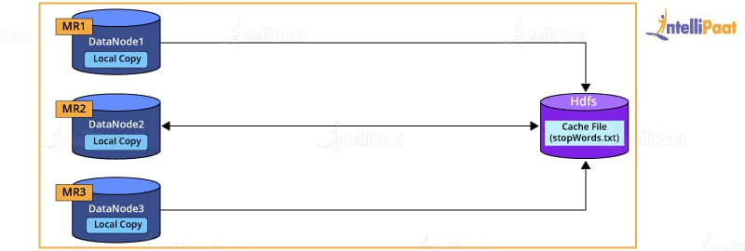
The benefits of using distributed cache are as follows:
- It distributes simple, read-only text/data files and/or complex files such as jars, archives, and others. These archives are then un-archived at the slave node.
- Distributed cache tracks the modification timestamps of cache files, which notify that the files should not be modified until a job is executed.
Learn more about MapReduce from this MapReduce Tutorial now!

27. Name the different configuration files in Hadoop
Below given are the names of the different configuration files in Hadoop:
- mapred-site.xml
- core-site.xml
- hdfs-site.xml
- yarn-site.xml

28. Can you skip the bad records in Hadoop? How?
In Hadoop, there is an option where sets of input records can be skipped while processing map inputs. This feature is managed by the applications through the SkipBadRecords class.
The SkipBadRecords class is commonly used when map tasks fail on input records. Please note that the failure can occur due to faults in the map function. Hence, the bad records can be skipped in Hadoop by using this class.

29. What are the various components of Apache HBase?
There are three main components of Apache HBase that are mentioned below:
- HMaster: It manages and coordinates the region server just like NameNode manages DataNodes in HDFS.
- Region Server: It is possible to divide a table into multiple regions and the region server makes it possible to serve a group of regions to the clients.
- ZooKeeper: ZooKeeper is a coordinator in the distributed environment of HBase. ZooKeeper communicates through the sessions to maintain the state of the server in the cluster.

30. What is the syntax to run a MapReduce program?
The syntax used to run a MapReduce program is hadoop_jar_file.jar /input_path /output_path.

31. Which command will you give to copy data from the local system onto HDFS?
hadoop fs –copyFromLocal [source][destination]

32. What are the components of Apache HBase’s Region Server?
The following are the components of HBase’s region server:
- BlockCache: It resides on the region server and stores data in the memory, which is read frequently.
- WAL: Write ahead log or WAL is a file that is attached to each region server located in the distributed environment.
- MemStore: MemStore is the write cache that stores the input data before it is stored in the disk or permanent memory.
- HFile: HDFS stores the HFile that stores the cells on the disk.

33. What are the various schedulers in YARN?
Mentioned below are the numerous schedulers that are available in YARN:
- FIFO Scheduler: The first-in-first-out (FIFO) scheduler places all the applications in a single queue and executes them in the same order as their submission. As the FIFO scheduler can block short applications due to long-running applications, it is less efficient and desirable for professionals.
- Capacity Scheduler: A different queue makes it possible to start executing short-term jobs as soon as they are submitted. Unlike in the FIFO scheduler, the long-term tasks are completed later in the capacity scheduler.
- Fair Scheduler: The fair scheduler, as the name suggests, works fairly. It balances the resources dynamically between all the running jobs and is not required to reserve a specific capacity for them.

34. What are the main components of YARN? Can you explain them?
The main components of YARN are explained below:
- Resource Manager: It runs on a master daemon and is responsible for controlling the resource allocation in the concerned cluster.
- Node Manager: It is responsible for executing a task on every single data node. Node manager also runs on the slave daemons in Hadoop.
- Application Master: It is an important component of YARN as it controls the user job life cycle and the resource demands of single applications. The application master works with the node manager to monitor the task execution.
- Container: It is like a combination of the Hadoop resources, which may include RAM, network, CPU, HDD, etc., on one single node.

35. Explain the difference among NameNode, Checkpoint NameNode, and Backup Node
- NameNode is the core of HDFS. NameNode manages the metadata. In simple terms, NameNode is the data about the data being stored. It supports a directory tree-like structure consisting of all the files present in HDFS on a Hadoop cluster. NameNode uses the following files for namespace:
  - fsimage file: It keeps track of the latest checkpoint of the namespace.
  - edits file: It is a log of changes that have been made to the namespace since the checkpoint.
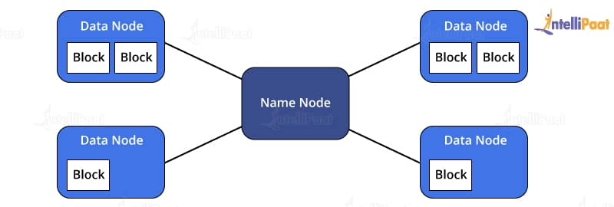
- Checkpoint NameNode has the same directory structure as NameNode. Checkpoint NameNode creates checkpoints for namespace at regular intervals by downloading the fsimage and editing files and margining them within the local directory. The new image after merging is then uploaded to NameNode. There is a similar node to Checkpoint, commonly known as the Secondary Node, but it does not support the upload-to-NameNode functionality.
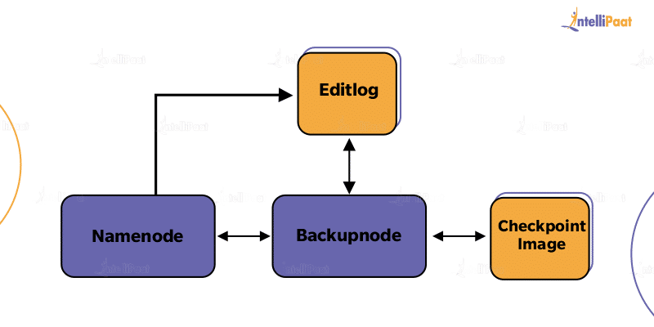
- Backup Node executes the online streaming of the File system edits transaction in the Primary Namenode. It is also responsible for implementing the Checkpoint functionality and acts as the dynamic backup for the Filesystem Namespace (Metadata) in the Hadoop system.
Go through this HDFS Tutorial to know how the distributed file system works in Hadoop!

36. What are the most common input formats in Hadoop?
There are three most common input formats in Hadoop:
- Text Input Format: Default input format in Hadoop
- Key-value Input Format: Used for plain text files where the files are broken into lines
- Sequence File Input Format: Used for reading files in sequence

37. What are the most common output formats in Hadoop?
The following are the commonly used output formats in Hadoop:
- Textoutputformat: TextOutputFormat is by default the output format in Hadoop.
- Mapfileoutputformat: Mapfileoutputformat writes the output as map files in Hadoop.
- DBoutputformat: DBoutputformat writes the output in relational databases and Hbase.
- Sequencefileoutputformat: Sequencefileoutputformat is used in writing sequence files.
- SequencefileAsBinaryoutputformat: SequencefileAsBinaryoutputformat is used in writing keys to a sequence file in binary format.

38. How to execute a Pig script?
The three methods listed below enable users to execute a Pig script:
- Grunt shell
- Embedded script
- Script file

39. What is Apache Pig and why is it preferred over MapReduce?
Apache Pig is a Hadoop-based platform that allows professionals to analyze large sets of data and represent them as data flows. Pig reduces the complexities that are required while writing a program in MapReduce, giving it an edge over MapReduce.
The following are some of the reasons why Pig is preferred over MapReduce:
- While Pig is a language for high-level data flow, MapReduce is a paradigm for low-level data processing.
- Without the need to write complex Java code in MapReduce, a similar result can easily be achieved in Pig.
- Pig approximately reduces the code length by 20 times, reducing the time taken for development by about 16 times than MapReduce.
- Pig offers built-in functionalities to perform numerous operations, including sorting, filters, joins, ordering, etc., which are extremely difficult to perform in MapReduce.
- Unlike MapReduce, Pig provides various nested data types such as bags, maps, and tuples.

40. What are the components of the Apache Pig architecture?
The components of the Apache Pig architecture are as follows:
- Parser: It is responsible for handling Pig scripts and checking the syntax of the script.
- Optimizer: Its function is to carry out the logical optimization such as projection pushdown, etc. It is the optimizer that receives the logical plan (DAG).
- Compiler: It is responsible for the conversion of the logical plan into a series of MapReduce jobs.
- Execution Engine: In the execution engine, MapReduce jobs get submitted in Hadoop in a sorted manner.
- Execution Mode: The execution modes in Apache Pig are local, and MapReduce modes and their selection entirely depends on the location where the data is stored and the place where you want to run the Pig script.

41. Mention some commands in YARN to check application status and to kill an application.
The YARN commands are mentioned below as per their functionalities:
1. yarn application - status ApplicationID
This command allows professionals to check the application status.
2. yarn application - kill ApplicationID
The command mentioned above enables users to kill or terminate a particular application.

42. What are the different components of Hive query processors?
There are numerous components that are used in Hive query processors. They are mentioned below:
- User-defined functions
- Semantic analyzer
- Optimizer
- Physical plan generation
- Logical plan generation
- Type checking
- Execution engine
- Parser
- Operators

43. What are the commands to restart NameNode and all the daemons in Hadoop?
The following commands can be used to restart NameNode and all the daemons:
- NameNode can be stopped with the ./sbin /Hadoop-daemon.sh stop NameNode command. The NameNode can be started by using the ./sbin/Hadoop-daemon.sh start NameNode command.
- The daemons can be stopped with the ./sbin /stop-all.sh The daemons can be started by using the ./sbin/start-all.sh command.

44. Define DataNode. How does NameNode tackle DataNode failures?
DataNode stores data in HDFS; it is a node where actual data resides in the file system. Each DataNode sends a heartbeat message to notify that it is alive. If the NameNode does not receive a message from the DataNode for 10 minutes, the NameNode considers the DataNode to be dead or out of place and starts the replication of blocks that were hosted on that DataNode such that they are hosted on some other DataNode. A BlockReport contains a list of all blocks on a DataNode. Now, the system starts to replicate what was stored in the dead DataNode.
The NameNode manages the replication of the data blocks from one DataNode to another. In this process, the replication data gets transferred directly between DataNodes such that the data never passes the NameNode.
You will find more in our Hadoop Community!

45. What is the significance of Sqoop’s eval tool?
The eval tool in Sqoop enables users to carry out user-defined queries on the corresponding database servers and check the outcome in the console.

46. Can you name the default file formats for importing data using Apache Sqoop?
Commonly, there are two file formats in Sqoop to import data. They are:
- Delimited Text File Format
- Sequence File Format

47. What is the difference between relational database and HBase?
The difference between relational database and HBase are mentioned below:
Relational Database | HBase
It is schema-based. | It has no schema.
It is row-oriented. | It is column-oriented.
It stores normalized data. | It stores denormalized data.
It consists of thin tables. | It consists of sparsely populated tables.
There is no built-in support or provision for automatic partitioning. | It supports automated partitioning.

48. What is the jps command used for?
The jps command is used to know or check whether the Hadoop daemons are running or not. The active or running status of all Hadoop daemons, which are namenode, datanode, resourcemanager, nodemanager, are displayed by this command.


49. What are the core methods of a reducer?
The three core methods of a reducer are as follows:
- setup(): This method is used for configuring various parameters such as input data size and distributed cache.
public void setup (context)
- reduce(): This method is the heart of the reducer and is always called once per key with the associated reduced task.
public void reduce(Key, Value, context)
- cleanup(): This method is called to clean the temporary files, only once at the end of the task.
public void cleanup (context)

50. What is Apache Flume? List the components of Apache Flume
Apache Flume is a tool or system, in Hadoop, that is used for assembling, aggregating, and carrying large amounts of streaming data. This can include data such as record files, events, etc. The main function of Apache Flume is to carry this streaming data from various web servers to HDFS.
The components of Apache Flume are as below:
- Flume Channel
- Flume Source
- Flume Agent
- Flume Sink
- Flume Event

Advanced Interview Questions

51. What are the differences between MapReduce and Pig?
The differences between MapReduce and Pig are mentioned below:
MapReduce | Pig
It has more lines of code as compared to Pig. | It has fewer lines of code.
It is a low-level language that makes it difficult to perform operations such as join. | It is a high-level language that makes it easy to perform join and other similar operations.
Its compiling process is time-consuming. | During execution, all the Pig operators are internally converted into a MapReduce job.
A MapReduce program that is written in a particular version of Hadoop may not work in others. | It works in all Hadoop versions.

52. List the configuration parameters in a MapReduce program
The configuration parameters in MapReduce are given below:
- Input locations of Jobs in the distributed file system
- Output location of Jobs in the distributed file system
- The input format of data
- The output format of data
- The class containing the map function
- The class containing the reduce function
- JAR file containing the classes—mapper, reducer, and driver

53. What is the default file size of an HDFS data block?
Hadoop keeps the default file size of an HDFS data block as 128 mb.

54. Why are the data blocks in HDFS so huge?
The reason behind the large size of the data blocks in HDFS is that the transfer happens at the disk transfer rate in the presence of large-sized blocks. On the other hand, if the size is kept small, there will be a large number of blocks to be transferred, which will force the HDFS to store too much metadata, thus increasing traffic.

55. What is a SequenceFile in Hadoop?
Extensively used in MapReduce I/O formats, SequenceFile is a flat-file containing binary key-value pairs. The map outputs are stored as SequenceFile internally. It provides reader, writer, and sorter classes. The three SequenceFile formats are as follows:
- Uncompressed key-value records
- Record compressed key-value records—only values are compressed here
- Block compressed key-value records—both keys and values are collected in blocks separately and compressed. The size of the block is configurable
Want to know more about Hadoop? Go through this extensive Hadoop Tutorial!

56. What do you mean by WAL in HBase?
WAL is otherwise referred to as a write ahead log. This file is attached to each Region Server present inside the distributed environment. WAL stores the new data, which is yet to be kept in permanent storage. WAL is often used to recover datasets in case of any failure.

57. List the two types of metadata that are stored by the NameNode server
The NameNode server stores metadata in disk and RAM. The two types of metadata that the NameNode server stores are:
- EditLogs
- FsImage

58. Explain the architecture of YARN and how it allocates various resources to applications?
There is an application, API, or client that communicates with the ResourceManager, which then deals with allocating resources in the cluster. It has an awareness of the resources present with each node manager. There are two internal components of the ResourceManager, application manager and scheduler. The scheduler is responsible for allocating resources to the numerous applications running in parallel based on their requirements. However, the scheduler does not track the application status.
The application manager accepts the submission of jobs and manages and reboots the application master if there is a failure. It manages the applications’ demands for resources and communicates with the scheduler to get the needed resources. It interacts with the NodeManager to manage and execute the tasks that monitor the jobs running. Moreover, it also monitors the resources utilized by each container.
A container consists of a set of resources, including CPU, RAM, and network bandwidth. It allows the applications to use a predefined number of resources.
The ResourceManager sends a request to the NodeManager to keep a few resources to process as soon as there is a job submission. Later, the NodeManager assigns an available container to carry out the processing. The ResourceManager then starts the application master to deal with the execution and it runs in one of the given containers. The rest of the containers available are used for the execution process. This is the overall process of how YARN allocates resources to applications via its architecture.

59. What are the differences between Sqoop and Flume?
The following are the various differences between Sqoop and Flume:

Sqoop | Flume
It works with NoSQL databases and RDBMS for importing and exporting data. | It works with streaming data, which is regularly generated in the Hadoop environment.
In Sqoop, loading data is not event-driven. | In Flume, loading data is event-driven.
It deals with data sources that are structured, and Sqoop connectors help in extracting data from them. | It extracts streaming data from application or web servers.
It takes data from RDBMS, imports it to HDFS, and exports it back to RDBMS. | Data from multiple sources flows into HDFS.

60. What is the role of a JobTracker in Hadoop?
A JobTracker’s primary role is resource management, managing the TaskTrackers, tracking resource availability, and task life cycle management, tracking the tasks’ progress and fault tolerance.
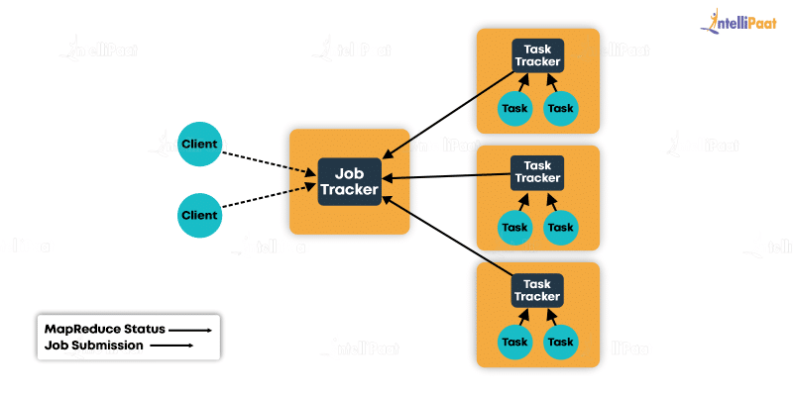

- JobTracker is a process that runs on a separate node, often not on a DataNode.
- JobTracker communicates with the NameNode to identify the data location.
- JobTracker finds the best TaskTracker nodes to execute the tasks on the given nodes.
- JobTracker monitors individual TaskTrackers and submits the overall job back to the client.
- JobTracker tracks the execution of MapReduce workloads local to the slave node.
Enroll in the Hadoop Course in London to get a clear understanding of Hadoop!

61. Can you name the port numbers for JobTracker, NameNode, and TaskTracker
JobTracker: The port number for JobTracker is Port 50030
NameNode: The port number for NameNode is Port 50070
TaskTracker: The port number for TaskTracker is Port 50060

62. What are the components of the architecture of Hive?
- User Interface: It requests the execute interface for the driver and also builds a session for this query. Further, the query is sent to the compiler in order to create an execution plan for the same.
- Metastore: It stores the metadata and transfers it to the compiler to execute a query.
- Compiler: It creates the execution plan. It consists of a DAG of stages wherein each stage can either be a map, metadata operation, or reduce an operation or job on HDFS.
- Execution Engine: It bridges the gap between Hadoop and Hive and helps in processing the query. It communicates with the metastore bidirectionally in order to perform various tasks.

63. Is it possible to import or export tables in HBase?
Yes, tables can be imported and exported in HBase clusters by using the commands listed below:
For export:
hbase org.apache.hadoop.hbase.mapreduce.Export “table name” “target export location”
For import:
create ‘emp_table_import’, {NAME => ‘myfam’, VERSIONS => 10}

hbase org.apache.hadoop.hbase.mapreduce.Import “table name” “target import location”

64. Why does Hive not store metadata in HDFS?
Hive stores the data of HDFS and the metadata is stored in the RDBMS or it is locally stored. HDFS does not store this metadata because the read or write operations in HDFS take a lot of time. This is why Hive uses RDBMS to store this metadata in the megastore rather than HDFS. This makes the process faster and enables you to achieve low latency.

65. What are the significant components in the execution environment of Pig?
The main components of a Pig execution environment are as follows:
- Pig Scripts: They are written in Pig with the help of UDFs and built-in operators and are then sent to the execution environment.
- Parser: It checks the script syntax and completes type checking. Parser’s output is a directed acyclic graph (DAG).
- Optimizer: It conducts optimization with operations such as transform, merges, etc., to minimize the data in the pipeline.
- Compiler: It automatically converts the code that is optimized into a MapReduce job.
- Execution Engine: The MapReduce jobs are sent to these engines in order to get the required output.

66. What is the command used to open a connection in HBase?
The command mentioned below can be used to open a connection in HBase:
Configuration myConf = HBaseConfiguration.create();
HTableInterface usersTable = new HTable(myConf, “users”);

67. What is the use of RecordReader in Hadoop?
Though InputSplit defines a slice of work, it does not describe how to access it. This is where the RecordReader class comes into the picture; it takes the byte-oriented data from its source and converts it into record-oriented key-value pairs such that it is fit for the Mapper task to read it. Meanwhile, InputFormat defines this Hadoop RecordReader instance.

68. How does Sqoop import or export data between HDFS and RDBMS?
The steps followed by Sqoop to import and export data, using its architecture, between HDFS and RDBMS are listed below:
- Search the database to collect metadata.
- Sqoop splits the input dataset and makes use of the respective map jobs to push these splits to HDFS.
- Search the database to collect metadata.
- Sqoop splits the input dataset and makes use of respective map jobs to push these splits to RDBMS. Sqoop exports back the Hadoop files to the RDBMS tables.

69. What is speculative execution in Hadoop?
One limitation of Hadoop is that by distributing the tasks on several nodes, there are chances that a few slow nodes limit the rest of the program. There are various reasons for the tasks to be slow, which are sometimes not easy to detect. Instead of identifying and fixing the slow-running tasks, Hadoop tries to detect when the task runs slower than expected and then launches other equivalent tasks as a backup. This backup mechanism in Hadoop is speculative execution.
Speculative execution creates a duplicate task on another disk. The same input can be processed multiple times in parallel. When most tasks in a job come to completion, the speculative execution mechanism schedules duplicate copies of the remaining tasks, which are slower, across the nodes that are free currently. When these tasks are finished, it is intimated to the JobTracker. If other copies are executing speculatively, then Hadoop notifies the TaskTrackers to quit those tasks and reject their output.
Speculative execution is, by default, true in Hadoop. To disable it, mapred.map.tasks.speculative.execution and mapred.reduce.tasks.speculative.execution JobConf options can be set to false.
Are you interested in learning Hadoop from experts? Enroll in our Hadoop Course in Bangalore now!

70. What is Apache Oozie?
Apache Oozie is nothing but a scheduler that helps to schedule jobs in Hadoop and bundles them as a single logical work. Oozie jobs can largely be divided into the following two categories:
- Oozie Workflow: These jobs are a set of sequential actions that need to be executed.
- Oozie Coordinator: These jobs are triggered as and when there is data available for them, until which, it rests.

71. What happens if you try to run a Hadoop job with an output directory that is already present?
It will throw an exception saying that the output file directory already exists.
To run the MapReduce job, it needs to be ensured that the output directory does not exist in the HDFS.
To delete the directory before running the job, shell can be used:
Hadoop fs –rmr /path/to/your/output/
Or the Java API:
FileSystem.getlocal(conf).delete(outputDir, true);

72. How can you debug Hadoop code?
First, the list of MapReduce jobs currently running should be checked. Next, it needs to be ensured that there are no orphaned jobs running; if yes, the location of RM logs needs to be determined.
- Run:
ps –ef | grep –I ResourceManager

Look for the log directory in the displayed result. Find out the job ID from the displayed list and check if there is an error message associated with that job.

- On the basis of RM logs, identify the worker node that was involved in the execution of the task.
- Now, log in to that node and run the below-mentioned code:
ps –ef | grep –iNodeManager

- Then, examine the NodeManager The majority of errors come from the user-level logs for each MapReduce job.

73. How to configure the replication factor in HDFS?
The hdfs-site.xml file is used to configure HDFS. Changing the dfs.replication property in hdfs-site.xml will change the default replication for all the files placed in HDFS.
The replication factor on a per-file basis can also be modified by using the following:
Hadoop FS Shell:[training@localhost ~]$ hadoopfs –setrep –w 3 /my/fileConversely,
The replication factor of all the files under a directory can also be changed.
[training@localhost ~]$ hadoopfs –setrep –w 3 -R /my/dir
Learn more about Hadoop from this Big Data Hadoop Training in New York to get ahead in your career!

74. How to compress a mapper output not touching reducer output?
To achieve this compression, the following should be set:
conf.set("mapreduce.map.output.compress", true)
conf.set("mapreduce.output.fileoutputformat.compress", false)

75. What are the basic parameters of a mapper?
Given below are the basic parameters of a mapper:
- LongWritable and Text
- Text and IntWritable

76. What is the difference between map-side join and reduce-side join?
Map-side join is performed when data reaches the map. A strict structure is needed for defining map-side join.
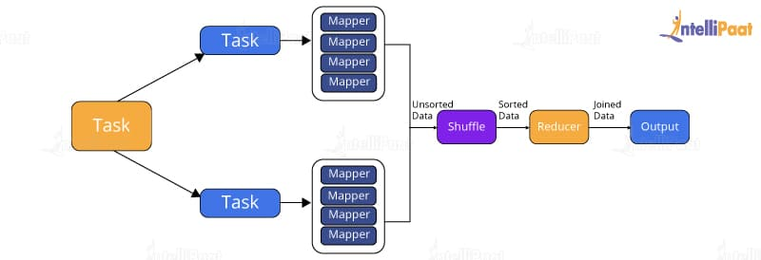
On the other hand, reduce-side join, or repartitioned join, is simpler than map-side join since the input datasets in reduce-side join need not be structured. However, it is less efficient as it will have to go through sort and shuffle phases, coming with network overheads.

77. How can you transfer data from Hive to HDFS?
By writing the query:
hive> insert overwrite directory '/' select * from emp;
Write the query for the data to be imported from Hive to HDFS. The output received will be stored in part files in the specified HDFS path.

78. Which companies use Hadoop?
- Yahoo! – It is the biggest contributor to the creation of Hadoop; its search engine uses Hadoop
- Facebook – developed Hive for analysis
- Amazon
- Netflix
- Adobe
- eBay
- Spotify
- Twitter

