1) Define the Pandas/Python pandas?
Pandas is defined as an open-source library that provides high-performance data manipulation in Python. The name of Pandas is derived from the word Panel Data, which means an Econometrics from Multidimensional data. It can be used for data analysis in Python and developed by Wes McKinney in 2008. It can perform five significant steps that are required for processing and analysis of data irrespective of the origin of the data, i.e., load, manipulate, prepare, model, and analyze.

2) Mention the different types of Data Structures in Pandas?
Pandas provide two data structures, which are supported by the pandas library, Series, and DataFrames. Both of these data structures are built on top of the NumPy.
A Series is a one-dimensional data structure in pandas, whereas the DataFrame is the two-dimensional data structure in pandas.
Play Videox

3) Define Series in Pandas?
A Series is defined as a one-dimensional array that is capable of storing various data types. The row labels of series are called the index. By using a 'series' method, we can easily convert the list, tuple, and dictionary into series. A Series cannot contain multiple columns.

4) How can we calculate the standard deviation from the Series?
The Pandas std() is defined as a function for calculating the standard deviation of the given set of numbers, DataFrame, column, and rows.
Series.std(axis=None, skipna=None, level=None, ddof=1, numeric_only=None, **kwargs)

5) Define DataFrame in Pandas?
A DataFrame is a widely used data structure of pandas and works with a two-dimensional array with labeled axes (rows and columns) DataFrame is defined as a standard way to store data and has two different indexes, i.e., row index and column index. It consists of the following properties:
- The columns can be heterogeneous types like int and bool.
- It can be seen as a dictionary of Series structure where both the rows and columns are indexed. It is denoted as "columns" in the case of columns and "index" in case of rows.

6) What are the significant features of the pandas Library?
The key features of the panda's library are as follows:
- Memory Efficient
- Data Alignment
- Reshaping
- Merge and join
- Time Series

7) Explain Reindexing in pandas?
Reindexing is used to conform DataFrame to a new index with optional filling logic. It places NA/NaN in that location where the values are not present in the previous index. It returns a new object unless the new index is produced as equivalent to the current one, and the value of copy becomes False. It is used to change the index of the rows and columns of the DataFrame.

8) What is the name of Pandas library tools used to create a scatter plot matrix?
Scatter_matrix

9) Define the different ways a DataFrame can be created in pandas?
We can create a DataFrame using following ways:
- Lists
- Dict of ndarrays
Example-1: Create a DataFrame using List:

- import pandas as pd
- # a list of strings
- a = ['Python', 'Pandas']
- # Calling DataFrame constructor on list
- info = pd.DataFrame(a)
- print(info)
Output:
0
0 Python
1 Pandas
Example-2: Create a DataFrame from dict of ndarrays:

- import pandas as pd
- info = {'ID' :[101, 102, 103],'Department' :['B.Sc','B.Tech','M.Tech',]}
- info = pd.DataFrame(info)
- print (info)
Output:
ID Department
0 101 B.Sc
1 102 B.Tech
2 103 M.Tech

10) Explain Categorical data in Pandas?
A Categorical data is defined as a Pandas data type that corresponds to a categorical variable in statistics. A categorical variable is generally used to take a limited and usually fixed number of possible values. Examples: gender, country affiliation, blood type, social class, observation time, or rating via Likert scales. All values of categorical data are either in categories or np.nan.
This data type is useful in the following cases:
- It is useful for a string variable that consists of only a few different values. If we want to save some memory, we can convert a string variable to a categorical variable.
- It is useful for the lexical order of a variable that is not the same as the logical order (?one?, ?two?, ?three?) By converting into a categorical and specify an order on the categories, sorting and min/max is responsible for using the logical order instead of the lexical order.
- It is useful as a signal to other Python libraries because this column should be treated as a categorical variable.

11) How will you create a series from dict in Pandas?
A Series is defined as a one-dimensional array that is capable of storing various data types.
We can create a Pandas Series from Dictionary:
Create a Series from dict:
We can also create a Series from dict. If the dictionary object is being passed as an input and the index is not specified, then the dictionary keys are taken in a sorted order to construct the index.
If index is passed, then values correspond to a particular label in the index will be extracted from the dictionary.

- import pandas as pd
- import numpy as np
- info = {'x' : 0., 'y' : 1., 'z' : 2.}
- a = pd.Series(info)
- print (a)
Output:
x 0.0
y 1.0
z 2.0
dtype: float64

12) How can we create a copy of the series in Pandas?
We can create the copy of series by using the following syntax:
pandas.Series.copy
Series.copy(deep=True)
The above statements make a deep copy that includes a copy of the data and the indices. If we set the value of deep to False, it will neither copy the indices nor the data.

Note: If we set deep=True, the data will be copied, and the actual python objects will not be copied recursively, only the reference to the object will be copied.

13) How will you create an empty DataFrame in Pandas?
A DataFrame is a widely used data structure of pandas and works with a two-dimensional array with labeled axes (rows and columns) It is defined as a standard way to store data and has two different indexes, i.e., row index and column index.
Create an empty DataFrame:
The below code shows how to create an empty DataFrame in Pandas:

- # importing the pandas library
- import pandas as pd
- info = pd.DataFrame()
- print (info)
Output:
Empty DataFrame
Columns: []
Index: []

14) How will you add a column to a pandas DataFrame?
We can add any new column to an existing DataFrame. The below code demonstrates how to add any new column to an existing DataFrame:

- # importing the pandas library
- import pandas as pd
- info = {'one' : pd.Series([1, 2, 3, 4, 5], index=['a', 'b', 'c', 'd', 'e']),
- 'two' : pd.Series([1, 2, 3, 4, 5, 6], index=['a', 'b', 'c', 'd', 'e', 'f'])}

- info = pd.DataFrame(info)

- # Add a new column to an existing DataFrame object

- print ("Add new column by passing series")
- info['three']=pd.Series([20,40,60],index=['a','b','c'])
- print (info)
- print ("Add new column using existing DataFrame columns")
- info['four']=info['one']+info['three']
- print (info)
Output:
Add new column by passing series
one two three
a 1.0 1 20.0
b 2.0 2 40.0
c 3.0 3 60.0
d 4.0 4 NaN
e 5.0 5 NaN
f NaN 6 NaN

Add new column using existing DataFrame columns
one two three four
a 1.0 1 20.0 21.0
b 2.0 2 40.0 42.0
c 3.0 3 60.0 63.0
d 4.0 4 NaN NaN
e 5.0 5 NaN NaN
f NaN 6 NaN NaN

15) How to add an Index, row, or column to a Pandas DataFrame?
Adding an Index to a DataFrame
Pandas allow adding the inputs to the index argument if you create a DataFrame. It will make sure that you have the desired index. If you don?t specify inputs, the DataFrame contains, by default, a numerically valued index that starts with 0 and ends on the last row of the DataFrame.
Adding Rows to a DataFrame
We can use .loc, iloc, and ix to insert the rows in the DataFrame.
- The loc basically works for the labels of our index. It can be understood as if we insert in loc[4], which means we are looking for that values of DataFrame that have an index labeled 4.
- The iloc basically works for the positions in the index. It can be understood as if we insert in iloc[4], which means we are looking for the values of DataFrame that are present at index '4`.
- The ix is a complex case because if the index is integer-based, we pass a label to ix. The ix[4] means that we are looking in the DataFrame for those values that have an index labeled 4. However, if the index is not only integer-based, ix will deal with the positions as iloc.
Adding Columns to a DataFrame
If we want to add the column to the DataFrame, we can easily follow the same procedure as adding an index to the DataFrame by using loc or iloc.

16) How to Delete Indices, Rows or Columns From a Pandas Data Frame?
Deleting an Index from Your DataFrame
If you want to remove the index from the DataFrame, you should have to do the following:
Reset the index of DataFrame.
Executing del df.index.name to remove the index name.
Remove duplicate index values by resetting the index and drop the duplicate values from the index column.
Remove an index with a row.
Deleting a Column from Your DataFrame
You can use the drop() method for deleting a column from the DataFrame.
The axis argument that is passed to the drop() method is either 0 if it indicates the rows and 1 if it drops the columns.
You can pass the argument inplace and set it to True to delete the column without reassign the DataFrame.
You can also delete the duplicate values from the column by using the drop_duplicates() method.

Removing a Row from Your DataFrame
By using df.drop_duplicates(), we can remove duplicate rows from the DataFrame.
You can use the drop() method to specify the index of the rows that we want to remove from the DataFrame.

17) How to Rename the Index or Columns of a Pandas DataFrame?
You can use the .rename method to give different values to the columns or the index values of DataFrame.

18) How to iterate over a Pandas DataFrame?
You can iterate over the rows of the DataFrame by using for loop in combination with an iterrows() call on the DataFrame.

19) How to get the items of series A not present in series B?
We can remove items present in p2 from p1 using isin() method.

- import pandas as pd
- p1 = pd.Series([2, 4, 6, 8, 10])
- p2 = pd.Series([8, 10, 12, 14, 16])
- p1[~p1.isin(p2)]
Solution
0 2
1 4
2 6
dtype: int64

20) How to get the items not common to both series A and series B?
We get all the items of p1 and p2 not common to both using below example:

- import pandas as pd
- import numpy as np
- p1 = pd.Series([2, 4, 6, 8, 10])
- p2 = pd.Series([8, 10, 12, 14, 16])
- p1[~p1.isin(p2)]
- p_u = pd.Series(np.union1d(p1, p2)) # union
- p_i = pd.Series(np.intersect1d(p1, p2)) # intersect
- p_u[~p_u.isin(p_i)]
Output:
0 2
1 4
2 6
5 12
6 14
7 16
dtype: int64

21) How to get the minimum, 25th percentile, median, 75th, and max of a numeric series?
We can compute the minimum, 25th percentile, median, 75th, and maximum of p as below example:

- import pandas as pd
- import numpy as np
- p = pd.Series(np.random.normal(14, 6, 22))
- state = np.random.RandomState(120)
- p = pd.Series(state.normal(14, 6, 22))
- np.percentile(p, q=[0, 25, 50, 75, 100])
Output:
array([ 4.61498692, 12.15572753, 14.67780756, 17.58054104, 33.24975515])

22) How to get frequency counts of unique items of a series?
We can calculate the frequency counts of each unique value p as below example:

- import pandas as pd
- import numpy as np
- p= pd.Series(np.take(list('pqrstu'), np.random.randint(6, size=17)))
- p = pd.Series(np.take(list('pqrstu'), np.random.randint(6, size=17)))
- p.value_counts()
Output:
s 4
r 4
q 3
p 3
u 3

23) How to convert a numpy array to a dataframe of given shape?
We can reshape the series p into a dataframe with 6 rows and 2 columns as below example:

- import pandas as pd
- import numpy as np
- p = pd.Series(np.random.randint(1, 7, 35))
- # Input
- p = pd.Series(np.random.randint(1, 7, 35))
- info = pd.DataFrame(p.values.reshape(7,5))
- print(info)
Output:
0 1 2 3 4
0 3 2 5 5 1
1 3 2 5 5 5
2 1 3 1 2 6
3 1 1 1 2 2
4 3 5 3 3 3
5 2 5 3 6 4
6 3 6 6 6 5

24) How can we convert a Series to DataFrame?
The Pandas Series.to_frame() function is used to convert the series object to the DataFrame.

- Series.to_frame(name=None)
name: Refers to the object. Its Default value is None. If it has one value, the passed name will be substituted for the series name.

- s = pd.Series(["a", "b", "c"],
- name="vals")
- s.to_frame()
Output:
vals
0 a
1 b
2 c

25) What is Pandas NumPy array?
Numerical Python (Numpy) is defined as a Python package used for performing the various numerical computations and processing of the multidimensional and single-dimensional array elements. The calculations using Numpy arrays are faster than the normal Python array.

26) How can we convert DataFrame into a NumPy array?
For performing some high-level mathematical functions, we can convert Pandas DataFrame to numpy arrays. It uses the DataFrame.to_numpy() function.
The DataFrame.to_numpy() function is applied to the DataFrame that returns the numpy ndarray.

- DataFrame.to_numpy(dtype=None, copy=False)

27) How can we convert DataFrame into an excel file?
We can export the DataFrame to the excel file by using the to_excel() function.
To write a single object to the excel file, we have to specify the target file name. If we want to write to multiple sheets, we need to create an ExcelWriter object with target filename and also need to specify the sheet in the file in which we have to write.

28) How can we sort the DataFrame?
We can efficiently perform sorting in the DataFrame through different kinds:
- By label
- By Actual value
By label
The DataFrame can be sorted by using the sort_index() method. It can be done by passing the axis arguments and the order of sorting. The sorting is done on row labels in ascending order by default.
By Actual Value
It is another kind through which sorting can be performed in the DataFrame. Like index sorting, sort_values() is a method for sorting the values.
It also provides a feature in which we can specify the column name of the DataFrame with which values are to be sorted. It is done by passing the 'by' argument.

29) What is Time Series in Pandas?
The Time series data is defined as an essential source for information that provides a strategy that is used in various businesses. From a conventional finance industry to the education industry, it consists of a lot of details about the time.
Time series forecasting is the machine learning modeling that deals with the Time Series data for predicting future values through Time Series modeling.

30) What is Time Offset?
The offset specifies a set of dates that conform to the DateOffset. We can create the DateOffsets to move the dates forward to valid dates.

31) Define Time Periods?
The Time Periods represent the time span, e.g., days, years, quarter or month, etc. It is defined as a class that allows us to convert the frequency to the periods.

32) How to convert String to date?
The below code demonstrates how to convert the string to date:

- fromdatetime import datetime

- # Define dates as the strings
- dmy_str1 = 'Wednesday, July 14, 2018'
- dmy_str2 = '14/7/17'
- dmy_str3 = '14-07-2017'

- # Define dates as the datetime objects
- dmy_dt1 = datetime.strptime(date_str1, '%A, %B %d, %Y')
- dmy_dt2 = datetime.strptime(date_str2, '%m/%d/%y')
- dmy_dt3 = datetime.strptime(date_str3, '%m-%d-%Y')

- #Print the converted dates
- print(dmy_dt1)
- print(dmy_dt2)
- print(dmy_dt3)
Output:
2017-07-14 00:00:00
2017-07-14 00:00:00
2018-07-14 00:00:00

33) What is Data Aggregation?
The main task of Data Aggregation is to apply some aggregation to one or more columns. It uses the following:
- sum: It is used to return the sum of the values for the requested axis.
- min: It is used to return a minimum of the values for the requested axis.
- max: It is used to return a maximum values for the requested axis.

34) What is Pandas Index?
Pandas Index is defined as a vital tool that selects particular rows and columns of data from a DataFrame. Its task is to organize the data and to provide fast accessing of data. It can also be called a Subset Selection.

35) Define Multiple Indexing?
Multiple indexing is defined as essential indexing because it deals with data analysis and manipulation, especially for working with higher dimensional data. It also enables us to store and manipulate data with the arbitrary number of dimensions in lower-dimensional data structures like Series and DataFrame.

36) Define ReIndexing?
Reindexing is used to change the index of the rows and columns of the DataFrame. We can reindex the single or multiple rows by using the reindex() method. Default values in the new index are assigned NaN if it is not present in the DataFrame.
DataFrame.reindex(labels=None, index=None, columns=None, axis=None, method=None, copy=True, level=None, fill_value=nan, limit=None, tolerance=None)

37) How to Set the index?
We can set the index column while making a data frame. But sometimes, a data frame is made from two or more data frames, and then the index can be changed using this method.

38) How to Reset the index?
The Reset index of the DataFrame is used to reset the index by using the 'reset_index' command. If the DataFrame has a MultiIndex, this method can remove one or more levels.

39) Describe Data Operations in Pandas?
In Pandas, there are different useful data operations for DataFrame, which are as follows:
- Row and column selection
We can select any row and column of the DataFrame by passing the name of the rows and columns. When you select it from the DataFrame, it becomes one-dimensional and considered as Series.
- Filter Data
We can filter the data by providing some of the boolean expressions in DataFrame.
- Null values
A Null value occurs when no data is provided to the items. The various columns may contain no values, which are usually represented as NaN.

40) Define GroupBy in Pandas?
In Pandas, groupby() function allows us to rearrange the data by utilizing them on real-world data sets. Its primary task is to split the data into various groups. These groups are categorized based on some criteria. The objects can be divided from any of their axes.
DataFrame.groupby(by=None, axis=0, level=None, as_index=True, sort=True, group_keys=True, squeeze=False, **kwargs)

1. Define Python Pandas?
Ans: Pandas refer to a data analysis and manipulation software library built specifically for Python. Wes McKinney designed Pandas, an open-source, cross-platform library. It was first released in 2008, and it included data structures and procedures for manipulating numerical and time-series data. Pandas can be installed with the pip package manager or the Anaconda distribution. Pandas make doing machine learning algorithms on tabular data a breeze.
If you would like to Enrich your career with a Python certified professional, then visit Mindmajix - A Global online training platform: “Python Online Training” Course. This course will help you to achieve excellence in this domain.

2. Mention different types of Data Structures in Panda?
Ans: Series and DataFrames are the two types of data structures that the Pandas library supports. Numpy serves as the foundation for both data structures. A DataFrame is a two-dimensional data structure in Pandas, while a Series is a one-dimensional data structure. A panel, a three-dimensional data structure that includes items, a major axis, and a minor axis, is another axis label.

3. What is Python Panda used for?
Ans: Pandas is a data manipulation and analysis software library for the Python programming language. It includes data structures and methods for manipulating numerical tables and time series, in particular. Pandas is open-source software licensed under the BSD three-clause license.
Also Read Related Article: Python Tutorial

4. List out the key features of Panda Library?
Ans: The pandas library has a number of features, some of which are shown here.
- Memory Efficient
- Time Series
- Reshaping
- Data Alignment
- Merge and join

5. Give a brief description about time series in Panda?
Ans: A time series is an organized collection of data that depicts the evolution of a quantity through time. Pandas have a wide range of capabilities and tools for working with time-series data in all fields.
Supported by pandas:
- Analyzing time-series data from a variety of sources and formats
- Create time and date sequences with preset frequencies.
- Date and time manipulation and conversion with timezone information
- A time series is resampled or converted to a specific frequency.
- Calculating dates and times using absolute or relative time increments is one way to

6. Explain how to create and copy a series in Pandas?
Ans: To copy the series in pandas:
pandas. series.copy
series.copy (deep=True)
pandas. series. copy. Make a significant copy of everything, including the data and indices. Deep=False copies of neither the indices nor the data. When deep = True, data is transferred, only the connection to the object is emulated recursively, not the actual Python objects.


7. Characterize the Data Frames in Pandas?
Ans: A DataFrame is a panda-specific lewis structure that functions with a two-dimensional display with tomahawks (rows and columns). A DataFrame is a typical way of storing data that has two separate indices, namely a row index and a column index. It includes the following characteristics:
Columns such as int and bool are heterogeneous.
It's commonly thought of as a term reference for a series structure that includes both rows and columns. If there are columns, it is denoted as "columns," and if there are lines, it is denoted as "index."
Syntax: import pandas as pd
df=pd.Dataframe()

8. Explain how to create a series from dict in Pandas?
Ans: A Series is a one-dimensional designated array that can hold any form of data (python objects, strings, integers, floating-point numbers, etc.). It's important to understand that, unlike Python lists, a series always contains the same type of data.
Let's look at how to make a Panda Series using the Dictionary.
The Series () method is used without the index parameter.

9. Explain about the operation on Series in Pandas?
Ans: The Pandas Series is a one-dimensional classified array that may hold any type of data (python objects, strings, integers, floating-point numbers, etc.). The axis identifiers are referred to as an index. The Pandas Series is merely a column in an excel spreadsheet.
Putting Together a Pandas Series-
A Pandas Series is built in the real world by loading datasets from existing storage, which can be a SQL database, a CSV file, or an Excel file. Pandas Series can be made from lists, dictionaries, and other things. A series can be developed in a number of ways; here are a few examples: cheval cheval cheval cheval cheval cheval cheval cheval cheval cheval cheval cheval cheval cheval cheval cheval cheval
Creating a series from an array: To construct a series from an array, we must first load a NumPy module and then use its array() functions.
# import pandas as pd
import pandas as pd
# import numpy as np
import numpy as np
# simple array
data = np.array([‘M’,’I’,’N’,’D’,’M’,’A’,’J’,’I’,’X’])
ser = pd.Series(data)
print(ser)
Output: MINDMAJIX
Read Also: Array Example in Python

10. Explain different ways of creating Data Frames in Panda?
Ans: A data frame can be created in 3 different ways:
By making use of lists:
d = [[‘a’, 2], [‘b’, 3], [‘c’, 4]]
Creating the Pandas Dataframe:
df = pd.DataFrame (d, columns = [‘Strings’, ‘Integer’])
print(df)
By making use of a dictionary of lists:
All of the arrays in a data frame made from a list's dictionaries must be the same length. If the list is passed, the running time of the list will match the running time of the shows. If no document is specified, the items will be a range (n), where n is the array length, as is conventional.
By using arrays:
import pandas as pd
d = {‘Name’:[‘XYZ, ‘ABC’, ‘DEFC’, ‘ASWE’], ‘marks’:[85, 80, 75, 70]}
df = pd.DataFrame(d, index =[‘first’, ‘second’, ‘third’, ‘fourth’])
print(df)

11. Explain how to create empty DataFrames in Panda?
Ans: To make a Pandas data frame that is fully empty, perform the following:
import pandas as pd
MyEmptydf ()= pd.DataFrame
This will result in a data frame that has no columns or rows.
We do the following to construct an empty dataframe with three empty columns (columns A, B, and C):
df= pd.DataFrame(columns=['A', 'B', 'C'])

12. How will you add a column to the Existing Data Frames in Panda?
Ans: Import pandas as a package, import pandas as pd
# Define a dictionary containing employee data.
Employee ={ ‘Emp_name’:{‘Name’: [‘Ravi’, ‘Roshan', ‘Vinod’, ‘Sailu’],
‘ Emp_id’: [123, 234, 145, 125],
‘Emp_qualification’= [‘Msc’, ‘BA’, ‘MBA’, ‘Msc’]}
# Convert the dictionary into DataFrame
df = pd.DataFrame(Employee)
# Declare a list that is to be converted into a column
Emp_address = [‘Hyderabad’, ‘Delhi’, ‘Lucknow’, ‘Vijayawada’]
# Using ‘Address’ as the column name
# and equating it to the list
df[‘Address’] = Emp_address
# Observe the result
df
Output:
 | Emp_name | Emp_id | Emp_qualification | Emp_address
0 | Ravi | 123 | MSC | Hyderabad
1 | Roshan | 234 | BA | Delhi
2 | Vinod | 145 | MBA | Lucknow
3 | Sailu | 125 | MSC | Vijayawada

13. Tell us now how to retrieve a single column from a Panda Dataframe?
Ans: Use the query $django-admin.py to start a Django project, and then use the following queries:
Project
_init_.py
manage.py
settings.py
urls.py

14. Explain about Categorical Data in Pandas?
Ans: Categorical is a data type in Pandas that corresponds to categorical variables in statistics. A categorical variable has a limited and usually fixed, set of possible values (categories; levels in R). Gender, social class, blood type, national affiliation, observation time, or rating using Likert scales are some examples. All categorical data values are either in categories or np. nan.
In the following situations, categorical data is useful:
A string parameter with a small number of distinct values. Transforming a string parameter to a category variable can help you save memory.
A variable's lexical order differs from its analytical order ("one," "two," and "three"). Indexing and min/max will utilize the analytical order rather than the lexical order after transforming to a categorical and providing order on the categories.
To indicate to other Python libraries that this column is a categorical variable (so that appropriate statistical technique or plot types can be used).

15. Explain about Multi Indexing in pandas?
Ans: Multiple indexing is classified as fundamental indexing because it simplifies information inspection and control, especially when dealing with higher-dimensional data. It also allows us to store and handle data in lower-dimensional data structures like series and dataframes with an unlimited number of measurements.

Advanced Pandas Interview Questions and Answers:

16. Explain about Pandas index?
Ans: Indexing in Pandas is the process of extracting specific rows and columns of data from a DataFrame. Indexing could simply be selecting all of the rows and some of the columns, or part of the rows and all of the columns, along with some of each row and column. Indexing is often referred to as subset selection.
Pandas Indexing with [],.loc[],.iloc[], and.ix []
There are numerous methods for obtaining the objects, elements, items, rows, and columns from a data frame. In Pandas, some indexing methods can be used to retrieve an object/element/item from a data frame. These indexing systems look to be extremely similar. However, they perform significantly differently. The Pandas support four methods of multi-axis indexing, which are as follows:
Dataframe. []: This method is also known as the indexing operator.
Dataframe. loc []: This method is used for labels.
Dataframe.iloc[] : This method is utilized for integer or position based
Dataframe. ix[]: This function is utilized for both integer and label based
They are referred to collectively as indexers. All of those are, by far, the most popular methods of indexing data. These four functions assist in retrieving the object/elements/items, rows, and columns from a DataFrame.
Also Read: Python Partial Function Using Functools

17. Explain about Reindexing in Pandas?
Ans: The DataFrame is reindexed to adhere to a new index with configurable filling logic. It inserts NA/NaN in the areas where the elements are missing from the previous index. Unless the new index is constructed as equivalent to the present one, in which case the copy value becomes false. It is used to modify the index of the dataframe's rows and columns.

18. Can you explain multi-indexing columns in Pandas?
Ans: Because it involves data manipulation and analysis, multiple indexing is characterized as vital indexing. This is certainly relevant when operating with hyperdimensional data. It also allows us to store and modify data in lower-dimensional data structures like DataFrame and series with an indefinite number of dimensions.
Multiple Index Columns
Two columns will be used as index columns in this case. The drop option is used to remove a column, whereas the append attribute is used to append given columns to an index column that already exists.
Example:
# importing pandas library from
# python
import pandas as pd
# Creating data
Information = {'name': ["Saikat", "Shrestha", "Sandi", "Abinash"],
'Jobs': ["Software Developer", "System Engineer",
"Footballer", "Singer"],
'Annual Salary(L.P.A)': [12.4, 5.6, 9.3, 10]}
# Data Framing the whole data
df = pd.DataFrame(dict)
# Showing the above data
print(df)
Output:

19. What is meant by set the index in Pandas?
Ans: Python is an excellent language for analyzing data, particularly with its vast ecological community of data-driven Python packages. Pandas is another of those packages, and it makes data import and analysis considerably easier.
Pandas set_index () is a function for modifiying the index of a data frame from a data frame, series, or list. The index column can also be set while creating a data frame. However, because a data frame might be made up of two or more data frames, the index can be altered later using this method.
Syntax:
DataFrame.set_index(keys, drop=True, append=False,
inplace=False, verify_integrity=False
Parameters:
keys: The name of the column or a list of column names.
If True, drop is a Boolean value that removes the index column.
If True, the column is appended to the existing index column.
Inplace, If True, the changes are made in the data frame.
If True, verify_integrity will check the new index column for duplicates.
Example:
# importing pandas library
import pandas as pd
# creating and initializing a nested list
students = [['jack', 34, 'Sydeny', 'Australia',85.96],
['Riti', 30, 'Delhi', 'India',95.20],
['Vansh', 31, 'Delhi', 'India',85.25],
['Nanyu', 32, 'Tokyo', 'Japan',74.21],
['Maychan', 16, 'New York', 'US',99.63],
['Mike', 17, 'las vegas', 'US',47.28]]
# Create a DataFrame object
df = pd.DataFrame(students,
columns=['Name', 'Age', 'City', 'Country','Agg_Marks'],
index=['a', 'b', 'c', 'd', 'e', 'f'])
# here we set Float column 'Agg_Marks' as index of data frame
# using dataframe.set_index() function
df = df.set_index('Agg_Marks')
# Displaying the Data frame
df

20. Explain how to reset the index in pandas?
Ans: Pandas is a one-dimensional ndarray with identifiers on the axes. The identifiers do not have to be distinct, but they must be of the hashable type. The entity allows both label-based and integer indexing, as well as a set of techniques for handling the index.
The pandas function series.reset_index () creates a reinvigorated series or data frame with the index reset. This is useful when an index must be utilized as a column.
Syntax:
reset_index(level=None, drop=False, inplace=False, col_level=0, col_fill='')
Parameters:
level: int, str, tuple, or list None(default)
Only the specified levels should be removed from the index. By default, all levels are removed.
drop: default False, bool
Inserting indexes into data frame columns is not recommended. This returns the index to its original integer value.
inplace: False by default bool
Modify the existing DataFrame (do not create a new object).
col_level: default 0 for int and str
This determines the level the labels are inserted into if the columns have several levels. It is inserted into the first level by default.
col_fill: default object
Evaluate how the other levels are named if the columns have different levels. If there is no value, the index name is replicated.
# Import pandas package
import pandas as pd
# Define a dictionary containing employee data
data = {'Name':['Jai', 'Kanth', 'Vinod, 'Seeraj', 'Kokila'],
'Age':[27, 26, 23, 30, 25],
'Address':['Delhi', 'Gujart', 'Hyderabad', 'Vizag', 'Noida'],
'Qualification':['MCA', 'Ms', ‘BA’, 'Phd', 'MS'] }
index = {'a', 'b', 'c', 'd', 'e'}
# Convert the dictionary into DataFrame
df = pd.DataFrame(data, index)
# Make Own Index as index
# In this case default index is exist
df.reset_index(inplace = True)
df

21. Explain about Data operations in Pandas?
Ans: There are several useful data operations for DataFrame in Pandas, which are as follows:
-> Row and column selection:
We can retrieve any row and column of the DataFrame by specifying the names of the rows and columns. It is one-dimensional and is regarded as a Series when you select it from the DataFrame.
-> Filter Data:
By using some of the boolean logic in DataFrame, you may filter the data.
-> Null values:
When no data is being sent to the items, a Null value can appear. There may be no values in the respective columns, which are commonly represented as NaN. Pandas provide several useful functions for identifying, deleting, and changing null values in Data Frames. The following are the functions:
- isnull(): isnull 's job is to return true if either of the rows have null values.
- notnull(): It is the inverse of the isnull() function, returning true values for non-null values.
- dropna(): This function evaluates and removes null values from rows and columns.
- fillna(): It enables users to substitute other values for the NaN values.
- replace(): It's a powerful function that can take the role of a regex, dictionary, string, series, and more.
- interpolate(): It's a useful function for filling null values in a series or data frame.
-> String Operation:
Pandas provide a set of string functions for working with string data while ignoring missing/NaN values. The .str. option can be used to conduct various string operations. The following are the functions:
- lower(): Any strings in the index or series are converted to lowercase letters.
- upper(): Any strings in the index or series are converted to uppercase letters.
- strip(): This method eliminates spacing from every string in the Series/index, along with a new line.
- split(' '): It's a method that separates a string according to a pattern.
- cat(sep=' '): With a defined separator, it concatenates series/index items.
- contains(pattern): If a substring is available in the current element, it returns True; otherwise, it returns False.
- replace(a,b): It substitutes the value b for the value a.
- repeat(value): Each element is repeated a defined multiple times.
- count(pattern): It returns the number of times a pattern appears in each element.
- startswith(pattern): If all of the components in the series begin with a pattern, it returns True.
- endswith(pattern): If all of the components in the series terminate in a pattern, it returns True.
- find(pattern): It can be used to return the pattern's first occurrence.
- findall(pattern): It gives you a list of all the times the pattern appears.
- swapcase: It is used to switch the lower/upper case.
- islower(): If all of the characters in the Series/Index string are lowercase, it returns True. Otherwise, False is returned.
- isupper(): If all of the characters in the Series/Index string are uppercase, it returns True. Otherwise, False is returned.
- isnumeric(): If all of the characters in the Series/Index string are numeric, it returns True. Otherwise, False is returned.
-> Count Values:
Using the 'value counts()' option, this process is used to count the overall possible combinations.

22. How Can A Dataframe Be Converted To An Excel File?
Ans: Using the to excel () function, we can export the data frame to an excel file. We must mention the target file name to write a single object to an excel file. If we wish to write to many sheets, we must build an ExcelWriter object with the target filename and the sheet in the file that we want to write to.
Visit here to learn Python Training in Bangalore

23. How To Format The Data in Your Pandas DataFrame?
Ans: Almost all of the time, you'll want to be ready to execute operations on the absolute measurements in your data frame.
Replacing All String Occurrences in a DataFrame:
The Replace() method can be used to easily replace specific strings in your data frame. Simply pass the values you are trying to enhance, accompanied by the values you would like to substitute them with.
It's worth noting that there's a regex argument that can come in handy when dealing with unusual string combinations. In a nutshell, replace() method is used when you wish to substitute values or strings in your DataFrame with those from elsewhere.
Removing Parts From Strings in the Cells of Your DataFrame:
Removing unnecessary strings is a time-consuming task. Fortunately, there is a remedy! You apply the lambda function to each element or element-by-element of the column using map() on the column result. The function takes the string value and removes the + or — on the left, as well as any of the six aAbBcC on the right.
Splitting Text in a Column into Multiple Rows in a DataFrame:
It's difficult to divide your text into many rows.
Applying A Function to Your Pandas DataFrame’s Columns or Rows:
You might want to use a function to alter the information in the DataFrame. The code pieces illustrate how to implement a method to a DataFrame.
Explore Python Sample Resumes! Download & Edit, Get Noticed by Top Employers!

24. Explain about Data Aggregation in Pandas?
Ans: To implement any aggregation method across one or more columns, use the Dataframe. aggregate() method. Use strings, callables, dictionaries, or a collection of strings to aggregate. The following are the most common aggregations:
- Sum: This method returns the sum of the values for the requested column.
- Min: This method returns the minimum value for the requested column.
- Max: This method returns the maximum value for the requested column.
Syntax: DataFrame.aggregate(func, axis=0, *args, **kwargs)
function: string, callable, list, or dictionary of callables. Use this function to aggregate the data. If a function is handed a data frame, it must either work or be allowed to pass to the data frame. apply. If the variables are DataFrame column names, you can give a dict to a DataFrame.
the axis (default 0) 1 or 'columns', 0 or 'index' Apply the method to each column with a 0 or index. 1 or 'columns': for each row, apply the function.
Let us see an example for data aggregation:
# importing pandas package
import pandas as pd
# making data frame from csv file
df = pd.read_csv("nba.csv")
# printing the first 10 rows of the dataframe
df[:10]

25. What is the use of GroupBy Pandas?
Ans: The data is divided into groups using GroupBy. It organizes the data according to certain parameters. Labels are mapped to group names when using grouping. It has a lot of different versions that can be made using the parameters, and it makes separating data a breeze.
Syntax: DataFrame.groupby(by=None, axis=0, level=None, as_index=True, sort=True, group_keys=True, squeeze=False, **kwargs)

26. What is Pandas Numpy?
Ans: Pandas Numpy is an open-source Python package that would be used to work with a huge number of datasets. It includes a robust N-dimensional array object as well as complicated mathematical algorithms for data processing with Python.
Fourier transformations, linear programming, and pseudo-random capabilities are among the prominent features provided by Numpy. It also includes integrated tools for C/C++ and Fortran programming.

27. What is Vectorization in Python pandas?
Ans: The procedure of executing operations on the full array is known as vectorization. This is intended to limit the number of iterations that the methods do. Pandas have a series of vectorized methods, such as string functions and aggregations, that are optimized for use with series and dataframes. As a result, it is preferable to use vectorized pandas methods to perform the tasks quickly.

28. How will you combine different Data Frames in Panda?
Ans: Following are the ways to combine different Data Frames in panda:
-> append() method: This is used to horizontally stack the dataframes.
Syntax: df1.append(df2)
-> concat() method: This is used to sequentially stack data frames. This works best because the data frames have the same fields and columns.
Syntax: pd.concat([df1, df2])
-> join() method: This is used to extract data from different dataframes that have one or more common columns.
Syntax: df1.join(df2)

29. How can you iterate over the Data frame in Pandas?
Ans: Iterating over a DataFrame in pandas for loop can be merged with an iterrows () call.
Read Related Article: Python for loop

30. What Method Will You Use To Rename The Index Or Columns Of Pandas Dataframe?
Ans: The .rename method is used to rename DataFrame index values or columns.

Frequently Asked Pandas Interview Questions:

1. What is the basic use of pandas?
Ans: Pandas is a popular open-source Python library used for analyzing the data, Machine learning and data science.

2. Is Panda a module or library?
Ans: Pandas is a programming interface for Python. It offers ready-to-use high-performance data analysis tools and data structures. Pandas is a Python package for analyzing the data and data science that runs on top of NumPy.

3. What is the full form of pandas?
Ans: The acronym for "Python Data Analysis Library" is "Python Data Analysis Library." The phrase comes from the multiple linear regression term "panel data," which applies to dimensional discrete classes "Pandas," according to the Wikipedia article. However, I feel it is a catchy moniker for a fantastic Python package!

4. What type of inputs are accepted by pandas?
Ans: Like Series, DataFrame accepts many different kinds of input:
- Dict of 1D ndarrays, lists, dicts, or Series.
- 2-D numpy. ndarray.
- Structured or recorded ndarray.
- A Series.
- Another DataFrame.

5. Which are the data structures available with Pandas?
Ans: Series and Data Frames are the two basic types of data structures supported by Pandas. Series is a one-dimensional data structure, whereas DataFrames are two-dimensional data structures.
Q1. Which programming language is the Pandas tool designed for?
Pandas is a data analysis and manipulation tool explicitly written for the Python programming language.
Q2. Which are some domain interviews where recruiters ask Panda interview questions?
Pandas interview questions are asked at domain interviews for data scientists, python software developers, data engineers, and data analysts.
Q3. What are Panda interview questions asked at Python interviews?
Panda interview questions are typically around indexing, Panda DataFrames, Panda data structures, and Panda functions.
Q4. Which are the data structures available with Pandas?
Pandas supports two main types of data structures - DataFrame and Series. DataFrames are two-dimensional data structures, while Series is a one-dimensional data structure.
Q5. What is NumPy in Pandas?
NumPy in Pandas is a built-in package used to perform numerical calculations and process elements in one-dimensional and two-dimensional arrays.
Question 1 – Define Python Pandas.
Pandas refer to a software library explicitly written for Python, which is used to analyze and manipulate data. Pandas is an open-source, cross-platform library created by Wes McKinney. It was released in 2008 and provided data structures and operations to manipulate numerical and time-series data. Pandas can be installed using pip or Anaconda distribution. Pandas make it very easy to perform machine learning operations on tabular data.
Question 2 – What Are The Different Types Of Data Structures In Pandas?
Panda library supports two major types of data structures, DataFrames and Series. Both these data structures are built on the top of NumPy. Series is a one dimensional and simplest data structure, while DataFrame is two dimensional. Another axis label known as the “Panel” is a 3-dimensional data structure and includes items such as major_axis and minor_axis.
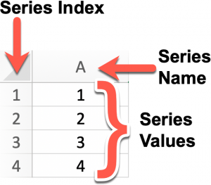
Source
Question 3 – Explain Series In Pandas.
Series is a one-dimensional array that can hold data values of any type (string, float, integer, python objects, etc.). It is the simplest type of data structure in Pandas; here, the data’s axis labels are called the index.
Question 4 – Define Dataframe In Pandas.
A DataFrame is a 2-dimensional array in which data is aligned in a tabular form with rows and columns. With this structure, you can perform an arithmetic operation on rows and columns.
Our learners also read: Free online python course for beginners!
Question 5 – How Can You Create An Empty Dataframe In Pandas?
To create an empty DataFrame in Pandas, type
import pandas as pd
ab = pd.DataFrame()

Also read: Free data structures and algorithm course!
Question 6 – What Are The Most Important Features Of The Pandas Library?
Important features of the panda’s library are:
- Data Alignment
- Merge and join
- Memory Efficient
- Time series
- Reshaping
Read: Dataframe in Apache PySpark: Comprehensive Tutorial
Question 7 – How Will You Explain Reindexing In Pandas?
To reindex means to modify the data to match a particular set of labels along a particular axis.
Various operations can be achieved using indexing, such as-
- Insert missing value (NA) markers in label locations where no data for the label existed.
- Reorder the existing set of data to match a new set of labels.
upGrad’s Exclusive Data Science Webinar for you –
How to Build Digital & Data Mindset
Video Player
00:00
33:02
Question 8 – What are the different ways of creating DataFrame in pandas? Explain with examples.
DataFrame can be created using Lists or Dict of nd arrays.
Example 1 – Creating a DataFrame using List
import pandas as pd
# a list of strings
Strlist = [‘Pandas’, ‘NumPy’]
# Calling DataFrame constructor on the list
list = pd.DataFrame(Strlist)
print(list)
Must read: Learn excel online free!
Example 2 – Creating a DataFrame using dict of arrays
import pandas as pd
list = {‘ID’: [1001, 1002, 1003],’Department’:[‘Science’, ‘Commerce’, ‘Arts’,]}
list = pd.DataFrame(list)
print (list)
Check out: Data Science Interview Questions
Question 9 – Explain Categorical Data In Pandas?
Categorical data refers to real-time data that can be repetitive; for instance, data values under categories such as country, gender, codes will always be repetitive. Categorical values in pandas can also take only a limited and fixed number of possible values.
Numerical operations cannot be performed on such data. All values of categorical data in pandas are either in categories or np.nan.
This data type can be useful in the following cases:
If a string variable contains only a few different values, converting it into a categorical variable can save some memory.
It is useful as a signal to other Python libraries because this column must be treated as a categorical variable.
A lexical order can be converted to a categorical order to be sorted correctly, like a logical order.

Explore our Popular Data Science Courses
Executive Post Graduate Programme in Data Science from IIITB | Professional Certificate Program in Data Science for Business Decision Making | Master of Science in Data Science from University of Arizona
Advanced Certificate Programme in Data Science from IIITB | Professional Certificate Program in Data Science and Business Analytics from University of Maryland | Data Science Courses
Question 10 – Create A Series Using Dict In Pandas.
import pandas as pd
import numpy as np
ser = {‘a’ : 1, ‘b’ : 2, ‘c’ : 3}
ans = pd.Series(ser)
print (ans)
Question 11 – How To Create A Copy Of The Series In Pandas?
To create a copy of the series in pandas, the following syntax is used:
pandas.Series.copy
Series.copy(deep=True)
* if the value of deep is set to false, it will neither copy data nor the indices.
Question 12 – How Will You Add An Index, Row, Or Column To A Dataframe In Pandas?
To add rows to a DataFrame, we can use .loc (), .iloc () and .ix(). The .loc () is label based, .iloc() is integer based and .ix() is booth label and integer based. To add columns to the DataFrame, we can again use .loc () or .iloc ().
Question 13 – What Method Will You Use To Rename The Index Or Columns Of Pandas Dataframe?
.rename method can be used to rename columns or index values of DataFrame
Question 14 – How Can You Iterate Over Dataframe In Pandas?
To iterate over DataFrame in pandas for loop can be used in combination with an iterrows () call.

Read our popular Data Science Articles
Data Science Career Path: A Comprehensive Career Guide | Data Science Career Growth: The Future of Work is here | Why is Data Science Important? 8 Ways Data Science Brings Value to the Business
Relevance of Data Science for Managers | The Ultimate Data Science Cheat Sheet Every Data Scientists Should Have | Top 6 Reasons Why You Should Become a Data Scientist
A Day in the Life of Data Scientist: What do they do? | Myth Busted: Data Science doesn’t need Coding | Business Intelligence vs Data Science: What are the differences?
Question 15 – What Is Pandas Numpy Array?
Numerical Python (NumPy) is defined as an inbuilt package in python to perform numerical computations and processing of multidimensional and single-dimensional array elements.
NumPy array calculates faster as compared to other Python arrays.
Question 16 – How Can A Dataframe Be Converted To An Excel File?
To convert a single object to an excel file, we can simply specify the target file’s name. However, to convert multiple sheets, we need to create an ExcelWriter object along with the target filename and specify the sheet we wish to export.
Question 17 – What Is Groupby Function In Pandas?
In Pandas, groupby () function allows the programmers to rearrange data by using them on real-world sets. The primary task of the function is to split the data into various groups.
Also Read: Top 15 Python AI & Machine Learning Open Source Projects

Frequently Asked Python Pandas Interview Questions For Experienced Candidates
Till now, we have looked at some of the basic pandas questions that you can expect in an interview. If you are looking for some more advanced pandas interview questions for the experienced, then refer to the list below. Seek reference from these questions and curate your own pandas interview questions and answers pdf.
1. What do we mean by data aggregation?
One of the most popular pandas questions that are frequently asked in interviews is this one. The main goal of data aggregation is to add some aggregation in one or more columns. It does so by using the following
Sum- It is specifically used when you want to return the sum of values for the requested axis.
Min-This is used to return the minimum values for the requested axis.
Max- Contrary to min, Max is used to return a maximum value for the requested axis.
2. What do we mean by Pandas index?
Yet another frequently asked pandas interview question is what do we mean by pandas index. Well, you can answer the same in the following manner.
Pandas index basically refers to the technique of selecting particular rows and columns of data from a data frame. Also known as subset selection, you can either select all the rows and some of the columns, or some rows and all of the columns. It also allows you to select only some of the rows and columns. There are mainly four types of multi-axes indexing, supported by Pandas. They are
- Dataframe.[ ]
- Dataframe.loc[ ]
- Dataframe.iloc[ ]
- Dataframe.ix[ ]
3. What do we mean by Multiple Indexing?
Multiple indexing is often referred to as essential indexing since it allows you to deal with data analysis and analysis, especially when you are working with high-dimensional data. Furthermore, with the help of this, you can also store and manipulate data with an arbitrary number of dimensions.
These are some of the most common python pandas interview questions that you can expect in an interview. Therefore, it is important that you clear all your doubts regarding the same for a successful interview experience. Incorporate these questions in your pandas interview questions and answers pdf to get started on your interview preparation!

Top Data Science Skills to Learn in 2022
SL. No | Top Data Science Skills to Learn in 2022
1 | Data Analysis Course | Inferential Statistics Courses
2 | Hypothesis Testing Programs | Logistic Regression Courses
3 | Linear Regression Courses | Linear Algebra for Analysis

Conclusion
We hope the above-mentioned Pandas interview questions and NumPy interview questions will help you prepare for your upcoming interview sessions. If you are looking for courses that can help you get a hold of Python language, upGrad can be the best platform.
If you are curious to learn about data science, check out IIIT-B & upGrad’s Executive PG Programme in Data Science which is created for working professionals and offers 10+ case studies & projects, practical hands-on workshops, mentorship with industry experts, 1-on-1 with industry mentors, 400+ hours of learning and job assistance with top firms.

Pandas library is used for which purpose?
The main reason behind the usage of Pandas is for data analysis. Pandas allows the users to import data from various formats like Microsoft Excel, SQL, JSON, and also comma-separated values. Pandas is considered to be very useful for data analysis because it allows the users to perform different data manipulation operations like selecting, reshaping, merging, and data cleaning too. Other than that, Pandas also provide various data wrangling features.
In simple terms, we can say that Pandas make it easy to perform various time-consuming and repetitive tasks that involve data. The tasks made easy with Pandas are:
1. Merging and joining Statistical
2.analysis Data
3. normalization Data
4. filling Data
5. cleansing Data
6. inspection Loading and saving data
7. Data visualization
These are just a few of the data manipulation tasks made easy with Pandas. Data Scientists vote Pandas to be the best tool available for data analysis and manipulation.

What are some of the essential features provided by Python Pandas?
For harnessing the true power of the Pandas library in Python, you should explore some of the essential features being offered to the users. When it comes to data analysis, Pandas is considered to be the most powerful tool with plenty of features to make things easier for users.
Some of the essential features that you should know about before starting your usage with Pandas library are:
1. Data handling
2. Data alignment and indexing
3. Data cleaning
4. Handling missing data
5. Various input and output tools for reading and writing data
6. Supports multiple file formats
7. Merge and join different datasets
8. Performance optimization
9. Data visualization
10. Grouping the data as per requirement
11. Performing different mathematical operations on the available data
12. Masking out irrelevant data to only use the required data
13. Taking out unique data from various repetitions in the dataset

Q1:
How to create new columns derived from existing columns in Pandas?
Entry

Pandas 68

Answer
- We create a new column by assigning the output to the DataFrame with a new column name in between the [].
- Let's say we want to create a new column 'C' whose values are the multiplication of column 'B' with column 'A'. The operation will be easy to implement and will be element-wise, so there's no need to loop over rows.
import pandas as pd
# Create example data
df = pd.DataFrame({
"A": [420, 380, 390],
"B": [50, 40, 45]})

df["C"] = df["A"] * df["B"]
- Also other mathematical operators (+, -, \*, /) or logical operators (<, >, =,…) work element-wise. But if we need more advanced logic, we can use arbitrary Python code via apply().
- Depending on the case, we can use rename with a dictionary or function to rename row labels or column names according to the problem.
Having Machine Learning, Data Science or Python Interview? Check 68 Pandas Interview Questions
Source: pandas.pydata.org

Q2:
A column in a df has boolean True/False values, but for further calculations, we need 1/0 representation. How would you transform it?
Junior

Pandas 68

Answer
A succinct way to convert a single column of boolean values to a column of integers 1 or 0 is:
df["somecolumn"] = df["somecolumn"].astype(int)
Having Machine Learning, Data Science or Python Interview? Check 68 Pandas Interview Questions
Source: stackoverflow.com

Q3:
Describe how you will get the names of columns of a DataFrame in Pandas
Junior

Pandas 68

Answer
- By Simply iterating over columns, and printing the values.
for col in data.columns:
print(col)
- Using .columns() method with the dataframe object, this returns the column labels of the DataFrame.
list(data.columns)
- Using the column.values() method to return an array of index.
list(data.columns.values)
- Using sorted() method, which will return the list of columns sorted in alphabetical order.
sorted(data)
Having Machine Learning, Data Science or Python Interview? Check 68 Pandas Interview Questions
Source: www.geeksforgeeks.org

Q4:
How are iloc() and loc() different?
Junior

Pandas 68

Answer
- DataFrame.iloc is a method used to retrieve data from a Data frame, and it is an integer position-based locator (from 0 to length-1 of the axis), but may also be used with a boolean array. It takes input as integer, arrays of integers, a slice object, boolean array and functions.
df.iloc[0]
df.iloc[-5:]
df.iloc[:, 2] # the : in the first position indicates all rows
df.iloc[:3, :3] # The upper-left 3 X 3 entries (assuming df has 3+ rows and columns)
- DataFrame.loc gets rows (and/or columns) with particular labels. It takes input as a single label, list of arrays and slice objects with labels.
df = pd.DataFrame(index=['a', 'b', 'c'], columns=['time', 'date', 'name'])
df.loc['a'] # equivalent to df.iloc[0]
df.loc['b':, 'date'] # equivalent to df.iloc[1:, 1]
Having Machine Learning, Data Science or Python Interview? Check 68 Pandas Interview Questions
Source: stackoverflow.com

Q5:
How can you sort the DataFrame?
Junior

Pandas 68

Answer
The function used for sorting in pandas is called DataFrame.sort_values(). It is used to sort a DataFrame by its column or row values. The function comes with a lot of parameters, but the most important ones to consider for sort are:
- by: The optional by parameter is used to specify the column/row(s) which are used to determine the sorted order.
- axis: specifies whether sort for row (0) or columns (1),
- ascending: specifies whether to sort the dataframe in ascending or descending order. The default value is ascending. To sort in descending order, we need to specify ascending=False.
Example
>>> df = pd.DataFrame({
'col1': ['A', 'A', 'B', np.nan, 'D', 'C'],
'col2': [2, 1, 9, 8, 7, 4],
'col3': [0, 1, 9, 4, 2, 3],
'col4': ['a', 'B', 'c', 'D', 'e', 'F']})
>>> df
col1 col2 col3 col40 A 2 0 a1 A 1 1 B2 B 9 9 c3 NaN 8 4 D4 D 7 2 e5 C 4 3 F
#Sort by col1>>> df.sort_values(by=['col1'])
col1 col2 col3 col40 A 2 0 a1 A 1 1 B2 B 9 9 c5 C 4 3 F4 D 7 2 e3 NaN 8 4 D

# Sort by multiple columns>>> df.sort_values(by=['col1', 'col2'])
col1 col2 col3 col41 A 1 1 B0 A 2 0 a2 B 9 9 c5 C 4 3 F4 D 7 2 e3 NaN 8 4 D
# Sort descending
df.sort_values(by='col1', ascending=False)
col1 col2 col3 col44 D 7 2 e5 C 4 3 F2 B 9 9 c0 A 2 0 a1 A 1 1 B3 NaN 8 4 D
Having Machine Learning, Data Science or Python Interview? Check 68 Pandas Interview Questions
Source: towardsdatascience.com

17 Recurrent Neural Network (RNN) Interview Questions For Data Scientists and ML Engineers

RNN 17

Q6:
How can you find the row for which the value of a specific column is max or min?
Junior

Pandas 68

Problem
>>> import pandas as pd>>> df = pandas.DataFrame(np.random.randn(5,3),columns=['A','B','C'])>>> df
A B C0 -0.068471 -0.006429 1.4537851 -0.655960 0.084291 0.3443512 -0.058856 0.025537 1.3034883 -0.300120 -0.207405 1.1087044 2.027010 0.190007 -0.064194
Answer
Use the pandas idxmax and idxmin function. It's straightforward:

Maximal value:

>>> df['A'].idxmax()
4

Minimal value:

>>>df['A'].idxmin()
1

Having Machine Learning, Data Science or Python Interview? Check 68 Pandas Interview Questions
Source: pandas.pydata.org

Q7:
How can you get a list of Pandas DataFrame columns based on data type?
Junior

Pandas 68

Answer
We can use the function select_dtypes() to select columns by dtype and then use the columns attribute to save the selected columns into a list.
In [2]: df = pd.DataFrame({'NAME': list('abcdef'),
'On_Time': [True, False] * 3,
'On_Budget': [False, True] * 3})

In [3]: df.select_dtypes(include=['bool'])
Out[3]:
On_Budget On_Time
0 False True
1 True False
2 False True
3 True False
4 False True
5 True False

In [4]: mylist = list(df.select_dtypes(include=['bool']).columns)

In [5]: mylist
Out[5]: ['On_Budget', 'On_Time']
Having Machine Learning, Data Science or Python Interview? Check 68 Pandas Interview Questions
Source: stackoverflow.com

Q8:
How does the groupby() method works in Pandas?
Junior

Pandas 68

Answer

In the first stage of the process, data contained in a pandas object, whether a Series, DataFrame, or otherwise, is split into groups based on one or more keys that we provide.

The splitting is performed on a particular axis of an object. For example, a DataFrame can be grouped on its rows (axis=0) or its columns (axis=1).

Once this is done, a function is applied to each group, producing a new value. Finally, the results of all those function applications are combined into a result object. The form of the resulting object will usually depend on what's being done to the data.

In the figure below, this process is illustrated for a simple group aggregation.

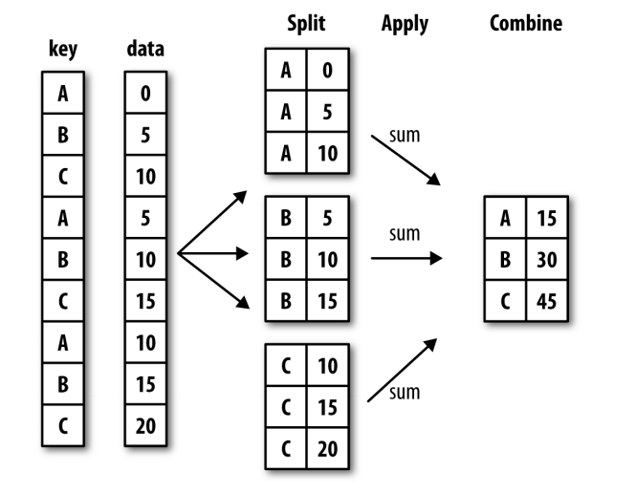
Having Machine Learning, Data Science or Python Interview? Check 68 Pandas Interview Questions
Source: www.amazon.com

Genetic Algorithms 45

Curse of Dimensionality 14

RNN 17

Cost Function 13

 Unsupervised Learning 27

CNN 13

Classification 43

 Julia 50

SQL 47

Recommendation Systems 30

Check FullStack.Cafe - 3877 Full-Stack, Coding & System Design Questions and Answers

Q9:
How to split a string column in a DataFrame into two columns?
Junior

Pandas 68

Problem
I have a dataframe with one (string) column and I'd like to split it into two (string) columns, with one column header as code and the other location.
>>>import pandas as pd>>> df = pd.DataFrame({'row': ['00000 UNITED STATES', '01000 ALABAMA',
'01001 Autauga County, AL', '01003 Baldwin County, AL',
'01005 Barbour County, AL']}
Answer
You can use str.split by whitespace (default separator) and parameter expand=True for DataFrame with assign to new columns:
>>> df[['code','location']] = df['row'].str.split(n=1, expand=True)>>> df
row code location
0 00000 UNITED STATES 00000 UNITED STATES
1 01000 ALABAMA 01000 ALABAMA
2 01001 Autauga County, AL 01001 Autauga County, AL
3 01003 Baldwin County, AL 01003 Baldwin County, AL
4 01005 Barbour County, AL 01005 Barbour County, AL
Having Machine Learning, Data Science or Python Interview? Check 68 Pandas Interview Questions
Source: stackoverflow.com

27 SVM Interview Questions (ANSWERED) To Master Before ML & Data Science Interview

SVM 56

Q10:
How to check whether a Pandas DataFrame is empty?
Junior

Pandas 68

Answer
You can use the attribute df.empty to check whether it's empty or not:
if df.empty:
print('DataFrame is empty!')
Having Machine Learning, Data Science or Python Interview? Check 68 Pandas Interview Questions
Source: stackoverflow.com

Q11:
How would you iterate over rows in a DataFrame in Pandas?
Junior

Pandas 68

Answer
DataFrame.iterrows is a generator which yields both the index and row (as a Series):
import pandas as pd

df = pd.DataFrame({'c1': [10, 11, 12], 'c2': [100, 110, 120]})
for index, row in df.iterrows():
print(row['c1'], row['c2'])
10 10011 11012 120
Having Machine Learning, Data Science or Python Interview? Check 68 Pandas Interview Questions
Source: stackoverflow.com

Q12:
What are the operations that Pandas Groupby method is based on ?
Junior

Pandas 68

Answer
- Splitting the data into groups based on some criteria.
- Applying a function to each group independently.
- Combining the results into a data structure.
Having Machine Learning, Data Science or Python Interview? Check 68 Pandas Interview Questions
Source: pandas.pydata.org

Q13:
What does describe() percentiles values tell about our data?
Junior

Pandas 68

Answer
The percentiles describe the distribution of your data: 50 should be a value that describes the middle of the data, also known as median. 25, 75 is the border of the upper/lower quarter of the data. With this can get an idea of how skew our data is.
If the mean is higher than the median, the data is right skewed.
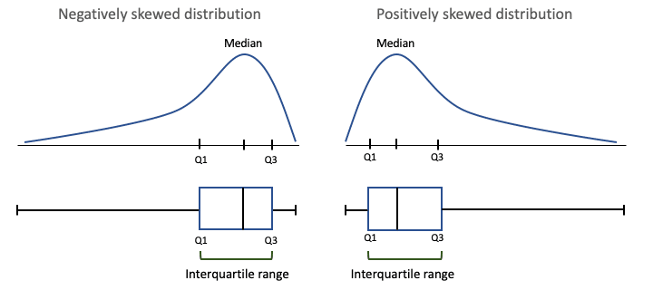
Having Machine Learning, Data Science or Python Interview? Check 68 Pandas Interview Questions
Source: datascience.stackexchange.com

17 Principal Component Analysis (PCA) Interview Questions (ANSWERED)

 PCA 17

Q14:
Why do should make a copy of a DataFrame in Pandas?
Junior

Pandas 68

Answer
In general, it is safer to work on copies than on original DataFrames, except when you know that you won't be needing the original anymore and want to proceed with the manipulated version.
This is because in Pandas, indexing a DataFrame returns a reference to the initial DataFrame. Thus, changing the subset will change the initial DataFrame. Thus, you'd want to use the copy if you want to make sure the initial DataFrame shouldn't change.
Normally, you would still have some use for the original data frame to compare with the manipulated version, etc. Therefore, depending on the case it's a good practice to work on copies and merge at the end.
Having Machine Learning, Data Science or Python Interview? Check 68 Pandas Interview Questions
Source: stackoverflow.com

Q15:
Compare the Pandas methods: map(), applymap(), apply()
Mid

Pandas 68

Answer

The map() method is an elementwise method for only Pandas Series, it maps values of Series according to input correspondence.

  - It accepts dicts, Series, or callable. Values that are not found in the dict are converted to NaN,
# Example:

s = pd.Series(['cat', 'dog', np.nan, 'rabbit'])print(s)0 cat1 dog2 NaN3 rabbit

s.map({'cat': 'kitten', 'dog': 'puppy'})
0 kitten1 puppy2 NaN3 NaN

The applymap() method is an elementwise function for only DataFrames, it applies a function that accepts and returns a scalar to every element of a DataFrame.

  - It accepts callables only i.e a Python function.
# Example:

df = pd.DataFrame([[1, 2.12], [3.356, 4.567]])print(df)
0 10 1.000 2.1201 3.356 4.567
# Square each element

df.applymap(lambda x: x**2)
0 10 1.000000 4.4944001 11.262736 20.857489

The apply() method also works elementwise, as it applies a function along input axis of DataFrame. It is suited to more complex operations and aggregation.

  - It accepts the callables parameter as well.
df = pd.DataFrame([[4, 9]] * 3, columns=['A', 'B'])
print(df)
A B0 4 91 4 92 4 9

df.apply(np.sqrt)

A B0 2.0 3.01 2.0 3.02 2.0 3.0
Having Machine Learning, Data Science or Python Interview? Check 68 Pandas Interview Questions
Source: stackoverflow.com

 Searching 24

NumPy 39

SVM 56

Unsupervised Learning 27

Pandas 68

Probability 34

RNN 17

 Data Processing 81

Keras 62

Logistic Regression 24

Check FullStack.Cafe - 3877 Full-Stack, Coding & System Design Questions and Answers

Q16:
Describe how you can combine (merge) data on Common Columns or Indices?
Mid

Pandas 68

Answer

Using .merge() method which merges DataFrame or named Series objects with a database-style join. You have inner, left, right and outer merge operation.

By default, the Pandas merge operation acts with an “inner” merge. An inner merge, keeps only the common values in both the left and right dataframes for the result.

- Left merge, keeps every row in the left dataframe. Where there are missing values of the “on” variable in the right dataframe, it adds empty / NaN values in the result.
- Right merge, keeps every row in the right dataframe. Where there are missing values of the “on” variable in the left column, it adds empty / NaN values in the result.
- A full outer join returns all the rows from the left dataframe, all the rows from the right dataframe, and matches up rows where possible, with NaNs elsewhere
df1 = pd.DataFrame({'a': ['foo', 'bar'], 'b': [1, 2]})
df2 = pd.DataFrame({'a': ['foo', 'baz'], 'c': [3, 4]})
df1
a b0 foo 11 bar 2
df2
a c0 foo 31 baz 4

df1.merge(df2, how='inner', on='a')
a b c0 foo 1 3

df1.merge(df2, how='left', on='a')
a b c0 foo 1 3.01 bar 2 NaN
Having Machine Learning, Data Science or Python Interview? Check 68 Pandas Interview Questions
Source: realpython.com

Q17:
Find a way to binary encode multi-valued categorical variables from a Pandas dataframe
Mid

Pandas 68

Problem
Suppose we have the following dataframe with multiple values for a certain column:
categories0 - ["A", "B"]1 - ["B", "C", "D"]2 - ["B", "D"]
How can you get a table like this?
"A" "B" "C" "D"0 - 1 1 0 01 - 0 1 1 12 - 0 1 0 1
Answer

If [0, 1, 2] are numerical labels and is not the index, then pandas.DataFrame.pivot_table works:

In []:
data = pd.DataFrame.from_records(
[[0, 'A'], [0, 'B'], [1, 'B'], [1, 'C'], [1, 'D'], [2, 'B'], [2, 'D']],
columns=['number_label', 'category'])
data.pivot_table(index=['number_label'], columns=['category'], aggfunc=[len], fill_value=0)

Out[]:
len
category A B C D
number_label 0 1 1 0 01 0 1 1 12 0 1 0 1

Now if [0, 1, 2] is the index, then collections.Counter is useful:

In []:>>> import collections>>> data2 = pd.DataFrame.from_dict(
{'categories': {0: ['A', 'B'], 1: ['B', 'C', 'D'], 2:['B', 'D']}})>>> data3 = data2['categories'].apply(collections.Counter)>>> data3 = pd.DataFrame.from_records(data3).fillna(value=0)>>> data3.applymap(lambda x: int(x))

Out[]:
A B C D0 1 1 0 01 0 1 1 12 0 1 0 1

Having Machine Learning, Data Science or Python Interview? Check 68 Pandas Interview Questions
Source: datascience.stackexchange.com

27 Advanced NumPy Interview Questions (ANSWERED) To Crush Your Data Science Interview

NumPy 39

Q18:
Group DataFrame Rows into a List
Mid

Pandas 68

Problem
You are given the Pandas DataFrame shown below, your task is to group the DataFrame rows into a list, and return a final DataFrame.
# Input

df = pd.DataFrame( {'a':['A','A','B','B','B','C'], 'b':[1,2,5,5,4,6]})
df
a b0 A 11 A 22 B 53 B 54 B 45 C 6
Output of the new column
# Row 1, has value of [1,2]# Row 2, has value of [5, 5, 4]# Row 3, has value of [6]
Answer
- The approach here is to use groupby to group on the column of interest and then use the apply() method to apply list the function to every group generated:
Consider:
df1 = df.groupby('a')['b'].apply(list).reset_index(name='new')

a new0 A [1, 2]1 B [5, 5, 4]2 C [6]
Having Machine Learning, Data Science or Python Interview? Check 68 Pandas Interview Questions
Source: stackoverflow.com

Q19:
How can I achieve the equivalents of SQL's IN and NOT IN in Pandas?
Mid

Pandas 68

Answer
- Use pd.Series.isin.
- For IN use: something.isin(somewhere)
df[df['A'].isin([3, 6])]
- For NOT IN: ~something.isin(somewhere)
df[-df["A"].isin([3, 6])]
df[~df["A"].isin([3, 6])]
df[df["A"].isin([3, 6]) == False]
df[np.logical_not(df["A"].isin([3, 6]))]
- For alternative readable solution use .query() method:
In [5]: df.query("countries in @countries")
Out[5]:
countries1 UK3 China

In [6]: df.query("countries not in @countries")
Out[6]:
countries0 US2 Germany
Having Machine Learning, Data Science or Python Interview? Check 68 Pandas Interview Questions
Source: stackoverflow.com

Q20:
How do you split a DataFrame according to a boolean criterion?
Mid

Pandas 68

Answer
We can create a mask to separate the dataframe and then use the inverse operator (~) to take the complement of the mask.
import pandas as pd
# Create example data>>> df = pd.DataFrame({'A': 'foo bar foo bar foo bar foo foo'.split(),
'B': 'one one two three two two one three'.split(),
'C': np.arange(8), 'D': np.arange(8) * 2})>>> df
A B C D0 foo one 0 01 bar one 1 22 foo two 2 43 bar three 3 64 foo two 4 85 bar two 5 106 foo one 6 127 foo three 7 14
# Mask with boolean criterion>>> m = df['A'] != 'foo'# Split dataframe>>> a, b = df[m], df[~m]# Results>>> a
A B C D1 bar one 1 23 bar three 3 65 bar two 5 10>>> b
A B C D0 foo one 0 02 foo two 2 44 foo two 4 86 foo one 6 127 foo three 7 14
Having Machine Learning, Data Science or Python Interview? Check 68 Pandas Interview Questions
Source: stackoverflow.com

Q21:
How will you write DataFrame to PostgreSQL table?
Mid

Pandas 68

Answer
Using Pandas to_sql module, you can create an SQLAlchemy engine, and write records stored in a DataFrame to a SQL database.
from sqlalchemy import create_engine
engine = create_engine('your_connection_string')
df.to_sql('table_name', engine)
Having Machine Learning, Data Science or Python Interview? Check 68 Pandas Interview Questions
Source: stackoverflow.com

Top 21 Scikit-learn Interview Questions (SOLVED with CODE) ML Devs Must Know

Scikit-Learn 31

Q22:
How would you encode a large Pandas dataframe using Scikit-Learn?
Mid

Scikit-Learn 31

Answer
We can use LabelEncoder to encode a Pandas DataFrame of string or numerical labels. If the dataframe has many columns (50+, for example) creating a LabelEncoder for each feature is not efficient. In scikit-learn, the recommended way is to encode all the features is:
OneHotEncoder().fit_transform(df)
On other hand, if we are interested in applying OneHotEncoder only to certain columns then we can use ColumnTransformer.
Having Machine Learning, Data Science or Python Interview? Check 31 Scikit-Learn Interview Questions
Source: stackoverflow.com

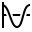 Gradient Descent 28

 TensorFlow 30

Cost Function 13

 Feature Engineering 27

K-Nearest Neighbors 13

 Random Forests 40

Logistic Regression 24

Reinforcement Learning 54

Time Series 38

Optimisation 30

Check FullStack.Cafe - 3877 Full-Stack, Coding & System Design Questions and Answers

Q23:
How would you convert continuous values into discrete values in Pandas?
Mid

Pandas 68

Answer
Depending on the problem, continuous values can be discretized using the cut() or qcut() function:

cut() bins the data based on values. We use it when we need to segment and sort data values into bins evenly spaced. cut will choose the bins to be evenly spaced according to the values themselves and not the frequency of those values. For example, cut could convert ages to groups of age ranges.

qcut() bins the data based on sample quantiles. We use it when we want to have the same number of records in each bin or simply study the data by quantiles. For example, if in a data we have 30 records, and we want to compute the quintiles, qcut() will divide the data such that we have 6 records in each bin.

Having Machine Learning, Data Science or Python Interview? Check 68 Pandas Interview Questions
Source: stackoverflow.com

Q24:
How would you create Test (20%) and Train (80%) Datasets with Pandas?
Mid

Scikit-Learn 31

Answer
scikit learn's train_test_split is a good one - it will split both numpy arrays as dataframes.
from sklearn.model_selection import train_test_split

train, test = train_test_split(df, test_size=0.2)
Having Machine Learning, Data Science or Python Interview? Check 31 Scikit-Learn Interview Questions
Source: stackoverflow.com

Q25:
Is it a good idea to iterate over DataFrame rows in Pandas?
Mid

Pandas 68

Answer
Iteration in Pandas is an anti-pattern and is something you should only do when you have exhausted every other option. Iterating through pandas objects is generally slow. In many cases, iterating manually over the rows is not needed. You should not use any function with "iter" in its name for more than a few thousand rows or you will have to get used to a lot of waiting.
Do you want to print a DataFrame? Use DataFrame.to_string().
Do you want to compute something? In that case, search for methods in this order (list modified from here):
- Vectorization
- Cython routines
- List Comprehensions (vanilla for loop)
- DataFrame.apply(): i) Reductions that can be performed in Cython, ii) Iteration in Python space
- DataFrame.itertuples() and iteritems()
- DataFrame.iterrows()
iterrows and itertuples (both receiving many votes in answers to this question) should be used in very rare circumstances, such as generating row objects/nametuples for sequential processing, which is really the only thing these functions are useful for.
Having Machine Learning, Data Science or Python Interview? Check 68 Pandas Interview Questions
Source: stackoverflow.com

19 Feature Engineering Interview Questions (EXPLAINED) for Data Scientists

Data Mining 13

Feature Engineering 27

Q26:
Name some type conversion methods in Pandas
Mid

Pandas 68

Answer
- to_numeric() - provides functionality to safely convert non-numeric types (e.g. strings) to a suitable numeric type.
- astype() - convert (almost) any type to (almost) any other type. Also allows you to convert to categorial types (very useful).
- infer_objects() - a utility method to convert object columns holding Python objects to a pandas type if possible. It does this by inferring better dtypes for object columns.
- convert_dtypes() - convert DataFrame columns to the "best possible" dtype that supports pd.NA (pandas' object to indicate a missing value).
Having Machine Learning, Data Science or Python Interview? Check 68 Pandas Interview Questions
Source: stackoverflow.com

Q27:
Name the advantage of using applymap() vs apply() method
Mid

Pandas 68

Answer
- The applymap() method is good for elementwise transformations across multiple rows/columns.
df[['A', 'B', 'C']].applymap(str.strip)
- The apply method is useful for applying any function that cannot be vectorised.
df['sentences'].apply(nltk.sent_tokenize)
Having Machine Learning, Data Science or Python Interview? Check 68 Pandas Interview Questions
Source: stackoverflow.com

Q28:
Pivot Table Challenge
Mid

Pandas 68

Problem
I have a pandas dataframe:
>>> df = pd.DataFrame({"Col X": ['class 1', 'class 2', 'class 3', 'class 2'],
"Col Y": ['cat 1', 'cat 1', 'cat 2', 'cat 3']})>>> df
Col X Col Y
0 class 1 cat 1
1 class 2 cat 1
2 class 3 cat 2
3 class 2 cat 3

You are required to transform the dataframe into:
+------------------------------------------+
| cat 1 cat 2 cat 3 |
+------------------------------------------+
| class 1 1 0 0 |
| class 2 1 0 1 |
| class 3 0 1 0 |
+------------------------------------------+
Answer
To provide the required df we use the function pivot_table with the parameters index='Col X', columns='Col Y' and as aggfunc, len:
>>> pd.pivot_table(df, index=['Col X'], columns=['Col Y'], aggfunc=len, fill_value=0)
Col Y cat 1 cat 2 cat 3
Col X
class 1 1 0 0
class 2 1 0 1
class 3 0 1 0
Another solution is using groupby on 'Col X','Col Y' with unstack over Col Y, then fill NaNs with zeros.
>>> df.groupby(['Col X','Col Y']).size().unstack('Col Y', fill_value=0)['Col Y'], aggfunc=len, fill_value=0)
Col Y cat 1 cat 2 cat 3
Col X
class 1 1 0 0
class 2 1 0 1
class 3 0 1 0
Having Machine Learning, Data Science or Python Interview? Check 68 Pandas Interview Questions
Source: stackoverflow.com

Q29:
What is the difference between join() and merge() in Pandas?
Mid

Pandas 68

Answer
merge is a function in the pandas namespace, and it is also available as a DataFrame instance method, with the calling DataFrame being implicitly considered the left object in the join.
The related DataFrame.join method, uses merge internally for the index-on-index and index-on-column(s) joins, but joins on indexes by default rather than trying to join on common columns (the default behavior for merge). If you are joining on index, you may wish to use DataFrame.join to save yourself some typing.
These are the main differences between df.join() and df.merge():
- lookup on right table: df1.join(df2) always joins via the index of df2, but df1.merge(df2) can join to one or more columns of df2 (default) or to the index of df2 (with right_index=True).
- lookup on left table: by default, df1.join(df2) uses the index of df1 and df1.merge(df2) uses column(s) of df1. That can be overridden by specifying df1.join(df2, on=key_or_keys) or df1.merge(df2, left_index=True).
- left vs inner join: df1.join(df2) does a left join by default (keeps all rows of df1), but df.merge does an inner join by default (returns only matching rows of df1 and df2).
Having Machine Learning, Data Science or Python Interview? Check 68 Pandas Interview Questions
Source: stackoverflow.com

Computer Vision 36

Random Forests 40

Linear Regression 48

Linear Algebra 41

Anomaly Detection 47

Clustering 40

Supervised Learning 31

R 41

Model Evaluation 32

Dimensionality Reduction 42

Check FullStack.Cafe - 3877 Full-Stack, Coding & System Design Questions and Answers

23 Advanced R Programming Interview Questions (ANSWERED) For Data Scientists

R 41

Q30:
What is the difference(s) between merge() and concat() in Pandas?
Mid

Pandas 68

Answer
At a high level:
- .concat() simply stacks multiple DataFrame together either vertically, or stitches horizontally after aligning on index
- .merge() first aligns two DataFrame' selected common column(s) or index, and then pick up the remaining columns from the aligned rows of each DataFrame.
More specifically, .concat():
- Is a top-level pandas function
- Combines two or more pandas DataFrame vertically or horizontally
- Aligns only on the index when combining horizontally
- Errors when any of the DataFrame contains a duplicate index.
- Defaults to outer join with the option for inner join
And .merge():
- Exists both as a top-level pandas function and a DataFrame method (as of pandas 1.0)
- Combines exactly two DataFrame horizontally
- Aligns the calling DataFrame's column(s) or index with the other DataFrame's column(s) or index
- Handles duplicate values on the joining columns or index by performing a cartesian product
- Defaults to inner join with options for left, outer, and right
Having Machine Learning, Data Science or Python Interview? Check 68 Pandas Interview Questions
Source: stackoverflow.com

Q31:
What's the difference between at and iat in Pandas?
Mid

Pandas 68

Answer
at and iat are functions meant to access a scalar, that is, a single element in the dataframe.

With .at:

  - Selection is label based but it only selects a single 'cell' in your DataFrame.
  - We can assign new indices and columns.
  - To use .at, pass it both a row and column label separated by a comma.

With .iat:

  - Selection with .iat is position based but it only selects a single scalar value.
  - We can't assign new indices and columns.
  - To use iat you must pass it an integer for both the row and column locations.
>>> df = pd.DataFrame([[0, 2, 3], [0, 4, 1], [10, 20, 30]],
columns=['A', 'B', 'C'],
index=['first', 'second', 'third'])
>>> df
A B C
first 0 2 3
second 0 4 1
third 10 20 30
>>> df.at['second','B',]
4>>> df.iat[1, 1]
4
Having Machine Learning, Data Science or Python Interview? Check 68 Pandas Interview Questions
Source: stackoverflow.com

Q32:
What's the difference between interpolate() and fillna() in Pandas?
Mid

Pandas 68

Answer

fillna() fills the NaN values with a given number with which you want to substitute. It gives you an option to fill according to the index of rows of a pd.DataFrame or on the name of the columns in the form of a python dict.

interpolate() it gives you the flexibility to fill the missing values with many kinds of interpolations between the values like linear, time, etc (which fillna does not provide).

Having Machine Learning, Data Science or Python Interview? Check 68 Pandas Interview Questions
Source: datascience.stackexchange.com

Q33:
What's the difference between pivot_table() and groupby()?
Mid

Pandas 68

Answer
Both pivot_table and groupby are used to aggregate your dataframe. The difference is only with regard to the shape of the result.

When using pd.pivot_table(df, index=["a"], columns=["b"], values=["c"], aggfunc=np.sum) a table is created where:

  - a is on the row axis,
  - b is on the column axis,

and the values are the sum of c.

For example,
df = pd.DataFrame({"a": [1,2,3,1,2,3], "b":[1,1,1,2,2,2], "c":np.random.rand(6)})
pd.pivot_table(df, index=["a"], columns=["b"], values=["c"], aggfunc=np.sum)
c
b 1 2
a 1 0.528470 0.4847662 0.187277 0.1443263 0.866832 0.650100

Using groupby:

  - The dimensions given are placed into columns.
  - The rows are created for each combination of those dimensions.
  - To obtain the "equivalent" output as before, we can create a Series of the sum of values c, grouped by all unique combinations of a and b.
df.groupby(['a','b'])['c'].sum()
a b
1 1 0.951714
2 0.270743
2 1 0.661338
2 0.343530
3 1 0.210315
2 0.220240
Name: c, dtype: f
  - A similar usage of groupby is if we omit the ['c']. In this case, it creates a DataFrame of the sums of all remaining columns grouped by unique values of a and b.
df.groupby(["a","b"]).sum()
c
a b 1 1 0.951714
2 0.2707432 1 0.661338
2 0.3435303 1 0.210315
2 0.220240
As we can see, with pivot_table() the output is a DataFrame, and is easier to specify the changes, meanwhile with groupby() the output can be a DataFrame or Series depending on how we specify the case.
Having Machine Learning, Data Science or Python Interview? Check 68 Pandas Interview Questions
Source: stackoverflow.com

23 Natural Language Processing (NLP) Interview Questions (ANSWERED) For ML Engineers

NLP 32

Q34:
When to use merge() over concat() and vice-versa in Pandas?
Mid

Pandas 68

Answer
- Consider .concat() first when combining homogeneous DataFrame, while consider .merge() first when combining complementary DataFrame.
- If need to merge vertically, go with .concat(). If need to merge horizontally via columns, go with .merge(), which by default merge on the columns in common.

Pandas Basics
Before we start working on different functionalities available in the Pandas library, we need to understand how Pandas organizes its data. This will help us understand the operations performed in detail. Please note that our aim for this article is understanding the workings of Pandas not code-optimization, hence we have chosen relatively easier data sets. We will be handling complex datasets and trickier problems in the next article in this series.
We use a simple dataset tracking Covid-19 data in India. We start off by looking at how the data looks like
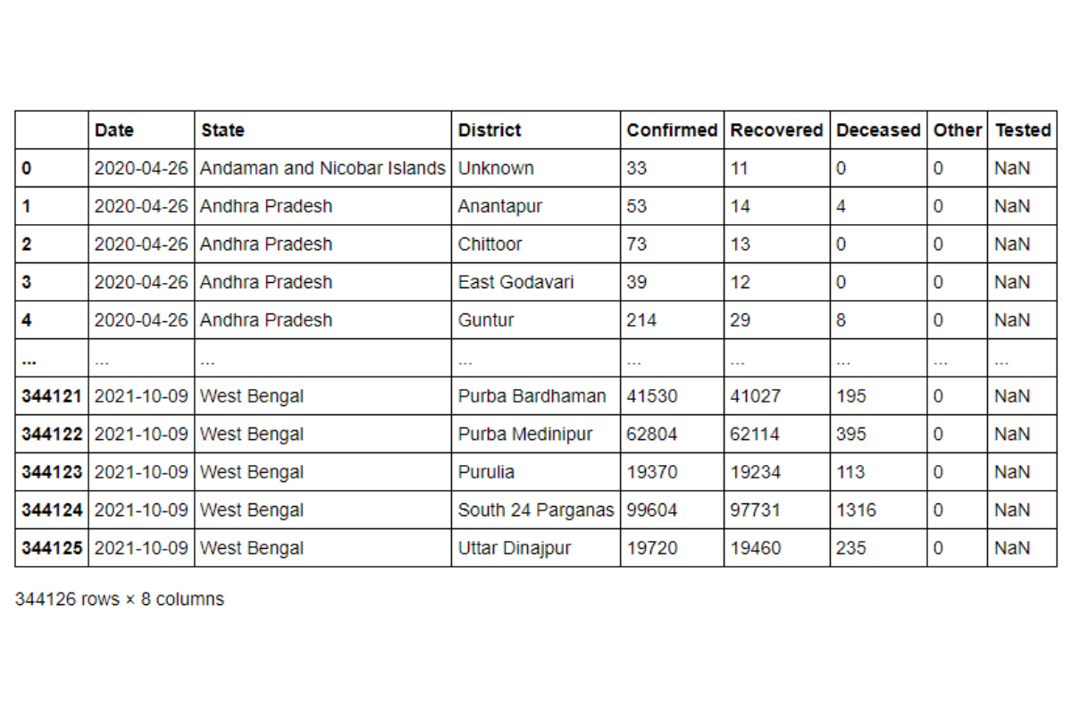
Pandas organizes the data in form of a two-dimensional data structure called DataFrame
This is very similar to a Spreadsheet or a SQL table. Here is a rough analogy of the various terms.
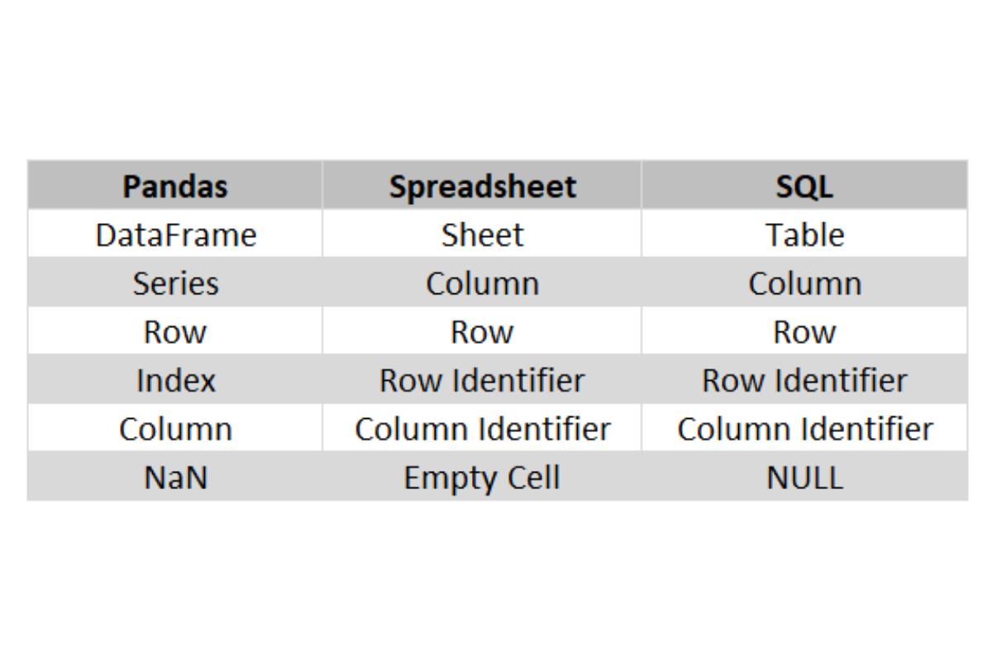
We can find the basic information about the DataFrame using the info method.
covid_df.info()
<class 'pandas.core.frame.DataFrame'>
RangeIndex: 344126 entries, 0 to 344125
Data columns (total 8 columns):
# Column Non-Null Count Dtype
--- ------ -------------- -----
0 Date 344126 non-null datetime64[ns]
1 State 344126 non-null object
2 District 344126 non-null object
3 Confirmed 344126 non-null int64
4 Recovered 344126 non-null int64
5 Deceased 344126 non-null int64
6 Other 344126 non-null int64
7 Tested 258862 non-null float64
dtypes: datetime64[ns](1), float64(1), int64(4), object(2)
memory usage: 21.0+ MB
Each of the column names is the identifier for a column. Similar to what one will get in an SQL table. Just as with an SQL table, we can change the column names using the rename() method.
Where DataFrames differ from a SQL table or an Excel Sheet is in flexibility of the row identifiers – The index. At present, the index contains sequential values just as with SQL Tables or a Spreadsheet. However, we can create our own row values and they need not be unique or sequential. For example, we can set the State Column to be the index using the set_index() method.
state_idx = covid_df.set_index('State')state_idx
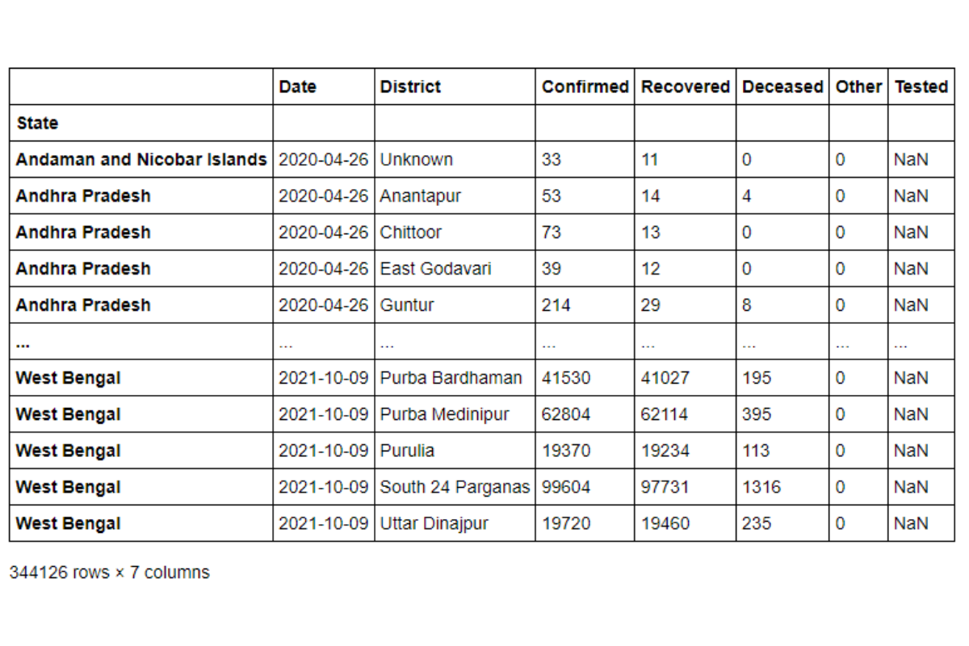
The state field is no longer considered a column. When we call the info() method on the new DataFrame, we can see that the state column from our older dataset is now set as the index.
<class 'pandas.core.frame.DataFrame'>
Index: 344126 entries, Andaman and Nicobar Islands to West Bengal
Data columns (total 7 columns):
# Column Non-Null Count Dtype
--- ------ -------------- -----
0 Date 344126 non-null datetime64[ns]
1 District 344126 non-null object
2 Confirmed 344126 non-null int64
3 Recovered 344126 non-null int64
4 Deceased 344126 non-null int64
5 Other 344126 non-null int64
6 Tested 258862 non-null float64
dtypes: datetime64[ns](1), float64(1), int64(4), object(1)
memory usage: 21.0+ MB
We can get back a sequential Index by calling the reset_index() method.
Each column of data in a Pandas DataFrame is referred to as a Pandas Series. Every time we access a Pandas Series, we also get the index along. Example, if we take the District Series, we will get a column with State field as the index.
state_idx['District']
State
Andaman and Nicobar Islands Unknown
Andhra Pradesh Anantapur
Andhra Pradesh Chittoor
Andhra Pradesh East Godavari
Andhra Pradesh Guntur
...
West Bengal Purba Bardhaman
West Bengal Purba Medinipur
West Bengal Purulia
West Bengal South 24 Parganas
West Bengal Uttar Dinajpur
Name: District, Length: 344126, dtype: object
This can help us in subsetting the data in a lot of ways that are not available with Spreadsheets or SQL Tables.
Some very useful DataFrame functions that can be used to explore the data quickly are
.head() : This method shows n observations from the start of the DataFrame. If no argument is passed, then by default it returns the first 5 rows.
covid_df.head(20)
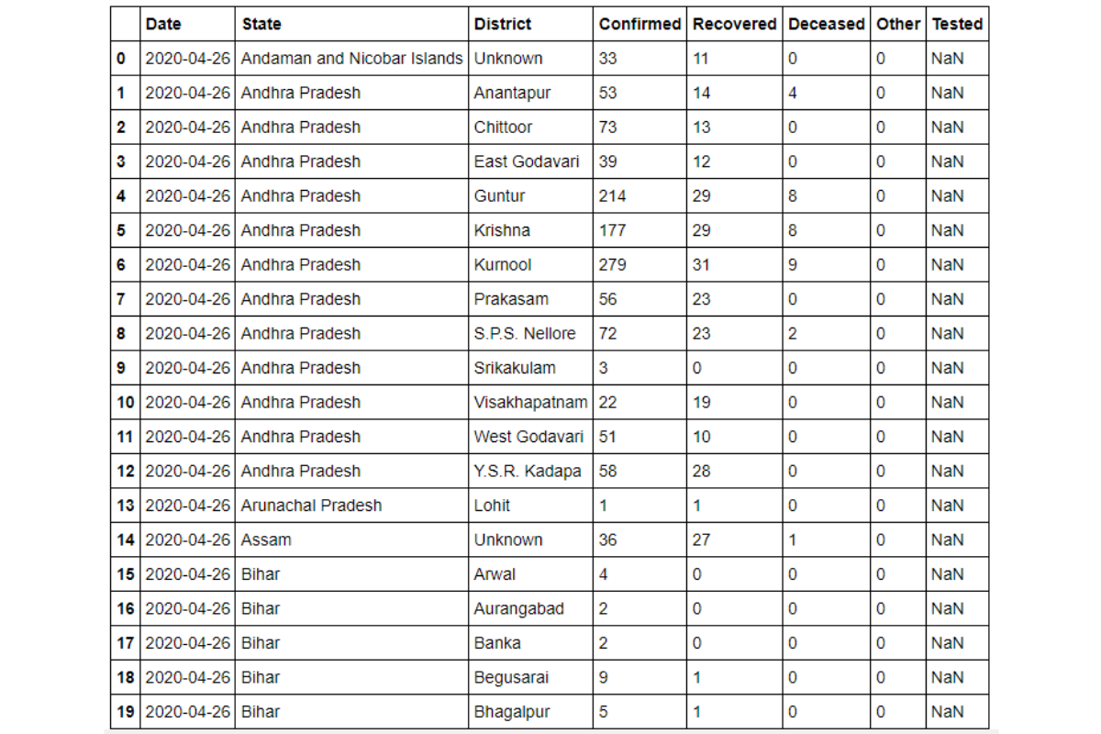
tail() : similar to the head() method, but this will give the last n rows of the DataFrame. If no argument is passed, then by default it returns the last five rows.
value_counts() : this gives us the frequency distribution of the values.
covid_df['State'].value_counts()
Uttar Pradesh 39738
Madhya Pradesh 27409
Tamil Nadu 21173
Bihar 20115
Rajasthan 19594
Maharashtra 19115
Gujarat 18044
Karnataka 16290
Odisha 16083
Chhattisgarh 14918
Arunachal Pradesh 12944
West Bengal 12581
Jharkhand 12497
Haryana 11872
Punjab 11695
Jammu and Kashmir 10596
Andhra Pradesh 7950
Kerala 7449
Uttarakhand 6790
Himachal Pradesh 6225
Nagaland 5717
Mizoram 5377
Meghalaya 5359
Tripura 4160
Puducherry 2063
Dadra and Nagar Haveli and Daman and Diu 1495
Assam 1421
Ladakh 1064
Manipur 962
Andaman and Nicobar Islands 532
Telangana 532
Goa 532
Delhi 532
Chandigarh 532
Sikkim 505
Lakshadweep 265
Name: State, dtype: int64
Note: it will ignore missing values in the frequency count. So, if you want to include missing values, set the dropna argument to False. In this case, there were no missing values so we omitted this argument.

Sorting
As with SQL and Spreadsheets, we can sort the table based on a column or a sequence of columns. By default the values are sorted in ascending order, we can change the order by changing the ascending parameter. Example we can sort our Covid Dataset by the descending order of the State Names but Ascending order of the District Names.
covid_df.sort_values(by = ['State', 'District'], ascending = [False, True])
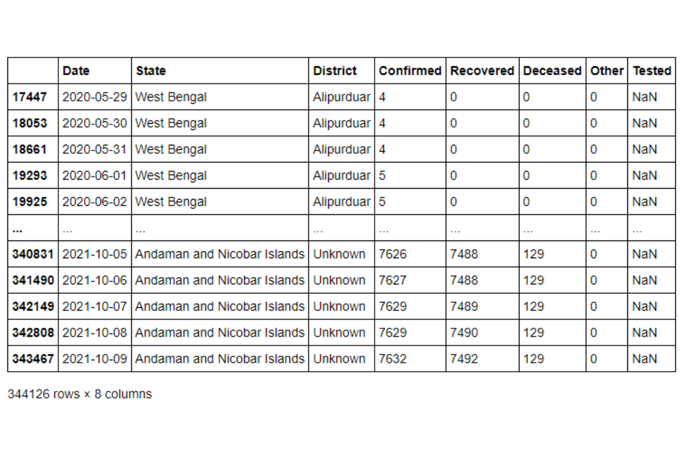

Duplicates
Dealing with duplicates is a very common problem encountered in Data Science Interview questions. The presence of duplicates need not mean incorrect data. For example, a customer might purchase multiple items, hence the transaction data might contain repeated values of the same card number or customer id. Pandas provides a convenient way of dropping duplicates and creating a unique set of records. Once can apply the drop_duplicates() method for this purpose.
Suppose we want to find the list of distinct states from our Covid Dataset. We can do it using passing the entire series to a Python set and then converting it back into a Pandas Series. Conversely, we can apply the drop_duplicates() method. We can either apply it to the Pandas Series,
covid_df['State'].drop_duplicates()
or on the entire dataset and specify a subset to remove duplicates from.
covid_df.drop_duplicates(subset = ['State'])['State']
0 Andaman and Nicobar Islands
1 Andhra Pradesh
13 Arunachal Pradesh
14 Assam
15 Bihar
37 Chandigarh
38 Chhattisgarh
43 Delhi
44 Goa
45 Gujarat
75 Himachal Pradesh
81 Haryana
101 Jharkhand
111 Jammu and Kashmir
128 Karnataka
149 Kerala
163 Ladakh
165 Maharashtra
198 Meghalaya
199 Manipur
200 Madhya Pradesh
227 Mizoram
228 Odisha
238 Punjab
257 Puducherry
259 Rajasthan
290 Telangana
291 Tamil Nadu
328 Tripura
330 Uttar Pradesh
388 Uttarakhand
394 West Bengal
3979 Dadra and Nagar Haveli and Daman and Diu
11267 Nagaland
13703 Sikkim
170212 Lakshadweep
Name: State, dtype: object
Let us try to apply this in one of the Python Pandas interview questions. This one came up in an AirBnB Data Science Interview.

Python Pandas Interview Questions

Find all neighborhoods present in this dataset

Link to the question: https://platform.stratascratch.com/coding/9626-find-all-neighborhoods-present-in-this-dataset
The problem uses the airbnb_search_details dataset that has the following fields.
id | int64
price | float64
property_type | object
room_type | object
amenities | object
accommodates | int64
bathrooms | int64
bed_type | object
cancellation_policy | object
cleaning_fee | bool
city | object
host_identity_verified | object
host_response_rate | object
host_since | datetime64[ns]
neighbourhood | object
number_of_reviews | int64
review_scores_rating | float64
zipcode | int64
bedrooms | int64
beds | int64
The dataset looks something like this.
Table: airbnb_search_details
id | price | property_type | room_type | amenities | accommodates | bathrooms | bed_type | cancellation_policy | cleaning_fee | city | host_identity_verified | host_response_rate | host_since | neighbourhood | number_of_reviews | review_scores_rating | zipcode | bedrooms | beds
12513361 | 555.68 | Apartment | Entire home/apt | {TV,"Wireless Internet","Air conditioning","Smoke detector","Carbon monoxide detector",Essentials,"Lock on bedroom door",Hangers,Iron} | 2 | 1 | Real Bed | flexible | FALSE | NYC | t | 89% | 2015-11-18 | East Harlem | 3 | 87 | 10029 | 0 | 1
7196412 | 366.36 | Cabin | Private room | {"Wireless Internet",Kitchen,Washer,Dryer,"Smoke detector","First aid kit","Fire extinguisher",Essentials,"Hair dryer","translation missing: en.hosting_amenity_49","translation missing: en.hosting_amenity_50"} | 2 | 3 | Real Bed | moderate | FALSE | LA | f | 100% | 2016-09-10 | Valley Glen | 14 | 91 | 91606 | 1 | 1
16333776 | 482.83 | House | Private room | {TV,"Cable TV",Internet,"Wireless Internet",Kitchen,"Free parking on premises","Pets live on this property",Dog(s),"Indoor fireplace","Buzzer/wireless intercom",Heating,Washer,Dryer,"Smoke detector","Carbon monoxide detector","First aid kit","Safety card","Fire extinguisher",Essentials,Shampoo,"24-hour check-in",Hangers,"Hair dryer",Iron,"Laptop friendly workspace","translation missing: en.hosting_amenity_49","translation missing: en.hosting_amenity_50","Self Check-In",Lockbox} | 2 | 1 | Real Bed | strict | TRUE | SF | t | 100% | 2013-12-26 | Richmond District | 117 | 96 | 94118 | 1 | 1
1786412 | 448.86 | Apartment | Private room | {"Wireless Internet","Air conditioning",Kitchen,Heating,"Suitable for events","Smoke detector","Carbon monoxide detector","First aid kit","Fire extinguisher",Essentials,Shampoo,"Lock on bedroom door",Hangers,"translation missing: en.hosting_amenity_49","translation missing: en.hosting_amenity_50"} | 2 | 1 | Real Bed | strict | TRUE | NYC | t | 93% | 2010-05-11 | Williamsburg | 8 | 86 | 11211 | 1 | 1
14575777 | 506.89 | Villa | Private room | {TV,Internet,"Wireless Internet","Air conditioning",Kitchen,"Free parking on premises",Essentials,Shampoo,"translation missing: en.hosting_amenity_49","translation missing: en.hosting_amenity_50"} | 6 | 2 | Real Bed | strict | TRUE | LA | t | 70% | 2015-10-22 |  | 2 | 100 | 90703 | 3 | 3
Show allToggle dTypes
Approach and Solution
This is a relatively straightforward problem. We simply need to drop the duplicates on the neighborhood column. As earlier, we can either apply the drop_duplicates() method on the entire dataset and then report the series. Or we can take the series and then drop the duplicates.
# Import your librariesimport pandas as pd # Take the relevant series and apply the drop_duplicates() methodairbnb_search_details['neighbourhood'].drop_duplicates()
Go to the question on the platform
PythonTables: airbnb_search_details
1
2
3
4
5
# Import your libraries
import pandas as pd
# Take the relevant series and apply the drop_duplicates() method
airbnb_search_details['neighbourhood'].drop_duplicates()
The dataset has already been loaded as a pandas.DataFrame. print() functions and the last line of code will be displayed in the output.
In order for your solution to be accepted, your solution should be located on the last line of the editor and match the expected output data type listed in the question.
ResetRun CodeCheck Solution
Use Alt + Enter to run query
And we get our required solution.

Slicing Pandas Dataset
We can use a subset of the DataFrame instead of the full set. If you want only particular columns from the dataset, one can simply pass the list of relevant columns into the slicer.
covid_df[['Date','State', 'District', 'Confirmed']]
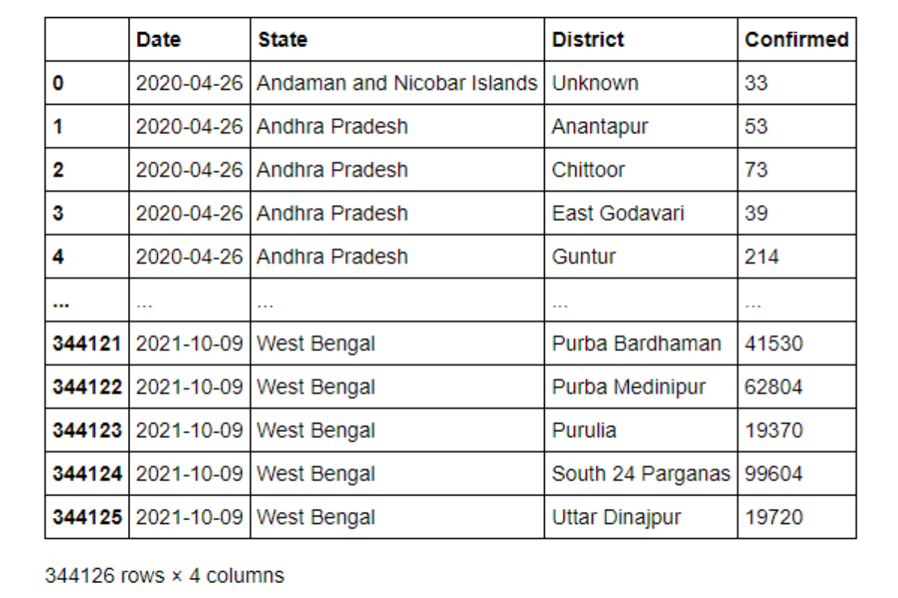
Note you must use two sets of square brackets. If we use only a single square bracket, Pandas will assume that you want to create a Series. But a series will have only one field and therefore it will give an error.
You can also subset specific rows based on their values, like the WHERE condition in SQL or Filter option in Spreadsheets. Suppose we want only data from the states of Goa and Maharashtra. We can simply pass this as a condition and slice the DataFrame as one would slice a string or a list.
covid_df[(covid_df['State'] == 'Goa' )| (covid_df['State'] == 'Maharashtra')]
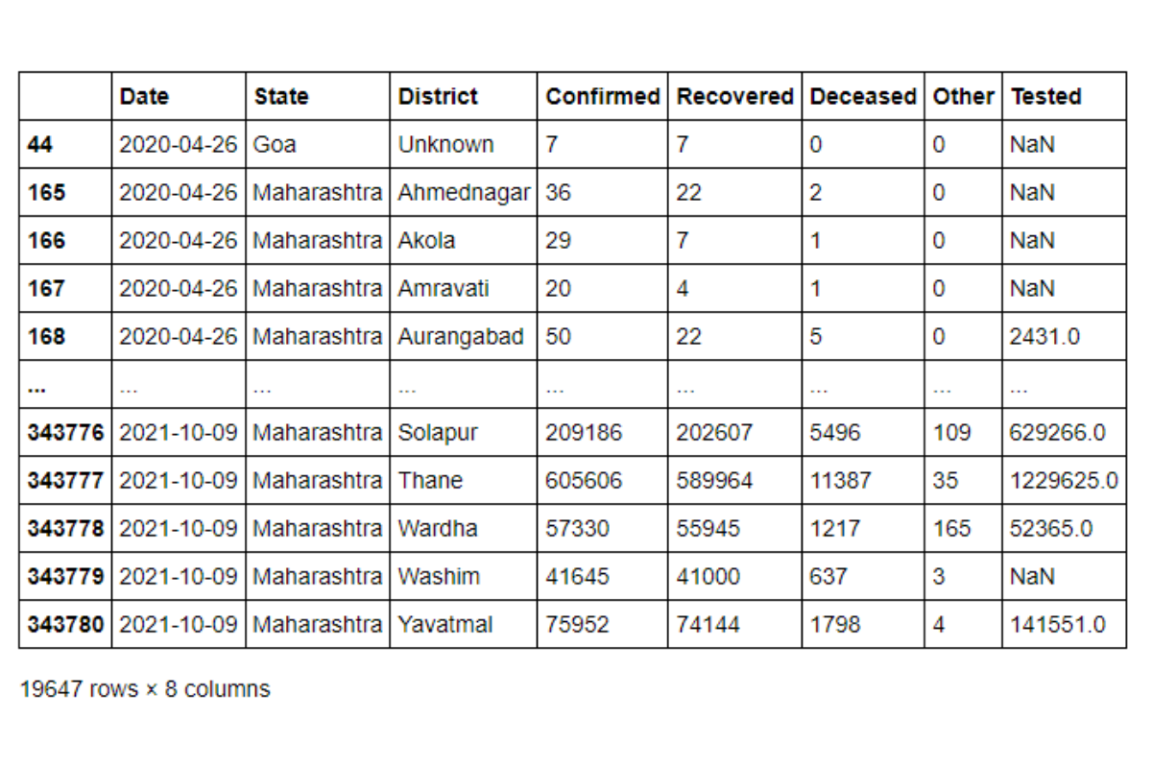
Let us see what happens under the hood. The DataFrame slicer uses a Boolean Masking array. The condition inside the slicer returns a Boolean Series.
(covid_df['State'] == 'Goa' )| (covid_df['State'] == 'Maharashtra')
0 False
1 False
2 False
3 False
4 False
...
344121 False
344122 False
344123 False
344124 False
344125 False
Name: State, Length: 344126, dtype: bool
When we pass this into the slicer, only the rows with True are retained. This is a very efficient and powerful way of filtering data.
Let us use this in a real-life Python Pandas interview question. This problem is from a Spotify Data Science Interview.
Top 10 Ranked Songs
Report the top 10 ranked songs by position. Output the track and the ranks in the descending order of ranks. If there are multiple songs with the same rank, sort them in alphabetical order of the track name.
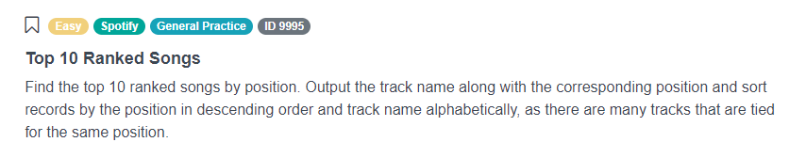
Link to the question: https://platform.stratascratch.com/coding/9995-top-10-ranked-songs
The problem uses the spotify_worldwide_daily_song_ranking dataset that has the following fields.
id | int64
position | int64
trackname | object
artist | object
streams | int64
url | object
date | datetime64[ns]
region | object
This is what the dataset looks like.
Table: spotify_worldwide_daily_song_ranking
id | position | trackname | artist | streams | url | date | region
303651 | 52 | Heart Won't Forget | Matoma | 28047 | https://open.spotify.com/track/2of2DM5LqTh7ohmmVXUKsH | 2017-02-04 | no
85559 | 160 | Someone In The Crowd - From "La La Land" Soundtrack | Emma Stone | 17134 | https://open.spotify.com/track/7xE4vKvjqUTtHyJ9zi0k1q | 2017-02-26 | fr
1046089 | 175 | The Greatest | Sia | 10060 | https://open.spotify.com/track/7xHWNBFm6ObGEQPaUxHuKO | 2017-03-06 | cl
350824 | 25 | Unforgettable | French Montana | 46603 | https://open.spotify.com/track/3B54sVLJ402zGa6Xm4YGNe | 2017-10-01 | no
776822 | 1 | Bad and Boujee (feat. Lil Uzi Vert) | Migos | 1823391 | https://open.spotify.com/track/4Km5HrUvYTaSUfiSGPJeQR | 2017-01-27 | us
Show allToggle dTypes
Approach and solution
To solve this problem, we first subset the songs that are ranked 10 or better.
# Import your librariesimport pandas as pd # get the top10 songstop10_songs = spotify_worldwide_daily_song_ranking[spotify_worldwide_daily_song_ranking['position'] <=10]
The output looks like this
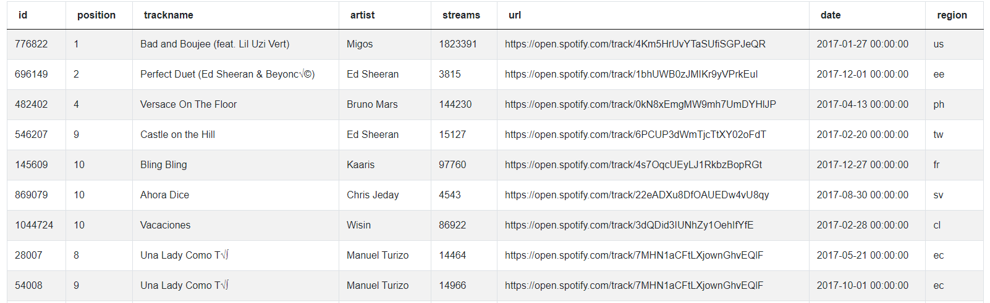
Now we need to sort this in descending order of position, ascending order of trackname and output the relevant fields.
# Sort and output relevant fieldstop10_songs.sort_values(by = ['position', 'trackname'], ascending = [False, True])[['trackname','position']]
The output looks like this.
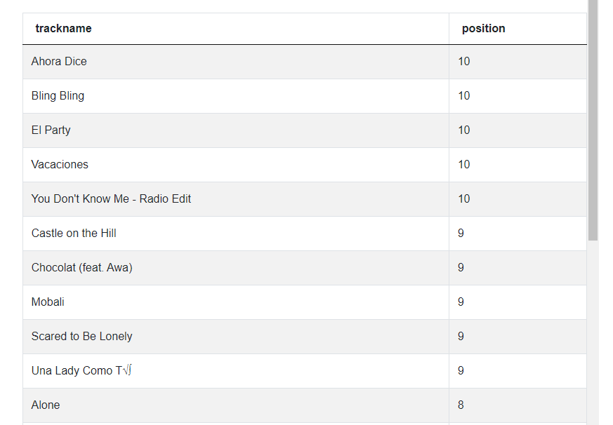
The problem is not over since we might have duplicate records as a song might be ranked No 1 in multiple locations. To remove duplicate records, we can simply call the drop_duplicates() method on the output.
# Sort and output relevant fieldstop10_songs.sort_values(by = ['position', 'trackname'], ascending = [False, True])[['trackname','position']].drop_duplicates()
Go to the question on the platform
PythonTables: spotify_worldwide_daily_song_ranking
1
2
3
4
5
6
7
8
9
10
11
# Import your libraries
import pandas as pd
# get the top10 songs
top10_songs = spotify_worldwide_daily_song_ranking[spotify_worldwide_daily_song_rankin
g['position'] <=10]
# Sort and output relevant fields
top10_songs.sort_values(by = ['position', 'trackname'], ascending = [False, True]
)[['trackname','position']]
# Sort and output relevant fields
top10_songs.sort_values(by = ['position', 'trackname'], ascending = [False, True]
)[['trackname','position']].drop_duplicates()

The dataset has already been loaded as a pandas.DataFrame. print() functions and the last line of code will be displayed in the output.
In order for your solution to be accepted, your solution should be located on the last line of the editor and match the expected output data type listed in the question.
ResetRun CodeCheck Solution
Use Alt + Enter to run query
And we have the desired output now.

Aggregations
A very common test area in Python Pandas interview questions is aggregations or rollups. Business professionals want a top-level overview of the metrics before digging down deeper into sub-segments. Aggregations are very handy in these situations. These are similar to a Pivot Table in a spreadsheet or Group By methods in SQL. Pandas provides many ways to create these aggregations. In this article we look at the most basic one – the groupby method.
Let’s say we wanted to find the average number of confirmed cases reported in each district. We can do this by passing the State and District combination as the grouper variables and then calculate the average by calling the mean() method.
covid_df.groupby(['State', 'District']).mean()
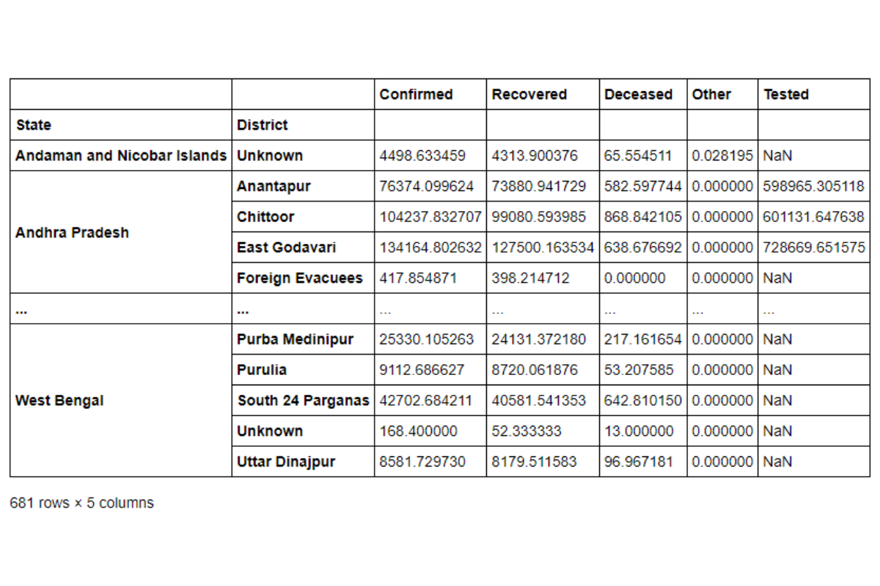
As you can see from the result, the State and District combination now becomes an index. In Pandas this is called a Multi-Index Data. You can easily get the index values back into the DataFrame by calling the reset_index() method. Or you can prevent the creation of this index by setting the as_index argument to False in the groupby method.
covid_df.groupby(['State', 'District'], as_index = False).mean()
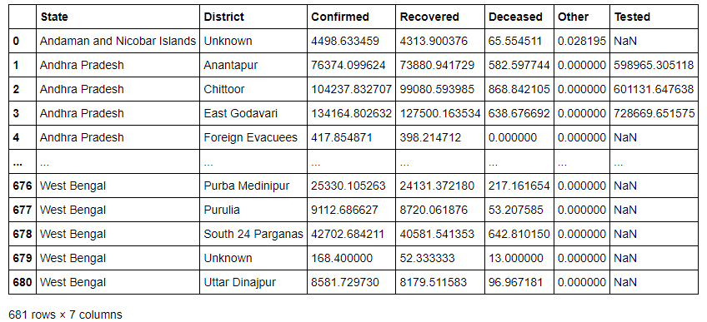
This gives us the grouper variable as columns in the DataFrame and we can use them for further analysis without having to resort to reset_index() again and again. Further, you would have noticed that Pandas calculates the mean of all numeric variables. We can retain the relevant columns by subsetting the final dataset. Or we can simply call the agg() method on a grouped DataFrame.
covid_df.groupby(['State', 'District'], as_index = False).agg({'Confirmed' : 'mean'})
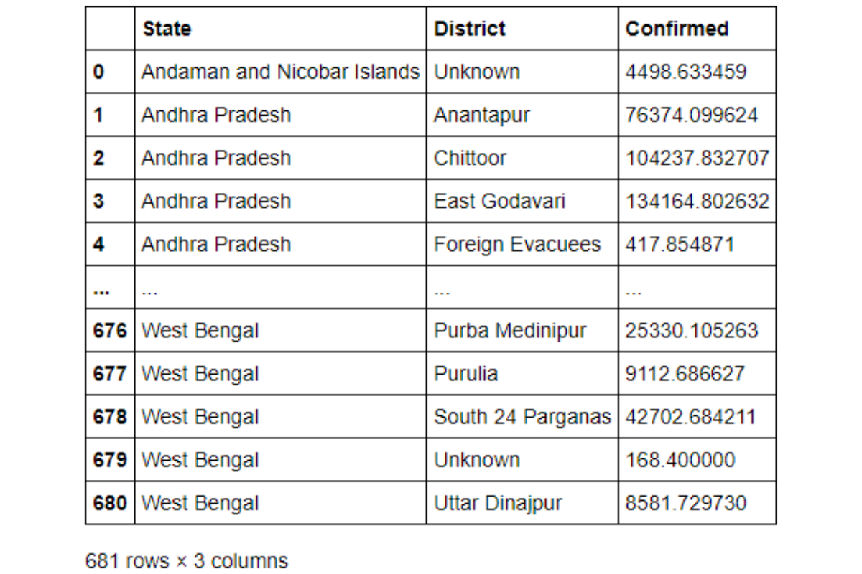
The agg() method is also advantageous in calculating multiple values aggregates at the same time. Suppose We want to report not only the average of the confirmed cases. but also, the maximum number of deaths, we can pass these as a dictionary to the agg() method.
covid_df.groupby(['State', 'District'], as_index = False).agg({'Confirmed' : 'mean', 'Deceased' : 'max'})
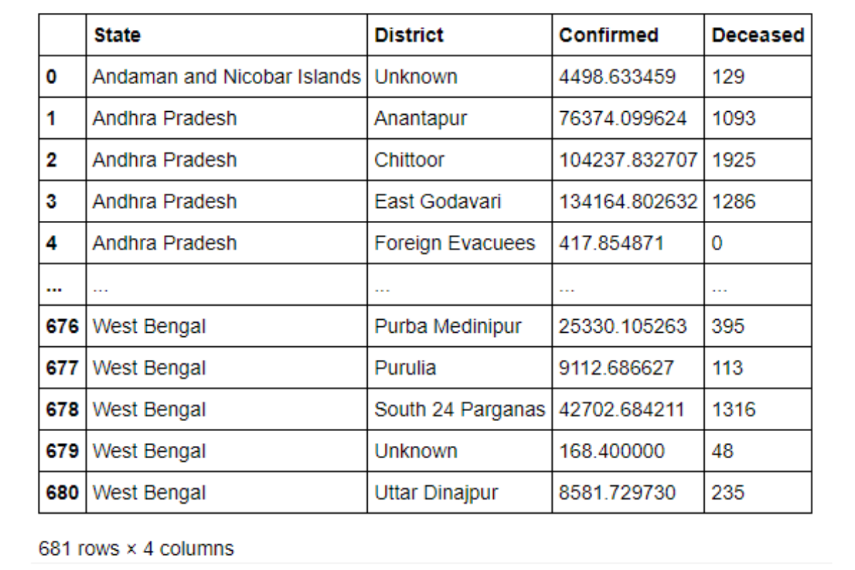
Let us try to use this in one of the Python Pandas interview questions. This one is from an AirBnB Data Science Interview.
Cheapest Properties
Find the price of the cheapest property for every city.

Link to the question: https://platform.stratascratch.com/coding/9625-cheapest-properties
This problem uses the airbnb_search_details that we had seen in an earlier problem. Let us recap the fields present.
id | int64
price | float64
property_type | object
room_type | object
amenities | object
accommodates | int64
bathrooms | int64
bed_type | object
cancellation_policy | object
cleaning_fee | bool
city | object
host_identity_verified | object
host_response_rate | object
host_since | datetime64[ns]
neighbourhood | object
number_of_reviews | int64
review_scores_rating | float64
zipcode | int64
bedrooms | int64
beds | int64
And this is what the data looks like.
Table: airbnb_search_details
id | price | property_type | room_type | amenities | accommodates | bathrooms | bed_type | cancellation_policy | cleaning_fee | city | host_identity_verified | host_response_rate | host_since | neighbourhood | number_of_reviews | review_scores_rating | zipcode | bedrooms | beds
12513361 | 555.68 | Apartment | Entire home/apt | {TV,"Wireless Internet","Air conditioning","Smoke detector","Carbon monoxide detector",Essentials,"Lock on bedroom door",Hangers,Iron} | 2 | 1 | Real Bed | flexible | FALSE | NYC | t | 89% | 2015-11-18 | East Harlem | 3 | 87 | 10029 | 0 | 1
7196412 | 366.36 | Cabin | Private room | {"Wireless Internet",Kitchen,Washer,Dryer,"Smoke detector","First aid kit","Fire extinguisher",Essentials,"Hair dryer","translation missing: en.hosting_amenity_49","translation missing: en.hosting_amenity_50"} | 2 | 3 | Real Bed | moderate | FALSE | LA | f | 100% | 2016-09-10 | Valley Glen | 14 | 91 | 91606 | 1 | 1
16333776 | 482.83 | House | Private room | {TV,"Cable TV",Internet,"Wireless Internet",Kitchen,"Free parking on premises","Pets live on this property",Dog(s),"Indoor fireplace","Buzzer/wireless intercom",Heating,Washer,Dryer,"Smoke detector","Carbon monoxide detector","First aid kit","Safety card","Fire extinguisher",Essentials,Shampoo,"24-hour check-in",Hangers,"Hair dryer",Iron,"Laptop friendly workspace","translation missing: en.hosting_amenity_49","translation missing: en.hosting_amenity_50","Self Check-In",Lockbox} | 2 | 1 | Real Bed | strict | TRUE | SF | t | 100% | 2013-12-26 | Richmond District | 117 | 96 | 94118 | 1 | 1
1786412 | 448.86 | Apartment | Private room | {"Wireless Internet","Air conditioning",Kitchen,Heating,"Suitable for events","Smoke detector","Carbon monoxide detector","First aid kit","Fire extinguisher",Essentials,Shampoo,"Lock on bedroom door",Hangers,"translation missing: en.hosting_amenity_49","translation missing: en.hosting_amenity_50"} | 2 | 1 | Real Bed | strict | TRUE | NYC | t | 93% | 2010-05-11 | Williamsburg | 8 | 86 | 11211 | 1 | 1
14575777 | 506.89 | Villa | Private room | {TV,Internet,"Wireless Internet","Air conditioning",Kitchen,"Free parking on premises",Essentials,Shampoo,"translation missing: en.hosting_amenity_49","translation missing: en.hosting_amenity_50"} | 6 | 2 | Real Bed | strict | TRUE | LA | t | 70% | 2015-10-22 |  | 2 | 100 | 90703 | 3 | 3
Show allToggle dTypes
Approach and Solution
This problem can be solved easily with the groupby method. We simply need to roll-up at city level and find the minimum of the prices column.
# Import your librariesimport pandas as pd # Calculate the mininum prices at city levelairbnb_search_details.groupby(by = ['city'], as_index = False).agg({'price': 'min'})
Go to the question on the platform
PythonTables: airbnb_search_details
1
2
3
4
5
# Import your libraries
import pandas as pd
# Calculate the mininum prices at city level
airbnb_search_details.groupby(by = ['city'], as_index = False).agg({'price': 'min'})
The dataset has already been loaded as a pandas.DataFrame. print() functions and the last line of code will be displayed in the output.
In order for your solution to be accepted, your solution should be located on the last line of the editor and match the expected output data type listed in the question.
ResetRun CodeCheck Solution
Use Alt + Enter to run query

Merging
Till now we have used only a single dataset. However real life dataset are optimized by splitting them into different tables. Pandas supports multiple ways of combining multiple datasets. We can stack one DataFrame on top of another or alongside other using the append() and concat() methods. Or we can use an SQL style merge using the merge() merge method. Let us see how to use the merge method using a SalesForce Python Pandas interview question.
Average Salaries
Report the department, first name and salary of each employee along with the average salary of the corresponding department.
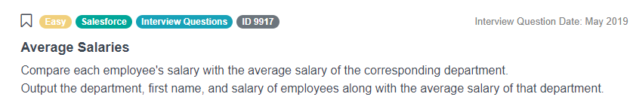
Link to the question: https://platform.stratascratch.com/coding/9917-average-salaries
This problem uses the employee dataset which has the following fields.
id | int64
first_name | object
last_name | object
age | int64
sex | object
employee_title | object
department | object
salary | int64
target | int64
bonus | int64
email | object
city | object
address | object
manager_id | int64
The dataset looks like this.
Table: employee
id | first_name | last_name | age | sex | employee_title | department | salary | target | bonus | email | city | address | manager_id
5 | Max | George | 26 | M | Sales | Sales | 1300 | 200 | 150 | Max@company.com | California | 2638 Richards Avenue | 1
13 | Katty | Bond | 56 | F | Manager | Management | 150000 | 0 | 300 | Katty@company.com | Arizona |  | 1
11 | Richerd | Gear | 57 | M | Manager | Management | 250000 | 0 | 300 | Richerd@company.com | Alabama |  | 1
10 | Jennifer | Dion | 34 | F | Sales | Sales | 1000 | 200 | 150 | Jennifer@company.com | Alabama |  | 13
19 | George | Joe | 50 | M | Manager | Management | 100000 | 0 | 300 | George@company.com | Florida | 1003 Wyatt Street | 1
Show allToggle dTypes
Approach and Solution
To solve this Python Pandas interview question we need to find the average salary of each department and add that field to the DataFrame. We start off by calculating the average salaries using the groupby method. We also rename the salary field so that the names do not conflict during merge. Note this will not result in an error, but the names will be suffixed with identifiers. We can change those, but to make life easier, we just rename one of the variables.
# Import your librariesimport pandas as pd # Calculate Average Salary for each departmentavg_sal = employee.groupby(by = ['department'], as_index = False).agg({'salary' : 'mean'}).rename(columns = {'salary' : 'average_salary'})
The aggregated dataset looks like this.
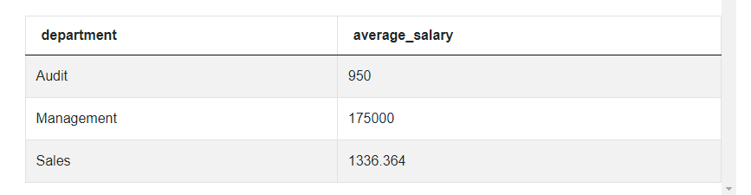
We now proceed to merge this back to the original DataFrame on the department field. While merging we pass only the relevant columns from the original DataFrame.
# Merge with the relevant fields from the original DataFramepd.merge(employee[['department', 'first_name', 'salary']], avg_sal, on = 'department', how = 'inner')
Go to the question on the platform
PythonTables: employee
1
2
3
4
5
6
7
8
9
# Import your libraries
import pandas as pd
# Merge with the relevant fields from the original DataFrame
avg_sal = employee.groupby(by = ['department'], as_index = False).agg({'salary' : 'mean'}
).rename(columns = {'salary' : 'average_salary'})
# Merge with the relevant fields from the original DataFrame
pd.merge(employee[['department', 'first_name', 'salary']], avg_sal,
on = 'department', how = 'inner')
The dataset has already been loaded as a pandas.DataFrame. print() functions and the last line of code will be displayed in the output.
In order for your solution to be accepted, your solution should be located on the last line of the editor and match the expected output data type listed in the question.
ResetRun CodeCheck Solution
Use Alt + Enter to run query
We specify inner join. If there are no missing departments, then this will give the same result as a left join or a right join or an outer join.

Calculated Fields
Till now we have used fields that were already present in the dataset. We can also create calculated fields very easily. Let us try one with our Covid dataset. Suppose we want to calculate the recovery rate (Number of Recovered Cases / Number of Confirmed Cases), then we can simply do it like this.
covid_df['Recovery Rate'] = covid_df['Recovered'] / covid_df['Confirmed'] covid_df
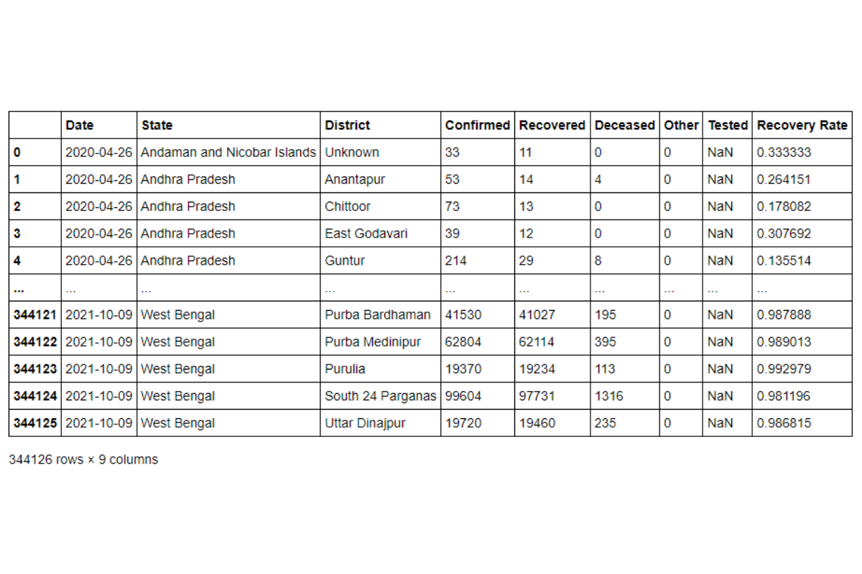
Let's use this in one of the Python Pandas interview questions. This Python Pandas interview question is from an Uber Data Science Interview.
Advertising Channel Effectiveness
Calculate the averages effectiveness for each advertising channel across the years 2017 and 2018. Report the channel and effectiveness sorted in the increasing order of effectiveness.
Advertising effectiveness is defined as the ratio of total money spent to total customers acquired.
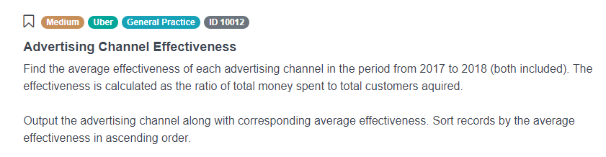
Link to the question: https://platform.stratascratch.com/coding/10012-advertising-channel-effectiveness
This problem uses the uber_advertising dataset that has the following fields.
year | int64
advertising_channel | object
money_spent | int64
customers_acquired | int64
The data is present like thus.
Table: uber_advertising
year | advertising_channel | money_spent | customers_acquired
2019 | celebrities | 10000000 | 1800
2019 | billboards | 1000000 | 2000
2019 | busstops | 1500 | 400
2019 | buses | 70000 | 2500
2019 | tv | 300000 | 5000
Show allToggle dTypes
Approach and Solution
To solve this Python Pandas interview question, we first aggregate the money_spent and customers_acquired columns across the advertising_channel. We need to ensure that we keep only the relevant years since the problem asks us to calculate these values across 2017 and 2018 only.
# Import your librariesimport pandas as pd # Summarize the spends and customer acquired by channelsumm_df = uber_advertising[uber_advertising['year'].isin([2017, 2018])].groupby( by = ['advertising_channel'], as_index = False ).agg(
{ 'money_spent' : 'sum', 'customers_acquired':'sum' }
)
The output looks thus.
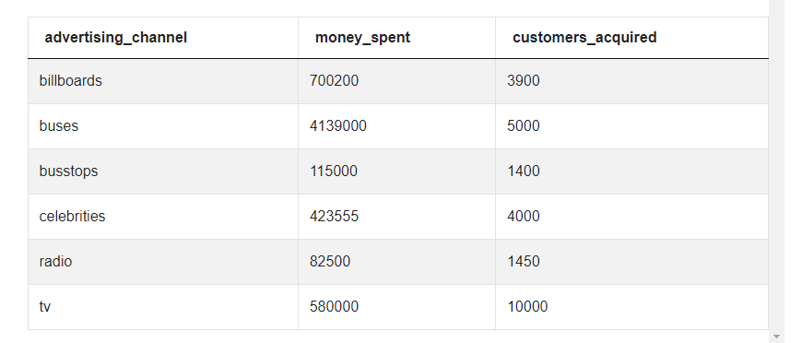
We can now calculate the effectiveness using the given formula, subset the relevant fields and sort as per the required specifications.
# Calculate effectiveness summ_df['effct'] = summ_df['money_spent'] / summ_df['customers_acquired']# Sort and output relevant fieldssumm_df[['advertising_channel', 'effct']].sort_values(by = ['effct'])
Go to the question on the platform
PythonTables: uber_advertising
1
2
3
4
5
6
7
8
9
10
11
12
13
# Import your libraries
import pandas as pd
# Summarize the spends and customer acquired by channel
summ_df = uber_advertising[uber_advertising['year'].isin([2017, 2018])].groupby(
by = ['advertising_channel'], as_index = False
).agg(
{
'money_spent' : 'sum', 'customers_acquired':'sum'
}
)
# Calculate effectiveness
summ_df['effct'] = summ_df['money_spent'] / summ_df['customers_acquired']

The dataset has already been loaded as a pandas.DataFrame. print() functions and the last line of code will be displayed in the output.
In order for your solution to be accepted, your solution should be located on the last line of the editor and match the expected output data type listed in the question.
ResetRun CodeCheck Solution
Use Alt + Enter to run query

Conclusion
In this article we looked at the basics of data manipulation with Pandas and the types of Python Pandas interview questions you can expect in any data science interview. You can find the Covid-19 dataset and the associated Python Notebook here. In the next part of this series, we will extend these concepts and look at slightly complex problems like -
- Datetime Manipulation
- Text Manipulation
- Applying Functions
- Advanced Aggregation
- Offsetting Data
- Statistics using Pandas
If you have worked with a Spreadsheet program or SQL tables, migrating to Pandas is very easy. In fact, you can use Pandas, a library to learn Python. On the StrataScratch platform, you will find over 700 coding problems and non-technical interview problems from Data Science Interviews. Check out our recent post on Top 30 Python Interview Questions and Answers. These problems are created from Data Science interviews at top companies like Netflix, Amazon, Google, Microsoft, et al. You can join a group of 20,000+ like minded data science aspirants to get a collaborative learning experience. Sign up for StrataScratch today and give yourself the best chance to crack interviews for the most in-demand jobs at big tech firms and start-ups across the world.

1| Define Python pandas
pandas is an open source, BSD-licensed library providing high-performance, easy-to-use data structures and data analysis tools for the Python programming language. This is a high-level data manipulation tool developed by Wes Mckinney and is built on the Numpy package. This package provides active and flexible data structures in order to make easy working with relational or labelled data.

2| Mention The Different Types Of Data Structures In pandas?
There are two data structures supported by pandas library, Series and DataFrames. Both of the data structures are built on top of Numpy. Series is a one-dimensional data structure in pandas and DataFrame is the two-dimensional data structure in pandas. There is one more axis label known as Panel which is a three-dimensional data structure and it includes items, major_axis, and minor_axis.

THE BELAMY

Sign up for your weekly dose of what's up in emerging technology.
窗体顶端
Email
SIGN UP
窗体底端

3| Explain Series In pandas. How To Create Copy Of Series In pandas?
Series is a one-dimensional labeled array capable of holding any data type (integers, strings, floating point numbers, Python objects, etc.). The axis labels are collectively referred to as the index. The basic method to create a Series is to call:
>>> s = pd.Series(data, index=index), where the data can be a Python dict, an ndarray or a scalar value.
To create a copy in pandas, we can call copy() function on a series such that
s2=s1.copy() will create copy of series s1 in a new series s2.

4| What Is A pandas DataFrame? How Will You Create An Empty DataFrame In pandas?
pandas DataFrame is two-dimensional size-mutable, potentially heterogeneous tabular data structure with labeled axes (rows and columns). It consists of three principal components, the data, rows, and columns. pandas DataFrame can be created from the lists, dictionary, and from a list of dictionary, etc.
To create an empty DataFrame in pandas, type
import pandas as pd
df = pd.DataFrame()

5| Explain Reindexing In pandas.
Reindexing means to conform DataFrame to a new index with optional filling logic, placing NA/NaN in locations having no value in the previous index. It changes the row labels and column labels of a DataFrame.

6| What Are The Key Features Of pandas Library?
There are various features in pandas library and some of them are mentioned below
- Data Alignment
- Memory Efficient
- Reshaping
- Merge and join
- Time Series

7| What Is pandas Used For?
This library is written for the Python programming language for performing operations like data manipulation, data analysis, etc. The library provides various operations as well as data structures to manipulate time series and numerical tables.

8| Explain Categorical Data In pandas.
Categoricals are a pandas data type corresponding to categorical variables in statistics. A categorical variable takes on a limited and usually fixed, number of possible values (categories; levels in R). Examples are gender, social class, blood type, country affiliation, observation time or rating via Likert scales. All values of categorical data are either in categories or np.nan.
The categorical data type is useful in the following cases:
- A string variable consisting of only a few different values. Converting such a string variable to a categorical variable will save some memory, see here.
- The lexical order of a variable is not the same as the logical order (“one”, “two”, “three”). By converting to a categorical and specifying an order on the categories, sorting and min/max will use the logical order instead of the lexical order, see here.
- As a signal to other Python libraries that this column should be treated as a categorical variable (e.g. to use suitable statistical methods or plot types).

9| What Are The Different Ways A DataFrame Can Be Created In pandas?
DataFrame can be created in different ways here are some ways by which we create a DataFrame:
- Using List:
# initialize list of lists
data = [[‘p’, 1], [‘q’, 2], [‘r’, 3]]
# Create the pandas DataFrame
df = pd.DataFrame(data, columns = [‘Letter’, ‘Number’])
# print dataframe.
df
- Using dict of narray/lists:
To create DataFrame from dict of narray/list, all the narray must be of same length. If index is passed then the length index should be equal to the length of arrays. If no index is passed, then by default, index will be range(n) where n is the array length.
- Using arrays:
# DataFrame using arrays.
import pandas as pd
# initialise data of lists.
data = {‘Name’:[‘Tom’, ‘Jack’, ‘nick’, ‘juli’], ‘marks’:[99, 98, 95, 90]}
# Creates pandas DataFrame.
df = pd.DataFrame(data, index =[‘rank1’, ‘rank2’, ‘rank3’, ‘rank4’])
# print the data
df

10| What Is Time Series In pandas
A time series is an ordered sequence of data which basically represents how some quantity changes over time. pandas contains extensive capabilities and features for working with time series data for all domains.
pandas supports:
- Parsing time series information from various sources and formats
- Generate sequences of fixed-frequency dates and time spans
- Manipulating and converting date time with timezone information
- Resampling or converting a time series to a particular frequency
- Performing date and time arithmetic with absolute or relative time increments

Define Series in Pandas?
A Series is defined as a one-dimensional array that is capable of storing various data types. The row labels of the series are called the index. By using a ‘series’ method, we can easily convert the list, tuple, and dictionary into a series. A Series cannot contain multiple columns.

How can we calculate the standard deviation from the Series?
The Pandas std() is defined as a function for calculating the standard deviation of the given set of numbers, DataFrame, columns, and rows.

Define DataFrame in Pandas?
A DataFrame is a widely used data structure for pandas. It works with a two-dimensional array with labeled axes (rows and columns) DataFrame is defined as a standard way to store data and has two different indexes, i.e., row index and column index.

Explain Reindexing in pandas.
Reindexing is used to conform DataFrame to a new index with optional filling logic. It places NA/NaN in that location where the values are not present in the previous index. It returns a new object unless the new index is produced as equivalent to the current one, and the value of copy becomes False. It is used to change the index of the rows and columns of the DataFrame.

Explain Categorical data in Pandas.
Categorical data is defined as a Pandas data type that corresponds to a categorical variable in statistics. A categorical variable is generally used to take a limited and usually fixed number of possible values. Examples: gender, country affiliation, blood type, social class, observation time, or rating via Likert scales. All values of categorical data are either in categories or np.nan.

How can we create a copy of the series in Pandas?
We can create a copy of the series by using the following syntax:
pandas.Series.copy
Series.copy(deep=True)
The above statements make a deep copy that includes a copy of the data and the indices. If we set the deep value to False, it will neither copy the index nor the data.

How will you create an empty DataFrame in Pandas?
A DataFrame is a widely used data structure of pandas and works with a two-dimensional array with labeled axes (rows and columns) It is defined as a standard way to store data and has two different indexes, i.e., row index and column index.

How to add an Index, row, or column to a Pandas DataFrame?
Adding an Index to a DataFrame
Pandas allow adding the inputs to the index argument if you create a DataFrame. It will make sure that you have the desired index. If you don’t specify inputs, the DataFrame contains, by default, a numerically valued index that starts with 0 and ends on the last row of the DataFrame.

How to Rename the Index or Columns of a Pandas DataFrame?
You can use the. rename method to give different values to the columns or the index values of DataFrame.

How to iterate over a Pandas DataFrame?
You can iterate over the rows of the DataFrame by using for loop in combination with an iterrows() call on the DataFrame.

1. Explain and Define Python Pandas?
Answer:
Pandas is characterized as an open-source library that gives superior information control in Python. The name of Pandas is gotten from the word Panel Data, which implies an Econometrics from Multidimensional information. It tends to be utilized for information investigation in Python and created by Wes McKinney in 2008. It can perform five huge advances that are required for handling and examination of information independent of the cause of the information, i.e., load, control, plan, model, and dissect.

2. Characterize DataFrame in Pandas?
Answer:
A DataFrame is a generally utilized information structure of pandas and works with a two-dimensional exhibit with marked tomahawks (rows and columns). DataFrame is characterized as a standard method to store information and has two distinctive indices, i.e., row index and column index. It comprises of the accompanying properties:
The columns are heterogenous like int and bool.
It tends to be viewed as a word reference of Series structure where both the rows and columns are recorded. It is signified as “columns” on account of columns and “index” if there should arise an occurrence of lines.
The syntax is:
import pandas as pd
df=pd.Dataframe()

3. Clarify Series In pandas. How to Create Copy of Series In pandas?
Answer:
Series is a one-dimensional array fit for holding any information type such as integers, floating-point numbers, strings, Python objects, and many more. The pivot names are on the whole alluded to as the index. By utilizing the ‘series’ strategy, we can without much of a stretch proselyte the list, tuple, and dictionary into series. A Series cannot contain numerous columns.
The syntax is:
s = pd.Series(data, index=index)
where,
data = integer, floating point number, string, or dictionary.

4. Characterize Categorical Data in Pandas?
Answer:
Categoricals are a pandas information type comparing to all-out factors in measurements. A clear cut variable takes on a constrained and generally fixed, number of potential qualities (classes; levels in R). Models are sexual orientation, social class, blood classification, nation connection, perception time, or rating through Likert scales. All estimations of straight out information are either in classes or np.nan. The straight-out information type is helpful in the accompanying cases:
A string variable comprising of just a couple of various qualities. Changing over such a string variable to a straight out factor will spare some memory, see here.
The lexical request of a variable is not equivalent to the consistent request (“one”, “two”, “three”). By changing over to a straight out and determining a request on the classes, arranging and min/max will utilize the sensible request rather than the lexical request, see here.
As a sign to other Python libraries that this segment ought to be treated as a downright factor (for example to utilize reasonable measurable strategies or plot types).

5. Explain the different procedures where Dataframe can be created in Pandas?
Answer:
Dataframe can be created in 3 different methods:
- By making use of Lists:
d = [[‘a’, 5], [‘b’, 6], [‘c’, 7]]
- Creating Pandas Dataframe:
df = pd.DataFrame(d, columns = [‘Strings’, ‘Integer’])
print(df)
- By making use of a dictionary of lists:
To make DataFrame from the dictionary of a list, all the array must be of the same length. In the case, the list is passed, by then the length list should be proportionate to the length of shows. If no document is passed, by then as per normal procedure, the record will be a range(n) where n is the display length.
- By using arrays:
import pandas as pd
d = {‘Name’:[‘Span’, ‘Vet’, ‘Such’, ‘Sri’], ‘marks’:[85, 80, 75, 70]}
df = pd.DataFrame(d, index =[‘first’, ‘second’, ‘third’, ‘fourth’])
print(df)

6. Explain the Pandas Time Series?
Answer:
A Time Series is an arranged grouping of information that essentially speaks to how some amount changes after some time. Pandas contain broad capacities and highlights for working with time arrangement information for all areas. Pandas support the following properties,
- Parsing time-series data from different sources and organizations.
- Create successions of fixed-recurrence dates and time ranges.
- Controlling and changing over date time with time zone data.
- Resampling or changing over a period arrangement to a specific recurrence.
- Performing date and time math with outright or relative time increases.

Part 2 – Pandas Interview Questions (Advanced)
Let us now have a look at the advanced Interview Questions

7. How to create a series copy in Pandas?
Answer:
The standard syntax to create copy series is,
pandas.Series.copy
Series.copy(deep=True)
If deep is set to False, the command does not copy the data. Instead, it deletes it.

8. How to create an empty Dataframe in Pandas?
Answer:
import pandas as pd
empty=pd.Dataframe()
print(empty)

9. Explain adding rows and columns to the Dataframe in Pandas?
Answer:
We use .loc() and .iloc() functions to add rows and columns to the Dataframe.
To display only a specific data in the particular row,
import pandas as pd
data={‘country’=[‘Canada’, ‘India’, ‘Switzerland’, ‘Belgium’],
‘continent’=[‘America’, ‘Asia’, ‘Europe’, ‘Europe’]}
df=pd.Dataframe(data,columns=[‘country’,’continent’])
df.iloc[0] print(df.iloc[1])
To display specific data in a column,
import pandas as pd
data={‘country’=[‘Canada’, ‘India’, ‘Switzerland’, ‘Belgium’],
‘continent’=[‘America’, ‘Asia’, ‘Europe’, ‘Europe’]}
df=pd.Dataframe(data,columns=[‘country’,’continent’])
df.iloc[:,1] print(df.iloc[:,1])

10. What is multiple Indexing?
Answer:
Multiple Indexing is characterized as basic indexing since it manages information examination and control, particularly for working with higher dimensional information. It additionally empowers us to store and control information with the discretionary number of measurements in lower-dimensional information structures like Series and DataFrame.
https://www.w3schools.com/python/pandas/default.asp
https://www.tutorialspoint.com/python_pandas/index.htm
https://pandas.pydata.org/pandas-docs/stable/getting_started/tutorials.html

