1. What are the different data structures in R? Briefly explain about them.
Broadly speaking these are Data Structures available in R:
Data Structures in R  Data Structure | Description
Vector | A vector is a sequence of data elements of the same basic type. Members in a vector are called components.
List | Lists are the R objects which contain elements of different types like − numbers, strings, vectors or another list inside it.
Matrix | A matrix is a two-dimensional data structure. Matrices are used to bind vectors from the same length. All the elements of a matrix must be of the same type (numeric, logical, character, complex).
Dataframe | A data frame is more generic than a matrix, i.e different columns can have different data types (numeric, character, logical, etc). It combines features of matrices and lists like a rectangular list.

2. How can you load a .csv file in R?
- Loading a .csv file in R is quite easy.
- All you need to do is use the “read.csv()” function and specify the path of the file.
house<-read.csv("C:/Users/John/Desktop/house.csv")
3. What are the different components of grammar of graphics?
Broadly speaking these are different components in grammar of graphics:
- Data layer
- Aesthetics layer
- Geometry layer
- Facet layer
- Co-ordinate layer
- Themes layer

4. What is Rmarkdown? What is the use of it?
RMarkdown is a reporting tool provided by R. With the help of Rmarkdown, you can create high quality reports of your R code.
The output format of Rmarkdown can be:
- HTML
- PDF
- WORD

5. How do you install a package in R?
The below command is used to install a package in R:
install.packages(“<package_name>”)
let’s look at an example:
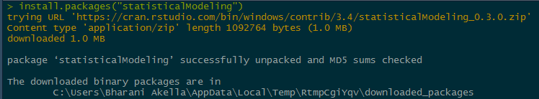
R Interview Questions

6. What are the steps to build and evaluate a linear regression model in R?
These are sequential steps which need to be followed while building a linear regression model:
- Start off by dividing the data into train and test sets, this step is vital because you will be building the model on the train set and evaluating it’s performance on the test set.
  - You can do this using the sample.split() function from the “catools” package. This function gives an option of split-ratio, which you can specify according to your needs.

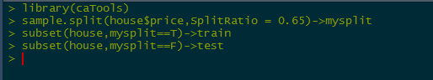
R Interview Questions
- Once, you are done splitting the data into training and test sets, You can go ahead and build the model on the train set.
  - The “lm()” function is used to build a model.
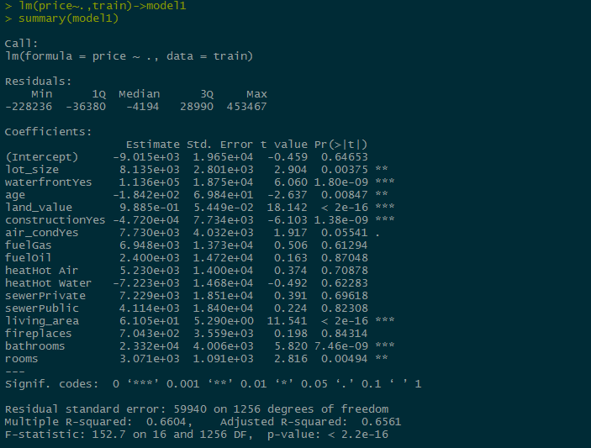
R Interview Questions
- Finally you can predict the values on the test set, using the “predict()” function.
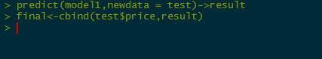
R Interview Questions
- The final step would be to find out the RMSE, the lower the RMSE value, the better the prediction.
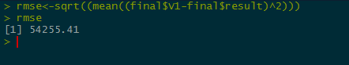
R Interview Questions
7. Name some packages in R, which can be used for data imputation?
These are some packages in R which can used for data imputation
- MICE
- Amelia
- missForest
- Hmisc
- Mi
- imputeR
8. Explain about confusion matrix in R?
A confusion matrix can be used to evaluate the accuracy of the model built. It Calculates a cross-tabulation of observed and predicted classes. This can be done using the “confusionmatrix()” function from the “caTools” package.
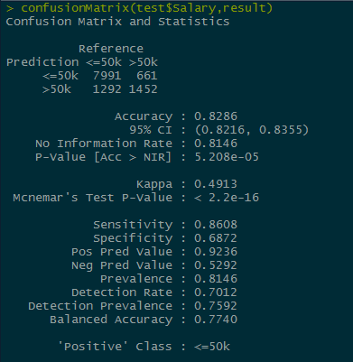

Here, we have created a confusion matrix, which gives a tabulated list for “actual” and “predicted” values.
9. How would you write a custom function in R? Give an example.
This is the syntax to write a custom function In R:
<object-name>=function(x){
—
—
—
}
Let’s look at an example to create a custom function in R ->
fun1<-function(x){ ifelse(x>5,100,0) }
v<-c(1,2,3,4,5,6,7,8,9,10)
fun1(v)->v

10. Name some functions available in “dplyr” package.
Functions in dplyr package:
- filter
- select
- mutate
- arrange
- count

11. How would you create a new R6 Class?
We would have to first create an object template, which consists of the “Data Members” and “Class Functions” present in the class.
An R6 object template comprises of these parts ->
- Class Name
- Private Data Members
- Public Member Functions
Let’s understand the object template through code ->

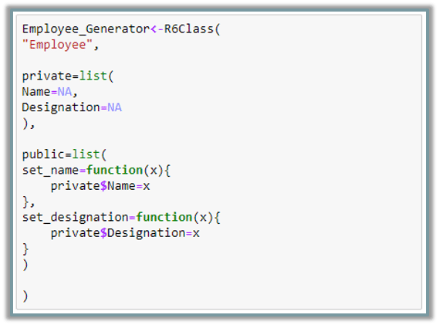
The above code consists of these parts:
- Class Name – “Employee”
- Private Data Members – “Name” & “Designation”
- Public Member Functions – “set_name()” & “set_designation”

12. What is a Random Forest? How do you build and evaluate a Random Forest in R?
Random Forest is an ensemble classifier made using many decision tree models. It combines the results from many decision tree models and this result is usually better than the result of any individual model.
We’ll be working with the “birth” data-set which comprises of these columns:

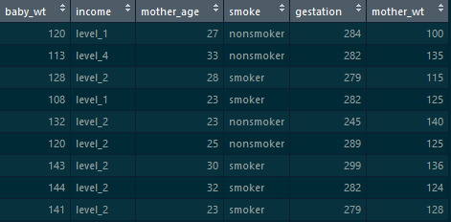
Let’s build a random forest model on top of this to predict the “smoke” column, i.e, whether the mother smokes or not.
- Let’s start off by dividing the data into train and test->

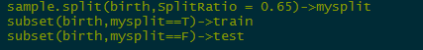
- Build random forest model on the train set->
randomForest(smoke~.,birth)->mod1
- Now, we’ll predict the model on the test set->
predict(mod1,test)->result

13. Tell me something about shinyR.
Shiny is an R package that makes it easy to build interactive web apps straight from R. You can host standalone apps on a webpage or embed them in Rmarkdown documents or build dashboards. You can also extend your Shiny apps with CSS themes, htmlwidgets, and JavaScript actions.

14. What is advantage of using apply family of functions in R?
The apply function allows us to make entry-by-entry changes to data frames and matrices.
The usage in R is as follows:
apply(X, MARGIN, FUN, …)
where:
X is an array or matrix;
MARGIN is a variable that determines whether the function is applied over rows (MARGIN=1), columns (MARGIN=2), or both (MARGIN=c(1,2));
FUN is the function to be applied.
If MARGIN=1, the function accepts each row of X as a vector argument, and returns a vector of the results. Similarly, if MARGIN=2 the function acts on the columns of X. Most impressively, when MARGIN=c(1,2) the function is applied to every entry of X.
Advantage:
With the apply function we can edit every entry of a data frame with a single line command. No auto-filling, no wasted CPU cycles.

15. What packages are used for data mining in R?
Some packages used for data mining in R:
- data.table- provides fast reading of large files
- rpart and caret- for machine learning models.
- Arules- for associaltion rule learning.
- GGplot- provides varios data visualization plots.
- tm- to perform text mining.
- Forecast- provides functions for time series analysis

16. What is clustering? What is the difference between kmeans clustering and hierarchical clustering?
Cluster is a group of objects that belongs to the same class. Clustering is the process of making a group of abstract objects into classes of similar objects.
Let us see why clustering is required in data analysis:
- Scalability − We need highly scalable clustering algorithms to deal with large databases.
- Ability to deal with different kinds of attributes − Algorithms should be capable of being applied to any kind of data such as interval-based (numerical) data, categorical, and binary data.
- Discovery of clusters with attribute shape − The clustering algorithm should be capable of detecting clusters of arbitrary shape. They should not be bounded to only distance measures that tend to find spherical cluster of small sizes.
- High dimensionality − The clustering algorithm should not only be able to handle low-dimensional data but also the high dimensional space.
- Ability to deal with noisy data − Databases contain noisy, missing or erroneous data. Some algorithms are sensitive to such data and may lead to poor quality clusters.
- Interpretability − The clustering results should be interpret-able, comprehensible, and usable.
K-MEANS clustering:
K-means clustering is a well known partitioning method. In this method objects are classified as belonging to one of K-groups. The results of partitioning method are a set of K clusters, each object of data set belonging to one cluster. In each cluster there may be a centroid or a cluster representative. In the case where we consider real-valued data, the arithmetic mean of the attribute vectors for all objects within a cluster provides an appropriate representative; alternative types of centroid may be required in other cases.
Example: A cluster of documents can be represented by a list of those keywords that occur in some minimum number of documents within a cluster. If the number of the clusters is large, the centroids can be further clustered to produce hierarchy within a dataset. K-means is a data mining algorithm which performs clustering of the data samples. In order to cluster the database, K-means algorithm uses an iterative approach.
R code
# Determine number of clusters
wss <- (nrow(mydata)-1)*sum(apply(mydata,2,var))
for (i in 2:15) wss[i] <- sum(kmeans(mydata,
centers=i)$withinss)
plot(1:15, wss, type=”b”, xlab=”Number of Clusters”,
ylab=”Within groups sum of squares”)
# K-Means Cluster Analysis
fit <- kmeans(mydata, 5) # 5 cluster solution
# get cluster means
aggregate(mydata,by=list(fit$cluster),FUN=mean)
# append cluster assignment
mydata <- data.frame(mydata, fit$cluster)
A robust version of K-means based on mediods can be invoked by using pam( ) instead of kmeans( ). The function pamk( ) in the fpc package is a wrapper for pam that also prints the suggested number of clusters based on optimum average silhouette width.
Hierarchical Clustering:
This method creates a hierarchical decomposition of the given set of data objects. We can classify hierarchical methods on the basis of how the hierarchical decomposition is formed. There are two approaches here:
- Agglomerative Approach
- Divisive Approach
Agglomerative Approach:
This approach is also known as the bottom-up approach. In this, we start with each object forming a separate group. It keeps on merging the objects or groups that are close to one another. It keeps on doing so until all of the groups are merged into one or until the termination condition holds.
Divisive Approach:
This approach is also known as the top-down approach. In this, we start with all of the objects in the same cluster. In the continuous iteration, a cluster is split up into smaller clusters. It is down until each object in one cluster or the termination condition holds. This method is rigid, i.e., once a merging or splitting is done, it can never be undone.
R code
Cars example
# The mtcars data set is built into R:
help(mtcars)
# We will focus on the variables that are continuous in nature rather than discrete:
cars.data <- mtcars[,c(1,3,4,5,6,7)]
# Standardizing by dividing through by the sample range of each variable
samp.range <- function(x){
myrange <- diff(range(x))
return(myrange)
}
my.ranges <- apply(cars.data,2,samp.range)
cars.std <- sweep(cars.data,2,my.ranges,FUN=”/”)
# Getting distance matrix:



Data Analytics with R Programming Certification Training
- Instructor-led Sessions
- Real-life Case
- Assignments
- Lifetime Access
Explore Curriculum

dist.cars <- dist(cars.std)
# Single linkage:
cars.single.link <- hclust(dist.cars, method=’single’)
# Plotting the single linkage dendrogram:
plclust(cars.single.link, labels=row.names(cars.data), ylab=”Distance”)
# Opening new window while keeping previous one open
windows()
# complete linkage:
cars.complete.link <- hclust(dist.cars, method=’complete’)
# Plotting the complete linkage dendrogram:
plclust(cars.complete.link, labels=row.names(cars.data), ylab=”Distance”)
# Average linkage:
cars.avg.link <- hclust(dist.cars, method=’average’)
# Plotting the average linkage dendrogram:
plclust(cars.avg.link, labels=row.names(cars.data), ylab=”Distance”)
# Average Linkage dendrogram seems to indicate two major clusters,
# Single Linkage dendrogram may indicate three.
# Single Linkage Solution:
cut.3 <- cutree(cars.single.link, k=3)
# printing the “clustering vector”
cut.3
cars.3.clust <- lapply(1:3, function(nc) row.names(cars.data)[cut.3==nc])
# printing the clusters in terms of the car names
cars.3.clust
# Cluster 1 seems to be mostly compact cars, Cluster 2 is sports cars, Cluster 3 is large Luxury sedans

17. Give examples of “rbind()” and “cbind()” functions in R
Cbind(): As the name suggests, it is used to bind two columns together. One fact to be kept in mind while binding two columns is, the number of rows in both the columns need to be same.
Let’s understand this with an example:
This is “Marks” data-set which comprises of marks in three subjects->
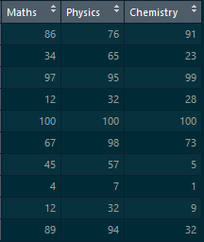
We’ll bind this with a new dataset “Percentage” which consists of two columns :-> “Total” and “Percentage”
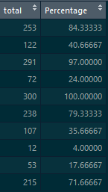
Let’s combine the columns from these two data-sets using the “cbind()” function->
cbind(Marks,Percentage)

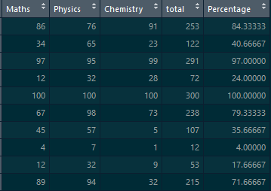
Since, the number of rows in both the data-sets is same we have combined the columns with the help of “cbind()” function

18. Give examples of while and for loop in R.
While loop:
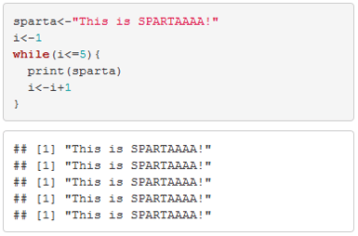

For loop:

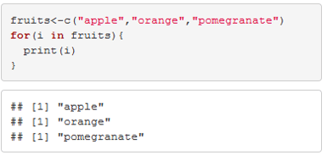

19. Give examples of “select” and “filter” functions from “dplyr” package.
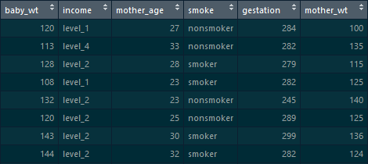
Select: This function from “dplyr” package is used to select some specific columns from the data-set
Birth_weight %>% select(1,2,3)->birth
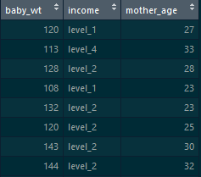
Birth_weight %>% select(-5)->birth
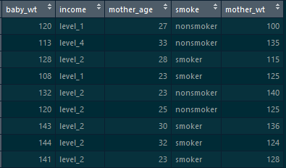
Filter: This function from “dplyr” package is used to filter out some rows on the basis of a condition:
Birth_weight %>% filter(mother_age>35)->birth
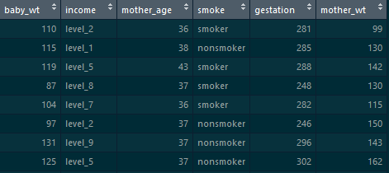
Birth_weight %>% filter(baby_wt>125 & smoke=="smoker")->birth
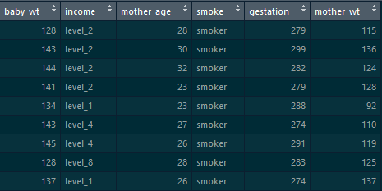

20. What is the use of stringR package. Give some examples of the functions in Stringr.
Some functions in StringR:
Initial:
fruit->
- Converting the strings into capital:
str_to_upper(fruit)
- Finding the count of number of letters:
str_count(fruit)

21. What do you know about the rattle package in R?
Rattle is a popular GUI for data mining using R. It presents statistical and visual summaries of data, transforms data so that it can be readily modelled, builds both unsupervised and supervised machine learning models from the data, presents the performance of models graphically, and scores new datasets for deployment into production. A key features is that all of your interactions through the graphical user interface are captured as an R script that can be readily executed in R independently of the Rattle interface.

22. How would you make multiple plots onto a single page in R?
Plotting multiple plots onto a single page using base graphs is quite easy:
For, example if you want to plot 4 graphs onto the same pane, you can use the below command:
par(mfrow=c(2,2))
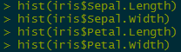

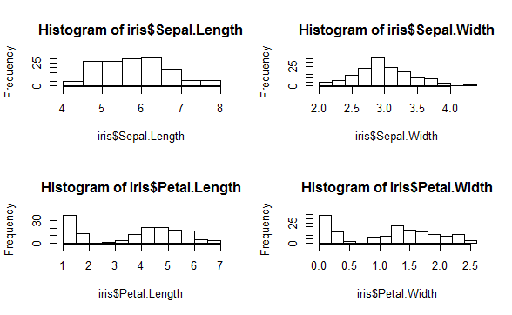

23. How would you create a scatterplot using ggplot2 package?
A scatter-plot can be used to visualize the correlation between two or more entities at the same time.
Let’s take an example and understand how to make a scatter-plot using ggplot2 package->
ggplot(iris,aes(y=Sepal.Length,x=Petal.Length))+geom_point()

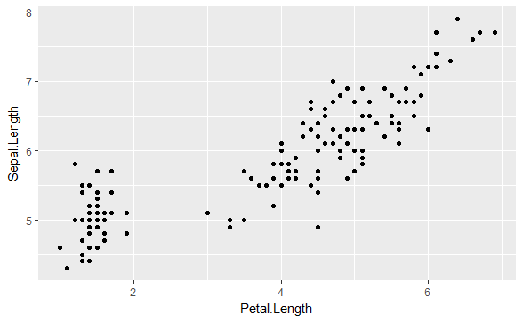

24. How would you facet the data using ggplot2 package?
Let’s take an example to understand faceting with ggplot2
Initial:
ggplot(house,aes(y=price,x=waterfront))+geom_boxplot()

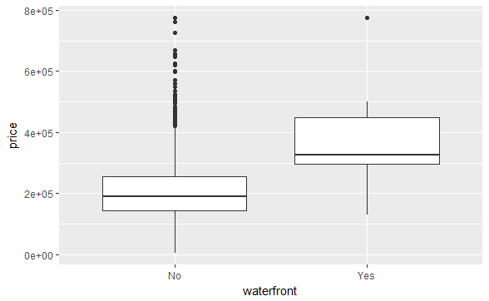
ggplot(house,aes(y=price,x=waterfront))+geom_boxplot()+facet_grid(.~waterfront)

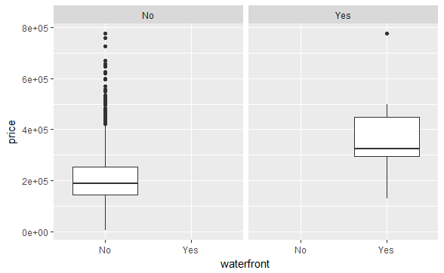

25. Given a vector of values, how would you convert it into a time series object?
Let’s say this is our vector->
a<-c(1,2,3,4,5,6,7,8,9)
To convert this into a time series object->
as.ts(a)->a

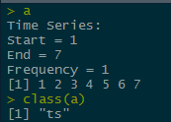
Let’s plot this:
ts.plot(a)

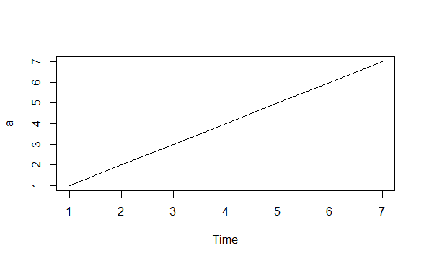

26. What is a White Noise model and how can you simulate it using R?
The white noise (WN) model is a basic time series model.It is the simplest example of a stationary process.
A white noise model has:
- A fixed constant mean
- A fixed constant variance
- No correlation over time
Simulating a white noise model in R:
arima.sim(model=list(order=c(0,0,0)),n=50)->wn
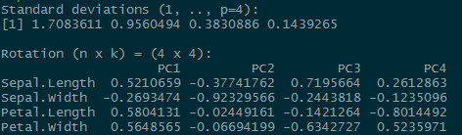
ts.plot(wn)

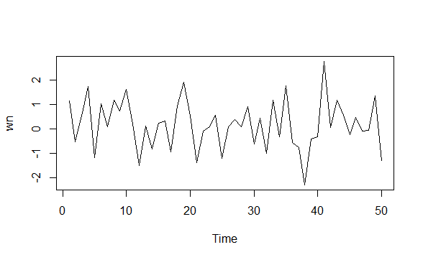

27. What is a Random Walk model and how can you simulate it using R?
A random walk is a simple example of non-stationary process.
A random walk has:
- No specified mean or variance
- Strong dependence over time
- It’s changes or increments are white noise
Simulating random walk in R:
arima.sim(model=list(order=c(0,1,0)),n=50)->rw ts.plot(rw)

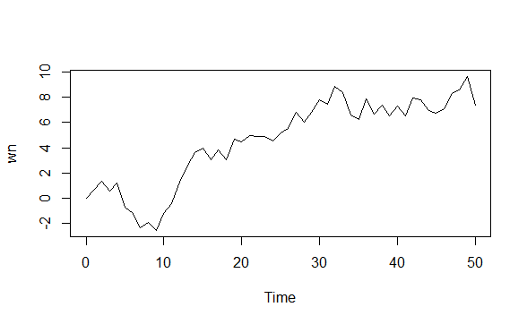

28. What is Principal Component Analysis and how can you create a PCA model in R?
Principal Component Analysis is a method for dimensionality reduction. Many a times, it happens that, one observation is related to multiple dimensions(features) and this brings in a lot of chaos to the data, that is why it is important to reduce the number of dimensions.
The concept of Principal Component Analysis is this:
- The data is transformed to a new space, with equal or less number of dimensions. These dimensions(features) are known as principal components.
- The first principal component captures the maximum amount of variance from the features in the original data.
- The second principal component is orthogonal to the first and captures the maximum amount of variability left.
- The same is true for each principal component, they are all uncorrelated and each is less important than the previous one.
We can do PCA in R with the help of “prcomp()” function.
prcomp(iris[-5])->pca
Let’s see how thee variability decreases across different principal components
screeplot(pca)

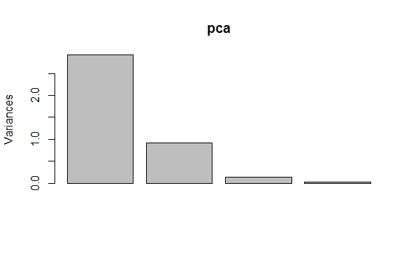

29. How would you find out the mean of one column w.r.t another?
Let’s perform the operation on the iris data-set:
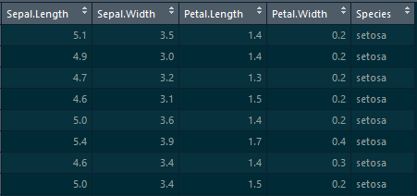
We’ll be using the mean() function from the mosaic package
mean(iris$Sepal.Length~iris$Species)
This command gives the mean values of Sepal-Length across different species of iris flower.

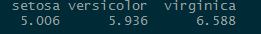
We observe that “virginica” has the highest sepal length and “setosa” has the lowest sepal length.

30. Explain about “initialize()” function in R?
initialize() function is used to initialize the private data members while declaring the object.

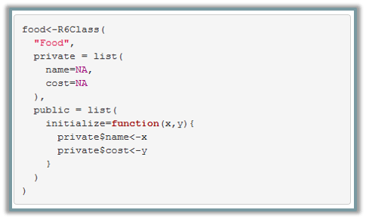
With the above code, we are initializing the values of “name” and “cost” during the time of declaration

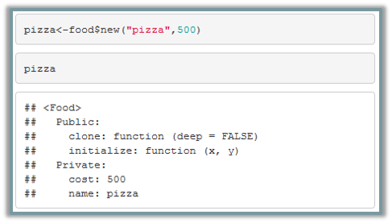
We have initialized the values of ‘500’ to cost and ‘pizza’ to name

31. How would you fit a linear model over a scatter-plot?
We can do that using the “ggplot2” package.
We’ll first make a scatter-plot with the help of geom_point() function, then we’ll make the linear model, by adding the geom_smooth() layer on top of it.

Data Science Training

DATA SCIENCE AND MACHINE LEARNING INTERNSHIP PROGRAM

Data Science and Machine Learning Internship Program
Reviews
5(10)

DATA SCIENCE WITH PYTHON CERTIFICATION COURSE

Data Science with Python Certification Course
Reviews
5(110552)

PYTHON CERTIFICATION TRAINING COURSE

Python Certification Training Course
Reviews
5(39041)

PYTHON MACHINE LEARNING CERTIFICATION TRAINING

Python Machine Learning Certification Training
Reviews
5(12992)

DATA ANALYTICS WITH R PROGRAMMING CERTIFICATION TRAINING

Data Analytics with R Programming Certification Training
Reviews
5(25825)

DATA SCIENCE WITH R PROGRAMMING CERTIFICATION TRAINING COURSE

Data Science with R Programming Certification Training Course
Reviews
5(39493)

STATISTICS ESSENTIALS FOR ANALYTICS

Statistics Essentials for Analytics
Reviews
5(6331)

SAS TRAINING AND CERTIFICATION

SAS Training and Certification
Reviews
5(5259)

ANALYTICS FOR RETAIL BANKS

Analytics for Retail Banks
Reviews
5(1544)

Next
ggplot(data = house,aes(y=price,x=living_area))+geom_point()
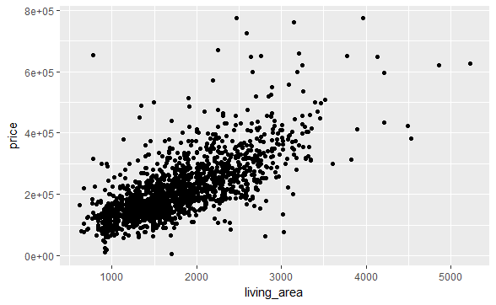
we’ll be adding the geom_smooth() layer on top of this, to fit a linear model.
ggplot(data = house,aes(y=price,x=living_area))+geom_point()+geom_smooth(method = "lm")
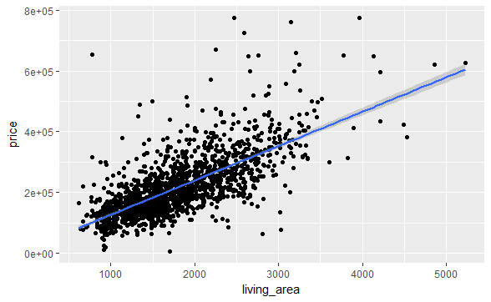

32. What do you know about the evaluate_model() function from “statisticalModeling” Package
This is an alternative to the “predict()” function . i.e. It is used to predict the values of the built model.
The difference between this and predict function is that, it automatically selects more sensible values than the predict function.

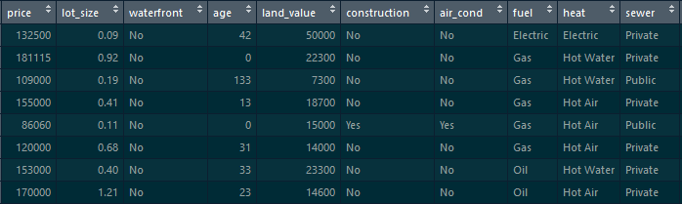
Let’s build a linear regression model on top of this and then predict the values using evaluate_model()
lm(price~.,data = house)->mod1
evaluate_model(mod1)->result
It gives a data-set, which also comprises a new column for the model_output

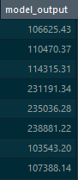

33. How would you build a Scatter-plot using plotly?
With the help of “plotly” we can create stunning visualizations.
This is the command to create a stunning scatter plot with the help of “plotly” package.
plot_ly(house,y=~price,x=~living_area,color=~rooms)

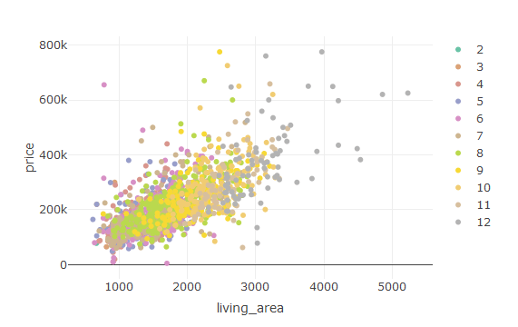

34. What is the difference between a bar-chart and a histogram? Where would you use a bar-chart and where would you use a histogram?
People most often get confused where to use a histogram and where to use a bar-graph. One simple point to be kept in mind is, histograms are used to plot the distribution of a continuous variable and bar-charts are used to plot the distribution of a categorical variable.
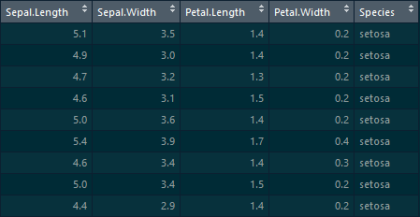
Let’s plot a histogram for the iris dataset with the help of ggplot2 package:

ggplot(data = iris,aes(x=Sepal.Length))+geom_histogram(fill="palegreen4",col="green")
We have plotted “Sepal.Length”- a continuous variable, onto the x-axis.
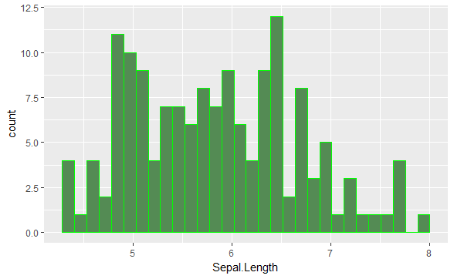
Now, let’s make a bar-graph:
ggplot(data = iris,aes(x=Species))+geom_bar(fill="palegreen4")
We’ll plotted “Species”- a categorical variable onto the x-axis.
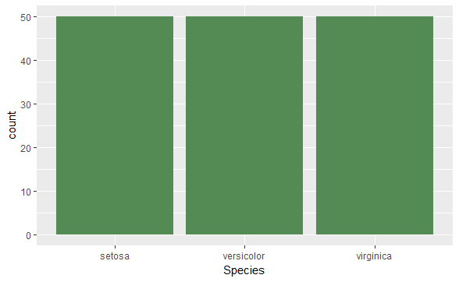

35. How would you create a box-plot using “plotly”?
This is the command to create a box-plot in R:
plot_ly(house,y=~price,x=~rooms,color=~rooms,type="box")

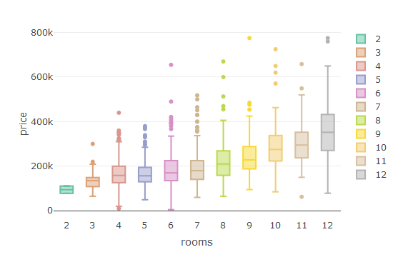

36. How would you do a left and right join in R?
We’ll be using the help of “dplyr” package to make a left join and right join.
We have two data-sets -> employee salary and employee designation:
Employee_designation->
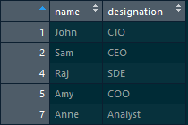
Employee_salary->

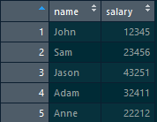
Let’s do a left join on these two data-sets using “left_join()” function from dplyr package:
left_join(employee_designation,employee_salary,by="name")
Result->
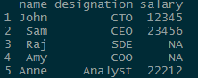
Now, let’s perform a right join between these two data-sets:
right_join(employee_designation,employee_salary,by="name")
Result->
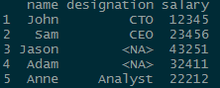

37. What is a factor? How would you create a factor in R?
Conceptually, factors are variables in R which take on a limited number of different values; such variables are often referred to as categorical variables. One of the most important use of factors is in statistical modeling; since categorical variables enter into statistical models differently than continuous variables, storing data as factors ensures that the modeling functions will treat such data correctly.
Initially, we have a character vector of names of fruits, let’s convert it into a factor:

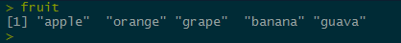
Converting the character vector into a factor can be done using the as.factor() function:
as.character(fruit)->fruit

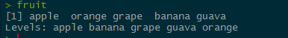
let’s look at the class of the vector now:

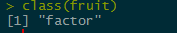

38. Given a vector of numbers, how would you turn the values into scientific notation?
We have the below vector:
a<-c(0.1324,0.0001234,234.21341324,09.324324)
We can convert it into scientific notation using the “formatC()” function:
formatC(a,format="e")
This is the result:
39. How would you join multiple strings together?
Joining strings in R is quite an easy task. We can do it either with the help of “paste()” function or “string_c()” function from “stringR” package.
Let’s understand this with an example:
We have the “fruit” vector, which comprises of names of fruits, and we would want to add the string “fruit” before the name of the fruit. Let’s go ahead and do that.
First, let’s have a glance at the “fruits” vector.
print(fruit)
Now, let’s use the paste function:
paste("fruit",fruit)
Now, let’s perform the same task using “str_c()” function from “stringR” package.
str_c("fruit",fruit,sep="-")
40. Write a custom function which will replace all the missing values in a vector with the mean of values.
Let’s take this vector:
a<-c(1,2,3,NA,4,5,NA,NA)
Now, let’s write the function to impute the values:
mean_impute<-function(x){
ifelse(is.na(x),mean(x,na.rm = T),x)
}

This is the result:
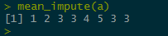

41. What are the different import functions in R?
Data from different sources and different formats can be imported into R. Let’ have a look at the different import functions available in R:
- read.csv()-> for reading .csv files
- read_sas()-> for reading .sas7bdat files
- read_excel()-> for xl sheets
- read_sav()-> for spss data

42. Name some functions which can be used for debugging in R?
These are some functions which can be used for debugging in R:
- traceback()
- debug()
- browser()
- trace()
- recover()

43. How would you check the distribution of a categorical variable in R?
We would often want to find out how are the values of a categorical variable distributed.
We can use the table() function to find the distribution of categorical values.
table(iris$Species)

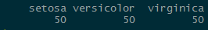
Now, let’s find out the percentage distribution of these values.
table(iris$Species)/nrow(iris)
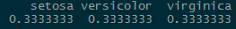

44. How would you rename the columns of a dataframe?
Most often the column names do not convey the right information about the values present in the column, thus we need to rename them.
Let’s take an example which will illustrate on how to rename the columns.
This is the fruits data-set, which consists of two columns:

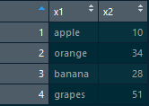
We see that the column names do not give any information about the data present in them, so let’s go ahead and rename those columns.
The “colnames()” function is used to rename the columns.
colnames(fruits)<-c("name","cost")
Now, let’s look at the result: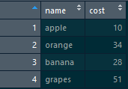

45. How would you find the number of missing values in a dataset and remove all of them?
Missing values bring in a lot of chaos to the data. Thus, it is always important to deal with the missing values before we build any models.
Let’s take an example:
This is an employee data-set which consists of missing values, let’s go ahead and remove them.
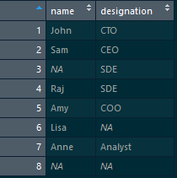
This Code gives the number of missing values->
sum(is.na(employee))
Now, let’s delete the missing values:
na.omit(employee)
This is the result after deleting the missing values:
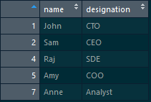

46. What is correlation? How would you measure correlation in R?
Correlation is a measure to find the strength of association between two variables.
We can use the cor() function in R to find the correlation coefficient.
We’ll be working with the iris data-set:

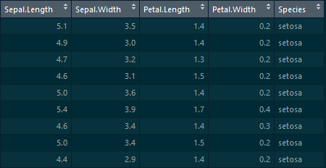
Let’s find the extent of correlation between these variables, using the cor() function
cor(iris[-5])
Let’s have a look at the result:



Data Analytics with R Programming Certification Training
Weekday / Weekend BatchesSee Batch Details

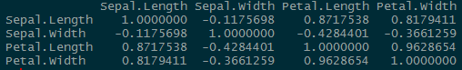
If the correlation coefficient is closer to +1, then there is a strong positive relation between the variables. Similarly, if the correlation coefficient is closer to -1, then there would be a strong negative correlation between the two variables.
If we take “Sepal.Length” and “Petal.Length”, the correlation coefficient is 0.8717538, which means there is strong positive relation between these two variables.

47. How would you extract one particular word from a string?
The string_extract_all() function from the “stringR” package can be used to extract a particular pattern from a string.
sparta<-"This is Sparta! This is Sparta! This is Sparta! This is Sparta! This is Sparta!"
Let’s extract the pattern “Sparta!” from it.
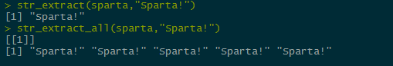

48. From the below data-set, extract only those values where Age>60 and Sex=”F”.
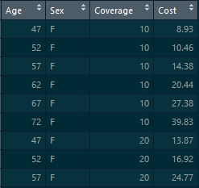
We can do it using the “dplyr” package. “dplyr” is a package which provides many functions for data manipulation, one such function is filter().
Let’s go ahead and perform the desired task using the filter() function
AARP %>% filter(Age>60 & Sex=="F")
With the above command, we are filtering out those values where Age is greater than 60 and “Sex” is female.
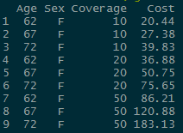

49. You have an employee data-set, which comprises of two columns->”name” and “designation”, add a third column which would indicate the current date and time.
This is the employee data-set:
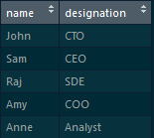
We can add the date using cbind() function
cbind(employee,date())
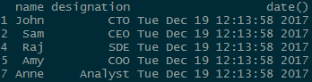

50. How would you do a cross-product of two tables in R?
“merge()” function can be used to perform a cross-product in R:
We have two tables-> “employee_designation” and “employee_salary”
employee_designation table: which consists of “name” and “designation”
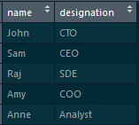
employee_salary table: which consists of “name” and “salary”
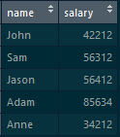
By following the below command, we will get a cross-product:
merge(employee_designation,employee_salary,by=NULL)

1) What is R?
R is an interpreted computer programming language which was created by Ross Ihaka and Robert Gentleman at the University of Auckland, New Zealand". It is a software environment used to analyze statistical information, graphical representation, reporting, and data modeling. R is the implementation of the S programming language, which is combined with lexical scoping semantics.

2) Differentiate between vector, List, Matrix, and Data frame.
A vector is a series of data elements of the same basic type. The members in the vector are known as a component.
The R object that contains elements of different types such as numbers, strings, vectors, or another list inside it, is known as List.
Play Videox
A two-dimensional data structure used to bind the vectors from the same length, known as the matrix. The matrix contains the same types of elements.
A Data frame is a generic form of a matrix. It is a combination of lists and matrices. In the Data frame, different data columns contain different data types.

3) Give names of those packages which are used for data imputation.
There are the following packages which are used for data imputation
- MICE
- missFores
- Mi
- Hmisc
- Amelia
- imputeR

4) Explain initialize() function in R?
This function is used to initialize the private data members while declaring the object.

5) How can we find the mean of one column with respect to another?
In iris dataset, there are five columns, i.e., Sepal.Length, Sepal.Width, Petal.Length, Petal.Width and Species. We will calculate the mean of Sepal-Length across different species of iris flower using the mean() function from the mosaic package.

- mean(iris$Sepal.Length~iris$Species)

6) What is a Random Walk model?
A random walk is the simplest example of a non-stationary process. A random walk has no specified mean or variance, strong dependence over time, and its changes or increments are white noise. Simulating random walk in R:
arima.sim(model=list(order=c(0,1,0)),n=40)->rw ts.plot(rw)

7) What is a White Noise model?
It is a basic time series model and a simple example of a stationary process. A white noise model has a fixed constant mean, a fixed constant variance, and no correlation over time. We can simulate a white noise model in the following way:
arima.sim(model=list(order=c(0,0,0)),n=50)->wn

8) Give any five features of R.
- Simple and effective programming language.
- It is a data analysis software.
- It gives effective storage facility and data handling.
- It gives high extensible graphical techniques.
- It is an interpreted language.

9) Differentiate between R and Python in terms of functionality?
For data analysis, R has inbuilt functionality, but in Python, the data analysis functionalities are not inbuilt. They are available by packages like Pandas and Numpy.

10) What are the applications of R?
There are various applications available in real-time. These applications are as follows:
- Facebook
- Google
- Twitter
- HRDAG
- NDAA

11) Explain RStudio.
RStudio is an integrated development environment which allows us to interact with R more readily. RStudio is similar to the standard RGui, but it is considered more user-friendly. This IDE has various drop-down menus, windows with multiple tabs, and so many customization processes. The first time when we open RStudio, we will see three Windows. The fourth Window will be hidden by default.

12) What are the advantages and disadvantages of R?
Advantages
- Open Source
- Data Wrangling
- Array of Packages
- Platform Independent
- Machine Learning Operations
Disadvantages
- Weak origin
- Data Handling
- Basic Security
- Complicated Language
- Lesser Speed

13) What is the purpose behind R and Hadoop integration?
- For executing Hadoop to execute R code.
- For using R to access the data stored in Hadoop.

14) Give the name of the Hadoop integration methods.
- R Hadoop
- Hadoop Streaming
- RHIPE
- ORCH

15) What will be the output of the expression all(NA==NA)?
[1] NA

16) What is the difference b/w sample() and subset() in R?
The sample() method is used to choose a random sample of size n from a dataset while the subset method is used to choose variables and observations.

17) Why do we use the command - install.packages(file.choose(), repos=NULL)?
This command is used to install an R package from the local directory by browsing and selecting the file.

18) Give the command to create a histogram and to remove a vector from the R workspace?
hist() and rm() function are used as a command to create a histogram and remove a vector from the R workspace.

19) Differentiate b/w "%%" and "%/%".
The "%%" provides a reminder of the division of the first vector with the second, and the "%/%" gives the quotient of the division of the first vector with the second.

20) Why do we use apply() function in R?
This is used to apply the same function to each of the elements in an Array. For example, finding the mean of the rows in every row.

21) Differentiate between library() and require() functions.
If the desired package cannot be loaded, then the library() function gives an error message and display while the required () function is used inside the function and throws a warning message whenever a particular package is not found.

22) What is the t-test() in R?
The t-test() function is used to determine that the mean of the two groups are equal or not.

23) What is the use of with() and by() functions in R?
The with() function applies an expression to a dataset, and the by() function applies a function to each level of factors.

24) Differentiate b/w lapply and sapply.
The lapply is used to show the output in the form of the list, whereas sapply is used to show the output in the form of a vector or data frame.

25) Explain aggregate() function.
The aggregate() function is used to aggregate data in R. There are two methods which are collapsing data by using one or more BY variable and other is an aggregate() function in which By variable should be in the list.

26) Explain the doBy package?
This package is used to define the desired table using function and model formula.

27) Explain the use of the table() function.
This function is used to create the frequency table in R.

28) Explain fitdistr() function?
This function is used to give the maximum likelihood fitting of univariate distribution and defined under the MASS package.

29) What are GGobi and iPlots?
The GGobi is an open-source program for visualization to exploring high dimensional typed data, and the iPlots is a package which provides bar plots, mosaic plots, box plots, parallel plots, histograms, and scatter plots.

30) Explain the lattice package.
The lattice package is meant to improve upon the base R graphics by giving better defaults and has the ability to display multivariate relationships easily.

31) Explain anova() function.
The anova() function is used for comparing the nested models.

32) Explain cv.lm() and stepAIC() function.
The cv.lm() function is defined under the DAAG package used for k-fold validation while the stepAIC() function is defined under the MASS package that performs stepwise model selection under exactAIC.

33) Explain leaps() function.
The leaps() function is used to perform the all-subsets regression and defined under the leaps package.

34) Explain relaimpo and robust package.
This package is used to measure the relative importance of every predictor in the model, and the robust package gives a library of robust methods, including regression.

35) Give full form of MANOVA and what is the use of it.
MANOVA stands for Multivariate Analysis of Variance, and it is used to test more than one dependent variable simultaneously.

36) Explain mashapiro.test() and barlett.test().
This function defines in the mvnormtest package and produces the Shapiro-wilk test to multivariate normality. The barlett.test() is used to provide a parametric k-sample test of the equality of variances.

37) Explain the use of the forecast package.
The forecast package gives the functions which are used to automatic selection of exponential and ARIMA models.

38) Differentiate between qda() and lda() function.
The qda() function prints a quadratic discriminant function while lda() function print the discriminant functions based on the centered variable.

39) Explain the auto.arima() and principal() function.
The auto.arima() function handle both the seasonal and non-seasonal ARIMA model and the principal() function used for rotating and extracting the principal components.

40) Explain FactoMineR.
The FactoMineR is a package that includes qualitative and quantitative variables. The observations and supplementary variables are also included in these packages.

41) What is the full form of SEM and CFA?
CFA stands for Confirmatory Factor Analysis, and SEM stands for Structural Equation Modeling.

42) Define cluster.stats() and pvclust() function().
The cluster.stats() function define in the fpc package that provides a method for comparing the similarity of two cluster solutions using different validation criteria, and the pvclust() function is defined in the pvclust package that provides p-values for hierarchical clustering.

43) Define MATLAB and party packages.
This package includes wrapper functions and variable which are used for replicating Matlab function calls.

44) Explain S3 and S4 systems.
In oops, the S3 is used to overload any function. So that we can call the functions with different names, and it depends on the type of input parameter or the number of parameters, and the S4 is the most important characteristic of oops. However, this is a limitation, as it is quite difficult to debug. There is an optional reference class for S4.

45) Give names of visualization packages.
There are the following packages of visualization in R:
- Plotly
- ggplot2
- tidyquant
- geofacet
- googleVis
- Shiny

46) Explain Chi-Square Test
The Chi-Square Test is used to analyze the frequency table (i.e., contingency table), which is formed by two categorical variables. The chi-square test evaluates whether there is a significant relationship between the categories of the two variables.

47) Explain Random Forest.
The Random Forest is also known as Decision Tree Forest. It is one of the popular decision tree-based ensemble models. The accuracy of these models is higher than other decision trees. This algorithm is used for both classification and regression applications.

48) Explain Time Series Analysis.
Any metric which is measured over regular time intervals creates a time series. Analysis of time series is commercially important due to industrial necessity and relevance, especially with respect to the forecasting (demand, supply, and sale, etc.). A series of data points in which each data point is associated with a timestamp is known as time series.

49) Explain Pie chart in R.
R programming language has several libraries for creating charts and graphs. A pie-chart is a representation of values in the form of slices of a circle with different colors.

50) Explain Histogram.
A histogram is a type of bar chart which shows the frequency of the number of values which are compared with a set of values ranges. The histogram is used for the distribution, whereas a bar chart is used for comparing different entities. In the histogram, each bar represents the height of the number of values present in the given range.

1) Explain what is R?
R is data analysis software which is used by analysts, quants, statisticians, data scientists and others.

2) List out some of the function that R provides?
The function that R provides are
- Mean
- Median
- Distribution
- Covariance
- Regression
- Non-linear
- Mixed Effects
- GLM
- GAM. etc.
List of the Most Frequently Asked R Programming Interview Questions:

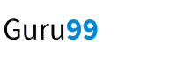EXPLORE MORELearn Java Programming with Beginners Tutorial08:32Linux Tutorial for Beginners: Introduction to Linux Operating...01:35What is Integration Testing Software Testing Tutorial03:04What is JVM (Java Virtual Machine) with Architecture JAVA...02:24How to write a TEST CASE Software Testing Tutorial01:08Seven Testing Principles Software Testing05:01Linux File Permissions Commands with Examples13:29How to use Text tool in Photoshop CC Tutorial08:32What is NoSQL Database Tutorial02:00Important Linux Commands for Beginners Linux Tutorial15:03

3) Explain how you can start the R commander GUI?
Typing the command, (“Rcmdr”) into the R console starts the R commander GUI.

4) In R how you can import Data?
You use R commander to import Data in R, and there are three ways through which you can enter data into it
- You can enter data directly via Data → New Data Set
- Import data from a plain text (ASCII) or other files (SPSS, Minitab, etc.)
- Read a data set either by typing the name of the data set or selecting the data set in the dialog box
R Programming Interview Questions

5) Mention what does not ‘R’ language do?
- Though R programming can easily connects to DBMS is not a database
- R does not consist of any graphical user interface
- Though it connects to Excel/Microsoft Office easily, R language does not provide any spreadsheet view of data

6) Explain how R commands are written?
In R, anywhere in the program you have to preface the line of code with a #sign, for example
- # subtraction
- # division
- # note order of operations exists

7) How can you save your data in R?
To save data in R, there are many ways, but the easiest way of doing this is
Go to Data > Active Data Set > Export Active Data Set and a dialogue box will appear, when you click ok the dialogue box let you save your data in the usual way.

8) Mention how you can produce co-relations and covariances?
You can produce co-relations by the cor () function to produce co-relations and cov () function to produce covariances.

9) Explain what is t-tests in R?
In R, the t.test () function produces a variety of t-tests. T-test is the most common test in statistics and used to determine whether the means of two groups are equal to each other.

10) Explain what is With () and By () function in R is used for?
- With() function is similar to DATA in SAS, it apply an expression to a dataset.
- BY() function applies a function to each level of factors. It is similar to BY processing in SAS.

11) What are the data structures in R that is used to perform statistical analyses and create graphs?
R has data structures like
- Vectors
- Matrices
- Arrays
- Data frames

12) Explain general format of Matrices in R?
General format is
Mymatrix< - matrix (vector, nrow=r , ncol=c , byrow=FALSE,
dimnames = list ( char_vector_ rowname, char_vector_colnames))

13) In R how missing values are represented ?
In R missing values are represented by NA (Not Available), why impossible values are represented by the symbol NaN (not a number).

14) Explain what is transpose?
For re-shaping data before, analysis R provides various method and transpose are the simplest method of reshaping a dataset. To transpose a matrix or a data frame t () function is used.

15) Explain how data is aggregated in R?
By collapsing data in R by using one or more BY variables, it becomes easy. When using the aggregate() function the BY variable should be in the list.

16) What is the function used for adding datasets in R?
rbind function can be used to join two data frames (datasets). The two data frames must have the same variables, but they do not have to be in the same order.

17) What is the use of subset() function and sample() function in R ?
In R, subset() functions help you to select variables and observations while through sample() function you can choose a random sample of size n from a dataset.

18) Explain how you can create a table in R without external file?
Use the code
myTable = data.frame()
edit(myTable)

1. Compare R & Python
R programming Language | Python programming language
Model Building is similar to Python | Model Building is similar to R.
Model Interpretability is good | Model Interpretability is not good
Production is not better than Python. | Production is good
R has good community support over Python. | Community Support is not better than R
Data Science Libraries are same as Python. | Data Science Libraries are same as R.
R has good data visualizations libraries and tools | Data visualization is not better than R
R has a steep learning curve. | Learning Curve in Python is easier than learning R.

2. Explain the data import in R language.
R provides to import data in R language. To begin with the R commander GUI, user should type the commands in the command Rcmdr into the console. Data can be imported in R language in 3 ways such as:
- Select the data set in the dialog box or enter the name of the data set as required.
- Data is entered directly using the editor of R Commander via Data->New Data Set. This works good only when the data set is not too large.
- Data can also be imported from a URL or from plain text file (ASCII), or from any statistical package or from the clipboard.

3. Explain how to communicate the outputs of data analysis using R language.
Combine the data, code and analysis results in a single document using knitr for Reproducible research done. Helps to verify the findings, add to them and engage in conversations. Reproducible research makes it easy to redo the experiments by inserting new data values and applying it to different various problems.

4. Difference between library () and require () functions in R language.
library() | require()
Library () function gives an error message display, if the desired package cannot be loaded. | Require () function is used inside function and throws a warning messages whenever a particular package is not Found
It loads the packages whether it is already loaded or not, | It just checks that it is loaded, or loads it if it isn’t (use in functions that rely on a certain package). The documentation explicitly states that neither function will reload an already loaded package.
Consider a related program for the above differentiation.
if(!require(package, character.only=T, quietly=T)) {

install.packages (package)

library(package, character.only=T)

}
For multiple packages you can use
for(package in c('', '')) {

if(!require(package, character.only=T, quietly=T)) {

install.packages (package)

library(package, character.only=T)

}

}

5. What is R?
R is a programming language which is used for developing statistical software and data analysis. It is being increasingly deployed for machine learning applications as well.
Get 100% Hike!
Master Most in Demand Skills Now !
窗体顶端
窗体底端

6. How R commands are written?
By using # at the starting of the line of code like #division commands are written.

7. What is t-tests() in R?
It is used to determine that the means of two groups are equal or not by using t.test() function.
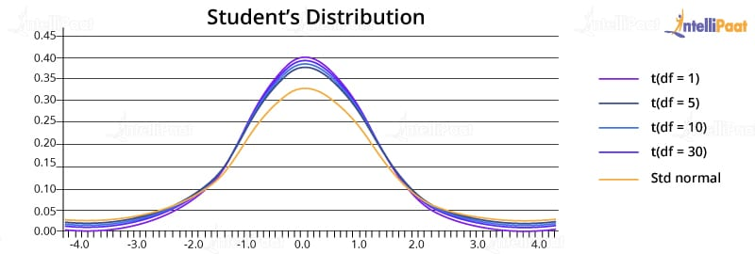

8. What are the disadvantages of R Programming?
The disadvantages are:-
- Lack of standard GUI
- Not good for big data.
- Does not provide spreadsheet view of data.

9. What is the use of With () and By () function in R?
with() function applies an expression to a dataset.
#with(data,expression)
By() function applies a function t each level of a factors.
#by(data,factorlist,function)

10. In R programming, how missing values are represented?
In R missing values are represented by NA which should be in capital letters.

11. What is the use of subset() and sample() function in R?
Subset() is used to select the variables and observations and sample() function is used to generate a random sample of the size n from a dataset.

12. Explain what is transpose.
Transpose is used for reshaping of the data which is used for analysis. Transpose is performed by t() function. Here is an example of data in the form of matrix and its transpose:
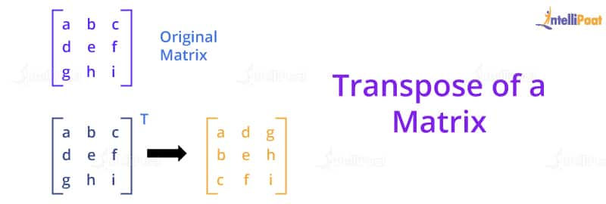

13. What are the advantages of R?
- The advantages are:-
- It is used for managing and manipulating of data.
- No license restrictions
- Free and open source software.
- Graphical capabilities of R are good.
- Runs on many Operating system and different hardware and also run on 32 & 64 bit processors etc.
Now that you are aware of the benefits of R programming, to know more check out R Course.

14. What is the function used for adding datasets in R?
For adding two datasets rbind() function is used but the column of two datasets must be same.
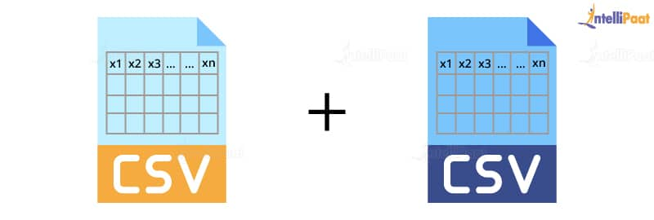
Syntax: rbind(x1,x2……) where x1,x2: vector, matrix, data frames.

15. How you can produce co-relations and covariances?
Cor-relations is produced by cor() and covariances is produced by cov() function.

16. What is difference between matrix and dataframes?
Dataframe can contain different type of data but matrix can contain only similar type of data. Here are the different types of data structures in R:
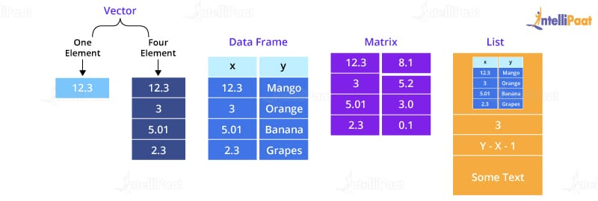
Career Transition




17. What is difference between lapply and sapply?
lapply is used to show the output in the form of list whereas sapply is used to show the output in the form of vector or data frame

18. What is the difference between seq(4) and seq_along(4)?
Seq(4) means vector from 1 to 4 (c(1,2,3,4)) whereas seq_along(4) means a vector of the length(4) or 1(c(1)).

19. Explain how you can start the R commander GUI.
rcmdr command is used to start the R commander GUI.

20. What is the memory limit of R?
In 32 bit system memory limit is 3Gb but most versions limited to 2Gb and in 64 bit system memory limit is 8Tb.

Check out this Data Science Interview Questions video by Intellipaat:


21. How many data structures R has?
There are 5 data structures in R i.e. vector, matrix, array which are of a homogenous type and the other two are list and data frame which are heterogeneous.
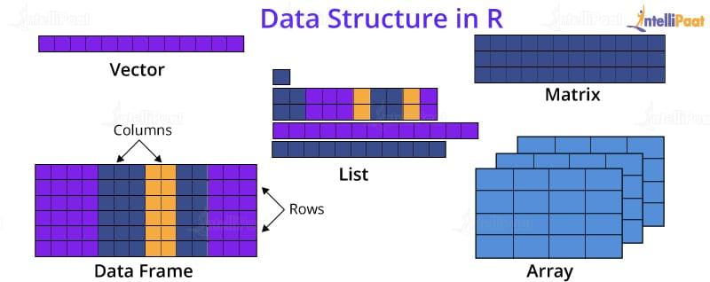
Learn more about data structure in the R programming tutorial.

22. Explain how data is aggregated in R.
There are two methods that is collapsing data by using one or more BY variable and other is aggregate() function in which BY variable should be in list.

23. How many sorting algorithms are available?
There are 5 types of sorting algorithms are used which are:-
- Bubble Sort
- Selection Sort
- Merge Sort
- Quick Sort
- Bucket Sort

24. How to create new variable in R programming?
For creating new variable assignment operator ‘<-’ is used
For e.g. mydata$sum <- mydata$x1 + mydata$x2

25. What are R packages?
Packages are the collections of data, R functions and compiled code in a well-defined format and these packages are stored in library. One of the strengths of R is the user-written function in R language.
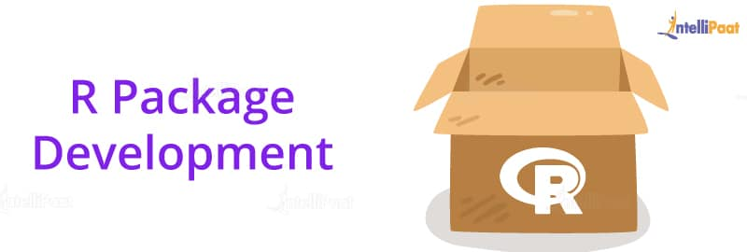

26. What is the workspace in R?
Workspace is the current R working environment which includes any user defined objects like vector, lists etc.
Courses you may like




27. What is the function which is used for merging of data frames horizontally in R?
Merge()function is used to merge two data frames
Eg. Sum<-merge(data frame1,data frame 2,by=’ID’)

28. what is the function which is used for merging of data frames vertically in R?
rbind() function is used to merge two data frames vertically.
Eg. Sum <- rbind(data frame1,data frame 2)

29. What is the power analysis?
It is used for experimental design .It is used to determine the effect of given sample size.
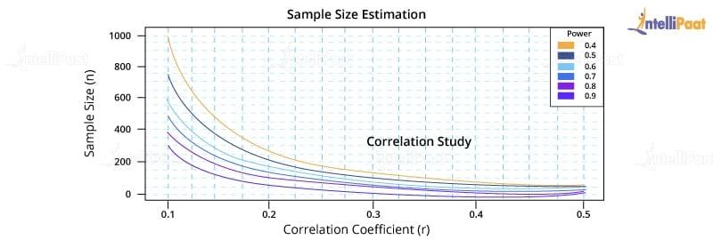

30. Which package is used for power analysis in R?
Pwr package is used for power analysis in R.

Intermediate R Interview Questions

31. Which method is used for exporting the data in R?
There are many ways to export the data into another formats like SPSS, SAS , Stata , Excel Spreadsheet.

32. Which packages are used for exporting of data?
For excel xlsReadWrite package is used and for sas,spss ,stata foreign package is implemented.

33. How impossible values are represented in R?
In R NaN is used to represent impossible values.

34. Which command is used for storing R object into a file?
Save command is used for storing R objects into a file.
Syntax: >save(z,file=”z.Rdata”)

35. Which command is used for restoring R object from a file?
load command is used for storing R objects from a file.
Syntax: >load(”z.Rdata”)

36. What is the use of coin package in R?
Coin package is used to achieve the re randomization or permutation based statistical tests.

37. Which function is used for sorting in R?
order() function is used to perform the sorting.

38. What is the use of tapply?
IOS-6.1.3

39. What happens when the application object does not handle an event?
The event will be dispatched to your delegate for processing.

40. Explain app specific objects which store the app contents.
The app specific objects are Data model objects that store app’s contents.

41. Explain the purpose of using UIWindow object?
UIWindow object coordinates the one or more views presenting on the screen.
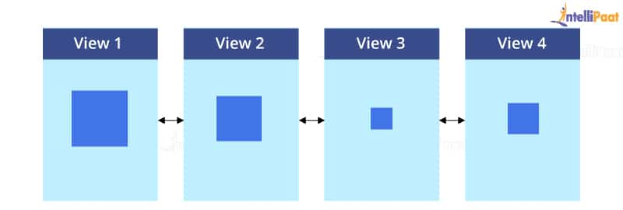


42. Tell me the super class of all view controller objects.
UIView Controller class.

43. How to create axes in the graph?
Using axes() function custom axes are created.

44. What is the use of abline() function?
abline() function is add the reference line to a graph.
Syntax: abline(h=yvalues, v=xvalues)

45. Why vcd package is used?
vcd package provides different methods for visualizing multivariate categorical data.

46. What is GGobi?
GGobi is an open-source program for data visualization for exploring high dimensional typed data.

47. What is iPlots?
It is a package which provide bar plots, mosaic plots, box plots, parallel plots, scatter plots and histograms.
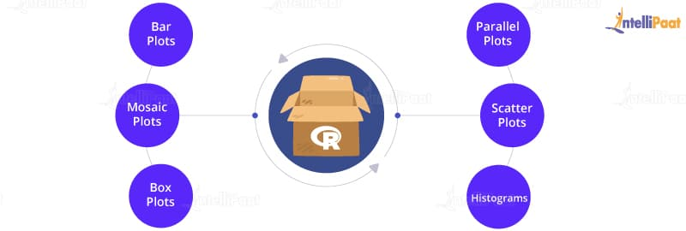

48. What is the use of lattice package?
lattice package is to improve on base R graphics by giving better defaults and it have the ability to easily display multivariate relationships.

49. What is fitdistr() function?
It is used to provide the maximum likelihood fitting of univariate distributions. It is defined under the MASS package.

50. Which data structures are used to perform statistical analysis and create graphs.
Data structures are vectors, arrays, data frames and matrices.

51. What is the use of sink() function?
It defines the direction of output.

52. Why library() function is used?
This function is used to show the packages which are installed.

53. Why search() function is used?
By this function we see that which packages are currently loaded.

54. On which type of data binary operators are worked?
Binary operators are worked on matrices, vectors and scalars.

55. What is the use of doBY package?
It is used to define the desired table using function and model formula.

56. Which function is used to create frequency table?
Frequency table is created by table() function.

57. Define loglm() function.
Loglm() function is used to create log-linear models.


58. What is the use of corrgram() function?
corrgram() function is used to plot correlograms.
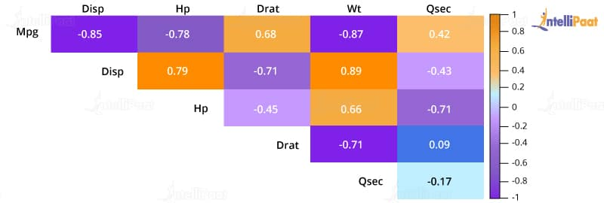

59. How to create scatterplot matrices?
Pair() or splom() function is used for create scatterplot matrices.

60. What is npmc?
It is a package which gives nonparametric multiple comparisons.

Advanced R Interview Questions

61. What is the use of diagnostic plots?
It is used to check the normality, heteroscedasticity and influential observations.
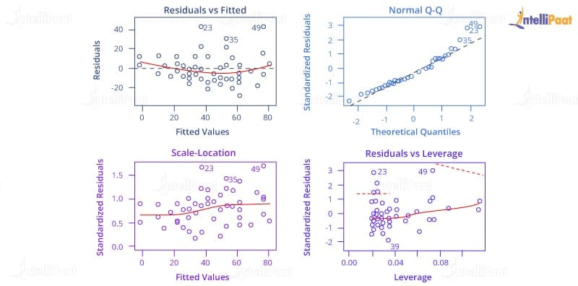

62. Define anova() function.
anova() is used to compare the nested models.

63. What is cv.lm() function?
It is defined under the DAAG package which is used for k-fold validation.

64. Define stepAIC() function.
It is define under the MASS package which performs stepwise model selection under exact AIC.

65. Define leaps().
It is used to perform the all-subsets regression and it is defined under the leaps package.

66. Define relaimpo package.
It is used to measure the relative importance of each of the predictor in the model.

67. Why car package is used?
It provide a variety of regression including scatter plots, variable plots and it also enhanced diagnostic.

68. Define robust package.
It provides a library of robust methods including regression.

69. What is robustbase?
It is a package which provides basic robust statistics including model selection methods.

70. Define plotmeans().
It is define under gplots package which includes confidence intervals and it produces mean plot for single factors.

71. What is the full form of MANOVA?
MANOVA stands for multivariate analysis of variance.

72. What is the use of MANOVA?
By using MANOVA we can test more than one dependent variable simultaneously.
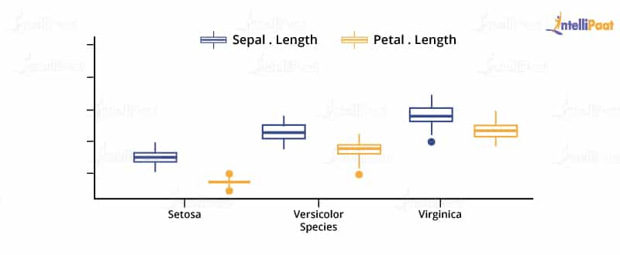

73. Define mshapiro.test( ).
It is a function which defines in mvnormtest package. It produces the Shapiro-wilk test for multivariate normality.

74. Define barlett.test().
Barlett.test() is used to provide a parametric k-sample test of the equality of variances.

75. What is fligner.test()?
It is a function which provides a non-parametric k sample test of the equality of variances.

76. Define hovplot().
It is define in HH package which provides a graphic test of homogeneity of variance based on brown forsyth.

77. Which variables are represented by lower case letters?
Numerical variables are represented by lower case letters.

78. Which variables are represented by upper case letters?
Categorical factors are represented by upper case letters.
Learn more about R in this insightful article on R programming

79. What is logistic regression?
Logistic regression is used to predict the binary outcome from the given set of continuous predictor variables.
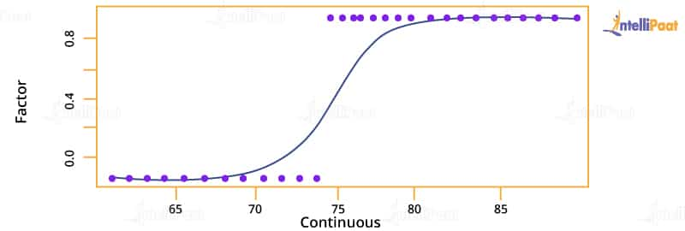

80. Define Poison regression.
It is used to predict the outcome variable which represents counts from the given set of continuous predictor variable.
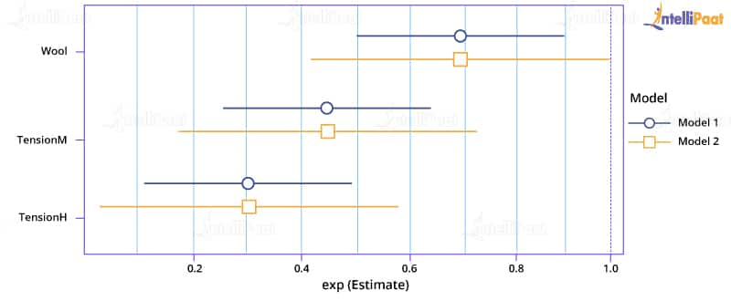

81. Define Survival analysis.
It includes number of techniques which is used for modeling the time to an event.

82. What is the use survfit() function?
It estimates a survival distribution one or more groups.

83. Define survdiff().
It determines the differences in survival distribution between two or more groups.

84. What is coxph()?
It is a function which is used to model the hazard function on the set of predictor variable.

85. In which package survival analysis is defined?
Survival analysis is defined under the survival package.

86. What is the use of MASS package?
MASS functions include those functions which performs linear and quadratic discriminant function analysis.

87. Define qda().
qda() prints a quadratic discriminant function.

88. Define lda().
lda() is used to print the discriminant functions which is based on centered variable.

89. What is the use of forecast package?
It provides the functions which are used for automatic selection of ARIMA and exponential models.
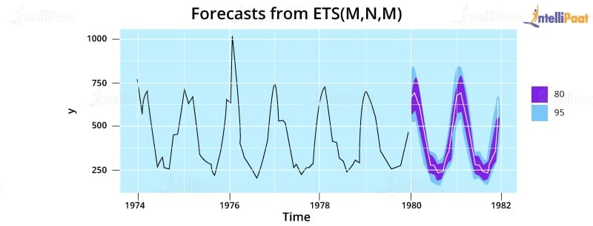

90. Define auto.arima().
It is used to handle the seasonal as well as non-seasonal ARIMA models.

91. What is principal() function?
It is define in psych package which is used to rotate and extract the principal components.

92. What is FactoMineR?
It is a package which includes quantitative and qualitative variables. It also includes supplementary variables and observations.

93. What is the full form of CFA?
CFA stands for Confirmatory Factor Analysis.

94. What is the use of boot.sem() function?
It is used to bootstrap the structural equation model.

95. What is the full form of SEM?
SEM stands for Structural Equation Modeling.

96. Which function performs classical multidimensional scaling?
cmdscale() function is used to perform classical multidimensional scaling.

97. Define isoMDS().
This function is defined under the MASS package which performs nonmetric multidimensional scaling.

98. Which function perform individual difference scaling?
It is done by indscal() function.

99. What is pvclust() function ?
It comes under the pvclust package which provides p-values for hierarchical clustering.

100. Define cluster.stats() ?
It is define in fpc package which provide a method for comparing the similarity of two clusters solution using different validation criteria.
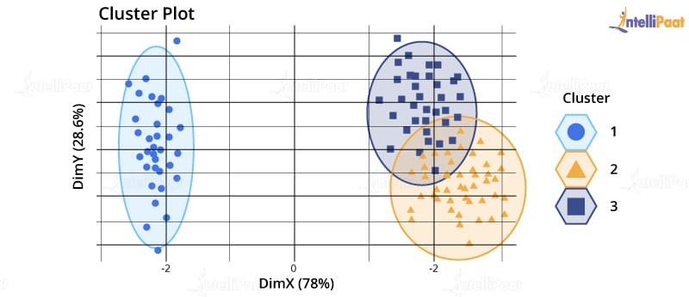

101. What we use party package?
It is used to provide a non-parametric regression for ordinal, nominal, censored and multivariate responses.

102. Which package provide the bootstrapping?
boot package is used which provide bootstrapping.

103. Define MATLAB package.
Matlab package includes those wrapper functions and variable which are used to replicate matlab function calls.

104. What is the of use Matrix package?
Matrix package includes those function which support sparse and dense matrices like Lapack, BLAS etc.

1. What is R?
This should be an easy one for data science job applicants. R is an open-source language and environment for statistical computing and analysis, or for our purposes, data science.

2. Can you write and explain some of the most common syntax in R?
Again, this is an easy—but crucial—one to nail. For the most part, this can be demonstrated through any other code you might write for other R interview questions, but sometimes this is asked as a standalone. Some of the basic syntax for R that’s used most often might include:
# — as in many other languages, # can be used to introduce a line of comments. This tells the compiler not to process the line, so it can be used to make code more readable by reminding future inspectors what blocks of code are intended to do.
"" — quotes operate as one might expect; they denote a string data type in R.
<- — one of the quirks of R, the assignment operator is <- rather than the relatively more familiar use of =. This is an essential thing for those using R to know, so it would be good to display your knowledge of it if the question comes up.
\ — the backslash, or reverse virgule, is the escape character in R. An escape character is used to “escape” (or ignore) the special meaning of certain characters in R and, instead, treat them literally.

3. How do you list the preloaded datasets in R?
To view a list of preloaded datasets in R, simply type data() into the console and hit enter.
I’m running R version 3.5.1 for Windows on my machine with a standard, default install. The output in RStudio for me looks something like this:
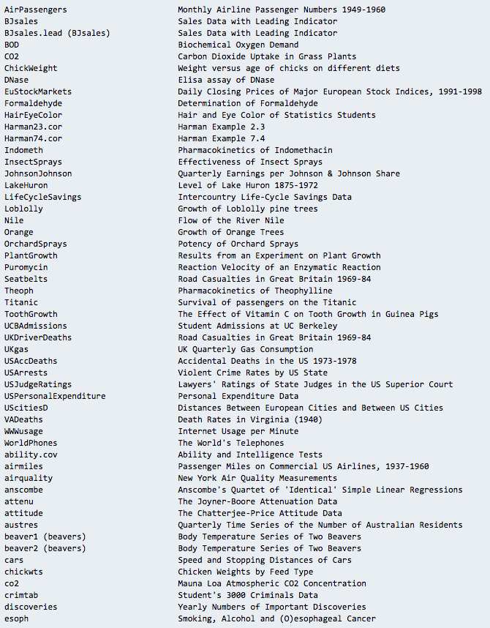
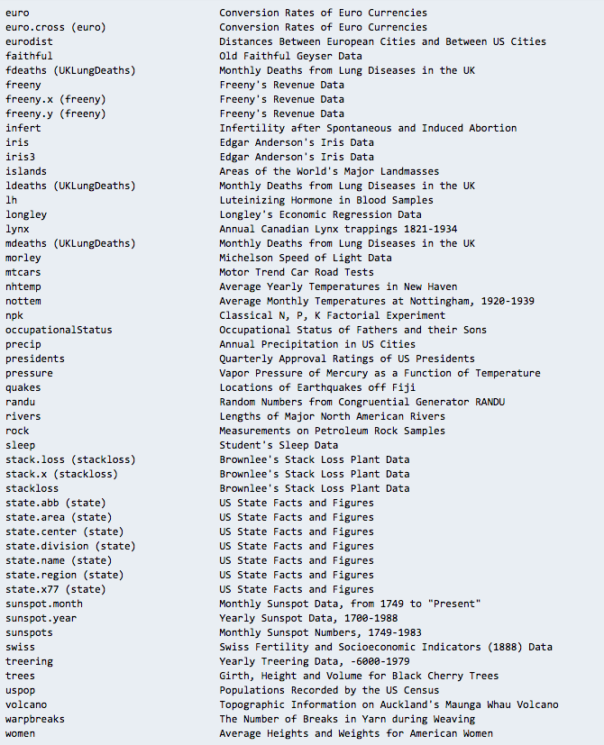

4. What are some advantages of R?
It’s important to be familiar with the advantages and disadvantages of certain languages and ecosystems. R is no exception. So what are the advantages of R?
Its open-source nature. This qualifies as both an advantage and disadvantage for various reasons, but being open source means it’s widely accessible, free to use, and extensible.
Its package ecosystem. The built-in functionality available via R packages means you don’t have to spend a ton of time reinventing the wheel as a data scientist.
Its graphical and statistical aptitude. By many people’s accounts, R’s graphing capabilities are unmatched.

5. What are the disadvantages of R?
Just as you should know what R does well, you should understand its failings.
Memory and performance. In comparison to Python, R is often said to be the lesser language in terms of memory and performance. This is disputable, and many think it’s no longer relevant as 64-bit systems dominate the marketplace.
Related: Our list of Python Interview Questions and Answers and Programming Interview Questions and Answers
Open source. Being open source has its disadvantages as well as its advantages. For one, there’s no governing body managing R, so there’s no single source for support or quality control. This also means that sometimes the packages developed for R are not the highest quality.
Security. R was not built with security in mind, so it must rely on external resources to mind these gaps.

6. What are the similarities and differences between R and Python?
Attribute | Python | R
Cost | ★★★★★ | ★★★★★
Security | ★★★★☆ | ★☆☆☆☆
Model building | ★★★★★ | ★★★★★
Learning curve | ★★★☆☆ | ★★☆☆☆
Visualization tools and libraries | ★★★☆☆ | ★★★★★
There are many comparisons to draw between Python and R. They are both free. They both have strong modeling capabilities. Python is generally considered more secure and easier to learn, but R is typically thought to have better visualization tools and libraries. In many jobs, you’ll be expected to use both R and Python, so it’s good to know about both, even if you aren’t fluent in both languages.

7. Write code to accomplish a task
In just about any interview for a position that involves coding, companies will ask you to accomplish a specific task by actually writing code. Facebook and Google both do as much. Because it’s difficult to predict what task an interviewer will set you to, just be prepared to write “whiteboard code” on the fly.

8. When is it appropriate to use the “next” statement in R?
A data scientist will use next to skip an iteration in a loop. As an example:
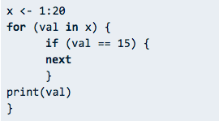
This code iterates through a range of numbers from 1 to 20 and prints the values. I don’t want to print 15, though, so I’ve used the next statement to skip that iteration and move on to other values. The output would print 1-14 and 16-20.

9. How do you assign a variable in R?
Variable assignment in R is a bit different from other languages. Rather than using an = sign, we typically use a less-than sign, <, followed by a minus, –. An equals sign, =, still works, but there are arguments about its readability in addition to instances where it can actually muck up your code. I suggest you stick with <- for assignment in R, if for no other reason than it’s expected (Google’s R style manual, which is widely used, prohibits = for assignment).
myVar <- 15
print(myVar
Notice the following is also valid:
myVar = 15
print(myVar)
You can also assign variables the other way around in R.
"helloWorld" -> myVar
The string “helloWorld” is now stored in the myVar variable. Note that this would produce an error if we got mixed up and tried to plug an undefined variable object into a string, as in:
myVar -> "helloWorld"
Error: object 'myVar' not found
Scoping of variables is something to consider as well. <<- acts as the “superassignment” operator and is useful for closures. A good example on how to use this can be found on stackoverflow.
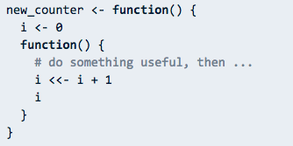

10. What are the different data types/objects in R?
This is another good opportunity to show that you know R, and you’re not winging it. Unlike other object-oriented languages such as C, R doesn’t ask users to declare a data type when assigning a variable. Instead, everything in R correlates to an R data object. When you assign a variable in R, you assign it a data object and that object’s data type determines the data type of the variable. The most commonly used data objects include:
- Vectors
- Matrices
- Lists
- Arrays
- Factors
- Data frames

11. What are the objects you use most frequently?
This question is meant to gather a sense of your experiences in R. Simply think about some recent work you’ve done in R and explain the data objects you use most often. If you use arrays frequently, explain why and how you’ve used them.

12. Why use R?
This is a variant of the “advantages of R” question. Reasons to use R include its open-source nature and the fact that it’s a versatile tool for statistical plotting, analysis, and portrayal. Don’t be afraid to give some personal reasons as well. Maybe you simply love the assignment operator in R or feel that it’s more elegant than other languages—but always remember to explicate. You should be answering follow-up questions before they’re even asked.

Get To Know Other Data Science Students

Ginny Zhu
Data Science Intern at Novartis
Read Story

Mikiko Bazeley
ML Engineer at MailChimp
Read Story

Pizon Shetu
Data Scientist at Whiterock AI
Read Story

13. What are some of your favorite functions in R?
As a user of R, you should be able to come up with some functions on the spot and describe them. Functions that save time and, as a result, money will always be something an interviewer likes to hear about.

14. Write a custom function in R
Sometimes you’ll be asked to create a custom function on the fly. An example of a custom function from quick-r’s guide:
myFunction <- function(arg1, arg2, ... ){
statements
return(object)
}
Functions can be simple or complex, but they should make your code more extensible, readable, and efficient. This is a chance to show your ingenuity and experience.

15. How do you import data in R?
Let’s use CSV as an example, as it’s a very common data format. Simply make sure the file is saved in a CSV format, then use the read function to import the data.
yourRDateHere <- read.csv("Data.csv", header = TRUE)
Though not required, strictly speaking, the argument header = TRUE is used to ensure that labels are not parsed as data. Making this argument false means you either don’t have labels in your CSV or you want them to be part of the data output in R.
To do the same with data in a .txt file, simply change read.csv to read.table.

16. How do you install a package in R?
There are many ways to install a package in R. Some even include using the GUI. We’re coders, so we’re not going to give those attention.
Type the following into your console and hit enter:
install.packages("package_name")
Followed by:
library(package_name)
It’s that simple. The first command installs the package and the second loads the package into the session.

17. What is the use of with() in R?
We use the with() function to write simpler code by applying an expression to a data set. Its syntax looks like this:
with(randomDataSet, expression.test(sample))

18. What is the use of by() in R?
Like with(), by() can help write DRY (don’t repeat yourself) code.
You can use by() to apply a function to a data frame split by factors. Its usage is something like this:
by(data, factor, function, ...)
The data frame plugged into this function is split into data frames (by row) subsetted by the values of factor(s), and a function is then applied to each subset.
A good example of this function in action can be found here:
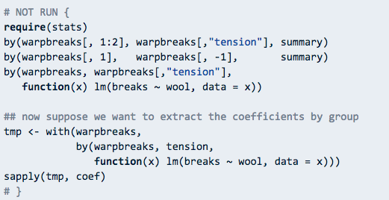

19. When is it appropriate to use mode()?
By default, mode() gets or sets the storage mode of an object. It’s default usage is equivalent to storage.mode(). A sample usage:
x <- 1:25
mode(x)
[1] "numeric"
y <- "helloWorld"
mode(y)
[1] "character"
mode(state.name)
[1] "character"
In the first line, we assign x to values 1 through 25, so when we run it through mode, we get “numeric” because the variable stores numeric values. If we, instead, assign the variable to a string such as in the y variable above, we get “character” as the mode. You can try this out with predefined data sets as well, such as with state.name.
You can view documentation here.

20. What is a factor variable, and why would you use one?
A factor variable is a form of the categorical variable that accepts either numeric or character string values. The most salient reason to use a factor variable is that it can be used in statistical modeling with great accuracy. Another reason is that they are more memory efficient.
Simply use the factor() function to create a factor variable. There’s more information here.

21. When is it appropriate to use the which() function?
The which() the function loops through a logical object until the condition returns TRUE and returns the index (position) of the element.
To get a sense of how this works, plug in the letters array and search for the index of a specific letter using which().
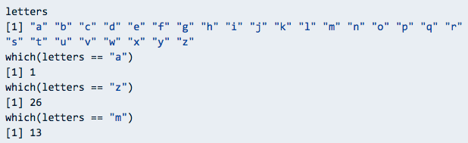
In my console, I’ve checked the letters array, which contains the English alphabet in lowercase. I’ve used which() to find the positions of a, z, and m, which returned the indexes 1, 26, and 13, respectively, because these are the positions in the array, as they are typically the positions in the alphabet.

22. How do you concatenate strings in R?
Concatenating strings in R is less than intuitive. You don’t use a . operator, nor a + operator, and forget about the & operator. In fact, you don’t use an operator at all. Concatenating strings in R requires the use of the paste() function. Here’s an example:
hello <- "Hello, "
world <- "World."
paste(hello, world)
[1] "Hello, World."
I’ve stored Hello, and World. in variables aptly named hello and world. With paste(), I’ve simply plugged in the two variables, and it concatenates them such that it creates the single phrase “Hello, World.”
An oddity with this function is that it will automatically insert spaces between the terms. Try it out with some numbers.
paste(1,2,3,4)
[1] "1 2 3 4"
This can be a sort of “gotcha” with this question. If we don’t want spaces, we can adjust the sep parameter in the function, which defaults to a space " ".
paste(1,2,3,4,sep=“”)
[1] "1234"

23. How do you read a CSV file in R?
We’ve covered this already with the import process. Simply use the read.csv() function.
yourRDateHere <- read.csv("Data.csv", header = TRUE)

24. What are 3 sorting algorithms available in R?
R uses the sort() function to order a vector or factor, listed and described below.
Radix: Usually the most performant algorithm, this is a non-comparative sorting algorithm that avoids overhead. It’s stable, and it’s the default algorithm for integer vectors and factors.
Quick Sort: This method “uses Singleton (1969)’s implementation of Hoare’s Quicksort method and is only available when x is numeric (double or integer) and partial is NULL,” according to R Documentation. It’s not considered a stable sort.
Shell: This method “uses Shellsort (an O(n4/3) variant from Sedgewick (1986)),” according to R Documentation.

25. Can you create an R decision tree?
A decision tree is a familiar graph for data scientists. It represents choices and results through the graphical form of a tree. To keep things simple, let’s just go over the basics.
Install the party package to get started with making the tree.
install.packages("party")
This gives you access to a fancy new function: ctree(), and, at its most basic, this is all we need to create a tree. First, let’s grab some data from our package; make sure the package is loaded.
library(party)
Now we have access to some new data sets. Part of the strucchange package that bundles with party includes data on youth homicides in Boston called BostonHomicide. Let’s use that one. You can print the data to the screen if you like.
print(BostonHomicide)
Now we’ll create the tree. The usage of ctree() goes something like this:
ctree(formula,dataset)
We’ve got our data set. I’ll assign it to a variable for simplicity.
inputData <- BostonHomicides
Now we can determine our formula and create the tree.
treeAnalysis <- ctree(year~population+homicides+unemploy, data = inputData)
Let’s plot it!
plot(treeAnalysis)
Here’s the result I got.
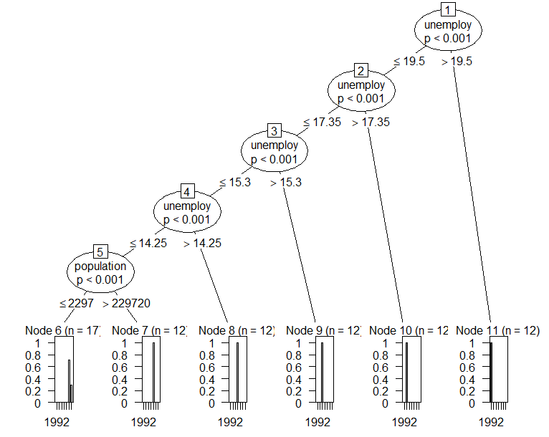

26. Why is R useful for data science?
R turns otherwise hours of graphically intensive jobs into minutes and keystrokes. In reality, you probably wouldn’t encounter the language of R outside the realm of data science or an adjacent field. It’s great for linear modeling, nonlinear modeling, time-series analysis, plotting, clustering, and so much more.
Simply put, R is designed for data manipulation and visualization, so it’s natural that it would be used for data science.

27. Describe how R can be used for predictive analysis
As a data manipulation and visualization tool, R can most definitely be used for predictive analytics. Using the same sort of decision tree we developed earlier, one could predict how many shootings might occur in 2019 in Boston. R as a whole provides numerous tools and packages for predictive modeling, so it’s the right tool for a data scientist.
Q.1. When should you apply “next” statement in R? When is it appropriate to use the “next” statement in R?
A data scientist will use next to skip an iteration in a loop. As an example:
> val1 <- 1:30
> for(val in val1){
+ if(val == 25){
+ next
+ }
+ print(val)
+ }
This piece of code will iterate through the numbers from 1 to 30. It will skip 25 as we have used the next statement to skip the iteration from which we move on to the next value. We will obtain the output from 1-24 and 26-30.
Q.2 What is the value of equation1(3) for the following R code?
> num <- 4
> equation1 <- function (val)
+ {
+ num <- 3
+ num^3 + g (val)
+ }
> equation2 <- function (val)
+ {
+ val*num
+ }
}
For the above code snippet, we obtain the output as 39.
Q.3 What arguments are required in the R6Class?
In order to create an R6 class in R, the following arguments are required –
- The first argument in the R6 class is the classname itself. It improves the error messages and allows us to make use of R6 objects with the given S3 generics.
- The second argument of the R6 argument is ‘public’. This argument provides several methods and fields which make use of snake_case.
Did you answer the above question? If no, you can revise the concept of arguments in R with DataFlair’s detailed guide.
Q.4 R suffers from the disadvantage of being restricted to the local memory. Could you elaborate the precise memory limit in R?
For a 32-bit, R program is executed, the maximum value that can be obtained is under 4 GB.
Furthermore, for systems that are 64-bits, the limit is just 8 TB.
Q.5 regmatches(number, gregexpr(pattern = “2.?2”,text = number)) Is this an example of non-greedy quantifier? If yes, then why and what would be the equivalent greedy quantifier?
No. This is an example of a non-greedy quantifier. An equivalent greedy approach would be –
regmatches(number, gregexpr(pattern = "2.*2",text = number)) .
Suppose that for a given number, val1 = 2020000200
The greedy approach would initiate from the first digit ‘2’. It then moves ahead and encounters the second digit ‘2’. It keeps searching for another ‘2’ digit which it also encounters. However, it does not find any more digits after that and hence, it returns the value: 20200002.
A non-greedy approach on the other hand, stops at the first match and returns us the value of 202.
Q.6 A csv file consists of missing values that are represented by hashtags (“#”) and ampersands (“&”). How can you read this type of a csv file in R?
We can read this type of data with the following line of code –
csv2(‘data-file.csv’,header=FALSE,sep=’,’,na.strings=c(‘#’,’&’))
Q.7 Suppose that you have an array consisting of several objects. This object is of the type string. Let this string be “DataFlair”. Now, you want to find the location of this string in the character array ‘arr’. How will you carry this out?
which( arr == “DataFlair”)
Learn everything about R arrays in detail
Q.8 Suppose that while writing the R code that consists of multiple functions. While executing the code, there is an error within one of the functions present in the code. What command will you use to find the function that is facing problem?
traceback()
Q.9 You are solving a data science problem that is ridden with many missing values. You want to clean the data before fitting your model. What would you do to replace these missing values? Develop your own function.
Let’s take this vector:
arr<-c(1,2,4,NA,NA,11,NA,10)
Now, let’s write the function to impute the values:
missing_mean <- function(arr){
ifelse(is.na(arr),mean(arr,na.rm = T),arr)
}
Don’t forget to check DataFlair’s detailed tutorial on R Vectors
Q.10 You have been assigned the task of reshaping the data wherein you have to convert the wide format data into long format data and vice versa. How will you carry out this operation?
melt() and dcast()
Q.11 You have two tables “employee_salary” and “employee_experience”. The first table consists of two columns “Name” and “Salary”. The second table consists of “Name” and “Experience” columns. How will you merge these two tables to create a single table that does not have any redundant column in it?
In order to join these two tables, we will have to perform their cross-product. R provides the function “merge” that can be used for the same.
merge(employee_salary,employee_experience,by=NULL)
Q.12 How will you use rattle package in R?
Rattle package provides a graphical user interface to the other R packages provides functionality for data mining operations. After installing the Rattle Package, we type rattle() in the R Studio’s Script Panel.
rattle()
Q.13 How do tibbles differ from the traditional data-frames?
The two main areas that differentiate tibble from the traditional data-frames are – printing and subsetting:
Tibbles consists of a refined print method that displays the first 10 rows as well as the columns that can be fit on the screen. This facilitates easy working with the large data. In addition to the name, each column reports the type of tibble.
The second area where Tibbles differ from data-frames is subsetting. Tibbles have a strict notion about subsetting. If we access a variable that does not exist, we will get an error.
Q.14 How is seq_along(5) different from seq(5)?
The seq_along(6) will result in a vector that has a length of 6 whereas seq(6) will deliver us a consecutive vector from 1 to 6c( (1,2,3,4,5,6)).
Q.15 Suppose that I want to convert factor to number. I write the following code:
fac <- factor(c(2.3, 1.5, 3, 4.9))
as.numeric(fac)
I obtain the output as – 2,1,3,4 which is clearly not what was expected. How should I rectify this problem?
In the above code, you are converting factor to number which is problematic. R simply floors the values without any warning. In order to convert factors to numbers properly, we use the integer vector to perform indexing on the factor levels as follows –
levels(fac)[fac]
Have you checked R factor analysis
Q.16 Suppose that I want to know the values in c(1, 2, 6, 3, 19) that are not present in c(2, 6, 14, 3, 15). How can you carry this out using built-in function as well as without it?
There are two methods to execute this problem –
- By using setdiff() function – setdiff(c(1, 2, 6, 3, 19), c(2, 6, 14, 3, 15)) and,
- Through the %in% as – c(1, 4, 5, 9, 10)[!c(1, 4, 5, 9, 10) %in% c(1, 5, 10, 11, 13)
Q.17
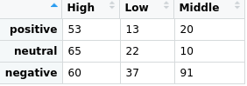
The above data table is written to a csv file called ‘Datatable.csv’. Suppose you want to read this csv file with all 3 rows. How will you carry this out?
csv2(‘Datatable.csv’,header=FALSE,sep=’,’)
Q.18 You have a dataset from which you want to extract a subset. For example, for a data consisting of employee details, you want to create a subset of employees who are above 30 years and who make salary less than 10,000. How will you execute this in R? The salary dataframe be denoted by the variable ‘age’ and the data is contained within the variable ‘employee_data’.
To create a subset of employees older than 30, we will make use of the filter() function as follows –
filter(employee_data, age >30 1, salary < 10000)
Q.19 Suppose you have a vector of numbers vec <- (1,3,4,7) that needs to be combined with the symbols (“#”,”?”) consecutively such that we obtain the output 1-#, 3-?, 4-#, 7-? How will you proceed with this?
Ans. We will use the paste() function as follows –
paste(vec,c("#","?"),sep = "-")
Q.20 What are the differences between t.test() and t.data.frame()? When do you use these two functions?
Ans. Due to the naming scheme of S3’s generic class, both functions are similar to one another. However, they are not related to each other.
- t.test() performs t-test and is generic in nature.
- t.data.frame() is called by the generic t() for transposing the input data.
As a result of S3 dispatch rules, t.test() along with t() would get called when the latter is applied to the class “test”
Q.21 What does the following code denote about index updation?
for (index in 1:3) {
index <- index * 2
print(index)
}
Ans. In a for-loop the index is updated at the beginning of each iteration. Therefore, reassigning the index symbol during one iteration doesn’t affect the following iterations.
Q.22 Why do we obtain five missing values from the following lines of code?
x <- 1:5
x[NA]
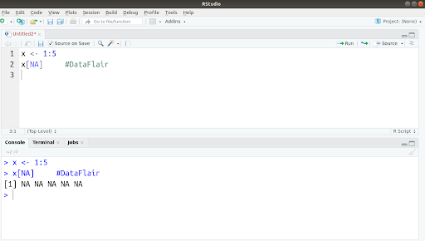
Ans. NA is a logical type object and the logical vectors are reused to the equal length shared between vector and its subset. For example, x[NA] when iterated five times becomes x[NA, NA, NA, NA, NA].
Q.23 Is it possible to model transitioning data like time-zone or a working directory? State reason behind your answer.
Ans. No. S3 models are not adept at capturing models that transition over a period of time. This is because the S3 methods are designed to take the exact input and provide the same result.
Q.24 Is it possible to plot all the features of a dataset at once? If so, how?
Ans.
> library(tabplot) #DataFlair
> tableplot(iris)
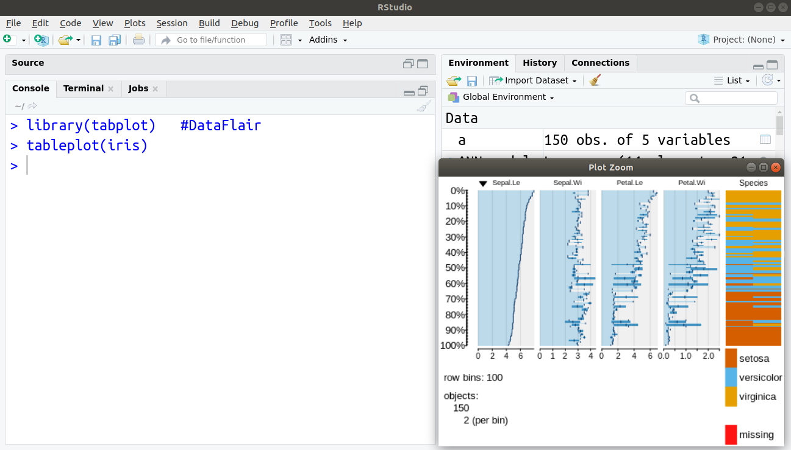
Q.25 What are is.atomic(), is.vector() and is.numeric() functions responsible for?
Ans. These three functions are responsible for –
- The role of is.atomic is to test if the vector is atomic in nature.
- Is.numeric checks if the object has an integer or a double type and does not belong to “factor”, “Data”, “POSIXt” or “difftime” class.
- is.vector() is responsible for testing if the object is vector and therefore, has no attributes excluding names.
Recommended Reading – R Functions Tutorial
Q.26 How can we test if the time-series model is stationary in R? Take the first column and all the rows of EuStockMarkets as your time-series data.
Ans. For testing if the time-series model is stationary, we make use of the Augmented Dickey Fuller Test (adf test). If the p-value is below 0.05, then that model is stationary. We can implement this in R as follows –
library(tseries)
adf.test(timedata)
kpss.test(timedata)
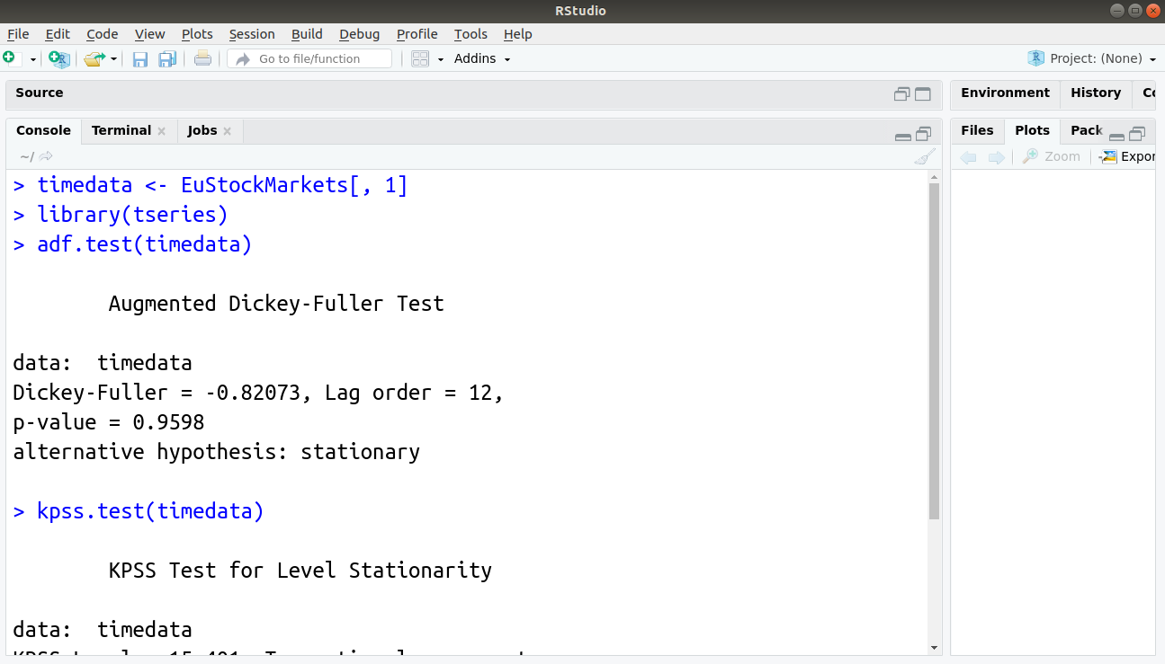
Q.27 How will you explain R programming to person from a non-technical background?
Ans. R is a programming language that many data analysts, data scientists, statisticians utilize to analyze data and perform statistical analysis using graphs and other forms of visualizations. Using R, one can analyze large datasets. It is an ever-expanding programming language with thousands of packages that provide support to a variety of applications.
This is the frequently asked R interview question. You can learn or master any concept in R with DataFlair’s Free R Tutorials Library
Q.28 Suppose your data science project requires the installation of the ggplot2 package. How will you install it?
Ans. We can perform installation of R packages using a common syntax –
install.packages(“package-name”). In the case of ggplot2, it will be -
install.packages(“ggplot2”)
Practice the latest Data Science Projects for your upcoming interviews.
Q.29 What is RShiny. What are the several advantages of using it?
Ans. Using the Shiny package, you can build interactive web applications. Following are the advantages of RShiny.
- Shiny allows the R developers to develop interactive data visualizations that can directly be hosted on the web.
- It facilitates dis-intermediation of the relationship between data scientists and the business user as it allows high fidelity relations and high-quality data experience.
- It helps to create appealing visualizations, overcoming the cost of proprietary BI tools.
- You can avail any package in R to solve your problem with the Shiny framework.
- RShiny advocates for an open-source ecosystem for JavaScript visualization. With this, you can customize high-quality applications.
- It can be hosted behind firewalls with RStudio Connect or with Shiny Server Pro. These are highly scalable and can support thousands of concurrent users. Furthermore, with these products, you can have security, support, and other professional features.
Q.30 What do you know about RMarkdown?
Ans. RMarkdown provides a notebook interface to the R user. We generally use it to produce high-quality reports for sharing it with the audience. It supports several static as well as dynamic output formats. Using RMarkdown, one can present the code alongside its output (graph, plot, tables) with conventional text to explain the program. The RMarkdown makes use of the Markdown syntax which is a markup language providing methods for the creation of documents with header, links, images etc. from the plain text files while maintaining the original plain text.
Q.31 What are the various sorting functions available in R?
Ans. R provides us with the sort() function that we can use for carrying out sorting of the data. Within this function, there are several parameters through which different sorting operations can be carried out. R provides support for two types of sorting –
The first type of sort is comparison-based sorting wherein the algorithm compares key values of the input vector with the other input which takes place before ordering the data.
Non-comparison based sorting is the second type where the algorithm performs computation on each key-value which then proceeds to perform ordering on the computed values.
The three sorting algorithms are –
>Insertion sort
>Bubble sort
>Selection sort
- Shell sort
- Heapsort
- Quicksort
- Merge sort
- Bin sort and radix sort
So, these were some of the R interview questions with answers that will help you to crack your upcoming interview. For the remaining R technical interview questions refer to the next part of this series – R Programming Interview Questions and Answers.

Conclusion
So, how many questions you have answered on your own. If you want to go ahead of all the other aspirants then you can practice these top data science interview questions and answers.
Most of the Data Scientists recommend practicing at least 3 projects in R before facing the interview. You can check the top projects on our website along with their source code.
All the best!

Top R Interview Questions and Answers
Features of R programming language:
- R is used to handle a large amount of data and storage facilities.
- R is handy while dealing with statistical analysis and graphical representation of data.
- R provides a large number of operators to perform the calculation on arrays, lists, vectors, and metrics.
Here is a list of R interview questions to help you prepare for that interview and get a job in the field of data science.

Question: What is the data structure in R, which helps in statistical analysis and graphical representation?
Answer: The following are the data structure in R, which is widely used:
- Array
- Matrix
- Vector
- Data Frame
- List
- Tables

Question: How to print something in R? <Practice of R basic syntax>
Answer: To write something, R uses print command.
>string_variable_name <- “R is an analytical language”
>print(string_variable_name)

Question: What is class() function R?
Answer: This function in R is a character vector giving the names of classes form which the object inherits.
Example:
>x <- 1:10
>class(x)
[1] “integer”

Question: What is a vector?
Answer: A vector is a sequence of data elements of the same primary type. Members in a vector are called components.
Example.
>vector_example <- c(2,3,4,5)
> print(vector_example)
[1] 2,3,4,5
>print (length(vector_example)
[1] 4

Question: How to perform arithmetic operations on Vectors? Show with some example
Answer: Many arithmetic operators are used in R. Remember, R uses the operators component by component. Let’s look at it with some standard operators.
>x <- c(1,2,3,4)
> y <- c(4,5,6,7)
> x+y
[1] 5 7 9 11
> x-y
[1] -3 -3 -3 -3
> z <- (4,4,4,4,4,4,4)
> x+z
[1] 5 6 7 8 5 6 7
When we have two vectors with unequal lengths, and we need to operate on both, then the shorter vector is used again and again to match the length of both the vectors.

Question: Define Index in Vector.
Answer: Index in the vector is used to give the element at that position of the vector. Few programming languages start the index with 0, and the other starts at 1. R counts the index from 1. There are many possibilities while putting an index number i.e.
1. Positive and in range index
> x<- (1,3,4,5)
> x[2]
[1] “3”
2. Out of range
>x <- (2,3,4,5)
> x[110]
[1] NA
3. Negative index- removes this element and replies back with all the left numbers.
> x <- (3,4,5,6,7)
> x[-3]
[1] “3” “4” “6” “7”
4. Range of values
>x <- (3,4,5,6,7,8)
> x[2:5]
[1] “4” “5” “6” “7”
5. Duplicate index
>x <- (3,4,5,6,7)
>s[c(2,1,2,3)]
[1] “4” “3” “4” “5”
6. Logical index
If we want to select a particular group of an index number, then you should use logical operators i.e., TRUE and FALSE
> x <- (2,3,4,5,6)
> s[c(TRUE, FALSE, FALSE, TRUE, TRUE)
[1] “2” “5” “6”

Question: What is a list?
Answer: A list, as the name suggests, are several vectors collected together. Suppose you have a numeric vector, a character vector, a Boolean vector, and some numbers. We want to combine it into one, which obviously won’t have the same data type. So we need to create a list.
> n = c(2,3,5)
> s = c (“a”, “b”, “c”, “d”, “e”)
> b= c(TRUE, FALSE, TRUE, FALSE, FALSE)
> x = list (n, s, b, 3)
> print(x)
[[1]]
[1] 2 3 5
[[2]]
[1] “a” “b” “c” “d” “e”
[[3]]
[1] TRUE FALSE TRUE FALSE FALSE
[[4]]
[1] 3

Question: What is Matrices?
Answer: A matrix is a two-dimensional rectangular data set. It can be created using a vector input to the matrix function.
Example.
# Matrix creation
> M = matrix(c(1,2,3,4,5,6), nrow=2, ncol=3, by-row =TRUE)
print(M)
[1] [2] [3]
[1] 1 2 3
[1] 4 5 6
Where
nrow = number of rows in the matrix
ncol = number of columns in the matrix
byrow = TRUE/FALSE will get value first by row or column.

Question: What is an Array?
Answer: Array is a superset of Matrices. On the one hand, the matrices can be of 2 dimensions, but the array can be of any number of dimensions.
Example.
> a<- array(c(“car”, “bike”), dim (3,3,2))
> print (a)
, , 1
[,1] [,2] [,3]
[1,] “car” “bike” “car”
[2,] “bike” “car” “bike”
[3,] “car” “bike” “car”
, , 2
[,1] [,2] [,3]
[1,] “bike” “car” “bike”
[2,] “car” “bike” “car”
[3,] “bike” “car” “bike”
>my_array <- array(1:24, dim = c(3,4,2))
< my_array
, , 1
[,1] [,2] [,3] [,4]
[1,] 1 4 7 10
[2,] 2 5 8 11
[3,] 3 6 9 12
, , 2
[,1] [,2] [,3] [,4]
[1,] 13 16 19 22
[2,] 14 17 20 23
[3,] 15 18 21 24

Question: What is the factor?
Answer: Factors are the r-objects which are created using a vector. Factors in R are stored as a vector of integer values with a corresponding set of character values to use when the factor is displayed. The factor function is used to create a factor. The only required argument to factor is a vector value which will be returned as a vector of factor values. It stores the vector along with the distinct values of the elements in the vector labels.
Factors are created using the factor() function. The nlevels functions give the count of levels.
Example.
#First let’s create a vector
>vector_example <- c(‘a’, ‘b’, ‘c’, ‘a’, ‘a’)
#Now create a factor object
>factor_example <- factor(vector_example)
>print(factor_example)
[1] a b c a a
>print(nlevels(factor_example))
[1] 3
nlevels gives you the number of distinct values in the vector.

Question: What is the difference between Matrix and an array?
Answer: Matrix can have only two dimensions, whereas an array can have as many dimensions as you want. Matrix is defined with the help of data, number of rows, number of columns, and whether the elements are to be put in row-wise or column-wise.
In array, you need to give the dimension of the array. An array can be of any number of dimensions, and each dimension is a matrix. For example, a 3x3x2 array represents two matrices, each of dimension 3x3.

Question: What is a data frame?
Answer: The data frame is a list of vectors of equal length. It can consist of any vector with a particular type and can combine it into one. So, a data frame can have a vector of logical and another of numeric. The only condition is that all the vectors should have the same length.
Example.
#This is how the data frame is created
> student_profile <- data.frame(
Name <-c(“Ray”, “Green”, “Justin”)
Age <- c(22,23,24)
Class <- c(6,7,8)
)
print(stuent_profile)
The above code will create three columns with the columns name as name, age, and class.

Question: What is the difference between a matrix and a data frame?
Answer: A data frame can contain vectors with different inputs, and a matrix cannot. We can have a data frame of characters, integers, and even other data frames, but you can’t do that with a matrix since a matrix must be all the same type.
So, the data frame can have a different vector of character, numbers, and logic.
But, for the matrix, we need only one type of data type.

Question: How to read input from the user in R?
Answer:
Readinteger <- function()
{
n <- readline(prompt = “Enter an integer: “)
return(as.integer(n))
}
print(readinteger())
Readline lets the user enter one line string in R.
The prompt argument is printed on the screen of the user.

Question: Write a function to get the square of a number
Answer:
Square <- function(x) {
return(x^2)
}
print(Square(4))

Question: Write a countdown function in R?
Answer:
timer <- function(time)
{
print(time)
while(time!-0)
{
Sys.sleep(!)
Time <- time -1
print(time)
}
}
countdown(5)
[1] 5
[2] 4
[3] 3
[2] 2
[1] 1

Question: How to use mode function in R?
Answer: The mode is the value that has the highest number of occurrences in a set of data. Unlike the mean and median, the mode can have both numeric and character data.
R does not have a standard in-built function to calculate the mode. So we create a user function to calculate the mode of a data set in R. This function makes the vector as input and gives the mode value as output.
Example.
#Create the function
getmode <- function(v){
uniqv <- unique(v)
uniqv[which.max(tabulate(match(v,uniqv)))]
}
#Create the vector with numbers.
v <- c(2,1,2,3,1,2,3,4,1,5,5,3,2,3)
#Calculate the mode using the user function
result <- getmode(v)
print(result)
[1] 2
#Create the vector with characters
charv <- c(“o”, “it”, “the”, “it”, “it”)
#Calculate the mode using the user function.
result <- getmode(charv)
print(result)
[1] “it”

Question: What does an enlist function does?
Answer: It converts a list to a vector

Question: What is the apply function in R?
Answer: apply(), and its family is one of the most used functions in R. We use apply when we want to apply a function to the rows or columns of the matrix.
Example:
M<- matrix(seq(1,16),4,4)
apply (M,1,min)
[1] 1 2 3 4

Question: What is the lapply() function in R?
Answer: lapply() function is used when we want to apply a function to each

Question: Differentiate between lapply and sapply
Answer: If the programmers want the output to be a data frame or a vector, then the sapply function is used, whereas if a programmer wants the output to be a list, then lapply is used.

Question: How to install a new package in R?
Answer: We need to know the name of the package
Syntax:
install.packages(“name_of_package”)

Question: What is the function of merge() function?
Answer: We can merge two data frames by using the merge function(). The data frames must have the same column names on which merging happens.
Example.
df1 <- data.frame(id <- c(1:6), name <-c(rep(“Amit”,3), rep(“Sumit”,3))
df2 < - data.frame(id <- c(7,8,9), name <- c(rep(“Nitin”,2),rep(“Paplu”,1))
*outer join
merge(x=df1, y= df2, by =”id”, all TRUE)
This all = TRUE will give you the outer join, so the new data set will have all the value from both the data frames merged on the id.

Question: What is data cleaning?
Answer: Data cleaning is a process in analytics that involves removing or amending data in a database that is incorrect, incomplete, improperly formatted, or duplicated.

Question: What is data reshaping?
Answer: Sometimes, we need data in a particular format. Initially, we import the data from a particular .csv file or txt file in a data frame. But, most of the time we also need a data set that is different from the initial data set plus we also need to add columns or position of the columns. So all this is data reshaping where you give the shape of the initial data frame according to the need.

Question: Write a function to add two numbers in R
Answer:
add <- function(a,b)
{
c <- a+b
print(c)
}

Question: How can R be closed from the command line?
Answer: Use the function q()

Question: How to read the csv_input file in R?
Answer:
data <- read.csv(“csv_input.csv”)

Question: Explain the use of the scan function in R.
Answer: The scan() function is used to read various types of data or data objects, for example, data vectors. The command can be customized to read specific data. The command waits for input from the data and then return the value entered at the prompt.

Question: What are the different file formats using in the R programming language?
Answer:
- .RDA file format: These are the R objects that are used to attaching and loading files in R.
- .Rfiles: These are the files that are created inside the R editor by the dump function.
- .txt files: The .txt files are used to store datasets. R uses theread.table() and write.table() function.
- .csv files: The comma-separated values files are common data files.

Question: What is the function od summary() function?
Answer: summary() is an important command which helps us to get the statistical summary of the data. It contains all the statistical data like mean, median, min, max, 1st quartile, and 3rd quartile.

Question: How can you add datasets in R?
Answer: rbind() function can be used to add datasets in R language provided the columns in the datasets should be the same.

Question: What are the factor variables in the R language?
Answer: Factor variables are categorical variables that hold either string or numeric values. Factor variables are used in various types of graphics and particularly for statistical modeling, where the correct number of degrees of freedom is assigned to them.

Question: What is the use of the seq() function in R?
Answer: seq() function in R is used to provide the user with a sequence of numbers. If we need a sequence of numbers with a particular step i.e., 4,8,12,16, then we need to provide another attribute “by = ?” which will provide the steps.
Example.
> print(seq(5,11, by = 2))
[1] 5,7,9,11

Question: Define repeat loop
Answer: Repeat loop executes a sequence of statements multiple times. It doesn’t put the condition at the same place where we put the keyword repeat.
Example.
>name <-c(“Parry”,”John”)
>temp <-5
> repeat {
print(name)
temp <- temp +2
if(temp >11){
Break
}
}
This would return the name vector four times. First, it prints the name and increases the temperature to 7 and so on.

Question: How can one perform decision making in R?
Answer: Decision making in R is performed in the same way as in other languages. The three main decision-making statements contain:
- If statement
- If.else statement
- Switch statement

Question: There exist two vectors, a <- (3,4,5) and b <- (1,2), then what will be the output for c <- a * b?
Answer: c<- (3,8,5)

Question: What are the binary functions in R on which binary operators can be applied?
Answer: Scalars, Matrices, and Vectors

Question: What are the main characteristics of a data frame?
Answer: The following are the main characteristics:
- Row names should be unique.
- The column name should be non-empty
- There are only three types supported by the data stored in the data frame i.e., number, factor, and character.
- Each column should have the same number of data items. This is one of the main rules of data frames.

Question: Explain the use of string function in R
Answer: The str() function in R is used to get the structure of a data frame along with the first few observations. Suppose a data frame has four variables, each with three values. Then the output of this function will be like:
‘data.frame’: 3 obs. And 4 variable
$name: chr “Nitin” “Kamal” “Xtramous”
$age : int 16 18 20
$class: int 6 8 10

Question: What is the difference between seq(4) and seq_along(4)
Answer: seq(4) produces a vector from 1 to 4 (c(1,2,3,4)), whereas seq_along(4) produces a vector of length(4), or 1(c(1)).

Question: How to read a .csv file in R?
Answer: read.csv() function is used to read a CSV (Comma Separated Values) from the current working directory.
Example.
data_store<- read.csv(“abc.csv”)
print(data_store)

Question: Get all the data of the person having a maximum salary.
Answer:
max_salary_person <- subset(data,
salary == max(salary))
print(max_salary_person)

Question: How to get outer join, left join, right join, inner join, and cross join?
Answer:
outer join - merge (x= df1, y=df2, by= “id”, all= TRUE)
left join - merge (x= df1, y= df2, by = “id”, all.x = TRUE)
right join - merge (x= df1, y= df2, by = “id”, all.y = TRUE)
inner join - merge (x= df1, y= df2, by = “id”)
cross join - merge (x= df1, y= df2, by = NULL)

Question: What do you mean by casting? What is the use of cast() function?
Answer: It is used to get aggregate after melt(). So, now we have data arranged in some order, if we want to aggregate the columns with similar company_name and age, then we should use the cast() function.
Example.
Casted_data_set <- cast(new_data_set, company_name+age ~ variable, sum)
The function gives the aggregate salary and number of children with the same company and age.

Question: What is the use of sample function in R programming?
Answer: Sample() function can be used to select a random sample of size ‘n’ from a huge dataset.

Question: What is the use of subset function in R programming?
Answer: Subset() function is used to select variables and observations from a given dataset.

Question: What is the function of the rnorm() function? Explain with syntax.
Answer: rnorm function generates “n” normal random numbers based on the mean and standard deviation arguments passed to the function.
Syntax:
rnorm(n, mean = , sd= )

Question: How to make a scatterplot in R?
Answer: Scatterplot is a graph which shows many points plotted in the Cartesian plane. Each point holds two values that are present on the x and y-axis. The simple scatterplot is plotted using plot() function.
The syntax for scatterplot is:
plot(x,y,main,xlab,ylab,xlim,ylim,axes)
Where
x is the data set whose values are the horizontal coordinates
y is the data set whose values are the vertical coordinates
main is the tile in the graph
xlab and ylab is the label in the horizontal and vertical axis
xlim and ylim are the limits of values of x and y used in the plotting
axes indicate whether both axes should be there on the plot.
plot(x = input$wt,y = input$mpg,
xlab = “Weight”,
ylab = “Mileage”,
xlim = c(2.5,5)
ylim = c(15,30)
main = “Weight vs Mileage”
)

Question: What is the sink function in R?
Answer: The sink() function defines the direction of the output.
#direct output to a file
sink(“myfile”, append = FALSE, split = FALSE)
#return output to the terminal sink()
The append option controls whether output overwrites or adds to a file. The split option determines if the output is also sent to the screen as the output file.

1. Define R Programming. What Are Some of the R Functions That Exist?
You know what R programming is and does your interviewer, but he or she wants to hear you define it in your own words. This is why there’s a good chance this type of question will be part of your R programming questions. This seems like a simple R programming interview question, and in comparison, it may be, but the way you define R programming in your response can demonstrate the extent of your knowledge. Although you’ll want to answer that R programming is data analysis software, you may also want to explain who uses R programming - i.e. data scientists, data analysts, and so on.
Knowing R’s functions is an essential part of knowing R programming in general. While you may not be expected to list every single function that exists, listing as many as you can be optimal, memorize as many essential functions as you can - mean, median, distribution, etc. prior to your interview, in case this commonly asked question pops up.

2. What Can’t You Do with R Programming?
When it comes to demonstrating what you know about R programming and its capabilities, your interviewer may throw a curveball at you by asking what R programming isn’t capable of. Clearly, when it comes to any type of software, there is going to be an infinite list of what can’t be done, so it’s important to know what lack of features to focus on. Think about the things that a novice R programming user might mistakenly think that the software is capable of. For example, a new data scientist might think that with R programming, you can view data in a spreadsheet. This is a good example of a feature not available through R programming and would be a good one to mention. New users might also mistakenly think R is a database or that it may contain a graphical user interface; these are two other features that are not included in R programming and would be good to include in your response. When you give these answers, be sure to explain why you specifically chose them.

3. In the R Programming Language, How Are Missing Values and Impossible Values Represented?
Aside from telling the interviewer exactly how these two values are represented in R programming (NA for missing values and NaN for impossible values), you should also briefly explain what these two values mean and why a user might encounter them. You should also explain that while some users may be tempted to just delete missing values and move on, it ’s ideal to try and uncover the primary cause of these erroneous values. Because there could be a flaw somewhere in the programming, finding and fixing this root cause can potentially prevent similar mistakes from popping up later on.

Professional Certificate Program in Data Science
The Ultimate Ticket To Top Data Science Job RolesEXPLORE COURSE


4. How Do You Solve a Problem in R?
The solutions available are referred to as “packages” in R, so be sure to use this term in your answer. First, explain that the CRAN package ecosystem has an extensive amount of packages available (over 6,000) to solve potential issues. Each R user might have their own way of making their selection, but the best way to answer this question is to explain how reviews from others go a long way: Were other R users with similar issues able to solve their problems with a particular package? If so, were these issues similar to the problems you’re encountering? In your answer, explain that you’d be wary of packages that don’t encompass good software development principles, have poor reviews, or are lacking reviews altogether.

5. What Objects Do You Use Most Often in R?
Your interviewer wants to get a sense of how experienced you are in R programming with this question. Be prepared by knowing, in detail, some of your recent work and explain your most frequently used objects, while also explaining how and why you use them.
Preparing for a career in Data Science? Take up answering this Data Science Practice Test and assess your knowledge.

6. Can You Write a Specific Code to Accomplish a Task?
Interviewers will likely want to see you demonstrate that you know how to code when you’re interviewing for an R programming job. While you can expect a lot of questions that will test your knowledge and experience, nothing can demonstrate your skills in R quite like actually showing the interviewer what you can do.
Because you should be prepared for this type of hands-on question, be prepared before your interview to write code that can accomplish a specific task. You may be asked to write a specific type of code, or you may have the choice to choose your own. You should not only have some of the basics memorized but in case you’re given the freedom to choose what you want, be sure to choose something you’re comfortable with. After all, it can be a little nerve-wracking to be asked to code right there on the spot and during an interview.
Although you’ll want to be prepared with something you know inside and out, don’t be too afraid to step out of your comfort zone, either. You’ll likely get bonus points if you can perform a specific task that is somewhat challenging and will impress your interviewer.

7. How Is R Similar to Python? How Are the Two Different?
This is your interviewer’s way of seeing that you are familiar with other types of programming and coding language, and not just R. If R is the only programming language you’re familiar with, you may want to familiarize yourself with others just in case you’re asked to compare and contrast the two, which is likely. Even if you don’t know Python as well as R, you can stick to some of the basics: i.e. for similarities, they both have strong modeling capabilities and they are both free to use. As far as differences, you can point out that although many software programmers feel that Python tends to be easier to use and is more secure, R is better for those who appreciate visualization tools.

8. What Are Some of the Pros and Cons of R?
With just about any program out there, there are going to be advantages and disadvantages. Your interviewer is not necessarily looking for all of the pros and cons, nor is he or she necessarily expecting you to name specific features. Your interviewer is just using this as another question to test the extent of your knowledge, so be sure to know some pros and cons before heading into your interview. For example, you can say that many programmers like R because it’s free, widely accessible, and has built-in functionality via R packages. For disadvantages, you may want to point out that there are some security flaws, and that it is also open-source, which some people even consider a disadvantage. Keep it simple by thinking about what you personally like about R, and what you don’t.
Looking forward to becoming a data scientist? Check out the Data Scientist Course and get certified today.

9. What Are Some of Your Favorite R Programming Functions?
If you’re interviewing for a job in R programming, it’s not just important that you understand and know R inside and out, but that you’re passionate about it, too. Your interviewer should expect that as an expert in R, you’ll not only be able to easily come up with functions on the spot but that you can easily name the ones you like the most (and why). Be sure to answer this question with confidence and enthusiasm.

10. How Many Data Structures Are Available in R Programming?
It’s important not just to answer this question with a number, but also explain what these structures are and what they include. Tell your interviewer that there are two data structures: homogeneous and heterogeneous. When responding to this question, also mention that homogeneous data structures include the same type of objects: array, matrix, and vector. Heterogeneous data structures include different types of objects: data lists and frames.

Conclusion
Are you a new data scientist, or an experienced data scientist looking to expand your skills and learn something new? Whether you’ve got a job interview coming up soon or you’re planning for the future, Simplilearn has you covered. Our comprehensive Data Science with R Programming course includes everything you need to master R programming. Get ready to nail that job interview!

1. Define R programming. What are some of the R functions that exist?
You know what R programming is and does your interviewer, but he or she wants to hear you define it in your own words. This is why there’s a good chance this type of question will be part of your R programming questions. This seems like a simple R programming interview question, and in comparison, it may be, but the way you define R programming in your response can demonstrate the extent of your knowledge. Although you’ll want to answer that R programming is data analysis software, you may also want to explain who uses R programming - i.e. data scientists, data analysts, and so on. Knowing R’s functions is an essential part of knowing R programming in general. While you may not be expected to list every single function that exists, listing as many as you can be optimal. Memorize as many essential functions as you can - mean, median, distribution, etc. prior to your interview, in case this commonly asked question pops up

2. How do you solve a problem in R?
The solutions available are referred to as “packages” in R, so be sure to use this term in your answer. First, explain that the CRAN package ecosystem has an extensive amount of packages available (over 6,000) to solve potential issues. Each R user might have their own way of making their selection, but the best way to answer this question is to explain how reviews from others go a long way: Were other R users with similar issues able to solve their problems with a particular package? If so, were these issues similar to the problems you’re encountering? In your answer, explain that you’d be wary of packages that don’t encompass good software development principles, have poor reviews, or are lacking reviews altogether.

3. What objects do you use most often in R?
Your interviewer wants to get a sense of how experienced you are in R programming with this question. Be prepared by knowing, in detail, some of your recent work and explain your most frequently used objects, while also explaining how and why you use them.

4. In the R programming language, how are missing values and impossible values represented?
Aside from telling the interviewer exactly how these two values are represented in R programming (NA for missing values and NaN for impossible values), you should also briefly explain what these two values mean and why a user might encounter them. You should also explain that while some users may be tempted to just delete missing values and move on, it ’s ideal to try and uncover the primary cause of these erroneous values. Because there could be a flaw somewhere in the programming, finding and fixing this root cause can potentially prevent similar mistakes from popping up later on.

5. What objects do you use most often in R?
Your interviewer wants to get a sense of how experienced you are in R programming with this question. Be prepared by knowing, in detail, some of your recent work and explain your most frequently used objects, while also explaining how and why you use them.

6. How is R similar to Python? How are the two different?
This is your interviewer’s way of seeing that you are familiar with other types of programming and coding language, and not just R. If R is the only programming language you’re familiar with, you may want to familiarize yourself with others just in case you’re asked to compare and contrast the two, which is likely. Even if you don’t know Python as well as R, you can stick to some of the basics: i.e. for similarities, they both have strong modeling capabilities and they are both free to use. As far as differences, you can point out that although many software programmers feel that Python tends to be easier to use and is more secure, R is better for those who appreciate visualization tools.

7. What are some of the pros and cons of R?
With just about any program out there, there are going to be advantages and disadvantages. Your interviewer is not necessarily looking for all of the pros and cons, nor is he or she necessarily expecting you to name specific features. Your interviewer is just using this as another question to test the extent of your knowledge, so be sure to know some pros and cons before heading into your interview. For example, you can say that many programmers like R because it’s free, widely accessible, and has built-in functionality via R packages. For disadvantages, you may want to point out that there are some security flaws, and that it is also open-source, which some people also consider a disadvantage. Keep it simple by thinking about what you personally like about R, and what you don’t.

8. What are some of your favorite R programming functions?
If you’re interviewing for a job in R programming, it’s not just important that you understand and know R inside and out, but that you’re passionate about it, too. Your interviewer should expect that as an expert in R, you’ll not only be able to easily come up with functions on the spot but that you can easily name the ones you like the most (and why). Be sure to answer this question with confidence and enthusiasm.

9. How many data structures are available in R programming?
It’s important not to just answer this question with a number, but also explain what these structures are and what they include. Tell your interviewer that there are two data structures: homogeneous and heterogeneous. When responding to this question, also mention that homogeneous data structures include the same type of objects: array, matrix, and vector. Heterogeneous data structures include different types of objects: data lists and frames.

10. Can you write specific code to accomplish a task?
Interviewers will likely want to see you demonstrate that you know how to code when you’re interviewing for an R programming job. While you can expect a lot of questions that will test your knowledge and experience, nothing can demonstrate your skills in R quite like actually showing the interviewer what you can do. Because you should be prepared for this type of hands-on question, be prepared before your interview to write code that can accomplish a specific task. You may be asked to write a specific type of code, or you may have the choice to choose your own. You should not only have some of the basics memorized but in case you’re given the freedom to choose what you want, be sure to choose something you’re comfortable with. After all, it can be a little nerve-wracking to be asked to code right there on the spot and during an interview. Although you’ll want to be prepared with something you know inside and out, don’t be too afraid to step out of your comfort zone, either. You’ll likely get bonus points if you can perform a specific task that is somewhat challenging and will impress your interviewer.

Top 50 R Interview Questions & Answers
08-Sep-2022
If you are here, you must be looking for a concrete guide that can help you in your R interview. This post covers the most important top R interview questions and answers to give you an idea of the relevant and probable questions that you may expect in your R interview.

These R interview questions will provide you with a competitive edge in the expanding analytics sector where big and small local and international businesses are looking for experts with verified R proficiency.
R is a programming language that you can use for whichever purpose you like. You have a tool at your disposal that can be utilized for a variety of tasks, including forecast analysis, predictive modeling, data manipulation, and statistical analysis. Top businesses like Twitter, Google, and Facebook, use R.

1. What are the various data structures in R. Explain each of them briefly?
The various data structures that are available with R are discussed below:
- Vector: A vector is a series of data elements that belong to a similar basic type. The members present in a vector are known as components.
- List: A list can be referred to as the R objects consisting of different types of elements like strings, numbers, vectors, or a variant of a list inside it.
- Matrix: A matrix is a data structure that is two-dimensional. Matrices are utilized for binding vectors from the same length. Matrix elements belong to the same type such as numeric, complex, character, and logical.
- Datafraame: In comparison to Matrix Data Frame are more generic for instance the varied columns in the matrix consist of elements of different types. It also merges features of both lists and matrices like a rectangular list.

2. What are the various grammar for graphics?
Below is a list of the parts of grammar for graphics:
- Data layer
- Aesthetics layer
- Geometry layer
- Facet layer
- Co-ordinate layer
- Themes layer

3. Describe Rmarkdown. What purpose does it serve?
R has a reporting tool called Rmarkdown. You can produce excellent reports using Rmarkdown using R code.
Rmarkdown's output format options include:
- HTML
- PDF
- WORD

4. What are the packages that are utilized for data imputation?
The packages that are utilized in data imputation are as follows:
- MICE
- missFores
- Mi
- Hmisc
- Amelia
- imputeR

5. State the function that R() perform.
When an object is declared, this function is used to initialize the private data members.

6. How do we calculate the average of One column in relation to another?
There are five columns in the iris dataset:
- Species
- Sepal.Length
- Sepal.Width
- Petal. width
- Petal.Length.
Using the mean() function from the mosaic package, we will determine the average Sepal-Length across many species of Iris flowers.

7. Define a Random Walk Model.
A Random Walk model can be referred to as the simplest illustration of a non-stationary process is a random walk. A random walk has an undefined mean and variance, substantial temporal dependence, and changes or increments that are nothing more than white noise.

8. Define White Noise Model?
It is a straightforward illustration of a stationary process and a basic time series model. A white noise model has no temporal correlation, a fixed constant mean, and a fixed variance.

9. Name any 5 characteristics of R.
The following are the major 5 characteristics of R:
- Effective and simple programming language.
- It is a program for data analysis.
- It provides efficient data handling and storage.
- High-extensibility graphical approaches are provided.
- It is a language that is interpreted.

10. Describe the functional differences between Python and R?
R comes with built-in functionality for data analysis, however, Python does not have these features. They can be found in packages such as Pandas and Numpy.

11. Describe RStudio.
We can interact with R more easily with the help of RStudio, an integrated programming environment. While RGui is still used, RStudio is thought to be more user-friendly. There are numerous drop-down menus, windows with multiple tabs, and customization options in this IDE. Three Windows will appear when we initially launch RStudio. The fourth Window will by default be hidden.

12. Can you name some of the applications of R?
Numerous applications are available in real-time. Some of the R applications are:
- Facebook
- Twitter
- Googl
- NDAA
- HRDAG

13. Briefly list out the merits and demerits of R.
The following are some of the advantages and disadvantages of R:
Advantages:
- Open Source
- Data Wrangling
- Array of Packages
- Platform Independent
- Machine Learning Operations
- Disadvantages
- Weak origin
- Data Handling
- Basic Security
- Complicated Language
- Lesser Speed

14. What is the goal of integrating R and Hadoop?
R code is executed in order to run Hadoop.
for accessing data stored in Hadoop using R.

15. What are the Hadoop integration techniques?
The following are the techniques of Hadoop Integration:
- R Hadoop
- Hadoop Streaming
- RHIPE
- ORCH

16. Can you tell the output of the given expression all(NA==NA)?
The output of the given expression will be NA

17. What distinguishes R's sample() and subset() functions?
The subset method is used to choose variables and observations, whereas the sample() method is used to select a random sample of size n from a dataset.

18. State the purpose of using the command install.packages(file.choose(), repos=NULL)
By navigating and choosing the file, this command can be used to install an R package from the local directory.

19. What is the procedure to give the R workspace the commands to produce a histogram and remove a vector?
To produce a histogram and remove a vector from the R workspace, use the hist() and rm() functions.

20. Distinguish between "%%" and "%/%."
The "%%" serves as a reminder of the division of the first and second vectors, and the "%/%" represents the quotient of that division.

21. Why do we employ the apply() function in R?
This is used to provide each element in an array with the same function. Take the average of each row's rows as an example.

22. Explain the differences between the require() and library() functions.
The necessary () function is utilized inside the function and throws a warning whenever a specific package is not found. If the desired package cannot be loaded, the library() method displays an error message.

23. What does R's t-test() do?
To determine whether the means of the two groups are equal or not, use the t-test() function.

24. In R, what are the purposes of the with() and by() functions?
The by() function applies a function to each level of components, whereas the with() function applies an expression to a dataset.

25. Distinguish between Lapply and Sapply.
The lapply is used to display output as a list, whereas the sapply is used to display output as a vector or data frame.

26. What does aggregate() function do?
In R the aggregate() function is utilized for aggregatingg data. Two methods of collapsing data - One is by employing one or more By variable and Aggregate () is the other wherein By variable must be in the list.

27. What does doBy package mean?
The desired table is defined using this package's functions and model formula.

28. Describe how to use the table() function.
The frequency table in R is created using this function.

29. What is the function of fitdistr()?
This function, which is part of the MASS package, is used to provide the maximum likelihood fitting of a univariate distribution.

30. Explain GGobi and iPlots.
The iPlots package includes bar plots, mosaic plots, box plots, parallel plots, histograms, and scatter plots. The GGobi is an open-source tool for visualisation to explore high dimensional typed data.

31. Describe the lattice package.
By providing better defaults and the capability to depict multivariate connections simply, the lattice package aims to enhance the base R graphics.

32. Describe the function anova().
The hierarchical models are compared using the anova() algorithm.

33. Describe the functions stepAIC() and cv.lm().
While the stepAIC() function is defined under the MASS package and performs stepwise model selection under exactAIC, the cv.lm() function is defined under the DAAG package and is used for k-fold validation.

34. Describe the leap() function.
The all-subsets regression is carried out using the leaps() function, which is part of the leaps package.

35. Describe the sturdy packaging and relaimpo.
This package provides a library of robust methods, including regression, and is used to assess the relative weights of each predictor in the model.

36. Describe MANOVA and explain how it works.
Multivariate Analysis of Variance, or MANOVA, is a technique used to assess multiple dependent variables at once.

37. Describe mashapiro.test() and barlett.test in detail ().
The Shapiro-Wilk test for multivariate normality is produced by this function, which is defined in the mvnormtest package. To give a parametric k-sample test of the equality of variances, the barlett.test() is utilized.

38. Describe how to utilize the forecasting package.
The forecasting program provides the tools for selecting exponential and ARIMA models automatically.

39. Describe how the qda() and lda() functions differ.
While lda() writes discriminant functions based on the centered variable, qda() prints a quadratic discriminant function.

40. Describe the principal() and auto.arima() functions.
Both the seasonal and non-seasonal ARIMA models, as well as the rotation and extracting of the primary components, are handled by the auto.arima() function.

41. Describe FactoMineR.
A software called FactoMineR has both qualitative and quantitative variables. These packages also contain the observations and auxiliary variables.

42. What are SEM and CFA's complete names?
Confirmatory factor analysis (CFA) and structural equation modeling (SEM) are two related statistical techniques.

43. Describe the functions cluster () stats() and pvclust().
The pvclust() function is defined in the pvclust package and offers p-values for hierarchical clustering. The cluster.stats() function in the fpc package provides a way for assessing the similarity of two cluster solutions using different validation criteria.

44. Define party packages and MATLAB.
To replicate Matlab function calls, this package offers wrapper functions and variables.

45. Describe the S4 and S3 systems.
The S3 is employed in oops to overload any function. The S4 is the most significant attribute of oops, and it allows us to call the functions by multiple names depending on the type of input parameter or the number of parameters. This is a drawback, too, as it is challenging to debug. For S4, there is a reference class that is optional.

46. List the visualization software programs.
The following R packages are available for visualization:
- Plotly
- ggplot2
- tidyquant
- geofacet
- googleVis
- Shiny

47. Can you explain Chi-Square Test?
The frequency table, or contingency table, is analyzed using the Chi-Square Test and is made up of two categorical variables. The chi-square test determines whether there is a meaningful correlation between the two variables' categories.

48. Describe the Random Forest.
Decision Tree Forest is another name for the Random Forest. It is one of the widely used ensemble models based on decision trees. These models in comparison with other decision trees have higher accuracy. Both classification and regression applications employ this approach.

49. Describe Time series analysis.
A time series is produced by any metric that is measured throughout time at regular intervals. Due to its industrial significance and necessity, time series analysis is commercially significant, particularly in terms of forecasting (demand, supply, sale, etc.). Time series refers to a collection of data points where each data point has a timestamp.

50. Describe shinyR in detail.
An R tool called Shiny makes it simple to create dynamic web applications directly from R. You can create dashboards, embed standalone apps in Rmarkdown pages, or host them on a website. Additionally, you may add CSS themes, HTML widgets, and JavaScript actions to your Shiny apps.
Those are the best R interview questions and answers covering the fundamental concepts and practices. This brief guide on R interview questions and answers should provide you with the idea of what all R Interview questions you can expect in your interview, and come out successful.

