1. What is a Cloud Technology?
A cloud is a combination of services, networks, hardware, storage, and interfaces that helps in delivering computing as a service. It broadly has three users. These are the end-user, business management user, and cloud service, provider. The end-user is the one who uses the services provided by the cloud. The responsibility of the data and the services provided by the cloud is taken by the business management user in the cloud. The one who takes care of or is responsible for the maintenance of the IT assets of the cloud is the cloud service provider. The cloud acts as a common center for its users to fulfill their computing needs.

2. What are some of the key features of Cloud Computing?
The following are some of the key features of cloud computing:
- Agility: Helps in quick and inexpensive re-provisioning of resources.
- Location Independence: This means that the resources can be accessed from everywhere.
- Multi-Tenancy: The resources are shared amongst a large group of users.
- Reliability: Resources and computation can be dependable for accessibility.
- Scalability: Dynamic provisioning of data helps in scaling.

3. What do you mean by cloud delivery models?
Cloud delivery models are models that represent the computing environments. These are as follows:
- Infrastructure as a Service (IaaS): Infrastructure as a Service (IaaS) is the delivery of services, including an operating system, storage, networking, and various utility software elements, on a request basis.
- Platform as a Service (PaaS): Platform as a Service (PaaS) is a mechanism for combining Infrastructure as a Service with an abstracted set of middleware services, software development, and deployment tools. These allow the organization to have a consistent way to create and deploy applications on a cloud or on-premises environment.
- Software as a Service (SaaS): Software as a Service (SaaS) is a business application created and hosted by a provider in a multi-tenant model.
- Function as a Service (FaaS): Function as a Service (FaaS) gives a platform for customers to build, manage and run app functionalities without the difficulty of maintaining infrastructure. One can thus achieve a "serverless" architecture.
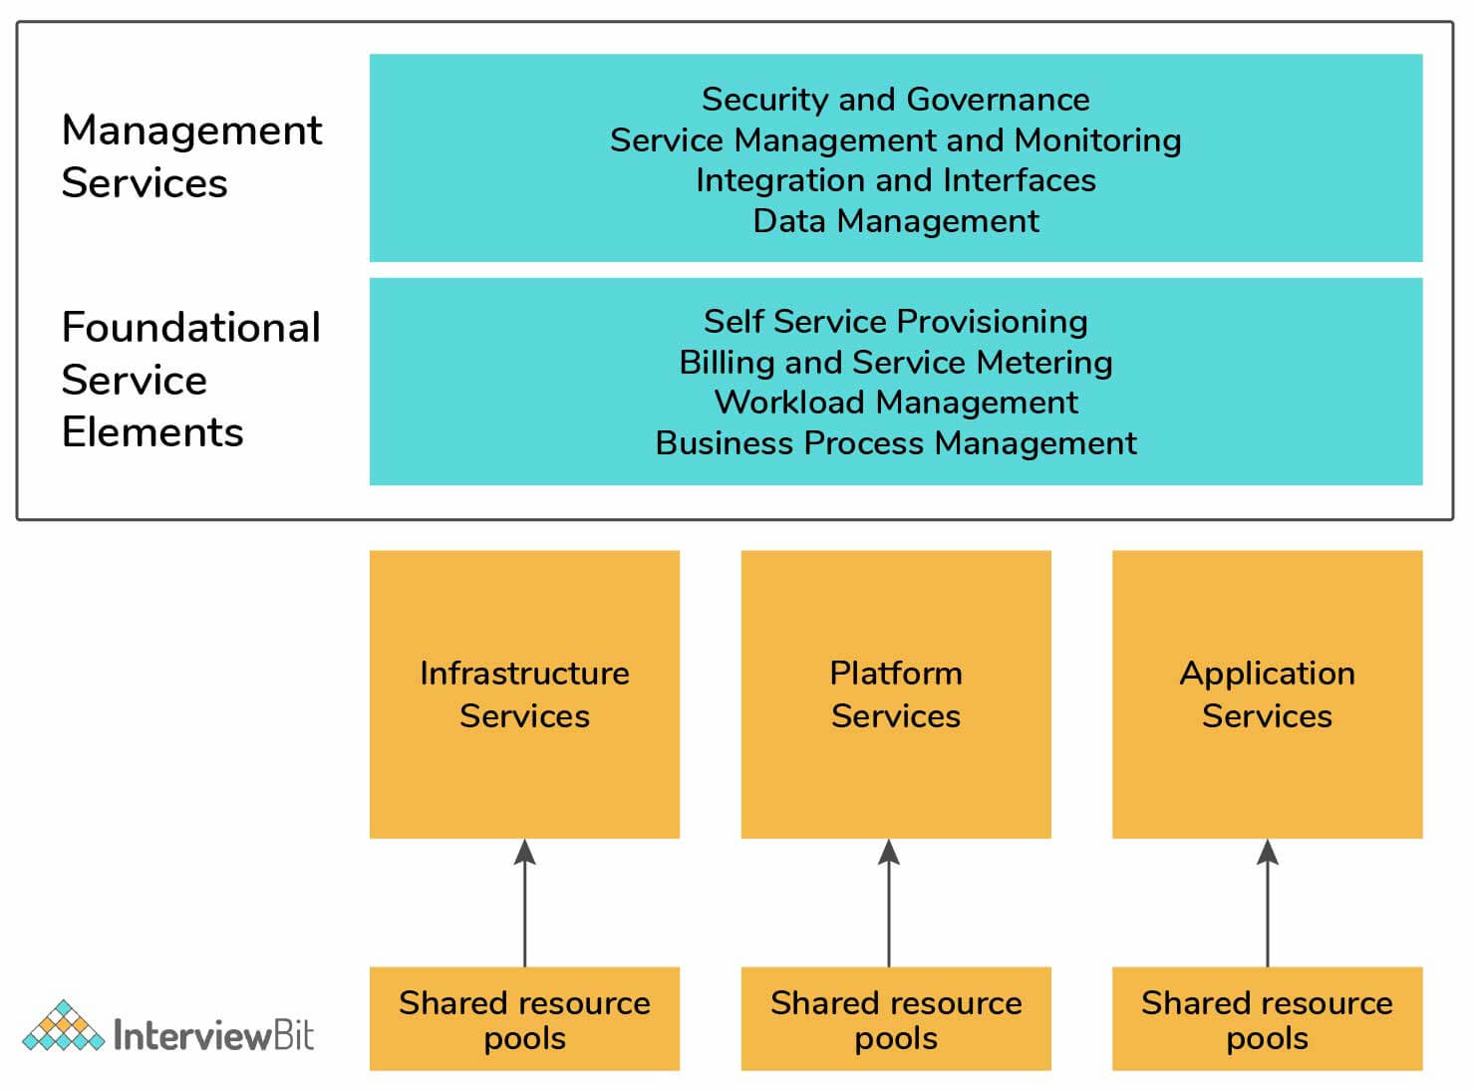

4. What are the different versions of the cloud?
There are two primary deployment models of the cloud: Public and Private.
- Public Cloud: The set of hardware, networking, storage, services, applications, and interfaces owned and operated by a third party for use by other companies or individuals is the public cloud. These commercial providers create a highly scalable data center that hides the details of the underlying infrastructure from the consumer. Public clouds are viable because they offer many options for computing, storage, and a rich set of other services.
- Private Cloud: The set of hardware, networking, storage, services, applications, and interfaces owned and operated by an organization for the use of its employees, partners, or customers is the private cloud. This can be created and managed by a third party for the exclusive use of one enterprise. The private cloud is a highly controlled environment not open for public consumption. Thus, it sits behind a firewall.
- Hybrid Cloud: Most companies use a combination of private computing resources and public services, called the hybrid cloud environment.
- Multi-Cloud: Some companies, in addition, also use a variety of public cloud services to support the different developer and business units – called a multi-cloud environment.

5. What are the main constituents that are part of the cloud ecosystem?
The parts of the cloud ecosystem that determine how you view the cloud architecture are:
- Cloud consumers
- Direct customers
- Cloud service providers

6. Who are the Cloud Consumers in a cloud ecosystem?
The individuals and groups within your business unit that use different types of cloud services to get a task accomplished. A cloud consumer could be a developer using compute services from a public cloud.

7. Who are the Direct customers in a cloud ecosystem?
Users who often take advantage of services that your business has created within a cloud environment. The end-users of your service have no idea that you’re using a public or private cloud. As long as the users are concerned, they’re interacting directly with the services and value.

8. Who are the Cloud service providers in a cloud ecosystem?
Cloud service providers are the commercial vendors or companies that create their own capabilities. The commercial vendors sell their services to cloud consumers. In contrast to this, a company might decide to become an internal cloud service provider to its own partners, employees, and customers, either as an internal service or as a profit center. Cloud service providers also create applications or services for such environments.

9. Describe the Cloud Computing Architecture.
The cloud computing architecture is all the components of a cloud model that fit together from an architectural perspective. The figure below depicts how the various cloud services are related to support the needs of businesses. On the left side, the cloud service consumer represents the types of uses of cloud services. No matter what the requirements of the particular constituent are, it is important to bring the right type of services together that can support both internal and external users. Management of the consumers should be able to make services readily available to support the changing business needs. The applications, middleware, infrastructure, and services that are built based on on-premises computing models are within this category. In addition to this, the model depicts the role of a cloud auditor. This organization provides an oversight either by an internal or external group which makes sure that the consumer group meets its obligations.
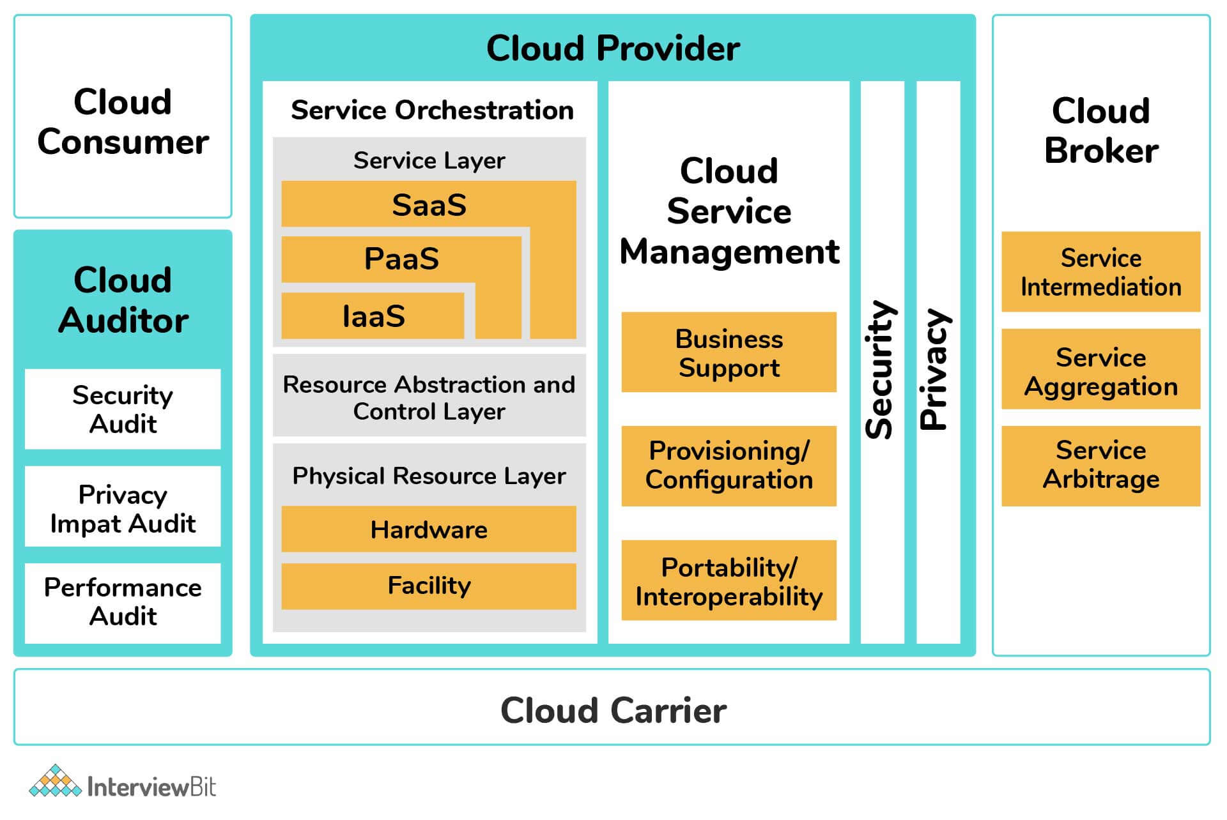The NIST Cloud Reference Model

10. What are the Cloud Storage Levels?
Cloud storage device mechanisms provide common levels of data storage, such as:
- Files – These are collections of data that are grouped into files that are located in folders.
- Blocks – A block is the smallest unit of data that is individually accessible. It is the lowest level of storage and the closest to the hardware.
- Datasets – Data sets organized into a table-based, delimited, or record format.
- Objects – Data and the associated metadata with it are organized as web-based resources.
Each of the above data storage levels is associated with a certain type of technical interface. This interface corresponds to a particular type of cloud storage device and the cloud storage service used to expose its API.
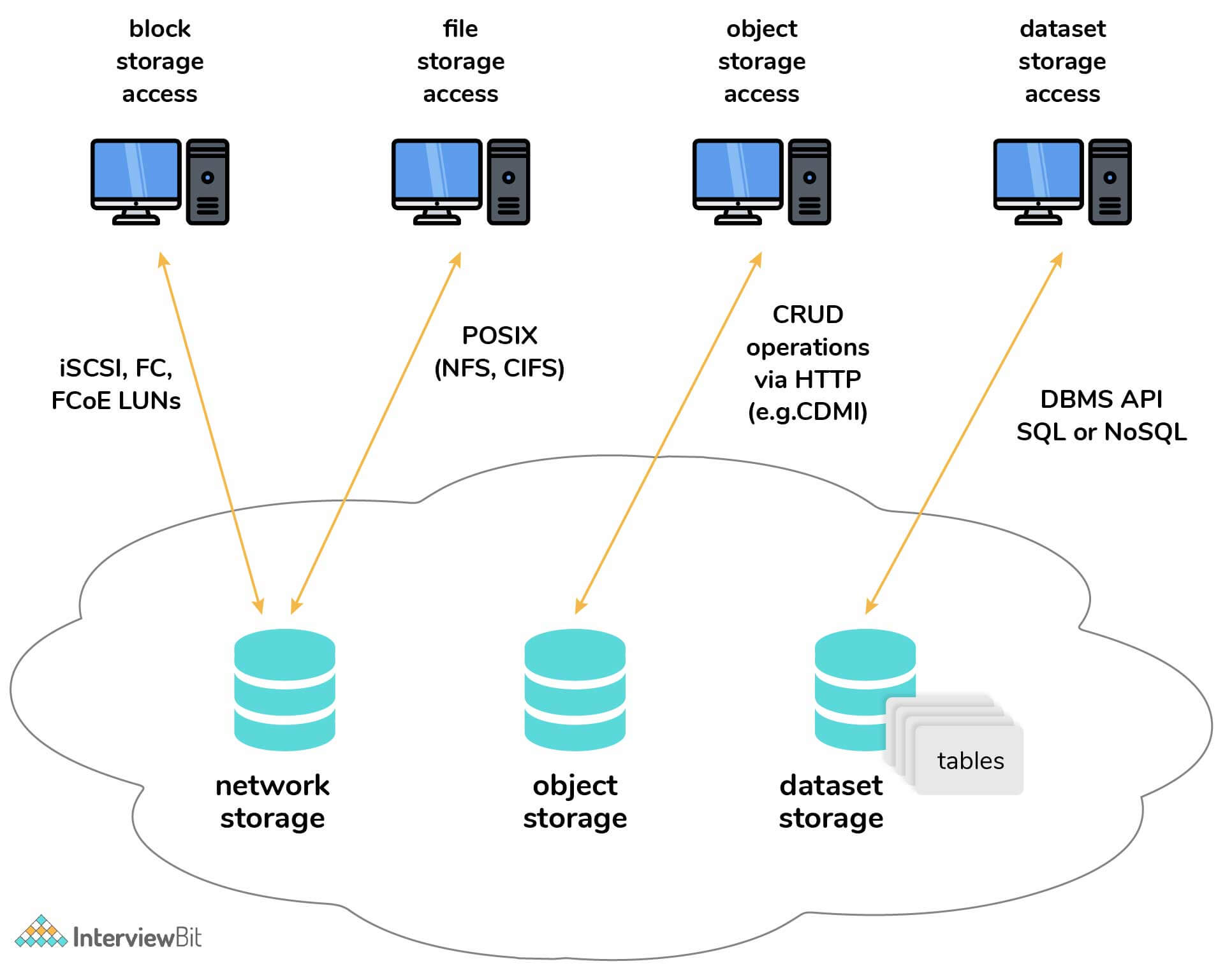

Cloud Computing Interview Questions for Experienced

11. What are serverless components in cloud computing?
Serverless components in cloud computing allow the building of applications to take place without the complexity of managing the infrastructure. One can write code without having provision to a server.
Serverless machines take care of virtual machines and container management. Multithreading, hardware allocating are also taken care of by the serverless components.

12. What are the advantages and disadvantages of serverless computing?
Serverless computing has the following advantages and disadvantages:
Advantages:
- It is cost-effective.
- The operations on serverless computing are simplified.
- Serverless computing helps boost productivity.
- It offers scaling options.
- It involves zero server management.
Disadvantages:
- Serverless code can cause response latency.
- It is not ideal for high-computing operations because of resource limitations.
- For serverless computing, the responsibility of security comes under the service company and not the consumer, which might be more vulnerable.
- Debugging serverless code is a bit more challenging.

13. What are cloud-enabling technologies?
There are several areas of technology that contribute to modern-day cloud-based platforms. These are known as cloud-enabling technologies. Some of the cloud-enabling technologies are:
- Broadband Networks and Internet Architecture
- Data Center Technology
- (Modern) Virtualization Technology
- Web Technology
- Multitenant Technology
- Service Technology

14. What are Microservices?
Microservices is a process of developing applications that consist of code that is independent of each other and of the underlying developing platform. Each microservice runs a unique process and communicates through well-defined and standardized APIs, once created. These services are defined in the form of a catalog so that developers can easily locate the right service and also understand the governance rules for usage.

15. Why are microservices important for a true cloud environment?
The reason why microservices are so important for a true cloud environment is because of these four key benefits:
- Each microservice is built to serve a specific and limited purpose, and hence application development is simplified. Small development teams can then focus on writing code for some of the narrowly defined and easily understood functions.
- Code changes will be smaller and less complex than with a complex integrated application, making it easier and faster to make changes, whether to fix a problem or to upgrade service with new requirements.
- Scalability — Scalability makes it easier to deploy an additional instance of a service or change that service as needs evolve.
- Microservices are fully tested and validated. When new applications leverage existing microservices, developers can assume the integrity of the new application without the need for continual testing.

16. What is the cloud usage monitor?
The cloud usage monitor mechanism is an autonomous and lightweight software program that is responsible for collecting and processing the IT resource usage data.
Cloud usage monitors can exist in different formats depending on what type of usage metrics these are designed to collect and how the usage data needs to be collected. The following points describe 3 common agent-based implementation formats.
- Monitoring Agent
- Resource Agent
- Polling Agent

17. How does the Monitoring Agent monitor the cloud usage?
An intermediary and an event-driven program that exists as a service agent and resides along the existing communication paths is a monitoring agent. It transparently monitors and analyzes dataflows. Commonly, the monitoring agent is used to measure the network traffic and also message metrics.

18. How does the Resource Agent monitor the cloud usage?
A processing module that is used to collect usage data by having event-driven interactions with the specialized resource software, is a resource agent. This agent is applied to check the usage metrics based on pre-defined, observable events at the resource software level, like initiating, suspending, resuming, and vertical scaling.

19. How does the Polling Agent monitor cloud usage?
A processing module that gathers cloud service usage data by polling IT resources is called a polling agent. The polling agent has also been used to timely monitor the IT resource status, like uptime and downtime.
Each of these can be designed to forward collected usage data to a log database for post-processing and for reporting purposes.

20. What are Cloud-Native Applications?
‘Cloud native’ is a software framework designed with containers, microservices, dynamic orchestration, and also continuous delivery of software. Every part of the cloud-native application has within it its own container and is dynamically orchestrated with other containers to optimize the way the resources are utilized.

21. How does the Cloud Native Computing Foundation define cloud-native applications?
The Cloud Native Computing Foundation gives a clear definition of cloud-native:
- Container packaged: This means a standard way to package applications that is resource-efficient. By using a standard container format, more applications can be densely packed.
- Dynamically managed: This means a standard way to discover, deploy, and scale up and down containerized applications.
- Microservices oriented: This means a method to decompose the application into modular, independent services that interact through well-defined service contracts.

22. What is meant by Edge Computing?
Edge and cloud are complementary. These are both parts of a broader concept called the distributed cloud. A majority of those pursuing edge computing strategies are now viewing edge as part of their overall cloud strategy.
Edge computing, unlike cloud computing, is all about the physical location and issues related to latency. Cloud and edge combine the strengths of a centralized system, along with the advantages of distributed operations at the physical location where things and people connect. In IoT scenarios, the edge is very common. Cloud is different from the edge, in that it has never been about location. As opposed, it has always been about the independence of location.
The popular scenarios are where you have cloud and edge together, and the cloud provider controls to run and defines the architecture for what is out at the edge.

23. What is an API Gateway?
An API gateway allows multiple APIs to act together as a single gateway to provide a uniform experience to the user. In this, each API call is processed reliably. The API gateway manages the APIs centrally and provides enterprise-grade security. Common tasks of the API services can be handled by the API gateway. These tasks include services like statistics, rate limiting, and user authentication.

24. What do you mean by Rate Limiting?
Rate Limiting is a way to limit the network traffic. Rate limiting runs within the app rather than the server. It typically tracks the IP addresses and the time between each request.
It can eliminate certain suspicious and malicious activities. Bots that impact a website can also be stopped by Rate Limiting. This protects against API overuse which is important to prevent.

25. What do you mean by encapsulation in cloud computing?
A container is a packaged software code along with all of its dependencies so that it can run consistently across clouds and on-premises. This packaging up of code is often called encapsulation. Encapsulating code is important for developers as they don’t have to develop code based on each individual environment.

26. What are the different Datacenters deployed for Cloud Computing?
Cloud computing is made up of various data centers put together in a grid form. It consists of the data centers like:
- Containerized Data Centers
- Low-Density Data Centers

27. What are Containerized Data Centers?
Containerized Data Centers are the traditional data centers that allow a high level of customization with servers, mainframes, and other resources. These require planning, cooling, networking, and power to access and work.

28. What are Low-Density Data Centers?
Low-Density Data Centers are optimized to give high performance. The space constraint is being removed and there is an increased density in these data centers. One drawback it has is that with high density the heat issue also creeps in. These data centers are quite suitable to develop the cloud infrastructure.

29. What are some issues with Cloud Computing?
Following are some of the issues of cloud computing:
- Security Issues: As it would be in any other computing paradigms, security is as much of a concern as Cloud computing. Cloud Computing is vaguely defined as the outsourcing of services, which in turn causes users to lose significant control over their data. With the public Cloud, there is also a risk of seizure associated.
- Legal and Compliance Issues: Sometimes, clouds are bounded by geographical boundaries. The provision of different services is not location-dependent. Because of this flexibility Clouds face Legal & Compliance issues. Though these issues affect the end-users, they are related mainly to the vendors.
- Performance and Quality of Service (QoS) Related Issues: Paradigm performance is of utmost importance for any computing. The Quality of Service (QoS) varies as the user requirements may vary. One of the critical Quality of Service-related issues is the optimized way in which commercial success can be achieved using Cloud computing. If a provider is unable to deliver the promised QoS it may tarnish its reputation. One faces the issue of Memory and Licensing constraints which directly hamper the performance of a system, as Software-as-a-Service (SaaS) deals with the provision of software on virtualized resources,
- Data Management Issues: An important use case of Cloud Computing is to put almost the entire data on the Cloud with minimum infrastructure requirements for the end-users. The main problems related to data management are scalability of data, storage of data, data migration from one cloud to another, and also different architectures for resource access. It is of utmost importance to manage these data effectively, as data in Cloud computing also includes highly confidential information.

30. How does Resource Replication take place in Cloud Computing?
Resource Replication is the creation of multiple instances of the same IT resource. It is typically performed when an IT resource’s availability and performance are needed to be enhanced. The virtualization technology is adopted to implement the resource replication mechanism in order to replicate the cloud-based IT resources.
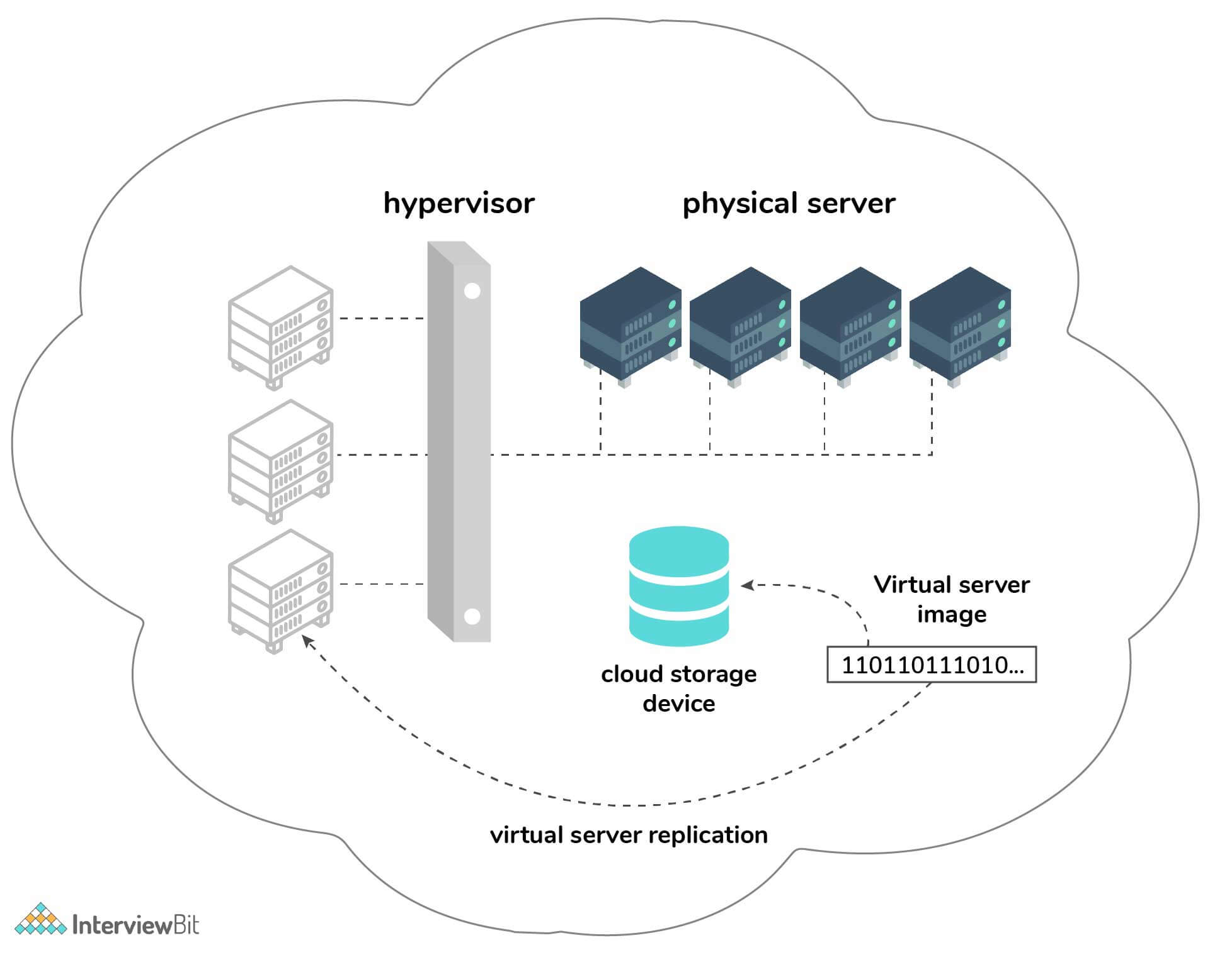

Conclusion:
Cloud computing is completely based on the Internet. It is the next stage in the evolution of the Internet. Cloud computing uses the cloud that provides the way to deliver the services whenever and wherever the user needs them. Enterprises use cloud computing to provide solutions to the needs of their customers, partners, and providers.
Cloud computing includes partners, vendors, and business leaders as the three major contributors. The vendors provide applications and their related technology, infrastructure, hardware, and integration. The partners offer cloud services and provide support services to the customers. The business leaders evaluate the cloud service provided by the partners.
Cloud computing enables enterprises to treat their resources as a pool and not as independent resources.

1) What is cloud computing?
Cloud computing is an internet based new age computer technology. It is the next stage technology that uses the clouds to provide the services whenever and wherever the user need it.It provides a method to access several servers world wide.

2) What are the benefits of cloud computing?
The main benefits of cloud computing are:
- Data backup and storage of data.
- Powerful server capabilities.
- Incremented productivity.
- Very cost effective and time saving.
- Software as Service known as SaaS.

3) What is a cloud?
A cloud is a combination of networks ,hardware, services, storage, and interfaces that helps in delivering computing as a service. It has three users :
- End users
- Business management users
- cloud service provider

4) What are the different data types used in cloud computing?
There are different data types in cloud computing like emails, contracts, images , blogs etc. As we know that data is increasing day by day so it is needed to new data types to store these new data. For an example, if you want to store video then you need a new data type.

5) Which are the different layers that define cloud architecture?
Following are the different layers that are used by cloud architecture:
- CLC or Cloud Controller
- Walrus
- Cluster Controller
- SC or Storage Controller
- NC or Node Controller

6) Which platforms are used for large scale cloud computing?
The following platforms are used for large scale cloud computing:
- Apache Hadoop
- MapReduce

7) What are the different layers in cloud computing? Explain working of them.
There are 3 layers in the hierarchy of cloud computing.
Infrastructure as a service (IaaS):It provides cloud infrastructure in terms of hardware as like memory, processor, speed etc.
Platform as a service (PaaS):It provides cloud application platform for the developer.
Software as a service (SaaS)::It provides the cloud applications to users directly without installing anything on the system. These applications remains on cloud.

8) What do you mean by software as a service?
Software As a Service (SaaS) is an important layer of cloud computing. It provides cloud applications like Google is doing. It facilitate users to save their document on the cloud and create as well.

9) What is the platform as a service?
It is also a layer in cloud architecture. This model is built on the infrastructure model and provide resources like computers, storage and network. It is responsible to provide complete virtualization of the infrastructure layer, make it look like a single server and invisible for outside world.

10) What is on-demand functionality? How is it provided in cloud computing?
Cloud computing provides a on-demand access to the virtualized IT resources. It can be used by the subscriber. It uses shared pool to provide configurable resources. Shared pool contains networks, servers, storage, applications and services.

11) What are the platforms used for large scale cloud computing?
Apache Hadoop and MapReduce are the platforms use for large scale cloud computing.

12) What are the different models for deployment in cloud computing?
These are the different deployment model in cloud computing:
Private cloud
Public cloud
Hybrid cloud
Community cloud

13) What is private cloud?
Private clouds are used to keep the strategic operations and other reasons secure. It is a complete platform which is fully functional and can be owned, operated and restricted to only an organization or an industry. Now a day, most of the organizations have moved to private clouds due to security concerns. Virtual private cloud is being used that operate by a hosting company.

14) What is public cloud?
The public clouds are open to the people for use and deployment. For example: Google and Amazon etc. The public clouds focus on a few layers like cloud application, infrastructure providing and providing platform markets.

15) What are Hybrid clouds?
Hybrid clouds are the combination of public clouds and private clouds. It is preferred over both the clouds because it applies most robust approach to implement cloud architecture. It includes the functionalities and features of both the worlds. It allows organizations to create their own cloud and allow them to give the control over to someone else as well.

16) What is the difference between cloud computing and mobile computing?
Mobile computing and cloud computing are slightly same in concept. Mobile computing uses the concept of cloud computing . Cloud computing provides users the data which they required while in mobile computing, applications run on the remote server and gives user the access for storage and manage.

17) What is the difference between scalability and elasticity?
Scalability is a characteristic of cloud computing which is used to handle the increasing workload by increasing in proportion amount of resource capacity. By the use of scalability, the architecture provides on demand resources if the requirement is being raised by the traffic. Whereas, Elasticity is a characteristic which provides the concept of commissioning and decommissioning of large amount of resource capacity dynamically. It is measured by the speed by which the resources are coming on demand and the usage of the resources.

18) What are the security benefits of cloud computing?
Cloud computing authorizes the application service, so it is used in identity management.
It provides permissions to the users so that they can control the access of another user who is entering into the cloud environment.

19) What is the usage of utility computing?
Utility computing is a plug-in managed by an organization which decides what type of services has to be deployed from the cloud. It facilitates users to pay only for what they use.

20) What is "EUCALYPTUS" in cloud computing? Why is it used?
It is an acronym stands for Elastic Utility Computing Architecture For Linking Your Program To Useful Systems. It is an open source software infrastructure in cloud computing and used to implement clusters in cloud computing platform. It creates public, private and hybrid cloud. It facilitate a user to create his own data center into a private cloud and use its functionalities to many other organizations.

21) Explain System integrators in cloud computing.
System integrator provides a strategy of a complicated process used to design a cloud platform. It creates more accurate hybrid and private cloud network because integrator have all the knowledge about the data center creation.

22) What are the open source cloud computing platform databases?
MongoDB, CouchDB, LucidDB are the example of open source cloud computing platform database.

23) Give some example of large cloud provider and databases?
Google bigtable
Amazon simpleDB
Cloud based SQL

24) What is the difference between cloud and traditional datacenters?
The cost of the traditional datacenter is higher than cloud because in traditional databases, there is overheating problems and some software and hardware issue.

25) What are the different in Software as a Service (SaaS)?
Simple Multi-tenancy:In this mode, Every user has independent resources and are uniquely different from other users. This is an efficient mode.
Fine grain multi-tenancy:: In this mode, the resources can be shared by many users but the functionality remains the same.

26) Why API's is used in cloud services?
API's (Application Programming Interfaces) is used in cloud platform because:
It provide an alternative way that you don't need to write the fully fledged program.
It makes communication between one or more applications.
It creates applications and link the cloud services with other systems.

27) What are the advantages of cloud services?
Following are the main advantages of cloud services:
- Cost saving: It helps in the utilization of investment in the corporate sector. So, it is cost saving.
- Scalable and Robust: It helps in the developing scalable and robust applications. Previously, the scaling took months, but now, scaling takes less time.
- Time saving: It helps in saving time in terms of deployment and maintenance.

28) What are the different datacenters in cloud computing?
- Containerized datacenter
- Low density datacenter

29) What do you mean by CaaS?
CaaS is a terminology used in telecom industry as Communication As a Service. CaaS offers the enterprise user features such as desktop call control, unified messaging and desktop faxing.

30) What do you mean by VPN? What does it contain?
VPN stands for Virtual Private Network. VPN is a private cloud that manage the security of the data during the communication in the cloud environment. With VPN, you can make a public network as private network.

31) What are the basic clouds in cloud computing?
There are three basic clouds in cloud computing:
- Professional cloud
- Personal cloud
- Performance cloud

32) What are the most essential things that must be followed before going for cloud computing platform?
- Compliance
- Loss of data
- Data storage
- Business continuity
- Uptime
- Data integrity in cloud computing

33) Which services are provided by Window azure operating system?
There are three core services provided by Window azure operating system:
- Compute
- Storage
- Management

34) What is the usage of virtualization platform in implementing cloud?
The main usage of virtualization platform in implementing cloud is:
- It is used to manage the service level policies.
- Cloud Operating System.
- Virtualization platforms help to keep the backend level and user level concepts different from each other.

35) We source cloud computing platform databases?
Following are the open source cloud computing platform databases:
- MongoDB
- CouchDB
- LucidDB

36) What are some large cloud providers and databases?
Following are the mostly used large cloud providers and databases:
- Google bigtable
- Amazon simpleDB
- Cloud based SQL

37) How would you secure data for transport in cloud?
This is the most obvious question accurued in mind that if the cloud data is secure; To ensure that, check that there is no data leak with the encryption key implemented with the data you sending while the data moves from point A to point B in cloud.

Q1. What is Cloud?
Ans. It is a global network of servers, each with a unique function. It includes networks, hardware, services, storage, and interfaces that help in delivering computing as a service.

Q2. What is Cloud Computing?
Ans. Cloud computing is an emerging computing paradigm that allows data and applications to remain in cyberspace and allows users to access their data through any web-connected device.
For more information, you can also explore:
Introduction to Cloud Computing
In this blog, we will explore cloud computing? We will also discuss Deployment models, Service models, advantages, challenges, and characteristics...read more

Evolution of Cloud Computing
The term "cloud computing" refers to renting computing resources. Five technologies were critical in the evolution of cloud computing into...read more

Different characteristics of cloud computing
The characteristics of cloud computing explain why cloud computing is the go-to destination for building and deploying modern applications.

Q3. Explain different types of clouds.
Ans. There are three types of clouds –
- Private clouds – Commonly offered as web applications or web services
- Public clouds – Deployed and managed within the user’s organization
- Hybrid clouds – A combination of both public and private clouds

Q4. What are the benefits of cloud computing?
Ans. Primary benefits of cloud computing include-
- Data backup and storage
- Reduced costs of managing and maintaining IT systems
- Powerful server capability and scalability
- Better productivity and collaboration efficiency
- Access to automatic updates

Q5. What are the different platforms of cloud architecture?
Ans. It is one of the most commonly asked cloud computing interview questions. Following are the different platforms used by cloud architecture:
- Infrastructure as a service (IaaS) – It is a cloud service that provides services on a “pay-for-what-you-use” basis
- Platform as a service (PaaS) – It offers cloud platforms and runtime environments to develop, test and manage software
- Software as a service (SaaS) – It allows hosting and managing software applications on a pay-as-you-go pricing model
Check Out Our Cloud Computing Courses>>

Q6. What are the different layers of cloud architecture?
Ans. There are 5 layers of cloud architecture-
- CC- Cluster Controller
- SC- Storage Controller
- CLC- Cloud Controller
- NC- Node Controller
- Walrus

Q7. Which platforms are used for large-scale cloud computing?
Ans. Platforms used for large scale cloud computing are Apache Hadoop and MapReduce.

Q8. Explain the security aspects of the cloud.
Ans. Cloud Computing offers 3 types of security aspects, which are –
- Identity Management – Authorizes application services
- Access Control – Controls the access of users entering the cloud environment
- Authentication & Authorization – Allows only authorized and authenticated users to access the data and applications

Q9. What is API and what is its use in cloud services?
Ans. API or Application Programming Interface. It has the following uses–
- Eliminates the workload to write the fully-fledged programs
- Eases applications usage
- Links cloud services with other systems

Q10. Why a virtualization platform is required to implement a cloud?
Ans. A virtualization platform helps to –
- Decouple hardware from software
- Manage service level policies and cloud operating system
- Deploys cloud computing models like SaaS, PaaS, and IaaS

Q11. What is “EUCALYPTUS”?
Ans. “EUCALYPTUS” is the abbreviation for Elastic Utility Computing Architecture For Linking Your Programs To Useful Systems”.

Q12. Explain the use of “EUCALYPTUS” in cloud computing.
Ans. It is an open-source software infrastructure that helps in the implementation of clusters in the cloud computing platform. It can build public, hybrid, and private clouds, and can create a data centre into a private cloud. It also helps the users to utilize their functionalities across other organizations.

Do Read>> Cloud Computing Offers Multiple Job Prospects

Q13. Can you name some open source cloud computing platform databases?
Ans. Some open-source cloud computing platform databases are –
- MongoDB – It is a schema-free and document-oriented database. It is written in C++ and provides high storage space.
- CouchDB – A database system based on the Apache server. It is used in data storage.
- LucidDB – It is a Java/C++ database for data warehousing.

Q14. Which are the biggest cloud providers and databases?
Ans. It is one of the most commonly asked cloud computing interview questions. Some of the biggest cloud providers and databases are –
- Amazon Web Services
- SAP
- EnterpriseDB
- Garantia Data
- Cloud SQL by Google
- Azure by Microsoft
- Rackspace
- Google bigtable
- Amazon simpleDB
- Cloud-based SQL

Q15. Name different phases of cloud architecture?
Ans. Various phases of cloud architecture are Launch Phase, Monitor Phase, Shutdown Phase and Cleanup Phase.

Q16. What is Memcached?
Ans. Memcached is an open-source distributed memory caching system. It is a free system that helps to improve the data response time by speeding up dynamic web applications.

Q17. Why should you use Memcache?
Ans. Memcache helps to:
- Speed up the application processes
- Establish which elements to store
- Reduces page load time
- Cuts down the input/output access

Q18. What is the significant difference between Memcache and Memcached?
Ans. Memcache – It enables a user to work through handy object-oriented and procedural interfaces and reduces database load in dynamic web applications.
Memcached – It uses libmemcached library to provide API for communicating with Memcached servers. It is the latest API that alleviates database load.

Q19. Which platforms are used for large-scale cloud computing?
Ans. The most popular platforms for large-scale cloud computing are –
- Apache Hadoop – It enables dispersed storage and distributed dispensation of huge data sets
- MapReduce – It helps in the processing of colossal datasets using cloud and other commodity hardware

Q20. What is the code for implementing load balancing?
Ans. The code to implement load balancing is Apache mod_proxy_balancer.

Q21. Why is load balancing required?
Ans. Load balancing helps to –
- Increase utilization and output
- Lower latency
- Cut back response time
- Avoid system overload

Q22.What is the need for a virtualization platform to implement the cloud?
Ans. Virtualization in cloud computing is very much required to –
- Decouple hardware from software
- Save the cost for components like hardware and servers
- Store the data in the virtual server
- Reduce the wastage, electricity bills, and maintenance costs

Q23. Name different types of virtualization in cloud computing.
Ans. Different types of virtualization in cloud computing are –
- Hardware Virtualization
- Software Virtualization
- Memory Virtualization
- Storage Virtualization
- Data Virtualization
- Network Virtualization
- Desktop Virtualization

Q24. How would you secure the data while it is being transported in the cloud?
Ans. We can secure the data while it is being transported in the cloud by implementing the encryption key. This not helps in ensuring data security but also data leakage.

Q25. What is the most crucial concern people often have in mind regarding the use of Cloud Computing?
Ans. The prevailing concern is about the security of data in Cloud Computing. Most people remain worried about the misuse of data.

Q26. What is utility computing?
Ans. Utility computing is a service-provisioning model that enables users to pay only for the services that they are using. It doesn’t include any upfront costs. It provides computing resources and infrastructure management and is a plug-in managed by the organization. Most of the organizations these days are using a hybrid strategy.

Q27. What are the system integrators?
Ans. Systems integrator or SI helps to create strategies for designing a cloud platform and creating accurate cloud networks. This can be achieved by combining hardware, software, networking, and storage products from multiple vendors.

Q28. What is the benefit of using system integrators in cloud computing?
Ans. The significant benefits of using system integrators in cloud computing are –
- Cost-effective because of the usage of cheaper, pre-configured components, and commercial off-the-shelf software
- Combine various subsystems into an integrated offering
- Helping consumers by simplifying contracting and vendor management
- Integrating on-premises IT systems with cloud-based applications

Q29. What is a VPN?
Ans. VPN stands for Virtual Private Network. This is a connection method for adding security and privacy to private and public networks, such as Wi-Fi Hotspots and the Internet. VPN helps in establishing a secure dial-up connection to a remote server.
For more information, please explore: What is a Virtual Private Network (VPN)?

Q30. What is data encapsulation?
Ans. Data encapsulation is also known as data hiding. It is performing a restricted set of operations like breaking down information into smaller, manageable chunks before their transmission across the network. It is a process of keeping the class implementation details away from the users.

Q31. Mention the different data types used in cloud computing?
Ans. Following are the different data types in cloud computing:
- Emails
- Contracts
- Images
- Blogs
- Text
- Boolean
- Decimal
- Locale
- Number
- Date
In Cloud Computing, multiple data types are used to store various kinds of data, such as if you want to keep a video; you have to use a new data type.

Q32. What are the necessary things that must be followed before going for the cloud computing platform?
Ans. Following are the essential things that must be followed before going for the cloud computing platform:
- Uptime
- Loss of data
- Data storage
- Compliance
- Business continuity
- Data integrity in cloud computing

Q33. Mention the list of different layers that define cloud architecture?
Ans. The different layers used by cloud architecture are:
- Walrus
- Cluster Controller
- NC or Node Controller
- CLC or Cloud Controller
- SC or Storage Controller

Q34. How is cloud architecture involved in business benefits?
Ans. The business benefits involved in cloud architecture are:
- Just in time infrastructure
- Zero infrastructure investment
- Adequate resource utilization

Q35. What are the components needed in cloud architecture?
Ans. Following are the components needed in cloud architecture:
- Cloud Ingress
- Cloud provided services
- Cloud storage services
- Processor Speed
- Intra-cloud communications

Q36. Mention the essential characteristics of cloud computing?
Ans. Essential characteristics of cloud computing are:
- Standardized interfaces
- Elasticity and Scalability
- Billing self-service based usage model
- Self-service provisioning and automatic de-provisioning

Q37. Mention the different data centres in cloud computing?
Ans. Low-density datacenter and Containerized data centres are the different data centres in cloud computing:

Q38. Name the services offered by Windows azure operating system?
Ans. Storage, compute and management, are the essential services offered by the Window azure operating system:

Q39. Explain what CaaS is?
Ans. CaaS is defined as the terminology used in the telecom industry as Communication As a Service. CaaS provides enterprise user features such as unified messaging, desktop call control, and desktop faxing.

Q40. Mention what the advantages of cloud services are?
Ans. Below are the main advantages of cloud services:
- Time-saving: It helps in saving time in terms of deployment and maintenance.
- Cost-saving: It works in investment in the corporate sector.
- Scalable and Robust: It performs in such a way to make the application scalable and robust. Earlier, scaling took lots of time, but now, scaling takes less time.

Q41. Mention the difference between Cloud and traditional data centres?
Ans. The cost of the traditional data centre is higher than earlier due to heating and hardware/software issues.
When the demand increases, Cloud automatically gets scaled. Most of the expenses are spent on maintaining the data centres, while that is not the case with cloud computing.

Q42. Mention what the difference between elasticity and scalability in cloud computing is?
Ans. Scalability is a part of cloud computing where the increasing workload can be managed by increasing the amount of resource capacity. Whereas elasticity is one of the features that highlight the concept of commissioning and decommissioning of a large amount of resource capacity.

Q43. How is the buffer used on Amazon web services?
Ans. Buffer is used to build the system more accurately against the burst of traffic. It helps to align different components. The components are equivalent because it is managed by buffers and make them work at the same speed to provide faster services.

Q44. Mention some characteristics of cloud architecture that differentiate it from the traditional one?
Ans. Following are some characteristics of cloud architecture that differentiate it from traditional architecture:
- Cloud architecture can perform scaling of the resource on demand
- As per the demand, cloud architecture offers the hardware requirement
- Cloud architecture can also manage and handle dynamic workloads

Q45. How does cloud architecture provide automation and performance transparency?
Ans. There are tremendous tools used by cloud architecture to provide performance transparency and automation. It is used to manage cloud architecture and monitor reports. Automation is an essential component of cloud architecture, which is used to improve the degree of quality.

Q46. What is OpenStack?
Ans. OpenStack is an open-source cloud computing element serving IaaS (Infrastructure as a Service). OpenStack controls big chunks of computing, storage, and networking resources; all managed through APIs or a dashboard.

Q47. Name some of the top Cloud Platforms.
Ans. Some of the top-rated cloud platforms are –
- Microsoft Azure
- Amazon Web Services (AWS)
- Google Cloud Platform
- IBM Bluemix
- Oracle
- Salesforce
- SAP
- VMWare

Q48. Explain AWS and its components.
Ans. AWS stands for Amazon Web Services. It is an infrastructure as a service. The main components of AWS are:
- DNS – Offers a service platform based on a domain name server; also called route-53
- Simple Email Service – A cost-effective email service built on a reliable and scalable infrastructure. It allows the users to send transactional emails, marketing messages, or other high-quality content to your customers.

Q49. What is Microsoft Azure?
Ans. Microsoft Azure is a Microsoft Cloud platform. It offers services like content delivery networks (CDNs), Virtual Machines (VMs), and some advanced proprietary software that makes it perfect like IaaS. RemoteApp, for example, helps you use virtual machines to deploy Windows programs. Then there is the Active Directory service and the SQL server. It also supports open technologies like Linux distributions that can be contained in virtual machines.

Q50. What are the different types of roles in Microsoft Azure?
Ans. There are three types of roles in Microsoft Azure-
- Web Role – Helps in the deployment of websites.
- Worker Role – Assists the role of the Web, run background processes to support Web Role.
- VM Role – Allows users to customize the servers on which the web role and worker roles run.

Q51. What is the Azure Active Directory service?
Ans. Azure Active Directory Service is a multi-tenant cloud-based identity and directory management service that combines core directory services, application access management, and identity protection.
In other words, Azure Active Directory Service is an identity and access management system. It helps to grant users access privileges to different network resources and update information about the graph and related resources.

Q52. Which web applications can be deployed with Azure?
Ans. Many web applications, including open-source ones, can be deployed on Azure. Some examples of such web applications are PHP, WCF and ASP.NET.

Q53. What are Azure Storage Queues?
Ans. Azure Queue storage allows you to retrieve messages and access them from anywhere on the planet. The service uses a simple hypertext transfer protocol (HTTP or HTTPS).

Q54. What is Poison in Azure Storage Queues?
Ans. Messages exceeding the maximum number of delivery attempts to the application are called Poison in the Microsoft Azure language.

Q55. What is the function of AD and Azure AD?
Ans. Windows AD is a system built for local networks, while Azure AD is a separate system built just for the cloud. Both store information about networks, network resources and help provide access or restrict privileges to different users for different network resources.
Azure AD is scalable and has been built to support resource allocations on a global scale. Azure AD is helpful while it also helps you when you move your on-premises computing to the cloud.

Q56. What are the different phases in cloud architecture?
Ans. There are four phases in the cloud architecture –
- Launch Phase
- Monitor Phase
- Shutdown Phase
- Cleanup Phase

Q57. What are the building blocks in cloud architecture?
Ans. The building blocks in cloud architecture are –
- Reference architecture
- Technical architecture
- Deployment operation architecture

Q58. Explain hybrid and community clouds.
Ans. Hybrid cloud – Hybrid cloud consists of multiple service providers and is a combination of public and private cloud features.
Community Cloud – Community cloud is an expensive model and is used when organizations having common goals and requirements are ready to share the costs and benefits of the cloud service.

Q59. How would you secure data for transport in cloud computing?
Ans. While transporting data in a cloud computing environment, one should ensure that no one can intercept your data as it moves from point A to point B in the cloud. It is also important to make sure that there are no data leaks from any storage in the cloud. A virtual private network (VPN) is one effective medium to manage data security during its transport in a cloud environment.

Q60. What is ‘scalability’?
Ans. Scalability is the ability to increase or decrease IT resources as per the requirements. Scalability is one of the hallmarks of cloud computing.

Q61. What are the different types of ‘scalability’?
Ans. There are two types of scalability, horizontal and vertical.
Horizontal scalability refers to increasing cloud computing’s performance rates by adding additional hardware to the system (or upgrading the current one).
Vertical scalability is used to increase performance rates by upgrading the storage capacity of current machines.
Even when the two types of scalability are very different, they have a similar goal and are equally important.

Q62. What is ‘BLOB’?
Ans. BLOB stands for ¨ Large Binary Object ¨. It is a collection of binary data stored as a single entity in a database management system, including images, audio, or other multimedia objects.

Q63. What is Cloud-Native?
Ans. Cloud-native is an approach to build and run applications exploiting the advantages of the cloud computing delivery model.

Q64. What are the different principles of Cloud-Native?
Ans. There are 12 principles of Cloud-Native –
- Code: A single code traceable from many implementations
- Dependencies: Explicitly Declare and Isolate Dependencies
- Configuration: Store config in the environment
- Backup Services – Treat Backup Services as attached resources
- Build, release, run: Strictly separate build and run stages
- Processes: Run the application as one or more stateless processes
- Union of ports: Export services through port links
- Concurrency: Scale through the process model
- Disposability – Maximize robustness with quick start-up and smooth shutdown
- Development and production parity: Keep development, preparation, and production in sync
- Logs – Treat logs as event streams
- Administrative processes – Run administration tasks as single processes

Q65. What is Edge Computing?
Ans. Unlike cloud computing, edge computing is all about the physical location and latency issues. Cloud and edge are complementary concepts that combine a centralized system’s strengths with the benefits of distributed operations in the physical location where things and people connect. Edge computing is ubiquitous in the Internet of Things scenarios and is very different from the cloud.

Q66. What are the characteristics of community cloud?
Ans. Community clouds are beneficial for businesses that want to avail cost-effective cloud services for collaborating on joint projects. It has various advantages including:
1. Users can modify properties as per their individual use cases.
2. Companies can interact with employees remotely
3. Support of different device usage is there thus allowing more flexibility
4. Fewer complexities in comparison with private cloud as the data stays close to its owner organization
5. Promotes environmental sustainability

Q67. How does cloud computing ensure data security?
Ans. There are various methods that ensure data security in cloud computing:
- Identity management: controls access to resources within the organization and manages access privileges of individual network entities to cloud services.
- Access control: users are granted permissions to decide whether to provide access to another user who has entered the cloud environment.
- Authentication and authorization: Only authorized and authenticated users are allowed to access applications and data.

Q68. What is load balancing in cloud computing?
Ans. Load balancing in cloud computing refers to the process of transferring workload to ensure that no computing machine is overloaded, underloaded, or unutilized.

Q70. What is Iaas infrastructure in cloud computing?
Ans.In the IaaS infrastructure, the cloud provider manages IT infrastructures such as storage, server, and networking resources and delivers them to subscriber organizations via virtual machines accessible via the internet.

1) What are the advantages of using cloud computing?
The advantages of using cloud computing are
- Data backup and storage of data
- Powerful server capabilities
- SaaS ( Software as a service)
- Information technology sandboxing capabilities
- Increase in productivity
- Cost effective & Time saving

2) Mention platforms which are used for large scale cloud computing?
The platforms that are used for large scale cloud computing are
- Apache Hadoop
- MapReduce

3) Explain different models for deployment in cloud computing?
The different deployment models in cloud computing are
- Private Cloud
- Public Cloud
- Community Cloud
- Hybrid Cloud

4) What is the difference in cloud computing and computing for mobiles?
Mobile computing uses the same concept as cloud computing. Cloud computing becomes active with the data with the help of internet rather than individual device. It provides users with the data which they have to retrieve on demand. In mobile, the applications runs on the remote server and gives user the access for storage and manage.

5) How user can gain from utility computing?
Utility computing allows the user to pay only for what they are using. It is a plug-in managed by an organization which decides what type of services has to be deployed from the cloud.
Most organizations prefer hybrid strategy.

6) For a transport in cloud how you can secure your data?
To secure your data while transporting them from one place to another, check that there is no leak with the encryption key implemented with the data you are sending.

7) What are the security aspects provided with cloud?
- Identity management: It authorizes the application services
- Access control: permission has to be provided to the users so that they can control the access of another user who is entering into the cloud environment.
- Authentication and Authorization: Allows only the authorized and authenticated user only to access the data and applications

8) List out different layers which define cloud architecture?
The different layers used by cloud architecture are
- CLC or Cloud Controller
- Walrus
- Cluster Controller
- SC or Storage Controller
- NC or Node Controller

9) What are system integrators in Cloud Computing?
In Cloud Computing, systems integrator provides the strategy of the complicated process used to design a cloud platform. Integrator allows to create more accurate hybrid and private cloud network, as integrators have all the knowledge about the data center creation.

10) What is “ EUCALYPTUS” stands for?
“ EUCALYPTUS” stands for Elastic Utility Computing Architecture For Linking Your Programs To Useful Systems”

11) Explain what is the use of “EUCALYPTUS” in cloud computing?
“Eucalyptus” is an open source software infrastructure in cloud computing, which is used to implement clusters in cloud computing platform. It is used to build public, hybrid and private clouds. It has the ability to produce your own data center into a private cloud and allows you to use its functionality to many other organizations.

12) What is the requirement of virtualization platform in implementing cloud?
The requirement of virtualization platform in implementing cloud is to
- Manage the service level policies
- Cloud Operating System
- virtualization platforms helps to keep the backend level and user level concepts different from each other

13) Before going for cloud computing platform what are the essential things to be taken in concern by users?
- Compliance
- Loss of data
- Data storage
- Business continuity
- Uptime
- Data integrity in cloud computing

14) Mention some open source cloud computing platform databases?
The open source cloud computing platform databases are
- MongoDB
- CouchDB
- LucidDB

15) What are the security laws which are implemented to secure data in a cloud?
The security laws which are implemented to secure data in cloud are
- Processing: Control the data that is being processed correctly and completely in an application
- File: It manages and control the data being manipulated in any of the file
- Output reconciliation: It controls the data which has to be reconciled from input to output
- Input Validation: Control the input data
- Security and Backup: It provides security and backup it also controls the security breaches logs

16) Mention the name of some large cloud providers and databases?
- Google bigtable
- Amazon simpleDB
- Cloud based SQL

17) Explain the difference between cloud and traditional datacenters?
- The cost of the traditional data center is higher due to heating and hardware/software issues
- Cloud gets scaled when the demand increases. Majority of the expenses are spent on the maintenance of the data centers, while that is not the case with cloud computing

18) Explain what are the different modes of software as a service (SaaS)?
- Simple multi-tenancy: In this each user has independent resources and are different from other users, it is an efficient mode.
- Fine grain multi-tenancy: In this type, the resources can be shared by many but the functionality remains the same.

19) What is the use of API’s in cloud services?
API’s (Application Programming Interface) is very useful in cloud platforms
- It eliminates the need to write the fully fledged programs
- It provides the instructions to make communication between one or more applications
- It allows easy creation of applications and link the cloud services with other systems

20) What are the different data centers deployed for cloud computing?
Cloud computing consists of different datacenters like
- Containerized Datacenters
- Low Density Datacenters

21) In cloud computing what are the different layers?
The different layers of cloud computing are:
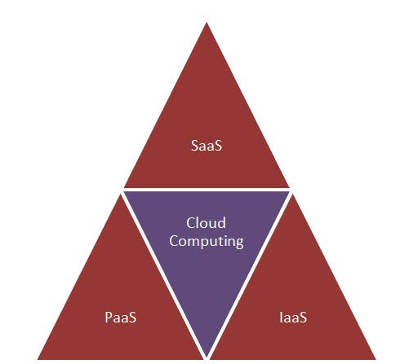
- SaaS: Software as a Service (SaaS), it provides users access directly to the cloud application without installing anything on the system.
- IaaS: Infrastructure as a service, it provides the infrastructure in terms of hardware like memory, processor speed etc.
- PaaS: Platform as a service, it provides cloud application platform for the developers

22) How important is the platform as a service?
Platform as a service or PAAS is an important layer in cloud computing. It provides application platform for providers. It is responsible for providing complete virtualization of the infrastructure layer and makes it work like a single server.

23) What is a cloud service?
Cloud service is used to build cloud applications using the server in a network through internet. It provides the facility of using the cloud application without installing it on the computer. It also reduces the maintenance and support of the application which are developed using cloud service.

24) List down the three basic clouds in cloud computing?
- Professional cloud
- Personal cloud
- Performance cloud

25) As a infrastructure as a service what are the resources that are provided by it?
IAAS ( Infrastructure As A Service) provides virtual and physical resources that are used to build a cloud. It deals with the complexities of deploying and maintaining of the services provided by this layer. Here the infrastructure is the servers, storage and other hardware systems.

26) What are the business benefits involved in cloud architecture?
The benefits involved in cloud architecture is
- Zero infrastructure investment
- Just in time infrastructure
- More efficient resource utilization

27) What are the characteristics of cloud architecture that separates it from traditional one?
The characteristics that makes cloud architecture above traditional architecture is
- According to the demand cloud architecture provides the hardware requirement
- Cloud architecture is capable of scaling the resource on demand
- Cloud architecture is capable of managing and handling dynamic workloads without failure

28) Mention what is the difference between elasticity and scalability in cloud computing?
Scalability is a characteristics of cloud computing through which increasing workload can be handled by increasing in proportion the amount of resource capacity. Whereas, elasticity, is being one of the characteristics that highlights the concept of commissioning and decommissioning of a large amount of resource capacity.

29) Mention the services that are provided by Window Azure Operating System?
Window Azure provides three core services which are given as
- Compute
- Storage
- Management

30) In cloud architecture what are the different components that are required?
- Cloud Ingress
- Processor Speed
- Cloud storage services
- Cloud provided services
- Intra-cloud communications

31) In cloud architecture what are the different phases involved?
- Launch Phase
- Monitor Phase
- Shutdown Phase
- Cleanup Phase

32) List down the basic characteristics of cloud computing?
- Elasticity and Scalability
- Self-service provisioning and automatic de-provisioning
- Standardized interfaces
- Billing self service based usage model

33) In cloud architecture what are the building blocks?
- Reference architecture
- Technical architecture
- Deployment operation architecture

34) Mention in what ways cloud architecture provide automation and performance transparency?
To provide the performance transparency and automation there are many tools used by cloud architecture. It allows to manage the cloud architecture and monitor reports. It also allows them to share the application using the cloud architecture. Automation is the key component of cloud architecture which helps to improve the degree of quality.

35) In cloud computing explain the role of performance cloud?
Performance cloud is useful in transferring maximum amount of data instantly. It is used by the professionals who work on high performance computing research.

36) Explain hybrid and community cloud?
Hybrid cloud: It consists of multiple service providers. It is a combination of public and private cloud features. It is used by the company when they require both private and public clouds both.
Community Cloud: This model is quite expensive and is used when the organizations having common goals and requirements, and are ready to share the benefits of the cloud service.

37) In cloud what are the optimizing strategies?
To overcome the maintenance cost and to optimize the resources ,there is a concept of three data center in cloud which provides recovery and back-up in case of disaster or system failure and keeps all the data safe and intact.

38) What is Amazon SQS?
To communicate between different connectors Amazon SQS message is used, between various components of AMAZON, it acts as a communicator.

39) How buffer is used to Amazon web services?
In order to make system more efficient against the burst of traffic or load, buffer is used. It synchronizes different component . The component always receives and processes the request in an unbalanced way. The balance between different components are managed by buffer, and makes them work at the same speed to provide faster services.

40) Mention what is Hypervisor in cloud computing and their types?
Hypervisor is a Virtual Machine Monitor which manages resources for virtual machines. There are mainly two types of hypervisors
Type 1: The guest Vm runs directly over the host hardware, eg Xen, VmWare ESXI
Type 2: The guest Vm runs over hardware through a host OS, eg Kvm, oracle virtualbox

What is Cloud Computing?
Cloud computing is an on-demand availability of computer system resources that uses the cloud to provide services when the user needs them. It also helps the users avail of a more extensive network of global web servers.
This is because it’s seen the fastest adoption into the mainstream than the other technology within the domain. This adoption has been fueled mainly by the ever-increasing number of smartphones and mobile devices which may access the web.
Cloud computing isn’t just for organizations and businesses; it’s also useful for the standard person. It enables us to run software programs without installing them on our computers and store and access our multimedia content online. Pooled computing resources available through cloud computing have tremendous benefits to business organizations.
Learn the basics of Cloud Computing with this Cloud Foundations Course.
Cloud computing examples are:
- Software-as-a-Service (SaaS): Salesforce [Check out the free SaaS Course]
- Infrastructure-as-a-Service (SaaS): DigitalOcean
- Platform-as-a-Service (SaaS): AWS
- File Sharing + Data Storage: Dropbox
- Big Data Analysis: Civis Analytics [Check out the free Big Data Analytics course]
- Data Governance: Carbonite
- Cybersecurity: Forcepoint [Check out the free Cybersecurity course]

What are the benefits of Cloud Computing?
There are many benefits of cloud computing, some of which are:
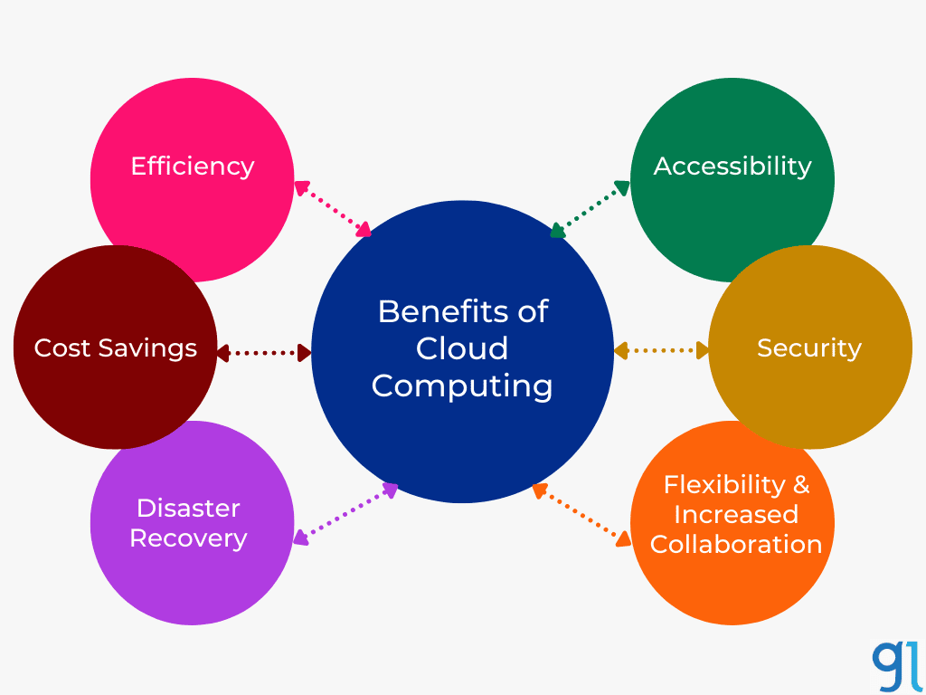
Efficiency; Efficiency in business operations is achieved in the following ways through the utilization of cloud computing:
Accessibility; Cloud computing facilitates the access of applications and data from any location worldwide and any device with an online connection.
Cost savings; Cloud computing over businesses with scalable computing resources, saving them on the worth of acquiring and maintaining them. These resources are purchased on a pay-as-you-go basis, suggesting businesses pay just for the resources they use. This has proven to be less expensive than acquiring the resources independently.
Security; Cloud providers, especially those private cloud services, have strived to implement the most straightforward security standards and procedures to guard clients’ data saved within the cloud.
Disaster recovery; Cloud computing is the only efficient means for small, medium, and even large enterprises to back up and restore their data and applications quickly and safely.
Flexibility and Increased collaboration; with cloud computing capabilities, individuals from different places can collaborate on business projects without necessarily having to satisfy them.

What is the cloud?
The cloud comprises servers and a combination of networks, storage, service, and hardware that help companies save money and convenience for users.
Cloud is essentially a series of servers that might be accessed through the web, and all one piece of information is stored on physical servers in information centers. Intrinsically by cloud computing, we can access the physical servers and run computer code applications on their machines.
Cloud permits users to access computing services from any device due to the computing and storage taking place on servers throughout a knowledge Centre instead of regionally on the user device.
Examples include cloud email suppliers like Gmail and Microsoft 365 and cloud storage suppliers like Dropbox or Google Drive. IT business has shifted to cloud computing intrinsically it removes the prices and burden of change and maintenance of servers, as the cloud seller can pay attention to this.

What are the different data types used in cloud computing?
The various cloud data types include – emails, text, Boolean, decimal, locale, number, date, images, contacts, etc. As we know that data is increasing day by day, so it is needed for new data types to store these new data. For example, if you want to store video, you need a new data type.

What are the different layers that define cloud architecture?
The 4 layers of the Cloud
- Infrastructure as a Service (IaaS)
- Platform as a Service (PaaS)
- Software as a Service (SaaS)
- Function as a service (FaaS)

How will you describe Cloud Computing as concisely and simply to a Layman?
Even though this might sound like a fundamental question, this was asked in one of the interviews. (source- Quora)
Now, you must use simple words while answering this question. The use of technical terms is not advised. In cloud computing, ‘cloud’ refers to the internet metaphorically. So cloud computing is a method where the internet acts as the fuel to computing services, and you can now use the word- Internet-based computing.

Give the best example of open source Cloud Computing.
Open–source cloud is a cloud service or solution built using open–source software and technologies. This includes any public, private or hybrid cloud model providing SaaS, IaaS, PaaS, or XaaS built and operated entirely on open–source technologies.
The best example of open source Cloud Computing is OpenStack.
This is one of the most frequently asked cloud computing interview questions.
Cloud computing lets us store and access our applications or data over remote computers instead of our computer. First of all, the cloud is just a metaphor for technology. Cloud data centers might be anywhere globally; we can also access them from anywhere with an Internet-connected device. It has the following benefits as given below:
- Pay-per-use model: We only have to pay for the services we use.
- 24/7 Availability: It is always online! There is no such time when you simply cannot use our cloud service; you’ll use it whenever you want.
- Easily Scalable: it’s effortless to proportion and down or turn off as per customers’ needs. For instance, if your website’s traffic increases only on Friday nights, you can opt for scaling up your servers that particular day and then scaling down for the rest of the week.
- Security: Cloud computing offers excellent data security. Especially if the data is mission-critical, then that data can be wiped off from local drives and kept on the cloud only for your access to stop it from ending up in the wrong hands.
- Easily Manageable: You only have to pay subscription fees; the Cloud Provider entirely maintains all maintenance, up-gradation, and delivery of services. This is backed by the Service-level Agreement (SLA).
Cloud Computing Examples
Further, various places where Cloud Computing is applied as given below:
Big Data Analytics: Cloud computing helps businesses store and analyze many structured, semi-structured, and unstructured data to find underlying relationships. It analyzes customer buying patterns and uses them for marketing and advertising campaigns.
File Storage: the most important advantage of cloud storage is that it’s virtually unlimited. Cloud storage will be available for nearly an equivalent or maybe a lesser price, which is 10 times quite your local storage.
Backup: Backup generally requires a storage unit where the data is secure and infinite storage is provided. Both can be achieved by using Cloud Computing.

What are system integrators in cloud computing?
System Integrators emerged on the scene in 2006. System integration brings together system components into a whole and ensures that the system performs smoothly.
A person or company specializing in system integration is called a system integrator.

List the platforms which are used for large-scale cloud computing.
The timely processing of massive digital collections demands large-scale distributed computing resources and the flexibility to customize the processing performed on the collections.
The platforms that are used for large-scale cloud computing are:
- Apache Hadoop
- MapReduce

Mention the different types of models used for deployment in cloud computing.
You need the perfect cloud deployment model to help you gain a competitive edge in the market. You will have access to IT resources and services that can make your business flexible and agile concerning volume and scale.
The different deployment models in cloud computing are
- Private Cloud
- Public Cloud
- Community Cloud
- Hybrid Cloud

What is SaaS (software as a service)?
Software as a service (SaaS) is a software distribution model in which a third-party provider hosts applications and makes them available to their customers over the Internet. SaaS is one of three main categories of cloud computing, alongside infrastructure as a service (IaaS) and platform as a service (PaaS).

What is a Private Cloud?
A private cloud delivers similar advantages to public cloud-like scalability and self-service. In the private cloud, this is done using a proprietary architecture, and private clouds focus on the needs and demands of a single organization.
As a result, the private cloud is best for businesses with dynamic or unpredictable computing needs that require direct control over their environments. Security, governance, and regulation are best suited for private cloud services.
Private clouds are used to keep strategic operations and others secure. It is a complete platform that is fully functional and can be owned, operated, and restricted to only an organization or an industry. Nowadays, most organizations have moved to private clouds due to security concerns, and a hosting company is using a virtual private cloud.
This is one of the most frequently asked cloud computing interview questions.
Read More: Public Vs. Private Vs. Hybrid

What is the Public Cloud?
The primary objective is to deliver internet services in a public or private cloud. Unlike a private cloud, public cloud services are third-party applications that can be used by anybody who wants to access them. The service may be free or sold on demand.
Public clouds are open to people for use and deployment. For example, Google and Amazon, etc. The public clouds focus on a few layers like cloud application, providing infrastructure, and providing platform markets.

What are Hybrid Clouds?
A hybrid cloud is a cloud computing environment where we can use the services available locally and use third-party private and public services to meet the demand. By allowing workloads to move between private and public clouds as computing needs and costs change, a hybrid cloud gives businesses greater flexibility and more data deployment options.
Hybrid clouds are a combination of public clouds and private clouds. It is preferred over both clouds because it applies the most robust approach to implementing cloud architecture. It includes the functionalities and features of both worlds. It allows organizations to create their cloud and give control over someone else as well.

What is the difference between cloud computing and mobile computing?
Cloud Computing is when you store your files and folders in a “cloud” on the Internet. This will allow you to access all your files and folders wherever you are in the world, but you need a physical device with Internet access.
Mobile computing is taking a physical device with you, which could be a laptop, mobile phone, or some device. Mobile computing and cloud computing are somewhat analogous, and mobile computing uses the concept of cloud computing. Cloud computing provides users with the data they require. In contrast, applications run on the remote server in mobile computing and give the user access to storage and managing the data.

What is the difference between Scalability and Elasticity?
Scalability is a characteristic of cloud computing that is used to handle the increasing workload by increasing the proportion of resource capacity. Using scalability, the architecture provides on-demand resources if the traffic raises the requirement.
Elasticity is a characteristic that dynamically provides the concept of commissioning and decommissioning a large amount of resource capacity. It is measured by the speed at which the resources are on demand and the usage of the resources.

What are the security benefits of cloud computing?
Complete protection against DDoS: Distributed Denial of Service attacks have become very common and are attacking the cloud data of companies. So cloud computing security ensures restricting traffic to the server, and traffic that can threaten the company and its data is thus averted.
Data security: As data develops, data breaching becomes a significant issue, and the servers become soft targets. The security solution of cloud data helps protect sensitive information and helps the data stay secure against a third party.
Flexibility feature: Cloud offers flexibility, and this makes it popular. The user has the flexibility to avoid server crashing in case of excess traffic. When the high traffic is over, the user can scale back to reduce the cost.
Cloud computing authorizes the application server, which is used in identity management. It provides permissions to the users to control the access of another user who is entering the cloud environment.

What is the usage of utility computing?
Utility computing, or The Computer Utility, is a service provisioning model. A service provider makes computing resources and infrastructure management available to the customer and charges them for specific usage rather than a flat rate.
Utility computing is a plug-in managed by an organization that decides what type of cloud service has to be deployed. It facilitates users to pay only for what they use.

Explain security management regarding Cloud Computing.
- Identity management access provides the authorization of application services.
- Access control permission is given to the users to have complete controlling access to another user who is entering into the cloud environment.
- Authentication and Authorization provide access to authorized and authenticated users only to access the data and applications.

How would you secure data for transport in the cloud?
This is a frequently asked question. Don’t forget to dive in more in-depth on this topic.
When transporting data in a cloud computing environment, keep two things in mind: Make sure that no one can intercept your data as it moves from point A to point B in the cloud, and make sure that no data leaks (malicious or otherwise) from any storage in the cloud.
A virtual private network (VPN) is one way to secure data while transported in a cloud. A VPN converts the public network to a private network instead. A well-designed VPN will incorporate two things:
- A firewall will be a barrier between the public and any private network.
- Encryption protects your sensitive data from hackers; only the computer you send it to should have the key to decode the data.
- Check that there is no data leak with the encryption key implemented with the data you send while moving from point A to point B in a cloud.
This is one of the most frequently asked cloud computing interview questions.

What are some large cloud providers and databases?
Following are the most used large cloud providers and databases:
- Google BigTable
- Amazon SimpleDB
- Cloud-based SQL

What are some of the cloud computing platform databases?
Following are the open-source cloud computing platform databases:
- MongoDB
- CouchDB
- LucidDB

Explain the full form and usage of “EUCALYPTUS” in cloud computing.
“EUCALYPTUS” stands for Elastic Utility Computing Architecture for Linking Your Programs to Useful Systems.
Eucalyptus is an open-source software infrastructure in cloud computing, enabling us to implement clusters in the cloud computing platform. The main application of eucalyptus is to build public, hybrid, and private clouds. Using this, you can produce your personalized data center into a private cloud and leverage it for various other organizations to make the most out of it and use the functionalities offered by eucalyptus.

Explain the Public, Static, and Void classes.
Public: This is an access modifier, and it is used to specify who can access a particular method. When you say public, the method is accessible to any given class.
Static: This keyword in Java tells us that it is class-based, which means it can be accessed without creating the instance of any particular class.
Void: Void defines a method that does not return any value. So this is the return-related method.

List down the three necessary functioning clouds in cloud computing.
- Professional cloud
- Personal cloud
- Performance cloud

What are the building blocks in cloud architecture?
- Reference Architecture
- Technical architecture
- Deployment operation architecture
- Reference Architecture
- Technical architecture
- Deployment operation architecture

What do you mean by CaaS?
CaaS is a terminology used in the telecom industry as Communication As a Service. CaaS offers enterprise user features such as desktop call control, unified messaging, and desktop faxing.

What are the advantages of cloud services?
Following are the main advantages of cloud services:
- Cost-saving: It helps in the utilization of investment in the corporate sector. So, it is cost-saving.
- Scalable and Robust: It helps in developing scalable and robust applications. Previously, the scaling took months, but now, scaling takes less time.
- Time-saving: It helps in saving time regarding deployment and maintenance.

Before going for a cloud computing platform, what are the essential things to be taken into concern by users?
- Compliance
- Loss of data
- Data storage
- Business continuity
- Uptime
- Data integrity in cloud computing

Give A Brief Introduction To Windows Azure Operating System.
The Windows Azure operating system is used for cloud services to be run on the Windows Azure Platform. Azure is preferred as it includes the essential features for hosting all the services in the cloud. You also get a runtime environment consisting of a Web Server, Primary Storage, Management services, and load balancers. The Windows Azure system provides the fabric for developing and testing services before their deployment on the Windows Azure in the cloud.

Mention About The Top Cloud Applications Nowadays?
Top cloud computing applications include Google docs which are very fast and secure. There is also a mobile version of google docs to access your data from a smartphone. Pixlr and, Phoenix, jaycut also are applications used for cloud computing.
Now, if you want to know more, you can enroll in our cloud computing course- with training from industry professionals, use cases, and hands-on projects.
Check out the PGP-Cloud Computing program by Great Learning; with 3 Million+ hours of learning delivered, 5000+ alumni, 300+ industry experts, and 8 top-ranked programs, Great Learning is among the top-ranked institution for analytics.
Get in touch with us for further details, and don’t forget to mention your questions in the comments section. We will get back to you with the most industry-relevant answer.
This is one of the most frequently asked cloud computing interview questions

Advanced Cloud Computing Interview Questions
We have compiled the questions below, keeping in mind the idea that you may already be a cloud professional or may already have a basic understanding of cloud computing. So, let’s get started and have a look at the advanced cloud computing interview questions that will help you crack the interview.

What is a hypervisor in Cloud Computing?
It is a virtual machine screen that can logically manage resources for virtual machines. It allocates, partitions, isolates, or changes the program given as a virtualization hypervisor. Hardware hypervisor allows having multiple guest Operating Systems running on a single host system simultaneously.
It is also known as Virtual Machine Manager. There are two types of hypervisors as defined below:
Type 1: The guest Vm runs directly over the host hardware, e.g., Citrix XenServer and VMware ESXi.
Type 2: The guest Vm runs over hardware through a host OS, e.g., oracle virtual box, Vmware Player.
Type 1 Hypervisor works much better than Type 2 because there is no underlying middleware and thus making the best environment for critical applications and workloads. To compare the performance metrics, we need to determine the CPU overhead, the amount of maximum host and guest memory, and support for virtual processors.

Why is cloud computing the future?
Considering the various benefits of cloud computing to organizations, a good case is that cloud computing is increasingly becoming the new normal. Cloud computing helps society deal with future problems like managing big data, cyber security, and internal control.
In addition to the present, emerging technologies like AI, distributed ledger technology, and many other capabilities are getting available through cloud computing. Consequently, these technologies adapt to varied platforms like mobile devices, increasing their use.
Innovations supported cloud computing, like cloud automation. Therefore, the Industry cloud is also being developed to integrate cloud computing into specific industrial activities, making various operations even more streamlined. The verdict for cloud computing is that it’s a transitional technology that has helped organizations in several jurisdictions deliver their products and services better than before.

What are the cons of cloud computing?
Cloud computing refers to an open space of knowledge technology (IT) that touches on the following areas: We can begin with a basic assumption: you don’t want a degree or a computing or pc engineering degree to search out cloud computing.
You’ll begin learning cloud computing from scratch, albeit you have basic IT skills.
You may need to learn a variety of the initial ideas and how those ideas relate to each other. Then get some active apply, particularly in fixing issues. Every technology has positive and negative aspects that are vital to be mentioned before implementing it.
The points above highlight the advantages of exploiting cloud technology, and so the following discussion can define the potential cons of Cloud Computing.
Vulnerability to attacks: Storing information within the cloud might cause serious challenges {of information of knowledge} thievery since, within the cloud, each data of a corporation is online. A security breach is something that even the only organizations have suffered from, and it’s a potential risk inside the cloud conjointly .though advanced security measures are deployed on the cloud, still storing confidential information inside the cloud is usually a risky affair.
Network property dependency: Cloud Computing is entirely enthusiastic about the net. This direct tie-up with the net means that an organization should have reliable and consistent web service conjointly as a fast affiliation and information measure to reap the advantages.
Downtime: Time is considered the only vital potential downside of exploiting Cloud Computing. The cloud suppliers might typically face technical outages, which might owe varied reasons, like loss of power, low web property, information centers going out of service for maintenance, etc., which could cause a brief time inside the cloud service.
Vendor lock-in: Once needed to migrate from one cloud platform to a distinct one, an organization would possibly face some serious challenges thanks to the variations between seller platforms. Hosting and running the applications of this cloud platform on another platform might cause support problems, configuration complexities, and additional expenses.
The corporate information might boot be left liable to security attacks due to compromises created throughout migrations.
Limited management: Cloud customers might face restricted control over their deployments. Cloud services run on remote servers that are closely held and managed by service suppliers, making it arduous for businesses to possess the extent of management.
This is one of the most frequently asked cloud computing interview questions

What are the disadvantages of the SaaS cloud computing layer?
1) Security
Data is stored in the cloud, so some users may have security issues. However, cloud computing is not more secure than in-house deployment.
2) Latency issue
Since data and applications are stored in the cloud at a variable distance from the end-user, there is a possibility that there may be more significant latency when interacting with the application compared to local deployment. Therefore, the SaaS model is not suitable for applications whose demand response time is milliseconds.
3) Total Dependency on the Internet
Without an internet connection, most SaaS applications are not usable.
4) Switching between SaaS vendors is difficult
Switching SaaS vendors involves the slow and challenging task of transferring massive data files over the internet and then converting and importing them into another SaaS.

What is IaaS in Cloud Computing?
IaaS, i.e., Infrastructure as a Service, also known as Hardware as a Service. Organizations usually give their IT infrastructures such as servers, processing, storage, virtual machines, and other resources in this model type. Customers can access the resources very quickly on the internet using the on-demand pay model.
Take up IaaS for cloud computing course and understand more about these clouds and their specifications.
The Iaas platform eliminates the need for every organization to maintain its IT infrastructure.
IaaS is divided into three aspects: public, private, and hybrid. The private cloud can offer that infrastructure that resides at the customer end. In contrast, the public cloud is located at the cloud computing data Centre end, and the hybrid cloud is a combination of both public and private clouds.
IaaS provides us with various services, which are listed below:
Compute: Computing various services, including virtual CPUs, Virtual main memory for virtual machines at the user end.
Storage: IaaS provider provides back-end support for storage for storing files.
Network: Network as a Service provides networking components such as routers, switches, and bridges for virtual machines.
Load Balancers: It gives load balancing at the infrastructure layer.

Advantages of IaaS in Cloud Computing:
- Shared Infrastructure
- IaaS gives shared users to share the same physical infrastructure.
- Web Access to the resources
- IaaS allows IT users to access resources over the internet.
- On-demand as per usage model
- Iaas providers provide services only as a clients pay-as-you-go model.
- Business model focus
- Iaas Providers give business core organization focus rather than IT infra.
- Update versions of the Software
- There is the scalability of services provided as there is no problem with software upgrades and troubleshooting issues related to IT infrastructure.

Disadvantages of IaaS in Cloud Computing
- Security
- Security is the main concern in IaaS as it is not 100percent sure.
- Maintenance and up gradation
- Although IaaS providers maintain the software but not for all.
- Interoperability issues
- It is difficult to migrate Virtual Machine form one IaaS provider to another, so customers experience problem related to vendor lock.
- Main Iaas Cloud Service providers are Amazon Web Services, Microsoft Azure, and Google Cloud Platform etc.
This is one of the most frequently asked cloud computing interview questions.

What is PaaS in Cloud Computing?
Platform as Service, abbreviated as PaaS, is the runtime environment for developers to create, test, run and debug web applications. We can easily buy these web applications from the cloud service provider on a pay-as-you-go basis and access them easily using the internet. There is back scalability that the cloud service provider manages, so end users do not need to worry about managing the infrastructure.
PaaS includes infrastructure, servers, storage and networking, platform-middleware, development tools, database management systems, and business intelligence to support the web application life cycle.
PaaS providers support programming languages, Application frameworks, Databases, and other tools.

Advantages of PaaS in cloud computing
- Simple Development: Paas allows developers to focus on development and innovation without worrying about infrastructure management.
- Lower Risk: No need for investment in hardware equipment and software.
- Prebuilt business functionality: Some Paas Providers have a prebuilt framework so that users do not need to build everything from scratch and can directly start projects.
- Instant Community: PaaS vendors have a community where developers can share experiences.
- Scalability: Applications deployed can scale with one user

Disadvantages of PaaS in Cloud Computing
Vendor lock-in: Development according to the particular vendor can be easy, but migration to another cloud provider can be a problem.
Data privacy: Corporate data, whether can be essential or not, will always be private, and it should always be an insecure environment.
Synchronization of system applications: We have integrated many applications with local and on the cloud, so there is the problem of increased complexity when mixing local data with cloud data.
Most PaaS cloud providers are Salesforce, Windows Azure, Google App Engine, etc.
This is one of the most frequently asked cloud computing interview questions.

What are the following cloud computing key enabling technologies?
The key enabling technologies in Cloud Computing are given below:
- Distributed Computing -Cluster, Grid Computing.
- Internet Technologies -Service Oriented Architecture, Web 3.0, etc.
- Hardware Technologies – Virtualizations, Multi-core chips, etc.
- System Management – Automatics Computing
Distributed Computing
Distributed computing visualizes the idea of connecting multiple computers through computer networks by using a distributed system. These computers can be different and the same and are located globally also. Distribute Computing consists of various parts: grid, clusters, web 2.0, and clouds. Clusters can be defined as multiple servers grouped to provide computing services to users.
Service-Oriented Architecture
Service-Oriented Architecture can be defined as the core development of cloud computing systems. It adopts the primary building block of application and system development. It is an architectural approach in which applications use services available in the network.SOA allows users to combine many facilities from existing services to form applications.SOA provides various functionalities for systematic design and integrates components into a smooth centralized system.
Web Services
A web service is application software available over the internet and uses a standard messaging system.XML is used to encode all communications to a web service. Software applications developed in various programming languages and running over various platforms use web services for intercommunication data exchange over networks.

What are the security risks in cloud computing?
Various factors are responsible for advantageous cloud computing, including improved scalability, excellent accessibility, mobility, storage, etc. Cloud Computing still has security issues and are given below:
Data Loss
Data Loss is a shared cloud computing risk. It is given as data stored on the cloud is either leaked, deleted, corrupted, or misused by a user or application. It mainly occurs when critical data is in somebody’s hand, the hard disk is not working correctly, and the software is not updated.
Hacked Interfaces and Insecure APIs
Interfaces through which we can connect to the internet for most cloud services as APIs and interfaces are connected to cloud services through third parties. Hackers can quickly attack them as they are in the public domain.
Data Breach
Data Breach is when secured data is retrieved illegally and unauthorizedly as hackers hack such an organization’s data.
Business lock-in
Various issues arise due to the transfer of data from one organization to another as there are different platforms for different companies. Hence, it is difficult to move from one cloud to another.
Denial of Service Attacks
Denial of Service Attacks occurs when the system receives traffic beyond the threshold to congest the server. DoS attacks usually attack large organizations’ web servers like banking, media, and government companies. We must deal with money and time to recover from these attacks.
Increased Complexity for IT workers
Shifting, integrating, and operating cloud services are complex for IT workers, and IT workers must require extra capability and skills to manage, integrate and maintain the data on the cloud.
Specter and Meltdown
It allows stealing data from computers that are currently available on it. It can run on personal computers and various electronic devices. It can store the password, and your personal information, such as images, emails, and business documents, in the memory.
Account Hijacking
It is one of the serious security risks in cloud computing. Hackers can steal sensitive information regarding the cloud account, including bank accounted-mail accounts and social media accounts, to perform illegal activities.
This is one of the most frequently asked cloud computing interview questions.

What is AWS in Cloud Computing?
Amazon web services –AWS in cloud computing offers IT services to customers in the form of web services. With these services, we can offer online demand software to avail services according to pay. We get a reliable, scalable, low-cost infrastructure platform in the cloud with hundreds of businesses worldwide. Amazon net Service (AWS) could be a well-liked cloud services platform created by Amazon Iraqi National Congress.
It’s secure and offers mighty cipher power, content delivery, networking, info storage, and alternative functionalities.AWS was developed to serve enterprises and businesses of all sizes to grow and scale quickly and affordably.AWS has become the popular cloud service platform by several influential organizations – not the smallest amount that embraces Pinterest, conference Baseball, and General Electrical. Over time, new options are developed with various info engines, secret writing techniques, server configurations, and powerful tools for extensive knowledge analysis.AWS additionally offers security certifications, hardware security modules, and encoding so corporations will manage their businesses a lot more firmly.
In addition, AWS provides auditing and dominant capabilities like Cloud Watch, serving corporations that meet compliance and restrictive standards like HIPAA and PCI. Amazon offers versatile rating choices for its cloud services platform – users pay just for what they use, and there aren’t any direct charges or long-run plans. It’s thought-about in all the original low price, efficient platforms offered and even offers a free tier of services certainly corporations.AWS’s massive cloud infrastructure permits users to experiment and initiate.
AWS makes it easier for corporations to deploy new applications and scale up/down their workloads per their business demands. This cloud platform is platform agnostic, providing enterprises with the flexibility to decide on their development platform, tools, and languages or to still leverage existing investments. Users may also choose between the embarrassment of provided services and buying what they use. This ensures that users and firms focus on innovation instead of infrastructure.
Other well-liked services or solutions offered by AWS include: From SaaS offerings to internal applications, users have the choice to use reliable infrastructure to power their applications.AWS contains a scalable infrastructure platform to fulfill a user’s dynamic hosting necessities. AWS offers cheap storage services that might enable users to store knowledge and backup solutions. AWS has created it doable to share and distribute content simply and quickly with high knowledge transfer speeds and low running prices. Starting from relative info to non-relational info services to enterprise database solutions, users will choose between any of the scalable software systems.
Thanks to its quantifiability and adaptability, AWS may be utilized by enterprises and businesses of all sizes – from native mom-and-pop retailers to international firms. A recent study found that enterprise-scale users contribute to AWS’s user base of ten p.c. Among these, Netflix has been the foremost distinguished user of AWS, exploiting it since 2009. corporations that have large databases to manage and manipulate and United Nations agencies that need large-scale distribution of their services will significantly profit by exploiting AWS.
However, smaller corporations and startups may also profit by either repeating their infrastructure directly into AWS, migrating to a cloud-based platform or slowly moving individual items of the application or infrastructure into AWS to allow them insights into their usage patterns and that of the rating models most closely fits their utilization. With Amazon’s pay-as-you-go model, startups and tiny to medium-sized businesses will dip their toe into cloud computing to ascertain if it works for them.
This is one of the most frequently asked cloud computing interview questions.

What is the primary step within deploying a Cloud Computing offering?
The primary step in deploying Cloud Computing is settling on an acceptable Cloud supplier like AWS, Azure, or GCP. Once you successfully choose the cloud supplier, you wish to {make to form} AN account to log in and use that supplier’s services. Then, you wish to settle on a service like Amazon Elastic Cloud reason (EC2) that you just got to produce. This is just an outline of the method of deploying Cloud Computing.

What is big data in cloud computing?
Huge information is a high volume {of information of knowledge of data} with sensitive information and data sets that area unit hold on on clusters. Cloud computing suppliers usually utilize a “software as a service” model to permit customers to simply method information. Typically, a console that will absorb specialized commands and parameters is offered. However, everything can even be done from the site’s interface. Some products that area unit, sometimes a part of this package, embody direction systems, cloud-based virtual machines and containers, identity management systems, machine learning capabilities, and more. In turn, colossal information is usually generated by giant, network-based systems.
It may be in either a typical or non-standard format. If the information is in a very non-standard format, computing from the Cloud Computing supplier is also employed in machine learning to standardize the information.
The information may be controlled through the Cloud Computing platform and used identically. For example, it may be searched, edited, and used for future insights. This cloud infrastructure permits the data processing of massive information. It will take Brobdingnagian “blasts” of information from intensive systems and interpret them in a time.
Another typical relationship between huge information and Cloud Computing is that the cloud’s ability permits massive information analytics to occur in a very fraction of the time. Comprehensive information & Cloud Computing: an ideal match as you’ll be able to see, their area unit infinite prospects we tend to once after we mix huge information and Cloud Computing!
Cloud application development is additionally burning by huge information. While not huge information, there would be fewer cloud-based applications since there wouldn’t be an absolute necessity.
Remember, huge information is usually collected by cloud-based applications, as well! In short, Cloud Computing services, for the most part, exist because of enormous information. Likewise, we tend to collect huge information because we’ve got services that area unit capable of taking it in and deciphering the 2 area unit as an ideal match since neither would exist while not the other!

Which delivery model is an example of cloud computing?
Cloud Computing allows you to store and access information victimization the net. It provides 3 styles of delivery services, namely, computer code as a Service (SaaS), Platform as a Service (Paas), and Infrastructure as a Service (Iaas).
The cloud provides pay-as-you-go services for networking, storage, and information virtualization. SaaS: As SaaS, it provides computer code that will be accessed through a third-party supplier with the assistance of the net SaaS: As PaaS, the cloud offers hardware and computer code tools that will be used via the net Software as a Service (SaaS) may be thought of as an example of a Cloud Computing delivery model. It’s a computer code distribution model that permits suppliers to host varied applications and provides users with their access online.

Which layer is to blame for user authentication in cloud computing?
The IaaS layer is to blame for user authentication in cloud computing. The IaaS layer is to blame for user authentication in cloud computing. IaaS could be a primarily user-based system to blame for authentication services like accessing, managing, and watching.

What is Load Balancing in Cloud Computing?
It’s the distribution of workloads across multiple computing resources. It reduces prices related to management systems and will increase the handiness of resources. It has an advantage over different load equalization in that it will transfer masses to servers globally as hostile distributing it across native servers. In the event of an area server outage, cloud equalization delivers users to the nearest regional server.

What types of data are used in cloud computing?
This may sound like a simple question, but to answer it, an IT professional has to show they are up to date with the latest trend in cloud computing. Three types of data are necessary to work with the cloud to save and store various data files. First of all, you want the candidate to talk about unstructured data. Unstructured data is data that has an unknown or unclassified structure. You can classify all those file types as unstructured data, such as images, videos, text, and search engine results. After unstructured data, a cloud computing expert should talk about structured data. This type of data is processed, accessed, and stored in a fixed format. An example of structured data is contained in database management systems. Finally, we find semi-structured data, a mix of structured and unstructured data. An excellent example of this type of data is in XML format.

Can you name some of the most critical cloud platform databases?
Cloud computing is a rapidly evolving technology in terms of speed, scalability, and efficiency. This is mainly happening thanks to open-source software becoming an integral part of the cloud. Just to name a few, your candidate should be familiar with MongoDB, CouchDB, and LucidDB. The first one, MongoDB, is written in C++ and offers high storage capabilities. Also, this database system is schema-free and document-oriented. On the other hand, CouchDB is based on an Apache server and is very efficient and reliable at its job (which is storing data). Finally, we find LucidDB, employed for data warehousing, and it is written in Java/C++.

Name the different service models provided by cloud computing.
Again, this question will test the cloud computing expert’s knowledge of the different types of services offered by cloud computing. There are three different types of service: Infrastructure as a Service (IaaS), Platform as a Service (PaaS), and Software as a Service (SaaS). The first one, Infrastructure as a Service, is a hardware facility provided by a third party that also manages it. Platform as a Service consists of the operating system layer and is operated by another company. Software as a Service regards all applications and programs hosted in the cloud.

How can cloud computing help our company?
This is an important question, especially for mid-size to big companies that are more interested in building a private cloud than small businesses that may opt for the public cloud. Besides private and public clouds, there are also community and hybrid cloud infrastructures. A company may build a private cloud to be used exclusively for its internal needs. It can be supervised by the company itself, another enterprise, or both. Its physical position may be where the company is located or in a remote data center.
A community cloud infrastructure aims to provide services to a limited community of users with a shared interest in their businesses. What about the public cloud? As the name says, the public cloud is thought to be used by the public. A third organization can operate it, and its location is situated where the cloud provider’s data center is. When merging two or more cloud infrastructures, you create a hybrid cloud, even though the different clouds keep distinct attributes. They are called hybrid because they share the proprietary tech that enables data and app portability.

Why should a company opt for utility computing?
This complex question requires a complex answer: thanks to utility computing, the end-user will only have to pay for the service on a per-use basis. The user will be able to increase the number of services he uses to satisfy his needs. This approach to cloud computing can be very remunerative for those businesses that plan to scale and grow their product.

What is the best way to make this operation safe when transferring data to the cloud?
By adopting a secure key, you can ensure there will not be any data leaks from the cloud storage, whether they’re malicious or not. This action will make intercepting your data impossible when it moves into the cloud.

What do you understand about cloud delivery models?
There are 4 basic cloud delivery models.
- IaaS: Infrastructure as a Service is a delivery model where the cloud manages all infrastructure-based resources like network, storage, servers, virtualization, and other resources like Operating system, middleware, and runtime environments for the user’s application, and the user manages data.
- PaaS: Platform as a Service is a delivery model where all platform-based resources like network, storage, servers, virtualization, operating system, middleware, and runtime are managed by the cloud, and the application and data have to be managed by the user.
- SaaS: Software as a Service is a delivery model where all software-based resources like network, storage, servers, virtualization, operating system, middleware, runtime, and the application are managed by the cloud. The user has to provide only the data required for using the application.
- XaaS: This refers to everything as a service, describing a generic category of various services like databases, servers, networks, etc., that can be provided as a cloud service.

What are cloud storage levels?
The most commonly seen cloud storage levels are
- Object storage: Data and its metadata are stored in object format. It is the most flexible form of storage and can also be used with web applications.
- File storage: Data is stored in the form of files and often clubbed together as folders.
- Block storage: data is stored in the form of blocks. It is the lowest level of storage and closest to the hardware.
- Dataset storage: data is organized into a structured form like tables, record format, or delimited format

What do you mean by cloud-enabling technologies?
Cloud-enabling technologies help a cloud in providing services to users. They are not the building blocks of cloud services but provide the platform via which services are provisioned to cloud consumers.
- Broadband Networks and Internet Architecture
- Data Center Technology
- (Modern) Virtualization Technology
- Web Technology
- Multitenant Technology

What do you mean by cloud usage monitor?
A cloud usage monitor is a lightweight, autonomous program situated on a cloud that aids in monitoring resources and collecting and processing resource usage data.
There are three standard agent-based implementations of the usage monitor as follows.
- Monitoring agent: responsible for transparent monitoring and analysis of the data flow. It is an event-driven program that resides on the existing communication paths. It aids in measuring network traffic and metrics.
- Polling agent: responsible for gathering cloud service usage data by polling The resources. It also monitors the resource status and forwards usage data to log databases for reporting and post-processing purposes.
- Resource agent: processing models that collect data using event-driven interactions with resources. It aids in checking the usage metrics based on pre-defined, tangible events, like initiation, suspension, resumption, and scaling of resources.

What is edge computing?
Edge computing is complementary to cloud computation. It is a distributed computing paradigm that combines cloud computing and data storage to solve the latency issues that plague the infrastructure. It is a prevalent paradigm in the IoT scenario. Edge computing aims to manipulate the edge on the edge devices, such as tabs, mobile phones, laptops, gateways, etc., to take on some of the provisioning and management responsibilities of the cloud.

What is an API gateway?
An API gateway is a management service between the client and the backend services and processes. It aids in easier management of the API services available such as user authentication, rate limiting, and statistical analysis.

What is rate-limiting?
Rate limiting is a technique by which a network’s traffic can be limited by putting a cap on the frequency of a particular action in a given timeframe. It can help eliminate suspicious activities, especially those caused by bots on any network, by tracking the IP address where the request originated. It also protects against instances of API overuse.

What do you mean by Containerized Data Centers?
A containerized data center, also known as a modular data center, is a highly portable, self-contained data storage module with dedicated provisions like air conditioning, dehumidifier, uninterruptible power supply, etc. It is designed for portability and parallel usage to build large data centers.

What do you mean by Low-Density Data Centers?
Low-density data centers have a lower density of data servers in terms of numbers. It is used in use cases where there is a need for high performance. Increasing the number or density of servers in such a data center will lead to outages due to power and heating issues. Thus optimizing the density of servers is essential to reaching required high-performance goals.

What is the difference between traditional data centers and the cloud?
Traditional Data Center | Cloud Data Center
Physically present, on-premise, and tangible and accessible. | Remotely located, off-premise and intangible.
Businesses pay capital expenditures for the acquisition of hardware and software resources and operational expenditures like those for usage, maintenance, and repair of resources. | Businesses pay only the operational cost for using the resources being used.
Management and administration of the resources are the responsibility of personnel within the business. | Management and administrative responsibilities are the responsibilities of the cloud providers.
Multiple challenges to scaling, like availability of resources and latency in the acquisition process due to the procedures involved | Completely and almost instantly scalable as per requirements.
Failure may lead to loss of business as the responsibility of downtime and repair of services is entirely on the business, affecting the reliability of services. | A cloud service provider is responsible and trusted to replace the resources due to its promise of reliability and availability.

What is the advantage of using Azure Content Delivery Network?
Azure Content Delivery Network, or Azure CDN, is a remote server cluster. It aids in delivering content at geographically distinct locations to users with minimal transactions and networks for fast content delivery. Some of the salient advantages of the Azure CDN are as below:
- Faster performance results in a better user experience.
- No requirements for added hardware or/and software resources. Requires only configuration to set up the CDN features.
- Decreased load on the actual servers since data is sent via the edge servers.
- It is a robust delivery system requiring minimal maintenance
- Extremely easy to configure with no additional resource requirements.

What are the benefits of using Traffic Manager in Azure?
Microsoft Azure Traffic Manager is a component of the Azure cloud that aids the system by managing the distribution of user traffic for various service endpoints in the system. These service endpoints may be a web app, an Azure VM, or even an incorporated cloud. It utilizes the DNS to apply traffic routing methods to incoming client request traffic to facilitate its traversal to the most suitable endpoints.

What are the different phases associated with cloud architecture?
There are four primary phases associated with cloud architecture. They are as follows:
- Launch Phase: Here, the essential services are initiated to get the system ready for communication or app-building.
- Monitoring Phase: This is the next phase, where the launched services are monitored and subsequently managed on user demand.
- Shutdown Phase: In this phase, the services shut down in the order of least recently used to most recently used, and all the system services are closed.
- Cleanup Phase: Here, all the services and processes left from the shutdown phase due to incorrect or faulty shutdown are cleaned up.

What is Amazon S3?
Amazon Simple Storage Service, also called Amazon S3, is an object storage service offered by AWS. It is highly scalable and offers high data availability, security, and performance. Data of any use case can be stored using this structure, for example, data lakes, cloud-native applications, and mobile apps. It provides cost-effective storage classes with easy-to-use management features that optimize costs, organizes data, and configure fine-tuned access controls to meet specific business requirements.

What is Amazon Machine Image?
An Amazon Machine Image, or AMI, provides an instance with the setup and environment-building information required to configure and launch an instance in AWS. It is a mandatory part of instance creation, and multiple instances requiring the same configuration can be instantiated using the same AMI. Users can create custom AMIs for later usage in AWS. An AMI includes the following:
- Configurations for all setup requirements for any system, including resources like operating system, application server, and applications.
- A specific volume to instance mapping in the form of a block device mapping to aid in configuration during instance launch.
- Permissions regarding which AWS instances will be able to access a given AMI.

How is Geo Restriction in CloudFront helpful?
Geo Restriction, also known as geo-blocking, is used to prevent users from a specific geographical location from accessing a resource in cloud architecture on Cloudfront. There are two ways to use the restrictions set by geo Restrict.
- CloudFront’s geographical restriction feature restricts access to files associated with distribution on a country access level.
- Using a third-party geolocation service restricts access to files associated with distribution on a finer granularity than the country level.

Conclusion
We hope this cloud computing interview questions article will help you strengthen your cloud computing knowledge base.
So, we wrap up our cloud computing interview questions here. These cloud computing interview questions will help you in the interview, All The Best!
Check out our PG Program in Cloud Computing, get trained by industry professionals
Solve 15+ use cases, and many more challenging projects as well. Enroll Now!

Cloud Computing FAQs
What are the 4 types of cloud computing?
There are four primary types of cloud computing: private clouds, public clouds, hybrid clouds, and multi-clouds. Also, there are three main types of cloud computing services: Infrastructure-as-a-Service (IaaS), Platforms-as-a-Service (PaaS), and Software-as-a-Service (SaaS).
What are the advantages of using cloud computing?
There are many benefits of cloud computing, some of which are:
Storage of data and backup facilities
Enhanced collaboration
Reduced hardware and software maintenance cost
Accessing cloud data through mobile
Improved data security and accessibility
Is Gmail IaaS or PaaS?
Gmail is a popular SaaS mobile provider, which is short for Software as a Service.
What is PaaS vs. SaaS?
PaaS gives developers access to the framework, software, and tools they need to create apps and software online. PaaS, which is frequently viewed as a condensed form of IaaS, offers its users greater access to servers, storage, and networking, all of which are handled by a third-party provider.
SaaS is the most extensively used service within the cloud environment. SaaS platforms make software available to customers via the internet, typically for a monthly subscription price. They are often ready-to-use and function from a user’s browser, which allows enterprises to forgo any extra downloading or application installations.
Is Amazon IaaS or PaaS?
Amazon’s cloud computing platform, AWS (Amazon Web Services), is extensive and constantly expanding. It combines infrastructure as a service (IaaS), platform as a service (PaaS), and packaged software as a service (SaaS) products.
Is API SaaS or PaaS?
APIs are known to be a distinct subset of SaaS.
Is Azure IaaS or PaaS?
Microsoft’s Azure cloud computing platform provides Platform as a Service (PaaS) and Infrastructure as a Service (IaaS). They are necessary elements for developing, deploying, and managing applications hosted on Azure or any other cloud computing platform, along with Software as a Service (SaaS).

1. Compare between Cloud and On-premise Computing.
Criteria | Cloud | On-premise
Initial cost | Low | High
Maintenance and support | Hassle-free | Needs attention
Upgrade | Automatic | Manual
Scalability | Excellent | Good
Pay as you go | Yes | No

2. What is a Cloud?
A cloud is a collaboration of networks, hardware, services, storage, and interfaces that help in delivering computing as a service. It has three users:
- End users
- Business management users
- Cloud service providers
Learn more about AWS from this insightful AWS blog!

3. What is Cloud Computing?
It is an advanced-stage technology implemented so that the cloud provides its services globally as per the user requirements. It provides a method to access several servers worldwide.
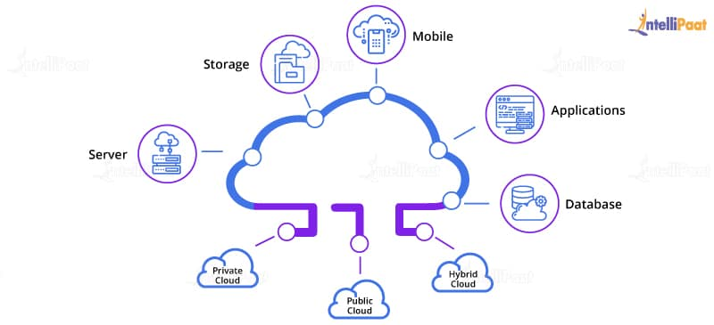

4. What are some of the key features of Cloud Computing?
- Reliable
- Scalable
- Agile
- Location Independent
- Multi-tenant

5. What are the benefits of Cloud Computing?
The main benefits of Cloud Computing are:
- Data backup and storage of data
- Powerful server capabilities
- Incremented productivity
- Cost-effective and time-saving

6. Mention the layers of PaaS architecture.
Cloud Controller
- Automatically creates virtual machines and controllers
- Deploys applications
- Connects to services
- Automatically scales up and down
Storage Services
- Object
- NoSQL
- Relational
- Block storage
Applications Stored in Storage Services
- Simple-to-scale applications
- Easier recovery from failure

7. What are the cloud service models?
Infrastructure as a Service (IaaS)
Platform as a Service (PaaS)
Software as a Service (SaaS)

8. Write about Function as a Service.
FaaS provides users with a fully functional platform where they can create, manage and run their applications without having to worry about maintaining the infrastructure.
Go through the AWS Course in London to get a clear understanding of AWS!
窗体底端

9. What are the components of Windows Azure?
Windows Azure Platform Services
- Cloud
- SQL Azure
- App Fabric: Allows fabric cloud
Want to master the core concepts of Azure? Check out our Microsoft Azure Training Course and become a Certified Administrator!

10. Which are the main constituents of the cloud ecosystem?
- Cloud service providers
- Cloud consumers
- Direct consumers

11. Who are the cloud consumers in a cloud ecosystem?
People and teams who use different types of cloud services, within your organization.

12. Who are the direct consumers in a cloud ecosystem?
The individuals who utilize the service provided by your company, build within a cloud environment.

13. Who are the Cloud service providers in a cloud ecosystem?
Cloud service providers are the companies that sell their cloud services to others. Sometimes these companies also provide cloud services internally to their partners, employees, etc.

14. What are the differences occurred in distributed operations?
FC: Master–Slave operations
Nova: Parallel process and its shared database

15. Which agent is equivalent of Nova Compute?
Azure Agent
Learn more about AWS in this AWS Training in New York to get ahead in your career!

16. Mention the reliability and availability of Cloud Computing.
Use of Fault Domains:
- Two virtual machines are in a single fault domain if a single hardware can bring down both the virtual machines.
- Azure automatically distributes instances of a role across fault domains.
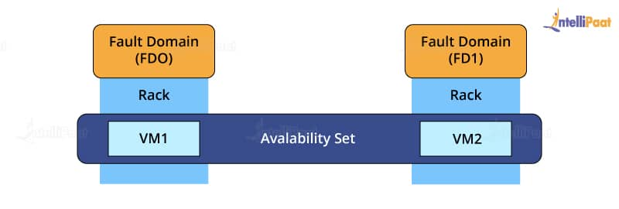
Use of Upgrade Domains:
- When a new version of the software is rolled out, then only one up-gradation of the domain is done at a time.
- It ensures that any instance of the service is always available.
- There is an availability of the applications in multiple instances.
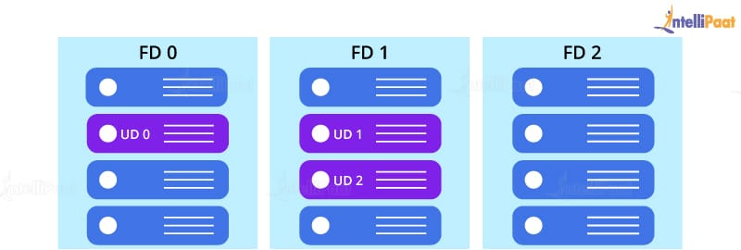
Look into the Cloud Computing Tutorial by Intellipaat.
Storage and Network Availability:
- Copies of data are stored in different domains.
- it is a mechanism to guard against DoS and DDoS attacks.
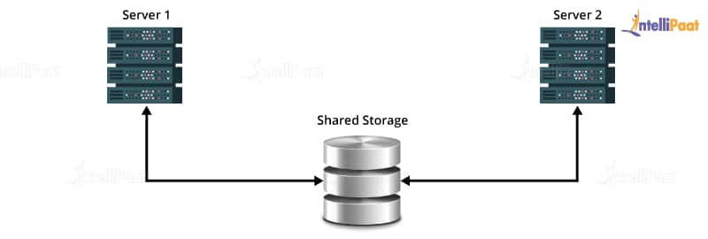
Career Transition
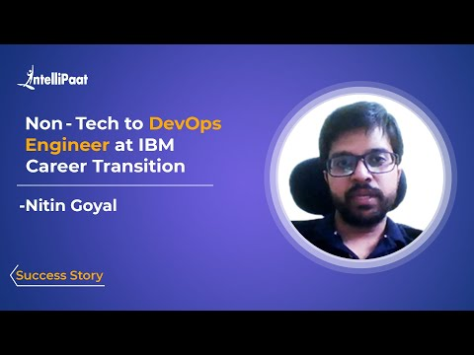

17. Explain the Cloud Computing Architecture.
Cloud Computing Architecture brings together two components of cloud computing – the front-end and the back-end. It is important to bring the correct services together for the benefit of both internal and external people. If need be, the cloud management should be able to quickly make required changes.
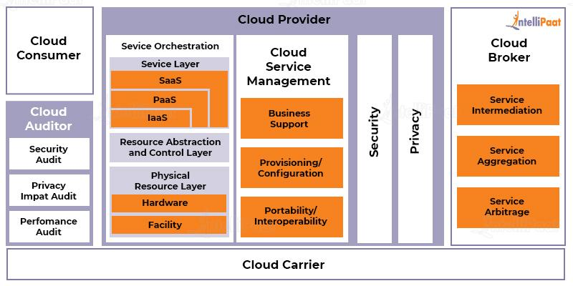

18. What are the Cloud Storage Levels?
- Files
- Blocks
- Datasets
- Objects
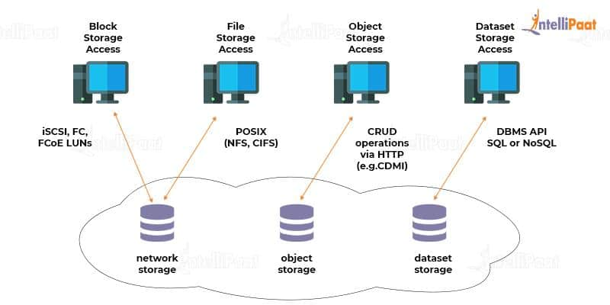

Intermediate Interview Questions

19. What are the serverless components in cloud computing with their advantages and disadvantages?
These components allow you to create apps without the stress of managing the infrastructure.
Advantages | Disadvantages
Cost-effective | Can cause late responses
Increases productivity | Not ideal for high-computing operations
Scalable | More vulnerable when it comes to security
No server management | Debugging is challenging
To know more pros and cons of cloud computing check our blog on the Advantages and disadvantages of cloud computing now!

20. Give the best example for the open-source Cloud Computing.
OpenStack

21. What are microservices and their importance in the cloud?
Microservices help create apps that consist of codes that are independent of one another and the platform they were developed on. Microservices are important in the cloud because of the following reasons:
- Each of them is built for a particular purpose. This makes app development simpler.
- They make changes easier and quicker.
- Their scalability makes it easier to adapt the service as needed.

22. What is an AMI? How do we implement it?
AMI is Amazon Machine Image, which basically is a copy of your root file system. It feeds the information required to launch an instance.
We implement AMI by specifying an AMI whenever we want to launch an instance. Multiple instances can be launched from a single AMI with the same configuration.
In the case of launching instances with different configurations, we would need to launch different AMIs.
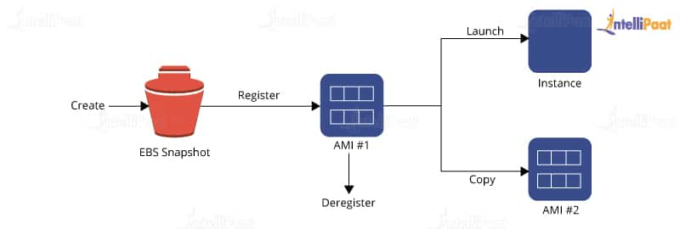
AMI includes one or more snapshots of your EBS volumes, in the case of instance-store backed AMIs, along with a template for the root volume of your instance (like an operating system, an application server, and applications).
It launches the permissions that decide which AWS accounts can use the AMI for launching instances. It also needs a block device mapping for specifying the volumes in order to attach them to the instances whenever they are launched.
Interested in learning AWS? Check out our AWS Training in Sydney!

23. Why Hybrid Clouds are so important?
Cloud Bursting:
Access capacity and specialized software are available in the public cloud and not in the private cloud.
Examples: Virtual Amazon and Dynamo
Leveraging the best of both worlds, there are hybrid clouds.
vCloud:
- It is a VMware cloud.
- It is expensive.
- It gives enterprise quality.
OpenStack:
- It has commodity servers and storage.
- It is less reliable.
- We can run web servers on OpenStack.
- the database is built on vCloud.

24. List the platforms that are used for large-scale Cloud Computing.
The platforms that are used for large-scale Cloud Computing are:
- Apache Hadoop
- MapReduce

25. Mention the different types of models used for the deployment in Cloud Computing.
The different deployment models in Cloud Computing are:
- Private Cloud
- Public Cloud
- Community Cloud
- Hybrid Cloud
Become a master of AWS by enrolling in this online AWS Course in Toronto!

26. Explain security management in terms of Cloud Computing.
- Identity management access provides the authorization of application services.
- Access control permission is given to users to have complete controlling access of another user who is entering into the cloud environment.
- Authentication and authorization provide permission to only the authorized and authenticated users to access the data and applications.

27. Which are the layers of Cloud Computing?
The different layers used by cloud architecture are as follows:
- CLC or Cloud Controller
- Walrus
- Cluster Controller
- Storage Controller (SC)
- Node Controller (NC)

28. Explain the full form and the usage of 'Eucalyptus' in Cloud Computing.
The full form of ‘Eucalyptus’ is ‘Elastic Utility Computing Architecture for Linking Your Programs to Useful Systems.
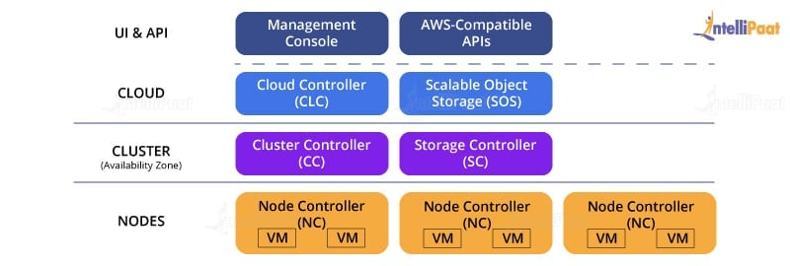
Eucalyptus is an open-source software infrastructure in Cloud Computing, which enables us to implement clusters in the Cloud Computing platform. It is mainly used to build public, hybrid, and private clouds. It has capabilities to convert our own data center into a private cloud and provides its functionalities for various other organizations.
Get certified from the top AWS Course in Singapore now!

29. Mention the names of some large cloud providers and databases.
- Google Bigtable
- Amazon Simple Database
- Cloud-based SQL (Sequential Query Language)
Courses you may like

30. Explain the difference between cloud and traditional data centers.
- The traditional data center is expensive due to heating and hardware/software issues. Mostly, the expenditure is on the maintenance of the data centers.
- Cloud is scaled up when there is an increase in demand, hence such expenditure issues are not faced in Cloud Computing.
Learn more about AWS in AWS Tutorial!

31. What is meant by Edge Computing?
Edge computing is a part of the distributed computing structure. It brings companies closer to the sources of data. This benefits businesses by giving them better insights, good response time and better bandwidth.

Advanced Interview Questions

32. What are the uses of APIs in cloud services?
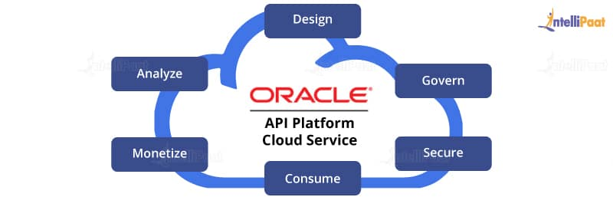
- APIs (Application Programming Interfaces) are used to eliminate the necessity to write complete programs.
- Here, instructions are provided to make communication between one or more applications.
- Creation of applications is made easy and accessible for the link of cloud services with other systems.

33. Mention different data center deployments of Cloud Computing.
Cloud Computing consists of different data centers as follows:
- Containerized data centers: Containerized data centers are the packages that contain a consistent set of servers, network components, and storage delivered to large warehouse kind of facilities. Here, each deployment is relatively unique.
- Low-density data centers: Containerized data centers promote heavy density which in turn causes much heat and significant engineering troubles. Low-density data centers are the solution to this problem. Here, the equipment is established far apart so that it cools down the generated heat.
Learn the complete concepts of AWS at Hyderabad in 26 hours!

34. List down the three basic functioning clouds in Cloud Computing.
- Professional cloud
- Personal cloud
- Performance cloud

35. What are the characteristics of cloud architecture that differ from traditional cloud architecture?
The characteristics are:
- In cloud, the hardware requirement is fulfilled as per the demand created for cloud architecture.
- Cloud architecture is capable of scaling up resources when there is a demand.
- Cloud architecture is capable of managing and handling dynamic workloads without any point of failure.

36. What are the building blocks of cloud architecture?
- Reference architecture
- Technical architecture
- Deployment operation architecture

37. Explain AWS.
AWS stands for Amazon Web Services which is a collection of remote computing services also known as Cloud Computing. This technology is also known as IaaS or Infrastructure as a Service.
Be a master of AWS by enrolling in Intellipaat’s AWS Training in Bangalore!

38. Mention the key components of AWS.
The key components of AWS are as follows:
- AWS Route 53: AWS Route 53 is a DNS (Domain Name Server) web-based service platform.
- Simple E-mail Service: Sending of e-mail is done by using a RESTFUL API call or via regular SMTP (Simple Mail Transfer Protocol).
- Identity and Access Management: Improvised security and identity management are provided for an AWS account.
- Simple Storage Device (S3): It is a huge storage medium, widely used for AWS services.
- Elastic Compute Cloud (EC2): It allows on-demand computing resources for hosting applications and is essentially useful for unpredictable workloads.
- Elastic Block Stores (EBS): They are storage volumes attached to EC2 and allow the data lifespan of a single EC2.
- CloudWatch: Amazon CloudWatch is used to monitor AWS resources, and it allows administrators to view and collect the keys required. Access is provided so that one can set a notification alarm in the case of trouble.

39. Explain how you can vertically scale an Amazon instance.
This is one of the essential features of AWS and cloud virtualization. We spinup a newly developed large instance where we pause that instance and detach the root EBS volume from the server and discard. Later, we stop our live instance and detach its root volume connected. here, we note down the unique device ID and attach the same root volume to the new server, and we restart it again. This results in a vertically scaled Amazon instance.

40. Explain the security usage in the Amazon Web Services model.
- AWS supports security groups.
- Access is provided to create a security group for a jump box with SSH access only for port 22 open. Later, a webserver group and a database group are created. The webserver group provides 80 and 443 from around the world, but only port 22 will be vital among the jump box group. The database group allows port 3306 from the webserver group and port 22 from the jump box group. The addition of any machines to the webserver group can store in the database. No one can directly SSH to any of our boxes.

41. What are reasons that make Amazon so big?
- In Amazon, the backup storage of EBS volumes is maintained by inserting the snapshot facility via an API call or via a GUI interface like Elasticfox.
- Performance is improved by using Linux software RAID and striping across four volumes.
Hope that you will find these interviews questions for the role of Cloud Engineer useful. Do let us know in the comments section below!
Do you want to become an AWS expert? Learn about the technology from Intellipaat’s AWS Certified Solutions Architect Course.

42. How does Resource Replication take place in Cloud Computing?
Resource Replication creates duplicates of the same resource. Replication is employed when a resource is needed more and more. The resource is virtualized to replicate cloud-based resources.
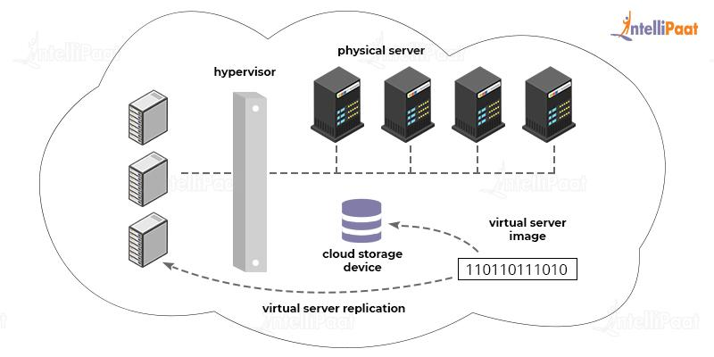

43. What is Containers as a Service (CaaS)?
CaaS is a system that allows developers to run, scale, manage, upload, and organize containers by using virtualization.
A container is a software pack. It allows teams to scale their apps to highly available cloud infrastructures.
Hope that you will find these interview questions for the role of Cloud Engineer useful. Do let us know in the comments section below!
Next

