1. What is Android?
Android is an open-sourced operating system that is used on mobile devices, such as mobiles and tablets. The Android application executes within its own process and its own instance of Dalvik Virtual Machine(DVM) or Android RunTime(ART).

2. What are the features of Android architecture?
Android architecture refers to the various layers in the Android stack. It consists of operating systems, middleware, and applications. Each layer in the Android architecture gives different services to the layer just above it.
The five layers present in the Android stack are:
- Linux Kernel - It is responsible for device drivers, device management, memory management, power management, and resource access.
- Libraries - There are a set of libraries having open-source Web browser engine WebKit, well-known library libc, libraries to play and record audio and video, SQLite database for sharing of application data and storage, SSL libraries for internet security, etc.
- Android Runtime - There are core libraries along with DVM (Dalvik Virtual Machine) or ART(Android RunTime) as runtime which is helpful for running an Android application. DVM is optimized for mobile devices. DVM provides fast performance and consumes less memory. Replacing DVM, ART(Android RunTime) virtual machine was introduced to execute android apps from Android lollipop 5.0 version (API level 21).
- Android Framework - It consists of Android APIs like UI (User Interface), resources, content providers (data), locations, telephony, and package managers. It provides interfaces and classes for the development of Android applications.
- Android Applications - Applications like home, games, contacts, settings, browsers, etc. uses the Android framework that will make use of Android runtime and libraries.
Android Architecture

3. List the languages used to build Android.
The most popular programming languages that can be used to develop applications in Android are:
- Java: It has always been a starting point for new developers and used by the majority of people who work with Android development. Eclipse, NetBeans, and IntelliJ IDE are the most popular IDE’s(Integrated Development Environment) used for developing an Android application using java.
- Kotlin: Kotlin is a relatively new, modern, safe, and object-oriented cross-platform programming language used in developing an Android application. IDE’s used with kotlin are Android studio, Eclipse IDE, etc.
- C#: Developers can build native iOS and Android mobile applications by using the C# language. Visual Studio is the best tool for developing an Android application using C#.
- Python: It is a dynamic and object-oriented programming language. It is very popular in machine learning. Pydroid 3, Dcoder, spck code editor is some of the code editors for Python.
- Other languages which can be used in Android development are C++, HTML 5. C4droid, CppDroid, AIDE, etc. are IDE’s for C++. Acode, spck code editor, etc. are examples of IDE’s used with HTML.
You can download a PDF version of Android Interview Questions.
Download PDF

4. What is an activity?
Activity in java is a single screen that represents GUI(Graphical User Interface) with which users can interact in order to do something like dial the phone, view email, etc.
For example, the Facebook start page where you enter your email/phone number and password to log in acts as an activity.

5. What is a service in Android?
Service is an application component that facilitates an application to run in the background in order to perform long-running operations without user interaction. A service can run continuously in the background even if the application is closed or even after the user switches to another application.

6. Differentiate Activities from Services.
Activities can be terminated or closed anytime the user wishes. On the other hand, services are designed to run in the background, and they can act independently.
Most of the services run continuously, irrespective of whether there are certain or no activities being executed.
Activities | Services
They are designed to run in the foreground. | These are mainly designed to run in the background. Foreground services are also available.
Used when the user interface is necessary. | Used when the user interface is not necessary.
They are dependent. | They act independently.

7. What is Google Android SDK? Which are the tools placed in Android SDK?
The Google Android SDK is a toolset used by developers to write applications on Android-enabled devices.
The tools placed in Android SDK are given below:
- Android Emulator - Android Emulator is a software application that simulates Android devices on your computer so that you can test the application on a variety of devices and Android API levels without having each physical device.
- DDMS(Dalvik Debug Monitoring Services) - It is a debugging tool from the Android software development kit (SDK) which provides services like message formation, call spoofing, capturing screenshots, etc.
- ADB(Android Debug Bridge) - It is a command-line tool used to allow and control communication with the emulator instance.
- AAPT(Android Asset Packaging Tool) - It is a build tool that gives the ability to developers to view, create, and update ZIP-compatible archives (zip, jar, and apk).

8. What is the use of Bundle in Android?
Bundles are used to pass the required data between various Android activities. These are like HashMap that can take trivial data types. Below code shows how to transfer a piece of data by using bundle:
Bundle b=new Bundle();
b.putString("Email","abc@xyz.com");
i.putExtras(b); // where i is intent

9. What is an Adapter in Android?
An adapter in Android acts as a bridge between an AdapterView and the underlying data for that view. The adapter holds the data and sends the data to the adapter view, the view can take the data from the adapter view and shows the data on different views like a spinner, list view, grid view, etc.

10. What is AAPT?
AAPT stands for Android Asset Packaging Tool. It is a build tool that gives the ability to developers to view, create, and update ZIP-compatible archives (zip, jar, and apk). It parses, indexes, and compiles the resources into a binary format that is optimized for the platform of Android.

11. What is portable Wi-Fi hotspot?
Portable Wi-Fi Hotspot permits you to share your mobile internet connection with other wireless devices. For example, using your Android phone as a Wi-Fi hotspot, you can use your laptop to connect to the internet using that access point.

12. What is Android Debug Bridge(ADB)?
Android Debug Bridge is a command-line tool used to allow and control communication with an emulator instance. It gives the power for developers to execute remote shell commands to run applications on an emulator.

13. What is DDMS?
DDMS(Dalvik Debug Monitor Server) is a debugging tool in the Android platform. It gives the following list of debugging features:
- Port forwarding services.
- Thread and heap information.
- Logcat.
- Screen capture on the device.
- Network traffic tracking.
- Incoming call and SMS spoofing.
- Location data spoofing.

14. What is AIDL? Which data types are supported by AIDL?
AIDL(Android Interface Definition Language) is a tool that handles the interface requirements between a client and a service for interprocess communication(IPC) to communicate at the same level.
The process involves dividing an object into primitives that are understood by the Android operating system. Data Types supported by AIDL is as follows:
- String
- List
- Map
- CharSequence
- Java data types (int, long, char, and boolean)

Android Intermediate Questions

15. What is the life cycle of Android activity?
- OnCreate(): It is called when activity is created. Using this, the views are created and data is collected from bundles.
- OnStart(): It is called if the activity is becoming visible to the user. It may be succeeded by onResume() if the activity comes to the foreground, or onStop() if it becomes hidden.
- OnResume(): It is called when the activity will start an interaction with the user.
- OnPause(): This is called when the activity is moving to the background but hasn’t been killed yet.
- OnStop(): This is called when an activity is no longer visible to the user.
- OnDestroy(): This is called when the activity is finished or destroyed.
- OnRestart(): This is called after the activity has been stopped, prior to it being started again.
Life Cycle of Android

16. Explain Sensors in Android.
Android-based devices have a collection of built-in sensors in them, which measure certain parameters like motion, orientation, and many more through their high accuracy. The sensors can be both hardware and software based on nature. There are three prominent categories of sensors in Android devices. They are:
- Position Sensor: It is used for measuring the physical position of the Android device. This has orientation sensors and magnetometers.
- Motion Sensors: These sensors consist of gravity, rotational activity, and acceleration sensors which measure the rotation of the device or the acceleration, etc.
- Environmental Sensor: It includes sensors that measure temperature, humidity, pressure, and other environmental factors.

17. Explain the dialog boxes supported on Android.
Android supports four dialog boxes. They are:
- AlertDialog:
  - The AlertDialog supports 0-3 buttons, along with a list of selectable items such as checkboxes and radio buttons.
  - It is used when you want to ask the user about taking a decision between yes or no in response to any particular action taken by the user, by remaining in the same activity and without changing the screen.
- DatePickerDialog:
  - It is used for selecting the date by the user.
- TimePickerDialog:
  - Used for selecting the time by the user.
- ProgressDialog:
  - It is an extension of the AlertDialog and is used to display a progress bar. It also supports the addition of buttons.
  - This class was deprecated in API level 26 because it prevents the user from interacting with the application. Instead of this class, we can use a progress indicator such as ProgressBar, which can be embedded in the user interface of your application.

18. What is AndroidManifest.xml file and why do you need this?
- The AndroidManifest.xml file contains information regarding the application that the Android system must know before the codes can be executed.
- This file is essential in every Android application.
- It is declared in the root directory.
- This file performs several tasks such as:
  - Providing a unique name to the java package.
  - Describing various components of the application such as activity, services, and many more.
  - Defining the classes which will implement these components.

19. What is an intent?
An intent is a messaging object that is used to request an action from other components of an application. It can also be used to launch an activity, send SMS, send an email, display a web page, etc.
It shows notification messages to the user from within an Android-enabled device. It alerts the user of a particular state that occurred. There are two types of intents in Android:
- Implicit Intent- Used to invoke the system components.
- Explicit Intent- Used to invoke the activity class.
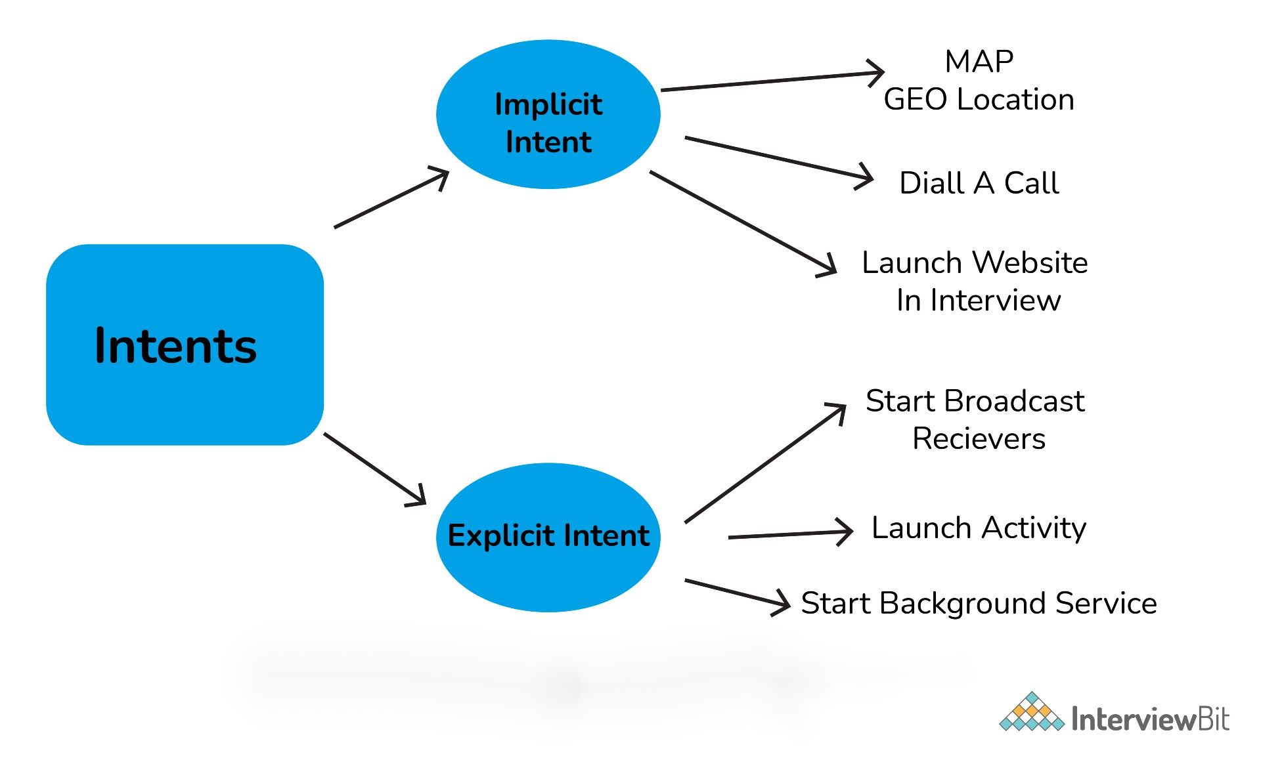Types Of Intents

20. Mention the difference between class, file and activity in Android?
The difference between them is as follows:
- Class is a compiled form of a .java file that Android uses to produce an executable .apk file.
- A file is a block of arbitrary information or resources used for storing information. It can be of any file type.
- Activity is a single screen that represents GUI(Graphical User Interface) with which users can interact in order to do something like dial the phone, view email, etc.

21. What is a Toast? Write its syntax.
Toast is a message that pops up on the screen. It is used to display the message regarding the status of the operation initiated by the user and covers only the expanse of space required for the message while the user’s recent activity remains visible and interactive.
Toast notification automatically fades in and out and it does not accept interaction events.
Syntax:
Toast.makeText(ProjectActivity.this, "Your message here", Toast.LENGTH_LONG).show();

22. What is context?
The context in Android is the context of the current state of the application or object. The context comes with services like giving access to databases and preferences, resolving resources, and more.
There are two types of context. They are:
Activity context
- This activity context is attached to the lifecycle of an activity.
- The activity context can be used when you are passing the context in the scope of an activity or you need the context whose lifecycle is attached to the context of the activity.
Application context:
- This application context is attached to the lifecycle of an application.
- The application context should be used where you need a context whose lifecycle is separate from the current context or when you are passing a context beyond the scope of activity.
Types of Context

23. Explain the difference between Implicit and Explicit Intent.
The difference between the implicit and explicit Intents are given below:
Explicit Intent:
An Explicit Intent is where you inform the system about which activity should handle this intent. Here target component is defined directly in the intent.
For example,
Intent i = new Intent(this, Activitytwo.class); #ActivityTwo is the target component
i.putExtra("Value1","This is ActivityTwo");
i.putExtra("Value2","This Value two for ActivityTwo");
startactivity(i);
Implicit Intent:
An Implicit Intent permits you to declare the action you want to carry out. Further, the Android system will check which components are registered to handle that specific action based on intent data. Here target component is not defined in the intent.
For example,
Intent i = new Intent(ACTION_VIEW,Uri.parse("http://www.interview bit.com"));
startActivity(i);

24. What is ANR in Android? What are the measures you can take to avoid ANR?
ANR(Application is Not Responding) is a dialog box that appears when the application is not responding. This ANR dialogue is displayed whenever the main thread within an application has been unresponsive for a long time under the following conditions:
- When there is no response to an input event even after 5 seconds.
- When a broadcast receiver has not completed its execution within 10 seconds.
Following measures can be taken to avoid ANR:
- An application should perform lengthy database or networking operations in separate threads to avoid ANR.
- For background task-intensive applications, you can lessen pressure from the UI thread by using the IntentService.

25. What are the troubleshooting techniques you can follow if an application is crashing frequently?
If an Android application is crashing frequently, you can follow the below-given techniques:
Compatibility Check:
It is not possible to test an application for all kinds of devices and operating systems. There might be a possibility that an application is not compatible with your OS.
Memory Management:
- Some apps run perfectly on one mobile device but might crash on other devices. This is where processing power, memory management, and CPU speed are considered.
- As there is a limited amount of memory space on mobile devices, you can free up memory space for the application to function properly.
- If an application is frequently crashing, you can delete the application’s data, which will clear its cache memory and allow some free space on your device and might boost the app’s performance.

26. Explain different launch modes in Android.
The different launch modes in Android are given below:
Standard:
- This launch mode generates an activity’s new instance in the task from which it originated.
- It is possible to create several instances for the same activity.
- For Example, suppose our current stack is A -> B -> C. Now, if we launch activity B again with the “standard” launch mode, then the new stack will be A -> B -> C -> B.
SingleTop:
- This launch mode is similar to the Standard launch mode except if there exists an activity’s previous instance on the top of the stack, then a new instance will not be created.
- But the intent will be sent to the activity’s existing instance.
- For example, suppose our current stack is A -> B -> C. Now, if we launch the activity B again with “singleTop” launch mode,then the new stack will be A -> B -> C -> B.
- Consider another example, where the current stack is A -> B -> C. Now, if we launch activity C again with the “singleTop” launch mode, then the stack will remain the same i.e., A -> B -> C. The intent will be passed to the onNewIntent() method.
SingleTask:
- This launch mode will create a new task and push a new instance to the task as the root.
- For example, suppose our current stack is A -> B -> C -> D. Now, if we launch activity B again with the “singleTask” launch mode, then the new stack will be A -> B. Here, a callback has been received on the old instance and C and D activities are destroyed.
SingleInstance:
- This launch mode is similar to the SingleTask launch mode. But the system doesn’t support launching any new activities in the same task.
- In a situation where the new activity is launched, it is launched in a separate task.
- For example, Suppose our current stack is A -> B -> C. Now, if we launch the activity D with the “singleInstance” launch mode, then there will be two stacks:
  - A -> B -> C
  - D, If you call activity E, then it will be added to the first stack.
  - A -> B -> C -> E
  - D
Again if you Call the activity D, then it will call the same activity from the 2nd stack and pass the intent to onNewIntent().

27. What are containers?
Containers carry objects and widgets together, based on which specific items are required and in what particular arrangement is needed. Containers may hold labels, buttons, fields, or even child containers, etc. For example, if you want a form with fields on the left and labels on the right, you will need a container. If you want the OK and Cancel buttons to be below the rest of the form, next to one another, and flush to the right side of the screen, you will need a container. If you have several widgets, you will need a container to have a root element to place the widgets inside.
Android provides a collection of view classes that serve as containers for views. These container classes are called layouts, which are defined in the form of XML files that cannot be changed by our code during execution. The layout managers provided by Android SDK are LinearLayout, RelativeLayout, FrameLayout, AbsoluteLayout, GridLayout, and TableLayout.

28. What is the role of Dalvik in Android development?
Dalvik serves as a virtual machine, and it is responsible for running every Android application. Because of Dalvik, a device will have the ability to execute multiple instances of virtual machines efficiently through better memory management.

29. What is the latest version of Android? List all the versions of Android.
The latest version is Android 11.0 released in September 2020. Most of the Android version has been named after either sweet or desserts. The following table represents the different versions, Android name, API level, and the year of release. Here API level is the integer value that identifies the API framework revision given by the version of the android platform.
Version | Android Name | API Level | Year of Release
Android 1.0 | No Codename | 1 | 2008
1.1 | No Codename | 2 | 2009
1.5 | Cupcake | 3 | 2009
1.6 | Donut | 4 | 2009
2.0 - 2.1 | Eclair | 5 - 7 | 2009
2.2 – 2.2.3 | Froyo | 8 | 2010
2.3 – 2.3.7 | Gingerbread | 9 - 10 | 2010
3.0 – 3.2.6 | Honeycomb | 11 - 13 | 2011
4.0 – 4.0.4 | Ice Cream Sandwich | 14 - 15 | 2011
4.1 – 4.3.1 | Jelly Bean | 16 - 18 | 2012
4.4 – 4.4.4 | Kitkat | 19 - 20 | 2013
5.0 – 5.1.1 | Lollipop | 21 - 22 | 2014
6.0 – 6.0.1 | Marshmallow | 23 | 2015
7.0 – 7.1.2 | Nougat | 24 - 25 | 2016
8.0 – 8.1 | Oreo | 26 - 27 | 2017
9.0 | Pie | 28 | 2018
10.0 | Android 10 | 29 | 2019
11.0 | Android 11 | 30 | 2020
Android 1.0 (API 1): There were numerous loopholes in this Android version including the necessity of physical keyboards or hardware buttons. Important features are:
- Browser, Google maps, and calendar.
- Camera and scroll down the notification bar.
- Wireless supports Wi-Fi and BlueTooth.
- Contacts, Gmail integration, and Google synchronization.
Android 1.1 (API 2): This version was released with API changes and resolved issues found in 1.0. Important features of this version are:
- Display details as well as reviews for locations.
- Gives detailed information by clicking on the business.
- Add save an attachment in the message.
Android 1.5 Cupcake (API 3): It brought the third-party app widgets that were the most distinguishing and valuable feature. Important features of this version are:
- Video recordings, copy and paste facility.
- Supports MPEG4 and 3GP formats.
- Search function and on-screen keyboard.
- Uploading images and videos.
Android 1.6 Donut (API 4): It had valuable changes including the ability to operate on various screen resolutions and sizes. Donut provides the text and voice entry search including bookmark history and capacity to select multiple images for deletion. Important features of this version are:
- Camera quick toggling features and gallery.
- WVGA screen resolution speed.
- Power control widget for handling Wi-Fi, GPS, BlueTooth, etc.
- Technology support for CDMA/EVDO, VPNs, 802.1x, and a text-to-speech engine.
- Searching applications and speed improvements for cameras.
- Supports quick search Box.
Android 2.0-2.1 Eclair (API 5-API 7): It was released with multiple email account synchronizations and contacts. Many new features were added including flash support, color effect, scene mode, white balance, macro focus, and digital zoom. Android 2.1 version brought bug fixes and stability improvements. The most valuable feature introduced was real-time traffic information and voice-guided turn by turn navigation. Important features are:
- Updated UI.
- Minor API changes.
- Support Bluetooth 2.1.
- Improved Google map.
- Supports live and animated Wallpapers.
- Has the ability to add contact’s photo and select to call, message or email.
Android 2.2-2.2.3 Froyo (API 8): It was released with memory, speed, and performance improvements. It was introduced with the enhanced Bluetooth functionality and also compatibility with docks, portable Wi-Fi hotspot for 3G connection sharing. Features are:
- Upload file support in the browser.
- Supports alphanumeric and numeric passwords to enhance security.
- Support for animated GIF and multiple keyboard languages.
- Increased compatibility with headsets and car kits.
Android 2.3-2.3.7 Gingerbread (API 9-API 10): The main enhanced feature was the introduction of gaming API with improved graphical intense gaming. Features are:
- Updated UI.
- Support for VP8 and WebM video format.
- Improvement in copy and paste facility.
- Easier use of keyboard with faster and intuitive typing.
- Supports video calling and social networking.
Android 3.0-3.2.6 Honeycomb (API 11-API 13): It was a tablet-only release to launch the Motorola Xoom. It was suitable for those mobiles having a larger view than current smartphones. Features will include:
- Updated 3D UI and encrypted storage.
- Gmail, camera, contacts, and gallery improvements.
- Supports passwords with complex characters.
- Supports multiprocessors and recent applications for easy visual multitasking.
- Media sync from SD card.
- Talk video chat and google eBooks.
- Support adobe flashes in the browser.
- More sensor support.
- High-performance Wi-Fi connections.
- Action bar for application control and system bar for global status and notifications
- Chinese handwriting and redesigned keyboard.
Android 4.0-4.0.4 Ice Cream Sandwich (API 14-API 15): It is released with many enhanced features to enter the era of modern design. The snapshot was introduced to take screenshots by holding the power and volume button. Ice cream sandwich widgets are more robust and resizable compared to all older versions. Supported features are:
- Unlocking with face-fixing.
- Card-like appearance for app-switching.
- Better camera performance and improved video recording with high resolution.
- Spelling check feature, Wi-Fi direct.
- On-screen buttons and better camera performance.
- Ability to open up to 16 tabs in the web browser.
Android 4.1-4.3.1 Jelly Bean (API 16-API 18): It is released with Google digital assistant technology accessible from the home screen. The spectacular predictive intelligence utility gives expandable and interactive notifications. Users can enjoy multi-user support(Only for tablets). Supported features are:
- Power control, support USB audio.
- The improved camera app, security improvements.
- Voice search and typing, panorama.
- Expandable notifications, daydream as a screensaver.
- Google displays relevant content based on search history.
- Native emoji support, new gestures, and accessibility features
- 4k resolution support, supporting Bluetooth with low energy.
- Bi-directional text and different language support.
- Set or adjust the volume of incoming calls and show a message alert as well.
Android 4.4-4.4.4 KitKat (API 19-API 20): It is released with more focus on better user experience. Supported features are:
- GPS Support, smarter caller ID.
- Offline music support, screen recording.
- Contact prioritization.
- Cartoonish ideograms and emojis to the Google keyboard.
- UI updates for Google map navigations and alarm.
- ‘OK, Google’ feature allows access to Google to the users without touching your smartphones.
Android 5.0-5.1.1 Lollipop (API 21-API 22): It was released with a redesigned user interface and built with “material design”. It is having many amazing features including support for better notification management. Supported features are:
- Support ART, better and improved UI.
- Better device protection, built-in battery saver feature.
- Notification can be flicked away from the lock screen.
- The revamped navigation bar supports multiple SIM cards.
- The high definition of a voice call.
Android 6.0-6.0.1 Marshmallow (API 23): Google used “Macadamia Nut Cookie” to describe Android version 6.0 before the official announcement of Marshmallow. Supported features are:
- Support for fingerprint readers, type-C USB support.
- Multi-window experience, clear permission system.
- ’Sleep Mode’ for saving the life of the battery.
- Custom Google tabs and improved copy-pasting.
Android 7.0-7.1.2 Nougat (API 24-API 25): It was released with a native split-screen mode, data saver functionality, and a “bundled-by-app” system to organize notifications. Supported features are:
- Multitasking and split-screen mode.
- Storage manager enhancements, quick setting toggles.
- Display touch enhancements, better setting application.
- Inline reply to message and notification without opening an application.
Android 8.0-8.1 Oreo (API 26-API 27): It is having notification snoozing options, native picture-in-picture mode, and better control over how applications can alert you by notifications. Supported features are:
- Password autofill, auto-enable Wi-Fi.
- Downloadable fonts, multi-display support.
- Support picture-in-picture.
- Adaptive icons and smart text selection.
- Notification channels and snooze notifications.
- Google play support and new emoji styling.
Android 9.0 Pie (API 28): It is having plenty of amazing features according to the user interests and requirements. Supported features are:
- HDR, HD audio, multiple Bluetooth connections.
- Much more information about notification and easier text selection.
- Sound amplifier with select to speak option.
- Artificial Intelligence(AI) compatibility.
- Adaptive battery and brightness with the background restrictions.
- Supports for multi-camera with external camera compatibility.
- New shortcut key for screenshot and accessibility menu.
- Improved security features for protection.
- Android backups, privacy enhancements.
- Easier screen rotation, edge-to-edge screens support.
- Volume and sound enhancements, selectable dark mode.
Android 10.0 (API 29): It is released with enhanced features and functionalities with higher API levels. Supported features are:
- Support for foldable smartphones with a flexible display.
- Dark mode for the comfortability of eyes.
- Navigation control over gesture quicker and intuitive ever.
- Smart reply suggestions for all messaging applications.
- Live caption for media playing on a smartphone device.
- Undo removal of the app.
- Better notification control with many options.
- Sound amplifier with much more clear sound.
Android 11.0 (API 30): Android developers are continuously working to provide more advanced applications as per the user requirements. Important features included are:
- Native screen recording.
- Auto revokes app permission.
- Mute notifications during the video.
- Increase in touch sensitivity.
- Notification history.

Android Interview Questions For Experienced

30. What are broadcast receivers? How is it implemented?
A broadcast receiver is a mechanism used for listening to system-level events like listening for incoming calls, SMS, etc. by the host application. It is implemented as a subclass of BroadcastReceiver class and each message is broadcasted as an intent object.
public class MyReceiver extends BroadcastReceiver
{
public void onReceive(context,intent){}
}

31. Explain in detail about the important file and folders used when you create a new Android application.
App:
It describes the basic characteristics of the application and defines each of its components.
java:
- This contains the .java source files and .kt(source code written in Kotlin) source files of your project. By default, it includes a MainActivity.java or MainActivity.kt source file.
- You create all the activities which have .java and .kt extensions under this file and also it includes all the code behind the application.
res:
- It is used to store the values for the resources that are used in various Android projects to include features of color, styles, dimensions, etc.
- It is a directory for files like styles.xml, strings.xml, colors.xml, dimens.xml, etc.
Scripts:
This is an auto-generated file that consists of compileSdkVersion, buildToolsVersion, minSdkVersion, targetSdkVersion, applicationId, versionCode, and versionName. For example, build.gradle is a script file placed in the root project directory, defines build configurations that will be applied to all modules in your project.

32. What is the difference between Serializable and Parcelable? Which is the best approach in Android?
While developing applications usually it needs to transfer data from one activity to another. This data needs to be added into a corresponding intent object. Some additional actions are required to make the data suitable for transfer. For doing that the object should be either serializable or parcelable.
Serializable:
- Serializable is a standard Java interface. In this approach, you simply mark a class Serializable by implementing the interface and java will automatically serialize it.
- Reflection is used during the process and many additional objects are created. This leads to plenty of garbage collection and poor performance.
Parcelable:
- Parcelable is an Android-specific interface. In this approach, you implement the serialization yourself.
- Reflection is not used during this process and hence no garbage is created.
- Parcelable is far more efficient than Serializable since it gets around some problems with the default Java serialization scheme. Also, it is faster because it is optimized for usage on the development of Android, and shows better results.

33. What database is used in Android? How it is different from client-server database management systems?
SQLite is the open-source relational database used in Android. The SQLite engine is serverless, transactional, and also self-contained. Instead of the client-server relationship of most database management systems, the SQLite engine is integrally linked with the application. The library can be called dynamically and it can make use of simple function calls that reduce latency in database access.

34. What are the differences between Service and Thread?
The main difference between Service and Thread is given below:
Service | Thread
Service is an application component that facilitates an application to run in the background in order to perform long-running operations without user interaction. | A Thread is a concurrent unit of execution.
It exposes few functionalities to other applications by calling Context.bindService(). | Google has brought in handlers and loopers into threads.
When an application is killed, service is not killed. | When an application is killed, the thread is killed.

35. What is the content provider? How it is implemented?
Content provider is one of the primary building blocks of Android applications, which manages access to a central repository of data. It acts as a standard interface that connects data in one process with code running in another process. So it can be used to share the data between different applications.
They are responsible for encapsulating the data and providing mechanisms for defining data security. It is implemented as a subclass of ContentProviderclass and must implement a set of APIs that will enable other applications to perform transactions.
public class MyContentprovider extends ContentProvider
{
public void onCreate(){}
}

36. What is the significance of the .dex file?
Android programs are compiled into a .dex file (Dalvik Executable file) by DVM, which are then zipped into a .apk file on the device. .dex files are created by translating compiled applications written in java. .dex is a format that is optimized for effective storage and memory-mappable executions.

37. What is the difference between compileSdkVersion and targetSdkVersion?
compileSdkVersion:
- The compileSdkVersion is the version of API the application is compiled against. You can use Android API features involved in that version of the API (as well as all previous versions).
- For example, if you try and use API 15 features but set compileSdkVersion to 14, you will get a compilation error. If you set compileSdkVersion to 15 you can still run the app on an API 14 device as long as your app’s execution paths do not attempt to invoke any APIs specific to API 15.
targetSdkVersion:
- The targetSdkVersion indicates that you have tested your app on (presumably up to and including) the version you specify. This is like a certification or sign-off you are giving the Android OS as a hint to how it should handle your application in terms of OS features.
- For example, setting the targetSdkVersion value to “11” or higher permits the system to apply a new default theme (Holo) to the application when running on Android 3.0 or higher. It also disables screen compatibility mode when running on larger screens (because support for API level 11 implicitly supports larger screens).

38. Explain about java classes related to the use of sensors on Android.
Android sensor API provides many classes and interface for the use of sensors on Android. The important classes and interfaces of sensor API are given below:
- Sensor class: This class helps you to create an instance of a specific sensor. It provides methods that let you determine a sensor’s capabilities.
- SensorManager class: This class is used to create an instance of the sensor service. It provides methods to access and list sensors, to register and unregister sensor listeners, etc.
- SensorEvent class: This Java class is used to create a sensor event object. It provides information about the sensor event including raw sensor data, the accuracy of data, type of sensor, timestamp of event, etc.
- SensorEventListener interface: This interface is used to create two callback methods that receive sensor event notifications when sensor value changes or when sensor accuracy changes. Those two methods are void onAccuracyChanged(Sensor sensor, int accuracy) which is called when sensor accuracy is changed and
void onSensorChanged(SensorEvent event) which is called when sensor values are changed.

39. What is JobScheduler?
The JobSchedular API is used for scheduling different types of jobs against the framework that will be executed in your app’s own process. This allows your application to perform the given task while being considerate of the device’s battery at the cost of timing control.
The JobScheduler supports batch scheduling of jobs. The Android system can combine jobs for reducing battery consumption. JobManager automatically handles the network unreliability so it makes handling uploads easier.
Here is some example of the situation where you would use this job scheduler:
- Tasks that should be done when the device is connected to a power supply.
- Tasks that require a Wi-Fi connection or network access.
- Tasks that should run on a regular basis as batch where the timing is not critical.

Conclusion
Android system gives a platform for a developer from which they can display the applications to the smartphone users and find potential customers out of them. It also provides paid and free applications for the users that could secure their data serves as a platform for information and gives various services as per the needs of the customers.

Q1:
List some benefits of using React Native for building mobile apps?
Entry

React Native 72

Answer
Some benefits of React Native are:
- Known for Optimal Performance
- Can Reuse the Codes and Pre-Developed Components
- Large Community of Developers
- Advantage of Live and Hot Reloading
- Cost Effective Solution
- Offers Simple User Interface
- Support for Third-Party Plugins
- Modular Architecture
- Providing Handy Solutions and Libraries
Having Tech or Coding Interview? Check 72 React Native Interview Questions
Source: brainhub.eu

Q2:
What are the advantages of hybrid apps over native apps?
Entry

React Native 72

Answer
- Works across multiple platforms.
- Unified development.
- Faster build and lower cost of development.
- Easier to make changes and update.
Having Tech or Coding Interview? Check 72 React Native Interview Questions
Source: FullStack.Cafe

Q3:
What is Ionic Framework?
Entry

 Ionic 29

Answer
Ionic Framework is an open source UI toolkit for building performant, high-quality mobile and desktop apps using web technologies (HTML, CSS, and JavaScript). Ionic Framework is focused on the frontend user experience, or UI interaction of an app (controls, interactions, gestures, animations). Currently, Ionic Framework has official integrations with Angular and React, and support for Vue is in development.
Having Tech or Coding Interview? Check 29 Ionic Interview Questions
Source: ionicframework.com

Q4:
What is Xamarin?
Entry

 Xamarin 83

Answer
Xamarin is a Cross Platform Mobile Development technology by Microsoft where we can develop the native app using the same code base across all platforms (iOS, Android, UWP) using the C# language. Xamarin uses two approaches for the app development:
- Xamarin.Forms and
- Xamarin Native.
Xamarin.Forms uses MVVM & XAML while Xamarin Native uses native UI technology and MVC or MVVMCross Architecture.
Having Tech or Coding Interview? Check 83 Xamarin Interview Questions
Source: codeproject.com

Q5:
What is Singleton pattern?
Entry

Design Patterns 68

Answer
Singleton pattern comes under creational patterns category and introduces a single class which is responsible to create an object while making sure that only single object gets created. This class provides a way to access its only object which can be accessed directly without need to instantiate the object of the class.
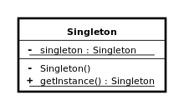

Q6:
What is a progressive web app?
Entry

PWA 22

Answer
The concept of the progressive web app (PWA) was approached by Google in late 2015. They are basically web applications (Website) but have look and feel like other native mobile apps. The progressive web app enabled websites can offer functionalities such as working offline, push notifications, and device hardware access.
Having Tech or Coding Interview? Check 22 PWA Interview Questions
Source: stackoverflow.com

Q7:
What is an Activity?
Entry

Android 113

Answer
An Activity provides the window in which the app draws its UI.
This window typically fills the screen, but may be smaller than the screen and float on top of other windows. Generally, one activity implements one screen in an app. For instance, one of an app’s activities may implement a Preferences screen, while another activity implements a Select Photo screen.
Having Tech or Coding Interview? Check 113 Android Interview Questions
Source: github.com

Q8:
Explain activity lifecycle
Junior

Android 113

Answer
As a user navigates through, out of, and back to your app, the Activity instances in your app transition through different states in their lifecycle.
To navigate transitions between stages of the activity lifecycle, the Activity class provides a core set of six callbacks: onCreate(), onStart(), onResume(), onPause(), onStop(), and onDestroy(). The system invokes each of these callbacks as an activity enters a new state.
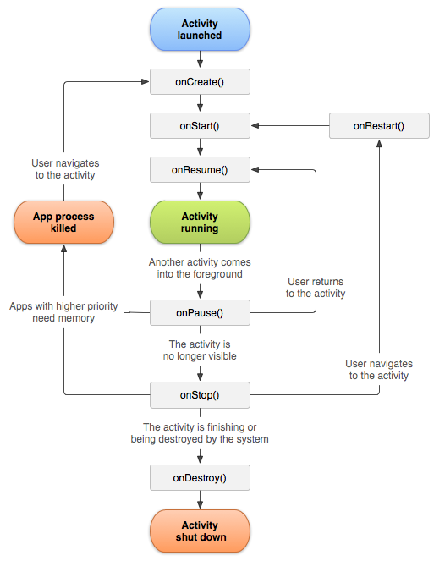
Having Tech or Coding Interview? Check 113 Android Interview Questions
Source: developer.android.com
Full-Stack, Web & Mobile
 Coding & Data Structures
 System Design & Architecture

Q9:
Explain briefly all the Android application components
Junior

Android 113

Answer
App components are the essential building blocks of an Android app. Each component is an entry point through which the system or a user can enter your app.
There are four different types of app components:
- Activities - An activity is the entry point for interacting with the user. It represents a single screen with a user interface.
- Services - A service is a general-purpose entry point for keeping an app running in the background for all kinds of reasons. It is a component that runs in the background to perform long-running operations or to perform work for remote processes.
- Broadcast receivers - A broadcast receiver is a component that enables the system to deliver events to the app outside of a regular user flow, allowing the app to respond to system-wide broadcast announcements.
- Content providers - A content provider manages a shared set of app data that you can store in the file system, in a SQLite database, on the web, or on any other persistent storage location that your app can access.
Having Tech or Coding Interview? Check 113 Android Interview Questions

Q10:
Explain the build process in Android
Junior

Android 113

Answer
- First step involves compiling the resources folder (/res) using the aapt (android asset packaging tool) tool. These are compiled to a single class file called R.java. This is a class that just contains constants.
- Second step involves the java source code being compiled to .class files by javac, and then the class files are converted to Dalvik bytecode by the “dx” tool, which is included in the sdk ‘tools’. The output is classes.dex.
- The final step involves the android apkbuilder which takes all the input and builds the apk (android packaging key) file.
Having Tech or Coding Interview? Check 113 Android Interview Questions
Source: android.jlelse.eu

Q11:
How to persist data in an Android app?
Junior

Android 113

Answer
There are basically four different ways to store data in an Android app:
- Shared Preferences - to save primitive data in key-value pairs
- Internal Storage - you need to store data to the device filesystem, but you do not want any other app (even the user) to read this data
- External Storage - you might want the user to view the files and data saved by your app
- SQLite database
Having Tech or Coding Interview? Check 113 Android Interview Questions
Source: www.androidauthority.com

Q12:
What are the advantages of native apps over hybrid apps?
Junior

React Native 72

Answer
- They work efficiently as they are built for that specific platforms
- Native apps are responsive on all the platform-specific devices
- They are very fast and the best in the app performance
- Native apps better integrate with mobile hardware
- They have interactive and intuitive User Interface (UI) and User Experience (UX) as per the user expectations based on specific platforms
- Some of the Native mobile apps work even without the Internet connection
- Native apps are secured and reliable
- They can easily access or utilize the other device-specific capabilities like GPS, Camera, Contacts, etc.
Having Tech or Coding Interview? Check 72 React Native Interview Questions
Source: www.quora.com

Q13:
What is Builder pattern?
Junior

Design Patterns 68

Answer
Builder pattern builds a complex object using simple objects and using a step by step approach. This builder is independent of other objects.
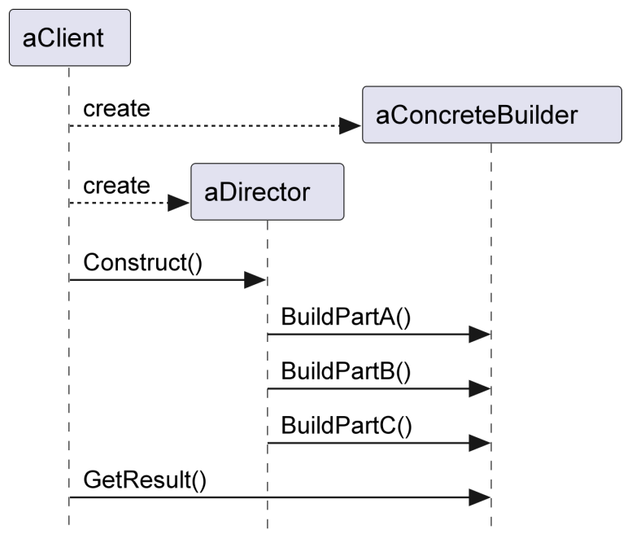
The Director class is optional and is used to make sure that the building steps are executed in the right order with the right data by the right builder. It's about validation and delegation.
Builder/Director pattern's steps invocations could be semantically presented by method chaining or so called Fluent Interface syntax.
Pizza pizza = new Pizza.Builder()
.cheese(true)
.pepperoni(true)
.bacon(true)
.build();
Having Tech or Coding Interview? Check 68 Design Patterns Interview Questions
Source: tutorialspoint.com
22 Essential WCF Interview Questions (SOLVED) That'll Make You Cry

WCF 37

Q14:
What is an Intent in Android?
Junior

Android 113

Answer
An Intent is basically a message that is passed between components (such as Activities, Services, Broadcast Receivers, and Content Providers).So, it is almost equivalent to parameters passed to API calls. The fundamental differences between API calls and invoking components via intents are:
- API calls are synchronous while intent-based invocations are asynchronous.
- API calls are compile-time binding while intent-based calls are run-time binding.
To listen for an broadcast intent (like the phone ringing, or an SMS is received), you implement a broadcast receiver, which will be passed the intent. To declare that you can handle another's app intent like "take picture", you declare an intent filter in your app's manifest file.
If you want to fire off an intent to do something, like pop up the dialer, you fire off an intent saying you will.
An Intent provides a facility for performing late runtime binding between the code in different applications.
Having Tech or Coding Interview? Check 113 Android Interview Questions
Source: stackoverflow.com

Q15:
What is hybrid app development?
Junior

Ionic 29

Answer
Hybrid apps are developed using web technologies like HTML, CSS and Javascript, and then wrapped in a native application using platforms like Cordova. The apps are shown in its own embedded browser, like UIWebView in iOS and WebView in Android (not Safari or Chrome). This allows you to use any web-native framework for mobile app development.
Having Tech or Coding Interview? Check 29 Ionic Interview Questions
Source: netguru.com
Check MLStack.Cafe - 1704 Data Science & ML Interview Questions & Answers!

Q16:
What is the difference between Upcast and Downcast in Swift?
Junior

Swift 72

Answer
- The upcast, going from a derived class to a base class, can be checked at compile time and will never fail.
- However, downcasts can fail since you can’t always be sure about the specific class. If you have a UIView, it’s possible it’s a UITableView or maybe a UIButton.
  - downcasts must be either optional with as? or
  - “forced failable” with as! when sure about the type
Having Tech or Coding Interview? Check 72 Swift Interview Questions
Source: stackoverflow.com

Q17:
What are some disadvantages of PWA?
Mid

PWA 22

Answer
Disadvantages of the progressive web app:

Less access to system features: Currently, Progressive Web Apps have limited access to native system features than native apps. Also, all browsers are not supporting its full features but maybe in near future, it will be the new standard of development.

More Android – Less Apple’s iOS: progressive web apps are currently, most supported by Android devices. Apple’s iOS is only partially supporting.

No review standard: progressive web apps don’t need any kind of review system which is applicable for native apps from the app store. It may make the process faster but lack of promotional benefits from the app store.

Having Tech or Coding Interview? Check 22 PWA Interview Questions
Source: stackoverflow.com

Guest Voice: The Solution For The CV Problem In IT Recruitment

Career 1

Q18:
What are some possible security issues with Ionic apps?
Mid

Ionic 29

Answer
When building hybrid applications, security is a common issue, as long as your app can be reverse engineered. Since version 4, Ionic CLI does provide built-in code uglification — a common technique of making the code difficult to read by hackers. But you also need to know that if you are using Angular CLI or older versions of Ionic, there is no code uglification going on. Your developers will have to uglify the code on their own.
There are a lot of ways to compromise what’s happening with your mobile app or PWA, like a man-in-the-middle attack. Why does it matter? Well, because basically, your Ionic application is a website, running on the device. The important takeaway is that Ionic communicates with the backend using usual HTTP calls. So, you also want to use the security measures on your Ionic app that you use to protect your website, like using HTTPS connection instead of the HTTP.
Having Tech or Coding Interview? Check 29 Ionic Interview Questions
Source: altexsoft.com

Q19:
What are the differences between onCreate(), onCreateView(), and onActivityCreated() in Fragments and what would they each be used for?
Mid

Android 113

Answer
They are all called in the Fragment but are called at different times. The onCreate() is called first, for doing any non-graphical initialisations. Next, you can assign and declare any View variables you want to use in onCreateView(). Afterwards, use onActivityCreated() to do any final initialisations you want to do once everything has completed.
Also check this two diagrams:
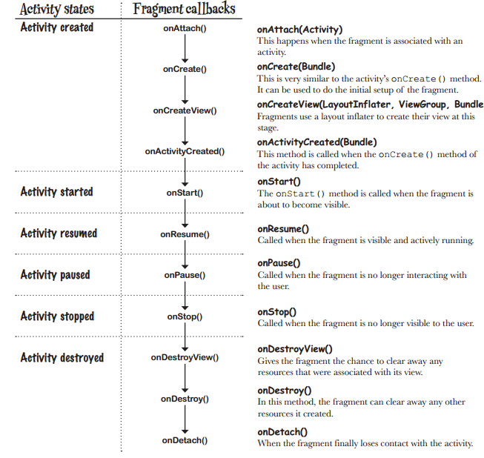
Having Tech or Coding Interview? Check 113 Android Interview Questions
Source: stackoverflow.com

Q20:
What does program to interfaces, not implementations mean?
Mid

Design Patterns 68

Answer
Coding against interface means, the client code always holds an Interface object which is supplied by a factory.
Any instance returned by the factory would be of type Interface which any factory candidate class must have implemented. This way the client program is not worried about implementation and the interface signature determines what all operations can be done.
This approach can be used to change the behavior of a program at run-time. It also helps you to write far better programs from the maintenance point of view.
Having Tech or Coding Interview? Check 68 Design Patterns Interview Questions
Source: tutorialspoint.com

Q21:
What does the Swift mutating keyword mean?
Mid

Swift 72

Answer
Being the value type structs are immutable. Meaning other variables can not change the values for instance of structure at any given point.
The mutating word is required for changing the values of self variables inside structure's function only.
For. e.g
struct MyStruct {
var abc: String = "initila value"

func changeValue() {
abc = "some other value". //Compile time error: Cannot assign to property: 'self' is immutable. Mark method 'mutating' to make 'self' mutable.
}}
Here as we are trying to change value of variable abc inside function declared in struct itself, we get the compile time error.
So here we need to make function mutating to make change value inside structure. Hence the correct code will be:
struct MyStruct {
var abc: String = "initila value"

mutating func changeValue() {
abc = "some other value"
}}
Having Tech or Coding Interview? Check 72 Swift Interview Questions
Source: stackoverflow.com

21 Kubernetes Interview Questions (ANSWERED) For Senior and DevOps Developers

 Kubernetes 27

Q22:
What is IndexedDB and how is it used by PWA?
Mid

PWA 22

Answer
IndexedDB is a large-scale, NoSQL storage system. It lets you store just about anything in the user's browser. In addition to the usual search, get, and put actions, IndexedDB also supports transactions.
IndexedDB is a low-level API for client-side storage of significant amounts of structured data, including files/blobs. This API uses indexes to enable high performance searches of this data. While DOM Storage is useful for storing smaller amounts of data, it is less useful for storing larger amounts of structured data. IndexedDB provides a solution.
In a context of PWA a general recommendation for storing data offline:
- For the network resources necessary to load your app while offline, use the Cache API (part of service workers).
- For all other data, use IndexedDB (with a promises wrapper).
Having Tech or Coding Interview? Check 22 PWA Interview Questions
Source: developers.google.com
Check MLStack.Cafe - 1704 Data Science & ML Interview Questions & Answers!

Q23:
What is Android Data Binding?
Mid

Android 113

Answer
The Data Binding Library is a support library that allows you to bind UI components in your layouts to data sources in your app using a declarative format rather than programmatically.
Layouts are often defined in activities with code that calls UI framework methods. For example, the code below calls findViewById() to find a TextView widget and bind it to the userName property of the viewModel variable:
TextView textView = findViewById(R.id.sample_text);
textView.setText(viewModel.getUserName());
The following example shows how to use the Data Binding Library to assign text to the widget directly in the layout file. This removes the need to call any of the Java code shown above.
<TextView
android:text="@{viewmodel.userName}" />
The pros of using Android Data Binding:
- Reduces boilerplate code which in turns brings
- Less coupling
- Stronger readability
- Powerful, easy to implement custom attribute and custom view
- Even faster than findViewById - The binding does a single pass on the View hierarchy, extracting the Views with IDs. This mechanism can be faster than calling findViewById for several Views.
Having Tech or Coding Interview? Check 113 Android Interview Questions
Source: developer.android.com

Q24:
What is Explicit Intent?
Mid

Android 113

Answer
Explicit Intents used to call a specific component.
When you know which component you want to launch and you do not want to give the user free control over which component to use. For example, you have an application that has 2 activities. Activity A and activity B. You want to launch activity B from activity A. In this case you define an explicit intent targeting activity B and then use it to directly call it.
Having Tech or Coding Interview? Check 113 Android Interview Questions
Source: stackoverflow.com

Q25:
What is typecasting?
Mid

Swift 72

Answer
Sometimes you know information that Swift doesn’t: you know that the UIViewController you have a reference to is in fact your custom PictureViewController subclass, and you want to treat it like one. As an example, here’s how we create new view controllers from a storyboard:
let vc = storyboard?.instantiateViewController(withIdentifier: "Detail") as? DetailViewController
That as? is a typecast - we’re passing on to Swift the knowledge that the view controller we expect to be created is in fact a DetailViewController. If the typecast fails then vc will be nil, but if it succeeds then Swift will be able to use it as a DetailViewController.
Having Tech or Coding Interview? Check 72 Swift Interview Questions
Source: www.hackingwithswift.com

Top 60+ MEAN Stack Developer Interview Questions And Answers

API Design 46

Angular 120

 CSS 50

Q26:
What is difference between as?, as! and as in Swift?
Mid

Swift 72

Answer
- In Swift 1.2 and later, as can only be used for upcasting (or disambiguation) and pattern matching:
// 'as' for pattern matchingswitch item {case let obj as MyObject:
// this code will be executed if item is of type MyObjectcase let other as SomethingElse:
// this code will be executed if item is of type SomethingElse...}
- as? produces an optional value, which is either the value if it can be cast to the specified type, or nil if it can't.
- as! doesn't produce an optional, it just produces a value of the specified type, and if the cast fails, it aborts the program. Saying foo as! SomeType is basically the same thing as saying (foo as? SomeType)! (except you get a better error message).
You should only ever use as! if you're 100% certain the cast will succeed (because if you're wrong, the whole program aborts).
Having Tech or Coding Interview? Check 72 Swift Interview Questions
Source: stackoverflow.com

Q27:
What is the difference between PhoneGap, Cordova, and Ionic?
Mid

Ionic 29

Answer
PhoneGap is a library that exposes native mobile phone functionalities as JavaScript API. When Adobe purchased PhoneGap, its open source core was donated to the Apache Software Foundation under the name Cordova. In the beginning, there was almost no difference between Cordova and PhoneGap. Although, over the years of development, Adobe started adding a proprietary set of the services to PhoneGap. Today, it is safe to say PhoneGap is Cordova plus extra Adobe services.
Ionic uses Cordova, not PhoneGap for its core tools. Beside native mobile phone functionalities, Ionic gives structure and code scalability to JavaScript applications by using AngularJS (Angular, React and Vue for IOnic 4). It also provides a set of Angular directives and components to speed up application development.
Having Tech or Coding Interview? Check 29 Ionic Interview Questions
Source: toptal.com

Q28:
What is the difference between Xamarin.Forms and Xamarin Native?
Mid

Xamarin 83

Answer
The main difference is that in Xamarin Forms, you share NOT ONLY the business logic, but also the UI. In Xamarin forms, you'll use basic components on all platforms (Button, Label, etc). That's the reason why it's called Xamarin.Forms, because it's suitable for basic forms.
But for Xamarin Native (Xamarin.iOS and Xamarin.Android ), you'll create a UI per platform (One for iOS, one for Android). You can do much more with Xamarin Native, because you'll use native components.
Having Tech or Coding Interview? Check 83 Xamarin Interview Questions
Source: stackoverflow.com

Q29:
What is the difference between Activity and Context?
Mid

Android 113

Answer
- Context is the Base Object. So every Activity same as Application derives from Context. This means that every Activity and every Application IS a Context.
- An Application context lasts, as long as your app is alive, while
- the Activity context dies with your Activity (it is not valid after onDestroy() of that Activity).
So if you need the Context across Activities (i.e. in a Singleton) you will be better off using an Application context.
Having Tech or Coding Interview? Check 113 Android Interview Questions
Source: stackoverflow.com
Full-Stack, Web & Mobile
Coding & Data Structures
System Design & Architecture

 Golang 49

Ruby on Rails 72

Flutter 67

OOP 58

Python 112

Objective-C 43

Dependency Injection 17

ASP.NET 54

Redux 35

 AngularJS 61

Check MLStack.Cafe - 1704 Data Science & ML Interview Questions & Answers!

45 Advanced React Interview Questions (With Hooks) Devs Must Clarify and Know

React 130

Q30:
What is the difference between Handler vs AsyncTask vs Thread?
Mid

Android 113

Answer
- The Handler class can be used to register to a thread and provides a simple channel to send data to this thread. A Handler allows you communicate back with the UI thread from other background thread.
- The AsyncTask class encapsulates the creation of a background process and the synchronization with the main thread. It also supports reporting progress of the running tasks.
- And a Thread is basically the core element of multithreading which a developer can use with the following disadvantage:
  - Handle synchronization with the main thread if you post back results to the user interface
  - No default for canceling the thread
  - No default thread pooling
  - No default for handling configuration changes in Android
Having Tech or Coding Interview? Check 113 Android Interview Questions
Source: stackoverflow.com

Q31:
What is the difference between compileSdkVersion and targetSdkVersion?
Mid

Android 113

Answer

The compileSdkVersion is the version of the API the app is compiled against. This means you can use Android API features included in that version of the API (as well as all previous versions, obviously). If you try and use API 16 features but set compileSdkVersion to 15, you will get a compilation error. If you set compileSdkVersion to 16 you can still run the app on a API 15 device as long as your app's execution paths do not attempt to invoke any APIs specific to API 16.

The targetSdkVersion has nothing to do with how your app is compiled or what APIs you can utilize. The targetSdkVersion is supposed to indicate that you have tested your app on (presumably up to and including) the version you specify. This is more like a certification or sign off you are giving the Android OS as a hint to how it should handle your app in terms of OS features.

Having Tech or Coding Interview? Check 113 Android Interview Questions
Source: stackoverflow.com

Q32:
What is the difference between let and var in Swift?
Mid

Swift 72

Problem
Is there any changes in your answer for reference types?
Answer

For fundamental types the let keyword defines a constant:

let theAnswer = 42

The value of a constant doesn’t need to be known at compile time, but you must assign the value exactly once.

The var defines an ordinary variable.

Both var and let are references/pointers, therefore let is a const reference/pointers. Using fundamental types doesn't really show how let is different than const. The difference comes when using it with class instances (reference types):
class CTest{
var str : String = ""}
let letTest = CTest()
letTest.str = "test" // OK

letTest.str = "another test" // Still OK
//letTest = CTest() // Error
var varTest1 = CTest()var varTest2 = CTest()var varTest3 = CTest()

varTest1.str = "var 1"
varTest2.str = "var 2"
varTest3 = varTest1
varTest1.str = "var 3"

varTest3.str // "var 3"
Having Tech or Coding Interview? Check 72 Swift Interview Questions
Source: stackoverflow.com

Q33:
What's the difference between Self vs self?
Mid

Swift 72

Answer
When you’re writing protocols and protocol extensions, there’s a difference between Self (capital S) and self (lowercase S). When used with a capital S, Self refers to the type that conform to the protocol, e.g. String or Int. When used with a lowercase S, self refers to the value inside that type, e.g. “hello” or 556.
As an example, consider this extension on BinaryInteger:
extension BinaryInteger {
func squared() -> Self {
return self * self
}}
Remember, Self with a capital S refers to whatever type is conforming to the protocol. In the example above, Int conforms to BinaryInteger, so when called on Int the method returns an Int.
On the other hand, self with a lowercase S refers to whatever value the type holds. If the example above were called on an Int storing the value 5 it would effectively be 5 * 5.
Having Tech or Coding Interview? Check 72 Swift Interview Questions
32 Linked List Interview Questions (ANSWERED) To Nail Your Coding Interview

 Linked Lists 43

Q34:
When to use strong, weak and unowned references?
Mid

Swift 72

Answer
- To determine if you even need to worry about strong, weak, or unowned, ask, “Am I dealing with reference types”. If you’re working with Structs or Enums, ARC isn’t managing the memory for those Types and you don’t even need to worry about specifying weak or unowned for those constants or variables.
- Strong references are fine in hierarchical relationships where the parent references the child, but not vice-versa. In fact, strong references are the most appropraite kind of reference most of the time.
- When two instances are optionally related to one another, make sure that one of those instances holds a weak reference to the other.
- When two instances are related in such a way that one of the instances can’t exist without the other, the instance with the mandatory dependency needs to hold an unowned reference to the other instance.

1. Explain the Architecture of iOS.
iOS operates in a Layered structure. iOS Architecture is comprised of four layers, each of which offers a programming framework for creating applications that operate on top of the hardware. Communication will be enhanced by the layers between the Application Layer and the Hardware Layer. A lower-level layer provides the services that all applications require, while an upper-level layer (or high-level layer) provides graphics and interface-related services.
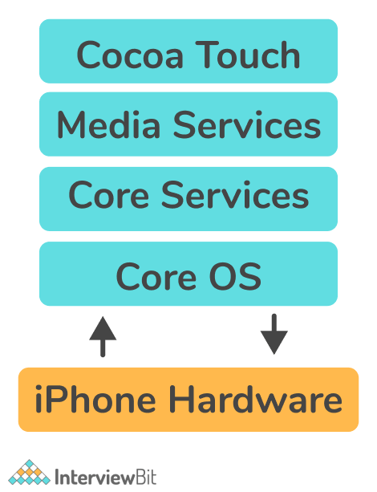
- Core OS ( or Application) Layer: Core OS Layer sits directly on top of the device hardware and is the bottom layer of the iPhone OS stack. In addition to basic operating system services, such as memory management, handling of file systems, and threads, this layer provides low-level networking, access to external accessories, etc.
- Service Layer: Its purpose is to design the services that upper layers or users demand. Among its other essential features are block objects, Grand Central Dispatch, in-app purchases, and iCloud storage. The service layer has been strengthened by the addition of ARC Automatic Reference Counting.
- Media Layer: It handles media like video, audio, graphics, etc. The media layer will allow us to use all graphics, video, and audio technology of the system.
- Cocoa Touch Layer: It is also known as the application layer. This is the place where frameworks are created when applications are built. In addition, it functions as the interface for iOS users to work with the operating system. This includes touch and motion capabilities.

2. What do you mean by property in iOS?
Properties are basically values that are associated with a class, struct, or enum. They can be thought of as "sub-variables," i.e., parts of another object.
Example:
struct Icecream
{
var flavor: String = ""
}
var choco = Icecream()
choco.flavor = "Chocolate Icecream"
In the above code, we created a structure called Icecream. One of its properties is called flavor, a String whose initial value is empty.
Classification of Properties
- Stored Properties: This type of property can be used to store constant or variable values as instances and is usually provided by classes and structures.
Example:
class Programmer {
var progName: String
let progLanguage: String
var totalExperience = 0
var secondLanguage: String?
}
Above, the Programmer class defines four stored properties: progName, progLanguage, totalExperience, and secondLanguage. These are all stored properties since they can contain values that are part of the instance of the class. The above example shows properties with and without default values, as well as an optional one.
- Computed properties: These properties can be used to calculate values instead of storing them and are usually provided by classes, enumerations, and structures.
Example:
struct Angle {
var degrees: Double = 0

var rads: Double {
get {
return degrees * .pi / 180
}
set(newRads) {
degrees = newRads * 180 / .pi
}
}
}
As mentioned above, the angle structure has a stored property called degrees for storing angles in degrees. Moreover, angles can also be expressed in radians, so the Angle structure contains a Rads property, which is a computed property.

3. Can you explain the difference between atomic and nonatomic properties? What is the default for synthesized properties?
Atomic Property: It is the default property and ensures a valid value will be returned from the getter or set by the setter. This ensures that only one thread can access the getter/setter of a given property at a time and that all other threads must wait until the first thread releases the getter/setter. Despite being thread-safe, it is not fast, since it ensures that the process is completely completed.
Non-Atomic Property: With non-atomic properties, multiple threads can access the getter/setter method of a given property at the same time, so the potential for inconsistency between values exists. They come with enhanced access, but no guarantee of the return value.
You can download a PDF version of Ios Interview Questions.
Download PDF

4. What are different types of iOS Application States?
During the course of its execution, an iOS application goes through a series of states. Each of these states is referred to as an application's lifecycle state. Below are the five possible states for an iOS app:
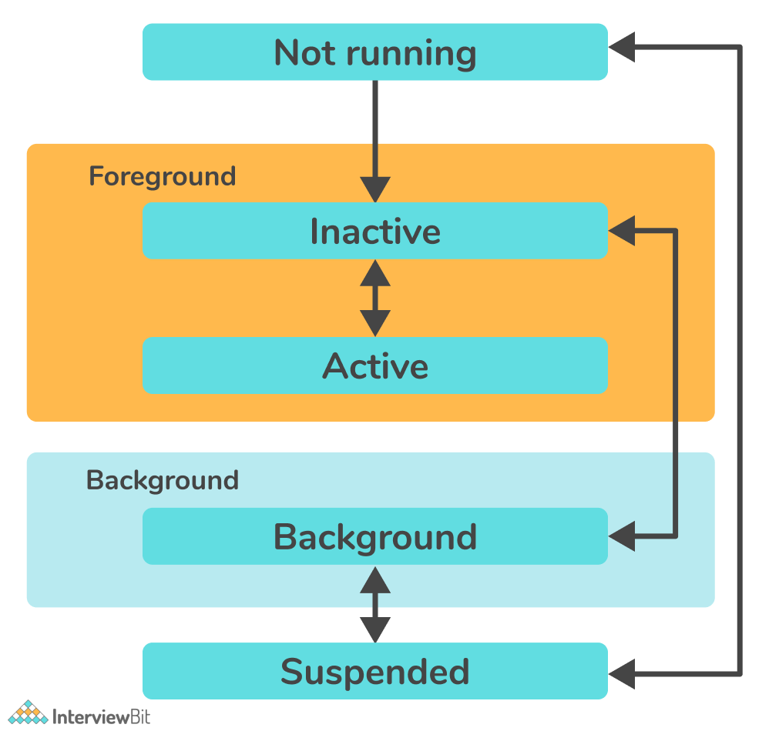
- Not running: In the Not Running state, an application has either not been launched or has been closed/shut down by the system.
- Inactive: A brief state of inactivity occurs while the app is leaving or entering its active state. Despite running in the foreground, it isn't yet ready to accept user input or events. This means that the application remains inactive at this time.
- Active: The Active state indicates that the app is running in the foreground and receiving events. This is usually the normal mode for foreground apps and the User Interface is accessible.
- Background: During this state, the application's user interface is hidden, but it continues to run in the background of the iOS system. Applications usually pass through this state prior to being suspended.
- Suspended: In this case, the application is in the background but is not running code. However, it stays in my memory. Under low memory conditions, the system can delete apps in the suspended state without warning.

5. What is an iOS developer and what are his responsibilities?
An iOS developer is a programmer or software engineer who designs and develops applications that run Apple's iOS on iOS devices. Ideally, the iOS developer should be skilled in two programming languages i.e., Objective-C and Swift.
Main Responsibilities of an iOS Developer
- Clean, efficient coding for iOS applications.
- Ensure clean and secure codes by performing troubleshooting and bug fixes for applications.
- The development and deployment of advanced app features as well as the maintenance and improvement of existing features.
- Develop innovative solutions to meet the business needs of customers.
- Assisting with all aspects of application development, including design, testing, release, and support.
- Exploring, evaluating, and implementing new technologies continuously to maximize development efficiency.

6. State the difference between Android and iOS.
Android: It is the mobile operating system for Android devices offered by Google LLC (limited liability company) and is focused on touchscreen mobile devices like smartphones and tablets. Several programming languages were used in its development, including C, Java, C++, and others.
iOS: It is the operating system for Apple devices offered by Apple incorporation and it is considered the second most popular mobile operating system globally after Android. It is primarily designed for Apple mobile devices like the iPhone, iPod Touch, etc. Several programming languages were used in its development, including Objective-C, Swift, C++, and others.
Difference between iOS and Android -
Android | iOS
It is the mobile operating system for Android devices offered by Google LLC (limited liability company). | It is the operating system for Apple devices offered by Apple incorporation.
It is specially designed for smartphones, tablets. | It is specially designed for Apple iPhones, iPods, and iPads.
It is mainly written in C, C++, Java and other languages. | It is mainly written in C, C++, Objective-C, Swift, and other languages.
On Android devices, Google Chrome is the default internet browser. However, any other browser can be installed. | Safari is the default Internet browser on iOS devices. However, any other browser can be installed.
The Android software is available for many manufacturers including Samsung, LG, etc., which could cause some quality issues in cheaper phones. | Apple has strict quality control over iOS and there are no quality problems.
Contrary to this, the performance of Android devices may deteriorate over time. | iOS devices run at a consistent speed over time.
In contrast, Android devices have open-source code, meaning that owners can alter their phones and tablets operating systems at their discretion. If owners tinker (change/modify) with their devices too much, they could weaken their devices' security. | iOS is a closed system. The source code of Apple's apps isn't available for developers, and iPhone and iPad owners can't modify the code on their devices. This makes iOS-powered devices harder to hack.

7. What do you mean by deep linking in iOS?
Deep links are links that send users directly to an app directly instead of a website or store using URI (Uniform resource locator) or universal links. The URL scheme is a well-known method of having deep links, but Universal Links are Apple's new approach to connecting your web page and your app under the same link. Deep linking involves not only creating a clickable link that opens up your app, but also a smart one that navigates to the resource you desire. Users are directed straight to in-app locations using these links, which saves them the time and effort of finding those pages themselves thus improving their user experience tremendously.
Explanation: If you use the URL fb://, you may open the Facebook app. However, if you use fb://profile/33138223345, you will open Wikipedia's profile in the Facebook app.
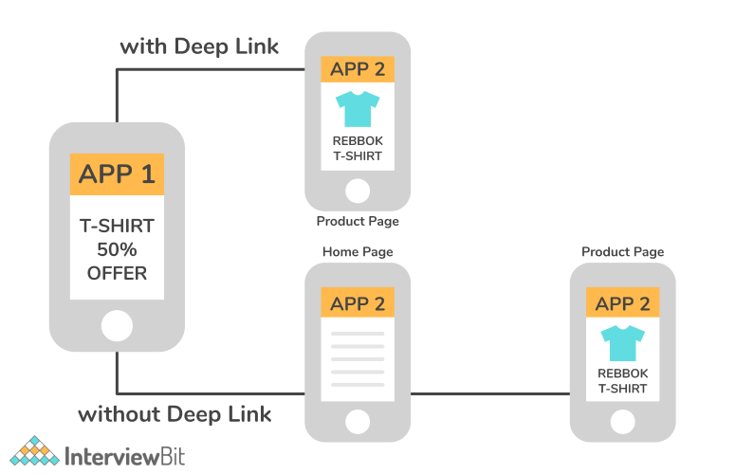

8. Explain what is GCD (Grand Central Dispatch) in iOS.
Grand Central Dispatch (GCD) is a low-level API that enables users to run concurrent tasks (occurring simultaneously) by managing threads in the background. Grand Central Dispatch is Apple's solution to build concurrency and parallelism into iOS applications, so multiple background tasks can be run concurrently in the background without affecting the main thread. It was introduced in iOS 4 to avoid the tedious process of serial execution of tasks.

9. What is ARC (Automatic Reference Counting)?
In the Swift programming language, automatic reference counting (ARC) is used to manage apps' memory usage. It initializes and deinitializes system resources, thereby releasing memory reserved by a class instance when it no longer needs it. ARC keeps track of how many properties, constants, and variables currently refer to each class instance. When there is at least one active reference to an instance, ARC will not deallocate that instance. The use of ARC concepts is an essential part of iOS development.
Functions of ARC -
- ARC creates a new class instance using init() and allocates a chunk of memory to store the information.
- Memory stores information about the instance type and its values.
- As soon as the class instance is no longer required, ARC automatically frees memory by calling deinit().
- By tracking current referring classes' properties, constants, and variables, ARC ensures that deinit() is only applied to those instances that are unused.

10. State the difference between Cocoa and Cocoa Touch.
Cocoa and Cocoa Touch are two of Apple's widely used application frameworks used for building applications. However, they differ in the following ways:
Cocoa | Cocoa Touch
It is an application framework for building applications that run on Mac OS X. | It is the application framework for building applications that run on devices like iPhones and iPad.
Frameworks such as Foundation and AppKit are incorporated into Cocoa. | Cocoa Touch is a combination of Frameworks such as Foundation and UIKit are incorporated into Cocoa Touch.
Cocoa classes use the NS (used for all classes and constants in the cocoa framework) prefix (like NSTextField, NSWindow). | Cocoa Touch classes, on the other hand, use the UI (used for all classes and constants in the cocoa touch framework) prefix (like UITextField and UIWindow).

11. Which programming languages are used for iOS development?
iOS development is done using the following programming languages:
- HTML5
- .NET
- C
- C++
- Swift
- Javascript
- Objective-C.

12. What is the framework that is utilized to build an application's interface for iOS?
Contrary to the Foundation framework that defines classes, protocols, and functions for both iOS and OS X development, UIKit is specifically designed for iOS development. In iOS, the user interface and graphical infrastructure of the application are developed using UIKit. It includes:
- Event handling (handle different gestures like input gestures, button-tap gestures, multi-touch gestures, etc.)
- App structure (Manages the interaction between the system and user)
- User Interface (Provides user interactions, the ability to share text and content, select images, edit videos, print files, etc.)
- Graphic, Drawing, and Printing

13. Write different ways to achieve concurrency in iOS?
Concurrency means "running multiple tasks simultaneously". Concurrency allows iOS devices to handle background tasks (such as downloading or processing data) while maintaining a responsive user interface. In iOS, you can manage concurrent tasks using Grand Central Dispatch (or GCD), and Operations (formally known as NSOperation). In order to achieve concurrency, iOS provides three ways as follows:
- Dispatch queues: They are used to manage tasks in first-in-first-out (FIFO) order and execute tasks sequentially or concurrently. This is an easy way to handle asynchronous (not occurring at the same time) and concurrent tasks in your application.
- Threads: An independent sequence of instructions can be executed separately from other code within a program. Through threads, one can execute multiple code paths simultaneously in a single application. Having a thread is especially useful when you need to perform a lengthy task without affecting the execution of the rest of the program.
- Operation Queues: Operation queue objects are invoked in accordance with their priority and readiness. Essentially, operation queues are high-level abstractions of queueing models, built on top of GCD (Grand Central Dispatch). It is possible, therefore, to execute tasks concurrently, just like GCD, but in an object-oriented manner.

14. State the difference between App ID and Bundle ID?
- Bundle ID: They are the unique identifiers of applications in Apple's ecosystem. In other words, no two applications can have the same identifier. The bundling ID is used for both OS X and iOS apps and can be used to recognize app updates.
  - Example:
If our organization’s domain is scaler.com and we create an app named Edge, you could assign the string com.scaler.edge as our app’s bundle ID.
- App ID: This string uniquely identifies one or more apps from the same development team. There are two components to the string, the Team ID and the Bundle ID, separated by a period (.). Apple supplies a Team ID to identify a specific development team, whereas developers supply Bundle IDs to identify a single app or a collection of apps.
  - Example:
ABCDE12345.com.scaler.edge
In the above example, ABCDE12345 is the Team ID and com.scaler.edge is the Bundle ID.

15. What do you mean by the SpriteKit and SceneKit framework in the context of game development?
SpriteKit: This framework is designed to make it easier and faster for game developers to create animated 2D assets/objects in casual games. With it, you can draw shapes, particles, text, images, and videos in two dimensions.
SceneKit: It is an iOS framework inherited from OS X, which helps to create 3D graphics. With SceneKit, you can build 3D animated scenes and effects for your iOS games and apps.

16. Write the difference between assign and retain keywords.
- Assign: With Assign, a reference is created from one object to another without increasing the source's retain count (a number that keeps track of how many objects are “holding onto" another object). It does not copy or retain the value but assigns it directly to the instance variable.
Example:
if (object != object)
{
[object release];
object = nil;
object = object;
}
Here, Assign will generate a setter that assigns the value to the instance variable directly, rather than copying or retaining it.
- Retain: Using this method, you create a reference from one object to another and increase the retain count of the source object.
Example:
if (object != object)
{
[object release];
object = nil;
object = [object retain];
}
A retain message prevents an object from being deallocated until you are done using it.

iOS Interview Questions for Experienced

17. Explain Objective-C in OS.
Since the 1990s, Objective-C has been used by Apple as an object-oriented programming language. This language combines the advantages of two earlier languages - C and Smalltalk. As a superset of C, it provides object-oriented functionality and a dynamic runtime environment.
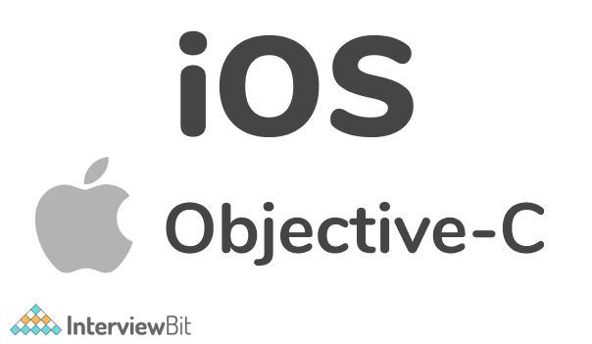
Features:
- In Objective C, meta classes are automatically created and managed during runtime.
- Dynamic typing and static typing are both supported.
- It is easy to understand.

18. Name the most important data types in Objective-C?
Following are data types that the developers mostly use in Objective – C:
- BOOL: Represents a Boolean value that is either true or false. Both the _Bool or BOOL keywords is valid.
  - Example:
_Bool flag = 0;
BOOL secondflag = 1;
- NSInteger: Represents an Integer.
  - Example:
typedef long NSInteger;
typedef int NSInteger;
- NSUInteger: Represents an unsigned integer.
  - Example:
typedef unsigned long NSUInteger;
typedef unsigned int NSUInteger;
- NSString: Represents a string.
  - Example:
NSString *greeting = @"Hello";

19. Explain Swift in iOS?
Swift is the fastest-growing programming language today, created by Apple. With a significant advantage pool over the well-known Objective-C, Swift holds a leading position in iOS development. It's an entirely new language created specifically to develop software for Apple's operating systems. Since Swift implements all the features of other modern languages, you can find type inference, optional, generics, and such higher-order functions. It is compatible with macOS, iOS, watchOS, and tvOS.
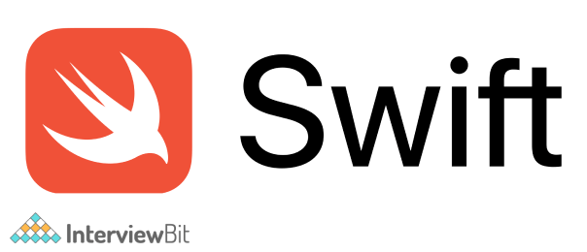

20. What are the important features of Swift?
Swift programming language is being designed so that developers can write correct programs and maintain them easily. It offers the following features:
- Safety: Swift is an efficient way to write programs. Checking code before it is used in production is very important. Apple Swift removes any unsafe code before it is used in production.
- Simple syntax: Swift's syntax is simple and easy-to-use, just as developers would expect it. The syntax features of Swift enable you to write more expressive code.
- Readability: Swift has a simple syntax, which is easier to read and write. It is easier for developers to write Swift code since it is more similar to plain English, enabling them to spend less time looking for problematic code.
- Multiplatform support: Swift is fully compatible with iOS, macOS, tvOS, watchOS, Linux, and many other platforms. This means you are able to develop software that is compatible with all operating systems.
- Open-source: Swift is developed at swift.org, an open-source framework. For Swift to become a defining programming language, the technology had to be open to all. Swift supports all Apple platforms and makes programming easier, faster, and safer.
- Compatible with Objective C: Swift has full compatibility with Objective-C. Swift enables programmers to import frameworks from Objective-C using the Swift syntax. Programmers can utilize Objective-C libraries and classes inside Swift code.

21. Explain NSError in Swift.
Information about an error condition is encapsulated within an NSError object in an extendable and object-oriented manner. An NSError object is comprised of three basic attributes: a predefined error domain (represented as a string), a domain-specific error code, and a user info dictionary containing application-specific information.
Example: The examples below show how to create custom errors.
NSString *domain = @"com.MyCompany.MyApplication.ErrorDomain";
NSString *desc = NSLocalizedString(@"Unable to complete the process", @"");
NSDictionary *userInfo = @{ NSLocalizedDescriptionKey : desc };
NSError *error = [NSError errorWithDomain:domain code:-101 userInfo:userInfo];

22. What is Enum or Enumerations in Swift?
The term enumeration refers to a user-defined data type consisting of a set of related values that allows you to work with those values in your code in a type-safe manner. An enumerated data type is defined by the keyword enum.
Syntax:
enum enum_name
{
// enumeration values are described here
}
Example:
enum MonthsofaYear
{
case January
case Februrary
…
case December
}
Values defined in an enumeration MonthsofaYear such as January, February, and so on until December are its enumeration cases. New enumeration cases can be introduced using the case keyword. You can put multiple cases on a single line, separated by commas as follows:
enum MonthsofaYear
{
case January, February,....,December
}

23. What do you mean by lazy property in iOS?
Lazy properties are properties whose initial value isn't computed until the first time they are used. Including the lazy modifier/keyword before the declaration of a stored property indicates it is lazy. This lets you delay the initialization of stored properties. This could be a great way to streamline your code and reduce unnecessary work. When a code is expensive and unlikely to be called consistently, a lazy variable can be a great solution.
Example:
class Person {
var name: String
lazy var personalizdgreeting : String = {
return “HelloScala \(self.name)!”
}()
init(name: String) {
self.name = name
}
}
As shown above, we aren't sure what value personalizedgreeting should have. To know the correct greeting for this person, we need to wait until this object is initialized.

24. What are generics in swift and write its usage?
A major feature of Swift is generics, and much of the Swift standard library is written in generic code. Swift's 'Array' and 'Dictionary' types, for example, constitute generic collections. Generic code allows you to create flexible, reusable functions and types that work with any data type. You can create code that does not get too specific about underlying data types, resulting in cleaner code.
Example:
func Swapping(x: inout Int, y: inout Int)
{
let temp = x
x = y
y = temp
}
var num1 = 10
var num2 = 50
print("Before Swapping: \(num1) and \(num2)")
Swapping(x: &num1, y: &num2)
print("After Swapping: \(num1) and \(num2)")
Output:
Before Swapping: 10 and 50
After Swapping: 50 and 10
In the above example, we have defined a function called Swapping() to swap integers. It takes two parameters x and y of int type. As seen in the output, the values of x and y are exchanged after the swapping.

25. Explain dictionary in Swift.
Swift programming defines a dictionary as an unordered collection of items. It stores items in key-value pairs. A dictionary uses a unique identifier called a key to store an associated value which can later be referenced and retrieved through the same key.
Syntax:
var Dict_name = [KeyType: ValueType]()
Example:
var examresult= ["Rahul": "79", "Aditya": "86", "Aditi": "67"]
print(examresult)
Output:
["Rahul": "79", "Aditya": "86", "Aditi": "67"]
In the above example, we have created a dictionary named examresult. Here,
- Keys are "Rahul", "Aditya", "Aditi"
- Values are "79", "86", "67"

26. Why design patterns are important? Name some of the popular design patterns used in iOS?
A design pattern is a solution to a specific problem you might encounter while designing an app's architecture. They are templates designed to make coding easier and more reusable for you. Following are some of the design patterns that can be used in iOS:
MVC (Model-View-Controller): MVC is a design pattern for developing web applications in which three components are connected i.e., view, controller, and model. Views can be conceived as the user interface shown to the end-user at a certain point in time. The model represents the data to be shown on the view. The controller acts as a link between view and model. There is always a relationship between these three components.
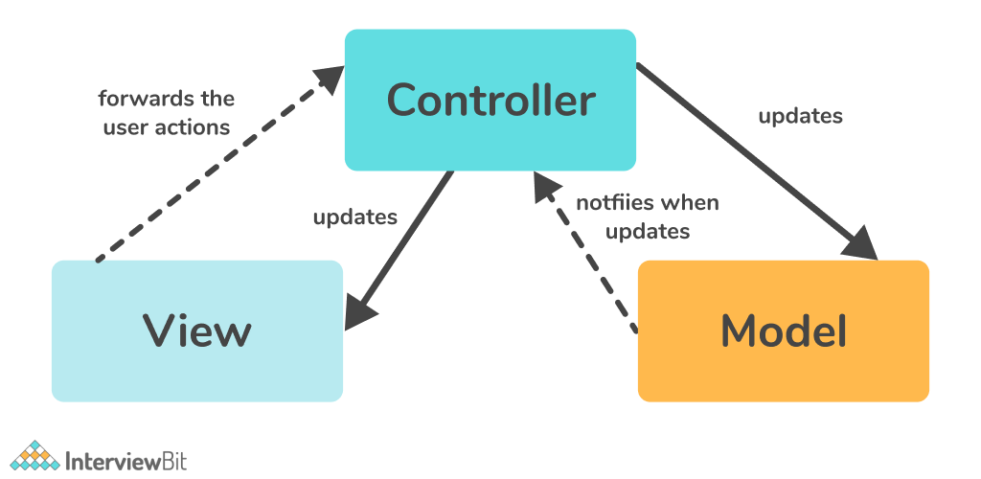
MVVM (Model-View-View Model): Unlike MVM, there is a special layer in MVVM called the View Model between the View and the Model. Using a view model, model information can be transformed into values that can be displayed on the view. There is a binding link between the view and View model that allows the view model to share updates with the view.
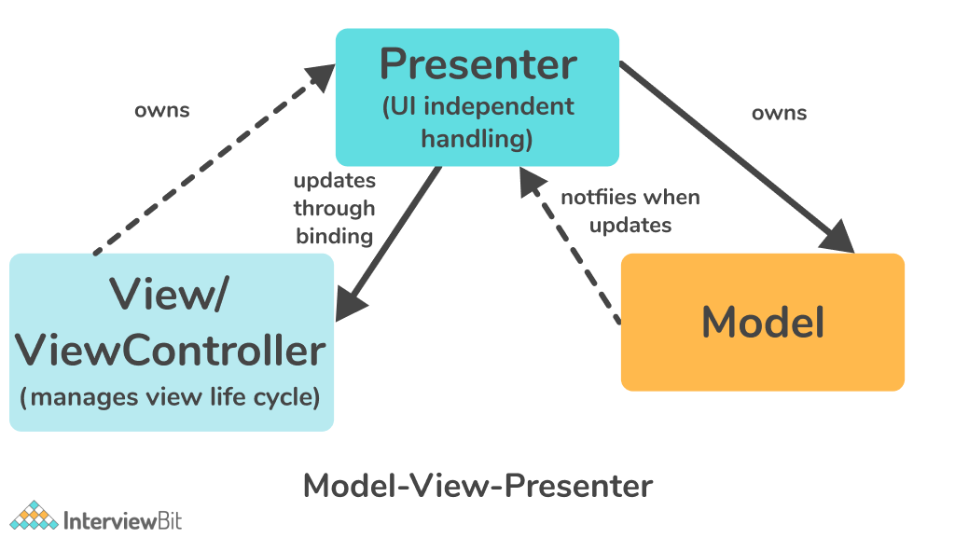
Facade: The facade design pattern provides a simplified (but limited) interface to a complex set of classes, libraries or frameworks. As opposed to providing the user with a set of classes and their APIs, you instead provide a simple, unified API. While Facade helps to reduce overall application complexity, it also helps to move unwanted dependencies to a single location.
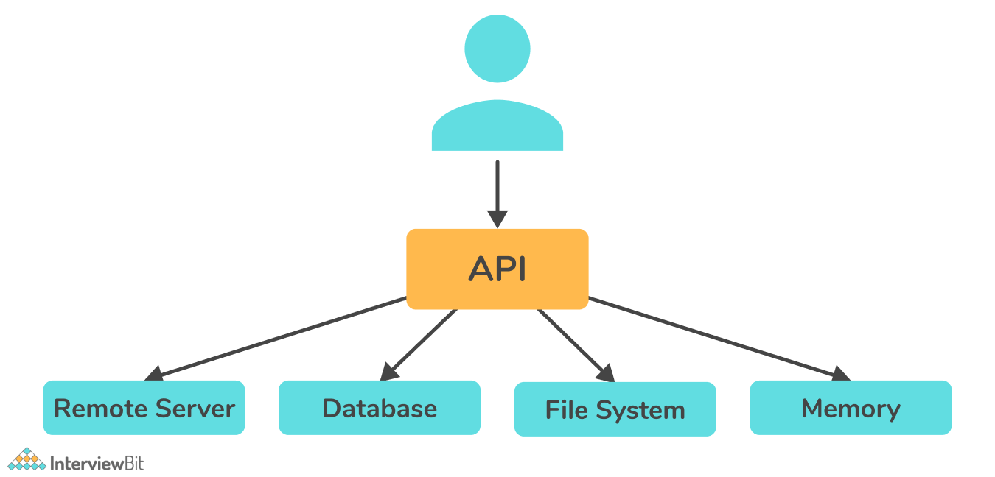

27. What is the JSON framework supported by iOS?
iOS supports the SBJson framework as the JSON framework. Humans and computers alike can easily read and write this lightweight data exchange formatter. JSON handling is simplified with SBJson's flexible APIs and additional control.

28. Explain iBeacons in iOS.
iBeacon, Apple's new low-energy Bluetooth wireless technology, allows iPhone and other iOS users to receive location-based information and services on smartphones. IBeacons are small, wireless transmitters that transmit signals to nearby smart devices via Bluetooth low energy technology.
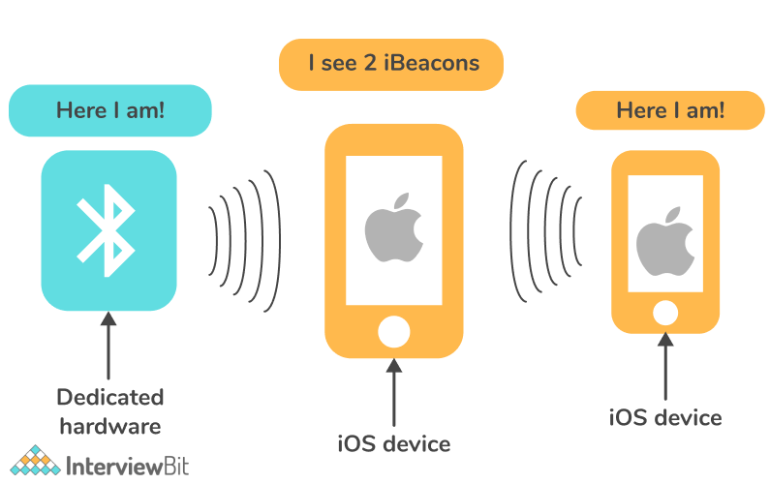

29. State the difference between KVC and KVO in Swift.
KVC (Key-Value Coding): It enables object properties to be accessed at runtime using strings rather than knowing the property names statically during development.
KVO (Key-Value Observing): In Objective-C and Swift, KVO is one of the methods for observing program state changes. If an object has instance variables, KVO enables other objects to observe the changes to those variables.

30. Explain TDD (Test-Driven Development).
Software developers can use testing-driven development (TDD) in the development of software. In TDD, developers plan the features of the software that they want to create and then write test cases for each feature before implementing it. Through test-driven development, we can gain insight into both the quality of the implementation (does it work) and the quality of the design (is it well structured).
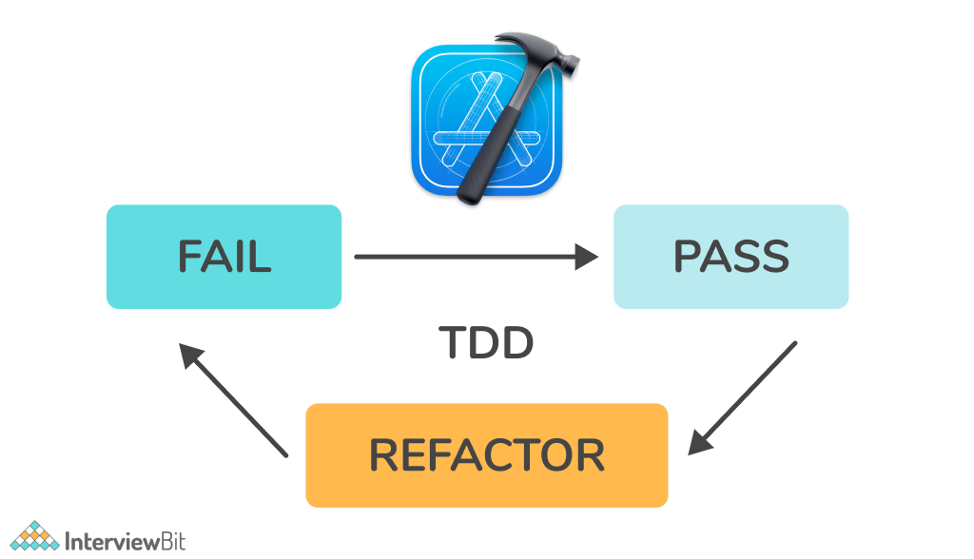
At first, the test case will fail because the code is not yet implemented, and this is usually referred to as the red phase. After that, code is written to ensure that the test case passes and does not break any components or current test cases, which is called the green phase. The developer should then refactor the implementation of the code by cleaning and maintaining the codebase, as well as optimizing the efficiency. This process should then be repeated every time a new test case is added.

31. Explain the function of the completion handler.
Completion handlers are basically just functions passed as parameters to other functions. They are used to dealing with the response of asynchronous tasks since we do not know when they will end. Completion handlers inform an application when an operation, such as an API call, has been completed. The program is informed that the next step needs to be executed.
Example:
Let's create a simple class called CompletionHandler that has one method called count that counts from 0 to 50. Once it reaches 25 (a random value), it will make a network request to https://scaler.com. Once the request has been completed, we will print Received response.
class CompletionHandler {
func count() {
for i in 0...50 {
if i == 25 {
if let url = URL(string: "https://scaler.com") {
URLSession.shared.dataTask(with: url) { (data, response, error) in
print("Received response")
}.resume()
}
}
print("I = ", i)
}
}
}
let newInstance = CompletionHandler()
newInstance.count()
You will see all the numbers printed out in the console as soon as the code runs, but the Received response will be printed only after all those other numbers have been printed.

32. State the difference between strong, weak, read only and copy.
The difference between strong, weak, read-only and copy is as follows:
- Strong: This property maintains a reference to property throughout the lifetime of an object. When you declare strong, you intend to "own" the object you are referencing. Data you assign to this property will not be destroyed as long as you or any other object references it strongly.
- Weak: It means that the object should be kept in memory as long as someone points to it strongly, and you don't need control over its lifetime.
- Read-only: An object's property can be defined initially, but it cannot be altered or modified.
- Copy: This attribute is an alternative to strong. In place of taking ownership of a current object, it creates a copy of whatever you assign to the property, then takes ownership of that copy.

33. What do you mean by dynamic dispatch?
In simple terms, dynamic dispatch means that the program decides at runtime which implementation of a particular method or function it needs to invoke. In the case where a subclass overrides a method of its superclass, dynamic dispatch determines whether to invoke the subclass implementation of the method or the parents.

34. Explain the @dynamic and @synthesize commands in Objective-C.
- @synthesize: This command generates getter and setter methods within the property and works in conjunction with the @dynamic command. By default, @synthesize creates a variable with the same name as the target of set/get as shown in the below example.
  - Example1:
@property (nonatomic, retain) NSButton *someButton;
...
@synthesize someButton;
It is also possible to specify a member variable as its set / get target as shown below:
  - Example2:
@property (nonatomic, retain) NSButton *someButton;
...
@synthesize someButton= _homeButton;
Here, the set / get method points to the member variable _homeButton.
- @dynamic: This tells the compiler that the getter and setter methods are not implemented within the class itself, but elsewhere (like the superclass or that they will be available at runtime).
  - Example:
@property (nonatomic, retain) IBOutlet NSButton *someButton;
...
@dynamic someButton;

35. How can you implement storage and persistence in iOS?
Persistence means storing data on the disk so that it can be retrieved without being altered the next time the app is opened. From simple to complex, there are the following methods for storing data:
- Data structures such as arrays, dictionaries, sets, and other data structures are perfect for storing data intermediately.
- NSUserDefaults and Keychains are both simple key-value stores. NSUserDefaults is insecure, whereas Keychains is secure.
- A file or disk storage is a way to store data (serialized or not) to or from a disk using NSFileManager.
- Relational databases, such as SQLite, are good for implementing complex querying mechanisms.

36. What are synchronous and asynchronous tasks in iOS? In what way can you execute asynchronous tasks in iOS?
Apple's iOS supports both synchronous and asynchronous tasks. In synchronous operations, tasks are performed one at a time. Therefore, other tasks must wait until the previous task is completed before continuing. Asynchronous tasks run simultaneously in the background. If background tasks are completed, you will be notified. Asynchronous programming allows you to process multiple requests at the same time, so you can accomplish more tasks in a shorter amount of time.
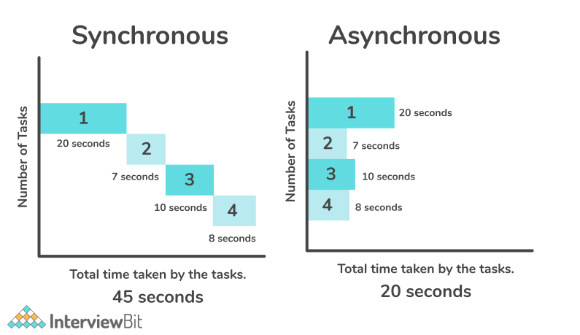
The figure clearly indicates that synchronous tasks take more time to complete, i.e. 45 seconds since each task is performed one at a time. Asynchronous tasks, on the other hand, take less time to complete i.e. 20 seconds as they run simultaneously.
Async work can be handled using third-party libraries. A few notable examples are Promises (PromiseKit), RxSwift, and ReactiveCocoa.
Here are Android interview questions and answers for fresher as well as experienced candidates to get their dream job.

1) What is Android?
It is an open-sourced operating system that is used primarily on mobile devices, such as cell phones and tablets. It is a Linux kernel-based system that’s been equipped with rich components that allows developers to create and run apps that can perform both basic and advanced functions.

2) What Is the Google Android SDK?
The Google Android SDK is a toolset that developers need in order to write apps on Android enabled devices. It contains a graphical interface that emulates an Android driven handheld environment, allowing them to test and debug their codes.


3) What is the Android Architecture?
Android Architecture is made up of 4 key components:
- Linux Kernel
- Libraries
- Android Framework
- Android Applications

4) Describe the Android Framework.
The Android Framework is an important aspect of the Android Architecture. Here you can find all the classes and methods that developers would need in order to write applications on the Android environment.

5) What is AAPT?
AAPT is short for Android Asset Packaging Tool. This tool provides developers with the ability to deal with zip-compatible archives, which includes creating, extracting as well as viewing its contents.

6) What is the importance of having an emulator within the Android environment?
The emulator lets developers “play” around an interface that acts as if it were an actual mobile device. They can write and test codes, and even debug. Emulators are a safe place for testing codes especially if it is in the early design phase.

7) What is the use of an activityCreator?
An activityCreator is the first step towards the creation of a new Android project. It is made up of a shell script that will be used to create new file system structure necessary for writing codes within the Android IDE.

8) Describe Activities.
Activities are what you refer to as the window to a user interface. Just as you create windows in order to display output or to ask for an input in the form of dialog boxes, activities play the same role, though it may not always be in the form of a user interface.

9) What are Intents?
Intents displays notification messages to the user from within the Android enabled device. It can be used to alert the user of a particular state that occurred. Users can be made to respond to intents.

10) Differentiate Activities from Services.
Activities can be closed, or terminated anytime the user wishes. On the other hand, services are designed to run behind the scenes, and can act independently. Most services run continuously, regardless of whether there are certain or no activities being executed.

11) What items are important in every Android project?
These are the essential items that are present each time an Android project is created:
- AndroidManifest.xml
- build.xml
- bin/
- src/
- res/
- assets/

12) What is the importance of XML-based layouts?
The use of XML-based layouts provides a consistent and somewhat standard means of setting GUI definition format. In common practice, layout details are placed in XML files while other items are placed in source files.

13) What are containers?
Containers, as the name itself implies, holds objects and widgets together, depending on which specific items are needed and in what particular arrangement that is wanted. Containers may hold labels, fields, buttons, or even child containers, as examples.

14) What is Orientation?
Orientation, which can be set using setOrientation(), dictates if the LinearLayout is represented as a row or as a column. Values are set as either HORIZONTAL or VERTICAL.

15) What is the importance of Android in the mobile market?
Developers can write and register apps that will specifically run under the Android environment. This means that every mobile device that is Android enabled will be able to support and run these apps. With the growing popularity of Android mobile devices, developers can take advantage of this trend by creating and uploading their apps on the Android Market for distribution to anyone who wants to download it.

16) What do you think are some disadvantages of Android?
Given that Android is an open-source platform, and the fact that different Android operating systems have been released on different mobile devices, there’s no clear cut policy to how applications can adapt with various OS versions and upgrades. One app that runs on this particular version of Android OS may or may not run on another version. Another disadvantage is that since mobile devices such as phones and tabs come in different sizes and forms, it poses a challenge for developers to create apps that can adjust correctly to the right screen size and other varying features and specs.

17) What is adb?
Adb is short for Android Debug Bridge. It allows developers the power to execute remote shell commands. Its basic function is to allow and control communication towards and from the emulator port.

18) What are the four essential states of an activity?
- Active – if the activity is at the foreground
- Paused – if the activity is at the background and still visible
- Stopped – if the activity is not visible and therefore is hidden or obscured by another activity
- Destroyed – when the activity process is killed or completed terminated

19) What is ANR?
ANR is short for Application Not Responding. This is actually a dialog that appears to the user whenever an application have been unresponsive for a long period of time.

20) Which elements can occur only once and must be present?
Among the different elements, the “and” elements must be present and can occur only once. The rest are optional, which can occur as many times as needed.

21) How are escape characters used as attribute?
Escape characters are preceded by double backslashes. For example, a newline character is created using ‘\\n’

22) What is the importance of settings permissions in app development?
Permissions allow certain restrictions to be imposed primarily to protect data and code. Without these, codes could be compromised, resulting to defects in functionality.

23) What is the function of an intent filter?
Because every component needs to indicate which intents they can respond to, intent filters are used to filter out intents that these components are willing to receive. One or more intent filters are possible, depending on the services and activities that is going to make use of it.

24) Enumerate the three key loops when monitoring an activity
- Entire lifetime – activity happens between onCreate and onDestroy
- Visible lifetime – activity happens between onStart and onStop
- Foreground lifetime – activity happens between onResume and onPause

25) When is the onStop() method invoked?
A call to onStop method happens when an activity is no longer visible to the user, either because another activity has taken over or if in front of that activity.

26) Is there a case wherein other qualifiers in multiple resources take precedence over locale?
Yes, there are actually instances wherein some qualifiers can take precedence over locale. There are two known exceptions, which are the MCC (mobile country code) and MNC (mobile network code) qualifiers.

27) What are the different states wherein a process is based?
There are 4 possible states:
- foreground activity
- visible activity
- background activity
- empty process

28) How can the ANR be prevented?
One technique that prevents the Android system from concluding a code that has been responsive for a long period of time is to create a child thread. Within the child thread, most of the actual workings of the codes can be placed, so that the main thread runs with minimal periods of unresponsive times.

29) What role does Dalvik play in Android development?
Dalvik serves as a virtual machine, and it is where every Android application runs. Through Dalvik, a device is able to execute multiple virtual machines efficiently through better memory management.

30) What is the AndroidManifest.xml?
This file is essential in every application. It is declared in the root directory and contains information about the application that the Android system must know before the codes can be executed.

31) What is the proper way of setting up an Android-powered device for app development?
The following are steps to be followed prior to actual application development in an Android-powered device:
-Declare your application as “debuggable” in your Android Manifest.
-Turn on “USB Debugging” on your device.
-Set up your system to detect your device.

32) Enumerate the steps in creating a bounded service through AIDL.
1. create the .aidl file, which defines the programming interface
2. implement the interface, which involves extending the inner abstract Stub class as well as implanting its methods.
3. expose the interface, which involves implementing the service to the clients.

33) What is the importance of Default Resources?
When default resources, which contain default strings and files, are not present, an error will occur and the app will not run. Resources are placed in specially named subdirectories under the project res/ directory.

34) When dealing with multiple resources, which one takes precedence?
Assuming that all of these multiple resources are able to match the configuration of a device, the ‘locale’ qualifier almost always takes the highest precedence over the others.

35) When does ANR occur?
The ANR dialog is displayed to the user based on two possible conditions. One is when there is no response to an input event within 5 seconds, and the other is when a broadcast receiver is not done executing within 10 seconds.

36) What is AIDL?
AIDL, or Android Interface Definition Language, handles the interface requirements between a client and a service so both can communicate at the same level through interprocess communication or IPC. This process involves breaking down objects into primitives that Android can understand. This part is required simply because a process cannot access the memory of the other process.

37) What data types are supported by AIDL?
AIDL has support for the following data types:
-string
-charSequence
-List
-Map
-all native Java data types like int,long, char and Boolean

38) What is a Fragment?
A fragment is a part or portion of an activity. It is modular in a sense that you can move around or combine with other fragments in a single activity. Fragments are also reusable.

39) What is a visible activity?
A visible activity is one that sits behind a foreground dialog. It is actually visible to the user, but not necessarily being in the foreground itself.

40) When is the best time to kill a foreground activity?
The foreground activity, being the most important among the other states, is only killed or terminated as a last resort, especially if it is already consuming too much memory. When a memory paging state has been reach by a foreground activity, then it is killed so that the user interface can retain its responsiveness to the user.

41) Is it possible to use or add a fragment without using a user interface?
Yes, it is possible to do that, such as when you want to create a background behavior for a particular activity. You can do this by using add(Fragment,string) method to add a fragment from the activity.

42) How do you remove icons and widgets from the main screen of the Android device?
To remove an icon or shortcut, press and hold that icon. You then drag it downwards to the lower part of the screen where a remove button appears.

43) What are the core components under the Android application architecture?
There are 5 key components under the Android application architecture:
– services
– intent
– resource externalization
– notifications
– content providers

44) What composes a typical Android application project?
A project under Android development, upon compilation, becomes an .apk file. This apk file format is actually made up of the AndroidManifest.xml file, application code, resource files, and other related files.

45) What is a Sticky Intent?
A Sticky Intent is a broadcast from sendStickyBroadcast() method such that the intent floats around even after the broadcast, allowing others to collect data from it.

46) Do all mobile phones support the latest Android operating system?
Some Android-powered phone allows you to upgrade to the higher Android operating system version. However, not all upgrades would allow you to get the latest version. It depends largely on the capability and specs of the phone, whether it can support the newer features available under the latest Android version.

47) What is portable wi-fi hotspot?
Portable Wi-Fi Hotspot allows you to share your mobile internet connection to other wireless device. For example, using your Android-powered phone as a Wi-Fi Hotspot, you can use your laptop to connect to the Internet using that access point.

48) What is an action?
In Android development, an action is what the intent sender wants to do or expected to get as a response. Most application functionality is based on the intended action.

49) What is the difference between a regular bitmap and a nine-patch image?
In general, a Nine-patch image allows resizing that can be used as background or other image size requirements for the target device. The Nine-patch refers to the way you can resize the image: 4 corners that are unscaled, 4 edges that are scaled in 1 axis, and the middle one that can be scaled into both axes.

50) What language is supported by Android for application development?
The main language supported is Java programming language. Java is the most popular language for app development, which makes it ideal even for new Android developers to quickly learn to create and deploy applications in the Android environment.

