1. What is Database?
A database is an organized collection of data, stored and retrieved digitally from a remote or local computer system. Databases can be vast and complex, and such databases are developed using fixed design and modeling approaches.

2. What is DBMS?
DBMS stands for Database Management System. DBMS is a system software responsible for the creation, retrieval, updation, and management of the database. It ensures that our data is consistent, organized, and is easily accessible by serving as an interface between the database and its end-users or application software.

3. What is RDBMS? How is it different from DBMS?
RDBMS stands for Relational Database Management System. The key difference here, compared to DBMS, is that RDBMS stores data in the form of a collection of tables, and relations can be defined between the common fields of these tables. Most modern database management systems like MySQL, Microsoft SQL Server, Oracle, IBM DB2, and Amazon Redshift are based on RDBMS.
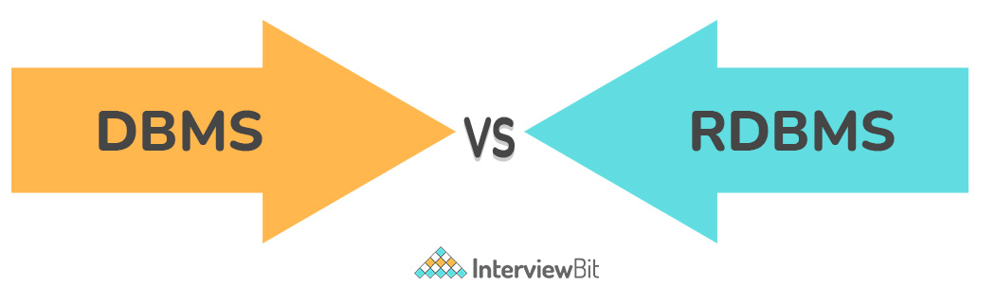
You can download a PDF version of Sql Interview Questions.
Download PDF

4. What is SQL?
SQL stands for Structured Query Language. It is the standard language for relational database management systems. It is especially useful in handling organized data comprised of entities (variables) and relations between different entities of the data.

5. What is the difference between SQL and MySQL?
SQL is a standard language for retrieving and manipulating structured databases. On the contrary, MySQL is a relational database management system, like SQL Server, Oracle or IBM DB2, that is used to manage SQL databases.
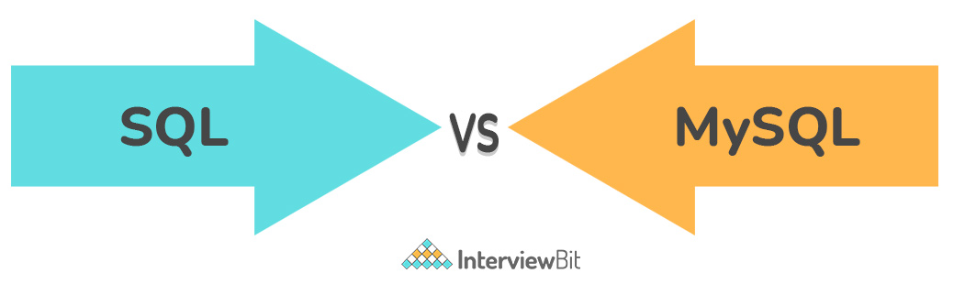

6. What are Tables and Fields?
A table is an organized collection of data stored in the form of rows and columns. Columns can be categorized as vertical and rows as horizontal. The columns in a table are called fields while the rows can be referred to as records.

7. What are Constraints in SQL?
Constraints are used to specify the rules concerning data in the table. It can be applied for single or multiple fields in an SQL table during the creation of the table or after creating using the ALTER TABLE command. The constraints are:
- NOT NULL - Restricts NULL value from being inserted into a column.
- CHECK - Verifies that all values in a field satisfy a condition.
- DEFAULT - Automatically assigns a default value if no value has been specified for the field.
- UNIQUE - Ensures unique values to be inserted into the field.
- INDEX - Indexes a field providing faster retrieval of records.
- PRIMARY KEY - Uniquely identifies each record in a table.
- FOREIGN KEY - Ensures referential integrity for a record in another table.

8. What is a Primary Key?
The PRIMARY KEY constraint uniquely identifies each row in a table. It must contain UNIQUE values and has an implicit NOT NULL constraint.
A table in SQL is strictly restricted to have one and only one primary key, which is comprised of single or multiple fields (columns).
CREATE TABLE Students ( /* Create table with a single field as primary key */
ID INT NOT NULL
Name VARCHAR(255)
PRIMARY KEY (ID)
);
CREATE TABLE Students ( /* Create table with multiple fields as primary key */
ID INT NOT NULL
LastName VARCHAR(255)
FirstName VARCHAR(255) NOT NULL,
CONSTRAINT PK_Student
PRIMARY KEY (ID, FirstName)
);
ALTER TABLE Students /* Set a column as primary key */ADD PRIMARY KEY (ID);ALTER TABLE Students /* Set multiple columns as primary key */ADD CONSTRAINT PK_Student /*Naming a Primary Key*/PRIMARY KEY (ID, FirstName);

write a sql statement to add primary key 't_id' to the table 'teachers'.

Write a SQL statement to add primary key constraint 'pk_a' for table 'table_a' and fields 'col_b, col_c'.

9. What is a UNIQUE constraint?
A UNIQUE constraint ensures that all values in a column are different. This provides uniqueness for the column(s) and helps identify each row uniquely. Unlike primary key, there can be multiple unique constraints defined per table. The code syntax for UNIQUE is quite similar to that of PRIMARY KEY and can be used interchangeably.
CREATE TABLE Students ( /* Create table with a single field as unique */
ID INT NOT NULL UNIQUE
Name VARCHAR(255)
);
CREATE TABLE Students ( /* Create table with multiple fields as unique */
ID INT NOT NULL
LastName VARCHAR(255)
FirstName VARCHAR(255) NOT NULL
CONSTRAINT PK_Student
UNIQUE (ID, FirstName)
);
ALTER TABLE Students /* Set a column as unique */ADD UNIQUE (ID);ALTER TABLE Students /* Set multiple columns as unique */ADD CONSTRAINT PK_Student /* Naming a unique constraint */UNIQUE (ID, FirstName);

10. What is a Foreign Key?
A FOREIGN KEY comprises of single or collection of fields in a table that essentially refers to the PRIMARY KEY in another table. Foreign key constraint ensures referential integrity in the relation between two tables.
The table with the foreign key constraint is labeled as the child table, and the table containing the candidate key is labeled as the referenced or parent table.
CREATE TABLE Students ( /* Create table with foreign key - Way 1 */
ID INT NOT NULL
Name VARCHAR(255)
LibraryID INT
PRIMARY KEY (ID)
FOREIGN KEY (Library_ID) REFERENCES Library(LibraryID)
);
CREATE TABLE Students ( /* Create table with foreign key - Way 2 */
ID INT NOT NULL PRIMARY KEY
Name VARCHAR(255)
LibraryID INT FOREIGN KEY (Library_ID) REFERENCES Library(LibraryID)
);
ALTER TABLE Students /* Add a new foreign key */ADD FOREIGN KEY (LibraryID)REFERENCES Library (LibraryID);

What type of integrity constraint does the foreign key ensure?

Write a SQL statement to add a FOREIGN KEY 'col_fk' in 'table_y' that references 'col_pk' in 'table_x'.

11. What is a Join? List its different types.
The SQL Join clause is used to combine records (rows) from two or more tables in a SQL database based on a related column between the two.
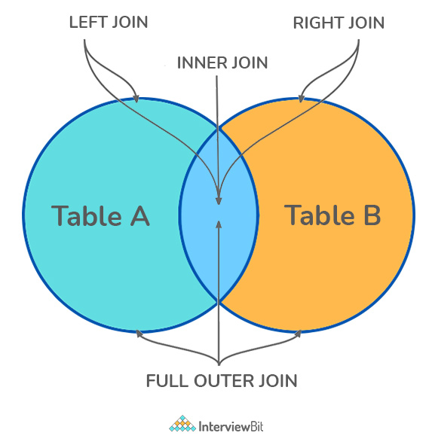
There are four different types of JOINs in SQL:
- (INNER) JOIN: Retrieves records that have matching values in both tables involved in the join. This is the widely used join for queries.
SELECT *FROM Table_AJOIN Table_B;SELECT *FROM Table_AINNER JOIN Table_B;
- LEFT (OUTER) JOIN: Retrieves all the records/rows from the left and the matched records/rows from the right table.
SELECT *FROM Table_A ALEFT JOIN Table_B BON A.col = B.col;
- RIGHT (OUTER) JOIN: Retrieves all the records/rows from the right and the matched records/rows from the left table.
SELECT *FROM Table_A ARIGHT JOIN Table_B BON A.col = B.col;
- FULL (OUTER) JOIN: Retrieves all the records where there is a match in either the left or right table.
SELECT *FROM Table_A AFULL JOIN Table_B BON A.col = B.col;

12. What is a Self-Join?
A self JOIN is a case of regular join where a table is joined to itself based on some relation between its own column(s). Self-join uses the INNER JOIN or LEFT JOIN clause and a table alias is used to assign different names to the table within the query.
SELECT A.emp_id AS "Emp_ID",A.emp_name AS "Employee",
B.emp_id AS "Sup_ID",B.emp_name AS "Supervisor"FROM employee A, employee BWHERE A.emp_sup = B.emp_id;

13. What is a Cross-Join?
Cross join can be defined as a cartesian product of the two tables included in the join. The table after join contains the same number of rows as in the cross-product of the number of rows in the two tables. If a WHERE clause is used in cross join then the query will work like an INNER JOIN.
SELECT stu.name, sub.subject FROM students AS stuCROSS JOIN subjects AS sub;
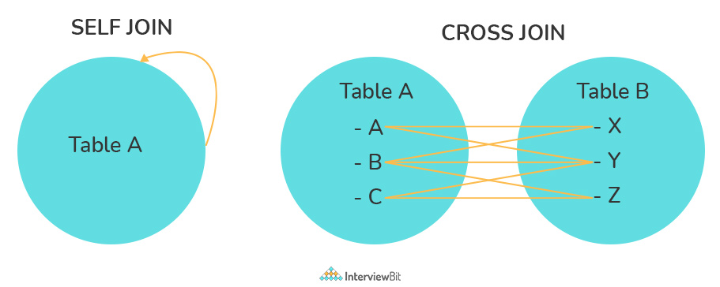

Write a SQL statement to CROSS JOIN 'table_1' with 'table_2' and fetch 'col_1' from table_1 & 'col_2' from table_2 respectively. Do not use alias.

Write a SQL statement to perform SELF JOIN for 'Table_X' with alias 'Table_1' and 'Table_2', on columns 'Col_1' and 'Col_2' respectively.

14. What is an Index? Explain its different types.
A database index is a data structure that provides a quick lookup of data in a column or columns of a table. It enhances the speed of operations accessing data from a database table at the cost of additional writes and memory to maintain the index data structure.
CREATE INDEX index_name /* Create Index */ON table_name (column_1, column_2);DROP INDEX index_name; /* Drop Index */
There are different types of indexes that can be created for different purposes:
- Unique and Non-Unique Index:
Unique indexes are indexes that help maintain data integrity by ensuring that no two rows of data in a table have identical key values. Once a unique index has been defined for a table, uniqueness is enforced whenever keys are added or changed within the index.
CREATE UNIQUE INDEX myIndexON students (enroll_no);
Non-unique indexes, on the other hand, are not used to enforce constraints on the tables with which they are associated. Instead, non-unique indexes are used solely to improve query performance by maintaining a sorted order of data values that are used frequently.
- Clustered and Non-Clustered Index:
Clustered indexes are indexes whose order of the rows in the database corresponds to the order of the rows in the index. This is why only one clustered index can exist in a given table, whereas, multiple non-clustered indexes can exist in the table.
The only difference between clustered and non-clustered indexes is that the database manager attempts to keep the data in the database in the same order as the corresponding keys appear in the clustered index.
Clustering indexes can improve the performance of most query operations because they provide a linear-access path to data stored in the database.

Write a SQL statement to create a UNIQUE INDEX "my_index" on "my_table" for fields "column_1" & "column_2".

15. What is the difference between Clustered and Non-clustered index?
As explained above, the differences can be broken down into three small factors -
- Clustered index modifies the way records are stored in a database based on the indexed column. A non-clustered index creates a separate entity within the table which references the original table.
- Clustered index is used for easy and speedy retrieval of data from the database, whereas, fetching records from the non-clustered index is relatively slower.
- In SQL, a table can have a single clustered index whereas it can have multiple non-clustered indexes.

16. What is Data Integrity?
Data Integrity is the assurance of accuracy and consistency of data over its entire life-cycle and is a critical aspect of the design, implementation, and usage of any system which stores, processes, or retrieves data. It also defines integrity constraints to enforce business rules on the data when it is entered into an application or a database.

17. What is a Query?
A query is a request for data or information from a database table or combination of tables. A database query can be either a select query or an action query.
SELECT fname, lname /* select query */FROM myDb.studentsWHERE student_id = 1;
UPDATE myDB.students /* action query */SET fname = 'Captain', lname = 'America'WHERE student_id = 1;

18. What is a Subquery? What are its types?
A subquery is a query within another query, also known as a nested query or inner query. It is used to restrict or enhance the data to be queried by the main query, thus restricting or enhancing the output of the main query respectively. For example, here we fetch the contact information for students who have enrolled for the maths subject:
SELECT name, email, mob, addressFROM myDb.contactsWHERE roll_no IN (
SELECT roll_no
FROM myDb.students
WHERE subject = 'Maths');
There are two types of subquery - Correlated and Non-Correlated.
- A correlated subquery cannot be considered as an independent query, but it can refer to the column in a table listed in the FROM of the main query.
- A non-correlated subquery can be considered as an independent query and the output of the subquery is substituted in the main query.

Write a SQL query to update the field "status" in table "applications" from 0 to 1.

Write a SQL query to select the field "app_id" in table "applications" where "app_id" less than 1000.

Write a SQL query to fetch the field "app_name" from "apps" where "apps.id" is equal to the above collection of "app_id".

19. What is the SELECT statement?
SELECT operator in SQL is used to select data from a database. The data returned is stored in a result table, called the result-set.
SELECT * FROM myDB.students;

20. What are some common clauses used with SELECT query in SQL?
Some common SQL clauses used in conjuction with a SELECT query are as follows:
- WHERE clause in SQL is used to filter records that are necessary, based on specific conditions.
- ORDER BY clause in SQL is used to sort the records based on some field(s) in ascending (ASC) or descending order (DESC).
SELECT *FROM myDB.studentsWHERE graduation_year = 2019ORDER BY studentID DESC;
- GROUP BY clause in SQL is used to group records with identical data and can be used in conjunction with some aggregation functions to produce summarized results from the database.
- HAVING clause in SQL is used to filter records in combination with the GROUP BY clause. It is different from WHERE, since the WHERE clause cannot filter aggregated records.
SELECT COUNT(studentId), countryFROM myDB.studentsWHERE country != "INDIA"GROUP BY countryHAVING COUNT(studentID) > 5;

21. What are UNION, MINUS and INTERSECT commands?
The UNION operator combines and returns the result-set retrieved by two or more SELECT statements.
The MINUS operator in SQL is used to remove duplicates from the result-set obtained by the second SELECT query from the result-set obtained by the first SELECT query and then return the filtered results from the first.
The INTERSECT clause in SQL combines the result-set fetched by the two SELECT statements where records from one match the other and then returns this intersection of result-sets.
Certain conditions need to be met before executing either of the above statements in SQL -
- Each SELECT statement within the clause must have the same number of columns
- The columns must also have similar data types
- The columns in each SELECT statement should necessarily have the same order
SELECT name FROM Students /* Fetch the union of queries */UNIONSELECT name FROM Contacts;SELECT name FROM Students /* Fetch the union of queries with duplicates*/UNION ALLSELECT name FROM Contacts;
SELECT name FROM Students /* Fetch names from students */
MINUS /* that aren't present in contacts */SELECT name FROM Contacts;
SELECT name FROM Students /* Fetch names from students */INTERSECT /* that are present in contacts as well */SELECT name FROM Contacts;

Write a SQL query to fetch "names" that are present in either table "accounts" or in table "registry".

Write a SQL query to fetch "names" that are present in "accounts" but not in table "registry".

Write a SQL query to fetch "names" from table "contacts" that are neither present in "accounts.name" nor in "registry.name".

22. What is Cursor? How to use a Cursor?
A database cursor is a control structure that allows for the traversal of records in a database. Cursors, in addition, facilitates processing after traversal, such as retrieval, addition, and deletion of database records. They can be viewed as a pointer to one row in a set of rows.
Working with SQL Cursor:
- DECLARE a cursor after any variable declaration. The cursor declaration must always be associated with a SELECT Statement.
- Open cursor to initialize the result set. The OPEN statement must be called before fetching rows from the result set.
- FETCH statement to retrieve and move to the next row in the result set.
- Call the CLOSE statement to deactivate the cursor.
- Finally use the DEALLOCATE statement to delete the cursor definition and release the associated resources.
DECLARE @name VARCHAR(50) /* Declare All Required Variables */DECLARE db_cursor CURSOR FOR /* Declare Cursor Name*/SELECT nameFROM myDB.studentsWHERE parent_name IN ('Sara', 'Ansh')OPEN db_cursor /* Open cursor and Fetch data into @name */ FETCH nextFROM db_cursorINTO @nameCLOSE db_cursor /* Close the cursor and deallocate the resources */DEALLOCATE db_cursor

23. What are Entities and Relationships?
Entity: An entity can be a real-world object, either tangible or intangible, that can be easily identifiable. For example, in a college database, students, professors, workers, departments, and projects can be referred to as entities. Each entity has some associated properties that provide it an identity.
Relationships: Relations or links between entities that have something to do with each other. For example - The employee's table in a company's database can be associated with the salary table in the same database.
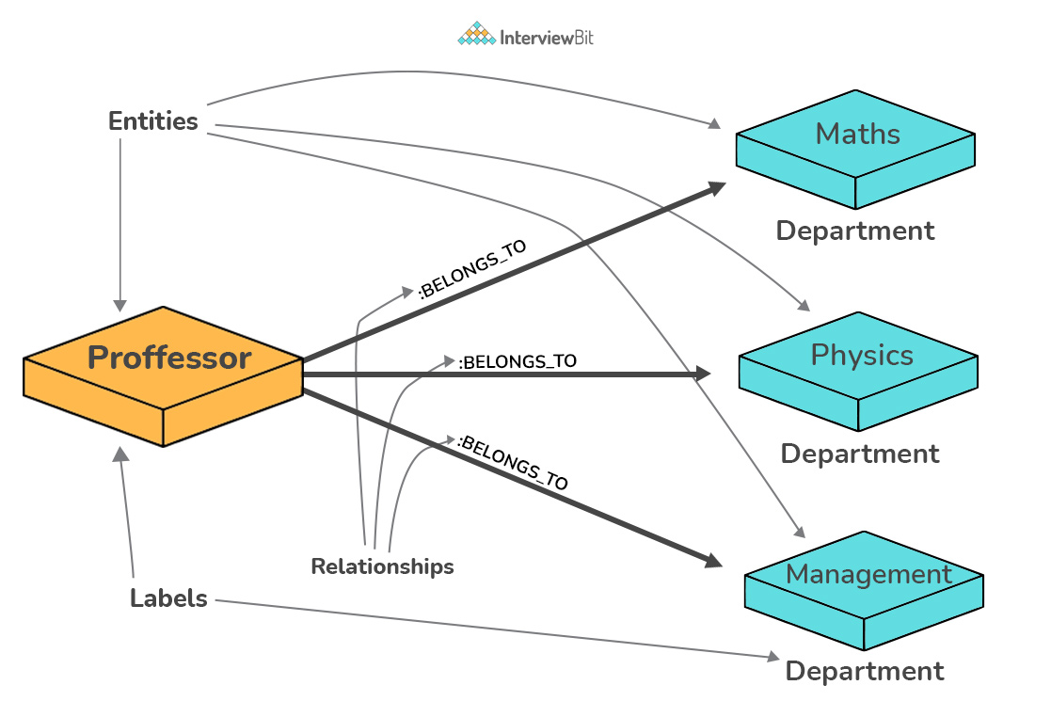

24. List the different types of relationships in SQL.
- One-to-One - This can be defined as the relationship between two tables where each record in one table is associated with the maximum of one record in the other table.
- One-to-Many & Many-to-One - This is the most commonly used relationship where a record in a table is associated with multiple records in the other table.
- Many-to-Many - This is used in cases when multiple instances on both sides are needed for defining a relationship.
- Self-Referencing Relationships - This is used when a table needs to define a relationship with itself.

25. What is an Alias in SQL?
An alias is a feature of SQL that is supported by most, if not all, RDBMSs. It is a temporary name assigned to the table or table column for the purpose of a particular SQL query. In addition, aliasing can be employed as an obfuscation technique to secure the real names of database fields. A table alias is also called a correlation name.
An alias is represented explicitly by the AS keyword but in some cases, the same can be performed without it as well. Nevertheless, using the AS keyword is always a good practice.
SELECT A.emp_name AS "Employee" /* Alias using AS keyword */
B.emp_name AS "Supervisor"FROM employee A, employee B /* Alias without AS keyword */WHERE A.emp_sup = B.emp_id;

Write an SQL statement to select all from table "Limited" with alias "Ltd".

26. What is a View?
A view in SQL is a virtual table based on the result-set of an SQL statement. A view contains rows and columns, just like a real table. The fields in a view are fields from one or more real tables in the database.
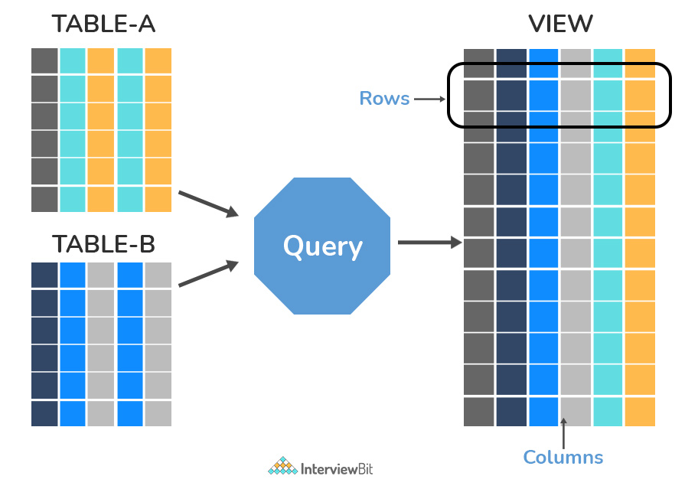

27. What is Normalization?
Normalization represents the way of organizing structured data in the database efficiently. It includes the creation of tables, establishing relationships between them, and defining rules for those relationships. Inconsistency and redundancy can be kept in check based on these rules, hence, adding flexibility to the database.

28. What is Denormalization?
Denormalization is the inverse process of normalization, where the normalized schema is converted into a schema that has redundant information. The performance is improved by using redundancy and keeping the redundant data consistent. The reason for performing denormalization is the overheads produced in the query processor by an over-normalized structure.

29. What are the various forms of Normalization?
Normal Forms are used to eliminate or reduce redundancy in database tables. The different forms are as follows:
- First Normal Form:
A relation is in first normal form if every attribute in that relation is a single-valued attribute. If a relation contains a composite or multi-valued attribute, it violates the first normal form. Let's consider the following students table. Each student in the table, has a name, his/her address, and the books they issued from the public library -
Students Table
Student | Address | Books Issued | Salutation
Sara | Amanora Park Town 94 | Until the Day I Die (Emily Carpenter), Inception (Christopher Nolan) | Ms.
Ansh | 62nd Sector A-10 | The Alchemist (Paulo Coelho), Inferno (Dan Brown) | Mr.
Sara | 24th Street Park Avenue | Beautiful Bad (Annie Ward), Woman 99 (Greer Macallister) | Mrs.
Ansh | Windsor Street 777 | Dracula (Bram Stoker) | Mr.
As we can observe, the Books Issued field has more than one value per record, and to convert it into 1NF, this has to be resolved into separate individual records for each book issued. Check the following table in 1NF form -
Students Table (1st Normal Form)
Student | Address | Books Issued | Salutation
Sara | Amanora Park Town 94 | Until the Day I Die (Emily Carpenter) | Ms.
Sara | Amanora Park Town 94 | Inception (Christopher Nolan) | Ms.
Ansh | 62nd Sector A-10 | The Alchemist (Paulo Coelho) | Mr.
Ansh | 62nd Sector A-10 | Inferno (Dan Brown) | Mr.
Sara | 24th Street Park Avenue | Beautiful Bad (Annie Ward) | Mrs.
Sara | 24th Street Park Avenue | Woman 99 (Greer Macallister) | Mrs.
Ansh | Windsor Street 777 | Dracula (Bram Stoker) | Mr.
- Second Normal Form:
A relation is in second normal form if it satisfies the conditions for the first normal form and does not contain any partial dependency. A relation in 2NF has no partial dependency, i.e., it has no non-prime attribute that depends on any proper subset of any candidate key of the table. Often, specifying a single column Primary Key is the solution to the problem. Examples -
Example 1 - Consider the above example. As we can observe, the Students Table in the 1NF form has a candidate key in the form of [Student, Address] that can uniquely identify all records in the table. The field Books Issued (non-prime attribute) depends partially on the Student field. Hence, the table is not in 2NF. To convert it into the 2nd Normal Form, we will partition the tables into two while specifying a new Primary Key attribute to identify the individual records in the Students table. The Foreign Key constraint will be set on the other table to ensure referential integrity.
Students Table (2nd Normal Form)
Student_ID | Student | Address | Salutation
1 | Sara | Amanora Park Town 94 | Ms.
2 | Ansh | 62nd Sector A-10 | Mr.
3 | Sara | 24th Street Park Avenue | Mrs.
4 | Ansh | Windsor Street 777 | Mr.
Books Table (2nd Normal Form)
Student_ID | Book Issued
1 | Until the Day I Die (Emily Carpenter)
1 | Inception (Christopher Nolan)
2 | The Alchemist (Paulo Coelho)
2 | Inferno (Dan Brown)
3 | Beautiful Bad (Annie Ward)
3 | Woman 99 (Greer Macallister)
4 | Dracula (Bram Stoker)
Example 2 - Consider the following dependencies in relation to R(W,X,Y,Z)
WX -> Y [W and X together determine Y]
XY -> Z [X and Y together determine Z]
Here, WX is the only candidate key and there is no partial dependency, i.e., any proper subset of WX doesn’t determine any non-prime attribute in the relation.
- Third Normal Form
A relation is said to be in the third normal form, if it satisfies the conditions for the second normal form and there is no transitive dependency between the non-prime attributes, i.e., all non-prime attributes are determined only by the candidate keys of the relation and not by any other non-prime attribute.
Example 1 - Consider the Students Table in the above example. As we can observe, the Students Table in the 2NF form has a single candidate key Student_ID (primary key) that can uniquely identify all records in the table. The field Salutation (non-prime attribute), however, depends on the Student Field rather than the candidate key. Hence, the table is not in 3NF. To convert it into the 3rd Normal Form, we will once again partition the tables into two while specifying a new Foreign Key constraint to identify the salutations for individual records in the Students table. The Primary Key constraint for the same will be set on the Salutations table to identify each record uniquely.
Students Table (3rd Normal Form)
Student_ID | Student | Address | Salutation_ID
1 | Sara | Amanora Park Town 94 | 1
2 | Ansh | 62nd Sector A-10 | 2
3 | Sara | 24th Street Park Avenue | 3
4 | Ansh | Windsor Street 777 | 1
Books Table (3rd Normal Form)
Student_ID | Book Issued
1 | Until the Day I Die (Emily Carpenter)
1 | Inception (Christopher Nolan)
2 | The Alchemist (Paulo Coelho)
2 | Inferno (Dan Brown)
3 | Beautiful Bad (Annie Ward)
3 | Woman 99 (Greer Macallister)
4 | Dracula (Bram Stoker)
Salutations Table (3rd Normal Form)
Salutation_ID | Salutation
1 | Ms.
2 | Mr.
3 | Mrs.
Example 2 - Consider the following dependencies in relation to R(P,Q,R,S,T)
P -> QR [P together determine C]
RS -> T [B and C together determine D]
Q -> S
T -> P
For the above relation to exist in 3NF, all possible candidate keys in the above relation should be {P, RS, QR, T}.
- Boyce-Codd Normal Form
A relation is in Boyce-Codd Normal Form if satisfies the conditions for third normal form and for every functional dependency, Left-Hand-Side is super key. In other words, a relation in BCNF has non-trivial functional dependencies in form X –> Y, such that X is always a super key. For example - In the above example, Student_ID serves as the sole unique identifier for the Students Table and Salutation_ID for the Salutations Table, thus these tables exist in BCNF. The same cannot be said for the Books Table and there can be several books with common Book Names and the same Student_ID.

30. What are the TRUNCATE, DELETE and DROP statements?
DELETE statement is used to delete rows from a table.
DELETE FROM CandidatesWHERE CandidateId > 1000;
TRUNCATE command is used to delete all the rows from the table and free the space containing the table.
TRUNCATE TABLE Candidates;
DROP command is used to remove an object from the database. If you drop a table, all the rows in the table are deleted and the table structure is removed from the database.
DROP TABLE Candidates;

Write a SQL statement to wipe a table 'Temporary' from memory.

Write a SQL query to remove first 1000 records from table 'Temporary' based on 'id'.

Write a SQL statement to delete the table 'Temporary' while keeping its relations intact.

31. What is the difference between DROP and TRUNCATE statements?
If a table is dropped, all things associated with the tables are dropped as well. This includes - the relationships defined on the table with other tables, the integrity checks and constraints, access privileges and other grants that the table has. To create and use the table again in its original form, all these relations, checks, constraints, privileges and relationships need to be redefined. However, if a table is truncated, none of the above problems exist and the table retains its original structure.

32. What is the difference between DELETE and TRUNCATE statements?
The TRUNCATE command is used to delete all the rows from the table and free the space containing the table.
The DELETE command deletes only the rows from the table based on the condition given in the where clause or deletes all the rows from the table if no condition is specified. But it does not free the space containing the table.

33. What are Aggregate and Scalar functions?
An aggregate function performs operations on a collection of values to return a single scalar value. Aggregate functions are often used with the GROUP BY and HAVING clauses of the SELECT statement. Following are the widely used SQL aggregate functions:
- AVG() - Calculates the mean of a collection of values.
- COUNT() - Counts the total number of records in a specific table or view.
- MIN() - Calculates the minimum of a collection of values.
- MAX() - Calculates the maximum of a collection of values.
- SUM() - Calculates the sum of a collection of values.
- FIRST() - Fetches the first element in a collection of values.
- LAST() - Fetches the last element in a collection of values.
Note: All aggregate functions described above ignore NULL values except for the COUNT function.
A scalar function returns a single value based on the input value. Following are the widely used SQL scalar functions:
- LEN() - Calculates the total length of the given field (column).
- UCASE() - Converts a collection of string values to uppercase characters.
- LCASE() - Converts a collection of string values to lowercase characters.
- MID() - Extracts substrings from a collection of string values in a table.
- CONCAT() - Concatenates two or more strings.
- RAND() - Generates a random collection of numbers of a given length.
- ROUND() - Calculates the round-off integer value for a numeric field (or decimal point values).
- NOW() - Returns the current date & time.
- FORMAT() - Sets the format to display a collection of values.

34. What is User-defined function? What are its various types?
The user-defined functions in SQL are like functions in any other programming language that accept parameters, perform complex calculations, and return a value. They are written to use the logic repetitively whenever required. There are two types of SQL user-defined functions:
- Scalar Function: As explained earlier, user-defined scalar functions return a single scalar value.
- Table-Valued Functions: User-defined table-valued functions return a table as output.
  - Inline: returns a table data type based on a single SELECT statement.
  - Multi-statement: returns a tabular result-set but, unlike inline, multiple SELECT statements can be used inside the function body.

35. What is OLTP?
OLTP stands for Online Transaction Processing, is a class of software applications capable of supporting transaction-oriented programs. An essential attribute of an OLTP system is its ability to maintain concurrency. To avoid single points of failure, OLTP systems are often decentralized. These systems are usually designed for a large number of users who conduct short transactions. Database queries are usually simple, require sub-second response times, and return relatively few records. Here is an insight into the working of an OLTP system [ Note - The figure is not important for interviews ] -
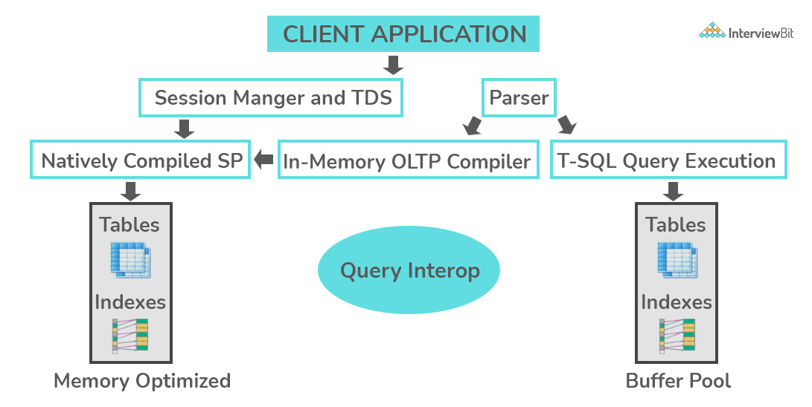

36. What are the differences between OLTP and OLAP?
OLTP stands for Online Transaction Processing, is a class of software applications capable of supporting transaction-oriented programs. An important attribute of an OLTP system is its ability to maintain concurrency. OLTP systems often follow a decentralized architecture to avoid single points of failure. These systems are generally designed for a large audience of end-users who conduct short transactions. Queries involved in such databases are generally simple, need fast response times, and return relatively few records. A number of transactions per second acts as an effective measure for such systems.
OLAP stands for Online Analytical Processing, a class of software programs that are characterized by the relatively low frequency of online transactions. Queries are often too complex and involve a bunch of aggregations. For OLAP systems, the effectiveness measure relies highly on response time. Such systems are widely used for data mining or maintaining aggregated, historical data, usually in multi-dimensional schemas.
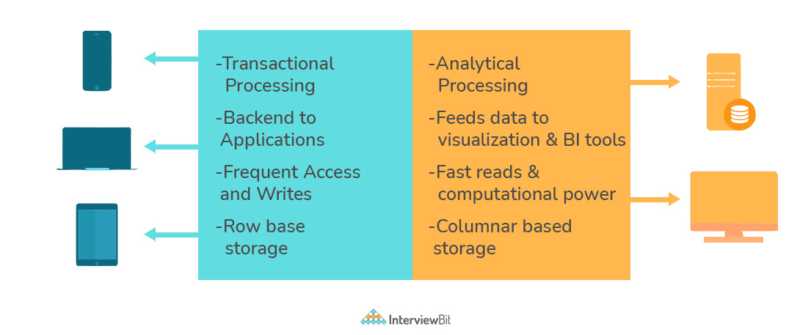

37. What is Collation? What are the different types of Collation Sensitivity?
Collation refers to a set of rules that determine how data is sorted and compared. Rules defining the correct character sequence are used to sort the character data. It incorporates options for specifying case sensitivity, accent marks, kana character types, and character width. Below are the different types of collation sensitivity:
- Case sensitivity: A and a are treated differently.
- Accent sensitivity: a and á are treated differently.
- Kana sensitivity: Japanese kana characters Hiragana and Katakana are treated differently.
- Width sensitivity: Same character represented in single-byte (half-width) and double-byte (full-width) are treated differently.

38. What is a Stored Procedure?
A stored procedure is a subroutine available to applications that access a relational database management system (RDBMS). Such procedures are stored in the database data dictionary. The sole disadvantage of stored procedure is that it can be executed nowhere except in the database and occupies more memory in the database server. It also provides a sense of security and functionality as users who can't access the data directly can be granted access via stored procedures.
DELIMITER $$CREATE PROCEDURE FetchAllStudents()BEGINSELECT * FROM myDB.students;END $$
DELIMITER ;
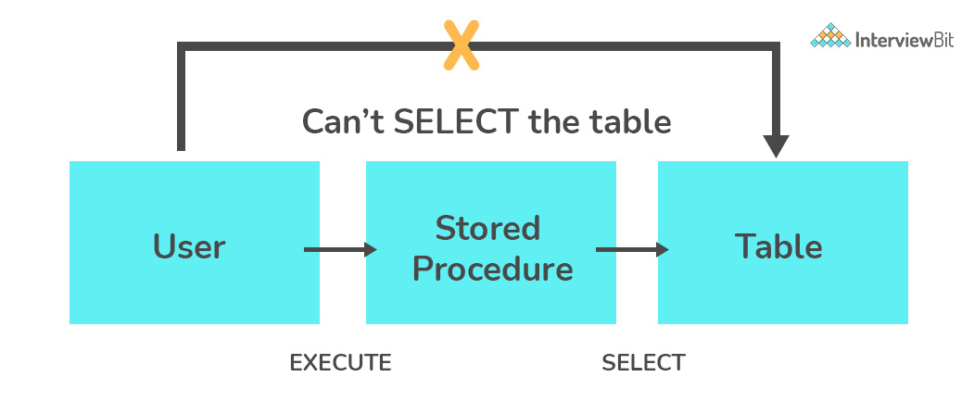

39. What is a Recursive Stored Procedure?
A stored procedure that calls itself until a boundary condition is reached, is called a recursive stored procedure. This recursive function helps the programmers to deploy the same set of code several times as and when required. Some SQL programming languages limit the recursion depth to prevent an infinite loop of procedure calls from causing a stack overflow, which slows down the system and may lead to system crashes.
DELIMITER $$ /* Set a new delimiter => $$ */CREATE PROCEDURE calctotal( /* Create the procedure */
IN number INT, /* Set Input and Ouput variables */
OUT total INT
) BEGINDECLARE score INT DEFAULT NULL; /* Set the default value => "score" */SELECT awards FROM achievements /* Update "score" via SELECT query */WHERE id = number INTO score;
IF score IS NULL THEN SET total = 0; /* Termination condition */ELSECALL calctotal(number+1); /* Recursive call */SET total = total + score; /* Action after recursion */END IF;END $$ /* End of procedure */
DELIMITER ; /* Reset the delimiter */

40. How to create empty tables with the same structure as another table?
Creating empty tables with the same structure can be done smartly by fetching the records of one table into a new table using the INTO operator while fixing a WHERE clause to be false for all records. Hence, SQL prepares the new table with a duplicate structure to accept the fetched records but since no records get fetched due to the WHERE clause in action, nothing is inserted into the new table.
SELECT * INTO Students_copyFROM Students WHERE 1 = 2;

41. What is Pattern Matching in SQL?
SQL pattern matching provides for pattern search in data if you have no clue as to what that word should be. This kind of SQL query uses wildcards to match a string pattern, rather than writing the exact word. The LIKE operator is used in conjunction with SQL Wildcards to fetch the required information.
- Using the % wildcard to perform a simple search
The % wildcard matches zero or more characters of any type and can be used to define wildcards both before and after the pattern. Search a student in your database with first name beginning with the letter K:
SELECT *FROM studentsWHERE first_name LIKE 'K%'
- Omitting the patterns using the NOT keyword
Use the NOT keyword to select records that don't match the pattern. This query returns all students whose first name does not begin with K.
SELECT *FROM studentsWHERE first_name NOT LIKE 'K%'
- Matching a pattern anywhere using the % wildcard twice
Search for a student in the database where he/she has a K in his/her first name.
SELECT *FROM studentsWHERE first_name LIKE '%Q%'
- Using the _ wildcard to match pattern at a specific position
The _ wildcard matches exactly one character of any type. It can be used in conjunction with % wildcard. This query fetches all students with letter K at the third position in their first name.
SELECT *FROM studentsWHERE first_name LIKE '__K%'
- Matching patterns for a specific length
The _ wildcard plays an important role as a limitation when it matches exactly one character. It limits the length and position of the matched results. For example -
SELECT * /* Matches first names with three or more letters */FROM studentsWHERE first_name LIKE '___%'
SELECT * /* Matches first names with exactly four characters */FROM studentsWHERE first_name LIKE '____'

PostgreSQL Interview Questions

42. What is PostgreSQL?
PostgreSQL was first called Postgres and was developed by a team led by Computer Science Professor Michael Stonebraker in 1986. It was developed to help developers build enterprise-level applications by upholding data integrity by making systems fault-tolerant. PostgreSQL is therefore an enterprise-level, flexible, robust, open-source, and object-relational DBMS that supports flexible workloads along with handling concurrent users. It has been consistently supported by the global developer community. Due to its fault-tolerant nature, PostgreSQL has gained widespread popularity among developers.

43. How do you define Indexes in PostgreSQL?
Indexes are the inbuilt functions in PostgreSQL which are used by the queries to perform search more efficiently on a table in the database. Consider that you have a table with thousands of records and you have the below query that only a few records can satisfy the condition, then it will take a lot of time to search and return those rows that abide by this condition as the engine has to perform the search operation on every single to check this condition. This is undoubtedly inefficient for a system dealing with huge data. Now if this system had an index on the column where we are applying search, it can use an efficient method for identifying matching rows by walking through only a few levels. This is called indexing.
Select * from some_table where table_col=120

44. How will you change the datatype of a column?
This can be done by using the ALTER TABLE statement as shown below:
Syntax:
ALTER TABLE tname
ALTER COLUMN col_name [SET DATA] TYPE new_data_type;

45. What is the command used for creating a database in PostgreSQL?
The first step of using PostgreSQL is to create a database. This is done by using the createdb command as shown below: createdb db_name
After running the above command, if the database creation was successful, then the below message is shown:
CREATE DATABASE

46. How can we start, restart and stop the PostgreSQL server?
- To start the PostgreSQL server, we run:
service postgresql start
- Once the server is successfully started, we get the below message:
Starting PostgreSQL: ok
- To restart the PostgreSQL server, we run:
service postgresql restart
Once the server is successfully restarted, we get the message:
Restarting PostgreSQL: server stopped
ok
- To stop the server, we run the command:
service postgresql stop
Once stopped successfully, we get the message:
Stopping PostgreSQL: server stopped
ok

47. What are partitioned tables called in PostgreSQL?
Partitioned tables are logical structures that are used for dividing large tables into smaller structures that are called partitions. This approach is used for effectively increasing the query performance while dealing with large database tables. To create a partition, a key called partition key which is usually a table column or an expression, and a partitioning method needs to be defined. There are three types of inbuilt partitioning methods provided by Postgres:
- Range Partitioning: This method is done by partitioning based on a range of values. This method is most commonly used upon date fields to get monthly, weekly or yearly data. In the case of corner cases like value belonging to the end of the range, for example: if the range of partition 1 is 10-20 and the range of partition 2 is 20-30, and the given value is 10, then 10 belongs to the second partition and not the first.
- List Partitioning: This method is used to partition based on a list of known values. Most commonly used when we have a key with a categorical value. For example, getting sales data based on regions divided as countries, cities, or states.
- Hash Partitioning: This method utilizes a hash function upon the partition key. This is done when there are no specific requirements for data division and is used to access data individually. For example, you want to access data based on a specific product, then using hash partition would result in the dataset that we require.
The type of partition key and the type of method used for partitioning determines how positive the performance and the level of manageability of the partitioned table are.

48. Define tokens in PostgreSQL?
A token in PostgreSQL is either a keyword, identifier, literal, constant, quotes identifier, or any symbol that has a distinctive personality. They may or may not be separated using a space, newline or a tab. If the tokens are keywords, they are usually commands with useful meanings. Tokens are known as building blocks of any PostgreSQL code.

49. What is the importance of the TRUNCATE statement?
TRUNCATE TABLE name_of_table statement removes the data efficiently and quickly from the table.
The truncate statement can also be used to reset values of the identity columns along with data cleanup as shown below:
TRUNCATE TABLE name_of_table
RESTART IDENTITY;
We can also use the statement for removing data from multiple tables all at once by mentioning the table names separated by comma as shown below:
TRUNCATE TABLE
table_1,
table_2,
table_3;

50. What is the capacity of a table in PostgreSQL?
The maximum size of PostgreSQL is 32TB.

51. Define sequence.
A sequence is a schema-bound, user-defined object which aids to generate a sequence of integers. This is most commonly used to generate values to identity columns in a table. We can create a sequence by using the CREATE SEQUENCE statement as shown below:
CREATE SEQUENCE serial_num START 100;
To get the next number 101 from the sequence, we use the nextval() method as shown below:
SELECT nextval('serial_num');
We can also use this sequence while inserting new records using the INSERT command:
INSERT INTO ib_table_name VALUES (nextval('serial_num'), 'interviewbit');

52. What are string constants in PostgreSQL?
They are character sequences bound within single quotes. These are using during data insertion or updation to characters in the database.
There are special string constants that are quoted in dollars. Syntax: $tag$<string_constant>$tag$ The tag in the constant is optional and when we are not specifying the tag, the constant is called a double-dollar string literal.

53. How can you get a list of all databases in PostgreSQL?
This can be done by using the command \l -> backslash followed by the lower-case letter L.

54. How can you delete a database in PostgreSQL?
This can be done by using the DROP DATABASE command as shown in the syntax below:
DROP DATABASE database_name;
If the database has been deleted successfully, then the following message would be shown:
DROP DATABASE

55. What are ACID properties? Is PostgreSQL compliant with ACID?
ACID stands for Atomicity, Consistency, Isolation, Durability. They are database transaction properties which are used for guaranteeing data validity in case of errors and failures.
- Atomicity: This property ensures that the transaction is completed in all-or-nothing way.
- Consistency: This ensures that updates made to the database is valid and follows rules and restrictions.
- Isolation: This property ensures integrity of transaction that are visible to all other transactions.
- Durability: This property ensures that the committed transactions are stored permanently in the database.
PostgreSQL is compliant with ACID properties.

56. Can you explain the architecture of PostgreSQL?
- The architecture of PostgreSQL follows the client-server model.
- The server side comprises of background process manager, query processer, utilities and shared memory space which work together to build PostgreSQL’s instance that has access to the data. The client application does the task of connecting to this instance and requests data processing to the services. The client can either be GUI (Graphical User Interface) or a web application. The most commonly used client for PostgreSQL is pgAdmin.
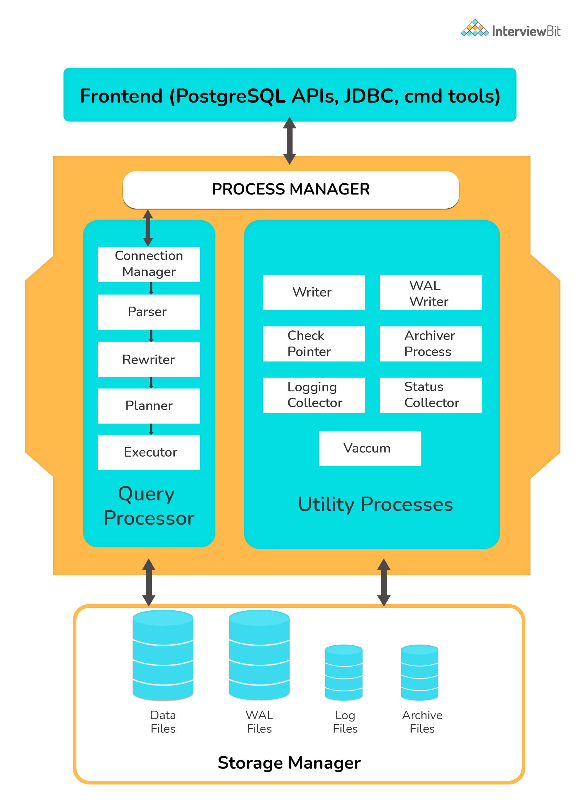

57. What do you understand by multi-version concurrency control?
MVCC or Multi-version concurrency control is used for avoiding unnecessary database locks when 2 or more requests tries to access or modify the data at the same time. This ensures that the time lag for a user to log in to the database is avoided. The transactions are recorded when anyone tries to access the content.
For more information regarding this, you can refer here.

58. What do you understand by command enable-debug?
The command enable-debug is used for enabling the compilation of all libraries and applications. When this is enabled, the system processes get hindered and generally also increases the size of the binary file. Hence, it is not recommended to switch this on in the production environment. This is most commonly used by developers to debug the bugs in their scripts and help them spot the issues. For more information regarding how to debug, you can refer here.

59. How do you check the rows affected as part of previous transactions?
SQL standards state that the following three phenomena should be prevented whilst concurrent transactions. SQL standards define 4 levels of transaction isolations to deal with these phenomena.
- Dirty reads: If a transaction reads data that is written due to concurrent uncommitted transaction, these reads are called dirty reads.
- Phantom reads: This occurs when two same queries when executed separately return different rows. For example, if transaction A retrieves some set of rows matching search criteria. Assume another transaction B retrieves new rows in addition to the rows obtained earlier for the same search criteria. The results are different.
- Non-repeatable reads: This occurs when a transaction tries to read the same row multiple times and gets different values each time due to concurrency. This happens when another transaction updates that data and our current transaction fetches that updated data, resulting in different values.
To tackle these, there are 4 standard isolation levels defined by SQL standards. They are as follows:
- Read Uncommitted – The lowest level of the isolations. Here, the transactions are not isolated and can read data that are not committed by other transactions resulting in dirty reads.
- Read Committed – This level ensures that the data read is committed at any instant of read time. Hence, dirty reads are avoided here. This level makes use of read/write lock on the current rows which prevents read/write/update/delete of that row when the current transaction is being operated on.
- Repeatable Read – The most restrictive level of isolation. This holds read and write locks for all rows it operates on. Due to this, non-repeatable reads are avoided as other transactions cannot read, write, update or delete the rows.
- Serializable – The highest of all isolation levels. This guarantees that the execution is serializable where execution of any concurrent operations are guaranteed to be appeared as executing serially.
The following table clearly explains which type of unwanted reads the levels avoid:
Isolation levels | Dirty Reads | Phantom Reads | Non-repeatable reads
Read Uncommitted | Might occur | Might occur | Might occur
Read Committed | Won’t occur | Might occur | Might occur
Repeatable Read | Won’t occur | Might occur | Won’t occur
Serializable | Won’t occur | Won’t occur | Won’t occur

60. What can you tell about WAL (Write Ahead Logging)?
Write Ahead Logging is a feature that increases the database reliability by logging changes before any changes are done to the database. This ensures that we have enough information when a database crash occurs by helping to pinpoint to what point the work has been complete and gives a starting point from the point where it was discontinued.
For more information, you can refer here.

61. What is the main disadvantage of deleting data from an existing table using the DROP TABLE command?
DROP TABLE command deletes complete data from the table along with removing the complete table structure too. In case our requirement entails just remove the data, then we would need to recreate the table to store data in it. In such cases, it is advised to use the TRUNCATE command.

62. How do you perform case-insensitive searches using regular expressions in PostgreSQL?
To perform case insensitive matches using a regular expression, we can use POSIX (~*) expression from pattern matching operators. For example:
'interviewbit' ~* '.*INTervIewBit.*'

63. How will you take backup of the database in PostgreSQL?
We can achieve this by using the pg_dump tool for dumping all object contents in the database into a single file. The steps are as follows:
Step 1: Navigate to the bin folder of the PostgreSQL installation path.
C:\>cd C:\Program Files\PostgreSQL\10.0\bin
Step 2: Execute pg_dump program to take the dump of data to a .tar folder as shown below:
pg_dump -U postgres -W -F t sample_data > C:\Users\admin\pgbackup\sample_data.tar
The database dump will be stored in the sample_data.tar file on the location specified.

64. Does PostgreSQL support full text search?
Full-Text Search is the method of searching single or collection of documents stored on a computer in a full-text based database. This is mostly supported in advanced database systems like SOLR or ElasticSearch. However, the feature is present but is pretty basic in PostgreSQL.

65. What are parallel queries in PostgreSQL?
Parallel Queries support is a feature provided in PostgreSQL for devising query plans capable of exploiting multiple CPU processors to execute the queries faster.
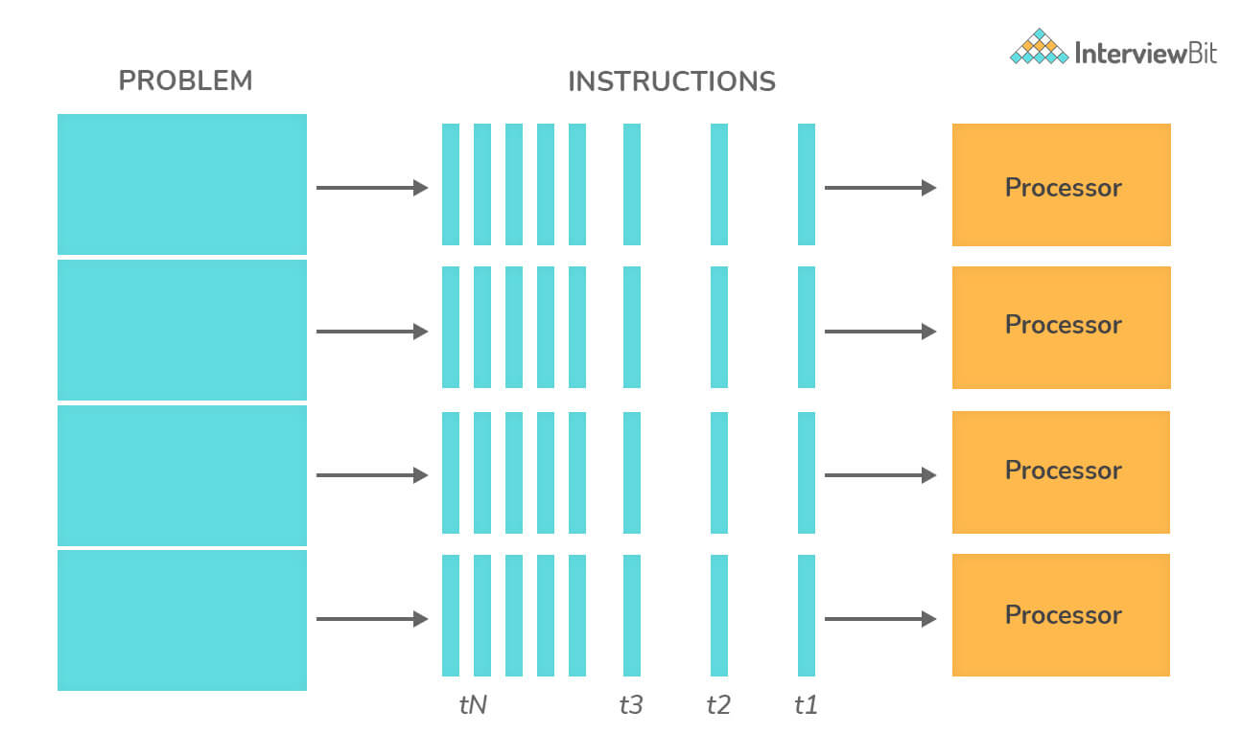

66. Differentiate between commit and checkpoint.
The commit action ensures that the data consistency of the transaction is maintained and it ends the current transaction in the section. Commit adds a new record in the log that describes the COMMIT to the memory. Whereas, a checkpoint is used for writing all changes that were committed to disk up to SCN which would be kept in datafile headers and control files.

1) What is SQL?
SQL stands for the Structured Query Language. It is the standard language used to maintain the relational database and perform many different data manipulation operations on the data. SQL was initially invented in 1970. It is a database language used for database creation, deletion, fetching and modifying rows, etc. sometimes, it is pronounced as 'sequel.' We can also use it to handle organized data comprised of entities (variables) and relations between different entities of the data.

2) When SQL appeared?
SQL first appeared in 1974. It is one of the most used languages for maintaining the relational database. In 1986, SQL became the standard of the American National Standards Institute (ANSI) and ISO (International Organization for Standardization) in 1987.

3) What are the usages of SQL?
SQL is responsible for maintaining the relational data and the data structures present in the database. Some of the common usages are given below:
Play Videox
- To execute queries against a database
- To retrieve data from a database
- To inserts records in a database
- To updates records in a database
- To delete records from a database
- To create new databases
- To create new tables in a database
- To create views in a database
- To perform complex operations on the database.

4) Does SQL support programming language features?
SQL refers to the Standard Query Language. Therefore, it is true that SQL is a language but does not actually support the programming language. It is a common language that doesn't have a loop, conditional statements, and logical operations. It cannot be used for anything other than data manipulation. It is a command language to perform database operations. The primary purpose of SQL is to retrieve, manipulate, update, delete, and perform complex operations like joins on the data present in the database.

5) What are the subsets of SQL?
The following are the four significant subsets of the SQL:
- Data definition language (DDL): It defines the data structure that consists of commands like CREATE, ALTER, DROP, etc.
- Data manipulation language (DML): It is used to manipulate existing data in the database. The commands in this category are SELECT, UPDATE, INSERT, etc.
- Data control language (DCL): It controls access to the data stored in the database. The commands in this category include GRANT and REVOKE.
- Transaction Control Language (TCL): It is used to deal with the transaction operations in the database. The commands in this category are COMMIT, ROLLBACK, SET TRANSACTION, SAVEPOINT, etc.

6) What is the purpose of DDL Language?
DDL stands for Data definition language. It is the subset of a database that defines the data structure of the database when the database is created. For example, we can use the DDL commands to add, remove, or modify tables. It consists of the following commands: CREATE, ALTER and DELETE database objects such as schema, tables, indexes, view, sequence, etc.
Example

- CREATE TABLE Students
- (
- Roll_no INT,
- Name VARCHAR(45),
- Branch VARCHAR(30),
- );

7) What is the purpose of DML Language?
Data manipulation language makes the user able to retrieve and manipulate data in a relational database. The DML commands can only perform read-only operations on data. We can perform the following operations using DDL language:
- Insert data into the database through the INSERT command.
- Retrieve data from the database through the SELECT command.
- Update data in the database through the UPDATE command.
- Delete data from the database through the DELETE command.
Example

- INSERT INTO Student VALUES (111, 'George', 'Computer Science')

8) What is the purpose of DCL Language?
Data control language allows users to control access and permission management to the database. It is the subset of a database, which decides that what part of the database should be accessed by which user at what point of time. It includes two commands, GRANT and REVOKE.
GRANT: It enables system administrators to assign privileges and roles to the specific user accounts to perform specific tasks on the database.
REVOKE: It enables system administrators to revoke privileges and roles from the user accounts so that they cannot use the previously assigned permission on the database.
Example

- GRANT * ON mydb.Student TO javatpoint@localhsot;

9) What are tables and fields in the database?
A table is a set of organized data in the form of rows and columns. It enables users to store and display records in the structure format. It is similar to worksheets in the spreadsheet application. Here rows refer to the tuples, representing the simple data item, and columns are the attribute of the data items present in a particular row. Columns can categorize as vertical, and Rows are horizontal.
Fields are the components to provide the structure for the table. It stores the same category of data in the same data type. A table contains a fixed number of columns but can have any number of rows known as the record. It is also called a column in the table of the database. It represents the attribute or characteristics of the entity in the record.
Example
Table: Student
Field: Stud_rollno, Stud_name, Date of Birth, Branch, etc.

10) What is a primary key?
A primary key is a field or the combination of fields that uniquely identify each record in the table. It is one of a special kind of unique key. If the column contains a primary key, it cannot be null or empty. A table can have duplicate columns, but it cannot have more than one primary key. It always stores unique values into a column. For example, the ROLL Number can be treated as the primary key for a student in the university or college.
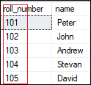
We can define a primary key into a student table as follows:

- CREATE TABLE Student (
- roll_number INT PRIMARY KEY,
- name VARCHAR(45),
- );
To read more information, click here.

11) What is a foreign key?
The foreign key is used to link one or more tables together. It is also known as the referencing key. A foreign key is specified as a key that is related to the primary key of another table. It means a foreign key field in one table refers to the primary key field of the other table. It identifies each row of another table uniquely that maintains the referential integrity. The primary key-foreign key relationship is a very crucial relationship as it maintains the ACID properties of the database sometimes. It also prevents actions that would destroy links between the child and parent tables.
We can define a foreign key into a table as follows:

- CONSTRAINT constraint_name]
- FOREIGN KEY [foreign_key_name] (col_name, ...)
- REFERENCES parent_tbl_name (col_name,...)
To read more information, click here.

12) What is a unique key?
A unique key is a single or combination of fields that ensure all values stores in the column will be unique. It means a column cannot stores duplicate values. This key provides uniqueness for the column or set of columns. For example, the email addresses and roll numbers of student's tables should be unique. It can accept a null value but only one null value per column. It ensures the integrity of the column or group of columns to store different values into a table.
We can define a foreign key into a table as follows:

- CREATE TABLE table_name(
- col1 datatype,
- col2 datatype UNIQUE,
- ...
- );
To read more information, click here.

13) What is the difference between a primary key and a unique key?
The primary key and unique key both are essential constraints of the SQL. The main difference among them is that the primary key identifies each record in the table. In contrast, the unique key prevents duplicate entries in a column except for a NULL value. The following comparison chart explains it more clearly:
Primary Key | Unique Key
The primary key act as a unique identifier for each record in the table. | The unique key is also a unique identifier for records when the primary key is not present in the table.
We cannot store NULL values in the primary key column. | We can store NULL value in the unique key column, but only one NULL is allowed.
We cannot change or delete the primary key column values. | We can modify the unique key column values.
To read more information, click here.

14) What is a Database?
A database is an organized collection of data that is structured into tables, rows, columns, and indexes. It helps the user to find the relevant information frequently. It is an electronic system that makes data access, data manipulation, data retrieval, data storing, and data management very easy. Almost every organization uses the database for storing the data due to its easily accessible and high operational ease. The database provides perfect access to data and lets us perform required tasks.
The following are the common features of a database:
- Manages large amounts of data
- Accurate
- Easy to update
- Security
- Data integrity
- Easy to research data

15) What is meant by DBMS?
DBMS stands for Database Management System. It is a software program that primarily functions as an interface between the database and the end-user. It provides us the power such as managing the data, the database engine, and the database schema to facilitate the organization and manipulation of data using a simple query in almost no time. It is like a File Manager that manages data in a database rather than saving it in file systems. Without the database management system, it would be far more difficult for the user to access the database's data.
The following are the components of a DBMS:
- Software
- Data
- Procedures
- Database Languages
- Query Processor
- Database Manager
- Database Engine
- Reporting

16) What are the different types of database management systems?
The database management systems can be categorized into several types. Some of the important lists are given below:
- Hierarchical databases (DBMS)
- Network databases (IDMS)
- Relational databases (RDBMS
- Object-oriented databases
- Document databases (Document DB)
- Graph databases
- ER model databases
- NoSQL databases

17) What is RDBMS?
RDBMS stands for Relational Database Management System. It is a database management system based on a relational model. It facilitates you to manipulate the data stored in the tables by using relational operators. RDBMS stores the data into the collection of tables and links those tables using the relational operators easily whenever required. Examples of relational database management systems are Microsoft Access, MySQL, SQL Server, Oracle database, etc.

18) What is Normalization in a Database?
Normalization is used to minimize redundancy and dependency by organizing fields and table of a database.
There are some rules of database normalization, which is commonly known as Normal From, and they are:
- First normal form(1NF)
- Second normal form(2NF)
- Third normal form(3NF)
- Boyce-Codd normal form(BCNF)
Using these steps, the redundancy, anomalies, inconsistency of the data in the database can be removed.

19) What is the primary use of Normalization?
Normalization is mainly used to add, delete or modify a field that can be made in a single table. The primary use of Normalization is to remove redundancy and remove the insert, delete and update distractions. Normalization breaks the table into small partitions and then links them using different relationships to avoid the chances of redundancy.

20) What are the disadvantages of not performing database Normalization?
The major disadvantages are:
The occurrence of redundant terms in the database causes the waste of space in the disk.
Due to redundant terms, inconsistency may also occur. If any change is made in the data of one table but not made in the same data of another table, then inconsistency will occur. This inconsistency will lead to the maintenance problem and effects the ACID properties as well.

21) What is an inconsistent dependency?
An Inconsistent dependency refers to the difficulty of getting relevant data due to a missing or broken path to the data. It leads users to search the data in the wrong table, resulting in an error as an output.

22) What is Denormalization in a Database?
Denormalization is a technique used by database administrators to optimize the efficiency of their database infrastructure. The denormalization concept is based on Normalization, which is defined as arranging a database into tables correctly for a particular purpose. This method allows us to add redundant data into a normalized database to alleviate issues with database queries that merge data from several tables into a single table. It adds redundant terms into the tables to avoid complex joins and many other complex operations.
Denormalization doesn't mean that normalization will not be done. It is an optimization strategy that takes place after the normalization process.

23) What are the different types of SQL operators?
Operators are the special keywords or special characters reserved for performing particular operations. They are also used in SQL queries. We can primarily use these operators within the WHERE clause of SQL commands. It's a part of the command to filters data based on the specified condition. The SQL operators can be categorized into the following types:
- Arithmetic operators: These operators are used to perform mathematical operations on numerical data. The categories of this operators are addition (+), subtraction (-), multiplication (*), division (/), remainder/modulus (%), etc.
- Logical operators: These operators evaluate the expressions and return their results in True or False. This operator includes ALL, AND, ANY, ISNULL, EXISTS, BETWEEN, IN, LIKE, NOT, OR, UNIQUE.
- Comparison operators: These operators are used to perform comparisons of two values and check whether they are the same or not. It includes equal to (=), not equal to (!= or <>), less than (<), greater than (>), less than or equal to (<=), greater than or equal to (>=), not less than (!<), not greater than (!>), etc.
- Bitwise operators: It is used to do bit manipulations between two expressions of integer type. It first performs conversion of integers into binary bits and then applied operators such as AND (& symbol), OR (|, ^), NOT (~), etc.
- Compound operators: These operators perform operations on a variable before setting the variable's result to the operation's result. It includes Add equals (+=), subtract equals (-=), multiply equals (*=), divide equals (/=), modulo equals (%=), etc.
- String operators: These operators are primarily used to perform concatenation and pattern matching of strings. It includes + (String concatenation), += (String concatenation assignment), % (Wildcard), [] (Character(s) matches), [^] (Character(s) not to match), _ (Wildcard match one character), etc.

24) What is a view in SQL?
A view is a database object that has no values. It is a virtual table that contains a subset of data within a table. It looks like an actual table containing rows and columns, but it takes less space because it is not present physically. It is operated similarly to the base table but does not contain any data of its own. Its name is always unique. A view can have data from one or more tables. If any changes occur in the underlying table, the same changes reflected in the views also.
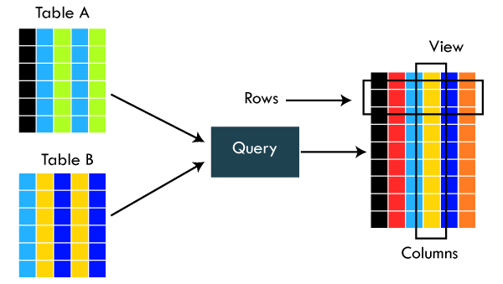
The primary use of a view is to implement the security mechanism. It is the searchable object where we can use a query to search the view as we use for the table. It only shows the data returned by the query that was declared when the view was created.
We can create a view by using the following syntax:

- CREATE VIEW view_name AS
- SELECT column_lists FROM table_name
- WHERE condition;

25) What is an Index in SQL?
An index is a disc structure associated with a table or view that speeds up row retrieval. It reduces the cost of the query because the query's high cost will lead to a fall in its performance. It is used to increase the performance and allow faster retrieval of records from the table. Indexing reduces the number of data pages we need to visit to find a particular data page. It also has a unique value meaning that the index cannot be duplicated. An index creates an entry for each value which makes it faster to retrieve data.
For example: Suppose we have a book which carries the details of the countries. If you want to find out information about India, why will you go through every page of that book? You could directly go to the index. Then from the index, you can go to that particular page where all the information about India is given.

26) What are the different types of indexes in SQL?
SQL indexes are nothing more than a technique of minimizing the query's cost. The higher the query's cost, the worse the query's performance. The following are the different types of Indexes supported in SQL:
- Unique Index
- Clustered Index
- Non-Clustered Index
- Bit-Map Index
- Normal Index
- Composite Index
- B-Tree Index
- Function-Based Index

27) What is the unique index?
UNIQUE INDEX is used to enforce the uniqueness of values in single or multiple columns. We can create more than one unique index in a single table. For creating a unique index, the user has to check the data in the column because the unique indexes are used when any column of the table has unique values. This indexing does not allow the field to have duplicate values if the column is unique indexed. A unique index can be applied automatically when a primary key is defined.
We can create it by using the following syntax:

- CREATE UNIQUE INDEX index_name
- ON table_name (index_column1, index_column2,...);
Example

- CREATE TABLE Employee(
- ID int AUTO_INCREMENT PRIMARY KEY,
- Name varchar(45),
- Phone varchar(15),
- City varchar(25),
- );
Suppose we want to make a Phone column as a unique index. We can do this like below:

- CREATE UNIQUE INDEX index_name_phone ON Employee (Phone);
To read more information, click here.

28) What is clustered index in SQL?
A clustered index is actually a table where the data for the rows are stored. It determines the order of the table data based on the key values that can sort in only one direction. Each table can have only one clustered index. It is the only index, which has been automatically created when the primary key is generated. If many data modifications needed to be done in the table, then clustered indexes are preferred.
To read more information, click here.

29) What is the non-clustered index in SQL?
The indexes other than PRIMARY indexes (clustered indexes) are called non-clustered indexes. We know that clustered indexes are created automatically when primary keys are generated, and non-clustered indexes are created when multiple joins conditions and various filters are used in the query. The non-clustered index and table data are both stored in different places. It cannot be able to alter the physical order of the table and maintains the logical order of data.
The purpose of creating a non-clustered index is for searching the data. Its best example is a book where the content is written in one place, and the index is at a different place. We can create 0 to 249 non-clustered indexes in each table. The non-clustered indexing improves the performance of the queries which use keys without assigning the primary key.

30) What are the differences between SQL, MySQL, and SQL Server?
The following comparison chart explains their main differences:
SQL | MySQL | SQL Server
SQL or Structured Query Language is useful for managing our relational databases. It is used to query and operate the database. | MySQL is the popular database management system used for managing the relational database. It is a fast, scalable, and easy-to-use database. | SQL Server is an RDBMS database system mainly developed for the Windows system to store, retrieve, and access data requested by the developer.
SQL first appeared in 1974. | MySQL first appeared on May 23, 1995. | SQL Server first appeared on April 24, 1989.
SQL was developed by IBM Corporation. | MySQL was developed by Oracle Corporation. | SQL Server was developed by Microsoft Company.
SQL is a query language for managing databases. | MySQL is database software that uses SQL language to conduct with the database. | SQL Server is also a software that uses SQL language to conduct with the database.
SQL has no variables. | MySQL can use variables constraints and data types. | SQL Server can use variables constraints and data types.
SQL is a programming language, so that it does not get any updates. Its commands are always fixed and remain the same. | MySQL is software, so it gets frequent updation. | SQL Server is also software, so it gets frequent updation.

31) What is the difference between SQL and PL/SQL?
The following comparison chart explains their main differences:
SQL | PL/SQL
SQL is a database structured query language used to communicate with relational databases. It was developed by IBM Corporations and first appeared in 1974. | PL/SQL or Procedural Language/Structured Query Language is a dialect of SQL used to enhance the capabilities of SQL. Oracle Corporation developed it in the early 90's. It uses SQL as its database language.
SQL is a declarative and data-oriented language. | PL/SQL is a procedural and application-oriented language.
SQL has no variables. | PL/SQL can use variables constraints and data types.
SQL can execute only a single query at a time. | PL/SQL can execute a whole block of code at once.
SQL query can be embedded in PL/SQL. | PL/SQL cannot be embedded in SQL as SQL does not support any programming language and keywords.
SQL can directly interact with the database server. | PL/SQL cannot directly interact with the database server.
SQL is like the source of data that we need to display. | PL/SQL provides a platform where SQL data will be shown.

32) Is it possible to sort a column using a column alias?
Yes. We can use the alias method in the ORDER BY instead of the WHERE clause for sorting a column.

33) What is the difference between clustered and non-clustered indexes in SQL?
Indexing is a method to get the requested data very fast. There are mainly two types of indexes in SQL, clustered index and non-clustered index. The differences between these two indexes are very important from an SQL performance perspective. The following comparison chart explains their main differences:
Clustered Index | Non-Clustered Index
A clustered index is a table or view where the data for the rows are stored. In a relational database, if the table column contains a primary key, MySQL automatically creates a clustered index named PRIMARY. | The indexes other than PRIMARY indexes (clustered indexes) are called non-clustered indexes. It has a structure separate from the data row. The non-clustered indexes are also known as secondary indexes.
Clustered indexes store the data information and the data itself. | Non-clustered indexes stores only the information, and then it will refer you to the data stored in clustered data.
There can only be one clustered index per table. | There can be one or more non-clustered indexes in a table.
A clustered index determines how data is stored physically in the table. Therefore, reading from a clustered index is faster. | It creates a logical ordering of data rows and uses pointers for accessing the physical data files. Therefore, reading from a clustered index is slower.
A clustered index always contains an index id of 0. | A non-clustered index always contains an index id>0.
To read more information, click here.

34) What is the SQL query to display the current date?
There is a built-in function in SQL called GetDate(), which is used to return the current timestamp.

35) Which are joins in SQL? Name the most commonly used SQL joins?
SQL joins are used to retrieve data from multiple tables into a meaningful result set. It is performed whenever you need to fetch records from two or more tables. They are used with SELECT statement and join conditions.
The following are the most commonly used joins in SQL:
- INNER JOIN
- LEFT OUTER JOIN
- RIGHT OUTER JOIN

36) What are the different types of joins in SQL?
Joins are used to merge two tables or retrieve data from tables. It depends on the relationship between tables. According to the ANSI standard, the following are the different types of joins used in SQL:
- INNER JOIN
- SELF JOIN
- LEFT OUTER JOIN
- RIGHT OUTER JOIN
- FULL OUTER JOIN
- CROSS JOIN
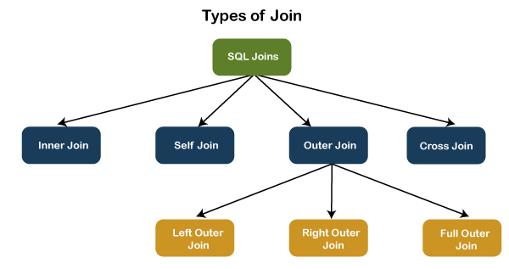
To read more information, click here.

37) What is INNER JOIN in SQL?
Inner join returns only those records from the tables that match the specified condition and hides other rows and columns. In simple words, it fetches rows when there is at least one match of rows between the tables is found. INNER JOIN keyword joins the matching records from two tables. It is assumed as a default join, so it is optional to use the INNER keyword with the query.
The below visual representation explain this join more clearly:
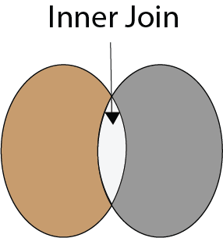
The following syntax illustrates the INNER JOIN:

- SELECT column_lists
- FROM table1
- INNER JOIN table2 ON join_condition1
- INNER JOIN table3 ON join_condition2
- ...;
To read more information, click here.

38) What is the Right JOIN in SQL?
The Right join is used to retrieve all rows from the right-hand table and only those rows from the other table that fulfilled the join condition. It returns all the rows from the right-hand side table even though there are no matches in the left-hand side table. If it finds unmatched records from the left side table, it returns a Null value. This join is also known as Right Outer Join.
The below visual representation explain this join more clearly:
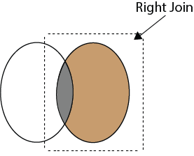
The following syntax illustrates the RIGHT JOIN:

- SELECT colum_lists
- FROM table1
- RIGHT JOIN table2
- ON join_condition;
To read more information, click here.

39) What is Left Join in SQL?
The Left Join is used to fetch all rows from the left-hand table and common records between the specified tables. It returns all the rows from the left-hand side table even though there are no matches on the right-hand side table. If it will not find any matching record from the right side table, then it returns null. This join can also be called a Left Outer Join.
The following visual representation explains it more clearly:
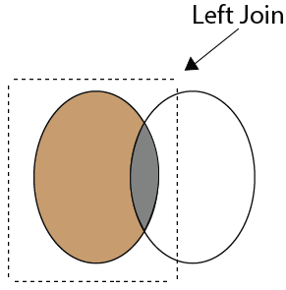
The following syntax illustrates the RIGHT JOIN:

- SELECT colum_lists
- FROM table1
- LEFT JOIN table2
- ON join_condition;
To read more information, click here.

40) What is Full Join in SQL?
The Full Join results from a combination of both left and right join that contains all the records from both tables. It fetches rows when there are matching rows in any one of the tables. This means it returns all the rows from the left-hand side table and all the rows from the right-hand side tables. If a match is not found, it puts NULL value. It is also known as FULL OUTER JOIN.
The following visual representation explains it more clearly:
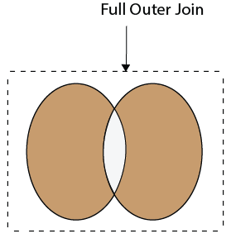
The following syntax illustrates the FULL JOIN:

- SELECT * FROM table1
- FULL OUTER JOIN table2
- ON join_condition;
To read more information, click here.

41) What is a "TRIGGER" in SQL?
A trigger is a set of SQL statements that reside in a system catalog. It is a special type of stored procedure that is invoked automatically in response to an event. It allows us to execute a batch of code when an insert, update or delete command is run against a specific table because the trigger is the set of activated actions whenever DML commands are given to the system.
SQL triggers have two main components one is action, and another is an event. When certain actions are taken, an event occurs as a result of those actions.
We use the CREATE TRIGGER statement for creating a trigger in SQL. Here is the syntax:

- CREATE TRIGGER trigger_name
- (AFTER | BEFORE) (INSERT | UPDATE | DELETE)
- ON table_name FOR EACH ROW
- BEGIN
- --variable declarations
- --trigger code
- END;
To read more information, click here.

42) What is self-join and what is the requirement of self-join?
A SELF JOIN is used to join a table with itself. This join can be performed using table aliases, which allow us to avoid repeating the same table name in a single sentence. It will throw an error if we use the same table name more than once in a single query without using table aliases.
A SELF JOIN is required when we want to combine data with other data in the same table itself. It is often very useful to convert a hierarchical structure to a flat structure.
The following syntax illustrates the SELF JOIN:

- SELECT column_lists
- FROM table1 AS T1, table1 AS T2
- WHERE join_conditions;
Example
Suppose we have a table 'Student' having the following data:
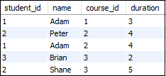
If we want to get retrieve the student_id and name from the table where student_id is equal, and course_id is not equal, it can be done by using the self-join:

- SELECT s1.student_id, s1.name
- FROM student AS s1, student s2
- WHERE s1.student_id=s2.student_id
- AND s1.course_id<>s2.course_id;
Here is the result:
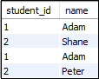
To read more information, click here.

43) What are the set operators in SQL?
We use the set operators to merge data from one or more tables of the same kind. Although the set operators are like SQL joins, there is a significant distinction. SQL joins combine columns from separate tables, whereas SQL set operators combine rows from different queries. SQL queries that contain set operations are called compound queries. The set operators in SQL are categories into four different types:
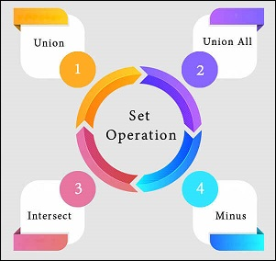
A. UNION: It combines two or more results from multiple SELECT queries into a single result set. It has a default feature to remove the duplicate rows from the tables. The following syntax illustrates the Union operator:

- SELECT columns FROM table1
- UNION
- SELECT columns FROM table2;
B. UNION ALL: This operator is similar to the Union operator, but it does not remove the duplicate rows from the output of the SELECT statements. The following syntax illustrates the UNION ALL operator:

- SELECT columns FROM table1
- UNION ALL
- SELECT columns FROM table2;
C. INTERSECT: This operator returns the common records from two or more SELECT statements. It always retrieves unique records and arranges them in ascending order by default. Here, the number of columns and data types should be the same. The following syntax illustrates the INTERSECT operator:

- SELECT columns FROM table1
- INTERSECT
- SELECT columns FROM table2;
D. MINUS: This operator returns the records from the first query, which is not found in the second query. It does not return duplicate values. The following syntax illustrates the MINUS operator:

- SELECT columns FROM table1
- MINUS
- SELECT columns FROM table2;
To read more information, click here.

44) What is the difference between IN and BETWEEN operators?
The following comparison chart explains their main differences:
BETWEEN Operator | IN Operator
This operator is used to selects the range of data between two values. The values can be numbers, text, and dates as well. | It is a logical operator to determine whether or not a specific value exists within a set of values. This operator reduces the use of multiple OR conditions with the query.
It returns records whose column value lies in between the defined range. | It compares the specified column's value and returns the records when the match exists in the set of values.
The following syntax illustrates this operator:  SELECT * FROM table_name  WHERE column_name BETWEEN 'value1' AND 'value2'; | The following syntax illustrates this operator:  SELECT * FROM table_name  WHERE column_name IN ('value1','value 2');

45) What is a constraint? Tell me about its various levels.
The constraint is used to specify the rule and regulations that allows or restricts what values/data will be stored in the table. It ensures data accuracy and integrity inside the table. It enforces us to store valid data and prevents us from storing irrelevant data. If any interruption occurs between the constraint and data action, the action is failed. Some of the most commonly used constraints are NOT NULL, PRIMARY KEY, FOREIGN KEY, AUTO_INCREMENT, UNIQUE KEY, etc.
The following syntax illustrates us to create a constraint for a table:

- CREATE TABLE table_name (
- column1 datatype constraint,
- column2 datatype constraint,
- .........
- );
SQL categories the constraints into two levels:
Column Level Constraints: These constraints are only applied to a single column and limit the type of data that can be stored in that column.
Table Level Constraints: These constraints are applied to the entire table and limit the type of data that can be entered.
To read more information, click here.

46) How to write an SQL query to find students' names start with 'A'?
We can write the following query to get the student details whose name starts with A:

- SELECT * FROM student WHERE stud_name like 'A%';
Here is the demo example where we have a table named student that contains two names starting with the 'A' character.
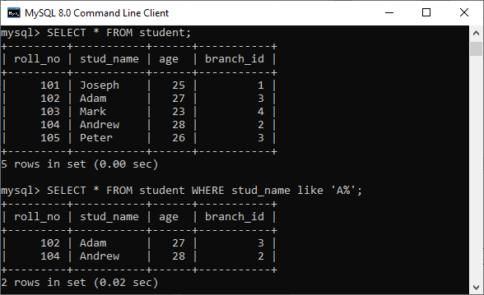

47) Write the SQL query to get the third maximum salary of an employee from a table named employees.
The following query is the simplest way to get the third maximum salary of an employee:

- SELECT * FROM `employees` ORDER BY `salary` DESC LIMIT 1 OFFSET 2
Here is the demo example that shows how to get the third maximum salary of an employee.
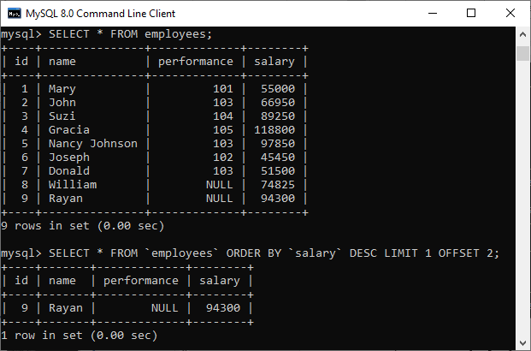
The following are the alternative way to get the third-highest salary of an employee:
A. Using LIMIT Keyword

- SELECT salary FROM employees
- ORDER BY salary DESC
- LIMIT 2, 1;
B. Using Subquery

- SELECT salary
- FROM
- (SELECT salary
- FROM employees
- ORDER BY salary DESC
- LIMIT 3) AS Temp
- ORDER BY salary LIMIT 1;
C. Using TOP Keyword

- SELECT TOP 1 salary
- FROM
- (SELECT DISTINCT TOP 3 salary
- FROM employees
- ORDER BY salary DESC) AS Temp
- ORDER BY salary ASC;

48) What is the difference between DELETE and TRUNCATE statements in SQL?
The main difference between them is that the delete statement deletes data without resetting a table's identity, whereas the truncate command resets a particular table's identity. The following comparison chart explains it more clearly:
No. | DELETE | TRUNCATE
1) | The delete statement removes single or multiple rows from an existing table depending on the specified condition. | The truncate command deletes the whole contents of an existing table without the table itself. It preserves the table structure or schema.
2) | DELETE is a DML command. | TRUNCATE is a DML command.
3) | We can use the WHERE clause in the DELETE command. | We cannot use the WHERE clause with TRUNCATE.
4) | DELETE statement is used to delete a row from a table. | TRUNCATE statement is used to remove all the rows from a table.
5) | DELETE is slower because it maintained the log. | TRUNCATE statement is faster than DELETE statement as it deletes entire data at a time without maintaining transaction logs.
6) | You can roll back data after using the DELETE statement. | It is not possible to roll back after using the TRUNCATE statement.
7) | DELETE query takes more space. | TRUNCATE query occupies less space.
To read more information, click here.

49) What is the ACID property in a database?
The ACID properties are meant for the transaction that goes through a different group of tasks. A transaction is a single logical order of data. It provides properties to maintain consistency before and after the transaction in a database. It also ensures that the data transactions are processed reliably in a database system.
The ACID property is an acronym for Atomicity, Consistency, Isolation, and Durability.
Atomicity: It ensures that all statements or operations within the transaction unit must be executed successfully. If one part of the transaction fails, the entire transaction fails, and the database state is left unchanged. Its main features are COMMIT, ROLLBACK, and AUTO-COMMIT.
Consistency: This property ensures that the data must meet all validation rules. In simple words, we can say that the database changes state only when a transaction will be committed successfully. It also protects data from crashes.
Isolation: This property guarantees that the concurrent property of execution in the transaction unit must be operated independently. It also ensures that statements are transparent to each other. The main goal of providing isolation is to control concurrency in a database.
Durability: This property guarantees that once a transaction has been committed, it persists permanently even if the system crashes, power loss, or failed.
To read more information, click here.

50) Is a blank space or zero the same as a NULL value?
No. The NULL value is not the same as zero or a blank space. The following points explain their main differences:
- A NULL value is a value, which is 'unavailable, unassigned, unknown or not applicable.' It would be used in the absence of any value. We can perform arithmetic operations on it. On the other hand, zero is a number, and a blank space is treated as a character.
- The NULL value can be treated as an unknown and missing value, but zero and blank spaces differ from the NULL value.
- We can compare a blank space or a zero to another blank space or a zero. On the other hand, one NULL may not be the same as another NULL. NULL indicates that no data has been provided or that no data exists.

51) What are functions and their usage in SQL?
SQL functions are simple code snippets that are frequently used and re-used in database systems for data processing and manipulation. Functions are the measured values. It always performs a specific task. The following rules should be remembered while creating functions:
- A function should have a name, and the name cannot begin with a special character such as @, $, #, or other similar characters.
- Functions can only work with the SELECT statements.
- Every time a function is called, it compiles.
- Functions must return value or result.
- Functions are always used with input parameters.
SQL categories the functions into two types:
- User-Defined Function: Functions created by a user based on their needs are termed user-defined functions.
- System Defined Function: Functions whose definition is defined by the system are termed system-defined functions. They are built-in database functions.
SQL functions are used for the following purposes:
- To perform calculations on data
- To modify individual data items
- To manipulate the output
- To format dates and numbers
- To convert data types

52) What is meant by case manipulation functions? Explains its different types in SQL.
Case manipulation functions are part of the character functions. It converts the data from the state in which it is already stored in the table to upper, lower, or mixed case. The conversion performed by this function can be used to format the output. We can use it in almost every part of the SQL statement. Case manipulation functions are mostly used when you need to search for data, and you don't have any idea that the data you are looking for is in lower case or upper case.
There are three case manipulation functions in SQL:
LOWER: This function is used to converts a given character into lowercase. The following example will return the 'STEPHEN' as 'stephen':

- SELECT LOWER ('STEPHEN') AS Case_Reault FROM dual;

NOTE: Here, 'dual' is a dummy table.
UPPER: This function is used to converts a given character into uppercase. The following example will return the 'stephen' as 'STEPHEN':

- SELECT UPPER ('stephen') AS Case_Reault FROM dual;
INITCAP: This function is used to converts given character values to uppercase for the initials of each word. It means every first letter of the word is converted into uppercase, and the rest is in lower case. The following example will return the 'hello stephen' as 'Hello Stephen':

- SELECT INITCAP ('hello stephen') AS Case_Reault FROM dual;

53) Explain character-manipulation functions? Explains its different types in SQL.
Character-manipulation functions are used to change, extract, and alter the character string. When one or more characters and words are passed into the function, the function will perform its operation on those input strings and return the result.
The following are the character manipulation functions in SQL:
A) CONCAT: This function is used to join two or more values together. It always appends the second string into the end of the first string. For example:
Input: SELECT CONCAT ('Information-', 'technology') FROM DUAL;
Output: Information-technology
B) SUBSTR: It is used to return the portion of the string from a specified start point to an endpoint. For example:
Input: SELECT SUBSTR ('Database Management System', 9, 11) FROM DUAL;
Output: Management
C) LENGTH: This function returns the string's length in numerical value, including the blank spaces. For example:
Input: SELECT LENGTH ('Hello Javatpoint') FROM DUAL;
Output: 16
D) INSTR: This function finds the exact numeric position of a specified character or word in a given string. For example:
Input: SELECT INSTR ('Hello Javatpoint', 'Javatpoint');
Output: 7
E) LPAD: It returns the padding of the left-side character value for right-justified value. For example:
Input: SELECT LPAD ('200', 6,'*');
Output: ***200
F) RPAD: It returns the padding of the right-side character value for left-justified value. For example:
Input: SELECT RPAD ('200', 6,'*');
Output: 200***
G) TRIM: This function is used to remove all the defined characters from the beginning, end, or both. It also trimmed extra spaces. For example:
Input: SELECT TRIM ('A' FROM 'ABCDCBA');
Output: BCDCB
H) REPLACE: This function is used to replace all occurrences of a word or portion of the string (substring) with the other specified string value. For example:
Input: SELECT REPLACE ( 'It is the best coffee at the famous coffee shop.', 'coffee', 'tea');
Output: It is the best tea at the famous tea shop.

54) What is the usage of the NVL() function?
The NVL() function is used to convert the NULL value to the other value. The function returns the value of the second parameter if the first parameter is NULL. If the first parameter is anything other than NULL, it is left unchanged. This function is used in Oracle, not in SQL and MySQL. Instead of NVL() function, MySQL have IFNULL() and SQL Server have ISNULL() function.

55) Which function is used to return remainder in a division operator in SQL?
The MOD function returns the remainder in a division operation.

56) What are the syntax and use of the COALESCE function?
The COALESCE() function evaluates the arguments in sequence and returns the first NON-NULL value in a specified number of expressions. If it evaluates arguments as NULL or not found any NON-NULL value, it returns the NULL result.
The syntax of COALESCE function is given below:

- COALESCE (exp1, exp2, .... expn)
Example:

- SELECT COALESCE(NULL, 'Hello', 'Javatpoint', NULL) AS Result;
This statement will return the following output:
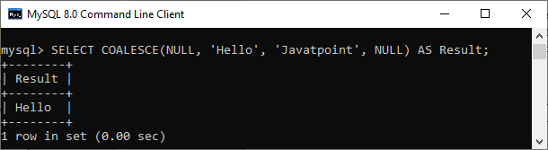

57) How do we use the DISTINCT statement? What is its use?
The DISTINCT keyword is used to ensure that the fetched value always has unique values. It does not allow to have duplicate values. The DISTINCT keyword is used with the SELECT statement and retrieves different values from the table's column. We can use it with the help of the following syntax:

- SELECT DISTINCT column_lists FROM table_name WHERE [condition];
Suppose we have a table 'customer' containing eight records in which the name column has some duplicate values.
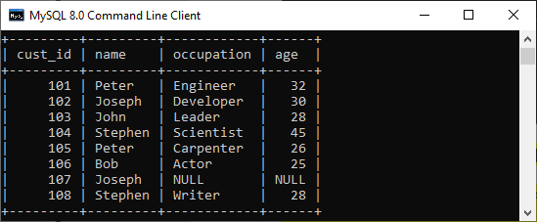
If we want to get the name column without any duplicate values, the DISTINCT keyword is required. Executing the below command will return a name column with unique values.
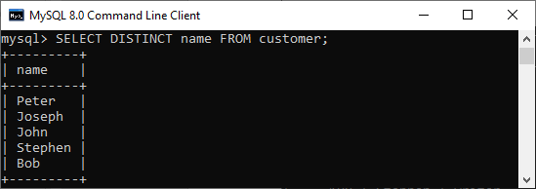

58) What is the default ordering of data using the ORDER BY clause? How could it be changed?
The ORDER BY clause is used to sort the table data either in ascending or descending order. By default, it will sort the table in ascending order. If we want to change its default behavior, we need to use the DESC keyword after the column name in the ORDER BY clause.
The syntax to do this is given below:

- SELECT expressions FROM tables
- WHERE conditions
- ORDER BY expression [ASC | DESC];
We have taken a customer table in the previous example. Now, we will demonstrate the ORDER BY clause on them as well.
In the below output, we can see that the first query will sort the table data in ascending order based on the name column. However, if we run the second query by specifying the DESC keyword, the table's order is changed in descending order.
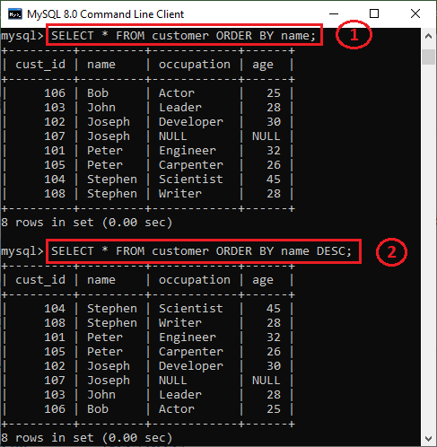

59) Is the following query returns the output?

- SELECT subject_code, AVG (marks)
- FROM Students
- WHERE AVG(marks) > 70
- GROUP BY subject_code;
Answer: No. The above query does not return the output because we cannot use the WHERE clause to restrict the groups. We need to use the HAVING clause instead of the WHERE clause to get the correct output.

60) What is the difference between the WHERE and HAVING clauses?
The main difference is that the WHERE clause is used to filter records before any groupings are established, whereas the HAVING clause is used to filter values from a group. The below comparison chart explains the most common differences:
WHERE | HAVING
This clause is implemented in row operations. | This clause is implemented in column operations.
It does not allow to work with aggregate functions. | It can work with aggregate functions.
This clause can be used with the SELECT, UPDATE, and DELETE statements. | This clause can only be used with the SELECT statement.
To know more differences, click here.

61) How many Aggregate functions are available in SQL?
The aggregate function is used to determine and calculate several values in a table and return the result as a single number. For example, the average of all values, the sum of all values, and the maximum and minimum value among particular groupings of values.
The following syntax illustrates how to use aggregate functions:

- function_name (DISTINCT | ALL expression)
SQL provides seven (7) aggregate functions, which are given below:
- AVG(): This function is used to returns the average value from specified columns.
- COUNT(): This function is used to returns the number of table rows, including rows with null values.
- MAX(): This function is used to returns the largest value among the group.
- MIN(): This function is used to returns the smallest value among the group.
- SUM(): This function is used to returns the total summed values(non-null) of the specified column.
- FIRST(): This function is used to returns the first value of an expression.
- LAST(): This function is used to returns the last value of an expression.

62) What is SQL Injection?
SQL injection is a type of vulnerability in website and web app code that allows attackers to control back-end operations and access, retrieve, and destroy sensitive data from databases. In this technique, malicious SQL statements are inserted into a database entry field, and once they are performed, the database becomes vulnerable to an attacker. This technique is commonly used to access sensitive data and perform administrative activities on databases by exploiting data-driven applications. It is also known as SQLi attack.
Some common examples of SQL injection are:
- Accessing confidential data to modify an SQL query to get desired results.
- UNION attacks to steal data from different database tables.
- Examine the database to extract information regarding the version and structure of the database.

63) What is the difference between the RANK() and DENSE_RANK() functions?
The RANK function determines the rank for each row within your ordered partition in the result set. If the two rows are assigned the same rank, then the next number in the ranking will be its previous rank plus a number of duplicate numbers. For example, if we have three records at rank 4, the next rank listed would be ranked 7.
The DENSE_RANK function assigns a unique rank for each row within a partition as per the specified column value without any gaps. It always specifies ranking in consecutive order. If the two rows are assigned the same rank, this function will assign it with the same rank, and the next rank being the next sequential number. For example, if we have 3 records at rank 4, the next rank listed would be ranked 5.

64) Is it possible to implicitly insert a row for the identity column?
Yes. We can implicitly insert a row for the identity column. Here is an example of doing this:

- SET IDENTITY_INSERT TABLE1 ON
- INSERT INTO demo_table1 (id, name, branch)
- SELECT id, name, branch FROM demo_table2
- SET IDENTITY_INSERT OFF

65) What are SQL comments?
Comments are explanations or annotations in SQL queries that are readable by programmers. It's used to make SQL statements easier to understand for humans. During the parsing of SQL code, it will be ignored. Comments can be written on a single line or across several lines.
- Single Line Comments: It starts with two consecutive hyphens (--).
- Multi-line Comments: It starts with /* and ends with */.

Q1. What is the difference between SQL and MySQL?
SQL vs MySQL  SQL | MySQL
SQL is a standard language which stands for Structured Query Language based on the English language | MySQL is a database management system.
SQL is the core of the relational database which is used for accessing and managing database | MySQL is an RDMS (Relational Database Management System) such as SQL Server, Informix etc.

Q2. What are the different subsets of SQL?
- Data Definition Language (DDL) – It allows you to perform various operations on the database such as CREATE, ALTER, and DELETE objects.
- Data Manipulation Language(DML) – It allows you to access and manipulate data. It helps you to insert, update, delete and retrieve data from the database.
- Data Control Language(DCL) – It allows you to control access to the database. Example – Grant, Revoke access permissions.

Q3. What do you mean by DBMS? What are its different types?
A Database Management System (DBMS) is a software application that interacts with the user, applications, and the database itself to capture and analyze data. A database is a structured collection of data.
A DBMS allows a user to interact with the database. The data stored in the database can be modified, retrieved and deleted and can be of any type like strings, numbers, images, etc.
There are two types of DBMS:
- Relational Database Management System: The data is stored in relations (tables). Example – MySQL.
- Non-Relational Database Management System: There is no concept of relations, tuples and attributes. Example – MongoDB
Let’s move to the next question in this SQL Interview Questions.

Q4. What is RDBMS? How is it different from DBMS?
A relational database management system (RDBMS) is a set of applications and features that allow IT professionals and others to develop, edit, administer, and interact with relational databases. Most commercial relational database management systems use Structured Query Language (SQL) to access the database, which is stored in the form of tables.
The RDBMS is the most widely used database system in businesses all over the world. It offers a stable means of storing and retrieving massive amounts of data.
Databases, in general, hold collections of data that may be accessed and used in other applications. The development, administration, and use of database platforms are all supported by a database management system.
A relational database management system (RDBMS) is a type of database management system (DBMS) that stores data in a row-based table structure that links related data components. An RDBMS contains functions that ensure the data’s security, accuracy, integrity, and consistency. This is not the same as the file storage utilized by a database management system.
The following are some further distinctions between database management systems and relational database management systems:
The number of users who are permitted to utilise the system
A DBMS can only handle one user at a time, whereas an RDBMS can handle numerous users.
Hardware and software specifications
In comparison to an RDBMS, a DBMS requires fewer software and hardware.
Amount of information
RDBMSes can handle any quantity of data, from tiny to enormous, whereas DBMSes are limited to small amounts.
The structure of the database
Data is stored in a hierarchical format in a DBMS, whereas an RDBMS uses a table with headers that serve as column names and rows that hold the associated values.
Implementation of the ACID principle
The atomicity, consistency, isolation, and durability (ACID) concept is not used by DBMSs for data storage. RDBMSes, on the other hand, use the ACID model to organize their data and assure consistency.
Databases that are distributed
A DBMS will not provide complete support for distributed databases, whereas an RDBMS will.
Programs that are managed
A DBMS focuses on keeping databases that are present within the computer network and system hard discs, whereas an RDBMS helps manage relationships between its incorporated tables of data.
Normalization of databases is supported
A RDBMS can be normalized , but a DBMS cannot be normalized.

Q5. What is a Self-Join?
A self-join is a type of join that can be used to connect two tables. As a result, it is a unary relationship. Each row of the table is attached to itself and all other rows of the same table in a self-join. As a result, a self-join is mostly used to combine and compare rows from the same database table.

Q6. What is the SELECT statement?
A SELECT command gets zero or more rows from one or more database tables or views. The most frequent data manipulation language (DML) command is SELECT in most applications. SELECT queries define a result set, but not how to calculate it, because SQL is a declarative programming language.

Q7. What are some common clauses used with SELECT query in SQL?
The following are some frequent SQL clauses used in conjunction with a SELECT query:
WHERE clause: In SQL, the WHERE clause is used to filter records that are required depending on certain criteria.
ORDER BY clause: The ORDER BY clause in SQL is used to sort data in ascending (ASC) or descending (DESC) order depending on specified field(s) (DESC).
GROUP BY clause: GROUP BY clause in SQL is used to group entries with identical data and may be used with aggregation methods to obtain summarised database results.
HAVING clause in SQL is used to filter records in combination with the GROUP BY clause. It is different from WHERE, since the WHERE clause cannot filter aggregated records.

Q8. What are UNION, MINUS and INTERSECT commands?
The UNION operator is used to combine the results of two tables while also removing duplicate entries.
The MINUS operator is used to return rows from the first query but not from the second query.
The INTERSECT operator is used to combine the results of both queries into a single row.
Before running either of the above SQL statements, certain requirements must be satisfied –
Within the clause, each SELECT query must have the same amount of columns.
The data types in the columns must also be comparable.
In each SELECT statement, the columns must be in the same order.

Q9. What is Cursor? How to use a Cursor?
After any variable declaration, DECLARE a cursor. A SELECT Statement must always be coupled with the cursor definition.
To start the result set, move the cursor over it. Before obtaining rows from the result set, the OPEN statement must be executed.
To retrieve and go to the next row in the result set, use the FETCH command.
To disable the cursor, use the CLOSE command.
Finally, use the DEALLOCATE command to remove the cursor definition and free up the resources connected with it.

Q10. List the different types of relationships in SQL.
There are different types of relations in the database:
One-to-One – This is a connection between two tables in which each record in one table corresponds to the maximum of one record in the other.
One-to-Many and Many-to-One – This is the most frequent connection, in which a record in one table is linked to several records in another.
Many-to-Many – This is used when defining a relationship that requires several instances on each sides.
Self-Referencing Relationships – When a table has to declare a connection with itself, this is the method to employ.

Q12. What is OLTP?
OLTP, or online transactional processing, allows huge groups of people to execute massive amounts of database transactions in real time, usually via the internet. A database transaction occurs when data in a database is changed, inserted, deleted, or queried.

Q13. What are the differences between OLTP and OLAP?
OLTP stands for online transaction processing, whereas OLAP stands for online analytical processing. OLTP is an online database modification system, whereas OLAP is an online database query response system.

Q14. How to create empty tables with the same structure as another table?
To create empty tables:
Using the INTO operator to fetch the records of one table into a new table while setting a WHERE clause to false for all entries, it is possible to create empty tables with the same structure. As a result, SQL creates a new table with a duplicate structure to accept the fetched entries, but nothing is stored into the new table since the WHERE clause is active.

Q15. What is PostgreSQL?
In 1986, a team lead by Computer Science Professor Michael Stonebraker created PostgreSQL under the name Postgres. It was created to aid developers in the development of enterprise-level applications by ensuring data integrity and fault tolerance in systems. PostgreSQL is an enterprise-level, versatile, resilient, open-source, object-relational database management system that supports variable workloads and concurrent users. The international developer community has constantly backed it. PostgreSQL has achieved significant appeal among developers because to its fault-tolerant characteristics.
It’s a very reliable database management system, with more than two decades of community work to thank for its high levels of resiliency, integrity, and accuracy. Many online, mobile, geospatial, and analytics applications utilise PostgreSQL as their primary data storage or data warehouse.

Q16. What are SQL comments?
SQL Comments are used to clarify portions of SQL statements and to prevent SQL statements from being executed. Comments are quite important in many programming languages. The comments are not supported by a Microsoft Access database. As a result, the Microsoft Access database is used in the examples in Mozilla Firefox and Microsoft Edge.
Single Line Comments: It starts with two consecutive hyphens (–).
Multi-line Comments: It starts with /* and ends with */.

Q17. What is the usage of the NVL() function?
You may use the NVL function to replace null values with a default value. The function returns the value of the second parameter if the first parameter is null. If the first parameter is anything other than null, it is left alone.
This function is used in Oracle, not in SQL and MySQL. Instead of NVL() function, MySQL have IFNULL() and SQL Server have ISNULL() function.
Let’s move to the next question in this SQL Interview Questions.

Q18. Explain character-manipulation functions? Explains its different types in SQL.
Change, extract, and edit the character string using character manipulation routines. The function will do its action on the input strings and return the result when one or more characters and words are supplied into it.
The character manipulation functions in SQL are as follows:
A) CONCAT (joining two or more values): This function is used to join two or more values together. The second string is always appended to the end of the first string.
B) SUBSTR: This function returns a segment of a string from a given start point to a given endpoint.
C) LENGTH: This function returns the length of the string in numerical form, including blank spaces.
D) INSTR: This function calculates the precise numeric location of a character or word in a string.
E) LPAD: For right-justified values, it returns the padding of the left-side character value.
F) RPAD: For a left-justified value, it returns the padding of the right-side character value.
G) TRIM: This function removes all defined characters from the beginning, end, or both ends of a string. It also reduced the amount of wasted space.
H) REPLACE: This function replaces all instances of a word or a section of a string (substring) with the other string value specified.

Q19. Write the SQL query to get the third maximum salary of an employee from a table named employees.
Employee table
employee_name | salary
A | 24000
C | 34000
D | 55000
E | 75000
F | 21000
G | 40000
H | 50000

SELECT * FROM(
SELECT employee_name, salary, DENSE_RANK()
OVER(ORDER BY salary DESC)r FROM Employee)
WHERE r=&n;
To find 3rd highest salary set n = 3

Q20. What is the difference between the RANK() and DENSE_RANK() functions?
The RANK() function in the result set defines the rank of each row within your ordered partition. If both rows have the same rank, the next number in the ranking will be the previous rank plus a number of duplicates. If we have three records at rank 4, for example, the next level indicated is 7.
The DENSE_RANK() function assigns a distinct rank to each row within a partition based on the provided column value, with no gaps. It always indicates a ranking in order of precedence. This function will assign the same rank to the two rows if they have the same rank, with the next rank being the next consecutive number. If we have three records at rank 4, for example, the next level indicated is 5.
Q21. What are Tables and Fields?
A table is a collection of data components organized in rows and columns in a relational database. A table can also be thought of as a useful representation of relationships. The most basic form of data storage is the table. An example of an Employee table is shown below.
ID | Name | Department | Salary
1 | Rahul | Sales | 24000
2 | Rohini | Marketing | 34000
3 | Shylesh | Sales | 24000
4 | Tarun | Analytics | 30000

A Record or Row is a single entry in a table. In a table, a record represents a collection of connected data. The Employee table, for example, has four records.
A table is made up of numerous records (rows), each of which can be split down into smaller units called Fields(columns). ID, Name, Department, and Salary are the four fields in the Employee table above.

Q22. What is a UNIQUE constraint?
The UNIQUE Constraint prevents identical values in a column from appearing in two records. The UNIQUE constraint guarantees that every value in a column is unique.

Q23. What is a Self-Join?
A self-join is a type of join that can be used to connect two tables. As a result, it is a unary relationship. Each row of the table is attached to itself and all other rows of the same table in a self-join. As a result, a self-join is mostly used to combine and compare rows from the same database table.

Q24. What is the SELECT statement?
A SELECT command gets zero or more rows from one or more database tables or views. The most frequent data manipulation language (DML) command is SELECT in most applications. SELECT queries define a result set, but not how to calculate it, because SQL is a declarative programming language.

Q25. What are some common clauses used with SELECT query in SQL?
The following are some frequent SQL clauses used in conjunction with a SELECT query:



SQL Essentials Training & Certification
- Course Duration
- Real-life Case Studies
- Assignments
- Lifetime Access
Explore Curriculum

WHERE clause: In SQL, the WHERE clause is used to filter records that are required depending on certain criteria.
ORDER BY clause: The ORDER BY clause in SQL is used to sort data in ascending (ASC) or descending (DESC) order depending on specified field(s) (DESC).
GROUP BY clause: GROUP BY clause in SQL is used to group entries with identical data and may be used with aggregation methods to obtain summarised database results.
HAVING clause in SQL is used to filter records in combination with the GROUP BY clause. It is different from WHERE, since the WHERE clause cannot filter aggregated records.

Q26. What are UNION, MINUS and INTERSECT commands?
The UNION operator is used to combine the results of two tables while also removing duplicate entries.
The MINUS operator is used to return rows from the first query but not from the second query.
The INTERSECT operator is used to combine the results of both queries into a single row.
Before running either of the above SQL statements, certain requirements must be satisfied –
Within the clause, each SELECT query must have the same amount of columns.
The data types in the columns must also be comparable.
In each SELECT statement, the columns must be in the same order.
Let’s move to the next question in this SQL Interview Questions.

Q27. What is Cursor? How to use a Cursor?
After any variable declaration, DECLARE a cursor. A SELECT Statement must always be coupled with the cursor definition.
To start the result set, move the cursor over it. Before obtaining rows from the result set, the OPEN statement must be executed.
To retrieve and go to the next row in the result set, use the FETCH command.
To disable the cursor, use the CLOSE command.
Finally, use the DEALLOCATE command to remove the cursor definition and free up the resources connected with it.

Q28. List the different types of relationships in SQL.
There are different types of relations in the database:
One-to-One – This is a connection between two tables in which each record in one table corresponds to the maximum of one record in the other.
One-to-Many and Many-to-One – This is the most frequent connection, in which a record in one table is linked to several records in another.
Many-to-Many – This is used when defining a relationship that requires several instances on each sides.
Self-Referencing Relationships – When a table has to declare a connection with itself, this is the method to employ.

Q29. What is SQL example?
SQL is a database query language that allows you to edit, remove, and request data from databases. The following statements are a few examples of SQL statements:
- SELECT
- INSERT
- UPDATE
- DELETE
- CREATE DATABASE
- ALTER DATABASE

Q30. What are basic SQL skills?
SQL skills aid data analysts in the creation, maintenance, and retrieval of data from relational databases, which divide data into columns and rows. It also enables users to efficiently retrieve, update, manipulate, insert, and alter data.
The most fundamental abilities that a SQL expert should possess are:
- Database Management
- Structuring a Database
- Creating SQL clauses and statements
- SQL System SKills like MYSQL, PostgreSQL
- PHP expertise is useful.
- Analyze SQL data
- Using WAMP with SQL to create a database
- OLAP Skills

Q31. What is schema in SQL Server?
A schema is a visual representation of the database that is logical. It builds and specifies the relationships among the database’s numerous entities. It refers to the several kinds of constraints that may be applied to a database. It also describes the various data kinds. It may also be used on Tables and Views.
Schemas come in a variety of shapes and sizes. Star schema and Snowflake schema are two of the most popular. The entities in a star schema are represented in a star form, whereas those in a snowflake schema are shown in a snowflake shape.
Any database architecture is built on the foundation of schemas.

Q32. How to create a temp table in SQL Server?
Temporary tables are created in TempDB and are erased automatically after the last connection is closed. We may use Temporary Tables to store and process interim results. When we need to store temporary data, temporary tables come in handy.
The following is the syntax for creating a Temporary Table:
CREATE TABLE #Employee (id INT, name VARCHAR(25))
INSERT INTO #Employee VALUES (01, ‘Ashish’), (02, ‘Atul’)
Let’s move to the next question in this SQL Interview Questions.
Q33. How to install SQL Server in Windows 11?
Install SQL Server Management Studio In Windows 11
Step 1: Click on SSMS, which will take you to the SQL Server Management Studio page.
Step 2: Moreover, click on the SQL Server Management Studio link and tap on Save File.
Step 3: Save this file to your local drive and go to the folder.
Step 4: The setup window will appear, and here you can choose the location where you want to save the file.
Step 5: Click on Install.
Step 6: Close the window after the installation is complete.
Step 7: Furthermore, go back to your Start Menu and search for SQL server management studio.
Step 8: Furthermore, double-click on it, and the login page will appear once it shows up.
Step 9: You should be able to see your server name. However, if that’s not visible, click on the drop-down arrow on the server and tap on Browse.
Step 10: Choose your SQL server and click on Connect.
After that, the SQL server will connect, and Windows 11 will run good.

Q34. What is the case when in SQL Server?
The CASE statement is used to construct logic in which one column’s value is determined by the values of other columns.
At least one set of WHEN and THEN commands makes up the SQL Server CASE Statement. The condition to be tested is specified by the WHEN statement. If the WHEN condition returns TRUE, the THEN sentence explains what to do.
When none of the WHEN conditions return true, the ELSE statement is executed. The END keyword brings the CASE statement to a close.
1  2  3  4  5  6 | CASE  WHEN condition1 THEN result1  WHEN condition2 THEN result2  WHEN conditionN THEN resultN  ELSE result  END;
Q35. NoSQL vs SQL
In summary, the following are the five major distinctions between SQL and NoSQL:
Relational databases are SQL, while non-relational databases are NoSQL.
SQL databases have a specified schema and employ structured query language. For unstructured data, NoSQL databases use dynamic schemas.
SQL databases scale vertically, but NoSQL databases scale horizontally.
NoSQL databases are document, key-value, graph, or wide-column stores, whereas SQL databases are table-based.
SQL databases excel in multi-row transactions, while NoSQL excels at unstructured data such as documents and JSON.

Q36. What is the difference between NOW() and CURRENT_DATE()?
NOW() returns a constant time that indicates the time at which the statement began to execute. (Within a stored function or trigger, NOW() returns the time at which the function or triggering statement began to execute.
The simple difference between NOW() and CURRENT_DATE() is that NOW() will fetch the current date and time both in format ‘YYYY-MM_DD HH:MM:SS’ while CURRENT_DATE() will fetch the date of the current day ‘YYYY-MM_DD’.
Let’s move to the next question in this SQL Interview Questions.
Q37. What is BLOB and TEXT in MySQL?
BLOB stands for Binary Huge Objects and can be used to store binary data, whereas TEXT may be used to store a large number of strings. BLOB may be used to store binary data, which includes images, movies, audio, and applications.
BLOB values function similarly to byte strings, and they lack a character set. As a result, bytes’ numeric values are completely dependent on comparison and sorting.
TEXT values behave similarly to a character string or a non-binary string. The comparison/sorting of TEXT is completely dependent on the character set collection.
Q38. How to remove duplicate rows in SQL?
If the SQL table has duplicate rows, the duplicate rows must be removed.
Let’s assume the following table as our dataset:

ID | Name | Age
1 | A | 21
2 | B | 23
2 | B | 23
4 | D | 22
5 | E | 25
6 | G | 26
5 | E | 25
The following SQL query removes the duplicate ids from the table:
DELETE FROM table WHERE ID IN (
SELECT
ID, COUNT(ID)
FROM table
GROUP BY ID
HAVING
COUNT (ID) > 1);
Q39. How to create a stored procedure using SQL Server?
A stored procedure is a piece of prepared SQL code that you can save and reuse again and over.
So, if you have a SQL query that you create frequently, save it as a stored procedure and then call it to run it.
You may also supply parameters to a stored procedure so that it can act based on the value(s) of the parameter(s) given.
Stored Procedure Syntax
CREATE PROCEDURE procedure_name
AS
sql_statement
GO;
Execute a Stored Procedure
EXEC procedure_name;
Q40. What is Database Black Box Testing?
Black Box Testing is a software testing approach that involves testing the functions of software applications without knowing the internal code structure, implementation details, or internal routes. Black Box Testing is a type of software testing that focuses on the input and output of software applications and is totally driven by software requirements and specifications. Behavioral testing is another name for it.
Q41. What are the different types of SQL sandbox?

Databases Training

SQL ESSENTIALS TRAINING & CERTIFICATION

SQL Essentials Training & Certification
Reviews
5(10329)

MYSQL DBA CERTIFICATION TRAINING

MySQL DBA Certification Training
Reviews
5(6275)

MONGODB CERTIFICATION TRAINING COURSE

MongoDB Certification Training Course
Reviews
4(16172)

APACHE CASSANDRA CERTIFICATION TRAINING

Apache Cassandra Certification Training
Reviews
5(12683)

TERADATA CERTIFICATION TRAINING

Teradata Certification Training
Reviews
5(2837)

MASTERING NEO4J GRAPH DATABASE CERTIFICATION TRAINING

Mastering Neo4j Graph Database Certification Training
Reviews
5(994)

Next
SQL Sandbox is a secure environment within SQL Server where untrusted programmes can be run. There are three different types of SQL sandboxes:
Safe Access Sandbox: In this environment, a user may execute SQL activities like as building stored procedures, triggers, and so on, but they can’t access the memory or create files.
Sandbox for External Access: Users can access files without having the ability to alter memory allocation.
Unsafe Access Sandbox: This contains untrustworthy code that allows a user to access memory.
Let’s move to the next question in this SQL Interview Questions.
Q42. Where MyISAM table is stored?
Prior to the introduction of MySQL 5.5 in December 2009, MyISAM was the default storage engine for MySQL relational database management system versions. It’s based on the older ISAM code, but it comes with a lot of extra features. Each MyISAM table is split into three files on disc (if it is not partitioned). The file names start with the table name and end with an extension that indicates the file type. The table definition is stored in a.frm file, however this file is not part of the MyISAM engine; instead, it is part of the server. The data file’s suffix is.MYD (MYData). The index file’s extension is.MYI (MYIndex). If you lose your index file, you may always restore it by recreating indexes.
Q43. How to find the nth highest salary in SQL?
The most typical interview question is to find the Nth highest pay in a table. This work can be accomplished using the dense rank() function.
Employee table
employee_name | salary
A | 24000
C | 34000
D | 55000
E | 75000
F | 21000
G | 40000
H | 50000

SELECT * FROM(
SELECT employee_name, salary, DENSE_RANK()
OVER(ORDER BY salary DESC)r FROM Employee)
WHERE r=&n;
To find to the 2nd highest salary set n = 2
To find 3rd highest salary set n = 3 and so on.

Q44. What do you mean by table and field in SQL?
A table refers to a collection of data in an organised manner in form of rows and columns. A field refers to the number of columns in a table. For example:
Table: StudentInformation
Field: Stu Id, Stu Name, Stu Marks

Q45. What are joins in SQL?
A JOIN clause is used to combine rows from two or more tables, based on a related column between them. It is used to merge two tables or retrieve data from there. There are 4 types of joins, as you can refer to below:
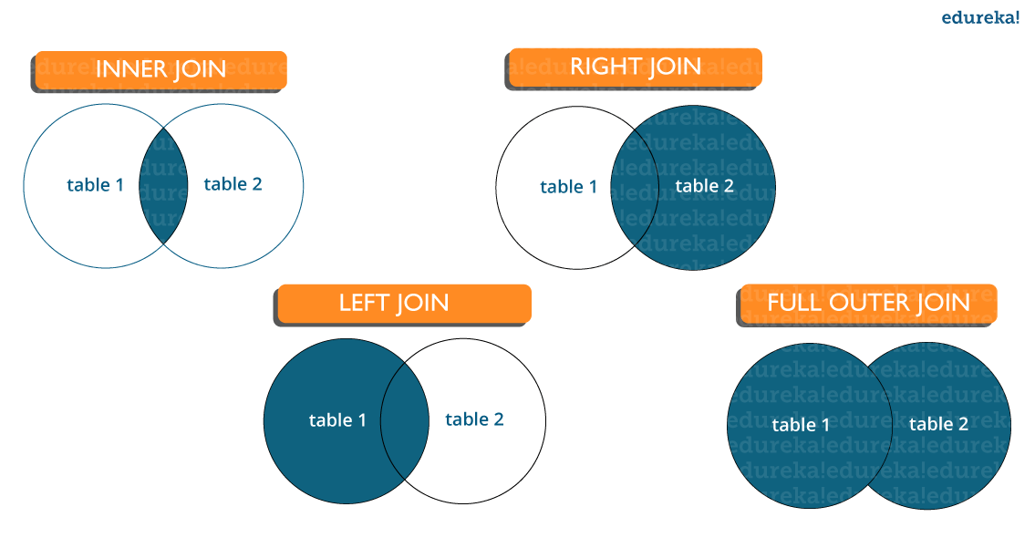
- Inner join: Inner Join in SQL is the most common type of join. It is used to return all the rows from multiple tables where the join condition is satisfied.

Left Join: Left Join in SQL is used to return all the rows from the left table but only the matching rows from the right table where the join condition is fulfilled.

Right Join: Right Join in SQL is used to return all the rows from the right table but only the matching rows from the left table where the join condition is fulfilled.

Full Join: Full join returns all the records when there is a match in any of the tables. Therefore, it returns all the rows from the left-hand side table and all the rows from the right-hand side table.

Let’s move to the next question in this SQL Interview Questions.

Q46. What is the difference between CHAR and VARCHAR2 datatype in SQL?
Both Char and Varchar2 are used for characters datatype but varchar2 is used for character strings of variable length whereas Char is used for strings of fixed length. For example, char(10) can only store 10 characters and will not be able to store a string of any other length whereas varchar2(10) can store any length i.e 6,8,2 in this variable.

Q47. What is a Primary key?
- 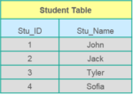A Primary key in SQL is a column (or collection of columns) or a set of columns that uniquely identifies each row in the table.
- Uniquely identifies a single row in the table
- Null values not allowed
Example- In the Student table, Stu_ID is the primary key.

Q48. What are Constraints?
Constraints in SQL are used to specify the limit on the data type of the table. It can be specified while creating or altering the table statement. The sample of constraints are:
- NOT NULL
- CHECK
- DEFAULT
- UNIQUE
- PRIMARY KEY
- FOREIGN KEY

Q49. What is the difference between DELETE and TRUNCATE statements?
DELETE vs TRUNCATE  DELETE | TRUNCATE
Delete command is used to delete a row in a table. | Truncate is used to delete all the rows from a table.
You can rollback data after using delete statement. | You cannot rollback data.
It is a DML command. | It is a DDL command.
It is slower than truncate statement. | It is faster.

Q50. What is a Unique key?
- Uniquely identifies a single row in the table.
- Multiple values allowed per table.
- Null values allowed.
Apart from this SQL Interview Questions blog, if you want to get trained from professionals on this technology, you can opt for structured training from edureka!

Q51. What is a Foreign key in SQL?
- Foreign key maintains referential integrity by enforcing a link between the data in two tables.
- The foreign key in the child table references the primary key in the parent table.
- The foreign key constraint prevents actions that would destroy links between the child and parent tables.

Q52. What do you mean by data integrity?
Data Integrity defines the accuracy as well as the consistency of the data stored in a database. It also defines integrity constraints to enforce business rules on the data when it is entered into an application or a database.

Q53. What is the difference between clustered and non-clustered index in SQL?
The differences between the clustered and non clustered index in SQL are :
- Clustered index is used for easy retrieval of data from the database and its faster whereas reading from non clustered index is relatively slower.
- Clustered index alters the way records are stored in a database as it sorts out rows by the column which is set to be clustered index whereas in a non clustered index, it does not alter the way it was stored but it creates a separate object within a table which points back to the original table rows after searching.

One table can only have one clustered index whereas it can have many non clustered index.

Q54. Write a SQL query to display the current date?
In SQL, there is a built-in function called GetDate() which helps to return the current timestamp/date.

Q55.What do you understand by query optimization?
The phase that identifies a plan for evaluation query which has the least estimated cost is known as query optimization.
The advantages of query optimization are as follows:
- The output is provided faster
- A larger number of queries can be executed in less time
- Reduces time and space complexity

Q56. What do you mean by Denormalization?
Denormalization refers to a technique which is used to access data from higher to lower forms of a database. It helps the database managers to increase the performance of the entire infrastructure as it introduces redundancy into a table. It adds the redundant data into a table by incorporating database queries that combine data from various tables into a single table.

Q57. What are Entities and Relationships?
Entities: A person, place, or thing in the real world about which data can be stored in a database. Tables store data that represents one type of entity. For example – A bank database has a customer table to store customer information. The customer table stores this information as a set of attributes (columns within the table) for each customer.
Relationships: Relation or links between entities that have something to do with each other. For example – The customer name is related to the customer account number and contact information, which might be in the same table. There can also be relationships between separate tables (for example, customer to accounts).
Let’s move to the next question in this SQL Interview Questions.

Q58. What is an Index?
An index refers to a performance tuning method of allowing faster retrieval of records from the table. An index creates an entry for each value and hence it will be faster to retrieve data.

Q59. Explain different types of index in SQL.
There are three types of index in SQL namely:

Unique Index:
This index does not allow the field to have duplicate values if the column is unique indexed. If a primary key is defined, a unique index can be applied automatically.

Clustered Index:
This index reorders the physical order of the table and searches based on the basis of key values. Each table can only have one clustered index.

Non-Clustered Index:
Non-Clustered Index does not alter the physical order of the table and maintains a logical order of the data. Each table can have many nonclustered indexes.

Q60. What is Normalization and what are the advantages of it?
Normalization in SQL is the process of organizing data to avoid duplication and redundancy. Some of the advantages are:
- Better Database organization
- More Tables with smaller rows
- Efficient data access
- Greater Flexibility for Queries
- Quickly find the information
- Easier to implement Security
- Allows easy modification
- Reduction of redundant and duplicate data
- More Compact Database
- Ensure Consistent data after modification
Apart from this SQL Interview Questions Blog, if you want to get trained from professionals on this technology, you can opt for structured training from edureka!

Q61. What is the difference between DROP and TRUNCATE commands?
DROP command removes a table and it cannot be rolled back from the database whereas TRUNCATE command removes all the rows from the table.

Q62. Explain different types of Normalization.
There are many successive levels of normalization. These are called normal forms. Each consecutive normal form depends on the previous one.The first three normal forms are usually adequate.
Normal Forms are used in database tables to remove or decrease duplication. The following are the many forms:
First Normal Form:
When every attribute in a relation is a single-valued attribute, it is said to be in first normal form. The first normal form is broken when a relation has a composite or multi-valued property.
Second Normal Form:
A relation is in second normal form if it meets the first normal form’s requirements and does not contain any partial dependencies. In 2NF, a relation has no partial dependence, which means it has no non-prime attribute that is dependent on any suitable subset of any table candidate key. Often, the problem may be solved by setting a single column Primary Key.
Third Normal Form:
If a relation meets the requirements for the second normal form and there is no transitive dependency, it is said to be in the third normal form.
Q63. What is OLTP?
OLTP, or online transactional processing, allows huge groups of people to execute massive amounts of database transactions in real time, usually via the internet. A database transaction occurs when data in a database is changed, inserted, deleted, or queried.
What are the differences between OLTP and OLAP?
OLTP stands for online transaction processing, whereas OLAP stands for online analytical processing. OLTP is an online database modification system, whereas OLAP is an online database query response system.
Q64. How to create empty tables with the same structure as another table?
To create empty tables:
Using the INTO operator to fetch the records of one table into a new table while setting a WHERE clause to false for all entries, it is possible to create empty tables with the same structure. As a result, SQL creates a new table with a duplicate structure to accept the fetched entries, but nothing is stored into the new table since the WHERE clause is active.
Q65. What is PostgreSQL?
In 1986, a team lead by Computer Science Professor Michael Stonebraker created PostgreSQL under the name Postgres. It was created to aid developers in the development of enterprise-level applications by ensuring data integrity and fault tolerance in systems. PostgreSQL is an enterprise-level, versatile, resilient, open-source, object-relational database management system that supports variable workloads and concurrent users. The international developer community has constantly backed it. PostgreSQL has achieved significant appeal among developers because to its fault-tolerant characteristics.
It’s a very reliable database management system, with more than two decades of community work to thank for its high levels of resiliency, integrity, and accuracy. Many online, mobile, geospatial, and analytics applications utilise PostgreSQL as their primary data storage or data warehouse.
Q66. What are SQL comments?
SQL Comments are used to clarify portions of SQL statements and to prevent SQL statements from being executed. Comments are quite important in many programming languages. The comments are not supported by a Microsoft Access database. As a result, the Microsoft Access database is used in the examples in Mozilla Firefox and Microsoft Edge.
Single Line Comments: It starts with two consecutive hyphens (–).
Multi-line Comments: It starts with /* and ends with */.
Let’s move to the next question in this SQL Interview Questions.
Q67. What is the difference between the RANK() and DENSE_RANK() functions?
The RANK() function in the result set defines the rank of each row within your ordered partition. If both rows have the same rank, the next number in the ranking will be the previous rank plus a number of duplicates. If we have three records at rank 4, for example, the next level indicated is 7.



SQL Essentials Training & Certification
Weekday / Weekend BatchesSee Batch Details

The DENSE_RANK() function assigns a distinct rank to each row within a partition based on the provided column value, with no gaps. It always indicates a ranking in order of precedence. This function will assign the same rank to the two rows if they have the same rank, with the next rank being the next consecutive number. If we have three records at rank 4, for example, the next level indicated is 5.
Q68. What is SQL Injection?
SQL injection is a sort of flaw in website and web app code that allows attackers to take control of back-end processes and access, retrieve, and delete sensitive data stored in databases. In this approach, malicious SQL statements are entered into a database entry field, and the database becomes exposed to an attacker once they are executed. By utilising data-driven apps, this strategy is widely utilised to get access to sensitive data and execute administrative tasks on databases. SQLi attack is another name for it.
The following are some examples of SQL injection:
- Getting access to secret data in order to change a SQL query to acquire the desired results.
- UNION attacks are designed to steal data from several database tables.
- Examine the database to get information about the database’s version and structure
Q69. How many Aggregate functions are available in SQL?
SQL aggregate functions provide information about a database’s data. AVG, for example, returns the average of a database column’s values.
SQL provides seven (7) aggregate functions, which are given below:
AVG(): returns the average value from specified columns.
COUNT(): returns the number of table rows, including rows with null values.
MAX(): returns the largest value among the group.
MIN(): returns the smallest value among the group.
SUM(): returns the total summed values(non-null) of the specified column.
FIRST(): returns the first value of an expression.
LAST(): returns the last value of an expression.
Q70. What is the default ordering of data using the ORDER BY clause? How could it be changed?
The ORDER BY clause in MySQL can be used without the ASC or DESC modifiers. The sort order is preset to ASC or ascending order when this attribute is absent from the ORDER BY clause.
Q71. How do we use the DISTINCT statement? What is its use?
The SQL DISTINCT keyword is combined with the SELECT query to remove all duplicate records and return only unique records. There may be times when a table has several duplicate records.
The DISTINCT clause in SQL is used to eliminate duplicates from a SELECT statement’s result set.
Q72. What are the syntax and use of the COALESCE function?
From a succession of expressions, the COALESCE function returns the first non-NULL value. The expressions are evaluated in the order that they are supplied, and the function’s result is the first non-null value. Only if all of the inputs are null does the COALESCE method return NULL.
The syntax of COALESCE function is COALESCE (exp1, exp2, …. expn)

Q73. What is the ACID property in a database?
ACID stands for Atomicity, Consistency, Isolation, Durability. It is used to ensure that the data transactions are processed reliably in a database system.
- Atomicity: Atomicity refers to the transactions that are completely done or failed where transaction refers to a single logical operation of a data. It means if one part of any transaction fails, the entire transaction fails and the database state is left unchanged.
- Consistency: Consistency ensures that the data must meet all the validation rules. In simple words, you can say that your transaction never leaves the database without completing its state.
- Isolation: The main goal of isolation is concurrency control.
- Durability: Durability means that if a transaction has been committed, it will occur whatever may come in between such as power loss, crash or any sort of error.
Want to upskill yourself to get ahead in your career? Check out this video in this SQL Interview Questions

Top 10 Technologies to Learn in 2023 | Edureka
This Edureka video on 3 will introduce you to all the popular and trending technologies in the market which you should focus on in 2023. These are the trending technologies that you need to learn in order to have a successful career in the year 2023.


Q74. What do you mean by “Trigger” in SQL?
Trigger in SQL is are a special type of stored procedures that are defined to execute automatically in place or after data modifications. It allows you to execute a batch of code when an insert, update or any other query is executed against a specific table.

Q75. What are the different operators available in SQL?
There are three operators available in SQL, namely:
- Arithmetic Operators
- Logical Operators
- Comparison Operators
Apart from this SQL Interview Questions blog, if you want to get trained from professionals on this technology, you can opt for structured training from edureka!

Q76. Are NULL values same as that of zero or a blank space?
A NULL value is not at all same as that of zero or a blank space. NULL value represents a value which is unavailable, unknown, assigned or not applicable whereas a zero is a number and blank space is a character.

Q77. What is the difference between cross join and natural join?
The cross join produces the cross product or Cartesian product of two tables whereas the natural join is based on all the columns having the same name and data types in both the tables.

Q78. What is subquery in SQL?
A subquery is a query inside another query where a query is defined to retrieve data or information back from the database. In a subquery, the outer query is called as the main query whereas the inner query is called subquery. Subqueries are always executed first and the result of the subquery is passed on to the main query. It can be nested inside a SELECT, UPDATE or any other query. A subquery can also use any comparison operators such as >,< or =.

Q79. What are the different types of a subquery?
There are two types of subquery namely, Correlated and Non-Correlated.
Correlated subquery: These are queries which select the data from a table referenced in the outer query. It is not considered as an independent query as it refers to another table and refers the column in a table.
Non-Correlated subquery: This query is an independent query where the output of subquery is substituted in the main query.
Let’s move to the next question in this SQL Interview Questions.

Q80. List the ways to get the count of records in a table?
To count the number of records in a table in SQL, you can use the below commands:
SELECT * FROM table1
SELECT COUNT(*) FROM table1
SELECT rows FROM sysindexes WHERE id = OBJECT_ID(table1) AND indid < 2

Apart from this SQL Interview Questions Blog, if you want to get trained from professionals on this technology, you can opt for structured training from edureka!

Q81. Write a SQL query to find the names of employees that begin with ‘A’?
To display name of the employees that begin with ‘A’, type in the below command:
1 | SELECT * FROM Table_name WHERE EmpName like 'A%'

Q82. Write a SQL query to get the third-highest salary of an employee from employee_table?
1  2  3  4  5  6 | SELECT TOP 1 salary  FROM(  SELECT TOP 3 salary  FROM employee_table  ORDER BY salary DESC) AS emp  ORDER BY salary ASC;

Q83. What is the need for group functions in SQL?
Group functions work on the set of rows and return one result per group. Some of the commonly used group functions are: AVG, COUNT, MAX, MIN, SUM, VARIANCE.

Q84. What is a Relationship and what are they?
Relation or links are between entities that have something to do with each other. Relationships are defined as the connection between the tables in a database. There are various relationships, namely:
- One to One Relationship.
- One to Many Relationship.
- Many to One Relationship.
- Self-Referencing Relationship.

Q85. How can you insert NULL values in a column while inserting the data?
NULL values in SQL can be inserted in the following ways:
- Implicitly by omitting column from column list.
- Explicitly by specifying NULL keyword in the VALUES clause

Q86. What is the main difference between ‘BETWEEN’ and ‘IN’ condition operators?
BETWEEN operator is used to display rows based on a range of values in a row whereas the IN condition operator is used to check for values contained in a specific set of values.

Example of BETWEEN:
SELECT * FROM Students where ROLL_NO BETWEEN 10 AND 50;
Example of IN:
SELECT * FROM students where ROLL_NO IN (8,15,25);

Q87. Why are SQL functions used?
SQL functions are used for the following purposes:
- To perform some calculations on the data
- To modify individual data items
- To manipulate the output
- To format dates and numbers
- To convert the data types

Q88. What is the need for MERGE statement?
This statement allows conditional update or insertion of data into a table. It performs an UPDATE if a row exists, or an INSERT if the row does not exist.

Q89. What do you mean by recursive stored procedure?
Recursive stored procedure refers to a stored procedure which calls by itself until it reaches some boundary condition. This recursive function or procedure helps the programmers to use the same set of code n number of times.

Q90. What is CLAUSE in SQL?
SQL clause helps to limit the result set by providing a condition to the query. A clause helps to filter the rows from the entire set of records.
For example – WHERE, HAVING clause.
Apart from this SQL Interview Questions Blog, if you want to get trained from professionals on this technology, you can opt for a structured training from edureka! Click below to know more.

Q91. What is the difference between ‘HAVING’ CLAUSE and a ‘WHERE’ CLAUSE?
HAVING clause can be used only with SELECT statement. It is usually used in a GROUP BY clause and whenever GROUP BY is not used, HAVING behaves like a WHERE clause.
Having Clause is only used with the GROUP BY function in a query whereas WHERE Clause is applied to each row before they are a part of the GROUP BY function in a query.

Q92. List the ways in which Dynamic SQL can be executed?
Following are the ways in which dynamic SQL can be executed:
- Write a query with parameters.
- Using EXEC.
- Using sp_executesql.

Q93. What are the various levels of constraints?
Constraints are the representation of a column to enforce data entity and consistency. There are two levels of a constraint, namely:
- column level constraint
- table level constraint

Q94. How can you fetch common records from two tables?
You can fetch common records from two tables using INTERSECT. For example:
Select studentID from student. <strong>INTERSECT </strong> Select StudentID from Exam

Q95. List some case manipulation functions in SQL?
There are three case manipulation functions in SQL, namely:
- LOWER: This function returns the string in lowercase. It takes a string as an argument and returns it by converting it into lower case. Syntax:
LOWER(‘string’)
- UPPER: This function returns the string in uppercase. It takes a string as an argument and returns it by converting it into uppercase. Syntax:
UPPER(‘string’)
- INITCAP: This function returns the string with the first letter in uppercase and rest of the letters in lowercase. Syntax:
INITCAP(‘string’)

Apart from this SQL Interview Questions blog, if you want to get trained from professionals on this technology, you can opt for a structured training from edureka! Click below to know more.

Q96. What are the different set operators available in SQL?
Some of the available set operators are – Union, Intersect or Minus operators.

Q97. What is an ALIAS command?
ALIAS command in SQL is the name that can be given to any table or a column. This alias name can be referred in WHERE clause to identify a particular table or a column.
For example-
Select emp.empID, dept.Result from employee emp, department as dept where emp.empID=dept.empID
In the above example, emp refers to alias name for employee table and dept refers to alias name for department table.
Let’s move to the next question in this SQL Interview Questions.

Q98. What are aggregate and scalar functions?
Aggregate functions are used to evaluate mathematical calculation and returns a single value. These calculations are done from the columns in a table. For example- max(),count() are calculated with respect to numeric.
Scalar functions return a single value based on the input value. For example – UCASE(), NOW() are calculated with respect to string.
Let’s move to the next question in this SQL Interview Questions.

Q99. How can you fetch alternate records from a table?
You can fetch alternate records i.e both odd and even row numbers. For example- To display even numbers, use the following command:
Select studentId from (Select rowno, studentId from student) where mod(rowno,2)=0
Now, to display odd numbers:
Select studentId from (Select rowno, studentId from student) where mod(rowno,2)=1

Q100. Name the operator which is used in the query for pattern matching?
LIKE operator is used for pattern matching, and it can be used as -.
- % – It matches zero or more characters.
For example- select * from students where studentname like ‘a%’
_ (Underscore) – it matches exactly one character.
For example- select * from student where studentname like ‘abc_’
Apart from this SQL Interview Questions Blog, if you want to get trained from professionals on this technology, you can opt for structured training from edureka!

Q101. How can you select unique records from a table?
You can select unique records from a table by using the DISTINCT keyword.
Select DISTINCT studentID from Student
Using this command, it will print unique student id from the table Student.

Q102. How can you fetch first 5 characters of the string?
There are a lot of ways to fetch characters from a string. For example:
Select SUBSTRING(StudentName,1,5) as studentname from student

Q103. What is the main difference between SQL and PL/SQL?
SQL is a query language that allows you to issue a single query or execute a single insert/update/delete whereas PL/SQL is Oracle’s “Procedural Language” SQL, which allows you to write a full program (loops, variables, etc.) to accomplish multiple operations such as selects/inserts/updates/deletes.

Q104. What is a View?
A view is a virtual table which consists of a subset of data contained in a table. Since views are not present, it takes less space to store. View can have data of one or more tables combined and it depends on the relationship.
Let’s move to the next question in this SQL Interview Questions.

Q105. What are Views used for?
A view refers to a logical snapshot based on a table or another view. It is used for the following reasons:
- Restricting access to data.
- Making complex queries simple.
- Ensuring data independence.
- Providing different views of same data.

Q106. What is a Stored Procedure?
A Stored Procedure is a function which consists of many SQL statements to access the database system. Several SQL statements are consolidated into a stored procedure and execute them whenever and wherever required which saves time and avoid writing code again and again.

Q107. List some advantages and disadvantages of Stored Procedure?

Advantages:
A Stored Procedure can be used as a modular programming which means create once, store and call for several times whenever it is required. This supports faster execution. It also reduces network traffic and provides better security to the data.

Disadvantage:
The only disadvantage of Stored Procedure is that it can be executed only in the database and utilizes more memory in the database server.

Q108. List all the types of user-defined functions?
There are three types of user-defined functions, namely:
- Scalar Functions
- Inline Table-valued functions
- Multi-statement valued functions
Scalar returns the unit, variant defined the return clause. Other two types of defined functions return table.
Let’s move to the next question in this SQL Interview Questions.

Q109. What do you mean by Collation?
Collation is defined as a set of rules that determine how data can be sorted as well as compared. Character data is sorted using the rules that define the correct character sequence along with options for specifying case-sensitivity, character width etc.
Let’s move to the next question in this SQL Interview Questions.

Q110. What are the different types of Collation Sensitivity?
Following are the different types of collation sensitivity:
- Case Sensitivity: A and a and B and b.
- Kana Sensitivity: Japanese Kana characters.
- Width Sensitivity: Single byte character and double-byte character.
- Accent Sensitivity.
Apart from this SQL Interview Questions Blog, if you want to get trained from professionals on this technology, you can opt for structured training from edureka!

Q111. What are Local and Global variables?

Local variables:
These variables can be used or exist only inside the function. These variables are not used or referred by any other function.

Global variables:
These variables are the variables which can be accessed throughout the program. Global variables cannot be created whenever that function is called.

Q112. What is Auto Increment in SQL?
Autoincrement keyword allows the user to create a unique number to get generated whenever a new record is inserted into the table.
This keyword is usually required whenever PRIMARY KEY in SQL is used.
AUTO INCREMENT keyword can be used in Oracle and IDENTITY keyword can be used in SQL SERVER.

Q113. What is a Datawarehouse?
Datawarehouse refers to a central repository of data where the data is assembled from multiple sources of information. Those data are consolidated, transformed and made available for the mining as well as online processing. Warehouse data also have a subset of data called Data Marts.

Q114. What are the different authentication modes in SQL Server? How can it be changed?
Windows mode and Mixed Mode – SQL and Windows. You can go to the below steps to change authentication mode in SQL Server:
- Click Start> Programs> Microsoft SQL Server and click SQL Enterprise Manager to run SQL Enterprise Manager from the Microsoft SQL Server program group.
- Then select the server from the Tools menu.
- Select SQL Server Configuration Properties, and choose the Security page.

Q115. What are STUFF and REPLACE function?
STUFF Function: This function is used to overwrite existing character or inserts a string into another string. Syntax:
STUFF(string_expression,start, length, replacement_characters)
where,
string_expression: it is the string that will have characters substituted
start: This refers to the starting position
length: It refers to the number of characters in the string which are substituted.
replacement_string: They are the new characters which are injected in the string.

REPLACE function: This function is used to replace the existing characters of all the occurrences. Syntax:
REPLACE (string_expression, search_string, replacement_string)

1. What is DBMS?
A Database Management System (DBMS) is a program that controls creation, maintenance and use of a database. DBMS can be termed as File Manager that manages data in a database rather than saving it in file systems.

2. What is RDBMS?
RDBMS stands for Relational Database Management System. RDBMS store the data into the collection of tables, which is related by common fields between the columns of the table. It also provides relational operators to manipulate the data stored into the tables.
Example: SQL Server.

3. What is SQL?
SQL stands for Structured Query Language , and it is used to communicate with the Database. This is a standard language used to perform tasks such as retrieval, updation, insertion and deletion of data from a database.
Standard SQL Commands are Select.
EXPLORE MORELearn Java Programming with Beginners Tutorial08:32Linux Tutorial for Beginners: Introduction to Linux Operating...01:35What is Integration Testing Software Testing Tutorial03:04What is JVM (Java Virtual Machine) with Architecture JAVA...02:24How to write a TEST CASE Software Testing Tutorial01:08Seven Testing Principles Software Testing05:01Linux File Permissions Commands with Examples13:29How to use Text tool in Photoshop CC Tutorial08:32What is NoSQL Database Tutorial02:00Important Linux Commands for Beginners Linux Tutorial15:03

4. What is a Database?
Database is nothing but an organized form of data for easy access, storing, retrieval and managing of data. This is also known as structured form of data which can be accessed in many ways.
Example: School Management Database, Bank Management Database.

5. What are tables and Fields?
A table is a set of data that are organized in a model with Columns and Rows. Columns can be categorized as vertical, and Rows are horizontal. A table has specified number of column called fields but can have any number of rows which is called record.
Example:.
Table: Employee.
Field: Emp ID, Emp Name, Date of Birth.
Data: 201456, David, 11/15/1960.

6. What is a primary key?
A primary key is a combination of fields which uniquely specify a row. This is a special kind of unique key, and it has implicit NOT NULL constraint. It means, Primary key values cannot be NULL.

7. What is a unique key?
A Unique key constraint uniquely identified each record in the database. This provides uniqueness for the column or set of columns.
A Primary key constraint has automatic unique constraint defined on it. But not, in the case of Unique Key.
There can be many unique constraint defined per table, but only one Primary key constraint defined per table.

8. What is a foreign key?
A foreign key is one table which can be related to the primary key of another table. Relationship needs to be created between two tables by referencing foreign key with the primary key of another table.

9. What is a join?
This is a keyword used to query data from more tables based on the relationship between the fields of the tables. Keys play a major role when JOINs are used.

10. What are the types of join and explain each?
There are various types of join which can be used to retrieve data and it depends on the relationship between tables.
- Inner Join.
Inner join return rows when there is at least one match of rows between the tables.
- Right Join.
Right join return rows which are common between the tables and all rows of Right hand side table. Simply, it returns all the rows from the right hand side table even though there are no matches in the left hand side table.
- Left Join.
Left join return rows which are common between the tables and all rows of Left hand side table. Simply, it returns all the rows from Left hand side table even though there are no matches in the Right hand side table.
- Full Join.
Full join return rows when there are matching rows in any one of the tables. This means, it returns all the rows from the left hand side table and all the rows from the right hand side table.

11. What is normalization?
Normalization is the process of minimizing redundancy and dependency by organizing fields and table of a database. The main aim of Normalization is to add, delete or modify field that can be made in a single table.

12. What is Denormalization?
DeNormalization is a technique used to access the data from higher to lower normal forms of database. It is also process of introducing redundancy into a table by incorporating data from the related tables.

13. What are all the different normalizations?
Database Normalization can be easily understood with the help of a case study. The normal forms can be divided into 6 forms, and they are explained below -.
Database Normal Forms
- First Normal Form (1NF):.
This should remove all the duplicate columns from the table. Creation of tables for the related data and identification of unique columns.
- Second Normal Form (2NF):.
Meeting all requirements of the first normal form. Placing the subsets of data in separate tables and Creation of relationships between the tables using primary keys.
- Third Normal Form (3NF):.
This should meet all requirements of 2NF. Removing the columns which are not dependent on primary key constraints.
- Fourth Normal Form (4NF):.
If no database table instance contains two or more, independent and multivalued data describing the relevant entity, then it is in 4th Normal Form.
- Fifth Normal Form (5NF):.
A table is in 5th Normal Form only if it is in 4NF and it cannot be decomposed into any number of smaller tables without loss of data.
- Sixth Normal Form (6NF):.
6th Normal Form is not standardized, yet however, it is being discussed by database experts for some time. Hopefully, we would have a clear & standardized definition for 6th Normal Form in the near future…

14. What is a View?
A view is a virtual table which consists of a subset of data contained in a table. Views are not virtually present, and it takes less space to store. View can have data of one or more tables combined, and it is depending on the relationship.

15. What is an Index?
An index is performance tuning method of allowing faster retrieval of records from the table. An index creates an entry for each value and it will be faster to retrieve data.

16. What are all the different types of indexes?
There are three types of indexes -.
- Unique Index.
This indexing does not allow the field to have duplicate values if the column is unique indexed. Unique index can be applied automatically when primary key is defined.
- Clustered Index.
This type of index reorders the physical order of the table and search based on the key values. Each table can have only one clustered index.
- NonClustered Index.
NonClustered Index does not alter the physical order of the table and maintains logical order of data. Each table can have 999 nonclustered indexes.

17. What is a Cursor?
A database Cursor is a control which enables traversal over the rows or records in the table. This can be viewed as a pointer to one row in a set of rows. Cursor is very much useful for traversing such as retrieval, addition and removal of database records.

18. What is a relationship and what are they?
Database Relationship is defined as the connection between the tables in a database. There are various data basing relationships, and they are as follows:.
- One to One Relationship.
- One to Many Relationship.
- Many to One Relationship.
- Self-Referencing Relationship.

19. What is a query?
A DB query is a code written in order to get the information back from the database. Query can be designed in such a way that it matched with our expectation of the result set. Simply, a question to the Database.

20. What is subquery?
A subquery is a query within another query. The outer query is called as main query, and inner query is called subquery. SubQuery is always executed first, and the result of subquery is passed on to the main query.
Let’s look into the sub query syntax –
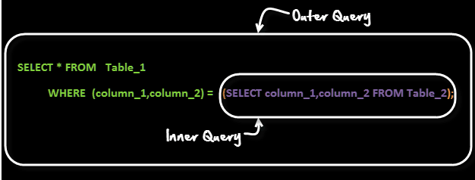
A common customer complaint at the MyFlix Video Library is the low number of movie titles. The management wants to buy movies for a category which has least number of titles.
You can use a query like
SELECT category_name FROM categories WHERE category_id =( SELECT MIN(category_id) from movies);

21. What are the types of subquery?
There are two types of subquery – Correlated and Non-Correlated.
A correlated subquery cannot be considered as independent query, but it can refer the column in a table listed in the FROM the list of the main query.
A Non-Correlated sub query can be considered as independent query and the output of subquery are substituted in the main query.

22. What is a stored procedure?
Stored Procedure is a function consists of many SQL statement to access the database system. Several SQL statements are consolidated into a stored procedure and execute them whenever and wherever required.

23. What is a trigger?
A DB trigger is a code or programs that automatically execute with response to some event on a table or view in a database. Mainly, trigger helps to maintain the integrity of the database.
Example: When a new student is added to the student database, new records should be created in the related tables like Exam, Score and Attendance tables.

24. What is the difference between DELETE and TRUNCATE commands?
DELETE command is used to remove rows from the table, and WHERE clause can be used for conditional set of parameters. Commit and Rollback can be performed after delete statement.
TRUNCATE removes all rows from the table. Truncate operation cannot be rolled back.

25. What are local and global variables and their differences?
Local variables are the variables which can be used or exist inside the function. They are not known to the other functions and those variables cannot be referred or used. Variables can be created whenever that function is called.
Global variables are the variables which can be used or exist throughout the program. Same variable declared in global cannot be used in functions. Global variables cannot be created whenever that function is called.

26. What is a constraint?
Constraint can be used to specify the limit on the data type of table. Constraint can be specified while creating or altering the table statement. Sample of constraint are.
- NOT NULL.
- CHECK.
- DEFAULT.
- UNIQUE.
- PRIMARY KEY.
- FOREIGN KEY.

27. What is data Integrity?
Data Integrity defines the accuracy and consistency of data stored in a database. It can also define integrity constraints to enforce business rules on the data when it is entered into the application or database.

28. What is Auto Increment?
Auto increment keyword allows the user to create a unique number to be generated when a new record is inserted into the table. AUTO INCREMENT keyword can be used in Oracle and IDENTITY keyword can be used in SQL SERVER.
Mostly this keyword can be used whenever PRIMARY KEY is used.

29. What is the difference between Cluster and Non-Cluster Index?
Clustered index is used for easy retrieval of data from the database by altering the way that the records are stored. Database sorts out rows by the column which is set to be clustered index.
A nonclustered index does not alter the way it was stored but creates a complete separate object within the table. It point back to the original table rows after searching.

30. What is Datawarehouse?
Datawarehouse is a central repository of data from multiple sources of information. Those data are consolidated, transformed and made available for the mining and online processing. Warehouse data have a subset of data called Data Marts.

31. What is Self-Join?
Self-join is set to be query used to compare to itself. This is used to compare values in a column with other values in the same column in the same table. ALIAS ES can be used for the same table comparison.

32. What is Cross-Join?
Cross join defines as Cartesian product where number of rows in the first table multiplied by number of rows in the second table. If suppose, WHERE clause is used in cross join then the query will work like an INNER JOIN.

33. What is user defined functions?
User defined functions are the functions written to use that logic whenever required. It is not necessary to write the same logic several times. Instead, function can be called or executed whenever needed.

34. What are all types of user defined functions?
Three types of user defined functions are.
- Scalar Functions.
- Inline Table valued functions.
- Multi statement valued functions.
Scalar returns unit, variant defined the return clause. Other two types return table as a return.

35. What is collation?
Collation is defined as set of rules that determine how character data can be sorted and compared. This can be used to compare A and, other language characters and also depends on the width of the characters.
ASCII value can be used to compare these character data.

36. What are all different types of collation sensitivity?
Following are different types of collation sensitivity -.
- Case Sensitivity – A and a and B and b.
- Accent Sensitivity.
- Kana Sensitivity – Japanese Kana characters.
- Width Sensitivity – Single byte character and double byte character.

37. Advantages and Disadvantages of Stored Procedure?
Stored procedure can be used as a modular programming – means create once, store and call for several times whenever required. This supports faster execution instead of executing multiple queries. This reduces network traffic and provides better security to the data.
Disadvantage is that it can be executed only in the Database and utilizes more memory in the database server.

38. What is Online Transaction Processing (OLTP)?
Online Transaction Processing (OLTP) manages transaction based applications which can be used for data entry, data retrieval and data processing. OLTP makes data management simple and efficient. Unlike OLAP systems goal of OLTP systems is serving real-time transactions.
Example – Bank Transactions on a daily basis.

39. What is CLAUSE?
SQL clause is defined to limit the result set by providing condition to the query. This usually filters some rows from the whole set of records.
Example – Query that has WHERE condition
Query that has HAVING condition.

40. What is recursive stored procedure?
A stored procedure which calls by itself until it reaches some boundary condition. This recursive function or procedure helps programmers to use the same set of code any number of times.

41. What is Union, minus and Interact commands?
UNION operator is used to combine the results of two tables, and it eliminates duplicate rows from the tables.
MINUS operator is used to return rows from the first query but not from the second query. Matching records of first and second query and other rows from the first query will be displayed as a result set.
INTERSECT operator is used to return rows returned by both the queries.

42. What is an ALIAS command?
ALIAS name can be given to a table or column. This alias name can be referred in WHERE clause to identify the table or column.
Example-.
Select st.StudentID, Ex.Result from student st, Exam as Ex where st.studentID = Ex. StudentID
Here, st refers to alias name for student table and Ex refers to alias name for exam table.

43. What is the difference between TRUNCATE and DROP statements?
TRUNCATE removes all the rows from the table, and it cannot be rolled back. DROP command removes a table from the database and operation cannot be rolled back.

44. What are aggregate and scalar functions?
Aggregate functions are used to evaluate mathematical calculation and return single values. This can be calculated from the columns in a table. Scalar functions return a single value based on the input value.
Example -.
Aggregate – max(), count – Calculated with respect to numeric.
Scalar – UCASE(), NOW() – Calculated with respect to strings.

45. How can you create an empty table from an existing table?
Example will be -.
Select * into studentcopy from student where 1=2
Here, we are copying student table to another table with the same structure with no rows copied.

46. How to fetch common records from two tables?
Common records result set can be achieved by -.
Select studentID from student INTERSECT Select StudentID from Exam

47. How to fetch alternate records from a table?
Records can be fetched for both Odd and Even row numbers -.
To display even numbers-.
Select studentId from (Select rowno, studentId from student) where mod(rowno,2)=0
To display odd numbers-.
Select studentId from (Select rowno, studentId from student) where mod(rowno,2)=1
from (Select rowno, studentId from student) where mod(rowno,2)=1.[/sql]

48. How to select unique records from a table?
Select unique records from a table by using DISTINCT keyword.
Select DISTINCT StudentID, StudentName from Student.

49. What is the command used to fetch first 5 characters of the string?
There are many ways to fetch first 5 characters of the string -.
Select SUBSTRING(StudentName,1,5) as studentname from student
Select LEFT(Studentname,5) as studentname from student

50. Which operator is used in query for pattern matching?
LIKE operator is used for pattern matching, and it can be used as -.
- % – Matches zero or more characters.
- _(Underscore) – Matching exactly one character.
Example -.
Select * from Student where studentname like 'a%'
Select * from Student where studentname like 'ami_'
Are you an aspiring SQL Developer? A career in SQL has seen an upward trend in 2023, and you can be a part of the ever-so-growing community. So, if you are ready to indulge yourself in the pool of knowledge and be prepared for the upcoming SQL interview, then you are at the right place.
We have compiled a comprehensive list of SQL Interview Questions and Answers that will come in handy at the time of need. Once you are prepared with the questions we mentioned in our list, you will be ready to get into numerous SQL-worthy job roles like SQL Developer, Business Analyst, BI Reporting Engineer, Data Scientist, Software Engineer, Database Administrator, Quality Assurance Tester, BI Solution Architect and more.
Great Learning has prepared a list of the top 10 SQL interview questions that will help you during your interview.
- What is SQL?
- What is Database?
- What is DBMS?
- What is RDBMS? How is it different from DBMS?
- How to create a table in SQL?
- How to delete a table in SQL?
- How to change a table name in SQL?
- How to delete a row in SQL?
- How to create a database in SQL?
- What is Normalization in SQL?
Now, without any further ado, let’s kick off our SQL learning journey.
- Basic SQL Interview Questions
- SQL Interview Questions for Experienced
- SQL Interview Questions for Developers
- SQL Joins Interview Questions
- Advanced SQL Interview Questions
- PostgreSQL Interview Questions
- SQL Practice Questions
- Frequently Asked Questions in SQL
Let’s get started!

Basic SQL Interview Questions
All set to kickstart your career in SQL? Look no further and start your professional career with these SQL interview questions for freshers. We will start with the basics and slowly move towards slightly advanced questions to set the pace. If you are an experienced professional, this section will help you brush up on your SQL skills.

What is SQL?
The acronym SQL stands for Structured Query Language. It is the typical language used for relational database maintenance and a wide range of data processing tasks. The first SQL database was created in 1970. It is a database language used for operations such as database creation, deletion, retrieval, and row modification. It is occasionally pronounced “sequel.” It can also be used to manage structured data, which is made up of variables called entities and relationships between those entities.

What is Database?
A database is a system that helps in collecting, storing and retrieving data. Databases can be complex, and such databases are developed using design and modelling approaches.

What is DBMS?
DBMS stands for Database Management System which is responsible for the creating, updating, and managing of the database.

What is RDBMS? How is it different from DBMS?
RDBMS stands for Relational Database Management System that stores data in the form of a collection of tables, and relations can be defined between the common fields of these tables.

How to create a table in SQL?
The command to create a table in SQL is extremely simple:
CREATE TABLE table_name (
column1 datatype,
column2 datatype,
column3 datatype,
....
);
We will start off by giving the keywords, CREATE TABLE, and then we will give the name of the table. After that in braces, we will list out all the columns along with their data types.
For example, if we want to create a simple employee table:
CREATE TABLE employee (
name varchar(25),
age int,
gender varchar(25),
....
);

How to delete a table in SQL?
There are two ways to delete a table from SQL: DROP and TRUNCATE. The DROP TABLE command is used to completely delete the table from the database. This is the command:
DROP TABLE table_name;
The above command will completely delete all the data present in the table along with the table itself.
But if we want to delete only the data present in the table but not the table itself, then we will use the truncate command:
DROP TABLE table_name ;

How to change a table name in SQL?
This is the command to change a table name in SQL:
ALTER TABLE table_nameRENAME TO new_table_name;
We will start off by giving the keywords ALTER TABLE, then we will follow it up by giving the original name of the table, after that, we will give in the keywords RENAME TO and finally, we will give the new table name.
For example, if we want to change the “employee” table to “employee_information”, this will be the command:
ALTER TABLE employee
RENAME TO employee_information;

How to delete a row in SQL?
We will be using the DELETE query to delete existing rows from the table:
DELETE FROM table_name
WHERE [condition];
We will start off by giving the keywords DELETE FROM, then we will give the name of the table, and after that we will give the WHERE clause and give the condition on the basis of which we would want to delete a row.
For example, from the employee table, if we would like to delete all the rows, where the age of the employee is equal to 25, then this will be the command:
DELETE FROM employee
WHERE [age=25];


How to create a database in SQL?
A database is a repository in SQL, which can comprise multiple tables.
This will be the command to create a database in sql:
CREATE DATABASE database_name.

What is Normalization in SQL?
Normalization is used to decompose a larger, complex table into simple and smaller ones. This helps us in removing all the redundant data.
Generally, in a table, we will have a lot of redundant information which is not required, so it is better to divide this complex table into multiple smaller tables which contain only unique information.
First normal form:
A relation schema is in 1NF, if and only if:
- All attributes in the relation are atomic(indivisible value)
- And there are no repeating elements or groups of elements.
Second normal form:
A relation is said to be in 2NF, if and only if:
- It is in 1st Normal Form.
- No partial dependency exists between non-key attributes and key attributes.
Third Normal form:
A relation R is said to be in 3NF if and only if:
- It is in 2NF.
- No transitive dependency exists between non-key attributes and key attributes through another non-key attribute

What is join in SQL?
Joins are used to combine rows from two or more tables, based on a related column between them.
Types of Joins:
• INNER JOIN − Returns rows when there is a match in both tables.
• LEFT JOIN − Returns all rows from the left table, even if there are no matches in the right table.
• RIGHT JOIN − Returns all rows from the right table, even if there are no matches in the left table.
• FULL OUTER JOIN − Returns rows when there is a match in one of the tables.
• SELF JOIN − Used to join a table to itself as if the table were two tables, temporarily renaming at least one table in the SQL statement.
• CARTESIAN JOIN (CROSS JOIN) − Returns the Cartesian product of the sets of records from the two or more joined tables.
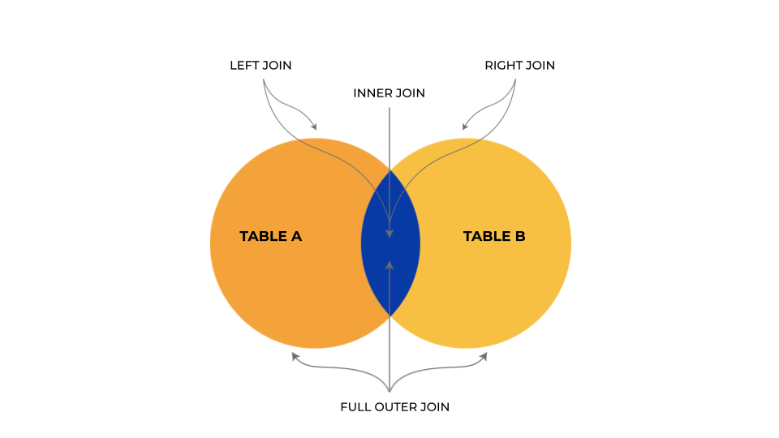
INNER JOIN:
The INNER JOIN creates a new result table by combining column values of two tables (table1 and table2) based upon the join-predicate. The query compares each row of table1 with each row of table2 to find all pairs of rows which satisfy the join-predicate.
SYNTAX:
SELECT table1.col1, table2.col2,…, table1.coln
FROM table1
INNER JOIN table2
ON table1.commonfield = table2.commonfield;
LEFT JOIN:
The LEFT JOIN returns all the values from the left table, plus matched values from the right table or NULL in case of no matching join predicate.
SYNTAX:
SELECT table1.col1, table2.col2,…, table1.coln
FROM table1
LEFT JOIN table2
ON table1.commonfield = table2.commonfield;
RIGHT JOIN:
The RIGHT JOIN returns all the values from the right table, plus matched values from the left table or NULL in case of no matching join predicate.
SYNTAX:
SELECT table1.col1, table2.col2,…, table1.coln
FROM table1
RIGHT JOIN table2
ON table1.commonfield = table2.commonfield;
FULL OUTER JOIN:
The FULL OUTER JOIN combines the results of both left and right outer joins. The joined table will contain all records from both the tables and fill in NULLs for missing matches on either side.
SYNTAX:
SELECT table1.col1, table2.col2,…, table1.coln
FROM table1
Left JOIN table2
ON table1.commonfield = table2.commonfield;
Union
SELECT table1.col1, table2.col2,…, table1.coln
FROM table1
Right JOIN table2
ON table1.commonfield = table2.commonfield;
SELF JOIN:
The SELF JOIN joins a table to itself; temporarily renaming at least one table in the SQL statement.
SYNTAX:
SELECT a.col1, b.col2,..., a.coln
FROM table1 a, table1 b
WHERE a.commonfield = b.commonfield;

Joins in SQL

GREAT LEARNING ACADEMY

Joins in SQL
1.5 Hours Online
Land your dream job


GREAT LEARNING ACADEMY

SQL Projects for Beginners
0.5 Hours Online
Stand out to recruiters

GREAT LEARNING ACADEMY

Advanced SQL
1.0 Hourse Online
Land your dream job

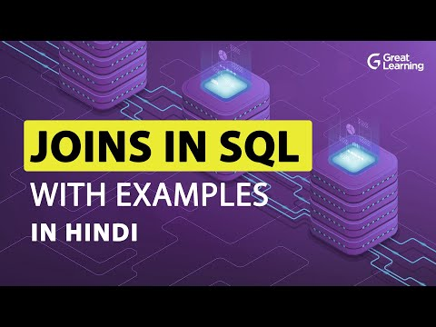

How to insert a date in SQL?
If the RDBMS is MYSQL, this is how we can insert date:
"INSERT INTO tablename (col_name, col_date) VALUES ('DATE: Manual Date', '2020-9-10')";

What is Primary Key in SQL?
Primary Key is a constraint in SQL. So, before understanding what exactly is a primary key, let’s understand what exactly is a constraint in SQL. Constraints are the rules enforced on data columns on a table. These are used to limit the type of data that can go into a table. Constraints can either be column level or table level.
Let’s look at the different types of constraints which are present in SQL:
Constraint | Description
NOT NULL | Ensures that a column cannot have a NULL value.
DEFAULT | Provides a default value for a column when none is specified.
UNIQUE | Ensures that all the values in a column are different
PRIMARY | Uniquely identifies each row/record in a database table
FOREIGN | Uniquely identifies a row/record in any another database table
CHECK | The CHECK constraint ensures that all values in a column satisfy certain conditions.
INDEX | Used to create and retrieve data from the database very quickly.
You can consider the Primary Key constraint to be a combination of UNIQUE and NOT NULL constraint. This means that if a column is set as a primary key, then this particular column cannot have any null values present in it and also all the values present in this column must be unique.

How do I view tables in SQL?
To view tables in SQL, all you need to do is give this command:
Show tables;

What is PL/SQL?
PL SQL stands for Procedural language constructs for Structured Query Language. PL SQL was introduced by Oracle to overcome the limitations of plain sql. So, pl sql adds in procedural language approach to the plain vanilla sql.
One thing to be noted over here is that pl sql is only for oracle databases. If you don’t have an Oracle database, then you cant work with PL SQL. However, if you wish to learn more about Oracle, you can also take up free oracle courses and enhance your knowledge.
While, with the help of sql, we were able to DDL and DML queries, with the help of PL SQL, we will be able to create functions, triggers and other procedural constructs.

Know More About SQL Triggers
SQL Triggers

How can I see all tables in SQL?
Different database management systems have different queries to see all the tables.
To see all the tables in MYSQL, we would have to use this query:
show tables;
This is how we can see all tables in ORACLE:
SELECT
table_name
FROM
User_tables;
This is how we can extract all tables in SQL Server:
SELECT
*
FROM
Information_schema.tables;

What is ETL in SQL?
ETL stands for Extract, Transform and Load. It is a three-step process, where we would have to start off by extracting the data from sources. Once we collate the data from different sources, what we have is raw data. This raw data has to be transformed into the tidy format, which will come in the second phase. Finally, we would have to load this tidy data into tools which would help us to find insights.

How to install SQL?
SQL stands for Structured Query Language and it is not something you can install. To implement sql queries, you would need a relational database management system. There are different varieties of relational database management systems such as:
- ORACLE
- MYSQL
- SQL Server
Hence, to implement sql queries, we would need to install any of these Relational Database Management Systems.

What is the update command in SQL?
The update command comes under the DML(Data Manipulation Langauge) part of sql and is used to update the existing data in the table.
UPDATE employees
SET last_name=‘Cohen’
WHERE employee_id=101;
With this update command, I am changing the last name of the employee.

How to rename column name in SQL Server?
Rename column in SQL: When it comes to SQL Server, it is not possible to rename the column with the help of ALTER TABLE command, we would have to use sp_rename.

What are the types of SQL Queries?
We have four types of SQL Queries:
- DDL (Data Definition Language): the creation of objects
- DML (Data Manipulation Language): manipulation of data
- DCL (Data Control Language): assignment and removal of permissions
- TCL (Transaction Control Language): saving and restoring changes to a database
Let’s look at the different commands under DDL:
Command | Description
CREATE | Create objects in the database
ALTER | Alters the structure of the database object
DROP | Delete objects from the database
TRUNCATE | Remove all records from a table permanently
COMMENT | Add comments to the data dictionary
RENAME | Rename an object

Write a Query to display the number of employees working in each region?
SELECT region, COUNT(gender) FROM employee GROUP BY region;

What are Nested Triggers?
Triggers may implement DML by using INSERT, UPDATE, and DELETE statements. These triggers that contain DML and find other triggers for data modification are called Nested Triggers.

Write SQL query to fetch employee names having a salary greater than or equal to 20000 and less than or equal 10000.
By using BETWEEN in the where clause, we can retrieve the Employee Ids of employees with salary >= 20000 and <=10000.
SELECT FullName FROM EmployeeDetails WHERE EmpId IN (SELECT EmpId FROM EmployeeSalary WHERE Salary BETWEEN 5000 AND 10000)

Given a table Employee having columns empName and empId, what will be the result of the SQL query below? select empName from Employee order by 2 asc;
“Order by 2” is valid when there are at least 2 columns used in SELECT statement. Here this query will throw error because only one column is used in the SELECT statement.

What is OLTP?
OLTP stands for Online Transaction Processing. And is a class of software applications capable of supporting transaction-oriented programs. An essential attribute of an OLTP system is its ability to maintain concurrency.

What is Data Integrity?
Data Integrity is the assurance of accuracy and consistency of data over its entire life-cycle, and is a critical aspect to the design, implementation and usage of any system which stores, processes, or retrieves data. It also defines integrity constraints to enforce business rules on the data when it is entered into an application or a database.

What is OLAP?
OLAP stands for Online Analytical Processing. And a class of software programs which are characterized by relatively low frequency of online transactions. Queries are often too complex and involve a bunch of aggregations.

Find the Constraint information from the table?
There are so many times where user needs to find out the specific constraint information of the table. The following queries are useful, SELECT * From User_Constraints; SELECT * FROM User_Cons_Columns;

Can you get the list of employees with same salary?
Select distinct e.empid,e.empname,e.salary from employee e, employee e1 where e.salary =e1.salary and e.empid != e1.empid

What is an alternative for the TOP clause in SQL?
1. ROWCOUNT function
2. Set rowcount 3
3. Select * from employee order by empid desc Set rowcount 0

Will the following statement gives an error or 0 as output? SELECT AVG (NULL)
Error. Operand data type NULL is invalid for the Avg operator.

What is the Cartesian product of the table?
The output of Cross Join is called a Cartesian product. It returns rows combining each row from the first table with each row of the second table. For Example, if we join two tables having 15 and 20 columns the Cartesian product of two tables will be 15×20=300 rows.

What is a schema in SQL?
Our database comprises of a lot of different entities such as tables, stored procedures, functions, database owners and so on. To make sense of how all these different entities interact, we would need the help of schema. So, you can consider schema to be the logical relationship between all the different entities which are present in the database.
Once we have a clear understanding of the schema, this helps in a lot of ways:
- We can decide which user has access to which tables in the database.
- We can modify or add new relationships between different entities in the database.
Overall, you can consider a schema to be a blueprint for the database, which will give you the complete picture of how different objects interact with each other and which users have access to different entities.

How to delete a column in SQL?
To delete a column in SQL we will be using DROP COLUMN method:
ALTER TABLE employees
DROP COLUMN age;
We will start off by giving the keywords ALTER TABLE, then we will give the name of the table, following which we will give the keywords DROP COLUMN and finally give the name of the column which we would want to remove.

What is a unique key in SQL?
Unique Key is a constraint in SQL. So, before understanding what exactly is a primary key, let’s understand what exactly is a constraint in SQL. Constraints are the rules enforced on data columns on a table. These are used to limit the type of data that can go into a table. Constraints can either be column level or table level.
Unique Key:
Whenever we give the constraint of unique key to a column, this would mean that the column cannot have any duplicate values present in it. In other words, all the records which are present in this column have to be unique.

How to implement multiple conditions using the WHERE clause?
We can implement multiple conditions using AND, OR operators:
SELECT * FROM employees WHERE first_name = ‘Steven’ AND salary <=10000;
In the above command, we are giving two conditions. The condition ensures that we extract only those records where the first name of the employee is ‘Steven’ and the second condition ensures that the salary of the employee is less than $10,000. In other words, we are extracting only those records, where the employee’s first name is ‘Steven’ and this person’s salary should be less than $10,000.

What is the difference between SQL vs PL/SQL?
BASIS FOR COMPARISON | SQL | PL/SQL
Basic | In SQL you can execute a single query or a command at a time. | In PL/SQL you can execute a block of code at a time.
Full form | Structured Query Language | Procedural Language, an extension of SQL.
Purpose | It is like a source of data that is to be displayed. | It is a language that creates an application that displays data acquired by SQL.
Writes | In SQL you can write queries and commands using DDL, DML statements. | In PL/SQL you can write a block of code that has procedures, functions, packages or variables, etc.
Use | Using SQL, you can retrieve, modify, add, delete, or manipulate the data in the database. | Using PL/SQL, you can create applications or server pages that display the information obtained from SQL in a proper format.
Embed | You can embed SQL statements in PL/SQL. | You can not embed PL/SQL in SQL

What is the difference between SQL having vs where?
S. No. | Where Clause | Having Clause
1 | The WHERE clause specifies the criteria which individual records must meet to be selected by a query. It can be used without the GROUP by clause | The HAVING clause cannot be used without the GROUP BY clause
2 | The WHERE clause selects rows before grouping | The HAVING clause selects rows after grouping
3 | The WHERE clause cannot contain aggregate functions | The HAVING clause can contain aggregate functions
4 | WHERE clause is used to impose a condition on SELECT statement as well as single row function and is used before GROUP BY clause | HAVING clause is used to impose a condition on GROUP Function and is used after GROUP BY clause in the query
5 | SELECT Column,AVG(Column_nmae)FROM Table_name WHERE Column > value GROUP BY Column_nmae | SELECT Columnq, AVG(Coulmn_nmae)FROM Table_name WHERE Column > value GROUP BY Column_nmae Having column_name>or<value

SQL Interview Questions for Experienced
Planning to switch your career to SQL or just need to upgrade your position? Whatever your reason, this section will better prepare you for the SQL interview. We have compiled a set of advanced SQL questions that may be frequently asked during the interview.

What is SQL injection?
SQL injection is a hacking technique which is widely used by black-hat hackers to steal data from your tables or databases. Let’s say, if you go to a website and give in your user information and password, the hacker would add some malicious code over there such that, he can get the user information and password directly from the database. If your database contains any vital information, it is always better to keep it secure from SQL injection attacks.

What is a trigger in SQL?
A trigger is a stored program in a database which automatically gives responses to an event of DML operations done by inserting, update, or delete. In other words, is nothing but an auditor of events happening across all database tables.
Let’s look at an example of a trigger:
CREATE TRIGGER bank_trans_hv_alert
BEFORE UPDATE ON bank_account_transaction
FOR EACH ROW
begin
if( abs(:new.transaction_amount)>999999)THEN
RAISE_APPLICATION_ERROR(-20000, 'Account transaction exceeding the daily deposit on SAVINGS account.');
end if;
end;


How to insert multiple rows in SQL?
To insert multiple rows in SQL we can follow the below syntax:
INSERT INTO table_name (column1, column2,column3...)
VALUES
(value1, value2, value3…..),
(value1, value2, value3….),
...
(value1, value2, value3);
We start off by giving the keywords INSERT INTO then we give the name of the table into which we would want to insert the values. We will follow it up with the list of the columns, for which we would have to add the values. Then we will give in the VALUES keyword and finally, we will give the list of values.
Here is an example of the same:
INSERT INTO employees (
name,
age,
salary)
VALUES
(
'Sam',
21,
75000
),
(
' 'Matt',
32,
85000 ),

(
'Bob',
26,
90000
);
In the above example, we are inserting multiple records into the table called employees.

How to find the nth highest salary in SQL?
This is how we can find the nth highest salary in SQL SERVER using TOP keyword:
SELECT TOP 1 salary FROM ( SELECT DISTINCT TOP N salary FROM #Employee ORDER BY salary DESC ) AS temp ORDER BY salary
This is how we can find the nth highest salary in MYSQL using LIMIT keyword:
SELECT salary FROM Employee ORDER BY salary DESC LIMIT N-1, 1

How to copy table in SQL?
We can use the SELECT INTO statement to copy data from one table to another. Either we can copy all the data or only some specific columns.
This is how we can copy all the columns into a new table:
SELECT *
INTO newtable
FROM oldtable
WHERE condition;
If we want to copy only some specific columns, we can do it this way:
SELECT column1, column2, column3, ...
INTO newtable
FROM oldtable
WHERE condition;

How to add a new column in SQL?
We can add a new column in SQL with the help of alter command:
ALTER TABLE employees ADD COLUMN contact INT(10);
This command helps us to add a new column named as contact in the employees table.

How to use LIKE in SQL?
The LIKE operator checks if an attribute value matches a given string pattern. Here is an example of LIKE operator
SELECT * FROM employees WHERE first_name like ‘Steven’;
With this command, we will be able to extract all the records where the first name is like “Steven”.

If we drop a table, does it also drop related objects like constraints, indexes, columns, default, views and sorted procedures?
Yes, SQL server drops all related objects, which exists inside a table like constraints, indexex, columns, defaults etc. But dropping a table will not drop views and sorted procedures as they exist outside the table.

Can we disable a trigger? If yes, How?
Yes, we can disable a single trigger on the database by using “DISABLE TRIGGER triggerName ON<>. We also have an option to disable all the trigger by using, “DISABLE Trigger ALL ON ALL SERVER”.

What is a Live Lock?
A live lock is one where a request for an exclusive lock is repeatedly denied because a series of overlapping shared locks keep interferring. A live lock also occurs when read transactions create a table or page.

How to fetch alternate records from a table?
Records can be fetched for both Odd and Even row numbers – To display even numbers –
Select employeeId from (Select rowno, employeeId from employee) where mod(rowno,2)=0
To display odd numbers –
Select employeeId from (Select rowno, employeeId from employee) where mod(rowno,2)=1

Define COMMIT and give an example?
When a COMMIT is used in a transaction, all changes made in the transaction are written into the database permanently.
Example:
BEGIN TRANSACTION; DELETE FROM HR.JobCandidate WHERE JobCandidateID = 20; COMMIT TRANSACTION;
The above example deletes a job candidate in a SQL server.

Can you join the table by itself?
A table can be joined to itself using self join, when you want to create a result set that joins records in a table with other records in the same table.

Explain Equi join with an example.
When two or more tables have been joined using equal to operator then this category is called an equi join. Just we need to concentrate on the condition is equal to (=) between the columns in the table.
Example:
Select a.Employee_name,b.Department_name from Employee a,Employee b where a.Department_ID=b.Department_ID

How do we avoid getting duplicate entries in a query?
The SELECT DISTINCT is used to get distinct data from tables using a query. The below SQL query selects only the DISTINCT values from the “Country” column in the “Customers” table:
SELECT DISTINCT Country FROM Customers;

How can you create an empty table from an existing table?
Lets take an example:
Select * into studentcopy from student where 1=2
Here, we are copying the student table to another table with the same structure with no rows copied.

Write a Query to display odd records from student table?
SELECT * FROM (SELECT *, ROW_NUMBER() OVER (ORDER BY student_no) AS RowID FROM student) WHERE row_id %2!=0

Explain Non-Equi Join with an example?
When two or more tables are joining without equal to condition, then that join is known as Non Equi Join. Any operator can be used here, that is <>,!=,<,>,Between.
Example:
Select b.Department_ID,b.Department_name from Employee a,Department b where a.Department_id <> b.Department_ID;

How can you delete duplicate records in a table with no primary key?
By using the SET ROWCOUNT command. It limits the number of records affected by a command. Let’s take an example, if you have 2 duplicate rows, you would SET ROWCOUNT 1, execute DELETE command and then SET ROWCOUNT 0.

Difference between NVL and NVL2 functions?
Both the NVL(exp1, exp2) and NVL2(exp1, exp2, exp3) functions check the value exp1 to see if it is null. With the NVL(exp1, exp2) function, if exp1 is not null, then the value of exp1 is returned; otherwise, the value of exp2 is returned, but case to the same data type as that of exp1. With the NVL2(exp1, exp2, exp3) function, if exp1 is not null, then exp2 is returned; otherwise, the value of exp3 is returned.

What is the difference between clustered and non-clustered indexes?
- Clustered indexes can be read rapidly rather than non-clustered indexes.
- Clustered indexes store data physically in the table or view whereas, non-clustered indexes do not store data in the table as it has separate structure from the data row.

What does this query says? GRANT privilege_name ON object_name TO {user_name|PUBLIC|role_name} [WITH GRANT OPTION];
The given syntax indicates that the user can grant access to another user too.

Where MyISAM table is stored?
Each MyISAM table is stored on disk in three files.
- The “.frm” file stores the table definition.
- The data file has a ‘.MYD’ (MYData) extension.
- The index file has a ‘.MYI’ (MYIndex) extension.

What does myisamchk do?
It compresses the MyISAM tables, which reduces their disk or memory usage.

What is ISAM?
ISAM is abbreviated as Indexed Sequential Access Method. It was developed by IBM to store and retrieve data on secondary storage systems like tapes.

What is Database White box testing?
White box testing includes: Database Consistency and ACID properties Database triggers and logical views Decision Coverage, Condition Coverage, and Statement Coverage Database Tables, Data Model, and Database Schema Referential integrity rules.

What are the different types of SQL sandbox?
There are 3 different types of SQL sandbox:
- Safe Access Sandbox: Here a user can perform SQL operations such as creating stored procedures, triggers etc. but cannot have access to the memory as well as cannot create files.
- External Access Sandbox: Users can access files without having the right to manipulate the memory allocation.
- Unsafe Access Sandbox: This contains untrusted codes where a user can have access to memory.

What is Database Black Box Testing?
This testing involves:
- Data Mapping
- Data stored and retrieved
- Use of Black Box testing techniques such as Equivalence Partitioning and Boundary Value Analysis (BVA).

Explain Right Outer Join with Example?
This join is usable, when user wants all the records from Right table (Second table) and only equal or matching records from First or left table. The unmatched records are considered as null records. Example: Select t1.col1,t2.col2….t ‘n’col ‘n.’. from table1 t1,table2 t2 where t1.col(+)=t2.col;

What is a Subquery?
A SubQuery is a SQL query nested into a larger query. Example: SELECT employeeID, firstName, lastName FROM employees WHERE departmentID IN (SELECT departmentID FROM departments WHERE locationID = 2000) ORDER BY firstName, lastName;

SQL Interview Questions for Developers

How to find duplicate records in SQL?
There are multiple ways to find duplicate records in SQL. Let’s see how can we find duplicate records using group by:
SELECT
x,
y,
COUNT(*) occurrences
FROM z1
GROUP BY
x,
y
HAVING
COUNT(*) > 1;

We can also find duplicates in the table using rank:
SELECT * FROM ( SELECT eid, ename, eage, Row_Number() OVER(PARTITION BY ename, eage ORDER By ename) AS Rank FROM employees ) AS X WHERE Rank>1

What is Case WHEN in SQL?
If you have knowledge about other programming languages, then you’d have learnt about if-else statements. You can consider Case WHEN to be analogous to that.
In Case WHEN, there will be multiple conditions and we will choose something on the basis of these conditions.
Here is the syntax for CASE WHEN:
CASE
WHEN condition1 THEN result1
WHEN condition2 THEN result2
WHEN conditionN THEN resultN
ELSE result
END;
We start off by giving the CASE keyword, then we follow it up by giving multiple WHEN, THEN statements.

How to find 2nd highest salary in SQL?
Below is the syntax to find 2nd highest salary in SQL:
SELECT name, MAX(salary)
FROM employees
WHERE salary < (SELECT MAX(salary)
FROM employees);

How to delete duplicate rows in SQL?
There are multiple ways to delete duplicate records in SQL.
Below is the code to delete duplicate records using rank:
alter table emp add sid int identity(1,1)

delete e
from emp e
inner join
(select *,
RANK() OVER ( PARTITION BY eid,ename ORDER BY id DESC )rank
From emp )T on e.sid=t.sid
where e.Rank>1

alter table emp
drop column sno
Below is the syntax to delete duplicate records using groupby and min:
alter table emp add sno int identity(1,1)

delete E from emp E
left join
(select min(sno) sno From emp group by empid,ename ) T on E.sno=T.sno
where T.sno is null

alter table emp
drop column sno

What is cursor in SQL?
Cursors in SQL are used to store database tables. There are two types of cursors:
- Implicit Cursor
- Explicit Cursor
Implicit Cursor:
These implicit cursors are default cursors which are automatically created. A user cannot create an implicit cursor.
Explicit Cursor:
Explicit cursors are user-defined cursors. This is the syntax to create explicit cursor:
DECLARE cursor_name CURSOR FOR SELECT * FROM table_name
We start off by giving by keyword DECLARE, then we give the name of the cursor, after that we give the keywords CURSOR FOR SELECT * FROM, finally, we give in the name of the table.

How to create a stored procedure using SQL Server?
If you have worked with other languages, then you would know about the concept of Functions. You can consider stored procedures in SQL to be analogous to functions in other languages. This means that we can store a SQL statement as a stored procedure and this stored procedure can be invoked whenever we want.
This is the syntax to create a stored procedure:
CREATE PROCEDURE procedure_name
AS
sql_statement
GO;
We start off by giving the keywords CREATE PROCEDURE, then we go ahead and give the name of this stored procedure. After that, we give the AS keyword and follow it up with the SQL query, which we want as a stored procedure. Finally, we give the GO keyword.
Once, we create the stored procedure, we can invoke it this way:
EXEC procedure_name;
We will give in the keyword EXEC and then give the name of the stored procedure.
Let’s look at an example of a stored procedure:
CREATE PROCEDURE employee_location @location nvarchar(20)
AS
SELECT * FROM employees WHERE location = @location
GO;
In the above command, we are creating a stored procedure which will help us to extract all the employees who belong to a particular location.
EXEC employee_location @location = 'Boston';
With this, we are extracting all the employees who belong to Boston.

How to create an index in SQL?
We can create an index using this command:
CREATE INDEX index_name
ON table_name (column1, column2, column3 ...);
We start off by giving the keywords CREATE INDEX and then we will follow it up with the name of the index, after that we will give the ON keyword. Then, we will give the name of the table on which we would want to create this index. Finally, in parenthesis, we will list out all the columns which will have the index. Let’s look at an example:
CREATE INDEX salary
ON Employees (Salary);
In the above example, we are creating an index called a salary on top of the ‘Salary’ column of the ‘Employees’ table.
Now, let’s see how can we create a unique index:
CREATE UNIQUE INDEX index_name
ON table_name (column1, column2,column3 ...);
We start off with the keywords CREATE UNIQUE INDEX, then give in the name of the index, after that, we will give the ON keyword and follow it up with the name of the table. Finally, in parenthesis, we will give the list of the columns which on which we would want this unique index.

How to change the column data type in SQL?
We can change the data type of the column using the alter table. This will be the command:
ALTER TABLE table_name
MODIFY COLUMN column_name datatype;
We start off by giving the keywords ALTER TABLE, then we will give in the name of the table. After that, we will give in the keywords MODIFY COLUMN. Going ahead, we will give in the name of the column for which we would want to change the datatype and finally we will give in the data type to which we would want to change.

Difference between SQL and NoSQL databases?
SQL stands for structured query language and is majorly used to query data from relational databases. When we talk about a SQL database, it will be a relational database.
But when it comes to the NoSQL databases, we will be working with non-relational databases.

SQL Joins Interview Questions

How to change column name in SQL?
The command to change the name of a column is different in different RDBMS.
This is the command to change the name of a column in MYSQL:
ALTER TABLE Customer CHANGE Address Addr char(50);
IN MYSQL, we will start off by using the ALTER TABLE keywords, then we will give in the name of the table. After that, we will use the CHANGE keyword and give in the original name of the column, following which we will give the name to which we would want to rename our column.
This is the command to change the name of a column in ORACLE:
ALTER TABLE Customer RENAME COLUMN Address TO Addr;
In ORACLE, we will start off by using the ALTER TABLE keywords, then we will give in the name of the table. After that, we will use the RENAME COLUMN keywords and give in the original name of the column, following which we will give the TO keyword and finally give the name to which we would like to rename our column.
When it comes to SQL Server, it is not possible to rename the column with the help of ALTER TABLE command, we would have to use sp_rename.

What is a view in SQL?
A view is a database object that is created using a Select Query with complex logic, so views are said to be a logical representation of the physical data, i.e Views behave like a physical table and users can use them as database objects in any part of SQL queries.
Let’s look at the types of Views:
- Simple View
- Complex View
- Inline View
- Materialized View
Simple View:
Simple views are created with a select query written using a single table. Below is the command to create a simple view:
Create VIEW Simple_view as Select * from BANK_CUSTOMER ;
Complex View:
Create VIEW Complex_view as SELECT bc.customer_id , ba.bank_account From Bank_customer bc JOIN Bank_Account ba Where bc.customer_id = ba.customer_id And ba.balance > 300000
Inline View:
A subquery is also called an inline view if and only if it is called in FROM clause of a SELECT query.
SELECT * FROM ( SELECT bc.customer_id , ba.bank_account From Bank_customer bc JOIN Bank_Account ba Where bc.customer_id = ba.customer_id And ba.balance > 300000)
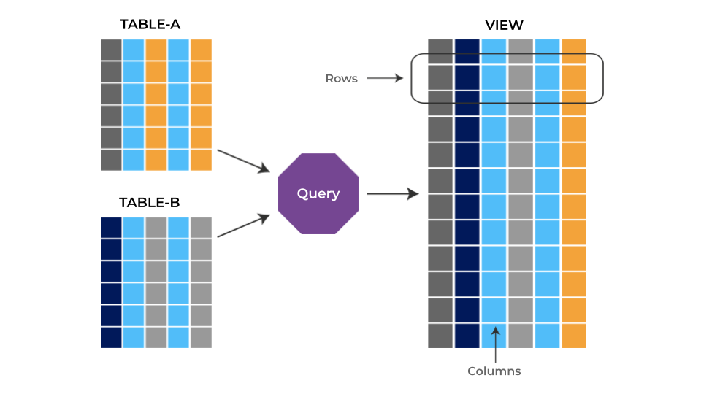

How to drop a column in SQL?
To drop a column in SQL, we will be using this command:
ALTER TABLE employees
DROP COLUMN gender;
We will start off by giving the keywords ALTER TABLE, then we will give the name of the table, following which we will give the keywords DROP COLUMN and finally give the name of the column which we would want to remove.

How to use BETWEEN in SQL?
The BETWEEN operator checks an attribute value within a range. Here is an example of BETWEEN operator:
SELECT * FROM employees WHERE salary between 10000 and 20000;
With this command, we will be able to extract all the records where the salary of the employee is between 10000 and 20000.

Advanced SQL Interview Questions

What are the subsets of SQL?
- DDL (Data Definition Language): Used to define the data structure it consists of the commands like CREATE, ALTER, DROP, etc.
- DML (Data Manipulation Language): Used to manipulate already existing data in the database, commands like SELECT, UPDATE, INSERT
- DCL (Data Control Language): Used to control access to data in the database, commands like GRANT, REVOKE.

Difference between CHAR and VARCHAR2 datatype in SQL?
CHAR is used to store fixed-length character strings, and VARCHAR2 is used to store variable-length character strings.

How to sort a column using a column alias?
By using the column alias in the ORDER BY instead of where clause for sorting

Difference between COALESCE() & ISNULL() ?
COALESCE() accepts two or more parameters, one can apply 2 or as many parameters but it returns only the first non NULL parameter.
ISNULL() accepts only 2 parameters.
The first parameter is checked for a NULL value, if it is NULL then the 2nd parameter is returned, otherwise, it returns the first parameter.

What is “Trigger” in SQL?
A trigger allows you to execute a batch of SQL code when an insert,update or delete command is run against a specific table as Trigger is said to be the set of actions that are performed whenever commands like insert, update or delete are given.

Write a Query to display employee details along with age.
SELECT * DATEDIFF(yy, dob, getdate()) AS 'Age' FROM employee

Write a Query to display employee details along with age?
SELECT SUM(salary) FROM employee

Write an SQL query to get the third maximum salary of an employee from a table named employee_table.
SELECT TOP 1 salary FROM ( SELECT TOP 3 salary FROM employee_table ORDER BY salary DESC ) AS emp ORDER BY salary ASC;

What are aggregate and scalar functions?
Aggregate functions are used to evaluate mathematical calculations and return single values. This can be calculated from the columns in a table. Scalar functions return a single value based on input value.
Example -. Aggregate – max(), count – Calculated with respect to numeric. Scalar – UCASE(), NOW() – Calculated with respect to strings.

What is a deadlock?
It is an unwanted situation where two or more transactions are waiting indefinitely for one another to release the locks.

Explain left outer join with example.
Left outer join is useful if you want all the records from the left table(first table) and only matching records from 2nd table. The unmatched records are null records. Example: Left outer join with “+” operator Select t1.col1,t2.col2….t ‘n’col ‘n.’. from table1 t1,table2 t2 where t1.col=t2.col(+);

What is SQL injection?
SQL injection is a code injection technique used to hack data-driven applications.

What is a UNION operator?
The UNION operator combines the results of two or more Select statements by removing duplicate rows. The columns and the data types must be the same in the SELECT statements.

Explain SQL Constraints.
SQL Constraints are used to specify the rules of data type in a table. They can be specified while creating and altering the table. The following are the constraints in SQL: NOT NULL CHECK DEFAULT UNIQUE PRIMARY KEY FOREIGN KEY

What is the ALIAS command?
This command provides another name to a table or a column. It can be used in the WHERE clause of a SQL query using the “as” keyword.

What are Group Functions? Why do we need them?
Group functions work on a set of rows and return a single result per group. The popularly used group functions are AVG, MAX, MIN, SUM, VARIANCE, and COUNT.

How can dynamic SQL be executed?
- By executing the query with parameters
- By using EXEC
- By using sp_executesql

What is the usage of NVL() function?
This function is used to convert the NULL value to the other value.

Write a Query to display employee details belongs to ECE department?
SELECT EmpNo, EmpName, Salary FROM employee WHERE deptNo in (select deptNo from dept where deptName = ‘ECE’)

What are the main differences between #temp tables and @table variables and which one is preferred?
1. SQL server can create column statistics on #temp tables.
2. Indexes can be created on #temp tables
3. @table variables are stored in memory up to a certain threshold

What is CLAUSE?
SQL clause is defined to limit the result set by providing conditions to the query. This usually filters some rows from the whole set of records. Example – Query that has WHERE condition.

What is a recursive stored procedure?
A stored procedure calls by itself until it reaches some boundary condition. This recursive function or procedure helps programmers to use the same set of code any number of times.

What does the BCP command do?
The Bulk Copy is a utility or a tool that exports/imports data from a table into a file and vice versa.

What is a Cross Join?
In SQL cross join, a combination of every row from the two tables is included in the result set. This is also called cross product set. For example, if table A has ten rows and table B has 20 rows, the result set will have 10 * 20 = 200 rows provided there is a NOWHERE clause in the SQL statement.

Which operator is used in query for pattern matching?
LIKE operator is used for pattern matching, and it can be used as- 1. % – Matches zero or more characters. 2. _(Underscore) – Matching exactly one character.

Write a SQL query to get the current date?
SELECT CURDATE();

State the case manipulation functions in SQL?
- LOWER: converts all the characters to lowercase.
- UPPER: converts all the characters to uppercase.
- INITCAP: converts the initial character of each word to uppercase

How to add a column to an existing table?
ALTER TABLE Department ADD (Gender, M, F)

Define lock escalation?
A query first takes the lowest level lock possible with the smallest row level. When too many rows are locked, the lock is escalated to a range or page lock. If too many pages are locked, it may escalate to a table lock.

How to store Videos inside SQL Server table?
By using FILESTREAM datatype, which was introduced in SQL Server 2008.

State the order of SQL SELECT?
The order of SQL SELECT clauses is: SELECT, FROM, WHERE, GROUP BY, HAVING, ORDER BY. Only the SELECT and FROM clauses are mandatory.

What is the difference between IN and EXISTS?
IN: Works on List result set Doesn’t work on subqueries resulting in Virtual tables with multiple columns Compares every value in the result list.
Exists: Works on Virtual tables Is used with co-related queries Exits comparison when the match is found

How do you copy data from one table to another table?
INSERT INTO table2 (column1, column2, column3, …) SELECT column1, column2, column3, … FROM table1 WHERE condition;

List the ACID properties that make sure that the database transactions are processed
ACID (Atomicity, Consistency, Isolation, Durability) is a set of properties that guarantee that database transactions are processed reliably.

What will be the output of the following Query, provided the employee table has 10 records?
BEGIN TRAN TRUNCATE TABLE Employees ROLLBACK SELECT * FROM Employees
This query will return 10 records as TRUNCATE was executed in the transaction. TRUNCATE does not itself keep a log but BEGIN TRANSACTION keeps track of the TRUNCATE command.

What do you mean by Stored Procedures? How do we use it?
A stored procedure is a collection of SQL statements that can be used as a function to access the database. We can create these stored procedures earlier before using it and can execute them wherever required by applying some conditional logic to it. Stored procedures are also used to reduce network traffic and improve performance.

What does GRANT command do?
This command is used to provide database access to users other than the administrator in SQL privileges.

What does the First normal form do?
First Normal Form (1NF): It removes all duplicate columns from the table. It creates a table for related data and identifies unique column values.

How to add e record to the table?
INSERT syntax is used to add a record to the table. INSERT into table_name VALUES (value1, value2..);

What are the different tables present in MySQL?
There are 5 tables present in MYSQL.
- MyISAM
- Heap
- Merge
- INNO DB
- ISAM

What is BLOB and TEXT in MySQL?
BLOB stands for the large binary objects. It is used to hold a variable amount of data. TEXT is a case-insensitive BLOB. TEXT values are non-binary strings (character strings).

What is the use of mysql_close()?
Mysql_close() cannot be used to close the persistent connection. Though it can be used to close a connection opened by mysql_connect().

Write a query to find out the data between ranges?
In day-to-day activities, the user needs to find out the data between some range. To achieve this user needs to use Between..and operator or Greater than and less than the operator.
Query 1: Using Between..and operator
Select * from Employee where salary between 25000 and 50000;
Query 2: Using operators (Greater than and less than)
Select * from Employee where salary >= 25000 and salary <= 50000;

How to calculate the number of rows in a table without using the count function?
There are so many system tables which are very important. Using the system table user can count the number of rows in the table. following query is helpful in that case, Select table_name, num_rows from user_tables where table_name=’Employee’;

What is wrong with the following query? SELECT empName FROM employee WHERE salary <> 6000
The following query will not fetch a record with the salary of 6000 but also will skip the record with NULL.

Will the following statements execute? if yes what will be output? SELECT NULL+1 SELECT NULL+’1′
Yes, no error. The output will be NULL. Performing any operation on NULL will get the NULL result.

SQL Server Interview Questions

What is an SQL server?
SQL server has stayed on top as one of the most popular database management products ever since its first release in 1989 by Microsoft Corporation. The product is used across industries to store and process large volumes of data. It was primarily built to store and process data that is built on a relational model of data.
SQL Server is widely used for data analysis and also scaling up of data. SQL Server can be used in conjunction with Big Data tools such as Hadoop.
SQL Server can be used to process data from various data sources such as Excel, Table, .Net Framework application, etc.

How to install SQL Server?
- Click on the below SQL Server official release link to access the latest version: https://www.microsoft.com/en-in/sql-server/sql-server-downloads
- Select the type of SQL Server edition that you want to install. SQL Server can be used on a Cloud Platform or as an open-source edition(Express or Developer) in your local computer system.
- Click on the Download Now button.
- Save the .exe file on your system. Right-click on the .exe file and click on Open.
- Click on ‘Yes’ to allow the changes to be made on your system and have SQL Server Installed.
- Once the installation is complete, restart your system, if required, and launch the SQL Server Management Studio application from the START menu.

How to create a stored procedure in SQL Server?
A Stored Procedure is nothing but a frequently used SQL query. Queries such as a SELECT query, which would often be used to retrieve a set of information many times within a database, can be saved as a Stored Procedure. The Stored Procedure, when called, executes the SQL query saved within the Stored Procedure.
Syntax to create a Stored Proc:
1  2  3  4 | CREATE PROCEDURE PROCEDURE_NAME  AS  SQL_QUERY (GIVE YOUR OFTEN USED QUERY HERE)  GO;
Stored procedures can be user-defined or built-in. Various parameters can be passed onto a Stored Procedure.

How to install SQL Server 2008?
- Click on the below SQL Server official release link: https://www.microsoft.com/en-in/sql-server/sql-server-downloads
- Click on the search icon and type in – SQL Server 2008 download
- Click on the result link to download and save SQL Server 2008.
- Select the type of SQL Server edition that you want to install. SQL Server can be used on a Cloud Platform or as an open-source edition(Express or Developer) in your local computer system.
- Click on the Download Now button.
- Save the .exe file on your system. Right-click on the .exe file and click on Open.
- Click on ‘Yes’ to allow the changes to be made on your system and have SQL Server installed.
- Once the installation is complete, restart your system, if required, and launch the SQL Server Management Studio application.

How to install SQL Server 2017?
- Click on the below SQL Server official release link: https://www.microsoft.com/en-in/sql-server/sql-server-downloads
- Click on the search icon and type in – SQL Server 2017 download
- Click on the result link to download and save SQL Server 2017.
- Select the type of SQL Server edition that you want to install. SQL Server can be used on a Cloud Platform or as an open-source edition(Express or Developer) in your local computer system.
- Click on the Download Now button.
- Save the .exe file on your system. Right-click on the .exe file and click on Open.
- Click on ‘Yes’ to allow the changes to be made on your system and have SQL Server installed.
- Once the installation is complete, restart your system, if required, and launch the SQL Server Management Studio application from the START menu.

How to restore the database in SQL Server?
Launch the SQL Server Management Studio application and from the Object Explorer window pane, right-click on Databases and click on Restore. This would automatically restore the database.

How to install SQL Server 2014?
- Click on the below SQL Server official release link: https://www.microsoft.com/en-in/sql-server/sql-server-downloads
- Click on the search icon and type in – SQL Server 2014 download
- Click on the result link to download and save SQL Server 2014.
- Select the type of SQL Server edition that you want to install. SQL Server can be used on a Cloud Platform or as an open-source edition(Express or Developer) in your local computer system.
- Click on the Download Now button.
- Save the .exe file on your system. Right-click on the .exe file and click on Open.
- Click on ‘Yes’ to allow the changes to be made on your system and have SQL Server Installed.
- Once the installation is complete, restart your system, if required, and launch the SQL Server Management Studio application from the START menu.

How to get the connection string from SQL Server?
Launch the SQL Server Management Studio. Go to the Database for which you require the Connection string. Right-click on the database and click on Properties. In the Properties window that is displayed, you can view the Connection String property.
Connection strings help connect databases to another staging database or any external source of data.

How to install SQL Server 2012?
- Click on the below SQL Server official release link: https://www.microsoft.com/en-in/sql-server/sql-server-downloads
- Click on the search icon and type in – SQL Server 2012 download
- Click on the result link to download and save SQL Server 2012.
- Select the type of SQL Server edition that you want to install. SQL Server can be used on a Cloud Platform or as an open-source edition(Express or Developer) in your local computer system.
- Click on the Download Now button.
- Save the .exe file on your system. Right-click on the .exe file and click on Open.
- Click on ‘Yes’ to allow the changes to be made on your system and have SQL Server Installed.
- Once the installation is complete, restart your system, if required, and launch the SQL Server Management Studio application from the START menu.

What is cte in SQL Server?
CTEs are Common Table Expressions that are used to create temporary result tables from which data can be retrieved/ used. The standard syntax for a CTE with a SELECT statement is:
1  2  3  4  5 | WITH RESULT AS  (SELECT COL1, COL2, COL3  FROM EMPLOYEE)  SELECT COL1, COL2 FROM RESULT  CTEs can be used with Insert, Update or Delete statements as well.
Few examples of CTEs are given below:
Query to find the 10 highest salaries.
with result as
(select distinct salary, dense_rank() over (order by salary desc) as salary rank from employees)
select result. salary from result where the result.salaryrank = 10

Query to find the 2nd highest salary
with the result as
(select distinct salary, dense_rank() over (order by salary desc) as salaryrank from employees)
select result. salary from result where the result.salaryrank = 2
In this way, CTEs can be used to find the nth highest salary within an organisation.

How to change the SQL Server password?
Launch your SQL Server Management Studio. Click on the Database connection for which you want to change the login password. Click on Security from the options that get displayed.
Click on Logins and open your database connection. Type in the new password for login and click on ‘OK’ to apply the changes.

How to delete duplicate records in SQL Server?
Select the duplicate records in a table HAVING COUNT(*)>1
Add a delete statement to delete the duplicate records.
Sample Query to find the duplicate records in a table-
(SELECT COL1, COUNT(*) AS DUPLICATE
FROM EMPLOYEE
GROUP BY COL1
HAVING COUNT(*) > 1)

How to uninstall SQL Server?
In Windows 10, go to the START menu and locate the SQL Server.
Right-click and select uninstall to uninstall the application.

How to check SQL Server version?
You can run the below query to view the current version of SQL Server that you are using.
1 | SELECT @@version;

How to rename column name in SQL Server?
From the Object Explorer window pane, go to the table where the column is present and choose Design. Under the Column Name, select the name you want to rename and enter the new name. Go to the File menu and click Save.

What is the stored procedure in SQL Server?
A Stored Procedure is nothing but a frequently used SQL query. Queries such as a SELECT query, which would often be used to retrieve a set of information many times within a database, can be saved as a Stored Procedure. The Stored Procedure, when called, executes the SQL query saved within the Stored Procedure.
Syntax to create a Stored Proc:
1  2  3  4 | CREATE PROCEDURE PROCEDURE_NAME  AS  SQL_QUERY (GIVE YOUR OFTEN USED QUERY HERE)  GO;
You can execute the Stored Proc by using the command Exec Procedure_Name;

How to create a database in SQL Server?
After installing the required version of SQL Server, it is easy to create new databases and maintain them.
- Launch the SQL Server Management Studio
- In the Object Explorer window pane, right-click on Databases and select ‘New Database’
- Enter the Database Name and click on ‘Ok’.
- Voila! Your new database is ready for use.

What is an index in SQL Server?
Indexes are database objects which help in retrieving records quickly and more efficiently. Column indexes can be created on both Tables and Views. By declaring a Column as an index within a table/ view, the user can access those records quickly by executing the index. Indexes with more than one column are called Clustered indexes.
Syntax:
1  2 | CREATE INDEX INDEX_NAME  ON TABLE_NAME(COL1, COL2);
The syntax to drop an Index is DROP INDEX INDEX_NAME;
Indexes are known to improve the efficiency of SQL Select queries.

How to create the table in SQL Server?
Tables are the fundamental storage objects within a database. A table is usually made up of
Rows and Columns. The below syntax can be used to create a new table with 3 columns.
CREATE TABLE TABLE_NAME(COLUMN1 DATATYPE, COLUMN2 DATATYPE, COLUMN3 DATATYPE);
Alternatively, you can right-click on Table in the Object Explorer window pane and select ‘New -> Table’.
You can also define the type of Primary/ Foreign/ Check constraint when creating a table.

How to connect to SQL Server?
- Launch the SQL Server Management Studio from the START menu.
- In the dialogue box shown below, select the Server Type as Database Engine and Server Name as the name of your laptop/ desktop system.
- Select the appropriate Authentication type and click on the Connect button.
- A secure connection would be established, and the list of the available Databases will be loaded in the Object Explorer window pane.
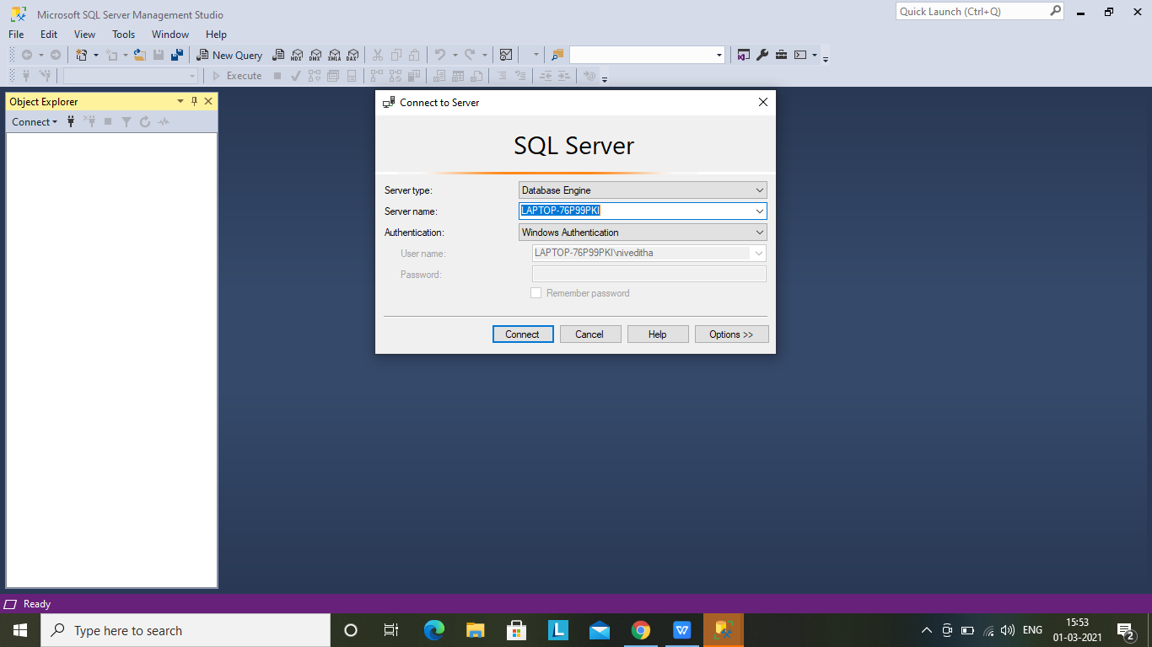

How to delete duplicate rows in SQL Server?
Select the duplicate records in a table HAVING COUNT(*)>1
Add a delete statement to delete the duplicate records.
Sample Query to find the duplicate records in a table –
(SELECT COL1, COUNT(*) AS DUPLICATE
FROM EMPLOYEE
GROUP BY COL1
HAVING COUNT(*) > 1);

How to download SQL Server?
The Express and Developer versions (open-source versions) of the latest SQL Server release can be downloaded from the official Microsoft website. The link is given below for reference.
https://www.microsoft.com/en-in/sql-server/sql-server-downloads

How to connect SQL Server management studio to the local database?
- Launch the SQL Server Management Studio from the START menu.
- In the dialogue box shown below, select the Server Type as Database Engine and Server Name as the name of your laptop/ desktop system and click on the Connect button.
- Select the Authentication as ‘Windows Authentication.
- A secure connection would be established, and the list of the available Databases will be loaded in the Object Explorer window pane.

How to download SQL Server 2014?
- Both the Express and Developer versions (free editions) of SQL Server can be downloaded from the official Microsoft website. The link is given below for reference.
- Click on the link below: https://www.microsoft.com/en-in/sql-server/sql-server-downloads
- Click on the search icon and type in – SQL Server 2014 download
- Click on the result link to download and save SQL Server 2014.

How to uninstall SQL Server 2014?
From the START menu, type SQL Server. Right-click on the app and select uninstall to uninstall the application from your system. Restart the system, if required, for the changes to get affected.

How to find server names in SQL Server?
Run the query SELECT @@version; to find the version and name of the SQL Server you are using.

How to start SQL Server?
Launch the SQL Server Management Studio from the START menu. Login using Windows Authentication. In the Object Explorer window pane, you can view the list of databases and corresponding objects.

What is the case when in SQL Server?
Case When statements in SQL are used to run through many conditions and to return a value when one such condition is met. If none of the conditions is met in the When statements, then the value mentioned in the Else statement is returned.
Syntax:
1  2  3  4  5  6  7  8 | CASE  WHEN CONDITION1 THEN RESULT1  WHEN CONDITION2 THEN RESULT2  ELSE  RESULT  END;
Sample query:
HOW MANY HEAD OFFICES/ BRANCHES ARE THERE IN CANADA
select
sum (
case
when region_id >= 5 AND region_id <= 7 then
1
else
0
end ) as Canada
from company_regions;
Nested CASE statement:
SELECT
SUM (
CASE
WHEN rental_rate = 0.99 THEN
1
ELSE
0
END
) AS "Mass",
SUM (
CASE
WHEN rental_rate = 2.99 THEN
1
ELSE
0
END
) AS "Economic",
SUM (
CASE
WHEN rental_rate = 4.99 THEN
1
ELSE
0
END
) AS " Luxury"
FROM
film;

How to install SQL Server management studio?
Launch Google and in the Search toolbar, type in SQL Server Management Studio download.
Go to the routed website and click on the link to download. Once the download is complete, open the .exe file to install the content of the file. Once the installation is complete, refresh or restart the system, as required.
Alternatively, once SQL Server is installed and launched, it will prompt the user with an option to launch SQ Server Management Studio.

How to write a stored procedure in SQL Server?
A Stored Procedure is nothing but a frequently used SQL query. Queries such as a SELECT query, which would often be used to retrieve a set of information many times within a database, can be saved as a Stored Procedure. The Stored Procedure, when called, executes the SQL query saved within the Stored Procedure.
Syntax to create a Stored Proc:
1  2  3  4 | CREATE PROCEDURE PROCEDURE_NAME  AS  SQL_QUERY (GIVE YOUR OFTEN USED QUERY HERE)  GO;
You can execute the Stored Proc by using the command Exec Procedure_Name;

How to open SQL Server?
Launch the SQL Server Management Studio from the START menu. Login using Windows Authentication. In the Object Explorer window pane, you can view the list of databases and corresponding objects.

How to use SQL Server?
SQL Server is used to retrieve and process various data that is built on a relational model.
Some of the common actions that can be taken on the data are CREATE, DELETE, INSERT, UPDATE, SELECT, REVOKE, etc.
SQL Server can also be used to import and export data from different data sources. SQL Server can also be connected to various other databases/ .Net frameworks using Connection Strings.
SQL Server can also be used in conjunction with Big Data tools like Hadoop.

What is a function in SQL Server?
Functions are pre-written codes that return a value and which help the user achieve a particular task concerning viewing, manipulating, and processing data.
Examples of a few functions are:
AGGREGATE FUNCTIONS:
- MIN()- Returns the minimum value
- MAX()- Returns the maximum value
- AVG()- Returns the average value
- COUNT()
STRING FUNCTIONS:
- COALESCE()
- CAST()
- CONCAT()
- SUBSTRING()
DATE FUNCTIONS:
- GETDATE()
- DATEADD()
- DATEDIFF()
There are many types of functions such as Aggregate Functions, Date Functions, String Functions, Mathematical functions, etc.

How to find nth highest salary in SQL Server without using a subquery
Query to find the 10 highest salaries. For up-gradation of the b10 band.
with result as
(select distinct salary, dense_rank() over (order by salary desc) as salaryrank from employees)
select result.salary from result where result.salaryrank = 10
Query to find the 2nd highest salary
with the result as
(select distinct salary, dense_rank() over (order by salary desc) as salary rank from employees)
select result.salary from result where result.salaryrank = 2
In this way, by replacing the salary rank value, we can find the nth highest salary in any organisation.

How to install SQL Server in Windows 10?
Click on the below SQL Server official release link: https://www.microsoft.com/en-in/sql-server/sql-server-downloads
Click on the search icon and type in - SQL Server 2012 download
Click on the result link to download and save SQL Server 2012.
Select the type of the SQL Server edition that you want to install. SQL Server can be used on a Cloud Platform or as an open-source edition(Express or Developer) in your local computer system.
Click on the Download Now button.
Save the .exe file on your system. Right-click on the .exe file and click on Open.
Click on ‘Yes’ to allow the changes to be made on your system and have SQL Server Installed

How to create a temp table in SQL Server?
Temporary tables can be used to retain the structure and a subset of data from the original table from which they were derived.
Syntax:
1  2  3 | SELECT COL1, COL2  INTO TEMPTABLE1  FROM ORIGTABLE;
Temporary tables do not occupy any physical memory and can be used to retrieve data faster.

PostgreSQL Interview Questions

What is PostgreSQL?
PostgreSQL is one of the most widely and popularly used languages for Object-Relational Database Management systems. It is mainly used for large web applications. It is an open-source, object-oriented, -relational database system. It is extremely powerful and enables users to extend any system without problem. It extends and uses the SQL language in combination with various features for safely scaling and storage of intricate data workloads.

List different datatypes of PostgreSQL?
Listed below are some of the new data types in PostgreSQL
- UUID
- Numeric types
- Boolean
- Character types
- Temporal types
- Geometric primitives
- Arbitrary precision numeric
- XML
- Arrays etc

What are the Indices of PostgreSQL?
Indices in PostgreSQL allow the database server to find and retrieve specific rows in a given structure. Examples are B-tree, hash, GiST, SP-GiST, GIN and BRIN. Users can also define their indices in PostgreSQL. However, indices add overhead to the data manipulation operations and are seldom used

What are tokens in PostgreSQL?
Tokens in PostgreSQL act as the building blocks of a source code. They are composed of various special character symbols. Commands are composed of a series of tokens and terminated by a semicolon(“;”). These can be a constant, quoted identifier, other identifiers, keyword or a constant. Tokens are usually separated by whitespaces.

How to create a database in PostgreSQL?
Databases can be created using 2 methods
- First is the CREATE DATABASE SQL Command
We can create the database by using the syntax:-
1 | CREATE DATABASE <dbname>;
- The second is by using the createdb command
We can create the database by using the syntax:-
1 | createdb [option...] <dbname> [description]
Various options can be taken by the createDB command based on the use case.

How to create a table in PostgreSQL?
You can create a new table by specifying the table name, along with all column names and their types:
CREATE TABLE [IF NOT EXISTS] table_name (
column1 datatype(length) column_contraint,
column2 datatype(length) column_contraint,
.
.
.
columnn datatype(length) column_contraint,
table_constraints
);

How can we change the column datatype in PostgreSQL?
The column the data type can be changed in PostgreSQL by using the ALTER TABLE command:
ALTER TABLE table_name
ALTER COLUMN column_name1 [SET DATA] TYPE new_data_type,
ALTER COLUMN column_name2 [SET DATA] TYPE new_data_type,
...;

Compare ‘PostgreSQL’ with ‘MongoDB’
PostgreSQL | MongoDB
PostgreSQL is an SQL database where data is stored as tables, with structured rows and columns. It supports concepts like referential integrity entity-relationship and JOINS. PostgreSQL uses SQL as its querying language. PostgreSQL supports vertical scaling. This means that you need to use big servers to store data. This leads to a requirement of downtime to upgrade. It works better if you require relational databases in your application or need to run complex queries that test the limit of SQL. | MongoDB, on the other hand, is a NoSQL database. There is no requirement for a schema, therefore it can store unstructured data. Data is stored as BSON documents and the document’s structure can be changed by the user. MongoDB uses JavaScript for querying. It supports horizontal scaling, as a result of which additional servers can be added as per the requirement with minimal to no downtime. It is appropriate in a use case that requires a highly scalable distributed database that stores unstructured data

What is Multi-Version concurrency control in PostgreSQL?
MVCC or better known as Multi-version concurrency control is used to implement transactions in PostgreSQL. It is used to avoid unwanted locking of a database in the system. while querying a database each transaction sees a version of the database. This avoids viewing inconsistencies in the data, and also provides transaction isolation for every database session. MVCC locks for reading data do not conflict with locks acquired for

How do you delete the database in PostgreSQL?
Databases can be deleted in PostgreSQL using the syntax
1 | DROP DATABASE [IF EXISTS] <database_name>;
Please note that only databases having no active connections can be dropped.

What does a schema contain?
- Schemas are a part of the database that contains tables. They also contain other kinds of named objects, like data types, functions, and operators.
- The object names can be used in different schemas without conflict; Unlike databases, schemas are separated more flexibly. This means that a user can access objects in any of the schemas in the database they are connected to, till they have privileges to do so.
- Schemas are highly beneficial when there is a need to allow many users access to one database without interfering with each other. It helps in organizing database objects into logical groups for better manageability. Third-party applications can be put into separate schemas to avoid conflicts based on names.

What is the square root operator in PostgreSQL?
It is denoted by ‘|/” and returns the square root of a number. Its syntax is
1 | Select |/ <number>
Egs:- Select |/16

How are the stats updated in Postgresql?
To update statistics in PostgreSQL a special function called an explicit ‘vacuum’ call is made. Entries in pg_statistic are updated by the ANALYZE and VACUUM ANALYZE commands

What Is A Candid?
The CTIDs field exists in every PostgreSQL table. It is unique for every record of a table and exactly shows the location of a tuple in a particular table. A logical row’s CTID changes when it is updated, thus it cannot be used as a permanent row identifier. However, it is useful when identifying a row within a transaction when no update is expected on the data item.

What is Cube Root Operator (||/) in PostgreSQL?
It is denoted by ‘|/” and returns the square root of a number. Its syntax is
1 | Select |/ <number>
Egs:- Select |/16

Explain Write-Ahead Logging?
Write-ahead logging is a method to ensure data integrity. It is a protocol that ensures writing the actions as well as changes into a transaction log. It is known to increase the reliability of databases by logging changes before they are applied or updated onto the database. This provides a backup log for the database in case of a crash.

What is a non-clustered index?
A non-clustered index in PostgreSQL is a simple index, used for fast retrieval of data, with no certainty of the uniqueness of data. It also contains pointers to locations where other parts of data are stored

How is security ensured in PostgreSQL?
PostgreSQL uses 2 levels of security
- Network-level security uses Unix Domain sockets, TCP/IP sockets, and firewalls.
- Transport-level security which uses SSL/TLS to enable secure communication with the database
- Database-level security with features like roles and permissions, row-level security (RLS), and auditing.

SQL Practice Questions

PART 1
This covers SQL basic query operations like creating databases forms scratch, creating a table, inserting values etc.
It is better to get hands-on in order to have practical experience with SQL queries. A small error/bug will make you feel surprised and next time you will get there!
Let’s get started!
1) Create a Database bank
1  2 | CREATE DATABASE bank;  use bank
2) Create a table with the name “bank_details” with the following columns
— Product with string data type
— Quantity with numerical data type
— Price with real number data type
— purchase_cost with decimal data type
— estimated_sale_price with data type float
1  2  3  4  5  6 | Create table bank_details(  Product CHAR(10) ,  quantity INT,  price Real ,  purchase_cost Decimal(6,2),  estimated_sale_price Float);
3) Display all columns and their datatype and size in Bank_details
1 | Describe bank_details;
4) Insert two records into Bank_details.
— 1st record with values —
— Product: PayCard
— Quantity: 3
— price: 330
— Puchase_cost: 8008
— estimated_sale_price: 9009
— Product: PayPoints —
— Quantity: 4
— price: 200
— Puchase_cost: 8000
— estimated_sale_price: 6800
1  2 | Insert into Bank_detailsvalues ( 'paycard' , 3 , 330, 8008, 9009);  Insert into Bank_detailsvalues ( 'paypoints' , 4 , 200, 8000, 6800);
5) Add a column: Geo_Location to the existing Bank_details table with data type varchar and size 20
1 | Alter table Bank_details add geo_location Varchar(20);
6) What is the value of Geo_location for a product : “PayCard”?
1 | Select geo_location from Bank_details where Product = 'PayCard';
7) How many characters does the Product : “paycard” have in the Bank_details table.
1 | select char_length(Product) from Bank_details where Product = 'PayCard';
8) Alter the Product field from CHAR to VARCHAR in Bank_details
1 | Alter table bank_details modify PRODUCT varchar(10);
9) Reduce the size of the Product field from 10 to 6 and check if it is possible
1 | Alter table bank_details modify product varchar(6);
10) Create a table named as Bank_Holidays with below fields
— a) Holiday field which displays only date
— b) Start_time field which displays hours and minutes
— c) End_time field which also displays hours and minutes and timezone
1  2  3  4 | Create table bank_holidays (  Holiday date ,  Start_time datetime ,  End_time timestamp);
11) Step 1: Insert today’s date details in all fields of Bank_Holidays
— Step 2: After step1, perform the below
— Postpone Holiday to next day by updating the Holiday field
1  2  3  4  5  6  7  8 | -- Step1:  Insert into bank_holidays values ( current_date(),  current_date(),  current_date() );  -- Step 2:  Update bank_holidays  set holiday = DATE_ADD(Holiday , INTERVAL 1 DAY);
Update the End_time with current European time.
1 | Update Bank_Holidays Set End_time = utc_timestamp();
12) Display output of PRODUCT field as NEW_PRODUCT in Bank_details table
1 | Select PRODUCT as NEW_PRODUCT from bank_details;
13) Display only one record from bank_details
1 | Select * from Bank_details limit 1;
15) Display the first five characters of the Geo_location field of Bank_details.
1 | SELECT substr(Geo_location , 1, 5) FROM `bank_details`;

PART 2
— ——————————————————–
# Datasets Used: cricket_1.csv, cricket_2.csv
— cricket_1 is the table for cricket test match 1.
— cricket_2 is the table for cricket test match 2.
— ——————————————————–
Find all the players who were present in the test match 1 as well as in the test match 2.
1  2  3 | SELECT * FROM cricket_1  UNION  SELECT * FROM cricket_2;
Write a MySQl query to find the players from the test match 1 having popularity higher than the average popularity.
1 | select player_name , Popularity from cricket_1 WHERE Popularity > (SELECT AVG(Popularity) FROM cricket_1);
Find player_id and player name that are common in the test match 1 and test match 2.
1  2 | SELECT player_id , player_name FROM cricket_1  WHERE cricket_1.player_id IN (SELECT player_id FROM cricket_2);
Retrieve player_id, runs, and player_name from cricket_1 and cricket_2 table and display the player_id of the players where the runs are more than the average runs.
1 | SELECT player_id , runs , player_name FROM cricket_1 WHERE cricket_1.RUNS > (SELECT AVG(RUNS) FROM cricket_2);
Write a query to extract the player_id, runs and player_name from the table “cricket_1” where the runs are greater than 50.
1  2 | SELECT player_id , runs , player_name FROM cricket_1  WHERE cricket_1.Runs > 50 ;
Write a query to extract all the columns from cricket_1 where player_name starts with ‘y’ and ends with ‘v’.
1 | SELECT * FROM cricket_1 WHERE player_name LIKE 'y%v';
Write a query to extract all the columns from cricket_1 where player_name does not end with ‘t’.
1  2 | SELECT * FROM cricket_1 WHERE player_name NOT LIKE '%t';
# Dataset Used: cric_combined.csv
Write a MySQL query to create a new column PC_Ratio that contains the popularity to charisma ratio.
1  2  3  4 | ALTER TABLE cric_combined  ADD COLUMN PC_Ratio float4;  UPDATE cric_combined SET PC_Ratio = (Popularity / Charisma);
Write a MySQL query to find the top 5 players having the highest popularity to charisma ratio
1 | SELECT Player_Name , PC_Ratio FROM cric_combined ORDER BY PC_Ratio DESC LIMIT 5;
Write a MySQL query to find the player_ID and the name of the player that contains the character “D” in it.
1 | SELECT Player_Id , Player_Name FROM cric_combined WHERE Player_Name LIKE '%d%';
Dataset Used: new_cricket.csv
Extract the Player_Id and Player_name of the players where the charisma value is null.
1 | SELECT Player_Id , Player_Name FROM new_cricket WHERE Charisma IS NULL;
Write a MySQL query to impute all the NULL values with 0.
1 | SELECT IFNULL(Charisma, 0) FROM new_cricket;
Separate all Player_Id into single numeric ids (example PL1 = 1).
1  2 | SELECT Player_Id, SUBSTR(Player_Id,3)  FROM new_cricket;
Write a MySQL query to extract Player_Id, Player_Name and charisma where the charisma is greater than 25.
1 | SELECT Player_Id , Player_Name , charisma FROM new_cricket WHERE charisma > 25;
# Dataset Used: churn1.csv
Write a query to count all the duplicate values from the column “Agreement” from the table churn1.
1 | SELECT Agreement, COUNT(Agreement) FROM churn1 GROUP BY Agreement HAVING COUNT(Agreement) > 1;
Rename the table churn1 to “Churn_Details”.
1 | RENAME TABLE churn1 TO Churn_Details;
Write a query to create a new column new_Amount that contains the sum of TotalAmount and MonthlyServiceCharges.
1  2  3  4  5 | ALTER TABLE Churn_Details  ADD COLUMN new_Amount FLOAT;  UPDATE Churn_Details SET new_Amount = (TotalAmount + MonthlyServiceCharges);  SELECT new_Amount FROM CHURN_DETAILS;
Rename column new_Amount to Amount.
1  2  3 | ALTER TABLE Churn_Details CHANGE new_Amount Amount FLOAT;  SELECT AMOUNT FROM CHURN_DETAILS;
Drop the column “Amount” from the table “Churn_Details”.
1 | ALTER TABLE Churn_Details DROP COLUMN Amount ;
Write a query to extract the customerID, InternetConnection and gender from the table “Churn_Details ” where the value of the column “InternetConnection” has ‘i’ at the second position.
1 | SELECT customerID, InternetConnection, gender FROM Churn_Details WHERE InternetConnection LIKE '_i%';
Find the records where the tenure is 6x, where x is any number.
1 | SELECT * FROM Churn_Details WHERE tenure LIKE '6_';

Part 3
# DataBase = Property Price Train
Dataset used: Property_Price_Train_new
Write An MySQL Query To Print The First Three Characters Of Exterior1st From Property_Price_Train_new Table.
1 | Select substring(Exterior1st,1,3) from Property_Price_Train_new;
Write An MySQL Query To Print Brick_Veneer_Area Of Property_Price_Train_new Excluding Brick_Veneer_Type, “None” And “BrkCmn” From Property_Price_Train_new Table.
1 | Select Brick_Veneer_Area, Brick_Veneer_Type from Property_Price_Train_new where Brick_Veneer_Type not in ('None','BrkCmn');
Write An MySQL Query to print Remodel_Year , Exterior2nd of the Property_Price_Train_new Whose Exterior2nd Contains ‘H’.
1 | Select Remodel_Year , Exterior2nd from Property_Price_Train_new where Exterior2nd like '%H%' ;
Write MySQL query to print details of the table Property_Price_Train_new whose Remodel_year from 1983 to 2006
1 | select * from Property_Price_Train_new where Remodel_Year between 1983 and 2006;
Write MySQL query to print details of Property_Price_Train_new whose Brick_Veneer_Type ends with e and contains 4 alphabets.
1 | Select * from Property_Price_Train_new where Brick_Veneer_Type like '____e';
Write MySQl query to print nearest largest integer value of column Garage_Area from Property_Price_Train_new
1 | Select ceil(Garage_Area) from Property_Price_Train_new;
Fetch the 3 highest value of column Brick_Veneer_Area from Property_Price_Train_new table
1 | Select Brick_Veneer_Area from Property_Price_Train_new order by Brick_Veneer_Area desc limit 2,1;
Rename column LowQualFinSF to Low_Qual_Fin_SF fom table Property_Price_Train_new
1 | Alter table Property_Price_Train_new change LowQualFinSF Low_Qual_Fin_SF varchar(150);
Convert Underground_Full_Bathroom (1 and 0) values to true or false respectively.
# Eg. 1 – true ; 0 – false
1 | SELECT CASE WHEN Underground_Full_Bathroom = 0 THEN 'false' ELSE 'true' END FROM Property_Price_Train_new;
Extract total Sale_Price for each year_sold column of Property_Price_Train_new table.
1 | Select Year_Sold, sum(Sale_Price) from Property_Price_Train_new group by Year_Sold;
Extract all negative values from W_Deck_Area
1 | Select W_Deck_Area from Property_Price_Train_new where W_Deck_Area < 0;
Write MySQL query to extract Year_Sold, Sale_Price whose price is greater than 100000.
1 | Select Sale_Price , Year_Sold from Property_Price_Train_new group by Year_Sold having Sale_Price > 100000;
Write MySQL query to extract Sale_Price and House_Condition from Property_Price_Train_new and Property_price_train_2 perform inner join. Rename the table as PPTN and PPTN2.
1 | Select Sale_Price , House_Condition from Property_Price_Train_new AS PPTN inner join Property_price_train_2 AS PPT2 on PPTN.ID= PPTN2.ID;
Count all duplicate values of column Brick_Veneer_Type from tbale Property_Price_Train_new
1 | Select Brick_Veneer_Type, count(Brick_Veneer_Type) from Property_Price_Train_new group by Brick_Veneer_Type having count(Brick_Veneer_Type) > 1;
# DATABASE Cricket
Find all the players from both matches.
1  2  3 | SELECT * FROM cricket_1  UNION  SELECT * FROM cricket_2;
Perform right join on cricket_1 and cricket_2.
1  2  3  4  5  6 | SELECT  cric2.Player_Id, cric2.Player_Name, cric2.Runs, cric2.Charisma, cric1.Popularity  FROM  cricket_1 AS cric1  RIGHT JOIN  cricket_2 AS cric2 ON cric1.Player_Id = cric2.Player_Id;
Perform left join on cricket_1 and cricket_2
1  2  3  4  5  6 | SELECT  cric1.Player_Id, cric1.Player_Name, cric1.Runs, cric1.Popularity, cric2.Charisma  FROM  cricket_1 AS cric1  LEFT JOIN  cricket_2 AS cric2 ON cric1.Player_Id = cric2.Player_Id;
Perform left join on cricket_1 and cricket_2.
1  2  3  4  5  6 | SELECT  cric1.Player_Id, cric1.Player_Name, cric1.Runs, cric1.Popularity, cric2.Charisma  FROM  cricket_1 AS cric1  INNER JOIN  cricket_2 AS cric2 ON cric1.Player_Id = cric2.Player_Id;
Create a new table and insert the result obtained after performing inner join on the two tables cricket_1 and cricket_2.
1  2  3  4  5  6  7 | CREATE TABLE Players1And2 AS  SELECT  cric1.Player_Id, cric1.Player_Name, cric1.Runs, cric1.Popularity, cric2.Charisma  FROM  cricket_1 AS cric1  INNER JOIN  cricket_2 AS cric2 ON cric1.Player_Id = cric2.Player_Id;
Write MySQL query to extract maximum runs of players get only top two players
1 | select Player_Name, Runs from cricket_1 group by Player_Name having max(Runs) limit 2;

PART 4
# Pre-Requisites
# Assuming Candidates are familiar with “Group by” and “Grouping functions” because these are used along with JOINS in the questionnaire.
# Create below DB objects
1  2  3  4  5  6  7  8  9  10  11  12  13  14  15  16  17  18  19  20  21  22  23  24  25  26  27  28  29  30  31  32  33  34  35  36  37  38  39  40  41  42  43  44  45  46  47  48  49  50  51  52  53  54  55  56  57  58  59  60  61  62  63  64  65  66  67  68  69  70  71  72  73  74  75  76  77  78  79  80  81  82  83  84  85  86  87  88  89  90  91  92  93  94  95  96  97  98  99  100  101  102  103  104  105  106  107  108  109  110  111  112  113  114  115  116  117  118  119  120  121  122  123  124  125  126  127  128  129  130  131  132  133  134  135  136  137  138  139  140  141  142  143  144  145  146  147  148  149  150  151  152  153  154  155  156  157  158  159  160  161  162  163  164  165  166  167  168  169  170  171  172  173 | CREATE TABLE BANK_CUSTOMER ( customer_id INT ,  customer_name VARCHAR(20),  Address VARCHAR(20),  state_code VARCHAR(3) ,  Telephone VARCHAR(10) );  INSERT INTO BANK_CUSTOMER VALUES (123001,"Oliver", "225-5, Emeryville", "CA" , "1897614500");  INSERT INTO BANK_CUSTOMER VALUES (123002,"George", "194-6,New brighton","MN" , "1897617000");  INSERT INTO BANK_CUSTOMER VALUES (123003,"Harry", "2909-5,walnut creek","CA" , "1897617866");  INSERT INTO BANK_CUSTOMER VALUES (123004,"Jack", "229-5, Concord", "CA" , "1897627999");  INSERT INTO BANK_CUSTOMER VALUES (123005,"Jacob", "325-7, Mission Dist","SFO", "1897637000");  INSERT INTO BANK_CUSTOMER VALUES (123006,"Noah", "275-9, saint-paul" , "MN" , "1897613200");  INSERT INTO BANK_CUSTOMER VALUES (123007,"Charlie","125-1,Richfield", "MN" , "1897617666");  INSERT INTO BANK_CUSTOMER VALUES (123008,"Robin","3005-1,Heathrow", "NY" , "1897614000");  CREATE TABLE BANK_CUSTOMER_EXPORT ( customer_id CHAR(10),  customer_name CHAR(20),  Address CHAR(20),  state_code CHAR(3) ,  Telephone CHAR(10));  INSERT INTO BANK_CUSTOMER_EXPORT VALUES ("123001 ","Oliver", "225-5, Emeryville", "CA" , "1897614500") ;  INSERT INTO BANK_CUSTOMER_EXPORT VALUES ("123002 ","George", "194-6,New brighton","MN" , "189761700");  CREATE TABLE Bank_Account_Details(Customer_id INT,  Account_Number VARCHAR(19),  Account_type VARCHAR(25),  Balance_amount INT,  Account_status VARCHAR(10),  Relationship_type varchar(1) ) ;  INSERT INTO Bank_Account_Details VALUES (123001, "4000-1956-3456", "SAVINGS" , 200000 ,"ACTIVE","P");  INSERT INTO Bank_Account_Details VALUES (123001, "5000-1700-3456", "RECURRING DEPOSITS" ,9400000 ,"ACTIVE","S");  INSERT INTO Bank_Account_Details VALUES (123002, "4000-1956-2001", "SAVINGS", 400000 ,"ACTIVE","P");  INSERT INTO Bank_Account_Details VALUES (123002, "5000-1700-5001", "RECURRING DEPOSITS" ,7500000 ,"ACTIVE","S");  INSERT INTO Bank_Account_Details VALUES (123003, "4000-1956-2900", "SAVINGS" ,750000,"INACTIVE","P");  INSERT INTO Bank_Account_Details VALUES (123004, "5000-1700-6091", "RECURRING DEPOSITS" ,7500000 ,"ACTIVE","S");  INSERT INTO Bank_Account_Details VALUES (123004, "4000-1956-3401", "SAVINGS" , 655000 ,"ACTIVE","P");  INSERT INTO Bank_Account_Details VALUES (123005, "4000-1956-5102", "SAVINGS" , 300000 ,"ACTIVE","P");  INSERT INTO Bank_Account_Details VALUES (123006, "4000-1956-5698", "SAVINGS" , 455000 ,"ACTIVE" ,"P");  INSERT INTO Bank_Account_Details VALUES (123007, "5000-1700-9800", "SAVINGS" , 355000 ,"ACTIVE" ,"P");  INSERT INTO Bank_Account_Details VALUES (123007, "4000-1956-9977", "RECURRING DEPOSITS" , 7025000,"ACTIVE" ,"S");  INSERT INTO Bank_Account_Details VALUES (123007, "9000-1700-7777-4321", "Credit Card" ,0 ,"INACTIVE", "P");  INSERT INTO Bank_Account_Details VALUES (123007, '5900-1900-9877-5543', "Add-on Credit Card" , 0 ,"ACTIVE", "S");  INSERT INTO Bank_Account_Details VALUES (123008, "5000-1700-7755", "SAVINGS" ,0 ,"INACTIVE","P");  INSERT INTO Bank_Account_Details VALUES (123006, '5800-1700-9800-7755', "Credit Card" ,0 ,"ACTIVE", "P");  INSERT INTO Bank_Account_Details VALUES (123006, '5890-1970-7706-8912', "Add-on Credit Card" ,0 ,"ACTIVE", "S");  # CREATE Bank_Account Table:  # Create Table  CREATE TABLE BANK_ACCOUNT ( Customer_id INT,  Account_Number VARCHAR(19),  Account_type VARCHAR(25),  Balance_amount INT ,  Account_status VARCHAR(10), Relation_ship varchar(1) ) ;  # Insert records:  INSERT INTO BANK_ACCOUNT VALUES (123001, "4000-1956-3456", "SAVINGS" , 200000 ,"ACTIVE","P");  INSERT INTO BANK_ACCOUNT VALUES (123001, "5000-1700-3456", "RECURRING DEPOSITS" ,9400000 ,"ACTIVE","S");  INSERT INTO BANK_ACCOUNT VALUES (123002, "4000-1956-2001", "SAVINGS" , 400000 ,"ACTIVE","P");  INSERT INTO BANK_ACCOUNT VALUES (123002, "5000-1700-5001", "RECURRING DEPOSITS" ,7500000 ,"ACTIVE","S");  INSERT INTO BANK_ACCOUNT VALUES (123003, "4000-1956-2900", "SAVINGS" ,750000,"INACTIVE","P");  INSERT INTO BANK_ACCOUNT VALUES (123004, "5000-1700-6091", "RECURRING DEPOSITS" ,7500000 ,"ACTIVE","S");  INSERT INTO BANK_ACCOUNT VALUES (123004, "4000-1956-3401", "SAVINGS" , 655000 ,"ACTIVE","P");  INSERT INTO BANK_ACCOUNT VALUES (123005, "4000-1956-5102", "SAVINGS" , 300000 ,"ACTIVE","P");  INSERT INTO BANK_ACCOUNT VALUES (123006, "4000-1956-5698", "SAVINGS" , 455000 ,"ACTIVE" ,"P");  INSERT INTO BANK_ACCOUNT VALUES (123007, "5000-1700-9800", "SAVINGS" , 355000 ,"ACTIVE" ,"P");  INSERT INTO BANK_ACCOUNT VALUES (123007, "4000-1956-9977", "RECURRING DEPOSITS" , 7025000,"ACTIVE" ,"S");  INSERT INTO BANK_ACCOUNT VALUES (123007, "9000-1700-7777-4321", "CREDITCARD" ,0 ,"INACTIVE","P");  INSERT INTO BANK_ACCOUNT VALUES (123008, "5000-1700-7755", "SAVINGS" ,NULL ,"INACTIVE","P");  # CREATE TABLE Bank_Account_Relationship_Details  CREATE TABLE Bank_Account_Relationship_Details  ( Customer_id INT,  Account_Number VARCHAR(19),  Account_type VARCHAR(25),  Linking_Account_Number VARCHAR(19));  INSERT INTO Bank_Account_Relationship_Details VALUES (123001, "4000-1956-3456", "SAVINGS" , "");  INSERT INTO Bank_Account_Relationship_Details VALUES (123001, "5000-1700-3456", "RECURRING DEPOSITS" , "4000-1956-3456");  INSERT INTO Bank_Account_Relationship_Details VALUES (123002, "4000-1956-2001", "SAVINGS" , "" );  INSERT INTO Bank_Account_Relationship_Details VALUES (123002, "5000-1700-5001", "RECURRING DEPOSITS" , "4000-1956-2001" );  INSERT INTO Bank_Account_Relationship_Details VALUES (123003, "4000-1956-2900", "SAVINGS" , "" );  INSERT INTO Bank_Account_Relationship_Details VALUES (123004, "5000-1700-6091", "RECURRING DEPOSITS" , "4000-1956-2900" );  INSERT INTO Bank_Account_Relationship_Details VALUES (123004, "5000-1700-7791", "RECURRING DEPOSITS" , "4000-1956-2900" );  INSERT INTO Bank_Account_Relationship_Details VALUES (123007, "5000-1700-9800", "SAVINGS" , "" );  INSERT INTO Bank_Account_Relationship_Details VALUES (123007, "4000-1956-9977", "RECURRING DEPOSITS" , "5000-1700-9800" );  INSERT INTO Bank_Account_Relationship_Details VALUES (NULL, "9000-1700-7777-4321", "Credit Card" , "5000-1700-9800" );  INSERT INTO Bank_Account_Relationship_Details VALUES (NULL, '5900-1900-9877-5543', 'Add-on Credit Card', '9000-1700-7777-4321' );  INSERT INTO Bank_Account_Relationship_Details VALUES (NULL, '5800-1700-9800-7755', 'Credit Card', '4000-1956-5698' );  INSERT INTO Bank_Account_Relationship_Details VALUES (NULL, '5890-1970-7706-8912', 'Add-on Credit Card', '5800-1700-9800-7755' );  # CREATE TABLE BANK_ACCOUNT_TRANSACTION  CREATE TABLE BANK_ACCOUNT_TRANSACTION (  Account_Number VARCHAR(19),  Transaction_amount Decimal(18,2) ,  Transcation_channel VARCHAR(18) ,  Province varchar(3) ,  Transaction_Date Date) ;  INSERT INTO BANK_ACCOUNT_TRANSACTION VALUES ( "4000-1956-3456", -2000, "ATM withdrawl" , "CA", "2020-01-13");  INSERT INTO BANK_ACCOUNT_TRANSACTION VALUES ( "4000-1956-2001", -4000, "POS-Walmart" , "MN", "2020-02-14");  INSERT INTO BANK_ACCOUNT_TRANSACTION VALUES ( "4000-1956-2001", -1600, "UPI transfer" , "MN", "2020-01-19");  INSERT INTO BANK_ACCOUNT_TRANSACTION VALUES ( "4000-1956-2001", -6000, "Bankers cheque", "CA", "2020-03-23");  INSERT INTO BANK_ACCOUNT_TRANSACTION VALUES ( "4000-1956-2001", -3000, "Net banking" , "CA", "2020-04-24");  INSERT INTO BANK_ACCOUNT_TRANSACTION VALUES ( "4000-1956-2001", 23000, "cheque deposit", "MN", "2020-03-15");  INSERT INTO BANK_ACCOUNT_TRANSACTION VALUES ( "5000-1700-6091", 40000, "ECS transfer" , "NY", "2020-02-19");  INSERT INTO BANK_ACCOUNT_TRANSACTION VALUES ( "5000-1700-7791", 40000, "ECS transfer" , "NY", "2020-02-19");  INSERT INTO BANK_ACCOUNT_TRANSACTION VALUES ( "4000-1956-3401", 8000, "Cash Deposit" , "NY", "2020-01-19");  INSERT INTO BANK_ACCOUNT_TRANSACTION VALUES ( "4000-1956-5102", -6500, "ATM withdrawal" , "NY", "2020-03-14");  INSERT INTO BANK_ACCOUNT_TRANSACTION VALUES ( "4000-1956-5698", -9000, "Cash Deposit" , "NY", "2020-03-27");  INSERT INTO BANK_ACCOUNT_TRANSACTION VALUES ( "4000-1956-9977", 50000, "ECS transfer" , "NY", "2020-01-16");  INSERT INTO BANK_ACCOUNT_TRANSACTION VALUES ( "9000-1700-7777-4321", -5000, "POS-Walmart", "NY", "2020-02-17");  INSERT INTO BANK_ACCOUNT_TRANSACTION VALUES ( "9000-1700-7777-4321", -8000, "Shopping Cart", "MN", "2020-03-13");  INSERT INTO BANK_ACCOUNT_TRANSACTION VALUES ( "9000-1700-7777-4321", -2500, "Shopping Cart", "MN", "2020-04-21");  INSERT INTO BANK_ACCOUNT_TRANSACTION VALUES ( "5800-1700-9800-7755", -9000, "POS-Walmart","MN", "2020-04-13");  INSERT INTO BANK_ACCOUNT_TRANSACTION VALUES ( '5890-1970-7706-8912', -11000, "Shopping Cart" , "NY" , "2020-03-12") ;  # CREATE TABLE BANK_CUSTOMER_MESSAGES  CREATE TABLE BANK_CUSTOMER_MESSAGES (  Event VARCHAR(24),  Customer_message VARCHAR(75),  Notice_delivery_mode VARCHAR(15)) ;  INSERT INTO BANK_CUSTOMER_MESSAGES VALUES ( "Adhoc", "All Banks are closed due to announcement of National strike", "mobile" ) ;  INSERT INTO BANK_CUSTOMER_MESSAGES VALUES ( "Transaction Limit", "Only limited withdrawals per card are allowed from ATM machines", "mobile" );  INSERT INTO `bank_account_transaction`(`Account_Number`, `Transaction_amount`, `Transcation_channel`, `Province`, `Transaction_Date`) VALUES  ('4000-1956-9977' , 10000.00 ,'ECS transfer', 'MN' , '2020-02-16' ) ;  -- inserted for queries after 17th  INSERT INTO `bank_account_transaction`(`Account_Number`, `Transaction_amount`, `Transcation_channel`, `Province`, `Transaction_Date`) VALUES  ('4000-1956-9977' , 40000.00 ,'ECS transfer', 'MN' , '2020-03-18' ) ;  INSERT INTO `bank_account_transaction`(`Account_Number`, `Transaction_amount`, `Transcation_channel`, `Province`, `Transaction_Date`) VALUES  ('4000-1956-9977' , 60000.00 ,'ECS transfer', 'MN' , '2020-04-18' ) ;  INSERT INTO `bank_account_transaction`(`Account_Number`, `Transaction_amount`, `Transcation_channel`, `Province`, `Transaction_Date`) VALUES  ('4000-1956-9977' , 20000.00 ,'ECS transfer', 'MN' , '2020-03-20' ) ;  -- inserted for queries after 24th  INSERT INTO `bank_account_transaction`(`Account_Number`, `Transaction_amount`, `Transcation_channel`, `Province`, `Transaction_Date`) VALUES  ('4000-1956-9977' , 49000.00 ,'ECS transfer', 'MN' , '2020-06-18' ) ;  # CREATE TABLE BANK_INTEREST_RATE  CREATE TABLE BANK_INTEREST_RATE(  account_type varchar(24),  interest_rate decimal(4,2),  month varchar(2),  year varchar(4)  ) ;  INSERT INTO BANK_INTEREST_RATE VALUES ( "SAVINGS" , 0.04 , '02' , '2020' );  INSERT INTO BANK_INTEREST_RATE VALUES ( "RECURRING DEPOSITS" , 0.07, '02' , '2020' );  INSERT INTO BANK_INTEREST_RATE VALUES ( "PRIVILEGED_INTEREST_RATE" , 0.08 , '02' , '2020' );  # Bank_holidays:  Insert into bank_holidays values( '2020-05-20', now(), now() ) ;  Insert into bank_holidays values( '2020-03-13' , now(), now() ) ;
Print customer Id, customer name and average account_balance maintained by each customer for all of his/her accounts in the bank.
1  2  3  4  5  6 | Select bc.customer_id , customer_name, avg(ba.Balance_amount) as All_account_balance_amount  from bank_customer bc  inner join  Bank_Account_Details ba  on bc.customer_id = ba.Customer_id  group by bc.customer_id, bc.customer_name;
Print customer_id , account_number and balance_amount ,
#condition that if balance_amount is nil then assign transaction_amount for account_type = “Credit Card”
1  2  3  4  5  6  7 | Select customer_id , ba.account_number,  Case when ifnull(balance_amount,0) = 0 then Transaction_amount else balance_amount end as balance_amount  from Bank_Account_Details ba  inner join  bank_account_transaction bat  on ba.account_number = bat.account_number  and account_type = "Credit Card";
Print customer_id , account_number and balance_amount ,
# conPrint account number, balance_amount, transaction_amount from Bank_Account_Details and bank_account_transaction
# for all the transactions occurred during march,2020 and april, 2020
1  2  3  4  5  6  7  8  9 | Select  ba.Account_Number, Balance_amount, Transaction_amount, Transaction_Date  from Bank_Account_Details ba  inner join  bank_account_transaction bat  on ba.account_number = bat.account_number  And ( Transaction_Date between "2020-03-01" and "2020-04-30");  -- or use below condition --  # (date_format(Transaction_Date , '%Y-%m') between "2020-03" and "2020-04");
Print all of the customer id, account number, balance_amount, transaction_amount from bank_customer,
# Bank_Account_Details and bank_account_transaction tables where excluding all of their transactions in march, 2020 month
1  2  3  4  5  6  7 | Select  ba.Customer_id,  ba.Account_Number, Balance_amount, Transaction_amount, Transaction_Date  from Bank_Account_Details ba  Left join bank_account_transaction bat  on ba.account_number = bat.account_number  And NOT ( date_format(Transaction_Date , '%Y-%m') = "2020-03" );
Print only the customer id, customer name, account_number, balance_amount who did transactions during the first quarter.
# Do not display the accounts if they have not done any transactions in the first quarter.
1  2  3  4  5  6  7 | Select  ba.Customer_id,  ba.Account_Number, Balance_amount , transaction_amount , transaction_date from  Bank_Account_Details ba  Inner join bank_account_transaction bat  on ba.account_number = bat.account_number  And ( date_format(Transaction_Date , '%Y-%m') <= "2020-03" );
Print account_number, Event adn Customer_message from BANK_CUSTOMER_MESSAGES and Bank_Account_Details to display an “Adhoc”
# Event for all customers who have “SAVINGS” account_type account.
1  2  3  4  5 | SELECT Account_Number, Event , Customer_message  FROM Bank_Account_Details  CROSS JOIN  BANK_CUSTOMER_MESSAGES  ON Event = "Adhoc" And ACCOUNT_TYPE = "SAVINGS";
Print Customer_id, Account_Number, Account_type, and display deducted balance_amount by
# subtracting only negative transaction_amounts for Relationship_type = “P” ( P – means Primary , S – means Secondary )
1  2  3  4  5  6  7  8  9 | SELECT  ba.Customer_id,  ba.Account_Number,  (Balance_amount + IFNULL(transaction_amount, 0)) deducted_balance_amount  FROM Bank_Account_Details ba  LEFT JOIN bank_account_transaction bat  ON ba.account_number = bat.account_number  AND Relationship_type = "P";
Display records of All Accounts, their Account_types, the transaction amount.
# b) Along with the first step, Display other columns with the corresponding linking account number, account types
1  2  3  4  5  6  7 | SELECT br1.Account_Number primary_account ,  br1.Account_type primary_account_type,  br2.Account_Number Seconday_account,  br2.Account_type Seconday_account_type  FROM `bank_account_relationship_details` br1  LEFT JOIN `bank_account_relationship_details` br2  ON br1.account_number = br2.linking_account_number;
Display records of All Accounts, their Account_types, the transaction amount.
# b) Along with the first step, Display other columns with corresponding linking account number, account types
# c) After retrieving all records of accounts and their linked accounts, display the transaction amount of accounts appeared in another column.
1  2  3  4  5  6  7  8  9  10 | SELECT br1.Account_Number primary_account_number ,  br1.Account_type primary_account_type,  br2.Account_Number secondary_account_number,  br2.Account_type secondary_account_type,  bt1.Transaction_amount primary_acct_tran_amount  from bank_account_relationship_details br1  LEFT JOIN bank_account_relationship_details br2  on br1.Account_Number = br2.Linking_Account_Number  LEFT JOIN bank_account_transaction bt1  on br1.Account_Number = bt1.Account_Number;
Display all saving account holders have “Add-on Credit Cards” and “Credit cards”
1  2  3  4  5  6  7  8  9 | SELECT  br1.Account_Number primary_account_number ,  br1.Account_type primary_account_type,  br2.Account_Number secondary_account_number,  br2.Account_type secondary_account_type  from bank_account_relationship_details br1  JOIN bank_account_relationship_details br2  on br1.Account_Number = br2.Linking_Account_Number  and br2.Account_type like '%Credit%' ;
That covers the most asked or SQL practiced questions.

Q1. What is DBMS?
Ans. A Database Management System (DBMS) is system software for creating and managing databases. It serves as an interface between databases and end-users or application programs so that data is consistently organized and remains easily accessible. It allows end-users to create, read, update, and delete data in a database. There are two types of DBMS:
- Relational Database Management System (RDBMS): In RDBMS, the data is stored in relations (tables). Example – MySQL.
- Non-Relational Database Management System (often called NoSQL databases): It stores data in a non-tabular form. Example – MongoDB
Explore courses related to SQL:
Popular Technology Courses | Popular Database Administration Courses
Popular Programming Courses | Popular Data Visualization Courses

Q2. What is SQL?
Ans. SQL (structured querying language) is a computer language used to create, update, and modify a database. It is the standard language for Relational Database System. All the RDMS like MySQL, MS Access, Oracle, and SQL Server use SQL as their standard database language.

Q3. What is MySQL?
And. MySQL is an open-source relational database management system (RDBMS) that is developed and distributed by Oracle Corporation. Supported by various operating systems, such as Windows, Unix, Linux, etc., MySQL can be used to develop different types of applications. Known for its speed, reliability, and flexibility, MySQL is mainly used for developing web applications.

Q4. What are the subsets of SQL? Explain them.
Ans. The following are the three subsets of SQL:
- Data Definition Language (DDL) – It allows end-users to CREATE, ALTER, and DELETE database objects.
- Data Manipulation Language (DML) – With this, you can access and manipulate data. It allows you to Insert, Update, Delete, and Retrieve data from the database.
- Data Control Language (DCL) – This lets you control access to the database. It includes the Grant and Revoke permissions to manipulate or modify the database.

Q5. What is the primary key?
Ans. A primary key constraint uniquely identifies each row/record in a database table. Primary keys must contain unique values. Null value and duplicate values are not allowed to be entered in the primary key column. A table can have only one primary key. It can consist of single or multiple fields.

Q6. What is a foreign key?
Ans. A foreign key (often called the referencing key) is used to link two tables together. It is a column or a combination of columns whose values match a Primary Key in a different table. It acts as a cross-reference between tables because it references the primary key of another table and established a link between them.
Learn – what is Database Administration?

Q7. What is RDBMS?
Ans. Relational Database Management System or RDBMS is based on the relational database model and is among the most popular database management systems.
Also Read: What is the Difference Between DBMS and RDBMS?

Q8. What are the features of MySQL?
Ans. Here are some of the important features of MySQL:
- It is reliable and easy to use
- It supports standard SQL (Structured Query Language)
- MySQL is secure as it consists of a data security layer that protects sensitive data from unauthorized users
- MySQL has a flexible structure and supports a large number of embedded applications
- It is one of the very fast database languages
- It is a suitable database software for both large and small applications
- MySQL offers very high-performance results compared to other databases
- It is supported by many well-known programming languages, such as PHP, Java, and C++
- It is free to download and use
Also Read>> PHP Interview Questions and Answers

Q9. What are the disadvantages of MySQL?
Ans. The disadvantages of MySQL are:
- It is hard to make MySQL scalable
- It does not support a very large database size as efficiently
- MySQL does not support SQL check constraint
- It is prone to data corruption
Check out the best Database Administration Courses

Q10. What are the differences between MySQL vs SQL?
Ans. This is one of the frequently asked SQL interview questions.
The differences between MySQL and SQL are:
MySQL | SQL
1. It is a relational database that uses SQL to query a database | 1. It is a query language
2. MySQL supports multiple storage engines and plug-in storage engines | 2. SQL supports a single storage engine
3. It is a database that stores the existing data in a database in an organized manner. | 3. SQL is used to access, update, and manipulate the data stored in a database
4. Supports many platforms | 4. Supports only Linux and Windows
5. It has a complex syntax | 5. It has a simpler syntax

Q11. What is a unique key?
Ans. A unique key is a set of one or more than one field/column of a table that uniquely identifies a record in a database table. A primary key is a special kind of unique key.

Q12. Explain the different types of indexes in SQL.
Ans. There are three types of indexes in SQL:
- Unique Index – It does not allow a field to have duplicate values if the column is unique indexed.
- Clustered Index – This index defines the order in which data is physically stored in a table. It reorders the physical order of the table and searches based on key values. There can be only one clustered index per table.
- Non-Clustered Index – It does not sort the physical order of the table and maintains a logical order of the data. Each table can have more than one non-clustered index.

Q13. What is the difference between TRUNCATE and DELETE?
Ans. This is one of the most commonly asked SQL interview questions. The difference between TRUNCATE and DELETE are:
DELETE | TRUNCATE
Delete command is used to delete a specified row in a table. | Truncate is used to delete all the rows from a table.
You can roll back data after using the delete statement. | You cannot roll back data.
It is a DML command. | It is a DDL command.
It is slower than a truncate statement. | It is faster.

Q14. What is the difference between:
SELECT * FROM MyTable WHERE MyColumn <> NULL
SELECT * FROM MyTable WHERE MyColumn IS NULL
Ans. The first syntax will not work because NULL means ‘no value’, and you cannot use scalar value operators. This is why there is a separate IS – a NULL predicate in SQL.
Also explore:
- Paid and free online courses by Coursera
- Popular online Udemy courses
- Top online edX courses

Q15. What is the difference between CHAR and VARCHAR?
Ans. CHAR is a fixed-length character data type, while VARCHAR is a variable-length character data type.

Q16. What is a subquery in SQL? What are the different types of subquery?
Ans. A subquery is a query within another query. When there is a query within a query, the outer query is called the main query, while the inner query is called a subquery. There are two types of a subquery:
- Correlated subquery: It obtains values from its outer query before it executes. When the subquery returns, it passes its results to the outer query.
- Non-Correlated subquery: It executes independently of the outer query. The subquery executes first and then passes its results to the outer query. Both inner and outer queries can run separately.
Also explore: Understanding Subqueries in SQL

Q17. What is collation sensitivity?
Ans. Collation sensitivity defines the rules to sort and compare the strings of character data, based on correct character sequence, case sensitivity, character width, and accent marks, among others.

Q18. What are the different types of collation sensitivity?
Ans. There are four types of collation sensitivity, which include –
- Accent sensitivity
- Case sensitivity
- Kana sensitivity
- Width sensitivity

Q19. What is a “scheduled job” or “scheduled task”?
Ans. Scheduled job or task allows automated task management on regular or predictable cycles. One can schedule administrative tasks and decide the order of the tasks.
Check out the best Programming courses.

Q20. Can you name different types of MySQL commands?
Ans. SQL commands are divided into the following –
- Data Definition Language (DDL)
- Data Manipulation Language (DML)
- Data Control Language (DCL)
- Transaction Control Language (TCL)

Q21. Explain different DDL commands in MySQL.
Ans. DDL commands include –
- CREATE – Used to create the database or its objects like table, index, function, views, triggers, etc.
- DROP – Used to delete objects
- ALTER – Used to change database structures
- TRUNCATE – It erases all records from a table, excluding its database structure
- COMMENT – Used to add comments to the data dictionary
- RENAME – Used to rename a database object

Q22. Explain different DML commands in MySQL.
Ans. This is one of the most popularly asked SQL interview questions.
DML commands include –
- SELECT – Used to select specific database data
- INSERT – Used to insert new records into a table
- UPDATE – It helps in updating existing records
- DELETE – Used to delete existing records from a table
- MERGE – Used to UPSERT operation (insert or update)
- CALL – It is used when you need to call a PL/SQL or Java subprogram
- EXPLAIN PLAN – Used to interpret data access path
- LOCK TABLE – Used to control concurrency

Q23. Explain different DCL commands in MySQL.
Ans. DCL commands are –
- GRANT – It provides user access privileges to the database
- DENY – Used to deny permissions to users
- REVOKE – Used to withdraw user access by using the GRANT command

Q24. Explain different TCL commands in MySQL.
Ans. DCL commands include –
- COMMIT – Used to commit a transaction
- ROLLBACK – Used to roll back a transaction
- SAVEPOINT – Used to roll back the transaction within groups
- SET TRANSACTION – Used to specify transaction characteristics

Q25. What are the different types of Database relationships in MySQL?
Ans. There are three types of Database Relationship –
- One-to-one – Both tables can have only one record
- One-to-many – The single record in the first table can be related to one or more records in the second table
- Many-to-many – Each record in both the tables can be related to any number of records

Q26. What is Normalization?
Ans. Normalization is a database design technique to organize tables to reduce data redundancy and data dependency.
Also explore: Introduction to Normalization – SQL Tutorial

Q27. What are the different types of Normalization?
Ans. There are six different types of Normalization –
- First Normal Form (1NF)
- Second Normal Form (2NF)
- Third Normal Form (3NF)
- Boyce-Codd Normal Form (BCNF)
- Fourth Normal Form (4NF)
- Fifth Normal Form (5NF)

Q28. What is Denormalization?
Ans. Denormalization is a database optimization technique for increasing a database infrastructure performance by adding redundant data to one or more tables.
Check out the list of Top Online IT Courses.

Q29. Is MySQL query case-sensitive?
Ans. MySQL queries are not case-sensitive by default. The following queries are the same.
SELECT * FROM `table` WHERE `column` = ‘value’
SELECT * FROM `table` WHERE `column` = ‘VALUE’
SELECT * FROM `table` WHERE `column` = ‘VaLuE’

Q30. How many TRIGGERS are allowed in the MySQL table?
Ans. 6 triggers are allowed in the MySQL table:
- BEFORE INSERT
- AFTER INSERT
- BEFORE UPDATE
- AFTER UPDATE
- BEFORE DELETE
- AFTER DELETE

Q31. What are the different column comparison operators in MySQL?
Ans. The =, <>, <=, <, >=, >, <<, >>, < = >, AND, OR or LIKE operator are the comparison operators in MySQL.
Comparisons operators are generally used with SELECT statements. They are used to compare one expression to another value or expression.

Q32. What syntax can we use to get a version of MySQL?
Ans. By using the given query in your phpmyadmin-
SELECT version();

Q33. What is Auto Increment in SQL?
Ans. Auto Increment allows a unique number to be generated whenever a new record is created in a table. Generally, it is the PRIMARY KEY field that we want to be created automatically every time a new record is inserted.

Q34. SQL Server runs in which TCP/IP port? Can it be changed?
Ans. SQL Server runs on port 1433, and it can be changed from the Network Utility TCP/IP properties.

Q35. Name symmetric key encryption algorithms supported in the SQL server.
Ans. SQL Server supports several symmetric key encryption algorithms, such as DES, Triple DES, RC2, RC4, 128-bit RC4, DESX, 128-bit AES, 192-bit AES, and 256-bit AES.

Q36. What is Database Relationship?
Ans. A Database Relationship is defined as the connection between two relational database tables. The primary table has a foreign key that references the primary key of another table. There are three types of Database Relationship –
- One-to-one
- One-to-many
- Many-to-many

Q37. What is faster between a table variable and a temporary table?
Ans. Between these, a table variable is faster mostly as it is stored in memory, whereas a temporary table is stored on disk. In case the size of the table variable exceeds memory size, then both the tables perform similarly.
Also Read>> Top Tableau Interview Questions and Answers

Q38. Mention the command used to get back the privileges offered by the GRANT command?
Ans. REVOKE command is used to get back the privileges offered by the GRANT command.

Q39. What is a Clause in SQL?
Ans. A clause in SQL is a part of a query that allows users to filter or customize how they want their data to be queried to them. It lets users limit the result set by providing a condition to the query. When there is a large amount of data stored in the database, Clause can be used to query and get data required by the user. The clause function helps filter and analyze data quickly.
For Example – WHERE clause, HAVING clause.

Q40. Explain the ‘WHERE’ Clause and the ‘HAVING’ Clause.
Ans. It is one of the most important SQL interview questions.
The WHERE clause is used to filter the records from the table or used while joining more than one table. It returns the particular value from the table if the specified condition in the WHERE clause is satisfied. It is used with SELECT, INSERT, UPDATE, and DELETE queries to filter data from the table or relation.
For Example:
SELECT * FROM employees
WHERE working_hour > 9;
The HAVING clause is used to filter the records from the groups based on the given condition in the HAVING Clause. It can only be used with the SELECT statement. It returns only those values from the groups in the final result that fulfills certain conditions.
For Example:
SELECT name, SUM(working_hour) AS “Total working hours”
FROM employees GROUP BY name
HAVING SUM(working_hour) > 6;

Q41. Explain the SELECT statement?
Ans. The SQL SELECT statement helps select data from a database. It returns a result set of records, from one or more tables.
Syntax:
SELECT * FROM myDB.employees;

Q42. What are the differences between the ‘WHERE’ Clause and the ‘HAVING’ Clause?
Ans. Below are the major differences between the ‘WHERE’ Clause and the ‘HAVING’ Clause:
WHERE Clause | HAVING Clause
It performs filtration on individual rows based on the specified condition. | HAVING clause performs filtration on groups based on the specified condition.
It can be used without GROUP BY Clause. | It is always used with the GROUP BY Clause.
WHERE Clause is applied in row operations. | HAVING is applied in column operations.
We cannot use the WHERE clause with aggregate functions. | This clause works with aggregate functions.
WHERE comes before GROUP BY | HAVING comes after GROUP BY.
This clause acts as a pre-filter. | HAVING clause acts as a post-filter.
WHERE Clause can be used with SELECT, INSERT, UPDATE, and DELETE statements. | This Clause can only be used with the SELECT statement.
Explore Popular Online Courses
Now, let’s move on to advanced-level SQL interview questions.

Advanced Level SQL Interview Questions
The following are the commonly asked advanced-level SQL and MySQL interview questions.

Q43. How to find:
duplicate records with one field?
duplicate records with more than one field?
Ans. Finding duplicate records with one field:
SELECT COUNT(field)
FROM table_name
GROUP BY field
HAVING COUNT(field) > 1
Finding duplicate records with more than one field:
SELECT field1,field2,field3, COUNT(*)
FROM table_name
GROUP BY field1,field2,field3
HAVING COUNT(*) > 1
Also Read>> Top Web Developer Interview Questions and Answers

Q44. What is a constraint, and how many levels of constraints are there?
Ans. Constraints are the representation of a column to enforce data entity and consistency. There are two levels of constraint –
- Column level – Limits only column data
- Table level – Limits whole table data
Following are the most used constraints that can be applied to a table:
- NOT NULL
- UNIQUE
- CHECK
- DEFAULT
- PRIMARY KEY
- FOREIGN KEY

Q45. What are the authentication modes in SQL Server?
Ans. SQL Server has two authentication modes –
- Windows Mode – Default. This SQL Server security model is integrated with Windows
- Mixed Mode – Supports authentication both by Windows and by SQL Server
We can change modes by selecting tools of SQL Server configuration properties and then hover over the security page.

Q46. What is PL/SQL?
Ans. PL/SQL or Procedural Language for SQL was developed by Oracle. It is an extension of SQL and enables the programmer to write code in a procedural format. Both PL/SQL and SQL run within the same server process and have features like – robustness, security, and portability of the Oracle Database.

Q47. What is SQL Profiler?
Ans. SQL Server Profiler is a graphical user interface for creating and saving data about each event of a file. It also allows a system administrator to analyze and replay trace results when a problem is being diagnosed. SQL Server Profiler is used to:
- Examine the problem queries to find the cause of the problem
- Diagnose slow-running queries
- Determine the Transact-SQL statements that lead to a problem
- Monitor the performance of the SQL Server
- Correlate performance counters to diagnose problems

Q48. What is the SQL Server Agent?
Ans. SQL Server Agent is a Microsoft Windows service that executes day-to-day tasks or jobs of SQL Server Database Administrator (DBA). This service enables the implementation of tasks on a scheduled date and time.
Also, Read>> Top Hadoop Interview Questions and Answers

Q49. What is Data Integrity?
Ans. Data integrity attributes to the accuracy, completeness, and consistency of the data in a database. It also refers to the safety and security of data and is maintained by a collection of processes, rules, and standards that were implemented during the design phase. Three types of data integrity are:
- Column Integrity
- Entity Integrity
- Referential Integrity

Q50. What is the difference between Rename and Alias?
Ans. Rename is actually changing the name of an object. Alias is giving another name (additional name) to an existing object. Rename involves changing the name of a database object and giving it a permanent name whereas Alias is a temporary name given to a database object.
Syntax of a table Alias:
SELECT column1, column2….
FROM table_name AS alias_name
WHERE [condition];
Syntax of a table Rename:
RENAME TABLE {tbl_name} TO {new_tbl_name};

Q51. Which are the main steps in Data Modeling?
Ans. Following are the main steps in Data Modeling:
- Identify and analyze business requirement
- Create a quality conceptual and logical data model
- Select the target database to create scripts for physical schema using a data modeling tool

Q52. What is Referential Integrity?
Ans. Referential integrity is a relational database concept that suggests that the accuracy and consistency of data should be maintained between primary and foreign keys.
Explore Free Online Courses with Certificates

Q53. What is Business Intelligence?
Ans. Business intelligence (BI) includes technologies and practices for collecting, integrating, analyzing, and presenting business information. It combines business analytics, data mining, data visualization, data tools and infrastructure, and best practices.

Q54. Mention the types of privileges available in SQL?
Ans. Following are the types of privileges used in SQL:
System Privilege: It deals with an object of a specific type and indicates actions on it which include admin that helps users to perform administrative tasks, alter any cache group, and alter any index.
Object Privilege: It helps users to perform actions on an object using commands like table, view, and indexes. There are other object privileges used in SQL EXECUTE, INSERT, SELECT, FLUSH, LOAD, INDEX, UPDATE, DELETE, REFERENCES, etc.

Q55. What is the difference between a clustered and non-clustered index?
Ans. Clustered Index – A clustered index is used to order the rows in a table. It has leaf nodes consisting of data pages. A table can possess only one clustered index.
Non-clustered Index – A non-clustered index stores the data and indices at different places. It also has leaf nodes that contain index rows. A table can possess numerous non-clustered indexes.

Q56. What is ERD?
Ans. ERD or Entity Relationship Diagram is a visual representation of the database structures and shows a relationship between the tables. The ER Diagrams have three basic elements:
- Entities – An entity is a person, place, thing, or event for which data is collected.
- Attributes – It refers to the data we want to collect for an entity. It is a property, trait, or characteristic of an entity, relationship, or another attribute.
- Relationships – It describes how entities interact.

Q57. How will you find the unique values, if a value in the column is repeatable?
Ans. To find the unique values when the value in the column is repeatable, we can use DISTINCT in the query, such as:
SELECT DISTINCT user_firstname FROM users;
We can also ask for several distinct values by using:
SELECT COUNT (DISTINCT user_firstname) FROM users;

Q58. Explain database white box testing.
Ans. White Box Testing is concerned with the internal structure of the database. The users are unaware of the specification details.
- Database white box testing includes testing of database triggers and logical views that support database refactoring.
- Validates database tables, data models, database schema
- Performs module testing of database functions and SQL queries
- Select default table values to check on database consistency
- Adheres to referential integrity rules

Q59. Exhibit the students who are having the same batch ID and study in the same department as student ids, 1002 and 1004.
Ans.
select x.student_id ,
x.department_id
from students x
where (department_id, batch_id)
in (Select department_id , batch_id
from students
where student_id in (1002,1004))
and x.student_id not in (1002, 1004)

Q60. What is the ACID property in SQL?
Ans. ACID is short for Atomicity, Consistency, Isolation, Durability. It ensures Data Integrity during a transaction.
Atomicity: It means either all the operations (insert, update, delete) inside a transaction take place or none. So, if one part of any transaction fails, the entire transaction fails and the database state is left unchanged.
Consistency: Consistency ensures that the data must meet all the validation rules. Irrespective of whatever happens in the middle of the transaction, Consistency property will never leave your database in a half-completed state.
Isolation: It means that every transaction is individual. One transaction can’t access the result of other transactions until the transaction is completed.
Durability: It implies that maintaining updates of committed transactions is important. These updates must never be lost. It refers to the ability of the system to recover committed transaction updates if either the system or the storage media fails.
Also Read>> Top MongoDB Interview Questions and Answers

Q61. Explain string functions in SQL?
Ans. SQL string functions are used for string manipulation.
Following are the extensively used SQL string functions:
- UPPER(): Converts character data to upper case
- LOWER(): Converts character data to lower case
- SUBSTRING() : Extracts characters from a text field
- RTRIM(): Removes all whitespace at the end of the string
- LEN(): Returns the length of the value in a text field
- REPLACE(): Updates the content of a string.
- LTRIM(): Removes all whitespace from the beginning of the string
- CONCAT(): Concatenates function combines multiple character strings

Q62. What are the differences between the Primary key and the Unique key?
Ans. Differences between the Primary key and the Unique key are:
Primary Key | Unique Key
Enforces column uniqueness in a table | Determines a row that isn’t a primary key
Does not allow NULL values | Accepts one NULL value
Has only one primary key | Has more than one unique key
Creates clustered index | Creates non-clustered index
Primary Key on CREATE TABLE Syntax: CREATE TABLE Students ( ID int NOT NULL PRIMARY KEY, LastName varchar(255) NOT NULL, FirstName varchar(255), Age int); | Unique Key on CREATE TABLE Syntax: CREATE TABLE Students ( ID int NOT NULL UNIQUE, LastName varchar(255) NOT NULL, FirstName varchar(255), Age int);

Q63. Write the SQL query to convert the string to UPPERCASE and LOWERCASE.
Ans. The SQL query used to convert the string to UPPERCASE and LOWERCASE is:
STRING UPPER(“naukrilearning”); => NAUKRILEARNING
STRING LOWER(“LEARNERS”); => learners

Q64. What is the procedure to hide a specific table name of the schema?
Ans. By using SYNONYMS, we can hide a specific table name of the schema.
Syntax:
CREATE SYNONYM STU for STUDENTS;
After creating the above synonym, we can access the data of the STUDENTS table using STU as the table name below
SELECT * from STU;

Q65. What is the syntax to eliminate duplicate rows?
Ans. By using the DISTINCT keyword, we can eliminate duplicate records.
Syntax:
SELECT DISTINCT CLASS_ID
FROM STUDENTS;

Q66. Find out nth highest salary from emp table?
Ans. Syntax:
select salary from
(select salary, rownum EP from
(select salary from employees
order by salary desc))
where EP=n;

Q67. Name the encryption mechanisms in the SQL server.
Ans. This is one of the most popular SQL interview questions. The encryption mechanism used in SQL servers are –
- Transact-SQL functions – Individual items can be encrypted as they are inserted or updated using Transact-SQL functions.
- Asymmetric keys – It is made up of a private key and the corresponding public key. Each key can decrypt data encrypted by the other.
- Symmetric keys – It is used for both encryption and decryption.
- Certificates – Also known as a public key certificate, it binds the value of a public key to the identity of the person, device, or service that holds the corresponding private key.
- Transparent Data Encryption – It is a special case of encryption using a symmetric key that encrypts an entire database using that symmetric key.

Q68. What is the procedure to pass variables in a SQL routine?
Ans. Variables can be passed to a SQL routine by using:
- “&” symbol
- SQLPLUS command
Also Read>> Top Database Interview Questions and Answers

Q69. Can a view be updated/inserted/deleted? If yes, at what conditions?
Ans. It is not possible to add the data through a view if the view contains the following:
- Group by clause
- Group functions
- DISTINCT keyword
- Columns defined by expressions
- Pseudo column ROWNUM keyword
- NOT NULL column in the base table that is not selected by the view.

Q70. How can you create an SQL table from another table without copying any values from the old table?
Ans. Syntax:
CREATE TABLE new_table
AS (SELECT *
FROM old_table WHERE 1=2);
This will create a new table with the same structure as the old table with no rows copied.

Q71. Explain what is an inline view?
Ans. An inline view is a SELECT statement in the FROM-clause of another SELECT statement. In-line views are used to reduce complex queries by removing join operations and summarizing multiple separate queries into a single query.
Syntax:
SELECT SALARY FROM
(SELECT SALARY, ROWNUN EP FROM
(SELECT SALARY FROM EMPLOYEES ORDER BY SALARY DESC) )
WHERE EP=7

Q72. What command is used to create a table by copying the structure of another table?
Ans. Syntax:
CREATE TABLE STU AS
SELECT * FROM STUDENTS
WHERE 1=2
Invalid Condition
We have to give the invalid condition in the where clause, where the whole data will copy to the new table (STU table).

Q73. Mention the use of the DROP option in the ALTER TABLE command.
Ans. The use of the DROP option in the ALTER TABLE command is to drop a particular COLUMN.
Syntax:
ALTER TABLE TABLE_NAME
DROP COLUMN COLUMN_NAME

Q74. What are the aggregate functions in SQL?
Ans. SQL aggregate functions allow us to return a single value, which is calculated from values in a column.
Following are the aggregate functions in SQL:
- AVG() : This function returns the average value
- COUNT(): This function returns the number of rows
- MAX() : It returns the largest value
- MIN() : This function returns the smallest value
- ROUND(): This function rounds a numeric field to the number of decimals specified
- SUM() : It returns the sum

Q75. Write the SQL query to update the student names by removing leading and trailing spaces.
Ans. This can be done by using ‘Update’ command with ‘LTRIM’ and ‘RTRIM’ function.
Syntax:
UPDATE StudentDetails
SET FullName = LTRIM(RTRIM(FullName));

Q76. Write the SQL query to fetch alternate records from a table
Ans. Records can be fetched for odd and even row numbers:
- Syntax to fetch even numbers:
Select employeeId from (Select rowno, employeeId from employee) where mod(rowno,2)=0
- Syntax to fetch odd numbers:
Select employeeId from (Select rowno, employeeId from employee) where mod(rowno,2)=1

Q77. How do you return a hundred books starting from the 15th?
Ans. The syntax will be:
SELECT book_title FROM books LIMIT 15, 100.
The first number in LIMIT is the offset, and the second is the number.

Q78. How will the query select all teams that lost either 1, 3, 5, or 7 games?
Ans. We will use-
SELECT team_name FROM teams WHERE team_lost IN (1, 3, 5, 7)

Q79. How will you delete a column?
Ans. We can delete a column by –
ALTER TABLE techpreparation_answers DROP answer_user_id.

Q80. What is the meaning of this query – Select User_name, User_isp From Users Left Join Isps Using (user_id)?
Ans. It means:
SELECT user_name, user_isp FROM users LEFT JOIN isps WHERE users.user_id=isps.user_id

Q81. How will you see all indexes defined for a table?
Ans. By using:
SHOW INDEX FROM techpreparation_questions;

Q82. How would you change a table to InnoDB?
Ans. By using:
ALTER TABLE techpreparation_questions ENGINE InnoDB;

Q83. Name the default port for the MySQL server.
Ans. The default port for the MySQL server is 3306.

Q84. What is the possible way to add five minutes to a date?
Ans. By using:
ADDDATE(techpreparation_publication_date, INTERVAL 5 MINUTE)

Q85. What is the possible way to convert between Unix timestamps and Mysql timestamps?
Ans. Example:
UNIX_TIMESTAMP converts from MySQL timestamp to Unix timestamp
FROM_UNIXTIME converts from Unix timestamp to MySQL timestamp

Q86. How do you implement Enums and sets internally in MySQL?
Ans. To implement an ENUM column, use the given syntax:
CREATE TABLE table_name ( … col ENUM (‘value1′,’value2′,’value3’), … );

Q87. How can we restart SQL Server in the single user or the minimal configuration modes?
Ans. The command line SQLSERVER.EXE used with ‘–m’ will restart SQL Server in the single-user mode.
The command line SQLSERVER.EXE used with ‘–f’ will restart it in the minimal configuration mode.

Q88. What is the use of the tee command in Mysql?
Ans. Tee is a UNIX command that takes the standard output of a Unix command and writes it to both the terminal and a file. Tee followed by a filename turns on MySQL logging to a specified file. It can be paused by a command note.

Q89. Is it possible to save your connection settings to a conf file?
Ans. Yes, it is possible, and you can name it ~/.my.conf. You can also change the permissions on the file to 600 so that it’s not readable by others.

Q90. How to convert numeric values to character strings?
Ans. We can convert numeric values to character strings by using the CAST(value AS CHAR) function, as shown in the following examples:
SELECT CAST(4123.45700 AS CHAR) FROM DUAL;
4123.45700

Q91. Use mysqldump to create a copy of the database?
Ans. mysqldump -h mysqlhost -u username -p mydatabasename > dbdump.sql

Q92. What are federated tables?
Ans. Federated tables allow access to the tables situated on other databases on other servers in MySQL. It lets you access data from a remote MySQL database without using replication or cluster technology. Querying a local FEDERATED table pulls the data from the remote (federated) tables. Data is not stored on the local tables.

Q93. What are the different groups of data types in MySQL?
Ans. There are three groups of data types in MySQL, as listed below:
String Data Types – BINARY, VARBINARY, TINYBLOB, CHAR, NCHAR, VARCHAR, NVARCHAR, TINYTEXT, BLOB, TEXT, MEDIUMBLOB, LONGBLOB, LONGTEXT, ENUM, SET, MEDIUMTEXT.
Numeric Data Types – MEDIUMINT, INTEGER, BIGINT, FLOAT, BIT, TINYINT, BOOLEAN, SMALLINT, DOUBLE, REAL, DECIMAL.
Date and Time Data Types – TIMESTAMP, TIME, DATE, DATETIME, YEAR.

Q94. What is the procedure to concatenate two character strings?
Ans. To concatenate various character strings into one, you can use the CONCAT() function. Example:
SELECT CONCAT(’Naukri’,’ Learning’) FROM DUAL;
Naukri Learning
SELECT CONCAT(‘Learner’,’Thing’) FROM DUAL;
Learner Thing

Q95. What is the procedure to change the database engine in Mysql?
Ans. By using:
ALTER TABLE EnterTableName ENGINE = EnterEngineName;

Q96. What is the default storage engine in MySQL?
Ans. InnoDB is the default storage engine in MySQL.

Q97. What is COALESCE?
Ans. COALESCE returns the first non-NULL expression within its arguments from more than one column in the arguments.
The syntax for COALESCE is –
COALESCE (expression 1, expression 2, … expression n)

Q98. What syntax is used to create an index in MySQL?
Ans. By using-
CREATE INDEX [index name] ON [table name]([column name]);

Q99. How to store videos in SQL Server table?
Ans. We use the FILESTREAM datatype to store videos in SQL server table.

Q100. Explain the use of the NVL() function.
Ans. The NVL()function converts the Null value to the other value.

Q101. What are the different storage engines/table types present in MySQL?
Ans. MySQL supports two types of tables: transaction-safe tables (InnoDB and BDB) and non-transaction-safe tables (HEAP, ISAM, MERGE, and MyISAM).
- MyISAM: This is a default table type that is based on the Indexed Sequential Access Method (ISAM). It extends the former ISAM storage engine. These tables are optimized for compression and speed.
- HEAP: It allows fast data access. However, the data will be lost if there is a crash. HEAP table cannot have BLOB, TEXT, and AUTO_INCREMENT fields.
- BDB: It supports transactions using COMMIT and ROLLBACK. It is slower than the others.
- InnoDB: These tables fully support ACID-compliant and transactions.
- MERGE: Also known as the MRG_MyISAM engine, MERGE is a virtual table that combines multiple MyISAM tables that have a similar structure to one table.

Q102. What are the differences between and MyISAM and InnoDB?
Ans. The following are the differences between and MyISAM and InnoDB
MyISAM | InnoDB
No longer supports transactions | Supports transactions
It supports Table-level Locking | It helps in Row-level Locking
No longer assist ACID (Atomicity, Consistency, Isolation, and Durability) | Supports ACID property
Supports FULLTEXT index | Does not support FULLTEXT index

Q103. What drivers are available in MySQL?
Ans. Below are the drivers available in MySQL:
- PHP Driver
- C WRAPPER
- ODBC Driver
- JDBC Driver
- PYTHON Driver
- RUBY Driver
- PERL Driver
- CAP11PHP Driver
- Ado.net5.mxj

Q104. What is a Join? What are the different types of joins in MySQL?
Ans. Join is a query that retrieves related columns or rows. There are four types of joins in MySQL:
- Inner Join – it returns the rows if there is at least one match in two tables.
- Left Join – returns all the rows from the left table even if there is no match in the right table.
- Right Join – returns all the rows from the right table even if no matches exist in the left table.
- Full Join – would return rows when there is at least one match in the tables.

Q105. What is a pattern matching operator in SQL?
Ans. The pattern matching operator in SQL allows you to perform a pattern search in data if you have no clue as to what that word should be. Rather than writing the exact word, this operator uses wildcards to match a string pattern. The LIKE operator is used with SQL Wildcards to get the required information.
LIKE operator is used for pattern matching in the below format:
- % – It matches zero or more characters.
For Example – To search for any employee in the database with the last name beginning with the letter A
SELECT *
FROM employees
WHERE last_name LIKE ‘A%’
- _ (Underscore) – it matches exactly one character.
For Example – This example matches only if A appears at the third position of the last name
SELECT *
FROM employees
WHERE last_name LIKE ‘_ _A%’

Q106. What is a Stored Procedure? What are its advantages and disadvantages?
Ans. A Stored Procedure is an SQL function that consists of several SQL statements to access the database system. It can be stored for later use and can be used many times. If you have to perform a particular task, repeatedly, you won’t have to write the statements repeatedly, you will just have to call the stored procedure. This saves time and avoids writing code again.
Syntax: To create a stored procedure
CREATE PROCEDURE procedure_name
AS
sql_statement
GO;
Syntax: To execute a stored procedure
EXEC procedure_name;
Advantages of Stored Procedure:
- Execution becomes fast and efficient as stored procedures are compiled once and stored in executable form.
- A Stored Procedure can be used as modular programming. Once created and stored, it can be called repeatedly, whenever required.
- Maintaining a procedure on a server is easier than maintaining copies on different client machines.
- Better security.
Disadvantages of Stored Procedure:
- It can be executed only in the database and utilizes more memory in the database server.
- Any data errors in handling stored procedures are not generated until runtime.
- Version control is not supported.

Q107. Explain the STUFF and REPLACE functions.
Ans. This is one of the commonly asked SQL interview questions.
The STUFF function deletes a substring of a certain length of a string and replaces it with a new string. It inserts the string at a given position and deletes the number of characters specified from the original string.
Syntax:
STUFF (string_expression, start, length, replacement_string)
Parameters:
- string_expression: the main string in which the stuff is to be applied.
- start: starting position of the character in string_expression.
- length: length of characters that need to be replaced.
- replacement_string: a new string that is to be applied to the main string.
The REPLACE function replaces all occurrences of a specific string value with another string.
Syntax:
REPLACE (string_expression, search_string, replacement_string)
Parameters:
- string_expression: the main string that contains the substring to be replaced.
- Search_string: to locate the substring.
- replacement_string: the new replacement string.

Q108. What is a Database Cursor?
Ans. A database cursor is a mechanism that allows for traversal over the records in a database. Cursors also allow processing after traversal, like retrieval, addition, and deletion of database records. A cursor is behaviorally similar to the programming language iterator.
How to use a Database Cursor in SQL Procedures
- Declare variables.
- Declare a cursor that defines a result set. The cursor declaration must always be associated with a SELECT Statement.
- Open the cursor to initialize the result set.
- FETCH statement to retrieve and move to the next row in the result set.
- Close the cursor.
- Deallocate the cursor.

Q109. What are SQL Scalar functions? Name some.
Ans. An SQL scalar function returns a single value based on the user input. Below are some of the commonly used scalar functions:
SQL Scalar Function | Format | Description
LCASE() | SELECT LCASE(column_name) FROM table_name; | converts the value of a field to lowercase
UCASE() | SELECT UCASE(column_name) FROM table_name; | converts the value of a field to uppercase
LEN() | SELECT LENGTH(column_name) FROM table_name; | returns the total length of the value in a text field
ROUND() | SELECT ROUND(column_name,decimals) FROM table_name; | rounds a numeric field to the number of decimals specified
NOW() | SELECT NOW() FROM table_name; | returns the current system date and time
FORMAT() | SELECT FORMAT(column_name,format) FROM table_name; | sets the format to display a collection of values

Q110. What is the difference between SQL and PL/SQL?
Ans. This is an important question that you must prepare for your SQL interview.
Below are some of the major differences between SQL and PL/SQL:
SQL | PL/SQL
SQL is a database Structured Query Language. | PL/SQL or Procedural Language/Structured Query Language is a database programming language using SQL. It is a dialect of SQL to enhance SQL capabilities.
It was developed by IBM Corporation and first appeared in 1974. | It was developed by Oracle Corporation in the early 90s.
Data variables are not available. | Data variables are available.
SQL is a declarative language. | PL/SQL is a procedural language.
It is data-oriented. | PL/SQL is application-oriented.
It can execute only a single query at a time. | It can execute a whole block of code at a time.
SQL can directly interact with the database server. | PL/SQL cannot directly interact with the database server.
It can be embedded in PL/SQL. | It cannot be embedded in SQL.
SQL is used to write queries, DDL, and DML statements. | It is used to write program blocks, functions, procedures triggers, and packages
+ More 1 Rows

Q111. Explain SQL comments.
Ans. SQL comments help in explaining the sections of the SQL statements. They also help in avoiding the execution of SQL statements. There are three types of comments:
- Single line comments: They start and end within a single line. Single line comments start with –. The text between — and the end of the line is not executed.
- Multi-line comments: These comments start in one line and end in a different one. Any text between /* and */ will not be executed.
- Inline comments: They are an extension of multi-line comments. We can write the comments between the statements enclosed within ‘/*’ and ‘*/.’

1. Define database.
A database is an organized collection of structured data that can be stored, easily accessed, managed, and retrieved digitally from a remote or local computer system. Databases can be complex and vast and are built with a fixed design and modeling approach. While smaller databases can be stored on a file system, large ones are hosted on computer clusters or cloud storage.

2. What is DBMS and RDBMS? Explain the difference between them.
A database management system or DBMS is system software that can create, retrieve, update, and manage a database. It ensures the consistency of data and sees to it that it is organized and easily accessible by acting as an interface between the database and its end-users or application software. DBMS can be classified into four types:
- Hierarchical Database: It has a treelike structure with the data being stored in a hierarchical format. The parent in a database can have multiple children, but a child can have only a single parent.
- Network Database: This type of database is presented as a graph that can have many-to-many relationships allowing children to have multiple children.
- Relational Database: It is the most widely used and easy-to-use database. It is represented as a table and the values in the columns and rows are related to each other.
- Object-oriented Database: The data values and operations are stored as objects in this type of database, and these objects have multiple relationships among them.
RDBMS stores data in the form of a collection of tables. The relations are defined between the common fields of these tables. MS SQL Server, MySQL, IBM DB2, Oracle, and Amazon Redshift are all based on RDBMS.
DBMS vs RDBMS
Parameters | DBMS | RDBMS
Access | Data elements need to be accessed separately | Multiple data elements can be accessed at the same time
Relationship Between Data | No relationship between data | Data in tables is related to each other
Normalization | It is not present | It is present
Distributed Database | It does not support distributed database | It supports distributed database
Data Storage Format | Data is stored in either a navigational or hierarchical form | Data is stored in a tabular structure with headers being the column names and the rows containing corresponding values
Amount of Data | It deals with a small quantity of data | It deals with a larger amount of data
Data Redundancy | It is prevalent | Keys and indexes do not allow data redundancy
Number of Users | It supports a single user | It supports multiple users
Data Fetching | It is slower for large amounts of data | It is speedy due to the relational approach
Data Security | Low-security levels when it comes to data manipulation | Multiple levels of data security exist
Software and Hardware Requirements | Low | High
Examples | XML, Window Registry, etc. | MySQL, SQL Server, Oracle, Microsoft Access, PostgreSQL, etc.

3. What is SQL?
SQL stands for Structured Query Language. It is the standard language for RDBMS and is useful in handling organized data that has entities or variables with relations between them. SQL is used for communicating with databases.
According to ANSI, SQL is used for maintaining RDBMS and for performing different operations of data manipulation on different types of data by using the features of SQL. Basically, it is a database language that is used for the creation and deletion of databases. It can also be used, among other things, to fetch and modify the rows of a table.

4. What is normalization and its types?
Normalization is used in reducing data redundancy and dependency by organizing fields and tables in databases. It involves constructing tables and setting up relationships between those tables according to certain rules. The redundancy and inconsistent dependency can be removed using these rules to make normalization more flexible.
The different forms of normalization are:
- First Normal Form: If every attribute in a relation is single-valued, then it is in the first normal form. If it contains a composite or multi-valued attribute, then it is in violation of the first normal form.
- Second Normal Form: A relation is said to be in the second normal form if it has met the conditions for the first normal form and does not have any partial dependency, i.e., it does not have a non-prime attribute that relies on any proper subset of any candidate key of the table. Often, the solution to this problem is specifying a single-column primary key.
- Third Normal Form: A relation is in the third normal form when it meets the conditions for the second normal form and there is not any transitive dependency between the non-prime attributes, i.e., all the non-prime attributes are decided only by the candidate keys of the relation and not by other non-prime attributes.
- Boyce-Codd Normal Form: A relation is in the Boyce-Codd normal form or BCNF if it meets the conditions of the third normal form, and for every functional dependency, the left-hand side is a super key. A relation is in BCNF if and only if X is a super key for every nontrivial functional dependency in form X –> Y.

5. What is denormalization?
Denormalization is the opposite of normalization; redundant data is added to speed up complex queries that have multiple tables that need to be joined. Optimization of the read performance of a database is attempted by adding or grouping redundant copies of data.

6. What are Joins in SQL?
Join in SQL is used to combine rows from two or more tables based on a related column between them. There are various types of Joins that can be used to retrieve data, and it depends on the relationship between tables.
There are four types of Joins:
- Inner Join
- Left Join
- Right Join
- Full Join

7. Explain the types of SQL joins.

There are four different types of SQL Joins:

  - (Inner) Join: It is used to retrieve the records that have matching values in both the tables that are involved in the join. Inner Join is mostly used to join queries.
SELECT *
FROM Table_A
JOIN Table_B;
SELECT *
FROM Table_A
INNER JOIN Table_B;

  - Left (Outer) Join: Use of left join is to retrieve all the records or rows from the left and the matched ones from the right.
SELECT *
FROM Table_A A
LEFT JOIN Table_B B
ON A.col = B.col;

  - Right (Outer) Join: Use of Right join is to retrieve all the records or rows from the right and the matched ones from the left.
SELECT *
FROM Table_A A
RIGHT JOIN Table_B B
ON A.col = B.col;

- Full (Outer) Join: The use of Full join is to retrieve the records that have a match either in the left table or the right table.
SELECT *
FROM Table_A A
FULL JOIN Table_B B
ON A.col = B.col;

Get 100% Hike!
Master Most in Demand Skills Now !
窗体顶端
窗体底端

8. What are the subsets of SQL?
SQL queries are divided into four main categories:
- Data Definition Language (DDL)
DDL queries are made up of SQL commands that can be used to define the structure of the database and modify it.

  - CREATE Creates databases, tables, schema, etc.
  - DROP: Drops tables and other database objects
  - DROP COLUMN: Drops a column from any table structure
  - ALTER: Alters the definition of database objects
  - TRUNCATE: Removes tables, views, procedures, and other database objects
  - ADD COLUMN: Adds any column to the table schema
- Data Manipulation Language (DML)
These SQL queries are used to manipulate data in a database.

  - SELECT INTO: Selects data from one table and inserts it into another
  - INSERT: Inserts data or records into a table
  - UPDATE: Updates the value of any record in the database
  - DELETE: Deletes records from a table
- Data Control Language (DCL)
These SQL queries manage the access rights and permission control of the database.

  - GRANT: Grants access rights to database objects
  - REVOKE: Withdraws permission from database objects
- Transaction Control Language (TCL)
TCL is a set of commands that essentially manages the transactions in a database and the changes made by the DML statements. TCL allows statements to be grouped together into logical transactions.

  - COMMIT: Commits an irreversible transaction, i.e., the previous image of the database prior to the transaction cannot be retrieved
  - ROLLBACK: Reverts the steps in a transaction in case of an error
  - SAVEPOINT: Sets a savepoint in the transaction to which rollback can be executed
  - SET TRANSACTION: Sets the characteristics of the transaction

9. What are the applications of SQL?
The major applications of SQL include:
- Writing data integration scripts
- Setting and running analytical queries
- Retrieving subsets of information within a database for analytics applications and transaction processing
- Adding, updating, and deleting rows and columns of data in a database

10. What is a DEFAULT constraint?
Constraints in SQL are used to specify some sort of rules for processing data and limiting the type of data that can go into a table. Now, let us understand what is a default constraint.
A default constraint is used to define a default value for a column so that it is added to all new records if no other value is specified. For example, if we assign a default constraint for the E_salary column in the following table and set the default value to 85000, then all the entries of this column will have the default value of 85000, unless no other value has been assigned during the insertion.
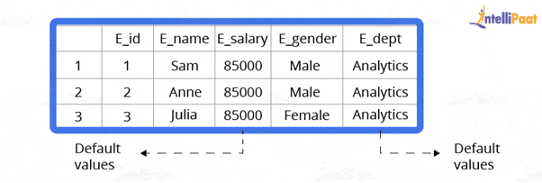
Now, let us go through how to set a default constraint. We will start by creating a new table and adding a default constraint to one of its columns.
Code:
create table stu1(s_id int, s_name varchar(20), s_marks int default 50)
select *stu1
Output:
Now, we will insert the records.
Code:
insert into stu1(s_id,s_name) values(1,’Sam’)
insert into stu1(s_id,s_name) values(2,’Bob’)
insert into stu1(s_id,s_name) values(3,’Matt’)
select *from stu1
Output:
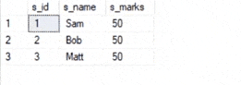
Also, learn from our blog on MySQL Interview Questions and Answers to crack any Interview.

11. What is a UNIQUE constraint?
Unique constraints ensure that all the values in a column are different. For example, if we assign a unique constraint to the e_name column in the following table, then every entry in this column should have a unique value.
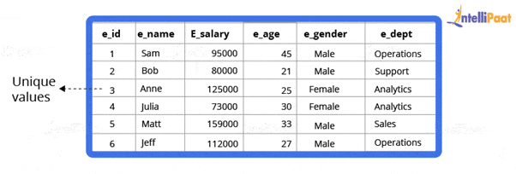
First, we will create a table.
create table stu2(s_id int unique, s_name varchar(20))
Now, we will insert the records.
insert into stu2 values(1,’Julia’)
insert into stu2 values(2,’Matt’)
insert into stu2 values(3,’Anne’)
Output:
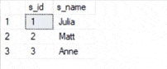
A PRIMARY KEY constraint will automatically have a UNIQUE constraint. However, unlike a PRIMARY KEY, multiple UNIQUE constraints are allowed per table.

12. What is meant by table and field in SQL?
An organized data in the form of rows and columns is said to be a table. Simply put, it is a collection of related data in a table format.
Here rows and columns are referred to as tuples and attributes, and the number of columns in a table is referred to as a field. In the record, fields represent the characteristics and attributes and contain specific information about the data.

13. What is a primary key?
A primary key is used to uniquely identify all table records. It cannot have NULL values and must contain unique values. Only one primary key can exist in one table, and it may have single or multiple fields, making it a composite key.
Now, we will write a query for demonstrating the use of a primary key for the employee table:
//
CREATE TABLE Employee (
ID int NOT NULL,
Employee_name varchar(255) NOT NULL,
Employee_designation varchar(255),
Employee_Age int,
PRIMARY KEY (ID)
);

14. What is a unique key?
The key that can accept only a null value and cannot accept duplicate values is called a unique key. The role of a unique key is to make sure that all columns and rows are unique.
The syntax for a unique key will be the same as the primary key. So, the query using a unique key for the employee table will be:
//
CREATE TABLE Employee (
ID int NOT NULL,
Employee_name varchar(255) NOT NULL,
Employee_designation varchar(255),
Employee_Age int,
UNIQUE(ID)
);

15. What is the difference between primary key and unique key?
Both primary and unique keys carry unique values but a primary key cannot have a null value, while a unique key can. In a table, there cannot be more than one primary key, but there can be multiple unique keys.
Career Transition




16. What is a foreign key?
A foreign key is an attribute or a set of attributes that reference the primary key of some other table. Basically, a foreign key is used to link together two tables.
Let us create a foreign key for the following table:
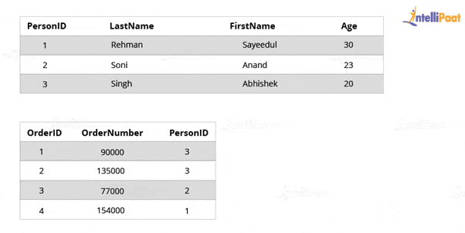
CREATE TABLE Orders (
OrderID int NOT NULL,
OrderNumber int NOT NULL,
PersonID int,
PRIMARY KEY (OrderID),
FOREIGN KEY (PersonID) REFERENCES Persons(PersonID)
)

17. What are the subsets of SQL?
The main subsets of SQL are:
- Data Definition Language (DDL)
- Data Manipulation Language (DML)
- Data Control Language (DCL)
- Transaction Control Language (TCL)

18. Explain the different types of SQL commands.
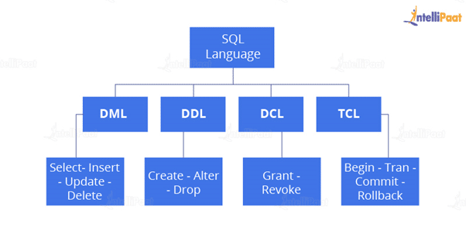
- DDL: DDL is that part of SQL that defines the data structure of the database in the initial stage when the database is about to be created. It is mainly used to create and restructure database objects. Commands in DDL are:
  - Create table
  - Alter table
  - Drop table
- DML: DML is used to manipulate already existing data in a database, i.e., it helps users to retrieve and manipulate data. It is used to perform operations such as inserting data into the database through the insert command, updating data with the update command, and deleting data from the database through the delete command.
- DCL: DCL is used to control access to the data in the database. DCL commands are normally used to create objects related to user access and to control the distribution of privileges among users. The commands that are used in DCL are Grant and Revoke.
- TCL: TCL is used to control the changes made by DML commands. It also authorizes the statements to assemble in conjunction with logical transactions. The commands that are used in TCL are Commit, Rollback, Savepoint, Begin, and Transaction.
Also, Have a look at SQL Command Cheatsheet.

19. What are the usages of SQL?
The following operations can be performed by using SQL database:
- Creating new databases
- Inserting new data
- Deleting existing data
- Updating records
- Retrieving the data
- Creating and dropping tables
- Creating functions and views
- Converting data types

20. What is an index?
Indexes help speed up searching in a database. If there is no index on a column in the WHERE clause, then the SQL Server has to skim through the entire table and check each and every row to find matches, which may result in slow operations in large data.
Indexes are used to find all rows matching with some columns and then to skim through only those subsets of the data to find the matches.
Syntax:
CREATE INDEX INDEX_NAME ON TABLE_NAME (COLUMN)

21. Explain the types of indexes.
Single-column Indexes: A single-column index is created for only one column of a table.
Syntax:
CREATE INDEX index_name
ON table_name(column_name);
Composite-column Indexes: A composite-column index is created for two or more columns of a table.
Syntax:
CREATE INDEX index_name
ON table_name (column1, column2)
Unique Indexes: A unique index is used for maintaining the data integrity of a table. A unique index does not allow multiple values to be inserted into the table.
Syntax:
CREATE UNIQUE INDEX index
ON table_name(column_name)
Courses you may like




22. What are entities and relationships?
Entities: An entity can be a person, place, thing, or any identifiable object for which data can be stored in a database.
For example, in a company’s database, employees, projects, salaries, etc., can be referred to as entities.
Relationships: A relationship between entities can be referred to as a connection between two tables or entities.
For example, in a college database, the student entity and the department entities are associated with each other.
That ends the section of basic interview questions. Let us now move on to the next section of intermediate interview questions.

Intermediate SQL Interview Questions

23. What are SQL operators?
SQL operators are the special keywords or characters that perform specific operations. They are also used in SQL queries. These operators can be used within the WHERE clause of SQL commands. Based on the specified condition, SQL operators filter the data.
The SQL operators can be categorized into the following types:
- Arithmetic Operators: For mathematical operations on numerical data
  - addition (+)
  - subtraction (-)
  - multiplication (*)
  - division (/)
  - remainder/modulus (%)
- Logical Operators: For evaluating the expressions and return results in True or False
  - ALL
  - AND
  - ANY
  - ISNULL
  - EXISTS
  - BETWEEN
  - IN
  - LIKE
  - NOT
  - OR
  - UNIQUE
- Comparison Operators: For comparisons of two values and checking whether they are the same or not
  - equal to (=)
  - not equal to (!= or <>)
  - less than (<),
  - greater than (>)
  - less than or equal to (<=)
  - greater than or equal to (>=)
  - not less than (!<)
  - not greater than (!>)
- Bitwise Operators: For bit manipulations between two expressions of integer type. It first performs conversion of integers into binary bits and then applied operators
  - AND (& symbol)
  - OR (|, ^)
  - NOT (~)
- Compound Operators: For operations on a variable before setting the variable’s result to the operation’s result
  - Add equals (+=)
  - subtract equals (-=)
  - multiply equals (*=)
  - divide equals (/=)
  - modulo equals (%=)
- String Operators: For concatenation and pattern matching of strings
  - + (String concatenation)
  - += (String concatenation assignment)
  - % (Wildcard)
  - [] (Character(s) matches)
  - [^] (Character(s) not to match)
  - _ (Wildcard match one character)

24. What do you mean by data integrity?
Data integrity is the assurance of accuracy and consistency of data over its whole life cycle. It is a critical aspect of the design, implementation, and usage of systems that store, process, or retrieve data.
Data integrity also defines integrity constraints for enforcing business rules on data when it is entered into a database or application.

25. What is a data warehouse?
A data warehouse is a large store of accumulated data, from a wide range of sources, within an organization. The data helps drive business decisions.

26. How would you find the second highest salary from the following table?
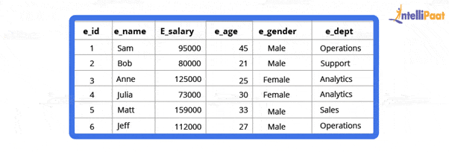
Code:
select * from employee
select max(e_salary) from employee where e_salary not in (select max(e_salary) from employee)
Output:
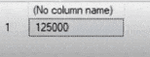

27. Why is the FLOOR function used in SQL Server?
The FLOOR() function helps to find the largest integer value to a given number, which can be an equal or lesser number.

28. State the differences between clustered and non-clustered indexes
- Clustered Index: It is used to sort the rows of data by their key values. A clustered index is like the contents of a phone book. We can open the book at “David” (for “David, Thompson”) and find information for all Davids right next to each other. Since the data is located next to each other, it helps a lot in fetching the data based on range-based queries. A clustered index is actually related to how the data is stored; only one clustered index is possible per table.
- Non-clustered Index: It stores data at one location and indexes at another location. The index has pointers that point to the location of the data. As the indexes in a non-clustered index are stored in a different place, there can be many non-clustered indexes for a table.
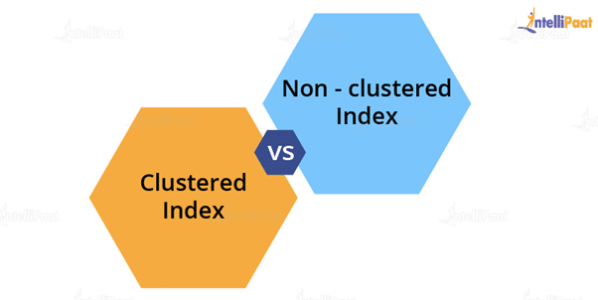
Now, we will see the major differences between clustered and non-clustered indexes:
Parameters | Clustered Index | Non-clustered Index
Used For | Sorting and storing records physically in memory | Creating a logical order for data rows; pointers are used for physical data files
Methods for Storing | Stores data in the leaf nodes of the index | Never stores data in the leaf nodes of the index
Size | Quite large | Comparatively, small
Data Accessing | Fast | Slow
Additional Disk Space | Not required | Required to store indexes separately
Type of Key | By default, the primary key of a table is a clustered index | It can be used with the unique constraint on the table that acts as a composite key
Main Feature | Improves the performance of data retrieval | Should be created on columns used in Joins

29. What do you know about CDC in SQL Server?
CDC refers to change data capture. It captures recent INSERT, DELETE, and UPDATE activity applied to SQL Server tables. It records changes to SQL Server tables in a compatible format.


30. What is the difference between SQL and MySQL?
Now Let’s compare the difference between SQL and MySQL.
SQL | MySQL
It is a structured query language used in a database | It is a database management system
It is used for query and operating database system | It allows data handling, storing, and modifying in an organized manner
It is always the same | It keeps updating
It supports only a single storage engine | It supports multiple storage engines
The server is independent | During backup sessions, the server blocks the database

31. State the differences between SQL and PL/SQL
SQL | PL/SQL
It is a database structured query language | It is a programming language for a database that uses SQL
It is an individual query that is used to execute DML and DDL commands | It is a block of codes that are used to write the entire procedure or a function
It is a declarative and data-oriented language | It is a procedural and application-oriented language
It is mainly used for data manipulation | It is used for creating applications
It provides interaction with the database server | It does not provide interaction with the database server
It cannot contain PL/SQL code | It can contain SQL because it is an extension of SQL

32. What is the ACID property in a database?
The full form of ACID is atomicity, consistency, isolation, and durability. ACID properties are used to check the reliability of transactions.

  - Atomicity refers to completed or failed transactions, where a transaction refers to a single logical operation on data. This implies that if any aspect of a transaction fails, the whole transaction fails and the database state remains unchanged.
- Consistency means that the data meets all validity guidelines. The transaction never leaves the database without finishing its state.
- Concurrency management is the primary objective of isolation.
- Durability ensures that once a transaction is committed, it will occur regardless of what happens in between such as a power outage, fire, or some other kind of disturbance.

33. What is the need for group functions in SQL?
Group functions operate on a series of rows and return a single result for each group. COUNT(), MAX(), MIN(), SUM(), AVG(), and VARIANCE() are some of the most widely used group functions.

34. What do you understand about a character manipulation function?
Character manipulation functions are used for the manipulation of character data types.
Some of the character manipulation functions are:
UPPER: It returns the string in uppercase.
Syntax:
UPPER(‘ string’)
Example:
SELECT UPPER(‘demo string’) from String;
Output:
DEMO STRING
LOWER: It returns the string in lowercase.
Syntax:
LOWER(‘STRING’)
Example:
SELECT LOWER (‘DEMO STRING’) from String
Output:
demo string
INITCAP: It converts the first letter of the string to uppercase and retains others in lowercase.
Syntax:
Initcap(‘sTRING’)
Example:
SELECT Initcap(‘dATASET’) from String
Output:
Dataset
CONCAT: It is used to concatenate two strings.
Syntax:
CONCAT(‘str1’,’str2’)
Example:
SELECT CONCAT(‘Data’,’Science’) from String
Output:
Data Science
LENGTH: It is used to get the length of a string.
Syntax:
LENGTH(‘String’)
Example:
SELECT LENGTH(‘Hello World’) from String
Output:
11

35. What is AUTO_INCREMENT?
AUTO_INCREMENT is used in SQL to automatically generate a unique number whenever a new record is inserted into a table.
Since the primary key is unique for each record, this primary field is added as the AUTO_INCREMENT field so that it is incremented when a new record is inserted.
The AUTO-INCREMENT value starts from 1 and is incremented by 1 whenever a new record is inserted.
Syntax:
CREATE TABLE Employee(
Employee_id int NOT NULL AUTO-INCREMENT,
Employee_name varchar(255) NOT NULL,
Employee_designation varchar(255)
Age int,
PRIMARY KEY (Employee_id)
)
Do check out our Blog on PL/SQL Interview Questions to crack your SQL Interview.

36. What is the difference between DELETE and TRUNCATE commands?
- DELETE: This query is used to delete or remove one or more existing tables.
- TRUNCATE: This statement deletes all the data from inside a table.
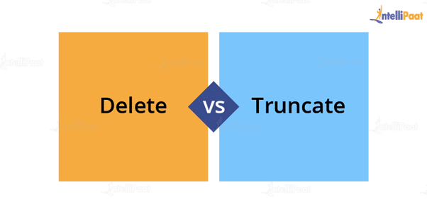
The difference between DELETE and TRUNCATE commands are as follows:
- TRUNCATE is a DDL command, and DELETE is a DML command.
- With TRUNCATE, we cannot really execute and trigger, while with DELETE, we can accomplish a trigger.
- If a table is referenced by foreign key constraints, then TRUNCATE will not work. So, if we have a foreign key, then we have to use the DELETE command.
The syntax for the DELETE command:
DELETE FROM table_name
[WHERE condition];
Example:
select * from stu
Output:
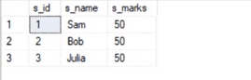
delete from stu where s_name=’Bob’
Output:
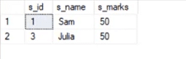
The syntax for the TRUNCATE command:
TRUNCATE TABLE
Table_name;
Example:
select * from stu1
Output:
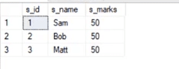
truncate table stu1
Output:
This deletes all the records from a table.


37. What is the difference between DROP and TRUNCATE commands?
If a table is dropped, all things associated with that table are dropped as well. This includes the relationships defined on the table with other tables, access privileges, and grants that the table has, as well as the integrity checks and constraints.
To create and use the table again in its original form, all the elements associated with the table need to be redefined.
However, if a table is truncated, there are no such problems as mentioned above. The table retains its original structure.

38. What is a “TRIGGER” in SQL?
The trigger can be defined as an automatic process that happens when an event occurs in the database server. It helps to maintain the integrity of the table. The trigger is activated when the commands, such as insert, update, and delete, are given.
The syntax used to generate the trigger function is:
CREATE TRIGGER trigger_name

39. Where are usernames and passwords stored in SQL Server?
In SQL Server, usernames and passwords are stored in the main database in the sysxlogins table.

40. What are the types of relationships in SQL Server databases?
Relationships are developed by interlinking the column of one table with the column of another table. There are three different types of relationships, which are as follows:
- One-to-one relationship
- Many-to-one relationship
- Many-to-many relationship

41. What are the third-party tools that are used in SQL Server?
The following is the list of third-party tools that are used in SQL Server:
- SQL CHECK
- SQL DOC 2
- SQL Backup 5
- SQL Prompt
- Litespeed 5.0

42. How can you handle expectations in SQL Server?
TRY and CATCH blocks handle exceptions in SQL Server. Put the SQL statement in the TRY block and write the code in the CATCH block to handle expectations. If there is an error in the code in the TRY block, then the control will automatically move to that CATCH block.

43. How many authentication modes are there in SQL Server? And what are they?
Two authentication modes are available in SQL Server. They are:
- Windows Authentication Mode: It allows authentication for Windows but not for SQL Server.
- Mixed Mode: It allows both types of authentication—Windows and SQL Server.

44. What is a function in SQL Server?
A function is an SQL Server database object. It is basically a set of SQL statements that allow input parameters, perform processing, and return results only. A function can only return a single value or table; the ability to insert, update, and delete records in database tables is not available.

45. Mention different types of replication in SQL Server?
In SQL Server, three different types of replications are available:
- Snapshot replication
- Transactional replication
- Merge replication

46. Which command is used to find out the SQL Server version?
The following command is used to identify the version of SQL Server:
Select SERVERPROPERTY('productversion')

47. What is the COALESCE function?
The COALESCE function takes a set of inputs and returns the first non-null value.
Syntax:
COALESCE(val1,val2,val3,……,nth val)
Example:
SELECT COALESCE(NULL, 1, 2, ‘MYSQL’)
Output:
1

48. Can we link SQL Server with others?
SQL Server allows the OLEDB provider, which provides the link, to connect to all databases.
Example: Oracle, I have an OLEDB provider that has a link to connect with an SQL Server group.

49. What is SQL Server Agent?
SQL Server Agent plays an important role in the daily work of SQL Server administrators or DBAs. This is one of the important parts of SQL Server. The aim of the server agent is to easily implement tasks using a scheduler engine that enables the tasks to be performed at scheduled times. SQL Server Agent uses SQL Server to store scheduled management task information.

50. What do you know about magic tables in SQL Server?
A magic table can be defined as a provisional logical table that is developed by an SQL Server for tasks such as insert, delete, or update (DML) operations. The operations recently performed on the rows are automatically stored in magic tables. Magic tables are not physical tables; they are just temporary internal tables.

51. What are some common clauses used with SELECT queries in SQL?
There are many SELECT statement clauses in SQL. Some of the most commonly used clauses with SELECT queries are:
- FROM
The FROM clause defines the tables and views from which data can be interpreted. The tables and views listed must exist at the time the question is given.
- WHERE
The WHERE clause defines the parameters that are used to limit the contents of the results table. You can test for basic relationships or for relationships between a column and a series of columns using subselects.
- GROUP BY
The GROUP BY clause is commonly used for aggregate functions to produce a single outcome row for each set of unique values in a set of columns or expressions.
- ORDER BY
The ORDER BY clause helps in choosing the columns on which the table’s result should be sorted.
- HAVING
The HAVING clause filters the results of the GROUP BY clause by using an aggregate function.

52. What is wrong with the following SQL query?
SELECT gender, AVG(age) FROM employee WHERE AVG(age)>30 GROUP BY gender
When this command is executed, it gives the following error:
Msg 147, Level 16, State 1, Line 1
Aggregation may not appear in the WHERE clause unless it is in a subquery contained in the HAVING clause or a select list; the column being aggregated is an outer reference.
Msg 147, Level 16, State 1, Line 1
Invalid column name ‘gender’.
This basically means that whenever we are working with aggregate functions and are using the GROUP BY clause, we cannot use the WHERE clause. Therefore, instead of the WHERE clause, we should use the HAVING clause.
When we are using the HAVING clause, the GROUP BY clause should come first, followed by the HAVING clause.
select e_gender, avg(e_age) from employee group by e_gender having avg(e_age)>30
Output:
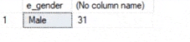

53. What do you know about the stuff() function?
The stuff() function deletes a part of the string and then inserts another part into the string, starting at a specified position.
Syntax:
STUFF(String1, Position, Length, String2)
Here, String1 is the one that will be overwritten. Position indicates the starting location for overwriting the string. Length is the length of the substitute string, and String2 is the string that will overwrite String1.
Example:
select stuff(‘SQL Tutorial’,1,3,’Python’)
This will change ‘SQL Tutorial’ to ‘Python Tutorial’
Output:
Python Tutorial

54. What are views? Give an example.
Views are virtual tables used to limit the tables that we want to display. Views are nothing but the result of an SQL statement that has a name associated with it. Since views are not physically present, they take less space to store.
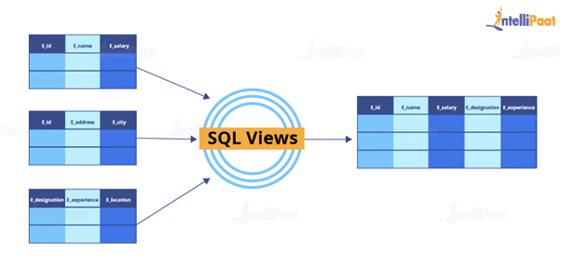
Let us consider an example. In the following employee table, say we want to perform multiple operations on the records with gender “Female”. We can create a view-only table for the female employees from the entire employee table.
Now, let us implement it on SQL Server.
This is the employee table:
select * from employee
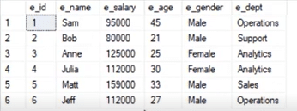
Now, we will write the syntax for the view.
Syntax:
create view female_employee as select * from employee where e_gender=’Female’
select * from female_employee
Output:
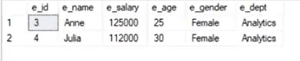

55. What are the types of views in SQL?
In SQL, the views are classified into four types. They are:
- Simple View: A view that is based on a single table and does not have a GROUP BY clause or other features.
- Complex View: A view that is built from several tables and includes a GROUP BY clause as well as functions.
- Inline View: A view that is built on a subquery in the FROM clause, which provides a temporary table and simplifies a complicated query.
- Materialized View: A view that saves both the definition and the details. It builds data replicas by physically preserving them.

Advanced SQL Interview Questions

56. What is a stored procedure? Give an example.
A stored procedure is a prepared SQL code that can be saved and reused. In other words, we can consider a stored procedure to be a function consisting of many SQL statements to access the database system. We can consolidate several SQL statements into a stored procedure and execute them whenever and wherever required.
A stored procedure can be used as a means of modular programming, i.e., we can create a stored procedure once, store it, and call it multiple times as required. This also supports faster execution when compared to executing multiple queries.
Syntax:
CREATE PROCEDURE procedure_name
AS
Sql_statement
GO;
To execute we will use this:
EXEC procedure_name
Example:
We are going to create a stored procedure that will help us extract the age of the employees.
create procedure employee_age
as
select e_age from employee
go
Now, we will execute it.
exec employee_age
Output:
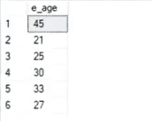

57. Explain Inner Join with an example.
Inner Join basically gives us those records that have matching values in two tables.
Let us suppose that we have two tables, Table A and Table B. When we apply Inner Join on these two tables, we will get only those records that are common to both Table A and Table B.
Syntax:
SELECT columns
FROM table1
INNER JOIN table2
ON table1.column_x=table2.column_y;
Example:
select * from employee
select * from department
Output:
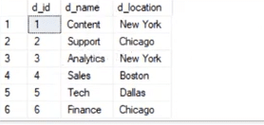
Now, we will apply Inner Join to both these tables, where the e_dept column in the employee table is equal to the d_name column of the department table.
Syntax:
select employee.e_name, employee.e_dept, department.d_name, department.d_location
from employee inner join department
on
employee.e_dept=department.d_name
Output:
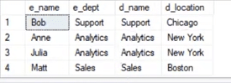
After applying Inner Join, we have only those records where the departments match in both tables. As we can see, the matched departments are Support, Analytics, and Sales.

58. State the differences between views and tables.
Views | Tables
A view is a virtual table that is extracted from a database | A table is structured with a set number of columns and a boundless number of rows
A view does not hold data itself | A table contains data and stores it in databases
A view is utilized to query certain information contained in a few distinct tables | A table holds fundamental client information and cases of a characterized object
In a view, we will get frequently queried information | In a table, changing the information in the database changes the information that appears in the view

59. What do you understand about a temporary table? Write a query to create a temporary table
A temporary table helps us store and process intermediate results. Temporary tables are created and can be automatically deleted when they are no longer used. They are very useful in places where temporary data needs to be stored.
Syntax:
CREATE TABLE #table_name();
The below query will create a temporary table:
create table #book(b_id int, b_cost int)
Now, we will insert the records.
insert into #book values(1,100)
insert into #book values(2,232)
select * from #book
Output:
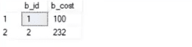

60. Explain the difference between OLTP and OLAP.
OLTP: It stands for online transaction processing, and we can consider it to be a category of software applications that are efficient for supporting transaction-oriented programs. One of the important attributes of the OLTP system is its potential to keep up the consistency. The OLTP system often follows decentralized planning to keep away from single points of failure. This system is generally designed for a large audience of end users to perform short transactions. The queries involved in such databases are generally simple, need fast response time, and, in comparison, return in only a few records. So, the number of transactions per second acts as an effective measure for those systems.
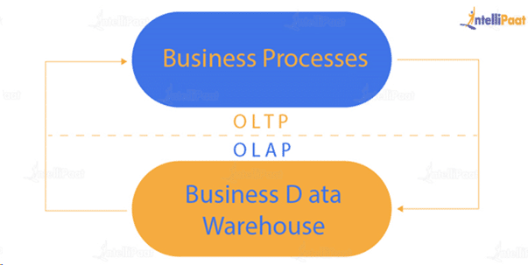
OLAP: It stands for online analytical processing, and it is a category of software programs that are identified by a comparatively lower frequency of online transactions. For OLAP systems, the efficiency of computing depends highly on the response time. Hence, such systems are generally used for data mining or maintaining aggregated historical data, and they are usually used in multidimensional schemas.

61. What is Hybrid OLAP?
Hybrid OLAP (HOLAP) uses a combination of multidimensional data structures and relational database tables to store multidimensional data. The aggregations for a HOLAP partition are stored by analysis services in a multidimensional structure. The facts are stored in a relational database.

62. What do you understand by Self Join? Explain using an example
Self Join in SQL is used for joining a table with itself. Here, depending on some conditions, each row of the table is joined with itself and with other rows of the table.
Syntax:
SELECT a.column_name, b.column_name
FROM table a, table b
WHERE condition
Example:
Consider the customer table given below.
Example:
Consider the customer table given below.
ID | Name | Age | Address | Salary
1 | Anand | 32 | Ahmedabad | 2,000.00
2 | Abhishek | 25 | Delhi | 1,500.00
3 | Shivam | 23 | Kota | 2,000.00
4 | Vishal | 25 | Mumbai | 6,500.00
5 | Sayeedul | 27 | Bhopal | 8,500.00
6 | Amir | 22 | MP | 4,500.00
7 | Arpit | 24 | Indore | 10,000.00
We will now join the table using Self Join:
SQL> SELECT a.ID, b.NAME, a.SALARY
FROM CUSTOMERS a, CUSTOMERS b
WHERE a.SALARY < b.SALARY;
Output:
ID | Name | Salary
2 | Anand | 1,500.00
2 | Abhishek | 1,500.00
1 | Vishal | 2,000.00
2 | Vishal | 1,500.00
3 | Vishal | 2,000.00
6 | Vishal | 4,500.00
1 | Sayeedul | 2,000.00
2 | Sayeedul | 1,500.00
3 | Sayeedul | 2,000.00
4 | Sayeedul | 6,500.00
6 | Sayeedul | 4,500.00
1 | Amir | 2,000.00
2 | Amir | 1,500.00
3 | Amir | 2,000.00
1 | Arpit | 2,000.00
2 | Arpit | 1,500.00
3 | Arpit | 2,000.00
4 | Arpit | 6,500.00
5 | Arpit | 8,500.00
6 | Arpit | 4,500.00

63. What is the difference between Union and Union All operators?
The Union operator is used to combine the result set of two or more select statements. For example, the first select statement returns the fish shown in Image A, and the second statement returns the fish shown in Image B. The Union operator will then return the result of the two select statements as shown in Image A U B. If there is a record present in both tables, then we will get only one of them in the final result.
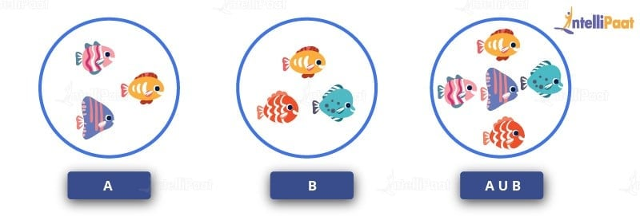
Syntax:
SELECT column_list FROM table1
Union:
SELECT column_list FROM table2
Now, we will execute it in the SQL Server.
These are the two tables in which we will use the Union operator.
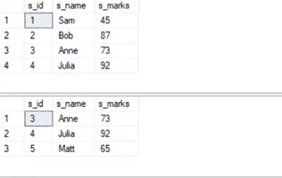
select * from student_details1
Union:
select * from student_details2
Output:
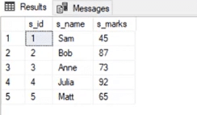
The Union All operator gives all the records from both tables including the duplicates.
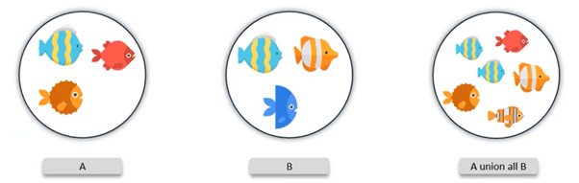
Let us implement it in the SQL Server.
Syntax:
select * from student_details1
Union All:
select * from student_details2
Output:
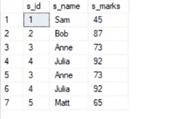

64. What is a cursor? How to use a cursor?
A database cursor is a control that allows you to navigate around a table’s rows or documents. It can be referred to as a pointer for a row in a set of rows. Cursors are extremely useful for database traversal operations such as extraction, insertion, and elimination.
- After any variable declaration, DECLARE a cursor. A SELECT statement must always be aligned with the cursor declaration.
- To initialize the result set, OPEN statements must be called before fetching the rows from the result table.
- To grab and switch to the next row in the result set, use the FETCH statement.
- To deactivate the cursor, use the CLOSE expression.
- Finally, use the DEALLOCATE clause to uninstall the cursor description and clear all the resources associated with it.
Here is an example SQL cursor:
DECLARE @name VARCHAR(50)

DECLARE db_cursor CURSOR FOR
SELECT name
From myDB.company
WHERE employee_name IN (‘Jay’, ‘Shyam’)
OPEN db_cursor
FETCH next
FROM db_cursor
Into @name
Close db_cursor
DEALLOCATE db_cursor

65. What is the use of the INTERSECT operator?
The INTERSECT operator helps combine two select statements and returns only those records that are common to both the select statements. So, after we get Table A and Table B over here, and if we apply the INTERSECT operator on these two tables, then we will get only those records that are common to the result of the select statements of these two tables.
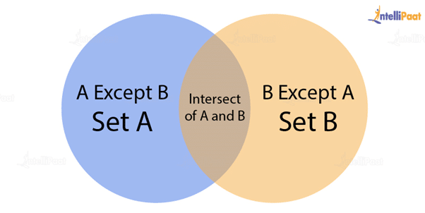
Syntax:
SELECT column_list FROM table1
INTERSECT
SELECT column_list FROM table2
Now, let us take a look at an example for the INTERSECT operator.
select * from student_details1
select * from student_details1
Output:
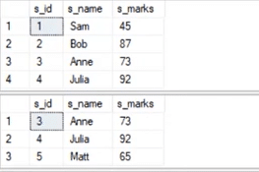
select * from student_details1
intersect
select * from student_details2
Output:
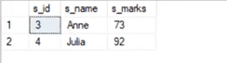

66. How can you copy data from one table into another table?
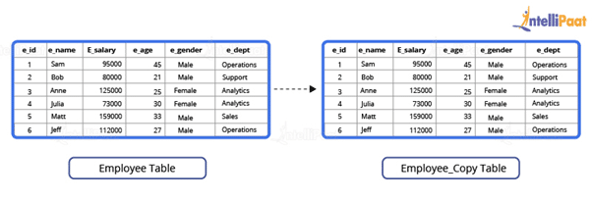
Here, we have our employee table.
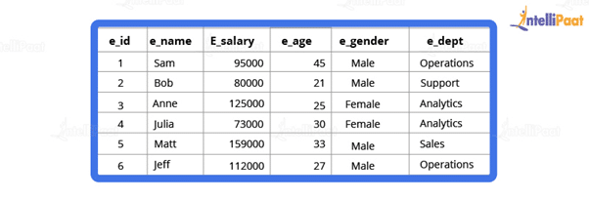
We have to copy this data into another table. For this purpose, we can use the INSERT INTO SELECT operator. Before we go ahead and do that, we will have to create another table that will have the same structure as the above-given table.
Syntax:
create table employee_duplicate(
e_id int,
e_name varchar(20),
e_salary int,
e_age int,
e_gender varchar(20)
e_dept varchar(20)
)
For copying the data, we will use the following query:
insert into employee_duplicate select * from employees
Let us take a look at the copied table.
select * from employee_duplicate
Output:
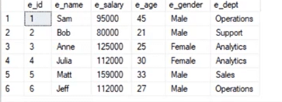

67. What is the difference between BETWEEN and IN operators in SQL?
The BETWEEN operator is used to represent rows based on a set of values. The values may be numbers, text, or dates. The BETWEEN operator returns the total number of values that exist between two specified ranges.
The IN condition operator is used to search for values within a given range of values. If we have more than one value to choose from, then we use the IN operator.

68. Describe how to delete duplicate rows using a single statement but without any table creation.
Let us create an employee table where the column names are ID, NAME, DEPARTMENT, and EMAIL. Below are the SQL scripts for generating the sample data:
CREATE TABLE EMPLOYEE
(
ID INT,
NAME Varchar(100),
DEPARTMENT INT,
EMAIL Varchar(100)
)

INSERT INTO EMPLOYEE VALUES (1,'Tarun',101,'tarun@intellipaat.com')
INSERT INTO EMPLOYEE VALUES (2,'Sabid',102,'sabid@intellipaat.com')
INSERT INTO EMPLOYEE VALUES (3,'Adarsh',103,'adarsh@intellipaat.com')
INSERT INTO EMPLOYEE VALUES (4,'Vaibhav',104,'vaibhav@intellipaat.com')
–These are the duplicate rows:
INSERT INTO EMPLOYEE VALUES (5,'Tarun',101,'tarun@intellipaat.com')
INSERT INTO EMPLOYEE VALUES (6,'Sabid',102,'sabid@intellipaat.com')
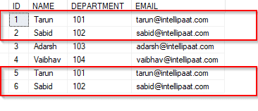
We can see the duplicate rows in the above table.
DELETE e1 FROM EMPLOYEE e1, EMPLOYEE e2 WHERE e1.name = e2.name AND e1.id > e2.id
The SQL query above will delete the rows, where the name fields are duplicated, and it will retain only those unique rows in which the names are unique and the ID fields are the lowest, i.e., the rows with IDs 5 and 6 are deleted, while the rows with IDs 1 and 2 are retained.
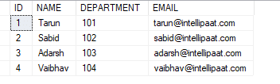

69. Can you identify the employee who has the third-highest salary from the given employee table (with salary-related data)?
Consider the following employee table. In the table, Sabid has the third-highest salary (60,000).
Name | Salary
Tarun | 70,000
Sabid | 60,000
Adarsh | 30,000
Vaibhav | 80,000
Below is a simple query to find out the employee who has the third-highest salary. The functions RANK, DENSE RANK, and ROW NUMBER are used to obtain the increasing integer value by imposing the ORDER BY clause in the SELECT statement, based on the ordering of the rows. The ORDER BY clause is necessary when RANK, DENSE RANK, or ROW NUMBER functions are used. On the other hand, the PARTITION BY clause is optional.
WITH CTE AS
(
SELECT Name, Salary, RN = ROW_NUMBER() OVER (ORDER BY Salary DESC) FROM EMPLOYEE
)
SELECT Name, Salary FROM CTE WHERE RN =3

70. What is the difference between HAVING and WHERE clauses?
The distinction between HAVING and WHERE clauses in SQL is that while the WHERE clause cannot be used with aggregates, the HAVING clause is used with the aggregated data. The WHERE clause works on the data from a row and not with the aggregated data.
Let us consider the employee table below.
Name | Department | Salary
Tarun | Production | 50,000
Tarun | Testing | 60,000
Sabid | Marketing | 70,000
Adarsh | Production | 80,000
Vaibhav | Testing | 90,000
The following will select the data on a row-by-row basis:
SELECT Name, Salary FROM Employee WHERE Salary >=50000
Output:
Name | Salary
Tarun | 50,000
Tarun | 60,000
Sabid | 70,000
Adarsh | 80,000
Vaibhav | 90,000
The HAVING clause, on the other hand, operates on the aggregated results.
SELECT Department, SUM(Salary) AS total FROM Employee GROUP BY Department
Output:
Department | Total
Marketing | 70,000
Production | 130,000
Testing | 150,000
Now, let us see the output when we apply HAVING to the above query.
SELECT Department, SUM(Salary) AS total FROM Employee GROUP BY Department HAVING SUM(Salary)>70000
Output:
Department | Total
Production | 130,000
Testing | 150,000

71. Explain database white box testing and black box testing.
The white box testing method mainly deals with the internal structure of a particular database, where users hide specification details. The white box testing method involves the following:
- As the coding error can be detected by testing the white box, it can eliminate internal errors.
- To check for the consistency of the database, it selects the default table values.
- This method verifies the referential integrity rule.
- It helps perform the module testing of database functions, triggers, views, and SQL queries.
The black box testing method generally involves interface testing, followed by database integration. The black box testing method involves the following:
- Mapping details
- Verification of incoming data
- Verification of outgoing data from the other query functions

72. How can you create empty tables with the same structure as another table?
This can be achieved by fetching the records of one table into a new table using the INTO operator while fixing a WHERE clause to be false for all records. In this way, SQL prepares the new table with a duplicate structure to accept the fetched records. However, there are no records that will get fetched due to the WHERE clause in action. Therefore, nothing is inserted into the new table, thus creating an empty table.
SELECT * INTO Students_copy
FROM Students WHERE 1 = 2;

1. What do you understand by database, and what does it have?
A database can be defined as the structured form of data storage from which data can be retrieved and managed based on requirements. Basically, a database consists of tables where data is stored in an organized manner. Each table consists of rows and columns to store data. Data can be stored, modified, updated, and accessed easily in a database. For instance, a bank management database or school management database are a few examples of databases.

2. What are DBMS and RDBMS?
DBMS – Database Management System.
DBMS is the software that allows storing, modifying, and retrieving data from a database. And it is a group of programs that act as the interface between data and applications. DBMS supports receiving queries from applications and retrieving data from the database.
RDBMS – Relational Database Management System
Like DBMS, RDBMS is also the software that allows storing, modifying, and retrieving data from a database but a RELATIONAL database. In a relational database, the data in the tables have a relationship. Besides, RDBMS is useful when data in tables are being managed securely and consistently.

3. What are Query and Query language?
A query is nothing but a request sent to a database to retrieve data or information. The required data can be retrieved from a table or many tables in the database.
Query languages use various types of queries to retrieve data from databases. SQL, Datalog, and AQL are a few examples of query languages; however, SQL is known to be the widely used query language. SQL returns data as columns and rows in a table, whereas other languages return data in other forms, like graphs, charts, etc.

4. What do you mean by subquery?
It is a query that exists inside the statements such as SELECT, INSERT, UPDATE, and DELETE. It may exist inside a subquery too. A subquery is also known as an inner query or inner select. The statement with a subquery is an outer query or outer select.
Let’s see the example shown below in which the maximum unit price is the result that will be returned by the subquery using the SELECT statement. Also, orders is the value that will be returned by the outer query using the SELECT statement.

5. What is SQL, and mention its uses?
SQL – Structured Query Language
SQL is known as the query programming language. It uses SQL queries to store, modify and retrieve data into and from databases. Briefly, SQL inserts, updates, and deletes data in databases; creates new databases and new tables; creates views and stored procedures; and sets permissions on the database objects.

6. What is Dynamic SQL, and when can you use it?
Dynamic SQL is the programming method that allows building SQL statements during runtime. You can use dynamic SQL when you do not know the full text of the SQL statements used in the program until runtime. Moreover, dynamic SQL can execute SQL statements that are not supported by static SQL programs. So, Dynamic SQL helps to build more flexible applications.

7. What do you understand by tables and fields in a database?
Tables are the database objects where data is stored logically. Like a spreadsheet, data is stored in the form of rows and columns in a database table. A row in a table represents a record, and columns represent the different fields. Fields have the data types such as text, dates, numbers, and links.
For example, consider the below customer database in which rows consist of the company names and columns consist of the various details of customers like first name, last name, age, location, etc. Here, number 1 indicates a record, number 2 indicates a field, and number 3 indicates the field value.

8. What are the different types of tables used in SQL?
The following are the table types used in SQL:
- Partitioned tables
- Temporary tables
- System tables
- Wide tables

9. What are temporary tables?
Temporary tables only store data during the current session, and they will be dropped once the session is over. With temporary tables, you can create, read, update and delete records like permanent tables. Know that there are two types of temporary tables: local and global temporary tables.
Local temporary tables are only visible to the user who created them, and they are deleted the moment the user disconnects from the instance of the SQL server.
On the contrary, global temporary tables are visible to all users, and they are deleted only when all the users who reference the tables get disconnected.

10. What do you mean by Primary Key and Foreign Key in SQL?
Primary Key: A primary is a field or combination of many fields that help identify records in a table. Note that there can be only one primary key for a table. The table that has the primary key is known as the parent table.
Foreign Key: A foreign key is the field or combination of fields of a table that links the primary key of another table. A foreign key is used to create a connection between two tables. Unlike a primary key, a table can have one or many foreign keys. The table that has a foreign key is known as the child table.
For example, customer ID (1) is the primary key of the Customers table, and customer ID (2) in the orders table is identified as the foreign key to the customer's table.

11. What are Superkey and candidate key?
A super key may be a single or a combination of keys that help to identify a record in a table. Know that Super keys can have one or more attributes, even though all the attributes are not necessary to identify the records.
A candidate key is the subset of Superkey, which can have one or more than one attributes to identify records in a table. Unlike Superkey, all the attributes of the candidate key must be helpful to identify the records.
Note that all the candidate keys can be Super keys, but all the super keys cannot be candidate keys.

12. What are composite keys?
A composite key is the combination of two or more columns in a table used to identify a row in a table. Know that a combination of columns is essential in creating composite keys because a single column in a composite key cannot identify a row in a table. We can say that the composite key is the primary key with a few more attributes or columns. Also, a composite key can be a combination of candidate keys.

13. What is JOIN operation in SQL, and mention their types?
JOIN is the logical operation used to retrieve data from two or more tables. It can be applied only when there is a logical relationship between two tables. Moreover, the JOIN operator uses the data of one table to retrieve data from another table.
Following are the different types of logical operations:
- INNER JOIN
- LEFT (OUTER) JOIN
- RIGHT (OUTER) JOIN
- FULL (OUTER) JOIN
- CROSS JOIN

14. What do you mean by Self Join?
In self-join operation, a table is joined with itself to retrieve the desired data. Every join operation needs two tables as a basic rule. Therefore, in self-join, a table is joined with an instance of the same table. By doing this, values of the two table columns are compared with each other, and the desired data is retrieved as the result set.

15. What do you mean by Cross Join?
Cross Join is basically the Cartesian product type in which each row in a table is paired with all the rows of another table. So, the result set will be the paired combinations of the rows of two tables. Generally, cross join is not preferred by developers as it increases complexity in programs when there are many rows in tables. But, it can be used in queries if you identify normal join operation won’t be effective for your query.

16. What are the SQL constraints?
SQL constraints specify conditions for a column or table to manage the data stored in tables effectively.
The following are the commonly used SQL constraints.
- NOT NULL - This condition ensures columns won’t accept a NULL value.
- UNIQUE - It ensures that all the values in a column must be unique.
- CHECK - It ensures that all the column fields obey a specific condition.
- DEFAULT - It provides a default value for the fields of a column unless no value is specified for the fields
- CREATE INDEX - It ensures creating an index for tables so that retrieving data from the tables becomes easier
- PRIMARY KEY - It must identify every row of a table
- FOREIGN KEY - It must link tables based on common attributes

17. What are local and global variables?
Local variables are declared inside a function so that only that function can call them. They only exist until the execution of that specific function. Generally, local variables are stored in stack memory and cleaned up automatically.
Global variables are declared outside of a function. They are available until the execution of the entire program. Unlike local variables, global variables are stored in fixed memory and not cleaned up automatically.

18. What is an index in SQL, and mention its types?
An index is used to retrieve data from a database quickly. Generally, indexes have keys taken from the columns of tables and views. We can say, SQL indexes are similar to the indexes in books that help to identify pages in the books quickly.
There are two types of indexes:
- Clustered indexes
- Non-clustered indexes

19. Mention the different types of SQL commands or SQL subsets?
There are five types of SQL commands offered in SQL. They are given as follows;
- DDL - Data Definition Languages
- DML - Data Manipulation Languages
- DCL - Data Control Language
- TCL - Transaction Control Language
- DQL - Data Query Language

20. What are the Various Commands used in SQL Subsets?
DDL | CREATE, DROP, ALTER, TRUNCATE, ADD COLUMN, and DROP COLUMN
DML | INSERT, DELETE, and UPDATE
DCL | GRANT and REVOKE
TCL | COMMIT, ROLLBACK, SAVEPOINT, and SET TRANSACTION
DQL | SELECT

21. Can you brief me on a few DDL Commands?
ALTER | This command allows changing the structure of a table
CREATE | It allows the creation of database objects such as tables, views, and indexes.
DROP | This command allows removing database objects from a database
TRUNCATE | This command helps to delete all the rows of a table permanently.

22. Can you brief the DML Commands?
INSERT | This command allows inserting a data into a table of a database
DELETE | This command allows deleting specific rows from a table
UPDATE | This command allows modifying a data in a table

23. Can you brief me on a few DCL Commands?
GRANT | This command can be used to share a database with other users. All the database objects can be granted access with certain rights to users.
REVOKE | This command can be applied if you want to restrict the access of database objects by other users.

24. Can you brief me about TCL commands?
COMMIT | This command allows for saving the transactions made in a database.
ROLLBACK | This command helps undo the transactions made in a database with the condition that the transactions shouldn't be saved yet.
SAVEPOINT | This command helps to roll the transactions up to a certain point but not the entire transaction.

25. What are Stored Procedures?
It is a function that consists of a group of statements that can be stored and executed whenever it is required. Know that stored procedures are compiled only once. They are stored as ‘Named Object’ in the SQL server database. Stored procedures can be called at any time during program execution. Moreover, a stored procedure can be called another stored procedure.
Explore Oracle PL SQL Interview Questions

26. What are the SQL database functions?
SQL offers the flexibility to developers to use built-in functions as well as user-defined functions.
The functions are categorized as follows:
- Aggregate functions: They process a group of values and return a single value. They can combine with GROUP BY, OVER, HAVING clauses and return values. They are deterministic functions.
- Analytic functions: They are similar to aggregate functions but return multiple rows as result set after processing a group of values. They help calculate moving averages, running totals, Top-N results, percentages, etc.
- Ranking functions: They return ranking values for rows in a table based on the given conditions. Here, the results are non-deterministic.
- Rowset functions: They return an object used as the table reference.
- Scalar functions: They operate on a single value and return a single value.

27. Mention the different types of operators used in SQL?
There are six types of operators used in SQL. They are given as follows:
Arithmetic Operators | Addition, Subtraction, Multiplication, Division, and Remainder/Modulus
Bitwise Operators | Bitwise AND, Bitwise OR, Bitwise XOR, etc.
Comparison Operators | Equal to, Not equal to, Greater than, Not greater than, Less than, Not less than, Not equal to, etc.
Compound Operators | Add equals, Multiply equals, Subtract equals, Divide equals, and Modulo equals
Logical Operators | ALL, ANY/SOME, AND, BETWEEN, NOT, EXISTS, OR, IN, LIKE, and ISNULL
String Operators | String concatenation, wildcard, character matches, etc.

28. What are the Set Operators?
There are four types of set operators available in SQL. They are given as follows:
Union | This operator allows combining result sets of two or more SELECT statements.
Union All | This operator allows combining result sets of two or more SELECT statements along with duplicates.
Intersect | This operator returns the common records of the result sets of two or more SELECT statements.
Minus | This operator returns the exclusive records of the first table when two tables undergo this operation.

29. What do you mean by buffer pool and mention its benefits?
A buffer pool in SQL is also known as a buffer cache. All the resources can store their cached data pages in a buffer pool. The size of the buffer pool can be defined during the configuration of an instance of SQL Server. The number of pages that can be stored in a buffer pool depends on its size.
The following are the benefits of a buffer pool:
- Increase in I/O performance
- Reduction in I/O latency
- Increase in transaction throughput
- Increase in reading performance

30. What are Tuple and tuple functions?
A tuple is a single row in a table that represents a single record of a relation. A tuple contains all the data that belongs to a record. At the same time, tuple functions allow retrieving tuples from a database table. They are extensively used in analysis services that have multidimensional structures.
For example, the highlighted row in the below table shows all the data belonging to a customer, which is nothing but a tuple.
Customer Name | Phone Number | Email Address | Postal Address
Naren | 123 -456 -789 | xyz@gmail.com | PO No:123, New Delhi
Raman | 234 -567 -891 | abc@gmail.com | PO No:143, Mumbai
Krishna | 345 -678 -912 | pqr@gmail.com | PO No:443, Hyderabad

31. What do you mean by dependency and mention the different dependencies?
Dependency is the relation between the attributes of a table. The following are the different types of dependencies in SQL.
- Functional dependency
- Fully-functional dependency
- Multivalued dependency
- Transitive dependency
- Partial dependency

32. What do you mean by Data Integrity?
Data integrity ensures the accuracy and consistency of data stored in a database. Data integrity, in a way, represents the data quality. So, the data characteristics defined for a column should be satisfied while storing data in the columns. For instance, if a column in a table is supposed to store numeric values, then it should not accept Alphabetic values; otherwise, you can mean that data integrity is lost in the table.

33. What is Database Cardinality?
Database Cardinality denotes the uniqueness of values in the tables. It supports optimizing query plans and hence improves query performance. There are three types of database cardinalities in SQL, as given below:
- Higher Cardinality
- Normal Cardinality
- Lower Cardinality

34. What are database Normalisation and various forms of Normalisation?
It is the process that reduces data redundancy and improves data integrity by restructuring the relational database.
The following are the different forms of normalization:
- First normal form – 1NF
- Second normal form – 2 NF
- Third normal form – 3 NF
- Boyce Codd Normal Form/Fourth Normal form – BCNF/4NF

35. What is Cursor, and how to use it?
In general, the result set of a SQL statement is a set of rows. If we need to manipulate the result set, we can act on a single row of the result set at a time. Cursors are the extensions to the result set and help point a row in the result set. Here, the pointed row is known as the current row.
Cursors can be used in the following ways:
- Positions a row in a result set
- Supports retrieving the current row from the result set
- Supports data modifications in the current row
- Allowing SQL statements in stored procedures, scripts, and triggers to access the result set

36. Mention the different types of Cursors?
- Forward Only: It is known as the firehose cursor that can make only a forward movement. The modification made by the current user and other users is visible while using this cursor. As it is the forward-moving cursor, it fetches rows of the result set from the start to end serially.
- Static: This cursor can move forward and backward on the result set. Here, only the same result set is visible throughout the lifetime of the cursor. In other words, once the cursor is open, it doesn’t show any changes made in the database that is the source for the result set.
- Keyset: This cursor is managed by a set of identifiers known as keys or keysets. Here, the keysets are built by the columns that derive the rows of a result set. When we use this cursor, we can’t view the records created by other users. Similarly, if any user deletes a record, we can’t access that record too.
- Dynamic: Unlike static cursors, once the cursor is open, all the modifications performed in the database are reflected in the result set. The UPDATE, INSERT and DELETE operations made by other users can be viewed while scrolling the cursor.

37. What are Entity and Relationship?
Entities are real-world objects that are individualistic and independent. Rows of a table represent the members of the entity, and columns represent the attributes of the entity. For instance, a ‘list of employees of a company is an entity where employee name, ID, address, etc., are the attributes of the entity.
A relationship indicates how entities in a database are related to each other. Simply put, how a row in a table is related to row(s) of another table in a database. The relationship is made using the primary key and the foreign key primarily.
There are three types of relationships in DBMS, as mentioned below:
- One-to-one relationship
- One-to-many relationship
- Many-to-many relationship

38. What is a Trigger, and mention its various types?
Triggers are nothing but they are special stored procedures. When there is an event in the SQL server, triggers will be fired automatically.
There are three types of triggers – LOGON, DDL, and DML.
LOGON triggers: They get fired when a user starts a Logon event
DDL triggers: They get fired when there is a DDL event
DML Triggers: They get fired when there is a modification in data due to DML

39. What is Schema in SQL, and mention its advantages?
The schema represents the logical structures of data. Using schemas, the database objects can be grouped logically in a database. Schema is useful for segregating database objects based on different applications, controlling access permissions, and managing a database's security aspects. Simply out, Schemas ensure database security and consistency.
Advantages:
- Schemas can be easily transferred
- You can transfer database objects between schemas
- It protects database objects and achieves effective access control

40. What are the types of UDFs?
There are three types of UDFs. They are defined as follows:
- User-defined scalar functions
- Table-valued functions
- System functions

41. What is the difference between char and varchar data types?
Char data type is a fixed-length data type in which the length of the character cannot be changed during execution. It supports storing normal and alphanumeric characters.
On the other hand, varchar is the variable-length data type in which the length of the character can be changed during execution. That's why, it is known as a dynamic data type.

42. Mention the Aggregate Functions used in SQL?
The following aggregate functions are used in SQL.
- COUNT
- SUM
- AVG
- MAX
- MIN

43. What are Case Manipulation Functions used in SQL?
The following are the case manipulation functions used in SQL.
- LOWER
- UPPER
- INITCAP

44. What are Character Manipulation Functions used in SQL?
The following are the character manipulation functions used in SQL.
- CONCAT
- SUBSTR
- LENGTH
- INSTR
- LPAD
- RPAD
- TRIM
- REPLACE
45. How would you differentiate single-row functions from multiple-row functions?
Single row functions can act on a single row of a table at a time. They return only one result after executing a row. Length and case conversions are known to be single-row functions.
Multiple row functions can act on multiple rows of a table at a time. They are also called group functions and return a single output after executing multiple rows.
Experienced:

46. What is the difference between SQL and NoSQL?
SQL | No SQL
Works on relational databases | Works on non-relational databases
Stores data in tables based on schemas so that data are organized and structured | No specific method is followed for data storage, so it offers flexibility in storing data.
Easy to execute complex queries | Difficult to execute complex queries
Scaling is performed vertically increasing the processing power of servers | Scaling is performed horizontally adding more servers and nodes
SQL satisfies ACID Properties such as atomicity, consistency, isolation, and durability. | Follows CAP theory – according to this, any two of the following need to be satisfied – Consistency, Availability, and Partition tolerance.
47. What is the difference between SQL and MySQL?
SQL | MySQL
It is the programming language | It is the RDMS – Relational Database Management System
It is used for querying relational database systems | It is used to store, modify and delete data in a database in an organized way.
It is a licensed product of Microsoft. | It is an open-source platform managed by Oracle corporation
It provides adequate protection to SQL servers against intruders | As it is an open-source platform, security cannot be reliable
It doesn’t support any connectors | Support connectors such as the Workbench tool to build databases

48. What is the difference between Index and View?
Generally, an index is created in a separate table. They are the pointers that indicate the address of data in a database table. An index helps speed up querying and the data retrieval process in a database.
On the other hand, a view is a virtual table created from the rows and columns of one or more tables. The main thing about a view is that the rows and columns are grouped logically. With the support of views, you can restrict access to the entire data in a database.

49. What is the use of Views, and mention its types in SQL?
Views are the virtual database tables created by selecting rows and columns from one or more tables in a database. They support developers in multiple ways, such as simplifying complex queries, restricting access to queries, and summarising data from many tables.
There are two types of views, as mentioned below:
- System-defined views: They can be used for specific purposes and perform specific actions only. It provides all the information and properties of databases and tables.
- User-defined views: They are created as per the requirements of users. They are routines that accept parameters, perform complex functions, and return a value.

50. Compare: LONG and LOB Data types
LONG Datatype | LOB Datatype
helps store large scale semi-structured and unstructured data | Known as Large Objects. It is used to store large size data
Stores up to 2GB of data | Can store up to 4GB of data
Difficult to maintain | Supports manipulating and accessing data easily
A table can have only one LONG column | A table can have multiple LOB columns where LOB type data is stored
Subqueries cannot select LONG data types | Subqueries can select LOB datatypes
Access data only sequentially | Access data randomly

51. What is the difference between Zero and NULL values in SQL?
When a field in a column doesn’t have any value, it is said to be having a NULL value. Simply put, NULL is the blank field in a table. It can be considered as an unassigned, unknown, or unavailable value. On the contrary, zero is a number, and it is an available, assigned, and known value.

52. What is the difference between INNER JOIN and OUTER JOIN?
INNER JOIN | OUTER JOIN
It is the intersection of two tables | It is the union of two tables
Only retrieves rows that are common to two tables | Retrieves the rows common to two tables and all the values of one table

53. What are Database Testing and its benefits?
Database testing is also known as back-end testing. It consists of the SQL queries executed to validate database operations, data structures, and attributes of a database. It helps to ensure the data integrity by eliminating duplicate entries of data in a database, failing which will create many problems while managing the database. Besides, it deals with testable items hidden and not visible to users.

54. What is Database Black box testing?
Blackbox testing helps to examine the functionality of a database. It is performed by validating the integration level of a database. The incoming and outgoing data are verified by various test cases such as the cause-effect graphing technique, equivalence partitioning, and boundary value analysis. This kind of testing can be performed at the early stages of development to ensure better performance.

55. What is the use of Defaults in SQL?
In a database, default values are substituted when no value is assigned to a field in a table column. Basically, each column can be specified with a default value. In this way, SQL server management studio specifies default values, which can be created only for the current databases. Note that if the default value exceeds the size of the column field, it can be truncated.

56. What is SQL Injection, and how to avoid it?
SQL injection is a malicious attack sent targeting an SQL server instance. It is usually sent through strings of statements and passed into the SQL server for execution. To avoid SQL injection, all statements must be verified for malicious vulnerabilities before allowing for execution.
In addition to that, the following methods can be applied to avoid SQL injections. They are given as follows:
- Using type-safe SQL parameters
- Using parameterized input with stored procedures
- Filtering inputs
- Reviewing codes
- Wrapping parameters

57. What do you mean by Autonomous Transaction?
An autonomous transaction is an independent transaction initiated by a transaction that is the main transaction. Autonomous transaction holds the main transaction, performs SQL operations, and commits or rolls back. After that, it resumes the main transaction. Note that autonomous transaction doesn’t share locks and resources with the main transaction.

58. Write the SQL statements that can be used to return even number records and odd number records?
You can use the following statement to retrieve even number records from a table.
SELECT * from table where id % 2 = 0
You can use the following statement to retrieve odd number records from a table.
SELECT * from table where id % 2 ! = 0

59. What is Alias in SQL?
SQL aliases help to assign temporary names for a table or column. It is used to simplify table or column names. And aliases can exist only for that query period. It can be created using the ‘AS’ keyword. Know that creation of an alias is in no way affecting the column names in the database. It can be applied when more than one table is involved in a query.

60. What is the difference between OLAP and OLTP?
OLAP is known as Online Analytical Processing. It consists of tools used for data analysis that will be used for making better decisions. It can work on multiple database systems' historical data and provide valuable insights. For example, NETFLIX and SPOTIFY generate insights from past data.
On the other hand, OLTP is known as Online Transaction Processing, and it works on operational data. OLTP manages ACID properties during transactions. Specifically, it performs faster than OLAP so that it can be used in online ticket booking, messaging services, etc.

61. What do you mean by Data Inconsistency?
Data inconsistency occurs when the same data exists in many tables in different formats. In other words, the same information about an object or person may be spread across the database in various places creating duplication. It decreases the reliability of the data and decreases the query performance significantly. To overcome this drawback, we can use constraints on the database.

62. What do you mean by Collation in SQL?
Collation allows to sort and compare data with pre-defined rules. These rules help to store, access and compare data effectively. The collation rules are applied while executing insert, select, update and delete operations. SQL servers can store objects that have different collations in a single database. Note that collation offers case-sensitivity and accent sensitivity for datasets.

63. How to create a table from an existing table?
A copy of a table can be created from an existing table using the combination of CREATE and SELECT statements. Using these statements, you can select all the columns or specific columns from an existing table. As a result, the new table will be replaced with all the values of the existing table. Here, the WHERE clause can select the specific columns from the table.
The syntax for this type of table creation is given below:
CREATE TABLE NEW_TABLE_NAME1 AS
SELECT [column1,column2,…..columnN]
FROM EXISTING_TABLE_NAME1
[WHERE]

64. How to fetch common records from two tables?
We can fetch common records using INTERSECT commands in SQL. The main thing about this statement is that it returns only the common records. It means that this statement helps to eliminate duplication of data.
The syntax for this statement is given as below:
SELECT CustomerID
FROM Sales. customers
INTERSECT
SELECT CustomerID
FROM Sales. Orders
WHERE Month (Orderdate) = December;

65. What are the common clauses used with SELECT Statements?
The common clauses such as FOR, ORDER BY, GROUP BY, and HAVING are used with SELECT statements.
- FOR Clause - it specifies the different formats for viewing result sets such as browser mode cursor, XML, and JSON file.
- ORDER BY Clause - It sorts the data returned by a query in a specific order. It helps to determine the order for ranking functions.
- GROUP BY Clause - It groups the result set of the SELECT statement. It returns one row per group.
- HAVING Clause – It is used with the GROUP BY clause and specifies a search condition for a group.

66. What is COALESCE and describe any two properties of COALESCE functions?
COALESCE is an expression that evaluates arguments in a list and only returns the non-NULL value.
For example, consider the following statement:
SELECT COALESCE (NULL, 14, 15);
This statement will return 14 after the execution since the first value is the NULL in this argument list.
Properties of COALESCE function:
- The datatype must be the same
- It functions as a syntactic shortcut for the case expression

67. What is the use of the MERGE statement?
MERGE allows combining the INSERT, DELETE and UPDATE functions altogether. This statement can be applied when two statements have complex matching characteristics. Though the MERGE statement seems to be complex, it provides much more advantages to developers when they get familiar with this statement. It reduces I/O operations significantly and allows to read data only from the source.

68. What is the use of CLAUSE in SQL?
Clauses are nothing but they are the built-in functions of SQL. They help to retrieve data very quickly and efficiently. Clauses are much-needed for developers when there is a large volume of data in a database. The result set of clauses would be a pattern, group, or an ordered format.
The following are the various clauses used in SQL:
- WHERE Clause
- OR Clause
- And Clause
- Like Clause
- Limit Clause
- Order By
- Group By

69. How to change a table name in SQL?
If you need to rename a table name in SQL, you can use the RENAME OBJECT statement to achieve the same.
You have to execute the following steps to change a table name using SQL.
- First, connect to a database engine in Object Explorer
- Select a new query on the standard bar
- Then, write the query and execute it.
The following example will show the use of rename query.

Advanced SQL Interview Questions & Answers

70. What are the differences between SQL and PL/SQL?
SQL | PL/SQL
It is a Structured Query Language | It is a Procedural Language where SQL statements are processed effectively
Only a single operation can be performed at a time | A Group of operations as a single block can be performed at a time
SQL executes the queries such as creating tables, deleting tables, and inserting into tables. | It is used to write program blocks, functions, procedures, triggers, packages, and cursors.
Mainly, it is used to retrieve data from databases and modify tables. | Used for creating web applications and server pages
Processing speed is low | It has the excellent processing speed

71. What are the advantages of PL/SQL functions?
- It has tight interaction with SQL.
- It has high performance and productivity.
- It has high portability and scalability.
- It is highly flexible and secure.
- Supports developing web applications and server pages

72. Differentiate: CHAR and VARCHAR data types in SQL?
CHAR | VARCHAR
It is a fixed-length character string data type | It is a variable-length character string data type.
The data type can be a single byte or multiple-byte | It can accept character strings up to 255 bytes
This data type can be used when the character length is known | This data type is used when the character length is not clear
It uses static memory location | It uses dynamic memory location
This is used when the character length of the data is the same. | This is used when the character length of the data is variable.

73. How can you avoid Duplicate Keys in SQL?
We can eliminate duplicate keys in SQL by using the following methods:
- Using INSERT INTO SELECT
- Using WHERE NOT IN
- Using WHERE NOT EXISTS
- Using IF NOT EXISTS
- Using COUNT(*)=0

74. Brief the factors that affect the functionalities of databases?
The following five factors affect the functionalities of databases.
- Workload
- Throughput
- Resources
- Optimization
- Contention

75. List out the factors that affect the query performance?
The following are the factors that affect the performance of queries.
- Number of nodes, processors, or slices
- Node types
- Data distribution
- Data sort order
- Dataset size
- Concurrent operations
- Query structure
- Code compilation
76. Differentiate: UNION and INTERSECT statements?
UNION: It is the operator that returns a single result set for two separate queries. And this operator functions based on specific conditions.
Syntax: query 1 UNION query2
INTERSECT: It is the operator that returns only the distinct rows from two separate queries.
Syntax: query 1 INTERSECT query2

77. What is the difference between DROP and TRUNCATE statements?
DROP | TRUNCATE
It removes a whole database | It removes a table or data or index
All the constraints will be removed after the execution of the DROP function. | Constraints don’t get affected because of the execution of this statement
The structure of the data also will be removed | The structure of the data won’t get affected
It is a slow process | It is faster than the DROP statement

78. What is the use of the SELECT DISTINCT statement?
This statement is used to select distinct values from a table. The table might consist of many duplicate records, whereas this statement helps to return only the distinct values.
The syntax for the statement is given as follows;
SELECT DISTINCT column1, column2,
FROM table_name1;

79. How can you differentiate the RANK and DENSE_RANK functions?
Both RANK and DENSE_RANK are used as the ranking functions, which perform ranking of data based on specific conditions. When the RANK statement is executed, it returns a ranking of values of a table based on specific conditions. At the same time, the result set up skip positions in the ranking if there are the same values. Simply put, there will be a discontinuity in the numbering of ranking. On the other hand, when the RANK_DENSE function is executed, it doesn’t skip any position in the ranking of values even though there are the same values present in the table. It returns continuous numbering of ranking.
The following example will explain the use of the RANK and DENSE_RANK functions.

80. What is the difference between IN and BETWEEN operators?
Both IN and BETWEEN operators are used to return records for multiple values from a table. The IN operator is used to return records from a table for the multiple values specified in the statement. On the other side, BETWEEN operator is used to return records within a range of values specified in the statement.
Syntax for the IN statement is given as:
SELECT * FROM table_name1
WHERE column_name1 IN (value 1,value2)
The syntax for the BETWEEN statement is given as:
SELECT * FROM table_name1
WHERE column_name1 BETWEEN ‘value 1’ AND ‘value2’

81. Compare: STUFF and REPLACE statements?
Both STUFF and REPLACE statements are used to replace characters in a string. The STUFF statement inserts the specific characters in a string replacing existing characters. In comparison, the REPLACE statement replaces existing characters with specific characters throughout the string.
For example, consider the following examples:
For the STUFF statement;
SELECT STUFF (‘raman’,2,3,’aja’)
Output: rajan
For the REPLACE statement;
SELECT REPLACE (‘ramanathan’,’an’,’ar’)
Output: ramarathar

82. What do you mean by COMMIT in SQL?
COMMIT statement allows saving the changes made in a transaction permanently. Once a transaction is committed, the previous values cannot be retrieved.
The following syntax is used for this operation:
SELECT *
FROM Staff
WHERE incentive = 1000;
sql>COMMIT;

83. What is the use of the GRANT Statement?
This statement grants permissions for users to perform operations such as SELECT, UPDATE, INSERT, DELETE, or any other operations on tables and views.
For example, if you would like to provide access to a user for updating tables, then the following statement must be used. In addition, the user too can grant permissions to other users.
GRANT UPDATE ON table_name TO user_name WITH GRANT OPTION

84. What is the difference between White Box Testing and Black Box Testing?
Black Box Testing | White Box Testing
The internal structure of the program is hidden from testers | Testers know the internal structure of the program
It is performed by software testers | It is performed by software developers
Testing is known as outer or external software testing | Testing is known as inner or internal software testing
Programming knowledge is not required for testers | Programming knowledge is a must for testers
Functional testing, non-functional testing, and regression testing are the types of black-box testing. | Path testing, loop testing, and condition testing are types of white box testing.

85. What do you mean by ETL in SQL?
ETL in SQL represents Extract, Transform and Load.
Extracting – It is about extracting data from the source, which can be a data warehouse, CRMs, databases, etc.
Transforming – It includes many processes such as cleansing, standardization, deduplication, verification, and sorting.
Loading – It is the process of loading the transformed data into the new destination. There are two types of loading data: full loading and incremental loading.

86. What do you mean by NESTED triggers?
If a trigger fires another trigger while being executed, it is known as a NESTED trigger. Nested triggers can be fired while executing DDL and DML operations such as INSERT, DROP and UPDATE. Nested triggers help to back up the rows affected by the previous trigger. There are two types of nested triggers: AFTER triggers and INSTEAD OF triggers.

87. How to insert multiple rows in a database table in SQL?
We can use the INSERT INTO statement to insert multiple rows in a database table in SQL.
The following syntax can be used for this case:
INSERT INTO table_name VALUES (value1, value), (value3, value4)…;
The inserted data can be selected using the following syntax:
SELECT * FROM table_name;

88. What do you mean by live-lock in SQL?
When two processes repeat the same type of interaction continually without making any progress in the query processing, it leads to a live-lock situation in the SQL server. There is no waiting state in live-lock, but the processes are happening concurrently, forming a closed loop.
For example, let us assume process A holds a resource D1 and requests resource D2. At the same time, assume that process B holds a resource D2 and requests resource D1. This situation won’t progress any further until any of the processes should either drop holding a resource or drop requesting a resource.

89. What do you mean by Equi-JOIN and non-Equi-JOIN?
Equi-join creates a join operation to match the values of the relative tables. The syntax for this operation can be given as follows:
SELECT column_list
FROM table1, table2,…..
WHERE table1.column_name = table.2column_name;
On the other side, Non-Equi join performs join operations except equal. This operator works with <,>,>=, <= with conditions.
SELECT *
FROM table_name1,table_name2
WHERE table_name1.column[>|<|>=|<=] table_name2.column;

90. What are the different types of SQL sandboxes?
There are three types of SQL sandboxes. They are given as follows:
- Safe access sandbox
- Unsafe access sandbox
- External access sandbox

91. What do you mean by lock escalation?
It is the process of converting row and page locks into table locks. Know that Reduction of lock escalation would increase the server performance. To improve performance, we need to keep transactions short and reduce lock footprints in queries as low as possible. Besides, we can disable lock escalation at the table and instance levels, but it is not recommended.

92. How can you update a table using SQL?
The UPDATE statement allows you to update a database table in SQL. After the execution, one or more columns in a table will be replaced by new values.
The syntax for the UPDATE statement is given as follows:
UPDATE table_name
SET
Column1 = new_value1,
Column2 = new_value2,
..…..
WHERE
Condition;
This statement requires a table name, new values, and conditions to select the rows. Here, the WHERE statement is not mandatory. Suppose the WHERE clause is used, all the rows in a table will be updated by the new values.

93. How to create a Stored Procedure using T-SQL?
- Connect to the instance of a database engine in ‘object explorer’
- Click ‘new query’ from the ‘files menu’
- Copy and paste the following sample codes in the query window
USE AdventureWorks2012;
GO
CREATE PROCEDURE HR.GetEmployeesTest2
@LastName nvarchar(25),
@FirstName nvarchar(25)
AS
SET NOCOUNT ON
SELECT FirstName, LastName, Division
FROM HR.vEmployeeDivisionHistory
WHERE FirstName = @FirstName AND LastName = @LastName
AND EndDate IS NULL;
GO
- Now, execute the codes
You can use the following statement to run the newly created stored procedure.
EXECUTE HR.GetEmployeesTest2 N'Ackerman', N'Pilar';

94. What do you mean by DELETE CASCADE constraint?
When a foreign key is created under this option, and if a referenced row in the parent table is deleted, the referencing row(s) in a child table also gets deleted.
On similar tracks, when a referenced row is updated in a parent table, the referencing row(s) in a child table is also updated.

95. Explain the different types of indexes in SQL?
The following are the different types of indexes in SQL.
- Single-column indexes
- Unique indexes
- Composite indexes
- Implicit indexes

96. What do you mean by auto-increment?
It is a unique number that will be generated when a new record is inserted into a table. Mainly, it acts as the primary key for a table.
The following syntax is used for this purpose:
IDENTITY (starting_value, increment_value)

97. What do you mean by Pattern Matching?
We can use the LIKE command in SQL to identify patterns in a database using character strings. Generally, a pattern may be identified using wildcard characters or regular characters. So, pattern matching can be performed using both wildcard characters and string comparison characters as well. However, pattern matching through wildcard characters is more flexible than using string comparison characters.

98. What is the difference between blocking and deadlocking?
Blocking is a phenomenon that occurs when a process locks a resource ‘A’, and the same resource is requested by another process ‘B’. Now, process ‘B’ can access the resource ‘A’ only when process ‘A’ releases the lock. The process ‘B’ has to wait until the process ‘A’ releases the lock. The SQL server doesn't interfere and stops any process in this scenario.
On the contrary, deadlocking is the phenomenon that occurs when a resource 'A' is locked by a process 'A' and the same resource is requested by another process 'B'. Similarly, a resource 'B' is locked by process 'B' and requested by process A. This scenario causes a deadlock situation, and it is a never-ending process. So, the SQL server interferes and voluntarily stops any one of the processes to remove the deadlock.

99. What is the difference between COALESCE ( ) and ISNULL ( )?
COALESCE function returns the first value that is non-NULL in the expression, whereas ISNULL is used to replace the non-NULL values in the expression.
Syntax for COALESCE function is given as:
SELECT column(s),COALESCE (exp_1,…..,exp_n)
FROM table_name;
Syntax for ISNULL is given as:
SELECT column(s),ISNULL(column_name,value_to_replace)
FROM table_name;

100. What is the difference between NVL and the NVL (2) functions in SQL?
Both the functions are used to find whether the first argument in the expression is NULL. The NVL function in the SQL query returns the second argument if the first argument is NULL. Otherwise, it returns the first argument.
The NVL2 function in SQL query returns the third argument if the first argument is NULL. Otherwise, the second argument is returned.
Conclusion:
All of us know that knowledge is power. After reading this blog, we hope you might have gathered good knowledge about SQL and understood it in depth. Keep reading the Q&A questions for few more times. It will help you get familiar with the terminologies and syntaxes used in this blog.
Ques.1. Write an SQL query to fetch the EmpId and FullName of all the employees working under the Manager with id – ‘986’.
Ans. We can use the EmployeeDetails table to fetch the employee details with a where clause for the manager-
SELECT EmpId, FullName
FROM EmployeeDetails
WHERE ManagerId = 986;
Ques.2. Write an SQL query to fetch the different projects available from the EmployeeSalary table.
Ans. While referring to the EmployeeSalary table, we can see that this table contains project values corresponding to each employee, or we can say that we will have duplicate project values while selecting Project values from this table.
So, we will use the distinct clause to get the unique values of the Project.
SELECT DISTINCT(Project)
FROM EmployeeSalary;
Ques.3. Write an SQL query to fetch the count of employees working in project ‘P1’.
Ans. Here, we would be using aggregate function count() with the SQL where clause-
SELECT COUNT(*)
FROM EmployeeSalary
WHERE Project = 'P1';
Ques.4. Write an SQL query to find the maximum, minimum, and average salary of the employees.
Ans. We can use the aggregate function of SQL to fetch the max, min, and average values-
SELECT Max(Salary),
Min(Salary),
AVG(Salary)
FROM EmployeeSalary;
Ques.5. Write an SQL query to find the employee id whose salary lies in the range of 9000 and 15000.
Ans. Here, we can use the ‘Between’ operator with a where clause.
SELECT EmpId, Salary
FROM EmployeeSalary
WHERE Salary BETWEEN 9000 AND 15000;
Ques.6. Write an SQL query to fetch those employees who live in Toronto and work under the manager with ManagerId – 321.
Ans. Since we have to satisfy both the conditions – employees living in ‘Toronto’ and working in Project ‘P2’. So, we will use AND operator here-
SELECT EmpId, City, ManagerId
FROM EmployeeDetails
WHERE City='Toronto' AND ManagerId='321';
Ques.7. Write an SQL query to fetch all the employees who either live in California or work under a manager with ManagerId – 321.
Ans. This interview question requires us to satisfy either of the conditions – employees living in ‘California’ and working under Manager with ManagerId – 321. So, we will use the OR operator here-
SELECT EmpId, City, ManagerId
FROM EmployeeDetails
WHERE City='California' OR ManagerId='321';
Ques.8. Write an SQL query to fetch all those employees who work on Projects other than P1.
Ans. Here, we can use the NOT operator to fetch the rows which are not satisfying the given condition.
SELECT EmpId
FROM EmployeeSalary
WHERE NOT Project='P1';
Or using the ‘not equal to’ operator-
SELECT EmpId
FROM EmployeeSalary
WHERE Project <> 'P1';
For the difference between NOT and <> SQL operators, check this link – Difference between the NOT and != operators.
Ques.9. Write an SQL query to display the total salary of each employee adding the Salary with Variable value.
Ans. Here, we can simply use the ‘+’ operator in SQL.
SELECT EmpId,
Salary+Variable as TotalSalary
FROM EmployeeSalary;
Ques.10. Write an SQL query to fetch the employees whose name begins with any two characters, followed by a text “hn” and ends with any sequence of characters.
Ans. For this question, we can create an SQL query using like operator with ‘_’ and ‘%’ wild card characters, where ‘_’ matches a single character and ‘%’ matches ‘0 or multiple characters.
SELECT FullName
FROM EmployeeDetails
WHERE FullName LIKE ‘__hn%’;
Ques.11. Write an SQL query to fetch all the EmpIds which are present in either of the tables – ‘EmployeeDetails’ and ‘EmployeeSalary’.
Ans. In order to get unique employee ids from both tables, we can use the Union clause which can combine the results of the two SQL queries and return unique rows.
SELECT EmpId FROM EmployeeDetails
UNION
SELECT EmpId FROM EmployeeSalary;
Ques.12. Write an SQL query to fetch common records between two tables.
Ans. SQL Server – Using INTERSECT operator-
SELECT * FROM EmployeeSalary
INTERSECT
SELECT * FROM ManagerSalary;
MySQL – Since MySQL doesn’t have INTERSECT operator so we can use the subquery-
SELECT *
FROM EmployeeSalary
WHERE EmpId IN
(SELECT EmpId from ManagerSalary);

Ques.13. Write an SQL query to fetch records that are present in one table but not in another table.
Ans. SQL Server – Using MINUS- operator-
SELECT * FROM EmployeeSalary
MINUS
SELECT * FROM ManagerSalary;
MySQL – Since MySQL doesn’t have a MINUS operator so we can use LEFT join-
SELECT EmployeeSalary.*
FROM EmployeeSalary
LEFT JOIN
ManagerSalary USING (EmpId)
WHERE ManagerSalary.EmpId IS NULL;
Ques.14. Write an SQL query to fetch the EmpIds that are present in both the tables – ‘EmployeeDetails’ and ‘EmployeeSalary.
Ans. Using subquery-
SELECT EmpId FROM
EmployeeDetails
where EmpId IN
(SELECT EmpId FROM EmployeeSalary);
Ques.15. Write an SQL query to fetch the EmpIds that are present in EmployeeDetails but not in EmployeeSalary.
Ans. Using subquery-
SELECT EmpId FROM
EmployeeDetails
where EmpId Not IN
(SELECT EmpId FROM EmployeeSalary);
Ques.16. Write an SQL query to fetch the employee’s full names and replace the space with ‘-’.
Ans. Using the ‘Replace’ function-
SELECT REPLACE(FullName, ' ', '-')
FROM EmployeeDetails;
Ques.17. Write an SQL query to fetch the position of a given character(s) in a field.
Ans. Using the ‘Instr’ function-
SELECT INSTR(FullName, 'Snow')
FROM EmployeeDetails;
Ques.18. Write an SQL query to display both the EmpId and ManagerId together.
Ans. Here we can use the CONCAT command.
SELECT CONCAT(EmpId, ManagerId) as NewId
FROM EmployeeDetails;
Ques.19. Write a query to fetch only the first name(string before space) from the FullName column of the EmployeeDetails table.
Ans. In this question, we are required to first fetch the location of the space character in the FullName field and then extract the first name out of the FullName field.
For finding the location we will use the LOCATE method in MySQL and CHARINDEX in SQL SERVER and for fetching the string before space, we will use the SUBSTRING OR MID method.
MySQL – using MID
SELECT MID(FullName, 1, LOCATE(' ',FullName))
FROM EmployeeDetails;
SQL Server – using SUBSTRING
SELECT SUBSTRING(FullName, 1, CHARINDEX(' ',FullName))
FROM EmployeeDetails;
Ques.20. Write an SQL query to uppercase the name of the employee and lowercase the city values.
Ans. We can use SQL Upper and Lower functions to achieve the intended results.
SELECT UPPER(FullName), LOWER(City)
FROM EmployeeDetails;
Ques.21. Write an SQL query to find the count of the total occurrences of a particular character – ‘n’ in the FullName field.
Ans. Here, we can use the ‘Length’ function. We can subtract the total length of the FullName field from the length of the FullName after replacing the character – ‘n’.
SELECT FullName,
LENGTH(FullName) - LENGTH(REPLACE(FullName, 'n', ''))
FROM EmployeeDetails;
Ques.22. Write an SQL query to update the employee names by removing leading and trailing spaces.
Ans. Using the ‘Update’ command with the ‘LTRIM’ and ‘RTRIM’ functions.
UPDATE EmployeeDetails
SET FullName = LTRIM(RTRIM(FullName));

Ques.23. Fetch all the employees who are not working on any project.
Ans. This is one of the very basic interview questions in which the interviewer wants to see if the person knows about the commonly used – Is NULL operator.
SELECT EmpId
FROM EmployeeSalary
WHERE Project IS NULL;
Ques.24. Write an SQL query to fetch employee names having a salary greater than or equal to 5000 and less than or equal to 10000.
Ans. Here, we will use BETWEEN in the ‘where’ clause to return the EmpId of the employees with salary satisfying the required criteria and then use it as a subquery to find the fullName of the employee from the EmployeeDetails table.
SELECT FullName
FROM EmployeeDetails
WHERE EmpId IN
(SELECT EmpId FROM EmployeeSalary
WHERE Salary BETWEEN 5000 AND 10000);
Ques.25. Write an SQL query to find the current date-time.
Ans. MySQL-
SELECT NOW();
SQL Server-
SELECT getdate();
Oracle-
SELECT SYSDATE FROM DUAL;

Ques.26. Write an SQL query to fetch all the Employee details from the EmployeeDetails table who joined in the Year 2020.
Ans. Using BETWEEN for the date range ’01-01-2020′ AND ’31-12-2020′-
SELECT * FROM EmployeeDetails
WHERE DateOfJoining BETWEEN '2020/01/01'
AND '2020/12/31';
Also, we can extract the year part from the joining date (using YEAR in MySQL)-
SELECT * FROM EmployeeDetails
WHERE YEAR(DateOfJoining) = '2020';

Ques.27. Write an SQL query to fetch all employee records from the EmployeeDetails table who have a salary record in the EmployeeSalary table.
Ans. Using ‘Exists’-
SELECT * FROM EmployeeDetails E
WHERE EXISTS
(SELECT * FROM EmployeeSalary S
WHERE E.EmpId = S.EmpId);

Ques.28. Write an SQL query to fetch the project-wise count of employees sorted by project’s count in descending order.
Ans. The query has two requirements – first to fetch the project-wise count and then to sort the result by that count.
For project-wise count, we will be using the GROUP BY clause and for sorting, we will use the ORDER BY clause on the alias of the project count.
SELECT Project, count(EmpId) EmpProjectCount
FROM EmployeeSalary
GROUP BY Project
ORDER BY EmpProjectCount DESC;

Ques.29. Write a query to fetch employee names and salary records. Display the employee details even if the salary record is not present for the employee.
Ans. This is again one of the very common interview questions in which the interviewer just wants to check the basic knowledge of SQL JOINS.
Here, we can use the left join with the EmployeeDetail table on the left side of the EmployeeSalary table.
SELECT E.FullName, S.Salary
FROM EmployeeDetails E
LEFT JOIN
EmployeeSalary S
ON E.EmpId = S.EmpId;
Ques.30. Write an SQL query to join 3 tables.
Ans. Considering 3 tables TableA, TableB, and TableC, we can use 2 joins clauses like below-
SELECT column1, column2
FROM TableA
JOIN TableB ON TableA.Column3 = TableB.Column3
JOIN TableC ON TableA.Column4 = TableC.Column4;
For more questions on SQL Joins, you can also check our top SQL Joins Interview Questions.

Powered By
Play
Unmute
Loaded: 1.02%
Fullscreen

SQL Query Interview Questions for Experienced
Here is a list of some of the most frequently asked SQL query interview questions for experienced professionals. These questions cover SQL queries on advanced SQL JOIN concepts, fetching duplicate rows, odd and even rows, nth highest salary, etc.
Ques. 31. Write an SQL query to fetch all the Employees who are also managers from the EmployeeDetails table.
Ans. Here, we have to use Self-Join as the requirement wants us to analyze the EmployeeDetails table as two tables. We will use different aliases ‘E’ and ‘M’ for the same EmployeeDetails table.
SELECT DISTINCT E.FullName
FROM EmployeeDetails E
INNER JOIN EmployeeDetails M
ON E.EmpID = M.ManagerID;
To learn more about Self Join along with some more queries, you can watch the below video that explains the self-join concept in a very simple way.
Self Join and Its Demonstration

Ques.32. Write an SQL query to fetch duplicate records from EmployeeDetails (without considering the primary key – EmpId).
Ans. In order to find duplicate records from the table, we can use GROUP BY on all the fields and then use the HAVING clause to return only those fields whose count is greater than 1 i.e. the rows having duplicate records.
SELECT FullName, ManagerId, DateOfJoining, City, COUNT(*)
FROM EmployeeDetails
GROUP BY FullName, ManagerId, DateOfJoining, City
HAVING COUNT(*) > 1;
Ques.33. Write an SQL query to remove duplicates from a table without using a temporary table.
Ans. Here, we can use delete with alias and inner join. We will check for the equality of all the matching records and then remove the row with a higher EmpId.
DELETE E1 FROM EmployeeDetails E1
INNER JOIN EmployeeDetails E2
WHERE E1.EmpId > E2.EmpId
AND E1.FullName = E2.FullName
AND E1.ManagerId = E2.ManagerId
AND E1.DateOfJoining = E2.DateOfJoining
AND E1.City = E2.City;

Ques.34. Write an SQL query to fetch only odd rows from the table.
Ans. In case we have an auto-increment field e.g. EmpId then we can simply use the below query-
SELECT * FROM EmployeeDetails
WHERE MOD (EmpId, 2) <> 0;
In case we don’t have such a field then we can use the below queries.
Using Row_number in SQL server and checking that the remainder when divided by 2 is 1-
SELECT E.EmpId, E.Project, E.Salary
FROM (
SELECT *, Row_Number() OVER(ORDER BY EmpId) AS RowNumber
FROM EmployeeSalary
) E
WHERE E.RowNumber % 2 = 1;
Using a user-defined variable in MySQL-
SELECT *
FROM (
SELECT *, @rowNumber := @rowNumber+ 1 rn
FROM EmployeeSalary
JOIN (SELECT @rowNumber:= 0) r
) t
WHERE rn % 2 = 1;
Ques.35. Write an SQL query to fetch only even rows from the table.
Ans. In case we have an auto-increment field e.g. EmpId then we can simply use the below query-
SELECT * FROM EmployeeDetails
WHERE MOD (EmpId, 2) = 0;
In case we don’t have such a field then we can use the below queries.
Using Row_number in SQL server and checking that the remainder, when divided by 2, is 1-
SELECT E.EmpId, E.Project, E.Salary
FROM (
SELECT *, Row_Number() OVER(ORDER BY EmpId) AS RowNumber
FROM EmployeeSalary
) E
WHERE E.RowNumber % 2 = 0;
Using a user-defined variable in MySQL-
SELECT *
FROM (
SELECT *, @rowNumber := @rowNumber+ 1 rn
FROM EmployeeSalary
JOIN (SELECT @rowNumber:= 0) r
) t
WHERE rn % 2 = 0;
Ques.36. Write an SQL query to create a new table with data and structure copied from another table.
Ans.
CREATE TABLE NewTable
SELECT * FROM EmployeeSalary;
Ques.37. Write an SQL query to create an empty table with the same structure as some other table.
Ans. Here, we can use the same query as above with the False ‘WHERE’ condition-
CREATE TABLE NewTable
SELECT * FROM EmployeeSalary where 1=0;
Ques.38. Write an SQL query to fetch top n records.
Ans. In MySQL using LIMIT-
SELECT *
FROM EmployeeSalary
ORDER BY Salary DESC LIMIT N;
In SQL server using TOP command-
SELECT TOP N *
FROM EmployeeSalary
ORDER BY Salary DESC;
Ques.39. Write an SQL query to find the nth highest salary from a table.
Ans. Using Top keyword (SQL Server)-
SELECT TOP 1 Salary
FROM (
SELECT DISTINCT TOP N Salary
FROM Employee
ORDER BY Salary DESC
)
ORDER BY Salary ASC;
Using limit clause(MySQL)-
SELECT Salary
FROM Employee
ORDER BY Salary DESC LIMIT N-1,1;

Ques.40. Write SQL query to find the 3rd highest salary from a table without using the TOP/limit keyword.
Ans. This is one of the most commonly asked interview questions. For this, we will use a correlated subquery.
In order to find the 3rd highest salary, we will find the salary value until the inner query returns a count of 2 rows having the salary greater than other distinct salaries.
SELECT Salary
FROM EmployeeSalary Emp1
WHERE 2 = (
SELECT COUNT( DISTINCT ( Emp2.Salary ) )
FROM EmployeeSalary Emp2
WHERE Emp2.Salary > Emp1.Salary
)
For nth highest salary-
SELECT Salary
FROM EmployeeSalary Emp1
WHERE N-1 = (
SELECT COUNT( DISTINCT ( Emp2.Salary ) )
FROM EmployeeSalary Emp2
WHERE Emp2.Salary > Emp1.Salary
)
This concludes our post on frequently asked SQL query interview questions and answers. I hope you practice these questions and ace your database interviews.
If you feel, we have missed any of the common interview questions on SQL then do let us know in the comments and we will add those questions to our list.
Q #1) What is SQL?
Answer: Structured Query Language SQL is a database tool that is used to create and access the database to support software applications.
Q #2) What are tables in SQL?
Answer: The table is a collection of records and information in a single view.
Q #3) What are the different types of statements supported by SQL?
Answer:
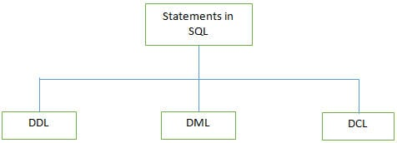
There are 3 types of SQL statements:
a) DDL (Data Definition Language): It is used to define the database structure such as tables. It includes three statements such as CREATE, ALTER, and DROP.
Also read =>> MySQL Create Table Tutorial
Some of the DDL Commands are listed below:
CREATE: It is used for creating the table.
CREATE TABLE table_name
column_name1 data_type(size),
column_name2 data_type(size),
column_name3 data_type(size),
ALTER: The ALTER table is used for modifying the existing table object in the database.
ALTER TABLE table_name
ADD column_name datatype
OR
ALTER TABLE table_name
DROP COLUMN column_name
b) DML (Data Manipulation Language): These statements are used to manipulate the data in records. Commonly used DML statements are INSERT, UPDATE, and DELETE.
The SELECT statement is used as a partial DML statement, used to select all or relevant records in the table.
c) DCL (Data Control Language): These statements are used to set privileges such as GRANT and REVOKE database access permission to the specific user.
Q #4) How do we use the DISTINCT statement? What is its use?
Answer: The DISTINCT statement is used with the SELECT statement. If the record contains duplicate values then the DISTINCT statement is used to select different values among duplicate records.
Syntax:
SELECT DISTINCT column_name(s)
FROM table_name;
Q #5) What are the different Clauses used in SQL?
Answer:
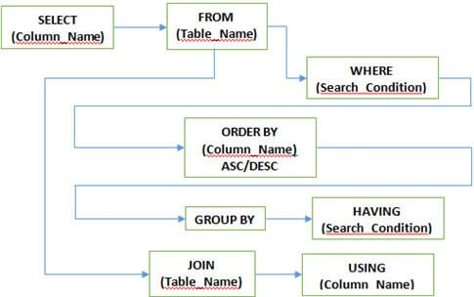
WHERE Clause: This clause is used to define the condition, and extract and display only those records which fulfill the given condition.
Syntax:
SELECT column_name(s)
FROM table_name
WHERE condition;
GROUP BY Clause: It is used with the SELECT statement to group the result of the executed query using the value specified in it. It matches the value with the column name in tables and groups the end result accordingly.
Further reading => MySQL Group By Tutorial
Syntax:
SELECT column_name(s)
FROM table_name
GROUP BY column_name;
HAVING clause: This clause is used in association with the GROUP BY clause. It is applied to each group of results or the entire result as a single group. It is much similar to the WHERE clause but the only difference is you cannot use it without the GROUP BY clause
Syntax:
SELECT column_name(s)
FROM table_name
GROUP BY column_name
HAVING condition;
ORDER BY clause: This clause is used to define the order of the query output either in ascending (ASC) or in descending (DESC). Ascending (ASC) is set as the default one but descending (DESC) is set explicitly.
Syntax:
SELECT column_name(s)
FROM table_name
WHERE condition
ORDER BY column_name ASC|DESC;
USING clause: USING clause comes in use while working with SQL JOIN. It is used to check equality based on columns when tables are joined. It can be used instead of the ON clause in JOIN.
Syntax:
SELECT column_name(s)
FROM table_name
JOIN table_name
USING (column_name);
Q #6) Why do we use SQL constraints? Which constraints we can use while creating a database in SQL?
Answer: Constraints are used to set the rules for all records in the table. If any constraints get violated then it can abort the action that caused it.
Constraints are defined while creating the database itself with the CREATE TABLE statement or even after the table is created once with the ALTER TABLE statement.
There are 5 major constraints used in SQL, such as
- NOT NULL: That indicates that the column must have some value and cannot be left NULL.
- UNIQUE: This constraint is used to ensure that each row and column has a unique value and no value is being repeated in any other row or column.
- PRIMARY KEY: This constraint is used in association with NOT NULL and UNIQUE constraints such as on one or the combination of more than one column to identify the particular record with a unique identity.
- FOREIGN KEY: It is used to ensure the referential integrity of data in the table. It matches the value in one table with another using the PRIMARY KEY.
- CHECK: It ensures whether the value in columns fulfills the specified condition.
Suggested Reading => Boost Your Career with these SQL Certifications
Q #7) What are different JOINS used in SQL?
Answer:
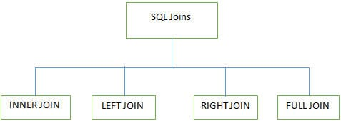
4 major types of Joins are used while working on multiple tables in SQL databases:
INNER JOIN: It is also known as SIMPLE JOIN which returns all rows from BOTH tables when it has at least one matching column.
Syntax:
SELECT column_name(s)
FROM table_name1&amp;nbsp;
INNER JOIN table_name2
ON column_name1=column_name2;
For Example,
In this example, we have a table Employee with the following data:
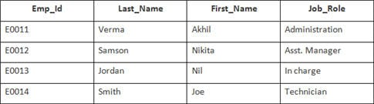
The second table’s name is Joining.
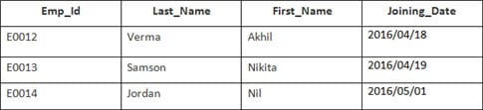
Enter the following SQL statement:
SELECT Employee.Emp_id, Joining.Joining_Date
FROM Employee
INNER JOIN Joining
ON Employee.Emp_id = Joining.Emp_id
ORDER BY Employee.Emp_id;
There will be 4 records selected. Results are:
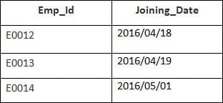
Employee and Orders tables have a matching customer_id value.
LEFT JOIN (LEFT OUTER JOIN): This join returns all rows from the LEFT table and its matched rows from a RIGHT table.
Syntax:
SELECT column_name(s)
FROM table_name1
LEFT JOIN table_name2
ON column_name1=column_name2;
For Example,
In this example, we have a table Employee with the following data:
The second table’s name is Joining.
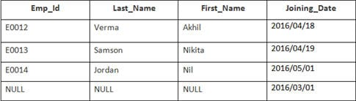
Enter the following SQL statement:
SELECT Employee.Emp_id, Joining.Joining_Date
FROM Employee
LEFT OUTER JOIN Joining
ON Employee.Emp_id = Joining.Emp_id
ORDER BY Employee.Emp_id;
There will be 4 records selected. You will see the following results:
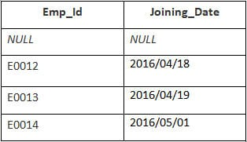
RIGHT JOIN (RIGHT OUTER JOIN): This joins returns all rows from the RIGHT table and its matched rows from the LEFT table.
Syntax:
SELECT column_name(s)
FROM table_name1
RIGHT JOIN table_name2
ON column_name1=column_name2;
For Example,
In this example, we have a table Employee with the following data:
The second table’s name is Joining.
Enter the following SQL statement:
SELECT Employee.Emp_id, Joining.Joining_Date FROM Employee
RIGHT JOIN Joining
ON Employee.Emp_id = Joining.Emp_id
ORDER BY Employee.Emp_id;
Output:
Emp_id | Joining_Date
E0012 | 2016/04/18
E0013 | 2016/04/19
E0014 | 2016/05/01
FULL JOIN (FULL OUTER JOIN): This joins returns all results when there is a match either in the RIGHT table or in the LEFT table.
Syntax:
SELECT column_name(s)
FROM table_name1
FULL OUTER JOIN table_name2
ON column_name1=column_name2;
For Example,
In this example, we have a table Employee with the following data:
The second table’s name is Joining.
Enter the following SQL statement:
SELECT Employee.Emp_id, Joining.Joining_Date
FROM Employee
FULL OUTER JOIN Joining
ON Employee.Emp_id = Joining.Emp_id
ORDER BY Employee.Emp_id;
There will be 8 records selected. These are the results that you should see.
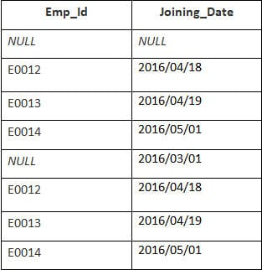
Also, Read => MySQL Join Tutorial
Q #8) What are transactions and their controls?
Answer: A transaction can be defined as the sequence task that is performed on databases in a logical manner to gain certain results. Operations like Creating, updating, and deleting records performed in the database come from transactions.
In simple words, we can say that a transaction means a group of SQL queries executed on database records.
There are 4 transaction controls such as
- COMMIT: It is used to save all changes made through the transaction.
- ROLLBACK: It is used to roll back the transaction. All changes made by the transaction are reverted back and the database remains as before.
- SET TRANSACTION: Set the name of the transaction.
- SAVEPOINT: It is used to set the point where the transaction is to be rolled back.
Q #9) What are the properties of the transaction?
Answer: Properties of the transaction are known as ACID properties. These are:
- Atomicity: Ensures the completeness of all transactions performed. Checks whether every transaction is completed successfully or not. If not, then the transaction is aborted at the failure point and the previous transaction is rolled back to its initial state as changes are undone.
- Consistency: Ensures that all changes made through successful transactions are reflected properly on the database.
- Isolation: Ensures that all transactions are performed independently and changes made by one transaction are not reflected on others.
- Durability: Ensures that the changes made in the database with committed transactions persist as it is even after a system failure.
Q #10) How many Aggregate functions are available in SQL?
Answer: SQL Aggregate functions determine and calculate values from multiple columns in a table and return a single value.
There are 7 aggregate functions in SQL:
- AVG(): Returns the average value from specified columns.
- COUNT(): Returns the number of table rows.
- MAX(): Returns the largest value among the records.
- MIN(): Returns the smallest value among the records.
- SUM(): Returns the sum of specified column values.
- FIRST(): Returns the first value.
- LAST(): Returns last value.
Q #11) What are Scalar functions in SQL?
Answer: Scalar functions are used to return a single value based on the input values.
Scalar Functions are as follows:
- UCASE(): Converts the specified field in the upper case.
- LCASE(): Converts the specified field in lowercase.
- MID(): Extracts and returns characters from the text field.
- FORMAT(): Specifies the display format.
- LEN(): Specifies the length of the text field.
- ROUND(): Rounds up the decimal field value to a number.
Q #12) What are triggers?
Answer: Triggers in SQL is kind of stored procedures used to create a response to a specific action performed on the table such as INSERT, UPDATE or DELETE. You can invoke triggers explicitly on the table in the database.
Action and Event are two main components of SQL triggers. When certain actions are performed, the event occurs in response to that action.
Syntax:
CREATE TRIGGER name {BEFORE|AFTER} (event [OR..]}
ON table_name [FOR [EACH] {ROW|STATEMENT}]
EXECUTE PROCEDURE functionname {arguments}
Q #13) What is View in SQL?
Answer: A View can be defined as a virtual table that contains rows and columns with fields from one or more tables.
Syntax:
CREATE VIEW view_name AS
SELECT column_name(s)
FROM table_name
WHERE condition
Q #14) How we can update the view?
Answer: SQL CREATE and REPLACE can be used for updating the view.
Execute the below query to update the created view.
Syntax:
CREATE OR REPLACE VIEW view_name AS
SELECT column_name(s)
FROM table_name
WHERE condition
Q #15) Explain the working of SQL Privileges.
Answer: SQL GRANT and REVOKE commands are used to implement privileges in SQL multiple user environments. The administrator of the database can grant or revoke privileges to or from users of database objects by using commands like SELECT, INSERT, UPDATE, DELETE, ALL, etc.
GRANT Command: This command is used to provide database access to users other than the administrator.
Syntax:
GRANT privilege_name
ON object_name
TO {user_name|PUBLIC|role_name}
[WITH GRANT OPTION];
In the above syntax, the GRANT option indicates that the user can grant access to another user too.
REVOKE command: This command is used to provide database deny or remove access to database objects.
Syntax:
REVOKE privilege_name
ON object_name
FROM {user_name|PUBLIC|role_name};
Q #16) How many types of Privileges are available in SQL?
Answer: There are two types of privileges used in SQL, such as
- System privilege: System privilege deals with the object of a particular type and provides users the right to perform one or more actions on it. These actions include performing administrative tasks, ALTER ANY INDEX, ALTER ANY CACHE GROUP creates/ALTER/DELETE TABLE, CREATE/ALTER/DELETE VIEW, etc.
- Object privilege: This allows us to perform actions on an object or object of another user(s) viz. table, view, indexes, etc. Some of the object privileges are EXECUTE, INSERT, UPDATE, DELETE, SELECT, FLUSH, LOAD, INDEX, REFERENCES, etc.
Q #17) What is SQL Injection?
Answer: SQL Injection is a type of database attack technique where malicious SQL statements are inserted into an entry field of the database in a way that once it is executed, the database is exposed to an attacker for the attack. This technique is usually used for attacking data-driven applications to have access to sensitive data and perform administrative tasks on databases.
For Example,
SELECT column_name(s) FROM table_name WHERE condition;
Q #18) What is SQL Sandbox in SQL Server?
Answer: SQL Sandbox is a safe place in the SQL server environment where untrusted scripts are executed. There are 3 types of SQL sandbox:
- Safe Access Sandbox: Here a user can perform SQL operations such as creating stored procedures, triggers, etc. but cannot have access to the memory as well as cannot create files.
- External Access Sandbox: Users can access files without having the right to manipulate the memory allocation.
- Unsafe Access Sandbox: This contains untrusted codes where a user can have access to memory.
Q #19) What is the difference between SQL and PL/SQL?
Answer: SQL is a Structured Query Language to create and access databases whereas PL/SQL comes with procedural concepts of programming languages.
Q #20) What is the difference between SQL and MySQL?
Answer: SQL is a Structured Query Language that is used for manipulating and accessing the relational database. On the other hand, MySQL itself is a relational database that uses SQL as the standard database language.
Q #21) What is the use of the NVL function?
Answer: The NVL function is used to convert the null value to its actual value.
Q #22) What is the Cartesian product of the table?
Answer: The output of Cross Join is called a Cartesian product. It returns rows combining each row from the first table with each row of the second table. For Example, if we join two tables having 15 and 20 columns the Cartesian product of two tables will be 15×20=300 rows.
Q #23) What do you mean by Subquery?
Answer: Query within another query is called as Subquery. A subquery is called an inner query which returns output that is to be used by another query.
Q #24) How many row comparison operators are used while working with a subquery?
Answer: There are 3-row comparison operators that are used in subqueries such as IN, ANY, and ALL.
Q #25) What is the difference between clustered and non-clustered indexes?
Answer: The differences between the two are as follows:
- One table can have only one clustered index but multiple non-clustered indexes.
- Clustered indexes can be read rapidly rather than non-clustered indexes.
- Clustered indexes store data physically in the table or view whereas, non-clustered indexes do not store data in the table as it has a separate structure from the data row.
Q #26) What is the difference between DELETE and TRUNCATE?
Answer: The differences are:
- The basic difference in both is DELETE command is the DML command and the TRUNCATE command is DDL.
- DELETE command is used to delete a specific row from the table whereas the TRUNCATE command is used to remove all rows from the table.
- We can use the DELETE command with the WHERE clause but cannot use the TRUNCATE command with it.
Q #27) What is the difference between DROP and TRUNCATE?
Answer: TRUNCATE removes all rows from the table which cannot be retrieved back, DROP removes the entire table from the database and it also cannot be retrieved back.
Q #28) How to write a query to show the details of a student from the Students table whose
name start with K?
Answer: Query:
SELECT * FROM Student WHERE Student_Name like ‘K%’;
Here ‘like’ operator is used to perform pattern matching.
Q #29) What is the difference between Nested Subquery and Correlated Subquery?
Answer: Subquery within another subquery is called Nested Subquery. If the output of a subquery depends on column values of the parent query table then the query is called Correlated Subquery.
SELECT adminid(SELEC Firstname+' '+Lastname&amp;nbsp;&amp;nbsp;FROM Employee WHERE
empid=emp. adminid)AS EmpAdminId FROM Employee;
The result of the query is the details of an employee from the Employee table.
Q #30) What is Normalization? How many Normalization forms are there?
Answer: Normalization is used to organize the data in such a manner that data redundancy will never occur in the database and avoid insert, update and delete anomalies.
There are 5 forms of Normalization:
- First Normal Form (1NF): It removes all duplicate columns from the table. It creates a table for related data and identifies unique column values.
- First Normal Form (2NF): Follows 1NF and creates and places data subsets in an individual table and defines the relationship between tables using the primary key.
- Third Normal Form (3NF): Follows 2NF and removes those columns which are not related through the primary key.
- Fourth Normal Form (4NF): Follows 3NF and does not define multi-valued dependencies. 4NF is also known as BCNF.
Q #31) What is a Relationship? How many types of Relationships are there?
Answer: The relationship can be defined as the connection between more than one table in the database.
There are 4 types of relationships:
- One-to-One Relationship
- Many to One Relationship
- Many to Many Relationship
- One to Many Relationship
Q #32) What do you mean by Stored Procedures? How do we use it?
Answer: A stored procedure is a collection of SQL statements that can be used as a function to access the database. We can create these stored procedures earlier before using it and can execute them wherever required by applying some conditional logic to them. Stored procedures are also used to reduce network traffic and improve performance.
Syntax:
CREATE Procedure Procedure_Name
(
//Parameters
)
AS
BEGIN
SQL statements in stored procedures to update/retrieve records
END
Q #33) State some properties of Relational databases.
Answer: Properties are as follows:
- In relational databases, each column should have a unique name.
- The sequence of rows and columns in relational databases is insignificant.
- All values are atomic and each row is unique.
Q #34) What are Nested Triggers?
Answer: Triggers may implement data modification logic by using INSERT, UPDATE, and DELETE statements. These triggers that contain data modification logic and find other triggers for data modification are called Nested Triggers.
Q #35) What is a Cursor?
Answer: A cursor is a database object which is used to manipulate data in a row-to-row manner.
The cursor follows steps given below:
- Declare Cursor
- Open Cursor
- Retrieve row from the Cursor
- Process the row
- Close Cursor
- Deallocate Cursor
Q #36) What is Collation?
Answer: Collation is a set of rules that check how the data is sorted by comparing it. Such as character data is stored using the correct character sequence along with case sensitivity, type, and accent.
Q #37) What do we need to check in Database Testing?
Answer: In Database testing, the following thing is required to be tested:
- Database connectivity
- Constraint check
- Required application field and its size
- Data Retrieval and processing with DML operations
- Stored Procedures
- Functional flow
Q #38) What is Database White Box Testing?
Answer: Database White Box testing involves:
- Database Consistency and ACID properties
- Database triggers and logical views
- Decision Coverage, Condition Coverage, and Statement Coverage
- Database Tables, Data Model, and Database Schema
- Referential integrity rules
Q #39) What is Database Black Box Testing?
Answer: Database Black Box testing involves:
- Data Mapping
- Data stored and retrieved
- Use of Black Box testing techniques such as Equivalence Partitioning and Boundary Value Analysis (BVA)
Q #40) What are Indexes in SQL?
Answer: The index can be defined as the way to retrieve data more quickly. We can define indexes using CREATE statements.
Syntax:
CREATE INDEX index_name
ON table_name (column_name)
Further, we can also create a Unique Index using the following syntax:
CREATE UNIQUE INDEX index_name
ON table_name (column_name)
UPDATE: We have added a few more short questions for practice.
Q #41) What does SQL stand for?
Answer: SQL stands for Structured Query Language.
Q #42) How to select all records from the table?
Answer: To select all the records from the table we need to use the following syntax:
Select * from table_name;
Q #43) Define join and name different types of joins.
Answer: Join keyword is used to fetch data from two or more related tables. It returns rows where there is at least one match in both the tables included in the join. Read more here.
Type of joins are:
- Right join
- Outer join
- Full join
- Cross join
- Self join.
Q #44) What is the syntax to add a record to a table?
Answer: To add a record in a table INSERT syntax is used.
For Example,
INSERT into table_name VALUES (value1, value2..);
Q #45) How do you add a column to a table?
Answer: To add another column to the table, use the following command:
ALTER TABLE table_name ADD (column_name);
Recommended reading =>> How to add a column to a table in MySQL
Q #46) Define the SQL DELETE statement.
Answer: DELETE is used to delete a row or rows from a table based on the specified condition.
The basic syntax is as follows:
DELETE FROM table_name
WHERE &amp;lt;Condition&amp;gt;
Q #47) Define COMMIT?
Answer: COMMIT saves all changes made by DML statements.
Q #48) What is the Primary key?
Answer: A Primary key is a column whose values uniquely identify every row in a table. Primary key values can never be reused.
Q #49) What are Foreign keys?
Answer: When a table’s primary key field is added to related tables in order to create the common field which relates the two tables, it is called a foreign key in other tables. Foreign key constraints enforce referential integrity.
Q #50) What is CHECK Constraint?
Answer: A CHECK constraint is used to limit the values or type of data that can be stored in a column. They are used to enforce domain integrity.
Q #51) Is it possible for a table to have more than one foreign key?
Answer: Yes, a table can have many foreign keys but only one primary key.
Q #52) What are the possible values for the BOOLEAN data field?
Answer: For a BOOLEAN data field, two values are possible: -1(true) and 0(false).
Q #53) What is a stored procedure?
Answer: A stored procedure is a set of SQL queries that can take input and send back output.
Q #54) What is identity in SQL?
Answer: An identity column where SQL automatically generates numeric values. We can define a start and increment value of the identity column.
Q #55) What is Normalization?
Answer: The process of table design to minimize data redundancy is called normalization. We need to divide a database into two or more tables and define the relationship between them.
Q #56) What is a Trigger?
Answer: The Trigger allows us to execute a batch of SQL code when a tabled event occurs (INSERT, UPDATE or DELETE commands are executed against a specific table).
Q #57) How to select random rows from a table?
Answer: Using a SAMPLE clause we can select random rows.
For Example,
SELECT * FROM table_name SAMPLE(10);
Q #58) Which TCP/IP port does SQL Server run?
Answer: By default SQL Server runs on port 1433.
Q #59) Write a SQL SELECT query that only returns each name only once from a table.
Answer: To get the result as each name only once, we need to use the DISTINCT keyword.
SELECT DISTINCT name FROM table_name;
Q #60) Explain DML and DDL.
Answer: DML stands for Data Manipulation Language. INSERT, UPDATE and DELETE are DML statements.
DDL stands for Data Definition Language. CREATE, ALTER, DROP, RENAME are DDL statements.
Q #61) Can we rename a column in the output of the SQL query?
Answer: Yes, using the following syntax we can do this.
SELECT column_name AS new_name FROM table_name;
Q #62) Give the order of SQL SELECT.
Answer: The order of SQL SELECT clauses is: SELECT, FROM, WHERE, GROUP BY, HAVING, ORDER BY. Only the SELECT and FROM clauses are mandatory.
Q #63) Suppose a Student column has two columns, Name and Marks. How to get names and marks of the top three students.
Answer: SELECT Name, Marks FROM Student s1 where 3 <= (SELECT COUNT(*) FROM Students s2 WHERE s1.marks = s2.marks)
Q #64) What are SQL comments?
Answer: SQL comments can be inserted by adding two consecutive hyphens (–).
Q #65) Difference between TRUNCATE, DELETE, and DROP commands?
Answer:
- DELETE removes some or all rows from a table based on the condition. It can be rolled back.
- TRUNCATE removes ALL rows from a table by de-allocating the memory pages. The operation cannot be rolled back
- DROP command removes a table from the database completely.
Q #66) What are the properties of a transaction?
Answer: Generally, these properties are referred to as ACID properties. They are:
- Atomicity
- Consistency
- Isolation
- Durability.
Q #67) What do you mean by ROWID?
Answer: It’s an 18-character long pseudo-column attached to each row of a table.
Q #68) Define UNION, MINUS, UNION ALL, INTERSECT?
Answer:
- MINUS – returns all distinct rows selected by the first query but not by the second.
- UNION – returns all distinct rows selected by either query
- UNION ALL – returns all rows selected by either query, including all duplicates.
- INTERSECT – returns all distinct rows selected by both queries.
Q #69) What is a transaction?
Answer: A transaction is a sequence of code that runs against a database. It takes the database from one consistent state to another.
Q #70) What is the difference between UNIQUE and PRIMARY KEY constraints?
Answer: The differences are as follows:
- A table can have only one PRIMARY KEY whereas there can be any number of UNIQUE keys.
- The primary key cannot contain Null values whereas the Unique key can contain Null values.
Q #71) What is a composite primary key?
Answer: The primary key created on more than one column is called the composite primary key.
Q #72) What is an Index?
Answer: An Index is a special structure associated with a table to speed up the performance of queries. The index can be created on one or more columns of a table.
Q #73) What is the Subquery?
Answer: A Subquery is a subset of select statements whose return values are used in filtering conditions of the main query.
Q #74) What do you mean by query optimization?
Answer: Query optimization is a process in which a database system compares different query strategies and selects the query with the least cost.
Q #75) What is Collation?
Answer: Set of rules that define how data is stored, how case sensitivity and Kana character can be treated etc.
Q #76) What is Referential Integrity?
Answer: Set of rules that restrict the values of one or more columns of the tables based on the values of the primary key or unique key of the referenced table.
Q #77) What is the Case function?
Answer: Case facilitates the if-then-else type of logic in SQL. It evaluates a list of conditions and returns one of the multiple possible result expressions.
Q #78) Define a temp table.
Answer: A temp table is a temporary storage structure to store the data temporarily.
Q #79) How can we avoid duplicating records in a query?
Answer: By using the DISTINCT keyword, duplication of records in a query can be avoided.
Q #80) Explain the difference between Rename and Alias.
Answer: Rename is a permanent name given to a table or column whereas Alias is a temporary name given to a table or column.
Q #81) What is a View?
Answer: A view is a virtual table that contains data from one or more tables. Views restrict data access to the table by selecting only required values and making complex queries easy.
Q #82) What are the advantages of Views?
Answer: Advantages of Views are:
- Views restrict access to the data because the view can display selective columns from the table.
- Views can be used to make simple queries to retrieve the results of complicated queries. For Example, views can be used to query information from multiple tables without the user knowing.
Q #83) List the various privileges that a user can grant to another user.
Answer: SELECT, CONNECT, RESOURCES.
Q #84) What is schema?
Answer: A schema is a collection of database objects of a User.
Q #85) What is a Table?
Answer: A table is the basic unit of data storage in the database management system. Table data is stored in rows and columns.
Q #86) Does View contain Data?
Answer: No, Views are virtual structures.
Q #87) Can a View be based on another View?
Answer: Yes, A View is based on another View.
Q #88) What is the difference between the HAVING clause and WHERE clause?
Answer: Both specify a search condition but the Having clause is used only with the SELECT statement and typically used with the GROUP BY clause.
If the GROUP BY clause is not used then Having behaved like the WHERE clause only.
Q #89) What is the difference between Local and Global temporary tables?
Answer: If defined inside a compound statement a local temporary table exists only for the duration of that statement but a global temporary table exists permanently in the DB but its rows disappear when the connection is closed.
Q #90) What is CTE?
Answer: A CTE or common table expression is an expression that contains a temporary result set which is defined in a SQL statement.

25 Advanced SQL Interview Questions for Data Scientists
Check out this collection of advanced SQL interview questions with answers.
By Vaishnavi Amira Yada, Technical Content Writer on October 18, 2022 in SQL
Share48

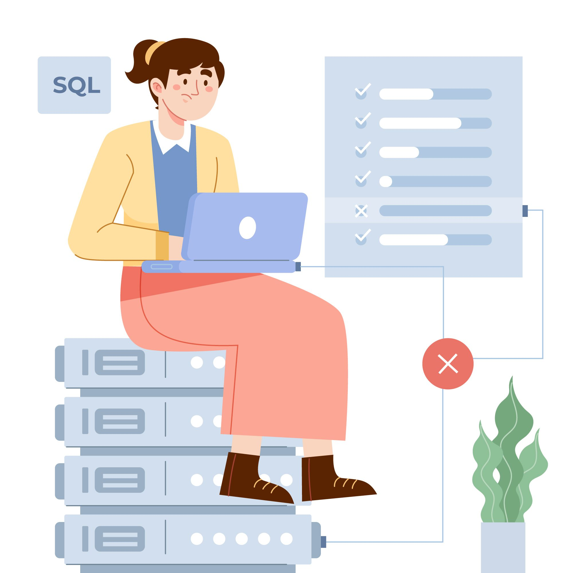
Image by Freepik

Introduction

The standard language used for all databases is Structured Query Language(SQL).
It plays a key role to fetch the demandable data from the database. All the big data platforms like Hadoop, and Spark uses SQL as a high-level language for their organizations.
Data science is the only field of study and analysis of data. The outcomes of the data should be accurate and correct to perform a survey.
This is how SQL comes into the picture with data science. Though certain organizations have made a switch to NoSQL, the fundamentals lie in SQL.
Gearing up for a data science interview?

25 Advanced SQL Interview Questions

Here are some necessary interview questions and answers on SQL that you must learn.

1. Explain Normalization?

Normalization is a method of organization of the data in the database to minimize redundancy from a set of relations. The concept of Normal forms is used to perform normalization on a relation.
- 1NF:- If a relationship has an atomic value it is in 1NF.
- 2NF:- For a relation to be in 2NF, it should be in 1NF and all the non-key attributes are fully functionally dependent on the primary key.
- 3NF:- For a relation to be in 3NF, it should be in 2NF and additionally no transition dependency exists.
- BCNF:- Boy Codd’s Normal form is a strong representation of 3NF.

2. Explain the Difference Between DDL and DML?

- DDL stands for Data Definition language whereas, DML is called Data Manipulation Language.
- DDL creates a schema with some constraints. DML adds, retrieves or updates the data in that schema.
- DDL defines the column attribute of the table. DML provides the row attribute of the table.
- Examples of DDL commands are created, alter, drop, rename, etc. and those of DML are merged, update, insert, etc.
- The WHERE clause is not used in DDL but is used in DML.

3. What are ACID Properties in SQL?

The ACID properties are as follows:
- Atomicity - Changes in the data must be like a single operation.
- Consistency - The data must be consistent before and after the transaction.
- Isolation - Multiple transactions can be done without any hindrance.
- Durability - Transaction gets successful in case of system failures.

4. Write a Query to Find all the Duplicates in a Table?

In terms of a general scenario, the approaches that can be followed to find all duplicates in a table are as follows:
- Using the GROUP BY command to group all the rows by target columns. Here target columns are the ones where you can check the duplicates.
- Use the HAVING command and integrate the COUNT function to check if any group has more than one entry.

5. Difference Between a Clustered and non-clustered Index?

Below are the differences between a clustered and non-clustered index:
- A clustered index is used to define the order to sort the index or table just like a dictionary. A non-clustered index collects all the data in one place and records it at a different place.
- The clustered index is faster than the non-clustered index.
- Less memory is used to perform operations on a clustered index as compared to a non-clustered index.

6. Explain Denormalisation?

The database optimization technique in which we add data(redundant) to the table(s) is called denormalization. The technique is useful as it helps to reduce the costly joins in the database.

7. What is Collation?

In a SQL server, collation provides sorting rules, accent, and case sensitivity properties to the data in the database. It represents each character in the database by defining the bit patterns using collation.
Some of the collation levels are as below:
- Case-sensitive (_CS)
- Accent-sensitive (_AS)
- Kana-sensitive (_KS)
- Width-sensitive (_WS)
- Variation-selector-sensitive (_VSS)a
- Binary (_BIN)
- Binary-code point (_BIN2)

8. What is the Difference Between inner, outer, and full outer join?

Below are the differences between inner, outer, and full outer join:
- In an inner join, the rows that are common in both tables are the outputs.
- In a full outer join, all the rows in both tables are returned.
- An outer join returns the values from either or both tables.

9. Explain the Difference Between a Join and a Union?

Below are the differences between a join and a union:
- Join retrieves the matched records from the tables whereas union is used to combine the set of two different SELECT statements.
- Join does not remove duplicate data whereas union removes duplicate data(rows) from selected statements.

10. Explain the Difference Between UNION AND UNION ALL?

Union keeps unique records whereas Union keeps all records including all the duplicates. Also, the union does a deduplication step before returning the data and the union all prints concatenated results

11. Write a Query to Print the Highest Salary from a Table?

Consider a table with the below data and table name as EMP-
Name Salary
---------------------
John 990000
Ellie 100000
Nick 400000
Sam 500000
The query would be:
SELECT * FROM EMP WHERE salary=(select Max(salary) FROM EMP);

12. What is the Difference Between Shared and Inclusive Locks?

- In the shared lock, the lock mode is only in read operation but in the inclusive lock, it is in reading and writes operation.
- A shared lock prevents others from updating the data whereas an inclusive lock prevents others from reading or updating the data.
- Any number of transactions can hold a shared lock on a particular item whereas, only one transaction can be held in an exclusive lock.

13. Explain the Mechanism of Transpose Using SQL?

Transpose in SQL is defined as changing a row or column into a particular format to visualize the data from a new perspective.
One basic transpose is changing a row to a column or a column to a row. Typical transpose methods are dynamic and joined transposition.
All of the transpose methods are used for data analysis for a fruitful outcome.

14. Explain the Working of the B-trees Index?

A B-tree is defined as a self-balancing search tree in which all leaves are at the same level. To insert data in a B-tree, it is inserted at the leaf node.
In the B-trees index, the tree has a key-value pair which is called a payload. This value is referenced to the actual data record.
When we use a B-tree index, the database searches a given key with correspondence to B-tree and gets the index.

15. Explain the Effect of Truncate and Delete on an Identity?

Below are the differences between DELETE and TRUNCATE commands:
- The DELETE command is used to delete a specific row in the table whereas, TRUNCATE deletes all the data from the rows.
- DELETE is a DML command and slower than the TRUNCATE command which is a DDL command.
- DELETE command active triggers whereas TRUNCATE does not.

16. Explain the Cost of Having a Database Index?

It eats up your space. The larger your table, the larger will be the index.
ADD, DELETE or UPDATE of certain rows in the table must be also done to our index.
As a thumb rule, an index must be created on a table if the table in the indexed column will be required frequently.

17. What are the Advantages of Having an Index?

Below are the advantages of having an index:
- It speeds up the SELECT query.
- Data retrieval becomes quite easy.
- Indexes can be used for sorting.
- It makes a row unique without any duplicates.
- Large string text can be inserted when the index is set to fill-text index.

18. Explain Indexing in the Database?

Indexing is a data structure technique to optimize the database performance by reducing disk access during the time a query is being processed.
Indexing has the following attributes:
- Access Types: Based on the search type
- Access Time: Based on search time
- Insertion Time: Based on quick insertion
- Deletion Time: Based on quick deletion
- Space Overhead: Based on additional overhead space.

19. What is OLAP and OLTP?

Online Analytical Processing (OLAP)
Businesses have to comprehend a set of data that helps finance leaders and business teams to get insights into their users and the performance of multiple related factors.
A business can have various data across the business process and strategies that help teams to analyze the performance at a more granular level.
These data are stored in multiple database systems and thus require consistent, real-time, and more flexible processes that help the team analyze the data and process further for more analysis.
Online Analytical Processing or OLAP contains software tools that are used for analyzing business data and help get insights into the database.
For example, OLAP can be used to build the Spotify song recommendation engine that automatically generates a playlist for users based on their song choices and historical listening data.

Online Transaction Processing(OLTP)
The transaction is an integral part of every business. A business offering services to its customers receive an amount when the customer uses the services.
An invoice gets immediately generated when users pay for the services of their choice.
The transaction database comes into the picture when we have to store the transaction information of all users.
However, Online Transaction Processing (OLTP) offers transaction-oriented applications that are categorized in a 3-tier architecture.

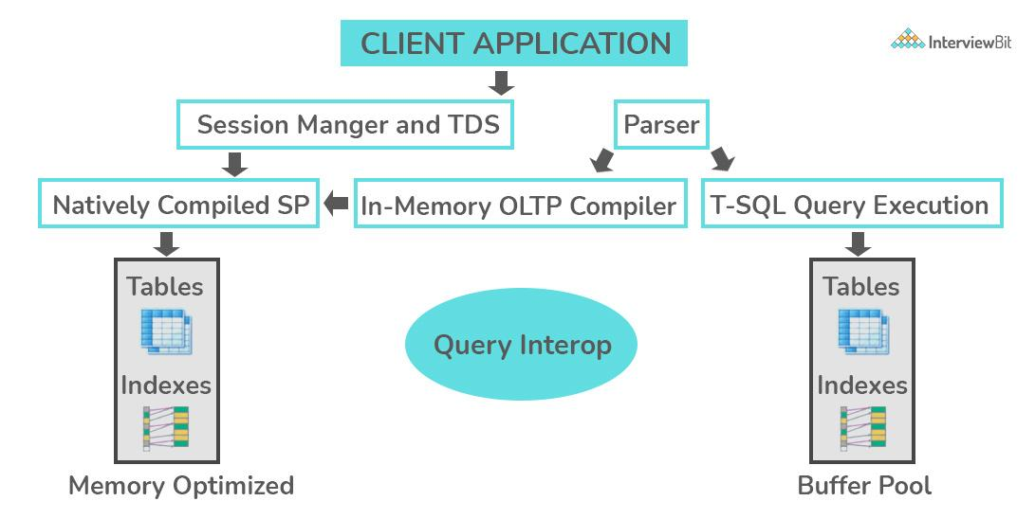
Source: InterviewBit

OLTP helps businesses to perform certain activities related to the transaction database.
For example, Transaction through online banking serves the same purpose where OLTP can be used to operate the user transaction information.

20. In What Conditions Does CASE WHEN Apply?

SQL is used for querying databases and modifying the values in large datasets. It also provides a way to manipulate data when there are multiple cases.
For example, a table contains a list of employees(name) along with experience (EXP) and joining date(ac_date).
Now, if we want to query the data in such a way that if the experience is greater than(>) “4”, then insert “Is a senior” in a new column named “exp_level”, otherwise insert NULL in the column.
You can query the database in such cases using the CASE WHEN statement.
The CASE WHEN statement is similar to the If/else condition in programming languages like C, C++, Python, etc.
The CASE statement is followed by one pair of WHEN and THEN statements. However, you can add nested statements based on your requirements.
Once the CASE statement is completed, it is finished by adding the ending statement that starts with ELSE and END AS.
In the example above, we have employee.database that lists out the employees of a company with attributes such as employee name, joining year, experience, and more. Using the CASE WHEN statement in this example,
SELECT employee_name,
exp,
CASE WHEN exp > 4 THEN 'Is a Senior'
ELSE NULL END AS exp_level
FROM xyz.marketing_employees

21. Explain the Cases to Use HAVING versus WHERE?

HAVING Clause in SQL

SQL offers HAVING clauses to filter a group of data in a database.
For example, company XYZ has a list of employees who have more than 1 year of experience.
The database contains rows and columns including the employee name, joining data, experience, and experience level.
You can retrieve a list of employees who have more than 5 years of experience.
The HAVING clause provides you with a way to control the information and modify the data with a bunch of data.
The syntax of the HAVING clause is the HAVING condition.
In the example, we can retrieve the list of employees having more than 5 years of experience by querying the database as below:
SELECT employee_name, exp_level,
FROM EMPLOYEE
GROUP BY experience
HAVING COUNT(experience) > 5;

WHERE Clause in SQL

WHERE clause is used when you want to filter the records based on a particular condition.
For example, in an employee table, we can retrieve the list of all employees who have exactly 5 years of experience in a company. The syntax of the WHERE clause is, WHERE condition.
In the example, we can extract the name of employees who have 5 years of experience by querying the database as below:
SELECT employee_name, exp_level,
FROM EMPLOYEE
WHERE experience= 5;

22. What is PL/SQL?

The PL/SQL is a block-structured language that encourages developers to use the power of SQL using procedural statements.
It is a featured procedural language that has embedded the power of decision-making and many more features of POP.
Using a single block command, PL/SQL can run multiple queries with the support of extensive error checking.
PL/SQL is an extension of SQL that is used to create applications.

23. What is ETL in SQL?

ETL stands for ‘Extract, Transform and Load”. It uses the concept of data warehousing to make data visualization and data analysis. In a broader context, it is used for data integration.
Any system where data is taken from one system and stored/copied in another destination system and its data is represented differently is called an ETL process.

24. What are Nested Triggers?

SQL offers Data Manipulation Language (DML) and Data Definition Language(DDL) to perform certain operations while querying the database.
When a particular type of operation is performed on the database, it automatically executes some actions on the database as well.
When these types of actions are triggered in the database, they are known as Nested triggers.
SQL categorizes the nested triggers into two main categories- AFTER triggers and INSTEAD OF triggers.
As the name suggests AFTER trigger is executed after a DML or DDL operation is performed on the database.
However, INSTEAD OF trigger is executed in place of DML and DDL operations.

25. What are Commits and Checkpoints?

The commit makes sure the data is consistent and maintained in the updated state after the current transaction ends. A new record is added to the log memory when a commit is used.
In the case of a checkpoint, it is used to write all the changes that are committed to disk up the system change number in the control files and header files.

1. What are the 5 basic SQL commands?
The 5 basic SQL commands are ALTER, UPDATE, DELETE, INSERT and CREATE. Of course, there are many more commands, some more nuanced, but the aforementioned are the fundamentals.

2. What is the difference between DBMS and RDBMS?
A Database Management System (DBMS) is a software application that helps you build and maintain databases. A Relational Database Management System (RDBMS) is a subset of DBMS, and it is one based on the relational model of the DBMS.

3. Can we embed Pl/SQL in SQL? Justify your answers.
PL/SQL is a procedural language, and it has one or more SQL statements in it, so SQL can be embedded in a PL/SQL block; however, PL/SQL cannot be embedded in SQL as SQL executes a single query at a time.
DECLARE /* this is a PL/SQL block */

qty_on_hand NUMBER(5);
BEGIN

SELECT quantity INTO qty_on_hand FROM inventory /* this is the SQL statement embedded in the PL/SQL block */

WHERE product = 'TENNIS RACKET';

END;

4. What do you mean by Data Manipulation Language (DML)?
Data Manipulation Language (DML) includes the most common SQL statements to store, modify, delete, and retrieve data. They are SELECT, UPDATE, INSERT, and DELETE.
DECLARE /* this is a PL/SQL block */

qty_on_hand NUMBER(5);
BEGIN

SELECT quantity INTO qty_on_hand FROM inventory /* this is the SQL statement embedded in the PL/SQL block */

WHERE product = 'TENNIS RACKET';

END;

5. What is a join in SQL? What are the types of joins?
A join is used to query data from multiple tables based on the relationship between the fields.
There are four types of joins:
Inner Join
Rows are returned when there is at least one match of rows between the tables.
select first_name, last_name, order_date, order_amount
from customers c
inner join orders o
on c.customer_id = o.customer_id
/* customers and orders are two tables. Data will be displayed from the two tables where the customer_id from customer table matches
The customer_id from the orders table. */
Right Join
Right join returns all rows from the right table and those which are shared between the tables. If there are no matching rows in the left table, it will still return all the rows from the right table.
select first_name, last_name, order_date, order_amount
from customers c
left join orders o
on c.customer_id = o.customer_id
/* customers and orders are two tables. All rows from the Orders table is returned with matching rows from the Customers table if any */
Left Join
Left join returns all rows from the Left table and those which are shared between the tables. If there are no matching rows in the right table, it will still return all the rows from the left table.

select first_name, last_name, order_date, order_amount
from customers c
left join orders o
on c.customer_id = o.customer_id
/* customers and orders are two tables. All rows from the customers table is returned with matching rows from the orders table if any */
Full Join
Full join return rows when there are matching rows in any one of the tables. This means it returns all the rows from the left-hand side table and all the rows from the right-hand side table.
select first_name, last_name, order_date, order_amount
from customers c
full join orders o
on c.customer_id = o.customer_id
/* customers and orders are two tables. All rows from the Orders table and customer table are returned */

6. What is the difference between the CHAR and VARCHAR2 datatype in SQL?
CHAR is used to store fixed-length character strings, and VARCHAR2 is used to store variable-length character strings.
For example, suppose you store the string ‘Database’ in a CHAR(20) field and a VARCHAR2(20) field.
The CHAR field will use 22 bytes (2 bytes for leading length).
The VARCHAR2 field will use 10 bytes only (8 for the string, 2 bytes for leading length).

7. Explain SQL constraints.
Constraints are used to specify the rules of data type in a table. They can be specified while creating and altering the table. The following are the constraints in SQL:
- NOT NULL: Restricts NULL value from being inserted into a column
- CHECK: Verifies that all values in a field satisfy a condition
- DEFAULT: Automatically assigns a default value if no value has been specified for the field
- UNIQUE: Ensures unique values to be inserted into the field
- INDEX: Indexes a field providing faster retrieval of records
- PRIMARY KEY: Uniquely identifies each record in a table
- FOREIGN KEY: Ensures referential integrity for a record in another table

8. What is a primary key, a foreign key, and a unique key?
Primary Key
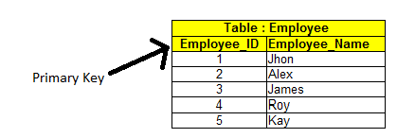
The primary key is a field in the table which uniquely identifies a row. It cannot be NULL
Foreign Key
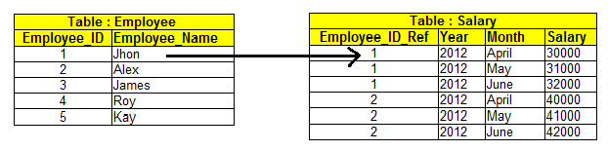
A foreign key is a field in one table that is a primary key in another table. A relationship is created between the two tables by referencing the foreign key of one table with the primary key of another table.
In the example below, the employee_id_ref in the salary table is the foreign key.
Unique Key
The Unique Key uniquely identifies a record in a table. There can be many unique key constraints defined on a table.
EMP_ID | EMP_NAME | Government_ID
222 | Harry | 111-203-987
333 | Stephan | 789-456-123
444 | Lan | 745-562-321
In the table above Emp_id is the primary key but Government_id is the unique key. You may want the Government_id to be unique for every employee. Since the data belongs to the government, you may not want it to be the primary key.

9. What is a trigger?
Triggers are stored programs that get automatically executed when an event such as INSERT, DELETE, and the UPDATE (DML) statement occurs. Triggers can also be evoked in response to Data definition statements(DDL) and database operations, for example, SERVER ERROR, LOGON.
create trigger dbtrigger
on database
for

create_table,alter_table,drop_table
as

print'you can not create ,drop and alter table in this database'
rollback;
create trigger emptrigger
on emp
for
insert,update,delete
as

print'you can not insert,update and delete this table i'
rollback;

10. What is the difference between SQL and MySQL?
SQL is a structured query language used to access the DBMS whereas MYSQL is an Open Source Relational DBMS. The latter operates on the relational model, allowing for more advanced ways to deal with data.

11. What is a NULL Value field?
A NULL value is a field with No Value.

Intermediate-Level Interview Questions

12. What are ACID properties in a transaction?
In order to maintain consistency in a database’s ‘before and after’ transactions, certain properties are followed. They are:

- Atomicity: The transaction must happen fully and cannot be left midway
- Consistency: This maintains integrity constraints to ensure valid data enters the database
- Isolation: Controls concurrency
- Durability: Once a transaction is committed, it remains committed

13. What is Dateadd in SQL?
Dateadd is a function that is used to add a number to a specified part of the date and returns the modified date. The syntax is DATEADD (date_part, value, input_date).
The Date part can take any of the following forms:
date_part | abbreviations
Year | yy, yyyy
Quarter | qq, q
Month | Mm, m
dayofyear | dy, y
Day | dd, d
Week | wk, ww
Hour | hh
Minute | mi, n
Second | ss, s
Millisecond | ms
Microsecond | mcs
Nanosecond | ns

14. What is SAVEPOINT in transaction control?
A SAVEPOINT is a point in a transaction when you can roll the transaction back to a certain point without rolling back the entire transaction.
SQL> SAVEPOINT A
SQL> INSERT INTO TEST VALUES (1,'Savepoint A');
1 row inserted.
SQL> SAVEPOINT B
SQL> INSERT INTO TEST VALUES (2,'Savepoint B');
1 row inserted.
SQL> ROLLBACK TO B;
Rollback complete.
SQL> SELECT * FROM TEST;

ID MSG
-------- -----------

1 Savepoint A

15. What is a Natural Join?
SELECT * FROM COUNTRIES NATURAL JOIN CITIES

SELECT * FROM COUNTRIES JOIN CITIES

USING (COUNTRY, COUNTRY_ISO_CODE)
A natural join by default is an inner join that creates an implicit join based on the common columns in the two tables being joined:
A NATURAL JOIN can be an INNER join, a LEFT OUTER join, or a RIGHT OUTER join. The default is INNER join.
If the tables COUNTRIES and CITIES have two common columns named COUNTRY and COUNTRY_ISO_CODE, the following two SELECT statements are equivalent:

16. What is a Cross Join?
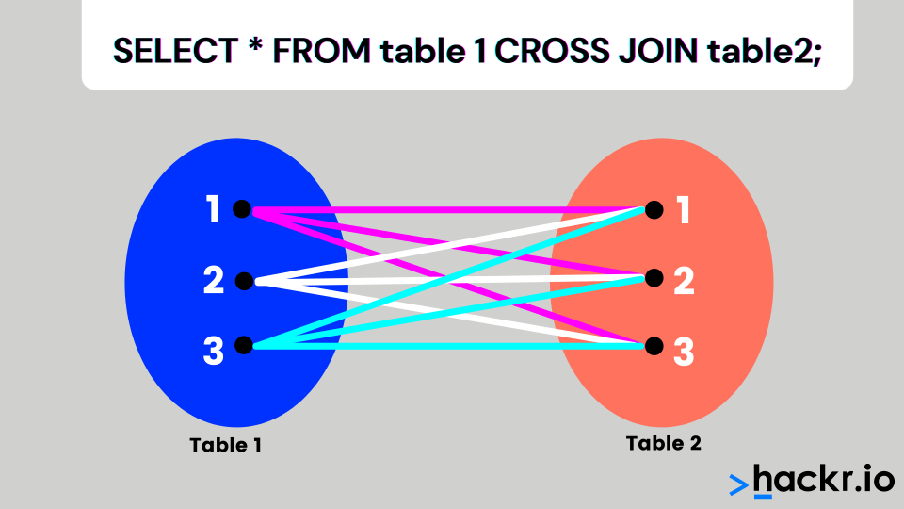
In an SQL cross join, a combination of every row from the two tables is included in the result set. This is also called cross-product join.
For example, if table A has ten rows and table B has 20 rows, the result set will have 10 * 20 = 200 rows provided there is a NOWHERE clause in the SQL statement.

17. What are the subsets of SQL?
The following are the subsets of SQL
- DDL(Data Definition Language): Includes SQL commands like CREATE, ALTER, and DELETE
- DML(Data Manipulation Language): Accesses and manipulates data, including the INSERT and UPDATE commands
- DCL(Data Control Language): Controls access to the database. Uses commands like GRANT and REVOKE.

18. What are scalar functions in SQL?
Scalar Functions are used to return a single value based on the input values. Scalar Functions are as follows:
- UCASE(): Converts the specified field in upper case
SELECT UCASE("SQL Tutorial is FUN!") AS UppercaseText;

UppercaseText

SQL TUTORIAL IS FUN!
- LCASE(): Converts the specified field in lower case

19. What is a cursor, and when do you use it?
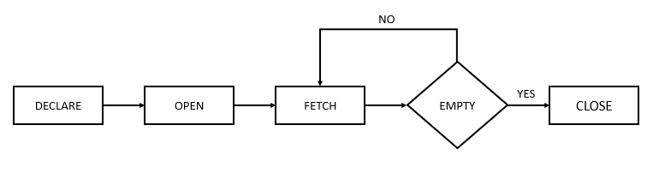
A cursor is a database object which is used to manipulate data by traversing row by row in a result set. A cursor is used when you need to retrieve data, one row at a time from a result set and when you need to update records one row at a time.
DECLARE @CustomerId INT

,@Name VARCHAR(100)

,@Country VARCHAR(100)

--DECLARE AND SET COUNTER.

DECLARE @Counter INT

SET @Counter = 1

--DECLARE THE CURSOR FOR A QUERY.

DECLARE PrintCustomers CURSOR READ_ONLY

FOR

SELECT CustomerId, Name, Country

FROM Customers

--OPEN CURSOR.

OPEN PrintCustomers

--FETCH THE RECORD INTO THE VARIABLES.

FETCH NEXT FROM PrintCustomers INTO

@CustomerId, @Name, @Country

--LOOP UNTIL RECORDS ARE AVAILABLE.

WHILE @@FETCH_STATUS = 0

BEGIN

IF @Counter = 1

BEGIN

PRINT 'CustomerID' + CHAR(9) + 'Name' + CHAR(9) + CHAR(9) + CHAR(9) + 'Country'

PRINT '------------------------------------'

END

--PRINT CURRENT RECORD. PRINT CAST(@CustomerId AS VARCHAR(10)) + CHAR(9) + CHAR(9) + CHAR(9) + @Name + CHAR(9) + @Country

--INCREMENT COUNTER.

SET @Counter = @Counter + 1

--FETCH THE NEXT RECORD INTO THE VARIABLES.

FETCH NEXT FROM PrintCustomers INTO

@CustomerId, @Name, @Country

END

--CLOSE THE CURSOR.

CLOSE PrintCustomers

DEALLOCATE PrintCustomers

20. What is a set-based solution?
Cursors operate on individual rows, and in the case of a set, it works on a resultant set of data, which could be a table/view or a join of both. The resultant set is an output of a SQL query.

21. What is a forward cursor?
Forward cursors support fetching of rows from start to end from a result set. You cannot go to the previous row in the result set.

22. State one situation where set-based solutions are better than cursor-based solutions.
Set-based solutions provide better performance when you are working on a result set, as opposed to one row at a time. They are concise and more readable.

23. What is normalization and what are the normal forms?
Normalization is a process in database design to minimize data redundancy and dependency. The database is divided into two or more tables, and relationships are defined between them.
First Normal Form
Every record is unique in a table and is identified by a primary or a composite key.
StudiD Name Phonenum
-----------------------
1 John 9176612345,9176645698
2 Susie 9176645789
3 Jim 9176696325
In the above table the field ‘phonenum’ is a multi-valued attribute, so it is not in 1NF.
The table below is in 1NF as there is no multi-valued attribute.
StudiD Name Phonenum
------------------
1 John 9176612345
1 John 9176645698
2 Susie 9176645789
3 Jim 9176696325
Second Normal Form
The table must be in First Normal Form, and it should have a single column as its primary key. 2NF tries to reduce the redundant data getting stored in memory. To transform the table above into 2NF, we split the table into two tables:
StudiD Name /* student table */
- John
2 Susie
- Jim
StudiD Phonenum /* studentphonenumber table */
------------------
1 9176612345
1 9176645698
2 9176645789
3 9176696325
Third Normal Form
The table must be in Second Normal Form and must have no transitive functional dependencies, i.e., a non-key column must not be dependent on another non-key column within the same table.
Consider the EMPLOYEE_DETAIL table: This table is not in the third normal form because the fields emp_state and emp_city depend on emp_zip and not on the primary key emp_id.
EMP_ID | EMP_NAME | EMP_ZIP | EMP_STATE | EMP_CITY
222 | Harry | 201010 | CT | Monro
333 | Stephan | 02228 | TX | Dallas
444 | Lan | 060007 | IL | Chicago
The table above is split into 2 tables and now the tables are in the third normal form.
EMPLOYEE table:
EMP_ID | EMP_NAME | EMP_ZIP
222 | Harry | 201010
333 | Stephan | 02228
444 | Lan | 060007
EMPLOYEE_ZIP table:
EMP_ZIP | EMP_STATE | EMP_CITY
201010 | CT | Monro
02228 | TX | Dallas
060007 | IL | Chicago

24. What is denormalization and when do you use it?
Denormalization is a technique used to improve performance so the table design allows you to avoid complex joins with redundant data. If the application involves heavy read operations, then denormalization is used at the expense of the write operations performance.

25. What are clustered indexes and non-clustered indexes?
A table can have only one clustered index. In this type of index, it reorders the table based on the key values and physically stores them in that order.
The non-clustered index does not have the physical ordering of the data in the table; it has a logical order.
CREATE CLUSTERED INDEX IX_tblStudent_Gender_Score
ON student(gender ASC, total_score DESC)
The script above creates a clustered index named “IX_tblStudent_Gender_Score” on the student table. This index is created on the “gender” and “total_score” columns. An index that is created on more than one column is called the “composite index”.
A non-clustered index doesn’t sort the physical data inside the table. A non-clustered index is stored in one place, and table data is stored in another place. This allows for more than one non-clustered index per table.
CREATE NONCLUSTERED INDEX IX_tblStudent_Name
ON student(name ASC)
The script above creates a non-clustered index on the “name” column of the student table — the index sorts by name in ascending order. The table data and index will be stored in different places.

26. What is T-SQL?
It is an extension of SQL (Structured Query Language) developed by Sybase and used by Microsoft.

27. What are system functions? Offer an example.
System functions are operations performed on the database server, and values are returned accordingly. Example @@ERROR - Returns 0 if the previous Transact-SQL statement encountered no errors. Otherwise, it returns an error number.
@@ERROR - Returns 0 if the previous Transact-SQL statement encountered no errors.

28. What is a transaction log?
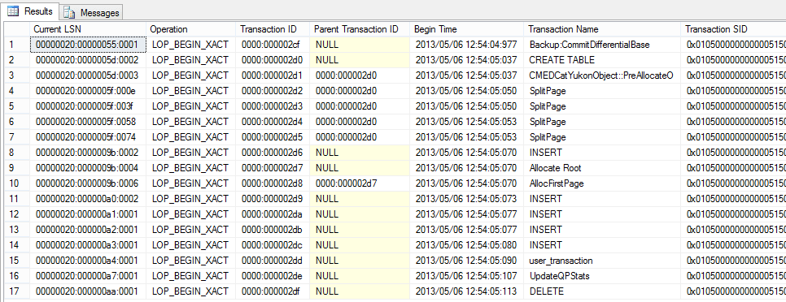
A log is an audit trail file where the history of actions executed by the DBMS is stored.

29. How do you maintain database integrity when deletions from one table automatically cause deletions in another?
ON DELETE CASCADE is a command that is used when deletions happen in the parent table, and all child records are automatically deleted, and the child table is referenced by the foreign key in the parent table.
CREATE TABLE products

( product_id INT PRIMARY KEY,

product_name VARCHAR(50) NOT NULL,

category VARCHAR(25)

);
CREATE TABLE inventory

( inventory_id INT PRIMARY KEY,

product_id INT NOT NULL,

quantity INT,

min_level INT,

max_level INT,

CONSTRAINT fk_inv_product_id

FOREIGN KEY (product_id)

REFERENCES products (product_id)

ON DELETE CASCADE

);
The Products table is the parent table and the inventory table is the child table. If a productid is deleted from the parent table all the inventory records for that productid will be deleted from the child table

30. Can we use TRUNCATE with a WHERE clause?
No, we cannot use TRUNCATE with the WHERE clause.

31. Define COMMIT.
When a COMMIT is used in a transaction, all changes made are written into the database permanently.
BEGIN TRANSACTION;
DELETE FROM HumanResources.JobCandidate

WHERE JobCandidateID = 13;
COMMIT TRANSACTION;
The example above deletes a job candidate in an SQL server.

32. What does CHECK CONSTRAINT do?
Check Constraint limits the values that can enter a column in a database table. It is used as an integrity constraint check.
The following SQL creates a CHECK constraint on the "Age" column when the "Persons" table is created. The CHECK constraint ensures that you can not have any person below 18 years:
The syntax below is in MySQL.
CREATE TABLE Persons (
ID int NOT NULL,
LastName varchar(255) NOT NULL,
FirstName varchar(255),
Age int,
CHECK (Age>=18)

);

33. What is a schema?
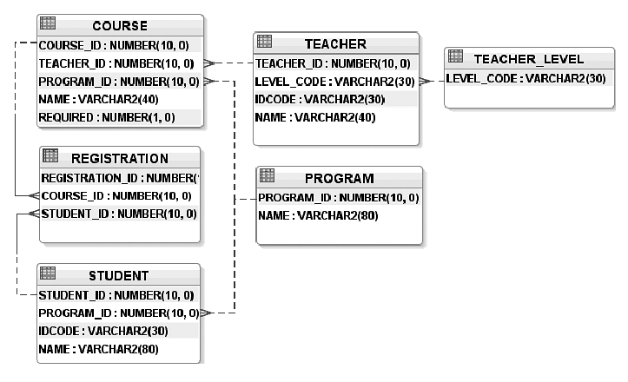
A schema is a collection of database objects in a database for a particular user/owner. Objects can be tables, views, indices, and so on.

34. How can you create an empty table from an existing table?
CREATE TABLE NEW_TABLE_NAME AS SELECT [column1, column2 ……column]
FROM EXISTING_TABLE_NAME [WHERE ]

35. What is a composite key?
When more than one column is used to define the primary key, it is called a composite key. Here is a SQL syntax to create a composite key in MySQL:
CREATE TABLE SAMPLE_TABLE
(COL1 integer,
COL2 varchar(30),
COL3 varchar(50),
PRIMARY KEY (COL1, COL2));

36. How do you sort records in a table?
The ORDER BY Clause is used to sort records in a table.
SELECT * FROM Emp ORDER BY salary;
By default, the records are returned in ascending order.

37. What is a shared lock?
When two transactions are granted read access to the same data, they are given a shared lock. This enables reading the same data, and data is not updated until the shared lock is released.

38. What is a deadlock?
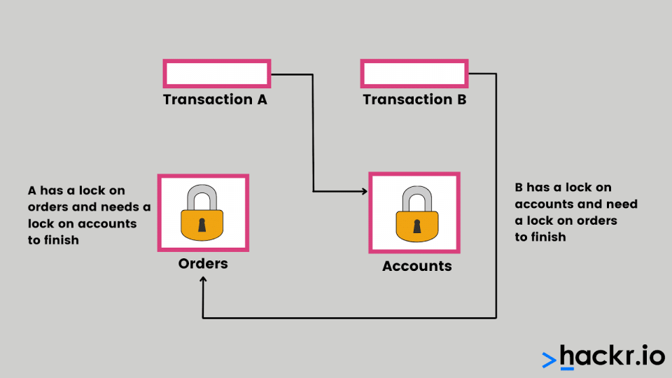
A deadlock is a situation where two or more transactions are waiting indefinitely for each other to release the locks.
The following is an example of a deadlock situation:

39. What is lock escalation?
Lock escalation is the process of converting row or page locks into table locks. It is an optimization technique used by RDBMS like SQL Server dynamically.

40. What is SQL injection?
SQL injection is a code injection technique used to hack data-driven applications.

41. What are views, and why are they used?
SQL views are virtual tables created from one or more tables. Views are a subset of data; hence, it can limit the degree of exposure of data from the tables.
The following SQL creates a view that shows all customers from Brazil:
CREATE VIEW Brazil_Customers_view ASSELECT CustomerName, ContactNameFROM CustomersWHERE Country = "Brazil";
You can query the view above as follows:
SELECT * FROM Brazil_Customers_view;

42. How do we avoid getting duplicate entries in a query?
The Select DISTINCT is used to get distinct data from tables using a query.
The following SQL statement selects only the DISTINCT values from the "Country" column in the "Customers" table:
SELECT DISTINCT Country FROM Customers;

43. Give an example of a comparison operator in SQL.
EQUAL TO written as = is used to compare data values

44. What is a Subquery?
A subQuery is a SQL query nested into a larger Query.
SELECT
employee_id, first_name, last_nameFROM
employeesWHERE
department_id IN (SELECT
department_id
FROM
departments
WHERE
location_id = 1700)ORDER BY first_name , last_name;
The query placed within the parentheses is called a subquery. It is also known as an inner query or inner select. The query that contains the subquery is called an outer query or an outer select.

45. What is a non-correlated subquery?
A non-correlated subquery is an independent query, and the output of the subquery is substituted in the main query.

Advanced SQL Interview Questions and Answers

46. What is a SYSTEM Privilege?
This is when rights are given to a user, usually by the DBA, to perform a particular action on the database schema objects like creating tablespaces.
The following are examples of system privileges that can be granted to users:
- CREATE TABLE allows a grantee to create tables in the grantee's schema
- CREATE USER allows a grantee to create users in the database
- CREATE SESSION allows a grantee to connect to an Oracle database to create a user session

47. What are Object Privileges?
An object-level privilege is a permission granted to a database user account or role to perform some action on a database object. These object privileges include SELECT, INSERT, UPDATE, DELETE, ALTER, INDEX on tables, and so on.
The following examples are object privileges that can be granted to users:
- SELECT ON hr.employees TO myuser
- INSERT ON hr.employees TO myuser

48. What does the BCP command do?
The BCP (Bulk Copy) is a utility or a tool that exports/imports data from a table into a file and vice versa.

49. What does the VARIANCE function do?
This function returns the VARIANCE of a set of numbers:
CREATE TABLE EMP (EMPNO NUMBER(4) NOT NULL,

ENAME VARCHAR2(10),
JOB VARCHAR2(9),
SAL NUMBER(7, 2),
DEPTNO NUMBER(2));
INSERT INTO EMP VALUES (1, 'SMITH', 'CLERK', 800, 20);INSERT INTO EMP VALUES (2, 'ALLEN', 'SALESMAN', 1600, 30);INSERT INTO EMP VALUES (3, 'WARD', 'SALESMAN', 1250, 30);INSERT INTO EMP VALUES (4, 'JONES', 'MANAGER', 2975, 20);INSERT INTO EMP VALUES (5, 'MARTIN','SALESMAN', 1250, 30);INSERT INTO EMP VALUES (6, 'BLAKE', 'MANAGER', 2850, 30);INSERT INTO EMP VALUES (7, 'CLARK', 'MANAGER', 2850, 10);INSERT INTO EMP VALUES (8, 'SCOTT', 'ANALYST', 3000, 20);INSERT INTO EMP VALUES (9, 'KING', 'PRESIDENT',3000, 10);INSERT INTO EMP VALUES (10,'TURNER','SALESMAN', 1500, 30);INSERT INTO EMP VALUES (11,'ADAMS', 'CLERK', 1500, 20);

SQL> SELECT VARIANCE(sal)

2 FROM emp;

VARIANCE(SAL)
-------------

759056.818

50. What is the role of GRANT and REVOKE commands?
The GRANT command enables privileges on the database objects and the REVOKE command removes them. They are DCL commands.
GRANT CREATE ANY TABLE TO usernameGRANT sysdba TO usernameGRANT DROP ANY TABLE TO usernameREVOKE CREATE TABLE FROM username

51. What is a UNION operator?
The UNION operator combines the results of two or more SELECT statements by removing duplicate rows. The columns and the data types must be the same in the SELECT statements.
SELECT City FROM CustomersUNIONSELECT City FROM SuppliersORDER BY City;

52. Where are stored procedures stored and can we call one inside another?
Stored Procedures are stored in the Data Dictionary of the database.
Yes, we can call a stored procedure from another stored procedure. For example, Procedure2 is the procedure which is called Procedure1. Both Procedure1 and Procedure2 can have business logic implemented in it.
Create PROCEDURE Procedure1AS BEGIN
Exec Procedure2END

53. Does the data stored in the stored procedure increase access time or execution time?
Data stored in stored procedures can be retrieved much faster than the data stored in the SQL database. Data can be precompiled and stored in stored procedures. This reduces the time gap between query and compiling as the data has been pre-compiled and stored in the procedure. Procedures may or may not return values.

54. Can a view be active if the base table is dropped?
No, the view cannot be active if the parent table is dropped.

55. What is a One-Many Relationship in SQL?
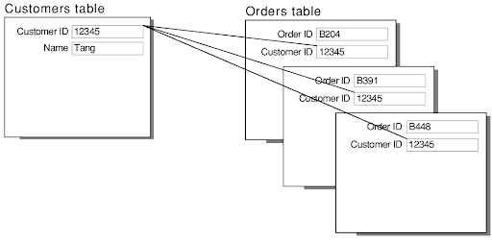
In a One-Many relationship, a record in one table can be associated or related to many records in another table.

56. Distinguish between a table and a field in SQL.
The collection of data organized in the form of columns and rows refers to the table. The number of columns in a table refers to the field.
Table: Employee_Details
Fields: Emp_id, Emp_name, Emp_dept, Emp_salary

57. What is data integrity?
Data integrity defines the accuracy, consistency, and reliability of data that is stored in the database.
There are four kinds of data integrity:
- Row integrity
- Column integrity
- Referential integrity
- User-defined integrity

58. What are entities and relationships?
- Entity: A person, place, or any real-world thing that can be represented as a table is called an entity. An example is an employee table that represents the details of an employee in an organization.
- Relationship: Relationship defines the dependency that entities share amongst each other. An example is the fact that an employee name, ID, salary might belong to the same or different tables.

59. How do TRUNCATE and DELETE Differ?
DELETE | TRUNCATE
DML command | DDL command
Can use WHERE | Cannot use WHERE
Deletes one row from the table | Deletes all rows from the table
Rollback possible | No rollback

60. What is the difference between null, zero, and blank space?
NULL refers to a value that is unknown, not available, inapplicable, or unassigned. Zero is a number, and blank space is treated as a character.

61. Which function is used to return the remainder in a division operator in SQL?
The MOD function returns the remainder in the division operation.

62. What are case manipulation functions?
Case manipulation functions convert existing data in the table to lower, upper or mixed case characters.

63. What are the different case manipulation functions in SQL?
- LOWER: Converts all the characters to lowercase
- UPPER: Converts all the characters to uppercase
- INITCAP: Converts initial character of each word to uppercase

64. What are the different character manipulation functions?
- CONCAT: Joins two or more string values
- SUBSTR: Extracts string of a specific length
- LENGTH: Returns the length of the string
- INSTR: Returns the position of the specific character
- LPAD: Padding of the left-side character value for right-justified value
- RPAD: Padding of right-side character value for left-justified value
- TRIM: Removes the defined character from beginning and end or both
- REPLACE: Replaces a specific sequence of characters with another sequence of characters

65. Define inconsistent dependency.
The difficulty of accessing data as the path may be broken or missing defines inconsistent dependency. Inconsistent dependency enables users to search for data in the wrong different table which afterward results in an error as an output.

66. What are GROUP functions? Why do we need them?
Group functions work on a set of rows and return a single result per group. The popularly used group functions are AVG, MAX, MIN, SUM, VARIANCE, COUNT

67. Distinguish between BETWEEN and IN conditional operators.
BETWEEN displays the rows based on a range of values. IN checks for values contained in a specific set of values.
Example:
SELECT * FROM Students where ROLL_NO BETWEEN 10 AND 50;SELECT * FROM students where ROLL_NO IN (8,15,25);

68. What is the MERGE statement?
The statement enables conditional updates or inserts into the table. It updates the row if it exists or inserts the row if it does not exist.

69. Explain the recursive stored procedure.
A stored procedure calling itself until it reaches some boundary condition is a recursive stored procedure. It enables the programmers to use a set of code any number of times.

70. How can dynamic SQL be executed?
It can be executed in the following ways:
- By executing the query with parameters.
- By using EXEC
- By using sp_executesql

71. What is the stored procedure?
It is a function consisting of many SQL statements to access the database system. Several SQL statements are consolidated into a stored procedure and are executed wherever and whenever required.

72. What is auto increment?
This keyword allows a new unique number to be generated whenever a new record is inserted into the table. It can be used wherever we need the PRIMARY KEY.

73. What is a data warehouse?
Data from multiple sources of information is stored in a central repository called the data warehouse. Data warehouses have subsets of data called data marts. The data stored is transformed and used for online mining and processing.

74. What are user-defined functions?
Functions written to use the specific logic whenever required are user-defined functions. It avoids redundancy by avoiding writing the same logic again.

75. What is the ALIAS command?
This command provides another name to a table or a column. It can be used in the WHERE clause of a SQL query using the as keyword.
Example:
SELECT S.StudentID, E.Result from student S, Exam as E where S.StudentID = E.StudentID
S and E are alias names for student table and exam table respectively.

76. What is Collation?
Collation is defined as the set of rules that determines how to store and compare data.

77. Mention the different types of collation sensitivity.
The following are the types of collation sensitivity:
- Case
- Kana
- Width
- Accent

78. What are STUFF and REPLACE functions?
STUFF: Overwrites the existing character or inserts a string into another string. The syntax is:
STUFF(string_expression,start, length, replacement_characters)
REPLACE: replaces the existing characters of all the occurrences. The syntax is:
REPLACE (string_expression, search_string, replacement_string)

1. What do you understand by NoSQL?
Ans: Nowadays, developers are dealing with a large volume of data which is called big data. So naturally, big complexity and big issues will be there. Once most of the systems are getting online, so data load increases. NoSQL helps to manage unstructured, messy, and complicated data. This is not a traditional database or relational database management.

2. How many types of mechanism works in NoSQL? Write down their name?
Ans: There are four types of mechanisms:
A. Graph database
B. Key value calculation
C. Document oriented
D. Column view presentation
Enthusiastic about exploring the skill set of Cassandra? Then, have a look at the Cassandra Online Course together with additional knowledge.

3. Write down the difference between vertical and horizontal databases?
Vertical Database | Horizontal Database
You can do vertical scaling, adding more power to the present PC. | Here you can do horizontal scaling with more equipment.
All data will be stored in a single node. | Only part data will be stored in all nodes.
Multi-core scaling will be done. | Single-core scaling will be done.
Example: Amazon cloud | Example: Cassandra

4. Can you tell me when you should use NoSQL in place of the normal database?
Ans: If you are looking for key-value stores with massive high-speed performances, you can use NoSQL. Because in the relational databases, we use ACID transactions. Once we use this kind of transaction, the schema-based process will slow down the database performance.
Suggestive possible situations to use NoSQL are:
A. If you use multiple JOIN queries.
B. If the client wants high traffic site.
C. If you are using denormalized data.
[Also Read: What is NoSQL?]

5. Write down the NoSQL's different features?
Ans: These are different features of NoSQL:
A. It can store a big amount of unstructured, structured, and semi-structured data.
B. It is object-oriented programming based, which is best for a web application.
C. It is agile, sprints based, which is best for project management.
D. It is cost-effective with scale-out architecture and efficiency.

6. What do you know about polyglot persistence in NoSQL?
Ans: Once the applications are used and developed with mixed programming languages, debugging becomes easy in databases. However, tough complex problems will be there. Now let's talk about an e-commerce web application with a huge database of carts that is highly available to the buyer and will be easy to manage by this hybrid concept of polyglot. This hybrid technology helps the database to give suggestions to buyers.

7. Can we use NoSQL in an Oracle-based database?
Ans: Yes, NoSQL is applicable in the Oracle database to record data. This database helps to find out the data records through external table functions. As well, it is easier to perform some queries in the Oracle base database. It is very flexible and key-value based.
[Related Article: NoSQL Performance Management]

8. Clarify the key value in the NoSQL database?
Ans: Generally, in a database, we store the data in a table. In NoSQL, we usually store data in the hash table. These all have tables are having unique identities. If you are finding some data, then using a key-value store is a better option than working with joins. This key value will be picking up data faster from the hash table.

9. What is a hash table? How does it work in NoSQL?
Ans: This is like a data structure that provides an associative array of abstract data types. This table uses to function in a complex database. You need to write has code-based queries in this type of database.


10. What is the meaning of document-oriented DB?
Ans: This is one of the features of the NoSQL database. It helps to store the data as schema-free. As a result, JavaScript object notation will be used, and scalability will be higher. The project will be developed faster at a low cost too. You can use given below these DocumentDB:
A. MongoDB
B. Amazon DocumentDB
C. Microsoft Azure CosmosDB

11. How can you perform column view data presentation in NoSQL?
Ans: If you are looking for a highly analytical output, you can use this column view data presentation. This NoSQL can store a huge analytical amount of data in columns rather than rows. You can also build subgroups by collecting columns. You don't need to give any key names to this type of database. This is mainly recommended for the data belonging to the data science field.
[Explore More: MongoDB vs DynamoDB]

12. How to increase scalability in the NoSQL database?
Ans: All these databases are heavy and need good server configuration on PC. To increase scalability, you can use a vertical database or a horizontal database also. Now on the PC, you can increase the RAM and SSD hard disk size so that the PC will be running faster. This way also, you can increase the scalability in NoSQL.

13. What is a Graph database?
Ans: A graph database is one of the most important of all databases. It is mainly specific for storing and navigating data relationships. The concept is entity information, and edges will store data relationships. This database is used by banks or social media or new channels etc.

14. Explain the CAP theorem in NoSQL?
Ans: It is the most reliable three guarantees for a database. CAP theorem is expertise with skills like consistency, availability, and partition tolerance. The nodes will be working in the network seamlessly. As a result, the database will work faster.
[Also Read Related Article: Cassandra Tutorial]

15. What do u know about database sharding in the NoSQL database?
Ans: In NoSQL, database sharding means partitioning the database in patterns for the NoSQL age. You can store data by sharding in different potentially separate servers around the world. Then, a database administrator can access these stored data easily with high data speed performances from all over the world.

NoSQL Interview Questions and Solutions for Experienced

1. How does the NoSQL database control machine price range memory?
Ans: The replication node that manages the NoSQL database save information is the replication node. It is likewise the primary client of reminiscence. The java heap and the cache length that the replication node can utilize are the critical elements in performance phrases. By default, those matters are calculated via way of means of NoSQL in phrases of the quantity of memory to be had to the storage node. Specification of the to be had reminiscence for a storage node is recommended. The memory can be calmly divided among all of the RNs if the garage node hosts a couple of replication node.

2. What do you know about Big SQL in NoSQL?
Ans: This Big SQL is developed by IBM. This is a high-speed performance database that follows MPP ( Massive parallel processing) SQL engine for a large amount of data managed by Hadoop. Mainly enterprise data will be stored by this process. By using Big SQL, you can access data from across the organization with the permission of the database administrator. It is fully secured too. Mainly banking industries are using this.

3. How is this impedance mismatch happening in the database?
Ans: Let's talk about the main difference between NoSQL and relational databases. This is a problem statement that happens due to the miss-match of database models and programming languages. If you want to use a richer memory structure, then you have translated this database to a relational database to store on disk. As a result, impedance mismatch will occur.

4. What is the role of the aggregate-oriented database?
Ans: Actually, this is a collection of data that interacts with other data as a unit. By using ACID operations and key-value, all data can be seen as a form of an aggregate-oriented database. It helps to manage the storage over the cluster. This often reduces computation.

5. Write down the script for NoSQL DB config?
Ans: If you are looking forward to building a NoSQL DB connection repeatedly, then you need to admin CLI commands. It can be used as scripted in different ways. For example, you can build a file that will store a sequence of commands to run using any programming language suitable for the particular database. Please go through the given below script:

6. If we ask you to track data record relations in NoSQL, how will you do?
Ans: You can follow these steps to track data records in NoSQL:
A. First, you can embed all data in any user object.
B. Then, you can create the user id credentials.
C. By using login id, need to give comments value with a list of comments.
D. Your expected data will be found.
Explore Cassandra Sample Resumes! Download & Edit, Get Noticed by Top Employers!

7. What is eventual consistency in the context of NoSQL?
Ans: In the database, we do use service logic. Once you execute these service logics, the database system will be left in a constant state. To increase the data availability, you can use this concept. It has a distributed database system too.

8. Explain the base property of the NoSQL database?
Ans: These are the base property of NoSQL:
A. Availability of stored data after even multiple data search failures.
B. In the soft state, all base data will be stored in the ACID model.
C. Regularity.

9. Why do we use impala in the NoSQL database?
Ans: Once the database administrators handle big data with the Hadoop system, then this impala provides parallel processing in database technology. You can also do low latency queries by using impala. Due to this parallel processing, data fetching time will be less.

Top 10 Frequently Asked NoSQL Interview Questions

1. Is NoSQL occurring in a normal database table?
Ans: NoSQL does not mean no to SQL; obviously, SQL is there. It works in the non-tabular form. Actually, you do not need to create any table for this type of database. By using NoSQL, you can improve the database performance. Mostly in dynamic SQL, to make parameterized queries, database developers use this NoSQL.

2. What is the main target of NoSQL?
Ans: The main target of NoSQL is to create an alternate database in SQL. It helps to store textual data in a database easily that is also in a non-structured format.

3. Can you tell me what the main principle of NoSQL is?
Ans: The main principle of NoSQL is to make the database high availability.

4. If I learn NoSQL, what will be my future career scope?
Ans: Data Science is booming nowadays. It's all about a huge amount of data management by adopting a big data methodology. If you see, other types of databases are not going to business on a large scale, but NoSQL is coming up with high demand in business. It has very faster career growth.

5. Do you give me any idea which particular NoSQL database is most demanding?
Ans: See, there are many database systems under NoSQL. But MongoDB is a most helpful and efficient database as it is a document-based NoSQL database. It is also use case sensitive.
MongoDB is the best if anyone wants to do read and write operations in the database.

6. What is your opinion on NoSQL replacing SQL?
Ans: The answer is yes. As per market demand, the database is also changing and getting replaced by NoSQL. Because it can manage big data, the cost is less, the latest technologies are compatible with this new database, but the traditional database is costly as well as doe's not matched with new technologies.

7. Can I learn NoSQL easily?
Ans: Yes, of course, you can learn NoSQL easily and quickly. It is a bit different from the traditional database, but it has some easily understandable logic. Here you don't need to maintain schemas or normalize at all. As a result, your workload will be less.

8. Name a few of the companies that are using NoSQL?
Ans: There are lots of companies that are using NoSQL. Mostly these companies are using a huge volume of data and also using AI, Data science to pretend the future business. In this situation, NoSQL is the best solution. Companies are:
A. Google
B. Amazon
C. Netflix
D. Facebook

9. What do you think, NoSQL uses normalization?
Ans: Yes, normalization is used by the NoSQL database. One of the famous NoSQL named Cassandra is based on normalization to finding stored data. It creates a series of tables related to the different fields. All these fields will be given true value in the table.

10. What kind of data can we manage in NoSQL?
Ans: Mainly this NoSQL types database can manage semi-structured data as well as unstructured data. Moreover, it has a flexible data model system.

1) What do you understand by NoSQL databases? Is MongoDB a NoSQL database? explain.
At the present time, the internet is loaded with big data, big users, big complexity etc. and also becoming more complex day by day. NoSQL is answer of all these problems, It is not a traditional database management system, not even a relational database management system (RDBMS). NoSQL stands for "Not Only SQL". NoSQL is a type of database that can handle and sort all type of unstructured, messy and complicated data. It is just a new way to think about the database.
Yes. MongoDB is a NoSQL database.

2) Which are the different languages supported by MongoDB?
MonggoDB provides official driver support for C, C++, C#, Java, Node.js, Perl, PHP, Python, Ruby, Scala, Go and Erlang.
You can use MongoDB with any of the above languages. There are some other community supported drivers too but the above mentioned ones are officially provided by MongoDB.
Play Videox

3) What are the different types of NoSQL databases? Give some example.
NoSQL database can be classified as 4 basic types:
- Key value store NoSQL database
- Document store NoSQL database
- Column store NoSQL database
- Graph base NoSQL databse
There are many NoSQL databases. MongoDB, Cassandra, CouchBD, Hypertable, Redis, Riak, Neo4j, HBASE, Couchbase, MemcacheDB, Voldemort, RevenDB etc. are the examples of NoSQL databases.

4) Is MongoDB better than other SQL databases? If yes then how?
MongoDB is better than other SQL databases because it allows a highly flexible and scalable document structure.
For example:
- One data document in MongoDB can have five columns and the other one in the same collection can have ten columns.
- MongoDB database are faster than SQL databases due to efficient indexing and storage techniques.

5) What type of DBMS is MongoDB?
MongoDB is a document oriented DBMS

6) What is the difference between MongoDB and MySQL?
Although MongoDB and MySQL both are free and open source databases, there is a lot of difference between them in the term of data representation, relationship, transaction, querying data, schema design and definition, performance speed, normalization and many more. To compare MySQL with MongoDB is like a comparison between Relational and Non-relational databases.

7) Why MongoDB is known as best NoSQL database?
MongoDb is the best NoSQL database because, it is:
Document Oriented
Rich Query language
High Performance
Highly Available
Easily Scalable

8) Does MongoDB support primary-key, foreign-key relationship?
No. By Default, MongoDB doesn't support primary key-foreign key relationship.

9) Can you achieve primary key - foreign key relationships in MongoDB?
We can achieve primary key-foreign key relationship by embedding one document inside another. For example: An address document can be embedded inside customer document.

10) Does MongoDB need a lot of RAM?
No. There is no need a lot of RAM to run MongoDB. It can be run even on a small amount of RAM because it dynamically allocates and de-allocates RAM according to the requirement of the processes.

11) Explain the structure of ObjectID in MongoDB.
ObjectID is a 12-byte BSON type. These are:
- 4 bytes value representing seconds
- 3 byte machine identifier
- 2 byte process id
- 3 byte counter

12) Is it true that MongoDB uses BSON to represent document structure?
Yes.

13) What are Indexes in MongoDB?
In MondoDB, Indexes are used to execute query efficiently. Without indexes, MongoDB must perform a collection scan, i.e. scan every document in a collection, to select those documents that match the query statement. If an appropriate index exists for a query, MongoDB can use the index to limit the number of documents it must inspect.

14) By default, which index is created by MongoDB for every collection?
By default, the_id collection is created for every collection by MongoDB.

15) What is a Namespace in MongoDB?
Namespace is a concatenation of the database name and the collection name. Collection, in which MongoDB stores BSON objects.

16) Can journaling features be used to perform safe hot backups?
Yes.

17) Why does Profiler use in MongoDB?
MongoDB uses a database profiler to perform characteristics of each operation against the database. You can use a profiler to find queries and write operations

18) If you remove an object attribute, is it deleted from the database?
Yes, it be. Remove the attribute and then re-save() the object.

19) In which language MongoDB is written?
MongoDB is written and implemented in C++.

20) Does MongoDB need a lot space of Random Access Memory (RAM)?
No. MongoDB can be run on small free space of RAM.

21) What language you can use with MongoDB?
MongoDB client drivers supports all the popular programming languages so there is no issue of language, you can use any language that you want.

22) Does MongoDB database have tables for storing records?
No. Instead of tables, MongoDB uses "Collections" to store data.

23) Do the MongoDB databases have schema?
Yes. MongoDB databases have dynamic schema. There is no need to define the structure to create collections.

24) What is the method to configure the cache size in MongoDB?
MongoDB's cache is not configurable. Actually MongoDb uses all the free spaces on the system automatically by way of memory mapped files.

25) How to do Transaction/locking in MongoDB?
MongoDB doesn't use traditional locking or complex transaction with Rollback. MongoDB is designed to be light weighted, fast and predictable to its performance. It keeps transaction support simple to enhance performance.

26) Why 32 bit version of MongoDB are not preferred ?
Because MongoDB uses memory mapped files so when you run a 32-bit build of MongoDB, the total storage size of server is 2 GB. But when you run a 64-bit build of MongoDB, this provides virtually unlimited storage size. So 64-bit is preferred over 32-bit.

27) Is it possible to remove old files in the moveChunk directory?
Yes, These files can be deleted once the operations are done because these files are made as backups during normal shard balancing operation. This is a manual cleanup process and necessary to free up space.

28) What will have to do if a shard is down or slow and you do a query?
If a shard is down and you even do query then your query will be returned with an error unless you set a partial query option. But if a shard is slow them Mongos will wait for them till response.

29)Explain the covered query in MongoDB.
A query is called covered query if satisfies the following two conditions:
- The fields used in the query are part of an index used in the query.
- The fields returned in the results are in the same index.

30) What is the importance of covered query?
Covered query makes the execution of the query faster because indexes are stored in RAM or sequentially located on disk. It makes the execution of the query faster.
Covered query makes the fields are covered in the index itself, MongoDB can match the query condition as well as return the result fields using the same index without looking inside the documents.

31) What is sharding in MongoDB?
In MongoDB, Sharding is a procedure of storing data records across multiple machines. It is a MongoDB approach to meet the demands of data growth. It creates horizontal partition of data in a database or search engine. Each partition is referred as shard or database shard.

32) What is replica set in MongoDB?
A replica can be specified as a group of mongo instances that host the same data set. In a replica set, one node is primary, and another is secondary. All data is replicated from primary to secondary nodes.

33) What is primary and secondary replica set in MongoDB?
In MongoDB, primary nodes are the node that can accept write. These are also known as master nodes. The replication in MongoDB is single master so, only one node can accept write operations at a time.
Secondary nodes are known as slave nodes. These are read only nodes that replicate from the primary.

34) By default, which replica sets are used to write data?
By default, MongoDB writes data only to the primary replica set.

35) What is CRUD in MongoDB?
MongoDB supports following CRUD operations:
- Create
- Read
- Update
- Delete

36) In which format MongoDB represents document structure?
MongoDB uses BSON to represent document structures.

37) What will happen when you remove a document from database in MongoDB? Does MongoDB remove it from disk?
Yes. If you remove a document from database, MongoDB will remove it from disk too.

38) Why are MongoDB data files large in size?
MongoDB doesn't follow file system fragmentation and pre allocates data files to reserve space while setting up the server. That's why MongoDB data files are large in size.

39) What is a storage engine in MongoDB?
A storage engine is the part of a database that is used to manage how data is stored on disk.
For example: one storage engine might offer better performance for read-heavy workloads, and another might support a higher-throughput for write operations.

40) Which are the storage engines used by MongoDB?
MMAPv1 and WiredTiger are two storage engine used by MongoDB.

41) What is the usage of profiler in MongoDB?
A database profiler is used to collect data about MongoDB write operations, cursors, database commands on a running mongod instance. You can enable profiling on a per-database or per-instance basis.
The database profiler writes all the data it collects to the system. profile collection, which is a capped collection.

42) Is it possible to configure the cache size for MMAPv1 in MongoDB?
No. it is not possible to configure the cache size for MMAPv1 because MMAPv1 does not allow configuring the cache size.

43) How to configure the cache size for WiredTiger in MongoDB?
For the WiredTiger storage engine, you can specify the maximum size of the cache that WiredTiger will use for all data. This can be done using storage.wiredTiger.engineConfig.cacheSizeGB option.

44) How does MongoDB provide concurrency?
MongoDB uses reader-writer locks for concurrency. Reader-writer locks allow concurrent readers shared access to a resource, such as a database or collection, but give exclusive access to a single write operation.

45) What is the difference between MongoDB and Redis database?
Difference between MongoDB and Redis:
- Redis is faster than MongoDB.
- Redis has a key-value storage whereas MongoDB has a document type storage.
- Redis is hard to code but MongoDB is easy.
For more information: click here

46) What is the difference between MongoDB and CouchDB?
Difference between MongoDB and CouchDB:
- MongoDB is faster than CouchDB while CouchDB is safer than MongoDB.
- Triggers are not available in MongoDB while triggers are available in CouchDB.
- MongoDB serializes JSON data to BSON while CouchDB doesn't store data in JSON format.
For more information: click here

47) What is the difference between MongoDB and Cassandra?
Difference between MongoDB and Cassandra:
- MongoDB is cross-platform document-oriented database system while Cassandra is high performance distributed database system.
- MongoDB is written in C++ while Cassandra is written in Java.
- MongoDB is easy to administer in the case of failure while Cassandra provides high availability with no single point of failure.
For more information: click here

48) Is there any need to create database command in MongoDB?
You don't need to create a database manually in MongoDB because it creates automaically when you save the value into the defined collection at first time.

9 NoSQL Interview Questions With Sample Answers
If you are interested in pursuing a career in computer programming, reviewing NoSQL interview questions can help you craft answers that demonstrate your knowledge of this database management system. With the growing reliance on information and technology systems for companies, NoSQL developers have job prospects in different fields. If the company you are interviewing at uses the same, the hiring manager may want to check your knowledge on the subject to ensure you can work efficiently after getting hired. Here are some sample interview questions along with their answers on NoSQL:

1. What is NoSQL?
NoSQL databases are non-tabular databases which store data differently than relational databases. The hiring manager may start your interview question to check your basic understanding of data management. In your answer, you may briefly explain what NoSQL is and consider sharing some of its unique traits or features
Example: 'NoSQL is a highly scalable and flexible data management system compared to the previously used relational database. It is an advanced data management system where the data is not connected to the relational database. It allows us to store unstructured or semi-structured data and process it. Conventional data systems may not always manage the massive amount of data in real time.
NoSQL solves this problem by offering a non-linear structure. Large companies primarily use it to support large-scale cloud application requirements that are accessed globally. In my personal experience, it can offer a variety of benefits to technology companies who required rapid growth and expansion.'
Related: Data Architect Vs. Data Engineer (With Duties And Salaries)

2. What are the different NoSQL databases?
There are four different types of NoSQL databases. List all four of them in your answer to show your understanding of the data management system to the hiring manager.
Example: 'Primarily, there are four different databases under NoSQL. All four differ from each other and have their use cases. They are document databases, key-value stores, column-oriented databases and graph databases.'

3. What are some advantages of NoSQL?
The company for which you interview might use NoSQL systems as it aligns with their requirements. The hiring manager may want to know if you possess technical expertise in NoSQL to fulfil the responsibilities the role may entail. By stating a few advantages of NoSQL, you can show that you are aware of the benefits of the system and of how you can contribute after getting hired. Answer based on your experience using this system.
Example: 'In my experience, I think the primary benefit of NoSQL is that it supports semi-structured data and volatile data and that it does not have a schema. We can achieve horizontal scalability easily using this system, as it supports big data in volumes of terra bytes and peta bytes. I also think it provides a faster development life cycle for developers like us and is also economical.'
Related: Useful Data Engineer Skills You Can Develop (With Steps)

4. What is the key value offering in NoSQL?
NoSQL has a few value offerings that differ from other database management systems. Based on your experience, tell the interviewer what you feel provides the most value. Try to keep the language as simple as possible since the interviewer may not be from a technical background.
Example: 'Usually we store the data in a table in databases. But in NoSQL, we can store data in hash tables. These tables have unique identities. Instead of working with joins, using a key-value store is much easier if we want to find some data. I believe the best value offering of NoSQL is that we can pick data faster from the hash table.'
Related: How Much Does An iOS Developer Make? (Skills And Duties)

5. How to increase scalability in NoSQL?
As the company grows, scalability is often a priority. As a team member, you may search for ways to scale the database and offer solutions effectively. You can discuss one such solution in your answer and prove your problem-solving ability to the hiring manager.
Example: 'Heavy databases require a good server configuration on the computer. We can use a vertical database or a horizontal database to increase scalability. We can also consider increasing the RAM and SSD hard disk size to make the computer run faster. These are some ways to increase scalability in NoSQL.'
Related: What Is A Software Developer? Definition And Skills

6. What is a graph database?
As a technical professional, you may work with members outside of your team. The hiring manager may want to assess your ability to explain complex terms simply. In your answer, define what a graph database is and consider talking about its usage.
Example: 'A graph database is one of the four NoSQL databases. We primarily use it to store and navigate data relationships. Its concept is entity information where edges store data relationships. Social media platforms, news channels and banks usually use this kind of database.'
Related: How To Become A Web Developer

7. Can I learn NoSQL easily?
If you are applying for a senior role, you may be required to train your juniors or other team members to use NoSQL. Your hiring manager may also want to know your ability to train people and positively introduce new concepts. Answer this question by talking about the simplicity of learning NoSQL and try to make it sound easy to learn. Consider using a cordial and friendly tone.
Example: 'Yes, of course, you may easily and quickly learn NoSQL. Even though it differs slightly from the traditional database, it is still quite understandable. As we do not require maintaining schemas or normalising them, it can be easier for one to learn the system easily. Learning this system can be quite helpful in decreasing workload. I have taught two of my colleagues in the past, and they learned the system thoroughly in a week.'
Related: How Much Does A Web Developer Make? A Salary Guide

8. What is the difference between column-oriented and document-oriented NoSQL?
Understanding the basic concepts of NoSQL can help you determine which is the best option to use at the company. The employer may want to ensure that you can make the right decisions that align with the company's technical requirements and business goals. In your answer, explain the primary differences between column-oriented and document-oriented NoSQL.
Example: 'The primary difference between document-oriented and column-oriented databases is that the document stores allow complex documents, whereas the column stores allow a fixed format like a one or two-level dictionary. For instance, a document-oriented database can intern entire documents while the column-oriented database can address individual columns or super columns and update them individually.'
Related: Web Developer Skills: Definition And Examples

9. Why use a NoSQL database instead of a relational database?
Confidence is an important skill for a leader. As a technical professional, the employer expects you to be confident about the choice you make for the company's technology. The hiring manager may like to assess if you are actually an expert in NoSQL. Answer this question by stating the benefits of NoSQL based on your experience.
Example: 'A relational data based has schema based transactional data stores which are suitable for most of the real world web applications. They are useful and proven to be used by many technology-driven companies. But for scaling and speed, relational databases cannot usually handle large volumes of data. Because of this, NoSQL databases are useful for companies such as yours looking to scale and manage massive data.'

