Go to Azure DevOps account [link](https://dev.azure.com/dsteamarcelormittal/Ninasteel/_git/NinasteelDatabase?path=/ns_visualization/Views/price_instruction_tableau_v.sql&version=GBmaster),   
Then click a project for ***NinaSteel*** project for example, after click on **Repos** on the left:

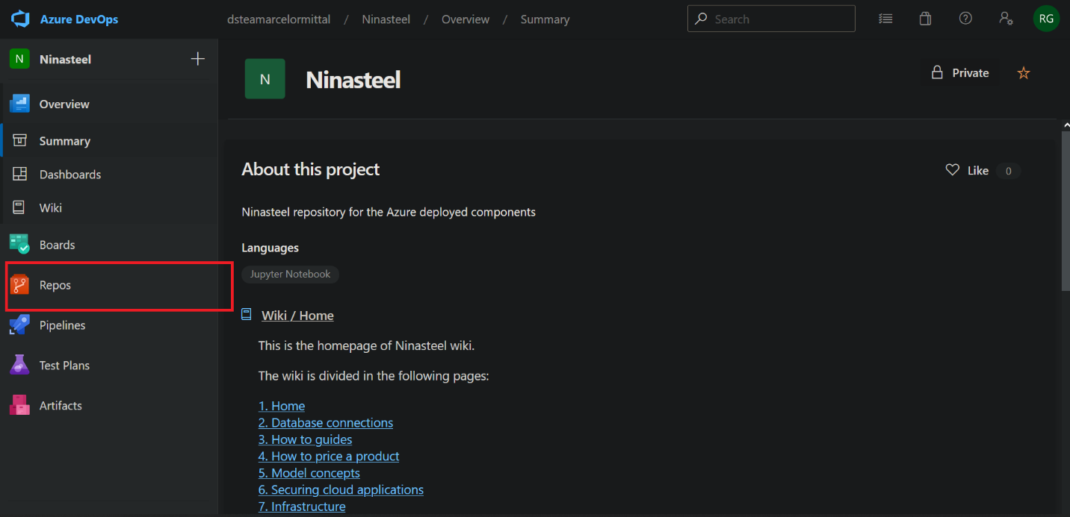

## Cloning a repository

1. Then go to repository  
   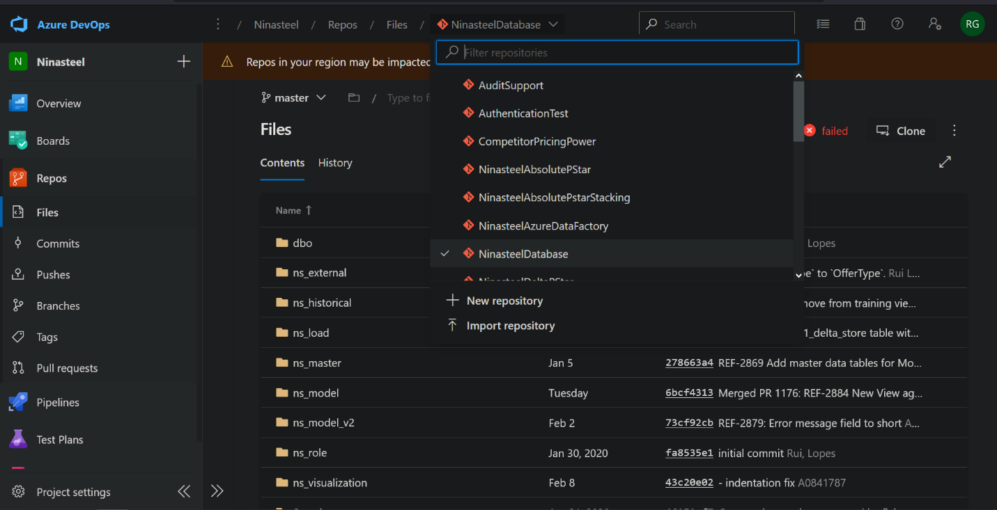
2. Consider we target NinasteelDatabase, we have to click on **Clone**  
   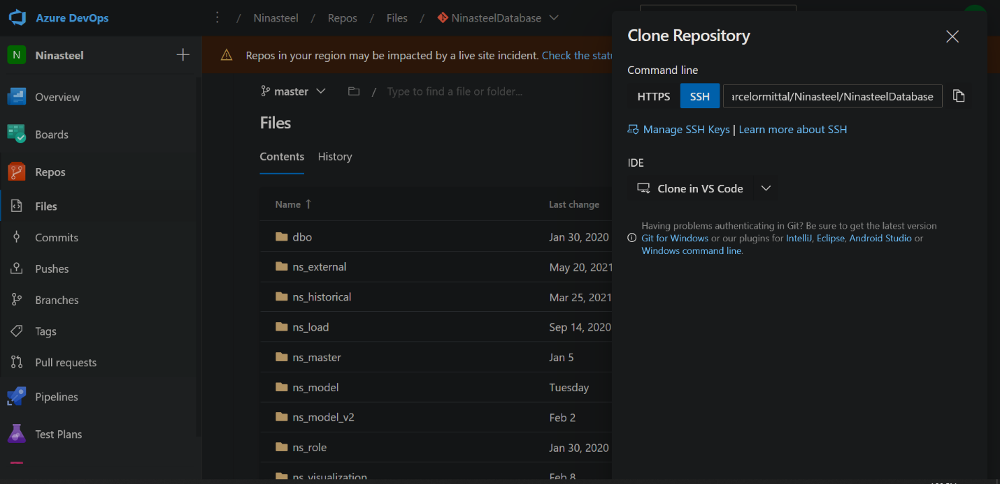
3. Then open a git bash terminal and go to a desired repository where you want to clone the repository, then:   
   Text

   Description automatically generated

## Pull Request

On the left click on Repos > Pull Request then:

1. Then:  
   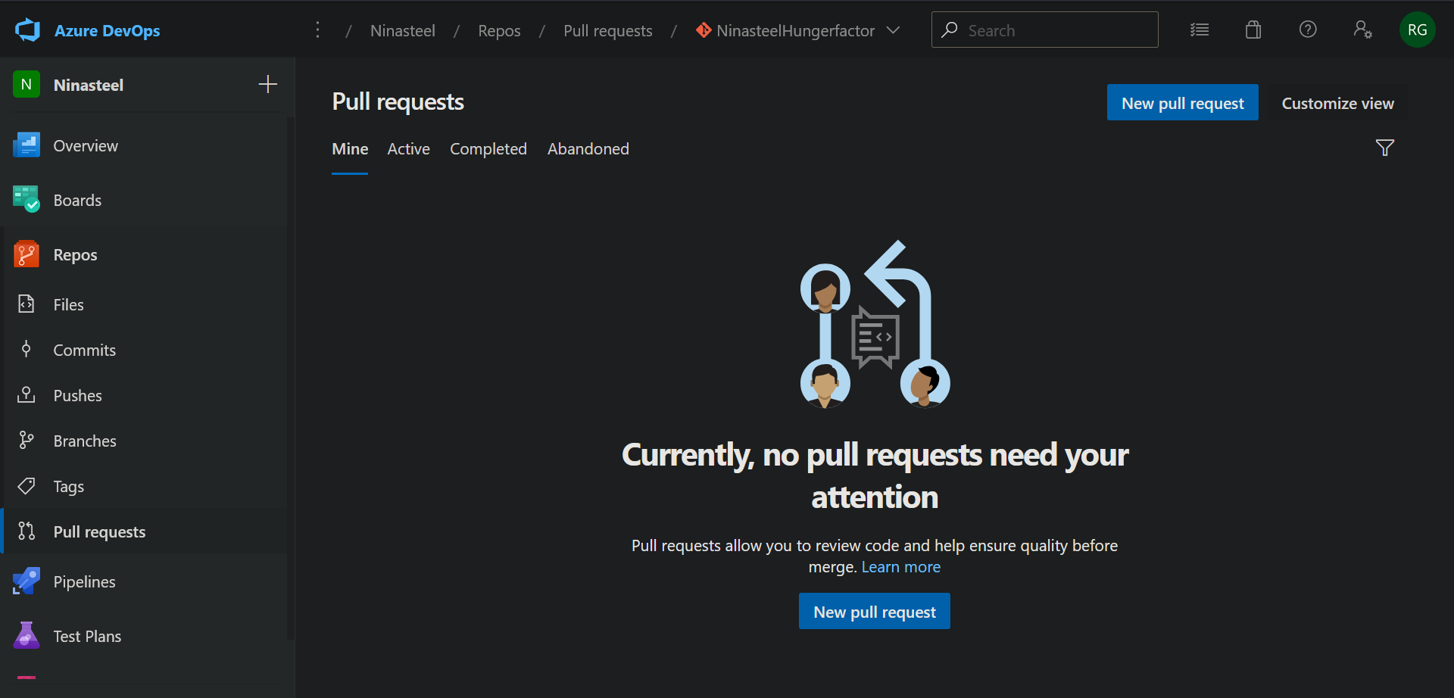
2. And fill all the fields:  
   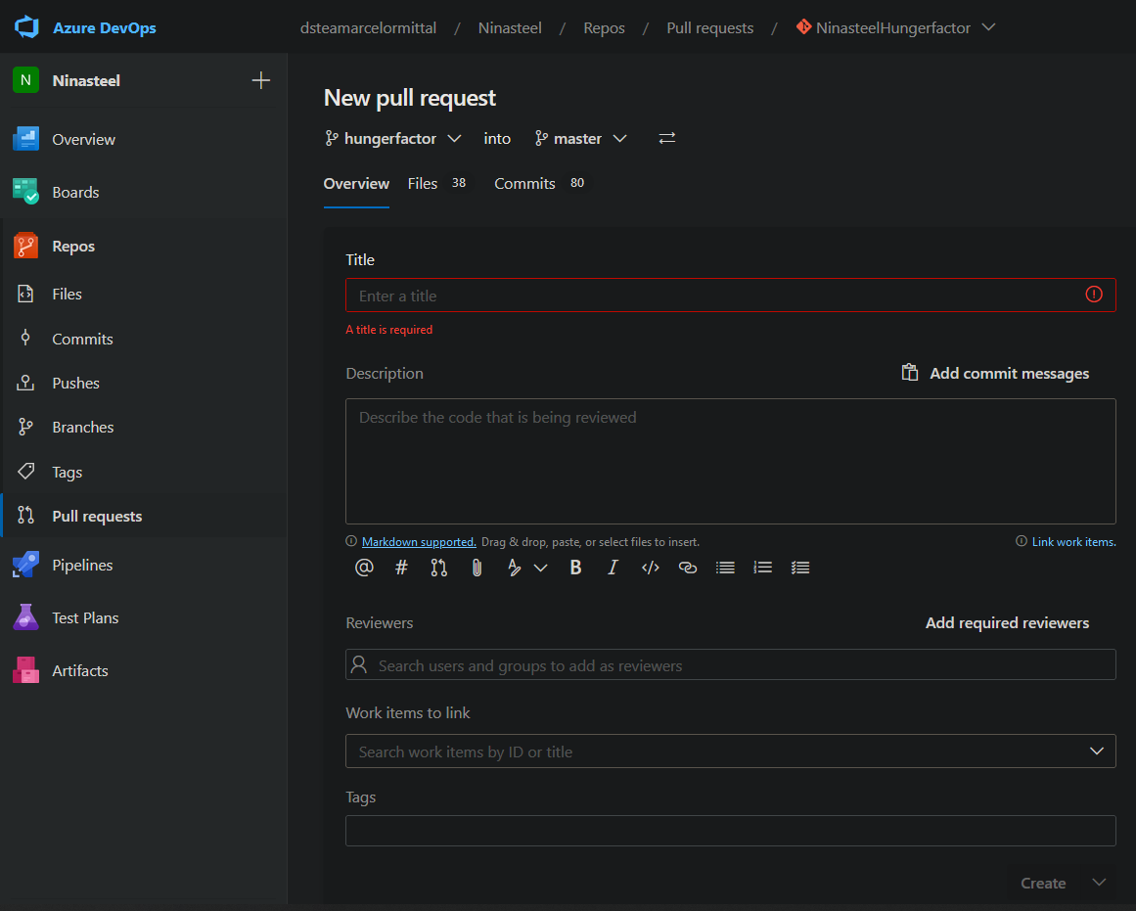

## SSH connection

If communication is not allowed like this

1. we have to generate a new ssh key, with **ssh-keygen -t rsa**Text

   Description automatically generated
2. Then copy the content of the generated key  
   Text

   Description automatically generated
3. Then we can go back to Azure DevOps account, and click on SSH public keysw<  
   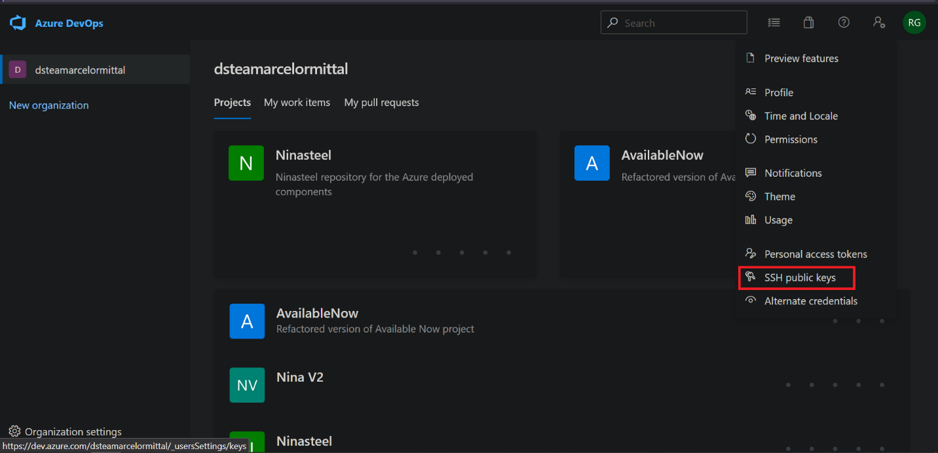
4. Then  
   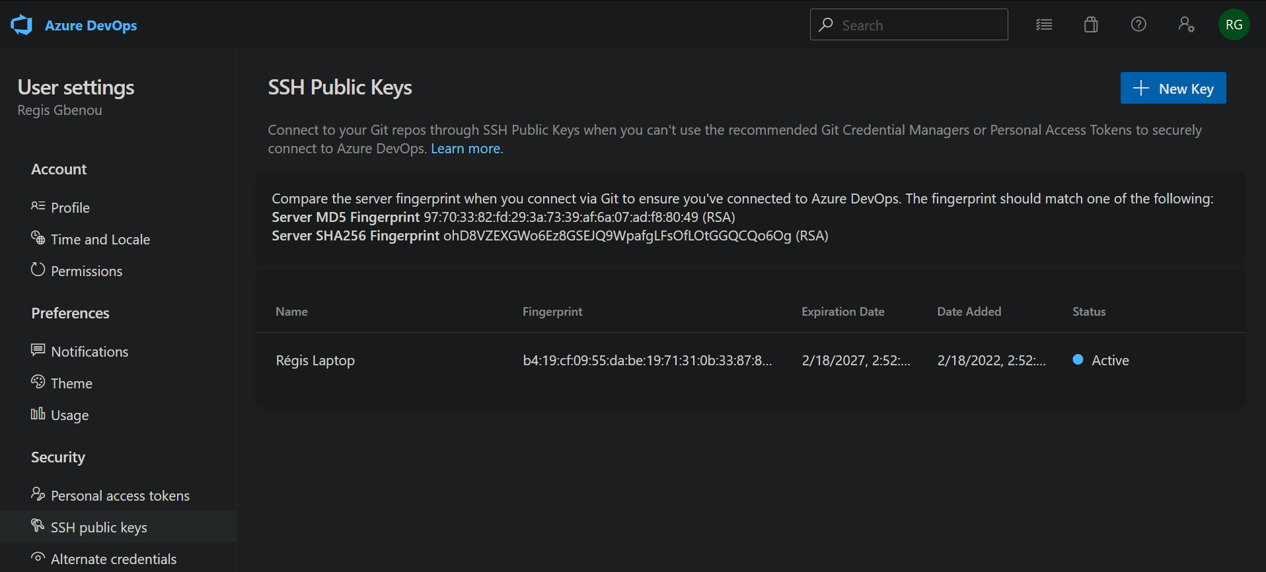
5. And finally  
   